

Graduate School of Development Studies

Public Sector Human Capital Investment in Pakistan

Is Economics or Politics at Play?

A Research Paper presented by:
Muhammad Saleh
(Pakistan)
in partial fulfillment of the requirements for obtaining the degree of
MASTERS OF ARTS IN DEVELOPMENT STUDIES
Specialization:
Economics of Development
(ECD)
Members of the examining committee:
Prof. Sayed Mansoob Murshed [Supervisor]
Prof. Arjun Bedi [Reader]
The Hague, The Netherlands
November, 2011

Disclaimer:
This document represents part of the author’s study programme while at the Institute of Social Studies. The views stated therein are those of the author and not necessarily those of the Institute.
Research papers are not made available for circulation outside of the Institute.

Inquiries:
Postal address: Institute of Social Studies
P.O. Box 29776
2502 LT The Hague
The Netherlands
Location: Kortenaerkade 12
2518 AX The Hague
The Netherlands
Telephone: +31 70 426 0460
Fax: +31 70 426 0799

Contents
List of Tables v
List of Figures v
List of Acronyms vi
Acknowledgement vii
Abstract viii
Section 1: Establishing A Case For The Research Agenda: Why And What Is To Be Explored? 1
Chapter 1 Introduction 2
1.1 Analysis of the problem: why is it important to explore? 3
1.2 Objective of the study 14
1.3 Research Question 14
1.3.1 The Specific/sub Research Questions 14
1.3.2 Working Hypothesis: 15
1.4 Organization of the Paper: 15
Chapter 2 Developing theoretical & analytical orientation 16
2.1 On economics of public sector human capital investment: A case for the public debt in theory and evidence 16
2.2 On politics of public sector human capital investment: A case for the political factors in theory and evidence 20
2.3 A literature synthesis and conceptualization of the study 25
Section2: Operationalization of the Research Questions: How is it to be explored? 28
Chapter3 Data & Methodology 29
3.1 Data Collection & addressing some potential challenges faced 29
3.2 Modelling the research Question 30
3.2.1 Theoretical Model 30
3.2.2 Empirical Model 32
Section3: Exploring Answers To The Research Questions 42
Chapter 4 A report on and analysis of the findings: rethinking relevant theoretical and empirical debates 43
4.1 Pakistan’s Debt Net Cost Index (DNI) 43
4.2 On determinants of low human capital investment in Pakistan 45
4.2.1 Interpretation of main findings 45
4.2.2 Analysis of findings with theory and evidence: Is economics or politics at play? 54
Chapter 5 Concluding Remarks 63
5.1 Limitations and prospective areas of research 64
References 66
Appendices 71

List of Tables
Table 1.1 Average estimates of different economic indicators in Pakistan 5
Table 1.2 Regional comparison in terms of different economic indicators’ average estimates 8
Table 1.3 Average shares of different spending heads in total government spending in Pakistan 9
Table 4.1 OLS estimates of Equation.8 with and without imputed values 43
Table 4.2 Granger causality test statistics 46
Table 4.3 VAR estimates for the whole sample with exogenous political and elections dummies 49
Table 4.4 VAR estimates for the periods of dictatorship (with dictatorship and election dummies as endogenous 52
Table 4.5 VAR estimates for the periods of democracy (with democracy and elections dummies as endogenous) 53
Table 4.6 Tabulated answers to the question 62

List of Figures
Figure 1.1 Trends in different economic inidcators of Pakisatn 10
Figure 1.2 Trends in Debt to GDP Ratios of Pakistan 10
Figure 1.3 Trends in Debt Servicing and military burden (combined) and total government spendings as share of GDP 11
Figure 1.4 Child Mortality Indicators 12
Figure 1.5 Literacy rates in Pakistan 13
Figure 2.2 The conceptual flow chart of the study 27
Figure 4.1 Debt Net Cost Index of Pakistan 44

List of Acronyms
BLUE Best Linear Unbiased Estimator
DNI Debt Net Cost Index
FBS Federal Bureau of Statistics
GDP Gross Domestic Product
HIPC Highly Indebted Poor Countries
LICs Low Income Countries
MDGs Millennium Development Goals
MDRI Multilateral Debt Relief Initiative
ODA Official Development Assistance
OECD Organization for Economic Cooperation and Development
OLG Overlapping Generations
OLS Ordinary Least Squares
PML Pakistan Muslim League
PPP Pakistan Peoples Party
PPP Purchasing Power Parity
VAR Vector Auto Regressive
VECM Vector Error Correction Model
VIF Variance Inflation Factor
WDI World Development Indicators

Acknowledgement
On successful completion of this research, I am extremely grateful to my supervisor, Prof. Sayed Mansoob Murshed, who not only has supervised me through this endeavour but also made this challenging journey a smooth sailing and creatively learning experience for me. And for this I am intellectually indebted to his objective academic guidance.
I am also thankful to my second reader, Prof. Arjun Bedi, whose academic acumen and constructive critique has made me think out of the box and helped me give this study a more pragmatic and relevant orientation. His qualified quantitative insights, which have helped me refine this work in great deal, are highly appreciated.
Especial thanks for Dr. Susan Newman for allowing me to seek her valuable guidance whenever needed and successfully steering me through some of the methodological issues. I also appreciate the assiduous efforts of the convenor, Dr. Howard Nicholas, for extending me some valuable motivational support during this research.
I do sincerely value the time and support provided by my friends, especially Fabio, Arshad, Saleem, Sana and Shahadat at the ISS and brother Kashif in Pakistan, whose discussions and inputs right from the beginning have undoubtedly augmented the quality of this work. The all out efforts made by all of my colleagues both at the Planning Commission and the FBS, for helping me out in collecting required data, are highly acknowledged and appreciated.
I do owe a lifelong debt to my Ammi (mother) whose blessed warmth of love and affection has always been a source of immense inspiration and strength for whatever I have achieved so far.
Last but not the least I do express my gratitude to my Lord for blessing me with an intellect & inquisitive thirst of the Truth first, and then providing clues to quench this thirst through keen observation, critical cognition and rational inferences.

Abstract
The paper investigates factors responsible for low public sector human capital investment in Pakistan. For economic factors, budget constraint of the government leads to debt burden both in stock and flow forms, which can either positively or negatively affect the public sector human capital investment. To account for this, a Debt Net Cost Index (DNI) has been developed to measure the net cost of public debts that has been shifting from one year to another since 1960. The political factors in terms of regime type, frequency of elections and international aid preferences; elite capture in terms of industrial and military elite burden and institutional factors in terms of institutional quality and propensity of external conflicts have been analyzed. Treating the DNI as a proxy for the economic cost that limits the capacity of the Government to invest in human capital, the paper explores the comparative significance of this economic factor vis-a-vis political factors responsible for low public sector human capital investment in Pakistan.

Keywords
[Human capital investment, Public sector, Public debt, Debt net cost index, Industrial elite, Military burden, Pakistan]

Section 1: Establishing A Case For The Research Agenda: Why And What Is To Be Explored?
The aim of this section is both to develop a sound descriptive rational for carrying out this research in the light of some factual analysis and to formulate a theoretical premises within which the study will be operationalized and the findings will be analysed in our subsequent sections.

Chapter 1 Introduction
During the last two decades, the evolution of economic thinking characterized by ‘New Growth Theory’ has not only endogenized human capital to explain observed patterns of long run economic growth but also placed it as a driver of physical capital accumulation through fostering technological advancements in an economy (Lucas 1988, Lucas 1990). It has also been observed that countries’ total factor productivity crucially depends upon their stocks of human capital in a way that any observed differences in their initial stocks of human capital do shape their respective paths of economic convergence in the long run (Benhabib and Spiegel 1994, Temple 1999). This is because, that unlike the physical capital accumulation which is characterized by diminishing returns, the increasing returns of investment in human capital are important to explain why certain countries in a particular region converge or do not converge to some specific growth trajectories in the long run (Martin and Sunley 1998).
Health and education are two core components of human capital. Considering the fact that four out of seven goals of the Millennium Development Goals (MDGs) are directly covered by these two sectors, the importance of investment in these sectors is, therefore, greatly emphasised whenever the issue of achieving MDGs is discussed ( Baldacci et al. 2008).
Moreover in a developing country’s perspective, both the slower rates of economic return and higher opportunity costs of investment attached to health and education, make the role of public investments in these sectors extremely important for reducing income inequalities and achieving sustainable development (Glomm and Ravikumar 1992, Gupta et al. 2002). Nevertheless, it has been observed that low preferential treatment has not only resulted into historically inadequate public sector human capital spending in these countries but also made their growth experiences neutral to sustainable development (Easterly 2001).
It is in this backdrop, the importance of analyzing determinants of low public sector human capital spending, particularly in the developing world, has increased manifold in recent years. The study, while focusing on the case of Pakistan, aims at exploring and explaining the causes of low levels of public sector human capital investment. While analysing the economic and political factors, it will examine whether these are the economic factors in the form of net costs of excessive reliance on public debts raised both from domestic and external sources; or some political factors; or an inter-relationship of both that explain the behaviour of low public sector human capital expenditures in Pakistan.

1.1 Analysis of the problem: why is it important to explore?
Various episodes of reasonable economic growth; a fraction of manpower being graduated from world renowned institutions and a sizeable amount of small scale entrepreneurs well settled in the industrialized world albeit almost half of the population being deprived of basic health and education facilities are all what make Pakistan a unique developing country among its contemporaries. The contradiction is established by the fact that the country, which has benefited from $98 billion of development assistance with an average real GDP per capita growth rate of 3.0 percent over the last five decades (1960-2010), is still struggling to raise its literacy rate, which as per an estimate in 2008 was 57 percent; with female and male rates of 42 percent and 68 percent respectively. The health status of general masses is also deplorable as Infant Mortality Rate (a key MDG health indicator) is still estimated at 73 per 1000 live births.
Why does such an inconsistency persist in the country? One crude argument could be that government cannot invest in human capital because it does not have enough resources in the form of taxes (economic argument motivated by budget or resource constraint). Others may contend that although the country has witnessed buoyant periods of economic growth, the agenda of launching an all-out drive of educating the masses, especially the poor at primary level, with the provision of basic health facilities has never been the top priority of public sector in Pakistan, i.e. rulers don’t want to invest in human capital (political argument). As can be seen from the average public sector expenditures on health and education, that have dropped to as low as 0.51 percent of GDP during 2006-10 from 1.18 percent during 1961-65, whereas average defence expenditures were as high as 4.12 percent of GDP during the last five decades (See table-1.1 below).
But the factors that may actually deter the public sector in Pakistan to allocate sufficient amounts of funds for promoting mass education and health services can be far more intricate than these apparent and partially relevant causal argumentations.

Table 1.1 Average estimates of different economic indicators in Pakistan
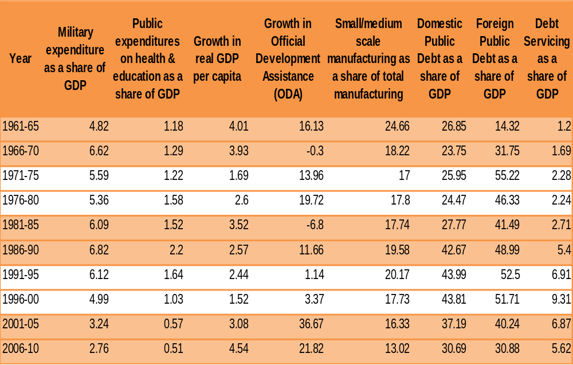
(in percent)
Source: Author’s own calculations based on the data gathered from different national and international sources

First, if the country, which emerged as an independent state in 1947, has seen different episodes of growth on economic front, its political stage has also been consistently shifting between feudalistic democratic regimes and military dictatorships (see the shaded periods in Table 1.1). It is mainly due to the fact that the country has inherited and nurtured a landed aristocracy, feudalistic political elite and a politically influential military over the periods of time. These actors having strong economic and political power may prefer to keep the economic inequalities at certain levels to get their power legitimized (Acemoglu and Robinson 2008). One crude method of measuring the capture of say industrialist elite is the small scale manufacturing as a share total industrial manufacturing, i.e. any fall in the share of small scale manufacturing is a source of industrial elite concentration (Cimoli and Rovira 2008). And in Pakistan this ratio from an average of 24.66 percent in 1961-65 has reduced to only 13.02 percent in 2006-10 (see Table 1.1).
Second, the growth in official development assistance (ODA), if seen as a proxy for donors’ political preferences, has remained extremely volatile in Pakistan. Having witnessed some positive shocks during the dictatorial regimes of 80’s and 2000’s, the trend shows that the official development assistance in Pakistan might have had a close association with the type of regime in the country (see Table 1.1). Again the, dictatorial periods were though the periods of higher growths in GDP per capita as compare to the periods of democracy yet the human capital investment remained unaffected by those periods of economic revival.
This shows that the political structure, elite burden and international political preferences do have some resonance to the public sector human capital preferences in Pakistan.
Moreover, along with this political structure at large, the existential geographical security threats on two of its borders have also played their due roles in defining the national fiscal preferences. The issue of state security has always been called into question due to on-going conflicts with two of its bordering nations- India and Afghanistan, that in turn generated not only a need to maintain a military well accoutred with state of the art arsenal but also required availability of sufficient financial resources. The country as per an estimate has to spend the highest proportions of total government spending on military as compared with other regional countries; almost an average of 27 percent of total government expenditures went directly to defence during the last two decades (see Table 1.2).
Does Pakistan have enough of its own financial resources to meet these inevitable expenditures as well as invest in its human capital? No! is the answer, because even after implementing eight Five Year National Economic Plans, the country is still struggling to generate sufficient amount of tax revenues. Over all tax to GDP ratio was estimated at 10.0 percent in 2009-10, which was far less than Sri Lanka and South Korea– the countries who have managed to attain high literacy rates through substantially investing in their respective masses (See Table 1.2). The precedence of the fastest growing regional economies shows that the public sectors in countries like South Korea did spend more than 20 percent of their total government spending on health and education but Pakistan has never been able to spend on average more than 7.5 percent of the total government expenditures on health and education during the last two decades. The amount was even lower than other regional developing countries like India, Sri Lanka and Bangladesh. (See Table 1.2).

Table 1.2 Regional comparison in terms of different economic indicators’ average estimates
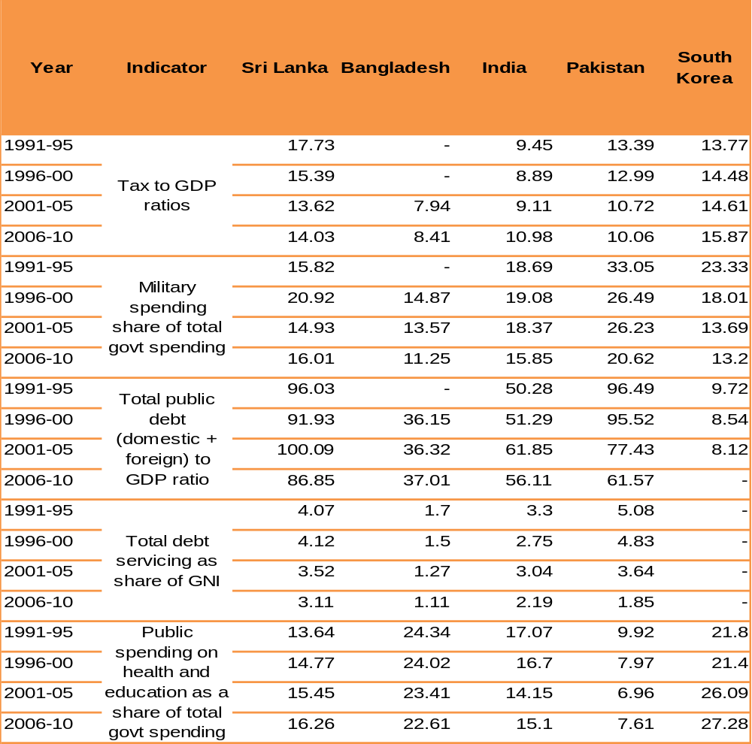
(in percent)
Source: Author’s own calculations based on the data collected from different national and international sources

What is the economic consequence of such a huge military burden on public exchequer and the limited capacity to mobilize domestic resources in the form of taxes? It is an excessive reliance on public debts to finance developmental and social spending requirements. As of 2009-10, Pakistan is publicly indebted with an accumulated amount of Rs. 9178 billion ($111.9 billion) to both the domestic and foreign creditors. The overall Debt-GDP ratio stood at 60 percent with almost 30 percent each for the domestic and foreign public debt, whereas the overall debt servicing to GDP ratio increased up to 14 percent in 1999 and has been estimated at 6 percent in 2010. The indebtedness has not only increased the burden of debt servicing but also shrunk the amount of resources available for making developmental and social sector spending in the country. Interestingly, one can see that Bangladesh, which more or less is comparable with Pakistan both on political and economic spheres–but with lowest debt to GDP ratios and the military spending in the region–managed to spend more than 20 percent of its government spending on health and education during the last two decades (see Tables 1.2-1.3).

Table 1.3 Average shares of different spending heads in total government spending in Pakistan
(in percent)
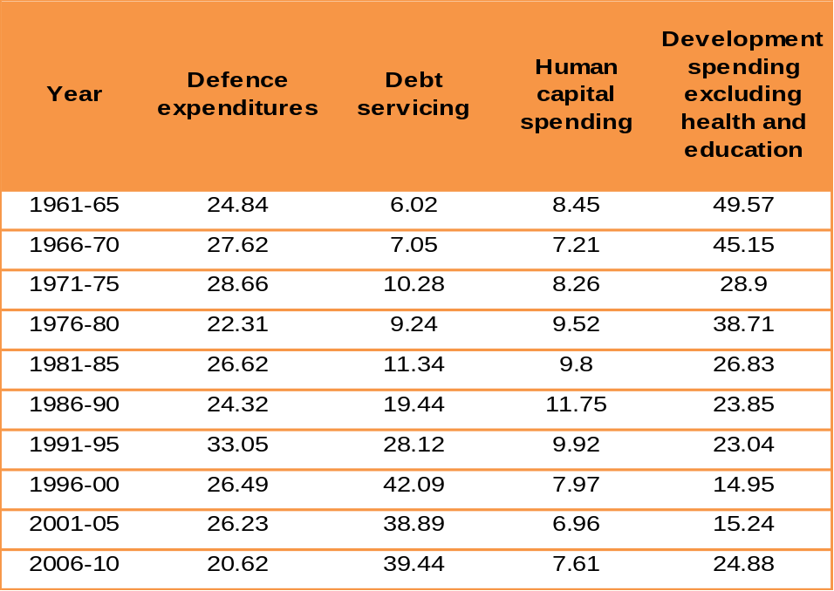
Source: Author’s own calculations based on the data collected from different national and international sources

But for Pakistan with higher military and debt burdens, both the development spending and human capital spending as a share of its GDP show declining trends during the last five decades (See fig 1.1-1.3 below).

Figure 1.1 Trends in different economic inidcators of Pakisatn
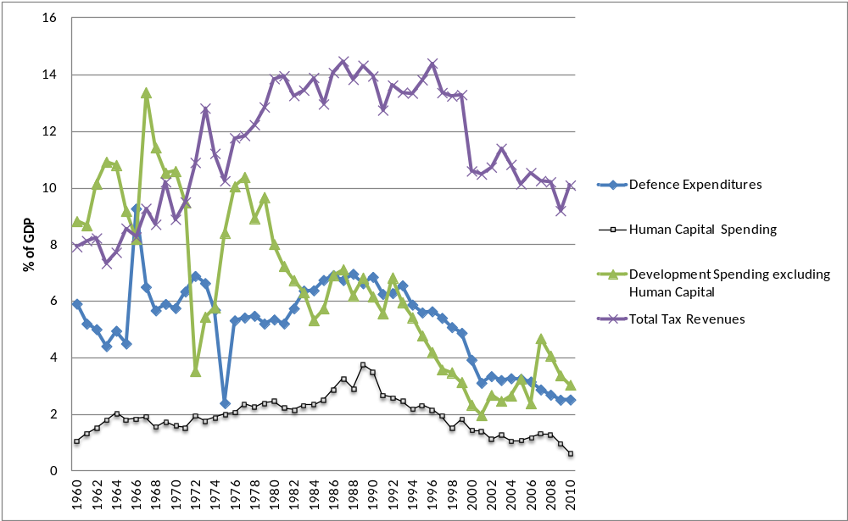Source: Based on the secondary data collected from different national and international sources

Figure 1.2 Trends in Debt to GDP Ratios of Pakistan

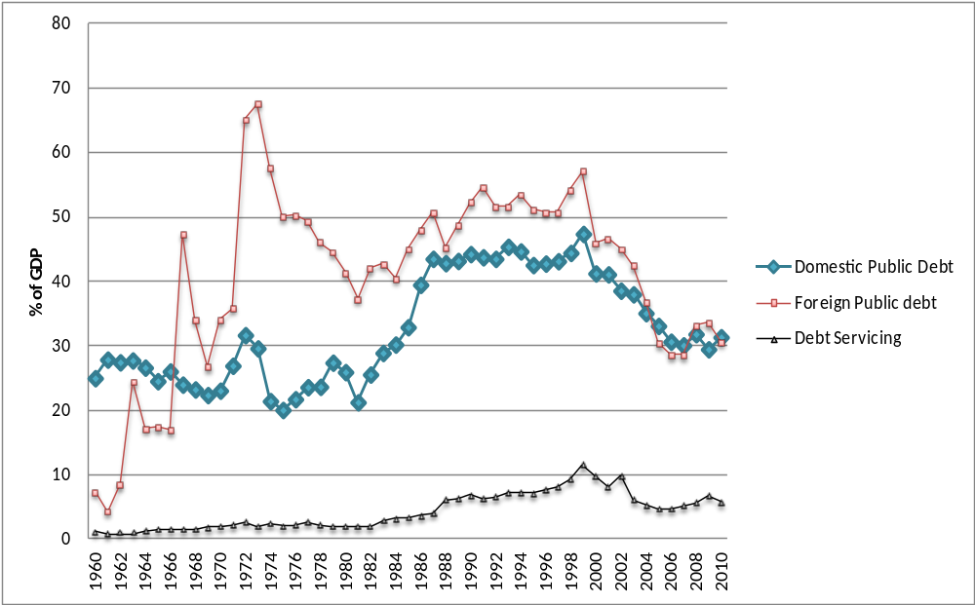
Source: Based on the secondary data collected from different national and international sources

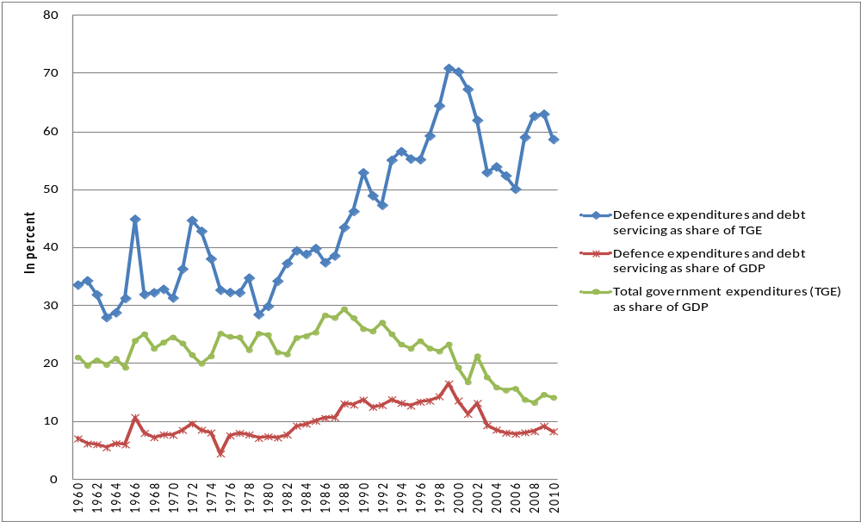
Figure 1.3 Trends in Debt Servicing and military burden (combined) and total government spendings as share of GDP

Source: Based on the secondary data collected from different national and international sources

What are the implications of debt accumulation in a country like Pakistan? It is contended that amounts of debt, accumulated in stocks at a particular time, can be welfare enhancing for general public if the larger chuck of these resources are spent on development activities and social services. However, if more of these debts are spent on non-development activities, the increased burden of debt servicing can render a cost for future generations in the form higher taxes and lower public sector development and social spending. This shows that it is utilization not the composition of public debts, which is crucial for sustainability and public sector social spending (Aghion and Bolton 1997).
Furthermore, the adverse effects of this economic factor in the form of unsustainable public debts on a developing country’s capacity to make social spending were reinforced when the IMF and World Bank along with other multilateral creditors launched a huge debt relief HIPC (Highly Indebted Poor Countries) initiative in 1996 and Multilateral Debt Relief Initiative (MDRI) in 2006 in the African continent. The main rational behind was that the huge public debts of African countries were obstructing their social financial allocations including health and education and once their debts are sustained, these countries would be able to invest in human capital and achieve MDGs by 2015. The initiative went well and posted some achievements. As once the debt burden started to decline after the initiative, the ratio of pro poor spending including health and education to total government spending was increased from 27.6 percent to 40.9 percent in 1999 and 2003 respectively. All in all the issue of debt reduction especially for the poor countries at present is primarily related with their ability to invest in human capital and propensity to achieve MDGs (Gupta et al. 2002, Gunter et al. 2009, Fosu 2007).
Take a case of MDGs in Pakistan. The country; as other developing countries of the world did, adopted them in 2000 to bring its masses out of extreme poverty and deprivation through gradually augmenting the share of human capital spending. However, the desired indicators seem not to be achievable by 2015 with existing mass illiteracy and high maternal and child mortality ratios. It is estimated that with an MDG target of achieving 88 percent literacy and infant mortality ratio of 40 per 1000 live births by 2015, the country is living far below its targets and could only achieve a literacy rate of 57 percent in 2010 as compared with 51 percent in 2001 and IMR of 73 from 78 per 1000 live births during the same period. Both the under five mortality and the proportion of fully immunized children remained almost stagnant during the same period (2001-09) (See Figures 1.4-1.5).

Figure 1.4 Child Mortality Indicators
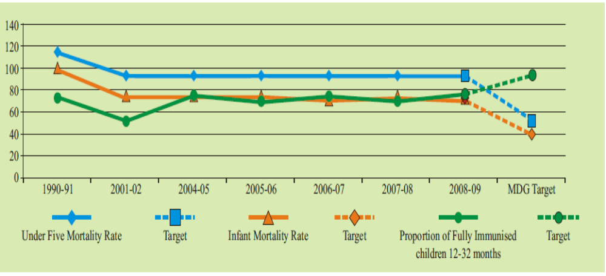
Source: Planning Commission of Pakistan, 2010

Figure 1.5 Literacy rates in Pakistan
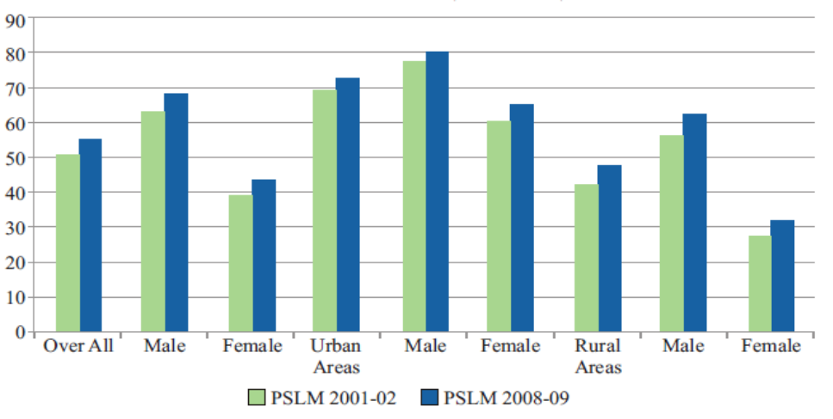
Source: Planning Commission of Pakistan (2010)

In view of all the above descriptions, one can develop a situational triangle where on the one side there is a huge debt burden due to limited resource availability (budget constraint); on the second a unique political structure with successive periods of dictatorial regimes, elite and military burden; and on the third an underdeveloped human capital due to historically low levels of public sector investment in health and education. And the study will explore is there anything in this economic and political structure that can explain the low levels of public sector human capital spending in Pakistan.
What does make this study a worthwhile exercise? First, the revolution in economic thinking during the 90’s has unanimously put human capital, particularly educated workers with sound health, as a driver of physical capital accumulation. This denotes that poor health and education are more than just a consequence of low income; they are also one of its fundamental causes. Such a breakthrough has led the question of analyzing the determinants of low public sector investments in human capital as well as the scope of alternative policy interventions (such as improvements in fiscal sustainability or improvements in governance) to the forefront during the past decade, particularly in low income countries (Bloom et al. 2004, Bloom and Canning 2000, Baldacci et al. 2008).
Therefore, it is important to explore in case of Pakistan that why it is so that the public sector human capital investment, since 1960’s could never go beyond 3.0 percent of its GDP. For this, the present study will explore whether it’s the economic cost of accumulating huge public debts which has transferred from one generation to another or there are some other political factors like a particular form of political setup, military burden, institutional quality or the country’s engagement in a conflict like war that explain the patterns public sector human capital investments in Pakistan.

1.2 Objective of the study
The objective of the study is to investigate and analyze the comparative significance of economic and political factors responsible for low human capital investment, i.e. investment in health and education, by the public sector in Pakistan.

1.3 Research Question
Why is public sector human capital investment low in Pakistan?

1.3.1 The Specific/sub Research Questions
The following sub-questions are developed to answer the main question:
- What is the level of net welfare gain/cost of high public debts (both in stock and flow forms)?
- What are the political factors that can directly or indirectly explain the behavior of public sector human capital spending?
- Is low levels public sector human capital investment caused by political or economic factors (net cost of public debt both in stock and flow forms); or some significant inter-relationship of both political and economic factors explain the behavior of public sector human capital investment?

1.3.2 Working Hypothesis:
In light of our main question and subsequent sub-questions, the study will test the following working hypothesis and subsequent inferences will be made to answer our questions:
H1: The low levels of public sector human capital investment are caused by the economic factor, i.e. net cost of high public debts
H2: The low levels of public sector human capital investment are caused by some political factors
H3: Neither the economic nor the political factors explain the low levels of public sector human capital investment but their inter-relationship or joint causation explains the behaviour of human capital spending in Pakistan

1.4 Organization of the Paper:
The paper is divided into three main sections broadly covering the three distinct questions in each one of them: i) why the study is being carried out and what is to be found; ii) how will it be carried out; iii) what we have found to answer our research questions. Section 1 trying to develop the rational for carrying out the subject study has two chapters in it. Starting with this chapter containing introduction, objective and the research question, chapter 2 will state and analyse some relevant theoretical debates and empirical evidences. Section 2 will cover the broader descriptions on how the study will be operationalized. It will have one chapter, i.e. Chapter 3, wherein the issues like data collection and selection of appropriate methodology for analysing this data will be discussed. Section 3 will have two chapters again. The estimation results will be presented and analysed in Chapter 4. And at the end the conclusion will be presented in chapter 5 with some limitations and issues for the prospective research in this particular field of study.

Developing theoretical & analytical orientation
In theory there is no consensus on determinants of low human capital spending in developing or low income countries; except that both the economic and political factors are crucial with varying specifications and degrees of validity in different geographical boundaries. Secondly, the question of why public debt is a crucial need, particularly for developing countries to ensure minimum resource allocations to human capital and what are the relevant political factors that may deter a state to invest in its human capital, has historically been an issue of extensive debate among economic and political-economic theorists, who all have produced alternative theoretical explanations and empirical observations in this regard.
Considering nature of the study and our research question, our review and analysis of theoretical and empirical literature is divided into two broader categories: i) theory and evidence on economic factor (public debts) responsible for low public sector human capital investment ii) theory and evidence on political and institutional factors responsible for low human capital investment.

On economics of public sector human capital investment: A case for the public debt in theory and evidence
The question of why public debt is essential to finance human capital investment and how it can have some costs for future generations carries within itself a vast and contradictory theoretical debate. For the ancestors of classical economic thought such as Adam Smith and J.S. Mill the acts of savings for a nation were essentially the acts of investment, hence budget deficits are intolerable. For them governments have to spend some money to ensure smooth provisioning of social services, which should be raised through equal amount of taxes. Deficit financing is still crucial for future capital accumulation in an economy (Tsoulfidis 2007). Ricardo on the other hand, held tax and bond financing equivalent explaining the essential case of a government which has to tax in order to redeem its debt in some future moment. Hence either method of financing public spending will lead up to the same final results, i.e. more taxes and low investment either now or in future to finance deficits (Barro 1974).
For neoclassical economists, the more the volume of internal and external debt the lesser will be the individual utility in long run equilibrium. In conventional neoclassical growth model of Solow, a competitive equilibrium can be inefficient with an indebted public sector. Furthermore, the magnitude of utility reduction by internal debt is more than that of the external debt in standard neoclassical model (Diamond 1965).
One theoretical drawback of the above schools of thought was that the fraternity although reckoned public debt as a part not the solution for the long run economic problems and low public spending for provisioning of social services yet the issue of whether debt can shift the costs from one generation to another has contradictory opinions in their ranks. And this difference mainly emanates from the issue of how one defines the real burden of public debt. The authors like Samuelson argues that the debt does not burden future generations because government spending must drain real resources from the community at the time the government project is undertaken regardless of whether the project is financed by borrowing, taxes, or money creation. This is because of the fact that these authors see the real burden of debt as the total amount of private consumption goods given up by the community at the moment, the borrowed funds are spent. But if one defines it- like J.M. Buchanan does-as the total consumption of private goods foregone during the lifetime of that generation as a consequence of government borrowing and attendant public spending, then the burden will be shifted to future generations in the shape of higher interest and tax payments and lower public sector development and social spending (Bowen et al. 1960, Tobin 1965).
The theoretical debate on the role of public debts in explaining behaviour of public sector human capital spending, however, entered into a new phase following African debt crisis in early 1990’s. The global financers came up with HIPC and MDRI initiatives on the premise that high indebtedness of African nations is crucially limiting states’ capacities to invest into their respective human capital. Two arguments, i.e. ‘Debt Overhang’ & ‘Crowding Out’, can aptly be called the theoretical foundations of the HIPC and MDRI initiatives explaining that why and when public debt in a highly indebted poor country becomes unsustainable.
Paul Krugman and Jeffery Sachs were the first two to introduce the term of ‘Debt Overhang’ for highly indebted poor countries. Both were of the view point that in LICs the amount of debt can initially be a growth enhancing factor but if crosses a certain point than becomes unsustainable and creates a situation where both the public and private investors hesitate to invest. They do this on the pretext that the yields of investment will ultimately go to the creditors of the country. Such a paradox, according to them was ‘Debt Overhang’ where for every country lying beyond a certain thresh whole; the policy of debt relief is more efficient than the provision of more loans (Krugman 1988, Sachs 1990).
The Crowding Out effect of debt on investment is based on the premise that any reduction in the current level of debt servicing burden will render a fiscal space to increase investment without affecting consumption for any level of indebtedness. For this effect to be at work the country must have imperfect access to world capital markets, which is certainly the case for HIPCs; the argument also assumes that the way in which debt service is reduced does not affect access to new official assistance (Claessens et al. 1997).
However, one crucial aspect of this theoretical formulation is that the debt overhang theory was developed for countries heavily indebted towards private commercial creditors. The governments of the HIPCs and Pakistan as well, on the other hand, were mostly indebted to official creditors, and they also received substantial transfers often in the form of concessional assistance. Now the ‘debt Overhang’ theory was to remain relevant to the HIPCs as long as the creditors made foreign assistance independent of the size of debt of an economy. But the HIPC countries’ foreign grants and concessional loans were strictly made contingent upon the ability of the countries to apply PRSP and reaching a point where they showed a capacity to service their future debts effectively (Claessens et al. 1997).
Again it has empirically been observed that aligning foreign assistance with the relief and future funding creates a ‘reverse causation’ for the creditors because as the economic conditions of a targeted country improves after the relief, the creditors may reduce the amount of aid and grants to that economy, which may in turn prompt the country to screw up growth enhancing measures. Such a situation not only makes the standard ‘Debt Overhang’ theory irrelevant for the HIPCs but also alludes to the problem when a country even after reducing her debt burden may fall into a ‘low debt-low growth’ nexus (Gunter et al. 2009, Claessens et al. 1997).
Furthermore, at what levels debts will become unsustainable and countries will face debt overhang problem is unclear. Countries with as high debt to GDP ratios as 160 percent, like Japan, can still be able to manage their debts sustainably while for others they may become unsustainable even at 6o percent of their GDPs like in Pakistan where debt servicing has significant share in the total government expenditures (See Table 1.3 Chapter 1) and shrinks its capacity to make social spending. It has also been found that conventional debt to GDP ratios may not depict true debt overhang situation under varying economic and political conditions (For discussions apropos of these issues see for example Haber and Neck 2006, Akyuz 2007, Köller et al. 2007, Marks 2004, Qin et al. 2006, Gunter 2002).
In sum the economic factor that may deter public sector human capital investment is the cost of public debt meted out of the resource or budget constraints of developing countries.

On politics of public sector human capital investment: A case for the political factors in theory and evidence
In a state like Pakistan three main actors interact; military and political elite (both land owning and industrialist) whose aspiration is to hold and sustain power while neutralizing any risks of revolt, institutions like bureaucracy and judiciary whose role is to define and lead the transition process of de jure power from one regime to another and powerless poor masses who though possess an inherent threat of revolt and revolution yet because of their disorganization, remain contended to the transitory concessions offered by the ruling elite.
The authors like Acemoglu D. and Robinson J. have moved on to extensive theoretical formulations to capture the dynamics of these interacting forces. The authors point out that emancipation of poor lies in consolidation of democracy and reduction in inequality but the survival of ruling political elite is contingent to maintaining the levels of inequality at certain levels. Hence they collude with the institutions to offer poor masses some concessions in bad times and seek economic rents for themselves in good times. For such states, the few periods of democracy do not move on to consolidation because of what they call it a ‘captured democracy’ where democratic regimes’ survival is contingent upon choosing economic institutions favouring elite. Again since the rulers in such states enjoy more political power than the masses, they invest more and more to increase their ‘de facto’ power and make the institutions distribute ‘de jure’ power to their own vested interests as well. They further contend that since the poor possess a destabilizing thereat in terms of revolution, it may force the political elite initially to democratize and introducing truly pro-poor fiscal initiatives. However, considering the distributive nature of these measures and comparative loss of power by the elite, this will serve as an incentive for military elite to mount a coup and restore the status quo. Hence for them, these countries experience perpetual political oscillations between ‘captured democratic’ and non-democratic military regimes with high degrees of fiscal volatility(Acemoglu and Robinson 2007, Acemoglu and Robinson 2008, Acemoglu and Robinson 2006, Acemoglu and Robinson 2001)
The high degrees of fiscal volatility and the power oscillating between democratic and non-democratic regimes with low public sector allocations to human capital, are what that have exactly been observed in case of Pakistan. (see Table 1.1 Chapter 1 above for presidential dictatorial and parliamentary democratic periods).
Now whether these forms of differentiations are also crucial for public policy choices meant for human capital development or not? On theoretical fronts, it has been stated that the level and composition of government expenditures do crucially depend upon the type of regime in power. The two criteria have been developed namely ‘legislative cohesion’ and ‘effective separation of power’. The countries where majority votes are mandatory for the cabinet survival, parliament has strong rights over executive. This will lead to ineffective separation of powers and more rent seeking practices by the parliamentarians. And this in turn will obstruct the budgetary allocations to public good provisioning including health and education of poor masses at large. Contrarily, a presidential regime will be having lesser size of government and fewer rents to the politicians because of ‘effective separation of power’. However, the public good provisioning will be insufficient in these regimes too, considering the lack of will on part of the leaders to consolidate democracy (Roland et al. 2000).
Along with major regime types that can have some implications for public sector human capital investment, it has been observed empirically in several cross sectional studies that the consistency of electoral politics may also define the patterns of public preferences for spending more on social services. Any prospective constitutional change from one government to anther through elections makes the acting political leaders enhance general welfare expenditures including health and education to gain maximum electoral mileage and therefore, parliamentary form of government is associated with higher social spending (Tabellini and Persson 2004).
Uptill now, evidence shows that that in case of Pakistan the broader political structure; formed of political elite, influential military and poor masses may in itself be one of the crucial impediments for public sector human capital investment.
What does make that structure to persist or why does any external intervention has not been able to change this situation? The question pertains more to the functioning of the state. Start with the issue of the state survival, which has always been conditioned upon the development and maintenance of highly sophisticated armed force. Such a paradigm not only eats a lot of available resources but also creates strong political-military collusion. The chief concern of the collusion is to make sure that sufficient amount of resources (for military budgets) and rents (for politicians) are available to invest into their own respective ‘de facto’ powers. Hence both exist to serve as compliments rather than substitutes for each other. The implications of such a situation can both be negative and positive for the democratization and human capital investment at large.
The authors like Glaser et al. (2004) have observed that poor countries have been found to get out of poverty on the basis of good polices often led by dictators. Such a sustainable growth trajectory will lead to sustainable democratic institutional development.
However, the countries, which the authors have studied in their cross sectional study were mainly those who though had dictators yet did not have initial conditions of elite political and military nexus along with high ethnic diversity and income inequality like in Pakistan. Therefore, those states were able to lower the threats of both proletariat revolutions and military coups, which helped them, consolidate democracy. How countries like Pakistan can then invest in human capital through having consolidated democracy?
The creation of ‘state capacity’ is the idea that has been propounded by Besley & Persson who point out that today’s investments in fiscal and legal capacity of the states are welfare enhancing factors for the masses in future through state capacity to enforce property rights and levy taxes. Again the development of a ‘common interest public goods’ like some war and ‘inclusive political’ environment are among the chief determinants of these investments. Hence for them a permanent risk of external conflict is welfare enhancing at initial stages if more resources are collected and allocated towards building state capacity (Besley and Persson 2009, Besley and Persson 2010).
However, simply contending that permanent risk of external conflict is welfare enhancing at initial stages is misleading if those risks lead to internal strife in a state. Like in Africa, it has been found that a constant state of conflict both within and among nations can jeopardize the transfer of resources to concerned quarters, because under these circumstances the rebel leaders may capture most of the pro-poor fiscal transfers. And a transfer that could have prevented conflict may be insufficient to stop a war once it begins and the international community has only limited influence over these problems (Murshed 2003). Same has been observed in Pakistan where permanent risk of conflict with India and a decade old (2001 to present) conflict on its western border in wake of War against Terror has engendered a significant internal unrest and intra regional strife in the state.
Moreover, the notion of ‘state capacity’ has largely been equated to growth which can lead to institutional development sometimes later. But even if more resources are allocated to fiscal and legal capacity of a state along with bearing unavoidable military burden, this is not sufficient to ensure that the growth processes and institutional development will lead to more developed human capital. Alternately, all such processes are not sufficient for state to invest more in health and education of poor masses. Like in Pakistan where regardless of respectable growth episodes and institutional development the country failed to develop a sound human capital by investing more in its people (Easterly 2001).
Take a case of huge military burden generated by the constant state of conflict between Pakistan and its bordering state India. The implications of the state of conflict for the development of human capital in both states have been empirically tested. The authors like Deger & Sen (as cited in Hartley and Sandler 1990) have analysed the defence spending in Pakistan though positive but has insignificant impact on overall growth of the economy. However, in the long run it’s a strong force to crowd out investment and shrinking public capacity to make more welfare expenditures. The extent of the country’s military burden is evident from the Table1.1 in Chapter 1 above, which says that during 1960-2010 it has spent on average as high as 5.00 percent of its GDP on military expenditures.
Now given the country’s incapacity to generate enough amounts of taxes and a mismatch between government resources and desired expenditures, the greater economic consequence of such a constant fiscal is persistent accumulation of public debts. Such an economic situation with the unique political structure living under persistent threats of conflict are all what can potentially contribute to the low levels of public spending on health and education of the masses.
Previously, the relationship between human capital investment and public debt has been estimated in cross country panel analysis by several studies, wherein the impacts of high public debts as a share of GDP have been estimated on the capacity of Governments to make social spending across different countries (see for example Lora and Olivera 2007a, Uctum 2006). However, a literary gap has been found as far as the simultaneous study of economic and political factors vis-a-vis their effects on public spending on health and education in a particular single country over a long time horizon, is concerned. Therefore, the study will help fill this gap in by not only assessing the net cost of public debt over successive periods in Pakistan but also answering the question for a single country time series data rather than for cross country panel analysis.

A literature synthesis and conceptualization of the study
Focusing on the case of Pakistan our analysis of literature can be synthesised as under:
First, the state’s incapacity to mobilize domestic resources (taxes) has resulted into debt accumulation, which can squeeze the government budget constraint and affect public sector human capital expenditures in successive periods. Second, the elite being influential politically can collude with the public officials and subsequently influence the policy decisions meant for human capital investment. Third, the considerable amount of defence burden with successive periods of military rules has made the military an institution potent enough to define national budgetary priorities in the country. Fourth, with mass illetracy and poverty, the survival and growth of ‘de facto’ elite power largely rests on maintaining the status quo by spending less on social services and making ‘de jure’ institutional power serve their vested interests (Acemoglu and Robinson 2008).
In view of the above, the study will conceptualize two distinct factors that can be responsible for low public sector investment in health and education in a country like Pakistan–economic factors in the form of resource or budget constraint that engender debt burden and political factors in the form of strong elite, political environment like regime type and institutional set up.
For economic factor that can reduce the capacity of the state to spend more on health and education is resource or budget constraint. This constraint can in turn result into debt accumulation with some prospective benefits and costs to the nation. The study will focus on the net cost/benefit of that indebtedness and its implications for the low public sector human capital investment in Pakistan.
For the political factors, the study will divide them into international political preferences and domestic political environment. International political preferences can be judged by analyzing what is the relationship between development assistance and health and education development in Pakistan. Domestic political environment can be analyzed by focusing on formal political intuitions and informal political/institutional power. The formal political institutions are broadly the form of government; democracy or dictatorship, which can influence fiscal allocations meant for human capital investment. However, for informal political/institutional power, the role of three main actors, elite, military and state institutions, will be analyzed.
Lastly it is important to mention that the influence of both political and economic factors at some point of time cannot be separated from each other. As the authors like Acemoglu (2005) and Dixit (2003) argue that both economic policy and politics are inseparable. However, the issue of economic efficiency or optimality is independent of political outcomes. The study will therefore, be operationalized on the broader framework that finding an answer to the question; why human capital investment is low in Pakistan, can best be pursued by focusing on economic and political factors and their respective interdependencies simultaneously (See Conceptual Flow Chart in Figure 2.2).

Figure 2.2 The conceptual flow chart of the study
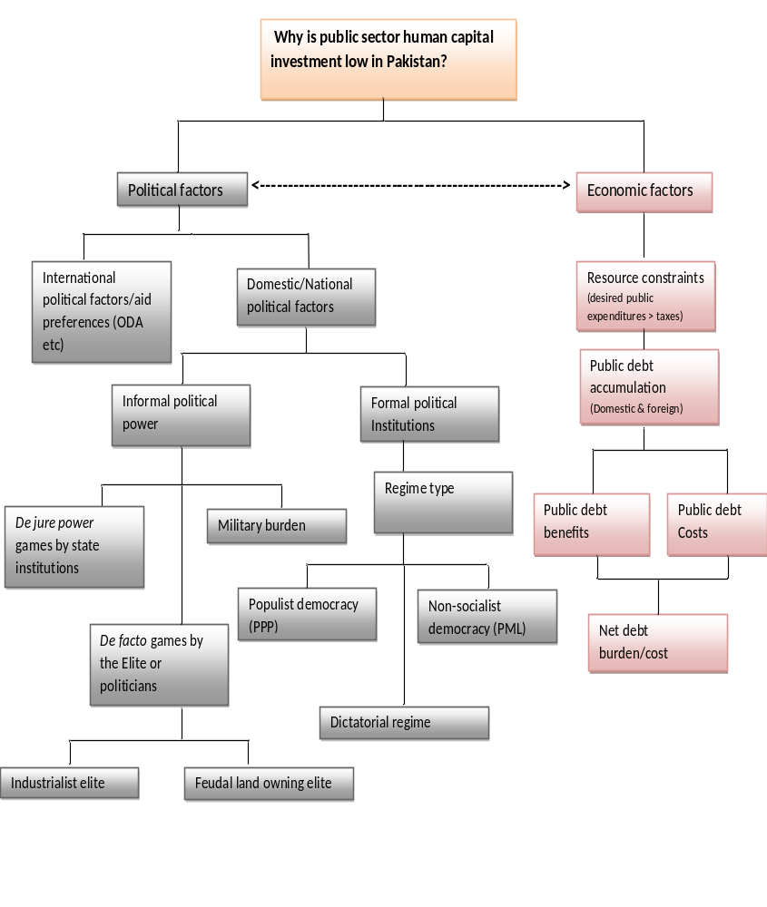

Source: Author’s own construction

Section2: Operationalization of the Research Questions: How is it to be explored?

After developing rational and evaluating relevant theoretical debates, this section is aimed at describing how our conceptualization of the issue can be operationalized.

Chapter3 Data & Methodology

3.1 Data Collection & addressing some potential challenges faced
Fifty years (1960-2010) secondary data, primarily both on nominal and real GDP (at constant factor cost), real per capita GDP growth, total amounts of domestic and foreign public debts, debt servicing, defence expenditures, public spending on health and education both on development and current side, size of population and incidence of income taxes measured by tax to GDP ratio will be used for the study. The data has been collected from the different national and international sources. For the national sources, data has been compiled from various annual issues of Economic Surveys (1947-2010) published by the Ministry of Finance, ‘50 years of Pakistan in Statistics (1947-1997)’ published by the Federal Bureau of Statistics (FBS) and yearly statistical supplements published by the Planning Commission of Pakistan. The series on GDP and the size of population have been gathered from WDI and Madison’s historical data respectively. Again since national debt of a country is composed both of private and public debt, the study will however, consider only the public debt as it claims more than 80 percent of the total national debt. Secondly, the issue of whether to incorporate public debt as a measure of stock or flow process, we suggest to take both measures into account in order to have a more accurate impact of debt burden on our dependent variable (See Appendix-A for detailed summary of the data).
None of the sources accessed for the subject study appeared to have the data series on education expenditures with a break up of both development and non-development ranging from 1999-2003. Only the official budget documents were supposed to have the said figures, where only the one line figure with the detailed break-up of current expenditures was found. To fill this gap, missing values for the series on education expenditures have been generated by minimizing the error of omission. For this the study has followed a technique adopted by (Honaker and Gary 2010) called multiple imputations where for each missing value there are as many as five imputations based on the previous trends of the series are produced. Then an average of each of the five imputed values has been used as a proxy of the missing value with which the probability of making an error is minimized.

3.2 Modelling the research Question

3.2.1 Theoretical Model
Assuming a country with politically influential military that has high financial burden and also colludes with the policy makers and politicians to get their respective interests protected, the utility function of the public policy maker while allocating funds to health and education can take the form:
U = U(S, H)………………………………………..Eq.1
Where S is military expenditures and H is spending on health and education by the public sector. The policy maker maximizes his utility function subject to the budget or resource constraint as:
Y^{D} = R – r.D + A……………………………………….Eq.2
Where Y^{D} is the amount of resources available to be spent on different heads, which is equal to the amount of total tax revenues (R) minus the interest cost to be born on existing stocks of debt (r.D) plus any inflow of aid or new amounts of public debt raised either by the domestic or foreign sources (A).
Again for the given amount of available resources, the amounts that are spent on S and H simply depend upon the respective unit prices of both the S and H; where the unit price (p) is assumed to be determined exogenously. Hence the budget constraint can alternately be written as:
Y^{D} = pH + pS ………………………………………….Eq.3
Setting up the Langrangian, L, we have
L(S, H, λ) = U = U(S, H) – λ[Y^{D} – pH – pS]....................................Eq.4
And the first order conditions give
U_{S} – λp = 0 ...............................................................................Eq.5
U_{H} – λp = 0 .......................................................................................Eq.6
At the equilibrium point, the utility maximizing combination we have
U_{S} /p = U_{H} /p = λ* .....................................................................Eq.7
This shows that in ideal conditions, the policy maker will allocate resources in such a way that the marginal utilities of both H and S are equated to their respective unit prices. Alternately, ideally he should arrange the public resources in such a way that the marginal utility per rupee spent is equal across defence and human capital.
But crucially the value of λ* , which is the marginal utility of available public resources or alternately which can be called as the shadow price of H relative to S, actually explains how marginal utilities can differ across H and S for the policy maker. And these differences in turn can make him choose sub-optimal combinations.
This is because of the fact that for achieving optimality alone, the policy maker can follow the economic factor (budget or resource constraint given in Eq.2) independent of any political considerations. But when it comes to making policy decisions on the resource allocations to H and S, politics will strongly influence the objective function, i.e. the optimal choices of the policy maker vis-a-vis H and S in the model (see for example Acemoglu 2005, Dixit 2003 on how economic policy and politics interact at optimality and policy decision levels).
As politics (domestic or international) can alter the shadow price, λ*, by altering relative marginal utilities of H and S, this difference will denote how resources are spent both on defence and human capital. Say if the degree of political influence by the military or rural elite engendered by their deep rooted collusion with politicians and bureaucrats is high in a society than U_{S} /p_{S} > U_{H} /p_{H} for the policy maker, i.e. marginal utility of defence spending will be higher than that of the human capital investment. In this situation, the expenditures made on defence will be higher than those on the human capital and vice versa.
On basis of the above theorization, we now move on to develop an appropriate empirical model for analyzing how politics and economics (debt net cost generated by budget/resource constraint) interact and explain the behaviour of low public sector human capital spending in Pakistan.

3.2.2 Empirical Model
How to estimate net cost of public debt? Unlike the conventional forward looking Overlapping Generation Model (OLG) model, which measures net welfare impacts of public debts for overlapping generations living from time (t) to (t+1), in the present study, we intend to estimate the net costs of public debt not on the future but on the past and current population in terms of low human capital spending. Therefore, we first use the simple Ordinary Least Squares (OLS) to assess what is net cost/burden of public debt accumulation in Pakistan that has been transferring from one period to another since 1960. For this we take into account both the costs of public debt in the form of tax incidence and its benefits in the form of public sector development expenditures. Conventional Dynamic Time Series methodological tools like Vector Autoregressive (VAR) or Vector Error Correction Model (VECM) will then be used to assess what are the more significant factors explaining the behaviour of low human capital spending by the public sector in Pakistan (Blanchard and Perotti 2002).

3.2.2.1 Measuring Debt Net Costs in Pakistan
What is the level of net welfare gain/cost of high public debts in Pakistan?
In theory though it has been suggested that public debt can transfer burden from current to the next generations or from period (t) to (t+1) in terms of higher taxes and lower public sector development spending, it is also important to note that the government raises debt to meet its both development and non development liabilities. Therefore, if debts are largely spent on development projects, it will generate prospective income streams for the future generations. Such a situation warrants that the benefits of public debt, if any, must be taken into account while analyzing the cost of public debt and before analyzing the impact of this economic factor on public sector human capital investment. One way to do this is to consider net debt cost or burden of public debts, which has been defined as: “The aggregate cost to the nation less the aggregate capitalized value of the future expected services to the nation from newly acquired public assets” (West 1975). Hence, in order to have net debt burden, the benefits accrued from public debt must be taken into account.
The argument justifies that why it is necessary to calculate net burden or cost of public debt first and incorporate this net debt burden into the model rather than directly including debt ratios into our VAR or VECM. Again the inclusion of all the explanatory variables in Eq.8 below directly into our VAR or VECM will though specify the response of X_{t} due to individual variations in those variables yet how debt has evolved with its positive and negative effects, and how X_{t} is affected by the net effects of public debt accumulation over the periods of time; cannot be analyzed unless net costs of public debt are calculated beforehand.
For measuring the net debt burden or cost which has shifted from one generation to another we will develop a debt net cost index on the analogy of the “policy index” developed by Burnside and Dollar (Burnside and Dollar 2000). For our purposes, we will be assuming that the total amount of public debt burden (stock +flow liabilities) accumulated at time‘t-1’ will be treated as a cost for the population in time ‘t’ if in the latter period the public sector expenditures on human capital accumulation will decrease with an increase of debt burdens and higher incidence of taxes. To do this we will first regress public sector health and education expenditures on public debt (domestic and foreign separately), debt servicing, development expenditures excluding health and education and the tax incidence. Such a regression will help us measure the net impact of debt accumulation in stocks, tax incidence, debt servicing and development spending through successive generations in terms of public sector human capital accumulation.
The Index will be developed with the help of following public sector human capital spending regression in Pakistan
Where
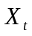 = Government spending on health and education as share of GDP
Z _{1t} = Domestic Public debt as a share of GDP
Z _{2t} = Foreign Public debt as a share of GDP
Z _{3t} = Debt Servicing as a share of GDP
Z _{4t} = development spending (excluding health and education) as a share of GDP
Z _{5t} = total tax revenues as share of GDP; a measure of the tax incidence
If with an increase in the amount of resources generated through debt financing (domestic & foreign), the government also increases allocations to health and education sectors then both the 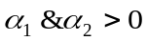 and 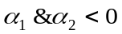otherwise. However, since debt servicing is a flow liability which with an increase in every period shrinks the capacity of the public sector to invest in human capital, it is expected that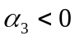. Based on the regression coefficient estimates in Eq.5, a series on predicted values of X_{t} will be generated as:
Now taking 1960 as base, a simple debt net cost index (DNI) based on these predicted values of X_{t} will be developed from (1961-2010). It will be a simple index measured as (V_{n}/V₀)*100, where V_{n} is the fitted value of X_{t} in corresponding year while V₀ is fitted value of X_{t} in the base year.
The trend of the index will show how public sector human capital investment has evolved over the last 50 years as a result of debt accumulation (both in stock and flow terms), tax incidence and public sector development expenditures. Again if the index rises from a period (t-1) to (t), this will imply that the population living in the period (t) has received net welfare gain in terms of higher public sector human capital spending as consequence of both the stock and flow debt burdens lying with the public sector in period (t-1) and has accrued a net cost if it falls for the same period.
The reason we take predicted values of X_{t} in Eq.9 above, as a proxy for measuring the debt net cost that the population has to bear, is because of the crucial importance of the public sector human capital spending not only for the welfare of the people in successive periods but also for the long run sustainable growth of the economy (see for example Lucas 1988, Lucas 1990)
The regression estimates of both with and without imputed data will be produced for checking reliability and consistency of the imputed values. The absence of any significant differences in both of the estimates would imply consistency in our imputations and establish the case for moving on with the imputed data in our further analysis of VAR or VECM.
Lastly for checking whether coefficients estimated in Eq. 8 above are Best Linear Unbiased Estimators (BLUE), White’s test for detecting heteroscedasticity and Breuch-Godfrey test for autocorrelation will be applied. For checking precision of the estimates, the multicolinearity among our regressors will be checked by computing values of formal detection-tolerance or Variance Inflation Factor (VIF).

3.2.2.2 Incorporating political factors into the Model
What are the political factors that can directly or indirectly explain the behaviour of public sector human capital spending?
For the domestic political environment, it has been observed that both the form of government and the periods of elections can have significant impacts on public spending decisions meant for the social welfare of the masses. The elections can affect the fiscal policy choices both before and after they are held since the political parties want to get them re-elected and later ensure fiscal consolidation once they are in the office. It has also been observed that the supply side strategies of the public sector are significantly influenced by the type of government in the office (Schuknecht 2000, Boix 1997). The study will incorporate both the type of government in office and probable effects of elections on the public sector human capital spending. For that purpose dummies will be generated assigning the value 1 for the periods of presidential rule led by military dictators, 2 for the democratic rule (prime ministerial system) led by the Pakistan Peoples Party (PPP) and 3 for the democratic rule (prime ministerial system) led by Pakistan Muslim League (PML). To capture the effects of elections, dummies will be generated assigning 1 for each of the two years before the periods of elections when expansionary policies are expected, - 1 for each of the two years after the elections when fiscal contraction is expected and zero otherwise (Schuknecht 2000).
The international political preferences can best be judged by the aid preferences of the donors and performance of the recipient for ensuring intended utilization of the inflows. Again for aid it has been emphasised that the recipient of aid must be made signal out more commitment and policy reforms with the aid money. This is because of the fact that aid can often be motivated by some strategic partnership by the recipient like War on Terror and if the recipient country has a strong domestic agent who can influence the allocative decisions then both the donor and the recipient may suffer from ‘double moral hazard’ problem. In such a situation both of them may opt for second best optimal solution where aid may fall short of intended goals (Murshed 2009). However, even if both the donor and recipient can suffer from the moral hazard problem, it will not make the donor to reduce the share of aid flows to social sector of the recipient including on health and education. One proxy of measuring the impact of aid flows on human capital spending could be the ratio of total official development assistance to GDP. The study will use this measure along with impact of economic openness measured by the ratio of imports and exports to GDP.
The informal elite influences though can be divided into land owning, industrialist and military burden yet all the three classifications can overlap because rural elite can enjoy both the large land holdings and considerable industrial might at the same time. Again if these agro-industrial elite also enjoy some political power, they can largely influence government decisions meant for human capital spending. The authors like Cimoli and Revira (2008) observe that more diversified and knowledge based an economy is lesser will be the elite concentration and rent seeking by the politicians. Two indicators to measure the industrial elite capture can be used: i) Based on the argument propounded by Prebisch and Fajnzylber that highly concentrated proportion of industrial resources along with small sector of other manufacturing is a source income inequality and power accumulation(as cited in Cimoli and Rovira 2008), share of small scale manufacturing to total manufacturing can be used as a proxy for measuring industrial elite concentration ii) share of financial advances (both bank and nonbank) to SMEs in total advances to manufacturing sector.
However considering the fact that the small enterprises may lack collateral or access to finance, the second measure may not be capturing the true industrial elite concentration in Pakistan. The study will therefore, use the ratio of small scale manufacturing to total manufacturing as an indicator to measure industrial elite concentration. Any fall in the ratio will allude to an increase in share of large scale manufacturing, i.e. more concentration of industrial elite in Pakistan. Again total military expenditures as share of GDP will be used to as a measure of military burden in the country.
For institutional factors several measures have been developed including polity index, ICRG institutional quality indices, measures of government effectiveness, risk of expropriation by the government and constraints on the executive. Although none of them can truly measure the norms, procedures and rules of the developing countries’ institutions and permanent feature of their political landscape yet the Polity IV index appears to be less volatile and more efficient than others(Glaeser et al. 2004). Because of this and following (Mansoob and Mamoon 2010), the study will make use of polity index to capture the institutional quality. The polity index examines qualities of democratic and autocratic authority in governing institutions, rather than discreet and mutually exclusive forms of governance. On a 21 point scale index ranging from -10 (hereditary monarchy) to +10 (consolidated democracy), it measures different forms of government covering fully institutionalized autocracies through mixed, or incoherent, authority regimes (termed "anocracies") to fully institutionalized democracies. The hostility index will be used to analyze whether the sates of country’s involvement in some major conflict in the region has some impact on public sector human capital preferences or not. The index is again developed on a 5 point scale to capture the different states of peace and conflicts among states, with 1 representing a year of peace while 5 will stand for a year of full scale war.

3.2.2.4 Modelling VAR and VECM
Before moving on to VAR or VECM, Dickey Fuller and Augmented Dicky Fuller tests, will be used to determine stationarity and nature of the true data generating process for each of the series. Since VAR or VECM estimates the interrelationship of all endogenous variables incorporated into the model and on the pretext that there can be bi directional causality especially regarding human capital expenditures and other endogenous variables, we will prefer using these models to a single equation model of estimation. To substantiate this Granger Causality tests will be applied to see if there is a uni-directional or bidirectional causality in our variables.
To determine whether our series can be modelled as VECM or not, we will have to determine if there is at least one cointegrating vector in our VAR model. The Johansen test for co integration will help us know whether the series are cointegrated or not.
The primitive nine variable ‘n’ order unrestricted Vector Auto Regressive (VAR) model can be written in the following short hand form
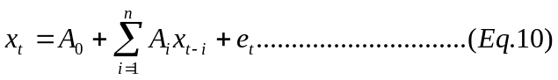

Where x_{t} is an (nx1) vector containing each of the endogenous variables included in the VAR, A₀ is a (nx1) vector of intercept terms and A_{i} are (nxn) matrices of coefficients depending upon the AR terms included in the VAR. Following list of variables will be modelled in our VAR model.
= Government spending on health and education as share of GDP
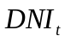= Debt net cost index
W₁= ratio of small scale manufacturing to total manufacturing
W₂ = military expenditures as a share of GDP
W₃=Elections dummies
W₄= Dummies for the form of government in power
W₅= ODA to GDP ratio
W₆=Total value of exports and imports as a share of GDP
W₇=Polity Index
W₈= Hostility Index
W₉=Real GDP growth rate
W₁₀=Population growth rate
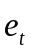 = vector of mutually uncorrelated structural shocks
It is important to mention that since our DNI is based on the predicted values of X_{t} in response to debt accumulation (stock & flow), tax incidence and public sector development expenditures; regressing X_{t} on the DNI will not entail misspecification error in the VAR for two reasons: i) the VAR explains how current values of an independent variable, say X_{t}, responds to the lagged values of itself and other endogenous variables including DNI ii) regressing current values of X_{t} on the lagged values of itself and the DNI will show how X_{t} in the period (t) responds to its own observed values as well as the net cost of public debt predicted by DNI in (t-1). Precisely the lagged value of DNI shows how public sector human capital spending evolved as a result of both positive and negative impacts of debt accumulation, which has been used as a proxy for debt net cost, and how this lagged debt net cost (DNI) explains the observed value of X_{t} in period (t).
To further support this rational, we will include all of our debt ratios, tax incidence and development expenditures directly into our VAR or VECM model rather than the DNI and check if there are any significant differences in our parameter estimates. The absence of a significant difference, if found, will justify the use DNI as a proxy for measuring net costs of public debt and including it into our VAR or VECM.
Now, if our series are found to be co integrated with an I(1) process, there must be a single value for the respective parameter estimates such that the linear combination of our series is also stationary. In that case we can model our series as VECM rather than VAR. The standard VECM representation will take the following form:
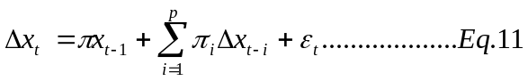

The key feature of Eq.11 (that sets it apart from a simple VAR in first difference) is the presence of matrix π, such that if all elements of π are equal to zero, eq.7 is a traditional VAR in first differences. In such case we will prefer VAR to VECM because there will be no error-correction representation since Δx_{t} does not respond to the previous period’s deviation from long-run equilibrium.
Considering the fact that all of the variables capturing politics like both the form of government and the timing of elections may affect the human capital investment preferences but are not determined directly by any of our other modelled variables, they will be treated as exogenous in our VAR or VECM estimations. Again for the institutional quality the polity index will also be treated as exogenous because it largely captures qualities of democratic and autocratic authority in governing institutions, which may not be directly affected by our other endogenous variables. For the hostility index, since it measures the level of conflict from a small scale to full scale war, it can significantly be influenced by the defence expenditures and then the human capital spending in Pakistan. The index will therefore be treated as endogenous in our VAR or VECM.
Although our estimations for the whole sample (with democratic and dictatorial periods together) will help us analyze the underlying dynamics of public sector human capital spending vis-a-vis political and economic factors yet they will not be able to explain how preferences for human capital spending shift during each one of these ruling political setups. In subsample estimates, the study will, therefore analyze the cases for both democratic and dictatorial regimes separately. Given political dummies are found to be significant in our whole sample estimates, the exercise inter alia important dynamics for other endogenous variables, will primarily help us know: i) what form of government, either dictatorship or democracy is actually beneficial for public sector human capital spending ii) within democratic regimes whether it is PPP or PML, which is more significant in explaining the behaviour of human capital spending in Pakistan. Lastly, all of the political dummies will be treated as endogenous because sampled years in these particular cases will strictly be restricted to the periods of a specific political setup. Any unpopular shift in the fiscal preferences or adverse shock to the institutional quality can jeopardize the popularity of the ruling government and cause a regime change subsequently. The regimes changes of PPP in early 1990’s and then of Gen. Pervez Musharraf in 2008 are particular instances in this regard.

Section3: Exploring Answers To The Research Questions
The aim of this final section is again twofold. First, to explore probable answers to our research questions by reporting and analysing our main findings in the light of our empirical methodology, theoretical descriptions and empirical evidences and trace out the appropriate place of our findings in the broader theoretical framework conceptualized earlier for the study.

Chapter 4 A report on and analysis of the findings: rethinking relevant theoretical and empirical debates

4.1 Pakistan’s Debt Net Cost Index (DNI)
The OLS estimates of the Eq. 8 above, both with and without imputed values are produced in Table 4.1 below. The results show that the estimates in both cases are not significantly different, signifying the fact that the imputed data values of public sector spending on education are consistent with the previous periods trends in our observed data. We therefore, can use the data with imputed values in our subsequent analysis. The public sector human capital investment in Pakistan is positively and significantly affected by public sector development expenditures, tax to GDP ratio and domestic public debt. The signs and magnitudes of the estimates, with a strong negative vertical intercept show that the periods of high debt servicing burden on our economy can potentially outweigh the positive gains of public debt accumulated in stock form by the government.

Table 4.1 OLS estimates of Equation.8 with and without imputed values
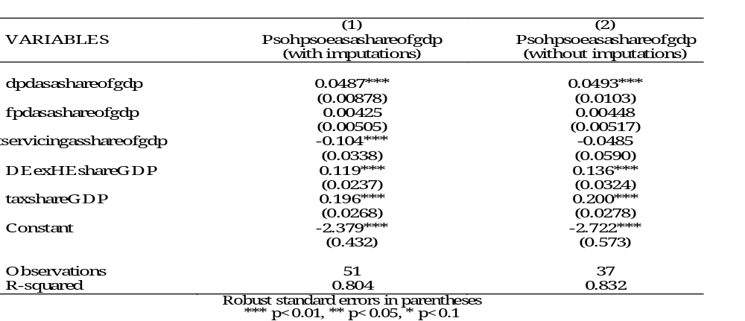
Based on the above estimates, the estimated form of Eq.5, with imputed data is:
It is evident and as predicted by theoretical descriptions that the amount of debt in its own right is not threatening for the prospects of public sector human capital investment, rather it is the form and outstanding flow liabilities of debt which are significantly prone to make debts unsustainable and affect adversely the growth of human capital investment in Pakistan.
Following estimates of the above equation, we develop a debt net cost index for Pakistan, depicting that whether the people of Pakistan were better or worse off in terms government spending on their health and education with debt accumulation in stocks, debt servicing, tax incidence and development expenditures made by the public sector.
It is important to note that any increase in the index say from 1984 to 1985 will signify that the generation living in 1985 has received a net gain as a result of accumulated debt stocks, tax incidence and development spending made by the government in the 1984; whereas a decrease will denote a transfer of net cost for the same period (See Appendix-B for detailed list of DNI for Pakistan).

Figure 4.1 Debt Net Cost Index of Pakistan
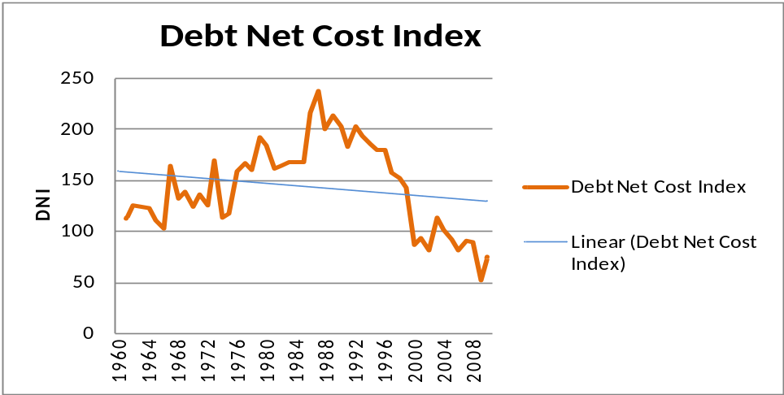

The figure 4.1 above shows DNI for Pakistan. During the sampled period, the negative linear trend shows that on average people have been worse off in terms of public sector spending on health and education as a result of debt burden tax incidence and public sector development expenditures.
Based on our post estimation tests for unbiasdness, efficiency and precision of the estimates, we infer that all of the coefficients estimated in Eq.8 are BLUE (see Appendix-B for details of tests’ results).

4.2 On determinants of low human capital investment in Pakistan

4.2.1 Interpretation of main findings
To determine stationarity and nature of the underlying data generating process for each of the series, the Dickey Fuller and Augmented Dicky Fuller tests were applied and all of them except series on the ODA were found to have random walk with drift and trend. The ODA appeared to follow a pure random walk data generating process. Again all of the series were found to be stationary at first difference. The Granger Causality test results mainly for human capital investment and all other variables show that there is a significant bidirectional Granger causality between public sector human capital investment and defence expenditures in Pakistan. Moreover, both the DNI and small scale manufacturing as a share of total manufacturing are significantly Granger caused by the public sector human capital spending. These findings substantiate our preference of dynamic VAR or VECM modelling to standard single equation estimation methods (see Table 4.2).

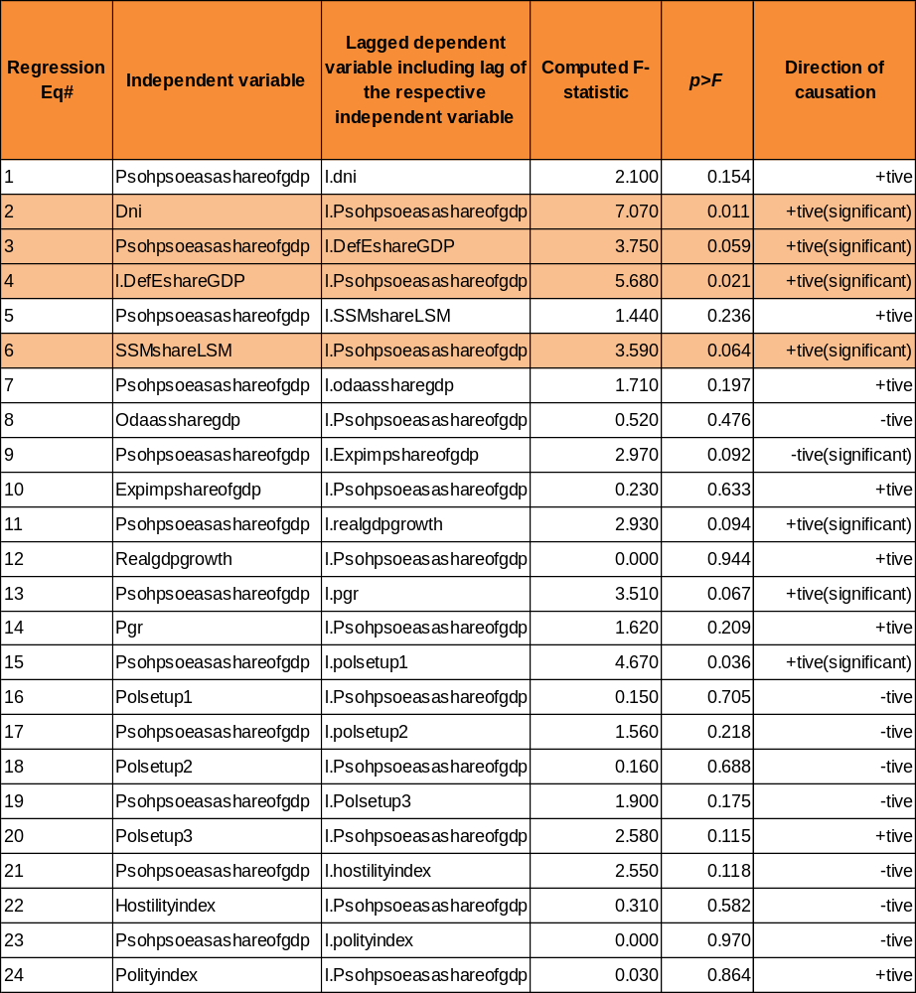
Table 4.2 Granger causality test statistics

We choose one lag based on the AIC and QIC information criteria to be included in our unrestricted VAR estimations. The results of the Johansen Test for Cointegration manifest the absence of a single cointegrating vector in our VAR model, which implies that the variables cannot be modelled as VEC due to absence of any error correction term in them. We therefore, will prefer standard unrestricted VAR to the VECM modelling (See Appendix-C for results of these pre-requisite estimations).
Now in VAR, the question whether variables should enter at level or with difference has some important implications. Like (Stock and Watson 2001) has argued that if the series in the model are found to be co-integrated and can be modelled as VECM, estimating VAR at first difference will entail a misspecification error. But if the variables are I(1) and not co integrated, estimating the VAR in levels may lose power because you estimate n² more parameters, and the impulse responses at long forecast horizons are inconsistent estimates of the true responses. On the basis of this argument and since our variables are found to be following I(1) but not co integrated, we would include all of the endogenous variables at first difference to enhance the power and precision of the estimates.
The VAR estimates for the whole sample to depict the interrelationships in our variables are produced in Table 4.3 below. The results show that the low levels of public sector human capital spending in Pakistan are not significantly determined by the economic factor meted out of the budget constraint, i.e. net cost of public debt that transfers from one period to another. The public sector expenditures in health and education have significant negative relationship with their own lagged values and the positive relationship with the lagged military burden/capture, i.e. defence burden, and international development assistance in Pakistan. A one percent increase in each of the defence burden and ODA as a share of GDP will increase public sector human capital spending by almost 0.06 percent and 0.51 percent respectively. The form of government appears to be a significant determinant of public sector human capital investment. Government spending on health and education during the PPP democratic government (polsetup2) was 0.15 percent higher than the periods of dictatorial regimes in Pakistan. However, it was 0.33 percent lower in PML democratic periods (polsetup3) than the periods of dictatorship in Pakistan. For a one percent rise in ODA will increase the hostility index (propensity of state to engage in a external conflict) by 2.1 percent. Unlike the military capture, the industrial elite capture does not appear to be significantly explaining the behaviour of public sector human capital spending.
For checking efficiency, stability and consistency in our estimates in the above VAR model, we applied Langrange Multiplier (LM) test, Eigen values stability test and computed VAR forecasts with the observed data for the last ten years (2001-10) respectively. The absence of any significant correlation between residuals will signify efficiency and difference between the trends of observed and forecasted values of variables will establish consistency in our estimates. On basis of all these tests applied to our whole sample estimates, we infer that the estimates are efficient, stable and consistent (See Appendix-C for all tests’ results).
Lastly, we found insignificant differences in our parameter estimates when instead of DNI, all of the explanatory variables listed in Eq.8 above were included directly into our VAR model with whole sample (See Appendix-C for VAR estimations without DNI). The results show that only domestic public debt positively affects human capital investment and ODA becomes insignificant determinant of public sector human capital spending. The rest of all the estimates including political setup in the form of regime type are not significantly different from our VAR estimates with the DNI. These results, therefore, justify the use of DNI as a proxy for measuring debt net cost first and then including it into the VAR model.

Table 4.3 VAR estimates for the whole sample with exogenous political and elections dummies
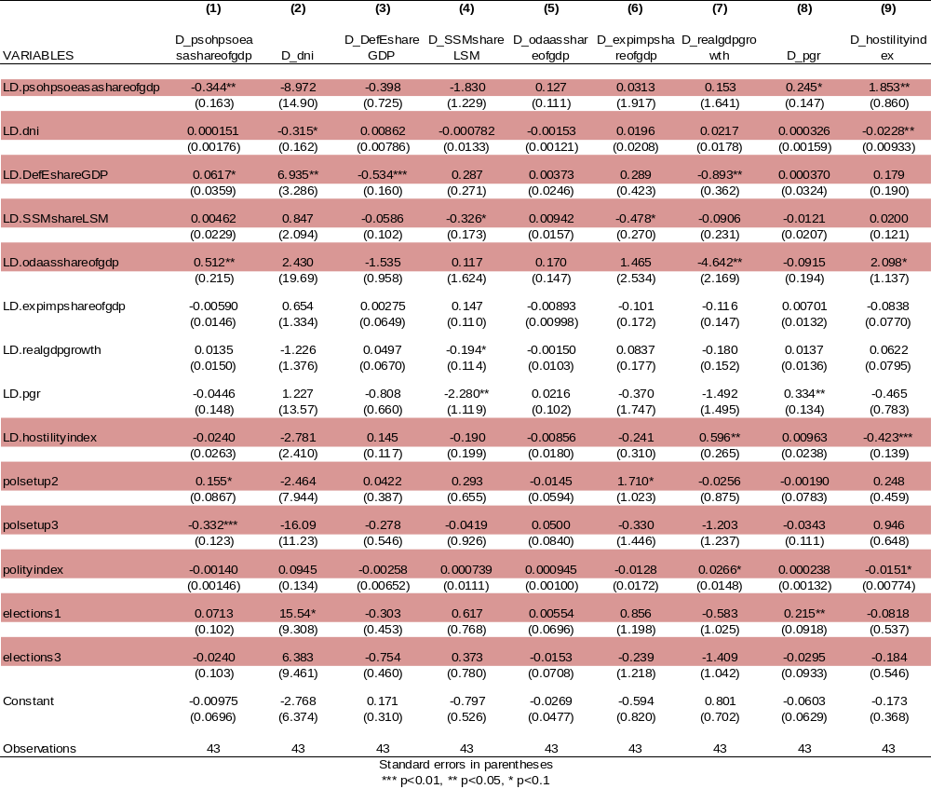

The above results show that the low levels of human capital investment in Pakistan are significantly explained by the political factors, i.e. domestic political environment in terms of regime type, international political factors in terms of ODA and military burden rather than determined by any economic cost. Since the form of government appears to be significantly relevant, we now examine how public preferences of human capital spending are determined within democratic and dictatorial regimes while focusing exclusively on their respective periods in office. For this we run two subsample VAR models for the democratic and dictatorial regimes in Pakistan.
For the periods of dictatorship in Pakistan (Table 4.4 below), the results show that both ODA and defence burden appear to be strong and significant determinants of human capital investment in Pakistan. But how ODA and defence burden are determined in the model? The results show that defence burden is negatively affected by the ODA and its own lagged values but positively affects the human capital spending in Pakistan. Whereas the ODA is positively affected by the defence burden and its own lagged values and subsequently leads to a positive shift in public sector human capital spending. Both the industrial elite and DNI are not significant determinants of public sector human capital spending during the periods of dictatorships as well. Again for the periods of dictatorships too, one percent rise in ODA will increase the hostility index (propensity of state to engage in a external conflict) by 2.5 percent.
For the periods of parliamentary civilian democratic rule in Pakistan (Table 4.5 below) the public sector human capital spending, during PPP led government (polsetup2), was 1.15 percent significantly higher than the periods of dictatorship. The estimate of PML government (polsetup3) though positive yet is insignificant. The democratic government spending on health and education increased by 0.5 percent more during the periods immediately followed by elections than the non-election periods in the country. Here again ODA and defence burden appear to be a strong and positive determinants of public sector human capital spending. In democratic periods the DNI, real GDP growth and the small scale manufacturing as a share of total manufacturing appear to be negatively related with the human capital spending in Pakistan. Any rise in conflict (one unit in the hostility index) shrinks public sector spending on health and education by 0.299 percent in democracies. Again the possibility of the occurrence of a conflict during both PPP and PML regimes would be 5.5 and 7.0 percent less than the periods of dictatorships in Pakistan. The institutional quality in each of the PPP and PML appears respectively 80 and 78 percent better than the periods of dictatorships in Pakistan. And any improvement in the institutional quality than leads to 0.016 percent rise in human capital spending in Pakistan. Lastly, contrary to the whole and sub sample estimates of dictatorship, in periods of democracy a one percent rise in ODA will decrease the hostility index (propensity of state to engage in a external conflict) by 18.9 percent.

Table 4.4 VAR estimates for the periods of dictatorship (with dictatorship and election dummies as endogenous
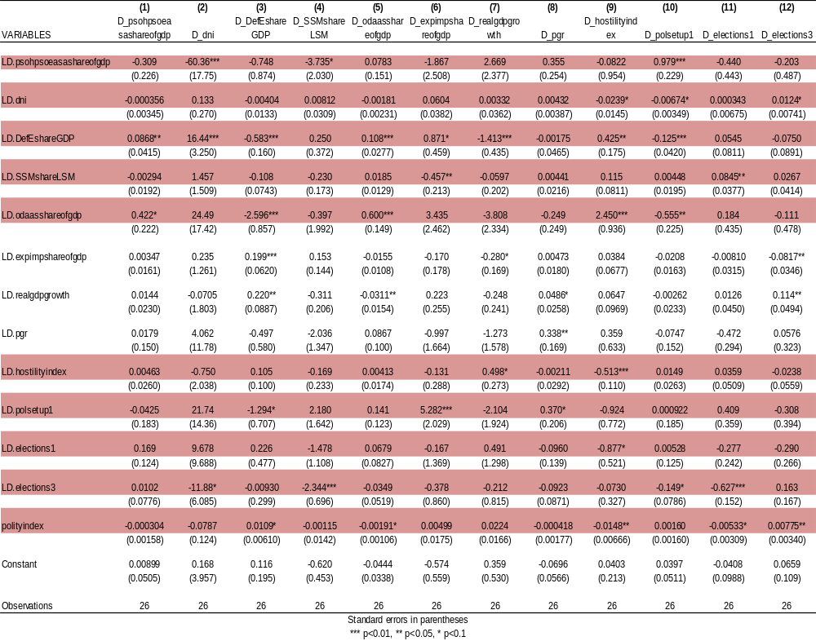

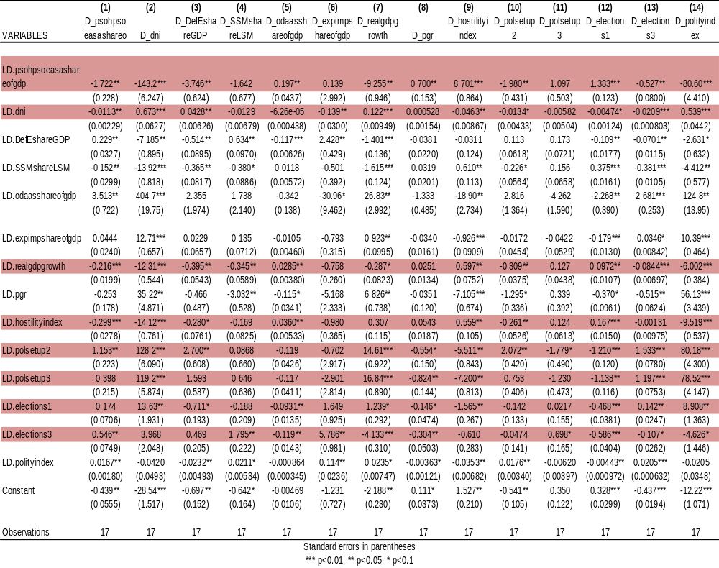
Table 4.5 VAR estimates for the periods of democracy (with democracy and elections dummies as endogenous)

4.2.2 Analysis of findings with theory and evidence: Is economics or politics at play?
We restate our hypothesis and analyse our findings in light of the determinants highlighted above, our broader theoretical framework and relevant empirical studies while explaining that why government expenditures on health and education has historically been low in Pakistan.
H1: The low levels of public sector human capital investment are caused by the net cost of high public debts
Jaffery Sachs once quoted: “No civilized country should try to collect the debts of people that are dying of hunger and disease and poverty.” The quotation was largely motivated by the theoretical argument propounded by theoretical rational of the HIPC debt relief initiatives, i.e. debt burden of African countries was limiting their capacities to enhance social spending (Gunter et al. 2009, Gunter 2002).
The findings of the subject study, however, do not confirm to this broader theoretical foundation as low levels of public sector human capital investment in Pakistan do not appear to be significantly explained by the net cost of public debt that transfers from one period to another.
This could mainly be due to the fact that in a country like Pakistan–where both politicians either from landed feudal or industrialist class and military elite coexist amongst the large illiterate segment of the society–public sector human capital investment decisions are neutral to any surpluses or shortages of economic resources; the aspect which has totally been ignored by the HIPC theorists. The said argument and our findings on the economic factors are primarily in line with the theoretical explanations of (Acemoglu and Robinson 2007, Acemoglu and Robinson 2008, Acemoglu and Robinson 2006, Acemoglu and Robinson 2001) and empirical explanations made by (Easterly 2001). Easterly (2001), while focusing on Pakistan as a state of growth without development, points out that despite having reasonable episodes of economic growth, the governments did not invest in human capital due to: i) In a patriarchal and highly diversified society along the ethnic, linguistic and gender lines as Pakistan is, the more efforts the ruling elite makes to keep its masses illiterate, the more their power will get consolidated ii) The rulers in such states are analogous to “roving bandit” who are more interested in amassing personal wealth rather than social and economic uplift of their masses.
And all instances of mass illiteracy, inherited feudal and industrial elite, political instability and military capture present in the country; as has been highlighted in the Sections 1 & 2 above, allude to the fact any rise or fall in the fiscal resource availability is neither necessary nor sufficient for governments to enhance human capital spending in Pakistan. The same idea has largely been pronounced by one of the famous Pakistani economist, Ishrat Hussain, who states that how ethnic diversity, economic inequality and ruling bourgeoisie can interact with the choices of public sector human capital spending who in turn be largely defined by political rather than any economic factors (as cited in Easterly 2001).
Empirically, though some studies have found that public debt burden limits the capacity of states to make social spending (see for example Lora and Olivera 2007a), yet all of these studies largely miss upon to incorporate both political and institutional determinants of human capital spending into their panel estimates. Our finding that low levels of human capital spending is not significantly explained by the debt burden or net cost of public debts, does not confirm to this strand of empirical literature mainly because: i) the study has incorporated broader institutional and political factors ii) unlike the panel estimations as most of these study have, our study is primarily based on analysis of the one country time series estimations.
Lastly, in both the military and democratic periods in Pakistan, though real GDP per capita growth rates did have some positive fluctuations yet the public sector human capital spending remained more or less stagnant since 1960, which shows that even periods of high economic growth are not sufficient to ensure a rise in human capital spending by the public sector. Therefore, considering our findings that growth in real GDP as well as the public debt burden is completely neutral to public sector human capital spending (see Table 4.3 above), we reject our first hypothesis that low levels of public sector human capital spending are significantly caused by an economic factor, i.e. the net cost of public debts in Pakistan.
H2: The low levels of public sector human capital investment are caused by some political factors
Contrary to the findings of (Ross 2006) that politics in terms of regime type does not affect public policy choices of human capital investment, our findings suggest that public sector human capital investment in Pakistan is significantly determined by the regime type, military elite capture and international developmental aid. These results (both in our whole and sub sample estimates) have some important ramifications:
The result that democratic period led by the PPP is good for human capital development is in line with that strand of literature which focuses on how public expenditures on social welfare behave in transition democracies. One reason for higher human capital spending under democracies could be the existence of high political ‘pay offs’ for making such investments. This is because of the fact that under political uncertainty and short time horizons, the politicians feel an incentive to discount the future political risk of any economic shock by increasing current social welfare expenditures (Synder 2000). Moreover, our sub sample findings for democracy (see Table 4.5 above) that human capital spending even after the periods of election were significantly higher comparing with the other periods in Pakistan do confirm the assertion made by Tabellini & Persson (2004) that consistent electoral politics has strong and positive effects on public sector human capital investment.
In Pakistan it is important to note that public sector expenditures on health and education as a share of GDP witnessed some positive shocks both during the dictatorial periods of Ayub in 60’s and Zia in 80’s as well as during PPP’s democratic regime in early 70’s (see Appendix–B Figures B1-B3). However, the finding that human capital spending was higher during PPP regime and lower during PML regime (see Table 4.3 above) but significantly higher only in case of PPP regime in our sub sample estimates (see Table 4.5 above) does imply that even if public sector expenditures on health and education showed some increasing trends in dictatorial periods in observed data, they were still statistically insignificant and economically meaningless.
One reason for this could be that in military regimes though there was a tendency of overall economic boom due to politically motivated inflow of foreign capital in the form of both debt and foreign direct investment yet those were also the periods when huge public debts were accumulated either in the form of soft or concessionary loans, which in turn created a fiscal burden both for the existing and upcoming governments.
Secondly, due to relatively higher concentration of military elite in urban areas and their collusion with the political rural elite, dictators find it more lucrative to invest in higher education both for having more popularity and seeking rents for themselves and their political allies. The case of the last dictatorial regime’s coalition on ‘War against Terror’, and structure of its education spending during the last decade verify this argument. This was the period (2001-05) when not only huge economic concessions in the form of debt rescheduling were made but also an inflow of foreign private investment was witnessed. And this resulted into a rise in government spending on education (see Appendix-B figure B5). But the said rise in government spending was mainly focused on higher education, without paying an iota of attention to revive the primary and secondary education in Pakistan; which are indeed considered to be the chief and sustainable engines of accumulating human capital (see for expamle Shuanglin 1998, Stasavage 2005 on importance of investing in primary and secondary education).
On the contrary, the democratic governments, no matter how deep elitist lineages they manifest, always have some incentives to invest in mass education, especially at primary levels in rural areas. Such acts not only help them sustain their power but also their mass popularity; the pre requisites for getting themselves re-elected in future elections. This was evident during the PPP democratic regime in early 7o’s when public sector social expenditures witnessed a sharp rising trend (See Fig B2 Appendix B) not only at higher but at the primary levels.
Although the effectiveness of his acts of nationalization of all economic entities including education has been questioned on the grounds of corruption, lack of governance and politicization of public service delivery (Easterly 2001), yet evidences show that that consistency of a democratic political process, often led by populist democratic parties, is more important for higher social spending than initial experiences of corrupt practices if an eventual transition to a consolidated democracy is needed (Kaufman and Stalling 1989).
The empirical findings that poor countries get out of poverty thorough high human capital spending often led made by dictators Glaeser et al. (2004), are again not supported by the findings of the subject study. One of the prime factors why democracy appears to be a better governmental set up for enhancing human capital investment is mainly because of the nationalization policies of Zulfiqar Ali Bhutto in 70’s, when a lot was spent on developing infrastructure especially in health and education. Now considering the fact that GDP growth during his period remained relatively lower than both of his predecessor and successor dictatorial regimes (See Table 1.1 Chapter 1), the inference may appear misleading as share of health and education in GDP might have increased just because of a fall in its denominator, i.e. gross domestic product. However, no matter expenditures on health on education actually increased or remained constant in absolute terms, one thing we can safely state that these were the periods when human capital spending as share of GDP was largely spent on developing primary health and education infrastructure in the rural areas, which by any means set that democratic period apart from dictatorships in Pakistan.
An increase in military expenditures has been found to be followed by an increase in human capital spending by the public sector in Pakistan. Such a behaviour does not confirm to both the theoretical and empirical explanations made by the studies like Berthelemy, et al. (1995), who while analyzing the case of India and Pakistan have endogenized the military expenditures and contended that in both countries increased military spending can retard growth by lowering their public sectors’ human capital spending.
Why do increased military expenditures lead to high public sector human capital expenditures in Pakistan? One possible explanation could be that military in Pakistan is both an institution responsible for national security and an enterprise running businesses and providing reasonable amount of social services. Secondly, the country cherishes the issue of national security as a common public good. In these situations, our findings are in line with those explanations which say that increased military expenditures are welfare enhancing at initial stages because they can develop a “state capacity” to generate revenues and invest in human capital (Besley and Persson 2009, Besley and Persson 2010).
Nevertheless, it is important to note that the scope of these studies is limited only to the short time horizon. In the long run, it is suggested that if there are constantly higher expenditures on defence inter alia internal and external threats of conflicts, the amounts even allocated to social sectors can ultimately be spent on state security (Murshed 2003). Hence in the short run military burden and threats of conflicts can be helpful for human capital accumulation, but the policy by all means is not relevant in the long time horizons as has been observed in case of Pakistan.
ODA appears to be significantly followed by an increase in public sector expenditures on health and education in Pakistan. The relationship was consistent and robust as it remains same in both the whole and sub sample estimates. To understand dynamics of this relationship, one must explore the dynamics of developmental aid in Pakistan.
The whole and sub sample estimates of dictatorship show that if any increase in aid leads to a rise in public sector human capital spending, it is also followed by a significant rise in the hostility index, i.e. the propensity of the country to get engaged in a conflict increases. This relationship is interesting and uncovers an important fact that developmental aid rather than motivated by any developmental perspectives, is largely motivated by the countries engagement in some external conflict. The rise in development aid both during Soviet war in Zia’s era (1980’s) and for war against terror in Musharraf’s regime (2000’s) clearly denote that any likelihood of the state to serve as an ally of the west in a conflict will largely result in a rise in unconditional development assistance (see Table 1.1 Chapter 1). And the part of that amount in turn could be allocated to health and education sectors of the economy.
Murshed, S. observes that if aid is actually motivated by some strategic partnership in a conflict or war, donors will not have enough leverage on accountability of their resources. This will not only result into inefficient resource utilization due to strong influences of domestic political agents but also make aid neutral to any long term sustainable development in the recipient countries (Murshed 2009).
It was only in the periods of democracy, when a rise in development aid led to a reduction in hostility, which means that it got disengaged from strategically motivated alliances of the state during democracies (See Table 4.5). However, considering the lesser periods of democratic rule and the amounts of aid inflows during those periods, once say that aid has largely been aligned with strategically motivated alliances in Pakistan.
Hence though aid significantly leads to a positive change in public sector human capital spending yet for ensuring transparency and effectiveness it must get disengaged from conflict oriented motives pursued by the donors in case of Pakistan.
In view of all the above analysis, we can sum up our discussion in light of our theoretical model developed in Chapter 3 and explain why public sector human capital spending is low:
- Due to successive periods of dictatorships, politically influential military, high defense burden meted out of constant threats of conflicts and high degree of collusion among politicians, military and policy makers, the marginal utility of defense spending is higher than that of the human capital investment in Pakistan.
- Both of the country’s engagement as a strategic western ally in the conflicts and all out wars with its bordering country India took place during the military regimes in Pakistan. This was accompanied by increased aid flows and concessionary loans, which in turn relaxed the budget constraint for the policy maker (Eq.2 above). Hence more was spent not only on defense but also on health and education. However, the spending on health and education was economically meaningless as discussed above.
- During democratic periods, although human capital investment was higher but the excessive debt burdens in terms of flow liabilities and lesser inflow of aid and concessionary loans squeezed the budget constraint, which led to an economic turmoil. This resulted into a fall in the total utility of the policy maker and due to high collusion among all state institutions including military, successive coups were witnessed in the country. And such a paradox not only sustained the threats of coups but also served as a great hurdle in way of consolidating democracy. And that is why public sector human capital spending could never increase sustainably in Pakistan.
Hence we are unable to reject our second hypothesis and infer that these are indeed the political factors–regime type and donors preferences in terms of ODA– and elite capture in terms of military elite burden that actually explain the behaviour of low human capital spending in Pakistan.
H3: Neither the economic nor the political factors explain the low levels of public sector human capital investment but their inter-relationship or joint causation explains the behaviour of human capital spending in Pakistan
Only in our sub sample estimates of democracy we have found that the economic factor, i.e. DNI, and political and institutional factors significantly interact with one another and subsequently affect the human capital expenditures by the public sector in Pakistan. However, neither in the whole sample nor in sub sample of dictatorship periods, we have been able to find any significant instances of their joint influences on human capital spending by the public sector in Pakistan. In view of these, we reject our third hypothesis and infer that human capital spending is low not because of any joint influence of economic and political factors but these are the only political factors and military burden that are more robust and consistent in explaining the behaviour of low human capital spending by the public sector in Pakistan.
The findings of the study are summarized in the table below:
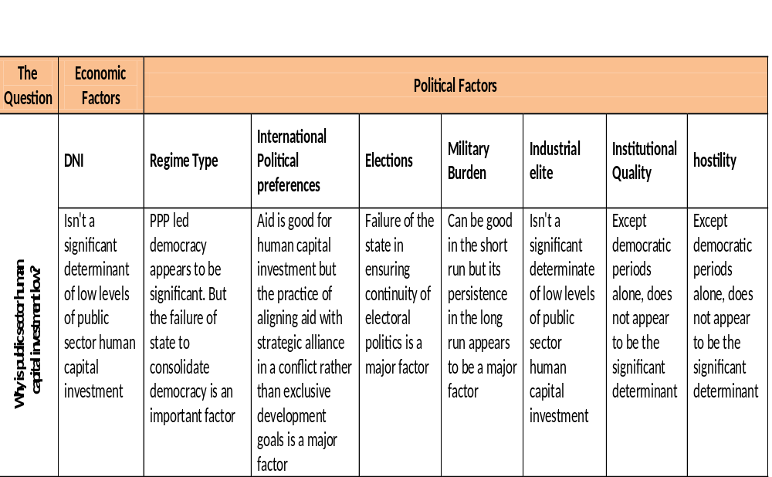

Table 4.6 Tabulated answers to the question

Chapter 5 Concluding Remarks
The study was aimed at dissecting the role and significance of economic and political factors responsible for low public sector human capital spending in Pakistan. Based on some existing macroeconomic facts; which inter alia consists of limited capacity of the state to generate resources and persistent accumulation of public debts over the past half a century, the study explored whether they are the huge net costs of public debt that shift from one period to another or certain political factors which could significantly be a cause of low human capital investment in Pakistan.
After applying conventional time series techniques of VAR, to measure the interrelationship between human capital investment and the DNI as well as the other exogenous political and institutional variables, the study has found that its none but the political factors in terms of regime type; international political preferences in terms of development assistance and the elite military burden which largely and significantly explain the behaviour of low human capita spending by the public sector in Pakistan. For the regime type, public sector expenditures on health and education have found to be significantly higher in PPP led democratic periods than any other regime.
Development assistance is though crucial for public sector human capital expenditures, but its long term effectiveness and relevance for developing a sound human capital through public spending largely rest on the condition that it should first, get disengaged from the strategically motivated alliance of the recipient in conflicts and then aligned to an exclusive purpose of developing the poor masses.
In Pakistan, where military serves not only to secure the state but also helps develop state capacity for generating revenues, excessive military burden is found to lead to higher public sector health and education expenditures. However, persistence of this phenomenon ever since from independence with high political volatility, constant threats of coups coupled with internal and external conflicts has found to be a great hurdle for democratic consolidation, which in turn shrinks the level of public sector spending on health and education.
In sum, this is not the economics; in the form of net cost of public debts caused by resource or budget constraint, but the politics; in the form of political instability; failure of the state to avert threats of persistent coups and consolidate democratic norms; persistent threats of conflict; high military burden and practice of donors to align development assistance with conflict oriented motives rather than with exclusive development goals, which is the significant factor responsible for low public sector human capital spending in Pakistan.

5.1 Limitations and prospective areas of research
Our findings though are statistically significant and theoretically relevant yet cannot be divest of certain limitations as illustrated below:
- An increase in ODA leads to higher public sector human capital spending is not sufficient to contend that donors actually prefer funding human capital in developing world. Most of the times, development assistance is meant for developing infrastructure in rather than promoting social sectors. Availability of excessive unconditional finance may make governments spend more on health and education but treating it as proxy for preference of the donors may mislead. One way of capturing true preferences; which had not been done both due to time and data availability constraints, could have been to incorporate development aid to social sectors as share of total development aid in Pakistan.
- To capture industrial elite by small scale manufacturing as a share of total manufacturing is acceptable as long as large proportion of the politicians belong to industrial class of the country. On the contrary, the greater proportion of Pakistani politicians hail from rural landed elite, who not only bar spread of mass rural education but also influence public policies at large. Land concentration ratio is an indicator for measuring landed elite capture in a country. However, in Pakistan a complete time series of 50 long years on the said indicator was not available in anyone of the sources approached for the study.
Despite the above limitations, our findings unleash some interesting landscapes for future research in the subject field: First, if democracy is good for human capital investment than what are the underlying factors which define that one form of democratic government is better than the other? Second, are consolidation of democratic norms and aligning aid with development exclusively, both necessary and sufficient for enhancing public sector human capital investment, i.e. at what levels of politics economics may come into play? Lastly, how will utility function of the policy maker evolve along the democratization processes and what impact this will have on human capital investment?

References
Acemoglu, D. & Robinson, J. 2007, "On the economic origins of democracy", Daedalus, vol. 136, no. 1, pp. 160-162.
Acemoglu, D. & Robinson, J. 2001, "A theory of political transitions", American Economic Review, vol. 91, no. 4, pp. 938-963.
Acemoglu, D. 2005, "Constitutions, Politics, and Economics: A Review Essay on Persson and Tabellini's The Economic Effects of Constitutions", Journal of Economic Literature, vol. 43, no. 4, pp. 1025-1025.
Acemoglu, D. & Robinson, J.A. 2008, "Persistence of Power, Elites, and Institutions", American Economic Review, vol. 98, no. 1, pp. 267-293.
Acemoglu, D. & Robinson, J.A. 2006, Economic origins of dictatorship and democracy: Daron Acemoglu, James A. Robinson, Cambridge University Press, Cambridge [etc.].
Aghion, P. & Bolton, P. 1997, "A Theory of Trickle-Down Growth and Development", The Review of Economic Studies, vol. 64, no. 2, pp. pp. 151-172.
Akyüz, Y. 2007, "Debt Sustainability in Emerging Markets: A Critical Appraisal"
Economic and Social Affairs DESA Working Paper No. 61 PP. 1-24
Allgood, S. & Snow, A. 2006, Marginal Welfare Costs Of Taxation With Human And Physical Capital, Western Economic Association.
Auerbach, A.J., Gokhale, J. & Kotlikoff, L.J. 1994, "Generational Accounting: A Meaningful Way to Evaluate Fiscal Policy", The Journal of Economic Perspectives, vol. 8, no. 1, pp. pp. 73-94.
Baldacci, E., Clements, B., Gupta, S. & Cui, Q. 2008, "Social Spending, Human Capital, and Growth in Developing Countries", World Development, vol. 36, no. 8, pp. 1317-1341.
Barro, R.J. 1974, "Are Government Bonds Net Wealth?", The Journal of Political Economy, vol. 82, no. 6, pp. pp. 1095-1117.
Benhabib, J. & Spiegel, M.M. 1994, "The Role of Human Capital in Economic Development Evidence From Aggregate Cross-Country Data", Journal Of Monetary Economics, Vol. 34, No. 2, Pp. 143-173.
Berthelemy, J., Herrera, R. & Sen, S. 1995, "Military Expenditure And Economic-Development - An Endogenous Growth Perspective", Economics Of Planning, Vol. 28, No. 2-3, Pp. 205-233.
Besley, T. & Persson, T. 2010, "State Capacity, Conflict, and Development", Econometrica, vol. 78, no. 1, pp. 1-34.
Besley, T. & Persson, T. 2009, "The Origins of State Capacity: Property Rights, Taxation, and Politics", The American Economic Review, vol. 99, no. 4, pp. 1218-1218.
Blanchard, O. & Roberto, P. 2002, "An Empirical Characterization of Dynamic Effects of Changes in Government Spending and Taxes on Output", Quarterly Journal of Economic, no.4, pp1329-1368
Bloom, D.E. & Canning, D. 2000, "The Health and Wealth of Nations", Science, vol. 287, no. 5456, pp. 1207-1209.
Bloom, D.E., Canning, D. & Sevilla, J. 2004, "The Effect of Health on Economic Growth: A Production Function Approach", World Development, vol. 32, no. 1, pp. 1-13.
Boix, C. 1997, "Political parties and the supply side of the economy: The provision of physical and human capital in advanced economies, 1960-90", American Journal of Political Science, vol. 41, no. 3, pp. 814-845.
Bowen, W.G., Davis, R.G. & Kopf, D.H. 1960, "The Public Debt: A Burden on Future Generations?", The American Economic Review, vol. 50, no. 4, pp. pp. 701-706.
Burnside, C. & Dollar, D. 2000, "Aid, Policies, and Growth", The American Economic Review, vol. 90, no. 4, pp. pp. 847-868.
Cimoli, M. & Rovira, S. 2008, "Elites and Structural Inertia in Latin America: An Introductory Note on the Political Economy of Development", Journal Of Economic Issues, vol. 42, no. 2, pp. 327-347.
Claessens, S., Detragiache, E., Kanbur, R. & Wickham, P. 1997, "HIPCs' debt review of the issues", Journal Of African Economies, vol. 6, no. 2, pp. 231-254.
Diamond, P.A. 1965, "National Debt in a Neoclassical Growth Model", The American Economic Review, vol. 55, no. 5, Part 1, pp. pp. 1126-1150.
Dixit, A. 2003, "Some Lessons from Transaction-Cost Politics for Less-Developed Countries", Economics & Politics, vol. 15, no. 2, pp. 107-133.
Easterly, W. 2001, "The Political Economy of Growth without Development: A Case Study of Pakistan" Paper for the Analytical Narratives of Growth Project, Kennedy School of Government, Harvard University, Development Research Group World Bank, pp. 1-53
Fosu, A.K. 2007, "Fiscal Allocation for Education in Sub-Saharan Africa: Implications of the External Debt Service Constraint", World Development, vol. 35, no. 4, pp. 702-713.
Glaeser, E.L., La Porta, R., Lopez-de-Silanes, F. & Shleifer, A. 2004, "Do Institutions Cause Growth?", Journal of Economic Growth, vol. 9, no. 3, pp. 271-303.
Glomm, G. & Ravikumar, B. 1992, "Public versus Private Investment in Human Capital: Endogenous Growth and Income Inequality", Journal of Political Economy, vol. 100, no. 4, pp. pp. 818-834.
Gunter, B.G. 2002, "What’s Wrong with the HIPC Initiative and What’s Next?", Development Policy Review, vol. 20, no. 1, pp. 5-24.
Gunter, B.G., Rahman, J. & Shi, H. 2009, "Linking Social Development with the Capacity to Carry Debt: Towards an MDG-Consistent Debt-Sustainability Concept", Development Policy Review, vol. 27, no. 3, pp. 269-286.
Gupta, S., Verhoeven, M. & Tiongson, E.R. 2002, "The effectiveness of government spending on education and health care in developing and transition economies", European Journal of Political Economy, vol. 18, no. 4, pp. 717-737.
Haber, G. & Neck, R. 2006, "Sustainability of Austrian public debt: a political economy perspective", Empirica, vol. 33, no. 2, pp. 141-154.
Hartley, K. & Sandler, T.M. 1990, The economics of defence spending: an international survey / edited by Keith Hartley and Todd Sandler, Routledge, London [etc.].
Honaker, James, and Gary King. 2010 "What to do About Missing Values in Time Series Cross-Section Data." American Journal of Political Science 54, pp. 561-581.
Kaufman, R. & Stallings, B. 1989, "Debt and Democracy in the 1980s: The Latin
American Experience" in Debt and Democracy in Latin America, ed. Barbara Stallings and Robert Kaufman, pp. 201-33. Boulder, Colo. West view Press.
Köller, U., Greiner, A. & Semmler, W. 2007, "Debt sustainability in the European Monetary Union: Theory and empirical evidence for selected countries", Oxford Economic Papers, vol. 59, no. 2, pp. 194-218.
Krugman, P. 1988, "Financing vs. forgiving a debt overhang", Journal of Development Economics, vol. 29, no. 3, pp. 253-268.
Lora, E. & Olivera, M. 2007a, "Public debt and social expenditure: Friends or foes?", Emerging Markets Review, vol. 8, no. 4, pp. 299-310.
Lora, E. & Olivera, M. 2007b, "Public debt and social expenditure: Friends or foes?", Emerging Markets Review, vol. 8, no. 4, pp. 299-310.
Lucas, R.E. 1988, "On the mechanics of economic development", Journal of Monetary Economics, vol. 22, no. 1, pp. 3-42.
Lucas, R.E.,Jr. 1990, "Why Doesn't Capital Flow from Rich to Poor Countries?", The American Economic Review, vol. 80, no. 2, Papers and Proceedings of the Hundred and Second Annual Meeting of the American Economic Association, pp. pp. 92-96.
Mansoob Murshed, S. & Mamoon, D. 2010, "Not loving thy neighbour as thyself: Trade, democracy and military expenditure explanations underlying India—Pakistan rivalry", Journal of Peace Research, vol. 47, no. 4, pp. 463-476.
Marks, S.V. 2004, "Fiscal sustainability and solvency: theory and recent experience in Indonesia", Bulletin of Indonesian Economic Studies, vol. 40, no. 2, pp. 227-242.
Martin, R. & Sunley, P. 1998, "Slow Convergence? The New Endogenous Growth Theory and Regional Development*", Economic Geography, vol. 74, no. 3, pp. 201-227.
Murshed, S. M. 2003, "Debt Relief and Civil War", Journal of Peace Research, vol. 40, no. 2, pp. 159-176.
Murshed, S.M. 2009, "On the Non-Contractual Nature of Donor-Recipient Interaction in Development Assistance", Review Of Development Economics, vol. 13, no. 3, pp. 416-428.
Planning Commission of Pakistan. 2010, "Pakistan Millinium Development Goals' Report". Accessed on 13th October, 2011 <http://www.planningcommission.gov.pk/mdgs-pak2010.html>
Qin, D., Cagas, M.A., Ducanes, G., Magtibay-Ramos, N. & Quising, P. 2006, "Empirical Assessment Of Sustainability And Feasibility Of Government Debt: The Philippines Case", Journal of Asian Economics, vol. 17, no. 1, pp. 63-84.
Roland, G., Persson, T. & Tabellini, G. 2000, "Comparative Politics and Public Finance", Journal of Political Economy, vol. 108, no. 6, pp. 1121-1161.
Ross, M. 2006, "Is Democracy Good for the Poor?", American Journal of Political Science, vol. 50, no. 4, pp. 860-874.
Sachs, J.D. 1990, "A Strategy for Efficient Debt Reduction", The Journal of Economic Perspectives, vol. 4, no. 1, pp. pp. 19-29.
Schuknecht, L. 2000, "Fiscal Policy Cycles and Public Expenditure in Developing Countries", Public Choice, vol. 102, no. 1, pp. 113-128.
Schultz, T.W. 1961, "Investment in Human Capital", The American Economic Review, vol. 51, no. 1, pp. pp. 1-17.
Shuanglin, L. 1998, "Government education spending and human capital formation", Economics Letters, vol. 61, no. 3, pp. 391-393.
Stasavage, D. 2005, "Democracy and Education Spending in Africa", American Journal of Political Science, vol. 49, no. 2, pp. pp. 343-358.
Stock, J. H. & Watson, M. W. 2001, “Vector Autoregressions", Journal of Economic
Perspectives, Vol. 15, No. 4, pp. 101-115.
Synder, J. 2000, "Political and Economic Determinants of Changes in Government Spending on Social Protection Programs" MIT Discussion Paper
Tabellini, G. & Persson, T. 2004, "Constitutions and Economic Policy", The Journal of Economic Perspectives, vol. 18, no. 1, pp. 75-75.
Temple, J. 1999, "The New Growth Evidence", Journal of Economic Literature, vol. 37, no. 1, pp. pp. 112-156.
Tobin, J. 1965, "The Burden of the Public Debt: A Review Article", The Journal of Finance, vol. 20, no. 4, pp. pp. 679-682.
Tsoulfidis, L. 2007, “Classical Economists and Public Debt”, International Review of Economics, vol. 54, pp.1-12
'Uctum, R. 2006, "Public Debt, the Unit Root Hypothesis and Structural Breaks: A Multi‐Country Analysis", Economica (London), vol. 73, no. 289, pp. 129-156.
Weil, P. 2008, "Overlapping Generations: The First Jubilee", The Journal of Economic Perspectives, vol. 22, no. 4, pp. pp. 115-134.
West, E. 1975, "Public Debt Burden and Cost Theory", Economic inquiry, vol. 13, no. 2, pp. 179-190.

Appendices

Appendix-A

Pakistan People’s Party (PPP)

Established in 1967, the ideological roots of the party can broadly be traced into egalitarian democracy and socialist ideas for alleviating poverty, developing economy and addressing social injustice. The overall democratic period led by the PPP in its four different tenures accounts for almost 16 years in Pakistan.

Pakistan Muslim League (PML)

The party, originally established in 1906 to spearhead Pakistan movement, has seen several makes and breaks since independence in 1947. The broader ideological roots of the party lie in pre-partition two nation theory and post independence economic freedom based on industrial development and a just society with equal opportunities for all based on the universal principles of Islam. In our sampled period (1960-2010), the total democratic period led by this party accounts for around 6 years in Pakistan.

Detailed list of variable labels used in our estimations

Psohpsoeasashareofgdp = Both development and non development public sector expenditures on health and education as a share of GDP
taxshareGDP = tax to GDP ratio, used as a measure of tax incidence
dpdasashareofgdp = Domestic public debt as a share of GDP
fpdasashareofgdp = Foregin public debt as a share of GDP
debtservicingasshareofgdp = Debt servicing as a share of GDP; to measure the flow burden of public debt in Pakistan
DEexHEshareGDP = Public sector Development Spending excluding health and education as a share of GDP
Dni = Debt net cost index
DefEshareGDP = Defense expenditures as a share of GDP to measure military burden on our economy
SSMshareLSM = Small scale manufacturing as a share of total manufacturing in Pakistan
Odaasshareofgdp = Official development assistance as a share of GDP
Expimpshareofgdp = exports and imports as a share of GDP, to measure the degree of openness
realgdpgrowth = real GDP growth rate
pgr = Population growth rate
hostilityindex = Hostility Index
polsetup1 = Dummy for the periods of dictatorship, i.e. all the periods when an army chief served as a president or Marshal Law Administrator
polsetup2 = Dummy for the periods of civilian parliamentary democracy led by (PPP) and with a civilian President in office
polsetup3 = Dummy for the periods of civilian parliamentary democracy led by the (PML) and with a civilian President in office
polityindex = Polity Index
elections1 = Dummy for two years before elections
elections2 = Dummy for the periods of no elections
elections3 = Dummy for two years after elections

Data Summary
(Rs. in million)
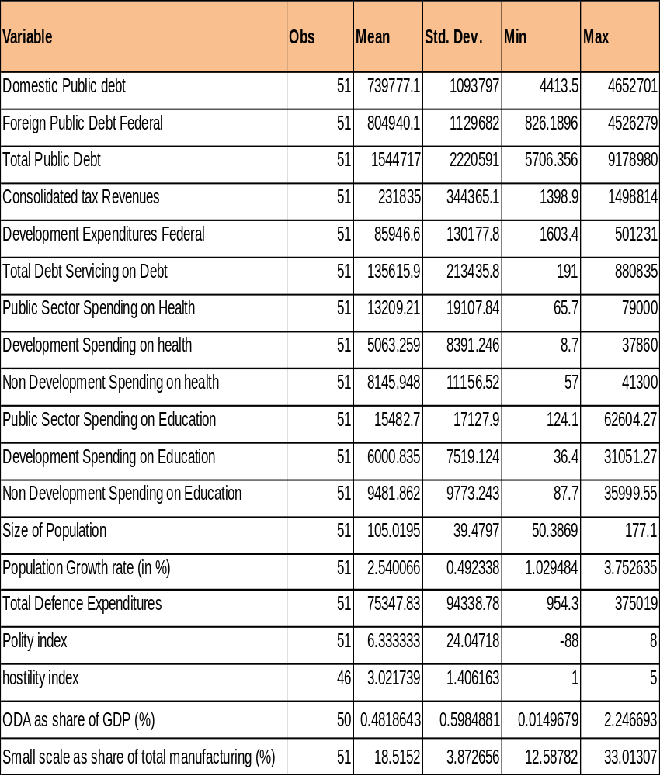

Appendix-B

Debt Net Cost Index (DNI)

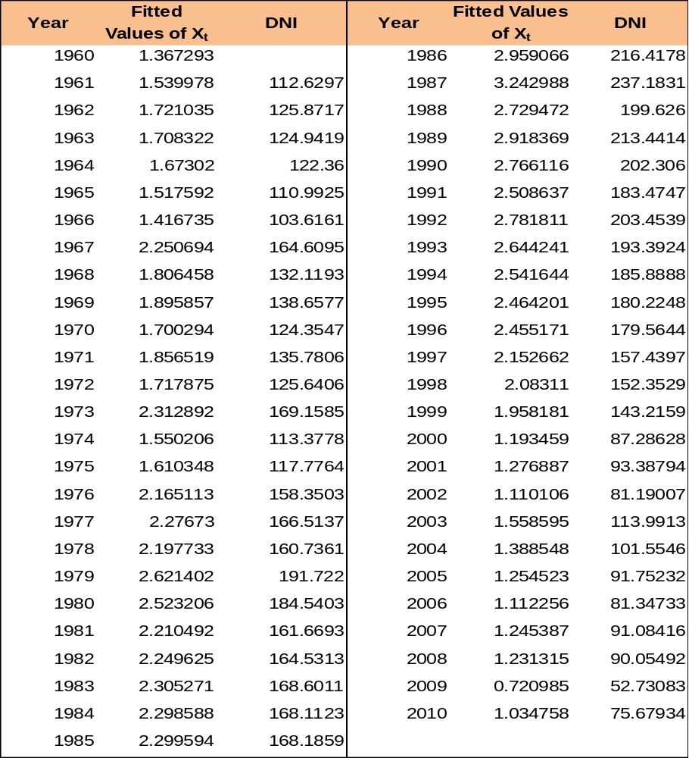

Regression results of DNI on Xt
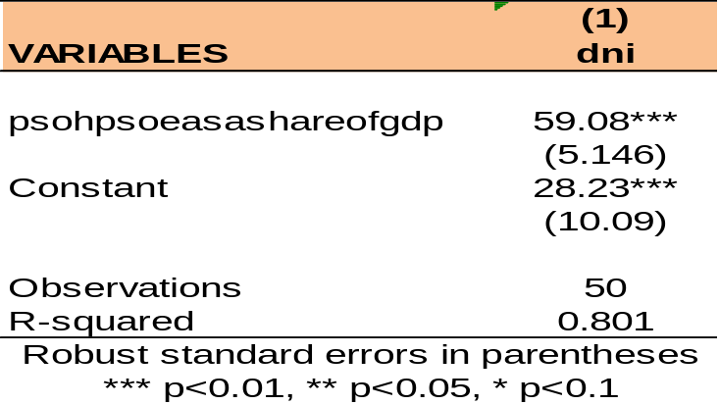
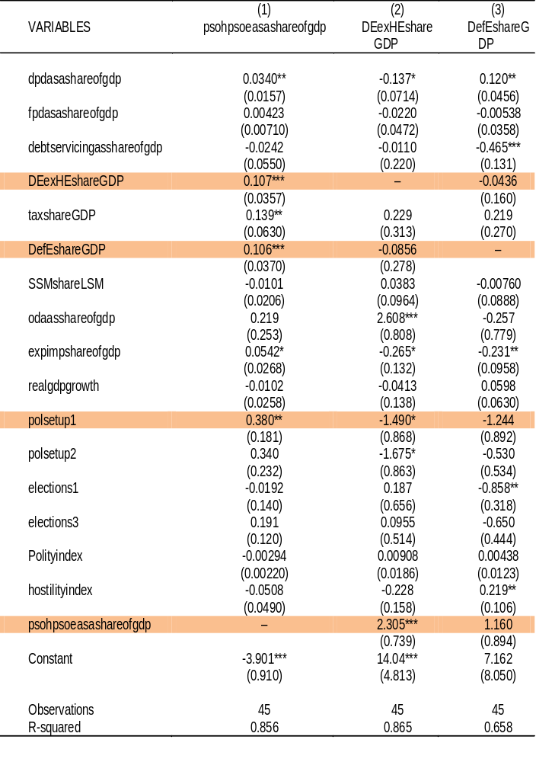
OLS estimates of single equation models with all debt ratios as explanatory variables

Robust standard errors in parentheses
*** p<0.01, ** p<0.05, * p<0.1

Tests results for Checking Efficiency, precision and unbiasdness of our estimates in Eq.8

- White test results for heteroscedasticity
Ho: Errors are homoscedastic
H1: Errors are heteroscedastic
After computing residuals from Eq.8, we ran the auxiliary regression of the squared residuals on all of the explanatory variables, their squares and respective products. Based on this, we computed n.R², i.e. 19.7. Where n is number of observations and R² is the coefficient of determination in the auxiliary regression. Since this computed value is less than the tabulated value of chi-square both at 5 and 10 percent levels of significance with df=20, we are unable to reject Ho and infer that our residuals are homoscedastic.
- Breuch-Goldfrey test results for autocorrelation
Ho: Errors are not serially autocorrelated at first order
H1: Errors are serially autocorrelated at first order
Here again on the basis of residuals computed in Eq.8 we ran the following auxiliary regression and computed n.R².
Since the value of n.R² computed on the basis of above equation, i.e. 6.55, is less than the tabulated value of chi-square at 5 and 10 percent level of significance with df=6, we are unable to reject Ho and infer that the residuals are not serially correlated at first order.
- Multicolinearity test for precision
multicollinearity diagnostic test results
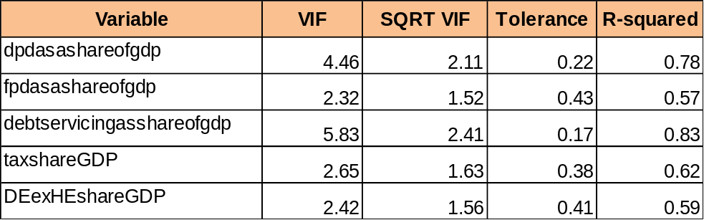
Here Tolerance= 1–R² and VIF = 1/tolerance. Since a tolerance of less than 0.2 or VIF of 5 or above means indicates a problem of muliticollinearity, we can infer that there are not significant of instances of collinearity in our explanatory variables.

Different political setups and trends in selected variables

Military regimes Democratic regimes
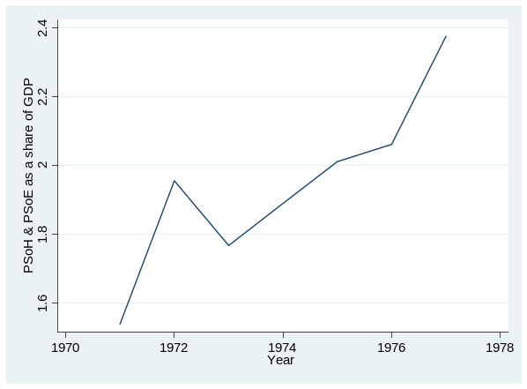
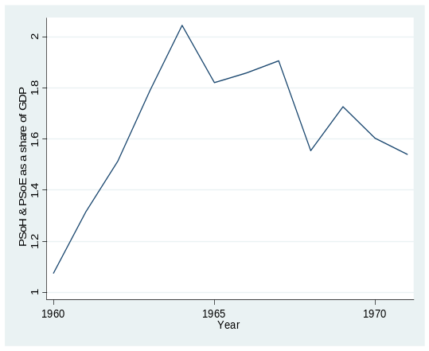
Figure B1 Figure B2

Figure B3 Figure B4
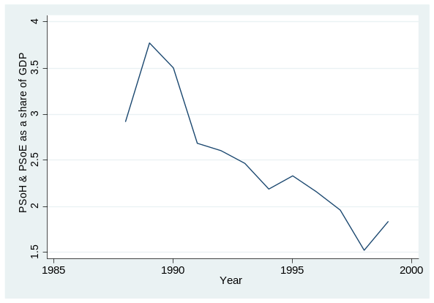
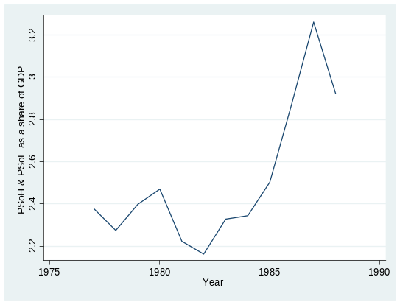

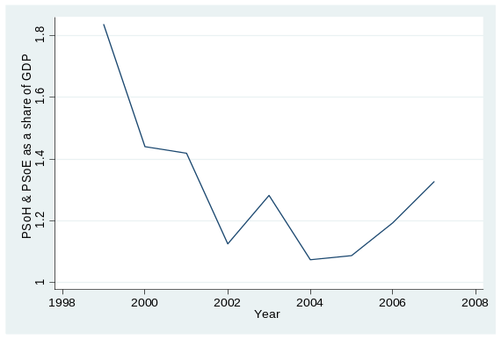
Figure B5 Figure B6
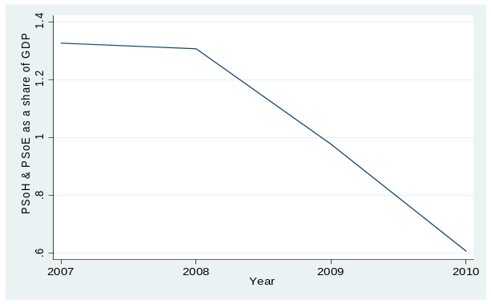

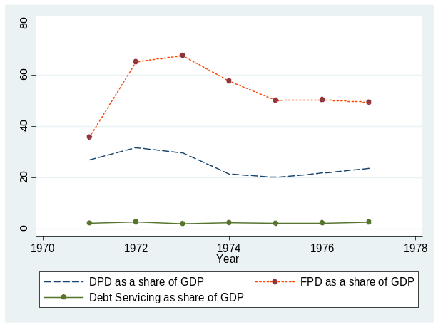
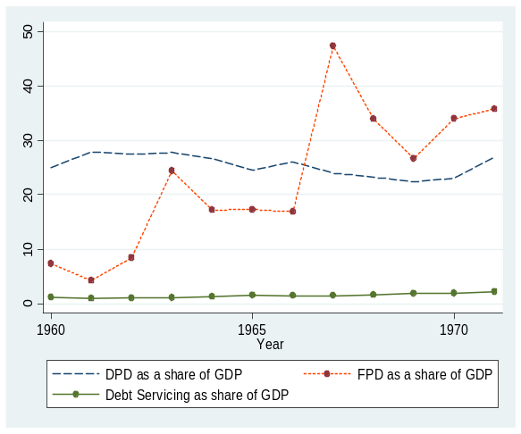
Figure B9 Figure B8
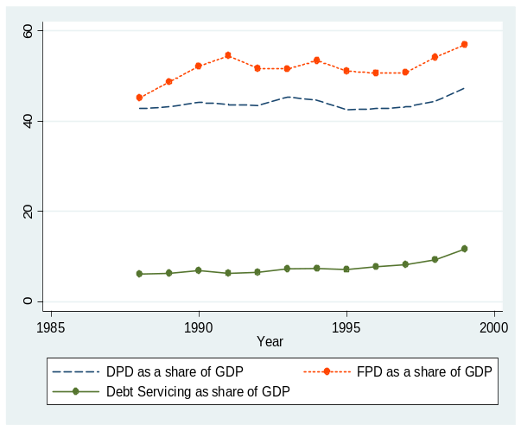
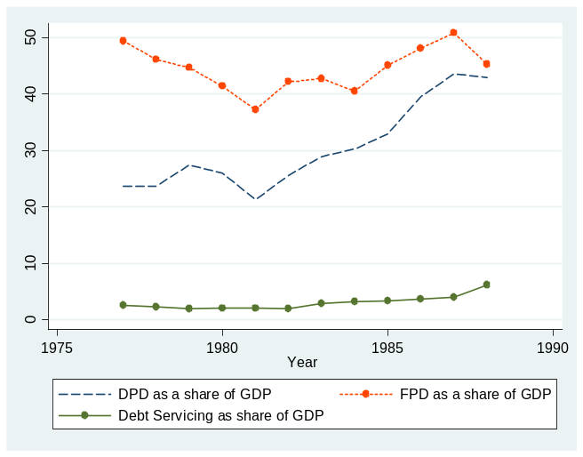
Figure B10 Figure B11
Figure B12 Figure B13
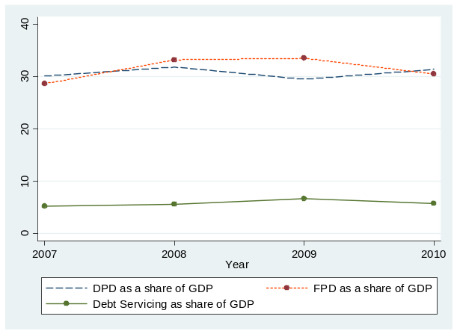
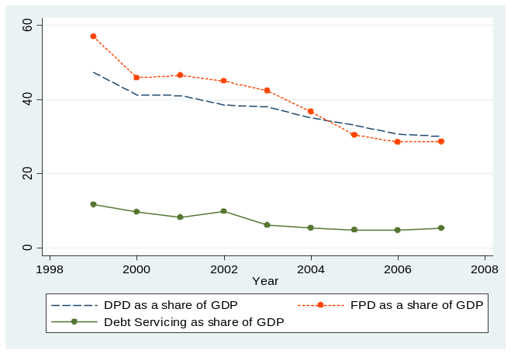

Figure B14 Figure B15
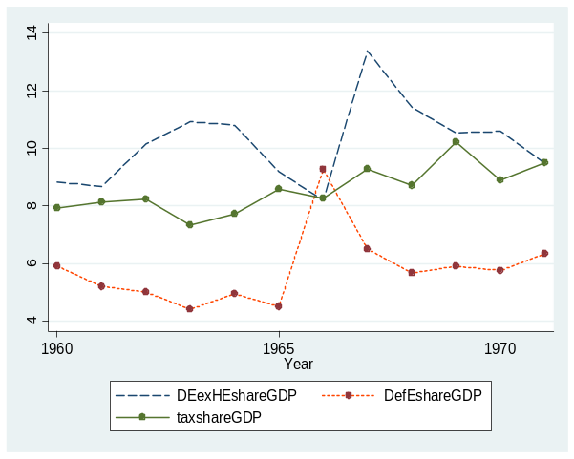
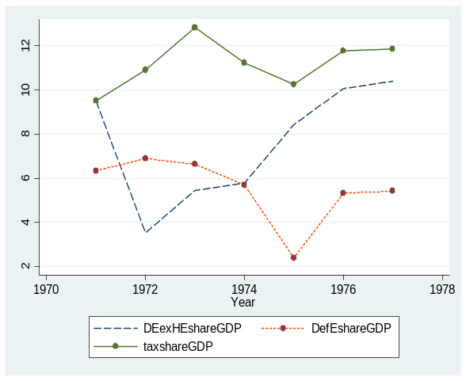
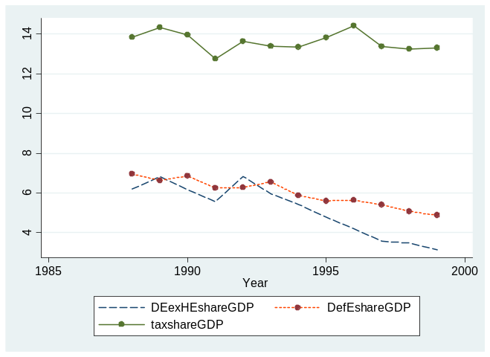
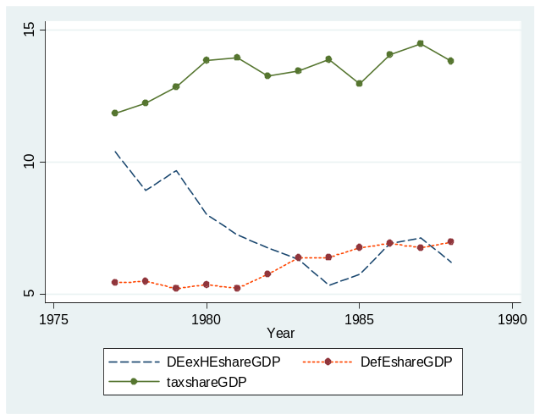
Figure B16 Figure B17
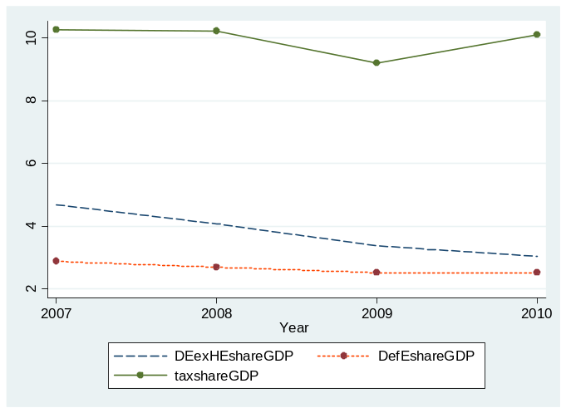
Figure B18 Figure B19
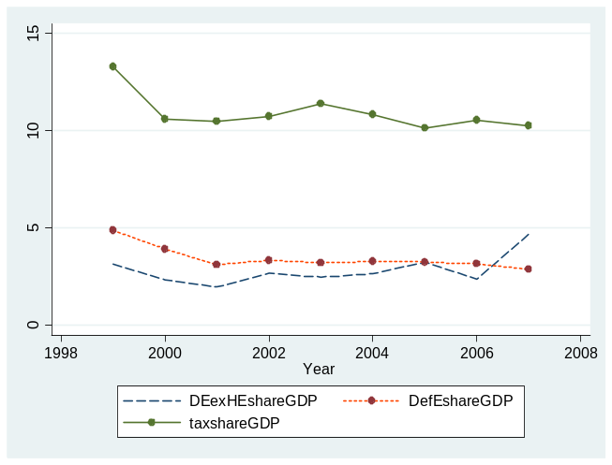

Appendix-C

VAR estimates without DNI but including debt ratios for the whole sample with exogenous political and elections dummies
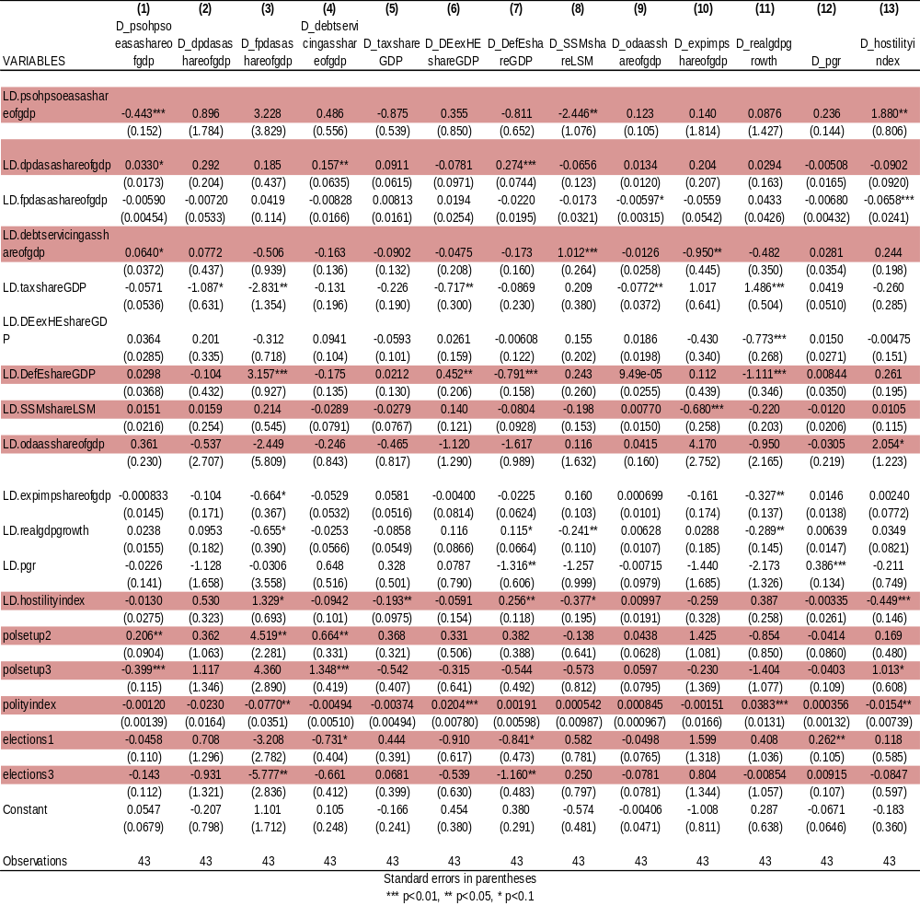

Tests Results for lag and model selection criteria

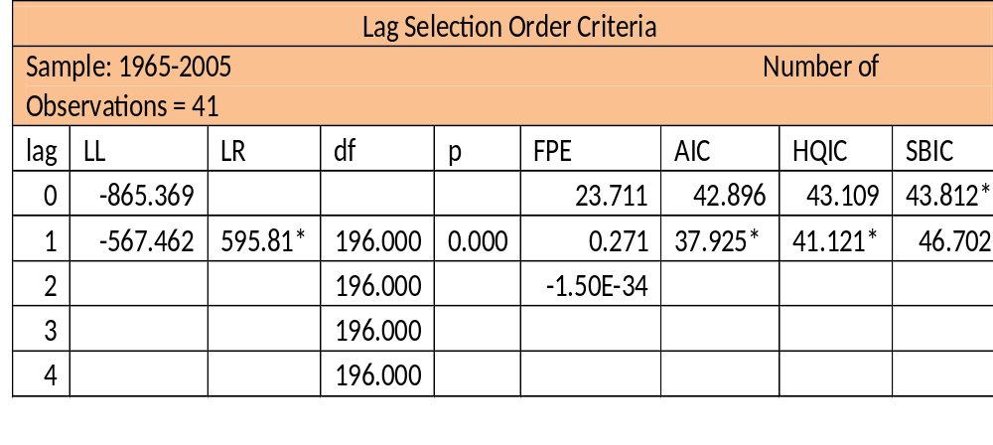
- Lag selection test for VAR model

- Model selection test results

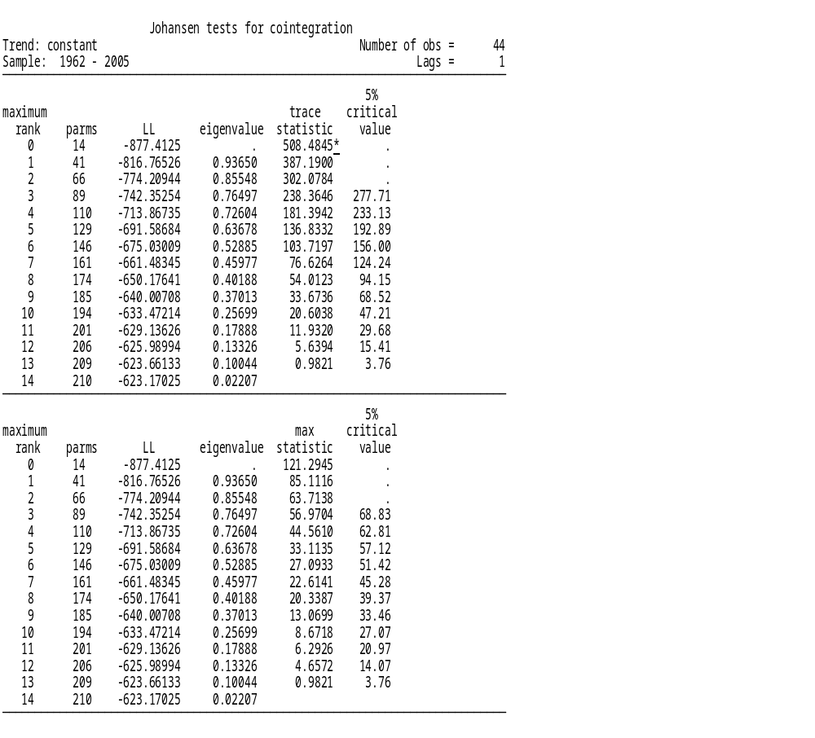

Tests results for some post estimation consistency and stability checks for VAR

- Langrange Multiplier (LM) test for the VAR with whole sample

Lag | Chi² | Df | P> Chi²
1 | 73.4161 | 81 | 0.71318
2 | 75.3760 | 81 | 0.65535

H0: residuals are not autocorrelation at lag order
H1: autocorrelation at lag order

We are unable to reject H0 at 5% significance level

- Plot of Eigen values for VAR stability test with whole sample

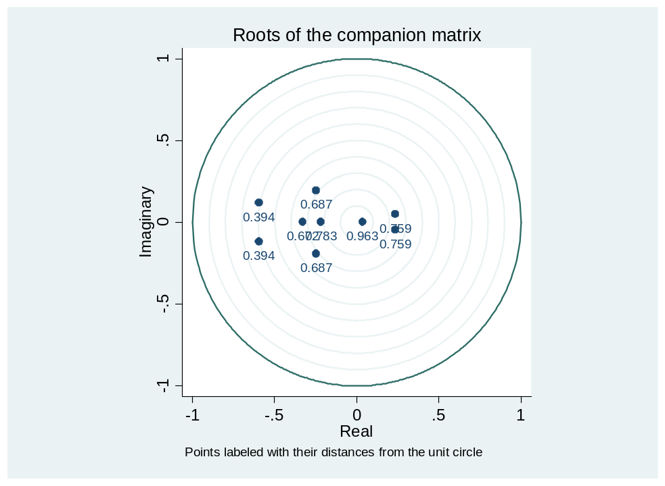

Our VAR model with the whole sample is stable as long as all of the roots lie within the unit circle. The subject roots satisfy the stability condition

- Plots of observed and VAR forecasted series of endogenous variables at first difference based on the VAR estimates of the whole sample

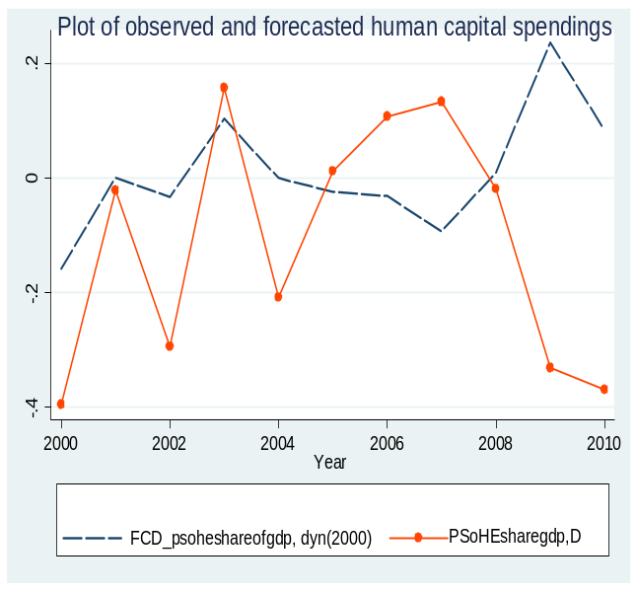
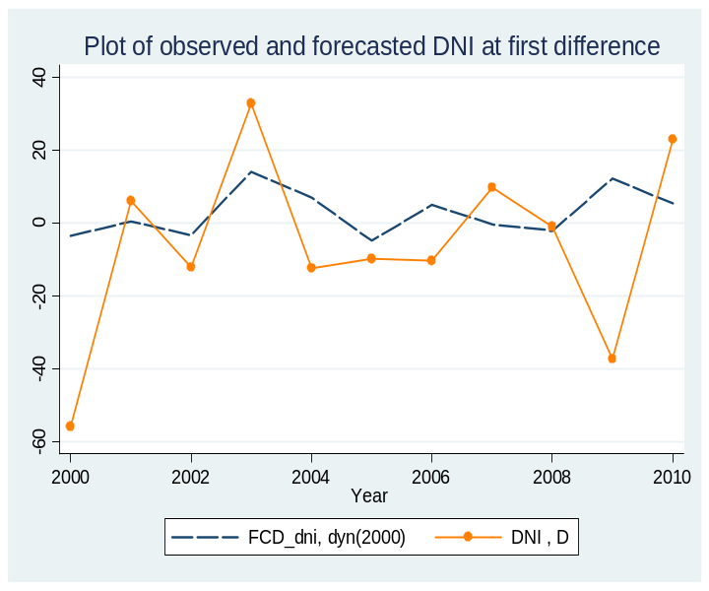

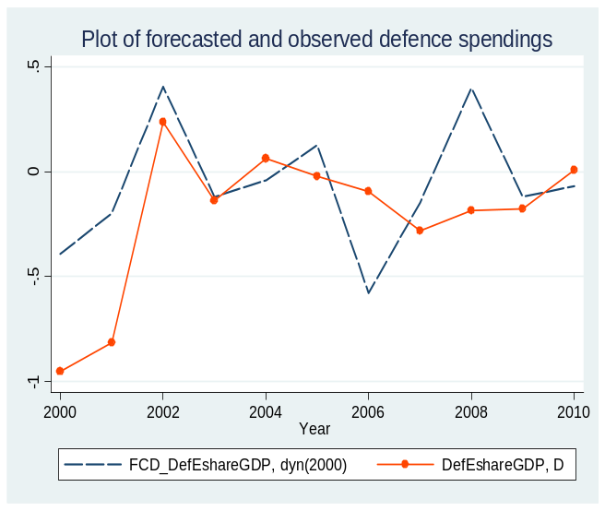
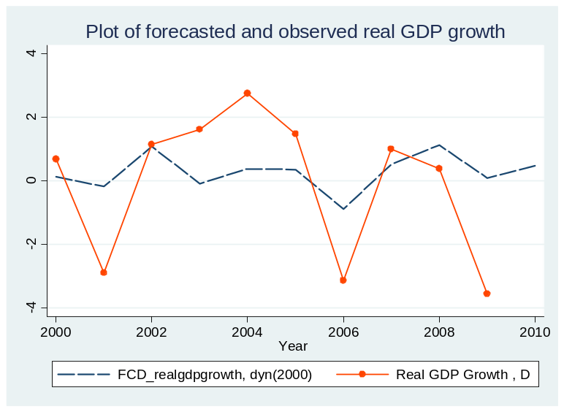

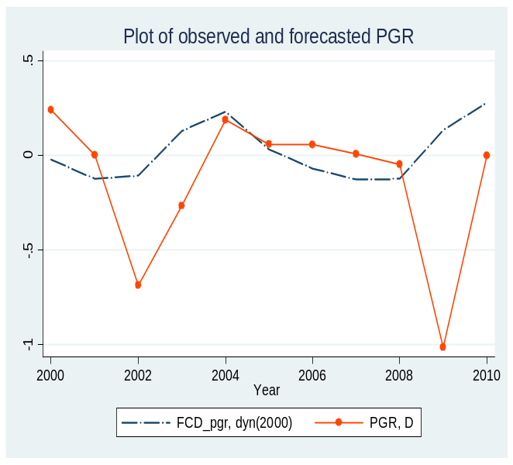
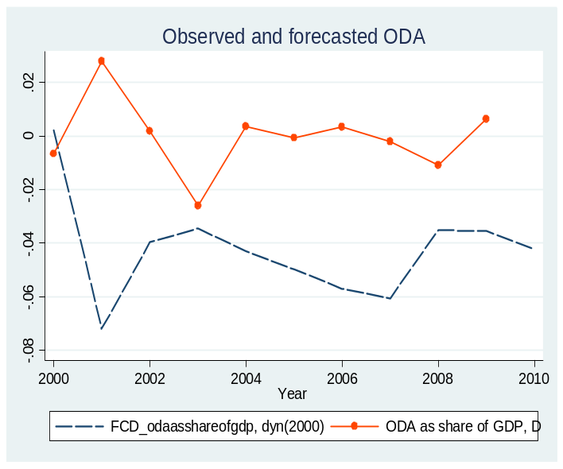

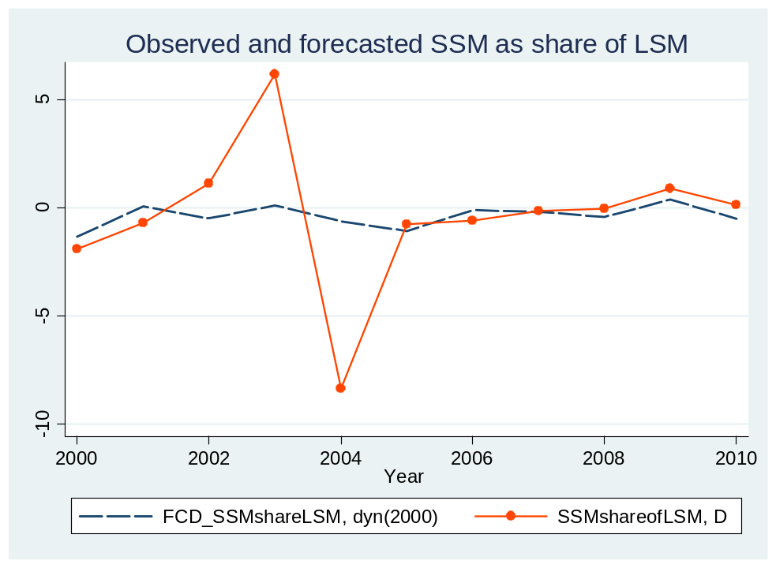

Human capital investment primarily means investment in health and education as have been stated by Schultz, W. “Much of what we call consumption constitutes investment in human capital. Direct expenditures on education, health, and internal migration to take advantage of better job opportunities are clear examples. Earnings foregone by mature students attending school and by workers acquiring on-the-job training are equally clear examples........ ...I contend that such investment in human capital accounts for most of the impressive rise in the real earnings per worker.”(Schultz 1961). The study therefore, will use the human capital investment and expenditures on health and education interchangeably.
See for example (Easterly 2001) for the detailed descriptions on how Pakistan’s reasonably good episodes of economic growth had not necessarily translated into a sustainable development.
Shaded periods are the periods of military dictators. Average estimates in two periods, i.e. 1986-90 and 2006-10 are considered as dictatorial periods’ estimates because military dictators ruled the country for at least 3 years out of the five years in each case.
Two political parties have largely been heading the democratically elected civilian parliamentary system in Pakistan since 1960: Pakistan Peoples Party (PPP) and Pakistan Muslim League (PML). Their detailed political ideologies can be seen in Appendix-A
The country’s first national five year Plan was adopted for the period of (1955-60) followed by (1960-65), (1965-70), (1977-83), (1983-88), (1988-93), (1993-98) and lastly (2005-10) plan periods.
For detailed discussion on OLG model (see for example Auerbach et al.1994, Allgood and Snow 2006, Weil 2008)
Based on our DNI, we ran a simple regression of DNI on X_{t}, which shows that how a percent change in human capital spending can influence the net cost of public debt being born the population. A positive and significantly large coefficient justifies our use of predicted values of X_{t} as a proxy for measuring debt net cost index. This also shows that any increase in X_{t} will cause a net welfare gain as a result of debt accumulation in Pakistan (See Appendix-B for the results of this regression).
For our purposes we run three simple OLS regression with all debt ratios as explanatory and each of the defense expenditures, development expenditures and public sector human capital spending as dependent variables separately. The results show that public sector human capital spending is not only determined by others but also explain the behavior of other variables in our model. This also substantiates the endogenous nature of these variables and the use of our VAR or VECM methodology (See Appendix-B for detailed results)
See Appendix A for the detailed list of variables’ labels used in our estimations
Considering the number of values in the sample, significance levels are based on the standard ‘t’ rather than ‘z’ statistics.
Quoted in the Financial Times, July 6, 2004, as cited in (Lora and Olivera 2007b)
See section 2 for the detailed discussion of their theoretical debates
Further details are available at their official web pages at www.ppp.org.pk
Further details are available at their official web pages at www.pmln.org
All charts in first column are related to dictatorial periods whereas the charts in second column are for the periods of democracy.

