Bachelor thesis:

The positive effects of Merger and Acquisition on Chinese iron and steel stocks

ERASMUS UNIVERSITY ROTTERDAM
Faculty of Economics of Business

Supervisor: V.Volosovych

Name: Hongshan Xu
Student number: 325239
E-mail address: zhoumengfeijiajia@hotmail.com
Study: International Business & International Economics
Thesis: corporate finance
Bachelor (FEB13100X)

Abstract: 3
Keywords: stock price, Chinese iron and steel market, event study, abnormal return 3
1. Introduction: 3
2. Literature review: 5
a) Empirical study: 5
c) The argument of negative abnormal returns: 8
d) The characteristics of Chinese iron and steel industry 11
i. Possible reasons for positive AR: 11
ii. Possible reasons for negative AR: 13
Table 2.3.1: 14
e) The M&A characteristics of iron and steel enterprises: 15
f) The impact of reform of non-tradable shares: 16
3. Methodology: 17
4. Data: 19
5. Results: 22
Table 5.1: 22
Table 5.3: 24
Table 5.4: 24
6. Discussion: 25
7. Conclusion: 31

Abstract:
This research paper will take close look at the Chinese iron and steel market and the abnormal return caused by merger and acquisition announcement. At first, we will analysis the reason which cause the positive and negative abnormal return based on the previously research and then combine these with the real Chinese iron and steel market situation to find some unique characteristics that may yield different result. Furthermore, the paper will give more background knowledge about Chinese iron and steel markets. The main methodology will use the event study, and invest the real data through cross-sectional test. The final result of positive abnormal return in China market will bring a new hot issue in the further study.

Keywords: stock price, Chinese iron and steel market, event study, abnormal return

- Introduction:
In 1978, China began to reform of the planned economic system. Through the past 30 years till now, the process of China's market economy has made remarkable achievements. Firstly, as the governments change the economic system direction from the planned economy to a market economy, the allocation of resources is no longer planed beforehand, but distributed according to the market needs. Secondly, the development of different forms of ownerships (not just the state-owned) has become the basic pattern. Finally, the marketing system is gradually improved. After those policy changes, China has become to be the fastest developing country in the world. Merger and Acquisitions which are popular in developed countries, have a short history in China. Thus, according to the previous paper, there is not much information about the recent Chinese market with enough data support. In this research the case study of Chinese iron and steel stock market will be used to find the special condition in China and the possible problems about the abnormal return after M&A announcement will be discussed.

According to the research paper from western countries in previous years most merger cases within the iron and steel industries will cause a lot of negative impact, but in China, it is usually the opposite. There are several reasons why a company chooses for M&A. Firstly, they want to get more time and assets to deduct the transaction cost of the market in a limited time. Then through the M&A, it develops company’s degree of centralized organization, and strengthens the enterprise group level management decision-making functions. Last but not least, in western countries, the following reasons like estimates of the target company, an incentive to get higher salaries by building empire and hubris of the management will bring a large amount of negative abnormal cost after the public announcement events.

However, in China the situation is different. There are several reasons that may cause the iron and steel industry to distinguish its performance after M&A. The major reason causing these differ is that government policies encourage M&A in iron and steel industry and favorable policies are given to companies merged. As the worlds’ first iron and steel production, consuming and exporting country, China suffered from loss of pricing power of iron ore, and from the lower industrial concentration, which causes the loss of control and low technology development. One of the major resolutions proposed by government is to increase the industrial concentration by M&A. The state council has issued constantly policies facilitating the M&A in iron and steel industries, especially after 2003, including policies in terms of equity financing, loaning, land supplying, project approve, investing, technology development and other supports. Policies include ‘Guidelines for further accelerating industrial structure adjustment of Iron and Steel industries (State council, 2010)’,’Guidelines for further eliminating old production technology and encouraging new ones (state council, 2009)’,’Guidelines for facilitating iron and steel industry’s structure adjustment (state council, 2005)’ and ‘Guidelines for avoiding iron and steel industries overproduction (state council, 2003)’. The aim is to increasing industrial concentration, develop several leading companies and control the total production volume. These policies should have different effects on the performance after M&A so it is worth testing. Secondly, the infrastructure construction helps them to perform better which should have positive effects on abnormal returns after M&A. Besides, as all the iron and steel companies are state owned companies, the M&A is under the government’s command, so that the management has no incentive to build empire as western manager, and the hubris play minimum role in M&A. During the event, the company is also possible to get more different preference from bank and other institutions, which would be a significant factor that leads to prospect positive abnormal return. Not only these, some more detailed analysis will be presented in the following literature part.

Other than the unique industrial traits described before, in 2006, there is a major reform in capital market, the non-tradable stocks reform, which have significant influences on agency problem. This is expected to influence abnormal returns of MA. This reform will be discussed later in detail.

According to those reasons, the research question is proposed: whether the MA in iron and steel industry has positive abnormal return around the announcement days? Does the reform of non tradable stocks have influence on abnormal returns after MA? In order to test the hypothesis above, this paper will use the actual datasets to find the abnormal return after the M&A event. After that the possible causes of the empirical results will be analyzed and the discussion combine the data findings with the recent Chinese market condition will be given. The final conclusion will present a clear opinion and further suggestions about Chinese iron and steel stock market.

- Literature review:
  - Empirical study:
Through the past papers related to the M&A in western countries, the market generally is found to generate negative abnormal return after the M&A announcements to buyers. Like in paper of Andrade, Mitchell and Stafford (2001), they found there is -1.5% significantly negative abnormal returns from 1973-1998. In the following parts, different arguments about the hypothesis that causes positive and negative abnormal returns will be discussed first, and then the main focus will be on the special conditions in Chinese market which is expected to yield different result during the M&A activities. These studies will not only help to make the final conclusion, but also would be useful to find solution for further researchers.

  - The argument of positive abnormal returns:
The abnormal return is a term which is used to describe the returns different from the expect rate of return of a security or portfolio in a period of time. If the abnormal return value is positive, then it means this MA is good news as the actual return is high than expect return based on the historical represent. It also can be explained as the individual stock performs better than the market average during that time. There are several reasons can lead to positive AR after M&A, such as the growth of company itself, synergy (economy of scale and scope), geographic diversification, vertical integration benefits, horizontal acquisitions, taxation, etc. In the following, we will detail analysis each motives one by one.

    - Growth:
The companies want to do the M&A because it may not be able to grow fast enough by internal expansion, and they also have to make sure that they gain greater than the cost of merger. This is the economic basis for mergers. According to this reason, M&A is a key part of growth strategy for many companies. So the acquisition is good news for the stock markets as it usually takes less time than internal expansion for the company growth. It helps the company raise their market cap, and should be the possible reason behind to the positive AR. For instant, Johnson &Johnson, a medical device maker and pharmaceutical company, grew up through doing the more than 20 deals of M&A in past ten years. (Stephen Simpson, April 2011).

    - Synergy:
The operating synergy is another main positive effect of the M&A, and it contains the economy of scale and scope. The component of economies of scale is declining per unit costs as output rises, but the limitation of this is it may only last within certain range of output. The economies of scope mean the company being able to offer wider range of services or products to same customers. In November 20 of 2006, Bank of America (BOA) acquired U.S. Trust from Charles Schwab for $3.3 billion, which is the typical commercial bank with major retail network acquiring a bank with strong trust department (Anthony Saunders and Michael Smirloc, December 1987). The M&A event to companies are like the equation 2+2=5 shows, the combined firm is more valuable than the value of the separate firms. Furthermore, the combined technology leads to reduction in operating costs through elimination of duplicate facilities and reduction in various departments.

    - Diversification:
After the M&A, the company becomes more diversified. The company will be diversified to obtain the optimal capital structure. In the paper of Morck, Shliefer, and Vishny (1990), they analyze 327 M&A cases during 1975-1987. The research found that related diversification showed positive returns but unrelated diversification showed negative returns to acquiring firm shareholders. And till Fan and Lang (2000), they use the input-output data rather than SIC code definitions to measure relatedness over period 1979-1997, and looked at firm value for diversified firms relative to pure plays in the same industry. Finally, the paper define relatedness in 2 ways, one is vertically related which means two businesses or diversions are vertically related if one buys inputs from the other, and the other one is complementary if two businesses jointly procure inputs or share distribution channels or marketing. There are some counter arguments that the shareholders can diversify their portfolios much less costly than companies can do for shareholders. Shareholders do not incur the sizeable transaction costs when the company does M&A and they do not have to pay a premium. Then diversification also forms a lower risk which is easier for shareholders to do on their own or at a lower cost. In conclusion, the values of both vertically and complementary are increased over time, vertically related firms do poorly compared to more focused firms, and complementary firms show higher values.

    - Horizontal acquisitions:
The horizontal mergers are specialized in the combination of two firms which are at the same level in the production to market process. The benefits of these kinds of M&A are duplicate facilities elimination and offer broader production line after. The earlier research have hypothesis that the firms do horizontal merger to achieve monopoly power, and if so you would accept the stock prices of competitors to fall. However, in the previous studies of Stillman (1983) and Eckbo (1983) found no statistically significant effects.

    - Vertical mergers:
Vertical mergers are separated into backward expansion and forward expansion. The backward expansion is towards the source of supply, for example, the oil company buying another oil company with abundant reserves. In 1984, Mobil Oil acquisition of Superior Oil which has large reserves and Mobil has strong marketing and refining operations. (Cibin&Renato, December 1996). The forward expansion is towards the ultimate consumer, such as the acquired firm with a large retail network, which is opposite with the backward expansion.

  - The argument of negative abnormal returns:
As we have introduced in former paragraphs, the companies are willing to do the M&A because of advantage introduced. On the other hand, it is strongly argued by scholars that due to the separation of ownership and control, the company would have negative ARs in the end. The main reason causing the negative ARs are, empire building, management hubris, overpayment, etc.

    - Management hubris:
The hubris hypothesis is put forward by Richard Roll (1986), it describes that the manager is overconfident, value the target irrationally upwards and believe their valuations are superior to the market. These cause them to overpay during the M&A.

Dodd (1980) believes Hubris Hypothesis is true and he supposes the stock price of the acquirer to fall after the announcement of the M&A. The final found statistically significant negative ARs following the announcement of M&A prove his idea. In order to make it more persuasive, Hayward and Hambrick (1997) use the 106 samples which all are larger than $100 million events during 1989-1992. The result shows significant relationship between Hubris indicators and size of acquisition premiums. The indicators they defined are recent organization performance (shareholder returns), recent media praise (scale rating of content of articles), CEO self importance (CEO pay relative to other executive pay in same company since CEOs have great influence on this) and CEO inexperience (tenure of CEO with firm). The Malmendier and Tate (2008) find that overconfident managers who voluntarily retain in-the-money stock options in their own firms are more likely to make diversifying and value-destroying takeovers, which is support the Hubris Hypothesis as well.

    - Empire building:
The explanation of Stulz (1990) of empire building said, if compensation (or private benefits) is tied to company size, managers have incentives to acquire other firms to increase their size which in return, allow them to enjoy higher compensation and benefits. Also in the paper of Harford and Li (2007), they use the completed M&A transactions as the sample from 1993 to 2000 and found acquiring firm CEOs are generally better off even when shareholders are worse off during the transactions. Moreover, the payment and total wealth are insensitive to negative performance and vice versa (except in the case of strong corporate governance).

    - Free cash flow Hypothesis:
Jensen (1986) found that managers are reluctant to pay out cash to minimize external capital market monitoring. Furthermore, the managers also engage in negative NPV merger transactions when running out of good ones for the purpose of reducing personal undiversified risk and increasing the scope of their authority. And in the later study by Harford (1999) he found there is a negative mount of the abnormal stock return to takeover announcements by cash-rich bidders, and it will decrease the amount of free cash flow held by the bidder.

    - Winner’s Curse:
The concept of winner’s curse is associated with many auction contents; those that overestimate the value of the auction item will overbid and will win the auctions. This concept support the Hubris hypothesis and helps explain the reason of overpay by bidders.

    - Agency cost:
An agency cost is the cost used to solve the organization problem which will lead to divergent management-shareholder objectives and information asymmetry. There are different interests among managers, bondholders and shareholders. To the managers, they have their own objectives and they want more cash in their hand to control and higher wages. As a general idea, they will optimize their own benefits which are contradiction with the interest of the company. To bondholders, they are the typically rise-reverse person because if the company deficit, the bondholders cannot get money back then. To shareholders prefer the riskier subject, as the higher except return with the higher risk. If the company loses, they can share the losses with bondholders because bondholders only bear the risks if the projects fail. And if the company wins, they can get the profits back from the investment. According to the article from Frank H. Easterbrook (September 1984), he found that the cost of company’s capital is raised up due to keep the balance among these relationships. And these agency costs always out of the expectations before the M&A, which lead to the negative effect of the events.

  - The characteristics of Chinese iron and steel industry
After the analysis of above reasons which cause the different effects of AR, we will talk about the characteristics of Chinese iron and steel industry. The main points we should cover is the characteristics of state-owned enterprise and the status of the iron and steel industry in Chinese current conditions. Due to the fact that China is a socialism developing country, the stock market is not as mature as western countries. (Zhang Yichun&Zhou Yinggang, March 2001). First, we will introduce some unique features in China and do some theoretical analyses combine with the findings in front to learn this special market.

    - Possible reasons for positive AR:
Financial Synergy: Thanks to the impact of national policy, all of the steel industries can get the special offers as they are state-owned company. The Chinese state-owned enterprises seem to be able to access the bank credit resources relatively easily, and in a relatively low price. Of course, many factors may explain the low cost of debt state-owned enterprises, such as the huge state-owned capital can be used as collateral, and default rates are relatively low. (Robert Cull, March 2011). Therefore, the creditor may provide a lower lending rates, the private company cannot do this because of the limited firm scale. Meanwhile, the advantages of state-owned enterprises in which the industry also means lower operational risks that facilitate its access to low interest rates. In developing countries like China, the capital is the scarcity of resources. If you can make use of these capitals to do M&A, it will be not hard to obtain the high profits.

Economy of scale: When becoming a large firm, the firm will have more bargain power in the pricing of iron ore. There is a dual track system in the ore pricing, in which the large company can purchase at the long term negotiated price, a price much lower than the spot price which is beard by small firms (Larry, 2010). Becoming a large firm thus present a significant synergy in cost saving.

Steel industry is a capital and resource- intensive industries, so economies of scale play a major factor for efficiency and competitiveness of them. In China, there is a long-run equilibrium relationship between the steel firm size and efficiency. Most steel company’s economies of scale effects were not obvious, which means that is not the casual relation. (Xiaorong Guo, 2010). Furthermore, due to the blind investment and expansion of production capacity in previous years, steel industry shows overall excess capacity in the beginning of 2008. The significant structure surplus within the steel industries is mainly displayed as high-end excess capacity and the relative lack of low-end production. But according to the experience from the developed countries, the Chinese steel consumption has not research the saturation point yet. The consumption of steel market will keep the increasing trend in the future because of China not achieve one of the basic three conditions of saturation point. (The three basic conditions are countries per capital GDP reached 6000 U.S. dollars, basically complete of industrialization and the tertiary-industry accounted for more than 50%). (Sanchez-Robles&Blanca, January 1998).

Cross selling: As China entered a new round of economic growth rising cycle, in the steel industry and the macroeconomic environment interaction, domestic demand contributed to the rapid development of steel industry. The each steel mill is based on product characteristics, to establish a relatively perfect channel structure. Although the main channel of the steel structure is different, the common pattern is: Supplying the user, protocol dealer and agent, or branch office (subsidiary), and spot or distribution center. Because of the characteristics of steel products, the marketing channels also have focused on. Some was intensive in the steel region, and may be choose the channels of cooperation, self-channel or set up special agency for the one series of products when selected distributors around the country. Some steel mills may also establish exclusive agent for the new trial, new promote product. Its core are exploring the end-user, development the direct supply customers, improve value-added special steel products with higher sales ratio and starting to reduce intermediate links, finally to achieve the channel high efficiency and maintain the stability of demand. (Yongjun Li, Ruhai Chen & Chenjie Xing, 2005).

Taxation: At present, China's steel products price advantage has been significantly reduced, profits from the vast majority of products exported to Europe, America, Japan, Korea and other developed countries and regions are less than the domestic sales revenue. (There is no dumping of power). Therefore, the future of China's steel exports basic decisions in the international supply and demand gap, when the international situation of tight supply and demand caused by rising international steel prices and thus widen the spread at home and abroad, the export revenue will be more than domestic income, China will determined export volume in accordance with international supply and demand gap. (Youtian He, 2006)

The adjustment of export tax adjustment will continue to affect Chinese steel exports to a certain extent. It will be helpful to control the future excessive growth of exports, ease Chinese trade surplus is too large to bring the outstanding contradictions, optimize the export structure, and restraint the exports of product, which is high energy consumption, high pollution and resources. After the modification, it will also useful to keep the balance of import and export trade and promote the changing of foreign trade growth pattern and import and export trade balance, reduce trade frictions, in order to ensure sustain the social economy sustainable development. (Youtian He, 2006)

    - Possible reasons for negative AR:
Agency cost: It may be significantly result a negative AR because of the low proportion of managerial ownership in the Chinese state-owned enterprises. Managerial shareholding become a means of the company incentives and constraints the corporate management. It not only can confirm the value of labor management in the past, but also estimate the rewards according to the past performance. Managerial shareholding help the enterprise reach the excepted profits through increasing the expected value of labor management. It also adjusts the single ownership to a mixed property, which has laid a solid foundation to establish the perfect modern enterprise system. However, the low proportion of managerial ownership in iron and steel industries leads the raising of agency cost, which brings the negative effects of the M&A. In the paper from Dongfang Shao(2009) also find the similar relationship between managerial shareholding and the performance of the company.

Hubris & Empire Building: The hubris effects will not exist in Chinese market. Due to the special situation in China, all the steel industries and state-owned enterprises, the M&A in this field is not dominated by the enterprises itself, but by higher level, like SAC (State Asset Regulatory Commission), NDRC (National Development and Reform Commission) or State Council. So the management has no right and permission to make this mistake. (Weihua Peng & Jiangfeng Liu, 2003).

Overpayment: With the same reason of the above, the price of the M&A is not based on the market price and the government will give the preference to the buyer company, so normally, there will not be overpay during the M&A events in iron and steel industries. (Weihua Peng & Jiangfeng Liu, 2003).

To conclusion, we will use the table to figure out if there is effect to Chinese market of all the reasons which has been mentioned before in the below table. The “P” means there is a positive effect exist and “N” means negative.

Table 2.3.1:
The effect of reasons to Chinese steel industry M&A
The positive reasons | Financial Synergy | P
The positive reasons | Economy of scope | P
The positive reasons | Economy of scale | P
The positive reasons | Cross selling | P
The positive reasons | Taxation | P
The negative reasons | Agency cost | P
The negative reasons | Hubris & Empire building | N
The negative reasons | Overpayment | N

  - The M&A characteristics of iron and steel enterprises:
Merger integration is the world's steel industry development trend. The highlighted opportunities of domestic steel industry in M&A mean it is the time for Chinese Iron and Steel industry to do the integration. From the view on reset the capital and equity investment, the equity capital is much lower than the replacement cost, which lead the equity capital (also called acquisition costs) will get more excess profits. At this time, merger integration brings a good investment opportunity to steel stocks. Most of M&A cases of iron and steel industry are holistic listing in China; select the holistic listing will help enhance the strength of the enterprise.

The offer of defined the holistic listing is relative to equity carve-out. The holistic listing is a behavior of assets restructures activity of enterprise restructuring the major assets and businesses to a stock limited corporation in order to list; or controlling shareholder put his major assets into the listed company. Generally, there are two kinds of holistic listing in steel industry. One is private placement of anti-takeover parent asset model. The company acquires the assets held in their hands through the placement of large shareholders, which becomes popular after in circulation. (eg. Angang New Steel, TISCO, Benxi Iron and Steel plates). The other one is backdoor listing of the whole group model (Listed subsidiaries reverse merger main assets of parent company). The Group's main put the operating assets into the listed subsidiary by refinancing (issuance, placement, or convertible bonds) the acquisition of parent company assets, to achieve the holistic listing. Such as the Baoshan steel company and Wuhan steel company. (Baolong Wang, 2011).

  - The impact of reform of non-tradable shares:
There are parts of the shares of listed companies traded, and mostly state-owned shares and legal personal shares are not traded. Because of the historical reasons of Chinese stock market and the, China A-share market listed companies within the general form of the "two different kinds of stocks”. They are non-tradable shares and social tradable shares, and formed a market system and structure as "different weights in different stocks of different price". At that time, two-third of Chinese stock market shares was not in circulation.

The reasons and the motivation behind this reform are to align the interests between shareholders and management team. The conflict of interest is the major issue for the listed companies. The listed companies before 2006 are mainly formed by state owned companies, of which the management team has no claim on tradable shares (Xiaoqiu Wu, 2006). Whether the company performs well or not did not link to their compensations. The non-tradable stocks, however, has the right to vote, and this forms the majority of the shares, which block the voting right from shareholders of tradable shares. After the reform, however, there are links between the management compensations and the voting right can be distributed as usual listed companies in matured capital market. This is expected to have significant impact on the result of M&A because the agency problem plays crucial roles in the M&A as described before (ibid)

There are several problems of Chinese stock market under the reform of non-tradable shares. First of all, it will lead to the unbalance of market supply and demand. As the exits of two-thirds of non-tradable legal person shares will cause the oversupply when once allowed trading of them. The oversupply is the main reason of the stock crash which is threat to Chinese security market.

Secondly, this reform will cause the shareholders conflict of interest. The non-tradable shares are without wealth before the reform and are acquired by the management team or the local government with negligible costs. After the reform, the shares owned by old shareholders are diluted. Although there are compensation plans for each firm, there are still imbalances (Chaolong Chen, 2005).

- Methodology:
The major methodology of the research paper will use the event study to investigate if the magnitude of security price reactions to the M&A announcements of the firm will cause a positive abnormal return or not. Especially, the stock return is analyzed in short run period of time, like few days after the public announcement date. The analysis will be more powerful and reliable with the more precisely measured announcement date. Considering information leaks already found in US stock market and more severe in Chinese market, and the investors’ under-reaction because of the price limit policies (10% up limit per day), it will be the best choice to estimate the abnormal return on the 5 days before and after the public announcement.

In order to get more accurate results from the database, the abnormal return within 10 days from -5 to +5 will be accumulated, which is presented as CAR in the following equation.

CAR = ΣAR_{it} (t=-5,…,+5)

The AR is the abnormal return of the firm I at the time t.

In daily life, lots of events can contribute to an abnormal return, such as company earnings announcements, interest rate changes, lawsuits and mergers, etc. abnormal return means the difference of a single stock or portfolio's performance and the expected return over a set period of time in stock markets. For instants, if a firm stock increase 12% because of the merger announcement, but the increase percentage of the expect return is only 2%, the abnormal return of this case is positive 10% (10% = 12% - 2%). Then we can use the following equation:

AR_{it} = R_{it} – E (R_{it}), where t = -1... -180
Where the AR_{it} is the abnormal return of the firm I at the time t, the R_{it} is the actual return of firm I at time t, and E (R_{it}) is the expect return of the same firm with same time point.

From the above equation the direct value of E (R_{it}) hasn’t been found from the data set. So the CAPM will be used to estimate the beta and thus expected return in the next step. The full name of CAPM is capital asset pricing model, which is found by Sharpe (1964), lintner (1965) and Black (1972). Normally, the CAPM is used to calculate the appropriate required rate of return of the firm. The model defines the market risk into a risky asset in term of the beta coefficient. In financial industry, the CAPM is the ways to assessment expect return of the aim asset based on the relationship between volatility of the individual stock and the volatility of the whole market.

To calculate the expected return, the beta (market risk) of the each individual stock will be estimated first. In the beginning, the exact date of the price announcement happened for each sample firms, t=0, must be find out and it is also necessary to make sure there are no other similar events announced in last one year or less. After having the clean sample of events is obtained, the daily returns of the sample firms in the last one year will be collected. This should be a reasonable length for the period like 180 observations, R_{it} (t= -1…..-180), in order to make more accurate result in further test. At the same time, also the data of the whole market returns (the index number of china) in the same period which is record as R_{mt} (t= -1…….-180), should be collected. Then the systematic risk betas (β) of each firm can be easily estimated through the following equation:

R_{it} = α_{i} + β_{i} R_{mt} + ε_{it}, where t = -1... -180
Where the R_{it} is the rate of return on the ith asset, α_{i} is a constant term; β_{i} is the market beta of the ith firm stock, R_{mt} is the actual market return and ε_{it} is the normal error term.

After this, the second step is to use calculate expected return using the beta got from first step. Here, make the days after announcement day, t equal to 1, and the market return value of this date is also necessary for the calculation. The equation of the relationship is as follows:

E (R_{it}) = R_{ft} +β_{i} (R_{mt} – R_{ft}), t =1
Where the E (R_{it}) is the expect return of the ith firm, R_{ft} is the risk free rate of return β_{i} is the measure of the market risk (also called systematic risk). The R_{ft} here use the Shanghai Interbank Offered Rate, which simply called SIBOR. And R_{mt} is the actual return on the market portfolio.

- Data:
The research of this paper uses the data from database CSMAR (China Securities Markets and Accounting Research) in order to have a precise proof to support main point of view. The database will be separated into three part, they are M&A database, the iron and steel industry database and individual daily trade database.

The M&A database not only have the name of buyer’s firm and seller’s firm, it also contain the basic information of the event, such as the first public announcement date, deal size and total transactions amounts. The document record the restructuring type in nominal numbers as well which will help the further analysis to find if this is the special reason for the abnormal return in Chinese iron and steel market. From the primary database of all the M&A happened during 2000-01-01 to 2010-12-31, chose the data which related the iron and steel industries. Furthermore, make another table which shows the time series of the M&A. From here, it can easily recognize if the M&A happened more than once of same company within one year, the example of this event will be inactive and it will not be used during the future test. (Here is some meaning of the abbreviation, e.g. stkcd=stock code, datfst=date of the announcement, bcotc=buyer’s company’s code, car= accumulated abnormal return of 10days.)

And there will be one more table of daily stock price and return in order to help calculating the beta number as the methodology explained.

Table 4.1
The table 4.1 shows sample information of merger and acquisition cases. (Tkcd is the stock number, Stknme is the name of the stock, Conme is the full name of the company, Conme_en is the English full name of the company, Indcd is the industry code A, Indnme is the industry name, Nindcd is the industry code B, Nindnme is the iron and steel industry, Ipoprc is the publish price, Nshripo is the publish mount of the stock, Parval is the value of the publish stock.)
As the table shows, all the numbers of the research needed can be download from the database system. The following table is just a similar example.

tkcd | Stknme | Conme | Conme_en | Indcd | Indnme | Nindcd | Nindnme | Ipoprc | Nshripo | Parval
证券代码 | 证券简称 | 公司全称 | 公司英文全称 | 行业代码A | 行业名称A | 行业代码B | 黑色金属冶炼及压延加工业 | 发行价格 | 发行数量 | 股票面值
000569 | 长城股份 | 攀钢集团四川长城特殊钢股份有限公司 | SICHUAN CHUANTOU CHANGCHENG SPECIAL STEEL CO., LTD. | 0005 | 工业 | C65 | 黑色金属冶炼及压延加工业 | 4 | 90000 | 1
000629 | 攀钢钒钛 | 攀钢集团钢铁钒钛股份有限公司 | PANGANG GROUP STEEL VANADIUM & TITANIUM CO.,LTD. | 0005 | 工业 | C65 | 黑色金属冶炼及压延加工业 | 3.7 | 24200 | 1
000708 | 大冶特钢 | 大冶特殊钢股份有限公司 | DAYE SPECIAL STEEL CO .,LTD. | 0005 | 工业 | C65 | 黑色金属冶炼及压延加工业 | 8.7 | 70000 | 1
000709 | 河北钢铁 | 河北钢铁股份有限公司 | HEBEI IRON AND STEEL CO., LTD | 0005 | 工业 | C65 | 黑色金属冶炼及压延加工业 | 9.22 | 120000 | 1
000717 | 韶钢松山 | 广东韶钢松山股份有限公司 | SGIS SONGSHAN CO., LTD. | 0005 | 工业 | C65 | 黑色金属冶炼及压延加工业 | 7.76 | 80000 | 1

- Results:
In order to discover the importance of the reform of non-tradable shares in 2006, the research will calculate the CAR during the 2000-2010. And compare the difference of CAR in period 2000-2010, 2000-2005 and 2006-2010, and then we can say there is important effect of the innovation in 2006 and make more accurate conclusion about the cause of abnormal return in the end.

Table 5.1:
(The Table 5.1 shows the CAR value of the choose data during 2000-2010).

stkcd | Datfst | car
629 | 2000/8/1 | 0.019768
717 | 2000/8/16 | -0.03143
600102 | 2000/11/29 | -0.08558
600001 | 2000/12/9 | -0.02137
600282 | 2000/12/20 | -0.01771
629 | 2001/2/7 | 0.034724
600894 | 2001/3/13 | -0.02036
600231 | 2001/5/12 | -0.00728
600102 | 2001/6/13 | -0.00503
600117 | 2001/11/13 | -0.00281
932 | 2001/11/24 | -0.01589
600019 | 2002/8/3 | 0.001669
932 | 2002/8/15 | 0.02305
600102 | 2002/8/21 | -0.00389
600894 | 2002/8/23 | -0.01452
600001 | 2002/10/9 | -0.00032
825 | 2002/11/21 | -0.11078
600399 | 2003/1/17 | 0.000733
600581 | 2003/3/5 | 0.02178
708 | 2003/3/11 | 0.001209
600126 | 2003/3/15 | -0.02581
600282 | 2003/3/19 | 0.012037
600001 | 2003/4/25 | -0.00553
825 | 2003/5/30 | -0.03631
600010 | 2003/6/18 | -0.00904
600102 | 2003/6/27 | 0.023947
600126 | 2003/9/26 | 0.001276
932 | 2003/11/25 | -0.00752
600117 | 2003/11/25 | 0.081157
708 | 2004/1/31 | 0.074016
600894 | 2004/4/30 | -0.05232
600117 | 2004/9/28 | -0.0299
600808 | 2004/10/21 | -0.0939
629 | 2004/10/23 | -0.03604
600894 | 2004/10/30 | -0.04013
600126 | 2004/11/12 | -0.00851
932 | 2004/11/18 | 0.019155
600399 | 2004/11/25 | 0.028989
600102 | 2004/12/9 | 0.047315
708 | 2004/12/20 | -0.05301
959 | 2005/3/19 | 0.056597
709 | 2005/3/22 | 0.056366
600808 | 2005/4/29 | -0.08105
600019 | 2005/9/22 | -0.02482
600117 | 2005/9/24 | -0.05744
717 | 2005/10/15 | -0.04897
600001 | 2005/12/31 | -0.01603
569 | 2006/1/5 | -0.01369
600357 | 2006/2/28 | -0.07422
600282 | 2006/5/24 | 0.031265
600117 | 2006/6/27 | -0.05323
932 | 2006/8/10 | 0.038392
932 | 2007/3/6 | 0.180178
2110 | 2007/4/10 | -0.0799
600005 | 2007/8/9 | 0.024151
825 | 2007/8/21 | 0.033075
600894 | 2007/9/1 | 0.023081
717 | 2007/9/6 | 0.08545
600126 | 2007/10/29 | 0.022952
629 | 2007/11/5 | 0.13063
569 | 2007/11/5 | 0.168681
600231 | 2008/3/18 | 0.017569
600102 | 2008/3/21 | 0.093143
600894 | 2008/3/27 | 0.081095
2075 | 2008/4/7 | 0.020558
600117 | 2008/4/12 | 0.018105
717 | 2008/6/30 | -0.00898
709 | 2008/7/1 | -0.05642
932 | 2008/7/29 | 0.010874
600581 | 2008/7/30 | -0.06725
825 | 2008/8/2 | -0.08981
600581 | 2008/8/22 | 0.047905
932 | 2008/8/30 | 0.0828
600005 | 2008/9/11 | 0.094002
600808 | 2008/9/13 | 0.131966
959 | 2008/10/21 | 0.029223
600894 | 2009/3/11 | 0.012162
629 | 2009/3/31 | -0.00178
569 | 2009/3/31 | -0.00016
600126 | 2009/4/28 | -0.04562
761 | 2009/7/21 | -0.01197
600117 | 2009/7/23 | -0.02788
600005 | 2009/8/27 | -0.05225
600808 | 2009/9/12 | 0.027691
600691 | 2009/10/19 | 0.108608
2075 | 2009/12/30 | 0.02699
629 | 2010/2/27 | -0.0118
601005 | 2010/3/19 | -0.01908
600282 | 2010/5/19 | 0.032402
600117 | 2010/6/18 | -0.01386
2318 | 2010/7/9 | 0.015075
2318 | 2010/11/25 | 0.066574
932 | 2010/12/3 | 0.005818
601005 | 2010/12/4 | -0.01042
601003 | 2010/12/22 | -0.01222
600282 | 2010/12/30 | -0.01371

Trough the above tables, clear differences can’t be distinct That’s why the average and relevant values of the CAR should be estimated to help find the better period, which can obviously prove the positive abnormal return of the iron and steel industries. The further data are display in the following two tables.

Table 5.3:
(The table shows the t-test data from table 5.1 in time period 2000-2010).
Analysis Variable: CAR
Mean | Std Error | Pr >｜t｜ | Lower 90%  CL for Mean | Upper 90%  CL for Mean
0.0055900 | 0.0055217 | 0.3139 | -0.0035818 | 0.0147619

Table 5.4:
(The table shows the t-test data from table 5.2 in time period 2006-2010).
Analysis Variable: CAR
Mean | Std Error | Pr >｜t｜ | Lower 90%  CL for Mean | Upper 90%  CL for Mean
0.0203302 | 0.0087415 | 0.0243 | 0.0056687 | 0.0349917

Table 5.5:
(The table shows the t-test data from table 5.2 in time period 2000-2005)
Analysis variable: CAR
Mean | Std Error | Pr > |t| | Lower 90%  CL for Mean | Upper 90%  CL for Mean
-0.00978 | 0.005952 | 0.1073 | -0.01977 | 0.000214

From the table 5.3, it shows that the mean of the CAR during 2000-2010 is 0.0055900. The calculate interval is between -0.0035818 to 0.0147619, and the p value of the t-test is 0.3139. In the table 5.4, the mean of the CAR is 0.0203302 in period 2006-2010. The calculate interval is from 0.0056687 to 0.0349917, and the p value is 0.0243 of the t-test. As normally, use the 5% interval here, so the p value 0.0243 of table 5.4 is smaller than 0.05, which means the results in table 5.2 are significantly show the results. In table 5.5, the mean of the CAR is insignificantly negative, which suggests no positive abnormal return for MA before 2006. And the p value in table 5.3 is larger than 0.05, so the results from table 5.1 are not significantly effect. The similar conclusion can make also from comparison of the means. Because 0.0055900 < 0.0203302, then the positive of CAR is more clear during 2006-2010. In conclusion, the CAR from period 2006-2010 is better to support the hypothesis and also more significantly.

- Discussion:
From the results above, there is no significantly positive AR during 2000 to 2010, which is not the same as the hypothesis we expect before. However, we can use the cut-off point in 2006 which is the finish of reform of non tradable stock. (The share structure reform separates the tradable shares and non-tradable shares. Non-tradable shares are not traded shares before IPO. This condition only exists in China stock market.) The AR before this time point is negative and the after is positive and both of these two results are significantly effect. Until here, it is rational to infer that the reform of non-tradable shares may be the major element cause the positive abnormal return for the firms after M&A.

Robustness test:
In order to ensure that the reform factor contributes significantly to the positive AR, we need to control for other variables. Based on the former research, there are some other factors can impact the AR besides the reform of non-tradable shares. They are ROE of the target company, Tobin Q, size of the debt, form of the payment; and if there is a competitor during M&A. If we want to analysis these elements one by one, the best solution is use the regression models.

If data can be fully accessed, the following regression will be conducted:
AR=α+β₁*ROE+β₂*Debtlevel+β₃*Tobin’sQ+β₄*Competitor+β₅*Payment +β₆*Reform

Competitor is a dummy variable which is 1 when there are competitors, and otherwise it is 0. Reform takes 1 after the non-tradable reform and 0 otherwise.
Tobin Q is the ratio between the market value and replacement value of the same physical asset, which was defined by James Tobin (Tobin 1969). The general equation of Tobin Q is:
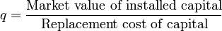
However, there are difficulties because of it is necessary to find an individual database for each factors, but the required data of the target company are often missing (this is the reason why). However, at least qualitative analysis can be conducted.

The ROE in Chinese iron and steel industries are basically the same as well. The targets firms are mostly not listed companies, the information of these firms are generally not available. Despite this, the ROE of the target firm can be indirectly estimated by looking at the industrial ROE of listed companies. The ROEs of listed firm are representative of the not listed target firm because the iron and steel industry is a mature and fully competitive market, in which abnormal ROE is not likely.

The following figure shows the industrial average ROE during 2000 and 2010. It can be seen that the ROE after 2005 are significantly lower than before except for 2007. The empirical studies done before shows the ROE has positive relationship with ARs. Thus, if controlled for ROE, the AR would be even higher in after 2005. As to the 2007, only 9 out of 50 cases are found in after 2005, which should not have significant effects on ARs.

As to the distribution of the ROEs, we can measure the excess Kurtosis coefficient, which is 33.92, showing very high convergence (in SAS, Kurtosis=0 means standard deviation, Kurtosis>0 means high convergence. The formula is: G₂=$\frac{Σ{(X-\overline{X})}^{4}/N}{{[\frac{Σ{\left(X-\overline{X}\right)}^{2}}{N}]}^{2}}$-3).
The mean processure
Variable | N | Mean | Std Dev | Kurtosis | 10th Pctl | 90th Pctl
T40801 | 1075 | 0.072982 | 0.060107 | 33.92642 | 0.010347 | 0.15068
The normal distribution is shown in the following histogram chart. High central limit is shown.
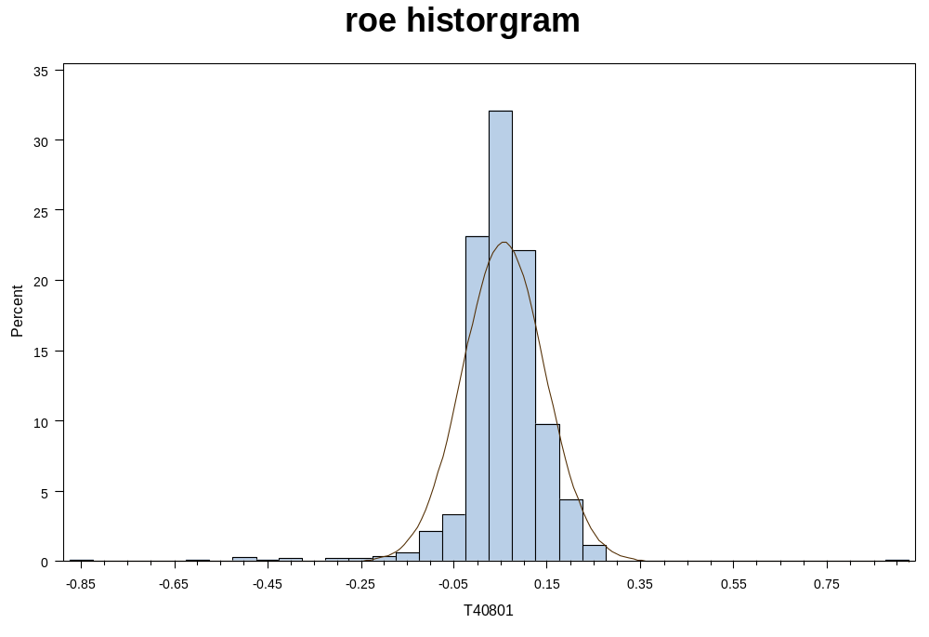

Higher value of Tobin Q means less worthwhile of the M&A, so it is the negative coefficient with the AR. After 2006, China stocks experience a huge wave of bull market, which lead a great increase of the Tobin Q value. So the AR should decrease after all of these. However, the actual AR value at this time is still positive. If we add back the decreased component of AR which caused by Tobin Q, the AR value would be much higher. Therefore, we underestimate the AR value here.
In China, the level of debt is almost the same in iron and steel market. So the size of debt would not affect the final AR too much.

Again, the high mean convergence is detected.
The MEANS Procedure
Variable | N | Mean | Std Dev | Kurtosis | 10th Pctl | 90th Pctl
TQ | 1151 | 1.098134 | 0.201518 | 4.773753 | 0.927541 | 1.334845

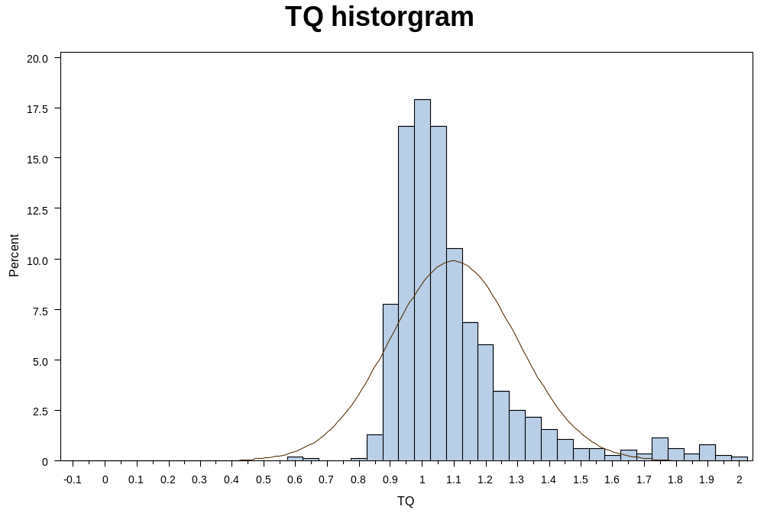
As to the debt level, the same procedure is conducted. As it shows in the following graph, the Liability to Asset ratio increases between 2000 and 2010. It means the debt level increases. The higher debt level means lower AR. Controlling for this factor; the CAR should be even higher after 2005. The Kurtosis coefficient is greater than 0 although not as large as the former two, it is still high convergent.

The MEANS Procedure

Variable | N | Mean | Std Dev | Kurtosis | 10th Pctl | 90th Pctl
LAratio | 1213 | 0.554333 | 0.166248 | 1.943204 | 0.339099 | 0.714782

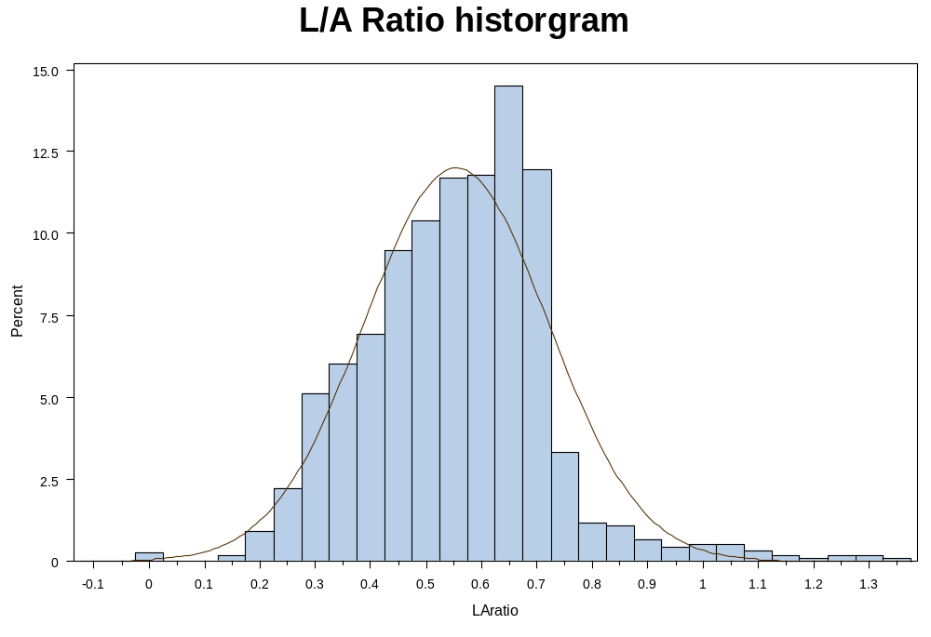
In China, all the M&A in iron and steel industries are all paid by equity instead of cash.
About whether there is a competitor during the M&A event, the answer is always no. As the iron and steel company is normally state-owned, there is never a competitor in this trade.

The above variables are all the similar in cross sectional and partly similar in time series, which will be strong support for the robustness. To sum up, the control of other variables besides the reform of non-tradable shares are unchanged before and after 2006. Even some small difference is also support the results findings and makes it more significantly. Therefore, we can basically judge the reason of the positive AR in Chinese market is caused by the reform of non-tradable shares from this research. Moreover, to link up with the literature review, reform of non-tradable shares mainly to solve the agency problems. Well then, it can explain the agency problem is a considerable role through the M&A in Chinese iron and steel stock market.

- Conclusion:
To the final summary, the M&A announcements are good for are good for the state-owned enterprises for general in Chinese stock market. However, to the iron and steel industries, the degree of positive abnormal return is much lower than the general. And according to the findings from the discussion part, the agency problem plays a very important role to the AR during the M&A of the iron and steel industries. If people want more substantial improvement of the AR value of this field, they need to look out the solution of the agency problem, and consider more about the Chinese policy as well.

- Reference:

Ajeyo Banerjee and E. Woodrow Eckard. “Are Mega-Mergers Anticompetitive? Evidence from the First Great Merger Wave”. Winter, 1998. The RAND Journal of Economics, Vol. 29, No. 4, pp. 803-827.

Allen Michel and Israel Shaked. “ Airline Performance under Deregulation: The shareholders' Perspective”. Financial Management, Vol. 13, No. 2 (Summer, 1984), pp. 5-14.

Anthony Saunders and Michael Smirloc. “Intra- and Interindustry Effects of Bank Securities Market Activities: The Case of Discount Brokerage”. The Journal of Financial and Quantitative Analysis, Vol. 22, No. 4 (Dec., 1987).

B.Espen Eckbo. “Horizontal mergers, collusion, and stockholder wealth”. Journal of Financial Economics. April 1983.

Baolong Wang. “The study about the holistic listing of State-owned industry”. 30th June, 2011.

Chaolong Chen. “Why the resolution system has the impact on the abnormal movement in Reform of non-tradable stocks”. Finance and economics. 2005.

Cibin & Renato. “Restructuring Among the World’s Leading Oil Companies”. British journal of management. December 1996.

Daniel R. Fusfeld. “Joint Subsidiaries in the Iron and Steel Industry”. The American Economic Review, Vol. 48, No. 2, Papers and Proceedings of the Seventieth Annual Meeting of the American Economic Association (May, 1958), pp. 578-587.

Dongfang Shao. “Research of the relationship between ownership and corporate performance management”. University of Chong Qin. 2009.

E. Han Kim and Vijay Singal. “Mergers and Market Power: Evidence from the Airline Industry”. June, 1993. The American Economic Review, Vol. 83, No. 3, pp. 549-569.

Frank H. Easterbrook. “Two Agency-Cost Explanations of Dividends”. The American Economic Review, Vol. 74, No. 4 (Sep., 1984).

Gergor Andrade, Mark L. Mitchell & Erik Stafford. “New Evidengce and Perspectives on Merger”. January 2001.

James W. Wansley, Rodney L. Roenfeldt, Philip L. Cooley. “Abnormal Returns from Merger Profiles”. June, 1983. The Journal of Financial and Quantitative Analysis, Vol. 18, No. 2, pp.149-162

Jarrad Harford, Kai Li. “Decoupling CEO Wealth and Firm Performance: The case of acquiring CEOs”. The journal of Finance. April 2007.

Jarrad Harford. “Corporate Cash Reserves and Acquisitions”. The Journal of Finance. December 1999.

John J. McConnell and Timothy J. Nantell. “Corporate Combinations and Common Stock Returns: The Case of Joint Ventures”. The Journal of Finance, Vol. 40, No. 2 (Jun., 1985), pp. 519-536.

Joseph P. H. Fan and Larry H. P. Lan. “The Measurement of Relatedness: An Application to Corporate Diversification”. The Journal of Business, Vol. 73, No. 4 (October 2000).

Larry. “The unfairness to SMEs from dual track system”. 2010.

Linda Wa˚rell. “A horizontal merger in the iron ore industry: An event study approach”. 27th August 2007. Lulea° University of Technology, SE-971 87 Lulea°, Sweden.

Mathew L. A. Hayward and Donald C. Hambrick. “Explaining the Premiums Paid for Large Acquisitions: Evidence of CEO Hubris”. Administrative Science Quarterly, Vol. 42, No. 1. Mar., 1997

Michael C. Jensen. “Agency Costs of Free Cash Flow, Corporate Finance, and Takeovers”. The American Economic Review, Vol. 76, No. 2, Papers and Proceedings of the NinetyEighth Annual Meeting of the American Economic Association. May, 1986.

Michael D. Whinston and Scott C. Collins. “Entry and competitive structure in deregulated airline markets: an event study analysis of People Express”. Winter, 1992. The RAND Journal of Economics, pp. 445-462.

Peter Dodd. “Merger proposals, management discretion and stockholder wealth”. Journal of Financial Economics. June 1980.

Randall Morck, Andrei Shleifer, Robert W. Vishny, Matthew Shapiro, James M.Poterba. “The Stock Market and Investment: Is the Market a Sideshow?” Brookings Papers on Economic Activity, Vol. 1990, No. 2 (1990), pp. 157-215.

Richard Roll. “The Hubris Hypothesis of Corporate Takeovers”. The Journal of Business, Vol. 59, No. 2, Part 1. Apr., 1986.

Robert Cull. “Bureaucrats, State Banks, and the Efficiency of Credit Allocation: The Experience of Chinese State-Owned Enterprises”. Journal of Comparative Economics, March 2000.

ReneM. Stulz. “Mnagerial discretion and optimal financing policies”. Journal of Financial Economics. July 1990.

Robert Stillman. “Examining antitrust policy towards horizontal mergers”. Joural of financial Economics. April 1983.

Sanchez-Robles&Blanca. “Infrastructure Investment and Growth: Some Empirical Evidence”. Contemporary Economic Policy. January 1998.

Sayan Chatterjee. “Gains in Vertical Acquisitions and Market Power: Theory and Evidence”. The Academy of Management Journal, Vol. 34, No. 2 (Jun., 1991), pp. 436-448.

Stephen Simpson. “Johnson & Johnson: Potential M&A Targets to Recharge Growth, Divert Investor Attention”. April 13th, 2011.

Tobin, J. (1969). "A general equilibrium approach to monetary theory". Journal of Money Credit and Banking

Ulrike Malmendier and Geoffrey Tate. “Who makes acquisitions? CEO overconfidence and the market’s reaction”. Journal of Financial Economics. July 2008.

Vijay Singal. “Airline Mergers and Competition: An Integration of Stock and Product Price Effects”. Apr 1996. The Journal of Business(pp. 233-268).

Weihua Peng & Jiangfeng Liu. “The government behavior analysis of Merger in the State-owned industry”. 2003.

Xiaoqiu Wu. “Hot issues about the reform of non-tradable shares Finance & trade economics”. 2006.

Xiaorong Guo. “China’s iron and steel enterprises are not obvious scale analysis of the causes and policy recommendations”. Heilongjiang Science and Technology Information. May 2010.

Yongjun Li, Ruhai Chen & Chenjie Xing. “The analysis of selling direction in recent iron industry”. 2005.

Youtian He. “A Study on Domestic Demands and Exports in the Steel Industry of China”. University of QingHua. December 2006.

Zhang Yichun&Zhou Yinggang. “Are China’s Stock Markets Weak Efficient?”. Journal of Finance. March 2001.

- Appendix:
Table 1: （unit: billion Yuan）
Company name: | Time : | Detail : |  | Bank Name : | Amount of Credit
Hebei iron and steel co., ltd | Augest, 2008 | Strategy corporation agreement | Bank Of China |  | 480
Sichuan chuantou changcheng special steel co., ltd. | Augest， 2008 | Credit agreement | China Construction Bank |  | 20
 | June， 2008 | Financial corporation agreement | Bank Of China |  | 200
Jiangsu shagang co.,ltd | July， 2008 | Energy efficiency loans | Industrial Bank |  | 2.8
 | February，2008 | Strategy corporation agreement | China Export-Import Bank |  | 20
Angang steel company limited | July， 2008 | Strategy corporation agreement | China Construction Bank |  | 150
 | February， 2008 | Comprehensive bank-enterprise cooperation agreement | Agricultural Bank Of China |  | 200
Wuhan steel processing co., ltd. | June， 2008 | Foreign syndicated loan agreement | Foreign Banks |  | 11.6
Bengang steel plates co., ltd. | April， 2008 | Comprehensive bank-enterprise cooperation agreement | Agricultural Bank Of China |  | 100
Maanshan iron & steel co., ltd. | February， 2008 | Strategy corporation agreement | China Export-Import Bank |  | 60
Beijing shougang co., ltd. | February， 2008 | Credit agreement | Agricultural Bank Of China And Other 5 Banks |  | 420
Source from: Mysteel.

