Master of Science in Accounting & Finance

Master Thesis

An Empirical Analysis of Implied Basel II & III Asset Correlation Values for US & UK banks

Author: Daria Luzyk

Supervisors: Ron Jongen
(Department of Finance)

Ghulame Rubbaniy
(Department of Business Economics)

Date: August 2011

Abstract
Credit risk analysis based on the Basel II Internal Ratings-Based (IRB) framework employs Asset Correlation Values (ACVs) to estimate the vulnerability of loans to systemic crisis. The correlation values specified by regulators are a critical factor in determining the level of IRB Capital requirements needed to cover Unexpected Loss. In this study, building on an empirical analysis technique proposed in a 2008 Fitch article, we derive implied asset class correlations by setting the empirically observed unexpected loss equal to the regulatory capital requirement. Historical loan loss data for UK & US bank loan portfolios form the basis of the analysis - in principle, correlation should be manifested in the variability of these portfolio losses over time. The original Fitch study covers a period up to Q1 2007, during which relatively normal market conditions prevailed and therefore the resulting empirical analysis may have understated correlations. The study presented below extends the coverage period up to Q1 2011, thus including loss rate data resulting from the recent extreme shock to the financial markets. This provides a more useful basis for an empirical assessment of current regulatory ACVs and should produce more reliable results. The implied correlation resulting from this analysis can be used to determine whether the supervisory values have been set sufficiently high enough to protect against periods of extreme market stress. In addition, we perform empirical analysis for the new “financial institutions” asset class introduced in Basel III (previously included under “corporate lending” class) and investigate whether the proposed new regulatory ACV value of 1.25 is appropriate.

Keywords: Credit Risk, Basel II, Basel III, Asset Correlation, Asset Class, IRB Framework, Regulatory capital requirements.

Table of Contents

1. Introduction 4
1.1 Basel II IRB Methodology and Assumptions 5
1.2 Unexpected Loss for Large Corporate, Sovereign and Bank exposures 5
1.3 Unexpected Loss for Retail exposures 6
1.4 Review of Related Literature 7
2. Research Methodology and Empirical Dataset 9
2.1 Conceptual Framework 9
2.2 Empirical Dataset 10
2.3 Fixed Regulatory Correlation Levels 10
2.4 Fitting a Distribution Function to Empirical data 11
2.5 Deriving Asset Correlation value from Total loss 12
2.6 Solving a Vasicek Distribution Function for Asset Correlation 12

3. Results 15
3.1 Reproducing results from Fitch article 2008 15
3.2 Correlation Value Results for dataset period extended to Q1 2011 17
3.3 Distribution Function Fit Comparison per Asset Class 18

4. Discussion 23

5. Conclusion 24
Reference 25

1. Introduction
Within the Basel II Internal Ratings-Based (IRB) framework, borrowers’ asset values are all correlated with a single systematic risk factor, which, in general terms, can be considered to be a proxy for the prevailing economic climate. For IRB capital calculation formulae, each asset class is assigned an Asset Correlation Value (ACV) set by regulators to quantify this systematic risk. Statistical analysis of empirical loss rate data for a selected asset class allows a loss distribution curve to be generated based on mean loss rate and standard deviation. An estimation of Unexpected Loss (UL) can be extracted for the 99.9% confidence interval of the curve (equivalent to the regulatory capital requirement), and from this an implied ACV can be calculated. The empirically derived correlation values can then be compared to the corresponding values fixed by Basel regulations to determine their level of appropriateness. We can also gain an insight into the different degrees of dependency that each asset class exhibits on the overall economy.
An empirical analysis for AVCs will be done for the following Basel II asset classes: commercial mortgages, residential mortgages, credit cards, corporate and consumer lending. In Basel III, a new separate asset class has been defined for “financial institutions” with an ACV set to 1.25, which will also be analysed.
The two primary sources of historical data (1985-2011) are: quarterly charge-off rates for bank-held exposures published by the Federal Reserve, and quarterly loss rates for UK banks published by the Bank of England. This source data is already segmented according to Basel II asset class definitions as well as the “financial institutions” class category. Estimates used for LGD rates per asset class are based on the Basel Committee’s quantitative impact studies (QIS5).
Currently there is no geographical factor associated with regulatory assigned portfolio correlations – it is a global value in order to assure a level playing field internationally in relation to capital charges. This study can determine whether there is significant variance in empirically derived correlation values when calculated separately for UK and US regions. We consider the question of whether introducing a regional-based regulatory correlation value is appropriate for a particular asset class.
The other critical driver in modelling portfolio credit risk is Probability of Default (PD). Basel II assumes an inverse relationship between PD and asset correlation - that asset correlation decreases with higher default probability. The empirical validity of this assumption will be examined in this paper.
In September 2010, the Basel Committee on Banking Supervision (BCBS) announced a new asset class for ‘financial institutions’ and fixed the correlation at 1.25. To our knowledge, this paper is the first to empirically verify the validity of this assumption.
The rest of this paper proceeds as follows. Section 2 explains the Basel II IRB Methodology describing the relationship between asset correlation and portfolio credit risk measurement. We also give an overview on some of the current literature and previous studies related to the subject under investigation. We describe our dataset and empirical framework. Section 3 presents the main empirical results. Section 4 interprets the results and examines their significance in relation to current Basel assumptions. Section 5 provides concluding remarks.

1.1 Basel II IRB Framework and Assumptions.
Under Basel II, banks have the option of adopting one of two credit risk models for calculating the minimum amount of capital needed to cover portfolio losses: the ‘foundation’ approach, or the more complex ‘internal ratings-based’ (IRB) approach. Under the ‘foundation’ approach, banks provide their own estimates of probability of default (PD) and then apply supervisory risk weightings for different PD grades to estimate total losses.
With the more advanced IRB methodology, a formula-based approach is used in which banks provide their own estimates of the risk component inputs: probability of default (PD), loss given default (LGD), exposure at default (EAD), and effective maturity (M).
PD, the probability of default (per rating grade), is the average percentage of obligors that default in this rating grade over a one year period. At a portfolio level, if all borrowers are assumed to be the same, then PD becomes an aggregated measure representing the proportion of borrowers in a portfolio expected to default in one year. If the portfolio has a large number of borrowers, each with small exposures (‘infinitely fine grained’), then the portfolio can be considered to be perfectly diversified leaving only a systemic risk factor. Therefore, idiosyncratic risk is assumed to be diversified away with no significant concentrations of risk relating to individual borrowers, industry or region.
LGD represents the proportion of the exposure that will not be recovered after default. Assuming a uniform value of LGD for a given portfolio, Expected Loss (EL) can be calculated as PD multiplied by its LGD (also equal to the sum of individual ELs in the portfolio). In practice, EL can be viewed as the expected “cost of doing business” and does not by itself represent ‘risk’ (unlike unexpected loss). Banks calculate how much capital is needed to cover EL via individual loan pricing and ex-ante loan loss provisioning and they allocate sufficient reserves to fully cover this exposure.
The Total Loss for a portfolio is the sum of the Expected Loss and Unexpected Loss (UL) components (see figure 1 below). Within the IRB methodology, the regulatory capital charge depends only on the UL – minimum capital levels must be calculated that will be sufficient to cover portfolio Unexpected Loss (UL). Unlike EL, total UL is not an aggregate of individual ULs but rather depends on the loss correlations between all loans in the portfolio due to systemic risk.
The asset correlation parameter ρ quantifies this systematic risk factor (i.e a general proxy for the prevailing economic climate), with each asset class being assigned an Asset Correlation value (ACV) set by regulators. A highly correlated portfolio will require a higher level of capital than a more diversified portfolio, as it contains loans that tend to default together more often, thus increasing credit losses during downturns.

1.2 Unexpected Loss for Large Corporate, Sovereign and Bank exposures
For corporate, sovereign and bank exposures, the Unexpected Loss is defined as
$UL=\left(Total Loss-EL\right)×Maturity Adjustment$
The Vasicek formula underlying the IRB method assumes that asset returns are normally distributed and is calculated as follows:
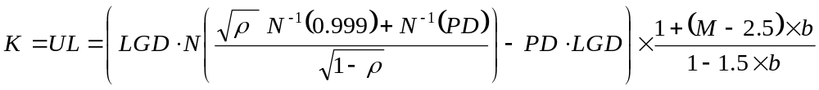

where
N and 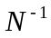represent the normal and inversed distribution function respectively
Asset correlation $ρ=0.12× +0.24×\left[1-\right]$
$ρ$ has a permitted range of 12% - 24%.
M is the average portfolio effective maturity
Maturity Adjustment b = ${\left(0.11852-0.05478×ln(PD)\right)}^{2}$

By inspecting the Vasicek formula some important characteristics are evident:
- Loss correlation is seen to be modelled entirely as a function of PD alone.
- Minimum capital is calibrated to cover unexpected losses to a probability of 99.9% over a one-year horizon (i.e 99.9% chance this level of loss will not occur).
- Average portfolio maturity is assumed to be 2.5 years - exposures with maturities beyond that time period are penalized (and vice versa)

Figure 1 illustrates the concepts of UL and EL, showing a time series of loss rates versus PD. The Vasicek distribution shown describes the dispersion of credit losses for a large number of banks which have been approved by regulators as qualifying for the IRB approach.

For the IRB approach, banks must categorise banking-book exposures into five general
asset classes: (a) corporate (5 sub-classes), (b) sovereign, (c) bank, (d) retail (3 sub-classes; commercial mortgages, residential mortgages, credit cards), and (e) equity.

1.3 Unexpected Loss for Retail exposures.
For retail exposures, banks must provide their own estimates of PD, LGD and EAD. There is no distinction between a foundation and advanced approach for this asset class.
Also for retail asset classes, no maturity adjustment applies, therefore we have a simpler form of the Vasicek formula.
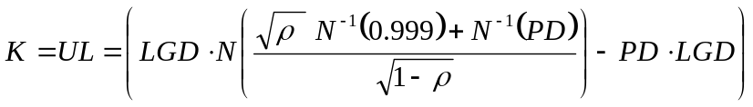

The correlation values fixed by regulators are
(i) Residential mortgage exposures, $ρ$ = 0.15
(ii) Qualifying revolving retail exposures (Credit Cards), $ρ$ = 0.04
(iii) Other retail exposures
For all other retail exposures that are not in default, risk weights are assigned based
on the following function, which allows correlation to vary with PD:
$$ρ=0.16-0.03×\left[\right]$$

1.2 Review of Related Literature
The correlation values per asset class fixed by regulators are specified in the Basel II Capital Measurement and Capital Standards revised framework document [BIS, 2006]. Although the Basel II specifications define the ’mechanics’ of the IRB approach, explaining risk component elements and presenting required formulas for UL calculation and capital level requirements, it does not go into theory regarding derivation of these formulas (or it’s basis from the Vasicek distribution).

The theoretical basis for the IRB framework stems from the ground-breaking paper from Vasicek on the subject of Probability of Loss on Loan Portfolios [Vasicek 1987]. We utilise the probability density function formula from this source to plot the Vasicek cumulative distribution of loan loss empirical data, to aid our analysis.

This thesis builds on an empirical analysis technique proposed in a 2008 Fitch article [van Vuuren] in which historical loss rate data for retail and corporate lending was analysed to derive implied asset correlation values based on the IRB formulas and concepts.
A beta distribution was first chosen as the best fit for the mean and standard deviation of loss rate data. The Basel II UL and the empirical UL was then equated, which allowed the asset correlation to be derived. A significant finding of the Fitch study is that asset correlations derived empirically (from historical data) are significantly lower than Basel II specified correlation values. It was demonstrated that the choice of distributional assumption had minimal impact on the results, whether a Beta, Weibull, Lognormal, or Vasicek distribution was chosen for the analysis. Also, the authors demonstrated that empirically-derived correlations varied geographically and no uniform statistical relationship between asset correlations and default probability could be identified.

Van Vuuren documented the empirical-based methodology used in the Fitch article in more detail in a follow up article in the Journal of Risk Management in Financial Institutions [2009], in which the time span of the historical dataset was increased to Q1 2009. The derived correlation results were broadly similar to those derived from the previous study whose dataset ended on Q1 2007 [Fitch, 2008] and in general, well below regulatory levels.

Data used in the Fitch study covers a period from 1985 up to Q1 2007, during which relatively normal market conditions prevailed and therefore the resulting empirical analysis may have somewhat understated correlations. A more recent study investigating implied asset correlation from the Italian banking system [Curcio 2011] reuses the same methodology as introduced by Van Vuuren but covers the recent dramatic market downturn period by including data from 1990 to Q1 2010. Curcio’s investigations concentrated on the relation between PD and asset correlation, based on Italian banking system empirical loss data for non-financial corporations. Note that as the study grouped SMEs and large corporates together, the data is not consistent with the Basel II asset class definitions (which have different correlation formulas for each of these classes). The paper attempts to understand why the Basel II inverse relation hypothesis does not always apply. The author identifies the “PD volatility effect” - when the PD volatility rises, implied correlation gets higher. The paper breaks down implied correlation results for different industry sectors and Italian regions, all of which are significantly lower than the fixed regulatory values. The effects of the downturn did not seem to have manifested in significantly increased correlations by Q1 2010 however - indicating that there may be a time-lag of a couple of years for realized losses from bad debts to appear on the balance sheet.

Curcio used one generic LGD value of 45% for all corporates when converting net losses to gross losses. The LGD value used was the value fixed by the Basel Committee for senior unsecured claims on corporate, sovereigns and banks within the IRB-Foundation approach. Estimates for LGD rates per asset class used in the Fitch (2008) article calculations are taken from the results of the Basel Committee’s fifth quantitative impact study QIS5 [BIS,2005] from which the Committee reviewed the calibration of the Basel II Framework. Average realized LGD values for different retail and corporate portfolios are documented in QI5 and using these ‘real-world’ average LGDs in the analysis allows a more accurate asset correlation to be derived (instead of simple using the value fixed by IRB-Foundation approach). Fitch explains how choosing a lower LGD in the empirically based analysis means a higher PD level for the same mean loss rate (by definition, as LGDxPD = EL), and the end result will be a higher correlation estimate.

The Basel assumption that average asset correlation decreases as PD increases has been challenged previously. Zhang et al (2009) investigates this relationship using asset returns obtained from equity returns and financial statements, and found little empirical support for this assumption for corporates. Using a different methodology, Zhang investigated a second time using realized defaults data and found the opposite effect. However empirical analyse based on realized defaults data can be biased as the result of either low PD or a low number of firms within a defined PD group.

The question of how much the asset correlation parameter depends on the size of the firm is explored by Dullmann & Scheule (2003). Basel II assumes higher asset correlation values for large firms than smaller ones implying that larger firms are more affected by systemic risk. This may be because of relatively higher firm-specific (idiosyncratic) risk for smaller firms compared to the more diversified larger firms. Ten years of monthly default data were analysed for over 50,000 German companies with the data being divided into homogenous categories with respect to default probability (PD) and firm size. The study then empirically explored the simultaneous dependency of asset correlation on PD and firm size. The results indicate that the asset correlation increases with size but that the relationship between an asset correlation and PD can be ambiguous in some cases.

In theory, historical default data would be the obvious source on which to base an empirical analysis of default correlations – without introducing the simplifying assumption that ‘loss correlation’ equates to ‘default correlation’ (i.e the measurement of the degree to which two borrowers will default simultaneously). However we see that both Dullmann (2003) and Lee (2009) empirical studies mentioned above are hampered by statistical bias introduced by the relative infrequency (or unavailability) of default events in historical datasets. Zhang et al (2008) have collated the results of Default-implied Asset Correlations studies based on realized default data where wide variations in correlation are evident. We will base our analysis on a large data set of historical loan loss data (consistent with the Basel asset class definitions) as this appears to be a more efficient and accurate estimation method.

2. Research Methodology.
2.1 Conceptual Framework.
The empirical methodology used in this study is adopted from a 2008 Fitch Ratings article (van Vuuren) in which implied asset correlation values are derived from realized historical loss data whose segmentation is consistent with Basel II asset class definitions. Statistical analysis of the loss rate data for a selected asset class allows calculation of mean annualized loss rate plus standard deviation, from which a loss distribution curve can be generated which best fits the empirical data. An estimation of Unexpected Loss (UL) can be extracted for the 99.9% confidence interval of this empirical loss distribution curve - the interval that equates to the Total Loss (EL + UL) in the Basel II model. This total loss is equal to the value of x when P(x) = 99.9% where P(x) represents the probability density function P(x) of the best fit distribution function. In summary, we can derive implied asset class correlations by setting the empirically observed UL equal to the regulatory capital requirement – in other words, by discovering which correlation value would generate that same level of empirically observed UL within the IRB formulas.

The following formula derivations show two variations for solving the Basel vasicek formula using i) Net Loss Rates and ii) Gross Loss Rates. Note that the Fitch article (2008) published results correspond to net loss rates results while this author will base analysis later in the paper on gross loss rates.

i) Vasicek formula based on Net Loss Rates:
Taking the Standard Basel Vasicek formula:
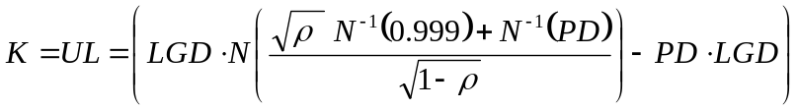

(1)

where K is the capital requirement, N and N⁻¹ stand for the normal and inversed distribution function respectively, and ρ is an asset correlation.

To derive empirically an asset correlation we transform the equation into:
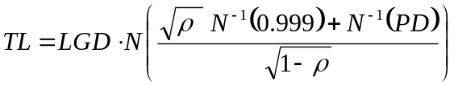(2)

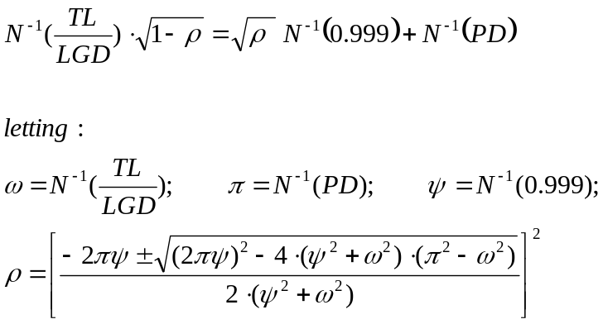

(3)

ii) Vasicek formula based on Gross Loss Rates:
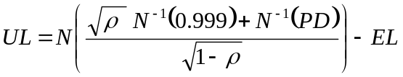

(4)

As EL + UL = TL, we can derive asset correlation empirically using the following solution:
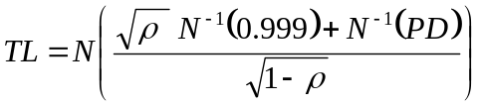

(5)

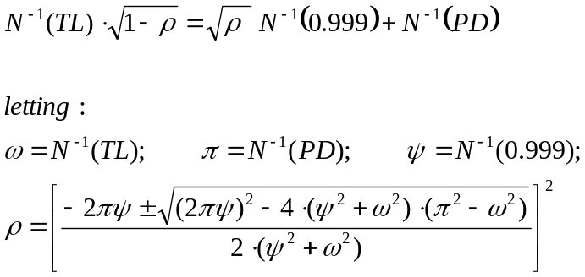

(6)

2.2 Empirical Dataset.
The two primary sources of historical data used are: quarterly charge-off rates for bank-held exposures published by the Federal Reserve, and quarterly loss rates for UK banks published by the Bank of England. These sources supply a large dataset which is already segmented according to Basel II asset class definitions (also including the Basel III “financial institutions” class category). The data sourced covers the period 1985-Q1 2011, thus capturing the recent period of market stress.
Initially analysis will be done on the same dataset as used by Fitch (ending on Q1 2007) in order to prove the methodology by matching derived correlation value results with those derived by Fitch. The loss distribution function will be fitted to Net loss rate data as per the original Fitch article. Then the dataset will be extended to Q1 2011 to determine what the impact of these 4 additional years is on implied asset correlation values. Note that our standard methodology described in the next section will described for Gross loss rate data for ease of analysis.
Estimates used for LGD rates per asset class are based on the Basel Committee’s quantitative impact studies (QIS5). Estimates for LGD rates per asset class are taken from the results of the Basel Committee’s fifth quantitative impact study ‘QIS5’ [BIS,2005] which documents average realized LGD values for different retail and corporate portfolios. Using these realistic ‘real-world’ average LGDs in the analysis produces a more accurate mean loss rate and therefore a more accurate asset correlation can be derived.

Table 1A. LGD averages for different portfolios in percent, QIS 5 Consolidated.

 | IRB Retail |  |  |  | AIRB
 | RM | QRE | Other | SME | Wholesale |  |  |  | SME Corp.
 |  |  |  |  | Corp. | Bank | Sov. |  | SME Corp.
G10 Group (excl.US) |  |  |  |  | 39.8% | 40.9% | 33.3% |  | 35.0%
G10 Group (incl.US) | 20.3% | 71.6% | 48.0% | 46.2%

[Note: RM - residential mortgages, QRE - qualifying revolving exposures].

Source: Basel Committee on Banking Supervision. (June 2006). Results of the fifth quantitative impact study (QIS 5)

Table 1B. Key Parameters for AIRB (Retail)
All Banks Wtd. Avg. |  | HELOC |  | Other Mortgage |  |  | QRE |  | Other Retail |  | Retail Business Exposures
PD, all exposures |  | 0.33% |  | 1.37% |  |  | 3.02% |  | 4.29% |  | 3.02%
PD, drawn |  | 0.41% |  | 1.39% |  |  | 4.53% |  | 3.93% |  | 3.23%
LGD, drawn |  | 40.80% |  | 17.70% |  |  | 91.70% |  | 47.40% |  | 43.70%
EAD-CCF |  | 66.70% |  | 51.20% |  |  | 22.20% |  | 25.40% |  | 41.60%
Risk Weight (EL+UL drawn) |  | 19.00% |  | 21.60% |  |  | 126.80% |  | 85.10% |  | 69.70%
Note: HELOCs - home equity lines of credit, QRE - qualifying revolving exposures.
Source:
Office of the Comptroller of the Currency Board of Governors of the Federal Reserve System Federal Deposit Insurance Corporation, (February, 2006). Summary Findings of the Fourth Quantitative Impact Study

Table 1C. Illustrative IRB Risk Weights for UL: assumed LGD.
% | LGD
Mortgage retail | 25%
Qualifying revolving exposures | 85%
Other non-mortgage retail | 45%
SME retail | 45%
Basel Committee on Banking Supervision. (June 2006). International Convergence of Capital Measurement and Capital Standards. A Revised Framework. Comprehensive Version
Table 1D. Retail portfolios UK banks: average risk weight, PD and LGD
% | % of total wholesale risk-weighted exposures |  | Av.RW |  | Av. PD | Av.LGD
Mortgage retail | 34% |  | 15% |  | 3% | 14.0%
Qualifying revolving exposures | 22% |  | 23% |  | 8% | 42.6%
Other non-mortgage retail | 35% |  | 72% |  | 9% | 55.3%
SME retail | 9% |  | 35% |  | 9% | 23.1%
Source:
Financial Services Authority. FSA UK Country Report: The fifth Quantitative Impact Study (QIS5) for Solvency II, March 2011
http://www.fsa.gov.uk/
Table 1E. Key Parameters for AIRB (Wholesale), US
 | All Banks - Wtd. Avg.
 | Corp., Bank, Sov. |  | SME Corporate |  | HVCRE | IPRE
PD, all exposures | 0.63% |  | 1.92% |  | 1.41% | 1.40%
PD, drawn | 1.00% |  | 2.06% |  | 1.48% | 1.31%
LGD, drawn | 31.60% |  | 32.90% |  | 26.00% | 24.50%
EAD-CCF | 59.80% |  | 50.30% |  | 60.40% | 57.90%
Risk Weight (EL+UL drawn) | 47.30% |  | 76.40% |  | 63.80% | 56.80%
Note: HVCRE - High Volatility Commercial Real Estate and IPRE - Income Producing Real Estate.
Source:
Office of the Comptroller of the Currency Board of Governors of the Federal Reserve System Federal Deposit Insurance Corporation, (February, 2006). Summary Findings of the Fourth Quantitative Impact Study
Table 1F. Wholesale portfolios UK banks: average risk weight, PD and LGD
% | % of total wholesale risk-weighted exposures |  | AIRB (5 G1 firms) |  |  |  |  | FIRB (G1 firms)
% |  |  | Av.RW |  | Av. PD | Av.LGD |  | Av.RW |  | Av. PD |  | Av.LGD
Corporate | 69.8% |  | 52.2% |  | 1.9% | 37.4% |  | 50.0% |  | 1.6% |  | 44.4%
Sovereign | 7.0% |  | 10.8% |  | 0.2% | 27.8% |  | 19.1% |  | 0.2% |  | 45.0%
Bank | 17.1% |  | 22.5% |  | 0.2% | 49.4% |  | 17.4% |  | 0.2% |  | 42.5%
SME Corporate | 6.1% |  | 64.0% |  | 4.2% | 35.4% |  | 68.0% |  | 2.7% |  | 41.2%
Note 1: Group 1 banks cover 85% of the whole UK financial system according to the amount of exposures. We assume average LGD for all Group 1 banks, incl. both with AIRB and FIRB.
Source:
Financial Services Authority. FSA UK Country Report: The fifth Quantitative Impact Study (QIS5) for Solvency II, March 2011
http://www.fsa.gov.uk/

2.3 Fixed Regulatory Correlation Levels.
The following summarises the current asset correlation values fixed by Basel regulators which are relevant to this thesis:
Retail:
Credit cards (fixed): 4%
Residential mortgages (fixed): 15%

For the other consumer lending the correlation is calculated as the function of PD:
Correlation (R) = 0.03 × (1 – EXP(-35 × PD)) / (1 – EXP(-35)) + 0.16 × [1 – (1 – EXP(-35 × PD))/(1 – EXP(-35))]

Corporates:
Correlation for corporate loans is a function of PD, and can vary between upper and lower limits of 12% and 24%:
Correlation (R) = 0.12 × (1 – EXP (-50 × PD)) / (1 - EXP(-50))+ 0.24 × [1 - (1 - EXP(-50 × PD))/(1 - EXP(-50))]

For Corporate mortgages, the correlation formula corresponding to the capital standards for HVCRE is used.
Correlation (R) = 0.12 x (1 – EXP(-50 x PD)) / (1 – EXP(-50)) + 0.30 x [1 – (1 – EXP(-50 x PD)) / (1 – EXP(-50))

2.4 Extracting Total Loss from the Empirical Distribution Function.
The procedure to empirically derive asset correlations is outlined in the steps below taking the example of a Beta distribution function. The same process applies for other distribution functions that were identified as ‘best-fit’ for the empirical data by the @Risk modelling tool, but different formulas will apply for that particular curve shape parameters.

(1) Convert quarterly gross loss data into an annualised loss rate as a percentage of total loan value for each asset class.

(2) For each quarter, we calculate the corresponding loss rate by multiplying the annualized default rate by the appropriate LGD for that asset class (see table 1) and then the mean µ, and standard deviation σ of the gross loss rates for the given time series is calculated for each dataset. The mean loss rate is assumed to be directly comparable to EL.

(3) Where a Beta distribution is used to calculate the total empirical losses, calculate the Beta distribution ‘shape parameters’ α and β from the mean and standard deviation of the annualised gross loss rates using Equations 7 and 8.

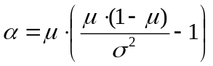
(7)
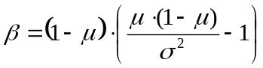 (8)

(4) If α and β are known, the probability density function for a beta distribution can now be plotted (in our case using the ‘@Risk’ modelling tool) and visually inspected for goodness-of-fit against a histogram of loss rate data.

The probability density function for a beta distribution is described by the following formula (9):
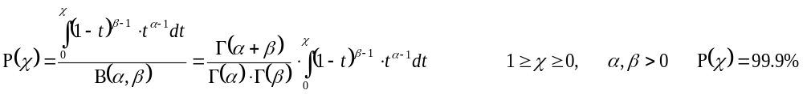

where x is the distribution variable, and Γ is the standard Gamma function evaluated at the relevant parameters.

Once the distribution has been fitted to the data, the total loss (EL + UL) can be identified (by @Risk) as the value of x when P(x) = 99.9%, which we can call L_{total 99.9%} (i.e total gross loss value at 99.9% confidence interval).

2.5 Deriving Asset Correlation value from Total loss
Now that we have extracted Total Loss from the empirical distribution function we can return to the Vasicek formula used by Basel and set L_{total 99.9%} = TL):

(5) (formula from section 2.1)

A numerical root finding solution for ρ can then be found:

(6)
The results per asset class and data source are shown in Results section later in the paper.

2.6 Solving a Vasicek Distribution Function for Asset Correlation.
In the analysis for individual asset classes we compare the empirical Total Loss returned by the ‘best-fit’ distribution function (from the @Risk modelling tool) to the Total Loss empirically derived from the Vasicek probability density function (which was selected by Basel Committee to base it’s modelling of loss rate on). We also compare visually the plots for inspection of goodness-of-fit. However, due to the non-inclusion of the Vasicek distribution in the @Risk application, we must plot this Vasicek probability density function ourselves by embedding the corresponding formula in excel.

Vasicek distribution has the density:
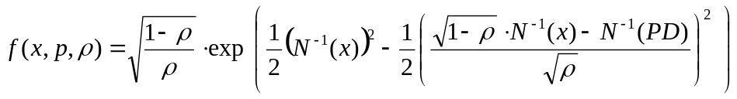

(10)

where
x is the value for evaluation,
PD is the default probability of the portfolio and
ρ is the asset correlation.
This distribution is unimodal, meaning the mode (the most prevalent loss) has to be calculated as follows:
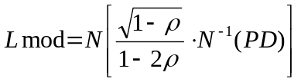
(11)

The MODE of the sample (loss rate series) is calculated in Matlab application using the following code:
X = sort(x);
indices = find(diff([X; realmax]) > 0); % indices where repeated values change
[modeL,i] = max (diff([0; indices])); % longest persistence length of repeated values
mode = X(indices(i));

After sorting the sample in ascending order the algorithm then evaluates the sorted sample at the point where that maximum occurs for the number of times a value is repeated.
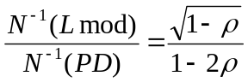Knowing p and Lmode, the empirical asset correlation may be extracted using

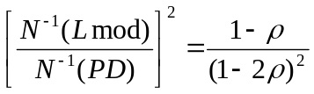Squaring both sides =>

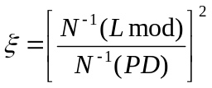Substituting for

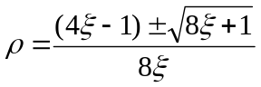Results in a quadratic equation in ρ (asset correlation) with solutions:

2.4 Fitting a Distribution Function to Empirical Data.
In order to fit a distribution function to the empirical data, loss rate data is imported into the @Risk statistical modelling tool. A histogram plot is then generated and from that a probability density function is selected which best fits the histogram based on a goodness-of-fit program called BestFit embedded in the @Risk modelling tool.

In order to find the best fit for density and cumulative data, BestFit first uses the method of least squares to minimise the distance between the input curve points and the theoretical function. The fitted distributions is then ranked using the Anderson-Darling goodness-of-fit statistic. The Anderson–Darling test uses the integral of a ‘weighted’ squared difference between the empirical and the estimated distribution functions, where the weighting relates the variance of the empirical distribution function [Drossos, 1980]. For our analysis Anderson-Darling test was preferred as it is more sensitive to deviations in the tails of the distribution than is the older Komolgorov-Smirnov test.

Before accepting the results of the BestFit rankings, we also visually inspect the plot of the the two highest ranked distributions for goodness-of-fit against the histogram of loss rate data. The value of total loss at a 99.9% confidence level for each distribution is calculated automatically by @Risk. We have also added the Vasicek distribution to the graphs for comparison.

3. Results.
3.1 Reproducing results from Fitch article 2008
In order to prove the methodology, the first task was to reproduce the derived correlation results which appeared in the FitchRatings article from 2008 using the same source data.
This was done successfully – results are shown below.
We compared results for two approaches: i) based on Net UL ii) based on gross UL.
The results are broadly similar. We use gross UL in the remaining analysis when deriving correlations. The bottom rows of tables below highlight the difference between correlations fixed by Basel and the empirically derived values.

End Period: 2007
Distribution Type: Beta
Total Loss: Net

Table 2a
Parameters | CCard US | CCard UK | ConsL US | ConsL UK | ResM US | ResM UK | CORP US | CORP UK | ComM US | FinI UK
Mean (EL, net) | 4.26% | 0.61% | 1.02% | 0.42% | 0.15% | 0.01% | 0.84% | 0.11% | 0.44% | 0.003%
St Dev | 1.0% | 0.33% | 0.31% | 0.1% | 0.07% | 0.01% | 0.52% | 0.05% | 0.7% | 0.003%
LGD | 71.6% | 85% | 48% | 45% | 20.3% | 25% | 37.25% | 22.0% | 37.25% | 46.0%
PD | 5.95% | 0.71% | 2.12% | 0.94% | 0.72% | 0.03% | 2.26% | 0.52% | 1.17% | 0.01%
α | 16 | 3 | 11 | 9 | 5 | 2 | 3 | 5 | 0 | 1
β | 358 | 551 | 1,066 | 2,238 | 3,153 | 21,248 | 301 | 4,240 | 89 | 40,352
Total Loss, net | 8.17% | 2.1% | 2.23% | 0.97% | 0.45% | 0.04% | 3.38% | 0.34% | 5.50% | 0.02%
UL, net | 3.9% | 1.5% | 1.2% | 0.5% | 0.3% | 0.03% | 2.54% | 0.23% | 5.1% | 0.02%
ω | - 1.20 | - 1.96 | - 1.68 | - 2.02 | - 2.02 | - 2.96 | - 1.34 | - 2.15 | - 1.05 | - 3.36
π | - 1.56 | - 2.45 | - 2.03 | - 2.35 | - 2.45 | - 3.44 | - 2.00 | - 2.56 | - 2.27 | - 3.84
ψ | 3.09 | 3.09 | 3.09 | 3.09 | 3.09 | 3.09 | 3.09 | 3.09 | 3.09 | 3.09
Empir. Correl. | 1.38% | 3% | 1.35% | 1% | 2.2% | 3% | 5.15% | 2% | 18% | 2.93%
Basel Correl. | 4% | 4% | 9.18% | 12.37% | 15% | 15% | 16% | 21% | 19% | 24%
Over/  Under | 3% | 1% | 8% | 11% | 13% | 12% | 11% | 19% | 0.4% | 21%

End Period: 2007
Distribution Type: Beta
Total Loss: Gross

Table 2b
Parameters | CCard US | CCard UK | ConsL US | ConsL UK | ResM US | ResM UK | CORP US | CORP UK | ComM US | FinI UK
Mean (EL, gross) | 4.65% | 1.42% | 2.15% | 0.76% | 0.50% | 0.05% | 2.67% | 0.29% | 1.73% | 0.01%
St Dev | 1.14% | 0.77% | 0.65% | 0.25% | 0.23% | 0.04% | 1.66% | 0.13% | 2.75% | 0.01%
LGD | 91.7% | 42.6% | 47.4% | 55.3% | 29.3% | 14.0% | 31.6% | 39.6% | 25.3% | 46.0%
PD | 4.65% | 1.42% | 2.15% | 0.76% | 0.50% | 0.05% | 2.67% | 0.29% | 1.73% | 0.01%
α | 16 | 3 | 11 | 9 | 5 | 2 | 2 | 5 | 0 | 1
β | 325 | 230 | 493 | 1,228 | 915 | 2,971 | 91 | 1,672 | 21 | 18,542
Total Loss, gross | 8.91% | 4.99% | 4.68% | 1.75% | 1.52% | 0.28% | 10.57% | 0.87% | 21.11% | 0.04%
UL, gross | 4.26% | 3.57% | 2.53% | 0.99% | 1.02% | 0.22% | 7.91% | 0.58% | 19.39% | 0.03%
UL, net | 3.9% | 1.5% | 1.2% | 0.5% | 0.3% | 0.0% | 2.5% | 0.2% | 4.9% | 0.0%
ω | - 1.35 | - 1.65 | - 1.68 | - 2.11 | - 2.16 | - 2.78 | - 1.25 | - 2.38 | - 0.80 | - 3.36
π | - 1.68 | - 2.19 | - 2.02 | - 2.43 | - 2.58 | - 3.28 | - 1.93 | - 2.76 | - 2.11 | - 3.84
ψ | 3.09 | 3.09 | 3.09 | 3.09 | 3.09 | 3.09 | 3.09 | 3.09 | 3.09 | 3.09
Empir. Correl. | 1.2% | 3% | 1.35% | 1.15% | 2.0% | 3.19% | 5.38% | 1.67% | 20.46% | 2.93%
Basel Correl. | 4% | 4% | 9% | 13% | 15% | 15% | 15.2% | 22.4% | 17.1% | 24%
Over/Under | 3% | 1% | 8% | 12% | 13% | 12% | 10% | 21% | -3% | 21%

3.2 Correlation Value Results for dataset period extended to Q1 2011
The following correlation values result from the two best-fit distribution types identified in the analysis for empirical loss data per asset class.
Table 3a: Correlation values derived from two Best-Fit distribution functions
Distribution type | Parameters | CCard US | CCard UK | ConsL US | ConsL UK | ResM US | ResM UK | CORP US | CORP UK | ComM US | FinI UK
LogLogistic | Total Loss, gross | 23.13% |  | 17.66% |  |  |  |  |  |  | 0.26%
LogLogistic | UL, gross | 17.97% |  | 15.14% |  |  |  |  |  |  | 0.26%
LogLogistic | UL, net | 16.48% |  | 7.18% |  |  |  |  |  |  | 0.12%
LogLogistic | ω | - 0.7 |  | - 0.9 |  |  |  |  |  |  | - 2.8
LogLogistic | Empir. Correl. | 9.0% |  | 12.4% |  |  |  |  |  |  | 15.5%
LogLogistic | Over/Undercap | -5% |  | -4% |  |  |  |  |  |  | 8%
Pearson5 | Total Loss, gross | 16.83% |  | 12.02% | 2.42%
Pearson5 | UL, gross | 11.67% |  | 9.50% | 1.61%
Pearson5 | UL, net | 0.11 |  | 0.05 | 0.01
Pearson5 | ω | - 0.96 |  | - 1.17 | - 1.97
Pearson5 | Empir. Correl. | 5.04% |  | 7.13% | 2.15%
Pearson5 | Over/Undercap | -1% |  | 1% | 11%
Expon | Total Loss, gross |  | 10.60% |  |  |  |  |  | 3.24%
Expon | UL, gross |  | 8.55% |  |  |  |  |  | 2.66%
Expon | UL, net |  | 3.6% |  |  |  |  |  | 1.1%
Expon | ω |  | - 1.25 |  |  |  |  |  | - 1.85
Expon | Empir. Correl. |  | 7.46% |  |  |  |  |  | 5.60%
Expon | Over/Undercap-n |  | -3% |  |  |  |  |  | 15%
Lognorm | Total Loss, gross |  | 27.42% |  | 2.31% | 54.33% |  |  | 9.45%
Lognorm | UL, gross |  | 25.37% |  | 1.50% | 52.85% |  |  | 8.87%
Lognorm | UL, net |  | 10.8% |  | 0.8% | 15.5% |  |  | 3.5%
Lognorm | ω |  | - 0.60 |  | - 1.99 | 0.11 |  |  | - 1.31
Lognorm | Empir. Correl. |  | 24.26% |  | 1.95% | 45.98% |  |  | 18.87%
Lognorm | Over/Undercap-n |  | -20% |  | 11% | -31% |  |  | 2%
InvGauss | Total Loss, gross |  |  |  |  | 36.86% | 0.40% |  |  | 85.03% | 0.07%
InvGauss | UL, gross |  |  |  |  | 35.38% | 0.34% |  |  | 82.34% | 0.06%
InvGauss | UL, net |  |  |  |  | 10.3% | 0.0% |  |  | 20.8% | 0.0%
InvGauss | ω |  |  |  |  | - 0.34 | - 2.65 |  |  | 1.04 | - 3.21
InvGauss | Empir. Correl. |  |  |  |  | 38.27% | 4.07% |  |  | 9.26% | 4.21%
InvGauss | Over/Undercap |  |  |  |  | -23% | 11% |  |  | 6% | 20%
Weibull | Total Loss, gross |  |  |  |  |  | 0.36% | 12.58%
Weibull | UL, gross |  |  |  |  |  | 0.29% | 9.61%
Weibull | UL, net |  |  |  |  |  | 0.0% | 3.0%
Weibull | ω |  |  |  |  |  | - 2.69 | - 1.15
Weibull | Empir. Correl. |  |  |  |  |  | 3.45% | 6.29%
Weibull | Over/Undercap-n |  |  |  |  |  | 12% | 8%
Triang | Total Loss, gross |  |  |  |  |  |  | 8.19%
Triang | UL, gross |  |  |  |  |  |  | 5.22%
Triang | UL, net |  |  |  |  |  |  | 1.6%
Triang | ω |  |  |  |  |  |  | - 1.39
Triang | Empir. Correl. |  |  |  |  |  |  | 2.74%
Triang | Over/Undercap |  |  |  |  |  |  | 12%

Using the Vasicek distribution fitted to ‘2011’ empirical data (rather than the ‘best-fit’ curve), results in significantly lower implied correlation values for most categories.
Table 3b: Vasicek distribution fitted to ‘2011’ empirical data
Parameters | CCard US | CCard UK | ConsL US | ConsL UK | ResM US | ResM UK | CORP US | CORP UK | ComM US | FinI UK
Mode | 3.25% | 0.59% | 2.09% | 0.45% | 0.27% | 0.003% | 0.82% | 0.13% | 0.12% | 0.004%
ξ | 1.28 | 1.51 | 1.08 | 1.18 | 1.63 | 1.53 | 1.62 | 1.43 | 2.48 | 1.10
Empir. Correl. | 7.53% | 11.8% | 2.6% | 5.1% | 13.6% | 12.2% | 13.4% | 10.4% | 22.0% | 3.1%
Total Loss, gross | 20.8% | 14.8% | 6.9% | 4.0% | 13.3% | 1.1% | 21.0% | 5.3% | 29.3% | 0.1%
UL, gross | 15.64% | 12.77% | 4.40% | 3.16% | 11.78% | 1.06% | 17.98% | 4.76% | 26.63% | 0.04%
UL, net | 14.3% | 5.4% | 2.1% | 1.7% | 3.4% | 0.1% | 5.7% | 1.9% | 6.7% | 0.0%
Over/Undercap | -4% | -8% | 6% | 8% | 1% | 3% | 1% | 11% | -7% | 21%

3.3 Distribution Function Fit Comparison per Asset Class.
The following graphs show the two best fit probability density functions and the histogram plot of empirical loss data upon which they are based. The Beta and Vasicek distributions are also plotted for reference. The values of the Total Gross Loss corresponding to the 99.9% percentile are also shown for all distribution functions. Also shown is the EL and UL areas of the distribution.

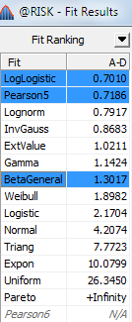

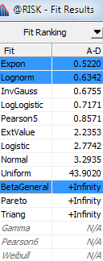
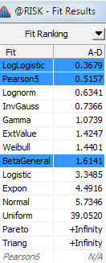

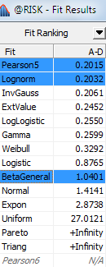

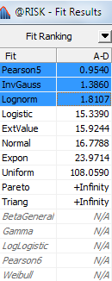

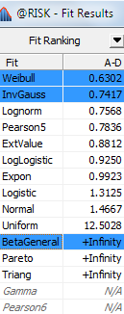

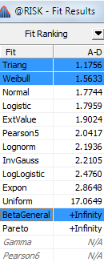

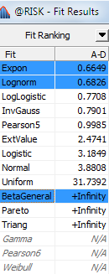

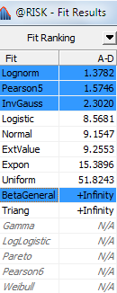

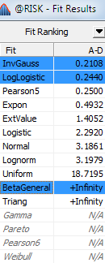

4. Discussion

In the graphs below the relative effect of systemic risk factor per asset class over time is evident when loss rates per asset class are plotted over a long period which includes downturn cycles. The pattern visible in the graph should be supported by the derived correlation value from the same loss rate data.

Table 4a: US loss rates per asset classes from 1991-2011

Table 4b: UK loss rates per asset classes from 1991-2011

Implied correlations resulting from the initial dataset used by Fitch for end-period 2007 were, in general, significantly lower than levels fixed by Basel. The following graph compares the implied correlation values for end-period 2007 and 2011 derived using the same methodology and distribution assumption (Beta distribution).
Table 5: Correlation values based on Beta distribution assumption for 2007 & 2011 end-periods

When comparison between the two data periods is done where best fit distribution functions were employed (i.e different functions for 2007 and 2011) then the difference is more evident. The exceptions were for CreditCard US (1% diff) and Commercial Mortgages US (0.4% diff) which had nearly the same result. The most striking difference was for Corp UK with the Basel level fixed at 21% compared with an implied correlation value of 2% (19% diff).
For more recent dataset with end period 2011, and only taking implied correlations based on Best fit distributions, of the 10 categories of asset class per region, 4 of the implied correlations were above the levels fixed by Basel. We see the greatest discrepancy for Residential Mortgages US with implied correlation 23% higher than the fixed regulatory level. The other categories for which implied correlation was above Basel levels was for CC UK (3% diff), CC US (5% diff), and Consumer Lending US (4% diff) - see table 3b.

The modelling methodology underpinning the Basel IRB framework may be one factor in the discrepancies between the correlation levels fixed by Basel and the implied values. In particular, the choice of vasicek distribution function by Basel as the distribution used to fit loss rate data to. We investigated this factor by deriving correlation values using the vasicek distribution fitted to our ‘2011’ empirical data (rather than the ‘best-fit’ curve). The result was significantly lower implied correlation values for some categories (see table 3b). In particular, US residential mortgages is now 1% lower than the fixed Basel level (instead of being 23% higher when modelled with our best fit - the Inverse Gaussian distribution). On the other hand, higher implied correlation values resulted in the following categories
For CC UK, Vasicek distribution results in implied correlation being now 8% above the IRB level compared with 3% above it with best-fit curve. Also Commercial Mortgages US in implied correlation being now 7% above the IRB level compared with 6% below it with best-fit curve.
The following graphs illustrate this observation.
Table 6a: Correlation values per asset class based on different distributions (US).

Table 6b: Correlation values per asset class based on different distributions (UK).

It is evident that there is a relatively large variation in implied correlation results depending on the choice of distribution curve used for fitting the loss rate data. On this point we differ from the findings of the Fitch 2008 paper when they conclude that “the choice of distributional assumption has a minimal impact on the empirically derived correlation values”.
The above results suggests there may be some limitation to the extent to which normal distributions can accurately model data exhibiting extreme variability as evidenced during severe financial crises. A relatively new area of statistical research for extreme value distributions has opened up to address this problem, as explained by Dr. Svetlozar (Zari) Rachev & Dr. Stefan Mittnik (2006): “In virtually all financial markets we observe that the probability of big losses is by far larger than predicted by the Gaussian (normal) distribution… Returns on financial assets are generally “fat-tailed” and, thus, cannot be adequately handled by a Gaussian distribution.”
When we analysed the new Basel III asset class ‘financial institutions’ using both vasicek and the ‘best fit’ distribution (Inverse Gaussian) to fit the UK loss data, we arrive at implied values of 21% below & 20% below the now fixed Basel III correlation level of 1.25. This suggests that the regulators have set the correlation level too high. On the other hand, true losses for uk financial institutions have been offset by government bailout money and thus our empirical results are not definitive in this case.

There is also a significant regional variation for US and UK implied correlation values for the same asset classes. The contrast is most obvious for Residential Mortgages: UK is 12% below Basel levels while US is 23% above (a 35% difference). This example supports the argument for introducing regional based correlation values rather than a global value for all as is currently the case.

5. Conclusion

In summary, our analysis based on severe downturn conditions, supports the regulatory levels of correlation value applied to some asset classes which were previously considered too high. However, the levels for some asset classes need to be reviewed, in particular for US Residential Mortgages, with a view to raising them even higher.

In September 2010, the Basel Committee on Banking Supervision (BCBS) announced a new asset class for ‘financial institutions’ and fixed the correlation at 1.25. To our knowledge, this paper is the first to empirically verify the validity of this assumption. The empirical results suggest that this is a conservative figure (i.e too high) but true losses for financial institutions have been offset by government bailout money and thus no realistic conclusions can be drawn from our empirical results in this particular case.

We find that there is significant regional variation for US and UK implied correlation values for some asset classes and the results support the argument for introducing regional based correlation values rather than a global value for all as is currently the case.

One possible application for the results would be for developing stress test scenarios. The implied correlation values calculated in this paper could be used to quantify systemic risk for certain stress test scenarios.

A weakness in this study is the lack of data for ‘downturn’ LGD values on which to base the analysis. should the Basel Committee perform a QI6 exercise based on recent market conditions then perhaps this study could be repeated with more relevant results.

References
Basel Committee on Banking Supervision (2006). Basel II: International Convergence of Capital Measurement and Capital Standards: A Revised Framework - Comprehensive Version. Bank of International Settlements, June.

Basel Committee on Banking Supervision. (Dec. 2010). "Basel III: A global regulatory framework for more resilient banks and banking systems". Bank for International Settlements.

Curcio (2011). Investigating implied asset correlation and capital requirements: Empirical evidence from the Italian banking system. Banks and Bank Systems, Volume 6, Issue 2, 2011 Banks and Bank Systems, Volume 6, Issue 2, 2011.

Dullmann, K. and Scheule, H. (696-2003). Asset correlation of German corporate obligors: Its estimation, its drivers and implications for regulatory capital. Available at:
http://www.bis.org/bcbs/ events/wkshop0303/p02duelsche.pdf

Drossos, Constantine A.; Andreas N. Philippou (1980). "A Note on Minimum Distance Estimates".

Financial Services Authority. FSA UK Country Report: The fifth Quantitative Impact Study (QIS5) for Solvency II, March 2011

FitchRatings (2008), Basel II Correlation Values - An Empirical Analysis of EL, UL and the IRB Model. http://research.fitchratings.com/dtp/pdf2-08/ibas0519.pdf

FitchRatings (2004). Demystifying Basel II: A Closer Look at the IRB Measures and
DisclosureFramework. http://research.fitchratings.com/creditdesk/reports/report_frame.cfm?rpt_id=218952

Office of the Comptroller of the Currency Board of Governors of the Federal Reserve System Federal Deposit Insurance Corporation, (February, 2006). Summary Findings of the Fourth Quantitative Impact Study.

Singh (2007), Quantitative social research methods.

Van Vuuren, Botha. (June, 2009) Implied asset correlation in retail loan portfolios. Journal of Risk Management in Financial Institutions Vol. 3, 2 156–173

Vasicek (1987). Probability of Loss on Loan Portfolio. KMV Corporation.
http://www.moodyskmv.com/research/files/wp/Probability_of_Loss_on_Loan_Portfolio.pdf
Zhang, Zhu, and Lee, (2008). Asset Correlation, Realized Default Correlation, and Portfolio Credit Risk. Moody’s KMV Company.

http://research.fitchratings.com/dtp/pdf2-08/ibas0519.pdf
Previously included under “Corporates”
Note that for the retail exposures asset class, there is no distinction between a foundation and advanced approach - all banks must provide their own estimates of PD, LGD and EAD.
Maturity is relevant as a longer tenor means a greater likelihood of experiencing an adverse credit event.
http://www.bis.org/publ/bcbs128.htm Basel II: International Convergence of Capital Measurement and Capital Standards: A Revised Framework - Comprehensive Version [June 2006].
Which due to simplifying assumptions in the model also covers concentration risk and lack of diversification
Loans extended to small businesses are classified as retail provided the total exposure is less than €1 million.
QIS 4/QIS 5survey results include 32 countries altogether. All G10 countries participated in QIS 5, with the exception of the US, whose data is included in the QIS 4 exercise.
http://www.bis.org/bcbs/qis/qis5.htm
http://www.moodyskmv.com/research/files/wp/Dynamic_Relationship_Between_Average_Asset_Correlation_and_Default_Probability.pdf
http://www.bis.org/bcbs/events/wkshop0303/p02duelsche.pdf
Basel Committee on Banking Supervision. (June 2006). International Convergence of Capital Measurement and Capital Standards. A Revised Framework. Comprehensive Version
par. 283 of Basel II Framework
These steps are based on the example from Van Vuuren & Botha (June, 2009)
BestFit company homepage is at www.ritme.com/tech/risk/bestfit.html
Kultar Singh (2007), Quantitative social research methods, pg101.

