Master Marketing Thesis
‘Gift giving: exploring the antecedents of a gift choice’
Peter Pernet
290833
Supervisor: dr. C.J. da Silva Lourenço

2011-10-12

Index
1. Introduction 4
2. Literature background 6
2.1. The gift 6
2.2 Gift giving motives 7
2.3. The process itself 8
2.4 Gift giving anxiety 9
2.5 Requested vs. Surprise gifts 9
2.5.1. Risk relievers 10
2.5.2 Purchasing patterns 10
2.5.3. Personal factors 10
3. Theoretical Framework 12
3.1. Requested vs. surprise gifts 12
3.2.1. Self-confidence 13
3.2.2. Fear of rejection 13
3.2.3. Buying impulsiveness 13
3.2.4. Altruism 14
3.3. Relationship continuum 15
4. Hypotheses 16
4.1. Personal traits 16
4.1.1. Self-confidence 16
4.1.2. Fear of Rejection 16
4.1.4. Altruism 17
4.2. Relationship continuum 17
5. Methodology 19
5.1. Research design 19
5.2. Survey design 20
5.3. Measures 21
5.3.1. Independent variables 21
5.3.2. Dependent variable 23
5.3.3. Controlling variables 23
6. Results 24
6.1. Restructuring the dataset 24
6.2. Data set quality 24
6.2.1 Used sample 25
6.2.2. Quality of the personal traits 25
6.3. Regression analysis 28
6.3.1. No Controlling variables 28
6.3.2. With Controlling variables 29
6.3.3. Relationship type not treated as continuum 30
6.3.4. Assessing multicollinearity 31
6.4. Other correlations 32
7. Conclusion 33
8. Discussion, limitations and future research 35
9. Managerial implications 38
10. References 39
11. Appendices 42
11.1 Larsen and Watson’s theoretical framework (2001) 42
11.2 Questionnaire 43
11.3 Database quality output 55
11.4 Factor analysis output 58
11.5 Reliability analysis personal traits 63
11.6 Regression models output 65
11.7 Collinearity diagnostics 74
11.8 Correlations matrix 76

1. Introduction

For century’s, even millennia, gift giving has been an important gesture as a token of appreciation in interpersonal relationships. The market has continuously evolved and with the growing amount of annual gift occasions, lifecycle milestones (graduation, marriage and retirement) and business relations, retailers see many opportunities in this market. Currently, it is estimated that gift purchases account for 4.3% of the total household expenditures (Garner, 1991). Only in the Netherlands this creates an estimated industry turnover of more than 10 billion euro’s in 2010.
In the large body of literature about the gift giving process, certain keywords are emphasized. The concept of reciprocity for instance, has been widely scrutinized (Joy, 2001; Giesler 2006; Charness et al. 2002). But also motives, involvement and gender roles have been the subject of many studies (Sherry, 1983; Larsen and Watson, 2001; Fischer and Arnold, 1990; Cheal 1987, 1988; Bodur and Grohmann, 2005).
Although giving a surprise gift enhances pleasure for the recipient (Charlesworth 1969; Desai 1939; Mellers, Schwartz, and Ritov 1999), donors often tend to buy a requested gift. However, many processes and characteristics underlying the choice to give a requested- or a surprise gift have yet to be uncovered.
Academic statistics provide the information that approximately 40% of all gift purchases are requested gifts and 60% is bought as a surprise (Belk, 1979; Vanhamme & De Bont, 2008). For managers and academic researchers, it is essential to know what antecedents influence this choice in order to respectively, adept sales and segmenting strategies and gain further knowledge of gift giving process.
This study looks for, and attempts to quantify, relationships between this gift choice and individual- as well as interpersonal antecedents. Therefore, the research question is: “Which personal and relational antecedents affect a donor’s gift choice?”. In the literature review, it was found that several personal traits are related with gift giving. In a ‘self report’ survey, the most relevant traits where tested and the respondents where instructed to select a gift for various types of relationships.
The final results show that the relation between ‘type of relationship’ and the gift choice is highly significant in all of the performed regression models. Contrarily with statements from Otnes et. al. (1996), the intensity of the relationship is positively related with buying a surprise gift. Furthermore, the results indicate a positive relationship of marginal significance between consumer self-confidence and buying a surprise gift. Although the measurement for fear of rejection was assessed as unreliable, the results provide reason to believe that consumer’s fear of rejection relates to the outcome variable. Along with the discovered relationships between the gift choice and demographic indicators such as age and gender, this study provides sufficient information to improve segmenting strategies and future business-concept development.
In the next section, the literature background of gift giving will be discussed. Followed by the theoretical framework for this research. Section 4 provides the hypotheses that will be tested. In the methodology, chapter 5, survey design and measurement for the traits will be explained. The next section assesses data set quality. This is also the section in which the factor analysis for the personal traits measurement and the regression models will be performed. Section 7 will discuss the conclusion of the statistical models and accept or reject the hypotheses. After the conclusion we discuss the research, its limitations, suggestions for future research and managerial implications.

2. Literature background

2.1. The gift
A fair amount of research has been done on the gift exchange process from one party to another. The gift process between a donor and a recipient has been scrutinized throughout many disciplines, including: anthropology, sociology, economics, psychology and, of course, marketing (Otnes and Beltramini, 1996).
To research the process of gift giving, we first need to define the word ‘gift’. The free online dictionary describes a gift as: ‘Something that is bestowed voluntarily and without compensation’¹. However, ‘voluntarily’ and ‘compensations’ are open for argumentation in this case. How voluntary is a gift when, at for instance a birthday party, all invitees bring a present? And what kind of compensation is referred to? It is widely accepted that the donor doesn’t expect a direct financial compensation. But one might argue the absence of a relational compensation. A relational compensation is any non-financial compensation, be it a direct benefit from giving or being emotionally rewarded (Davies et al, 2010). A better definition of a gift is found in the literature about this subject. Davies et al (2010) describe: “The gift involves the selection and transfer of something to someone without the expectation of direct compensation, but with the expectation of a return, be it reciprocity, a change in the relationship with the recipient or a favor or another social or psychological benefit.”
In his review in 1979, Belk imputes four functions to the gift. These are communication, social exchange, economic exchange, and socialization. “Each of these functions reflects the others and further highlights the importance of exchange, according to Belk”.

2.2 Gift giving motives
Sherry (1983) describes two motives for a gift exchange from the donor’s perspective. The first is the ‘altruistic’ one, which lays focus on the recipient’s benefit. The second is ‘agonistic’. This motive focuses more on the benefits from the donor’s perspective. Sherry also notes that both of the motives can be present in one exchange, considering that these motives anchor both ends of a spectrum.

Wolfinbarger and Yale (1993) also describe different motivations. However, they use a different outlay:

1. Experiential/positive motivation. This motive allocates a lot of time and effort to the gift selection. These gift givers enjoy picking a gift and feel that gifts are a way of showing love and friendship to receivers.
2. Obligated motivation. Givers with this motive experience (1) guilt if they don't give, (2) give because of others' expectations or, (3) feel they must reciprocate when they have received a gift (these obligated motives will receive some more attention further on in this literature study).
3. Practical motivation. This motivation is to provide practical assistance to receivers (e.g. household appliances, tools, etc.).

Looking at these motives from Sherry’s (1983) angle, the first and last are obviously altruistic motives. They have a more interpersonally oriented perspective, whereas the second indicates that the giver doesn’t want to feel guilt. Which is a more agonistic point of view.

Within these motives, the donor’s role in gift giving is also of certain significance. Along with the meaning of ‘easy’ and ‘difficult’ recipients, Otnes et al (1993) propose six donor roles in gift selection: The pleaser, the provider, the compensator, the socializer, the acknowledger and the avoider. “By definition, the avoider role is expressed through the absence of any actual gift exchange.”
These roles were formed in a qualitative study using in depth interviews. All these roles were linked to ‘gift buying strategies’ for easy- as well as hard recipients. The most prevalent role expressed by the participants was ‘the pleaser’. Donors found themselves in this role across a wide range of recipients, varying from parents to friends and spouses to more distant relatives (Otnes et al. 1993). Also, the third motivation or ‘practical motivation’ (Wolfinbarger and Yale, 1993) is typically found in the role of ‘the provider’. The message conveyed by providers is simply: “I want to take care of your needs.”
What is particularly interesting for this research is the most used buying strategy: ‘Buy what they want’. “Thus, givers who employed ‘Buy what they want’ took pains to ensure that a gift was desired, either by directly inquiring what the recipient wanted or by employing indirect sleuthing” (Otnes et al. 1993). This sheds some light on the dependent variable in this thesis.
In 1979, Belk reported that approximately 40% of all actually bought gifts where based on wish lists or hints. The remainder where surprise gifts. In 2008, Vanhamme & De Bont acquired similar results when researching gifts focused on the small electric appliances market. 43% of all gifts where bought on request, the remaining 57% was a surprise gift. In further research, one might argue whether this balance has shifted due to easiness of sharing information through the use of the Internet. Another possibility is that this balance differs according with a donor-recipient relationship. In the results of this study, more light will be shed on this comment.

2.3. The process itself
Several attempts have been made to develop a model of the gifting process. Overall, we find that Sherry (1987) formulates the most complete theoretical framework. It describes three stages. These are (1) the gestation stage, encompassing information search and motives; (2) the prestation stage, which is the act of giving the present and the recipient’s response; and (3) reformulation. In the last stage, any effect that the gift giving has on the donor-recipient relationship emerges. Prior to these three stages there has to be a stimulus for giving a present. This can be ‘for no reason’ between loved ones for example, but it often is an occasion like a birthday, a wedding, Christmas or mothers-/fathers day.
Partly extending the research of Belk and Coon (1993). Larsen and Watson (2001) develop a framework - appendix I - of the value of a gift within the gift giving process. They emphasize that their framework is the first one to really put the value of the gift giving experience in the centre of the exchange. Their framework imputes four values to the gift in an exchange: The economic value, the functional value, the social value and the expressive value. To the best of our knowledge, this is also the first framework where the ‘relationship continuum’ is introduced in a comprehendible way. What this framework also emphasizes is the appropriateness of the gift. Below, this issue is further discussed.

2.4 Gift giving anxiety
Although the donor, as earlier described, might voluntarily give a gift, several researchers like D’Souza (2003), Joy (2001), Belk (1976) Rugimbana et al. (2002) introduce the concept of obligation to the gifting process. Although a gift might be seen as ‘voluntarily bestowed’, obligation can be the most prevalent reason for giving a gift.
The latter introduces negative characteristics to the gift giving process. Larson and Watson (2001) and Wooten (2000) find that obligation to give, or to repay, can be a significant cause of gifting stress or –anxiety. “Gifting is a paradox: while the giver reaches out to the receiver through an act of sharing, s/he also places the receiver in a position of indebtedness, a duty to reciprocate (Godelier, 1990).”
Vanhamme and de Bont (2008) stipulate that there are several risks involved in gift giving. The two most prevalent ones are financial- and social risk. Whereas the financial risk stands for the monetary loss that a donor suffers from a bad gift (for the same money, one could have bought a better gift), the social risk relates to expected negative gift evaluations from the recipients’ perspective. To the best of our knowledge, this effect might increase in two situations. (1) When the gift is given with a larger group of ‘spectators’ (a wedding or a birthday party), or (2) when the recipient is thought of as a ‘picky’ person.

2.5 Requested vs. Surprise gifts

Prior literature indicates that there are, roughly, two major giftcategories (Belk, 1979; Otnes et. al. 1996; Vanhamme & De Bont, 2008). (1) A specific gift that a recipient would like to receive, or has wanted for a long time or (2) A gift that the recipient did not think of. The surprise aspect of the gift can also be the gift occasion, or the absence of such an occasion. When a gift is not expected, also a requested gift can come as a surprise.
To quote Vanhamme and de Bont (2008) “Some authors argue that surprise represents a central emotion for gift-giving (Ruffle 1999) and may be the most valued characteristic of gifts in individualistic Western cultures (Belk 1996). Yet recipients often use wish lists or ask directly for something they want (Belk 1979; Sherry 1983).”⁵
A surprise gift has proved to be the most valued gift by a recipient (Areni, Kiecker, and Palan 1998; McGrath, Sherry, and Levy 1993). The impression seems to last longer than that of a requested gift. However, the donor’s point of view has received less attention in the literature. This may sound surprising due to the fact that the choice whether to surprise is up to the donor, not the recipient. The choice to buy a surprise or a requested gift depends on several factors. Vanhamme & De Bont (2008) group these in three sets: (1) Risk relievers, (2) Purchasing Patterns and (3) Personal factors.

2.5.1. Risk relievers
The two most prevalent risks associated with a purchase, are the social and financial risks. These perceived risks arise when a gift purchase has some social and financial consequences that cannot be estimated with certainty at the moment of purchase. In this case a financial risk would evolve into an opportunity cost; the money spent on the gift could have been used for a better gift. The social risk represents the risk that a recipient doesn’t like the gift, reflecting a poor gift choice on the donor’s behalf. (Davies et al, 2010)

2.5.2 Purchasing patterns
These patterns are quite different in the case of a request versus a surprise gift. If the recipient has already given certain hints as to what sort of gifts s/he might like, the donor comes to the (e-)store with some kind of idea in mind. This is not the case with surprise gifts (Vanhamme and de Bont, 2008).
A consumer’s purchase pattern also includes the addressed external sources of information. (Conchar et al. 2004). This pattern is more extensive for surprise gift buyers than for a buying a requested gift.

2.5.3. Personal factors
The last set that Vanhamme & De Bont describe, is that of the personal factors. This is also their least extensive set of factors. They only shed light on gender differences and the donor-recipient relationship. However, solely they use a dummy for ‘gift bought for person in household’. You can imagine that buying a gift for a colleague that a donor hardly knows, is a different process from buying a present for a ‘romantic other’, be it partner or boy-/girlfriend.
Gender differences have been scrutinized widely in the gift buying process (Larsen and Watson, 2001; McGrath, 1998; Fischer and Arnold, 1990; Cheal, 1987, 1988; Codorrow, 1978; Bodur and Grohmann, 2005). These papers mainly focus on gender differences in information search and shopping involvement. In both of these research directions men seem to turn out lowest.
A thesis written by Mike Maurik (2009) extends these factors by trying to find a correlation between buying impulsiveness tendency and the question whether someone would rather buy a requested or a surprise gift. His main hypothesis: ‘A higher Impulsive Buying Tendency of the consumer might cause that the consumer actually buys surprise gifts more impulsively.’ was accepted marginally. Next to buying impulsiveness, there are more personal factors that can influence someone’s gift decision. Wooten (2000) describes self-confidence as an important factor: “Confidence is defined as self-assurance. Givers who lack it doubt their abilities to elicit desired reactions from recipients. Such doubts are often not based solely on gifting capacity.“ Wooten also finds that gifting capacity consists of several antecedents. “Gifting capacity refers to the quality of possessing the necessary means to succeed as givers. People with limited gifting capacity are likely to be anxious givers because they perceive their resources to be inadequate to meet their demands. Both cognitive (e.g., creativity and knowledge) and productive (e.g., money, time, and effort) resources were deemed as necessities for givers.” Wooten did not quantify these findings.
The last personal trait in this thesis is ‘fear of rejection’. In the paragraph of gifting anxiety, the social risks associated with buying a gift are described as the perceived risk that a recipient will have negative evaluations of the gift, reflecting poor gift choice. The fear of this negative evaluation might vary due to measurement of a donor’s fear of rejection.

3. Theoretical Framework

3.1. Requested vs. surprise gifts
In their study, Vanhamme & De Bont base their hypotheses development on the following three assumptions:
- ‘Surprise gifts intensify recipients’ pleasure.’ The fact that surprise intensifies pleasure is supported by a number of other researchers (Charlesworth 1969; Desai 1939; Mellers, Schwartz, and Ritov 1999). In the same study, another hypothesis is formed:
- ‘Surprise gifts encompass more social and financial risks’. This leads to the question as to how motivated a donor is, to surprise the recipient.
- Surprise gift purchase is usually prompted by an experiential motivation. This is one of the three motivations that Wolfinbarger and Yale (1993) formulate.

From these hypotheses, it can be assumed that the donor has to balance the risks of a surprise gift and the desire to please the recipient. The following explains why certain personal traits are able to affect this balancing process.
In their qualitative research, Otnes et al. (1993) describe strategies used for donors in various roles. Donors acting as ‘Pleasers’ - by far the most prevalent role in their article -, often employ the strategy “buy what they want”. However, this strategy is only valid for ‘easy recipients’ like family members, or close friends. With ‘difficult recipients’, obtaining information about the donor’s desires can be harder. In these cases, the donor is tended (unwillingly or not) to go for a surprise gift.

3.2. Personal traits
Many personal traits can influence one’s buying patterns. As mentioned in the literature study, the following traits are expected be the most relevant in affecting consumers’ purchase behavior, revolving around gift giving.

- Self-confidence
- Fear of rejection
- Buying impulsiveness
- Altruism

3.2.1. Self-confidence
“Confidence is defined as self-assurance. Givers who lack it doubt their abilities to elicit desired reactions from recipients. Such doubts are often not based solely on gifting capacity.“ (Wooten, 2000) This finding implies that confident consumers do not doubt their abilities to get a desired reaction from a recipient. Judging from Wootens article, higher confidence seems to correlate with lower gifting anxiety. However, this study only attempts to prove that self-confidence correlates with the choice whether to buy a requested gift or a surprise.

3.2.2. Fear of rejection
“Social risk exists to the extent that consumers expect negative evaluations from others because of their poor gift choice.” (Vanhamme and de Bont, 2008). In the worst case, these risks result in the recipient rejecting the present, or not using/liking it. In the article “Gift-Giving, for Many Men, Means Avoiding Rejection” Barber (2011) states that “Men looking for Valentine's Day gifts are most concerned with finding something that is least likely to be rejected”. These quotations lead to the belief that consumer fear of rejection might correlate with selecting a requested present instead of trying to surprise someone.

3.2.3. Buying impulsiveness
Wells et al. (2011) state that: In general, impulse buying has been studied from two key perspectives: the state of mind created by the shopping environment (Rook, 1987) or a specific personality trait inherent to the individual consumer (Rook and Fisher, 1995). The latter of these two perspectives will be looked into in more detail.
Impulse buying has been defined as “a purchase that is unplanned, the result of an exposure to a stimulus, and decided on the spot” (Piron, 1991, p. 512). Beatty and Ferrell (1998) provide a more extensive definition in that impulse buying is considered to be “a sudden and immediate purchase with no pre-shopping intentions either to buy the specific product category or to fulfill a specific buying task.” The definition that perhaps best grasps the concept of buying impulsiveness is provided by Rook and Fisher (1995). “A consumer’s tendency to buy spontaneously, unreflectively, immediately and kinetically.” In addition, high impulse buyers are more likely to have more open, or undefined, shopping lists. They are likely to be more receptive to sudden and unexpected buying ideas
Stern (1962) has identified different types of impulse purchases, namely pure, reminder, suggestive, and planned impulse purchases. From the definitions of these purchases that Wells et al (2011) provide, only the reminder impulse purchase is of essence to this research. The reminder is defined as a purchase that occurs when the individual did not plan to make a purchase until he or she remembered a previous experience with or a need for the product when exposed to it, the gift here being the ‘need’.
Furthermore, in his dissertation, Maurik (2009) finds that using factor analysis, the factor “Impulsive Buying Tendency” explains 54,6% of the respondents’ behavior towards buying surprise gifts. This factor has a reported reliability of .784.

3.2.4. Altruism
Altruism has often been associated with gift giving (Sherry, 1989. Vd Ven, 2002. Giesler, 2006). But this personal trait reaches further than this literature alone. Altruism can be detected by helping strangers carry belongings, donating to charity, giving someone a lift and so on (Rushton et al. 1981). Altruism can also change when the number of recipients for gift giving changes. (Andreoni, 2007). Until this day, to the best of our knowledge, altruism has not been connected to the choice whether to surprise or buy a request. However, there is extensive evidence that a surprise gift is valued more than a requested gift to a recipient (Areni, Kiecker, and Palan 1998; McGrath, Sherry, and Levy 1993). So far, no research has been able to establish a relationship between level of altruism and the gift choice.

3.3. Relationship continuum
Areni et al. (1998) present the following findings: “Given that the nature of the relationship between the giver and the receiver strongly influences giver’s motivations and receiver’s interpretations (caplow, 1984; Cheal, 1986, Otnes et al, 1993; Sherry, 1983)…”. In this article relationships varying in intimacy are modeled into five categories:

- The romantic other
- Parents-children
- Grandparents-grand children
- Siblings
- Friends and kin

The latter category describes platonic friends and colleagues. This model doesn’t quite grasp the fact that some friends may be seen as close as family. However, the basis of this continuum can be adopted in this study. Joy (2001) describes a slightly different continuum that indicates several ‘friend-categories’ according to the intimacy levels. It is as followed:

- Close friends
- Good friends
- Just friends
- hi-bye friends
- the romantic other

This model gives a more in depth view on the category that the previous model fails to describe. In the chapter concerning research methodology, a hybrid of these two models will be formed.

4. Hypotheses

4.1. Personal traits

4.1.1. Self-confidence

As noted earlier, the findings of Wooten (2000) imply that self-confident consumers experience less doubt about their ability to make a good purchase. Therefore, a self-confident donor might be attracted more to buy a surprise gift. One of the questions in ‘self-confidence scale’ in the survey actually states: “I have the ability to give good gifts” (with a scale from 1 -strongly agree- to 5 -strongly disagree-). Therefore, a higher composite score of self-confidence is expected to have a positive correlation with buying a surprise gift. Hence, the hypothesis is:

H1: ‘Higher self-confidence is positively related with buying a surprise gift.’

4.1.2. Fear of Rejection
Buying a gift may cause a form of gifting anxiety on the donor’s behalf. When the gift is presented in the presence of a larger audience, a birthday party for example, this anxiety may increase. This anxiety is exaggerated by two risks: the financial risk and the social risk (Vanhamme & De Bont, 2008). The latter can be described as the donor’s expectation of negative evaluations of the gift, due to poor gift choice. According to Rosenwald (Washington Post, 2010) up to 30% of purchases are returned. Recipients hypothetically rejecting a gift from a donor can cause gifting anxiety to increase. Therefore it is expected that higher composite scores of fear of rejection (FOR) relate negatively with buying a surprise gift. Hence the hypothesis is:

H2: ‘Fear of rejection is negatively correlated with buying a surprise gift.’

- 4.1.3. Buying impulsiveness
As mentioned earlier, an impulse purchase is an unplanned purchase, which is decided on the spot. Higher buying impulsiveness naturally results in more impulse purchases. In their book “Buying impulsiveness: a study on impulsive consumption” (2003) Herabadi describes: “Correlations with self-reported purchase patterns indicated that high impulse buying tendency resulted in more impulsive purchases with higher impulsivity”. The results from Herabadi’s dissertation also confirm that impulsive buying tendency is a personality-based trait.
Furthermore, in the theoretical framework the factor analysis of Maurik (2009) is partly described. Since this research uses another approach to the tendency to buy surprise gifts, it is relevant to check if a buying impulsiveness score also affects the choice to buy a requested gift or a surprise. The following hypothesis can be formed:

H3: ‘Buying impulsiveness is negatively related with gift choice’

4.1.4. Altruism
Altruism has often been associated with gift giving. However a relationship between this personal trait and the dependent variable in this study has not been found. Hence, this research attempts to look for this relationship. Prior research indicates that a surprise gift is valued more than a requested gift by recipients. Because altruism not only concerns selflessness but also the happiness of others, a positive relationship between altruism and buying a surprise gift is expected. Hence:

H4: ‘Altruism is negatively related with gift choice’

4.2. Relationship continuum
Areni et al. (1998) found that the nature of the donor’s relation with the recipient significantly influences the donor’s motivations and the recipient’s interpretations. Inherently, different motivations and expected interpretations lead to different types of gifts. Many studies have proven that surprise gifts intensify recipients’ pleasure (Charlesworth 1969; Desai 1939; Mellers, Schwartz, and Ritov 1999). The motivation to intensify pleasure naturally might become more pronounced when a relationship is valued higher. However, Otnes et al. (1993) find that in close relationships, the most prevalent ‘role’ of the donor is the ‘pleaser’. This role indicates that the giver wants to give the recipient something that they actually want. Therefore, the next hypothesis is non-directional:

H5: ‘The relationship continuum relates with the decision of buying a requested or a surprise gift’
4.3. Demographics
The controlling variables in this analysis are demographics, specifically: age, gender, education and income. In the literature study it became clear that gender issue has been scrutinized in multiple articles (Larsen and Watson, 2001; McGrath, 1998; Fischer and Arnold, 1990; Cheal, 1987, 1988; Codorrow, 1978; Bodur and Grohmann, 2005). Although gender role is not emphasized in this study, it is expected to have a (marginally) significant effect on the outcome variable. From the current literature cannot be derived if this effect is expected to have a negative or positive coefficient.

H6: ‘Gender will have a (marginally) significant effect on the outcome variable.’

The second control variable that is expected to influence the outcome is age. In their qualitative study, Otnes et al. (1996) find that older people have more experience in finding a suitable gift for a recipient than younger respondents. Due to the lack of gift selecting ability, age is expected to have a positive effect on buying a surprise gift.

H7: ‘Age is positively related with the gift choice.’

Concluding, there are several variables that are expected to correlate. A large body of research claims that women are more involved in gift giving than men. Therefore, the variables concerning ‘invested time’ and ‘number of sources looked at before the purchase’ should correlate with the gender.

H8a: ‘Gender correlates positively with time invested in thinking what gift to give’
H8b: ‘Gender is positively correlated with number of sources looked at before purchase’

5. Methodology

5.1. Research design

To our knowledge, the combination of personality traits and the choice whether to surprise or not is yet to be found in the existing body of data. Therefore, these two aspects are part of the core of this research. To unveil relationships between personal traits, intimacy of relationships and the type of present a donor wants to give, a new dataset had to be formed.
Two possible research designs can subtract this information. Starting with the experiment. However, in formulating the research question, it became clear that it would not be necessary to answer the questions and make the gift choices in a completely controlled environment. Furthermore, recreating an environment where a consumer could easily pick any gift that came to mind would be very costly. Maurik (2009) experiences the same difficulties, and finds it is very hard to recreate a ‘surprise gift buying’ situation. Also, it could become unclear what budget a participant could spend per recipient and how much information sources (or (online) retailers) he/she would have looked at. Such an experiment could have provided information with perhaps more credibility because a survey might have loss of validity as a result of fixed questions and answers about beliefs and/or feelings. The reason that an experiment is the best research method is the fact that an experiment is the best way to determine a causal relationship between different variables (Dul & Hak, 2006; Malhotra & Birks, 2006).
However, in conducting this research, it was also important to focus on the timeframe and the complexity of this thesis. The latter was the concluding argument for choosing a questionnaire instead of an experiment. Survey analysis is relatively easy compared to experiment analysis. The questionnaire tests several measures of personal traits and, for all categories in the relationship continuum, has a section of questions revolving around the outcome variable. The goal to see whether a participant chooses a request or a surprise gift is concealed into 6 possible choices for a gift.

5.2. Survey design

The outlay of the survey is as followed:
- Fear of rejection measurement
- Buying impulsiveness measurement
- Gift selection 1
- Gift selection 2
- Altruism measurement
- Self-confidence measurement
- Gift selection 3
- Gift selection 4
- Demographics

All variables are expected to lead to the following question: “will the participant choose a requested- or a surprise gift?”. There are four questions that will potentially give new insights into the first question of this paragraph. These questions are formulated accordingly with the relationship continuum. Per question there are several options to choose from for the participant, this variable will be coded as a dichotomous variable. The gift is either requested or not. To not complicate matters any further, certain assumptions have been made by the participants. All of which are mentioned in the question introductions:

- Prices are not included and all options are evenly priced. Therefore, the budget for a participant is fixed for all gift choices.
- The participant has to assume that these are actual gift requests
- The participant is told that s/he is the only one to see the request list. Therefore, the possibility that someone might buy the same gift becomes irrelevant.

5.3. Measures

5.3.1. Independent variables

5.3.1.1. Consumer Self-confidence

For this personal trait, the Consumer Self-confidence (Bearden, Hardesty and Randall. 2001) scale is used. The two main arguments are that 1) it is easily calculated. 2) The summary of the extensive evidence of validity by the creators. In order to sustain the respondent’s focus throughout the questionnaire, the construct of the used scales are abbreviated. For Consumer Self-Confidence the original measure consists of 31 items, divided across six sub dimensions, Information Acquisition (IA), Consideration Set Formation (CSF), Personal Outcomes Decision Making (PO), Social Outcomes Decision Making (SO), Persuasion Knowledge (PK) and Marketplace Interfaces (MI). The first 4 dimensions are factored as ‘decision making self-confidence’; the latter two are ‘protection self-confidence’. Not all of these dimensions are equally important for this research. The ‘protection self-confidence’ is deleted from the questionnaire. Since the suggested gifts are bought for another recipient, so is PO. This leaves three sub dimensions; SO, the most important one with three questions, IA with two questions and CSF with one question. The final score is composited by adding up the scores, all of which are rated on a 5-point likert scale. The self-confidence score in this construct will therefore range between 6 and 30. In this construct, the lowest score stands for the highest self-confidence.

5.3.1.2. Fear of rejection

Downey & Feldman (1996) have created a measurement that is used for Fear of Rejection (FOR) or Rejection Sensitivity in this dissertation. Unlike other rejection sensitivity measures, it includes questions that use examples of relationships that are all mentioned in the relationship continuum used in this research. The original questionnaire consists of thirty hypothetical interpersonal situations, formed by another group of undergraduates. For all of these situations, two questions have to be answered. The first question measures one’s rejection concern and the second question concerns the acceptance expectancy of the respondent. The measurement is formed out of 20 open-ended interviews with other undergraduate students. (Downey & Feldman, 1996) However, the authors of the article state that this measure is not created for a specific group of people. The test-retest reliability (n=104) of the Rejection Sensitivity Questionnaire reads a score of .83. Scoring the measurement is as followed: Calculate a score of rejection sensitivity for each situation by multiplying the level of rejection concern (the response to question a.) by the reverse of the level of acceptance expectancy (the response to question b.). Therefore, the formula is:
rejection sensitivity = (rejection concern) * (7-acceptance expectancy)

5.3.1.3. Buying impulsiveness

Rook and Fisher (1995) have developed a Buying Impulsiveness Scale, consisting of nine questions. Initially, this scale consisted of 35 items. After performing numerous scaling procedures, such as exploratory- and confirmatory factor analysis, this was brought down to nine items, four of which are measured in the survey. The second question is calculated with reverse scoring, therefore this variable will be recoded in SPSS. All the questions are of equal significance to the final score, which is the sum of all scores (in the original questionnaire ranging from 9 to 45, in the abbreviated one 4 to 20). This equality made it relatively easy to delete five questions from the score.

5.3.1.4. Altruism

Rushton et al (1981) have developed a self-reported altruism scale. Their paper attempt to demonstrate that there is more consistency to altruistic behavior across situations than is often supposed, i.e., that there is a trait of altruism. Indeed one that is sufficiently broad to warrant the concept of 'the altruistic personality.' The respondent is asked to answer questions about twenty interpersonal situations. For research purposes, this list has been abbreviated to seven items. Answers to these questions are of dichotomous nature. The conclusive score is calculated by the sum of answered variables.

5.3.1.5. Relationship continuum

Both the continuums of Joy and Areni are simplified and put together into a single list. In this list, 1 stands for the most distant relationship and 4 is the closest. The participant is asked to select a gift for all 4 of these categories. The variable of ‘the gift occasion’ will be held constant: a birthday party.

- Other friends and colleagues
- Siblings/close friends
- Parents/children
- The romantic other

5.3.2. Dependent variable
Gift selection

The variable measuring the selection of a requested or a surprise gift is concealed in six choices. Three being requests and three being surprise gifts. These variables are later recoded in a dichotomous variable with 0 as a surprise and 1 as a request. The earlier mentioned assumptions, that have to be made by the respondent, stand in the introduction of each of the gift selection questions. The gift requests are randomly selected throughout gift category. Prices are not included to eliminate budget restrictions.

5.3.3. Controlling variables
The controlling variables in this experiment are demographics. The following demographics where used in this dissertation: Gender, age, education and income. Especially between the relations ‘age – income’ and ‘education – income’, multicollinearity might arise. This may be caused by the size of the sample. In the results section, multicollinearity in controlling- but also all other variables will be assessed.

6. Results

6.1. Restructuring the dataset
The original dataset that was created from the survey responses included several flaws that had to be fixed before the actual quality of the dataset could be assessed. Starting with the variable of gift selection. As mentioned before, the actual dichotomous variable is concealed in sets of six answers. With 0 being a surprise and 1 being a requested gift, the variables where noted as 0₁, 0₂, 0₃ and 1₁, 1₂ and 1₃. These variables needed to be recoded to solely zeros and ones. After that, the missing variables had to be recoded in order to perform a correct reliability analysis. Also, invalid responses (with more than 70% missing variables) where removed. In total this was a number of four responses.

The questions concerning the gift selection contained a concealed variable of the friendship continuum, one of the predictors in the regression analysis. To extract this variable from the data, a set of four rows per respondent needed to be created. In these sets, all variables except three where considered fixed. The three variables that differed across these rows are the variable of the actual gift selection (dependent variable), how long before the occasion a respondent starts thinking on what gift to give per recipient and the number of sources looked at before purchase. The latter two are gift giving involvement indicators.

Restructuring multiplies the dataset by four, inflating the number of variables used for the personality traits. Therefore, prior to restructuring this data, factor analyses for the personality traits where performed. These results will be covered in chapter 6.2.2.2.

6.2. Data set quality
This section assesses whether the quality of the dataset is good enough for the data analysis. Certain actions have to be made to assess the quality of the dataset. Here under are the results from the demographics analysis and the quality of the measures for personality traits. The quality assessment of the dataset is created from the SPSS output placed in appendix 11.3.

6.2.1 Used sample
The questionnaire was sent to 432 potential respondents. With a response of 103 filled in surveys, the redemption rate is 23,8%.
The frequencies in the demographic variables of the questionnaire show that the data is not normally distributed. This is as expected, due to the distribution channels in which the questionnaire is pushed to the respondents. The dataset (n=103) consists of 52.3% male and 35.5% female respondents with 12.2% missing values.
Most respondents have an educational background in university, in total 69.2%. From these students or alumni, 55 respondents have reached master’s degree. 22 have a bachelor’s degree. The remainder of the respondents has an HBO degree or finished High School.
The highest reported skewness and kurtosis are found in the distribution of the variables resp_age and resp_income, respectively s: 1.745, k:2.761 and s: 1.763, k:2.681. From the crosstabs for income, age and education can be derived that the larger part of the respondents are aged between 23 and 32 and have an income lower than €5.000,- per month. Therefore, this sample is not representative for the Dutch population.

6.2.2. Quality of the personal traits

6.2.2.1. Factor analysis

As noted in the methodology section, the tests for personality traits are abbreviated from their original format. Although the literature tells us that the original measurements for personality traits are tested and retested on their reliability, it is wise to perform a factor analysis for all of these traits. All factor analyses are performed using the Principal Component Analysis and Varimax rotation method with Kaiser normalization.
variable | component
variable | 1 | 2
FOR_1 | .511 | .116
FOR_2 | .257 | .725
FOR_3 | .785 | -.148
FOR_4 | -.297 | .612
FOR_5 | .748 | .083
FOR_6 | -.501 | .449
FOR_7 | .597 | -.295
FOR_8 | -.031 | .753
Table 1: Rotated components FOR
Starting with the Fear of Rejection measurement (FOR). This questionnaire consists of two separate measurements that are later recalculated to one score. The first measure is ‘rejection concern’, the second: ‘acceptance expectancy’. The factor analysis should therefore formulate two dimensions. In table one you can see the rotated component. Component one indicates rejection concern, the second acceptance expectancy. Together they account for a cumulative variance of 49.95% in the measure.

The second trait we cross is the buying impulsiveness, the measurement with the least questions. This factor analysis reads no more than one component, explaining 52.19% of all variance.

Rotated Component Matrixª
 | Component
 | 1 | 2 | 3
alt_1 | -.254 | -.335 | .467
alt_2 | .064 | -.142 | .616
alt_3 | .776 | -.087 | .213
alt_4 | .064 | .754 | .073
alt_5 | .027 | .326 | .664
alt_6 | .779 | -.019 | -.216
alt_7 | -.268 | .607 | -.145
a. Rotation converged in 5 iterations.

Table 2: Rotated components Altruism

The scale for altruism reads the most components, namely three. However, it should be noted that it is harder to perform a Principal Component Analysis for SPSS when the variables are dichotomous. The components are named as followed: (1) ‘helping a stranger’, (2) ‘public favor’ and (3) ‘the selfless act’. Together these three dimensions account for 52.77% of all variance.

The last scale is for Consumer Self-confidence (CSC). Several aspects of self-confidence are measured, such as: Information Acquisition (IA), Consideration Set Formation (CSF) and Social Outcomes Decision Making (SO). This measurement consists of six questions in total. The factor analysis indicates that there are two components, respectively called ‘decision making confidence’ and ‘information acquisition’. The cumulative explained variance has the highest reported score: 68.82%.

Rotated Component Matrixª
 | Component
 | 1 | 2
cons_self1 | .134 | .893
cons_self2 | .298 | .837
cons_self3 | .722 | .258
cons_self4 | .752 | .336
cons_self5 | .857 | .061
cons_self6 | .699 | .173
Table 3: Rotated components CSC

6.2.2.2. Reliability analysis
The measures for Consumer Self-confidence (CSC), Buying Impulsiveness (BI) and Rejection Sensitivity (RS) and Altruism have been abbreviated. Therefore, the reliability of these measures will differ from their original construct. The reliability checks have been performed on the overall measure and for the individual components of the measurement.
Reliability test | Cronbach | # items
FOR_total | .315 | 8
FOR_RC | .549 | 4
FOR_AE | .602 | 4
Table 4: Reliability FOR Scale

A broadly accepted value for Cronbach’s Alpha is between .7 and .8 (Kline, 1999). So the reliability of this measurement is questionable to such a degree that the results coming from this measurement are not reliable. The measurement of buying impulsiveness reads a Cronbach’s Alpha of .692. Also making this measurement questionable but not rejected. The measurement for altruism reads by far the lowest scores on the total measurement as well as the individual components. This, again, might be due to the dichotomous construct of the questions. The scores are noted in table 5.
Reliability test | Cronbach | # items
ALT_Total | .011 | 7
Alt_SH | .392 | 2
Alt_PF | .214 | 2
Alt_SA | .152 | 3
Table 5: Reliability Altruism Scale

Reliability test | Cronbach | # items
CSC_Total | .810 | 6
CSC_DM | .753 | 2
CSC_IA | .793 | 4
Table 6: Reliability CSC Scale
The final reliability test is performed for CSC. Table 6 shows that this test has proven most reliable. It has the only Cronbach’s Alpha that is above the .8 acceptance level. Also, this is the only measurement where the total score has a higher Cronbach’s Alpha than the two separate dimensions.

6.3. Regression analysis
There are several models that can be applied to this regression analysis. However, due to the dichotomous nature of the dependent variable, a standard linear regression does not provide relevant results. Hence, a binary logistic regression using the ‘enter’ method is used. Each model has a different outcome as to how well it predicts the dependent variable. Furthermore, within these models the predictors have different coefficients and levels of significance. In the first three models, the controlling variables are not included.

6.3.1. No Controlling variables
Due to the outcomes of the factor analysis, two separate models regression models are performed: one with the individual components of the traits and one with the overall scores of the traits, copied from the handbook of marketing scales. The last model is a single regression, using only the relationship type as a predictor.
- rel_gift = β₀ + β₁(rel_type) + β₂(FOR_Score) + β₃(CSC_Score) + β₄(Buy_imp_score) + β₅(Alt_score) + ε_{i}
- rel_gift = β₀ + β₁(rel_type) + β₂(FOR_RC) + β₃(FOR_AE) + β₄(CSC_IA) + β₅(CSC_DM) + β₆(Buy_Imp_Score) + β₇(Alt_SH) + β₈(Alt_PF) + β₉(Alt_SA) + ε_{i}
- rel_gift = β₀ + β₁(rel_type) + ε_{i}
The last model is included because the ‘relationship type’ seems to have the only highly significant (.000) effect on the outcome variable. It is therefore suspected that the third model has the highest probability of predicting the dependent variable correct. In table 7, the most important statistics are put together.
 | Rel_type & Traits | Rel_type, individual factors in traits | only Rel_type
Overall % | 66.3 | 66.6 | 68.9
Log likelyhood | 441.726 | 440.226 | 484.683
Intercept | 0.981 | -0.101 | 1.403
Intercept | (.420) | (.950) | (.000)
Table 7: Output Regression model without controlling variables

Without the controlling variables, the simplest model, using only the relationship type seems to be the best predictor of the gift choice a respondent would make. A small difference can be found between the models that include personality traits. The individual component scores from the factor analysis give a .3% higher probability of predicting the outcome of the dependent variable.

A notable fact is that, in the first model, the score for FOR has a marginally significant (.100) effect on the outcome variable. It has a negative coefficient of -0.016 indicating that the higher a respondent scores on the FOR trait, the sooner this person will tend to buy a surprise gift. This is the opposite of the hypothesis. However, due to the low Cronbach’s Alpha notation, this score cannot be accepted as reliable.
This model failed to prove a significant relationship between buying impulsiveness and the chosen gift. However, although insignificant, the positive coefficient for buying impulsiveness implies that higher buying impulsiveness tendency results in a higher probability to buy a requested gift.

6.3.2. With Controlling variables
In these regression analyses, the models are controlled for by 4 demographic variables: gender, age, income and education. The models that best predict the outcome are:
- rel_gift = β₀ + β₁(Rel_type) + β₂(FOR_Score) + β₃(CSC_Score) + β₄(Buy_imp_score) + β₅(Alt_score) + β6(Resp_age) + β7((Resp_income) + β8(Resp_gender) + β9(Resp_edu) + ε_{i}
- rel_gift = β₀ + β₁(Rel_type) + β₂(FOR_RC) + β₃(FOR_AE) + β₄(CSC_IA) + β₅(CSC_DM) + β₆(Buy_Imp_Score) + β₇(Alt_SH) + β₈(Alt_PF) + β₉(Alt_SA) + β10(Resp_age) + β11(Resp_income) + β12(Resp_gender) + β13(Resp_edu) + ε_{i}
Also here, the measurement of the traits is divided in a total score and the individual components that were created by performing the factor analyses. The first model predicts the correct outcome with a 69.4% certainty. Notable is that, as supposed to the model without controlling variables, several personal traits rise in significance. The most significant variable is ‘Rel_type’ with a value of (.000). The coefficient is -.766, indicating that the more intense a relationship becomes, the higher the probability that the respondent will buy a surprise gift. The exp(B) value for this variable is .473.
None of the personal traits are significant at a .05 level. However, Consumer Self-confidence, the trait that is tested most reliable, is marginally significant (.059) and has a coefficient of .066. Due to the inverse scoring of this measurement, this implies that a higher self-confidence leads to a higher chance of buying a surprise gift.
The second model predicts the outcome variable with a 70.5% certainty and has a log likelihood of 419.268. However, except relationship type, not a single one of the independent variables is of significance to the model. The two controlling variables, ‘resp_age’ and ‘resp_gender’ approach the threshold for ‘marginally significant’ with respectively (.132) and (.122). Their coefficients note -.193 and .399. The former indicates that the older a person becomes, the more he or she is tended to buy a surprise gift. The positive coefficient for gender indicates being a female results in a higher probability to buy a requested gift. The odds ratio for gender reaches a 1.490 value whereas age is .824. Relationship type has the lowest with .463.

In the second model the individual factors per trait are treated as different variables. In the first model we saw a marginally significant effect for CSC. The coefficients of the factors change when treated as individual variables, the factor ‘decision making confidence’ has a higher coefficient, .285, than ‘information acquisition’, .123. Also the significance levels change, for the former factor this is (.167), for the latter (.458).
The individual traits also differ from the overall score per trait. For example, the FOR measurement, when split up, shows that rejection concern remains negative. The acceptance expectancy are more significant than the former, but also have a positive effect.

6.3.3. Relationship type not treated as continuum
Treating the relationship type not as a continuum but as a dummy can lead to new insights concerning its effect on the dependent variable. In the data the base situation is colleague (the first, most distant relationship). For the other three relationships dummies are inserted.
- rel_gift = β₀ + β₁(Rel_dummy_rom) + β₂(Rel_dummy_par) + β₃(Rel_dummy_fri) + β₄(FOR_Score) + β₅(CSC_Score) + β₆(Alt_Score) + β₇(Buy_Imp_Score) + β₈(Buy_Imp_Score) + β₉(Resp_age) + β₁₀(Resp_income) + β₁₁(Resp_gender) + β₁₂(Resp_edu) + ε_{i}

The observed values for ‘rel_dummy_friend’, ‘-parents’ and ‘–romantic’ other are respectively -1.337, -1.483 and -2.552. All dummies are significant at a (.000) level. These values increase accordingly with the intensity of the relationship. In overall predicting value this model scores second best with a 70.2% success rate. However, in this model, several variables reach a higher significance. CSC has a positive effect of .067 on the outcome variable. It is comes very close to the .05 significance level, but remains marginally significant at (.057). The CSC score is inverted, meaning that a low score actually indicates that the respondent is more self-confident. This positive effect therefore, is accordingly with the hypothesis. Furthermore, age has a negative effect on the outcome variable. This indicates that, as age increases, the respondent is more likely to buy a surprise gift. The significance value of this variable approaches the marginally significant threshold with a (.118) score. The Exp(B) value is .891. Gender, is marginally significant at (.089) and has a positive effect on gift choice. Given that gender is coded with a 1 for male and 2 for female, this indicates that a female is tended to buy a requested gift than a man. The odds ratio for gender is 1.529.

6.3.4. Assessing multicollinearity
The best predicting models that were formed are models five and six. To know if the coefficients in these models are not inflated by collinearity, a standard regression analysis was made and collinearity diagnostics were extracted. In these models, the most important indicators of multicollinearity are the ‘Tolerance’ and the ‘VIF’, short for variance inflation index. The full table is placed in appendix 5.
The highest score for tolerance is .970 for respondent education. The lowest is for respondent age, which is measured at .570. The average tolerance of the variables, is .757. Inherently, the highest and lowest VIF scores match with the variables for tolerance. The highest is 1.737 and the lowest 1.031. The average of all variables is 1.355.
These statistics indicate that there is no need to further investigate any of these variables on multicollinearity. All the values for tolerance are reported high above the investigation ‘threshold’ of .1. The VIF is simply 1/Tolerance. This value is by definition equal or higher than 1. Values of VIF that exceed 10 are often regarded as indicating multicollinearity, but in weaker models values above 2.5 may be a cause for concern. This raises no concern for the variables in this model.

6.4. Other correlations
Although measuring correlations with Pearson’s r is not really robust, some of these statistics can be useful. Due to the multiple-choice nature of the variables used in these correlations, outliers form no threat to the robustness of this statistical indicator. Note that the interpretation of a correlation coefficient depends on the context and purpose of the research. Correlations of 0.9 may be very low if one is verifying a physical law using high-quality instruments, but may be regarded as very high in the social sciences.
Aside from the performed regression models, several variables are expected to correlate. Appendix 6 contains the complete correlations matrix. For example, Consumer Self-confidence is positively correlated with age. With a Pearson’s r of .197 the effect is small but significant at the (.01) level. Due to the inverse scoring, this implies that in this questionnaire, younger respondents rate themselves as more confident. However, a common misconception is that correlation proves a causal relationship. It merely indicates that the CSC values and age coincide more than other variables.
Furthermore, the buying impulsiveness score correlates negatively with age. Pearson’s r is -.171, indicating that in this survey, older respondents are less tended to impulsive buying decisions. Gender however, is positively correlated with buying impulsiveness. The score for Pearson’s r, is .148. This gives reason to believe that women are more sensitive to impulsive buying decisions.
‘Time spent on thinking of a gift’ and ‘the number of sources looked at’ both correlate negatively with the eventually chosen type of gift. From this can be derived that when buying a surprise gift, respondents often think longer about what gift to give. Both of the correlations have a small Pearson’s r though, respectively -.139 and -.145. These two variables are also expected to differ across gender types. Gender and ‘time spent’ correlate at a relatively high Pearson’s r value of .278, this correlation is significant at the (.01) level. Second, the ‘number of sources looked at’ variable correlates at a significance level of .05 and has a value of .102. Both of these variables are antecedents of the involvement or effort put into the gift choice. This finding is accordingly with what the literature states about gender differences and gift giving involvement: “women tend to be more involved in gift giving than men” (Larsen and Watson, 2001)

7. Conclusion
The results from this study show that, although further research is needed, multiple factors are antecedents of the choice whether to surprise a recipient with a gift, or to give something that the donor knows s/he wants. Furthermore, this study attempts to quantify certain results from the prior research. The used sample is broad enough to check several assumptions made by other researchers for the gift market. For example, Belk (1979) and Vanhamme & De Bont (2008) provide the information that the gift market is roughly divided into 40% gifts bought on request and 60% surprise gifts. This study proves that this balance has remained quite stable over time. Here, 58.1% of the times the decision was made to buy a surprise gift. 41.9% of the times, the respondent chose to buy a requested gift.
The results show that CSC is not only the most reliable measurement in this questionnaire, it also has a positive correlation with the outcome variable. Due to the inverse scoring of this measure, this implies that a higher CSC results in a higher probability of a consumer buying a surprise gift. Therefore, H1 is accepted. However, in the fifth model the effect of the individual factors of the traits is insignificant. In the sixth one, the variable is marginally significant with a value of (.057).
H2 Concerns the fear of rejection measurement and stipulates that higher fear of rejection leads to a lower probability of buying a surprise gift. Sadly, even though the measurement of the trait was tested reliable in the literature, the Cronbach’s alpha value is to low in this survey. Hence, there is no need to further examine this trait’s correlation with the dependent variable.
H3 tests whether buying impulsiveness has a positive effect towards buying a surprise gift. First, the Cronbach’s Alpha for this rather short questionnaire was .549. This indicates a questionable reliability for the measurement of the trait. With a very low significance of (.349), the coefficient reaches .172. Even in the least predictive model, the reported significance is no lower than (.250). Its coefficient is .021 higher than in the former model. The outcome variable is coded with ‘0’ for a surprise and ‘1’ for a requested gift. Therefore, there is a positive, but insignificant, relationship between buying a requested gift and ones buying impulsiveness score. Hence, H3 is rejected.

Sadly, the reliability of the measurement of this trait is so low that it has to be neglected. The relationship is highly insignificant. However, as suspected, the altruism score has a negative coefficient of -.076. Therefore H4 is rejected.
H5 looks if the relationship-continuum has an effect on the choice whether to buy a surprise or a requested gift. In the different regression models, this variable is treated as a continuum variable and as a dummy variable. The continuum is coded with ‘1’ for a distant relationship and ‘4’ as the closest one. The dummy variable is included to report the individual effect of the relationship on the outcome variable. Both the continuum- and the dummy variable are extremely significant in all models at the (.000) level. In the model using only the relationship variable the model has a correct prediction value of 68.9%. When treated as a continuum, the coefficient reaches -.770 in the best predictive model. This indicates, that as the intensity of a relationship increases, so does the probability to buy a surprise gift. When treated as a dummy variable, the closest relationship has a coefficient of -2.552, the second closest a -1.483 and the third a -1.337. Implying a minor difference in the two middle categories of the continuum. Due to the above, H5 is accepted.
H6 states that, based on previous research, there should be a (marginally) significant effect of gender on the outcome variable. In the second best predictive model, model six, the variable is marginally significant with (.089). The coefficient reads .425, indicating that being a female results in a higher probability of buying a requested gift. H6 is therefore accepted.
The hypothesis H7, expects that age, also a controlling variable, will have a negative effect on the outcome variable. Accordingly with Otnes et al. (1993), this indicates that, due to previous gift giving experience, older respondents are more likely to buy a surprise gift. The results confirm this hypothesis. Its coefficient is -.200. However, although the variable approaches the marginally significant value, (.118) cannot be taken into account as significant. Hence, H7 is rejected.
The final hypothesis is a twofold hypothesis, that claims correlations between controlling variables and variables concerning time and effort. Pearson’s r for the correlation ‘gender – invested’ time is significant at the .01 level, (.000) and has a positive value of .278. H8a is therefore accepted. In H8b, the same assumption is made for the correlation ‘gender – number of sources looked at’. Although Pearson’s r, .102, as well as significance, (.049) are lower, This result is still significant at the .05 level. Hence, H8b is accepted.

8. Discussion, limitations and future research
In this research, the goal was to uncover new relationships between personal traits and the gift choice. A secondary objective was to quantify certain findings that resulted from other studies, especially Vanhamme & de Bont (2008) and Otnes et al (1993). Vanhamme & De Bont present three main antecedents that affect the choice to buy a requested or a surprise gift. In this exploratory study, we further scrutinized one of these antecedents: Personal factors. These personal factors remained somewhat underexposed in the study from 2008.
Due to the measurement of multiple personal traits, this study ran the risk of underexposing the measurement of these traits. For example, the scale used to measure buying impulsiveness consists of a list of four items. Unlike Maurik (2009), this study failed to establish results in which buying impulsiveness has a (marginally) significant relationship with the outcome variable. The Cronbach’s Alpha of this trait was questionable with a score of .549. Even though this measurement is derived from the handbook of marketing scales, it has been abbreviated, what might have caused the original Cronbach’s Alpha value to drop.
Consumer Self-confidence as an antecedent is relatively new to the gift giving process. Wooten (2000) indicates confidence as an important trait to affect gift-giving anxiety. However, that study emphasizes gift giving anxiety rather than the actual gift choice. Also, the study Wooten performed is a qualitative study. So far, these results have not been quantified. In this dissertation, the results indicate that, although marginally significant, there exists a positive relation between CSC and the choice to buy a surprise gift. Moreover, we suggest that for market segmentation purposes, this trait should be further quantified in future studies.
Sadly, due to the unacceptable reliability of the measurement for fear of rejections and altruism, these traits do not deliver results that are of value to this study. However, the marginally significant relationship between fear of rejection and the outcome variables in one of the first models, gives reason to believe that a future study is able to demonstrate a significant relationship. Furthermore, the dichotomous nature of the questions to measure altruism, have counteracted the reliability and the factor analysis of this measure. Because there is still reason to believe that altruism is related with gift choice, we advise future studies to use likert scale variables and a greater number of questions.
As Vanhamme & De Bont stipulate, intensity of relationships is related with the gift choice. However, this finding was based on the recipient being present in the household of the donor. This study further examines and quantifies their assumptions. Furthermore, this is the most significant relationship between the dependent- and independent variable(s). However, there are several limitations to this relationship. It was mandatory for all the respondents to make a gift choice for all levels of the relationship continuum. To counter possible biases, the first two questions where put in the beginning of the questionnaire and the second two are at the end of the survey. As knowledge progressed during this study, the conclusion was drawn to use different groups of respondents per level of the relationship continuum. Consequently, we strongly advise future research to divide the respondents into multiple, demographically representative, pools accordingly with the number of levels in the relationship continuum.
A second limitation to the dependent variable is the hypothetical nature of the gift choice. Inherently, the respondents did not feel, or could not recall, similar levels of gift giving anxiety from real life. However, the balance between requested en surprise gifts provides confidence in a representative sample.
A question that rises from the results of the controlling variables is why males are more tended to buy a surprise gift than females. Typically, buying a surprise gift demands a higher involvement in the gift selection process. Prior research, as well as this study, has indicated that women are typically more involved in gift giving than men (Larsen and Watson, 2001. McGrath, 1989. Fischer and Arnold, 1990. Cheal, 1987. Cheal, 1988). Nevertheless, these studies only provide insight concerning involvement of gift giving, not the nature of the actual gift choice.
The second demographic that is related to the outcome variable is age. Previous research stipulates that gift giving experience comes with age (Wooten, 2000. Otnes et al, 1996). Otnes et al find that “younger givers may not yet have experienced selecting gifts for a wide variety of recipients, and thus have not yet learned (by necessity) to become chameleon-like in their gift exchange behavior.” Although the hypothesis for this relation is rejected due to insignificance, the value of (.118) approaches the threshold closely. These results may be influenced by the large degree of skewness and kurtosis in the resp_age variable. To test whether age is related to the gift choice, a more representative sample of the Dutch population.
Concluding, gift giving is a highly personal process, including countless variables. One trait that is expected to influence the outcome variable is a respondent’s creativity. Measuring creativity involves extensive research. Creativity is only part of ones gift giving capacity (Wooten, 2000). The sole (partly) extrinsic variable in this study is the relationship continuum. Naturally, there are more variables that influence a gift choice, such as shopping environment, product pricing and brands. Inherently, it can be assumed that although the extensive body of research concerning gift giving is growing every year, many insights and relations are yet to be uncovered.

9. Managerial implications
It is widely accepted that the worldwide gift market is of significant importance to certain retailing companies. Even in the Netherlands this is an industry with a turnover of multiple billions of euros. Sales managers of firms, that produce and sell products that can be presented as gifts, are given the task to maximize profits or create higher turnovers. In doing so, many of these managers look for new ways to segment markets. Inclusion of certain traits, like buying impulsiveness and consumer self-confidence can help managers in this segmenting process.
Moreover, gender differences in the choice for requested or surprise gifts, provide new opportunities for companies to work with a system of wish lists. Amazon.com introduced these several years ago in the United States. However, in the Netherlands and other European countries the number of users of these wish lists has yet to reach critical mass. The remainder of the gifts, around 60% of the full market, is based on surprise gifts. Significant correlations were found between gender and gift giving involvement. Moreover, the positive coefficient for gender in the regression analysis shows that men are more likely to buy a surprise gift. Additionally, in Western Europe, men are the biggest online shoppers (CB Richard Ellis, 2011) Consequently, segmenting this market and aiding men in finding surprise presents is possibly a big business opportunity. In the questionnaire, respondents where asked the question “If there was a Facebook application that automatically provided gift suggestions for a certain recipient, would you use it?” Roughly 70% indicates that they would use such an application. 13% is even prepared to pay for the use of this hypothetical tool. There was found no significant correlation between gender and the use of this application. However, age was found to correlate positively with the openness to try the hypothetical Facebook application. This finding implies that older respondents are less open to use a digital gift generator.
Based on the reasoning in the latter paragraph, gender differences were found in the gift giving process, that have so far remained uncovered. Similar results were found for traits influencing gift choice. Hence, this dissertation is able to help managers in developing new segmenting strategies and derive business development insights.

10. References

Cited references:
- http://www.thefreedictionary.com/gifting, definition ‘1.’
- “Gifts and Gifting”, Davies, G. et al, ‘International Journal of Management Reviews’, Vol. 12, pp. 414, par. 1, l. 5-10
- Sherry, John F. Jr. (1983), “Gift Giving in Anthropological Perspective,” Journal
of Consumer Research, 10 (2), pp. 157, al. 2, l. 6-8
- Otnes, C., Lowry, T.M. and Kim, Y.C. (1993). Gift selection for easy and difficult recipients: a social roles interpretation. Journal of Consumer Research, Vol. 20, pp. 239, al. 3, l. 1-2
- Vanhamme, J., Bont, C.J.M. de, (2008). “Surprise Gift” Purchases: Customer Insights from the Small Electrical Appliances Market. Journal of Retailing, Vol. 84, pp 354, al. 1-2 l. 18-23
- Otnes, C., Lowry, T.M. and Kim, Y.C. (1993). Gift selection for easy and difficult recipients: a social roles interpretation. Journal of Consumer Research, Vol. 20, pp. 232, al. 9, l. 10-14
- “Gifts and Gifting”, Davies, G. et al, ‘International Journal of Management Reviews’, Vol. 12, 413-434, P 414-415, par. 5, l. 4-7
- Otnes, C., Lowry, T.M. and Kim, Y.C. (1993). Gift selection for easy and difficult recipients: a social roles interpretation. Journal of Consumer Research, Vol. 20, pp. 232, al. 3, l. 10-13

Used references
- Areni, C.S., Kiecker, P. and Palan, K.M. (1998). Is it better to give than to receive? Exploring gender differences in the meaning of memorable gifts. Psychology and Marketing, 15, pp 81-109
- Andreoni, James. (2007) Gift giving to groups, how altruism depends on the number of recipients. JOURNAL OF PUBLIC ECONOMICS, ISSN 0047-2727, 2007, Volume 91, Issue 9, pp. 1731 - 1749
- Beatty, S. E. and M. E. Ferrell (1998) "Impulse Buying: Modeling its Precursors," Journal of Retailing (74) 2, pp. 169-191
- Belk, Russell W. and Gregory S. Coon (1993), “Gift Giving as Agapic Love: An Alternative to the Exchange Paradigm based on Dating Experience,” Journal of Consumer Research, 20 (December), 393–417.
- Bodur, H.O. and Grohmann, B. (2005). Consumer reponses to gift receipt in business to consumer contexts. Psychology and Marketing, 22, pp. 441–456.
- Charness, G., Frechette, G.R., Kagel, J.K. (2004). How robust is laboratory gift exchange? Eperimental economics, 7, pp. 189-205
- Cheal, D. (1987). Showing them you love them: gift giving and the dialectic of intimacy. Sociological Review, 35, pp. 150–169.
- Cheal, D. (1988). The Gift Economy. New York: Routledge. Chodorow, N. (1978). The Reproduction of Mothering. Berkeley, CA: University of California Press.
- Conchar, Margy P., George M. Zinkhan, Cara Peters and Sergio Olavarrieta (2004), “An Integrated Framework for the Conceptualization of Consumers’ Perceived-risk Processing,” Journal of the Academy of Marketing Science, 32 (4), 418–36.
- Davies, G., Whelan, S., Foley, A., Walsh, M. (2010). Gifts and Gifting. International Journal of Management reviews, Vol. 12, pp. 413-434
- Downey, G., & Feldman, S. I. (1996). Implications of Rejection Sensitivity for Intimate Relationships. Journal of Personality and Social Psychology, 70, 1327-1343.
- Dul, J. and Hak, T. (2006) ‘Principles of empirical research’, manuscript, Department of Management of Technology and Innovation, RSM Erasmus University.
- Fischer, E. and Arnold, S.J. (1990). More than a labor of love: gender roles and Christmas gift shopping. Journal of Consumer Research, 17, pp. 333–346.
- Garner, T.I. and Wagner, J. (1991). Economic Dimensions of Household Gift Giving. Journal of Consumer Research, 18, pp. 368-379
- Giesler, M. (2006). Consumer gift systems. Journal of Consumer Research, 33, pp. 283–290.
- Herabadi, A.G. (2003). Buying impusiveness: a study on impulsive consumption. ISBN 90-9017360-9
- Joy, A. (2001). Gift giving in Hong Kong and the continuum of social ties. Journal of Consumer Research, 28, pp. 239–257.
- Kline, P. The handbook of psychological testing (2nd ed.). London: Routlegde
- Komter, A.E. (2005). Social Solidarity and the Gift. Cambridge: Cambridge University Press
- Larsen, D. and Watson, J.J. (2001). A guide map to the terrain of gift value. Psychology and Marketing, 18, pp. 889–906.
- Malhotra, N.K. and Birks, D.F. (2006) Marketing Research an Applied Approach, Updated Second European Version, Harlow: Prentice-Hall.
- McGrath, M.A. (1989). An ethnography of a gift store: trappings, wrappings, and rapture. Journal of Retailing, 65, pp. 421–449.
- Otnes, C. and Beltramini, R.F. (1996). Gift giving and gift receiving: an overview. in Otnes, C. and Beltramini, R.F. (eds), Gift Giving: A Research Anthology. Bowling Green, OH: Bowling Green State University Popular Press, pp. 3-18
- Rook, D. W. (1987) "The Buying Impulse," Journal of Consumer Research (14) 2, pp. 189-199.
- Rook, D. W. and R. J. Fisher (1995) "Normative Influences on Impulsive Buying," Journal of Consumer Research (22) 3, pp. 305-313.
- Rosenwald, S. Michael, (dec-27-2010) Amazon proposing early gift rejection Plan would let you return the thing before you ever receive it, Washington Post
- Rugimbana, R., Donahay, B., Neal, C. and Polonsky, M.J. (2002). The role of social power in gift giving on Valentine's day. Journal of Consumer Behavior, 3, pp. 63–73.
- J. Philippe Rushton, Roland D Chrisjohn and G. Cynthia Fekken, Person. (1981) THE ALTRUISTIC PERSONALITY AND THE SELF-REPORT ALTRUISM SCALE* iml:l'id. Dil')'i Vol 2, pp. 293 to 302.
- Sherry, J.F. (1983). Gift giving in anthropological perspective. Journal of Consumer Research, 10, pp. 157–169.
- Stern, H. (1962) "The Significance of Impulse Buying Today," Journal of Marketing (26) 2, pp. 59-62.
- Ven van de, J. (2002) The demand for social approval and status as a motivation to give. Journal of institutional and theoretical economics, 158, pp. 464-482
- Wells, D. J., Parbooteeah, V., Valacich, S.J., (2011) Online Impulsive Buying: Understanding the Interplay between Consumer Impulsiveness and Website Quality, Journal for the Association for Information Systems, Vol 12, Issue 1, pp.32-56
- Wooten, D.B. (2000). Qualitative steps towards an expanded model of anxiety in gift-giving. Journal of Consumer Research, 27, pp. 84–96. (P. 93, par. 3, l1-4)
- Wooten, D.B. (2000). Qualitative steps towards an expanded model of anxiety in gift-giving. Journal of Consumer Research, 27, pp. 84–96 (P. 93, par. 2, l. 1-7)
- http://health.usnews.com/health-news/family-health/brain-and-behavior/articles/2011/02/11/gift-giving-for-many-men-means-avoiding-rejection 2011, (p. 1, l. 1-4)
- http://www.dutchcowboys.nl/online/23200

11. Appendices

11.1 Larsen and Watson’s theoretical framework (2001)
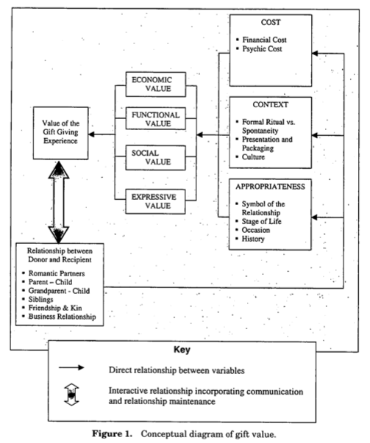

11.2 Questionnaire

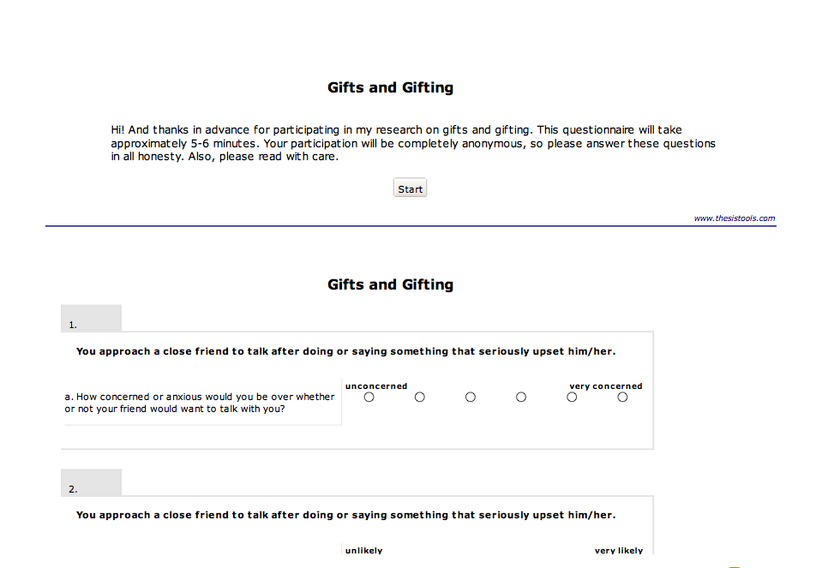

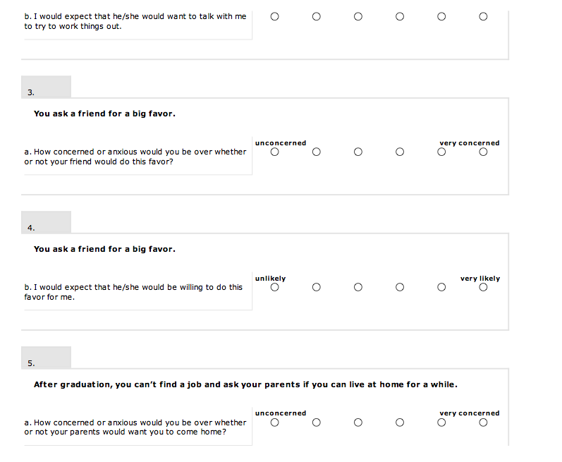

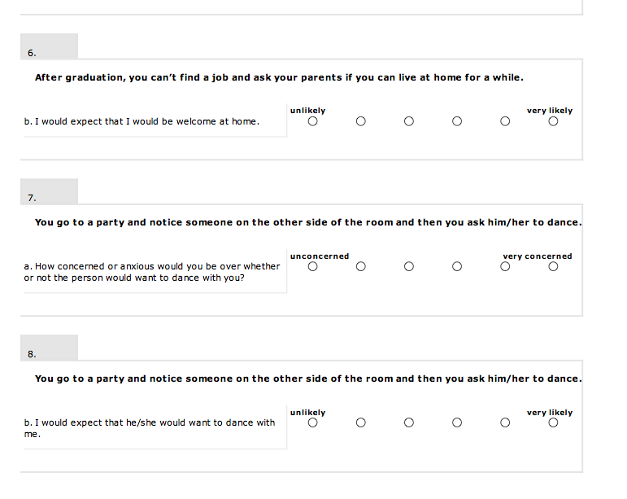

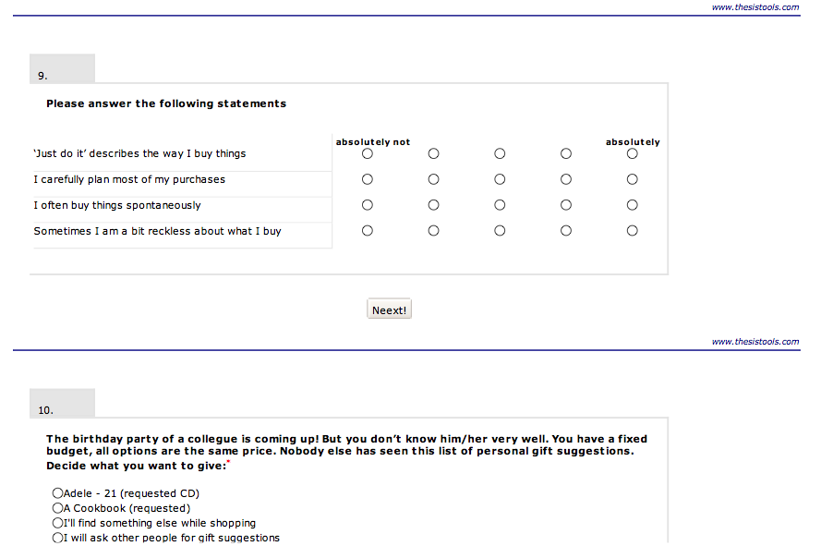

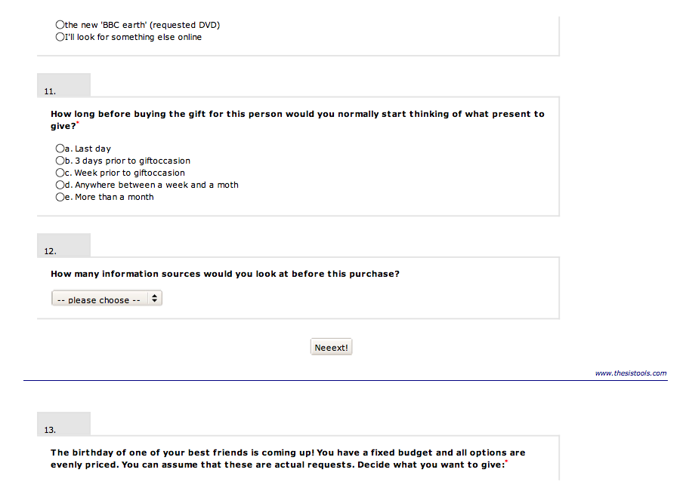

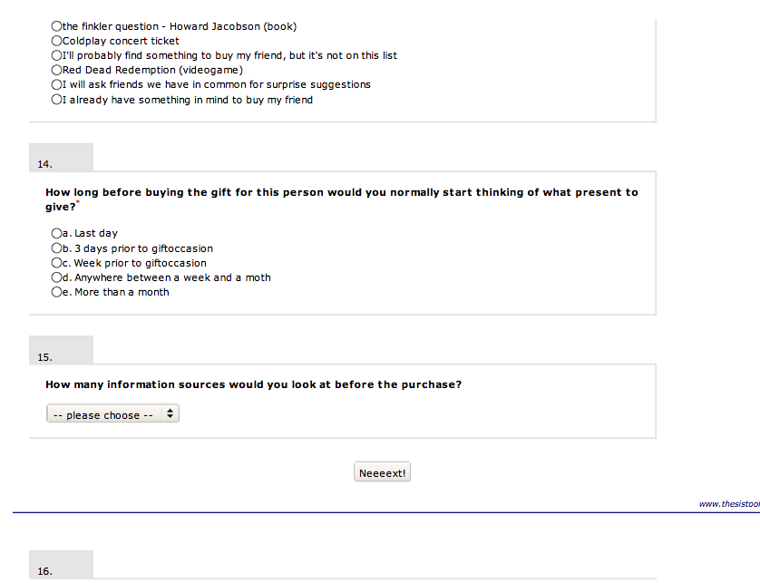

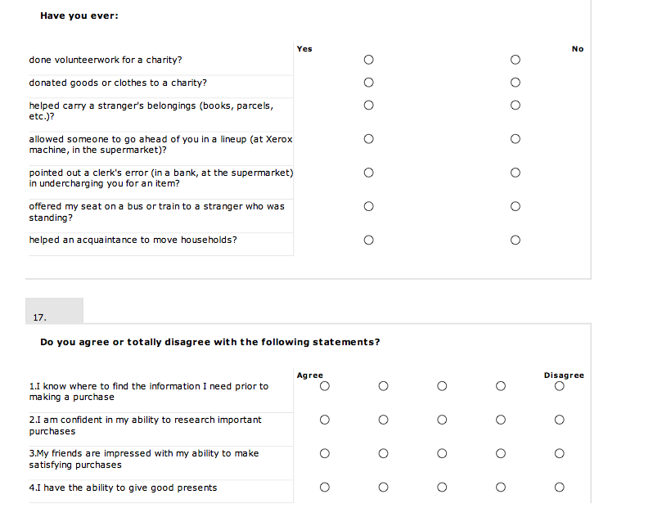

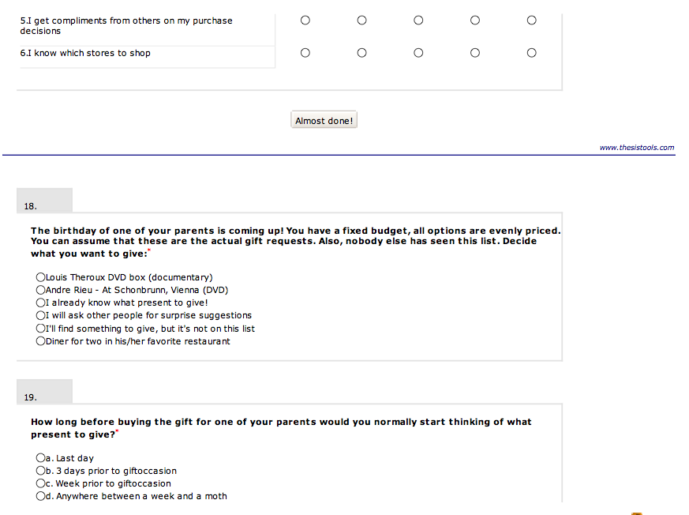

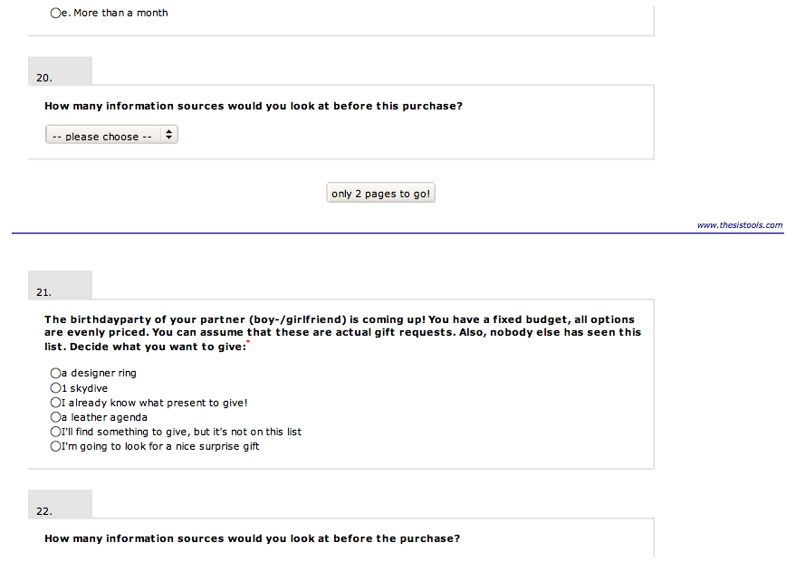

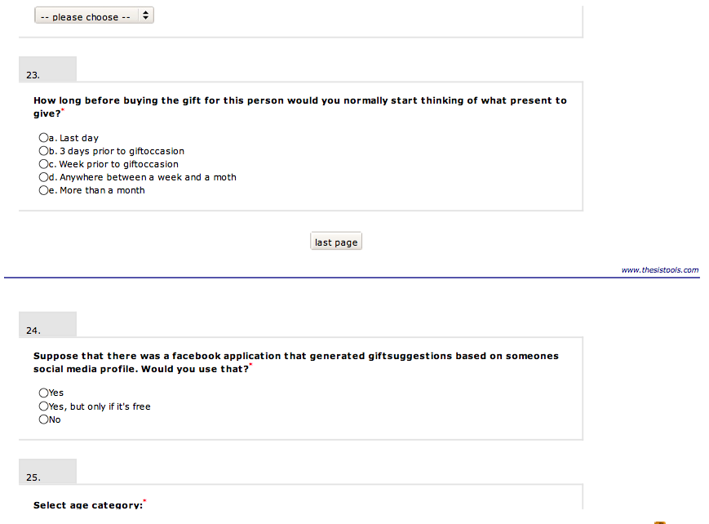

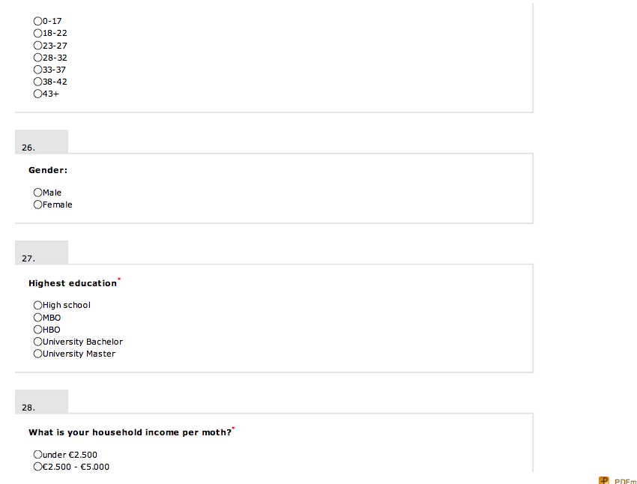

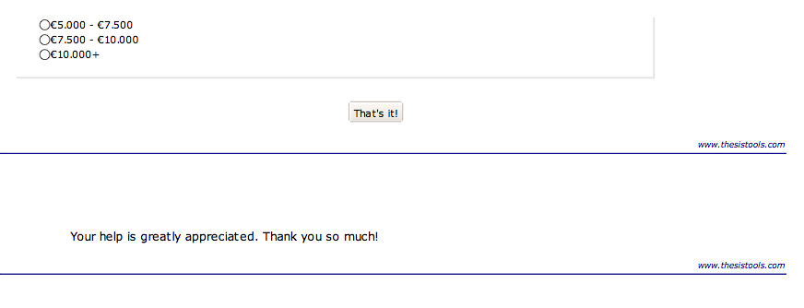

11.3 Database quality output

Frequencies

Statistics
 |  | resp_age | resp_gender | resp_edu | resp_income
N | Valid | 95 | 95 | 95 | 95
N | Missing | 12 | 12 | 12 | 12
Mean |  | 3.36 | 1.39 | 4.22 | 1.77
Std. Error of Mean |  | .134 | .052 | .110 | .112
Std. Deviation |  | 1.304 | .511 | 1.074 | 1.096
Variance |  | 1.700 | .262 | 1.153 | 1.201
Skewness |  | 1.745 | .216 | -1.509 | 1.763
Std. Error of Skewness |  | .247 | .247 | .247 | .247
Kurtosis |  | 2.761 | -1.392 | 1.962 | 2.681
Std. Error of Kurtosis |  | .490 | .490 | .490 | .490

Frequency Table

resp_age
 |  | Frequency | Percent | Valid Percent | Cumulative Percent
Valid | 18-22 | 18 | 16.8 | 18.9 | 18.9
Valid | 23-27 | 52 | 48.6 | 54.7 | 73.7
Valid | 28-32 | 14 | 13.1 | 14.7 | 88.4
Valid | 33-37 | 3 | 2.8 | 3.2 | 91.6
Valid | 43+ | 8 | 7.5 | 8.4 | 100.0
Valid | Total | 95 | 88.8 | 100.0
Missing | System | 12 | 11.2
Total |  | 107 | 100.0

resp_gender
 |  | Frequency | Percent | Valid Percent | Cumulative Percent
Valid | 0 | 1 | .9 | 1.1 | 1.1
Valid | male | 56 | 52.3 | 58.9 | 60.0
Valid | female | 38 | 35.5 | 40.0 | 100.0
Valid | Total | 95 | 88.8 | 100.0
Missing | System | 12 | 11.2
Total |  | 107 | 100.0

resp_edu
 |  | Frequency | Percent | Valid Percent | Cumulative Percent
Valid | High school | 5 | 4.7 | 5.3 | 5.3
Valid | HBO | 16 | 15.0 | 16.8 | 22.1
Valid | Bachelor | 22 | 20.6 | 23.2 | 45.3
Valid | Master | 52 | 48.6 | 54.7 | 100.0
Valid | Total | 95 | 88.8 | 100.0
Missing | System | 12 | 11.2
Total |  | 107 | 100.0
resp_income
 |  | Frequency | Percent | Valid Percent | Cumulative Percent
Valid | under 2500 | 50 | 46.7 | 52.6 | 52.6
Valid | 2500-5000 | 31 | 29.0 | 32.6 | 85.3
Valid | 5000-7500 | 6 | 5.6 | 6.3 | 91.6
Valid | 7500-10000 | 2 | 1.9 | 2.1 | 93.7
Valid | 10000+ | 6 | 5.6 | 6.3 | 100.0
Valid | Total | 95 | 88.8 | 100.0
Missing | System | 12 | 11.2
Total |  | 107 | 100.0

Rel_gift
 |  | Frequency | Percent | Valid Percent | Cumulative Percent
Valid | surprise | 230 | 58.1 | 58.1 | 58.1
Valid | request | 166 | 41.9 | 41.9 | 100.0
Valid | Total | 396 | 100.0 | 100.0

Rel_time
 |  | Frequency | Percent | Valid Percent | Cumulative Percent
Valid | 1 day | 3 | .8 | .8 | .8
Valid | 1-3 days | 61 | 15.4 | 15.6 | 16.3
Valid | 3-7 days | 97 | 24.5 | 24.7 | 41.1
Valid | week and a month | 92 | 23.2 | 23.5 | 64.5
Valid | month + | 109 | 27.5 | 27.8 | 92.3
Valid | 5 | 30 | 7.6 | 7.7 | 100.0
Valid | Total | 392 | 99.0 | 100.0
Missing | System | 4 | 1.0
Total |  | 396 | 100.0

Rel_source
 |  | Frequency | Percent | Valid Percent | Cumulative Percent
Valid | 1 | 92 | 23.2 | 23.7 | 23.7
Valid | 2 | 101 | 25.5 | 26.0 | 49.6
Valid | 3 | 104 | 26.3 | 26.7 | 76.3
Valid | 4 | 42 | 10.6 | 10.8 | 87.1
Valid | 5 | 18 | 4.5 | 4.6 | 91.8
Valid | 6 | 32 | 8.1 | 8.2 | 100.0
Valid | Total | 389 | 98.2 | 100.0
Missing | System | 7 | 1.8
Total |  | 396 | 100.0

11.4 Factor analysis output

GET
FILE='S:\thesis gifting1.7.sav'.
DATASET NAME DataSet3 WINDOW=FRONT.
DATASET ACTIVATE DataSet3.
DATASET CLOSE DataSet2.
FACTOR
/VARIABLES FOR1 FOR2 FOR3 FOR4 FOR5 FOR6 FOR7 FOR8
/MISSING LISTWISE
/ANALYSIS FOR1 FOR2 FOR3 FOR4 FOR5 FOR6 FOR7 FOR8
/PRINT INITIAL EXTRACTION ROTATION
/CRITERIA MINEIGEN(1) ITERATE(25)
/EXTRACTION PC
/CRITERIA ITERATE(25)
/ROTATION VARIMAX
/METHOD=CORRELATION.

Factor Analysis

Total Variance Explained
Component | Initial Eigenvalues |  |  | Extraction Sums of Squared Loadings |  |  | Rotation Sums of Squared Loadings
Component | Total | % of Variance | Cumulative % | Total | % of Variance | Cumulative % | Total | % of Variance | Cumulative %
1 | 2.458 | 30.731 | 30.731 | 2.458 | 30.731 | 30.731 | 2.199 | 27.482 | 27.482
2 | 1.537 | 19.218 | 49.949 | 1.537 | 19.218 | 49.949 | 1.797 | 22.468 | 49.949
3 | .944 | 11.795 | 61.744
4 | .886 | 11.078 | 72.822
5 | .790 | 9.879 | 82.701
6 | .597 | 7.466 | 90.167
7 | .434 | 5.422 | 95.590
8 | .353 | 4.410 | 100.000
Extraction Method: Principal Component Analysis.

Rotated Component Matrixª
 | Component
 | 1 | 2
FOR_1 | .511 | .116
FOR_2 | .257 | .725
FOR_3 | .785 | -.148
FOR_4 | -.297 | .612
FOR_5 | .748 | .083
FOR_6 | -.501 | .449
FOR_7 | .597 | -.295
FOR_8 | -.031 | .753
Extraction Method: Principal Component Analysis.
Rotation Method: Varimax with Kaiser Normalization.
a. Rotation converged in 3 iterations.

FACTOR
/VARIABLES buy_imp1 buy_imp2 buy_imp3 buy_imp4
/MISSING LISTWISE
/ANALYSIS buy_imp1 buy_imp2 buy_imp3 buy_imp4
/PRINT INITIAL EXTRACTION ROTATION
/CRITERIA MINEIGEN(1) ITERATE(25)
/EXTRACTION PC
/CRITERIA ITERATE(25)
/ROTATION VARIMAX
/METHOD=CORRELATION.

Factor Analysis

Total Variance Explained
Component | Initial Eigenvalues |  |  | Extraction Sums of Squared Loadings
Component | Total | % of Variance | Cumulative % | Total | % of Variance | Cumulative %
1 | 2.088 | 52.189 | 52.189 | 2.088 | 52.189 | 52.189
2 | .888 | 22.200 | 74.389
3 | .628 | 15.694 | 90.083
4 | .397 | 9.917 | 100.000
Extraction Method: Principal Component Analysis.

Component Matrixª
 | Component
 | 1
buy_imp1 | .752
buy_imp2 | .442
buy_imp3 | .852
buy_imp4 | .774
Extraction Method: Principal Component Analysis.
a. 1 components extracted.

FACTOR
/VARIABLES alt1 alt2 alt3 alt4 alt5 alt6 alt7
/MISSING LISTWISE
/ANALYSIS alt1 alt2 alt3 alt4 alt5 alt6 alt7
/PRINT INITIAL EXTRACTION ROTATION
/CRITERIA MINEIGEN(1) ITERATE(25)
/EXTRACTION PC
/CRITERIA ITERATE(25)
/ROTATION VARIMAX
/METHOD=CORRELATION.

Factor Analysis

[DataSet3] S:\thesis gifting1.7.sav

Total Variance Explained
Component | Initial Eigenvalues |  |  | Extraction Sums of Squared Loadings |  |  | Rotation Sums of Squared Loadings
Component | Total | % of Variance | Cumulative % | Total | % of Variance | Cumulative % | Total | % of Variance | Cumulative %
1 | 1.410 | 20.145 | 20.145 | 1.410 | 20.145 | 20.145 | 1.354 | 19.343 | 19.343
2 | 1.220 | 17.427 | 37.572 | 1.220 | 17.427 | 37.572 | 1.183 | 16.906 | 36.248
3 | 1.064 | 15.200 | 52.772 | 1.064 | 15.200 | 52.772 | 1.157 | 16.524 | 52.772
4 | .997 | 14.247 | 67.020
5 | .912 | 13.034 | 80.054
6 | .797 | 11.382 | 91.436
7 | .599 | 8.564 | 100.000
Extraction Method: Principal Component Analysis.

Rotated Component Matrixª
 | Component
 | 1 | 2 | 3
alt_1 | -.254 | -.335 | .467
alt_2 | .064 | -.142 | .616
alt_3 | .776 | -.087 | .213
alt_4 | .064 | .754 | .073
alt_5 | .027 | .326 | .664
alt_6 | .779 | -.019 | -.216
alt_7 | -.268 | .607 | -.145
Extraction Method: Principal Component Analysis.
Rotation Method: Varimax with Kaiser Normalization.
a. Rotation converged in 5 iterations.

FACTOR
/VARIABLES cons_self1 cons_self2 cons_self3 cons_self4 cons_self5 cons_self6
/MISSING LISTWISE
/ANALYSIS cons_self1 cons_self2 cons_self3 cons_self4 cons_self5 cons_self6
/PRINT INITIAL EXTRACTION ROTATION
/CRITERIA MINEIGEN(1) ITERATE(25)
/EXTRACTION PC
/CRITERIA ITERATE(25)
/ROTATION VARIMAX
/METHOD=CORRELATION.

Factor Analysis

Total Variance Explained
Component | Initial Eigenvalues |  |  | Extraction Sums of Squared Loadings |  |  | Rotation Sums of Squared Loadings
Component | Total | % of Variance | Cumulative % | Total | % of Variance | Cumulative % | Total | % of Variance | Cumulative %
1 | 3.107 | 51.783 | 51.783 | 3.107 | 51.783 | 51.783 | 2.417 | 40.282 | 40.282
2 | 1.022 | 17.036 | 68.819 | 1.022 | 17.036 | 68.819 | 1.712 | 28.537 | 68.819
3 | .613 | 10.218 | 79.037
4 | .541 | 9.009 | 88.047
5 | .395 | 6.579 | 94.625
6 | .322 | 5.375 | 100.000
Extraction Method: Principal Component Analysis.

Rotated Component Matrixª
 | Component
 | 1 | 2
cons_self1 | .134 | .893
cons_self2 | .298 | .837
cons_self3 | .722 | .258
cons_self4 | .752 | .336
cons_self5 | .857 | .061
cons_self6 | .699 | .173
Extraction Method: Principal Component Analysis.
Rotation Method: Varimax with Kaiser Normalization.
a. Rotation converged in 3 iterations.

11.5 Reliability analysis personal traits

Fear of rejection

[DataSet1] S:\thesis gifting1.7.sav

Scale: ALL VARIABLES

Reliability Statistics
Cronbach's Alpha | N of Items
.315 | 8
Reliability Statistics
Cronbach's Alpha | N of Items
.549 | 4
Reliability Statistics
Cronbach's Alpha | N of Items
.602 | 4

Buying impulsiveness

Reliability Statistics
Cronbach's Alpha | N of Items
.692 | 4

Altruism

Reliability Statistics
Cronbach's Alpha | N of Items
.011 | 7
Reliability Statistics
Cronbach's Alpha | N of Items
.392 | 2

Reliability Statistics
Cronbach's Alpha | N of Items
.214 | 2
Reliability Statistics
Cronbach's Alpha | N of Items
.152 | 3

Consumer Self Confiddence
Reliability Statistics
Cronbach's Alpha | N of Items
.753 | 2

Reliability Statistics
Cronbach's Alpha | N of Items
.810 | 6
Reliability Statistics
Cronbach's Alpha | N of Items
.793 | 4

11.6 Regression models output

LOGISTIC REGRESSION VARIABLES Rel_gift
/METHOD=ENTER Rel_type
/CRITERIA=PIN(.05) POUT(.10) ITERATE(20) CUT(.5).

Block 1: Method = Enter
Omnibus Tests of Model Coefficients
 |  | Chi-square | df | Sig.
Step 1 | Step | 53.900 | 1 | .000
Step 1 | Block | 53.900 | 1 | .000
Step 1 | Model | 53.900 | 1 | .000

Model Summary
Step | -2 Log likelihood | Cox & Snell R Square | Nagelkerke R Square
1 | 484.683ª | .127 | .171
a. Estimation terminated at iteration number 4 because parameter estimates changed by less than .001.

Classification Tableª
 | Observed |  | Predicted
 |  |  | Rel_gift |  | Percentage Correct
 |  |  | surprise | request | Percentage Correct
Step 1 | Rel_gift | surprise | 202 | 28 | 87.8
Step 1 | Rel_gift | request | 95 | 71 | 42.8
Step 1 | Overall Percentage |  |  |  | 68.9
a. The cut value is .500

Variables in the Equation
 |  | B | S.E. | Wald | df | Sig. | Exp(B)
Step 1ª | Rel_type | -.712 | .103 | 47.583 | 1 | .000 | .491
Step 1ª | Constant | 1.403 | .267 | 27.602 | 1 | .000 | 4.067
a. Variable(s) entered on step 1: Rel_type.

LOGISTIC REGRESSION VARIABLES Rel_gift
/METHOD=ENTER Rel_type Buy_imp_Score FOR_total_Score CSC_total_Score ALT_score
/CRITERIA=PIN(.05) POUT(.10) ITERATE(20) CUT(.5).

Block 1: Method = Enter
Omnibus Tests of Model Coefficients
 |  | Chi-square | df | Sig.
Step 1 | Step | 58.604 | 5 | .000
Step 1 | Block | 58.604 | 5 | .000
Step 1 | Model | 58.604 | 5 | .000

Model Summary
Step | -2 Log likelihood | Cox & Snell R Square | Nagelkerke R Square
1 | 441.726ª | .147 | .198
a. Estimation terminated at iteration number 4 because parameter estimates changed by less than .001.

Classification Tableª
 | Observed |  | Predicted
 |  |  | Rel_gift |  | Percentage Correct
 |  |  | surprise | request | Percentage Correct
Step 1 | Rel_gift | surprise | 159 | 55 | 74.3
Step 1 | Rel_gift | request | 69 | 85 | 55.2
Step 1 | Overall Percentage |  |  |  | 66.3
a. The cut value is .500

Variables in the Equation
 |  | B | S.E. | Wald | df | Sig. | Exp(B)
Step 1ª | Rel_type | -.752 | .109 | 47.462 | 1 | .000 | .471
Step 1ª | Buy_imp_Score | .193 | .168 | 1.324 | 1 | .250 | 1.213
Step 1ª | FOR_total_Score | -.016 | .009 | 2.909 | 1 | .088 | .984
Step 1ª | CSC_total_Score | .042 | .033 | 1.603 | 1 | .206 | 1.042
Step 1ª | ALT_score | -.005 | .120 | .002 | 1 | .965 | .995
Step 1ª | Constant | .981 | 1.218 | .649 | 1 | .420 | 2.668
a. Variable(s) entered on step 1: Rel_type, Buy_imp_Score, FOR_total_Score, CSC_total_Score, ALT_score.

LOGISTIC REGRESSION VARIABLES Rel_gift
/METHOD=ENTER Rel_type FOR_rej_concern FOR_acc_anxiety CSC_desc_mak_score CSC_info_acq_score ALT_stranger_help_score ALT_public_fav_score ALT_selfl_act_score
/CRITERIA=PIN(.05) POUT(.10) ITERATE(20) CUT(.5).

Block 1: Method = Enter
Omnibus Tests of Model Coefficients
 |  | Chi-square | df | Sig.
Step 1 | Step | 58.023 | 8 | .000
Step 1 | Block | 58.023 | 8 | .000
Step 1 | Model | 58.023 | 8 | .000

Model Summary
Step | -2 Log likelihood | Cox & Snell R Square | Nagelkerke R Square
1 | 452.277ª | .143 | .193
a. Estimation terminated at iteration number 4 because parameter estimates changed by less than .001.

Classification Tableª
 | Observed |  | Predicted
 |  |  | Rel_gift |  | Percentage Correct
 |  |  | surprise | request | Percentage Correct
Step 1 | Rel_gift | surprise | 170 | 50 | 77.3
Step 1 | Rel_gift | request | 68 | 88 | 56.4
Step 1 | Overall Percentage |  |  |  | 68.6
a. The cut value is .500

Variables in the Equation
 |  | B | S.E. | Wald | df | Sig. | Exp(B)
Step 1ª | Rel_type | -.736 | .108 | 46.786 | 1 | .000 | .479
Step 1ª | FOR_rej_concern | -.165 | .139 | 1.411 | 1 | .235 | .848
Step 1ª | FOR_acc_anxiety | .259 | .186 | 1.934 | 1 | .164 | 1.295
Step 1ª | CSC_desc_mak_score | .265 | .192 | 1.897 | 1 | .168 | 1.303
Step 1ª | CSC_info_acq_score | .023 | .156 | .021 | 1 | .884 | 1.023
Step 1ª | ALT_stranger_help_score | .106 | .245 | .189 | 1 | .664 | 1.112
Step 1ª | ALT_public_fav_score | -.003 | .253 | .000 | 1 | .989 | .997
Step 1ª | ALT_selfl_act_score | -.070 | .153 | .212 | 1 | .645 | .932
Step 1ª | Constant | .142 | 1.570 | .008 | 1 | .928 | 1.153
a. Variable(s) entered on step 1: Rel_type, FOR_rej_concern, FOR_acc_anxiety, CSC_desc_mak_score, CSC_info_acq_score, ALT_stranger_help_score, ALT_public_fav_score, ALT_selfl_act_score.

LOGISTIC REGRESSION VARIABLES Rel_gift
/METHOD=ENTER Rel_type FOR_rej_concern FOR_acc_anxiety CSC_desc_mak_score CSC_info_acq_score ALT_stranger_help_score ALT_public_fav_score ALT_selfl_act_score resp_age gender edu income
/CRITERIA=PIN(.05) POUT(.10) ITERATE(20) CUT(.5).

Block 1: Method = Enter
Omnibus Tests of Model Coefficients
 |  | Chi-square | df | Sig.
Step 1 | Step | 63.943 | 12 | .000
Step 1 | Block | 63.943 | 12 | .000
Step 1 | Model | 63.943 | 12 | .000

Model Summary
Step | -2 Log likelihood | Cox & Snell R Square | Nagelkerke R Square
1 | 431.387ª | .161 | .217
a. Estimation terminated at iteration number 4 because parameter estimates changed by less than .001.

Classification Tableª
 | Observed |  | Predicted
 |  |  | Rel_gift |  | Percentage Correct
 |  |  | surprise | request | Percentage Correct
Step 1 | Rel_gift | surprise | 163 | 48 | 77.3
Step 1 | Rel_gift | request | 65 | 88 | 57.5
Step 1 | Overall Percentage |  |  |  | 69.0
a. The cut value is .500

Variables in the Equation
 |  | B | S.E. | Wald | df | Sig. | Exp(B)
Step 1ª | Rel_type | -.750 | .111 | 45.734 | 1 | .000 | .473
Step 1ª | FOR_rej_concern | -.090 | .151 | .351 | 1 | .553 | .914
Step 1ª | FOR_acc_anxiety | .312 | .221 | 1.999 | 1 | .157 | 1.367
Step 1ª | CSC_desc_mak_score | .321 | .200 | 2.573 | 1 | .109 | 1.379
Step 1ª | CSC_info_acq_score | .122 | .164 | .555 | 1 | .456 | 1.130
Step 1ª | ALT_stranger_help_score | .093 | .256 | .132 | 1 | .716 | 1.098
Step 1ª | ALT_public_fav_score | -.106 | .263 | .164 | 1 | .685 | .899
Step 1ª | ALT_selfl_act_score | -.136 | .161 | .718 | 1 | .397 | .873
Step 1ª | resp_age | -.211 | .126 | 2.829 | 1 | .093 | .809
Step 1ª | gender | .404 | .251 | 2.592 | 1 | .107 | 1.497
Step 1ª | edu | .077 | .122 | .394 | 1 | .530 | 1.080
Step 1ª | income | -.079 | .143 | .307 | 1 | .580 | .924
Step 1ª | Constant | -.179 | 1.910 | .009 | 1 | .925 | .836
a. Variable(s) entered on step 1: Rel_type, FOR_rej_concern, FOR_acc_anxiety, CSC_desc_mak_score, CSC_info_acq_score, ALT_stranger_help_score, ALT_public_fav_score, ALT_selfl_act_score, resp_age, gender, edu, income.

LOGISTIC REGRESSION VARIABLES Rel_gift
/METHOD=ENTER Rel_type resp_age gender edu income Buy_imp_Score FOR_total_Score CSC_total_Score ALT_score
/CRITERIA=PIN(.05) POUT(.10) ITERATE(20) CUT(.5).

Block 1: Method = Enter
Omnibus Tests of Model Coefficients
 |  | Chi-square | df | Sig.
Step 1 | Step | 64.357 | 9 | .000
Step 1 | Block | 64.357 | 9 | .000
Step 1 | Model | 64.357 | 9 | .000

Model Summary
Step | -2 Log likelihood | Cox & Snell R Square | Nagelkerke R Square
1 | 420.941ª | .165 | .222
a. Estimation terminated at iteration number 4 because parameter estimates changed by less than .001.

Classification Tableª
 | Observed |  | Predicted
 |  |  | Rel_gift |  | Percentage Correct
 |  |  | surprise | request | Percentage Correct
Step 1 | Rel_gift | surprise | 161 | 44 | 78.5
Step 1 | Rel_gift | request | 65 | 86 | 57.0
Step 1 | Overall Percentage |  |  |  | 69.4
a. The cut value is .500

Variables in the Equation
 |  | B | S.E. | Wald | df | Sig. | Exp(B)
Step 1ª | Rel_type | -.766 | .112 | 46.406 | 1 | .000 | .465
Step 1ª | resp_age | -.196 | .127 | 2.391 | 1 | .122 | .822
Step 1ª | gender | .419 | .248 | 2.853 | 1 | .091 | 1.520
Step 1ª | edu | .093 | .122 | .571 | 1 | .450 | 1.097
Step 1ª | income | -.069 | .142 | .238 | 1 | .626 | .933
Step 1ª | Buy_imp_Score | .182 | .182 | 1.006 | 1 | .316 | 1.200
Step 1ª | FOR_total_Score | -.013 | .010 | 1.958 | 1 | .162 | .987
Step 1ª | CSC_total_Score | .066 | .035 | 3.574 | 1 | .059 | 1.069
Step 1ª | ALT_score | -.075 | .127 | .351 | 1 | .554 | .928
Step 1ª | Constant | 1.004 | 1.495 | .451 | 1 | .502 | 2.728
a. Variable(s) entered on step 1: Rel_type, resp_age, gender, edu, income, Buy_imp_Score, FOR_total_Score, CSC_total_Score, ALT_score.

RECODE Rel_type (1=0) (2=0) (3=0) (4=1) INTO rel_dummy.
VARIABLE LABELS rel_dummy 'rel_dummy'.
EXECUTE.
LOGISTIC REGRESSION VARIABLES Rel_gift
/METHOD=ENTER Buy_imp_Score FOR_total_Score CSC_total_Score ALT_score Rel_type rel_dummy resp_age gender edu income
/CRITERIA=PIN(.05) POUT(.10) ITERATE(20) CUT(.5).

Block 1: Method = Enter
Omnibus Tests of Model Coefficients
 |  | Chi-square | df | Sig.
Step 1 | Step | 66.030 | 13 | .000
Step 1 | Block | 66.030 | 13 | .000
Step 1 | Model | 66.030 | 13 | .000

Model Summary
Step | -2 Log likelihood | Cox & Snell R Square | Nagelkerke R Square
1 | 419.268ª | .169 | .227
a. Estimation terminated at iteration number 4 because parameter estimates changed by less than .001.

Classification Tableª
 | Observed |  | Predicted
 |  |  | Rel_gift |  | Percentage Correct
 |  |  | surprise | request | Percentage Correct
Step 1 | Rel_gift | surprise | 162 | 43 | 79.0
Step 1 | Rel_gift | request | 62 | 89 | 58.9
Step 1 | Overall Percentage |  |  |  | 70.5
a. The cut value is .500

Variables in the Equation
 |  | B | S.E. | Wald | df | Sig. | Exp(B)
Step 1ª | resp_age | -.193 | .128 | 2.269 | 1 | .132 | .824
Step 1ª | gender | .399 | .258 | 2.395 | 1 | .122 | 1.490
Step 1ª | edu | .083 | .124 | .452 | 1 | .501 | 1.087
Step 1ª | income | -.090 | .144 | .392 | 1 | .531 | .914
Step 1ª | Buy_imp_Score | .172 | .183 | .877 | 1 | .349 | 1.187
Step 1ª | FOR_rej_concern | -.109 | .153 | .512 | 1 | .474 | .896
Step 1ª | FOR_acc_anxiety | .318 | .223 | 2.042 | 1 | .153 | 1.375
Step 1ª | CSC_desc_mak_score | .285 | .206 | 1.906 | 1 | .167 | 1.330
Step 1ª | CSC_info_acq_score | .123 | .166 | .550 | 1 | .458 | 1.131
Step 1ª | ALT_stranger_help_score | .095 | .257 | .136 | 1 | .712 | 1.099
Step 1ª | ALT_public_fav_score | -.121 | .267 | .204 | 1 | .652 | .886
Step 1ª | ALT_selfl_act_score | -.104 | .164 | .402 | 1 | .526 | .901
Step 1ª | Rel_type | -.770 | .113 | 46.542 | 1 | .000 | .463
Step 1ª | Constant | -.627 | 2.015 | .097 | 1 | .756 | .534
a. Variable(s) entered on step 1: resp_age, gender, edu, income, Buy_imp_Score, FOR_rej_concern, FOR_acc_anxiety, CSC_desc_mak_score, CSC_info_acq_score, ALT_stranger_help_score, ALT_public_fav_score, ALT_selfl_act_score, Rel_type.

Block 1: Method = Enter
Omnibus Tests of Model Coefficients
 |  | Chi-square | df | Sig.
Step 1 | Step | 69.221 | 11 | .000
Step 1 | Block | 69.221 | 11 | .000
Step 1 | Model | 69.221 | 11 | .000

Model Summary
Step | -2 Log likelihood | Cox & Snell R Square | Nagelkerke R Square
1 | 416.077ª | .177 | .237
a. Estimation terminated at iteration number 4 because parameter estimates changed by less than .001.

Classification Tableª
 | Observed |  | Predicted
 |  |  | Rel_gift |  | Percentage Correct
 |  |  | surprise | request | Percentage Correct
Step 1 | Rel_gift | surprise | 169 | 36 | 82.4
Step 1 | Rel_gift | request | 70 | 81 | 53.6
Step 1 | Overall Percentage |  |  |  | 70.2
a. The cut value is .500

Variables in the Equation
 |  | B | S.E. | Wald | df | Sig. | Exp(B)
Step 1ª | FOR_total_Score | -.014 | .010 | 1.991 | 1 | .158 | .987
Step 1ª | CSC_total_Score | .067 | .035 | 3.631 | 1 | .057 | 1.070
Step 1ª | Buy_imp_Score | .186 | .183 | 1.025 | 1 | .311 | 1.204
Step 1ª | ALT_score | -.076 | .128 | .356 | 1 | .550 | .927
Step 1ª | resp_age | -.200 | .128 | 2.442 | 1 | .118 | .819
Step 1ª | income | -.070 | .143 | .239 | 1 | .625 | .932
Step 1ª | edu | .094 | .123 | .584 | 1 | .445 | 1.099
Step 1ª | gender | .425 | .250 | 2.896 | 1 | .089 | 1.529
Step 1ª | rel_dummy_rom | -2.552 | .372 | 46.989 | 1 | .000 | .078
Step 1ª | rel_dummy_par | -1.483 | .330 | 20.243 | 1 | .000 | .227
Step 1ª | rel_dummy_fri | -1.337 | .327 | 16.677 | 1 | .000 | .263
Step 1ª | Constant | .432 | 1.499 | .083 | 1 | .773 | 1.540
a. Variable(s) entered on step 1: FOR_total_Score, CSC_total_Score, Buy_imp_Score, ALT_score, resp_age, income, edu, gender, rel_dummy_rom, rel_dummy_par, rel_dummy_fri.

11.7 Collinearity diagnostics

Coefficientsª
Model |  | Unstandardized Coefficients |  | Standardized Coefficients | t | Sig. | Collinearity Statistics
 |  | B | Std. Error | Beta | t | Sig. | Tolerance | VIF
1 | (Constant) | .400 | .415 |  | .965 | .335
1 | resp_age | -.036 | .025 | -.094 | -1.449 | .148 | .576 | 1.737
1 | resp_gender | .081 | .053 | .081 | 1.529 | .127 | .871 | 1.149
1 | resp_edu | .016 | .025 | .031 | .614 | .540 | .970 | 1.031
1 | resp_income | -.019 | .029 | -.040 | -.640 | .523 | .615 | 1.627
1 | buy_imp_score | .033 | .037 | .045 | .869 | .385 | .913 | 1.095
1 | FOR_rej_concern | -.021 | .031 | -.039 | -.685 | .494 | .757 | 1.320
1 | FOR_acc_anxiety | .064 | .046 | .080 | 1.401 | .162 | .741 | 1.349
1 | CSC_desc_mak_score | .060 | .042 | .085 | 1.412 | .159 | .673 | 1.486
1 | CSC_info_acq_score | .024 | .034 | .043 | .702 | .483 | .636 | 1.573
1 | ALT_stranger_help_score | .018 | .053 | .018 | .347 | .729 | .855 | 1.170
1 | ALT_public_fav_score | -.024 | .055 | -.023 | -.434 | .664 | .878 | 1.139
1 | ALT_selfl_act_score | -.022 | .034 | -.034 | -.650 | .516 | .870 | 1.150
1 | Rel_type | -.165 | .022 | -.374 | -7.597 | .000 | 1.000 | 1.000
a. Dependent Variable: Rel_gift

Coefficientsª
Model |  | Unstandardized Coefficients |  | Standardized Coefficients | t | Sig. | Collinearity Statistics
 |  | B | Std. Error | Beta | t | Sig. | Tolerance | VIF
1 | (Constant) | .610 | .302 |  | 2.018 | .044
1 | resp_age | -.037 | .025 | -.096 | -1.504 | .134 | .587 | 1.702
1 | resp_gender | .085 | .051 | .085 | 1.681 | .094 | .937 | 1.067
1 | resp_edu | .018 | .025 | .035 | .706 | .481 | .985 | 1.015
1 | resp_income | -.014 | .028 | -.031 | -.504 | .615 | .638 | 1.567
1 | buy_imp_score | .035 | .037 | .049 | .957 | .339 | .925 | 1.081
1 | FOR_total_score | -.003 | .002 | -.077 | -1.364 | .174 | .756 | 1.323
1 | CSC_total_score | .014 | .007 | .109 | 1.889 | .060 | .709 | 1.410
1 | ALT_score | -.016 | .026 | -.030 | -.601 | .548 | .942 | 1.061
1 | rel_dummy | -.539 | .068 | -.473 | -7.908 | .000 | .667 | 1.500
1 | rel_dummy_par | -.337 | .068 | -.295 | -4.943 | .000 | .667 | 1.500
1 | rel_dummy_fri | -.303 | .068 | -.266 | -4.448 | .000 | .667 | 1.500
a. Dependent Variable: Rel_gift

11.8 Correlations matrix

Correlations
 |  | resp_age | resp_gender | resp_edu | resp_income | fb_app | Rel_gift | Rel_time | Rel_source | buy_imp_score | FOR_total_score | CSC_total_score | ALT_score
resp_age | P’s Corr. | 1 | .038 | -.042 | .624** | .160** | -.051 | .083 | .008 | -.171** | .275** | .197** | -.171**
resp_age | Sig. (2-t) |  | .468 | .415 | .000 | .002 | .326 | .105 | .872 | .001 | .000 | .000 | .001
resp_age | N | 380 | 376 | 380 | 380 | 380 | 380 | 380 | 379 | 372 | 368 | 380 | 380
resp_gender | P’s Corr. | .038 | 1 | .002 | -.010 | .024 | .038 | .278** | .102* | .148** | .036 | -.089 | -.029
resp_gender | Sig. (2-t) | .468 |  | .967 | .845 | .636 | .458 | .000 | .049 | .004 | .493 | .085 | .573
resp_gender | N | 376 | 376 | 376 | 376 | 376 | 376 | 376 | 375 | 368 | 364 | 376 | 376
resp_edu | P’s Corr. | -.042 | .002 | 1 | -.037 | .000 | .010 | -.149** | -.081 | .026 | -.062 | -.035 | .075
resp_edu | Sig. (2-t) | .415 | .967 |  | .467 | .995 | .849 | .004 | .116 | .618 | .239 | .494 | .144
resp_edu | N | 380 | 376 | 380 | 380 | 380 | 380 | 380 | 379 | 372 | 368 | 380 | 380
resp_income | P’s Corr. | .624** | -.010 | -.037 | 1 | -.073 | -.011 | -.014 | .186** | -.092 | .153** | .183** | -.102*
resp_income | Sig. (2-t) | .000 | .845 | .467 |  | .154 | .831 | .781 | .000 | .076 | .003 | .000 | .047
resp_income | N | 380 | 376 | 380 | 380 | 380 | 380 | 380 | 379 | 372 | 368 | 380 | 380
fb_app | P’s Corr. | .160** | .024 | .000 | -.073 | 1 | .035 | .168** | .000 | -.024 | -.004 | -.104* | .120*
fb_app | Sig. (2-t) | .002 | .636 | .995 | .154 |  | .484 | .001 | .995 | .631 | .942 | .040 | .018
fb_app | N | 380 | 376 | 380 | 380 | 396 | 396 | 392 | 389 | 388 | 384 | 388 | 388
Rel_gift | P’s Corr. | -.051 | .038 | .010 | -.011 | .035 | 1 | -.139** | -.145** | .025 | -.038 | .024 | -.003
Rel_gift | Sig. (2-t) | .326 | .458 | .849 | .831 | .484 |  | .006 | .004 | .620 | .457 | .637 | .956
Rel_gift | N | 380 | 376 | 380 | 380 | 396 | 396 | 392 | 389 | 388 | 384 | 388 | 388
Rel_time | P’s Corr. | .083 | .278** | -.149** | -.014 | .168** | -.139** | 1 | .338** | .042 | .072 | -.083 | -.091
Rel_time | Sig. (2-t) | .105 | .000 | .004 | .781 | .001 | .006 |  | .000 | .408 | .164 | .103 | .073
Rel_time | N | 380 | 376 | 380 | 380 | 392 | 392 | 392 | 389 | 384 | 380 | 388 | 388
Rel_source | P’s Corr. | .008 | .102* | -.081 | .186** | .000 | -.145** | .338** | 1 | -.036 | .112* | .042 | -.085
Rel_source | Sig. (2-t) | .872 | .049 | .116 | .000 | .995 | .004 | .000 |  | .483 | .030 | .408 | .094
Rel_source | N | 379 | 375 | 379 | 379 | 389 | 389 | 389 | 389 | 381 | 377 | 387 | 387
buy_imp_score | P’s Corr. | -.171** | .148** | .026 | -.092 | -.024 | .025 | .042 | -.036 | 1 | .014 | .107* | -.070
buy_imp_score | Sig. (2-t) | .001 | .004 | .618 | .076 | .631 | .620 | .408 | .483 |  | .792 | .038 | .174
buy_imp_score | N | 372 | 368 | 372 | 372 | 388 | 388 | 384 | 381 | 388 | 376 | 380 | 380
FOR_total_score | P’s Corr. | .275** | .036 | -.062 | .153** | -.004 | -.038 | .072 | .112* | .014 | 1 | .457** | -.047
FOR_total_score | Sig. (2-t) | .000 | .493 | .239 | .003 | .942 | .457 | .164 | .030 | .792 |  | .000 | .363
FOR_total_score | N | 368 | 364 | 368 | 368 | 384 | 384 | 380 | 377 | 376 | 384 | 376 | 376
CSC_total_score | P’s Corr. | .197** | -.089 | -.035 | .183** | -.104* | .024 | -.083 | .042 | .107* | .457** | 1 | .083
CSC_total_score | Sig. (2-t) | .000 | .085 | .494 | .000 | .040 | .637 | .103 | .408 | .038 | .000 |  | .102
CSC_total_score | N | 380 | 376 | 380 | 380 | 388 | 388 | 388 | 387 | 380 | 376 | 388 | 388
ALT_score | P’s Corr. | -.171** | -.029 | .075 | -.102* | .120* | -.003 | -.091 | -.085 | -.070 | -.047 | .083 | 1
ALT_score | Sig. (2-t) | .001 | .573 | .144 | .047 | .018 | .956 | .073 | .094 | .174 | .363 | .102
ALT_score | N | 380 | 376 | 380 | 380 | 388 | 388 | 388 | 387 | 380 | 376 | 388 | 388
**. Correlation is significant at the 0.01 level (2-tailed).
*. Correlation is significant at the 0.05 level (2-tailed).

¹ http://statline.cbs.nl/StatWeb/publication/?VW=T&DM=SLNL&PA=37312&D1=a&D2=a,!1-4,!6-7&HD=111011-1500&HDR=G1&STB=T
Results from prior research and this study varied less than 5% from this estimation.

