What Makes a Theory Influential?
A Study on the Takeoff of Behavioral Economics Theories within the Marketing Literature

Master thesis
to obtain the degree of MASTER OF SCIENCE in Business and Economics, Marketing from the Erasmus University Rotterdam



Author: Steef Viergever
348922
Supervisor: Drs. N.M.A Camacho

Abstract
This research focuses on the diffusion of 53 behavioral economics theories within the marketing literature, and the influence of some article quality characteristics and interdisciplinary differences on this diffusion process. This diffusion is measured with the use of a citation analysis, which is a common tool to investigate the dissemination of knowledge over some area or between disciplines. Two models are produced, the first one with takeoff as dependent variable, and the second one with total number of citations within the marketing literature. Takeoff of a theory means that the impact of the focal article can be considered large within the marketing field, meaning that the theory found widespread applications in marketing. In other words, the takeoff of a theory marks the point where the theory – given its citation pattern – crosses a threshold that allows us to call it an influential theory in marketing. The marketing literature is in this research defined as the academic journals Journal of Consumer Research, Journal of Marketing, Journal of Marketing Research, and Marketing Science. Article quality characteristics is defined as a multi-dimensional construct with three dimensions, namely (i) length, (ii) number of references and (iii) the number of citations the original article introducing the focal theory under analysis has received in the corresponding mother-discipline. Because the field of behavioral economics ‘overlaps’ multiple disciplines, it is assumed that there exist interdisciplinary differences within the articles that are investigated. These differences are operationalized as (i) readability, (ii) journal of introduction within the marketing literature, and (iii) orientation or mother disciplines of the journal that introduced the focal article.
With respect to the article quality perspective, both models show a positive relationship between the number of citations the focal article received in total and the dependent variable. In addition, the citations model revealed that the number of references positively influences the number of citations received in the marketing literature as well. With respect to the interdisciplinary differences, it turned out that behavioral economics theories introduced in the marketing literature through the Journal of Consumer Research as compared to the Journal of Marketing haa a positive influence on the dependent variable for both models. Moreover, behavioral economics theories introduced in marketing focused journals positively influences the dependent variables for both models as compared to theories introduced in psychology or economics focused journals.

Preface
This master thesis is the result of my study economics and business with as main subject marketing at the Erasmus University Rotterdam. When graduating high school, it was a long road to reach the stage that I will finish with this master thesis. Every time I finished a study, whether it was on MBO level, or my bachelors, I realized that I was not finished studying yet. I realized that I was able to do a higher level study, and I motivated myself to reach the highest. My personal development always served as the main driver of motivation every time a setback occurred. Besides my personal motivation, some relatives have been very important for me during this whole phase in my life.
First of all, I like to thank the person that keeps saying that I have to carry on, even when I was frustrated because of the things that I could not do. She always tried to motivate me and reminds me every time to the fact that when I was finished, the world is open to both of us. Therefore I would like to say, Rislan thank you! Furthermore, my parents always motivated me to keep studying as long as I was willing to study and develop myself. They remind me what the value of studying was, and which opportunities will open for me after graduating for my masters. The comments and positive communication of my supervisor, Nuno Camacho, surely helped me a lot too. He was always willing to help me with the problems that occur while I was writing my thesis. His bright insights into the problems that I encountered gave me morale and motivation to end this study with a high grade for my thesis. Finally, I would like to thank my friends which gave me the pleasure and relaxation in life that I really needed sometimes to blow off steam.
Now a new phase in my life will start, because every end starts a new beginning. I realize that I made this beginning a lot easier for myself and I am motivated to reach the highest possible in my working life. But before the new start begins, a travel along the shore of Australia with my everlasting love lies ahead.
Steef Viergever
Rotterdam, 14 September 2011

Table of contents

Inhoud
1. Introduction 5
1.1 Citation analysis 5
1.2 Field of research 7
1.3 Outline 10
2. Literature review and hypotheses 12
2.1 Diffusion 12
2.2 Takeoff 13
2.3 Analogy between diffusion of theories and products 14
2.4 Drivers of article success 16
2.5 Hypotheses 20
3. Data and measurement 26
3.1 Measures 26
3.2 Data descriptives 31
3.2.1 Different diffusion patterns 31
3.2.2 Descriptive statistics 35
4. Methodology 36
4.1 Takeoff Model 36
4.1.1 The Logistic regression model 36
4.1.2 Dummies 36
4.1.3 Method of regression 37
4.1.4 Outliers 38
4.1.5 Assumptions 38
4.2 Citations Model 39
4.2.1 The regression model 39
4.2.2 Outliers 39
4.2.3 Assumptions 39
5. Results 41
5.1 Takeoff Model 41
5.1.1 Goodness-of-fit 41
5.1.2 Hypotheses 41
5.2 Amount of citations in marketing 44
5.2.1 Goodness-of-fit 44
5.2.2 Hypotheses 45
6. Conclusions 49
6.1 Conclusions 49
6.2 Implications 51
6.3 Limitations 51
References 53
References Behavioral economics theories 56
Technical appendices 61
Technical appendix chapter 4 61
Outliers Takeoff model 61
Outliers Citations model 63
Technical appendix chapter 5 67
Technical appendix chapter 4 68
Takeoff model 68
Citations model 70
Appendices 73
Appendix chapter 3 73
Appendix chapter 4 73
Appendix chapter 5 84

Introduction
The influence of science to society is immense, one should only think about innovations such as the internet and the discoveries in the life sciences that improve the length and quality of our lives to quickly realize the impact science has in our lives. At the basis of these innovations is the research made by scientists in companies, as well as in private and public research institutions, such as Universities. Scientific research is also considered as an important driver of economic progress. Social sciences in particular increase the overall knowledge of a society and our understanding of economic phenomena and human behavior. This indicates that the value of science for the society is enormous, which implicates that serious amounts of resources are dedicated to the scientific field.
Scholars use scientific journals to publish the results of their research, and thus these journals have “become a primary medium to communicate scholarly knowledge” (Baumgartner & Pieters, 2003, P. 123). The scholars that do research and produce the knowledge feel pressure to publish their results in these peer-reviewed journals, especially the high quality journals (Van Campenhout and Van Caneghem, 2010). Every doctoral student, assistant professor, associate professor and even full professor is familiar with the term ‘publish-or-perish’. The publication records from individual scholars, faculties or universities are seen as the key driver of their success (Seggie and Griffith 2009), and the success of scientific articles is usually measured in the amount of citations received (Stremersch, Verniers and Verhoef 2007). Furthermore, it is common to investigate the evolution of science in general or a certain scientific area in particular with the use of citations (see e.g. Baumgartner and Pieters, 2003; Cote, Leong, and Cote, 1991; Garvey and Griffith, 1972; Hamelman and Mazze, 1973; Jobber and Simpson, 1988; Leong, 1989; Moravcsik and Murugesan, 1975; Tellis, Chandy, and Ackerman, 1999; Zinkhan, Roth, and Saxton, 1992). The science of measuring and analyzing scientific articles is called ‘scientometrics’ and its preferred method of analysis relies on econometric analysis if citations, or ‘citation analysis.’

1.1 Citation analysis
Citation analysis is a common tool to investigate the dissemination of knowledge in a certain scientific field. Hamelman and Mazze (1973) propose that a particular journal’s use by the scholarly community could be measured objectively by the number of citations of the articles published in a certain journal. Moreover, according to Baumgartner and Pieters (2003), articles that cite papers from journals in another discipline contribute to the exchange of ideas in a field of inquiry.
Numerous studies are based on the analysis of citations and their goals are diverse. For instance, Bettencourt and Houston (2001) test whether the method type and subject area influences the number of citations received and the reference diversity. Hamelman and Mazze (1973) use a citation indexing system, named CASPER, to analyze the cross-references of the Journal of Marketing (JM) and the Journal of Marketing Research (JMR) to determine their influence to the marketing discipline. Jobber and Simpson (1988) describe the cross-referencing patterns of 19 marketing oriented journals and 8 general business journals to ascertain their impact in the marketing area. Baumgartner and Pieters (2003) use citation networks to investigate the dependencies between marketing journals and the resulting structural influence of each marketing journal. Cote, Leong, and Cote (1991) use citation analysis to investigate the influence of the Journal of Consumer Research (JCR) on the social science literature due to a simple count of the citations of articles published in JCR, and an analysis of the source of the citations. Zinkhan, Roth, and Saxton (1992) use multidimensional scaling to investigate the cocitation patterns and determine the position of the JCR in the interdisciplinary network of knowledge diffusion. Finally, Van Campenhout and Van Caneghem (2010), Mingers and Xu (2010), and Stremersch, Verniers, and Verhoef (2007) all use regression analysis analysis to determine the influencing factors of the articles and/or authors on the number of citations received.
Despite the wide use of citation analysis, there is also a movement that is pointing to the problems that could occur with the use of citation analysis. MacRoberts and MacRoberts (1989) wrote an article in which they describe these limitations extensively. The main findings are summarized table 1.1.
 | Problem | Explanation
1 | Formal influences not cited. | Most authors do not cite the majority of their main influences; citations are omitted due to a lack of awareness.
2 | Biased Citing. | Some facts are always cited where others were never credited or credited to secondary sources.
3 | Informal influences not cited. | The so-called ‘tacit knowledge’ of researchers, which is only known to the insiders, is mostly not cited.
4 | Self-citing. | Self-citing appears to be excessive, with approximately 10-30% of all citations.
5 | Different types of citations. | Difficulties in considering fundamental differences between different types of citation goals. For instance, is the reference conceptual or operational, organic or perfunctory, evolutional or juxtapositional, confirmatory or negational
6 | Variations in citation rate related to type of publication, nationality, time period, and size and type of specialty. | Citing follows an evolving pattern over time, there exist different citations rates in different disciplines and different countries.
7 | Technical limitations of citation indices and bibliographies.  - Multiple authorship.  - Synonyms.  - Homonyms.  - Clerical errors.  - Coverage of literature. | This refers to all problems that could occur with an electronic database that contains all data with respect to the scientific articles and scholars.
Table 1.1
One major limitation that is often pointed to the vast majority of studies using citation analysis is the lack of adequate measurement of the motivation behind the decision to cite an article, e.g. the lack of valence in citation behavior. In fact, a particular paper can cite another paper for several reasons. For example, a reference can be either conceptual or operational, which means that the reference can be made in connection with a concept or theory that is used in the referring paper, or that it is made because a methodological tool or technique is used. There are some exceptions though and some researchers have done research in this specific area, although in other areas than economics or marketing. This means that the results may be biased when projected to other disciplines. According to Moravcsik and Murugesan (1975), more than 50% of the citations they analyzed in the physics journals are conceptual, which means that the concept of the theory is used in the referring paper. Furthermore, almost 90% of the referring papers confirm that the theory is correct. In addition, Amsterdamska and Leydesdorff (P. 457, 1989) found that in biochemical oriented journals “the overwhelming majority of citations ... treated the claims they cited as valid results without reporting any attempts to replicate or modify them.” This means that the referred paper is adopted as a fact by the majority of the citing papers. One can say that the majority of the citing papers confirm the paper they have referred, and that most of them proceed with the development of a particular theory.
Another criticism often voiced against citation analysis, is that, with its focus on the marginal citation (what drives an additional cite, ceteris paribus), it misses the more important question of what makes a theory influential. In my research, I try to bridge this gap by complementing citation analysis with an analysis of the drivers of theory takeoff. To achieve this goal, I make an analogy between the life cycle of products and the life cycle of theories. The main research question is therefore: How do certain characteristics of articles in the field of research affect the life cycle of theories within the marketing discipline? The goal of my research is then to investigate the ‘theory life cycle’ of articles, and the influence of some article characteristics on this life cycle. Stremersch et al. (2007) investigated a similar research question, but without the restriction of a particular field of research and by focusing only on citation analysis. They investigated all articles published in five marketing journals in a certain time frame. Mingers and Xu (2010), and Van Campenhout and Van Caneghem (2010) investigate the drivers of citations respectively in management journals and the European Accounting Review. In addition, Baumgartner and Pieters (2003) investigated the influence of marketing journals in other areas. In my research, I contribute to this literature by comparing the results of standard citation analysis with a new approach, a binary choice model aimed at studying the drivers of theory takeoff. In other words, I will look not only at what drives an additional cite for a theory but, importantly, at what drives the likelihood that a theory crosses a threshold that allow us to classify it as influential, and therefore the chance that a citations are conceptual and and application is found for the theory. Next, the field of research is discussed.

1.2 Field of research
As human behavior becomes more and more an important topic of investigation within the marketing literature, the overlap with other disciplines has increased enormously. Alderson wrote already in 1952 that “marketing will offer opportunities for the application of psychological principles and research techniques. Eventually marketing research will provide a laboratory for testing new psychological insights” (P. 119). According to this paper scholars doubted in the 1950s what path to take with consumer behavior research, but finally it has developed to a subdiscipline of marketing with strong ties to economics and psychology (Mittelstaedt, 1990). Originally, economics was the roots of marketing, but psychology became the discipline from which the new field was borrowing most of its conceptual frameworks and methodological tools. Mittelstaedt (P. 308) further states that “it is a common pattern for marketing scholars to borrow concepts from other disciplines and use them in their research to explain the phenomena with which they are concerned”. Simonson, Carmon, Dhar, Drolet, and Nowlis (2001) examined the development and current situation of consumer research. Moreover, the multidisciplinary nature of the field and their consequences are investigated, and finally the distinguishing factors in relation to other fields are discussed. Although they conclude that the research topics in consumer research are still influenced by trends in other disciplines, especially psychology, they found a significant decrease of articles that are merely applications or minor extensions of established theories and phenomena in the period 1969-1998. This development is caused by the development of the consumer research field and the declined appreciation for research that just applies theories developed elsewhere. Thus we can state that psychology is widely applied within the marketing discipline and, as can be concluded from Simonson et al. (2001), also the other way around. But the diffusion of psychological knowledge within neoclassical economics seems to be a more complex phenomenon. As neoclassical economics focuses “almost exclusively on the behavior of groups of people, particularly as expressed in levels of price and total production and/or consumption in economic markets” (P. 29, MacFayden, 1986), and psychology is mainly concerned with the prediction and explanation of individual behavior, it seems obvious that psychology has fewer applications in this area. But as we will see in the next part, psychology has found its applications in the neoclassical economics as well.

Behavioral economics
During the 1970s psychologists as Kahneman, Tversky, Lichtenstein and Slovic began applying psychological theories into neoclassical economics. The 1980 article ‘Toward a theory of consumer choice’ of Richard Thaler is considered by many to be the first genuine article in modern behavioral economics (Camerer , Loewenstein and Rabin, 2004). This was the first behavioral economics article published by an economist, and not a psychologist. According to Camerer et al. (2004), “the core of behavioral economics is the conviction that increasing the realism of the psychological underpinnings of economic analysis will improve the field of economics on its own terms” (P. 3). This means that neoclassical economics will serve as a starting point, and that behavioral economists modify the assumptions to make them psychologically more realistic. According to Prelec (2006) and Narasimhan et al. (2005), behavioral economics combines two research modes. The first one is pointing to anomalies that conflict with the rational model of economics. This mode is called the ‘destructive’ mode as well, because the predictive power of existing economic theories are called into question. The second mode embraces the creation of a new theory that extends the rational model with factors that deal with the anomaly described earlier.
One classical example is ‘Prospect theory’ from Kahneman and Tversky which is published in Econometrica in 1979. This theory is an alternative for the expected utility theory, which they propose contains some anomalies, in which they apply several psychological insights (disposition effect, reflection effect, pseudocertainty effect) to create a theory of human decision making under risk that better fits reality. This is one of the most influential papers in behavioral economics, and is widely cited up to and including these days. Note that Kahneman received the Nobel Prize in economics "for having integrated insights from psychological research into economic science, especially concerning human judgment and decision-making under uncertainty" (www.nobelprize.org).

Behavioral economics and marketing
As we have seen in the previous paragraphs, as well as stated by Camerer et al. (2004), “behavioral economics tries to increase the explanatory power of economics by providing it with more realistic psychological foundations” (P. 3). Moreover, we have seen that marketing uses conceptual frameworks and methodological tools from psychology for already quite some decades. But what we do not know by now, is how behavioral economics theories are used by marketing scholars. As we have seen in the previous paragraphs, psychology is a discipline that found its way within economics, due to the emergence of behavioral economics, and within marketing, mainly through consumer behavior research. Therefore, one may assume that there is ground for the usage of behavioral economics theories by marketing scholars, which is a notion that was thought in 1983 by Richard Thaler as well. The reality was that he found a lot resistance when he tried to publish his behavioral economics theory, Mental Accounting, in the marketing oriented journal Marketing Science. In his commentary on this article, published in Marketing science in 2008, he proposed a possible explanation for this resistance. He states that it seemed problematic that there are a lot of psychologists that use behavioral economics theories, and refer to these articles as well. This implicates that behavioral economics theories should have economics and psychology of high quality to be accepted by both disciplines. It turned out that the article eventually was published in Marketing Science and that, over time, is has proven to be successful. Moreover, Ho, Lim, and Camerer (2006) prove in their article that behavioral economics theories can be applied in a marketing context, which they demonstrate with the marketing applicability of six behavioral economics theories. In addition, Narasimhan et al. (2005) identified some research directions, and discussed the importance and relevance within the marketing area for three anomalies described by behavioral economists.
This thesis tests, by means of a citation analysis, the diffusion patterns and takeoff of behavioral economics theories within the marketing literature, and whether some article characteristics influence this diffusion and takeoff. The field of research needs to be demarcated with respect to several aspects. The following part describes marketing literature where after the next chapter is dedicated to diffusion, takeoff, and the drivers of article success.

Marketing literature
One could state that scientific ideas and knowledge diffuse through marketing journals, which have become the primary medium to communicate scholarly knowledge in marketing (Baumgartner and Pieters, 2003). The last two decades the amounts of journals that publish articles with marketing topics have increased significantly. According to Baumgarther and Pieters (2003) marketing journals have increased from a handful to a total of 551 in the year 2003. Hence the selection of journals that will serve as marketing literature should be taken with great care. Several researchers try to capture the most influential articles in the marketing field, some with the subjective opinion from key persons in the field such as Becker and Browne (1979), Coe and Weinstock (1983), Hult, Neese, and Bashaw (1997), and Luke and Doke (1987). According to Tellis, Chandy, and Ackerman (1999), and Seggie and Griffith (2009) Journal of Consumer Research (JCR), Journal of Marketing (JM),Journal of Marketing Research (JMR), and Marketing science (MKS) are a good representation of the major marketing journals. Stremersch and Verhoef (2005), and Stremersch, Verniers and Verhoef (2007) did research on the globalization of authorship and the drivers of citations within the marketing area. The authors inventoried all articles in JCR, JM, JMR, and MKS. But because all these journals are US-based journals, they included a major European marketing journal as well: the International Journal of Research in Marketing (IJRM).
Furthermore, it seems that the Journal of Retailing and the Harvard Business Review are also considered by some authors to be influential in the marketing field (Browne and Becker, 1979; Bettencourt and Houston, 1999; Coe and Weinstock, 1983; Cote, Leong, and Cote, 1991; Harzing, 2011; Hult, Neese, and Bashaw, 1997; Luke and Doke, 1997; Moussa and Touzani, 2010). However, the Harvard Business Review has a more generic nature, and that the Journal of Retailing is only partly devoted to marketing.
Finally, The Financial Times created a list of 40 top journals in 2006, which assigned the four above mentioned marketing journals (JCR, JM, JMR and MKS) as the top with respect to marketing journals. For this particular research, I follow Tellis et al. (1999), and Seggie and Griffith (2009) in that JCR, JM, JMR, and MKS are the four major marketing journals, and that these journals represent the “quality and breadth of publications in marketing” (P. 121 Tellis et al., 1999).

1.3 Outline
This thesis will go on with a review of all relevant literature. Diffusion, takeoff, and drivers of article success are discussed after which the hypotheses are reviewed. Chapter three is dedicated to the data and measurement of the variables and an actual description of the diffusion of the theories are given. The methodology is discussed in chapter four, and chapter five focuses on the results of the analysis and the answers to. Finally, chapter six describes the conclusions, limitations and directions for future research. Figure 1.1 gives a visual representation of the chapters of this thesis.

Chapter 1: Introduction

Chapter 2: Literature review and hypotheses

Chapter 5: Results
Chapter 6: Conclusions and limitations
Chapter 4: Methodology
Chapter 3: Data and measurement
Chapter 5: Hypotheses and models
Chapter 4: Methodology

Figure 1.1

Literature review and hypotheses
This chapter is dedicated to a review of the existing literature of respectively diffusion, takeoff, and drivers of article success. Moreover, an analogy between the diffusion of products and scientific theories is illustrated. Finally, this existing literature serves as input for the creation of the hypotheses used for this particular research.

2.1 Diffusion
Diffusion research overlaps a lot of areas and scientific disciplines such as anthropology, sociology, education, public health, communication, geography and of course marketing. Within these disciplines, several diffusion questions have been investigated over time and with different goals and paradigms. The most prominent researcher in this area is Everett M. Rogers, who published five editions of his famous book Diffusion of Innovations. According to Rogers (2003), diffusion could be defined as “the process in which an innovation is communicated through certain channels over time among the members of a social system” (P. 5). As we can see from the definition of diffusion, there are four elements that characterize the diffusion process: 1) the innovation, 2) communication channels, 3) time, and 4) the social system.
The main contribution of Rogers was the identification of the five adopter categories. He stated that each member in a particular social system can be allocated to one of these categories based on their timing of adoption of an innovation, the innovativeness. This model has applications that are widespread in a lot of disciplines and are generally known and taught throughout the world. Most famous is Rogers’ S-shaped diffusion curve, which displays the adopter categories visually (displayed in the figure below).
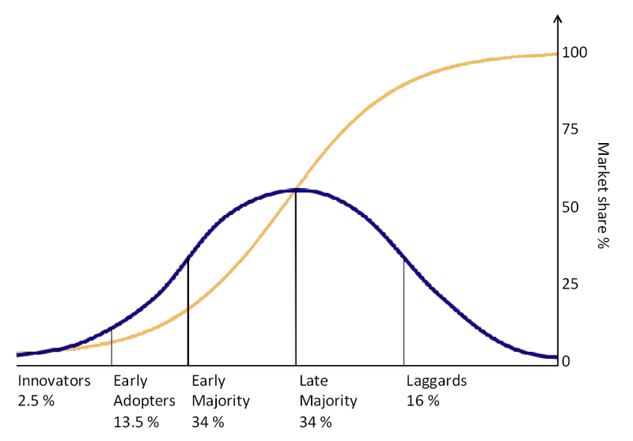
Figure 2.1 Source: Wikipedia

Another great contributor to the diffusion research is Frank M. Bass, which introduced his famous Bass model in his 1969 article ‘A new product growth for model consumer durables’. This article is voted one of the Top 10 most influential papers in the history of Management Science (Bass, 2004), which is a signal of its influence. Bass is influenced by the work of Rogers with his contribution to the diffusion theory (Bass, 2004). His goal was to create a mathematical model that describes and could predict the diffusion process which would empirically hold. The five adopter categories described by Rogers are adapted by Bass, who makes the distinction between innovators and imitators. Innovators decide to adopt an innovation without being influenced by others in a social system; this is the first class of Rogers’s diffusion curve. Imitators, according to Bass, make their decisions based on the adoption of other members in the social system, and are represented by the classes two through five of Rogers’ diffusion curve.
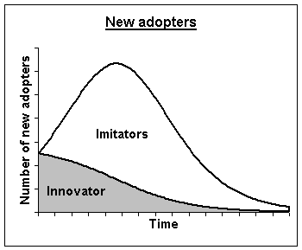
Figure 2.2 Source: Wikipedia

2.2 Takeoff
Takeoff is a term that is initially introduced by Golder and Tellis (1997) and is described as “the transition point from the introductory stage to the growth stage of the product life cycle of consumer durables” (P. 257). This dramatic increase in sales is the point that the product is adopted by the mass market. As we can see from figure 2.1 and 2.2 that the growth of products do not follow a linear pattern, but sales increase significantly after some time. According to Rogers (2003), takeoff of innovations occurs at 10%-20% of adoption of the cumulative diffusion curve. Golder and Tellis propose that not the diffusion curve as a whole, but the takeoff in particular should be of interest to managers. Eventually, this is the moment that significant investments are required with respect to production, marketing, distribution, and sales staff. In addition, it is a sign for the investors and managers that their products will be adopted by the mass market, and thus it is a signal of its success. This implicates that factors that decrease the time-to-takeoff, which means that the takeoff is accelerated and lies closer to the introductory stage, are of importance by the introduction of new products.
Since its introduction in 1997, a lot of scholars investigated the factors that influence the takeoff. Golder and Tellis (1997) have included price, market penetration, and year of introduction into their model and tested them with 31 consumer durables. Price (Golder and Tellis, 1997; Van den Bulte, 2000; and Agarwal and Bayus, 2002) and market penetration seem to affect the time-to-takeoff significantly, where the year of introduction does not make any difference. Agarwal and Bayus (2002) argue that the first commercialized forms of new innovations are relative primitive. An increase in sales occurs when new firms enter the market with product improvements, expanded distribution, and increased consumer awareness of brand quality of the new innovation. The authors found evidence with an analysis of 30 product innovations that a ‘firm takeoff’ consistently occurs before the sales takeoff, which is therefore the justification for their argumentation. Furthermore, the price reductions of innovations occur after new firms enter the market with the innovation. Tellis, Stremersch, and Yin (2003), Stremersch and Tellis (2004) and Chandrasekaran and Tellis (2008) found evidence that culture, and the product categories have significant influence on the time-to-takeoff or growth rate and duration of product innovations (a distinction between brown and white goods is made by Tellis et al. and between fun and work products by Chandrasekaran and Tellis).

2.3 Analogy between diffusion of theories and products
An analogy between the diffusion of products and the diffusion of scientific theories can be made, the diffusion runs not through sales but though citations received. The definition of Rogers (section 2.1) can be adapted to make it suitable for scientific theories published in articles. The definition becomes than ‘The process in which a scientific theory is communicated through scientific journals over time among the members of the scientific community.’ The first scholar that tries to model the diffusion of scientific publications, and made the comparison with the diffusion of new products, is Franses in his 2003 article ‘The diffusion of scientific publications: The case of Econometrica 1987.’ This article served as a pilot for further research, his next publication (Fok and Franses, 2007) about diffusion of theories. Both articles are discussed in more detail in the next sections.

The diffusion of scientific publications: Franses (2003) and Fok and Franses (2007)
In both the articles from Franses (2003) and Fok and Franses (2007) the dependent variable is operationalized as the amount of citations received. The 2003 article reports the empirical analysis of the citations of a 1987 journal of Econometrica whereas the 2007 article characterizes the citation processes of 527 articles from two major econometrics journals, Journal of Econometrics and Econometrica. The goal of these analyses is to provide generalizable statements about the diffusion process of the innovations, which are the main characteristics of the article and the observable key features of the individual diffusion curves. Both articles used the Bass model (1969) to describe the S-shaped diffusion pattern of the cumulative citations.
The first article investigates the time between publication and peak citations and the cumulative citations, and concluded that the average number of citations at the upper bound of the S-shaped curve is about 200, while the median value is 52 (one article receives almost 2.500 citations). Furthermore, it seems that 14 years after publication, the articles that are investigated received 85% of their total citations. The parameters show values in accordance with their values of consumer durables, confirming the similarity. Finally, the peak citations occur on average approximately 5.5 years after publication. An additional contribution of the author of the 2003 article is that he predicts whether some predictor variables have their influence on the cumulative citations, estimated inflection point and the estimated rates in 2001. The independent variables are the number of authors, the amount of pages and whether it is a note or not. It seems that the number of authors or whether the article is a note or not does not matter much. However, longer articles seem to receive more citations in time, and it lasts longer for the peak citations are reached.
In addition to the time between peak citations and the cumulative citations, the 2007 article discusses the fraction of the cumulative citations at the peak as well. Furthermore, the annual development of citations received is described. For the journal Econometrica the cumulative amount of citations seems to decrease over time, which could be in part explained by the fact that more recent articles could not receive as many citations as older articles. The peak citations for both journals occur approximately 5 to 7 years after publication. In addition to the diffusion process, the authors investigate whether some characteristics of the article influences (i) the level of maturity, (ii) the fraction of cumulative citations at the peak, and (iii) the timing of the peak. The variables that are included as independent variables in the model as well are (i) the number of references, (ii) the number of pages of the article, and (iii) the number of authors. Furthermore, a trend variable and interaction variables for the number of pages, the number of authors, and the number of references with the trend variable are included in the model.
Analysis of the data revealed that the number of citations seems to decrease over the years. This could be in part explained by the fact that more recent articles could not receive as many citations as older articles. Furthermore, it seems that the number of references has increased and that articles have become longer over the years. The authors hypothesize that longer articles, articles with more references, and articles with more authors tend to get more citations. Moreover, according to the literature, it seems that more recent articles are cited less often.
Two models are estimated, one for the articles published in Econometrica, and the other for the articles published in the Journal of Econometrics. The conclusions that could be drawn from the first model are that more authors, more references, and more pages will lead to more citations, where these effects get smaller over time. The amount of pages positively influences the cumulative citations and results in a later peak of citations. A remarkable conclusion is that the amount of references negatively influences these two features, although these results are either significant. Finally, the interaction between references and the trend positively influences the fraction of the cumulative citations at the moment of peak citations. The results for the model of the Journal of Econometrics show quite similar results.
Finally, the authors demonstrate their results to show the difference between two fictitious articles, which are published in either Econometrica of the Journal of Econometrics, that differ in number of authors and number of references. They show that more pages and more authors result in more citations and a later peak, and for Econometrica the amount of references result in more citations as well and an earlier peak. Moreover, it is interesting to note that the maturity levels, which is defined as the upper bound of the cumulative diffusion curve, for Econometrica have decreased whereas the maturity levels for the Journal of Econometrics have increased and that the citations peak later. Thus, it seems that article related characteristics influence the diffusion patterns in several ways, and thus the author(s) could have influence on the citation diffusion patterns of their scientific publications. Furthermore, the conclusions that can be drawn from both of these articles is that there is ground for an analogy between the diffusion patterns of products and the diffusion patterns of scientific theories.

Takeoff of theories
The contribution of this particular thesis lies in the analogy that is made between the takeoff of consumer durables and the takeoff of scientific theories. The goal is to determine what drives the takeoff of new behavioral economic theories in marketing, and whether the drivers of takeoff differ from the drivers of citations, which are more often studied. Such a goal will also allow me to test the attractiveness of the concept of product takeoff when applied to the study of the diffusion of scientific knowledge, i.e. new theories, and how this pattern of takeoff occurs with behavioral economics theories within the marketing field. This moment of takeoff should be of great interest for the scholars because, as with the takeoff of consumer durables, this is the moment of significant increase in adoption of the theory. Therefore, takeoff of a theory means that the impact of the focal article can be considered large within the marketing field, meaning that the theory found widespread applications in marketing. In other words, the takeoff of a theory marks the point where the theory – given its citation pattern – crosses a threshold that allows us to call it an influential theory in marketing. Moreover, when a theory takes off within a certain discipline, the chance that the citations are conceptual is larger than when it receives only one citation. As we have seen in the foregoing chapter, most of the referring articles accept the theory they cited as correct, and more than 50% use the concept presented in the article cited.

2.4 Drivers of article success
As mentioned before, ‘publish or perish’ is a term familiar by every scholar, and the success of scientific articles is measured in the amount of citations received. Prior studies have researched whether characteristics of the article and/or the author(s) influences the ‘success’ of an article. Next, the articles of Stremersch, Verniers, and Verhoef (2003); Mingers and Xu (2010); Van Campenhout, and Van Caneghem (2010); and Fok, and Franses (2007) are discussed with respect to the drivers of article success.
Stremersch et al. (2007) investigate the influence of three scientometric perspectives – universalism, social constructivism, and presentation – on the amount of citations received in five selected marketing journals (JCR, JM, JMR, MKS, and IJRM). The universal characteristics of an article are article quality, and the domain of the article. Indicators for article quality are article order, which is considered as the perception of quality by the editorial board members of the journals, journal awards, and article length, as editors allow more space in the journals for high quality journals. Article domain is made specific with the method type, subject area, and orientation of the article. The researcher coded every paper as being 1) conceptual, 2) empirical, 3) methodological, or 4) analytical, which should reflect the method type of the article. The researchers classified 19 subject areas and classified each article to one of these subjects. The last measure for the universalist perspective is the article orientation, which means that the article is either behavioral, quantitative, or both. Note that all mentioned characteristics are subjective opinions of the researchers.
The social constructivist perspective can be dub-divided in two dimensions: visibility and personal promotion. Visibility is operationalized as the publication record of the authors, whether at least on of the authors is an editorial board member, and the average business school ranking across all authors. Furthermore, U.S. affiliation, the number of authors, and centrality are factors that should reflect the visibility.
Research by Stremersch and Verhoef (2005) showed that marketing oriented articles from U.S.-based scholars receive more citations than international-based scholars. More authors indicate that there exist more opportunities to give attention to the research. The centrality is a measure based on coauthor relationships, and means that more connected scholars are more important in a scientific network, and thus receive more citations. Personal promotion is captured by the amount of references the article cites, and the number of self citations of the author(s) in future works.
Finally the presentation perspective is divided in three dimensions: the title length, the use of attention grabbers, and the expositional clarity. Title length is measured in amount of significant words in the title. Attention grabbers are words which attract special attention when they appear in the title. Expositional clarity is measured as the number of equations, -figures, -tables, -footnotes, and indices. Finally, the Flesch reading ease score is inserted into analysis.

Perspective | Dimension | Effect
Universalism | Quality | Yes
Universalism | Domain | Partial
Social constructivism | Visibility | Partial
Social constructivism | Personal promotion | Partial
Presentation | Title length | No
Presentation | Attention grabbers | No
Presentation | Expositional clarity | Partial, at best
Table 2.1. Source: Stremersch et al. (2007)
A brief summary of the results of the analysis are presented in table 2.1, whereas table 2.2 displays the results in more detail. From the dimension domain of the perspective universalism, only the subject area affects the amount of citations received within the marketing literature. The variables orientation and method type do not affect the amount of citations.
This results in a confirmation for the universalist perspective on citations. With respect to the visibility of the social constructivism perspective, publication record, editorial board membership, and business school ranking positively affects the amount of citations received. Against the expectation of the researchers, the results for centrality and the number of authors negatively affects the amount of citations received. Whether an author is U.S. based of international-based does not make any significant difference. The personal promotion of the authors does positively influence the number of citations as operationalized by self-citation intensity. But the reference intensity does not make any significant contribution. As we can see from the table above, the title length and attention grabbers do not contribute to the number of citations received. With respect to the expositional clarity of an article, the number of equations and the reading ease negatively affects the amount of citations, where the number of appendices positively affects the amount of citations. The other variables do not make a significant contribution.
Mingers and Xu (2010) investigate the factors that influences the number of citations received by articles published in in six management journals. These journals are Management Science, Journal of Operational Research Society, European Journal of Operational Research, Operations Research, Decision Science, and Omega. The authors divided the variables involved in this analysis into three levels; journal level, author level, and article level.
The author level consist of four dimensions; number of authors, publication record of the sole author or the first author, ranking of the institution of the sole author or the first author, and the nationality of the sole author or the first author. The authors chose to use the characteristics of the first author because 1) the difference in publications makes it impossible to deduce the relative contribution of the authors from the order, and 2) the first author normally contributes at least as much as the other authors.
Article level embraces the variables title length, number of references, article length, keywords, and method type. Keywords represent the number of key words in each paper, which are words that have a high possibility to be found by search engines. The variable method type segments each article into one of the following groups: theoretical, empirical, methodological, review, case study, and viewpoint. Note that the two authors made the decision to which of the groups the different articles belongs, thus it is the subjective opinion of the researchers.
This research revealed that the variables method type, journals, article length, references, and ranking of institution are making a significant contribution to predict the amount of references. The variables country, title length, number of authors, keywords, and publication record are not significant.
Van Campenhout and Van Caneghem (2010) investing whether some characteristics of the article as well as the reputation of the authors influences the number of citations received of articles published in the European Accounting Review. The authors distinguish between two different perspectives: the universalistic perspective and the particularistic perspective, which could be compared with the social constructivist perspective used by Stremersch et al. (2007).
Table 2.2: Summary of results existing literature
Characteristics of the article |  | Author(s) | Effect | Significance
 | Article length | Stremersch, Verniers and Verhoef | Positive effect | Significant ( p < .01)
 |  | Van Campenhout and Van Caneghem | Positive effect | Slightly significant (p<0.10)
 |  | Fok and Franses | Positive effect | Significant
 |  | Mingers and Xu | Positive effect | Significant (p < .01)
 | Method type | Mingers and Xu | There exist differences between method types | Significant (p < .01)
 |  | Stremersch, Verniers and Verhoef | There exist differences between method types | Significant (p < .01)
 | Subject area | Stremersch, Verniers and Verhoef | Some areas are more cited than other areas | Some significant
 | Orientation | Stremersch, Verniers and Verhoef | Just little effect | Not significant
 | Article order/position in journal | Stremersch, Verniers and Verhoef | Positive effect | Significant (p < .05)
 |  | Van Campenhout and Van Caneghem | No effect | Not significant
 | Attention grabbers/Keywords | Mingers and Xu | No effect | Not significant
 |  | Stremersch, Verniers and Verhoef | No effect | Nos significant
 | Awards | Stremersch, Verniers and Verhoef | Positive effect | Significant (p < .01)
 | Self-citation intensity | Stremersch, Verniers and Verhoef | Positive effect | Significant (p < .01)
 | References | Van Campenhout and Van Caneghem | Positive effect | Significant (p < .01)
 |  | Mingers and Xu | Positive effect | Significant (p < .01)
 |  | Fok and Franses | Positive effect
 |  | Stremersch, Verniers and Verhoef | Positive effect | Significant (p < .10)
 | Title length | Mingers and Xu | No effect | Not significant
 |  | Stremersch, Verniers and Verhoef | No effect | Not significant
 | Readability | Stremersch, Verniers and Verhoef | Negative effect | Significant (p < .01)
 | Thema issue in journal | Van Campenhout and Van Caneghem | Positive effect | Significant (p < .10)
 | Journal of publication | Mingers and Xu | Some journals receive more citations than others | Significant (p < .01)
Characteristcs of the author(s)
 | Publication record of the author | Van Campenhout and Van Caneghem | No effect | Not significant
 |  | Mingers and Xu | No effect | Not significant
 |  | Stremersch, Verniers and Verhoef | Positive effect | Slightly significant (p < .10)
 | Editorial board membership | Van Campenhout and Van Caneghem | No effect | Not significant
 |  | Stremersch, Verniers and Verhoef | Positive effect | Significant (p < .01)
 | Ranking institution/business school | Van Campenhout and Van Caneghem | No effect | Not significant
 |  | Mingers and Xu | Positive effect | Significant (p < .01)
 |  | Stremersch, Verniers and Verhoef | Positive effect | Significant (p < .01)
 | Number of authors | Stremersch, Verniers and Verhoef | Negative effect | Significant (p<.05)
 |  | Van Campenhout and Van Caneghem | Positive effect | Significant (p < .10)
 |  | Fok and Franses | Positive effect | Significant
 |  | Mingers and Xu | No effect | Not significant
 | Nationality of the author | Stremersch, Verniers and Verhoef | No effect | Not significant
 |  | Mingers and Xu | No effect | Not significant
Table 2.2
The universalistic perspectives are all characteristics of the article, and consist of the following variables: article length, article order, theme issue, number of authors, and number of references. The theme issue variable is included because it seems that special (or thematic) issues of top management journals tend to enhance the citations received.
The particularistic perspective contains variables that are related to the reputation of the author(s). This perspective consists of the variables publication record of the author(s), ranking institution, and whether or not one of the authors is or has been a member of the editorial board of the European Accounting Review.
Although it is not the primary contribution of the article of Fok and Franses (2007), they tested whether some characteristics of the articles are of influence on the cumulative amount of citations received and the timing to peak citations. The articles they investigated are published in the journals Econometrica, and Journal of Econometrics. They included the variables article length, number of authors, and amount of references. Moreover, they included a trend variable and interaction terms between the trend variable and the other variables.
The authors conclude that more authors, more references, and more pages result in more citations received. Furthermore, more pages lead to a later peak of citations and to more cumulative citations at that peak. Although not significant, it is notable to see that the amount of references has a negative influence on peak of citations and cumulative citations at the peak.
The most important results of the treated articles with respect the characteristics of the articles and the author characteristics are displayed in table 2.2

2.5 Hypotheses
This particular research focuses on variables that are grouped in two categories, namely article quality and interdisciplinary differences. According to a paper from Gilbert (1977), there exist a positive correlation between the quality of an article and the amount of citations received. Stremersch et al. (P. 172, 2007) add that “high-quality articles may represent bigger breakthroughs and therefore may be path breaking.” Moreover, they state that high-quality articles present findings of higher reliability than low-quality articles. Thus, we can state that high-quality articles receive more citations than low-quality articles.
As the field of behavioral economics is multidisciplinary, the variety of journals in which the focal articles are introduced is quite large. The hard procedure of Thaler (2008) to publish an article that, as it turns out, has proven to be popular is an indication of the ‘identity crisis’ behavioral economics is experiencing. He further states in his article that behavioral finance, as a movement of behavioral economics, did make a significant increase since 1985, whereas the field did not exist around that time. The first volume of the Journal of Behavioral Finance is published in the year 2000, which include articles from specialists in the disciplines personality, social, cognitive and clinical psychology; psychiatry; organizational behavior; accounting; marketing; sociology; anthropology; behavioral economics; finance and the multidisciplinary study of judgment and decision making (www.journalofbehavioralfinance.org), which is a clear proof of its multidisciplinary nature. According to Althouse, West, Bergstrom and, Bergstrom (2009), there exist wide variation in impact factors - which is a bibliometric measure to determine a journal’s influence based on citations - between the 50 largest scientific disciplines. Moreover, Van Raan (P. 25, 2003) concludes in his paper that “there are (very!) different publication and citation characteristics in the different fields of science” and that “research fields should never be compared on the basis of absolute numbers of citations.” Therefore, the conclusion could be drawn that the differences between the disciplines that come together in behavioral economics influences the amount of citations received and its diffusion pattern.
The dependent variable of this research is operationalized with the use of the number of citations received within the marketing literature, which is an indication of the diffusion and applicability of the behavioral economics theory in a marketing context. The first model that is produced has as dependent variable whether a behavioral economics theory takes off within the marketing literature. As mentioned before, the takeoff of a theory should be of great interest to the scholars because this is the moment that the theory found widespread applications within a marketing context. I operationalized takeoff in line with Golder and Tellis (1997), and tested its robustness visually. The definition of takeoff can be found in paragraph 3.1, whereas paragraph 3.2 tests the robustness of this definition. Because analysis of the citations within the marketing literature revealed that there exist great variety in the citations received, and that takeoff could occur with just five citations, a second model is created that tests the influence of the independent variables on the total number of citations received in the marketing literature. Note, that the hypotheses for both models test the influence of the same independent variables in the dependent variable. It is expected that the relations of the two models show similar results, but that is an empirical question. The hypotheses that are related to the article quality are described first, where after the field of research related hypotheses are explained. See figure 2.5 for the conceptual framework.
Article quality
I define article quality as a multi-dimensional construct defined by the following dimensions: (i) length, (ii) number of references and (iii) the number of citations the original article introducing the focal theory under analysis has received in the corresponding mother-discipline. I will turn to each dimension now. The first characteristic of the article quality is the article length. According to Stremersch et al. (2007) and Van Campenhout and Van Caneghem (2010), the length of an article could be used as a measure for article quality. This is because editors have to deal with limited space and a lot of articles, thus they provide more space in their journals for articles with a major contribution. Therefore, the first hypothesis becomes:
H_{1A}: The length of an article is positively related to whether or not a behavioral economics theory takes off within the marketing literature.
H_{1B}: The length of an article is positively related to the amount of citations a behavioral economics theory receives within the marketing literature.
In addition to length, the number of references included in a manuscript can also be a proxy for manuscript quality. Van Campenhout and Van Caneghem (2010) state that the number of references could serve as an indication of how well the authors have deepened themselves into the existing literature, and therefore the familiarity with the subject. The fact that behavioral economics uses psychological insights to explain economic phenomena, and thus a good theoretical foundation should be created with both literature from psychology and economics, should result in more than average citations. In addition, the dependent variable is operationalized as the number of citations received within the marketing literature, and thus the behavioral economics theory should be made suitable to apply it in a marketing context. As Thaler (P. 13, 2008) states it: “to be successful, a behavioral economist in marketing will have to produce economics that the economist think is high quality and psychology that the psychologist think is up to the snuff.” Moreover, research of Adair and Vohra (2003) revealed that the number of references in psychology focused articles has extremely increased the last decades as compared to other disciplines. All aforementioned reasons are indicators that articles with a large amount of citations are considered as well embedded in the relevant literature, and are therefore of high quality. Thus it is assumed that the following hypothesis should hold:
H_{2A}: The amount of references of an article is positively related to whether or not a behavioral economics theory takes off within the marketing literature.
H_{2B}: The amount of references of an article is positively related to the amount of citations a behavioral economics receives within the marketing literature.
Behavioral economics theories that are of high quality are assumed to diffuse to other disciplines as well, for example the disciplines management, organizational behavior, finance, and sociology can benefit from behavioral economics theories. High-quality articles are assumed to diffuse to all of these disciplines, which means that the total amount of citations received could be used as a proxy for article quality. Thus I assume that the more citations an article receives in general, the number of citations in the marketing literature is large as well.
H_{3A}: The number of citations an original article receives is positively related to whether or not a behavioral economics theory takes off within the marketing literature.
H_{3B}: The number of citations an original article receives is positively related to the amount of citations a behavioral economics theory receives within the marketing.
Interdisciplinary Differences
Next, the hypotheses that are related to the interdisciplinary differences are discussed. As the field of behavioral economics ‘overlaps’ multiple disciplines, some theories are introduced in psychological oriented journals, whereas others are introduced in economics or marketing focused journals. As with the article quality, these interdisciplinary differences are measured with a multi-dimensional construct as well. This construct consist of the dimensions (i) readability, (ii) journal of introduction, and (iii) orientation of introducing journal. Each dimension is discussed in more detail now. Although not specific for the disciplines psychology, economics, and marketing, Hartley, Sotto, and Fox (2004) found evidence that the Flesch reading ease scores differ across scientific disciplines. For example, Hartley and Trueman (1992) found Flesch reading ease scores less than 20 for 12 extracts from psychology journals. In addition, Hartley et al. (2004) found an average Flesch reading ease scores of 25.4 of 30 extracts in the journal American Historical Review. One possible explanation for this phenomenon is the prestige of the academic journal. Hartley, Trueman, and Meadows (1988) state there is a relationship between readability scores and the prestige or academic standing of journals. Although their study does not provide strong quantitative conclusions, they produced some findings that points at a negative relationship between prestige and readability scores. Moreover, Hartley, Sotto, and Pennebaker (2002) consider two reasons related to the purpose of writing academic articles for differences in Flesch reading ease scores. The first one is that scholars write ‘to make the grade’, and the second is to make a useful contribution to the society. This means other starting points, and thus the use of another writing style. Although Stremersch et al. (2007) found that harder to read articles receive more citations within the marketing realm, this research is based on the conviction that harder to read articles receive less citations, and thus have less chance to takeoff within the marketing literature. This is based on the fact that behavioral economics is multidisciplinary, and thus the articles should be of interest to different academic communities. The authors should take this into consideration while writing their papers, and therefore the following hypothesis should hold.
H_{4A}: The readability of an article is positively related to whether or not a behavioral economics theory takes off within the marketing literature.
H_{4B}: The readability of an article is positively related to the amount of citations a behavioral economics theory receives within the marketing literature.
Although all journals included in this study (JCR, JM, JMR and MKS) are marketing focused, the specific research areas differ. As Baumgartner and Pieters (P. 136, 2003) state: “marketing is not a homogenous field of inquiry with a single broad group of tightly knit journals, but rather a diverse discipline consisting of specific subareas.” According to its website (www.marketingpower.com), the Journal of Marketing is positioned as the premier, broad-based, scholarly journal of the marketing discipline that focuses on substantive issues in marketing and marketing management. In contrast, the Journal of Marketing Research focuses on marketing research, from its philosophy, concepts, and theories to its methods. The audiences for this journal are therefore the more technical marketers such as research analysts and statisticians. Marketing Science’s primary focus is on answering marketing questions with the use of mathematical modeling. The Journal of Consumer Research is primarily focused on explaining consumer behavior, and uses theories from different disciplines such as psychology, sociology, economics, communications, and anthropology (www.ejcr.org). Zinkhan et al. conclude in their 1992 article that JCR performs an important bridging function between the psychology and marketing literatures, psychological knowledge flows through JCR to the marketing discipline. Therefore it is assumed that this journal overlaps most with the field of behavioral economics which explains economic phenomena with insights of psychology.
H_{5A}: The journal of consumer research as journal of introduction in the marketing discipline is positively related to whether or not a behavioral economics theory takes off within the marketing literature.
H_{5B}: The journal of consumer research as journal of introduction in the marketing discipline is positively related to the amount of citations a behavioral economics theory receives within the marketing literature.
As we have seen before the theories of behavioral economics are introduced in a wide variety of journals, all with another orientation and audience. In the 1970s, most of the theories are introduced in psychology oriented journals after which the 1980s is characterized by introductions in economics focused journals. Some theories are even introduced in the ‘regular scientific’ journal Science (‘The Framing of Decisions and the Psychology of Choice’ and ‘Judgment under Uncertainty: Heuristics and Biases’ both of Kahneman and Tversky), although this articles are strongly psychology focused. Moreover, scholars in a wide variety of disciplines are responsible for the emergence of behavioral economics as a field. The diffusion pattern is influenced by tje journal that introduced a theory, because these academic journals focus on different target groups. For example, the journal Psychological Review focuses, according to its website (www.apa.org), to “any area of scientific psychology... [and] systematic evaluation of alternative theories”. Therefore, the target audience of this journal, that introduced behavioral economics theories such as ‘Conjunction fallacy’, is considerably different as the target audience of the Journal of Marketing Research, which introduced several theories as well. Therefore, it is assumed that the diffusion across marketing scholars is assumed to take place easier when a theory is introduced in marketing oriented journals, and to a lesser extent economics oriented journals, as compared to a psychology journal. Therefore, the following hypothesis should hold.
H_{6A}: The orientations economics and marketing of the journal that published the article that introduced a particular theory are positively related to whether or not a behavioral economics theory takes off within the marketing literature in comparison to the orientation psychology.
H_{6B}: The orientations economics and marketing of the journal that published the article that introduced a behavioral economics theory are positively related to the amount of citations a behavioral economics theory receives within the marketing literature in comparison to the orientation psychology.
These hypotheses could be visualized with the use of a conceptual framework which is displayed in figure 2.5.

H1: Article Length
H2: # of references
DV: Amount of citations
DV: Takeoff Yes/No
H3: # of citations
H4: Readability
H5: Journal of introduction

H6: Orientation

Figure 2.5

3. Data and measurement
This research focuses on behavioral economics theories that takeoff in the marketing literature. Therefore, a list of 53 behavioral economics theories is composed, which can be found in table 3.1 on the pages 27 and 28, and the articles that introduced the theories are identified via extensive search in ISI database and Google Scholar. I composed a list which consists of the most important behavioral economics theories since the 1970s in my opinion. The first three chapters of the book ‘Advances in Behavioral Economics’ by Camerer, Loewenstein and Rabin (2004) has proved to be very useful by composing the theories list as well as the main contributors list. In addition, a list of the main contributors to the behavioral economics field is created. Here after, the contribution of each scholar to the behavioral economics field is determined to see whether the theories list is complete and thus served as a robustness check.
I collected all citations that the articles that introduced the 53 behavioral economics of investigation received up to and including May 2011. Hereafter, the list of citations is filtered for the citations that have been made in the top four marketing journals (JCR, JM, JMR and MKS), which served as input for the dependent variable of this research. For example, the theory ‘prospect theory’ is introduced by Kahneman and Tversky in 1979 and received a total of 6512 citations, whereof 186 citations come from the top four marketing journals. Specifically, I used ISI Web of Knowledge to gather the citations of the articles that introduced the behavioral economics theories. ISI Web of Knowledge started in 1974 with creating their citation indexing and search service. Several articles from before 1974, as well as one article that could not be found with ISI Web of Knowledge (Status Quo Bias in Decision Making, 1988) are also included in the analysis. The citations of these articles are gathered either with the tool Scopus or with Google scholar.

3.1 Measures
As stated before, takeoff is the transition point from the introductory stage to the growth stage. Visual inspection of the citation rates revealed that there exist great differences in total number of citations received, and that some theories receive the first 2 to 6 years after publication none or only less than 4 citations. This is possibly due to the type of citation that is used (see paragraph 1.1). A conceptual citation within the marketing literature, which is defined by Murugesan and Moravcsik as “a concept or theory of the cited paper is used directly of indirectly in the citing paper in order to lay foundations to build on it or to contribute to the citing paper” (P. 142, 1987), has a much higher chance to be followed up by more citations in the marketing literature. Besides conceptual citations, other citations have a more operational nature. This means that a reference is to proof the claim of an author or to indicate alternative approaches. In addition, when a methodological technique is used, or when results, references or conclusions from the cited paper are referred to, the citation is called operational as well. Thus, operational citations have less chance to be followed up by more citations in the marketing literature. A good example of this situation occurs with the theory ‘Availability heuristic’. This theory is introduced by Kahneman and Tversky in 1973 and received their first citation in the marketing literature in 1977, which is a note of Assmus (1977) that reviews studies of behavioral decision making. Possibly because it is not a conceptual application within a marketing context, this is a ‘stand-alone’

Table 3.1, List of behavioral economics theories
Theory | Article name | Author(s)
Anchoring and Adjustment effects | Judgment under Uncertainty: Heuristics and Biases | Amos Tversky and Daniel Kahneman
Attraction effect | Market Boundaries and Product Choice: Illustrating Attraction and Substitution Effects | Joel Huber and Christopher Puto
Availability Heuristic | Availability: A heuristic for judging Frequency and Probability | Daniel Kahneman and Amos Tversky
Behavioral Game Theory | Progress in Behavioral Game Theory | Colin F. Camerer
Behavorial Life-cycle Model | The Behavioral Life-cycle Hypothesis | Hersh M. Shefrin and Richard H Thaler
Choice Bracketing | Choice Bracketing | Daniel Read, George Loewenstein and Matthew Rabin
Coherent Arbitrariness | "Coherent Arbitrariness": Stable Demand Curves Without Stable Preferences | Dan Ariely, George Loewenstein and Drazen Prelec
Compromise Effects | Choice in Context: Tradeoff Contrast and Extremeness Aversion | Itimar Simonson and Amos Tversky
Conjunction fallacy | Extensional Versus Intuitive Reasoning: The Conjunction Fallacy in Probability Judgment | Amos Tversky and Daniel Kahneman
Cumulative prospect theory | Advances in Prospect Theory: Cumulative Representation of Uncertainty | Amos Tversky and Daniel Kahneman
Curse of Knowledge | Hindsight ≠ Foresight: The Effect of Outcome Knowledge on Judgment Under Uncertainty | Baruch Fischhoff
Decoy Effect | Adding Asymmetrically Dominated Alternatives: Violations of Regularity and the Similarity Hypothesis | Joel Huber, John W. Payne and Christopher Puto
Disposition Effects | The Disposition to Sell Winners Too Early and Ride Losers Too Long: Theory and Evidence | Hersh M. Shefrin and Meir Statman
Diversification heuristic | The Effect of Purchase Quantity and Timing on Variety-Seeking Behavior | Itimar Simonson
Endowment effect | Experimental tests of the endowment effect and the Coase theorem | Daniel Kahneman, Jack L. Knetsch and Richard H. Thaler
Equity Premium | Myopic Loss Aversion and the Equity Premium Puzzle | Shlomo Benartzi and Richard H. Thaler
Fair Wage-Effort Hypothesis | The Fair Wage-Effort Hypothesis and Unemployment | George A. Akerlof and Janet L. Yellen
Fairness Equilibrium | Incorporating Fairness into Game Theory and Economics | Matthew Rabin
Framing Effects | The Framing of Decisions and the Psychology of Choice | Amos Tversky and Daniel Kahneman
Gambler's Fallacy | Belief in the Law of Small Numbers | Amos Tversky and Daniel Kahneman
Hindsight Bias | I Knew It Would Happen: Remembered Probabilities of Once-Future Things | Baruch Fischhoff and Ruth Beyth
History-of-Ownership Effect | The Effect of Ownership History on the Valuation of Objects | Michal A. Strahilevitz and George Loewenstein
Home Bias | How Distance, Language, and Culture Influence Stockholdings and Trades | Mark Grinblatt and Matti Keloharju
Hyperbolic (time)discounting | Some Empirical Evidence on Dynamic Inconsistency | Richard H. Thaler
Inequity Aversion | A Theory of Fairness, Competition and Cooperation | Ernst Fehr and Klaus M. Schmidt
Loss Aversion | Choices, Values, and Frames | Daniel Kahneman and Amos Tversky
Mental Accounting | Toward a Positive Theory of Consumer Choice | Richard H. Thaler
Money Illusion | Money Illusion | Eldar Shafir, Peter Diamong and Amos Tversky
Norm Theory | Norm Theory: Comparing Reality to its Alternatives | Daniel Kahneman and Dale T. Miller
Optimism bias | Unrealistic Optimism About Future Life Events | Neil D. Weinstein
Order effects | Order Effects in Belief Updating: The Belief-Adjustment Model | Robin M. Hogarth
Overchoice/Choice Overload | Choice Under Conflict: The Dynamis of Deferred Decision | Amos Tversky and Eldar Shafir
Overconfidence/overreaction effect | Knowing with Certainty: The Appropriateness of Extreme Confidence | Baruch Fischhoff, Paul Slovic, and Sarah Lichtenstein
Payment depreciation | Payment Depreciation: The Behavioral Effects of Temporally Seperating Payments from Consumption | John T. Gourville and Dilip Soman
Placebo Effect | Placebo Effect of Marketing Actions: Consumers may get what they pay for | Baba Shiv, Ziv Carmon and Dan Ariely
Preference Reversals | Reversals of Preference Between Bids and Choices in Gambling Decisions | Sarah Lichtenstein and Paul Slovic
Projection bias | Projection Bias in Predicting Future Utility | George Loewenstein, Ted O'Donoghue, Matthew Rabin
Prospect Theory | Prospect Theory: An Analysis of Decision Under Risk | Daniel Kahneman and Amos Tversky
Reciprocity | Fairness and Retaliation: The Economics of Reciprocity | Ernst Fehr and Simon Gächter
Recognition heuristic | Models of Ecological Rationality: The Recognition Heuristic | Daniel G. Goldstein
Regret Theory | Regret Theory: An Alternative Theory of Rational Choice Under Uncertainty | Graham Loomes and Robert Sugden
Representativeness Heuristic | Subjective Probability: A Judgment of Representativeness | Daniel Kahneman and Amos Tversky
Robust Control | Robust Permanent Income and Pricing | Lars Peter Hansen, Thomas L. Sargent and Thomas D. Tallarini
Self control | An economic theory of self control | Richard H. Thaler
Self-serving Bias | Self-serving biases in the attribution of causality: Fact or fiction? | Dale T. Miller and Michael Ross
Shopping momentum Effect | The Shopping Momentum Effect | Ravi Dhar, Joel Huber and Uzma Khan
Similarity Hypothesis | Elimination by aspects: a theory of choice | Amos Tversky
Sophistication effect | Doing it Now or Later | Ted O'Donoghue and Matthew Rabin
Status Quo Bias | Status Quo Bias in Decision Making | William Samuelson and Richard Zeckhauser
Support theory | Support theory: A Nonextensional Representation of Subjective Probability | Amos Tversky and Derek J. Koehler
Uncertainty Aversion/Ambiguity Aversion | Intertemporal Asset Pricing under Knightian Uncertainty | Larry G. Epstein and Tan Wang
Visceral Factors/Influences | Out of Control: Visceral Influences on Behavior | George Loewenstein
Zero price effect | Zero as a Special Price: The True Value of Free Products | Kristina Shampanier, Nina Mazar, and Dan Ariely
Table 3.1

citation that is not followed by more citations. Therefore, the real takeoff occurs after the article is cited two times in 1982, followed by three citations in 1983. This implies that several citations should follow in a relative short time period in order to be able to speak from takeoff in the marketing discipline.
Dependent variable
This research consists of two models to describe the diffusion pattern of the citations received within the marketing literature. The first model has takeoff as dependent variable, which is the moment of widespread application of a particular theory, and the second model uses total amount of citations received as dependent variable.
With respect to the takeoff of a scientific theory, it seems obvious that if an application of this theory is found within the marketing literature (the reference is conceptual) and explained in an article that is published in one of the top four marketing journals, other authors will look for extensions and additives for this application. While the theory develops, there is a trend of toward an increasing number of references. As we can see from appendix 3.1, the average number of citations received within the marketing literature for this particular research is 23, with a standard deviation of 32. This large standard deviation shows that there is a lot of variety, which is possibly due to one case - prospect theory received 186 citations – which is more than twice as many as the second most citations receiving theory. Note further that there are five theories that do not have received any citation within the marketing literature. Furthermore, the average time-to-takeoff, which is defined as the number of years between the year that the article that introduced the theory is published up to and including the year of takeoff, is 11. This could therefore be defined as the time a behavioral economics theory needs to develop to a marketing worthy theory that diffuses in the marketing literature. Analysis of the cumulative diffusion curves revealed that not many theories receive more than three citations in a year after the first citations. Moreover, when an application is found for a particular theory, the article receives citations each consecutive year. Therefore is chosen that a particular theory needs a minimal of five citations in three consecutive years. Paragraph 3.2 dedicates more attention to the takeoff of scientific theories within the marketing literature, and the the robustness of this measurement is tested with a visual inspection of the cumulative diffusion curve.
The second model that is produced uses the amount of citations received within the marketing literature as dependent variable. This is operationalized by all the citations an article that introduced a particular behavioral economics theory receives in the marketing literature, JCR, JM, JMR, and MKS.
Independent variables
The first set of hypotheses test the article quality; article length, number of references and number of citations. The article length is operationalized as the number of pages of the article. Second, the number of references are all references displayed in the reference list of the articles used for analysis. The last indicator of article quality is the number of citations received in total. Note that this variable always should at least have the same value as the dependent variable, and most of the times exceed this value, because the citations received within the marketing literature are included in this variable as well. Because the number of citations can change every time a scientific journal is published, and these days the number of journals is enormous, all citations are count on the same day to prevent for unreliability. The second set of hypotheses that test the field of research are readability, journal of introduction, and orientation. The readability is obtained by a process process that starts with converting all pdf documents of the articles into Microsoft Word format. Next, the Flesch score is calculated by Microsoft Word for all the papers. To give meaning to these values Table 3.2 show the different ranges that wherein the reading ease scores could fall, and their description of style and typical magazine levels as formulated by its developer Rudolf Flesch (1948).
Reading ease score | Description of style | Typical magazine level
0 to 30 | Very difficult | Scientific
30 to 50 | Difficult | Academic
50 to 60 | Fairly difficult | Quality
60 to 70 | Standard | Digests
70 to 80 | Fairly easy | Slick-fiction
80 to 90 | Easy | Pulp-fiction
90 to 100 | Very easy | Comics
Table 3.2
The fifth hypothesis measures the influence of the journal of introduction in the marketing literature. The journal of consumer research is the journal that introduced the most theories within the marketing area, and seems to overlap the most with the field of behavioral economics, and is therefore used as the baseline group. Finally, the orientation of the article that introduced the behavioral economics theory is operationalized by the focus of the journal that introduced the theory. These articles are either psychology, economics, regular scientific, or marketing focused. Table 3.3 summarizes all variables and their measurement scales.
Hypothesis | Name | Variable | Measurement | Values
DV Model 1 | Takeoff | Takeoff_{i} | Yes/No | 0/1
DV Model 2 | Citations in marketing literature | Citations_{i} | Amount | 0 -
H₁ | Article length | Len_{i} | Pages | 1 -
H₂ | Number of references | Ref_{i} | Amount | 1 -
H₃ | All citations received | Cit_{i} | Amount | 1 -
H₄ | Readability | Rea_{i} | Score | 0 - 100
H₅ | Journal of introduction | Joi_{i} | JMR, JCR, MKS, JM | Dummies
H₆ | Orientation | Ori_{i} | Psych., Econ., Marketing, Science | Dummy
Table 3.3

3.2 Data descriptives
This part gives insight in the cumulative diffusion curves of the theories being tested. I define a theory as cited as a paper that is published in one of the four top-notch marketing journals added an article to its reference list. Note that the years are represented on the x-axis, and the amount of citations the article receives on the y-axis. To test the robustness of the definition of takeoff, the year of takeoff is compared with the cumulative diffusion curves of the behavioral economics theories in the marketing literature. According to Rogers (2003), takeoff occurs at approximately 10% of the cumulative diffusion curve. A comparison between the diffusion curves of innovations with the diffusion curves of theories that are included in this analysis is made to see whether there exist characteristics that are similar. Finally, some descriptive statistics of the data sets for the two analyses are discussed.

3.2.1 Different diffusion patterns
Because it is assumed that theories that are introduced later have a higher change that the diffusion curve is still growing, this part starts with an analysis of the theories that are introduced before 1980. After this analysis the different patterns will be tested against the diffusion curves of the theories that are introduced after 1980 to see whether the conclusions are suitable for these articles as well. Ten theories in the data set are introduced before 1980. From these theories three do not takeoff at all and one theory is cited that much that it is adapted to prevent biased results (Prospect theory). The six remaining theories show some different patterns. Two theories have a time period that they are cited a lot and then the amount if citations decline, this are ’Representativeness’ and the ‘Similarity hypothesis’. The cumulative diffusion curve of the ‘Similarity hypothesis’ is represented in figure 3.3.
Tversky, (1972)
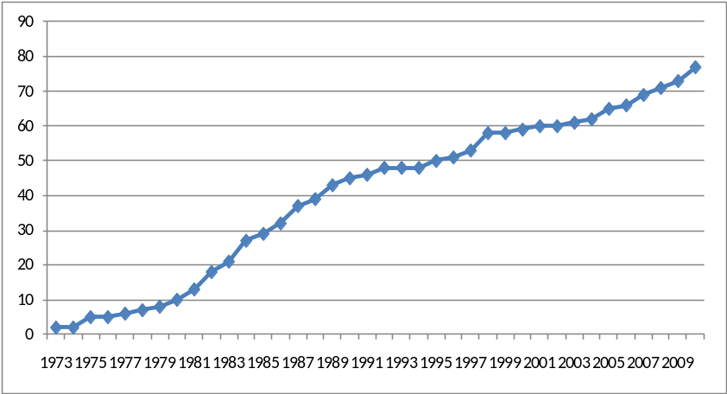
Figure 3.3
One theory show two different points in time that an increase in amount of citations received occurs, ‘Availability heuristic’ show an increase between 1982 – 1988, and another increase between 1997 - 2001. This second increase occurs possibly due to a new application in marketing for the same theory, but it is beyond the scope of this thesis to investigate whether this theory is correct. The cumulative diffusion curve is represented in figure 3.4.
Kahneman and Tversky (1973)
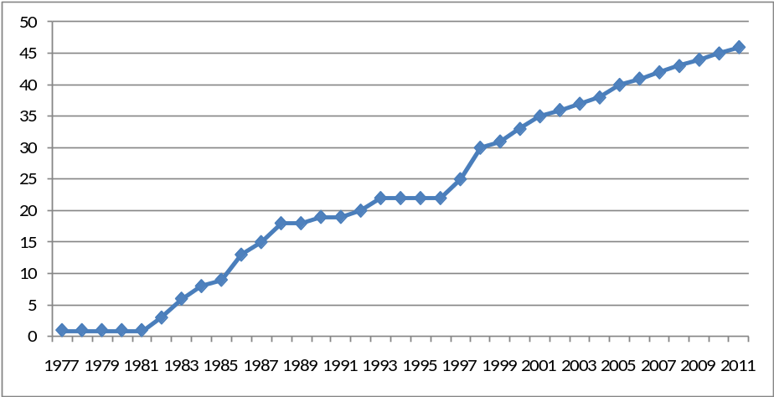
Figure 3.4
Furthermore, anchoring/adjustment is applied that much within the marketing literature, that it is cited since 1986 and is still cited a lot. The average citations this article receives between the years 1986 – 2011 is 2.4, and in the range 2006 – 2011 it receives even 4.2 citations on average in this time period. It seems that this theory has that much applicability’s, that its cumulative diffusion curve is not ended yet. The diffusion curve is
Tversky and Kahneman (1974)
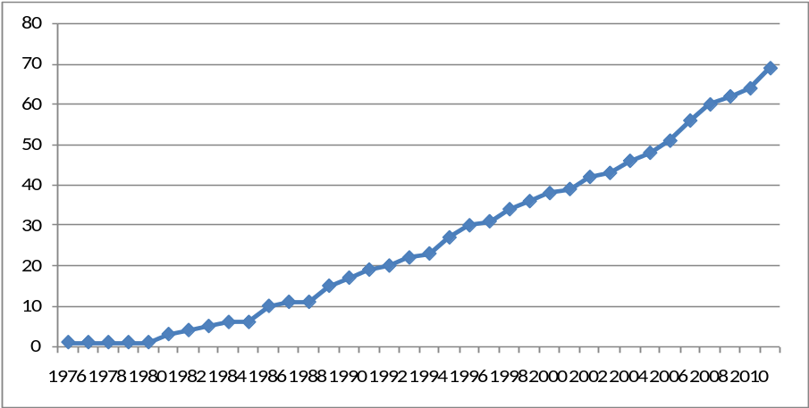
Figure 3.5
displayed in figure 3.5. Prospect theory seems to show the same diffusion pattern as described for anchoring/adjustment, it is cited in marketing literature since 1983, has taken off in 1986 and receives 185 citations since then.
The conclusion is that there exist at least four types of diffusion patterns. The first one is a pattern similar to the pattern of diffusion of innovations, the amount of citations slowly starts to grow and after a few years it is cited a lot. After that peak of citations it declines over time until it is almost not cited anymore. Second, there exist theories that seem to have the same pattern as described before, but after a few years when it seems that the decline has been deployed another peak tends to occur. Third, there exist theories that have unbounded influence within the marketing literature. These theories citations start slow, but after a few years it is cited each year with a regular amount without starting to decline. These theories may still fall in one of the other patterns but have still not reached maturity. Finally, some theories are not cited a lot, and whether they pass the threshold of takeoff seems to be based on chance. A further analysis of these four types of diffusion patterns seems to hold when the theories that are introduced after 1980 are analyzed. All theories could be allocated to one of the four diffusion patterns. Figure 3.6 summarizes the different diffusion patterns visually.
S-Shaped Diffusion 2-waves Diffusion

Unbounded Diffusion Slow acceptance

Figure 3.6

A robustness check of takeoff
To see whether the definition of takeoff holds, I manually compared all cases through a visual inspection of takeoff. Rogers (2003) stated that takeoff occurs approximately after 10% of the cumulative diffusion curve. Golder and Tellis (1997) define takeoff as “the point of transition from the introductory stage to the growth stage of the product life cycle”. This means that the point where the cumulative diffusion curve shows a dramatic increase in citations could be considered as the moment of takeoff. Note that this definition is based on the researcher’s subjective opinion, but as robustness check it is sufficient.
Kahneman and Tversky (1984)
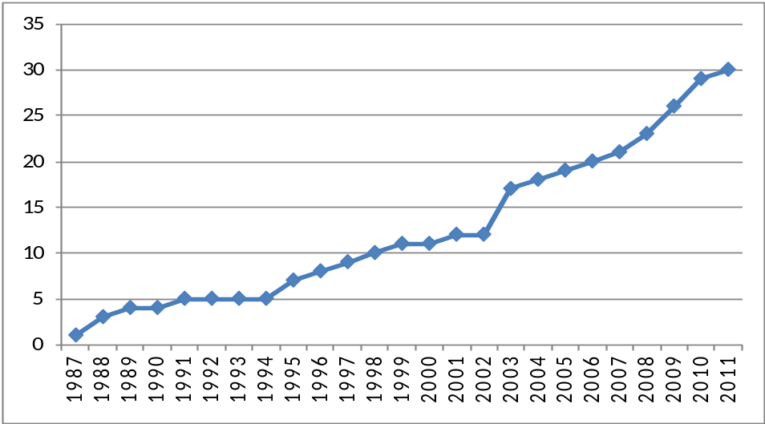
Figure 3.7
It appears that from the 35 theories that eventually have taken off; three theories are doubtful whether the definition correctly predicted the moment of takeoff. This means that the definition predicted more than 90% of the cases correct, and therefore we can assume that the definition is robust. The cases that are doubtful whether the moment of takeoff is predicted well are all incidents that are always inherent with formal descriptions. By the first two cases, loss aversion and representativeness, the increase in amount of citations stops for a couple of years right after the moment when the takeoff has occurred according to the definition. The first of these cases is the theory of loss aversion, which is displayed in figure 3.7 above. As we can see from the figure, when takeoff occurs according to the definition in 1991, there are three years that the theory is not
Loomes and Sugden (1982)
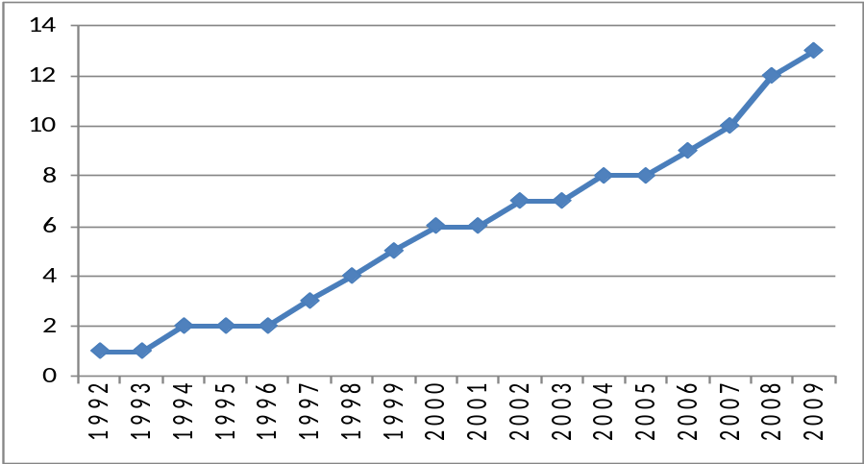
Figure 3.8
cited at all. The second case is a situation where the article that introduced the theory is cited quite a lot, but the citations never passed the threshold for takeoff. It seems that this theory takes off earlier than predicted by the definition, which is the year 2008. The cumulative diffusion curve is displayed in the figure 3.8.

3.2.2 Descriptive statistics
Table 3.4 shows us the mean, minimum- and maximum values for the continuous variables that are included in this analysis for the takeoff model, which can be found in appendix 3.2 as well. On average, articles are 20 pages long, have 40 citations and are cited 706 times. The range of the citations that the different articles received is very large, with a minimum amount of 15, and a maximum of 3600. Not that this upper value is an adapted value to prevent for too much biased results, and that the real amount of citations is 6512 (Prospect theory of Kahneman and Tversky, 1979). The variance of the citations is 806.656, and the standard deviation is 898, which means that the dispersion of this variable is very large. Note further that the average Flesh reading ease score is 43.68, which means that, on average, the articles investigated are difficult to read and written on academic level. It is notable that the maximum reading ease score is 58.4, but that this is an adapted value to prevent for outliers as well. This value implicates that this article has standard difficulty level to read (see table 1.1), which is not common in scientific journals. Further analysis of this variable revealed that this is the only case in the range 60-70, all other cases have smaller reading ease values.
Variable | Mean | Minimum | Maximum
Article length | 20 | 4 | 44
References | 40 | 6 | 102
Readability | 43.68 | 33.1 | 58.4
Citations | 706 | 15 | 3600
Table 3.4
Because the analysis of the citations model is carried out with the logarithmic transformation of the original values, the descriptives are displayed with the transformations as well and can be found in appendix 3.3. As we can see from this table, the dispersion of the variable “Citations in marketing” is the largest of all continuous variables, whereas the dispersion of the variable readability is very small, which increases the possibility of insignificance.
Variable | Mean | Minimum | Maximum
Log Citations in Marketing | 2.46 | 0.00 | 5.23
Log Article length | 1.26 | 0.60 | 1.74
Log References | 1.53 | 0.78 | 2.12
Log Readability | 1.64 | 1.52 | 1.80
Log Citations | 2.58 | 1.32 | 3.81
Table 3.5

4. Methodology
As mentioned in chapter one, the first model that is used for analysis is the logistic regression model (also Logit model called). This model is suitable for data that has an outcome that is categorical, which in this situation is the case namely whether a behavioral economics theory has taken off in the marketing literature or not. Furthermore, it is possible to have either categorical and/or continuous predictor variables. Both cases arise in this research, which justifies the use of a logistic regression model. Furthermore, it is of interest to see which characteristics influence the amount of citations an article receives in the marketing literature. Therefore, a second model tests whether the characteristics of the articles that introduced a behavioral economics theory are of influence on the amount of citations in the top four marketing journals. The dependent variable is in this case continuous, which makes it suitable for an ordinary regression model.

4.1 Takeoff Model

4.1.1 The Logistic regression model
Instead of predicting a value for a continuous dependent variable, logistic regression predicts the probability of the dependent variable occurring given known values of the predictor variables. The equation of the logistic regression model with several predictors for theory i is as follows (Field, 2009):
$$P\left(Y\right)= \frac{1}{1+e^{-(β0+β1X1+β2X2+…+βnXn)}}$$
In which P(Y) is the probability of Y occurring. The logit term in this equation results in an outcome that varies between zero and one, whereas a value of zero means that the probability of Y occurring is very small and a value of one means that Y is very likely to occur. The values of the parameters for the predictor variables, the betas in the equation, are estimated using maximum-likelihood estimation. This means that coefficients will be selected that make the observed values most likely to have occurred.
As already mentioned in chapter one, this research tests the influence of a couple of predictors on whether a behavioral economics theory takes off within the marketing literature. If these predictors are included in the logistic regression model, it takes the following form for theory i.
$$Probability (Takeoff=Yes)= \frac{1}{1+e^{-(β0+β1*Len. +β2*Ref.+β3*Cit.+ β4*Rea. + β5*JoI.+β6*Ori )}}$$
Where the variables that are included in the analysis depending on their significant contribution to the model.

4.1.2 Dummies
Because there are three independent variables in the model that are not continuous, but categorical, these variables should be converted into dummies. Whether one of the authors is a member of an editorial board of a scientific journal is a binary variable, so for this variable no further actions have to be undertaken. Just code the variable as zero if one of the authors is not a member of an editorial board and one if one of the authors is a member of an editorial board. Because the variables “journal of introduction”, and “mother discipline” have more than two categories, dummies should be created to make them suitable for the analysis.
Note that these dummies are used to test the assumptions and the problems that could occur. SPSS has a build in possibility of dummy coding which is used for the analysis, but the effect will be the same. The contrast that is chosen is the indicator contrast.

Journal of introduction
This variable consists four categories, namely Journal of consumer research, Journal of marketing, Journal of marketing research, and Marketing science. A visual inspection reveals that the journal of consumer research is the journal that introduced the most behavioral economics theories into the marketing discipline, therefore this group will serve as baseline group. The final coding scheme is shown in table 4.1.
 | JM | JMR | MKS
Journal of consumer research | 0 | 0 | 0
Journal of marketing | 1 | 0 | 0
Journal of marketing research | 0 | 1 | 0
Marketing science | 0 | 0 | 1
Table 4.1

Mother discipline
Mother discipline is a variable with four categories as well. Because the baseline group is not clear according to the hypothesis, the majority of the group should be treated as baseline. In this case the Economics category is indicated as the group with highest attendance, and will be therefore the baseline group. Analyzing the dummies revealed that regular science has only two occurrences, which presumably results in insignificant results for this dummy. Therefore these cases will be combined with the psychology group, and only two dummies remain. The final coding scheme is given in table 4.2.
 | Dummy Marketing | Dummy Psychology
Economics | 0 | 0
Psychology | 0 | 1
Marketing | 1 | 0
Table 4.2

4.1.3 Method of regression
There exist several ways to include the independent variables into the analysis. All variables can be included at once, the so-called “forced entry method”, and the variables can be included or excluded one by one, the “stepwise method”. The forced entry method is most suitable when hypotheses are formulated based on previous research. Because the predictor variables are based on previous research, except hypothesis five about the mother discipline, the forced entry method is used. If it turns out that one or more variables or interaction terms do not contribute to the predictive power of the model, they are excluded manually and a new model is produced. This steps will be repeated until a model is produced with predictors that make a contribution that is desirable, although it is not an obligation for the predictors to contribute significantly.

4.1.4 Outliers
Before the analysis could be executed, the data set needs to be checked for outliers that bias the results of the analysis. To check whether there exist outliers in the data set, the data is investigated visually with the use of boxplots first. Hereafter, z-scores should clarify if there are outliers in the data set even after the visual inspection has been done. A more detailed description of this analysis can be found in the technical appendix of chapter four.
The two analyses revealed that there are some outliers in the data set. Because the data set embraces only 52 cases, exclusion of the outliers results in a large decrease of statistical power of the model. Therefore, the values of the outliers are adapted so that (i) they still have the largest values as compared to the other cases but (ii) the values are not that extreme in order to avoid for distortions.

4.1.5 Assumptions
As in normal regression, logistic regression has some assumptions that should have been met to obtain accurate results. The following assumptions need to be considered:
- Linearity: This assumption assumes that there is a linear relationship between any continuous predictors and the logit of the outcome variable.
- Independence of errors: This assumption means that cases of data should not be related.
- Multicollinearity: Although not really an assumption, multicollinearity is a problem that should be dealt with. Predictors should not be too highly correlated.
Moreover, there exist some problems that frequently occur when applying logistic regression; these problems need to be considered as well. The first one is incomplete information from the predictors, which means that a particular combination of predictors is not available in the data set. For this specific combination it is impossible to make predictions of the outcome. This problem could be signaled by creating cross tabulations of all categorical independent variables, or by carefully checking whether there exist reasonably large standard errors of the coefficients.
Complete separation refers to the situation when the outcome variable can be perfectly predicted by one variable or a combination of variables. Because there are only observations for sure outcomes, and nothing in between, it is not possible to predict the outcome of an intermediate value.
Finally, overdispersion occurs when the variance is larger than expected from the model. This can be caused by violating the assumption of independence. This problem can be signaled due to the chi-square goodness-of-fit statistic that is produced by SPSS. This statistic is likely to be problematic if its ratio to its degrees of freedom approaches or is greater than two.
The assumptions described above are all tested, and are described in more detail in the technical appendix of chapter four. With respect to linearity of the logit, multicollinearity and complete seperation there are no problems in the data set. Overdispersion, which is a result of the independence of errors, is very likely to have occurred here.
Moreover, the variable ‘journal of introduction’ suffers possibly from incomplete information from the predictors, which can results in insignificant results.

4.2 Citations Model
Another signal of the applicability of behavioral economics within marketing is the amount of citations the initial article receives within the marketing literature, that is, in one of the top four marketing journals. Therefore, a model as dependent variable the amount of citations in the top four marketing journals is constructed. The predictor variables in this model are the same as with the logit model, and therefore the equation takes the following form.

4.2.1 The regression model
The right side of the regression model is the same as the exponent of the numerator of the logistic regression model. The dependent variable changes from takeoff in amount of citations within the marketing literature. The equation takes the following form for theory i.
$${Citations}_{i}=β0+β1*Len._{i} +β2*Ref._{i}+β3*Cit._{i}+ β4*Rea._{i} + β5*JoI._{i}+β6*Ori._{i}$$

4.2.2 Outliers
As with the outliers of the takeoff model, the outliers in the data set with respect to the citations model are adapted. A more detailed description can be found in the technical appendix of chapter four.

4.2.3 Assumptions
Because another model is used, other assumptions should have been met to have accurate results. The assumptions of importance are the following.
- Normally distributed errors: the residuals in the model are random, normally distributed variables with a mean of zero.
- Linearity: A linear relationship between the independent and the dependent variables is assumed. There is not a method to test this assumption, but according to the hypotheses stated in chapter one, such a linear relationship is present in the data set.
- Independence of errors: the residual terms of any two variables should be independent.
- Homoscedasticity: the variance of the residuals of the predictor variables should be approximately the same.
- No perfect multicollinearity: the predictor variables should be be to high correlate with each other.
Furthermore it is assumed that all variables have a quantitative or categorical measurement scale, that all values of the outcome variable are independent, and that the predictor variables show some variation. These assumptions are so obvious, that they do not need to be explained and tested. Finally, it is assumed that the predictor variables are uncorrelated with external variables which are not included in the model. Because it is undoable to determine whether there exist such external variables that have a high correlation with the predictors included in the model, there is not further attention devoted to this assumption.
The technical appendix of chapter four discusses these assumptions in more detail, and here we just mention the main results. The assumptions with respect to the normally distributed errors, independence of errors and multicollinearity are met, which means that there is no problem in the data set. The only possible problem occurs with the variable ‘Citations’, which suffers from problematic heteroscedasticity.

5. Results
This chapter is dedicated to the analysis of the results, and will serve as input for the conclusions and limitations in the next chapter. The first paragraph discusses the model that tests whether a theory takes off in the marketing literature and the second paragraph discusses the model that tests the amount of citations that theory gather in the marketing literature.

5.1 Takeoff Model
This part starts with a description of the takeoff model with all predictor variables included, and the fit of the model. Hereafter a review of the hypotheses takes place, and to what extent these hypotheses could be accepted or rejected is discussed. Furthermore, the conclusions and limitations of the model are discussed.

5.1.1 Goodness-of-fit
Besides the estimation of the predictors, the robustness of the model with the predictors included is tested. The statistics that test the fit of the model are interpreted in this paragraph. The model with all predictors included is displayed below.
$$Probability \left(Takeoff_{i}= Yes\right)= \frac{1}{1+e^{-\left(-6.025+0.002*Len._{i} +0.031*Ref._{i}+0.002*Cit._{i} + 0.111*Rea._{i}-1.390*Psych._{i}+3.045*Markt._{i} -3.163*JM_{i}+0.077*JMR_{i}+19.867*MKS_{i}\right)}}$$
SPSS provide us with several statistics that could give an estimate about the predictive power and fit of the model. A more technical explanation can be found in the technical appendix of chapter five, and the most important conclusions are discussed below. The statistics that are discussed are the log-likelihood, Cox and Snell’s R², Nagelkerke’s R², and Hosmer and Lemeshow’s R².
The log-likelihood statistic is significant, which means that the model with the predictors included significantly better predicts whether a theory takes off than the model with only the constant included. Cox and Snell’s R² and Nagelkerke’s R² indicate that the effect of the model is medium to large with values of respectively 0.302 and 0.438. Moreover, Hosmer and Lemeshow’s R² indicates that the model fits the data quite good.

5.1.2 Hypotheses
The hypotheses that are developed and described in chapter one of this thesis are discussed in this section one by one. The betas displayed in this model could be replaced in the equation described in the previous chapter to establish the probability of whether a theory of behavioral economics takes off in marketing or not. The most important table for this analysis is called “variables in the equation” and can be found in appendix 5.1. The statistics that will be discussed in this part are the betas with its significance levels, the Wald statistic, the Odds ratio, and the confidence intervals. Because the data set is quite small, we accept a significance level of P < 0.10 as significant. The Wald statistic tells us whether the coefficient for a particular predictor is significant different from zero, and thus if we can assume that the predictor is making a significant contribution to the prediction of the dependent variable. The results of the Wald statistic could be underestimated which results in making a type II error; rejecting a predictor on false grounds because it is making a significant contribution to the model. The odds ratio is displayed in the column “Exp(B)” and is an indicator of the change in odds resulting from a unit change in a predictor variable. This statistic could be interpreted in that a value greater than one indicates that as the predictor increases, the odds of the outcome occurring increases as well. A value smaller than one indicates that as the predictor variable increase, the odds of the outcome occurring will decrease. The confidence interval could be interpreted in that when the odds ratios for 100 different samples are calculated, the values fall for 95% within the boundaries of this interval. Thus, it means that when the interval is very large, the prediction is not very confident. The most important thing to note with respect to the confidence intervals is that if they not cross the value of one. When this situation is present, one could not state clear the direction of the variable with respect to the outcome, thus whether a theory takes off or not. The next table displays all aforementioned statistics for each hypothesis.
Variable | Beta | Significance | Odds ratio | Lower confidence interval | Upper confidence interval
Article length | 0.002 | 0.976 | 1.002 | 0.867 | 1.158
References | 0.031 | 0.266 | 1.031 | 0.977 | 1.089
Citations | 0.002 | 0.062 | 1.002 | 1.000 | 1.005
Readability | 0.111 | 0.179 | 1.117 | 0.950 | 1.313
Joi: JM vs JCR | -3.163 | 0.055 | 0.042 | 0.002 | 1.066
Joi:JMR vs JCR | 0.077 | 0.937 | 1.080 | 0.158 | 7.375
Joi: MKS vs JCR | 19.867 | 1.000 | - | - | -
MD: Psych. vs Econ. | -1.390 | 0.179 | 0.249 | 0.033 | 1.888
MD: Mark. vs Econ. | 3.045 | 0.073 | 21.002 | 0.755 | 583.965
Table 5.1
H_{1A}: The length of an article is positively related to whether or not a behavioral economics theory takes off within the marketing literature.
On first sight, the influence from the article length to whether a theory takes off is slightly positive but very close to zero. This means that the amount of pages only have a small influence on whether a theory takes off in marketing or not. The odds ratio for this variable is 1.002, which means that as the number of pages increases, the probability of takeoff increases as well. This result is in accordance with the value of the beta parameter. The fact that the lower and upper confidence interval crosses one indicates on very little confidence on the direction of whether the article length positively or negatively influences the takeoff of the theory. Yet, note that this predictor, with a significance level of the Wald statistic of 0.976, is not significant at all and thus the hypotheses is rejected.
H_{2A}: The amount of references of an article is positively related to whether or not a behavioral economics theory takes off within the marketing literature.
The amount of references an article received seems to positively influence whether a theory takes off in marketing literature or not, the parameter takes the value 0.031. The positive direction is confirmed by the odds ratio, which is 1.031, which is larger than one. The confidence interval shows us that this direction is not as clear as the odds ratio is predicting, because it crosses one. Yet, with a Wald statistic of 0.266, the hypothesis is not significant and thus H_{2A} is rejected.
H_{3A}: The number of citations an original article receives is positively related to whether or not a behavioral economics theory takes off within the marketing literature.
The amount of citations an article has received seems to be positively related to whether a theory takes off in marketing literature, with a parameter value of 0.002. This result is significant with a value of 0.062, and therefore we can conclude that articles that receive more citations have a higher chance of takeoff in marketing. The hypothesis is confirmed by this research. As we take a closer look at the odds ratio, which has a value of 1.002, the result seems to be robust in the positive direction. This is confirmed by the confidence intervals, which do not cross one. Finally the range between the lower and upper interval is very small, which makes this prediction very confident.
H_{4A}: The readability of an article is positively related to whether or not a behavioral economics theory takes off within the marketing literature.
The parameter of the readability is positive, which implies that easier to read articles (higher values for the Flesch reading ease score) have a higher chance of takeoff with a beta value of 0.111. The odds ratio is larger than one, which indicates on a positive relationship between the Flesch reading ease score and whether a theory takes off or not. The confidence intervals cross one, which weakens the results, but is not very large. Nevertheless, the hypothesis is rejected because the Wald statistic is not significant with 0.179.
H_{5A}: The journal of consumer research as journal of introduction in the marketing discipline is positively related to whether or not a behavioral economics theory takes off within the marketing literature.
With respect to the journal of introduction, only the Journal of Marketing as compared to the Journal of Consumer Research show significant results. The hypothesis is confirmed with respect to JM¸with a beta value of -3.136. The Wald statistic is significant with a value of 0.055, and the direction is confirmed by the odds ratio, which is smaller than one. However, the confidence interval show that this result should be taken with care because it crosses one.
The Journal of Marketing Research and Marketing Science have both highly insignificant values. JMR differs not significant from JCR, although it seems that the direction is positive. This is against the expectations and confirmed by the odds ratio which is larger than one. Note that this direction is not certain as the confidence interval cross one and is quite large. For MKS this is possibly caused by the few theories that are introduced with this journal, only one.
H_{6A}: The orientations economics and marketing of the journal that published the article that introduced a particular theory are positively related to whether or not a behavioral economics theory takes off within the marketing literature in comparison to the orientation psychology.
This variable is included in analysis as a dummy variable, and therefore the results of the orientations psychology and marketing are compared against the base line group, which is economics. On first sight, it seems that articles with psychology as mother discipline have less chance of takeoff than articles with economics as mother discipline (beta is -1.390), and articles with marketing have a higher change of takeoff than articles with the baseline group (beta is 3.045). However, note that psychology against economics is not significant, and that only marketing against economics is significant. This means that behavioral economics theories that are introduced in marketing journals have a higher chance to takeoff within the marketing literature as compared against those introduced in economics or psychology focused journals. The odds ratio confirms the directions that come from the parameters. Both confidence intervals cross one, whereas the confidence interval of marketing against economics is very large, which is possibly caused by the few number of theories that have marketing as mother discipline (9 cases). Therefore one cannot state with clear confidence that the direction is as clear as mentioned before.

5.2 Amount of citations in marketing
This part starts the model with the predictor variables included and the fit of the model. Hereafter a review of the hypotheses takes place, and to what extent these hypotheses could be accepted or rejected is discussed.

5.2.1 Goodness-of-fit
As with the first analysis, the goodness-of-fit of this model is determined with the help of several statistics. The model with all predictors included takes the following form.
$$Citations_{i}=-12.925-1.256*Len._{i} +1.217*Ref._{i}+ 1.786*Cit._{i}+ 6.316*Rea._{i}-0.676*JM_{i}-0.106*JMR_{i}+1.319*MKS_{i}-0.356*Psych._{i}+2.296*Marketing_{i}$$
As with the takeoff model, a more technical description of the goodness-of-fit of the model can be found in the technical appendix of chapter five. The multiple correlation coefficients revealed that there is a large linear relationship between the dependent variable and the predictors. Moreover, R² = 0.63, so 63% of the variability of the dependent variable can be explained by the predictors. Finally, Anova statistic reveals that this model is significantly better in predicting the amount of citations received within the marketing literature than simply using the mean.

5.2.2 Hypotheses
This part describes the hypotheses formulated for the second model, which has as dependent variable the amount of citations a theory receives in the top-four marketing journals. The SPSS output used to describe the predictor variables can be found in appendix 5.7. As compared to the foregoing analysis, the betas, significance levels and boundaries for the confidence intervals will be discussed. In the logistic regression model, the significance level is related to the Wald statistic, which gives us information about whether the betas differ from zero. In regular regression models, the significance level is related to the t-statistic which can be found in the table as well. When the t-statistic is significant, the beta differs from zero and vice versa. Moreover, when the t-statistic is large, the contribution of that predictor is large as well. Thus the significance levels have the same interpretation. The confidence interval means that the real beta value falls within this interval with 95% chance. This means that small confidence intervals are more accurate than large intervals, and the direction could be stated with confidence (at least 95%) if these interval does not cross zero.
Note that the dependent variable as well as the continuous independent variables are log transformations, which means that the outcome is log transformed as well. This means that the intercept, which is the constant -13.805, is the exponent of the natural logarithm. Thus $e^{-13.805}=0.00000101565988$, which means that when all predictors are held constant at zero the amount of citations received in the marketing journals is approximately zero (the y-intercept is approximately zero). The relation between the log transformed dependent variable and log transformed predictor variables is always relative. Thus an increase of 10% in the predictor variable gets the beta value as exponent to calculate the percentage increase in amount of citations in the marketing literature. Next, a table with all aforementioned statistics is displayed and then the interpretation of the predictor variables will be discussed one-by-one.
Variable | Beta | T-statistic | Significance | Lower confidence interval | Upper confidence interval
Article length | -1.256 | -1.382 | 0.174 | -3.090 | 0.578
References | 1.217 | 1.919 | 0.062 | -0.063 | 2.497
Citations | 1.786 | 6.179 | 0.000 | 1.203 | 2.370
Readability | 6.316 | 2.692 | 0.010 | 1.581 | 11.052
Joi: JM vs JCR | -0.676 | -1.240 | 0.222 | -1.776 | 0.424
Joi:JMR vs JCR | -0.106 | -0.361 | 0.720 | -0.701 | 0.488
Joi: MKS vs JCR | 1.319 | 1.360 | 0.181 | -0.639 | 3.277
MD: Psych. vs Econ. | -0.356 | -1.084 | 0.285 | -1.018 | 0.307
MD: Mark. vs Econ. | 2.296 | 4.882 | 0.000 | 1.347 | 3.245
Table 5.2
H_{1B}: The length of an article is positively related to the amount of citations a behavioral economics theory receives within the marketing literature.
The beta value for this predictor is negative, which assumes a negative relationship between the length of an article and the amount of citations the article receives in the four marketing journals. This means that an increase of 10% in article length, results in a ${1.10}^{-1.256}=0.89,$a decrease of amount of citation in marketing of 9%. Further analysis reveals that the t-statistic is not significant, which means that the beta is not significantly different from zero, and thus not makes a significant contribution. Furthermore, the confidence interval cross zero, which means that the direction is not assured. Therefore, this hypothesis is rejected.
H_{2B}: The amount of references of an article is positively related to the amount of citations a behavioral economics receives within the marketing literature.
The beta of the amount of references is positive, and the t-statistic is significant at a 10% level. This means that a 10% increase of references an article has, will result in a ${1.10}^{1.086}=1.12$, is 12% increase the amount of citations an article receives in the marketing journals. This result is significant with a significance value of 0.062, in support of h_{2B} Note that this is the result when the other variables are held constant. The range of the confidence interval is small, which means that this result is quite accurate.
H_{3B}: The number of citations an original article receives is positively related to the amount of citations a behavioral economics theory receives within the marketing literature.
The total amount of citations an article received seems to be positively related to the amount of citations an article receives in the marketing literature. A 10% increase in the total amount of citations an article received is accompanied with a ${ 1.10}^{1.786}=1.18$, is 18% increase in the amount of citations the article receives in the marketing literature. This result is significantly different from zero with a value of 0.000, so h_{3B} is accepted. Finally, the direction seems confident on a 95% scale, as the confidence interval does not cross zero. Note further that the range is very small, 1.147, and thus the beta value is highly accurate.
H_{4B}: The readability of an article is positively related to the amount of citations a behavioral economics theory receives within the marketing literature.
The readability of an article is positively related to the amount of citations an article receives in the top four marketing journals. A 10% increase in the Flesch reading ease score results in a${ 1.10}^{6.316}=1.83$, is 83% increase in the amount of citations the article receives in the marketing literature. Thus easier to read articles receive more citations in marketing than harder to read articles. This result differs significantly from zero with a significance value of 0.010, thus h_{4B} is not rejected. The direction is confident on a 95% scale, because the confidence intervals do not cross zero.
H_{5B}: The journal of consumer research as journal of introduction in the marketing discipline is positively related to the amount of citations a behavioral economics theory receives within the marketing literature.
On first sight, it seems that the theories introduced in the marketing literature through the journals JM and JMR receive fewer citations than theories introduced through JCR. Against the expectations, it seems that theories introduced in the marketing literature through MKS receive more citations. Note that all results are insignificant, and that the confidence intervals cross zero, thus the differences are not significant different and the directions should be taken with great care.
H_{6B}: The orientations economics and marketing of the journal that published the article that introduced a behavioral economics theory are positively related to the amount of citations a behavioral economics theory receives within the marketing literature in comparison to the orientation psychology.
The interpretation of this variable differs from the other predictors because this variable is a dummy, and thus not a log transformation. Note that economics is set as baseline category, and therefore the differences are in comparison with articles that have an economic orientation. Psychology has a negative beta value, and therefore the direction is assumed to be negative as well. This result is not significant (p = 0.285). The interpretation is as follows, one takes the natural logarithm with the beta value as exponent, $e^{-0.356 }=0.70.$ This means that articles with psychology as orientation approximately one-third less citations (30%) than articles with economics as orientation. Note that the confidence interval crosses zero, which weakens the confidence in the direction.
On the other hand, articles with marketing as orientation receive more citations in the marketing literature in comparison to articles with economics as orientation; $e^{2.296}=9.93$. This means that marketing oriented articles receive 993% more citations in the top four marketing journals than economics oriented articles. This result is significantly different from zero with a 99% probability. Moreover, the confidence interval does not cross zero, which means that one can say with 95% confidence that the direction if positive. This means that h_{6B} is only partially rejected and one can say that articles introduced in marketing oriented journals receive more citations than articles introduced in economics and psychology focused journals.
 | Takeoff model | Citations model
Article length | Not significant | Not significant
References | Not significant | +
Citations | + | ++
Readability | Not significant | ++
Joi: JM vs JCR | - | Not significant
Joi: JMR vs JCR | Not significant | Not significant
Joi: MKS vs JCR | Not significant | Not significant
MD: Psych. vs Econ. | Not significant | Not significant
MD: Mark vs Econ. | + | ++
Table 5.3
To test the empirical question stated in paragraph 2.5 that the relations of the takeoff model and the citations model are similar, next a summary of the results is displayed in table 5.3. This table shows that, although their exist similarities between the two models, there are some differences as well.
The first thing to notice is the variables References and Readability which are not significant in the takeoff model and significant in the citations model. With respect to the amount of references this effect possibly occurs due to the high correlation between the independent variable citations and the dependent of the citations model. Furthermore, it seems that the relative differences of the Readability variable have increased as a result of the logarithmic transformation used in the citations model as compared to the original value of the Citations variable used in the takeoff model.
With respect to the Journal of Introduction, theories introduced in the marketing discipline through the Journal of Consumer Research have a significantly higher chance to takeoff than theories introduced in the marketing discipline through the Journal of Marketing. In contrast, the results for the citations model are not significant and thus the hypothesis is rejected. This is possibly the case because there are just a few theories introduced through the Journal of Marketing (4 cases), which makes the results statistically unreliable with respect to the citations model. However, visual inspection revealed that 3 of the 4 theories introduced through JM did not take off, which means that the chance that a theory takes off while introduced in the marketing discipline with JCR is much higher. Therefore, this result is significant for the takeoff model.

6. Conclusions
This chapter describes respectively the conclusions, implications, and the limitations of this research.

6.1 Conclusions
This research investigates the diffusion pattern of theories of behavioral economics and whether they takeoff within the marketing literature, the research area is therefore specified as the diffusion process between behavioral economics and marketing. The use of citation analysis to describe the dissemination of knowledge of one (sub)-discipline to another is common, and is used for this research as well. Although not in the marketing field, previous research revealed that more than 50% of the citations made are of conceptual nature. Therefore, there is a high chance that a rapid increase in the amount of citations is mainly the cause of the applicability of the theory in a marketing context, although another reason can not be excluded.
Using takeoff to describe the diffusion pattern of scientific theories has never been done before, and is therefore a major contribution to the area. The definition of takeoff of literature has appeared to be fairly applicable to decide whether a behavioral economics theory takes off within the marketing literature. Only three of 53 cases, which correspond with approximately 5% of the cases, are not well predicted with the use of this definition. With respect to future research, a more formal definition that could be applied within multiple disciplines should help the use and applicability of takeoff of scientific theories or publications.
Diffusion pattern
It appears that, as with the diffusion of products, the diffusion of theories show a distinct takeoff within the marketing literature some time after introduction. The most common diffusion curve available in the data set is the one similar to the diffusion curve of innovations. The first couple of years after publications the number of citations is limited. It seems that after some years, takeoff occurs and the amount of citations increases significantly. One possible explanation for this phenomenon could be that a marketing scholar found an application for the particular behavioral economics theory within the marketing area. Other researchers follow this application and extent or specify it for specific marketing contexts. After some years of growth, the annual number of citations starts to decline and finally the article is cited only seldom within the marketing discipline. A striking phenomenon is the second significant increase in annual number of citation within the marketing literature. Numerous behavioral economics theories have followed such a pattern. This happens possibly due to a new application of the theory within the marketing field, and could therefore be interpreted as a new takeoff of the theory within marketing. Moreover, it seems that a select group seems to have unbounded influence within the marketing area. Theories such as ‘Prospect theory’ and ‘Decoy effects’ are penetrated that deep into the marketing area that these articles keep receiving citations. Finally, some theories do not receive many citations from the marketing literature at all, and are therefore considered as less suitable for marketing applications. One can think of behavioral economics with respect to financial related topics.

Drivers of article success
A logistic regression model is produced to investigate the influence of two perspectives, article quality and interdisciplinary differences, on whether a behavioral economics theory takes off within the marketing literature or not. Furthermore, an ordinary regression model is created to investigate the drivers of article success, thus the influence of the two perspectives on the amount of citations behavioral economics theories receives within the marketing literature.
Partial confirmation for the first perspective is found, the number of citations articles received are positively related to the amount of citations an article receives within the marketing literature. Although the direction of all three variables, article length, number of references, and number of citations received, is positive, only the number of citations received have significant impact on whether a theory takes off in the marketing literature or not. The interdisciplinary differences have partial influence on the takeoff of a theory as well. It turned out that theories that are introduced in the marketing literature through the Journal of Consumer Research have a higher chance to takeoff than theories that are introduced through the Journal of Marketing. Furthermore, behavioral economics theories introduced in marketing journals have higher chance to takeoff within the marketing literature than theories introduced in psychology or economics focused journals. Although not significant, it seems that easy to read articles have higher chance to takeoff within the marketing literature.
With respect to the amount of citations received in the marketing literature, partial confirmation for the perspective article quality is found. In accordance with previous research (Van Campenhout and Van Caneghem, 2010; Fok and Franses, 2007; Mingers and Xu, 2010; Stremersch et al., 2007) the number of references is positively related to the amount of citations received within the marketing area. Furthermore, there is a positive relationship between the total number of citations received and the citations received in the marketing literature. In contrast with previous research, the direction of the article length the amount of citations received in the marketing field seems negative, although not significant. We noted earlier that the length of articles is actively managed by the editors of the journals, and that articles with major contributions to the field are provided more space in the journals. One possible explanation is that the articles that introduced the behavioral economics theories are not the ‘core-area’ of the journal, and therefore the contribution to the core-area of the journal is limited. Because this study overlaps multiple disciplines the contribution to a particular (sub)field, say cognitive psychology, may be small. On the other side, the contribution of the article in another (sub)discipline, say consumer behavior, may be very large. In contrast with previous research (Stremersch et al., 2007), easy to read articles receive more citations than hard to read articles. This difference with the research of Stremersch is possibly the results of the discipline overlapping nature of this study. Because of this overlap, the articles need to be understood by people with very different backgrounds, which only can be achieved through a higher readability. Therefore, the diffusion of psychologically focused articles goes better for easy to read than for hard to read articles. As with the takeoff model, behavioral economics theories introduced in marketing journals have higher chance to takeoff within the marketing literature than theories introduced in psychology or economics focused journals. Finally, behavioral economics theories that are introduced in marketing oriented journals diffuse faster within the marketing literature than theories that are introduced in economic-, or psychology oriented journals.

6.2 Implications
This research shows that high quality articles, operationalized by the total number of citations received and the amount of references, result in higher chance of takeoff and more citations within the marketing discipline. Therefore, the primary goal for academic scholars should be to produce high quality research. Furthermore, the orientation and the readability of the article influence the takeoff and citations rate. However, there are some specific implications that could be deduced from this research.
When it is important for scholars to reach high citations rates, they should carefully keep an eye on whether a theory or articles takes off or not. This research demonstrated that most behavioral economics theories show a distinct takeoff in the marketing area. Presumably this takeoff occurs because an appliance is found in the marketing context. Therefore, not the individual citations, but a large increase in the amount of citations in a time period of a year should be of interest of particular researchers, scientific departments, of other stakeholders. This is presumably the year that the concept of the theory found an application within the other discipline, and the citation is conceptual.
As scholars use more and more psychological insights to explain marketing phenomena, the overlap between these disciplines keeps growing. Researchers should consider carefully which goals they want to achieve with the publication of a particular article. For example: when scholars apply a theory of one discipline in another, and they want the theory explained in the article to diffuse in a particular field, they should try to publish the article in a journal of the field they want them to diffuse in. I.e. when a psychological theory is applied in a marketing context, and the aim of the researcher is a takeoff or diffusion within the marketing field, the scholar should try to publish his article in a marketing oriented journal.

Limitations
The first and most important implication is that there are possibly some measurement issues that are caused by the citation analysis. First, sometimes a theory is not the main research interest of an article, but it is this article that introduced a particular term. Although I know that this is the case, I decided to use this article as article of introduction of that specific theory. The result is that this article is cited a lot because of the main research interest of the article, and less often because of the theory investigated. As it is impossible to investigate all citing articles, we accept this situation as acceptable due to a lack of better options. Furthermore, some articles that introduced a particular theory are not cited a lot, mainly because another article uses the theory as well. For example, representativeness is a theory that is widely applied within the marketing literature, but the article that introduced the theory is only cited 12 times within the marketing literature. This is possibly because theories that use the theory, such as ‘Prospect theory’ of Kahneman and Tversky (1979), cite to other papers or books where the theory is treated .
The definition of takeoff appeared to be well suited to predict whether behavioral economics theories takeoff within the marketing literature. Further research must reveal whether this definition is generalizable to other situations. Because this research concerns such a specific case, the chance that this definition is suitable in other situation is small. Therefore, future research with respect to takeoff of scientific theories or publications should be aimed at a more formal definition of takeoff.
Furthermore, there are two violations of the statistical assumptions in the data set. First, with respect to the takeoff mode, overdispersion is very likely to have occurred here. The variance of the continuous predictor variable log-citations in the citations model is not homogeneous, which is a violation of the assumption of homoscedasticity. Finally, because only 53 cases are included in this analysis, the statistical power is limited. This results in non significant or just slightly significant outcomes, especially with respect to the model that predicts whether a theory takes off. Possibly the results are more significant when the data set is more comprehensive.

References
Adair, J.G. & Vohra, N. (2003). ‘The Explosion of Knowledge, References, and Citations: Psychology’s Unique Response to a Crisis.’ American Psychologist, Vol. 48, No. 1, 15-23
Agarwal, R. & Bayus, B.L. (2002). ‘The Market Evolution and Sales takeoff of Product Innovations.’ Management Science, Vol. 48, No. 8, 1024-1041
Alderson, W. (1952). ‘Psychology for Marketing and Economics.’ Journal of Marketing, Vol. 17, No. 2, 119-135
Amsterdamska, O. & Leydesdorff, L. (1989). ‘Citations: Indicators of Significance?’ Scientometrics, Vol. 15, No. 5, 449-471
Assmus, G. (1977). ‘Bayesian Analysis for the Evaluation of Marketing Research Expenditures: A Reassassment.’ Journal of Marketing Research, Vol. 14, No. 4, 562-568
Bass, F.M. (1969). ‘A New Product Growth for Model Consumer Durables.’ Management science, 15, 215-227
Bass, F.M. (2004). ‘Comments on "A New Product Growth for Model Consumer Durables": The Bass Model.’ Management science, 50, 1833-1840
Baumgartner, H. & Pieters, R. (2003). ‘The Structural Influence of Marketing Journals: A Citation Analysis of the Discipline and Its Subareas Over Time.’ Journal of Marketing, 67, 123-139
Bettencourt, L.A. & Houston, M.B. (2001). ‘Reference Diversity in JCR, JM, and JMR: A Reexamination and Extension of Tellis, Chandy, and Ackerman (1999).’ Journal of Consumer Research, Vol. 28, No. 2, 313-323
Bowerman, B.L. & O’Connell, R.T. (1990). Linear Statistical Models: An Applied Approach (2nd ed.). Belmont, CA: Duxbury
Browne, W.G. Becker, B.W. (1979). ‘Perceived Quality of Marketing Journals.’ Journal of Marketing Education, Vol. 1, No. 2, 6-15
Van den Bulte, C. (2000). ‘New Product Diffusion Acceleration: Measurement and Analysis.’ Marketing Science, Vol. 19, No. 4, 366-380
Camerer, C.F., Loewenstein, G. & Rabin, M. (2004). Advances in Behavioral Economics. New York: Princeton University Press
Van Campenhout, G. & Van Caneghem, T. (2010). ‘Article Contribution and Subsequent Citation Rates: Evidence from European Accounting Review.’ European Accounting Review, 19, 837-855
Coe, R.K. & Weinstock, I. (1983). ‘Evaluating Journal Publications of Marketing Professors: A Second Look.’ Journal of Marketing Education, Vol. 5, No. 1, 37-42
Chandrasekaran, D. & Tellis, G.J. (2008). ‘Global Takeoff of New Products: Culture, Wealth, or Vanishing Differences?’ Marketing Science, Vol. 27, No. 5, 844-860
Cote, J.A., Leong, S.M. & Cote J. (1991). ‘Assessing the Influence of Journal of Consumer Research: A Citation Analysis.’ Journal of Consumer Research, Vol. 18, No. 3, 402-410
Field, A. (2009). Discovering statistics using SPSS, third edition. Sage Publications
Flesch, R. (1948). ‘A New Readability Yardstick.’ Journal of Applied Psychology, 32, 221-233
Fok, D. & Franses, P.H. (2007). ‘Modeling the diffusion of scientific publications’ Journal of econometrics, 139, 376-390
Franses, P.H. (2003). ‘The diffusion of scientific publications: The case of Econometrica, 1987.’ Scientometrics, 56, 29-42
Garvey, W.D. & Griffith, B.C. (1972). ‘Communication and Information Processing Within Scientific Disciplines: Empirical Findings for Psychology.’ Information Storage and Retrieval, Vol. 8, No. 3, 123-136
Gilbert, G.N. (1977). ‘Referencing as Persuasion.’ Social Studies of Science, Vol. 7, No. 1, 113-122
Golder, P.N. & Tellis, G.J. (1997). ‘Will It Ever Fly? Modeling the Takeoff of Really New Consumer Durables’ Marketing Science, 16, 256-270
Hamelman, P.W. & Mazze, E.M. (1973). ‘Cross-Referencing between AMA Journals and Other Publications.’ Journal of Marketing Research, Vol. 10, No. 2, 215-218
Hartley, J., Sotto, E. & Fox, C. (2004). ‘Clarity Across the Disciplines: An Analysis of Texts in the Sciences, Social Sciences, and Arts and Humanities.’ Science Communication, Vol. 26, No. 2, 188-210
Hartley, J., Sotto, E. & Pennebaker, J. (2002). ‘Style and Substance in Psychology: Are Influential Articles More Readable than Less Influential Ones?’ Social Studies of Science, Vol. 32, No. 2, 321-334
Hartley, J. & Trueman, M. (1992). ‘Some Observations on Using Journal Articles in the Teaching of Psychology.’ Psychology Teaching Review, Vol. 1, No. 1, 46-51
Hartley, J., Trueman, M. & Meadows, A.J. (1988). ‘Readability and Prestige in Scientific Journals.’ Journal of Information Science, 14, 69-75
Harzing, A.W. (2011). ‘Journal Quality List.’ Unpublished manuscript. University of Melbourne, Department of Management.
Hosmer, D.W. & Lemeshow, S. (2000). Applied Logistic Regression, Second Edition. Amherst, Massachusetts. Wiley Interscience
Hult, G.T.M., Neese, W.T. & Bashaw, R.E. (1997). ‘Faculty Perceptions of Marketing Journals.’ Journal of Marketing Education, Vol. 19, No. 1, 37-52
Jobber, J. & Simpson, P. (1988). ‘A Citation Analysis of Selected Marketing Journals.’ International Journal of Research in Marketing, Vol. 5, No. 2, 137-142
Leong, S.M. (1989). ‘A Citation Analysis of the Journal of Consumer research.’ Journal of Consumer Research, Vol. 15, No. 4, 492-497
Luke, R.H. & Doke, E.R. (1987). ‘Marketing Journal Hierarchies: Faculty Perceptions, 1986-87.’ Journal of the Academy of Marketing Science, Vol. 15, No. 1, 74-78
MacFayden, A.J. (1986). ‘Rational Economic Man: An Introduction Survey.’ In: Economic Psychology: Intersections in Theory and Application. Alan J. MacFayden and W. Heather, eds. Amsterdam: North-Holland
MacRoberts, M.H. & MacRoberts, B.R. (1989). ‘Problems of Citation Analysis: A Critical Review.’ Journal of American Society for Information Science, Vol. 40, No. 5, 342-349
Menard, S. (1995). Applied Logistic Regression Analysis, Sage University paper series on quantitative applications in the social sciences, 07-106. Thousand Oaks, CA: Sage
Moravcsik, M.J. Murugesan, P. (1975). ‘Some Results on the Function and Quality of Citations.’ Social Studies of Science, 5, 86-92
Myers, R. (1990). Classical and Modern Regression With Applications (2nd ed.). Boston, MA: Duxbury
Mingers, J. & Xu, F. (2010). ‘The Drivers of Citations in Management Science Journals.’ European Journal of Operational Research, 205, 422-430
Moussa, S. & Touzani, M. (2010). ‘Ranking marketing journals using the Google Scholar-based hg-index.’ Journal of Infometrics, Vol. 4, No. 1, 107-117
Mittelstaedt, R.A. (1990). ‘Economics, Psychology, and the Literature of the Subdiscipline of Consumer Behavior.’ Journal of the Academy of Marketing Science, Vol. 18, No. 4, 303-311
Narasimhan, C., He, C., Anderson, E.T., Brenner, L., Desai, P., Kuksov, D., Messinger, P., Moorthy, S., Nunes, J., Rottenstreich, Y., Stealin, R., Wu, G. & Zhang, Z.J. (2005) ‘Incorporating Behavioral Anomalies in Strategic Models.’ Marketing Letters, Vol. 16, No. 3-4, 361-373
Prelec, D. (2006). ‘Rebuilding the Boat While Staying Afloat: The Modeling Challenge for Behavioral Economics.’ Journal of Marketing Research, Vol. 43, No. 3, 332-336
Rogers, E.M. (2003). Diffusion of Innovations, fifth edition. Albuquerque, New Mexico: Simon & Schuster Ltd
Seggie, S.H. & Griffith, D.A. (2009). ‘What Does It Take to Get Promoted in Marketing Academia? Understanding Exceptional Publication Productivity in the Leading Marketing Journals.’ Journal of Marketing, Vol. 73, No. 1, 122-132
Simonson, I., Carmon, Z., Dhar, R., Drolet, A. & Nowlis, S.M. (2001). ‘Consumer Research: In Search of Identity.’ Annual Review of Psychology, Vol. 52, No. 1, 249-275
Stremersch, S. & Tellis, G.J. (2004). ‘Understanding and Managing International Growth of New Products.’ International Journal of Research in Marketing, Vol. 21, No. 4, 421-438
Stremersch, S. & Verhoef, P.C. (2005). ‘Globalization of Authorship in the Marketing Discipline: Does It Help or Hinder the Field?’ Marketing Science, Vol. 24, No. 4, 585-594
Stremersch, S., Verniers, I. & Verhoef, P.C. (2007). ‘The Quest for Citations; Drivers for article impact.’ Journal of Marketing, 71, 171-193
Tellis, G.J., Chandy, R.K. & Ackerman D.S. (1999). ‘In Search of Diversity: The Record of Major Marketing Journals.’ Journal of Marketing Research, Vol. 36, No. 1, 120-131
Tellis, G.J., Stremersch, S. & Yin, E. (2003). ‘The International Takeoff of New Products: The Role of Economics, Culture, and Country Innovativeness.’ Marketing Science, Vol. 22, No. 2, 188-208
Thaler, R. H. (2008) ‘Commentary: Mental Accounting and Consumer Choice: Anatomy of a Failure.’ Marketing Science, Vol. 27, No. 1, 12-14
Zinkhan, G.M., Roth, M.S. & Saxton M.J. (1992). ‘Knowledge Development and Scientific Status in Consumer-Behavior Research: A Social Exchange Perspective.’ Journal of Consumer Research, Vol. 19, No. 2, 282-291

References Behavioral economics theories
Kahneman, D. & Tversky, A. (1983). ‘Choices, Values, and Frames.’ American Psychologist, 39, 341-350
Kahneman, D. & Tversky, A. (1979). ‘Prospect Theory; An Analysis of Decision Under Risk.’ Econometrica, 2, 263-291
Thaler, R.H. (1981). ‘Some Empirical Evidence on Dynamic Inconsistency.’ Economics Letters, 8, 201-207
Tversky, A. & Kahneman, D. (1973). ‘Availability: A Heuristic for Judging Frequency and Probability’ Cognitive Psychology, 5, 207-232
Kahneman, D. & Tversky, A. (1972). ‘Subjective Probability: A Judgment of Representativeness.’ Cognitive Pscyhology, 3, 430-454
Fischhoff, B. & Beyth, R. (1975). ‘”I Knew it Would Happen” Remembered Probabilities of Once-Future Things.’ Organizational Behavior and Human Performance, 13, 1-16
Fischhoff, B. (1975). ‘Hindsight ≠ Foresight: The Effect of Outcome Knowledge on Judgment Under Uncertainty.’ Journal of Experimental Psychology; Human Perception and Performance, Vol. 1, No. 3, 288-299
Tversky, A. & Kahneman, D. (1981). ‘The Framing of Decisions and the Psychology of Choice.’ Science, 211, 453-458
Tversky, A. & Kahneman, D. (1974). ‘Judgment Under Uncertainty: Heuristics and Biases.’ Science, 185, 1124-1131
Lichtenstein, S. & Slovic, P. (1971). ‘Reversals of Preference Between Bids and Choices in Gambling Decisions.’ Journal of Experimental Psychology, 89, 46-55
Simonson, I. & Tversky, A. (1992). ‘Choice in Context: Tradeoff Contrast and Extremeness Aversion.’ Journal of Marketing Research, 29, 281-295
Ariely, D., Loewenstein, G. & Preleze, D. (2003). ‘”Coherent Arbitrariness: Stable Demand Curves Without Stable Preferences.’ The Quarterly Journal of Economics, 118, 73-105
Benartzi, S. & Thaler, R.H. (1995). ‘Myopic Loss Aversion and the Equity Premium Puzzle.’ The Quarterly Journal of Economics, 110, 73-92
Strahilevitz, M.A. & Loewenstein, G. (1998). ‘The Effect of Ownership History on the Valuation of Objects.’ Journal of Consumer Research, 25, 276-289
Thaler, R.H. (1980). ‘Toward a Positive Theory of Consumer Choice.’ Journal of Economics Behavior and Organization, 1, 39-60
Read, D., Loewenstein, G. & Rabin, M. (1999). ‘Choice Bracketing.’ Journal of Risk and Uncertainty, 19, 171-197
Huber, J., Payne, J.W. & Puto, C. (1982). ‘Adding Asymmetrically Dominated Alternatives: Violations of Regularity and Similarity Hypothesis.’ Journal of Consumer Research, 9, 90-98
Epstein, L.G. & Wang, T. (1994). ‘Intertemporal Asset Pricing Under Knightian Uncertainty.’ Econometrica, 3, 283-322
Grinblatt, M. & Keloharju, M. (2001). ‘How Distance, Language, and Culture Influence Stockholdings and Trades.’ The Journal of Finance, Vol. 56, No. 3, 1053-1073
Hansen, L.P., Sargent, T.J. & Tallarini, T.D. (1999). ‘Robust Permanent Income and Pricing.’ Review of Economic Studies, 66, 873-907
Samuelson, W. & Zeckhauser, R. (1988) ‘Status Quo Bias in Decision Making.’ Journal of Risk and Uncertainty, Vol. 1, No. 1, 7-59
Miller, D.T. & Ross, M. (1975). ‘Self-Serving Biases in the Attribution of Causality: Fact or Fiction? Psychological Bulletin, Vol. 82, No. 2, 213-225
Shafir, E., Diamond, P. & Tversky, A. (1997). ‘Money Illusion.’The Quaryterly Journal of Economics, Vol. 112, No. 2, 341-374
Shefrin, H. & Statman, M. (1985). ‘The Disposition to Sell Winners Too Early and Ride Losers Too Long: Theory and Evidence.’ The Journal of Finance, Vol. 40, No. 3, 777-790
Fehr, E. & Schmidt, K.M. (1999). ‘A Theory of Fairness, Competition, and Cooperation.’ The Quarterly Journal of Economics, Vol. 114, No. 3, 817-868
Fehr, E. & Gächter, S. (2000). ‘Fairness and Retaliation: The Economics of Reciprocity.’ Journal of Economic Perspectives, Vol. 14, No. 3, 159-181
Tversky, A. & Shafir, E. (1992). ‘Choice Under Conflict: The Dynamics of Deferred Decision.’ Psychological Science, Vol. 3, No. 6, 358-361
Dhar, R., Huber, J. & Khan, U. (2007). ‘The Shopping Momentum Effect.’ Journal of Marketing Research, Vol. 44, No. 3, 370-378
Fischhoff, B., Slovic, P. & Lichtenstein, S. (1977). ‘Knowing With Certainty; The Appropriateness of Extreme Confidence.’ Journal of Experimental Psychology: Human Perception and Performance, Vo. 3, No. 4, 552-564
Shiv, B., Carmon, Z. & Ariely, D. (2005). ‘Placebo Effects of Marketing Actions: Consumers May Get What They Pay For.’ Journal of Marketing Research, Vol. 42, No. 4, 383-393
Tversky, A. & Kahneman, D. (1983). ‘Extensional Versus Intuitive Reasoning: The Conjunction Fallacy in Probability Judgment.’ Psychological review, Vol. 90, No. 4, 293-315
Weinstein, N.D. (1980). ‘Unrealistic Optimism About Future Life Events.’ Journal of Personality and Social Psychology, Vol. 39, No. 5, 806-820
Tversky, A. & Kahneman, D. (1992). ‘Advances in Prospect Theory: Cumulative Representation of Uncertainty.’ Journal of Risk and Uncertainty, Vol. 5, No. 4, 297-323
O'Donoghue, T. & Rabin, M. (1999). ‘Doing it Now or Later.’ The American Economic Review, Vol. 89, No. 1, 103-124
Shefrin, H.M. & Thaler, R. H. (1988) ‘The Behavioral Life-Cycle Hypothesis.’ Economic Inquiry, 26, 609-643
Huber, J. & Puto, C. (1983). ‘Market Boundaries and Product Choice: Illustrating Attraction and Substitution Effects.’ Journal of Consumer Research, 10, 31-44
Camerer, C.F. (1997). ‘Progress in Behavioral Game Theory.’ Journal of Economic Perspectives, Vol. 11, No. 4, 167-188
Akerlof, G.A. & Yellen, J.L. (1990). ‘The Fair-Wage Effort Hypothesis and Unemployment.’ The Quarterly Journal of Economics, Vol. 105, No. 2, 255-283
Shampanier, K., Mazar, N. & Ariely, D. (2007). ‘Zero as a Special Price: The True Value of Free Products.’ Marketing Science, Vol. 26, No. 6, 742-757
Rabin, M. (1993). ‘Incorporating Fairness into Game Theory and Economics.’ The American Economic Review, Vol. 83, No. 5, 1281-1302
Gourville, J.T. & Soman, D. (1998). ‘Payment Depreciation: The Behavioral Effects of Temporally Seperating Payments from Consumption.’ Journal of Consumer Research, 25, 160-174
Loewenstein, G., O’Donoghue, T. & Tabin, M. (2003). ‘Projection Bias in Predicting Future Utility.’ The Quarterly Journal of Economics, Vol. 118, No. 4, 1209-1248
Loomes, G. & Sugden, R. (1982). ‘Regret Theory: An Alternative Theory of Rational Choice Under Uncertainty.’ The Economic Journal, 92, 805-824
Loewenstein, G. (1996). ‘Out of Control: Visceral Influences on Behavior.’ Organizational Behavior and Human Decision Processes, Vol. 65, No. 3, 272-292
Hogarth, R.M. & Einhorn, H.J. (1992). ‘Order Effects in Belief Updating: The Belief-Adjustment Model.’ Cognitive Psychology, 24, 1-55
Tversky, A. & Kahneman, D. (1971). ‘Belief in the Law of Small Numbers.’ Psychological Bulletin, Vol. 76, No. 2, 105-110
Kahneman, D. & Miller, D.T. (1986). ‘Norm Theory: Comparing Reality to Its Alternatives.’ Psychological Review, Vol. 93, No. 2, 136-153
Simonson, I. (1990). ‘The Effect of Purchase Quantity and Timing on Variety-Seeking Behavior.’ Journal of Marketing Research, 27, 150-162
Thaler, R.H. & Shefrin, H.M. (1981). ‘An Economic Theory of Self-Control.’ Journal of Political Economy, Vol. 89, No. 2, 392-406
Tversky, A. (1972). ‘Elimination by Aspects: A Theory of Choice.’ Psychological Review, Vol. 79, No. 4, 281-299
Goldstein, D.G. & Gigerenzer, G. (2002). ‘Models of Ecological Rationality: The Recognition Heuristic.’ Psychological review, Vol. 109, No. 1, 75-90
Kahneman, D., Knetsch, J.L. & Thaler, R.H. (1990). ‘Experimental Tests of the Endowment Effect and the Coase Theorem.’ Journal of Political Economy, Vol. 98, No. 6, 1325-1348
Tversky, A. & Kahneman, D. (1991). ‘Loss Aversion in Riskless Choice: A Reference-Dependent Model.’ The Quarterly Journal of Economics, Vol. 106, No. 4, 1039-1061
Thaler, R.H. (1985). ‘Mental Accounting and Consumer Choice.’ Marketing Science, Vol. 4, No. 3, 199-214
Tversky, A. & Koehler, D.J. (1994). ‘Support Theory: A Nonextensional Representation of Subjective Probability.’ Psychological Review, Vol. 101, No. 4, 547-567

Technical appendices

Technical appendix chapter 4

Outliers Takeoff model
First, the data is checked visually with the use of boxplots. Next, z-scores are used to check whether there exist outliers in the data.

Boxplots
Boxplots are produced for each continuous independent variable, and could be found in appendix 4.4. Analysis of these boxplots reveals that there exist possible outliers in the variables article length (cases 22, 26, and 47), references (cases 45, 47, and 49), Readability (case 10), and citations (case 5). Furthermore, the cases with an asterisk are outliers and are only present in the variable citations (cases 2, 4, 8, and 9). Because the data set is relatively small, exclusion of all these cases will result in an even smaller data set of 42 cases. The result of the small data set when the cases are excluded is probably that the results are highly insignificant, which is therefore undesirable. An alternative is transforming the continuous variables in a logarithm of the original value, and recheck whether there exist outliers in the data. The boxplots of the logarithms of the continuous variables are displayed in the appendix as well. The results is that, on first sight, there now seems only four possible outliers in the data, and no sure outliers. The possible outliers are summarized in the table 4.3.

Variable | Case
Article length | 28
References | 6
Citations | 48
Readability | 10
Table 4.3
Although the data set looks better with respect to the outliers present in the data, the results of the model are less significant. Therefore another method to deal with these outliers is preferred, but first the outliers will be determined with the use of z-scores.

Z-scores
To test whether there exist outliers in the continuous predictor variables, the values of these predictors are converted into its z-scores. That is, the values are conversed into values with a mean of zero and a standard deviation of one. Of the resulting absolute values, less than 5% of the values should exceed 1.96, 1% of the values should exceed 2.58 and none of the values should exceed 3.29. The table below displays the cases for each predictor that has values greater than 1.96.

Predictor | Case | Absolute value
Article length | 22 | 2.70926
Article length | 26 | 2.62464
Article length | 47 | 2.87849
References | 45 | 2.19593
References | 47 | 3.06936
References | 49 | 3.32411
Readability | 10 | 3.09116
Readability | 28 | 2.25741
Citations | 2 | 4.52030
Citations | 4 | 2.16453
Citations | 9 | 3.65084
Table 4.4
As we can see from table 4.4, there exist some problematic outliers in the data set. All cases with a higher value of 3.29 are problematic, this are the cases 49 of references, and the cases 2 and 9 of citations. Furthermore, less than 1% of the cases may have z-scores that exceed 2.58. Because the data set has less than 100 cases, this means that no case may have a z-score larger than 2.58. Finally, 5% of the cases may exceed 1.96, which means that 2 cases. In the following, the problematic cases will be discussed for the four variables.

Article length
Before we look at the options to reduce the impact of the outliers, we take a more comprehensive look at them. The cases that are problematic are numbers 22, 26, and 47 with respectively 53, 52, and 55 pages. These cases are the theories Status Quo bias, Inequity aversion and Order effects. When these three cases are not taken into account, the largest articles are 40 pages long. Because excluding these cases from analysis will decrease the statistical power, and thus is undesirable, the values of these three cases will be adapted into new values. The new values are displayed in table 4.5, and are believed to have the least negative effect on the model.
Case | Old value | New value
26 | 52 | 41
22 | 53 | 42
47 | 55 | 44
Table 4.5

Readability
The outliers found for the variable readability are respectively the articles for the theories preference reversals and choice under conflict. The first thing to notice is that both articles have psychology as mother discipline. Thus a further analysis of these values with only the readability scores of psychological articles should shed more light on the outliers. Because both articles have the same mother discipline, and are comparable with respect to article length (10 and 4), references (9 and 10), and amount of citations (261 and 179) is decided to adapt case ten to case 28. This will result in two possible outliers that have lower values than 2.58, which is acceptable.
Case | Old value | New value
10 | 63.8 | 58.4
Table 4.6

References
The cases that show problematic z-scores are cases 45 with 102 references, 47 with 126 references, and 49 with 133 references. The fourth highest score for references is 80, and thus these three outliers should be changed in a score higher than 80. Furthermore, two values may exceed 1.96, and thus the highest two cases will get the values 100 and 102. The case with 102 references is adapted to the value 90. The following table summarizes this conclusion.
Case | Old value | New value
45 | 102 | 90
47 | 126 | 100
49 | 133 | 102
Table 4.7

Citations
The variable citations show three outliers, which are the theories Prospect theory, availability, and anchoring. All three theories have had big influence on the development of the field of behavioral economics, and thus removing these cases (besides the decreasing of the statistical power) results in a negative influence on the results of the model. Therefore, these values will be adapted in such a way that their z-scores do not exceed 2.58, but without too much loss of information.
Case | Old value | New value
2 | 6512 | 3600
4 | 3537 | 3200
9 | 5414 | 3500
Table 4.8

Outliers Citations model
Because this analysis is carried out with the use of another dependent variable, the data needs to be checked on outliers. First a boxplot of the dependent variable, the amount of citations received in the marketing literature, is created. This boxplot is displayed in appendix 4.5. This boxplot shows that there exist one outlier in the data, case number 2, and three possible outliers, case numbers 11, 18, and 51. Moreover, it shows us that the data seems to be skewed at the lower part of the boxplot. A transformation of this variable into the logarithm should solve this problem, and therefore a boxplot of the transformed data is shown in appendix 4.6. As we can see from this boxplot, the assured outlier as well as the potential outliers are disappeared.
To test this visual inspection, the data is checked again using z-scores. As we have seen before, one case has been deleted from the data set, thus the following 52 cases are included in this analysis. As mentioned before, less than 5% of the values should exceed 1.96, 1% of the values should exceed 2.58 and none of the values should exceed 3.29. The table below displays the cases for each predictor that has values greater than 1.96.
Case | Absolute value
2 | 2.12421
19 | 2.02766
20 | 2.02766
21 | 2.02766
38 | 2.02766
52 | 2.02766
Table 4.9
Further analysis of these cases revealed that case number two is the article “Prospect theory”, which is such an important article that removing this case will have a more negative influence than remaining it. The other cases have no citations within the marketing literature, and are therefore outliers. Removing these cases will decrease the statistical power which is very undesirable. Therefore the scores of these cases are changed to one, which give them an absolute value of 1.86558. Because these values do not exceed 1.96, the cases do not have to be removed. An additional advantage is that the z-score of prospect theory decreased to 2.09788.
As we shall see in the next chapter, the logarithms of the dependent variables give better results when included in the analysis than the the actual values. Therefore, the independent variables of the transformed variables need to be checked on outliers again.

Boxplots
The boxplots of the logarithms of the continuous variables are displayed in appendix. The results is that, on first sight, there now seems only four possible outliers in the data, and no sure outliers. The possible outliers are summarized in the table below.
Variable | Case
Log article length | 28
Log References | 6
Log References | 48
Log readability | 10
Table 4.10

Z-scores
To test whether there exist outliers in the continuous predictor variables, the values of these predictors are converted into its z-scores. That is, the values are conversed into values with a mean of zero and a standard deviation of one. Of the resulting absolute values, less than 5% of the values should exceed 1.96, 1% of the values should exceed 2.58 and none of the values should exceed 3.29. The table below displays the cases for each predictor that has values greater than 1.96.
Predictor | Case | Absolute value
Article length | 28 | 2.64177
Readability | 10 | 2.70093
Readability | 28 | 2.08347
References | 6 | 2.05053
References | 48 | 2.46194
References | 49 | 1.96928
Citations | 2 | 2.22038
Citations | 9 | 2.07940
Citations | 29 | 2.15935
Citations | 40 | 2.41623
Table 4.11
Because the data set exist of 53 cases, only 2 cases may exceed absolute values greater than 1.96, and 0.5 may exceed 2.58 (which means zero in practice) per variable. As we can see from the table, case 28 of article length and case 10 of readability have a greater value than 2.58, and thus their impact needs to be restricted to decrease their influence. Moreover, the variable references have one outlier too much, and citations even two. Thus, to produce results that are robust and a good representation of reality, it is necessary to reduce the impact of these values.

Article length
Before we look at the options to reduce the impact of the outliers, we take a more comprehensive look at them. The case involves the article “Choice under conflict” which is published in the journal “Psychological science”, thus it is an article with mother discipline psychology. If all the cases that have as mother discipline are analyzed, it seems that this specific case is not an outlier. In fact, when the z-scores are calculated for the psychological articles, Choice under conflict seems to be not an outlier at all with an absolute value of 1.16425. Therefore, we can conclude that the articles with psychology as mother discipline are, on average, shorter than the articles with the other two mother disciplines, economics and marketing. Removing this case would bias the results in a more negative way than keeping this value.

Readability
The outliers found for the variable readability are respectively the articles for preference reversals and again choice under conflict. The first thing to notice is that both articles have psychology as mother discipline. Thus a further analysis of these values with only the readability scores of psychological articles should shed more light on the outliers. The absolute z-scores of the readability scores when they are analyzed are respectively 2.53493 for preference reversals and 1.80253 for choice under conflict, This means that the case of preference reversals biases the results for the readability scores too much, and thus this value needs to be adapted or removed. In the case of choice under conflict there seems to be no problem, and this case remains unchanged.

References
The cases that show problematic z-scores are cases 6 with 8 references, 48 with 6 references, and 49 with 133 references. Again, all these articles have psychology as mother discipline, and thus we can conclude that there is more variance in the amount of references for articles with psychology as mother discipline. Because all scores are all objective measures, and the z-scores do not exceed 2.58, it is assumed that this situation is not problematic for the analysis

Citations
The variable citations show on first sight four outliers, which all have smaller z-scores than 2.58. Because two scores with values higher than 1.96 is allowed, the two highest scores are analyzed. These cases are the articles with the highest amount of citations received, prospect theory with 6.512 citations, and the lowest amount of citations received, zero price effect with 15 citations received. Prospect theory is, by far, the most famous theory that is developed since the introduction of behavioral economics as a field. Its influence for the field is exceptional, and the article is seen as the driving force behind the development of behavioral economics as a field. The other case concerns the zero price effect, which is an article introduced in November 2007. Therefore, the time to gather citations is very short and it is not surprisingly that it has just received 15 citations.

Conclusion
There exist two possibly problematic cases in the data, which is “preference reversals” that has a strongly different value for readability score. Because removing cases will result in less statistical power and thus is undesirable, this score will be changed. The method that is used is taking the next highest score plus one. This means that the value of 63.8 is changed into 59.4 (the next highest score is 58.4 of choice under conflict). Furthermore, because the article about zero price effect is published at the end of 2007, it is unable to gather enough citations. This is a very important variable for the second analysis, where in fact citations within marketing literature is the dependent variable, that its influence biases the results considerably. Therefore, this is the only case that will be removed from analysis.

Technical appendix chapter 5

Takeoff model
Log-likelihood
This statistic gives us more insight into how well the model fits the actual data. A comparison between the most basic model, with only a constant included, and the final model can be made to see to what extent the predictors contribute to the model. In fact, the log-likelihood tells us how much unexplained information there remains when this model is applied to the data. Large values for the log-likelihood mean large amounts of unexplained information, and small values for the log-likelihood means small amounts of unexplained information.
Appendix 5.2 displays the log-likelihood for the model in the column “-2 Log likelihood”, and appendix 5.3 show the log-likelihood for the model with only the constant included. The log-likelihood for the final model is 38.817, and for the most basic model 56.072, which means that including the predictors increased the model with 17.255. Note that this is the value of the chi-square statistic which is displayed in appendix 5.4. This statistic is significant which means that the model with the predictors included significantly better predicts whether a theory takes off than the model with only the constant included.
The contingency tables from appendices 5.5 and 5.6 shows that the model with the predictors included predicts 77.1% of the observations right. The model with only the constant included predicts 72.9% of the observations right. Note that this observations are all the cases that eventually have taken off, because only the constant is included (which predicts that the theories take off). This means that including the predictors into the model only resulted into an increase of 4.2% in predicting the observed cases.
Cox and Snell’s R², Nagelkerke’s R² and Hosmer and Lemeshow’s R²
In the same table as the log-likelihood we can find the statistics Cox and Snell’s R² and Nagelkerke’s R², appendix 5.2. Hosmer and Lemeshow’s R² can be found in appendix 5.7. These statistics are very helpful to decide to what extent the model fits the data. Cox and Snell’s R² and Nagelkerke’s R² should be as high as possible, but can never exceed the value of one. Cox and Snell’s R² takes a value of 0.302, which indicate that the effect of the model is medium. Nagelkerke’s R² has the size 0.438, which means that the model has a medium to large effect. Large chi-square values and significant p-values for the Hosmer and Lemeshow’s R² indicate on a poor fit of the model. The chi-square value is approximately 5.7 and not significant, which indicate a model that fits the data quite good.

Citations model
Multiple correlation coefficient
The statistics that are explained here are the multiple correlation coefficient; R, the multiple correlation coefficient squared; R² and the adjusted R². The multiple correlation coefficient, R in appendix 5.9, is in this particular case 0.794. This means that there is a large linear relationship between the dependent variable and the predictors. The multiple correlation coefficient squared, displayed as R² in appendix 5.9, give us some idea of how much of the variability can be allocated to the predictor variables. This statistic takes the value 0.631, which means that more than 60% of the variability of the amount of citations in the marketing literature is accounted for by the predictors. Finally, the adjusted R² show us that when the data was taken from the whole population, the predictors explain 55.2% of the variability of the dependent variable. This means that the shrinkage is about 7.9% in comparison to the R² statistic, which is an acceptable shrinking.
Anova
The Anova is a statistic that tests whether the model significantly better predicts the outcome than the most basic model, the mean (Field, 2009), and can be found in appendix 5.10 Note that the F-ratio has the same values and thus the same interpretation as the F-ratio in the table from appendix 5.9, it give us insight into the improvement of the predictive power of the model, relative to the inaccuracy that still exist in the model. The F-ratio takes the value of 7.977, and is significant on a 99% level. This means that this model is significantly better in predicting the amount of citations an article receives from the top-four marketing journals than simply using the mean.

Technical appendix chapter 4
This appendix describes in more detail the assumption and possible problems that could occur with the data set. The first part describes the assumptions of the Takeoff model, and the second part describes the assumptions for the citations model.

Takeoff model

Linearity of the logit
This assumption assumes that there is a linear relationship between the logit of the outcome variable and any continuous variables, which are in this case Article length, Amount of references, Readability score, and Amount of citations. These variables are transformed into a natural log and a logistic regression model with the normal continuous variables as well as an interaction between the regular variable and the Ln of that variable is created. The assumption is violated when the interaction terms are significant. The outcome is displayed in appendix 4.1 and the table below show that all significance levels are greater than 0,05. We can conclude that this assumption is met.
Variable | Significance
Article_Length by LnArticle_Length | 0,135
References by LnReferences | 0,685
Readability by LnReadability | 0,210
Citations by LnCitations | 0,165
Table 4.1

Independence of errors
Violating the assumption of independence of errors will result in overdispersion. Therefore this assumption will be dealt with in the paragraph overdispersion.

Multicollinearity
As stated before, multicollinearity is not really an assumption in logistic regression, although it is important that the predictors are not to high correlated. This assumption is tested by creating a linear regression analysis, with all the continuous variables, and dummies for the categorical variables. The results are displayed in appendix 4.2.
SPSS provide us with the values for the tolerance, Variance Inflation Factors (VIF), eigenvalues, condition indices, and variance proportions. These values will help us to decide whether the independent variables show high correlation. There exist several rules of thumb to decide whether some variables are highly correlated, which are the following:
- Bowerman and O’Connell (1990) and Myers (1990) suggest that a VIF value greater than 10 is cause for concern.
- Bowerman and O’Connell (1990) suggest that if the average VIF value is greater than one, the regression analysis may be biased.
- Menard (1995) suggests that a tolerance value below 0.1 almost certainly indicates a serious collinearity problem, whereas a tolerance value below 0.2 indicates to a potential problem.
As we can see from the coefficients table in the appendix, as well from table 4.2, no serious problems occurs with respect to multicollinearity according to the rules of thumb described above. All tolerance scores are above 0.2, and all VIF scores below ten, which do not point to great concerns. Although the average VIF score is above one, and this probably results in a biased regression analysis, this problem will not be treated because all values are greater than one so there is not one variable that causes this average score.
Variables | Tolerance | VIF
Article length | 0.380 | 2.629
References | 0.466 | 2.147
Readability | 0.751 | 1.332
Citations | 0.783 | 1.277
Psychology Vs. Economy | 0.567 | 1.764
Marketing Vs. Economy | 0.585 | 1.708
Table 4.2
Finally, analysis of the variance proportions can reveal problems of multicollinearity. A problem will occur if an eigenvalue associated with a particular predictor is small, and there are two or more predictors that have a very large score. Because this not seems to be the case, no problem is assumed to occur here.

Incomplete information from the predictors
As mentioned before, incomplete information from the predictor variables could be signaled by producing multiway crosstabulations of all categorical independent variables. Because the variable “editorial board membership” showed too little variance, it will not be included in the analysis. The only remaining categorical independent variables are “journal of introduction” and “mother discipline’.
The results, which are shown in appendix 4.3, indicate that for the journals “Journal of marketing” and “Marketing science” have too little observations. Also the expected counts for the Journal of marketing and Marketing science are too small, namely below five. When it turns out that the results are insignificant, this is possibly due to the fact that there is incomplete information from the predictors.

Complete seperation
This problem will arise when doing the analysis. When complete separation or quasi-complete separation is present in the data set, SPSS will stop the analysis and not all tables will be produced. Evidence of the fact that complete or quasi separation is present are very large values for the parameter of the particular variable as well as an even larger the standard error. If this seems to be the case, a crosstabulation should be inspected visually to see whether there exist complete or quasi separation between the independent variable and that particular predictor.
When the table “Variables in the equation” of block one is analyzed, the result is that there are no very large standard errors, no matter what step one takes into account. In fact, the largest standard error is 3.563, which is from the constant in the model.

Overdispersion
As mentioned before, overdispersion occurs when the observed variance is bigger than expected from the logistic regression model. This can happen for two reasons, namely due to correlated observations and due to the variability in success probabilities. The first reason will only happen when the assumption of indepence is broken. Because this research concerns academic articles and its characteristics, and not answers of persons who can influence each other, we assume that this condition is not present in this particular case. Furthermore, the effect could be measured by dividing the chi square statistic by their degrees of freedom. We know from the table “Omnibus tests for model coefficients” of appendix 5.4 that the chi square divided by its degree of freedom is larger than two (2.43). This means that overdispersion is very likely to have occurred here.

Citations model

Normally distributed errors
As mentioned earlier, it is assumed that the residuals in the model are random, normally distributed variables with a mean of zero. This implicates that the differences between the model and the observed data are most frequently zero or a value that is very close to zero. This assumption is first checked visually, which gives us a first impression of the distribution of the data. Hereafter the data is checked numerically, which should give security as the data is distributed normally.

Visual inspection
A histogram and p-p plot is created to see whether the dependent variable is distributed normally. Because the variable is transformed into the logarithm to prevent for outliers, this new variable is used as input. The histogram and p-p plot for the actual variable is produced as well, both histograms and p-p plots are displayed in appendix 4.8. As we compare the actual values and logarithms, we see that the data is strongly improved with respect to the normality assumption. As we look to the p-p plots, this improvement is visible here as well. Although the histogram does not look perfectly symmetrical, and the data points fall not perfectly on the “ideal” line of the p-p plot, there seems to be no problematic skewness or kurtosis available in the data. One potential problem occurs at the beginning and the end of the distribution, where there is a gap visible between zero and one, and between four and five. As we have seen in the outliers’ part, these gaps are caused by the smallest and largest values in the data. Quantification of this data will give us more insight into the properties of the distribution, and should give an answer to whether the smallest and largest values are problematic.

Numerical inspection
To see whether the subjective conclusion of the analysis of the histograms and p-p plots are confirmed by the numerical analysis, several statistics are calculated with the use of SPSS. These statistics are displayed in appendix 4.9. As we can see from this table; the scores for both skewness and kurtosis are slightly negative. This means that the distribution peaks at the right side and is flatter than a perfectly normal distribution. To give an objective interpretation of these values the are transformed into z-scores. The calculations are as follows.
$$z-score Skewness=\frac{Skewness-0}{Standard error Skewness}$$
$$= \frac{-0.343-0}{0.330}$$
$$= -1.03939$$
$$z-score Kurtosis=\frac{Kurtosis-0}{Standard error Kurtosis}$$
$$= \frac{-0.263-0}{0.650}$$
$$= 0.40461$$
The absolute values of the z-scores are for both skewness and kurtosis far below the lowest threshold of 1.96, which means that there is no problematic skewness or kurtosis present in the data.

Independent errors
As we will see in the appendix of the model in the next chapter, the Durbin-Watson statistic is 1.764. This means that there exists slightly positive correlation between the residual terms of the variables. Because this value is close to two, it is assumed that this correlation is not problematic.

Homoscedasticity
To test whether there exist homogeneity of variances of the different variables used in analysis, Levene’s test is carried out. This test tests the hypothesis that the variances in different groups are equal. When Levene’s test shows significant results, it means that the variances are significantly different from zero and thus the assumption is violated. This assumption should be applied on the continuous independent variables only.
The results for Levene’s test are displayed in appendix 4.10 As we can see from the rows based on the mean; the only problematic heteroscedasticity is present in the variable citations, and thus this assumption is violated for this variable. All other scores show insignificant results. The result of the variable references is possibly caused due to the characteristics of the sample.

Multicollinearity
As with the model of logistic regression, multicollinearity is a problem that could occur in this model as well. The variance inflation factor (VIF) and Tolerance factor are the most important statistics to detect multicollinearity between two or more predictors. The table below displays these VIF scores and tolerance factors.
Variables | Tolerance | VIF
LogArticle length | 0.375 | 2.663
LogReferences | 0.457 | 2.187
LogReadability | 0.717 | 1.394
LogCitations | 0.656 | 1.524
Psychology Vs. Econonomy | 0.593 | 1.686
Marketing Vs. Econonomy | 0.559 | 1.789
Table 4.14
The rules with respect to the values of the tolerance and VIF scores are already mentioned in the methodology part of the takeoff model, and will be leaved out here. Because there exist no VIF score greater than 10, no serious problems with multicollinearity exist between the predictors. The fact that the average VIF score is larger than one means that the regression model is possibly biased. All tolerance values are greater than 0.2, which confirms the results of the VIF scores that no problematic multicollinearity is available in the data set.

Appendices

Appendix chapter 3
Appendix 3.1
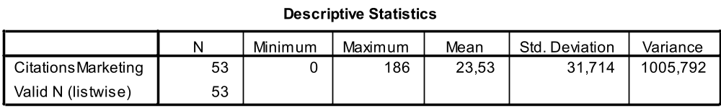
Appendix 3.2
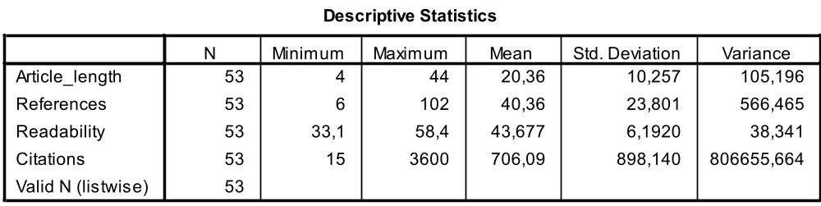
Appendix 3.3
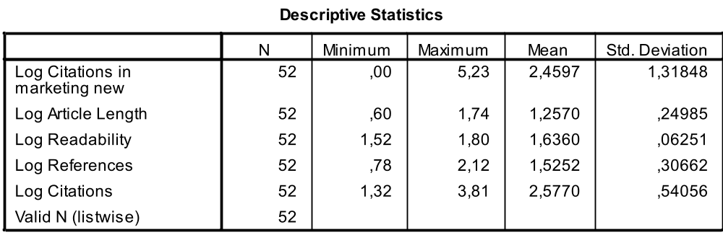

Appendix chapter 4
Appendix 4.1
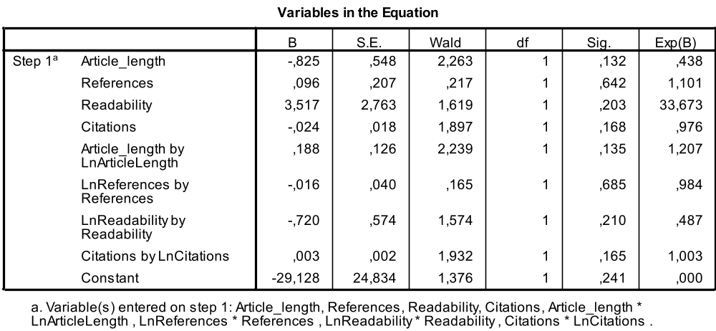
Appendix 4.2
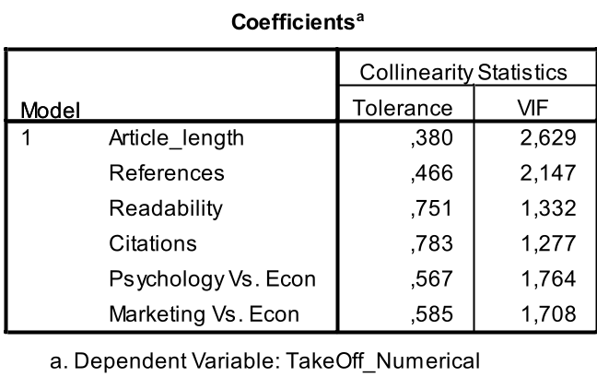
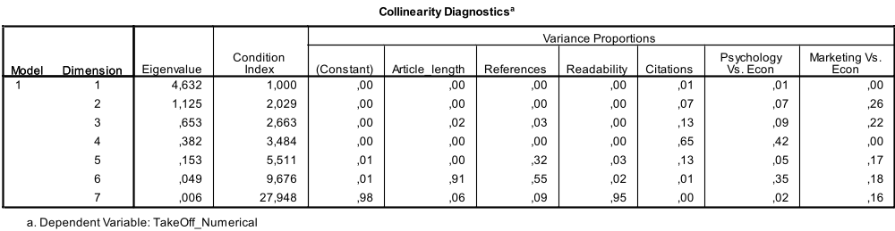

Appendix 4.3
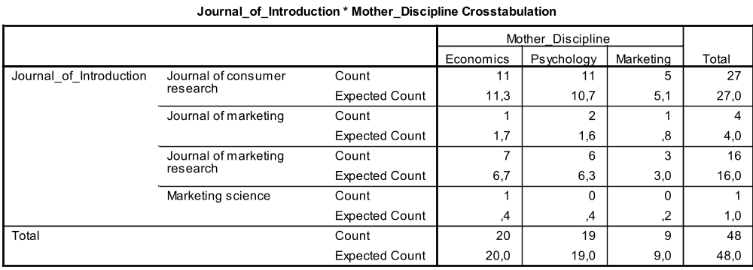
Appendix 4.4
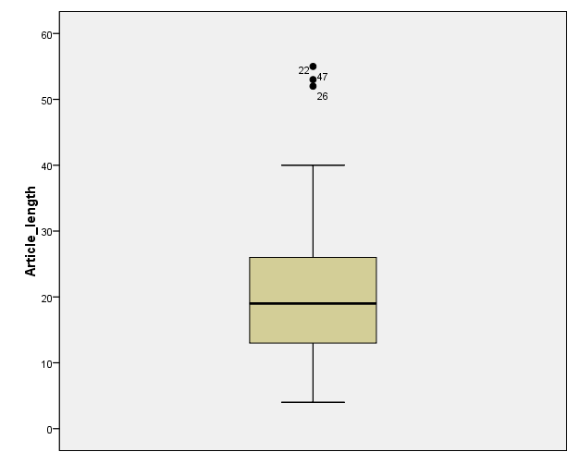
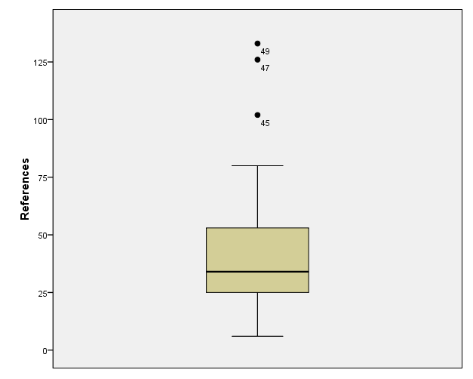
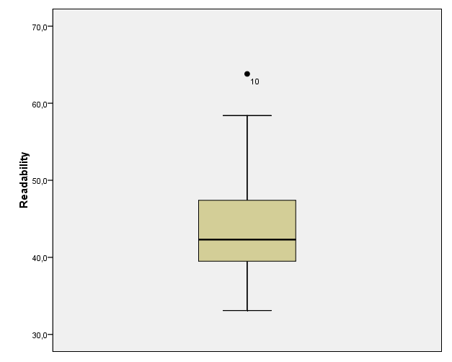
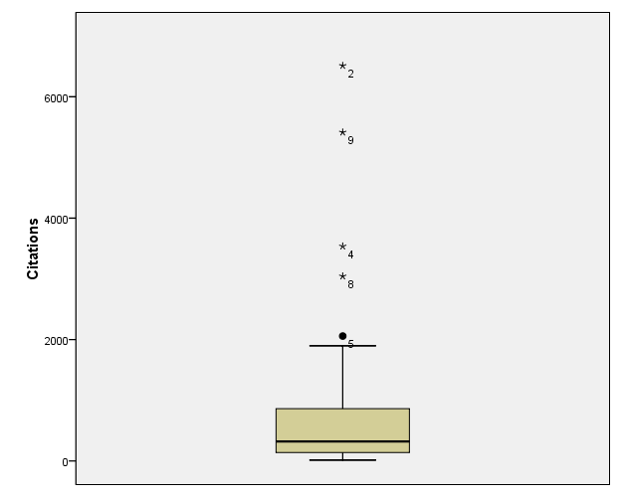
Appendix 4.5
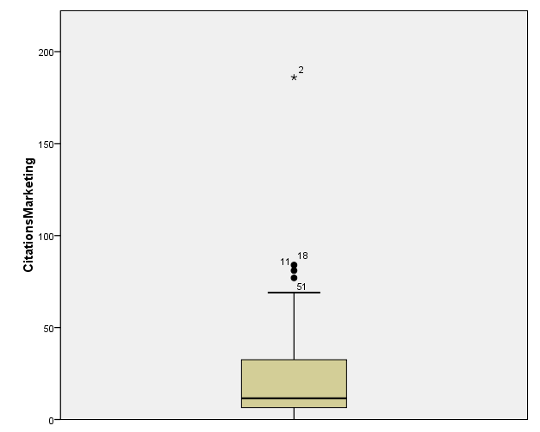

Appendix 4.6
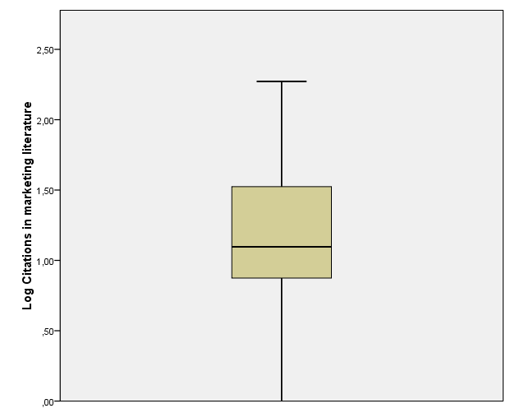
Appendix 4.7
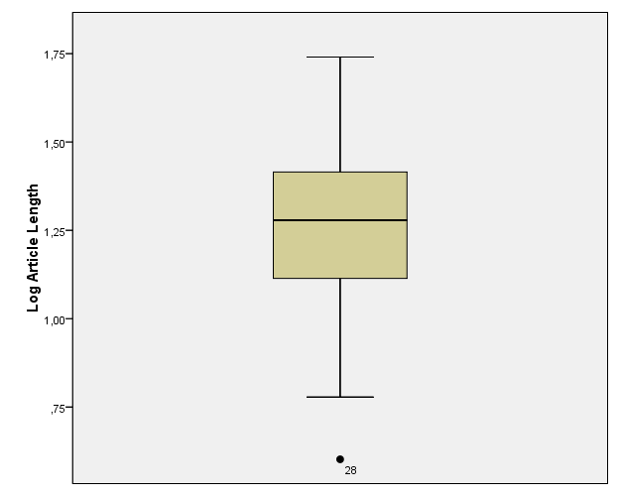
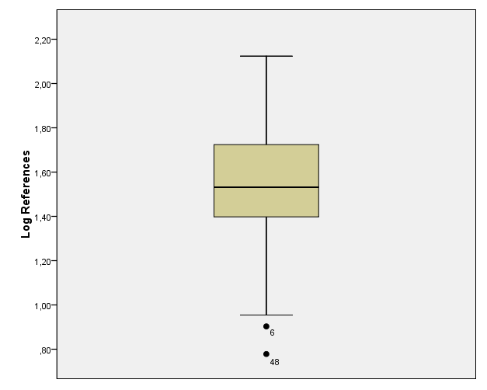
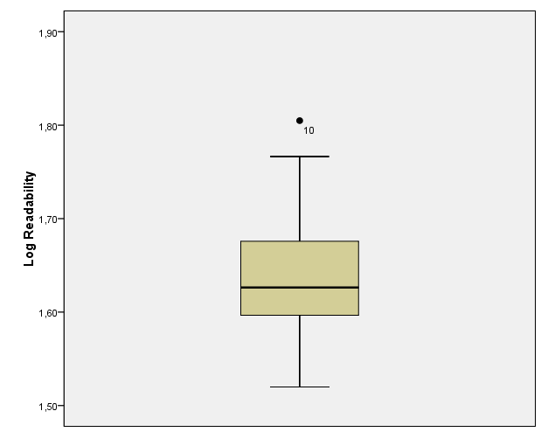
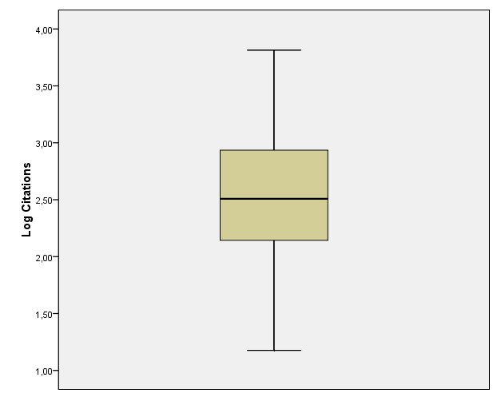
Appendix 4.8
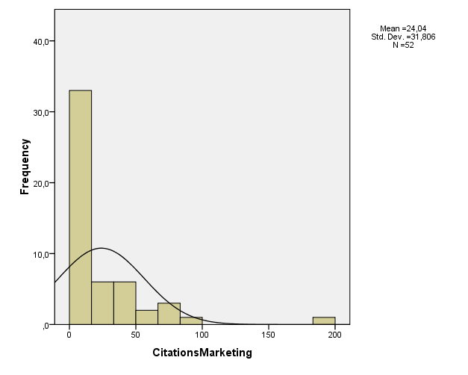
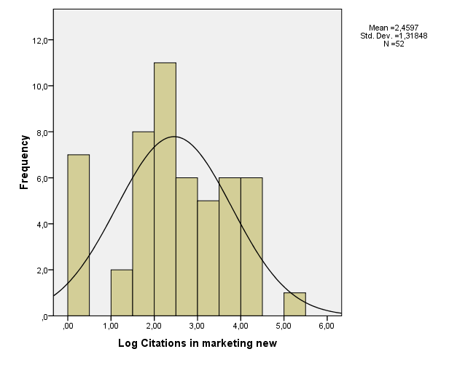
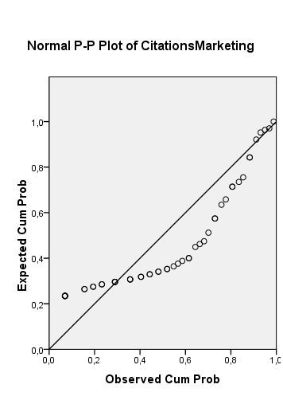
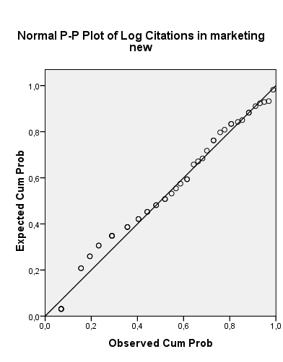
Appendix 4.9
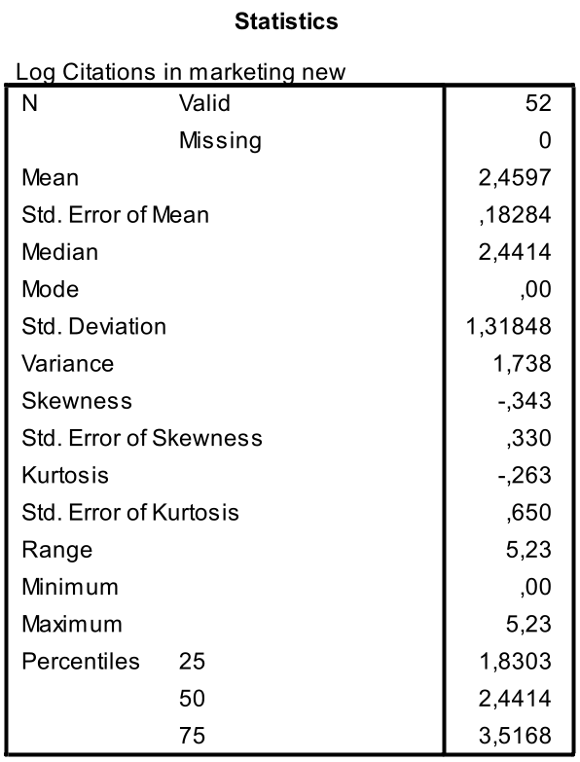

Appendix 4.10
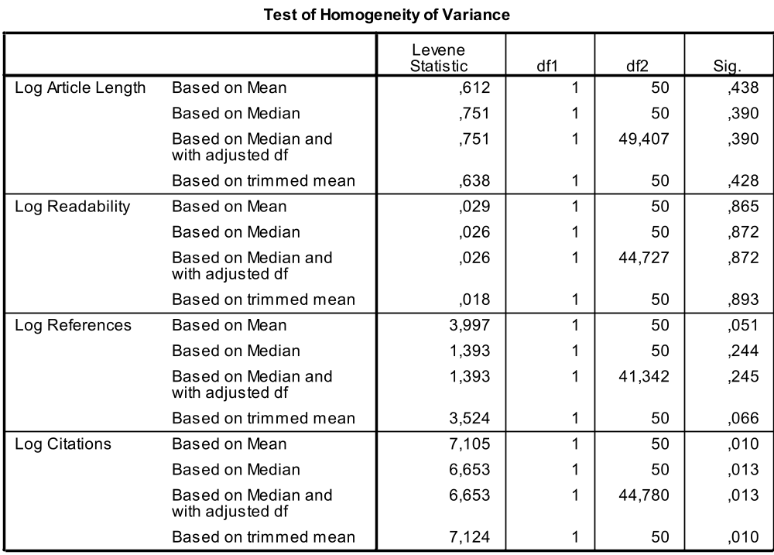
Appendix 4.11
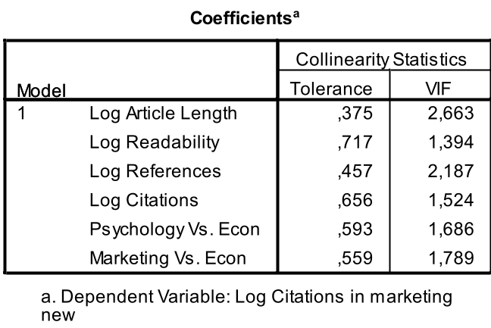
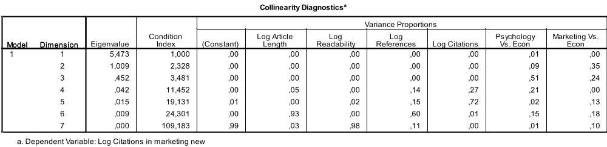

Appendix chapter 5
Appendix 5.1
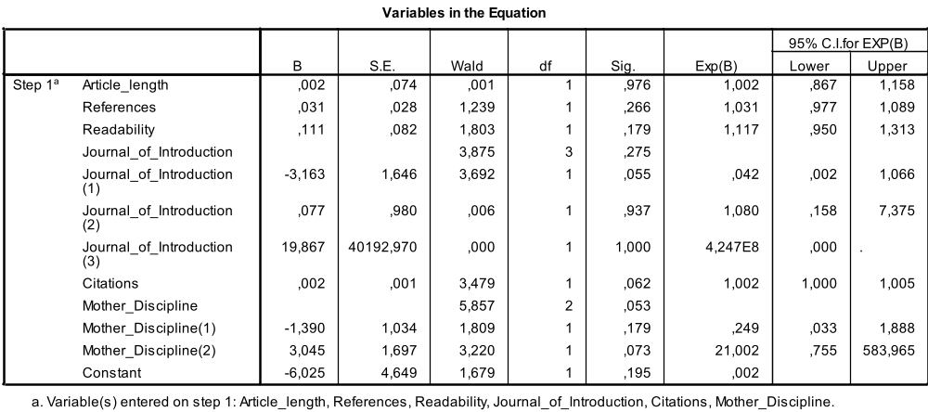
Appendix 5.2
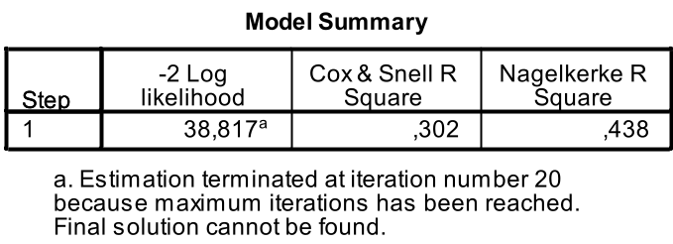
Appendix 5.3
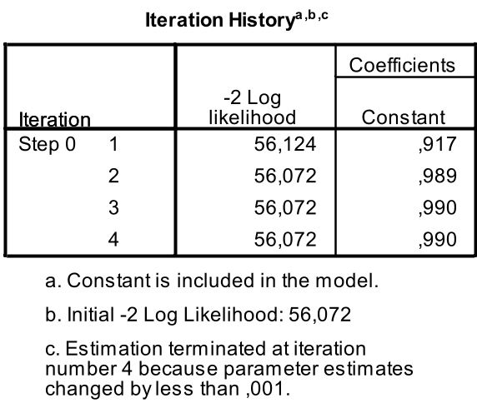

Appendix 5.4
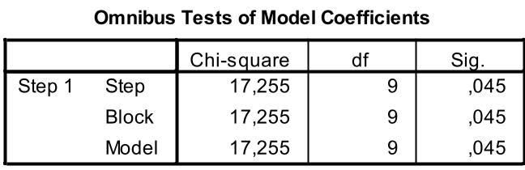
Appendix 5.5
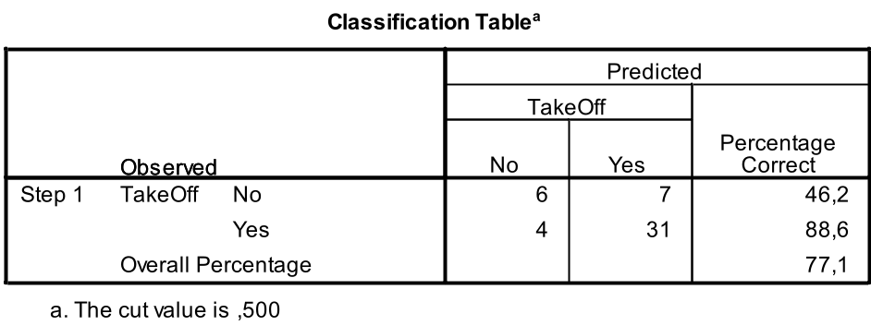
Appendix 5.6
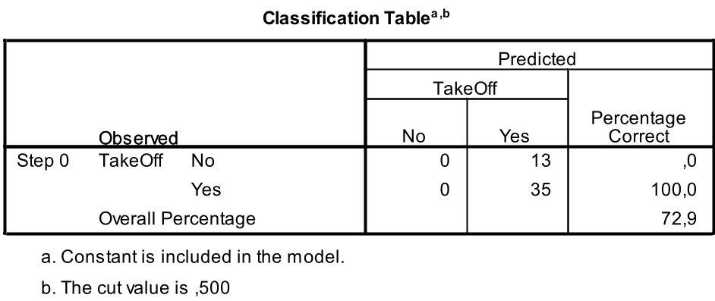
Appendix 5.7
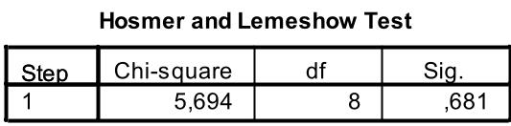

Appendix 5.8
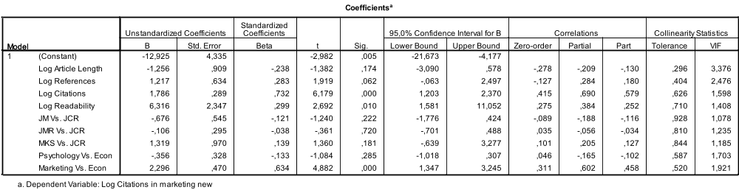
Appendix 5.9
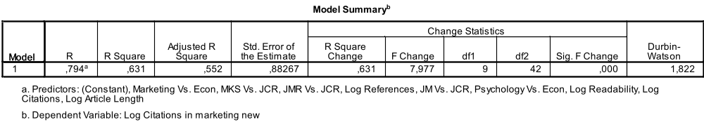
Appendix 5.10
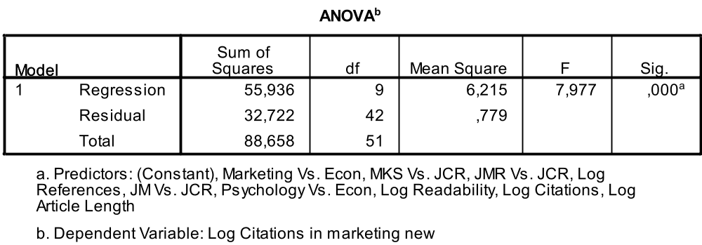

The subject areas identified by the researchers are: new products, business-to-business, relationship, brand and product, advertising, pricing, promotions, retailing, strategy, sales, methodology, services, consumer knowledge, consumer emotions, other consumer behavior, consumption behavior, international marketing, other, and e-commerce.
Note that the original article is defined as the article that introduced the theory in the scientific community, and that the focal theory refers to the theory presented in this article.
Tversky, A. (1972). ‘Elimination by aspects: A theory of choice.’ Psychological Review, Vol. 79, No. 4, 281-299
Kahneman, D. & Tversky, A. (1973). ‘Availability: A heuristic for judging Frequency and Probability.’ Cognitive Psychology, Vol. 5, No. 2, 207-232
Tversky, A. & Kahneman, D. (1974). ‘Judgment under Uncertainty: Heuristics and Biases.’ Science, Vol. 185, No. 4157, 1124-1131
Kahneman, D. & Tversky, A. (1984). ‘Choices, Values, and Frames.’ American Psychologist, Vol. 39, No. 4, 341-350
Loomes, G. & Sugden R. (1982). ‘Regret Theory: An Alternative Theory of Rational Choice Under Uncertainty.’ The Economic Journal, Vol. 92, No. 368, 805-824

