Pathways to Technology Adoption:

Understanding Smallholders Dairy Farmers in Southern Zambia

A Research Paper presented by:
Sharon Ngonde Manjekwa Ndandula
(Zambia)
in partial fulfillment of the requirements for obtaining the degree of
MASTERS OF ARTS IN DEVELOPMENT STUDIES
Specialization:
Rural Livelihoods and Global Change
(RLGC)
Members of the examining committee:
Supervisor’s name Professor Max Spoor
Reader’s name Professor Marc Wuyts
The Hague, The Netherlands
November, 2011
Disclaimer:
This document represents part of the author’s study programme while at the Institute of Social Studies. The views stated therein are those of the author and not necessarily those of the Institute.

Inquiries:
Postal address: Institute of Social Studies
P.O. Box 29776
2502 LT The Hague
The Netherlands
Location: Kortenaerkade 12
2518 AX The Hague
The Netherlands
Telephone: +31 70 426 0460
Fax: +31 70 426 0799

Acknowledgements
This Journey was not always smooth sailing. It definitely had its ups and downs. But God was with me all the way. The words of Prophet Jeremiah guided my every step; “For I know the plans I have for you,” declares the LORD, “plans to prosper you and not to harm you, plans to give you hope and a future” (Jeremiah 29:11). Thank you Lord. Thus far you have brought me.
I am very grateful to my Supervisor, Professor Max Spoor. I considered it a privilege to be supervised by the Convenor of the Rural Livelihoods and Global Change (RLGC) Specialisation. Thank you for your guidance and encouragement. I learned a lot. To my second reader, Professor Marc Wuyts, Thank you for the valuable insights you provided to help improve my paper. I wish you a wonderful retirement! To the RLGC Class of 2010, you were simply the best.
I would not have been here without the support of Dutch government through the NFP fellowship. Thank you for giving me the opportunity. I am also grateful to my employers Golden Valley Agricultural Research Trust (GART) for granting me leave of absence to pursue my degree. Special thanks also go to Dr. S. W. Muliokela, Professor G.S. Pandey, and Professor K. Samui for the valuable input throughout the development of this paper. I also wish to extend my gratitude to all who were instrumental during field work; Mr Martin Njovu, Parmalat; The Managers of the Dairy Cooperatives I worked with, all the respondents who offered their time to facilitate my data collection and all those who assisted in one way or the other, Thank you!
To my Zambian Colleagues – Pity, Chomba, Mercy and Nalishiwa, thanks for keeping ‘Zed’ very close. A special thank you to my New Apostolic Church family. Thank you for your prayers. I always felt at home amongst you. Dorica Nkhoma, we are destined for greater things! Mutibo, thank you for putting up with me during my field work. Mrs G. Mwansa, I could never thank you enough! To all my friends at ISS and beyond, too numerous to mention, I am grateful to you all. You played your roles in more ways than I can mention. May God bless you all! My babies, Charles, Kunda, Taonga and Liseli..Talking to you always brightened up my days when the light at the end of this tunnel flickered. Mercy, Gloria, Charles and Aubrey, Love you!
Dad and Mum, thank you for always encouraging me to pursue my dreams. You’re the world’s greatest and I love you! And yes, Next stop is PHD! God bless you!
Contents
List of Tables v
List of Figures v
List of Maps v
List of Acronyms vi
Abstract vii
Chapter 1
Introduction 1
1.2 The Research Context 2
Main Question 3
1.3 Methodology 3
1.4 Organisation of the Paper 4
1.5 Limitations, Methodological and Ethical Considerations of the Study 4
Chapter 2
Analytical Framework 6
2.1 Models for Technology Adoption 6
Innovation –Diffusion Model 7
Theory of Social Construction of Technology 8
Actor Network Theory 9
2.2 Adoption Strategy 10
Chapter 3
Smallholder Dairy Development and Technology Adoption 16
3.1 The Dairy sub-sector: Where from? Where to? 18
The Setting: Milk Production 20
3.2 Who are the smallholders? 25
Farmer profiles and socio-economic characteristics 25
Chapter 4
Adopting Dairy Technologies 29
4.1 Technology adoption and milk productivity 31
4.2 Influence of dairy cooperatives in achieving quality and safe milk 36
Milk quality 36
4.3 Constraints in Milk Production 37
4.4 Case Studies: Dairy farming and HIV/AIDS 38
White Gold 38
4.5 Role of Government 41
Chapter 5
Conclusion 43
References 45
Appendices 50
List of Tables
Table 4.1: Marital Status of Heads of Households 23
List of Figures
Figure 2.1: Illustration of the processes in technology adoption 9
Figure 2.2: Conceptual Framework of dairy technology adoption 12
Figure 3.1: Production of the most important food and agricultural commodities (ranked by value) in Zambia for 2009 17
Figure 3.2: Production of the most important food and agricultural commodities (ranked by quantity) in Zambia for 2009 18
Figure 3.3: Trends in Raw Milk Production in Zambia (1998-2009) 24
Figure 3.4: Educational Level among Smallholder farmers 26
Figure 3.5: Herd size among smallholder farmers 28
Figure 4.1: Effect of milking cows on milk productivity by educational level 29
Figure 4.3 Farm size in relation to Land allocated to pasture (in hectares) 31
Figure 4.4 Effect of Productivity of Farmer Incomes 32
Figure 4.6: Proportion of smallholders that save part of their income 35
Figure 4.7: Access to credit facilities 36
Figure 4.8: Milk production for Mrs Malia Hara 2008 - 2010 39
List of Maps
Map 1.1 Map of Zambia showing research sites 21
Map 1.2 Map of Zambia showing Agro-ecological zones 22

List of Acronyms
AIDS Acquired Immune Deficiency Syndrome
ANT Actor Network Theory
ASP Agriculture Support Programme
CBPP Contagious Bovine Pleuropnemounia
CSI Corporate Social Responsibility
DPB Dairy Produce Board
EPA Economic Partnership Agreement
FMD Foot and Mouth Disease
FNDP Fifth National Development Plan
GART Golden Valley Agricultural Research Trust
GRZ Government of the Republic of Zambia
FAO Food and Agriculture Organisation
HIV Human Immune Virus
ICA International Cooperative Alliance
IDT Innovation Diffusion Theory
MACO Ministry of Agriculture and Co-operatives
MCC Milk Collection Centre
MLFD Ministry of Livestock and Fisheries Development
MBT Micro Bankers Trust
NSCB National Credit and Savings Bank
SCOT Social Construction of Technology
SIDA Swedish International Development Agency
SNF Solid Non Fat
UN United Nations
US$ United States Dollar
ZANACO Zambia National Commercial Bank
ZATAC Zambia Agribusiness Technical Assistance Centre
ZMK Zambian Kwacha
Abstract
Dairy farming is an important livelihood strategy for smallholder farmers in Zambia. This is especially so for those in rural areas as it provides food security and livelihoods for rural households. It is important for smallholders to therefore invest in reliable dairy technologies to ensure that they have a constant flow of milk to provide to the market that is already assured to them by virtue of being part of networks such as dairy cooperatives. This study focuses on understanding how smallholder farmers construct the technology in order to ensure it is adapted and adopted. The study, which was done among smallholder households in Mapepe, Magoye and Monze districts in Zambia, revealed that various factors motivate farmers to adopt particular dairy technologies. These technologies include improved animal breeds, improved feeding techniques, milk hygiene and quality, animal health and better management practices for the farmers. A farmer’s major interest is to ensure that total productivity of his/ her animal is optimal. Determining factors include income, age and level of education of the farmers, labour availability and the contribution of dairy farming to improved standards of living for the smallholder household. The farmers also revealed that follow-ups after trainings are very vital to encourage them in sustainable technology adoption. Government investment in extension services would therefore play a major role in ensuring that these technologies are taken up and really implemented.
Relevance to Development Studies
The importance of diversified strategies cannot be over emphasised for improved livelihoods. In this way, having access to and taking up improved technologies plays a major role in ensuring that the standards of living and quality of lives of smallholder farmers in rural areas are raised. Dairy farming has been very successful in contributing to households in rural areas in this way. The study is therefore relevant to the Development Studies discipline in that it helps to understand the characteristics that the farmers possess which enable them to take up the technologies that are offered to them and how these improve their lives through increased income and improved nutrition. It also contributes to the development of rural areas by encouraging other goods and services to reach these areas, which would otherwise have not been the case as purchasing power improves as well.
Keywords
Smallholder farmers, dairy farming, income, nutrition, livelihoods, technology adoption, dairy technologies

Chapter 1
Introduction

1.1 Background
Livestock production is booming as it accounts for over 40% of the world’s agricultural gross domestic product (FAO 2009). Apart from playing a major role in contributing to food and income generation through milk and meat, livestock are a valuable asset to farmers as they are a store of wealth, collateral for credit and are an essential safety net in times of crisis. In general, the adoption of improved agricultural technologies is said to be a vital pathway out of poverty for many farmers in developing countries (Bandiera and Rasul 2006; Mendola 2007). However, adoption does not happen immediately as a lot of factors need to be considered.
In recognition of the importance of dairy farming in most countries, Zambian farmers are often faced with a myriad of questions: What type of technologies would increase their output? Would the adoption of newer technologies lead to any improvements in the quality and quantity of their yield? To what extent would their living conditions improve with increased production levels? It is in light of this recognition that the foregoing questions and more arise because dairy farming has proved to be a key livelihood strategy for smallholder farmers in many countries as it is an instrument through which the socio economic conditions of smallholder farmers can be improved. It is not only a valuable source of nutrition and income, but is an avenue for asset accumulation. Further, it is an important component in sustainable agriculture particularly in coping with the risks of climate change.
As a buffer and alternative strategy to unpredictable seasonal changes, various dairy technologies have been promoted by the Government of the Republic of Zambia though various non-governmental organisations and developmental agencies as a way of improving productivity among smallholder farmers in order to contribute to their livelihoods. Despite these interventions, challenges in milk animal productivity persist among the smallholder farmers.
In order to gain a fuller understanding of the subject matter, an exploration of the characteristics of smallholder farmers is needed as it helps to establish who they are and what features distinguish them from other groups of farmers. The dairy sector in Zambia is made up of three groups of farmers – commercial, small-scale and traditional farmers. Production differences among them could be attributed to variations in the levels of production (yield/cattle) that exists among the three groups. According to the World Bank (2003), smallholder farmers form the majority of Zambia’s agricultural producers who use simple technologies such as hand hoes and oxen and cultivation practices that do not require many inputs. The productivity of smallholders is also said to be considerably low, producing primarily for subsistence on five or less hectares of land and lacking access to functioning markets and support services. Though largely dependent on available resources, there is high potential for smallholder dairy farming to improve food security, nutrition and incomes among rural communities in Zambia.
Farmers use a number of dairy technologies which include the use of the cross breeds which are an improved version of the traditional milking animals used by local people. These give a higher yield than the traditional animals and are more resistant to diseases than the exotic milk breeds in the country. Improved feeding technologies and better management practices are vital for improved milk production and these involve growing feed/pasture crops for animal feeding. Whilst growing of pasture is key for improved animal feeding, it is important that these crops do not compete for resources with food for the households as this could influence farmers not to adopt the technology. Due to the prevalence of highly infectious diseases like foot and mouth (FMD), contagious bovine pleuropnemounia (CBPP) and production diseases like mastitis, vaccinations and proper animal health care measures are vital for sustained milk production and quality. As such animal health is important because when animals are in good health, they produce more and high quality milk and this translates into higher incomes for the farmers. The choice of technology is largely influenced by differing perceptions and this ultimately determines the adoption of different technologies by farmers.
It is assumed that small-scale farmers in rural areas are adopting technologies that have a low external input as most don’t have the financial capacity to access purchased inputs and this option turns out to be cost effective for them (Moser and Barret 2011). However, this does not always hold because farmers are differentiated in many ways. These differences can be seen in their resource endowment, wherein some farmers tend to have more resources than others who have limited access to resources. The majority of smallholders operate under resource-poor conditions with few purchased inputs and limited technology. In light of this, they have to employ strategies which not only guarantee some profit but also enable them avert as much risk as possible (Ellis, 1998:15). This is one way of ensuring that they are less vulnerable to the shocks inherent in farming. Dairy farming therefore complements crop farming, which is hampered by low productivity.
This study therefore aims at understanding households’ pathways to the adoption of dairy technology, in light of the different characteristics and resources that smallholders possess. Technological options promoted should therefore be adaptable to individual farmer circumstances and this can only be done if the farmers’ characteristics are understood. This would then result in the development of technologies that are appropriate to their needs as well as the creation of relevant policies by the government.

1.2 The Research Context
Dairy development is expected to create employment and facilitate income generation for farmers through improved diary production and productivity (Staal et al 2008). In view of this, several productivity and production enhancing technologies have been provided to farmers such as knowledge transfer through trainings, loan facilities at favourable repayment rates and the provision of appropriate breeds of dairy animals. Local participation is critical, as the successful adoption of these technologies by farmers heavily depends on the general responsiveness of these households. This is so because the decision making patterns and adoption behaviour of the farmers will have a strong bearing on how much of the technology the farmer will take up. Although organizations carry out needs assessments before they introduce a particular technology to an area, hardly do they strive to understand the people whom they are giving the technology.
The objective of the paper is to investigate what factors influence or prohibit the process of adopting improved dairy technologies by smallholder farmers and assess the effect on household income. This will be done by exploring which technologies smallholders are adopting, how they adjust and transform them to suit their circumstances and why it happens this way.

Main Question
What are the complex factors that define adoption of new technologies by smallholder dairy farmers and their possible success and failure of implementation?
In order to do this, this research paper addresses the following sub questions;
- Which dairy technologies are available to the smallholders and what reasons do they have for or against taking them up?
- To what extent do social networks influence farmers to adopt dairy technologies?
- What role does the Dairy Development Policy of the Government of Zambia play in dairy technology adoption?
The study was therefore concerned with exploring and understanding factors that determine farmers’ decisions in adopting or not adopting particular dairy technologies whilst considering that financial capacity, health, labour availability and productivity are important aspects in ensuring enhanced productivity.

1.3 Methodology
A questionnaire was administered to farmers while an exploratory case study was done with a farmer from in order to capture a different perception and view on how choices regarding technology adoption at household level are made. O’Leary notes that working with cases provides opportunities to “bring new variables to light” (2010: 175). Tellis (1997) reveals that case studies can be applied to explain complex causal links that happen in real life as well as describe the context in which various interventions have occurred. Information collected in the case study was checked for consistency and accuracy with the manager of the cooperatives to ensure its reliability and validity.
An interview was conducted with a representative from the Ministry of Livestock and Fisheries to provide insights into the role of government in generating and facilitating the adoption of technology. This interview was also meant to give clarity on the role of the government in creating the relevant policies in technology adoption. Although the process of obtaining information from the official was challenging to say the least, substantial information was eventually collected. Key information was also collected from the processor, Parmalat in an interview with the Quality Manager to understand what requirements and incentives they have in place concerning milk quality and how they ensure that smallholders achieve this.
The research critically engaged with secondary sources by reviewing available literature on the subject matter from various peer reviewed journals, credible internet sources and books. Literature on the various dairy technologies in Sub Saharan Africa was also considered and reviewed.
The findings of this study can hopefully assist policy makers and development planners in designing interventions that will benefit the farmers as the knowledge generated from this study will make them more aware of the farmers’ decision making process in dairy farming. The study is also expected to provide a better understanding of the farmers’ choices and possibly feed into policy making processes, considering that dairy farming is very important for food security, asset accumulation and indeed, improvement of livelihoods.

1.4 Organisation of the Paper
Theoretical approaches which will be used in the analysis are reviewed and presented in Chapter 2. Here, the strategy to technology adoption is presented using the innovation-diffusion model, the theory of social construction of technology and the actor- network theory. The role of improved agricultural technology is discussed giving the monetary and non-monetary benefits.
Chapter 3 begins with a brief profile of agriculture in Zambia and the contribution of livestock sector. It goes on to describe the evolution of smallholder dairy development and how it has fared since market liberalization. The chapter further looks at the importance of dairy development not only at macro level but also at farm and household level. The methodology employed during the research is also described. The chapter concludes with a description of the socio economic characteristics of the sampled farmers.
In Chapter 4, factors affecting technology adoption are analysed while exploring correlations among the variables to understand what drives farmers in the technology adoption process. Chapter 5 presents a reflection of the findings.

1.5 Limitations, Methodological and Ethical Considerations of the Study
This study is based on cross-sectional data which give information about what technologies dairy farmers are using, how and why, while paying particular attention to identify the constraints they face. Doss (2006: 210) reveals that although these provide vital descriptive information about the farmers, they leave out much about the long-term dynamics of technology adoption which makes policy formulation difficult. Due to the constraints on time, panel data could not be used.
It goes without saying that samples are supposed to be representative enough in order to generate information about a particular country, region or study area. However, due to the nature of the sampling techniques employed in this study, the data analysed could only be applied to the sampled population as it does not give much scope for broader representation.
The study employed both quantitative and qualitative methodological approaches. Some challenges were faced in effectively utilising the data using quantitative analyses. Collecting some of the qualitative data was not easy as some informants were not forthcoming with providing the information.
The case study involved a widow living with HIV/AIDS as this presents an additional complication in terms of labour demands (Nguthi 2008: 63). Being a sensitive issue, the respondent signed a consent form to assure her that confidentiality would be guaranteed.

Chapter 2
Analytical Framework
This chapter therefore aims to provide a review of literature on technology adoption and present a framework through which this process can be explained.
De Souza Filho (1997: 82) suggests that farmers are influenced by various economic and non-economic factors to make decisions regarding the adoption of agricultural technologies. Farmers will hesitate to adopt a technology if income increase is expected to be low and if costs outweigh the benefits. Other common exploratory variables include farm size, risk and uncertainty, human capital, labour availability, credit and supply constraints. According to El-Osta and Morehart (2000), farmers have been able to succeed financially through increased productivity and lower per unit costs as a result of the contribution that technological advances make to the dairy industry. These advances have been categorized as capital-intense such as genetically superior dairy cows and management-intense practices such as improved nutrition and feeding. However, these are not applicable to those smallholder farmers that are already constrained financially and do not have the appropriate breeds. These limitations have been observed among Zambian farmers in their quest to increase productivity by smallholder farmers (Zvomuya 2007: 19). Research and technology directed at addressing constraints such as feeding, appropriate breeds, animal health and other such constraints has led to an improvement. This has been done by organisations such as Golden Valley Agricultural Research Trust, which has invested in ensuring that smallholder farmers are given assistance in improving the productivity of their herds. Byerlee and Polanco (1986) suggest that although transferring technology as a package allows interactions among components and emphasizes the large difference in yields between traditional and improved methods, it comes at a cost as farmers are constrained by capital and have to consider the risks associated with it.
Due to the fact that there are a lot of demands from the processor and the consumer as end user, milk quality plays an important role particularly from the point of production until it is consumed. Frouws (as cited in Schwarzweller, 2000: 213) reveals that the methods of producing milk are just as important as the product itself. This explains the great emphasis placed on the process of milk production from the time it hits the milking can until it reaches the consumer as well as the institutions that provide knowledge about this technology. This suggests the importance of ensuring that the milk is of the highest quality possible as this can increase the returns by increasing income and improving rural livelihoods.

2.1 Models for Technology Adoption
Straub (2009: 626) posits that no single model for technology adoption can explain the process an individual engages in before adopting a new innovation. However, it is important to understand how farmers choose and adopt technology. The study will make use of three theories in technology adoption; the innovation–diffusion theory, the theory of social construction of technology and the actor-network theory.

Innovation –Diffusion Model
The decision process to adopt a particular technology involves farmers acquiring information because they face yield uncertainties and varying risk preferences. This implies that there is a relationship between production uncertainty and technology adoption as farmers will attempt to protect themselves against input related production risks. An individual therefore has to make choices from the pool of alternatives that are at their disposal. In the context of dairy technologies, smallholder farmers are provided with these technologies by the government, organisations providing interventions through various projects or even milk processors such as Parmalat in the case of Zambia. It is assumed that they will make decisions of adopting or rejecting the technology based on socio-economic factors such as herd size, farm size, labour availability, credit constraints and risk and uncertainty, among others. Focus should therefore be on the adopter as they determine how much of the technology will be adopted.
According to Rogers (2003: 168), the decision to adopt is a process that does not happen spontaneously, but happens over time. A farmer will try out different technologies to see what works well on their farm with the available resources before making the decision to incorporate a particular technology into practice. The model presents 5 stages that an individual should go through before a technology is adopted. In the first instance, farmers learn about various technologies that are available through information dissemination workshops and other training programmes. The farmers hear about these technologies from their neighbours, the cooperative society to which they belong and extension officers. Some farmers are interested in having the latest information at their fingertips and therefore carry out research and read widely on the latest technologies and are able to apply them to their practice. In the second stage, farmers are persuaded to know more about the technology after hearing about it. Their attitudes therefore change and are interested in knowing more about the technology, how it works and what it can do for them. This is a vital stage because it plays a major role in influencing their decision to adopt or reject the technology. The farmers then decide to try out the technology. The knowledge gained forms a basis for adoption or rejection depending on how well the technology is understood and their perception of benefits.
At implementation, the farmer incorporates the technology in their practice while adapting it to suit their circumstances. This aspect of re-inventing makes the technology flexible and could be beneficial to adopters ( Rogers 2003: 185). However, farmers can also decide to discontinue with the technology if they feel it doesn’t provide the expected benefits. The last stage involves confirmation of the farmer’s decision –positive or negative.
Farmers make their decisions based on expected impacts on the wellbeing of their households particularly on household income. If there are prospects for higher profitability; greater consumption and higher nutritional outcomes, chances of adoption could possibly be higher (Quisumbing 2003).

Theory of Social Construction of Technology
The theory of social construction of technology (SCOT) links the social to the technical processes by understanding how society understands new technology and alters/adapts it to its practices and acts on it (Williams and Edge 1996; Callon 1987; Bijker et al 1987). According to this theory, technology adoption is not just a process of introducing new technologies, releasing them into society and expecting society to take them up. It is a complex process where social relations come into play where social dynamics are mapped onto the specific technical characteristics. Society tries to understand the new technology by negotiating ways by which it can be altered. In this way, the smallholders engage with the technology and experiment with it to find ways that are most suitable for them. It is therefore not just about the technology ‘working’ or ‘not working’ or ‘succeeding’ or ‘failing’ or even being ‘adopted’ or ‘not being adopted’, but it is about how these smallholders participate in their networks to re-construct the technology to suit their needs and capabilities.
The social construction of technology has four basic concepts (Klein and Kleinman 2002: 29). An open process implies flexibility in that it is accessible to different users and has the ability to produce different results. There is not one single way of doing something. This flexibility supports the non- linearity of technology adoption. Technology is generated for multiple users, and all these have different conceptions of the technology. They also relate with it differently. There is need for these different groups to negotiate among themselves and decide on its best use. Once the technology is stabilized such that there are no further modifications to be done and as such does not present problems for any of the users, there is closure. Throughout this process, the technology should operate within the socio-political context thus the importance of understanding group interactions and the rules ordering these interactions.

Figure 2.1: Illustration of the processes in technology adoption

Adapted from Cramb (2003)

The figure above is an illustration of the processes that farmers have to go through in order for them to adopt a particular technology. The technology is first generated in the ‘laboratory’. This laboratory can be research institutions or development organisations. Researchers may discover that improved feeding has a positive influence on milk productivity. Once it is tested that it works, this information is then disseminated to the would-be adopters, the farmers. This is done through workshops, demonstrations and trainings

Actor Network Theory
The Actor Network Theory describes the dynamics of society by showing how farmers either form or are part of social groups and the process through which they construct technology. This construction is through sociological analysis and not in the engineering sense (Callon 1987). Farmers are individuals with different characteristics, thus a heterogeneous group. Because of this, they associate differently amongst each other and thus influence and re-define themselves in different ways.
Long and van der Ploeg (1989: 226) present this as an “actor-oriented analysis that views intervention as a multiple reality made up of differing cultural perceptions and social interests, and constituted by the ongoing social and political struggles that take place between the social actors involved.” This explains the interaction of actors particularly in interventions that are planned such as the introduction of technologies to the rural communities. The introduction of an intervention does not immediately imply that it will be taken up but that it will be negotiated and adapted to suit the potential adopters. How they interact with the various actors involved and internalize these determines which and how much of the technology will be adopted. Moore (2008) also observes that there is more to technology adoption than just making the decision and a change in behavior. It is important to understand the technology as a whole if a farmer is to enjoy the bull benefits of their decision.
The three theories will be used to analyze the various processes associated with adopting new technologies among the smallholder farmers in the sample. It is clear that a farmer will endeavour to produce output that will provide more benefits than costs to their farming operations. However, this depends on the choices the farmer makes based on the means available to reach their desired ends.
The innovation diffusion model provides the ‘debut’ of the technology as this is when a farmer first comes into contact with it. After farmers are persuaded about the benefits the technologies provides for their dairy animals, decisions are made and the farmers adopt the technology. However, this is not a straight forward process. At each stage, there is a forward and backward process going on. This innovation diffusion model therefore poses a limitation on the farmers as it implies a linear process and assumes that the innovation will remain as it is throughout (Zendejas and Chiasson 2008: 528). Technology is dynamic. There are always new inventions and new ways of doing things and therefore there is need to keep up otherwise one may become obsolete before their time.
Allowing farmers to participate and adapt their technology to what suits them encourages them to take up a particular technology. However, it is important to consider the learning challenges the farmers may have as some may not have had experience or may have just observed from their neighbours at a distance. As most of the technology is transferred through the social networks, power relations may arise in the interactions among the farmers and this may cause resistance (Whittle and Spicer 2008).

2.2 Adoption Strategy
Farmers will take up technologies from which they expect to gain from. Farming in resource-poor conditions, with few purchased inputs and limited technology, they will prefer technologies with high returns but low cost as they are both producers and consumers (Byerlee and Polanco 1986).
Dairy farming therefore complements crop farming, which is hampered by low productivity. Technological options promoted should therefore be adaptable to individual circumstances of the farmers. This can only be done if the farmers’ characteristics are understood in order to develop technologies that are appropriate to their needs and feed into the policies that government can make regarding dairy farming. Through this study, understanding the knowledge, attitudes and practices of smallholders farmers in dairy farming in relation to the kind of technologies they adopt to improve their production is vital as it provides government and other policy makers with information as to what kind of technologies to generate that will be adopted by farmers.
Adoption is the decision to maximise the use of an innovation as the best course of action available and diffusion as a process where communication of innovations or technologies happens overtime among members in a society through certain channels, while innovation is the idea, practice or object perceived as new by the individual or other unit of adoption (Boz et al 2011). Straub (2009) reveals that historically, adoption was understood in terms of behavioural change. This implies that adoption happens over time and only when an innovation has been accepted will it be used and integrated into the farmer’s system. Adoption is farmer driven and is done by farmer choice. The farmer makes his own choice to adopt or not adopt a particular technology depending on various factors such as socio-economic characteristics, perceptions, policy and technology features (Bhattarai 2009). However, farmers will take up at least one thing or the other from the package of technologies offered to them unless there are serious barriers that completely prohibits them (ibid).

Figure 2.2: Conceptual Framework of dairy technology adoption

- Household characteristics e.g. education, labour
- Cultural e.g. gender
- Social e.g. networks, dairy cooperatives
- Economic e.g. profitability
- Environmental e.g. climate change

Benefits
- Monetary
- Non-monetary
Factors

Adoption
Introduction of dairy technologies

Costs
- Monetary
- Non-monetary

Source: Author’s construction, 2011

The framework above illustrates the linkages between technology adoption and the various factors that influence the adoption of dairy technologies. It shows the benefits that accrue to households such as increased income and the improved rural livelihoods and costs attached to these technologies. Farmers will adopt a technology based on what inputs are required and whether it contributes to the household either in monetary or non-monetary form. High milk yields are vital for the household because the marketed milk will contribute to the household income; enabling households have access to health services, inputs, veterinary services and other household requirements.
Smallholders are differentiated in many ways. Some are more educated, own more assets while others have more labor available for various farm activities. With these, they could take up these technologies and adjust them to their circumstances and maximize benefits derived from them. Increasing milk production is very important for the farmers as this provides them with sufficient milk for consumption to improve their household’s nutrition and still be able to sell the surplus on the market providing smallholder farmers with a means to sustainable livelihoods at a time when farming systems are changing as a result of climatic conditions.
Households are involved in both on-farm and off-farm activities in order to sustain their livelihoods. Because of the constraints that smallholders face in terms of time, labour and land, adopting intensive dairy technologies would mean a trade-off on one activity or the other (Mullins et al 1996). While women contribute the most to the dairy enterprise in terms of labour, with children pitching in to do menial jobs; the benefits are not shared equally with the men. This may present significant consequences to technology adoption and sustainability because the time and effort may not determine the financial reward and equity (ibid: 242). Access and control over household resources is not entitled to the female member of the households. This affects not only the willingness to adopt a new technology, but also the efficiency of its use if it is adopted.
With increased productivity, costs are lowered and this has the potential for higher incomes. However, trade-offs are evident in terms of high management requirements, time in terms of having to learn new skills and costs. Dairy technologies are a package of technologies which contribute to increased milk production, higher incomes and have an impact on rural households.
Labour is another important aspect in the framework as this is a major resource the farmers have at their disposal. They will channel it towards activities that will bring more returns but also does not take too much of their time and keep them away from doing other important activities, that may be essential for improving their livelihood. This is useful in establishing whether adopting a particular technology will push the farmers to participate more in off-farm employment thereby work more hours and earn higher income. The technology may involve trade-offs in that although it may increase incomes, it may also increase labour inputs and time constraints of certain members of the household (Tangka et al 2000). It is important to detect trade-offs such as these early and correct them to avoid short-term adverse effects of technology change on the smallholder households. Gender is also important because men and women have different roles to play not only in dairy farming, but in agriculture as a sector. Targeting the decision maker is therefore vital in the adoption process as they are the final choice rests on them (Solano et al 2000). Labour-intensive technology may not be preferred by the women if it takes up too much of their time considering they have reproductive and other productive roles to perform.
Although dairy technology can reduce production costs and induce shifts to more commercial systems that allow for higher yields in milk, the purchase, maintenance and capacity to develop skills to run these may induce costs. Through dairy cooperatives, the package of technologies reaches the farmers as they are provided with services at a more reasonable cost than what they would have negotiated for in their individual capacity (Wollini et al 2008).
Social networks therefore play an important role as individuals will be influenced to adopt a technology through ‘family and friends’ of the farmer (Bandiera and Rasul 2006). If a farmer sees a neighbour adopting a particular technology and what benefits are accruing to that farmer, they may also decide to adopt it depending on available resources. The farmer may also decide to wait and establish the costs and returns, or may have to raise some resources before they can make the decision to adopt. This suggests that there is interplay of various actors in the diffusion of these technologies. These actors have specific roles and responsibilities and possess different resources and capabilities as they make strategic decisions in technology adoption. Within the social networks, cooperatives therefore play an important role in raising the socio-economic conditions of member and surrounding communities. They provide the poor people with an opportunity to raise their incomes and contribute to finding solutions to their various challenges and strive to ensure that there is participation and control by member producers. Individual members have the ability to influence policy and management matters through registered membership bodies that are regulated by laws or rules of a community or state as the case is with dairy cooperatives. Dairy cooperatives do have the ability to raise standards of living for the poor through the facilitation of development of the remote rural economies especially if cooperative principles are adhered to. as these guide them.
Climate change has had a significant impact on agriculture and dairy farming in particular. Although livestock provides a buffer to the detrimental impacts of climate change, it also contributes to climate change through the emission of greenhouse gases (Greenpeace 2010). Like many other African countries, Zambia faces challenges in agriculture with semi-arid conditions (Dinar et al 2008). Decisions the farmers make is a manifestation of their attempt to avert risks and not necessarily as a response to their risk. If farmers are risk averse, they will be reluctant to invest in ‘modern’ technologies and will be stuck in the poverty trap particularly if there are no mechanisms to reduce the downside effects. Farmers also have the tendency to adopt a technology that is beneficial to them. If farmers do not see any benefits from adopting a particular technology, they may not consider it. However, when they decide to take it up, they expect it to have a relative advantage over the existing technology.
An individual’s decision and the time frame to make that choice has an influence on all aspects of life (Straub 2009). If a technology takes too much time for the benefits to be seen, farmers may avoid it. This is because the decisions smallholders make regarding the adoption, partial adoption or non-adoption of dairy technologies will have an effect their livelihoods. Valuable outcomes include income, employment generation and improved nutrition of both farm households and resource poor consumers. Livestock and dairy farming in particular also contributes to the quality of the soil through manure. Where chemical fertilizers are neither available nor unaffordable, manure is the best organic option as it improves soil quality and boosts crop yields. These benefits will influence farmers to enhance their milk productivity. Cost issues come to play as households need a stable cash flow in order to sustain these technologies.
In Zambia, farmers have been assisted in organising themselves into groups/cooperatives as it is easier to provide assistance to a group rather than to individual farmers. This knowledge is transferred through farmers training, research work and financing. The major stakeholders are milk producers who are the smallholder farmers themselves; Parmalat, the major processor; local and international organisations that provide the technical assistance and the government, which provides the policy framework and creates an enabling environment. Milk collection centres have also been built and provided with cooling tanks in order to provide farmers with access to markets of clean and high quality milk as required by the processor. Local and international organisations such as Zambia Agribusiness Technical Assistance Centre (ZATAC), Heifer International and GART, have introduced and implemented these new technologies. These organisations have also been instrumental in establishing formal linkages with the leading processors in Zambia.
The theories therefore help to analyse the processes farmers go through in making their decisions on what technologies to take up, based on their characteristics and circumstances and considering constraints they face as smallholder farmers.

Chapter 3
Smallholder Dairy Development and Technology Adoption
This chapter seeks to analyse the importance of agriculture vis-à-vis dairy farming to the national economy and specifically to smallholder livelihoods and will provide empirical evidence of the factors that influence the adoption of dairy technologies among smallholder farmers. Agriculture is the main driver of Zambia’s economy which has the potential to significantly contribute to the national economy and reduce poverty (FNDP 2006; Govereh et al 2006). Despite being a landlocked country, Zambia is endowed with abundant natural resources and vast areas of land, much of which has not been fully exploited due to various reasons such as unfavourable weather patterns, macroeconomic environment and sectoral policies. (Haambulo 2009; Ministry of Agriculture and Cooperatives 2004)). Sinyangwe and Clinch (2002: 1) observed that for a long time, the country’s economy depended on a single commodity - copper, but low prices and a drop in production prompted the government to pursue other avenues of economic diversification, of which agriculture was priority. Mulemba (2009) observes that the agricultural sector can contribute more effectively to the economy if there is a conducive business environment with supporting policies.
Out of a total of 7.5 million hectares of land, 4.2 million hectares or 58% is classified as medium to high potential for agricultural production while 12% is suitable for arable production, with only an estimated 14% currently cultivated. The Zambian climate is favourable for agricultural production, with abundant arable land receiving 650mm of rain in the southern part of the country and 1800mm in the North each year. It has been estimated that only 65,000 hectares or 13% of a potential 500,000 hectares has been developed for irrigation in Zambia. Smallholder farmers account for more than 80% of the national output but because of their dependence on rain fed agriculture, poor access to agriculture inputs and poor produce marketing arrangements – their productivity is still poor and vulnerable to vagaries of nature. This situation has resulted in intermittent spatial food insecurity which the country has continued to encounter over the years (Haambulo 2009: 1)
Although 34% of total land area is agricultural land, only 7% is arable land. This shows that Zambia has a lot of potential to ensure that agriculture plays its role in economic development especially that about 56% of the population lives in rural areas and 90% of these depend on agriculture for their livelihoods. Additionally, Agriculture is a large employer accounting for more than 70% of total employment (Haambulo 2009).
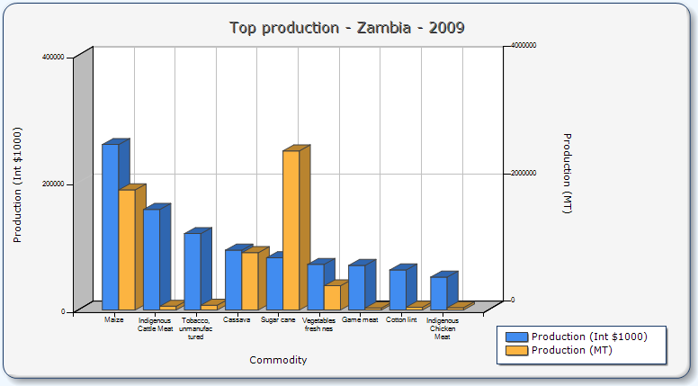Figure 3.1: Production of the most important food and agricultural commodities (ranked by value) in Zambia for 2009
Source: FAOSTAT 2009

The fact that the Zambian government devotes about 70% of the Ministry of Agriculture’s budget to fertilizer subsidies and maize marketing confirms maize as the most valued crop (FAOSTAT 2009, Jayne et al 2007). It is therefore not surprising that livestock production is low as the sector does not receive much funding. Greater importance is given to other commodities such as sugar cane and maize because prices are good on the international market. In 2009, 84,842 MT of fresh, whole Cow milk were produced compared to other commodities, as shown in figure 4.2 below.

Figure 3.2: Production of the most important food and agricultural commodities (ranked by quantity) in Zambia for 2009
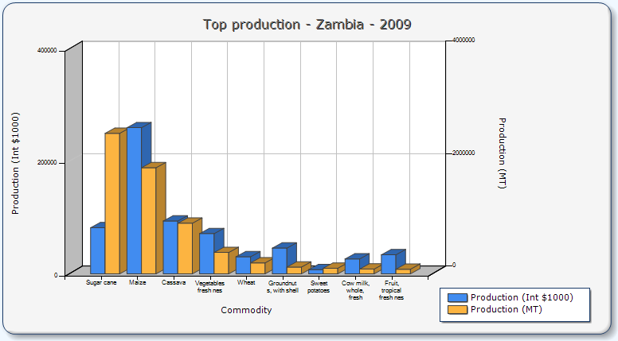Source: FAOSTAT 2009

3.1 The Dairy sub-sector: Where from? Where to?
Although crop production is significant, the livestock sector contributes about 35% of the total agricultural production and comprises 2.8 million cattle (Sinyangwe and Clinch 2002; World Bank 2011). Despite Zambia being endowed with land, cattle population is small compared to other countries in the region. The World Bank observes that Zambia has 0.14 herds of cattle per hectare while Kenya and Zimbabwe stand at 0.63 and 0.44 herds per hectare respectively (2011: 10). Potential therefore exists for the dairy sector to make a significant contribution to the national economy. Dairy production provides smallholder farmers with livestock products such as milk which has high nutritional value and plays a major role in food security. Farmers make use of by-products such as manure and animal draft power as an integral part of sustainable mixed crop livestock farming. In this way, smallholder farmers are able to save on costs of commercial fertilizers while making use of organic fertilizers to improve not only their production but also the quality of the soil. However, it should be noted that,
The behaviour and incentives of traditional farmers differ significantly from those of commercial farmers, and are influenced by social and cultural factors (e.g. a tendency to view cattle as a store of wealth, a means of subsistence and of mechanical power rather than a means of generating income), as well as a lack of information and of access to commercial markets. As a result, traditional farmers use fewer and lower quality inputs (e.g. feed, breeding stock and veterinary care) and their cattle have poorer nutrition, lower product yields, and higher rates of disease (World Bank 2011: 11)
With the largest number of cattle population, southern province is home to the Tonga and Ila tribes, who have a strong attachment to their cattle (Mulemba 2009). Not only are cattle used as savings and a buffer to a bad crop year, they are also an avenue for asset accumulation particularly emergency funds, an important symbol of wealth, status and prestige (Bebe et al 2003). As such, it is very rare to find a Tonga who will tell you the exact number of animals in his kraal. Milk production therefore plays a very important role in the lives of smallholder farmers.
A relatively good number of farmers produced milk prior to the market liberalization era, due to the favourable milk price. However, they were constrained by high transport costs as they had to travel long distances to find a market for their milk. The Dairy Produce Board (DPB) was a parastatal institution which was responsible for controlling the existing dairy organizations and creameries at independence in 1964. High control of the milk prices made it unattractive to the dairy farmers. In the 1980’s however, milk productivity was encouraged as the DPB relaxed price controls (Valeta 2004).
After transitioning to a democratic liberal state from a socialist state in 1991, the Zambian economy underwent structural adjustment which resulted in price liberalisation, privatisation of parastatals as well as the removal of subsidies. During this time, the agriculture sector was commercialised as markets were opened up to promote private sector-driven initiatives and allow free market policies to drive the economy (Yambayamba et al 2003; Sinyangwe and Clinch 2002). This process of liberalisation had dramatic and drastic impact on the dairy sector as various government interventions were pulled back, leaving the industry exposed to the world market forces. This also devastated many families who depended on agriculture for their livelihoods. Livestock farmers were unable to adjust to the free market system and this was made even worse by the fact that there were no safety nets to counteract the effects of liberalization (Mulemba 2009: 3).
In 1996, the Dairy Produce Board, which had previously been instrumental in regulating and supporting the sector was privatized (Neven et al 2006). This attracted foreign direct investment from large international dairy processors, stimulating the introduction of modern technologies for increased milk productivity. The government launched various donor funded schemes to increase milk production such as the Dairy Settlement Scheme, the Rural Milk Production Scheme and the Smallholder Dairy Development Project to improve milk production among small holder farmers (ibid).
However, these were not successful due to insufficient extension services in dairy cattle management, insufficient financial resources by the beneficiaries and inadequate/lack of credit provision. The continued dependence on manufactured feeds also contributed as the farmers had no money to purchase these feeds; there was no investment in pasture management so that dairy farmers could make use of feeds from their own farms (Kenny and Mather 2008: 57). Almas (2010:3) has observed that farmers have been forced to search for new ways to organise agricultural production as a result of the changing conditions for farming all over the world. Dairy farmers are not excluded as milk production is a full time job unlike crop production which is seasonal and as a result households involved work long hours. The profitability of dairy farming is dependent on the system practised by a particular farmer. This is because more inputs are required in intensive systems such as supplementary feeds, costs of vaccinations and drugs and other such measures smallholders would take up in increasing their production (Mumba et al 2011).
Although Zambia produces 8.2litres/day/cow compared to Kenya (15.1litres/day/cow) and South Africa (15.2litres/day/cow), she has the highest milk prices in the region. Ideally, this should make smallholders better off but the sector has been struggling to remain productive because there has not been sufficient investment by government and other stakeholders (Kenny and Mather, 2008). High cost of inputs, poor breeds, disease outbreaks are additional factors that could explain this (Yambayamba et al 2006).
Farmers continue to be affected by liberalisation policies. In the recent past, there has been much debate about the effects of the European Partnership Agreements (EPA), particularly to the dairy sector. The flooding of EU products on the market will choke the local industry, a source of livelihoods for many poor farmers. The unequal price competition will have unfavourable effects on small and medium scale producers and could worsen the already drastic effects the smallholders are currently experiencing and possibly increase poverty levels especially that majority of rural dwellers depend on agriculture-related activities (Lanje et al, 2009: 16). The government’s lifting of the ban on Kenyan milk imports also puts the local farmers at risk of losing out on their livelihood.

The Setting: Milk Production
Cattle play an important role as alternative sources of livelihoods to rural households in the research area. Much of the dairy activities are in the Southern Province, where the cattle population is highest. The study is set in three dairy cooperatives in Mapepe, Magoye and Monze. Magoye and Monze districts are in Southern province, while Mapepe is in Kafue district in Lusaka Province of Zambia. Southern province is an area that is very popular for cattle rearing and as such, the majority of smallholder farmers own cattle and are involved in dairy farming. Siegel and Alwang (2005: 3) observe that after Eastern and Northern provinces, Southern province has the third most rural households and is of particular interest due to the relatively abundant land and water resources. This makes it favourable for livestock and dairy production in particular.
Map 1.1
Map of Zambia showing research sites
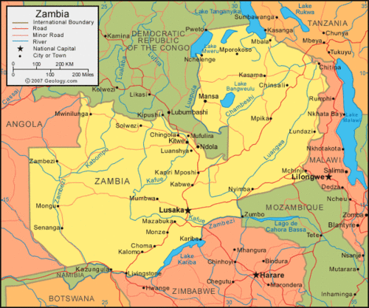
MAPEPE
MAGOYE
MONZE
Source: Aregheore, 2005
The terrain, the Tonga plateau between Lusaka and Livingstone, is at around 1200 metre above sea level and has a sub-humid tropical climate. Most of the Zambian farmers integrate livestock activities with their crop production (Lungu, 2002: 1). Farmers depend on animal draught power to till their cropping area, animal manure as fertilisers while making use of crop residues for feeding their livestock especially in the dry season. The farming communities in the Magoye and Monze areas are largely small-scale farmers engaged in crop cultivation and cattle rearing. They grow maize as both a cash and food crop as this is the staple food in Zambia. Most of the produce such as milk and maize are for household consumption and a source of income.
Farmers in these areas are organised in dairy cooperatives; Magoye Smallholder Dairy farmers’ Cooperative Society, Monze Dairy Farmers’ Cooperative Society and Mapepe Dairy Cooperative and have all benefited from various interventions in improving milk productivity by development organisations, non-governmental organisations and the government. The cooperatives are run by Managers, who are also veterinary assistants, on secondment from the Ministry of Livestock and Fisheries Development. They are responsible for running the administrative needs of the cooperative while also providing the technical needs of the farmers. Mapepe is 16 km from the capital city Lusaka, in Chilanga district. Some of the farmers in this area are retired, while others are in formal employment in the city but are also involved in dairy farming, crop farming and rearing other livestock such as pigs. Magoye Cooperative is located in Mazabuka district, about 167 km from the capital city while Monze Cooperative is located in Monze district, about 195km from Lusaka. The study areas lie in agro-ecological zone IIa with annual rainfall ranging from 800 to 1000 mm, and moderate temperatures. However, Livestock can be supported in all the agro ecological zones and thus providing the potential to increase cattle population from the current 3 million to 7million (World Bank, 2011: 12)
Map 1.2
Map of Zambia showing Agro-ecological zones
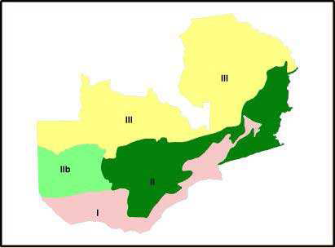
Region Annual Rainfall
I Luangwa-Zambia Rift Valley: Less than 700 mm
IIa Central, Southern and Eastern Plateaux: 800-1000mm
IIb Western Semi-arid Plains: 800-1000mm
III Northern High Rainfall Zone: 1000-1500mm

Source: Aregheore, 2005
Milk production has increased from 135 million litres in 2000 to 215 million litres in 2009 (Valeta, 2004). This has been attributed to various projects that have aimed at enhancing the productivity of smallholder dairy farmers and thereby improving their livelihoods. The Ministry of Livestock and Fisheries Development (MLFD) provides technical assistance in terms of extension services, collaboration with other development organisations and non-governmental organisations such as GART, Heifer International, World Vision (WV) and Micro-Bankers Trust (MBT). This assistance ranges from knowledge transfer to loans in form of dairy animals. Magoye, Mapepe and Monze dairy cooperatives benefitted from a smallholder dairy development programme initiated by GART to improve household food security, enable households generate income and as a way of mitigating HIV/AIDS. It is through these programmes that dairy technologies are made available to smallholder farmers. HIV/AIDS is a major component in the dairy development programme, hence it became necessary that a case study be undertaken in order to understand how affected households are influenced in the adoption of dairy technologies. This is vital because HIV/AIDS has had incapacitating impacts on the livelihoods of rural farming households in Zambia, and Southern Province in particular, where prevalence rates among adults are as high as 15.6% (Hamusimbi et al 2006). Kaliba et al (1997: 139) suggests that female household heads (who are usually poor) benefit more from projects that target them as this enables them to not only earn an income, but also invest in asset acquisition. The case study therefore targeted a widow that benefited from a (heifer) loan.
The decline in the prevalence of livestock diseases was due to a vigorous and successful vaccination programme which also significantly contributed to the increase in milk productivity. However, this was only for “diseases of national economic importance,” these being CBPP and FMD leaving other diseases such as anthrax and corridor disease considered as ‘management diseases’ to the private sector to manage in the event of an outbreaks. This puts the farmer at a disadvantage as they have to source funds to pay for the treatment of their animals (Mulemba 2009; 5).
Figure 4.3 below shows the volume of milk produced after the privatization of the DPB from 1998 to 2003. It is clear that there was a steady rise over the years in the volumes of milk produced. However, milk production dropped in 2000 due to the drought that was experienced at the time, which also affected livestock.

Figure 3.3: Trends in Raw Milk Production in Zambia (1998-2009)
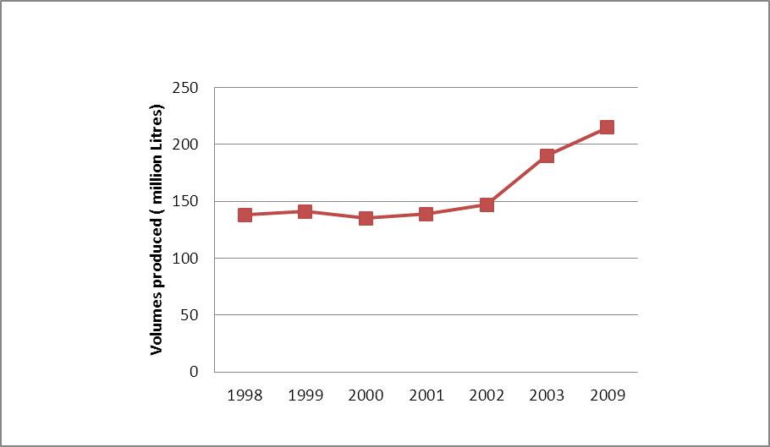
Source: Author’s construction from Raw Production figures, Valeta, 2004
Parmalat, an Italian multinational is the dominant processor in the country which buys the raw milk from the smallholder farmers. Parmalat collects milk from 11 cooperatives of smallholder farmers 5 in Southern Province, 1 in Lusaka and 5 in the Copperbelt Province. Although they are not the major suppliers, the cooperatives contribute a significant amount of milk. In the last year for instance, Parmalat received 3.6 million litres of milk from them out of a total of about 30 million litres. This translates into almost 10% coming from smallholders. The average price for A grade milk, which is very good milk in terms of bacteria load and also looking at volumes that is received from the cooperative- approximately 2000 litres per day, is K2600/litre taking into account the grade, composition of the milk, and also a volume premium to encourage producers to deliver as much milk as possible.
The objective of Corporate Social Involvement (CSI) is to contribute to Parmalat’s overall stakeholder relations objectives by demonstrating our commitment to improving the wellbeing of the communities in which we operate. In this regard we focus our efforts on the dairy industry to strengthen this important key chain in terms of food security for all South Africans
Parmalat therefore provides corporate social responsibility to the community in which it operates. Some of the volumes individual farmers deliver to the cooperative are quite low – such as 2 litres per day. The processor collects and processes this milk in order to contribute to livelihoods of the producers particularly the small-scale farmers. Overall, Parmalat plays a role in poverty reduction as it provides a market to the producers, enabling them to increase their household income. The company also provides extension to producers through the Extension Department which falls under the Quality Control Department. Their job is to train farmers on good hygienic practices during milk production, the whole supply chain up to the point where the milk is delivered to the processor. Farmers are also trained in animal production and animal health. Although extension officers are not experts on animal health, Parmalat has linkages with stakeholders in the dairy supply chain such as stock feed producers; suppliers of pasture seed – during trainings. Parmalat concentrates on hygiene while the stakeholder concentrates on feeding. There are also people who just have the knowledge who also provide training on hay and silage making. So training is provided on issues such as production, improving animal productivity, hygiene etc.

3.2 Who are the smallholders?
Smallholder farmers are heterogeneous and face different circumstances in decision making but they are all brought together by need to produce more so that they can have better livelihoods (Moll et al 2006). The following section provides empirical evidence of the characteristics of the smallholders and what kind of dairy technologies they have incorporated in their farming practice. Two case studies are also presented to provide an explanation and real life context in which the intervention has occurred.
Cross-sectional data was collected from 60 smallholder farmers; 40 from Magoye, 10 from Monze and 10 from Mapepe using structured questionnaires. The questionnaire made use of open ended questions in order to allow the farmers to fully express their ideas without limitations that closed questions pose. With the help of the managers of the cooperatives, farmers were selected by virtue of being active members of the dairy cooperatives and consistently delivering milk throughout the year. It should be noted that this could prove to be biased as farmers are not chosen randomly and the Managers played a role in influencing the selection of farmers in the sample. This has limitations in that the selection could have excluded farmers who are not regular producers and have not attended trainings and therefore covering only a portion of the population.
Data collected from these farmers revealed different household characteristics among smallholder farmers. It should be noted however that this sample of farmers was purposively sampled and hence represents those farmers that quite resourceful as they have the ability to produce and deliver milk regularly. The results collected and analysis will therefore be confined to this sample and will not be representative of the whole population of smallholder dairy farmers. Most of the farmers in this sample are emergent smallholder farmers are they are transitioning from the traditional type of farming as they attempt to improve their farming practices and improve their productivity (World Bank 2011).

Farmer profiles and socio-economic characteristics
48 of the household heads were male while the remaining 12 were female. It is important to understand that this does not mean that more men are involved in dairy that women. Household heads are merely the ones who control household resources. In this part of the country, the culture is such that the men are the overall decision makers in the home. Although they may sit together with the spouse and maybe with the children, the ultimate decision rests on the male household head. Hence gender relations come into play. The 12 were mainly composed of widows running the farm single-handedly.
Table 3.1 represents the marital status of the smallholder farmers that were interviewed. The majority were married and living with their spouses and family members or living with their spouses only as their children are grown up and living off the farm.
Table 3.1: Marital Status of Heads of Households
Marital Status | Frequency | Percentage (%)
Single | 1 | 1.7
Married | 49 | 81.7
Widowed | 10 | 16.7
Total | 60 | 100.0
Source: Field data 2011
It is clear from the age that most of the farmers in the sample practicing dairy farming are older – with the median age of 57 years. In a similar study done by Makhoka et al (2000) in Western Kenya, results revealed that the age of the household head is not relevant in short term technology such as dairy technologies. Only when the technology requires having substantial information does the age become relevant because the number of years one has been exposed to the technology will make a significant contribution to it being adopted and not just how long one has been involved in general farming (Morris and Venkatesh 2000). This assumption can also be applied to the Zambian case because only when one has enough experience with a particular technology and after they understand well how it works will it be adopted. Those that have been practicing dairy farming for a longer time are keen to adopt new technologies that are provided to them because they are eager to produce large volumes and increase their income.
Figure 3.4: Educational Level among Smallholder farmers
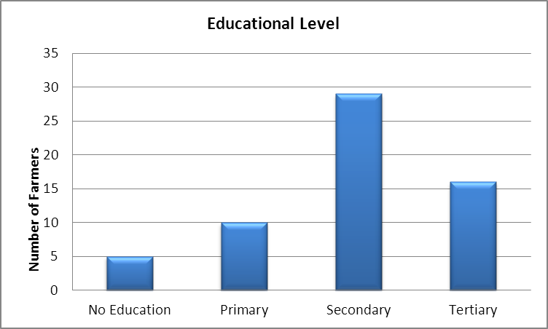

Source: Elaboration by the Author using Field data 2011

In Figure 3.4 above, the educational level of the smallholder farmers was disaggregated in terms of No education, Primary, and Secondary and Tertiary levels of education with majority of the smallholder farmers having acquired secondary level education. Almost 50% of the farmers in the sample have attained secondary education while 26.6% have attained higher education. Being smallholder farmers based in rural areas, one would assume that they have not attained such high levels of education. However, most of the farmers are retirees who have moved to the rural area after having retired from their formal employment. Others are ‘telephone farmers’ who are still employed or have jobs in the city but have farms in the rural areas. They have workers or relatives looking after their farms.
Table 3.2: Summary of Descriptive Statistics of Smallholder Dairy Farmers
Descriptive Statistics
 | N | Missing | Median | Minimum | Maximum
Age (Years) | 60 | 0 | 56.5 | 23 | 88
Total Household Composition | 60 | 0 | 8 | 2 | 34
Adult Household members | 60 | 0 | 4.5 | 1 | 14
Years of practicing dairy farming | 58 | 2 | 5 | 1 | 16
Total Cattle Herd | 58 | 2 | 16.5 | 2 | 119
Herd size | 58 | 2 | 4 | 1 | 19
Milk productivity/cow/day (Litres) | 58 | 2 | 4 | 0 | 13.3
Monthly Milk Income (ZMK) | 57 | 3 | 300,000 | 40,000 | 3,000,000
Income per cow/day (ZMK) | 58 | 2 | 100,000 | 0 | 666,667
Total Farm size (Ha) | 58 | 2 | 14.5 | 1.2 | 100
Land allocated to Pasture (Ha) | 60 | 0 | 0.5 | 0 | 5
Author’s elaboration from Field findings, 2011
Household composition is crucial for technologies that require labour such as growing pasture for improved feeding. If a household does not have enough labour, in as much as growing pasture will contribute to raising their milk volumes and possibly improve the quality of their soils, they will not adopt that technology. Children are also involved in routine activities such as herding, while activities to do with milking and feeding are left to the older household members as these are important when it comes to milk production and quality. According to Ngongoni et al (2006), a family’s labour investment is determined by the family size as this can affect milk production for home consumption as well as for the market.
Most of the farmers interviewed revealed that they have not invested in growing pasture because they do not have enough labour on the farm. Hiring labour is expensive especially that a worker is needed to deal directly with dairy as it is so demanding and requires constant attention. More farmers have preferred to adopt mixing feeds at home because of the high cost of concentrates.
The figure below reveals that despite being the major producers of milk, majority of the smallholder farmers sampled owned between 1 and 3 cows, with low milk production due to the many constraints that they face.
Figure 3.5: Herd size among smallholder farmers
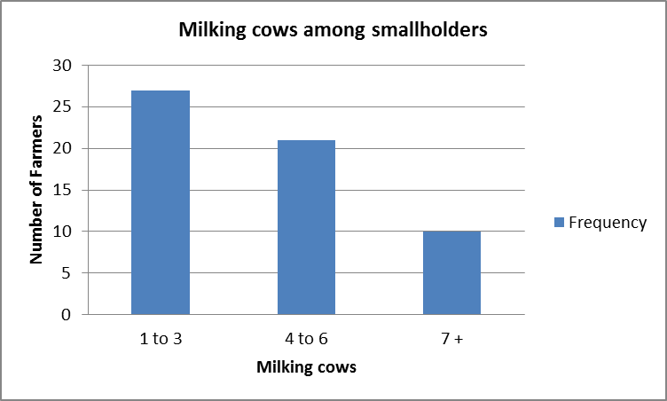
Author’s elaboration from Field findings, 2011

The farmers therefore strive to ensure that their milking herds are healthy and make use of animal health measure from the cooperatives. This is because ensuring a health herd is critical for farm profitability and makes managing the risk of disease outbreaks easier (Gramig et al 2010). The farmers therefore consider adopting technologies in animal health especially that this area is usually riddled with disease outbreaks.

Chapter 4
Adopting Dairy Technologies
Educational level also plays a straightforward role in technology adoption. According to Doss (2003: 9),
Simply entering years of education on the right hand side of the equation assumes that there is a linear relationship and that each year of education has a similar effect on the outcome.
She suggests that it is important to indicate the different levels of education because a big difference might exist between an illiterate and literate person. Levels of understanding are very different and are explained by the level of education one has received. However, it may not always be this way. Even though one’s literacy may not be as high as expected, they may be able to apply themselves to ensure that they get as high results as possible. Riddell and Song (2008: 4) suggest that the type of technology to be adopted will be dependent on how education affects technology adoption. This is because the relationship between technology adoption and the kind of skills one possesses varies across different types of technologies. For instance farmers who haven’t received much education may be able to take up most of the technology he/she has been trained in because they realise the importance of these technologies in improving their standard of living.
Notwithstanding, education is an important indicator and effective route for adoption and subsequently exiting poverty (Banda et al 2011: 3). Farmers are not only able to participate in activities that lead to higher productivity, but also provide access for them to other pathways. Doss further suggests that as long as there is someone more educated in the household, production will be enhanced (2006: 216)
Figure 4.1: Effect of milking cows on milk productivity by educational level
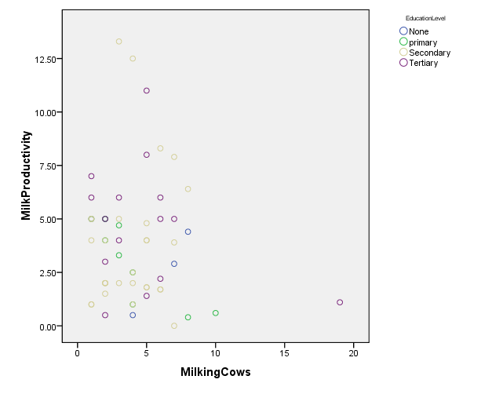
Based on Author’s results from the field, 2011
The figure above shows the role education plays in the relationship between the number of milking cows and effect on milk productivity. It is expected that education will have a positive effect on milk productivity because it has the potential to improve the farmer’s ability to understand the knowledge they receive in trainings compared to those who have had limited education. Farmers will adopt technologies that will improve the productivity of their animals so they have surplus to sell to the market without compromising their consumption. Education therefore predefines an individual farmer’s productivity levels, as long as they have the necessary pre-requisites such as productive animals, ability to provide improved feeding and clean and healthy milk to the market.
Land is a very important factor of production, more so in dairy production. Agricultural producers in Zambia are traditionally classified in three groups; small scale, emergent and large- scale farmers. Small-scale farmers cultivate on less than 5 hectares of land and use basic production methods which are low input output. Because they are resource constrained they largely depend on family labour. Emergent farmers cultivate on areas between 5 and 20 hectares are more resourceful and use modern agricultural methods which enable them produce a surplus for the market. Large scale farmers produce at a high level with high management technologies on areas more than 20 hectares (Siegel 2008; 16).
Results reveal that the majority are emergent farmers with most having 10 hectares, although they do not cultivate much of their land. Although some farmers are practicing dairy farming on farmland as small as 1.2 ha of land, it is surrounded by communal grazing land and hence they cannot apply zero grazing. Some of the farmers did not know exactly how big their farms and could therefore not give a specific value.

Figure 4.2: Distribution of size of farm holdings among smallholder farmers
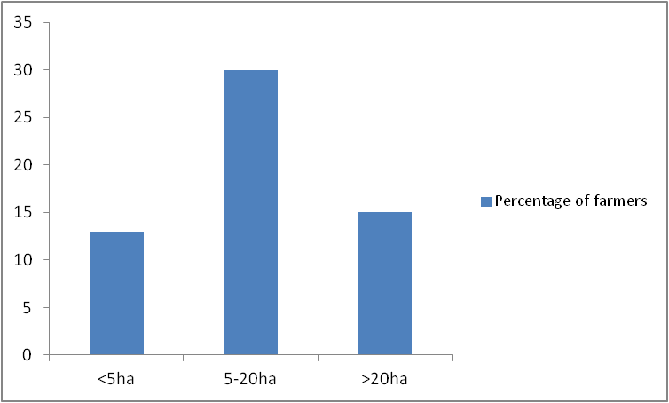
Author’s elaboration from Field findings, 2011

Some of the farmers own the land, while others are on customary land. The farms are also not fenced therefore making it difficult to grow pasture, which could be eaten by a neighbour’s cows grazing near a farmer’s and. One farmer narrated how the velvet beans she had planted for her animals were eaten by cows from a neighbouring farm. Situations such as there are exacerbated by the fact that most of the farms are not fenced and farmers do not have the resources to ensure that their farms are fenced. Mosnier and Wiek observe that advances in technology adoption could have a positive relationship with farm size due to economies of scale (2010: 20). This implies that the bigger the farm size, the more likely the farmer benefits from economies of scale. The figure below shows a positive relationship between farm size and land allocated to pasture adjusted for the number of cows per farmer. In that the larger the farm holdings, the more land per cow the farmer allocates to growing pasture. However, this is also dependent on the availability of pasture and other resources the farmer may need. Some of the farmers with larger farms but with very small pieces for pasture depend on concentrates.
Figure 4.3 Farm size in relation to Land allocated to pasture (in hectares)
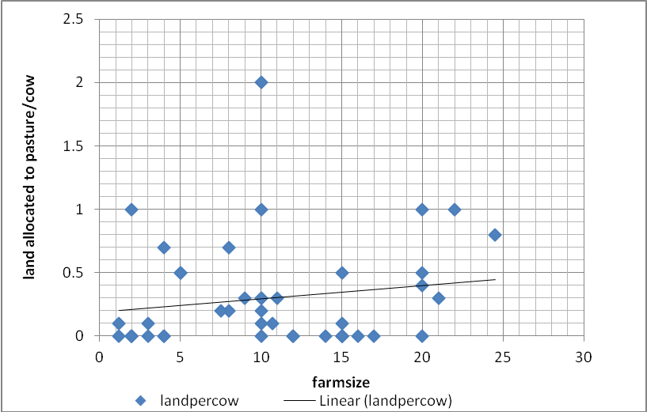
Author’s elaboration from Field findings, 2011

4.1 Technology adoption and milk productivity
Technology plays a major role in dairy production. This is so because production can be done anywhere as long as traditional constraints are abated by improvements in technology (Mosnier and Wiek 2010: 20). Therefore, with improved techniques in feeding, breeding and animal health, milk productivity is likely to be a major determinant for income generation among smallholder farmers. According to Medola (2007), what farmers gain from new agricultural technology has a direct influence on the poor households by raising their income while indirectly raising employment and wage rates on landless labourers. This ultimately lowers the price of food staples as the producers of the food are also the consumers. This may benefit the majority of rural dwellers as the country continues to experience persistent poverty with 64% of the population living below the poverty level according to the Living Conditions Monitoring Survey (CSO 2006).The benefits that a farmer derives from the technology therefore play a role in the farmer’s decision to adopt a new technology.
The study revealed that farmers milk a daily average of 55 litres per day per herd; have 4 milking cows producing 4 litres per cow per day and earn an estimated monthly income of K300, 000. However, because some farmers still produce very low volumes and only deliver about 1 litre of milk per day, they only earn about K40, 000per month.. This translates to $0.28 per day which is way below the UN poverty rate of $1.25 per day. These results are consistent with findings from a project that was carried out by GART on 730 smallholder farmers in Zambia where the average annual milk productivity was 5.5 litres.
Figure 4.4 Effect of Productivity of Farmer Incomes
Author’s elaboration from Field findings, 2011
A positive relationship exists between the productivity of a herd and the income received by the farmer per cow. This was evident in the sample as the more productive the milking herd was, the more milk the farmers produced and the more income the received from marketing it. There are various factors that contribute to the productivity of the farmers’ milking herds. Some of these include the operation size or the area in which the farmers conduct their farming activities. In the sample of farmers researched in this study.
Although dairy farming contributes significantly to household income, it is not their only source of income. Farmers are also involved in crop farming where they grow maize, a staple food in Zambia. However, income from maize is earned annually and depends on how good the harvest was for a particular household. Farmers also keep other livestock such as goats, pigs and rear chickens and other birds. Although they are able to earn an income from these, it does not compare to what they earn from dairy considering that they are paid for everyday they deliver. Other farmers revealed that they have vegetable gardens from which they sell to supplement household income. They are able to use manure from the kraals in their vegetable gardens as well as in the main fields where they grow maize.
Various factors motivate farmers to participate in dairy farming, more so that it contributes to household welfare (Urassa and Raphael 2002). Most farmers are concerned about what the family will eat before they think about money. When asked about the importance of dairy farming to the farmers, a large majority disclosed the significance of income to their households. Even though they have other livestock which they can sell for an income such as sheep, goats and pigs, farmers revealed that the income received from milk sales is more than that from other livestock because it is regular and predictable as it comes every month. Other livestock however are not sold on a regular basis and the money received is lump sum. Therefore, if there are technologies that are introduced to increase the levels of income, farmers are more than willing to take them up. This is based on the assumption that wealthy farmers have more access to resources and will invest more because they are able to manage the risk that they would be under (Doss 2003).
Figure 4.6 below reveals that the majority of the farmers have other livestock such as sheep, pigs, goats and various poultry which they sell to earn extra income. However, although this is not every day, they receive a lump sum earning which contributes to running their households. However, this income cannot be compared to what they receive from dairy as they earn some money from every litre they sell every day. According to one farmer interviewed,
You get money every day with dairy farming. And the more you produce, the more you deliver, and therefore the more money you get at the end of the month. You cannot compare with selling Chickens or pigs because you cannot sell pigs every day. When the piglets are born, you have to wait until they are older before you can sell them and during that time, you have to feed them. But the case is different with milk; you have money for every litre you milk.
10 farmers reported that although they have other livestock, it is specifically for household consumption. Although they lose out on extra income, it contributes to household nutrition. 6 farmers did not respond and therefore it is unclear what they do with their other types of livestock.
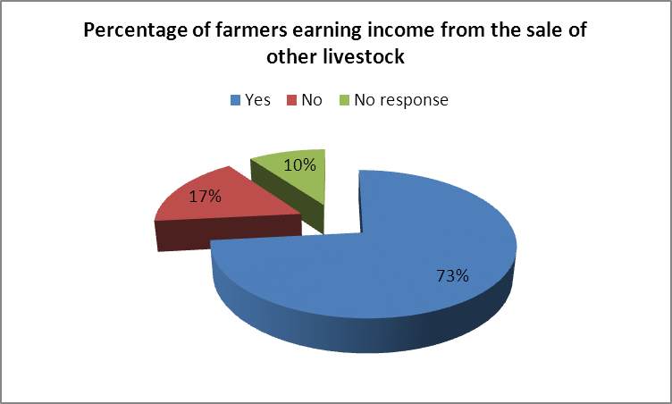Figure 4.5: Income received from other livestock
Author’s elaboration from Field findings, 2011
Dairy farming, it was revealed, is a major contributor to household nutrition. Although results from the analysis suggest that some of the households do not leave any milk for home consumption. It is more important for them to sell everything so that they can purchase the required food from the income they receive. An average of 2 litres of milk per day is kept aside for home consumption. This is vital especially for those households with young members and also for maintaining good health especially those people living with HIV/AIDS. Milk being a highly nutritious product therefore is a good source of food for them.
Farmers have to use their own sources of income to finance the production process. This is because credit facilities are hardly available, and even when they are, it is difficult for farmers to access them. The study revealed that majority of the farmers kept some savings in a bank account. These savings are from what is left over from the dairy income, but also from other activities done on the farm such as maize farming. The farmers have bank accounts because it has now become compulsory to have an account. This was a directive from the cooperative management because it became dangerous to handle large sums of money at ‘pay day’.

Figure 4.6: Proportion of smallholders that save part of their income
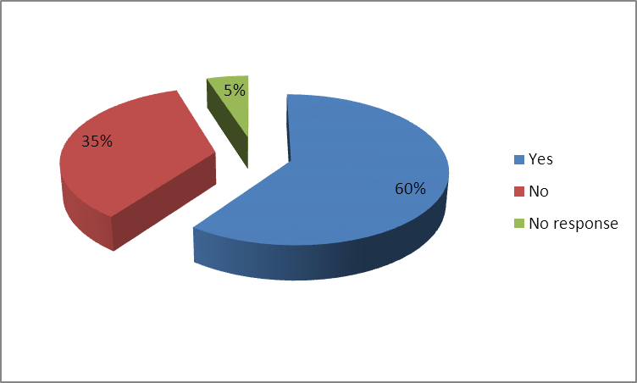
Author’s elaboration from Field findings, 2011
As regards to access to credit facilities, Figure 4.2 suggests that majority of the farmers do not have access to credit facilities. This is because accessing credit in Zambia is difficult, more so for the smallholder farmers because they don’t have collateral against which they can borrow. They cannot even use their farms as surety because most of them are on customary land and don’t hold title deeds. According to Harrison (2005: 2) accessing credit, particularly rural credit is not easy.
Most of the 1.2 million small farmers in Zambia currently have virtually no access to credit, although perhaps 20% of them receive some input supplies on credit through outgrower schemes. Most Zambian commercial banks prefer to lend against security and their Kwacha denominated lending is almost all short term. Transaction costs for lending are generally high and small loans, for business purposes of less than about $10,000 equivalent are not attractive to most of them. Typically, they are urban based, with few branches outside Lusaka and the Copperbelt. However both Finance Bank and NSCB are now beginning to expand their rural networks. Microfinance institutions are not very well developed in Zambia, and have little rural presence. Furthermore, the type of lending they practice is poorly suited to financing seasonal inputs. In the past, there has been some credit financing under development projects by bilateral and multilateral institutions and through NGOs. Generally, this has not proved sustainable and may have contributed to the poor “credit culture” in Zambia.
To some extent, the data confirms Harrison’s assertion about rural credit. Only 3 farmers reported having received credit from ZANACO and Indo Zambia Banks. Other farmers got credit from organisations like Micro Bankers’ Trust (MBT), a microfinance organisation and the Cooperative which offers credit facilities in form of animal drugs and feed. A few farmers did not state whether they have access to credit or not. However, during the interviews, one farmer revealed his scepticism about the credit facility system in Zambia, and this has discouraged him from accessing credit.

Figure 4.7: Access to credit facilities
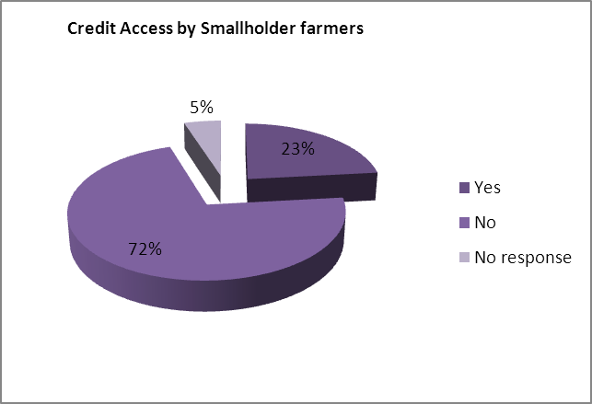
Author’s elaboration from Field findings, 2011

4.2 Influence of dairy cooperatives in achieving quality and safe milk
Cooperatives are significant economic and social actors. This makes it easy for the transfer of technologies by various organisations and reach the personal as well as community goals of the farmers. Byerlee and Polanco observe that “farmers are themselves the innovation through the contacts they make with each other” (1986: 520). The farmers interviewed revealed that being part of the cooperative has helped them acquire and share knowledge with fellow farmers, consistent with the actor network theory. It provided them with a ready market for their milk as they are effectively linked to the processor. As a result, they were able to sell their surplus milk and are assured of income at the end of the month which contributes to improving the quality of their lives.
Farmers revealed that they were able to learn about feeding technologies and benefitted from cooperative equipment such as the hammer mill and dehuller, which were used to grind stock feeds. Although they have to pay for using this equipment, it is at their disposal. This has enabled farmers improve the dry season feeding of their animals. Milk production is usually low in the dry season because of the low quantity and quality of forage.
Technical assistance provided is meant to guarantee the supply of inputs such as stock feeds, drugs and other inputs that affect the dairy production. As much as milk is liquid cash, the trend in the industry is to pay at the end of the month. Parmalat therefore serves as guarantee that they will be paid from the milk cheque. The provision of a market translates into a competitive market. The price is good and almost works against the industry. In the region, Zambia pays the highest to its producers.

Milk quality
Quality plays a very important role in ensuring that markets are accessible and that milk is able to be retained at retail level. This is because milk can be a carrier of life-threatening diseases. The processor therefore puts measures in place to ensure that it is not compromised and farmers comply with the regulations on health standards throughout the dairy supply chain (Land O’Lakes 2007: 2)
The quality should be acceptable for use both for the processor and producer regardless of whether the farmer is commercial or smallholder. This is important because when dealing with issues of food safety, hygiene becomes paramount. Parmalat categorises quality in terms of nutrition, butterfat and solid non-fat (SNF). The milk should have acceptable butterfat- legally the minimum fat content for raw milk is 3.2% and 2.2% SNF. The Quality manager however disclosed that the company prefers milk with high butterfat because a lot more can be done with it - cream to make other by products such as butter. Since the farmers are paid based on composition and hygiene, the higher the butter fat, the more profitable the raw milk is. Nonetheless, proper milk hygiene is vital as it could be detrimental for those farmers for whom milk income significantly contributes to livelihoods. Although milk processing reduces the bacterial load, maintaining good quality at the producer level is cardinal.
In their quest to meet standard quality, some smallholders use a well-kept cloth to clean and vaseline to lubricate the udder before milking. This is their way of re-inventing and re-constructing the technology to suit their circumstances.
Parmalat prides itself in being a trusted brand on the market and as such takes matters of milk quality very seriously. Due to the fact that composition and food safety are the key aspects in the criteria for accepting milk, it is vital that all producers comply to the quality and safety procedures throughout the process from production and collection to processing and distribution (Land O’Lakes 2007)

4.3 Constraints in Milk Production
Farmers face various challenges in milk production. Feed scarcities especially in the dry season; lack of appropriate breeds; disease outbreaks; poor management practices; lack of access to resources and unavailability of infrastructure are some of the major constraints that smallholders face (Kaluba as cited in Kategile and Mubi 1992; Muriuki, 2002; Ngongoni et al, 2006; Yambayamba et al, 2003; Tassew and Seifu 2009; Tebug 2011). Smallholder farmers are very keen to learn and are interested in being trained to acquire fresh knowledge, information about new trends, best practices if they can afford these and how they can maximise on them because they want to have the knowledge. However, they revealed that there are no follow ups or backstopping by the technical staff and thus they backslide.
Due to the communal nature of grazing land, it is not enough to feed all cattle in the area. The dualistic tenure of land equally makes it difficult for farmers to make long term investments that would contribute to increased production (Ngongoni 2006; World Bank 2011). Pasture seed is also not readily available making it difficult for the farmers to prepare for dry season feeding. However, some households produce other crops such as sunflower and cotton and after these are pressed for oil, the cakes are mixed with maize bran as this adds value to the feed.
With EPAs, there is risk of unfair competition as Zambian milk competes against European milk. The cheap imports are a hindrance to the development of the agricultural sector and the economy as a whole
Parmalat also faces challenges in milk collection due to the poor road infrastructure. To ensure that there is no spoilage, the company has to ensure that the milk trucks are insulated to keep the temperatures down and the milk is collected as quickly as possible.

4.4 Case Studies: Dairy farming and HIV/AIDS
The section below presents a case study of the effects of HIV/AIDS on a female headed household where dairy farming is a major part of their livelihood.

White Gold
Dairy farming is the best thing that has ever happened in my life.
These are the words that started our interview with Mrs Malia Hara, a 37 year old widow from Monze. As a mother of 4, she has had to raise them up single-handedly since her husband died from an HIV/AIDS related illness in 2007. This has not been an easy task at all:
After my husband died in 2007, I started getting sick a lot and decided to go for an HIV test in 2008, where I tested positive. At first it was not easy because of the culture that was there then. When you are found positive, there used to be a lot of discrimination as people would not even want to be around you. However, with a lot of information being disseminated and many programmes about HIV/AIDS, things have changed. People are even coming out in the open about their status.
Her journey through dairy started in 2007 when she received a cow from Land O’Lakes through a programme that they had for widows. Land O’Lakes is an organisation that has been supporting smallholder dairy development in sub-Saharan Africa since 1994. Land O’Lakes in Zambia directed most of its investments of time and resources towards improving farms, productivity and development (Dairy mail, 2007). Key outputs of the majority of Land O’Lakes projects include increasing dairy production, smallholder market access and milk consumption (Land O’Lakes 2007). Initially, Malia delivered to Nteme Milk Collection Centre, which was just a few kilometres from her homestead. She later moved to Monze Dairy because she was getting a much better deal as they were paying more money per litre of milk. In 2010, she received an in-calf heifer from the GART in July 2010. Unfortunately, the cow died 2 weeks after calving. Her herd is growing and she currently has 4 animals, 3 female cows and 1 male calf, which she plans to sell. Many of the farmers consider the male calves to be a liability, particularly when they do not intend to raise them as bulls. As female calves are a source for more cows, they are thus more ‘profitable’ to have. However, only one cow is being milked at the moment as the others are still heifers, and she is producing 11liters per day.
Figure 4.8: Milk production for Mrs Malia Hara 2008 - 2010
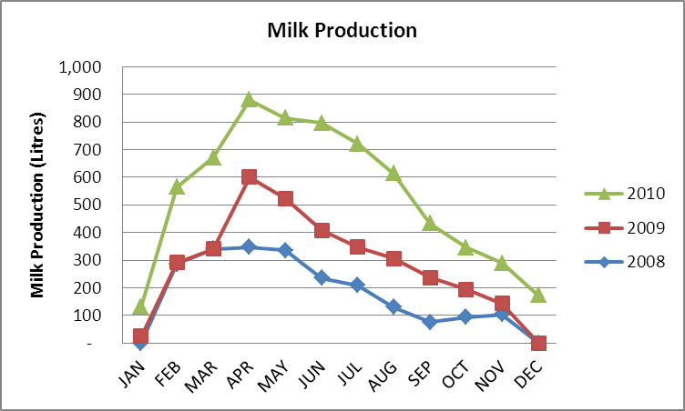
Source: Author’s construction based on Monze Dairy Farmers’ Cooperative Milk Production records

Malia has attended many trainings and workshops in dairy and believes is now well trained in how to look after dairy animals. Although it is not always been easy, she has tried to incorporate most of the knowledge she has received into her dairy practices and she attributes the growth in the production to this. She further revealed that dairy farming has brought so many benefits to her family. Through income from milk, she has been able to build a new home for her family; her children are all in school as she can afford to pay school fees. “Everything is possible because I can now get money from dairy”. She is also able to save money on fertilizers as she makes use of manure from her kraal. The manure has helped improve the quality of her soils and she is now able to produce more yields per hectare. Malia has incorporated feeding technologies into her dairying practice. She realised the importance of improved feeding and was able to make to make silage last season.
If you don’t feed the cow well and you don’t give it enough water, you will not have much milk. I always make sure my cow has enough to eat, even if its crop residues or hay. I try to mix it with some molasses to make it palatable for the cow. I also try to make silage especially for the dry season. Sometimes it’s not easy
However in the 2010/11 farming season, she was unable to make any silage because she had trouble accessing the chaff cutter to cut the fodder for silage. A chaff cutter is a machine used to chop forages or grasses into pieces, which is later mixed with molasses and fed to animals. It is used my dairy farmers to help make feeds palatable and easy to digest for their animals and can be operated manually or can be run by a motor.
Malia has proved that crosses are better than pure breeds because they are easier to manage. Some of her neighbours received pure breed animals from a certain organisation and had since all died. This is because pure breeds require zero grazing and are susceptible to diseases. They have very high management levels and usually smallholder farmers cannot afford to maintain them. Due to the nature of communal grazing land, it is therefore not easy to ensure that they have enough forage to graze and buying supplementary feeds are expensive. She buys and uses 7-8 bags of maize bran, wheat bran or cotton cake per month; cuts hays and mixes with molasses.
Animal health is just as important. Malia has been trained in animal health and can detect when an animal is not well. Veterinary services provided by the government are not reliable as there are usually no vet assistants available. To curb this unreliability, Malia and a group of other dairy farmers have joined hands in ensuring that their animals are dipped every fortnight. They have hired the services of private veterinary doctor to provide drugs and vet services as and when needed. They have invested in a motorized ‘spray less’ machine to ensure that all surfaces on the cow are covered because the knapsack sprayer does not reach all the corners and hidden places on the cow. The private vet also offers AI services. However, this does not work well for the farmers because the vet stays very far away and it is not easy to get their services especially at times when the cow is on heat. By the time the vet gets to them, the cow would no longer be on heat, or there would be no semen available. Because she does not have a bull of her own, Malia relies on the neighbour’s bull. Breeding is therefore a major challenge that farmers have to deal with.
With increasing income from dairy, Malia has been able to open an account. This has also been an initiative of the dairy cooperative to have all the farmers open accounts as it makes payments and other accounting easier to manage. She receives about K 600, 000 per month during off peak season – dry season- and the income increases towards the rain season. She started working on what should now be a milking parlour but has been unable to complete it due to lack of funds.
Apart from the Monze Dairy Farmer’s Cooperative where she has an assured market for her milk, she is also a member of the Kalala Cooperative, where she receives fertiliser support. It is also from this group that she received a cow on the basis of being a widow. Because of her status, Malia is the Chairperson of the Tulyabe Support Group, which is a self-help group of people living with HIV/AIDS. Social networks are consolidated as members are able to engage in fundraising activities in order to raise money to lend to the member to enable them earn a livelihood. Malia uses Moringa, a ‘miracle tree’ that is said to boost one’s immunity as it had high nutritive value and is beneficial in the treatment and prevention of various diseases (Fahey 2005: 3). Since she started using Moringa a year ago, her CD4 count has increased from 120 to 360. The nutrition she is getting from the milk is also making a significant contribution to improving her health.

4.5 Role of Government
The role of the Zambian government in dairy development is in terms of Policy by creating an enabling environment for the dairy sector to succeed. After the demise of the Dairy Produce Board, the subsector witnessed declining production as there was insufficient investment being poured in (Kaimana 2010). In order to improve the productive efficiency of the sector, the Livestock policy, a subset of the National Agricultural Policy was developed to support the marketing of livestock and livestock products. It was designed to contribute to the improving income and food security of the smallholder farmers (Ministry of Agriculture and Cooperatives 2004).
Most recently, the Dairy Industry Development Act No. 22 of 2010 was passed aimed at developing a dairy industry that will contribute effectively to income generation, household food security and most importantly, poverty alleviation. Being relatively new, the Ministry of Livestock and Fisheries Development is still in the process of formulating and implementing policies that will benefit all the stakeholders in the dairy industry. With the commercialization of agriculture, there was need to improve market access by linking producers to the market. In this process, it is important for all stakeholders to participate because they all have different needs. However, local farmers should not be disadvantaged by the need to globalise. Allowing imports hurts the local farmers and this harms the domestic milk production and has an effect on those whose livelihoods depend on milk production.
The government also provides extension workers who are attached to institutions such as GART that working directly with the farmers. The managers at Magoye and Monze cooperatives are government employees who are on ‘secondment’ to GART. However, most of the investment is left to the organisations that work with government. This demotivates the local staff especially if they are not consulted during the design of the interventions that these development partners bring and will be ineffective when it is time to have them implemented (Yambayamba 2003: 46) There is need for government to create the necessary environment to ensure that extension staff is knowledgeable with modern technology and this is passed on to the smallholders farmers with ease. Building capacity among the extension officers creates a sense of motivation and hence they are able to discharge their duties well. For instance, if farmers are trained in methods of improving and maintaining animal health, this should be in tandem with government providing inputs at an affordable price for the farmers. If the taxes on drugs are high, then it befits the purpose of the trainings because the smallholder farmers will not have the financial capacity to purchase the inputs.

Chapter 5
Conclusion
“With one foot in the market and the other in subsistence they are neither fully integrated into that economy nor wholly insulated from its pressures” (Ellis 1993: 3). For dairy farmers, increasing milk production provides a means through which their livelihoods can be improved. The goal of any farmer is to produce output that will provide more benefits than costs to his/her farming operations. However, this depends on the choices the farmer makes based on the means available to reach their desired ends. The paper has therefore provided the processes through smallholder farmers’ decide on adoption or non-adoption of dairy technologies.
Technology is dynamic. It does not stay the same and sometimes is generated faster than adopters and potential adopters can keep up. It was very clear that smallholder farmers were particularly eager to learn about new innovations because their major concern is improving their productivity, earning more income and eventually having a better livelihood. Organisations such as GART that provide development interventions were instrumental in generating solutions for farmers to cater to their productivity enhancing needs. Being part of cooperatives serves as an entry point for them to get access to these technologies and as such confirms the need and importance of social networks. Cooperatives also played their role by being mediums through which these technologies can be transferred as individuals interact and share knowledge as described in the Actor- Network theory. However, because of the heterogeneity of smallholders, it is important to note that not all farmers perceive the technology in the same way. Power relations always exist among groups of people and some farmers would think of themselves as knowing more than others and this could lead to resistance. Education of the farmers therefore plays a major role as evidenced in the study because farmers as actors will understand it and translate it differently. If a farmer has not received much education and does not understand the need to have clean udders, they will not invest hygienic practices. Education clearly enables farmers search for new knowledge and drives them to effectively use that knowledge for their benefit.
No matter how learned, it was revealed that farmers cannot adopt all the technologies at once. This ties in with the flexibility component in the theory of social construction of technology which suggests that farmers engage with the technology to discover what works for them and what doesn’t. This however doesn’t mean that they do not completely take up any of the other technologies offered. This was also clear in the framework that based on their characteristics they will adopt or reject technologies. This was reflected in the case study where the widow farmer with limited labour takes advantage of her interactions with fellow farmers in the network in ensuring laborious activities are done. Further farmers in the study, although purposively selected from the cooperatives, confirmed that they took advantage of the services offered by the cooperatives as the relevant social group that provides them with access to technology. This presents a weakness of the innovation- diffusion model because accessing technology is expensive and not always easy especially for smallholder farmers.
The study revealed that farmers are faced with complex factors and as such have to make decisions that will benefit them while not costing them much. Other than education, farmers may be constrained by productive animals. Considering the study was done in an area where cattle play a major role as a status symbol, most of the farmers owned traditional breeds that do not produce much. Feeding especially in the dry season also contributes to low productivity. The farmer therefore finds ways of making sure they maximise knowledge learnt from various trainings by mixing local feeds, whilst ensuring they are nutritious enough.
Undoubtedly there is need for the government to come and ensure that there is a conducive environment for the farmers if dairy farming is to contribute to improve their livelihoods. If farmers are to have access to appropriate breeds, they need cash or credit facilities at favourable interest rates. If the different actors in their networks can provide them with solutions to accessing these funds, they would have access to productive herds. However, as long as this challenge persists, smallholder farmers are locked to low milk production.
It cannot be over emphasised that studies in the field of agricultural technology adoption have the potential to greatly influence agricultural policy particularly when identifying and reducing constraints to adoption in order to make a positive impact on agricultural research.

References
Almas, R. (2010) ‘I Have Seen the Future, and it works! How Joint Farming may solve Contradictions between Technological Level and Farm structure in Norwegian Dairy Production’, in Bonanno A., Bakker H., Jussaume R., Kawamura Y and M. Shucksmith (eds), ‘From Community to Consumption : New and Classical Themes in Rural Social Research’, Research in Rural Sociology and Development 16: 3-16, UK: Emerald Group Publishing Limited
Banda D.J., Hamukwala P.,Haggblade S. and A. Chapoto, (2011) ‘Dynamic Pathways into and out of Poverty: A case of Smallholder Farmers in Zambia’, FSRP Working Paper No. 56
Bandiera, O. and I. Rasul (2006) ‘Social Networks and Technology Adoption in Northern Mozambique’, The Economic Journal 116(514): 869-902.
Bebe, B., H. Udo, G. Rowlands and W. Thorpe (2003) ‘Smallholder Dairy Systems in the Kenya Highlands: Cattle Population Dynamics Under Increasing Intensification’, Livestock Production Science 82(2-3): 211-221.
Bhattarai M. (2009) ‘Understanding Technology Pathways among Vegetable Farmers: A Theoretical Framework and Research Agenda’, The World Vegetable Centre
Bijker, W., Hughes, T. and Pinch, T., Editors, 1987. ‘The Social Construction of Technological Systems: New Directions in the Sociology and History of Technology’, MIT Press, Cambridge, MA.
Boz, I., C. Akbay, S. Bas and D.B. Budak, (2011) ‘Adoption of innovations and best management practices among dairy farmers in the Eastern Mediterranean region of Turkey’, Journal of Animal and Veterinary Advances 10(2): 251-261.
Byerlee, D. and E.H. de Polanco (1986) ‘Farmers’ Stepwise Adoption of Technological Packages: Evidence from the Mexican Altiplano’, American Journal of Agricultural Economics : 519-527.
Callon, M. (1987) ‘Society in the Making: The Study of Technology as a Tool for Sociological Analysis’, The social construction of technological systems: New directions in the sociology and history of technology : 83-103.
Central Statistics Office, (2006) Living Conditions Monitoring Survey. Lusaka, Zambia: CSO.
Chagunda, M., A. Msiska, C. Wollny, H. Tchale and J. Banda (2006) ‘An Analysis of Smallholder Farmers’ Willingness to Adopt Dairy Performance Recording in Malawi’, Livestock Research for Rural Development 18(5).
‘Dairy Farming and Climate Change’ (2010), Accessed 9th June, 2010 <http://www.greenpeace.org/new-zealand/en/campaigns/climate-change/smart-farming/agriculture-and-climate-change/dairy-and-climate-change/ >
de Souza Filho, H. M. (1997) The Adoption of Sustainable Agricultural Technologies : A Case Study in the State of Espirito Santo, Brazil. England: Ashgate Publishing.
Dinar, A., Mendelsohn, R., Hassan, R. and J. Benhin (2008) Climate Change and Agriculture in Africa: Impacts Assessment and Adaptation Strategies. Earthscan. London.
Doss, C.R. (2006) ‘Analyzing Technology Adoption using Microstudies: Limitations, Challenges, and Opportunities for Improvement’, Agricultural Economics 34(3): 207-219.
Doss C.R., (2003) ‘Understanding Farm-level Technology Adoption: Lessons Learned from CIMMYT’s Micro Surveys in Eastern Africa’, CIMMYT Economics Working Paper 03-07. Mexico, D.F.: CIMMYT.
Ellis, F. (1993) Peasant Economics: Farm Households and Agrarian Development. Cambridge University Press.
Ellis, F., (1998): ‘Household strategies and rural livelihood diversification’, Journal of Development Studies, 35(1): 1-38
El-Osta H.S. and M. J. Morehart (2000) ‘Technology Adoption and Its Impact on Production Performance of Dairy Operations’, Review of Agricultural Economics, Vol. 22(2): 477-498
Fahey, J.W. (2005) ‘Moringa Oleifera: A Review of the Medical Evidence for its Nutritional, Therapeutic, and Prophylactic Properties. Part 1’, Trees for Life Journal 1: 5.
FAO (2009) State of Food and Agriculture: Livestock in the balance, Rome: FAO, Accessed on 5th September, 2011 <ftp://ftp.fao.org/docrep/fao/012/i0876e/i0876e.pdf>
Gramig, B.M., C.A. Wolf and F. Lupi (2010) ‘Understanding Adoption of Livestock Health Management Practices: The Case of Bovine Leukosis Virus', Canadian Journal of Agricultural Economics/Revue canadienne d'agroeconomie 58(3): 343-360.
Haambulo, N. ‘The Agriculture Sector can Help Zambia Move Towards Sustainable Economic Development’, Economics Association of Zambia. Accessed on 9th October, 2011 <http://www.eaz.org.zm/newsletter.php?newsletter_id=49>
Halakati S.V., Kamaraddi, V. and S.M. Godwa (2007) ‘Determinants of Dairy farming technologies by Rural Women under the SGSY Scheme’, Agricultural Science 20(2): (323-325)
Harrison P., (2005) ‘Final Report of Short Term Consultancy on Formulation of Guidelines for Handling of Credit Funds and Financial Support within the Agricultural Support Programme’, HJP International Ltd
Jayne, T.S., Govereh J., Chilonda, P., Mason, N., and A. Chapoto. (2007) ‘Trends in agricultural and rural development indicators in Zambia’, ReSAKSS Working Paper No. 2. International Crops Research Institute for the Semiarid Tropics (ICRISAT), International Food policy Research Institute (IFPRI) and International Water Management Institute (IWMI)
Kaimana, G. (2010), ‘Dairy Sub-sector in Zambia: How can it be productive?’ Times of Zambia 29th July. Accessed on 14th March 2011 <http://www.zambiachambers.org/index.php?option=com_content&view=article&id=336:dairy-sub-sector-in-zambia-how-can-it-be-productive&catid=1:latest-news&Itemid=57 >
Kaliba, A.R.M., H. Verkuijl and W. Mwangi (2000) ‘Factors Affecting Adoption of Improved Maize Seeds and use of Inorganic Fertilizer for Maize Production in the Intermediate and Lowland Zones of Tanzania’, Journal of Agricultural and Applied Economics 32(1): 35-48.
Kategile, J.A. and S. Mubi (1993) ‘Future of Livestock Industries in East and Southern Africa’, proceedings of the Workshop Held at Kadoma Ranch Hotel, Zimbabwe, 20-23 July 1992. International Livestock Centre for Africa (ILCA), Ethiopia
Kenny, B. and C. Mather (2008) ‘Milking the Region? South African Capital and Zambia’s Dairy Industry’, African Sociological Review 12(2): 55-66
Klein, H.K. and D.L. Kleinman (2002) ‘The Social Construction of Technology: Structural Considerations’, Science, Technology & Human Values 27(1): 28-52.
Land O’Lakes (2007) ‘The increasing Importance of Quality Assurance to Smallholder Dairy Farmers in East and Southern Africa: The Experience of Land O’Lakes’, paper presented at Trade Standards Practitioners Network (TSPN) Workshop Washington. D.C. June 19-20, 2007, Accessed 25th July 2011 < tradestandards.org/proxy/Document.45.aspx>
Long, N. and J.D. Ploeg (1989) ‘Demythologizing Planned Intervention: An Actor Perspective’, Sociologia Ruralis 29(3‐4): 226-249.
Makhoka S.N., Karugia J., Staal S and.O.Kosura, (2000) ‘Adoption of dairy technologies: Lessons learnt from Case Study in Western Kenya’, Kenya Agricultural Research Institute Accessed 12th April 2011 < http://www.kari.org/fileadmin/publications/10thProceedings/Volone/AdoptionDairy.pdf>
Medola, M. (2007) ‘Agricultural Technology Adoption and Poverty reduction: A propensity score matching analysis for rural Bangladesh’, Food Policy 32 : 372-393, Elsevier
Ministry of Agriculture and Co-operatives, Government of the Republic of Zambia (2004) ‘National Agricultural Policy 2004-2015’. Accessed 4th April 2011 < http://www.sadc.int/fanr/agricresearch/icart/inforesources/situationanalysis/ZambiaSitAnalysisFinalReport_Annexes.pdf>
Moll, H.A.J., S.J. Staal and M.N.M. Ibrahim (2007) ‘Smallholder Dairy Production and Markets: A Comparison of Production Systems in Zambia, Kenya and Sri Lanka’, Agricultural Systems 94(2): 593-603.
Moore, K.M. (2008) ‘Network Framing of Pest Management Knowledge and Practice’, Rural Sociology 73(3): 414-439.
Morris, M.G. and V. Venkatesh (2000) ‘Age Differences In Technology Adoption Decisions: Implications For A Changing Work Force’, Personnel Psychology 53(2): 375-403.
Moser, C.M. and C.B. Barrett (2003) ‘The Disappointing Adoption Dynamics of a Yield-Increasing, Low External-Input Technology: The Case of SRI in Madagascar’, Agricultural Systems 76(3): 1085-1100.
Mulemba, H. (2009) ‘The Livestock Sector in Zambia and Rising Food Prices Country Briefing–Zambia’. International Institute for Sustainable Development Accessed on 17th October 2011< http://www.iisd.org/tkn/pdf/ag_scenarios_south_africa_zambia.pdf>
Mullins, G., L. Wahome, P. Tsangari and L. Maarse (1996) ‘Impacts of Intensive Dairy Production on Smallholder Farm Women in Coastal Kenya’, Human Ecology 24(2, Gender and Livestock Management): pp. 231-253.
Mumba C, Samui K L, Pandey G S, Hang’ombe B M, Simuunza M, Tembo G and Muliokela S W (2011) ‘Economic analysis of the viability of smallholder dairy farming in Zambia’. Livestock Research for Rural Development. 23(137).
Muriuki, H. (2002) ‘Smallholder Dairy Production and Marketing in Kenya’, Smallholder dairy production and marketing-Opportunities and constraints.Actas de un taller Sur-Sur celebrado en la NDDB, Anand, India : 13–16.
Mwirigi, J.W., P.M. Makenzi and W.O. Ochola (2009) ‘Socio-Economic Constraints to Adoption and Sustainability of Biogas Technology by Farmers in Nakuru Districts, Kenya’, Energy for Sustainable Development 13(2): 106-115.
Neven, D., H. Katjiuongua, I. Adjosoediro, T. Reardon, P.N. Chuzu, G. Tembo et al. (2006) ‘Food Sector Transformation and Standards in Zambia: Smallholder Farmer Participation and Growth in the Dairy Sector’, MSU Staff Papers 2006-18. Michigan: Michigan State University.
Ngongoni, N., C. Mapiye, M. Mwale and B. Mupeta (2006) ‘Factors Affecting Milk Production in the Smallholder Dairy Sector of Zimbabwe’, Livestock Research for Rural Development 18(5): 1–21.
Nguthi, F.N. (2008) ‘Adoption of Agricultural Innovations by Smallholder Farmers in the Context of HIV/AIDS: The Case of Tissue-Cultured Banana in Kenya’, Wageningen: Wageningen Academic Publishers.
O’Leary, Z. (2010) The Essential Guide to Doing Your Research Project. London: Sage.
Quisumbing, A. R. (ed) (2003) Household decisions, gender, and development: a synthesis of recent research, Washington D.C, International Food Policy Research Institute.
Rogers, E. M. (2003) Diffusion of Innovations (5th edn). New York: Free Press.
Schwarzweller, H.K and A.P. Davidson (ed.) (2000) Dairy Industry Restructuring, Research in Riral Sociology and Development. (First edn) Vol. 8. New York: Elsevier Science Inc.
Siegel, P., (2008), ‘Profile of Zambian Smallholders: Where and Who are the potential beneficiaries of Agricultural Commercialization’, Africa Region Working Paper Series No. 113, World Bank. Accessed on 7th October 2011 <http://www.worldbank.org/afr/wps/WPS113_Zambia_Smallholder.pdf>
Siegel, P., and J. Alwang (2005), ‘Poverty Reducing Potential of Smallholder Agriculture in Zambia: Opportunities and Constraints’, Africa Region Working Paper Series No. 85, World Bank. Accessed on 7th October, 2011 <http://www.worldbank.org/afr/wps/wp85.pdf>
Solano, C., H. León, E. Pérez and M. Herrero (2001) ‘Who Makes Farming Decisions? A Study of Costa Rican Dairy Farmers’, Agricultural Systems 67(3): 181-199.
Staal, S.J., Pratt, A.N and M. Jabbar (2008) ‘A Comparison of Dairy Policies and Development in South Asia and East Africa’, PPLPI Working Paper No. 44-1 Pro-Poor Livestock Policy Initiative, International Livestock Research Institute
Straub, E. (2009), ‘Understanding Technology Adoption: Theory and Future Directions for Informal learning’, Review of Educational Research, 79(2): 625-649
Tangka F.K., Emerson R.D. and Jabbar M.A. (2002) ‘Food security effects of intensified dairying: Evidence from the Ethiopian highlands’, Socio-economics and Policy Research Working Paper 44. ILRI (International Livestock Research Institute), Nairobi, Kenya.
Tassew, A. and E. Seifu (2009) ‘Smallholder Dairy Production System and Emergence of Dairy Cooperatives in Bahir Dar Zuria and Mecha Woredas, Northwestern Ethiopia.’, World Journal of Dairy & Food Sciences 4(2): 185-192.
Tebug, S.F., V. Kasulo, S. Chikagwa-Malunga, S. Wiedemann, D.J. Roberts and M.G.G. Chagunda (2011) ‘Smallholder Dairy Production in Northern Malawi: Production Practices and Constraints’, Tropical animal health and production: 1-8.
Tellis, W. (1997) ‘Application of a Case Study Methodology', The qualitative report 3(3): 1-17.
Urassa, J. and E. Raphael (2002) ‘The Contribution of Small Scale Dairy Farming to Community Welfare: A Case Study of Morogoro Municipality’, Sokoine University of Agriculture, eSAP database. Accessed 2 March 2010. <http://www.fiuc.org/esap/MOROG/MOROG5/General/dairyfarming.pdf>
Whittle, A. and A. Spicer (2008) ‘Is Actor Network Theory Critique?’, Organization Studies 29(4): 611.
Williams, R. and D. Edge (1996) ‘The Social Shaping of Technology’, Research Policy 25(6): 865-899.
Wollini, M., D.R. Lee and J.E. Thies (2008) ‘Effects of participation in organic markets and farmer-based organizations on adoption of soil conservation practices among small-scale farmers in Honduras’, A Paper provided by Agricultural and Applied Economics Association in its series 2008 Annual Meeting, July, pp27-29.
World Bank (2011) ‘Zambia: More Jobs & Prosperity in Zambia. What would it Take? Based on Jobs & Prosperity: Building Zambia's Competitive Programme No. 62376-ZM’ Finance & Private Sector Development Unit Africa Region: World Bank
World Bank (2003) ‘Zambia: The Challenge of Competitiveness and Diversification Report, No. 25388-ZA’. Washington, D.C: World Bank
Yambayamba, K., W. Mukumbuta, E. Chileshe, S. Simainga and D. Chonde (2003) ‘Assessment of the Existing Livestock Status and Production Systems in the ASP Operational Areas’. SIDA-ASP, Lusaka.
Zendejas, G. and M. Chiasson (2008) ‘Reassembling the Information Technology Innovation Process: An Actor Network Theory Method for Managing the Initiation, Production, and Diffusion of Innovations’, Open IT-Based Innovation: Moving Towards Cooperative IT Transfer and Knowledge Diffusion: 527-539.
Zvomuya, F., (2007) ‘Zoning in on transformation’ Dairy Mail Africa, December 2007, Accessed 4th April, 2011 <http://www.dairymailafrica.co.za/images/acrobat/dma_dec07/articles2.pdf>

Appendices
Appendix 1: Questionnaire on Factors influencing the adoption of dairy technologies among smallholder dairy farmers in southern province
Demographic information
- Name of household head……………………..………………………
- Age………………………………….
- Sex of household head

1. Male 2. Female
- Marital Status

1. Single 2. Married 3. Divorced 4. Widowed
- Educational Level
1. None 2. Primary 3. Secondary

4. Tertiary

- Household Composition
1. Adult Males…..2. Adult Females……3. Children (below 16)….
- How long have you been practicing dairy farming?
- How important is dairy farming to your household?
………………………………………………………………………………………………………………………………………………
Milk Production
- How many cattle do you own?................................
 |  | Breed | Number | Use (e.g. breeding, transport, milking, etc) | Source (e.g. bought, inherited, pass on
Bulls
Cows
Heifers
Steers
Calves | female
Calves | male

- How many milking cows do you have?..................................
- What is the total milk yield on average per day? (liters)...........................
- How much milk do you get per cow per day? (liters)........................
- How much milk do you consume per day? (liters)……………………..
- On average how much do you earn from the milk per month?
(in Kwacha).........................
- What other livestock do you own besides cattle?......................................
- Do you get any income from these livestock? Yes No

If yes how does this compare to the income from dairying?............................
Breeding System
- What type of breeding do you practice?
1. Year round 2. Seasonal

(Year round = you have a Bull available Seasonal= you use AI)
- What are the reasons for your choice? ……………………………………………………………..
…………………………………………………………….

- . Do the bulls graze and sleep separately from the cows? Yes No
- . How many cows and heifers were bred last breeding season/ year?..........................
- How many became pregnant?. ............................................................
- How many successfully calved?............................................................
- How many aborted…………had still births………… or calves died soon after calving………………….
- Do you involve veterinary services in your breeding program?

Yes No
. If the answer to 24. above is no, what are your reasons?
………………………………………………………………………
………………………………………………………………………
Farm Size and Livestock feeding
- What is the size of your farm land? (Ha)...............
- Is the land 1. Yours 2. Leased 3. Rented

4. Other (specify) ………………………………………………………………………

- How much land is devoted to growing pastures/fodder? (Ha).........................................
- In the last season, what pastures did you grow for your animal?
1…………………………………2……………………………
3…………………………………4……………………………
5…………………………………6……………………………
- Do you supplement your dairy herd? Yes/ No……………
If yes, what feeds do you supplement with?................................................
………………………………………………………………………..
If no, what are your reasons...........................................................................
……………………………………………………………………….

Dairy Technologies
- What dairy technologies are available to you?
1. Cross breeds Yes No
2. Improved feeding Yes No
3. Better management practices Yes No
4. Improved animal health Yes No
5. Improved milk quality and hygiene Yes No
6. Other (please specify)…………………………………………
- Which organization(s) provided you with these technologies?
………………………………………………………………………………………………………………………………………………
- At what cost were they provided? (e.g. time spent in trainings, volunteering land for demonstrations, etc)
………………………………………………………………………………………………………………………………………………
- Which technologies have you adopted? (and incorporated into your farming system)
………………………………………………………………………………………………………………………………………………
- Why these technologies?(and why not the others)
……………………………………………………………………………………………………………………………………………..
- What challenges/ constraints have you faced in the process of taking up these technologies?
………………………………………………………………………………………………………………………………………………
- Has there been a change in income since you began using these technologies?
1. Yes 2. No

- To what extent? (on a scale of 1 to 5 with 1 being the least and 5 the greatest)
1 2 3 4 5
- Do you have savings from this income?
1. Yes 2. No

- Do you have access to credit?

1. Yes 2. No
- If Yes, specify from which sources you access the credit
………………………………………………………………………..
- What contributions have dairy technologies made to the household income in
1. The short term 2. The long term
………………………… ………………………………
………………………… ……………............................

Social Networks
- Which groups/co-operatives do you belong to?
………………………………………………………………
- What benefits do you derive from these groups?
………………………………………………………………………
- To what extent has the network you belong to influenced you to adopt particular dairy technologies? (on a scale of 1 to 5 with 1 being the least and 5 the greatest)

1 2 3 4 5

Appendix 2: Typology of Agricultural Producers in Zambia

 | Approximate  # of Producers | Approximate Farm  Size | Technology,  Cultivation  Practice | Market  Orientation | Location | Major  Constraints
Small-Scale  Producers | 800,000 hhs | < 5ha (with majority  cultivating 2 or less ha of rain fed  land) | Hand hoe,  minimal inputs,  household labour | Staple foods,  primarily home  consumption | Entire country | Remoteness,  seasonal labour  constraints, lack  of input and  output markets
Emergent  Farmers | 50,000 hhs | 5 - 20 ha | Oxen, hybrid  seed and  fertilizer, few  with irrigation,  mostly  household labour | Staple foods  and cash crops,  primarily  market  orientation | Mostly line-of rail  (Central, Lusaka,  Southern Provinces),  some Eastern,  Western Provinces | Seasonal labour  constraints, lack  of credit, weak  market  information
Large-Scale  Commercial  Farms | 700 farms | 50 - 150ha | Tractors, hybrid  seed, fertilizer,  some irrigation,  modern management,  hired labour | Maize and cash  crops | Mostly Central,  Lusaka,  Southern  Provinces | High cost of  credit,  indebtedness
Large  Corporate  Operations | 10 farms | 1000+ ha | High  mechanization,  irrigation,  modern management,  hired labour | Maize, cash  crops, vertical  integration | Mostly Central,  Lusaka,  Southern  Provinces | Uncertain policy environment

Adapted from Siegel and Alwang, World Bank 2005: 36 <http://www.worldbank.org/afr/wps/wp85.pdf>

Appendix 3: Daily production per cow (Litres) in 2010 – 2011 (Averages for Mapepe, Magoye and Monze)

The average milk production of 5.5 litres for Mapepe, Magoye and Monze Dairy Cooperatives show a dip in production from July to October due to the feeding constraints faced during the dry season.

http://betuco.be/voorlichting/Rethinking%20the%20Development,%20Dissemination,%20Adoption%20of%20Agricultural%20Technologies.pdf
See International Cooperative Alliance website, http://www.ica.coop/coop/index.html
The co-operative principles are guidelines by which co-operatives put their values into practice. These include the following; Voluntary and open membership; Democratic member control; Member economic participation; Autonomy and independence; Education, training and information; Cooperation among cooperatives and Concern for the community.
“The sector comprises about 85% small-scale farmers who utilise about 75% of the cultivated land and about 15% commercial farmers who utilise the remaining 25%. The human population density is very low at 11.8 per km² compared to many other countries and only about 20% of the arable land is utilized” (Sinyangwe and Clinch, 2002)
http://www.tradingeconomics.com/zambia/arable-land-hectares-per-person-wb-data.html
http://faostat.fao.org/site/339/default.aspx
With only 20% of the farmers using fertilisers, 35,000 to 50,000 tons of fertilizer has been distributed to small farmers at 50% of the full cost over the past several years.
Cow milk ranks 14 in the production of the 20 most important food and agricultural commodities (ranked by value) in Zambia for 2009 http://faostat.fao.org/site/339/default.aspx
These figures are based on FAO calculated data for 2009. Cow milk is ranked 8th in terms of quantity produced.
http://faostat.fao.org/site/339/default.aspx
The Dairy Produce Board was responsible for regulating the dairy industry and marketing all dairy products. The DPB was also tasked with increasing milk production through initiatives that were more in line with the developmental priorities of the Zambian government.
$0.68/litre compared to $0.20/litre in Kenya and $0.40/litre in South Africa (World Bank 2011; 12)
In the Zambia–EU case, the EU will liberalize 100 per cent of its imports from Zambia, while Zambia will liberalize 79.6 per cent of its imports from the EU (Mulemba 2009: 6)
http://www.znfu.org.zm/index.php?option=com_content&view=article&id=316:znfu-position-on-lifting-of-the-ban-of-the-kenyan-milk&catid=1:latest-news&Itemid=78
http://www.fao.org/ag/AGP/AGPC/doc/Counprof/zambia/zambia.htm
http://www.fao.org/ag/AGP/AGPC/doc/Counprof/zambia/zambia.htm
Interview with Mr Martin Njovu, Quality Manager at Parmalat, 5th August, 2011 at Parmalat Head Office, Lusaka
$0.54 per litre (at $1=K4840)
Corporate Social Investment of Parmalat, http://www.parmalat.co.za/qa/content.asp?page_id=92&menu_id=123
See Typology of Agricultural Producers in Zambia in the Appendix
Approximately $61.98 at the exchange rate of $1=K4, 840 at Stanbic Bank Zambia Ltd on 15th August, 2011.
This translates into $8.26 per month
http://unstats.un.org/unsd/mdg/Metadata.aspx?IndicatorId=1
Project Completion Report on Strengthening the Productivity and Competitiveness of the Smallholder Dairy Sector in Lesotho and Zambia (CFC/FIGMDP/14)
See Appendix 3
Interview with Mrs Matambo, dairy farmer in Magoye, 24th July, 2011
Interview with Mr F.J. Ndungu, Manager at Magoye Smallholder Dairy Farmers’ Cooperative on 23rd July, 2010.
Interview with Mr Martin Njovu, Quality Manager at Parmalat, 5th August, 2011 at Parmalat Head Office, Lusaka
The grading system is based on hygiene as follows; A grade milk with total bacterial count below 50,000 attracts a bonus of 8% of the basic price; B grade (50,001 -200,000) attracts a bonus of 4% of the basic price; while C grade (200,001 and above) attracts a penalty of the 6% of the basic price.
http://www.afriqueavenir.org/en/2011/01/19/successes-in-the-african-agriculture-the-stakes-of-the-dairy-sector-in-africa/
Name changed for ethical reasons
Interview with Mr Michelo Kasauta, Manager of Monze Dairy Farmers Cooperative Society, 19th August, 2011 at Monze Dairy offices
Before becoming a separate Ministry, it was a department under the Ministry of Agriculture and Cooperatives. It was split in order to deal specifically with issues related to Livestock and Fisheries Management. However, after the new government came to power on 20th September, 2010, it reverted to the Ministry of Agriculture.

