Master Thesis

Construal Level Theory

An Experiment in the Tourism-Marketing Field

Erasmus University Rotterdam

Erasmus School of Economics

Justin Raimond Zuure

ID: 325380

MSc. in Business & Economics

Marketing Program

7 November 2011

Supervisor: Prof. Dr. Willem J.M.I. Verbeke

Contents

1.0 Introduction

2.0 Theoretical Background

2.1 Psychological Distance

2.2 Temporal Distance before Construal Level Theory

2.3 Roots of Construal Level Theory

3.0 Construal Level Theory

3.1 Distinguishing Between High- and Low-Level Features

3.2 Different Applications of Construal Level Theory

3.3 Changes in Attitude as Time Goes By

3.4 Interaction Effects

3.5 Contribution of this Thesis

4.0 Method of Testing

4.1 Previous Experiments as Base

4.2 Hypotheses

4.3 The Questionnaire

5.0 Data

5.1 Population

5.2 Control Questions

5.2.1 High-Level and Low-Level Features

5.2.2 Perception of Temporal Distance

5.3 Measuring the Distance

5.4 Results

6.0 Conclusions

6.1 Theoretical Conclusions

6.2 Limitations and Future Research

References

Appendix
1.0 Introduction

Research in the past has shown that there are a number of ways in which the amount of time remaining to a particular activity, the temporal distance, has an effect on an individual’s decision making concerning and the attitudes towards these activities. As an example, Gilovich et al. (Gilovich, Kerr, Medvec – 1993) introduced the term cold feet referring to the idea that people get less positive about near future activities compared to distant future activities. For instance, people might get more nervous as activities like weddings or exams come closer.

In 1998, Liberman and Trope introduced the Construal Level Theory, a theory that deals with the question of how people’s decisions regarding events that will happen in their near or far future are affected by the amount of time left until that event. They show that high-level features of events play a more important part in decision making when the event is in the far future, and low-level features become more decisive in the near future. High-level features include the more descriptive, abstract features that are linked to the main purpose of an event. Low-level features are more detailed, concrete features, relating more to the practical matters of an event. As time goes by, people’s attitudes towards an event can change, as there is a shift in relative importance from the high-level to the low-level features. An interesting (high-level feature) lecture a half year from now, which is held at a conference far away from home (low-level feature), might sound appealing at first. However, as time goes by, the large distance to travel becomes a more important factor and might decrease the utility gain from attending the lecture however interesting it may be.

This thesis contains an experiment to find proof whether or not Construal Level Theory holds in the tourism-marketing industry. An analysis will be made of differences in evaluations of vacations after changes in high-level or low-level features for vacations in the near and distant future.

It turns out that this experiment does not provide enough proof to confirm Construal Level Theory in the tourism-marketing industry.

2.0 Theoretical Background

2.1 Psychological Distance

Before discussing the Construal Level Theory it is necessary to discuss psychological distance. The word distance most likely evokes geographical thoughts (e.g. distance in kilometers or miles between cities) or perhaps thoughts related to sports (e.g. athletes running a 100 meter dash in track and field). Psychological distance however, is a much wider concept and it can entail several kinds of distances. The most important distance discussed in this thesis is temporal distance. Temporal distance is “a measurement of the distance between two points or intervals in time” (Dahl, 1983). Practical issues that can be addressed with the future dimension of temporal distance are questions concerning savings, durable investments, investments in future goods, planning and taking actions for goals to be achieved in the future. Regret is an issue that deals with past temporal distance (Liberman, Trope & Wakslak, 2007). Besides temporal distance, Liberman et al (2007) mention social, probability, and spatial distance. A close friend is an example of a person at a close distance to you, whereas a complete stranger is at a large social distance. Social distance deals with situations such as those in which you would make a decision for someone else. In such cases you might think in a different way than you would if you had to make the same decision for yourself. Probability distance involves certainty versus uncertainty such as in gambling and when launching a new product. Internet shopping is an example of a larger spatial distance, compared to physically going to the store.

2.2 Temporal Distance before Construal Level Theory

The role of temporal distance on decision-making has been at the focus of a number of papers over the last fifty years. Nisan (1972) researched how temporal distance between the moment of making and executing a decision has and effect on the making of those decisions. More precisely, his test was to investigate how expected temporal distance affects an individual’s level of risk taken in skill-dependent tasks.

One of the determinants of risk taking is expectancy. Expectancy is defined as “the subjective probability that a given outcome will follow the individual’s choice”. When it comes to skill dependent tasks, temporal distance increases the amount of expectancy for success since more time allows an individual to become more familiar with the task and gain confidence. This higher expectancy is also generalized to other skill dependent tasks, even if a greater temporal distance has no effect on the preparation quality. Results indicated that there is a consistent trend to higher expectancies for success when students were told they had to take a test four weeks from now, compared to taking the test on the same day.

The results found by Nisan are in line with findings by Gilovich, Kerr, and Medverc (1993), although they state Nisan’s findings are somewhat limited. According to them the group taking the test after four weeks might not have been fully convinced they would actually have to take the test. Therefore they doubt that the difference between the immediate group and the delayed group is not due to expectancy about the test itself, but rather due to confidence in actually having to take the test. Gilovich, Kerr, and Medverc focus on the relationship between temporal distance and the confidence in succeeding in various tasks, prospectively and retrospectively. That means that students would feel more confident about taking up a heavier workload during next year’s semester than for the current one. In retrospect, students are more confident about having signed up for an extra course during a semester a year ago than during the semester that just ended.

Results of their second study show a strong relationship between temporal distance and confidence in performing various tasks. Tasks for which there was neither a possibility in learning more about as time went by and therefore allow for better performance, nor could the subjects have unrealistic expectations about the amount of preparation time they would dedicate, which could have an effect on the performance. Tasks such as pressing a button as soon as they hear a beep through an earphone or watching a videotape of job interviews and pick out the people who were lying.

The test concerning the retrospective temporal distance (study 3) was conducted on three groups of students; the first group was asked how an increased workload during the current semester would affect their performance, for the second group it concerned the semester that had just finished, and the third group was a group of alumni students. The alumni students were asked how they would have performed if they had had an increased workload during a semester of one of their undergraduate years. The results were as expected; the alumni students indicated the extra workload would be easiest the handle, followed by the recently finished semester subjects. Students asked about the current semester feared the largest negative effect on their performance.

Cold feet (Gilovich, Kerr, Medvec – 1993) is a phenomenon that occurs when people get nervous, anxious, or insecure when a certain event comes closer in time, and is another great example of how attitudes towards events change over time. It is a real life example of future optimism as described in their studies discussed earlier. When it comes to sports, there are plenty of fans that are convinced their team will become the next champion beforehand, but when the time arrives for the team to make it happen, those same fans are worried and not at all as confident as before. Another example is the cliché about the fully-in-love couple experiencing doubts on the day of their wedding. Also, going to the dentist might not seem so bad when it is supposed to happen two months from now, but when the visit will take place an hour from now, you probably don’t feel the same way; you might be afraid the dentist will have to perform an uncomfortable procedure.

These examples are of situations where utility is decreases as the amount of time between now and the event decreases, and is in line with what we have discussed so far even though it does not involve a skill-dependent task. However, this is not necessarily always the way it happens. There has also been research showing a reversed effect with increased temporal distance through consumption of expectations; people might be savoring a certain positive event so much, that anticipation of it already adds value to the activity. Conversely, people might not be looking forward to an activity at all; dreading it, so that their value decreases even more if the negative activity is further away in time (Elster & Loewenstein, 1992; Loewenstein, 1987).

2.3 Roots of Construal Level Theory

A relating theory is Construal Level Theory (Liberman & Trope, 1993). This theory is an extension of a related study by Buhler, Griffin, and Ross (1994) that showed that people tend to be victim of the planning fallacy; systematically underestimating task completion times. This over-confidence is caused by individuals failing to “incorporate into their construal of future events non-schematic aspects of reality, that is, aspects that are not part of the constructed scenario” (Liberman & Trope, 1998). This basically means that people do not take into account certain events that are unforeseen but do have an influence on the progress of completing a main activity, and therefore underestimate the time to complete a task. As an example they mention a visit from the in-laws, which is not incorporated in the predictions for the final goal of finishing writing a paper, even though this visit was known beforehand.

Even though a direct comparison between near and distant future judgments has not been part of the above researches, it does suggest that individuals somehow fail to incorporate certain aspects that are not directly part of the distant future activity; aspects that in fact do have an influence as time goes by and the distant future activity becomes a near future activity. Reason for this failing is that if the event is in the far future, people do not yet have all the information and therefore can not make the most accurate predictions about it. When thinking about events in the far future, only the incidental and contextual features are thought of. When the event gets closer in time the more detailed features become more apparent (Trope & Liberman, 2003).

3.0 Construal Level Theory

Construal Level Theory extends the planning fallacy by making a difference between low and high levels of construal. Construal Level Theory discusses the differences in behavior when it comes to decision-making concerning activities in the near versus the distant future. According to Liberman et al (1998), distant future activities are construed on a higher level whereas near future ones are done so on a lower level. The theory suggests that when it comes to near future events, peripheral and incidental features are present in the mind and features are more detailed. As an example: describing the activity “watching a movie on TV”; in the near future, the feature “commercials” (being low level) is included more often compared to the distant future. For the distant future, events are represented in terms of general, superordinate, and decontextualized features. For instance, where the first mentioned are high-level: pet vs. dog, being talented vs. being musical, and aggressive behavior vs. pushing someone. In each of these three examples, the second item is more detailed.

3.1 Distinguishing Between High- and Low-Level Features

Construal Level Theory can also be explained with the use of the terms desirability and feasibility. High-level features of activities concern the more central and abstract features, and are represented by the desirability of the activity’s end state. Low-level features deal with the more incidental and concrete features, and are represented by the feasibility of attaining the end state of an activity. In other words, high level features are motivations for a specific activity; why a person would engage in it. Low-level features describe how one gets to the end state of an activity, i.e. whether it is easy or difficult, very time consuming or not, etc. (Carver & Scheier, 1981, 1990; Vallacher & Wegner, 1987). Obtaining a high grade for a course is the desirability; the work that needs to be done for it is the feasibility. Compared to the low-level incidental and peripheral features, high-level central features have greater explanatory power (Liberman & Trope, 1998) and are more able to catch the essence of the event. As Liberman & Trope (2003) state, “a defining characteristic of high-construal features is that changes in these features produce major changes in the meaning of an event [while] changes in [low-construal] features produce relatively minor changes in the meaning of an event.”

Another way to distinguish between high and low-level features is by placing them in a certain structure. Hampson et al. (1986) state that when it comes to goal-directed activities, high-level features fit the “[description] by [activity]” structure, while low-level ones fit the “[activity] by [description]” structure. The activity “reading a science fiction book”, for instance, can be described by “broadening my horizons” or “flipping pages”. According to Hampson, the former description is a high-level feature (“broadening my horizons by reading a book”) and is superordinate, whereas the latter is a low-level feature (“I’m reading a science fiction book by flipping pages”) and is subordinate. Table 3.1 shows the different characteristics of high- and low-levels of construal.

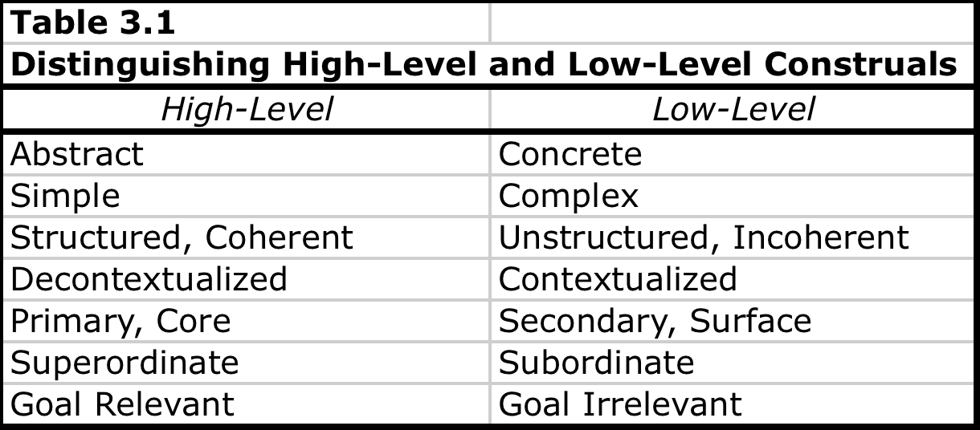

3.2 Different applications of Construal Level Theory

Another field where feasibility and desirability concerns are important is when it comes to seeking feedback. Feasibility of feedback would entail being more vulnerable while being exposed to criticism, which might not be pleasant. The desirability would be obtaining true and honest information about yourself or your work. Freitas, Solavey, and Liberman (2001), predicted and found that in the distant future people prefer informative and possibly negative evaluations more than in the near future, where people tend to prefer less informative but more flattering feedback.

Feasibility and desirability are also applicable to gambling situations. The ultimate goal of gambling is winning money or some other prize; therefore the payoff is the desirability. An obstacle obstructing the way to that prize is the probability of winning the prize; the feasibility factor. Liberman, Sagristano, and Trope (2002) showed by testing that the level of interest in the payoff is high no matter whether the probability of winning is high or low. When the pay-off is low however, the level of interest in the probability was much lower than the level of interest in the probability when the payoff is high. From the point of view of Construal Level Theory, this would mean that, in near future gambles, probability (the subordinate feature) would be more decisive and in distant future gambles the payoff (superordinate feature) would be. In the same paper they tested this and the result was indeed that in the near future gambles with high probability of winning and low payoffs were preferred, while in the distant future high payoff, low probability gambles were more attractive.

When it comes to category breadth, Construal Level Theory predicts that people would use fewer categories when it comes to classifying objects concerning distant-future activities compared to near-future activities. In a study conducted by Liberman, Sagristano, and Trope (2002, study 1), participants were asked to imagine they would go on a camping trip. This trip would either be the coming weekend or during a weekend a few months later. Participants were presented with a list of 38 objects that were related to the trip and were asked to organize them in as many different categories as they wished. The result was that the number of categories people used for the distant-future camping trip was lower than for the near-future trip. This supports the theory’s idea that distant-future events consist of more abstract features, while near-future events consist of more detailed, concrete features.

In study 3, Liberman et al (2002) looked at expectations about good and bad days in the near of distant future. A good day would consist of mainly positive experiences, while a bad day would obviously consist of mainly negative experiences. After having participants describe what they would think of as a good or bad day in the near of distant future, and also rating the valence of the events during such a day, the following conclusions were made. First, near-future days consisted of more diverse expected experiences than distant-future days. Secondly, expected experiences in the distant-future were more extreme than in the near-future, making a good (bad) day in the future better (worse) than a good (bad) day tomorrow. Future good and bad days showed less diversity of experiences in each type of day and at the same time a future good day would be more different from a future bad day compared to near-future good and bad days.

3.3 Changes in Attitude As Time Goes By

As said, distant future activities are more represented by high-level features and near future activities more by low-level features. This means that as temporal distance to an event decreases, low-level features become more important relative to high-level ones.

Besides being high-level or low-level, features can be labeled as being either positive or negative. Positive features increase the value of an event while negative features decrease the value. A positive feature of a soon to be held concert may be the fact that the concert will be held at a venue very close to home. Conversely, a negative feature could be that the concert is held at a far-away venue. The distance to home is considered to be a peripheral and incidental feature, therefore low-level. According to Construal Level Theory, when the concert is still in the distant future, the distance to the venue is not yet a big factor in deciding whether or not attend the concert. A high-level feature, such as whether or not you are a big fan of the band that is playing, plays a more important role. However, as time goes by, the distance that needs to be traveled becomes a more practical matter, and gains importance in the decision-making process relative to the level of the idolization of the artist. Therefore, a concert of your favorite band far away from home might initially sound very appealing, but as time goes by, and the realization comes that a long travel is necessary to get there, the level of appeal decreases. The probability that someone will attend a concert of a band he or she is not that big a fan of but is close to home might increase as time goes by. In both cases it then becomes a matter of relative importance of the two factors that will lead to a decision whether or not to go. Liberman and Trope (1998) conclude from this: “the overall value of a distant future event should be closer to the value associated with its high-level construal, whereas the overall value of a near future event should be closer to the value associated with its low-level construal”.

3.4 Interaction Effects

Kim, Zhang, and Li (2008) focused on multiple dimensions of psychological distance to study the interaction effect. Their experiment was to find out how social and temporal distances interact when it comes to the formation of representations and evaluations of certain events or products. They stress that consumers and marketers are regularly faced with decisions in which more than one type of distance plays a role; planning a trip for yourself versus for someone else for the coming weekend versus a weekend a year from now, for example. Their main conclusion is that when two dimension of distance are present and both of them are proximal, low-level construals are of main influence on consumer evaluations. However, when either one or both dimensions became distal, high- level construals gained importance.

Bloquiaux (2010) researched how temporal distance affected consumers’ evaluations of different travel offers and also how previous experience in booking vacations interacted with temporal distance. Participants were faced with either one of two different travel offers; the first had positive high-level and negative low-level features, the second had negative high-level and positive low-level features. Furthermore, there was a variation in temporal distance; last minute (departure 7 days from now) vs. a regular booking (departure 365 days from now). Results showed that the main cause in different ratings of the offers lies in the difference in travel description and not in the temporal distance. The offers with the positive high-level features and negative low-level features were preferred to the offers with negative high-level and positive low-level features, no matter the temporal distance. Theoretically and practically this is not surprising. Since high-level features can be seen as the primary and most goal-relevant features of a vacation, it can be expected that any vacation will be rated less compared to a vacation with better high-level features. Making secondary, goal irrelevant features more positive will not make a huge difference, and the results confirmed this. I believe that the method of testing the Construal Level Theory was not optimal in this research. The main reason for this is because the two different travel offers were different on both level of construal, the high and low levels, in one step. Therefore, I believe that the rejection of the Construal Level Theory hypothesis in Bloquiaux’s work is not a convincing argument against it in the tourism-marketing field. In my thesis, I want to research whether Construal Level Theory holds in this field by only changing the features of one of the two levels of construal at a time, while holding the other constant.

3.5 Contribution of this Thesis

The main focus point of this thesis is to test whether or not Construal Level Theory holds in the tourism-marketing field by measuring the change in response to vacations when they vary in high-level or low-level features, and temporal distance. According to Construal Level Theory, low-level features are more decisive in near future situations while high-level features are more important for decision making in the distant future. Therefore, a change in low-level features should have a larger impact in the near future compared to a same change in a distant future situation. A change in high-level features should then have a larger effect in distant future situations compared to a same change in the near-future situation. Therefore, two hypotheses of this thesis are as follows:

H1: A change in the low-level features of a vacation, ceteris paribus, has more impact on its evaluation when the departure date is three days from now, compared to a vacation for which the departure date is one year from now.

H2: A change in the high-level features of a vacation, ceteris paribus, has more impact on its evaluation when the departure date is one year from now, compared to a vacation for which the departure date is three days from now.

4.0 Method of Testing

4.1 Previous Experiments as Base

The experiment designed to research the Construal Level Theory in tourism-marketing finds its practical base in two last discussed papers. The first one is by Kim, Zhang & Li (2008), and the second by Bloquiaux (2010).

In their paper, Kim et al (2008) focus on multiple dimensions of psychological distance and how they interact with each other. They researched the interaction effect of temporal and social distance on consumer evaluations of products. They hypothesized that when those two dimensions of psychological distance are involved in an event or product, they interactively influence the events’ evaluations. Only when both dimensions are proximal (e.g. for self and in the near future), evaluations would be more associated with the low-level construals. As soon as either one or both dimensions become distal (e.g. for another and/or in the distant future), values associated with high-level construals are more of influence on the evaluations.

In experiment 1 they had participants rate two versions of an online training program; one with positive high-level and negative low-level features, the other with negative high-level and positive low-level features. Furthermore, participants were divided into groups where they either had to give their own ratings or predict how another student whom they didn’t know would rate the program (social distance variation), and where the program would either be available tomorrow or next year (temporal distance variation). After reading the descriptions about programs, the participants evaluated the programs measured on four items: bad versus good, favorability, satisfaction, and usefulness; all measured on a 9-point scale.

This method of rating products was also used by Bloquiaux (2010) in her research about a three-way interaction effect on the evaluation of different vacations. The three factors considered were, firstly, the experience people had in booking vacations, secondly the temporal distance to the vacation, and thirdly the different travel descriptions. Relevant for the method of conducting the experiment in this thesis was the way Bloquiaux varied the different vacations by changing high-level and low-level features.

To determine which features of a vacation are considered to be high-level, and which features are considered to be low-level, Bloquiaux conducted a pre-test. A list of possible vacation features was presented to the participants which were then rated by them on five levels; to what extent the feature was a primary, essential, central, critical, and goal-relevant attribute when it comes to booking a vacation. This is the same method as Kim et al (2008) in their second experiment, though the product was different. Fourteen different features were rated. Results showed that the fitness facilities, room service, medical requirements in the form of vaccinations, and the distance to the airport were the four most significant features considered to be low-level. The four most significant high-level features were the possibility to participate in excursions and activities, the star rating of the hotel, the presence of a swimming pool, and the possibility to discover a new culture and environment. Bloquiaux finally decided to use the two high-level features “the possibility to participate in excursions and activities” and “the star rating of the hotel”, and the two low-level features “distance to the airport” and “medical requirements” for her main research. These four features will also be the four features relevant in this experiment.

In the main research, participants were asked to rate a travel offer, which consisted of the four (two high-level, two low-level) features. Bloquiaux had the participants rate the offer on the same four measures as Kim et al (2008) in their first experiment, and added a fifth one: a question rating the matter of attractiveness. Participants were divided in four groups, two of which concerned the near future, the other two the distant future situations. Within each temporal group, participants were asked to rate a vacation with positive high-level and negative low-level features, or a vacation with negative high-level and positive low-level features. Table 4.1 shows this in a structured form.
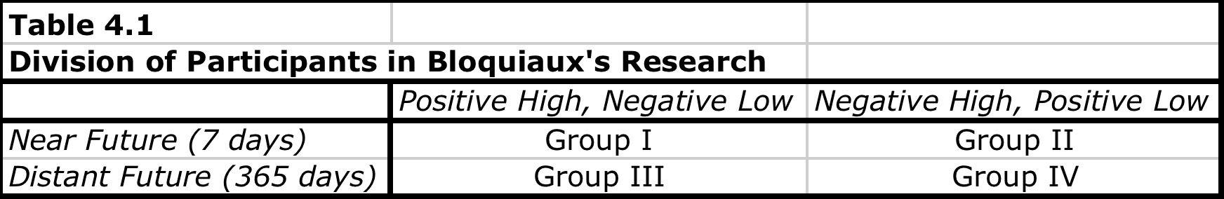
Bloquiaux’s hypothesis concerning the construal level theory was that the participants in Group II and III would evaluate the vacation higher than the participants in Group I and IV. The result was that Group I and III were the ones with the higher evaluations. In other words, high-level features are preferred to low-level features, no matter if the vacation is in the near or the distant future. In paragraph 3.4 I already explained why this is not surprising.

4.2 Hypotheses

The main difference between Bloquiaux’s experiment and the one in this thesis lies in the column part of Table 4.1. Where Bloquiaux measured the difference between a vacation with positive high-level and negative low-level features and a vacation with the opposite of features, I will measure the difference in evaluations when only the high-level or only the low-level features change and the other remains constant. See Table 4.2.

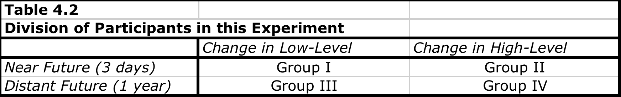
Per group, Bloquiaux measured the evaluations of the vacations themselves. In my research, I will measure the change in evaluation of a vacation. Other minor but already clear differences in the experiment are in defining the near future. I chose a period of three days in order to make it even more apparent that the vacation is in the near future.

For the sake of convenience I will now repeat my hypothesis and also explain them using Table 4.2.

H1: A change in the low-level features of a vacation, ceteris paribus, has more impact on its evaluation when the departure date is three days from now, compared to a vacation for which the departure date is one year from now.

H2: A change in the high-level features of a vacation, ceteris paribus, has more impact on its evaluation when the departure date is one year from now, compared to a vacation for which the departure date is three days from now.

Hypothesis 1 states that the change in the evaluations of a vacation derived from a change in the low-level features of that vacation, will be larger if the vacation has a departure date three days from now, compared to a vacation one year from now. This means that the change measured in Group I is expected to be larger than the change measured in Group III.

Hypothesis 2 states that the change in the evaluations of a vacation derived from a change in the high-level features of that vacation, will be larger if the vacation has a departure date one year from now, compared to a vacation three days from now. This means that the change measured in Group IV is expected to be larger than the change measured in Group II.

4.3 The Questionnaire

To conduct this experiment, a standard questionnaire was designed of which four different versions were made. The only difference between the different versions is found in the temporal distance factor and the change in either the high-level or the low-level features. The questionnaires can be found in the appendix.

The questionnaire can be divided in seven sections:

- Introduction
- Explanation of variables
- Evaluation of vacation before change of features
- Evaluation of vacation after change of features
- Control questions
- Demographics
- Thank you

In the first section the participants were welcomed, thanked in advance for their participation, and told how many questions they could expect. A headline in the top of the screen immediately indicated the topic of the questionnaire and which temporal distance was in effect (either departure in 3 days or 1 year from now).

In the second section the situation was described a bit further and an explanation was given about the four features that would be dealt with. Concerning the star rating of the hotel it was important to make sure that the rating would reflect the opinion of the participant. For instance, if a hotel would have a five-star rating, the hotel should be the perfect hotel in the mind of the participant. Personal experience has learned that sometimes stars are given where they are not appropriate, and therefore results might be influenced.

Also noteworthy is the description of the medical requirements. It was important to stress that the vaccinations for this vacation still needed to be gotten before the vacation and that previous vaccinations were not sufficient for this trip. This to make sure that all the participants had the idea that, if relevant, the vaccinations were still necessary.

The final note of the introduction was about money. Since the purpose of this experiment is to single out the effects of the change in the features of the vacation and the temporal distance, it is important to cancel the effect that money can have on the situation. Therefore the participants were told that money is not a relevant factor and that they should evaluate the vacations purely on the features shown, not on a value-for-money basis.

The third and forth section are similar to each other and is where the questionnaire really starts. In both, participants are presented with a vacation described by the four features. The vacation in section three is the before-change version, the vacation in section four has either low-level features that are changed or high-level features that are changed. The features that did not change are kept at an average level.

The first three questions the participants were asked to answer were based on the questions Kim et al (2008) and Bloquiaux (2010) used in their research. On a 9-point scale participants were asked what their first impression was about this vacation, how satisfied they think they would be, and to what extent they felt appealed to this vacation. Adding to this, participants were asked to rate the vacation based on the shown features on a scale from 1 to 100. The section’s last question was if they would book the vacation in real life or not (no, probably not, I don’t know, probably, yes).

On the next page, participants were told that due to a mistake at the travel agency they were misinformed about either the star rating of the hotel and the number and variety of excursions and activities (high-level features) or the required vaccinations and the airport of departure (low-level features). In either case the change resulted in an improvement of the features. Participants were then asked to rate the improved vacation using the same exact questions as for the vacation before. As a reminder the features of the first vacation were listed as well.

The fifth part of the questionnaire consisted of a number of control questions. First in order to make sure that the participants regarded “3 days from” as near future, and “1 year from now” as distant future when it comes to leaving for vacation. Next the participants were asked to rank the four features used to
Version 1: Change in the low-level features.
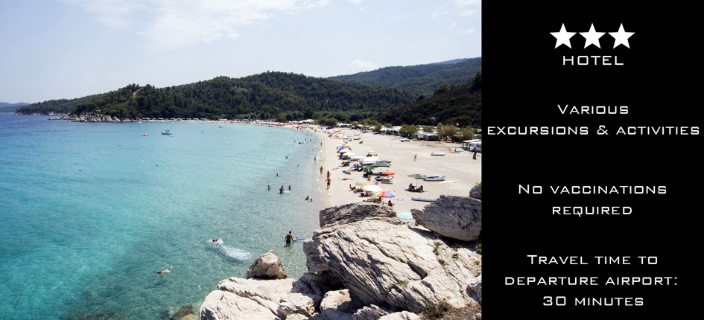

Version 2: Change in the high-level features.


describe the vacation from “adding most value to the vacation” to “adding least value to the vacation”. The more value a feature adds to a vacation, the more primary or goal-relevant a feature can be regarded as, and the more a feature can be treated as a high-level one.

The last section consisted of a number of demographic questions, after which the results were submitted. After that the participants were thanked again for their participation.

5.0 Data

5.1 Population

The four versions of the questionnaire were posted online and with the help of social media platforms participants were invited to participate with an incentive of winning a large poster of a photo of their choice. A total of 134 people participated in the experiment. Since the population is defined as people who are likely to book a travel, the population is very broad. However, in order to make sure the participants are familiar with booking vacations, participants were asked about their travel frequency. One participant was dropped from the sample who indicated to travel less than twice per year. That resulted in a total of 65 males and 68 females from 15 different countries of which a majority of 74,4% coming from the Netherlands. Ages ranged from 16 to 67 years, all indicating that they travel at least once every two years, and averaging 27.55 years with a standard deviation of 7.688 years.

5.2 Control Questions

5.2.1 High-level and Low-Level Features

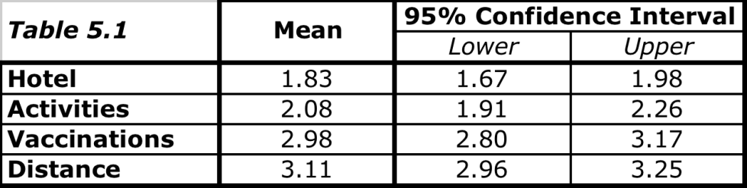
The first thing to make sure of is to check whether or not the participants considered the four different features to be high-level or low-level. Questions 12 through 15 were created to test this. Participants were asked to rank the features from adding most to least value to the vacation. A one-sample t-test was performed to look at the different means and at the 95%-confidence intervals. Results show that the star rating of the hotel (Hotel) and the number and variety of activities and excursions (Activities) are clearly rated as more important compared to the required vaccinations (Vaccinations) and the distance to the airport of departure (Distance). The more important the participants regard a certain feature to be, the more primary or goal-relevant the feature is to a vacation. Therefore Hotel and Activities can indeed be seen as high-level features.

5.2.2 Perception of Temporal Distance

The second thing to make sure of is whether or not the participants regard a departure in three days to be in the near future and a departure in one year to be in the distant future. Since two different groups of people were assigned to either a near- or distant-future situation, an independent-means t-test should provide the answer to this.

Levene’s test for Equality of Variances gave a significance level of .399 and is therefore insignificant resulting in the assumption that the variances are equal. On average, and as expected, participants regard 3 days from now (M = 2.78 on a 9-point scale, SE = .199) to be closer in the future than 1 year (M = 7.27 on a 9-point scale, SE = .215). This difference is highly significant t(131) = -15.235, p<.05.

The mean difference is -4.483 with a standard error of difference of 0.293. The t-statistic is -15.325 and is highly significant with a significance value of 0.000. That makes the r-value equal to .801, from which can be concluded that the difference in time perception is large as the benchmark for a large effect is .5 (Field, 2009).

We can make the following conclusions:
- The star rating of the hotel and the number and variety of activities and excursions are regarded as high-level features.
- The number of required vaccinations and the distance to the airport of departure are regarded as low-level features.
- Leaving for vacation three days from now is regarded as being near future, leaving for vacation one year from now is regarded as being distant future.

5.3 Measuring the Differences

Now that the control questions provided us with the confirmation of the high- and low-level features and the time perception, we can continue analyzing the data for the vacation evaluations. The participants were asked to rate two vacations of which the second one had either improved high-level or improved low-level features on a 9-point scale. The difference between these two ratings is caused by the effect of the change in the features. By subtracting the rating of the first vacation from the rating of the second vacation, we are left with the numeric value of this effect.

According to Construal Level Theory, when it comes to the low-level feature improvements, the average change in evaluation should be larger for the vacation in the near future compared to the change resulting from the same improvements of the vacation in the distant future. Conversely, when the improvements are made in the high-level features, the average change in evaluation should be larger for the vacation in the distant future compared to the change resulting from the same improvements for the vacation in the near future.

The vacations were rated on first impression, expected satisfaction, and level of appeal. Also, participants gave a score on a scale from 1 to 100 and they indicated the probability that they would book the vacation in real life. By conducting independent-means t-tests we can compare the means of the changes and conclude whether or not the theory holds.

5.4 Results

After conducting the t-tests and analyzing the results it turns out that in only one case there is a significant result. This is for the rating that is given for the participants’ first impression of the vacations where the change is in the low-level features. Results show that when the departure date of the vacation is in three days, the effect of the improvements of the low-level features is larger than when the departure is one year from now. Results can be seen in Table 5.4.

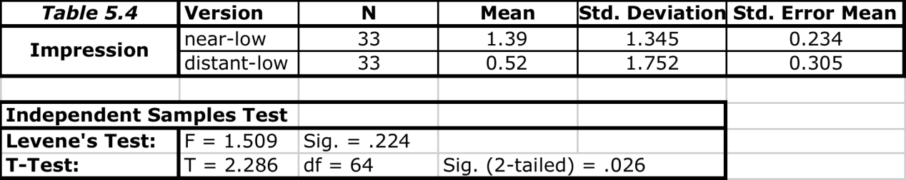
In the table we find that Levene’s test for Equality of Variances resulted in a significance level of .224, which means that we can assume that equal variances of the sample are assumed. On average, the participants’ first impressions about the vacation were more affected by the improvements when the departure was in three days (M = 1.39, SE = 1.345) compared to a departure one year from now (M = .52, SE = 1.752). The difference is significant at a 5%-level (t(64) = 2.286, p < .05).

This result is in line with Construal Level Theory, which predicted that the secondary, subordinate, and goal irrelevant features become more important as the temporal distance to departure decreases.

However, results of all the other t-tests comparing the changes in expected satisfaction, level of appeal, the given score on a scale from 1 to 100, and the chance the participant would book this vacation on a 5-point scale after improvements in either high-level or low-level did not provide any significant results. Neither did the t-test comparing the changes in first impressions after improvements in high-level features.

Even though most of the tests gave insignificant results, there were some results that are notable. First of all when comparing the means, in nine of the ten cases, changes in near future vacations resulted in larger differences in evaluations compared to the changes in distant future vacation changes. This could indicate that as temporal distance to a vacation decreases (e.g. it gets closer in time), the larger the effects are of changes made to the vacation.

The second result that is noticeable is that for each category (first impression, expected satisfaction, etc.) the size of the difference in evaluation was larger when the high-level features changed compared to when the low-level features changed. However, even if the results were significant, this does not necessarily mean that high-level features are more decisive for an evaluation than the low-level features. In this case it would merely mean that the an upgrade from a 2-star to a 4-star hotel combined with an upgrade from a limited number to many and various excursions and activities is regarded as a larger improvement than the combination of a decrease of 2.5 hours in travel time to the airport of departure and needing zero instead of two medical vaccinations. Basically, this is comparing apples to oranges, and this was not the aim of the experiment.

6.0 Conclusions

6.1 Theoretical Conclusions

With the experiment that has just been discussed, an attempt was made to find out whether or not the Construal Level Theory holds in the tourism-marketing industry. We tested the following hypotheses:

H1: A change in the low-level features of a vacation, ceteris paribus, has more impact on its evaluation when the departure date is three days from now, compared to a vacation for which the departure date is one year from now.

H2: A change in the high-level features of a vacation, ceteris paribus, has more impact on its evaluation when the departure date is one year from now, compared to a vacation for which the departure date is three days from now.

Ten independent-means t-tests were conducted to compare the mean change in vacation evaluations after a change in the low-level or the high-level features. These ten t-tests were equally divided among the two possible changes in the vacations (either the low-level features or the high-level features changed) and were conducted for the change in the following factors:
- First impression
- Expected satisfaction
- Level of appeal
- Score of the vacation on a scale from 1 to 100
- The chance the participant would book the vacation in real life, on a 5-point scale.

In only one of the 10 tests a significant result was found. The change in participants’ first impressions after a change in the low-level features changed more for a vacation in the near future compared to the same feature-changes in the distant future. This is in line with Construal Level Theory. However, because in all nine other tests we couldn’t find any significant results it would be too much to conclude from this that Construal Level Theory holds in the tourism industry. Moreover, we can reject hypothesis 2, because for the high-level feature changes, no significant results were found at all.

The main conclusion from this experiment is that, overall, there is no relationship between temporal distance and way changes in vacations are being evaluated and that Construal Level Theory does not hold in this situation.

6.2 Limitations and Future Research

The circumstances this experiment was conducted under are subject to a number of limitations, which may have had an influence on the results. The most important limitation is one that is similar to the one Gilovich, Kerr, and Medverc (1993) had as comment on Nisan’s work from 1972, discussed in section 2.2. That is, the participants who were randomly assigned to the hypothetical vacation in three days may not have been in the same mental state as they would have been in if they actually would have gone on a vacation in three days. It is nearly impossible to replicate that same mind condition. However, by really putting an accent on it and repeating it several times throughout the experiment, a serious attempt was made to replicate this mind state as well as possible. The same holds for replicating the mind-set for people who are leaving for a vacation in one year.

Also, due to timing constraints, the experiment was conducted as soon as each of the four versions had at least thirty participants who submitted usable data. Even though this might be enough to show statistical differences, if there had been more participants, this would have made the results more precise.

This research has opened up a door to future research in a number of ways. First of all, for travel agencies it might be interesting to research which changes to which features could be made at a certain point in time in order to pull a customer over the line and convince them to book a vacation. Customers might be more sensitive to a change in a certain feature when the vacation is a last-minute vacation than when it is a regular vacation. Changes could be used as persuasion instruments. In order to conduct such a research it will be very important to conduct it with real customers who are actually in the correct state of mind.

Just because results of this experiment were not in favor of Construal Level Theory for the tourism-marketing industry, it obviously does not mean that the theory does not hold in other industries. It is important not to generalize, especially because the method of testing in this thesis had some limitations.

References

Bloquiaux, L. (2010),
“The Construal Level Theory for Last-Minutes vs. Regular Bookings”.

Buhler, R., Griffin, D. & Ross, M. (1994).
“Exploring the “planning fallacy”: Why people underestimate their task completion times. Journal of Personality and Social Psychology, 36, 917-927. In Liberman & Trope (1998).

Carver, C. & Scheier, M. (1981).
“Attention and self-regulation: A control theory approach to human behavior.” New York: Springer-Verlag.

Carver, C. & Scheier, M. (1990).
“Principles of self-regulation.” In Liberman & Trope (1998)

Dahl, Ö. (1983).
“Temporal Distance: remoteness distinctions in tense-aspect systems. “Linguistics: Volume 21, Issue 1, Pages 105-122.

Elster, J., & Loewenstein, G. (1992).
“Utility from memory and anticipation.” In Liberman & Trope (1998).

Field, A. (2009).
“Discovering Statistics Using SPSS.” Third Edition

Freitas, A., Solavey, P., and Liberman, N. (2001).
“Abstract and concrete self-evaluative goals.” Journal of Personality and Social Psychology, 80, 410-412. In Liberman, N. & Trope, Y. (2003).

Gilovich, T., Kerr, M. & Medverc, V (1993).
“Effect of Temporal Perspective on Subjective Confidence”. Journal of Personality and Social Psychology, Vol. 64, No. 4, 552-560.

Hampson, S., John, O. & Goldberg, L. (1986).
“Category breadth and hierarchical structure in personality: Studies of asymmetries in judgments of trait implications. Journal of Personality and Social Psychology, 51, 37-54. In Liberman & Trope (1998).

Kim, K., M. Zhang, and X. Li (2008).
“Effects of Temporal and Social Distance on Consumer Evaluations.” Journal of Consumer Research: Volume 35, December 2008.

Liberman, N. & Trope, Y. (1998).
“The Role of Feasibility and Desirability Considerations in Near and Distant Future Decisions: A Test of Temporal Construal Theory”. Journal of Personality and Social Psychology, Vol. 75, No. 1, 5-18.

Liberman, N. & Trope, Y. (2003).
“Temporal Construal”. Psychological Review: Volume 110, No. 3, 403-421.

Liberman, N., Trope, Y. & Wakslak, C. (2007).
“Construal Level Theory and Consumer Behavior”. Journal of Consumer Psychology, 17(2), 113-117.

Loewenstein, G. (1987).
“Anticipation and the valuation of delayed consumption.” The Economic Journal, 97, 666-684. In Liberman & Trope (1998).

Nisan, M. (1972),
“Dimension of Time in Relation to Choice Behavior and Achievement Orientation”. Journal of Personality and Social Psychology, Vol. 21, No. 2, 175-182.

Sagristano, M., Trope, Y., and Liberman, N. (2002).
“Time-dependent gambling: Odds now, money later. Journal of Experimental Psychology: General, 131, 364-376. In Liberman, N., Trope, Y. & Wakslak, C. (2007).

Vallacher, R., & Wegner, D. (1987).
“What do people think they’re doing? Action identification and human behavior.” Psychological Review, 94, 3-15.

Appendix

Appendix A: Questionnaires
Appendix B: Data Tables

Appendix B: Data Tables

Test Temporal Distance:

Group Statistics
 | Near future or Distant Future? |  | N | Mean | Std. Deviation | Std. Error Mean
Time Perception | dimension1 | Near Future | 69 | 2.78 | 1.653 | .199
Time Perception | dimension1 | Distant Future | 64 | 7.27 | 1.720 | .215

Independent Samples Test
 |  | Levene's Test for Equality of Variances |  | t-test for Equality of Means
 |  | F | Sig. | t | df | Sig. (2-tailed) | Mean Difference | Std. Error Difference | 95% Confidence Interval of the Difference
 |  |  |  |  |  |  |  |  | Lower | Upper
Time Perception | Equal variances assumed | .715 | .399 | -15.325 | 131 | .000 | -4.483 | .293 | -5.062 | -3.904
Time Perception | Equal variances not assumed |  |  | -15.301 | 129.264 | .000 | -4.483 | .293 | -5.063 | -3.903

T-Test First Impression

Near-low vs. Distant-low
Group Statistics
 | Version | N | Mean | Std. Deviation | Std. Error Mean
Impression Difference | near-low | 33 | 1.39 | 1.345 | .234
Impression Difference | distant-low | 33 | .52 | 1.752 | .305

Independent Samples Test
 |  | Levene's Test for Equality of Variances |  | t-test for Equality of Means
 |  | F | Sig. | t | df | Sig. (2-tailed) | Mean Difference | Std. Error Difference | 95% Confidence Interval of the Difference
 |  |  |  |  |  |  |  |  | Lower | Upper
Impression Difference | Equal variances assumed | 1.509 | .224 | 2.286 | 64 | .026 | .879 | .385 | .111 | 1.647
Impression Difference | Equal variances not assumed |  |  | 2.286 | 59.990 | .026 | .879 | .385 | .110 | 1.648

Near-high vs. Distant-high

Group Statistics
 | Version | N | Mean | Std. Deviation | Std. Error Mean
Impression Difference | near-high | 35 | 2.00 | 2.262 | .382
Impression Difference | distant-high | 30 | 1.50 | 1.408 | .257

Independent Samples Test
 |  | Levene's Test for Equality of Variances |  | t-test for Equality of Means
 |  | F | Sig. | t | df | Sig. (2-tailed) | Mean Difference | Std. Error Difference | 95% Confidence Interval of the Difference
 |  |  |  |  |  |  |  |  | Lower | Upper
Impression Difference | Equal variances assumed | 1.092 | .300 | 1.048 | 63 | .298 | .500 | .477 | -.453 | 1.453
Impression Difference | Equal variances not assumed |  |  | 1.085 | 57.831 | .282 | .500 | .461 | -.422 | 1.422

T-Test Satisfaction
Near-low vs. Distant-low

Group Statistics
 | Version | N | Mean | Std. Deviation | Std. Error Mean
Satisfaction Difference | near-low | 33 | .79 | 1.293 | .225
Satisfaction Difference | distant-low | 33 | .64 | 1.388 | .242

Independent Samples Test
 |  | Levene's Test for Equality of Variances |  | t-test for Equality of Means
 |  | F | Sig. | t | df | Sig. (2-tailed) | Mean Difference | Std. Error Difference | 95% Confidence Interval of the Difference
 |  |  |  |  |  |  |  |  | Lower | Upper
Satisfaction Difference | Equal variances assumed | .147 | .703 | .459 | 64 | .648 | .152 | .330 | -.508 | .811
Satisfaction Difference | Equal variances not assumed |  |  | .459 | 63.683 | .648 | .152 | .330 | -.508 | .811

Near-high vs. Distant-high

Group Statistics
 | Version | N | Mean | Std. Deviation | Std. Error Mean
Satisfaction Difference | near-high | 35 | 2.06 | 2.274 | .384
Satisfaction Difference | distant-high | 30 | 1.63 | 1.564 | .286

Independent Samples Test
 |  | Levene's Test for Equality of Variances |  | t-test for Equality of Means
 |  | F | Sig. | t | df | Sig. (2-tailed) | Mean Difference | Std. Error Difference | 95% Confidence Interval of the Difference
 |  |  |  |  |  |  |  |  | Lower | Upper
Satisfaction Difference | Equal variances assumed | .833 | .365 | .861 | 63 | .393 | .424 | .493 | -.560 | 1.408
Satisfaction Difference | Equal variances not assumed |  |  | .885 | 60.338 | .380 | .424 | .479 | -.534 | 1.382

T-Test Appeal
Near-low vs. Distant-low

Group Statistics
 | Version | N | Mean | Std. Deviation | Std. Error Mean
Appeal Difference | near-low | 33 | 1.30 | 1.531 | .266
Appeal Difference | distant-low | 33 | .85 | 1.253 | .218

Independent Samples Test
 |  | Levene's Test for Equality of Variances |  | t-test for Equality of Means
 |  | F | Sig. | t | df | Sig. (2-tailed) | Mean Difference | Std. Error Difference | 95% Confidence Interval of the Difference
 |  |  |  |  |  |  |  |  | Lower | Upper
Appeal Difference | Equal variances assumed | .886 | .350 | 1.320 | 64 | .192 | .455 | .344 | -.233 | 1.142
Appeal Difference | Equal variances not assumed |  |  | 1.320 | 61.598 | .192 | .455 | .344 | -.234 | 1.143

Near-high vs. Distant-high

Group Statistics
 | Version | N | Mean | Std. Deviation | Std. Error Mean
Appeal Difference | near-high | 35 | 2.51 | 2.418 | .409
Appeal Difference | distant-high | 30 | 1.93 | 1.507 | .275

Independent Samples Test
 |  | Levene's Test for Equality of Variances |  | t-test for Equality of Means
 |  | F | Sig. | t | df | Sig. (2-tailed) | Mean Difference | Std. Error Difference | 95% Confidence Interval of the Difference
 |  |  |  |  |  |  |  |  | Lower | Upper
Appeal Difference | Equal variances assumed | 3.046 | .086 | 1.139 | 63 | .259 | .581 | .510 | -.438 | 1.600
Appeal Difference | Equal variances not assumed |  |  | 1.179 | 57.870 | .243 | .581 | .493 | -.405 | 1.567

T-Test Score
Near-low vs. Distant-low

Group Statistics
 | Version | N | Mean | Std. Deviation | Std. Error Mean
Score Difference | near-low | 33 | 9.73 | 8.247 | 1.436
Score Difference | distant-low | 33 | 9.85 | 25.721 | 4.477

Independent Samples Test
 |  | Levene's Test for Equality of Variances |  | t-test for Equality of Means
 |  | F | Sig. | t | df | Sig. (2-tailed) | Mean Difference | Std. Error Difference | 95% Confidence Interval of the Difference
 |  |  |  |  |  |  |  |  | Lower | Upper
Score Difference | Equal variances assumed | 4.821 | .032 | -.026 | 64 | .980 | -.121 | 4.702 | -9.515 | 9.272
Score Difference | Equal variances not assumed |  |  | -.026 | 38.511 | .980 | -.121 | 4.702 | -9.636 | 9.393

Near-high vs. Distant-high

Group Statistics
 | Version | N | Mean | Std. Deviation | Std. Error Mean
Score Difference | near-high | 35 | 23.06 | 23.276 | 3.934
Score Difference | distant-high | 30 | 17.83 | 15.182 | 2.772

Independent Samples Test
 |  | Levene's Test for Equality of Variances |  | t-test for Equality of Means
 |  | F | Sig. | t | df | Sig. (2-tailed) | Mean Difference | Std. Error Difference | 95% Confidence Interval of the Difference
 |  |  |  |  |  |  |  |  | Lower | Upper
Score Difference | Equal variances assumed | 2.075 | .155 | 1.052 | 63 | .297 | 5.224 | 4.967 | -4.701 | 15.149
Score Difference | Equal variances not assumed |  |  | 1.085 | 59.067 | .282 | 5.224 | 4.813 | -4.406 | 14.854

T-Test Booking Chance
Near-low vs. Distant-low

Group Statistics
 | Version | N | Mean | Std. Deviation | Std. Error Mean
Booking Chance Difference | near-low | 33 | .73 | .944 | .164
Booking Chance Difference | distant-low | 33 | .39 | .864 | .150

Independent Samples Test
 |  | Levene's Test for Equality of Variances |  | t-test for Equality of Means
 |  | F | Sig. | t | df | Sig. (2-tailed) | Mean Difference | Std. Error Difference | 95% Confidence Interval of the Difference
 |  |  |  |  |  |  |  |  | Lower | Upper
Booking Chance Difference | Equal variances assumed | .250 | .619 | 1.496 | 64 | .140 | .333 | .223 | -.112 | .778
Booking Chance Difference | Equal variances not assumed |  |  | 1.496 | 63.497 | .140 | .333 | .223 | -.112 | .779

Near-high vs. Distant-high

Group Statistics
 | Version | N | Mean | Std. Deviation | Std. Error Mean
Booking Chance Difference | near-high | 35 | 1.29 | 1.274 | .215
Booking Chance Difference | distant-high | 30 | 1.07 | 1.112 | .203

Independent Samples Test
 |  | Levene's Test for Equality of Variances |  | t-test for Equality of Means
 |  | F | Sig. | t | df | Sig. (2-tailed) | Mean Difference | Std. Error Difference | 95% Confidence Interval of the Difference
 |  |  |  |  |  |  |  |  | Lower | Upper
Booking Chance Difference | Equal variances assumed | .963 | .330 | .732 | 63 | .467 | .219 | .299 | -.379 | .817
Booking Chance Difference | Equal variances not assumed |  |  | .740 | 62.972 | .462 | .219 | .296 | -.372 | .810

