Consumer decision making process in Cinema markets: the role of service and quality.

Erasmus Universiteit Rotterdam
Erasmus school of economics

Name: Ad Huige Erasmus Contact:
Exam number: 308810 Secretariat: Tülay Varisli (H15-02)
E-mail: 308810ah@student.eur.nl be-marketing-secr @ese.eur.nl
Specialization: marketing Supervisor: Isabel Verniers (H15-11)
Thesis: Master verniers@ese.eur.nl
Date:

The author developed a model of consumer decision making in the cinema market. The research question is: What is the consumer decision making process in the cinema markets, and what is the role of service and quality? The focus was on these variables, because they are not explained by the academic literature, but also the factors: price, availability, perceptual- and learning construct and distinctiveness are researched. The changing environment in the cinema market is interesting because many technological- and behavioral factors influenced this market the last 15 years. A model containing 22 different consumer behavior variables was tested with an online survey. The data of 151 participants was a quality sub-set of the population. So a factor analysis and regression model could test the collected data. As a result a regression formula is constructed, and has an explaining value of 20.6% on dependent variable, the number of visits a cinema consumer. The role of quality has an important role in the consumer decision making process, were the role of service is not important. The role of the control variables: availability and perceptual- and learning construct is changed in comparison with their first role as reviewed in the academic literature. The paper concludes with a discussion section, where the constructed model is implemented with the managerial implications.
Index
1.0 Introduction p. 3

2.0 Literature study p. 4
2.1.1 Consumer behaviour p. 4
2.1.2 Needs p. 4
2.1.3 Choice set p. 5
2.1.4 Consumer Decision process p. 7
2.2 Cinema market p. 9
2.2.1 Introduction of the cinema market p. 9
2.2.2 Overview of the cinema market p. 10
2.2.3 The need experience in the entertainment industry p. 11
2.2.4 The changing role of the cinema p. 12
2.3 Explaining variables p. 14
2.3.1 The two gaps p. 14
2.3.2 Quality of the cinema p. 16
2.3.3 Service of the cinema p. 17
2.3.4 Conclusion p. 19
3.0 Method p. 20
3.1 Introduction p. 20
3.2 Research questions p. 20
3.3 Factor Analysis and Lineair regression p. 21
3.4 Variables p. 23
3.5 Conclusion p. 26
4.0 Data description p. 27
4.1 Survey p. 27
4.2 Sample group p. 27
4.3 Data collection p. 29

5.0 Results p. 30
5.1 Data descriptive and Continuous variable p. 30
5.2 Factor analysis p. 32
5.3 regression model p. 35
5.4 Hypotheses testing p. 37
5.5.Conclusion p. 38
6.0 Discussion p. 39
6.1 Introduction p. 39
6.2 The study Improvements/ critics p. 39
6.3 Explanations and managerial implication of the results p. 40
6.4 Comparing means for managerial implications p. 42
6.5 Further research p. 43
6.6 Conclusion p. 44
7.0 Conclusion p. 45

References: p. 46
Appendices p. 49
Appendix A: Survey p. 49
Appendix B: Scree-plots factor analysis p. 51
Appendix C: Rotated Component matrix p. 52
Appendix D: Cronbach’s Alpha results p. 52

1.0 Introduction
Everybody knows which type of intense feeling you can get from an evening out. As costumer you can get totally relaxed and you only do the things you want to do. There is even a whole industry build on this type of entertainment feeling. In the entertainment industry different types of amusement are offered, every moment of the day a person can do what he wants to, to enjoy this passionate feeling. So, it does not matter if the feeling is caused by a romantic dinner, an evening in the casino or watching a movie it is about feeling the emotions: fun, fear or excitement. The purpose of the entertainment industry is to let the consumer experience an intense feeling. In total there are twelve different types of entertainment companies that try to fulfil this need of entertainment (Vogel, 2004). In the academic literature this type of feeling is called experiential view (Holbrook and Hirschman 1982) and is associated with the characteristics: feelings, fun and fantasy. In this paper the focus will be on the topic of need for entertainment combined together with the cinema market. The cinema market is one the biggest markets in the entertainment industry and went through a change in consumer decision making process.
The last few decades many things changed in the home cinema technology, almost every person in the Netherlands has a television in their living room with the possibilities to watch movies on a high quality level. So the possibility exists that consumers do not go to the cinema any longer, to see the newest movie, in the best possible way. One of the main topics of this paper will be the question, what the reasons for a consumer nowadays are to go to the cinema. The part need for entertainment will play an important role in this paper. By adding the existing academic literature to this phenomenon a model will be made that predicates the consumer decision making process inside the cinema market.

The constructed model is a combination of two areas of expertise: the consumer behaviour market and the consumer behaviour literature. In both areas many academic papers are written. The role of service and quality are both topics that are an important variable in the consumer decision making process. In the literature of cinema markets both factors are not researched. For that reason the role of these factors are researched and if they can influence the number of times a consumer visits the cinema. Not only the factors service and quality will be researched. The role of the variables: price, availability and distinctiveness are also researched. In chapter 2.0, the literature study is discussed on the topics that were just introduced in the introduction. In following chapters the research method, data collection and the results are described. In the last chapter a discussion over the results is stated and what the implications for the cinema managers are.

2.0 Literature study
2.1.1 Consumer behaviour
In consumer behaviour, researchers are investigating the consciousness and the unconsciousness of purchase decisions of a consumer. In one of the most important models of consumer behaviour, “the consumer buying process”, a five stage decision-model is developed (Engel, Blackwell, and Kollat, 1978). These five steps can help a marketer to give an insight in which steps a consumer makes, before he chooses a particular product. The five stages used in this model are problem recognition, information search, alternative evaluation, making the choice, and evaluation of the outcome. In the seventies and eighties of the previous century, a lot of research was done in the area of consumer behaviour. These relatively older models have been used many times as reference and are nowadays still supported by many economists. The importance of consumer behaviour has not decreased. Most of the companies have a human resource department, where a lot of consumer behaviour questions are answered. Also, in the academic literature a lot of research is done nowadays, for example the research about consumer behaviour and the online decision- making process (Darley, Blankson and Luethge, 2010). Likewise, new insights of the human body, such as DNA, are linked to the consumer behaviour (Durante, Griskevicius, Hill, Perilloux and Li, 2010).
The area of expertise in consumer behaviour is a combination of disciplines; the economic vision of sales is combined with personality factors of psychology (Kassarjian, 1971). With the use of both the disciplines we can try to answer the question: Why and how do products fail and what can a marketing manager do (Narayana and Markin, 1975)? For example: what are the reasons for a consumer to prefer one brand above the other, to choose for a substitute or to be price-sensitive? With the help of a combination of both disciplines, the answers to these kind of questions can be described. The personality factors of a consumer can be used to make economic models that will be profitable.
In this paper the focus is on a specific topic of consumer behaviour: “the decision making process”. This means that the focus is on the fourth step of the model described by Engel, Blackwell and Kollat (1978).
2.1.2 Needs
To understand why consumers are prepared to take an action on a particular purchase, the marketer needs to know their motives. A marketer tries to understand these motives by describing the target group: their needs, wants and demands (Kotler and Keller, 1994). In 1943, Maslow introduced his theory of “hierarchy needs”. This theory introduces five different types of needs an individual could distinguish. The different levels of motives are portrayed in a pyramid, at the bottom is the most fundamental level of need and in the top is self-actualization (Maslow, 1943). The main purpose of many of these economic need-theories is to make needs profitable. When a marketer knows what the motives or drives of a consumer are, he can try to full-fill these needs. The fulfilling of these needs can be done by offering a product that introduces a proper solution. Alongside these needs, there are a lot of other influences that determines how persons will full-fill these needs. In the literature the separation between individual and environmental influences is made. In table 1, the most common determinants are listed.
Table 1
Individual Influences | Environmental Influences
Demographics  Psychographics  Personality  Motivation Knowledge Beliefs  Feelings  Attitudes/intention | social class  culture  ethnicity  family  household group  personal  influence  situation

To combine the need theory and the influencing determinants theory, a model is developed to research the “structure of consumer choice process” (Bettman, 1970). For this research, Bettman investigated five different households on their buying process, with 37 different cues/questions. He estimates which cues are important for the consumer choice process and divided them into three different categories: the individual-, environmental- and attribute cues. These three main categories could be used to predict the choice process of a consumer. A year after his first publication, Bettman already improved his original model (Bettman, 1971). In this article, he simplified his previous model by decreasing the number of questions, and by introducing a tree diagram. In this way he used lesser connection and pairs of nodes, so the survey was easier to use for market researchers. As a consequence of this decrease in questions, the prediction of the last model of consumer choice accuracy dropped from 90% to 70%. A criticism on this theory is that the consumption pattern of each new consumer has to be analysed. So, this type of research isn’t effective because for every consumer a new tree diagram has to be developed (Hansen, 1969).
This concludes that if consumer behaviour theories are combined together with needs models theory, the effects from intern and extern factors are explained. Consumers use these internal, external and attribute influences to decide which product to buy. These factors can be used to predict the target market and what the influence is on their buying decision- making process.
2.1.3 Choice set
The fourth step of the consumer buying process is that consumers make a final decision about their favourite products. The final decision is made from a list with potential products that fulfil the needs of the consumer. This list with potential products is generated in steps one and three of the consumer buying process (Engel, Blackwell, and Kollat, 1978). The process of step four is divided into two stages that every consumer goes through, to make a decision (Ben-Avika, Boccara, 1995):
- Choice set generation;
- Choice from a given choice set.
In this section the first stage of the consumer choice behaviour is discussed and in the next section, the following second step. In the stage of choice set generation, a consumer specifies his or her needs. First, a consumer follows the first three steps: (1) the consumer specifies the problem, (2) which information does he need and (3) what are the potential products? When all these questions are answered, a list of best options for fulfilling the need is constructed. From this list of potential options, the consumer needs to choose the best option. This couple of options together is called the choice set; how big this group is, is depending on several factors (Narayana and Markin, 1975).
When a consumer needs to fulfil a need, he is aware of some options and of some options he is unaware. It depends on the availability of information, recourses and the cost to evaluate this information, to become aware of all products. The probability of beginning with a search depends on the starting choice set and the prior information possessed by the decision-maker. How involved the consumer is with a product, also depends whether he searched for complete or minimum prior information (Richardson, 1982). In the research of Shocker, Ben-Avika, Boccara and Nedungadi (1991), the model for an individual choice is divided in five steps. First, an individual starts with his awareness set that is constructed out of the universal set of options. From this awareness set, the individual makes a consideration set of options. These four or five options are the best options to fulfil the needs of the consumer. The consideration set is developed with context of external alternatives. From this consideration set, the consumer specifies a choice set; the number of options is decreased to two or three options where only the best options stay. From this specific choice set, the final decision will be made.
A consumer does not always choose rational from a choice set. The asymmetric dominance effect indicates that a person finds one alternative more dominating than the other alternatives (Huber, Payne, and Puto 1982). Other effects are that consumers use compromises inside a choice set. This means when a consumer observes your product as a compromise, the consumer prefers your product above two extreme options. Most of the time you will gain market share. These effects occur most of the times with hard and difficult decisions (Simonson 1989).
Per product category, there is a different amount of products that belongs to the consideration set. Hauser and Wernerfelt (1990) performed a research were they found how many products on average belong to a product category. One of the theories is, that there is an order-of-entry Penalty: when a producer enters the market in a later stage, the lower the chance of entering the consideration set of a consumer. Beside this effect, there is an advertisement response: more advertising means higher chance in the consideration set. In other literature, the importance of the consideration set is investigated. When a product is not adopted in the consideration set, sales will eventually go down (Roberts and Lattin,1990).
The importance of the consideration is now clear. Next, an analysis will be made with important factors that a consumer uses to make a choice. Which theories are created to model the decision making process of a consumer?

2.1.4 Consumer Decision process
In the introduction of the previous section, the model of a consumer decision is clarified. In this model there are two stages mentioned, in this section the second step will be discussed, “how does a consumer choose the right product from the consideration set?” There are a lot of different types of consumer decision models. In this section the most important or relevant options are discussed. Two examples of the first models of consumer decision making process are the “satisfying” model (Simon, 1955), and the “elimination-by aspects” model of Tversky (1972). In both models, the consumer is assumed to act rational. Besides this assumption, both models combine economic and psychological arguments to explain the consumer decision process.
In these models, Simon and Tversky assume that all consumers act rational and that many of the consumers think in the same way. In academic literature that follows, most of the authors find that consumers do not think rational. Consumers use four stages to take a good decisions process: the pre-, partial-, final-, and post decions making stage (Zeleny, 1981). Zeleny developed these stages of decisions making, because a lot of factors are influencing the decision making of a consumer. A lot of the models regarding consumer decisions are mathematical models, the most important models will be discussed.

Choice probabilities (Manski & Lerman,1977)
In this article the author computes a probability to summarize the entire choice problem. The outcome of the computation predicts how likely the change is that a consumer will purchase a product. In this formula, Manski and Lerman use the variables: choosing for alternatives i, or for alternatives G, given that the probability C is a given choice set for a specific individual. In this model the most important thing is that a consumer has his specific needs and compares the attributes of product I, against the attributes of alternatives G. Consumers try to match these specific needs together with the characteristics of a given product and their alternatives. Other important mathematical models that are influenced on this model are The Analytic Hierarchy Process (Saaty, 1980) and the Multi-attribute Utility Theory (Baker et al., 2001).
Formula 1
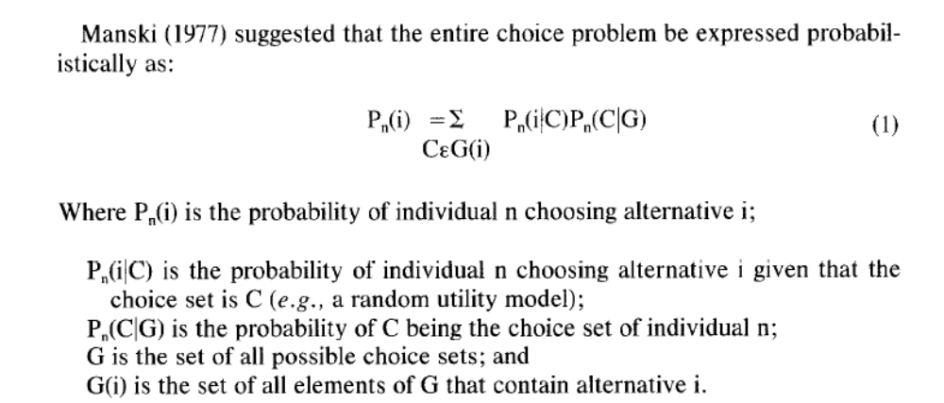
A theory of buying behaviour (Howard and Sheth, 1969)
The previously discussed theories are mathematical models that compute the outcome of a decision making. These models are all based on one theory: “buying behaviour” of Howard and Sheth. The model they developed is widely used by many researchers and is in Google-Scholar 2443 cited. In their S-O-R Scheme they connect most of the buying decisions variables to each other in a scheme. All these variables have an influence on the final outcome of the buying decision process. All the variables are classified in four major components: stimulus variables, respond variables, hypothetical constructs and exogenous variables. In figure 1, the S-O-R scheme of Howard an Sheth is posted.

On the left-hand side of the figure, the input of a company is discussed. On these stimuli, the company can make an easy influence. In the rest of the constructs, the company does not have the opportunity to make big differences. By doing advertising and promotion they can partially influence these constructs. The so called brand elements are quality, price distinctiveness, service and availability. Eventually, Howard and Sheth used the data for a regression model so that outcomes could be predicted.
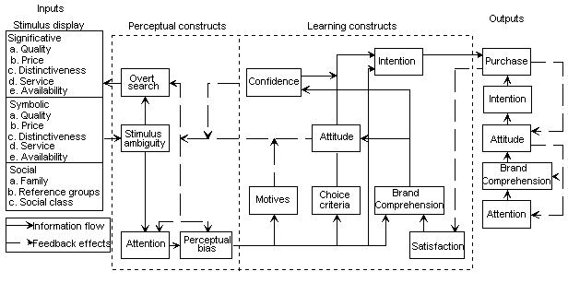Figure 1
With the help of the theories and models described above we will use these decision making models to describe a phenomenon in the cinema market. In the next section this phenomenon will be described, and eventually in section three, both parts will be combined together.
2.2 Cinema market

2.2.1 Introduction of the cinema market
The cinema market is has been discussed and reviewed often in the academic literature. For instance, there are two different meta studies with cinema market as main subject (McKenzie, 2010; Hadida, 2009). This means that the cinema market is an interesting topic to research; a lot of factors are influencing the outcome. The cinema market is part of the entertainment industry; the main purpose of this industry is to fulfil the need “experience”. For this reason, a nickname of the entertainment industry is the experience industry. To this fast growing industry belong movies, music, television, casino, gambling and wagering, publishing performing arts, sports, theme parks, toys and games (Vogel, 2004). In this section, the cinema market with the following outline will be discussed: First, an overview of the cinema market, second, the need of experience and finally, a changing effect in the cinema market. Further on in this article, the changing effect will be combined with the previous mentioned consumer behaviour theory.

2.2.2 Overview of the cinema market
The cinema market is an old market that exists since the invention of Edison’s kinetoscope. Until 1957, the demand for movies in the cinema kept growing. After this period, the demand went down, and a couple of reasons were the foundation of this decrease (Cameron 1986). The reason of the decline in demand has been researched over time. The start of the decline was the introduction of the VCR and television set for home use (Cameron 1988, 1990). After the introduction of the VCR and television, other products were also introduced that stimulated the decline of customers in the cinema market. In 2001, a VAR (vector auto-regression) on variables that influences the amount of cinema customers was tested. The researchers found that the ticket price, TV ownership, number of cinema sites, income per capita and demographics of the population had a significant effect on the demand (MacMillan and Smith, 2001). The data that the researchers used were cinema data from 1950 until 1987 in the United Kingdom. The number of cinema attendances decreased over the years, but after 1995 this changed. In 2010, the number of cinema attendances in the Netherlands changed back on the level of 1978 (Jurtschenko, 2011). The main reason of this stabling of cinema customers is of the changing role of the cinema. Until 1987, consumers went to the cinema to see the newest movies in the best possible quality. With the introduction of all the new technologies, this experience need does not have to be fulfilled necessarily in a cinema (Rawsthorn, 1997; Dewenter and Westermann, 2005). In figure 2, an example of cinema attendance in time is given about the German market: it shows that after 1960, cinema attendance went down, and that after 1970 the visits were stable. Since 1995, cinema attendance is slowly growing. Nowadays, consumers go the cinema to fulfil their need of experience, details will be discussed in section 2.2.3. The factors that have a role in the changing demand are discussed in section 2.2.4. Finally, in section 2.2.5, it is investigated if there are any other possible factors that could explain the stabilization of the amount of customers.
Figure 2
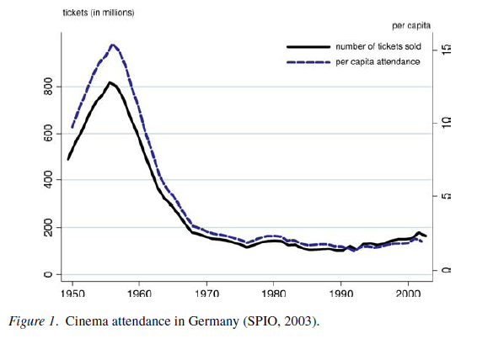

2.2.3 The need experience in the entertainment industry
The cinema market is a sustainable part of the entertainment industry. A characteristic of the entertainment industry is that it is a service-orientated industry, which means that there is no materialistic product involved (Vogel, 2004). The service market is fast growing and is getting more important in the advanced economies. In the advanced economies the production of service becomes higher and more people are employed in these sectors (Riddle, 1986; Shugan, 1994). When the consumers of the entertainment industry are buying a ticket, they are looking for a period of fantasy, feelings and fun (Holbrook and Hirschman 1982). The fulfilling of this needs is called experiential view. With other words can be concluded that consumers are looking for some excitement or experience. Because there are different kind of experiences, there are also nine different types of markets in the entertainment industry. Every kind of experience can be satisfied with a right method (Eliashberg & Sawhney, 1994). To get a definition of the need experience, we first need to formulate the important characteristics. After that, we will investigate which factors are important for fulfilling a need experience.

What are the important characteristics of a need experience and how are these needs created? By creating an experiential view, the consumer first makes a historic imagery, second, he makes a fantasy imagery. The difference between the two steps is that a historic imagery is recalling an event and by fantasy imagery the consumers remember specific details of the events; smell, colours or sounds. These imageries will influence the buying behaviour of a consumer with his next purchase (Hirschman and Holbrook 1982). What are the factors that influence the experiential view’s outcome? These factors can be separated in environmental inputs and consumer inputs. Regarding the environmental inputs, you can distinguish the categories: products, stimulus properties and content of communication. By consumer inputs, four categories can be distinguished: personal characteristics, temporary moods, the emotional content and what kind of utility the consumer is looking for. Al these effects have a significant effect on the kind of need a consumer is looking for, and will influence the outcome of his decision (Eliashberg and Sawhney, 1994).

A lot of research is done with movie audience (Austin, 1989), but most of this research is out dated: it is from before the change to the need experience. Austin did a research to the substitutes of movies with the need leisure time. The conclusions of this research were that people prefer to read a book or to sports instead of going to the movie (Austin, 1984). Nowadays, people see the reading of a book not as a direct substitute of seeing a movie. Factors such as leisure-time, smell, colour and sound are important characteristic of fulfilling the need experience. The change to another kind of experience is no radical problem, the values of consumers always change over time. The market has to prepare a solution and must continuously update the research studies to understand the change of consumer needs (Kim, Forsythe, Gu and Moon, 2002). The changing role of the cinema will be discussed in the next section.

2.2.4 The changing role of the cinema
In previous sections, the need experience is discussed and the reasons why the introduction of the television / VCR had a negative impact on the demand of cinema seats. The conclusion was that people, most of the time, went to the movies to see the latest movies with the best possible quality. With the introduction of the discussed technologies, this need of movie watching could be fulfilled with other products. After 1995, the demand for cinema became stable and even grew a bit. This meant that people went to the cinema for another reason instead of watching the newest movie. Regarding this new need, this paper will research the need of experience and which factors are important. In this section four main reasons will be introduced about why people nowadays tend to go less to the cinema then in 1960. Because the change of need only has changed in the last decades, this section only uses articles that are published recently.

Argument 1 - Change in price elasticity:
The first argument is the most obvious one; because over time the price of cinema tickets went up the number of attendance went down. Not only the price of the tickets changed but the attitude towards ticket pricing changed. In 1988, Cameron performed a research regarding the price elasticity of consumers in the cinema market. The conclusion of this research was that consumers were price inelastic. In other words, this means that a small change in price did not change the demand for cinema (Cameron, 1988). In researches done in the last decade, the price elasticity of cinema tickets changed to price elastic (-2, 55) (Dewenter and Westermann, 2005; Blanco and Banos-Pino, 1997). This means that consumers became more price-sensitive and that they knew better what they wanted from the product. Cinema’s in the United States used prices that are uniform for everybody in every period. From the literature discussed earlier, it would be smart and profitable to use different prices for different occasions (Orbach and Einav, 2007).

Argument 2 - Higher availability of technology:
By the introduction of televisions sets and internet, the availability of movies increased. Consumers could watch the newest movies at home, for a lower price than that cinema’s offered. Most of the homes nowadays have their own cinema theatre in their living room (Barlow, 2005). In a research of Currah (2006), the availability of illegal film spreading by internet was researched and what kind of effect this had on the sales of DVD’s and cinema. Eventually this illegal spreading would increase the sales, because of the free publicity and word of mouth advertisement (Smith and Telang, 2009). This new kind of technology also had other consequences. One of these effects was for instance in Cuba, where it is impossible to travel abroad. This limitation has as consequence that for the most Cubans, film is the only way to travel (Parker, 2008).

Argument 3 - Distinctiveness with close-substitutes
In the cinema, not a lot of things changed regarding the used technology in the last decades, except the introduction of 3D cinema the last two years. When you compare the technologies used now and four decades ago, the differences are not very big. As discussed in argument one, the technology in the close-substitutes have changed much. The quality of these movies are closer to the quality of cinema than they were a couple of years ago (Sistro and Zanola, 2007). This smaller gap of quality is dangerous for the distinctiveness of cinema. This argument is very close with the second argument. Yet, there is a difference because the new technology argument stimulated the availability of films. This argument describes the smaller range of core competences which a cinema can use to differentiates. “Estimates provide evidence of a complementary relationship between cinema and TV, even if cinema and TV movie consumption seem to substituted when weekend and weekday TV movie consumption are distinguished” (Burgess and Evans, 2005).

Argument 4 - Human capital is more interested in cinema-Arts
People are more interested in arts and cinema-Arts. A book written by Robert Warshow discusses the culture around the experience of movies, comics, theatre and other popular cultural aspects. This means that people are getting more involved with movie and are willing to spend money on that subject, for instance starting a collection of DVD’s (Warshow, 2001; Barlow, 2005). In another research, the cinema attendees were separated in three groups: the social, the apathetic and cinema buff. In this distribution there is also an important role for the group of cinema-arts users (Cuadrado and Fransquet, 1999). The cinema-user can also have another goal when they go to the cinema. The consumer is trying to collect new information that is easy to process. By watching a movie the consumer does not spend a lot of energy by thinking hard, but he still gets all kinds of new information (Naficy, 2010).

Conclusion
Out of these four arguments can be concluded that the reason a person goes to the cinema is changed compared with 1960. This does not mean that that the role of the cinema is less important (Rawsthorn, 1997). In the next section, two theories of consumer behaviour will be combined with the knowledge about the cinema consumers.
2.3 Explaining variables
In the previous sections, two main concepts were discussed. A combination of these two theories will be the base of this paper. The outline of chapter 2.3 will be as following: first, we will start with the model of Howard and Sheth, whose model explains the dependable variables of consumer choice behaviour. This model will be combined with the argument from section 2.2.4. This combination will create two gaps. These gaps exist of dependable variables, but are not explained in the cinema literature. In section 2.3.2 we will discuss the first gap; cinema quality and in section 2.3.3 the second gap; cinema service.
2.3.1 The two gaps
In section 2.1.4 the main theories of consumer decision making were discussed. One of these models was the Howard and Sheth model (Howard and Sheth,1969). In this model there are five main characteristics in the stimulus display: price, quality, distinctiveness, service and availability. These characteristics are the input of the developed model and can be influenced by decisions of a company. Next to this input, we have the social input where information from family, reference groups and social classes will be analysed. All these inputs are used by the individual consumer to choose the best possible option from the consideration set. After the decision is made by the consumer, the perceptual- construct and the learning construct can influence the next purchase decision. In figure 3 the connection between the model and the arguments of section 2.2.4 is specified.
Figure 3
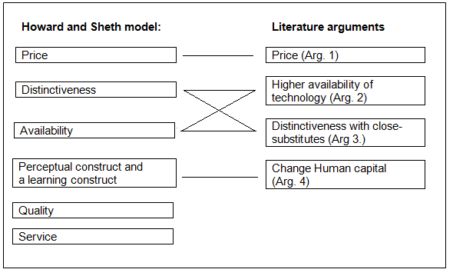
Figure 3 shows that most of the arguments given by the literature explain the decrease of demand for cinemas. The figure also shows that two of the main characteristic are not discussed in the literature. These gaps, quality and service, will be the main topic of this research and will be further discussed in the next sections. The research question is: what is the role of service and quality, when analyzing the consumer decision making model in cinema markets? In the Howard and Sheth model, the input factors family, reference groups and social class are discussed. In this paper the assumption is made that these factors have not changed over time. If these factors have not changed they also cannot explain the decrease in demand. In the next two sections, 2.3.2 and 2.3.3, both gaps will be discussed and research methods will be analysed, but first, the other four arguments price, distinctiveness, availability and perceptual- and learning construct will be discussed briefly.
Price – Price
The arguments in the literature are matching perfectly on the model of Howard and Sheth. The difference in consumer behaviour outcome could be explained by this factor. Cinemas are charging a higher entrance price and the consumer changed their behaviour from price inelastic to price elastic. This means that consumers see a cinema ticket more as a luxurious product.
Distinctiveness – technology and close substitutes
Both in the Howard and Sheth model and in the arguments of the literature is a factor that is about distinctiveness between the product and closely related substitutes. Closely related substitutes of a cinema are watching home movies and other products of the entertainment industry that are providing experience. The distinctiveness has changed over time because of the change in need of the consumers. In the fifties, the need was to watch a movie, whereas now the need is experience. The substitutes are in this way also changed. The factor distinctiveness is closely related with the factor of availability. This is because of the technological changes in the last decades. These changes have caused a repositioning of the cinema in the market. The core-competence of a cinema in comparison with other close-substitutes is not as obvious as it was before.
Availability - technology and close substitutes
As with distinctiveness, technological changes provide the consumer with more availability to watch a movie. Next to that, consumers have the opportunity to make more use of products in the entertainment industry.
Perceptual- and learning construct – change human capital
In this factor, the change of a product is evaluated by the consumer. There are a lot of factors that eventually can influence the attitude of consumer for a product. With the argument of changing human capital there is a shift to more cultural loaded movies. The change in human capital will be used as the overall explanation of change in perceptual- and learning constructs. The other factors of the Howard and Sheth are assumed to be equal over the years. In the next two sections we will discuss the last two factors: quality and service.
2.3.2 Quality of the cinema
The factor quality is a widely common used concept. In the oxford dictionary it is described as follows: ‘the standard of something as measured against other things of a similar kind; the degree of excellence of something.’ There are different goals a company can aim for. The most used goals are making a lot of profit or gaining a big market share. Research has shown that a strategy of aiming for high quality is also a successful strategy (Jacabson and Aanker, 1985; 1987). When companies use a high quality strategy, they need to create a superior quality. This quality needs to be produced at a low-cost price so that the margin of the products is high enough, which is called premium pricing (Phillips, Chang, and Buzzell, 1983). Quality improvements are obtained through improvements in technology and result in a higher quality or a lower production cost. Eventually, these improvements result in cost savings (Crosby, 1980). In the article of Landesberg (1999), the two most notable and respected authors of quality management are discussed: W. Edwards Deming and Joseph Juran. With the theories ‘system of profound knowledge’, ‘the fourteen points’, ‘the quality trilogy’ and ‘quality improvement process’ these two authors helped a lot of different industries to develop a profitable strategy (Juran, 1988; Deming, 1994). In the last century a lot of academic papers have been published about quality. From these theories, a general model has not been constructed. This can be explained by the difficulty and flexibility of the concept quality. In every industry the outcome of quality factors differs and because of these changing factors, every industry uses other attributes and measurement tools. For instance, the multi-models in the education (Cheng and Tam, 1997), video quality assessment based on structural distortion measurement (Wang, Lu and Bovink, 2004).

To create a non-general model, we need to develop important quality attributes that are used for the cinema market. Because there has not been done any research in this small area of expertise, a general theory of quality will be used and this will be implemented in the cinema market theory. In the quality handbook, Juran introduces the model “fitness for use”. In this model he describes five attributes that have an important impact on the perceived quality. These five attributes are design, conformance, availability, safety and field use (Juran, 1988). With the use of these five general attributes, the possibility of the perceived quality change is discussed. The perceived quality and consumer satisfaction of the attributes of a cinema are investigated (Gotlieb, Grewal and Brown, 1994). When people perceive the quality lower than it was decades ago, these factors can also explain the difference in demand. With the technological changes that were introduced earlier in the model, the outcome of higher quality could be connected. For this reason, the perceived quality level of the cinema will be used.
The five attributes that were introduced by Juran will be implemented with the attributes of a cinema. In this model, the five attributes advised by Juran cannot be used. This is because one of the five attributes, availability, is also one of the factors suggested by Howard and Sheth, that we will use in the model to explain consumer behaviour.
Table 2
 | Design | Conformance | Safety | Field Use
Attributes those are important for a cinema quality? | - Furniture  - Building | - Conform, expected quality?  - Quality change over time? | - Feel safe?  - Light use | - Quality of the movies  - Beverage and food

With the help of these attributes the perceived quality can be tested. Is there a change in attributes and are these an explanation for the change in cinema demand over the years?

2.3.3 Service of the cinema
In the oxford dictionary, service is described as the action of helping or doing work for someone. The cinema industry is a part of the entertainment industry. This entire group of different markets is service orientated. The entrepreneurs of the entertainment products try to offer the consumer a new experience (Vogel, 2004). For measuring and managing quality of service, a widely used technology is developed: SERVQUAL (Parasuraman et al, 1985). After the introduction of the technology, a lot of extra research and implementations of the technology were made by the authors; 1985, 1986, 1988, 1990, 1991a, 1992b, 1993, 1994 etc. Not only the original authors used SERVQUAL for their articles, other authors also used the technology as a base of their own papers: critics (Cronin & Taylor 1994), meta-study (Buttle, 1994) or implementations of the technology in reality (Taylor et al., 1993; Williams, 1998). What is the main concept of the SERVQUAL technology? With the help of a standard survey a researcher can answer the question: is the quality of the delivered service good? When this is not the case, were does the service fail? To measure all these factors inside the SERVQUAL, the authors made a distinction between five different dimensions. By each of these dimensions, they have done research to investigate how many questions have to be asked. The findings are summarized in table 3 (Buttle, 1994).

Table 3
Dimensions | Definition | Items in scale
Reliability | The ability to perform the promised service dependably and accurately | 4
Assurance | The knowledge and courtesy of employees and their ability to convey trust and confidence | 5
Tangibles | The appearance of physical facilities, equipment, personnel and communication materials | 4
Empathy | The provision of caring, individualized attention to consumers | 5
Responsiveness | The willingness to help customers and to provide prompt service | 4

The authors of SERVQUAL use these five different dimensions to find gaps between the level of delivered service and the perceived service. These gaps are the biggest problems for a producer of service. When the gaps are getting to big, the dissatisfaction of the consumer will grow (Parasuraman et al., 1988). The authors made a schematic model to explain these gaps, which are illustrated in figure 4.
Figure 4
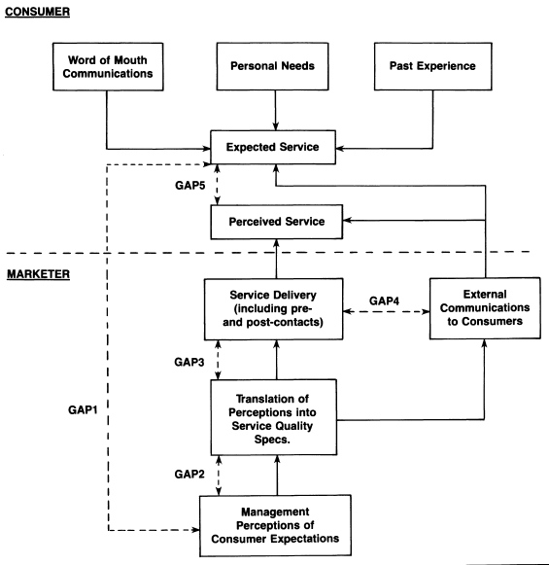
Gap 1: A difference is in the expectation(E) and outcome(O) levels, if E exceeds O than this will result in a customer dissatisfaction.
Gap 2: In this gap there is a difference between the expectations of the managements and the perception that the managers have about the level of service demanded by the consumer.
Gap 3: The difference between the perception that the managers have about the level of service demanded by the consumer and the actually delivered level of service.
Gap 4: The difference between the actual delivered service and the communicated service level.
Gap 5: The difference between the perceived service level and the expected service level. To score high on this gap, the producer needs to deliver a constant level of service over time.
The theory of SERVQUAL will be used to measure the level of perceived quality and if this could be a reason for the cinema consumers to adopt their need and make less use of the cinema. When the service level of the cinema does not match with the expected level, than this could also be an extra argument for the decline in demand.
2.3.4 Conclusion
In the previous chapter, the importance of consumer behaviour and how this influences the decision making process is described. As mentioned in most consumer behaviour theories, a need is necessary to influence a consumer to act. In the cinema market this need has been changed in the last decades. This will be the research platform. A couple of theories of the consumer decision process are discussed. Eventually, the theory of Howard and Sheth (1969) was the best approvable for the cinema market. In this model they use different factors that can explain the consumer decision process. After discussing the theories, the literature of the cinema market was analysed. From the factors given by Howard and Sheth, four of the six factors are already proven by the existing literature. The main purpose of this paper is to investigate if the other two factors also have an explaining value. These two factors, quality and service, are discussed in the last sections of the literature study. In the following part of this paper, it will be analysed if these factors have an explaining value for the change in demand in the cinema market.

3.0 Method
3.1 Introduction
In the previous chapter, the context within the academic literature was discussed and the relation with the managerial implication was explained. This knowledge will now be used and expanded in the rest of this paper, with as final goal answering the main question: what is the role of service and quality, when analysing the consumer decision making model in cinema markets? With the help of a survey study, parameters of the consumer decision making model will be researched. In the existing academic literature the role from four of the six parameters is described. In this paper the last two parameters, service and quality will be researched on their importance and explaining value. The research is done with the knowledge that there is a change in the need environment, what could explain the shifting in parameters. In this chapter, the methodology will be discussed on how to answer the main question.
3.2 Research questions
The main question of this paper is: what is the role of service and quality, when analyzing the consumer decision making model in cinema markets? This main question can be divided in several parts. The answer will be tested by using hypotheses. Gilbert said: “The hypothesis has been called a 'scientific guess,' and unless the title 'guess' carries with it something of disrespect it is not inappropriate” (Gilbert, 1896). With this quotation Gilbert meant that a researcher needs to consider a fact or a group of facts, whose origin or cause is unknown. The first step of trying to discover the origin is making a calculated guess. The second step is testing the ‘guessing’ in reality.

The main question can be separated in two different parts, service and quality. These two factors will be researched, because it is unclear what the effects of these factors are since 1995. When using the form of a scientific guess, there can be expected that the perceived service and quality for the cinema went up. This is because consumers started to pay more for their entree ticket, but did not receive anything extra in the arguments of availability, distinctiveness or perceptual- and learning construct. Still, the numbers of cinema visitors kept rising every year since 1995. Because cinema consumers nowadays see cinema as a need experience instead of watching a movie. For cinemas it is important to offer this extra need experience. A possibility for cinema’s to do this, is by improving the service and quality. So, it is reasonable to assume that consumers get a higher service and quality when they go to the cinema. In the first part the effect of perceived service will be investigated, in the second part the effect of perceived quality is researched. For each of the invested factors, there are some parameters that can be used. These parameters were discussed in the literature study. In table 4 these factors are summarized. The change in service and quality will be measured by these factors.
Table 4
Service | Quality
- Reliability  - Assurance  - Tangibles  - Empathy  - Responsiveness | - Design  - Conformance  - Safety  - Field use

H1: People go more often to the cinema if they perceive a higher service level in the cinema.

H2: People go more often to the cinema if they perceive a higher quality level in the cinema.

The factors service and quality are the most important research factors in this paper, but other factors are also important to research. In the literature research the factors: price, availability, distinctiveness and perceptual- and learning construct were also important arguments for the change in the cinema market. These factors are going to be researched as explaining variables. We already know what kind of effect these factors have on the dependent but we do not actually know how big the effects of each variable are.

H3: People go less often to the cinema if they perceive a higher price level for entering the cinema

H4: People go less often to the cinema if they perceive a lower availability level in the cinema

H5: People go less often to the cinema if they perceive a lower Distinctiveness level in the cinema
H6: People go less often to the cinema if they perceive a lower perceptual- and learning construct level in the cinema

In the next section, the method of linear model will be discussed and how the variables can be tested by factor analysis. Now the research goals have been described, it is time to explain the method of this study.

3.3 Factor Analysis and Lineair regression
There are a lot of different types of statistical tests and regression, why use lineair regression? What are de advantages of using this kind of model and, for instance, not a vector auto regression like MacMillan and Smith did in 2001 for the cinema industry? In the literature study, a couple of statistical methods were introduced. The most common type of model used in this research area is the lineair regression model. The lineair regression model is a statistical measurement where, with help of a link function, different types of error distributions are moderated to a standard linear regression model. With the help of related response variables, the link function is tested if the magnitude of variance has a predicting value (Nelder en wedderburn, 1972). The reason for not using the vector auto regression in this study is because of needed data for a vector auto regression is not available. To do this kind of research a period of time need to be analysed. (MacMillan and Smith) In this paper the focus is on one moment in time, so it is not possible to use the vector auto regression.

In the first part of this section the factor analysis will be explained. In the current study, a lot of different variables are used. Therefor it is a difficult job to manage this amount of variables. Combining these different kinds of variables together can be done by performing factor analysis. With factor analysis, a couple of variables are clustered together to a new variable (Churchill, 1979). This is a method that is used very often in the marketing research literature. In marketing many factors are influencing the decisions of a consumer. The clustering is made on the variance of the different variables. The variables that are correlated to each other most closely, combined to one new variable. In section 3.4, the six variables are explained and the sub-variables are introduced. With the help of confirmatory factor analysis, these clusterings will be tested (Mulaik, 1988). The confirmatory factor analysis is a specific type of clustering, where before starting the clustering each new variable is already distinguished. The reason for confirmatory analysis is to test where the made assumptions are correct. In section 3.4, these variables are tested and the 17 sub-variables are reduced to six main-variables. The confirmatory factor analysis is used to test if the assumptions of the in figure three made reduction can be found in reality and if it is reliable. In the previous part there has not been made a difference between factor analysis and cluster analysis. The major difference between these two types of variable reduction is that in factor analysis the researcher predicts what the outcome of the variables will be. In cluster analysis the researcher is looking for an explaining variable. In this paper the variables are predicated before the survey. So, in this study the factor analysis is used (Stewart, 1981). In the article of Stewart, more differences between cluster analysis and factor analysis are discussed.

The Cronbach’s Alpha is a test which can be used to test the newly constructed variables on their reliability. It is important to know if all parts of the new variable are relevant and usable. The Cronbach’s Alpha test, tells us which sub-parts of the question are closely related with each other. Also, the Cronbach’s alpha method shows which part of the new variable are not closely related and should be deleted for a better reliable construct (Field, 2005).

When the factor analysis is completed, a multiple regression analysis is used for constructing a model. In a multiple regression, the variables are analyzed on the variance, so that the computed interaction effect on the dependent variable is explained. So, in this paper, what is the effect of service and quality on the number of cinema visits in a year? For using this model, it is important that the dependent variable (number of cinema visits in a year) is normally distributed. As part of this criterion, it is also important that other assumptions are tested:
  - Multi-collinearity
  - quantitative or categorical variables
  - Non-zero variance
  - Predictors are uncorrelated
  - Errors are normally distributed

When tested for all the assumptions, the regression gives a linearity model. The most standard model is given in formula 2 (Cohen, 2001). In this formula, every Beta represents the behavior of the consumer on the impact of the variable. Every Beta needs to be tested on significant values. This means that the change of getting the same value by accidence is lower that 5% or 10%.
Formula 2
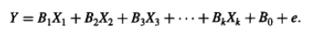

When the model is fully constructed, the R square of the model can be computed. The R-square explains how much the variables explain over the dependent variable Y. For example, if the R-square is 0.2 this means that 20% of the variance can be explained by the independent variables.
3.4 Variables
The dependent variable will measure how many times the consumer goes to the cinema in one year. In the constructed model, the dependent variable will be computed by using the independent variables. With the help of the GLM model it is possible to construct a regression model (Nelder and Wedderburn, 1972). In this paper, the dependent variable is not the most important factor. For a manager it is important to know how many times the consumer goes to the cinema, but it is more important how he can increase the number of visits. In the paper the focus is on the independent variables, because these are the instruments to change the outcome. With the independent variables the manager can influence the decision making process. When a manager changes the independent variables inside his cinema (example: higher quality beamer) he wants to know which effect this has on the number of cinema visits. In that way, the importance of service and quality can be compared with the other control variables: price, availability, distinctiveness and perceptual- and learning construct.

Service and quality
In table 4 of section 3.2 the important factors for quality and service were discussed. Now, the important sub-variables of the control variables will be discussed. With the help of the studies used in the literature study and the Howard and Seth model, a list of sub-variables will be constructed. All the independent variables are ordinal variables (Winship and Robert, 1984), which means that they get a likert-scale value between one and seven, where one means bad and seven means good.

Price
In the literature study is concluded that the cinema is charging higher entrance prices, and that the consumer changed his behaviour from price inelastic to price elastic. It means they see a cinema ticket as a luxury product. There are two different papers where the impact of the price is researched, both models use the same determinants.
Formula 3
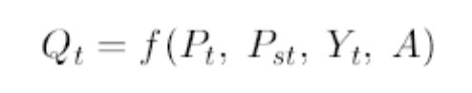

According to this function, the amount of cinema demanded in the period t (Qt) will depend on the admission price (Pt), the price of substitute or complementary goods (Pst), income (Yt) and on a vector of variables (A) which comprises the influence exerted by other factors, which in some way can reflect any changes in the audience’s preferences (Blanco and Banos-Pino, 1997). In the article of Globerman (1978), the author did research the price sensitivity inside the performing arts. He compares movies, theatre, concert, dance and opera on different price determinants. Almost the same determinants for price are used in the paper of Blanco and Banos-Pino (1997). Globerman uses the prices determents compared with substitutes, homogeneity of the prices, house income and an error term (Globerman, 1978). In this paper no research has been done about what the importance of price is: the main focus is on perceived price level. For this reason, the third factor income will not be researched.

Availability
Through technological changes, the consumer has more availabilities or options to watch a movie. In addition, consumers have the opportunity to make more use of different products of the entertainment industry. So for both the needs, watching the newest movie and the experience need, availability rose over the last years. As sub question can be asked: did the perceived availability of cinemas went up in an area? How do consumers perceive this, now almost everyone has his own cinema in the living room (Barlow, 2005)? Another important factor is the number of movies consumers watch, compared with a couple of years ago. Because the possibility exists that people in exact numbers see more movies, but that the number of cinema visits stays equal (Smith and Telang, 2009). With the introduction of the internet it is easy to watch the newest movies in your own home in high quality. This affects the number of visitors in cinema (Currah 2006). For this reason, the focus by the factor availability is on the amount of perceived level of cinemas and on the interest in movies.

Distinctiveness
The distinctiveness theory is a theory developed by Brewer (1991). It is a psychological phenomenon where individuals try to distinct their self from the group. Important factors are the relations to the in- and out-group, homogeneity and self-concept (Leonardelli et al, 2010). These factors are designed for testing individuals, but are also usable for testing the distinctiveness between the cinema and other close substitutes. As said before, distinctiveness is highly involved with availability. So it is also important to look at different aspects between movies, theatre, concert dance and opera (Globerman, 1978). In this paper, the interest is in the change of need, for that reason we only watch to the in- and out-group factors. These factors will tell why people change their behaviour towards the cinema.

Perceptual- and learning construct
In the perceptual- and learning construct, the perceived image of the cinema is tested. In the literature study was discussed that consumers go to the cinema because they can learn something in an easy way. The human capital is more interested in the cinema arts and cultural aspects of the movie. These variables are a part of the perceptual- and learning construct of the Howard and Sheth model. Only a few relevant variables will be tested and not all eleven variables as described in the Howard and Sheth model. Because adding all the variables to the model, the model exists of to many variables. There have been chosen by us of three arguments: attention, attitude and motives. These three sub variables represent the perceived human capital and tell us why consumers nowadays go to the movie in comparison with a couple of years ago.

In figure 5, all variables and sub variables are summarized. These variables will be used for constructing the answer and test the hypotheses from section 3.2. In total, there are six variables. Every variable has a different amount of sub variables, with a maximum of five sub variables and a minimum of two sub variables. The total of all variables that are going to be researched, are six main variables and 22 sub-variables.

3.5 Conclusion
Figure 5
Consumer decision making process
Service
Quality
Price
Perceptual- and learning construct

Distinctiveness
Availability
Reliability
Assurance
Empathy
Responsiveness
Design

Conformance

Safety

Field use

Admission price
Price of substitute or complementary goods
Number of perceived Cinema’s
Number of viewed movies
In-Group
Out-group
Attention
Attitude
Motives
Question: 1-3
Question: 4-5

Question: 6-8

Question: 9-12

Question: 13-15

Question: 16-18

Question: 19-21

Question: 22-24

Question: 25-26

Question: 27-29

Question: 30-33

Question: 34-36

Question: 37-39

Question: 40-42

Question: 43-46

Question: 47-48

Question: 49-52

In the last, chapter a description of the hypotheses and how to test them is given. By introducing an econometric model where different levels of variables are used the, hypotheses could be tested individually. For this testing, a regression model is going to be used in combination with the 22 sub variables. In the next section, the data is going to be introduced and the method of data collected is discussed.

4.0 Data description
4.1 Survey
In this paper, the data will be collected by using a survey. Questionnaires are used for descriptive or explanatory research. Descriptive research, such as that undertaking attitude, opinion questionnaires and organisational practice, will enable you to identify and describe the variability in different phenomena (Saunders, Lewis and Thornhill, 2003). In figure 5, a lot of variables were summarized. In the survey, these variables are tested on their impact in consumer behaviour. Each variable will be tested with three or four questions, like they did in the surveys of SERVQUAL, table 3 (Parasuraman et al, 1985).
In the survey, a couple of statements will be used. The participant needs to answer the question, how important this statement is in his or her opinion. When testing with different statements, half of the statements need to be positively formulated and half can be negatively formulated, which will prevent measuring a bias (Churchill, 1979). Churchill clarifies the importance of validity, measuring the thing you want to measure. In this case, the difference between objective and perceived quality needs to be clear. By perceived quality, the opinion of the consumer is measured. This is different with objective quality, most of the time the opinion of the researcher is measured. This is an important thing to distinguish, because in this paper the need of a consumer is researched. The need of a consumer is depending on the perceived view a consumer has (Dodds and Monroe, 1984). In total, 52 items are tested in this research. These items are divided in six different dimensions and are tested with a seven point scale were; 1: strongly agree and 7: strongly disagree (Mattel & Jacoby, 1972). In the paper of Green and Roa (1970) there was researched what the best number of scale options is for a survey-research. They concluded that a seven point scale is the best option to use when you also concern the usability of the data. Eventually, the questionnaire will be tested on validity and on reliability by doing some pilot testing.

4.2 Sample group
When using a survey study it is important to specify a representative sample group. It is possible to investigate the whole population of a country. In this type of research a part of the population is used, called the sample group. An important characteristic of the sample group is that it must represent the whole population, so that the results can be used for making decisions for the whole population. The variety of demographics of the cinema population is diverse. Everybody goes to the cinema, so it is important that the whole population is represented. In this paper, the surveys are distributed on the internet; therefore the mailing list needs to be good. This list will be constructed with the help of non-probability sampling, which occurs when statistical inferences must be made from the sample and there is a suitable sampling frame (Saunders, Lewis and Thornhill, 2003). In non-probability sampling there are some different types of sampling. In this paper the convenience sampling will be used.
“Convenience or haphazard sampling involves selecting haphazardly those cases that are easiest to obtain for your sample, such as the person interviewed at random in a shopping centre for a television programme. The sample selection process is continued until your required sample size has been reached. Often the sample is intended to represent the total population” (Saunders, Lewis and Thornhill, 2003 p.177).
This type of sampling can bring a bias problem in the results. For that reason, the results of demographics of the population need to be divided equally. Then it can be concluded that the results are telling something about the whole population. In figure 6 (Digital cinema entertainment, 2009), a chart is given about the demographics of the Dutch cinema user. The conclusion of this chart is that everyone in the population goes to the cinema at some time. A difference can be found in the frequencies, these are dependent on the age of the user. Younger users are going more often to the cinema, so they need to be more represented in sample group. In the survey the age groups will be divided in: 15-20, 20-30, 30-40, 40-50, 50+.

Figure 6
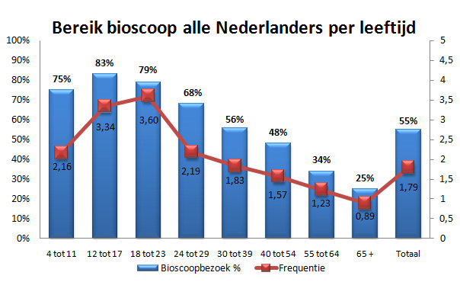

In figure 7, the same kind of figure is constructed as Digital cinema entertainment used in figure 6. The difference between figure 6 and 7 is that the data of figure 7 is from the sample group used in this paper. When looking at the outcome of the figures, the conclusion can be made that the sample group goes more often to the cinema than the consumers of the population in figure 9. In addition, the users of the sample group go at least once a year to the cinema. The groups used in figure 7 are corresponding with the groups used in the survey: where group 1 represent the age of 15-20 and group 5 represent the age of 50+.
Figure 7

Table 5
Age group: | 15-20 | 20-30 | 30-40 | 40-50 | 50+ | Total
nr. of participants: | 2 | 56 | 22 | 29 | 46 | 155

In table 5, the number of participants (155) and the dividing in different groups is shown. The different groups do not have an equal size: there are more participants from the group 20-30 and 50+. This is no problem because the other groups are big enough for joining the results. The group 15-20 is with 2 participants too small and is therefore misleading the graph in figure 7. From figure 7 the conclusion could be made that everybody within the age of 15-20 is going to the cinema 10 times a year, which is obviously not the case in the real world.
4.3 Data collection
The survey will be distributed by different target groups that go to the cinema. For the people that go to the cinema very often, the database of a cooperative cinema will be used. Next to that, students, adults and elderly will be asked to fill in the survey. This way, a real mix of the cinema population will be made. A minimum is 150 responses are needed to get enough statistical background, so that the significant results are reliable. The online program “thesis-tools” will be used for distributing and collection the data. The survey will be in Dutch because it is distributed and used in the Dutch market.
Before filling in the questionnaire, a message was used that the survey didn’t take more than five minutes. Participants first thought that five minutes would not take long, but after starting, they thought the five minutes were too long. The results showed that after a couple of questions, people stopped filling in the questionnaire. Eventually, of the 250 participants only 155 participants filled in the survey completely. This meant that the survey had a 40% loss of participants. This high stop-ratio could be the cause of the imbalance of age participants. Participants aged 15-20, are perhaps not used to fill in surveys. The distribution of the survey was online, which meant that it was easy for participants to stop before the end.

5.0 results
5.1 Data descriptive and Continuous variable
In this chapter a model will be constructed which will explain the effect of different variables on the dependent variable. The data that are used will be described, and the dependent variable will be defined and tested on normal distribution. In total, 252 participants started with the survey, after correction for missing values and non-serious responses there were 155 participants left. In table 6, the descriptive statistics over 155 observations are summarized. In the table is shown that the dependent variable has a minimum of zero and a maximum of 52. This means that there are participants in the sample, who never go to the cinema (zero) and there are participants who go once a week to the cinema (52). The sum of all the cinema visits of the whole sample group is 1035, with a standard deviation of 8.091 and a mean visiting of 6.68 times a year per customer.
Table 6
Descriptive Statistics | N | Minimum | Maximum | Sum | Mean | Std. Deviation | Variance | Skewness | Kurtosis
Dependent | 155 | 0 | 52 | 1035 | 6.68 | 8.091 | 65.467 | 2.995 | 11.144

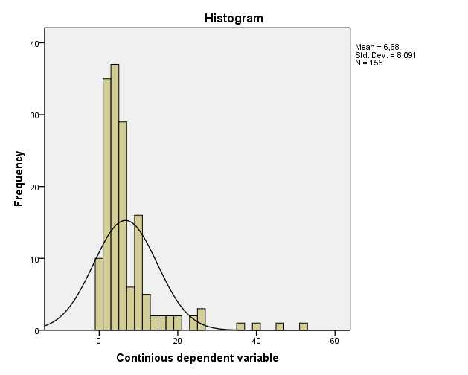
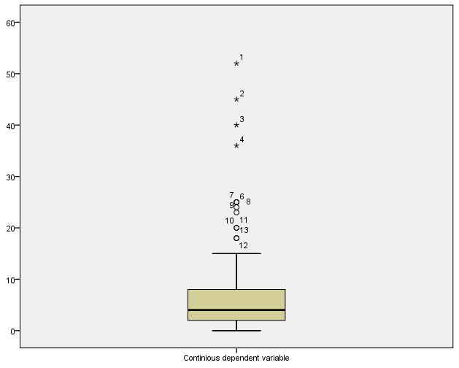
The last two columns are the most important for checking the dependent variable on normal distribution. The skewness and kurtosis are indicators if the data line is normally distributed and if these factors are significant. A normal distribution is one of the key aspects of a regression model and therefore needed to be tested. In the histogram below (figure 8) the line of the skewness and kurtosis is drawn: the black line is the optimal normal distribution line. The collected data is not matching with the black line, so the data used in the histogram
Figure 9

Figure 8

is not normally distributed. In the figure 9 the data is visually drawn with the help of a scatterplot. Four of the values are indicated with a small star. These stars mean that values are outliners, so the values are not matching with a normal distribution. For that reason these four values need to be deleted from the observations. This means there are now 151 observations left.
With the help of a LG 10 function and deleting the four outline distributions, the dependent variable is now normally distributed. There is chosen for an LG10 function, because this helps against skewness and kurtosis. After doing these LG10 calculations, the histogram of figure 10 can be found. The skewness and kurtosis are now significantly normal distributed, which can be tested by dividing the statistics: 0.004 (skewness) and -0.766 (kurtosis) through the standard error: 0.197 (skewness) and -0.392 (kurtosis). Both outcomes are significantly lower than 5%.
Figure 10
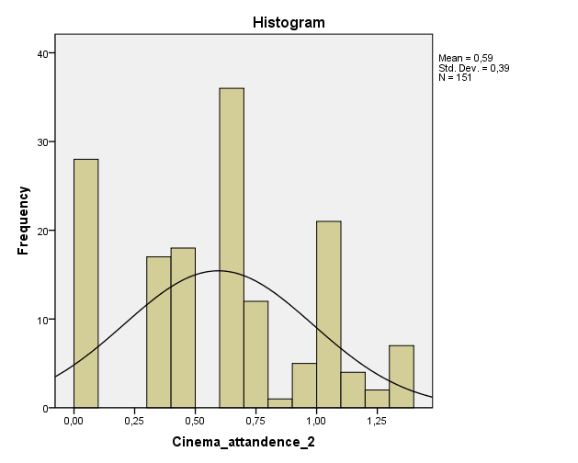

5.2 Factor analysis
The statistical method of factor analysis will test if the used variables are correctly selected. Another advantage of this method is, that it can be used to analyze the sub-variables and whether they are disturbing the correlations within variables. If they are disturbing the results it is better if they are deleted, so that the results are more usable for the predicting model. In the first step, the sub-variables will be tested with a scree-plot. A scree-plot is used to determine how many sub-variables have an underlying prediction effect. To illustrate the use of a scree plot, figure B.1 of the appendix is explained briefly. In figure B.1 all the questions that are used for testing the consumer behavior service are noted. The graph line of the scatterplot bends at point four, which means that out of the twelve questions there are four different forces correlating together. The newly constructed forces are explaining something about the used questions. In the academic research it is stated that how and why these forces are correlated together. These four forces are not something new, when looking at figure 5 (figure with variables) the conclusion was made that there are four forces explaining service. In this section, the underlying forces were tested on confirmation with figure 5.
For the variable service, all the underlying forces were found. This meant that we made the right assumptions by dividing service in these four forces. Not only the scree-plots are used for this conformation, also the total variance can be explained in numbers. In table 7 the example of service is further explained with the total of variance table. In the table of variance, the twelve questions are tested on underlying forces in each question. When a component scores higher than 0,900, this means there is enough underlining correlation. This means that there can be made use of the sub-variables constructed in figure 5. In table 7 it is shown that the first four forces score higher than 0.900. The methods scatterplot and total variance (table 11) are a solution to the same problem. In this paper it has been chosen to use the scatterplots in the appendix and not the variance numbers. In the appendix are also the other variables tested on conformity.
Table 7
Service: the total variance |  | Initial Eigenvalues |  |  | Extraction Sums of Squared Loadings
 |  | Total | % of Variance | Cumulative % | Total | % of Variance | Cumulative %
 | 1 | 4,725 | 39,376 | 39,376 | 4,725 | 39,376 | 39,376
 | 2 | 1,421 | 11,844 | 51,22 | 1,421 | 11,844 | 51,22
 | 3 | 0,996 | 8,297 | 59,517
 | 4 | 0,929 | 7,743 | 67,26
 | 5 | 0,689 | 5,744 | 73,005
 | 6 | 0,669 | 5,573 | 78,578
 | 7 | 0,618 | 5,154 | 83,732
 | 8 | 0,558 | 4,647 | 88,379
 | 9 | 0,509 | 4,244 | 92,623
 | 10 | 0,4 | 3,332 | 95,955
 | 11 | 0,285 | 2,376 | 98,331
 | 12 | 0,2 | 1,669 | 100

In all the sub-variables: service, quality, availability, distinctiveness and perceptual-and learning construct the right number of forces were found. Except for the variable price, for this variable the number of explaining variables were not found, latter in this section this problem around price will be further discussed.
Evidence is found that that the sub-variables have the right number of underlying forces. The previous factor analysis was on the question level, from these questions: the sub variables were tested on conformity. This next factor analysis is on a higher level: the sub variables are tested on the level of the dependent variable. In appendix C, a table with a rotated factor analysis is noted (Varimax with Kaiser Normalization). In this table the variables are tested on their correlation with the dependent variable. In the left column, the 17 sub-variables are stated and in the upper row, the six components. In the table, is made use of colors, each color owns information and these are descripted below. In the second column (first component), the variables reliability, assurance empathy and responsiveness are highly correlated. These four sub variables together are the main variable: service. The second main variable of this paper is quality; this one is not as good as service visible in the table. When looking at component six, this component is called quality but is not really clustered with the quality variables. This is because quality is clustered together with other components. So, it is divided with the components: service, price and quality. This not visible clustering of quality is not a big problem, because quality is an important part of all the other components and therefor closely related. Almost all the sub-variables are correlated with their main variable: service (column 1), distinctiveness (column 5), perceptual-and learning construct (column 3), and availability (column 2). The main variable price is divided in two correlation clusters. With the help of the Cronbach’s Alpha’s method, the issue around price will be discussed and explained. In the table of appendix C, colors are used to explain the most important correlations. What does every color mean?
- Yellow: correlation with the main variable
- Blue: correlation distortion of quality
- Red: price
- Gray: overall correlations that aren’t clarified.
All correlations with a higher score than 0.4 have a color, because then the correlation is high enough to be significant.

The Cronbach’s alpha test is used for testing on the question level: is every used question relevant and does it measure the correct answer? In other words, will it test the reliability of each factor? When the Cronbach’s alpha is between 0.7 and 0.8, it is perfect and when it is between 0.6 and 0,7, it is good. In appendix D, the results of the Cronbach’s alpha are shown. Most of the factors have a higher score than 0.6. This means that they score well on the reliability scale. Next to that they cannot get a higher result by deleting some questions. The variables availability and price do not score higher than 0.6. For the variable availability it is not possible to get a higher reliability result by deleting other questions. For this reason, the factor availability stays the same but with a remark that availability can measure something else than only the availability of the cinema’s. In appendix C, the factor out-group (availability) is closely related with the factor perceptual- and learning construct and with component six. This correlation is also reflected in the results of the Cronbach’s alpha test. Therefore, the correlation is not higher than 0,251.
The factor price scores badly in all the aspects of the factor analysis and the Cronbach’s alpha test. From the result of Cronbach’s alpha, it was suggested that a couple of questions of the price needed to be deleted. The suggested questions were all the questions about the sub variable price of substitute or complementary goods. In the regression model, the factor price only will exist of the variable admission price. A possible reason for this splitting of the price variable, is that consumers find the cinema price too high for the product category movie, but compared with substitutes in the entertainment industry, the cinema is perceived low priced. These mixed attitudes of the consumer are not possible to measure in this model.
5.3 Regression model
In the previous section the selected variables are tested on reliability. In this section, the variables can be used to construct a predicting model. For this model, a regression analysis will be used. In table 8, the model summary of the analysis is noted, three different levels of the model are used. In model one, only the six main variables are used, model two is expanded with the control variable age, and in model three the education is included. Under the column of adjusted R square, the number of explaining percentages is shown. The used variables in model one are explaining 10,8% of the variance of the dependent variable. In model two the control variable age is included. Then, the model explains more than twenty percent of the variance. This means that the age of the consumer can predict the decision making process of the consumer. In model three education was included; this did not lead to more explained variance.

Table 8
Model Summary |  | R | R Square | Adjusted R Square | Std. Error of the Estimate
 | 1 | ,387ª | ,150 | ,108 | ,36849
 | 2 | ,509^{b} | ,259 | ,206 | ,34764
 | 3 | ,521^{c} | ,272 | ,202 | ,34852

In table 9 the coefficients of model 2 are presented, there was chosen to use the variables of model 2, because this model explains the most of the variance in the dependent variable.
 | Table 9
 |  | Unstandardized Coefficients |  | Std. Coefficients | T | Sig.
Main variables: |  | B | Std. Error | Beta | T | Sig.
(Constant) |  | 0,57 | 0,249 |  | 2,293 | 0,023
Service |  | -0,027 | 0,048 | -0,054 | -0,556 | 0,579
Quality |  | 0,102 | 0,058 | 0,181 | 1,762 | 0,08
Adm_pr |  | -0,14 | 0,035 | -0,329 | -4,023 | 0,00
Availability |  | 0,027 | 0,034 | 0,059 | 0,777 | 0,439
Distinctiveness |  | 0,07 | 0,03 | 0,194 | 2,305 | 0,009
Perceptual_Learning |  | 0,035 | 0,04 | 0,073 | 0,869 | 0,386
Control variables:
1 = male |  | -0,143 | 0,063 | -0,183 | -2,253 | 0,026
Age_30_40 |  | -0,229 | 0,093 | -0,208 | -2,466 | 0,015
Age_40_50 |  | -0,233 | 0,089 | -0,232 | -2,604 | 0,01
Age_50 |  | -0,32 | 0,073 | -0,376 | -4,356 | 0,00

There are three different levels of significance: 1%, 5% and 10%. When looking at the normal 5% level, there are only 2 of the 6 main variables that have a significant effect. When looking at the 10% level, 3 of the 6 variables have a significant effect. For this reason, the 10% significant level is used. When constructing the model formula, the significant variables are used:
Formula 4
Nr_Cinema_visited = 0.57+0.102*Quality-0.14*adm_pr+0.07*distinctiveness-.143*Male(=1)-0.0229*Age(30_40)-0,233*Age(40-50)-0.32*Age(50+)+error

From this formula, it can be concluded that the quality and distinctiveness of the cinema have a positive effect on cinema attendance. When these attributes will increase, consumers are more likely to take a visit to the cinema. The price of the cinema has a negative effect on the result for cinema users; this is a logical consequence, because when consumers need to pay more for their ticket they tend to go less to the cinema. The influence of the control variables is that female consumers go more often to the cinema than male consumers, and how older people get how less they go to the cinema. The age group (20_30) is the dummy variable and is not in the formula for that reason. So when people are in that age, they are more likely to go to the cinema.
5.4 Hypotheses testing
In section 3.2, the hypotheses of this paper were stated. With the help of a regression model, these hypotheses are tested. What are the conclusions that can be made out of these hypotheses? As stated in section 5.3, in this paper the 10% significant level is used and the hypotheses will be tested on that level.
H1: People go more often to the cinema if they perceive a higher service level in the cinema.

The outcome of the service level is not significant. When people perceive a higher service level this does not have to result in a higher audience rate. Consumers of the cinema do not find the service level important enough; they do not let their behavior influence by the service level.

H2: People go more often to the cinema if they perceive a higher quality level in the cinema.

The quality level is an important issue for the consumers of the cinema. When a cinema does not have a distinctive quality, the chance exists that consumers will go to the competitor who offers higher quality. The competition can also exists in the form of a substitute of the cinema, for example home cinema or the entertainment industry. With a positive Beta of 0.102, people will go 10% more often to the cinema when they perceive one point higher quality on the quality scale.

H3: People go less often to the cinema if they perceive a higher price level for entering the cinema.

The outcome of this hypothesis is as expected, which means that people go more often to the cinema when the prices are lower. The significant level is 0.00, which means that all the significant levels are accepted.

H4: People go less often to the cinema if they perceive a lower availability level in the cinema.

From the academic literature, it became clear that availability is an important aspect of the consumer behavior theory. This is not the case when people are choosing for the cinema nowadays. The availability level is not significant in this research, which means that consumers are more likely to travel to a cinema or combine it with other occasions, such as going to a restaurant.

H5: People go less often to the cinema if they perceive a lower distinctiveness level in the cinema.

The distinctiveness level is important for the cinema consumer; the level of significance is lower than the 10%. A remark needs to be noted; in the factor analysis, the distinctiveness level was not correctly correlated. This has as implication that the in-group and out-group distinctiveness is differently weighted by the consumer.
H6: People go less often to the cinema if they perceive a lower perceptual- and learning construct level in the cinema.

The level of perceptual- and learning construct is not significantly distributed. So the attention, attitude and motives of the consumer do not have a role on their decision behavior. This was also visible in the open-question results of the data. People have a lot of different reasons to go to the movie. Most of the time these are secondary motivations: for my children, with my girlfriend etc.

5.5.Conclusion
In chapter 5 the analyses of the data collection is made and described. The conclusion can be made, that service does not influence the decision making process. The quality of the cinema is important for the decision making process. In the academic literature the variables availability and perceptual- and learning construct, were proven to be important. In this research these variables were tested as unimportant. These levels were not significant; this could be explained because of technological improvements. In this section also the importance, reliability and correlations of the used variables were tested. The variables and conclusions are made, so the consequences for the managerial implications can be discussed. This will be done in section 6: the discussion.

6.0 Discussion
6.1 Introduction
In the discussion the method and findings will be discussed in a practical setting. Practical setting means that the results, critics and solutions about the research paper are distributed for managerial implications. Eventually, the cinema managers are the group of readers that will use the outcome of this paper. This does not mean that the academic literature and the constructed variable model (figure 5) are not adding information and structure to the consumer buying behavior theories. The theories of the consumer buying behavior are already researched for 40 years. This has as implication that a lot of research is done in this area of expertise. The change of the cinema market environment was something that was not researched before. Also all the different aspects of the consumer buying behavior theory were not summarized in one model and then tested. The conclusion can be made that this paper is adding new insights on the managerial and academic level. The previous sections were especially based on the academic value, in this chapter the focus is more on the managerial level but still with a basic level, of academic knowledge.
6.2 The study Improvements/ critics
In the current study, research is done by using a survey, with as target group the Dutch consumer market. One goal of the study was representing the whole market as good as possible with a reasonable sample group. For those reasons, two different figures in section 4.2 are noted; the first one is representing the Dutch cinema audience (investigated by the CBS), the other represents the used sample group. When comparing the two different groups, they look the same. This is positive, because the sample group is representing the population in a similar way. As remark has to be made that the sample group only exists out of 151 participants, while the population of Dutch cinema consumers is 16.000.000. The sample group is a small percentage of the population. The consequence of this small percentage is that there is a chance that the sample group has other values than the population. The lack of time and money is the main-reason why there has not been a bigger sample group used. This paper is made as master Theses; therefore the resources weren’t available to get a sample group of 1000 people or more as they did in the CBS graph. (Figure 6) But still is enough for the minimum requirements of statistical regression.
In total, 250 surveys where filled in. After correcting the data on outliners, bad data and missing values, there were 151 good participants left. This is a loss of 40% of the participants, which is a big part of the investigated target group. What could be a reason for this big loss? The feedback of participants was that the survey was too long or had too many difficult questions. For that reason, participants stopped before the end of the survey. The survey was constructed so that all questions could be answered with a likert-scale, so consumers could fill in the survey easily. Out of feedback could be concluded that, people found this likert-scale, useful but after 30 questions they stopped to focus on answering. Another reason could be found in the distribution via the internet. On the internet there is no social control, so participants can stop the survey without any direct personal consequences. This leads to a higher stopping rate than when chosen for interview distribution.
The distribution through the internet has advantages and disadvantages: the high stop rate is a good example of a disadvantage. An advantage of this type of distribution is that many people can be reached. This advantage has been the main reason why there is chosen for this type of distribution. A critical point is the distribution around the age group of 15-20 years. Eventually there were only 2 persons of that age category that finished the survey. For that reason, this part of the target group is deleted from the research. A big part of the cinema visitors is of this age group, so their values are as important as the other target groups. The type of distribution can be the reason why this target group is missing. For younger people the online step of stopping is easier because they are used to the online environment and know there are no direct consequences of stopping.
6.3 Explanations and managerial implication of the results
In section 5.4, the hypotheses were accepted or rejected, and a small explanation was given. What could be the reason for these acceptations or rejections, what is the feedback in combination with the literature study? First, the two main factors are going to be discussed; service and quality. Availability will be included later on in this section. Eventually, an analysis of the other rejected control variables is made. Then, in section 6.4, the consequences for managers are going to be made also including the accepted hypotheses.
Service, quality and availability:
The need experience is the reason why service is an insignificant factor in the cinema market. When consumers use a substitute of cinema in the entertainment industry, these services are important. Why is this not the case in the cinema market? When you are going to a: restaurant, theater or a casino an important factor of your experience is service. A customer wants to be served with respect and dignity. Research showed that this is not the case in the cinema market. Consumers do not care if the staff is doing its best or not. This is to a certain level of service, when you are helped rudely or aggressively this will lead to a negative association. This negative association to the cinema eventually will cost consumers.
The factor quality is more important for the consumer than service. To get the same need experience in a cinema as in a restaurant, the consumer wants to see the movie in a way he cannot see it on television or computer. For that reason a cinema needs to provide a high quality: high quality seats, perfect music and a big screen. These factors are a couple of examples in which a consumer thinks quality is measurable. If the service is of a high quality, this does not matter to the consumer. The consumer goes to the cinema for the movie. In this way it does not change with the past (Cameron, 1986). However there is a change visible, otherwise the need experience does not have an effect on the cinema market. The availability of movies has changed the last decade; people can see movies everywhere, all the time. The results showed that availability of the cinema is not an important factor for the consumer decision process. A conclusion of the literature study was that this was the case in the past. When combining the availability, quality and the need experience together, it can be concluded that the whole concept of cinema needs to be focused on quality. Consumers are prepared to travel (availability) to see the movie in the best possible way with for them the highest form of need experience.
The factor perceptual- and learning construct were not significant, what means that there is not an overall attitude or motive for consumers to go to the cinema. In the last open question in the survey, participants were asked why they go to the cinema. A common answer here was: ‘with my children’, ‘with my girlfriend’ etc. Most of the time people go to the cinema with other people because the perceived need experience is then higher. When looking back on the part of perceptual- and learning construct, the survey missed some important aspects that needed to be measured. The perceptual- and learning construct needed another type of testing. What needed to be researched, was what increased the need experience of the consumer? The way the questions were formulated in the current questionnaire, non-clear conclusions could be made. If there was made use of more open questions the motives, attitude and attention would have been better specified.
What are the managerial implications? As a manager of a cinema it is important to know what the interest of your cinema audience is. In this paper a lot of factors are researched, but what are the key aspects for a manager to focus on? As discussed before: the focus of the manager needs to lie on creating a need experience. To create this experience the quality of the cinema is important and the service is not. A cinema needs to have a unique look and needs to give a pleasant feeling by entering. This feeling is for every consumer different, so it is important for the manager to make a clear segmentation of his target group. Another unique selling point is the place and positioning of the cinema. There is a trade off with the location of a cinema together with other need-experience substitutes. This means that people, who go to a restaurant or bar, are more likely to go to the cinema. When consumers are already fulfilling the need experience, then they are more likely to go to another need experience event. This trade-off effect also works vice versa for the bars and restaurants. The conclusion is that, the cinema managers do not have to concentrate to distance themselves from the out-group substitutes but, they need to focus on the in-group cinema competitors.
6.4 Comparing means for managerial implications
In this chapter the managerial implications are discussed. With the collected data of the survey it is also possible to compare the different means. This can be useful for managerial implications, because it is possible to target which type of factors are important for which segmentation group. For example, are female customers more interested in the factor quality than men? In the survey, three types of control variables were used to segment the participants: gender, education and age. These means are compared on each level, and analyzed with an ANOVA test.
Comparing means Gender Table 10
 |  | Means | Sign.
Service | Male | 4,2329 | 0,24
Service | Female | 4,4418
Quality | Male | 4,4765 | 0,029
Quality | Female | 4,6084
Price | Male | 3,9188 | 0,048
Price | Female | 4,0571
Availability | Male | 3,8718 | 0,381
Availability | Female | 3,8584
Distinctiveness | Male | 3,7543 | 0,043
Distinctiveness | Female | 3,8653
Perceptual  Learning | Male | 3,5552 | 0,674
Perceptual  Learning | Female | 3,6971

In table 10, the means of each factor are tested on the control variable gender. In the fourth column, the significance level is shown. The level of quality, price and distinctiveness are significant, which means that men and women think differently about these factors. In the three variables quality, price and distinctiveness, female consumers believe that the factors are more important than the male consumers. The other factors are not significant, which means that men and women think roughly the same about these factors.
Comparing means education Table 11
 | Service | Quality | Price | Availability |  | Distinctive-ness | Perceptual  Learning
High school | 4,0833 | 4,5379 | 3,8485 |  | 3,6364 | 3,5152 | 3,6187
MBO | 4,5044 | 4,7281 | 4,1316 |  | 3,8947 | 4,2193 | 3,7529
HBO | 4,415 | 4,6127 | 3,9608 |  | 3,8366 | 3,7092 | 3,6721
WO+ | 4,2679 | 4,4369 | 3,9857 |  | 3,9143 | 3,8143 | 3,5544
Total | 4,3339 | 4,5403 | 3,9857 |  | 3,8653 | 3,8079 | 3,6238
ANOVA (Sign.) | 0,389 | 0,318 | 0,69 |  | 0,783 | 0,262 | 0,773

In table 11, the means of each factor are tested on the level of education. In the last row, the significance level is shown, tested with an ANOVA test. The conclusion can be made that none of the factors are significant. So, the level of education does not play a role in the consumer decision making process of a cinema costumer.

Comparing means Age Table 12
 | Service | Quality | Price | Availability | Distinctive-  ness | Perceptual  Learning
20-30 | 4,1204 | 4,358 | 3,9321 | 3,9198 | 3,6944 | 3,5139
30-40 | 4,4053 | 4,428 | 4,053 | 3,9848 | 4,1515 | 3,3056
40-50 | 4,4702 | 4,5417 | 3,9583 | 3,7381 | 3,9107 | 3,7897
50+ | 4,4852 | 4,7907 | 4,0296 | 3,8074 | 3,6852 | 3,7951
Total | 4,3339 | 4,5403 | 3,9857 | 3,8653 | 3,8079 | 3,6238
ANOVA (Sign.) | 0,134 | 0,021 | 0,93 | 0,794 | 0,368 | 0,109
The means of each factor are tested in table 12 on the age of a cinema costumer. In the last row, the significance level is shown. Only the factor quality has a significant level, which means that people with different ages believe differently about quality. In table 12 is shown that older people believe quality is more important than younger people. In the age group 20-30, consumers find quality 4.358 important and this lineair grows to 4.7907 in the age group of 50+. In short, if a customer gets older, quality becomes more important.

6.5 Further research
In this chapter, a couple of further research subjects were already mentioned. For instance: adding the population group of 15-20, a better formulation for the perceptual- and learning construct, and clarify the pushing force of the need experience. These three points are a small addition to the research done in this paper.
Further research can be done in other types of consumer related industries. The consumer behavior decision making process has already been investigated in a lot of different industries, but there are still industries left were research can be done. Every type of industry that is consumer related can work more effectively with the results known of this type of consumer behavior research. In each of the new industries a good literature study needs to be done about already investigated factors. Most of the time, the most important factors of that industry are already, researched but the secondary important factors are most of the time new in the academic literature. By combining the overview model with the already investigated subjects, new subjects, views and niches can be found in the marked. In this way entrepreneurs can find new company strategies or niches in the market.
Another type of research that can be made is related to the cinema market. In this paper, the focus was on the whole Dutch population. A cinema manager can also investigate the same factors that are used in this paper on his loyal consumers. In this way, the results will differ from the findings in this paper. The findings with loyal customers will be more specific for that cinema. When you optimize your cinema to the wishes of your loyal customers they will visit with a higher frequency. This is a strategy where cinema managers can choose for. When you follow the findings in this paper, your audience will be more diverse and when you follow the strategy for your loyal customers the group, the consumers will have more depth.
6.6 Conclusion
In the discussion the role of quality is highlighted so that cinema managers know how they can improve their cinema so they get more customers. Improving the quality of the cinema is depending on the specific target group a manager is focusing on. When a manager wants to know his segmentation group, he needs to talk to his loyal customers. Further in the discussion a couple of improvements for following research were noted.

7.0 Conclusion

The research question was: what is the role of service and quality, when analyzing the consumer decision making model in cinema markets? A survey was used for questioning 151 participants in their opinion about cinema statements. After the literature study a model was constructed where two different disciplines were combined:
1) Consumer behavior factors
2) Cinema factors.
The newly constructed model contained six variables that were important for both the disciplines and would be tested with a lineair regression. Two of these six variables are the research question variables service and quality. The other factors were price, availability, distinctiveness and perceptual- and learning construct.

The role of service is not from a significant impact on the decision making process of the consumers. The role of quality is found significantly important for the consumers. This leads to the implication that managers need to focus more on the quality of their cinema. Next to that, the impact of availability is found to be insignificant in contrast with the literature. The results of these three variables can be explained by the phenomenon: need experience. Consumers nowadays go to the entertainment industry, were cinema is a part off, to experience an exciting feeling. Because the need: watching a movie, can easily be fulfilled in many ways, cinemas need to focus on the need experience. By creating a quality standard in the cinema that is higher than somewhere else can be found, consumers need to come to the location of the cinema. Consumers find the location of the cinema not important and are prepared to travel further for a better cinema that is near other experience fulfilling products like restaurants. The factor perceptual- and learning construct was the factor that was needed to research the perceived view of need experience. Out of the results non-significant result could be found, the reason for this finding was the survey. The factor perceptual- and learning construct, needed to be tested with more open questions to see what consumers their motivations and associations are towards the cinema. The likert-scale result of this study was too bounded to test the concept perceptual- and learning construct. The result of the open question was that people go to the cinema for their child, girlfriend etc. When you go to the cinema with somebody, a higher need experience is expected.

The reason for consumers to go to the cinema has changed the last decade to a need for experience; the role of quality has become more important over the years. Service is not, but it can change in the developing cinema market as the role of the other factors can change.

References:

Book:

- Austin, B. A. (1989). Immediate Seating: A Look at Movie Audiences. Belmont, Wadsworth Publishing Co.
- Barlow A.J. (2005). The DVD revolution: movies, culture, and technology. Westport, Preager Publisher
- Cohen J. (2002). Applied Multiple Regression/Correlation Analysis for the Behavioral Sciences. Routledge Academic; Third edition, isbn: 0805822232
- Crosby P.B. (1980). Quality is free : the art of making quality certain. York, McGraw-Hill Companies
- Deming W.E. (1994). The new economics: for industry, government, education, 2nd edition. Massachusetts, Inst Technology
- Engel J. F., Blackwell R.D. & Miniard P.W. (1994). Consumer behavior; Marketing research, 4th edition. Chicago, Dryden Press
- Field A. (2005), Discovering statisticsUsing SPSS (2nd ed.), Sage Publications Ltd, Lodon ISBN: 0761944516
- Howard, J.A. & Sheth, N.J.(1969). The Theory of Buyer Behavior. New York: John Wiley & Sons, 1969.
- Juran J.M. (1988). Quality Control Handbook, 4th. McGraw-Hill Book Company
- Kotler P. and Keller K.L. (2006). Marketing management, 12e edition. New Jersey, Pearson education. p.24
- Mulaik, S. A. Nesselroade, J. R., Cattell, R.B. (1988). Confirmatory factor analysis. Handbook of multivariate experimental psychology (2nd ed.) New York, NY, US: Plenum Press
- Riddle, D.I. (1986). Service-led growth, The Role of the Service Sector in World Development. New York: Praeger.
- Saaty, T.L.(1980). The Analytical Hierarchy Process. New York: Mc Graw Hill. USA
- Saunders, M. ,Lewis, P. & Thornhill, A. (2003). Research Methods for Business Students, 3th edition. Harlow, Pearson Education
- Shugan, S. (1994) Chapter 10: Explanations for Service Growth. In Service Quality, Richard Oliver and Roland Rust, Newbury Park, CA: Sage Publications,.
- Vogel H.L. (2004). Entertainment industry economics, a guide for financial analysis. Cambridge, University Press
- Warshow R. (2001). The immediate experience, movies, comics, theatre & other aspects of popular culture. Harvard, University Press
- Williams, C. (1998). Is the SERVQUAL model an appropriate management tool for measuring service delivery quality in the UK leisure industry?, 3th edition. London, publisher Routledge
- Zeleny, M.(1981). Multiple Criteria Decision Making. Mcgraw-Hill (February 1981), chapter 3

Articles:
- Austin, B. A. (1984). Portrait of an Art Film Audience. Journal of Communication, 34 (Winter), pp. 74-87.
- Baker, D. Bridges, D. Hunter, R. Johnson, G. Krupa, J. Murphy, J. & Sorenson, K. (2001). Guidebook to Decision making Methods. Department of Energy, 2001 pp. 1-40.
- Ben-Avika, M. & Boccara, B. (1995). Discrete Choice models with Latent choice Sets. Intern. Journal of Research in Marketing ,12, pp. 9-24.
- Bettman, J. R. (1970). Information Processing Models of Consumer Behavior. Journal of Marketing Research, Vol. 7, No. 3, pp. 370-376.
- Bettman, J. R. (1971). The Structure of Consumer Choice Processes. Journal of Marketing Research, Vol. 8, No. 4, pp. 465-471.
- Blanco, V.F. & Pino, J.F.B. (1997). Cinema demand in Spain: a cointegration analysis. Journal of Cultural Economics, 21 pp. 57–75.
- Brewer, M.B., (1991) The social self – On being the same and different at the same time. Personality and Social Psychology Bulletin. 17(5): 475-482.
- Burgess, M. & Evans, L. (2005). Parallel importation and service quality: an emprirical investigation of competition between DVDs and cinemas in New Zealand. Journal of Competition Law and Economics, 1(4), pp. 747–770.
- Buttle, F. (1996). SERVQUAL: Review, critique, research agenda. European Journal of Marketing, 30 (1), pp. 8
- Cameron, S. (1986). The supply and demand for cinema tickets: some U.K. evidence. Journal of Cultural Economics, 10(1), pp. 38–62.
- Cameron, S. (1988). The impact of video recorders on cinema attendance. Journal of Cultural Economics, 12(1), pp. 73–80.
- Cameron, S.(1990). The demand for cinema in the United Kingdom. Journal of Cultural Economics, 14(1), pp. 35–47.
- Cheng, Y.C. & Tam, W.M. (1997). Multi-models of quality in education. Quality Assurance in Education, Volume 5 (1), pp. 22–31.
- Churchill, G. A., Jr. (1979). A Paradigm for Developing Better Measures of Marketing Constructs. Journal of Marketing Research, 16 (February), pp. 64-73.
- Cronin, J.J., Jr. & Taylor S.A. (1994). SERVPERF versus SERVQUAL: Reconciling Performance-Based and Perceptions-Minus-Expectations Measurement of Service Quality. The Journal of Marketing, Vol. 58 (1), (Jan., 1994), pp. 125-131.
- Cuadrado, M. & Frasquet, M. (1999). Segmentation of cinema audiences: an explanatory study applied to young consumers. Journal of Cultural Economics, 23, pp. 257–267.
- Currah, A, (2006). Hollywood versus the Internet: the media and entertainment industries in a digital and networked economy. Journal of Economic Geography, 6 (2006), pp. 439–468.
- Darley, W.K., Blankson, C. and Luethge, D.J. (2010). Toward an Integrated Framework for Online Consumer Behavior and Decision Making Process: A Review. Psychology & Marketing, Vol. 27(2), pp. 94–116.
- Dewenter, R. & Westermann, M. (2005). Cinema demand in Germany. Journal of CulturalEconomics, 29, pp. 213–231.
-Dodds, W.B. & Kent, B.M. (1984). The Effect of Brand and Price Information on Subjective Product Evaluations. Advances in Consumer Research XII.
- Durante, K.M., Griskevicius, V., Hill, S.E., Perilloux, C. & Li, N.P. (2010). Ovulation, Female Competition, and Product Choice: Hormonal Influences on Consumer Behavior. Carlson School of Management, University of Minnesota.
- Eliashberg, J. & Sawney, M.S. (1994). Modeling Goes to Hollywood: Predicting Individual Differences in Movie Enjoyment. Management Science, 40 (September), pp. 1151-1173.
- Gilbert, G.K. (1896). The Origin of Hypotheses, Illustrated by the Discussion of a Topographic Problem. Science, New Series, Vol. 3, No. 53 (Jan. 3, 1896), pp. 1-13.
- Globerman, S. (1978). Price awareness in the performing arts. Journal of cultural economics, volume 2, number 2, pp. 27-41.
- Gotlieb, J.B., Grewal, D. & Brown, S.W. (1994). Customer satisfaction and perceived quality: complementary or divergent constructs. Journal of applied Psychology, 1994, vol. 79, no. 6, pp. 875-885.
- Green, P.E. & Rao V.R. (1970). Rating Scales and Information Recovery. How Many Scales and Response Categories to Use? The Journal of Marketing, Vol. 34, No. 3 (Jul., 1970), pp. 33-39.
- Hadida, A.L. (2009). Motion picture performance: A review and research agenda. International Journal of Management Reviews, Volume 11, Issue 3, pp. 297–335.
- Hansen, F. (1969). Consumer Choice Behavior: An Experimental Approach. Journal of Marketing Research, Vol. 6, No. 4 (Nov., 1969), pp. 436-443.
- Hauser, J.R. & Wernerfelt, B. (1990). An Evaluation Cost Model of Evoked Sets, Journal of Consumer, Vol. 16, No. 4 (Mar., 1990), pp. 393-408
- Hirschman, E.C. & Holbrook, M.B. (1982). Hedonic Consumption: Emerging Concepts, Methods, and Propositions. Journal of Marketing, 46 (Summer), pp. 92-101.
- Holbrook, M.B.& Hirschman, E.C. (1982). The Experiential Aspects of Consumption: Consumer Fantasies, Feelings and Fun. Journal of Consumer Research, 9 (September), pp.132-140.
- Huber, J. Payne, J.W. & Puto, C. (1982). Adding Asymmetrically Dominated Alternatives: Violations of Regularity and the Similarity Hypothesis. The Journal of Consumer Research, Vol. 9, No. 1 (Jun., 1982), pp. 90-98.
- Jacobson, R. & Aaker, D.A. (1985). Is market share all that it’s cracked Up to be? Journal of Marketing (pre-1986), vol. 49, pp.11-22.
- Jacobson, R. & Aaker, D.A. (1987). The Strategic Role of Product Quality. The Journal of Marketing, Vol. 51, No. 4 (Oct., 1987), pp. 31-44.
- Kassarjian, H.H. (1971). Personality and Consumer Behavior: A Review. Journal of Marketing Research, Vol. 8, No. 4 (Nov., 1971), pp. 409-418.
- Kim, J., Forsythe, S., Gu, Q. & Moon, S.J. (2002). Cross-cultural consumer values, needs and purchase behaviour. The Journal of Consumer Marketing; 2002; 19 (6) pp. 48
- Landesberg, P. (1999). In the Beginning, There Were Deming and Juran. The Journal for Quality & Participation, November/december 1999, pp. 59-61.
- Leonardelli, G.J., Picket C.L. & Brewer M.B. (2010). Optimal Distinctiveness Theory: A Framework for Social Identity, Social Cognition, and Intergroup Relations. Advances in experimental social psychology, volume 43, 2010, Pages 63-113
- MacMillan, P. & Smith, I. (2001). Explaining Post-War Cinema Attendance in Great Britain. Journal of Cultural Economics 25: 91–108.
- Manski, C.F. & Lerman, S.R. (1977). The Estimation of Choice Probabilities from Choice Based Samples. Econometrica, Vol. 45, No. 8 (Nov., 1977), pp. 1977-1988.
- Maslow, A.H. (1943). Theory of Human Motivation. Psychological Review, 50, pp. 370-396.
- Matell, M.M. & Jacoby, J. (1971). Is there an optimal number of alternatives for Likert scale items? Reliability and validity. Educational and Psychological Measurement, Vol 31(3), pp.506-509.
- McKenzie, J. (2010). The economics of movies: A literature survey. Journal of Economic Surveys (2010) C 2010 Blackwell Publishing Ltd., doi: 10.1111/j.1467-6419.2010.00626.x
- Naficy, H. (2010). Multiplicity and multiplexing in today’s cinemas: Diasporic cinema, art cinema, and mainstream cinema. Journal of Media Practice, Volume 11, Number 1, pp11-20.
- Narayana, C.L. & Markin, R.J. (1975). Consumer Behavior and Product Performance: An Alternative Conceptualization. The Journal of Marketing, Vol. 39 (4), pp. 1-6.
- Nelder, J. A. & Wedderburn, R. W. M. (1972). Generalized Linear Models. Journal of the Royal Statistical Society, Series A (General), Vol. 135, No. 3 (1972), pp. 370-384.
- Orbach, B.Y. Einav, L. (2007). Uniform prices for differentiated goods: The case of the movie-theater industry. International Review of Law & Economics, doi:10.1016/j.irle.2007.06.002.
- Parasuraman, A., Zeithaml V.A. & Berry, L.L. (1985). A Conceptual Model of Service Quality and Its Implications for Future Research. The Journal of Marketing, Vol. 49, No. 4 (Autumn, 1985), pp. 41-50.
- Parasuraman, A., Zeithaml V.A. & Berry, L.L. (1988). SERVQUAL: a multiple-item scale for measuring consumer perceptions of service quality. Journal of Retailing, Vol. 64, Spring, pp.12-40.
- Parker, E.(2008). For Most Cubans, Film Is the Only Way to Travel. Wall street journal (Eastern Edition), New York, N.Y. pp. D7
- Phillips, L.W., Chang D.R. & Buzzell R.D. (1983). Product Quality, Cost Position and Business Performance: A Test of Some Key Hypotheses. The Journal of Marketing, Vol. 47, No. 2 (Spring, 1983), pp. 26-43.
- Rawsthorn, A. (1997). Europe's multiplexes multiply: Alice Rawsthorn reports on the hunger for new cinemas. Financial Times London (UK): Apr 17, 1997. pg. 03
- Richardson, A. (1982). Search models and choice set generation. Transportation Research, A16, 403-419.
- Roberts, J.H. & Lattin, J.M. (1990). Development and Testing of a Model of Con&duration Set Formation. Journal of Marketing Research, Vol. 28, No. 4 (Nov., 1991), pp. 429-440
- Shocker, A. D., Ben Akiva, M., Boccara, B., & Nedungadi, P. (1991). Consideration set influences on consumer decision making and choice: Issues,models and suggestions. Marketing Letters, 2, 181–197.
- Shugan, S. (1994). Explanations for Service Growth. In Service Quality, Richard Oliver and Roland Rust, eds. Newbury Park, CA: Sage Publications. Chapter 10.
-Simon, H.A. (1995). A Behavioral model of raional choice. Quarterly Journal of Economics, 1 Feb. (1955), pp. 99-118.
- Simonson, I. (1989). Choice Based on Reasons: The Case of Attraction and Compromise Effects.The Journal of Consumer Research, Vol. 16, No. 2 (Sep., 1989), pp. 158-174
- Sistro, A. & Zanola, R. (2007). Cinema and tv: an empirical investigation of Italian consumers. Advances in Austrian Economics, Volume 10, 139–154.
- Smith, M.D. & Telang, R. (2009). Competing with free: the impact of movie broadcasts on DVD sales and internet piracy. MIS Quarterly Vol. 33 No. 2, pp. 321-338.
- Spector, L.C. & Mazzeo, M. (1980). Probit Analysis and Economic Education. The Journal of Economic Education, Vol. 11, No. 2 (Spring, 1980), pp. 37-44
- Stewart, D.W. (1981). The Application and Misapplication of Factor Analysis in Marketing Research Journal of Marketing Research, Vol. 18, No. 1. (Feb., 1981), pp. 51-62.
- Taylor, S.A., Sharland A., Cronin J.J. JR. & Bullard W. (1993). Recreational service quality in the international setting. International Journal of service industry management, Vol. 4 No, 4 (1993), pp. 68-86
- Tversky, A. (1972). Choice by elimination. Journal of Mathemetical psychology 9, 341-367
- Wang, Z., Lu, L. & Bovink, A.C. (2004). Video quality assessment based on structural distortion measurement. Signal Processing: Image Communication 19, pp.121–132
- Westin, R.B. (1974). Predictions from Binary Choice Models. Journal of Econometrics, 2 (1974), pp. 1-16.
- Winship, C. and MareSource, R.D. (1984). Regression Models with Ordinal Variables American Sociological Review, Vol. 49, No. 4 (Aug., 1984), pp. 512-525

Internet Articles:
- Redaction Digital cinema entertainment, (2009), Bezoekers profile., DCE entertainment (2011), http://www.digitalcinemaentertainment.nl/bereik/bezoekersprofiel/
- Jurtschenko I., Bezoekersaantal bioscopen in 2010 verbreekt record uit 1978, redactie Dutchcowgirls, Tue 4 January 2011, http://www.dutchcowgirls.nl/video/4631

Appendices
Appendix A: Survey

De bioscoop markt
Momenteel ben ik bezig met het schrijven van mijn master scriptie. Hierbij onderzoek ik de belangrijke consumenten factoren met als toepassing de bioscoopmarkt.
U zou me erg helpen wanneer u deze online enquête zou willen invullen, hij duurt niet langer dan 5 minuten.
Alvast bedankt,
Ad Huige
Enquête:
Tot welke leeftijdsgroep behoort u:
o 0-15 o 30 - 40
o 15-20 o 40 - 50
o 20-30 o 50+

Hoe vaak per jaar gaat u naar de bioscoop:

Wat is u hoogst genoten opleiding:
o lagere school o HBO
o middelbare school o WO
o MBO
Geef bij de volgende stellingen aan, in welke mate deze voor u van toepassing is?
1 totaal mee oneens, 4 neutraal en 7 totaal mee eens.

Onderdeel over service: 1 2 3 4 5 6 7
1. In de bioscoop is de service van een betrouwbaar, hoog niveau: O O O O O O O
2. Bij een bioscoopbezoek is klantvriendelijke service belangrijk voor u: O O O O O O O
3. Het kennisniveau van bioscoopmedewerkers is hoog: O O O O O O O
4. Bij een bioscoopbezoek bent u verzekerd van een gezellige tijd: O O O O O O O
5. Na een bioscoopbezoek heeft u precies gekregen wat u van tevoren had verwacht: O O O O O O O
6. Medewerkers in een bioscoop zijn nooit te druk om te reageren op een verzoek: O O O O O O O
7. U krijgt veel individuele aandacht bij een bioscoopbezoek: O O O O O O O
8. Bioscoopmedewerkers tonen goed inlevingsvermogen bij een probleem: O O O O O O O
9. Er is voldoende personeel in een bioscoop: O O O O O O O
10. Medewerkers in een bioscoop zien er over het algemeen verzorgd uit: O O O O O O O
11. Medewerkers in een bioscoop zien het als hun taak u een leuke
avond te bezorgen: O O O O O O O
12. Medewerkers in de bioscoop stralen vertrouwen uit: O O O O O O O

Onderdeel over Kwaliteit: 1 2 3 4 5 6 7
13. Het gebruikte design in een bioscoop is inspirerend: O O O O O O O
14. De inrichting van een bioscoop is onderscheidend: O O O O O O O
15. De documenten (flyers, brochures) rond een bioscoop zien er fraai en
verzorgd uit: O O O O O O O
16. Een bioscoopbezoek biedt een hoog comfortniveau: O O O O O O O
17. Bij een bioscoop verwacht u de beste filmkwaliteit: O O O O O O O
18. De sanitaire voorzieningen zijn van een goed niveau: O O O O O O O
19. Een bioscoop bezoek is veilig: O O O O O O O
20. Er zouden meer noodverlichtingen moeten zijn in een bioscoopzaal: O O O O O O O
21. In de bioscoop zouden meer maatregelen moeten worden genomen voor mijn
veiligheid: O O O O O O O
22. De gebruikte apparatuur in een bioscoop wekt vertrouwen: O O O O O O O
23. Het is makkelijker om een film te kijken in de bioscoop dan thuis: O O O O O O O
24 Een bioscoopbezoek is laagdrempelig: O O O O O O O

Onderdeel over Prijs: 1 2 3 4 5 6 7
25. De hoogte van een toegangskaartje tot de bioscoop is goed: O O O O O O O
26. U ziet een avondje naar de bioscoop als een luxe product: O O O O O O O
27. U kijkt liever thuis een film, omdat dit goedkoper is: O O O O O O O
28. Wanneer je een bioscoop met andere uitgaansactiviteiten vergelijkt, is een
bioscoopbezoek duur: O O O O O O O
29. De prijs van hapjes/drankjes in een bioscoop zijn goed: O O O O O O O

Onderdeel over beschikbaarheid: 1 2 3 4 5 6 7
30. Er zijn veel bioscopen bij u in de buurt: O O O O O O O
31. Er zijn te veel bioscopen in Nederland, die qua programmering op elkaar lijken: O O O O O O O
32. Er zijn te veel bioscopen in Nederland, die qua imago op elkaar lijken: O O O O O O O
33. Het filmaanbod in de bioscoop is breed genoeg om interessant te blijven: O O O O O O O
34. Door het gevarieerde aanbod van films, kijkt u veel soorten films: O O O O O O O
35. Voor 3D films zou u eerder naar de bioscoop gaan: O O O O O O O
36. U kijkt veel films (dvd/bioscoop/internet….): O O O O O O O

Onderdeel over onderscheidendheid: 1 2 3 4 5 6 7
37. U gaat vaker naar een grote bioscoop dan naar een kleine bioscoop: O O O O O O O
38. U gaat vaker naar een bioscoop met kaskrakers in plaats van art-house films: O O O O O O O
39. U voelt zich verbonden met één bioscoop: O O O O O O O
40. U combineert een bioscoop vaak met een gezellig avondje uit (bv. café of etentje): O O O O O O O
41. De bioscoop is de eerste optie bij het kiezen van een avondje uit: O O O O O O O
42. Als u een avondje uit gaat, gaat u de ene avond naar een bioscoop en de andere
avond naar iets anders (bv. het theater, uiteten…..): O O O O O O O

Onderdeel over u beleving: 1 2 3 4 5 6 7
43. Tijdens een bioscoopbezoek is gezelligheid het belangrijkste: O O O O O O O
44. U zou graag willen dat er meer aandacht was voor cultuur in de bioscoop. O O O O O O O
45. Wanneer u iets kunstzinnigs wil doen, ziet u de bioscoop als goede optie: O O O O O O O
46. Door de gepubliceerde reclame van bioscopen gaat u vaker naar de film: O O O O O O O
47. Thuis kijkt u een ander soort film dan in de bioscoop: O O O O O O O
48. Mogelijk geluidsoverlast van onbekende mensen, weerhoudt u ervan om naar de
bioscoop te gaan: O O O O O O O
49. Uw hoofdmotief om naar de bioscoop te gaan is het zien van de nieuwste films: O O O O O O O
50. Een motief om naar de film te gaan is vanwege sympathie voor de filmmakers: O O O O O O O
51. Het belangrijkste motief om naar de bioscoop te gaan is interactie met vrienden: O O O O O O O
52. Wanneer u naar de film gaat doet u dit om gemakkelijk kennis op te doen: O O O O O O O

Heeft u nog een ander motief om naar de bioscoop te gaan (naast de hier boven besproken motieven)

Bedankt voor het invullen van deze enquête.

Appendix B: Scree-plots factor analysis
B.1 Service B.2 Quality
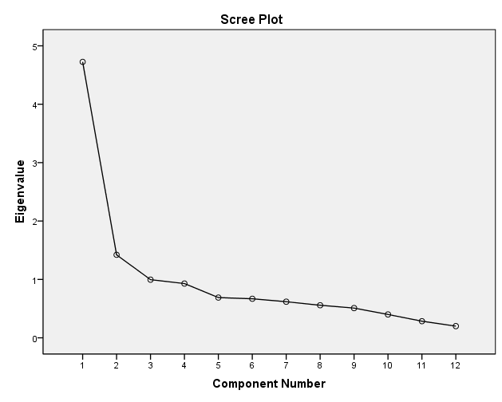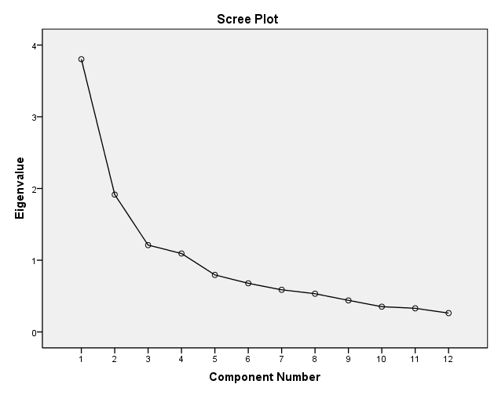
B.3 Price B.4 Availability
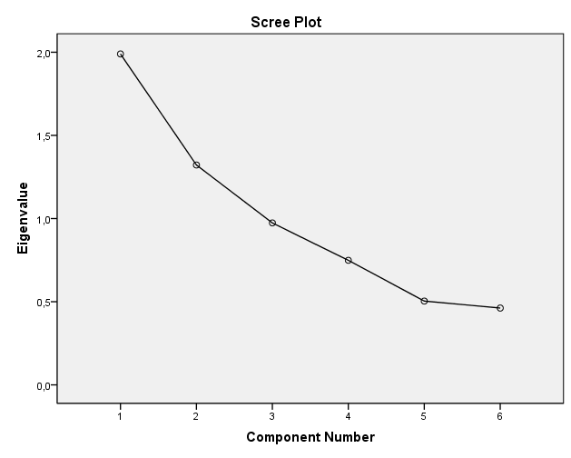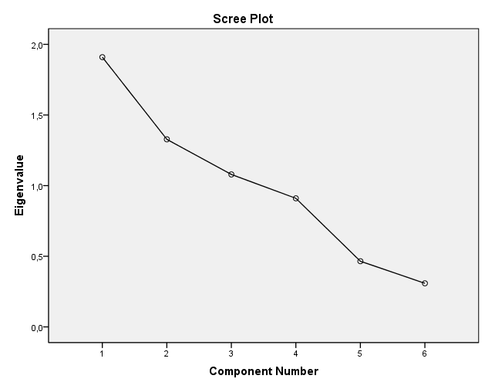
B.5 Distinctiveness B.6 Perceptual- and learning construct
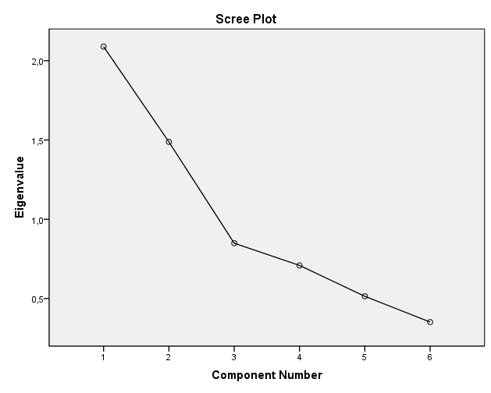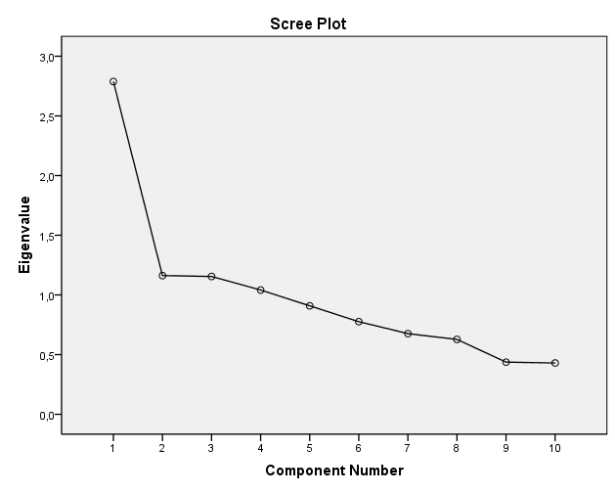

Appendix C: Rotated Component matrix

Principal Component Analysis, rotation converged in 6 iterations (Varimax with Kaiser Normalization).

 | Service | Availability | Perceptual and learing | Price | Distinctiveness | Quality
Reliability | 0,792 | 0,027 | -0,078 | 0,041 | 0,087 | 0,108
Assurance | 0,785 | 0,099 | -0,048 | 0,135 | 0,068 | 0,012
Empathy | 0,751 | 0,138 | 0,338 | -0,005 | -0,025 | -0,07
Responsiveness | 0,789 | 0,013 | 0,156 | 0,186 | -0,024 | -0,081
Design | 0,42 | 0,133 | 0,071 | 0,589 | 0,032 | 0,225
Conformance | 0,706 | -0,015 | -0,223 | 0,381 | 0,059 | 0,063
Safety | 0,224 | 0,086 | 0,172 | 0,156 | 0,079 | 0,834
Field_Use | 0,59 | 0,09 | 0,069 | -0,002 | 0,1 | 0,223
Adm_pr | 0,128 | 0,036 | 0,148 | 0,901 | 0,023 | 0,02
Pr_of_sub | 0,089 | 0,993 | 0,022 | 0,045 | 0,028 | 0,028
Nr_of_Cinemas | 0,089 | 0,993 | 0,022 | 0,045 | 0,028 | 0,028
Nr_of_viewed | 0,089 | 0,993 | 0,022 | 0,045 | 0,028 | 0,028
IN_group | 0,067 | 0,048 | 0,018 | 0,045 | 0,922 | 0,037
Out_group | 0,284 | 0,103 | 0,427 | 0,049 | 0,437 | -0,412
Attention | 0,088 | 0,035 | 0,761 | 0,255 | 0,076 | -0,101
Attitude | -0,052 | 0,008 | 0,736 | -0,021 | -0,032 | 0,193
Motives | 0,068 | -0,016 | 0,601 | -0,026 | 0,542 | 0,138

Color legend
Yellow | Correlation with the main variable
Blue | Correlation distortion of quality
Red | Price
Gray | Overall correlations that aren’t clarified

Appendix D: Cronbach’s Alpha results

 | Cronbach's Alpha Based on Standardized Items | Cronbach's Alpha if Item Deleted
Service | ,858 | No higher score
Quality | ,756 | No higher score
Price | ,004 | (sub variable: price of substitutes needed to be deleted)
Availability | ,251 | No higher score
Distinctiveness | ,622 | No higher score
Perceptual learning construct | ,686 | No higher score

