
Graduate School of Development Studies

Two Errors in Targeting Poverty:
A Review of CTA Poverty Identification in Exile Tibetan Community in
India, Nepal & Bhutan

A Research Paper presented by:

Thilpa Tenzin Sherab
(Tibet)

in partial fulfillment of the requirements for obtaining the degree of
MASTERS OF ARTS IN DEVELOPMENT STUDIES

Specialization:
Poverty Studies and Poverty Analysis
(POV)

Members of the examining committee:
Supervisor: Dr. Andrew Fischer
Reader: Prof. Ashwani Saith

The Hague, The Netherlands
November, 2011
Disclaimer:
This document represents part of the author’s study programme while at the Institute of Social Studies. The views stated therein are those of the author and not necessarily those of the Institute.

Inquiries:
Postal address: Institute of Social Studies
P.O. Box 29776
2502 LT The Hague
The Netherlands
Location: Kortenaerkade 12
2518 AX The Hague
The Netherlands
Telephone: +31 70 426 0460
Fax: +31 70 426 0799

Contents
Acknowledgements iii
List of Tables iv
List of Figures iv
List of Acronyms iv
Abstract v
Keywords v
Chapter 1: The Introduction 1
Legislature vs. Executive 1
Research focus 2
Methodology 3
Research outline: 4
Chapter 2: Review of Literature 5
Introduction 5
Internal errors in poverty identification 5
External errors in poverty identification 7
Institutions and errors in poverty identification 9
Chapter 3: Research Findings 11
Introduction to Tibetan community in exile 11
Poverty and social welfare in exile 14
CTA poverty identification policy 16
The historical evolution of CTA poverty policy and program 19
The story so far… 24
Chapter 4: Research Analysis 27
Introduction 27
Errors in CTA poverty identification 27
Causes of errors in CTA poverty identification 31
The institutional roles on errors in poverty identification 34
Chapter 5: The Conclusion 37
Reference 40
Appendices 43

Acknowledgements
This paper is an outcome of contributions from so many people without which, this research is almost impossible. First of all, I would like to thank Mr. Nodup Dorjee la (Secretary of Dept. of Home) for taking interest in this research and showing all necessary supports. I then would like to thank Mr. Pema Jungney la, (Former Speaker of exile Tibetan parliament), Mrs. Tashi Dolma la (Additional Secy. of Dept. of Education), Mrs. Yanki la (Joint Secy. of Depart. of Health) and above all Mrs. Tsewang Dolma la (Joint Secy. of Depart. of Home) for spending time with me and sharing valuable information on CTA poverty identification, which are now not easily accessible. I then would like to thank Mr. Jigmay Tsultrim la (Head of the CTA poverty program) for providing necessary data and letting me with their live review on CTA identified poor. I also would like to thank my wife Mrs. Pema Lhamo la for assisting me in collecting data when I was in the Dharamsala and in Netherlands. She kept me feeding with all necessary data that I am unable to collect due to time and distances.

I then would like to thank the two most important persons, who were with me all time during my journey in this paper, my supervisor Dr. Andrew Fischer, who is also a well-known Tibetologist and my reader Prof. Aswani Saith for reading my paper again and again and giving their valuable and comments. Whatever I have achieved from this paper is all because of their guidance. Besides, I am very thankful to the Dutch Government and the NUFFIC for giving me the opportunity to study in Netherlands and ISS for giving me education that I have longed for. I am also grateful to Public Service Commission, CTA for their support and last but not the least, I am grateful to my boss Dr. Kunchok Tsundue la (Chief Planning Commissioner, CTA) for the inspiration.

List of Tables
Table 1: CTA Social Welfare Program 14
Table 2: Distribution of Overall CTA poverty population, 2011 15
Table 3: Year wise distribution of CTA poverty population 24
Table 4: CTA Poverty categories and its identification criteria, 2008 33

List of Figures
Figure 1: Occupation structure of exile Tibetan Community, 2009 12
Figure 2: Category wise distribution of CTA poverty population, 2000 21
Figure 3: Category wise distribution of CTA poverty population, 2011 23
Figure 4: Settlement wise distribution of CTA poverty population, 2003, 2006 & 2011 25
Figure 5: Settlement wise level of well-being and distribution of CTA poverty population, 2011 28
Figure 6: Relationship between levels of well-being and distribution of CTA poverty population, 2011 29
Figure 7: Poverty mapping of exile community in India, Nepal & Bhutan, 2011 30

List of Acronyms
ATPD: Assembly of Tibetan People’s Deputy
CTA: Central Tibetan Administration
CPIC: Central Poverty Identification Committee
LPIC: Local Poverty Identification Committee
TDS: Tibetan Demographic Survey

Abstract
This paper presents an analysis on the controversies surrounding CTA poverty program, which basically revolves around exclusion and inclusion errors in poverty identification. The paper indicates a significant identification error in CTA poverty program as it finds that distribution of CTA poverty population is not correlated to level of well-being in settlements. The paper argues, poverty identification errors have been going on for a long time in exile Tibetan community because of narrow poverty conception accompanied by weak identification criteria. Due to unique exile political system, social policy and particularly poverty policy have received less attention. With little information on causes and nature of the exile poverty, policy elites then come up with their own discourse on a work disincentive, which ultimately led to high external errors in CTA poverty identification.

Relevance to Development Studies
There are two ways to eradicate poverty in a society. The first is to provide market to the poor and make them engage in economic activity to help themselves. This is more sustainable way to eradicate poverty but it will take longer time because poor also have to deal with lots of other structural issues in a society to earn a better living. So, the second alternative way is to transfer social welfare to poor. It will eradicate poverty in short run but temporarily and it is an important building block for poor to get out of poverty. This paper falls into the later part on social welfare to eradicate poverty. Unfortunately, due to shift in the social policy from Universalism to Targeting, many poor are excluded of such social welfare. Thus, taking exile Tibetan community as research context, this paper tries to understand why many exile Tibetan poor in India, Nepal and Bhutan are excluded from such social welfare.

Keywords
[Poverty, Exclusion and inclusion errors, External and internal errors, Work disincentives]
Chapter 1

The Introduction

Legislature vs. Executive
On 18th March 2002, His Holiness, The Dalai Lama gave a speech to a newly elected 13th Assembly of Tibetan People’s Deputy (A.T.P.D), in which he urged to support the poorer section of exile community (DIIR 2002, 1). Later, the speech started a big debate in the assembly raising the issue of inaccuracy and favoritism in identification of poverty. Parliamentarians assuming errors in CTA poverty identification, they discussed whether to involve themselves in the poverty identification process or not. On October 2002, A.T.P.D passed a bill in which the Parliament standing committee was given power to review poverty list identified by Kashag (A.T.P.D 2002, 56-73). A year later, the parliament formed committees and started reviewing the CTA poverty list, and together they also started to identify new poor from household visits. Unfortunately, the poor identified by parliamentarian committees were questioned within and outside parliament. Finally in 2005, A.T.P.D completely handed-over the poverty identification and implementation program back to the CTA by passing another bill in the parliament. (A.T.P.D 2005, 15).

In response to criticisms during controversies, Kashag started reforming poverty policy in 2004. The same Kashag then revised the whole poverty alleviation policy and came with new version of poverty policy in 2008. However, the debates between legislature and executive on poverty identification continued, despite Kashag’s reforms. The parliament being representative of exile population made periodic visits to Tibetan refugee settlements, and they often raise issues of public resentments on poverty identification during parliamentary discussion. One of such issue was raised by Mr. Tsultrim Tenzin la in 2009, an MP from Dotoe Province. He said
“I saw people identified as poor by CTA coming with own bike and car to collect stipends. Is it possible that poor people can own motor bike and car?... There are many people telling me that CTA poverty identification is not done properly… thus we need a fresh review on CTA poverty program…”(A.T.P.D 2009, 88).
There is a general belief in the public domain that poverty identifications are not conducted honestly, where voiceless poor are always excluded and non-poor, crafty people get into the poverty program and take benefits. The worst is, some of the people interviewed say, the poverty alleviation program should be stopped because it doesn’t identify poor correctly and instead the poverty program divides the whole exile community into receiver and non-receiver of government benefits and thus, it creates social tension between the two. However, these public views are not very visible because there is no way a common person can make his/her issues heard to policy elite except through parliamentarians.

Although there is no poverty study conducted in exile community to prove significant errors in CTA poverty identification but there is persistent disbelieving among exile Tibetans in the mechanism of CTA poverty identification, even after various reforms made by Kashag in 2002, 2004 and 2008. So, considering such vagueness in exile poverty identification, the paper wanted to understand three important issues, and they are;
- How significant is the size of identification errors in the CTA poverty program?
- What causes these identification errors? and
- Why such causes exist in the CTA poverty program despite various reforms in the past? What is Kashag doing to reslove these errors?
Since CTA poverty policy has a unique way of understanding and identifying poverty, which are somehow related to identification errors, the paper focuses on the evolution of CTA poverty policy and programs to answer above questions.

Research focus
Errors in poverty identification are generally considered inevitable and are very much accepted in all targeted social transfer programs. However, the fact is errors are bad for poverty alleviation and even worse for poor. It is easy for us to say that errors are side effects or collateral damages of targeting but for poor it is a matter of life; for themselves and their children, who may also lead an intergenerational poverty life. Following the seriousness of such consequences, this paper presents the underlying reasons for CTA poverty identification errors in exile Tibetan community. The research undergoes in-depth analysis of existing CTA poverty policy and changing institutions in the evolution of poverty policy and program, where it focuses mainly on identification part of the poverty policy and program. The paper argues that poverty issue in exile community has been neglected for longtime because of its politically insignificant in exile context. There were no studies, no information on exile poverty, which then led to discourse on a work disincentive. Such discourse and unique exile political and economic systems led to identification errors in the CTA poverty program.

The paper makes three important arguments. Firstly, the paper although, doesn’t have a figure to show errors rate in the CTA poverty identification because such a figure requires a huge household survey, which is impossible under this MA thesis. However, the paper has collected enough secondary data on poverty population as well as on the well-being of exile community to argue that there are indications of significant size of identification errors in the CTA poverty program. The analysis found that distribution of poverty population across settlements is not correlated to level of well-being rather it is influenced by its distance from Dharamsala, where powerful actors of the poverty program are located.

Secondly, in the poverty policy, CTA assumes that poverty identification is caused by favoritism and irresponsibility of LPIC. The paper however argues that main cause of errors in CTA poverty identification is the narrow conception of poverty. It not only excludes section of targeted poor internally, along with the non-targeted population, but it also keeps large section of poor out from policy definition of poverty. The policy narrowly defines poor on individual’s physically capability to engage in economic activities so, all working poor, e.g., farmers, carpet weavers and all newly arrived Tibetans, who are able-bodied but earn little income due to lack of skill and low economic opportunities are excluded from the CTA poverty program. Besides, weak criteria for poverty identification are also responsible for errors, as it lack the economic characteristics, whereby non-poor easily get into the poverty program. Weak criteria further provide space for manipulation in poverty identification, resulting in errors.

Finally, to answer why such causes of errors exist in CTA poverty program, the paper argues that Kashag has acted very little to strengthen the poverty program because poverty issues benefits little to policy elites in exile context. Besides, the policy elites have a strong approach on a work disincentive discourse, which further restricts the exile poverty program to evolve from the narrow definition. CPIC and LPIC also have done little to resolve this issue because, firstly they are all part-time members and secondly decision-making in poverty identification is highly centralized. Overall, paper believes that past policy reforms made by Kashag were not enough to reduce errors because they are not based on ground realities or experiences of poor rather they are guided by policy elites own perspective of knowledge on exile poverty. Thus, the paper urges CTA to conduct a thorough poverty study on exile Tibetan community and then reform poverty policy according to findings.

Methodology
The paper uses both quantitative and qualitative data to analyze the research questions. However, since it focuses mainly on institutional change in the evolution of CTA poverty policy and program, the paper adopts more of qualitative research methodology. The other reasons for adopting qualitative research methodology are, it is relatively less time-consuming and above all it is more descriptive for analysis such as institutions and policy framing. This qualitative research will uncover logical reasons behind CTA poverty policy choice and understand processes of change over time, e.g., How CTA poverty policy changes over time and why it changes and subsequently, how people respond to changes are the key elements of this research paper.

The research arguments are built on interviews from CTA poverty policy elites, who were actually involved in the formulation of CTA poverty policy and those currently heading poverty alleviation program. All available CTA official documents and notices related to poverty policy and program are collected, matched with interview data and where there are no explanations, meanings are created using logical deduction approach from available data. For example, there is no explanation, not even from interviews on how the concept of three poverty categories came about in the program. However, as research found the directive principles of exile constitution mentioning above categories to be supported by CTA and since exile constitution was framed before poverty policy, the research argues those three poverty categories were taken from the exile constitution.

Along with above sources of information, the paper also builds its argument from a small non-representative household questionnaire survey conducted along with the CPIC officials, who are as well conducting a live review of CTA poverty identification in Bir and Chauntra settlements. The main objective of this survey is to understand how poverty policy is put into practiced at the grassroots level. At that same time, the research also tried to conduct a survey on excluded poor, however due to unreliability of data, the survey had to call-off. Since, this is the first research study on CTA poverty policy and program, there is no literature or logical claims for analysis of CTA poverty identification errors. So in few cases, the paper had to make own standpoint without much deeper analysis. This is one limitation in this research paper.

Research outline:
After introduction of the research problems and questions, Chapter 2 looks into the scholarly works of researchers, who have dealt with similar issues to see what their research findings are and how they refute or support specific arguments. Such state of knowledge provides context and evidence to research arguments.

Chapter 3 focuses on research findings, which begins with socio-economic conditions of exile community to provide a context for research analysis. It is followed by detail description of CTA poverty identification policy and its evolution, which are the key findings of this paper. The chapter basically tries to explain what is happening related to poverty identification in exile community.

Chapter 4 analyzes research questions with available information from the findings. The chapter provides evidence of identification errors in exile community. It identifies factors causing errors and above all, explains why these errors are occurring in the CTA poverty program and why CTA is not doing enough to resolve this issue.

Finally, Chapter 5 is the conclusion of this paper. It wraps up all findings and analysis into a single argument that answers the main research questions and provides future direction to resolve the issue of CTA poverty identification.

Chapter 2

Review of Literature

Introduction
As the paper analyzes the controversies surrounding CTA poverty program, which basically revolves around errors in poverty identification, this chapter on literature review looks into the past researches to provide background understanding and approaches to analyze, what causes errors in exile Tibetan community and why. To begin with, the paper focuses on two broad types of identification errors namely, exclusion & inclusion errors and internal & external errors. Cornia and Stewart (1993, 2), defines exclusion error as Type-I error or F-mistake, which means failure to identify real poor. Exclusion error not only reduces program cost, but it also reduces program impact on poverty alleviation. Besides, it increases horizontal inequalities among individuals of same income, and creates resentment and social instability (Bibi and Duclos 2007, 113). The second error is ‘Error of inclusion’ also called as Type-II error or E-mistake, which means excessive coverage, where non-poor are erroneously included into the poverty program. Inclusion error wastes resources and increases budget without increasing efficiency of the program. It also increases vertical inequality between individuals of different incomes (Cornia and Stewart 1993, 2). Identification errors are generally measured within the policy definition of poverty, which are referred as internal errors. However, sometimes errors are also measured outside a policy definition within broad poverty discourse, which are referred as external errors. The exile poverty identification suffers from both internal and external errors, but it is the external errors that are causing a bigger problem to exile community, due to its narrow definition of poverty.

Complete end of identification errors as aimed by CTA poverty policy is impossible because the CTA poverty program is a targeted program, and errors are inevitable in all targeted poverty programs (Coady et al. 2003, 6). A shift from Universalism to Targeting social policy has increased identification errors significantly in many social assistance programs, because Targeting unknowingly eliminates some of the target groups in the programs along with non-target population. For example, Swaminathan & Mishra (2001, 2451) study on Public Distribution System in Maharashtra, India and Cornia & Stewart (1993, 5-15) studies in nine developing countries show an increase in identification errors with the shift to Targeting social policy. However, these identification errors can be reduced by resolving issues caused by wrong information, methods and policies. This chapter first discusses issues related to internal errors in poverty identification.

Internal errors in poverty identification
In exile community, there are evidence of families with too many children to support, who according to policy definition are poor but excluded from the poverty program and to the contrary, there are cases of people having two wheeler and car, who according to policy definition are non-poor but identified as poor. The CTA poverty policy considers these internal exclusion and inclusion errors are caused by favoritism and irresponsibility of LPICs (Kashag 2008, 2). However, the main reasons for identification errors in many of the literatures are explained as the lack of information or the imperfect access to information (Bibi and Duclos 2007, 109:, Coady et al. 2003, 10:, Swaminathan and Misra 2001, 2447). Since the government agencies do not have enough information on welfare of its people, policy elites are thus forced to identify recipients of public support in their own terms (Bibi and Duclos 2007, 110). Lack of information further constrains governmental agencies to develop robust criteria for poverty identification, which result in ambiguous, non-transparent, irrelevant, cumbersome and non-verifiable criteria. Such criteria give implementing agency more discretionary power for corruptions, nepotism and favoritism in poverty identification (Lavallee et al. 2010, 8). For example, the main criticisms for errors in Indian poverty identification are the weak thirteen indicators of multi-dimensional scoring scheme (Saith 2007, 257:, Hirway 2003, 4803:, Sundaram 2003, 889).

Besides technical feasibility, the capability of government agencies in targeting poverty are also deciding factor for identification errors. In exile context, all poverty committees consist of part-time members and fewer funds are spent on administrative cost. However, poverty identification generally requires strong statistical information and a powerful institution thus, average administrative cost for targeting is high (Dutrey Alexander Peyre 2007, 8). Many of the developing countries don’t have strong institution, good manpower infrastructure and high administrative cost for targeting. That’s why targeting errors are higher in poorer countries. Targeting program in Africa transfers 8% fewer resources to poor individuals than a universal program (Coady et al. 2004, 70).

Such administrative inefficiency not only hurdle governments to identify poor effectively, it also hinders poor reaching to the governments because they have to bear the private cost, which is a cost incurred by poor in proving themselves as eligible. Studies in Armenia reveal that many poor were excluded from targeting program because they were unable to pay bus fees for registration and other under-table payments needed to pay for required documents (Grosh et al. 2008, 96). In the case of a self-targeting program, poor couldn’t access program due to its inability to pay the in-between cost or unable to give up their opportunity cost (Coady et al. 2003, 8). Hirway (2003, 4803) claims that real poor are often excluded in the poverty program because firstly, they don’t know about the programs. Even if they know the program, they find it difficult to get recognized as poor because they couldn’t fulfill the administrative requirements. Again if they could fulfill the administrative requirement, they were not helped or favored by the local administration. So, these are the issues that this paper will look into the analysis of CTA internal errors in poverty identification.

External errors in poverty identification
As mentioned earlier, CTA poverty identification has bigger issues with external errors due to narrow policy definition of poverty. The poverty literature reveals that this narrow conception and definition of poverty are caused by economic and socio-cultural reasons. Economic reason is quite obvious that targeting poverty in social policy is generally guided by budget availability. A shift from lesser error Universalism to more error Targeting is actually driven by budget constrained. Within targeting, poverty identification is furthered narrowed down due to fewer allocations of funds. The very low poverty line in China is one of the examples, where large sections of poor get externally excluded from the poverty program (Ghosh 2010, 9). In exile context, budget constrained is not considered as cause for narrow identification of poverty (Ngamdrung 2011, personal interview), although CTA is experiencing deficit in planned budget over last two years (Dept. of Finance 2010, iv). Thus, paper assumes socio-cultural factor as the main reason for external errors in CTA poverty identification.

The literature reveals that many times poor are purposefully excluded on moral grounds. The policy elites deliberately define poverty narrowly to avoid the work disincentive and to exclude sections of people, who they think undeserved for state welfare. The CTA too has very a strong view on the work disincentive as it is expressed twice in the poverty policy (Kashag 2008, 3&11). The issue of work disincentive and undeserving poor has its historical roots from Elizabethan English poor law of nineteen century and is still debating in modern US and Canada poor laws. An experiential study conducted in US and Canada to understand the socio-economic impact of Guaranteed Livable Income on general public revealed that social welfare reduces the work incentive by 1% to 8% hours annually to men and 3% to 28% hours annually to women. However, these reductions in working hours are considered minimum and even negligible (Pasma 2010, 1).

Work disincentive and poverty trap
Disincentive to work literally means erosion of work ethics due to receipt of free income. Such concept considers welfare as moral hazard because it assumes people will stop working and engage in leisure activities, if they were given welfare payments. It believes welfare will create more people dependent on welfare. Policy elites with such a standpoint advocate government to spend money on an economy to create jobs than on welfare programs (Zeigler Jenifer. 2011, 1). Such argument on work ethics of poor goes back as far to the Speenhamland English Poor Law of 1795 in which, the poor law called “Aid-in-wage” under a parish gives relief funds to poor families, whenever the price of bread exceeds their family wage. It is said that poor people in Speenhamland gradually began to work less as the gap between their wage and bread price are supplemented by parish thus, developed disincentive to work (Block and Somers 2003, 286). Many scholars like Townsend, Malthus, Von Mises, and Marvin Olasky concluded that this welfare program interfered with the self-regulating system in Speenhamland, and people began to marry early, produce more children and stay voluntarily unemployment. Such factor led to low production, low wage, high population growth and increase poverty (ibid. 292). So, the incidence of Speenhamland English Poor Law is often used to link welfare with a disincentive to work.

The finding of Speenhamland in 1996 has led to the end of social assistance to poor families in United States. Similarly social policies of many other countries like Canada are influenced by Speenhamland English Poor Law. However, the sociologists like Block and Somers (2003, 300) believes that findings of Speenhamland were wrongly interpreted. They assumed parish also provides jobs along with relief aids to seasonal and general unemployed poor people. Thus, Block and Somers believe that unemployment has never increased and there was no work disincentive in Speenhamland. The rise in the price of bread and persistence of poverty was not due to welfare, but due to external factors like Napoleon’s war in beginning of 1800s. They finally conclude that Speenhamland English Poor Law was not the cause of poverty in the region rather it was a response to the lowering income of poor families.

Since, a work disincentive is more a political than technical concept, policy elites continue to debate whether welfare payment will reduce people’s incentive to work. According to Chandra Pasma (2010, 5), there are five key assumptions under a work disincentive concept. They are;
- People work solely for money, and if they get money freely, people won’t work.
- If people are not engaged in paid labor or physically not involved in economic activities, they are considered not working.
- Jobs are always available if people are willing to work.
- Since disabled people are not expected to work, it is easy to determine who should work and who shouldn’t. And finally
- Welfare payment is wrong because, it is wrong to pay people to do nothing

He, however believes that all assumptions of a work disincentive are wrong. He argues that assuming people works solely for money dismisses wide range of human experiences and motivation, including self-fulfillment, ambition and so on. Secondly, people who do not engage in paid labor do not mean they are not working. Single parents may not be working in the market, but they are looking after children or taking care of elders. They are as important and good as working paid labor. The definition of work under work disincentive contradicts feminist standpoint theory. The third assumption of work being freely available is also not true. The fourth assumption categorizes poor into deserving and undeserving poor is again wrong, which will be dealt in the later section. The fifth assumption of paying people to do nothing is also debatable because any government works on the social contract between state and citizens, where citizens support government through taxes and in return, governments protect citizens with basic minimum quality of life as rights (Ortiz 2007, 6). We should rather look from another side of Universal Declaration of Human Rights; Article 22, which says, “Everyone… has rights to social security” and article 25 says, “Everyone has the right to a standard of living adequate for the health and well-being of himself and of his family…” (Kidd. 2008, 2).

The neo-liberal discourse of a work disincentive further raises the issue of deserving and undeserving poor. They argue undeserving poor are poor because of their bad choice, and state should not be responsible for welfare support. The Elizabethan English poor law in 1600s gave welfare to old and sick people but punished idle and vagrant poor (Marjorie 2005, 458). The exile Tibetan government also follows a similar approach. It considers old, sick and children as a deserving poor rest all as undeserving. However, many poverty literatures argue the concept of undeserving poor as a mere moral judgment and not based on evidence. Poor are not homogeneous and any differentiation of poor in deserving and undeserving is an act of generalization and stereotype (Gans 1994, 270:, Caniglia S. Alan 1996, 65). While others argue the use of a work disincentive and undeserving poor in the poverty program has a positive function for non-poor. For example, the label is used by decision-makers as a scapegoat from failure of their actions and to escape from responsibility (Gans 1994, 272). Thus, any discourse on work disincentive and undeserving poor needs to be critically analyzed on above lines, including CTA. However, the bigger issue with CTA poverty identification errors is, why exile government supports work disincentive and narrow poverty identification, which require institutional analysis.

Institutions and errors in poverty identification
We discussed a number of factors causing errors in identification of poverty both internally and externally. However, reasons behind the emergence of these factors may differ according to the contextual and institutional setup. To understand the structural causes of errors require institutional analysis on the poverty identification process. To begin with the concept, “Institution” in many literatures is referred as “rule of game”. It is explained as humanly devised rules that structure all political, economic and socio-culture interactions (North 1991, 97). These rules can be informal, e.g., customs, traditions and codes of conduct or formal, e.g., constitutions, laws, property rights, etc… Institutions are different from organizations, which are a group or association, both formal and informal having specific roles and responsibilities, structured in some relationship to achieve specific objectives. Institutions set the rule whereas organizations are actors who comply, violate and seek those rules to influence or change them (Lobo 2008, 12). The interplay between institutions, organizations and their outcomes become keys to the institution analysis. Such analysis provides better understanding of a problem situation and its intervention requirement.

According to the IFAD (2009, 3), four major steps are critical in an institutional analysis for poverty identification errors. The first step is to understand how the poverty is conceptualized, defined and identified. The second step is to analyze how the roles and responsibilities, capacities and relationships of various institutional actors generate definition and identification of poverty, which is called mapping of results. The third step is to analyze the institutional context, which is more than analysis of just institutional arrangement. It includes analysis on a) policy factors, e.g., how poverty policy was framed, implemented and evaluated. b) Legal framework, e.g., constitutions and other rules related to poverty identification c) Resource and incentive structure, e.g., political economy of resources distribution. Again, behind policies and legal frameworks lies the power, playing the key role in shaping policy and are deeply rooted in the process. The fourth step is to analyze that power and process, which comes in a form of authority and influence. It focuses on who has the authority/influence, how it is exercised, what is the source of that authority/ influence and what benefit drives from it and for whom. Such analysis will help this research to understand more clearly the structural issues and influences of exile institutions on errors, through deconstruction of power and politics in the evolution of CTA poverty policy.

Poverty policy in exile Tibetan community is framed and reformed by Kashag on recommendations from CPIC. However, many studies on poverty policy confirm the underlying assumptions of institutional analysis. That is, despite a range of technical choices available for framing poverty policy, it is power and politics that play major role not only in shaping methods for poverty assessment but also for developing the dominant discourse in the policy. Thus, analyzing roles and responsibilities of those powerful actors and their perspective of knowledge in poverty is important for understanding poverty policy (McGee and Brock 2001, 1&6).

Policy making generally passes through four stages of Conception, Formulation, Implementation and Evaluation. The traditional model of policy making explains a policy process as a linear model, relaying on evidence based rational action in decision-making and implementation towards optimal policy possible, which is referred as a problem-solving process (Lobo 2008, 20). Here, the expert knowledge is critical in all four stages of policy making. However such model obscures the interaction of various actors and their construction of knowledge, which are mostly unseen in shaping policy or influencing the technical choice of policy making. Thus, the contemporary model views policy making as non-linear, complex and incremental, which they referred as “policy as practice.” This model explains policy making as a combination of knowledge, power and politics. It is a combination of knowledge because unintended effects and unanticipated progress from policy evaluation influence policy to change, that may be different from those intended by powerful actors. Secondly, Development discourses and narratives also influence poverty policy in making. Policy is a combination of power and politics because interest groups, actors, policy networks and coalitions continue to influence policy making. Besides, governance efficiency, political context and International regime also influence in policy making (ibid. 21).

To conclude, this literature review sheds light on what causes identification errors in poverty policy and how such poverty policy is made and reformed with a combination of knowledge, politics and power. The following analysis on the findings of institutional evolution of CTA poverty policy and program will incorporate above literature review as background to develop deeper understanding on the issue of CTA poverty identification errors in exile Tibetan community.

Chapter 3

Research Findings

Introduction to Tibetan community in exile
Tibetans started coming to exile since 1951 (Woodcock 1970, 1). It was however, after the flight of His Holiness The Dalai Lama in 1959 that some 8500 Tibetans fled along with him and as many as 1500 Tibetans were arriving each week from Tibet, walking 16,000-foot passes to Nepal, Bhutan and India. On 29 April 1959, His Holiness, The Dalai Lama established Central Tibetan Administration (CTA) to rehabilitate newly-arrived Tibetan refugees and to continue the struggle for Tibet’s independence. By 1960, Government of India started planning its first resettlement program for Tibetan refugees in the state of Karnataka, Madhya Pradesh and Orissa. Gradually, they initiated resettlement programs in other parts of India with responses from various state governments.

In Bhutan, the Royal Government of Bhutan provided the land and Government of India funded for resettlement of Tibetan refugees. In Nepal, it was Red Cross, Technical Co-operation Switzerland, and other voluntary organizations that supported for resettlement of Tibetan refugees. By 1970s, resettlement works were completed and basic living problems of Tibetan refugees were almost resolved. However, Tibetan refugees kept coming from Tibet to exile and resettlement for these newly-arrived Tibetan remained a big challenge.

Livelihood in exile
Livelihood is broadly defined in academic literature as a combination of economic, ecological, political/institutional security and socio-cultural viability. However, here the research refers livelihood mainly to economic security, which is an ability to produce stable and adequate income to provide a basic minimum needs. All Tibetan refugee settlements have primary schools, health centers and livelihood opportunities directly or indirectly supported by CTA. Settlements, where lands are in abundant, agriculture was made as the main source of livelihood, whereas in northern hilly areas, where land is less abundant, handicraft centers and local small-scale industries were set up and made it as the source of livelihood. Unfortunately, these small-scale industries gradually had to close-down due to lack of expertise in management and marketing (Conway 1975, 81). Many people in these settlements gradually find their way out of settlements to sweater business, where they buy wholesale ready-made garments from factories and retail along the roadside in different towns and cities. People in sweater business become economically better-off as business proves profitable. However, those working inside the settlements remain mostly poor.

In agricultural settlements, five acres of agricultural land were originally distributed to family of five members (Department of Home 1992, 10), however, we presently don’t know the average landholding, but some studies show as 2.7 acres (Butler 2003, 21) due to increase in population over last 50 years. Since, land cannot be sold as it is on lease from Government of India, almost all families in agricultural settlements still have land. However, the real issue with agricultural livelihood in exile community is not the availability of land rather, it is low return from the land. Tibetan settlements are located in drought-prone regions and practice rain-fed agriculture. Thus, they have only one crop per annum. Their average net income per acre is approximately Rs 7000 thus, per day per capita income for five members family with average 2.7 acres of land comes to Rs 10.5, which is a way below the recent poverty line of India – Rs 26 per day (Utsa Patnaik. 2011, 1). Besides, crop failure is quite common, where many farmers also get into debt. So, these farmers also gradually find their livelihood out of agriculture to other occupations, especially sweater business. Younger generations, who are school dropped-out, mostly remain in settlements doing agriculture, rest all migrate to near by towns and cities for better economic opportunities. From 1992 to 2011, percentage of population in agriculture decreased from 33.6% to 8% (Department of Home 1992, 18; Planning Commission 2010, 48) and those 8% of exile population, who continue to depend on low income agriculture remain mostly poor.

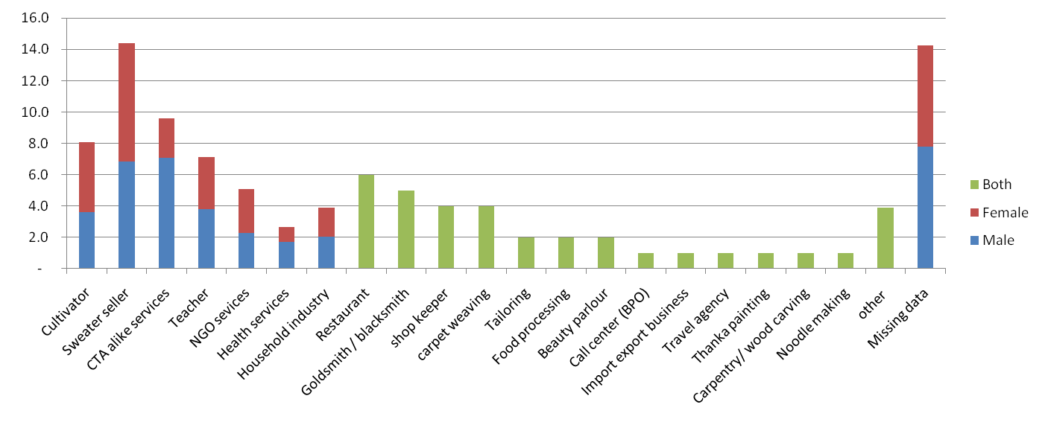
Figure1: Occupational structure of exile Tibetan community, 2009
14%
4%
1%
2%
2%
2%
5%
4%
4%
6%
4%
3%
5%
7%
10%
14%
8%
Source: Planning Commission, CTA 2010, 48
1%
1%
1%
1%
1%

Besides, many Tibetans refugees in India, Nepal and Bhutan find their way outside to North-America, Europe and Australia for better economic opportunities. There is no data on the outflow of population, but it is generally believed that on average, most of the families in exile community have at least one family member or relative living abroad, who send remittances back to support home. Those who do not have a family member in abroad usually remain less well-off. Within the community, the newly-arrived Tibetans are more prone to oversea migrations due to sheer insecurity and lack of opportunities in India. Every year, from 1000 to 3000 Tibetans join the exile community from Tibet (Plowright. 2010, 1). Newly arrived children, monks and nuns are rehabilitated in boarding schools and monasteries while, rests are left on their own for livelihood. Since there is no resettlement program for newly arrived Tibetans, and they also cannot speak Indian language to adapt themselves in the new environment, many tend to go west to start new life and those who cannot, remain mostly in poverty.

Exile poverty in context of the host countries
On 12th April 2009, the total population of Tibetans outside Tibet stood at 127,935 comprising of 94,203 Tibetans living in India, 13,514 in Nepal, 1,298 in Bhutan and 18,920 elsewhere (Planning Commission 2010, 13). Relationships between exile Tibetan community and the host countries are rather informal and complex. Although, there are provisions e.g., under Indian Citizenship Act of 1955, Section-3, those Tibetans came and born between 26th January 1950 to 1st July, 1987 can apply for citizen. However, only 3% have done so believing, they will go back to Tibet soon (The Hindu. 2005, 1). Similar is the case with Bhutan and Nepal. Under Bhutanese 1985 Citizenship Act, Tibetan refugee proficiency in the Dzongkha language and have 15-20 years of residency in the country can apply for citizen (International Observatory on Statelessness. 2011a). Under Nepali Citizen Act, Tibetans came or born before 1989 can apply for citizenship (International Observatory on Statelessness. 2011b). However, the majority of Tibetans never relinquished their prior citizenship and face discriminations, which is worse in Bhutan ((Denyer. 2008, 1).

Thus overall, exiled Tibetans are considered as foreign visitors and not even as refugees. Constitutionally, they do not have rights to express and move freely and cannot reside in any parts of the country. They have to seek permission from Foreign Registration Office (FRO) to travel. They can’t own property, or can’t get government jobs. However, Tibetans in the exile community move freely and engage in all sorts of economic activities. In India, more and more exile Tibetans are scattering and migrating to all parts of India for job opportunities, they engage in diverse economic activities along with fellow Indian citizens. The situation in Bhutan is exceptional, where Tibetans with no citizenship can’t obtain a license to run private business.

Similarly, as per host country’s social policy, exile Tibetans are not entitled to any social welfare because they are neither citizens nor refugees in the country. In India, exile Tibetans were excluded in all poverty and other socio-economic related surveys. Tibetans were even excluded from the national population census until recently when Government of India started with the Unique Identification Project. So all targeted social welfare programs like National Rural Employment Grantee Scheme (NREGA) and Targeted Public Distribution System (TPDS), which are implemented through municipalities and panchayats do not cover exile population, where as universal welfare programs on free primary education benefits exile population through 30 Tibetan schools run by Government of India. National Rural Health mission, although do not support the existing health care system of CTA in the rural settlements, but Tibetans can visit these health centers and avail services. Similarly, Tibetans can also issue temporary ration card and can avail subsidized Public Food Distributions (PDS), however, accessibility is not same in all settlements. There is less information on Nepal and Bhutan’s coverage of their national welfare programs to exile Tibetans but the situation seems more or less similar to India.

So there exist a complex relationship between exile Tibetan community and the host countries, which may require a further research. Analysis on causes and nature of exile poverty may require investigation into these relationships because economic securities of exile Tibetans depend on socio political, and economic freedom granted by host countries. However, exile poverty identification and alleviation has no concern with the host countries because Tibetans are constitutionally not entitled to any social welfare schemes, and they are often excluded and discriminated from host country’s social policy. So, the institution of CTA remains the only body responsible for welfare of exile Tibetan community, and it has been providing welfare to exile community since 1959. In such context, this research will focus mainly on the institution of CTA and its policy for analysis of errors in poverty identification in exile Tibetan community.

Poverty and social welfare in exile
Before we begin with the exile poverty interventions, it is important to discuss briefly on the social welfare system in exile Tibetan community because it serves as background to poverty interventions. By social welfare, the paper refers to “transfer of cash and service to people facing contingencies, e.g., illness, disabled, unemployment, working poor, etc…, which aims to maintain minimum living standards and opportunities.”

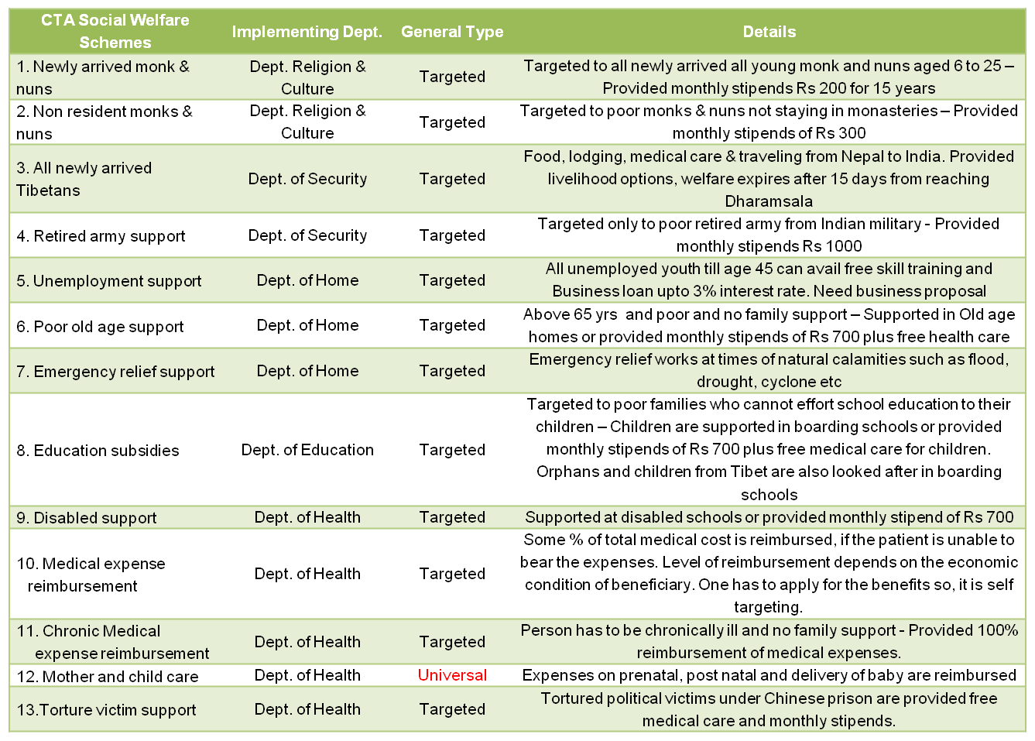
Table 1: CTA Social Welfare Program
Source: Own tabulation from www.tibet.net, 2011

The exile community receives both public social welfare by CTA and private social welfare by various non-governmental organizations. CTA doesn’t have social welfare policy except one on poverty, because types of social welfare provided by CTA are strongly integrated into the mandates of various departments. Of total seven departments, five are involved in the provision of social welfare services. The details of public social welfare schemes are above in the table 1.

Social welfare in exile community is targeted, and it is focused on the provision of minimum income through cash transfers, while few are focused on provisions of social services. Welfare schemes 7, 9 and 10 may not be targeting directly to income but the main objective behind such welfare is to maintain minimum income. Private social welfare plays an important role in the well-being of exile community. There are many autonomous organizations like Tibetan Children Village Schools (TCV), Homes Foundation, Tibetan Medical Astro Institutes (TMI), Snow Lion Foundation in Nepal (SLF) and all other big monasteries, which provide welfare to their thousands of their working members. It includes social insurances like old-age pensions, medical insurance and social assistance programs like free education for children. All these welfares are universal within the organizations and people benefiting from these private social welfares are generally excluded from the CTA social welfare program. Besides, many settlement officers and monasteries also arrange individual sponsorships mainly from Europe to support family’s education and health expenses, which then add to the secondary income of households. Sponsorship, which is an unconditional cash transfer is quite widespread in both well-off and poor families in exile community yet they are overlooked in many socially welfare analysis because of less transparent. Of total thirteen CTA welfare schemes in Table 1, five schemes e.g., 2, 4, 6, 8 and 11 are poverty alleviation schemes. There are 6,065 poor individuals identified and supported under these welfare schemes, which constitute 5.4% of exile population. The details are below in the Table 2.

Table 2: Distribution of Overall CTA poverty population, 2011
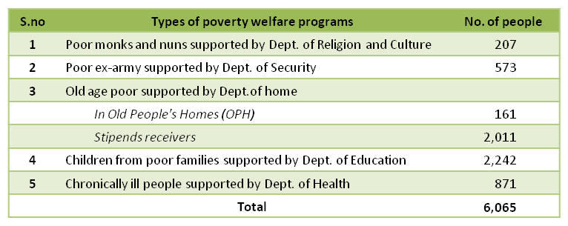

Source: Records compiled from five CTA Departments, 2011

Although all welfare schemes in table 2 are poverty alleviation schemes but CTA has separated the first two schemes from the mainstream poverty program because of administrative convenience. It is debatable whether such division creates convenience or more complexities in the alleviation of poverty, but the more important debate in the CTA poverty alleviation is the errors on poverty identification. As mentioned above in the introduction, CTA poverty alleviation program is experiencing continuous controversies related to poverty identification errors. There is a feeling of dissatisfaction among the people that voiceless real poor are ignored and instead non-poor get identified into the poverty program and enjoy benefits. So, what causes these errors and why such causes exist in CTA poverty identification is the topic for discussion in this paper. To understand, what causes errors, we need to know the CTA poverty policy on identification of poor.

CTA poverty identification policy
There are two CTA poverty policies. The revised policy of 2008 contains eleven and half pages, divided into two sections. The first section introduces the background, objectives and challenges of the CTA poverty alleviation program while the second section talks about guidelines and methods for identification and alleviation of poverty. However, this paper will deal only with the poverty identification policy.

Problems and objectives
CTA poverty policy assumes that identification of poor is one of the major challenges in the poverty program since its beginning in 1994. The policy explains two sections of people in exile community, one being destitute, courteously do not seek CTA welfare while other being well-off, greedily and deceitfully takes poverty welfare. The policy then notifies that non-poor that avail poverty benefits are guilty and officials who recommend these non-poor either knowingly or without proper investigation are equally guilty. The poverty policy acknowledges identification errors in the past and claims Kashag and settlement officers are responsible for this failure (Kashag 2008, 3).

Thus, based on the above problems, the policy ambitiously aims to eliminate exclusion error by identifying all exile poor in settlements as well as from scattered population living in various towns and cities. Secondly, the policy believes that due to wrong welfare, young people remain dependent on welfare and do not work, thus the second objective of the policy is to restrain all young non-working people from work disincentives. The third objective of the policy is to eliminate inclusion error by restraining all non-poor from getting into poverty schemes and stop passing single benefit towards them (ibid. 3&4). However, the overall objective of the CTA poverty policy aims to reduce poverty in exile Tibetan community through proper identification of poor. The next section of policy deals with definition and identification of poverty.

Poverty definitions
Poverty means different things to different people. Thus, defining poverty is crucial for identifying poor and setting up policy objectives. CTA poverty policy explicitly defines exile poverty as;

“Person who is unable to survive on her/his own and (her/his poverty) is easily observable. She/he presently has neither adequate income, security nor has any future source of income for living and without external support (that person) is difficult to survive” (Kashag 2008, 8).
The policy further classifies exile poverty into three categories for identification purpose. They are

Old age led poverty
The policy defines an old age led poverty as old man or woman who is above 65 years and do not have support from either family or relatives. People above 60 years are also considered as old age poor, if they are unhealthy and cannot engage in economic activities.

b) Child led poverty
Child led poverty is defined as a family, whose income is insufficient to raise children and provide basic need like education and health care. Under this category, children are direct beneficiaries. This category has no cap on income or on number of children for identification. Poverty under this category is identified through observation and personal judgment, which is arbitrary and may differ from time, place and people.

Chronic ill led poverty
People below 65 years, who are ailing for long time and do not have support from either family or relatives are defined as chronic ill led poverty. The policy assumes that since they are sick, they cannot engage in economic activities thus, they won’t be able to neither support themselves nor meet medical expenses. There is again no specific indicator for identification of poor in this category except their illness and family support system.

It is important to mention that policy definition of poverty focuses more on income aspects. The policy implicitly focuses on sections of people who cannot engage in any economic activities or earn income. However, there is no income criterion for poverty identification. So, to understand how CTA identifies poverty, we need to look at CTA structure and process for identification of poverty.

Institutional structure and process for poverty identification
The CTA poverty policy has developed a three-tier system for poverty identification. At the top is the Kashag, which consist of cabinet ministers headed by Prime Minister. They are the decision-making body for poverty policy and program. Next is the Central Poverty Identification Committee (CPIC), which consists of six members headed by Secretary of Department of Home as chairperson, committee secretary, assistant secretary and three representatives from each of the department of Home, Education and Health. Except the committee secretary, who is the coordinator of the program, rest all are part-time members, who normally engage in their own departmental works and meet only once in two or three months. At the bottom is the Local Poverty Identification Committees (LPICs). It is headed by a settlement officer as chairperson and consists of not less than four members elected by settlement people themselves. All LPICs members are settlement people, who occasionally involved in poverty identification, and they also meet only once in two or three months according to the number of poverty applications.

Unlike conventional poverty identification, the procedure for exile poverty identification starts from the bottom. The poor has to first apply for poverty welfare from one of three categories defined in the policy. A poor can apply anytime, and the poverty committees identify poor all around the year. The settlement officers who are the head of the LPIC receives all applications and s/he then convenes committee meeting and visit applicant’s house, fill the questionnaire form and according to the definition in the policy, discuss whether the applicant is poor or not. If the LPICs find the applicant not poor, they reject the application and the person cannot apply for some time. However, if the LPICs find the applicant poor, his/her application is forwarded to the CPIC with a recommendation. It is important to mention that there is a system of automatic exclusion, in which, people with motor bike and car, fancy mobiles phones, cabled television and own house with good living standard are automatically excluded from the process” (ibid. 8).

CPIC secretary, after receiving applications from LPICs, convenes meeting. In the meeting, the committee members again review the applications and based on the information filled in the questionnaire, decide whether the applicant is poor or not. The decision is normally taken by the department representative, who is actually supporting that welfare scheme. For example, if a person is applying for welfare of chronic ill poverty, member from Department of Health will take the decision because his/her department is implementing that scheme. In the end, the applications are sent to Kashag for final decision but generally, Kashag always goes along with the decisions of CPIC on identification of poverty. Once the application is accepted, the list is sent to the related departments for welfare provision. The concern department then transfers cash or services to the beneficiary through settlement office. The whole process of poverty identification is a long process, which could take more than five months. However, during emergency, applicants are immediately supported right after their acceptance from LPICs. Once poor are identified under the poverty program, they will receive welfare for continuous two years and after that review is done. The policy says except the old-age led poverty, the rest of the two categories will be reviewed after every two years by the LPICs and take a decision whether to terminate or to continue their poverty welfare. However, if there is no review within two years, the beneficiaries will continue to receive poverty welfare. The policy says in times of necessary, the CPIC can review the decisions of LPICs.

To sum up, the institutional structure and process for poverty identification look perfect. The three-tier system lets involvement of all agencies e.g., Kashag the enabling agency (policymakers), CPIC the service provider and LPICs the elected representatives into identification of poverty, although the power is centralized. The poverty identification process incorporates the dynamic nature of poverty, by which poor can apply for welfare anytime of need and there is a special arrangement for emergency too. Unfortunately, policy definition of poverty is quite narrow. There is a gap between the narrative definition of poverty and exclusive poverty categories in the policy. Poverty identification criteria are also not very clear, which may be causing arbitrary decisions. The detail analysis on identification errors will be discussed in the latter chapter, but to understand more on why CTA has narrow conception and identification of poverty, from where the idea of three categories came from and what policy reforms were made in the past on poverty identification, we need to go through the historical evolution of CTA poverty policy and program.

The historical evolution of CTA poverty policy and program
This section deals with the origin and past experiences of CTA poverty identification to provide a background for analysis and most importantly to understand the rational of existing poverty policy. For the analytical purpose of this research, the historical development of CTA poverty identification is divided into four phases. Each phase has its own characteristic for analysis and interpretation. The first phase is referred as “The early development phase,” which took place before the start of the CTA poverty alleviation program and it is the root of existing poverty identification policy. The second phase is referred as “Initial phase,” which is the beginning of first the CTA poverty program. The third phase is referred as “Intermediated phase” when the CTA poverty program evolved with first ever written poverty policy, and the fourth phase is called “Final phase” which describes the existing revised CTA poverty policy.

The early developments: before 1994
Tibetans were living an impoverished life when they first came to exile in 1959. Many of them came empty handedly from Tibet, where they end up working in road construction, living in unhealthy camp makeshifts. Wages were very low that both husband and wife had to work leaving small children and babies on the road side in dust. Others joined the mendicant population of India, begging and queuing for small food distribution by missionaries and relief organizations (Woodcock 1970, 415 & 6). By 1970s, resettlement works were almost complete and basic living problems of Tibetan refugees were resolved. In 1973, Central Schools for Tibetan run by Government of India started charging school fees from Tibetans families. Poorer families, who could not effort education fees, seek financial support from CTA. Since the problem is related to education, Department of Education started providing stipends to poorer families for their children education. (Ngamdrung 2011, personal interview). This informal support later turned into formal welfare scheme. Questionnaire was formulated and families who can’t pay for children education had to fill that form with a recommendation from the settlement officer. Based on the application and recommendation, poor were verified and supported. Then exile poor then started seeking help for other basic needs like employment, old age assistance, medical treatment and subsequently, Department of Home and Health also started verifying and supporting poor. This marked the early phase of poverty identification and alleviation in exile Tibetan community. Such poverty identification and alleviation are not visible in official poverty documents because they are implemented subtly at the department level without any coordination from Kashag at the centre. Actually, these schemes were not even called as poverty alleviation program at that time.

The initial phase: 1994 – 2000
In December 1994, After His Holiness The Dalai lama saw a poor father who couldn’t effort his son’s education, he urged Kashag to provide a special care to poorer section of Tibetan population. Cabinet meetings were then held, and finally, Kashag decided to launch a poverty alleviation program in exile Tibetan community. The task of poverty identification and alleviation was handed over to three Departments of Home, Education and Health. The Central Poverty Identification Committee (CPIC) was formed, and CPIC then formed a Local Poverty Identification Committee (LPIC) to identify poor at the settlement level. At that time, LPIC comprised of settlement officer and village leaders of not less than six members. By mid 1995, LPICs identified 2449 people as poor (Dolma 2011, personal interview). In October 1995, those 2449 poor were further reviewed by five members of CPIC, which took almost a year and finally 1,233 people were identified as poor (ibid.). These identified poor were described as “Poorest of the Poor” (Chae - Nyamdak). It is a rhetorical phrase meaning, most of Tibetan refugees in exile are poor, and the identified poor are the poorest. The phrase somehow justifies the narrow poverty identification and small size of CTA poverty population.

On 1st January 1997, the first poverty alleviation program officially began in exile Tibetan community (Kashag 2008, 2; Kashag 2002, 2). There was no written poverty policy because CTA poverty program at that time was managed by Departments through CPIC. The most important feature in this phase of the poverty program is that although poverty is identified on an individual basis yet all family members are equally considered poor and thus eligible for poverty benefits. For example, if an individual is identified as poor, his/her all family members will receive free medical treatment and free education for children. So, 1,233 poor identified during that time constitute only 1.4% of total exile population (See Table 3) but if we take into account their family members, assuming an average of five family members, the CTA poverty population increases to 6,165 people, which then constitute 6.9% of total exile population.

In the year 2000, there was a review and update on condition of CTA identified poor, which saw increased in the number of poverty population from 1,233 to 2,054 people. There were 679 people in old age poverty, 1,146 children in child poverty and 229 people in chronic ill poverty. The new poverty population accounts for 2.1 % of exile population and it reaches to 10.6% if their family members are taken into account. This poverty program which started in 1994 can be marked as initial phase of CTA poverty identification because it is the first formal launch poverty program in exile Tibetan community. Departmental poverty welfare schemes were consolidated to form a central poverty program. The power to control poverty welfare also shifted from the individual department to CPIC (joint departments), with little intervention from the center. This program provided the basis for CTA poverty identification and alleviation policy in the later years.

Figure 2: Category wise distribution of CTA poverty population, 2000
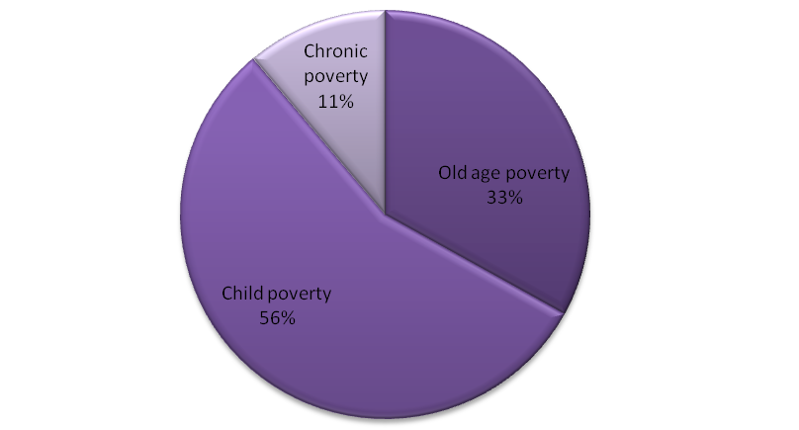

Source: Department of Home official record

The intermediate phase: 2001 to 2006
In 2001, a new government came in power. On 24th May 2002, CPIC presented a report on the status of the CTA poverty alleviation program to the new government along with some recommendations. The recommendations included requirement of written policy for proper implementation of the poverty program holistically in all India, Nepal and Bhutan. It also talked about the issue of unemployed youth and requirement of LPICs in continuous action to carry out poverty identification all around the year (Dolma 2011, personal interview). Thus, on 25th June 2002, first CTA poverty identification and alleviation policy was announced. Most of the provisions in the policy were drawn from the past poverty program but there were few major reforms. The first major reform was turning poverty program direct under administration of Kashag. The objective was to have Kashag better control over ongoing errors in poverty identification. The second major reform was the removal of the family benefits from the poverty program. The poverty welfares were provided only to the identified poor. It is because Kashag felt that unnecessary welfare to all family members increases dependency to welfare, work disincentive and results in the poverty trap. Such poverty discourse was very clear in policy’s problem statement and in conclusion (Kashag 2002, 2&6). The third major reform in the new policy was the introduction of new poverty category called “Unemployment led poverty.” Since CTA can neither control labor markets nor can create jobs, the problem of unemployment was rising in exile community in 1990s. Thus unemployed poor were incorporated into the poverty program. The forth major reform was the change in the members of LPIC. Educated members from civil societies like Tibetan Youth Congress, Tibetan Women Association, Cooperative societies and others were invited to form LPIC at the settlement level (ibid. 2). It is because Kashag views the constant errors in CTA poverty identification is due to favoritism and inefficient identification of poverty at the settlement level. Such opinion is indicated in the policy’s problem statement (ibid. 2).

Immediately, after the announcement of CTA poverty policy, fresh poverty identification was conducted in July 2002. The identification process involved first application from people to LPICs. The LPICs then studied each application, and those accepted were sent to CPIC. CPIC again reviewed applications by visiting each household and those applicants who found poor were further sent to Kashag for final decision. However, amidst of the identification process in October 2002, Tibetan Parliament in Exile, the Assembly passed a bill in which, poor identified by LPIC and CPIC under Kashag has to pass through Parliament standing committee for review (A.T.P.D 2002, 56-73). Few months later, the Assembly formed own poverty committees and were reviewing the poverty list identified by CPIC. At the same time, they were also identifying new poor, out from CPIC list.

On October 2003 in the midst of controversies, the Kashag came up with the list of identified poor that were already reviewed by Parliament standing committee and from 1st January 2004, CTA poverty welfare again resumed. Of total 13,103 applicants, 2,990 people (23%) were identified as poor. There were 1188 people from old age poverty, 1128 children from child poverty, 339 people from chronic ill poverty and 335 people from unemployed poverty (Dolma 2011, personal interview). However, the poverty review and new identification of poor by the parliamentary standing committee were still going on, and the number kept increasing. A year later, the parliamentary standing committee themselves caught into controversy regarding identification of poor and in March 2005, the parliament’s involvement in poverty review was withdrawn (A.T.P.D 2005, 15). The following year, on June 2006, the total poverty population identified by the assembly and Kashag together reached 6,186 people. There were 2294 people under old age poverty, 2344 children under child poverty, 751 people under chronic ill poverty and 797 people were unemployed poverty (Depart. Of Home, unpublished poverty documents). That was the highest poverty population since the beginning of the program. It accounted for 5.9% of total population according to TDS 2009.

This phase of poverty identification can be treated separately because, firstly, central power in CTA poverty identification shifted from CPIC to Kashag. Secondly, a written poverty policy came out during this time, although the structure and process for poverty identification were similar to the previous phase. Thirdly, new category of unemployed poverty was introduced in the program. However, no welfare support was provided to this category because there was no consensus on how to support unemployed poor. The CPIC wanted to give unemployed poor a lump-sum as grant to start their own business. However, Kashag was not confident with unemployed poor, if they are really going to invest govt. grant to create self-employment so, they propose a loan to unemployed poor. Since there is already a program for a skill training and loan provision for general unemployed people, this category of unemployed poor was removed later from the CTA poverty program.

The final phase: 2007 till now
As per Kashag’s decision to review the CTA poverty policy, on 10th July 2007, the CPIC submitted 15 point recommendations on the amendment of CTA poverty policy. In the recommendation report, three points were related to the poverty identification process while remaining thirteen points were on the implementation of the poverty alleviation program (CPIC 2007). Following CPIC recommendation, on 2nd April 2008, a revised CTA poverty identification policy was announced. The major changes in the new policy were, firstly, the introduction of new indicators for automatic exclusion from the CTA poverty program. The new policy introduced, households having two wheelers, car, fancy mobile phone, cabled television and own decent house are automatically excluded from the poverty program. Similarly, poor receiving cash transfers similar to CTA welfare from other sources are also excluded from the poverty program. Secondly, the policy dropped out category of unemployed poor from the poverty program because policy elites didn’t find a suitable welfare scheme for them under the poverty program. Thirdly, procedure for appointment of members of LPIC was revised from educated civil society’s representation to local election by settlement people themselves to increase accountability. This reform in LPIC is, however, not mentioned in the policy. Rest of the policy provisions like policy problem statement and objectives and poverty identification definition and indicators remain same since the introduction of poverty policy in 2002.

A poverty review was again conducted after the announcement of the new policy. However, after the review, CPIC has kept adding the new list of identified poor on the same database, until now. So, we don’t know how many poor were identified during that review but by September 2011, after three years of review, the total poverty population stands on 5,124 people out of which, 2011 people are old age led poverty, 2242 children are child poverty, and 871 are chronic ill led poverty.

Figure 3: Category wise distribution of CTA poverty population, 2011
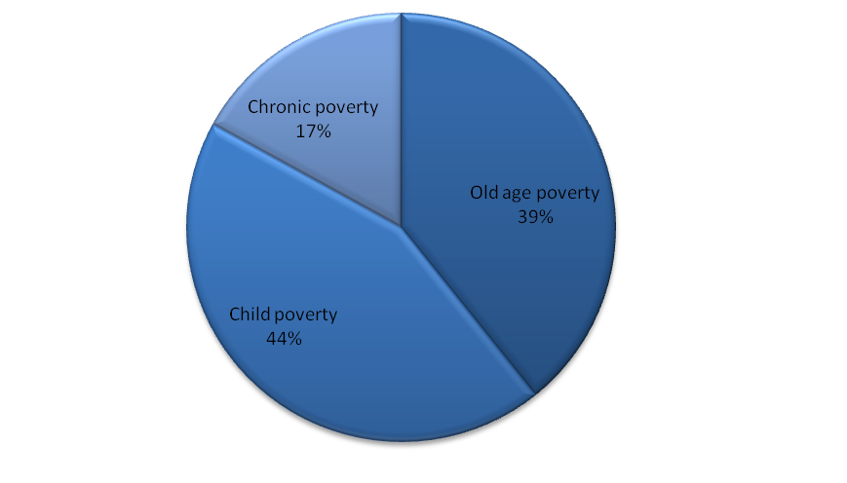

Source: Department of Home official record

The story so far…
To sum up, poverty in exile Tibetan community is very much related to economic freedom and opportunities available in the host countries but welfare of exile community doesn’t concern host countries because constitutionally, exile Tibetans doesn’t belong to the residing countries thus, Central Tibetan Administration (CTA) becomes the primary responsible for well-being of these people. Besides, CTA also has been consistently providing welfare to exile population since its inception. There are more than twelve welfare schemes provided by CTA through its various Departments to exile population. Three of such welfare schemes were later grouped to form poverty alleviation program in 1994. The program was then turned to federal program in 2002 with clear set out policy. The policy divides exile poverty into three categories based on the welfare schemes for identification purpose. They are Old age led poverty, Child led poverty and Chronic ill led poverty. There is a fourth category of Unemployment led poverty, which was introduced in 2002 but removed in 2008. There are other two programs for poor monks & nun and for poor ex-army, which are excluded from the mainstream poverty program for administrative convenience.

Over the past decades, there has been a steady increase in number of poor under the CTA poverty program, even though, policy’s definitions of poverty and criteria for identification of poor have remained exact same. When the first poverty program launched in 1997, there were 1,233 people identified as poor, which accounts for approx. 1.4% of exile population. The focus was more on Child poverty (56%). Now in 2011 with same definition and criteria, there are 5,124 people identified as poor, which is approx. 4.6% of exile population. The child poverty (44%) is decreasing due to either change in the focus of CTA or change in the nature of exile poverty. The poverty population remains highest during 1996, which almost touched 6% because Kashag and Parliament both were identifying poor in their own ways, but the population came down after withdrawal of parliament intervention from the identification. For details see the table 3.

Table 3: Year wise distribution of CTA poverty population
Year | POVERTY POPULATION |  |  |  |  | Exile population | % of pop under the poverty program
Year | Old age poor | Child poor | Chronic ill poor | unemployed poor | Total | Exile population | % of pop under the poverty program
1997 | - | - | - | 0 | 1,233 | 88,742 | 1.4
2000 | 679 | 1,146 | 229 | 0 | 2,054 | 95,982 | 2.1
2003 | 1,188 | 1,128 | 339 | 335 | 2,990 | 10,0326 | 3.0
2006 | 2,294 | 2,344 | 751 | 797 | 6,186 | 10,4671 | 5.9
2011 | 2,011 | 2,242 | 871 | 0 | 5,124 | 11,1911 | 4.6
Source: DoH unpublished poverty documents, CTA poverty database & Planning Commission, CTA TDS 09

Notes: 1) Exile population is interpolated from the two censuses conducted so far. The total exile population in India, Nepal & Bhutan in 1998 was 93,086 people and in 2009 was 109,015 people. Population increased in one year is calculated from the two censuses and imposed on the rest of year. 2) CTA doesn’t have a year wise data, so the paper only able to access data that are available.

Souce: DoH unpublished poverty documents, CTA poverty database. Notes: See the data detail in annexure
Figure 4: Settlement wise distribution of CTA poverty population, 2003, 2006 & 2011
However, the detail year-wise and settlement-wise distributions of poverty population do not confirm the broad picture of exile poverty trend. There is a big fluctuation of poverty population between and within the settlements (See figure 4). Some settlements like Herbertpur, Kamrao and Hunsur experienced less people being identified as poor over years whereas, settlements like Rawangla, Mandi and Shimla have experienced a sharp increase in poverty population. In some settlements, large numbers of people are identified as poor during 2006 and maintained the size over later years whereas other have dropped sharply. So, looking back at the past evolution of CTA poverty program, many issues come to surface like why overall poverty population is increasing despite same poverty definition and criteria for identification? Increasing population under poverty program is good because it increases coverage but is the program covering real poor? Why CTA is identifying very less number of people comparing to host countries like India? Why there is a high fluctuation in poverty identification in between time and places? Why Kashag and Parliaments identified poor differently despite same policy? Thus, the next chapter looks at all these questions along with the main research questions through in-depth analysis of CTA poverty policy.

Chapter 4

Research Analysis

Introduction
While looking at the past poverty population and its distribution across settlements, it is clear that CTA poverty program was passing through major difficulties in identification of poor. Both 2002 and 2008 poverty policies mentioned the challenges of poverty identification in exile community and admitted the occurrence of identification errors in the past poverty program. (Kashag 2008, 3;, Kashag 2002, 3). However, this paper finds that errors in CTA poverty identification are still evident now days, and the revised poverty policy has failed to achieve its objectives of reducing both exclusion and inclusion errors in poverty program. The paper argues that such errors are primarily caused by narrow policy definition of poverty and weak criteria for identification of poor within those three poverty categories. To elaborate above arguments, this chapter will outline three main sections. The first section analyzes the recent data on distribution of CTA poverty population to indicate errors are still prevalent and ongoing in CTA poverty identification. The second section focuses on CTA poverty policy and links it with the ongoing errors and controversies in poverty identification. It will explain how the narrow definition of poverty and weak identification criteria in the CTA poverty policy causes identification errors. The final section traces the institutional influences on CTA poverty policy formulation and analyzes how these institutional power and politics play a role in identification errors and who are responsible for errors of poverty identification. So basically, this chapter will first establish the existence of errors in poverty identification. It will then uncover the causes of errors and finally relate those causes to the institution of CTA to give a bigger picture on the problem of identification errors in exile community.

Errors in CTA poverty identification
So to begin with, the paper believes that problems of identification errors continue to exist even now, despite policy reforms in 2008. The paper doesn’t have figures to show errors rate in CTA poverty identification because such figures require huge household survey, which is not feasible under this MA thesis. However, the paper has collected enough secondary data on poverty population as well as well-being of exile community to show a possible indication of errors in CTA poverty identification. First of all, there is a huge variation in the percentage of population covered by poverty program across settlements, which indicate identification errors in the poverty program. Although variations are said to be common in any distribution but the variation here in poverty population across settlements is more than the variations in their level of well-being. Figure 5 shows the comparison between the levels of well-being in the settlement (Ordered from settlement with least well-being) and percentage of total population identified as poor. It is important to mention that percentage of total population here does not include monastic populations because, firstly, they are not eligible for the poverty program and secondly, their huge populations concentrated in few settlements distorts the demographic picture of that settlement.

Settlements | % of people having
Settlements | TV | Phone | Saving | Toilet | Light
Ladakh | 62 | 56 | 97 | 62 | 79
Nepal | 66 | 83 | 69 | 73 | 91
Tenzingang | 75 | 52 | 96 | 77 | 97
Bhutan | 63 | 62 | 87 | 97 | 89
Mundgod Doeguling | 86 | 81 | 43 | 91 | 99
Tezu &Tuting | 72 | 69 | 97 | 82 | 81
Kullu manali | 82 | 76 | 85 | 65 | 96
Orrisa Phuntsokling | 83 | 83 | 51 | 92 | 95
Bomdila Tawang | 77 | 69 | 89 | 78 | 91
Kamrao | 83 | 86 | 59 | 93 | 97
Mainpat Phendeling | 80 | 80 | 72 | 93 | 96
Kollegal Dhondenling | 88 | 89 | 53 | 95 | 100
Sonada | 88 | 78 | 100 | 60 | 100
Hunsur Rabgyaling | 91 | 91 | 54 | 95 | 100
Sataun | 91 | 88 | 72 | 85 | 98
Gangtok | 84 | 77 | 90 | 90 | 95
Darjeeling | 86 | 83 | 86 | 86 | 97
Rajpur | 85 | 78 | 92 | 91 | 95
Mandi | 81 | 79 | 92 | 95 | 100
Miao Chompheling | 90 | 72 | 98 | 93 | 98
Dekyi Larsoe | 93 | 91 | 71 | 97 | 99
Dharamsala | 81 | 90 | 96 | 86 | 100
Kalimpog | 91 | 85 | 96 | 84 | 98
Bandra Norgyaling | 93 | 89 | 73 | 100 | 100
Shimla | 92 | 87 | 99 | 79 | 100
Solan Bonshi | 79 | 87 | 100 | 92 | 100
Purwala | 88 | 85 | 91 | 96 | 99
Bir Chauntra | 95 | 88 | 89 | 88 | 100
Ling, Munduwala | 93 | 85 | 100 | 82 | 100
Bir Dege | 89 | 90 | 85 | 97 | 100
Bir Tibetan society | 91 | 84 | 90 | 98 | 100
Lugsam | 91 | 90 | 87 | 97 | 99
Dalhasousie | 90 | 86 | 95 | 95 | 99
Shilong | 95 | 95 | 86 | 94 | 99
Delhi samyeling | 87 | 93 | 95 | 96 | 100
Herbertpur | 93 | 85 | 98 | 96 | 99
Tashi Jong | 87 | 90 | 100 | 96 | 99
Poanta cholsum | 87 | 91 | 96 | 99 | 99
Clementown | 95 | 86 | 93 | 99 | 100
Dekeyling | 94 | 89 | 97 | 94 | 100
Rawangla | 90 | 89 | 100 | 98 | 100
Dimapur | 97 | 98 | 91 | 99 | 100
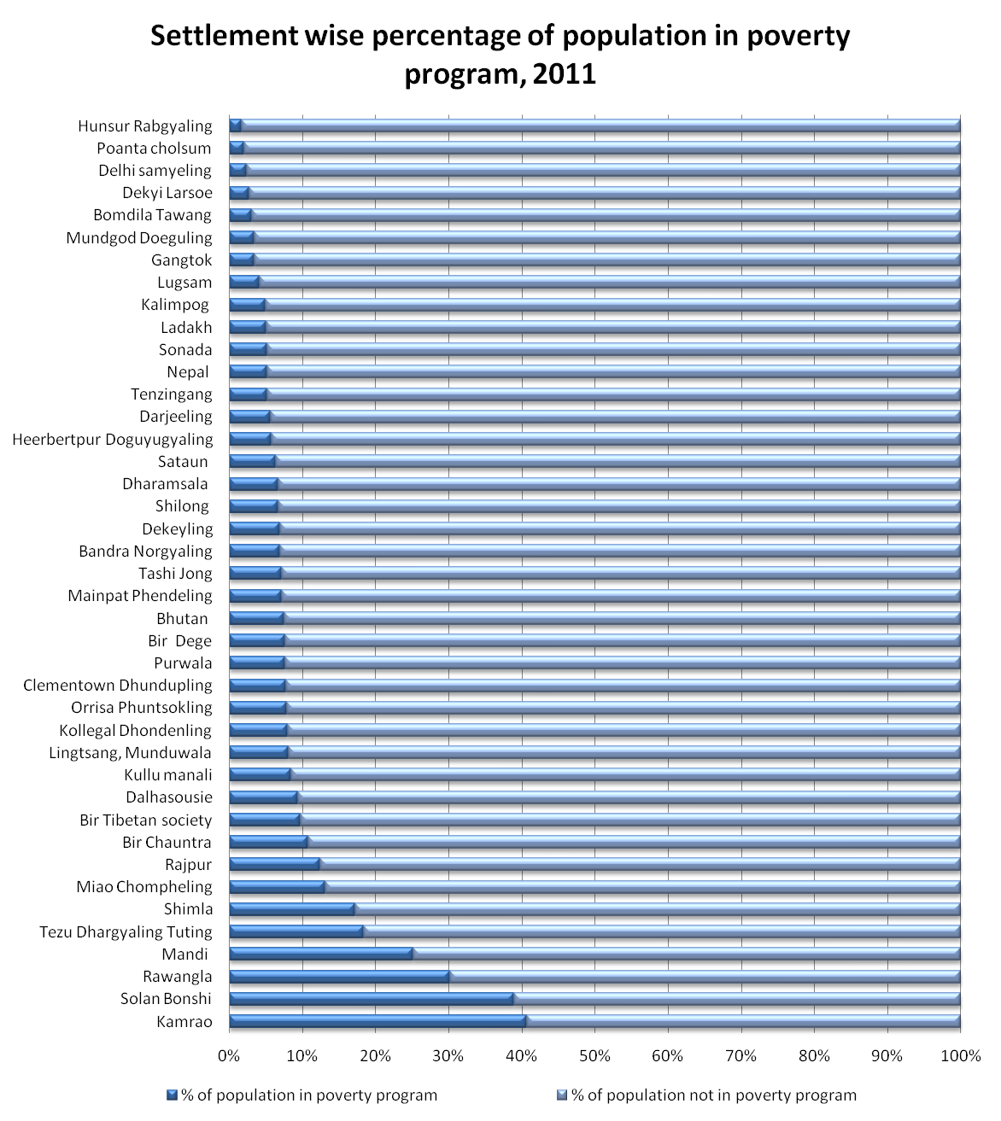
Figure 5: Settlement wise level of well-being and distribution of CTA poverty population, 2011

Source: Planning Commission, CTA TDS 09 Source: Dept. of Home, CTA poverty database 2011

The above comparison shows settlements in Ladakh, Nepal, Tenzingang, Bomdila and Hunsur, where almost half of the population doesn’t have phone, TV and almost quarter of population doesn’t have toilet and electricity, have only less than 5% of population identified as poor. On the other hand, settlements in Rawangla, Clementown, Bir Tibetan Socierty, Chauntra, Shimla, where all people have electricity, almost all households have saving, TV, Phone and Toilets, have a population more than 10% identified as poor. Although, the level of well-being across exile settlements is more or less equal (See the table in Figure 5) but there is relatively high variation in distribution of poverty population. Some settlements have 2% to 5%of their population identified as poor while others have 30% to 40%, which is more than 10 times higher. The average poor identified in a settlement is 6%. Thus, these poverty population distributions clearly indicate significant errors in CTA poverty identification.

A further relationship is tested between the level of well-being in various Tibetan refugee settlements and its percentage of population in the poverty program to see if there is any correlation between the two. Since all exile settlements have education, health centers and clean drinking water, the percentage of people having TV, Phone, Toilet, Electricity and Household saving are taken as indicators for well-being. The analysis reveals CTA poverty identification has no correlation with the level of well-being in the settlements (See figure 6). Correct poverty identification generally has a causal relationship between a level of well-being and poverty - high well-being lowers poverty population and vice versa. Poverty data, which doesn’t have this type of relationship, are generally not correct. So, CTA poverty data too can be treated with significant error.

Figure 6: Relationship between levels of well-being and distribution of CTA poverty population, 2011
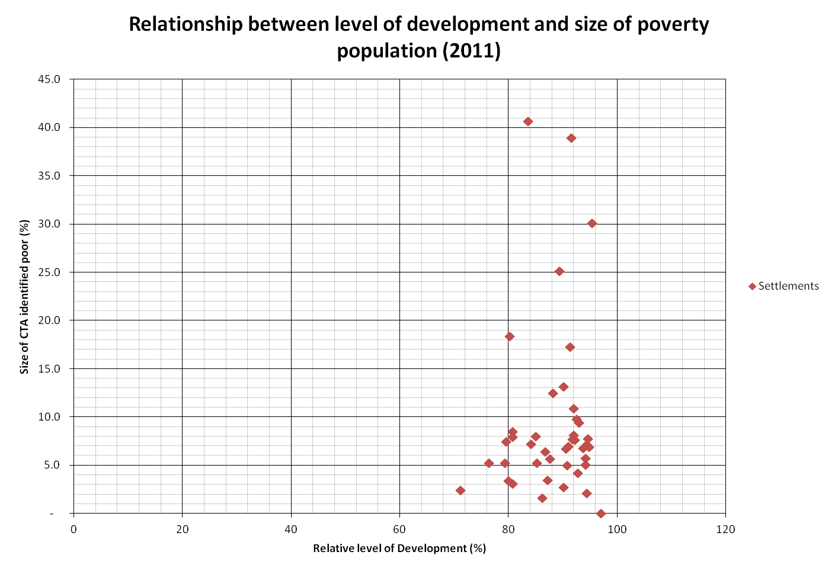
Source: Planning Commission, CTA TDS 09 and Dept. of Home CTA poverty database

The final evidence that suggests errors in CTA poverty identification is the pattern of poverty population with respect to distance from Dharamsala where the powers and influences are located. The CTA poverty identification process is bottom up, which means poor have to make the first move for poverty identification whereas poverty decision-making is top down, in which all final decisions are taken by Kashag and CPIC at Dharamsala. So, paper believes that it is easier for settlements nearer to Dharamsala to being identified as poor because they can approach directly to Departments. Although the CTA poverty identification process doesn’t entertain a direct approach to Departments but people do frequently visit departments for support, and since CTA poverty identification more arbitrary, personal visit seems to be making a difference in identification of poverty. People far away from Dharamsala cannot approach CPIC and departments so, for them “No” by LPIC is “No” for the rest of their life. The figure 7 shows a poverty mapping of exile Tibetan population in India, Nepal and Bhutan. It is shaded according to the aggregate percentage of poor to the total population in the area. The poor here referred to CTA identified poor. The distribution of poverty population somehow exactly follows the pattern assumed above in the argument except Arunachal Pradesh, Sikkim and Delhi. The settlements in Ladakh (J&K) being nearer to Dharamsala have only 3% to 6% of poor population because they are located in rugged terrain and remote Himalayan ranges thus, have low mobility.

Figure 7: Poverty mapping of exile community in India, Nepal & Bhutan, 2011
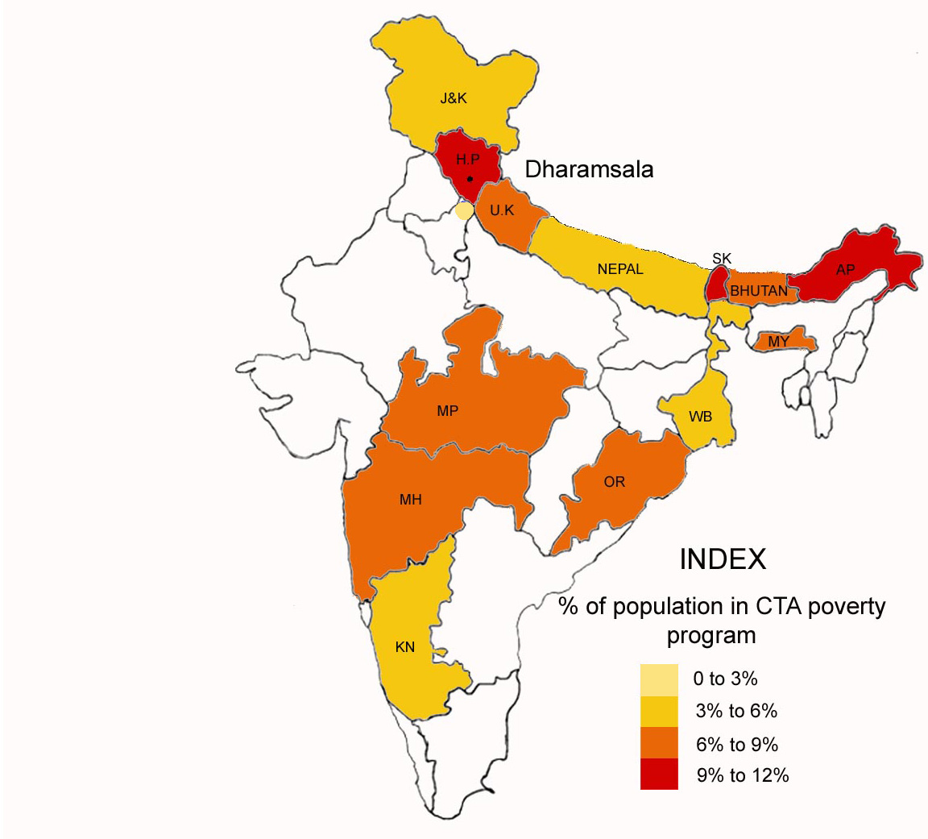
Source: Data from CTA poverty database

Thus, the above three evidence support the first argument that errors in CTA poverty identification still persist, and the past policy reforms have failed to reduce errors in poverty identification. Since poverty is broadly defined as deprivation of well-being and if distribution of poverty is not functional to level of well-being then, it can be called as error or as external errors. The above analysis reveal, existing CTA poverty population is not distributed according to the level of wellbeing rather it is distributed according to distances from the power. Some may criticize the well-being indicators selected above are either too narrow or irrelevant to poverty distribution. The paper, however, found only these data available for analysis and argues that no matter how narrow the well-being criteria are, it should have a certain relationship with poverty distribution irrespective of clarity. The paper also insists that people living in exile community can just tell that settlements in and around Dharamsala are more prosperous than the rest of the settlements, yet they have the highest number of poor identified from 9% to 12%. So based on above reasons and evidence, paper claims that there are indications of errors in CTA poverty identification and these errors seems significant. Detail research can be carried on above evidence to further strengthen the claims. As the indication of errors in CTA poverty identification is established, the paper now looks into the cause of such errors.

Causes of errors in CTA poverty identification
The policy being norms and rules for implementation of an action, the section analyzes poverty policy to understand the causes of identification errors in exile community. The paper argues that overall, narrow targeting and weak criteria for identification in the CTA poverty policy cause errors. Generally, narrow targeting always creates identification errors because when a policy targets fewer sections of people, some of the targeted people automatically get eliminated along with non-targeted people. This is inevitable according to Universalism against Targeting social policy but in exile context, narrow targeting is more than a process led errors. It deliberately excludes some section of poor, out of the policy definition of poverty. So, it is an error external to the definition of poverty. Similarly, CTA poverty policy also suffers from lack of clear focus on exile poverty that directly affects the selection of criteria for identification of poor, and ultimately results in errors. This section will first discuss issues related to narrowing targeting followed by weak criteria for poverty identification.

According to World Bank official website (2011), the host countries India has 29% of population living in poverty, Nepal has 42% of people in poverty and Bhutan showing n/a but other source estimates 25% of population living in poverty (World Bank. 2011, 1). However, CTA estimation of poverty in exile community is only 4.6%, which is relatively very low. It is difficult to relate one to one the exile poverty with the host countries because poverty definition, criteria and unit of identification are all different. So, the meaning of poverty by host government is different from the meaning of poverty by CTA and these differences in both numbers of poverty population as well as the definition of poverty indicates how narrow the CTA poverty identification is.

However, there are reasons for exile poverty population being small because as mentioned earlier, there are many non-governmental organizations in exile community including monasteries, which have their own social policy and provide welfare to their members. They account for more than 20% of exile population and they are generally not covered under the CTA poverty program. Besides, the rural socio-economic condition in exile community also seems slightly better than host countries because looking at India’s BPL census 2002 Scoring Scheme, many of the Tibetans may find themselves non-poor. However, the difference in the poverty population between host countries and exile community is too high to justify with above reasons. So, the paper claims errors in CTA poverty identification and believes that narrow identification of poverty by CTA has led to smaller poverty population rather than better quality of life by exile community.

Narrow poverty identification in exile community can be more clearly explained by analyzing CTA policy definition of poverty. Theoretically, CTA defines poor in the policy as “Person… presently has neither adequate income… nor has any future source of income… without external support (that person) is difficult to survive” (Kashag 2008, 8). However, practically, CTA simply identifies only three sections of people as poor, and they are Old people, who can’t engage in economic activity, b) Chronic ill people, who also can’t engage in economic activity and c) Children, whose parents can’t effort to provide them education and other basic health care and they themselves can’t engage in economic activity. So basically, CTA perceives only those as poor, who are physically not capable of earning income. This is the real meaning of poverty in CTA policy, which is very narrow. Unlike host countries, where poverty is defined by estimating certain minimum income to meet all basic needs from food, clothes, shelter, educational and medical care, CTA policy definition of poverty narrowly focuses on physical capability of an individual to engage in economic activity. The policy implicitly says that if a person is able-bodied, she/he is not poor. Such a strict and narrow definition of poverty overlooks multi-dimensional characteristic of poverty. First of all, the policy definition doesn’t consider the basic minimum needs required for decent life. Secondly, it doesn’t consider properly the capability of individual if she/he is achieving those basic minimum needs or not. Finally, it doesn’t consider the structural issues like social exclusion in poverty and assumes all able-bodied have the equal opportunity to livelihood, which is very naïve. Thus, all working poor, especially farmers, carpet weavers and all newly-arrived Tibetans who are able-bodied but earn little income due to low skill and low economic opportunities are all excluded from CTA poverty definition. Such exclusions are external error caused by narrow definition of poverty in CTA policy. Besides, CTA poverty policy identifies individual as a unit of measurement. So in a family, a father can be identified as poor but mother and children are not, which is again narrow.

Understanding narrow definition is also important because many of the controversies in CTA poverty identification are caused by unclear and narrow poverty definition. Firstly, CTA policy narrowly identifies poverty as old age, chronic ill poverty and child poverty and above all, there is no clear definition of what is meant by chronic ill poverty and child poverty. On the other hand, people in general tend to view poverty based on income, expenditure and assets. If one is having a below average living standard in a settlement, s/he is considered as poor. People don’t look at whether they are above the age 65 or chronic ill to consider themselves as poor. For example, a parliamentarian argues in a session that an unemployed divorced mother with small children deserves poverty benefits more than her old mother (A.T.P.D 2009, 112-113), which according to policy definition is not correct. Thus, it creates confusion, criticism and dissatisfaction on the poverty program.

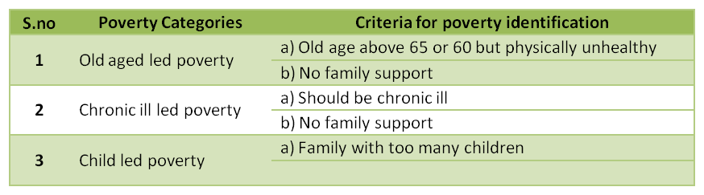
Table 4: CTA Poverty categories and its identification criteria, 2008
Source: CTA Poverty Policy, 2008, 5
to support

Within the narrow definition of poverty, the paper argues that weak criteria for poverty identification further fail to identify those smaller targeted sections of poor. This can be explained very clearly by referring back to CTA poverty policy. The above table 4 shows, CTA poverty categories and its identification criteria in the policy. The first criterions of the first two poverty categories seem acceptable but their second criterion “No family support” is vague. It doesn’t specify what kind of family support to the poor. During the field work, the researcher visited many identified poor in these two categories. Those without any family support are really poor with no proper house, no assets and no sustainable income, whereas there are many other identified poor, who lives in a family or supported informally by separated family members or relatives. They are economically much better and do not look poor. There is a big difference between identified poor with family support and identified poor without family support. Unfortunately, CTA poverty identification criteria fail to differentiate the two. Surprisingly, the third category doesn’t even have a clear identification criterion. There is neither threshold on children size nor on income. In fact, there is no income criterion for poverty identification in any of three poverty categories. Although money metric measurement of poverty is widely criticized for its errors but after all, the concept of poverty should have some relationship with the income because we cannot call a person with high income as poor. In exile context, due to lack of economic characteristics in poverty thresholds, old people and chronic ill people from well-off families easily get into the poverty program.

Some may argue that the situation of poverty is dynamic and multi-dimensional, so a hard-and-fast rule for poverty identification may create more errors. It may be right not to have a strict poverty line, but the paper argues that arbitrary nature of poverty threshold reduces transparency and identification errors becomes very difficult to evaluate thus, it remains for very long time. Few weeks back, Government of India introduced a new poverty line of Rs 26 a day for rural area and Rs 32 a day for urban area (Utsa Patnaik. 2011, 1). Although these identification criteria are very low and may create huge external errors, but these poverty thresholds are very loud and clear, so, it led to direct criticisms from all parts of the country and few months later, government had to rethink on the poverty line. However, in exile context, there is no possibility of direct criticism because identification criteria are vague and arbitrary. The exile community is experiencing identification errors since the launch of the poverty program in 1994 and yet there is no direct criticism on policy definition and identification criteria so far. The researcher met a family during field work, who has applied for poverty welfare to their children. Unfortunately, their application was rejected and were told that if they cannot look after children, then why they produced them. The family then asked the researcher about the identification criteria for “child led poverty” category, so that they can approach again. The fact is there are no specific criteria, and it is arbitrary.

There are, however, few clear exclusion criteria, e.g., families with cabled TV, motor bike, car and fancy phones are automatically excluded from the poverty program but surprisingly almost all identified poor visited during survey have cable TV and some have motor bikes. So now the question is, does CTA know about these identification errors? Why do CTA still follow narrow poverty identification? To understand the bigger picture of CTA poverty identification errors require analysis on the institution of CTA by focusing on structure and evolution of poverty policy and program.

The institutional roles on errors in poverty identification
Technically, identification of poor has to be based on the firm knowledge of poverty in a society. Indian poverty identifications are drawn from household consumer expenditure collected by the National Sample Survey Organization (NSSO). In exile context, no such studies are being done because policy elites consisting of Kashag and CPIC seem indifferent to exile poverty issue. Instead, they informally use their own perspective of knowledge to identify poverty. Thus, paper argues that Kashag has so far done little to understand and resolve the issue of identification errors. Unlike other governmental institutions, where social policy forms a major stake for a political player to remain in power, exile poverty program has no such stake in their political process. Lack of political will from policy elite towards poverty program results in continuous errors. To support the argument, the section will first discuss evidence on Kashag and CPIC being indifferent towards the exile poverty program, followed by reasons behind it.

First of all, the exile poverty program was launched with an instruction from His Holiness private office in 1994 (Kashag 2008, 2). It was never a self-initiated Kashag program. When Kashag was planning its first poverty program, they never put effort to understand who are poor in exile community, why they are poor and what support they need, rather they just cut and paste the ongoing departmental welfare schemes to form a new poverty program (see page 19). So, all these years, Kashag has been implementing the same poverty program without major changes. Socio-economic situation in exile community is significantly changing but CTA’s poverty definition, categories and identification criteria have remained same for last 17 years. There is no update, no evaluation on CTA poverty policy and program and above all there are no records of year-wise past poverty population in the database to check if poverty population is increasing or decreasing . So, all these evidence show Kashag’s indifferent attitude towards the poverty program.

Reason for low motivation of Kashag in the poverty program is the low significance of social policy in the overall exile political power struggle. Unlike host countries, where government elections run on social policies and poverty policies, such election manifestations does not exist in exile community. The exile democracy doesn’t have a political party system so, when an individual candidate is elected for ministerial positions, s/he is judged by her/his past public image rather than the future election manifestation. So, policy elite’s social policy makes a little impact on their political career. Besides, exile community has more pressing issues of continuing dialogue with China and securing international support for Tibetan struggle movement, so social issues like poverty become less important and significant to these powerful actors.

Secondly, political economy of CTA also somehow reduces the significance of social policy in overall exile political process. CTA on average receives only 25% of its funds from exile population, 25% from His Holiness private office and remaining 50% of funds from foreign donors. Welfare and development expenditure constitutes more than 75% of foreign funds. (Dept. of Finance 2010, iv). So unlike host countries, where people have more voices on government social expenditure because money comes from people’s taxes, CTA’s fund for social expenditure comes from international donors so, exile population has less say on this issue. For example, from 2003 to 2007, CTA identified some 800 people as unemployed poor, but they were never provided any welfare and in 2008, they were all removed from the poverty program. Surprisingly, there was no voice against such decision. People often talk about errors in poverty identification but nobody openly criticizes CTA. The bottom line is such behavior reduces pressure on institutional agencies like Kashag and CPIC and makes the poverty program insignificant. Besides, CTA also doesn’t receive conditions from funding agencies on welfare funds so, they are less accountable for an outcome.

Generally, exile parliament has the upper hand in distribution of CTA budget. They review and sanction the overall budget of each program but it is Kashag, who do the initial distribution of where to spend and how much to spend in CTA budget thus, practically they are more powerful. Like all other policy elites, they too are attracted to programs, which have a higher return. In the past, Kashag has invested heavily in research studies and infrastructure building for the Organic farming project. Although the organic farming project is meant for poverty alleviation, but it is the economic, social and political return of the organic farming project that attracted exile policy elites. On the other hand, almost no budget is spent on research studies and infrastructure building for the poverty program. All CPIC and LPIC members are part time staffs. CPIC members have an own job description in their respective Departments. Poverty identification is just an extra work given to them. So, their interest and focus lies in their departmental work rather than the poverty program. LPICs are also part time elected local people. They are supposed to have true knowledge of local poverty, but they have no power to influence decisions-makings so, they mostly remain unaccountable without power.

Due to overall negligence on the poverty program, very little is known on nature and causes of exile poverty. So, policy elites came up with their own stereotyped discourse on a work disincentive. It is felt during the interviews that many of CTA officials have neo-liberal approach to explain poverty, as they explain poverty is because of their wrong decisions and less hardworking. However, poor people view themselves as powerless with minimum economic opportunities. So this structural element of poverty is missing in the policy elite’s discourse on poverty. As saying goes with the politics of truth, policy elites being more educated and powerful, their discourse become policy and it further reduce the scope of poverty program, making poverty issue less significant in exile community. Moral judgment on poor led to narrow definition and identification of poverty. CTA policy elites believe, if coverage of poverty welfare is increase, poorer section will not work, which is not true (See literature review, page 7).

Parliamentarians are the only powerful actors in CTA, who focus on poverty welfare to build their public image for election. They proactively involved in poverty identification in 2003 but unfortunately, they failed and sidelined since then (see chapter 1). However, as poverty issues are still in their interest, they keep raising poverty issues and asking question to Kashag on identification errors. So, this force makes exile poverty keeps moving ahead but slowly. Overall, it is because of unique exile political system that social policy and particularly poverty program are receiving less attention from policy elites, which discourages studies on poverty. With little information on causes and nature of the exile poverty, policy elites then come up with own discourse on poverty, which ultimately distorted and downsized the exile poverty.

Chapter 5

The Conclusion

The paper presents the issues surrounding CTA poverty identification in exile Tibetan community. The identification of poor is a big challenge for CTA since the beginning of the poverty program in 1994. It is often encircled by controversies of exclusion and inclusion errors. In 2002 and 2008 poverty policies, CTA admits prevalence of identification errors in the poverty program and made few reforms each time to eliminate these errors. The paper, however, argues that despite all these reforms, errors continue in CTA poverty identification. The paper finds that distribution of CTA poverty population in exile community is not correlated to level of well-being in settlements. It is rather influenced by its distance from Dharamsala. The paper finds more poor identified in and around Dharamsala and poverty population decreases as move away on Dharamsala. The paper also experiences high fluctuation in the distribution of CTA poverty population across Tibetan refugee settlements against relatively equal socio-economic development. Thus, assuming significant identification errors in CTA poverty program, the paper makes two important arguments.

Firstly, both 2002 and 2008 poverty policies indicate, errors in CTA poverty identification are caused by favoritism and irresponsibility of LPICs, which saw the frequent change in the composition and selection process of LPICs. While looking at the existing distribution of poverty population, the paper, however, disagrees that although LPICs may be causing errors, but they are not the main causes of errors because even after reshuffling of LPICs twice in 2002 and 2008, errors continue in CTA poverty identification. The paper argues that CTA’s narrow policy definition of poverty accompanied by weak identification criteria are the main reasons for errors in CTA poverty identification. This narrow definition and identification of poverty not only exclude sections of targeted poor internally along with a non-targeted population, but it also externally keeps large sections of poor out from the definition of poverty. The policy narrowly defines poor as individual, who are physically not capable of earning income. So, all working poor, e.g., farmers, carpet weavers and all newly arrived Tibetans who are able-bodied but earn very little income due to lack of skills and low economic opportunities are all excluded from CTA poverty definition. Weak criteria for poverty identification are also responsible for errors as it lack an economic characteristic, whereby non-poor easily get into poverty program. The third poverty category “Child led poverty” doesn’t even have an explicit identification criterion. Thus, lack of clear and robust identification criteria provides spaces for manipulation in poverty identification resulting in errors.

The bigger issue in the CTA poverty program is that, the identification errors are going on from very long time in exile community because the same narrow poverty definition and weak criteria were there since the beginning of the poverty program. So, the questions arise, e.g., Does CTA know about these errors and why the poverty definition and criteria were not updated despite a significant change in the exile socio-economic situation. Thus, the paper’s second argument asserts, although poverty alleviation is considered one thrust area in CTA Integrated Development Plans, welfare part of the poverty alleviation is vastly overlooked so far. Policy elites have done very little to understand and resolve the identification errors. The paper argues that Kashag has acted very little to the strengthen poverty program because of its political insignificance in exile context. Since government election in exile is not run on social policies, poverty programs give a little benefit to policy elites. Besides, people in exile community also have fewer voices on CTA’s social expenditure. Thus, there is also no pressure on policy elites to focus on the poverty issue. Instead they use discourse of a work disincentive to divert the issue. CPIC and LPIC, who are the other two actors in the CTA poverty program also have done little to resolve this issue because, firstly, they are all part time members and secondly decision-making in poverty identification is highly centralized.

Thus based on the exile experiences, the paper strongly believes that poverty identification errors may be seen as a technical issue e.g., imperfect access to information, wrong targeting methods and narrow definition of poverty as discussed in the literature review but beneath the technical issues lie a institutional issue, which is the interaction of various powerful actors and their construction of knowledge shape policy and influence the technical choice of policy making. These institutional issues are mostly unseen but can be analyzed by focusing on who has the power, how power is exercised, what is the source, what benefit drives from it and for whom. In exile context, it is the lesser political benefits that policy elites exempt their power exercise from poor welfare to others, where there is a higher return. On the other hand, exile parliamentarians benefit from poverty issues and exercise their full power, but they have lesser influences to make a difference.

So to conclude, the paper assumes that social policy, particularly poverty welfare is very important for exile Tibetan situation. Tibetans fled their country to fight for homeland back from exile so, well-being of exile Tibetans population is vital to sustain the Tibetan freedom movement against Chinese occupation. In 1960s, when Tibetan first came to exile, rehabilitation and universal welfare in education, health care and livelihood sustainability were highly prioritized however, post rehabilitation era turned CTA focus towards higher level of development activities with little attention to welfare of those poor, who couldn’t catch up with the rest of exile population. They continue to remain vulnerable and way away from Tibetan struggle movement. So, to strengthen the exile movement, we need a stronger welfare system with bigger coverage to larger section of poor. Work disincentives as proposed by CTA policy elites are not all true. The paper argues that past policy reforms made by Kashag were not enough to reduce errors because they are not based on ground realities or experiences of poor rather they are guided by policy elites own perspective of knowledge on exile poverty. Thus, the paper urges CTA for a thorough poverty study on exile Tibetan community and then reform poverty policy and program as per findings and experiences of poor. It is hoped that a comprehensive poverty study on exile Tibetan community will definitely resolve to the issue of identification errors to some greater extent.

Finally, the paper admits that it has failed to incorporate the views of former Prime Minister of exile Tibetan government Prof. Samdong Rinpoche and Finance Minister Mr. Tsering Dhundup la, who were the two masterminds in the formulation of CTA poverty policy. The fieldwork coincides during the period of government change in early September 2011, thus researcher couldn’t get the opportunity to interview above two influential people. However, any future research on early CTA poverty policies should seek their experiences and ideas as they have a larger perspective on the background of CTA poverty policy and may provide deeper understanding for the research.

Reference
A.T.P.D (2009) '8th Session of 14th Assembly of Tibetan People Deputy', No. 04, Dharamsala: Nathang press.
A.T.P.D (2005) '8th Session of 13th Assembly of Tibetan People Deputy', No. 31, Dharamsala: Narthang press.
A.T.P.D (2002) '3rd Session of 13th Assembly of Tibetan People Deputy', No. 3, Dharamsala: Narthang press.
Bibi, S. and J. Duclos (2007) 'Equity and Policy Effectiveness with Imperfect Targeting', Journal of Development Economics 83(1): 109-140.
Block, F. and M. Somers (2003) 'In the Shadow of Speenhamland: Social Policy and the Old Poor Law', Politics & Society 31(2): 283- 323
Butler, A. (2003) Feminism, Nationalism and Exiled Tibetan women. New Delhi: Kali for Women.
Caniglia S. Alan (1996) 'How Large are welfare’s Work Disincentives?', International Journal of Social Economics 23(9): 61-68.
Coady, D., Grosh M. and J. Hoddinott (2004) 'Targeting Outcome Redux', World Bank Research Obsever 19(1): 61 - 85.
Coady, Grosh and Hoddinott (2004) 'The Targeting of Transfers in Developing Countries: Review of Experience and Lessons', International Food Policy Research Institute (IFPRI), World Bank .
Conway, J.S. (1975) 'The Tibetan Community in Exile', Pacific Affairs 48(1): 74-86.
Cornia, G.A. and F. Stewart (1993) 'Two Errors of Targeting', Journal of international development 5 (5): 459- 96
Denyer, S. (Last updated 2008) 'In Bhutan, Tibetan Refugees Yearn to Join Protests' (a webpage of Reuters). Accessed 13 November 2011 <http://www.reuters.com/article/2008/04/01/idUSDEL251885>.
Department of Home (1992) 'Life in Exile', Dharamsala: Tibetan Computer Resouce Center (TCRC).
Dept. of Finance (2010) 'CTA Planned Budget 2010 - 2011 '. Dharamsala: Department of Finance.
DIIR (2002) 'His Holiness Speech on 3rd Session of 13th Assembly of Tibetan People Deputy' Tibetan Freedom, 42. 25th March 2002, p. 1.
Dutrey Alexander Peyre (2007) 'Successful Targeting? Reporting Efficiency and Costs in Targeted Poverty Alleviation Programmes', Social Policy and Development Programme, Geneva: UNRISD. Paper Number- 35
Gans, J.H. (1994) 'Positive Functioning of Undeserving Poor, use of Underclass in America', Politics & Society 22(2): 269-283.
Ghosh, J. (2010) 'Poverty Reduction in China and India: Policy Implications of Recent Trends', United Nations Department of Economic and Social Affairs DESA Working Paper No. 92.
Grosh, del Ninno, Tesliuc and Ouerghi (2008) 'For Protection & Promotion: The Design and Implementation of Effective Safety Nets'. Washington DC: The International Bank for Reconstruction and Development, The World Bank. <http://siteresources.worldbank.org/SPLP/Resources/461653-1207162275268/For_Protection_and_Promotion908.pdf>.
Hirway, I. (2003) 'Identification of BPL Households for Poverty Alleviation Programmes', Economic and Political Weekly 38(45): 4803-4808.
International Observatory on Statelessness (Last updated 2011a) 'Bhutan' (a webpage of The International Observatory on Statelessness). Accessed October 24 2011 <http://www.nationalityforall.org/bhutan>.
International Observatory on Statelessness (Last updated 2011b) 'Nepal' (a webpage of The International Observatory on Statelessness). Accessed October 24 2011 <http://www.nationalityforall.org/nepal>.
Kashag (2008) 'CTA Poverty Identification and Alleviation Policy'. Dharamsala: Central Tibetan Administration (CTA).
Kashag (2002) 'CTA Poverty Identification and Alleviation Policy '. Dharamsala: Central Tibetan Administration (CTA).
Kidd, S. (Last updated 2008) 'Universal Values:Universal Social Protection' (a webpage of Director of Policy and Communications HelpAge International). Accessed 06/14 2011 <http://www.eclac.org/dds/noticias/paginas/2/36122/StephenKidd.pdf>.
Lavallee, Olivier, Pasquier-Doumer and Robilliard (2010) 'Poverty Alleviation Policy Targeting: A Review of Experiences in Developing Countries', Institut de Recherche pour le Development, Dauphine Universite Paris : 1- 29 http://www.dial.prd.fr/dial_publications/PDF/Doc_travail/2010-10.pdf.
Lobo, C. (2008) 'Institutional and Organizational Analysis for Pro-Poor Change: Meeting IFAD’s Millennium Challenge'. Rome: International Fund for Agricultural Development.
Marjorie, K.M. (2005) 'Poverty, Charity, and Coercion in Elizabethan England', Journal of Interdisciplinary History xxxv(3): 457–479.
McGee, R. and K. Brock (2001) 'From Poverty Assessment to Policy Change: Processes, Actors and Data', Institute of Development Studies Working paper 133.
North, D.C. (1991) 'Institutions', The Journal of Economic Perspectives 5(1): 97-112.
Ortiz, I. (2007) 'Social Policy', United Nations National Development Strategies Policy Notes, New York, United Nations Department of Economic and Social Affairs (UNDESA), http://papers.ssrn.com/sol3/papers.cfm?abstract_id=1001486
Pasma, C. (2010) 'Working through the Work Disincentive
', International Jounral for Basic Income Studies, 5(2).
Planning Commission, C. (2010) Demographic Survey of Tibetans in Exile. Dharamsala: Planning Commission, CTA.
Plowright, A. (Last updated 2010) 'Fewer Tibetans Fleeing to the Dalai Lama' (a webpage of Tibet Sun). Accessed October 7, 2011 2011 <http://www.tibetsun.com/features/2010/07/25/fewer-tibetans-fleeing-to-the-dalai-lama/>.
Saith, A. (2007) 'Downsizing and Distortion of Poverty in India: The Perverse Power of Official Definitions', Indian Journal of Human Development 1(2): 247-282.
Sundaram, K. (2003) 'On Identification of Households Below Poverty Line in BPL Census 2002: Some Comments on the Proposed Methodology', Economic and Political Weekly 38(9): 896-901.
Swaminathan, M. and N. Misra (2001) 'Errors of Targeting: Public Distribution Food in a Maharashtra Village 1995 -2000', Economic & Political Weekly 36(26): 2447-2542.
The Hindu (Last updated 2005) 'Nurturing a Dream of Returning Home' (a webpage of The Hindu). Accessed October 7, 2011 2011 <http://www.hindu.com/lf/2005/05/26/stories/2005052614240200.htm>.
Utsa Patnaik (Last updated 2011) 'How Little can we Live on?' (a webpage of The Hindu). Accessed October 7, 2011 2011 <http://www.thehindu.com/opinion/lead/article2497773.ece>.
Woodcock, G. (1970) 'Tibetan Refugees in a Decade of Exile', Pacific Affairs 43(3): 410-420.
World Bank (Last updated 2011) 'South Asia: Data. Project and Research' (a webpage of World Bank). Accessed October 30 2011 <HASIAEXT/0,,paghttp://web.worldbank.org/WBSITE/EXTERNAL/COUNTRIES/SOUTePK:158889~piPK:146815~theSitePK:223547,00.html>.
Zeigler Jenifer (Last updated 2011) 'Poor Decision for Poor' (a webpage of CATO Institute). Accessed September 17 2011 <http://www.cato.org/pub_display.php?pub_id=3680>.

Appendices

Appendix A: CTA poverty database, year wise, settlement wise and category wise

Sno | Settlements | January 2004 |  |  |  |  |  | June 2006 |  |  |  |  |  | September 2011
Sno | Settlements | Poverty Categories* |  |  |  | Total |  | Poverty Categories* |  |  |  | Total |  | Poverty Categories* |  |  | Total
Sno | Settlements | B | C | D | E | Total |  | B | C | D | E | Total |  | B | C | D | Total
1 | Bir Dege | 24 | 4 | 2 | 0 | 30 |  | 48 | 6 | 11 | 4 | 69 |  | 31 | 10 | 14 | 55
2 | Bir Tibetan society | 6 | 7 | 2 | 4 | 19 |  | 13 | 9 | 3 | 6 | 31 |  | 19 | 16 | 5 | 40
3 | Bir Chauntra | 14 | 7 | 2 | 7 | 30 |  | 31 | 9 | 9 | 16 | 65 |  | 28 | 14 | 14 | 56
4 | Tashi Jong | 0 | 0 | 0 | 0 | 0 |  | 1 | * | * | * | 1 |  | 12 | 3 | 1 | 16
5 | Dalhasousie | 21 | 1 | 7 | 2 | 31 |  | 24 | 14 | 3 | 8 | 49 |  | 22 | 17 | 9 | 48
6 | Dharamsala | 125 | 102 | 51 | 52 | 330 |  | 113 | 205 | 112 | 104 | 534 |  | 119 | 266 | 172 | 557
7 | Kullu manali | 32 | 2 | 7 | 16 | 57 |  | 36 | 4 | 13 | 51 | 104 |  | 54 | 13 | 29 | 96
8 | Poanta cholsum | 3 | 0 | 3 | 4 | 10 |  | 5 | * | 4 | 6 | 15 |  | 4 | 4 | 3 | 11
9 | Purwala | 11 | 6 | 2 | 2 | 21 |  | 20 | 13 | 4 | 10 | 47 |  | 17 | 9 | 5 | 31
10 | Sataun | 6 | 3 | 2 | 0 | 11 |  | 4 | 5 | 3 | * | 12 |  | 5 | 4 | 2 | 11
11 | Shimla | 11 | 22 | 4 | 0 | 37 |  | 100 | 177 | 18 | * | 295 |  | 75 | 93 | 14 | 182
12 | Solan Bonshi Dolanji | 28 | 12 | 4 | 6 | 50 |  | 47 | 18 | 15 | 16 | 96 |  | 32 | 24 | 25 | 81
13 | Mandi | 6 | 0 | 5 | 2 | 13 |  | 60 | 46 | 13 | 3 | 122 |  | 45 | 48 | 12 | 105
14 | Kamrao | 28 | 7 | 6 | 10 | 51 |  | 27 | 24 | 11 | 21 | 83 |  | 20 | 18 | 8 | 46
15 | Delhi samyeling | 17 | 15 | 9 | 8 | 49 |  | 11 | 34 | 12 | 17 | 74 |  | 8 | 30 | 12 | 50
16 | Ladakh | 33 | 51 | 41 | 20 | 145 |  | 345 | 54 | 102 | 64 | 565 |  | 246 | 33 | 61 | 340
17 | Heerbertpur Doguyugyaling | 20 | 6 | 4 | 11 | 41 |  | 12 | 8 | 5 | 8 | 33 |  | 11 | 17 | 3 | 31
18 | Lingtsang, Munduwala | 6 | 3 | 1 | 0 | 10 |  | 15 | 5 | 1 | 4 | 25 |  | 12 | 2 | 2 | 16
19 | Rajpur | 19 | 11 | 9 | 1 | 40 |  | 36 | 32 | 17 | 17 | 102 |  | 34 | 30 | 15 | 79
20 | Clementown Dhundupling | 30 | 9 | 5 | 1 | 45 |  | 45 | 35 | 11 | 2 | 93 |  | 39 | 22 | 11 | 72
21 | Dekeyling | 33 | 27 | 22 | 5 | 87 |  | 90 | 72 | 27 | 8 | 197 |  | 93 | 109 | 24 | 226
22 | Mainpat Phendeling | 16 | 4 | 5 | 4 | 29 |  | 25 | 30 | 15 | 6 | 76 |  | 23 | 29 | 13 | 65
23 | Bandra Norgyaling | 17 | 0 | 7 | 9 | 33 |  | 13 | * | 5 | 6 | 24 |  | 15 | 35 | 10 | 60
24 | Orrisa Phuntsokling | 63 | 110 | 11 | 9 | 193 |  | 121 | 75 | 23 | 20 | 239 |  | 79 | 47 | 20 | 146
25 | Miao Chompheling | 59 | 241 | 8 | 7 | 315 |  | 88 | 247 | 5 | * | 340 |  | 72 | 184 | 4 | 260
26 | Tenzingang | 13 | 9 | 8 | 7 | 37 |  | 12 | 17 | 12 | 6 | 47 |  | 17 | 7 | 11 | 35
27 | Bomdila Tawang | 9 | 5 | 3 | 0 | 17 |  | 17 | 16 | 1 | * | 34 |  | 11 | 8 | 9 | 28
28 | Tezu Dhargyaling Tuting | 85 | 41 | 12 | 10 | 148 |  | 134 | 68 | 40 | 11 | 253 |  | 130 | 92 | 60 | 282
29 | Shilong | 7 | 6 | 1 | 0 | 14 |  | 7 | 9 | 1 | * | 17 |  | 5 | 30 | 4 | 39
31 | Gangtok | 43 | 80 | 5 | 3 | 131 |  | 40 | 88 | 6 | 2 | 136 |  | 33 | 60 | 7 | 100
32 | Rawangla | 13 | 4 | 4 | 0 | 21 |  | 76 | 295 | 18 | 19 | 408 |  | 64 | 241 | 15 | 320
33 | Darjeeling | 73 | 44 | 10 | 11 | 138 |  | 99 | 74 | 16 | 17 | 206 |  | 74 | 48 | 12 | 134
34 | Sonada | 8 | 9 | 2 | 3 | 22 |  | 8 | 8 | 3 | 2 | 21 |  | 9 | 7 | 3 | 19
35 | Kalimpog | 32 | 25 | 0 | 1 | 58 |  | 46 | 31 | 12 | 1 | 90 |  | 23 | 36 | 15 | 74
37 | Lugsam | 56 | 27 | 12 | 11 | 106 |  | 55 | 51 | 13 | 44 | 163 |  | 81 | 57 | 16 | 154
38 | Dekyi Larsoe | 27 | 17 | 12 | 11 | 67 |  | 46 | 25 | 12 | 29 | 112 |  | 39 | 20 | 14 | 73
39 | Hunsur Rabgyaling | 9 | 10 | 3 | 18 | 40 |  | 11 | 23 | 3 | 36 | 73 |  | 13 | 14 | 5 | 32
40 | Mundgod Doeguling | 30 | 83 | 3 | 25 | 141 |  | 29 | 99 | 3 | 28 | 159 |  | 71 | 54 | 40 | 165
41 | Kollegal Dhondenling | 31 | 36 | 17 | 15 | 99 |  | 91 | 147 | 36 | 21 | 295 |  | 92 | 145 | 30 | 267
42 | Bhutan | 26 | 14 | 3 | 13 | 56 |  | 45 | 24 | 6 | 13 | 88 |  | 34 | 51 | 9 | 94
 | Nepal
43 | Pokra tashi palkyel | 21 | 23 | 0 | 4 | 48 |  | 22 | 28 | 2 | 11 | 63 |  | 17 | 26 | 3 | 44
44 | Pokra tashiling | 0 | 0 | 0 | 2 | 2 |  | 2 | 2 | 1 | 3 | 8 |  | 3 | 2 | 0 | 5
45 | Dorpatan norzinling | 2 | 0 | 0 | 0 | 2 |  | 8 | * | 2 | 1 | 11 |  | 9 | 0 | 1 | 10
46 | Kathmandu & around | 28 | 28 | 14 | 9 | 79 |  | 34 | 54 | 28 | 49 | 165 |  | 50 | 92 | 52 | 194
47 | Manang | 9 | 9 | 0 | 6 | 24 |  | 11 | 10 | 3 | 6 | 30 |  | 8 | 8 | 0 | 16
48 | Lotserok namgyaling | 10 | 2 | 0 | 1 | 13 |  | 14 | 5 | 1 | 4 | 24 |  | 7 | 2 | 2 | 11
49 | Rasuwa gyegyeling | 8 | 0 | 1 | 1 | 10 |  | 5 | * | 1 | 2 | 8 |  | 31 | 83 | 10 | 124
50 | Sharkhumbu delekling | 5 | 1 | 0 | 1 | 7 |  | * | * | * | * | 0 |  | 50 | 45 | 43 | 138
51 | Walung sampheling | 1 | 1 | 0 | 1 | 3 |  | 3 | * | 2 | 1 | 6 |  | 13 | 33 | 12 | 58
52 | nepal lhodikstug | 14 | 4 | 10 | 2 | 30 |  | 17 | 6 | 8 | 10 | 41 |  | 12 | 5 | 11 | 28
53 | Others |  |  |  |  |  |  | 132 | 142 | 79 | 84 | 437 |  |  |  |  | 9

Appendix B: Research questionnaire:

There are total 25 questions divided into three sections. The objective of the first ten questions is to understand the history and framework of CTA poverty alleviation policy. These questions will be asked to a senior officer who were there and involved in the designing of program and policy. The next 10 questions are for section heads who presently involved in poverty identification process. The objective of these questions is to analyze the identification errors and exclusion in the program and policy. The third part has five questions on issues of CTA poverty policy to be asked to few officers at the center as well as local level to analyze their perception on the policy. The fourth part is planned analysis to be done on poverty data.

Background:
- How CTA Poverty alleviation program start of in 1992? What are the outlying and immediate factors that led to the beginning of the program?
- Do CTA support separately to poor before the beginning of this Poverty alleviation program? If yes, what support they provide and how they deliver to poor. If not, are there universal program in terms of basic services like healthcare, school education, Old age, unemployment and childcare?
- What process CTA went through in designing poverty alleviation program? What were the major steps followed in decision-making process?
- Who were involved in the designing CTA poverty alleviation program? Were there any outside community consultant?
- Were any problem analysis done prior to designing of program? If so, what were the nature and issue of poverty at that time?
- Who is the main target of the CTA poverty program – ‘Poorest of the poor’ or all poor? If CTA targets only ‘Poorest of the poor’, why is it so? How does CTA poverty program define poorest of poor and general poor? These definitions are not very clear in policy paper.
- Why CTA is targeting poor on risk factor rather than income or other multi-dimensional physical quality of life? What are the key considerations for adopting old age, chronic ill, child poor and unemployed poor as targeting criteria for poverty alleviation?
- When CTA did actually came up with poverty alleviation policy? Were there any changes in objectives or target or implementation on poverty program in between start of the program and formulation of poverty policy?
- From where the budget for poverty alleviation program come from? Is the budget fixed every year or it varies? If the budget varies, what are the factors that led to vary of poverty alleviation budget every year?
- What is the role of Tibetan exile Parliament in the poverty alleviation program? How they are involved and what are their interventions in the identification of poor so far?

Identification errors and exclusion:
- How CTA perceives poor? There seems gap between the definition of poverty and criteria for targeting poor? Poverty criteria are more narrow which automatically excludes some section of poor.
- How CTA poverty program identifies poor? What are the steps involved in the identification of poor and which institutions are responsible for various actions? What is the coordination between settlements and Centre and among three departments (Home, Health and Education) involved in identification of poor?
- How many poverty surveys were carried out so far, which institutions lead those surveys and how they carried out? Have they all use same approach or different?
- How list of poverty are reviewed after every two years? What is the process and who are involved? How long it takes for finish review?
- What is the average cost of targeting poor in CTA poverty program – both survey and review?
- Why criteria for targeting chronic ill and child poverty are open? How they are identified because unlike old age poverty, there is no specific criterion for eligibility to chronic poverty and for child poverty, there is neither limit on number of children or in income of the family.
- Why the 4th criterion ‘unemployed poor’ is taken out from targeting in 1998? Are they no more considered poor? And also why CTA increase the age limit for old age poverty? What is the procedure for amendment of poverty policy?
- How poverty program deals if some one appeals or become poor in between the period of survey and poverty revision year?
- The cross-cutting eligibility for all categories of poor in the policy is that there should not be any family member looking after the person who is considers as poor however on the other hand CTA poverty policy also identify poor on individual basis in a family. So, how this contradictions are resolved during the identification process? How individual poverty is different from their family members?
- What are the general problems faced by CTA in indentifying poor? What are the possible causes of these problems?

Issues:
- Isn’t the criteria for poverty identification is too narrow for overall objective of poverty alleviation in exile community? There can be able-bodied working poor who are automatically excluded from CTA poverty program.
- Are poor missed-out from CTA poverty program as raised by Member of Parliament due to just exclusion (lie outside CTA criteria of poor) or are they due to exclusion error (miss-out within CTA criteria). If they are due to exclusion error, who can be these people and how and why are they are miss-out?
- Is the inclusion error in CTA poverty program be due to wrong type of program interventions (incentives) to poor? What can be the targeting efficiency of each of the category or sub program e.g old age poverty, chronic ill poverty and child poverty?
- Has there been any evaluation study done on CTA poverty program? If no, why there has been no study or revision on CTA identification of despite errors?
- Does CTA has other alternatives to identify poor, where error and exclusion will be less in poverty alleviation program?

Analysis on CTA poverty data:
- Trend in number of Poor identified during each program period?
- Distribution of identified poor according to category, settlement and time?
- The flow of people coming in and out of poverty program during one program period?

Household questionnaire
For CTA indentified poor

Age ………… Gender …………… Village name …………………………… House no …………………………

The objective of this questionnaire is to understand people perception and experience on poverty program and policy
- In which category of poverty are you in?
- For how many years you have been receiving CTA benefits
- On what ground were you identified as poor?
…………………………………………………………………………………...…………..
- Was it difficult for you to get into poverty program?
a) Yes ……………..…… b) No……….……..…
Why and why not? ………
- do you think you are poor? Why and why not?
…………………………………………………………………………………...…………..
…………………………………………………………………………………...…………..
…………………………………………………………………………………...…………..
…………………………………………………………………………………...…………..
- Is your poverty different from your family? As CTA identifies poverty on individual basis. …………………………………………………………………………………...…………..
…………………………………………………………………………………...…………..
…………………………………………………………………………………...…………..
…………………………………………………………………………………...…………..
…………………………………………………………………………………...…………..
- Does the government social assistance helps to get out of poverty?
a) Yes ………… b) No ………………
Why and why not? …………………………………………………………………………………………………………………………………………………………………………………………………………………………………………………………………………………………………………………………………………………………………………………………………………………………………………………………………………………………………………………………………………………………………………………………………………………………………….……………..……………………………………………………………………………………………………………………………………………………………
- Do you or your family receive any kind of support other than CTA program like sponsoring?
a) Yes …….… b) No ……… If yes, how is it helpful to improve your family living? ……………………………………………………………………………………………………………………………………………………………………………………...…………..
…………………………………………………………………………………...…………..

Household questionnaire
For excluded poor

Age ………… Gender …………… Village name …………………………… House no …………………………
The objective of this questionnaire is to understand people perception and experience of poverty and reason for error and exclusion in the program. The responded will be selected based on community participation as mentioned in proposal. It is based on the principal of community based targeting is social policy.

- Is any of your family members been identified before in CTA poverty program? a) Yes…… b) No……
If yes, why it is cut-off now? …………………………………………………………………..………………………………
…………………………………………………………………………………………………
If no, were you not poor before? …………………………………………………………………………………..………………
…………………………………………………………………………………………………
- Do you think yourself as poor now? a) Yes ……….… b) No ……..……..
If yes, Why? ……………………………………………………………………………………………………………………………………………………………………………………………………
- What kind of help you want from CTA? ………………………………………………………………………………………………
- Have you applied for CTA poverty program in the last survey or latter? a) Yes …….… b) No ………..
If yes, why were you rejected? …………………………………………………………………………………………………
If no, why haven’t you applied? What process do you have to go through to apply for social assistance?
How difficult is it for you?
- Do you know anything about CTA criteria for identification of poor? a) Yes ……….… b) No …………..
- Do you or your family receive any other support like sponsoring? a) Yes ……….… b) No …….……..
If yes, how is it helpful? ………………………………………………………………………………….………………………………..
- Do you benefit and receive any private transfer from ongoing development projects like toilets, solar lamps, drinking water pipeline etc…
a) Yes ……….… b) No
If yes, how is it helpful? ………………………………………………………………………………….…………………
Household questionnaire
For both excluded and identified poor
Age ………… Gender …………… Village name …………………………… House no …………………………

The objective of this questionnaire is to review the living standard of sampled respondent to identify error and exclusion in CTA poverty program.
S.no | Indicator | Value | Tick
1 | How many people age 0 – 17 in the household | Five or more
1 | How many people age 0 – 17 in the household | Three
1 | How many people age 0 – 17 in the household | Two
1 | How many people age 0 – 17 in the household | One
1 | How many people age 0 – 17 in the household | None
2 | What is the highest education qualification in the household? | Primary
2 |  | Secondary
2 |  | High
2 |  | University
3 | What is the household principal occupation | Primary
3 | What is the household principal occupation | Secondary
3 | What is the household principal occupation | Tertiary
4 | Did you built new house or extended from original distributed by CTA | Yes
4 |  | No
5 | Number of person per room | Three and more
5 | Number of person per room | Less than two
6 | What is the household primary source of energy for cooking | Firewood
6 | What is the household primary source of energy for cooking | Others
6 | What is the household primary source of energy for cooking | LPG
7 | Does the household owns television | Yes
7 | Does the household owns television | No
8 | Does Household have refrigerator | Yes
8 | Does Household have refrigerator | No
9 | Does Household have landline or mobile Phone | Yes
9 | Does Household have landline or mobile Phone | No
10 | Does the household owns two/four wheeler | Yes
10 | Does the household owns two/four wheeler | No

Assembly of Tibetan People’s Deputy (ATPD) is the legislature body of Central Tibetan Administration (CTA) . It is a Tibetan parliament in exile representing three provinces and five religious sects of Tibet. They are elected directly by exile Tibetans for the period of five years.
Kashag is the executive body of CTA. It is a Tibetan Government in Exile consist of Prime Minister and his/her cabinet ministers which is again elected directly by exile Tibetans for the period of five years.
Since there has been no study on exile poverty, there are many issues disconnected, unexplained and unclaimed.
Bir and Chauntra are two small agro industrial settlements with population of 932 and 1878 respectively (TDS 09) located some 200km east of Dharamsala.
Personal interview with Tashi Dolma Ngamdrung la, former member of CPIC on evolution of CTA poverty alleviation policy at Dept. of Education
In 2004, I conducted a survey on experience of poverty in 4 agricultural settlements and fond that average net income per acre per year is just Rs 7000 and it is decreasing with loosing soil fertility.
Personal interview with Tashi Dolma Ngamdrung la, former member of CPIC on evolution of CTA poverty alleviation policy at Dept. of Education
Personal interview with Tsewang Dolma la, present member of CPIC on evolution of CTA poverty alleviation policy at Dept. of Home
This is an unpublished CTA document, which is recommendation made by Central Poverty Identification Committee (CPIC) to Kashag on review of poverty policy and program on 10th April 2007
Dept. of Religion Culture’s unpublished report on list of monasteries (2010) show 39,479 as monastic population, which accounts for 36% of exile population. Even if we exclude half of the population as non-Tibetans ( many non-Tibetans from Himalayan region are enrolling in Tibetan monasteries), the monastic population still remains more than 15% plus big organizations like TCV, Homes and TMAI having more than 1000 members will constitute at least 5% of exile population.
Except 2011, remaining data on exile poverty in this paper are from other sources. There is no continuous year wise (See Table 3)

