Neither a Curse, nor a Blessing:
Mining and Local Economic Development in Peru

A Research Paper presented by:
Juan Francisco Chávez Ramírez
Perú
in partial fulfilment of the requirements for obtaining the degree of
MASTERS OF ARTS IN DEVELOPMENT STUDIES
Specialization:
Local Development Strategies
LDS
Members of the examining committee:
Prof. A.H.J. (Bert) Helmsing (Supervisor)
Dr. Georgina Gómez (Reader)
The Hague, The Netherlands
November 2011
Disclaimer:
This document represents part of the author’s study programme while at the Institute of Social Studies. The views stated therein are those of the author and not necessarily those of the Institute.

Inquiries:
Postal address:
Institute of Social Studies
P.O. Box 29776
2502 LT The Hague
The Netherlands
Location:
Kortenaerkade 12
2518 AX The Hague
The Netherlands
Telephone: +31 70 426 0460
Fax: +31 70 426 0799

Acknowledgements
First and foremost I offer my sincerest gratitude to my supervisor, Prof. Bert Helmsing, for his valuable guidance and inspiration throughout the research process and for always being one step ahead of my reflections and findings. I am particularly grateful to my second reader and convenor, Dr. Georgina Gómez, for her unconditional support and encouragement during the master’s process and research period. I extend my thanks to the LDS staff and colleagues for theirs stimulating debates and advise. I want also to thank all my friends at ISS, especially my dear floor mates; their love, care and understanding have kept me sane and cheerful throughout the last 15 months.

Finalmente, agradezco a mis padres y a mi familia, por su eterno apoyo, soporte y cariño. A ellos les debo todo lo que soy y a ellos les dedico cada logro. También agradezco a Patricia, por completarme, por estar donde más la necesito y por nunca darse por vencida.

Contents
Acknowledgements iii
List of Tables vii
List of Figures vii
List of Maps viii
List of Acronyms ix
Abstract x
Chapter 1 Introduction 1
1.1 Research objectives and questions 2
1.1.1 Main question 3
1.1.2 Secondary questions 3
1.2 Methodology 3
1.2.1 Cases 3
1.2.2 Information gathering 4
1.2.3 Limitations 4
Chapter 2 Setting up the terms: a local approach to a global phenomenon 6
2.1 Resource Curse Theories 6
2.2 Multinational Enterprise (MNE) theories and Global Value Chain (GVC) approaches 7
2.3 Embeddedness of Multinational Enterprises (MNEs) 8
2.4 Business Systems Approach (BSA) 9
2.4.1 Touching Down Process (TDP) 9
2.4.2 Inclusion Process 10
2.4.3 Leveraging Process 10
2.4.4 Upgrading Process 11
2.4.5 Considerations for the analysis of mining cases 11
2.5 Competitiveness theories 11
2.6 Local Economic Development (LED) 12
2.7 Analytical Framework 14
Chapter 3 Mining policy framework and mining firms 16
3.1 Social and environmental frameworks 16
3.2 Localizing the benefits of mining 17
3.2.1 Mining revenue 18
3.2.2 Mining activity per se 19
3.2.3 Corporate Social Responsibility (CSR) 20
3.3 Mining firms and projects 21
Chapter 4 Competitiveness of the local economies 23
4.1 Main characteristics and trends 23
4.2 Brief assessment of the competitiveness capitals 24
4.3 Characteristics of the local economies 25
4.4 Main characteristics of the local governments (LGs) 27
Chapter 5 Challenges, opportunities and nuances: a business systems approach for mining districts 30
5.1 The Touching Down Process (TDP) 30
5.1.1 The nature of doing business and the forms of business association 31
5.1.2 Nature and role of the state (and other institutions) in the economy 32
5.1.3 State-business relationship 33
5.2 The Inclusion Process 34
5.3 The Leveraging Process 35
5.3.1 Mining revenue and local governments (LGs) 36
5.3.2 Programa Minero de Solidaridad con el Pueblo (PMSP) and Mining Firms 37
5.4 The Upgrading Process 39
5.5 Mining firms: solutions to poverty or actors in Local Economic Development (LED)? 39
5.6 Is this a Resource Curse? 40
Chapter 6 Conclusions 42
Appendices 45
1. Peru’s macroeconomic and mining indicators 45
2. Poverty reduction in Peru 45
3. Main characteristics of the department of Ancash and the provinces of Bolognesi and Huaraz 45
4. Personal interviews 47
5. Value chain approaches variants 50
6. Touching Down Process (TDP): main components 50
7. Poverty definitions and measures 51
8. Agricultural & farming policy framework: the withdrawal of the state 51
9. Local government’s policy and decentralization framework: LGs autonomy and the need for governance 53
10. Mining policy evolution: towards a more flexible framework 54
11. Social regulatory framework related to mining activities 56
12. Mining revenue distribution 57
13. Programa Minero de Solidaridad con el Pueblo: regulated CSR 58
14. Mining firms’ owners & partners 59
15. Mineral prices’ fluctuations 60
16. Satellite view of Project Pierina (Barrick) 61
17. Population, migration and urban vs. rural shares 61
18. Poverty and inequality 63
19. Assessment of the competitiveness capitals 64
Human capital 64
Physical capital 64
Productive capital 65
Infrastructural capital 66
Knowledge/Creative capital 67
Social and Institutional Capital 67
Cultural capital 68
Market and local demand 69
20. Characteristics of the local economy 70
21. Huallanca’s agriculture productivity 71
22. Mining employment and local purchases 72
23. Local government’s (LG’s) expenditure 73
24. Programa Minero de Solidaridad con el Pueblo (PMSP) and Mining Firms 74
References 77
List of Tables
Table 1.1 Selected districts main features 4
Table 2.1 Types of LED 13
Table 3.1 Firm and Project’s main characteristics 22
Table 4.1 Competitiveness capitals of Huallanca and Jangas 25
Table 4.2 Budget, mining revenue and revenue collection of Huallanca and Jangas (2010) 28
Table 5.1 TDP main features 31
Table 5.2 PMSP main characteristics 38
Table 1 Peru macroeconomic and mining indicators 45
Table 2 Poverty rates variation (2003-2009) in the six most important mining departments (%) 46
Table 3 Bolognesi and Huaraz basic information 47
Table 4 Interviews regarding Huallanca 48
Table 5 Interviews regarding Ancash and the Districts of Huallanca and Jangas 49
Table 6 Interviews regarding Jangas 49
Table 7 Interviews regarding mining in general 49
Table 8 Peru’s position in mineral production 56
Table 9 Distribution of the Mining Canon 58
Table 10 Owners & Partners main characteristics 60
Table 11 Huallanca and Jangas basic information 62
Table 12 Huallanca and Jangas population and urban vs. rural shares 62
Table 13 Poverty, malnutrition, inequality and HDI in Huallanca and Jangas 64
Table 14 Economic activities (1993 – 2007) (%) 71
Table 15 Impacts of the PMSP (2007 – 2010) 76
List of Figures
Figure 2.1 Kitson’s Regional Competitiveness Framework 12
Figure 2.2 Analytical Framework 15
Figure 1 Mineral Prices’ Fluctuation 60
Figure 2 Satellite view of Pierina (Barrick) 61
Figure 3 Yield (kg./ha.) of Huallanca’s main agriculture products (1997-2009) 71
Figure 4 LG’s expenditure per topic in Huallanca and Jangas (2010) 73
Figure 5 LG’s expenditure per type in Huallanca and Jangas (2010) 74
Figure 6 Local fund investment (2007-2010) 76
List of Maps
Map 1 Department of Ancash and provinces 46
Map 2 Map of the province of Bolognesi and Huaraz 47

List of Acronyms
ACN Civil Association Neoandina (Asociación Civil Neoandina)
BS Business System
BDS Business Development Services
BSA Business Systems Approach
CG Central Government
CCRR Community Relations
CSR Corporate Social Responsibility
DRAA Regional Directorate of the Ministry of Agriculture (Dirección Regional del Ministerio de Agricultura)
FMA Mining Fund Antamina (Fondo Minero Antamina)
GCC Global Commodity Chains
GDP Gross Domestic Product
GPN Global Production Networks
GVC Global Value Chains
INEI National Institute of Statistics and Information (Instituto Nacional de Estadística e Informática)
LED Local Economic Development
LG Local Government
LSME Local Small and Micro Enterprise
MEF Ministry of Economy and Finance (Ministerio de Economía y Finanzas)
MINAG Ministry of Agriculture (Ministerio de Agricultura)
MINEM Ministry of Energy and Mines (Ministerio de Energia y Minas)
MNE Multinational Enterprises
NGO Non-Governmental Organization
PDC Participatory Development Plan (Plan de Desarrollo Concertado)
SL Santa Luisa (Mining Firm)
SME Small and Micro Enterprise
TDP Touching Down Process

Abstract
Several reforms implemented in Peru during the ’90s aimed to create an attractive environment for private investors. Several privileges were offered to investors, and institutional restrictions regarding mining exploitation were relaxed. At the same time, the state withdrew from its developmental tasks, creating a void that the private sector started to fill.
In a period of economic and political distortions, the mining sector started to bloom and expand, becoming crucial to the country’s macroeconomic performance. Its contribution to local development, however, remains contested. The predominance of a laissez-faire mining framework and an absence of mediators between firms and the population have created several liabilities that undermine the development opportunities generated by the sector. At the same time, the absence of an institutional framework supporting the local economy has limited the capacity to absorb and endogenize the spillover effects of mining.
It is in the relationship between mining and local economic development that this research situates its focus of interest, trying to understand the extent to which the mining presence contributes to the emergence of local economic development processes and under which conditions.
Relevance to Development Studies
The question of how to generate development processes from the presence of mining has been at the core of several studies in the last few years. This question becomes more important when considering that mining is a temporary activity based on the extraction of non-renewable resources− an activity that generates several environmental and social impacts in the localities where it operates, and where its developmental impacts remain contested. The academic research in the field has usually focused on the mining sectoral policy, overlooking both the wider institutional framework that shapes the dynamics of the local economy, and the relationship between mining and its local context. This research recognizes these gaps, and attempts to use a comprehensive and territorial approach to understand mining as a force embedded in wider institutional frameworks and processes, that touches down in a context with on-going social and economic dynamics.
Keywords
Mining, Local Economic Development, Business Systems, Global Value Chains, Multinational Enterprises, Territorial Competitiveness, Peru

Chapter 1
Introduction
Mining is one of the pillars of the Peruvian economy, which has experienced growth rates of between 5% and 10% in its Gross Domestic Product (GDP) in the last 10 years (Dammert and Molinelli, 2007: 73; Arellano, 2008: 39; Fairlie, 2010: 3) (see Appendix 1). This macroeconomic bonanza has relied on a primary-export economy, consolidated since the structural adjustment policies implemented in the ’90s. Since the introduction of these adjustments, the country has shifted towards a neoliberal framework aimed at reintegrate “the country into the international financial world” (De Echave et al., 2009a: 13; De Echave et al. 2009b: 292; OXFAM, 2009: 3; Durand, 2010: 20).
These reforms aimed to create an attractive and flexible institutional framework for the extractive industries. At the same time, it caused the withdrawal of the state from the development of other activities, such as agriculture, which together with the decentralization process in the country, left local governments unprepared (lack of technical and managerial skills) to manage and steer the local economy. This new context generated several distortions that reconfigured the political, economic and social dimensions of the locality, and presented new challenges for the emergence of developmental processes, especially in mining districts.
While economic growth in Peru has undeniably been accompanied by the reduction of the overall poverty rates of the country (see Appendix 2), there has been skepticism about the reality of these figures at local level, and the contribution of mining in these rates. These debates are well represented in the available literature, where several papers have discussed the importance of mining for the country, not only because of the considerable inflow of resources and its potential for development, but also for the challenges that the industry presents in terms of sustainability (Bebbington and Bury, 2009: 17297; Ticci, 2011: 2). The sustainability of the benefits generated by the mining presence represents another challenge to the sector, as poverty reduction outcomes do not necessarily mean sustainable (local) development.
The recognition of these opportunities, together with the poverty persisting in several mining areas, have generated intense debate on how to create spillover effects where mining projects settle (Barrantes, 2005: 17; Damonte, 2008: 1; Fairlie, 2010: 3). For instance, authors like Ticci (2011: 2) voice concerns about the negative impacts that usually accompany mining presence, like poor management or distribution of mining resources, low complementarity of mining firms and local producers, low labor intensity, the so-called Dutch Disease (crowding out investment in other sectors), environmental degradation (that may affect other productive sectors) and social conflict. Resource Curse theories have likewise tried to explain the lack of developmental impacts that resource-based economies face.
The limitations of these frameworks are their focus almost exclusively on the mining sectoral policy and on issues related to the generation and distribution of revenue, as well as the role of the state and its subnational units in the management of this revenue. Likewise, Peru’s traditional response to the challenge of creating development from the mining presence has been through the implementation of policies aiming to increase the mining revenue and the distribution of these resources, as well as regulating the mining Corporate Social Responsibility.
To some extent, mining is seen as a solution to poverty, and not as actors that must interplay with a series of different elements. At the same time, local economic development is seen as a something that can be achieved by the force of a single actor, and not as a “process in which partnerships between LGs, community-based groups and the private sector are established to manage existing resources to create jobs and stimulate the economy of a well-defined territory” (Helmsing, 2010: 2)
The aim of this research is to go beyond these ways of understanding the causality relation between mining and local development, as they overlook the multiple factors that are crucial for the generation of spillover effects, for an optimal relationship between the mining presence and local populations, for the competitiveness of the local economy, and for the emergence of developmental outcomes.

Research objectives and questions
Knowledge is embedded in policy. In recent years, public debate about mining and development in Peru has focused on issues regarding the fiscal policy applied to mining firms; what share should be transferred to the local governments (LGs), and how Corporate Social Responsibility (CSR) should be regulated. Additionally, the observation of reduced poverty rates has been claimed as proof of the successful management of the country’s affairs. These types of policies and use of national data represent specific ways of framing reality, which are coherent with particular epistemologies.
The objectives of this research focus on investigating the connection between mining presence and local economic development (LED) in a critical and comprehensive way. This means to situate the mining presence within an overall economic and political framework, while looking into the local dynamics that influence this relationship. The four main objectives of this research are:
- To identify the main characteristics of the poverty reduction and/or LED processes observed in mining districts.
- To assess the extent to which the income poverty reduction results observed in mining districts respond to an LED process.
- To identify the main elements, crucial for the reduction of poverty and/or LED, in the relationship between mining firms and business systems.
- To look for ways in which the relationship between mining firms and the local context can be shaped to create a sustainable and desirable model of LED, going beyond the frameworks that focus only on the role and performance of LGs (with the resources of the mining canon) and mining firms (through CSR initiatives).

Main question
To what extent does the presence of mining firms contribute to the reduction of poverty and/or to the emergence of LED processes?

Secondary questions
- How do the characteristics of the mining firm (size, CSR, technology, etc.) influence the development outcomes in mining districts (reduction or prevalence of poverty, emergence or absence of an LED process)?
- How do the characteristics of the Business System (institutional milieu, capabilities, legislation, etc.) influence the development outcomes in mining districts (reduction or prevalence of poverty, emergence or absence of an LED process)?
- How does the interaction between the mining firms and the local context (consultation, land acquisition, conflict, etc.) influence/mediate development outcomes in mining districts (reduction or prevalence of poverty, emergence or absence of an LED process)?
- What are the other endogenous and exogenous factors/conditions/ processes that influence the development outcomes in mining districts (reduction or prevalence of poverty, emergence or absence of an LED process)?

Methodology
The methodology employed a comparative analysis of two mining districts in the Peruvian Andes based on primary and secondary data. The information analyzed was primarily qualitative data (interviews with key stakeholders) and some statistics.

Cases
The selected cases are the two best performers, as they have shown a significant 30% of income poverty reduction between 2007 and 2009 (INEI, 2007; INEI 2009). In districts of persisting poverty, it can be said that mining presence has not made significant changes, but in the selected cases, questions can be raised regarding the extent to which the poverty reduction outcomes represent the existence of an LED process. We can investigate whether the mining presence has contributed to that specific outcome, how, to what extent, and under what conditions.

Table 1.1
Selected districts main features
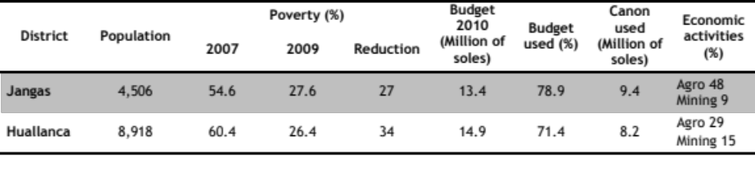
Source: MEF Economic Accountability Site, 2011; INEI National Survey 2007, INEI Poverty Map 2007 (INEI, 2007), INEI Poverty Map 2009 (INEI, 2009). Own elaboration.

The cases for comparison are located in the same department, under the same regional government, had similar budgets and mining revenues, and were similar in relation to the importance of traditional activities to the local economy (for general information and maps about Ancash and these provinces, see Appendix 3). As the main difference was the type of mining firm operating in each district, it was possible to see how different firms can influence processes and open up different development opportunities. The firms differ in size, origin, mineral and method of extraction. These differences influence the shape that the mining operations take at local level, and their effects on local development. Further description of the mining firms and projects will be provided in Chapter 3.

Information gathering
The gathering of information occurred in two stages: the first being a review of literature to identify possible research approaches and to elaborate the theoretical section of this research; the second was a fieldwork period of 5 weeks between July and August 2011.
The fieldwork period was based on observation of public and productive infrastructure and non-structured interviews with key stakeholders: outside actors and local actors (for a complete list of personal interviews, see Appendix 4). Public officers, NGO representatives and scholars were interviewed on the former, while local authorities, business associations, local producers, and other actors were interviewed concerning the latter. Interviews were also conducted with representatives of the mining firms, in some cases including their CSR operators. Information from the interviews has been treated as confidential.
Secondary information was gathered through visits to specific institutions (like municipalities and mining firms) and through the literature review. It is important to note that both the primary and secondary information were cross-referenced using several sources.

Limitations
In spite of the international conventions on transparency and accountability, the access to information from mining firms is usually difficult. Information from local authorities is usually scattered and unsystematized. Mining is also a sensitive issue, which can bias the information provided by local authorities. Although this observation is data in itself, it is, more significantly, a limitation for research. These drawbacks can be solved by cross-referencing sources and secondary information.
Finally, the time frame represented another limitation, especially considering the change of government that took place on 28th July 2011. During work on this paper, several significant and permanent reforms took place, such as the approval of a consultation law and proposals for transectoral reforms in the mining regulatory framework. These reforms have not been included in this research, as they are still premature and do not affect the described facts or findings.

Setting up the terms: a local approach to a global phenomenon
The aim of this research is to understand, from a local perspective, the causal relationship between mining and development. To do so, theories that provide analytical tools for approaching the extractives industries and their impacts on local development will be engaged, while theories like the Resource Curse will be approached critically.
The theoretical framework for this research highlights the importance of the local conditions for understanding the characteristics and performance of the local economy and the development opportunities that may emerge from it. In this matter, the competitiveness theories will provide analytical tools for that specific assessment. Likewise, the Business System Approach (BSA), as developed by Helmsing and Vellema (2011), will be used to analyse local economies dealing with Global Value Chains (GVC), and the potential developmental processes that may emerge from this relation.

Resource Curse Theories
The subject of this research is situated in the midst of an academic debate surrounding Resource Curse theory, which Porter (2008: 45) defines as a thesis that explains the negative relation between resource abundance and prosperity levels.
According to Arellano (2011: 267), the exploitation of natural resources with high rents generates low rates of economic growth, governance problems and inequality. Humpreys and Bebbington (2009: 262) add that these distortions are also expressed in terms of frustrated economic diversity, poverty and inequality. The resources’ abundance can be said to “generate(s) a series of economic and political distortions which ultimately undermine the contributions of extractive industry to development” (Bebbington et al., 2008b: 890).
‘The Dutch Disease’ is another argument, which refers to the fluctuations in exchange rates and wages generated by the rents of the extractive industries and that affect non-mineral economic activities (Arellano, 2011: 267). These fluctuations are caused by high “levels of consumption and investment during boom periods that cannot be sustained through subsequent downswings” (Bebbington et al., 2008b: 890). Other sub-arguments mention that the abundance of revenue triggers struggles over control, corruption and lack of transparency in the management of resources, the undermining of the taxation base (making the government less responsive to its citizens), and the emergence of social conflict (Bebbington et al., 2008b: 892).
Previous elaborations on the Resource Curse have focused on its effect on a national level and in the economic and political institutions regulating the extractive industry. Arellano (2008: 36) and Humpreys and Bebbington (2009: 263) do elaborate on the Resource Curse at a local level, but focus more on the generation of inequality (political and economic) and the emergence of social conflicts, as two effects inherent to the mining industry.
Rather than attempting to prove or reject these theses, this research will use analytical theoretical approaches in order to explain how the mining presence contributes to the reduction of poverty and/or to the emergence of LED processes.

Multinational Enterprise (MNE) theories and Global Value Chain (GVC) approaches
Mining firms are MNEs and GVCs. Therefore, an understanding of the main characteristics of these actors is crucial to grasping their influence in the local economy and in LED processes.
The MNEs theories define the firm “as a complex of interdependent activities, linked by flows of knowledge and intermediate products” (Buckley and Casson, 2009: 1565). According to Buckley and Casson (2009: 1564) and London and Hart (2004: 354), MNEs are characterized by having a multistage process of production, which is performed in more than one place.
The multinational character is explained in terms of strategies of location and internalization of markets. These allow the firm to reduce costs or to access to new markets, ensuring its stability and competitiveness. The characteristics and efficiency of these strategies are mainly defined in terms of the existence of a set of crucial capabilities, like global efficiency (leveraging), national responsiveness (adaptability to local institutions) and worldwide learning (sharing of knowledge) (London and Hart, 2004: 354; Gifford and Kestler, 2008: 343; Meyer et al., 2011: 237).
Such theories are situated within the limits of the firm, while the value chain approaches extend to “the networks and arrangements that bridge the entire chain of actors, directly and indirectly, involved in the production of a particular commodity or service” (Helmsing and Vellema, 2011: 4). The scope of the value chain approaches thus reach beyond the limits of the firm and focus on the organization of global industries into networks of different actors, and on the operation of these actors in their specific positions and geographies. A brief description of the variants of value chain approaches is given on Appendix 5.
The firm-centred approach of MNE theories presents several limitations for an analysis of the development impacts of mining firms. On the other hand, GVC approaches offer similar limitations, as they focus only on chain-actors. Within this framework, LED is understood in terms of how the governance framework of the chain may influence the terms of inclusion and/or upgrading of the chain-actors (Helmsing, 2010: 12).
Despite the limitations that they present for LED issues, it must be recognized that both approaches have been developed to give more attention, with different nuances, to the local conditions. The notions of embeddedness and the BSA are examples of these further developments.

Embeddedness of Multinational Enterprises (MNEs)
Meyer et al. (2011), in their paper on the multiple embeddedness of MNE, recognizes the importance of the local context for understanding the characteristics and impacts of MNEs. For the author, embeddedness refers to the interaction between MNEs and their social environment, and is defined as the capability of the firm to adapt to new markets and participate in networks of knowledge transfer and learning in new contexts (Meyer et al., 2011: 235). Therefore, embeddedness is seen as an action or strategy undertaken by the MNEs to create a competitive advantage and innovative performance. The following types of embeddedness were identified in the literature:
- Social embeddedness: refers to the ability “to craft a strategy that relies on resources and knowledge in the external environment as sources of competitive advantage” (London and Hart, 2004: 364). For this, a “deep understanding of and integration with the local environment” is required (see also: Gifford and Ketler, 2008: 341).
- Dual embeddedness: refers to the capability of the firm to be embedded not only internally (maintaining coherence with its parent and sister companies), but also externally (with its social environment), in order to “to create capabilities to achieve innovative performance” (Figueredo, 2010: 420).
- Multiple embeddedness: MNEs face the challenge of maintaining a dual embeddedness when having multiple subsidiaries in several heterogeneous contexts. In these cases, MNEs “must organize their networks to exploit effectively both the differences and similarities of their multiple host locations” (Meyer et al., 2011: 235). Internal embeddedness is challenging because of the complexity and heterogeneity of an extended MNE network. Maintaining this balance may result in trade-offs in order to ensure increase in the MNE’s competitiveness.
- Other types of Social Embeddedness: refers to the adoption of strategies that aim not only to increase competitiveness or move products into new markets, but to obtaining local legitimacy for the firm’s operations (Gifford and Kestler, 2008: 341). This approach is related to mining MNEs.
Notions of embeddedness are helpful in understanding the challenges that MNEs face in infusing corporate culture into their different subsidiaries. Through this we can understand how and the extent to which the internal elements of the MNE, like the social and environmental standards adopted by mining headquarters, influence operations at the local level.
The limitations of this framework relate to the analysis of the spillover effects or the opportunities for LED that mining firms can create, as many of these do not respond to the firm’s strategy or are not linked to the process of production. For this, the BSA offers more analytical tools.

Business Systems Approach (BSA)
The BSA is an analytical framework with an explicit focus on the institutional context(s) that steer the economic relations in a territory. As it is not a firm-centred approach, BSA includes local conditions and institutions, beyond the GVC, as relevant factors that influence firm-performance and local developmental processes (Whitley, 2000: 855; Helmsing and Vellema, 2011: 9; Andriesse et al., 2011: 2). Andriesse et al. (2011: 2), in reference to Whitley (1999: 2005), add: “Business systems analysis assumes, therefore, that the characteristics of spatially embedded economic institutions play a key role in economic development.”
The notion of Business System (BS) can be described as a conglomerate of local institutions and conditions embedded in “distinct territorial societies” that interplay and develop into “distinctive systems of economic organization” (Andriesse et al., 2011: 4). This framework requires an understanding of the characteristics of the local economy, as these conditions limit the number of combinations possible for the BS when interacting with other actors and institutions, like mining GVC. Therefore, competitiveness theories are quite helpful in this matter, as they provide a good assessment of the local economy.
Helmsing and Vellema’s (2011: 8) elaboration of the BSA includes a description of four processes (touching down, inclusion, leveraging and upgrading) that constitute the causal chain between development interventions, value chain dynamics, and context. This emphasis on processes over effects reveals the relational character of the framework, and the importance of interpreting these relationships as ‘pathways’. Path dependency must be considered when approaching these dynamics.
Therefore, this method of approaching the relationship between GVC and the local context “composes a framework for gaining a more precise insight about why certain intervention strategies may or may not work for development … and how these outcomes depend on the context in which the value chains touch ground” (Helmsing and Vellema, 2011: 1). The authors present the abovementioned processes in a sequential way, with the following characteristics:

Touching Down Process (TDP)
This stage refers to the interaction between “the logics and institutions embedded in a (new) value chain and those from the business system in which it operates” (Helmsing and Vellema, 2011: 8). The outcomes of this interaction will result in the ‘playing field’ on which the GVC will operate, delimited by the institutions (formal and informal) already existing in the BS, as well as those emerging from the interaction as GVCs look to influence the environment to their competitive advantage (Helmsing and Vellema, 2011: 8).
According to this framework, it is in this stage that the processes leading to development impacts have their beginnings. Important components of the BS in which GVCs usually try to exert their influence are: the nature of doing business, the role of the state in the economy, and state-business relationships (Helmsing and Vellema, 2011: 9). These components are further described on Appendix 6.

Inclusion Process
The second stage refers to the level of a GVC’s embeddedness in the BS through the absorption of local actors in its structure. Significantly, the BSA understands inclusion as a process and not only as a binary effect (in or out). The inclusion process is thus seen as the result of the interaction between the vertical dimensions of the GVC and local dimensions like culture, economy and politics.
A consideration of the processes (such as negotiations, dialogues and settlement agreements) is important, as they will define the “configurations in which actors operate” and the terms of inclusion, which will finally tell us about the development impacts (Helmsing and Vellema, 2011: 13). Issues of agency and power relations become relevant in this assessment (Andriesse et al., 2011: 6). What the framework ultimately states is that development is not simply about inclusion or exclusion from the GVC, but about how this inclusion occurs, and in what context.

Leveraging Process
In a more traditional approach, this notion refers to identification of the weaker points of a system and intervention in order to strengthen the position and enhance the overall performance of that system. The BSA “contrasts with a focus on individual and localized project-based interventions”, and focuses more in the interface between the chain and BS (Helmsing and Vellema, 2011: 15).
The implications are that emphasis is granted to institutional concerns and resource access as it relates to the embedding of the chain. The interventions thus aim to facilitate not only the performance of chain actors, but also, through a change in the whole system, the inclusion of the most vulnerable. Partnerships and the improvement of the institutional milieu are the main focus of the leveraging process.

Upgrading Process
This stage refers to the improvement or enhancing of the product or the GVC’s process of production. Its focus is on the chain actors and more specifically on the forms of governance that affect the performance and configuration of the chain. According to Helmsing and Vellema (2011: 15), the adopted standards and the processes of upgrading are expressions of the terms of inclusion in and coordination of the chain. The framework considers that the factors for upgrading are also those that influence the emergence of desired or undesired development outcomes.

Considerations for the analysis of mining cases
The pertinence of the BSA relies in its relational character, which extends beyond the limits of the firm and focuses on the local conditions and the relationship between firm and locality. This approach is relevant for LED, although certain particularities must be taken into account for its application to the analysis of mining industries.
First, the place where the GVC settles responds to the availability of factor endowments, and not to the particularities of the BS (institutional environment) or the competitiveness of the local economy. Second, the development of a mining project requires legitimacy and social license from the population surrounding the project. It is therefore not only the economic actors and institutions managing mining activities that are important, but also those related to the non-mining activities of the locality, as well as social and political actors (regarding, e.g., land tenure and use of natural resources).
Finally, the power variant is of extreme importance, as this framework refers to the relationship between the GVC, local actors and institutions within the BS (Andriesse et al., 2011: 6). Thus, one must note the extent to which the institutional framework enables the local actors to participate in the TDP. Here, political empowerment is relevant in terms of providing the mechanisms and spaces for negotiation and deliberation. Economic empowerment is also relevant for understanding the options that local populations have when facing negotiations with GVCs.

Competitiveness theories
These theories vouch for the importance of local conditions to the performance of firms (and the success of economic activities) and their impacts in the development of the locality, in terms of increasing the population’s standard of living (Porter et al., 2008: 44). Kitson et al. (2004: 994) label these conditions as ‘externalities’, as they refer to conditions that are outside the limits of the firm, but that affect its performance, productivity and innovative capacity.
The existence, characteristics and combination of local assets, is what defines the local economy, its developmental opportunities, and its limits. As Porter et al. (2008: 52) recognize, there is a clear distinction between having the resources and endowments (‘inherited prosperity’) and transforming them into productivity (‘creative prosperity’). This distinction is quite relevant considering that what is being addressed is the manner in which available resources are being used to create productivity and therefore improve living standards. Under this scheme, institutions are important, at both micro level (firm’s strategy and quality of the business environment) and macro level (national economic policy, rule of law, and social infrastructure), as the latter exerts influence in shaping the former.
While Porter et al. (2008: 43) attempts to explain competitiveness at the national level, Kitson et al. (2004: 994) distinguish the particularities of competitiveness according to its scale (local, regional and national) and focus on regional and local competitiveness. Regardless of the scale, we must identify different ways to unpack the concept of competitiveness, which will allow us to identify a set of factors that influence the characteristics of the local economy and the potential LED processes that may emerge.
Kitson et al. (2004: 995) elaborate on the notion of regional competitiveness, identifying a series of factors (or capitals) that sustain this condition at the regional level (Figure 2.1). The authors focus on the meso level, rather than on the firm (micro) or the national level (macro). This framework may share some commonalities with Porter’s elaboration of the “National Business Environment” and the “Social Infrastructure and Political Institutions”, which Porter (2008) situates at the macro and micro level, but with some adaptations to a regional scope.

Figure 2.1
Kitson’s Regional Competitiveness Framework
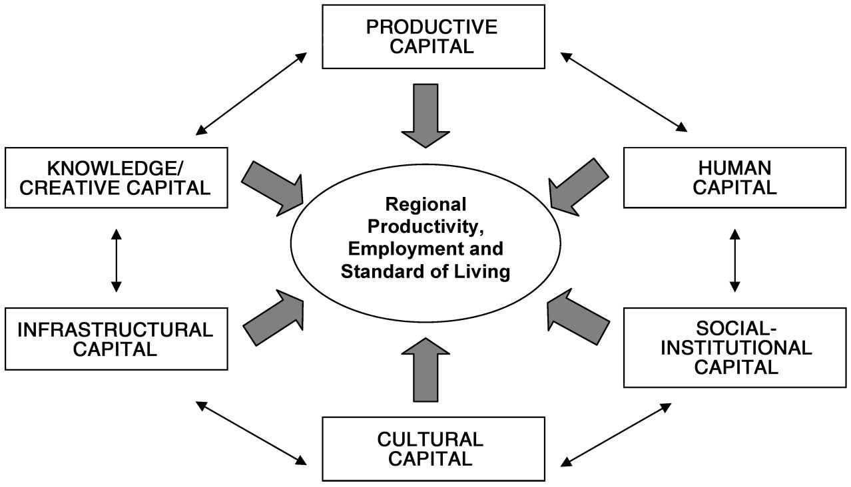
Source: Kitson et al. (2004: 995).

For Kitson et al. (2004: 994), competitiveness extends beyond what he calls ‘hard productivity’, and considers other ‘softer dimensions’ like the existence of a skilled labour force (human capital), social networks (social/institutional capital) and cultural assets (cultural capital). Regional competitiveness is defined not only as the existence of these assets, but also as the interaction among them.

Local Economic Development (LED)
We must note that poverty reduction is an outcome that accounts for quantitative accumulation, while LED accounts for qualitative processes. Indeed, it is possible for poverty reduction to occur without sustainable LED (an elaboration of the different definitions of poverty is given on Appendix 7). Helmsing (2010: 2) defines LED as a “process in which partnerships between LGs, community-based groups and the private sector are established to manage existing resources to create jobs and stimulate the economy of a well-defined territory”. Other authors add that a certain set of factors, actors and interrelations are needed for the development process to occur, in terms of innovative capacity, competitive advantage, regional competitiveness or economic development (Cooke and Morgan, 1998: 17; Porter, 1998: 78; Kitson et al., 2004: 991).
In general, approaches defining LED agree on its multi-actor character and the importance of ‘place’ in economic development (Helmsing, 2005: 1). This territorial and systemic approach also highlights how essential it is for local actors to maintain control over the development process and its outcomes as a condition for endogenization (Helmsing, 2010: 12). This emphasis explains the attention paid to the meso level, at which the institutional environment and the local capabilities function (employability and specialization).
The focus on actors, institutions and processes within a territory (and their different combinations in a local economy) imply the existence of different types of LED. Helmsing (2003: 69) identified three categories that may help us to understand and identify the diversity of the LED processes:

Table 2.1
Types of LED
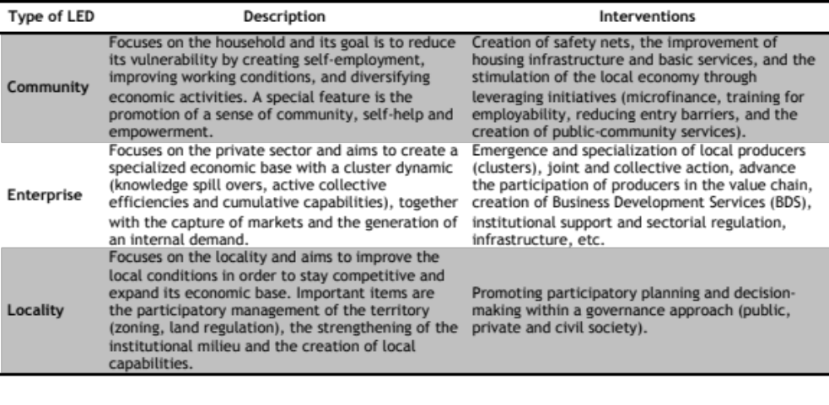
Source: Helmsing (2003: 69). Own elaboration.

These frameworks can be considered within the category of Market-Driven LED, as developed by Helmsing (2010: 9), which focuses specially in the private sector as a unit of analysis and recipient of interventions, directly (through BDS or credit) or indirectly (through the creation of capabilities and institutions that support specific sectors).

Analytical Framework
In this research, the premises of the BSA will be the guiding approach to analyse the causality relation between mining presence and LED within a territory.
The first step is to review the most relevant policy and legal frameworks related to mining and to provide a brief description of the mining firms and projects. Both are expected to influence the TDP and shape the mining operations at local level.
The second step is to identify the characteristics of the localities where the processes described in the BSA take place. To this end, a competitiveness analysis of the selected cases will be performed in order to identify the assets, endowments, social dynamics and institutional environment that may or may not influence the development of the local economy. It is expected that the features of the local economy determine possible configurations of the BS in interaction with the mining GVC.
Third, an analysis of the processes leading to LED will be performed. The main process for investigation is the TDP, which refers to the interaction between the mining GVC and the local actors within a specific set of conditions. The importance of this process is its role in determining the BS, the mining operations and their level of embeddedness, the following processes of inclusion, leveraging and upgrading, and the development opportunities.
Finally, the outcomes observed from the interaction of the mining presence and the BS will be assessed according to the LED theories. It will therefore be possible to establish: whether the mining presence influences the emergence of an LED process, what type of LED and under which circumstances. The assessment will also reveal what elements and actors seem to play a prominent role and which processes are the most critical for LED. The Figure 2.2 explains the rationale of the analytical framework.

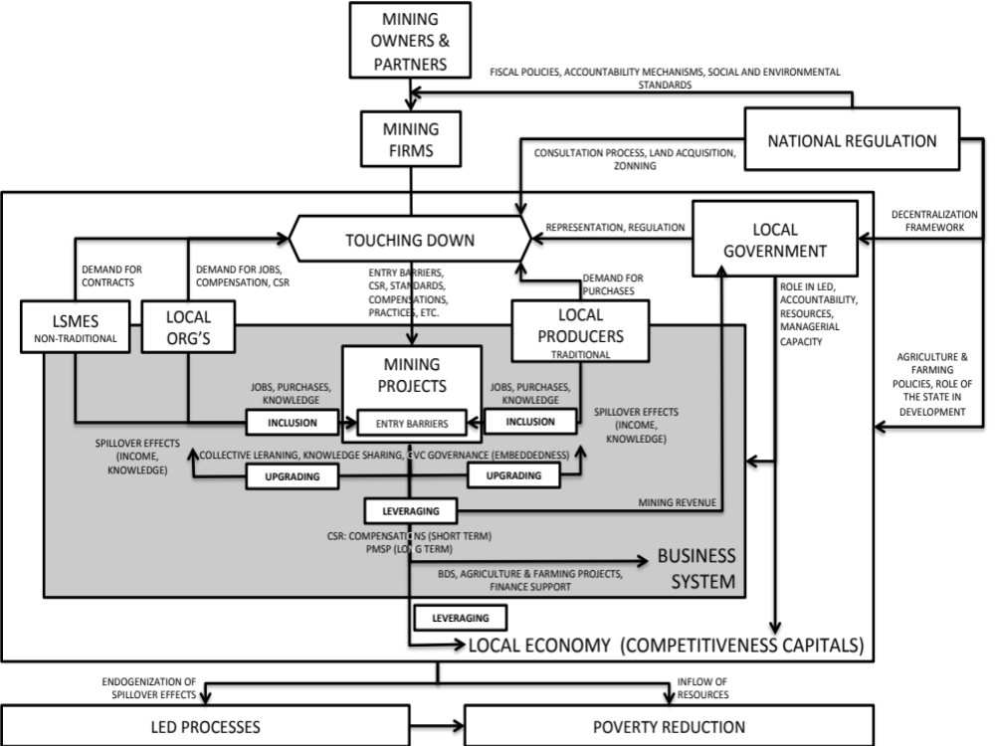
Figure 2.2
Analytical Framework
Source: Own elaboration.

Mining policy framework and mining firms
The reforms undertaken by the Peruvian central government since the ’90s had two main objectives: to ensure the large amounts of investment required for mining, which have substantial impacts in the economy of the nation (Glave and Kuramoto, 2002: 530); and to provide an attractive environment for foreign investors in an era of intense competition. This entailed the withdrawal of state support from agriculture and farming activities, which are predominant in many mining districts, in order to support other activities, such as mining, that were more market-oriented and profitable. For a further description of the changes in the agriculture and farming policy, see Appendix 8.
During the same period, the environmental standards for mining became more flexible, the land regimes were modified to favor this activity, and no consultation mechanisms were implemented. The centralization of decision-making on mining-related issues was another feature of these reforms. The latter aimed to maintain control of an activity considered of national interest but that contravened the country’s decentralization processes. For further reflections on the decentralization process in Peru, see Appendix 9.
These reforms left a series of gaps that allowed for the emergence of liabilities. These deficiencies have several consequences for the TDP, as they shape mining operations, the local economy, and the relationship between mining and the affected populations. A review of the most important dimensions of the mining legislation follows, while an overview of the evolution of the mining policy framework is given on Appendix 10.

Social and environmental frameworks
One of the most important changes to the environmental framework was the reduction of standards as a means of creating a favourable environment for foreign investors (Glave and Kuramoto, 2002: 547; Pinto, 2009: 93). In a similar vein, the supervision and control of the environmental and social dimensions of mining (like the approval of the Socio-environmental Impact Assessment reports), started to be handled by the Ministry of Energy and Mines (MINEM).
The social policy framework was also reformed and some issues remained unregulated. This contributed to the emergence of several liabilities and conflicts at the local level. While further information is provided on Appendix 11, the main points of the social policy framework are as follows:
- Consultation and consent: no veto power, decisions undertaken by the firm, asymmetry of information, no mediation by the state, several promises for social legitimacy that result in huge expectations.
- Territorial planning and land use: lack of a consistent and comprehensive plan of Territorial Planning and Land Use, mining concessions overlap areas with other economic and cultural uses.
- Land policy: reduced protection of peasants’ collective property rights, concentration of land in market-oriented actors (mining, export-oriented agriculture), and state’s right to declare easement zones.
The consultation, concession and land acquisition processes in Peru usually take place in contexts where the owners of the land are in a disadvantaged position. The absence of the state and self-regulation in these matters are evident in the establishment of land values, which are set up by the firms in an asymmetric relation in terms of power and knowledge. As a consequence, there are several cases of resettled populations complaining about unfair negotiations, as in the case of Jangas.
As a whole, the policy framework for mining is particularly sectoral and centralized, with little coordination with other institutions specializing in environmental and/or social issues. As indicated by De Echave et al. (2009b: 358), one of the main points that should be considered in a new mining agenda is the adoption of a transectoral approach in the regulation of mining. This is most necessary in the case of mining-related environmental issues, as the institution intended to promote mining should not be the one regulating it in all dimensions.

Localizing the benefits of mining
The presence of mining, besides its effects in macroeconomic terms, opens a series of opportunities for development in other areas (Bebbington and Bury, 2009: 17297). Indeed, mining activities can provide important revenue for the LGs, help technological transfers and innovation, as well as generating job opportunities to reduce vulnerability and poverty (SNMPE, 2008: 58; Ticci, 2011: 2; MINEM, 2011a: 83). In addition to these potentialities, other opportunities arise from voluntary mechanisms, like CSR initiatives, which are considered as an important means of generating development, especially at local level (MINEM, 2011a: 88).
In synthesis, it could be said that there are 3 main channels for generating mining related benefits at local level: through mining revenue, through the mining activity per se (technological transfers, job opportunities, linkages with local suppliers), and through CSR initiatives.

Mining revenue
The revenues generated by the mining sector represent an important income for the country in general, and for LGs in particular. For instance, mining revenue represents 20% of the total LG’s annual expenditure, and in some districts represents 99% of the annual budget (MEF Economic Accountability Site, 2011). The mining canon represents the 50% of the taxes paid by the mining firms to the Central Government, and can only be used in infrastructure projects and not in capacity building. For further details about the distribution of the mining revenue and the challenges using it, see Appendix 12.
As pointed out by Ticci (2011: 9), the distribution structure of the mining canon concentrates large sums of revenue in a few areas. This concentration of revenue, even if considered fair under a principle of compensation, can generate a series of distortions and conflicts, especially when the resources received far exceed the local needs and/or the LG’s managerial capabilities. Regarding this issue, Arellano (2008: 15) mentions that in the context of a weak state, the mining boom or the country’s wealth in terms of mining revenues will not necessarily result in positive outcomes or in substantial development. The four dimensions of state weakness mentioned by Arellano (2008: 15) are:
- Lack of representation of the population’s interests, expressed in support to business conglomerates while overlooking the poor and vulnerable
- Centralization of the country and few power-sharing mechanisms, in terms of the granting of licences and regulations of authority
- Limited capacities of the bureaucratic apparatus, related to the structure of the public system and the availability of skilled professionals
- Generation of ad hoc policies that undermine the overall system, regarding the fiscal privileges given to firms and the distribution of the mining canon, which are policies formed as responses to circumstantial situations such as the economic crisis of the ’90s and pressures from the population
Indeed, the availability of resources represents a huge potential for undertaking significant local improvements and for setting up the conditions for local development processes. For instance, mining revenue plays an important role in leveraging local assets. This potential is compromised by the weaknesses of the state apparatus in terms of planning and managerial capacity, making it difficult to start the processes of territorial governance and/or to respond to local needs effectively.

Mining activity per se
Other approaches to the impacts of mining in (local) development include reflections on issues like employment generation and the role of CSR in these matters (de Waal and Orcotoma, 2007: 14; Bebbington, n.d.: 11). Concerning the former, estimations of the impact of mining at meso and micro level, in terms of direct and indirect employment, are still uncertain (Glave and Kuramoto, 2007: 175; Fairlie, 2010: 3).
It is important to draw a distinction between employment generated directly by the firm and employment generated through the establishment of linkages with the BS. Concerning the latter, Fairlie (2010: 5) mentions that the mining industry in Peru has traditionally developed as an enclave, without generating important linkages with the locality in which it operates, thus limiting the emergence of spillover effects. Kuramoto (2000: 3) similarly observes that big mining firms’ contribution to the strengthening of local suppliers has been very limited, as high technological standards result in high entry barriers for LSME.
In terms of employment, Hiba et al. (2002: 13) mention that the mining industry absorbs only 1% of the world’s labor force. In the case of Peru, according to the INEI National Survey 2007, the mining sector directly employs 1.3% of the country’s working population. On the other hand, the MINEM, in its annual report (MINEM, 2011a: 75), states that the sector employs about 6.2% of the working population (1.2% direct and 5% indirect).
In spite of these estimations, the mining sector still represents a minimum share of the working population when compared to other sectors like commerce (35.3%), agriculture (23%) or manufacturing (9.3%) (INEI National Survey 2007). Ticci (2011: 9) explains this phenomenon arguing that the capital-intensive character of the mining industry, which usually requires highly specialized labor, is the factor that limits its capacity for absorption of local labor force, especially in areas where the educational level is low. In general terms, mining firms have high entry barriers that limit the process of inclusion and the embeddedness of the GVC in the BS.

Corporate Social Responsibility (CSR)
Some authors consider CSR to be a cosmetic measure to justify the existence of an industry with several implications for the environment and society (Porter and Kramer, 2006: 4; Bebbington et al. 2008b: 900; Aroca, 2008: 54; Gifford and Kestler, 2008: 340). This accounts for CSR when utilised as a ‘business tool’, which usually conflicts with the logic of its use as a ‘development tool’. The former focuses on outputs (short-term), the latter on processes (long-term) (Newell and Frynas, 2007: 677). This emphasis is relevant to the arguments of this research, especially in terms of a BSA.
Since the structural adjustment policies and the withdrawal of the state from its developmental duties, CSR initiatives have had an important role in promoting local development, especially in the leveraging process (enhancing local assets). As CSR it is possible to include: i) voluntary contributions; ii) compensations to affected population; iii) voluntary principles and standards; and iv) mixed mechanisms like the Programa Minero de Solidaridad con el Pueblo (PMSP).
Although the first two groups are voluntary mechanisms, they fall under certain national guidelines, which emphasise the principles of dialogue and participation, fulfilment of agreements, environmental excellence, respect of local culture and institutions, and promotion of local employment and purchases. In terms of investments and projects, there are 9 areas to be prioritized: education, health, nutrition, environment, local employment, institutional capacity, local culture, infrastructure, and economic development. These measures also suggest mechanisms for planning and accountability, like annual reports and plans for Community Relations, the latter to be included in the Socio-Environmental Impact Assessment Report (MINEM, 2011a: 89).
Thus, even if voluntary (there are no sanctions in place in case of failure to comply with these principles), there are some state-given guidelines to steer CSR towards certain areas. The MINEM estimates that the economic contribution of mining firms in local development initiatives was US$ 75.1 million in 2009 (MINEM, 2011a: 89).
The third group refers to the principles and standards assumed by firms to guide their operations and contributions to the locality in which they operate. These conventions usually lose impetus when they reach operation level, in comparison to the conditions printed in the mining operations as a result of interactions with the BS in the TDP. Here, the challenges of dual and multiple-embeddedness described by Figueredo (2010: 420) and Meyer et al. (2011: 236) are appropriate.
Finally, the PMSP is neither completely voluntary nor mandatory. This fund is privately administered through a Technical Commission of Coordination, at local and regional level. These commissions are integrated by authorities from the locality, as well as by firm’s officers, who identify needs, design projects and prioritize interventions (GPC, 2010: 22). Some projects undertaken by this fund also fall under regulations for public investment, especially those of public infrastructure, as their maintenance and administration will pass to the public institutions in each jurisdiction. For further details, see Appendix 13.

Mining firms and projects
The three mining firms included in this research are: Antamina and Santa Luisa (SL), which exert influence in Huallanca; and Barrick, which exerts influence in Jangas (Table 3.1). Two levels can be differentiated within these firms: the level of the owners and partners, and the level of the firm and project.
At the level of the owners and partners, the vertical and global character of long mining GVCs makes it difficult to generalize the same corporate culture along the chain and to establish at this level the characteristics of the firm (origin, size, standards and principles) which have effects in the mining operations and/or in the TDP. According to Meyer et al. (2011: 235), MNEs face several challenges to maintain their vertical and horizontal embeddedness, especially when they operate in different contexts that force them to adapt. This usually results in the loss of a corporate culture and the dilution of the influence that standards and principles have when reaching the project level. This is accentuated by the fact that mining firms usually outsource a series of services, like drilling, transport, geology, etc., which makes it even harder to extend this corporate culture to other actors in the value chain. For further details about the owners and partners, see Appendix 14.
Prior to the ’90s, this set of variables seems to have been more relevant for two main reasons: first, the institutional and regulatory mining framework was weak or non-existent, so the characteristics of mining operations were basically defined by the firms’ corporate culture; second, the appearance of a more comprehensive (but still flexible) legislation, the emergence of international standards and regulations, the empowerment of local populations and their demands, and the learning processes of mining firms, have all led to a relative standardization of mining operations. For this reason, the focus of this research will be at firm and project level, the elements of which have a more direct influence on the TDP.
Of the three mining firms, more attention will be given to those that have a direct impact in the chosen districts: SL and Barrick. The variables that are considered of main importance are those regarding the profitability and capital of the firm (minerals exploited and assets), the perception of impact that they generate in the population (size, method of extraction and lifetime), and the age of the project (a consideration to be developed further in the next chapter). These elements (Table 3.1) have a major influence on the TDP and subsequent processes.

Table 3.1
Firm and Project’s main characteristics
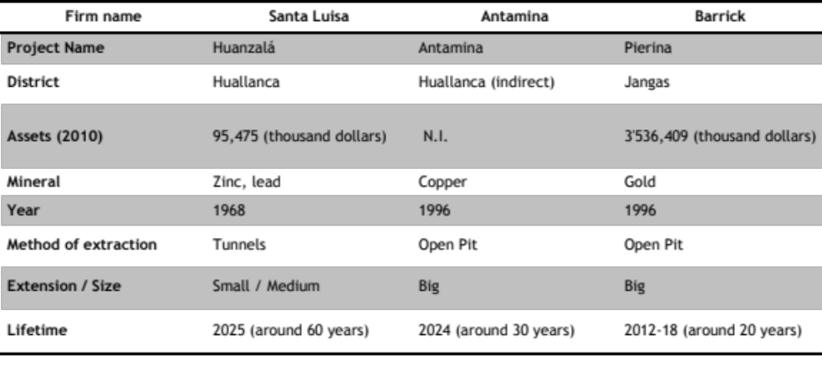
Source: Superintendence of the Share Market (SMV, 2011); www.antamina.com; www.barricksudamerica.com; Santa Luisa Closure Plan (OSEL, 2007). Own elaboration.

The profitability and assets of the firm have an impact on the expectations that the population have regarding the benefits to be received. The higher the assets and profitability, the higher the expected benefits. In this regard, SL and Barrick present substantial differences: SL exploits non-precious minerals (lead and zinc), far below the gold extracted by Barrick in value. Additionally, the values of lead and zinc have not changed dramatically, while gold has increased in value by 218.7% in the last 15 years (MINEM, 2011c). For further information about the mineral prices’ fluctuations, see Appendix 15.
The other set of variables references elements that directly affect the perception of the population regarding the impacts that the mining presence creates in the locality− visible elements. The perception of being affected generates a series of claims and demands for compensation, which then pollute further business relations and developmental interventions. These main variables are:
- Area: SL uses an area of about 5 km2 for its operations, while Pierina’s concession is 67.5 km2 (VECTOR, 2006: 2).
- Method of extraction: SL extracts through tunnels, which has reduced the impact on the landscape, while Pierina uses an open pit of a length of 5 km according to satellite pictures (for the image see Appendix 16).
- Water usage: the technique of extraction and the magnitude of the operations impact on the amount of water used. Water is a scarce resource in Jangas (PDC Jangas, 2007: 13).
Finally, one more variable is the media attention that Barrick and Antamina received as big MNE’s on Peruvian soil. Visibility also plays a role, as protests and mobilizations against the firms attract more national and international attention. This increases the bargaining power of local movements, as the corporate image of the firm is compromised.

Competitiveness of the local economies
Local economy is not synonymous with BS, but the characteristics of the former largely influence the BS and the development opportunities that may arise from it. The following sections therefore offer a brief analysis of the localities’ main features and a competitiveness analysis of the local economy, in order to understand the main characteristics of the BS where the TDP takes place.

Main characteristics and trends
The districts of Huallanca and Jangas are located in the provinces of Bolognesi and Huaraz, in the Sierra region of the department of Ancash (for general information and maps about Ancash and these provinces, see Appendix 3). These districts present several commonalities, but also critical differences. A brief description of the main characteristics of both districts is given here:
- Demographic concentration: Huallanca has a larger population than Jangas (8,249 vs. 4,403) but a lower population concentration (9.4 per km² vs. 73.6 per km²) (PDC Huaraz, 2008: 21; PDC Bolognesi, 2009: 31).
- Rural vs. urban shares: Huallanca has a decreasing but predominantly urban share (58.5%) while Jangas has a predominantly rural share (60%). There is no deruralization process (INEI National Survey 2007).
- Role of mining in population growth: 34% of newcomers to Jangas work in mining, as opposed to 24% in Huallanca. These statistics are above those for agriculture (7% and 9% respectively) (INEI National Survey 2007).
- Deagrarization process: In Huallanca, 35% of newcomers into rural areas work in mining, while 9% work in agriculture and farming. In Jangas, 50% of newcomers work in mining and 5% in agriculture and farming. The deagrarization process is not invalidated by rural immigration (INEI National Survey 2007).
- Increase of the costs of agriculture and farming activities: the cost of agricultural labor has increased, from US$ 7 to approximately US$ 18 (similar to the daily wage for mining). This means higher costs for agriculture and farming activities, but not higher profits.
- Internal migration: temporary (seasonal) and partial (only some family members) displacements to access better basic and educational services (usually absent in the rural areas), and also to access other employment opportunities (economic diversification strategy).
- Poverty reduction and inequality: income poverty rates dropped by about 30%, together with the improvement of HDI and inequality indexes (GINI). However, malnutrition rates remain significant.
Further information about demographic dynamics, rural vs. urban shares and migration trends is provided on Appendix 17. This section includes information about the importance of mining in the population growth, the deagrarization trends and the increase of costs in agriculture and farming activities. Likewise, further information about poverty and inequality is offered on Appendix 18.

Brief assessment of the competitiveness capitals
The competitiveness assessment will provide information about the characteristics of the local economy, which in turn influences the characteristics of the BS (Table 4.1). These conditions also influence the TDP (nature of the demands), inclusion process (employability, level of specialization and diversity), leveraging process (weak and strong capitals) and upgrading process (embeddedness and existence of support institutions). This analysis includes an assessment of the market conditions, as they play an important role in defining the economic opportunities and threats of the local economy. An extended analysis is provided on Appendix 19.
Table 4.1
Competitiveness capitals of Huallanca and Jangas
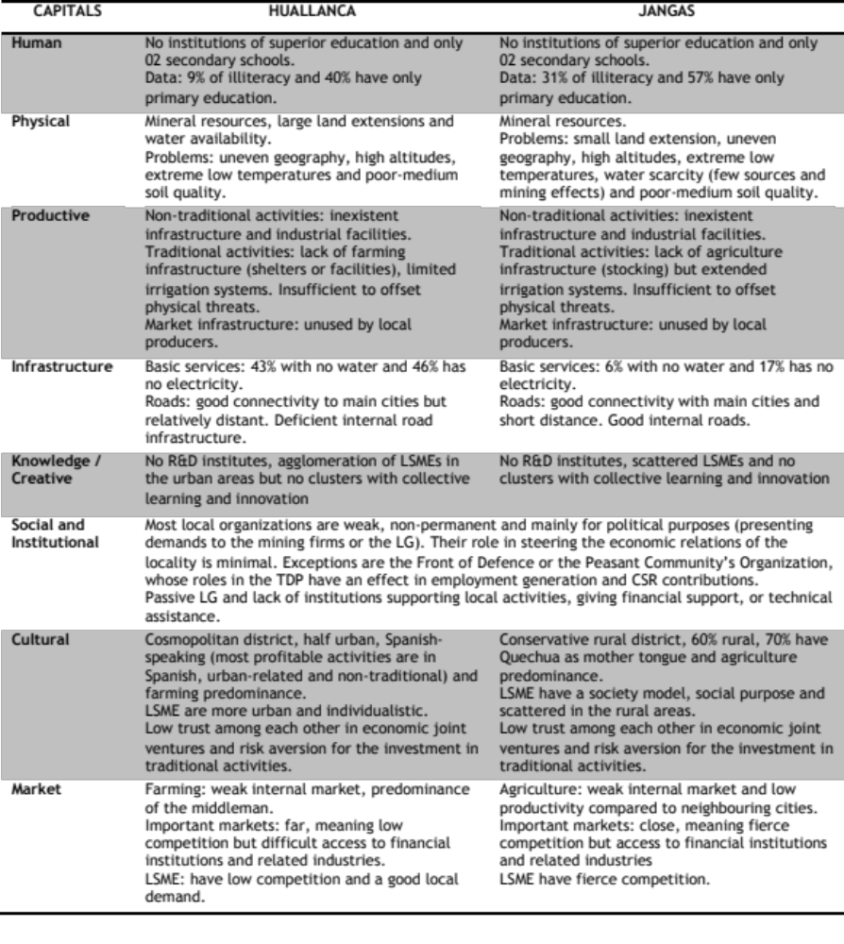
Source: Own elaboration

Characteristics of the local economies
It is important to discover how the characteristics and trends of the selected districts, as established in the above analysis, shape the local economy. Important changes observed in these districts since 1993 are the deconcentration of the population in traditional activities and the diversification of economic activities in both districts (see Appendix 20 for more details), especially as related to the increase in population (small commerce), the flow of persons (transport) and the urbanization process of the district (construction).
Of the two districts, Huallanca is the one that shows a more dynamic economic environment. Three factors play a key role in this:
- Intense flow of population: in Huallanca, 20% of the population do not live permanently in the district, compared to Jangas’ 6%. This has an impact on the demand for goods and services (INEI National Survey 2007).
- Higher concentration of LSMEs: in Huallanca, LSMEs are concentrated in the urban areas, forming an agglomeration of businesses, while in Jangas they are scattered in the rural areas, in those communities affected by the mining presence. In the latter, LSMEs depend directly on the mining presence and the business relationship has an element of compensation to it.
- Better market conditions: Huallanca is an economic centre in the area with no important surrounding markets, enabling LSMEs to capture the local demand. The proximity of Jangas to Huaraz exposes LSMEs to fierce competition.
- Higher competitiveness capitals: Huallanca provides a higher level of human capital than Jangas, which impacts on the employability of its population.
These characteristics have allowed Huallanca to achieve a relative level of consolidation, as the sustainability of its economy functions outside of the mining presence (local suppliers and local demand). However, the lack of networks and related industries is one of the factors that limits further upgrading and clustering of the LSMEs.
In regard to traditional activities, Huallanca has improved its agriculture and farming productivity since 2007 (see Appendix 21 for data), while Jangas’ productivity has decreased (MINAG, n.d.). In the case of the former, a pre-existing potential in the production of milk-based products has assisted the focalization of resources and efforts from the private and public sector. But, even though productivity in Huallanca has improved, the amount of surplus produced is not enough for large-scale commercialization, as is evident in the poor representation of local producers in the local markets. A contributing factor is the lack of irrigation infrastructure and the poor soil quality (PDC Huallanca, 2009: 93). In the case of Jangas, self-consumption and small-scale agriculture have not suffered significant changes.
Finally, the mining activities represent the second most important source of employment. Employment figures generated directly by these mining firms are presented below and on Appendix 22):
- Santa Luisa (Huallanca): this firm employs around 60 permanent workers and contracts LSMEs for specific construction work.
- Antamina (Huallanca as area of indirect influence): this firm hires local employees through operators. Due to its size, Antamina generates more employment, sometimes reaching 300 positions in a temporary arrangement.
- Barrick (Jangas): this firm has hired around 400 workers from the district, but mainly from the communities within the area of influence and in a temporary arrangement.
To some extent, the small-medium size of SL limits its potential as an employment generator. However, those jobs that are created are more permanent than the ones offered by the larger firms. Barrick and Antamina are important employment generators, but provide mostly temporary jobs.
It is possible to state that the presence of mining firms have influenced the diversification of the economic activities and the improvement of the agricultural productivity (mostly in Huallanca). The information also reveals the efforts of the LG of Jangas in building basic and productive infrastructure. However, the developmental outcomes in terms of improved productivity of traditional and non-traditional activities seem to rely largely on market factors, physical endowments, and human capital. This highlights the centrality of the BS and the characteristics of the local economy for the success of LGs’ and mining firms’ interventions (more information about this relationship can be appreciated on Chapter 5).

Main characteristics of the local governments (LGs)
In a decentralized framework such as Peru, the role of the LG is particularly important, as they are expected to coordinate and stimulate the economic and institutional development of the locality (Helmsing and Vellema, 2011: 30). While the Peruvian decentralization framework allows the LG to have an active role in the local economy, this is not enforced. The main characteristics of the LGs are as follows:
- Role: both LGs perceive themselves as facilitators or enablers, and not as promoters or active players in LED. Their tasks are limited to issuing licenses or permits, or being partners in initiatives promoted by other actors, such as NGOs or the private sector.
- Managerial capacity: there is a lack of systematized knowledge about the locality and the needs of the population, which affects methods of prioritizing and designing projects. The Participative Development Plans and the Participatory Budgeting minutes are not used in the every-day administration.
- Performance measurement: there are no mechanisms to assess the performance of public servants. The performance of the LG is measured in terms of expenditure, which is misleading, as the achievement of goals or the responsiveness of the LG towards the local demands is not considered (Table 4.2).
- Structure: there are Directorates for several concerns, such as Economic Development, Rural and Urban Development and Environmental Affairs. However, even though the legislation allows these offices to modify their structure to include agencies for the promotion of the local activities, none of the selected cases has a department or office for agriculture or farming.
- Budget and mining revenue: both districts have similar resources (around US$ 3.9 million) and percentages of mining canon (over US$ 3 million). The latter represents 77.2% (Huallanca) and 89.4% (Jangas) of the total budget (Table 4.2).
- Tax base: the amount collected directly by the LG in Huallanca is 9.3% and 2.3% in Jangas. A larger population and a more dynamic, concentrated and urban economy in Huallanca may explain this difference. In Jangas, there are not only fewer businesses that generate local revenue, but as most of them are located in the rural areas, without private property, tax collection is affected (Table 4.2).
- Accountability: the data offered by the MEF is not detailed and the criteria of classification for the LG’s expenditure is not rigorous, revealing deficiencies in the accountability system. Likewise, the lack of transparency in the bidding processes permits forms of corruption.

Table 4.2
Budget, mining revenue and revenue collection of Huallanca and Jangas (2010)
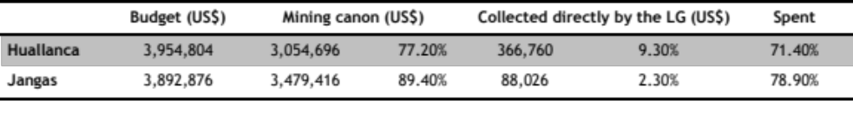Source: MEF Economic Accountability Site, 2011. Own elaboration.

The characteristics described define the capacity and vision of the LG for leveraging local assets. In terms of public expenditure and investment, there are both commonalities and differences between the studied cases (see Appendix 23). In Jangas, for example, the LG invests important shares in agriculture and farming, like in projects such as irrigation infrastructure; while in Huallanca the large tracts of land are an obstacle to public investment, as large sums of money would be required to benefit only a few farmers, an investment model which is forbidden by the national regulations.
Additionally, it is important to observe the types of investments made. Most of the LG’s investment focuses on infrastructure, with very little being sown into capacity building (see Appendix 23). This is explained partially by the dependence on mining revenue. Construction firms, public servants and other local actors, however, mention two additional reasons: corruption and clientelism, which are related to the lack of effective accountability and performance measurement mechanisms. A fourth reason is the fact that infrastructure projects generate more employment for non-qualified members of the population, thus generating employment and ensuring votes.
The main issues are: the importance of and dependency on the mining revenue; the deficient tax collection procedures of the LGs and the consequent limitation of public investment possibilities; the fact that the LG’s performance is measured in terms of budget spent, and not in terms of the achievement of goals or objectives with the managerial tools available (Development Plans and Participatory Budgeting); the concentration of the budget in infrastructure, not only because of the policy framework does not enforce efficient investment, but also because of the existence of rent-seeking and electoral interests.

Challenges, opportunities and nuances: a business systems approach for mining districts
The information provided in the previous sections has described the actors and elements that are involved in the relationship between local actors and mining firms, and that influence the processes leading to development outcomes. The following section will use the BSA, as developed by Helmsing and Vellema (2011), to gain a more precise insight into why and how different set of actors, interventions, local conditions and relationships generate different development outcomes or opportunities.

The Touching Down Process (TDP)
Since the ’90s, the central state has given up several of its developmental tasks, such as the provision of support to small and medium agricultural and farming projects, activities that employ most of the population in the observed districts. Simultaneously, the process of decentralization gave little attention to fostering the capabilities of the local authorities to make LGs active players in local development. In these circumstances, mining firms, through CSR initiatives, took over tasks that had originally been conceived of as being the state’s responsibility: building health centres, schools, giving technical and financial assistance to local producers, etc.
The promulgation of laws promoting foreign investment, especially in mining (with tax holidays and contracts of fiscal stability), and the flexibility of the legal frameworks that could ‘hinder’ this process (like environmental and social regulations) started to characterize the overall economic and political framework of the country. This context left many issues related to mining exploitation unregulated, or allowed for the self-regulation of the mining firms.
As Glave (2007: 17) points out, in order to reduce mining-related social conflict, it is important to reform the processes of land acquisition, territorial zoning and land valuation. These issues are crucial in the initial stages of a mining project, when abuses and irregularities are most frequently observed by the population. These irregularities can later develop into conflicts.
In mining districts, the power struggles are particularly asymmetric, as negotiations take place between local authorities (with poor managerial capacity and access to information) and mining firms. The latter not only have more resources to fund their interventions and campaigns, but also count on state support in their planning, and better access to information (as in the valuation of land).
Assuming this to be the case for most of the districts where mining firms settle, the significance of the first interaction between the firms and the local population cannot be underestimated. This meeting acts as the cornerstone for understanding the subsequent limitations, challenges and potentialities of the mining presence and its interventions in any locality. This first phase can be divided into the consultation/negotiation processes and the land acquisition processes (Table 5.1). These processes represent the stages in which most of the liabilities that affect the relationship between firm and population emerge.

Table 5.1
TDP main features
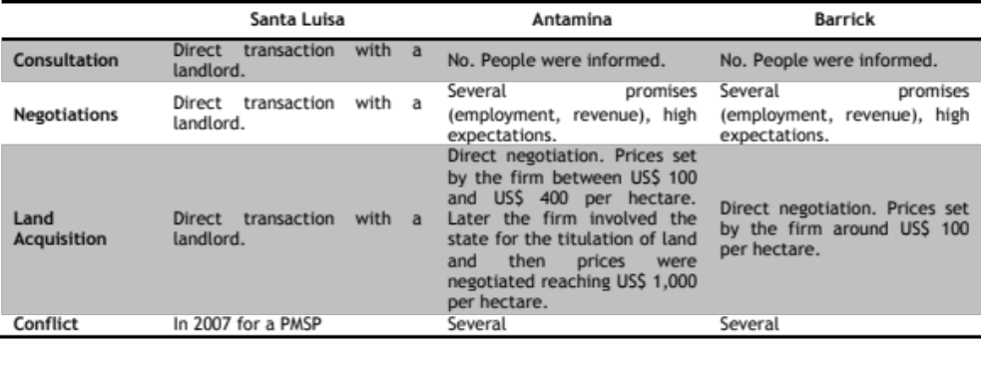
Source: Glave, 2007: 11; Personal interviews. Own elaboration.

The perceptions that arise from this stage influence the emergence of conflicts, the size and type of local demands, and the character of the developmental interventions undertaken by the firms (or where the firms will be involved). If positive, they can result in processes of trust building and alliances; if negative, they result in liabilities generating greed, complaints and continuous demands.
The case of SL had few such liabilities. The land was purchased from a landlord in the late ‘60s, before the Peruvian land reform; its purchase did not conflict with a traditional economic activity, nor did it require negotiations with large numbers of landholders or resettlement processes, as was the case in the other two observed instances.
These and further interactions can be systematized into the three components identified by Helmsing and Vellema (2011: 9) as part of the TDP, and sites where clashes and encounters among local actors can be identified. There are cases of mining districts where the TDP, as well as the processes of inclusion and leveraging, are not limited exclusively to business relationships with mining firms. It is therefore important to make flexible and comprehensive use of the theory in order to include other types of interaction that may also generate local development processes.

The nature of doing business and the forms of business association
The nature of doing business makes reference to the logics, interests and strategies used by local actors to do business and/or interact among themselves. At this point, several particularities can be observed: local producers do business mainly through informal institutions, with no standardization or attention to quality standards, with no association or cooperation, and mainly in labor intensive activities.
These characteristics contrast with the requirements of the mining firms: high standards, long-term contracts and high levels of specialization. As large firms tend to have generated liabilities and expectations, there is an element of compensation that pollutes the business relationship. This highlights the importance of the TDP− one of the reasons why many business relations fail is that they turn into a handout relationship, impeding the further development of LSMEs.
Another issue relates to the BS’s configuration. In Huallanca there is an agglomeration of LSMEs in the urban areas, partially sharing knowledge and expertise, while in Jangas there is a fragmented BS (scattered LSMEs in the rural areas). Resultantly, the way of doing business in Huallanca is be more compatible with the business approach of the mining firms: predominantly Spanish-speaking, more profit-oriented than survivalist, more focused on investment than social purpose, etc.
In Jangas, for example, interviews with LSMEs engaged in mining complementary activities reveal that most of the enterprises emerged in rural communities, with a short-term view, a large number of associates (up to 85), a survival character, and a social purpose. For this reason, the capital reinvested by LSME has been minimal or non-existent, as most of the profits are distributed among the associates and/or used for communal activities. The need for reinvestment is sometimes truncated, as business owners rely on a compensatory relationship with the mining firms, demanding subsidies in order to keep their business alive.
This also applies to the relationship between the mining firms and the development interventions established through CSR initiatives. Many projects or interventions that aim to create synergies among different local actors and that anticipate the response of the population (contributing with time, work and resources), are frustrated by the element of compensation. In these cases, the population and their leaders refuse to contribute as they expect the firm to cover all expenses (labor, materials, tools, etc.).

Nature and role of the state (and other institutions) in the economy
It must be differentiated the meso (BS) and macro level (national legislation), and also the three main activities of the observed districts: agriculture and farming, mining, and commerce.
At the macro level, the state has developed a framework for promoting mining activities while neglecting agriculture and farming activities. This is evidenced by the reduction of personnel and services in these areas. At the meso level, these voids have not been filled by the LGs, who remain passive.
Regarding commercial activities and the support provided to LSMEs, there is a lack of BDS and other instruments to help in the formalization and certification processes. Mining firms provide the few existing services in this matter, such as the Competitiveness Plan of Antamina, the individual advice provided by SL, or the attempts of Barrick to support LSMEs.
The lack of guidance and BDS from public institutions results in the institutionalization of informality and corruption (as in the ‘Diezmo’ system when bidding for contracts), which hinders inclusion (due to increased entry barriers) and upgrading processes.
Helmsing and Vellema (2011: 10) highlight the importance of the state in guiding the spaces of governance in order to articulate the GVC with the BS, in order to stimulate the economic and institutional development of the locality. In the context of weak states, it is expected that “other actors will employ their resources and powers to construct a favourable environment for their economic activity” (Helmsing and Vellema, 2011: 10). The studied cases reflect how local organizations and institutions have emerged and evolved to face this context.
For instance, many of the concessions given by the mining firms in terms of employment and CSR are not determined by the principles and standards of the firm, or by the national legislation, but by the actions of local organizations. Therefore, in the absence of formal institutions, other sets of institutions arise: protests as a legitimized means of negotiation, the emergence of Fronts of Defence, the evolution of the Peasant Communities’ Organization and institutionalized corruption.

State-business relationship
As has been mentioned above, the legal frameworks that regulate mining in the environmental and social dimensions are quite flexible and leave room for self-regulation. This has resulted in the emergence of liabilities, informal institutions and resistances. The latter’s visibility in the media and global organizations, pushes mining firms to negotiate issues like employment and CSR in order to obtain social legitimacy for their extractive projects.
This laissez-faire framework employs tax policies and distribution mechanisms as one of the only ways to localize the benefits from mining. Another recent attempt of the state to intervene in the leveraging process is through the PMSP. These efforts aim to articulate the local actors’ efforts on a more efficiently organized platform, and to strategically identify the developmental direction that the firm-BS relationship is taking. This reduces the opportunities for liabilities cause a rift in the relationship between firm and population. While in the short term this may mean less chance for the GVC to modify the BS, it represents the long term benefit of an increase in local assets, which is useful to the mining firm (skilled labor, local suppliers, etc.) and locality (reduction of vulnerabilities).

The Inclusion Process
There are three different types of inclusion and two modes of embeddedness that can be identified in the observed cases. The different types of inclusion are:
- Direct employment: opportunities generated by the firm. This employment is usually permanent if linked to mining operations, and temporary when linked to complementary activities. The former roles are usually specialized and are not numerous.
- Employment generated through non-local enterprises: these enterprises organize and manage labor-intensive tasks related to mining operations (construction, electrical works, etc.). Usually they require certain specialization but local workers do most of the basic tasks.
- Employment generated through local agents: this refers to agents that supply labor to mining firms for exploitation-related tasks. This is more common in the strategies of SL, as the mining operations are not completely capital intensive (extraction by tunnels). There is therefore a group of agents (usually former SL workers) that organize and manage the labor force. These tasks are not very specialized but are also temporary.
- Employment generated through LSMEs: this refers to LSMEs that are suppliers of goods and services going beyond the modality of simply providing workers. These LSMEs take over projects and must fulfil contracts. Theoretically, these firms have different levels of specialization.
These different job types are partially defined by the technology and method of extraction involved, as more labour intensive operations would generate more job opportunities for non-skilled workers. The more capital-intensive firms have created more job opportunities, as they are bigger in size and have more capital to invest in complementary jobs (conducting the flow of vehicles, cleaning the roads, etc.). However, these jobs are usually temporary and have little effect in strengthening the local human capital.
In proportional terms, SL can generate more direct and permanent employment opportunities (labor-intensive tasks), temporary employment through local agents (labour-intensive tasks) and through LSMEs (not too specialized). On the other hand, large firms with high entry barriers usually contract the services of non-local and more specialized firms to take over projects, but use non-skilled local labor for basic and complementary tasks. Further details about the number of people hired and local purchases are given on Appendix 22.
In terms of embeddedness, SL is more equipped to absorb LSMEs, as it has lower entry barriers and the LSMEs are more specialized than in Jangas. This is a matter of compatibility. Antamina, because of higher entry barriers and capital-intensive operations, is less embedded in the BS.
For Jangas, there is another type of embeddedness, as the relationship between firms and BS has a stronger compensatory nature, which ensures privileged access to contracts. This means that the development of the LSMEs depend directly on the mining presence instead of their own capabilities and competitiveness to survive or upgrade.
In synthesis, the most relevant elements in this process are the following:
- Relevance of the BS: the competitiveness capitals and market conditions of the BS determine the levels of employability and specialization, which affect the level of embeddedness of the mining GVC. This limits or expands the chances for the generation of spillover effects, which in the studied cases is not significant.
- Relevance of the TDP: the liabilities that arise in the TDP are crucial, as higher liabilities generate higher expectations and distortions in the business relationships. At the same time, the demand for jobs and the inclusion of LSMEs is usually a result of the demands of the local authorities and organizations for more benefits and compensations, and not a requirement of the mining operations.
- Relevance of the GVC: this element is relevant in relation to the characteristics of the BS. In the observed cases, smaller firms generate less direct employment but more inclusion opportunities for local producers, as they have lower entry barriers. This can create the conditions for agglomerations of businesses to emerge, transcending the mining presence and increasing the levels of employability and specialization of the local economy.
The overall impact of this contribution is the boosting and diversification of the local economy. The capacity to endogenize these contributions depends on the level of embeddedness of the firm in the BS and the competitiveness of the local economy. This depends on the availability of local assets in the BS to respond to potential demands. Huallanca possesses more local assets than Jangas, allowing the firm to be embedded less superficially in the BS. Here, the emergence of an LED process is more of a possibility, as is evidenced in the appearance of agglomerations of LSMEs that do not depend exclusively on the mining presence. Additionally, the LSMEs have been able to capture an increasing local demand.

The Leveraging Process
Helmsing and Vellema’s (2011: 15) elaboration of the leveraging process abandons a traditional approach based on interventions in individual and localized projects for a focus on the institutional environment and the access to resources that limits the embeddedness of the GVC in the BS. These types of interventions also create more spillover effects, as they transform the BS and may also benefit the non-chain actors (beyond inclusion).
In the case of mining firms, interventions do not focus only on institutional arrangements or access to resources that may improve the BS for the benefit of the firm. As mentioned by Gifford and Kestler (2008: 340), in mining scenarios there is another type of embeddedness, which concerns the need for social legitimacy. Therefore, leveraging in these cases also takes as core issues the agricultural and farming activities, which are concerns resulting from the TDP.
Mining firms, through CSR and BDS (formalization, business culture, market information), and LGs, through the use of mining revenue, have done important interventions in this arena. The former in terms of capacity building of local authorities and local producers, and also in terms of productive infrastructure; while the latter in terms of basic and public infrastructure.
Both have experienced several limitations in modifying the social/institutional capital (associativity, corruption), the cultural capital (nature of doing business) and the market conditions (competition, role of the middleman), which are areas that are crucial for LED. Likewise, the interventions promoted by mining firms, who are involved in the emergence of liabilities in the TDP, usually deviate from their objectives and fail. Here, a weak institutional framework regulating the TDP and the absence of institutions steering the economic relations in the locality have lead to distortions where those who have benefitted most have been the rent seeking groups instead of the population.
A description of the two main components of the leveraging process follows:

Mining revenue and local governments (LGs)
LGs have relative autonomy to perform their activities, allocate resources and interact with other local actors. Despite this freedom, restrictions like the National System of Public Investment (SNIP), the lack of managerial capacity and weak assessments of the LGs’ performance, reinforces the passive role of LGs in LED (Arellano, 2008: 23; Ticci, 2011: 9). The following five points describe some of the problems that arise from the large inflow of mining revenue in a weak (local) government system:
- Exclusion from development initiatives: the concentration of resources in a few localities is also a cause of exclusion from initiatives at a regional or province level. As reflected by the fieldwork interviews, the regional and provincial governments usually focus on districts that lack mining revenue in their budgets, maintaining a close relationship with them for joint activities or projects.
- Rent seeking and corruption: poor accountability systems allow the emergence of other types of institutions that undermine the formal structure of the government, increase costs, create corruption and affect the reliability of the formal system.
- Poor revenue collection: poor planning, lack of synergies and deficient transparency affect the legitimacy of the governmental structure, which at the same time undermines the fiscal base of the LGs (Bebbington et al. 2008b: 892). This dependency on the mining revenue limits the possibilities for investment in initiatives that are not related to infrastructure building.
- Loss of LGs’ legitimacy: the population distrust their authorities, as they do not perceive substantial benefits from them. They instead opt for informal systems that provide lower costs and more immediate benefits.
- Mining firms as state: with an uninvolved state and a passive LG, the perception exists that mining firms are responsible for assuming the costs of public and social services (education, electricity, water, security, etc.). In mining districts there is a perverse relationship between the population, the state and the mining firms, where the latter are considered, to some extent, to be the state itself.
Considering that most of the LGs’ budgets come from mining revenue, the importance that this activity has for the districts, especially in terms of leveraging, is undeniable. This potential is unfortunately undermined by weak LGs that do not perceive themselves as active players in LED (instead considering themselves promoters and coordinators), that have low managerial capacity, that depend on mining revenue and therefore face the constraints of national legislation (due to the SNIP and the restrictions on the use of mining revenue). These results in interventions that are not based in a correct diagnosis and identification of problems, are too focused on infrastructure, are not articulated with complementary interventions, and do not solve the weak institutional arrangements that hinder the development process. These deficiencies end up damaging more the LG’s legitimacy, distorting the roles of the local actors, and allowing rent seeking and corruption to undermine the institutional environment.

Programa Minero de Solidaridad con el Pueblo (PMSP) and Mining Firms
The CSR initiatives are an important mechanism in the leveraging process. Of the different types of CSR, the PMSP is the most important, as it focus on processes, and not only on outcomes. This qualifies it as a developmental tool, as defined by Newell and Frynas (2007: 677).
The PMSP differs from the mining revenue in that its use of resources has fewer restrictions, it seeks the participation and engagement of all local actors (alliances with public institutions, civil society organizations and grassroots organizations), and it has several mechanisms of accountability and diffusion in place. This more participative approach makes the PMSP less vulnerable to local pressures and rent seeking groups, and more strongly linked to strategic objectives.
Aside from certain general regulations, there are differences in terms of the size of the contribution and the scope of intervention undertaken, by the firms (Table 5.2). These differences depend also on the size and profitability of the firm, and in combination with the GVC and BS characteristics, have different consequences.

Table 5.2
PMSP main characteristics
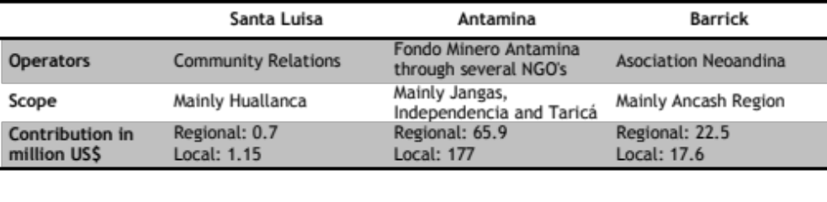
Source: MINEM, 2011b; Moreno, 2011; Instituto Cuanto, 2011; Asociación Civil Huanzalá, 2010. Own elaboration.

One important difference is the use of operators. This depends on the scope and contribution of each firm, as a larger scope and contribution requires a larger staff and more operators. More operators reduce the element of compensation that compromises the developmental interventions of large firms. But, it faces problems when trying to articulate different interventions, which is less severe when the chain of command is shorter (as in the case of SL and the articulation of farming and nutrition interventions).
There are mixed results regarding the investments of the PMSP that can be linked to different factors. In Huallanca, a clear and identified potential in productive activities has allowed the focalization of resources and efforts in this area. For instance, most of the investment of SL has been in farming activities (see Appendix 26, Figure 6), resulting in an improvement of the farming productivity noted by local producers (see Appendix, Table 15). Further information about the characteristics of the PMSP in each case (including investment and results) is given on Appendix 24).
In the case of Jangas, Barrick’s investment in agriculture has not improved the local productivity (MINAG, 2009; Instituto Cuánto, 2011). Here, the characteristics of the BS have had more influence in the outcomes than the firm’s interventions, evidencing the limitations of the PMSP. Even though project goals may have not been achieved, the emphasis on infrastructure has created a significant number of local jobs. Therefore, productivity may not have improved, but the household’s income may have been temporarily supplemented (see Appendix 24).
Finally, the investment of Antamina in capacity building in the LGs is significant. By financing the Participatory Development Plans of several municipalities, including Huallanca (district) and Bolognesi (province), the firm has made an effort to break with the traditional short-term interventions of CSR initiatives and recognized the importance of the LGs in the development process. In particular, Antamina aims to socialize the needs of the population, make important managerial tools available and draw up a wider development strategy for the locality. The limitations of the PMSP are that the possibilities of affecting crucial elements of the BS, like cultural and social/institutional capitals, as well as market conditions, are quite limited.
A final reflection assesses the sustainability of the PMSP as a long-term process. The PMSP depends on the resources and leadership of external actors, which is problematic when planning beyond the mining presence. This is the main problem noted in De Echave’s (2008: 63) discussion of the regulation of CSR, which could be seen to have taken over the role of the state in development.

The Upgrading Process
This process refers mainly to the forms of governance that affect the performance and configuration of the GVC. Therefore, the standards and terms for inclusion into the GVC, and the ability of the BS to meet these conditions, determine the process of upgrading.
As has been mentioned, mining GVCs are not deeply embedded in the observed BSs, as few LSMEs are included in the GVC. This relies on the high entry barriers of most mining firms and the low local assets (human and social/institutional capitals). In the case of SL in Huallanca, there is some room for upgrading, as the GVC is slightly more embedded and the BS is more competitive than in Jangas. Here, some LSMEs have managed to upgrade and achieve certain levels of specialization and certifications in order to obtain contracts with the mining firms. In this process, SL has contributed, acting as BDS.
Jangas presents a different situation. Its proximity to a big market with more competitive businesses has made it difficult for LSMEs to emerge, a challenge compounded by the fact that local assets are lower than in Huallanca. However, the market proximity has played an important role in further upgrading the few businesses that were able to survive (around 2), as the access to related industries and suppliers is better than in Huallanca. At the same time, they have changed their way of doing business, abandoning their social purpose, short-term vision and compensation reliant business relationships.

Mining firms: solutions to poverty or actors in Local Economic Development (LED)?
The review of the previous processes evidences the important role of mining in the reduction of poverty. Indeed, the rise in income, and the boosting and diversification of the local economy are consequences of the mining presence. Considering the lack of public support for agriculture and farming activities of medium and small scale, and the obstacles that they face, the diversification of the local economy is particularly positive in reducing households’ vulnerability.
However, these outcomes do not indicate the presence of an LED process. Considering LED as a process where different sectors work “alongside others in bringing about successful place making” (Haughton and Allmendingerr, 2008: 141), and contrasting it with the predominance of sectoral and self-regulated mining activity at a local level, the lack of public support for traditional activities, the low competitiveness of the mining districts, and the passivity of the LGs, it can be said that the conditions for LED remain weak.
In spite of this, some traces of different types of LED can be identified in the selected cases. The diversification of the local economy and the reduction of vulnerabilities are signs of Community LED. However, negative impacts in the sense of community caused by social conflicts and the reinforcement of migration trends, contravene this category. Likewise, reduction of vulnerabilities is still dependent on external factors and is not part of an endogenous process.
The case of Huallanca presents evidence of Enterprise LED, due to the presence of an agglomeration of LSMEs that have captured a local market. This relationship has generated a dynamic local economy, where LSMEs are fuelling the local demand. In this case, it is possible to talk about an endogenization process as defined by Helmsing (2010: 12). In the case of Jangas, the income generated by the mining presence is largely spent outside of the locality, while mainly outsiders capture the internal demand.
Jangas is far from experiencing any type of LED, as they have brought about poverty reduction through two formulas: increasing the income of local households, who have decided to invest outside or to migrate; and creating LSME that provide services almost exclusively to the mining firm. The latter is a business relationship based on compensation (firms are located in the communities affected directly by the mine) and not in competitiveness.
Locality LED is not seen in any case, as it refers to the process of maintaining the competitiveness of a locality through participatory processes. In both cases, there is a lack of specialised clusters, collective action, and local actors, such as civil society and government, creating the institutional milieu to generate or maintain competitiveness. This applies to agriculture and farming, but also to commerce and other local activities (construction, transport, etc.).

Is this a Resource Curse?
Resource Curse Theories provide several theses and explanations for the lack of development in mining scenarios that, in the Peruvian case, do not hold or are explained by other sets of factors rather than by mining. Therefore, even though Peru fulfils characteristic around which the theory is built, the causality relations seem to be misleading or inaccurate.
In the Peruvian case, the country has experienced outstanding economic growth and reduction of poverty indexes in the last years, which contradicts the thesis of poor growth performance. The frustrated economic diversification mentioned by Humpreys and Bebbington (2009: 262) does not apply either, as diversification of the economic spectrum in the observed districts is evident.
After reviewing the country’s policy shifts, it is possible to trace the distortions in the political and economic framework to the early ’90s, before the mining boom began in the late ’90s. This means that the mining bonanza did not create the distortions, but rather the distortions created the mining bonanza. In the same vein, the lack of development is not a consequence of mining exploitation, but is a consequence of a political and economic framework the effects of which may be accentuated or evidenced by the mining presence.
For instance, the regulation of traditional economic activities and the protection of rural populations’ rights become more flexible in recent decades, undermining their political and economic empowerment. In this context of vulnerability and of excessive freedom for mining firms to operate (due to concessions procedures, land acquisition and consultation processes), several distortions took place. The mining firms took on a prominent role in development, following the withdrawal of the state in these matters. These distortions, rather than being caused by the mining presence are the actual causes for it.
One problem of the Resource Curse Theories is that they tend to focus only on the mining sectoral policy, when in reality a combination of local characteristics and different policy frameworks work to determine the development opportunities. This interplay of factors influences the process of settlement of mining projects, which is particularly relevant for LED, and seems to be overlooked by the Resource Curse Theories.
This research has shown the different challenges and opportunities that mining represents for LED. As these challenges and opportunities are dependent on the TDP and the competitiveness of the local economy, there is neither a curse, nor a blessing. The relevant concept here is ‘nuance’, as LED is context and path dependent.
The way of framing reality produced by Resource Curse Theories leads to policy recommendations focused on the generation of mining revenue, its distribution, the role of the state in spending these resources, and on regulations that influence the mining activities at a macro level. While these reforms might make some improvements, on their own they will not bring about LED, as they do not represent modifications in the competitiveness of the local economy or the regulation of the TDP.

Conclusions
LED processes are not created by single actors or forces, but are processes that emerge from specific configurations of assets and active actors. Within this framework, conceptions where mining firms are seen as solutions for the lack of LED are illusory.
The analysis of the selected cases has shown the existence of a causal relationship between mining presence and income poverty reduction outcomes. Taking into consideration the differences between the mining firms studied and the particularities of their methods of localizing benefits, it is still safe to state that these outcomes are not backed up by the presence of sound LED processes. Therefore, the empirical data suggests that mining presence alone cannot create LED, and that certain conditions in the local economy and the TDP are necessary for it to emerge.
The focus on location rather than on the firm has several implications, and is supported by several arguments. One important argument is that the characteristics of the firm at the owner level are not conducive to the emergence of LED. The challenges of multiple-embeddedness make it difficult for MNEs to maintain the same corporate culture throughout the firm, minimizing the effects that international standards and voluntary principles may have at local level. In contrast, the characteristics of the firm at project level do have a significant impact. The size, assets and profitability, method of extraction and mineral exploited, influence the TDP and the type and magnitude of the perceptions and demands that the population will level at the mining firm. For instance, the perceptions of environmental and social risks, and of fair share of benefits, are related to the elements mentioned above.
This illustrates the importance of the relationship between the mining firm and the locality, which has several dimensions, such as the purchase of land, the establishment of mining areas (land management and zoning) and consultation mechanisms. The flexibility of the regulations regarding these issues has generated several distortions, which have in turn generated several liabilities. These liabilities undermine the potential for development and pollute the business relationships between firm and populace with a nuance of entitlement and compensation. Likewise, liabilities transform developmental projects into handout interventions.
If the TDP develops within a weak institutional framework, liabilities will emerge and the subsequent processes of inclusion, leveraging and upgrading will be doomed to fail. Here, the possibilities of transforming handout interventions and compensation-oriented business relations into sound LED process are few, even in competitive local economies.
A laissez-faire institutional framework for mining, rather than increasing these firms ability to modify the BS to improve its own competitiveness, have generated the emergence and evolution of other institutions (formal and informal), like Fronts of Defence, protests and even corruption. This institutional environment allows particular groups and rent seeking parties to capture many of the development opportunities, such as jobs, compensations and CSR interventions, provided by the mining presence. In the short term, the distortions mentioned may assist the expansion of mining by making project approval easier, but their consequences at the local level are negative and undermine potential LED opportunities.
It is important to consider that consultation mechanisms and comprehensive territorial zoning plans, are not only instruments for political empowerment, but also developmental tools. An effective consultation process, adequate land management tools, and regulated processes of land purchase all play an important role in LED.
In terms of the importance of the characteristics of the local economy and the BS for LED, it has been shown that territorial competitiveness and good market conditions are key to endogenizing the development opportunities created by the mining presence. This entails a change of focus; instead of considering the mining firms as inherently enclave industries, their enclave characteristics should be considered as an outcome of the TDP. This entails assessing how local conditions, together with the firm’s characteristics, create a specific relationship where linkages and spillover effects are few. Therefore, it is not the type of governance or the standards of mining GVCs that determines this outcome, but the fact of having capital-intensive industries operating in localities where the absence of the state has created non-competitive local economies, with poor human, productive and institutional capital. In these contexts, the access to skilled employment opportunities in mining is poor, the absorption of spillover effects is limited, and the embeddedness of the mining GVC is superficial (reducing the opportunities for upgrading).
It can be said that a competitive local economy, a supportive institutional framework for that economy, and the protection of the people’s rights to consultation and land, are more vital to the emergence of LED than the standards and regulations regarding the mining industry. Likewise, institutional arrangements at the local level, formal or informal, have a deeper impact on shaping mining operations than national regulations and international conventions.
These conclusions lead to a series of reflections regarding the current situation of mining districts in particular, and the country in general. The first reflection is on the necessity of looking beyond reforms that aim to regulate CSR or increase the mining revenue as automatic means of creating LED. Increasing the competitiveness of the local economy by reinforcing the role of the state, LGs and other civil society organizations at local level will prove more effective in promoting LED than experimenting with mining regulations.
A second reflection is on the need of a transectoral regulatory framework that articulates environmental, social, economic and cultural institutions at all levels. This should ensure the empowerment of local populations, the protection of their economic activities and elemental rights, and the compatibility of the economic activities within a territory. This way, the mentioned liabilities could be mitigated, neutralized or managed, to avoid the undermining of developmental opportunities.
Third, I propose that it is erroneous to consider the mining firms as responsible for the lack of LED processes. Mining firms cannot be responsible for something that is and has been absent. The absence of LED in mining districts, an on-going deagrarization process, and the migration trends in the rural areas, are consequences of the overall policy framework in Peru. The government’s lack of support to traditional activities, in combination with market conditions and other social trends (political and economic disempowerment of civil society) has made the LED process very difficult to kick-start. The mining presence may have exacerbated these trends, but not necessarily created them. Likewise, the power of the mining firms to revert this situation is limited or non-existent, especially in contexts of an absent state and passive LGs.
Reframing the issue of the lack of development in mining districts into a more territorial approach, challenges theses that put all the responsibility for the success or failure of LED on the private sector. This approach is also self-defeating, as it legitimizes neoliberal approaches that advocate for reduced states and foreign investment as only alternatives for development. This research also challenges theories and reforms that focus only on the mining policy framework, seeking to regulate CSR and increase mining revenue as only means of developing mining districts.
This research, in an attempt to understand the causal relationship between mining presence and LED, has unveiled several deficiencies in the Peruvian government’s framing of these issues. Knowledge is embedded in policy, and these deficiencies call for other epistemologies to make optimal use of an industry that is temporary and that represents a huge potential for the development of the country.
The problem of the lack of development in mining districts in Peru is a matter of decentralization, of land rights, of land management, of the right to be consulted, of the active role of the state and its subnational units in LED, of accountability, and of support to traditional activities and rural areas, rather than a matter of mining.

Appendices
- Peru’s macroeconomic and mining indicators
The mining production has represented shares between 4% and 8% of the GDP (Dammert & Molinelli, 2007: 73; Arellano, 2008: 39; Fairlie, 2010: 3). In terms of national exports, the country has experienced an increase of 361% since 2002, from which the mining sector has had shares between 49.4% in 2002 and 61.1% in 2010 (MINEM, 2011: 6; SNMPE, 2011: 1).

Table 1
Peru macroeconomic and mining indicators
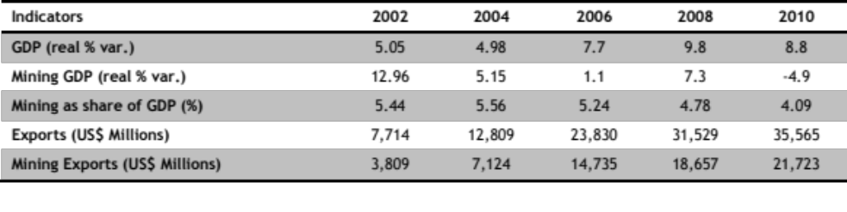Source: MINEM (2011a: 6) and Central Reserve Bank of Peru (2010: 228). Own elaboration.

- Poverty reduction in Peru
The percentage of households under the poverty line has decreased in about 14% between 2004 and 2009, with special emphasis in the urban areas (37.1% to 69.8%), while in the rural areas the population below the poverty line remains above 60% (INEI, 2010a: 21).
The Unmet Basic Needs Index (NBI in Spanish) also shows a decrease of about 8% between 2005 and 2009, with a difference between the urban (21.7% to 18.2%) and rural areas (65.8% to 49.5%) (INEI, 2010b: 62).
In terms of the Human Development Index (HDI), Peru has improved from 0.675 to 0.723 in the last 10 years, placing the country above the regional average (0.706) (UNDP, 2011).
- Main characteristics of the department of Ancash and the provinces of Bolognesi and Huaraz
The department of Ancash is located in the northern part of Peru, occupying areas of the coast and Sierra region. This department has had a prominent position in Peru’s economy in the last 10 years, thanks to the increasing number of mining projects that have been developed within the jurisdiction. Indeed, Ancash is now the country’s first producer of copper, the sixth of gold, the second of silver and the first in zinc (MINEM, 2011a: 23). At the same time, it has also witnessed an important reduction of income poverty in the last years (from 56.1% to 31.5%) being the best performer of the five most important mining departments.

Map 1
Department of Ancash and provinces
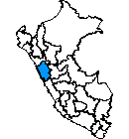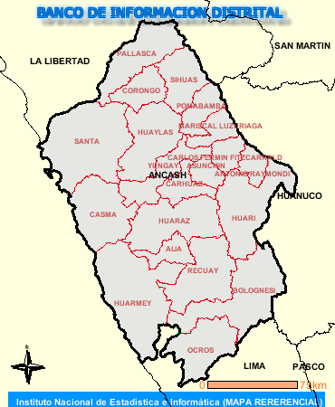
Source: INEI, 2011b

Among the most important mining departments, Ancash is the one that has performed the best in terms of income poverty reduction. As can be observed in Table 9, Ancash has reduced its income poverty in 24.6% between 2003 and 2009.

Table 2
Poverty rates variation (2003-2009) in the six most important mining departments (%)
Depart. | 2003 | 2004 | 2005 | 2006 | 2007 | 2008 | 2009 | Var. %
Ancash | 56.1 | 53.3 | 48.4 | 42.0 | 42.6 | 38.4 | 31.5 | -24.6
Arequipa | 36.9 | 34.2 | 24.9 | 26.2 | 23.8 | 19.5 | 21.0 | -15.9
Cajamarca | 73.3 | 66.2 | 68.8 | 63.8 | 64.5 | 53.4 | 56.0 | -17.2
La Libertad | 51.3 | 48.5 | 43.0 | 46.5 | 37.3 | 36.7 | 38.9 | -12.4
Moquegua | 34.0 | 38.7 | 30.3 | 27.3 | 25.8 | 30.2 | 19.3 | -14.8
Tacna | 29.7 | 24.7 | 30.3 | 19.8 | 20.4 | 16.5 | 17.5 | -12.3
Source: INEI (2011a: 42).

About the provinces, Huallanca is located in Bolognesi, at the south east of Ancash, while Jangas is located in the northern part of the province of Huaraz, in the centre of the department and at 16 km from the department’s capital. In spite of the distance that separate them from one another, both share a mountainous geography with altitudes above the 3,000 m.a.s.l., and similar environmental characteristics.

Map 2
Map of the province of Bolognesi and Huaraz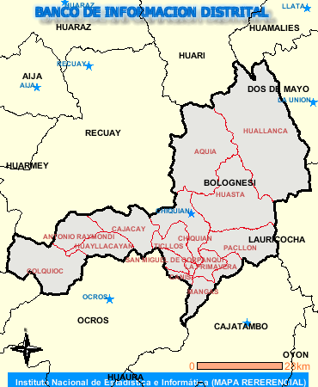 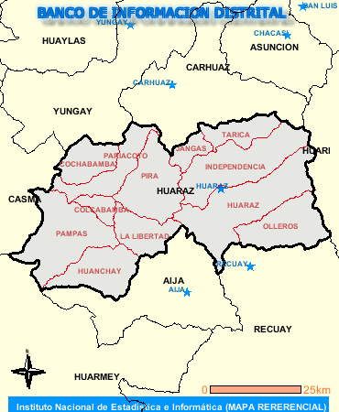
Source: INEI, 2011b

An important difference between the two provinces is that Bolognesi, in spite of having about 13.9% of the department’s population, is the 5th with lowest demographic concentration among the 20 provinces of the department (10 pers. per km2). In contrast, Huaraz has a small share of the department’s population but still is the 2nd with highest demographic concentration in the province (59 pers. per km2), which responds to the importance of the department’s capital (PDC Bolognesi, 2009: 25; PDC Huaraz, 2009: 6; INEI National Survey 2007).

Table 3
Bolognesi and Huaraz basic information
 | Province of  Huaraz | % of the  department | Province of  Bolognesi | % of the  department
Surface (Km2) | 2,492.90 | 6.9 | 3,116.90 | 8.7
Population | 147,463 | 13.9 | 30,725 | 2.9
Nº of Districts | 12 | 7.2 | 15 | 9.0
Altitude (m.a.s.l.) | 3,100 | - - | 3,526 | - -
Source: INEI National Survey 2007, PDC Huaraz (2009) and PDC Bolognesi (2009). Own elaboration.

- Personal interviews
All the interviews for this research were done personally between July and September 2011, and were done in situ. The only interview conducted by Skype was with Walter Maguiña. The following charts are separated according to the case o study. The first two address directly issues regarding the locality and/or the firm operating in it; while the last two provided information about broader subjects, like regional development projects, mining legislation, mining contexts in general, etc. All of the interviewees are key stakeholders from different sectors.

Table 4
Interviews regarding Huallanca
Name | Position | Institutions / Organization | Date
Luis Alburqueque | Chief of Community Relations | Antamina | 25/07
Marco Linares | Community Relations Officer | Antamina | 14/07
César Gonzáles | Coordinator of Productive Projects | CARE (Huaraz) - Operator of Antamina | 21/07
David Ocaña | Director of Regional Office | CARE (Huaraz) - Operator of Antamina | 21/07
Eliana Cerdan | Project Specialist | CARE (Huaraz) - Operator of Antamina | 22707
Ricardo Santos | General Manager | Electricistas y Contratistas Generales LIDERSAC (Huallanca) | 15/07
Gilberto Villanueva | General Manager | Empresa de Servicios G.V.V. (Huallanca) | 15/07
Hansel Ariza | President | Farming Producers Association - Buena Vista (Huallanca) | 14/07
Manuel Llanos | President | Farming Producers Association - Galaniog (Huallanca) | 14/07
Manuel Santamaria | Coordinator Productive Development | Fondo Minero Antamina | 25/07
Abelardo Paucar | President | Front of Defence (Huallanca) | 15/07
Juan Marco | Hostel Owner | Hostel (Huallanca) | 15/07
Elmer Lozano | Chief of the Office of Economic Development | Municipality of Huallanca | 13/07
Lincoln Marques | Chief of the Office of Urban & Rural Development | Municipality of Huallanca | 13/07
Jimmy Castro | Chief of the Office of Economic Development | Municipality of the Province of Bolognesi | 27/07
Marta Flores & John Zapana | Project promoters | NGO Alli Mikuy - Operator of Antamina | 13/07
Carlos Muñoz | Restaurant Owner | Restaurant (Huallanca) | 15/07
Becquer Soto | President | Rondas Campesinas (Huallanca) | 14/07
Serafín Valer | Manager of Environmental and Social Affaires | Santa Luisa | 11/07
Takahiro Kojima | Chief of Community Relations | Santa Luisa | 14/07
Gianina Ramirez | Community Relations Officer | Santa Luisa | 15/07
Luis Camacho | Coordinator | Technoserve - Competitividad Ancash (Operator of Antamina) | 25/07
Walter Maguiña | Executive Director | Technoserve - Competitividad Ancash (Operator of Antamina) | 14/07
Maria Chavez | President | Women's Association (Huallanca) | 15/07
Source: Own elaboration

Table 5
Interviews regarding Ancash and the Districts of Huallanca and Jangas
Name | Position | Institutions / Organization | Date
Richard Moreno | Analyst | CEDEP – Centro de Estudios Para el Desarrollo y la Participación
Eloy Camones | Director of Regional Office | FONCODES - Fondo de Cooperación para el Desarrollo Social (Huaraz) | 20/07
Agustín Corzo | Project Manager | FONCODES - Fondo de Cooperación para el Desarrollo Social (Huaraz) | 20/07
Gladys Olivera | Former Coordinator of Projects of FONCODES / Manager | FONCODES - Fondo de Cooperación para el Desarrollo Social / NGO Arcoiris - Operator of Antamina | 21/07
Edgar Brito Gonzales | Chief of the Office of Budget and Planning | Municipality of the Province of Huaraz | 12/07
Sósimo Guzman | Director of Agrarian Promotion | Regional Directorate of the Ministry of Agriculture | 19/07
Fernando Zevallos | Advisor of Economic Development Office | Regional Government of Ancash | 11/07
Laura Acosta | Chief Animal Sanitation | SENASA- Servicio Nacional de Sanidad Animal (Huaraz) | 19/07
Tito Tinoco | Professor of land management and planning | University of Huaraz | 22/07
Source: Own elaboration
Table 6
Interviews regarding Jangas
Name | Position | Institutions / Organization | Date
Ernesto Sirani | Priest / Leader | Artesanos de Don Bosco (Jangas) | 24/07
Eugenio Obispo | President | Community of San Isidro (Jangas) | 18/07
Erik Damian Gloria | Governor of Jangas | Jangas Government | 18/07
Jaime Cadillo | General Manager / Founding member and shareholder | JC Constructores / San Francisco de Antahurán Constructores (Jangas) | 26/07
Confidential | Manager | Minivan company (Jangas) | 22/07
Jimmy Jaramillo | Chief of the Office of Infrastructure | Municipality of Jangas | 22/07
Carlos Chong | Municipal Manager | Municipality of Jangas | 22/07
Johnny Henostroza | Chief of the Office of Development | Municipality of Taricá | 19/07
Mario Mendoza | Alderman / Flower producer | Municipality of Taricá | 19/07
Victoria Quito | Owner | Nueva Era Transport Services (Jangas) | 26/07
Betsy Julca | General Manager | San Francisco de Antahurán Constructores (Jangas) | 26/07
Teófilo Rodrigues | Teacher | School in Jangas | 22/07
Source: Own elaboration
Table 7
Interviews regarding mining in general
Name | Position | Institutions / Organization | Date
Gerardo Damonte | Senior Researcher | GRADE (Lima) | 08/08
Manuel Glave | Senior Researcher | GRADE (Lima) | 08/08
Juana Kuramoto | Senior Researcher | GRADE (Lima) | 08/08
Marta Vasques | Legal Advisor | Ministry of Energy and Mines | 08/08
Source: Own elaboration
- Value chain approaches variants
Coe et al. (2008: 267) distinguish the three main “strands of research” within the “chain” theories:
- GCC: concerned more in understanding how global industries are organized, by identifying actors involved in the production and distribution of a good or service and mapping their relationships.
- GVC: concerned in the governance structures within and among different global industries and sectors, in terms of diversity of the knowledge characteristics in each of them (see also: Helmsing, 2010: 11).
- GPN: concerned on the “multi-actor and multi-scalar characteristics of transnational production systems through intersecting notions of power, value and embeddedness. In particular, attempts are made to connect with understandings of sub-national regional development and clustering dynamics.” (Coe et al., 2008: 267) In general terms, this branch combines GCC and GVC with the actor-network theory and capitalism/BSs literatures.
- Touching Down Process (TDP): main components
The three main components of the TDP, as described by Helmsing & Vellema, (2011: 9), are the following:
- Nature of doing business: it assumes that in the BS, local producers and local small and micro enterprises (LSMEs) may have particular ways of doing business, following logics that may differ from those of the GVC. This assumption is also valid for the way of organization and associating. The outcome of this relationship, which results in the way GVC and the local producer do business, is then the result of an interaction. In the process, items to consider are the way in which actors do business, how do they organize, what objectives and interests do they pursue, how do they expect to achieve those objectives (strategy), and which are the main elements that influence the previous items (political relationships, cultural background or perception of development).
- Nature and role of the state in the economy: in this component the formal and informal institutions are taken into consideration, as they “shape” the BS where the GVC operates. Defining the characteristics of these institutions, and the role they play in doing business and/or in the different development processes, is fundamental for understanding the way the BS operates and the foreseeable outcomes from its relationship with GVC. An emphasis in the state and public institutions is given.
- State-Business relationship: it is assumed that GVC will try to influence the BS in order to enhance the competitiveness and productivity of the firm. By the side of the state, there might be different dimensions that are more prone to change than other, or which are more feasible to be modified. The relationships between both actors “consist of a field of forces that can help or hinder the touching down process.” (Helmsing & Vellema, 2011: 9).
- Poverty definitions and measures
Stewart et al. (2007: 3) mentions the challenge of defining and measuring poverty because of its multidimensionality, the delimitation of poverty lines, the selection of the units, among other issues. The author offers an overview of the four most common approaches to this notion.
- The monetary approach: it defines poverty in terms of the shortfall between income or consumption of a family and an established poverty line. The poverty line is usually defined in terms of family basic basket and has two standards: alimentary (defines extreme poverty) and total (defines poverty) (Barrantes, n.d.: 3).
- The capabilities approach: this framework tries to move beyond monetary considerations and focuses on indicators of “freedom to live a valued life” (Stewart et al. 2007: 15). The Human Development Index (HDI) can be considered in this category, as it is a multidimensional approach that defines poverty considering issues like access to health, education and a “decent standard of living”, but also includes political and social liberties, like Human Rights (UNDP, 2010: 2). It is important to acknowledge that the HDI, and the UNDP in general, make special emphasis on the institutional and political framework that helps enabling the mentioned capabilities.
- The social exclusion approach: this type of poverty refers to marginalization that some populations may suffer, in terms of deprivation from a way of living that is ordinary or typical in the society where he/she lives in. In this category, measures like the Exclusion Index elaborated by FONCODES (2007) or the indexes of Unmet Basic Needs, first designed by the UN Economic Commission for Latin America and the Caribbean (ECLAC) and used by the National Institute of Statistics (INEI), are the most significant.
- Participatory methods: the previous methods have been criticized for its exogenous approach. Participatory methods aim to build, from the people itself, particular definitions and magnitudes of poverty.
- Agricultural & farming policy framework: the withdrawal of the state
The policy framework guiding and regulating the agriculture & farming sector in Peru suffered several changes, not only due to the predominance of different rural development approaches in the last decades, but also because of the different roles given to the public sector. Trivelli et al. (2009) points out that between the 60’s and 90’s the state had an active role in the promotion of the agricultural sector, whether under the principles of the Green Revolution in the 60’s, Import Substitution in the 70’s (p. 20), or a decentralized and “from within” approach in the 80’s (p. 102).
A series of factors that interplayed in the late 80’s, like the failure in the implementation of a series of reforms to boost the agricultural sector together with the deep economic and social crisis that hit the nation, created an scenario for severe reforms that affected not only the agricultural sector, but the whole economic and political system (Otero & Chau, 1999: 7; Trivelli et al. 2009: 106). For instance, Vincent (2010: 66) states that the “neoliberal turn beginning in the 1980’s” meant the “decline of the state” and the replacement of the welfare state.
Structural adjustment policies started to be heavily implemented in the early 90’s, meaning that a specialized and focalized agriculture, mostly export-oriented, took place instead of a more comprehensive understanding of the rural areas and a wager for the small and medium agriculture as a way to reduce poverty (Eguren, 2007: 12; Trivelli et al., 2009: 21). According to specialists from the public sector interviewed during the fieldwork, it is widely accepted that the series of mechanisms designed before the 90’s were quite appropriate to improve the productivity of small and medium producers from the rural areas, but that the lack of supervision and the widespread corruption took over institutions like the Agrarian Bank and the deconcentrated Agrarian Agencies, undermining the overall positive impacts of the system.
As mentioned by Euguren (2007: 18), the agriculture in Peru followed a path of exclusion since the 90’s, where the prioritized production were non-traditional products in a framework of specialized agriculture, mainly in the coast. This aimed to capture a market that countries from the northern hemisphere were not able to satisfy due to seasonal changes. This focus on the large and coastal agriculture meant also that the institutions supporting the small and medium producers, mostly from the Andes, were dismantled. The predominance of a neoliberal framework, a minimum state, and the dissolution of the institutions supporting the local producers, confined this sector of the population to a position of dependency towards a series of “social programs”, due to their lack of capabilities to compete in the newly liberalized markets (Euguren, 2007: 18).
In Ancash, the change of paradigm mentioned above, had impacts in many fronts: access to credit, access to technical assistance, and access to supplies (through state subsidies). For example, according to the staff from the Regional Directorate of the Ministry of Agriculture in Ancash, the number of employees in the unit of Agricultural Promotion before the 90’s was of 04 specialists per province, while after the 90’s it was of only 04 specialists for around 12 provinces.
It is important to acknowledge the several attempts and initiatives to devolve to the state its active role in the development of the national economy, and to reform the institutional framework to support local and regional economies. For instance, the National Strategy for Rural Development (MINAG, 2004: 15), the Regional Agrarian Strategic Plan 2009-2015 (DRAA, 2008: 15) and the 2007-2011 Strategic Sectorial Plan for Agriculture (MINAG, 2008: 12) points several issues that have been claimed in this section, like the low productivity and competitiveness of the rural agricultural sector, the lack of technical assistance and R&D services, the poor infrastructure of roads and irrigation, the lack of financial support, the scarce coordination between public institutions and with institutions from the private sector and civil society, among others.
The recognition of these deficiencies has been the result of several debates among different sectors of the society and represents an accurate diagnosis of the rural and agrarian problems. But, as authors like Eguren (2007: 19) and Trivelli et al. (2009: 327) point out, even if the policy framework has become more comprehensive and a series of institutions have been reformed, the gaps remain. The main challenges that these authors foresee for the next years can be synthesised in the following: how to articulate the strategy with an effective coordination among the different institutions and actors involved in rural and agricultural development; how to align the different levels of government to the overall objectives of these strategies; and finally, how to achieve these objectives.
When reviewing the theories of LED and competitiveness, it is possible to observe the importance of a strong institutional milieu for the success of any economic activity. In the case of Ancash non-coastal areas, this milieu is deficient and almost inexistent, with no agencies for the promotion of these activities, no subsidies or financial support, no articulation with R&D institutions, etc. This explains largely the poor productivity of these activities. Likewise, the lack of opportunities also disempowers the population, as the need for a better way of living sometimes puts them in the position of negotiating over their natural resources and their lands.
- Local government’s policy and decentralization framework: LGs autonomy and the need for governance
Since 2002, Peru started a new process of decentralisation, in order to restore the “confidence in government and prove its legitimacy” (Vincent, 2010: 67). As mentioned by Arellano (2011: 621), referring to the UNDP (2006), this process was basically conceived as crucial part in the process of re-democratisation. This meant that the decentralisation process was more a top-down initiative, rather than an adjustment to the existing local institutions.
Authors like Falleti (2005: 331), Dickovick (2006: 19) and Ticci (2011: 8), mention the problems that arise when these kind of processes give little attention to the implementation sequence, matching political, administrative and fiscal decentralization. In the same way, special attention to the existence of the managerial capabilities at the local level is crucial, as well as strong institutions for maintaining spaces of effective governance. As mentioned by Goldfrank, (2006: 14), together with the matching of resources with duties, a matching with social capital is also an important condition for a successful management of a local government. Indeed, one problem observed in several Peruvian LGs is the lack of capacity to design projects that passes all the feasibility studies done by the CG, which is considered by several authorities as a bottleneck that undermines the enthusiasm of the local authorities to design new projects and of the population to participate (Goldfrank, 2006: 14).
In general terms, local authorities are elected by popular elections and LGs have relative autonomy to design their own development plans, undertake processes of participatory budgeting, and modify its internal structure in order to be more responsive to the needs of its particular locality. Even though, there are some limitations in terms of issues related to territorial planning and mining decisions, as it would be explained later.
From the cases studied, there are some issues that should be pointed out. In spite of the structural modifications towards a more decentralised, participative and planned administration at the local level, with an increasing emphasis in governance approaches, there is sort of a time-lag in the autoperception of the local authorities. In general, LGs do not perceive themselves as active actors in the LED process, they do not use the managerial tools (baselines and development plans) and have not adjusted their internal structure to the local needs, as non of the cases studied have an office for agricultural or farming issues. Local authorities perceive themselves as an enabler, and not as coordinator, promoter or planner.
- Mining policy evolution: towards a more flexible framework
In general terms, since the 1950’s, the literature recognizes four moments in which the mining policy has had substantial changes. These modifications have relied on changes in the general view of governing and development the government, but also have been influenced by external factors like the global market conditions. Glave & Kuramoto (2002: 547; 2007: 137) elaborates on the main changes in the policy framework since the 1950’s and the present:
- 1950 - 1970: in 1950 the Peruvian government promulgated the Mining Code, which was focused on attracting foreign investors for the exploitation of mining sites in the country.
- 1970 - 1980: with the military government since 1968, several changes took place. Import Substitution Strategies and the creation of state enterprises where among the main features of the new orientation of the country’s economy. In 1971, a new General Law of Mining was promulgated, taking away most of the incentives given to foreign corporations and giving to the state the role of production, refinement and commercialization of minerals, through the expropriation and nationalization of mining projects. Since this year and until the 80’s, there are no significant mining projects developed in the country so far.
- 1980 - 1990: in 1981 a new General Law of Mining was promulgated, now within a democratic framework. The main changes were the dissolution of the state monopoly in mineral extraction, creating a series of incentives for foreign investors to undertake projects of medium scale in the country, like tax holidays and other kind of exonerations in the reinvestment of utilities. These measures did not result in positive outcomes, mainly because of the country’s economic and social crisis and the contraction of the mineral prices in the global market.
- 1990 - to present: the structural adjustment policies implemented in Peru aimed to create a favorable environment for private investment and the extractive industries. The main change was the establishment of mining as of national interest, through the promulgation of the DL 708 Law for the Promotion of Investment in the Mining Sector (1990). This Law meant a series of privileges for transnational enterprises, like legal stability contracts and fiscal benefits. Other set of legal innovations were the DL 757 Law for Growth of Private Investment (1991), the DS 014-92EM General Law of Mining (1991), DS 016-93EM Regulation for the Protection of the Environment in the Mining and Metallurgic Activity (1993), among others.
The consolidation of the neoliberal framework in Peru and in other neighboring countries, together with the availability of resources, technological improvements, and favorable mineral prices in the early 90’s had significant effects on the inflows of private foreign investment in the continent (Szablowski, 2002: 247; Glave & Kuramoto, 2007: 140; De Echave et al., 2009a: 13). During these years (1990 – 2001), 12 of the 25 largest capitals in mining invested in South America, especially in Peru, Chile and Argentina (Bebbington et al., 2008a: 2889). In the same period, the legal framework protecting land and the environment in Peru was also made more flexible, in order to facilitate the development of projects within the extractive sector (De Echave et al., 2009a: 13).
As a result of Peru’s favorable environment for mining industries the country is now ranked as one of the main mineral producers in the world, with a profile for further expansion. For instance, in the Corporate Overview 2011 of Malaga Inc., owner of Pasto Bueno mine in Ancash, Peru is seen as “pro-mining jurisdiction”.

Table 8
Peru’s position in mineral production
Mineral | World | Latin America
Silver | 1 | 1
Zinc | 2 | 1
Tin | 3 | 1
Lead | 4 | 1
Gold | 6 | 1
Mercury | 4 | 2
Copper | 2 | 2
Molybdenum | 4 | 2
Selenium | 9 | 2
Cadmium | 12 | 2
Iron | 17 | 5
Source: elaborated by MINEM (2011a: 21), based on U.S. Geological Survey-USGS-; The Silver Institute; Gold Fields Minerals Services -GFMS-; International Copper Study Group -ICSG-; International Lead and Zinc Study Group -ILZSG-; International Tin Research Institute -ITRI-; International Molybdenum Association -IMOA-; Instituto Latinoamericano del Hierro y el Acero – ILAFA.
- Social regulatory framework related to mining activities
Some of legal instruments regarding the social regulatory framework are the Law for the Private Investment and the Development of Economic Activities in lands of the National Territory and of Peasant and Native Communities (Law Nº 26505), the Regulation of Consultation and Citizen Participation in the Procedures of Approval of Environmental Studies in the Energy and Mining Sector (RM Nº 596-2002-EM/DM) and the Environmental Regulation for Mining Exploration Activities (DS Nº 038-98-EM). Other legal instruments are the General Law of Environment (Law Nº 28611), the Law of the National System of Environmental Impact Assessment (Law Nº 27446) and the Resolution Nº 26253, where the Peruvian Government adheres to the 169 Convention of the ILO.
From these set of norms, the main features of the social policy regarding mining can be drawn. The main points are described as follow:
- Consultation and consent: one first issue is the fact that the responsibility of undertaking the consultation process relies on the mining firms themselves (Alayza, 2007: 141). This results not only in an asymmetric negotiation with the local populations, but also in huge expectations due to the several promises done by the firms to “buy” the social legitimacy of their projects. A second issue is that the so-called consultation process only ensures partially the right of information of the affected populations, through a series of hearings, but do not takes into consideration their consent or opinions towards a particular project (see also De Echave et al., 2011).
- Territorial planning and land use: in spite of the existence of a law for territorial zoning, the country lacks of a consistent and comprehensive plan of Territorial Planning and Land Use, considering the economic, ecologic and cultural characteristics of the territory (Glave & Kuramoto, 2002: 586, De Echave et al., 2009b: 350). De Echave et al. (2009b: 350), referring to Glave (2002), recognize that the absence of these instruments results in the expansion of mining in areas were this activity may not be feasible or accepted. The consequences are that the local way of living may be threatened, as well as the people’s will, creating a series of liabilities.
- Land policy: important threads in this area has been the reduction of the protection of peasant’s collective property rights to promote land concentration in market-oriented actors (mining, export-oriented agriculture), the reduction of the (environmental) requirements and conditions for the extractive industries to operate, and the concentration of decision-making power regarding land use in the central state (Pinto, 2009: 87) Additionally, in 1995 the state’s right to declare easement zones in areas where collective rights clashed with the development of extractive industries was established.
- Mining revenue distribution
According to the MINEM (2011: 83), the mining revenue generated in 2010 was more than US$ 1.4 thousand millions, divided in three concepts: mining canon, mining royalty and concession fees. From these, the most important is the mining canon, which represents about 82% of the mentioned contributions (MINEM, 2011a: 86) and around 20% of the local government’s annual expenditure (MEF Economic Accountability Site, 2011). In the following figure it could be seen how the mining canon is distributed and the main changes since 2002.

Table 9
Distribution of the Mining Canon
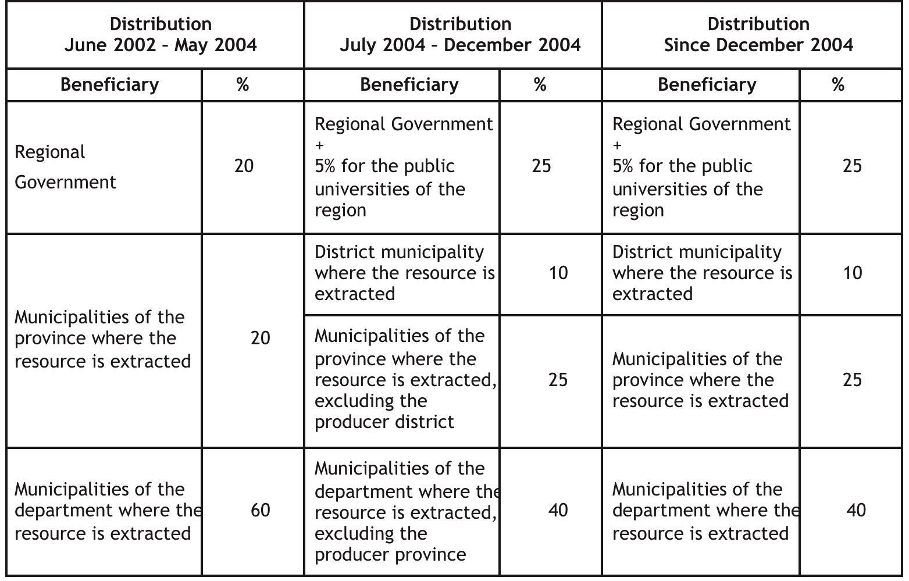
Source: Arellano (2008: 21).
- Programa Minero de Solidaridad con el Pueblo: regulated CSR
The appearance of this program portrait very well the debates mentioned in the previous paragraph. According to the Grupo Propuesta Ciudadana (2011: 1), during the presidential election of 2006, Alan Garcia proposed to increase the tax burden of the mining sector as part of a set of policies to achieve better developmental results from these activity. Once elected, Garcia negotiated with the mining representatives for alternatives to promote local development, which lead to the creation of the PMSP as a way to avoid an increase in taxes. The Supreme Decree that establishes the origin of this program is DS 071-2006-EM, which states as main objective the contribution “to the improvement of the life conditions of the population within the areas of influence of the mining activities”. The PMSP then became a voluntary fund to be executed under certain regulations established by the government, which includes issues of accountability, participation, and prioritization of projects.
- Mining firms’ owners & partners
The relevance of this level in the TDP is not as evident as the firms & projects characteristics. What matters the most is the way in which the TDP is developed, and the pressures that local actors exert over the firm. Considering that there is a relatively standardized set of demands from populations affected by mining operations (environmental responsibility, job opportunities and CSR interventions), the relevant characteristics of the owners & partners is in terms of previous experiences and the ability to share and transfer this knowledge to the different points of the GVC.

This is the case, according to testimonies, of BHP Billiton because of their innovative ideas in terms of social and environmental responsibility. This differs from SL, which is part of a Japanese conglomerate specialized in refining, manufacturing and R&D. In this case, SL’s involvement with the surrounding communities through CSR initiatives or its respect for the environment was more a response of mobilizations and protests (for the PMSP in 2007) and of changes in the environmental legislation (modernization of machinery since the 60’s) than a product of a corporate culture based on international standards and voluntary principles.
In the case of Barrick, it is a firm specialized in mining but that has been known for lacking an effective mechanism for sharing knowledge across the different levels of the firm and of concentrating the decision-making processes in the parent company. In this regard, the adoption of standards and voluntary principles seems to not be relevant for explaining the way in which they operate.
Table 10
Owners & Partners main characteristics
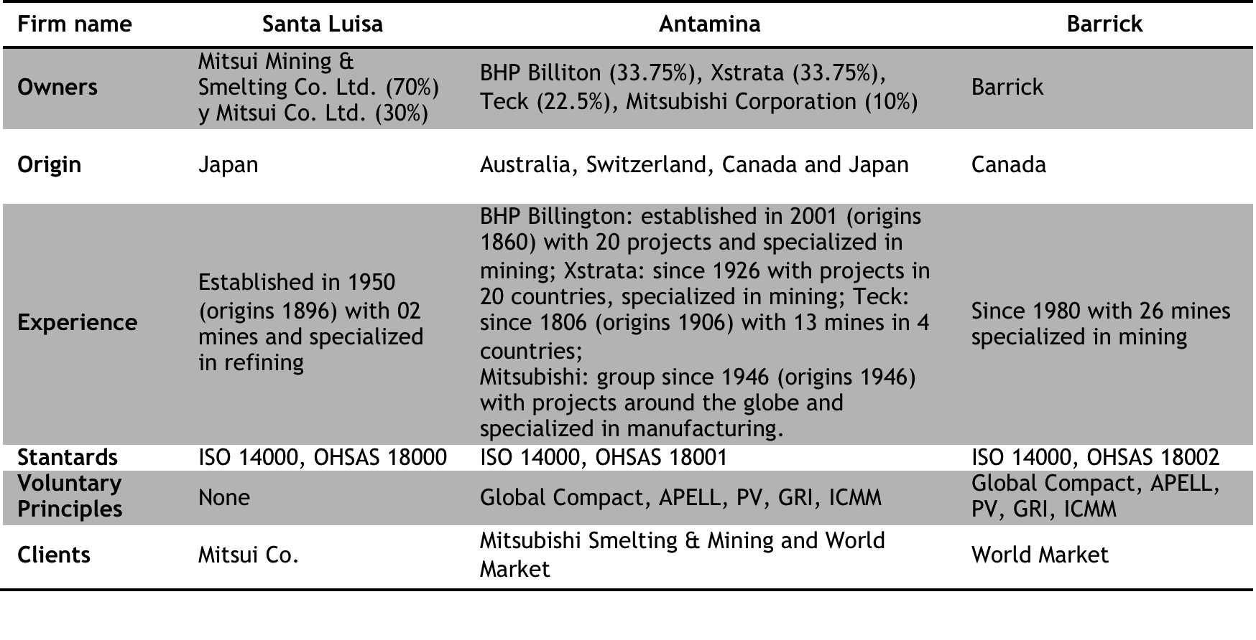
Source: www.mitsui.com; www.bhpbilliton.com; www.xstrata.com; www.teck.com; www.barricksudamerica.com; www.antamina.com. Own Elaboration.
- Mineral prices’ fluctuations
According to the data presented in the following chart, it is possible to appreciate the significant increase in the gold price in the last years. This has meant an important increase and profitability of gold mining projects, like Barrick. For instance, the closure of this project was projected to start in 2006 (VECTOR, 2006: 13), but according to information from the LG of Jangas, the closure of the project is now estimated for 2014. This increase in the profitability of the project has had consequences on the demands of the population, as it is expected that the share of benefits received by the population also increase.

Figure 1
Mineral Prices’ Fluctuation

Source: MINEM, 2011c. Own elaboration.
- Satellite view of Project Pierina (Barrick)
According to measurements done over Google Earth Software, it is possible to measure the length of Pierina project. The length estimated is of 5 km.

Figure 2
Satellite view of Pierina (Barrick)
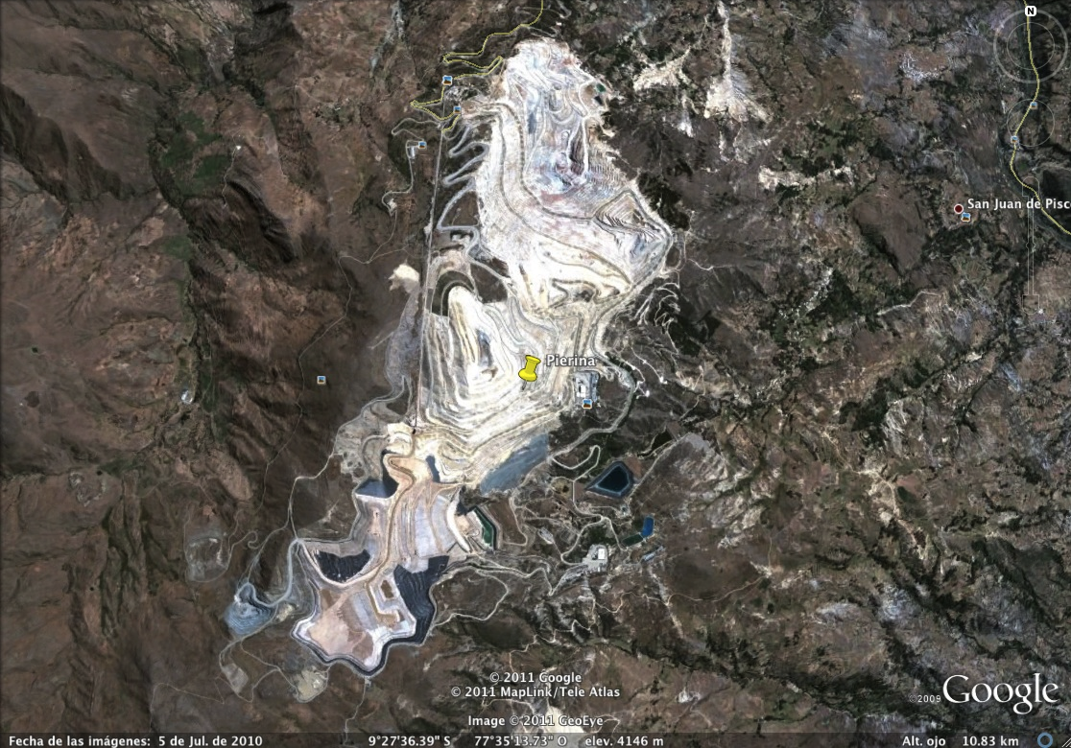
Source: Google Earth, 2011.
- Population, migration and urban vs. rural shares
Huallanca has a larger population and land extension than Jangas, which results in lower demographic concentration and more land extension per household: 9.4 persons per km² in Huallanca and 73.6 persons per km² in Jangas.

Table 11
Huallanca and Jangas basic information
 | Huallanca | Jangas
Surface (Km2) | 873.4 | 59.8
Population | 8,249 | 4,403
Demographic concentration | 9.4 | 73.6
Source: INEI National Survey 2007, PDC Jangas (2007), PDC Huallanca (2009) and PDC Huaraz. Own elaboration.

In both districts there has been an increase in the overall population in the last 14 years (between the INEI National Surveys of 1993 and 2007). According to the National Survey of 2007, from the newcomers to Jangas about 34% work in mining, while in Huallanca this share is of 24%. These shares are way above those of agriculture & farming, which have about 7% and 9% respectively. This reveals the importance of mining in the demographic dynamics of the district. Likewise, this increase in population is supposed to have a direct impact in the local economy, in terms of demand and flows of money.
About the urban vs. rural share, Huallanca is more urban but with a growing rural area, while Jangas is more rural and with a trend towards urbanization, but still with an increasing population in the rural areas (in absolute terms). Even if there is no deruralization process, there seems to be a deagrarization process. In Huallanca, about 35% of the newcomers into the rural areas work in mining, while only 9% work in agriculture & farming. In Jangas the situation is similar, with 50% of the newcomers working in mining and about 5% in agriculture & farming. This means that the increase of the rural population is not necessarily because of the attractiveness of the rural activities, like agriculture & farming, but because of the job opportunities in mining.
Table 12
Huallanca and Jangas population and urban vs. rural shares
 | Huallanca |  |  |  | Jangas
 | 1993 |  | 2007 |  | 1993 |  | 2007
 | Population | % | Population | % | Population | % | Population | %
Urban | 4,973 | 64 | 4,829 | 58.5 | 1,216 | 34.1 | 1,764 | 40
Rural | 2,799 | 36 | 3,420 | 48.5 | 2,353 | 65.9 | 2,639 | 60
Source: INEI National Survey 1993 and 2007. Own elaboration.

On the side immigration due to agriculture and farming jobs, this is mainly explained because the mining job opportunities absorb many local population that move to the urban areas, reducing the availability of labour force in the rural areas. Additionally, the cost of agricultural labour has increased, from US$ 7 to US$ 18, similar to the price of a mining day’s wage. In general terms, this means the reduction of agricultural workers and an opportunity for people from the poor nearby areas (that lack of mining direct or indirect employment), which arrive to these lands to work as tenants. This phenomenon is more common in Huallanca, where farming activities seems to demand more labour force (due to the land extensions) and where a share of the produce is for marketing.
In terms of migration flows within the localities, households adopt a system of temporary displacements. The main reasons for this are the access to better basic and educational services (usually absent in the rural areas), and also to access other employment opportunities (as part of an economic diversification strategy). Even though, this represents temporary and partial displacement, because the rural properties are not abandoned or sold, and not all the family members move to the urban centre.
Additionally, it is important to point out that the most common places for migration are not only the department capital, but also Lima (about 04 and 08 hrs. respectively) and Barranca (06 hrs.). From these, Lima is considered the more attractive for local entrepreneurs, as the availability of suppliers offering good prices and quality is more abundant.
- Poverty and inequality
One of the reasons for the studied cases of this research was because of the significant reduction of income poverty between 2007 and 2009 (INEI, 2007; INEI, 2009). In both cases, the poverty rates dropped in about 30%, while other indexes, like HDI and inequality (GINI), have also shown a relative improvement. Even though, as observed, malnutrition rates remain significant.
In general terms, Huallanca and Jangas have received an important inflow of economic resources, which seems to have had an important impact on the monthly income of the local households. But, the relationship between that income poverty reduction and the presence of a LED process is still dubious. For example, in the case of malnutrition that affects more Jangas than Huallanca, it is possible to observe deficiencies in terms of Human and Productive capital, which may have a direct impact in malnutrition rates (education and food security).
Table 13
Poverty, malnutrition, inequality and HDI in Huallanca and Jangas
 | Huallanca |  |  | Jangas
 | 2003 | 2007 | 2009 | 2003 | 2007 | 2009
Income Poverty | 0 | 60.4 | 26.4 | 0 | 54.6 | 27.6
Malnutrition (from 6 to 9 years) | 0 | 34 | 0 | 0 | 46 | 0
GINI | 0 | 0.26 | 0.32 | 0 | 0.25 | 0.3
HDI | 0.5487 | 0.5783 | 0 | 0.4318 | 0.5495 | 0
Source: INEI Poverty Map 2007 and 2009 (INEI, 2007; INEI, 2009); FONCODES, 2007; UNDP, 2005; UNDP, 2009. Own elaboration.
- Assessment of the competitiveness capitals
Following Kitson et al. (2004: 995) and his work regarding regional competitiveness, an assessment of the studied cases will be provided in the following pages.

Human capital
The mining presence in Huallanca had an important role in the development of educational sector since the 60’s. In this case, there are lower illiteracy rates than in Jangas (9% against 31% in in 2007) (INEI National Survey 2007). The same disparities appear in terms of educational achievement, as in Huallanca the share of population between 20 and 64 years old with only primary education remains large: 59% in 1993, improving into 40% in 2007. These rates are more optimistic than those of Jangas, where the share of population in the same conditions improved from 76% in 1993 to 57% in 2007 (INEI National Survey 1993 and 2007).
These deficiencies may be related to some cultural factors (cosmopolitan background vs. a more rural and traditional rationale) and also due to the lack of a substantial educational offer. In both cases, there are 09 primary and 02 secondary schools, the latter only in the urban centres and hardly accessible for those living in the rural communities (ESCALE, 2011). The inexistence of institutions of superior education is as well relevant.
This data reflects a weak human capital, which has an effect in the levels of employability of the local population. This characteristic partially explains the predominance of non-qualified employment and the lack of a sound LED process, especially in Jangas.

Physical capital
Huallanca and Jangas share some commonalities in terms of geography, availability of underground resources (minerals) and weather. Both have an uneven and hilly geography with altitudes between 3,200 and 5,000 m.a.s.l.,. The altitude also influences the type of weather in these areas, which can reach extremely low temperatures and ruin whole harvests.
In terms of availability of hydric resources, Huallanca has a relative abundance of water bodies, which is particularly evident in rainy seasons (PDC Huallanca, 2009: 88). Even though, in dry seasons, there is a relative scarcity of this resource due to the lack of reservoirs and an irrigation system. In the case of Jangas, what is found is the opposite, a more extended irrigation system but the lack of water bodies, characteristic shared by all the localities across the Black Cordillera. Additionally, in the PDC Jangas (2007: 13), it is mentioned that the presence of mining activities has had a direct impact in the reduction of the hydric resources in the locality.
These factors, together with the lack of productive capital to overcome the mentioned obstacles, increase the risk of developing agricultural & farming projects, reinforcing the self-consumption character of the production in Jangas and the low scale production in Huallanca.

Productive capital
The productive capital for economic activities like construction and metal works is inexistent. Most of these SMEs have their own workshops, as no industrial park is found in the localities. The same is for restaurants and hostels, as they are done and built randomly. In terms of agriculture & farming, the productive infrastructure can be divided as follows:
- Quality and extension of land: both districts present a land quality from average to low. In the case of Huallanca, the availability of land is superior to Jangas, due to a lower demographic concentration (10 has. vs. 1 has. respectively).
- Irrigation systems: Jangas have about 300 has. under irrigation, which represents nearly a third of the land available for agriculture. In the case of Huallanca, the area reported by local authorities and NGO’s is of 50 has., which represents less than 2% of the land available for agriculture. Even though, local producers recognize that the access to irrigation systems has improved the grass quality and therefore the weight of the cattle and the daily milk production.
- Other productive infrastructure: reservoirs, shelters and modules for artificial insemination, as well as green houses, are absent in both districts. Similar situation appears regarding infrastructure for adding value to the produce (processing wool or stocking and processing milk).
Regarding market infrastructure, Huallanca and Jangas have their own municipal market since the last 3-4 years. Even if it is recognized as being one of the demands of the population, the local producers do not make an intensive use of them, as the predominance is of stalls of foreign products.
In general terms, Huallanca presents a better physical capital for the development of traditional activities, due to the land extensions and availability of water. But, the lack of productive infrastructure is hindering the process of achieving a more competitive economy, in order to offset the adversities of the geography and weather, and also to add value to the local production. Jangas, on the other side, has better productive infrastructure but with poor physical assets.

Infrastructural capital
This capital can be divided in two main categories: basic infrastructure and vial infrastructure. Both are developed as follow:

- Basic infrastructure: Jangas present a much better coverage of basic services (like water and electricity) than Huallanca. The lack of basic services is usually a deficiency observed in the rural areas because of the scattered distribution of the households and the uneven territory.
- Vial infrastructure: both districts are well connected to important cities like Huaraz (department’s capital) or Lima (Country’s capital) but with differences in terms of distance (Huallanca is at 04 hrs. from Huaraz while Jangas is only at 20-30 mins.). Internally, the road infrastructure in Huallanca present several deficiencies, as some communities remain isolated and have to displace in horses or by foot to access to the urban centre. In the case of Jangas, the internal connectivity is much better and there are roads to almost all communities.
This information reveals a more exhaustive work done by the LG of Jangas in terms of infrastructure, which matches with what has been done also in terms of productive capital. It is important to acknowledge the importance of the existence of basic services and roads for the enhancement of the competitiveness of local producers. In this matters, the mining presence has been crucial leveraging these capitals, as the road between Huaraz and Huallanca is to a large extent work of Antamina and the internal roads in Jangas of Barrick. As local producers recognize, the absence of vial infrastructure is a serious drawback for their productive activities, as the displacement for selling their products means an increase in the cost of their produce, losing competitiveness in spite of the high quality of their milk and meat.

Knowledge/Creative capital
In terms of knowledge/creative capital, both districts lack of institutions supporting innovation, collective learning or sharing of knowledge. This is mainly related to a weak social and institutional capital, as would seen later. Even though, Huallanca seems to have more potential for this capital to be fostered, as the economic activities that have emerged in the last years are agglomerated in the same area and keep some similarities among them. In Jangas, a different configuration of the local assets and distribution of the local businesses make it harder for the emergence of agglomerations and for dynamics of shared knowledge, collective learning and innovation.

Social and Institutional Capital
In spite of the existence of grassroots organizations, both in the urban and rural areas, as well as associations of producers and social clubs, most of them are weak, non-permanent. The identified organizations have mostly a political role, which in most cases is based on presenting demands to the mining firms or the local government, and their role in steering the economic relations of the locality is minimal. The organizations can be classified as follow:
- Associations of SMEs or local businesses: there have been attempts to establish them but they have failed shortly. They emerge or regroup when there is a clear opportunity to bargain for job opportunities in the mining projects.
- Farming or Producers Associations: they are active but weak, as they do not have an economic role in the organization of local producers (standardization of prices or purchase of equipment). Their role is more political, as they represent the producers in demands against the local authorities or the mining firms. In this context, the weak organization of local producers represents an opportunity for the consolidation of the middleman as key actor in the agriculture & farming value chain, especially in Huallanca where traditional activities are also market-oriented and not only for self-consumption.
- Peasant Communities and Peasant Rondas: these are considered traditional organizations with a structure that has remained but with functions that have extended, from just organizing and attending the internal affairs of the community to representing their communities in negotiations with external actors (like the mining firms). Before the 90’s, these organizations were barely considered, which represents an important change in terms of empowerment. These organizations are more important in Jangas, as the population makes their living mostly in their own communities and not in the urban areas. Their role is more political and do not represent cooperation in productive activities.
- Front of Defence: this is a mixed organization that groups representatives of other urban and rural organizations, reason why they manage to have an important bargaining power, as they can mobilize around 500 people. Its origin is closely related to the presence of mining firms, with whom they keep most of the negotiations, like in issues regarding the number of job opportunities or contributions with the locality.
The political empowerment of local organizations is determinant for the way in which the TDP is developed, like the Front of Defense in terms of employment generation (inclusion) or contributions (leveraging). In contexts with little central state presence it can be expected that the characteristics of the GVC will be determinant in TDP, but the studied cases reflect how local organizations have evolved to face new challenges. Many of the concessions given by the mining firms in terms of employment and CSR are not determined by the principles and standards of the firm, or the national legislation, but by the actions of the mentioned organizations. Therefore, in the absence formal institutions, other set of institutions arises, from protests as a legitimized mean of negotiation, to institutionalized corruption.

Cultural capital
The importance of this capital relies in the fact that the cultural background and the internal dynamics of each society influence components of the TDP: nature of doing business and role of the institutions that steer the local economy (especially when the formal institutions are absent). Likewise, the way of doing business and the business relation also determine the opportunities of upgrading. Three elements can be considered as relevant in terms of the cultural capital of the chosen districts:
- Cosmopolitan and urban vs. rural and traditional: Huallanca presents a more urban and cosmopolitan fashion, in contrast with Jangas, which is more rural and traditional. This is also related to the following point.
- Consolidation of an urban centre vs. scattered rural population: in Huallanca most of the population converge, share, exchange and interact in this space, and also many of the local businesses are located here. In the case of Jangas, the urban centre is small and the people remain mostly in the rural areas, where even many of the SME that emerged in Jangas are located.
- Spanish speakers vs. Quechua speakers: in Jangas 71.5% of the population has as mother tongue Quechua, characteristic of the rural Andean region. This share is in Huallanca of 14.5%, due to its more cosmopolitan character (INEI National Survey 2007).
- Role of the existent organizations: in the case of Jangas, there is an important cohesion within the communities, but unfortunately that cohesion has no impact in the cooperation or competition networks among local producers, who develop their activities in a more individualistic fashion.
- Risk aversion and lack of trust: this is a characteristic that several NGO workers and LG’s officials have agreed with. Many interventions to develop organizations and projects that required the cooperation of the population have failed due to these two elements. Many can argue that this is a cultural feature, but it must be recognized that the lack of support institutions in these areas increase the risk of undertaking initiatives that involve investment or trying new ways of doing business.
Features like the rural predominance and the use of Quechua are relevant as speaking Spanish can be considered an asset when trying to apply to jobs in the urban areas, which usually are more profitable and part of the diversification strategy that many households follow. Likewise, attached to the language are cultural considerations that affect also the way of doing business in scenarios where the predominant activities are more urban-related, non-traditional and where Spanish is the spoke language.

Market and local demand
The access to markets in both cases present some commonalities and crucial differences. Regarding traditional activities, the lack of producer’s associations to agree on prices, qualities and amounts of produce, limit their access to markets. In this scenario, the role of the middleman in the produce value chain is crucial, as they usually buy the produce in situ and take over the stocking, classification, transportation and commercialization with other cities, like Huaraz or Lima. This represents a big obstacle for functional and product upgrading of local producers as there are a set of norms and rules for the commercialization of products that cannot be by-passed, ensuring the power position of the middleman. In this relationship, there is little bargaining power from the local producers, which affects the share they get from their production.
One main difference between both districts is the proximity to other markets. Huallanca is considered as an economic centre in the area because of the distance to other important markets, like Huaraz. This allows the local businesses to capture the local demand generated by the increase of the household’s income. In the case of Jangas, there is an increase of the purchase power of the local households, but the new demand is captured by businesses in Huaraz, which is a bigger and close market, offering better prices and quality.
Even though, the distance of Huallanca from other economic centres represents also an obstacle for further upgrading, as support institutions and related industries are not close. For these reasons, most of the local businesses remain small and informal. In the case of Jangas, in spite of the difficulty to establish a business due to the harsh competition, the few that have been able to overcome this situation have been able to grow considerably, capturing markets in bigger cities and contracts with big mining firms. This is because the access to financial institutions, suppliers, and related industries is easier from Jangas than from Huallanca.
- Characteristics of the local economy
The data provided in Table 14, shows the deconcentration or labour force in traditional activities, like agriculture & farming, and the diversification of non-traditional activities. In general the diversification of the local economy have allowed the local households to access complementary sources of income, reducing their vulnerability. Even though, this process of diversification is more evident in Huallanca, largely explained by a more consolidated urban centre and a more competitive local economy.

Table 14
Economic activities (1993 – 2007) (%)
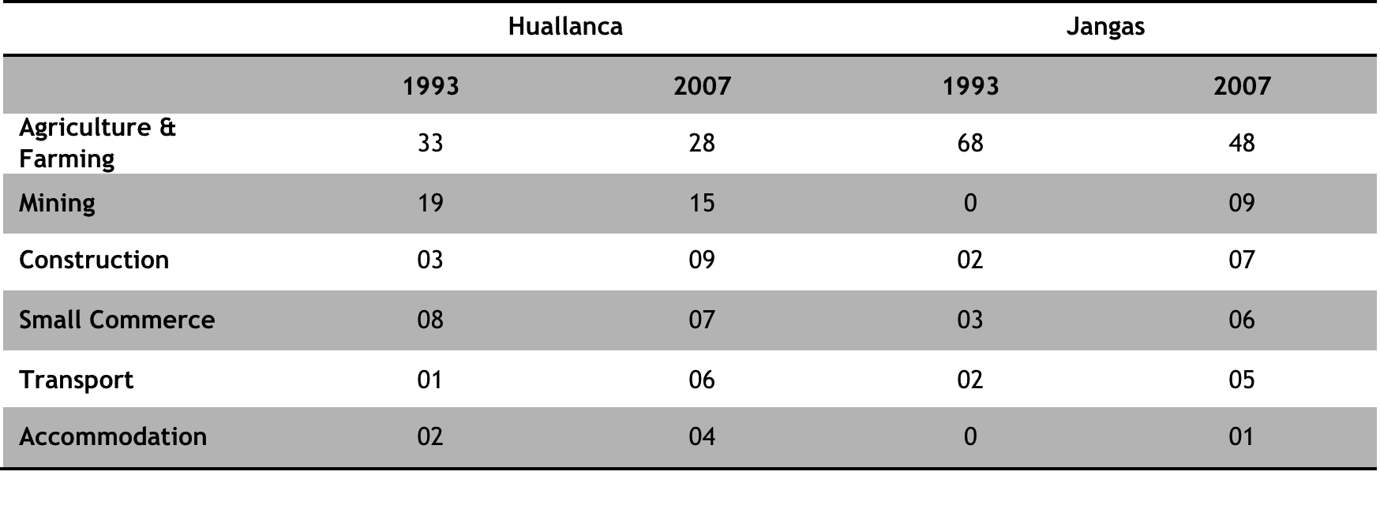
Source: INEI National Survey 1993 and 2007. Own elaboration.
- Huallanca’s agriculture productivity
The data provided by the Regional Directorate of the Ministry of Agriculture matches with the testimonies of local producers in Huallanca and Jangas. These sources show a relative improvement of Huallanca’s production, while in Jangas this trend is absent. Factors that may be playing a key role are the availability of water sources and land extension.

Figure 3
Yield (kg./ha.) of Huallanca’s main agriculture products (1997-2009)
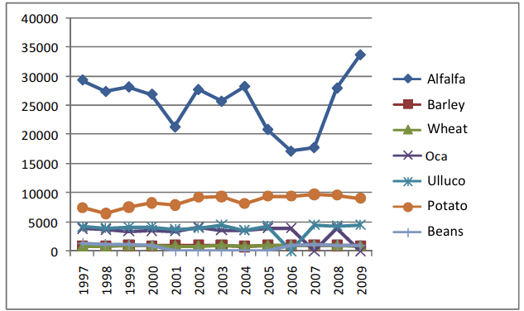
Source: PDC Huallanca (2009: 92), based on MINAG (2009).
- Mining employment and local purchases
SL is a small-medium project with less capital than Antamina and Barrick. This limits its possibility to generate and create job opportunities, and its demand for local products. According to SL Closure Plan (OSEL, 2007: 22), the number of employees of the firm was of 391, from which 138 (35.4%) were from Huallanca. From this number, 29 were hired directly by SL (13.4% of the total hired directly). Additionally, 109 persons were hired from Huallanca through labour mediation firms (89.3% from the total hired through this system), which generally offer temporary jobs. It must be mentioned that many of the labour intermediation firms are local agents and former SL employees.
Additionally, SL also hires LSME for some projects and tasks, like construction, electricity, metal works and painting. Usually, this tasks are given to local firms, most of which are also owned by former SL workers who have received some guidance and assistance from the firm to formalize and fulfil the requirements (like security and safety certifications). Likewise, some local producers mention that SL purchase local produce (cheese and milk) through middlemen agents. Even though, this is not significant.
For the case of Antamina, it is a large mining project with more capital for investing in more job opportunities for the local population, and with more purchase power. According to local authorities, Antamina employs in Huallanca about 100 persons permanently and 200 under a temporary regime. The latter can increase according to eventual demands of labour force, like for construction and maintenance. Additionally, Antamina uses local infrastructure in Huallanca to accommodate temporary employees and engineers that are not involved in the routine of the production process. This represents an important demand of local services and goods (hostels, commerce, restaurants, etc.).
The large size of Antamina, on the other side, represents higher standards for LSME to be included in the GVC. Formalization and the basic safety standards are not enough, as more upfront investment capital, more experience and certifications are required for becoming a permanent provider of this mining firm. Additionally, Huallanca is not Antamina’s area of direct influence, reason why there are not direct obligations in contracting LSME for mining or complementary activities.
In Jangas, Barrick have hired around 450 workers from the communities surrounding the project (Lopez & Condori, 2006: 18). These job opportunities are usually under a temporary regime and in non-qualified and complementary activities. In the same way, Barrick uses the services of some LSME, especially for activities like transportation, construction and aggregates. These local enterprises are located in the communities most affected by the mining presence (like Antahurán and Cuncashca), and where is a strong nuance of compensation in the business relationship. The inclusion of other local firms is less frequent, as Barrick is a large firm with high entry barriers, due to the requirements like high upfront investment (vehicles, machinery, equipment, etc.) and certifications.
- Local government’s (LG’s) expenditure
Figure 4 and Figure 5 shows the concentration of public resources per locality. In Jangas, it is observed the prioritization of three sectors: planning & management, agriculture & farming, and education culture & sports; while in Huallanca education, culture & sports concentrates the largest share of resources. As described in the section of productive capital, Jangas has undertaken more projects for the expansion of irrigation systems in the districts, which is more difficult to do in Huallanca due to the constraints in the use of budget and the land extensions in this jurisdiction.

Figure 4
LG’s expenditure per topic in Huallanca and Jangas (2010)
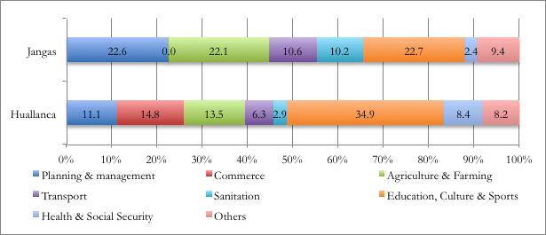
Source: MEF Economic Accountability Site, 2011. Own elaboration.

Likewise, despite the sector where resources are allocated, the type of investment is in infrastructure, mainly due to the dependence on the mining revenue, which only can be used in these types of projects.

Figure 5
LG’s expenditure per type in Huallanca and Jangas (2010)
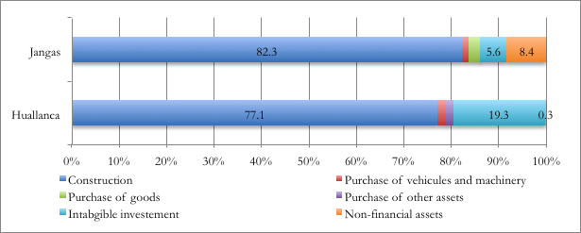
Source: MEF Economic Accountability Site, 2011. Own elaboration. Note: These amounts refer to the investment or purchase of good and services, and do not include expenses like staff salaries. In both cases, this amount is of 9.4 millions of nuevos nuevos soles (US$ 3.5 millions), representing 87.7% of the LG’s budget in Huallanca 89.5% in Jangas (MEF Economic Accountability Site, 2011).

Finally, it must be added that the accountability mechanisms present several inconsistencies. For instance, among the agriculture & farming projects, it is possible to find tourism projects. These deficiencies undermine the accountability and transparency of the LGs.
- Programa Minero de Solidaridad con el Pueblo (PMSP) and Mining Firms
One main difference between the different PMSPs is regarding the chain by which the compromised funds are transformed into developmental interventions, which is linked to the scope and amount of resources compromised for the PMSP. SL executes its funds through the Community Relations Staff (CCRR) under the name of Asociación Civil Huanzalá (ACH), but with basically the same personnel, which are around 05 coordinators and other technicians hired for specific projects. The implementation of the projects is usually done in alliance with other public institutions (i.e. sanitation programs with the Ministry of Agriculture, health and nutrition programs with the staff of the local health centres, etc.), operators of PMSP (i.e. CARE who is operator of Antamina for productive projects) and local governments. The small size of the ACH and the need for building alliances is partially explained by the amount of resources compromised for the PMSP and due to the scope of the intervention, which is basically the district of Huallanca and the area of influence of the mine.
This structure hardly breaks the nuance of compensation that characterizes the relationship between firm’s and local populations, and that pollutes the development interventions and business relations. Even though, in the case of SL, the local demands are not as high as those of bigger mining firms. On the other side, the fact that SL’s PMSP has a smaller scope and is managed by the same staff, results in better coordination. An example is the articulation of the nutrition and productive interventions, which promote not only the improvement of the local productivity, but also the consumption of these products.
In the case of Antamina, the firm is the one that has compromised more resources among all the mining firms in the country, mainly because of the profits achieved in the last years. The availability of a large sum of money and the existence of other PMSP operating locally in Ancash meant that these funds were assigned mainly for projects at a regional scope. For this, Antamina established the Fondo Minero Antamina (FMA) to manage these resources and to implement projects through several operators, like CARE (productive), ADRA (nutrition), Technoserve (BDS), etc.
In contrast with SL, Antamina rise huge expectation among the population. Therefore, the use of operators becomes quite functional, as it helps to mitigate the compensation character of the relationship between firm and population. Even though, the tensions within the commissions for the prioritization and design of the interventions are still present and deteriorate the development processes.
In the case of Barrick, there is a similar situation in terms of expectations but a different strategy of intervention. Barrick manage and executes the PMSP funds through the Asociación Civil Neoandina (ACN) in alliance with other organizations. The ACN is a separate team from the one of CCRR and is composed by specialist in different areas. In this case, the nuance of compensation in the relationship is not neutralized, as the staff that executes this funds is from within the mining firm and not from pre-existent organizations. Even though, the coordination of the different areas of intervention is better, as the chain of command is smaller.
The following tables present how the different PMSPs have distributed its resources. Likewise, Table 15 shows the main results of this investment. It is important to notice the poor positive results in the case of Barrick, which is in concordance with the low competitiveness capitals of Jangas, which impeded the absorption of spillover effects.
Figure 6
Local fund investment (2007-2010)
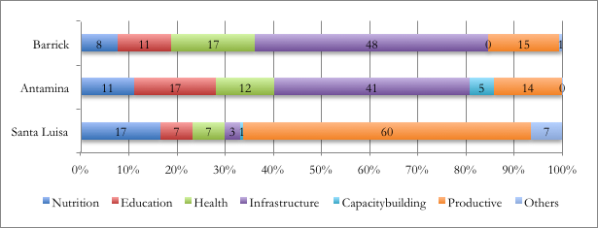
Source: MINEM, 2011b; Moreno, 2011; Instituto Cuanto, 2011; Asociación Civil Huanzalá, 2010. Own elaboration.

Table 15
Impacts of the PMSP (2007 – 2010)
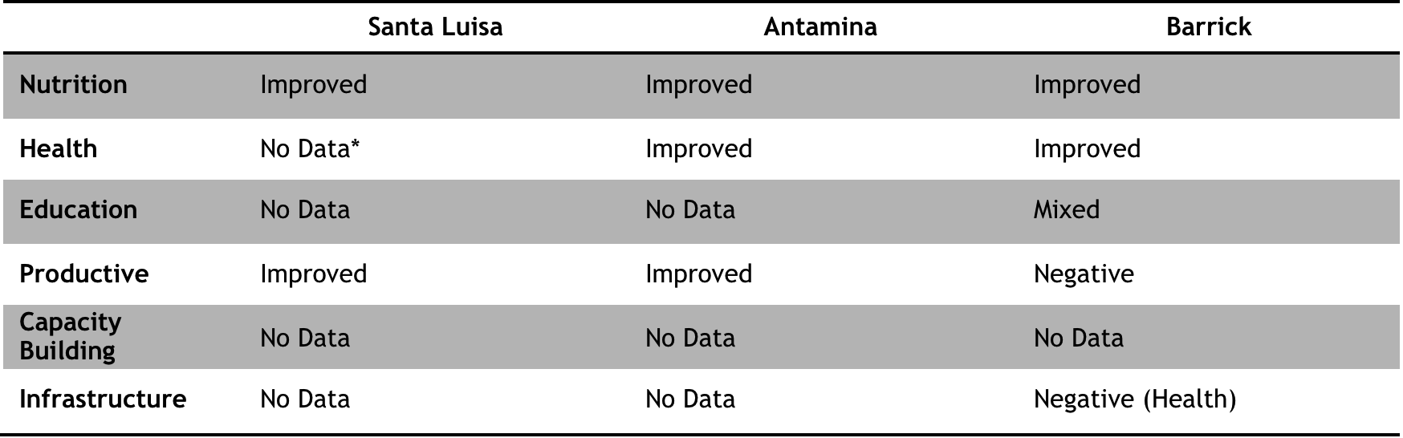
Source: MINEM, 2011b; Moreno, 2011; Instituto Cuanto, 2011; Asociación Civil Huanzalá, 2010. Own elaboration. *No data: the reports show the interventions done and the results but not the impacts over a set of indicators, reason why they have not been included in this chart.

References
Alayza, A. (2007) No peru Sí: Comunidades y Minería: Consulta y Consentimiento previo, ibre e informado en el Perú. Lima: OXFAM, Cooperacción.
Andriesse, E., N. Beerepoot, B. van Helvoirt and G. van Westen (2011) “Business Systems and Inclusive Regional Development in South-East Asia”, in: A.H.J. Helmsing and S. Vellema (eds) Value Chains, Inclusion and Endogenous Development: Contrasting Theories and Realities. Oxon: Routledge.
Arellano-Yanguas, J. (2008) “A Thoroughly Modern Resource Curse? The New Natural Resource Policy Agenda and the Mining Revival in Peru” (Working Paper Nº 300). Brighton: IDS.
Arellano-Yanguas, J. (2011) “Aggravating the Resource Curse: Decentralisation, Mining and Conflict in Peru”, in: Journal of Development Studies, Vol. 47, Nº 4, pp. 617-638.
Aroca, J. (2008) “La responsabilidad social en el Perú / El character de la ley de RSE”, in: La Responsabilidad Social de las Empresas Mineras y el Derecho a la Información (Seminar Summary). Lima: OXFAM, Cooperacción, Comunicaciones Aliadas.
Asociación Civil Huanzalá (2010) “V Taller: Buenas Prácticas de Inversión Reional y Local para la Descentralización, el Desarrollo y Gibernabilidad” (Presentation). Huallanca: Asociación Civil Huanzalá.
Barrantes, R. (n.d.) “Minería, Desarrollo y Pobreza en el Perú” (Working paper). Lima: IEP.
Barrantes, R. (2005) “Minería, Desarrollo y Pobreza en el Perú, o de cómo todo depende del cristal con que se mire”, in: R. Barrantes, P. Zárate and A. Durand Te quiero pero no: minería, desarrollo y poblaciones locales, pp. 17-79. Lima: IEP, OXFAM.
Bebbington, A., D. Humphreys, J. Bury, J. Lingan, J.P. Muñoz and M. Scurrah (2008a) “Mining and Social Movements: Struggles Over Livelihood and Rural Territorial Development in the Andes”, in: World Development, Vol. 36, Nº 12, pp. 2888-2905.
Bebbington, A., L. Hinojosa, D. Humphreys, M.L. Burneo and X. Warnaars (2008b) “Contention and Ambiguity: Mining and the Possibilities of Development”, in: Development and Change, Vol. 36, Nº 6, pp. 887-914.
Bebbington, A. and J.T. Bury (2009) “Institutional challenges for mining and sustainability in Peru”, in: PNAS, Vol. 106, Nº 41, pp. 17296-17301.
Bebbington, A. (n.d.) “Extractive industries and stunted states: conflict, responsibility and institutional change in the Andes”, forthcoming in: R. Raman (ed) Corporate Social Responsibility: Discourses, Practices and Perspectives. London: Palgrave MacMillan.
Buckley, P.J. and M. C. Casson (2009) “The internalisation theory of the multinational enterprise: A review of the progress of a research agenda after 30 years”, in: Journal of International Business Studies, Vol. 40, Nº 9, pp. 1563-1580.
Coe, N.M., P. Dicken and M. Hess (2008) “Introduction: global production networks – debates and challenges”, in: Journal of Economic Geography, Vol. 8, Nº 3, pp. 267-269.
Cooke, P. and K. Morgan (1998) “The institutions of innovation”, in: P. Cooke and K. Morgan (eds) The associational economy: Firms, regions and innovation, pp. 9-34. Oxford: Oxford UP.
Dammert, A. and F. Molinelli (2007) OSINERGMIN: Panorama de la Minería en el Perú. Lima: OSINERGMIN.
Damonte, G. (2008) “El esquivo desarrollo social en las localidades mineras”, in: Análisis & Propuestas: Contribuciones al debate sobre formulación de políticas públicas, Nº 14, pp. 1-5. Lima: GRADE.
De Echave, J. (2008) “La RSE y el derecho a la información en las comunidades de presencia minera”, in: La Responsabilidad Social de las Empresas Mineras y el Derecho a la Información” (Seminar Summary). Lima: OXFAM, Cooperacción, Comunicaciones Aliadas.
De Echave, J., M. Palacios and R. Hoetmer (2009a) “Introducción”, in: J. De Echave, R. Hoetmer and M. Palacios (eds) Minería y Territorio en el Perú: Conflictos, resistencias y propuestas en tiempos de globalización, pp. 13-29.
De Echave, J., A. Diez, L. Huber, B. Revesz, X. Ricard and M. Tanaka (2009b) Minería y Conflicto Social. Lima: CBC, CIPCA, CIES, IEP.
De Echave, J., E. Gomez and G. Salazar (2011) “¿Los Talleres y Las Audiencias Públicas son Procesos de Consulta?”, in: http://www.cooperaccion.org.pe/ index.php?option=com_content&view=article&id=505:ilos-talleres-y-las-audiencias-publicas-son-procesos-de-consulta&catid=54:comentario-institucional&Itemid=103 (accessed on July 2011).
De Waal, A. and G. Orcotoma (2007) “The relation between corporate social responsibility and the high performance organizations framework: the case of mining multinationals in Peru”, in: http://www.hpocenter.nl/uploads/ BAM%202008%20-%20CSR%5B1%5D.pdf (accessed on July 2011). Maastricht: Maastricht School of Management.
Defensoría del Pueblo (2009) “Decimotercer Informe Annual de la Defensoria del Pueblo al Congreso de la República”. Lima: Defensoría del Pueblo.
Dickovick, J.T. (2006) “Municipalization as Central Government Strategy: Central-Regional-Local Politics in Peru, Brazil, and South Africa”, in: The Journal of Federalism, Vol. 33, Nº 1, pp. 1-25.
DRAA – Dirección Regional Agraria de Ancash (2008) “Plan Estratégico Regional Agrario 2009-2015”. Huaraz: DRAA, Gobierno Regional Ancash.
Durand, A. (2011) ¿Tierras de Nadie? Actividad extractive, territorio y conflict social en la Amazonía peruana: el río Cenepa. Lima: CISEPA (PUCP), SER, CIRAD ILC.
Eguren, F. (2007) “Reforma Agraria y Desarrollo Rural en el Perú”. Lima: CEPES.
El Comercio (23/05/2011) “(Editorial) Positiva, pero insuficiente reducción de la pobreza” (Newspaper article), in: http://elcomercio.pe/opinion/761862/noticia-editorial-positiva-insuficiente-reduccion-pobreza (accessed on July 2011). Lima: El Comercio.
Equlibrium (2010) “Informe de Clasificación: Minera Barrick Misquichilca S.A.”. Lima: Equibrium Clasificadora de Riesgo S.A.
Equlibrium (2011) “Informe de Clasificación: Minera Barrick Misquichilca S.A.”. Lima: Equibrium Clasificadora de Riesgo S.A.
ESCALE – Estadística de la Calidad Educativa del Ministerio de Educación (2011), in: http://escale.minedu.gob.pe/ (accessed on July 2011).
Fairlie, A. (2010) “Encadenamientos Productivos de las Actividades Exportadoras en América Latina: El caso de la minería en Perú” (Working Paper Nº 134). Latin American Trade Network.
Falleti, T. (2005) “A Sequential Theory of Decentralization: Latin American Cases in Comparative Perspective”, in: American Political Science Review, Vol. 99, Nº 3, pp. 327-346.
Figueredo, P.N. (2011) “The Role of Dual Embeddedness in the Innovative Performance of MNE Subsidiaries: Evidence from Brazil”, in: Journal of Management Studies, Vol. 48, Nº 2, pp. 417-440.
FONCODES – Fondo de Cooperación para el Desarrollo Social (2007) “Mapa Intradistrital de FONCODES 2007”. Lima: FONCODES.
Gifford, B. and A. Kestler (2008) “Towards a theory of local legitimacy by MNEs in developing nations: Newmont mining and health sustainable development in Peru”, in: Journal of International Management, Vol. 14, Nº 4, pp. 1075-4253.
Glave, M. (2007) “Valor y renta de la tierra en los Andes peruanos”, in: Tema I: Industrias extractivas, agricultura y uso de recursos naturales / SEPIA XII Perú: El problema agrario en debate. Lima: CEDISA, SEPIA, UNSM, IIAP.
Glave, M. and J. Kuramoto (2002) “Minería, Minerales y Desarrollo Sustentable en Perú”, in: Centro de Investigación y Planificación del Medio Ambiente (CIPMA) and Centro Internacional de Investigaciones para el Desarrollo (IDRC) - Iniciativa de Investigación sobre Políticas Mineras (IIPM) (coeds.) Minería, Minerales y Desarrollo Sustentable en América del Sur.
Glave, M. and J. Kuramoto (2007) “La Minería Peruana: lo que sabemos y lo que aún nos falta por saber”, in: Investigación, políticas y desarrollo en el Perú, pp. 135-181. Lima: GRADE
Goldfrank, B. (2006) “Lessons from Latin American Experience in Participatory Budgeting”, presented at: Latin American Studies Association Meeting, San Juan, Puerto Rico.
GPC – Grupo Propuesta Ciudadana (2009) “Vigilancia de las Industrias Extractivas - Reporte Nacional Nº 10 (Perú 2009)”. Lima: GPC, RWI, EED.
GPC – Grupo Propuesta Ciudadana (2010) “Minería en Ancash: Vigilancia a la renta de las industrias extractivas – Reporte Nº 11 (Balance Annual 2009)”. Lima: GPC, CEDEP, Vigila Perú.
Haughton, G. and P. Allmendingerr (2008) “The Soft Spaces of Local Economic Development”, in: Local Economy, Vol. 23, Nº 2, pp. 138-148.
Helmsing, A.H.J. (2003) “Local Economic Development: New Generations of Actors, Policies and Instruments for Africa” in: Public Administration Development, Vol. 23, Nº 1, pp. 67-76.
Helmsing, A.H.J. (2005) “Governance of local economic development in Sub Saharan Africa: who are the dancers and do they act in concert?” (Working Paper Nº 408). The Hague: ISS.
Helmsing, A.H.J. (2010) “Perspectives and practices of local economic development: an overview” (Work in progress). The Hague: ISS.
Helmsing, A.H.J. and S. Vellema (2011) “Value chains governance and inclusive endogenous development: Towards a Knowledge Agenda”, in DPRN Phase II – report Nº 26.
Herrera, P. (2009) “Perú: propuesta de redistribución de los recursos del canon y regalia mineras a nivel municipal”, in: Economía, Vol. 33, pp. 45-82.
Hiba, J.C., J. De Echave and E. Ospina (2002) Condiciones de trabajo, seguridad y salud ocupacional en la minería del Perú. Lima: ILO, Cooperaccion, ISAT.
INEI - Instituto Nacional de Estadística e Informática (2010a) “Informe Técnico: Evolución de la Pobreza al 2009”. Lima: INEI.
INEI - Instituto Nacional de Estadística e Informática (2010b) “Perú: Perfil de la Pobreza por departamentos 2005-2009). Lima: INEI.
INEI National Survey 1993 – Instituto Nacional de Estadística e Informática (1993) “National Survey 1993”, in: http://www.inei.gob.pe/ (accessed on July, 2011).
INEI National Survey 2007 – Instituto Nacional de Estadística e Informática (2007), “National Survey 2007”, in: http://www.inei.gob.pe/ (accessed on July, 2011).
INEI – Instituto Nacional de Estadística e Informática (2007). “Mapa de Pobreza Provincial y Distrital 2007”. Lima: INEI.
INEI – Instituto Nacional de Estadística e Informática (2009). “Mapa de Pobreza Provincial y Distrital 2009: El Enfoque de la Pobreza Monetaria”. Lima: INEI.
INEI – Instituto Nacional de Estadística e Informática (2011a) “Perú: Perfil de la Pobreza por epartamentos 2001-2010”. Lima: INEI.
INEI – Instituto Nacional de Estadística e Informática (2011b) “Mapas referenciales”, in: http://proyectos.inei.gob.pe/mapas/bid/ (accessed on July 2011).
Instituto Cuanto (2010) “Evaluación de Impactos de Medio Término del Proyecto Minero de Solidaridad con el Pueblo: Minera Barrick Misquichilca S.A. – Asociación Civil Neoandina”. Lima: Instituto Cuanto.
Kamiya, M. (2004) “Japanese investment in Peru: limits of developmental investment” (MPRA Paper Nº. 14463), in: GSAPS Journal (Nov. 8, 2004).
Kitson, M., R. Martin and P. Tyler (2004) “Regional Competitiveness: An Elusive Concept?”, in: Regional Studies, Vol. 38, Nº 9, pp: 991-999.
Kuramoto, J. (2000) El cluster minero peruano en acción: el caso de Tamboraque. Lima: CIES, GRADE.
London, T. and S. L. Hart (2004) “Reinventing Strategies for Emerging Markets: Beyond the Transnational Model”, in: Journal of International Business Studies, Vol. 35, Nº 5, pp. 350-370.
López, J. and P. Condori (2006) “Gran minería Aurífera y sus repercusiones en el desarrollo económico local”, in: Gestión en el Tercer Milenio, Vol. 9, Nº 18, pp. 17-32. Lima: UNMSM.
Malaga (2011) “Malaga: An Investment of Quality in Tungsten” (Presentation). New York: Malaga Corp.
MEF Economic Accountability Site – Ministerio de Economía y Finanzas (2011), in: http://www.mef.gob.pe/index.php?option=com_content&view= section&id=37&Itemid=100143&lang=es (accessed on July 2011).
Meyer, K.E., R. Mudambi and R. Narurla (2011) “Multinational Enterprises and Local Contexts: The Opportunities and Challenges of Multiple Embeddedness”, in: Journal of Management Studies, Vol.48, Nº 2, pp. 235-252.
MINAG – Ministerio de Agricultura (2004) “Estrategia de Desarrollo Rural: Lineamientos de Política”. Lima: MINAG, Gobierno del Perú.
MINAG – Ministerio de Agricultura (2008) “Plan Estratégico Sectorial Multianual de Agricultura 2007-2011”. Lima: MINAG.
MINAG – Ministerio de Agricultura (n.d.) “Estadísticas de Producción Agrícola 2007 – 2009”. Ancash: MINAG, DRAA.
MINEM - Ministerio de Energia y Minas (2011a) “Peru 2010: Anuario Minero”. Lima: MINEM.
MINEM - Ministerio de Energia y Minas (2011b) “Programa Minero de Solidaridad con el Pueblo / Informe Nº 035”. Lima: MINEM.
MINEM - Ministerio de Energia y Minas Site (2011) “Evolución Histórica de los Precios de los Principales Minerales”, in: http://www.minem.gob.pe/ descripcion.php?idSector=1&idTitular=2309&idMenu=sub151&idCateg=639 (accessed on July 2011).
Moreno, R. (2011) Programa Minero de Solidaridad con el Pueblo en Ancash: Fondo Minero Antamina. Lima: CEDEP.
Newell, P., and J.G. Frynas (2007) “Beyond CSR? Business, poverty and social justice: an introduction”, in: Thirld World Quaterly, Vol. 28, Nº 4, pp. 669-681.
PDC Bolognesi (2009) “Plan de Desarrollo Concertado de la Provincia de Bolognesi 2009-2021 y Programas Municipales de Gestión e Inversión”. Bolognesi: Antamina, Peru Decentralizado, Municipalidad Provincial de Bolognesi.
PDC Huallanca (2009) “Plan de Desarrollo Concertado del Distrito de Huallanca”. Huallanca: Antamina, Apoyo Consultoría, Municipalidad Distrital de Huallanca.
PDC Huaraz (2009) “Reajuste del Plan de Desarrollo Concertado: Provincia de Huaraz 2009-2021”. Huaraz: Gobierno Provincial de Huaraz.
PDC Jangas (2007) “Plan de Desarrollo Concertado del Distrito de Jangas 2008-2018”. Jangas: Municipalidad Distrital de Jangas.
Otero, M. and R. Chau (1999) “Presentación”, in: F. Larios and M. Otero (eds) Nuevo Contexto Mundial y Reformas Institucionales en la Agricultura de América Latina y el Caribe. Lima: IICA, ASPA, KAS.
OSEL (2007) Estudio Socioeconómico para la realización del Plan de Cierre de la Unidad Minera Huanzalá de la Compañía Minera Santa Luisa. Lima: OSEL.
OXFAM (2009) Conflictos Mineros en el Perú: Condición Crítica. Washington: OXFAM.
Pinto, V. (2009) “Reestructuración neoliberal del Estado peruano, industrias extractivas y derechos sobre el territorio”, in: J. De Echave, R. Hoetmer and M. Palacios (eds) Minería y Territorio en el Perú: Conflictos, resistencias y propuestas en tiempos de globalización, pp. 85-104.
Porter, M. (1998) “Clusters and the New Economics of Competition”, in: Harvard Business Review, Vol. 76, Nº 6, pp. 77-90.
Porter, M. and M.R. Kramer (2006) “Strategy and Society: The Link Between Competitive Advantage and Corporate Social Responsibility”, in: Harvard Business Review (Dec., 2006).
Porter, M., M. Delgado, C. Ketels and S. Stern (2008) “Moving to a New Global Competitiveness Index”, in: M. Porter and K. Schwab (eds) The Global Competitiveness Report 2008-2009. Geneva: World Economic Forum.
Postigo, W. (2006) “La zonificación ecológica económica y la prevención de los conflictos mineros”, in: Economía y Sociedad, Nº 61, pp. 63-71. Lima: CIES.
SCG – Social Capital Group (2007) “Corporate Social Responsibility in the mining sector in Perú”. Lima: SCG, OXFAM.
SMV – Superintendencia del Mercado de Valores (2011), in: http://www.smv.gob.pe/ (accessed on July 2011).
SNMPE - Sociedad Nacional de Minería, Petróleo y Energía (2008) “Impacto Económico de la Actividad Minera en el Perú” (elaborated by Macroconsult). Lima: SNMPE
SNMPE - Sociedad Nacional de Minería, Petróleo y Energía (2011) “Memoria Anual 2010”. Lima: SNMPE
Stewart, F., C. Ruggeri and R. Saith (2007) “Introduction: Four Approaches to Defining and Measuring Poverty”, in: F. Stewart, R. Saith and B. Harriss White (eds) Defining poverty in the developing world. Palgrave Mcmillan.
Szablowski, D. (2002) “Mining, Displacement and the World Bank: A Case Analysis of Compañia Minera Antamina’s Operations in Peru”, in: Journal of Business Ethics, Nº 39, pp. 247-273.
Ticci, E. (2011) “Extractive Industries and Local Development in the Peruvian Highlands: Socio-Economic Impacts of the Mid-1990’s Mining Boom” (EUI Working Paper RSCAS 2011/14). Florence: RSCAS-EUI.
Trivelli, C., J. Escobal, B. Revesz (2009) Desarrollo Rural en la Sierra: Aportes para el Debate. Lima: IEP, CIPCA, GRADE, CIES.
UNDP (2005) “Informe Sobre Desarrollo Humano Perú 2005: Hagamos de la competitividad una oportunidad para todos”. Lima: PNUD-Perú.
UNDP (2009) “Informe Sobre Desarrollo Humano Perú 2009: Por una densidad del Estado al servicio de la gente”. Lima: PNUD-Perú.
UNDP (2010) “The Real Wealth of Nations: Pathways to Human Development”. New York: UNDP
UNDP (2011) “Peru: Country profile of human development indicators”, in: http://hdrstats.undp.org/en/countries/profiles/PER.html (accessed on July 2011)
VECTOR (2006) “Plan de Cierre Minera Pierina”. Lima: VECTOR.
Vincent, S. (2010) “Participatory budgeting in Peru: Democratization, state control, or community autonomy?”, in: Focaal – Journal of Global and Historical Anthropology, Nº 56, pp. 65-77.
Whitley, R. (2000) “The Institutional Structuring of Innovation Strategies: Business Systems, Firm Types and Patters of Technical Change in Different Market Economies”, in: Organization Studies, Vol. 21, Nº 5, pp. 855-886.

This quote is part of the speech given by Alberto Fujimori (President of Peru between 1990 and 2001) on April 10 1992. This speech announced the self-coup d’état and several political and economic reforms.
The National Society of Mining, Energy and Oil (SNMPE, 2008: 7) states that the mining sector has saved 2.5 million people from poverty, due to its income contribution. However, despite the pace of economic growth, about a third of the population remains in poverty, especially in the rural areas. This reveals that the government’s efforts to distribute mining wealth equally have been ‘shamefully insufficient’ (Peru 21, 19/05/2001; El Comercio, 23/05/2011).
Internal embeddedness is defined in terms of the existence of strong “linkages with the parent company and sister subsidiaries”, which intermediate innovation learning for production and linkages. External embeddedness is defined in terms of “linkages with local organizations”. This includes joint research, acquisition and sharing of knowledge for intermediating innovation, capacity-building and training of potential labor force, and other types of (in)formal relationships with local actors (Figueredo, 2010: 425).
An example given by Helmsing and Vellema (2011: 17) is chain actor’s lack of access to credit. An individual and localized intervention will aim to create a “new chain-level” institutional arrangement providing them with the necessary resources. According to a BSA, a more appropriate solution would be to improve the financial system regulation. The latter, as noted by the authors, will not only address a specific problem of the chain, but will also create spillover effects, as the institutional change will also benefit non-chain actors.
The Community Economic Development can also be considered within this category (but with elements of the wider category of Local Economic Regeneration), as it assesses ways of minimizing the negative effects of the incapacity to meet competitive standards and capture market shares (Helmsing, 2010: 9). Finally, Alternative Local Development is another variant that seeks alternatives outside of the market. This approach will not be expanded in this research.
This was done through the DL 757, which modified the Code of Environment in the early ’90’s. The latter had focused on mining activities and the preservation of natural resources.
In Peru there is an Ombudsman Office for the management of social conflicts, a Ministry of Culture, a National Institute of for the Development of Andean, Amazon, and Afroperuvian Populations, as well as a Ministry of Environment. None of these bodies participate in the approval of these reports.
In 2009 the number of social conflicts related to extractive industries was 154, about 44.4% of all the conflicts registered by the Ombudsman Authority (Defensoria del Pueblo, 2009: 247). This figure does not include conflicts related to the management of resources by local or regional governments.
An example of this is the case of La Granja Project in the Department of Cajamarca, where local authorities threatened the population with the declaration of an easement zone if they failed to arrive at an agreement with the mining company for the sale of their lands (Glave, 2007: 13).
Glave (2007: 11) mentions the case of the mining projects of Pierina (Department of Ancash) and Yanacocha (Department of Cajamarca), where the prices for land were first defined by the firm and based on the appraisal of the National Commission of Valuation (CONATA in Spanish). In these cases, the price per hectare was less than 100 dollars.
In the case of San Marcos (Ancash), the mining revenue is US$ 71 million (98.6% of the LG’s budget) with a population of 13,607 (MINEM, 2011a: 86; MEF Economic Accountability Site, 2010).
For instance, Herrera (2009: 3) mentions that between 2003 and 2007, the departments of Ancash, Cusco and Cajamarca where receiving between US$ 555-837 million each, while other departments received less than US$ 443 thousand. Likewise, Grupo Propuesta Ciudadana (GPC), in their 2009 report (GPC, 2009: 19) state that three departments (Ancash, Arequipa and Moquegua) received 52% of the total mining canon transfers.
According to Arellano (2008: 20), in 2004 the mining firms advocated for changes in the distribution structure of the mining canon, in order to emphasise their contribution to the mining localities and to calm the social unrest and pressure that they were experiencing from the population.
The D.S. 042-2003-EM and the D.S. Nº 052-2010-EM are the guidelines in this matter.
The RM Nº 192-2008-MEM/DM is the guideline in this matter.
Antamina mine is located in another district, so the size and technology of the operations do not affect Huallanca. The impacts of Antamina in this district are more of a social nature, in terms of employment, demography, etc.
Santa Luisa is a small-medium project, but the exact dimension of the project’s area is not clear. The dimension provided here should be treated as an approximate figure.
The inflow of resources has a direct effect on income poverty reduction, but the prevalence of malnutrition can be explained by the low human (education) and productive capital (food security), which affects more Jangas than Huallanca.
This dynamism in Huallanca explains the emergence of many LSMEs since the year 2000. In 10 years the number of LSMEs increased from 2 to 20, mainly in construction, painting, electrical works and metal works.
The mining CSR initiatives in Huallanca have focused on the implementation of systems for the rotation of grazing areas, the construction of fences, genetic improvement of the cattle and the construction of irrigation systems. Several producers affirm that milk production has increased from 2 litres per day to almost 8 litres, and that the price of livestock has improved by about US$ 37 per animal, a positive impact for household economy. According to interviews with local producers, which correspond with the PDC Huallanca (2009: 80), the average number of livestock owned per producer is between 80-200 sheep and 15-30 cows.
The Municipal Manager of Jangas (Carlos Chong, interviewed on July 22nd) recognized this issue and how it limited the type of activities the institution was able to undertake, as the mining revenue can only be used in infrastructure projects.
It is possible to find projects for tourism included in agriculture and farming expenditure, and education projects in Culture & Sports.
The Budget represents the amount transferred and available to the LG for the year’s administration. There are other concepts like the Approved Institutional Budget and the Modified Institutional Budget, which are estimations ultimately materializing in the transferred money. The latter is being used in these tables as a ‘budget’.
An example of this is the ‘Diezmo’, an accepted and widespread institution among the LGs. The Diezmo refers to the percentage (usually 10% of the utilities) that public servants charge to construction firms that are awarded with a contract from the LG.
This refers to the fact that infrastructure works are a tangible contribution from the local authority to its district, which can be used for electoral purposes.
The Personal Interviews were with reliable local authorities that requested confidentiality. The information has been cross-referenced with other sources.
Interviwes with Jaime Cadillo (General Manager of JC Constructores) and Betzi Sulca (Manager of San Francisco de Antahurán), both interviewed in Jangas on July 26.
Personal interview with Sosimo Guzman, Director of Agrarian Promotion, conducted in the Regional Directorate of the Ministry of Agriculture in Ancash, on July 19th, 2011.
The availability of information regarding the employment and purchases mining firms do locally is usually incomplete, non-systematized, scarce and often confidential. Through interviews and reports (like closure plans and MINEM statistics) it is possible to reach some approximations.
An example is the credit fund created by Antamina, which suffered several drawbacks, as many borrowers did not pay back, claiming that the firm had the responsibility of giving them money with no conditionalities.
According to the interviews, some initiatives in the agricultural sector, like irrigation, are rejected because they end up benefitting only one community or neighbourhood. This is usually an issue in areas where the land tenure per family is extensive, so that more investment benefits less families
The PMSP is formed by a commission composed of local authorities and mining firm officials, who identify needs, projects to tackle these needs, coordinate the efforts of different local actors and articulate initiatives. The chosen projects then are executed by the mining firms or the associations they create to manage these funds.
About the HDI, it is important to add that this index considers indicators about life expectancy, education index, expected years of schooling index and income index.
Sósimo Guzman, Director of Agrarian Promotion for Ancash, and Cesar Guzman, Project Coordinator in CARE but former employee in the Ministry of Agriculture, agree on this point. Both were interviewed in Huaraz, on July 19th and 21st respectively.
Personal interview with Sosimo Guzman, Director of Agrarian Promotion, conducted in the Regional Directorate of the Ministry of Agriculture in Ancash, on July 19th, 2011.
De Echave et al. (2009b: 295) makes reference to a World Bank report of August 21st 2003 titled “Revision of the Extractive Industries” where it is mentioned that the “structural adjustment” policies, inspired by the World Bank and implemented in many developing countries, aimed to create an attractive environment for foreign investment in the sector.
According to the Annual Report 2010 of the Ministry of Energy and Mines (MINEM, 2010: 12), Peru has 34,513 mining concessions occupying 14,767,834 has., which represents about 11.53% of the national territory. The same report also mentions that the number of requests for mining concessions in 2010 increased in more than 80% compared to the previous year (MINEM, 2011a: 10-12).
The Organic Law for the Sustainable Use of the Natural Resources (Nº 26821) and the National Regulation of Economic and Ecologic Zoning (DS 087-2004-PC) are the main legal instruments in this matter.
Postigo (2006: 71) has another point of view, as he says that Territorial Planning do not necessarily reduce social conflict, as this document do not have details about the environmental impacts that a mining Project might have.
Pinto (2009: 89), in his paper about the neoliberal restructuration of the territory in Peru, mentions how since the Constitution of 1993 the unalienable and inembargable character of the collective land of peasant’s communities was eliminated.
This was established with the Law of Land and the DS 017-96-AG.
The mining royalty is a monthly payment done by the mining firms that did not have legal stability contracts. This payment is for the exploitation of mineral resources and its amount is calculated based on the value of the extracted mineral. These resources should be used in productive projects that articulate the mining industry with the LED of the region and locality. The distribution is as follows: 20% for the district municipalities where the mineral is extracted (and 50% of this amount should be invested in the communities where the project is located), 20% for the province municipalities where the exploitation takes place, 40% for all the district and province municipalities of the department, 15% for the regional government (department authority), and 5% for the universities of the region.
The concession fee is the payment that mining firms do for requesting or validating a mining concession (in this case, the payment is annual). The amount to pay is calculated based on the number of hectares requested or to be validated.
It is important to highlight that the mining canon has increased more than 5,000% in the last 10 years (SNMPE, 2011: 3), reaching shares of the LG’s annual expenditure of 98.6%, like in the case of San Marcos (around 71 million US$ as mining revenue and a population of 13,607), district in the Department of Ancash, which is located in the department that receives more mining revenue in the country (MINEM, 2011a: 86; MEF Economic Accountability Site, 2010)
Kamiya (2004: 4) explains how the economic growth of Japan in the late 60’s forced the expansion of many Japanese conglomerates to other countries. In this scenario, firms like Mitsui Co. expanded in order to ensure the supply of raw materials of a growing manufacturing sector in its country of origin.
This appraisal of Barrick appeared in testimonies of people who were not involved directly with the company. Even though, it appeared as well in two Classification Reports in 2010 and 2011 done by Equilibrium, a prestigious Peruvian Credit Bureau affiliated to Moody’s Investor Service.
Some of these principles are: Voluntary Principles on Security and Human Rights (private sector initiative, with governments and NGO’s), Global Compact (United Nation’s initiative), Global Reporting Initiative (United Nations’ initiative), ICMM Principles for Sustainable Development (private sector initiative), Equator Principles (initiative of the International Financial Corporation of the World Bank), Extractive Industries Transparency Initiative – EITI – (alliance between governments, firms and civil society), among others (SCG, 2007: 14).
Personal interview with Carlos Chong, Municipal Manager of the Municipality of Jangas, conducted in the Municipality of Jangas, on July 2nd, 2011.
From the districts within the province of Bolognesi, Huallanca is the biggest (27.7% of the province’s surface) and the most populated (26.8% of the province’s population) (PDC Bolognesi, 2009: 31), while Jangas is the 2nd smallest in the province of Huaraz (2.4% of the province’s surface) and has around 3% of the province’s population (PDC Huaraz, 2008: 21).
Another information pointing out the importance of mining in these shares is that the population increase has affected positively the male share (3% in Jangas and 6% in Huallanca) and the share of population between 20 and 39 years old (15% in Jangas and 10% in Huallanca). This data fluctuation can be explained by the labour demand of mining activities, which focuses basically in male workers without their family members. This explains why there is an increase in the male share but do not necessarily an increase in the population below 15 years old, which has decreased in 8% and 13% respectively (INEI National Survey 1993 and 2007).
The mining settlement of SL, before the 90’s, followed the pattern of a mining town, where all services were concentrated. The school of the mining settlement provided education to a large portion of the population, together with a service of transportation for the children that lived far away from the establishment. Additionally, the firm gave support to local schools since then.
For instance, the document mentions a study undertaken by the National Water Authority between 1997 and 2005 in an area Puca Uran, where the number of water bodies was reduced from 38 to only one (PDC Jangas, 2007: 13).
According to the PDC Jangas (2007: 27), only 10km2 are considered of cultivable lands. In Huallanca, only 7% of the land is used for agricultural purposes and 79.1% is of natural grass for farming activities (PDC Bolognesi, 2009: 27).
Jangas has been more successful in expanding the irrigated areas of the district thanks to partnerships between the public and the private sector. In the case of Huallanca, the existence of large extensions of land is an obstacle for public and private investment (more investment benefit less people).
This issue was mentioned by Hansel Ariza, President of the Farming Producers Association of Buena Vista in Huallanca, interviewed in Huallanca on July 14th.
In Jangas only 6.3% do not access to a water public network, while in Huallanca this share is of 42.6%. In terms of electric supply into the houses, Jangas report 16.9% households without that service against 45.9% in Huallanca (INEI National Survey 2007; PDC Huallanca, 2009: 17). It is important to acknowledge that in this regard, the situation of Jangas has improved considerably since 1993, where 69.5% did not have water and 85.5% did not have electricity (INEI National Survey 1993).
In the case of Huallanca, the road between the district and Huaraz was built by the firm Antamina, and according to the PDC Huallanca (2009: 134), this highway has meant the reduction of the time spent for travelling in 35% and has increased the economic relations between Huallanca and Huaraz.
This issue was mentioned by Becquer Soto, President of Rondas Campesinas and local producer, interviewed in Huallanca on July 14th.
The first group is composed by organizations like the Milk Glass Committee, Mother's Clubs, Welfare Kitchen, Neighbourhood Committees and Business Associations. The first three are considered mainly as women organizations and as social programs supported by the LG or state programs (provision of goods). The Neighbourhood Committees are territorial organizations subscribed to the LG and with periodic elections, but whose functions are not completely clear.
In the rural areas, some of the main organizations are the Farming Producers Associations (Huallanca), Irrigation Committee, Peasant’s Rounds and Peasant Communities.
According to testimonies of the local population, like Gianina Ramirez (current Community Relations Officer of SL but native of Huallanca), the district is considered a cosmopolitan district because the mining presence since the 60’s has implied the arrival of workers from all along the country and for many years.
For example, in Huallanca the middleman takes over the sacrifice (of the animal), the gathering of produce (agriculture & farming), the stocking, the selection (wool and milk-based products), transportation, and commercialization to wholesalers or retailers.
For instance, some projects to produce maize failed when trying to bypass the middleman and commercialized directly with retailers, as they refused to buy the produce from the producers themselves.
When LSME need to repair machinery or buy supplies, they have to travel to Huaraz or Lima, increasing costs and risks.
The different testimonies that were cross-referenced were of Sósimo Guzman (Director of Agrarian Promotion for Ancash interviewed on July 19th), Hansel Ariza (President of the Farming Producers Association of Buena Vista in Huallanca, interviewed on July 14th) and Eugenio Obispo (President of the Community of San Isidro in Jangas, interviewed on July 18th). These interviews were compared with the data provided by MINAG (n.d.).
The availability of information regarding the employment and purchases mining firms do locally is usually incomplete, non-systematized, scarce and often confidential. Even though, through interviews and reports (like closure plans and MINEM statistics) it is possible to reach some approximations.
This issue was mentioned by Becquer Soto, President of Rondas Campesinas and local producer, interviewed in Huallanca on July 14th.
This issue was mentioned by Abelardo Paucar, President of the Front of Defence, interviewed in Huallanca on July 15th.
In terms of investment, the information available of SL is exclusively about Huallanca, the one of Barrick includes its projects in Ancash and La Libertad (another Department), and the information of Antamina includes projects in localities across the entire region of Ancash. Likewise, the information of impacts, in the case of SL and Barrick are specifically of Huallanca and Jangas, while the information of Antamina is also from all the localities in the region. Even though, they allow us to see the patterns of investment and the main results of the interventions.

