A Quantitative Comparison of Generalized Fast Construction Heuristics for the Vehicle Routing Problem with Time Windows

Kasper Kisjes
334131

Master Thesis
MSc. Operations Research and Quantitative Logistics
Erasmus University Rotterdam

Supervisors
Dr. A.F. Gabor (EUR)
R. Spliet MSc. (EUR)
Drs. M. Dijkstra (Quintiq)
Drs. B. Kooijman (Quintiq)



Abstract

In this Master Thesis, we explore construction heuristics for the Vehicle Routing Problem with Time Windows (VRPTW). The VRPTW is an important problem that is encountered in many logistic processes. In this problem, a set of geographically dispersed customers needs to be routed from a central depot, within certain time constraints. The problem is further constrained by capacity of vehicles and earliest start and latest end times of routes. Many heuristics have already been proposed to solve this problem. In this thesis, we specifically look into construction heuristics (without improvement steps) and propose a generalized framework that distinguishes three building blocks of construction heuristics: heuristic frameworks, seed selection methods and search function components. In our computational experiments we vary the elements selected for the three building blocks, thus creating a wide range of different composite heuristics. In total, we tested thousands of composite heuristics on a wide range of benchmark problems. In the analysis of the results, we identified which elements contributed most to solution quality, measured in different ways. We did this analysis not only for the aggregate results, but also in relation to problem characteristics. We also explored issues such as flexibility with respect to incorporating additional problem constraints, and scalability. In the end, we provide a recommendation when and how to use the different heuristics (elements) most effectively.

Keywords: vehicle routing problem, time windows, construction heuristics, computation time

Acknowledgements

First I would like to thank Boudewijn Kooijman, for offering the opportunity to do this very interesting research project at Quintiq, making me feel welcome within the company and always being available for useful guidance whenever I somehow got stuck.

Also, I would like to thank Matthijs Dijkstra for helping me in making important choices along the course of the study, for being a critical reader and listener, for his enthusiasm and support and for his efforts to find time to discuss progress even when times were busy.

My gratitude further goes to Remy Spliet, who was the best co-reader I could wish for, very knowledgeable on the subject and a great sparring partner. By critically reading multiple draft versions in full detail he has helped me tremendously in filtering out a lot of inconsistencies as well as blunt errors.

Last but not least, special thanks go to Adriana Gabor, who was a great support from the start to the end of this project and who made sure that all our meetings were very humorous yet highly insightful, our discussions direct but always constructive. Thanks a lot for being a great supervisor!

Table of Contents

1 Introduction 9
1.1 The Vehicle Routing Problem with Time Windows 9
1.2 Quintiq 10
1.3 Research question 10
1.4 Outline of the report 11
2 Literature review 13
2.1 Introduction 13
2.2 Solomon: a VRPTW pioneer 13
2.3 Terminology 13
2.4 Components of heuristics 14
2.5 Classification of construction heuristics 15
2.6 Seed selection methods 17
2.7 Local search functions 18
2.8 Discussion of construction heuristics from literature 18
2.8.1 Savings 19
2.8.2 Nearest neighbour 20
2.8.3 Sequential insertion 20
2.8.4 Cost-based parallel insertion 22
2.8.5 Regret-based parallel insertion 22
2.9 Qualitative comparison and expected performance 25
2.10 Conclusion 26
3 Generalized construction heuristics for the computational experiments 27
3.1 Introduction 27
3.2 Generalized heuristic frameworks 27
3.3 Seed selection methods 29
3.4 Selection measures 29
3.4.1 Cost-related measures 29
3.4.2 Regret-related measures (only apply to the insertion-based heuristics). 30
4 Computational experiments I: detailed comparison on small-scale problems 33
4.1 Introduction 33
4.2 Test setup 33
4.2 Benchmark datasets 34
4.3 Analysis of results 34
4.3.1 Aggregate statistics 35
4.3.2 Statistics by problem class 37
4.3.3 Statistics without outliers 38
4.3.4 Relative importance of the weight parameters 40
4.3.5 Statistics with limited nr of parameters 42
4.3.6 Statistics without recalculating of scores 43
4.3.7 Statistics without regret measures 44
4.3.8 Best 100 45
4.3.9 Best of 4 46
4.3.10 Distance 48
4.4 Conclusion 50

5 Computational experiment II: fixed settings, large problems 51
5.1 Introduction 51
5.2 General approach 51
5.3 Analysis of results 53
5.3.1 Aggregate statistics 53
5.3.2 Comparison on problem size 54
5.3.3 Comparison on degree of clustering 55
5.3.4 Comparison on scheduling horizon 55
5.3.5 Comparison on time window characteristics 56
5.4 Conclusion 58
6 Conclusion 59
7 Recommendations for further research 63
Literature 65
APPENDICES 67
Appendix A. Pseudocodes of selected heuristic frameworks 69
Appendix B: Detailed characteristics of the Solomon benchmark datasets 73
Appendix C: Results per problem class 77
Appendix D: correlation between number of routes and total distance 81

1 Introduction

1.1 The Vehicle Routing Problem with Time Windows

The Vehicle Routing Problem with Time Windows (VRPTW) plays a key role in many logistics planning problems, including bank deliveries, industrial refuse collection and JIT (just in time) manufacturing (Bräysy et al. 2005a). Every VRPTW involves a set of geographically dispersed customers’ that all need to be serviced from a central depot within their individual time window, using one or more vehicles. Each vehicle is assumed to drive one route only. The total cost objective function is generally the sum of total vehicle activation cost, total distance-related cost (e.g. petrol gas) and total scheduling time cost (e.g. driver’s wages). Total cost should be minimized.

The VRPTW is NP-hard since it includes the Traveling Salesman Problem as a special case (see Garey & Johnson 1979). This means that it is very difficult, or at least computationally expensive, to find optimal solutions especially with larger numbers of customers. As a result of extensive research, many heuristics have been developed to find feasible solutions of (very) high quality within reasonable time limits. A varied set of benchmark problems has been widely adopted to facilitate unbiased comparison of heuristics performance. It is common to measure solution quality of solutions for these benchmark problems according to a lexicographic ordering of the number of vehicles (i.e. nr. of routes) needed (summed over all benchmark problem instances) and the total distance of the routes generated (although some researchers opt for travel time as the secondary criterion). This means that a solution with less routes and a larger travel distance is considered to be better than a solution with more routes and smaller travel distance. Throughout this thesis, we will adopt this practice.

Three main types of heuristics can be distinguished. Construction heuristics construct a feasible route and are usually very fast but least accurate. Improvement heuristics improve an existing solution by iterative improvement steps such as visit or path exchanges within or between routes. Finally, metaheuristics are “general solution procedures that explore the solution space to identify good solutions and often embed some of the standard route construction and improvement heuristics” (Bräysy et al. 2005b). Metaheuristics typically start with a large number of randomly generated (using construction heuristics) initial solutions and combine, filter and/or improve these initial solutions to work towards a final solution of high quality.

Currently, most VRPTW-related research focuses on the development of metaheuristics. The field of construction heuristics is generally considered less interesting, as such heuristics are very unlikely to achieve the desired near-optimal results. We believe that the importance of good construction heuristics is currently underrated, especially when used for creating starting solutions for metaheuristics. Such heuristics are often initialized by generating a number of relatively poor starting solutions and slowly working towards better solutions using mutations, combinations and other operations. We think it is possible to improve, or at least accelerate, this process by using start solutions of better quality. We are interested in identifying the most suitable construction heuristics and possibly enhancing them by combining features of well-performing heuristics. It may also be interesting to relate performance of certain heuristics to problem characteristics.

In addition to their contribution to metaheuristics, construction heuristics can still be useful themselves as well, especially for quickly generating acceptable solutions in case speed is a very important consideration (e.g. emergency situations or businesses that involve very short response times).

1.2 Quintiq

This study was performed at the request of Quintiq. Quintiq is a Netherlands-based supplier of Advanced Planning and Scheduling Software and is currently one of the market leaders in this field. Many of the problems Quintiq solves for its customers involve the vehicle routing problem with time windows. Quintiq has developed an excellent, versatile metaheuristic to solve these (and many other) problems, providing solutions of very high quality. However, in some cases, the computation time that the algorithm requires is too long for practical use. Quintiq has a need for a fast alternative that can also be used to create better starting solutions for the metaheuristic. The present study thus focuses on fast construction heuristics and provides a quantitative assessment of their performance on a varied set of benchmark problems.

1.3 Research question

In this thesis our central aim is to find the ‘best’ (according to total routes, distance and computation speed) fast construction heuristic for Quintiq – overall and in specific situations. We have specified the following research questions:
- Based on a literature study, which fast construction heuristics, seed selection methods and search function components seem most worthwhile to include in our experiments?
- How do these heuristics compare on simplicity of implementation and flexibility with respect to incorporating additional constraints?
- Which (combinations of) heuristic frameworks, seed methods and search function components generate the best solutions, in terms of number of routes and total distance, on a varied set of benchmark problems?
- Can we relate the solution quality of certain elements of heuristics to the properties of the benchmark problems? In other words, which heuristic is most suitable for what situation?
- What happens to computation time and relative (between different heuristics) solution quality as the problem size increases? In other words: how scalable are the heuristics?

1.4 Outline of the report

We will start by providing an overview of heuristics from literature in chapter 2. To structure this, we first identify key components (or building blocks) of construction heuristics. We will provide examples of heuristics from literature, including classical, well known heuristics as well as more recent developments. Together, this provides the basis for answering the first two research questions.

In chapter 3, we make a selection of heuristics elements that we include in our computational experiments, based on three building blocks: heuristic framework, seed selection and search function components. In our first series of experiments (chapter 4), we explore a large amount of combinations of these elements (i.e., composite heuristics) and analyse which elements contribute most to high quality solutions for the VRPTW. These experiments are based on relatively small-scale benchmark problems with varying characteristics. The second series of experiments (chapter 5) considers larger problems and is limited to fixed setup values for the heuristics, based on the results of the first experiment. This second experiment will provide further insight into the relation between problem characteristics and heuristic performance. It will also provide an indication of the scalability of the heuristics. Together, the two series of experiments will allow us to answer research questions 3 through 5.

To conclude this report, we provide a final overview of features, strengths and weaknesses of the heuristics that we investigated and recommendations for use of the heuristics in practice.

2 Literature review

2.1 Introduction

In this chapter, we introduce construction heuristics from literature. First, to structure the literature review, we classify construction heuristics into some general classes and introduce seed selection methods. Next, we elaborate further on each of the classes of heuristics, providing examples from literature and referring to our classification. Not all heuristics that we discuss were originally designed for the VRPTW: some have been known for decades for creating solutions for the VRP (no time windows) before they were adjusted to use for the VRPTW. When discussing the heuristics, we will first indicate what the goal was that the designer of the heuristic wanted to achieve. We then briefly explain how the heuristic works and discuss some strengths and weaknesses (known or expected) of the heuristic. In the end of this chapter, we perform an initial comparison based on simplicity of implementation and flexibility to incorporate additional constraints.

2.2 Solomon: a VRPTW pioneer

We believe the most important contribution in the field of research on the VRPTW to be the paper by Solomon (1987) called ‘The Vehicle Routing Problem with Time Windows’. Before 1987, research on the VRPTW was limited to standalone case studies of practical problems with time windows and possible approaches to tackle these specific problems. In his paper, Solomon makes three important advancements that structured the (then very limited) field of research on the VRPTW. First, he mathematically defines the VRPTW in a way that was adopted by virtually all following studies. Second, he distinguishes four major classes of heuristics to construct initial solutions for the VRPTW, most of them being adjusted versions of heuristics for the basic vehicle routing problem. Third, he introduces a varied set of benchmark datasets to compare the performance of these four heuristics on problems with time windows and introduced a methodology to compare solution quality on these general problem datasets. This methodology involves a lexicographic objective function that minimizes the number of routes, total scheduling time, total distance and total waiting time, in that order. Although in practice total cost is the main objective to minimize, most VRPTW literature uses this lexicographic objective function to evaluate the performance of (new) heuristics and compare the results on the Solomon benchmark datasets with the results of other heuristics. Typically, only total number of routes and total distance are evaluated, in that lexicographic order.

2.3 Terminology

We adopted most of the terminology from Solomon (1987). In the VRPTW, assume we have n customers i, i=1…n with known locations. We refer to the central depot as ‘customer 0’. Each customer has placed one order of size o_{i}. Orders will be assigned in a certain sequence to vehicle v with capacity c_{v}, forming a route beginning and ending at the depot. The visit to customer i requires service time s_{i}, beginning at start time b_{i} which needs to fall in the time window given by e_{i} (earliest start time) and l_{i} (latest start time) and cannot be earlier than earliest arrival time: b_{i-1} + s_{i-1} + t_{i-1,I}, where t_{i-1,I} is the driving time from the previous visit.

Travel distance between customers i and j is denoted as d_{ij}. If a vehicle arrives too early at customer i, waiting time w_{i}=max(e_{i}-b_{i},0) is incurred. Vehicles are not allowed to depart from the depot before e₀ or arrive there after l₀.

For the sake of simplicity, time is measured using one unit only. In order words, time units are given as scalars and not, for example, as a combination of minutes and seconds.

Heuristics for the VRPTW usually consist of steps or iterations that extend a route by merging two routes or by inserting an unrouted customer. We refer to this event of route extension as a ‘move’. Please note that we only consider route construction. Hence, the only moves we consider are extensions of routes, not resequencing or temporal destruction of visits. Moves can be specified as in the following two examples: 1) place route a after route b, 2) create a visit to customer c, after the visit to customer d on route e.

2.4 Components of heuristics

The construction heuristics that we consider consist of initialization logic and construction logic (see Figure 1). The initialization logic determines the starting situation from which the routes will be constructed. Some heuristics start by creating a direct route to each order (from and to the depot), whereas others select one or more ‘seed’ customers to initiate new routes. Different sets of seeds typically lead to different solutions, although exceptions to this observation are not unthinkable, especially in case of clustered orders or a small problem scope.

The construction logic describes a process that iteratively extends routes (i.e. executes ‘moves’) until this is no longer possible (or desirable). This logic has three characterizing components: the type of moves that it allows, the procedural logic to create these moves and iteratively select the best one, as well as one or more (local) search functions to select the ‘best’ new move out of all options available. These search functions consist of a weighted combination of different selection measures, related to the direct or indirect cost (i.e. increase of the objective function) of making that move, or to the urgency of scheduling the customer involved in the move. Some construction logic involves a two-step approach: after a first selection of customers has been made based on one search function, the best move possible for any of those customers is selected using a second function.

Figure 1. The ‘building blocks’of VRPTW construction heuristics.

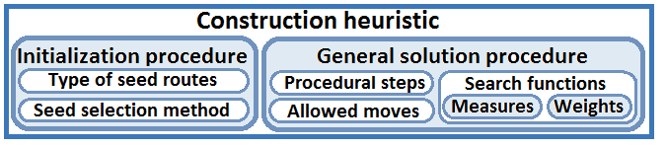

We distinguish two types of measures: cost-related and regret-related (or urgency-related). Cost measures, such as additional (or saved) distance or additional scheduling time represent a direct indication of the effect on solution quality. In contrast, regret measures attempt to minimize ‘costs’ of future moves, especially with respect to the number of routes. One of the main challenges faced by designers of construction heuristics is to prevent the highly undesirable situation where the last customers to be routed are geographically dispersed and cannot be included in any of the constructed routes. These customers then need to be serviced using a very inefficient route. Or even worse – as number of routes is the most important performance criterion – additional routes may be needed. Customers that are located far from the depot, those with a very tight time window or those with a large demand size are the most difficult to insert to partially constructed routes and thus most likely to remain unrouted. Regret measures attempt to indicate these ‘difficult’ customers and prioritize them for early inclusion in a route.

2.5 Classification of construction heuristics

In following sections, we will discuss a number of construction heuristics from literature. First, we provide some structure in the form of a classification framework based on the varying general solution procedures. The best-known general classification of construction heuristics is given by Solomon (1987), who distinguishes the savings, nearest neighbour, insertion and sweep heuristics. We will discuss here the different classes of heuristics, also distinguishing further subclasses (see Figure 2).

Savings heuristics initialize by creating a direct route from and to the depot for every customer (see Figure 3a and 3b) and then combine these routes based on the largest cost saving. Traditionally, the basic savings heuristic only allows routes to be placed in a head-to-tail fashion (hence the label SavHT): either all visits of route 1 are placed in front of the first visit of route 2, or they are all placed after the last (non-depot) visit.. Solution quality can improve by also allowing a route to be placed into another route, but this heavily increases computational requirements, as the search space increases. We refer to this extended interpretation of the savings heuristic as ‘SavPlus’.
Figure 2. Classification of VRPTW construction heuristics.

Nearest neighbour heuristics are probably the most greedy of nature, simply extending routes by adding the customer ‘closest’ to the last added customer. This procedure iterates until no further extension is possible, then creates a new route and repeats itself once again. The measure of closeness can include cost and regret measures (see subsequent paragraphs). A major disadvantage of this method is that it is very likely to end with geographically dispersed non-routed customers, which need a relatively large number of additional routes.

Now considering the insertion-based heuristics, they have in common that they insert one customer at a time, somewhere in a route. The first distinction we make is between sequential and parallel route construction. The sequential approach, which is the most straightforward, constructs one route at a time, creating an additional seed route if no further extension of the current route is possible. In contrast, the parallel method initializes multiple routes at the same time and adds one customer at a time, at the most favourable place available over all routes. An advantage over sequential insertion is that, provided that proper seed customers are chosen for the routes, this approach is more likely to distribute the routes relatively equally over the geographical area. This reduces the average minimal distance from unrouted customers to seed routes and is thus more likely to result in efficient routes. However, this approach may require multiple runs until the right number of seeds has been found. It also depends strongly on good seeds.

The last distinction we make here is between cost-driven and regret-driven parallel insertion methods. Cost-driven heuristics, in our definition, will always select for the next move the customer that can be inserted against lowest ‘cost’ into any route. This approach does not exclude regret measures, it simply considers them as a discount to the insertion cost. In contrast, we distinguish regret-driven heuristics. Such heuristics select as the next customer the one with the highest regret score, which is usually a weighted combination of regret measures. Only after the new customer has been selected is the cheapest insertion place determined, reducing computational requirements since a lot less possible moves have to be considered (some regret measures can be computationally expensive as well, though).

Finally, sweep heuristics first group customers by dividing the geographic area into a predefined number of sections. The result is a set of geographically clustered groups of customers, see Figure 3c. The heuristic then creates one route for each group of customers, which can be done by applying any of the other heuristics (typically sequential insertion). In effect, the sweep heuristic thus only affects the initialization phase, by creating multiple subproblems of significantly reduced complexity. The actual routing procedure for each subproblem is executed using another heuristic. Although this approach has been successfully applied on simpler VRP problems (e.g. Gillett and Miller, 1974), the presence of time windows generally makes it undesirable to pre-group customers based on their location only. Doing so may very well group customers that are impossible to be combined onto the same route due to incompatibility of time windows, thus requiring the creation of additional routes. For this reason, we exclude the sweep heuristic in the remainder of our analyses.

Figure 3 (a-c). Three illustrative figures. Blue-coloured circles represent unrouted customers, red-coloured customers have been selected as seeds. Each of the remaining customers will be inserted into one of the seed routes. The orange square in the middle represents the central depot (i.e. customer 0), where all routes start and end.

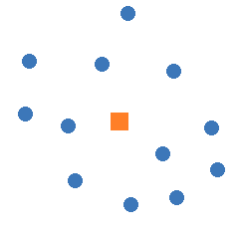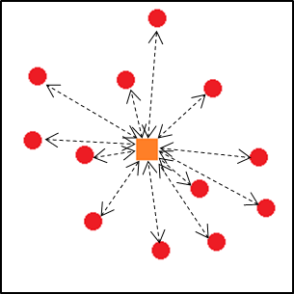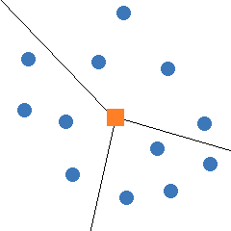
c. Sweep-based initialization
b. Savings initialization
a. Starting situation

2.6 Seed selection methods

Except for the savings heuristics, which simply create a direct route for each customer and then combine those into longer routes, construction heuristics always need to initiate new routes. A good seed selection method creates seeds in such a way that all orders can be (efficiently) appointed to at least one of the seed routes, preferably not all to the same one. Several methods exist to appoint seed customers, with different degrees of complexity. The most straightforward methods include selection based on largest distance to depot (see Figure 4a), largest time window width or earliest due date. However, these methods may result in seeds that are very close to each other, which is not a desired situation.

An alternative method is to select customers that are as far from each other as possible, either by solving a linear programming problem or using an approximation. One such approximation is described in Fisher (1981) and is based on the creation of virtual seeds that are far apart. This ‘virtual seeds method’ (‘VirSeeds’) temporarily creates a predefined number of virtual locations (defined by coordinates, visualized as stars in Figure 4b) at a fixed distance from the depot, with equal distances between them. The seed customers are then those customers that are located closest in distance to those abstract locations. Although smarter than the previously described approach, it causes a problem in sub-areas with high customer density. Such areas will have many customers, but few seed routes. Not all customers can be inserted into the available seed routes and will have to use seed routes that are further away. More efficient routes can be created if more seed routes are available in dense areas.

This leads us to the last alternative that we consider (although many more methods are possible), which is inspired by the sweep heuristic (see section 2.5) and thus referred to as ‘sweep-based’. Assume there are n customers, and we want m routes, then we make a clockwise sweep over all customers and select every $\left\lceil k*n/m\right\rceil$^{th} customer as a seed, with k ranging from 1 to m. See Figure 4c. This approach attempts in a relatively simple yet quite effective way to distribute seed routes according to customer density, as each sector between two seed routes contains the same number of customers. More advanced variants, which become especially more important on problems of a larger scale, could make use of multiple sweep rounds (one for distant customers and one for those nearby) or clustering coefficients. In this paper we will only consider the simple variant, purely based on a clockwise sweep.

Figure 4 (a-c). Three seed selection methods. The red-coloured customers have been selected as seeds, and a direct route has been created to those customers.

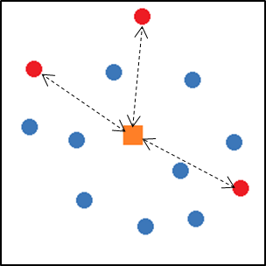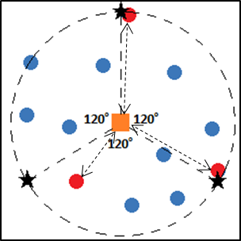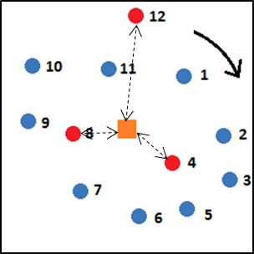
a. Distance to depot
c. Sweep-based
b. Fisher

2.7 Local search functions

Every heuristic that we consider needs local search functions to select the ‘best’ customers or moves. These functions generally look like the following: 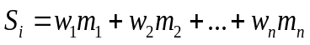, where S_{i} is the total score belonging to customer or move i, m_{i} is one measureable characteristic of the customer or move and w_{k} is the weight factor belonging to measure k. Depending on the heuristic, the score belongs to a move or to a customer and needs to be either minimized or maximized. To illustrate this, regret-driven parallel insertion heuristics need two search functions. The first function determines the total regret score of each customer and includes regret measures only. Assume customer A has the highest regret score, and is selected for the next move. Then the second function calculates the ‘costs’ of inserting (the visit to) customer A anywhere in the routes currently under construction. This cost function may include both distance-related and time-related measures, as well as specific penalties. The heuristic will insert customer A at the insertion place with the lowest associated costs.

2.8 Discussion of construction heuristics from literature

In this section, we will discuss several examples (from literature) of the classes of fast construction heuristics for the VRPTW. These include Solomon’s (1987) generalized algorithms, parallel insertion methods by Potvin (1993) and Russell (1995), an algorithm based on market forces as proposed by Antes (1995) and a greedy look-ahead algorithm by Ioannou (2001).

2.8.1 Savings

The (basic) savings heuristic was first developed by Clarke and Wright (1964) and is therefore also known as the Clarke-Wright algorithm. The heuristic was designed to minimize distances in vehicle routing problems without time windows. It initializes by serving each customer directly from the depot. Next, it calculates the saved distance if any two routes are merged (provided that the proposed merge is feasible). The heuristic then iteratively executes the merge with the highest associated savings.

Solomon (1987) adapted the savings heuristic for use on problems with time windows. He uses the parallel version of this heuristic (i.e. multiple trips are built simultaneously) and only takes into account the savings in distance, not any time aspects. At every iteration, two routes are merged by removing the links between the depot and two end customers i and j, then adding the link between i and j (see Figure 5). This is only possible if both routes have the same orientation (i.e. i is a begin and j is an end or vice versa) and if the merge is feasible with respect to time windows. The two routes that can be feasibly combined against lowest cost will be combined next.
Figure 5. Example of a ‘move’ in the savings heuristic.
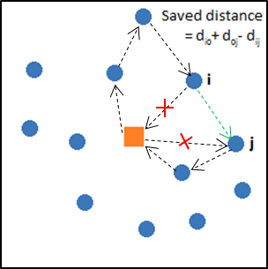
The savings heuristic, in its basic form, does not consider time windows and is focused on minimizing distance. As a result, it produces solutions that generally include a lot of waiting time, often resulting in an unnecessarily high number of routes (Solomon, 1987). Several techniques have been proposed by various authors to make the savings heuristic more suitable for problems that involve time windows. For example, Solomon suggests to introduce a maximum waiting time. Braysy (2003) proposes to calculate the savings score (S) using the weighted combination of saved distance and additional waiting time caused by the merge. In terms of our framework, ‘additional waiting time’ is then included as a weighted measure.

As a final note on basic savings, Rand (2009) provides an overview of improvements to speed up the savings algorithm.

The heuristic that we have previously referred to as ‘SavPlus’ draws from the ideas behind both savings and insertion heuristics. As explained before, the main difference with basic savings is that it also allows to place routes within other routes entirely. The intuition behind it is that this allows to fill the time gaps that result from applying normal savings on a problem with time windows. The procedure resembles the well-known 3-opt improvement strategy, where three connections are broken and three new connections are created (Lin, 1965). Whereas the 3-opt strategy is usually applied to improve, on a route-by-route basis, a solution where all customers are already on a route (e.g. after applying the basic savings heuristic), we use it exclusively to merge routes until this is no longer possible and not to alter the configuration of single routes.

2.8.2 Nearest neighbour

In his nearest-neighbour heuristic, Solomon (1987) considers not only the geographical and temporal closeness of non-routed customers, but also their urgency, calculated as the remaining ‘slack’ of their time window (see v_{iu} below), relative to the current end time of the last added customer on the route under construction. We can classify this urgency measure as a regret measure. Assuming i to be the last customer on the current partial route and u a non-routed customer, Solomon defines the following measures:

d_{iu} | Distance between last customer on the route and customer u.
T_{iu} = b_{u} – (b_{i} + s_{i}) | Time difference between completing service at i and beginning service at u
v_{iu} = l_{u} – (b_{i} + s_{i} + t_{iu}) | Urgency of customer u, expressed by the remaining time of its time window, given the travel time between customers i and u.

The overall search function is given by S_{iu} = w₁d_{iu} + w₂T_{iu} + w₃v_{iu}. The customer with the lowest combined ‘costs’ (score) will be added to the end of the route under construction and the route continues from that customer.

Nearest neighbour did not perform very well in Solomon’s tests, nor is it applied in more recent literature (except some papers on the case with soft time windows, e.g. (Ioannou, 2003)). It can be seen as either a restricted version of insertion (where only insertion at the end of the route is allowed) or as a restricted version of savings (only allowing to merge with routes consisting of one visit only). We therefore will not pay further attention to this heuristic.

2.8.3 Sequential insertion

Sequential insertion heuristics construct one route at a time, iteratively inserting a non-routed customer u into the current partial route between two adjacent customers i and j. For each feasible combination of a customer and an available place for insertion, i.e. each possible move, the heuristic evaluates a search function. Solomon (1987) describes three variations of the sequential insertion heuristic for the VRPTW. We will only look at the one that performed best in his experiments. This variant is better known as the I1 heuristic (i.e., Insertion, variant 1). The search function evaluated for each feasible move is based on the following three measures:

d_{ou} | Distance between the depot and customer u (this is actually a regret measure)
c₁₁(i,u,j) = d_{iu} + d_{uj} – µd_{ij} | ‘Distance costs’: (adjusted) additional distance if u is inserted between customers i and j. µ≥0.
c₁₂(i,u,j) = b_{j_u} – b_{j} | ‘Time costs’: difference between original start time at customer j (b_{j}) and start time given insertion of u (b_{j_u})

The search function for I1 is thus given by S(i,u,j) = w₁d_{0u} – w₂c₁₁(i,u,j) – w₃c₁₂(i,u,j). The move with the highest score will be executed next.

Solomon also experimented with variations: one where the search function is simply a weighted combination of added distance and added time, and one that attempts to incorporate the temporal aspect of the measure used for insertion as a measure of urgency of the customer. He defines the measure c₁₃(i,u,j) = l_{u} – b_{u}, but we should actually interpret this as the remaining slack if customer u is inserted between customers i and j and not so much as the ‘urgency’ of servicing the customer. Of course, in case of the nearest neighbor heuristic, this is a valid measure of urgency, but for the insertion heuristic it provides little information about urgency.

Solomon’s I1 heuristic has been widely accepted as the standard construction heuristic for VRPTW problems, for reference purposes as well as for creating starting solutions for metaheuristics. Multiple different, feasible initial solutions of reasonable quality can be generated in a short amount of time by varying the weights just a little, which is a very useful quality for use in combination with metaheuristics, as it increases the chance of finding efficient customer sequences.

Ioannou (2001) takes the sequential insertion heuristic for the VRPTW to a higher level by introducing additional measures for customer selection. The basic idea behind these measures is that a customer u selected for insertion into a route should minimise the impact of the insertion on the customers already part of the route under construction, on all non-routed customers and on the time window of customer u himself. ‘Impact’ can be interpreted in this context as ‘reduced flexibility’. Ioannou uses the following measures to quantify the three types of impact mentioned. Note that components c_{1u} and c_{2u} of IR are similar to Solomon’s measures c₁₁ and c₁₂.

IS_{I} = b_{u} – e_{u} | Own impact. Closeness to earliest service time of the vehicle arrival time given insertion. Values close to 0 correspond with minimal impact.
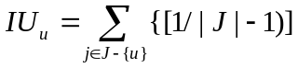  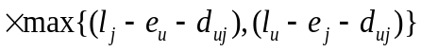  (J is the set of non-routed customers) | External impact. A non-routed customer can no longer be serviced during the proposed service time for customer u. IU calculates the average reduction of the effective time window to feasibly insert non-routed customers j given insertion of u. In other words, it indicates the time overlap between the proposed insertion and the time windows of other non-routed customers.
c₁₁(i,u,j) = d_{iu} + d_{uj} - d_{ij}  c₁₂(i,u,j) = b_{j_u} – b_{j}  c₁₃(i,u,j) = l_{u} - b_{u}(i,j)  LD_{u}(i,j) = w₁c₁₁ + w₂c₁₂ + w₃c₁₃  (w₁ + w₂ + w₃ = 1 )  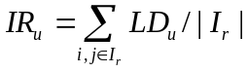  (I_{r} is the set of feasible insertion places for u)  Impact(u) = w_{s}IS_{u} + w_{e}IU_{u} + w_{r}IR_{u}  (w_{s} + w_{e} + w_{r} = 1 ) | Increase in distance if customer u is inserted between customers i and j.  Increase in start time at customer j, given insertion of u between i and j (‘push-forward’)  Remaining slack at customer u, given insertion between i and j.  Local disturbance caused by inserting u between i and j. Is a weighted combination of the three previous measures.  The internal impact is then the average impact over all possible insertion positions. According to the authors, this metric indicates ‘accessibility’ of the customer to the route.  Total impact is a weighted combination of own, external and internal impact.

This heuristic tries to maintain maximum flexibility by minimizing three types of impact. The own impact indicates the amount of slack left locally, the internal impact indicates accessibility and the external impact takes into account that other customers need to be inserted after this insertion as well.

The main thing to learn from this paper, since the results are much better than those from Solomon’s paper (i.e. 429 routes over all Solomon problems, whereas I1 needs a total of 453 – the best known total number of routes is 405) while still being a relatively simplistic heuristic, is the emphasis on looking-ahead: it is important to make sure that your next insertion move does not reduce the chance of inserting other unrouted customers too much.

2.8.4 Cost-based parallel insertion

We have not found any literature on VRPTW heuristics based on cost-based parallel insertion. Although a large number of parallel insertion heuristics has been developed, they all filter the set of non-routed customers based on some regret measure first, classifying them as regret-based instead of cost-based. In our own series of experiments, we will find out whether this is because cost-based parallel insertion is much worse than sequential or regret-based approaches or that this is actually quite a useful approach.

2.8.5 Regret-based parallel insertion

As mentioned above, all published parallel insertion heuristics that we know of involve a regret-based approach. We will describe three such heuristics.

First, Potvin et al. (1993) propose a heuristic that select customers based on the number of possible insertion positions. The heuristic runs I1 once to have an estimation for the required number of seed routes (n). Seeds are selected based on the routes created by I1: the farthest customer on each I1-route is selected as a seed for Potvin. The heuristic then calculates the costs of insertion for each possible move (a move is still given by the insertion of non-routed customer u after routed customer i). The regret measure consists of the difference between the costs of the insertion currently considered, and the costs of the cheapest insertion possibility known for that customer. Infeasible insertion spots receive a high regret value. The underlying intuition is clear: if the customer is not inserted at the cheapest insertion spot, this will bring additional costs. High additional (i.e. alternative) costs imply high urgency of routing the customer: routing another customer first can make the cheapest move for this customer infeasible, incurring additional cost of at least the difference with the second-cheapest option. A customer’s final regret score is based on its summed score over all insertion places available (feasible or not). The customer with the highest regret value is inserted first, at the cheapest insertion place.

We believe that this approach has a lot of potential: intuitively, selecting customers with few feasible insertion places first should be an effective way to reduce the necessity for additional routes. We also appreciate the intuitiveness of the regret measure that is used: it seems like one of the most direct ways to assess the influence of a move on the objective function. However, Potvin chooses to sum the regret value over all available moves, with high regret for infeasible moves. The consequence is that customers with few feasible moves (even if they are all equally good) always have priority over customers with more feasible moves (even if the customer only has one efficient insertion spot). To illustrate this, consider customer A with 20 insertion possibilities, of which only one is efficient with respect to total distance, and customer B 10 equally good insertion possibilities. The total number of available insertion places is equal, so customer B has 10 additional moves with the high infeasibility-related regret value. Customer B will be inserted first. Problem: this may cause the one efficient insertion place of customer A to become infeasible. Customer A will be inserted in a more expensive way, and total distance becomes worse. One way to prevent this might be to not sum over all possible moves (including infeasible moves) but to look only at the difference between the best and the second-best move, but we did not test this.

Another remark on the solution procedure is the way Potvin selects the seed customers: taking the farthest customer on each I1-route does not guarantee that the seeds are geographically dispersed – a requirement for good seed selection (because faraway seed customers that are close together are likely to be efficiently routed on the same route instead of having multiple routes going to the area).

Russell (1995) has adapted Potvin’s heuristic by altering some essential characteristics. To start with, the heuristic uses a seed selection method that is close to our VirSeeds method (section 2.6), but instead of selecting the customers closest to the n reference points on the circle (see Figure 4b), those points become virtual customers that are used as seeds. As soon as the first real customer is added to the (then) virtual route, based on Russell’s procedural logic, the respective virtual customer is deleted. In accordance with Potvin, I1 is run once first to determine an appropriate number of seed points.

When it comes to the construction procedure itself, Russell opts for a more indirect way of determining which customers should be routed first. His construction heuristic makes an ordering of the customers based on one of the following three regret measures:

l_{u} | Latest possible start time of service. Low values indicate high urgency (top of the list)
100*(l_{u} – e_{u}) – d_{u0} | Time window width augmented by distance to depot. Lower values indicate more difficulty of insertion.
d_{ou} | Distance to depot. Higher values indicate higher difficulty of insertion.

The customer that ranks highest on urgency or difficulty will be inserted next, at its cheapest insertion place according to a weighted combination of the following two measures.

c₁₁(i,u,j) = d_{iu} + d_{uj} - d_{ij} | Increase in distance.
c₁₂(i,u,j) = b_{j_u} – b_{j} | Increase in start time at customer j, given insertion of u between i and j (‘push-forward’)

This approach has two main advantages. Customers are added in a more look-ahead – and thus hopefully more ‘intelligent’ – fashion, which should lead to higher quality solutions if the right measures are chosen. Second, the number of possible moves that need to be considered at any point, as well as in total, reduces significantly as the heuristic only needs to check the insertion costs of the possible moves of one customer instead of those of all non-routed customers. These benefits come at the cost of some pre-processing (but this is very fast) and the fact that more routes are constructed at the same time, which may still result in quite a number of possible insertion places even for one customer only.

One run consists of six sub-runs, two for each regret measure, with different weights for c₁₁ and c₁₂: 1 and 0 and vice versa. If a run was successful, another try follows with one seed route less. This procedure repeats until the number of seeds is no longer sufficient, at which point the best solution from the previous run is selected. Russell reports that his heuristic produces solutions comparable in quality to I1 but that it is a lot faster especially on problems with many customers on each route.

Although Russell’s approach proves successful, we have a few critical notes. To start with, using l_{u} as a regret measure for an insertion heuristic does not seem to make much sense, as customers can be inserted early in partially constructed routes as well as late. This means that it is not more (or less) difficult to insert a customer that needs to start service early. Routes under construction are just as likely to have room for insertion at early insertion places as well as at the late ones. Admittedly, since customers are scheduled as early as possible by default, inserting a customer early in the route may require moving some customers forward in time. However, this action has no influence on solution quality and poses no problem as long as there is enough slack or waiting time that provides room for insertion. One might as well schedule all customers as late as possible during the construction process: this would not have any influence on the resulting sequence of customers (and thus on the total distance), just on the start times of service and the distribution of slack.
In addition,, we would not recommend activating c₁₂ only: for good solution quality it seems essential to consider at least a distance measure when it comes to selecting insertion points. The reason behind Russell’s choice is probably that he wanted highly varying starting solutions as starting points for his improvement heuristic, but for pure construction this is not advisable.

Antes and Derigs (1995) propose a different conceptual framework to find solutions for the VRPTW. Their method avoids the preprocessing procedures (i.e. seed selection and ranking of customers based on some measure) required by Potvin and Russell and simply creates a new route every time it finds a non-routed customer with no feasible insertion position in any of the previously constituted tours. The heuristic initializes by creating one seed route only, creating a new route whenever a non-routed customer cannot be inserted into any of the routes under construction. This makes the heuristic an interesting combination of sequential and parallel route construction, and in any case avoids the difficulties of parallel seed selection methods.

In the construction phase, the heuristic iteratively applies an auctioning process with proposals and acceptance consisting of three procedures:
- ‘make_request’ – each customer ‘receives’ from every route under construction a price for insertion
- ’make_proposals’ – each non-routed customer who received a finite (i.e. feasible) offer sends a proposal to the tour which offered the lowest price
- ‘accept_proposals’ – each route accepts the proposal of the customer for which insertion is most efficient, based on the gain of the insertion versus direct service of the customer (compare with savings). Routes may only choose among the customers with the fewest number of alternative routes.

During an iteration the heuristic may insert multiple customers – one for each partial route. Basically, what happens here is that a first selection takes place based on the number of route alternatives a customer has, similar to Potvin’s heuristic. Out of those most urgent customers, the one that can be inserted against the highest gain is selected for insertion. This ‘gain’ involves not only the increase in route distance but also a regret measure, i.e. the customer’s distance to the depot (similar to Russell’s heuristic).

We believe that the number of alternative routes is a very good regret (or urgency) measure when it comes to minimizing the number of routes. If a customer with only one alternative route is not inserted very soon, other customers may take its place, leaving no feasible insertion place. The heuristic then ends with non-routed customers that need additional routes for service. These late-stage routes are typically very inefficient, as the remaining customers are often geographically scattered. The ‘count alternative routes’ measure provides a means to make that undesired situation less likely.

However, we signal a drawback of the selected initialization procedure. The situation may arise where, for instance, two seed routes are under construction. A customer located far from both routes that can only be feasibly inserted into one of them currently has full priority over those customers that can be inserted very cheaply, even if insertion of the former customer requires a large detour and results in a very inefficient route. The customer should probably have been included in a new route that was not yet initialized. We therefore conclude that regret-driven approaches should only be applied with actual parallel construction procedures, where it is known in advance that customers have to be included in one of the seed routes and there will not be a new route that can service the customer much more efficiently.

2.9 Qualitative comparison and expected performance

Based on the previous sections, we can compare the heuristics based on qualitative aspects such as simplicity, computation time and flexibility.

With regard to simplicity, the only heuristic from our discussion that is significantly more complex is the impact-oriented heuristic suggested by Ioannou. The other heuristics are, in essence, rather straightforward and involve a limited number of measures and operations.

When it comes to computation time, the savings heuristic is known to be very fast and efficient: the distance savings of each merge of routes need to be computed only once, and then the moves can be checked for feasibility and then executed in order of highest savings. Although sequential insertion requires a more dynamic evaluation of possible moves, the total number of moves to be considered is lower, so computation time might be quite low for that heuristic as well. Parallel insertion heuristics need to evaluate more moves at a time and are probably slower.

Computation time also depends heavily on the types of measures involved. Some measures require re-evaluation after each iteration, increasing computational requirements. For example, if the push-forward measure is chosen as part of the search function, cost-driven insertion heuristics need to recalculate a lot of search functions after every insertion (i.e. for every combination of insertion places after the performed insertion with all non-routed customer), slowing down the heuristic. Regret-based heuristics are pretty much unaffected by this: the same amount of ‘checks’ needs to be performed, they just last a little longer. Furthermore, measures that involve the number of feasible insertion places or insertion routes for non-routed customers need to reassess feasibility of each possible move, or at least of each combination of available routes and non-routed customers, which requires even more computation time than the push-forward.

Regarding flexibility, we consider the savings heuristic to be a lot less flexible than insertion-based heuristics. The main reason is that the route-oriented approach does not support regret measures per customer, let alone a regret-driven construction approach. Additional constraints such as multiple vehicle types are also difficult to implement in the savings heuristic, but easy in insertion-based heuristics.

2.10 Conclusion

In this chapter we have introduced construction heuristics, distinguishing savings, nearest neighbour, insertion and sweep-based heuristics and also made further distinctions within these classes. We provided examples of such heuristics from literature and explained their main features. Some main conclusions:
- Nearest neighbour and sweep-based heuristics do not appear successful on problems with time windows.
- Except for the IMPACT heuristic by Ioannou, all construction heuristics reviewed have very simple core mechanics.
- Insertion-based heuristics are easier to adapt to additional constraints than savings-based heuristics and are thus more flexible to use. On the other hand, the savings heuristic is known to be very fast and to be excellent at minimizing total distance.

3 Generalized construction heuristics for the computational experiments

3.1 Introduction

. In this chapter, we propose a modular structure of construction heuristics that facilitates our computational experiments. Based on the literature review, we distinguish three main components (‘building blocks’) that together form a complete heuristic. See Figure 6.

Figure 6. The three building blocks that form the basis of our computational experiments
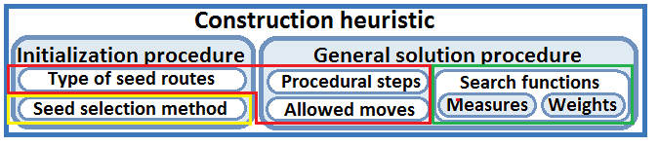

First, the heuristic framework (red box in Figure 6) governs the type of seed routes, the logical steps (i.e., the structure of the pseudocode), and allowed move types used to find a solution. We define six generalized heuristic frameworks, inspired by what we have seen in literature but formulated such that the structure allows combination with the other two components of our framework. As a second component, the initialization method for selection of seeds (yellow box in Figure 6) defines the starting points of routes and thus has major influence on route construction. For savings-based heuristics, the seed selection method is fixed. Third, the selection measures used in the local search functions (green box in Figure 6) determine which moves are executed in which sequence We distinguish cost-based and regret-based measures, see section 3.4.

3.2 Generalized heuristic frameworks

Based on the litereature review, we propose the following six generalized heuristic frameworks. These frameworks determine what type of seed routes the heuristic needs and what types of moves will be considered at which point during the construction process. Appendix A includes the pseudocode of the six heuristics.
- Basic, head-tail savings (‘SavHT’). This heuristic initializes by creating a direct route to each customer and then combines routes (in a head-to-tail fashion, hence the label ‘SavHT’) based on highest saving in distance. See 2.8.1 for further explanation. We further generalize this heuristic by also allowing to incorporate other cost-based search function measures, such as time gap and push-forward (see 3.4). We will not incorporate regret-based measures, as those apply to individual customers and savings-based heuristics consider routes as a whole, possibly containing multiple customers. The savings heuristic is a well-known heuristic, both in literature as in the advanced planning and scheduling industry, so it makes a good reference heuristic.

- SavPlus(‘SavPlus’). SavPlus is almost the same heuristic as SavHT, with the addition that complete routes can be inserted into other routes under construction. This provides a possibility to eliminate waiting time but increases the number of moves that need to be considered. It is thus a combination of savings-based and insertion based heuristics. We expect better solution quality (esp. with respect to the number of routes) than from SavHT, but reduced speed since saved distances need to be recalculated after each move and more moves are allowed.

- Cost-driven sequential insertion (‘SeqIns’). Sequential insertion means that one route is under construction each time, inserting customers one by one based on the best weighted combination of the scores on cost-based and regret-based measures. So, regret-based measures are treated as part of the total cost function (in effect, they provide a ‘discount’). The seed route can be chosen in different ways (see 3.3). Solomon’s I1 heuristic is a heuristic of this class that is a very popular construction heuristic for metaheuristics for the VRPTW.

- Parallel cost-driven insertion (‘ParIns’). Similar to SeqIns, ParIns inserts customers one by one based on the weighted combination of cost-based and regret-based measures. The difference is that ParIns creates multiple seed routes at once (according to a certain seed selection method). Surprisingly, no heuristic from literature has this form: all known parallel construction heuristics are regret-driven. Result quality is probably dependent on the quality of the seed routes. The next customer is selected based on a weighted combination of both cost and regret measures.

- Combined regret (‘CombReg’). This parallel insertion heuristic, which draws its basic concept from Russell’s heuristic (see 2.8.5), selects the next customer for insertion based on the weighted combination of its regret values only. The best insertion place for that customer is then determined according to the selected cost-based measures. .

- Fewest alternatives (‘FewAlt’). Similar structure as CombReg, but with a slightly different customer selection: the number of routes that a customer can choose from insertion is the dominant selection measure. This idea borrows from the heuristic described by Antes and Derigs (see 2.8.5), which only allows customers with fewest alternatives to be inserted next. In our FewAlt heuristic framework, an iteration starts by checking, for each unrouted customer, in how many of the seed routes it can be feasibly inserted. Out of all moves that involve those customers with the fewest alternatives, the move with the best weighted combination of scores on selected cost-based and regret-based measures is executed. Regret-measures count as a discount on the cost-based measures (similar to cost-based sequential of parallel insertion). Note that our version of this heuristic only allows insertion of one customer per iteration, whereas Antes’ original heuristic inserts one customer into each partial route.

We have excluded the nearest neighbour heuristic because of its bad solution quality according to Solomon, and the sweep heuristic for its apparent incapability of handling time windows.

3.3 Seed selection methods

The second main component that is varied throughout our test runs is the seed selection method. SavHT and SavPlus always initialize by creating direct routes for all customers. In our runs, SeqIns always selects the furthest non-routed customer as seed customer for a newly created route: the other two seed selection methods distinguished in section 2.6 make no sense if only one seed is needed. For the three parallel heuristics (ParIns, CombReg and FewAlt), we will experiment with three different methods for seed selection: furthest distance from depot, VirSeeds and sweep-based (see section 2.6).

3.4 Selection measures

We have chosen eight selection measures (for the local search function) to be varied throughout our test runs, which are listed below. The term between brackets is the label of the corresponding weight factor.

3.4.1 Cost-related measures

- Added distance (w_{ad}). Difference between the length of the original route (or routes in case of the two savings-based heuristics) and that of the route resulting from the move. In case of SavHT, the saved distance is defined as d_{0j} + d_{j0} - d_{ij}. In case of SavPlus, the formula needs to be generalized to d_{i,u1} + d_{u2,j} – d_{i,j} – d_{0,u1} – d_{u2,0}, where u1 and u2 are the first and last customer of inserted route u. For all insertion-based heuristics, we define the added distance as d_{iu} + d_{uj} - d_{ij}. These definitions are based on Solomon (1987).

- Push-forward (w_{pf}). After insertion of a customer, the visits later on the route (i.e. after the insertion point) may be pushed forward in time. The push-forward of time indicates the amount of time by which the visit directly after the newly inserted customer needs to be rescheduled. This measure is defined as b_{j_u} – b_{j}, where b_{j_u} is the start time of customer j after insertion of customer u directly before customer j and b_{j} is the current start time of customer j. Based on Solomon (1987).

- Time gap (w_{tg}, only applies to SavHT). Minimal waiting time resulting from making a move in SavHT. Defined as the time gap between the latest possible end time of customer i (last customer of route 1) and the (earliest) start time of customer j (first customer of route 2). The latest end time of i is equal to the sum of the current end time and the maximal push-forward of route 1 (which in turn is used to check feasibility).

- New route (w_{nr}, only applies to the savings-based heuristics). Fixed penalty for combining two routes that have only one customer, i.e. creating a new extended route (as opposed to merging routes that already contain multiple customers) , making it more attractive to (incrementally) extend current partial routes than to start new ones. This should reduce the risk that several medium-sized partial routes are created that can never be merged.

3.4.2 Regret-related measures (only apply to the insertion-based heuristics).

- Distance to depot (w_{dtd}). Is already included in Solomon’s cost components for I1, but we treat it as an explicit and standalone (regret) measure.

- Time window width (w_{tww}). This is one of the regret measures that Russell (1995) experimented with in his heuristic (see section 2.8.5). Customers with a smaller time window are generally more difficult to insert into partial seed routes.

- Demand/load size (w_{l}). Not found in literature, but probably not an entirely new concept. Customers with higher demand are considered more urgent.

- Number of alternative routes (w_{na}, only ParIns and CombReg). We have opted for number of routes instead of number of feasible insertion places. Not only is this less demanding with respect to computational requirements, it is also more stable: one insertion can drastically influence the number of feasible insertion places for another customer, but the number of available routes can only decrease by one. This regret measure is already an integral part of the FewAlt heuristic and is therefore not included as a weighted measure there. Adding this measure to the ParIns or CombReg heuristic creates a ‘hybrid’ between that heuristic and FewAlt, since the number of alternatives is only weighted into a larger score. Adding the measure requires feasibility checks of all possible moves after each move execution, which changes the pseudocode a bit: before updating cost and regret, feasibility checks are performed and infeasible moves are removed from the set of possible moves. Feasibility then needs not be checked again after move selection (see Appendix A for the original pseudocodes).

It is important to note here that, since we want to combine scores on multiple measures into one total score, the measures should be numerically comparable with each other. For this reason, we ‘normalize’ the score on each measure such that they can be interpreted as representing the relative impact on one aspect of the problem (see example later in this section). The weights are then applied on the normalized scores on the individual measures, and the results are combined into a total score.

The scores on ‘added distance’ and ’distance to depot’ are divided by the furthest distance to depot present in the problem. The time-related measures ‘push-forward’, ’time gap’ and ‘time window width’ are divided by the depot time window. ‘Load size’ is divided by the capacity of the vehicle. ‘New route’ simply takes value 0 (no new route) or 1, and ‘number of alternatives’ is compared with the total number of routes. We then apply weights 0, 0.5 or 1 to the normalized scores.

As an example, consider a move that increases the distance of a route by 10 km. The furthest distance to depot in the problem is 40 km. Then the normalized subscore on the ‘added distance’ measure is 0.25 for that problem. If the weight on added distance is 0.5, the weighted contribution of the added distance measure to the total cost associated with this move is calculated as 0.25*0.5=0.125.

Some of the measures that we did not select include, for example, time window end time (l_{i}), remaining slack, and unutilized time windows of non-routed customers (i.e., the ‘external impact’ measure from Ioannou 2001). We believe l_{i} is only a useful measure in case of nearest neighbour. The remaining slack could be effective as a measure at first sight, but is partially covered by the push-forward measure (which indicates slack reduction) and might even prioritize those customers with wide time windows, leaving the most difficult customers for later insertion. Finally, checking utilization or coverage of the time windows of all non-routed customers for every possible move (as in Iaonnou’s heuristic) is computationally very demanding and requires much more computational effort than our other heuristics.

4 Computational experiments I: detailed comparison on small-scale problems

4.1 Introduction

In this section, we introduce our first (out of two) series of experiments. We will test a large number of composite heuristics, created by combining heuristic frameworks, seeds selection methods and search function components (i.e. measures and weights) on varied benchmark problems with 100 customers. The main goal of this first series of experiments is to find out which elements of construction heuristics contribute most to solutions of high quality, overall and in specific situations.

4.2 Test setup

This series of experiments involves 3672 composite heuristics, created by combining heuristic frameworks, seed selection methods and selection measures, based on the selection made in chapter 3. . In general, we experimented with three weight parameter values for each measure: 0, 0.5 or 1. A value of 0 means that the measure is simply not taken into account in that run. The values 0.5 and 1 allow us to vary the relative importance of selection measures. In the remainder, we refer to weight parameters simply as ‘parameters’.

Since some of the selected measures are not applicable to every heuristic, the number of combinations tested per heuristic framework differs. Table 1 shows, for each heuristic framework, the number of seed selection methods and the number of different weight factors for each chosen selection measure.
Table 1. Test setup - number of tested values of weight parameters for each heuristic type.

 | SavHT | SavPlus | SeqIns | ParIns | CombReg | FewAlt
# of seed selection methods | 1 | 1 | 1 | 3 | 3 | 3
w_{ad} | 2 | 2 | 2 | 2 | 2 | 2
w_{pf} | 3 | 3 | 3 | 3 | 3 | 3
w_{tg} | 3 | 3 | 1 | 1 | 1 | 1
w_{nr} | 3 | 3 | 1 | 1 | 1 | 1
w_{dtd} | 1 | 1 | 3 | 3 | 3 | 3
w_{tww} | 1 | 1 | 3 | 3 | 3 | 3
w_{l} | 1 | 1 | 3 | 3 | 3 | 3
w_{na} | 1 | 1 | 1 | 3 | 3 | 1
# of combinations per heuristic | 54 | 54 | 162 | 1458 | 1458 | 486
Total # of combinations | 3672

Note that the value ‘1’ in this table means that we did not experiment with varying the parameter value of that measure for the corresponding heuristic (i.e., it only takes the value 0). Furthermore, notice that we do not allow w_{ad} to take value 0, since added (or saved) distance is the backbone of every heuristic. Only two values are allowed for w_{ad}: 0.5 and 1.

For the runs of parallel heuristics, we repeat the run with different numbers of seeds until the number of seeds is sufficient. This means that those combinations always need at least 2 runs: (at least) one run with a sufficient number of seeds, and one run with one seed route less to check whether this results in a lower number of routes in the end. The one exception is when the total capacity of the vehicles available is known to be insufficient beforehand if the number of seeds is decreased further: i.e. if (n-1) seeds multiplied by the vehicle capacity is lower than the total customer demand. In such cases, only one run with n seeds might be sufficient.

After each run, the number of routes created, the total distance and the runtime are saved. In case of multiple runs, we only save the results of the run with the lowest number of seeds that was still sufficient.

4.2 Benchmark datasets

An important aspect of the methodology is the set of benchmark data. The benchmark data should cover problems with a wide range of characteristics, and preferably have been used in previous literature as well for comparison purposes. In case of the VRPTW, the benchmark dataset of choice is definitely the one proposed by Solomon (1987), in the same paper where he defines the main classes of construction heuristics. Although some other datasets are available as well (most notably the Homberger and Gehring datasets for larger problems), we will also use the Solomon data during our computational experiments.

In total, the Solomon benchmark set consists of 56 problem instances. We will not discuss how Solomon generated these 56 instances, instead we simply consider their resulting characteristics. The interested reader is referred to Solomon (1987). The dataset consists of six problem classes, characterized by their degree of clustering and scheduling horizon. The degree of clustering refers to the degree to which customers geographically cluster together, i.e. if the customer density varies much on different sub-areas of the problem. Solomon defined three clustering types: random, clustered or mixed. The scheduling horizon refers to the time horizon of the problem, indicated by the time window width of the central depot. Typically, problems with a short horizon require more routes with fewer customers per routes than problems with a long horizon. Within a class, 8-12 problem instances have a fixed geographical positioning of 100 customers but differ in time window characteristics such as presence of time windows, tightness and average width. Appendix B specifies the characteristics of each of the Solomon datasets.

Together, the benchmark problems represent a wide spectrum of VRPTW problems, differing in some of the most distinguishing characteristics. The sets thus provide an excellent way to compare the performance of competing heuristics in several settings. The best heuristics are those that perform well in all categories of the Solomon datasets.

4.3 Analysis of results

In this section, we will present and discuss several observations from the test runs. We have identified different criteria to determine which heuristics, seed selection methods and combinations of parameter values perform best overall and on specific problem types. We consider the number of generated routes (totalled over all 56 Solomon problems) to be the most important performance criterion, but we will also report total distance. Each subsection below introduces one such measure and presents the respective results generated during the test runs. When interpreting the results, bear in mind that, since not all measures are applied in combination with every heuristic framework, the test setup is not completely symmetric and thus the results may be biased based on the settings.

An alternative approach to considering only average performance is to compare best results as well. This is a relevant means of comparison because practical cases also involve ‘tuning’ the measures and weights until the solution no longer improves. The average performance may provide misleading information in that case. This is why we will consider both measures (i.e. average and best performance) in our analysis. Throughout this section, unless otherwise mentioned, ‘best result’ refers to the one combination of parameter values that yields the lowest total number of routes over all problems, not to the sum of the best results per problem achieved with several combinations of parameter values per problem.

4.3.1 Aggregate statistics

Probably the most intuitive measure to assess the performance of heuristics, the total number of routes together with the total distance generated over all 56 Solomon problems provide a first indication of the overall performance of a heuristic. Table 2 presents the average, best and worst results for each heuristic. The best performance with regard to the number of routes is not necessarily generated using the same set of parameter values as the best performance with regard to total distance. Note that the savings heuristic was originally designed to minimize total distance, not the number of routes, so one should not expect the savings heuristics to score well on the number of routes criterion.
Table 2. Aggregate results over the whole experiment, averaged for each combination of heuristic type and seed selection method.

Heuristic | Seed selection | Total number of routes |  |  |  | Total distance
 |  | Avg. | Std. | Best | Worst | Avg. | Std. | Best | Worst
SavHT | N/A | 593 | 65.5 | 528 | 737 | 68767 | 3844 | 63230 | 74122
SavPlus | N/A | 515 | 51.8 | 472 | 612 | 66730 | 4057 | 61512 | 72823
SeqIns | Distance to depot | 483 | 19.2 | 455 | 532 | 80010 | 6229 | 72247 | 92920
ParIns | Distance to depot | 542 | 13.0 | 515 | 580 | 93556 | 1998 | 89620 | 99133
ParIns | VirSeeds | 501 | 14.3 | 472 | 546 | 73149 | 2097 | 68794 | 79419
ParIns | Sweep-based | 488 | 19.1 | 454 | 543 | 70940 | 4050 | 65338 | 81201
CombReg | Distance to depot | 546 | 14.9 | 528 | 598 | 97308 | 2887 | 91697 | 105368
CombReg | VirSeeds | 489 | 16.5 | 467 | 542 | 74917 | 2625 | 70890 | 81503
CombReg | Sweep-based | 473 | 14.0 | 456 | 531 | 72188 | 3870 | 66314 | 81393
FewAlt | Distance to depot | 532 | 3.0 | 525 | 539 | 97558 | 1244 | 95117 | 100079
FewAlt | VirSeeds | 472 | 3.4 | 464 | 481 | 74423 | 1193 | 71605 | 77410
FewAlt | Sweep-based | 462 | 3.7 | 455 | 473 | 72780 | 1682 | 70004 | 76721

When looking at the average number of routes, representing the main objective, we can derive from Table 2 that FewAlt and CombReg have the best overall performance, provided a more sophisticated seed selection method than ‘distance to depot’ is used. Sequential insertion follows closely. SavHT performs very badly and needs 28% more routes than sweep-based FewAlt. Comparing the results to the best known result from literature – 405 routes – SavHT even needs 46% more routes on average, where sweep-based FewAlt needs only 14% more routes on average, which means that the number of unnecessary routes is over three times larger for SavHT. SavPlus, although a significant improvement over SavHT, is still heavily outperformed by the other heuristics tested, given proper seeds. The observation that SavHT is not good at minimizing the total number of routes, especially if time windows are present, corresponds to our expectations and to findings from literature (e.g. Solomon, 1987). However, SavHT is relatively good at minimizing the total distance travelled, which is the secondary objective.
Figure 7. Visualization of the performance of heuristics in our experiments. Every dot represents the total number of routes generated using one of the 3672 combinations of heuristic frameworks, seed selection methods and values of weight parameters.
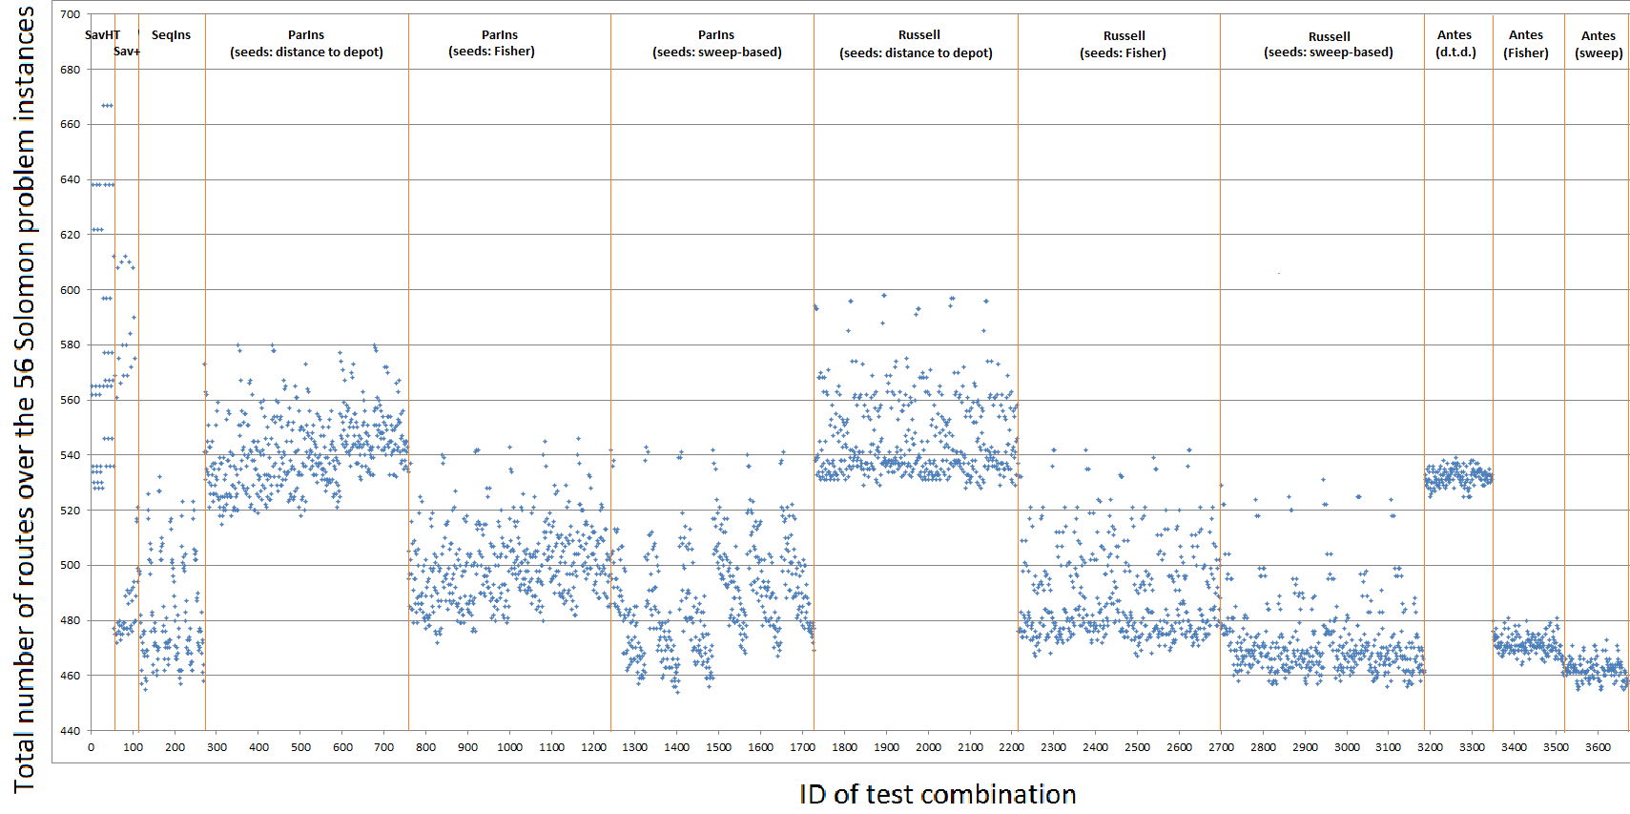

Looking at the other measures listed, we can conclude from the standard deviations that the results from the two savings-based heuristics vary heavily over all test runs, depending strongly on parameter settings. With the most successful settings tested (i.e. those that result in the lowest number of total routes), and only then, the performance of SavPlus is almost comparable to that of the other heuristics tested. However, since a new problem set may require different settings and testing all combinations is infeasible, such strong dependency on parameter values is undesirable. Still, it is quite possible that some parametric values (e.g. too much weight on load size) are responsible for large outliers, in which case more constant behaviour can be expected by avoiding those values. This possibility will be explored later.

Regarding the four remaining heuristics, for each of those one can find a setting that results in 454-456 total routes. This can be easily seen from Figure 7, where the best values of each heuristic are slightly below the ‘460’ line. Only FewAlt has a consistently high performance, with a worst-case performance of 473 routes for sweep-based seed selection, but this comes at the price of a longer average distance. This result follows quite naturally from the structure of the heuristic, which solely aims to avoid the creation of new routes: an ultimate regret-based approach. Recall that nodes with few alternatives are given priority by FewAlt, even if it is much cheaper to insert other nodes into the respective route. The result is often that, although routes become less efficient distance-wise, fewer nodes remain unscheduled and need additional routes. In contrast, savings-based heuristics do not use any regret measures, resulting in low total distance but a larger number of routes.

Finally, comparing the performance of the different seed selection method, it is clear that sweep-based seed selection performs better than VirSeeds and that both outperform ‘distance to depot’. Again, the explanation is rather straightforward. If seeds are (geographically) well distributed over all orders, it will not occur very often that a large detour is needed to reach certain customers. Thus, more efficient routes can be created. If the only selection measure to select seed nodes is their distance to the depot, the seeds may well be located in one corner of the ‘grid’, making it very difficult and inefficient to reach customers on the other side of the depot.

An important performance criterion, next to the number of routes and total distance generated, is computation time. However, since different combinations of selection measures were tested for different heuristics, and certain selection measures can really slow down the process, we will just say here that the runtimes for one run were very comparable: around 0.2 seconds without w_{pf}, w_{nr} and w_{na}, which need continuous revision. SavPlus needs twice as much time. Because parallel methods needed multiple (on average a little over 3) runs to find the best number of seeds for a certain combination, those methods (i.e. ParIns, CombReg and FewAlt) needed more computation time per combination.

4.3.2 Statistics by problem class

Since the Solomon problems consist of different classes, we can further investigate the performance of each heuristic on each problem class. This can be useful in practice when the problem class is known: The best performing heuristic (according to the number of routes generated) can be chosen accordingly. Appendix C contains full tables that compare the average and best results on each of the six problem classes, based on the average deviation of the best known results in literature. In this subsection we will note the most interesting patterns that we observe from those tables.

First, we compare based on degree of clustering: clustered, randomized or semi-clustered. Table 3 shows the average and best results per heuristic, based on the number of generated routes. We observe that SavHT is outperformed on all 3 clustering types. SavPlus performs reasonable on clustered problems but worse on the more randomized ones. Sequential insertion is able to produce very good results in (semi-) clustered problems and performs rather consistently overall as well. For the parallel methods, it seems that the seed selection method is more important than the heuristic type, especially on the clustered problems. Sweep-based CombReg and sweep-based FewAlt perform well on all clustering types and especially well on randomized problems. Based on these results only, they should be considered the heuristics of choice for all problem types.

Table 3. Comparison of heuristics and seed selection methods on degree of clustering. Reported results are average number of routes generated by the combination of heuristic and seed selection method.

 |  | Clustered |  | Randomized |  | Semi-clustered
Heuristic | Seed selection | Avg. | Best | Avg. | Best | Avg. | Best
SavHT | N/A | 138 | 132 | 268 | 233 | 188 | 162
SavPlus | N/A | 125 | 121 | 231 | 206 | 160 | 143
SeqIns | Distance to depot | 125 | 116 | 210 | 197 | 148 | 138
ParIns | Distance to depot | 139 | 135 | 228 | 215 | 175 | 163
ParIns | VirSeeds | 131 | 124 | 216 | 204 | 153 | 143
ParIns | Sweep-based | 122 | 115 | 218 | 198 | 148 | 136
CombReg | Distance to depot | 140 | 134 | 222 | 210 | 184 | 176
CombReg | VirSeeds | 132 | 123 | 210 | 199 | 148 | 140
CombReg | Sweep-based | 122 | 116 | 206 | 197 | 144 | 137
FewAlt | Distance to depot | 140 | 137 | 213 | 209 | 179 | 172
FewAlt | VirSeeds | 129 | 124 | 201 | 198 | 142 | 137
FewAlt | Sweep-based | 120 | 115 | 203 | 199 | 140 | 135

The same comparison can be made based on scheduling horizon. Table 4 shows these results. One interesting result is that SavPlus performs a lot better on short horizon problems than those with a long horizon. The opposite can be said of parallel methods with ‘distance to depot’ seed selection. Still, sweep-based CombReg and sweep-based FewAlt should be favoured in either case.

Table 4. Comparison of heuristics and seed selection methods on scheduling horizon. Reported results are average number of routes generated by the combination of heuristic and seed selection method.
 |  | Short horizon |  | Long horizon
Heuristic | Seed selection | Avg. | Best | Avg. | Best
SavHT | N/A | 420 | 393 | 174 | 135
SavPlus | N/A | 388 | 372 | 127 | 100
SeqIns | Distance to depot | 384 | 360 | 100 | 92
ParIns | Distance to depot | 434 | 415 | 107 | 98
ParIns | VirSeeds | 399 | 379 | 101 | 90
ParIns | Sweep-based | 387 | 363 | 101 | 89
CombReg | Distance to depot | 443 | 429 | 103 | 96
CombReg | VirSeeds | 392 | 373 | 97 | 90
CombReg | Sweep-based | 375 | 361 | 98 | 90
FewAlt | Distance to depot | 432 | 427 | 100 | 94
FewAlt | VirSeeds | 378 | 373 | 93 | 88
FewAlt | Sweep-based | 369 | 363 | 93 | 88

4.3.3 Statistics without outliers

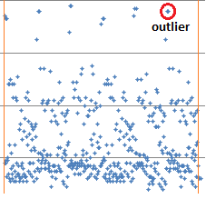
From Figure 7 we conclude that some results (i.e., the blue dots representing output values resulting from certain settings) are surprisingly poor compared to the overall performance of the respective heuristic. These ‘outliers’ (see example in Figure 8, which is a partial screenshot of Figure 7) have a significant influence on average performance and can thus make a heuristic look much worse than is realistic. From our tests we observed that this is typically because a certain selection measure has zero weight in those test runs. Apparently, for certain heuristics, certain selection measures are essential for reasonable performance. In this section, we identify such essential measures and filter out the test runs where the weight of those measures is zero. We consider a comparison without outliers to be more reliable.
Figure 8. This zoomed in version of Figure 7 illustrates what we consider an outlier.

In order to identify those essential parameters, we have compared how much the sample standard deviation reduces if any of the parameters is not allowed to take value zero (and thus is forced to be ‘used’). Table 5 shows the resulting sample standard deviations. Since some parameters are only relevant for certain heuristics, the table lists the effects on savings-based, sequential insertion based and parallel insertion based methods as separate categories. The value listed is equal to the sum of the sample standard deviations of total routes for all heuristics in that category – the result is not the sample standard deviation of the whole, this is just a means to aggregate the effects on the whole group. The table is not suitable for comparison between heuristics, only between parameter values.
Table 5. Comparison of standard deviations in the resulting total number of routes if certain weight parameters are not allowed to take value 0.

 | Sample standard deviation of total number of routes, per category
‘Forced’ parameter | SavHT, SavPlus | SeqIns | ParIns, CombReg, FewAlt | Sum
None (original) | 117.2 | 19.2 | 102.0 | 238.4
Push-forward (w_{pf}) | 117.8 | 19.4 | 101.9 | 239.1
Time gap (w_{tg}) | 94.9 | 19.2* | 102.0* | 216.1
New route (w_{nr}) | 27.3 | 19.2* | 102.0* | 148.5
Distance to depot (w_{dtd}) | 117.2* | 7.7 | 81.7 | 206.6
Time window width (w_{tww}) | 117.2* | 16.9 | 80.7 | 214.8
Load size (w_{l}) | 117.2* | 19.2 | 100.1 | 236.6
Number of alternatives (w_{na}) | 117.2* | 19.2 | 60.9 | 197.3
* In this cell, the combination of the parameter and heuristic is never used, so disabling has no impact here.

We see that savings-based heuristics benefit most from the parameter that penalizes creation of new extended routes (and thus favors sequential construction of routes). Removing the results where ‘w_{nr} = 0’, the sample standard deviation of the two savings-based heuristics reduces by 77%. SeqIns performs a lot more consistently when w_{dtd} ≠0: 60% reduction. The parallel heuristics benefit most if w_{na} ≠0, although disabling w_{dtd} or w_{tww} is also effective in reducing variance. Forcing a positive value for w_{na} reduces the sample standard deviation in the number of routes generated by parallel heuristics by 40%.

If we filter the results to those cases where w_{nr}, w_{dtd} and w_{na} only have non-zero values, the results plotted in Figure 9 remain. Approximately 1/2 of all combinations remain, which means that we filtered out a lot more than only the outliers. However, we have checked that the filter we applied did not remove any of the good results, which it did not: the runs that were filtered out did not produce results among the best 10% of their heuristic.
Figure 9. Visualization of the results without outliers. Again, every dot represents the total number of routes generated by a certain test combination. But now the most unsuccessful settings are filtered out, making the results more consistent for each heuristic, and better comparable.
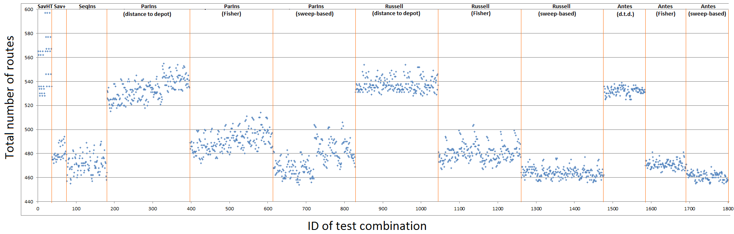

Table 6 presents the new standard deviations. The filtered standard deviations for the parallel heuristics differ a bit from those in Table 5 as we now deal with the combined effect of the w_{dtd} and w_{na} filters.
Table 6. Remaining standard deviation of number of routes after applying our filters:
w_{nr}, w_{dtd} and w_{na} only have non-negative values (i.e., 0.5 or 1).
 | SavHT, SavPlus | SeqIns | ParIns, CombReg, FewAlt | sum
original | 117.2 | 19.2 | 102.0 | 238.4
filtered | 27.3 | 7.7 | 55.2 | 90.2

Figure 9 convincingly shows that the (worst) outliers have been excluded from the results now (except for some of SavHT). The much more concentrated result clouds suggest that, as long as the three filtered parameters have a non-zero value, the heuristics all have a very consistent performance and they are not very sensitive to the other parameter values, nor to the specific value (0.5 or 1 in this case) of the filter parameters. This means that comparison of average values will be quite reliable. Still, some different patterns can be distinguished within each result cloud, indicating that there still is some sensitivity to the weights on the other measures.

4.3.4 Relative importance of the weight parameters

We will now try to point out, based on the filtered results, which parameters help most towards good solutions. Based on the filtered results, Table 7 compares the average number of routes (totalled over all Solomon problems) for each remaining parameter value and each of the main heuristics.

Table 7. Comparison based on number of routes, between different values of weight parameters, for each heuristic.

 | w_{ad} |  | w_{pf} |  |  | w_{tg} |  |  | w_{nr}
 | 0.5 | 1 | 0 | 0.5 | 1 | 0 | 0.5 | 1 | 0.5 | 1
SavHT | 543 | 565 | 554 | 554 | 554 | 572 | 548 | 540 | 562 | 545
SavPlus | 476 | 484 | 479 | 480 | 482 | 480 | 481 | 479 | 484 | 477
SeqIns | 471 | 472 | 469 | 471 | 473 | N/A | N/A | N/A | N/A | N/A
ParIns | 494 | 506 | 498 | 500 | 502 | N/A | N/A | N/A | N/A | N/A
CombReg | 495 | 493 | 493 | 494 | 495 | N/A | N/A | N/A | N/A | N/A
FewAlt | 488 | 488 | 488 | 488 | 488 | N/A | N/A | N/A | N/A | N/A

 | w_{dtd} |  | w_{tww} |  |  | w_{l} |  |  | w_{na}
 | 0.5 | 1 | 0 | 0.5 | 1 | 0 | 0.5 | 1 | 0.5 | 1
SeqIns | 474 | 468 | 478 | 466 | 469 | 470 | 470 | 473 | N/A | N/A
ParIns | 502 | 498 | 506 | 498 | 496 | 499 | 500 | 500 | 504 | 496
CombReg | 492 | 496 | 497 | 492 | 493 | 493 | 494 | 495 | 497 | 491
FewAlt | 488 | 488 | 491 | 487 | 487 | 488 | 488 | 488 | N/A | N/A

From the table we conclude that for SavHT, SavPlus and ParIns, results are better when added distance is given relatively less weight (0.5 instead of 1) than factors other than distance. Apparently, these heuristics perform better when factors other than distance are given more weight. The reason is probably that if time-related and regret-related measures receive too little weight, routes become less efficient with respect to time windows and difficult customers may remain non-routed until late in the construction process, creating the need for more routes. CombReg and FewAlt do not have this problem since they select customers based on regret measures.

The push-forward weight parameter (one of the key parameters in traditional VRPTW heuristics) does not seem to have a significant influence, yet results with higher w_{pf} are consistently a little better (or equally good). Apparently, when determining the exact insertion location, it is not by far as important to maintain the maximal amount of slack (by preventing push-forward) as it is to insert customers at the best location distance-wise provided that the existing slack allows it.

The parameter that penalizes the time gap between two routes only benefits SavHT, which makes sense since SavPlus is able to fill up time gaps with non-routed customers. A higher penalty for creating new routes benefits both savings-based heuristics.

When it comes to the regret-related parameters, only two of them have clear benefits. SeqIns performs a bit better when the distance to the depot becomes more important and both ParIns and CombReg benefit from a higher appreciation of having few alternative routes. Surprisingly, the exact values of w_{dtd} and w_{tww} do not seem to have a significant influence on the results, as long as they are non-zero.

The weight on order load can be ignored. This can probably be explained by the fact that most of the Solomon datasets involve a large number of relatively small orders (in terms of load). Capacity constraints are no decisive factor in such cases, and deciding which customer is next based on its order size is pointless. In some real-world cases involving few large packages, this may be different.

4.3.5 Statistics with limited nr of parameters

Heuristics with few parameters have several advantages over heuristics that have many. Results generated by easy-to-understand heuristics are easier to communicate, there is a smaller probability of faulty implementation, simplistic heuristics are easier to adapt to specific situations and fewer parameters require less experimentation with parameter values. In this section, we will find out how well the selected heuristics can perform if only a limited number of parameters is allowed to be non-zero, thus simplifying the search function(s) of those heuristics.

Since we have the results for all possible combinations of parameter values, we can simply filter the results based on the number of non-zero parameters (this number is now treated as a parameter itself). Table 8 below shows, for each heuristic, the best results when 0, 1, 2 or 3 parameters are allowed to be used. The weight on added distance is always non-zero, as this is the backbone of every heuristic, so we are actually talking about additional parameters next to w_{ad}. Each best result corresponds to one combination of parameter settings, which is different for each heuristic. For example, if only one parameter is allowed, SavHT produces its best result if you select w_{nr} (meaning that all other parameters values are 0), whereas other heuristics are best off aided by w_{dtd} or w_{na}. Table 8 also mentions the selected parameters in each case. For the parallel methods, we limit ourselves to the sweep-based seed selection method here, as this method proved superior in previous analysis.
Table 8. Best choice of parameters, and according best result (nr of routes), if a limited number of parameters is allowed. The table shows results for each heuristic.
# of parameters |  | 0 | 1 |  | 2 |  | 3
Heuristic | Seed selection | best | best | prm* | best* | prms* | best | prms*
SavHT | N/A | 737 | 562 | w_{nr} | 528 | w_{tg}, w_{nr} | 528 | w_{tg}, w_{nr}, w_{pf}
SavPlus | N/A | 612 | 475 | w_{nr} | 472 | w_{tg}, w_{nr} | 473 | w_{tg}, w_{nr}, w_{pf}
SeqIns | Distance to depot | 516 | 476 | w_{dtd} | 457 | w_{dtd}, w_{tww} | 455 | w_{dtd}, w_{tww}, w_{l}
ParIns | Sweep-based | 542 | 495 | w_{na} | 466 | w_{na}, w_{dtd} | 457 | w_{na}, w_{dtd}, w_{tww}
CombReg | Sweep-based | 529 | 478 | w_{na} | 459 | w_{na}, w_{dtd} | 460 | w_{na}, w_{dtd}, w_{tww}
FewAlt | Sweep-based | 471 | 459 | w_{dtd} | 455 | w_{dtd}, w_{tww} | 455 | w_{dtd}, w_{tww}, w_{l}

** wpf = push-forward, wtg = time gap, wnr = new route, wdtd = distance to depot, wtww = time window width, wl = load, wna = number of alternatives.

Figure 10 visualizes how the best possible solution for each heuristic framework changes as the number of allowed measures increases. From Table 8 and Figure 10 we can make some very interesting observations. First, the results with one (well-chosen) additional parameter improve significantly for all heuristics. FewAlt is already good without additional parameters, but this is because the w_{na} parameter is an intrinsic part of the FewAlt solution procedure and is not considered as a parameter here. It still means that FewAlt is already better without any tweaking than another heuristic with one parameter, and better than SavHT or SavPlus in any case. Still, SavPlus outperforms the remaining heuristics when only one parameter is allowed.
Figure 10. Relation between number of measures allowed and number of routes generated (i.e., solution quality).

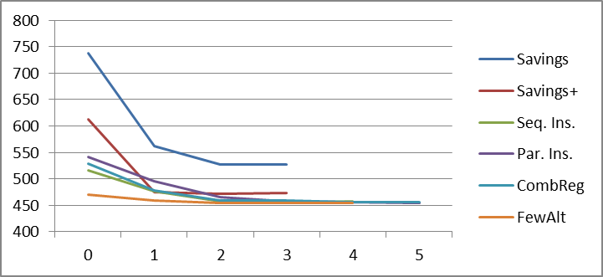

The second additional parameter provides a significant improvement for SavHT, SeqIns, ParIns and CombReg. FewAlt and SavPlus do not improve much further. The third parameter is only beneficial for ParIns. CombReg reaches its best score at four parameters but the difference with 2 parameters is negligible.

Examining the actual selected parameters, we conclude that these are different for the different heuristics. The savings-based heuristics benefit most from penalizing construction of a new route, ‘encouraging’ routes to expand until no longer possible. SavHT benefits further from penalizing time gaps, which again helps creating routes of more customers.

SeqIns and FewAlt perform especially well if the distance to depot is part of the search function. This is remarkable because if only w_{dtd} is applied, none of the time-related measures is considered in the process. The insertion procedure itself seems to be sufficient to eliminate waiting time and thus creating efficient routes. Still, SeqIns improves further if it takes the time window width into account. One instance of SeqIns (with settings w_{ad} =0.5, w_{dtd} =1, w_{tww} =0.5, 459 routes total) is especially robust: the number of routes never exceeds the best result we found by more than one route, on any of the 56 Solomon problems.

For ParIns and CombReg, the w_{na} parameter provides the largest improvement (it is also the most expensive). ParIns improves further with a high value of w_{dtd}. Once again, w_{pf} and w_{l} do not seem to contribute to better results anywhere. Explanations of this are given in section 4.3.4.

4.3.6 Statistics without recalculating of scores

In general, heuristics are significantly faster if all calculations of attributes, scores, etc. only have to be executed only once and do not constantly change in the process of creating routes. In that case, only feasibility needs to be checked before making a new move. Whether or not a heuristic has this feature depends on the solution process and on the parameters used. The FewAlt heuristic always needs to recalculate the number of alternative routes for every non-routed customer after each move. The same applies to the w_{na} parameter. w_{pf} and w_{tg} are dependent on the route configuration, which also changes after every move. The values of additional distance, minimum time gap, distance to depot and time window width need to be calculated only once (upon the ‘creation’ of a new possible move) and do not change after that.

Since speed is an important quality of good construction heuristics, we are interested in the test results if only those heuristics and parameters are allowed that do not need to recalculate search function values after each move. This excludes FewAlt, w_{na}, w_{pf} and w_{tg}. Table 9 shows the best results when applying this filter.
Table 9. Best choice of parameters, and according best result (nr of routes), if a limited number of parameters is allowed. The table shows results for each heuristic.
Heuristic | Seed selection | Original best score* | Filtered best score**
SavHT | N/A | 528 | 562
SavPlus | N/A | 472 | 475
SeqIns | Distance to depot | 455 | 455
ParIns | Sweep-based | 454 | 467
CombReg | Sweep-based | 456 | 467

*’score’ refers to the total number of routes over all Solomon problems
** filtered: average result over all runs that do not use the FewAlt heuristic or the wna, wpf and wtg measures

Interestingly, looking at the filtered best scores, SeqIns is now easily the best heuristic. Apparently, the best solutions created by SeqIns never needed w_{pf} (the other three filtered elements never apply to SeqIns anyway). ParIns and CombReg perform worse, apparently they are dependent on FewAlt and/or w_{na} for their best results. SavPlus is unaffected as well but still performs worse than other heuristics, and SavHT is handicapped without w_{tg} (further inspection showed that wpf does not have anything to do with the matter).

4.3.7 Statistics without regret measures

Since most heuristics do not include regret measures in literature, it may be interesting how much those measures contribute to the solution quality. Table 10 shows the results when none of the four regret measures (i.e., w_{dtd}, w_{tww}, w_{l} and w_{na}) is allowed. Although unaffected, the savings-based heuristics are also presented to facilitate a comparative analysis. CombReg and FewAlt are excluded from this analysis as their solution procedures fully rely on regret measures. For the insertion-based heuristics the new filter means that they only have the added distance and the push-forward in time as guidance to a good solution.
Table 10. Best results with and without regret measures.
Heuristic | Seed selection | Original best score | Best score without regret measures
SavHT | N/A | 528 | 528
SavPlus | N/A | 472 | 472
SeqIns | Distance to depot | 455 | 507
ParIns | Sweep-based | 454 | 537

From the table it is clear that regret measures are rather essential for the insertion-based heuristics to be effective. Their performance drops dramatically, promoting SavPlus to the best heuristic (according to total nr of routes) of this analysis.

4.3.8 Best 100

When regarding the best 100 results (i.e., the 100 combinations that resulted in the least number of routes), it might be interesting to see how many of these results were produced by which heuristic. It is possible that a heuristic performs well at only one or two specific combinations of parameter settings, making its expected performance on new problems a lot worse (as it may be tricky to find a good combination for the new problem). What we want is a heuristic that does not depend too heavily on the exact parameter settings for good solutions. We expect that a good indication of this can be found by looking at the 100 best results per problem class, trying to find out which heuristics contribute most to the best 100 results. Table 11 and Figure 11 provide the results of this analysis. Please be aware that – although insightful – this analysis is not completely unbiased, as some heuristics were run more often than others.
Table 11. Contribution of different heuristics to the top-100 results in several categories of problem instances. The number reported is the number of top-100 results generated by the heuristic in that category.

 |  | Overall | Degree of clustering |  |  | Scheduling horizon
Heuristic* | Seed selection |  | Clustered | Randomized | Semi-clustered | Short horizon | Long horizon
SeqIns | Distance to depot | 8 | 25 | 2 | 4 | 14
ParIns | VirSeeds |  |  |  |  |  | 5
ParIns | Sweep-based | 18 | 53 | 8 | 6 | 10 | 9
CombReg | VirSeeds |  |  | 8 |  |  | 8
CombReg | Sweep-based | 34 | 10 | 36 | 34 | 51 | 6
FewAlt | VirSeeds |  |  | 36 | 13 |  | 33
FewAlt | Sweep-based | 40 | 12 | 10 | 43 | 25 | 39

*SavHT, SavPlus and distance to depot seed selection for parallel heuristics are excluded as they never produced top-100 results
Figure 11. Representation of the various heuristics in the 100 best solutions: overall, and in certain problem classes.

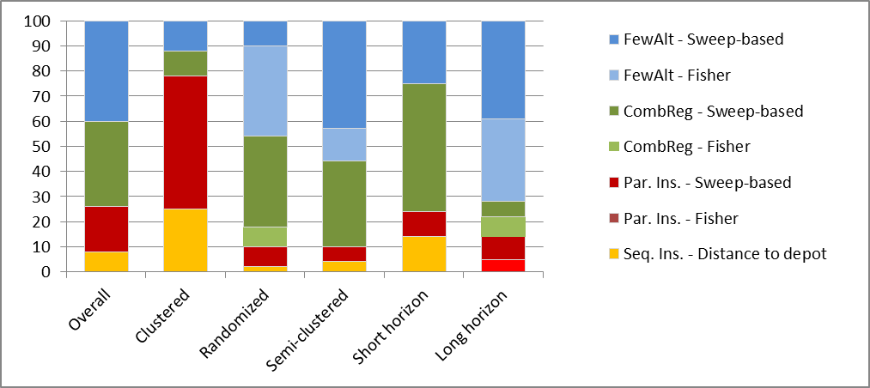

Our first conclusion from Table 11 is that FewAlt and CombReg are well represented in all categories, except for the clustered problems, where ParIns (the least regret-oriented of the three parallel heuristics) dominates, followed by SeqIns. Apparently, a regret-based approach to this type of problems is not always as fruitful as a more balanced approach (recall that ParIns only weighs regret values as part of the search function and does not select the next order purely based on regret measures).

In contrast, the randomized and semi-randomized problems are dominated by CombReg and FewAlt. Problems with a short scheduling horizon are most likely to be solved successfully by CombReg, whereas FewAlt convincingly dominates the long-horizon problems.

At this point we can conclude that regret-based heuristics are especially good for (semi-)randomized problems, whereas clustered problems are the domain of heuristics that combine distance, time and regret measures to one score. Our explanation for this phenomenon is that customers in clustered problems are less likely to be ignored during the solution procedure: it is ‘easier’ to combine clustered customers to one route without missing out on one or two of them, since there is less probability that you select a ‘wrong’ customer outside the cluster than when all customers are randomly distributed over the geographical area. Regret-based heuristics mainly try to avoid such cases of isolated customers, which is a bit unnecessary when customers are already clustered. The routing process of individual routes is handled more efficiently by distance-based heuristics, which might explain this difference.

The difference between CombReg and FewAlt in performance on short or long horizon problems makes sense as well: long horizon problems involve a small number of routes, and there is a significant difference in priority between customers that have 1 alternative and those that have 2. The strict selection by FewAlt on the number of alternatives is then very effective in keeping the number of routes low. On the other hand, short horizon problems involve many more routes to choose from. It does not really matter whether a customer has 7 or 8 routes to choose from – still, FewAlt will always select the one with 7 options in that case, even if the latter can be inserted much more efficiently. CombReg then provides a better trade-off by simply weighing the number of alternatives, as one contribution to the total search function. It might be a good idea to only apply the strict selection on number of alternatives only if customers have 2 options or fewer, thus making a hybrid CombReg-FewAlt heuristic, but this would be a topic for further research.

4.3.9 Best of 4

The computational results of the construction heuristics can be improved if the heuristic is run with four different parameter settings, saving the best result. This is also what – for instance – Solomon (1987) does in his computational experiments. For example, two parameters are allowed to take 2 values each. In this section, we try to find, for each heuristic, combinations of settings that together find the best solutions on each Solomon instance. We present in Table 13 the parameter combinations that should be varied to get a low total number of routes with each heuristic. The score mentioned is the sum of the best score out of the four runs on each problem instance. Example: we test four combinations of parameters for SeqIns, labelled 1 through 4. On C1 (the first Solomon problem instance), combination 1 has the best result. On C2, combination 2 has the best score. For the final score (listed in the table), we sum those best scores, not all scores generated by combination 1. This means that the score of combinations 2,3 and 4 on C1 are ignored.
Table 13. Results if 4 combinations (2x2) of parameter values are allowed to count as one ‘run’ (selecting the best result over the four runs for each problem). The main body of the table shows which settings are most effective, the most right column (‘score’) displays the resulting number of routes (i.e. best found on each problem).
Heuristic | Seed selection | w_{ad} | w_{pf} | w_{tg} | w_{nr} | w_{dtd} | w_{tww} | w_{l} | w_{na} | Score
SavHT | N/A | 0.5 or 1 | 0 | 1 | 0.5 or 1 | N/A | N/A | N/A | N/A | 522
SavPlus | N/A | 0.5 | 0 or 1 | 0 or 1 | 1 | N/A | N/A | N/A | N/A | 465
SeqIns | Distance to depot (standard) | 0.5 or 1 | 0 | N/A | N/A | 1 | 0.5 | 0 or 1 | N/A | 442
ParIns | Sweep-based | 0.5 | 0.5 or 1 | N/A | N/A | 0.5 or 1 | 0.5 | 0 | 1 | 447
CombReg | Sweep-based | 0.5 | 0.5 or 1 | N/A | N/A | 0.5 | 0.5 | 0 | 0.5 or 1 | 448
FewAlt | Sweep-based | 0.5 | 0 or 1 | N/A | N/A | 0 or 1 | 1 | 1 | N/A | 444

Again, we can make some interesting observations. Most importantly, the reported score of each heuristic is better than those mentioned in literature, but at the price of more parameters. However, the parameters used for SeqIns are all of the simple, computationally ‘cheap’ kind (since w_{pf} is 0). The result of 442 routes in total is significantly better than the 452 reported in literature. We thus definitely recommend using this set of settings whenever working with SeqIns, and we even recommend SeqIns as the heuristic of choice if it is allowed to do four sub-runs.

Another observation worth mentioning is that w_{dtd}, w_{tww} and w_{na} never take the value 0 in the optimal configurations (except w_{dtd} at FewAlt, which is already a consistent heuristic anyway). This corresponds to our findings in section 4.3.4. Furthermore, although we were not able to find a relation between w_{pf} values and performance during the previous analysis, w_{pf} does prove to be an influential parameter at this point, albeit not in a consistent way: sometimes a high weight on the push forward is better, sometimes lower, this seems unpredictable based on these data. Apparently, quite often it is beneficial to try two different runs while varying the w_{pf} value and selecting the best result, since the outcome is likely to differ. SeqIns appears to be less sensitive to parameter settings than its parallel alternatives. This we cannot explain.

If we are allowed to select any four combinations of all settings tested, we can achieve a score of 434 routes using a SeqIns, a ParIns, a VirSeeds-based FewAlt and a sweep-based FewAlt heuristic+parameter combination. For the exact settings, see Table 14. This is of course a lot less practical for actual application (it requires more implementation and makes it more complex), but it might be the best use of computational power.

Table 14. If for every Solomon instance the following four combinations are run, and the best selected, the total number of routes is only 434.
Heuristic | Seed selection | w_{ad} | w_{pf} | w_{dtd} | w_{tww} | w_{l} | w_{na}
SeqIns | Distance to depot | 1 | 0 | 1 | 0.5 | 0 | N/A
ParIns | Sweep-based | 0.5 | 0.5 | 1 | 1 | 0.5 | 1
FewAlt | VirSeeds | 0.5 | 1 | 1 | 0.5 | 0 | N/A
FewAlt | Sweep-based | 0.5 | 1 | 0.5 | 0.5 | 1 | N/A

4.3.10 Distance

Although minimization of the total number of routes is our primary objective, the total generated distance is quite interesting as well and might be the primary objective in some practical cases. Figure 12 visualizes the total distance achieved by each of the (filtered) test combinations. Table 15 displays the approximate range of the total distance of all routes generated by the selected heuristics.
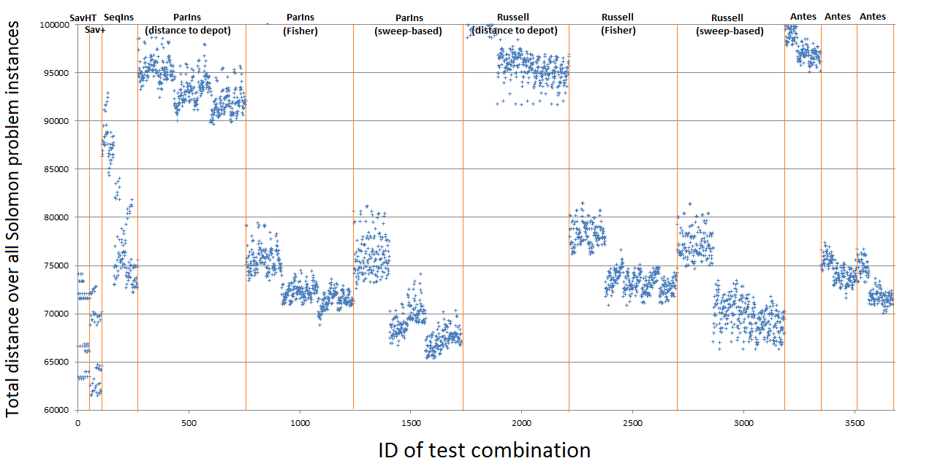
Figure 12. Visualization of realized distances. Every dot represents the total distance over all routes generated using one of the 3672 combinations of heuristic frameworks, seed selection methods and values of weight parameters.

Heuristic | Total distance range | Total distance range filtered w_{dtd} =1
SavHT, SavPlus | 60,000 - 75,000 | 60,000 - 75,000
SeqIns | 70,000 - 90,000 | 70,000 - 80,000
ParIns, CombReg (VirSeeds or sweep-based) | 65,000 - 80,000 | 65,000 - 75,000
FewAlt (VirSeeds or sweep-based) | 70,000 - 75,000 | 70,000 - 75,000
ParIns, CombReg and FewAlt with ssm=dtd | 90,000 - 105,000 | 90,000 - 100,000
Table 15. Approximate performance of heuristics on the total distance performance indicator.
The data points in Figure 12 show a clear pattern within a certain heuristic/seed selection column. The first 1/3 part of the results within one ‘result column’ shows significantly higher distances, and the last 1/3 shows the lowest (i.e. best) distances. Our analysis shows that this pattern correlates with the value of w_{dtd}. A higher weight on the ‘distance to depot’ regret measure apparently benefits total distance. Figure 13 shows that if w_{dtd} is set to 1 (its highest test value), the total distance generated does not differ much within certain heuristics.
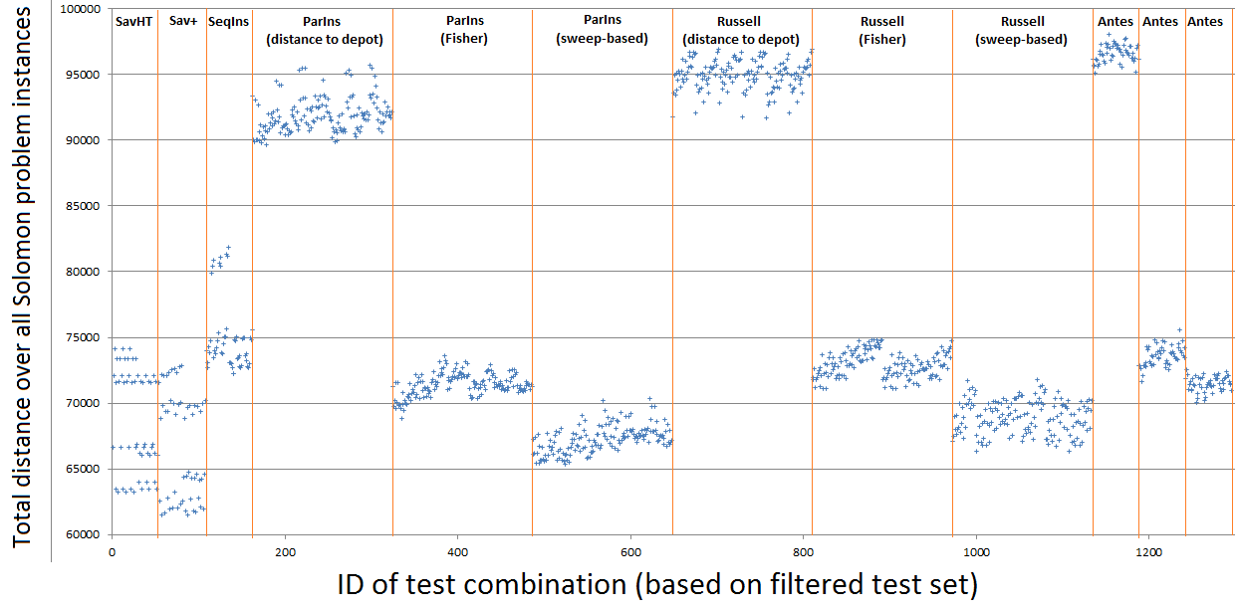
Figure 13. Visualization of distances, filtered on w_{dtd} = 1 to improve average performance.
Clearly, the savings-based heuristics can perform best on the distance criterion, but only with the right settings. Sweep-based heuristics do not perform too badly either, although FewAlt is not as good as ParIns and CombReg. This can be expected from the focus of FewAlt on avoiding new routes.

Apparently, SavHT and FewAlt both provide a different trade-off between number of routes and total distance. We wonder whether this trade-off also has to be made when it comes to selection measures (within certain heuristic frameworks). To find out whether the correlation always holds, we have plotted distance against the number of routes (see Appendix D). From the plots we can conclude that for SavHT, SavPlus and CombReg the trade-off holds, whereas the overall trend for SeqIns and ParIns is that those combinations that perform best on total number of routes also perform best on total distance. FewAlt shows no correlation at all.

The implications of this are quite interesting: those heuristics that show a positive correlation perform better on both measures at certain settings, making those settings better in any case. The heuristics that show a negative correlation offer the possibility to make sacrifices at one criterion, benefitting the other. This can be useful when the relative importance of distance versus number of routes varies.

4.4 Conclusion

Based on this first experiment we will now make a number of conclusive statements. First of all, according to our lexicographic performance measure, FewAlt with sweep-based seed selection provides the best solution quality on average and is best represented in the top-100 results. It also has the best worst-case performance and performs well regardless of parameter settings, which means that less time needs to be spent on parameter tuning when using this heuristic. The main disadvantages of FewAlt are that the number of alternative routes needs to be recalculated after every move (this becomes more of a problem as problem size increases) and, since it is a parallel method, execution needs to be repeated until the right number of seeds has been found. FewAltFewAlt also performs relatively bad on clustered problems.

Out of the other heuristics, in general, those that are most similar to sweep-based FewAlt perform best. ‘Sweep-based’ is the dominant seed selection method in all cases. Both parallel insertion and CombReg perform best when the number of alternative routes per customer is included in the total score, but still worse than FewAlt, where it is the dominant selection measure.

However, there is a viable alternative to FewAlt. Although more dependent on the right parameter settings, SeqIns is capable of generating very good solutions and has some interesting advantages over FewAlt. First, it is faster: not only is a single run sufficient in any case (whereas FewAlt needs to be repeated until the right number of seeds has been found), it also requires significantly fewer computational operations during the solution process (whereas FewAlt needs to re-assess the number of alternative routes after each move) and it considers a smaller number of customer-route combinations. Second, it performs very well when only a limited number of parameters is allowed: 2 parameters (w_{dtd} and w_{tww}) are sufficient for very good results and only need to be calculated once for each customer during initialization. Although FewAlt also performs well with few parameters, SeqIns does the trick with significantly less computation requirements. Third, SeqIns is also more simplistic than FewAlt: only one route is built at a time, and two straightforward functions determine which customer is inserted at which place.

Other remarkable observations include the good performance of ParIns on clustered problems, of CombReg on short-horizon problems and of FewAlt on long-horizon problems. Furthermore, the ‘w_{pf}’ parameter has an unpredictable effect: sometimes low values are better and sometimes high values, so it is a good parameter to vary when one run includes multiple parameter settings but redundant if it needs to be fixed at one value.

When comparing total distance, we see that savings-based heuristics perform best on this performance criterion, followed by sweep-based ParIns and CombReg. So, if distance is considered to be important (relative to total number of routes), one of the latter two heuristics is probably the most balanced approach, although they generally need a lot of tuning. If distance is the dominant output measure, SavPlus is best.

Altogether, based on this experiment we would generally recommend FewAlt if a reliable solution is needed within a relatively short time. On the other hand, if one needs starting solutions for metaheuristics, SeqIns is the best choice to generate good solutions very quickly. Two regret measures should then be taken into account for good results: distance to depot and time window width.

5 Computational experiment II: fixed settings, large problems

5.1 Introduction

In the first computational experiment, described in the previous sections, we have explored a wide range of combinations of heuristic frameworks, seed selection methods and selection measures. From these experiments we have learned which heuristics perform best with respect to number of routes and total distance, on the relatively small-scale Solomon datasets.

In the upcoming sections we will do a second series of computational experiments (‘second experiment), introducing larger problem instances, but using fixed settings for the different heuristic frameworks, based on what settings were successful in the first series of experiments. Our first goal in this second series of experiments is to reconsider the relation between problem characteristics and heuristics performance, based on fixed settings and large problems. The second goal is to investigate the issue of scalability: how well do these heuristics perform on problems with significantly more customers? To answer this question, we include not only Solomon problems, but also the Homberger & Gehring datasets in our experimental setup, which are essentially problems with the same characteristics as the Solomon problems, but with more customers (Homberger & Gehring, 2005).

5.2 General approach

In this second experiment we will analyse the performance of our chosen heuristics on a varied set of 54 problems: 18 unique problem characteristic combinations, each with 100, 400 and 1000 customers. We chose the combination in a structured way to make sure results are comparable between categories. Table 16 shows the names and characteristics of the chosen problem datasets. The problems with 100 customers are from the Solomon datasets (Solomon, 1987), the problems with 400 and 1000 customers are from the Homberger & Gehring datasets (Homberger & Gehring, 2005).

In this second experiment, for practical reasons, we only allow fast versions of the heuristics. More specifically, we only consider those heuristics and selection measures where the score of each move only needs to be calculated once. This excludes the SavPlus heuristic, as well as the ‘push-forward’, ‘new route’ and ‘number of alternatives’ selection measures. We do, however, include FewAlt, knowing that it will probably have long run times.

The limitation to fast settings leaves the ‘added distance’, ‘minimum time gap’, ‘distance to depot’, ‘time window width’ and ‘demand size’ measures, all of which have proven useful in our previous analysis. We used fixed settings for all problems, based on the first experiment. We do, however, vary the weights on ‘added distance’ and ‘distance to depot’, which need to increase as the problem size increases. The main reason is that customers on a route are not necessarily further apart in the larger problems of the benchmark datasets than in smaller problems, whereas the scaling factor (=max distance to depot) increases. Weight-related measures thus receive too little weight in comparison with time-related measures. We need to compensate for this by increasing the weight factor. Table 17 shows the settings we chose for the execution of each heuristic.
Table 16. Characteristics of the 54 problem instances chosen for this experiment.
Problem names  (100 cust., 400 cust., 1000 cust.) | Clustering | Horizon | Avg. TW Width | TW presence
C101, C1_4_1, C1_10_1 | Clustered | Short | Tight | All
C104, C1_4_4, C1_10_4 | Clustered | Short | Tight | Some
C108, C1_4_8, C1_10_8 | Clustered | Short | Loose | All
C201, C2_4_1, C2_10_1 | Clustered | Long | Tight | All
c204, C2_4_4, C2_10_4 | Clustered | Long | Tight | Some
C206, C2_4_6, C2_10_6 | Clustered | Long | Loose | All
R101, R1_4_1, R1_10_1 | Randomized | Short | Tight | All
R104, R1_4_4, R1_10_4 | Randomized | Short | Tight | Some
R110, R1_4_10, R1_10_10 | Randomized | Short | Loose | All
R201, R2_4_1, R2_10_1 | Randomized | Long | Tight | All
R204, R2_4_4, R2_10_4 | Randomized | Long | Tight | Some
R209, R2_4_9, R2_10_9 | Randomized | Long | Loose | All
RC101, RC1_4_1, RC1_10_1 | Semi-clustered | Short | Tight | All
RC104, RC1_4_4, RC1_10_4 | Semi-clustered | Short | Tight | Some
RC107, RC1_4_7, RC1_10_7 | Semi-clustered | Short | Loose | All
RC201, RC2_4_1, RC2_10_1 | Semi-clustered | Long | Tight | All
RC204, RC2_4_4, RC2_10_4 | Semi-clustered | Long | Tight | Some
RC207, RC2_4_7, RC2_10_7 | Semi-clustered | Long | Loose | All
Table 17. Parameter settings for each heuristic in the second experiment.
Heuristics | Problem size | Parameter settings (unspecified means 0)
SavHT |  | w_{ad} = 1, w_{tg} = 1
SeqIns, ParIns, CombReg, FewAlt | 100 customers | w_{ad} = 1, w_{dtd} = 1, w_{tww} = 1, w_{l} = 1
SeqIns, ParIns, CombReg, FewAlt | 400 customers | w_{ad} = 4, w_{dtd} = 2 w_{tww} = 1, w_{l} = 1
SeqIns, ParIns, CombReg, FewAlt | 1000 customers | w_{ad} = 8, w_{dtd} = 4, w_{tww} = 1, w_{l} = 1

In this experiment, the initial number of seeds for parallel methods is set to the number of routes produced by SeqIns. If the parallel heuristic then succeeds to create a solution without adding more routes, we repeat the process with one seed less, until the number of seeds is no longer sufficient. The best solution is stored (not necessarily the last solution created). If the parallel heuristic needed more seed routes, we simply store the solution and continue to the next run. In this case we only run the parallel heuristic once.

From the results we hope to learn which heuristics are most scalable with respect to solution quality and computation time. We also hope to see relations between heuristic performance and problem characteristics more clearly.

5.3 Analysis of results

In this section we present the results from our second series of experiments, which differs from the first series of experiments in the fact that we do not vary parameter settings but test fixed settings on large scale problems. We will compare heuristics based on number of routes created, total distance, and computation time. Although the computation times can probably be reduced much further, we expect that the implementation efficiency is comparable for the five heuristics tested, especially since we do not have to update moves during the run, only on creation. When comparing computation times, we are mainly interested how these increase with increasing problem size for the different heuristics. In order to compare on problem characteristics, we will also present tables with the results if the results are filtered on a certain problem characteristics.

Throughout the entire section, the tables we present do not contain the original numerical values for the realized number of routes, distance and computation time. Instead, for each problem instance we calculated the relative deviation (in %) from the best solution found by the five heuristics. The tables present the average deviation over all problem instances. The reason is that performance on large problems would contribute too heavily to the average values if we report unedited/unstandardized results. With regard to formatting: red cells indicate bad results, green cells mean that the solution was closest (on average) to the best solutions found. Yellow means the heuristic has a moderate performance on that criterion. This facilitates quick comparison of heuristics on a certain performance indicator. As a last note, in this chapter, we refer to the ‘number of routes’ performance indicator as ‘nroutes’.

5.3.1 Aggregate statistics

Table 18 presents the average results for the five heuristics over the 54 problems tested. From the table we learn that SeqIns was very close to the best found solutions on most problem instances: the average deviation from the best result found per problem instance is only 3% for SavHT. In contrast, SavHT performs very bad on this criterion: it creates 66% more routes on average (!). Of course, SavHT was designed to minimize distance, not number of routes, but 66% more routes makes the heuristic almost useless on big problems in practice. However, we will later see that this bad performance is not consistent over all problem types.
Table 18. Comparison of aggregate results
Heuristic | Nroutes | Distance | Runtime
SavHT | 66 | 3 | 192
SeqIns | 3 | 18 | 24
ParIns | 9 | 15 | 185
CombReg | 7 | 12 | 75
FewAlt | 7 | 33 | 341

When looking at distance, SavHT is the absolute winner, which is consistent with our findings in the first experiment. FewAlt performs worst, given the selected measures and weights. The other three heuristics are about 10% worse than SavHT on average.

In this experiment we also look at computation time, and we see that SeqIns and CombReg are most efficient for large problems. We will find out more details on this later. Overall, from the aggregate results we can already conclude that SeqIns performs best on number of routes and time, mediocre on total distance and thus best overall. If distance is really important, SavHT is probably the best choice, but the number of routes realized is extremely high in comparison to the other heuristics.

5.3.2 Comparison on problem size

In this and subsequent subsections, we will identify distinct relations between the performance of heuristics and problem characteristics. We will not repeat everywhere that SavHT is good on distance and SeqIns is good on number of routes and computation time, but rather identify where the results differ from the aggregate results.

The first comparison we make is based on problem size. Table 19 contains results for runs on the problems with 100, 400 and 1000 customers. As described in the introduction of this chapter, the values in the table show the average deviation from the best result found per problem instance. They do not show absolute values, as this would make it more difficult to compare between different problem sizes.
Table 19. Comparison of results based on problem size.
The numbers 100, 400 and 1000 refer to the number of customers.
 | Nroutes |  |  | Distance |  |  | Runtime
Heuristic | 100 | 400 | 1000 | 100 | 400 | 1000 | 100 | 400 | 1000
SavHT | 76 | 63 | 59 | 5 | 1 | 4 | 16 | 143 | 423
SeqIns | 3 | 2 | 4 | 21 | 18 | 14 | 29 | 54 | 39
ParIns | 9 | 11 | 8 | 10 | 18 | 16 | 46 | 173 | 337
CombReg | 5 | 6 | 9 | 11 | 12 | 11 | 28 | 64 | 132
FewAlt | 5 | 6 | 9 | 16 | 35 | 48 | 62 | 239 | 721

The most interesting observation here is about the relative computation times: SavHT is the fastest heuristic for small-scale problems, but almost the slowest for large problems. SeqIns and CombReg perform much better as the problem size increases: as Table 20 shows, the runtime increases less than quadratically with the problem size, whereas this relation is more than quadratic for the other heuristics. This is a result of the number of moves that needs to be evaluated, which is high in case of SavHT, ParIns and FewAlt, and the need to update the scores during execution, which further increases the computational needs of the FewAlt heuristic.

Of course, the ‘approximate orders’ listed in Table 20 are not the same as the theoretical complexity but rather an indication based on observations. The difference between order 1.7 and 2.2 is actually quite big: it means that if the problem size increases from 100 to 1000 customers, the runtime increases by a factor 150 in case of SavHT and FewAlt, but only by a factor 50 in case of SeqIns and CombReg. And as we will see later, this relation is also influenced by the problem characteristics.
Table 20. Evaluation of the increase of runtime (in seconds) compared to problem size. An approximate order of 2.2 means that if the number of customers increases by a factor x, the runtime increased by (approx.) a factor x^{2.2}.
Heuristic | 100 | 400 | 1000 | Approximate order
SavHT | 0.15 | 2.15 | 21.09 | 2.2
SeqIns | 0.17 | 1.68 | 7.69 | 1.7
ParIns | 0.19 | 2.94 | 22.86 | 2.1
CombReg | 0.16 | 1.45 | 9.23 | 1.7
FewAlt | 0.21 | 3.45 | 36.57 | 2.2

5.3.3 Comparison on degree of clustering

The next comparison is on the degree of clustering. Table 21 shows the relative performance of the five heuristics on heuristics with different degrees of clustering.
Table 21. Comparison of results based on degree of clustering.
C = clustered, R = randomized, RC = semi-clustered.
 | Nroutes |  |  | Distance |  |  | Runtime
Heuristic | C | R | RC | C | R | RC | C | R | RC
SavHT | 33 | 103 | 62 | 6 | 2 | 1 | 192 | 197 | 193
SeqIns | 2 | 4 | 3 | 9 | 24 | 21 | 24 | 55 | 42
ParIns | 6 | 11 | 11 | 12 | 20 | 13 | 170 | 209 | 176
CombReg | 6 | 6 | 8 | 12 | 13 | 10 | 77 | 77 | 70
FewAlt | 17 | 1 | 2 | 48 | 28 | 25 | 363 | 349 | 310

The first notable result here is that although FewAlt needs relatively many routes on clustered problems, it the average deviation from the best solutions on (semi-) randomized problems is only 1 or 2 percent on average, indicating that FewAlt usually finds the (near) best solution. SeqIns performs well on all three problems. SavHT is bad with respect to number of routes on all clustering types, albeit better on clustered than on (semi-)randomized problems. For distances, the story is mainly the same as for the overall scores, although SeqIns performs significantly better on this respect on clustered than other problems. The degree of clustering does not seem to affect runtimes.

5.3.4 Comparison on scheduling horizon

Next, we compare on scheduling horizon. Recall that the scheduling horizon refers to the time window width at the depot and, in effect, to the average number of customers on routes. A longer horizon means that longer routes can be constructed, and less routes are needed to solve the problem. Table 22 shows the comparison.
This is white on purpose
Table 22. Comparison of results based on scheduling horizon (short or long).
 | Nroutes |  | Distance |  | Runtime
Heuristic | Short | Long | Short | Long | Short | Long
SavHT | 12 | 120 | 1 | 6 | 199 | 188
SeqIns | 0 | 6 | 9 | 26 | 4 | 77
ParIns | 6 | 12 | 13 | 17 | 180 | 190
CombReg | 6 | 7 | 13 | 10 | 106 | 43
FewAlt | 7 | 6 | 32 | 34 | 454 | 227

Again, some interesting observations can be made. First, the number of routes realized by SavHT is not that bad for short horizons, especially if you consider the great score on distance. However, on long horizons SavHT performs dramatically when looking at the number of routes. SeqIns never fails to find the lowest number of routes on short horizons, but is equally as good as FewAlt on long scheduling horizons. In terms of total distance, SeqIns again performs quite good on short horizons but worse on long horizons. When looking at runtimes, we see that SavHT dominates on short horizons, whereas CombReg is usually the fastest heuristic on long horizons.

5.3.5 Comparison on time window characteristics

The final comparison we make for this experiment is about time window characteristics: in the selected problems we vary both the average time window width and the relative presence of time windows (i.e. the fraction of customers for which a time window is specified that is significantly tighter than the time window of the depot). A problem is that in our test datasets the combination of loose time windows and few time windows does not occur: there are twice as many problems with tight time windows in our set of problem instances. This means that we have a correlation between the results on tight/loose time windows and the results on many/few time windows. We have taken this into account by only making fair comparisons: the results for tight and loose time windows (seeTable 23) only take the results for ‘many’ time windows into account: the results for the problems with few loose time windows are left out of this analysis.
 | Nroutes |  | Distance |  | Runtime
Heuristic | Tight | Loose | Tight | Loose | Tight | Loose
SavHT | 67 | 67 | 4 | 1 | 305 | 206
SeqIns | 3 | 5 | 18 | 19 | 0 | 3
ParIns | 11 | 14 | 15 | 18 | 137 | 138
CombReg | 12 | 8 | 15 | 12 | 139 | 77
FewAlt | 10 | 8 | 27 | 44 | 421 | 278
Table 23. Comparison of results based on average time window width (tight or loose).

Similarly, Table 24 shows the result for few (25%) vs many (100%) time windows, but only for those problems where the time windows are loose. The problems with a high density of tight time windows are left out of this analysis.

Table 24. Comparison of results based on the fraction of customers that have a time window that is significantly tighter than the time window at the depot (100% or 25%).
 | Nroutes |  | Distance |  | Runtime
Heuristic | 100% | 25% | 100% | 25% | 100% | 25%
SavHT | 67 | 63 | 4 | 6 | 305 | 71
SeqIns | 3 | 1 | 18 | 16 | 0 | 118
ParIns | 11 | 3 | 15 | 10 | 137 | 279
CombReg | 12 | 1 | 15 | 7 | 139 | 7
FewAlt | 10 | 2 | 27 | 29 | 421 | 324

From the first table we cannot distinguish any notable correlation between the time window width and the performance of heuristics. This story is completely different for the time window density: in problems where all customers have a time window (even if these windows are relatively loose), SeqIns does not only provide solutions of high quality, it also does this in a very efficient way because it can quickly eliminate many moves that would otherwise have to be evaluated when selecting the best move. In contrast, CombReg is particularly efficient for problems with few time windows. Inspection of the absolute runtimes tells us that the absolute runtimes for CombReg remain almost constant, but the runtimes of SeqIns increase drastically as a lot more moves need to be considered during a large part of the construction process. Table 25 illustrates this relation. We can explain this by looking at the pseudocode of both heuristics. Sequential insertion creates a pool of possible moves that is extended and, most importantly, reduced during route construction. If many time windows are present, less moves will be feasible, reducing the number of moves for which the total score needs to be calculated and compared. CombReg first selects a customer and then creates a temporal pool of possible moves, selects the best move, checks feasibility, and if feasible makes the move. After insertion, the pool is emptied again. A less constrained problem actually reduces the time until a feasible move is found (because more moves are feasible) and makes the heuristic slightly faster. As a generalized result, the fastest heuristic on problems with many time windows is SeqIns, whereas the fastest heuristic on problems with few time windows is CombReg.
Table 25. Comparison of the runtimes of SeqIns and Russel on two problems that differ only in the fraction of customers that has time windows.
Problem | Runtime SeqIns | Runtime CombReg | Approx. ratio
R2_10_1 (100% TW) | 2.61 s | 6.97 s | 1 : 2.7
R2_10_4 (25% TW) | 27.73 s | 6.79 s | 4.1 : 1

5.4 Conclusion

In this second experiment we have compared five construction heuristics on problem datasets of 100, 400 and 1000 customers. Our analysis was focused on two questions: which heuristics perform best under what conditions, and how scalable are the heuristics?

When looking at the total number of routes realized, we see that SeqIns performed best over the whole experiment. This finding needs some nuance: SeqIns is especially good (with respect to the number of routes) on problems that are clustered, have a short time horizon and/or a high time window density. On (semi-) randomized problems, FewAlt performs slightly better. Problems with a long time horizon are solved equally good by CombReg and FewAlt, and CombReg dominates on problems with a low time window density. SavHT only provides reasonable numbers of routes if the problem is clustered and involves a short scheduling horizon. In other cases, the number of routes needed, on average, by SavHT is over 60% higher than solutions found by the insertion-based heuristics.

SavHT is unbeatable when it comes to total distance, but at the price of requiring many more routes. SeqIns compares well on clustered problems, but has to sacrifice its distance score for its score on the number of routes for (semi-) clustered problems. Similarly, CombReg is almost as good as SavHT in problems with long scheduling horizons or a low density of time windows, without paying the price of needing more routes.

Finally, we also find quite some variation in the performance of the five heuristics when looking at computation times. SeqIns is the fastest on most problem types, although on problems with few customers SavHT is faster and problems with long horizons or few time windows the heuristic are typically solved fastest by CombReg.

Considering all, we see that all heuristics, except for ParIns, (which is dominated on all performance criteria by its sequential counterpart in virtually all situations) are best on certain performance criteria in certain situations. The heuristic of choice for practical application thus depends strongly on the situation on hand. However, when looking for a heuristic that never disappoints and also is best in most combinations of problem characteristics, SeqIns seems the safest choice. The only exception to this advice is when problems have very few (or very loose) time windows: surprisingly enough, the regret-focused CombReg heuristic is the best choice to minimize number of routes, distance and runtime in this less constrained case. Choose the savings heuristic only if the following two conditions are satisfied:
- The number of customers is around 100 or smaller or runtime is not very important. If this is the case, based on the first series of experiments we recommend using SavPlus instead of SavHT, as SavPlus is still fast enough on that scale.
- The total distance is very important or the problem has a short scheduling horizon and the customers are strongly clustered together.

6 Conclusion

In this thesis we explored the world of construction heuristics for the Vehicle Routing Problem with Time Windows. Construction heuristics are used to (quickly) create an initial solution to such problems, for example by combining direct routes until this is no longer possible (savings-based), or by iteratively adding customers to seed routes until all customers are on a route (insertion-based). Solutions created by such heuristics can be further improved upon using improvement heuristics or metaheuristics, or they can simply be used without further improvement. We have limited ourselves to construction heuristics and did not dig further into improvement procedures.

We have attempted to find out which construction heuristics perform best overall and in more specific situations. We have experimented with a varied array of heuristic frameworks: savings-based and insertion-based, sequential and parallel, cost-based and regret-based., We created a large number of composite heuristics by combining the heuristics frameworks with different seed selection methods and with different measures used for the selection of moves. We performed a wide range of experiments on a comprehensive set of problem datasets, varying in number of customers, degree of clustering, scheduling horizon, time window width and time window density.

We believe that our findings are best summarized by giving a concise overview of the key features, strengths and weaknesses of the heuristics that we have investigated. Table 26 presents this overview and adds some recommendations for usage of the heuristics: when to use it (if at all) and which settings are essential?
Table 26. Final conclusions and recommendations on the heuristics that we have tested
Heuristic | Key features | Main advantages | Main disadvantages | Recommendations for use
Savings | Create direct routes to all customers, combine them based on highest savings in distance until no longer possible | Excellent in minimizing distance (see section 4.3.10)  Easy heuristic to comprehend and communicate | Poor w.r.t. number of routes  Difficult to incorporate additional constraints such as time windows  Not very scalable | Recommended only if total distance is much more important than computation time and number of routes, or on small-scale, clustered problems with a short horizon.  If used, at least use the ‘time gap’ selection measure to prevent too much waiting time in the solutions.  Next to that, penalizing the creation of new extended route, thus favouring sequential construction of routes, helps in route reduction.  The SavPlus variant (which allows more types of moves) is suitable for small-scale problems. It provides better solution but is not a pure savings heuristic: has elements of insertion
Cost-based Sequential Insertion | Create one seed route, insert customers with best combined score on insertion cost and regret until no longer possible, then repeat the process | Fast, also on bigger problems,  Only one run needed  Best performance if only fast settings are allowed (2nd experiment) | Relatively* poor results on the distance criterion  Not the best heuristic if few time windows are present | Recommended for overall use. Especially good on problems that are clustered, have a short time horizon and high time window density. Use the (regret-type) ‘distance to depot’ and ‘time window width’ selection measures
Cost-based Parallel Insertion (sweep-based seed selection) | Create multiple seed routes, insert customers based on combined score on insertion cost and regret | Better than regret-based parallel insertion on clustered problems | Outperformed by CombReg and FewAlt on R and RC,  Needs quite some tuning,  Needs multiple runs | Not recommended in any case
CombReg  (sweep-based seed selection) | Create multiple seed routes, select customer with highest regret/urgency, insert at place with lowest cost, etc. | Most scalable heuristic because it does not need to evaluate all moves at once | Needs multiple runs | Recommended in problems with few time windows  Good for long horizons  Good for (semi-) randomized  At least include the ‘distance to depot’ selection measure, preferably more regret measures
FewAlt  (sweep-based seed selection) | Create multiple seed routes, select customer with fewest route alternatives, insert at place with lowest combined score, etc. | Does not need much tuning | Relatively*slow, especially on bigger problems  Needs multiple runs  Relatively* poor results on the distance criterion | Only recommended for minimization of the number of routes on (semi-) randomized problems. Still, SeqIns is almost as good, gives better total distance and is much faster.  At least include the ‘distance to depot’ selection measure
* ‘relative’ refers to the other heuristics that we have tested.
It is good to emphasize here that, out of the methods that we tested to select seed customers for the parallel methods, sweep-based selection of seed customers dominates the other methods we tested and should be preferred over those in virtually any case.

When comparing with other literature on construction heuristics, first we observe that our findings are largely in accordance with other scientific literature. For the Solomon problems, the total number of generated routes is comparable, similar selection measures have proven useful and we can confirm that insertion-based methods perform a lot better than savings-based methods when time windows are present, except for specific situations.

This gives us confidence that the main findings of our research are reliable and that they enrich the existing literature on construction heuristics. In general, the main contribution of this thesis is the exploration of a large number of combinations of heuristics, leading to adapted versions of existing heuristics, with more suitable selection mechanisms, that perform better without needing additional computation time. It also provides a thorough, detailed overview and comparison of six important construction heuristics and enhances one’s understanding of good and bad choices for such heuristics.

Finally, it provides a comparison of the performance (in terms of solution quality and runtime) of different heuristics in problems with specific characteristics and provides recommendations for practical use.

7 Recommendations for further research

A very interesting topic for further research would be to experimentally assess the usefulness of the construction heuristics (especially variants of sequential insertion) for creating an initial solution for execution of certain metaheuristics (such as the Random Destruction Random Construction heuristic that Quintiq uses). The best set of initial solutions is not necessarily characterized by the least total number of routes or lowest distance: other measures, such as minimal overlap between solutions, may be more important for use within a metaheuristic framework.

Metaheuristics typically require multiple different starting solutions: the research proposed above can be expanded by finding out how to create a varied pool of starting solutions based on one of the heuristics we described in this thesis. However, large parts of the resulting route configurations may well show little variation between different starting solutions created by the same heuristic. More variation increases the chance of finding successful sequences of customers on routes. Our final recommendation for further research is thus to experiment with stochastic approaches (e.g., randomly selecting either the best, second-best or third-best option as the next move) and so bringing more variety in the starting solutions.

Literature

Antes, J. and Derigs, U. 1995, ‘A New Parallel Tour Construction Algorithm for the Vehicle Routing Problem with Time Windows’, working paper, Department of Economics and Computer Science, University of Köln, Germany.
Bräysy, 0. 2003, ‘Fast Local Searches for the Vehicle Routing Problem with Time Windows’, INFOR, Vol. 40, No. 4, pp. 319-330.
Bräysy, O. 2005a, ‘Vehicle Routing Problem with Time Windows, Part I: Route Construction and Local Search Algorithms’,Transportation Science, Vol. 39, No. 1, pp. 104-118.
Bräysy, O. 2005b, ‘Vehicle Routing Problem with Time Windows, Part II: Metaheuristics’,Transportation Science, Vol. 39, No.1 , pp. 119-139.
Clarke, G. and Wright, J. 1964, ‘Scheduling of Vehicles from a Central Depot to a Number of Delivery Points’, Operations Research, Vol. 12, No. 4, pp. 568-581.
Fisher, M. and Jaikumar, R. 1981, ‘A Generalized Assignment Heuristic for Vehicle Routing’, Networks, Vol. 11, pp. 109-124.
Garey, M. and Johnson, S., 1979, ‘Computer Intractability: A Guide to the Theory of NP-Completeness’, Freeman, San Francisco.
Gillett, B. and Miller, L. 1974, ‘A Heuristic Algorithm for the Vehicle-Dispatch Problem’, Operations Research, Vol. 22, No. 2, pp. 340-349.
Homberger, J. and Gehring, H. 2005, ‘A two-phase hybrid metaheuristic for the vehicle routing problem with time windows’, European Journal of Operational Research, Vol. 162, pp. 220-238.
Ioannou, G., Kritikos, M. and Prastacos, G. 2001, ‘A Greedy Look-Ahead Heuristic for the Vehicle Routing Problem with Time Windows’, The Journal of the Operational Research Society, Vol. 52, No. 5, pp. 523-537.
Ioannou, G., Kritikos, M. and Prastacos, G. 2003, ‘A problem generator-solver heuristic for vehicle routing with soft time windows’, Omega, Vol. 31, pp. 41-53.
Lin, S. 1965, ‘Computer solutions of the traveling salesman problem’, Bell Systems Journal, Vol. 44, pp. 2245-2269.
Potvin, J. and Rousseau, J. 1993, ‘A parallel route building algorithm for the vehicle routing and scheduling problem with time windows’, European Journal of Operational Research, Vol. 66, pp. 331-340.
Rand, G. 2009, ‘The life and times of the Savings Method for Vehicle Routing Problems’, Orion, Vol. 25, No. 2, pp. 125-145.
Russell, R. 1995, ‘Hybrid Heuristics for the Vehicle Routing Problem with Time Windows’, Transportation Science, Vol. 29, No. 2, pp. 156-166.
Solomon, M. 1987, ‘Algorithms for the Vehicle Routing and Scheduling Problems with Time Window Constraints’, Operations Research, Vol. 35, No. 2, pp. 254-265.

APPENDICES

Appendix A. Pseudocodes of selected heuristic frameworks

In this section, we present the pseudocodes (presented as flow diagrams) for the heuristics tested in our series of experiments.

Figure 14. Pseudocode for savings-based heuristics (SavHT and SavPlus). The main differences between the two variants are the move types that are allowed, and the exact calculation of added distance (see Chapter 4).

Create direct route to every customer
M = list of possible merges of routes. Calculate savings scores for every merge in M
m = move in M with highest savings score
Check feasibility of m.
m feasible?
Execute merge m
Update savings scores where needed**
Remove m from M. |M| > 0?
Stop
Remove merges from M that are no longer allowed*
No
No
Yes
No

* In case of SavHT, let’s say M merges route a and b to become route ab. Then all merges a-x or x-b are no longer allowed (x is any other route). In case of SavPlus, these moves are still allowed: route x can be placed in between subroute a and b in the new route.
** Because of the merge, visits may have been moved forward in time, so time-related attributes of merges involving such visits may need to be updated. In addition, in SavPlus, saved distances may change after executing a merge M, for merges with the same insertion point as M.
Figure 15. Pseudocode for cost-based insertion heuristics (SeqIns and ParIns).
Yes
Yes
Yes
No
No
No
s₁…s_{k} = k seed customers, selected based on seed selection method
S = set of seed routes to seed customers s_{i} (from/to depot)
U = set of unrouted customers
M = list of all possible insertion moves of customers in U into seed routes in S
Calculate/update costs and regret for all moves in M
m = move in M with lowest insertion cost*. u = the customer that m inserts
Check feasibility of m.
m feasible?
Execute move m. Remove u from U
Remove alternative moves in M that insert u or that use the same insertion place
Add moves to M from customers in U into the newly created insertion places (i.e. directly before and after u)
Remove m from M. |M| > 0?

|U| > 0?

Stop

Select s₁ from U based on highest distance from depot
SeqIns
ParIns

* Lowest insertion cost: regret counts as a ‘discount’ on the cost here, i.e. ‘cost’ = cost - regret
Figure 16. Pseudocode for the CombReg heuristic

s₁…s_{k} = k seed customers, selected based on seed selection method
S = set of seed routes to seed customers s_{i} (from/to depot)
U = set of unrouted customers
M = list of all possible insertion moves of customer u into seed routes in S
Calculate/update insertion costs for all moves in M
m = move in M with lowest insertion cost.
Check feasibility of m.
m feasible?
Execute move m. Remove u from U
Empty M
Remove m from M. |M| > 0?

s = new seed route to u. Add s to S

Stop

u = customer with highest regret score
|U| > 0?

No
Yes
Yes
Yes
No

Figure 17. Pseudocode for the FewAlt heuristic
s₁…s_{k} = k seed customers, selected based on seed selection method
S = set of seed routes to seed customers s_{i} (from/to depot)
U = set of unrouted customers
M = list of all possible insertion moves of customers in U into seed routes in S
Calculate/update costs and regret for all moves in M
C = set of customers with fewest seed routes to ‘choose’ from, based on M
Remove moves in M that insert u or that use the same insertion place as m
Add moves to M from customers in U into the newly created insertion places (i.e. directly before and after u)
|U| > 0?

Stop

Check feasibility of all moves in M. Remove infeasible moves from M
N = subset of M, only moves with customers that are in C. |N| > 0?
m = move from N with lowest insertion cost*. Execute m. Remove u from U
S = new seed route to the customer u in C with highest combined regret.
Add s to S. Remove u from U.
Yes
No
No
Yes

* Lowest insertion cost: regret counts as a ‘discount’ on the cost here, i.e. ‘cost’ = cost - regret

Appendix B: Detailed characteristics of the Solomon benchmark datasets

Figure 20 (a-d) shows the customer locations in the different Solomon problem classes. Table 27 shows further characteristics of the problem instances.

Figure 18. Customer locations in the Solomon problems.

a. Class C1
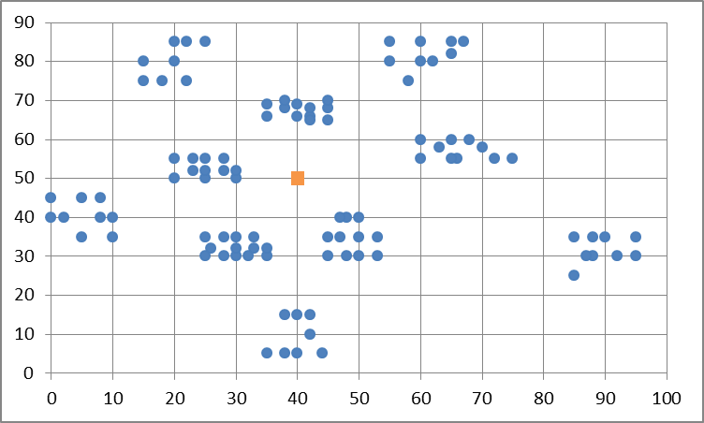

b. Class C2
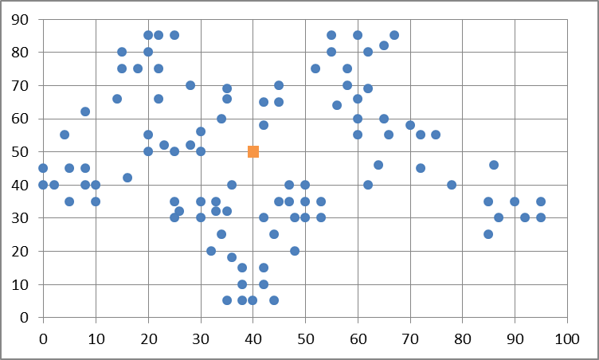

c. Classes R1/R2
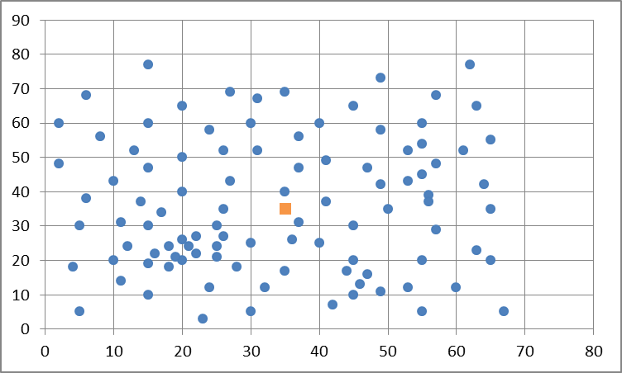

d. Classes RC1/RC2
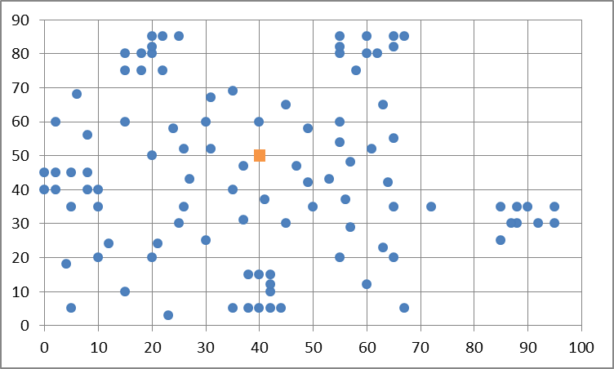
Table 27. Further characteristics of the Solomon benchmark dataset instances

Legend:
Clustering: C = clustered, R = randomized, RC = semi-clustered
Horizon: S = short horizon, L = long horizon
TW %: Percentage of customers that have time windows (i.e. significantly tighter windows than the depot has)
TW Width: Indication of the average width of time windows, relative to total time horizon in the problem (i.e. time window of the depot). Very tight: <5%. Tight: 5-15%. Loose: 15-35%. Very loose: >35%.
TW Std.: Standard deviation of time window width, relative to average time window width. This indicates variance in time window width. None: 0%. Small: 0-5%. Medium: 5-10%. Large: >10%.
Name | Cl. | Hor. | TW % | TW Width | TW Std. |  | Name | Cl. | Hor. | TW % | TW Width | TW Std.
C101 | C | S | 100 | very tight | none |  | R201 | R | L | 100 | tight | small
C102 | C | S | 75 | very tight | small |  | R202 | R | L | 75 | tight | small
C103 | C | S | 50 | very tight | small |  | R203 | R | L | 50 | tight | small
C104 | C | S | 25 | very tight | small |  | R204 | R | L | 25 | tight | small
C105 | C | S | 100 | tight | small |  | R205 | R | L | 100 | loose | none
C106 | C | S | 100 | tight | medium |  | R206 | R | L | 75 | loose | none
C107 | C | S | 100 | tight | none |  | R207 | R | L | 50 | loose | none
C108 | C | S | 100 | loose | small |  | R208 | R | L | 25 | loose | none
C109 | C | S | 100 | loose | none |  | R209 | R | L | 100 | loose | large
C201 | C | L | 100 | very tight | none |  | R210 | R | L | 100 | loose | large
C202 | C | L | 75 | very tight | none |  | R211 | R | L | 100 | very loose | medium
C203 | C | L | 50 | very tight | none |  | RC101 | RC | S | 100 | tight | none
C204 | C | L | 25 | very tight | none |  | RC102 | RC | S | 75 | tight | none
C205 | C | L | 100 | tight | none |  | RC103 | RC | S | 50 | tight | none
C206 | C | L | 100 | tight | small |  | RC104 | RC | S | 25 | tight | none
C207 | C | L | 100 | loose | medium |  | RC105 | RC | S | 100 | loose | large
C208 | C | L | 100 | loose | none |  | RC106 | RC | S | 100 | loose | none
R101 | R | S | 100 | very tight | none |  | RC107 | RC | S | 100 | very loose | large
R102 | R | S | 75 | very tight | none |  | RC108 | RC | S | 100 | very loose | large
R103 | R | S | 50 | very tight | none |  | RC201 | RC | L | 100 | tight | none
R104 | R | S | 25 | very tight | none |  | RC202 | RC | L | 75 | tight | none
R105 | R | S | 100 | tight | none |  | RC203 | RC | L | 50 | tight | none
R106 | R | S | 75 | tight | none |  | RC204 | RC | L | 25 | tight | none
R107 | R | S | 50 | tight | none |  | RC205 | RC | L | 100 | loose | large
R108 | R | S | 25 | tight | none |  | RC206 | RC | L | 100 | loose | none
R109 | R | S | 100 | loose | small |  | RC207 | RC | L | 100 | loose | large
R110 | R | S | 100 | very loose | medium |  | RC208 | RC | L | 100 | very loose | medium
R111 | R | S | 100 | loose | medium
R112 | R | S | 100 | very loose | small

Appendix C: Results per problem class

This appendix provides extensive results of the analysis performed in section 4.3.3. For better readability, we present the results as the relative (positive) deviation from the best known values. The main text includes the original values.
Table 27. Results compared on degree of clustering
 |  | Overall |  | Clustered |  | Randomized |  | Semi-clustered
Heuristic | Seed selection | Avg. | Best | Avg. | Best | Avg. | Best | Avg. | Best
Overall |  | 25% | 19% | 14% | 9% | 26% | 19% | 35% | 26%
SavHT | N/A | 46% | 30% | 21% | 16% | 55% | 35% | 59% | 37%
SavPlus | N/A | 27% | 17% | 10% | 6% | 34% | 19% | 36% | 21%
SeqIns | Distance to depot | 19% | 12% | 10% | 2% | 21% | 14% | 25% | 17%
ParIns | Distance to depot | 34% | 27% | 22% | 18% | 32% | 24% | 48% | 38%
ParIns | VirSeeds | 24% | 17% | 15% | 9% | 25% | 18% | 30% | 21%
ParIns | Sweep-based | 20% | 12% | 7% | 1% | 26% | 14% | 25% | 15%
CombReg | Distance to depot | 35% | 30% | 23% | 18% | 28% | 21% | 56% | 49%
CombReg | VirSeeds | 21% | 15% | 16% | 8% | 21% | 15% | 25% | 19%
CombReg | Sweep-based | 17% | 13% | 7% | 2% | 19% | 14% | 22% | 16%
FewAlt | Distance to depot | 31% | 30% | 23% | 20% | 23% | 21% | 52% | 46%
FewAlt | VirSeeds | 17% | 15% | 13% | 9% | 16% | 14% | 20% | 16%
FewAlt | Sweep-based | 14% | 12% | 5% | 1% | 17% | 15% | 19% | 14%
Table 28. Qualitative rescaling of the results, compared on degree of clustering. ++ means better performance than average, i.e. less routes.
 |  | Overall |  | Clustered |  | Randomized |  | Semi-clustered
Heuristic | Seed selection | Avg. | Best | Avg. | Best | Avg. | Best | Avg. | Best
Overall |  | 25% | 19% | 14% | 9% | 26% | 19% | 35% | 26%
SavHT | N/A | -- | -- | - | - | -- | -- | -- | --
SavPlus | N/A | +- | +- | + | + | - | +- | +- | +
SeqIns | Distance to depot | + | ++ | + | ++ | + | + | + | ++
ParIns | Distance to depot | - | - | -- | -- | - | - | - | -
ParIns | VirSeeds | +- | +- | +- | +- | +- | +- | + | +
ParIns | Sweep-based | + | ++ | ++ | ++ | +- | + | + | ++
CombReg | Distance to depot | - | -- | -- | -- | +- | +- | -- | --
CombReg | VirSeeds | + | + | +- | +- | + | + | + | +
CombReg | Sweep-based | ++ | ++ | ++ | ++ | + | ++ | ++ | ++
FewAlt | Distance to depot | - | -- | - | -- | +- | +- | -- | --
FewAlt | VirSeeds | ++ | + | +- | +- | ++ | ++ | ++ | ++
FewAlt | Sweep-based | ++ | ++ | ++ | ++ | ++ | ++ | ++ | ++

Table 29. Results compared on degree of scheduling horizon
 |  | Short horizon |  | Long horizon
Heuristic | Seed selection | Avg. | Best | Avg. | Best
Overall |  | 23% | 18% | 35% | 20%
SavHT | N/A | 29% | 21% | 118% | 69%
SavPlus | N/A | 19% | 14% | 59% | 25%
SeqIns | Distance to depot | 18% | 11% | 25% | 15%
ParIns | Distance to depot | 34% | 28% | 34% | 23%
ParIns | VirSeeds | 23% | 17% | 26% | 13%
ParIns | Sweep-based | 19% | 12% | 26% | 11%
CombReg | Distance to depot | 36% | 32% | 29% | 20%
CombReg | VirSeeds | 21% | 15% | 21% | 13%
CombReg | Sweep-based | 15% | 11% | 23% | 13%
FewAlt | Distance to depot | 33% | 31% | 25% | 18%
FewAlt | VirSeeds | 16% | 15% | 16% | 10%
FewAlt | Sweep-based | 14% | 12% | 16% | 10%

Table 30. Qualitative rescaling of the results, compared on scheduling horizon. ++ means better performance than average, i.e. less routes.

 |  | Short horizon |  | Long horizon
Heuristic | Seed selection | Avg. | Best | Avg. | Best
Overall |  | 23% | 18% | 35% | 20%
SavHT | N/A | - | - | --- | ---
SavPlus | N/A | + | + | -- | -
SeqIns | Distance to depot | + | ++ | +- | +
ParIns | Distance to depot | -- | -- | - | -
ParIns | VirSeeds | +- | +- | +- | +
ParIns | Sweep-based | + | ++ | +- | ++
CombReg | Distance to depot | -- | -- | +- | +-
CombReg | VirSeeds | +- | + | + | +
CombReg | Sweep-based | ++ | ++ | + | +
FewAlt | Distance to depot | -- | -- | +- | +-
FewAlt | VirSeeds | ++ | + | ++ | ++
FewAlt | Sweep-based | ++ | ++ | ++ | ++

Table 31. Results compared on problem class (combination of clustering and horizon).

 |  | C1 |  | C2 |  | R1 |  | R2 |  | RC1 |  | RC2
Heuristic | Seed selection | Avg. | Best | Avg. | Best | Avg. | Best | Avg. | Best | Avg. | Best | Avg. | Best
Overall |  | 12% | 7% | 25% | 12% | 23% | 17% | 42% | 21% | 34% | 26% | 37% | 18%
SavHT | N/A | 12% | 8% | 58% | 46% | 35% | 27% | 150% | 73% | 37% | 25% | 138% | 81%
SavPlus | N/A | 7% | 3% | 25% | 17% | 24% | 17% | 80% | 27% | 26% | 18% | 69% | 27%
SeqIns | Distance to depot | 8% | 0% | 21% | 0% | 20% | 12% | 27% | 17% | 25% | 15% | 27% | 15%
ParIns | Distance to depot | 19% | 14% | 33% | 29% | 31% | 24% | 37% | 20% | 52% | 42% | 35% | 19%
ParIns | VirSeeds | 16% | 8% | 17% | 0% | 23% | 17% | 33% | 17% | 29% | 22% | 27% | 12%
ParIns | Sweep-based | 4% | 0% | 17% | 4% | 24% | 14% | 33% | 13% | 26% | 17% | 27% | 8%
CombReg | Distance to depot | 21% | 16% | 33% | 21% | 28% | 22% | 30% | 17% | 64% | 55% | 27% | 12%
CombReg | VirSeeds | 14% | 8% | 21% | 4% | 20% | 14% | 27% | 17% | 26% | 17% | 19% | 8%
CombReg | Sweep-based | 3% | 0% | 21% | 4% | 18% | 13% | 23% | 17% | 23% | 16% | 19% | 8%
FewAlt | Distance to depot | 21% | 18% | 29% | 21% | 23% | 21% | 23% | 17% | 61% | 55% | 19% | 12%
FewAlt | VirSeeds | 12% | 10% | 13% | 0% | 15% | 13% | 20% | 13% | 22% | 17% | 15% | 8%
FewAlt | Sweep-based | 2% | 0% | 13% | 0% | 17% | 14% | 20% | 10% | 20% | 15% | 15% | 8%

Table 30. Qualitative rescaling of the results, compared on class (combination of clustering and horizon). ++ means better performance than average, i.e. less routes.

 |  | C1 |  | C2 |  | R1 |  | R2 |  | RC1 |  | RC2
Heuristic | Seed selection | Avg. | Best | Avg. | Best | Avg. | Best | Avg. | Best | Avg. | Best | Avg. | Best
Overall |  | 12% | 7% | 25% | 12% | 23% | 17% | 42% | 21% | 34% | 26% | 37% | 18%
SavHT | N/A | +- | +- | -- | -- | -- | -- | -- | -- | +- | +- | -- | --
SavPlus | N/A | + | + | +- | - | +- | +- | -- | - | + | ++ | -- | -
SeqIns | Distance to depot | + | ++ | +- | + | +- | ++ | + | + | + | ++ | + | +
ParIns | Distance to depot | - | -- | - | -- | - | -- | +- | +- | -- | -- | +- | +-
ParIns | VirSeeds | +- | +- | + | ++ | +- | +- | + | + | + | + | + | +
ParIns | Sweep-based | ++ | ++ | + | + | +- | + | + | ++ | + | ++ | + | ++
CombReg | Distance to depot | -- | -- | - | - | - | - | + | + | -- | -- | + | +
CombReg | VirSeeds | +- | +- | +- | + | +- | + | + | + | + | ++ | ++ | ++
CombReg | Sweep-based | ++ | ++ | +- | + | + | ++ | ++ | + | ++ | ++ | ++ | ++
FewAlt | Distance to depot | -- | -- | - | - | +- | - | ++ | + | -- | -- | ++ | +
FewAlt | VirSeeds | +- | +- | ++ | ++ | ++ | ++ | ++ | ++ | ++ | ++ | ++ | ++
FewAlt | Sweep-based | ++ | ++ | ++ | ++ | + | + | ++ | ++ | ++ | ++ | ++ | ++

Appendix D: correlation between number of routes and total distance

The plots in Figure 18 show the correlation between the number of routes and total distance, realized by the different heuristics. Each blue point represents the summed result of one of the 3672 test combinations in the first series of experiments.

Figure 19. Correlation between total number of routes (horizontal axis) and total distance (vertical axis)
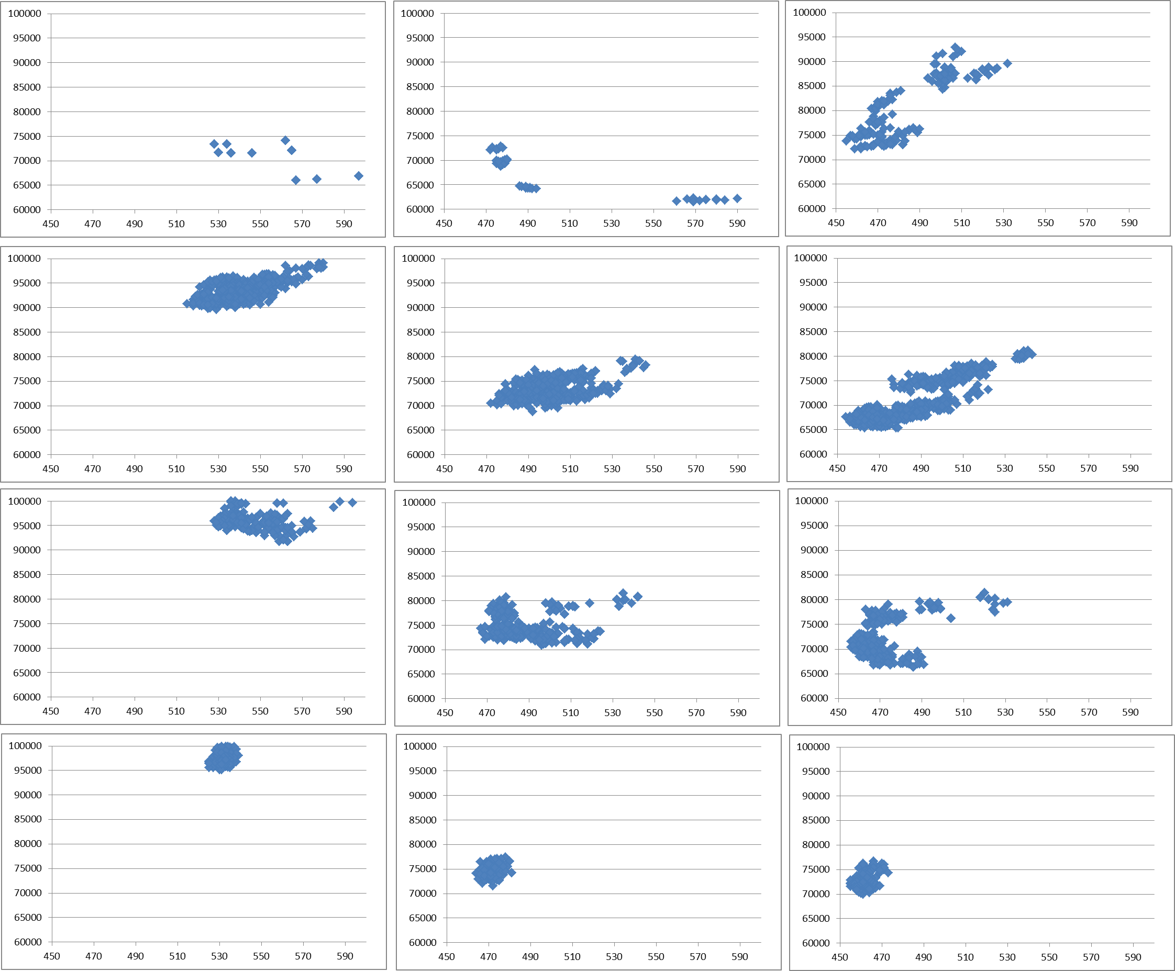
a. SavHT b. SavPlus c. SeqIns
d. ParIns (farthest distance) e. ParIns (VirSeeds) f. ParIns (sweep-based)

g. CombReg (farthest distance) h. CombReg (VirSeeds) i. CombReg (sweep-based)

j. FewAlt (farthest distance) k. FewAlt (VirSeeds) l. FewAlt (sweep-based)

