

-- Master thesis --
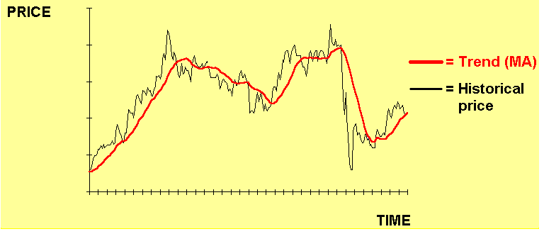




Rajan Ramautar 298893
Faculteit der Economische Wetenschappen
Erasmus Universiteit Rotterdam
Supervisor: Dr. M.P.E. Martens
Date: 8th March 2012

Abstract

Abstract is als een superkorte samenvatting van de conclusie. Wel even heel kort idee achter AMH uitleggen. Is nl eerste wat lezer leest. Dus dat moet begrijpelijk zijn in jip en janneke taal zodat de lezer meteen weet waar je scriptie over gaat (en de interesse is gewekt :-)).

Acknowledgements

The assignment of this thesis would have been an internship for Robeco. At the moment that I started with the assignment, it was made clear that there was no room for interns at Robeco, but there would be always the possibility to present the outcomes of the thesis at Robeco. I sincerely hope that the results in this thesis will be used at Robeco to answer the question if the trend is still our friend in the currency, bond, commodity and equity market.

I specially would like to thank Martin Martens, who supervised the process of this thesis. His feedback and ongoing support for this work kept me on track, by reviewing on mail and face to face sessions, for researching and writing this thesis in the right direction.

Many trend-following studies have been done in the currency market but less in other markets, so I sincerely hope that I helped other researchers with this thesis to further examine other markets for trend strategies.

Inhoudsopgave

Geef titel van hoofdstuk op (niveau 1) 1
Geef titel van hoofdstuk op (niveau 2) 2
Geef titel van hoofdstuk op (niveau 3) 3
Geef titel van hoofdstuk op (niveau 1) 4
Geef titel van hoofdstuk op (niveau 2) 5
Geef titel van hoofdstuk op (niveau 3) 6

1 Introduction

In this paper the central theme is ‘trend’, also indicated as momentum. In the past there have been successful strategies, which created huge profits, by using trend strategies.
Trend strategy is a form of technical analysis. Technical analysis comprises various techniques to study price movements, frequently occurrent in the forex market. The forex market usually trends strongly, that is why currency traders often use trend-trading strategies. Trend lines can be plotted on charts to determine price trends. It is beneficial to look at a broad time frame to determine which way the market is trending. Trading in the direction of the trend is critical for successful trading in any market. A trend is simply the predominant move in one direction. Therefore a trend can either be an up trend or a down trend.

Figure 1.1 Trend examples
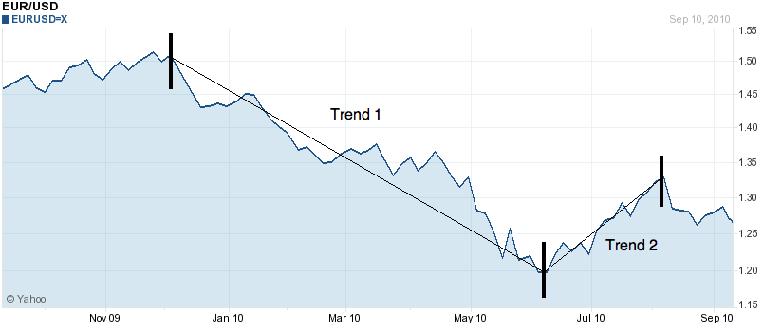
Once a market is identified to be in a trending phase, the trend strategy assumes that the performance will continue. What results in buying in an up trending market and selling in a down trending market.

Figure 1.2 Buying in an uptrending market

In this thesis I ask the question: Are these trend strategies still working well? Is trend still your friend? Because once these strategies became public, they may have stopped working. Simply because too many investors are using it, and the market becomes more efficient as a result. It is possible that only with complex strategies the advantage still is in favour of the active investor.

First the hypothesis of this thesis will be described. This is the adaptive market hypothesis (AMH) introduced by Lo (2004). And in the conclusion the AMH will be confirmed or rejected, according to the results of this study. In this hypothesis it is expected that the returns from a strategy will disappear after the profitability of the strategy is made public.

Secondly the literature will be described with some interesting papers about this subject. Particular we will look here at the performance before and after the announcement of the successfull strategy.
- Neely, Weller and Ulrich (2006) in “The adaptive markets hypothesis: Evidence from the foreign exchange market” look at the foreign exchange market.
Neely’s evidence supports the conclusion that the returns originally documented in a number of papers were genuine and not due to data mining. But these profit opportunities had disappeared by the early 1990s for moving average rules. So their findings are consistent with a view of markets as adaptive systems subject to evolutionary selection pressures. They also show that the excess returns declined over time for less-studied rules, but at a much slower speed than would be consistent with efficient markets. Allthough AMH will be affective after a slower speed than expected.
- Jegadeesh and Titman (2001) looked at the equity momentum strategy 10 years after they published it. Jegadeesh and Titman conclude that momentum still works so AMH is rejected. While it is now 10 years after the Jegadeesh and Titman (2001) study, it will be tested in this thesis, how good the profitability is nowadays for the equity momentum strategy. Do they still make profits? Or has there been a decline in returns at a much slower speed than would be expected by Jeegadeesh and Titman?

Thereafter, the data used for the empirical research will be discussed. This study will cover four markets. The foreign exchange market will be researched where we look at different exchange rates. Also the government bond market will be investigated for US, UK, Japan and Europe. The commodity market is studied using commodity futures and the equity market, which has been analysed by Jeegadeesh and Titman (2001) with a succesfull momentum strategy, will be analysed between 2001 en 2011.

Effectively AMH has been tested for the foreign exchange market and equity momentum. We will first try to confirm some of the conclusions with regard of AMH by Neely et al. (2006) and Jegadeesh and Titman (2001) for the foreign exchange market. This will also provide insight into whether we follow the right simple approach in the empirical research. Next we will expand this research into government bond markets and commodities, something that has not been done before.

In the bond and commodity market the expectation is that the AMH also holds. This paper will investigate the trend in these asset classes, with empirical research as a basis. Finally the results will be discussed being followed by a conclusion.

1.1 The adaptive market hypothesis

Before discussing the adaptive market hypothesis, the efficient market hypothesis (EMH) will be adressed. This hypothesis tells that assets always trade at their fair value in the market, making it impossible for investors to either purchase undervalued assets or sell assets for inflated prices. As such, it should be impossible to outperform the overall market through expert asset selection or market timing, and that the only way an investor can possibly obtain higher returns is by purchasing riskier investments.
So in its purest form, the EMH renders active portfolio management useless, calling into the question the very motivation for portfolio research.
A classical Efficient Market Hypothesis joke is widely told among economists, it is about an economist, who is strolling down the street with a companion, they come upon a $100 bill lying on the ground. As his companion reaches down to pick it up, the economist says: Do not bother, if it were a genuine $100 bill someone would already have picked it up.

The economist is actually telling that in an idealized world of frictionless markets and costless trading, prices must always fully reflect all available information. Therefore no profits can be garnered from information-based trading because such profits must have already been captured, as the $100 bill on the ground.
The current version of the EMH can be summarized compactly by the three P’s of total investment management: Prices, probabilities and preferences (Lo, 1999). The three P’s have their origins in one of the most basic and central ideas of modern economics: the principle of supply and demand. The price of any commodity and quantity traded are determined by the intersection of supply and demand curves.
In an informationally efficient market, prices must be unforecastable if they are properly anticipated. And if they fully incorporate the information and expectations of all market participants. Roberts (1967) and Fama (1970) operationalized this hypothesis, which is summarized in Fama’s well-known piece “Prices fully reflect all available information”, by placing structure on various information sets available to market participants.

But the adaptive market hypothesis (AMH) introduced by Lo (2004) modifies the EMH. This is the main hypothesis in this research. It asserts that the forces that drive prices to their efficient levels are weaker and operate over longer time horizons. In this article this new framework is proposed that reconciles market efficiency with behavioural alternatives by applying the principles of evolution, competition, adaption and natural selection to financial interactions.

The AMH paradigm views markets as ecological systems in which different groups compete for scarce resources. Specifically, the Adaptive Markets Hypothesis can be viewed as a new version of the EMH. AMH is based on an evolutionary approach to economic interactions. Evolutionary concepts have also appeared in a number of financial contexts. For example in a series of papers, Luo (1995, 1998, 2001, 2003) explores the implications of natural selection for futures markets and Hirschleifer and Luo (2001) consider the long-run prospects of overconfident traders in a competitive securities market. The dynamics of evolution determine the efficiency of markets and the waxing and waning of financial institutions, investment products and ultimately, institutional and individual fortunes. Prices reflect as much information as represented by the combination of environmental conditions and the number and nature of "species" in the economy or, to use a more appropriate biological term, the ecology. By species, I mean distinct groups of market participants, each behaving in a common manner. For example, pension funds may be considered one species; retail investors another; market makers a third; and hedge fund managers a fourth. If multiple species are competing for rather scarce resources within a single market, that market is likely to be highly efficient, for example the market for 10-year U.S. Treasury notes, where most relevant information is incorporated into prices within minutes. If, on the other hand, a small number of species are competing for rather abundant resources in a given market, that market will be less efficient, for example the market for oil paintings from the Italian Renaissance. Market efficiency cannot be evaluated in a vacuum, but is highly context dependent and dynamic, just as insect populations advance and decline as a function of the seasons, the number of predators and prey they face, and their abilities to adapt to an ever changing environment.

Under the AMH the traditional models of modern financial economics can coexist alongside behavioural models. Much of what behavioralists cite as counterexamples to economic rationality – loss aversion, overconfidence, overreaction and other behavioural biases – are, in fact, consistent with an evolutionary model of individuals adapting to a changing environment using simple heuristics. Emotion is also from an evolutionary perspective a powerful adaption that dramatically improves the efficiency with which animals learn from their environment and their past. We can fully reconcile the EMH with all of its behavioural alternatives, leading to a new synthesis: the AMH. Therefore, under the AMH, investment strategies undergo cycles of profitability and loss in response to changing business conditions, the number of competitors entering and exiting the industry, and the type and magnitude of profit opportunities available.

The AMH provides a way of resolving a paradox as well as a framework within which one can make sense of the empirical results of a paper. (Lo 2004) He also finds the following conclusions:
- Positive excess return opportunities have persisted for considerable periods and are not the result of data-mining;
- Investment strategies which generate periods of excess returns eventually fall into disuse as competitive pressures erode profits.

Both conclusions indicate that markets can (temporarily) deviate substantially from the EMH. More complex strategies appear to survive longer than simple strategies. The AMH is far from being a unified theory capable of generating sharp predictions. It provides some guidance on possible causal factors that may explain our results but without further argument is unsatisfactory on its own.

Despite the qualitative nature of this new paradigm, the Adaptive Markets Hypothesis offers a number of surprisingly concrete implications for the practice of portfolio management. The new paradigm of the AMH is still under development and certainly requires a great deal more research to render it “operationally meaningful” in Samuelson’s sense.

Implications addressed by Lo are as follows:
- To the extent that a relation between risk and reward exists, it is unlikely to be stable
over time;
- In contrary to the classical EMH, arbitrage opportunities do exist from time to time in the AMH;
- Investment strategies will also wax and wane, performing well in certain environments and performing poorly in other environments;
- Innovation is the key to survival. The AMH implies that the risk/reward relation varies
through time, and that a better way of achieving a consistent level of expected returns is to adapt to changing market conditions;
- Clear implication for all financial market participants: survival is the only objective that
matters. While profit maximization, utility maximization, and general equilibrium are
certainly relevant aspects of market ecology, the organizing principle in determining the
evolution of markets and financial technology is simply survival.

Lo concludes that there are many other practical insights and potential breakthroughs that can be derived from the AMH as we shift our mode of thinking in financial economics from the physical to the biological sciences. Although evolutionary ideas are not yet part of the financial mainstream, the hope is that they will become more commonplace as they demonstrate their worth. Perhaps over the next 30 years, the “Journal of Portfolio Management” will also bear witness to the relevance of the Adaptive Markets Hypothesis for financial markets and economics.

1.2 Testing the adaptive markets hypothesis

1.2.1 Neely, Weller and Ulrich (2006), “The adaptive markets hypothesis: Evidence from the foreign exchange market.”

Neely analyses the intertemporal stability of excess returns to technical trading rules in the foreign exchange market by conducting true out-of sample tests on previously studied rules.

The AMH has three relevant predictions in the Neely et al. (2006) paper:
- Profit opportunities will generally exist in financial markets;
- The forces of learning and competition will gradually erode these profit opportunities;
- More complex strategies will persist longer than simple ones.

The AMH is far from being a unified theory capable of generating sharp predictions. It provides some guidance on possible causal factors that may explain our results but without
further argument is unsatisfactory on its own.

The aim is to consider the evidence that technical trading in foreign exchange has offered excess return opportunities and to look at how those opportunities have changed over time. In particular, they examine the speed with which profit opportunities decline and disappear. They seek to establish whether the excess returns for particular rules, documented over specific samples, were indeed genuine or the product of data-mining. And they then characterize how excess returns evolve over time.

While AMH is still a theory which is not tested in the currency market, Neely et al. set the following two hypotheses.
- That excess returns never really existed and that data-mining and publication bias produced their apparent success.
- The AMH, the returns are genuine, but the rules will become much less profitable as markets will become aware of their existence.

The analysis of Neely et al. uses daily exchange rate data from the Federal Reserve H.10 Statistical Release. The exchange rates used are: Belgian franc (BEF), Canadian dollar (CAD), Deutschemark (DEM), French franc (FRF), Italian lira (ITL), Japanese yen (JPY), Swiss franc (CHF), Swedish krona (SEK), Spanish peseta (ESP) and British pound (GBP) all against the USD. The data span April 1973 through June 2005. The study in Neely et al. is done for filter rule results for individual currencies, based on Sweeney (1986), where 1973 till 1980 is looked for as the period before publication and 1981 till June 2005 the later period. They also do a replication of the Levich and Thomas (1993) study using spot exchange rates. The original sample is 1976 through 1990, which is expanded by Neely et al. with out of sample results from 1991 till June 2005. Also channel rules which were used by Taylor (1994) have been duplicated and extended. The original sample is from 1982 till 1990 and the extended period from 1991 through June 2005. Dueker and Neely (2007) used a Markov switching model, estimated over a 1982 till 1998 before and 1999 through June 2005 as a subsequent sample. Also with an equally weighted portfolio rules for the genetic programming rules of Neely, Weller and Ditmtmar (1997) a subsequent sample is made, 1981 till October 1995 before and October 1995 till June 2005 after.

The evidence found in extending the sample periods of the Sweeney (1986), Levich and Thomas (1993), Taylor (1994), NWD (1997) and Dueker and Neely (2007) show us that the excess returns of the 1970s and 1980s were genuine and not just the result of data mining. But these profit opportunities had disappeared by the early 1990s for filter and moving average rules. Returns to less studied rules also have declined but have probably not completely disappeared. High volatility prevents precise estimation of mean returns. These regularities are consistent with the AMH, but not with the EMH. While in the EMH a perfect market is assumed, where there is no possibility to get arbitrage opportunities, financial markets are informationally efficient given the information publicly available at the time the investment is made.

1.2.2 Jegadeesh and Titman (2001)” Profitability of momentum strategies: An evaluation of alternative explanations”

This article reviews the evidence of price and earnings momentum and the potential explanations for the momentum effect.

There is a substantial evidence that indicates that stocks that perform the best (worst) over a three to twelve month period tend to continue to perform well (poorly) over the subsequent three to twelve months. Momentum trading strategies that exploit this phenomenon have been consistently profitable in the United States and in most developed markets. Similarly, stocks with high earnings momentum outperform stocks with low earnings momentum.

Jegadeesh and Titman (JT) (1993) examine the performance of trading strategies with formation and holding periods between three and twelve months. Their strategy selects stocks on the basis of returns over the past J months and holds them for K months. This J-month/K-month strategy is constructed as follows: at the beginning of each month t, securities are ranked in ascending order on the basis of their returns in the past J months. Based on these rankings, JT form ten equally weighted decile portfolios. The portfolio with the highest return is called the “winners” decile and the portfolio with the lowest return is called the “losers” decile.

This buy and hold period is investigated for the period 1980 till 1995. And divided in a normal J-month/K-month strategy as mentioned before and in a strategy where formation of portfolios are formed one month after the ranking. Where in Jegadeesh and Titman (1993) only U.S. stocks are studied Rouwenhorst (1998) studied returns in local currency for 2.190 firms in 12 European countries (Austria, Belgium, Denmark, France, Germany, Italy, The Netherlands, Norway, Spain, Sweden, Switzerland and the United Kingdom) and this consists between 60 and 90 percent of each country’s market capitalization.

Momentum profits have been found in most major developed markets throughout the world. The only notible exception is Japan, where there is weak and statiscally insignificant evidence of momentum.

Jeegadeesh and Titman also offer the following risk explanations:
- Seasonality: the momentum startegies exhibit an interesting pattern of seasonality in January. The seasonality is that a negative return of -1,55% in January, and positive returns in every other month with an average of 1,48% per month are found. The 6 month/6 month momentum strategy within and outside January and shows that the January seasonality hurts the momentum effect. The study covers a sample period of 1965 to 1998 and it includes all stocks traded on the NYSE, AMEX or Nasdaq excluding stock priced less than $5.
- Stocks underreact to information
- Cross sectional dispersion in expected returns
- The potential to time the factor
- The average serial covariance of the idiosyncratic components of security returns
- lead-lag effects and momentum profits
- industry momentum
- investors overreact to past information with a delay

Finally they conclude that the momentum effect is quite pervasive and it is very unlikely that it can be explained by risk. Fianancial economists are far from reaching a consensus on what generates momentum profits.
Underlying the efficient market hypothesis is the notion that if any predictable patterns exist in returns, investors will quickly act to exploit them, until the source of predictability patterns exist in returns, investors will quickly act to exploit them, until the source of predictability is eliminated. However, this does not seem to be case in the Jegadeesh and Titman research. The stock return or earnings based momentum strategies have been well-known and were well-publicized by at least 1990s, but both continue to generate excess profits according to Jegadeesh and Titman (2001).

Jegadeesh and Titman are using a cross-sectional strategy with thousands of stocks. In my equity market research the strategy will also be to compare cross-sectionally all stocks. And in the three markets assets are used on which a single trend strategy is displayed, for example the EUR/USD or the US Bond Index.
Still this article is interesting, because of the result. After publication of Jegadeesh and Titman (1993) you would probably have expected that the returns would disappear, this is like my main hypothesis. But the results in Jegadeesh and Titman (2001) for 10 years of new data contradicts this expectation. In this thesis it will be tested how results are another 10 year after Jegadeesh and Titman published their article. Does the strategy still work? And is AMH not affecting the profitability of the rule?

1.3 Trend strategies for currencies, bonds and commodities

1.3.1 Currency market
Neely et al. (2006) assess the performance of the trading rules considered in earlier studies, over time periods which start from the end of the original samples (ex post). For all the papers that they considered, the trading rules produced poorer results in the ex post periods.

In the following table results of the considered papers in the forex exchange market are presented:

Table 1.1: Other studies in the forex exchange market
Study | Year | Methodology | Data span | Does the rule work
Sweeny | 1986 | Filter rules | 1973 - 1980 | yes
 |  |  | 1981 - 2005:6 | deteriorates
Levich and Thomas | 1993 | MA and filter rules | 1976 - 1990 | yes
 |  |  | 1991 - 2005:6 | no
Taylor | 1994 | channel rules | 1982 - 1990 | yes
 |  |  | 1991 - 2005:6 | Deteriorates
Taylor | 1994 | ARIMA rules | 1979 - 1987:11 | Yes
 |  |  | 1987:12 - 2005:6 | Deteriorates
NWD | 1997 | genetic programming rules | 1981 - 1995:10 | Yes
 |  |  | 1995:10 - 2005:6 | Deteriorates
Dueker and Neely | 2006 | Markov Model rules | 1982/83 - 1998 | Yes
 |  |  | 1999 - 2005:6 | Deteriorates
Lebaron | 2002 | MA rule | 1973 - 2002 | declined in 1990
Okunev and White | 2003 | Momentum strategies in MA rules | 1980 - 2000 | Yes
Olson | 2004 | MA rule | 1971 - 1989 | Yes
 |  |  | 1990 - 2000 | No
Notes: In de column data span the first period is the sample period used in the article, and the second period is the additional period used by Neely et al. (2006). In the final column it is shown as a first entry whether the results could be replicated. And as a second entry whether the results still hold up in the additional period.

Where Sweeny (1986) saw a transaction cost decline from 10 basispoints to 1,88 basispoints, Levich and Thomas (1993) mentioned that data-mining is very unlikely. The mean net return in the researches overall had a fall in the period after publication, where also the Sharpe ratio declined. Although it is not the case that then immediately the hypothesis that the mean returns in the two samples are the same can be rejected, for all the papers Neely (2006) consider that the trading rules produce poorer results in the ex post periods.

Studies revealed that currency traders have long favored technical analysis, but they do not disclose what particular rules are used. Favored rules change over time. Results for the Neely et al. (2006) study shows us that the filter size strongly influences trading frequency for all currencies.

A filter rule can be explained as followed, an analyst may set a filter rule at 15%. If then the stock rises 15%, the ananlyst recommends buying; if it falls 15% the analyst recommends selling. Larger filters generate fewer trades. But expirements with higher frequency data show that delaying trades by a few minutes to an hour after a trading signal is generated does not significantly change the risk-return performance of the rules.

Technical analysis is commonly used to guide trading decisions in the foreign exchange market. And market participants believe that such strategies influence exchange rates. 97% of banks and 87% of securities houses, a research for the Group of Thirty (1985) believed that technical analysis had a significant impact on the foreign exchange market. Studies revealed that currency traders have long favored technical analysis, but they do not disclose what particular rules are used. Favored rules almost certainly change over time.

The data Neely et al. (2006) use are daily exchange rate data from the Federal Reserve H.10 Statistical release. The exchange rates used are: BEF, CAD, DEM, FRF, ITL, JPY, CHF, SER, ESP, GBP and these all against the USD. And their data-span is from 1973 until June 2005

In their results there is a clear picture that the rules performance has generally deteriorated over time. But by looking closer at the decline, they are going to distinguish between two alternative explanations for the original findings. They use here two hypothesis. The first one is that data mining produced the apparent returns to the rules. The second one is the AMH, which holds that market participants have increasingly exploited and diminished the excess returns to technical rules.

Finally they concluded that the evidence supports the conclusion that the returns originally documented in a number of papers were genuine and not due to data mining. As you can see in Table 1.1, where the first 5 studies of Sweeney (1986), Levich and Thomas (1993), Taylor (1992) en Neely, Weller and Dittmar (1997) have been extended in the Neely et al. (2006) study. All the studies had deteriorating results in the post period with the new data.

They also show that these excess returns declined over time, but at a much slower speed than would be consistent with efficient markets. Their findings are consistent with a view of markets as adaptive systems subject to evolutionary selection pressures. The rather slow speed with which the market appeared to take advantage of the documented profit opportunities may be explained in part by the fact that an effective investment strategy required trading rule returns to be combined with a diversified stock portfolio. They conjecture that both institutional and behavioral factors might have delayed the implementation of such strategies.

In my research I follow the conclusion of Neely et al. (2006) that data-mining is not the case in a number of papers. And confirm the AMH-theory with my currency research, where the methodology of the MA rule is used to see if the trend is still my friend. This will be extended to two other markets, for commodities and government bonds. Over these other markets there is not much literature, because these markets are not studied by reseachers with trend rules like the currency market.

1.3.2 Government bond- and commodity market
Numereous studies have been done in the currency market, but in my research I want to explore new markets. These markets are not so much investigated, so there is not much literature, but still a couple of studies are interesting to look at. The few kind of trendstudies that were found for the government bond- and commodity market are presented in the following table, being followed by a couple of characteristics of the papers and some interesting information about these markets:

Table 1.2: Studies in the government bond market and the commodity market
Study | Year | Methodology | Data span | Does the rule work
Lukac, Brorsen | 1988 | technical rules on 12 commodities | 1978 - 1984 | Yes
and Irwin
Ilmanen | 1995 | Simple asset pricing model on bonds | 1978 - 1993:6 | yes
Park and Irwin | 2005 | technical rules on commodities, | 1978 - 1984 | yes
 |  | metals and futures | 1985 - 2003 | no
Miffre and Rallis | 2006 | Momentum strategy | 1979:2 - 2004:9 | Yes, over short
 |  |  |  | horizons

Ilmanen (1995) examines the predictability of continiously compounded excess government bond returns in six industrialized countries, the United States, Canada, Japan, Germany, France and the United Kingdom. The data availability and quality are better in these markets than in those of other countries. Ilmanen uses monthly data from January 1978 to June 1993, in my study I will research bonds until 31 July 2009, so a new data span will be analysed. Untill 1993 the result can be compared with the Ilmanen study and thereafter conclusions ca be taken over the new extended data. Ilmanen finds that with a small set of global instruments there can be a forecast of 4 to 12 percent of monthly variation in excess bond returns. The outcome is that the predictable variation is statistically and economically significant. Given the wide-spread documentation of momentum in e.g. currencies and equity it is logical that traders and investors also make use of them in other markets; Hence AMH could still hold for commodities and government bonds.

Domanski and Heath (2007) show us that commodities have been attracted considerable interest as a financial investment in recent years. Along with the rapid increase in commodity derivatives trading, the presence of financial investors in commodity markets has grown rapidly over the past few years. While commodity market investment is still small relative to overall managed funs, it is large relative to commodity production. In addition, there are indications that the types of financial investors and the strategies they employ have changed.
Traditionally, specialised fincial traders in commodity markets focused on exploiting arbitrage opportunities (Kolb, 1997). Typically, such opportunities arise as the consequence of commercial investors seeking to hedge their production or consumption in futures markets. These arbritrage trades, usually conducted by specialised commodity traders, typically involve taking long and short positions in forward markets for specific commodities and off-setting positions in spot markets. In doing so, financial investors provide liquidity in commodity derivatives markets.

So just like in this article is mentioned, taking long and short positions in commodities, moving average rules will be used to analyse this commodity market.

Park and Irwin (2005) try to mitigate the problems due to data snooping by confirming the results of Lukac, Brorsen and Irwin (1988) and then replicating the original testing procedure on a new body of data. When confirming the results this is done by comparing gross results, because gross results are more comparable. In net results, the possibility is e.g. that transaction costs are different. Technical trading systems are designed to recognize trends in commodity prices under the expectation that the trends will continue in the future. Also there are three conditions which a technical trading study must have to be a good study to replicate, confirmate and extend, these are as followed:

- Results of the old study must be representative of the actual use of technical systems
- Testing procedures must be carefully documented, so they can be fully written at the point the study was published.
- The original work should be old enough that a follow-up study can have a sufficient sample size.

Daily price data for each futures market from 1975 through 2003 are used to evaluate the technical trading rulesThe following futures are considered by Park and Irwin: commodities (corn, soybeans, cattle, pork, bellies, sugar, cocoa and lumber), metals (copper and silver), financials ( british pound, deutsche mark and US T-bills). Results indicate that in 12 U.S. futures markets technical trading profits have gradually declined over time. Technical trading profits during 1978 – 1984 period are no longer available in the 1985 – 2003 period. Exactly the same way, data snooping will be excluded in my research. Old data will tried to be confirmed with my results for older data and the extended data will give us new information on the trend.

Miffre and Rallis (2006) consider the following assets in their study, 13 agricultural futures (cocoa, coffe C, corn, cotton #2, milk, oats, orange juice, soybean meal, soybean oil, soybeans, sugar #11, wheat, white wheat), 4 livestock futures (feeder cattle, frozen pork bellies, lean hogs, live cattle), 6 metal futures (aluminium, copper, gold 100oz, palladium, platinum, silver 1000 oz, 5 oil and gas futures (heating oil, light crude oil, natural gas, regular gas, unleaded gas) and the futures on diammonium phosphate, lumber and western plywood. They use the momentum methodology where they analyse any combination of ranking periods of 1, 3, 6, 12, 24, 36 and 60 months and holding periods of 1, 3, 6, 12, 18, 24, 36 and 60 months. Of the 56 momentum and contrarian strategies ( a contrarian strategy is when an investor is acting against the trend), 13 momentum strategies are found to be profitable over horizons that range from 1 to 12 months. While contrarian strategies do not work. The possibility remains that the momentum profits may be eroded by transaction costs, but this seems unlikely, because transaction costs in futures markets range from 0,0004% to 0,033% (Locke and Venkatesh, 1997) and are therefore much less than the conservative 0,5% estimate of Jegadeesh and Titman (1993) or the 2,3%. estimate of Lesmond et al. (2004) for equity markets. But are these transaction costs realistic nowadays? What is a realistic amount of basispoints today? Because many researches differ about this amount, it is also important to at this factor when comparing studies.

Will the commodity market still be trending nowadays? It sure looks like a nice market to do a simple trend research in. First of all because of the results of the few studies mentioned before and secondly the low transaction costs making it more interesting for investors when the trend is still their friend in this market.

2.1 Data for the currency market
For the data selection of the forex exchanges, we choose the G-10 currencies. These currencies are considered to be the ten most liquid currencies in the world.
This G-10 is as follows: US Dollar (USD), Canadian Dollar (CAD), Japanese Yen (JPY), Australian Dollar (AUD), New Zealand Dollar (NZD), British Pound (GBP), Euro (EUR), Swiss Franc (CHF), Swedish Krona (SEK) and the Norwegian Krone (NOK).

In total 45 exchange rates could be formed from 10 currencies. We just focus on nine of the most traded crosses, such that each G10 currency is represented at least once. Hence the following pairs are selected to be used in the forex analysis:

Table 2.1 Selected exchange rates for the currency portfolio
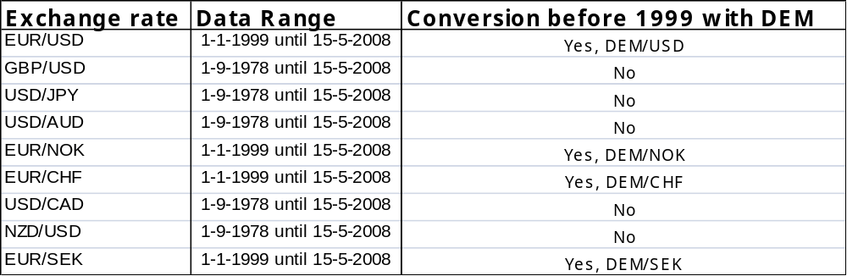
Notes: This data is collected from Thomson One Banker and are daily price index exchange rates. Given that the Euro only starts in 1999 the Deutsche Mark is used for the EUR crosses prior to 1999.

Daily exchange rates from each pair have been looked up in Thomson One Banker. In Table 2.1 the available and used data ranges are provided. Taking into account that the Euro is introduced from 1999 in the market, it would not be possible to use this currency for this trend research over a long period. It is, however, possible to make a conversion for older data than 1999 with the Deutsche Mark. The conversion factor of 1 euro to 1,95583 DEM is used, as in Lam, Fung and Yu (2008). And with this conversion an equal data range for every selected exchange rate within the portfolio is reached from
1-9-1978until 15-5-2008, which is 7750 trading days.We plot these data, to get a good view on the data over time and to visually check the quality of the data. Because it could be possible that false data is imported from Thomson one banker, DataStream or another program. The graphs 2.1 till 2.3 display the exchange rates over time.

Graph 2.1 Price index of Euro exchange rates
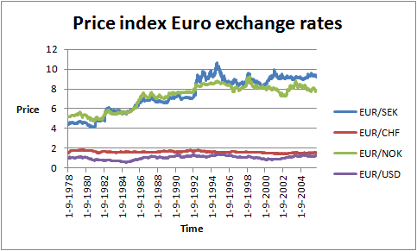
Notes: This data is collected from Thomson One Banker and are daily price index exchange rates. Where the price of the foreign currency is reflected in comparison to 1 Euro.

As seen in graph 2.1 exchange rates EUR/USD and EUR/CHF are very constant over the past 30 years. Although the EUR/NOK and EUR/SEK have an increase until 1995.

Graph 2.2 Price index of Non-Euro exchange rates
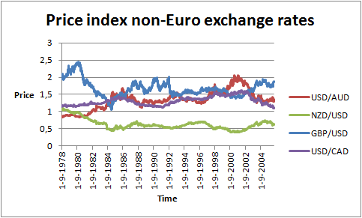
Note: This data is collected from Thomson One Banker and are daily price index exchange rates for non-Euro currencies.

There is not a similar trend behavior in graph 2.2 of the non-euro exchange rates spotted, the rates are fluctuating between a price of 0,40 and 2,50.

Graph 2.3 Price index Exchange rate with a high index
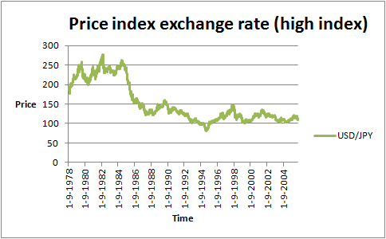
Notes: This data is collected from Thomson One Banker and are daily price index exchange rates. And is separated from the other starting data for a better view of the graph, because of the high index.

The USD/JPY has a fall of the index from 1985 until 1995, thereafter the price is relatively constant until the end of the sample period.

The buying and selling signals, will not directly be applied on these spot exchange rates. Speculators tend to use forward contracts to make currency bets. Hence forward returns are used, which take into account the cost of carry:

- $\text{F=Se}\text{(r-r*)t}$

Note: F is the forward price, S is the spot price, e is the base of natural logarithms, r is the short term interest rate, r* the short term interest rate of the other currency in the cross and t the time to maturity.

Forward returns are then calculated from the spot price, where the return on date t is the return from close t-1 to close t.

The carry is on itself also a good strategy. To focus on trends in exchange rates we compute the signals on cumulative forward returns and evaluate the strategy based on forward returns. This will matter especially for the slower rules, where the total amount of carry over the lookback period is larger than for faster rules. If a carry is 4% on a year-basis, the signals for trading can be different than for example when price index returns are used as a basis for the trading signals. We did check the results when applying the signals to spot returns and the conclusions are very similar. So now it is clear how the forward returns are calculated, these returns were provided by Robeco. The latest data of the retrieved price index rates was 15-5-2008, therefore the forward returns will also be analyzed until then. So the data range of the forward return of all 9 forex exchange rates will be 1980 until 15-5-2008.The signals will be made from the cumulative forward returns so plotting the basis for the signals will give us a lot information. Graph 2.4 until 2.6 will provide us with the following views:

Graph 2.4 Cumulative forward returns EUR/SEK, EUR/CHF and EUR/NOK
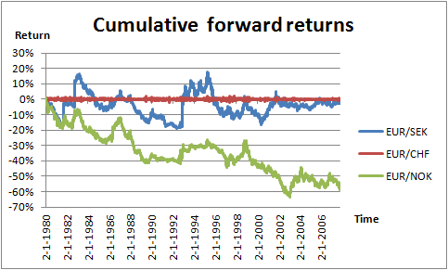
Note: These cumulative forward returns of these three EUR crosses are calculated from the daily price index.

It seems to be that all these three currency crosses will not be a good friend of the trend. While EUR/CHF is not heading down or up. This is in confirmation with the price index of the EUR/CHF cross, which is not changing much and always round 1,80. The EUR/SEK and EUR/NOK have too many switching points and give us a raw graph. Although over whole the sample period the EUR/NOK has a downward trend. In the next graph 2.5 three other pairs of the portfolio will be shown:

Graph 2.5 Cumulative forward returns NZD/USD, EUR/USD and GBP/USD
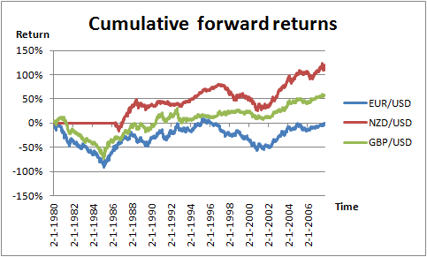
Note: These cumulative forward returns are calculated from the daily price index.

The three crosses, have similar movements, only data range of the NZD/USD starts at
2-5-1986. The price indices were available as the short term interest rates of the US, but the lack of short term interest rates of NZ is causing the later starting point. EUR/USD has only three big switching points in 1985, 1995 and 2001, where the periods from 1980-1988 and 1995-2005 seem to be very good trend trading periods. GBP/USD has only 1 major switching point in 1995, where 1980-1988, 1993-1999 and 2001-2008 will make strong trend friends. The next graph 2.6 will give a chart view of the last three currency USD crosses of the portfolio.

Graph 2.6 Cumulative forward returns USD/AUD, USD/CAD and USD/JPY
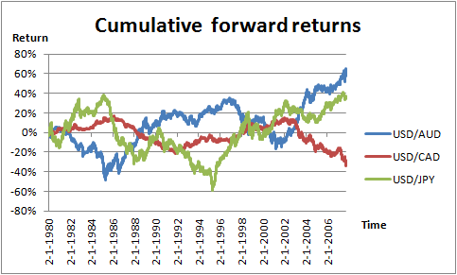
Note: These cumulative forward returns of the three USD crosses are calculated from the daily price index.
The last three currencies of the portfolio show all three trending phases in the chosen data range. Where USD/CAD has nice trend moves, but only is not so volatile as the other two crosses. Also the switching points are not nice sharp. USD/CAD has two long periods, which seem nice for trend traders: 1980-1999 and 1997-2008. And the last cross USD/JPY is showing three effective trend periods: 1985-1988, 1990-1999, 2000-2008.

Overall the starting data of the forward returns is giving the following view on the currency portfolio. EUR/CHF and EUR/SEK are giving no trending phases which could be useful, but the other 7 currency crosses show all different periods of trending phases. So investigating them could be interesting. Although only the whole portfolio will be separated in 3 subsamples, to look how trend is working over time. While looking on whole the portfolio, data-mining will be avoided, and also risk will be reduced.

2.2 Data for the bond market
The following category of data is from the bond market. In this market the largest bond markets are selected. These are in Japan, United States of America, Germany and the United Kingdom. These are the same markets which Barr and Priestley (2003) studied in their research about expected returns, risk and integration of the international bond market. Ilmanen (1995) also mentioned that these bond markets that are selected for my research belong to the biggest in the world. Ilmanen (1995) writes that the United States, Canada, Japan, Germany, France, and the United Kingdom markets constitute more than 80 percent of the world bond markets. It sounds, therefore, reasonable to take bond data of the four countries as in the following table, which has been picked up from DataStream:

Table 2.3 Selected bonds from DataStream for the bond-portfolio.
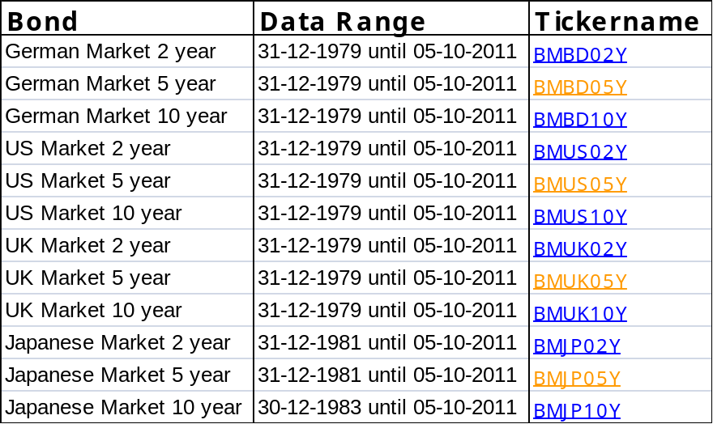
Notes: This data is collected from DataStream and are daily price index government bond rates. Three different maturities (2, 5 and 10 year) are chosen, to give a more diversified portfolio. The tickername is provided in the last column, with this tickername the original data can easily be collected in DataStream.

For all the markets the 2, 5 and 10 year bonds have been selected. So that we take a short, medium and long maturity into account. The series for the Japanese 10 year bonds start only at the end of 1983 and therefore we cover the same sample period for the whole bond-market portfolio: 30-12-1983 until 05-10-2011. This way all series ranges are equal to each other. Also in the last column the tickername is provided. With this tickername the data is collected in DataStream. These tickers are all benchmarks (BM) from the bonds, that is why they start with BM followed by initials of the country and the bond length.

For a good look at the starting data, they are plotted in the graphs 2.4 till 2.7.

Graph 2.4 Cumulative performance German Bonds
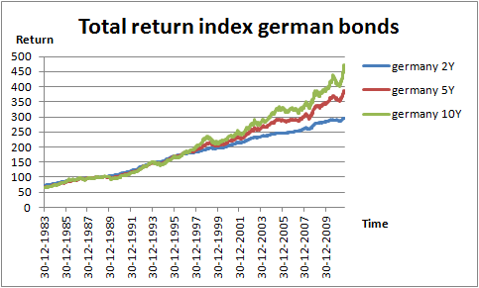
Note:The data consists of daily total return indices of German government bonds which includes coupons and assumes that all coupon payments are reinvested by buying more bonds in the index.

Graph 2.5 Cumulative performance US Bonds with coupons
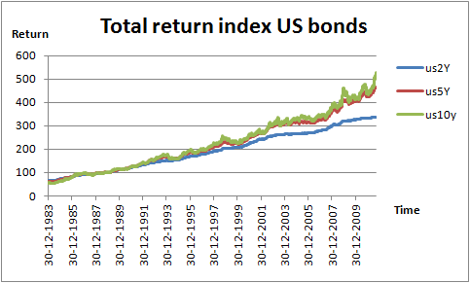
Note: The data consists of daily total return indices of US government bonds which includes coupons and assumes that all coupon payments are reinvested by buying more bonds in the index.

Graph 2.6 Cumulative performance UK Bonds with coupons
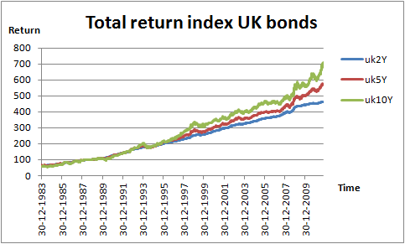
Note: The data consists of daily total return indices of UK government bonds which includes coupons and assumes that all coupon payments are reinvested by buying more bonds in the index.

Graph 2.7 Cumulative performance Japanese Bonds with coupons
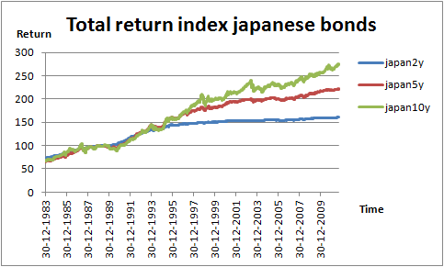
Note: The data consists of daily total return indices of Japanese government bonds which includes coupons and assumes that all coupon payments are reinvested by buying more bonds in the index.

As can be seen in the graphs all series are increasing over time, where the Japanese bonds have rather other lines where they flatten the most in recent years for the short maturity.

The total return index is taken to calculate the performance, because it assumes that coupons are reinvested. This total return index gives actually a more accurate measure of the actual performance than the price index where coupons are ignored.
As seen in the graphs above all bonds are equally increasing until 1995 and thereafter the longer maturity bonds have a higher return than the shorter maturity ones. The main reason for the great returns and higher returns for longer maturities is that yields have declined over this period resulting in capital gains. Longer maturity bonds have a higher duration meaning that yield decreases have a larger positive impact on these bonds.

The total return will not be the basis for the signal trades. Going long or short will be calculated from the cumulative excess returns. This performance criterion is taken, because looking the difference between investing in cash and investing in bonds is what an investor has to choose between. The assumption is that some amount is held as funding costs, this amount is reinvested daily at the domestic 3-month LIBOR rate.

First the excess returns are calculated and deducted with the funding:

(2)$Excessreturn t= \frac{Totalreturnt}{Totalreturnt-1}-1- daily 3 monthLIBORratet$

and secondly the cumulative excess returns will be summed up from these excess returns.

So actually these cumulative excess return lines and the moving average lines of 20 days and 200 days will give the signals to trade. Taking a good look at these cumulative lines will tell us much about the effectiveness of the whole strategy. In graphs 2.8 till 2.11 these cumulative excess returns are shown.

Graph 2.8 Cumulative excess returns German bonds
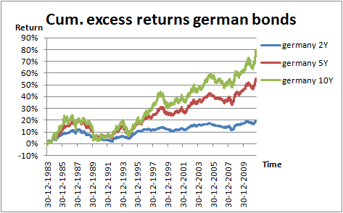
Note: This are daily cumulative excess returns, excess returns have been calculated from the daily total return indices. Also funding costs are taken into account, using the daily 3-month LIBOR rates.

The German excess bond returns are fluctuating for all maturities in a similar way until 1994 and from then we see a sharp increase until the end for the 10 year maturity. The shorter the maturity the smaller the increase.

Graph 2.9 Cumulative excess returns Japanese bonds
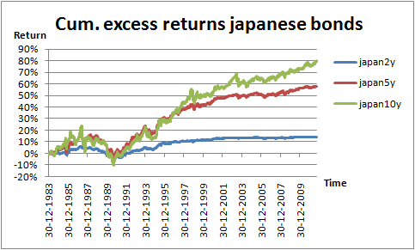
Note: This are daily cumulative excess returns, excess returns have been calculated from the daily total return indices. Also funding costs are taken into account, using the daily 3-month LIBOR rates.

The Japanese bonds have a similar view as the German, only the increase starts there earlier in 1990 and the shortest maturity of 2 years flattens from 2000.

Graph 2.10 Cumulative excess returns UK bonds
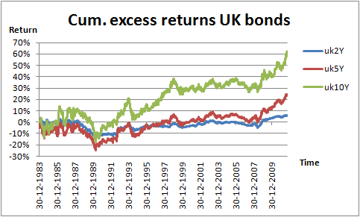
Note: This are daily cumulative excess returns, excess returns have been calculated from the daily total return indices. Also funding costs are taken into account, using the daily 3-month LIBOR rates.

The UK bonds have a decrease till 1989, suffering a loss. Which is followed by an increase until the end of the dataset, where the higher maturity increases the most. The shortest maturity has again the most flat line, giving only little positive results from 2008.

Graph 2.11 Cumulative excess returns US bonds
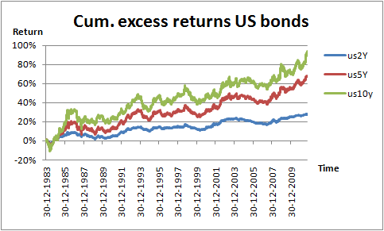
Note: This are daily cumulative excess returns, excess returns have been calculated from the daily total return indices. Also funding costs are taken into account, using the daily 3-month LIBOR rates.

And the US bonds also have an increase from 1989, the width between the different maturities are nice evenly spread.

An overall look at the starting data of the government bonds tell us that total return and cumulative excess returns are rising during whole sample period. Where 1989 seems to be a breaking point where the different maturities start to separate from each other.

2.3 Data for the commodity futures market
The selection for the portfolio of the commodities is made by taking into account several aspects. These aspects are the volumes which are traded in the commodity, the S&P GSCI (Goldman Sachs Commodity Index) and the availability of old data in DataStream.

The S&P GSCI is designed as a benchmark for investment in the commodity markets and as a measure of commodity market performance over time. The S&P GSCI is calculated primarily on a world production-weighted basis and comprises the principal physical commodities that are subject of active liquid future markets.

Liquidity is very important for active traders. So it is better to choose commodities with a high volume, while low volume commodity markets have often wild price swings. These price swings will not be good for trend traders.

The dollar weights of the commodities in the S&P GSCI index are shown in Table 2.4.

Table 2.4 Constituents of the S&P GSCI
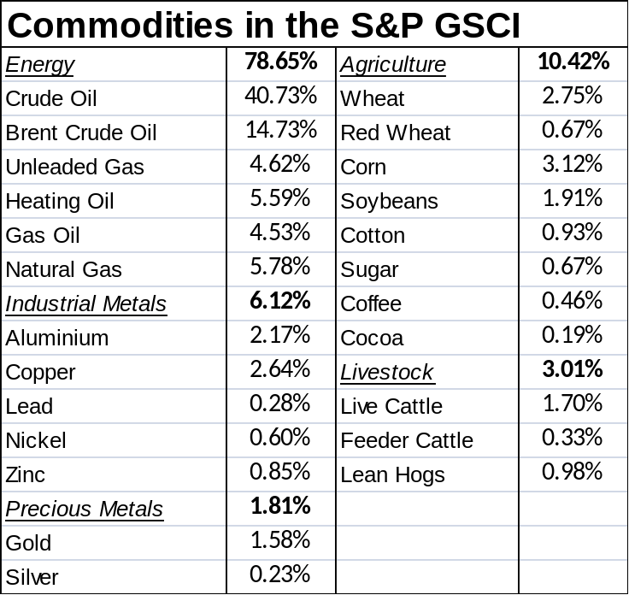
Note: This data is in dollar weights as of May 23, 2008. Source: Wikipedia.

In this research commodities are selected from the Table 2.4, where diversity of the different commodities and availability of good data in DataStream is also considered in selecting these commodities for the portfolio. Therefore the following thirteen commodities were the first selection for the portfolio: Gold, Crude Oil, Brent Crude, Natural Gas, Copper, Wheat (CBOT), Corn, Aluminum, Soybeans, Live cattle, Heating oil, Nickel and Sugar #11. Some of the data were not available in a long range equally like most of them back until 1-1-1979 in DataStream. They were cut out of the portfolio. And so the following commodities are selected:

Table 2.3 Selected commodities from for the commodity-portfolio
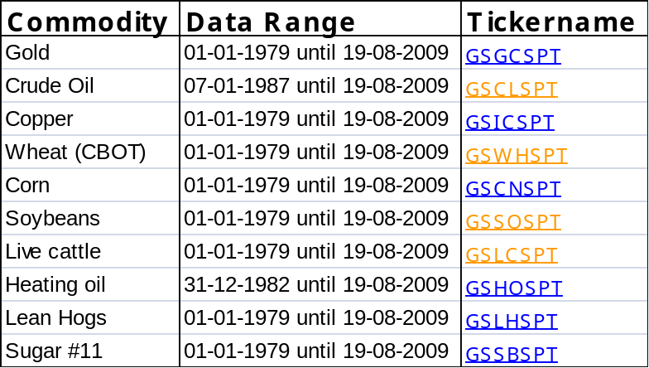
Notes: These commodities are daily priced benchmark data from the S&P GSCI index, which are downloaded from DataStream. In the last column the tickernames of DataStream are provided.

In the data above it is seen that the commodities Crude Oil and Heating Oil does not have the same starting date as the other commodities. Correcting starting dates of all the data gives us a smaller data range from 07-01-1987 until 19-08-2009. On the one hand this decision is not nice for the data range, it cuts out 8 year of data which will not be analyzed. On the other hand, the oil markets are liquid markets, which we certainly want to include in the research. In addition such a study is new, so the beginning (older data), will also not be comparable with other studies. Taking into account that still almost 22 years of data remains, it will not harm to cut the beginning 8 years of data, while the hypothesis if the trend is still my friend can still be answered.

The tickers provided in the last column are from the Goldman Sachs spot indices. Although these indices cannot be directly traded, they can make clear as a portfolio whether the trend is still my friend in the commodity market.

The cumulative performance of the starting data is plotted in the following graphs 2.8 till 2.10:

Graph 2.8 Cumulative performance Agriculture Commodities
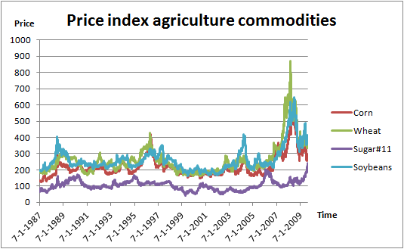
Notes: These agriculture commodities are daily priced benchmark data from the S&P GSCI index, which are downloaded from DataStream.

The price index for agriculture commodities have quite similar movements over the years for corn, wheat and soybeans, with an exception of the years 2007 until 19-8-2009. In that period the corn, wheat and soybeans have an up trend until 2008 and a down trend after 2008. The sugar#11, does not have such spectacular price movements in the same period. A couple of peeks can also been seen at 1988 (corn, wheat and soybeans), 1996 (corn, wheat and soybeans), 2004 (soybeans) and 2006 (sugar#11).

Graph 2.9 Cumulative performance Energy Commodities
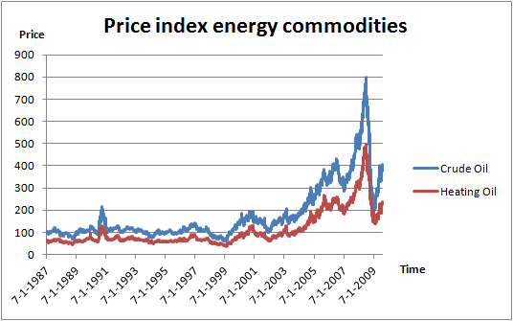
Notes: These energy commodities are daily priced benchmark data from the S&P GSCI index, which are downloaded from DataStream.
The energy commodities have totally similar movements, with an uptrend in 2002-2008. Turning sharply in a downtrend until 2009 and recovering from then until the end of the data set until 19-08-2009. Further are there two peaks at the end of 1990 and 2001.

Graph 2.10 Cumulative performance Metal Commodities
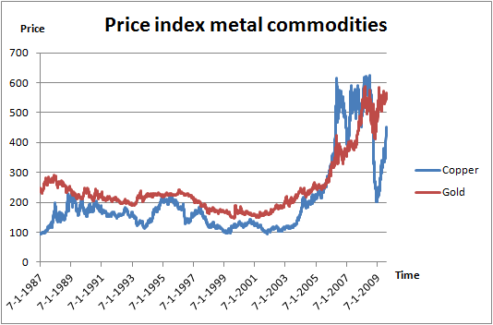
Notes: These metal commodities are daily priced benchmark data from the S&P GSCI index, which are downloaded from DataStream.

Metal commodities copper and gold have also the same climb in price at the end of the dataset. The copper metal goes up at the start, followed by a fall 1990-1994, again up in 1994-1995 and fall in 1995-2003. These periods do not have sharp bends, but the next one seems to be perfect: 2003-2006, has a nice sharp up trend movement. The period 2006-2008 is a period which I do not want to speculate about, it has sharp movements down and up, but the movements are in so a small data range, that working with the trend could be problematic. The end of the copper dataset seems to be very nice with a sharp fall 2008-2009 and a sharp rise from 2009 until the end of the dataset.
The gold metal can be divided and analyzed very shortly, because for looking at the trend we can cut the dataset in 2001. So before 2001 there is a light downward trend and after 2001 there is a strong upward trend.

Graph 2.11 Cumulative performance Livestock Commodities
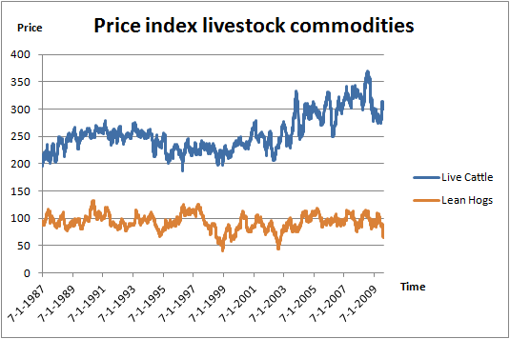
Notes: These livestock commodities are daily priced benchmark data from the S&P GSCI index, which are downloaded from DataStream.

Livestock commodities does not seem to be a profitable investment for the portfolio. Although the wide of diversification of the portfolio will be nice, that is why they will stay in the portfolio for futures commodities. The only period that could be interesting is the 2003-2008 period, which is an upward trend. But there are so many switches in this period, that high transaction costs are expected.

With the following formula the cumulative returns will be calculated from the price index:

(3)$Cumulative excess return t=\sum{\frac{Price index t}{Price index t-1}-1}$

The other asset classes which are researched for the MA rule in this study, have all cumulative returns as basis for the trade-signals. That is why we also take cumulative returns here as the basis for the signals. Although in this particular case for the commodities the cumulative returns will have almost the same signals as the price index. While with currencies and bonds there are made some corrections for the carry and funding, this is not the case with commodities.

As these cumulative returns will be the basis for the signals, graphs will presented in the follwing figures: graph 2.8 untill 2.11.

Graph 2.8 Cumulative returns Agriculture Commodities
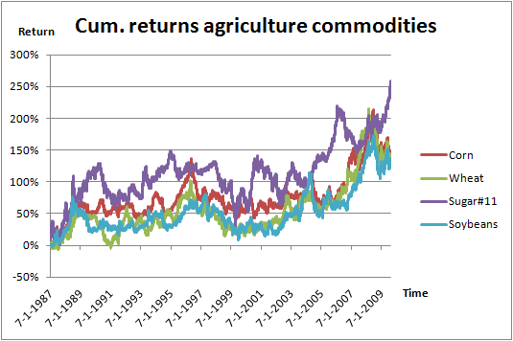
Notes: These livestock commodities are daily priced benchmark data from the S&P GSCI index, which are downloaded from DataStream.

In contradiction with the price graphs the sugar#11 is also having up trending phases in 1987-1999, 2004-2006 and 2007-2009:08. So it seems to be that cumulative returns give us a whole different view on trend then the price index data is revealing to us. The cause is the lower starting point of the index of sugar#11, so that absolute small changes in the price index graph will be relatively larger.

Graph 2.9 Cumulative returns Energy Commodities
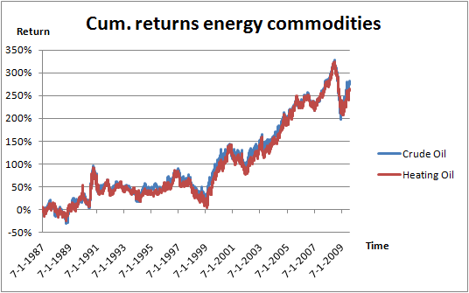
Notes: These livestock commodities are daily priced benchmark data from the S&P GSCI index, which are downloaded from DataStream.
Cumulative returns of the energy commodities crude oil and heating oil have the same movements, with nice trend periods after 1997.

Graph 2.10 Cumulative returns Metal Commodities
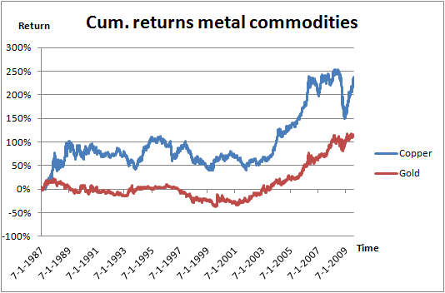
Notes: These livestock commodities are daily priced benchmark data from the S&P GSCI index, which are downloaded from DataStream.

Selected metals seem to have both nice uptrend period from 2002-2009:08, with the exception of copper between 2006-2008. The gold metal shows no movements in an up or down direction before 1997.

Graph 2.11 Cumulative returns Livestock Commodities
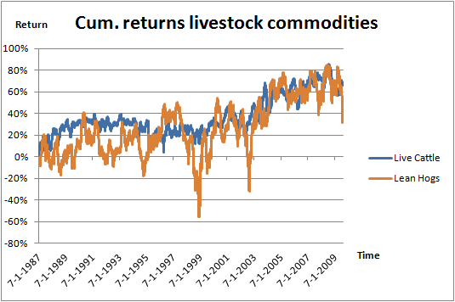
Notes: These livestock commodities are daily priced benchmark data from the S&P GSCI index, which are downloaded from DataStream.

Finally the livestock commodities, which did not have nice price graphs give us the above view in graph 2.11. The live cattle seem to have a nice trendable period in 1999-2009:08. Lean hogs on the other hand has very sharp turns in whole the dataset, lets see in the results what kind of an effect that has for the trend.

An overall look at the startingdata of the future commodities, gives us the information that commodity prices have a sharp increase in price in the period 2003-2008. Irwin, Sanders and Merrin (2009) considered the foloowing factors for the rising period. The main factors driving prices up in the energy market, which has the highest weight in the S&P GSCI, is the strong demand from China, India and other developing countries. The crude oil production gets short on supply and consumers are not changing their buying behaviour to ricing commodity prices. Also the drop in the Fed’s fund rate to 1% in 2003 is a cause of the boom in commodity prices as in Hamilton (2008)

2.4 Data for the equity market
With data from the equity market it will become clear how the equity momentum strategy performs, where the interest periods will be the two most recent decades, because Jegadeesh and Titman already did something like an AMH study in 2001 after introducing the momentum strategy in Jegadeesh and Titman (1993). For this market the data and strategy is not comparable with the other markets which are investigated in this thesis. Because here we do not have a dozen series, but many thousands of stocks. Since good quality momentum series are publicly available, the equity momentum return series is downloaded from an internet website (listed in the references) which is created by Fama and French. Kenneth French is an expert on the behavior of security prices and investment strategies. French and Fama are well known for their researches in investment strategies.

The momentum data for equity that is used in this research by Fama and French is picked up from the CRSP database. This is the database “Center for Research in Security Prices”.
This center is dedicated in its goal to provide the most complete, accurate and easily usable US securities data to all of its users. In this study, is chosen to cover only the US for the research. There is so many literature for the US momentum, so if AMH has taken its effect in a country it must be in the US. After the first publication in 1993 (Jegadeesh and Titman) there were many explanation with a risk based approach for the good momentum results. Although the 2001 (Jegadeesh and Titman) article rejects most of those risk-based explanations, so maybe AMH will be effective after the second publication. This kind of publication years and amount of literature does not exist for other countries. The last 10 years of the data range in this study is not covered by Jegadeesh and Titman (2001), so looking at the development of the trend (2001-2011) after the second article is interesting.

The data Fama and French created from CRSP contains a momentum factor, which is constructed from six value weight portfolios formed using independent sorts on size and prior returns of NYSE, AMEX and NASDAQ stocks. The daily data that I use for this research are daily UMD rates. The UMD (up minus down) is the average of the returns on two (big and small) high prior return portfolios minus the average of the returns on two low prior return portfolios. The data span is from 28-06-1963 till 30-06-2011. A graph of the used data is plotted in graph 2.4:

Graph 2.4 Selected data for the equity market
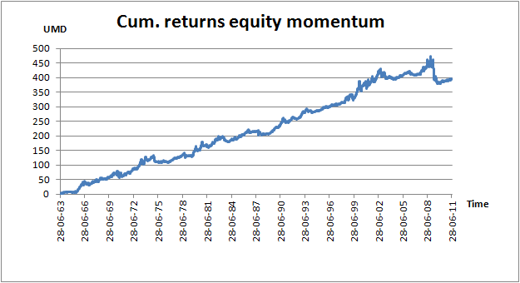
Note: The cumulative return is the cumulative UMD (up minus down), which is the average of the returns on two (big and small) high prior return portfolios minus the average of the returns on two low prior return portfolios of the US equity market.

As you can see these are results from the momentum equity strategy. So plotting original daily rates and then cumulate the returns is already done by Fama and French. With this cumulated UMD the profit can be analyzed over time. The results for the equity momentum strategy are positive until the Jegadeesh and Titman (2001) period. My expectation was that after Jegadeesh and Titman (1993) the market already would absorb the information, although the AMH is a learning process so it is not mentioned anywhere how quick information is picked up by the market. The cumulative UMD returns are increasing from 1963 till August 2002. It is possible that AMH takes over, because till 2007 the returns are stable and not increasing anymore. From 2007 till 2008 the momentum strategy seems to work, but thereafter the profits fall dramatically till 2009. This makes clear that the equity momentum strategy is not a winning strategy over the past 10 years. It looks like AMH is effective here, so the steadily increase of profits is not more possible after Jegadeesh and Titman (2001) is published. Or are there also other causes that could have led to this loss of the equity momentum strategy? This will be analyzed and discussed in the results.

2.5 Methodology
For doing this research Excel is used to program the data into it. In Excel there is the possibility to make a standard version for calculating trend characteristics of one exchange rate, futures rate or bond index. And then copy the other data within the portfolio into the standard version, showing immediately the same characteristics. The results will be presented and analyzed in the following chapter the “Empirical Results”.

2.5.1 Moving average and trend
First the data which is picked up from Thomson one banker or DataStream is transferred in the Excel sheet, which is going to be used for the analysis. This data is the daily forward return (for exchange rates), daily total return index (for government bonds) and daily S&P GSCI benchmark price index (for commodities). These are used for calculating the cumulative forward returns (exchange rates), cumulative excess returns (government bonds) and cumulative returns (commodities), which are the basis for the moving average (MA) rule as a trend trading signal.

The moving averages is one of the most popular tools available to technical analysts. They smooth out erratic movements in past prices thereby revealing and making it easier to spot trends, something that is especially helpful in volatile markets. Technical analysis assumes that past prices contain information about future prices. Thus, technicians try to discover trends and patterns in past prices, which can be related to an anticipated pattern in future prices.

To implement this strategy, average the closing prices over the past, say 200 days. This 200-day MA is updated each day, by eliminating the price 200 days back from the MA calculation, and adding the current price.

The trading strategy will then be as followed: Since the moving average lags the market, it will be above (below) the price in a bear (bull) market. Consequently, the decision strategy is as followed:
- Buy when the short-term MA crosses above its longer-term MA
- Sell when the short-term MA crosses below its longer-term MA

When using these two buying and selling strategies, the trend over the past is being followed. Using Excel as software program to calculate important statistics, this trend can be fully analyzed. So for following the trend in the asset classes the MA is used. The MA can be used to filter the market movements, so that the underlying trend will become clear. The moving average has different forms, there are fast, medium and slow moving averages, the quickness can be set by using different parameters. For determining which settings of MA will be used in this research the average holding period is estimated. The average holding period is a measurement that gives the time how long a position (short or long) is hold on average. By picking a setting and estimating the average holding period, the quickness can be seen. After seeing the quickness, the settings are adjusted to a fast, medium and slow moving average rule. In Table 3.1 the average holding period is shown for the settings that are picked for this research. These holding periods are specifically tested for the EUR/USD cumulative forward returns and then rolled out to all other crosses, bonds en futures.

Table 3.1 The average holding period of the used MA settings
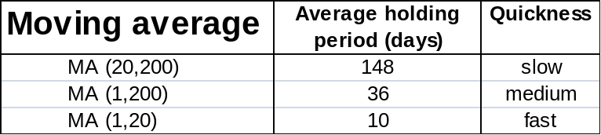
Note: These average holding periods are for the EUR/USD cumulative forward returns.

The cumulative profitability is estimated for the three different parameters. This is done by calculating the return on the daily positions and summing them up, taking into account the costs for the transactions.

2.5.3 Sharpe ratio and other statistics
When measuring the performance also the Sharpe ratio is taken into account. The Sharpe ratio is a measurement for the risk corrected performance of an investment of a business strategy. The formula for the Sharpe ratio is as follows:

(4) $S=(E\left(R-Rf\right))/σ$

Where S is the Sharpe ratio, R is the expected value, Rf is the risk-free rate and σ is the expected value of the expected remainder value. The Sharpe ratio is used as an information ratio. It describes if the extra value is compensating the extra risk that is taken. The higher the ratio, indicates the higher the compensation for the extra risk taken. Investors will have a preference for a high Sharpe ratio. The turnover which will be presented in the results is a single round-trip trade. This can be specified as going long at date t followed by going short at date t+1 and vice versa. The following statistics will also be provided: the gross mean return of the whole data sample, which will be annualized. For annualizing the mean is multiplied with 260 (number of trading days in a year). This gross mean return is than divided with the annualized standard deviation. This is the standard deviation of the sample times root 260. The net returns will include the turnovers which have transaction costs. For the currency market 15 basis points per turnover are used, 1,5 basis point for government bonds and 5 basis points for the commodity futures.
2.5.4 Always long strategy
The always long strategy is the simplest strategy an investor can make, if this speculative investment is smart that is his choice. It is simply buying the position and holding it without trading. The benefit in contrary to the MA rule is that only transaction costs are made at the start. By presenting this strategy in the results it can be compared with the different MA rules. This way the difference between the (dumb) always long strategy and (smart) MA rules can be analyzed.

2.5.5 Forex exchange strategy
The cumulative forward returns are already discussed and formulated in chapter 2.1. As an example the MA (1,20) will be used to make it clear. If the cumulative forward return of a trading day is higher than the average of the cumulative excess returns of the previous 20 days. The strategy is to follow the trend and buy the bond, otherwise sell.

2.5.6 Government bond strategy
The cumulative excess returns are as mentioned before shown in graphs in the data chapter 2.2. As an example the MA (1,20) will be used to make it clear. If the cumulative excess return of a trading day is higher than the average of the cumulative excess returns of the previous 20 days. The strategy is to follow the trend and buy the bond, otherwise sell.

2.5.7 Commodity futures strategy
The cumulative returns of the benchmark S&P GSCI which were presented in chapter 2.3 are the basis for the strategy. As an example the MA (1,20) will be used to make it clear. If the cumulative excess return of a trading day is higher than the average of the cumulative excess returns of the previous 20 days. The strategy is to follow the trend and buy the bond, otherwise sell.

2.5.8 Equity momentum strategy
Finally the equity market is researched with the momentum strategy. The data from the CRSP database are UMD rates. UMD is the average of the returns on two (big and small) high prior return portfolios minus the average of the returns on the low prior return portfolios. The portfolios are constructed daily. Big means a firm is above the median market cap on the NYSE at the end of the previous day; small firms are below the median NYSE market cap. Prior return is measured from day -250 to -21. Firms in the low prior return portfolio are below the 30th NYSE percentile. Those in the high portfolio are above the 70th NYSE percentile.

This data is available through Fama and French which investigated the markets with this equity momentum strategy. Using their data we can analyze the profits of this strategy over 1963 till 2011. Specifically will be looked at the periods before and after Jegadeesh and Titman, who published their articles in 1993 and 2001.

3. Empirical Results

3.1 Exchange market
In all the excel sheets of the currency pairs the Sharpe ratio and other statistics are calculated as mentioned before in the methodology. The results are presented in Table 3.1 until 3.4. The first table will consist the buy-and-hold strategy, which can be compared with results of the MA rules. Although this always long strategy will not have a meaning on itself for the currency portfolio.

Table 3.1 Currencies for the always long strategy.
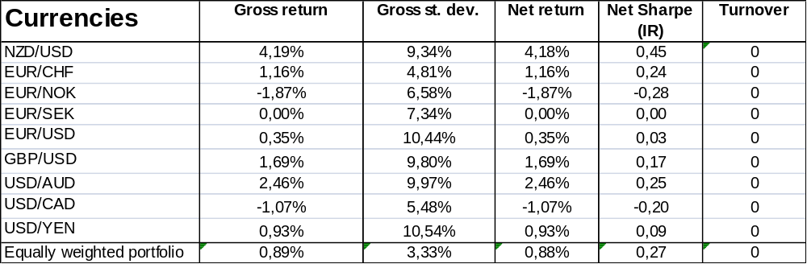
Notes: The results cover the period from 1980 until 15-5-2008. Where the strategy is to buy and hold the position, meaning always long the first named currency and short the second named currency. One-way costs are assumed to be 7,5 basis points. In this particular case these costs are only made at the start to set up the long position.

When we analyze these results of the buy and hold strategy, we see first of all a positive Sharpe ratio for whole the portfolio of 0,27. This is a positive result for the always long strategy. Of course there are no turnovers seen in the last column, because we stay in the long position. The return is 0,89% with a risk of 3,33%, interesting to compare this with results of the moving average rules later on. Individual crosses which are remarkable are: NZD/USD, USD/AUD, EUR/NOK, USD/CAD and EUR/SEK. NZD/USD and USD/AUD, because these have the highest return and Sharpe ratio. EUR/NOK and USD/CAD, because these crosses have a negative return and Sharp ratio. The EUR/SEK gives a 0% return.

Table 3.2 Currencies for the fast MA (1,20) rule.
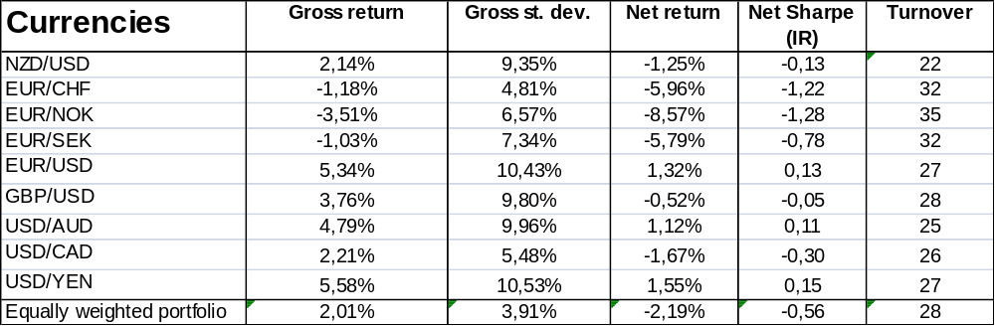
Notes: This research is done for 1980 until 15-5-2008, where the strategy is to buy if the current cumulative excess return forward return is higher than the average of the previous 20 days. To calculate net results, transaction costs of 15 basis points per turnover are taken into account. Turnover is the number of switches from long to short (counts for 1 turnover) or short to long per year.

The MA (1,20) strategy gives us the results as can be seen in Table 3.2. The net Sharpe ratio for the equally weighted portfolio is negative at -0.56, which gives traders the information that investing with the fast MA rule would not have been profitable. The portfolio consists of crosses which have positive and negative returns. Although overall there is a positive gross return result of 2,01%, which is higher than the always long strategy, the net return after taking into account transaction costs of 15 basis points per turnover is negative. In Table 3.3 we will analyze the medium MA rule.

Table 3.3 Currencies for the medium MA (1,200) rule.
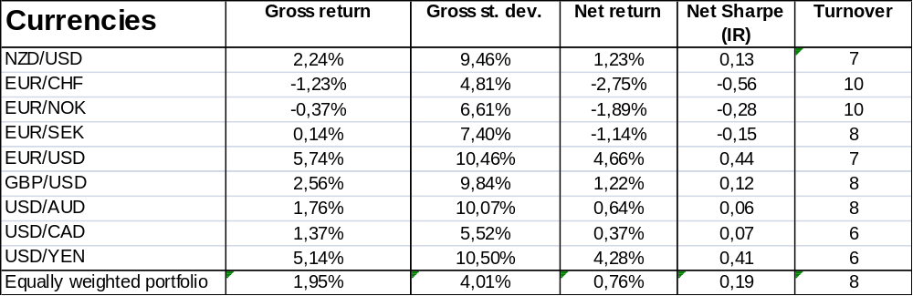
Notes: This research is done for 1980 until 15-5-2008, where the strategy is to buy if the current cumulative excess return forward return is higher than the average of the previous 200 days. To calculate net results, transaction costs of 15 basis points per turnover are taken into account. Turnover is the number of switches from long to short (counts for 1 turnover) or short to long per year.

Looking at the results in Table 3.3, we see a positive Sharpe ratio of 0,19, which is better than the fast strategy. The gross return of the equally weighted portfolio is 1,95%, but transaction costs are cutting the net return to a profit of 0,76%. When looking on the individual crosses: EUR/USD and USD/YEN are doing extremely well giving a gross return above 5% and net above 4%. The medium rule gave us better results than the fast one with similar gross returns achieved with less turnover. We now continue with the slowest MA rule in Table 3.4.

Table 3.4 Currencies for the slow MA (20,200) rule.
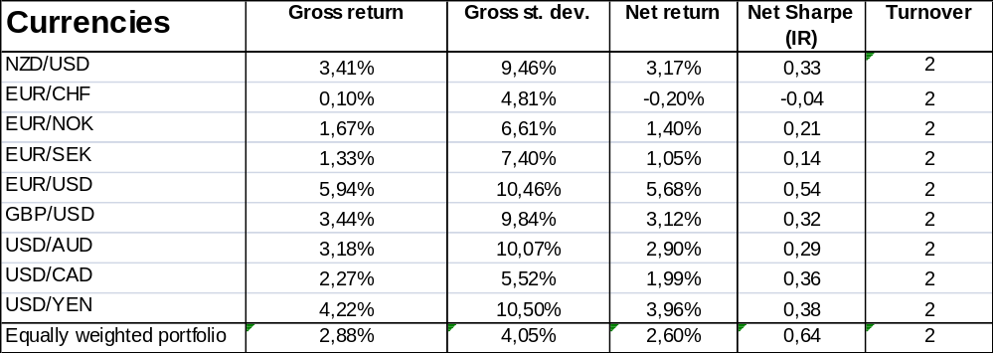
Notes: This research is done for 1980 until 15-5-2008, where the strategy is to buy if the cumulative excess return forward return of the past 20 days is higher than the average of the previous 200 days. To calculate net results, transaction costs of 15 basis points per turnover are taken into account. Turnover is the number of switches from long to short (counts for 1 turnover) or short to long per year.

With 0,64 as a net Sharp the slow MA rule is giving us the best profitable results for the forex exchange market. The gross return is the highest of all strategies, giving a return of 2,88%. The rule is also not losing much to transaction costs, because the turnover per year is rather low at 2. This means that on average the strategy makes only 2 switches per year from e.g. long the first currency to short the first currency. The net return is 2,60% with a standard deviation of approximately 4,05%, while the gross and net standard deviation are practically the same. The individual crosses are doing well with the slow MA rule, with the exception of the EUR/CHF cross, which has a negative net return and Sharp ratio.

These were the results of the rules for the individual exchange rates. In Table 3.5 the equally weighted portfolio will be analyzed over time, so we can see how well trend is doing in sub periods. The sub periods are chosen equally for all the asset classes at: 1980-1993, 1994-2002 and 2008:05 so they are comparable with each other. This way we can also draw a conclusion on the AMH-hypothesis.

Table 3.5 Currencies portfolio
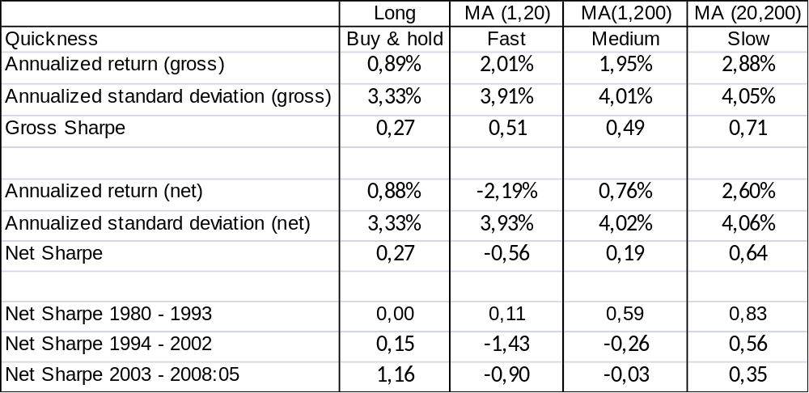
Notes: This research is done for 1980 until 15-5-2008, where the sub periods are important figures to take into account, because they let us see how the trend is doing over time. The currencies portfolio is an equally weighted portfolio of the 9 individual chosen currencies. To calculate net results, transaction costs of 15 basis points per turnover are taken into account for the MA rules. Turnover is the number of switches from long to short (counts for 1 turnover) or short to long per year. In the particular case of the long strategy these costs are only made at the start to set up the long position for 7,5 basis points.

We already discussed that the slow MA rule is giving the most profitable results over whole the data range, in Table 3.5 the figures are nicely presented in an overview so they can be compared with each other. Table 3.5 is also providing us how well the rules are doing over time. Showing rather interesting results, back in the days before 1993 where nobody published an article about the moving average strategy, the MA rules were outplaying the dumb always long strategy. Especially the slow rule is giving a high Sharpe ratio of 0,86. In the second subsample (1994-2002), there is a big change in profitability. The fast and medium rules are losing profitability and are no longer interesting, because the trend is not a friend anymore. Although the slow rule is still giving a good Sharp of 0,56 for trend investors. It seems to be that the most profitable MA rule (the slow one) is losing profit over the years declining from a Sharp ratio of 0,83 to 0,56 and finally still positive at 0,35. So AMH is taking his effect on the market, which is resulting in a less good friend of the trend for the slow rule and no friends with the trend for the faster MA rules. The last sub period 2003-2008:05 is confirming these statements. The dumb always long strategy is giving a nice profit in comparison with the trend rules, this brings us to the question: How well of a friend is trend trading actually, but before giving a conclusion we will look at a couple of return graphs.

For these exchange rate portfolios we plotted cumulative return graphs and these are presented in Graph 3.1 until Graph 3.4. This will give insight in whether there can be a trend spotted and shows how the returns are evolving in time when using the picked rule to trade. Off course it gives also the opportunity to see if there is no false data implemented in the excel sheets before and after calculating the returns. First cumulative performance of the MA strategies and then the always long strategy will be presented.

Graph 3.1 Cumulative performance of the fast rule
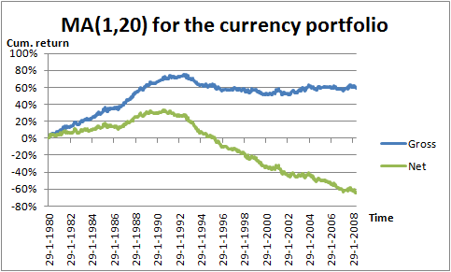
Notes: This cumulative performance is calculated for 1980 until 15-5-2008. The strategy is to buy if the current cumulative excess return total return index is higher than the average of the previous 20 days. To calculate net results, transaction costs of 1,5 basis points per turnover are taken into account. Turnover is the number of switches from long to short (counts for 1 turnover) or short to long per year.

In Graph 3.1 is clearly seen that the profitability of the fast rule disappears after 1993. The return line is than not increasing anymore, indicating to us that trend is not a friend anymore.

Graph 3.2 Cumulative performance of the medium rule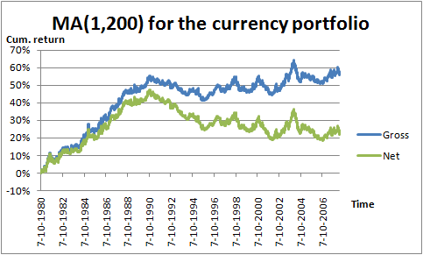
Notes: This cumulative performance is calculated for 1980 until 15-5-2008, where the strategy is to buy if the current cumulative excess return forward return is higher than the average of the previous 200 days. To calculate net results, transaction costs of 15 basis points per turnover are taken into account. Turnover is the number of switches from long to short (counts for 1 turnover) or short to long per year.

The profitability for the medium rule, Graph 3.2, is even earlier stopping in 1990. So profitable trend-trading with this strategy was only possible before 1990.

Graph 3.3 Cumulative performance of the slow rule
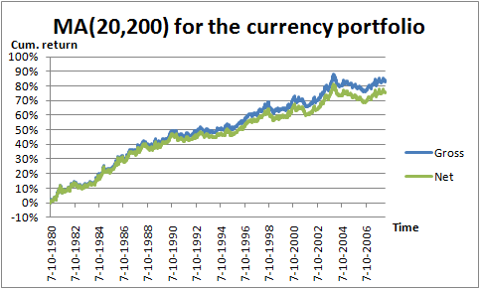
Notes: This cumulative performance is calculated for 1980 until 15-5-2008, where the strategy is to buy if the cumulative excess return forward return of the past 20 days is higher than the average of the previous 200 days. To calculate net results, transaction costs of 15 basis points per turnover are taken into account. Turnover is the number of switches from long to short (counts for 1 turnover) or short to long per year.
The slow rule in Graph 3.3 is presenting a nice plotted graph for trend. From 1990 until 2008:05 a nice trend-line can be drawn, where the return is sometimes a little bit above and sometimes under the trend-line. This rule is the best of all researched MA rules for the currency market.

Graph 3.4 Cumulative performance of the always long strategy
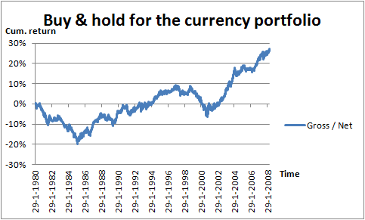
Notes: This research is done for 1980 until 15-5-2008, where the strategy is to buy and hold the position. Gross and net only differ 7,5 basis points from the start when the position is bought, because there are no turnovers.

The dumb buy and hold strategy has not so a beautiful graph as the slow MA rule. But in Graph 3.4 the periods 1985-1997 and 2001-2008:5 are good periods for the always long strategy.

In comparison with the existing literature we can see the following results. Neely, Weller and Ulrich (2006) extended the data range of the studies Sweeney (1986), Levich and Thomas (1993), Taylor (Channel rules, 1994), Taylor (ARIMA rules, 1994) and Neely Weller and Dittmar (1997). Dueker and Neely (2006) . Lebaron (2002) . Okunev and White (2003) . Olson (2004) [specifieke referenties noemen hier]in the literature are giving a deterioration of the MA rule around 1990. In this study that is also the case for the medium and fast MA rule. On the contrary the slow rule is giving other results in comparison with the existing literature [hoe kan dat? Gebruiken die niet zo’n langzame regel?], it still has a profitable effect after 1990.. This gives us the conclusion that the slow MA rule is the only rule that survived the first publication of the well performing strategy, but finally also AMH takes over from 2003. The dumb buy and hold strategy is giving nice results with the currencies, especially better than the MA rules in the last sub period, but with the currency portfolio this long strategy is not giving us much information on itself, it is just presented to put it in perspective with the MA rules. Overall it seems to be that AMH has taken such a hard effect on trend trading over time that the trend is not a friend anymore in the currency market.

3.2 Government bond market
Sharpe, return, risk and turnover results will be presented in tables 3.6 until 3.10 for every rule separately. The rules will be analyzed after all three tables by comparing them with each other and the always long strategy to see comparisons and differences.

Table 3.6 Bonds for the always long strategy.
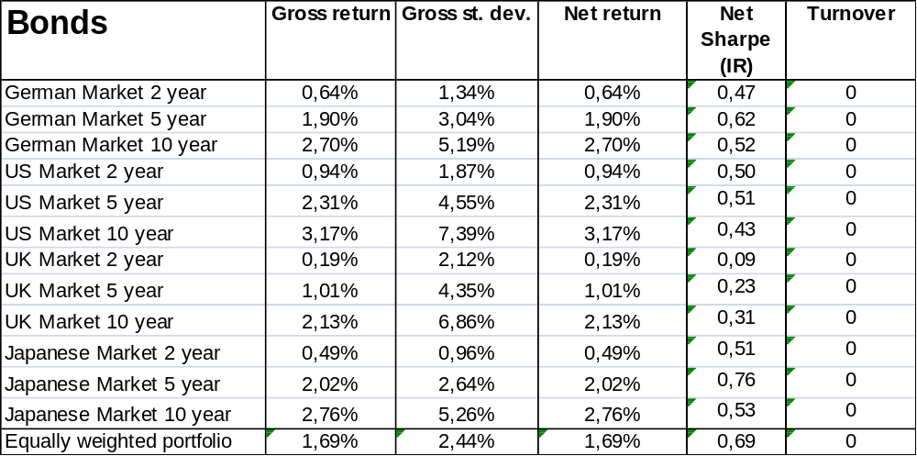
Notes: The results cover the period from 1984 until 2011. Where the strategy is to buy and hold the position. One-way costs are assumed to be 0,75 basis points. In this particular case these costs are only made at the start to set up the long position.

Table 3.6 Bonds for the fast MA (1,20) rule.
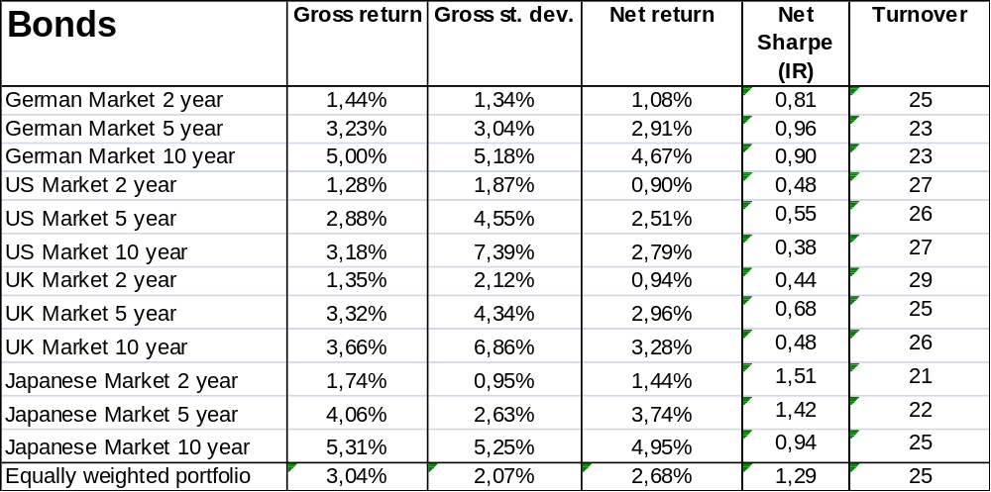
Notes: This research is done for 1984 until 2011, where the strategy is to buy if the current cumulative excess return total return index is higher than the average of the previous 20 days. To calculate net results, transaction costs of 1,5 basis points (Round-trip, so from long to short) are taken into account. Turnover is the number of switches from long to short (counts for 1 turnover) or short to long per year.

Table 3.7 Bonds for the medium MA (1,200) rule.
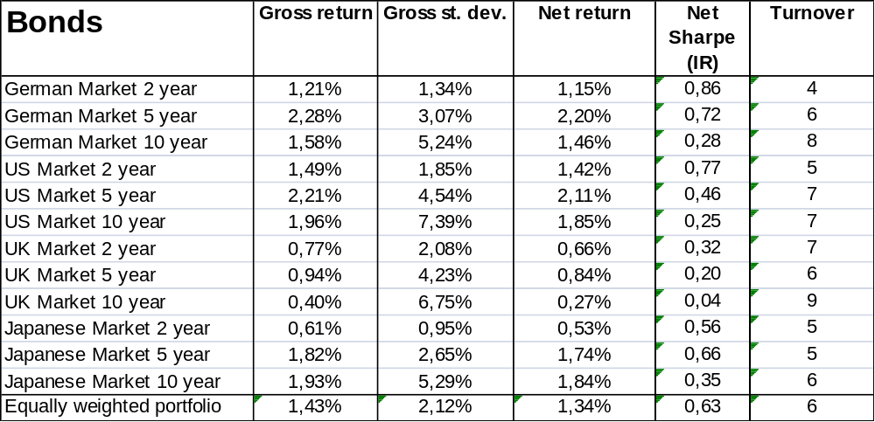
Notes: This research is done for 1984 until 2011, where the strategy is to buy if the current cumulative excess return total return index is higher than the average of the previous 200 days. To calculate net results, transaction costs of 1,5 basis points (Round-trip, so from long to short) are taken into account. Turnover is the number of switches from long to short (counts for 1 turnover) or short to long per year.

Table 3.8 Bonds for the slow MA (20,200) rule.
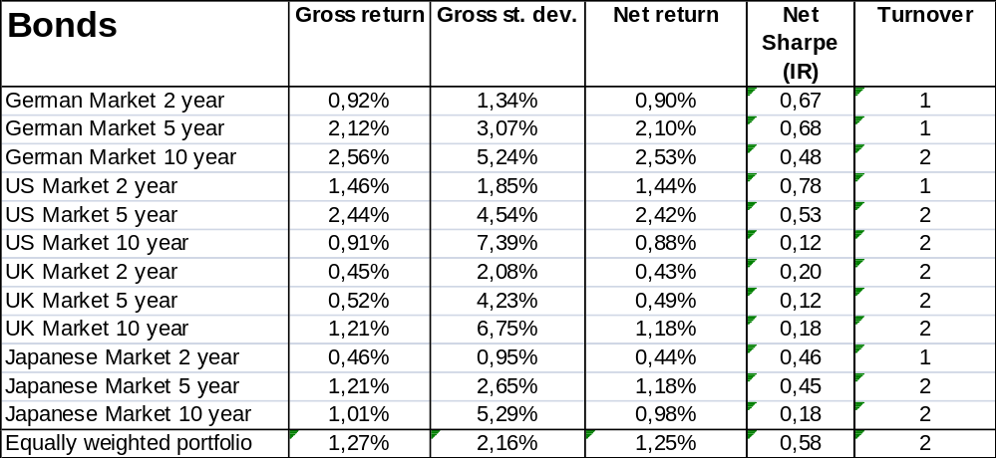
Notes: This research is done for 1984 until 2011, where the strategy is to buy if the average of the previous 20 days of the cumulative excess return total return index is higher than the average of the previous 200 days. To calculate net results, transaction costs of 1,5 basis points (Round-trip, so from long to short) are taken into account. Turnover is the number of switches from long to short (counts for 1 turnover) or short to long per year.

MA(1,200) table is missing??

The Sharpe figures for the equally weighted portfolios are the most interesting figures in the table. Sharpes are giving ratios above zero, where only the UK 10 year bond for the medium rule is practically zero. The results tell us that the information is high when using these rules on bonds and that the fast rule is suiting the best for investors, giving the highest Sharpe, gross and net return with the lowest standard deviation.

In comparison with the buy-and-hold strategy….. [COMPLETE]

If we look particular to each bond individually we can see that for each country trend works best for short-maturity bonds, and so contributing to a better Sharpe for the equally weighted portfolio. The longer the maturity the lower the Sharpe ratio gets.

The turnover in tables give us the number of switching position in going long or short in the currency. Obviously the turnover is higher with a faster rule than a slower one.

Now we have looked at all the Sharpe ratios, it is also interesting to look at gross and net returns. These will be given in table 3.8 below for the whole sample. The sample range is also divided in three periods, so the effectiveness of the rule can be compared in time. This way we can see if the trend was still our friend after Ilmanen (1995).

Table 3.10 Statistics for the bond portfolio.
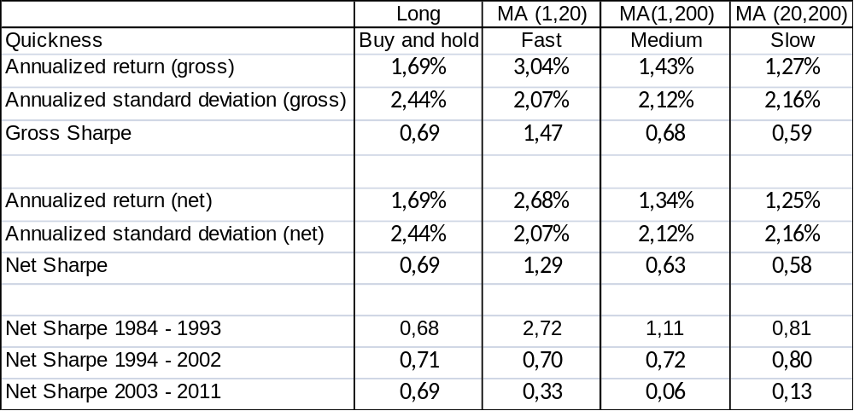
Notes: This research is done for 1984 until 2011, where the sub periods are important figures to take into account, because they let us see how the trend is doing over time. The bond portfolio is an equally weighted portfolio of the 12 individual chosen bonds. To calculate net results, transaction costs of 1,5 basis points per turnover are taken into account for the MA rules. Turnover is the number of switches from long to short (counts for 1 turnover) or short to long per year. In the particular case of the long strategy these costs are only made at the start to set up the long position for 0,75 basis points.

The bond portfolio is making a good return when using the trend strategy, actually the fast MA rule is making the most profit when looking at gross and net figures. But the slow and fast rules are also doing decently.

When adding transaction costs of 1.5 basis point to the returns of the fast rule are reduced the most but overall still provide a good Sharpe and return. That the fast rule is resulting in the highest transaction costs is of course natural, because the turnover will be higher with a faster rule.

When looking to the period 1984-1993 the Sharpe was extremely high, indicating good profits for all three rules. But when analyzing the period from 1994 - 2002, it is seen that the Sharpe ratios drop, indicating that the rules are less effective than before. And for the last years 2003 - 2011, it is seen that the Sharpe ratios drop heavily for the medium and slow rule, but the fast rule is still 0,33 after the drop. This is also seen in the cumulative gross results of the equally weighted bond portfolio as followed in graphs 2.8 until 2.10.

Graph 2.8 Cumulative performance of the always long strategy.
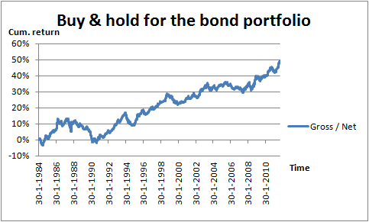
Notes: This research is done for 1984 until 2011, where the strategy is to buy and hold the position. Gross and net only differ 0,75 basis points from the start when the position is bought, because there are no turnovers.

[Check numbering bond tables]

Graph 2.8 Cumulative performance of the fast rule.
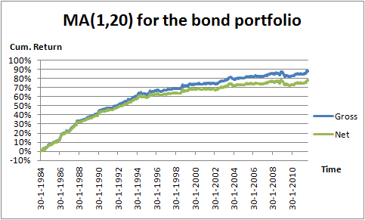
Notes: This research is done for 1984 until 2011, where the strategy is to buy if the current cumulative excess return total return index is higher than the average of the previous 20 days. To calculate net results, transaction costs of 1,5 basis points (Round-trip, so from long to short) are taken into account. Turnover is the number of switches from long to short (counts for 1 turnover) or short to long per year.

Graph 2.9 Cumulative performance of the medium rule.
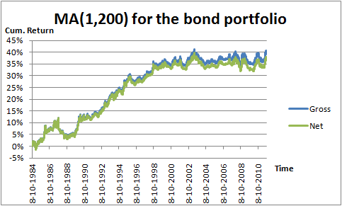
Notes: This research is done for 1984 until 2011, where the strategy is to buy if the current cumulative excess return total return index is higher than the average of the previous 20 days. To calculate net results, transaction costs of 1,5 basis points (Round-trip, so from long to short) are taken into account. Turnover is the number of switches from long to short (counts for 1 turnover) or short to long per year.

Graph 2.10 Cumulative performance of the slow rule.
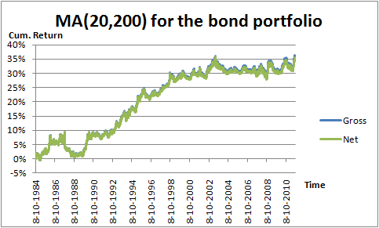
Notes: This research is done for 1984 until 2011, where the strategy is to buy if the current cumulative excess return total return index is higher than the average of the previous 20 days. To calculate net results, transaction costs of 1,5 basis points (Round-trip, so from long to short) are taken into account. Turnover is the number of switches from long to short (counts for 1 turnover) or short to long per year.

In the graphs above is good to see that the line is still increasing for the fast rule and recently is more constant for the medium and slow rule. Which gives the conclusion that the trend is a less good friend recently than in the past, but still gives Sharps above 0, so are still interesting for investors for making profit. Where the fast rule MA is recently (2003-2011) the most effective, doing much better than the medium and slow rule.

Ilmanen (1995) used monthly data from January 1978 to June 1993, he finds that with a small set of global instruments there can be a forecast of 4 to 12 percent of monthly variation in excess bond returns. The outcome is that the predictable variation is statistically and economically significant. In comparison with the Ilmanen study it is seen in table 3.8 that the net Sharpe is doing extremely well in the period before 1993. So Ilmanen found that trend was a friend, this research also indicates that trend is a (very good) friend in that period. Trend is still a friend after Ilmanen’s sample period, but to a lesser extent. So AMH is effective after Ilmanen’s publication, because the market absorbed information causing much less profit than before.

3.3 Commodities

For the futures market the following commodity futures are used [you use a price index, not futures? Or is it a futures index?]: Live cattle, Copper, Corn, Crude Oil, Gold, Heating Oil, Lean Hogs, Soybeans, Sugar #11 and Wheat. First the always long strategy will be presented in Table 3.11, so that this buy-and-hold strategy can be compared with the MA results.

Table 3.11 Commodities always long-strategy.
Commodities | Gross return | Gross st. dev. | Net return | Net Sharpe (IR) | Turnover
Copper | 9,87% | 26,53% | 9,87% | 0,37 | 0
Corn | 5,84% | 23,49% | 5,84% | 0,25 | 0
Crude Oil | 11,98% | 34,63% | 11,98% | 0,35 | 0
Gold | 4,78% | 15,52% | 4,78% | 0,31 | 0
Heating Oil | 11,33% | 33,26% | 11,33% | 0,34 | 0
Lean Hogs | 1,61% | 24,57% | 1,61% | 0,07 | 0
Live Cattle | 2,41% | 14,07% | 2,41% | 0,17 | 0
Soybeans | 5,40% | 22,94% | 5,40% | 0,24 | 0
Sugar#11 | 9,67% | 32,12% | 9,67% | 0,30 | 0
Wheat | 5,50% | 25,36% | 5,49% | 0,22 | 0
Equally weighted portfolio | 6,84% | 12,91% | 6,84% | 0,53 | 0
Notes: The results cover the period from 1987 until 2009:08. Where the strategy is to buy and hold the position. One-way costs are assumed to be 2,5 basis points. In this particular case these costs are only made at the start to set up the long position.

As usual with a buy-and-hold strategy there are no turnovers, because the only time you are taking a position is at the start to set up the long position. The final results show us therefore the same results for gross returns as net returns [nog niet helemaal consistent met currencies waar je wel 7.5bp in rekening brengt voor het opzetten van de eerste positive]. There is a positive gross return of 6,84% for the equally weighted portfolio with a standard deviation of 12,91% and a net Sharpe of 0,53. The individual commodities show all positive results. Let’s see how this buy-and-hold strategy compares with the chosen MA rules.

Table 3.12 Commodities for the fast MA (1,20) rule.
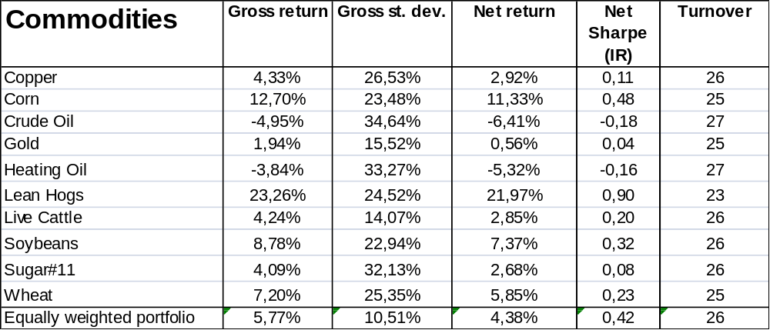
Notes: This research is done for 1987 until 2009:08, where the strategy is to buy if the current cumulative return is higher than the average of the previous 20 days. To calculate net results, transaction costs of 5 basis points (round-trip, so from long to short) are taken into account. Turnover is the number of switches from long to short (counts for 1 turnover) or short to long per year.

The fast MA rule gives us a slightly less profitable result than the always long strategy. Results show a 5,77% gross return with a standard deviation of 10,51% for the commodities portfolio. The Sharpe of 0,42 is still good for trend traders when using the fast MA rule. The turnover is on average 26 per year, resulting in 5 basis points transaction costs per turnover, which bring gross return from 5,77% to a net return of 4,38%. Looking individually on the commodities, there are two negative gross returns, these are for Crude Oil and Heating Oil. So it seems to be that the fast rule is not a profitable strategy for the energy commodities, resulting in negative Sharpe ratios. On the other hand there is a really strong livestock commodity, Lean Hogs. Lean Hogs have a gross return of 23,26% with a standard deviation of 24,52% and a high net Sharpe of 0,90.

Table 3.13 Bonds for the medium MA (1,200) rule.
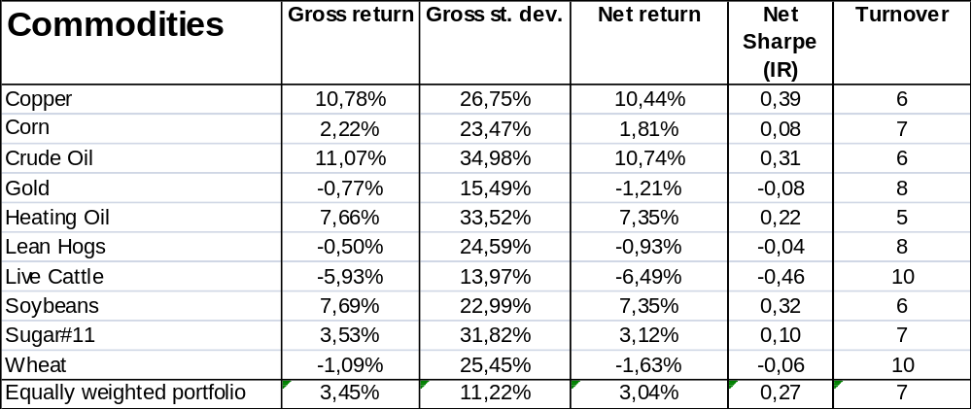
Notes: This research is done for 1987 until 2009:08, where the strategy is to buy if the current cumulative return is higher than the average of the previous 200 days. To calculate net results, transaction costs of 5 basis points (Round-trip, so from long to short) are taken into account. Turnover is the number of switches from long to short (counts for 1 turnover) or short to long per year.

In Table 3.13 the statistics of the medium MA rule will be presented. The medium MA rule has less transaction costs than the fast rule, because the average yearly turnover per year is 7. But the results are dropping in profitability, with a net return of 3,04%, risk of 11,22% and a Sharpe of 0,27 for the equally weighted portfolio. Cumulative return graphs will be presented at the end of this section, maybe they will give us a better insight why the medium rule is giving less profit. There are four individual commodities with a negative gross return, which leads to a negative net Sharpe for Gold, Live Cattle, Lean Hogs, [verrassend, gegeven dat die net nog het beste was. Hoe kan dat?] and Wheat. Although only Live Cattle has a Sharpe far below zero of -0,46, the other three commodities have only a slightly negative Sharpe ratio. Lean Hogs especially seem to be very sensitive for the quickness of the MA setting, because with the fast rule as mentioned before there was a high profit.

Table 3.14 Commodities for the slow MA (20,200) rule.
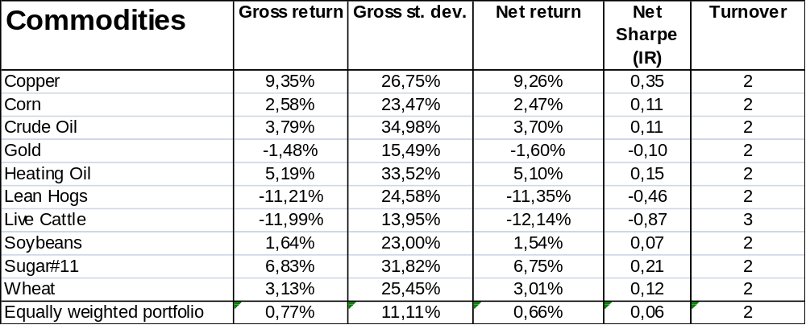
Notes: This research is done for 1987 until 2009:08, where the strategy is to buy if the average of the previous 20 days of the cumulative return is higher than the average of the previous 200 days. To calculate net results, transaction costs of 5 basis points (Round-trip, so from long to short) are taken into account. Turnover is the number of switches from long to short (counts for 1 turnover) or short to long per year.

The last MA setting for the commodities is the slow rule, see Table 14. The slow rule has the worst results of all with a gross return of 0,77%, standard deviation of 11,11% and a net Sharpe of almost zero at 0,06. The turnover per year is low at 2, but the way in which this turnovers have be chosen on following the trend seems to be not a good strategy. Looking at the individual results for this slow MA rule, there are three commodities with a negative Sharpe: Gold, Lean Hogs and Live Cattle. Therefore livestock commodities are individually not winners in the slow MA portfolio. We have looked at these rules separately, let’s see how well trend is doing over time in Table 3.15.

Table 3.15 Statistics for the commodities portfolio.
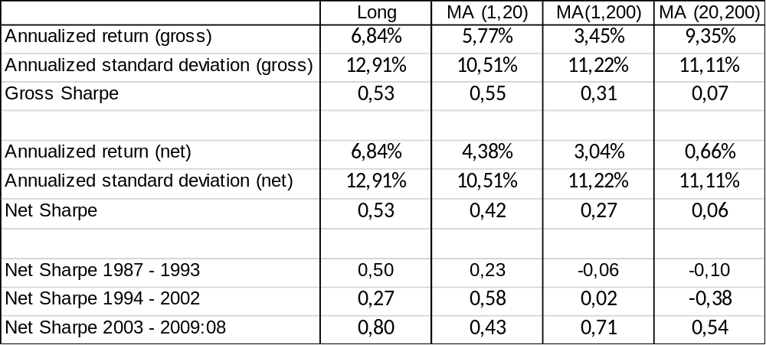
Notes: This research is done for 1987 until 2009:08, where the sub periods are important figures to take into account, because they let us see how the trend is doing over time. The commodities portfolio is an equally weighted portfolio of the 10 individual chosen commodities. To calculate net results, transaction costs of 5 basis points per turnover are taken into account for the MA rules. Turnover is the number of switches from long to short (counts for 1 turnover) or short to long per year.

With this overview it is clearly seen that the buy-and-hold strategy is doing better than all three MA rules on the whole data range with a net Sharpe of 0,53. Only the fast MA rule can keep up with a net Sharpe of 0,42. For analyzing trend over time, we will have to look at the figures in the final three rows of Table 3.15. In the first sub period (1987-1993), the always long and fast strategy show positive results, whilst the two slower MA rules have a negative net Sharpe. In the second sub period (1994-2002) this changes to a better Sharpe of 0,58 for the fast MA rule, but the buy-and-hold is dropping to 0,27. The medium is staying at almost the same level and the slow MA rule s even doing worse with Sharpe of -0,38. The final third sub period (2003-2009:08) is lovely for trend followers, with all strategies giving positive Sharpe ratios with the lowest at 0,43 and the highest at 0,80. So how well is trend trading over time for commodities? The fast rule is giving positive results over each sub period, but in the last sub period (2003-2009:08) all trend strategies are doing well. The buy-and-hold strategy has the best results in comparison with the trend MA rules. Only the fast MA rule in the second sub period (1994-2002) has a better statistic for the net Sharpe. To analyze the performance even further also for this asset class there are cumulative return graphs plotted in Graph 3.9 until Graph 3.12.

Graph 3.9 Cumulative performance of the always long strategy.
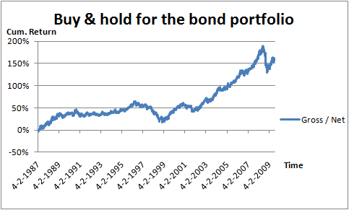
Notes: This research is done for 1987 until 2009:08, where the strategy is to buy and hold the position. Gross and net only differ 2,5 basis points from the start when the position is bought, because there are no turnovers.

Cumulative return for the buy-and-hold strategy, is giving a nice upwards line in Graph 3.9 in the period 1999 until 2008. This good period was already seen in the price index graphs of the commodities in the data section, where only Lean Hogs was an exception.

Graph 3.10 Cumulative performance of the fast rule.
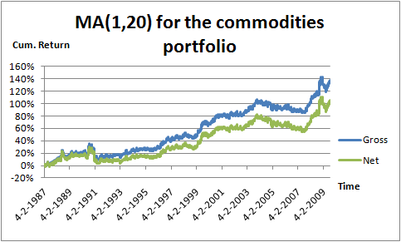
Notes: This research is done for 1987 until 2009:08, where the strategy is to buy if the current cumulative return is higher than the average of the previous 20 days. To calculate net results, transaction costs of 5 basis points (Round-trip, so from long to short) are taken into account. Turnover is the number of switches from long to short (counts for 1 turnover) or short to long per year.

The fast rule is showing us a different graph, where profit is rising from 1993 until 2004. Followed by a non profitable period until approximately half way 2007, and thereafter rising until 2009. Where it seems to be that the credit crises is causing a dip at end of the data range.

Graph 3.11 Cumulative performance of the medium rule
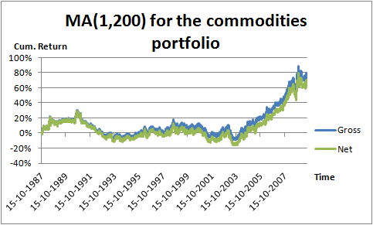
Notes: This research is done for 1987 until 2009:08, where the strategy is to buy if the current cumulative return is higher than the average of the previous 20 days. To calculate net results, transaction costs of 5 basis points (Round-trip, so from long to short) are taken into account. Turnover is the number of switches from long to short (counts for 1 turnover) or short to long per year.

The medium MA rule is showing again the positive period from 2003 till 2009. Other years in the data range are not trend friendly. The difference between net and gross returns is much fast than with the fast rule due to the lower turnover.

Graph 3.12 Cumulative performance of the slow rule
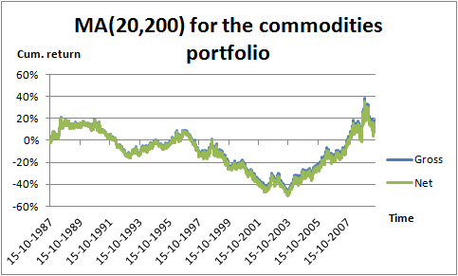
Notes: This research is done for 1987 until 2009:08, where the strategy is to buy if the current cumulative return is higher than the average of the previous 20 days. To calculate net results, transaction costs of 5 basis points (Round-trip, so from long to short) are taken into account. Turnover is the number of switches from long to short (counts for 1 turnover) or short to long per year.

The slow rule is showing horrendous results from the start of the data range until 2003. Although the extremely good period 2003-2009 is bringing cumulative return back to a positive figure.

Before discussing the overall results for the commodity portfolio and comparing the results with the existing literature. It is also nice to look at the actual S&P GSCI index, consequentially this index must have a comparable graph over the analyzed time period, because all the chosen commodities are taken out of this commodity index as mentioned before in the data section. Graph 3.13 will show the commodity index price which is compiled from the International Monetary Fund site.

Graph 3.13 Performance of commodity monthly price index
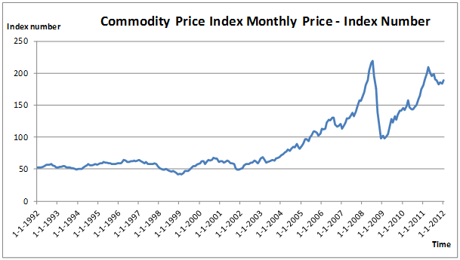
Notes: This graph is compiled for 1992 until 2012:02. Where the monthly commodity price index number is the unit on the vertical axis with 2005 = 100 including both fuel and non-fuel commodities. Source: International Monetary Fund.

The commodity price index, has rather the same pattern as the actual S&P GSCI chart, which can be compiled on www.barchart.com. Although on “barchart” there is not the possibility to download or copy any data. Therefore the alternative graph from the International Monetary Fund is chosen, it will give the same conclusions, through the similar pattern. The S&P GSCI is most comparable with the medium MA rule cumulative return and buy-and-hold cumulative return graphs. Being stable around 50 until 2003, thereafter rising until 2008. Followed by a sharp decrease until 2009. The last years of the graphs 2009-2012:02 cannot be compared, because this range does not cover the investigated period. The S&P GSCI index confirms that the chosen commodities are a good representation of the most important commodities in the S&P GSCI index. The increase of the index in the profitable period can also have the cause of being amplified by the increase of amount of derivatives in this period as seen in Graph 3.14.

Graph 3.14 Derivatives activity
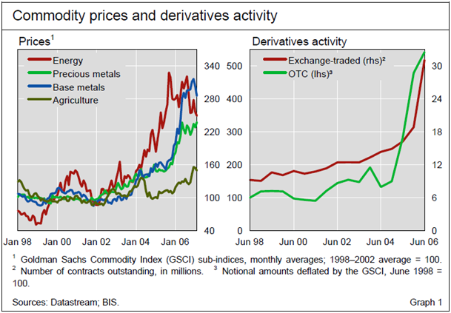
Notes: This graph is taken from the Domanski and Heath (2007) article: “Financial investors and commodity markets.” Presenting the increase in derivative activities in comparison with the S&P GSCI sub-indices.
Overall the most effective trend trading rule is the fast MA rule for commodities over time, although trend trading is a profitable strategy for trend traders in the last sub period 2003-2009:08 no matter which quickness of setting is chosen. Although the dumb always long strategy is also a good strategy to follow when looking at the results, so maybe trend trading in commodities can be seen as an overestimated advantage on non trend traders.
In comparison with the literature the following conclusions can be discussed. Park and Irwin (2005) replicated the Lukac, Brorsen and Irwin (1988) study and extended the data range. They found that the future markets profits gradually declined over time, the profits during the 1978–1984 period are no longer available in 1985–2003 period. In this study the 1978-1984 cannot be compared, because of the lack of good data. Allthough the 1985-2003 results can be confirmed for the period 1987-2003, where trend trading is not a winning strategy. On the contrary the extended period 2003-2009:08 shows us that trend trading is profitable (except of the dip after 2008). AMH seems not have taken an effect on the commodity market, because in the most recent period there is a profit. Although also other explanations than a trendful market could be seen as a source of the profitable trend rules in this period. Because the price index of commodities in this good economic period is mainly increasing the buy-and-hold strategy also give profitable results. The Sharpe of the buy-and-hold is even better than all the MA rules resulting in a net Sharpe of 0,80. The presence of financial investors in the commodity market could also have amplified the index of commodities. So the MA strategies in the commodity markets are working well. The assumption that AMH has taken an effect after the trend trading strategy has been published is doubtful, because of the rather minimum on literature in this asset class. Whether trend is still a friend in this asset class in the extended period can be answered positively.
Miffre and Rallis (2006), also studied the commodity market, but these results cannot be compared in this study. While the method Miffre and Rallis used is not comparable with this study, they used the momentum strategy [wat bedoel je hiermee? Trend en momentum worden vaak door elkaar gebruikt. Bedoel je dat Miffre en Rallis de commodities onderling vergelijken en dan een top en bottom vormen? Want bv een 6-maands momentum is vergelijkbaar met je langzamere MA regels]. The momentum strategy results, which in this study is only investigated for the equity market, will be presented in the following Section 3.4.

3.4 Equity market

Table 3.2 Statistics for the equity momentum strategy
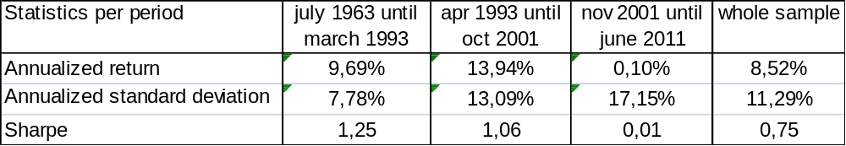
Notes:

With the sub periods in the table above we are taking into account the publication of Jegadeesh and Titman (1993) and (2001). First of all momentum returns are very good in the first and second sub period but horrendous in the third. Confirming the hypothesis of AMH; AMH would be expected to be effective after the first publication, but as we look at the statistics, the information ratio is declining but not as much as would be expected. After the second publication Sharpe is falling dramatically, what indicates that AMH could be effective. I mention could be, because when we look at the plot of the cumulated starting data, we see that the fall in return is in the credit crises. So maybe not only AMH is the cause, but also crises could affect the momentum strategy? When looking at the cumulated UMD data this could be a simple other explanation. In the following table I will present only the statistics for crises periods, so that these can be analyzed.

Table 3.3 Momentum in crises
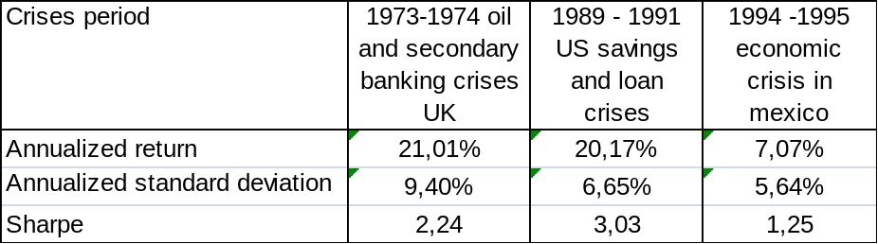

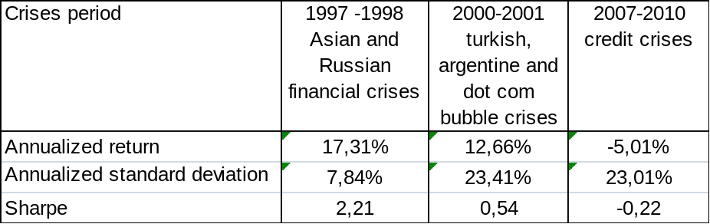
Notes:

Analyzing the momentum strategy in crises situations, the Sharp ratio indicates that the momentum strategy worked well in past crises situations. So it looks like there is more reason to think AMH is effective than that the crises situation is causing that the rule does not work anymore. Certainly it is still strange that after the first publication of Jegadeesh and Titmann the market did not absorb all information, when we say that AMH is effective after the 2001 publication. Overall AMH is a learning process and the quickness of the market picking up and learning from information is not discussed in this theory.

Conclusions

Belangrijkste resultaten
Currencies
Bonds
Commodities
Equity

AMH conclusie
Currencies
Bonds
Commodities
Equity

Benadruk je bijdrage. Bv nieuwere data tov anderen. Waardoor bv de conclusie is verandert. Eerste zo'n uitgebreide studie op AMH gebied.

References

Barr, D. and Priestley, R. 2003. “Expected returns, risk and the integration of international bond markets”, Department of Financial Economics, Norwegian School of Management, Elias Smith vei 15, N-1301, Sandvika, Norway

Domanski, D. and Heath, A. 2007. “Financial investors and commodity markets” BIS Quarterly review, March 2007.

Dueker, M., and Neely,C.J. 2007. “Can Markov switching models predict excess foreign exchange returns?” Journal of Banking and Finance, 31 (2007), 279-296.

Fama, E., 1970. “Efficient Capital Markets: A review of theory and empirical work”, journal of finance 25, 383-417.

Fama, K. and French, K. 2011 “Data for the equity market”, http://mba.tuck.dartmouth.edu/pages/faculty/ken.french/data_library.html#Research

Group of Thirty, 1985 “The foreign exchange market in the 1980’s”. In report of the foreign exchange market study group, New York, NY: Group of Thirty (1985).

Ilmanen, Antti, 1995. “Time-varying expected returns in international bond markets, journal of finance, 50, 481-506.

Jegadeesh, N. and Titman, S. 1993. “Returns to Buying Winners and Selling Losers: Implications for Stock Market Efficiency, journal of finance, 48, 65-91.

Jegadeesh, N. and Titman, S. 2001. “Momentum” University of Texas and the NBER.

Jegadeesh, N. and Titman, S. 2001. “Profitability of Momentum Strategies: An evaluation of alternative explanations.” Journal of Finance, Vol 2.

Kolb, R. 1997. “Understanding futures markets” Fifth edition, Blackwell Publishers, Oxford.

Lam, Fung and Yu 2008. “Comparing forecast performance of exchange rate models” Working paper series, www. scholar.google.com.

Lesmond, D. Schill, M., Zhou, C. 2004 “The illusionary nature of momentm profits”, Journal of Financial Economics 71, 349 – 380.

Levich, Thomas, 1993. “The significance of technical trading rule profits in the foreign exchange market: a bootstrap approach” Journal of International Money and Finance, 12, 451-474.

Lo, A., 1999. “The three P’s of Total Risk Management”, Financial analysts Journal, 55, 87-129.

Lo, Andrew, 2004. “The Adaptive Market Hypothesis; market efficiency from an evolutionary perspective”

Locke, P. Venkatesh, P. 1997. “Futures market transaction costs”, Journal of Futures Markets, Volume 17, Issue 2, pages 229 – 245, April 1997.

Lukac, L., Brorsen, B. and Irwin S. 1998. “A test of futures market disequilibrium using twelve different technical trading systems ”, Applied Economics, 20:623 - 639

Luo, G., 1995. “Evolution and Market Competition”, Journal of Economic Theory, 67, 223-250.

Luo, G., 1998. “Market Efficiency and Natural Selection in a Commodity Futures Market”, Review of Financial Studies, 11, 647-674.

Luo, G., 2001. “Natural Selection and Market Efficiency in a Futures Market with Random Shocks”, Journal of Futures Markets.

Luo, G., 2003. “Evolution, Efficiency and Noise Traders in a one-sided auction market”, Journal of Financial Markets, 6, 163-197.

Miffre, J. and Rallis, G., 2006. “Momentum in Commodity Futures Markets” Journal of Banking & Finance, 31, 1863-1886.

Neely, Weller, Dittmar, 1997. “Is Technical Analysis in the Foreign Exchange Market Profitable? A Genetic Programming Approach.” Journal of Financial and Quantitative Analysis, 32, 405-426.

Neely, Weller, Ulrich, 2006. “The Adaptive Markets Hypothesis: Evidence from the foreign exchange market”.

Okunev, J. and White, D, 2003. “Do momentum strategies still work in foreign currency markets?” Journal of Financial and Quantitative Analysis, 38, 425-447.

Park, C. and Irwin, S. 2005. “The Profitability of technical trading rules in US Futures Markets: A data snooping free test, AgMAS Project Research Report 2005-04

Roberts, H., 1967. “Statistical versus Clinical Prediction of the Stock Market”, unpublished manuscript, Center for Research in Security Prices, University of Chicago, May.

Rouwenhorst, K., 1998. “International momentum strategies”, Journal of Finance 53, pp 267-284.
Sweeney, R.J., 1986. “Beating the foreign exchange market” Journal of Finance, 41, 163-182.

Taylor, M. P. and Allen, H. 1992. “The use of technical analysis in the foreign exchange market” Journal of international money and finance, 11(3), pp. 304-314.

Basis points: these numbers of transaction costs are provided by Robeco.

