Master Thesis| Blaz Mateljic 3 February 2012
Can cultural differences divide Europe into different regions and what implications would this have on consumers sentiment within the regions?

MSc.Thesis Marketing

Supervisor: Dr. Bas Donkers

Department of Business Economics
Erasmus School of Economics
Erasmus University Rotterdam

Executive Summary

Whether Europe actually is forms one single market or is divided into segments is a question that has kept many researchers in marketing related fields intrigued. The purpose of this study is to get a better understanding and insight in the role that culture plays in the geographical segmentation of the countries in Europe. Another aim is to find out what implications these segments would have on the perceived economic sentiment of the consumers within these segments.

Data on Culture and Consumer Sentiment has been gathered for 23 European countries over the last 15 years (1995- 2011). The four dimensional framework of Hofstede (1987) has been used for the measurement of culture and the Consumer Confidence Indicator was used for the measurement of Sentiment. For the segmentation of the countries the Hierarchical and K-means cluster analysis where applied .The Multiple regression analysis was used to test the significance of the cluster analysis output. In Multiple regression analysis also data on GDP growth and unemployment rate were added to enhance the strength and reliability of the model.

The results of the hierarchical cluster analysis revealed that, based upon Hofstedes cultural dimensions, Europe could be segmented into three regions. The K-means cluster analysis revealed which countries shared a similar culture and therefore belonged to the same cluster/ region.
The first region consisted mostly out of Anglo-Saxion and Germanic countries, respectively; Austria, Germany, Ireland, Italy, Luxembourg, United Kingdom and Hungary. The second region is dominated by the Scandinavian countries, respectively; Denmark, Finland, the Netherlands, Norway and Sweden. And the third region is mixed but dominated by Iberian and Mediterranean countries; Belgium, Bulgaria, Czech Republic, France, Greece, Malta, Poland, Portugal, Romania and Spain.
The Multiple Regression Analysis pointed out that consumers sentiment differs among these three cultural different regions. Consumers in the Scandinavian region are most optimistic, simultaneously followed by the Anglo-Saxion / Germanic and the Iberian/Mediterranean region. The three regions also react differently upon – and have different characteristics with respect to GDP growth and the Unemployment rate. The Scandinavian region has the lowest unemployment rate, but a rise in this rate has the highest negative effect on the consumer sentiment of all three regions. The opposite is true for the Iberian/ Mediterranean regions that has the highest unemployment rate over the last 15 years. A rise in this rate has a relatively low negative impact, if compared to the other regions, on consumers sentiment.
The result of this research shows that, if Europe is segmented on Hofstede’s Cultural Framework, three significant regions emerge. These three regions significantly differ from one another with respect to their: Culture, their consumer confidence levels and how they value and deal with Unemployment. Their response to welfare growth (GDP) is positive and this effect does not, unlike the negative effect of Unemployment, differ among the three cultural clusters.

Key words: Culture, Regions, Europe, Consumer Confidence, Unemployment, GDP-growth, Sentiment

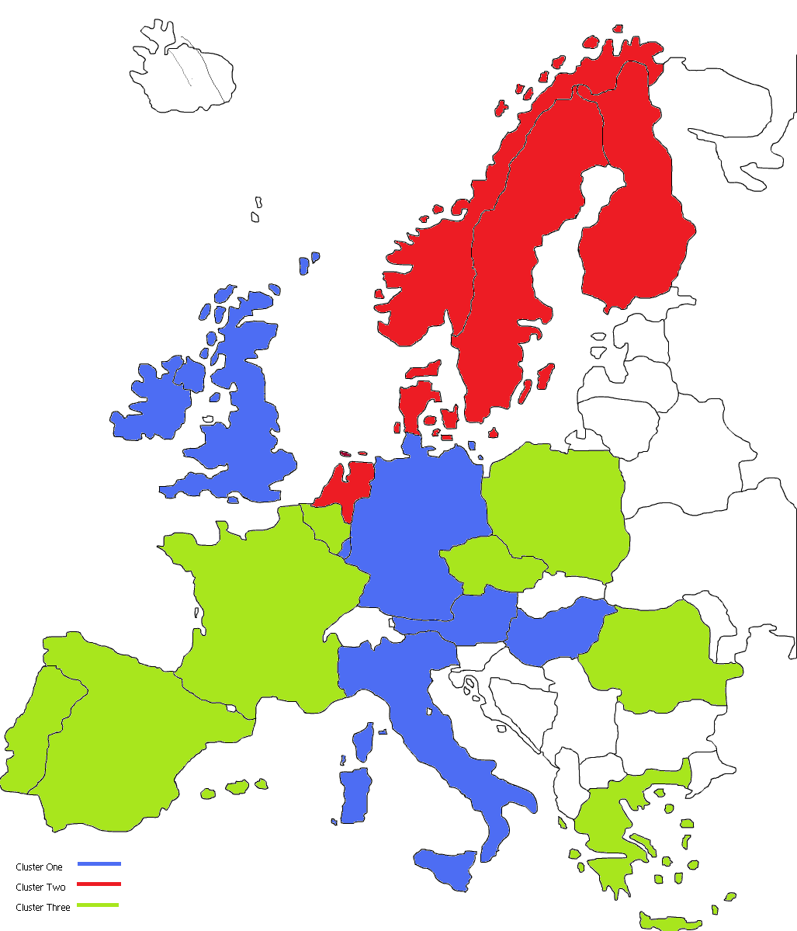

Table of Contents

Executive Summary 3
1. Introduction 3
Research Question 3
2. Literature Review 3
2.1 The economy and Animal spirits. 3
2.2 The meaning of “Confidence” 3
2.3 The consumer confidence indicator (CCI) 3
2.3.1 Development of the CCI measure 3
2.3.2 The Consumer Confidence Index 3
2.3.3 Causes for change in Consumer confidence. 3
2.3.3 Economic behavior & Region 3
2.4 Culture 3
2.4.1 The meaning of Culture 3
2.4.2 Conceptualizing Culture 3
2.4.3 Cultural dimensions of Hofstede. 3
2.4.4 Clustering European Countries. 3
3. Empirical analysis 3
3.1 Sample selection 3
3.2 Variable description 3
3.2.1 Dependent variable 3
3.2.1 Independent variable 3
3.3 Methodology and Statistical analysis of data 3
3.3.1 Cluster analysis 3
3.3.2 Hierarchical cluster Methodology 3
3.3.3 Non-hierarchical cluster method: K-means 3
3.3.4 Multiple regression analysis 3
3.3.5 ANCOVA- analysis 3
3.4 Results 3
3.4.1 Hierarchical cluster analysis 3
3.4.2 Determining the ideal number of clusters 3
3.4.3 Non- Hierarchical cluster analysis K-means 3
3.4.4 Cultural Characteristics of the clusters 3
3.4.5 Regression Model 3
3.4.6 Multiple Regression Model & ANCOVA 3
3.4.7 Summary of the results 3
4. Conclusion 3
4.1 limitations 3
4.2 Directions for further research 3
References 3
Appendices 3
Appendix A:Histogram and Scatter plots for normality, hetroscedasticity and Non-linearity test. 3
Appendix B: Hofstedes 4 dimensional Framework scores per country per dimension. 3
Appendix C: Clustering steps. 3
Appendix D: Distance per country from center of the cluster 3
Appendix D: Cultural characteristic per Cluster 3
Appendix E: Multiple Regression Coefficients Models A,B,C,D, & E 3
Appendix F: ANCOVA output 3

List of Tables and figures

Figures:
Figure one: Spending Framework Katona. page 13
Figure two: Quantity of cluster determination. page 36
Figure three: Quarterly GDP growth per cluster 1995 – 2011. page 38
Figure four A: Unemployment rate per cluster 1995-2011 page 39
Figure four B: Centralized Unemployment rate per cluster 1995-2011 page 39
Figure five: Consumer confidence development per cluster 1995-2011 page 40
Figure six: Cluster characteristics and optimism ranking page 46

Tables:
Table one: Agglomeration schedule page 35
Table two: ANCOVA Summary output page 41
Table three: Regression analysis models A,B &C page 42
Table three: Multiple regression analysis model D &E page 43

Introduction

The economy is the thing that some way or another makes het world turn around. It is one of the reasons why people wake up early in the morning and go to work. And during the history there have been a lot of people thinking about this, one of these economic thinkers was Adam Smith. He advocated open economies and free capitalism because he thought that such a system would create and hold its own supply and demand equilibrium, making the system perfect and stable. He even stated that the interference and role of the government should be as little as possible in this economy. His main argument for this lies in the fact that governments could intervene and disturb the “open free market capitalism”, by doing so it would also destroy it’s stableness which would lead to major economic depressions.
This reasoning is derived from the assumption that people act rational and the basis of the idea lies in a thought experiment which asks: What do free, perfect markets imply? The answer : If people rationally pursue their own economics interests in such markets, the will exhaust all mutually beneficial opportunities to produce goods and exchange with one another. Such exhaustion of opportunities of opportunities for mutually beneficial trade results in full employment. This is true because a worker willing to work is going to find work because a employer could hire this person according to Smith at an wage he requires in order to still have some spare extra output for a larger profit. But there will be unemployment because some worker are going to insist on wages that are higher than what they add to the producing making these wages unreasonable. Adam Smith calls this kind of unemployment voluntary. The theory of employment is important because it determines the spending of consumers, if a person is unemployed then this person is not adding anything to the production. Moreover this person also doesn’t earn money which he could spend. According to Akkerlof and Shiller this employment theory is remarkably successful. It explains for example why most people who seek work are employed most of the time, even in the troughs of severe depressions. On the other hand it does not explain why, for example, 25% of the U.S. labor force as unemployed in 1933 at the height of the great depression, but it does explain why 75% of the workers who sought jobs were employed. They were engaging in the mutually beneficial production and trade prediction as predicted by Adam Smith. Akkerlof and Keller state that they think that they believe that Smith was right regarding why so many people are employed. They also believe that Smith, with some qualifications, was right about the benefits of a capitalistic free market economy. But there is one big shortcoming of this theory – it simply fails to describe the big variations of the economy. These big variations are also known as the rollercoaster rides that the economy sometimes tends to make. Furthermore there is also some critics about Smiths view on the government. Peter Dougherty (2002) explains in his book ‘who is afraid of Adam Smith” why Smiths view with respect to the government is to condensed. He says that Smiths democratic capitalism is the same to society as the software that makes our computers run. This software runs according to it is programmed to run. That means that these programs are only as good as the instructions that drive the respective systems. So Smiths view that there is no need for governmental intervention is also unwarranted.
If I recap from Smiths thought experiment we see that this experiment correctly takes into account that people rationally pursue their economic interests. But the experiment fails to take into account the extent to which this so called ‘rational persuasion’ is influenced by non- economic motivations. This is very important because non-economic motivations are irrational and misleading, which makes the assumption that these people rationally pursue their economic interest incorrect. The most important thing here is Smith didn’t incorporate the phenomenon of animal spirits in his experiment and theory.

Animal spirits is a well known understanding in economics. It’s called animal spirits because implies that the consumers don’t always show rational choices and don’t always make rational decisions that increase their utility. Optimism and Pessimism could, according to Smith be the two most important drivers for aggregate economic activity. Optimism has a positive effect on business cycles whereas the opposite is true for pessimism. These two understandings can, because of Katona’s work, be measured by Consumer Sentiment Indexes. These indexes capture economic sentiment (i.e. optimism and pessimism) by measuring the change in confidence that consumers have towards the economy. An interesting link here, is that the perceived confidence that consumers have, to a large extend, is determined by their direct environment (Duch, Palme & Andersson, 2000). According to Henrich (1998), consumers economic choice/decision - making and economic behavior varies across the regions. He states that the main reason for this can be derived from the cultural differences that express themselves by socially transmitted rules about how to behave in not only social but also economic circumstances. The socially transmitted rules go, according to Hofstede (1980), beyond solely economic behavior and influence an individual’s behavior in general. The culture is deeply embedded in the individuals identity and is, even over time, hard to change. With respect to regional definition, Hofstede states that culture is rather bound to a region than to country borders. This implies that cultural borders might differ from country borders in an atlas.
Because culture is regionally bound and hard to change over time it likely that different countries can have homogenous cultural identities. Because the European Union has a deep-rooted historical identities, I expect to find different homogenous cultural clusters in this Union. I furthermore expect that the economic sentiment (i.e. optimism and pessimism) differs among these segments.

Research Question:

The aim of this research is to test whether there is a link between identity and behavior within Europe. Identity is going to be measured by Hofstede’s cultural Framework and consumer behavior by the consumer confidence indicator. Both variables are discussed in the previous chapter.
The question that is going to be answered in the upcoming part of this research is as follow:
“ Can cultural differences divide Europe in different segments and what implications would this segmentation hold for the consumers economic sentiment ? ”
Sub question:
Should stakeholders apply a Pan-region or a Pan-European approach in order to maximize their output?
Can Europe Culturally be divided into clusters, and if so, how does this relate to the economic behavior of the countries.

This research is divided into 4 chapters. I will start with elaborate explanation of Consumer Confidence & Culture. Thereafter the empirical analysis will be discussed which includes the sample and variable selection, the used methodology and Statistical analysis of the data followed by the results. The results are chronologically ordered and start with the output of the cultural clustering analysis and end with the output of the MRA, ANCOVA and a summary of the results. At the end the conclusions, limitations and directions for further research will be presented.

2. Literature Review
This chapter holds the theoretical background information. First I will briefly discuss different views on how the economy works and what role sentiment plays in this economy. Thereafter I will explain the concept and history of consumer confidence and the Consumer Confidence Index where influential variables like, political attitudes and GDP etc.. will elaborately be discussed. The last part of this chapter will be dedicated to the explanation and effect of “culture” on consumer behavior and CCI and a conceptualization of the “culture”.

2.1 The economy and Animal spirits.
Animal spirits is the description that John Maynard Keynes gave to irrationality, uncertainty, confidence et.. He wrote the following example where he stressed the fundamental role of animal spirits in businessmen calculations:

“ Our basis of knowledge for estimating the yield ten years hence for a railway, a copper min, a textile factory, the goodwill of a patent medicine, an Atlantic liner, a building the City of London amounts to little and sometimes to nothing. If people are so uncertain, how are decisions made? They “can be taken as a result of animal spirits.” They are the result of “spontaneous urge to action.” They are not, as rational economic theory would dictate, “the outcome of a weighted average quantitative benefits multiplied by quantitative probabilities.”(Keynes, 1936).

Animal spirits in human behavior which also could be described as consumer confidence. The term animal spirits originated in ancient times and is the translation of ‘spiritus animalis’ which the philosopher George Santayana (1923) defined as “a pure and absolute spirit, an imperceptible cognitive energy, whose essence is intuition. Nowadays the term obtained an economic meaning and refers to a restless and inconsistent element in the economy where it has an peculiar relationship with ambiguity or uncertainty (Akerloff & Shiller, 2009). Sometimes, when things go bad we are paralyzed by it and yet at other times it refreshes and energizes us to overcome our fears and indecisions. Akerloff and Shiller make this phenomenon more clear by comparing it with ordinary families, who sometimes cohere and argue at other times, are happy sometimes and depressed at other times, are sometimes successful an at other times in disarray. They state that the economy behaves similar, it has ups and downs. One of the last downs was the financial and housing crisis of 2009. The reason and explanations of this crisis differ, but blaming changing patterns in human thoughts for this crisis goes against standard economic thinking. But strangely enough this crisis bears witness to the role of such changes in thinking. It was caused precisely by our changing confidence, temptations, envy, resentment, and illusions and especially by changing stories about the nature of the economy.

2.2 The meaning of “Confidence”
Interesting point is that confidence is so vague that it is interpreted differently. If we go back to the Great Depression which happened in 1902, the stock market collapsed and the media was telling the people that the economy is going into an recession and that it was necessary to restore the confidence. Franklin Roosevelt analyzed this event and concluded in his first inaugural address in 1933 that the only thing there is to fear is fear itself and that this fear is directly linked to confidence because every business downturn, since the founding of the US, was proclaimed as a result in loss of confidence. In his statement he linked confidence as one of the most important factors that determine the state of the economy.

Roosevelt blamed fear and loss in confidence to have caused the depression and he used these terms in the same way as Keynes did by describing confidence as animal spirits. Interesting enough is to see that economist have a somewhat different interpretation of the meaning of confidence. They tend tot described it as something which has two or more equilibriums (cooper and John, 1988). For example, if no one rebuilds his house after the big inundation of 1953 (in the Netherlands), then it is very likely that no one else wants to because no one wants to life in an isolated place without neighbors and stores etc.. But on the other side, if many people rebuild than it is very likely that others are going to do the same thing. This means that at some point there is an equilibrium where people have confidence and are going to rebuild their houses, which is also true for the other way around where there is no confidence. In this view confidence is something that actually is an prediction, in this case whether or not to rebuild. A positive prediction is one that projects the future to be rosy and a negative predictions is one that predicts the future to be dark.
But if I look in a dictionary and look for the definition of the word confidence, ten I see that the word has an more extensive meaning than just confidence. Then dictionary says that confidences means ‘having trust or believing in someone or something’ (vandale, 2010). Interesting here is to know that confidence is derived from the latin word ‘fido’ which literary means – trust -.
Akkerlof and Shiller describe that trust and belief are just partly incorporated in the way economist view and interpret the word confidence. The economists view suggest that confidence is something rationale. That suggestion is based upon the assumption that people use information at hand and make rational predictions; after the rational prediction is made the same people make rational decisions and base them upon the rational predictions. Banabou (1993) disagrees strongly with the rational part of the economists view. To Banabou the notion of confidence corresponds to a psychological state in which people do not sufficiently utilize the information that is available to them. They are too trusting, he calls this – a state of mind that lead to overestimation. Akkerlof and Shiller agree with banabou’s and party with the view of economists. According to them people make decisions and these decisions can be made confidently. But the problem is that there is more notion to confidence, because the very meaning of ‘trust’ goes beyond the rational. This means that trust makes people discard or discount certain information. One may have a lot of information but the person is not going to process this available information rationally. And even if this person processes this information rationally, he may not act on it rationally. And this is because his actions are based on what he beliefs to be true.

2.3 The consumer confidence indicator (CCI)

2.3.1 Development of the CCI measure
Consumer confidence is a concept from the last decade and the pioneer in the development of this concept is George Katona. He was a psychologist trained to work on learning and memory related issues (i.e. gestalt psychology). His interest in economics was triggered when he saw the hyperinflation that hit Germany in the 1920’s. This interest brought him in 1933 to the United states where he eventually found himself employed at the Survey Research Center at the University of Michigan. The economic situation in the United States was, thanks to the Great Depression and World War II, in a very turbulent, uncertain and unpredictable situation (Duhigg, 2008). The leading economist from those times predicted high unemployment and rising inflation. Interesting enough unemployment didn’t rise to the predicted levels and instead of deflation the US suffered from inflation (Curtin, 2000). One of the main factors of this outcome is the unforeseen consumer demand. The economic models assumed that consumers had perfect information and reacted rationally upon that, therefore they neglected and didn’t include data that hold information with respect to the consumers thoughts about the economy (Katona, 1975; Lewin 1996). The assumption that there was an equilibrium between an individual’s economic preferences and the way this individual makes decisions to maximize his utility or preferences turned out, from psychological research, unrealistic (bonabou, 1993; Rabin, 1997). Therefore Katona argued for an approach to incorporate psychological aspects from consumers behavior in the economic models. According to Katona (1975) the traditional economic models only used changes in household income to predict future consumer spending. Nevertheless this approach was according to Katona (1975) a misunderstanding; he stated that there was a difference between the ability to spend (income component) and the willingness to spend (psychological component). One of the main reasons that consumer psychology wasn’t incorporated in the economic models was simply caused due to a lack of a good and reliable measure. Katona and his co-workers therefore developed a concept which could measure consumers expectations: “ the Index of Consumer Sentiment (ICS)”. This concept doesn’t measure absolute consumer confidence but the change in consumer confidence. This is important because the “change in confidence” directly reflects to change in economic behavior with respect to spending, buying, saving, investing etc.. (Curtin, 1982). To get a better understanding of Katona’s view it is good to describe the main spending-drivers in more detail, I will use Katona’s framework to explain . Willingness to spend is a factor that doesn’t stay stable over time and is influenced by political and social affairs (which I will explain later in more detail). Ability to buy reflects the consumers financial means and limits that can keep him from spending. For instance; a consumer could have enough financial means to purchase the car this person desires but he or she could postpone this purchase due to uncertainty about the economy and the fear of unemployment. And it is especially these big purchase like cars, motorcycles etc.. that can significantly influence the 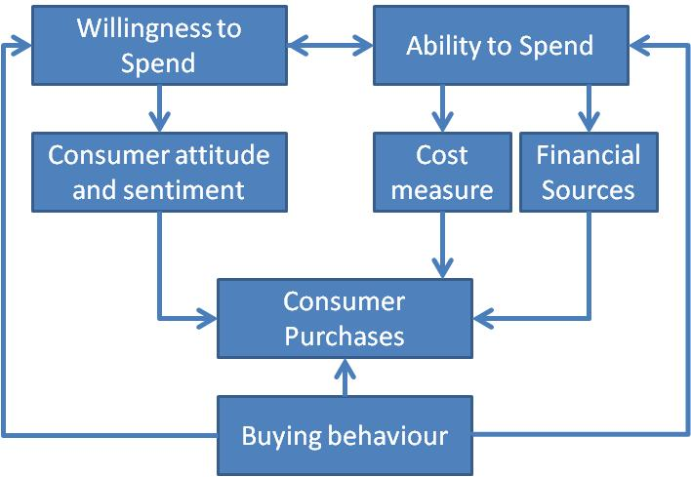economy.

Figure one: Spending Framework Katona (Leone and Gasken’s, 1995)

According to Katona (1975) these big expenditures were durable goods that had a discretionary character, which holds the following:
- The consumer doesn’t have a direct need at any time to purchase the good (the opposite is true for food for instance)
- The purchase is not habit driven.
- The purchase is usually made after careful consideration and discussion within the household.
Changes in these spending can significantly influence the economy; keeping track of this variable and being able to predict it is valuable information among interested parties like politicians and policymakers (Khoon, Lek Goh, 2003).

2.3.2 The Consumer Confidence Index
Katona’s Index of Consumer Confidence (ICS) started in 1955 and was measured quarterly until 1978 when it changed and the index was measured on a monthly base. In the meantime behavioral economics gained more interest and other indexes where developed whereof the most important one was the Consumer Confidence Index (CCI) from the Conference Board (Curtin, 1982). Because the consumers of the European Union are the research topic solely the CCI is going to be used from this point on.
The European Commission (EC) is responsible for the measurement of the CCI within the European Union (EU). From 1987 each month country based data is collected and announced. This data is the outcome of survey´s that measures the consumers feelings towards several economic factors. The consumers are asked, by an interviewer, to evaluate their own employment chances, financial situation, expenditure intentions and their general feelings towards the economy. Because the CCI is measured on the same way within the EU it is possible to compare outcomes of the CCI and see how countries behave with respect to one another.
The confidence indicator still remains, due it´s subjective underlying, a complex concept to explain and interpret. Nevertheless a lot of research has been performed with respect to this confidence concept. The outcomes of those researches are different and I have noticed that there are two main views. One stream argues that consumer confidence is narrowly intervened with the general economic conditions and actually is subordinated to it. The unemployment rate, rise of GDP, PPP etc.. are indicators that, according to Adams (1965) reflect the economic situation of a country, if those indicators are performing well than the CCI will show the same. The other view finds it roots in behavior economics and is described by Katona (1951,1968,1975)as: as a concept which embodies the consumers evaluation of the personal financial situation and their evaluation of the economy in general. If we think further then this explanation is very interesting because it holds some implications with regard to consumers spending. For instance, If an consumers feels confident about his personal situation and the state of the current economy than it should be obvious and very likely that this person is going to spend his money. These spendings are important as they stimulate production and employment. This effect has been researched and there has been found empirical evidence that consumer confidence has predictive power with regard to this example.
Furthermore it is believe that the CCI helps predicting the future economic state of countries because it improves the forecasting of important underlying macro-economical variables and other indicators like, consumer, -spending, -consumption, production and employment (Garner, 1981; Carroll, Fuhrer and Wilcox, 1994; Kumar, Leone and Gaskens, 1995; Bram and Ludvigson, 1998). The CCI has also been found an leading indicator of consumers’ willingness to buy and expenditures on durables (Burch & Gordon). Another remarkable point is that all post war recessions (since 1953) were preceded by a fall in consumer confidence, and all major falls in consumer confidence were followed by a recession. This means that consumers are able to correctly forecast output falls, or declines in consumer sentiment are inducing declines in output (Matsusaka & Sbordone, 1995) Next to the predictive power, the consumer confidence indicator is also found a useful indicator to measure the state of households financial situation, households expectations of the economy and about their ability to consume goods and services (lemmon and Portniagiuna, 2006). And another interesting point, which adds reliability to the CCI, is that the basic information for the index is gathered through surveys without controlling for macroeconomic data or stock-prices (Leger and Leone, 2008). But nevertheless the index seems to incorporate this information, the CCI shows that consumers respond on changes in GDP, unemployment, interstates, inflation and other variables (Lemmon and Portniguina, 2006). The Consumer Confidence Indicator of the Conference board and the Consumer sentiment Index of the University of Michigan are the most used confidence indicators in the world (Dion, 2006). Dion (2006) also states that both indicators have predictive power for consumer spending and incorporate information which can’t be captured by other economic indicators.

2.3.3 Causes for change in Consumer confidence.
Consumers perceptions about the state of economy are changing continuously and so does consumer confidence. Changes are caused by different reasons that affect consumers perceptions, these changes in confidence are found when a large group of consumers gains or looses confidence in the economy at the same time (Curtin, 2000). The fall of Lehmann Brothers in 2008 triggered the burst of the financial bubble and created the biggest financial crisis since the 1930’s. That event made consumers very pessimistic about the current en future state of the economy which made itself visible with a major drop in the CCI. Such drops in consumer confidence have happened in the past and academic researchers found four main variables that influence consumers evaluation and perception with respect to the state of the economy. Duch, Palme & Andersson(2000) identified the following variables;
- Personal financial circumstances.
- Group Membership.
- Political attitudes.
- Information.
Besides these four variables it is also believed that local (i.e. environmental) conditions are of influence to consumers evaluation of economic situation and conditions. In the upcoming part I will discuss these variables in more detail and explain the relation they have with consumer confidence.

2.3.2.1 Personal financial circumstances
Personal financial circumstances are, for consumer confidence, manifested in the consumers financial household situation. These households have a certain income which they use to overcome their expenditures to meet in their needs. The household can influence their expenditures by cutting on non-essential goods. But the household mostly doesn’t have any control with respect to employment which generates the income. According to Juster et. all (1981) rising unemployment makes employed peopled worried because it creates the awareness of the possibilities to get unemployed and loose income. In harsh and uncertain economic times where unemployment rises, a household may feel threatened by the unemployment-rate and postpone or limit their expenditures on non-essential goods (Ludvigson, 2004). For instance; During the recession of 2008 consumers limited their out-of-home-entertainment and switched to cheaper alternatives where activities with family and friends played a more central role. Instead of going out for dinner, take-away meals and homemade dinners where preferred by consumers. Therefore it is not remarkable that McDonalds and Walmart where the only two companies on the Dow Jones that were able show positive numbers (Nielsen, 2009).
Besides the fear of unemployment, inflation can also influence consumer confidence and influence a households expenditures (Delisle, 2008). The impact that inflation has on economic activities has been studied by macroeconomist over a long period of time. It is believed that consumers reaction towards inflation depends on the type of inflation. If the inflation is anticipated, than there are no harmful changes in economic behavior expected. But if the inflation is un-anticipated, which means that it wasn’t expected to happened, it will enhance the level of income uncertainty among consumers (Ball & Cecchetti, 1990). The un-anticipated inflation creates a trade-off between a households willingness to buy (consumption) and saving. According to Van Raaij and Gianotten (1990) consumer can become confident or pessimistic about future economic circumstance based upon the inflation levels. This is important because it alters a economic behavior, positive feelings leed to a higher willingness to spend than pessimistic feelings (Dion, 2006). Nevertheless Katona (1960) neglects the anticipated inflation and states that any form of rising prices in contrast to rising income will create a skeptic outlook to the future, rising uncertainty which will be accompanied by rising savings and dropping expenditures.
The way in which a consumer comes to his judgment, which determines his confidence, about the economy depends on different factors. According to Kraus (1997) the environment and provision of information play an important role in the determination of the consumers perception about the economy and the corresponding actions. He states that less informed consumers are more likely to personalize ‘bad economic’ news and directly reflect it upon their own situation and economic evaluation. Better informed consumers are more likely to realize that this bad news coverage just describes a part of general economy and doesn’t necessarily have an impact on their personal financial situation. Which is interesting if the findings of Gollinelli and Parigi (2004) are considered. They found that consumers directly react upon negative inflation news, whereas this is not the case with other indicators.
According to Ball & Cecchetti (1990) there exist a discrepancy on region level (country-level) with respect to the effect that inflation has on uncertainty and consumer confidence.

2.3.2.2 Group Membership
Because group members may have similar life experiences or have been socialized and raised in similar ways, there is very high likelihood that these persons also will have similar perception with respect to economic conditions (Katona, 1975). The formation of the groups is according to Hofstede (2004) a result of mental programming whereby the individual copies and makes environmental habits his own. This programming creates certain cultural values that are passed on and on through generations. There are for instance still values, stating from the roman empire, present in Europe as we know it today (Hofstede,1999). Furthermore Hofstede mentions that culture is bound to geographical regions and not to country-borders. Lemmens (2007) found similar results with respect to consumer confidence while studying it’s fluctuations in Europe.
According to Lemmens (2007) the short-term fluctuations in consumer confidence are country specific and not correlated across the respective countries in the EU. This means that consumer confidence, thus behavior, of consumers across Europe divers per country. On long term perspective Lemmens identified the following three different group: (I) the Scandinavian (DK, FI, and SE), (II) Mediterranean (GR, IT, PO, SP), and (III) Midwest countries (AU, BE, DE, FR, NL). The Scandinavian and Midwest group shows a certain level of homogeneity within the group. The countries in the Mediterranean group are more heterogeneous and form single-country segments.

2.3.2.3 Political attitudes
The members states of the European union all have their own political system and corresponding governments. The governments are elected by the voters (i.e. inhabitants of the country). According to Down (1957) the inhabitants vote for parties and political candidates that in essence could maximize the utility they receive from the government. The voters hold the chosen political parties responsible for the current economic conditions in their country . Therefore it is according to Curtin (2003) not remarkable that different economic conditions are associated with different political opinions and actions. Whereby unemployment and inflation are the two main variables that drive the voters motivation. Voters tend to react strong on negative changes with respect to these variables and tend to base their voting actions on short-term rather than long term economic perspectives (DeBoef & Kellstedt, 2004). The confidence that the consumers (i.e. voters) have in the economy plays a crucial role in their voting behavior. Policymakers and politicians are well aware of this and follow the CCI with great interest and accuracy for their own political future. According to Williams (1990) the current politicians in charge (i.e. incumbents) have interest to follow economic policies that are improving the current objective economic conditions and to convince the citizens that the economy is doing well under their management. By doing so they are likely to take grant for good economic outcomes and try to avoid blame for bad economic outcomes. In other words this means that the politicians are able to influence the citizens view on subjective economy and that there is an interaction between consumer confidence and politics. The one influences the other and visa versa.
These two variables can influence consumers confidence, especially events like elections influence consumer confidence. According to Hardouvales & Thomakos (2007) these elections can trigger changes in consumer confidence. When the economy isn’t performing as desired, the voters believe that change in politics can change the state of a countries economy, consumer confidence therefore rises before elections where changes in incumbents (i.e politics) are expected (Hardouvales & Thomakos, 2007). One of the reasons why politics, and changes in politics, have great impact on consumer confidence is because they control monetary and fiscal policy of a country which can influence economic conditions. The monetary policy is responsible for the demand of money, which based upon interest rates decreases/increases. The fiscal policy is responsible for the amount of money that is circulating in the economic system and therefore can affect consumers consumption levels. Politics are therefore able to influence consumers and trigger their optimism/confidence.
Also interesting to mention is Toblers (1970) “First law of geography” has been found true for political preferences: “Everything is related to everything else, but near things are more related than distant things.” According to Chen & Rodden (2009) the probability that two randomly drawn individuals show similar voting behavior is a function of the distance between their locations. In other words this means that the direct environment a person lives in influences this persons voting behavior, making the environment of influence to his behavior.

2.3.2.4 Information
The statement that the environment influences citizens voting behavior must be explain by an underlying fact which, in this case, is the type and amount of information a person receives. This information can for instance come from mass media and in that case it, according to Duch et all. (2000), depends on how well the voters are informed and how the process the information. But Katona (1975) noted that there are three different informational channels that a voter can take to get informed about the state of the economy. These routes are: (I) personal observation and experience, (II) interpersonal communication and (III) mass media. The influence that these channels have on the voter depends on the channel, it is believed that personal observation and experiences have a larger impact on voters evaluation of the economy (Katona, 1975). This makes sense if we consider Hofstedes finding that the environment where one is living in shapes this person. Personal observations and experiences are derived from the persons environment and therefore can have an impact on the persons voting behavior if compared with someone coming from another environment.

2.3.3 Economic behavior & Region
The factors influencing consumer confidence were personal financial circumstances, group membership, political attitudes and information. The decision making process to act in a certain way are central in these factors. Personal financial circumstances is believed to be a factor that can make someone very positive or negative with respect to this persons view on the economy. Interesting point is that according to Henrich (1998) people for different regions don’t perceive and act the same upon their economic circumstances. He states that economic reasoning is influenced by cultural differences that express themselves by socially transmitted rules about how to behave in certain economic circumstances which on their turn vary from region to region based upon differences in the culture and the historical development of the culture. This would mean that the culture is responsible for someone´s economic behavior, but it also implies that if culture changes, as a consequence, the economic behavior also needs to change.

Especially from a marketing point of view the economic behavior is an important variable to consider. Many research has been performed to test whether European consumers are the same or not. (i.e. whether the market is hetro, - or homogenous) (Jain and Ryans, 1994). Despite all the researches performed no consensus has been reached. There results of the different researches can be divided into two streams:

- The first stream that believes that the consumers, due to globalization effects, are becoming more alike and have the same entity and attitudes.
- The other stream rejects the view of one world consumers with one entity, and state that the consumers have different entities and should also be approached differently.

Some research claims that the European markets are integrating and creating an homogenous Euro- Consumer. (Vandermerwe and L’Huillier, 1989; Quelch and Buzzell, 1989). This view corresponds with Levits (1983) view on the emerging globalization of the world where consumer demands become more and more alike. Yip (1989) as well agrees with this point and states that the citizens of different countries are becoming more alike when it comes to their purchasing preferences. Also Ohmea (1989) is an proponent of the global consumer view, he argues that geographical borders no longer matter for financial and industrial markets and states that people are becoming more alike: Global consumers.

When looking at the European union, the choice for companies between standardization and customization remains a very difficult one (Chadraba and Czepiec, 1988). Which is strange considering all the effort that has been made to create a single entity for the European citizens. Standardization has been prompted more and more considering the cross-border information flow, increasing consumer mobility and the reinforcement of the political and economical integration of the countries (Reichel, 1989; Quelch and Buzzell, 1989). Yet the European citizens still don’t have the feeling that they have the same entity, they don’t see themselves as European citizens but rather as Spaniards, French, Italians etc.. (Caudron, 1994). Terpstra and Sarathy (1994) came with similar findings stating that “Europeans are first Italians, French, German or British, and they share a deep suspicion of other cultures; such deep-rooted distrust cannot be wished away through the pronouncements of civil servants”. Despite the effort to integrate the different countries economic and politically the entities of the citizens haven’t integrated. The main reason for this can according to Hofstede (1998) be addressed to the fact that European countries have deep-rooted historical identities that are very hard to change. Hofstede (1980) created a cultural framework that has been used by Kale (1994) to identify three significant different clusters within the European Union. Kale’s finding suggest that Europe is culturally divided and therefore doesn’t form a culturally homogenous market.

2.4 Culture
In the previous paragraph “culture” has been mentioned several times in relation to the identity and clustering of the EU. Furthermore culture has been found an important underlying variable in economic decision making (Henrich, 1998). Furthermore culture has also been found a important and significant underlying variable for the clustering of EU’s countries(kale, 1994). Because the concept of culture plays a crucial role in this research I will use the upcoming paragraph to explain the concept in more detail. I will start by discussing the general meaning of culture and continue with the conceptualization and end by explaining why cultural clustering could be beneficial and useful to do.

2.4.1 The meaning of Culture
Looking in a dictionary for the explanation of the word ‘culture’ results in approximately 10 different interpretations, meaning that the definition is quite abstract. Kale (1995) stated that the main problems in studying cultures impact on marketing have to do with definition and aggregation of the culture construct. This is not remarkable if we look at Kroeber and Kluckhohn (1952) who gathered 164 definitions of culture, each one varying in scope and frame of reference. Recent study of culture include simple laundry lists of outcomes of cultural differences (Bochner 1982), highly theoretical frameworks (Triandis, 1967), cultural metaphors (Gannon, 1994), ethnographic approach (Appadurai, 1991), and empirically derived dimensions of Hofstede (1980). Kluckhohn (1951) defined culture as something that consists in patterned ways of thinking, feeling an reacting, acquired and transmitted mainly by symbols, constitutions the distinctive achievements of human groups, including their embodiments in artifacts; the essential core of culture consists of traditional (i.e. historically derived and selected) ideas and especially their attached values. Kroeper and Parsons (1958) arrived at a cross-disciplinary definition of culture as ‘transmitted and created content and patterns of values, ideas, and other symbolic-meaningful systems as factors in the shaping of human behavior and the artifacts produced through behavior. Triandis (1972) distinguish subjective culture from its expression in objective artifacts and defines the former as “a cultural group’s characteristic way of perceiving the man-made part of its environment”. Tsoukatos and Rand (2007) define culture as “.. socially patterned human thoughts and behavior”. The empirical derived dimensions and definition of culture, which is based upon these dimension, include the main lines of the above mentioned definitions. Hofstede (2004) defines culture as “the collective programming of the mind or the that distinguishes the members of one group or category of people form another’s ‘mental programming’ and compares it with the software that is used for computer programming.
The big difference with the software that is used in computers is that the programmer of the computer determines what software he wants to install whereas there is no such thing with culture and mental programming of human beings. That is because the source of one’s mental programming lies within the social environment in which this person grew up and collected the necessary life experiences. This means that culture is learned from one’s social environment and is not inherited or genetically determined (Kale, 1995). Hofstede states that mental programming occurs because one’s first experiences are collected within the family; and secondly in the neighborhood, at school, in youth groups, at work and at the living community of this person. The social environment programs the people and that the people program the social environment, therefore the culture of a certain region remains quite stable over time and is hard to change. One of the interesting points here is that Hofstede links culture to a certain region and not to an country, this implies that culture is not bound to borders and that more countries could form an cultural region. The Cambridge dictionary (2010) defines culture as an derivative of Hofstede’s detailed and in depth explanation as “the way of life, especially the general customs, and beliefs, of a particular group at a particular time’.

2.4.2 Conceptualizing Culture
Many scholars have discussed the choice of dimensions most appropriate for conceptualizing and operationalizing ‘culture’ (Bond, 1987; Clark, 1990 Schwartz, 1994; Steenkamp, 2001). However Hofstede’s cultural framework is the one that is used most widely in psychology, sociology, marketing and management studies (Sondergaard, 1994; Steenkamp, 2001). Hofstede created five dimensions and assigned indexes on each to all nations, and linked the dimensions with demographic, geographic, economic, and political aspects of society. Which, according to Kale and Barnes (1992), is an feature that is unmatched by any other framework. Therefore it is not remarkable that Hofstedes operatinonalization of cultures (1984) has become the norm that is used in international marketing studies (Dawar et al., 1996; Engel et al., 1995; Samiee & Jeong, 1994; Sivakumar & Nakata, 2001; Sondergaard, 1994). Given this quantitative rigor and intuitive appeal of the cultural framework, an increasing number of marketing scholars are now using his classification to study cultural impacts on marketing strategies and other marketing related phenomena (Kale 1991; Kale and Barnes 1992; Kale and McIntyre 1991).
On the other hand Hofstede’s cultural network has been criticized by several scholars who state that this framework has several shortcomings. One point of criticism is that Hofstedes research that led to the uncovering of the initial four dimensions took place in 1976 – 1971, and therefore could be outdated. Although culture is subject to change its change is believed to be very slow (Sivakumar and Nkata, 2001). And Hofstede himself argued that cultural change basic enough to invalidate the country index scores should not be recognizable for a long period, perhaps until 2100 (Hofstede, 2001); He stated the following: ‘National cultural value systems are quite stable of time; the element of national culture can survive amazingly long, being carried away forward from generation to generation. For example countries that were once part of the Roman Empire still share some common value elements today, as opposed to countries without a Roman cultural heritage (Hofstede and Usunier, 1999).’ Another point that has been criticized by scholars is the process of identification of dimensions as empirically- rather than theoretically-derived (Albers-Miller & Gelb, 1996), as relying on chance (Erez & Early, 1993), and as based on just one corporation ( Schwartz, 1994; Erez & Early, 1993). And finaly the criticism is placed upon the applicability of the dimensions to all other cultures, emphasizing that other cultures could have very different dimensions which are not measured by Hofstedes framework but need to be measured to eventually capture the same results, this means that other types of samples might yield different dimensions and order of nations (Schwartz, 1994; Erez and Early, 1993). Nonetheless Hofstede argues that the actual need for matching samples derives from the difficulty of obtaining representative national samples. Furthermore he argues that his measurements were differences between national cultures and that ‘any set of functionally equivalent samples from national populations can supply information about such differences’ (Hofstede, 2001).
Hofstede collected his dimensional data at national (country) level because it asserts that most nations exert a strong unifying influence on their citizens through language, mass media education systems, political systems and the army. Clark (1990) agrees with this and states that Hofstede’s research methodology to study culture using nations (countries) as the unit of analysis makes sense because certain national differences exist, these differences can be observed and tabulated, and they have a major impact on the behaviors of consumers and decision makers. More support for Hofstede’s methodology is found at Soares (2005), she uses nationality (nations) to reflect culture. And Nations are appropriate for measuring culture since members within the nations tend to share similar language, history, religion, understanding of institutional systems, and sense of identity (Dawar & Parker, 1994; Hofstede, 1984).

2.4.3 Cultural dimensions of Hofstede.
One of the most known studies into cultural dimensions and diversification among nations was performed by Geert Hofstede. He distributed 116.000 questionnaires in 64 countries and developed dimensions in which different cultural aspects can be, and are, captured in different countries (Hofstede, 1980). His study was conducted by surveying employees of IBM, nevertheless the method and results have later been proven to be generalizeable outside of IBM (Furrer et al., 2003). In first instance there were four dimensions identified, later on a fifth one was added. These dimensions are going to be discussed in more detail in this paragraph.
The five cultural dimensions of Hofstede were:
- Power Distance Index (PDI), measured from Low vs. High.
- Individualism Index (IDV), measured from Individualism vs. Collectivism.
- Masculinity (MAS), measured form Masculinity vs. Femininity
- Uncertainty Avoidance Index (UAI), measured from Low vs. High.
- Long Term Orientation (LTO), measured form Long vs. Short term.

Power distance is defined as “ the extent to which the less powerful members of institutions and organizations within a country expect and accept that power is distributed unequally” (Hofstede 1991,p. 27). Institutions and organizations are the basic elements of society, such as the family, school, workplaces, and the community. Power distance also reflects general human inequality in areas such as prestige, wealth, power, and law. People of high power distance show great reliance on centralization and formalization of authority and great tolerance for the lack of autonomy which fosters inequalities in power and wealth (Hofstede, 1980). Furthermore, they show tolerance in accepting power hierarchy , tight control, vertical top-down communication, and even discrimination by age, gender, family background, education level, race, and occupation. In summary this means that showing more (less) power works well among high (low) power distance people because of their familiarity with tolerance of inequalities in power. The fundamental issue addressed by this dimension is how a society handles inequalities among people when they occur. This has obvious consequence for the way people build their institutions and organizations (Hofstede, 1984).

Uncertainty avoidance is defined “the extent to which the members of a culture feel threatened by uncertain or unknown situations” (Hofstede 1991, p. 113). That feeling is communicated through anxiety and manifested in a need for predictability: a need for explicit, clear rules or structured situations. Uncertainty avoidance reflects the level of tolerance for uncertainty indicating the way people respond to uncertainties and ambiguities embedded in everyday life (Hofstede, 1980). People of low uncertainty avoidance to accept uncertainty without much discomfort, take risks easily, and show tolerance for opinions and behaviors different from their own; more open-minded way of thinking. They do need precise and explicit rules such as job descriptions. People of high uncertainty avoidance have a strong need to control environment, events and situations. The fundamental issue addressed by this dimension is how a society reacts on the fact that time only runs one way and that the future is unknown: whether it tries to control the future or to let it happen. Like Power Distance, Uncertainty Avoidance has consequences for the way people build their institutions and organizations (Hofstede, 1984).

Individualism “pertains to societies in which the ties between individuals are loose: everyone is expected to look after himself or herself and his or her immediate family,” and collectivism, its opposite, “pertains to societies in which people from birth onwards are integrated into strong, cohesive in groups, which throughout people’s lifetime continue to protect them in exchange for unquestioning loyalty” (Hofstede 1991, p. 51). Individualistic people prefer to act as individuals rather than as members of groups. “I” exist by itself rather than a part of ”we”. In an individualistic society, where self-concept and free will or freedom prevail, people develop a great sense of autonomy and personal achievements as posed to a sense of collectivism and importance of social and security needs (Hofstede 1980). Individualistic people emphasize job specialization, individual rewards, competitive climate, and individual and nuclear family independence.
The fundamental issue addressed by this dimension is the degree of interdependence a society maintains among individuals. It relates to people's self-concept: “I” or "we" (Hofstede, 1984).

Masculinity and femininity represents “the dominant sec role pattern in the vast majority of both traditional and modern societies” (Hofdstede 1980, p 277). Masculine societies value male assertiveness, and feminine societies value female nurturance. Masculinity stands for a preference in society for achievement, heroism, assertiveness, and material success. Its opposite, Femininity, stands for a preference for relationships, modesty, caring for the weak, and the quality of life.
This fundamental issue addressed by this dimension is the way in which a society allocates social (as opposed to biological) roles to the sexes. differentiated gender roles, performance, ambition, and independence, whereas feminine ones value fluid gender roles, quality of life, service, and interdependence (Hofstede, 1984).

2.4.4 Clustering European Countries.
It has been found very useful to cluster countries for different reasons. For marketing point of view it is useful because it enhances marketing managers to use specific marketing strategies for specific clusters. This is very important if we consider the fact that a cluster is determined by a variable, which for instance could be GDP, GNP, °C, Employment rates etc.. If we find clusters based upon such a variable it means that the cluster significantly differs from the other with respect to this variable. Gupta, Hanges & Dofrman (2002) agree with this and state that clustering of countries/societies is beneficial from managerial but also from practical point of view. According to them the cultural similarities between countries is useful to examine as multinational corporations may find it less risky and more profitable to expand into countries with similar cultures rather than in countries who don’t have cultural similarities. For example, returns of cross-border mergers between the US and UK firms were 45% more successful than the average rate of return of all cross-boarders deals, while the mergers between US and other European countries, who don’t share the same culture, were 11% less successful than the average (Levy, 2001). Although this research is on European countries the example nevertheless shows us that having knowledge about cultural similarities and difference between countries is of great importance. Uncovering cultural similarities offers an opportunity for marketers to apply similar marketing strategies across nations (Jain, 1989).
Hofstede (1984) states that culture is a variable that has quite steady characteristics. It is, as we have seen before, bound to a certain geographical region but not to country borders, which makes it an interesting variable to research because it creates the possibility to have heterogeneous clusters of countries with homogenous cultural characteristics. This is interesting if companies change their strategy from a multi-domestic strategy where each country represents a separate cluster, into a global or pan regional strategy where similar countries make up one cluster (Jeannet & Hennessy, 1998). The global or pan-regional strategy is a strategy integrated across national borders. This strategy is gaining popularity because, in most industries, national borders are becoming less and less important as an organizing principle of international activities, making multi-domestic strategies less relevant (Yip, 1995).

3. Empirical analysis
In the previous chapter consumer confidence and culture are elaborately discussed. This chapter continues with discussing the research question and the corresponding data. At first the research questions is mentioned, followed by an explanation of the data that has been used to measure the relation between Consumer Confidence and Culture.

3.1 Sample selection
This research is based upon data from Hofstede’s 4-dimensional framework and consumer confidence data from the European commission. Data on both variables has been collected for the following 23 European countries:
“Austria, Belgium, Bulgaria, Czech Republic, Denmark, Estonia, Finland, France, Germany, Greece, Ireland, Italy, Luxembourg, Malta, The Netherlands, Norway, Poland, Portugal, Romania, Spain, Sweden, United Kingdom, Sweden and Hungary”
Data from Hofstede’s cultural framework has been leading for the country selection. Some European countries that emerged or changed after Hofstede´s research (1967 – 1973) haven’t been considered as there was no data available for these countries. The countries that were left out are:
“Albania, Andorra, Belarus, Bosnia And Herzegovina, Croatia, Georgia, Iceland, Latvia, Liechtenstein, Lithuania, Macedonia, Monaco, Montenegro, Slovakia, Turkey, Slovenia and Ukraine”

3.2 Variable description
The aim of this research is to see to what extend there is an effect of Culture on Consumer confidence. A total of five variables have been used to test this; their kind, dependency and source will be discussed in the underneath. Important to mention is that all continuous data in this research is quarterly collected for a time span of 11 years (1995 – 2011).

3.2.1 Dependent variable
The dependent variable is Consumer Confidence. This variable is going to be explain by the independent variables (i.e. the X-variables). The confidence that consumers of European nations have with respect to their current and future economic situation is measured by the European Commission. The measurement is interview based and the collected data is transformed in an index, which is called the “Consumer Confidence Index”. This index is versatile and holds general information with respect to the current, and therefore also, about the future state of the economy. Therefore the index is closely watched by different stakeholders like; politicians, banks, firms and pension funds etc. Considering the current financial crisis and the fear for further deepening of this crisis it is, for these stakeholders, extremely important to understand the underlying factors that influence this indicator.
The Consumer Confidence data that is used in this research is derived from the Eurostat Database. The statistical bureau’s of the EU-member states are responsible for the measurement of the Consumer Confidence Indicator for their country. The survey looks, for comparison reasons, the same in every member state. The data is collected by the European Commission (Eurostat) and harmonized and compared with the base year which = 1985. The questionnaire covers four topics. These are: general economic situation, personal financial circumstances, and scope for saving, intentions regarding the purchase of consumer durables and intentions regarding house purchases/construction or home improvements.
The questions are qualitative and give respondents the possibility to answer on a 5 point scale. An example of this scale and the five questions are shown underneath.
++ | + | = | - | --
Got a lot better | Got better | Remained the same | Got worse | Got a lot worse

- The current financial situation of the household compared to twelve months ago.
- The expectations regarding the financial situation of the household for the next twelve months.
- The assessment of the current general economic situation compared to twelve months ago.
- The outlook for the general economic situation over the next twelve months.
- The advisability of buying consumer durables.

3.2.1 Independent variable
The independent variables are the variables that influence the dependent variable, which in this case is the Consumer Confidence Indicator. From the literature review, mentioned in paragraph 2, several variables that should have explanatory power with respect to the variation of the CCI. With respect to this research the main explanatory variable that is going to be used is “Culture”. In order to increase accuracy of the research I have decided to control for two other important variables: rate of GDP growth, and rate of Unemployment.
Culture, The cultural 4-dimensional framework of Hofstede , as mentioned in the previous paragraph, has been found an accurate classification system to study cultural differences, identities, nations and other marketing related phenomena (Dawar & Parker, 1994; Hofstede, 1984; Kale, 1991; Soares, 1995). In this model cultures are differentiated on four dimensions: Power Distance, Individualism, Masculinity and Uncertainty Avoidance. For each dimension Hofstede ascribed scores that are based on a large database of employee values that are collected by IBM between 1967 – 1973.
The Cultural framework, that has been used for this research, with the corresponding cultural scores for the four dimensions for the 23 EU countries is visible in appendix one. This variable is categorical and has firstly been used to segment the 23 EU countries into clusters. These cultural clusters have, in a later stage, been recoded into dummy variables.

Rate of GDP-growth, Is used to measure income changes. The variable reflects the percentage growth of GDP per country in comparison to the growth of the same quarter in the previous year. I have chose this approach as it automatically controls for seasonal fluctuations. The quarterly data is obtained from the Eurostat database, which defines GDP as a measure of the economic activity, which corresponds to the value of all goods and services produced less the value of any goods or series used in their creation.
Rate of Unemployment, reflects the percentage of unemployed people in a country with respect to the total labor forces of that country. Eurostat defines labor force as the total number of people employed and unemployed. Unemployed persons comprise persons aged 15 – 74 who: are without work during the reference week; are available to start work within the next two weeks and have actively been seeking work in the past four weeks or had already found a job to start within the next three months. The used data is seasonally adjusted, which means that the seasonal component is removed.

3.3 Methodology and Statistical analysis of data
In the following paragraph I’m going to discuss the models that have been used to answer the research question. In order to understand the relation between culture and consumer confidence I have started with an cluster analysis. By doing a cluster analysis on hofdstedes 4 dimensional cultural framework I could combine different countries, based on their culture, to single clusters. These cultural clusters include all countries and are therefore the main topic in the research. In order to identify if the consumer confidence within these cultural clusters significantly differs across the clusters a linear regression has been used. For the different stakeholders it is important to know if culture only can cause significant deviations in consumer confidence. To control for this and enhance the accuracy of the models I have created two more models where simultaneously “the GDP growth rate and Unemployment rate” of the clusters were added. The steps that were taken in this process will be discussed, I will start with the cluster analysis and end with the regression model.

3.3.1 Cluster analysis
To determine whether countries in the European union are culturally divided, in essence means that we are looking for cultural homogeneity in clusters of countries. If we indeed find homogenous clusters than that would mean that would mean that Europe is culturally divided continent.

3.3.2 Hierarchical cluster Methodology
The hierarchical clustering analysis was used first to determine the number of clusters in the Hofstede´s cultural dataset. Although this clustering method is one of the most straightforward methods for clustering data it also has some important shortcomings (Field, 2000). One of these shortcomings lies in the nature of its algorithm and it affects the divisive as the agglomerative way of clustering. That is, at the beginning of the agglomerative procedure every case (country) forms an clusters on its own. At the first step of this procedure the two cases (countries) that have the largest Euclidian distance with respect to each other are combined into an new cluster. At the second step either a third case is added to a cluster that already contains two cases or a single case mergers with another single case to form a new cluster. A the other steps this process continues until every case is clustered. This happens because the algorithm calculates that either individual cases are added to existing clusters, two individual are combined, ore two existing clusters are combined into a new cluster (Norusis, 2010). As soon as a cluster is formed the single cases that form that cluster aren’t treated as single cases and can’t leave the cluster. As the cluster gets bigger the distance between the cases within the cluster gets smaller. This happens because the distance between the cluster and single cases changes as new cases are added to the cluster. At the last step of the procedure all cases and clusters from the other steps are combined into one single cluster that contains everything. The divisive way of clustering works oppositely where at the beginning every case is in one clusters en fragmented in steps until every case forms a cluster on its own. According to Field (2000) this could lead to mismatching because cases that join a cluster cannot leave this cluster, and at further steps clusters are combined into new clusters meaning that cases that are not alike also get matched.
Nevertheless the Hierarchical clustering method can be used to identify the optimum number of clusters. To find this optimum number of clusters the progression of the Euclidian distance between the clusters, which increases or decreases at every step in the procedure, has to be followed carefully. The Euclidian distance is the geometric distance between two cases and is express in the following equation:
The equation means that we can discover distances between different cases by taking their scores on a certain variable, k, and calculating the difference. This difference could end up in an negative value which could cause problems when the scores are added up, therefore the initial value is squared and the squared root is taken at the end to transform the data to its original value. With this measure the smaller the distance, the more similar the cases (Field, 2000).
As the fusion(agglomerative) or separation (divisive) process continues increasingly dissimilar clusters must be fused or separated and it is very likely that there will be sudden jumps in the level of similarity as dissimilar groups are fused, these jumps then again can be observed in an abnormal increase in the between-cluster distance. Plotting these coefficients into an line chart would result in an increasing asymptote that starts flat, increases gradually and as the distance between the clusters starts to increase more than normal big jumps reveal themselves as so called elbows/kinks in the chart. The clustering step at which the first elbow/kink is visible should be subtracted from the total steps or cases in the analysis in order to get the optimum number of clusters from the data
“Total number of steps – step of the elbow or kink = optimum number of clusters” (mazzocchi, 2004).

3.3.3 Non-hierarchical cluster method: K-means
Now we know the number of clusters form the hierarchical clustering analysis we can use the K-means clustering analysis to divide the 23 countries into the three clusters. The K-means analysis is used as it is differs from the hierarchical clustering analysis in several ways, but the most important difference is that the algorithm of the K-means repeatedly reassigns cases to clusters, by doing so cases are able to move from cluster to cluster during the analysis. The opposite is true for the hierarchical clustering analysis, which has been performed in the previous paragraph, where cases once dedicated to an clusters forever stay in that cluster while the circle of neighbors keeps widening as more cases are added.
The K in K-means stands for the number of clusters that have to be formed during the analysis. The means in K-means is derived from the way the algorithm assigns cases to the clusters, namely: for which its distance to the cluster mean is smallest. The algorithm starts with finding the means of the K’s (i.e. the centers of the K clusters). Once the initial clusters centers have been selected the algorithm starts assigning cases to the closest clusters based upon its distance the clusters center.

3.3.4 Multiple regression analysis
As shown at the variable description paragraph there are several independent variables or predictors that are very likely to influence the dependent variable; Consumer Confidence. These predictors are selected based upon the theoretical research as shown in paragraph two (literature review). Because I have one outcome variable and several predictor variables the MRA is the most appropriate method to use to determine the effect of the predictors with respect to the independent variable. With this method the unknown parameters of the X,Y variables are calculated by fitting a model to the data ( which in this MRA case is are straight lines, for which the sum of the squared differences between the line and the actual data points are minimized. The MRA equations looks as follow:
Whereby:
Yi = the outcome variable
ß1 = the coefficient for the first predictor (X1),
ß2 = is the coefficient of the second predictor (X2), ßn is the predictor for the nth predictor
εi = is the difference between the predicted and the observed value of Y for the ith participant.

Method of regression:
The data for the analysis has, based upon the theoretical research, selectively been collected. Therefore the Blockwise Entry method has been used to determine in which order the predicting variables are added to the model. In the first model I have only added the three cultural dummy variables that enabled me to see if there was an cultural effect on consumer confidence. In the next model I have added the “unemployment predictor” as the literature suggested that this variable had an big impact on consumer confidence. The last added predictor is the growth of GDP, this predictor was added last I expected, from the literature, that it would have less impact than the unemployment rate.
To get a thorough understanding of the relation between culture and Consumer confidence I have created six interaction variables that measure the relation of unemployment and GDP on consumer confidence. By doing this, the effect that GDP and Unemployment have becomes visible per Cultural Clusters. The information derived from these variables is valuable as it shows more specific information per cultural clusters.
Assumptions of the regression model:
Have controlled the data in the model for normality, hetroscedasticity and non-linearity by creating a so called Histogram, QQ plot and a scatter plot of the residuals against the fitted value. The plots are visible in the appendix. The data is normally distributed and there are no signs for hetroscedasticity and non-linearity.
Multi-Collinearity:
This is the so called variance inflation factor (VIF) and tells if independent variables are correlated and if they both the same effect on Y. If multicollinearity is detected than this means that two X-variables are highly correlated, which means that they hold the same information with respect tot the Y variable. I have detected strong evidence that multi co-linearity was present in my model between “Unemployment” & Cultural Cluster three. Both independent variables had, after Unemployment was added to the model, very high VIF levels; 15 & 13. (see appendix E)
By recoding and centering the data for the independent variable “unemployment” the problem has been solved. I have computed the mean of Unemployment per clusters and replaced each value with the difference between it and the mean. According to Gatignon & Vosgerau (2006) this manner is a good solution for this problem if the variable doesn’t have a natural zero-point and isn’t a dummy variable, both criteria are met. Also important to mention is that the R-square didn’t change after the transformation. Nevertheless the data transformation influenced the model in such that raw data on “unemployment rate” and the outcome of the model can’t, for purpose of predicting, be interpreted or used with raw unemployment-rate percentages. Instead the centralized data can be used. The goodness of fit of the data with the model is measured by the R-square. This indicator can have a value ranging from 0 to 1. If R-square has a value of 1 it indicates that the regression line perfectly fits with the data, and visa versa for the opposite. In other words, the R-square tells us how much of the variance in Y is accounted for by the regression model from the sample.

3.3.5 ANCOVA- analysis
The analysis of covariance has been used to test whether the outcomes for per cluster in the MRA are statistically significant. The ANCOVA analysis is a more extended version of the ANOVA, as it allows to include one or more continuous variables that are not a part of the main analysis but have an influence on the dependent variable, these variables are also known as covariates and can be included in the ANCOVA analysis. With respect to this research the ANCOVA analysis will reveal whether interactions effects between two independent variables significantly differ from one another. In other words: if the found effects of the independent on the depend variables in the MRA are truly caused (i.e. significantly) by the interaction effect and not

3.4 Results

3.4.1 Hierarchical cluster analysis
In this part we are going to use the theory of the previous to determine the optimum number of clusters for Hofstede’s four dimensional cultural framework.
Table 1 shows the outcome of the Hierarchical cluster analyses that was performed on Hofstede’s 4-dimensional framework. Because this framework is measured with the same questionnaires and same scores across the different countries there was no need to standardize the data as it is standardize already.
Hofstede’s four variable’s where: PDI, IDV, MAS and UAI and the cases were labeled by the corresponding country. Here Ward’s cluster method was chosen because this method differs from the other linkage method as the aim of this method is to choose the successive clustering steps so as to minimize the increase in the ´error sum of squares´ (ESS) at each step, the other linkage methods use other criteria. Furthermore Ward’s method has been found the most reliable method for this kind of cluster analyses (Pelsmacker & Kernhove, 1999). With this method each case starts as an own cluster. The clusters are then merged in such a way that the (ESS) within the clusters is minimized. In other words this means that two clusters are merged if this merger results in the minimum increase in the ESS within the new cluster. And as this process continues the ESS within the cluster increases gradually and starts to make big jumps at the end where the distance between the joined clusters increases until all cases/clusters make up one final cluster.
From Table one we observe that at every stage a new clusters is created, starting at stage one with the merge of Germany and Switzerland and continues until CL22 is merged with CL23. The “coefficients” tell us the squared Euclidean distance over which these two cases were joined is 33.5 and is called a fusion coefficient. Because Ward’s algorithm first joins the most homogenous (i.e similar) cases into clusters the fusion coefficients stays relatively low at the beginning and increases rapidly as clusters are combined with other clusters which we can observe at stage 15 where CL12 is merged with CL15. Table two is added in the appendix and gives a clear understanding of countries that are in the clusters (CL1 – CL 23)

3.4.2 Determining the ideal number of clusters
To determine the ideal number of clusters the fusion coefficients from the agglomeration Schedule (table1) are used to plot line chart which is visible in figure 1.The x-axis represents the clustering stages and the y-axes represents fusion coefficients. The blue line shows the fusion coefficients at every single clustering stage. We observe that the blue stays relatively flat in the beginning and increases at every clustering stage. The first real elbow or kink is indicated by the black arrow and reveals itself at clustering stage 20.
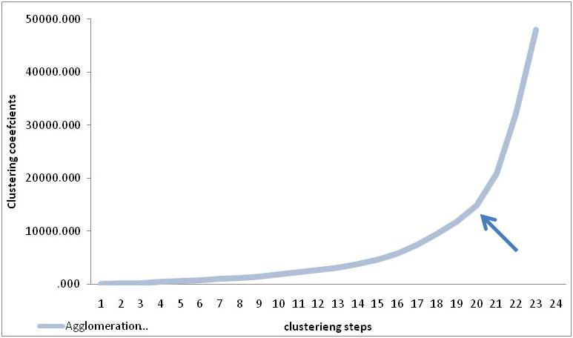
Figure 2 determination quantity of clusters
Now we know the location of the first elbow we can use this to determine the most optimal number of clusters by:
Taking the total number of steps: 23
Subtracting the elbow/kink step: 20 -
Most optimum number of clusters: 3
Total number of steps – step of the elbow or kink = optimum number of clusters” (mazzocchi, 2004).

3.4.3 Non- Hierarchical cluster analysis K-means
The K-means analysis has been run with 10 iterations, the algorithm has assign the countries for which the distance to the cluster mean is smallest. This is shown in table’s two, three and four, see appendix 1 for more detailed data.
Table two: Cultural Cluster membership per country.

3.4.4 Cultural Characteristics of the clusters
The Clusters are based upon Hofstede’s four dimensional cultural framework. Every cluster has unique characteristic which are described underneath:
Cluster one, consists of 7 countries: Austria, Germany, Ireland, Italy, Luxembourg, United Kingdom and Hungary. This cluster is accountable for 204 million people and is characterized by medium-high individualism, medium uncertainty avoidance, small power distance and a high level of masculinity. The cluster furthermore consists mostly of Anglo-Saxons and Germanics
Cluster two, consists of 5 countries, Denmark, Finland, the Netherlands, Norway and Sweden. These five countries are accountable for 38 million consumers and are therewith the smallest clusters. The clusters shows relatively high individualism, mild uncertainty avoidance, small power distance and is low on masculinity. Interesting is that this clusters is mainly dominated by Scandinavian countries.
Cluster three, includes 10 countries: Belgium, Bulgaria, Czech Republic, France, Greece, Malta, Poland, Portugal, Romania and Spain. The cluster is accountable for 194 million consumers is the biggest clusters. The countries show medium power distance, strong uncertainty avoidance, and are low on masculinity. The scores of individualism show a wide variation, Portugal has a relatively low score (27) whereas Belgium and France show relatively high scores, respectively (75,71). The countries within this clusters are mostly from Iberian and Mediterranean region and the Roman language spoken mostly.

3.4.5 Regression Model
In this paragraph I will discuss the results from the multiple regression analysis. In order to get a better understanding of the results I will show how Consumer Confidence, GDP (income) and Unemployment have developed in these cultural clusters in the last 16 years.
3.4.5.1 Graph GDP Growth & Culture (Clusters)
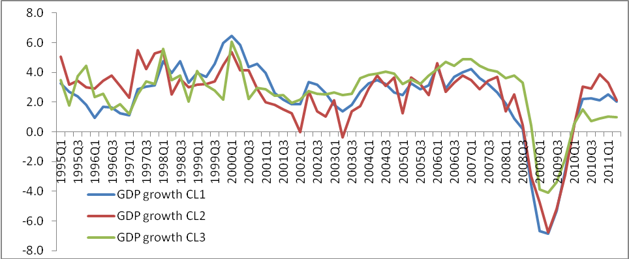
Figure three: Quarterly GDP Growth per Cluster 1995 - 2011
This figure shows the GDP growth per quarter in comparison to the growth in the same quarter in the previous year. Looking at the graph no big differences in the GDP growth between the clusters can be noticed. The red en blue line, representing cluster one and two, seem to be more related to each other than cluster three. Since 2000 a decline in GDP growth started, which made itself most visible in cluster two that even had negative growth in the first quarter of 2003. Cluster two is the only cluster that had negative and near negative growth in a quarter in 2002 and 2003. Afterwards Cluster two showed stronger growth fluctuations whereas cluster three showed more stable GDP growth. In 2008 GDP stops growing and shows a negative growth with a peak in 2009 followed by a strong recovery and positive growth numbers for all clusters in 2010. Cluster three GDP growth doesn’t drop as far cluster two and three in 2009. But most importantly, there is no big clear differences between the cultural clusters with respect to GDP growth.
The average GDP growth per clusters in these 16 years was:
Cluster one: 2.3%, Cluster two: 2.4%, Cluster three: 2.7%.
As described before the differences are present but they are not very big. Cluster three has the largest GDP growth rate of all clusters. This number doesn’t hold information about the current GDP levels in the different clusters.
3.4.5.2 Graph Unemployment percentage of total workforce & Culture (Clusters)

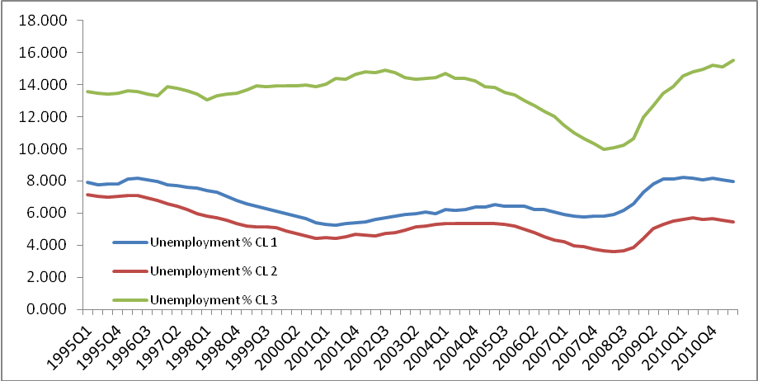
Figure four A: Unemployment rate per cluster 1995-2011
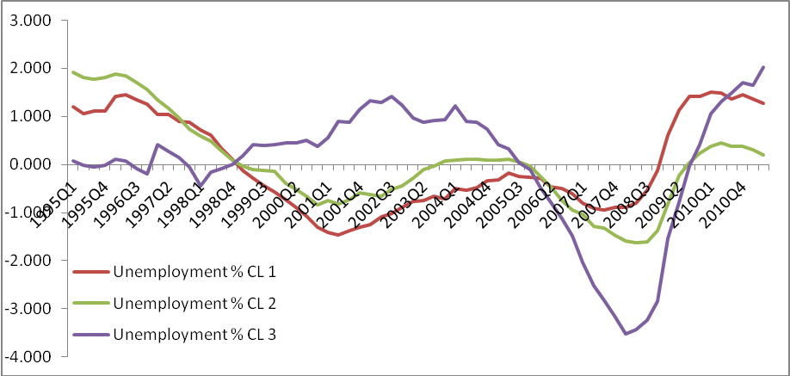
Figure four B : Centralized data of Unemployment rate per cluster 1995-2011 (figure four A)

Figure four A shows the unemployment percentage of the workforce in the different cultural clusters. There is a strong difference visible in al clusters. Cluster two shows the overall lowest unemployment rates, closely followed by cluster one. Cluster three has the highest unemployment rates over the whole time spam. For cluster two and three unemployment declined since 1995 until 2001. From 2001 it raised until 2003, declined again and showed a jump between 2008 and 2010. For cluster three unemployment steadily rose since 1998 and started dropping fast in 2004 until 2008. Since 2008 the unemployment rate in cluster three grew much stronger than in clusters two and one.
The average Unemployment rate per clusters in these 16 years was:
Cluster one: 6,7 %, Cluster two: 5,2%, Cluster three: 13,5%.
As visible from the graph and the average percentage, cluster three has the highest unemployment rate over time, followed by cluster one. Cluster two has the lowest unemployment rate, which is approximately 2.5 times lower than in cluster three.

Figure Four B shows the centralized data where the means of the unemployment rate series per cluster are distracted from the absolute number. As described on p. 35 this has been done in order to solve the problem with multicollinearity. The Graph gives a better comparison view on the strength of the unemployment rate changes per cluster. Because the centralized data is used in the construction of the data the above described average’s can’t be used in the analysis nor as input data for the model.

3.5.4.3 Graph Consumer confidence & Culture (clusters)
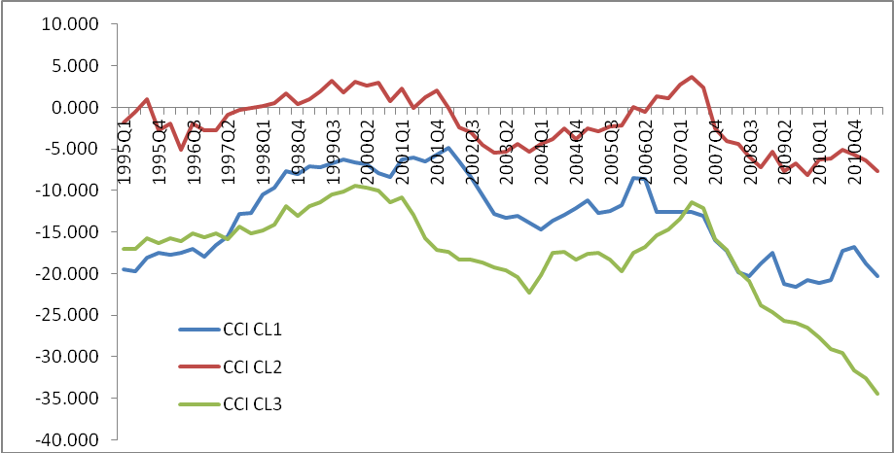
Figure five: Consumer confidence development per cluster 1995-2011
In the figure above we see that the confidence consumers have in cluster one has have higher in comparison to clusters one and cluster two. Cluster two and cluster one show a similar trend whereas cluster three, which has the lowest consumer confidence, is less stable and behaves slightly different. For all clusters an U-shaped drop and recovery in consumer confidence is visible in between 2001 and 2007. It took 6 years for the confidence to recover and around 2007 a very strong decline is confidence is observed for all clusters. Whereas confidence for cluster one and cluster two steadily stabilizes by the end of 2008 the confidence levels in cluster three continue a strong downwards trend.
The average Consumer Confidence per clusters in these 16 years is:
Cluster one: -13,2%, Cluster two: -1,9%, Cluster three: -17,7%.
Also visible in the graph the graph is that consumer confidence in cultural cluster three is the lowest and has the lowest average consumer confidence of the three clusters. The average consumer confidence in cultural cluster one are remarkably higher than in cluster two and three.

3.4.6 ANCOVA & Multiple Regression Model.

In this chapter the results of the ANCOVA and MRA will be discussed. The ANCOVA’s aim is to describes whether there are significant differences in the relations between the variables. The effects that these variables have on consumer confidence is going to be discussed secondly with the MRA.

In the table two the ANCOVA is summarized. This table tells us that both Unemployment and GDP Growth are significant covariates F(1,193) = 196,2, F(1,193) = 94,6
After controlling for the effects of the covariates; Unemployment and GDP Growth, the effect of culture which is described as “Cluster” significantly effects Consumer Confidence with the clusters F(2,193) = 334,6. The post hoc test in the appendix F shows that all three clusters significantly differ from one another. This finding is also supported by the planned contrast ( see appendix F) where all clusters are compared with the first cluster. These results show that all, on culture segmented, clusters significantly differ from each other with respect to their consumer confidence levels with a P< 0,001.

Table two: ANCOVA output dependent variable: consumer confidence

The multiple regression analysis is summarized in the table underneath. This table shows the strength of the relations between the dependent (CCI) and the independent ( Culture, Unemployment & GDP growth). In total there are five independent variables, whereby unemployment and GDP growth were added simultaneously in model B & C. The last model is model D. In this model the GDP growth and Unemployment change are replaced by six interaction variables that measure the effect of Unemployment and GDP per Cultural Cluster on Consumer Confidence.
Table three: Multiple Regression models A,B & C

In order to have a good understanding of the model it is important to understand the variables that have been used in this model. Prior to an in dept discussion of the result I will start with the explanation of these variables.

Explanation of the variables:
The first variable in the model is the Constant. Normally the intercept is the value of Y if all other X variables where 0. In this model dummies have added to control for differences in cultural clusters, therefore the meaning of the intercept has changed. In this model the intercept represents the consumer confidence of cluster two ( considering all other variables to be zero).
The second variable is Time and controls, in al three models (A,B &C), for the time of the data, which was 1995 until 2011. The indicator is very significant and has a relatively small coefficient of -0.501 indicating that consumer confidence in all three clusters has decreased over time and that time has got a negative impact on consumer confidence. This indicator only says something about the relation of consumer confidence with this timeframe and therefore can not be generalized to other clusters, countries nor used for predicting consumer confidence in the future.
The third and fourth variable are both dummy variables that represent Cultural cluster one and Cultural cluster three. The corresponding coefficient tells something about the consumer confidence levels in those clusters with respect to Cluster two (the constant). The fifth variable is Unemployment rate% 15 -65. This variable indicates how much effect the unemployment rate of a certain country has with respect to its level of consumer confidence. Also in this case the variable tells something about the difference in level with respect to the level in the other clusters. The last variable is GDP growth. This variable can, in essence, be interpret in the same way as the Unemployment rate.
Interpretation of the models
- Model A
In the first model I exclusively looked at the effect that culture had on consumer confidence. What this model tells is that culture has an effect on the confidence levels in the different clusters. The model says that consumer confidence significantly differ among the three cultural clusters. This model only controls for culture, and where there is only controlled for culture the level of consumer confidence would look as follow:
1. Cluster two has the highest consumer confidence level: ( -13.35 +15.801 = 2.301 )
2. Cluster one as seconds highest confidence levels: (-13.35 + 4.510 = -9.045)
3. Cluster three has the lowest confidence levels: (-18.072)
All variables are significant, nevertheless not a lot of value can be attached to this model as it only controls for culture and no other important variables are added. The observed effect that culture assumes the have in this model can also be caused by underlying other variables. This model has a R-square of .75, indicating that the observed variability in consumer confidence levels between the three clusters can for 75% be explained by culture. It also means that 25% is not explained. The adjusted R-square controls for sample size and because the sample size in this model is high, there is no big difference between the adjusted and the non adjusted R-square.

- Model B)
According to the literature Unemployment rate should be a important indicator for consumer confidence. Unemployment threatens consumers personal financial situation and by doing so it decreases their expenditures. Unemployment furthermore makes consumers feel les positive with respect to their future economic situation, this makes them cancel or postpone expenditures on non-essential goods. The variable Unemployment has therefore been added in model.
After adding unemployment to the model, the R-square rises from 0.75 to 0.836. The predictor is significant at P <0,001 and has coefficient of -2.302. This coefficient has a big impact consumer confidence level. It means that for every percent of unemployment the CCI depreciates with 2.302 points. The negative relation that it has with consumer confidence is as expected from the literature.
As cluster three has got the highest unemployment rates the impact of unemployment on consumer confidence is large compared to the other two. Nevertheless the relative distance between the clusters doesn’t change a lot compared to model A where culture is the only predictor. What this model does say is that unemployment can strongly influence consumer confidence. This effect is visible in cultural cluster three where unemployment rates where more than double as high as in cluster one and two.
The impact of this variable on consumer confidence is big. And in order to see how culture relates to Unemployment I have created an interaction variable between the cultural clusters and unemployment.
- Model C
In third model I have added the GDP growth-rate. Gross Domestic Product is the sum of: Private consumption + gross investments + government spending + (exports – Imports). The percentage change should, according to the literature be influential with respect to consumer confidence. In the model I see that that the predicator “GDP growth %” has a P value <0.001, stating that the predictor is significant. The coefficient is positive 0.682, indicating that every percent change in GDP in the cluster will change consumer confidence index with a factor of 0.682. As noted in the previous paragraph the percentage of GDP growth has been stable around 2.4% in all clusters. In all three clusters this predictor showed a similar pattern of the last 16 years. Although it’s impact on consumer confidence is significant it is not very strong, nevertheless it does make the R-square rise to 0.865 from 0.836.

- Model D E & F
From the previous models it became clear that culture had a significant influence on consumer confidence. It also became clear that the unemployment rate and GDP growth within the clusters had an impact on consumer confidence. In model D I have created interaction variables that could give me jdetailed information on how unemployment-rate and GDP relate to each cultural clusters. These results are visible in the table four and is shown on the next page.
First of all this model tells that almost all predictors are significant at P<.001, only Interaction Cluture2*GDP is significant at P<.05. Just like in the other models the Constant stands for a cultural clusters, which in this model is Cluster One. Also important to notice is that the R-square is now .885, which is higher than in model C, meaning that 88,5% of the observed variability in consumer confidence levels between the three cluster can be explained by the model. Also in this model, if only controlled for the cultural predictors, cultural cluster two will be the highest , followed by two and three. The interaction predictors Culture with Unemployment and GDP tell that the effect of unemployment and GDP on consumer confidence has different effects among the three cultural clusters. Note that the clusters three is almost 4 times less sensitive for unemployment rate than cluster one and two.
Model D tells that there are three, on cultural dimensions segmented, clusters in Europe that have significant differences in their consumer confidence. The model tells that: Unemployment, with an coefficient of 3.397 has the highest negative impact on Consumer Confidence in Cultural Cluster One and the lowest in Cultural Cluster Three which has a coefficient of 1.103. Increase in GDP has the highest effect on Consumer confidence in cultural cluster three and the lowest in cultural cluster one.

- Model E &F
Models E and F serve to test the significance of the interactions effects of GPD and Unemployment on, and per cultural cluster. In both models I have respectively replaced the first and the second interaction variable of GDP and Unemployment with the main variable of GDP and Unemployment. The missing interaction effect is than captured by the main effect of Unemployment or GDP.
What we see in Model E is that the interactions effects between cluster (i.e. culture) and unemployment are en remain significant. The P value in cluster two decreases a bit, but the effect still remain significant a P <0.051. The interaction results of the effects between culture and GDP show that there is no significant effect between GDP and culture on consumer confidence in cluster two.
Model F shows the results where the second interaction variables are replaced by the main variable for GDP or Unemployment. This model show that the interaction effects between Cluster and Unemployment have significant effect on consumer confidence. Not that the P value of this effect in cluster one has decreased to P<0,051 from P<,0001. The interaction results of the effects between culture and GDP show that there is no significant effect between GDP and culture on consumer confidence in cluster one.
Models E & F have showed that the interaction effects that initially were found in model D are not significant for GDP in clusters one and two. All other effect are significant. This means that the level of unemployment significantly influences consumer confidence. The countries that make up cluster three have the highest unemployment rates of all three clusters, but from model three we see that a change in unemployment rate has a the lowest effect on consumer confidence from all three clusters. Because the interaction effect of GDP is only significant at cluster three, no conclusions can be drawn with respect to the differences between the clusters with respect to the effect that changes in GDP would have on consumer confidence. This means that all clusters are as sensitive for GDP changes with respect to their consumer confidence.

If Europe really would have been one country, than GDP and Unemployment data would have been the same for every country. Culture would remain the same as it is now and the effect that culture has would therefore also be different. See the outcome underneath:

Cluster one: -9.625 – 3.397*1.168 (Unemployment)+0,35*1,71 (GDP growth) = -12.994

Cluster two: 10.897 – 2.294*1.168 (Unemployment) + 0.52*1.71 (GDP growth) = 7.93

Cluster three: -6.931 -1.103*1.168 (Unemployment) + 1.22*1.71 (GDP growth) = -6.13

This finding suggest that even when the Unemployment rates and GDP growth rates would be the same for Europe (i.e. all three clusters) that culture would still have the strongest impact on consumer confidence. Note that the ranking has changed: Cluster one is still most optimistic, followed by cluster three and cluster one as last one. In the previous analysis cluster three was most pessimistic which was mainly caused by the high unemployment in that cluster. Since I have used average unemployment rates this effect has diminished.

3.4.7 Summary of the results

In this section I will start with summarizing the results per Cultural Cluster and end by briefly going into the implications these results could have for stakeholders.
In the previous part of this research 23 countries in the European Union have been cluster based upon Hofstede’s four dimensional cultural network. The cluster analysis revealed that these 23 countries can, based upon their culture, be divided and segmented into three clusters. The cultural characteristics per segments are visible in figure 6. Furthermore I have added a ranking that shows which clusters has the highest consumer confidence (i.e. economic optimism) with respect to the other clusters. For instance, the Scandinavian clusters who’s society is characterized by Low power distance, High individualism, femininity and medium uncertainty avoidance has the most optimistic citizens.
Figure six: Cluster characteristics and optimism ranking 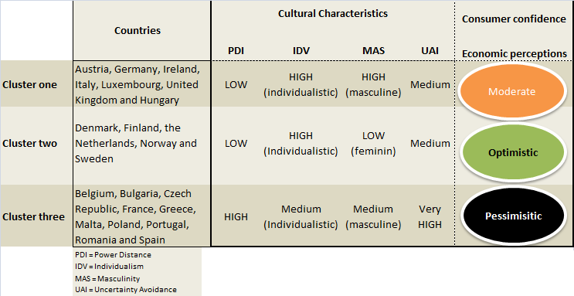

Besides the cultural aspect I have also controlled for GDP growth and Unemployment as factors that could influence consumers perception about their economic situation, thus their level of optimism. As we see in figure 7 Cluster two has had the lowest overall unemployment rates ( average of 5,2%), but if unemployment rises in his cluster it has a very strong negative effect on consumer confidence. And in cluster three, where unemployment rates have been more than twice as high as in cluster two the effects of unemployment on consumer confidence are three times lower. This means that the level of economic optimism in cluster two is strongly related to being employed or unemployed whereas in cluster three this effect is much less. If unemployment would rise in cluster two than pessimism would rise three times faster than in cluster three. This effect is significant for all three clusters.
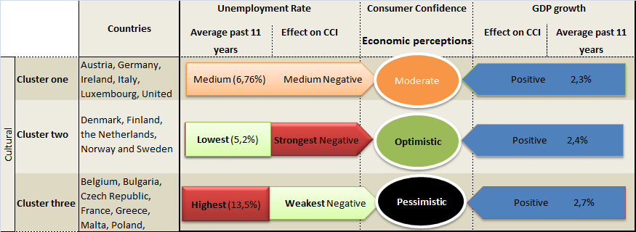
Figure seven: Unemployment and GDP effect on Economic perceptions
With respect to GDP there were small differences found in interaction effects between GDP per cluster on consumer confidence. These findings were not significant which means that there is no difference in effect of GDP among the three clusters. What I can say is that the effect of GDP growth has a positive effect on consumer confidence and there is no evidence that this effect differs among the three cultural clusters.

4. Conclusion

In this research I have used statistical methods to get a better understanding and insight about the role that culture, geographically, plays in Europe and which implications this has for the economic sentiment in the different geographic segments. Data on 23 countries has been used to perform the necessary analysis in order answer the following research question:
“ Can cultural differences divide Europe in different segments and what implications would this segmentation hold for the consumers economic sentiment ? ”

The four-dimensional cultural framework of Hofstede has been the basis for the Hierarchical clustering analysis. The analysis showed that Europe cultural – geographically could be divided into three regions . With the help of the K-means analysis the 23 countries could, based upon their culture, be assigned to one of the three clusters (i.e. regions). The countries that make up one region have very similar scores on the Hofstede´s four cultural dimensions; Power Distance, Individualism, Masculinity and Uncertainty Avoidance. The similarity mean that the citizens of these countries share a similar pattern of thinking, feeling & reactive, have similar believes/ideas and perceive the man-made part of the environment on a similar way. The first region consists mostly out of Anglo-Saxion and Germanic countries, respectively; Austria, Germany, Ireland, Italy, Luxembourg, United Kingdom and Hungary. The second region is dominated by the Scandinavian countries, respectively; Denmark, Finland, the Netherlands, Norway and Sweden. And the third region is mixed but dominated by Iberian and Mediterranean countries; Belgium, Bulgaria, Czech Republic, France, Greece, Malta, Poland, Portugal, Romania and Spain. Both cluster analysis can’t tell anything about the significance of the found results, therefore I have used the Multiple Regression analysis (MRA), this analysis pointed out that the found regions, based upon their culture, indeed significantly differ from one another. The MRA furthermore pointed out that the observed consumer confidence levels per regions also significantly differ from the other regions. The Scandinavian region has the overall highest consumer confidence levels and has therewith the most optimistic consumers, followed by the Anglo-Saxion/ Germanic region. The Iberian & Mediterranean region has the overall lowest consumer confidence levels and has therewith the most pessimistic consumers in Europe (with respect to the other two regions). To enhance the robustness and reliability of my model I added Unemployment rate and GDP growth rate to the model. According to the literature these two variables had a relation with consumer confidence and could significantly influence the indicator. I have added the quarterly data on these two variables to the MRA and used dummy variables to created interaction effects between these variables and the three cultural regions (clusters). The results of this MRA analysis shows that especially the unemployment rate could have a big influence on the consumer confidence levels in all three regions. An interesting finding was that a change in unemployment rate in the Scandinavian region, that is the most optimistic and the one with the lowest unemployment rates of all three regions, had the biggest impact on the consumer confidence. The opposite is true for the Iberian/Mediterranean region that has the highest unemployment rates and is most pessimistic, but a change in unemployment rate has a relatively low impact on the consumer confidence in this region. With respect to the GDP growth level, all three regions show a similar pattern and the impact that changes in GDP growth rate have on consumer confidence are very weak but still significant. Changes in GDP growth are experienced most strongly in the Iberian/Mediterranean region and have the weakest effect on in the Scandinavian region.
The result of this research shows that, if Europe is segmented on Hofstede’s Cultural Framework, three significant regions emerge. These three regions significantly differ from one another with respect to their: Culture, their consumer confidence levels and how they value and deal with Unemployment and the welfare growth (GDP-growth).

The ranking of the clusters has remain stable over time that makes it solid. In other words, the cluster that is most optimistic has been the most optimistic in last 11 years and the visa versa for the most pessimistic. Therefore I expect that this cluster ranking as showed in the results summary part is not likely to change a lot in the future. This result could be of great importance from a marketing point of view and especially for companies that operate in the consumer goods business. In this business consumers are directly responsible for the company’s revenue and profit and the return of investment (marketing) could be higher in countries where consumers are relatively more optimistic. This is wise as confident consumers are, according to Katona’s spending framework (1945), willing and able to spend more money on consumer goods than consumers who experience less confident levels. Also from a strategic point of view, it has been proven that expansions of the business to culturally similar countries has a significantly higher success rate (Gupta, Hanges & Dofrman 2002). According to Jain (1989) marketing strategies and activities should be adjusted per culture to deliver the same message. Being aware of cultural differences and similarities would offer marketing managers the opportunity to use similar marketing strategies in countries that have similar cultures and by doing so effectively reach the target market and save costs for adjustments of the marketing plan per country. This research has showed evidence that Europe can be culturally divided into three regions. From a marketing point of view this means that segmented local marketing strategies are favored against a all covering “Pan” strategy in Europe.

4.1 limitations
In this research countries were clustered based upon four cultural dimensions in order to point out whether there is a relation between culture and the economic optimism (consumer confidence) in Europe. Unfortunately for some European countries not all necessary data was available and these countries therefore couldn’t be added to the analysis. If these countries could have been added to the model it would have increased the accuracy of the model and a more complete view on Europe could have been given.
Furthermore this research is limited to a time period of 1995 - 2011. This time period does not have an effect on the cultural differences, as these are stable and don’t change in a short period of time, but it could have an effect on the confidence levels, GDP growth and Unemployment rates.

4.2 Directions for further research
I have pointed out that there is a relation between culture and the level of optimism in different European countries, but also that other factors like unemployment can play an important role in all of this. As shown in this research: being unemployed has a stronger effect on the confidence level in the second region where the unemployment is relatively low than in the third region which has a relatively high unemployment rate. It is not clear what causes this effect, it could for instance been caused by a higher “grey economy” in the third cluster but other reasons are also possible. The research has also pointed out that the level of unemployment plays an important role with respect to it’s effect on consumer confidence. In cultural cluster three, which has the highest unemployment, a change in unemployment rate would have the lowest impact on consumer confidence. But if all unemployment rates in Europe would have been the same than a change in this rate would have had the biggest effect on CCI in this cluster. More research with respect to this finding would be necessary to point out the exact cause of this relation.
Also as the economies in the world have become more and more intervened with each other, it would be interesting to perform a similar study that includes all continents in the world. But also the financial crisis that caused consumer confidence to drop and recover rapidly; is it likely that, an eventual, next crisis will be elapse in the same way. Do citizens of different countries learn from such happenings and react differently ( i.e. more or less confident) if faced with a similar situation? - are questions that aren’t answered in this research, but would be a good follow up for further research.

References
Appadurai, Arjun (1991) Global Ethnoscapes: Notes and Queries for a Transnational Anthropology. In: Fox, Richard J. (ed): Recapturing Anthropology:Working in the Present. Santa Fé: School of American Research Press

Ball, L. and Cecchetti, S.G. (1990), ‘Inflation and uncertainty at short and long horizons’, Brookings Papers on Economic Activity, 215–254.

Ball, L. and Cecchetti, S.G. (1990), ‘Inflation and uncertainty at short and long horizons’, Brookings Papers on Economic Activity, 215–254.

Banabou, Roland. 1993. ―Workings of a City: Location, Education, and Production.‖ Quarterly Journal of Economics. 108(3): 619-652.

Bochner, S. (1982). The social psychology of cross-cultural relations. In S. Bochner (Ed.), Cultures in contact: Studies in cross-cultural interactions (pp. 6-36). Oxford: Pergamon.

Bond, Michael H. 1987. Chinese values and the search for culture-free dimensions of culture. Journal of Cross-Cultural Psychology 18, no. June: 143-64.

Bram, J. & Ludvigson, S.(1998). „Does Consumer Confidence Forecast Household Expenditure? A Sentiment Index Horse

Carroll, C. (2003). Macroeconomic expectations of households and professional forecasters. Quarterly Journal of Economics, 118, 269–298.

Carroll, C. , Fuhrer, J. & Wilcox, D.(1994).”Does consumer sentiment forecast household spending? If so, why?” TheAmerican Economic Review, 84(5), pages 1397−1408.

Caudron, Shari. 1994. The myth of the European consumer. Industry Week, no. 21 Feb: 28-36.

Chadraba, Petr, and Helena Czepiec. 1988. Euroconsumers? A three country analysis of the feasibility of product value standardization. Journal of Global Marketing 1, no. 4: 63-74.

Chen J, Rodden J. 2009. Tobler’s law, urbanization, and electoral bias: why compact, contiguous districts are bad for the Democrats. Work. pap., Dep. Polit. Sci., Stanford Univ.

Clark, Terry. 1990. International Marketing and national character: A review and proposal for an integrative theory. Journal of Marketing, no. Oct: 66-79.

Cooper, Russell W. and Andrew John (1988) «Coordinating Coordination Failures in Keynesian Models.» Quarterly Journal of Economics 103: 441-463.

Cultural Dimensions In Management And Planning. 1983 Hofstede Asia Pacific Journal of Management, January 1984 Charles Duhigg, "Depression, You Say? Check Those Safety Nets", New York Times, March 23, 2008

Curtin, R. (1982), Indicators of Consumer Behavior: The University of Michigan Surveys of Consumers, Public Opinion Quarterly, 46, 340{352.

Curtin, R. T. (2000). Psychology and macroeconomics: Fifty years of the surveys of consumers. In J. House, T.

Juster, R. Kahn & E. Singer (Eds.), Telescope on Society: Survey Research and Social Science in the 20th and 21st Centuries. Ann Arbor: University of Michigan Press.

Dawar, N. and Parker, Ph.M. (1994), ``Marketing universals: consumers' use of brand name, price, physical appearance, and retailer reputation as signals of product quality'', Journal of Marketing, Vol. 58, April, pp. 81-95.

DeLisle, J. (2008). “The Three C’s of Our Disconnect: Credit,Confidence, and Collateral.” Appraisal Journal, 76(4), pages 301-312.

Dion, D.,(2006). "Does Consumer Confidence Forecast Household Spending?," MPRA Paper 902, University Library of Munich, Germany.

Douglas, Susan, and C. Samuel Craig. International Marketing Research.Englewood Gliffs, NJ: Prentice Hall, 1983.

Duch, R. N., Palmer, H. D., & Anderson, C. J. (2000). Heterogeneity in perceptions of national economic conditions. American Journal of Political Science, 44(4),635-652.

Duch, R.M., Harvey, D., Palmer., Andersson J.C.(2000) “Heterogeneity in Perception of National Economic Conditions”, American Journal of Political Science, Volume 44, Issue 4, 635-652.
Duhigg, Charles (2008, October 5). Pressured to take more risk, Fannie reached a tipping point. New York Times, 1, 34.

Engel, James, Roger Blackwell, and Paul Miniard. 1995. Consumer behavior. ForthWorth: The Dryden Press.

Erez, Miriam, and P. Christopher Earley. 1993. Culture, self-identity and work. New York : Oxford University Press.

Furrer, O., Shaw-Ching Liu, B, and Sudharshan, D., (2000), “The Relationships Between Culture and Service Quality Perceptions: Basis for Cross-Cultural Market Segmentation and Resource Allocation.” Journal of Service Research, Vol. 2, No. 4, pp. 355-371.

Gannon, Martin J. 2001. Understanding global cultures, 2nd ed. Thousand Oaks: Sage Publications.
Garner, C. Alan (1981). "Economic determinants of consumer sentiment," Journal of Business Research, Elsevier, 9(2), pages 205-220.

Gatignon Hubert and Joachim Vosgerau, “Stochastic Moderated Regression: An Efficient Methodology for Estimating Parameters in Moderated Regression” (Working Paper)

George A. Akerlof and Robert J. Shiller (2009) Animal Spirits: How Human Psychology Drives the Economy, and Why It Matters for Global Capitalism, Princeton Press, USA.

George Santayana, Skepticism and Animal Faith (1923), quoted from James A Haught, ed, 2000 Years of Disbelief.

Henrich, J,. Boyd R. (1998). “The evolution of conformist transmission and the emergence of Between-group differences, Department of anthropology, University of California, California.
Hirsch, E., & Collier, G. The ecological determinants of reinforcement in the guinea pig. Physiology and Behavior, 1974, 12, 239-249.

Hofstede, G., (1980), ‘Culture’s Consequences.’ Sage Publications, California, USA.

Hofstede, G., (1980), “Motivation, Leadership, and Organization: Do American Theories Apply Abroad?” Organizational Dynamics, Vol. 9, No. 1, pp.42-63.

Hofstede, G., (1991), ‘Cultures and Organizations: Intercultural Cooperation and Its Importance for Survival.’ HarperCollins Business, McGraw-Hill UK.

Hofstede, G., (1994), “Management Scientist Are Human,” Management Science, Vol. 40, No. 1, pp.4-13.

Hofstede, G., (2007), ‘Geert Hofstede Cultural Dimensions’ retrieved on May 15th, 2008 from: http://www.geert-hofstede.com/hofstede_dimensions.php.

Hofstede, Geert, and Jean-Claude Usunier. 1999. Hofstede's dimensions of culture and their influence on international business negotiations. International business negotiations. ed Pervez Ghauri, and Jean-Claude Usunier, 119-30. Amesterdam: Pergamon.

Hymans, S. H., Ackley, G., & Juster, F. T. (1970). Consumer durable spending: Explanation and prediction. Brookings Papers on Economic Activity, 1970(2),173-206.

Jain, Subhash C. 1989. Standardization of international marketing strategy: Some research hypothesis. Journal of Marketing 53, no. Jan: 70-79.

Jain, Subhash C., and John K. Ryans. 1994. A normative framework for assessing marketing strategy implications of Europe 1992. Euromarketing - Effective strategies for international trade and exports. Eds Erdener Kaynak, and Pervez Ghauri, 287-313. New York: International Business Press.

Jeannet, J. P., and H. Hennessey. 1988. International marketing management. Boston: Houghton Mifflin
Kagel, J. H., & Winkler, R. C. Behavioral economics: Areas of cooperative research between economics and applied behavior analysis. Journal of Applied Behavior Analysis, 1972, S, 335-342.

Kale, Sudbir H. "Gulture-Specific Marketing Communications: An Analytical Approach." International Marketing Review 8, no. 2 (1991): 18-30.

Kale, Sudbir H. "Gulture-Specific Marketing Communications: An Analytical Approach." International Marketing Review 8, no. 2 (1991): 18-30.

Kale, Sudbir H., and Jobn W. Barnes. "Understanding tbe Domain of Cross-National Buyer-Seller Interactions." Journal of International Business Studies 23, no. 1 (1992): 101-33.

Kale, Sudbir H., and Roger P. Mclntyre. "Distribution chaannel Relationships in Diverse Cultures." International Marketing Review8, no. 3 (1991): 31-45.

Katona, G. Private pensions and individual saving.Ann Arbor: University of Michigan, Survey Research Center, 1965.
Katona, G. Psychological economics. New York: American Elsevier, 1975.

Keynes, J. M. (1936). The general theory of employment interest and money. London: McMillan.

Keynes, J.M., The general theory of employment, interest and money., Harcourt Brace Jovanovich, New York (1936).

Khoon Lek Goh (2003). "Does Consumer Confidence Forecast Consumption Expenditure in New Zealand?," Treasury Working Paper Series 03/22, New Zealand Treasury.

Kramer, Gerald H. (1983). The Ecological Fallacy Revisited: Aggregate vs. Individual-Level Findings on Economics and Elections, and Sociotropic Voting. American Political Science Review 65:131-143.

Kraus, P. A. (2003). Cultural pluralism and European policy-building. Journal of Common Market Studies, 41(4), 665−686.

Kroeber, A. L., & Kluckhohn, C. (1952). Culture: A Critical Review of Concepts and Definitions (Vol. 47): Harvard University Peabody Museum of American Archeology and Ethnology

Kroeber, Alfred L. and Talcott Parsons. 1958. "The concept of culture and of social system." American Sociological Review 23: 582-583.

Kumar, V. , Leone, P. & Gaskins, N.(1995). "Aggregate and disaggregate sector forecasting using consumer confidence measures," International Journal of Forecasting, Elsevier, 11(3), pages 361-377.

Lemmon,M & Portniaguina,E. (2006). "Consumer Confidence and Asset Prices: Some Empirical Evidence," Review of Financial Studies, Oxford University Press for Society for Financial Studies, 19(4), pages 1499-1529.

Lisle, J. (2008). “The Three C’s of Our Disconnect: Credit,Confidence, and Collateral.” Appraisal Journal, 76(4), pages 301-312.

Ludvigson, S. (2004). Consumer confidence and consumer spending. Journal of Economic Perspectives, 18, 29–50.

Ludvigson, S. C. (2004). Consumer confidence and consumer spending. Journal of Economic Perspectives, 18(2), 29-50.

Luna, David, and Susan Forquer Gupta. 2001. An integrative framework for cross cultural consumer behavior. International Marketing Review 18, no. 1: 45-69.

Matsusaka, J. and A. Sbordone (1995) Consumer Confidence and Economic Fluctuation, Economic Inquiry 33, 296-318.

Mazzocchi, Mario, 2004. "Modeling the Impact of Food Safety Information with No Information," 2004 Annual meeting, August 1-4, Denver, CO 20252, American Agricultural Economics Association (New Name 2008: Agricultural and Applied Economics Association).

Norusis, Marija J., 2011. “PASW Statistics 18 Guide to Data Analysis”. University of Michigan, Prentice Hall.

Ohmea, K., 1989, ‘The Global Logic of Strategic Alliances’,Harvard Business Review (March-April), 143–154.

Pelsmacker, P,. & Kenhove, P. 1999., “Marktonderzoek” – Methode en toepassingen, tweede editie. Person education Benelux, Amsterdam.

Peter Dougherty., (2002), “who’s afraid of Adam Smith, how the market got it’s soul”,.Willey, Princeton University press.
Rabin, Matthew (1997). Working paper: “Psychology and Economics”. University of California at Berkley.

Race,” Economic Policy Review 4(2), Federal Reserve Bank of New York, pages 59-78.

Reichel, Jurgen. 1989. How can marketing be successfully standardized for the 323 European market? European Journal of Marketing 23, no. 7: 60-67.

Roosevelt, Franklin D. (1937). Second Inaugural Address. Retrieved October 25, 2008 from Bartleby.com

Samiee, Saeed, and Insik Jeong. 1994. Cross-cultural research in advertising: An assessment of methodologies. Journal of the Academy of Marketing Science 22, no. 3:205-17.

Schwartz, Shalom H. 1994. Beyond individualism/collectivism - New cultural dimensions of values. Individualism and collectivism - theory, method and applications. Eds Uichol Kim, Harry C. Triandis, Çigdem Kagitçibasi, Sang-Chin Choi,and Gene Yoon, 85-115. Vol. 18. Thousand Oaks: Sage Publications.
Shiller, R. (2000). Irrational exuberance. Princeton: Princeton University Press.

Sivakumar, K., and Cheryl Nakata. 2001. The stampede toward Hofstede's framework: Avoiding the sample design pit in cross-cultural research. Journal of International Business Studies 32, no. 3: 555-74.
Smith, P.B., Dugan, S. and Trompenaars, F. (1996), ``National culture and the values of organizational employees: a dimensional analysis across 43 countries'', Journal of Cross- Cultural Psychology, Vol. 27, March, pp. 231-64.

Soares, Ana, Minoo Farhangmehr, and Aviv Shoham. 2005. To standardize or not standardize International Marketing: Is it still a question?, Working paper 3/2003. NEGE - Núcleo De Estudos Em Gestăo, Universidade Do Minho. Braga

Sondergaard, Mikael. 1994. Research note: Hofstede's consequences: A study of reviews, citations and replications. Organization Studies 15, no. 3: 447-56.

Steenkamp, J.B.M.E and ter Hofstede, F, International market segmentation: Issues and perspectives, International Journal of Research in Marketing 19 (2002) (3), pp. 185–213

Steenkamp, Jan-Benedict. 2001. The role of national culture in international marketing research. International Marketing Review 18, no. 1: 30-44.
Steenkamp, J-B.E.M., ter Hofstede, F. and Wedel, M. (1999), ``A cross-national investigation into the individual and national cultural antecedents of consumer innovativeness'', Journal of Marketing, Vol. 63, April, pp. 55-69.

Triandis, H. C., & Vassiliou, V. (1967). Frequency of contact and stereotyping. Journal of Personality and Social Psychology, 7, 316-328.

Tsoukatos, E., and Rand, G., (2007), “Cultural Influences on Service Quality and Customer Satisfaction: Evidence from Greek Insurance.” Managing Service Quality, Vol. 7, No. 4, pp.467-485.

Tsouskatos E,. Gk And(2007) Cultural Influences on Service Quality and Customer Satisfaction: Evidence from Greek Insurance Managing Service Quality 17: 4. 467-485
Vandermerwe, Sandra, and Marc-André L'Huillier. 1989. Euro-consumers in 1992. Business Horizons, no. Jan-Feb: 34-40.

Yip, George S. 1989. Global strategy... In a world of nations. Sloan Management Review, no. fall: 29--41.

Appendices

Appendix A:Histogram and Scatter plots for normality, hetroscedasticity and Non-linearity test.
All necessary conditions are met.

Appendix B: Hofstedes 4 dimensional Framework scores per country per dimension.

Appendix C: Clustering steps.
At every step a country is added to a cluster or two clusters merge, this process continues until all countries are added to the final cluster.

Appendix D: Distance per country from center of the cluster

Appendix D: Cultural characteristic per Cluster
Final Cluster Centers
 | Cluster
 | 1 | 2 | 3
PDI | 35,00 | 37,43 | 65,40
IDV | 71,00 | 72,14 | 49,60
MAS | 69,57 | 18,00 | 47,70
UAI | 61,71 | 41,86 | 92,00

Appendix E: Multiple Regression Coefficients Models A,B,C &D

model A

model B: Before variable mean centralized for Unemployment. Note the high VIF values for D3 (region/cluster 3) and unemployment rate.

Model B: after variable mean centralized for Unemployment. VIF values are normal now.

Model C: Before variable mean centralized for Unemployment. Note the high VIF values for D3 (region/cluster 3) and unemployment rate.

Model C: after variable mean centralized for Unemployment. VIF values are normal now.

Model D

Model E:

Model F:

Appendix F: ANCOVA output

Tests of Between-Subjects Effects
Dependent Variable:CCI
Source | Type III Sum of Squares | df | Mean Square | F | Sig.
Corrected Model | 10566,783ª | 4 | 2641,696 | 196,211 | ,000
Intercept | 17146,881 | 1 | 17146,881 | 1273,579 | ,000
Unemploymentnew | 393,867 | 1 | 393,867 | 29,254 | ,000
growthGDPPreviousQuarter | 1273,512 | 1 | 1273,512 | 94,590 | ,000
Cluster | 9009,165 | 2 | 4504,582 | 334,576 | ,000
Error | 2598,463 | 193 | 13,464
Total | 36994,455 | 198
Corrected Total | 13165,246 | 197
a. R Squared = ,803 (Adjusted R Squared = ,799)

Parameter Estimates
Dependent Variable:CCI
Parameter | B | Std. Error | t | Sig. | 95% Confidence Interval
 |  |  |  |  | Lower Bound | Upper Bound
Intercept | -20,708 | ,545 | -37,993 | ,000 | -21,783 | -19,633
Unemploymentnew | -1,318 | ,244 | -5,409 | ,000 | -1,798 | -,837
growthGDPPreviousQuarter | 1,118 | ,115 | 9,726 | ,000 | ,892 | 1,345
[Cluster=1] | 4,855 | ,640 | 7,589 | ,000 | 3,593 | 6,117
[Cluster=2] | 16,118 | ,640 | 25,202 | ,000 | 14,857 | 17,380
[Cluster=3] | 0ª | . | . | . | . | .
a. This parameter is set to zero because it is redundant.

Contrast Results (K Matrix)
Cluster Simple Contrastª |  |  | Dependent Variable
 |  |  | CCI
Level 2 vs. Level 1 | Contrast Estimate |  | 11,263
Level 2 vs. Level 1 | Hypothesized Value |  | 0
Level 2 vs. Level 1 | Difference (Estimate - Hypothesized) |  | 11,263
Level 2 vs. Level 1 | Std. Error |  | ,639
Level 2 vs. Level 1 | Sig. |  | ,000
Level 2 vs. Level 1 | 95% Confidence Interval for Difference | Lower Bound | 10,003
Level 2 vs. Level 1 | 95% Confidence Interval for Difference | Upper Bound | 12,523
Level 3 vs. Level 1 | Contrast Estimate |  | -4,855
Level 3 vs. Level 1 | Hypothesized Value |  | 0
Level 3 vs. Level 1 | Difference (Estimate - Hypothesized) |  | -4,855
Level 3 vs. Level 1 | Std. Error |  | ,640
Level 3 vs. Level 1 | Sig. |  | ,000
Level 3 vs. Level 1 | 95% Confidence Interval for Difference | Lower Bound | -6,117
Level 3 vs. Level 1 | 95% Confidence Interval for Difference | Upper Bound | -3,593
a. Reference category = 1

Test Results
Dependent Variable:CCI
Source | Sum of Squares | df | Mean Square | F | Sig.
Contrast | 9009,165 | 2 | 4504,582 | 334,576 | ,000
Error | 2598,463 | 193 | 13,464

Pairwise Comparisons
Dependent Variable:CCI
(I) Cluster | (J) Cluster | Mean Difference (I-J) | Std. Error | Sig.ª | 95% Confidence Interval for Differenceª
 |  |  |  |  | Lower Bound | Upper Bound
1 | 2 | -11,263* | ,639 | ,000 | -12,802 | -9,725
1 | 3 | 4,855* | ,640 | ,000 | 3,314 | 6,396
2 | 1 | 11,263* | ,639 | ,000 | 9,725 | 12,802
2 | 3 | 16,118* | ,640 | ,000 | 14,578 | 17,659
3 | 1 | -4,855* | ,640 | ,000 | -6,396 | -3,314
3 | 2 | -16,118* | ,640 | ,000 | -17,659 | -14,578
Based on estimated marginal means
*. The mean difference is significant at the ,05 level.
a. Adjustment for multiple comparisons: Sidak.

