

“ “Liking” a brand page on Facebook; the effect of product involvement, brand loyalty and attitude to the brand on the consumer’s intention to “like” on Facebook and the effect of it on his intention to purchase and have a positive word of mouth.”

Erasmus School of Economics
Master of Science in Economics and Business
Specialization in Marketing

Effrosyni Panagopoulou-355691

Supervisor: Prof. Dr. Ir. Benedict G.C. Dellaert

Acknowledgements

Now that my master’s studies are almost done, I really feel that I should thank all those that helped me in this achievement-each of them in a different and special way.

First, I would like to express my gratefulness and gratitude to my supervisor, Dr. Benedict Dellaert for his contribution with his valuable comments, his suggestions on my Thesis and his overall support. In addition, I would like to thank my parents, Nikos and Efi, and my sister, Nansy, for their support throughout this whole year and, of course, for providing me with the chance to study abroad and have such an amazing experience. Moreover, I would like to express my special thanks to my friends Thanasis, Orestis, Kostas, Charis and Allina for their helpful comments during the whole process of writing this Thesis. Last but not least, I would like to thank all my friends that supported me all this year and, especially, my roommate Chrysa.

Abstract

Social media are a recent tool for the science of Marketing that is being increasingly used by firms to apply their marketing techniques. The specific study focuses on Facebook, which is one of the most well-known types of social media. The study examines the impact of product involvement, brand loyalty and attitude to the brand on the consumer’s intention to “like” a brand on Facebook and whether his intention to “like” leads to a further intention to purchase the brand and become a word of mouth referral.

The study concludes that product involvement, brand loyalty and attitude to the brand are positively correlated with the consumer’s intention to become a fan of the brand on Facebook. Moreover, the consumer’s intention to “like” the brand on Facebook is positively correlated with his intention to purchase a commodity brand, but there is no correlation between these two variables in the case of a luxury brand. Finally, the study concludes that the consumer’s intention to become a fan of a brand on Facebook increases his word of mouth referral for the brand.

Key words: product involvement, brand loyalty, attitude to the brand, intention to “like” a brand, intention to purchase, word of mouth, Facebook

Table of Contents

1. Introduction……………………………………………………………………………5
2. Theory…………….……………………………………………………………………8
2.1 Product Involvement…………………………………………………………..8
2.2 Brand Loyalty………………………………………………………………..10
2.3 Attitude towards the brand…………………………………………………...12
2.4 Intention to purchase…………………………………………………………13
2.5 Word of mouth……………………………………………………………….15
2.6 Table of Hypotheses…………………………………………………………17
2.7 Conceptual Framework………………………………………………………18
3. Methodology………………………………………………………………………….19
3.1 The survey……………………………………………………………………19
3.2 The brands……………………………………………………………………20
3.3 Method……………………………………………………………………….20
3.4 Data…………………………………………………………………………..24
3.4.1 Demographics……………………………………………………...24
3.4.2 Factor Analysis………………………………………………….....26
4. Results………………………………………………………………………………...28
4.1 Regression Analysis………………………………………………………….28
5. Conclusions…………………………………………………………………………...41
5.1 Implications…………………………………………………………………..44
5.2 Limitations…………………………………………………………………...45
6. References…………………………………………………………………………….46
7. Appendix……………………………………………………………………………...52

1. INTRODUCTION

Internet can be a decent mean for interactive communication that assists for a flexible search of product information, service testing, comparison between products and purchase decision. It facilitates access to a majority of products while reducing the time needed to accomplish all the above. The internet has turned into the most powerful channel for communication, and its intense usage has motivated several changes in the way consumers reach a purchase decision and action (Casalo et al., 2007). One of the most expanding means to prove the above is the amplified usage of social networks.

Social networks are now a well-known virtual place for consumers to gather and share information about themselves, their interests and preferences. Most of them allow consumers to share personal information and photographs, send and receive messages, blog or become part of groups-social communities. Consumers also exploit the opportunity to share information and opinions about products, services and branded goods through social networking. Furthermore, they have the chance to interact with individuals that share the same interests or preferences without even knowing each other. Hence, the existence of social networks has totally transformed the way consumers search for information and consider purchases, providing them with the opportunity to express their advocacy for products or brands they like. According to Swedowsky (2009) advocacy could always be expressed, but social networks have made this stage more critical increasing the audience reached. According to Kozinets (2002), consumers are turning to social networks to get information on which they can base their purchase decisions. They are using several ways online to share their ideas about a given brand, to express their advocacy on it and contact other consumers, as more objective sources of information.

Social networking sites constitute for one out of every five advertisements that a consumer can find online. The most well-known social media sites can promise high reach and frequency at a low cost. Hence, firms use them as a tool to enhance their marketing strategies; to learn more about their customers’ needs and wants and respond accordingly to them, to promote their products more effectively and approach new segments of customers. They exploit the benefits of social networking by tracking the customers’ attitude towards the brand as well as potential problems in customer service or customer dissatisfaction. Overall, firms use social networks to create a high quality public relations strategy that will prove effective in the long run.

Mislove et al. (2007) state that what makes social networks so powerful is the fact that they are organized around their users, hence, benefiting from them being interconnected and having the opportunity to reach many users at low cost. However, Swartz (2009) states “social networks are not a panacea” and firms should use them as a motivation for further innovative thinking to improve their services.
The creation of social networks may not replace the conventional market research overnight, but it has the potential to show the change in the way brands and consumers communicate and interact. It is getting more and more obvious that, in the future, insight about this type of communication will be acquired through social networks.
Every social networking site offers different characteristics that can be exploited to promote a firm; links, videos, pictures, groups, advertisements, fan pages are mostly used. Firms can also create generic pages like those of individuals so that customers can “friend” them and, thus, create an online word-of mouth promotion.
Facebook is the most well-known and expanded social network and brands get in touch with consumers through branded pages on it; in fact consumers begin their online interaction with brands by just “liking” them. Facebook is an online communication platform that “helps you connect and share with people in your life”. According to people in Facebook’s team, their goal is to “give people the power to share and make the world more powered and connected” (www.facebook.com/facebook, 2012).
Facebook has become one of the most respected sources of online traffic, having roughly 700 million active users, while it is estimated that one in ten visits to a website is a result of visiting Facebook beforehand. Based on Mahoney (2009), an active Facebook user spends on average 15 hours a week on the site, contributing to more than 3% of retail shops traffic online, while almost 25% of all Facebook users post content of firms, products or services. Consequently, more and more firms are getting involved with it, creating brand pages as a means to approach more consumers and build a strong bond with them. However, when firms decide to set their presence in social networks, like Facebook, they automatically allow consumers to state their positive or negative opinion about them. Thus, they have to be prepared to respond to them, collaborate with them, building an online relationship.
Facebook pages have certain aspects that differentiate them from other social networks and online communities. Brands create pages on Facebook to communicate and interact with consumers and so they have to create attractive and up-to-date content. However, fans of these pages/consumers also have the opportunity to create and distribute content on the page, which will be available for the brand, for other fans of the brand and potential fans of it. What forces users to “like” a brand page at first place is their interest for the brand, and that is also what bonds fans of the same brand together.
Consumers associate themselves with brands by just “liking” their Facebook page. In this way, they get intentionally exposed to the brand’s information and news, while having the opportunity to share their own consumption experiences with their friends and other fans of the brand. The “like” button is the way to enter into a brand’s Facebook page (Light and McGrath, 2010).
According to Schwartz (2010), boredom is a key reason to join social networks. Moreover, studies have proven that people mainly join Facebook while seeking for socialization, information, status and entertainment (Part et al., 2009). Other reasons, stated by Ridings and Gefen (2004) could be the need for belonging, goal-achievement, self-identity and notions of accepted behavior. More specifically, regarding “liking”, people actually do it to cover informational, entertainment or social needs. Mainly to support a brand and/or give feedback to it, to look for further information about the brand, its price or discounts and deals, to show-off and gain prestige from being fans of a brand. (Sicilia and Palazon, 2007)

2. THEORY

2.1 Product Involvement

According to previous researches, product involvement plays a crucial role in the way consumers behave and process marketing information and advertising messages. It can be influenced by the consumer’s age, his knowledge about the product, peer’s influence and product category; it can be a constant or stable variable, depending on other variables. Hence, it is likely to serve marketers and advertisers in the long-run (Harari and Hornik, 2010).
Zaichkowsky (1985) considers product involvement as a person’s felt relevance of the object-product according to his innate needs, values and preferences.
Traylor (1981) argues that product involvement depicts the feeling that a product category is more or less central to a person’s life, identity and relationship with the world. According to Andrews et al. (1990), involvement is an individual, inward situation of stimulation that influences how the consumer responds to stimuli such as products or advertisements. It is characterized by three principal attributes; intensity, direction and persistence. Involvement intensity is the level of stimulation or the vigilance of the involved consumer as regards to the goal-related object. Based on this, the involved consumer can engage in processing of information or behaviors related to his goals, up to a certain level. Intensity refers to this level as a consequence to consumer’s involvement. Intensity should be considered as a continuum of high and low levels of involvement. Thus, the consumer’s behavior towards products or advertisements will be formulated according to intensity levels of involvement. Persuasive influences are proved to be more persistent under high than low involvement. (Petty and Cacioppo, 1986)
Moreover, according to Mitchell (1981), the level of product involvement may affect the consumer’s attention and process of information; under circumstances of high involvement consumers are supposed to keep close attention to the advertisement and process immediately the information conveyed. However, the opposite applies for low involvement products-circumstances. A high involvement product is considered as personally relevant and meaningful, while this does not apply for a low involvement product, for which the attitude measures are affected at a lower extent (Te’eni-Harari et al., 2009).
Studies have shown that the level of product involvement can affect the process of decision making, the length to which consumers will look for information about a product, the time it will take them to acquire it, the way in which their attitudes and choices about it are affected, their attitudes and beliefs towards competitive products and brand loyalty (Harari and Hornik, 2010).
Consumers associate the shopping and consumption experiences with the products involved and perceive them as highly personal. Consequently, they tend to perceive products such as electronics as highly involving across many situations and frequently purchased, and consumed goods as of low involvement (Zaichkowsky, 1985).
In situations of low involvement, the feeling of satisfaction based on previous purchase may be sufficient to evaluate a brand. On the contrary, in cases of high involvement, since there is always greater uncertainty, brand attitude is most likely to serve as a base for evaluation (Suh and Yi, 2006). The same applies to the time consumers spend in order to evaluate a low or high involvement product; decisions for low involvement brands are taken spontaneously whereas, for high involvement, they are eager to spend more time and effort before finally deciding. In this case, the effects of corporate image, advertising and attitudes are visible.
According to Petty and Cacioppo (1979) the level of involvement directs the focus of a subject’s thoughts about a persuasive communication. Based on the methods used by Apsler and Sears (1968) high involvement products are perceived as personally relevant, whereas low involvement ones are not. Furthermore, in cases of high involvement, the message’s content is the primary determinant of persuasion. On the other hand, in low involvement cases, persuasion is affected by factors such as credibility and/or attractiveness of the message’s source.
Despite the above, it has to be mentioned that for high involvement brands, Facebook page and its content should be relevant to the consumer, he has to be able to process the content and the content itself has to be interesting and able to elicit favorable thoughts and attitudes. If all the above are applied, the consumer is more likely to carry positive attitudes towards the brand, that will persist and lead to subsequent actions like purchase or loyalty.
Based on the above, product involvement is supposed to determine the consumer’s satisfaction and loyalty by affecting as well the effects (direct or indirect) of advertisements, corporate image and purchase intentions. Hence, product involvement is likely to affect the consumer’s overall behavior and intention to “like” the brand.
Hypothesis 1:
H₁: The higher the product involvement, the more likely consumers will be to “like” a brand page on Facebook.

2.2 Brand Loyalty

According to Aaker (1992), brand loyalty is the degree of fidelity that a customer has towards a brand and signifies the repeated purchase of this brand over time along with a positive attitude to it at the same time. It arises from the fit between the consumer’s personality and the brand itself or the case that the brand offers benefits that the consumer looks for. Dick and Basu (1994) argue that what makes a consumer loyal to a brand is his profoundly favorable attitude to it or his definite differentiation towards competitive brands.
Nevertheless, Jacoby and Kyner (1973) define brand loyalty as “the biased behavioral response expressed over time by some decision-making unit with respect to one or more alternative brands and is a function of psychological processes.” Based on that, it is not just a repetitive action. Therefore, the fact that the consumer is psychologically bonded with a brand should lead him to a specific–positive-attitude towards it. It should be expected, thus, that a consumer that feels loyal to a brand would be more likely to “like” the brand, as well.
When consumers are satisfied from the use of a brand, a set of individual, product and social motives lead them to the feeling of “ultimate loyalty”. (Oliver, 1999) This set of motives can be reached through brand communities such as Facebook pages. Additionally, according to Pimental and Reynolds (2004), in order for a consumer to remain loyal to a brand, the above set of motives should be undertaken voluntarily. Therefore, consumers have to feel loyal to a brand in order to become “fans” of it on Facebook.
Amine (1998) summarizes all possible implications of brand loyalty, beginning from positive word-of-mouth as a consequence of brand support, confidence and feeling of commitment to it. Moreover, loyal customers are more likely to defend the brand from negative opinions or false ideas about it representing strong defenders of it. Supporters of a brand are likely to influence their friends and family by encouraging them to buy the brand, as a result of their satisfaction from using it. Overall, loyal customers serve as brand supporters that help in creating and maintaining the popularity and positive image of it.
According to Morrissey (2009), a customer’s direct communication with a firm or a brand representative creates a unique, personalized experience for the customer which leads to the building of trust and reaches higher levels of brand loyalty. Thus, the more loyal the consumer feels to the brand the more possible it will be for him to “like” the brand, expressing his loyalty and recommendation for it.
However, Oliver (1999) also mentions that even a loyal customer may be affected by the presence of situational factors, such as competitors’ discounts or coupons; so, satisfaction may not lead overtly to loyalty for a brand (Reichheld, 1996). Thus, brand loyalty and its consequences should be further researched. In this survey, it will be tested in terms of Facebook and the user’s intention to “like” a brand page according to his feeling of loyalty.
Hypothesis 2:
H₂: The more loyal a consumer feels to the brand, the more likely he is to “like” the brand on Facebook.

2.3 Attitude towards the brand

Through Facebook and brand pages, consumers have the opportunity to express their opinion about a branded product or service, share their attitude towards it and the way the brand resides in their minds. They can express their attitude by “liking” or not, posting or sharing information and feedback that relate to the brand.
However, as mentioned above, the motives that drive consumers to become fans of a brand vary significantly between them. In general, when people “like” a brand they have a positive attitude towards it; they “like” as a means to support it, as a means to obtain information about it or just to cover their social needs. Nevertheless, it is expected that whatever their individual motive, they should be positively adjacent to the brand in order to “like” it.
Attitude towards a brand is defined as the consumer’s assessment and feelings, associations and beliefs about it; it is what resides in the mind of the consumer about the brand based on his “experience” with it so far. Past experience, advertisements and corporate image define brand attitude and may lead to purchase, satisfaction and loyalty.
In general, consumers’ values affect their attitude on brands, their expectations from their use, and, therefore, their purchase intentions and actual buying choices (Kueh and Voon, 2007). Based on Baldinger and Rubinson (1996) consumers who are behaviorally loyal to a brand, are supposed to rate this brand attitudinally much more positively than they will do for brands they buy less or never. In fact, for many researchers brand loyalty is intimately linked with positive attitudes to the brand; both notions are conversely associated to each other.
Berger and Mitchell (1989) argued that indirect effects of advertisements can influence the consumer’s attitude towards the brand just as direct influential effects. Apart from this, the influence of both direct and indirect experiences stems from the extent to which they are elaborated (Priester et al., 2004).

Hypothesis 3:
H₃: The more positive a consumer’s attitude towards the brand the more likely he is to “like” the brand page on Facebook.

2.4 Intention to purchase – Product category as a moderator

Participating in the brand’s Facebook page, may lead the consumer to be more loyal to the brand, thus creating a sense of affective commitment. Such emotional bonds may have a positive influence on the consumer’s intention to purchase the brand. (Algesheimer et al., 2005)
According to Kim et al. (2004) the satisfaction of informational needs about a brand through online communities influences brand loyalty and intention to purchase.
Based on the above, it can be assumed that when the consumer gets involved with a brand page on Facebook, he is more likely to be exposed to information and marketing messages that may fulfill his need to know more about the brand. This is totally in line with Burnett’s (2000) opinion about online communities; they serve as informational environments through which consumers can browse and find information according to their interests and preferences.
Nevertheless, although the consumer’s intention to purchase may be influenced by his attitude towards the brand, it can also be influenced by some external factors like budget, social norms, search costs, inaccessibility or lack of choice (Suh and Yi, 2006). Thus, it would be useful to test the moderating effect of the product’s category on his intention to purchase the brand-even if he has “liked” its Facebook page.
In addition to the theories above, according to Jahng et al. (2000) decision making process can be more or less complex depending on the product and its type-characteristics. Products and services can be divided into several levels according to different characteristics such as tangibility, cost, utility, homogeneity. They can also be divided according to the consumer’s buying process. However, in this survey products will be divided into two main classes based on their type; commodities and specialties. Product category will be used as a moderator in the effect of the consumer’s intention to “like” the brand on his intention to purchase the brand. The classification will be used in order to understand the difference in consumers’ behavior among a commodity and a specialty brand.
De Figueiredo (2000) states that products can be sorted on a continuum, depending on the consumer’s ability to scale their quality, when viewed in a digital environment. Commodity products can be placed at one end of the scale while specialty goods are placed at the other end. Commodities are products whose quality and characteristics can be communicated without any vagueness; they are purchased on a regular basis and are, in most cases, low priced. Specialties are products of varying quality, more difficult to evaluate and in most cases more expensive, for which consumers need to do elaborate market research before purchasing them since they are not purchased regularly. Therefore, consumer behaves differently according to the product type, thus, influencing his intention to purchase a brand.
Hypothesis 4:
H₄:“Liking” a commodity brand page on Facebook, positively influences the consumer’s intention to purchase the brand.
2.5 Word Of Mouth

“The otherwise ﬂeeting word-of-mouth targeted to one or a few friends has been transformed into enduring messages visible to the entire world” (Duan et al., 2008).
According to Mark Zuckerberg “Nothing influences a person more than a recommendation from a trusted friend”; perhaps the whole “liking” process is based on this belief of the Facebook founder.
According to Katz and Lazarfeld (1955), word-of-mouth leads the consumers to exchange information, playing a crucial role in determining attitudes and behaviors regarding brands, products and services. With the increasing presence of the Internet, word-of-mouth is now apparent in the online environment, as well. It is characterized as a remark, either positive or negative, stated by potential, former or present customers of a brand, being accessible to everyone online (Henning et al., 2004). When it comes to social networks, Ferguson (2008) argues that their existence has facilitated the online collaboration among consumers since they are more likely to share their ideas, recommendations or consumption experiences more quickly, widely and with almost no cost. Hence, it can be assumed that social networking enhances word-of-mouth for brands that state their presence on relative platforms. The fact that more and more people signal their membership in social networks leads to an increase in networks’ density assisting in the spread of word-of-mouth (Warren, 2009). More specifically, it is easy to share their beliefs directly with a huge number of other users, either at the same time or asynchronously.
Regarding consumers, they are more likely to serve as word-of mouth referrals for several reasons; as found by Henning et al. (2004) the most noteworthy are; (i) their interest for other consumers, (ii) their desire to fulfill social needs, (iii) their ambition to help the brand by giving feedback, (iv) their need to express their positive/negative emotions and attitudes.
On Facebook brand pages, consumers may communicate their word-of-mouth by generating content; creating posts, commenting on posts of other users, posting questions or reviews of their consumption experience. Needless to say that just the fact that they may “like” a brand page may serve as a word-of-mouth point itself. Apart from this, since, on Facebook, the information comes from a “friend”, consumers are more likely to further process messages that appear in their news feed. Firms that state their presence on Facebook and other social media are satisfied when users create content about the brand, hence, showing that they get engaged to it. The above communication differs entirely from the one-way, passive marketing methods used in mass media. At first, putting a brand on Facebook and giving consumers the opportunity to create content about it seems risky since they can express either positive or negative attitudes to it; however, in the end conversations and posts about the brand are appealing, engaging and, above all, effective in the long run.
Despite the above, according to Hammond (2000), there are two main types of consumers in an online environment (such as Facebook); the “quiet members” and the “communicative members”. The “quiet” just read posts but rarely react by posting anything further. The “communicative”, on the contrary, are more active and usually interact with other users by generating content themselves. Hence, whether consumers can serve as word-of-moth referrals may also depend on which of the above categories they belong.
In brief, when it comes to Facebook, consumers may serve as endorsers of brands by just “liking” brand pages. Researches state that consumers are more likely to adopt content and opinions of other consumers since they find it more trustworthy (Steyn et al., 2010). According to Janusz (2009), when people become fans of a brand by “liking” it, the brand has the opportunity to set up a “world of virtual references”.
Hypothesis 5:
H_{5:} “Liking” a brand page on Facebook increases the consumer’s positive word-of-mouth referral.”
2.6 Table of Hypotheses
Hypothesis 1:
H₁: The higher the product involvement the more likely consumers will be to “like” a brand page on Facebook.
.

Hypothesis 2:
H₂: The more loyal a consumer feels to the brand, the more likely he is to “like” the brand on Facebook.

Hypothesis 3:
H₃: The more positive a consumer’s attitude towards the brand the more likely he is to “like” the brand page on Facebook.

Hypothesis 4:
H₄: “Liking” a commodity brand page on Facebook, positively influences the consumer’s intention to purchase the brand.

Hypothesis 5:
H_{5:} “Liking” a brand page on Facebook increases the consumer’s positive word-of-mouth referral.”

2.7 CONCEPTUAL FRAMEWORK

Product type: Commodity or Specialty

Product Involvement
Intention to purchase the brand
H₁
H₄
Brand Loyalty
Intention to “Like” on Facebook
H₂
Word of mouth referral
H₅
Attitude towards the brand
H₃

3. METHODOLOGY

Having defined the main concepts, hypotheses and conceptual framework of my study, in this part I am going to describe the methods used in order to test the above. The methods are comprised by the survey executed (Appendix 1) in order to test the relationships stated above and the tools used to execute it; the questionnaires and scales used to measure every relationship.

3.1 The Survey
The questionnaires were executed through online software of design and distribution of surveys (Qualtrics). A link of the questionnaire was distributed to the sample through the Facebook platform. The sample was comprised of active users of social networks and especially Facebook.
More specifically, at first, participants of the survey were asked some general questions about the two brands used -Nescafe and HTC- in order to test their awareness for the brands and if they have ever used them. Then, they were asked a series of questions with the aim to test how loyal they are, their attitude to the brands, and whether they consider the brands as of high or low involvement. Then they were kindly asked to follow the links (Appendix 2) in order to be carried on the Facebook pages of the brands. After being involved with the pages, they were asked some more questions in order to investigate their intention to purchase them and how likely they are to serve as a positive word-of-mouth referral. At the end of the questionnaire, since the sample had already understood what the whole questionnaire was about, they were asked some demographic questions.

3.2 The brands

Both brands were selected based on the fact that they depict clear examples of a commodity and a specialty product. Nescafe is a commodity product, since its quality and characteristics are known and granted; it can be regularly purchased and is low priced. On the other hand, HTC is considered a specialty product; the customer does not purchase on a regular basis and without carefully doing a small research on the market and its competitor brands, which is justified mainly by its high price.
Apart from the brands’ characteristics, both examples were also chosen based on their Facebook page; its design and content, how informative and absorbing it is. Both pages are pure examples of brand pages since they mainly address to users-fans of the brand; posts and content on pages are created by the firm and users, as well.
Specifically, both pages consist of (i) the Wall part, where firms and fans can post questions or comment, (ii) photos and videos of the brand, (iii) community guidelines, (iv) polls or reviews about the consumption experience.
Furthermore, both Nescafe and HTC are mainstream brands with about 1,500,000 Facebook fans. Their brand pages being so elaborate, consisting of almost the same parts, having almost the same number of fans and people talking about them was what made them suitable for the specific survey.

3.3 Method

An online questionnaire was created and distributed in order to collect primary data and measure the variables set in the conceptual framework. Each part of the questionnaire was based on a different variable, thus, consisting of different types of questions.

General Questions

The second part of the survey aimed to measure the participants’ perceptions about the brands. It consisted mainly of some general questions for Nescafe and HTC. Participants were asked if they already use/have used the brands and if they like them. They were supposed to answer these questions by Yes or No. Then they were asked if they consider the brands as commodities or luxury goods.

Product Involvement

“When developing scales to measure product involvement, construction of different items with slightly different shades of meaning of involvement may be preferable.” (Andrews et al. 1990)
Zaichkowsky’s (1994) abbreviated inventory was used by many researchers as a means to measure product involvement. Indeed it has been characterized as “a valid measurement” for product involvement (Goldsmith and Emmert, 1991) and has been the scale to rely on by many researchers like Celsi and Olson (1988), Ram and Jung (1994). Nevertheless, Harari and Hornik (2010) used Zaichkowsky’s scale as a base to create a new simpler one, through which consumers’ product involvement can be measured by their answers to ten indexes;
- Important-Unimportant
- Related to my life-Unrelated to my life
- Says a lot to me-Says nothing to me
- Has a value-Has no value
- Is interesting-Is boring
- Is exciting-Is unexciting
- Is attractive-Is unattractive
- Is great-Is not great
- Involved-uninvolved
- I “have to have” it- I don’t “have to have” it
For every pair of choices, the sample was asked to rate the one that best described their attitude on a five-point scale. Needless to say, the indexes above were adjusted to Nescafe and HTC.

Brand Loyalty

Brand loyalty was measured by items like those used by Quester and Lim (2003)-items 2, 3, Oliver (1999)-item 4, Harris and Goode (2004)-items 1, 5, and Lau and Lee (1999)-items 6-8, using a five-point scale ranging from 1= “Do not agree at all” to 5= “Totally agree”. More specifically, participants were asked to rate their agreement or disagreement given the sentences below.
- I prefer Nescafe to its competitor brands.
- I will keep purchasing Nescafe since I really like it.
- I consider myself loyal customer of Nescafe.
- I feel committed in purchasing Nescafe.
- I will keep choosing Nescafe within its competitors.
- If another brand is having a sale, I will generally buy the other brand instead of Nescafe.
- If Nescafe is not available in the store when I need it, I will buy it another time.
- If Nescafe is not available in the store when I need it, I will buy it somewhere else.
The same questions were asked for HTC, as well.

Attitude to the brand

Attitude to the brand was measured by the mean of three five-point scales ranging from 1(unfavorable) to 5(favorable), 1(dislike) to 5(like) and 1(unpleasant) to 5(pleasant), based on Mitchell’s (1986) measurement of brand attitude. Participants were asked to characterize the brands by rating them as favorable or unfavorable, pleasant or unpleasant and express if they like or dislike them before being exposed to their Facebook pages.

Intention to purchase the brand

Purchase intention was measured by measurement scales and items validated by previous research (Dodds et al., 1991, Park et al. 2007) using a five-point Likert scale with 1= “Do not agree at all” and 5= “Totally agree”.
The items were adapted to fit the context of this survey and the sample was asked to rate them for both brands (Nescafe and HTC). Specifically, the sample was asked to rate the likelihood to purchase the “liked” brand by rating the following sentences through the five-point scale;
- I will purchase the brand
- There is a strong likelihood that I will purchase the brand
- I would consider purchasing the brand
- I would like to recommend it to my friends

Word of mouth
To measure the sample’s likelihood to serve as a positive word-of-mouth referral, a five-point scale with 1= “Do not agree at all” and 5= “Totally agree” was used. The items mentioned below are the same used by Lau and Lee (1999)-items 1, 3 and Arnould and Price (1999)-items 2, 4, 5.
- If someone makes a negative comment about Nescafe, I would defend the brand.
- I would not believe a person who would make a negative comment about Nescafe.
- I say positive things about this brand to other people (family, friends etc).
- I would recommend Nescafe to others.

3.4 Data
The questionnaire was distributed on 210 respondents through a Facebook group which was created to cover the needs of the survey and was distributed online for one week. Of those 210, the majority of the answers were missing in 32 questionnaires. As a result, those respondents were not taken into account and the findings depict the responses of the rest 178 respondents.

3.4.1 Demographics
The study was executed in the Netherlands but since the survey was distributed online-through Facebook- it was sent to people of different residence and nationality. More than half of the respondents were between 18-24 years old (Table 3.4.1.a). Almost half of the sample (52.2%) was women, and the rest (47.8%) were men (Table 3.4.1.b).
Table 3.4.1.a Age Groups
Age Group | Percentage
18-24 | 55.6
25-35 | 42.1
36-50 | 1.1
>50 | 1.1
Total | 100

Table 3.4.1.b Gender
Gender | Percentage
Female | 52.2
Male | 47.8
Total | 100

Regarding the respondents’ nationality, as it is illustrated by Table 3.4.1.c below, 76.4% of them were Greek , and the rest were Dutch, Italian, Bulgarian, Cypriot, Canadian, German, Romanian, Russian or Spanish.
Table 3.4.1.c
Nationality | Percentage
Greek | 76.4
Dutch | 16.9
Italian | 1.1
Bulgarian | 0.6
Cypriot | 0.6
German | 1.1
Romanian | 1.7
Russian | 0.6
Spanish | 0.6
Canadian | 0.6
Total | 100

3.4.2 Factor Analysis

According to Field (2005), factor analysis is a method for identifying groups or clusters of variables. It is used primarily to understand the structure of a number of variables, to construct a questionnaire measuring a key variable and to reduce a dataset’s size, while keeping as much of the original data as possible (Field, 2005). Factor analysis examines the correlation between all variables. There is emphasis on isolating the factors that are common between the correlated observed variables, in order to summarize the most important information of the data and make the interpretation easier.
Also, according to Field (2005), Spss uses Kaiser’s principle of retaining factors with eigenvalues greater than 1.
First of all, before conducting factor analysis, the majority of the questions were recoded so that their scale would follow the same trend.
The conceptual framework of this study contains five factors; “Product Involvement”, “Brand Loyalty”, “Attitude towards the brand”, “Intention to purchase the brand” and “Word of mouth referral”. After executing factor analysis, the research variables were grouped into 5 factors for each of the two product categories (commodity-specialty) according to their ability to load under the same factor. The factor analysis formed 5 factors; “Product Involvement”, “Brand Loyalty”, “Attitude to the brand”, “Intention to purchase” and “Word of mouth referral”. What is worth mentioning about the factor analysis is that the factor of Involvement contained some questions that were supposed to measure “Attitude to the brand”. For the commodity product, these questions were; question 10 ”The brand has a value”, question 11 ”The brand is interesting”, question 12 ”The brand is exciting”, question 13 ”The brand is attractive”. For the specialty product, questions 11, 12 and 13 were included in the “Attitude” factor.
While executing the Factor Analysis, the first step was Bartlett’s test of Sphericity and the Kaiser-Meyer-Olkin measure of sampling adequacy (KMO). Kaiser-Meyer-Olkin measure of sampling adequacy (0.935 for the commodity product’s analysis and 0.926 for the specialty product) according to Fields (2005) indicates “patterns of correlations are relatively compact and factor analysis should provide reliable and distinct factors”. Apart from the above test, factors were also rotated using the Varimax with Kaizer Normalization method, as some of them might relate. (Appendix 3)
At first, four variables were removed since they did not load sufficiently on any factor. These were question 25.6 “If another brand is having a sale I will generally buy the other brand instead of Nescafe”, 25.7 “If Nescafe is not available in the store when I need it, I will buy it another time”, 25.8 “If Nescafe is not available in the store when I need it, I will buy it somewhere else” and 26.6 “If another brand is having a sale I will generally buy the other brand instead of HTC”. The factor analysis was tested again for both product categories and still 5 factors in total were extracted for each product category.
The reliability of the factors was tested using the Cronbach’s α test (Appendix 4). Alpha coefficient ranges in value from 0 to 1 and is used to determine the reliability of the factors extracted from questions with two possible answers and/or multipoint formatted questionnaires. The generated scale is considered as more reliable, the higher the alpha coefficient is. According to Nunnaly (1978) 0.7 can be an acceptable reliability coefficient but lower levels can be found as acceptable in the literature. (Reynaldo, 1999)
For all the factors, reliability levels were sufficiently high (all higher than 0.7) which indicated that they could be further used in the regression analysis in order to test the hypotheses formed in the first part of this study. For the further analysis, the average scores of the factors formed by the factor analysis were used.

4. RESULTS

This chapter contains the results and findings of the executed survey which tested the research questions, as well as the interpretation of them.

4.1 Regression Analysis

For further analysis of this study, logistic and linear regression was used. According to Field (2005) when executing regression analysis a predictive model fits to our data so that we will use it to predict values of the dependent variable from the independent variables.

- Dependent variable: Intention to “like” the brand on Facebook
  - Intention to “like”= b₀ + b₁ product involvement+ b₂ brand loyalty+ b₃ attitude to the brand+ ε_{i}

In order to test the effect of product involvement (Hypothesis 1), brand loyalty (Hypothesis 2) and attitude to the brand (Hypothesis 3) on the consumer’s intention to “like” the brand on Facebook, a binary logistic regression analysis was conducted. For both product categories Product Involvement, Brand loyalty and Brand Attitude were the three independent variables and Intention to “Like” the brand was the dependent one.

The binary logistic regression was chosen due to the fact that the dependent variable is a categorical one since the consumer would either intend to “like” the brand or not. Logistic regression uses binomial probability theory, does not assume linear relationship between the dependent and independent variable, does not require normally distributed variables and in general, has no stringent requirements. It is mostly used to: (a) determine how well people/events/etc are classified into groups by knowing the independent variables, (b) determine if the independent variables affect the dependent significantly, (c) figure out which particular independent variables affect significantly the dependent (Field, 2005). A test of the foul model against a constant only model was statistically significant, indicating that the independent variables as a whole reliably distinguished between those consumers intended to “like” the brand on Facebook and those not intend to “like” the brand (for the commodity product; chi-square=33.544, p < 0.000, with df=3, for the specialty product; chi-square=45.874 p < 0.000, with df=3). The result of the analysis signifies that, for the commodity, the model explains 23.0% (Negelkerke’s R² = 0.230) of the dependent variable’s variance; the model fits the data by 23%. For the specialty’s analysis, the model explains 30.3% (Negelkerke’s R² = 0.303) of the dependent variable’s variance; the model fits the data by 30.3%. (Appendix 5)

4.1 Logistic Regression Analysis for Intention to “like” a commodity brand page
 | B | S.E | Sig.
Constant | -3.309 | .711 | .000
Involvement | .051 | .242 | .832
Loyalty | .494 | .228 | .030
Attitude | .663 | .326 | .042

According to the 4.1 table above, showing the results of the binary logistic regression for the commodity product analysis, brand loyalty and attitude to the brand are significant (p<0.05), which means that they adequately explain the variation on the consumer’s intention to “like” a brand on Facebook. On the contrary, product involvement is insignificant (p=0.832>0.05), and cannot explain adequately the variation of the consumer’s intention to become a fan of the commodity brand on Facebook.

4.2 Logistic Regression Analysis for Intention to “like” a specialty brand page
 | B | S.E | Sig.
Constant | -4.708 | .894 | .000
Involvement | .201 | .257 | .435
Loyalty | .590 | .250 | .018
Attitude | .743 | .282 | .008

As far as the specialty product analysis is concerned, based on the 4.2 table above, which shows the results of the binary logistic regression; brand loyalty and brand attitude are significant with p<0.05, which means that they adequately explain the variation on the consumer’s intention to “like” a specialty brand on Facebook. On the other hand, product involvement is insignificant (p=435>0.05), not being able to explain adequately the variation of the dependent variable.
Like linear regression, logistic provides a “b” coefficient which indicates the partial contribution of every independent variable to the variation of the dependent; the dependent variable can only take on the value of 0 or 1. Thus, what is likely to be predicted from a logistic regression is the probability that the dependent variable is 1 rather than 0.
Regarding the current regression model as built for the commodity product, there is a positive relationship between the consumer’s loyalty to the brand, his attitude to the brand and his intention to “like” the brand on Facebook. Therefore, if brand loyalty increases by one unit, keeping all the rest constant, according to the model, the probability that the consumer intends to “like” the brand increases by 0.494 units. Regarding the effect of attitude to the brand on the intention to “like”; if attitude increases by one unit, the probability that the consumer intends to “like” the brand increases by 0.663 units, ceteris paribus.
For the specialty brand, there is also positive relationship between the consumer’s brand loyalty, brand attitude and his intention to “like” the brand on Facebook. Therefore, if the consumer’s feeling of loyalty to the brand increases by one unit, keeping all the rest independent variables constant, the probability that he intends to “like” the specialty brand on Facebook increases by 0.590 units. If the consumer’s brand attitude increases by one unit, while all the rest independent variables remain constant, the probability that he intends to become a fan of the brand increases by 0.743 units.
The model was also tested across the two product categories, to provide us with a general conclusion about the effect of the independent variables on the intention to “like” a brand on Facebook. As a result, the independent variables reliably distinguished between the consumers that intended to become fans of the brand and those who did not intend (chi-square=76.877, p<0.000, with df=3) and the model explained 26.0% of the dependent variable’s variance (Negelkerke’s R² = 0.260).(Appendix 5)

4.3 Logistic Regression Analysis for Intention to “like” a brand page across all products
 | B | S.E | Sig.
Constant | -3.828 | .546 | .000
Involvement | .143 | .174 | .413
Loyalty | .431 | .147 | .003
Attitude | .764 | .207 | .000
Based on table 4.3, illustrating the results of the binary logistic regression for the analysis across all product types, brand loyalty and attitude to the brand have a significant effect (p<0.05) on the intention to “like” the brand on Facebook. In fact, there is a positive relationship between these two independent variables and the dependent. To be more precise, if brand loyalty increases by one unit, the probability that the consumer intends to become a fan of the brand will be increased by 0.431 units, on condition that all the rest variables remain constant. If the consumer’s attitude towards the brand increases by one unit, the probability that he intends to become a fan of the brand on Facebook will increase by 0.764 units, ceteris paribus.
The above regression results do not allow for the confirmation of Hypothesis 1. The hypothesis stated that consumers are more likely to “like” a brand page on Facebook when it comes to high product involvement. According to the findings of this study there is no relationship between product involvement and the consumer’s intention to “like” a brand on Facebook. One possible explanation for this finding could be that the level of involvement that a consumer feels to a product, does not affect his intention to become a fan of it on Facebook. Moreover, what should be mentioned is that the relationship between product involvement and the consumer’s intention to become a fan of a brand is not affected by the product type, since the above result applies to both product categories.
Regarding Hypothesis 2, it stated that the more loyal a customer feels to a brand, the more likely he is to “like” the brand on Facebook. Based on the regression results presented above, this hypothesis is confirmed. In fact, it is proved that, regardless of the product category, the higher the brand loyalty the higher the consumer’s intention to become a fan of the brand on Facebook. An explanation for this could be that a loyal consumer wants to support the brand and express his loyalty in every possible way. Moreover, he may also want to be informed about every update concerning the brand, and social media-especially Facebook- is the perfect means for that.
The third hypothesis that was tested by the above regression stated that if consumers have a positive attitude towards the brand they are more likely to “like” the brand on Facebook. The regression results confirm Hypothesis 3 illustrating that there is a positive relationship between attitude to the brand, and the consumer’s intention to “like” the brand on Facebook, irrespectively of the product category. It is clear that consumers with a positive attitude towards a brand are willing to express their attitude through social media, by becoming fans of it on Facebook.

- Dependent Variable: Intention to purchase
  - Intention to purchase=b₀+ b₁intention to “like”+ ε_{i}
  - Intention to purchase=b₀+ b₁intention to “like”+ product type + interaction intention to “like”*product type+ ε_{i}
In order to test the effect of the consumer’s intention to “Like” the brand on Facebook on his intention to purchase the brand, a linear regression analysis was conducted. The consumer’s intention to purchase was the dependent variable, and his intention to “like” the brand on Facebook was the independent one.
The result of the analysis signifies that, for the commodity product, the model explains 14.3% (R² = 0.143) of the dependent variable’s variance; the variation in the outcome explained by the model is 14.3%. For the specialty product, the model explains 27.2% (R²=0.272) of the variation of the dependent variable. The effect of the independent variable on the consumer’s intention to purchase the brand is significant (for the commodity brand F=29.250, p<0.05, for the specialty brand F=65.698, p<0.05). (Appendix 6)

4.4 Linear Regression Analysis for Intention to purchase a commodity brand
 | B | S.E | Sig.
Constant | 2.331 | .097 | .000
Intention to “like” | .710 | .131 | .000

Based on the 4.4 table above, which illustrates the results of the regression analysis, the consumer’s intention to “like” the brand on Facebook adequately explains (p<0.05) his intention to buy the brand.

4.5 Linear Regression Analysis for Intention to purchase a specialty brand
 | B | S.E | Sig.
Constant | 2.536 | .086 | .000
Intention to “like” | .956 | .118 | .000

For the specialty product, based on the 4.5 regression analysis table above, the consumer’s intention to “like” the brand on Facebook explains adequately (p<0.05) his intention to buy the brand.
The model, in regression analysis, takes the form of an equation which contains a coefficient b for each independent variable. The value of b represents the change in the dependent variable as a result of a unit change in the independent variable. Therefore, if the consumer intends to “like” the commodity brand on Facebook (intention to “like”=1), his intention to purchase the brand is increased by 2.331+0.710=3.041 units, keeping all the rest constant (ceteris paribus). On the other hand, if the consumer does not intend to “like” the commodity brand on Facebook (intention to “like”=0), his intention to purchase it is stable by 2.331 units, ceteris paribus. Regarding the specialty brand, if the consumer intends to “like” the brand (intention to “like”=1), his intention to purchase the brand will be increased by 2.536+0.956=3.492 units, ceteris paribus. On the other hand, if he does not intend to become a fan of the specialty brand on Facebook (intention to “like”=0), his intention to purchase it will be stable by 2.536 units, ceteris paribus.
In spite of the above results, the main aim of this study was to test the effect of the consumer’s intention to “like” a brand on his intention to purchase the brand, along with the moderating effect of the product type. A linear regression was conducted with product type, intention to “like” and interaction between these two as the independent variables and intention to purchase as the dependent variable. The result of the analysis illustrates that the variation in the outcome explained by the model is 22.9% (R² = 0.229), and the effect of the independent variables on the dependent is significant (F= 34.939, p<0.05). (Appendix 6)
4.6 Linear Regression Analysis for Intention to purchase a brand across product types
 | B | S.E | Sig.
Constant | 2.434 | .065 | .000
Intention to Like | .833 | .088 | .000
Product Type | -.102 | .065 | .116
Interaction product type_intention to like | -.123 | .088 | .163

Table 4.6 illustrates that only intention to “like” the brand can explain adequately the consumer’s intention to purchase the brand since it is the only significant (p<0.05) among the three independent variables of the above regression. Therefore, product type has no moderating effect between the consumer’s intention to “like” and intention to purchase the brand. The consumer’s intention to become a fan of a brand on Facebook has a positive effect on his intention to purchase the brand. More specifically, if the consumer intends to “like” a brand on Facebook (intention to “like”=1), his intention to purchase the same brand will be increased by 2.434+0.833=3.267 units, ceteris paribus. If the consumer does not intend to become a fan of a brand on Facebook (intention to “like”=0), his intention to purchase the brand will be stable by 2.434 units. The above findings can be justified by the fact that the two separate regressions, which were executed separately for the commodity and the specialty brand, had almost the same results.
Therefore, it is clear that the moderating effect of the product type on the relationship between intention to “like” and intention to purchase a brand is insignificant, providing us with the same conclusion irrespectively of the product types that were used in this study.
Based on the above, Hypothesis 4 is partially confirmed. The hypothesis stated that “liking” a commodity brand page on Facebook positively influences the consumer’s intention to purchase the brand. More precisely, the hypothesis is not confirmed regarding the commodity product alone. However, it is confirmed that “liking” a brand page has a positive effect on the consumer’s intention to purchase a brand, irrespectively of the product category.
An explanation for this finding could be that consumers become fans of a brand page on Facebook because they actually like the brand and they consider it as a potential future purchase. Furthermore, another explanation could be that after “liking” a brand page on Facebook, consumers get more involved with the brand, they get more information about it and like it even more, thus, increasing the probability to purchase it.

- Dependent Variable: Word of Mouth Referral
  - Word of mouth=b₀+ b₁ intention to “like”+ ε_{i}

In order to test the effect of the consumer’s intention to “Like” the brand on Facebook on his function as a positive word of mouth referral, a linear regression analysis was conducted. Word of mouth referral was the dependent variable and intention to “like” the brand on Facebook was the independent one.
The result of the analysis signifies that, for the commodity product, the model explains 22.9% (R² = 0.229) of the dependent variable’s variance; the variation in the outcome explained by the model is 22.9%. For the specialty product, the model explains 25.1% (R² = 0.251) of the variation of the dependent variable. The effect of the independent variable on the consumer’s word of mouth is significant (F=52.399, p<0.05 for the commodity and F=58.828, p<0.05 for the specialty). (Appendix 7)

4.7 Linear Regression Analysis for Word of Mouth of a commodity brand
 | B | S.E | Sig.
Constant | 2.838 | .082 | .000
Intention to “like” | .795 | .110 | .000
Based on the 4.7 table above, which signifies the results of the regression analysis for the commodity product, the consumer’s intention to “like” the brand can adequately explain (p<0.05) his word of mouth. In fact, if the consumer intends to “like” the commodity brand (intention to “like”=1), his word of mouth increases by 2.838+0.795=3.633 units, keeping all the rest constant. If the consumer does not intend to become a fan of the brand (intention to “like”=0), his word of mouth will be stable by 2.838 units.
4.8 Linear Regression Analysis for Word of Mouth of a specialty brand
 | B | S.E | Sig.
Constant | 2.931 | .080 | .000
Intention to “like” | .843 | .110 | .000

According to the 4.8 table above, which illustrates the regression results for the specialty brand, if the consumer intends to “like” the brand on Facebook (intention to “like”=1), his word of mouth will be increased by 2.931+0.843=3.774 units, ceteris paribus. In case the consumer does not intend to become a fan of the brand on Facebook (intention to “like”=0) his word of mouth is stable by 2.931 units, ceteris paribus.

The analysis was also conducted across all product types. The results of the analysis illustrate that the model explains 23.8% of the dependent variable’s variation and the effect of the independent variable on the dependent is significant (F=110.493, p<0.05). (Appendix 7)

4.9 Linear Regression Analysis for Word of Mouth across product types
 | B | S.E | Sig.
Constant | 2.885 | .057 | .000
Intention to “like” | .817 | .078 | .000

Based on table 4.9 table above, the consumer’s intention to “like” the brand can explain adequately (p<0.05) his word of mouth. In fact, if the consumer intends to “like” the brand (intention to “like”=1), his word of mouth increases by 2.885+0.817=3.702 units; on condition that all the rest remain constant. If the consumer does not intend to become a fan of the brand (intention to “like”=0), his word of mouth will be stable by 2.885 units, ceteris paribus.

The above results allow for the confirmation of Hypothesis 5, which stated that becoming a fan of a branded page on Facebook increases the likelihood that a consumer will serve as a word of mouth referral. According to the findings of this study when consumers intend to “like” a branded page on Facebook-either for a commodity or for a specialty brand- they are more likely to serve as word of mouth referrals for the brand, defending and recommending the brand.

The above can be explained by the fact that, in most cases, consumers become fans of a brand because they like it or because they feel that the brand characterizes them. Thus, they are even more likely to talk positively about the brand and behave as word of mouth referrals.

- Intention to “like” on Facebook as a mediator

After responding to the research questions set at the first part of this study, it is worth testing if there is a relationship between product involvement, brand loyalty, attitude to the brand and intention to purchase the brand; if there is a mediating effect between them. In order for the mediating effect to exist, there are two preconditions that need to be covered. First; the effect of product involvement, brand loyalty and attitude to the brand on intention to purchase the brand should be significant. Additionally, when intention to “like” is added on the above model, the effect of the three independent variables on the dependent should be less impactful.
In order to test the existence of the mediating effect as described above, two linear regressions were conducted; one with product involvement, brand loyalty and attitude to the brand as the independent variables and intention to purchase as the dependent and one with the addition of intention to “like” as one more independent variable.
The first regression model explains 60.4% (R²=0.604) of the dependent variable’s variance and the effect of the independent variables on the dependent is significant (F=178.614, p<0.05). (Appendix 8)

4.10a Linear Regression Analysis for mediating effect
 | B |  | S.E | Sig.
Constant |  | .115 | .128 | .369
Involvement |  | .031 | .048 | .515
Brand Loyalty |  | .475 | .039 | .000
Attitude to brand |  | .373 | .051 | .000

According to table 4.10a above which illustrates the results of the regression between product involvement, brand loyalty, attitude to the brand and intention to purchase the brand, it is clear that there is a significant correlation between brand loyalty, attitude to the brand and intention to purchase the brand. However, there is no correlation between product involvement and intention to purchase the brand due to insignificance (p=0.515<0.05).
The second regression model explains 61.7% (R²=0.617) of the intention’s to purchase variance. The effect of the independent variables on the dependent is significant (F=141.264 p<0.05). (Appendix 8)

4.10b Linear Regression Analysis for mediating effect
 | B |  | S.E | Sig.
Constant |  | .184 | .127 | .149
Involvement |  | .022 | .047 | .636
Brand Loyalty |  | .453 | .039 | .000
Attitude to brand |  | .338 | .052 | .000
Intention to “like” |  | .242 | .069 | .001

Based on the table 4.10b above, which shows the regression results of the second model, all independent variables, apart from product involvement, have a significant effect on intention to purchase. In fact, the addition of intention to “like” in the model has a clear impact on the correlation loyalty, attitude and intention to purchase. More specifically, when “intention to like” is added to the model the effect of brand loyalty and attitude on intention to purchase is less impactful. The above findings illustrate the existence of a mediating effect of intention to ‘like” between brand loyalty, attitude to the brand and intention to purchase the brand.
5. CONCLUSIONS

The aim of this study was to expand the existing literature on consumer behavior and social media, being a valuable contribution to what is known so far. After examining some relevant existing literature, the research described above was executed. The first model of this study was formulated in order to test the effect of product involvement, brand loyalty and attitude to the brand on the consumer’s intention to use social media-more precisely Facebook- and express his opinion about a brand through the use of them. After testing his intention to become a fan of a brand on Facebook, this study formulated two more models to test whether this intention implies further intention to purchase the brand and become a word of mouth referral. All of the models explained above were used to test the effects on two different product categories and across all products, as well. After executing a survey as a base for the whole study, the research questions set can be replied.
The first question-hypothesis was set in order to test the effect of product involvement on the consumer’s intention to become a fan of a brand on Facebook. According to Petty and Cacioppo (1979) the level of involvement determines the focus of an individual’s thoughts when it comes to a persuasive communication. The study conducted demonstrated that product involvement and intention to become a fan of a brand are not correlated. More specifically, the study proved that there is no relationship between the consumer’s feeling of involvement with the product and his intention to become a fan of it on Facebook. One possible explanation for this finding could be that the level of involvement that a consumer feels to a product, does not affect his intention to become a fan of it on Facebook. It is worth mentioning that this finding applies at the same level on both commodity and luxury brands and across all product categories, as well.
The second question referred to the effect of brand loyalty on the consumer’s intention to “like” a brand on Facebook. According to already existing literature, loyal customers are more likely to defend the brand from negative opinions or false ideas about it and show that they can be strong defenders of it. However, Oliver (1999) argues that in some cases even brand loyalty may be affected by the presence of situational factors and, therefore, not lead to the expected behavior. The findings of this study indicated that brand loyalty has a positive effect on the consumer’s intention to “like” a brand on Facebook. More precisely, the higher the consumer’s feeling of loyalty to the brand, the higher his intention to become fan of the brand on Facebook. The above finding refers to both product categories as well, illustrating that the correlation between brand loyalty and the consumer’s intention to become a fan of the brand is irrespective of the product category.
The third question involved the relationship between the consumer’s attitude towards a brand and his intention to state that he is a fan of it on Facebook. According to the existing literature (Kueh and Voon, 2007) consumers’ values influence their attitude on brands and, thus, their intentions related to them. The findings of this study are in support to that, demonstrating that the consumer’s attitude towards a brand is positively correlated with his intention to become a fan of it on Facebook. Therefore, the more positive the consumer’s attitude, the higher his intention to “like” the brand on Facebook will be. The above result was found in the analysis of the overall model as well as in the product-specific analysis.
The fourth research question referred to one of the implications of becoming a fan of the brand; intending to purchase the brand. According to Kim et al. (2004) when the need for information about a brand is satisfied through online communities, the consumer’s intention to purchase the brand is affected along with his loyalty to the brand. The findings of this research allow for support of the above. More specifically, the consumer’s intention to become a fan of a brand implies his further intention to purchase the brand. The above result applies to both product categories (commodity and specialty) when they were tested separately. When the analysis was conducted with the use of a new model, which contained the interaction between product type and intention to “like” a brand, the findings were still the same; there was still positive correlation between intention to “like” and intention to purchase which was irrespective of the product category.
The last question was set in order to test the effect of the consumer’s intention to “like” a brand on Facebook on his likelihood to become a word of mouth referral about the brand. The findings of this study illustrate that there is a positive correlation between the consumer’s intention to become a fan of the brand and his likelihood to have a positive word of mouth about it. Since the consumer intends to express his positive opinion about the brand by becoming a fan of it on Facebook, he is more likely to talk positively about it and support it when needed.

5.1 Implications

Social media are a recent tool for the science of Marketing. Firms are increasingly using social media, and especially Facebook, to apply their marketing techniques and achieve customer acquisition and retention through them. The results of this study aim to become a valuable source of information and add to the existing literature about the consumer behavior within the Facebook platform.
The most interesting and useful finding of this study was the one regarding the consumer’s intention to purchase a brand as a result of his intention to become a fan of it on Facebook. Concerning the commodity brand, the consumer’s intention to “like” the brand on Facebook increases his intention to purchase it. Therefore, marketers should focus on influencing the consumer’s intention to purchase with the use of marketing techniques through social media. The effect of the existence of a branded Facebook page on the consumer’s intention to purchase the brand is depicted on the findings for the commodity brand, supporting that the brand’s presence on social media may lead the consumer to consider the brand as a potential item to purchase.
Apart from the above finding, it is also interesting that there is strong, positive relationship between product involvement, brand loyalty and the consumer’s intention to purchase the brand. Therefore, marketers’ aim should be the brands’ presence in social media but, on no occasion should they rest on that. A brand’s presence on social media, and specifically on Facebook, should be intense, with up-to-date posts from behalf of the marketers that will involve the consumer, thus creating greater engagement with the brand. Marketers’ aim should be to build a stronger relationship with the consumers through social media, motivating them to post comments, photos and their experience with the brands so that they bond with it and become loyal supporters of it.
It is also worth mentioning that the study was based on real, existing brands, and the respondents were asked to be transferred to the brands’ real Facebook pages. Thus, it cannot be assumed that the responses were based on hypothetical situations, a fact that adds to the reliability and validity of the findings.
5.2 Limitations

The study was conducted with several limitations, the most important of which was the sample size that might be considered as insufficient to provide full generalization of the results. The sample was comprised of 178 respondents of which 97.7% were at the age groups of 18-24 and 25-35. Regarding nationality, the fact that 76.4% of them were Greek shows that the responses might have been influenced by regional factors.
Moreover, this study did not measure the income of the respondents, which might have affected their responses. Specifically, since the majority of the respondents’ were young, it can be assumed that they were probably not high-salaried; hence, that might have influenced their attitude and responses towards the specialty brand.
Regarding the brands selected for this study, although they depict clear examples of a commodity and a specialty brand, they were arbitrarily selected at the first place. As far as the commodity brand (Nescafe) is concerned, although it is a coffee brand and coffee is a commodity product, it is still a brand that carries strong associations. Therefore, the respondents of this study, along with the majority of consumers in the market, might have gotten influenced by the brand’s image and associations that reside in their minds about it. The above is a possible explanation for the 10.7% of the respondents that characterized Nescafe as a specialty brand.
Moreover, the study measured the respondents’ intention to “like” and purchase the brand and not their actual behavior. Their responses might have been different if they had not come across the Facebook pages of the brands.
Further research is needed to test if the models could be applied to test the same effects on more than one product of each category. In this way, the results would be better validated and the whole study would be an even more useful tool for marketers using social media.

6. REFERENCES

- Aaker, David A. (1992), “The Value of Brand Equity”, Journal of Business Strategy, 13(4), 27-32.
- Algesheimer, Rene, Dholakia, Utpal M. And Herrmann, Andreas (2005), “The social influence of brand communities; Evidence from European car clubs,” Journal of Marketing, 69(3), 19-34.
- Amine, Abdelmajid (1998), “Consumers’ true brand loyalty: the central role of commitment,” Journal of Strategic Marketing, 305-319.
- Andrews, J. Craig, Durvasula, Srinivas and Akhter, Syed H. (1990), “A Framework for Conceptualizing and Measuring the Involvement Construct in Advertising Research”, Journal of Advertising, 19(4), 27-40.
- Apsler Robert, Sears David O., (1968), “Warning, personal involvement and attitude change,” Journal of Personality and Social Psychology, 9(2), 162-166.
- Arnould, Eric J., Price, Linda L. (1999), “Commercial Friendships: Service Provider-Client Relationships in Context”, Journal of Marketing, Vol. 63, No. 4, 38-56.
- Bagozzi, Richard P., Dholakia, Utpal M. (2002), “Open source software user communities; A study of participation in Linux user groups,” Management Science, 52(7), 1099-1115.
- Baldinger, L. Allan and Rubinson, Joel (1996), “Brand Loyalty: The link between attitude and behaviour,” Journal of Advertising Research, 22-35.
- Bendixen, Mike T. (1993), “Advertising Effects and Effectiveness”, European Journal of Marketing, 27 (10), 19–32.
- Berger, Ida E., Mitchell, Andrew A. (1989), “ The Effect of Advertising on Attitude Accessibility, Attitude Confidence and the Attitude-Behaviour Relationship”, 16(3), 269-279.
- Bradshaw, Dembosky (2010), “Facebook pokes big brands into action.” Financial Times [London (UK)] 25 June 2011: 1.
- Burnett, Gary (2000), “Information exchange in virtual communities; a typology,” Information Research, 5(4).
- Casalo, Luis V., Flavian, Carlos., Guinaliu, Miguel (2007), “The impact of participation in virtual brand communities on consumer trust and loyalty. The case of free software”, International Journal of Electronic Commerce, 31 (6), 775-792.
- Celsi, Richard L., Olson, Jerry C., “The role of involvement in attention and comprehension process”, Journal of Consumer Research, 15(2), 210-224.
- De Figueiredo, John M. (2000) “Finding sustainable profitability in electronic commerce”, Sloan Management Review, 41(4), 41-52.
- Dick, Alan S. and Basu, Kunal (1994) “Customer loyalty: towards an integrated conceptual framework,” Journal of the Academy of Marketing Science, 22(2), 99–113.
- Dodds, William B., Monroe, Kent B., Grewal, Dhruv (1991), “Effects of Price, Brand, and Store Information on Buyers' Product Evaluations”, Journal of Marketing Research, 28(3), 307-319.
- Duan, Wenjing., Gu, Bin, Whinston, Andrew B. (2008), “The dynamics of online word-of mouth and product sales- an empirical investigation of the movie industry,” Journal of Retailing, 84(2), 233-242.
- Field, Andy (2005), “Discovering Statistics using SPSS,” Second Edition, Sage Publications Ltd.
- Gangadharbatla, Harsha (2007) “Facebook Me: Collective Self-Esteem, Need to Belong, and Internet Self-Efficacy as Predictors of the iGeneration’s Attitudes toward Social Networking Sites,” Journal of Interactive Advertising, 8(2), 5-15.
- Goldsmith, Ronald E., Emmert, Janelle (1991), “Measuring product category involvement; A multitrait- multimethod study,” Journal of Business Research, 23(4), 363-371.
- Hammond, Michael (2000), “Communication within online forums; the opportunities, the constraints and the value of a communicative approach”, Computers and Education, Issue 4, 251-262.
- Harari, Tali Te’eni and Hornik, Jacob (2010), “Factors influencing product involvement among young consumers”, Journal of Consumer Marketing, 27(6), 499-506.
- Harari, Tali Te’eni, Lampert, Shlomo I., Lehman-Wilzig, Sam N. (2009), “The importance of product involvement for predicting advertising effectiveness among young people,” International Journal of Advertising, 28(2), 203-29.
- Harris, Lloyd C. and Goode, Mark M.H. (2004), “The four levels of loyalty and the pivotal role of trust; a study of online service dynamics,” Journal of Retailing, 80, 139–158.
- Hennig-Thurau, Thorsten, Gwinner, Kevin P., Walsh, Gianfranco and Gremler, Dwayne D. (2004), “Electronic word-of-mouth via consumer-opinion platforms: What motivates consumers to articulate themselves on the internet?” Journal of Interactive Marketing, 18(1), 38-52.
- Jacoby, Jacob (1971), “Brand loyalty: a conceptual definition,” Proceedings, 79th American Psychological Association Convention, 6(2), 655-656.
- Jacoby, Jacob and Kyner, David B. (1973), “Brand Loyalty vs. Repeat Purchasing Behavior,” Journal of Marketing Research, 10(1), 1-9.
- Jahng, J., Jain, H., Ramamurthy, K. (2000), “Effective design of electronic commerce environments: a proposed theory of congruence and an illustration”, Transactions on Systems, Man, and Cybernetics, 30(4), 456-471.
- Janusz, Ted (2009), “Marketing on Social Networks; Twitter, Myspace and Facebook Demystified”, Key Words, 17(4), 124-125.
- Jensen, Jan Moller and Hansen, Torben (2006), “An empirical examination of brand loyalty”, Journal of Product & Brand Management, 15 (7), 442–449.
- Kim, Woo Gon, Lee, Chang and Hiemstra, Stephen J. (2004), “Effects of an online virtual community on customer loyalty and travel product purchases,” Tourism Management, 25(3), 343-35.
- Kozinets, Robert V. (2002), “The field behind the screen: Using netnography for marketing research in online communities,” Journal of Marketing Research, 61-72.
- Kueh, Karen, Voon,Boo Ho (2007), “Culture and service quality expectations: Evidence from Generation Y consumers in Malaysia”, Managing Service Quality, 17 (6), 656 – 680.
- Lau, Geok Theng and Lee, Sook Han (1999), “Consumers’ Trust in a Brand and the Link to Brand Loyalty”, Journal of Market Focused Management, 4, 341–370.
- Light, Ben, McGrath, Kathy (2010), “Ethics and social networking sites: A disclosive analysis of face-book,” Information Technology & People, 23(4), 290-311.
- Mahoney, Sarah (2009), “Social media expected to drive holiday shoppers”, Marketing Daily.
- Mislove, Alan, Marcon, Massimiliano, Druschel, Peter, Gummadi, Krishna P.,(2007) “Measurement and analysis of online social networks,” Proceeding IMC 07, 29-42.
- Mitchell, Andrew A. (1981), “The dimensions of advertising involvement”, Advances in Consumer Research, 8, 25-30.
- Mitchell, Andrew A. (1986), “The Effect of Verbal and Visual Components of Advertisements on Brand Attitudes and Attitude toward the Advertisement,” Journal of Consumer Research, 13(1), 12-24.
- Mittal, Banwari (1995), “A Comparative Analysis of Four Scales of Consumer Involvement”, Psychology and Marketing, 12(7), 663-682.
- Moon, Junyean, Chadee, Doren, Tikoo Surinder (2006), “Culture, product type, and price influences on consumer purchase intention to buy personalized products online”, Journal of Business Research, 31-39.
- Morrissey, Brian (2009), “For Some Marketers, Real Time is the New Prime Time”, Brandweek, 50(39), 28.
- Oliver, Richard L.(1999), “Whence Consumer Loyalty?”, Journal of Marketing, Fundamental Issues and Directions for Marketing, 63, 33-44.
- Park Whan C., Mittal Banwari (1985), “A theory of involvement in consumer behavior: issues and problems”, Research in consumer behavior, Jai Press, Greenwich, 201-231.
- Petty, Richard E. and Cacioppo, John T. (1979), “Issue involvement can increase or decrease persuasion by enhancing message-relevant cognitive responses”, Journal of Personality and Social Psychology, 37(10), 1915-1926.
- Petty, Richard E. and Cacioppo, John T. (1981), "Issue involvement as a moderator of the effects on attitude of advertising content and context”, Advances in Consumer Research, 8, 20-24.
- Petty, Richard E. and Cacioppo, John T. (1986), “Need for cognition and advertising; Understanding the role of personality variables in consumer behavior”, Journal of Consumer Psychology, 1(3), 239-260.
- Pimental, Ronald W., Reyonolds Kristy E. (2004), “A Model for Consumer Devotion; Affective Commitment with Proactive Sustaining Behaviours,” Academy of Marketing Science Review, 5, 1-45.
- Poynter, Ray (2008), “Facebook: the future of networking with customers,” International Journal of Market Research, 50(1), 11-14.
- Priester, Joseph R, Petty, Richard E., Wegener, Duane T. (1994), “Cognitive Processes on Attitude Change”, Handbook of Social Cognition.
- Quester, Pascale and Lim, Ai Lin (2003), “Product involvement/brand loyalty: is there a link?” Journal of Product and Brand Management, 12(1), 22-38.
- Ram S., Jung, Hyung-Shik (1994), “Innovativeness in product usage; a comparison of early adopters and early majority”, Psychology and Marketing, 11(1), 57-67.
- Ratchford, Brian T. (1987), “New Insights about the FCB Grid,” Journal of Advertising Research, 27 (4), 24-38.
- Reichheld, Frederick F. (1996), “Learning from Customer Defections”, Harvard Business Review, 74(2), 56-69.
- Schwartz, Meredith (2010), “Social Media 101”, Gifts & Decorative Accessories
- Sicilia, Maria, and Palazon, Mariola (2007), “Brand Communities on the Internet: A Case Study of Coca-Cola’s Spanish Virtual Community”, Corporate Communications: An International Journal, 13(3), 255-270.
- Steyn, Peter, Wallstrom, Asa and Pitt, Leyland (2010), “Consumer-generated content and source effects in financial services advertising; an experimental study”, Journal of Financial Services Marketing, 15, 49-61.
- Suh Jung-Chae, Yi Youjae (2006), “When brand attitudes affect the customer satisfaction-loyalty relation; the moderating role of product involvement”, Journal of Consumer Psychology, 16 (2), 145-155.
- Swedowsky, Maya (2009), “A social media ’how-to’ for retailers”, Consumer Insight The Nielsen Company.
- Traylor, Mark B., (1981), “Product-involvement and brand commitment”, Journal of Advertising Research, 21 (6), 51-56.
- Trusov Michael, Bucklin, Randolph E. and Pauwels, Koen (2009) “Effects of Word-of-Mouth Versus Traditional Marketing: Findings from an Internet Social Networking Site,” Journal of Marketing, 73(September), 90-102.
- Vijayasarathy, Leo R. (2002), “Product characteristics and Internet shopping intentions,” Internet Research; Electronic Networking Applications and Policy, 12(5), 411-426.
- Warren, Adam, (2009), “Swimming through the social network pool”, Response magazine.
- Wu, Shwu-Ing (2001), “An experimental study on the relationship between consumer involvement and advertising effectiveness”, Asia Pacific Journal of Marketing and Logistics, 13(1), 43-56.
- Zaichkowsky Judith Lynne (1985), “Measuring the Involvement Construct,” Journal of Consumer Research, 12(3), 341-352.
- Zaichkowsky Judith Lynne (1994), “The Personal Involvement Inventory: Reduction, Revision and Application to Advertising,” Journal of Advertising, 23(4), 59-70.

Nielsen2010:http://blog.nielsen.com/nielsenwire/online%20mobile/friending-the-social-consumer

7. APPENDIX

Appendix 1 - Questionnaire
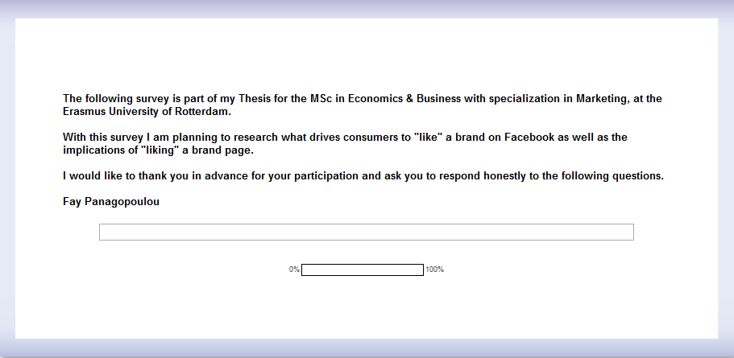
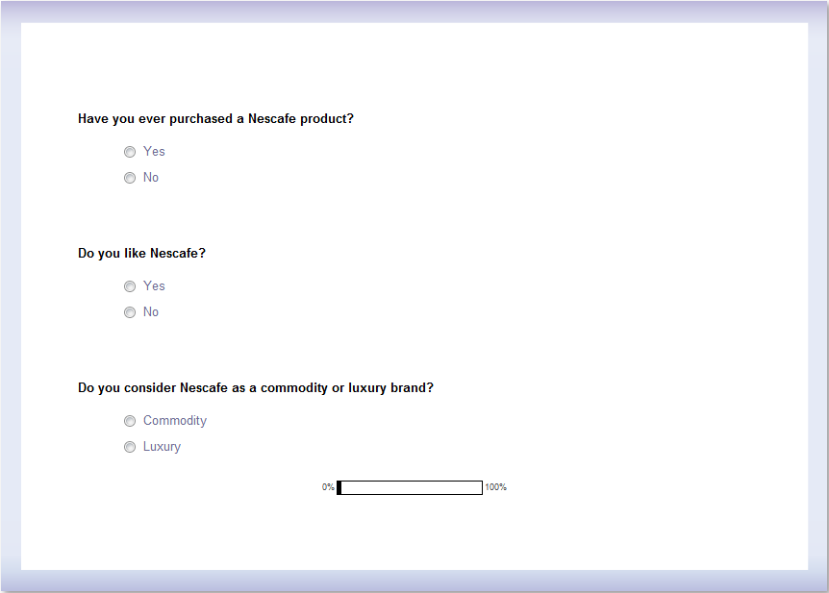
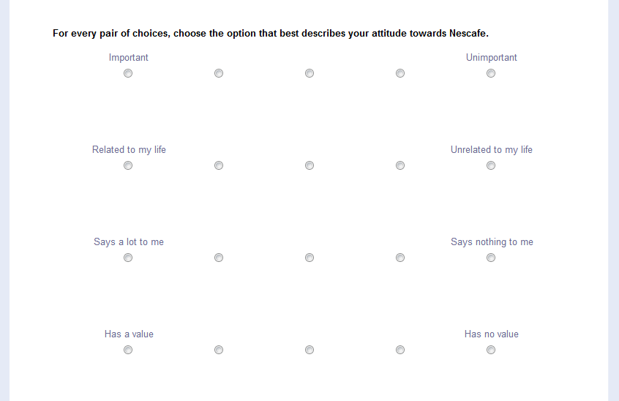
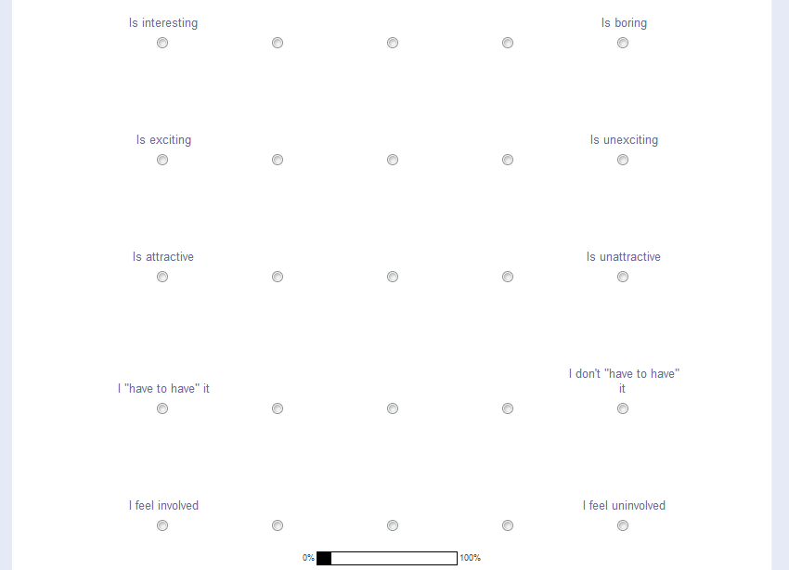
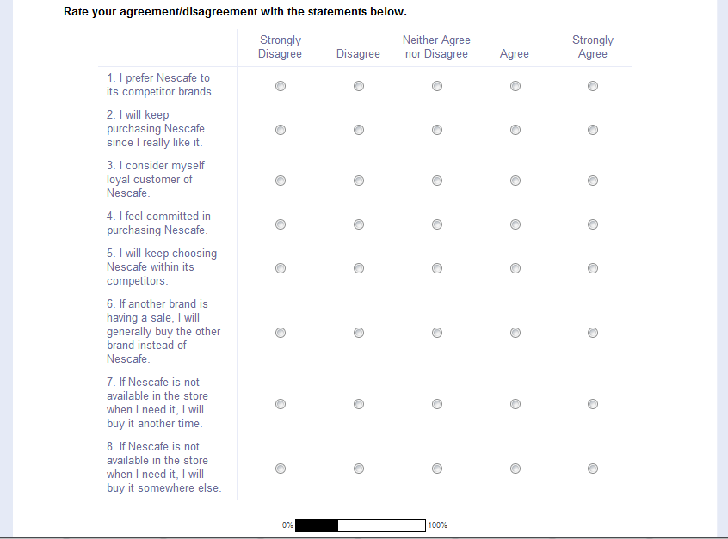
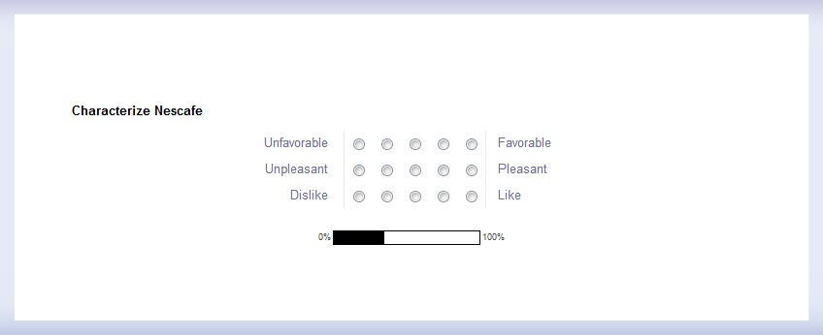
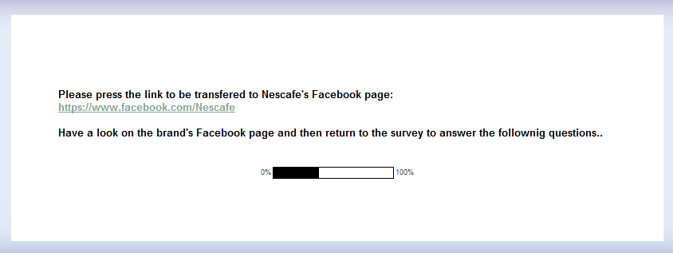
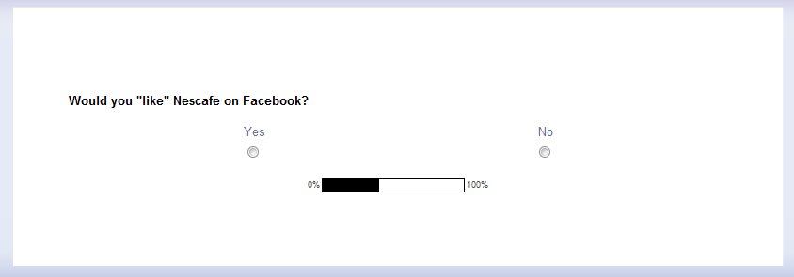
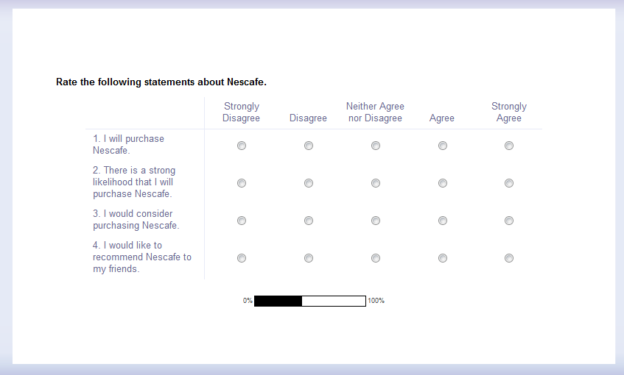
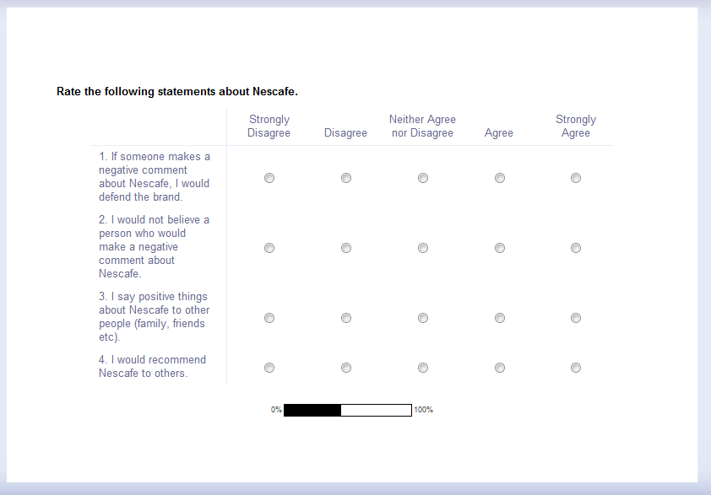
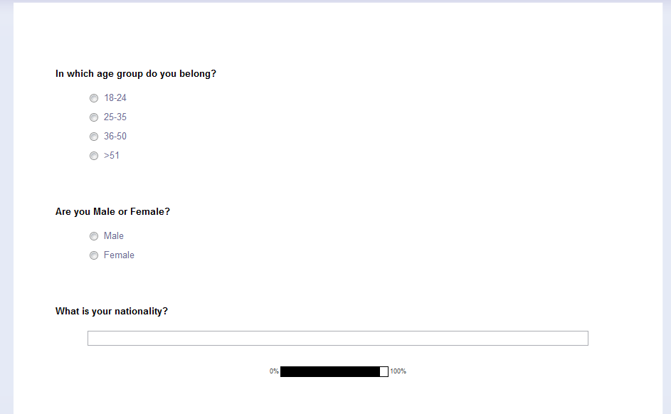


Appendix 2- Facebook pages (Nescafe, HTC)
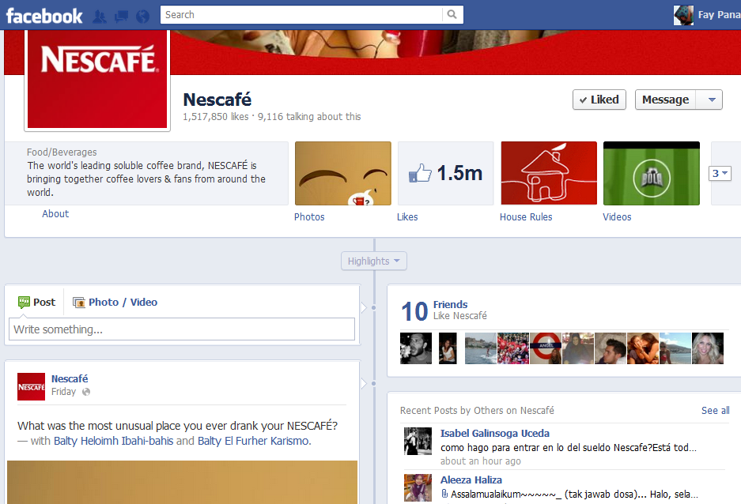

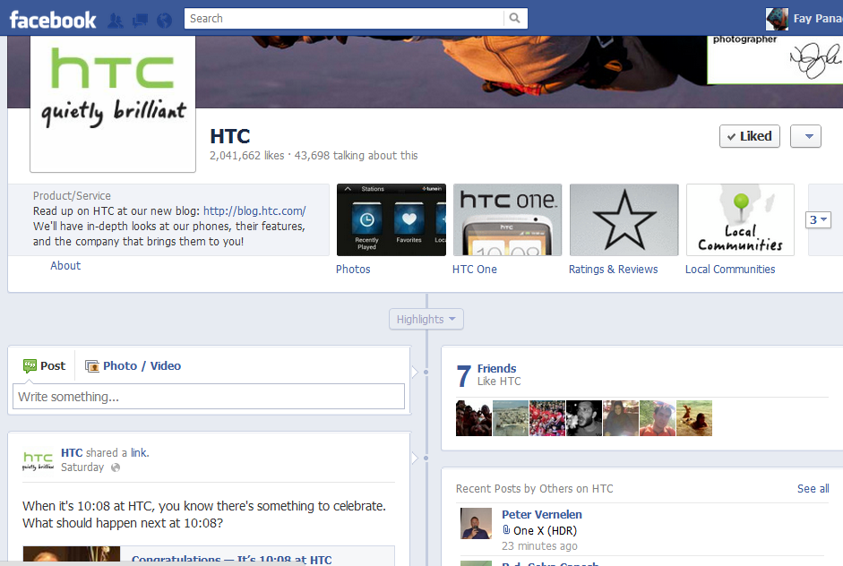

Appendix 3- Factor Analysis

Commodity

KMO and Bartlett's Test
Kaiser-Meyer-Olkin Measure of Sampling Adequacy. |  | ,935
Bartlett's Test of Sphericity | Approx. Chi-Square | 2580,348
Bartlett's Test of Sphericity | Df | 136
Bartlett's Test of Sphericity | Sig. | ,000

Rotated Component Matrixª
 | Component
 | 1 | 2 | 3
For every pair of choices, choose the option that best describes your attitude towards Nescafe. | ,370 | ,708 | ,287
InvolvementNescafe2 | ,311 | ,751 | ,297
InvolvementNescafe3 | ,063 | ,727 | ,453
InvolvementNescafe4 | ,190 | ,422 | ,716
InvolvementNescafe5 | ,190 | ,260 | ,822
InvolvementNescafe6 | ,090 | ,424 | ,661
InvolvementNescafe7 | ,177 | ,345 | ,759
InvolvementNescafe8 | ,304 | ,765 | ,237
InvolvementNescafe9 | ,224 | ,761 | ,357
LoyaltyNes1 | ,854 | ,113 | ,143
LoyaltyNes2 | ,859 | ,224 | ,146
LoyaltyNes3 | ,741 | ,484 | ,132
LoyaltyNes4 | ,663 | ,462 | ,136
LoyaltyNes5 | ,838 | ,200 | ,154
AttNes1 | ,662 | ,177 | ,578
AttNes2 | ,601 | ,141 | ,618
AttNes3 | ,661 | ,211 | ,585

Specialty

KMO and Bartlett's Test
Kaiser-Meyer-Olkin Measure of Sampling Adequacy. |  | ,926
Bartlett's Test of Sphericity | Approx. Chi-Square | 3159,355
Bartlett's Test of Sphericity | df | 171
Bartlett's Test of Sphericity | Sig. | ,000

Rotated Component Matrixª
 | Component
 | 1 | 2 | 3
For every pair of choices, choose the option that best describes your attitude towards HTC. | ,330 | ,525 | ,571
InvolvementHTC2 | ,278 | ,242 | ,825
InvolvementHTC3 | ,218 | ,280 | ,824
InvolvementHTC4 | ,087 | ,583 | ,614
InvolvementHTC5 | ,011 | ,824 | ,306
InvolvementHTC6 | ,182 | ,808 | ,327
InvolvementHTC7 | ,131 | ,872 | ,135
InvolvementHTC8 | ,292 | ,282 | ,721
InvolvementHTC9 | ,401 | ,249 | ,768
LoyalHtc1 | ,778 | ,302 | ,126
LoyalHtc2 | ,822 | ,282 | ,174
LoyalHtc3 | ,838 | ,031 | ,338
LoyalHtc4 | ,818 | ,000 | ,331
LoyalHtc5 | ,856 | ,110 | ,177
LoyalHtc7 | ,701 | ,381 | ,203
LoyalHtc8 | ,662 | ,344 | ,202
AttHtc1 | ,371 | ,706 | ,325
AttHtc2 | ,274 | ,790 | ,214
AttHtc3 | ,374 | ,756 | ,191

Appendix 4- Reliability test Cronbach a
Commodity-Involvement
Reliability Statistics
Cronbach's Alpha | N of Items
,837 | 11

Brand Loyalty

Reliability Statistics
Cronbach's Alpha | N of Items
,847 | 12

Attitude to the brand
Reliability Statistics
Cronbach's Alpha | N of Items
,762 | 6

Intention to purchase
Reliability Statistics
Cronbach's Alpha | N of Items
,804 | 8

Word of Mouth
Reliability Statistics
Cronbach's Alpha | N of Items
,851 | 8

Appendix 5- Logistic Regressions
Commodity

Omnibus Tests of Model Coefficients
 |  | Chi-square | df | Sig.
Step 1 | Step | 33,544 | 3 | ,000
Step 1 | Block | 33,544 | 3 | ,000
Step 1 | Model | 33,544 | 3 | ,000

Model Summary
Step | -2 Log likelihood | Cox & Snell R Square | Nagelkerke R Square
1 | 211,393ª | ,172 | ,230
a. Estimation terminated at iteration number 4 because parameter estimates changed by less than ,001.

Specialty
Omnibus Tests of Model Coefficients
 |  | Chi-square | df | Sig.
Step 1 | Step | 45,874 | 3 | ,000
Step 1 | Block | 45,874 | 3 | ,000
Step 1 | Model | 45,874 | 3 | ,000

Model Summary
Step | -2 Log likelihood | Cox & Snell R Square | Nagelkerke R Square
1 | 200,077ª | ,227 | ,303
a. Estimation terminated at iteration number 5 because parameter estimates changed by less than ,001.

Across all products

Omnibus Tests of Model Coefficients
 |  | Chi-square | df | Sig.
Step 1 | Step | 76,877 | 3 | ,000
Step 1 | Block | 76,877 | 3 | ,000
Step 1 | Model | 76,877 | 3 | ,000

Model Summary
Step | -2 Log likelihood | Cox & Snell R Square | Nagelkerke R Square
1 | 414,113ª | ,194 | ,260
a. Estimation terminated at iteration number 4 because parameter estimates changed by less than ,001.

Appendix 6-Linear Regressions
- Dependent Variable; Intention to purchase
Commodity
Model Summary
Model | R | R Square | Adjusted R Square | Std. Error of the Estimate
1 | ,378ª | ,143 | ,138 | ,87072
a. Predictors: (Constant), Would you "like" Nescafe on Facebook?

ANOVA^{b}
Model |  | Sum of Squares | df | Mean Square | F | Sig.
1 | Regression | 22,176 | 1 | 22,176 | 29,250 | ,000ª
1 | Residual | 133,434 | 176 | ,758
1 | Total | 155,610 | 177
a. Predictors: (Constant), Would you "like" Nescafe on Facebook?
b. Dependent Variable: INTNESC

Specialty

Model Summary
Model | R | R Square | Adjusted R Square | Std. Error of the Estimate
1 | ,521ª | ,272 | ,268 | ,78497
a. Predictors: (Constant), Would you "like" HTC on Facebook?

ANOVA^{b}
Model |  | Sum of Squares | df | Mean Square | F | Sig.
1 | Regression | 40,482 | 1 | 40,482 | 65,698 | ,000ª
1 | Residual | 108,448 | 176 | ,616
1 | Total | 148,930 | 177
a. Predictors: (Constant), Would you "like" HTC on Facebook?
b. Dependent Variable: INTHTC

Across all products

Model Summary
Model | R | R Square | Adjusted R Square | Std. Error of the Estimate
1 | ,479ª | ,229 | ,223 | ,82895
a. Predictors: (Constant), INTERACTION, Would you "like" Nescafe on Facebook?, PRODUCT_TYPE

ANOVA^{b}
Model |  | Sum of Squares | df | Mean Square | F | Sig.
1 | Regression | 72,026 | 3 | 24,009 | 34,939 | ,000ª
1 | Residual | 241,882 | 352 | ,687
1 | Total | 313,908 | 355
a. Predictors: (Constant), INTERACTION, Would you "like" Nescafe on Facebook?, PRODUCT_TYPE
b. Dependent Variable: INT_ACROSS

Appendix 7-Linear Regressions
- Dependent Variable; Word of Mouth

Commodity

Model Summary
Model | R | R Square | Adjusted R Square | Std. Error of the Estimate
1 | ,479ª | ,229 | ,225 | ,72902
a. Predictors: (Constant), Would you "like" Nescafe on Facebook?

ANOVA^{b}
Model |  | Sum of Squares | df | Mean Square | F | Sig.
1 | Regression | 27,848 | 1 | 27,848 | 52,399 | ,000ª
1 | Residual | 93,538 | 176 | ,531
1 | Total | 121,386 | 177
a. Predictors: (Constant), Would you "like" Nescafe on Facebook?
b. Dependent Variable: WOMNESC

Specialty

Model Summary
Model | R | R Square | Adjusted R Square | Std. Error of the Estimate
1 | ,501ª | ,251 | ,246 | ,73149
a. Predictors: (Constant), Would you "like" HTC on Facebook?

ANOVA^{b}
Model |  | Sum of Squares | df | Mean Square | F | Sig.
1 | Regression | 31,477 | 1 | 31,477 | 58,828 | ,000ª
1 | Residual | 94,173 | 176 | ,535
1 | Total | 125,651 | 177
a. Predictors: (Constant), Would you "like" HTC on Facebook?
b. Dependent Variable: WOMHTC

Across all products

Model Summary
Model | R | R Square | Adjusted R Square | Std. Error of the Estimate
1 | ,488ª | ,238 | ,236 | ,73073
a. Predictors: (Constant), Would you "like" Nescafe on Facebook?

ANOVA^{b}
Model |  | Sum of Squares | df | Mean Square | F | Sig.
1 | Regression | 59,000 | 1 | 59,000 | 110,493 | ,000ª
1 | Residual | 189,025 | 354 | ,534
1 | Total | 248,024 | 355
a. Predictors: (Constant), Would you "like" Nescafe on Facebook?
b. Dependent Variable: WOM_ACROSS

Appendix 8-Linear Regressions
- Mediation Test

Model Summary
Model | R | R Square | Adjusted R Square | Std. Error of the Estimate
1 | ,777ª | ,604 | ,600 | ,59461
a. Predictors: (Constant), ATT_ACROSS, LOYAL_ACROSS, INVOLV_ACROSS

ANOVA^{b}
Model |  | Sum of Squares | df | Mean Square | F | Sig.
1 | Regression | 189,454 | 3 | 63,151 | 178,614 | ,000ª
1 | Residual | 124,454 | 352 | ,354
1 | Total | 313,908 | 355
a. Predictors: (Constant), ATT_ACROSS, LOYAL_ACROSS, INVOLV_ACROSS
b. Dependent Variable: INT_ACROSS

Model Summary
Model | R | R Square | Adjusted R Square | Std. Error of the Estimate
1 | ,785ª | ,617 | ,612 | ,58538
a. Predictors: (Constant), Would you "like" Nescafe on Facebook?, LOYAL_ACROSS, ATT_ACROSS, INVOLV_ACROSS

ANOVA^{b}
Model |  | Sum of Squares | df | Mean Square | F | Sig.
1 | Regression | 193,629 | 4 | 48,407 | 141,264 | ,000ª
1 | Residual | 120,278 | 351 | ,343
1 | Total | 313,908 | 355
a. Predictors: (Constant), Would you "like" Nescafe on Facebook?, LOYAL_ACROSS, ATT_ACROSS, INVOLV_ACROSS
b. Dependent Variable: INT_ACROSS

