

Annette van Dam
296440

Preface
For my master Marketing I had to write a thesis. I choose the subject: “Information search for purchase decision.”
By my thesis I had some help of others, who I would like to thank for their support.
First of all, my supervisor drs. Donkers for his advice and patience. I would also like to thank Raymond de Jong for checking my English grammar. Last but not least all the respondents for filling in my survey.
Annette van Dam

Executive summary
Before people buy a product, people in general will search for information. The information search process tells something about the behavior that people have towards choice- and purchase decisions (Peterson and Merino, 2003).
There are two distinctive type of goods: search and experience goods. Search goods are objective and easy to compare (Nelson, 1970) whereby experience goods are difficult to evaluate and subjective and there will be more uncertainty (Huang, Lurie and Mitra, 2009).
To see if there is a difference in information search between these two goods, this research will answer the research question:
“What are the differences in the information search process between a search good and an experience good?”
To obtain data for my research, I asked hundred people to fill in my survey. In the survey were different questions concerning the usage and time people spent on searching for information for a search and an experience good. People also had to fill in some propositions.
From the data, it became clear that the search for a search good is shorter compared to an experience good (hypothesis 1). This can be explained by the fact that with an experience good, you can only experience the quality during the purchase and the experience itself. (Ward and Lee, 2000). So for this good the opinion of others is an important information source (for example forums). This is underlined by the second hypothesis, that stated that people will more listen to the opinion of others by making a choice for a experience good compared to a search good.
Use of internet has grown really fast over the past years. Following Peterson and Merino (2003), people can easily find information with less effort in time and money. This will make it easier for people to make a (better) decision. The paired sample t-test shows that WebPages are the most important source of the information search process (hypothesis 3).
There are two different ways in which people can search for information on WebPages: depth and breadth. The depth of search is the time people spent on a single Webpage and the breadth of search is about the number of WebPages a person visits (Huang, Lurie and Mitra, 2009). The paired sample t-test shows that people do not use less WebPages (breadth) by an experience good and the time spent on a WebPage (depth) is also not longer for an experience good compared to a search good (hypothesis 4).
The degree of satisfaction or dissatisfaction can be seen as the discrepancy between the expected quality and the real experience (Gilly and Gelb, 1982). When one compares a search and an experience good there is no difference between the expected and real quality (hypothesis 5).

Table of contents

1. Introduction 7
1.1 Research objectives 7
1.2 Research question 7
1.3 Overview 8
2. Theoretical framework 9
2.1 Sub questions of the research question 9
2.1.1 What is an information search process? 9
2.1.2 What are search goods? 10
2.1.3 What are experienced goods? 10
2.2 Theories 11
2.2.1 Consumer decision process model 12
2.2.2 The information search process 13
2.2.3 Herzberg’s theory 14
3. Hypotheses 15
3.1 Hypothesis 1 15
3.2 Hypothesis 2 16
3.3 Hypothesis 3 17
3.4 Hypothesis 4 19
3.5 Hypothesis 5 20
3.6 Conceptual framework 21
4. Method 22
4.1 Survey 22
4.2 Three Categories 22
4.2.1 Sources 22
4.2.2 Time 23
4.2.3 Proposition 23
4.3 Data process 24
4.3.1 Coding the data 24
4.3.2 Testing the data 24
5. Results 25
5.1 Hypothesis 1 25
5.2 Hypothesis 2 29
5.3 Hypothesis 3 33
5.4 Hypothesis 4 36 5.5 Hypothesis 5 44
6. Discussion, managerial implications and limitations 47
6.1 Discussion 47
6.2 Managerial implications 48
6.3 Limitations 49
7. References and WebPages 50
7.1 References 50
7.2 WebPages 53
8. Appendices 54
8.1 Appendix 1: Information search process 54
8.2 Appendix 2: Survey 54
8.3 Appendix 3: Histogram’s (hypothesis 2) 59
8.4 Appendix 4: Chi square crosstabs (hypothesis 4) 60

Chapter 1: Introduction

Before I started with my thesis, I didn’t know exactly what my subject would be. On the Blackboard I saw the subject ‘Information search for purchase decision’ and it seemed very interesting to me. Why do people sometimes search for information when purchasing a product and on the other hand how come that in other cases they just don’t? They just seem to purchase it without considering any alternatives.

  - Research objectives
For my thesis, I will investigate the differences in information search process between a search and an experience good. I assume that for these two different goods, the information search process will be different too. So I like to know how this search for information process differs from a search and experience good.
I also like to know which sources one uses to get information. So does a person listen to a company, friends or does he or she use the internet and magazines to get more information on a product in order to become more convinced to buy it.
For my survey, I have chosen to compare two products. In the case of a search good I have chosen for a ‘laptop’ and in the case of an experience for ‘ booking a vacation’. This would make the survey for people more understandable and easier, because not everyone knows what search and experience goods are.

  - Research Question
Knowing that most people always search for information before they buy a search or an experience good, it is interesting to know how the information search process of a person will develop.
So for my research, I have the following problem statement:
“What are the differences in the information search process between a search good and an experience good?”
  - Overview
My paper starts with an introduction in which I explain my topic and research question.
In chapter two I introduce the theoretical framework. In this chapter different theories will be described, that can be used for my research.
In chapter three, I have written the hypotheses that are tested for my research. You can also see the conceptual framework.
In chapter four I introduce the method I used to investigate my research.
In chapter five you see the results of the tested hypotheses.
Finally, in chapter six I have written down my conclusions.

Chapter 2: Theoretical framework
In this chapter I will answer the sub questions, that will come to mind by answering the research question. After answering the sub questions, I describe the theories that can be used for my research question.

2.1 Sub questions of the research question
For answering the research question, some sub questions will come in mind, like:
- What is an information search process?
- What are search goods?
- What are experienced goods?

2.1.1. What is an information search process?
The information search process is the process whereby a person is searching for information and tries to understand the information to extend his knowledge about a topic (Kuhlthau, 1991).
Following Beatty and Smith (1987) is the external search, the degree of effort whereby you want to obtain information which you can use for the specific purchase under consideration. Schmidt and Spreng (1996), have the same definition as Beatty and Smith, but believe that the acquired information is not for a specific purchase but more for consumption-related objects.
So the information search process is about the behavior of people towards choice- and purchase decisions (Peterson and Merino, 2003).
It is not possible to understand the decision making process by checking out the final outcome. It is also important to know what the intermediate steps of the information search process are. Choices are made on a scale of attractiveness, which means that people make a decision on what they think that is attractive (Svenson, 1979).

2.1.2 What are search goods?
By a search you can get information from secondhand sources, like advertisements and worth-of-mouth, without trying or buying the product (Wright and Lynch, 1995). Following Nelson (1970) it is possible to do a search procedure for this kind of good, because it isn’t too difficult to do so. So search goods have more objective qualities (Weathers, Harma and Wood, 2007) and for this type of good you can acquire information prior to purchase (Nelson, 1970).
Consumers are least skeptical about advertisement for a search good compared with experience goods (Ford, Smit and Swasy, 1990).
So search goods are objective and easy to compare (Huang, Lurie and Mitra, 2009).

2.1.3 What are experienced goods?
By an experience good it is about the firsthand experience and is the experience subjective (Wright and Lynch, 1995). Following Nelson (1970) can it be too expensive or too difficult to do a search procedure for this good. So customers will need more direct experience to evaluate quality (Weathers, Harma and Wood, 2007) and don’t know the product until they have purchased or used it (Nelson, 1970).
In general, consumers are more skeptical about the advertisements of low priced experience goods compared with the high priced experience goods (Ford, Smit and Swasy, 1990).
So experience goods are difficult to evaluate and subjective and there will be more uncertainty compared with a search good (Huang, Lurie and Mitra, 2009) .

2.2 Theories
For my research I can use different theories. I have chosen the following:
- Consumer Decision Model
- The information search process
- Herzberg’s theory

The reason why I have chosen for these four theories is because all the four fit very well within my research.
The Consumer decision process, tells something about the choices people have to make before they buy a product. During this process, people have to search for information.
The information search process, is about the information search process (just what the name is tells us).
The last theory, Herzberg’s theory, tells something about factors that cause satisfaction and dissatisfaction. Nowadays, you can also read the satisfaction or dissatisfaction of other people about a product, that a person can us by their information search.

2.2.1 Consumer decision process model.
The consumer decision model shows the stages a person takes to come to a buying decision. This model exists of five stages:
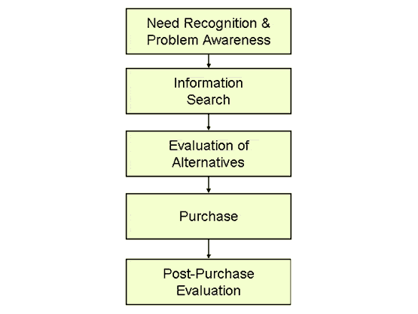
(http://tutor2u.net/business/marketing/buying_decision_process.asp)

A need recognition means that a person becomes aware that he needs something and can arise by internal or external influences. An internal influence is the basic human need. An external influence is something that a person can observe and which triggers him to buy. In the post-purchase evaluation, you can see if the product is satisfying to your needs. (Kotler and Keller, 2006)
In the case of common goods, which have a high purchase frequency, the information search and evaluation stage will be very short while for a more durable purchase, these two stages will be longer. Durable purchases have a low purchase frequency and therefore the frequency of the decisions are also very low. This is the reason why these two stages will be longer for durable goods (Punj and Brookes, 2001).
The feeling and mood of a person can influence all the five stages of the decision process. When people are feeling good, they can prefer other information than when they are in a bad mood (Puccinelli, Goodstein, Grewal, Price, Raghubir and Stewart , 2009).

There are four facts about the consumer decision model:
- There are at least two alternatives, so you have to make choices.
- Evaluation of the alternatives helps to see the consequences of each alternative, for the objectives of the consumers.
- The alternative a person can chose, is defined by decision process or evaluative procedure.
- The information that a person gets from external sources or from his own memory is also processed in the process of the decision model or evaluation procedure. (Olshavsky and Granbois, 1979)

2.2.2 The information search process
The Information Search Process, also called the ISP, is the action that people do to extend their knowledge on a particular topic. The process has three realms of activity, namely:
- affective: The feelings people experience.
- cognitive: The thoughts people have about the process and the content.
- physical: The actual actions people take.

This process exists of six stages:
- initiation: People become aware of the lack of knowledge and they recognize that they need more information.
- selection: People have to select a topic and choose an approach. When the selection is delayed, people will feel more anxiety.
- exploration: People will search for information about their topic, so that they get more knowledge about the topic and so more understanding. In general, at this stage people are more frustrated and confused, because the information they found is rarely consistent with their prior findings of their topic.
- Formulation: At this stage the confidence will grow and so the uncertainty will diminish. People focus on one point from the information they have found and so the topic becomes more personalized.
- Collection: Because people have a clearer sense of direction, it is easier to collect information for the topic they focus on.
- Presentation: At this stage you are satisfied or dissatisfied with your research. If you are satisfied then you can use the findings.(Kuhltau, 1991)
See appendix 1 for the schedule of the information search process.

2.2.3 Herzberg’s theory
The Herzberg’s theory is about factors that cause satisfaction or dissatisfaction. It is not the case that a person purchase a product when there are no dissatisfactors. People need satisfiers to motivate them to buy the product. (Kotler and Keller, 2006)

Chapter 3: Hypotheses
For my research, I want to test the following hypotheses:

3.1 Length of the search process
The theory of the consumer decision model (paragraph 2.2.1) tells us that there are five steps that people take to come to a decision. In this research we focus especially on the second part of the theory: the search for information. This part can influence the length of time before people come up with a decision. How more a one searches for information, how longer it will take to make a decision.
The length of the search process depends on the costs and the purchase frequency. It depends also on the type of good. So the length of search is different for a search and an experience good (Ekelund Jr, R.B., F.G Mixon Jr and R.W. Ressler, 1995).
In general, people know what kind of features are important to them by a search good. They will select the product which fulfill all of their wishes and choose one of them. Important will be the satisfiers of a good, which will motivate to buy the product (Herzberg’s theory; paragraph 2.2.4) .
This can be different in the case of an experience good. Only during the purchase and the experience, you will know if it´s what you have expected (Ward and Lee, 2000).
So for an experience good, it will be more important to be sure that the product is what a person expects it will be and therefore the search for information will be higher.
Based on this, my first hypothesis is:

Hypothesis 1: The information search process for a search good is shorter than for an experience good.

3.2 Opinion of others

An experience good is a more subjective good (Huang, Lurie and Mitra, 2009), because each person has his own personality and so his own experience. Through the different personalities, persons can react differently on different situations (Mischel, 1968). A person who is satisfied will tell a few persons about his experience, but someone who is dissatisfied wants to tell that to the most people that he speaks (Chatterjee, 2001).
So there is always a risk that the experience good is not what you had expected to be and the chance of a bad post purchase experience might be happen. This can be a reason why people will be more prone to listen to the opinion of others by an experience good.
A search good, on the other hand, is a more objective good (Huang, Lurie and Mitra, 2009). For this good it is more obvious what important features are and so the product attributes will be sufficient enough for a person to know if he likes it or not.

Word-of-mouth is a very powerful tool in the marketplace (Henricks, 1998). Following Harrison and Walker (2001) is word-of-mouth an informal communication between a noncommercial sender and a receiver.
Although word-of-mouth is noncommercial and the opinion of the staff can be commercial, I will also use this group by the opinion of others. The reason is that the staff of a shop can also give good information and advice.
Following Townsend (1951) helpful and nice staff have a positive influence on the customers. When the pressure of the staff becomes too high and the staff becomes over-helpful, this will have a negative effect.
.
This will lead to my second hypothesis:

Hypothesis 2: People will listen more to the opinion of others by making a choice for a experience good compared with a search good.

3.3 WebPages

Following Pan (2006) the internet has a hypertext system and it differs from other information
sources. The hypertext system, whereby people are totally unrestricted where they want to go
and navigate on the web to find their valuable information, is also explained by the foraging
theory, which is one of the leading theories. The information foraging theory has its origin in
the biology, where is was used to understand the foraging by animals. It is also
possible to use this theory by the information seeking behavior of people (Pirolli and Card,
1995). The core of the information foraging theory is: how quick can you find your valuable
information. (Pirolli, 2007)

Internet has a major impact on the information search. Thanks to internet, people will find
more and better information with less effort in time and money, which in turn will help them
to make a better decision (Peterson and Merino, 2003). Also the perceived risk
will be reduced. (Ha, 2002)
However, there is a threshold whereby extra effort in searching for more information, does not change the final decision. These extra information can be seen as unnecessary. (Lee and Cotte, 2009)
When the search costs become very low, people can easily find the seller with the lowest cost.
On the contrary, sellers are worst off because of the lower search costs (Bakos, 1998).
Also customers have negative elements by the use of internet, like problems with the
examination and post-service costs. (Liang and Huang, 1998)

The knowledge and purchase intentions for a product are higher by forums on the
internet compared with corporate WebPages. On these forums, people can share their opinion
and experience about a product (Bickart and Schindler, 2001). So also their
satisfaction or dissatisfaction (Herzberg’s theory; paragraph 2.2.4). Negative information,
dissatisfiers, weighted more heavily than positive information (Weiss, Lurie and Macinnis,
2008).
Especially experience goods benefit the most of these online forums. Search goods on the
other hand, rely more on the retailers and manufacturers sites (Bei, Chen and Widdows,
2004).

The amount of people that use the internet has grown enormously. In the graph below you will notice a steep line above. How younger the group, how higher the use of the internet.

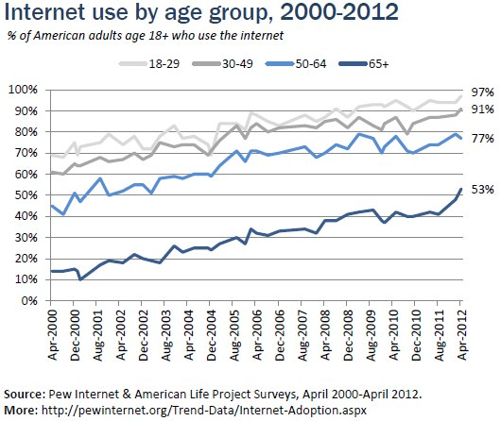

My third hypothesis is:

Hypothesis 3: WebPages are the most important source for the information
search process.

.

3.4 Search on internet

The information search process (paragraph 2.2.2) explains how and why a person searches for information in six steps. The theory tells us that when a person finds out that he has too less knowledge about a product, people will search for more information. It describes a model a person follows when he is looking for more information. One source people can use to get more information, is the internet.

Following Nelson (1970) people don’t search for prepurchase information for an experience good, because the experience itself will be cheaper and takes less effort in time than the search itself. For a search good this is less difficult.
On the contrary, there are several other authors who assume that the difference between a search and an experience good declines because of internet. On the internet, every good becomes searchable (Lynch and Ariely, 2000). You can easily find information which is normally difficult to obtain and people are more able to know the experience and opinion of others (Alba et al. 1997; Klein 1998; Peterson, Balasubramanian and Bronnenberg, 1997).

By searching on the internet, there are two different ways people can read a Webpage:
- Depth of search: The time people spent on a single Webpage
- Breadth of search: The amount of WebPages a person visits.

Information about a search good is easier to find, because on the internet you can find the attributes you are looking for more easily. On the other hand, by an experience good, you want to read more about the opinion of others and inspect more products (Huang, Lurie and Mitra, 2009).
I expect the breadth of search will be stronger by an search good than the depth of search, because a person wants to check all sites of different companies, to know where they would have the best price and the best service. For the experience good it will be reversed.

My fourth hypothesis is:
Hypothesis 4: By the information search on the internet people use less WebPages (breath) by an experience good, but the time spent on a WebPage (depth) is longer compared to a search good.

3.5 Quality
Following Swan and Trawick (1979), a person has two type of expectations: predictive and desired. The predictive expectations is what a person expects the performance will be and the desired expectation is how a person desires the product to perform. When the desired expectations are fulfilled, a person will be satisfied, while the predictive expectations are fulfilled a person is indifferent.
How higher the price of a good, how higher the predictive and desired expectation will be (Zeithaml, Berry and Parasuraman, 1993).
When the price becomes higher for a good, also the cost for a bad post-purchase experience will become higher. In this case, people are more tended to search for information. (Laband, 1991)
An experience good can be different than you had expected. Only during the purchase and experience stages, you will experience whether you have read about it, if that is true (Nelson, 1970). The experience is a determinant of the satisfaction level of the customer (Cho, Im, Hiltz and Fjermestad, 2002).
A search good, on the other hand, is a more objective good (Weathers, Harma and Wood, 2007). So I expect that the chance for a bad post-purchase experience will be lower for a search good compared to an experience good.
This will lead to my fifth hypothesis:

Hypothesis 5: The expected quality of an experience good is more positive than the real quality. So the post-purchase experience is often worse for an experience good compared to a search good.

3.6 Conceptual model
H 1
Length of information search

Difference in information search between a search and an experience good
H2
Other people
Opinion of others

H3
Most important source
WebPages

H4
WebPages
Depth vs. breadth of search

H5
Expected vs. real experience
Post-purchase experience

Chapter 4: Method
4.1 Survey
For my research I will use the survey methodology to see what the differences are in the information search process between a search and an experience good. Because not everyone knows what search and an experience goods are, in my survey I have used a ´laptop´ for a search good and ´booking an holiday´ for an experience good. I have interviewed one hundred persons for my survey, because that amount will be enough to have a representative sample. The people that I have asked, are persons over eighteen years old. It is my believe that people over eighteen will reasonably belong to a group that can go on holiday and purchase a laptop.
First I asked my family and friends to fill in the survey and asked if they could send it to their family and friends. I also went to the centre of Spijkenisse and asked different persons to fill in my survey.
4.2 Three categories
There are three categories of questions I have asked about the information search process. These three are:
- Sources people use (4.1)
- Time people spent on a source (4.2)
- Propositions (4.3)

4.2.1 Sources
In my survey people could choose between five kind of sources. For every source, they had to fill in if they use it by their search for a search and/ or experience good. These five sources are:
- Friends/ family
- Staff of a shop
- Other people
- WebPages
- Magazines
If a person answered the source ‘WebPages’, I furthermore asked two other questions:
- How many WebPages do you watch?
- In what way do you watch WebPages?
In the second question, people had to fill in how radical or superficial they watch WebPages.

4.2.2 Time
When people use a source, I also wanted to know how many minutes it takes them to use this source. This number is subjective, because people had to estimate how many minutes it took them.
4.2.3 Proposition
In my survey I have used three propositions. Namely:
- I know what is important by buying a laptop/ booking a vacation, so I don’t need the opinion of others.
- I’m afraid that the laptop I have bought/ /the holiday I booked, will be a disappointment.
- After I have bought the laptop/ been on holiday, it satisfied my expectations.
For every proposition people had to fill in how strongly they agree or disagree these propositions.

4.3 Data process
For my data I used the programs SPSS and Excell. I used excell to fill in the answers of the survey for a clear overview. For the histograms and doing the tests, I used the program SPSS.

4.3.1 Coding the data
For every category of questions I will now describe how I processed the data.
- Sources
When people have used a source, I code them with the number ‘1 ‘and ’2’ when they didn’t use it.
- Time
By the amount of time that people use a source, I filled in the precise amount of time that people had filled in.
- Propositions
For the propositions people had to fill in how strongly they agree or disagree to a sense. I coded ‘disagree very much’ as number ‘1’ up to ‘agree very much’ as the ‘5’.
4.3.2 Testing the data
For testing the data I used the following three types of tests:
- Paired sample t-test
For my research I tested the data with the paired sample t-test, because I wanted to compare the search with the experience goods. This test also shows the differences between these two variables.
- Chi-square
For my fourth hypothesis I used the Chi-square test to see if the distribution is the same for the frequency table compared with the Chi-square data as to how people watch WebPages.
- Histogram
For hypotheses two and four I have made histograms to get a good overview of the data. In these histograms you can also see the normal curve, so that it would be easier to see what the outliners are and which good has no normal distribution.
Chapter 5: Results
5.1 Hypothesis 1

For my first hypothesis I want to know if there is a difference in the length of search between a search and an experience good. I expect that the time spent on searching for information for a search good will be shorter, because search goods have more objective qualities (Weathers, Harma and Wood, 2007). On the other hand, an experience good is a more subjective good (Huang, Lurie and Mitra, 2009). So for an experience good, it will be more important to be sure that the product is what a person expects it will be. My first hypothesis is:

The information search process for a search good is shorter than for an experience good.

I will first test the hypothesis by comparing the time spent on the information search for a search good with the time spent on an experience good. Secondly, I want to compare the sources people have used for their information search process between both kind of goods. Here are the results.

For testing the time spent on searching I used the paired sample t-test, because I want to compare both goods with each other.

Table 1
 | Search | Experience
Mean | 99,82 | 181,00
N | 95 | 95
Std. Deviation | 77,955 | 170,053
Correlation | 0,354
t | -4,944
df | 94
Sig. (2-tailed) | 0,000
Some people haven’t filled in all the answers concerning the amount of time they spent on the different sources. This is the reason why the amount of answers is 95 (see N). In SPSS I have filled in the empty columns as missing values, so that these persons are repressed of the analyze.
In table 1 we can see the outcomes of both goods compared on time with each other. Hereby you can see that the mean of time for a search good is lower than for an experience good.
The correlation is 0,354 which means that the time spent on searching for information between a search and experience good are very low positive correlated. So there is no much correlation between both search processes.
The significantly level is very high, which means that there is a very significant effect and that there’s a difference in time spent on searching for information for both kind of goods.
So the first hypothesis is supported by all the outcomes in the table.
For my second test, I compare the sources people used. There are five sources that people could choose from in my survey: friends, staff of a shop, other people, WebPages and magazines. For each source I want to know how many people have used the source for getting their information on both kind of goods. In table 2 we can see how many people use one or more of the different sources for a search and an experience good.
I have used the paired sample t-test to compare the amount of people for every source between a search (S) and an experience (E) good.
The column N is hundred, because in my survey there are hundred people who have filled in the question whether they used the source or not. The column N (use source) shows the amount of people who have used the source for both kind of goods. So the people who said they didn’t use the source, are filtered out in this column.

Table 2
 |  |  |  |  |  |  | Friends |  | Staff |  |  | Other people |  | WebPages |  | Magazines |  |  | Total
 |  |  | N |  | S |  | 100 |  | 100 |  |  | 100 |  | 100 |  | 100 |  |  | 100
 |  |  |  |  | E |  | 100 |  | 100 |  |  | 100 |  | 100 |  | 100 |  |  | 100
 |  |  | N use  source |  | S |  | 84 |  | 79 |  |  | 55 |  | 84 |  | 55 |  |  | 357
 |  |  |  |  | E |  | 70 |  | 54 |  |  | 56 |  | 91 |  | 61 |  |  | 332
 |  |  | Std.  Deviation |  | S |  | 0,368 |  | 0,409 |  |  | 0,500 |  | 0,368 |  | 0,500 |  |  | 1,112
 |  |  |  |  | E |  | 0,461 |  | 0,501 |  |  | 0,499 |  | 0,288 |  | 0,490 |  |  | 1,399
 |  |  | Correlation |  |  |  | 0,310 |  | 0,066 |  |  | 0,332 |  | 0,149 |  | 0,225 |  |  | 0,342
 |  |  | T |  |  |  | -2,841 |  | -3,996 |  |  | 0,173 |  | 1,619 |  | 0,973 |  |  | 1,713
 |  |  | df |  |  |  | 99 |  | 99 |  |  | 99 |  | 99 |  | 99 |  |  | 99
 |  |  | Sig. (2-tailed) |  |  |  | 0,005 |  | 0,000 |  |  | 0,863 |  | 0,109 |  | 0,333 |  |  | 0,090
The first source is friends. In the table you can see that the amount of people who ask their friends or family for their opinion on a search good is higher than by an experience good.
The second source in my survey is the staff of a shop or travel agency. Here the percentage of people who ask for information at the staff is also higher for a search good compared with an experience good.

The significance levels for friends and staff are the highest, which means that these two sources have a significant effect on the difference in information search process between both kind of goods. The other three sources have a (very) low significance level and do not have a significant effect.
For the source other people, the percentages are almost equal. The correlation rate for this source is the highest. The correlation effect shows the correlation between the different sources for both kind of goods. All the other different sources are not strongly (positive) correlated to each other. Friends and other people are correlated most, but are still not that high.
Last years, internet has become an important source. You can find anything on the web.
The percentages of people who use the source WebPages is therefore very high for both kind of goods, but higher for an experience good. So more people use the internet to search for information on an experience good.
The last source in my survey are magazines. In the table you can see that more people use magazines for their information search by an experience good compared to a search good.
You can also see in the table the total amount of people who have used one or more sources for both kind of goods. In the table you can see that the total amount of people who use different sources for their information search, is higher for a search good. So there are more people who used one or more sources by their information search process for a search good. Especially the sources friends and staff are significantly higher. The significance level of the total amount is too low to be significant, which means that there is not a significant difference between a search and an experience good in the amount of people using the different sources.
We can conclude that it’s hard to say if hypothesis one is supported by the amount of sources that people use. We can say that most people use slightly more sources by their search for information on an experience good compared to a search good. In case of three of the five sources, the amount of people is (a little) higher for an experience good. Only friends and staff are significantly higher for a search good compared to an experience good. The total amount of people using different kind of sources is not significantly different for both goods. But of course, the time people spent on all the different sources is an important feature.
So when we look at the time people spent on searching for information for both kind of goods, it’s obvious that this is much longer for an experience good.
Based on especially test one means that hypothesis 1 is supported. So the information search process for a search good is shorter than for an experience good.

5.2 Hypothesis 2
For my second hypothesis I want to know if people listen more to the opinion of others for an experience good compared to a search good. For an experience good it’s more complicated to know if you make the right choice. You have to experience the good before you know if you like it or not (Ward and Lee, 2000). So for this type of good, the opinion of others can be important. Search good have more objective qualities (Weathers, Harma and Wood, 2007). So the attributes should be sufficient enough for this type of good.
My second hypothesis is:
People will listen more to the opinion of others by making a choice for an experience good compared to a search good.
For testing this hypothesis, I will also do two tests. Firstly, I want to test the difference between the time spent on asking other people for information between a search and an experience good.
Secondly, I want to look at the answers that people gave on the proposition: ‘I know where I have to look out for, so I don’t need the opinion of others’. People had to fill in how strongly they agree or disagree to this proposition. So with this outcome we can also see how important the opinions of other people are.
For my first test, I will compare the time spent on asking people for information on a search and an experience good. In my survey there are three type of sources, namely: friend/family, staff of a shop/travel agency and other people. I will compare the total amount of time spent on these three kind of sources for a search and an experience good. I use the paired sample t-test, because this test shows the difference for both goods. The results are below (table 3).

Table 3a

 | Search | Experience
Mean | 38,65 | 32,58
N | 97 | 97
Std. Deviation | 38,366 | 40,639
Correlation | 0,407
t | 1,388
df | 96
Sig. (2-tailed) | 0,168

In table 3a you see that the mean of time for a search good is a bit higher compared to an experience good. This means that the time people ask others for their opinion on a search good is higher.
In the table you can see that the correlation coefficient is 0,407, which means that the information search process for a search and an experience good is slightly positive related.
The significance level is low, which means that there is not a significance difference between a search and an experience good.
In table 3b you see the time people spent on the three sources as a relation of the total amount of time on all the five sources for each good. The reason for this extra table is, that we than pay attention to the fact that there has been more time spent in total on one of the both goods. In this table we can see that the mean for a search good is some higher than the mean of an experience good. The correlation coefficient is slightly lower as in table 3a but the significance level is very high, which means that there is a significant difference between a search and an experience good in the amount of time people spent on asking others for information.
Table 3b
 |  |  |  |  | Search |  | Experience
 |  |  | Mean |  | 0,412629 |  | 0,317327
 |  |  | N |  | 95 |  | 95
 |  |  | Std. Deviation |  | 0,2328758 |  | 0,2427236
 |  |  | Correlation |  | 0,383
 |  |  | t |  | 3,514
 |  |  | df |  | 94
 |  |  | Sig. (2-tailed) |  | 0,001
Because table 3b shows the relation between the three sources (friends, staff and other people) and all the five sources, it gives a more realistic view.
We can also look at the histograms 1a and 1b in appendix 3. For these histograms I used the data of table 3b. It is obvious that the experience good has more outliners and the search good has more a normal curve. In the histograms you can see that the relation of the three sources towards the total amount of time, is higher for a search good compared to an experience good.
So hypothesis two is not supported by the first test.

For my second test I looked at the proposition: ‘I know where I have to look out for, so I don’t need the opinion of others’.
In table 4a we can see the results of the paired sample t-test. Here you can see that there is a slightly positive correlation between the outcomes of the search and experience good. The significance level is very high, which means that people gave different answers on the proposition for both kind of goods. The mean is also higher for a search good than for an experience good. People could choose between ‘totally agree’, which counts for one point and ‘totally disagree’, which counts for five points. It is obvious that by a search good more people disagree with the proposition, so they need the opinion of others more for their information search.
So hypothesis two is neither supported by the second test.

Table 4a
 | Search | Experience
Mean | 3,50 | 2,88
N | 100 | 100
Std. Deviation | 1,150 | 1,335
Correlation | 0,447
t | 4,710
df | 99
Sig. (2-tailed) | 0,000

We can conclude that there is not enough evidence for supporting the second hypothesis. So people won’t be listing more to the opinion of others by making a choice for an experience good compared to a search good.

5.3 Hypothesis 3
If we look back at the data for hypothesis one and two, we can see that the mean of time people spent on asking ‘other people’ for information by hypothesis two (table 3a) is very low compared to the mean of the time people spent on ‘all the sources’ (table 1) by hypothesis one. Especially experience is much higher by hypothesis one. In table 3a we have the mean of the time people spent on asking other people for information, which are three sources. In table 1 we have the time people spent on searching for information with all the five sources. The two sources that we miss in table 3a are: WebPages and magazines. So we can say that WebPages and/or magazines are the most important source of the information search process. Last time internet has become an important source for everyone, so my third hypothesis is:
WebPages are the most important source of the information search process.
By the first hypothesis in table 2, we could already see the number of people using the different sources. In table 5a you can see a summary of these data. In this table you notice the number of people and the significance levels between both goods for every source. We can see that most people use WebPages by their search for information and that only the number of people for ‘friends’ and ‘staff’ significantly differ for both goods.

Table 5a
 | Search | Experience | Sig. (2-tailed)
Friends | 84 | 70 | 0,005
Staff | 79 | 54 | 0,000
Other people | 55 | 56 | 0,863
WebPages | 84 | 91 | 0,109
Magazines | 55 | 61 | 0,333

Because we have already tested the number of people for hypothesis 1, I also want to test the amount of time people spent on WebPages compared with the amount of time people spent on the other four sources for each good. I have used the paired sample t-test. In table 5b you can find the results for a search good and in table 5c for an experience good.
 | Table 5b
 |  | WebPages | Friends | Staff | Other people | Magazines
 | Mean | 52,68 | 17,21 | 12,03 |  | 8,93
 | Other people | 51,91 |  |  | 8,82
 | N | 99 | 99 | 99 |  | 99
 | Other people | 97 |  |  | 97
 | Std. Deviation | 51,559 | 18,379 | 14,291 |  | 13,464
 | Other people | 51,627 |  |  | 15,667
 | Correlation |  | 0,212 | 0,372 | 0,197 | -0,068
 | t |  | 6,928 | 8,405 | 8,333 | 8,036
 | df |  | 98 | 98 | 96 | 98
 | Sig. (2-tailed) |  | 0,000 | 0,000 | 0,000 | 0,000
 | Table 5c
 |  | WebPages | Friends | Staff | Other people | Magazines
 | Mean | 97,19 | 24,56 | 17,24 |  | 28,93
 | Other people | 96,96 |  |  | 14,10
 | N | 98 | 98 | 98 |  | 98
 | Other people | 97 |  |  | 97
 | Std. Deviation | 141,080 | 28,721 | 22,954 |  | 35,539
 | Other people | 141,794 |  |  | 22,708
 | Correlation |  | 0,020 | - 0,118 | 0,050 | 0,182
 | t |  | 5,014 | 5,436 | 5,728 | 4,859
 | df |  | 97 | 97 | 96 | 97
 | Sig. (2-tailed) |  | 0,000 | 0,000 | 0,000 | 0,000

In these tables it’s obvious that for a search as an experience good, the mean of time that people spent on WebPages is higher compared with the other sources. For both goods, WebPages do have a significant effect with all the other four sources, which means that the amount of time people spent on WebPages is significantly higher compared with the time spent on the other sources. Also the correlation level is very low for all the sources compared with WebPages. The amount of N differs for the source ‘other people’, because this source has more missing values. This is the reason for the extra row ‘other people’.
We can conclude that hypothesis 3 is supported. So WebPages are the most important source of the information search process.

5.4 Hypothesis 4
Lately the internet has become an important source. Like we saw through hypothesis three, WebPages are the most important source of the information search process. This is also the case for table two of the first hypothesis. In this table we could see how many people use WebPages as a source for their information search process. This number was very high for both goods, namely 84 percent for a search good versus 91 percent for an experience good. So almost all the respondents use the internet for their information search process.
There are different ways to search on the internet, like depth and breadth. By depth of search we mean the time spent on a Webpage and by the breadth of search we mean the amount of WebPages you use (Huang, Lurie and Mitra, 2009).
I expect the breadth will be higher than the depth of search for a search good. For most search goods, people know what they are looking for and want the best price. So people will check different sites. For an experience good this will be vice versus.
My fourth hypothesis is:
By the information search on internet people use less WebPages (breadth) by an experience good, but the time spent on a Webpage (depth) is longer compared with a search good.
For testing this hypothesis, I will split the hypothesis in two separate hypotheses:
4a) By the information search on internet, people use less WebPages by an experience good compared to a search good.
4b) The time that people spent on a Webpage is longer for an experience good compared to a search good.

For testing hypotheses a en b, I will do three tests.
First I will test the amount of WebPages people use for both kind of goods to see if hypothesis a is supported.
For testing hypothesis b, I will test how many minutes people search on the web.
My last test (for testing hypothesis b) is to see how people watch the WebPages. In the survey, people had to fill in how radical or superficial they watch WebPages for both goods.

For testing hypothesis 4a, I made two histograms that show the amount of WebPages that people use for their search on the internet. In the histograms 2a and 2b we can see the numbers with the normal curve. It is obvious that the normal curve for the experience good is steeper than for the search good, which means that most people use the same amount of WebPages (namely 5). The mean for an experience good is a bit higher compared to a search good, but there is one outlier (by sixty number of WebPages). In this case it concerns one person, so the mean of the experience good will not be influenced that much by the gross of the others.
In table 6 you can see the results of the paired sample t-test. Here we can see that the amount of WebPages people use, differ significantly for both goods. The mean of the amount of WebPages is for an experience good higher compared to a search good. The mean by a search good (table 6) differs slightly from the mean in the histogram (2a) because by the histogram we used all the hundred respondents. This wasn´t the case for the paired sample t-test (table 6), because the experienced good has a ‘missing value’ and for this test we tested both goods dependent of each other. So both goods should have the same amount of people. That’s the reason why we also miss a value for the search good.
We can conclude that hypothesis 4a is not supported, because the higher amount of WebPages people watch for an experience good is significantly higher compared to a search good. So people use more WebPages for an experience good compared to a search good.

Histogram 2a
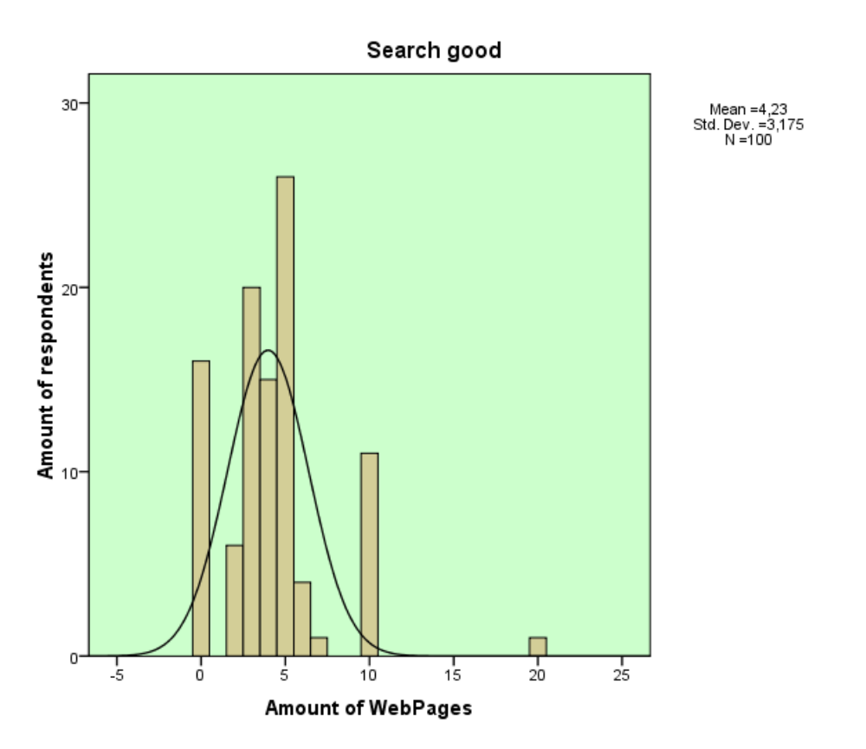
Histogram 2b
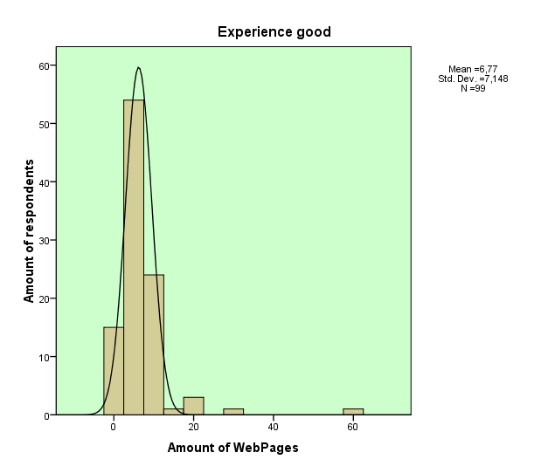
Table 6
 |  |  |  |  | Search |  | Experience
 |  |  | Mean |  | 4,27 |  | 6,77
 |  |  | N |  | 99 |  | 99
 |  |  | Std. Deviation |  | 3,162 |  | 7,148
 |  |  | Correlation |  | 0,131
 |  |  | t |  | -3,342
 |  |  | df |  | 98
 |  |  | Sig. (2-tailed) |  | 0,001

For testing hypothesis 4b, we want to know if the time spent on a Webpage is longer for an experience good compared to a search good. So we have to compare the time people spent on searching for both kind of goods.
Because some people generally tend to fill in more minutes than other persons, it’s important to see the relative value of the time people spent on WebPages in a relation to the total amount of time people spent on all the five sources for each good. The results of the paired sample t-test are below in table 7a.
In the table it´s obvious that the mean for both goods are almost equal to each other and therefore the significance level is too low. There is not a significant difference between the amount of time that people spent on WebPages for both goods.
So hypothesis b is not supported here, which means that the time people spent on a Webpage is not longer for an experience good compared to a search good.

Table 7a
 |  |  |  |  | Search |  | Experience
 |  |  | Mean |  | 0,479709 |  | 0,508398
 |  |  | N |  | 95 |  | 95
 |  |  | Std. Deviation |  | 0,2737565 |  | 0,2977282
 |  |  | Correlation |  | 0,364
 |  |  | t |  | -0,866
 |  |  | df |  | 94
 |  |  | Sig. (2-tailed) |  | 0,389

For my last test (for testing hypothesis b), I will investigate how people watch WebPages for both goods. In the survey, people had to fill in how radical or superficial they watch.
In table 8a and 8b we see how many people made a choice out of five different answer possibilities. By a search good most people watch the WebPages ‘radical’, while by an experience good most people chose ‘very radical’.
To get a good view of the distribution between both goods, have a look at the results of the Chi-Square test in table 8c. The Chi-Square shows that there is a relation between both variables. So we can see if the distribution is the same with this test as in table 8a and 8b.
In table 8c it is obvious that Chi-Square significance level is very high, which means that there is a relation between both goods.
In appendix 4 we can also see the table of the crosstab. In this table we can see that for a search good ‘radical’ has been the most filled in option (31,6%) and for an experience good ‘very radical’(41,8%). This is the same conclusion as by table 8a and 8b (there is only a little difference by the percentages). Of the people who have filled in when they radically read WebPages by a search good, 41,9 % read WebPages very radically by an experience good. Vice versus is this percentage 31,7%.
To test whether people agree with their statement by the proposition, it is also important to see what the outcome is when we divide the amount of time people search on the internet by the number of WebPages. Then we know on average how many minutes people watch a WebPage. In table 9 you see the results of these answers with a paired sample t-test. In this table you see that the correlation coefficient is slightly positive and the way people watch the WebPages is not significantly different for both goods. The mean by an experience good is some higher compared to a search good, but the difference is not high enough to be significant.
So hypothesis b is not supported here, which means that there is no difference in watching WebPages for both goods.
Table 8a

Watching WebPages/ Search good
 |  | Frequency | Percent | Valid Percent | Cumulative Percent
Valid | no use of Webpages | 16 | 16,0 | 16,2 | 16,2
Valid | very radical | 26 | 26,0 | 26,3 | 42,4
Valid | radical | 31 | 31,0 | 31,3 | 73,7
Valid | neutral | 18 | 18,0 | 18,2 | 91,9
Valid | superficial | 5 | 5,0 | 5,1 | 97,0
Valid | very superficial | 3 | 3,0 | 3,0 | 100,0
Valid | Total | 99 | 99,0 | 100,0
Missing | 999 | 1 | 1,0
Total |  | 100 | 100,0

Watching WebPages/ Experience good
 |  | Frequency | Percent | Valid Percent | Cumulative Percent
Valid | no use of WebPages | 8 | 8,0 | 8,1 | 8,1
Valid | very radical | 41 | 41,0 | 41,4 | 49,5
Valid | radical | 30 | 30,0 | 30,3 | 79,8
Valid | neutral | 15 | 15,0 | 15,2 | 94,9
Valid | superficial | 4 | 4,0 | 4,0 | 99,0
Valid | very superficial | 1 | 1,0 | 1,0 | 100,0
Valid | Total | 99 | 99,0 | 100,0
Missing | 999 | 1 | 1,0
Total |  | 100 | 100,0

Table 8c

Chi-Square Tests
 | Value | df | Asymp. Sig. (2-sided)
Pearson Chi-Square | 100,557ª | 25 | 0,000
Likelihood Ratio | 59,070 | 25 | 0,000
Linear-by-Linear Association | 3,985 | 1 | 0,046
N of Valid Cases | 98
a. 29 cells (80,6%) have expected count less than 5. The minimum expected count is ,03.

Table 8b

 | Table 9
 |  |  |  |  | Search |  | Experience
 |  |  | Mean |  | 11,82 |  | 15,01
 |  |  | N |  | 97 |  | 97
 |  |  | Std. Deviation |  | 12,535 |  | 21,951
 |  |  | Correlation |  | 0,337
 |  |  | t |  | -1,474
 |  |  | df |  | 96
 |  |  | Sig. (2-tailed) |  | 0,144

We can conclude that hypothesis 4 is not supported. So by the information search on the internet people
use more WebPages (breadth) for an experience good compared to a search good. The time people spent on searching (depth) and the way people watch WebPages is not significant different for both goods.

5.5 Hypothesis 5

My fifth hypothesis is:

The expected quality of an experience good is more positive than the real quality. So the post-purchase experience is often worse for an experience good compared to a search good.

For testing this hypothesis I will look to the answers people gave on two proposition in the survey. The first proposition is: ‘I’m afraid that the laptop I have bought/ the holiday I have been, will be a disappointment.’ and the second: ‘After I bought the laptop/ been with holiday, it satisfied my expectations’. People had to fill in how much they agree or disagree with the proposition for both goods. There are five values where people could choose of, whereby ‘1’ means agree very much till ‘5’ disagree very much.

First I will test the first proposition: ‘I’m afraid that the laptop I have bought/ the holiday I have been, will be a disappointment.’ For testing this proposition I have done a paired sample t-test for both goods. The results are shown in the table 10 below.

 | Table 10
 |  |  |  |  | Search |  | Experience
 |  |  | Mean |  | 3,84 |  | 3,56
 |  |  | N |  | 100 |  | 100
 |  |  | Std. Deviation |  | 1,061 |  | 1,328
 |  |  | Correlation |  | 0,279
 |  |  | t |  | 1,931
 |  |  | df |  | 99
 |  |  | Sig. (2-tailed) |  | 0,056

In this table you see that the answers do not significantly differ for both goods, although the p value is very low. This can be explained by the fact that most people don’t expect a disappointment. This makes sense because otherwise you wouldn’t have bought the laptop or booked the holiday. So it’s logical that people have positive expectations for both goods and therefore the p value is very low.
Also the means are very close to each other. The values of the means tell us that most people do not agree (value 4) the sense or are indifferent (value 3). So for both goods, most people have positive expectations on their goods.

For my second test I have tested the proposition: ‘After I bought the laptop/ been with holiday, it satisfied my expectations’.
In table 11 we see the results of the paired sample t-test. Here we see that the answers do not significantly differ for both goods. Both means are very close to each other and the value 2 tells us that most people agree with the proposition. So for most people the laptop/ holiday has satisfied their expectations.
 | Table 11
 |  |  |  |  | Search |  | Experience
 |  |  | Mean |  | 2,02 |  | 2,12
 |  |  | N |  | 100 |  | 100
 |  |  | Std. Deviation |  | 0,974 |  | 1,018
 |  |  | Correlation |  | 0,487
 |  |  | t |  | -0,990
 |  |  | df |  | 99
 |  |  | Sig. (2-tailed) |  | 0,325

We can conclude that hypothesis five is not supported. People are not afraid that their search and experience good will be disappointed and both goods have satisfied their expectations.
So the expected quality of an experience good is not more positive than the real quality and therefore the post-purchase experience is not often worse for an experience good compared with a search good.

Chapter 6: Discussion, managerial implications and limitations

To see if there is a difference in information search between these two goods, this research has answered the research question:
“What are the differences in the information search process between a search good and an experience good?”
In this chapter I will discuss the outcome of my research, which results in managerial implications. I will also look at the limitations and give suggestions for future research.

6.1 Discussion

The information search is the second part of the consumer decision model, which exists of five stages: need recognition, search for information, evaluation of alternatives, purchase of the product and post-purchase experience (Kotler and Keller, 2006). From my results of the questionnaire, it became clear that the search for a search good is shorter compared to an experience good.
The reason why the information search by a search good is shorter compared to an experience good, is that for an experience good, you can only experience the quality during the purchase and the experience itself. (Ward and Lee, 2000). So there will be more uncertainty compared with a search good (Huang, Lurie and Mitra, 2009) . People would hear the experience of other persons. That is the reason why especially experience goods benefit the most of online forums. Search goods on the other hand, rely more on the retailers and manufacturers sites. (Bei, Chen and Widdows, 2004).
The use of internet has grown really fast over the past years. The survey showed that for a search good, 84% of the respondents use the internet when searching for information and 91% by an experience good.
Following Peterson and Merino (2003), people can easily find information with less effort in time and money. This will make it easier for people to make a (better) decision. This is the reason why WebPages are the most important source of the information search process.
There are two different ways in which people can search for information on WebPages: depth and breadth. The depth of search is the time people spent on a single WebPage and the breadth of search is about the amount of WebPages a person visits (Huang, Lurie and Mitra, 2009). I find no difference in the depth as well as the breadth of search between a search and an experience good.
The degree of satisfaction or dissatisfaction can be seen as the discrepancy between the expected quality and the real experience (Gilly and Gelb, 1982).
Following the Herzberg’s theory, a product needs satisfiers to motivate a person to buy the product. The lack of dissatisfiers is not enough (Kotler and Keller, 2006)
In the case of a search and an experience good, there is no difference between the expected and real quality.

6.2 Managerial implications
Managers for both goods, have to keep in mind that the internet is a very important information source. A lot of information can be found on the web; people can easily compare different companies and can read the opinion and experience of others. For this reason, it will be very important to have happy customers. Even better are loyal customers. How higher the satisfaction of a person, how more loyal he will be. This again will lead to higher profitability.
So for managers it will be important for meeting the needs of the customer and because of that the satisfaction of the customers will increase (Helgesen, 2006). Not surprisingly, only monopoly market managers can risk to be less sensitive for customer satisfaction (Fornell, 1992)
Especially experience good managers have to be aware that their product is subjective and more difficult to judge before purchase (Nelson, 1970). So for this good, internet forums are one of the most important sources and managers have to make sure that these forums are positive about their product.
Because the degree of satisfaction can be seen as the discrepancy between the expected quality and the real quality (Gilly and Gelb, 1982), it will be important for managers to make sure that they don’t make empty promises. When the real experience is worse compared with the expected quality, people will be dissatisfied.

6.3 Limitations
Like other researches, my research has shortcomings too. A first shortcoming is my amount of respondents, because hundred people is not a high sample. For a more representative sample, is it better to have more respondents.
Another shortcoming in my survey was, that I haven’t asked the age of the respondents. Because of this, I couldn’t test if there is a difference in the information search process between young and older people. This can be a goal for a further research.
During the survey, I didn’t keep in mind that persons could have bought more than one search and experience good. I could also have asked, if there was a difference in the information search process between the different purchases of the same product. Now I have generalized the people’s information search for a search and an experience good.
For my research, I used for a search and an experience good only one good. This can be a limitation because, for other goods we might find other conclusions.
The last shortcoming was the time that people use a source. This number is not an objective, because people had to make a guess to the amount of time they used a source.

Chapter 7: References and WebPages

7.1 References
Alba, J., J. Lynch, B. Weitz, C. Janiszewski, R. Lutz, A. Sawyer and S. Wood (1997), “Interactive Home Shopping: Consumer, Retailer, and Manufacturer Incentives to Participate in Electronic Marketplaces,” Journal of Marketing, Vol. 61, p 38–53.
Bakos, Y (1998): “The Emerging Role of Electronic Marketplaces on the Internet.” Communications of the ACM, Vol. 41, No. 8.
Beatty, S.E. and S.M. Smith (1987): “External Search Effort: An Investigation Across Several Product Categories”. Journal of Consumer Research, Vol. 14, No. 1, pp. 83-95.
Bei, L.T., E.Y.I. Chen and R. Widdows (2004): “Consumers’ Online Information Search Behavior and the Phenomenon of Search vs. Experience Products. ” Journal of Family and Economic Issues, Vol. 25, No 4.
Bickart, B an R.M. Schindler (2001): “Internet forums as influential sources of consumer information”. Journal of Interactive Marketing, Vol. 15, No 3.
Chatterjee, P (2001): “Online Reviews: Do Consumers Use Them?” Advances in Consumer Research, Vol. 28.
Cho, Y., I. Im, R. hiltz and J. Fjermestad (2002): “The Effects of Post-Purchase Evaluation Factors on Online vs. Offline Customer Complaining Behavior: Implications for Customer Loyalty.” Advances in Consumer Research, Vol. 29.
Ekelund Jr, R.B., F.G Mixon Jr and R.W. Ressler (1995) ): “Advertising and information: an empirical study of search, experience and credence goods.” Journal of Economic Studies, Vol. 22, No 2, pp. 33-43.
Ford,G.,D.B. Smit and and J. L. Swasy (1990): “Consumer skepticism of advertising claims: Testing hypotheses from economics of information. Journal of Consumer Research, Vol. 16, pp. 433-44 1.
Fornell, C. (1992): “A National Customer Satisfaction Barometer: The Swedish Experience.” Journal of Marketing 6, Vol. 56, p 6-21.
Gilly, M.C. and B.D. Gelb (1982): “Post-Purchase Consumer Processes and the Complaining Consumer.” Journal of Consumer Research, Vol. 9.
Ha, Hong-Youl (2002), “The Effects of Consumer Risk Perception on Pre-Purchase Information in Online Auctions: Brand, Word of-Mouth, and Customized Information,” Journal of Computer Mediated Communication, Vol. 8, Issue 1.
Harrison, L. and J. Walker (2001). “The Measurement of Word-of-Mouth Communication and an Investigation of Service Quality and Customer Commitment As Potential Antecedents.” Journal of Service Research, Vol. 4, No. 1, p 60-75.
Helgesen, Ø (2006): “Are Loyal Customers Profitable? Customer Satisfaction, Customer (Action) Loyalty and Customer Profitability at the Individual Level.” Journal of Marketing Management, Vol. 22, pp 245-266.
Henricks, M.(1998): “Spread the Word.” Entrepreneur, Vol. 26 No 2, 120-25.
Huang, P., N.H. Lurie and S. Mitra (2009): “Searching for experience on the web: An empirical examination of consumer behavior for search and experience goods.” Journal of marketing, Vol. 73.
Klein, L.R. (1998), “Evaluating the Potential of Interactive Media Through a New Lens: Search Versus Experience Goods,” Journal of Business Research, Vol. 41, p 195–203.
Kotler and Keller (2006): “Marketing Management 12e.” Pearson Prentice Hall.
Kuhlthau, C.C. (1991), ‘Inside the search process: information seeking from the user’s perspective’. Journal of the American society for information science.
Laband, D.N. (1991): “An objective measure of search versus Experience goods.” Economic Injury.
Lee, S.H. and June Cotte (2009): “Post-purchase consumer regret: conceptualization and development of the PPCR scale.” Advances in Consumer Research, Vol. 36, McGill.
Liang, T.P. and J.S. Huang (1998): “An empirical study on consumer acceptance of products in electronic markets: a transaction cost model.” Decision Support Systems, Vol. 24, Issue 1, p 29-43.

Lynch, J.G. and D. Ariely (2000), “Wine Online: Search Costs Affect Competition on Price, Quality, and Distribution,” Marketing Science, Vol. 19, p 83–103.
Mischel, W. (1968): “Personality and Assesment.” Lawrence Erlbaum Associates.
Nelson, p. (1970): “Information and consumer behavior”. Journal of Political Economy, Vol. 78, No. 2, p 311-329.
Olshavsky, R.W. and D.H. Granbois (1979): “Consumer Decision Making- Fact or Fiction? Journal of Consumer Research, Vol. 60.
Pan, B. (2006): “Online Information Search: Vacation Planning Process.” Annals of Tourism Research, Vol. 33, Issue 3, P. 809–832, Elsevier.
Peterson, R.A., S. Balasubramanian, and B.J. Bronnenberg (1997), “Exploring the Implications of the Internet for Consumer Marketing,” Journal of the Academy of Marketing Science, Vol. 25, p 329–46.
Peterson, R.A. and M.C. Merino (2003): “Consumer Information Search Behavior and the Internet.” Psychology & Marketing, Vol. 20, Issue 2, p. 99 - 121. Wiley Periodicals.
Pirolli, P. (2007) : “Information foraging theory.” Oxford
Pirolli P. and S. Card (1995): “Information Foraging in Information Access Environments.” Chi ’95 Mosaic of Creativity.
Puccinelli, N.M., R. C. Goodstein, D. Grewal, R. Price, P. Raghubir, D.Stewart (2009): “Customer experience management in retailing: understanding the buying process.” Journal of Retailing, Vol. 85, p 15-30.
Punj, G and R. Brookes (2001): “Decision constraints and consideration-set formation in consumer durables.” Psychology & Marketing, Vol. 18, Issue 8, p 843-863. John Wiley & Sons Inc.
Schmidt, J.B. and R.A. Spreng (1996): “A proposed model of external consumer information search.”. Journal o f the Academy of Marketing Science. Volume 24, No. 3, pp. 246-256.
Svenson, O. (1979): “Process Descriptions of Decision Making.” Organizational Behavior and Human Performance, Vol. 23, Issue 1, p. 86-112.
Swan, J.E. and F. I. Trawick (1979), "Satisfaction Related to Predictive vs. Desired Expectations," in Refining Concepts and Measures of Consumer Satisfaction and Complaining Behavior, eds. Ralph L. Day and H. Keith Hunt, Blooming- ton, IN: Indiana University School of Business, 7-12
Townsend, H.W. (1951): “Ratings of Salespersons by Male Customers”. Journal of Applied Psychology.
Ward, M.R. and M.J. Lee (2000): “Internet shopping, consumer search and product branding.” The Journal of Product and Brand Management 9.1.
Weathers, D. S. Harma and S. L. Wood (2007): “Effects of online communication practices on consumer perceptions of performance uncertainty for search and experience goods.”Journal of Retailing, Vol. 83, Issue 4, p 393–401, Elsevier.
Weiss, A.M., N.H. Lurie and D.J. Macinnis (2008): “Listening to Strangers: Whose Responses Are Valuable, How Valuable Are They, and Why? Journal of Marketing Research, Vol. 45, Issue 4, p 425-436.
Wright, A., and J. G. Lynch (1995): “Communication effects of advertising versus direct experience when both search and experience attributes are present.” Journal of Consumer Research, Vol. 21, No 4, p 708-718.
Zeithaml, V.A., L.L.Berry and A. Parasuraman, (1993): ´The Nature and Determinants of Customer Expectations of Service.” Journal of the Academy of Marketing Science, Vol. 21.

7.2 WebPages

http://comminfo.rutgers.edu/~kuhlthau/information_search_process.htm
http://pewinternet.org/trend-data/internet-adaption.aspx
http://tutor2u.net/business/marketing/buying_decision_process.asp
http://wapedia.mobi/

Appendices
1) Information search process
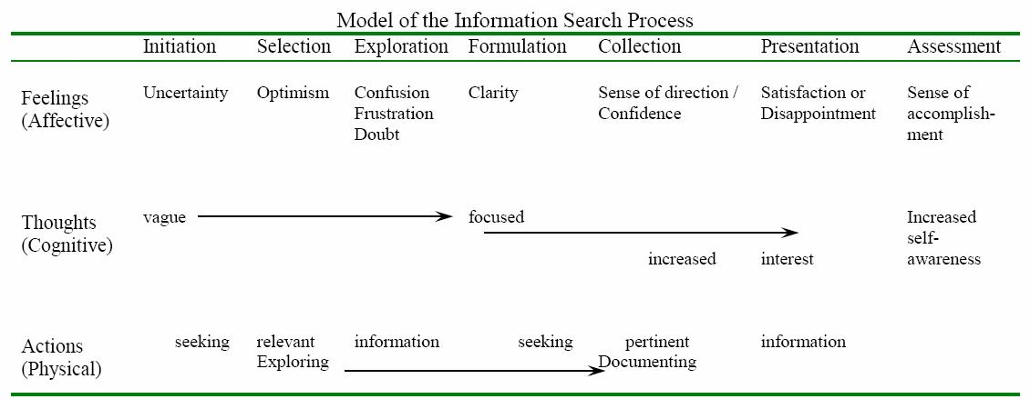 http://comminfo.rutgers.edu/~kuhltau/information_search_process.htm

2) Survey
Thank you for making my survey!
For my thesis I am doing research into the information seeking behavior of people.
You will be presented with questions about how you buy a laptop and how to book a holiday.
If you do not have a laptop but a computer, you can use the questions instead of laptop from
your computer that you purchased.
The middle of the possible answers means that it’s neutral to the scale.

First you get some questions about purchasing a laptop.
Ask yourself what kind of information source you would like when you buy a laptop.
Please circle what you would apply.

LAPTOP

- Do you let yourself informed by your friends/family?
yes
no

- If so, how long are these conversations?
number of minutes ……….

- Do you like get your advice by staff when you buy a laptop/computer?
yes
no

- If so, how long are these conversations?
number of minutes ………..

- Do you let yourself informed by other people?
yes
no

- If so, how long are these conversations?
number of minutes ………..

- I know where to look for when I am purchasing a laptop, so I don’t need information
from others.

totally agree totally disagree
- Do you visit websites to search your information?
yes
no

If you answered no, please continue to question 12.

- In what way do you watch WebPages?

very radical very superficial

- How many WebPages do you watch?

number of websites ……….

- How long do you browse?
number of minutes ……….

- Do you get your information from leaflets/magazines?
yes
no

- If so, how many minutes?
number of minutes ………

- I am afraid to that the laptop I have bought, will be a disappointment.

totally agree totally disagree

- After I bought the laptop, it satisfied my expectations.

totally agree totally disagree

Now I have some questions about booking an holiday. Ask yourself whether you take this
source of information when you go on an holiday. Please circle what you would apply.

BOOKING AN HOLIDAY
- Do you let yourself informed by your friends/family?
yes
no

- If so, how long are these conversations?
number of minutes ……….

- Do you like get your advice by staff when you want to book an holiday?
yes
no

- If so, how long are these conversations?
number of minutes ………..

- Do you let yourself informed by other people?
yes
no

- If so, how long are these conversations?
number of minutes ………..

- I know where to look for when I am booking an holiday, so I don’t need information
from others.

totally agree totally disagree

- Do you visit websites to search your information?
yes
no
If you answered no, please continue to question 27.

- In what way do you watch WebPages?

very radical very superficial

- How many WebPages do you watch?

number of websites ……….

- How long do you browse?
number of minutes ……….

- Do you get your information from leaflets/magazines?
yes
no

- If so, how many minutes?
number of minutes ………

- I am afraid to that the holiday I have been, will be a disappointment.

totally agree totally disagree

- After I been with holiday, it satisfied my expectations.

totally agree totally disagree

3) Histograms (hypothesis 2)
1a)
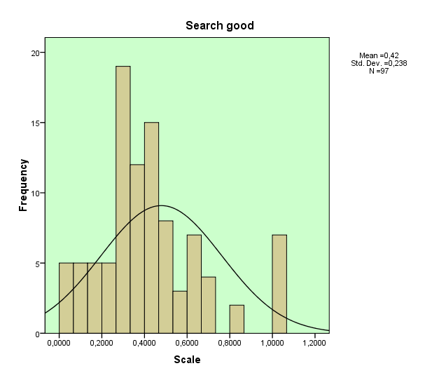

1b)
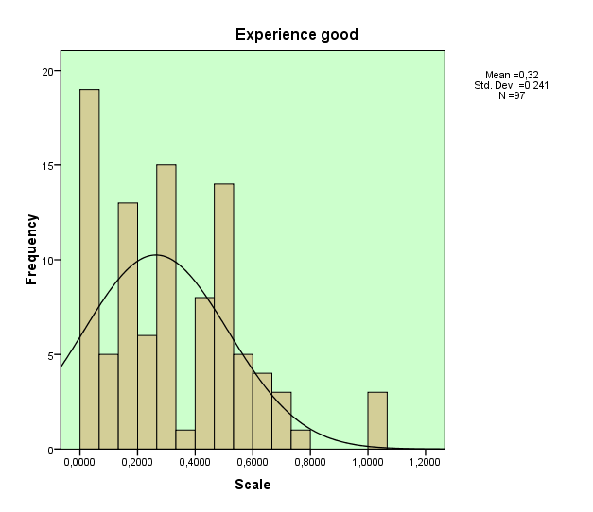
4) Chi Square Crosstabs (hypothesis 4)
Watching WebPages/ Search good * Watching WebPages/ Experience good Crosstabulation
 |  |  | Watching WebPages/ Experience good |  |  |  |  |  | Total
 |  |  | no use of WebPages | very radical | radical | neutral | superficial | very superficial | Total
Watching WebPages/ Search good | no use of Webpages | Count | 2 | 2 | 4 | 5 | 2 | 0 | 15
Watching WebPages/ Search good | no use of Webpages | % within Watching WebPages/ Search good | 13,3% | 13,3% | 26,7% | 33,3% | 13,3% | ,0% | 100,0%
Watching WebPages/ Search good | no use of Webpages | % within Watching WebPages/ Experience good | 25,0% | 4,9% | 13,8% | 33,3% | 50,0% | ,0% | 15,3%
Watching WebPages/ Search good | no use of Webpages | % of Total | 2,0% | 2,0% | 4,1% | 5,1% | 2,0% | ,0% | 15,3%
Watching WebPages/ Search good | very radical | Count | 1 | 20 | 4 | 1 | 0 | 0 | 26
Watching WebPages/ Search good | very radical | % within Watching WebPages/ Search good | 3,8% | 76,9% | 15,4% | 3,8% | ,0% | ,0% | 100,0%
Watching WebPages/ Search good | very radical | % within Watching WebPages/ Experience good | 12,5% | 48,8% | 13,8% | 6,7% | ,0% | ,0% | 26,5%
Watching WebPages/ Search good | very radical | % of Total | 1,0% | 20,4% | 4,1% | 1,0% | ,0% | ,0% | 26,5%
Watching WebPages/ Search good | radical | Count | 2 | 13 | 14 | 2 | 0 | 0 | 31
Watching WebPages/ Search good | radical | % within Watching WebPages/ Search good | 6,5% | 41,9% | 45,2% | 6,5% | ,0% | ,0% | 100,0%
Watching WebPages/ Search good | radical | % within Watching WebPages/ Experience good | 25,0% | 31,7% | 48,3% | 13,3% | ,0% | ,0% | 31,6%
Watching WebPages/ Search good | radical | % of Total | 2,0% | 13,3% | 14,3% | 2,0% | ,0% | ,0% | 31,6%
Watching WebPages/ Search good | neutral | Count | 3 | 4 | 6 | 5 | 0 | 0 | 18
Watching WebPages/ Search good | neutral | % within Watching WebPages/ Search good | 16,7% | 22,2% | 33,3% | 27,8% | ,0% | ,0% | 100,0%
Watching WebPages/ Search good | neutral | % within Watching WebPages/ Experience good | 37,5% | 9,8% | 20,7% | 33,3% | ,0% | ,0% | 18,4%
Watching WebPages/ Search good | neutral | % of Total | 3,1% | 4,1% | 6,1% | 5,1% | ,0% | ,0% | 18,4%
Watching WebPages/ Search good | superficial | Count | 0 | 2 | 1 | 2 | 0 | 0 | 5
Watching WebPages/ Search good | superficial | % within Watching WebPages/ Search good | ,0% | 40,0% | 20,0% | 40,0% | ,0% | ,0% | 100,0%
Watching WebPages/ Search good | superficial | % within Watching WebPages/ Experience good | ,0% | 4,9% | 3,4% | 13,3% | ,0% | ,0% | 5,1%
Watching WebPages/ Search good | superficial | % of Total | ,0% | 2,0% | 1,0% | 2,0% | ,0% | ,0% | 5,1%
Watching WebPages/ Search good | very superficial | Count | 0 | 0 | 0 | 0 | 2 | 1 | 3
Watching WebPages/ Search good | very superficial | % within Watching WebPages/ Search good | ,0% | ,0% | ,0% | ,0% | 66,7% | 33,3% | 100,0%
Watching WebPages/ Search good | very superficial | % within Watching WebPages/ Experience good | ,0% | ,0% | ,0% | ,0% | 50,0% | 100,0% | 3,1%
Watching WebPages/ Search good | very superficial | % of Total | ,0% | ,0% | ,0% | ,0% | 2,0% | 1,0% | 3,1%
Total |  | Count | 8 | 41 | 29 | 15 | 4 | 1 | 98
 |  | % within Watching WebPages/ Search good | 8,2% | 41,8% | 29,6% | 15,3% | 4,1% | 1,0% | 100,0%
 |  | % within Watching WebPages/ Experience good | 100,0% | 100,0% | 100,0% | 100,0% | 100,0% | 100,0% | 100,0%
 |  | % of Total | 8,2% | 41,8% | 29,6% | 15,3% | 4,1% | 1,0% | 100,0%

