Understanding User Acceptance of Mobile Television

ERASMUS UNIVERSITY ROTTERDAM
Supervisors: Remco Prins, Sarah Gelper & prof. Donkers
Name: M.G.J van Vianen
StudentNr. 268717
Emailadres: 268717mv@eur.nl/m.vanvianen@scalacollege.nl
Faculty: Marketing
Thesis: Master
Date: 18-06-2012
Phone: +31627405225

Summary:

This thesis analyses what the key determinant of behavioral intentions towards mobile television are. Emphasis is on the influence of variables that are included in existing UTAUT models. Using a well-developed survey, data is collected among 135 Dutch citizens who are (potential) consumers of mobile television. The analyses show that variables linked to the concept of ‘performance expectancy’ have the strongest effects on behavioral intentions. These findings support earlier findings. In addition, this study also claims that the relative moment of measurement influences which variables have an effect on the behavioral intentions. The effects of certain variables on behavioral intentions differ when users and non-users of mobile television are compared.

Table of content

Summary: 2
Table of content 3
1. Introduction 4
a. Mobile phones and the future 4
b. The downside of innovation 5
c. Research Question 8
d. Social and scientific value 9
2. Theoretical Background 10
a. The Theory of Reasoned Action 10
b. The Technology Acceptance Model 11
c. The Unified Theory of Acceptance and Use of Technology 12
d. The neglected factor of timing during the adoption cycle of a product 13
e. Research model and hypotheses 15
3. Methodology 23
a. Research design 23
b. Measures 24
4. Results 27
a. Multivariate regression analyses on behavioural intentions 27
b. The impact of the control variables 30
c. The effect of timing; separating users from non-users 33
d. Intention toward use of future mobile TV services 36
5. Conclusion 37
6. Discussion 40
References: 41
Internet sources: 43
Appendix 1 Questionnaire: Public opinion on Mobile Television 44
Appendix 2 Vragenlijst: Publieke opinie over het kijken mobiele Televisie 49

Introduction

- Mobile phones and the future

One specific market highly sensitive for innovations is the mobile phone industry. Ever since the introduction of mobile phones in 1956 it has been a platform for many innovations (Groen, 2006). Especially the last few years, mobile phones changed from portable phones to portable multimedia devices. Many existing technologies are integrated into one new multitask device. Nowadays, mobile phones possibly contain Bluetooth, wifi, Internet, fm radio, mp3 player and a touch screen. The latest addition to this already impressive list is mobile television, a technology introducing the streaming of television programmes on your mobile phone.
This study focuses on the introduction of mobile television in the Netherlands. Three big Dutch telecom providers introduced this service in 2008. The Dutch mobile phone market consists basically of these three telecom service providers (KPN, Vodafone and T-Mobile). The market in which these service providers operate can be considered relatively versatile as fairly recent research by TelecomPaper revealed that almost 90% of the Dutch population aged above 18 had a mobile phone and service contract (NRC.nl, 2007). This means that finding new markets and consumer is very difficult. However this does not mean that it is impossible for the providers to increase their market shares. Offering additional services and taking over customers of other providers create possibilities for growth. Actual research confirmed this idea by showing that Dutch consumers are not very loyal and willing to switch if offered a cheaper service or better features (Wijkman, 2008). Innovation therefore remains very important to distinguish one from another and gain a (temporary) competitive advantage.
KPN – the largest provider in the Netherlands - decided to adopt the new DVB-H network, specially developed for watching TV on the mobile phone. This type of network was announced the standard for mobile television by the EU in 2007 (de Vries, 2008). Originally designed by Nokia and partners, the DVB-H network is a network designed to pass digital television signals to mobile devices such as mobile phones. The DVB-H network has its own antenna masts and is independent to the normal GSM network. This network allowed live broadcasting of television programs similar to normal television broadcasting. By the end of 2008 KPN already acquired over 10.000 users of this new service and offered over 10 different channels.
Vodafone and T-Mobile – the other major providers in the Netherlands - choose a different approach to offering mobile television. By offering the service through mobile Internet using the ordinary UMTS network, the costs for those companies are a lot lower. However, the quality and convenience of this service was also considered to be lower. Programs can only be watched on demand or on websites offering live content. Additional searching is required and not all programs offered on ordinary television channels can be watched. Attracting customers solely on the base of mobile Television is more difficult in this case. Mobile television trough the UMTS network is more likely to be conceived as part of a ‘package deal’ including Internet and phone.

b. The downside of innovation

The endless search of companies for new innovations has a downside. Research and Development can be a costly process and often accounts for more than 60% of the budget in electronics companies. This would not be such a big problem if all new innovations were a success. However, statistics show that this is not the case by far. In fact quite the opposite seems true. It is stated that 50 to 90% of all new introduced innovations are not successful and are not accepted by customers (Acs & Audretsch, 1988).
It is predicted by some analysts that the greatest barrier to a successful implementation of TV on the mobile phone would be consumers. In the ever-changing technology environment, consumers must be convinced to adopt mobile television. Customers are questioning whether mobile television really offers better features, such as content, price and quality than existing devices (Shin 2009, 361). Therefore, some analysts argued that mobile television was unlikely to be perceived as an innovation, because it is just another way to receive a TV signal. However, other analysts argued that mobile television would be a killer application, as it is a new platform that not only allows consumers to customise their video programming experience but also empowers organisations of all types to directly and more inexpensively access new and targeted global audiences (Shin 2009, 370).
Who will be right in this discussion depends on the masses to accept the innovative product. In his book Diffusion of Innovations Rogers (1995) describes the acceptance of an innovation using the adoption cycle, an S shaped curve similar to the S shaped lifecycle of a product. In the adoption cycle five different groups are indentified who each decide whether or not to adopt or accept a new innovation.

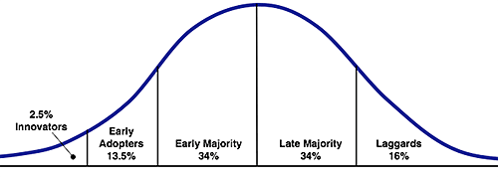
Over time, the small group of people directly interested in the development of the product are the first group to adopt the new product. This group of ‘innovators’ represents around 2,5% of the total of potential consumers. In the next period, the ‘early majority (13,5%) also adopts the new product. This phase is characterized by strong growth in sales. The next group of consumers represents the ‘early majority’ (34%). The product is absorbed and the mass reaches its maturity stage. Then the ‘late majority’ (34%) and the group of ‘laggards’ (16%) buy the product. This phase is characterized by decreasing prices and sales.
The developments in the Dutch market concerning the acceptance of mobile TV show a double-sided trend. Although the number of mobile television users KPN acquired in a short amount of time after the introduction in 2008 looked promising, it is apparently not a guarantee for success. After an initial strong start in 2008, indicating that the innovators and early adopters were keen to buy the product, the number of users of the DVB-H network only slowly continued to grow for KPN up to 40.000, who on average used the service for 9 minutes a day. From 2010 onwards this number of users started to decrease and as a result KPN shut down the service in early 2011, 3 years after the introduction (van Hoek, 2011A). Looking back at Roger’s adoption cycle, mobile television as offered by KPN stopped after the adoption by the early adopters. Mobile television trough the DVB-H network failed to reach the maturity stage, as the early majority did not adopt it. Apparently there is a bump or chasm between the adoption by the early adopters and the early majority. Moore (1991) explains that an innovation can only be successful if it is able to cross this chasm. After the initial phase, focus should be on choosing the most appropriate distribution, channel and pricing in order to make the product the standard for ordinary consumers. Mobile television trough the DVB-H network failed this task.
Nevertheless, the failure of mobile TV trough the DVB-H network did not main the end of television on the mobile phone in the Netherlands. It can be assumed that more and more people are using the television service offered over the UMTS network. Watching programs trough mobile Internet clearly became the standard over the last years. However, as mobile television is connected with using mobile Internet it is more difficult to obtain exact information about the amount of people using the service.
Most recent developments showed some cable companies, amongst them KPN, Ziggo and XS4ALL, starting up new Television services on tablets and mobile phones in the end of 2011. However, KPN and Ziggo limit this service to being only available in an area close to home as an extension of the normal digital television service. XS4ALL aims at a service called WebTV in which customers will be able to watch all programs within one Internet browser without special applications. It would be possible then to receive several channels in a similar way like ordinary television (Van Hoek, 2011B; Nu.nl 2011)

c. Research Question

The aforementioned discussion showed that certainly not all technical innovations make it to becoming a product accepted by the masses. For several economic, social and scientific reasons it is very worthwhile to study which factors influence why some products got accepted by the great public while other products fail to reach this state. As a result, ‘technology acceptance’ has become a key concept in a broad ﬁeld of research areas, such as marketing, ergonomics, pedagogic and psychology. The concept of technology acceptance can best be described as the approval, favourable reception and ongoing use of newly introduced devices and systems (Arning & Ziefle, 2006, 2905). It is important to note that this definition contains both the distinct concepts of ‘attitude-acceptance’ and ‘behavior acceptance’. Attitude-acceptance can also be explained as a positive intention towards a certain behavior and contains an affective (motivational-emotional) and a cognitive component, which implies a cost beneﬁt-analysis of system usage. The behavioral intention of a possible user towards a technological observation is not directly observable. ‘Behavior-acceptance’ refers to the observable part of technology acceptance and describes the adoption of innovations by using them. In other words: acceptance contains an intension towards a certain behavior and the behavior itself (Arning & Ziefle, 2006, 2905). Theoretical models like the ‘Theory of Reasoned Action’, the ‘Technology Acceptance Model’ and the ‘Unified Theory of Acceptance and Use of Technology’ - further discussed in the theoretical section - incorporate this distinction between intended behavior and actual behavior. Using the general theoretical background of these models and using the particular case of the acceptance of mobile television in the Netherlands the main purpose of this study is to discover the key determinants influencing the behavioural intention and the actual use of mobile television in the Netherlands. The central research question is:

What are the key determinants explaining consumer’s acceptance of UMTS based mobile television?

It would have been interesting to be able to make a comparison between the determinants of user acceptance of DVB-H based mobile television and the determinants of UMTS based mobile television, in order to explain why their implementation and acceptation took different paths. However, such a study was not really a feasible option within the opportunities of this thesis as former users of the KPN service would be hard to locate. Therefore this study focuses solely on analysing the determinants of consumer acceptance of the UMTS based mobile television as this service is widely used.

d. Social and scientific value

It is of great importance to companies to know what drives consumers in their decision making process. Knowledge about the key factors explaining mobile TV acceptance will suggest practical implications for the telecom industry (Shin 2009, 361). I hope to present a final model, which makes it easier for companies to estimate the likelihood of successful product implementation. Furthermore by knowing the key elements involved in the decision making process, it will be easier to influence those elements for companies by using all sorts of marketing instruments. Influencing the key elements by the use of marketing will increase the chance of successful adaptation even further. Although mainly of economical value, decreasing the costs of product innovations and developments also has a social component. When companies will be able to restrict their financial contributions to technologies that will not be adopted by consumers, this will have positive impact on the companies’ positions and on the national economy as a whole. A stable economy in which financial risks are reduced is certainly a social value.
This thesis’s scientific value is first of all that it will verify whether a modiﬁed version of the Unified Theory of Acceptance and Use of Technology is an appropriate model to explain consumer behavior in the case of accepting mobile television in the Netherlands. Furthermore the elements slightly added to the UTAUT will hopefully increase the predictive power of the model. By doing so, it will help to increase the scientific knowledge with regard to the field of consumer behavior and marketing.

Theoretical Background

a. The Theory of Reasoned Action

Over the last decades several successive models explaining consumer behavior were introduced. The Theory of Reasoned Action (TRA) - introduced in 1975 by Ajzen en Fishbein to explain individual behavior in the field of social psychology – serves as the point of departure for later models on consumer behavior. The model states that an individual’s actual behavior is determined by the individual’s intention to perform this behavior. With behavior being a directly observable phenomenon and intention being a non-directly observable mental state, this is an important distinction in the model. The theory in turn explains behavioral intentions using two important concepts: the ‘attitude towards behavior’ and the ‘subjective norm’. Attitude towards behavior represents the complete evaluation of a certain behavior by an individual and is influenced by beliefs about the expected consequences of the behavior and his or her valuation of these consequences. ‘Subjective norm’ is best described as “the person’s perception that most people who are important to him think he should or should not perform the behaviour in question” (Fishbein and Ajzen 1975, p.302). The model is shown in fig. 1
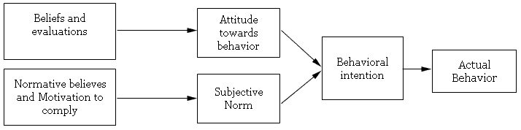
Fig 1. Theory of Reasoned Action from Fishbein and Ajzen (1975)

b. The Technology Acceptance Model

Although the Theory of Reasoned Action explained individual behaviour considerably well in many research fields, Davis, F., Bagozzi, R., and Warshaw, R. (1989) developed a new model fitting better to the specific behaviour of individuals with regard to new technologies. Their so-called ‘Technology Acceptance Model’ (TAM) (Davis, 1989) has its origin in the TRA but is slightly altered in order to better predict the acceptability of a technical/information system. Following the theory of reasoned action, a person’s actual use of a system is determined by the behavioural intention to use this system. This intention is assumed to be a function of one’s own attitude towards the behavior and individual norms (Arning & Siefle 2006, 2906). The most important determinants of the attitude towards using a new system and the behavioural intention to use a new system are the perceived ease of use of the system and its perceived usefulness. The ease of use describes ‘‘the degree to which a person believes that using a particular system would be free from effort’’; the perceived usefulness is ‘‘the degree to which a person believes that using a particular system would enhance his or her job performance’’ (Davis, 1989). Most empirical tests of the model showed that the perceived usefulness is the main predictor of the behavioral intention to use the system, whereas the ease of use strongly inﬂuences the perceived usefulness. The final step of the model assumes some external variables to inﬂuence the perceived ease of use as well as the perceived usefulness. However, the nature of those external variables is not described in the model. “Furthermore, a rather critical assumption of this model is, that perceived ease of use and perceived usefulness fully mediate the inﬂuence of external variables on IT usage behavior. As a consequence, this assumption allows excluding the effects of external variables, i.e. those variables related to a speciﬁc task, to system characteristics and user differences” (Arning & Siefle 2006, 2906). The TAM is shown in figure 2.

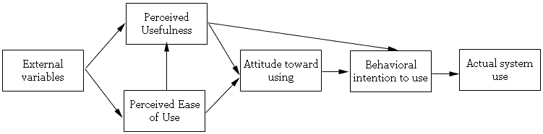

Fig 2. Technology Acceptance Model from Davis, Bagozzi and Warshaw (1989)

c. The Unified Theory of Acceptance and Use of Technology

Despite the basic TAM becoming widely adopted as the core model measuring technology acceptance, several researched felt the need to upgrade the model further. Davis (1989) himself stated that the TAM could be expanded with more determinants depending upon the research subject. Many others researchers also suggested that TAM needed to be given additional variables to provide an even stronger model (Wu and Wang 2005, 720). Several options were suggested. Venkatesh and Davis (2000) proposed an extension, TAM2, which included social inﬂuence processes (subjective norm, voluntarism, and image) and cognitive instrumental processes (job relevance, output quality, result demonstrability, and perceived ease of use). Other scholars adopted this extended technology acceptance model (TAM2) to integrate it with innovation diffusion theory (IDT). Perceived risks and costs were added to the model (Wu & Wang 2005, 720).
The most recognized successor of the TAM in the literature is the ‘Unified Theory of Acceptance and Use of Technology’ (UTAUT). UTAUT extends TAM by unifying different competing user acceptance models sharing the same basic concepts. The new model reintroduces some variables from the TRA and also incorporates moderators. Equal to the earlier models, the key dependent variable is the intention and/or the use of technology. The role of intention, as an antecedent of behaviour is the actual critical factor of the model (Sapio et al. 2010, 51). The UTAUT model consists of four core independent variables – performance expectancy, effort expectancy, social inﬂuence, and facilitating conditions – and four moderating variables – gender, age, experience, and voluntariness of use. (Im, Hong and Kang 2011, 1). Performance expectancy and effort expectancy are the equivalents of perceived usefulness and perceived ease of use in the traditional models. Facilitating conditions (environmental factors that make an action easy) and social inﬂuence (the degree to which a person perceives that system as socially valuable) are the two added constructs (Im, Hong and Kang 2011, 3). The UTAUT is also called the ‘revised technology acceptance model’. The model is shown in figure 3.
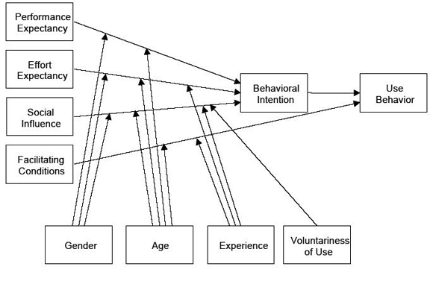
Fig 3. UTAUT model

d. The neglected factor of timing during the adoption cycle of a product

Most empirical tests of the above mentioned models show that most of the models have a large explaining power, as will be further set out in the next section. However, one contextual factor that - according to me - influences the outcome of analysing the determinants of product acceptance is often neglected in most analyses. This factor is the relative timing of the survey compared to the stage of adoption of the products by consumers. At least theoretically it seems obvious that it matters in which stage of the adoption cycle the analysis takes place. It is possible to study product acceptance in the case of a product that is just in development or just entered the market. Most respondents will only have a behavioural intention towards this product as know one actually uses this product already. In a lot of other studies the determinants of product acceptance were measured with regard to products that were already widely implemented. Although respondents still have to develop a behavioural intention to use the product again in the future it can be said that other factors will influence this behavioural intention than when the product was new. Ease of use and familiarity will improve over time as a person gets experienced with the product while perceived enjoyment will possibly decrease when a person gets bored over time with the product. In order to study this suspicion that the timing of the survey – the fact whether a respondent developed only intentions towards a product or has real experiences - matters for the outcome of the analyses, this study will incorporate an analysis in which the determinants of the intention to use mobile TV will be compared for users and non-users of mobile TV.

e. Research model and hypotheses

The aim of this thesis is to find out what the key factors influencing the acceptance of mobile TV are. Strongly based on the UTAUT model this study will test the following model:
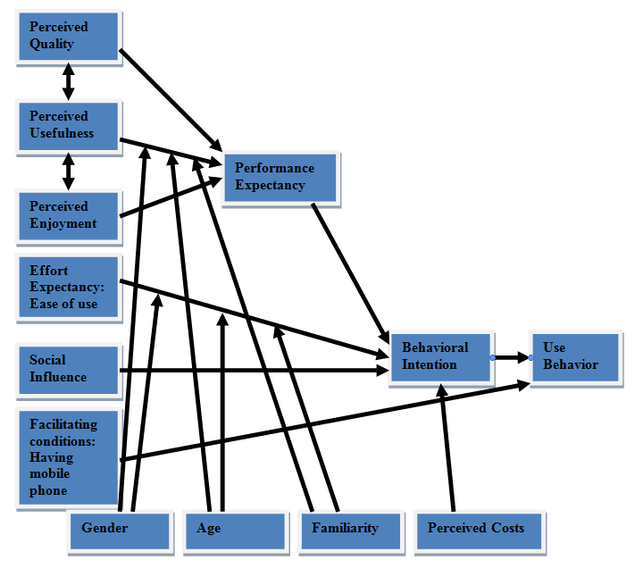Fig 4. The Research Model

The following section describes al the concepts mentioned in our research model and reviews the role of these factors in earlier studies. Based on theory and earlier findings hypotheses are developed for every concept in the model. There are two concepts that will be the main dependent variables in our analyses. The first concept to define is the ultimate dependent variable of the model; ‘Use of mobile TV’. This is the behavioral component of product acceptance and is placed in the last box of the model. The concept defines whether an individual just uses the technology and can be extended by quantifying the amount of use. The other concept that serves mainly as a dependent variable in our analyses is ‘behavioral intention’. This concept measures a mental attitude towards future behavior. In relation to actual behavior the behavioral intention precedes the actual behavior and is in this case a independent variable. The intention-behavior relationship is well documented in many research fields including the technology acceptance literature and has been found to be strong (Venkatesh, 2000; Kijsanayotin et al., 2009). Therefore, the following hypothesis is tested:
H1: There is a positive relation between the intention to use mobile television and actual usage of mobile television
Following our model based on the UTAUT most other variables only indirectly influence the actual behavior trough their influence on the behavioral intention. Therefore the behavioral intention serves as the main dependent variable in most of the analyses. The first major determinant of the behavioral intention in the UTAUT is ‘performance expectancy’. This variable is said to be the equivalent of ‘perceived usefulness’ in the original TRA and TAM. However our model adopts a bit broader definition as we conceive of the concepts of ‘perceived enjoyment’ and ‘perceived quality’ also as part of the broader concept of performance expectancy. At least theoretically it makes sense to believe that perceived enjoyment and the perceived quality of the technological device are part of the considerations when evaluating what kind of performance to expect. Other authors also integrated several concepts like perceived usefulness and intrinsic and extrinsic motivations into this construct (Kijsanayotina et al. 2009, 405). The analyses will show to what extend those three variables can be reduced to one underlying dimension of ‘performance expectancy’. In general, the following hypothesis is tested:
H2: There is a positive influence of performance expectancy on intention to use mobile television.
Besides looking at the combined effect of the construct ‘performance expectancy’ on behavioral intentions, the independent effects of the three concepts making up this construct are also examined. The most commonly used concept is the perceived usefulness. As mentioned earlier, perceived usefulness normally measures believes that using a particular system would enhance his or her job performance. However considering the nature of the innovation under investigation in this thesis, I propose to use a bit different definition. To make it more suitable to explain an individual’s intention to use mobile television, I will define Perceived usefulness as the degree to which a person believes that using mobile television will enhance to reach one’s general goals in life. The positive influence of perceived usefulness on the intention to use a technology has been widely studied and acknowledged (Davis, 1989; Dong, 2007; Lee, Cheung, & Chen, 2007). The following hypothesis is tested:
H2A: There is a positive influence of perceived usefulness on intention to use mobile television.
The second concept to be a part of ‘performance expectancy’ is the perceived quality of the technological device. In the long run, watching mobile TV content will be just like surfing different Web sites over the Internet. However, we are not at this stage of development yet. For mobile TV to survive, it has to develop towards comparable TV quality and experiences similar to those of the conventional cable, satellite, or digital TV services (She et al. 2007, 90). When developments stagnate and when customers are uncertain about product quality and brands, they may worry about an unjustiﬁable delay in product delivery (Wu and Wang 2005, 722). Existing research demonstrates that employing perceived content quality and perceived system quality would be a worthwhile extension of the TAM and the UTAUT, as both factors were found to be inﬂuential in predicting the behavioral intention to use mobile TV (Shin 2009, 369). In line with a study done by Dong (2007) the focus in this study will be on perceived quality of actual functionality. In case of Mobile Television this will be on things such as video and audio quality, reception and subtitle readability. It is expected that low perceived quality will have a negative influence on the behavioral intention towards mobile television. System quality is also said to have a positive impact on perceived usefulness (Shin 2009, 364), which supports the idea that both concepts are part of the broader concept of performance expectancy. The following hypothesis is tested:
H2B: There is a positive influence of perceived quality on intention to use mobile television.
The last concept linked to ‘performance expectancy’ is ‘perceived enjoyment’. One might argue that mobile television is not only a useful technology. Most people use normal television not only as an information source but also for entertainment and leisure. Therefore it might be useful to include perceived enjoyment as a factor in UTAUT. Davis et al. (1992) state that enjoyment is a form of intrinsic motivation and can be described as “the extent to which the activity of using the technology is perceived to be enjoyable in its own right, apart from any performance consequences that may be anticipated” (Davis et al., 1992 p.1113). This thesis will use the same hedonic definition as used by Davis (1992). There have been several previous studies on the positive influence of perceived enjoyment on intentions towards mobile television (Davis et al., 1992; Heiden, 2004; Lee et al., 2007). Other studies also showed that enjoyment is closely related to usefulness as a positive interaction between usefulness and enjoyment explained up to 75% of the variance in one study (Davis 1992). In line with the results of these studies the following hypothesis will be tested:
H2C: There is a positive influence of perceived enjoyment on intention to use mobile television.
The next major concept in UTAUT is ‘effort expectancy’ which is often taken as a synonym of ‘ease of use’. Davis (1989) defines perceived ease of use as ‘‘the degree to which an individual believes that using a particular system would be free of physical and mental efforts’’. Others talk about the hardly different concept of usability. The concept of usability refers to the effort required to use a technical system. “Nowadays it is usually associated to ease-of-use of a device and is considered a critical factor on the development of electronic commerce” (Casalo, Flavian and Guinaliu, 2007, 326). I conclude that both definitions almost intend the same and can both be described as good indicators of ‘effort expectancy’. This determinant has been widely studied to have a positive influence on the attitude and intentions towards a technology (Davis, 1989; Dong, 2007; Lee, Cheung, & Chen, 2007). This thesis will follow the definition of Davis with regard to perceived ease of use and there is no reason to expect different results. Considering the above this leads to the following hypothesis:
H3: There is a positive relationship between perceived effort expectancy and intention to use mobile television.
Normative pressure was already a component of the Theory of Reasoned Action. In the UTAUT this concept returns as ‘social influence’. Social influence is defined as the degree to which an individual perceives that important others believe he or she should use a new technology. Especially from a professional perspective social influence can be high. “The organization of professional and private activities, events and transactions heavily depends on the utilization of technical devices and demands the acceptance and application of IT from our society” (Arning & Ziefle 2006, 2905). People often imitate others in a public social context because this seems the easiest way to adapt to others’ interactions (Shin 2009, 364) The effect of social influence on intention to use technology has been shown to be significant in several previous acceptance studies, altough some studies exhibited a non-significant effect (Kijsanayotina et al., 2009, 405).
H4: Social influence to use new technological devices has a positive influence on intention to use Mobile television.
The fourth construct noted on the left side of the UTAUT model is ‘facilitating conditions’. This construct is defined as the degree to which an individual believes that an organizational and technical infrastructure exists to support use of the system (Kijsanayotina et al. 2009, 406). In the case of this study, the technical infrastructure of mobile Internet clearly exists. But the facilitating condition seems to be whether the respondent has easy access to mobile Internet and thus mobile television. So this study takes as the facilitating condition the possession of mobile Internet. Previous technology adoption studies exhibited a positive effect of facilitating conditions on innovation use. They found that facilitating conditions significantly predicted technology use but did not predict intention to use IT when both the performance expectancy and effort expectancy constructs are present in the model (Kijsanayotina et al. 2009, 406). This is why this study predicts the main effect of facilitating conditions on usage of mobile television instead of an effect on behavioral intentions. The following hypothesis is tested:
H5: When the facilitating conditions are met, individuals are more likely to use mobile television.

The next set of variables are the concepts placed at the bottom side of the original UTAUT model. These are the control variables that in the original model are not expected to have independent effects on the dependent variable. However, they are expected to moderate but the relationships between some of the core predictors and behavioral intention. “A moderator is a qualitative or quantitative variable that effects the direction and/or strength of the relation between an independent or predictor variable and an dependent or criterion variable” (Baron and Kenny 1986, 1174). It is argued that up to now the exact impact of these variables is not adequately regarded yet (Arning and Ziefle, 2006). The first concept mentioned is ‘gender’. Despite not being a part of earlier models, some studies mention a gender effect in studies that incorporated Technology Acceptance Models. However those effects were found in a differential way: While women reported higher values of perceived usefulness, men were found to report a higher ease of use with computers (Arning and Ziefle 2006, 2908). Venkatesh (2000) also examines gender differences in individual perceptions of information technology. His study focusses on the importance of differences in perceived usefulness and perceived ease of use among men and women in determining the behavioral intentions. He concludes that men consider perceived usefulness to be more important than women in making their adoption decision, whereas women consider perceived ease of use to be more important than men. All in all this study hypothesizes:
H6a: Gender moderates the effect of perceived usefulness on intentions to use mobile television.
H6b: Gender moderates the effect of ease perceived of use on intentions to use mobile television.

Age is believed to be an important moderator with regard to factors in the UTAUT. Older people are believed to be less technology minded than younger people. Results from earlier studies indeed show that age plays a mayor role in the interaction with technology. Age- speciﬁc relations were found in the assessment of the perceived ease of use, the judgment of perceived usefulness and in the relationship between subjective technical conﬁdence and performance (Arning & Ziefle 2006, 2922-2924). It is believed that older adults weigh the perceived usefulness against the time to learn how to operate a new system. Related to this balancing procedure is the fear of failure as additional cost, which is much more pronounced in older adults (Arning & Ziefle 2006, 2907).
H7a: Age has a negative moderating influence on the relationship between perceived usefulness and intention to use mobile television.
H7b: Age has a negative moderating influence on the relationship between ease of use and intention to use mobile television.
The next concept in the UTAUT model is experience, which is replaced in my research model by the almost similar concept of ‘familiarity’. Familiarity is defined as the number of product- related experiences that have been accumulated by the consumer (Alba and Hutchinson 1987, 411). Despite different tasks requiring different types of expertise, task performance is improved by different types of experiences with closely related other technical products. In a couple of studies looking at the influence of familiarity with products on product acceptance it was generally found that experts show a superior performance with respect to the utilization of technology (Arning & Ziefle 2006, 2907). Another article suggests that familiarity also has a signiﬁcant impact on consumer perceptions and preferences (Maenpaa et al. 2008). In this study familiarity mainly measures whether potential consumers perceive mobile television the same as normal television. Familiarity can be expected to precede perceptions of usefulness and ease of use and as such it can moderate in the relations between those predictors and the dependent variable. The following hypotheses are tested
H8a: Familiarity has a positive moderating influence on the relationship between perceived usefulness and intention to use mobile television.
H8b: Familiarity has a positive moderating influence on the relationship between perceived ease of use and intention to use mobile television.
The last concept listed in the UTAUT model is ‘voluntariness of use’. This is defined as the degree to which an individual perceives that he or she has a choice to use or not use a new technological device (Kijsanayotina et al., 2009, 406). However, in the case of this study this concept doesn’t seem to be very relevant as watching mobile television seems to be voluntary in all cases. The concept is replaced by a totally different concept. According to behavioral decision theory, the cost-beneﬁt pattern is signiﬁcant to both perceived usefulness and ease of use. It is argued that switching to a new technology always brings transition costs, as new technical systems are expensive. So, from the consumer perspective, cost is one of the important predictors of technological usage intentions (Wu and Wang 2005, 721-726). A direct effect on behavioral intentions is expected. Therefore, the following hypothesis is tested:
H9: There is a negative influence of increasing cost perceptions on intention to use mobile television.

3. Methodology

Research design

In order to examine our research model, we collected data using a paper-based survey among Dutch citizens. A total number of 135 persons participated and answered a total of 22 questions. All interviews took place in a shopping center in the city of Alphen aan den Rijn. As random sampling was not a feasible option for this survey, people were just asked to fill in the survey. It was made sure that people from different ages participated. The minimum age for respondents to participate in the survey was set on 18 years old. This is the minimum age to legally sign a contract with a mobile service provider.
The survey was preceded by an introductory statement, which clearly stated that all questions applied only to UMTS based mobile TV. It was also explained that watching Internet movies on youtube isn’t considered to be watching mobile TV. A program is only Internet television when the program also appears on an ordinary television channel.
Characteristics of the set of 135 respondents show that males are overrepresented with 61,5% of the respondents being male and 38,5% being female. Also younger persons are overrepresented with 57% of the respondents being younger than 30 years. An overwhelming 91% of the respondents have a mobile phone with Internet access. Only 2 persons reported not to have a mobile phone at all. User behaviour shows that half of the respondents (49.6%) once or more used mobile television on their mobile phones.

b. Measures

For measurement of most of the concepts in our model we used two items. Those items contained statements towards which the respondents could answer on a 7 point likert scale running from strongly disagree to strongly agree. This type of items is commonly used in survey studies. Most of the questions used in this study were adopted from earlier studies testing an UTAUT model (see Shin 2009, 272). As such the items are likely to be valid indicators of the measured concepts. The items were carefully restated to reflect the characteristics of mobile television. The exact questionnaires are in the Annexes.
Actual usage of mobile television was measured using two items. The first just asks whether respondents used mobile TV on their mobile phones once or more. The second item measured the intensity of watching mobile TV among users. Answers are on a seven-point scale.
The concept of ‘behavioral intention’ was measured using two likert scale items. “I intend to use mobile television in the future” and “I recommend others to use mobile television”. Reliability analysis shows a Cronbach’s Alpha of .918 for the internal consistency of those items, which is quite good. A scale variable for behavioral intention was constructed out of those two items.
The concept of perceived usefulness was also measured using two items. “I think that mobile television is very useful to my life in general” and “I think that mobile television provides very useful service and information to me”. Those items scored a Cronbach’s Alpha of .917. A scale variable was constructed for perceived usefulness.
The two items for perceived quality are: “I think mobile television will provide high quality video and audio” and “ I think mobile television will be free of delay and jitter”. However, those items show a low internal consistency as indicated by a Cronbach’s Alpha of .522. This is too low take develop a scale variable. Therefore only the first item that directly asks about the quality of the device is used in the further analyses.
Perceived enjoyment was measured using the items: “I think mobile television will be entertaining” and “Mobile television will make my life more fun”. Those items scored a Cronbach’s Alpha of .803. A scale variable was constructed for perceived enjoyment.
The concept of perceived ease of use was measured using the items: “Learning to operate mobile television on my phone will be (was) easy for me” and “Learning to operate Internet on a mobile phone will be (was) easy for me”. The reliability analysis showed a Cronbach’s Alpha of .891. A scale variable was constructed for perceived ease of use.
The two items for the concept of social influence are: “People important to me think I should use mobile television” and “It is expected that people like me use mobile television”. Those items scored a Cronbach’s Alpha of .767. A scale variable was constructed for social influence.
This study takes as the facilitating condition for usage of mobile TV the possession of mobile Internet. Respondents answered which situation was applicable to them on a three point scale: having no mobile phone, having a mobile phone without internet or having a mobile phone with internet application. 91% of the respondents fall within the scope of this last category.
Gender and Age were measured in the obvious way. However, the variable age was recoded to an ordinal variable in order to diminish the effects of the overrepresentation of younger people in our sample. This new variable was a 7-point scale in order to be able to compare regression coefficients in the following analyses .
Familiarity was again measured using two items. “I think mobile television will work similar to regular television” and “mobile television will provide me with similar service as regular television”. However, the Cronbach’s Alpha of .635 is questionable. I decided to hold both items in and constructed the scale variable for familiarity.
The perceived costs of mobile television are measured using only one item. Respondents were asked to indicate whether they think that mobile television is reasonably priced.
The last question asked in the survey was introduced by some information about a new type of mobile television that has recently been developed. It was asked to indicate whether one has the intention to use this new type of mobile TV with the following item: “I intend to use this next generation mobile television in the future”.
During the analysis, a last scale variable was constructed in order to measure the concept of performance expectancy. This construct includes the two items for perceived usefulness, the two items for perceived enjoyment and the first item indicating system quality. Factor analysis showed that those items belong to one underlying dimension. The factor loadings are presented in table 1. The internal consistency is very good with a Cronbach’s Alpha of .918.
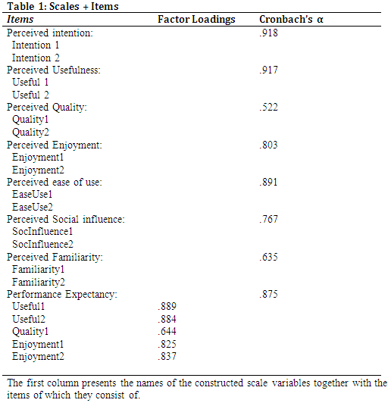

4. Results

The first relationship under investigation is the supposed central link between behavioural intentions and actual behaviour. As 49.6% of our respondents are actual users of the mobile television service we are able to observe whether stronger intentions towards this behaviour existed. Analysis showed that the group of people who did never use mobile television scored on average 3.1 on the intention 7 point scale while the group that actually uses mobile television scored on average 6.0 on the intention scale. This difference is statistically significant as indicated by an independent t-test (F = 21.4; sig. (2-tailed) .000; df 133). Stronger intentions towards watching mobile TV go hand in hand with a stronger chance of actual usage. The effect of behavioural intentions on the intensity of actual usage can also be obtained from the data. A regression coefficient of the effect of the intention scale on the scale indicating how often someone uses the service was calculated. An Adjusted R² of .293 shows that 29% of the variance in the use intensity can be contributed to the behavioural intention. The regression coefficient is .740 and is significant at the p < 0.001 level. Behavioral intentions towards using television do have a strong impact on actual user intensity. Those finding are hardly surprising. In complete agreement with the existing literature, hypothesis 1 cannot be rejected.

a. Multivariate regression analyses on behavioural intentions

In order to show the effects of the independent variables on the intention to use mobile TV several multivariate regression models were developed. However, before looking at these models, table 2 presents simple bivariate correlation coefficients among the independent variables. Although almost all of the coefficients are statistically significant, most relationships are intermediate or weak. The strongest relation exists between ‘perceived usefulness’ and ‘perceived enjoyment’ with the correlation coefficient being (.718). This value is not high enough to reveal possible problems of interrelatedness of the independent variables for the regression models.
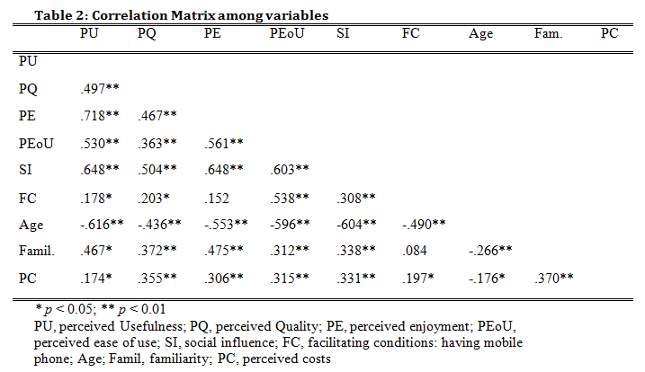
Table 3 shows four different regression models based on all respondents. Excluding two respondents due to missing data makes a total N of 133 in those four models. In the first model the three concepts belonging to the construct of ‘performance expectancy’ are entered separately. All other variables including the control variables are also entered in the equation. This model, including 11 variables, explains 78.9% of the variance in the behavioural intentions. Overall this is a very strong total explained variance. Four variables show a significant contribution (p < 0.01) to the total explained variance. ‘Perceived usefulness’ and ‘perceived enjoyment’ are the strongest determinants of intentions while ‘Perceived quality’ and ‘age’ also have an individual contribution to the explained variance in behavioural intentions. ‘Perceived ease of use’ is significant at the (p < 0.05) level. In this combination of variables all other concept turn out not to have any significant contributions to the dependent variable.
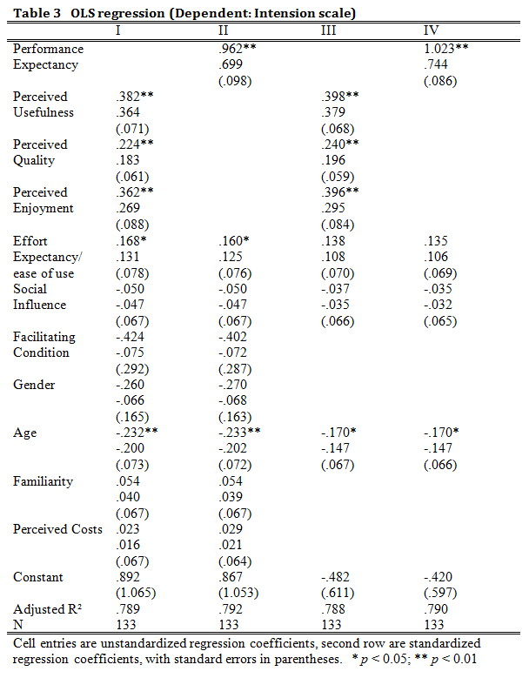
In model II, the scale variable for the construct of ‘performance expectancy’ substitutes the three separate concepts making up this construct. The explained variance of this model remains almost the same with 79.2 %. However, as a lower number of variables is introduced to this equation, this model is certainly as strong as the previous one. The ‘performance expectancy’ is by far the strongest determinant in this model with a regression coefficient of .961. Age and perceived ease of use are the only other variables with a significant impact on intentions in this model. Although some nuance may be lost in this model, substituting the three original variables by ‘performance expectancy’ brings the model closer to the parsimonious original UTAUT model.
Model III and IV partly replicate model I and II. But most of the variables that turned out to be non-significant were removed from the equation in order to look for a simpler model. Reducing those variables from the models didn’t decrease the overall explained variance. The same determinants have a statistically significant influence on the dependent variable as in the former two models. Only ‘perceived ease of use’ turns out to be non-significant in this model. In the fourth model the impact of ‘performance expectancy’ is even stronger with the elimination of the other variables. With only 4 variables included and almost 80% of the variance explained this is a simple but strong model.

b. The impact of the control variables

Although having introduced them in some of the regression equations, most of the variables listed on the bottom side of the model were supposed to have a moderating effect instead of a direct effect on intentions by the model. Only the perceived costs are supposed to have a direct impact on the behavioural intentions. But the regression models I and II showed that this impact is not significant in combination with the other variables in the model. Gender, age and familiarity were supposed to have an indirect moderating effect on intentions trough their impact on ‘perceived usefulness’ and ‘perceived ease of use’. The regression analyses showed that gender and familiarity indeed have no direct impact on the intention to use mobile TV. However, age turned out to be one of the core independent determinants of intentions to use mobile TV, as the zero-order effect of this variable was significant and considerably strong in all models.
In order to get some more insight into the effects of the control variables gender, age and familiarity on some of the independent variables and their supposed role as moderators some additional elaboration analyses were performed. As moderators those variables are hypothesized to affect the zero-order relations between perceived usefulness and intentions and between the perceived ease of use and intentions towards mobile TV. It is important to note that moderators and predictors are at the same level in regard to their role as causal variables antecedent or exogenous to certain criterion effects (Baron and Kenny 1986, 1174).
A first test looked at the distribution of the variables perceived usefulness and perceived ease of use when controlled for the nominal variable gender. This is done to check the argument presented by Arning and Ziefle that women report higher values of perceived usefulness and men were found to report a higher ease of use with computers. The mean score on perceived usefulness was for men 4.4 and for women 4.6. An independent t-test showed that those means are not significantly different (F = 1.6; sig. (2-tailed) .466; df 133). The mean score on perceived ease of use was for men 5.5 and for women 5.6. An independent t-test showed that also those means are not significantly different (F = 0.3; sig. (2-tailed) .620; df 133). It is now established that there are no zero-order effects between the moderator and the predictor perceived usefulness and between the moderator and the predictor perceived ease of use. However, with men and women on average having equal percetions toward usefulness and ease of use, this does not immideately imply that those perceptions are equally important in determining the behavioral intentions. In order to falsify the hypotheses that gender works as a moderator, an additional test must measure and test the differential effect of the independent variable on the dependent variable as a function of the moderator (Baron and Kenny 1986, 1174). In this case - dealing with a categorical moderator (gender) and a continuous predictor (perceived usefulness/perceived ease of use) - Baron and Kenny (1986, 1175) advise to compare the regression coefficients for the effects of the predictors on the dependent variable for both men and women. In this case the regression coefficient for the effect of perceived usefulness on intentions among men is .798 (sig.=.000) and the regression coefficient for the effect of perceived usefullness on intentions among women is .959 (sig.=.000).
In order to test whether those regression coefficients differ significantly from each other, two methods can be used. Paternoster et al. (1998, 862) claim that a Z test should be performed with the following correct formula:
$$\text{Z}=\frac{(b_{1}-b_{2})}{\sqrt{(SE{b_{1}}^{2}+SE{b_{2}}^{2}) }}$$
The numerator of this test is the estimated difference between the two coefficients in the population (b₁ - b₂). The SE’s in the denominator are the Standard Errors of the relevant regression coefficients b₁ and b₂. Calculating the Z score using the scores obtained in the regression analysis the Z score is -1.51 . This corresponds to a chance of .066 of falsily approving the hypothesis that the two groups differ. On a .05 level this chance is to high so the hypothesis 6a that gender moderates the relation between perceived usefulness and intentions should be rejected. A second method to do this test introduces the interaction/product term of the predictor and the moderator in the regression analysis as wel as the independent effects of the independent and the moderator. One of the categories of the moderator (females) is coded zero (SPSS FAQ 2012). The interaction term than tests the H₀ that B₁ = B₂. In this case, the t score of the interaction term is 1.453 with a significance of .149. The t value is not significant at the 0.05 confidence level indicating that the two slopes do not differ significantly from each other. The two methods lead to the same conclusion.
Controlling the relation between perceived ease of use and intenions for gender shows a regression coefficient of .802 (sig. =.000) among men and a regression coefficient of .755 (sig. = .000) among female. Introducing the data in the Z test formula obtains a Z score of .21. This indicates a chance of .42 of incorectly assuming that the difference is significant. This chance is much too high so hypothesis 6b should be rejected. The second method offers the same conclusion (t = -.267: Sig. = .790).
In order to investigate the hypothesized moderating role of age, a slightly different type of regression models were obtained. In those cases both the moderator and the independent variable are continuous (the 7 point scales). Presuming that the effect of the independent variable on the dependent variable varies linearly or quadratically with respect to the moderator – in the case of age this seems theoretically sound – adding the product variable of the moderator and the predictor to the regression model tests the moderating effect (Baron and Kenny 1986, 1176). Testing the moderating effect of age on the relation between perceived usefulness and intentions shows that the interaction term of Age and Usefulness is not significant (t=-.030; Sig. = .976). There is no moderating effect of age. Testing the moderating effect of age on the relation between perceived ease of use and intentions shows that the interaction term of Age and Ease of Use is significant at a 0.01 confidence level. (t=-3.381; Sig. = .001). This indicates that age indeed moderates the relation between perceived ease of use and the behavioral intentions towards mobile TV. However, this effect is much weaker than the independent effect of ease of use on intentions.
The role of familiarity as a possible mediator is analyzed in the same way as the role of age. Regressing familiarity on the usefulness scale obtained an R² of .212 and a coefficient of .605 significant on the (p < 0.01) level. This overall explained variance is rather small with only one variable in the equation. But familiarity at least seems to have a small effect on usefulness perceptions. Regressing familiarity on the ease of use scale obtained an R² of .090 and a coefficient of .339 significant on the (p < 0.01) level. It is surprising that familiarity has an even lower impact on ease of use with only 9% explained variance. If familiarity can be said to be a moderator at all, at least it is a weak moderator and doesn’t play a major explaining role in my research model.

c. The effect of timing; separating users from non-users

In order to investigate whether the determinants for the intention to use mobile TV differ for users and non-users of mobile TV the data split in two groups. Table 4 shows four different regression models. The first two models were obtained using only the people who reported that they used mobile television while model III an IV are obtained using only the people who reported not to use mobile television. The total amount of explained variance in the first two models is with 46% and 50% considerably lower than in the original models based on all respondents. However, as the original sample is divided in subgroups of respondents who share user characteristics it is not strange that the overall explained variance decreased. The part of the overall variance to be explained by the independent variables in the partitial models is smaller because the variance in the dependent variable itself is smaller as a result of selecting subgroups with more similar scores on the dependent variable than the scores for all participants.
Nevertheless, the overall models in table 4 are still all significant and a considerable amount of the overall variance is still explained by the predictors in the models. The first model shows that among users of mobile TV only the perceived usefulness and perceived quality are significant determinants of intention to use mobile TV. Surprisingly, perceived enjoyment and age turn out to be not significant. An explanation for the latter can be that almost all users will be of the same young age. The second model shows ‘performance expectancy’ to be the only, but very strong, determinant of intention to use mobile TV among users of mobile TV.
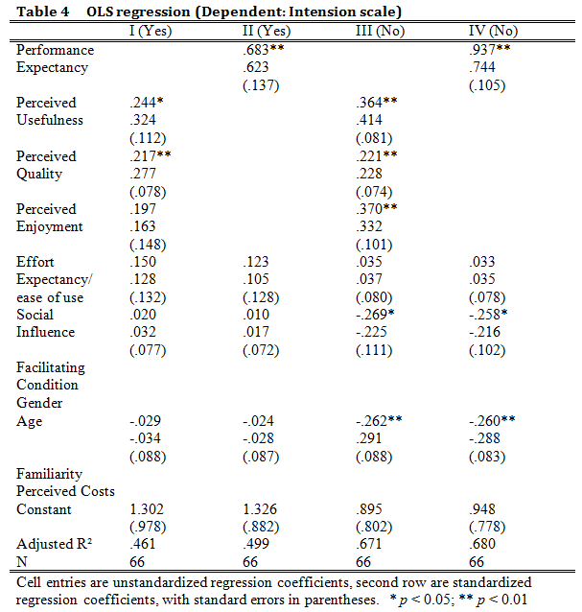
Model III and IV are based on the 66 other respondents who reported not to use mobile TV. These models explain more of the total variance, 67% and 68%, than the models including only users of mobile TV. Surprisingly some other variables turn out to have significant impact on the dependent variable. As already known from the other models, in model III the three variables related to the performance expectancy have a significant impact on the behavioral intention. In model IV the construct variable of performance expectancy is the strongest determinants of intention to use mobile TV. However, also the coefficients of age and social influence turn out to be significant in those models. Among people who do not use mobile TV up to now there is to some extent a believe that users expect them to become users of this service as well. With models I and II being considerably different from models III and IV, the suspicion that the place where the respondent finds himself in the consumer adoption cycle influences which determinants are important in influencing behavioral intentions cannot be rejected.

d. Intention toward use of future mobile TV services

As a last question in the survey it was asked whether the respondents intended to use a new type of mobile television presented to them. This new type of mobile television was said to be more similar to ordinary TV than the UMTS based mobile TV. The average score on this measure was 5.13 indicating that the average respondent somewhat agreed with the statement that they intend to use this next generation mobile television in the future. The average score for the UMTS based intention measure was 4.45.
This survey did not ask the right questions in order to be able to explain this difference. Maybe the improved service can be the cause of this difference. Another explanation can be that new products are always received with more enthusiasm, as actual negative experiences with the product are not developed yet. It would be interesting to explore this further.

5. Conclusion

The central aim of this thesis was to find out what are the key determinants explaining consumer’s acceptance of UMTS based mobile television. Testing a model based on the Unified Theory of Acceptance and Use of Technology the main findings of this study shows that the variables included in the models are able to explain together a major amount of the variance in the behavioural intentions towards adopting mobile television. The models are strong. Looking at all models the variables ‘perceived usefulness’ and ‘perceived enjoyment’ are the strongest determinants of the behavioural intentions. However, as the analyses showed, those variables seem to explain a similar underlying concept as the variables ‘perceived quality’, ‘perceived usefulness’ and ‘perceived enjoyment’ can be taken together into one scale variable ‘performance expectancy’ without loosing explanatory power of the overall model. Other variables such as gender, familiarity and costs did not turn out to have a significant impact on the behavioural intentions. Some small moderating effects were found for the variables age and familiarity.
In addition to identifying the key determinants of the behavioural intentions regarding mobile television one of the distinguishing aspects of this study is that it incorporates an analyses that controls for the moment in the product adoption cycle in which the respondent finds himself during the survey. This study analysed the relative timing of the survey compared to the stage of adoption of the products by consumers by performing separate analyses for actual users of the product and for non-users. These analyses showed that differences exist between those groups when determining the key determinants of behavioural intentions. First: the overall explaining power of the model containing only users of mobile television is lower than the other models. Second: another outstanding finding is that perceived enjoyment is not a significant predictor of the behavioural intention for the users of the product while it is a significant predictor for non-users. This suggests that consumers potentially loose some pleasure in dealing with a technical device at the moment they actually work with it. They now evaluate it mostly on its usefulness and technical quality while people who do not use the device yet still expect to get some pleasure from the device when they start using it. The third outstanding finding is that social influence plays a role in predicting behavioural intentions for non-users of mobile television while it does not for users of mobile television. This can possibly explained by the fact that the (early) users are most likely to be the people who practise some pressure on non-users to start using.
On the bases of the findings presented in the different models hypotheses H1, H2 + H2A + H2B + H2C, H7A + H7B cannot be rejected. The variables mentioned in those hypotheses showed a significant impact on the behavioural intentions towards mobile television. H5 can also not be rejected although the hypothesis was not completely tested in the models. However, possession of a mobile phone is obviously a necessary facilitating condition for using mobile Internet.
The status of H3 is doubtful. In some models the perceived ease of use has a significant impact on the behavioural intention, in other models not. At least, the effect of this variable is by far not as strong as supposed by some previous studies. H4 can be rejected in most cases. However, when only looking at the people who do not yet use mobile television social influence has a significant impact on the behavioural intention.
H6A + H6B can be rejected based on the results. Gender does not play any role in the formation of behavioural intentions towards mobile television. Evidence for a moderating effect of gender was also not found. Hypotheses H7A + H7B have a difficult status. Anstrong direct effect of age on intentions was established. However the hypothesized moderating effect of age with regard to the relation between usefulness and intention was not established. H7A is falsified. The analysis showed a significant moderating effect of age on the relationship between the ease of use and intentions H7B is not falsified.
Hypotheses H8A and H8B can not be rejected either. Direct effects of familiarity on behavioural intentions could not be observed. However, the hypothesized moderating effects were observed in the elaboration analyses. Although relatively weak, familiarity moderates the relation between perceived usefulness and intentions and between perceived ease of use and intentions. A significant impact of the perceived costs of mobile television on the behavioural intention was not found, which means that H9 can be rejected.
On the basis of these results it can be concluded that the role of the variables related to the performance expectancy in determining behavioural intentions towards mobile television is very strong. This finding supports most findings by other scholars. The role of the perceived ease of use is smaller than expected. All in all, the causal relations can be described in a more parsimonious model in which the non-significant variables are excluded. This simplified model shows the most basic and strongest relations.

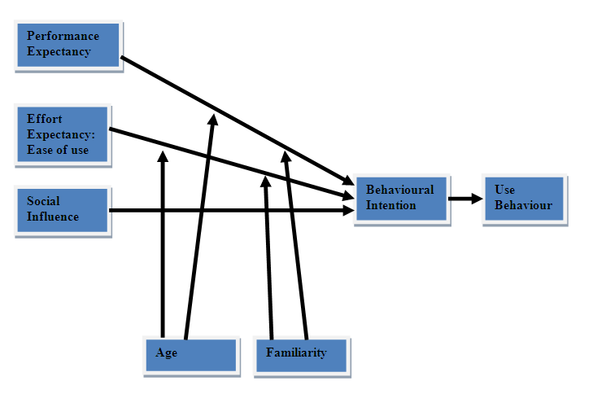
Fig 5. Simplified Model

6. Discussion

Most results are in line with previous studies testing UTAUT based research models. However, a special contribution of the current study seems to be that a difference between the determinants of behavioural intentions for users and non-users of mobile television was observed. Future studies are invited to do more work on the possible influence of this distinction and the relative moment of surveying a respondent compared to the stage in the adoption cycle where a product finds itself.
Weak points of this thesis are mostly within its methodology and the sample of respondents. The number of 135 respondents is maybe a bit low, although good significant results could be obtained from this sample. A more important problem is that younger respondents are over represented in the sample. This may bias the results as the younger people turned out to be more favourable towards mobile television. Future studies should avoid this problem. Also, the statistical procedure with regard to uncovering interaction effect in a multivariate context needs improvement.
All in all, this thesis offers enough new material to be a worthwhile contribution to the literature.

References:

Acs, Z.J. and Audretsch, D.B. (1988) Innovation in Large and Small Firms: An Empirical Analysis, The American Economic Review, 78(4) 678 - 90
Ajzen, I. (1991) The theory of planned behavior. Organizational Behavior and Human Decision Processes, Vol. 50, 179–211.

Alba, J.W. & Hutchinson, J.W. (1987) Dimensions of Consumer Expertise, The Journal of Consumer Research, Vol. 13, No. 4 (Mar., 1987), 411-454

Arning, K. & Ziefle, M. (2006). Understanding age differences in PDA acceptance and performance. Computers in Human Behavior, 23 (2007) 2904–2927

Baron, R.M. & Kenny, D.A. (1986). The Moderator-Mediator Variable Distinction in Social Psychological Research: Conceptual, Strategic, and Statistical Considerations. Journal of Personality and Social Psychology, Vol. 51, No. 6, 1173-1183

Casalo, J., Flavian, C. and Guinaliu, M. (2007) The role of perceived usability, reputation, satisfaction and consumer familiarity on the website loyalty formation process. Computers in Human Behavior, 24 (2008) 325–345

Davis, F., (1989) Perceived usefulness, perceived ease of use, and user acceptance of information technology. MIS Quarterly, 13 (3), 319–340.

Davis, F., Bagozzi, R., Warshaw, R., (1992) Extrinsic and intrinsic motivation to use computers in the workplace. Journal of Applied Social Psychology, 22, 1111–1132.

Dong, S.H.(2007). User acceptance of mobile Internet: Implication for convergence technologies. Interacting with Computers, 19, 472-483

Fishbein, M., & Ajzen, I. (1975). Belief, attitude, intention, and behavior: An introduction to theory and research. Reading, MA: Addison-Wesley

Heijden, H., (2004) User acceptance of hedonic information systems. MIS Quarterly 23 (4), 695–704.

Im, I., Hong, S. and Kang, M.S. (2011) An international comparison of technology adoption
Testing the UTAUT model. Information & Management 48 (2011) 1–8

Kijsanayotin, B., Pannarunothai, S. and Speedie, S.M. (2009) Factors influencing health information technology adoption in Thailand’s community health centers: Applying the UTAUT model, International journal of medical informatics 78, 404–416

Lee, M.K.O., Cheung, C.M.K., & Chen, Z.(2007) Understanding User Acceptance of Multimedia Messaging Services: An Empirical Study. Journal of the American Society for Information Science and Technology 58(13): 2066–2077

Maenpaa, K., Kale, S, H., Kuusel, H. & Mesiranta, N. (2008) Consumer perceptions of Internet banking in Finland: The moderating role of familiarity. Journal of Retailing and Consumer Services 15 (2008) 266–276

Moore, G.A. (1991) Crossing the Chasm: Marketing and Selling High-Tech Products to Mainstream Customers, New York: Harper business essentials.

Paternoster, R., Brame, R., Mazerolle, P. & Piquero, A. (1998) Using the correct Statistical Test for he Equality of Regression Coefficients, Criminology, Vol. 36, No. 4, 859-867

Porter, M. E. (2002) Regional foundations of competitiveness and implications for government policy. Paper presented to Department of Trade and Industry Workshop, April.

Rodrik, D. (1997) Has Globalization gone to Far? Washington: Institute for International Economics
Rogers, E.M. (1995) Diffusion of Innovation, New York: The Free Press
Sapio, B., Turk, T., Cornacchia, M., Papa, F., Nicolo, E. & Livi, S. (2010) Building scenarios of digital television adoption: a pilot study. Technology Analysis & Strategic Management, Vol. 22, No. 1, January 2010, 43–63
She, J., Hou, F., Ho, P.H. and Xie, L.L. (2007) IPTV over WiMAX: Key Success Factors, Challenges and Solutions. IEEE Communications Magazine, August 2007
Shin, D.H. (2009) An empirical investigation of a modiﬁed technology acceptance model of IPTV, Behaviour & Information Technology, Vol. 28, No. 4, July–August 2009, 361–372
Venkatesh, V., (2000) Determinants of perceived ease of use: integrating control, intrinsic motivation, and emotion into the technology acceptance model. Information Systems Research 11 (4), 342–365.

Venkantesh, V., & Davis, F., (2000) A Theoretical extension of the Technology Acceptance Model: Four Longitudinal Field Studies, Management Science, 46 (2), 186-204

Wu, J.H. and Wang, S.C. (2005) What drives mobile commerce? An empirical evaluation of the revised technology acceptance model. Information & Management 42 (2005) 719–729

Internet sources:

Groen, G. (2006). ‘Geschiedenis van de mobiele telefonie’ Telecomwereld.nl, http://www.telecomwereld.nl/mobgesch.htm [25-5-2009]
KPN komt met tv op iPad en laptop (2011) Nu.nl, http://www.nu.nl/internet/2596618/kpn-komt-met-tv-ipad-en-laptop.html [14-4-2012]
Nederland heeft meer mobieltjes dan mensen (2007) NRC.nl/economie, http://vorige.nrc.nl/economie/article1833007.ece/Nederland_heeft_meer_mobieltjes_dan_mensen [13-5-2009]
Wijkman, T. (2008) ‘Nederlander twijfelt over GSM abonnement’, GSMhelpdesk.nl
http://www.gsmhelpdesk.nl/read.php?id=3241&ch=1 [6-6-2009]
de Vries, W. (2008) ‘KPN introduceert eind mei mobiel tv-kijken via dvb-h’, Tweakers.net, http://tweakers.net/nieuws/53520/kpn-introduceert-eind-mei-mobiel-tv-kijken-via-dvb-h.html [24-4-2009]

van Hoek, C. (2011A) ‘KPN trekt stekker uit mobiele televisiedienst’, NU.nl, http://www.nu.nl/internet/2480343/kpn-trekt-stekker-mobiele-televisiedienst.html [13-4-2012]
van Hoek, C. (2011B) ‘XS4ALL brengt tv naar tablet en mobiel’, Nu.nl, http://www.nu.nl/internet/2632235/xs4all-brengt-tv-tablet-en-mobiel.html [13-4-2012]
SPSS FAQ (2012) How can I compare regression coefficients between two groups?, http://www.ats.ucla.edu/stat/spss/faq/compreg2.htm [27-06-2012]

Appendix 1 Questionnaire: Public opinion on Mobile Television

This survey wants to inquire your opinion and behavior regarding several aspects of Television on your Mobile Phone. The results will help to improve this service in the future. Please fill in the questionnaire completely in the proposed order. Thanks!
1) Which of the following applies to your situation?
I do not have a mobile phone. 
I have a mobile phone without Internet application 
I have a mobile phone with internet application 

Since a few years, it has become possible to watch Television on a mobile Phone using the Internet application of the phone. The most common used system nowadays is streaming television trough the UMTS/HSPA mobile data network. Programs can be watched on demand trough websites like Uitzendinggemist.nl. Live programs can be watched from some websites offering live-streams. A program is only a television program when it’s originally broadcasted at normal television networks. Watching YouTube for example, doesn’t count as watching mobile television.

The following questions are only about the specific type of mobile television using the UMTS/HSPA mobile data network!
2) I intend to use mobile television in the future
Strongly Disagree | Disagree | Disagree somewhat | Undecided | Agree somewhat | Agree | Strongly Agree
 |  |  |  |  |  | 

3) I recommend others to use mobile television
Strongly Disagree | Disagree | Disagree somewhat | Undecided | Agree somewhat | Agree | Strongly Agree
 |  |  |  |  |  | 

4) Learning to operate mobile television on my phone will be (was) easy for me
Strongly Disagree | Disagree | Disagree somewhat | Undecided | Agree somewhat | Agree | Strongly Agree
 |  |  |  |  |  | 

5) Learning to operate Internet on a mobile phone will be (was) easy for me
Strongly Disagree | Disagree | Disagree somewhat | Undecided | Agree somewhat | Agree | Strongly Agree
 |  |  |  |  |  | 

6) I think that mobile television is very useful to my life in general.
Strongly Disagree | Disagree | Disagree somewhat | Undecided | Agree somewhat | Agree | Strongly Agree
 |  |  |  |  |  | 

7) I think that mobile television provides very useful service and information to me.
Strongly Disagree | Disagree | Disagree somewhat | Undecided | Agree somewhat | Agree | Strongly Agree
 |  |  |  |  |  | 

8) I think mobile television will provide high quality video and audio
Strongly Disagree | Disagree | Disagree somewhat | Undecided | Agree somewhat | Agree | Strongly Agree
 |  |  |  |  |  | 

9) I think mobile television will be free of delay and jitter.
Strongly Disagree | Disagree | Disagree somewhat | Undecided | Agree somewhat | Agree | Strongly Agree
 |  |  |  |  |  | 

10) I think mobile television will be entertaining
Strongly Disagree | Disagree | Disagree somewhat | Undecided | Agree somewhat | Agree | Strongly Agree
 |  |  |  |  |  | 

11) Mobile television will make my life more fun
Strongly Disagree | Disagree | Disagree somewhat | Undecided | Agree somewhat | Agree | Strongly Agree
 |  |  |  |  |  | 

12) People important to me think I should use mobile television
Strongly Disagree | Disagree | Disagree somewhat | Undecided | Agree somewhat | Agree | Strongly Agree
 |  |  |  |  |  | 

13) It is expected that people like me use mobile television
Strongly Disagree | Disagree | Disagree somewhat | Undecided | Agree somewhat | Agree | Strongly Agree
 |  |  |  |  |  | 

14) I think mobile television will work similar to regular television
Strongly Disagree | Disagree | Disagree somewhat | Undecided | Agree somewhat | Agree | Strongly Agree
 |  |  |  |  |  | 

15) Mobile television will provide me with similar service as regular television
Strongly Disagree | Disagree | Disagree somewhat | Undecided | Agree somewhat | Agree | Strongly Agree
 |  |  |  |  |  | 

The costs for watching television on your mobile phone are incorporated in the costs of your mobile Internet agreement. The more television you watch the more data you use, the more expensive Internet contract you need. However, most companies offer unlimited use of Internet at a rate of €9,95 per month

16) I think Mobile television is reasonably priced.
Strongly Disagree | Disagree | Disagree somewhat | Undecided | Agree somewhat | Agree | Strongly Agree
 |  |  |  |  |  | 

17) Do you ever watch television on your mobile Phone?
Yes  → go to question 18
No  → go to question 19
18) How often do you watch Television programs on your mobile Phone
Once a half year | About once a month | Once a week | A couple of times in the week | Every day | Several times a day | Almost Every hour
 |  |  |  |  |  | 

19) How often do you watch Television programs on an ordinary television?
Once a half year | About once a month | Once a week | A couple of times in the week | Every day | Several times a day | Almost Every hour
 |  |  |  |  |  | 

20) What is your gender?

A) Male □
B) Female □

21) What is your age?
…………
A new type of mobile television is developed right now. Broadcasting companies now offer a service comparable to normal television offering a choice of several channels that can all be watched within one browser. No special applications are needed.
22) I intend to use this next generation mobile television in the future
Strongly Disagree | Disagree | Disagree somewhat | Undecided | Agree somewhat | Agree | Strongly Agree
 |  |  |  |  |  | 

Appendix 2 Vragenlijst: Publieke opinie over het kijken mobiele Televisie

Dit onderzoek wil inzicht krijgen in jouw opinie en jouw gedrag met betrekking tot het gebruik van televisie op de mobiele telefoon. De resultaten zullen eraan bijdragen dat deze dienst in de toekomst verbeterd kan worden. Vul de vragen a.u.b. in in de voorgestelde volgorde. Hartelijk dank!
1) Welke van de volgende situaties is op u van toepassing?
Ik heb geen mobiele telefoon. 
Ik heb een mobiele telefoon zonder Internet toepassing 
Ik heb een mobiele telefoon met Internet toepassing 

Sinds een aantal jaar is het mogelijk geworden om televisie te kijken op de telefoon. Hiervoor wordt de internet toepassing van uw mobiele telefoon gebruikt. Tegenwoordig is het uitzenden van televisie via het UMTS/HSPA mobiele dataverkeer het meest gebruikte systeem. Programma’s kunnen op afroep bekeken worden via websites zoals Uitzendinggemist.nl. Live programma’s kunnen ook bekeken worden via websites die deze uitzendingen aanbieden zoals NOS.nl. Een uitzending telt alleen als een televisie programma wanneer het programma in originele staat op de normale televisie is uitgezonden. Het kijken naar Youtube op de mobiele telefoon geld dus niet als televisie kijken.

De volgende vragen gaan enkel over het type televisie op de mobiele telefoon (mobiele TV) waarbij gebruik wordt gemaakt van het UMTS/HSPA mobiele data netwerk!
2) Ik heb de intentie om mobiele TV in de toekomst te gaan gebruiken.
Sterk oneens | Oneens | Een beetje oneens | Onbeslist | Een beetje eens | Eens | Sterk mee eens
 |  |  |  |  |  | 

3) Ik raad anderen aan om mobiele TV te gaan gebruiken.
Sterk oneens | Oneens | Een beetje oneens | Onbeslist | Een beetje eens | Eens | Sterk mee eens
 |  |  |  |  |  | 
4) Het leren bedienen van mobiele TV op mijn telefoon (was) zal makkelijk zijn voor mij.
Sterk oneens | Oneens | Een beetje oneens | Onbeslist | Een beetje eens | Eens | Sterk mee eens
 |  |  |  |  |  | 

5) Het leren bedienen van Internet op mijn mobiele telefoon (was) zal makkelijk zijn voor mij.
Sterk oneens | Oneens | Een beetje oneens | Onbeslist | Een beetje eens | Eens | Sterk mee eens
 |  |  |  |  |  | 

6) Ik denk dat het gebruik van mobiele TV erg handig zal zijn voor mijn leven in het algemeen
Sterk oneens | Oneens | Een beetje oneens | Onbeslist | Een beetje eens | Eens | Sterk mee eens
 |  |  |  |  |  | 

7) Ik denk dat mobiele TV mij voorziet van erg bruikbare diensten en informatie.
Sterk oneens | Oneens | Een beetje oneens | Onbeslist | Een beetje eens | Eens | Sterk mee eens
 |  |  |  |  |  | 

8) Ik denk dat mobiele TV een hoge kwaliteit video en audio levert
Sterk oneens | Oneens | Een beetje oneens | Onbeslist | Een beetje eens | Eens | Sterk mee eens
 |  |  |  |  |  | 

9) Ik denk dat mobiele TV vrij zal zijn van vertragingen en beeldstoringen.
Sterk oneens | Oneens | Een beetje oneens | Onbeslist | Een beetje eens | Eens | Sterk mee eens
 |  |  |  |  |  | 

10) Ik denk dat mobiele TV vermakelijk zal zijn.
Sterk oneens | Oneens | Een beetje oneens | Onbeslist | Een beetje eens | Eens | Sterk mee eens
 |  |  |  |  |  | 

11) Mobiele TV zal mijn leven leuker maken
Sterk oneens | Oneens | Een beetje oneens | Onbeslist | Een beetje eens | Eens | Sterk mee eens
 |  |  |  |  |  | 

12) Personen die belangrijk voor mij zijn vinden dat ik mobiele TV moet gebruiken.
Sterk oneens | Oneens | Een beetje oneens | Onbeslist | Een beetje eens | Eens | Sterk mee eens
 |  |  |  |  |  | 

13) Het wordt verwacht dat mensen zoals ik mobiele TV gebruiken.
Sterk oneens | Oneens | Een beetje oneens | Onbeslist | Een beetje eens | Eens | Sterk mee eens
 |  |  |  |  |  | 

14) Ik denk dat mobiele TV op dezelfde wijze zal werken als een normale televisie.
Sterk oneens | Oneens | Een beetje oneens | Onbeslist | Een beetje eens | Eens | Sterk mee eens
 |  |  |  |  |  | 

15) Mobiele TV zal mij voorzien van dezelfde diensten als reguliere televisie
Sterk oneens | Oneens | Een beetje oneens | Onbeslist | Een beetje eens | Eens | Sterk mee eens
 |  |  |  |  |  | 

De kosten voor het kijken van televisie op de mobiele telefoon zijn inbegrepen bij de kosten van het internetgebruik op de telefoon. Hoe meer TV je kijkt op je mobiel hoe meer data je verbruikt, hoe breder de internet bundel die je nodig hebt. Echter, de meeste aanbieders bieden ongelimiteerd internet gebruik aan voor €9.95 per maand.

16) Ik denk dat mobiele TV betaalbaar is.
Sterk oneens | Oneens | Een beetje oneens | Onbeslist | Een beetje eens | Eens | Sterk mee eens
 |  |  |  |  |  | 

17) Maak je ooit gebruik van je mobiele telefoon om TV te kijken?
Ja  → ga naar vraag 18
Nee  → ga naar vraag 19
18) Hoe vaak kijk je naar TV programma’s op je mobiele telefoon?
Eens per half jaar | Eens per maand | Eens per week | Een paar keer per week | Iedere dag | Een aantal keren per dag | Bijna ieder uur
 |  |  |  |  |  | 

19) Hoe vaak kijk je naar TV programma’s op een normale televisie?
Eens per half jaar | Eens per maand | Eens per week | Een paar keer per week | Iedere dag | Een aantal keren per dag | Bijna ieder uur
 |  |  |  |  |  | 

20) Wat is je geslacht?

A) Man □
B) Vrouw □

21) Wat is je leeftijd?
…………

Een nieuw type mobiele TV is recent ontwikkeld. Sommige media maatschappijen bieden nu een dienst aan die vergelijkbaar zal zijn met de diensten die ze aanbieden op de reguliere televisie. Er zal keuze zijn uit verschillende kanalen die allemaal bekeken kunnen worden binnen één enkele internet browser. Speciale applicaties zijn niet meer nodig.

22) Het is mijn intentie om dit nieuwe type mobiele TV in de toekomst te gaan gebruiken.
Sterk oneens | Oneens | Een beetje oneens | Onbeslist | Een beetje eens | Eens | Sterk mee eens
 |  |  |  |  |  | 

The survey was pre-tested on two persons, which resulted in some minor adjustments in order to avoid questions from being unclear.
All scale variables were reduced to a range of 1 to 7 like the original variables (SPSS Compute (intention 1 + Intention 2)/2).
Coding: 18-19 years = 1, 20-23 years = 2, 24-29 year = 3, 30-39 = 4, 40-49 = 5, 50-59 = 6, 60+ = 7
Although ordinary regression models assume an interval/ratio depedent variable, a seven point scale ordinal variable is by most scholars tolerated in a regression analysis.
Z = (b₁-b₂)/√(SEb₁² + SEb₂²) = (.798-.959) /√(.07² + .08²) = -.161 /√ (.0049 + .0064) = -.161 /√ .0113 = -.161 / .106 = -1.51 Z = -1.51 (alpha =area beyond Z = .065)
Z = (b₁-b₂)/√(SEb₁² + SEb2²) = (.802-.755) /√(.12² + .14²) = .047 /√ (.014 + .020) = .047 /√ .034 = .047 / .22 = .21 Z = .21 (alpha =area beyond Z = .42)
So if the independent variable is denoted as X, the moderator as Z, and the dependent variable as Y, Y is regressed on X, Z, and XZ. Moderator effects are indicated by the significant effect of XZ while X and Z are controlled (Baron and Kenny 1986, 1175)

