


The Evolution of China's Exchange Rate Regime and The Impact on Their Currency: A FEER Approach

Name: Rudolf Jakob Daniël Roozendaal
Student number: 295249
E-mail: RjdRoozendaal@gmail.com

Supervisors: Prof. dr. J.M. Viaene
MSc. Irena Mikolajun
Academic year: 2011/2012
Hand-in-date: 17-07-2012
Master: International Economics and Business Studies
University: Erasmus University Rotterdam
Erasmus School of Economics
Table of Contents
1. Introduction |  |  |  |  |  |  |  |  | 4
2. Literature Research |  |  |  |  |  |  |  |  | 7
 | 2.1 Evolution of China's Exchange Rate Regime |  |  |  |  |  |  |  | 7
 | 2.2 EER Methodology |  |  |  |  |  |  |  | 16
 |  | 2.2.1 The BEER Approach |  |  |  |  |  |  | 17
 |  | 2.2.2 The NATREX Approach |  |  |  |  |  |  | 17
 |  | 2.2.3 The FEER Approach |  |  |  |  |  |  | 18
3. Methodology and Data |  |  |  |  |  |  |  |  | 21
 | 3.1 Multinational Trade Model |  |  |  |  |  |  |  | 21
 | 3.2 Exogenous Variables, Elasticities and Trade Shares |  |  |  |  |  |  |  | 25
 |  | 3.2.1 Exogenous Variables |  |  |  |  |  |  | 25
 |  | 3.2.2 Elasticities |  |  |  |  |  |  | 26
 |  | 3.2.3 Trade Shares |  |  |  |  |  |  | 27
4. Empirical Research |  |  |  |  |  |  |  |  | 29
 | 4.1 External Balance |  |  |  |  |  |  |  | 29
 |  | 4.1.1 Panel Estimations |  |  |  |  |  |  | 29
 |  | 4.1.2 Dynamic Correction |  |  |  |  |  |  | 34
 |  | 4.1.3 Current Account Balances of the Trading Partners |  |  |  |  |  |  | 36
 | 4.2 Internal Equilibrium |  |  |  |  |  |  |  | 37
 | 4.3 Multinational Trade Model in Eviews |  |  |  |  |  |  |  | 39
5. Results |  |  |  |  |  |  |  |  | 40
 | 5.1 Preliminaries |  |  |  |  |  |  |  | 40
 | 5.2 Model Estimates |  |  |  |  |  |  |  | 41
 | 5.3 Adjusted Model |  |  |  |  |  |  |  | 44
 |  | 5.3.1 Adjusted Model Estimates |  |  |  |  |  |  | 45
 | 5.4 Comparison of Results |  |  |  |  |  |  |  | 47
 |  | 5.4.5 Regression Analysis on Results |  |  |  |  |  |  | 49
6. Concluding Remarks |  |  |  |  |  |  |  |  | 51
References |  |  |  |  |  |  |  |  | 53
Appendix 1: The multinational trade model in logarithmic differentials |  |  |  |  |  |  |  |  | 56
Appendix 2: Euro area data |  |  |  |  |  |  |  |  | 58
Appendix 3: Dynamic correction |  |  |  |  |  |  |  |  | 59
Appendix 4: Model equations in Eviews |  |  |  |  |  |  |  |  | 61
Acknowledgements
I would like to thank Irena Mikolajun for all her valuable comments and recommendations during the writing of this thesis.
I am most grateful to Jamel Saadaoui, Ph.D. candidate at the Paris North University, for his extensive advice on empirical research. His patient help and his experience with FEER's kept me motivated at times when the scope of the research seemed overwhelming.
1. Introduction
For newly economy students China has always been an interesting topic. A huge developing economy with significant growth rates that is playing an increasingly dominant role in world trade. This thesis will not focus on the momentum of China's economy growth but will rather concentrate on dynamics of the economy that contributed greatly to this growth. One fascinating aspect of the Chinese economy is the Chinese exchange rate or, more precisely the bilateral yuan/dollar exchange rate. While it is not a unique aspect of the Chinese economy, more economies fix or manage their exchange rates with respect to the dollar because of the status this currency has in international markets. The scale, however, at which the Chinese government implements this exchange rate policy, is truly distinctive. Their exchange rate policy of the past two decades comprehends one of the largest ever sustained interventions in foreign exchange markets. Periods of fixed exchange rate regimes follow periods of managed floating exchange rate regimes. The level, at which the People's Bank of China intervenes on foreign exchange market to sustain these regimes, has received international criticism. Especially the United States criticizes China for having a persistent undervalued currency, which brings unfair competitive advantages in world trade flows. As a member of the IMF and the WTO, China is evidently trespassing rules created by the international community. Rules created to prevent situations that resemble the beggar-thy-neighbor climate of the 1930's, which eventually resulted in the Great Depression. Although their exchange rate policy has had a huge impact on the world economy, the international community has not been particularly successful in imposing restrictions on China's exchange rate policy. Over the years China proved to be very resilient to foreign pressure regardless of magnitude. This struggle between the economic powerhouses of this world, which brings forth complicate geopolitics is intriguing and rises the interest in this topic.
China's exchange rate policy was implemented to support China's industrializing strategy, China wanted to improve their export sector with a "cheap" and competitive currency. This improved export sector resulted in huge surpluses on the current account and was one of the main catalysts for China's economic growth. Normally, such current account surpluses will cause an increase in yuan demand which appreciates the currency. The People's Bank of China, however, intervenes with sterilization to negate this equilibrium effect. By not trading the incoming dollar flows for yuans and instead buying U.S. dollar denominated government bonds, China decreases demand for the yuan in comparison to the dollar on international currency markets. This results in a massing up of foreign exchange reserves. In 2010 China's foreign exchange reserve had a worth of more than 2,4 trillion dollars. Consequently, China is now the largest owner of U.S. treasury securities, catching up with Japan, which had that position over the past years. It is interesting to analyze the evolution of China's exchange rate policy. Changes made in exchange rate regimes reflect not only different phases of China's industrialization strategy but also China's preventive measures in times of uncertainty to maintain economic stability.
Because of the large distortions this exchange rate policy brings to world trade, it is interesting to see what the world economy would have looked like in equilibrium, without the impact of Chinese government intervention. In economics this is commonly done by looking at the Equilibrium Exchange Rate (EER). With the actual exchange rate in comparison to the EER we can determine if the exchange rate was overvalued or, in the case of China, undervalued. Economic literature provides various methods of EER determination, the main methods will be briefly discussed in this thesis.
The most straight forward way to do this, is by analyzing a PPP framework. Although the PPP framework is thought useful to gain a better understanding of EER's, it does not provide with satisfying estimates due to its simplicity. In this thesis we base our empirical research on the macroeconomic balance framework, which overcomes the weaknesses of the PPP framework and is more flexible. Central in macroeconomic balance models is that the all trading partners in the model achieve both internal and external balance. And that is where an extensive taxonomy of EER models developed itself, each with different definitions of internal and external balance. In this thesis we use a Fundamental Equilibrium Exchange Rate (FEER) model to estimate the EER of the yuan. The methodology of FEER models has gradually improved over the years and today is the most commonly applied EER method in economic literature, most notably in the research of the IMF and Peterson Institute for International Economic (PIIE). Empirical research done in this thesis is an extension to the skillset obtained in my master and although these models utilize huge datasets, the empirical research can be done individually. Extensive research on the wide and recent available literature on this topic provided with the papers of Jeong and Mazier, that had developed their FEER methodology based on a partial trade equilibrium model. One of their recent papers provided a very detailed overview of the empirical research done required for FEER estimations. While this paper focuses on exchange rate misalignments between European countries, the model could also be used to estimate FEER's for China. In total, the FEER model implements 177 variables, parameters and elasticities which are all (with the exclusion of trade elasticities and output gap data of industrial countries) obtained through the author's calculations and empirical research.
The thesis is divided in six parts. The introduction in Chapter 1 is followed by the literature research. The results of the literature research in Chapter 2 are divided into two parts. The first part provides an overview of the various exchange rate regimes implemented by China over the years and their implications for foreign exchange and trade markets. The second part gives an overview of the EER methodology used in economic literature and explains the choice of methodology suggested by Jeong and Mazier. Chapter 3 interprets the methodology of the FEER model used in this thesis and discusses the implemented economic variables together with their associated data series. The empirical research is discussed in Chapter 4, which initially focuses on the exogenous variables of the model and then discusses the model simulation in which these exogenous variables play a role. Chapter 5 provides with the results of the model and answers the main question of this thesis: what would be the yuan/dollar exchange rate in equilibrium and what is the order of its misalignment with the actual exchange rate. Our FEER estimate will be compared with other results in economic literature and a fitting link will be made with the evolution of China's exchange rate policy. To conclude the thesis, the results found in our research are summarized in Chapter 6.
2. Literature Research
2.1 Evolution of China's Exchange Rate Regime
Over the past decades the Chinese government has, through the Peoples Bank of China (PBC), extensively influenced the yuan/dollar exchange rate. As can be seen in Figure 1, China's bilateral exchange rate with the dollar has known periods of fixed and managed floating exchange rate systems on top of high devaluations in the 1980's and 1990's. Especially the last two decades of China's exchange rate regime have raised fierce criticism on Chinese governmental "manipulation" that brings itself competitive advantages in world trade. In this sub Chapter we will explain how this comprehensive and evolving exchange rate policy of the past decades plays a crucial part in China's industrializing strategy.
Figure 1: Yuan/dollar exchange rate
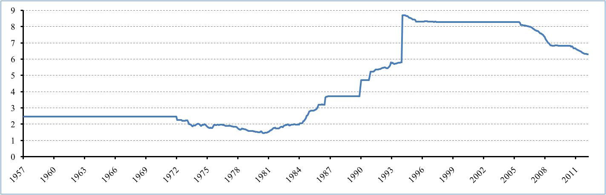
Source: IMF, International Financial Statistics

China's currency is officially called renminbi with the yuan being its principal unit. Renminbi translates to "people's currency". Since its creation in December 1948, the "people's currency" has been a crucial tool for the Chinese government to move from a central planned to a free market economy. Following this shift, both the yuan and China's exchange rate policy evolved accordingly.
The yuan was pegged at a fixed rate against the dollar in 1949, starting the first of multiple fixed exchange rate periods. While the past two decades China's exchange rate policy has been under criticism for creating an undervalued yuan, initially the yuan was pegged at a overvalued level as a part of China's import-substitution industrialization strategy (Goldstein and Lardy, 2009). This allowed the Chinese government to import the machinery and factory equipment, needed for this strategy, at a relatively lower price. China wanted to invest in the share of manufactured goods in their exports, which during the 1950's existed primarily out of food and agriculture products. Initially, the industrialization strategy exercised tight controls on the international trade by nationalizing trading companies while the foreign exchange sector was regulated by the Bank of China. Regulation of these sectors began to loosen in 1980's when the government gradually started to make its first steps towards a free market economy.
A dual exchange rate system was introduced in January 1981 which contained an official and internal exchange rate. This was to adjust for the, at the time, overvalued exchange rate used in commodity trade without influencing the domestic sector and non-commodity trade (Tam, 1995). The official exchange rate was set at 1,53 yuan/dollar and used in the domestic sector. An internal rate was set at 2,8 yuan/dollar and was used for commodity trade. The period between 1981 and 1985 in Figure 1 can be seen as the gradual unification of this dual exchange rate system, where the official rate converged to the internal rate of 2,8 yuan/dollar. The dual exchange rate system was therefore abolished in January 1985.
There was however another renminbi exchange rate in use during this period, which was known as the swap rate. The swap rate was used in swap centers controlled by the government where Chinese enterprises could "swap" foreign currencies at a rate set by the government. Initially when these swap centers were created in 1980, swap rates were only available for state owned enterprises and the rates were close to the internal exchange rate. From 1986 onwards these participation restrictions loosened and allowed foreign investment enterprises to act in these swap centers. Simultaneously, the Chinese government experimented with swap centers in the special economic zones of China by allowing the swap rates to float and be determined by supply and demand. Later this managed floating system was implemented in swap centers nationwide, making swap centers China's instrument to gradually move from a state controlled to a market determined exchange rate. China did this by devaluating their official exchange rate, letting it converge to the market rates used in swap centers. Periods of gradual devaluation of the yuan and steep lines in Figure 1 during 1986-1994 reflect this process of converging to a market determined exchange rate. In January 1994 these two rates were unified, resulting in a massive devaluation of the official exchange rate.
With the opening up of China's economy during the 1980's, the gradual devaluations of the yuan commenced the second stage of China's industrializing strategy. With the "cheap" currency created during this period, China improved the competitiveness of their commodity export sector. China wanted to expand this export sector being the primary catalyst of economic growth. To maintain this competitive advantage and position, the level of the yuan/dollar exchange rate had to be stable. The exchange rate was already very controlled since June 1995 set at 8,3 yuan/dollar, when the fixed exchange rate regime officially was announced in October 1997 at the rate of 8,28 yuan/dollar. This is the beginning of an interesting period, a period that will be central in the rest of this thesis. From here on China used their exchange rate as an instrument to attain a competitive export advantage, pegging their exchange rate to the dollar to maintain this advantage. Although not the first period of a fixed exchange rate regime, this one was globally criticized for bringing world trade in disequilibrium by distorting the foreign exchange market.
After nearly eight years of fixed exchange rate regime, a new regime was announced by the PBC on 21 July 2005. The renminbi was revaluated to 8,11 yuan/dollar and the peg of the exchange rate was lifted. The fixed exchange rate regime was replaced by a managed floating exchange rate regime which had a "reference to a basket of currencies" (People's Bank of China, 2005). This basket consisted largely of the currencies of China's largest trading partners, namely the U.S. dollar, the South Korean won, the Japanese yen and the euro. The term "floating" in this exchange rate regime could be perceived as inaccurate because the PBC still applied tight control on the appreciation of the yuan during this regime, not fully allowing the exchange rate equilibrium mechanism to work. It was however again part of the gradual strategy of China to open up the economy and bring the yuan to a more market based value. After the initiating revaluation to 8,11 yuan/dollar in the following three years the yuan appreciated with 19 percent to 6,83 yuan/dollar on 21 July 2008. While not officially announced, this date could be considered to be the beginning of a new fixed exchange rate period, where the Chinese government tried to stabilize the effects of the financial crisis on their export sector and GDP growth. The second half of 2008 the dollar was appreciating against most other currencies at a surprising rate caused by investors seeking the safety of U.S. treasury securities and the reversal of carry trades (McCauley and McGuire, 2009). Appreciating against a currency that is appreciating itself against most currencies caused deterioration of China's export and the PBC tried to limit this effect by creating certainty with a peg to the dollar. We can observe this policy change in Figure 2 below which represents the real effective dollar exchange rate. We can see that after the fixed exchange rate period in 2005 the yuan/dollar exchange rate appreciated against the dollar, that was itself during this
Figure 2: Real effective dollar exchange rate compared to the yuan/dollar exchange rate (Index base June 2005)
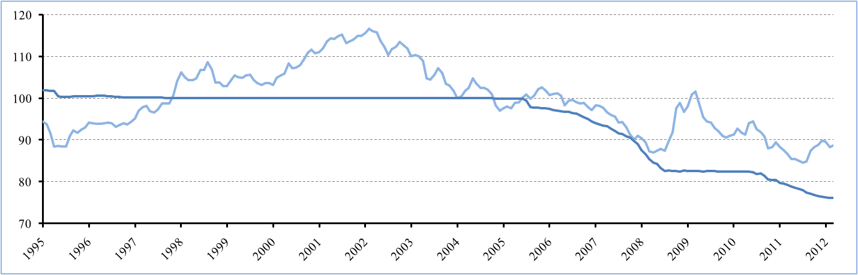
Source: IMF, International Financial Statistics

period effectively depreciating in real terms. After the steep appreciation of the dollar in mid 2008 we see the reaction of China by basically fixing the yuan against the dollar. One could argue that this fixed exchange rate regime did provide stability, based on the fact that China recovered relatively fast from the crisis and the momentum growth of their economy was largely sustained. Generally this shift in regime was perceived negatively by China's main trade partners and trade competitors, especially by the United States. In Figure 2 one can also observe that China does not only peg its currency when the dollar is effectively appreciating in real terms but also when it's depreciating so that in effect the Chinese yuan is also depreciating against all other currencies through dollar. This gives China advantages in comparison to its competitors on the world trade market, similar exporting countries like: Brazil, India, Mexico and South Korea will then have to compete with a cheaper Chinese currency.
After nearly two years of the fixed exchange rate regime, PBC announced on 19 June 2010 that they will continue their managed floating exchange rate regime. This regime had the same intentions as the original managed floating exchange rate regime: to steer the yuan to a more market based value with reference to a basket of currencies, consisting of China's main trading partners. In Figure 3 we can see the impact of this regime in best detail, in the following two years the yuan appreciated against the dollar by around seven percent from 6,83 yuan/dollar to 6,37 yuan/dollar in June 2012. It had however an unsmooth start with the yuan shortly depreciating in August 2010.
Figure 3: Yuan/dollar exchange rate
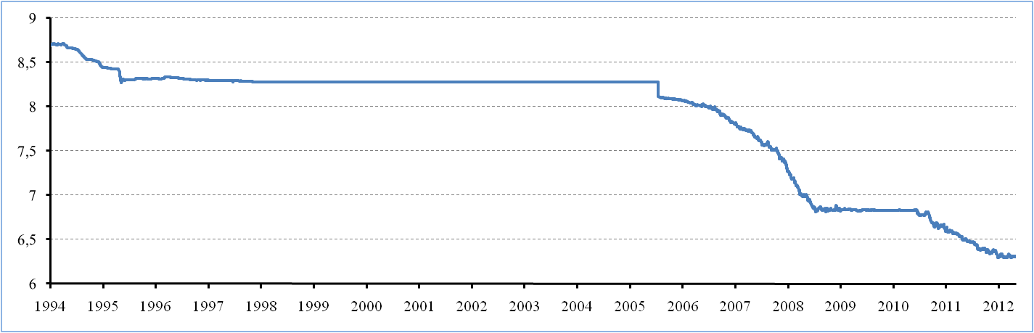
Source: Reuters

The evolution of China's exchange rate and its policy can be seen as different phases in China's industrializing strategy to develop the economy. To understand the process of gradual appreciation of the yuan against the dollar in this last decade we look at the logic behind it. The deputy governor of the PBC, Hu Xiaolian, stated in her speech on 30 July 2010: “The exchange rate regime is consistent with the market-based economic reform in China and an integral part of the restructuring package” (People's Bank of China, 2010). Gradual appreciation of the yuan is incorporated in this restructuring package as a positive stimulus for the economy. In order to retain the economic growth rates achieved in the past China wants to develop the corporate sector in the future.
One of the factors that had huge influence on past growth rates, China's relatively cheap labor force, will not be sustainable in the future. China's economic growth is also increasing the labor wages in China. While wealth and domestic consumption are increased this way, it will also cause inflation in domestic prices and increased labor costs. Labor wages are still very competitive compared to developed countries. In the future, however, China risks losing this competitive position to other emerging countries. A key element of this restructuring package is to shift from an economy relying heavily on a competitive labor force to an economy with an adapting and innovating corporate sector, which will be more sustainable in the future. Investment in technologic innovation and labor productivity is a part of China's industrial upgrading process that will sustain China's economic growth in the future. China's managed floating exchange rate regime plays the role of providing stimulus for this industrial upgrading by gradually appreciating the yuan against the dollar. China's corporate sector thrives with a "cheap" currency boosting their exports and will experience a deterioration of the competitiveness of their export goods with this gradual appreciation. The stimulus works by gradually forcing the corporate sector to adapt to these changes and to innovate their production processes with new technologies. This is a slow and delicate process but in the long term it will make China's future growth less dependent on their export sector. Ultimately China wants to develop the economy with their restructuring strategy to a more adapted and sustainable state, decreasingly focused on a "cheap" labor force and exports and increasingly focused on the domestic economy and the creation of new jobs through a growing service sector.
The pace of the yuan appreciation goes hand in hand with the ability of the Chinese corporate sector to adapt to the changes in competitive environment. In that sense China benefits from gradual appreciation and will tightly supervise exchange rates to prevent large fluctuations that may distort economic development. We recognize this protective nature in the fixed and managed controlled exchange rate regimes that China had in the past decades. They played and will play a huge role in China's orderly process of industrial upgrading. Understanding the background of China's exchange rate policy will prove useful in explaining the recent developments of the Chinese exchange rate.
While not in interest for the empirical part of this thesis, which is based on the 21 year period between 1991-2011, it is interesting to look at the future of China's exchange rate. Recent developments in the past 6 months show that the gradual appreciation of the managed floating exchange rate regime stagnated. This development can be seen in Figure 4 depicted by the
Figure 4: China's exchange rates with trade competitors (Index base June 2008)
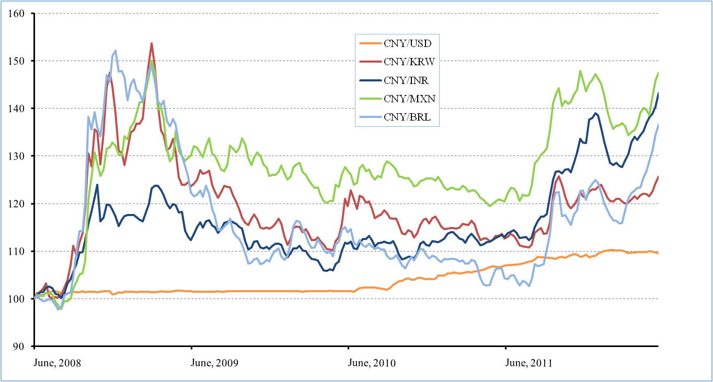
Source: Oanda
orange line. In the period from January till June this year the yuan actually appreciated by 1,1 percent from 6,3 yuan/dollar to 6,37 yuan dollar. Figure 4 represents the currencies of China's main competitors in trade: the South Korean won, the Indian rupee, the Mexican peso and the Brazilian real.
The stagnation of the appreciation of the yuan against the dollar is caused by similar conditions as in July 2008 during the financial crisis. As we can see in Figure 4 in both 2008 and 2011 around July the dollar appreciated sharply in real effective terms. Demand for dollars is increasing as investors are seeking the safety of the dollar in the euro crisis, explaining the recent dollar appreciation since the second half of 2011. As a consequence the yuan, in its turn, is appreciating against the currencies of its main trade competitors. Continued appreciation of the yuan against the dollar would further deteriorate the competitiveness of China's export sector and is therefore not convenient. The followed stagnation of yuan appreciation is the reaction of China's government to stabilize the effect of increased dollar demand on their competitive state in world trade. China, for now, has a managed floating exchange rate but this can turn into a new fixed exchange rate period based on the future appreciation of the dollar. Although it is China's intention to let the yuan appreciate to a market based value in the future we can conclude that a stable economy is the decisive condition for the pace of yuan appreciation.
This part concludes the evolution of the China's exchange rate over the years and their associated changes in exchange rate policy, providing more insight in why the exchange rate was formed the way it was. It is also important to understand how the Chinese government and the PBC accomplished the implementation of these exchange rate regimes.
The export competitiveness created with China's exchange rate has indeed been an effective tool to improve economic growth. This competitiveness boosted China's export sector and as can be seen in Figure 5, created China's net export position with subsequent significant current account surpluses. One of the main importers of these goods is the U.S., which is a net importer on the international trade market and subsequently runs a deficit on their current account.
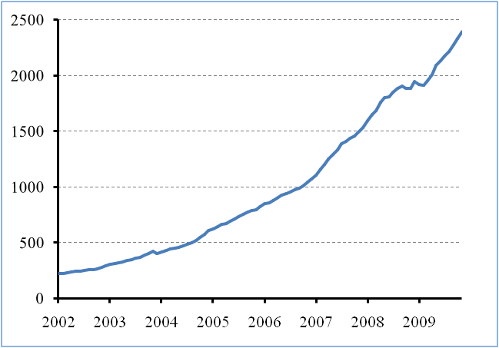
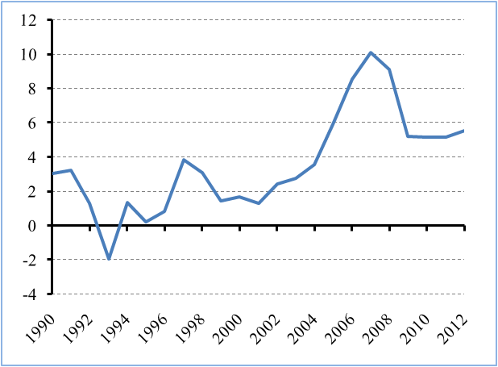
Figure 5: China's current account balance (% of GDP) Figure 6: China's foreign exchange reserves ($ billions)
Source: IMF, World Economic Outlook Source: People's Bank of China

When a Chinese export good is imported by a U.S. resident or company, the Chinese exporter will generally be paid in dollars. The Chinese export firm in its turn will trade these dollars for yuan through China's central bank. And because China's exports to the U.S. greatly exceed U.S. exports to China, the amount of dollars flowing to China's central bank will have to be traded for yuan on the foreign exchange markets, increasing demand for yuan while lowering demand for dollars. In other words the yuan would appreciate against the dollar, deteriorating China's export position and current account surplus. This is where the PBC intervenes with a so called "sterilization": instead of selling dollars in foreign exchange markets they use them to buy dollar denominated U.S. treasury securities or simply hold on to them. The Chinese export firm that supplied these dollars still has to be paid with corresponding Chinese currency. This is done by either printing yuans and increasing the money stock or by lending yuans from Chinese financial institutions through the issue of government bonds. Increasing the money stock leads to rising consumer prices. If economic growth can not keep up with this inflation this will destabilize the economy. This depicts the main issue for intervening on exchange rate markets: the PBC has to find balance between domestic inflation and the appreciation of the yuan to sustain their economic growth.
As a result China has amassed huge foreign currency reserves, as can be seen in Figure 6. Data for this figure originates from the PBC but it is considered to be poorly documented and actual values are thought to be even higher. The composition of these reserves is not made public by the PBC but because China is at the moment the second largest trading partner of the U.S., the dollar will reflect the largest part of these reserves. Consequently, a negative side of a large foreign currency reserve is that if the dollar depreciates effectively in real terms, the value of the reserve decreases significantly.
Another result is that China also massively invested in U.S. government bonds. Together with Japan they are the two primary holders of U.S. government debt. Especially this past decade, Chinese holdings of U.S. treasury securities have skyrocketed. In 2008 China consequently caught up with Japan, becoming the largest holder of U.S. treasury securities which amounted to 1,4 trillion dollars. Since June 2011 the PBC is the only central bank that can buy U.S. government debt straight from the U.S. treasury (normally this is done through major Wall street banks), which is a unique relationship with the Chinese government (Reuters, 2012). This relationship contradicts the simultaneous pressure from the U.S. government on China to appreciate their currency against the dollar.
The U.S. relies heavily on other countries to finance their debt, a surplus on their capital account is needed to offset the earlier described deficit on the current account. While the PBC intervenes to avoid appreciation of the yuan by buying U.S. treasury securities, China is in a way partially financing its own export. In that perspective intervention by the PBC seems self-sustaining, because China experiences economic growth through their export sector.
While China's exchange rate policy enhances their own economy positively, other countries experienced this policy negatively through its substantial impact on the world trade and foreign exchange markets. The unfair competitive advantage created by this policy is the main cause of criticism by the international community. Victims are the competitors of China in international trade. Especially the U.S. accuses China's undervalued currency to boost unemployment in sectors that compete directly with Chinese manufacturers. China, however, proved to be resilient to pressure by the IMF and the international community,
In the economic literature the consensus is that the yuan is significantly undervalued. There is however less agreement on the size of this misalignment. Because the Chinese government countered the equilibrium correction of foreign exchange markets, it is indeed logical to assume that the EER of the yuan is misaligned with the actual exchange rate. The main goal of this thesis is to empirically provide an original EER estimate that allows us to research the misalignment of the yuan. That brings us to our second part of the literature research which aims to find an appropriate model to estimate the EER of the yuan.
2.2 EER Methodology
To research the undervaluation of the Chinese currency, we will estimate a bilateral yuan/dollar EER to observe the exchange rate that would realize without intervention by China's central bank. Various methods for exchange rate determination exist in economic literature. Based on different macroeconomic frameworks and assumptions accompanying them, model results vary accordingly. In this paper we identify two main streams in methodology to estimate EER's: the PPP framework and the macroeconomic balance framework.
The PPP framework finds the equilibrium of exchange rates based on relative price changes among countries. The theory argues that, with inflation varying in countries the exchange rate should move accordingly to rule out strategies of arbitrage that could arise in trade. This relatively simple model ignores such aspects of the economy as: trade barriers, transaction and transportation costs. More recent literature proposed enhanced PPP models introducing more depth to these models with corrections for the Penn and Balassa-Samuelson effects (Coudert and Couharde, 2005; Frankel, 2006). The main drawback of PPP models is that the analysis starts from an arbitrarily defined base year in which the two currencies are assumed to be in equilibrium. As discussed in the previous part of the literature review, since the creation of the renminbi China intervened on international markets to counter the exchange rate equilibrium mechanism. There is therefore little reason to believe the yuan exchange rate was in exact market equilibrium these past decades, which complicates PPP analysis. Economic literature indicates that results are sensitive to these arbitrary base years for the implied undervaluation of the yuan (Lipman 2010). We conclude that although PPP models can give useful insight into misalignment of currencies, the results are not satisfying due to the strong assumptions of the model.
The second stream in EER methodology is the macroeconomic balance framework. Central in the macroeconomic balance framework is that the trading partners used in these models achieve both internal and external balance, so that under the macroeconomic assumptions of the model an EER can be estimated. Compared to PPP models macroeconomic balance models are more complex, subsequently final estimations require more subjective assumptions on macroeconomic theory and can utilize huge datasets. An EER could be defined as the exchange rate that resides when currencies are freely traded and without government intervention. In economics we try to recreate similar circumstances in models to replicate this market equilibrium. Different macroeconomic assumptions paired with different definitions of internal and external balance affect the results of the model and their conclusions. This is where a comprehensive taxonomy developed itself, creating wildly different acronyms for models that distinguish themselves with unique aspects toward EER estimation. Some examples of this taxonomy: FEER, DEER, BEER, PEER, APEER, ITMEER, NATREX, and CHEER. We will briefly discuss the three mainly applied macroeconomic balance approaches in the literature: BEER, NATREX and FEER.
2.2.1 The BEER Approach
Defining external and internal balances, especially for emerging economies, is difficult and based on arbitrary decisions. To avoid this, the Behavioral Equilibrium Exchange Rate (BEER) approach is relying on direct econometric estimations (Coudert and Couharde, 2009). Following techniques proposed by Clark and MacDonald (1998), the BEER approach estimates a reduced-form equation between real exchange rate and its economic fundamentals. Main fundamentals are: the terms of trade, exports to imports ratio and the net foreign assets as a percentage of GDP. Some BEER models are purely empirical while other have specifications that are more theoretically defined towards general-equilibrium models. If the data series of the fundamentals are cointegrated, a long term relationship can be estimated with the real exchange rate. This empirical research generally does not impose functional forms or links on the regression. The EER is then estimated by the fitted value of the regression using long run values of the fundamentals. Development of the BEER approach has been mainly due to improvements in econometric modeling. However, the biggest drawback of the BEER approach is the lack of theoretical basis in its empirical research. Although often not properly incorporating economic theory, the BEER approach gives a unique and useful insight into EER's.
2.2.2 The NATREX Approach
NATREX, which stands for NATural Real EXchange rate, comes forth from the works of Stein (1994), Stein and Allen (1995). Stein describes the exchange rate in equilibrium as "the rate that would prevail if speculative and cyclical factors could be removed while unemployment is at its natural rate" (Stein, 1994). Similar to the BEER approach, the NATREX estimates a reduced-form equation between the real exchange rate and its economic fundamentals. The economic fundamentals used in the model are disturbances to domestic and foreign savings and productivity, which are exogenous to the model. These fundamentals are measured with a 12-quarter moving average to eliminate cyclical and speculative factors. An investment function is provided to include stocks of capital and foreign debt and the real interest rate, which are endogenous to the model and affected by the fundamentals. The thought behind NATREX is that in the short run the exchange rate won't reflect the fundamentals. The identity equation used to estimate the EER therefore incorporates three states of the economy: medium run, long run and steady state. As the time horizon lengthens from medium to long run, the identity equation follows the evolution of the fundamentals and estimates the appropriate steady state NATREX. This interaction between the medium run and long run and its effect on EER's is the contribution of the NATREX approach.
2.2.3 The FEER Approach
The FEER model is the most commonly used method in economic literature to estimate EER's. After being introduced by Williamson (1983) the methodology has developed gradually over the years, with plenty of recent developments (Cline, 2008; Cline and Williamson, 2011). In the FEER methodology the internal balance is defined as non-inflationary full employment and the external balance is defined as a sustainable current account balance. With appropriate trade elasticities and trade shares the model then estimates the change needed in the exchange rate to achieve this equilibrium. The approach can implement a full-scale econometric model or a partial equilibrium model.
Most notable would be the contributions made by Cline and Williamson, both active at the Peterson Institute for International Economics (PIIE) where they produce annual FEER estimates. Their approach is based on large econometrical models and refined methodology that has been developed over the years. Their FEER model which currently incorporates 38 emerging and industrial countries, would be too large to implement as the basis for a thesis.
The goal of this thesis is to provide with an EER of the yuan, with a prerequisite that the estimation of the model, paired with its empirical research, could be done individually. Further research in economic literature brought forward the papers of Wren-Lewis (2003), Coudert and Couharde (2005, 2007) and Jeong and Mazier (2003, 2010).

Wren-Lewis provided with multiple FEER estimates over the years, eventually developing a Five Area Equilibrium Exchange Rate (FABEER) model, which in essence still is a FEER model. The five areas the model includes are: the Euro area, the U.S., the U.K., Japan and a residual area, representing the rest of the world. In contrast with the model used by Cline and Williamson, Wren-Lewis implemented a partial equilibrium model. The equations of this model are not econometrically estimated, but they are in line with econometric evidence in the literature. A unique equation in this model includes data series for net IPD flows (Interest, Profit and Dividends). It extends the current account equation which is only a function of imports and exports. The model works in two stages. First, an underlying current account is estimated with the model. That is, the current account that would emerge at historic exchange rates and with the five area economies being at their medium run trend. In the second stage, this underlying current account is an exogenous input to the model, which enables to estimate bilateral EER's for the five areas of the model. An EER for the yuan was provided by Wren-Lewis by adding China as a small country to this model and modeling its FEER recursively. In this added third stage of the model, China's economy has no impact on the exchange rates of the initial FABEER model and therefore this methodology does not provide a satisfying framework for the research of this thesis.

The work of Coudert and Couharde (2005, 2007) provide a similar partial equilibrium model which includes five countries: the U.S., Japan, the Euro area, South Korea and China. These countries are based on the resolution method developed by Borowski and Couharde (2003). It rests on the results of the NIGEM model, wherein the trade elasticities and trade equations of these countries were explicitly estimated with an error-correction model. The current account is a function of the real exchange rate, net foreign debt income and domestic and foreign output in the model, but this variable is based on exogenous estimation. The internal balance of the model is attained with the use of exogenous output gaps. In their approach Coudert and Couharde (2005) provide two definitions of a sustainable current account. The first definition is based on the work of Mahar and Williamson (1998) who provided equilibrium current account estimates for countries and regions of the world. The second definition of a sustainable current account is based on the work of Jeong and Mazier (2003), who implement two panel regressions on industrial and emerging countries to estimate equilibrium current accounts. Coudert and Couharde (2005) also proposed a correction for the actual current account to make it compatible in calculations of the model with the medium run sustainable current account. This so called structural current account is the medium run current account that resides if economies reach their potential output and exchange rate changes have been fully materialized. Then a dynamic FEER for the yuan can be estimated, with a fitting framework of equations.
The work of Jeong and Mazier (2003, 2010) provides a partial equilibrium model comparable with above discussed papers. Their recent paper in 2010 is especially interesting, because it is a synthesis between the contributions made in Jeong and Mazier (2003) and Borowski and Couharde (2003). A multinational trade model is provided to estimate the bilateral EER's of six areas and countries (Japan, China, the U.S., the Euro area, the U.K. and the Rest Of World). Similar to the structural current account implemented by Coudert and Couharde (2005, 2007), Jeong and Mazier provide a dynamic correction for the actual current account. Several improvements in methodology are made in this paper. Firstly, the approach to estimate equilibrium current accounts with panel regressions is thoroughly improved by incorporating contributions by Lee et al. (2008) and Coudert and Couharde (2005, 2007). Secondly, the model also includes net oil import and net foreign debt in the model through the current account equation, which is a unique contribution compared to other FEER literature. When compared to the work of Cline and Williamson, Jeong and Mazier provide a more manageable model than an econometrical model incorporating 38 countries. The model also takes into account the interdependencies of the trading partners in a more consistent manner.
We can conclude that the methodology provided by Jeong et al. (2010) rests on a selection of contributions and developments in FEER literature, which results in a refined model that can estimate dynamic FEER's. The model will thus provide a fitting framework for the empirical research in this thesis, estimating a FEER for the yuan. The following Chapter describes the adopted multinational trade model in greater detail.
3. Methodology and Data
The methodology of this thesis is based on the research in the paper: "Exchange rate misalignments at world and European levels: a FEER approach" (Jeong et al. 2010). The Multinational trade model used in this paper enables us to calculate the difference between the actual exchange rate and the equilibrium exchange rate and thus possible under- or overvaluation of currencies.
3.1 Multinational Trade Model
The multinational trade model represents the trade between the largest economies of the world. The following countries and area's are included: Japan $\left(i=1\right)$, China $\left(i=2\right)$, United States $\left(i=3\right)$, Euro area $\left(i=4\right)$, United Kingdom $\left(i=5\right)$ and the Rest of World (R.O.W.) $\left(i=6\right)$. These 6 countries and areas are from now on referred to as the trading partners of the model. The Rest of World can be seen as a residual trading partner in the model.
The base of the model are the export and import volume equations paired with their export and import price equations. There is no export and import volume equation for the residual country because these are calculated with the world trade equilibrium in volume and value equations. A consumer price equation is added to incorporate the impact of import prices on consumer prices. The current account equation is essential for the model and takes into account net oil import and net external debt of the trading partners. Again, a residual can be calculated for the current account of the R.O.W., although this equation is not required in calculations of the model. With the estimated equilibrium bilateral exchange rates of the model a Real Effective Exchange Rate (REER) can be calculated with the relevant consumer prices and trade relations.
The equations of the model are described below:
$i=1\sim 5$ Foreign trade volume equations
Export volume equation | $$X_{i}={DM}_{i}^{{ηx}_{i}} {COMPX}_{i}^{{εx}_{i}}$$ | (1)
Internal demand equation | $${DM}_{i}=\prod_{j≠i}{M_{j}^{α_{ij}}}$$
 | $${COMPX}_{i}=\left(\frac{{PMX}_{i}}{{PX}_{i}}\right)$$
Import volume equation: | $$M_{i}={DI}_{i}^{{ηm}_{i}}{\left(\frac{{PD}_{i}}{{PM}_{i}}\right)}^{{εm}_{i}}$$ | (2)

$i=1\sim 6$ World trade equilibrium equations
World trade in value: | $$\sum_{i}{\left(\frac{{PX}_{i}X_{i}}{E_{i}}\right)}=\sum_{i}{\left(\frac{{PM}_{i}M_{i}}{E_{i}}\right)}$$ | (3)
World trade in volume: | $$\sum_{i}{X_{i}}=\sum_{i}{M_{i}}$$ | (4)

$i=1\sim 6$ Price Equations
Export price equation: | $${PX}_{i}={PMX}_{i}^{{αx}_{i}}P_{i}^{1-{αx}_{i}}$$ | (5)
 | $${PMX}_{i}=\prod_{j≠i}{{\left(\frac{{PX}_{j}E_{i}}{E_{j}}\right)}^{λ_{ij}}}$$
Import price equation: | $${PM}_{i}={PMM}_{i}^{{αm}_{i}}{PD}_{i}^{1-{αm}_{i}}$$ | (6)
 | $${PMM}_{i}=\prod_{j≠i}{{\left(\frac{{PX}_{j}E_{i}}{E_{j}}\right)}^{μ_{ij}}}$$
Domestic price equation: | $${PD}_{i}={PM}_{i}^{a_{i}}P_{i}^{{1-a}_{i}}$$ | (7)

$i=1\sim 5$ Current Account Equations
 | $$B_{i}={PX}_{i}X_{i}-{PM}_{i}M_{i}-M_{petx,i}-{ED}_{i}$$ | (8)
 | $$B_{residual}=-\sum_{i=1}^{5}{B_{i}}$$

$i=1\sim 6$ Real Effective Exchange Rate Equation
 | $$R_{i}=\prod_{j≠i}{\left(\frac{{\left({{PD}_{j}}/{E_{j}}\right)}^{v_{ij}}}{{{PD}_{i}}/{E_{i}}}\right)}$$ | (9)

Because we want to calculate the difference between the actual exchange rate and the equilibrium exchange rate we will actually use this model in logarithmic differentials. The outcome of the most important variable of the model, the exchange rate, will then be in terms of under or overvaluation: $e=\frac{dE}{E}=\frac{E-E^{e}}{E^{e}}$.
To calculate the misalignment of the bilateral exchange rates with the dollar we use the model written in logarithmic differentials (Appendix 1).
For all variables the following transformation, $x=\frac{dX}{X}=\frac{X-X^{e}}{X^{e}}$, is applied with the exception of the current account, which is calculated by the difference between the actual current account and the equilibrium current account as a share of output, $b_{i}=d\frac{B_{i}}{Y_{i}}=\frac{B_{i}}{Y_{i}}-\frac{B_{i}^{e}}{Y_{i}^{e}}$.
When looking at the model in logarithmic differentials we assume that producer prices are in equilibrium, such that: $p=\frac{P-P^{e}}{P^{e}}=0$.
In Table 1 one can observe the explanation of variables of the trade model and if applicable the relevant source the data was taken from.
Table 1: Explanation of variables and their respective sources
 | Explanation | Source
$${PX}_{i}X_{i}$$ | Non-oil exports in value | Direction Of Trade Statistics, IMF, 2012
$${PM}_{i}M_{i}$$ | Non-oil imports in value | Direction Of Trade Statistics, IMF, 2012
$$X_{i}$$ | Non-oil exports in volume | -
$$M_{i}$$ | Non-oil imports in volume | -
$${DM}_{i}$$ | World demand in volume | -
$${DI}_{i}$$ | Internal demand in volume | -
$${COMPX}_{i}$$ | Export price competitiveness | -
$${PMX}_{i}$$ | Competitor export price index | -
$${PMM}_{i}$$ | World import price index | -
$${PX}_{i}$$ | Export price index | International Financial Statistics, IMF, 2012¹
$${PM}_{i}$$ | Import price index | International Financial Statistics, IMF, 2012¹
$${PD}_{i}$$ | Consumer price index | International Financial Statistics, IMF, 2012¹
$$P_{i}$$ | Producer price index | International Financial Statistics, IMF, 2012¹
$E_{i}$² | Nominal bilateral dollar exchange rate | International Financial Statistics, IMF, 2012
$$R_{i}$$ | Real effective exchange rate | -
$$B_{i}$$ | Current account | World Economic Outlook, IMF, 2011
$$M_{petx,i}$$ | Net oil import in value | World Economic Outlook, IMF, 2011
$${ED}_{i}$$ | Net external debt | International Financial Statistics, IMF, 2012
¹ Source for the price indices of China and Euro area was the Oxford Economics database.
² $E_{3}=1$
³ Data for R.O.W. was calculated with the help of world export and import data.

It is important to clarify the definition of exports and imports in volume. Normally, volume would stand for a certain quantity of export or import goods. With available data however, it is impossible to calculate an exact quantity. In order to do that, one would need data on average export and import prices. A common solution to solve this problem in similar macro-economic models is to incorporate indices in the model. In this model we work with both price and exchange rate indices with their base set to 2005. For the model itself this is no problem because export and import in volume for all trading partners are endogenous variables. The input data series for the trade shares in volume however are based on own calculations of export and import in volume. To calculate export and import in volume we divide export and import data in dollar value by their respective price and exchange rate indices. This implies that export and import in volume do not reflect precise quantities and still incorporate the bases of their respective price and exchange rate indices.
3.2 Exogenous Variables, Elasticities and Trade Shares
In total the multinational trade model in logarithmic differentials (Appendix 1) has 35 endogenous variables with 35 equations. The 35 endogenous variables result from: $x_{i}, m_{i}, {px}_{i}, {pm}_{i},{pd}_{i}$ with $i=1\sim 6$ and $e_{i}$ with $i=1,2,4,5,6$. Note that E is the bilateral exchange rate of the trading partner with the dollar, therefore the bilateral exchange rate of the U.S. with the dollar is equal to 1 ($E_{3}=1$, $e_{3}=0$).
The 35 equations result from: ${px}_{i}, {pm}_{i},{pd}_{i}$ with $i=1\sim 6$, $x_{i}, m_{i}, b_{i}$ with $i=1\sim 5$ and the two equations for world trade in volume and value.
The data for the model in logarithmic differentials consists of different types, next to the 35 endogenous variables we use:
- 10 exogenous variables ($b_{i}$and ${di}_{i}$ with $i=1\sim 5$),
- 18 price elasticities (${αx}_{i}$, ${αm}_{i}$ and $a_{i}$ with $i=1\sim 6$),
- 20 trade volume elasticities (${εx}_{i}$, ${εm}_{i}$, ${ηx}_{i}$ and ${ηm}_{i}$ with $i=1\sim 5$),
- 85 bilateral trade shares ($α_{ij}$, $λ_{ij}$ and $μ_{ij}$ with $i≠j$),
- 24 equilibrium world trade shares (${vx}_{i}$, ${vm}_{i}$, ${wx}_{i}$ and ${wm}_{i}$ with $i=1\sim 6$) and finally
- 20 current account ratios ($μ_{i}$, $T_{i}$, $σ_{petx, i}$ and $σ_{x,i}$ with $i=1\sim 5$).
All these series sum up to a total of 177 input data series for the model in logarithmic differentials. Below follows a more detailed specification of the different types of data input used in the multinational trade model.
3.2.1 Exogenous Variables
The multinational trade model is a partial model which means that it does not represent all aspects of the whole world economy. Two parts of the world economy are exogenous to the model, which means the model does not explain them. These two, the internal demand and the current account of countries are explained by other methodology.
The internal demand in logarithmic differentials looks at the difference between potential output and actual output of a country, $di=\frac{DI-{DI}^{e}}{{DI}^{e}}$. And as noted before, the current account in logarithmic differentials looks at the difference between equilibrium current account and the actual current account. These variables are discussed further in the empirical research Chapter, where the methods of deriving these variables are described.

3.2.2 Elasticities
Trade elasticities used in the model are taken from Jeong et al. (2010). Jeong and Mazier took these elasticities on their turn from econometric models in the economic literature with specifications similar to the equations used in our multinational trade model.
For Japan, the United States and the United Kingdom elasticities were taken from the Mimosa model. The Mimosa model is a macroeconomic model of the world economy created by a team of researchers from the French CEPII and OFCE institutes and is focused on the six largest industrialized countries. The Euro area elasticities are taken from a paper of Karine Hervé in 2000, which uses a trade model based on the Euro area, the United states and Japan. For China elasticities used originate from a macroeconomic model on the Chinese economy by Stephane Dées (1999). For the residual country, the R.O.W., finding appropriate trade elasticities is more difficult. Therefore: "For the R.O.W. ad hoc values have been used, but are close to estimations of elasticities made using data from CHELEM and OECD" (Jeong et al. 2010). These trade elasticities were extensively tested on sensitivity by Jeong and Mazier to ensure these elasticities could be applied to the multinational trade model.

The following Table describes the trade elasticities used in the model and their respective sources.
Table 2: Elasticities for the Multinational trade model
Country | Source | $$ε_{x}$$ | $$ε_{m}$$ | $$α_{x}$$ | $$α_{m}$$ | $$η_{x}$$ | $$η_{m}$$
Japan | Mimosa | 1,26 | 1,47 | 0,19 | 0,56 | 1,01 | 1,50
China | Dées | 0,71 | 1,02 | 0,56 | 0,66 | 0,75 | 1,04
U.S. | Mimosa | 0,91 | 1,44 | 0,09 | 0,50 | 1,04 | 1,56
Euro area | Hervé | 1,39 | 0,30 | 0,75 | 0,64 | 1,05 | 1,06
U.K. | Mimosa | 0,70 | 1,33 | 0,07 | 0,59 | 0,87 | 1,82
R.O.W. | Jeong et al. | 1,00 | 1,00 | 0,50 | 1,00 | 1,00 | 1,00
Source: (Jeong et al. 2010)
The elasticities $ε_{x}$ and $ε_{m}$ are found in the export and import volume equations and represent respectively the effect of the competitiveness of the country's export price on their export volume and the effect of the competitiveness of the domestic prices in comparison with the country's import prices on their import volume. The elasticities $η_{x}$ and $η_{m}$ are also found in the export and import volume equations and represent respectively the effect of the world demand on export volume and the effect of the internal demand on import volume. The elasticities $α_{x}$ and $α_{m}$ are found in the export and import price equations of the model and represent respectively the feedback of the competitors export price on own export prices and the feedback of world import prices on own import prices.
Although not specified further by Jeong and Mazier in their paper, the multinational trade model uses a seventh trade elasticity, represented by $a$. This elasticity can be found in the consumer price equation in the model and represents the feedback of import prices on domestic prices. This trade elasticity is approximated by the value of imported goods as a share of GDP for five of the six trading partners in the model. For the R.O.W. an ad hoc value is used, $a=0,2$ (Jeong and Mazier, 2003).
3.2.3 Trade Shares
In the multinational trade model in logarithmic differentials we use two different types of trade shares: the bilateral trade shares and the equilibrium world trade shares. An explanation of the bilateral trading shares and the equilibrium world trade shares of the model can be found in Table 13 of Appendix 1. The model in logarithmic differentials introduces four different equilibrium world trade shares in the world trade equilibrium equations as can be seen in Appendix 1. The function of these trade shares is to ensure that changes in export volumes of countries are offset by equal changes in import volumes in the model, so world trade equilibrium sustains.
To calculate the bilateral trade shares we assume that exports in value to trading partners are a function of the share of the trading partners in world import. Which means that if trading partner $i$ in the model has a 50 percent trade share in total world imports, trading partner $j$ will export the half of its total export to trading partner $i$. The bilateral trading shares are calculated based on the export and import in value data series of the Direction of Trade Statistics. With the shares of the trading partners in world import we thus can calculate the shares of the trading partners in export and import to each other. These shares are used in the model to calculate competitor export prices (${PMX}_{i}$), world import prices (${PMM}_{i}$) and world demand (${DM}_{i}$).
The equilibrium world trade in value shares are calculated again based on export and import in value data series of the Direction of Trade Statistics. For world trade in volume shares we make an appropriate correction with the relevant exchange rates and export and import price indices.
For the R.O.W. export and import in volume was calculated with adapted world trade volume equations:
$$X_{6}=μ_{1,6}M_{1}+{μ_{2,6}M}_{2}+{μ_{3,6}M}_{3}+μ_{4,6}M_{4}+{μ_{5,6}M}_{5}$$
$$M_{6}=λ_{1,6}X_{1}+λ_{2,6}X_{2}+λ_{3,6}X_{3}+λ_{4,6}X_{4}+λ_{5,6}X_{5}$$
Thanks go to professor Jacques Mazier for his notes on this relatively complicated problem. The world trade equilibrium equations can also be used to calculate values for ${PX}_{6}$ and $E_{6}$, which are later needed in the dynamic correction of the current account (Chapter 4.1.2).
4. Empirical Research
The research done in this thesis is split up into three parts: external equilibrium, internal equilibrium and the implementation of the model in Eviews.
First we start with the panel estimation for the equilibrium current accounts of China, Japan, the U.S., the U.K. and the Euro area at the medium term. We want to observe the difference between the actual current account and the equilibrium current account. This variable, $b_{i}$, is one of the two variables exogenous to the model in logarithmic differentials. However, to calculate this exogenous variable we will have to correct the actual current account for delayed effects of exchange rate movements, to be compatible in calculations with our equilibrium current account at the medium term. The second part of the research focuses on our second exogenous variable, the internal demand in logarithmic differentials. Finally the third part of the research is focused on the modeling choices made to incorporate the multinational trade model in Eviews.
4.1 External Balance
Panel estimations are used to estimate an equilibrium current account that represents external balance at the medium term. The current account can be seen as the difference between domestic savings and domestic investments. In this research we base the equilibrium current account on econometric estimates, the chosen method is regression on panel data (panel estimations). Faruqee and Debelle (1996) proposed to base the external balance of economies on panel estimations. Their early research studied panel data on industrial countries, to observe the effect of output, demographic and governmental states of the economy on the current account. The more recent literature on the this topic extends the original research by Faruqee and Debelle by including emerging countries and adding explanatory variables to these panel estimations.
4.1.1 Panel Estimations
The panel estimations try to characterize the movement of the medium term equilibrium current accounts. To achieve this: the variation of the equilibrium current account is based on macroeconomic determinants of longer-term saving and investment balances (Chin and Prasad, 2003). Specifically in interest are demographic dependency ratios of countries on the working age population. We expect that higher ratios of children and seniors, the economically inactive, in the population reduce overall savings in the country and therefore have a negative influence on the current account. The net foreign assets of a country are created by the net foreign income flows and are expected to have a positive influence on the current account. The government balance, the net lending of the government of a country compared to its GDP, is expected to have a positive influence on the current account through its effect on national savings. The oil balance is used to observe the effect of oil prices across countries. An increase in the oil price will have a positive effect on the current account of oil-exporting countries and a negative effect on oil-importing countries. This effect is captured in the oil balance which is defined as oil import in value minus oil export in value as percentage of GDP and is therefore expected to have a positive effect on the current account.
We also take into account the effect of the output gap of the economy, which is a short-term determinant of the current account. Deviation of country from its potential production with possible over capacity is expected to have a negative effect on the current account. However, when establishing the equilibrium current account, the effect of this variable due to its short term horizon is not taken into account.
We use to panel estimations to observe the effect of these determinants on the current account for two types of country groups: industrial and emerging. High frequency fluctuations are filtered out by using four-year non-overlapping averages of the data because we want the specification to uncover the medium-term relationship between the current account and macroeconomic determinants (Lee et al., 2008). An exception is the variable of the net foreign assets, for which we use not a four-year average but the initial stock of net foreign assets at the beginning of the 4 year period. With the medium term relationship of our determinants we want to estimate an equilibrium current account for the trading partners in our model, for each trading partner based on their respective country group: emerging or industrial. The methodology of these panel estimations is based primarily on Lee et al. (2008) and Jeong et al. (2010). Because of newer available data we extend the range of their panel estimations by four years from 1980-2004 to 1980-2007, which makes our equilibrium current account estimations more accurate for years after 2004. To optimize the significance and correlation of results, we provide original specifications of the panel estimations.
The industrial country group consists of 19 industrialized economies: Australia, Austria, Canada, Denmark, Finland, France, Germany, Ireland, Italy, Japan, Netherlands, New Zealand, Norway, Portugal, South Korea, Spain, Sweden, the United Kingdom and the United States.
The specification for our industrial country group panel estimation is:
$${CAS}_{i,t}=α_{i}+α_{t}+β_{0}+β_{1}{ISNFA}_{i,t}+β_{2}{CDR}_{i,t}+β_{3}{GB}_{i,t}+β_{4}{OG}_{i,t}+ε_{i,t}$$
In this equation the following variables are used. CAS stands for the current account as a percentage of GDP. The parameters $α_{i}$ and $α_{t}$ respectively include a cross-section or period fixed effect in the specification. ISNFA stands for the initial stock of net foreign assets at the beginning of each four year period. CDR stands for the child dependency ratio, which is defined as the population under 15 years as a percentage of the working age population (age 15 to 64). GB stands for government balance, which is defined as net lending of the general government as a percentage of GDP. OG stands for the output gap, which is defined as the difference between actual and potential output as a percentage of potential output. The sources for these variables are indicated in Table 5 at the end of this sub Chapter, Euro area data is for the largest part calculated with aggregates by the author and specified further in Appendix 2.
For our industrial panel, estimated coefficients of the variables can be seen in Table 3.
Table 3: Determinants of the current account for industrialized countries
 | OLS Pooled | Cross-Section Fixed Effects | Period Fixed Effects
Constant | 5,89¹ (4,81) | 3,77¹ (3,01) | 2,65 (1,31)
ISNFA | 0,07¹ (9,13) | 0,05¹ (4,21) | 0,07¹ (4,30)
CDR | -0,13¹ (-3,13) | -0,08³ (-1,86) | -0,03 (-0,44)
GB | 0,45¹ (7,43) | 0,38¹ (6,69) | 0,37¹ (4,48)
OG | -0,70¹ (-5,47) | -0,73¹ (-7,16) | -0.83¹ (-8,40)
Adjusted R² | 0,61 | 0,79 | 0,41
^{1,2,3} Test statistic is significant respectively at the 1%, 5% and 10% level.
We introduce three different effect specifications: OLS Pooled which is a normal ordinary least squares regression without effects, Cross-Section Fixed Effects which adds a country fixed effect and Period Fixed Effects which adds a temporal fixed effect. Most coefficients are significant across these three different effect specifications. We also see our previously stated expected effects back in our coefficients results which are bearing the appropriate signs. Based on the R squared values and the significance of the coefficients, we use the results of the cross-section fixed effects specification to estimate the equilibrium current account for the industrialized trading partners in our model (Japan, Euro area, the United Kingdom and the United States).
The emerging country group consists of 20 emerging economies: Argentina, Brazil, Chile, China, Colombia, Ecuador, Egypt, India, Indonesia, Malaysia, Mexico, Morocco, Pakistan, Peru, Philippines, South Africa, Sri Lanka, Thailand, Tunisia and Turkey.
The specification for our industrial country group panel estimation is:
$${CAS}_{i,t}=α_{i}+α_{t}+β_{0}+β_{1}{ISNFA}_{i,t}+β_{2}{DR}_{i,t}+β_{3}{OB}_{i,t}+β_{4}{OG}_{i,t}+ε_{i,t}$$
In this equation two new variables are introduced. DR stands for total dependency ratio which is the sum of the children dependency ratio (CDR) and the old age dependency ratio (ODR). The old age dependency ratio is defined as the population over 64 as a percentage of the working age population. OB stands for the oil balance, which is defined as the net oil export as a percentage of GDP.
For our emerging panel, estimated coefficients of the variables can be seen in Table 4.
Table 4: Determinants of the current account for emerging countries
 | OLS Pooled | Cross-section Fixed Effects | Period Fixed Effects
Constant | 6,72¹ (5,15) | 13,55¹ (11,76) | -1,66 (-0,72)
ISNFA | 0,02¹ (5,55) | 0,01³ (1,88) | 0,04¹ (5,28)
DR | -0,10¹ (-5,92) | -0,22¹ (-14,77) | 0,03 (0,83)
OB | 0,05 (1,09) | 0,14³ (1,73) | 0,14¹ (2,13)
OG | -0,68¹ (-8,33) | -0,65¹ (-12,31) | -0,66¹ (3,95)
Adjusted R² | 0,33 | 0,57 | 0,37
^{1,2,3} Test statistic is significant respectively at the 1%, 5% and 10% level.
Again, across the three specifications most coefficients are significant, although we observe lower values for the adjusted R squared. Based on the adjusted R squared values and the significance of the coefficients, we again use the results of the cross-section fixed effects specification to estimate the equilibrium current account for the only emerging trading partner in our model, which is China.
Panel estimations were done in Eviews 7. Next to an effect specification for the panel estimations, Eviews also provides an option to implement weights in the specification to correct for heteroskedasticity and an option for the adjusted computations of coefficient standard errors in the case of this heteroskedasticity. For both specifications appropriate weights and robust methods for computing coefficient standard errors were used, making the coefficient results robust to heteroskedasticity.
With the results of our panel estimations we can estimate the medium-term equilibrium current account of the trading partners in the model. This is done by using the coefficients of the relevant panel estimation excluding the coefficient of the output gap due to its short-term nature. These coefficients are then multiplied by the 4 year non-overlapping averages of their respective data series, for the initial stock of net foreign assets data series were constructed with values at the beginning of each four year period.

The equilibrium current account for the R.O.W. is calculated with the following formula:
$$B_{residual}=-\sum_{i=1}^{5}{B_{i}}$$

In Table 5 one can observe the various sources for the variables used in the panel estimations.
Table 5: Sources of the variables used in the panel estimations
Variable | Source
CAS | World Economic Outlook, IMF, September 2011
ISNFA | P.R. Lane and G.M. Milesi-Ferretti's Database, August 2009
CDR, ODR | World Population Prospects, ONU, 2010
GB | Economic Outlook, OECD, December 2011
OB | World Economic Outlook, IMF, September 2011
OG¹ | Economic Outlook, OECD, December 2011
¹ Own calculations for the output gap of the 20 emerging economies (Chapter 4.2).

In Table 6 one can observe the results of the unit root tests on our panel data series.
Table 6: Panel unit root tests
Variable | Industrial panel | Emerging panel
CAS | -2,52¹ | -2,85¹
ISNFA | -2,26² | -2,18²
CDR | -3,83¹ | -
DR | - | -2,78¹
GB | -3,08¹ | -
OB | - | -2,20²
OG | -2,48¹ | -5,52¹
^{1,2} Test statistic is significant respectively at the 1% and 5% level. We use the Im Pesaran Shin unit root test statistic to reject non-stationarity of the data series.
4.1.2 Dynamic Correction
Because the variables of in the model are expressed in logarithmic differentials, the formula for our current account can be formulated as: $b_{i}=d\frac{B_{i}}{Y_{i}}=\frac{B_{i}}{Y_{i}}-\frac{B_{i}^{e}}{Y_{i}^{e}}$
We want the actual current account $\left(\frac{B_{i}}{Y_{i}}\right)$ and the estimated equilibrium current account $\left(\frac{B_{i}^{e}}{Y_{i}^{e}}\right)$ to be comparable. The estimated equilibrium current account is based on medium term determinants and therefore has delayed effects of exchange rates included. To make actual and equilibrium variables compatible in calculations we have to correct for the short term delayed effects that are causing distortion in the actual current account variable. The model equations that are affected by these delayed effects of exchange rates (through the terms indicated in red), are the export and import volume equations:
$$x_{i}={ηx}_{i}\sum_{j≠i}{α_{ij}m_{i}}+{εx}_{i}\left({pmx}_{i}-{px}_{i}\right)$$
$$m_{i}={ηm}_{i}{di}_{i}+{εm}_{i}\left({pd}_{i}-{pm}_{i}\right)$$
Changes in exchange rates affect international prices and therefore the competitiveness of the exports of a country given by: $\left({pmx}_{i}-{px}_{i}\right)$. Not only the competitiveness of the exports is affected, but also import volume through: $\left({pd}_{i}-{pm}_{i}\right)$.
In the forthcoming dynamic correction we assume that the effect of exchange rates on international prices occurs over the range of three years. The distribution over this three years is as follows: 50% of the effect on international prices by the exchange rate occurs in the first year (t), 30% in the second year (t+1) and the rest, 20%, in the third year (t+2). We base this assumption on results of models with similar specifications used by Carton et al. ( 2006) and Pain et al. (2005).
For example when looking at the export price elasticity we get: ${εx}_{i}={εx1}_{i}+{εx2}_{i}+{εx3}_{i}$, with: ${εx1}_{i}=0,5{εx}_{i}$,${εx2}_{i}=0,3{εx}_{i}$ and ${εx3}_{i}=0,2{εx}_{i}$.
Thus, what we observe when looking at the actual current account is:
$$b_{i,t}=…{εx1}_{i,t}\left({pmx}_{i,t}-{px}_{i,t}\right)+{εx2}_{i,t-1}\left({pmx}_{i,t-1}-{px}_{i,t-1}\right)+{εx3}_{i,t-2}\left({pmx}_{i,t-2}-{px}_{i,t-2}\right)$$
And to be compatible with the equilibrium current account we want to observe:
$$b_{i,t}=…{εx1}_{i,t}\left({pmx}_{i,t}-{px}_{i,t}\right)+{εx2}_{i,t}\left({pmx}_{i,t}-{px}_{i,t}\right)+{εx3}_{i,t}\left({pmx}_{i,t}-{px}_{i,t}\right)$$
Because the price elasticity is constant over the years, the only correction needed is the increase or decrease of $\left({pmx}_{i}-{px}_{i}\right)$ between years.
The correction results in a rather complicated calculation and substitution with equations. The details are provided in Appendix 3.
The equation to correct the actual current account is specified as: $b_{i}^{corrected}=b_{i}^{actual}+b_{i}^{c}$, in which $b_{i}^{c}$ stands for the change implied by the dynamic correction and $b_{i}^{corrected}$ stands for the corrected current account. From Appendix 3 it follows that the final correction on the current accounts of the trading partners of the model equals:
$$b_{i}^{c}=μ_{i}T_{i}\left(\left({εx}_{i,2}+{εx}_{i,3}\right)\left(1-{αx}_{i}\right){rx}_{i,t}+{εx}_{i,3}\left(1-{αx}_{i}\right){rx}_{i,t-1}-\left({εm}_{i,2}+{εx}_{i,3}\right){αm}_{i}{rm}_{i,t}-{εm}_{i,3}{αm}_{i}{rm}_{i,t-1}\right)$$
The graphs of the current accounts of the six trading partners reflecting these corrections are provided on the next page. Because of limited availability for some data series, the range of this correction is 1991-2011.
4.1.3 Current Account Balances of the Trading Partners
Figure 7 incorporates the empirical research done in Chapter 4.1.1 and the dynamic correction calculated in Chapter 4.1.2.
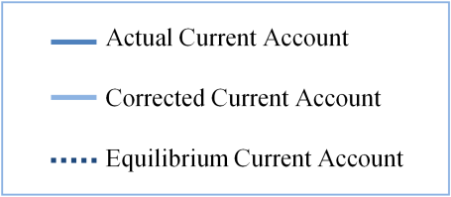
Figure 7: Actual, corrected and equilibrium current accounts (% of GDP)

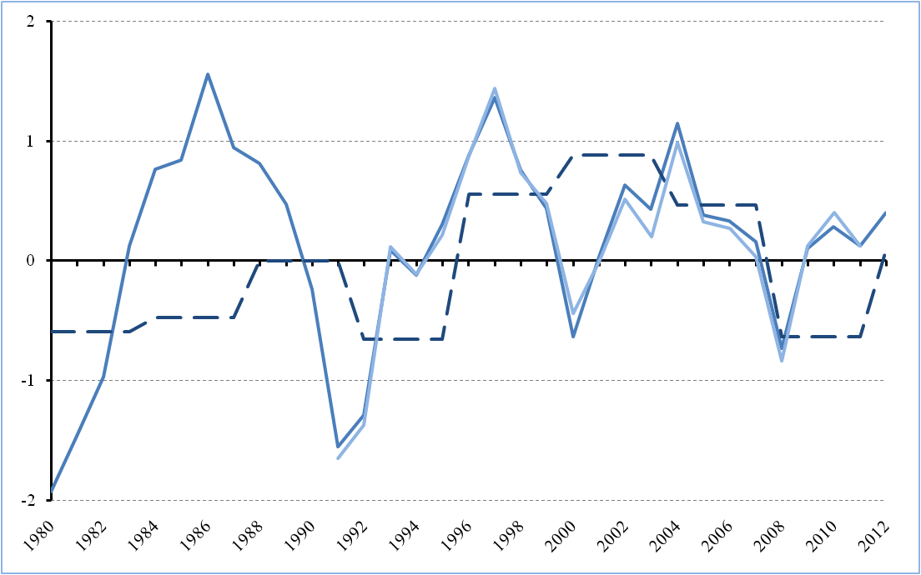
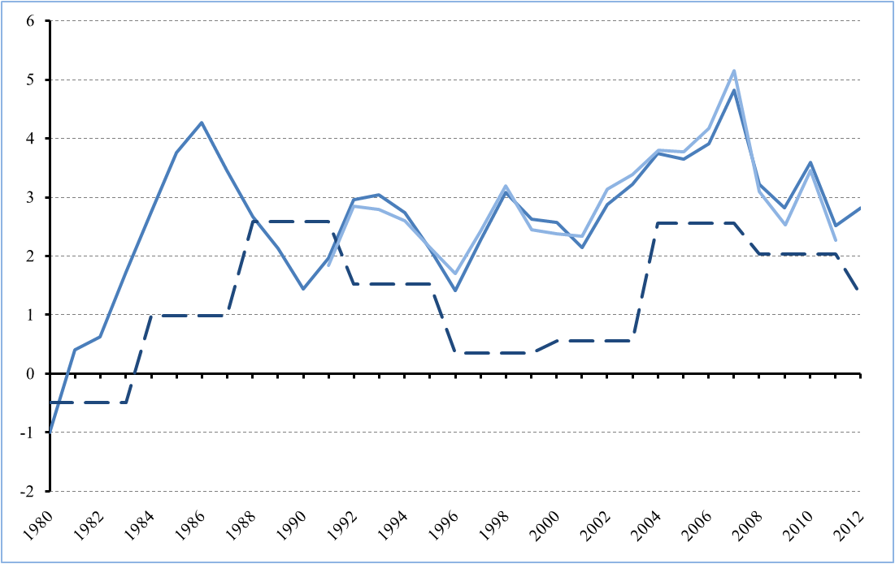
Japan Euro area
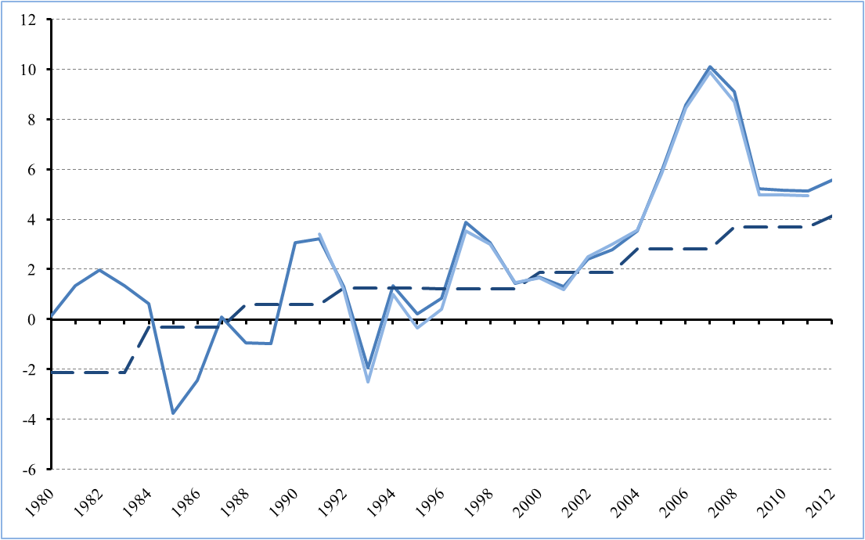
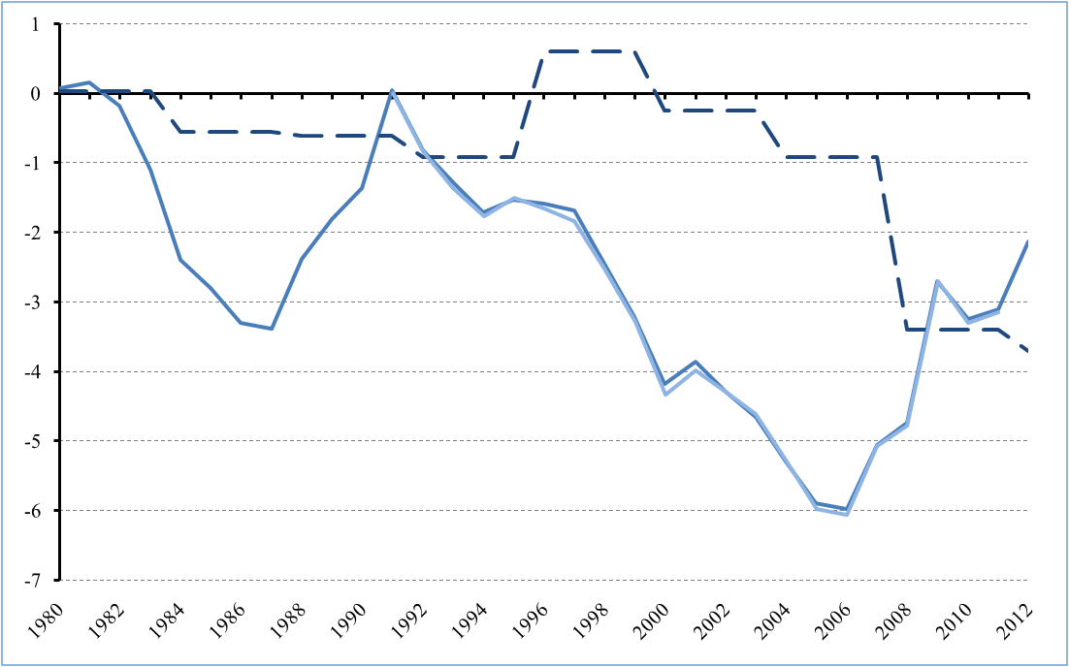
China The United States
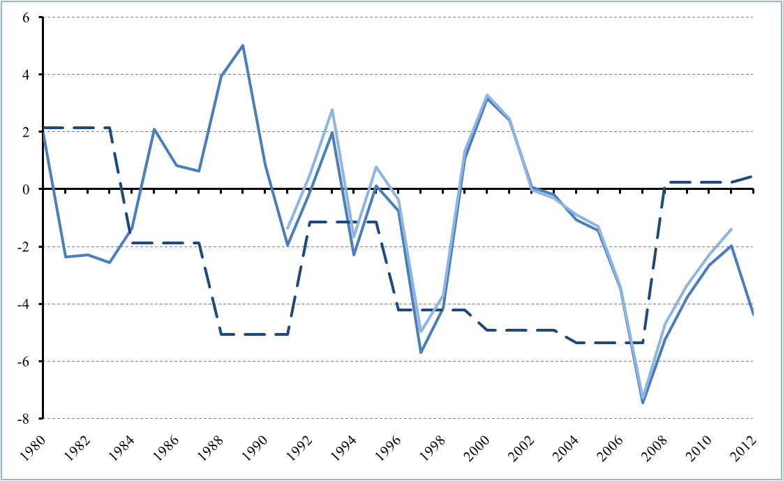
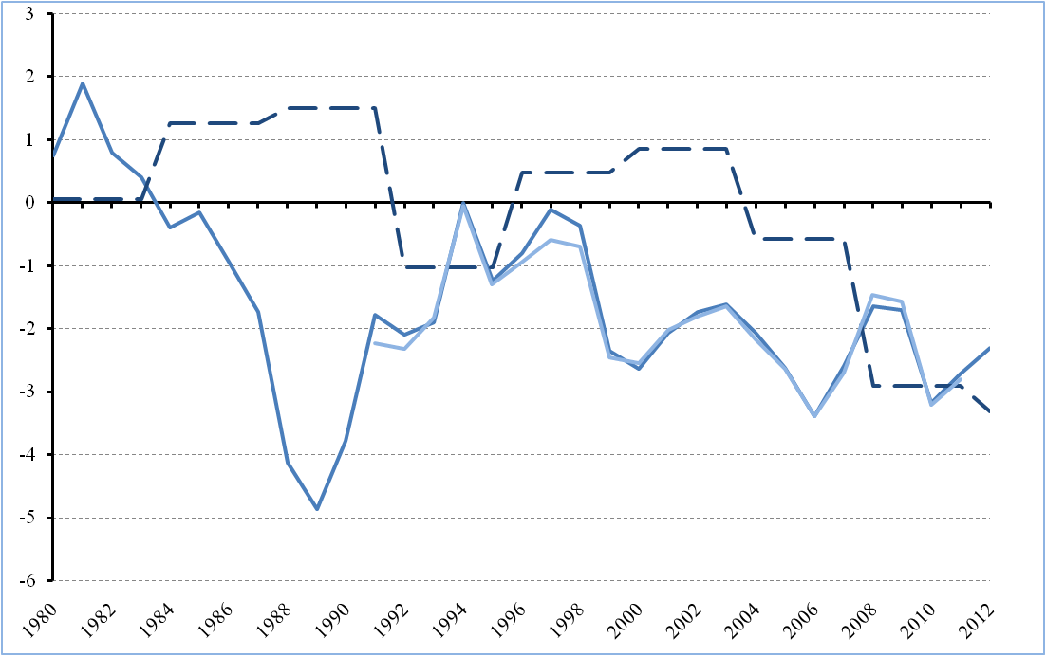
The United Kingdom Rest of World (residual)
Source: IMF, World Economic Outlook and author's calculations
4.2 Internal Equilibrium
Internal equilibrium is the second exogenous variable in the multinational trade model. The internal equilibrium is defined as the state of full utilization of productive resources, without inflation pressures (Jeong et al., 2010). In this model we approximate this state with the potential output of the trading partners in our model. Although this is a simplified version of internal equilibrium it can be applied in our model. Because the model we use to calculate FEER's is written in logarithmic differentials, we will look at the difference between actual output and potential output, the output gap. The output gap is defined as:
$$Output gap=\frac{Actual output-Potential output}{Potential output}=\frac{Y-Y^{e}}{Y^{e}}$$
Because of this definition it fits directly into our model in logarithmic differentials.
To calculate potential output and the corresponding output gap, different methods can be used. Without own calculations we use the output gap data estimated by the OECD for the industrialized trading partners of our model: Japan, Euro area, the United States and the United Kingdom. This output gap data was also used earlier in our industrial panel estimation for the 19 industrialized economies. Output gaps for our emerging panel estimation are not available because the OECD only has output gap data available for Mexico.
The potential output of the 20 countries of the emerging panel is thus estimated by applying a Hodrick-Prescott filter on GDP data at constant prices between 1970-2016. The Hodrick-Prescott filter is a detrending technique commonly used in macroeconomic research.
If we look at GDP data at constant prices over a certain period, we can divide this data series in a trend component ($g_{t}$) and a cyclical component ($c_{t}$).
$$y_{t}=g_{t}+c_{t}$$
The trend component would then reflect a path of long-term growth for the economy and the cyclical component would then reflect fluctuations from this path. To estimate the potential output we want to isolate the long-term growth component.
This is done by letting the Hodrick-Prescott filter, with a given value for lambda ($λ$), minimize the following equation:
$$\sum_{t=1}^{T}{{\left(y_{t}-g_{t}\right)}^{2}}+λ\sum_{t=2}^{T-1}{{\left(\left(g_{t+1}-g_{t}\right)-\left(g_{t}-g_{t-1}\right)\right)}^{2}}$$
The first term in this equation represents the fitness of the output data series, the second term in the equation represents the smoothness of the output data series. The trade-off parameter lambda regulates the conflict between the goodness of fit and the smoothness of the output data series ($g_{t}$). Note that when $λ$ approaches zero, the potential output series will approach the real GDP data series but if $λ$ approaches infinity the output series will approach a linear trend. In the economic literature a $λ$ of 100 is suggested for yearly GDP data of industrialized countries based on business cycles around 20 years. Emerging economies however have shorter business cycles, around 10 years, thus we correct for this difference by using a more appropriate $λ$ of 7 for our Hodrick-Prescott filter (Gutiérrez, 2008).
Hodrick-Prescott filters on real GDP data were applied with the use of Eviews 7. GDP data at constant prizes was taken from the International Financial Statistics database of the IMF, and was extended to 2016 with the use of compatible forecast data from the World Economic Outlook database of the IMF.
4.3 Multinational Trade Model in Eviews
Estimations of the FEER's is done in Eviews 7. Because of limited availability for some data series, the range of our model is 1991-2011. This range provides with 21 years of FEER estimates for China, similar FEER studies usually focus on single years. In that sense our model has the advantage that it can clarify changes in misalignment over this 21 year period.
First we incorporate the excel file of the 177 input data series in Eviews. We proceed with creating a model object, in the source text of this model we include the equations of the multinational trade model in logarithmic differentials as specified in Appendix 4. Eviews requires to pair an endogenous variable with every equation in the model. The modeling choices made can be seen in the following Table.
Table 7: Modeling Choices Eviews
Equations | Endogenous Variables
Export Volume | $e_{i}$ for $x_{i}$ with $i=1,2,4,5$ and $e_{6}$ for $x_{3}$
Import Volume | $m_{i}$ with $i=1\sim 5$
Export Price | ${px}_{i}$ with $i=1\sim 6$
Import Price | ${pm}_{i}$ with $i=1\sim 6$
Consumer Price | ${pd}_{i}$ with $i=1\sim 6$
World trade in value | $$x_{6}$$
World trade in volume | $$m_{6}$$
Current Account | $x_{i}$ with $i=1\sim 5$

Eviews then provides various options to solve this model. Because this is a general model, we use the default setting for most options. The simulation type of our model is set as deterministic and the dynamics was set to find a static solution. The results of our model are further discussed in Chapter 5.
This model does not incorporate the Symmetric Matrix Inversion Method (SMIM), recently proposed by Cline (2008). Cline argues that FEER models are in principle overdetermined because they implement n trading partners and n-1 bilateral exchange rates. The SMIM improves the estimation of the endogenous exchange rate variables, specifically the exchange rate of the residual country (R.O.W.). The shortcoming of the SMIM is that to implement it in this model, variables including output gap, net external debt and net oil import for the residual country has to be added. Since the residual country is an aggregate of all countries not included in the model, consistent data for these variables are challenging to find. The main interest of this thesis is the Chinese exchange rate, in which the exchange rate of the residual country plays a marginal role only. Therefore, we do not implement the SMIM in this model.
5. Results
In our approach we define FEER's as "the real effective exchange rates compatible with the simultaneous realization of the internal and external equilibrium at medium term of each trading partner" (Jeong et al., 2010). We implement this definition in the approach to be able to estimate the FEER's for China using the results provided by the model. Results of the multinational trade model in Eviews are the 35 endogenous variables. In this Chapter we will focus on the 11 endogenous variables that are essential to calculate the FEER: five bilateral exchange rates with the dollar and the consumer price indices for the six trading partners.
5.1 Preliminaries
The real effective exchange rates are calculated relative to consumer prices after the model simulation (ex post) with the following equation from our model in logarithmic differentials:
$$r_{i}=e_{i}-{pd}_{i}+\sum_{j≠i}{v_{ij}\left({pd}_{j}-e_{j}\right)}$$ | (9')
The model allows to calculate FEER's for each of the six trading partners present in the model, here we focus our analysis on the Chinese FEER's as in equation (10'):
$$r_{2}=e_{2}-{pd}_{2}+\sum_{j≠2}{v_{2j}\left({pd}_{j}-e_{j}\right)}$$ | (10')
The trade share $v_{2j}$ included in this equation, represents the share of trading partner $j$'s export and import from and to China as a ratio of China's total trade (imports and exports). These trade shares are based on IMF DOTS statistics and are calculated analogously as the bilateral trade shares in Chapter 3.2.3.
A convenience of the model is that it is written in logarithmic differentials. The key variables of our model, the bilateral dollar exchange rates $e=\frac{dE}{E}=\frac{E-E^{e}}{E^{e}}$ and the real effective exchange rates $r=\frac{dR}{R}=\frac{R-R^{e}}{R^{e}}$, are therefore directly expressed in terms of under- and overvaluation. Since we also work with indices of the exchange rates it follows from $E^{e}=E\left(1+e\right)$ and $R^{e}=R\left(1+r\right)$, that if $e$ and $r$ are positive the actual exchange rate is undervalued. Vice versa, when the equilibrium value of the exchange rate is higher than the actual value, it is implied again through $E^{e}=E\left(1+e\right)$ and $R^{e}=R\left(1+r\right)$, that this can only be the case with negative values for $e$ and $r$.
5.2 Model Estimates
Estimates of the standard model are presented in Table 8. Note that positive values represent undervaluation and negative values overvaluation.

Table 8: Model results for yuan/dollar exchange rate (misalignment in %)
Year | Bilateral exchange rate | Real effective exchange rate
1991 | 15,96 | 14,68
1992 | -2,58 | -2,73
1993 | -35,75 | -33,95
1994 | 3,23 | 1,33
1995 | -8,72 | -9,11
1996 | -1,11 | -5,13
1997 | 25,21 | 19,12
1998 | 21,31 | 14,99
1999 | 7,88 | 1,16
2000 | 4,37 | -2,90
2001 | 0,20 | -6,35
2002 | 11,69 | 2,71
2003 | 14,89 | 4,98
2004 | 10,15 | 0,91
2005 | 23,39 | 9,88
2006 | 36,03 | 19,78
2007 | 42,65 | 28,30
2008 | 30,03 | 23,45
2009 | 9,05 | 9,14
2010 | 9,29 | 7,82
2011 | 9,08 | 7,75
Source: Author's calculations
In figures 8 and 9 one can observe the indices of the exchange rates in comparison to the implied equilibrium exchange rates estimated by our model.
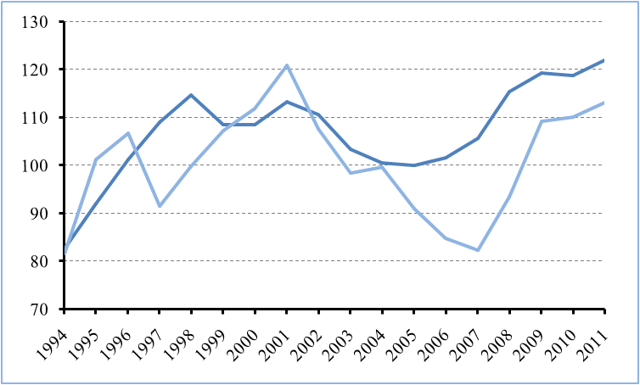
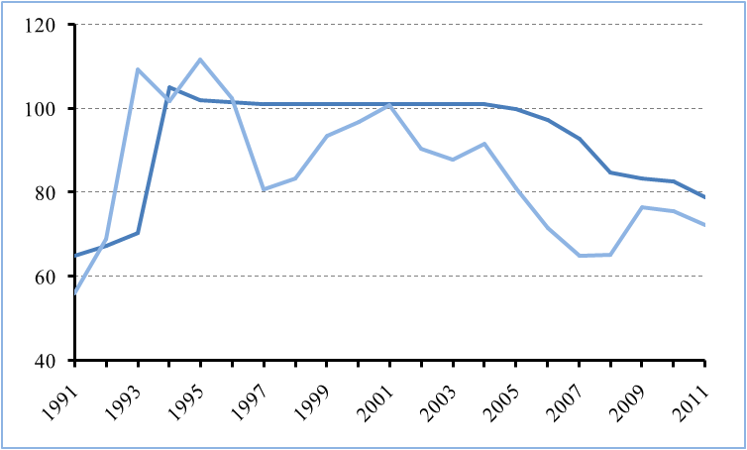
Figure 8: Bilateral comparison (2005=100) Figure 9: Real effective comparison (2005=100)
Source: IMF, International Financial Statistics and author's calculations

Results of the multinational trade model incorporated in this thesis, are in line with the consensus in economic literature that the yuan is undervalued against the dollar. The real effective exchange rate is, as can be seen in Figure 9, for the most part of the model range undervalued against its implied EER. There are also short periods of where the real effective exchange rate is overvalued against its implied EER, which can be justified by the economic conditions or the exchange rate regime present at this period.
Between 1992-1996 the real effective exchange rate was on the whole overvalued against other currencies, with a maximum around 34% in 1993. This can be explained by the unification of the official exchange rate with the swap rates during this period. The actual unification was in January 1994 with a massive devaluation of the official exchange rate. The peak of overvaluation in 1993 reflects a similar misalignment of the official exchange rate with the swap rate. In later years this overvaluation diminished. Since 1997 China's current account surplus has been steadily increasing as a result of their fixed exchange rate regime and their trade openness policy. In line with this evolution we also observe the first period of significant undervaluation starting in 1997 can be observed, which was temporarily reduced by the effects of the Asian crisis. During this crisis most Asian currencies experienced huge devaluations. The dollar appreciating effectively in real terms during this period eventually implied overvaluation of the real effective exchange rate through the peg of the yuan against the dollar. Since 2002 a second period of significant undervaluation started, as a result of China's exchange rate policy and increased trade competitiveness. During this period China's estimated equilibrium current account gradually diverged from China's actual current account balance, increasing China's external imbalance in the model and the subsequent implied undervaluation of the yuan. Even with the appreciation of the yuan against the dollar, which started when the new managed floating exchange rate regime was implemented in 2005, undervaluation of the Chinese real effective exchange rate still reached 28% in 2007. An undervaluation of 28% against other currencies was a huge competitive advantage for China's export sector and therefore heavily criticized by the U.S. and China's trade competitors. After 2007 gradual appreciation brought the exchange rate more towards equilibrium with a decrease in misalignment. Since 2009, during the financial crisis, China's current account surpluses converge with our estimated equilibrium current account surpluses. China's decreasing external imbalance causes misalignment to diminish and remain relatively stable for the last three years of the model range. The undervaluation in this period is moderate and fluctuating at around 8%.
In general, the implied bilateral EER follows the evolution of the implied real effective exchange rate. Since 1997, the bilateral yuan/dollar exchange rate has been mostly undervalued. The misalignment is however of a larger extent relative to real effective exchange rate. This reflects the trade relation between China and the U.S. and the focus of China's sterilization strategy on the dollar. The undervaluation of the bilateral exchange rate reaches its maximum during 2007 and 2008 with a respective undervaluation of 36 and 43%. In the last three years of the model range, the undervaluation of the bilateral exchange rate diminishes due to China's decreasing external imbalance, but remains moderate.
5.3 Adjusted Model
The multinational trade model in this thesis implements trade elasticities taken from the work of Jeong et al. (2010). These trade elasticities are in their turn taken from three independent studies with specifications close to the multinational trade model. The trade elasticities for China are taken from the study of Dées (1999), which estimates a trade model for the period 1985-1998 based on a data range between 1984-1995. The Chinese trade elasticities have weak values relative to their trading partners, which can be justified by the relatively small role of the Chinese trade in the period analyzed. However, after this period the Chinese economy has experienced substantial growth paired with increased influence on world trade. This gives a reason to believe that the results of Dées's model might not necessarily reflect China's impact on trade correctly for the years after 1998. The research of Dées is not updated and there is no recent literature on China's trade elasticities with comparable specifications. Thus, in this sub Chapter we provide with new ad hoc values for China's export trade elasticities based on Aziz and Li (2008). We then observe the impact of these stronger ad hoc trade elasticities on the misalignment of the yuan/dollar exchange rate in our adjusted model. Aziz and Li (2008) find evidence that Chinese trade elasticities are not stable due to the development of the Chinese economy in the past decades. They argue that the macroeconomic balance framework used to estimate EER's depends crucially on stable trade elasticities. Aziz and Li find that while the Chinese import trade elasticities remain relatively stable, China's export elasticities with respect to external demand $\left({ηx}_{i}\right)$and export price competitiveness $\left({εx}_{i}\right)$ have risen significantly from 1995-1999 to 2000-2006. In their paper, Jeong et al. only provide with sensitivity tests on the trade elasticities that represent export and import price competitiveness (${εx}_{i}$ and ${εm}_{i}$). They increase the value of these trade elasticities separately by 20% which results in small changes to real effective exchange rate.
Because here we have a combination of two trade elasticities that increased significantly, we provide with stronger ad hoc Chinese trade elasticities and test their impact on implied misalignment. With stronger trade elasticities we expect that smaller changes are needed in the exchange rate to correct for the external and internal imbalances of China. Rewriting equation (1') from Appendix 1 and substituting ${pmx}_{i}$, yields:

$$e_{i}=\left(-\frac{{ηx}_{i}}{{εx}_{i}}\right)\sum_{j≠i}{α_{ij}m_{j}}-\sum_{j≠i}{λ_{ij}}\left({px}_{j}-e_{j}\right)+\left(\frac{1}{{εx}_{i}}\right)x_{i}+{px}_{i}$$ | (1'a)
Equation (1'a) demonstrates that the exchange rate is influenced by trade elasticities ${ηx}_{i}$ and ${εx}_{i}$ in two terms. The adjusted model incorporates this dynamic by implementing new ad hoc Chinese trade elasticities for the period 1999-2011, based on Aziz and Li (2008). Which are for external demand $\left({ηx}_{i}\right)$ and export price competitiveness $\left({εx}_{i}\right)$ respectively: 0,90 and 0,85.
5.3.1 Adjusted Model Estimates
The estimates of the adjusted model are presented in Table 9. Note that as before positive values represent undervaluation and negative values overvaluation.

Table 9: Adjusted model results for yuan/dollar exchange rate (misalignment in %)
Year | Bilateral exchange rate | Real effective exchange rate
1991 | 15,96 | 14,68
1992 | -2,58 | -2,73
1993 | -35,75 | -33,95
1994 | 3,23 | 1,33
1995 | -8,72 | -9,11
1996 | -1,11 | -5,13
1997 | 25,21 | 19,12
1998 | 21,31 | 14,99
1999 | 7,66 | 0,95
2000 | 4,76 | -2,55
2001 | 1,22 | -5,42
2002 | 11,22 | 2,29
2003 | 13,98 | 4,18
2004 | 9,83 | 0,64
2005 | 21,18 | 8,03
2006 | 31,65 | 16,12
2007 | 36,71 | 23,28
2008 | 25,63 | 19,63
2009 | 7,86 | 8,04
2010 | 8,10 | 6,75
2011 | 7,90 | 6,71
Source: Author's calculations

In figure 10 and 11 one can observe the indices of the exchange rates in comparison with the implied equilibrium exchange rates estimated by the adjusted model.
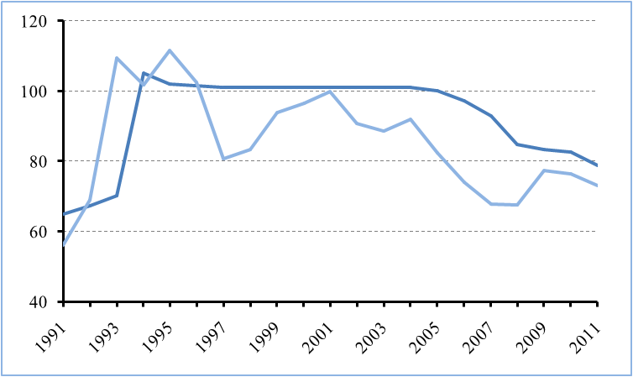
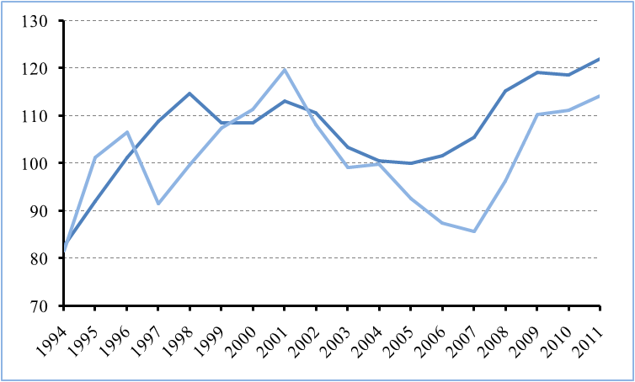
Figure 10: Bilateral comparison (2005=100) Figure 11: Real effective comparison (2005=100)
Source: IMF, International Financial Statistics and author's calculations
Results of our adjusted model incorporating the stronger Chinese trade elasticities are in line with expectations. In general, the changes in implied misalignment are small. This supports the sensitivity tests conducted by Jeong et al. (2010). In a way these ad hoc elasticities can be seen as a stress test for the robustness of the model, but even with the stronger Chinese trade elasticities the yuan remains on the whole undervalued. Figures 8 and 9 are nearly identical to 10 and 11. Table 8, however, depicts our expectation on a negative effect of stronger trade elasticities on misalignment, in more detail. Comparison to Table 7 reveals that in our adjusted model average undervaluation of both the bilateral and real effective exchange rate is lower than in our original model. This is especially the case for the years with higher undervaluation estimates in the original model. Implied undervaluation of the bilateral exchange rate decreases by 6% in 2007 and by 4,3% in 2006. With the stronger trade elasticities provided for China, we introduce a model that is more in line with the development of China's trade position over the past decades. The results of the adjusted model therefore shed more light on the misalignment of China's exchange rate without altering our general conclusion that the Chinese exchange rate was mostly undervalued over the period 1991-2011.
5.4 Comparison of Results
This sub Chapter compares our model results with similar FEER estimates in economic literature, which provides more insight into the true level of exchange rate misalignment. Since most FEER studies focus on single years, it is hard to consistently compare the complete range of our model. However, since 2008 Cline and Williamson provide annual FEER estimates for the PIIE. Their most recent paper on FEER estimates was published in May 2012, which gives 4 year range of consistent FEER estimates to compare with. We also compare our results with Jeong et al. (2010). Their most recent study provides with FEER estimates until 2010.
Differences in methodology are present in comparison to Williamson and Cline. Their FEER model includes a substantial amount of trading partners, which have increased from 34 to 38 in past years. Given that they work with such a large econometrical model, they implement a simpler analysis of the trade relations between countries than our multinational trade model. Their equilibrium current account, also known as the target current account, is based on a more arbitrary process implementing forecast projections of the IMF World Economic Outlook (WEO). Since 2010 Cline and Williamson based their target current accounts for China on the rule that a country's current account surplus should not exceed three percent of GDP. Their papers were annually published around May incorporating the latest available WEO database. Cline and Williamson adjust the WEO forecasted current account data and then define the external imbalance in their model as the difference between this adjusted current account and the target current account. In Table 10 one can observe the evident problem that occurs with this adjusted forecast data. In the past for years (2008-2011), WEO data projects significant higher current account surpluses for China than were actually realized.
Table 10: China's current account projections, actual values and targets (% of GDP)
 | Adjusted CA | Actual CA | Overestimation | Target CA
2008 | 10,0 | 9,1 | 0,9 | 4,3
2009 | 10,5 | 5,2 | 5,3 | 4,2
2010 | 7,5 | 5,2 | 2,3 | 3,0
2011 | 8,3 | 5,2 | 3,1 | 3,0
2012 | 2,3 | - | - | 3,0
Source: Cline and Williamson (2008, 2009, 2010, 2011, 2012)
This gives a reason to believe that Cline and Williamson overestimated China's external imbalances and subsequently the implied misalignment for the Chinese exchange rate. Our model works with actual data series and rules out this problem.
Because we based our model on the partial equilibrium framework of Jeong et al. (2010), methodology is in general similar. There are, however, some differences which will subsequently affect results. Our model extends the original research of Jeong et al. (2010) by one year. The model estimate of 2010 is also based on real and not on forecast data, which increases accuracy. Namely, Jeong et al. implemented current account projection of 5,9% of GDP in 2010, which deviates from the actual 5,2% of GDP. We also provide original panel estimations of the current account inspired primarily by Lee et al. (2008) and Jeong et al. (2010). Because of newer available data we extend the range of their panel estimations by four years to 1980-2007, which makes our equilibrium current account estimations more accurate for years after 2004. In addition, we provide an original estimation of China's internal equilibrium and implement an adjusted model based on stronger Chinese export trade elasticities.
The results of the three FEER studies are displayed in Table 11 below.
Table 11: FEER estimates comparison
 | Cline Williamson |  | Jeong Mazier |  | Own results |  | Own results (adjusted)
 | Bilateral | REER | Bilateral | REER | Bilateral | REER | Bilateral | REER
2008 | 23,4 | 12,6 | 34,5 | 16,2 | 30,0 | 23,5 | 25,63 | 19,63
2009 | 40,2 | 21,4 | 22,4 | 10,8 | 9,0 | 9,1 | 7,86 | 8,04
2010 | 24,2 | 13,5 | 23,8 | 11,4 | 9,3 | 7,8 | 8,10 | 6,75
2011 | 28,5 | 16,0 | - | - | 9,1 | 7,7 | 7,90 | 6,71
2012 | 7,7 | 2,8 | - | - | - | - | - | -
Source: Cline and Williamson (2008, 2009, 2010, 2011, 2012), Jeong et al. (2010) and author's calculations.

Model results of Jeong et al. (2010) are comparable with our own results. For 2009 and 2010 the implied undervaluation for the bilateral exchange rate is higher in the results of Jeong et al., which can be attributed to differences in the estimation of the equilibrium current account. Their undervaluation estimate of 2010 is also based on overestimated Chinese current account data. As mentioned before, they implement the projected 5,9% instead of the actual 5,2%. A higher external imbalance in their model has an increasing effect on the undervaluation estimate. The last three years of our results for both the original and the adjusted models are fairly stable. This observation is in line with the current account surplus during that period, which was around 5,2% of GDP.
Results of all the three studies show consistent lower undervaluation estimates for China's real effective exchange rate than for the bilateral yuan/dollar exchange rate, which is in line with the focus of China's sterilization strategy on the dollar. All the three studies show a decreasing trend for implied undervaluation for both the bilateral and real effective exchange rates. Results of Cline and Williamson fluctuate more over the years and depict this trend to a lesser extent. This could be the result of the adjusted current account data implemented in their model. In 2009 the adjusted current account of China appeared to be overestimated by 5,3% (Table 10), which has a substantial effect on implied undervaluation.
In general, we observe that the results of both the original and adjusted model estimate the smallest, but still moderate, undervaluation estimate of the Chinese exchange rate relative to the two comparable studies. This can be justified by the implementation of more accurate current account data in our model and the differences in determination of the equilibrium current account. In our adjusted model in particular we expected lower undervaluation estimates due to stronger Chinese trade elasticities.
5.4.5 Regression Analysis on Results
In this sub chapter we briefly provide the results from four simple linear regression specifications. In these four specifications we regress the results of the normal and the adjusted model ($e$, $r$, $e_{adj}$ and $r_{adj}$) on the external imbalance variable ($b_{i}$).
Table 12: Regressions of the estimated equilibrium exchange rates on China's external imbalance
 | $$e=β_{0}+β_{1}b_{i}$$ | $$r=β_{0}+β_{1}b_{i}$$ | $$e_{adj}=β_{0}+β_{1}b_{i}$$ | $$r_{adj}=β_{0}+β_{1}b_{i}$$
C | 0,026² | -0,015 | 0,023 | -0,018
$$b_{i}$$ | 6,457¹ | 5,101¹ | 5,843¹ | 4,579¹
R² | 0,906 | 0,869 | 0,862 | 0,810
^{1,2} Test statistic is significant respectively at the 1% and 5% level.
Table 12 provides an interesting insight in the significance of the external imbalance variable in the model. The regressions are based on a small sample of 21 years, thus caution is required when making conclusions. For all the regressions the external imbalance variable is highly significant and relatively high correlation is present. This implies that the model is sensitive to changes in the external imbalance. For the first regression $e=β_{0}+β_{1}b_{i}$, the increase of the external imbalance by 1% will increase the implied undervaluation of the yuan/dollar exchange rate by around 6,5%, a substantial increase.
The equilibrium current account directly influences the external imbalance and its estimation is therefore of vital importance for the model. Differences in methodology for the equilibrium current account can thus explain differences in model results we observe with Jeong et al. (2010). These regressions also strengthen a previously brought up argument that using forecast data for the current account can distort the accuracy of the external imbalance variable and subsequent undervaluation estimates.
6. Concluding Remarks
Over the past decades the Chinese government has extensively influenced the yuan/dollar exchange rate. China's exchange rate policy has known periods of fixed and managed floating exchange regimes, implemented to support China's industrializing strategy. The exchange rate policy was used as an instrument to attain a competitive export advantage, pegging the yuan to the dollar created a "cheap" competitive currency. The subsequent thriving Chinese export sector improved China's net export position and lead to significant surpluses on China's current account balance. By intervening with sterilization, China countered the equilibrium correction of foreign exchange markets. Because of the large scale distortion this intervention brought to world trade, China's exchange rate policy was globally criticized by the U.S. and China's trade competitors. The consensus in economic literature is that the yuan is significantly undervalued. To research the extent of this misalignment we estimate EER's of the yuan in this thesis.
After an assessment on EER methodology we base our estimations on the FEER approach of Jeong et al. (2010). Following their framework we provide a multinational trade model with six trading partners which includes China. Here we focus on the Chinese bilateral and real effective exchange rates and the implied misalignment with the FEER estimates of our model. The 177 input variables, parameters, trade shares and elasticities this model uses, are all (with the exclusion of trade elasticities and output gap data of industrial countries) obtained through the author's calculations and empirical research. The range of our model is 1991-2011, which extends the original research of Jeong et al. (2010) by one year.
We provide empirical estimations of the exogenous variables of the model which are represented by external and internal balance. External balance is defined as the difference between the actual and the equilibrium current account. We provide two original panel estimations of the current account for industrial and emerging countries, inspired primarily by Lee et al. (2008) and Jeong et al. (2010). Because of newer available data we extend the range of their panel estimations by four years to 1980-2007, which makes our equilibrium current account estimations more accurate for years after 2004. The estimated equilibrium current account for China gradually increased from 1% to around 4% between 1991-2011. With the equilibrium current account estimates and a dynamic correction on actual current account data, we estimate the external balance variables for the trading partners in our model. Internal balance is defined as the output gap. We provide output gap estimates based on real GDP data and the Hodrick-Prescott filter for 20 emerging countries including China. These estimates are used in the emerging panel estimation of the current account and China's estimate is also used as an exogenous variable in the model.
We incorporate the 177 input data series in the multinational trade model in Eviews, resulting in 21 years of FEER estimates for China. Results of the multinational trade model, are in line with the consensus in economic literature that the yuan is undervalued. China's real effective exchange rate is for the most part of the model range undervalued against its implied EER. There are short periods of where the real effective exchange rate is overvalued against its implied EER, which can be justified by the unification of the official exchange rate with the swap rates and the effects of the Asian crisis. Since 2002 China's estimated equilibrium current account gradually diverged from China's actual current account balance, increasing China's external imbalance in the model and the subsequent implied undervaluation of the yuan. Undervaluation of the Chinese real effective exchange rate reached a peak of 28% in 2007, a substantial competitive advantage for China's export sector. The bilateral yuan/dollar exchange rate reached a higher peak of undervaluation, 36 and 43% in respectively 2007 and 2008. This reflects the trade relation between China and the U.S. and the focus of China's sterilization strategy on the dollar. After 2007 gradual appreciation brought the exchange rate more towards equilibrium with a decrease in misalignment. Since 2009, during the financial crisis, China's current account surpluses converge with our estimated equilibrium current account surpluses. China's decreasing external imbalance causes misalignment to diminish and remain relatively stable for the last three years of the model range. We conclude that for these last three years the yuan was moderately undervalued in real effective terms, amounting to the misalignment of around 8%.
We provide and adjusted model with stronger trade elasticities for China based on Aziz and Li (2008). With the stronger Chinese trade elasticities the yuan remains on the whole undervalued but average undervaluation of both the bilateral and real effective exchange rate is lower than in our original model. This is in line with our expectation that stronger trade elasticities decrease the misalignment of exchange rates. We then provide a comparison of our results with the results of Cline and Williamson and Jeong et al. (2010). Although there are differences in methodology between studies, results are comparable. Furthermore we stress the importance of the external balance variable on undervaluation estimates. A solid estimation of the equilibrium current account is of vital importance for the model and the usage of forecast current account data can have a distorting effect on model results.
References
Aflouk, N., Jeong, S.-E., Mazier, J., Saadaoui, J., (2010). Exchange Rate Misalignments and World Imbalances: a FEER approach for Emerging Countries, Working Paper n°2010-12, November, CEPN, Paris.

Borowski, D., Couharde, C., (2003). The exchange rate macroeconomic balance approach: New methodology for the euro, the dollar, the yen and the pound, pages 169-190, Open Economies Review 14, Kluwer Academic Publishers.

Carton, B., Hervé, K., Terfous, N., (2006). Interventions de change en Asie et taux de change d'équilibre du dollar, pages 57-84, Économie Internationale 106, La Documentation Française.

Chinn, M.D., Prasad, E.S., (2003). Medium term determinants of current accounts in industrial and developing countries: an empirical exploration, pages 47-76, Journal of International Economics 59, Elsevier.

Clark, P.B., MacDonald, R., (1998). Exchange rates and economic fundamentals: a methodological comparison of BEERs and FEERs, IMF working Paper 98/67, International Monetary Fund.

Cline, W.R., (2008). Consistent estimates of fundamental equilibrium exchange rates, Working Paper 08-6, July, Peterson Institute for International Economics, Washington, DC.

Cline, W.R., Williamson, J., (2008). New estimates of fundamental equilibrium exchange rates, Policy Brief 08-7, July, Peterson Institute for International Economics, Washington, DC.

Cline, W.R., Williamson, J., (2009). 2009 Estimates of fundamental equilibrium exchange rates, Policy Brief 09-10, June, Peterson Institute for International Economics, Washington, DC.

Cline, W.R., Williamson, J., (2010). Estimates of fundamental equilibrium exchange rates, May 2010, Policy Brief 10-15, June, Peterson Institute for International Economics, Washington, DC.

Cline, W.R., Williamson, J., (2011). Estimates of fundamental equilibrium exchange rates, May 2011, Policy Brief 11-5, May, Peterson Institute for International Economics, Washington, DC.

Cline, W.R., Williamson, J., (2012). Estimates of fundamental equilibrium exchange rates, May 2012, Policy Brief 12-14, May, Peterson Institute for International Economics, Washington, DC.
Coudert, V., Couharde, C., (2005). Real Equilibrium Exchange Rate in China, Working Papers 2005-01, January, CEPII research center, Paris.

Coudert, V., Couharde, C., (2007). Real equilibrium exchange rate in China is the renminbi undervalued?, vol. 18(4), pages 568-594, August, Journal of Asian Economics, Elsevier.

Coudert, V., Couharde, C., (2009). Currency Misalignments and Exchange Rate Regimes in Emerging and Developing Countries, vol. 17(1), pages 121-136, 02., Review of International Economics, Willey Blackwell.

Dées, S., (1999). The Role of External Variables in the Chinese Economy: Simulation from a Macroeconomic Model of China, Working Paper n°1999-09, June, CEPII, Paris

Driver, R.L., Westaway, P.F., (2004). Concepts of equilibrium exchange rates, Bank of England Working Paper 248, Bank of England.

Faruqee, H., Debelle, G., (1998). Saving-investment balances in industrialised countries: an empirical investigation, in Isard, P., Faruqee, H., (editors), Exchange rate assessment: extensions to the macroeconomic balance approach, IMF Occasional Paper no. 167.

Flitter, E. (2012). Exclusive: U.S. lets China bypass Wall Street for Treasury orders, Reuters.

Frankel, J., (2006). On the Yuan: The Choice between Adjustment under a Fixed Exchange Rate and Adjustment under a Flexible Rate, vol. 52(2), pages 246-275, June, CESifo Economic Studies, Oxford University Press.

Goldstein, M., Lardy, R.L., (2009). The Future of China's Exchange Rate Policy, Policy Analyses in International Economics 87, July, Peterson Institute for International Economics, Washington, DC.

Gutiérrez, M., (2008). Economic growth in Latin America and the Caribbean: growth transitions rather than steady states, Chapter 3, pages 11-13, Volume 58 of Serie Macroeconomía del desarrollo, CEPAL, United Nations.

Jeong, S.-E., Mazier, J., (2003). Exchange rate regimes and equilibrium exchange rates in East Asia, pages 1161-1182, Revue économique 54, September, Presses de Sciences Po.

Jeong, S.-E., Mazier, J., Saadaoui, J., (2010). Exchange rate misalignments at world and European level: a FEER approach, pages 25-58, Économie Internationale 121, La Documentation Française.

Lee, J., Milesi-Ferreti G.M., Ostry J.D., Prati A., Ricci L.A., (2008). Exchange rate assessments: CGER methodologies, IMF Occasional Papers 261, April, International Monetary Fund, Washington, DC.

Lipman, J.K., (2010). Law of Yuan Price: Estimating Equilibrium of the Renminbi, pages 61-90, Volume 4 Issue 2, Michigan Journal of Business, Michigan.

Pain, N., Mourougane, A., Sédillot, F., Le Fouler, L., (2005). The NEW OECD International Trade Model, August, OECD Economics Department Working Papers 440, OECD publishing.

Peoples Bank of China (PBC), (2005). Public Announcement of the People's Bank of China on reforming the RMB Exchange Rate Regime, July 21.

Peoples Bank of China (PBC), (2010). Successful Experiences of Further Reforming the RMB Exchange Rate Regime, July 30.

McCauley, R.N., McGuire, P., (2009). Dollar appreciation in 2008: safe haven, carry trades, dollar shortage and overhedging, BIS Quarterly Review, December, Bank for International Settlements.

Stein, J.L., (1994). The natural real exchange rate of the US dollar and determinants of capital flows, in Williamson, J (editor), Estimating equilibrium exchange rates, Peterson Institute for International Economics, Washington DC.

Stein, J.L., Allen, P.R., (1995). Fundamental determinants of exchange rates, Clarendon Press.

Tam, O.K., (1995). Financial Reform in China, pages 154-160, Volume 2 Routledge Studies in the Growth Economies of Asia, Routledge.

Williamson, J., (1983). The Exchange Rate System, Policy Analyses in International Economics, No. 5, Peterson Institute for International Economics, Washington, DC.

Williamson, J., Mahar, M., (1998). Current account targets, in Wren-Lewis, S and Driver, R L, Real exchange rates for the year 2000, Policy Analyses in International Economics, No. 54, Peterson Institute for International Economics, Washington, DC.

Wren-Lewis, S., (2003). Estimates of equilibrium exchange rates for sterling against the euro, H.M. Treasury, EMU Study.
Appendix 1: The multinational trade model in logarithmic differentials
For example: $x=\frac{dX}{X}=\frac{\left(X-X^{e}\right)}{X^{e}}$, with the exception of $b_{i}=d\frac{B_{i}}{Y_{i}}=\frac{B_{i}}{Y_{i}}-\frac{B_{i}^{e}}{Y_{i}^{e}}$.
$$x_{i}={ηx}_{i}\sum_{j≠i}{α_{ij}m_{j}}+{εx}_{i}\left({pmx}_{i}-{px}_{i}\right)$$ | (1')
$${pmx}_{i}=\sum_{j≠i}{λ_{ij}}\left({px}_{j}-e_{j}\right)+e_{i}$$
$$m_{i}={ηm}_{i}{di}_{i}+{εm}_{i}\left({pd}_{i}-{pm}_{i}\right)$$ | (2')
$${pmm}_{i}=\sum_{j≠i}{μ_{ij}}\left(px_{j}-e_{j}\right)+e_{i}$$
$$\sum_{i}{{vx}_{i}\left(x_{i}+{px}_{i}-e_{i}\right)}=\sum_{i}{{vm}_{i}\left(m_{i}+{pm}_{i}-e_{i}\right)}$$ | (3')
$$\sum_{i}{{wx}_{i}x_{i}}=\sum_{i}{{wm}_{i}m_{i}}$$ | (4')
$${px}_{i}={αx}_{i}{pmx}_{i}+\left(1-{αx}_{i}\right)p_{i}$$ | (5')
$${pm}_{i}={αm}_{i}{pmm}_{i}+\left(1-{αm}_{i}\right){pd}_{i}$$ | (6')
$${pd}_{i}=a_{i}{pm}_{i}+\left(1-a_{i}\right)p_{i}$$ | (7')
$$b_{i}=μ_{i}T_{i}\left(1-σ_{petx, i}-σ_{x,i}\right)\left({px}_{i}+x_{i}-{pm}_{i}-m_{i}\right)$$ | (8')
$$r_{i}=e_{i}-{pd}_{i}+\sum_{j≠i}{v_{ij}\left({pd}_{j}-e_{j}\right)}$$ | (9')

Equation 8' is derived the following way:
$$b_{i}=\frac{B_{i}}{Y_{i}}-\frac{B_{i}^{e}}{Y_{i}^{e}}=d\frac{B_{i}}{Y_{i}}=\frac{{PM}_{i}M_{i}}{Y_{i}}d\frac{B_{i}}{{PM}_{i}M_{i}}=μ_{i}d\frac{B_{i}}{{PM}_{i}M_{i}}$$
$$B_{i}={PX}_{i}X_{i}-{PM}_{i}M_{i}-M_{petx,i}-{ED}_{i}$$
$b_{i}=μ_{i}d\left(\frac{{PX}_{i}X_{i}}{{PM}_{i}M_{i}}-\frac{{PM}_{i}M_{i}}{{PM}_{i}M_{i}}-\frac{M_{petx,i}}{{PM}_{i}M_{i}}-\frac{{ED}_{i}}{{PM}_{i}M_{i}}\right)$=$μ_{i}d\left(\frac{{PX}_{i}X_{i}}{{PM}_{i}M_{i}}-\left(\frac{M_{petx,i}}{{PX}_{i}X_{i}}\right)\left(\frac{{PX}_{i}X_{i}}{{PM}_{i}M_{i}}\right)-\left(\frac{{ED}_{i}}{{PX}_{i}X_{i}}\right)\left(\frac{{PX}_{i}X_{i}}{{PM}_{i}M_{i}}\right)\right)$
$$b_{i}=μ_{i}d\left(T_{i}-\left(\frac{M_{petx,i}}{{PX}_{i}X_{i}}\right)T_{i}-\left(\frac{{ED}_{i}}{{PX}_{i}X_{i}}\right)T_{i}\right)=μ_{i}dT_{i}\left(1-σ_{petx, i}-σ_{x,i}\right)=μ_{i}T_{i}\frac{dT_{i}}{T_{i}}\left(1-σ_{petx, i}-σ_{x,i}\right)$$
$$b_{i}=μ_{i}T_{i}\left(1-σ_{petx, i}-σ_{x,i}\right)\left({px}_{i}+x_{i}-{pm}_{i}-m_{i}\right)$$
With: $μ_{i}=\frac{{PM}_{i}M_{i}}{Y_{i}}, T_{i}=\frac{{PX}_{i}X_{i}}{{PM}_{i}M_{i}}$, $σ_{petx, i}=\frac{M_{petx,i}}{{PX}_{i}X_{i}}$ and $σ_{x,i}=\frac{{ED}_{i}}{{PX}_{i}X_{i}}$.

Table 13: Explanation of variables used in the model in logarithmic differentials.
 | Explanation
$${vx}_{i}$$ | Share of the country in world exports in value
$${vm}_{i}$$ | Share of the country in world imports in value
$${wx}_{i}$$ | Share of the country in world exports in volume
$${wm}_{i}$$ | Share of the country in world imports in volume
$$T_{i}={{PX}_{i}X_{i}}/{{PM}_{i}M_{i}}$$ | Ratio of exports to imports
$$μ_{i}={{PM}_{i}M_{i}}/{Y_{i}}$$ | Openness Ratio
$$σ_{petx, i}={M_{petx,i}}/{{PX}_{i}X_{i}}$$ | Ratio of net oil imports to non-oil exports
$$σ_{x,i}={{ED}_{i}}/{{PX}_{i}X_{i}}$$ | Ratio of net external debt to exports
$α_{ij}= \frac{X_{i→j}}{M_{j}}$ | Share of $i$ in import trading partner $j$
$λ_{ij}=\frac{X_{i→j}}{X_{i}}$ | Share of trading partner $j$ in export $i$
$μ_{ij}=\frac{M_{i←j}}{M_{i}}$ | Share of trading partner $j$ in import $i$
$v_{ij}=\frac{X_{i→j}+M_{i←j}}{X_{i}+M_{i}}$ | Share of trading partner $j$ in total trade $i$
Appendix 2: Euro area data
For most data series for Euro area data required by the model was not available for the earlier years due to the Euro not existing.

Table 14: Euro data sources and author's calculations
 | Method of calculation and data source
$${PX}_{4}X_{4}$$ | Aggregate of 13 euro countries (evolving membership), DOTS, IMF
$${PM}_{4}M_{4}$$ | Aggregate of 13 euro countries (evolving membership), DOTS, IMF
Price Indices | Oxford Economics database, 2012
CAS | 1980-1996 Weighted average of 9 euro countries based on GDP  1997-2011 Euro area data, World Economic Outlook, IMF, September 2011
CDR | Weighted average of 9 euro countries based on population
GB | Economic Outlook, OECD, 2012
ISFNA | 1980-1998 Weighted average of 9 euro countries based on GDP  1999-2011 Euro area data, P.R. Lane G.M. Milesi-Ferretti's Database, August 2009
$$Y_{4}$$ | 1980-1990 Aggregate of 9 euro countries  1991-2011 Euro area data, World Economic Outlook, IMF, September 2011
$$E_{4}$$ | Economic Outlook, OECD, 2012
$$M_{petx,4}$$ | Aggregate of 17 euro countries (evolving membership), WEO, IMF
$${ED}_{4}$$ | 1980-1997 Aggregate of 11 euro countries  1998-2011 Euro area data, International Financial Statistics, IMF, 2012

Appendix 3: Dynamic correction
For this dynamic correction we make a simplifying assumption for the current account equation:
$$B_{i}={PX}_{i}X_{i}-{PM}_{i}M_{i}$$
$$b_{i}=\frac{B_{i}}{Y_{i}}-\frac{B_{i}^{e}}{Y_{i}^{e}}=d\frac{B_{i}}{Y_{i}}=\frac{{PM}_{i}M_{i}}{Y_{i}}d\frac{B_{i}}{{PM}_{i}M_{i}}=μ_{i}d\frac{B_{i}}{{PM}_{i}M_{i}}=μ_{i}d\frac{{PX}_{i}X_{i}}{{PM}_{i}M_{i}}-\frac{{PM}_{i}M_{i}}{{PM}_{i}M_{i}}=μ_{i}dT_{i}$$
$$μ_{i}dT_{i}=μ_{i}T_{i}\frac{dT_{i}}{T_{i}}=μ_{i}T_{i}\left(\frac{{dPX}_{i}}{{PX}_{i}}+\frac{{dX}_{i}}{X_{i}}-\frac{d{PM}_{i}}{{PM}_{i}}-\frac{{dM}_{i}}{M_{i}}\right)$$
With: $μ_{i}=\frac{{PM}_{i}M_{i}}{Y_{i}}$ and $T_{i}=\frac{{PX}_{i}X_{i}}{{PM}_{i}M_{i}}$.
First we look at the corrections needed in the export volume equation.
$$x_{i,t}={ηx}_{i}\sum_{j≠i}{α_{ij,t}m_{i,t}}+{εx}_{i}\left({pmx}_{i,t}-{px}_{i,t}\right)$$
$$x_{i,t}={ηx}_{i}\sum_{j≠i}{α_{ij,t}m_{i,t}}+\left({εx}_{i,2}+{εx}_{i,3}\right)\left(\frac{{pmx}_{i,t}-{px}_{i,t}}{{pmx}_{i,t-1}-{px}_{i,t-1}}\right)+{εx}_{i,3}\left(\frac{{pmx}_{i,t-1}-{px}_{i,t-1}}{{pmx}_{i,t-2}-{px}_{i,t-2}}\right)$$
Substituting the export price equation ${px}_{i}={αx}_{i}{pmx}_{i}+\left(1-{αx}_{i}\right)p_{i}$ gives:
$$x_{i,t}={ηx}_{i}\sum_{j≠i}{α_{ij,t}m_{i,t}}+\left({εx}_{i,2}+{εx}_{i,3}\right)\left(1-{αx}_{i}\right)\left(\frac{{pmx}_{i,t}-p_{i,t}}{{pmx}_{i,t-1}-p_{i,t-1}}\right)+{εx}_{i,3}\left(1-{αx}_{i}\right)\left(\frac{{pmx}_{i,t-1}-p_{i,t-1}}{{pmx}_{i,t-2}-p_{i,t-2}}\right)$$
$${rx}_{i,t}=\frac{{pmx}_{i,t}-p_{i,t}}{{pmx}_{i,t-1}-p_{i,t-1}}$$
This leaves us with the following relevant factors for our correction in the export equation:
$\frac{{dX}_{i,t}}{X_{i,t}}=\left({εx}_{i,2}+{εx}_{i,3}\right)\left(1-{αx}_{i}\right){rx}_{i,t}+{εx}_{i,3}\left(1-{αx}_{i}\right){rx}_{i,t-1}$ $\left(x\right)$
Then we look at the corrections needed in the import volume equation.
$$m_{i,t}={ηm}_{i}{di}_{i,t}+{εm}_{i}\left({pd}_{i,t}-{pm}_{i,t}\right)$$
$$m_{i,t}={ηm}_{i}{di}_{i,t}+\left({εm}_{i,2}+{εx}_{i,3}\right)\left(\frac{{pd}_{i,t}-{pm}_{i,t}}{{pd}_{i,t-1}-{pm}_{i,t-1}}\right)+{εm}_{i,3}\left(\frac{{pd}_{i,t-1}-{pm}_{i,t-1}}{{pd}_{i,t-2}-{pm}_{i,t-2}}\right)$$
Substituting the import price equation ${pm}_{i}={αm}_{i}{pmm}_{i}+\left(1-{αm}_{i}\right){pd}_{i}$ gives:
$$m_{i,t}={ηm}_{i}{di}_{i,t}+\left({εm}_{i,2}+{εx}_{i,3}\right){αm}_{i}\left(\frac{{pd}_{i,t}-{pmm}_{i,t}}{{pd}_{i,t-1}-{pmm}_{i,t-1}}\right)+{εm}_{i,3}{αm}_{i}\left(\frac{{pd}_{i,t-1}-{pmm}_{i,t-1}}{{pd}_{i,t-2}-{pmm}_{i,t-2}}\right)$$
$${rm}_{i,t}=\frac{{pd}_{i,t}-{pmm}_{i,t}}{{pd}_{i,t-1}-{pmm}_{i,t-1}}$$
This leaves us with the following relevant factors for our correction in the import equation:
$\frac{{dM}_{i}}{M_{i}}=\left({εm}_{i,2}+{εx}_{i,3}\right){αm}_{i}{rm}_{i,t}+{εm}_{i,3}{αm}_{i}{rm}_{i,t-1}$ $\left(y\right)$
The relevant corrections needed for our import $\left(y\right)$ and export equation $\left(x\right)$ combined with:
$$μ_{i}T_{i}\frac{dT_{i}}{T_{i}}=μ_{i}T_{i}$$
Gives us:
$$b_{i}^{c}=μ_{i}T_{i}\left(\left({εx}_{i,2}+{εx}_{i,3}\right)\left(1-{αx}_{i}\right){rx}_{i,t}+{εx}_{i,3}\left(1-{αx}_{i}\right){rx}_{i,t-1}-\left({εm}_{i,2}+{εx}_{i,3}\right){αm}_{i}{rm}_{i,t}-{εm}_{i,3}{αm}_{i}{rm}_{i,t-1}\right)$$
Then the final correction for the current account will be:
$$b_{i}^{corrected}=b_{i}^{actual}+b_{i}^{c}$$
With this correction we can perceive the correct difference between the actual current account and our estimated equilibrium current account for the model.
Appendix 4: Model equations in Eviews
Eviews regards the first variable of the equation as the endogenous variable, thus the equations had to be rewritten. Model code displayed in green, blue and red respectively depict the summations of ${dm}_{i}$, ${pmx}_{i}$ and ${pmm}_{i}$, to provide a clearer distinction.

Export Value Equations
e1=(-1*etax1/epsilonx1) * (alpha12*m2+ alpha13*m3+ alpha14*m4+ alpha15*m5+ alpha16*m6) - (lambda12*(px2-e2)+lambda13*px3+lambda14*(px4-e4)+lambda15*(px5-e5)+lambda16*(px6-e6)) + (1/epsilonx1)*x1+px1
e2=(-1*etax2/epsilonx2) * (alpha21*m1+ alpha23*m3+ alpha24*m4+ alpha25*m5+ alpha26*m6) -(lambda21*(px1-e1)+lambda23*px3+lambda24*(px4-e4)+lambda25*(px5-e5)+lambda26*(px6-e6)) +(1/epsilonx2)*x2+px2
e4=(-1*etax4/epsilonx4) * (alpha41*m1+ alpha42*m2+ alpha43*m3+ alpha45*m5+ alpha46*m6) -(lambda41*(px1-e1)+lambda42*(px2-e2)+lambda43*px3+lambda45*(px5-e5)+lambda46*(px6-e6)) +(1/epsilonx4)*x4+px4
e5=(-1*etax5/epsilonx5) * (alpha51*m1+ alpha52*m2+ alpha53*m3+ alpha54*m4+ alpha56*m6) -(lambda51*(px1-e1)+lambda52*(px2-e2)+lambda53*px3+lambda54*(px4-e4)+lambda56*(px6-e6)) +(1/epsilonx5)*x5+px5

e6=(etax3/epsilonx3*lambda36)* (alpha31*m1+ alpha32*m2+ alpha34*m4+ alpha35*m5+ alpha36*m6)+(1/lambda36)* (lambda31*(px1-e1)+lambda32*(px2-e2)+lambda34*(px4-e4)+lambda35*(px5-e5))- (1/epsilonx3*lambda36)*x3+px6

Import Value Equations
m1=etam1*di1+alpham1*epsilonm1*((a1-1)/(1-a1*(1-alpham1)))* (mu12*(px2-e2)+mu13*px3+ mu14*(px4-e4)+ mu15*(px5-e5)+ mu16*(px6-e6)+e1)
m2= etam2*di2+alpham2*epsilonm2*((a2-1)/(1-a2*(1-alpham2)))* (mu21*(px1-e1)+mu23*px3+ mu24*(px4-e4)+ mu25*(px5-e5)+ mu26*(px6-e6)+e2)
m3= etam3*di3+alpham3*epsilonm3*((a3-1)/(1-a3*(1-alpham3)))* (mu31*(px1-e1)+mu32*(px2-e2)+ mu34*(px4-e4)+ mu35*(px5-e5)+ mu36*(px6-e6))
m4= etam4*di4+alpham4*epsilonm4*((a4-1)/(1-a4*(1-alpham4)))* (mu41*(px1-e1)+mu42*(px2-e2)+ mu43*px3+ mu45*(px5-e5)+ mu46*(px6-e6)+e4)
m5= etam5*di5+alpham5*epsilonm5*((a5-1)/(1-a5*(1-alpham5)))* (mu51*(px1-e1)+mu52*(px2-e2)+ mu53*px3+ mu54*(px4-e4)+ mu56*(px6-e6)+e5)
Price Equations
px1=alphax1*(lambda12*(px2-e2)+lambda13*px3+lambda14*(px4-e4)+lambda15*(px5-e5)+lambda16*(px6-e6)+e1)
px2= alphax1*(lambda21*(px1-e1)+lambda23*px3+lambda24*(px4-e4)+lambda25*(px5-e5)+lambda26*(px6-e6)+e2)
px3= alphax1*(lambda31*(px1-e1)+lambda32*(px2-e2)+lambda34*(px4-e4)+lambda35*(px5-e5)+lambda36*(px6-e6))
px4= alphax1*(lambda41*(px1-e1)+lambda42*(px2-e2)+lambda43*px3+lambda45*(px5-e5)+lambda46*(px6-e6)+e4)
px5= alphax1*(lambda51*(px1-e1)+lambda52*(px2-e2)+lambda53*px3+lambda54*(px4-e4)+lambda56*(px6-e6)+e5)
px6= alphax1*(lambda61*(px1-e1)+lambda62*(px2-e2)+lambda63*px3+lambda64*(px4-e4)+lambda65*(px5-e5)+e6)

pm1=(alpham1/(1-a1*(1-alpham1)))* (mu12*(px2-e2)+mu13*px3+ mu14*(px4-e4)+ mu15*(px5-e5)+ mu16*(px6-e6)+e1)
pm2=(alpham2/(1-a2*(1-alpham2)))* (mu21*(px1-e1)+mu23*px3+ mu24*(px4-e4)+ mu25*(px5-e5)+ mu26*(px6-e6)+e2)
pm3=(alpham3/(1-a3*(1-alpham3)))* (mu31*(px1-e1)+mu32*(px2-e2)+ mu34*(px4-e4)+ mu35*(px5-e5)+ mu36*(px6-e6))
pm4=(alpham4/(1-a4*(1-alpham4)))* (mu41*(px1-e1)+mu42*(px2-e2)+ mu43*px3+ mu45*(px5-e5)+ mu46*(px6-e6)+e4)
pm5=(alpham5/(1-a5*(1-alpham5)))* (mu51*(px1-e1)+mu52*(px2-e2)+ mu53*px3+ mu54*(px4-e4)+ mu56*(px6-e6)+e5)

pm6=(mu61*(px1-e1)+mu62*(px2-e2)+ mu63*px3+ mu64*(px4-e4)+ mu65*(px5-e5)+e6)

pd1=(a1*alpham1/(1-a1*(1-alpham1)))* (mu12*(px2-e2)+mu13*px3+ mu14*(px4-e4)+ mu15*(px5-e5)+ mu16*(px6-e6)+e1)
pd2=(a2*alpham2/(1-a2*(1-alpham2)))* (mu21*(px1-e1)+mu23*px3+ mu24*(px4-e4)+ mu25*(px5-e5)+ mu26*(px6-e6)+e2)
pd3=(a3*alpham3/(1-a3*(1-alpham3)))* (mu31*(px1-e1)+mu32*(px2-e2)+ mu34*(px4-e4)+ mu35*(px5-e5)+ mu36*(px6-e6))
pd4=(a4*alpham4/(1-a4*(1-alpham4)))* (mu41*(px1-e1)+mu42*(px2-e2)+ mu43*px3+ mu45*(px5-e5)+ mu46*(px6-e6)+e4)
pd5=(a5*alpham5/(1-a5*(1-alpham5)))* (mu51*(px1-e1)+mu52*(px2-e2)+ mu53*px3+ mu54*(px4-e4)+ mu56*(px6-e6)+e5)

pd6=a6*(mu61*(px1-e1)+mu62*(px2-e2)+ mu63*px3+ mu64*(px4-e4)+ mu65*(px5-e5)+e6)

Current Account Equations
x1=-px1+pm1+m1+b1/(mu1*T1*(1-sigmax1-sigmapetx1))
x2=-px2+pm2+m2+b2/(mu2*T2*(1-sigmax2-sigmapetx2))
x3=-px3+pm3+m3+b3/(mu3*T3*(1-sigmax3-sigmapetx3))
x4=-px4+pm4+m4+b4/(mu4*T4*(1-sigmax4-sigmapetx4))
x5=-px5+pm5+m5+b5/(mu5*T5*(1-sigmax5-sigmapetx5))

World Trade Equations
m6=(wx1/wm6)*x1+(wx2/wm6)*x2+(wx3/wm6)*x3+(wx4/wm6)*x4+(wx5/wm6)*x5+(wx6/wm6)*x6-(wm1/wm6)*m1-(wm2/wm6)*m2-(wm3/wm6)*m3-(wm4/wm6)*m4-(wm5/wm6)*m5
x6=-px6- (vx1/vx6)*(x1+px1) - (vx2/vx6)*(x2+px2) - (vx3/vx6)*(x3+px3) - (vx4/vx6)*(x4+px4) - (vx5/vx6)*(x5+px5) + (vm1/vx6)*(m1+pm1) + (vm2/vx6)*(m2+pm2) + (vm3/vx6)*(m3+pm3) + (vm4/vx6)*(m4+pm4) + (vm5/vx6)*(m5+pm5) + (vm6/vx6)*(m6+pm6)

Article IV, Section 1 of the Articles of Agreement of the IMF states that member countries should "avoid manipulating exchange rates or the international monetary system in order to prevent effective balance-of-payment adjustment or to gain unfair competitive advantage over other member countries."
The Bank of China is a commercial bank and the PBC is China's central bank.
The official press release stated: “It is desirable to proceed further with reform of the RMB exchange rate regime and increase the RMB exchange rate flexibility. In further proceeding with reform of the RMB exchange rate regime, continued emphasis would be placed to reflecting market supply and demand with reference to a basket of currencies.” (People's Bank of China, 2010).
I concluded my bachelor thesis, written in June 2010, with the prediction that with the managed floating exchange rate regime the Chinese exchange rate would appreciate by 5 to 10% in the following 2 years.
(Chinn and Prassad 2003) and (Lee et al. 2008).
"The initial NFA position used in the empirical model is measured before the period of reference for the current account balance, to avoid capturing a reverse link from the current account balance to NFA" (Lee et al, 2008)
"Countries should not run a current account deficit in excess of 3 percent of GDP on a sustained basis. A desire to have symmetrical rules on the surplus and deficit sides would then suggest extending this rule to surplus countries." (Cline and Williamson 2011)

