Rising body weight, obesity

and a declining smoking
participation in the Netherlands:
Coincidence?

Krieshen Ramlal, 281853

Supervisor: Tom van Ourti
Co-reader: Darjusch Tafreschi
August 2012
Master thesis: Health Economics

Erasmus School of Economics Erasmus University Rotterdam

Contents

Abstract 5
1. Background 5
2. Smoking and body weight 8
3. Increasing obesity prevalence and decreasing smoking prevalence 11
4. Analytical framework of Chou, Grossman and Saffer 15
5. Empirical implementation 17
5.1 Data and measure 17
5.2 The relationship between BF% and BMI 26
6. Results 30
6.1 Replication Chou, Grossman and Saffer 30
6.2 Replication Gruber and Frakes 33
6.3 Own model specification 37
6.3.1 Preferred model specification 37
6.3.2 Results quantile regression 39
7. Conclusion 47
References 49
Appendix 52

Abstract. Obesity is emerging as an epidemic health problem in many developed countries. Research by Chou, Grossman and Saffer point out several trends related to the increasing rate of obesity. One trend partly related to the rate of obesity discovered by Chou, Grossman and Saffer, is the decrease in smoking prevalence. Another study by Gruber and Frakes, investigating this relationship of obesity and smoking prevalence find the opposite. The purpose of this thesis is to investigate if such a relationship can be found in the Netherlands. This relationship is investigated by three different approaches. The first is by following the model of Chou, Grossman and Saffer as closely as possible. The second is by following the model of Gruber and Frakes as closely as possible. The third is by specifying an own model using quantile regression. All of the approaches indicate that such a relationship is not found in the Netherlands and even if significant results were found, the interpretation would be very difficult due to endogeneity bias.

1. Background

Rising obesity has developed into a considerable worldwide public health problem with significant economic and social consequences (Rosin, 2008). Poor diet and physical inactivity were the second leading cause of death in the USA in 2000 and may overtake tobacco as the leading cause of avoidable death (Mokdad et al., 2004). Prevalence among children and adolescents has doubled in the past two decades in the United States, furthermore American children and adolescents today are less physically active as a group than previous generations were, and less active children are more likely to be overweight (Krebs and Jacobson, 2003). The probability of childhood obesity persisting into adulthood is estimated to increase from approximately 20% at 4 years of age to approximately 80% by adolescence (Krebs and Jacobson, 2003). Evidence suggest that overweight individuals have an increased risk to a variety of health problems, including type 2 diabetes, hypertension, coronary artery disease, stroke, osteoarthritis and certain forms of cancers (Lau et al., 2007). It is estimated that between 280,000-350,000 deaths per year are attributable to obesity (Allison et al., 1999) and that for a white male with a body mass index (BMI) of 45 or greater the expected life span can be reduced by up to 13 years, and for white woman up to 8 years (Fontaine et al., 2003).
Obesity may create social as well as private costs, and if so, there is a question whether the government should intervene to reduce obesity (Philipson and Posner, 2008). Results of Finkelstein et al. (2009) revealed that, in the United States medical spending per capita for the obese is $1,429 more per year than for a individual of normal weight, which is approximately 42 percent higher than for a individual of normal weight. In 1998 the medical costs of obesity were estimated to be as high as $78.5 billion in the United States, with approximately half financed by Medicare and Medicaid (Finkelstein et al., 2009). The same authors estimate that the medical costs of obesity could have risen to $147 billion per year in 2008. Another economic impact of obesity can result from the discrimination imposed on obese individuals by society. Gortmaker et al. (1993) indicate that the most severely obese working-age individuals have a significantly lower household income per year and fewer years of education. Furthermore studies examining the effect of appearance on income, education and emotional well-being support the negative consequences of being obese (Martin et al., 2000). McCormick et al. (2007) point out that the high costs of obesity, in themselves, do not justify government intervention. Rather, market failure, inequity or promoting economic growth should be the criteria on which the case for government intervention should be judged (McCormick et al., 2007). An example of market failure are externalities. McCormick et al. (2007) argues that if the healthcare system is tax-based and funded independently of risk, the potential externality is that obese individuals may not bear the full cost of their health care. The authors outline that obese individuals are less likely to be in employment and while foregone earnings are carried by the individual, the costs of unemployment benefits and foregone tax revenues are carried by society. Both McCormick et al. (2007) and Philipson and Posner (2008) are skeptical if government intervention is justified because of the higher average medical expenses, as effects such as higher mortality rates of obese individuals, which reduce social security spending are not considered.
Lakdawalla and Philipson (2002), and Philipson and Posner (1999) argue that the growth in weight may be due to the technological progress that drives economic growth, by making home- and market-production more sedentary and by lowering food prices through agricultural innovation. Philipson and Posner (1999) discuss that growth of obesity in a population results from an increase in caloric consumption relative to physical activity. In an industrial or agricultural society, work is more physical and in effect a worker is paid to exercise, however technological change has freed up time from producing food, enabling a reallocation of time to producing other goods and eventually to producing services, shifting to a society in which most work requires less exercise (Philipson and Posner, 1999). Lakdawalla and Philipson (2002) provide a theoretical and empirical framework for the examination of long-run growth in weight over time. Individual data from 1976 to 1994 is used, they find that technology-based reductions in food prices and job-related exercise have significant impact on weight across time. Forty percent of recent growth in weight might be due to agricultural innovation that has lowered food prices, while sixty percent might be due to demand factors such as declining physical activity from technological changes in home and market production (Lakdawalla and Philipson, 2002). Cutler et al. (2003) indicate that caloric expenditure has not changed significantly since 1980, while caloric consumption has risen markedly. The authors explain this phenomenon by technological progress in food production and the mass preparation in food, such as vacuum packing, improved preservatives, deep freezing and microwaves, which enabled food manufacturers to cook food centrally and ship it to consumers for rapid consumption, thereby reducing the time of preparing a meal by an individual. The increased caloric intake is a result of consuming more meals rather than more calories per meal.
Although the precise mechanisms of becoming obese are complex, at the simplest level obesity results from a long term excessive intake and shortage of energy expenditure (Lau et al., 2007).
Different factors contribute to weight gain and obesity such as genetics, behavioral aspects and environmental influences. Studies of identical twins living in separate environments indicate that approximately two-thirds of the BMI can be attributed to genetic factors (Ravussin and Bogardus, 2000). While a high heritability for BMI is revealed, genes have not changed significantly during the past two decades where obesity rates increased to epidemic proportions. A behavioral spect might be an addiction to certain kinds of food. Timothy et al. (2007) tested for an addiction to specific food nutrients (protein, carbohydrate, fat and sodium) as a potential explanation for the apparent excessive consumption. The authors used a rational addiction model and results showed a particularly strong addiction to carbohydrates, a nutrient typically associated with obesity. The form of addiction in their model is a rational one, so consumers purchase nutrients in amounts that are likely harmful to their health, only through a reasoned process comparing current marginal utility to the discounted future costs of any negative health consequences (Timothy et al., 2007). Having awareness of the harmful health consequences of obesity, an individual may implement some preventive or corrective measures, for example, exercise and/or dietary control (Kan and Tsai, 2004). Kan and Tsai (2004) investigated the relationship between an individuals’ awareness of the health risks of obesity, and their tendency to be obese. Their study involved a longitudinal survey conducted in Taiwan and investigated the relationship using quantile regression models. The results showed that only males who are extremely overweight started to show more awareness to the harmful consequences of obesity. The authors suspect that males do not consider that adverse health outcomes are applicable to mildly overweight individuals, even if these males are aware and acknowledge that obesity can lead to harmful health consequences. For females however, knowledge of the detrimental consequences of obesity did not have any effect on BMI. Environmental factors which can contribute to obesity are the availability of high calorie-dense fast food, as well as the appeal of television, video games and computers, leading to a more sedentary lifestyle and thereby discourage energy expenditure (Chou et al., 2004b). Chou et al. (2004b) studied the effects of fast-food restaurant advertising on television and childhood obesity, using longitudinal survey data and linear probability models. The effects they find, is that a ban on fast-food advertising would reduce the number of overweight children aged 3-11 in a fixed population by 18 percent and would reduce the number of adolescents aged 12-18 by 14 percent.
Summarized obesity is a complex phenomenon , where the explanation of drivers and consequences of the increase in prevalence and incidence are still under debate in the literature. Diverse factors that have been identified in the literature as possible contributors to the rising obesity over time are behavioral aspects and environmental influences (Rosin, 2008). An understanding of the causes and consequences of obesity is essential for policy responses and whether government intervention is justified at all (Rosin, 2008). Section 3 discusses the main topic of this thesis, the decrease in smoking prevalence as a possible driver for the growth in overweight and obesity. First, in section 2, the relationship between smoking and body weight is discussed.

2. Smoking and body weight

Several papers in the field of economics indicate there is evidence, that the rise of obesity is partly due to the declining smoking prevalence, although not all papers confirm this hypothesis. This is also the main reason this topic is chosen. It is generally accepted that smoking and body weight are related. More fascinating is, proposing that the prevalence of smoking and obesity rates are related. On top of that researchers find mixed results for the same country, drawing data from comparable datasets. The first paper to start this topic, written by Chou, Grossman and Saffer, did not search particularly for the relationship between smoking and obesity, but rather trends relating to the rise of obesity. Clearly other researchers such as Gruber and Frakes also find this a fascinating relationship and focused on this topic but could not find this relationship. These and more relevant papers are discussed in section 3 in more detail. Before discussing these papers I find it important to discuss the relationship between smoking and body weight first, in order to assess if the relationship of smoking prevalence and obesity rates is intuitively understandable.
Smoking cessation, as described by several studies (Ward et al.,2001; Williamson et al., 1991; Flegal et al., 1995 ), produces weight gain in both men and women, although the magnitude of this gain, and mechanism involved are less clear (Ward et al., 2001). Williamson et al. (1991) report that the mean gain attributable to smoking cessation was 2.8 kg for men and 3.8 for women, using an US cohort of adults followed over 10 years. Flegal et al. (1995) compared the difference in body weight over 10 years and find that smokers who quit, had gained 4.4 kg (males) and 5.0 kg (females) more than did continuous smokers. Post-cessation weight appears to be largely related to increases in energy intake, particularly high fat and carbohydrate between meal snacking (Ward et al., 2001). Despite smoking generally suppresses body weight below “normal”, smoking cessation allows weight to return to normal (Perkins, 1993).
There is a general perception that smoking may decrease body weight by decreasing appetite and caloric intake, enhancing metabolism, and reducing fat accumulation (Wehby et al., 2011). This perception is mostly based on studies describing homogenous effects between body weight and smoking. Wehby et al. (2011) find heterogeneous effects across the distribution of BMI. Wehby et al. (2011) studied the relationship between smoking and bodyweight using quantile regression models and genetic instrumental variables for smoking. Within the field of economics this is a quite unique approach, considering the most likely instrument for smoking would be either cigarette prices or taxes. The authors cite four studies written by Carmelli et al., (1992), Heath and Martin (1993), Lessov et al., (2004), and Maes et al., (2004), indicating that genetic heritability is at least 50%, for both smoking initiation and persistence. Non genetic factors including economic, social, education and advertisements also affect smoking decisions. There is a strong and consistent evidence, that various types of smoking behavior are influenced by genetic factors. The authors used three specific nucleotide polymorphisms (SNPs) in a specific gene (GABBR2). GABBR2 is involved in neural activity inhibition by coding for a protein, for a receptor involved in neurotransmitter release. This gene is considered to be a high priority candidate gene for nicotine dependence. The data used is a population-level study of oral clefts in Norway between 1996 and 2001. The study obtained DNA samples from parents and children and obtained data from mothers about 3 to 4 months after delivery. The authors used a sample including 1057 mothers, from who they had complete data on the study measures and genetic instruments. The researchers find that smoking increases BMI at low/moderate BMI levels and decreases BMI at high levels. This implies that those with more risk factors for high BMI levels, who are at the extreme right margin of the BMI distribution, may experience weight loss due to smoking, while those with fewer factors for high BMI may experience weight gain (Wehby et al. 2011).
Klesges et al. (1998) point out several studies indicating that the decrease in body weight associated to smoking is much more pronounced in older individuals (for example 40 years and older), with minimal to no effects of smoking on body in younger subjects. Klesges et al. (1998) studied the relationship between smoking and BMI for adolescents. This research is based on self reported questionnaires including 6751 seventh-grade students. They find that smoking is actually positively related to BMI, suggesting that smoking is not related to lowered BMI in adolescents populations. A possible explanation the authors offer is that the anorectic effects of smoking are extremely slow to accumulate and may benefit only older individuals, this explanation is based on literature on this subject. Another possible explanation the authors offer is that smokers who have a higher body weight are more likely to start smoking. Thus heavier adolescents who are fighting weight problems, may be more likely to start smoking in the hope of losing weight.
This reverse causality where body weight influences the smoking decision is studied by Cawley et al. (2004). Cawley et al. (2004) examined the influence of body weight, body image and cigarette prices on smoking initiation of adolescents using discrete time duration models and data from the National Longitudinal Survey of Youth, 1997 Cohort (NLSY). The obesity status of the respondent’s mother is used as instrument variable for whether the respondent was overweight, this is done to address possible endogeneity of unobserved factors that affect both body weight and smoking. For example adolescents suffering from depression may both overeat and smoke (Cawley et al., 2004). The obesity status of the respondent’s mother is highly correlated with the respondent’s obesity status through genetics, this argument is supported by research in behavioral genetics (Cawley et al., 2004). Cawley et al. (2004) found that females who are overweight, who report that they are trying to lose weight, and who describe themselves as overweight are more likely to start smoking than other females. Also cigarette prices have an insignificant impact on female smoking initiation, whereas with males cigarette prices have a strong influence on smoking initiation and neither body weight or perceived body image predict their smoking initiation. Rees and Sabia (2010) also studied the relationship between body weight and smoking initiation, but using data from the National Longitudinal Study of Adolescent Health (Add Health). Method for research is derived from the work of Cawley et al.(2004). The result of Rees and Sabia (2010) is consistent with Cawley et al. (2004). The perception that smoking can control body weight may lead young overweight woman to pick up smoking, however there was little evidence that being overweight led to becoming a frequent smoker (Rees and Sabia, 2010).
Clark and Etilé (2002) studied whether past health developments affect smoking behavior, either by reducing cigarette consumption, or by encouraging individuals to stop smoking. Data is drawn from seven waves of British Household Panel Survey (BHPS). Heart and lung check-ups, heart and lung problems and subjective health status were considered as health variables and a myopic addiction model is used. The authors find that staying in excellent health reduces the probability to quit smoking, however worsening health increases the probability to quit. Those with a heart check-up are more likely to quit, as are those with heart or lung problems (Clark and Etilé, 2002). The relation between health check-ups and smoking remains unclear, as the researchers have no information on what the check-up revealed and the decision to have a check-up may well be endogenous, being more likely to be chosen by heavier smokers (Clark and Etilé, 2002).
In all the relation between body weight and smoking remains a topic of research, though literature generally converges that smoking cessation results in weight gain. Individuals that have high risk factors for high BMI levels may experience weight loss due to smoking as Wehby et al. (2011) indicated, though this may be contingent on age as described by Klesges et al. (1998). The magnitude of this weight gain continues to be unclear and the mechanism for this weight gain are not solely due to biological processes. A possible factor for weight gain beside biological are of behavioral factors, such as the increased energy intake of fat due to more meals (Ward et al. 2001; Cutler et al. 2003). Cawley et al. (2004), Rees and Sabia (2010), and Clark and Etilé (2002) provide reason to belief that smoking initiation and cessation can also be driven by body image or body health. This denotes the problem of endogeneity of researching the relationship between obesity rates and smoking prevalence. First there is the problem of simultaneity, where smoking influences body weight and body weight can influence smoking decisions. Furthermore there is a problem of an unobserved individual effect, where heterogeneous effects are found across the distribution of BMI. In section 6.3 specifying my own model, two separate models for males and females are estimated. As indicated by Cawley et al. (2004), females are more susceptible for reverse causality, where body image may influence smoking initiation, however this relationship was not found for males. Estimating two separate models, addresses the problem of simultaneity for females, where a conclusion for males is made with more confidence than for females. The problem of unobserved heterogeneity will be addressed by following the approach of Wehby et al. (2011), where quantile regression will be employed for the two estimated models.

3. Increasing obesity prevalence and decreasing smoking prevalence

While obesity rates have been steadily increasing, smoking rates have been steadily decreasing over the past three decades. Figure 1 shows the smoking rates among adults between 1971 and 2006 in the United States and Figure 2 provides an overview of smoking behavior of the Netherlands between 1997 and 2008, obtained from the dataset used in this thesis. The figures show that for both, the United States and the Netherlands, smoking rates for males are higher than for females, but obesity rates for males are lower than for females. One might expect this relationship as smoking should lower body weight. For both countries the opposing trends of smoking rates and obesity rates, suggest that smoking rates may have contributed to the increased obesity in the last 30 years and consequently researchers have questioned the extent to which the decrease in smoking rates have contributed to the rising obesity rates (Wehby et al., 2011), however section 2 indicates that this relationship is plagued by simultaneity and unobserved heterogeneity
Chou et al. (2004a) examined several factors that may be responsible for the large increase in the number of obese using a function for BMI and obesity that includes cigarette prices, alcohol prices, food prices, indicators for policy on public smoking, income and demographic characteristics. Data is used from the Behavioral Risk Factor Surveillance System (BRFSS) for years 1984-1999. The authors used a quadratic functional form for each continuous variable and estimated results using ordinary
least squares (OLS) regressions. Chou et al. (2004a) discuss that two results stand out in their findings. First is the large positive elasticities associated with the per capita number of restaurants. The authors point out two different interpretations for this result, namely that fast-food and full-service restaurants can be seen as culprits of undesirable weight outcomes. The other interpretation is that the growth in these restaurants, and especially fast-food restaurants, is to a large extent a

Figure 1. Adult smoking and obesity rates in 1971-2006 in the United States.
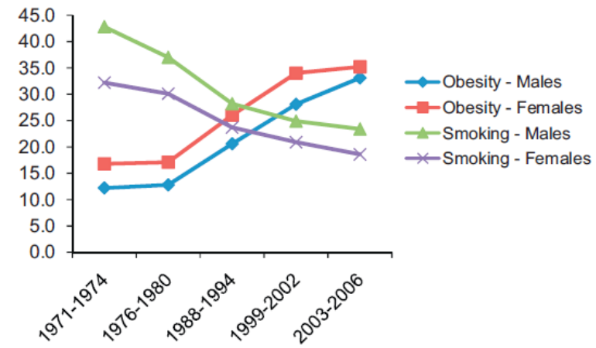
Source: Wehby et al. (2011).

Figure 2. Adult smoking and obesity rates in 1997-2008 in the Netherlands.

response to the increasing scarcity and increasing value of household or nonmarket time (Chou et al., 2004a). The second result in the paper which stands out is the positive cigarette price coefficient, indicating to an unintended consequence of the anti-smoking campaign (Chou et al., 2004a). Chou et al. (2004a) suggest that, state and Federal excise tax hikes and the settlement of state Medicaid lawsuit have caused the real price of cigarettes to increase substantially and that this development contributed to the upward trend in obesity.
Gruber and Frakes (2006) studied specifically the relationship between smoking and obesity, where Chou et. al. (2004a) studied multiple factors and coincidently found cigarette prices to be significant. The authors used data from the BRFSS for years 1984-2002 and cigarette taxes instead of prices. They find that higher cigarette taxes actually reduces BMI and obesity, the opposite of the findings from Chou et al. (2004a). Gruber and Frakes (2006) argue that there are three fundamental differences in their approach compared to Chou et al. (2004a). The first is the sample and control variables used. Chou et al. (2004a) include all those age 18 years and over, whereas Gruber and Frakes (2006) exclude those over 65 years for health reasons. Chou et al. (2004a) also controls for state-specific measures, including the density of restaurants, fast food prices, full service restaurant prices, food-at-home prices and clean indoor laws, which Gruber and Frakes (2006) do not include in their model. The second source of difference is the treatment of time controls. Gruber and Frakes (2006) include dummies for each year, while Chou et al. (2004a) use a quadratic time trend. The third source of difference is the measure for smoking cost. Gruber and Frakes (2006) use state-specific cigarette tax price, while Chou et al. (2004a) use state-specific cigarette price. Gruber and Frakes (2006) argue that cigarette taxes are a more appropriate measure than prices, because price changes may be driven by market factors that affect the rates of smoking and eating. However Chou et al. (2006) argue that prices are preferred to taxes as measures for cigarette cost, by reflecting differences in transportation costs and competition, and that year indicators in a long panel may over-control for unmeasured variables compared to the non-linear time trends employed in the study of Gruber and Frakes (2006).
Nonnemaker et al. (2009) also evaluate the relationship between the strong reduction in smoking rates and the rapid rise in obesity rates using the BRFSS data for years 1984-2004a. Their study builds upon the work of Chou et al. (2004a) and Gruber and Frakes (2006), and tax prices are used as instrument for prices. The study includes state and time fixed effects, state specific linear time trends and stratifies the model by smoking status (never smoker, former smoker, current smoker). Nonnemaker et al. (2009) ran regressions for the overall sample in addition to separate regressions stratified by smoking status. The researchers found no support for the claim that cigarette taxes have significant contributions to rising obesity rates, but found only a moderate sized effect for former smokers.
Another relevant study is from Baum (2009). The author examines the effects of cigarette costs on BMI and obesity using NLSY data for years 1979-2002. BMI and the probability of being obese is estimated using multivariate regression models. In the model a standard set of covariates are included to control for gender, race, age, education, marital status, household composition and urban residence. Baum (2009) also controls for state of residence and survey year of response with dummy variables and for state- and country-specific economic conditions (such as the local unemployment rate, local per capita income, local demographic composition, local education levels and local employment industry sector propensity). The effect of cigarette costs on obesity and BMI are evaluated using a difference-in-difference approach by subtracting the effect for individuals who smoked less than 100 cigarettes in their life from the effect of those who smoked 100 cigarettes or more. Baum (2009) finds that the effect of cigarette costs on BMI and obesity have significant positive effects.
Courtemance (2009) assesses the effect of lagged cigarette prices and taxes on BMI and obesity using the BFRFSS for years 1984-2005 and the NLSY for years 1979-2004. Lags are used for three reasons: cigarette smoking may lag price changes, changes in daily caloric consumption and expenditure patterns may lag changes in smoking, and changes in weight may lag changes in calories consumed or expended. Courtemanche (2009) explains that smoking may lag price changes since both models of myopic and rational addiction predict that long-run price elasticity of addictive goods is stronger than the short-run elasticity, as people may need a substantial amount of time to successfully quit addictive habits, such as smoking. Steady-state daily levels of calories consumed and burned may lag smoking, because if people who quit smoking next target other health-related goals, such as weight loss, some time may pass before smoking is no longer a threat and they are able to devote their energy to these other goals (Courtemanche, 2009). Body weight may lag caloric consumption and expenditure patterns since body weight is a capital stock that depends on calories consumed and burned in al prior periods, consequently, even if calories consumed and burned per day respond immediately to economic shocks, the effect of these shocks on weight will be gradual. Courtemanche (2009) provides an example by explaining that if food prices fall, a person’s calorie consumption may rise. This person will then begin to gain weight, and this gain will slowly increase until a new steady-state weight is reached, possibly for several years after the price change. First the author replicates the studies of Chou et al. (2004a) and Gruber and Frakes (2006), the author finds results quite similar to these studies. Next lags are added to the models and Courtemanche (2009) finds that, in the long run, a rise in cigarette prices and taxes is associated with a decrease in both in both BMI and obesity. Courtmance (2009) proposes as possible explanation that successfully reducing or quitting smoking could lead to a newfound enthusiasm in one’s health, improved confidence in one’s ability to make healthy decisions, or a replenished stock of willpower.
In summary, results on this topic are mixed. Chou et al. (2004a) and Baum (2009) find strong positive effects and Nonnemaker (2009) finds moderate effects only for former smokers. Frakes and Gruber (2006), and Courtemanche (2009) actually find an opposite effect. Differences in outcome stem from the methodological approach, as Gruber and Frakes (2006) find generally the same result as Chou et al.(2004a) when replicating the methodology of this study. Courtemance (2009) replicates both methodologies of Chou et al. (2004a) and Gruber and Frakes (2006), again finding similar results. Results will differ using cigarette prices or cigarette taxes and using a quadratic time trend or year dummies. Most of the papers discussed in this chapter largely build upon the framework of Chou et al. (2002; 2004a) and will at least refer to the study of Chou et al. (2004a), as such it may be concluded their work is the reference on this topic. For that reason, I choose to follow the work of Chou et al. (2002; 2004a) as closely as possible and use their framework, explained in more detail in the following section. In section 5 it is described in more detail how differences in the dataset between the United States and the Netherlands are adjusted.

4. Analytical framework of Chou, Grossman and Saffer

This section outlines the analytical framework as proposed by Chou et al. (2002;2004a). Although Chou et al. (2002) admittedly write that more refined models do exist, such as the model proposed by Philipson and Posner (1999) and Lakdawalla and Philipson (2002). Chou et al. (2002) argue that the Philipson studies focuses on body mass index rather than obesity. The aim of Chou et al. (2002) is to provide an elementary framework to consider the effects of variables not explicitly treated in the models by Philipson and his colleagues.
Obesity is a function of an individual’s energy balance over a number of time periods. In addition to this cumulative energy balance, age, gender, race, ethnicity, and genetic factors unique to an individual help to determine weight outcomes, by influencing the process by which energy balances are translated into changes in body mass (Chou et al. 2004a).
Calories are consumed via ingredients in food and meals are produced with inputs of food and time. Time is required to consume food, but it is also required to obtain and prepare food. The production of meals at home is the most intensive in the household’s own time, while the production in restaurants is the least intensive in time. Chou et al. (2004a) argue that one important economic change is the increase in the value of time, which is reflected by the growth in labor force participation rates and hours of work. Consequently, there is less time available for home and leisure activities such as food preparation and active leisure. This reduction in home time has been associated with an increase in the demand for convenience food and consumption in fast-food restaurants. Another trend discussed is the increasing availability of fast-food, which reduces search and travel time, and changes the relative cost of meals consumed in fast-food restaurants, full-service restaurants and meals prepared at home. Consumption of meals in restaurants requires travel and in some cases waiting time. The full price of a meal in a restaurant should reflect this component as well as the money price. Travel and waiting time should fall as the per capita number of restaurant rises. Therefore the per capita number of fast-food and full-service restaurants are included.
The other variable in the energy balance equation is caloric expenditure. Calories are expended at work, doing home chores, and at active leisure. Calories expended at work depend on the nature of the occupation. Individuals who work more hours in the market might substitute market goods for their own time in other activities (Chou et al. 2004a). An increase in hours of work raises the price of active leisure and might generate a substitution effect that causes the number of hours spent in this to fall, also an increase in hours worked lowers the time allocated to household chores (Chou et al. 2004a).
Cigarette smoking is included in this model, because smokers have higher metabolic rates than non-smokers and individuals who quit smoking typically gain weight. They also consume fewer calories than non-smokers, so that cigarette consumption is a partial indicator of caloric intake in previous periods. In the United States, since the late 1970s there was a substantial increase of states that enacted clean indoor air laws, that restrict smoking in public places and in the workplace. Restrictions on smoking in public places and in the workplace, raise the full price of smoking by increasing the inconvenience costs associated with this behavior. Trends in the enactment of clean air laws also may reflect increased information about the harmful effects of smoking.
Years of formal schooling completed may increase efficiency in the production in a variety of household commodities and increases the probability an individual’s knowledge concerning what entails a healthy diet. This should lower the incidence of obesity, possibly by lowering the demand for dense food or by increasing the demand for active leisure. Marital status may affect the time available for household chores and active leisure in a variety of ways. The price of alcohol is included because alcohol has a high caloric content. However Chou et al. (2004a) notes that the empirical evidence, relating increased alcohol intake to increased to weight gain is mixed.
The reduced form of determinants of Chou et al. (2004a), include hours of work or the hourly wage rate, family income, a vector of money prices including the prices of convenience foods, the prices of meals consumed at fast-food and at full-service restaurants, the prices of food requiring significant preparation time, the price of cigarettes, the price of alcohol, years of formal schooling completed, and marital status (Chou et al. 2004a).
In the following section, the framework of Chou et al. (2004a) is adopted as close as possible for Dutch data. However not all variables could be replicated for various reasons. These reasons, adjustments and deviations from the reference framework will be reported.

5. Empirical implementation

5.1 Data and measures

From this point on the studies of Chou, Grossman and Saffer (2002;2004a), and the study of Gruber and Frakes (2006) will be referenced frequent, therefore these studies will be shortened to CGS and GF.
To investigate the relationship between the decline in smoking prevalence and the rising obesity rates, the Permanent Onderzoek Leefsituatie (POLS) data for years 1997 through 2008 will be employed. These are all the years, that are provided by the Data Archiving and Networked Services (DANS). POLS is conducted by the Dutch Central Bureau of Statistics (CBS), research data include topics relevant to welfare such as health, labour circumstances, legal protection, safety and leisure use. POLS consists of different modules, however all respondents answer a basic survey. The module used for this thesis is the ‘Gezondheid’(Health) survey containing self-reported answers and face-to-face interviews. The face-to-face part of the survey relates to health status, lifestyle, medical consumption and preventive behavior of the Dutch population. POLS Gezondheid consists of repeated cross sections for the years 1997 through 2008, response ranging from 8,741 to 11,117 individuals aged zero and older.
In order to calculate the BMI the weight and length of each individual are needed, where BMI equals the mass of the body in kilograms divided by squared length in meters. The POLS dataset provides the length and weight of individuals in ordered categories. This entails that the exact values of length and weight for an individual is unknown, for example an individual is between 178 cm and 182 cm and weights between 58 kg and 62 kg. In this case interval regression can be employed ,where the outcome of this regression analysis can be interpreted as OLS (Woolridge).
Interval regression is regarded as the simplest version of possibilistic regression analysis as introduced by Tanaka and colleagues (Lee and Tanaka, 1999). The purpose of interval regression analysis is to explain a dependent variable y, as an interval output Y in terms of the variation of explanatory variables (Lee and Tanaka, 1999). To predict the BMI using interval regression, the lower and upper bound values of BMI for each observation must be calculated, describing the variation in BMI for each individual. The lower bound BMI can be calculated by taking for each category the lowest kilograms divided by the highest squared length. The upper bound BMI can be calculated by taking the highest kilograms divided by the lowest squared length. For the example where an individual is between 178 cm and 182 cm and weights between 58 kg and 62 kg, the outcome would be:

Lower bound BMI = 58 / 1.82² = 17.51
Upper bound BMI = 62 / 1.78² = 19.57

Another model is employed for explaining the relationship between the response variable ‘obesity’ and the explanatory variables. This is because BMI is a continuous variable and obesity is a binary variable either taking the value of ‘1’ or ‘0’. Hence, a discrete choice model is chosen. CGS argued that given the large sample size a linear probability model is chosen instead of a probit model. The sample size used in this thesis is more than a tenfold smaller and a probit model will employed. To calculate whether an individual is either obese or not, the BMI values must be calculated, where for the interval regression the variation in BMI would be enough. The midpoint of intervals are chosen in order to calculate the BMI for the response variable ‘obesity’ in the probit model. In this example the individuals length would be 180 cm and weigh 60 kg, the BMI can then be calculated as: BMI= 60kg/1.80m^2 = 18.5kg/m². Furthermore values from which the mean could not be calculated were deleted, these were: ‘203 cm or more’, ‘less than 52 cm’, ‘123 kg or more’, and ‘unknown’. Table 1 shows the percentage of deleted observations for these censored and ‘unknown’ categories. To determine the cut off points for whether an individual is obese or not, the international classification of adult underweight, overweight and obesity is used. Table 2 is provided by the World Health Organization (WHO), the same cut off point for obesity (BMI ≥ 30) are used in all studies summarized in section 2. Table 2 is only applicable to adults according to the WHO, to determine the starting age of adults the approach of Chou et al. (2002) is followed, which includes individuals of 18 years and older.
During inspection for outliers in BMI after omitting observations denoted in table 1, it was decided to include a minimum length an weight for an individual. Outliers are identified using matrix plots, these plots are included in the appendix. Matrix plots are chosen to easily identify outliers in large datasets. For example in matrix plot 1997.1 (see appendix) individuals aged 18 and on are shown, three individuals stand out with a BMI of over 100 kg/m². These individuals have a BMI of 112, 130 and 163 kg/m² (these figures are not direct derived from the plot, but from data statistics). There are three individuals under 100 cm and 2 individuals weight 15 kg or less. These are highly unlikely correct figures and can be caused by incorrect data entry, therefore restrictions on length and weight will be made. For length is chosen that an individual must be a full grown adult, this implies that an individual must be at least 147 cm as shorter will fall in the category of dwarfism (National Institute of Health, 2012). Selecting a minimal weight will be more arbitrary, the goal is to include as many individuals as possible, but reducing the chance of omitting correct data entry. After reviewing all matrix plots for datasets of 1997 through 2008. It is chosen to set the minimal weight to 20kg as

Table 1. Percentage of deleted observations, censored categories and unknown (age ≥18).
Year | 1997 | 1998 | 1999 | 2000 | 2001 | 2002 | 2003 | 2004 | 2005 | 2006 | 2007 | 2008
Length <52cm | 0,12 | 0,00 | 0,00 | 0,00 | 0,00 | 0,00 | 0,00 | 0,00 | 0,00 | 0,00 | 0,00 | 0,00
Length >203cm | 0,15 | 0,10 | 0,08 | 0,11 | 0,14 | 0,04 | 0,06 | 0,06 | 0,10 | 0,15 | 0,06 | 0,10
Length unknown | 0,34 | 0,37 | 0,39 | 0,39 | 0,51 | 0,51 | 0,70 | 0,56 | 0,46 | 0,44 | 0,44 | 0,52
Weight >123kg | 0,20 | 0,29 | 0,43 | 0,39 | 0,53 | 0,48 | 0,46 | 0,47 | 0,45 | 0,58 | 0,55 | 0,48
Weight unknown | 0,54 | 0,60 | 0,80 | 0,77 | 1,02 | 1,11 | 1,74 | 1,10 | 1,00 | 1,53 | 1,25 | 1,62

Table 2. WHO cutoff point of obesity.
Classification | BMI (kg/m²)
Underweight | <18.50
Normal range | 18.50-24.99
Overweight | 25.00-29.99
Obese | ≥30.00
source: http://apps.who.int/bmi/index.jsp?introPage=intro_3.html.

Table 3. Percentage of deleted observations after matrix plots (age ≥ 18).
Year | 1997 | 1998 | 1999 | 2000 | 2001 | 2002 | 2003 | 2004 | 2005 | 2006 | 2007 | 2008
Omitted observations | 1.28 | 1.68 | 1.83 | 1.27 | 0.4 | 0.25 | 0.27 | 0.39 | 0.10 | 0.06 | 0.07 | 0.14

this number will exclude most outliers. Matrix plot 1997.2 shows the result after the additional restrictions are implemented. One outlier can still be identified in this plot, this particular individual is 150cm tall and weighing 125kg, and is a highly unlikely observation, therefore this individual will also be excluded. Matrix plot 1997.3 shows the final dataset that will be used in the thesis for year 1997. This two stage process of implementing initial restrictions on length and weight, and thereafter omitting specific outliers in a particular year is done for all years 1997-2008. The percentage of observations per year that was omitted from the dataset is shown in the appendix (table 3). This ranged from 0.06% in 2006 to 1.83% in 1999.
Definitions and means of variables used in the regressions are shown in table 4. The regressions are based on the sample of 84,050 respondents. The mean BMI of the population is 24.9 kg/m² of that population only 9.3% is obese, compared to 17.5% in the data of CGS. According to this data, the problem of obesity is less prominent in the Netherlands than the United States. There is a possibility that this difference is due to calculation error, during the above described process. Official statistics can be obtained from the CBS. Figure 3 shows my results versus the official reported obesity. Result should be similar as POLS is a research conducted by CBS. In order to make a comparable figure as close to CBS, only individuals of 20 years and older are included, as the CBS also only includes individuals of 20 years and older. Data of CBS was available from 2000 and on. Figure 3 reveals minor deviations between official statistics and statistics used in this thesis, implying that the low obesity rate found in my data is not due to data error. For 2008 taking overweight plus obesity, approximately 45% of the Dutch population is overweight, which is according the report of the ‘Rijksinstituut voor Volksgezondheid en Milieu’ (RIVM). There seems to by a slight negative trend in the population of normal BMI and a slight increase in overweight and obese individuals. The mean BMI increased from 24.5 kg/m² in 1997 to 25.2 kg/m² in 2008, or by 2.9%. Compared to statistics by CGS, the mean BMI increased 9% between 1984 and 1999. The obesity rate in the Netherlands increased from 7.6% in 1997 to 10.8% in 2008.
CGS include a number of state-specific variables, whereas I include a number of country specific variables. These variables include fast food prices, full service restaurant prices, food at home prices, cigarette prices and alcoholic beverages prices, all these prices are indexed and corrected by the Consumer Price Index (CPI). All prices are indexed, because the price for several of the country-specific variables were only provided in price indexes. The disadvantage of using an index is that OLS results are less convenient to interpret. As with indexes a 1 point change in the price index results in a X-unit change of the variable. Another note is that changes in the index from year to year may not be interpreted as percentages. Comparisons in terms of percentages can only be made with the base year. The price index only measures the relative change of prices over time.
For the food at home price, CGS obtained 13 food prices from the American Chamber of Commerce Reseachers Association (ACCRA), where the final food at home price is a weighted average of these thirteen prices. Although it is not clear within the paper of CGS which food prices are averaged, on the website of ACCRA a survey for participants and example Excel sheets can be found, which offer insight to what food prices are possibly used and weights to different foods are given. The food items used to construct a comparable food at home price are potatoes, bread, pork, cheese, eggs, margarine, milk, steak and sugar. These 9 food items are also found on the survey form of ACCRA. To calculate a weighted average price the same weights are used by ACCRA (table 5), implying that Dutch household will buy these goods in the same shares as American household. Although Dutch households will probably not be buying in the same share in convenience goods, the aim is to find trends in the typical average convenience prices. Once the average weighted food at home price is

Figure 3. Weight class overview POLS and CBS, individuals age ≥20.

Table 5. Food at home items employed and ACCRA weights.
Item | Potatoes | Bread | Pork | Cheese | Eggs | Margarine | Milk | Steak | Sugar
ACCRA weight | 0.0264 | 0.0861 | 0.0454 | 0.0684 | 0.0100 | 0.0052 | 0.0374 | 0.0354 | 0.0380

calculated, it is corrected by the CPI for each year. Results indicate that the real food at home price
decreased.
Fast-food prices correspond to places where direct food consumption is available and food consumption is available for takeout. These establishments include fast-food restaurants, cafeterias, lunchrooms, snack bars and such like. Full-service restaurants are engaged in serving prepared food, in combination with takeout. Excluded in full service restaurants are fast-food restaurants, restaurants where only takeout is available and places where ‘small’ food consumption is available.
The distinction between fast-food restaurants and full-service made by CBS is not clear-cut, as full-
service restaurants may serve the type of high-caloric and inexpensive food that is offered by fast-food restaurants. But also by this definition fast-food restaurant may serve more expensive low caloric meals, such as lunchrooms. The definition for restaurants differs a little from CGS, where lunchrooms are included in full-service restaurants by CGS, whereas in this thesis these are included the category of fast-food restaurants. This is only a minor difference, the majority of establishments by definition of CGS and CBS fall in the same category of either fast food or full service restaurant, implying comparable prices. The price of fast-food meals and full service restaurants meals are indexed, unlike CGS where real weighted average food prices for fast food and full service restaurants are employed. During 1997 and 2008 the real CPI of fast-food and full-service restaurant meals increased. This trend contradicts theory where reductions in food prices, including restaurant prices, are expected. High elasticity for restaurant prices would suggest a substitution effect towards food at home, for reason that food at home prices have reduced and restaurant prices have increased. Thereby decreasing revenues for restaurants keeping the amount of meals sold constant. However the real revenue of restaurants has actually risen (source: CBS, statline), suggesting a low restaurant price elasticity, where restaurants are able to calculate rising costs such as wage, rent and regional taxes to customers. A possible explanation for the low price elasticity is, that an individual buying a meal in a restaurant, will value the price of time of producing a meal at home higher than buying a fast meal in a restaurant. An increase in worked hours will make home time a scarcer resource and raises its price. This creates incentives to purchase more convenience and restaurant food. The rising restaurant prices cannot be explained trough raised food prices, because food at home prices have decreased as previously stated. These same ingredients of food at home prices, are also bought by restaurants to produce a meal. Therefore the price of producing a meal for restaurants must have dropped and other factors have contributed to raised restaurant prices, such as higher wages, rent, regional taxes ,margins, and also the decrease in per capita number of restaurants might suggest less competition.
The total number of restaurants are calculated by adding the number of fast-food restaurants and full service restaurants. In order to calculate the per capita restaurants, the number restaurants and total population per year (1997 through 2008) were taken. The number of restaurants per 10,000 persons by CGS and this thesis are similar in rounded numbers, namely 13 restaurants per 10,000 residents.
The price of cigarettes is taken from the website of the pro-smoker association, Stichting Rokers Belangen (SRB, 2012). Prices are provided per pack of cigarettes and per 1000 cigarettes for the most popular price class (MPPC). The MPPC per 1000 cigarettes is used, because the number of cigarettes per pack changed over time from 25 cigarettes per pack to 19 cigarettes per pack. For years where a mid-year price raise is reported, the mean of that year is calculated. This approach is different than CGS where the real prices of cigarette packs are used. The provided nominal prices by SRB are corrected with the CPI whole and converted to the real price index.
The price of alcoholic beverages are also indexed, unlike CGS where real prices are used. In order to construct comparable results the sub index of alcoholic beverages is used, corrected by the CPI. The real price index of alcoholic beverages fluctuates, becoming relatively more expensive and cheaper in different periods. Declining in the years 1997-2000, increasing in 2001-2003 and dropping again in 2004-2008. Through the period 1997-2008 the price of alcoholic beverages were relatively cheaper in 2008 than in 1997. This trend is quite remarkable, but also noted by Dutch Institute for Alcohol Policy (STAP) in a letter to the Tweede Kamer (Lower House). Stating that the price of a liter beer corrected by inflation slightly dropped between 2003 and 2007.
The paper of CGS also controls for the smoking bans in private workplaces, local government workplaces, restaurants, and in other places such as elevators, public transportation and theaters. In the Netherlands smoking ban laws are enforced starting January 2004. The 2004 smoking ban enforces the right to a smoke free work place. The law mandates employers to provide employees a smoke free work environment, this includes both private and government workplaces. Starting July 2008 smoking bans were enforced in the catering industry, where individuals are solely allowed to smoke in specially designed smoke areas. This smoking ban stumbled upon heavy resistance, and in practice proved difficult to enforce. In the regression, two dummy variables are created, ‘clean indoor law 04’ and ‘clean indoor 08’, the former dummy correcting for the smoking ban starting 2004 and the latter dummy correcting for the smoking ban starting 2008.
The variables ‘Household income’ and indicators for ethnicity used by CGS could not be replicated, POLS does provide comparable information, however the measurement is not constant and differs over the years . The household income is provided in deciles, however these were only provided for years 1997-2000. In case of indicators for ethnicity, according to the documentation rapport ‘Permanent Onderzoek Leefsituatie module GEZOND (POLSmodGEZOND) 2008V1’ a variable called ‘glandop’, which provides information on the individuals country of birth should be included. The module ‘POLS GEZOND’ is used in this thesis, however this variable could not be located for any year. What could be found for years 1997-2008 is whether the individual has a Dutch nationality, however this is not included the thesis, for reason that this variable is a very weak indicator for ethnicity. In this variable the country of origin for an individual could be in any part of the world.

Table 4. Definitions and means of variables. Standard deviations are in parentheses. Sample size is 84050.
Variable | Definition | 1997-2008 | 1997 | 1998 | 1999
Body mass index | Weight in kilograms divided by height in meters squared | 24.931 | 24.538 | 24.519 | 24.744
Obese | Dichotomous variable that equals 1 if respondent 1 body mass index ≥ 30 kg/m² | 0.093 | 0.076 | 0.075 | 0.081
Male | Dichotomous variable that equals 1 if respondent is male | 0.487 | 0.493 | 0.485 | 0.490
Primary education (reference) | Dichotomous variable that equals 1 if respondent completed primary education (basisschool) | 0.170 | 0.191 | 0.191 | 0.181
Low education | Dichotomous variable that equals 1 if respondent completed ‘Lager Beroeps Onderwijs’ LBO | 0.163 | 0.173 | 0.176 | 0.173
Mid School | Dichotomous variable that equals 1 if respondent completed MAVO or VWO3 | 0.090 | 0.100 | 0.094 | 0.093
High School | Dichotomous variable that equals 1 if respondent completed HAVO, VWO, MBO | 0.360 | 0.351 | 0.345 | 0.358
College graduate | Dichotomous variable that equals 1 if respondent graduated from HBO or university | 0.170 | 0.184 | 0.189 | 0.195
Married | Dichotomous variable that equals 1 if respondent is married | 0.620 | 0.622 | 0.644 | 0.627
Age | Age of respondent | 46.826 | 44.381 | 45.053 | 45.325
Restaurants | Number of fast-food restaurants and full-service restaurants per 10,000 persons | 112.05 | 114.47 | 120.62 | 124.71
Fast-food price | Real fast-food price index, 2008=100 | 94.39 | 90.35 | 89.43 | 90.52
Full-service restaurant price | Real full-service price index, 2008=100 | 95.45 | 92.46 | 92.51 | 93.35
Food at home price | Real food at home price index: weighted average of 9 food items in 2008 euro’s, 2008=100 | 104.17 | 111.13 | 111.13 | 109.31
Cigarette price | Real cigarette price index per 1000 cigarettes in 2008 euro’s, 2008=100 | 84.05 | 68.65 | 71.49 | 73.31
Alcohol price | Real alcohol beverage price index, 2008=100 | 102.50 | 104.19 | 103.28 | 102.70
Clean indoor law 2004 | Dichotomous variable that equals 1 if smoking is prohibited at workplace
Clean indoor law 2008 | Dichotomous variable that equals 1 if smoking is prohibited at restaurants
Time | Time in years, 1997 equals 1

2000 | 2001 | 2002 | 2003 | 2004 | 2005 | 2006 | 2007 | 2008
24.846 | 24.933 | 24.978 | 25.049 | 25.158 | 25.059 | 25.155 | 25.078 | 25.211
0.085 | 0.090 | 0.091 | 0.099 | 0.104 | 0.103 | 0.109 | 0.106 | 0.108
0.487 | 0.486 | 0.485 | 0.492 | 0.488 | 0.492 | 0.486 | 0.485 | 0.488
0.174 | 0.176 | 0.167 | 0.165 | 0.116 | 0.167 | 0.165 | 0.161 | 0.154
0.170 | 0.166 | 0.171 | 0.161 | 0.131 | 0.689 | 0.157 | 0.160 | 0.157
0.090 | 0.088 | 0.098 | 0.092 | 0.075 | 0.091 | 0.085 | 0.083 | 0.081
0.353 | 0.351 | 0.349 | 0.350 | 0.427 | 0.356 | 0.359 | 0.358 | 0.361
0.207 | 0.211 | 0.208 | 0.229 | 0.247 | 0.216 | 0.232 | 0.238 | 0.243
0.634 | 0.630 | 0.624 | 0.627 | 0.623 | 0.607 | 0.603 | 0.594 | 0.587
45.496 | 46.018 | 46.301 | 46.998 | 47.030 | 47.05 | 47.524 | 47.565 | 47.945
122.16 | 118.90 | 108.37 | 111.50 | 105.10 | 108.24 | 108.38 | 101.41 | 100
90.62 | 91.74 | 95.14 | 95.29 | 96.08 | 96.24 | 96.86 | 99.08 | 100
93.32 | 94.08 | 96.15 | 96.04 | 96.19 | 96.39 | 97.33 | 98.41 | 100
107.13 | 111.32 | 107.61 | 104.33 | 99.33 | 95.98 | 97.52 | 94.58 | 100
74.60 | 77.68 | 77.97 | 79.57 | 95.29 | 94.44 | 97.41 | 99.86 | 100
101.39 | 103.02 | 105.28 | 107.67 | 103.25 | 100.77 | 98.98 | 98.82 | 100

5.2 The relationship between BF% and BMI

This section makes a small side-step from the subject, but an important one. BMI is the primary dependant variable used in this thesis, but has its shortcomings. I wanted to explore whether there is a better measurement of body weight than BMI, that can be employed with the POLS data.
BMI is the cornerstone of the current classification system for obesity, however it is only a surrogate measure of body fatness (Prentice and Jebb, 2001). Obesity is defined as an excess fat that correlates with ill-health. It is the excess body fat that is the cause of the comorbid conditions, not the excess weight (Prentice and Jebb, 2001).
The primary drawback of BMI is that it cannot distinguish fat mass from lean mass and therefore might misclassify individuals. Other methods occasionally used in epidemiologic studies are waist circumference, waist-to-hip ratio, and skin-fold thickness (Sturm, 2002). However BMI is an easy and cheap measure to assess health risks associated with an excess of body fat.
There are circumstances where there can be a mismatch between BMI and true body fatness, which results in BMI giving misleading information. Age is such a circumstance, for example aging is accompanied by a progressive increase in the ratio between fat and lean body mass, meaning the relationship between BMI and body is age dependent (Prentice and Jebb, 2001). According to men studied by Cohn (1987), a 25 year old individual would increase his body fat percentage from 15% to approximately 30% over the next 50 years, while BMI remains constant.
Active athletes will also indicate a BMI value not representative of their predicted body fat. An example used by Prentice and Jebb (2001) is of a professional athlete, which would have a predicted body fat percentage of up to 40%, however his actual body fat percentage would be below 20%.
Another circumstance where BMI can give misleading information, is that certain ethnic groups display a very different relationship between BMI and body fat compared to Caucasians. For example, many Asian races particularly those from the Indian subcontinent, tend to carry a proportionately higher body fat percentage (BF%) for a given BMI than Caucasians (Prentice and Jebb, 2001).
Burkhauser and Cawley (2008) point out that there is a consensus in the medical literature that BMI is a poor measure of fatness, however there is no consensus on which of the more accurate measures of fatness is best. Burkhauser and Cawley (2008) investigate whether obesity defined using BMI is a reasonable proxy for true obesity, where the true obesity is measured by BF%. The authors employ data from the national health and nutrition examination survey III (NHANES III) and calculate BF% by way of bioelectrical impedance analysis (BIA). A BF% greater than 25% for men or greater than 30% for females is defined as obese, this cutoff point is taken from the NIDDK (2006). In addition when controlling for the difference in thresholds for obesity, the authors determined the
Table 6. Cutoff points body fat percentage.
Female
Age | Underweight | Normal | Overweight | Obese
20-39 | <21% | 21%- <33% | 33%-<39% | >=39%
40-59 | <23% | 23%- <34% | 34%-<40% | >=40%
60-79 | <24% | 24%- <36% | 36%-<42% | >=42%
Male
Age | Underweight | Normal | Overweight | Obese
20-39 | <8% | 8% -<20% | 20%-<25% | >=25%
40-59 | <11% | 11%-<22% | 22%-<28% | >=28%
60-79 | <13% | 13%-<25% | 25%-<30% | >=30%
Calculated from equation (1) centering on the ages 30, 50, and 70 years. Source: Gallagher et al. (2000).

cutoff points of 29% for men 41% for females. The authors find that obesity defined using BMI is weakly correlated compared to obesity defined using BF% and that obesity defined using BMI results in substantial misclassification of individuals into weight classifications even when controlling for threshold effects.
However Burkhauser and Cawley (2008) only accounted for differences in body composition between males and females, but not the age-related increase in body fat mass and the decrease in fat-free mass. Gallagher et al. (2000) studied the relationship between BF% and BMI including the effect of age. The aim of the study was not solely predicting this relationship, but also to link the healthy BMI guidelines established by the WHO with predicted percentage body fat. This study measured body fat from three ethnic groups (Caucasian,African American and Asian). BF% is calculated by dual X-ray absorptiometry. Gallagher et al. (2000) found a curvilinear relationship between percentage body fat and BMI within all groups. The researchers experimented with logarithmic transformations and various power terms, which improved linearity and correlation coefficients for the relationship between percentage body fat and BMI, however for reason of convenience the authors chose to use 1/BMI as an independent variable. Gallagher et al. (2000) calculated the BF% for each ethnic group, but for practical reasons, Caucasian and African Americans were combined into one model and for Asians a separate model was calculated. The model proposed by Gallagher et al. (2000) for calculating BMI to BF% is shown in equation (1), where R² = 0.86. A similar study and equation by Deurenberg et al. (1991) also found a high R² of 0.79. The cutoff points for different BMI categories are shown in table 6.

BF% = 64.5 – 848*(1/BMI) + 0.079*age – 16.4*sex + 0.05*sex*age + 39.0*sex*(1/BMI) (1)
Sex: 1=male 0=female

Equation (1) is used to construct figure 4 and figure 5 uses table 6 in addition to equation (1). Figure 4 shows a comparison between the mean BMI and mean BF% throughout the years. Both variables are indexed in order to depict the trend for the Dutch population. The figure shows a steeper increasing rate of BF% relative to BMI. Indicating that the mean ‘real’ BF% will be underestimated as the upward trend of obesity continues. This may imply that the health risks associated to body fat in the future might be underestimated using BMI measures, although it is not clear whether this relationship of ill health, BMI and BF% is linear. A study by Yusuf et al. (2005) find that waist-to-hip ratio is a far better predictor of heart attack than BMI and conclude that BMI greatly underestimates the number of people for whom fatness impacts health. So while we do not know whether an increase in BF% and BMI are linear related to a increase in ill health, there is evidence that ill health associated to obesity defined by BMI is underestimated.
Figure 5 presents a comparison between the weight class of BMI and BF%, results show that the population of overweight individuals is slightly underestimated in BMI according to the BF% measure. The difference in underweight and obese individuals are negligible, these differences are not perceptible in figure 5 as they fall into one line. There is a systemic difference for individuals in the normal range, where BMI is overestimated compared to body fat measures. And a systemic difference for overweight individuals, where BMI is underestimated compared to BF%. For descriptive statistics, this ‘corrected’ BMI would imply that the Dutch population would be slightly unhealthier, where there are less individuals in the normal range and more in the overweight range.
Although the BF% measure is a better proxy for health risks, it is questionable whether using BF% calculated by BMI is also a more valuable than BMI itself. For instance equation (1) is a linear transformation from BMI to BF% and the cutoff points for BF% are based on BMI. Regression in the following sections were also made by BF% measure (not shown), but did not show any sign changes or different significant variables. Without epidemical data linking BF% to ill health and thereby developing a BF% specific cutoff point for obesity, we cannot know whether a higher BF% is linear related to increased ill health, compared to BMI. If this relation is to be found linear, the long term trend of an increasing obesity prevalence defined by BMI and its health consequences might be underestimated.

Figure 4. Mean BMI index and mean BF% index, 2002=100.

Figure 5. Weight class overview BF% and BMI, individuals aged 20-79.

6. Results
6.1 Replication Chou, Grossman and Saffer

CGS find evidence that most of the used continuous variables had non-linear effects. This is important because when doing interval regression, that is interpreted as OLS, it is assumed that the relationship between the response variable and the predictors is linear. In order to check whether my data suffered from non-linear effects, a three layer plot is used to inspect for indications of non-linear effects for the continuous variables used in this thesis (see appendix matrix plot 1-7). The first layer is a matrix plot of the response variable, BMI, and the continuous variables age, restaurants, fast-food price, full-service restaurant price, food-at-home price, cigarette price and alcohol price. The second layer is a fitted regression (red line) and the third is a non-parametric regression line (green line) using the lowess method. For each distinct value of the predictor, the lowess method produces a fitted value for the response variable by running a regression in the bandwidth of the predictor, giving more weight to points closer to the predictor. The stronger the lowess line deviates from the fitted line where it becomes curved, the more evidence there is of non-linear effects. The only variable showing indications of non-linear effects is age, the other variables do show clear indications of non-linear effects. An explanation for the difference in linearity in my data and CGS is that I only have 12 price observations for most of the continuous variables, whereas CGS data is state specific, and states will set different pricing, providing for more price observations. Although this method in looking for non-linear effects works better if more observations are provided, there is not enough evidence in my data for squaring all the continuous variables as CGS. I will only square age. Table 7 contains interval regressions of body mass index and the probability of being obese for persons aged 18 and on.
A problem in the model can be collinearity among the variables. In this research multicollinearity would be a problem, if the prices of cigarettes have a high degree of correlation among other explanatory variables. A simple pairwise correlation shows a result of >80% between cigarette prices, fast food prices, full service restaurant prices and food at home prices. This could indicate multicollinearity within the model, but pairwise correlation cannot detect multicollinearity when three or more variables are related to each other. The regression coefficient of the first of the two highly correlated variables, cigarette prices, is interpreted to measure the change in BMI that is due to a change in cigarette prices, other things being equal (Pindyck and Rubinfeld, fourth edition). Any time a given change in one variable occurs, the corresponding observation on its highly correlated partner, fast food prices, is likely to change in a predictably similar fashion (Pindyck and Rubinfeld, fourth edition). Thus the presence of multicollinearity implies that there will be very little data in the sample to provide a conclusion with confidence, whether it is cigarette prices or fast food prices causing a change in BMI or obesity. Performing a joint significance test, that these variables are equal to zero, resulted in rejecting the null hypothesis for both dependent variables. Thus cigarette prices, fast food prices, full service restaurant prices and food at home prices are jointly significant.
Table 7 shows a statistically significant relationship for gender, where males have higher levels of BMI, but are less likely to become obese. Age as expected is positive and significant related to BMI and obesity.
The relationship between marital status and BMI show that married individuals have significant higher levels of BMI, but the relationship to become obese is insignificant. However the variable is potentially endogenous, as it only states if the individuals are legally bound. It is highly likely that a part of the non-married individuals are not single, but are in a relationship living in one household and show a similar lifestyle to married individuals. Thus this variable may not be interpreted as a behavior change related to individuals living together or having a relationship, but rather as a change in behavior for having a ‘contract’ for being together. Another argument for omitted variables, which is not perceived in this model is that married males may show a different relationship to BMI than females.
The level of education shows that in general the more educated an individual is the lower the BMI is and the less likely an individual is obese. Though high school shows slightly higher levels of BMI compared to mid school. All education variables show a statistically significant relationship. The education variables may suffer from reverse causality, where poor health in early life may lead to a lower educational level as Cutler and Lleras-Muney (2012) point out. Cutler and Lleras (2012) also point out unobserved factors such as parents with more resources may increase the chance of survival of their children by investing in health, which in turn means they will perhaps invest in more education. Also smarter individuals are more likely to obtain more schooling and also have better health.
The number of restaurants per capita, fast food price, full service restaurant price, food at home price, alcoholic beverages price and cigarette prices were in all regressions insignificant. Though for both regression, BMI and obese, the variables are significant jointly related. As expected fast food prices, cigarette prices are positive related and alcoholic beverages negatively related for BMI. Remarkable is that the price of full service restaurant is negatively related to BMI and obesity. The coefficient of full service restaurants and fast food are very similar, but opposite in sign. Looking at index trend of both variables, this would be impossible to explain. Running the regression without fast food, results in the sign turning positive. Another remarkable result is when time dummies are employed the sign of the three food prices change. The problem here might be due to the collinearity among the three variables making predictions unstable and difficult to interpret.
Again unexpected, is that the result of alcoholic beverage prices is positively related to obesity, though the variable shows no significant relationship. It is harder to explain why the sign of alcohol prices turns from negative to positive for obesity, as there are no clear indications of multicollinearity for this variable. This implies that raising the price of alcohol is related to a positive probability in becoming obese, where an opposite effect is expected. Regression were also made for the probability of becoming overweight (not shown), this time the sign turns negative as is expected. At this point a decent explanation cannot be offered, other than interpreting the results that, raising prices for alcohol will only aid becoming less overweight but not obese. Obese individuals might be less sensitive to prices concerning their weight, than overweight individuals are.
The smoking ban dummies, again show some odd results. The smoking ban dummy starting from 2004 is negative and not significant, where the smoking dummy for 2008 is positive and significant. The smoking ban dummy for 2008 is only taken for one year, as data ends in 2008. It is very likely this dummy picks up trends other than the introduced, and hardly enforced smoking ban in 2008. The joint significance of these variables did not return a significant relationship, except for the probability of becoming obese. Whether the probability of becoming obese is either positively or negatively related to the smoking ban is difficult to conclude, for reason that the sign of the two dummies are mixed. I am inclined to interpret these results similar to CGS, that is, the smoking bans are not significant related to body weight.
Overall findings indicate that it is hard to disentangle the effect of cigarette prices from fast-food, full service restaurants and food at home prices. The variables are jointly significant and jointly contribute by either decreasing the probability of becoming obese in case of full service restaurant prices, or increasing the probability of becoming obese in case of fast food, food at home and cigarette prices. The price of cigarettes on its own did not reveal a significant relationship to the trend in BMI and obesity. But even if a significant relationship was found, results would still be difficult to be interpreted as causal, for endogeneity problems indicated in section 2.
In next section the findings of GF are replicated, where GF find that the relationship of cigarette taxes, BMI and the probability of becoming obese is negative, which is the opposite of CGS. This study employs time dummies for each year and the unemployment rate, but not the state-specific continuous variables for prices of fast-food, full-service restaurant, food-at-home, alcohol and the number of restaurants.

Table 7. Interval regression for BMI and probit regression for obese. Z-statistics are in parentheses for independent variables BMI and Obese. Observations, 84050.
Independent variable | Dependent variable: BMI |  | Dependent variable: Obese
Male | 0,618 | (24,18) | -0,096 | (-7,65)
Primary school | reference |  | reference
Low education | -0,328 | (-7,38) | -0,104 | (-5,44)
Mid school | -0,918 | (-17,28) | -0,295 | (-11,82)
High school | -0,883 | (-22,45) | -0,314 | (-17,76)
College | -1,527 | (-35,73) | -0,536 | (-25,79)
Married | 0,259 | (8,67) | -0,023 | (-1,63)
Age | 0,223 | (46,52) | 0,058 | (23,01)
Age² | -0,002 | (-37,61) | -0,001 | (-20,69)
Restaurants | 0,012 | (1,02) | 0,002 | (0,34)
Fast Food | 0,204 | (1,85) | 0,036 | (0,65)
Full service | -0,206 | (-1,58) | -0,054 | (-0,83)
Food at home | 0,009 | (0,59) | 0,002 | (0,31)
Alcoholic beverages | -0,017 | (-1,10) | 0,004 | (0,50)
Cigarette price | 0,034 | (1,47) | 0,008 | (0,76)
Smokeban04 | -0,360 | (-0,97) | -0,052 | (-0,29)
Smokeban08 | 0,389 | (2,55) | 0,048 | (0,66)
Time | 0,078 | (1,32) | 0,025 | (0,89)
Time² | -0,011 | (-3,91) | -0,001 | (-0,95)
Constant | 16,555 | (2,79) | -2,339 | (-0,79)
Replacing the quadratic time trend by year dummies resulted in sign changes for variables: fast food, full service and food at home for both dependent variables BMI and obese. The variables remain statistically not significant at α=0.05.

6.2 Replication Gruber and Frakes

The paper of GF, as with CGS, is frequently cited in other work related to the topic of tobacco and obesity. Where CGS aimed at explaining trends in obesity and ‘accidently’ found cigarette prices related to obesity, the model of GF is more aimed at relating smoking to obesity. GF find opposite results compared to CGS, making it interesting to replicate and investigate if such a sign change is observed for Dutch data.
There are some important differences between the study of CGS and GF. The first important difference that will impact the replication is the use of cigarette excise tax instead of cigarette prices. For the Netherlands these excise taxes are easy to calculate, as the excise tax rate on the retail price was a constant 57% for years 1997-2008 (Stichting Rokers Belangen; Taxing Tobacco in the European Union). This also means that the index for excise tax is equal to the cigarette price index employed in the replication of CGS. The second major difference will be in the treatment of time. GF uses time dummies, whereas I will be using a quadratic time trend. This difference is due to the dataset, the BRFSS enables GF to measure price differences between states and over time. The POLS dataset only enables to measure over time, therefore the use of time dummies for each year will not provide extra information. Another difference compared to CGS is the age of the population, GF only used individuals aged up to 65 for health reasons.
The authors suggest that states may raise cigarette taxes in times of recession and body weight goes down or up in recessionary periods. GF attempt to control for this by employing the variable unemployment rate to allow for time-varying economic conditions of the separate states.
The empirical model employed by GF to investigate the impact of cigarette taxes on measures of body weight is shown in equation (2).

$\text{BMI}\text{ijt}\text{= α+}\text{β}\text{1}\text{RTAX}\text{jt}\text{ + }\text{β}\text{2}\text{X}\text{ijt}\text{+}\text{ β}\text{3}\text{UR}\text{jt}\text{+ }\text{λ}\text{j}\text{+ }\text{τ}\text{t}\text{+ }\text{ε}\text{ijt}$ (2)

Where i are the individuals, j are the states and t the years. The response variable is either the BMI or the probability of becoming obese. RTAX the real cigarette tax in state j in year t ; X the set of individual-specific covariates (for example age), UR the unemployment rate in state j in year t and λ_{i} and τ_{t} are fixed effects for year, respectively.
In the model of GF it is changes in cigarette taxes within states, relative to other states that do not change their tax, that identifies the effect of taxes on body weight measures. This is also a major difference for I only employ data for ‘1’ state, which is the Netherlands and there is no data of other countries over time in this model. Consequently, the conclusions based on my outcomes will be weaker than the outcomes of GF.
Table 8 shows the result of interval regression for BMI and the probability of becoming obese for estimating the equation as close to GF. The primary difference between the results of GF and this model is the sign of cigarette excise taxes, or in my case cigarette price. GF found a negative relationship in both weight measures of BMI and obese, implying that higher cigarette taxes reduces weight. In this model for the Netherlands the sign remains positive as in CGS. A rise of 1 point in the cigarette price index would increase BMI by 0.006, whereas GF predicts that a rise of US$ 1.00 lowers BMI by 0.15. The same rise of 1 point in the cigarette price index would increase the probability of becoming obese by 0.004 percent point, whereas GF found that a rise of US$ 1.00 would decrease the probability of becoming obese by 0.015 percent point. The price of cigarettes remains statistically insignificant for the Netherlands. The unemployment rate also did not reveal any significant effects related to BMI or obese. Employing year dummies did change the result of cigarette prices and unemployment rates to significant. However year dummies do absorb price and year rate differences in my model. A regression where no time dummies were included returned similar results to year dummies. The disadvantage of employing no time dummies and in this case also year dummies, is that it limits a causal interpretation.
GF employs dummies for age categories and gender, this allows to observe changes throughout the age of males and females, with reference to females aged 61-65. For males, age follows a non-linear relationship to BMI. BMI rises with age and peaks in their 50s, and then rises again in their 60s. For females age follow a linear relationship, with younger individuals have a lower BMI. For both female and males as age rises, the probability of becoming rises up until the 60s. The probability of becoming obese is slightly lower for males until their 40s, thereafter probabilities are roughly equivalent. Results on the probability of becoming obese are insignificant for both males and females aged older than 51. Females have a lower BMI than males throughout all ages, with one insignificant result for males aged 46-50. Education level shows that in general, higher educated have a lower BMI, and the probability of becoming obese is lower for higher educated individuals. Married individuals have higher levels of BMI, but a lower probability of becoming obese compared to not married individuals. These results are close to the findings of GF.
This model compared the model of CGS is quite limited for explaining trends in BMI. Though this model is aimed at investigating one specific trend, the tradeoff is that the potential for endogeneity is higher. For example no controls for caloric intake are included, where CGS employ food prices and alcohol prices as instruments for caloric intake. Another control lacking for caloric expenditure in both models, but is discussed by CGS and Philipson and Posner (1999), is the intensity of labor and its change throughout the years. These omitted variables combined with endogeneity problems of relating smoking to body weight, makes the interpretation of either significant or insignificant results very hard. However both replications of CGS and GF show no indication that the trends of body weight, obesity and smoking prevalence are related in the Netherlands.

Table 8. Impact of cigarette prices on BMI and Obesity, GF specification. Aged 18-65. Z-statistics are in parentheses for independent variables BMI and Obese. Observations, 70984.
Independent variable | Dependent variable: BMI |  | Dependent variable: Obese
Cigarette price | 0,006 | (1,16) | 0,004 | (1,59)
Married | 0,410 | (12,27) | -0,017 | (-1,07)
Primary school | reference |  | reference
Unemployment | -0,008 | (-0,51) | 0,002 | (0,20)
Low education | -0,361 | (-7,00) | -0,118 | (-5,31)
Mid school | -0,913 | (-15,2) | -0,282 | (-10,05)
High school | -0,882 | (-19,58) | -0,330 | (-16,46)
College | -1,524 | (-31,53) | -0,554 | (-23,95)
Males (<25 years) | -2,793 | (-30,65) | -0,845 | (-16,56)
Females (<25 years) | -3,067 | (-33,58) | -0,630 | (-13,37)
Males (26-30 years) | -1,216 | (-12,61) | -0,444 | (-9,13)
Females (26-30 years) | -1,855 | (-19,69) | -0,243 | (-5,51)
Males (31-35 years) | -0,753 | (-8,20) | -0,308 | (-7,08)
Females (31-35 years) | -1,550 | (-17,12) | -0,157 | (-3,84)
Males (36-40 years) | -0,400 | (-4,44) | -0,235 | (-5,66)
Females (36-40 years) | -1,486 | (-16,71) | -0,120 | (-3,02)
Males (41-45 years) | -0,243 | (-2,66) | -0,139 | (-3,36)
Females (41-45 years) | -1,300 | (-14,53) | -0,142 | (-3,55)
Males (46-50 years) | 0,069 | (0,76) | -0,107 | (-2,63)
Females (46-50 years) | -0,921 | (-10,18) | -0,102 | (-2,55)
Males (51-55 years) | 0,345 | (3,74) | -0,034 | (-0,83)
Females (51-55 years) | -0,457 | (-4,98) | -0,037 | (-0,94)
Males (56-60 years) | 0,457 | (4,83) | 0,024 | (0,60)
Females (56-60 years) | -0,192 | (-2,03) | 0,030 | (0,75)
Males (61-65 years) | 0,296 | (3,04) | -0,077 | (-1,78)
Females (61-65 years) | reference |  | reference
Time | 0,125 | (5,74) | 0,034 | (3,16)
Time² | -0,007 | (-5,12) | -0,002 | (-2,98)
Constant | 25,372 | (78,55) | -1,353 | (-8,65)
Employing year dummies (OLS regression) changed cigarette prices and unemployment rates to significant results.

6.3 Own model specification
6.3.1 Preferred model specification
The aim for this thesis is to reach a confident conclusion to investigate whether the apparent relationship between the decline in smoking and the increase in obesity is causal. The replication of the two previous studies did not provide any evidence such a relationship exist in the Netherlands. However the foremost problem in the replication of the two studies is the lack of panel data in my models. GF employed the advantage of panel data to such an extent, where states were followed over time, that it did not add more value to employ excise taxes and year dummy variables in my replication. These two variables were a major difference aiding in the opposite results of CGS compared to GF. In the ideal situation I would build upon the model of Courtemanche (2009), and not CGS or GF. Courtemanche (2009) recognizes that BMI should not be captured by a static model, but by a dynamic model. Body weight is a dynamic and complex process, influenced by biological characteristics, behavioral characteristics and the (changing) environment. A lagged model structure would suit better for proposing a model, where the dependent variable is a measure of body weight. However by using the POLS dataset, it would not benefit to build upon the model of Courtemanche (2009) for two main reason. The first being that Courtemance (2009) not only lags cigarette prices but also the control variables, failing to do so could bias the coefficient estimators for the cigarette price lags, if lagged cigarette prices are correlated with lagged controls (Courtemanche 2009). The second reason is that I would want to employ an autoregressive function, where the predicted BMI would also depend on the BMI in the past. There is evidence to assume individuals make decisions about their current bodyweight, based on the bodyweight in the past. For example, deciding to quit smoking is not only based on pricing, but also partly a body image decision (believing that smoking cessation will gain weight). Cigarette prices in the current used models also pick up this body image trend, aside from other behavioral trends such as addictive behavior for ‘bad’ nutrients, as indicated by Timothy et al. (2007).
It must be taken into account that POLS consist of repeated pooled cross sections, therefore lagging control variables and lagging individual BMI level cannot be done. As such the possibility of quantile regression is explored. The advantage of quantile regression is the ability to reach different conclusions across the distribution of body weight. For example the conclusion of the previously discussed paper of Wehby et. al. (2011), where the authors find heterogeneous effects across the distribution of BMI.
The preferred model will be based on the framework proposed by CGS. The replicated model of CGS with Dutch data shows a high pairwise correlation among fast-food, full service restaurants and food at home prices, causing an unexpected and impossible sign for full service restaurant. Therefore full-service restaurant prices and fast-food prices are not included. The number of restaurants also did not show a significant relationship with BMI or obesity and will not be included.
An added proxy that will be included for caloric intake is the number of paid hours worked. A high number of worked hours, reduces the time available to produce a meal at home, thereby increasing the chance of consuming more prepared high caloric meals. A positive relationship between the hours worked and body weight is expected. Another argument for adding the number of worked hours stems from the theoretical framework of Philipson and Posner (1999), who argue that the growth in weight may due to making home- and market production more sedentary. The Netherlands does not provide big-scale labor intensive industrial production or agricultural service, but rather strives for being the gateway to Europe, and the provider for technology and science knowledge, which translates into a population where for the most part sedentary work is needed. There might be a reverse causality for the number of worked hours, as obese individuals may have lower levels of productivity and will have to work more hours to perform equivalent tasks compared to non-obese individuals. However this reverse causality is considered less likely, because most work demanded and supplied in the Netherlands is sedentary, and as Philipson and Posner (1999) imply that the change to sedentary work is before the trend in weight gain.
Clark and Etilé (2002), discussed in section 2, influenced to add a variable related to the body health of an individual. For this, a set of dummy variables is used related to the increased health risks of body weight, which are diabetes, hypertension and coronary diseases. Though these conditions are associated to increased body weight, they may well be endogenous as there are other factors influencing these conditions, and are not solely caused by increased weight gain.
An added proxy for caloric expenditure will be the times of weekly sport activity, this is expected to have negative relationship with bodyweight. An endogeneity problem for this variable might be omitted selection, where only healthy individuals choose to do sports, measuring only a healthy sub-population. Table 9 shows the definitions of the added variables.
Males and females are grouped into two separate regression, rather than employing a dummy variable. Cawley et al. (2004) show that the influence of body weight, body image and cigarette pricing on smoking initiation differs for males and females. Where problems of simultaneity is less likely for males, as body weight and perceived body image did not predict their smoking initiation. Furthermore the hours of paid work will also differ by gender, where females are inclined to work part-time. Another argument for grouping males and females is that the BF% shows that the composition of males and females substantially differs.

Table 9. Definitions, means and standard deviations of variables. Standard deviations are in parentheses.
Variable | Definition | Mean and standard deviation
Hours of paid work | Number of hours paid work | 24.624 (18.995)
Sport | Number of sports activity per week | 1.383 (1.918)
Diabetes | Dichotomous variable that equals 1 if respondent received treatment by a general practitioner or health specialist for diabetes during the last 12 months | 0.028 (0.164)
Hypertension | Dichotomous variable that equals 1 if respondent suffered from hypertension during the last 12 months | 0.107 (0.309)
Coronary | Dichotomous variable that equals 1 if respondent coronary conditions during the last 12 months | 0.012 (0.138)

6.3.2 Results quantile regression

Figures 6 to 15 show the result of quantile regression. The coefficients corresponding to this figures are for convenience, due to the large amount of data, put in the appendix (tables 1A and 2A). The vertical axes shows the coefficient of BMI and the horizontal axes shows the quantiles. Results reveal a heterogeneous effect in the distribution of BMI for all variables and differences in gender.
For males, cigarette prices are only significant in the 0.10 quantile, which equals a coefficient of 0.022, meaning a rise of 1 point in the price index of cigarettes, is associated with a 0.022 increase in BMI. The only statistically significant coefficient for females is in the 0.85 quantile, with 0.046. The figure implies that raising cigarette prices will affect body weight minimal, and that only for females of high BMI, a raise in cigarette prices will increase BMI relative the most. Due to the low coefficients it is difficult to argue that the decrease in smoking prevalence is related to trend in obesity. And if such an argument would be made, the rise of cigarette prices are more related to female obesity than male obesity. This finding for females is consistent with the finding of Wehby et. al. (2011), where only a female (mother) sample was used. Arguing that cigarette smoking increases BMI at low/moderate BMI and decreases BMI at high level. Interpreting this results in my case would be that decreases in cigarette prices would increase smoking and thereby would decrease BMI for female of high BMI level, more than females of moderate level of BMI.
Food at home prices reveal opposing results with respect to gender. For males a significant positive relationship is found in the 0.10, 0.35, 0.40 and 0.50 quantiles. For females none of the coefficients are significant. Indicating that a raise in food prices is associated with a increase in BMI for males of moderate BMI level, but is not associated to changes in BMI for females across the entire distribution. Food at home prices have decreased during the last years, the significant positive coefficients for males indicate that food at home prices actually contributed to a decrease in BMI of males of moderate BMI level.
The alcoholic beverages price index reveals for males a significant positive relationship in the 0.70 and 0.75 quantiles. For females no significant relationship is found. It is difficult to offer an explanation for this result, the prices of alcohol did fluctuate during the last the years, but have become relatively cheaper during the period 1997-2008. A negative relationship across the entire distribution would be expected, as lower prices should increase BMI. This result indicates that raising the price of alcohol increases the BMI of individuals of moderate/high BMI level.
The number of hours paid work for males shows a positive significant relationship for the 0.25 and 0.30 quantiles, and a negative significant relationship for the 0.65 and 0.80-0.95 quantiles. Females show a significant negative relationship for the 0.35-0.95 quantiles. Figure 9 shows that for both males and females as the BMI level rises the impact on BMI rises, but the impact for females is more than for males. Indicating that more worked hours only increases BMI for males of moderate level, but decreases BMI for males and females of high BMI level. A positive relationship across the distribution was expected, because technological progress changed physical work to sedentary work. Sedentary work burns less calories, this combined with increased worked hours, while keeping food intake constant or by choosing convenient high caloric food should increase weight. The negative relationship may be explained trough unobserved variables. For example if an individual spends more hours at work, physical appearance may become more important if this individuals works in an environment surrounded by other (normal weight) individuals. This may trigger high level BMI individuals to lose weight, either by decreasing caloric intake or increasing caloric expenditure. In this case females of high BMI level are more influenced by appearance at work and lose more weight than males per worked hour across the entire upper end of the BMI distribution.
The set health risk variables related to increased BMI, show for males a positive significant relationship for diabetes and hypertension across the entire distribution of BMI and a positive significant relationship for coronary diseases in the 0.25-0.35, 0.65, 0.75, 0.85-0.95 quantiles. Also females show a positive significant relationship across the entire distribution of BMI for diabetes and hypertension. Coronary diseases for females show a positive significant relationship in the 0.30, 0.35, 0.45-0.85 quantile. Hypertension will affect BMI the most, for both males and females. Females show a steeper increase of significant coefficients along the distribution, indicating that as an individual has a higher BMI level, the BMI will increase more for females relative to males. For the significant coefficients of diabetes, hypertension and coronary diseases, a higher BMI level is associated by a higher impact on BMI for both males and females. These results show as expected that diabetes, hypertension and coronary diseases are related to increased BMI, however the results do not show problems of simultaneity, where BMI not only increases the risks of these diseases, but these diseases also may increase BMI.
The education variables for both males and females show for almost all coefficients a negative significant relationship across the distribution of BMI. Interpreted as more education with respect to primary education relates to a lower BMI. Higher education, in the literature, is associated to better health and health knowledge, the figure shows very well across the distribution, better education is associated to lower BMI levels. Mid school and high school show a similar relationship. Though as Cutler and Lleroy (2012) point out, problems of reverser causality and unobserved factors are related to education and BMI.
The weekly sport activity for males shows a significant positive relationship in the 0.05-0,30 and significant negative relationship in the 0.55-0.95 quantiles. For females results show a significant positive relationship in the 0.05-0.15 quantiles, and significant negative relationship in the 0.40-0.95 quantiles. The variable shows as expected, that individuals of high level BMI will lose more weight than individuals of moderate level BMI from the same amount of weekly sport. Remarkable is the positive coefficients for low level BMI, implying that for each additional day in the week sport activity is performed, one will actually gain weight. This might be explained by unobserved factors. For example, an individual of normal weight will perform sport activity not so much to lose weight as this individual already has a normal BMI, but rather to stay in good health or shape. While overweight and obese individuals are more likely to perform sports in order to get into good shape and better health. This shows that the problem of endogeneity cannot be ignored and the amount of weekly sport does measure omitted selection. The variable can only measure BMI for those who choose to perform sport, it is not measured for those who choose to not perform sport and what the relation would be, if they had chosen to perform sport. Though results are sensible, as those with high level BMI are likely to lose more weight compared to low/moderate level BMI for equal intensity and period of time performing sport activity.
Marital status shows an insignificant relationship for males in the 0.85-0.95 quantiles and females in the 0.90, 0.95 quantiles. The figure shows differences between married and not married individuals. The definition of married is well interpretable as two individuals legally bound and living together. There are problems of omitted variables as not married includes besides singles, never married, divorced, also living together but not legally bound. Married males have across the distribution of significant coefficients, a higher BMI than not married males. Married females also have across the entire distribution a higher BMI. This does show some evidence, that singles or not legally bound but living together individuals, do put some more care into appearance and body weight than married individuals. Married males in the low/moderate BMI level have a higher BMI than females, although for moderate/high BMI level females have a higher BMI than males.
Figure 6. Quantile regression, cigarette price index.

Figure 7. Quantile regression, food at home price index.

Figure 8. Quantile regression, alcohol price index.

Figure 9. Quantile regression, paid worked hours.

Figure 10. Quantile resgression, diabetes, hyertension and coronary for males.

Figure 11. Quantile resgression, diabetes, hyertension and coronary for females.

Figure 12. Quantile regression education, males.

Figure 13. Quantile regression education, females.

Figure 14. Quantile regression, weekly sport.

Figure 15. Quantile regression marital status.

7. Conclusion
This thesis examines the extent to which the decrease in smoking prevalence and the increase in obesity rates are related in the Netherlands. Data from the United States suggest such an effect is credible, but evidence is mixed. A problem researching this topic is that the relation between smoking and bodyweight show problems of unobserved heterogeneity and simultaneity, making results difficult to interpret.
Models used by CGS and GF are replicated, including various country- and individuals specific variables. The main result of these two models is that no significant effect can be found, the increase in price of cigarettes did not contribute to either BMI or obesity. A major difference in the replication of CGS and GF was the availability of panel data, where different states were followed over time. By following different states over time, the price variation relative to other states could be measured, that identified the effect of cigarette price on BMI. The result of the CGS replication for the Netherlands shows that it is very hard to disentangle the separate effect of cigarette price, fast food price, full service restaurant price and food at home price due to their very high correlation. Taken jointly these variables did significantly contribute to body weight measures, but not as separate variables. GF find opposite results, for this reason it was interesting to replicate the study to investigate if this could also be the case for the Netherlands. GF employs a model more aimed to relate cigarette smoking and the obesity trend. The two most considerable differences between these two studies, and which could not be replicated, were the use of time dummies and cigarette excise tax. Results for the Netherlands did not show a sign change from positive to negative for cigarette prices, and neither showed a significant effect contributing to trend of BMI and obesity.
A short side step was taken, to explore a more valid measure for excess body fat. Currently BMI is employed in most studies, but not many studies address its shortcomings. Body fat is strongly correlated with age and gender, two variables not accounted for by BMI. BMI can misclassify persons of different race and athletes. The mean BF% did increase relatively more than the mean BMI over the years, suggesting that BMI may underestimate health risks. However there is no certainty if this is true, for reason that there is no classification of health risks according to BF% and we do not if this relationship is linear. Though not shown, BF%, calculated from BMI, showed that BF% corrects for age and gender, and shows the same trends in regression analysis. The main reason for this result is that the equation for the calculation of BF% is linear related to BMI. Thus BF% calculated by BMI provides no extra valuable information than BMI.
Furthermore an own model was specified using quantile regression and grouping gender. Results for cigarette price show a positive significant effect for females of high BMI level, though the coefficient may show a significant relationship to BMI it does not indicate a relationship to trend in obesity. This illustrates the complexity of the subject and predicting BMI. Most studies, including this one, use the price cigarette as an exogenous instrument variable for smoking. Though prices and smoking are correlated, the price of cigarettes as an instrument variable for smoking can pick up non-price based policies, such as advertising restrictions and health warnings.
Weight is not only a dynamic process, but in addition males and females can have opposite effects to exogenous instruments identifying BMI. Wehby et al.(2011) and this thesis show both heterogeneous effects of cigarette smoking on BMI, concluding that for females of high BMI level, cigarette smoking decreases BMI. The closest attempt to relate obesity and cigarette prices with a dynamic model is Courtemanche (2009). The author find that cigarette prices are negatively related to BMI and the trend of obesity. As possible explanation for this result Courtemanche (2009) proposed that, successfully reducing or quitting smoking could lead to a newfound enthusiasm in one’s health, improved confidence in one’s ability to make healthy decisions. Bodyweight is a function of biological, behavioral and environmental factors, and in addition this thesis showed that many of these factors suffer from endogeneity problems, making it challenging to predict and even harder to relate to a specific sub factor, such as smoking. Relating the decline in smoking prevalence to the increasing obesity proved to be very challenging and results of all studies related to this topic are to interpret for reason endogeneity problems, however there are no indications that these two trends are related in Netherlands.

References

Allison D, Fontaine K, Manson J, Stevens J, VanItallie T. 1999. Annual Deaths Attributable to Obesity in the United States. Journal of the American Medical Association.
Baum C. 2009. The effects of cigarette costs on BMI and obesity. Health Economics.
Burkhauser R, Cawley J. 2008. Beyond BMI: The value of more accurate measures of fatness and obesity in social science research. Journal of Health Economics
Carmelli D, Swan G, Robinette D, Fabsitz R. 1992. Genetic influence on smoking - A study of male twins. The New England Journal of Medicine.
Cawley J, Markowitz S, Tauras J. 2004. Lighting up and slimming down: the effects of body weight and cigarette prices on adolescent smoking initiation. Journal of Health Economics.
Chou S-Y, Grossman M, Saffer H. 2002 An economic analysis of adult obesity : results from the behavioral risk factor surveillance system. National Bureau of Economic Research (NBER).
Chou S-Y, Grossman M, Saffer H. 2004a. An economic analysis of adult obesity : results from the behavioral risk factor surveillance system. Journal of Health Economics.
Chou S-Y, Grossman M, Saffer H. 2006. Reply to Jonathan Gruber and Michael Frakes. Journal of Health Economics.
Chou S-Y, Rashad I, Grossman M. 2004b Fast-food advertising on television and its influence on childhood obesity. National Bureau of Economic Research (NBER).
Clark A, Etilé F. 2002. Do health changes affect smoking? Evidence from British panel data. Journal of Health Economics.
Cohn S. 1987. New concepts of body composition. The Institute of Physical Sciences in Medicine.
Courtemanche C. 2009. Rising cigarette prices and rising obesity: Coincidence or unintended consequence? Journal of Health Economics.
Cutler D, Glaeser E, Shapiro J. 2003. Why have Americans become more obese? American Economic Association.
Cutler D, Lleras-Muney A. 2012. Education and health: Insights from international comparisons. National Bureau of Economic Research (NBER).
Deurenberg P, Weststrate J, Seidell J. 1991. Body mass index a measure of body fatness: age- and sex-specific prediction formulas. British Journal of Nutrition.
Finkelstein E, Trogdon J, Cohen J, Dietz W. 2009. Annual medical spending attributable to obesity: Payer- and service-specific estimates.. Health Affairs.
Flegal K, Troiano R, Pamuk E, Kuczmarski R, Cambell S. 1995. The influence of smoking cessation on the prevalence of overweight in the United States. The New England Journal of Medicine.
Fontaine K, Redden D, Chenxi Wang, Westfall A, Allison D. 2003 Years of Life Lost Due Obesity. Journal of the American Medical Association.
Gallagher D, Heymsfeld S, Heo M, Jebb S, Murgatroyd P, Sakamoto Y. 2000.Healthy percentage body fat ranges: an approach for developing guidelines based on body mass index The American Journal of Clinical Nutrition.
Gortmaker S, Must A, Perrin J, Sobol A, Dietz W. 1993. Social and economic consequences of overweight in adolescence and young adulthood. The New England Journal of Medicine.
Gruber J, Frakes M. 2006. Does falling smoking lead to rising obesity? Journal of Health Economics.
Heath A, Martin N. 1993. Genetic models for the natural history of smoking: evidence for a genetic influence on smoking persistence. Addictive Behavior.
Kan K, Tsai W.-D. Obesity and risk knowledge. 2004. Journal of Health Economics.
Klesges R, Robinson L, Zbikowski S. 1998. Is smoking associated with lower body mass in adolescents?: A large-scale biracial investigation. Addictive Behaviors.
Krebs N, Jacobson M. 2003. Prevention of pediatric overweight and obesity. Pediatrics.
Lakdawalla D, Philipson T. 2002. The growth of obesity and technological change: A theoretical and empirical examination. National Bureau of Economic Research (NBER).
Lau D, Douketis J, Morrison K, Hramiak I, Sharma A, Ur E. 2007. 2006 Canadian clinical practice guidelines on the management and prevention of obesity in adults and children. CMAJ.
Lee H, Tanaka H. 1999. Upper and lower approximation models in interval regression using quantile techniques. European Journal of Operational Research.
Lessov C, Martin N, Statham D, Todorov A., et al,. 2004. Defining nicotine dependence for genetic research: evidence from Australian twin. Psychological Medicine.
Maes H, Sullivan P, Bulik C, Neale M., et al,. 2004. A twin study of genetic and environmental influences on tobacco initiation, regular tobacco and nicotine dependence. Psychological Medicine.
Martin L, Robinson A, Moore B. 2000. Socioeconomic issues affecting the treatment of obesity in the new millennium. Pharmacoeconomics.
McCormick B, Stone I, Corporate Analytical Team. 2007. Economic costs of obesity and the case for government intervention. Obesity Reviews.
Mokdad A, Marks J, Stroup D, Gerberding J. 2004. Actual causes of death in the United States, 2000. Journal of the American Medical Association.
National Institute of Diabetes and Digestive and Kidney Diseases (NIDDK). 2006. National Institutes of Health. Weight-control information network.
National Institute of Health. 2012. Online at: http://www.nlm.nih.gov/medlineplus/dwarfism.html. Accessed in 2012.
Nonnemaker J, Finkelstein E, Engelen M, Hoerger T, Farelly M. 2009.Have efforts to reduce smoking really contributed to the obesity epidemic? Economic Inquiry.
Perkins K. 1993. Weight gain following smoking cessation. Journal of Consulting and Clinical Psychology.
Pindyck R, Rubinfeld D. Fourth edition. Econometric models and economic forecasts. McGraw-Hill international editions.
Philipson T, Posner R. 1999. The long-run growth in obesity as a function of technological change. National Bureau of Economic Research (NBER).
Philipson T, Posner R. 2008. Is the obesity epidemic a public health problem? A decade of research on the economics of obesity. National Bureau of Economic Research (NBER).
Prentice A, Jebb S. 2001. Beyond body mass index. Obesity reviews.
Ravussin E, Bogardus C. 2000. Energy balance and weight regulation: genetics versus environment. British Journal of Nutrition.
Rees D, Sabia J. 2010. Body weight and smoking initiation: Evidence from Add Health. Journal of Health Economics.
Rosin O. 2008. The Economic causes of obesity: A survey. Journal of Economic Surveys.
SRB. 2012. Online at http://www.rokersbelangen.nl/news.php?action=details&id=513. Accessed in 2012.
Sturm R. 2002. The effects of obesity, smoking and drinking on medical problems and costs. Health Affairs.
Timothy J, Patterson P, Tegene A. 2007. Obesity and nutrient consumption: A rational addiction? Contemporary Economic Policy.
Ward K, Klesges R, Vander Weg M. 2001. Cessation of smoking and body weight. International Textbook of Obesity.
Wehby G, Murray J, Wilcox A, Lie R. 2011. Smoking and body weight: Evidence using genetic instruments. Economics and Human Biology.
Williamson D, Madans J, Anda R, Kleinman J, Giovino G, Byers T. 1991. Smoking cessation and severity of weight gain in a national cohort. The New England Journal of Medicine.
Woolridge J. Econometric analysis of cross section and panel data. The MIT Press.
World Health Organization. 1995. Physical Status: The Use and Interpretation of Anthropometry. Technical Report Series.
Yusuf S, Hawken S, Ounpuu S., et al,. 2005. Obesity and the risk of myocardial infarction in 27,000 participants from 52 countries: a case-control study. The Lancet.

Appendix

Matrix plot 1997.1 (all individuals aged ≥ 18).
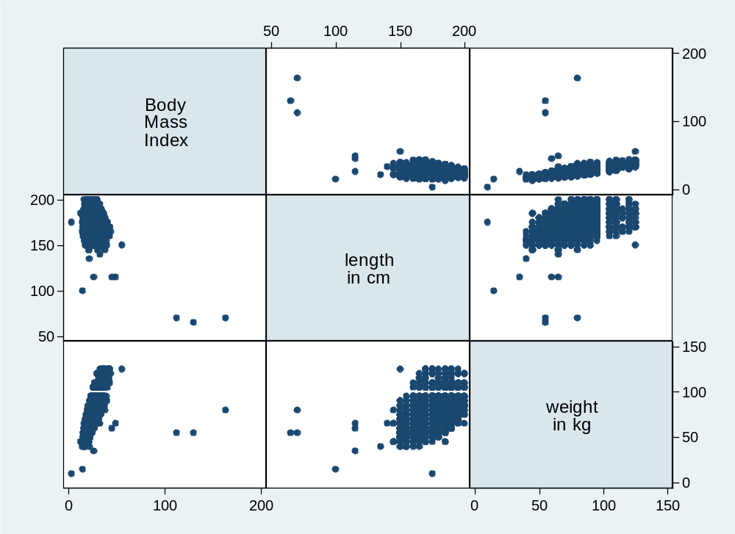
Matrix plot 1997.2 (all individuals aged ≥ 18, weight <20kg, length > 147cm).
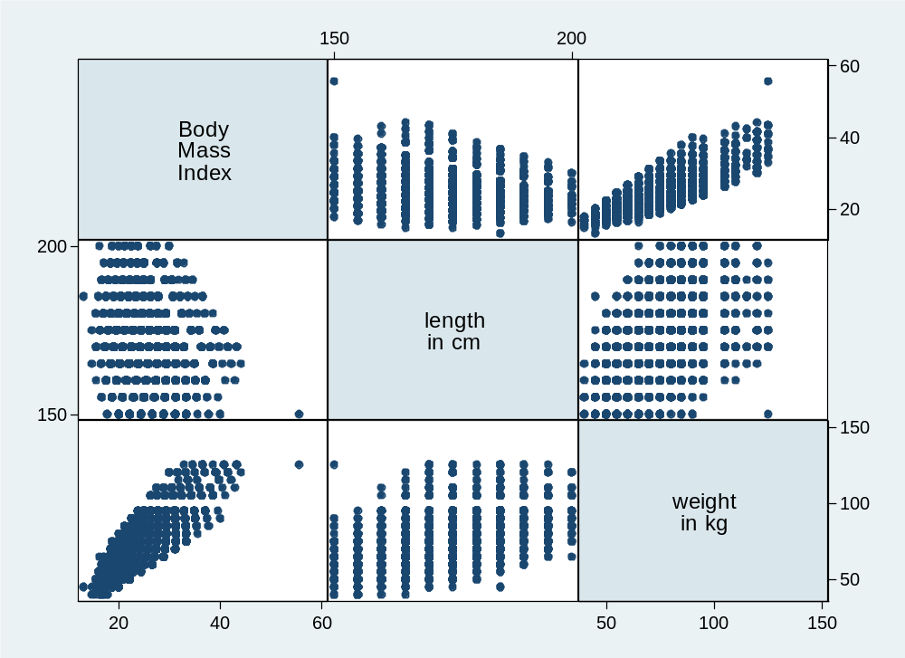
Matrix plot 1997.3 (final used in data set).
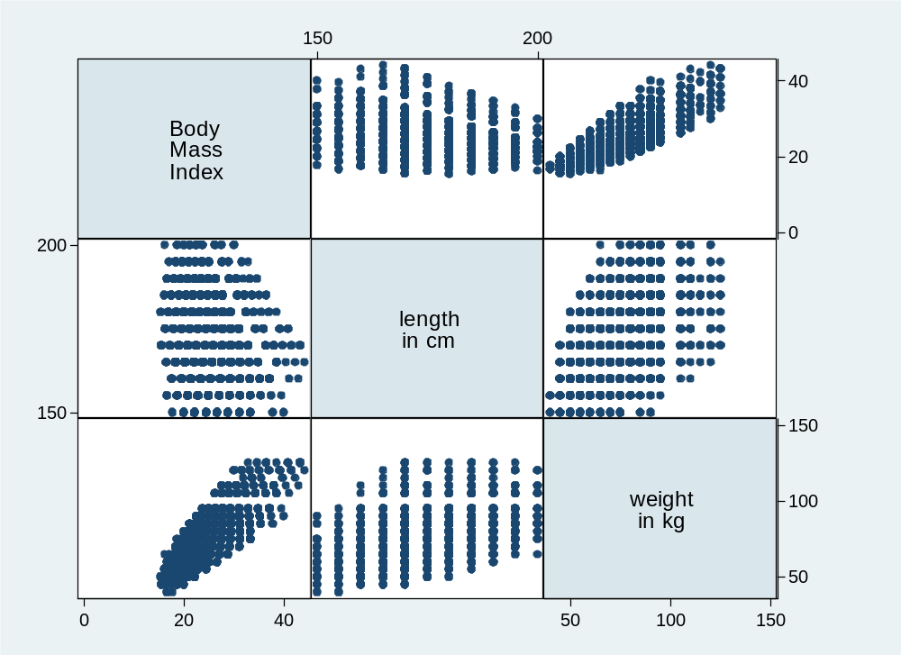

Matrix plot 1. Linearity variable restaurants.
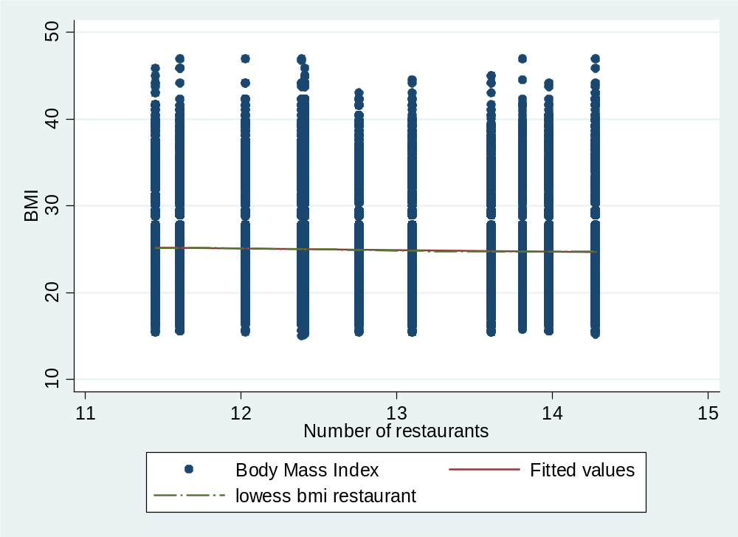

Matrix plot 2. Linearity variable fast-food price.
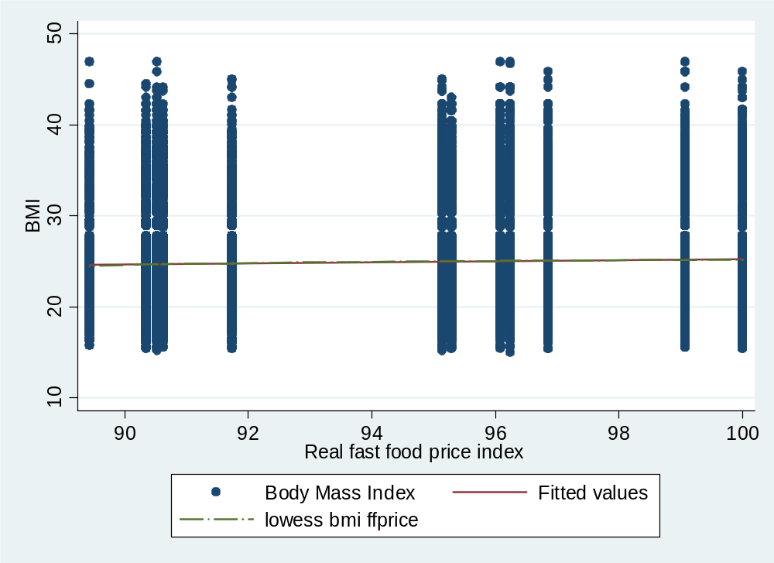

Matrix plot 3. Linearity variable full-service restaurants.
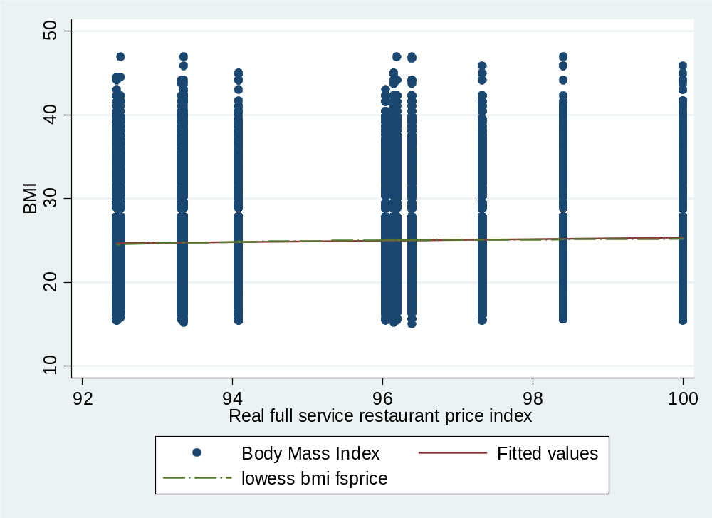
Matrix plot 4. Linearity variable food-at-home price.
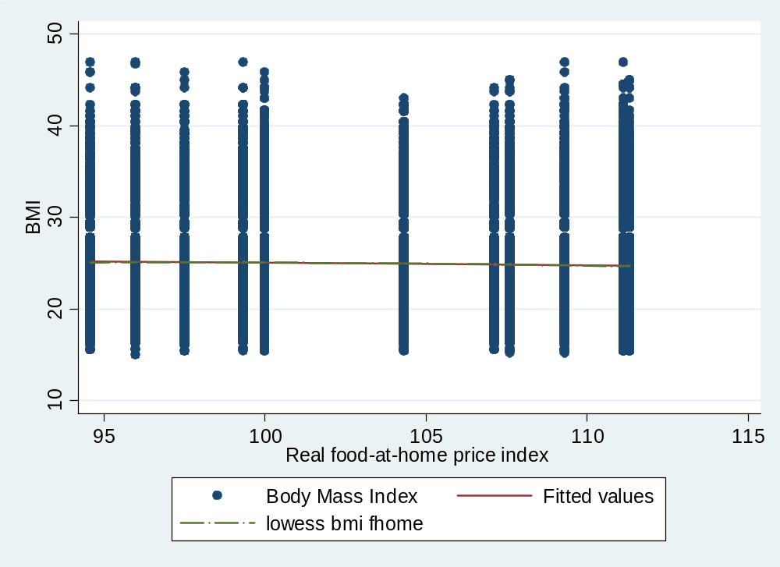

Matrix plot 5. Linearity variable cigarette price.
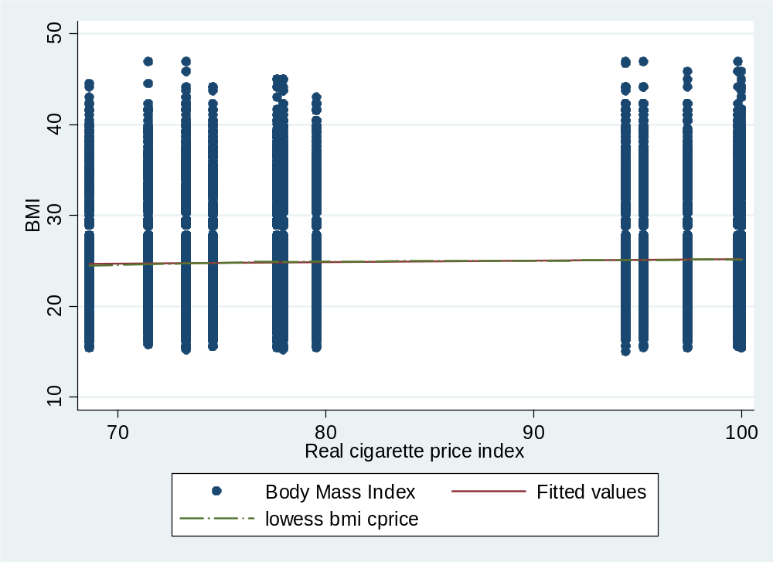
Matrix plot 6. Linearity variable price alcoholic beverages.
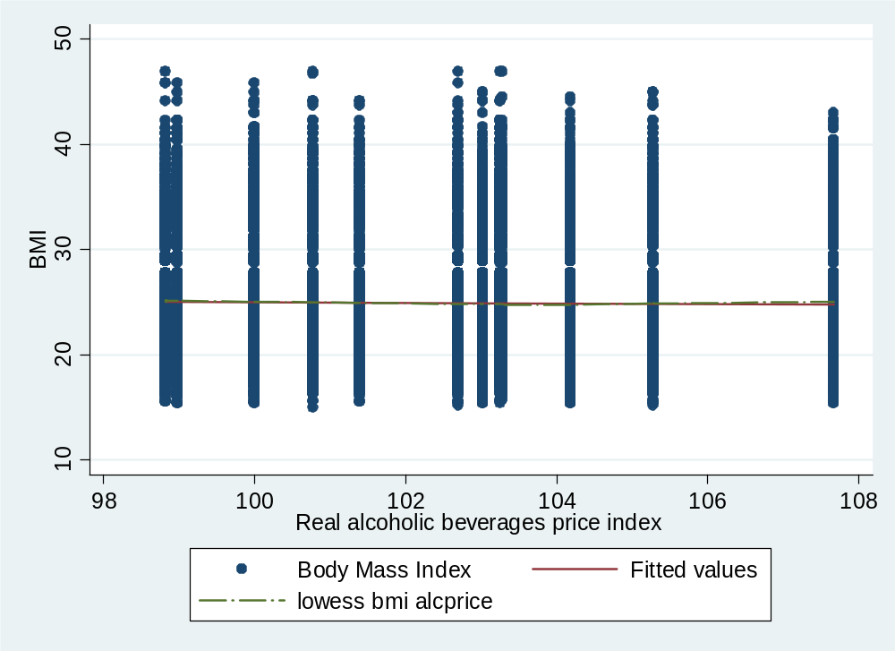

Matrix plot 7. Linearity variable age.
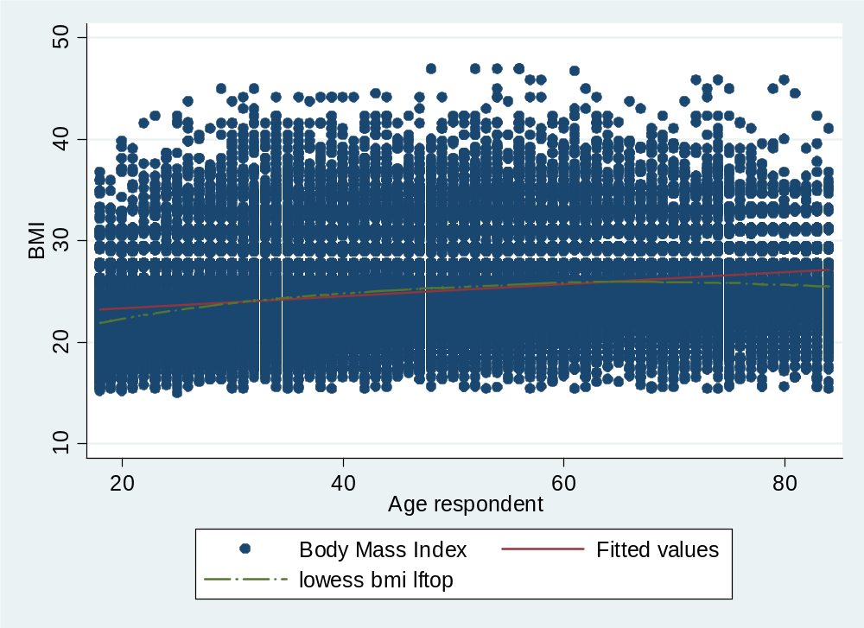
Matrix plot 8. Linearity variable paid worked hours.
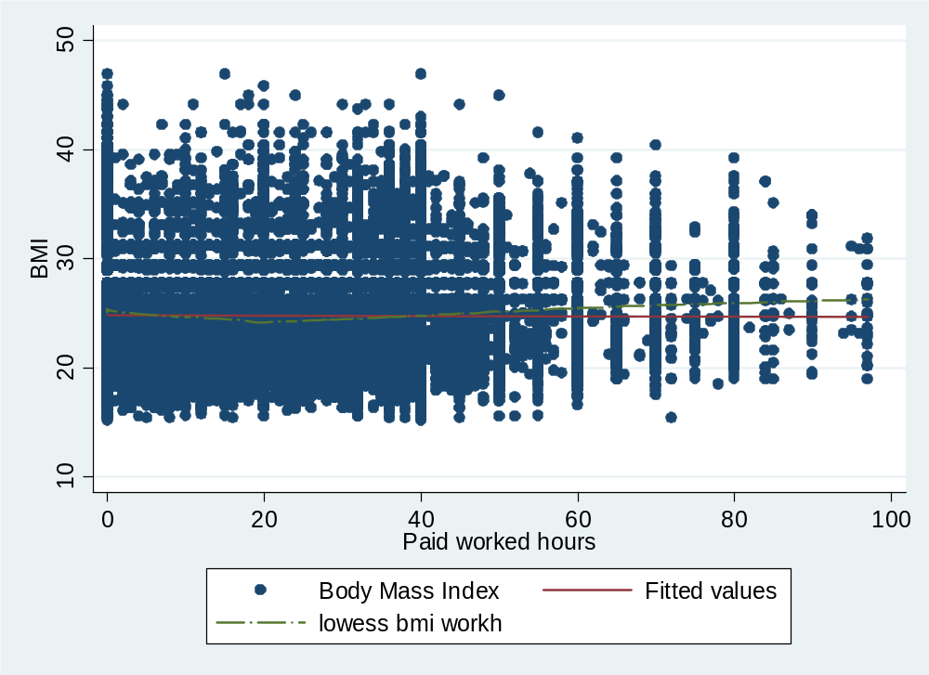

Matrix plot 9. Linearity variable weekly sport activity.
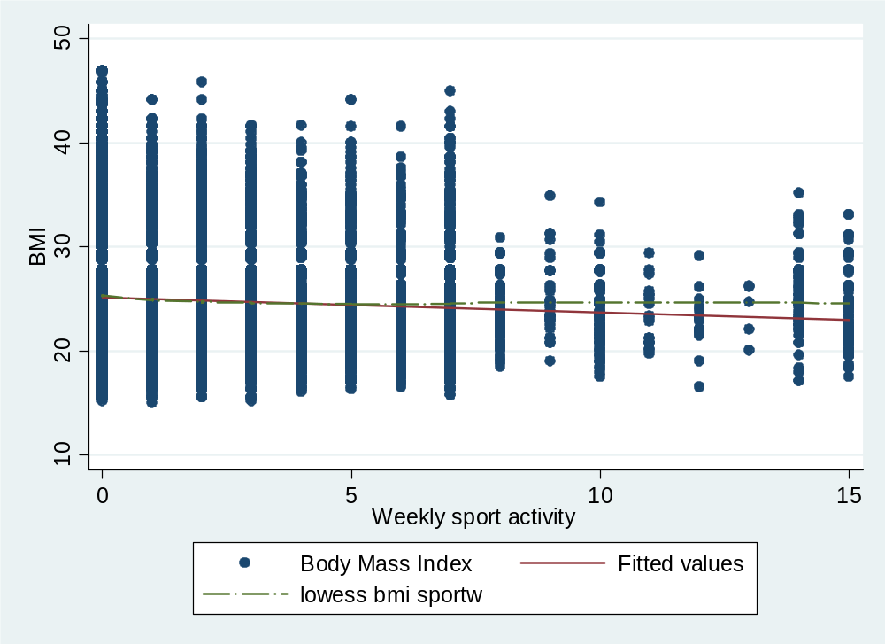
Table 1A. Quantile regression results. Male. T-statistics in parenthesis. Observations, 35965.
Variable | Quantile
Variable | 0.05 |  | 0.10 |  | 0.15 |  | 0.20 |  | 0.25
Primary education (reference)
Low education | 0,036 | (0,45) | -0,088 | (-1,01) | -0,094 | (-1,43) | -0,087 | (-1,38) | -0,170 | (-2,27)
Mid school | -0,100 | (-0,87) | -0,260 | (-1,98) | -0,244 | (-2,32) | -0,235 | (-2,06) | -0,353 | (-3,76)
High school | 0,011 | (0,14) | -0,163 | (-2,66) | -0,225 | (-3,69) | -0,233 | (-4,78) | -0,368 | (-7,61)
College | -0,256 | (-2,62) | -0,431 | (-6,47) | -0,571 | (-13) | -0,550 | (-11,64) | -0,722 | (-15,1)
Married | 0,482 | (9,15) | 0,490 | (11,07) | 0,483 | (13,57) | 0,476 | (11,74) | 0,465 | (12,88)
Age | 0,156 | (9,95) | 0,171 | (12,81) | 0,194 | (16,66) | 0,204 | (18,9) | 0,205 | (19,51)
Age^2 | -0,001 | (-6,87) | -0,001 | (-8,9) | -0,002 | (-12,2) | -0,002 | (-14,28) | -0,002 | (-14,29)
Cigarette price | 0,016 | (1,39) | 0,022 | (2,51) | 0,009 | (1,07) | 0,004 | (0,52) | 0,001 | (0,22)
Food at home price | 0,025 | (1,71) | 0,025 | (2,46) | 0,018 | (1,44) | 0,011 | (1,25) | 0,012 | (1,27)
Alcohol | -0,018 | (-1,13) | 0,002 | (0,13) | -0,004 | (-0,34) | -0,003 | (-0,24) | 0,004 | (0,31)
Worked hours | 0,009 | (1,69) | 0,006 | (1,4) | 0,007 | (1,67) | 0,004 | (1,22) | 0,009 | (2,86)
Worked hours^2 | 0,000 | (1,11) | 0,000 | (2,32) | 0,000 | (2,11) | 0,000 | (2,99) | 0,000 | (1,85)
Weekly sport | 0,292 | (7,73) | 0,195 | (4,99) | 0,147 | (4,73) | 0,109 | (5) | 0,091 | (5,29)
Weekly sport^2 | -0,037 | (-6,86) | -0,025 | (-3,74) | -0,017 | (-3,02) | -0,013 | (-3,69) | -0,011 | (-3,52)
Diabetes | 0,816 | (3,93) | 0,876 | (4,98) | 0,674 | (3,46) | 0,971 | (4,38) | 0,935 | (6,91)
Hypertension | 0,858 | (7,97) | 1,106 | (11,45) | 1,100 | (10,82) | 1,176 | (17,98) | 1,173 | (17,89)
Coronary | 0,176 | (0,54) | 0,283 | (1,14) | 0,252 | (1,53) | 0,286 | (1,85) | 0,363 | (2,59)
Time | 0,144 | (4,12) | 0,090 | (4,14) | 0,124 | (6,14) | 0,133 | (4,6) | 0,129 | (4,79)
Time^2 | -0,011 | (-4,03) | -0,008 | (-4,24) | -0,008 | (-4,9) | -0,008 | (-3,5) | -0,007 | (-3,19)
Constant | 12,862 | (4,59) | 11,224 | (5,38) | 13,725 | (5,84) | 15,077 | (6,86) | 14,979 | (7,11)

Table 1A, continued.
Variable | Quantile
Variable | 0.30 |  | 0.35 |  | 0.40 |  | 0.45 |  | 0.50
Primary education (reference)
Low education | -0,148 | (-2,07) | -0,166 | (-2,91) | -0,169 | (-2,15) | -0,188 | (-2,77) | -0,183 | (-3,15)
Mid school | -0,431 | (-4,57) | -0,410 | (-4,82) | -0,455 | (-6,05) | -0,692 | (-9,37) | -0,670 | (-6,21)
High school | -0,372 | (-10,5) | -0,359 | (-10,32) | -0,401 | (-7,56) | -0,551 | (-10,72) | -0,511 | (-11,25)
College | -0,813 | (-17,03) | -0,778 | (-15,12) | -0,794 | (-12,65) | -0,997 | (-17,31) | -1,056 | (-24,25)
Married | 0,485 | (11,2) | 0,484 | (9,34) | 0,425 | (8,53) | 0,421 | (9,62) | 0,391 | (7,63)
Age | 0,216 | (23,97) | 0,222 | (28,18) | 0,227 | (34,08) | 0,234 | (41,44) | 0,247 | (31,78)
Age^2 | -0,002 | (-17,95) | -0,002 | (-21,38) | -0,002 | (-25,46) | -0,002 | (-34,23) | -0,002 | (-26,23)
Cigarette price | -0,001 | (-0,15) | 0,001 | (0,18) | 0,004 | (0,55) | 0,000 | (-0,04) | -0,002 | (-0,26)
Food at home price | 0,013 | (1,54) | 0,014 | (2,03) | 0,016 | (1,97) | 0,016 | (1,83) | 0,018 | (2,35)
Alcohol | 0,001 | (0,08) | -0,005 | (-0,45) | 0,005 | (0,37) | 0,004 | (0,34) | 0,013 | (1,06)
Worked hours | 0,008 | (2,25) | 0,004 | (1,33) | 0,002 | (0,65) | 0,002 | (0,65) | 0,001 | (0,26)
Worked hours^2 | 0,000 | (1,57) | 0,000 | (3,27) | 0,000 | (3,56) | 0,000 | (2,88) | 0,000 | (3,21)
Weekly sport | 0,060 | (2,95) | 0,031 | (1,7) | 0,005 | (0,35) | -0,023 | (-1,33) | -0,034 | (-1,55)
Weekly sport^2 | -0,008 | (-2,13) | -0,004 | (-1,35) | -0,003 | (-1,64) | 0,000 | (0,00) | 0,000 | (-0,01)
Diabetes | 0,824 | (7,42) | 0,928 | (5,6) | 1,116 | (8) | 1,059 | (10,07) | 1,040 | (7,51)
Hypertension | 1,175 | (13,12) | 1,370 | (23,13) | 1,388 | (20,67) | 1,329 | (17,73) | 1,375 | (12,07)
Coronary | 0,278 | (3,12) | 0,259 | (2,16) | 0,165 | (1,44) | 0,190 | (1,19) | 0,312 | (1,56)
Time | 0,128 | (4,19) | 0,129 | (4,63) | 0,118 | (4,34) | 0,149 | (5,85) | 0,150 | (5,38)
Time^2 | -0,006 | (-2,48) | -0,006 | (-3,62) | -0,006 | (-2,82) | -0,007 | (-3,51) | -0,006 | (-2,53)
Constant | 15,522 | (8,48) | 16,189 | (9,84) | 15,228 | (7,79) | 15,741 | (7,33) | 14,882 | (8,16)

Table 1A, continued.
Variable | Quantile
Variable | 0.55 |  | 0.60 |  | 0.65 |  | 0.70 |  | 0.75
Primary education (reference)
Low education | -0,189 | (-2,91) | -0,180 | (-2) | -0,234 | (-2,78) | -0,167 | (-2,68) | -0,309 | (-2,74)
Mid school | -0,596 | (-7,34) | -0,665 | (-7,37) | -0,861 | (-9,67) | -0,765 | (-7,29) | -0,778 | (-4,88)
High school | -0,450 | (-11,19) | -0,508 | (-7,62) | -0,738 | (-14,33) | -0,562 | (-10,36) | -0,691 | (-7,8)
College | -1,007 | (-18,97) | -0,946 | (-12,52) | -1,207 | (-24,61) | -1,241 | (-22,91) | -1,325 | (-12,05)
Married | 0,346 | (6,11) | 0,337 | (5,69) | 0,296 | (4,65) | 0,245 | (3,72) | 0,197 | (2,56)
Age | 0,263 | (34,9) | 0,261 | (27,62) | 0,274 | (32,82) | 0,285 | (32,21) | 0,282 | (28,58)
Age^2 | -0,002 | (-28,38) | -0,002 | (-22,82) | -0,002 | (-28,46) | -0,003 | (-27,34) | -0,003 | (-23,43)
Cigarette price | -0,005 | (-0,63) | 0,005 | (0,69) | 0,004 | (0,45) | 0,009 | (0,7) | 0,010 | (0,72)
Food at home price | 0,011 | (1,17) | 0,016 | (1,62) | 0,010 | (1,04) | 0,008 | (0,63) | 0,003 | (0,25)
Alcohol | 0,014 | (1,39) | 0,021 | (1,58) | 0,025 | (1,85) | 0,027 | (1,98) | 0,028 | (2,2)
Worked hours | -0,003 | (-0,75) | -0,006 | (-1,62) | -0,007 | (-2,02) | -0,007 | (-1,73) | -0,006 | (-1,45)
Worked hours^2 | 0,000 | (3,52) | 0,000 | (4,25) | 0,000 | (4,18) | 0,000 | (3,19) | 0,000 | (3,28)
Weekly sport | -0,042 | (-2,11) | -0,080 | (-3,5) | -0,122 | (-7,43) | -0,156 | (-7,74) | -0,186 | (-7,62)
Weekly sport^2 | 0,001 | (0,46) | 0,005 | (1,59) | 0,008 | (4,42) | 0,011 | (4,71) | 0,015 | (6,7)
Diabetes | 1,185 | (9,48) | 1,190 | (9,76) | 1,349 | (9,67) | 1,411 | (7,65) | 1,376 | (6,92)
Hypertension | 1,447 | (15,64) | 1,470 | (16,58) | 1,481 | (15,44) | 1,532 | (19,26) | 1,527 | (16,13)
Coronary | 0,243 | (1,41) | 0,259 | (1,21) | 0,381 | (1,97) | 0,417 | (2,18) | 0,467 | (2,21)
Time | 0,142 | (7,9) | 0,139 | (6,76) | 0,150 | (5,69) | 0,133 | (4,06) | 0,135 | (3,23)
Time^2 | -0,005 | (-3,39) | -0,007 | (-3,58) | -0,007 | (-3,45) | -0,007 | (-2,89) | -0,008 | (-2,39)
Constant | 15,918 | (8,74) | 14,509 | (7,01) | 15,132 | (6,44) | 15,146 | (5,16) | 16,005 | (5,6)
Table 1A, continued.
Variable | Quantile
Variable | 0.80 |  | 0.85 |  | 0.90 |  | 0.95
Primary
education (reference)
Low education | -0,398 | (-3,22) | -0,320 | (-2,06) | -0,311 | (-1,73) | -0,298 | (-1,61)
Mid school | -0,925 | (-6,36) | -0,838 | (-5,48) | -1,099 | (-7,02) | -1,070 | (-4,38)
High school | -0,885 | (-9,97) | -0,849 | (-8,1) | -1,125 | (-8,25) | -1,180 | (-6,96)
College | -1,503 | (-16,09) | -1,609 | (-13,86) | -1,819 | (-16,68) | -2,053 | (-10,32)
Married | 0,150 | (2,26) | 0,119 | (1,29) | -0,052 | (-0,5) | -0,118 | (-0,73)
Age | 0,291 | (22,85) | 0,303 | (21,42) | 0,325 | (19,07) | 0,343 | (12,63)
Age^2 | -0,003 | (-18,61) | -0,003 | (-18,23) | -0,003 | (-16,44) | -0,003 | (-11,1)
Cigarette price | 0,008 | (0,59) | 0,022 | (1,32) | 0,006 | (0,39) | 0,025 | (1,03)
Food at home price | 0,007 | (0,51) | 0,008 | (0,57) | 0,005 | (0,29) | -0,010 | (-0,36)
Alcohol | 0,015 | (1,22) | 0,024 | (1,42) | 0,010 | (0,58) | 0,038 | (1,39)
Worked hours | -0,011 | (-2,72) | -0,016 | (-3,36) | -0,018 | (-2,74) | -0,019 | (-2,73)
Worked hours^2 | 0,000 | (4,27) | 0,000 | (4,55) | 0,000 | (3,51) | 0,000 | (3,44)
Weekly sport | -0,220 | (-8,33) | -0,218 | (-7,55) | -0,264 | (-5,54) | -0,336 | (-4,97)
Weekly sport^2 | 0,016 | (6,74) | 0,015 | (5,47) | 0,018 | (3,55) | 0,025 | (3,1)
Diabetes | 1,493 | (7,17) | 1,497 | (6,91) | 1,368 | (6,57) | 1,247 | (2,94)
Hypertension | 1,527 | (14,18) | 1,591 | (11,86) | 1,701 | (11,95) | 1,564 | (8,24)
Coronary | 0,406 | (1,45) | 0,701 | (2,21) | 0,784 | (2,47) | 1,337 | (3,4)
Time | 0,165 | (3,48) | 0,126 | (2,69) | 0,147 | (2,39) | 0,098 | (1,55)
Time^2 | -0,009 | (-2,95) | -0,008 | (-2,8) | -0,006 | (-1,63) | -0,008 | (-1,76)
Constant | 17,804 | (6,36) | 16,526 | (4,49) | 20,159 | (5,24) | 19,174 | (3,14)
Table 2A. Quantile regression results. Female. T-statistics in parenthesis. Observations, 35171.
Variable | Quantile
Variable | 0.05 |  | 0.10 |  | 0.15 |  | 0.20 |  | 0.25
Primary education (reference)
Low education | -0,065 | (-0,5) | -0,008 | (-0,08) | -0,076 | (-0,74) | -0,066 | (-0,81) | -0,118 | (-1,59)
Mid school | -0,153 | (-1,26) | -0,260 | (-2,77) | -0,464 | (-4,39) | -0,522 | (-5,32) | -0,550 | (-7,75)
High school | -0,138 | (-1,46) | -0,230 | (-2,46) | -0,414 | (-4,51) | -0,505 | (-6,71) | -0,569 | (-6,81)
College | -0,328 | (-2,93) | -0,488 | (-5,89) | -0,713 | (-7,99) | -0,863 | (-10,61) | -0,989 | (-11,45)
Married | 0,309 | (4,7) | 0,293 | (4,51) | 0,354 | (7,35) | 0,339 | (7,51) | 0,363 | (7,48)
Age | 0,094 | (6,17) | 0,104 | (8,17) | 0,103 | (8,12) | 0,109 | (10,73) | 0,106 | (9,09)
Age^2 | -0,001 | (-3,63) | -0,001 | (-4,85) | -0,001 | (-4,53) | -0,001 | (-5,89) | -0,001 | (-4,76)
Cigarette price | 0,010 | (0,95) | -0,012 | (-1,22) | -0,009 | (-0,96) | 0,001 | (0,17) | -0,001 | (-0,07)
Food at home price | 0,003 | (0,23) | -0,012 | (-1,02) | -0,005 | (-0,54) | -0,002 | (-0,24) | -0,006 | (-0,65)
Alcohol | 0,010 | (0,65) | -0,001 | (-0,07) | -0,005 | (-0,46) | 0,011 | (0,78) | 0,007 | (0,58)
Worked hours | 0,006 | (1,08) | 0,008 | (1,64) | 0,003 | (0,49) | 0,003 | (0,58) | 0,003 | (0,45)
Worked hours^2 | 0,000 | (-1,22) | 0,000 | (-2,2) | 0,000 | (-0,6) | 0,000 | (-0,21) | 0,000 | (0,18)
Weekly sport | 0,167 | (4,66) | 0,067 | (2,51) | 0,066 | (2,82) | 0,023 | (1,16) | 0,000 | (0,01)
Weekly sport^2 | -0,026 | (-4,5) | -0,012 | (-4,3) | -0,012 | (-3,36) | -0,007 | (-3,53) | -0,005 | (-2,48)
Diabetes | 1,219 | (5,14) | 1,156 | (6,04) | 1,158 | (6,68) | 1,473 | (7,89) | 1,632 | (10,41)
Hypertension | 1,044 | (7,39) | 1,075 | (8,56) | 1,095 | (9,81) | 1,307 | (14,24) | 1,359 | (15,5)
Coronary | -0,123 | (-0,25) | 0,021 | (0,1) | 0,184 | (0,61) | 0,080 | (0,28) | 0,370 | (0,99)
Time | 0,007 | (0,24) | 0,035 | (1,26) | 0,041 | (1,52) | 0,022 | (0,81) | 0,028 | (1,08)
Time^2 | -0,001 | (-0,25) | 0,000 | (-0,12) | 0,000 | (-0,12) | 0,000 | (-0,02) | 0,000 | (-0,16)
Constant | 14,049 | (5,69) | 19,067 | (8) | 19,102 | (10,97) | 16,797 | (11,95) | 18,213 | (16,06)
Table 2A, continued.
Variable | Quantile
Variable | 0.30 |  | 0.35 |  | 0.40 |  | 0.45 |  | 0.50
Primary education (reference)
Low education | -0,242 | (-2,4) | -0,248 | (-3,28) | -0,223 | (-3,23) | -0,322 | (-4,19) | -0,424 | (-4,23)
Mid school | -0,739 | (-7,79) | -0,708 | (-7,61) | -0,626 | (-6,46) | -0,756 | (-8,64) | -0,960 | (-8,83)
High school | -0,733 | (-7,14) | -0,794 | (-10,04) | -0,745 | (-8,62) | -0,826 | (-8,59) | -1,015 | (-9,65)
College | -1,190 | (-11,62) | -1,302 | (-17,07) | -1,317 | (-15,12) | -1,456 | (-18) | -1,607 | (-15,8)
Married | 0,327 | (7,2) | 0,310 | (6,62) | 0,313 | (5,47) | 0,358 | (6,34) | 0,347 | (6,16)
Age | 0,119 | (11,55) | 0,133 | (14,79) | 0,141 | (14,2) | 0,148 | (13,56) | 0,151 | (14,58)
Age^2 | -0,001 | (-6,52) | -0,001 | (-9,11) | -0,001 | (-9,04) | -0,001 | (-8,82) | -0,001 | (-9,45)
Cigarette price | -0,003 | (-0,28) | -0,001 | (-0,1) | 0,000 | (-0,03) | 0,001 | (0,08) | -0,002 | (-0,22)
Food at home price | -0,005 | (-0,61) | -0,005 | (-0,46) | -0,003 | (-0,27) | -0,001 | (-0,1) | -0,004 | (-0,39)
Alcohol | -0,003 | (-0,25) | -0,003 | (-0,22) | 0,001 | (0,04) | -0,003 | (-0,18) | -0,006 | (-0,43)
Worked hours | -0,004 | (-0,73) | -0,011 | (-1,81) | -0,012 | (-2,16) | -0,018 | (-3,22) | -0,018 | (-3,15)
Worked hours^2 | 0,000 | (1,11) | 0,000 | (2,05) | 0,000 | (2,22) | 0,000 | (3,39) | 0,000 | (3,46)
Weekly sport | -0,012 | (-0,61) | -0,029 | (-1,53) | -0,075 | (-3,11) | -0,122 | (-5,41) | -0,158 | (-6,24)
Weekly sport^2 | -0,005 | (-2,02) | -0,004 | (-1,77) | 0,000 | (0,11) | 0,005 | (1,58) | 0,008 | (2,25)
Diabetes | 1,851 | (7,99) | 1,845 | (13,93) | 1,879 | (9,64) | 2,112 | (8,41) | 2,106 | (9,43)
Hypertension | 1,457 | (15,73) | 1,595 | (17,97) | 1,623 | (20,61) | 1,717 | (17,89) | 1,855 | (17,73)
Coronary | 0,488 | (1,93) | 0,434 | (2,01) | 0,519 | (1,44) | 0,783 | (3,27) | 0,734 | (3,13)
Time | 0,076 | (2,07) | 0,089 | (2,49) | 0,070 | (1,79) | 0,089 | (2,04) | 0,105 | (2,6)
Time^2 | -0,003 | (-1,47) | -0,004 | (-1,94) | -0,002 | (-1,05) | -0,003 | (-1,24) | -0,004 | (-1,45)
Constant | 19,641 | (10,33) | 19,628 | (9,26) | 19,313 | (8,8) | 19,729 | (8,22) | 21,087 | (8,63)
Table 2A, continued.
Variable | Quantile
Variable | 0.55 |  | 0.60 |  |  | 0.65 |  | 0.70 |  | 0.75
Primary education (reference)
Low education | -0,361 | (-5,19) |  | -0,418 | (-4,49) | -0,603 | (-4,28) | -0,440 | (-3,53) | -0,565 | (-3,9)
Mid school | -1,005 | (-7,44) |  | -0,996 | (-7,12) | -1,286 | (-8,59) | -1,294 | (-8,28) | -1,410 | (-7,12)
High school | -1,043 | (-9,75) |  | -1,052 | (-8,53) | -1,286 | (-9,27) | -1,298 | (-10,19) | -1,346 | (-8,45)
College | -1,677 | (-18,42) |  | -1,731 | (-18) | -2,018 | (-14,83) | -2,078 | (-16,88) | -2,226 | (-13,62)
Married | 0,334 | (5,26) |  | 0,334 | (4,29) | 0,274 | (3,76) | 0,291 | (4,43) | 0,293 | (3,16)
Age | 0,164 | (15,32) |  | 0,173 | (17,1) | 0,186 | (20,38) | 0,189 | (16,09) | 0,202 | (11,7)
Age^2 | -0,001 | (-10,57) |  | -0,001 | (-12,83) | -0,002 | (-14,51) | -0,002 | (-12,23) | -0,002 | (-9,22)
Cigarette price | -0,015 | (-1,11) |  | -0,002 | (-0,12) | -0,003 | (-0,16) | 0,001 | (0,04) | 0,019 | (0,94)
Food at home price | -0,013 | (-1,01) |  | 0,002 | (0,17) | 0,007 | (0,46) | 0,006 | (0,33) | 0,016 | (0,73)
Alcohol | -0,014 | (-0,96) |  | -0,013 | (-0,76) | -0,015 | (-0,9) | -0,013 | (-0,99) | 0,018 | (1,2)
Worked hours | -0,020 | (-4,18) |  | -0,020 | (-3,48) | -0,022 | (-3,37) | -0,025 | (-4,04) | -0,027 | (-3,08)
Worked hours^2 | 0,000 | (4,53) |  | 0,000 | (3,65) | 0,000 | (3,37) | 0,001 | (4,04) | 0,001 | (3,36)
Weekly sport | -0,184 | (-5,76) |  | -0,212 | (-6,02) | -0,262 | (-5,78) | -0,276 | (-5,74) | -0,332 | (-6,15)
Weekly sport^2 | 0,011 | (2,31) |  | 0,014 | (2,56) | 0,019 | (3,09) | 0,021 | (3,6) | 0,025 | (3,63)
Diabetes | 2,202 | (6,45) |  | 2,595 | (7,38) | 2,509 | (8,65) | 3,001 | (6,97) | 3,344 | (9,66)
Hypertension | 1,910 | (15,66) |  | 2,011 | (18,99) | 2,109 | (14,43) | 2,254 | (17,6) | 2,530 | (15,85)
Coronary | 0,939 | (3,45) |  | 0,928 | (3,56) | 0,972 | (2,51) | 1,010 | (2,35) | 1,156 | (2,95)
Time | 0,130 | (3,27) |  | 0,133 | (2,93) | 0,168 | (4,05) | 0,145 | (4,12) | 0,104 | (2,76)
Time^2 | -0,004 | (-1,53) |  | -0,005 | (-1,64) | -0,007 | (-2,36) | -0,006 | (-1,9) | -0,004 | (-1,15)
Constant | 23,918 | (8,81) |  | 21,610 | (6) | 21,789 | (6,12) | 22,112 | (6,04) | 16,938 | (3,97)
Table 2A, continued.
Variable | Quantile
Variable | 0.80 |  | 0.85 |  |  | 0.90 |  | 0.95
Primary education (reference)
Low education | -0,711 | (-5,65) |  | -0,612 | (-3,4) | -0,575 | (-3,92) | -1,016 | (-5,06)
Mid school | -1,389 | (-7,66) |  | -1,297 | (-5,68) | -1,547 | (-5,62) | -2,137 | (-6,78)
High school | -1,460 | (-11,29) |  | -1,454 | (-8,12) | -1,585 | (-9,62) | -2,167 | (-12,37)
College | -2,423 | (-19,52) |  | -2,458 | (-14,45) | -2,813 | (-15,18) | -3,284 | (-14,82)
Married | 0,254 | (2,85) |  | 0,297 | (3,09) | 0,132 | (1,22) | 0,039 | (0,24)
Age | 0,227 | (12,6) |  | 0,222 | (8,89) | 0,251 | (9,26) | 0,292 | (11,43)
Age^2 | -0,002 | (-10,31) |  | -0,002 | (-7,54) | -0,002 | (-8,11) | -0,003 | (-10,8)
Cigarette price | 0,036 | (1,78) |  | 0,046 | (1,98) | 0,046 | (1,35) | 0,036 | (0,78)
Food at home price | 0,021 | (0,93) |  | 0,023 | (0,84) | 0,025 | (0,8) | 0,027 | (0,64)
Alcohol | 0,019 | (1,32) |  | 0,029 | (1,83) | 0,054 | (1,77) | 0,032 | (0,76)
Worked hours | -0,037 | (-4,38) |  | -0,042 | (-3,36) | -0,055 | (-4,28) | -0,068 | (-7,55)
Worked hours^2 | 0,001 | (4,86) |  | 0,001 | (3,8) | 0,001 | (4,38) | 0,002 | (10,84)
Weekly sport | -0,369 | (-5,73) |  | -0,455 | (-6,86) | -0,468 | (-7,19) | -0,567 | (-9,51)
Weekly sport^2 | 0,029 | (2,97) |  | 0,038 | (4,25) | 0,038 | (4,78) | 0,046 | (5)
Diabetes | 3,481 | (14,14) |  | 3,441 | (12,43) | 4,046 | (10,01) | 3,518 | (7,8)
Hypertension | 2,621 | (18,37) |  | 2,800 | (13,81) | 3,045 | (17,76) | 3,271 | (15,19)
Coronary | 0,971 | (2,61) |  | 0,783 | (2,31) | 0,354 | (0,89) | -0,214 | (-0,48)
Time | 0,105 | (2,79) |  | 0,140 | (2,25) | 0,120 | (1,28) | 0,222 | (2,39)
Time^2 | -0,008 | (-2,55) |  | -0,011 | (-2,6) | -0,007 | (-1,04) | -0,011 | (-1,71)
Constant | 15,654 | (3,42) |  | 1,476 | (3,06) | 1,319 | (1,75) | 17,703 | (1,6)

