

FEM11069 – Master’s Thesis Marketing 2011 - 2012

Master’s Thesis Marketing

“What is the optimal time to approach a customer? Exploring the effect of an employees’ time-to-approach a customer on the purchasing likelihood from a fashion retail store”

Author: Kevin Raymond Hendriksen
302118

Institution: Erasmus University Rotterdam (EUR)
Department: Erasmus School of Economics (ESE)
Marketing

Research mentor: Dr. N.M. Almeida Camacho

Institution: Erasmus University Rotterdam (EUR)
Department: Erasmus School of Economics (ESE)
Marketing

July 13, 2012

Executive summary

Marketing scholars have for long studied employee-customer interaction studied the interactions (Bitner et al. 1990, 1994), in particular the effect of such interactions on desirable performance metrics such as customer loyalty (Yim et al. 2008) and customer perceptions about service quality (Hartline and Ferrel 1996). Despite this rich academic literature, the majority of academics and practitioners believe that the effects of employee attention and interaction with customers are positive and independent of the actual timing of employee-customer approach. Yet, to date this widely held belief has not been tested empirically. This masters’ thesis therefore aims to fill this gap in employee-customer interaction literature and contribute to retail practice by examining the effect of approach timing on purchasing likelihood in a fashion retail setting. The central goal of my thesis is to develop a conceptual framework and a modeling approach that allows me to quantify the optimal timing of approach between an employee and a customer in a fashion retail setting.

Theoretical background
My research builds upon three literature streams: (1) consumer expectations from a service encounter (Parasuraman et al. 1988), (2) dynamics in consumer’ goals (Bell et al. 2011; Gollwitzer 1990, 1999; Tauber 1972), and (3) intrusiveness and interruption from irritation theories (Greyser 1973 and Li et al. 2002).

The first streams of literature offer sugget that approaching a customer will improve the customers’ perceptions about service quality, thus resulting in a higher purchasing likelihood. In addition, according to most of the second literature stream – dynamics in consumer goals (Bell et al. 2011; Gollwitzer 1990, 1999) – approaching a customer in the early stages of his shopping trip is preferable because the shopper can be influenced and persuaded more easily, by external stimuli, within these stages to do a purchase. In contrast, late approaches might be ineffective in influencing purchasing likelihood as by then the customers would’ve already made up their minds. However, some researchers studying dynamics in consumer goals (e.g. Tauber 1972) have also suggested that customer may visit stores for different motives, including gaining status and authority, which can be achieved by receiving employee attention or by effectively purchasing products or services. In such instances, employee-customer interaction can be a substitute for, rather than reinforce, a customers’ purchase intention.

Moreover, the third literature stream – on irritation and intrusiveness - suggests that- approaching a customer too early within his or her shopping trip would provoke feelings of irritation and intrusiveness as this early approach may be perceived by the consumer as an undesirable interruption of his or her shopping experience and pre-determined goals, -making them more likely to deflect.

Together these three literature streams clearly provide a theoretical basis for my main hypothesis: there is an inverted-U relationship between the timing of an employee-customer approach and the purchasing likelihood of this customer. In other words, an optimal timing of approach can be computed and will lie somewhere between an approach being too early, causing irritation, and being too late, causing this approach to be ineffective. My goal was to test this hypothesis and quantify the optimal timing for an employee-customer approach. Figure S1, below, summarizes my main hypothesis.

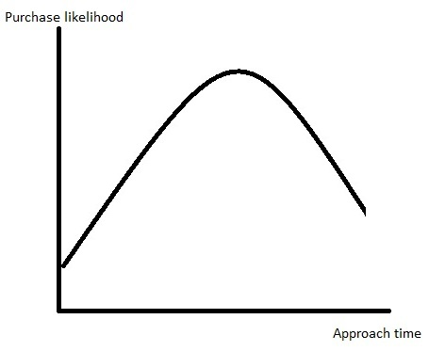
Figure S1, inverted-U relationship between employee-customer approach timing and purchasing likelihood

Empirical setting: Data and method
The data for this thesis was gathered by Around Knowledge using the innovative BIPS-technology. Data was collected in a fashion store in Braga, North Portugal. The fashion stores from this chain typically have a hip look and feel and they focus on young, life loving, energetic men and women. In the period of 14-12-2011 – 20-12-2011 and 02-01-2012 – 16-01-212 consumers were tracked by the radiofrequencies emitted by their mobile phones. The final dataset involved 9786 in-store customer observations.

The first model is focused on the direct effect of employee-customer interaction on purchasing likelihood. This model includes customer dwell time in seconds as well as dummy variables for the different store regions that a customer could have visited during his trip. To test the direct effect of employee-customer interaction on purchasing likelihood this model uses a dummy variable for employee-customer contact.

After re-specification of the contact variables the second model is focused on the moderating effect of approach timing in seconds. This model includes the same variables as the first model but in this model the dummy variable for employee-customer contact is replaced by a variable measuring after how many seconds customer contact took place and the quadratic function of customer contact in seconds.

Again after re-specification of the variables the third model is focused on the moderating effect of approach timing in 20 second intervals. In this model the employee-customer contact in seconds and it’s quadratic function are replaced by 20 second interval variables allowing for more practical implications than the optimal second approach and also acts as a robustness check for the previous model.

Since the outcome variable, purchase incidence (whether someone made a purchase or not), is a binary distributed variable all of the models are tested with the binary logistic regression.

Results
For the first model, focused on the direct effect of employee-customer interaction on purchasing likelihood, I found that when employee-customer interaction takes place during the shopping trip of the customer this negatively influences the purchasing likelihood of this customer. In fact, when employee-customer interaction takes place the purchasing likelihood of the customer drops from 11,38% to 9,74%.

In order to explore the optimal timing of approach in greater detail, I estimated a second model allowing for a quadratic effect of approach timing on a customers’ purchasing likelihood. In other words, in this model I focused on the moderating effect of approach timing in seconds. The results of my maximum likelihood estimation of this binary logistic regression indeed suggested – as hypothesized – a parabola (Figure S2) which indicates an inverted-U relationship between approach timing (in seconds) between an employee and a customer in a fashion retail store and that customers’ purchasing likelihood.

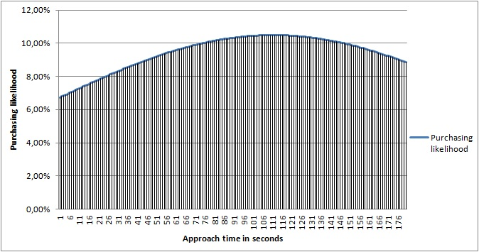
Figure S2, parabola model 2a

In the figure above we can clearly see the effect of approach timing on purchasing likelihood. We see for instance that approaching a customer within the early stages of a shopping trip results in a lower purchasing likelihood than an approach that is done in a later stage. The optimal moment of approach timing is between 107 and 116 seconds, all with a purchasing likelihood of 10,49%.

The robustness check of the third model indeed indicated that the estimated parabola in the second model is a correct visual demonstration of the effect on approach timing on purchasing likelihood, which is in line with the theoretical background described earlier.

Managerial implications
From a managerial point of view this thesis provides empirical evidence for encouraging employees to not approach a customer immediately after he enters the store. Sales floor employees should instead give customers some time to look around and therefore ‘see the merchandise.’

By approaching customers within the optimal interval of 107-116 seconds this fashion store could increase its transactions by approximately 11,11% within the group of customers who are approached at a certain time in their shopping trip, which would be around 1265 per year, per store. In monetary value this would mean that the entire brand currently is leaving 11,11% or 10,62M of possible revenue ‘on the table’ by not making the right approach timing decisions. These numbers don’t even include the 28,90% of customers who are never approached during their shopping trip.

Limitations and future research
Due to several limitations the results of this research should be interpreted with caution. For instance, a lot of unexplained variance still exists in this research meaning that the purchasing process is far more complex than proposed in this thesis. Furthermore, this thesis is written under the assumption that irritation and intrusiveness is causing customers to deflect when they are approached too early. However, since the purchasing process is very complex there could very well be other reasons than irritation and intrusiveness that is causing them to deflect.

Since this seems to be among the first of studies looking into optimal approach timing in a retail setting future research in my opinion should first be aimed to generalize the negative impact of an early approach on the purchasing likelihood. This can be done by looking at other types of retail settings (e.g. car dealership, specialty store for photo cameras) or for instance by focusing on cultural differences by doing the same research in another country.

Preface

This thesis is the final paper needed to graduate for my masters’ degree in Marketing and it is also, at least for now, the final result of years of hard work and studying. This could of course not have been possible if it wasn’t for many people always there supporting me. Therefore I would like to thank my friends and family, my parents and of course my fellow students, with in particular the student of my thesis group. There were times they were more convinced of me finishing the thesis than I was. Also they were always there to help, even if it was just to motivate me to keep going and equally important to get my mind of the thesis and relax, making it possible to see things from another perspective. Furthermore I would to thank my supervisor Nuno Camacho for his motivating words, his helpful insight but most of all his level of involvement. Talking to fellow students made me realize I should be really thankful for a supervisor with such level of involvement with his students’ masters’ thesis. Last but certainly not least I would like to thank Around Knowledge and the fashion retail store (who wishes to remain anonymous) for gathering and providing the data needed to complete this thesis.

Table of contents

1. Introduction 12
2. Theoretical background 15
2.1 Conceptual framework 15
2.2 Customer perceptions about a service encounter 16
2.2.1 Service quality 16
2.2.2 Service interaction 17
2.3 Dynamics in consumer goals 21
2.3.1 Mind-set theory perspective 21
2.3.2 Underlying shopping motives 22
2.4 Irritation effect 24
2.5 Hypothesis 25
3. Methodology 27
3.1 Data and measurement 27
3.1.1 Technology 28
3.1.2 Data collection 28
3.1.3 Data cleaning 30
3.1.4 Variables 31
3.1.5 Variable overview 32
3.1.6 Descriptives 32
3.2 Logistic regression model (Logit) 36
3.2.1 Model 1 37
3.2.2 Model 2a 37
3.2.3 Model 2b 37
3.3 Assumptions 37
3.3.1 Linearity 37
3.3.2 Multicollinearity 38
4. Analysis and results 39
4.1 Model 1 39
4.1.1 Assumptions 40
4.1.2 Goodness of fit 40
4.2 Model 2a 40
4.2.1 Assumptions 41
4.2.2 Goodness of fit 41
4.3 Model 2b 41
4.3.1 Assumptions 42
4.3.2 Goodness of fit 42
4.4 Results 42
5. Conclusions 48
5.1 Main findings 48
5.2 Managerial implications 49
5.3 Limitations and future research 52
5.3.1 Limitations 52
5.3.2 Future research 53
Bibliography 55
Appendices 59

List of figures

Figure | Name | Page
S1 | inverted-U relationship between employee-customer approach timing and purchasing likelihood | 3
S2 | Parabola model 2a | 5
1 | Conceptual framework | 15
2 | Dimensions of service quality | 16
3 | Overview literature in employee-customer interaction | 20
4 | inverted-U relationship between employee-customer approach timing and purchasing likelihood | 26
5 | BIPS technology antenna | 27
6 | Store division | 30
7 | Variable overview | 32
8a | Descriptives | 33
8b | Descriptives | 33
8c | Descriptives | 33
9 | Dwell time: purchase incidence NO | 34
10 | Dwell time: purchase incidence YES | 34
11 | Moment of contact purchase incidence NO | 35
12 | Moment of contact purchase incidence YES | 35
13 | Estimation results model 1 | 43
14 | Parabola model 2a | 45
15 | Estimation results model 2a | 45
16 | Estimation results model 2b | 47
17 | Overview missed transactions | 51

Introduction

Optimization of available resources is always an important part of a retailers’ strategy. Increasing competition from highly successful online retailers and tight economic conditions make this optimization even more important as there is little room left for mistakes and inefficiency. A large fraction of a retailers’ costs are typically spent on employees thus making the optimization of employees’ resources an important aspect of the strategy. Retailers generally believe that employee-customer interaction, by employees approaching customers within their shopping trip, increases the purchasing likelihood of customers and therefore usually hire sales floor employees with the goal of providing better sales, helping customers to find their ideal products and assist customers throughout the shopping process and thus increase sales.

However, an employee approaching a consumer might trigger different reactions depending on the timing of the approach. These different reactions could be positive as well as they could be negative merely due to the timing of the approach. When we can determine the optimal timing of approaching a customer this could result in a higher levels of purchase incidence and thus in a higher overall revenue. Despite the importance of this approaching decision, which is made dozens of time a day by each in-store employee, there is a lack of theoretical foundations and empirical evidence on the optimal timing of an employee approaching a customer. For this reason, salespeople nowadays make approaching judgments on gut feeling and company guidelines for making an approach but nevertheless, most salespeople still have difficulty in determining the optimal time to approach a customer.

In addition to the possible positive implications of early in-store consumer behavior identification on approaching decisions there seems to be no empirical evidence that an approach as such in fact results in a higher purchasing likelihood, let alone guidelines to an optimal approach time. Therefore, this thesis aims to fill the gap in employee-customer interaction literature and aims to find the optimal timing within an employee-customer approach in a fashion store retail setting.
I propose a novel conceptual framework that allows retailers to determine the optimal time for store employees to approach customers. My framework is build upon three streams of literature: (1) consumer expectations from a service encounter (Parasuraman et al. 1988), (2) dynamics in consumer goals (Gollwitzer 1990, 1999 and Bell et. al. 2011), and (3) intrusiveness and interruption from irritation theories (Greyser 1973 and Li et al. 2002). The first two streams of literature offer a different prediction for optimal approach time than the third stream of literature.

On the one hand, the first two literature streams (consumer expectations from a service encounter and dynamics in consumer goals) suggest that approaching consumers early in a shopping trip is preferable to approaching them later. Lee and Ariely (2006) and Bell et al. (2011) in particular, discuss shopping goal abstractness/concreteness. Both studies suggest that the shopping goal concreteness increases during a shopping trip and that the more concrete the shoppers goal is, the less likely it is that the shopper is to be influenced by external stimuli. This implies that consumer responsiveness to employees’ attempts to influence their purchase decision decreases as the shopping trip progresses. In other words, if an employee approaches a consumer late (vs. early) during the shopping trip, the employee will be unable (vs. better able) to influence the consumers’ purchase decision.

On the other hand, according to irritation theories, approaching a consumer to early will negatively influence the shoppers’ mood and thus have a negative effect on the purchasing likelihood of this shopper. In fact, research in advertising suggests that interrupting a customer when (s)he is completing a specific task is an important driver of consumer irritation and annoyance (Li et al. 2002). This could very well mean that interrupting someone, by for example approaching him too early, while browsing in a clothing store could have the same effect on perceived irritation and annoyance as it does in advertising. In such case, the timing of employee-customer approach could result in a lower purchase incidence.

The aim of this masters’ thesis is therefore to examine the effect approach timing on purchasing likelihood within a fashion retail setting.

This masters’ thesis is divided into four main parts. The previous literature is discussed in section two which will provide a theoretical background for the conceptual framework and hypotheses. Then, the methodology is discussed in section three, which is followed by the analysis and results in section four. In the fifth and last part of this thesis the conclusions are discussed as well as the managerial implications and recommendations for future research.

Theoretical background

The literature will cover three literature streams relevant to the optimal timing in store personnel approaching a customer in a fashion retail setting. The three literature streams that will be covered are, (1) consumer expectations from a service encounter, (2) dynamics in consumer goals, and (3) intrusiveness and interruption from irritation theories. Together these three streams of literature form a new conceptual framework focused on the dynamics of shopping behavior and motivations within a shopping trip. This conceptual framework centers around the optimal timing of approach from an employee towards a customer in a fashion retail setting.

2.1 Conceptual framework
Within this research the impact of an employee approaching a customer within a retail fashion setting on purchasing likelihood is examined, with in particular the moderating effect of the timing of the approach. The theory for the moderating effect of timing is based on (1) service encounter perceptions, (2) dynamics in consumer goals, and (3) the irritation effect through intrusiveness and allows for the following conceptual framework centered around the optimal timing of approaching a customer to be developed. This research is therefore based on the model in figure 1, conceptual framework.

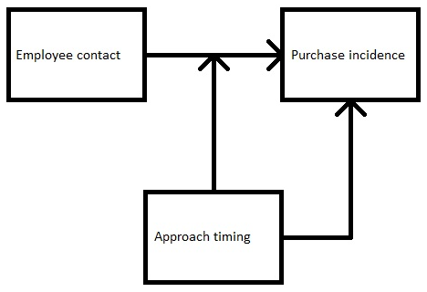
Figure 1, conceptual framework

2.2 Customer perceptions about a service encounter
In order to describe the important aspects of the service encounter it will be divided in two sub-topics: service quality and service interaction, which both have an immediate relationship with employee-customer interaction, perceived service quality and as a result of both, purchasing likelihood.

Service quality
The purchase intention of a customer, next to the actual products of a company, generally depends on the service encounter as a whole, meaning that, (1) the interaction itself needs to be agreeable and in line with the customers’ goals, and (2) the service provided by the company needs to be perceived as fulfilling. The service encounter has been studied by many researchers before. Parasuraman et al. (1985, 1988) for instance initially discovered ten dimensions of service quality (1985) which they later reduced to five independent dimensions of service quality (1988) that all directly relate to human interaction, see figure 2, dimensions of service quality:

Dimension | Explanation
Tangibles | The appearance of physical facilities, equipment, personnel, and communication materials
Reliability | The ability to perform the promised service dependably and accurately
Responsiveness | The willingness to help customers and provide prompt service
Assurance | The knowledge and courtesy of employees and their ability to convey trust and confidence
Empathy | The provided care and individualized attention of the firm and employees to its customers
Figure 2, dimensions of service quality

In regards to the timing of the employee approaching a customer this can for instance have the following consequences. On the one hand, when an employee approaches a customer too early this may be able to conflict with the customers’ goal of uncertainty reduction and therefore be perceived as intrusive, signaling a lack of courtesy and even low levels of empathy. On the other hand, when an employee approaches a customer too late this will most likely not result in perceptions of intrusiveness but this can for instance signal that the company lacks the ability to deliver the promised service dependably and accurately or that the company is not willing to provide prompt service, resulting in customers’ perceptions of low responsiveness and low reliability. Therefore an approach that is done too early as well as an approach that is done too late could result in a lower than optimal purchasing likelihood.

The service encounter and the service process as a whole also suffer and benefit from the level of personalization of the service process. Surprenant and Solomon (1987) for instance studied two conflicting goals when designing service delivery systems, (1) efficiency and (2) personalization. Their findings support the assertions that, (1) service personalization is a multidimensional construct, (2) all forms of personalization do not necessarily result in more positive evaluations of the service encounter and that, although this is more or less intuitive as well, (3) the degree of personalization desired by the customer is strongly dependent on the type, depth and importance of the service (Suprenant and Solomon 1987).

2.2.2 Service interaction
Interaction is considered an important part of the delivered service. It is therefore not surprising that the employee-customer interface is argued to be the most important in terms of enhancing service quality (Bowen and Schneider 1985), (Hartline and Ferrel 1996). Interaction in service encounters and the employee-customer interface has also been examined by many researchers before, again underlining the importance of the employee-customer interface. Bitner et al. (1990, 1994) for instance have studied specific events reported by customers (1990) and by employees (1994) during employee-customer interaction and whether these events resulted in the perception of a satisfying or a dissatisfying service from a customers’ point of view (1990) and from an employees’ point of view (1994). These specific event included employees’ response to service delivery failure, employees’ response to customer needs and requests and unprompted and unsolicited employee actions. They concluded that these interactions, positive as well as negative, can seriously influence customers’ quality perceptions of the delivered service.

Hess Jr. et al. (2007) on the other hand aimed their study to investigate customer responses to interactional failures (i.e. rudeness, unfriendliness) and the effect on the customers’ view of the company in a pseudorelationship. A pseudorelationship is described as a relationship between customers and a firm where customers repeatedly have contact with the firm, but with different employees every time, therefore making it harder to facilitate a employee-customer bond as such. They found that the more severe the rudeness or unfriendliness was the less likely this was to be generalized to the rest of the company.

Hartline and Ferrel (1996) tried to capture perceptions and judgments across managers, employees and customers and link them together in a single study aimed to enhance the delivery of service quality. They describe the influence of dimensions like self-efficacy, job satisfaction, role ambiguity, adaptability and empowerment the employee-customer interface. Within the employee-customer interface they found that employee self-efficacy and job satisfaction increases customers’ perceived service quality. Confident and satisfied employees are better motivated to deliver good service quality (Hartline and Ferrel 1996). Previous research has show that when employees’ self-efficacy increases their performance increases as well, resulting in higher customer quality perceptions (Earley 1994). A reason for this could be that when employees are confident of their abilities they are more likely to act proactively and persistent and put in a greater effort to please the customer (Hartline and Ferrel 1996).

In further regards to the employee-customer interface Yim et al. (2008) studied employee-customer relationships, customer-firm affection and whether affect transferability takes place among fast-food and hair salon services. Loyalty created by interaction is found to differ among sectors. A hair dresser for example can create a stronger loyalty bond through his/her performance as this is a key characteristic of the delivered service whereas a fast food employee is less able to establish a loyalty bond because his performance is not a key characteristic of the taste of, for example, his Big Mac (Yim et al. 2008). The positive findings for affect transfer imply that strong customer-staff relationships benefit customer-firm relationships. The positive relationship build up by employee-customer interaction during the service encounter is transferred from the employee towards the entire organization resulting in a positive attitude towards the organization, thus increasing purchasing likelihood (Yim et al. 2008).

The importance of the employee-customer interface is underlined by the numerous studies done in regards to employee-customer interaction by for example Hartline and Ferrel (1996), Yim et al. (2008), Bitner et al. (1990 & 1994), Hess Jr. et al. (2007), Schneider (1980), Shamir (1980), Folkes and Patrick’s (2003). However, in literature so far no one has looked at approach timing and therefore there is still a gap in literature regarding purchasing motivation dynamics from the moment the customer enters the store until he leaves the store or makes an eventual purchase. Interacting at the right time is crucial for customers to develop a favorable attitude towards the product, the store and the shopping experience as a whole, resulting in a higher purchasing likelihood.

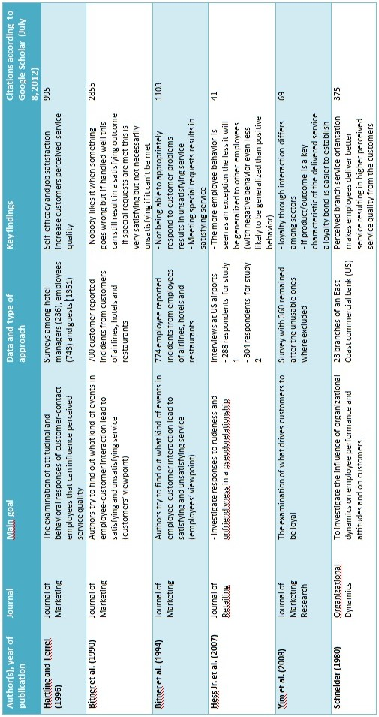
Figure 3, overview literature in employee-customer interaction

2.3 Dynamics in consumer goals
The second part of the literature review, dynamics in consumer goals is also divided into two parts. Part one describes the mind-set theory and how consumers goals change over time during a shopping visit and part two describes the underlying shopping motives consumers might have and how fulfilling this needs might influence their purchase decision.

2.3.1 Mind-set theory perspective
The mind-set theory states that shoppers have two phases in the shopping process. In the first phase, the deliberative phase, consumers are uncertain about their goals, they are in a deliberative mind-set and seek to define ‘a desired performance or outcome.’ In the second phase, the implemental phase, consumers have already established their goals and switch to an implemental mind-set where they pursue to achieve this goal (Gollwitzer 1990, 1999). The deliberative phase could very well be compared to the abstract goal effect described by Bell et. al. (2011) which makes consumers more vulnerable to external stimuli because they have not yet made up their minds about their shopping goals, in other words, while their shopping goals are still abstract. When customers still have abstract shopping goals they are more likely to be influenced by external stimuli, like for example being approached by an employee, thus resulting in an increased chance of buying when being approached by an employee.

These findings are supported in a study about the effect of coupons on people with low and high levels of shopping goal concreteness by Lee and Ariely (2006). Consumers in the deliberative phase of the earlier described mind-set theory, where shopping goals are more abstract, are more easily influenced by promotional activities (i.e. coupons) which means that conditional coupons can influence the amount of money spend, where higher minimum spending coupons tend to make people spend more, and lower minimum spending coupons tend to make people spend less (Lee and Ariely 2006). This same effect was found for conditions of amount of products to be bought in order to use the coupon. When time goes by during a shopping trip the more concrete, or in other words the less abstract, consumers’ shopping goals generally become (Lee and Ariely 2006). The effect of the conditional coupons is also largely diminished when they are handed out within the store instead of to the people who are yet to enter the store, which implies that when the shopping trip becomes longer the goals become more concrete. This means that when the time of the shopping trip increases it would get harder for external stimuli, for example an employee approaching a customer, to persuade a customer to do a purchase. The mind-set theory in the shopping process would therefore imply that an approach that is done too late, during the implemental phase of the mind-set theory and when shopping goals are more concrete, leads to an inefficient approach that is not necessarily good nor bad in regards to influencing purchasing likelihood.

2.3.2 Underlying shopping motives
Tauber’s (1972) research towards consumers’ underlying motives to shop suggest that consumers’ motives to go shopping are a function of many variables, some of which are unrelated to the actual buying of products. The results of his study concerning in-depth interviews suggest that consumers’ underlying motives can either be personal, social or a combination of both. The underlying motives suggest that consumers gain satisfaction from other aspects than the actual purchasing of products itself. The findings that consumers also use shopping as a leisure activity are supported by slightly more recent papers by Bellenger and Korgaonkar (1980), Bellenger et al. (1977) and Korgaonkar (1981). These shoppers’ categorized as recreational shoppers’ are a large proportion of all shoppers. Even if all non-respondents fell in the category of economic shoppers’ they would still account for 37% of Bellenger and Korgaonkar’s (1980) sample.

One of the most interesting motives for shopping Tauber (1972) discusses for this particular study is the social motive that consumers like to receive status and authority. Consumers love the attention they get from store personal while store personal is trying to compete for the business a consumer might bring them. This love or need for attention from a consumers’ perspective is a reason for them to considerably postpone the actual purchase (Tauber 1972), resulting in wasted time from some of the stores resources like store employees’ time. This is an interesting aspect of the underlying motives for consumers’ to go shopping because this could mean that when a customer who is approached too early would satisfy this need very easily which could make them postpone the purchase until they go shopping again, or somewhere else. Approaching a customer too late, or not at all however could very well result in this customer feeling neglected or ignored which could also harm the purchasing likelihood of this customer, thus again underlining the importance of an optimal timing of approach.

Then we also have Jarboe and McDaniel (1987) who examined browsers in regional shopping malls and, as a result of their research, argued that it would be wrong to assume browsers are simply window-shopping and do not intend to make a purchase. Instead of making this assumption they argued that browsers are not making a special trip with the intention of making a specific purchase but that people who browse are most likely on a trip with a number of possible purchases in mind, not all of which have to be completed on the current trip (Jarboe and McDaniel 1987). In relation to the mind-set theory and shopping goal concreteness this would mean that people who browse are in a deliberative mind-set and have fairly abstract goals during their shopping trip which would imply they are more easily influenced by external stimuli, like an employee approaching them, in the early stages of their shop visit.

2.4 Irritation effect
There does not seem to be any research on irritation- or annoyance effects in a retail setting. In particular, after a careful search of marketing literature, I could not find any research concerning irritation- or annoyance effects related to employee-customer interaction. However, there are several studies on this phenomenon within the field of advertising. Looking at irritation and annoyance in advertising provides us with a better understanding of the irritation and annoyance effect and also a possible theoretical background in regards to the optimal timing in employee-customer approaches within a retail environment.

Previous literature in advertising (Bauer and Greyser 1968, Greyser 1973, Aaker and Bruzzone 1985, Li et al. 2002, and Edwards et al. 2002) examined irritation and annoyance on viewers of a diversity of advertising media. Greyser (1973) for example discusses irritation and annoyance in advertising with television advertising (commercials) in general. He states that, (1) dislike of advertising generally leads to erosion of goodwill, and more speculatively that, (2) dislike of advertisements specific to an industry or company may reduce short-range and particularly long-range effectiveness of that advertising. Consumer annoyance and offense over advertisements comes from multiple reasons with the largest cluster being irritation itself, intrusiveness in particular (Bauer and Greyser 1968, Greyser 1973, Edwards et al. 2002). Li et al. (2002) examined the consumers’ perceptions of intrusiveness in advertisements. They developed and tested a scale to determine the underlying construct of the intrusiveness in advertisements that had not been previously measured. “Intrusiveness is a common complaint of advertising practices that interrupt the goals of consumers in traditional media.” Li et al. (2002, p. 37). Intrusiveness is thus a perception or psychological consequence that occurs when someone’s’ cognitive processes are being interrupted (Li et al. 2002).

The effect of interruption in TV programs is also said to be one of the main reasons for feelings of annoyance and irritation to arise because the proportion of advertisements on TV is much lower than in magazines but the stated irritation and annoyance is much higher (Greyser 1973). Irritation from interrupting the viewers’ goals, i.e. watch their show, most likely comes from the ability to skip advertisements in magazines more easily than advertisements on TV (internal pacing vs. external pacing). It is therefore very likely that not the advertisement itself is perceived as intrusive, but that the advertisements are merely interrupting the goals of the viewers which is perceived as intrusive (Li et al. 2002). This would imply that when the goals of a consumer are interrupted in a retail setting the same effect could arise, which is more likely to happen within the early stages of a shopping trip as customers are for example still processing the stores’ atmosphere, the stores’ merchandise and the location of the products. The result of an early approach within a store visit is that customers could become irritated and are therefore more likely to deflect instead of making a purchase. As time goes by during a store visit the feelings of interruption, and therefore intrusiveness, of an approach are expected to be replaced by perceived feelings of the employees being helpful and willing to offer a good service, making a later approach more positive.

2.5 Hypothesis
Bringing the three literature streams together, namely (1) service encounter perceptions, (2) dynamics in consumer goals, and (3) the irritation effect through intrusiveness allows for the following hypothesis to be developed in regards to the optimal timing of employee-customer interaction.

An employee approaching a customer is able to provide the customer with extra information and could, with his expertise, also ‘close the deal.’ It is therefore expected that employee-customer interaction will have a positive direct effect on purchase incidence.

H1: Employee-customer contact leads to a higher purchase incidence than when no employee-customer contact occurs.

Interrupting consumers or interfering with consumer goals in the early stages of a shopping visit could provoke perceived feelings of irritation and intrusiveness causing the customer to become annoyed. These feelings of irritation are therefore expected to make this customer decide to deflect instead of making a purchase.

H2: An employee-customer approach that is done ‘too early’ is less effective in terms of purchasing likelihood than the optimal moment due to the effect of irritation and intrusiveness on a customer in a shopping trip.

When a shopping trip increases in length a customers’ goals slowly become more and more concrete resulting in approaches that are done too late within the shopping trip in being inefficient and not being able to persuade a customer to make a purchase but also not very likely to make this customer more prone to deflecting.

H3: An employee-customer approach that is done ‘too late’ is an inefficient approach that doesn’t influence purchasing likelihood in a positive nor negative way.

According to the described literature it clearly makes sense to assume there is a difference in purchasing likelihood for different employee-customer approach times within a shopping trip. Based on this literature an inverted U-relationship is hypothesized (figure 4, graphical display of hypothesis).
Figure 4, inverted-U relationship between employee-customer approach timing and purchasing likelihood

Methodology

3.1 Data and measurement
Some researchers have made claims that although consumer behavior studies cover a wide range of methodologies measurement of actual in-store behavior using new technologies, like for example RFID, is what the industry has been waiting for as this would allow researchers to track actual behavior and not self-stated behavior (Grewal and Levy 2007). The relevance of measuring what you want to measure is also underlined by researchers from fields like advertising (Briggs 2006). This thesis is based on data captured by radio frequencies emitted by mobile phones which allow for even more precise analysis than RFID tags in shopping carts and shopping baskets. Next to the data being more precise, the technology is also a lot cheaper to use. With a standard computer and three antennas (20x8x2cm) (Figure 5, BIPS technology antenna) this technology is able to cover an area of 150m².

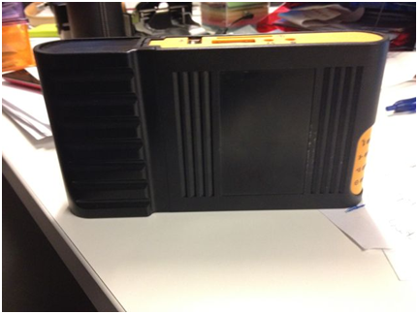
Figure 5, BIPS technology antenna

The collection and aggregation of data for this thesis was done by an external company called Around Knowledge (AK). AK is young Portuguese startup specialized in business analytics and was founded in May 2009 by three university researchers who saw the possibility of combining the academic world with the industry.

3.1.1 Technology
Existing shopping path analysis studies have so far used anonymous RFID-tags affixed to shoppers’ shopping- carts or baskets to determine consumer in-store behavior (Larson et. al. 2005; Hui et. al. 2009a; Hui et. al. 2009b). AK’s technology, called: ‘BIPS,’ allows shopping path data to be recorded based on shoppers’ cell phones. BIPS-technology, which is an award winning technology using radio frequencies emitted by mobile phones and is therefore able to accurately track in-store behavior with a precision of <0,2m by using one of the compatible radio frequencies emitted by mobile phones like GSM, Bluetooth, Wi-Fi, and CDMA. This innovative technology is used to passively collect real-time in-store behavior while preserving the customers privacy. The main advantages of this technology over RFID tags is that this technology tracks radio frequencies emitted by an item from the shopper, and not a shopping cart which could be left and picked up at will. This makes the data far more accurate and it also allows the technology to be used in retail stores where shopping carts and shopping baskets are not used.

3.1.2 Data collection
The data for this thesis was collected in a fashion store in Braga, North Portugal. The stores of this brand typically have a hip look and feel and they focus on young, life loving, energetic men and women.

It is worth noting that in this context, a jeans store, shoppers do not carry shopping baskets nor do they use a shopping cart which makes this dataset fairly unique as RFID tags would not allow for data collection in these kind of stores. In fact, to the best of my knowledge, this thesis is among the first studies, if not the very first, to analyze in-store consumer behavior in an non-intrusive way in fashion retailing with the employee-customer interaction in particular.

In the period of data collection, 14-12-2011 – 20-12-2011 and 02-01-2012 – 16-01-2012, sensors/smart meters where placed within the store to capture and sent the shopping patterns to the server in real time. When someone carrying a mobile phone entered the store this person was tracked throughout their entire visit. After the data collection, AK aggregated and derived several variables from the raw data. During the period of data collection 12115 observations were recorded.

For the sake of analysis the store was divided into several sections. The store division can be seen in figure 6, store division.
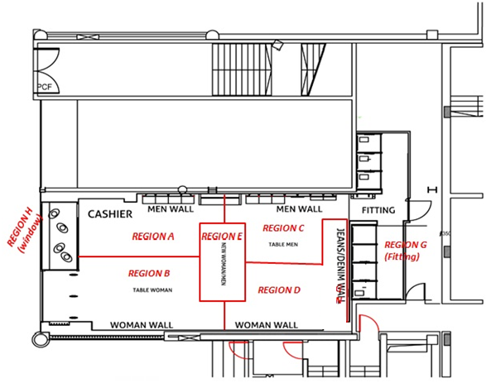
Figure 6, store division

3.1.3 Data cleaning
Observations from people who only visited section H (store-window), 2048 in total, were deleted before the analysis as there was no opportunity for them to be approached by an employee. Another 112 observations were deleted due to (partial) incompleteness or because they were wrongly coded in the data. 9 observations were deleted due to the fact they had a recorded purchase but were in the store less than 30 seconds, which is impossible if they had to be in the checkout area for more than 30 seconds in order to be counted as a purchase. 1 observation with a dwell time of 0 seconds was deleted because this person obviously has not been inside the store. Another 44 observations were deleted because they had reported employee contact within 0 seconds, which is highly unlikely.

Next, 115 univariate outliers in the variable DWELLSEC were detected by using the standard scores computed in SPSS. All outliers detected within this variable had a standard score of 3.0 or higher, and therefore an unusual high dwell time, and were deleted from the dataset. There were no univariate outliers detected within the variable CONTACTSEC. There were also no multivariate outliers detected using Mahalanobis D² between these variables. After general data cleaning and outlier detection there were still 9786 observations left to analyze.

3.1.4 Variables
While deriving variables from the raw path data AK used the following methods in order to measure the different variables.

Buy/purchase incidence: When a person spends more than 30 seconds in front of the check-out this is registered as a purchase and is then coded as either a 0, meaning purchase NO or a 1, meaning purchase YES. The 30 second rule was used after a test and was designed to filter out whether someone was just asking a question at the check-out.

Employee contact: When a person was not approached by an employee this is coded as NONE, meaning not approached by an employee. However, if a person was approached the value represents the time a customer spend in the store before being approached. By transforming the data from minutes + seconds into seconds both notations can be used in the analysis. A dummy variable for employee contact was also created 0 meaning a customer was not approached and 1 meaning a customer was approached. Finally a 20 second interval categorical variable has also been created for employee contact to aggregate the observations into 20 second interval in terms of approach time (Category 1 = 0-20 seconds, category 2 = 21-40 seconds, etc.).

Dwell time: The measurement of dwell time is rather straightforward and started the moment a person entered the store until (s)he left the store again. By transforming the data from minutes + seconds into seconds both notations can be used in the analysis.

Region variables: The region variables are coded with either a 0, meaning this region was not visited or only used to pass through, or a 1, meaning this region was visited. A region is only coded as 1, visited, if a person spend more than 12 seconds in this region. This 12 second rule was used after a test and designed to make sure that when people are merely passing through a region are not coded as a 1.

An overview of the variables used for this particular study are described in figure 7, variable overview

3.1.5 Variable overview
Variable | Type | Variable name | Explanation | Method | Coding
Dwell time | Independent | DWELLTIME | Time spent in store | Time from entering store until leaving the store | Minutes and seconds notation
Dwell time in seconds | Independent | DWELLSEC | Time spent in store in seconds | Dwell time transformed into seconds notation | Seconds notation
Buy | Dependent | BUY | Purchase incidence | More than 30 seconds at checkout is registered as a purchase | 0 = No  1 = Yes
Employee contact | Independent | CONTACT | If approached by employee, time of approach | Time spent in store before being approach by an employee (if approached, otherwise NONE) | Minutes and seconds notation
Employee contact in seconds | Independent | CONTACTSEC | If approached by employee, time of approach in seconds | Employee contact transformed into seconds notation | Seconds notation
Employee contact categories | Independent | CONTACTINTERVAL | Employee contact in 20 second intervals | Employee contact transformed into intervals of 20 seconds | 0 = No approach,  1 = 1 – 20 seconds,  2 = 21 – 40 seconds, etc.
Employee contact dummy | Independent | CONTACTDUMMY | Employee-customer contact yes or no | Dummy variable from employee contact, 1 if a time was noted, 0 if there was contact | 0 = No  1 = Yes
Region variables | Independent | A, B, C, D, E, (G: Fitting room, H: store window) | Region visited yes or no | Dummy variable | 0 = No  1 = Yes
Fitting room dummy | Independent | FITROOM | Visited fitting room yes or no | Dummy variable | 0 = No  1 = Yes
Figure 7, variable overview

3.1.6 Descriptives
Figure 8a and figure 8b both give some insight on what the dataset looks like. In figure 8a we can see how DWELLSEC and CONTACTSEC are distributed. We see for example that the average dwell time is 927 seconds. The average time for customers to be approached by an employee is almost 91 seconds. (appendix 14, descriptives)
Variable | N | Min | Max | Mean | Standard deviation
DWELLSEC | 9786 | 1 | 2758 | 927,07 | 561,373
CONTACTSEC | 6958* | 1 | 179 | 90,63 | 51,960
*Not approached don’t have CONTACTSEC Figure 8a, descriptives

In Figure 8b we see how many people visited the different store locations with region B being most popular, possibly because this is also the region were they enter the store and are recorded as a region visit if the customers were there for more than 12 seconds. Surprisingly more than half of the customers are recorded to go to the fitting room (57,4%). (appendix 14, descriptives)

Variable | N | People visited | % of people visited
Region A | 9786 | 5022 | 51,3%
Region B | 9786 | 9236 | 94,4%
Region C | 9786 | 3583 | 36,6%
Region D | 9786 | 7265 | 74,2%
Region E | 9786 | 6178 | 63,1%
Fitroom | 9786 | 5615 | 57,4%
Figure 8b, descriptives

Figure 8c displays the total number of purchases (925) as well as the number of purchases for people who were (637), and weren’t approached (288). Also the number of customers who were approached at some point during their shopping trip and who were not approached during their shopping trip can be seen in this figure.

 | Purchase incidence (NO) | Purchase incidence (YES) | Total
Employee-customer interaction (NO) | 2540 (26%) | 288 (3,9%) | 2828 (29,9%)
Employee-customer interaction (YES) | 6321 (64,6%) | 637 (6,5%) | 6958 (71,1%)
Total | 8861 (90,6%) | 925 (10,4%) | 9786 (100%)
Figure 8c, descriptives
Figure 9 and 10 respectively give a graphical display of the dwell time for customers who didn’t make a purchase (Figure 9) and customers who did make a purchase (Figure 10). The observations are aggregated to dwell time in minutes (rounded to the closest full minute).

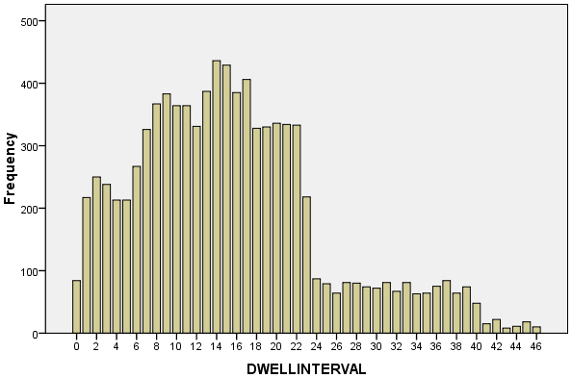
Figure 9, dwell time purchase incidence NO

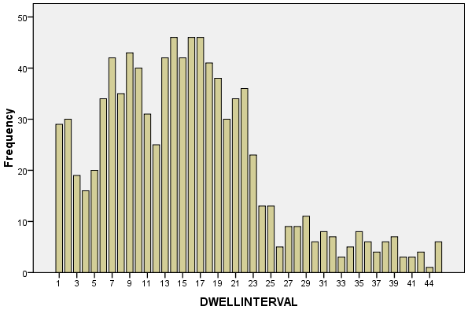
Figure 10, dwell time purchase incidence YES

Figure 11 and 12 respectively give a graphical display of the contact intervals in which the customers were contacted for customers who didn’t make a purchase (Figure 11) and customers who did make a purchase (Figure 12). For both bar charts the intervals of 20 seconds each (as described earlier) were used. From the customers who didn’t make a purchase 6321 were approached and 2540 were not approached by an employee. From the customers who did make a purchase 637 were approached and 288 were not approached.

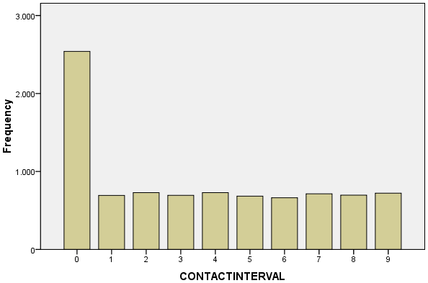
Figure 11, moment of contact purchase incidence NO

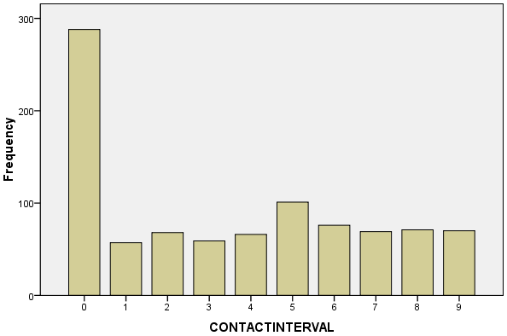
Figure 12, moment of contact purchase incidence YES

3.2 Logistic regression model (Logit)
The model for the analysis of the binomially distributed dependent variable, purchase incidence, is the logistic regression model also known as the logit model. In this research the logistic regression model is used to predict whether a person will either make a purchase or not (purchase incidence Yes/No) based on the independent, or so called ‘predictor’ variables. In order to describe a certain model as discrete choice set it must fulfill three requirements (Train 2009):

- The decision maker, in this case the customer, chooses one alternative which automatically implies he is not choosing the other options.
- All possibilities must be included, and therefore the customer can’t choose any other option than the ones presented to him.
- The number of options must be finite.

The probability whether a customer decides to make a purchase or not is a function of latent utility. The customer will only decide to make a purchase if the utility of purchasing for this particular customer is higher than the utility of not purchasing. The utility of customer ‘i’ making a purchase at store ‘s’ is as followed: U_{is} = V_{is} + ε_{is} where error term ε_{is} is an independently, identically distributed extreme value, also referred to as type I extreme value.

The general equation for the logistic regression model as described by Field (2009) is then derived after some algebraic manipulation of the above given formula (Train 2009) and is as followed: $P\left(Y\right)= \frac{1}{1+e^{-(β0+β1X1+β2X2+…+βnXn)}}$

In this model P(Y) is the probability of Y occurring with e being the base of natural logarithms. The outcome of this equation will always be between 0 and 1, where 0 theoretically means that the probability of Y occurring is non-existent and 1 theoretically means that the probability of Y occurring is certain.

As mentioned earlier, this study aims to find the optimal timing for approaching a customer in a retail fashion setting, therefore the following models are used to estimate the influence of approach timing on purchase incidence.

3.2.1 Model 1
To test H1, whether employee-customer contact in fact increases purchasing likelihood we use the following model: $Pi\left(Y\right)= \frac{1}{1+e^{-(β0 + β1 * DWELLSECi + β2 * CONTACTDUMMYi + β3 * Ai + β4 * Bi + β5 * Ci + β6 * Di + β7 * Ei + β8 * FITROOMi)}}$

3.2.2 Model 2a
To test H2, H3 and also if there is an optimal timing in between an early and a late approach model 2a and model 2b are used, where model 2a will be able to give a graphical display of the effect of approach timing on purchasing likelihood and where model 2b will look at an optimal interval of approaching a customer because of the fact that an interval will serve as a better guideline for practitioners.
$$Pi\left(Y\right)= \frac{1}{1+e^{\begin{aligned}-(β0 + β1 * DWELLSECi + β2 * CONTACTSECi + β3 * (CONTACTSEC{i)}^{2} \\ + β4 * Ai + β5 * Bi + β6 * Ci + β7 * Di + β8 * Ei + β9 * FITROOMi)\end{aligned}}}$$

3.2.3 Model 2b
$$Pi\left(Y\right)= \frac{1}{1+e^{\begin{aligned}-(β0 + β1 * DWELLSECi + β2 * CONTACTINTERVALi + β3 * Ai \\ + β4 * Bi + β5 * Ci + β6 * Di + β7 * Ei + β8 * FITROOMi) \end{aligned}}}$$

Where the outcome of Pi(Y) is the probability ‘P’ of person ‘i’ making a purchase according to the predictor variables and their significance.

3.3 Assumptions
As in most statistical models certain assumptions need to be met in order for the results to be accurate and interpreted correctly. The assumptions that have to be met for the logistic regression model are as followed (Field, 2009).

3.3.1 Linearity
The assumption of linearity in logistic regression assumes there is a linear relationship between any continuous predictors and the logit of the outcome variable. To test whether this assumption is violated the continuous variables need to be transformed into natural logs (Ln). The assumption of linearity is violated when the interaction of a continuous variable with the natural log (Ln) of that variable is significant (Field, 2009).

3.3.2 Multicollinearity
The ‘assumption’ of multicollinearity is not an assumption as such but it does need to be taken into account when doing a logistic regression analysis. It assumes that the predictor variables do not have a high correlation with one another. To test whether this ‘assumption’ is violated a linear regression producing collinearity reports has to be done including the same variables as were included in the logistic regression. Several rules of thumb are described to see whether variables are correlated. Very small values, <,100, for the tolerance indicator may indicate a problem. In terms of the variance inflation factor (VIF) values greater than 10 may also indicate a biased model. Furthermore, very low Eigenvalues for the latest dimension and very high values for the condition index may also indicate the model suffers from multicollinearity.

Two other problems that might arise with the logistic regression model are (1) incomplete information from the predictors where the data doesn’t have information about all predictor variables, and (2) complete separation where the outcome can be completely predicted by one variable or a combination of multiple variables.

Analysis and results

In this chapter the analysis and results of the different models will be discussed. The basis for the conclusions and managerial implications will also be formed in this chapter. A division of three parts is made to discuss each of the previously described models separately in terms of the assumptions, the ‘fit,’ and the results of the models, after which the hypothesis will be discussed.

To see if the models fit and predict the data better than when just the constant is included the -2 Log likelihood, Cox & Snell R², Nagelkerke R² and the Hosmer and Lemeshow test will be discussed for each model. The -2LL will indicate the unexplained variance in the model, where high scores for the -2LL indicate that there is a lot of unexplained variance (Field, 2009). The Cox & Snell’s R² and Nagelkerke’s R² both give an indication about the predictive power of the model with higher results meaning the model better predicts the outcome (Field, 2009). Hosmer and Lemeshow’s test will give an indication of the overall model fit where a non-significant outcome of this test indicates that the model fits the data well. The interpretation for the tests is similar to the standard R² in linear regression.

4.1 Model 1
The first model (1) was designed to test whether employee-customer interaction increases the purchasing likelihood of that particular customer. Several control variables where included in the model in order to increase the overall ‘fit’ and predictive power of the model. A version of the model with all of its predictor variables included is given below.

$$Pi\left(Y\right)= \frac{1}{1+e^{\begin{aligned}-(-2,052 + ,000 * DWELLSECi - ,174 * CONTACTDUMMYi + 19,651 * Ai \\ – 19,063 * Bi - ,108 * Ci - ,031 * Di + ,322 * Ei - ,028 * FITROOMi)\end{aligned}}}$$

Where Pi(Y) is the probability of customer ‘i’ making a purchase based on the included predictor variables and their significance.

4.1.1 Assumptions
The interaction of the continuous variables, in the case of model 1: ‘DWELLSEC,’ with the natural log (Ln) of that variable is not significant (p > 0,05) therefore the assumption of linearity for model 1 has been met (appendix 1, assumption of linearity model 1). Furthermore in regards to multicollinearity all of the tolerance values are above the problem indicating 0,100 and all of the VIF values are below the problem indicating value of 10. The Eigenvalues also do not seem to give a reason to be worried about a biased model (appendix 2, assumption of multicollinearity model 1).

4.1.2 Goodness of fit
Although there is still a lot of unexplained information according to the -2LL, after adding the predictor variables the Chi² statistic is significant for the degrees of freedom and therefore clearly explains the model better then when only the constant is included. The initial -2LL is 6123,655 versus the 4968,164 after adding the predictor variables. The Cox & Snell R² and the Nagelkerke R² are respectively ,111 and ,239 which means that predictor variables moderately predict the outcome of the model. Furthermore the results of the Hosmer and Lemeshow test show that the model fits the data very good with a Chi² of 2,318 for 8 degrees of freedom and a significance of ,970 (appendix 3, ‘fit’ model 1).

4.2 Model 2a
The second model (2a) was designed to test whether there is an optimal moment for employee-customer interaction in regards to the purchasing likelihood of that particular customer. Several control variables where included in the model in order to increase the overall ‘fit’ and predictive power of the model. A version of the model with all of its predictor variables included is given below.

$$Pi\left(Y\right)= \frac{1}{1+e^{\begin{aligned}-(-2,637 + ,000 * DWELLSECi + ,009 * CONTACTSECi + ,000 * (CONTACTSEC{i)}^{2} + 19,591 * Ai \\ -19,043 * Bi - ,141 * Ci + ,058 * Di + ,239 * Ei - ,108 * FITROOMi)\end{aligned}}}$$

Where Pi(Y) is the probability of customer ‘i’ making a purchase based on the included predictor variables and their significance.

4.2.1 Assumptions
The interaction of the continuous variables, in the case of model 2a: ‘DWELLSEC,’ ‘CONTACTSEC’ and ‘CONTACTSEC²’ with the natural log (Ln) of these variables is not significant (p > 0,05), therefore the assumption of linearity for model 2a has been met (appendix 4, assumption of linearity model 2a). Furthermore in regards to multicollinearity two of the tolerance values are below the problem indicating 0,100, namely CONTACTSEC and CONTACTSEC². Also for these two variables the VIF values are above the problem indicating value of 10 indicating the possibility of a biased model. The Eigenvalues however do not seem to give a reason to be worried about a biased model (appendix 5, assumption of multicollinearity model 2a).

4.2.2 Goodness of fit
In model 2a there is again still a lot of unexplained information according to the -2LL, after adding the predictor variables the Chi² statistic is significant for the number of degrees of freedom and therefore it clearly explains the model better then when only the constant is included. The initial -2LL is 4259,795 versus the 3479,653 after adding the predictor variables. The Cox & Snell R² and the Nagelkerke R² are respectively ,106 and ,232 which means that predictor variables moderately predict the outcome of the model. Furthermore the results of the Hosmer and Lemeshow test show that the model fits the data quite good with a Chi² of 3,802 for 8 degrees of freedom and a significance of ,974 (appendix 6, ‘fit’ model 2a).

4.3 Model 2b
The third model (2b) was designed to test whether there is an optimal interval for employee-customer interaction in regards to the purchasing likelihood of that particular customer. Several control variables where included in the model in order to increase the overall ‘fit’ and predictive power of the model. A version of the model with all of its predictor variables included is given below.

$$Pi\left(Y\right)= \frac{1}{1+e^{\begin{aligned}-(-2,049 + ,000 * DWELLSECi + β2 * CONTACTINTERVALi + 19,647 * Ai -19,069 * Bi \\ - ,110 * Ci - ,023 * Di + ,323 * Ei - ,034 * FITROOMi) \end{aligned}}}$$

Where Pi(Y) is the probability of customer ‘i’ making a purchase based on the included predictor variables and their significance.

4.3.1 Assumptions
The interaction of the continuous variables, in the case of model 2b: ‘DWELLSEC,’ with the natural log (Ln) of that variable is not significant (p > 0,05), therefore the assumption of linearity for model 2b has been met (appendix 7, assumption of linearity model 2b). Furthermore in regards to multicollinearity all of the tolerance values are above the problem indicating 0,100 and all of the VIF values are below the problem indicating value of 10. The Eigenvalues also do not seem to give a reason to be worried about a biased model (appendix 8, assumption of multicollinearity model 2b).

4.3.2 Goodness of fit
In model 2b there is again still a lot of unexplained information according to the -2LL, after adding the predictor variables the Chi²statistic is significant for the number of degrees of freedom and therefore it clearly explains the model better then when only the constant is included. The initial -2LL is 6123,655 versus the 4953,667 after adding the predictor variables. The Cox & Snell R² and the Nagelkerke R² are respectively ,113 and ,242 which means that predictor variables moderately predict the outcome of the model. Furthermore the results of the Hosmer and Lemeshow test show that the model fits the data quite good with a Chi² of 2,643 for 8 degrees of freedom and a significance of ,955 (appendix 9, ‘fit’ model 2b).

4.4 Results
The results for each of the models will be discussed by looking at the most important indicators from the SPSS output. Respectively the β and the significance level of the predictor variables, where a significance level of p < 0,05 is accepted as significant, in regards of purchase incidence will be discussed as well as their relation to the hypothesis. The outcome tables of the models further include the Wald statistic, the standard error and the Exp(B). Figure 13, 15 and 16 give the estimation results of respectively model 1, model 2a and model 2b. (also see appendix 10, 11 and 12)

H1: Employee-customer contact leads to a higher purchase incidence than when no employee-customer contact occurs.

To see whether we reject or do not reject H1 we look at the estimation results of model 1, presented in figure 13. The fact that an employee approaching a customer has a significant effect (p = ,028, p < ,05) on purchasing likelihood is not surprising. However what is very surprising and also contradicts H1 is the sizeable negative effect of β = -,174 of employee-customer interaction on purchasing likelihood, which means that when employee-customer interaction takes place during a shopping visit this would have a considerable negative influence on purchasing likelihood. To be more precise, when employee-customer interaction does not take place the purchasing likelihood of a customer is 11,38% whereas the purchasing likelihood of a customer when employee-customer interaction did take place is only 9,74%. All of the other included variables, DWELLSEC and the visited region variables are not significant are therefore do not influence purchasing likelihood. Because of the significant negative impact of employee-customer interaction on purchasing likelihood H1 is rejected.

Variable | β | S.E. | Wald | Significance | Exp(B)
DWELLSEC | ,000 | ,000 | 1,280 | ,258 | 1,000
CONTACTDUMMY | -,174 | ,079 | 4,848 | ,028 | ,840
REGION A | 19,651 | 618,588 | ,001 | ,975 | 3,424E8
REGION B | -19,063 | 618,588 | ,001 | ,975 | ,000
REGION C | -,108 | ,084 | 1,657 | ,198 | ,898
REGION D | -,031 | ,186 | ,028 | ,868 | ,970
REGION E | ,322 | ,216 | 2,211 | ,137 | 1,380
FITROOM | -,028 | ,164 | ,029 | ,864 | ,972
Constant | -2,052 | ,241 | 72,284 | ,000 | ,128
Figure 13, estimation results for model 1

H2: An employee-customer approach that is done ‘too early’ is less effective in terms of purchasing likelihood than the optimal moment due to the effect of irritation and intrusiveness on a customer in a shopping trip.

To see whether we reject or do not reject H2 we look at the estimation results of model 2a and 2b, respectively presented in figure 15 and 16. The estimation results of model 2a will be able to give us a parabola that describes the effect of approach time in seconds on purchasing likelihood because of both the unrounded β values and the significant results for CONTACTSEC (β =8,865E⁻⁰³ with p = ,011, p < 0,05) and
CONTACTSEC² (β = -3,984E⁻⁰⁵ with p = ,030, p < 0,05). Even though these β values seem relatively small and therefore may not seem to influence purchasing likelihood very much they do have a considerable impact. This is because the effect of CONTACTSEC increases in a linear direction with every second that is spend within the store before being approached. The same goes for CONTACTSEC² , however the effect here is multiplied with the square of CONTACTSEC and therefore influencing purchasing likelihood in a considerable way. Since these are the only significant results from model 2a the parabola is easily constructed by making minor calculations within Excel, resulting in figure 14. Please note that the constructed parabola looks more or less like the previously hypothesized inverted U-curve. The parabola graphically describes the relation between employee-customer approach time and the purchasing likelihood of the customer. We can see that an approach that is done in the early stages of a store visit is results in a lower purchasing likelihood of the customer than the optimal moment would do. This purchasing likelihood then increases when customers are longer in the store before being approached. According to this model the optimal timing for approaching a customer would be between 107 and 116 seconds (i.e. slightly below 2 minutes), all resulting in a purchasing likelihood of 10,49%. After this interval the purchasing likelihood slowly starts to decline again. Hence I do not reject H2, which states that an early approach results in a lower purchasing likelihood than the optimal moment of approaching a customer.

Figure 14, parabola model 2a

Variable | β | S.E. | Wald | Significance | Exp(B)
DWELLSEC | 8,017E⁻⁰⁶ | ,000 | ,005 | ,946 | 1,000
CONTACTSEC | 8,865E⁻⁰³ | ,003 | 6,461 | ,011 | 1,009
CONTACTSEC² | -3,984E⁻⁰⁵ | ,000 | 4,702 | ,030 | 1,000
REGION A | 19,591 | 738,248 | ,001 | ,979 | 3,22E8
REGION B | -19,043 | 738,248 | ,001 | ,979 | ,000
REGION C | -,141 | ,098 | 2,057 | ,151 | ,869
REGION D | ,058 | ,220 | ,070 | ,791 | 1,060
REGION E | ,239 | ,252 | ,899 | ,343 | 1,270
FITROOM | -,108 | ,194 | ,310 | ,578 | ,898
Constant | -2,637 | ,310 | 72,358 | ,000 | ,072

Figure 15, estimation results for model 2a

The estimation results of model 2b, figure 16, provides us with information about contact intervals in regards to approach timing, where the intervals described are 20 seconds each and are set against the baseline of the non-approach. The negative (β₀₋₂₀ = -,381) and significant (p = ,015, p < ,05) results for contact interval 1 are in line with H2 and an approach within the first 20 seconds of a store visit significantly negatively influences purchasing likelihood. The negative (β₄₁₋₆₀ = -,339) and significant (p = ,030, p < ,05) results for contact interval 3 are also in line with H2 and an approach between 41 and 60 seconds of a store visit also significantly negatively influences purchasing likelihood. Since the significant β values for both interval 1 and interval 3 are quite big, the negative effect of being approached within one of these intervals would result in a purchasing likelihood that is much lower than when a customer is not approached, meaning just the constant is included in the model. The results also give a negative β for contact interval 2 (β = -,274) and contact interval 4 (β = -,283), which is also in line with H2, however these results are only (marginally) significant at a significance level of p < ,10 as their p-values are respectively p = ,063 and p = ,058.

The first interval to give a positive β is interval 5 (β = ,162) which would imply that when a customer is approached within interval 5 this would positively influence purchasing likelihood, however this parameter is not significant (p = ,213) and therefore no firm conclusions can be made. Yet, this may be driven by the chosen interval (20 seconds) and other choices could eventually lead to a significant positive effect on purchase likelihood of approaches later during a shopping visit. In general, these results suggest that the parabola I found for the effect of approach timing is robust to different specifications of the model.

I now quantify these results more precisely. An approach that is done within contact interval 1 would result in a purchasing likelihood of 8,09%, where an approach that is done within contact interval 3 would result in a purchasing likelihood of 8,41% as opposed to the non-approach (or the approaches within contact intervals with insignificant results) where the purchasing likelihood would be 11,41%.

If we however set the categories against the baseline of the last contact interval we get contact interval 6 (101 – 120 seconds) as positive (β = ,385) and significant (p = ,025) which is exactly in line with the parabola described in model 2a (see appendix 12, estimation results model 2b (baseline last)).

$$Pi\left(Y\right)= \frac{1}{1+e^{\begin{aligned}-(-2,049 + β2 * CONTACTINTERVALi ) \\ \end{aligned}}}$$

Based on model 2b, H2 is not rejected because an early approach significantly and negatively influences purchasing likelihood.
H3: An employee-customer approach that is done ‘too late’ is an inefficient approach that doesn’t influence purchasing likelihood in a positive nor negative way.

Model 2b also indicates that all ‘late’ approach intervals (interval 6, 7, 8 and 9) in the model do not change (neither positive nor negative) purchasing likelihood because they give insignificant results (p > ,05). Regardless of their β values this finding is in line with H3, stating that an approach that is done “too late” will result in an ineffective approach and therefore not being able to influence purchasing likelihood in a good nor in a bad way. Taking into consideration both models, I find sufficient evidence to not reject H3.

Variable | β | S.E. | Wald | Significance | Exp(B)
DWELLSEC | ,000 | ,000 | 1,136 | ,286 | 1,000
CONTACTINTERVAL |  |  | 19,238 | ,023
CONTACTINTERVAL (1) | -,381 | ,157 | 5,869 | ,015 | ,683
CONTACTINTERVAL (2) | -,274 | ,147 | 3,453 | ,063 | ,760
CONTACTINTERVAL (3) | -,339 | ,156 | 4,736 | ,030 | ,713
CONTACTINTERVAL (4) | -,283 | ,149 | 3,600 | ,058 | ,753
CONTACTINTERVAL (5) | ,162 | ,130 | 1,549 | ,213 | 1,176
CONTACTINTERVAL (6) | -,050 | ,143 | ,122 | ,727 | ,951
CONTACTINTERVAL (7) | -,177 | ,147 | 1,446 | ,229 | ,838
CONTACTINTERVAL (8) | -,123 | ,146 | ,712 | ,399 | ,884
CONTACTINTERVAL (9) | -,223 | ,146 | 2,325 | ,127 | ,800
REGION A | 19,647 | 617,893 | ,001 | ,975 | 3,407E8
REGION B | -19,069 | 617,893 | ,001 | ,975 | ,000
REGION C | -,110 | ,084 | 1,713 | ,191 | ,896
REGION D | -,023 | ,186 | ,016 | ,900 | ,977
REGION E | ,323 | ,217 | 2,221 | ,136 | 1,381
FITROOM | -,034 | ,165 | ,044 | ,835 | ,966
Constant | -2,049 | ,242 | 71,862 | ,000 | ,129
Figure 16, estimation results for model 2b

Conclusions

In this chapter the main findings will be discussed as well as the managerial implications of the results. After the managerial implications the limitations of this research and guidelines for future research will also be briefly discussed.

5.1 Main findings
As stated earlier the aim of this masters’ thesis was to examine the effect of approach timing on purchasing likelihood in a fashion retail setting.

First the effect of employee-customer interaction on purchasing likelihood was examined. The finding that when employee-customer interaction takes place this negatively influences purchasing likelihood was surprising as much as it was counterintuitive. This finding also goes against general belief that a salesperson approaching a customer, and therefore establishing employee-customer interaction, would increase the likelihood of the customer making a purchase.

We then further examined the effect of employee-customer interaction on purchasing likelihood by introducing the moderating effect of timing of the approach to the model. With the approach timing in seconds and the square of the approach timing in seconds introduced to the model (model 2a) we discovered a parabolic relationship between approach timing on purchasing likelihood. The purchasing likelihoods differs between 6,74% (approach time = 1 second) and 8,85% (approach time = 179 seconds) with a maximum purchasing likelihood of 10,49% achieved at the interval between 107 second and 116 seconds.

When we introduced contact intervals (20 second intervals) to the model (model 2b, baseline first) however we found something slightly different. The significant negative effect of an early approach was still there for contact interval 1 and 3, meaning that when a customer is approached within the first 20 seconds of his store visit or in the interval of 41-60 seconds this would result in a significant lower purchasing likelihood. Contact interval 2 (21-40 seconds) and contact interval 4 (61-80 seconds) were only (marginally) significant in this model for a significance level of p = ,10. Furthermore there were no contact intervals with a significant positive effect on purchasing likelihood in this model which would imply that an approach that is not made before a customer has spend 60 or more seconds in the store is best, not because this would positively influence purchasing likelihood but more important because this would not negatively influence purchasing likelihood.

However, when the categories were set against the baseline of the last interval we found a positive and significant effect for interval 6 (101 – 120 seconds), which is exactly in line with the findings of the parabola, implying an optimal moment for employee-customer interaction exists.

In conclusion, the results of both models are slightly different, but they both lead to the most important finding of this research being that an employee-customer approach that is done too early within a customers’ store visit results in a lower purchasing likelihood of this customer. Next to that the models also indicate that there may very well be an optimal moment for employee-customer interaction in a fashion retail setting, with this moment being slightly earlier than the 2 minute mark.

5.2 Managerial implications
The following implications for managers and practitioners within a fashion retail setting and possibly other retail settings as well can be derived from this research.

First, this research shows that an employee-customer approach doesn’t necessarily result in a higher purchasing likelihood. In fact, it doesn’t only not result in a higher purchasing likelihood but an employee approaching a customer and therefore establishing employee-customer interaction may actually decrease the purchasing likelihood of the customer if it is not done at the right moment. This is very counterintuitive but can have several different explanations according to previously described literature. Customers who seek status and attention by employees competing for their business, for instance, may deliberately postpone an actual purchase when this need for attention is easily satisfied (Tauber 1972). Another reason for this negative effect of employee-customer interaction might be related to the inadequate timing of certain approaches. An early approach can be perceived as an interruption of consumers’ individual goals and, as an interruption does in advertising (Greyser 1973, Li et al. 2002), evoke feelings of irritation causing the customer to deflect. It could therefore be that employees generally tend to approach the customer too soon in their shopping visit resulting in the negative effect of employee-customer interaction.

Second, and more interestingly are the implications on the timing of an employee-customer approach. The implications on approach timing in this research are quite clear. An employee-customer approach that is done too early within a customers’ store visit will result in a lower purchasing likelihood. Perceived feelings of irritation due to the interruption of the customers’ goals are thought to be the main reason for this negative effect of an approach that is made too early. An employee should therefore give customers the chance to look around and wait before making the approach towards a customer. Of course this doesn’t mean an employee should not greet a customer upon entering the store, but this masters’ thesis clearly provides empirical evidence that the approach to make a ‘sale’ or ‘help’ a customer should be postponed up to a point where the customer has had a chance to, for example, ‘see the merchandise.’

In figure 17, on the next page, you can see an overview regarding the spread in approach times within this dataset with their weighted purchasing likelihood. We can for instance see that a very large fraction of the people who are approached, are approached too early (41,8%). Also a large fraction is approached too late (25,62%). Then there are another 28,90% of the people who aren’t approached at all. All in all, only a very small fraction of the customers (3,51%) actually was approached within the optimal interval indentified through my analysis (107-116 seconds). This suggests that the approach timing decisions of retail employees could perhaps be done much better, leading to higher sales and profits for fashion retailers.

 | Frequency | Percentage | Weighted average purchasing likelihood | Purchases according to weighted likelihood | Purchases according to optimal likelihood | Missed transactions
Not approached | 2828 | 28,90% | * | * | * | *
Approached too early | 4108 | 41,98% | 9,08% | 373 | 431 | 58
Approached in optimal interval | 343 | 3,51% | 10,49% | 36 | 36 | /
Approached too late | 2507 | 25,62% | 9,88% | 248 | 263 | 15
Total (excl. not approached) | 6958 | 71,10% | 9,44% | 657 | 730 | 73
*Non-approach is not calculated in the parabola
Figure 17, overview missed transactions

These 73 missed transactions are based on observations of three weeks and on the weighted purchasing likelihood in each of the three timing groups (too early, optimal, too late). This would mean that by not approaching the customers within the optimal timing interval of 107-116 seconds the store is missing approximately 11,11% or 24 (24,33) transactions per week within the customer group who is approached on a certain moment in their shopping trip. On a yearly basis this number would increase to approximately 1265 missed transaction.

The complete brand with all of its stores has a total revenue of approximately EUR 130M on a yearly base. If we try to translate the implications calculated above to the complete brand this would mean that they are missing out on approximately 11,11% of the total revenue (for customers who are approached 71,1%) by not approaching the customers at the right time. This would mean that approximately EUR 10,62M a year is left ‘on the table.’ Please note that this result is conditional on the limitations of my study (discussed below), namely the assumption that all shoppers react in the same manner in respect to approach timing. It is also conditional on the sample chosen (just a single store). A more sophisticated model considering customer heterogeneity and including data from multiple stores would allow me to more precisely estimate this effect, which could eventually be lower. Yet, the effect seems sufficiently strong to deserve more attention from retail managers and marketing scholars.

Please also note that these numbers don’t even include the customers who have not been approached, a group that still accounts for 28,90% of the customers.

5.3 Limitations and future research
One thing all studies and researches have in common is that they have limitation which should be taken into account when interpreting the results. For this masters’ thesis that is not different.

5.3.1 Limitations
First, in all of the models that where ran in this research a lot of unexplained variance still existed meaning that the purchasing process of customers is far more complex than just looking at whether there was employee-customer interaction or even by looking at the timing of the approach. The actual purchase decision of a customer is a result of a complex psychological and behavioral process that possibly can never be fully explained.

Second, this research is written under the assumption that the effect of irritation and intrusiveness is causing customers to deflect when they are approached too early and are interrupted in achieving their shopping goals within their shopping trip. However there could very well be other reasons than the feelings of irritation and intrusiveness causing these customers to deflect. In the field of advertising for instance the ‘liking’ and the ‘effectiveness’ are said to be two completely different things meaning that a disliked advertisement does not necessarily mean it is not effective and vice versa (Greyser 1973), and that no firm conclusions should be made about the effectiveness of advertisements because it is argued that they can still be effective despite the irritation it causes (Aaker and Bruzzone 1985). A better understanding of the psychological and behavioral process underlying the reduction in purchasing likelihood due to an early approach could therefore benefit from different types of data and approaches, for example self-stated data through questionnaires and/or lab and field experiments.

Third, the results of model 2a might be slightly biased. Model 2a provided some alarming values for parameters that might indicate a biased model in terms of multicollinearity. Therefore, the results of this model, producing the inverted U-curve, should be interpreted with care.

Fourth, this research is based on observations gathered by tracking the radio frequencies of customers’ mobile phones. Customers without mobile phones, typically a very small fraction of the population, are therefore not observed.

Fifth, this thesis is written under the assumption that all customers and therefore all customer segments react in the same manner in respect to approach timing.

Finally, the data for this research was collected in a fashion retail setting in Braga, Portugal and differences are very likely to exist between cultures and types of stores.

5.3.2 Future research
In this research we looked at employee-customer interaction and after how long this interaction took place in relation to purchase incidence. The results of this masters’ thesis might have raised some interesting questions for future research. The level of training of the employees and the interaction itself for instance are not observed and therefore not included in the model. An interesting direction for future research would be to see if the sales floor employees with higher levels of sales/approach training are able to counter the negative effect of an early approach on purchase incidence. Furthermore, there may be gender differences among customers in terms of their optimal approach times. Data that allows for the distinction between sexes would therefore be able to provide new insights in regards to approach timing in future research. Next to that, the gender of the employee approaching the customer or maybe even the difference between male and female employees approaching male or female customers and vice versa (same gender approaches vs. cross gender approaches) may exist. Future research could also focus to model observed (age) and unobserved (shopping goals) heterogeneity. Seasonality is another factor that could for instance be explored in future research, in some seasons for instance an earlier approach might be better and for other seasons a later approach could be more positive. Another direction for future research could also be aimed to find out if the findings of an early approach resulting in a lower purchasing likelihood exist among other types of retail settings than a fashion retail setting, a car dealership or a specialty store for photo cameras for instance. If the same results exist among other types of retail settings this would be a valuable addition for generalizing the conclusion of an early approach having a negative impact on purchasing likelihood.

Although the purchase decision is the results of a very complex psychological and behavioral process this thesis provided empirical evidence for the approach timing being a factor in that process. I therefore hope that this thesis is only the first of many studies in regards to approach timing and that the approach timing as such in time will be of better understanding among researchers, managers and practitioners.

Bibliography

Aaker, D. A., & Bruzzone, D. E. (1985), “Causes of Irritation in Advertising,” Journal of
Marketing, 49(2), 47−57.

Bauer, R. A., & Greyser, S.A. (1968), Advertising in America: The Consumer View, Boston, MA: Harvard University Press.

Bell, D. R., Corsten, D., Knox, G. (2011), “From Point of Purchase to Path to Purchase: How Preshopping Factors Drive Unplanned Buying,” Journal of Marketing, 75(1), 31-45.

Bellenger, D.N., & Korgaonkar, P.K. (1980), “Profiling the Recreational Shopper,” Journal of Retailing, 56(3), 77-92.

Bellenger, D.N., Robertson D., Greenberg B.A. (1977), "Shopping Center Patronage Motives," Journal of Retailing, 53 (Summer), 29-38.

Bitner, M.J., Booms, B.H., Tetreault, M.S. (1990), "The Service Encounter: Diagnosing Favorable and Unfavorable Incidents," Journal of Marketing, 54 (January), 71-84.

----, ---- and B.H., Mohr, L.A. (1994), “Critical Service Encounters: The Employee’s Viewpoint,” Journal of Marketing, 58(4), 95-106.

Bloch, P.H., & Richins, M.L. (1983), “Shopping Without Purchase: An Investigation of Consumer Browsing Behavior,” Advances in Consumer Research, 10, 389-393.

Bowen, D.E., & Schneider, B. (1985), "Boundary-Spanning-Role Employees and the Service Encounter: Some Guidelines for Management and Research," The Service Encounter: Managing Employee/Customer Interaction in Service Businesses, Czepiel, J.A., Solomon, M.R., Surprenant, C.F. eds. Lexington, MA: D. C. Heath and Company, 127-47.

Briggs, R. (2006), “Marketers who measure the wrong thing get faulty answers,” Journal of Advertising Research, Volume 46, Issue 4, pp. 462 – 468.

Earley, P.C. (1994), "Self or Group? Cultural Effects of Training on Self-Efficacy and Performance," Administrative Science Quarterly, 39 (March), 89-117.

Edwards, S.M., Li, H., Lee, J. (2002), “Forced Exposure and Psychological Reactance: Antecedents and Consequences of the Perceived Intrusiveness of Pop-up Ads,” Journal of Advertising, 31(3), 83-95.

Field, A. (2009), Discovering Statistics using SPSS, third edition. Sage Publications

Folkes, V.A., Patrick, V.M. (2003), “The Positivity Effect in Perceptions of Services: Seen One, Seen Them All?,” Journal of Consumer Research, 30 (1) 125–137.

Gollwitzer, P.M. (1990), “Action Phases and Mindsets,” Handbook of Motivation and Cognition: Foundations of Social Behavior, Vol. 2, ed. Tory E. Higgins and Richard M. Sorrentino, New York: Guilford, 53–92.

Gollwitzer, P.M. (1999), “Implementation Intentions: Strong Effects of Simple
Plans,” American Psychologist, 54 (7), 493–503.

Grewal, D., Levy, M. (2007), “Retailing Research: Past, Present and Future,” Journal of Retailing, 83(4), 447-464

Greyser, S.A. (1973), Irritation in Advertising. Journal of Advertising Research, 13(1),
3−10.

Hartline, M.D., Ferrel, O.C. (1996), “The Management of Customer-Contact Service Employees: An Empirical Investigation,” Journal of Marketing, 60(4), 52-70.

Hess Jr, R.L., Ganesan, S., Klein, N.M. (2007), “Interactional Service Failures in a Pseudorelationship: The Role of Organizational Attribution,” Journal of Retailing, 83(1), 79-95.

Hui, S.K., Bradlow, E.T., Fader, P.S. (2009a), “Testing Behavioral Hypotheses Using an Integrated Model of Grocery Store Shopping Path an Purchase Behavior,“ Journal of Consumer Research, ISSN 0093-5301, 10/2009, Volume 36(3), 478-493.

Hui, S.K., Fader, P.S., Bradlow, E.T. (2009b), “The Traveling Salesman Goes Shopping: The Systematic Deviations of Grocery Paths from TSP Optimality,” Marketing Science, 28(3), 566-572.

Jarboe, G.R., McDaniel, C.D. (1987), “A profile of browsers in regional shopping malls,” Academy of Marketing Science, Journal, 15(1), 46-46.

Korgoankar, P. (1981), "Shopping Orientations of Catalog Showroom Patrons," Journal of Retailing, 52, 78-90.

Larson, J.S., Bradlow, E.T., Fader, P.S. (2005), “An Exploratory Look at Supermarket Shopping Paths,” International Journal of Research in Marketing, Volume 22, Issue 4, December 2005, Pages 395-414.

Lee, L., Ariely, D. (2006), “Shopping Goals, Goal Concreteness, and Conditional Promotions,” Journal of Consumer Research, 06, Volume 33, Issue 1, pp. 60 – 70.

Li, H., Edwards, S.M., Lee, J. (2002), “Measuring the Intrusiveness of Advertisements: Scale Development and Validation,” Journal of Advertising, 31(2), 37-47.

Parasuraman, A., Zeithaml, V.A., Berry, L.L. (1985), "A Conceptual Model of Service Quality and its Implications for Further Research," Journal of Marketing, 49 (Fall), 41-50.

---- , ---- , ---- (1988), "SERVQUAL: A Multiple-Item Scale for Measuring Consumer Perceptions of Service Quality," Journal of Retailing, 64 (1), 12-40.

Schneider, B. (1980), "The Service Organization: Climate is Crucial," Organizational Dynamics, 9 (Autumn), 52-65.

Shamir, B. (1980), "Between Service and Servility: Role Conflict in Subordinate Service Roles," Human Relations, 33 (October), 741-56.

Surprenant, C.F., Solomon, M.R. (1987), “Predictability and Personalization in the Service Encounter,” Journal of Marketing, 51(2), 86-96.

Tauber, E.M. (1972), “Why do People Shop?” Journal of Marketing, 36 (October), 46-9

Train, K. (2009), Discrete Choice Methods with Simulation, Second Edition, Cambridge University Press

Yim, C.K. (Bennett), Tse, D.K., Chan, K.W. (2008), “Strengthening Customer Loyalty Through Intimacy and Passion: Roles of Customer–Firm Affection and Customer–Staff Relationships in Services,” Journal of Marketing Research, XLV, 741-756.

Appendices

Appendix 1 – Assumption of linearity model 1
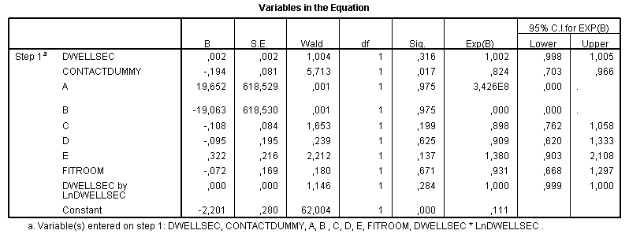

Appendix 2 – Assumption of multicollinearity model 1
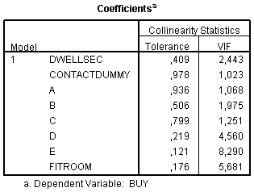
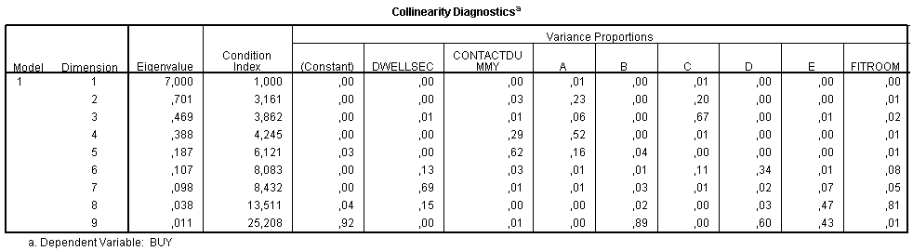

Appendix 3 – ‘Fit’ model 1
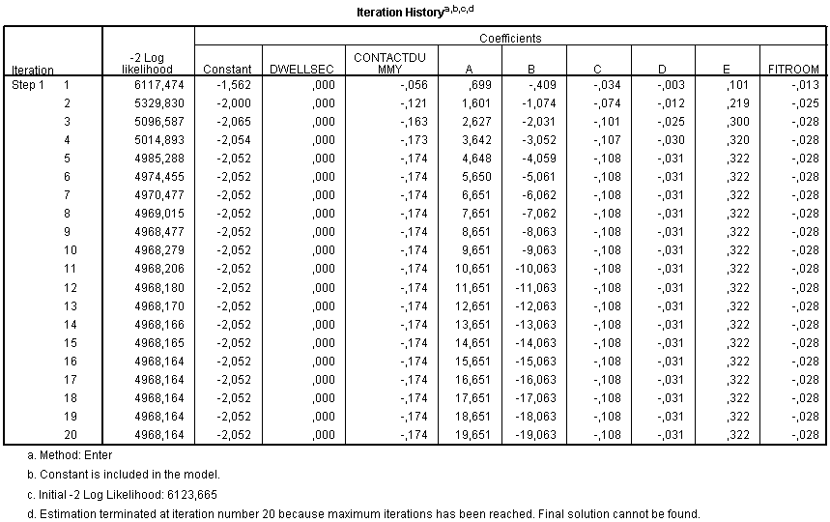


Appendix 4 – Assumption of linearity model 2a
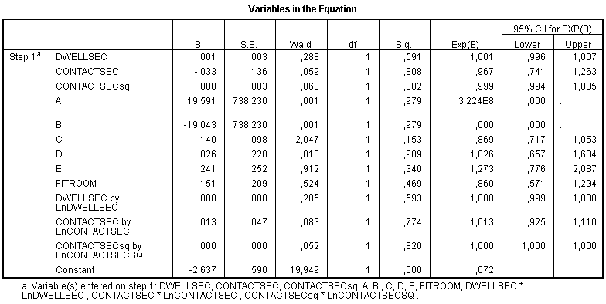

Appendix 5 – Assumption of multicollinearity model 2a
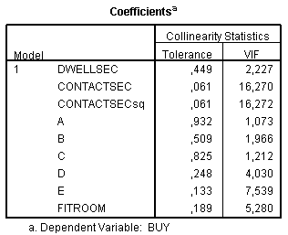
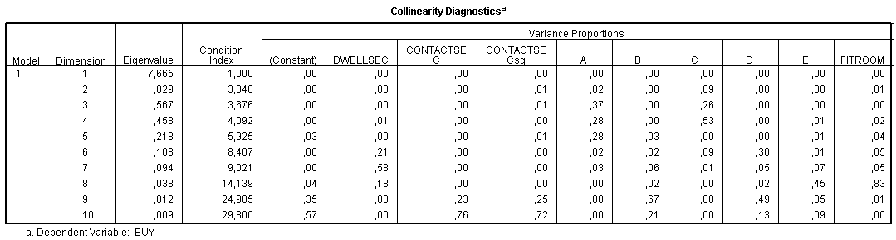

Appendix 6 – ‘Fit’ model 2a
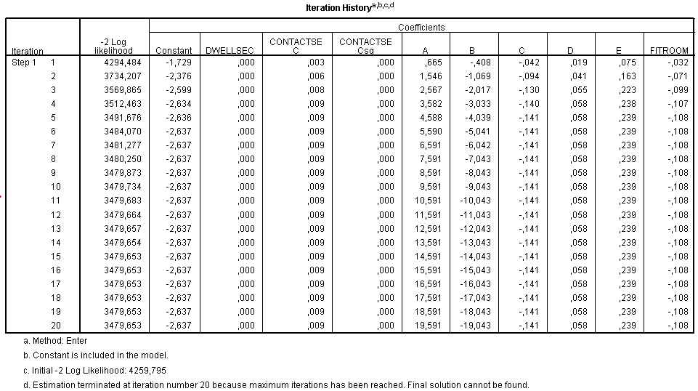


Appendix 7 – Assumption of linearity model 2b
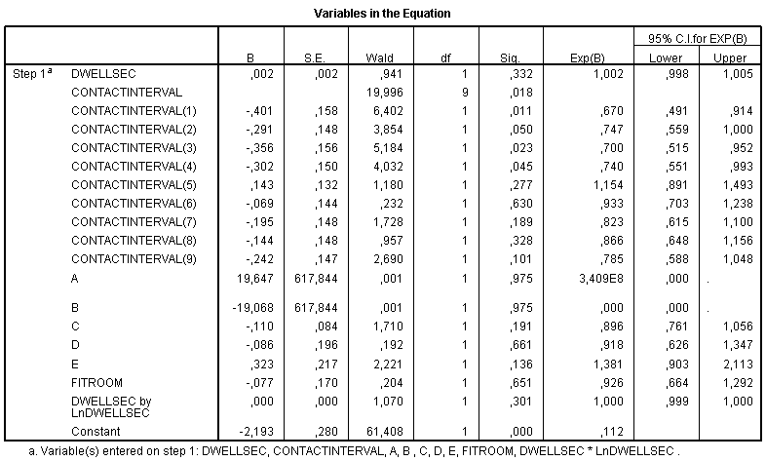

Appendix 8 – Assumption of multicollinearity model 2b
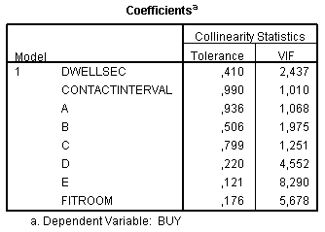
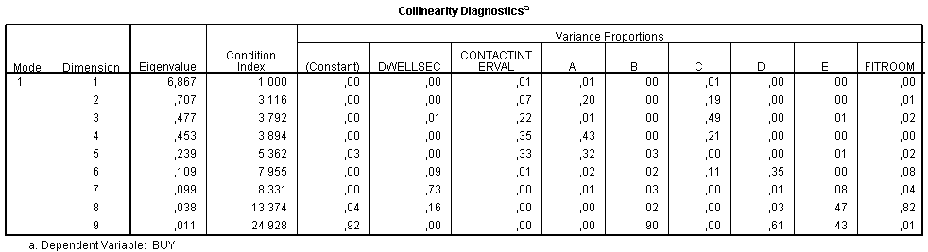

Appendix 9 – ‘Fit’ model 2b
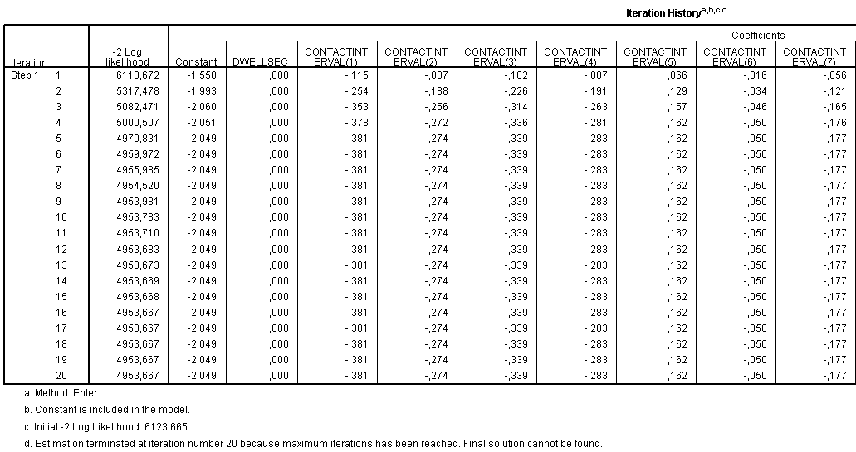
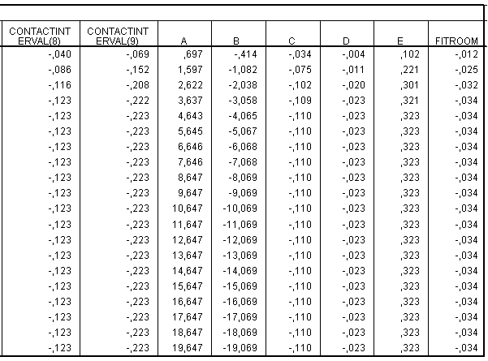


Appendix 10 – Estimation results model 1
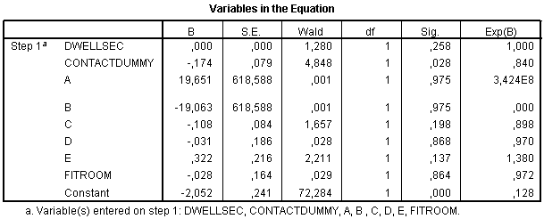

Appendix 11 – Estimation results model 2a
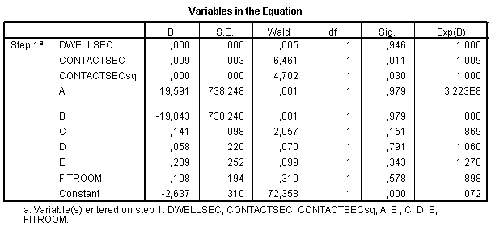

Appendix 12 – Estimation results model 2b (baseline first)
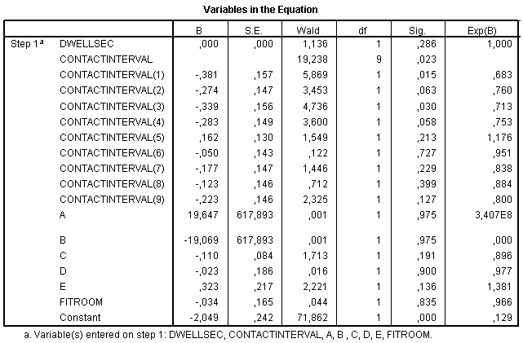

Appendix 13 – Estimation results model 2b (baseline last)
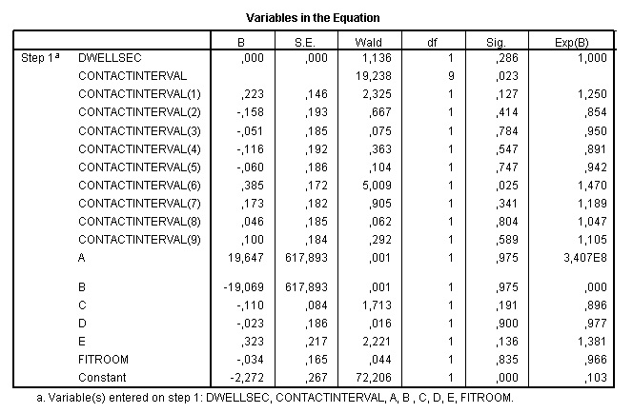

Appendix 14 – Descriptives
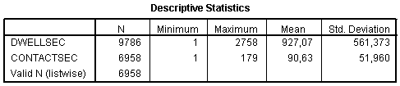

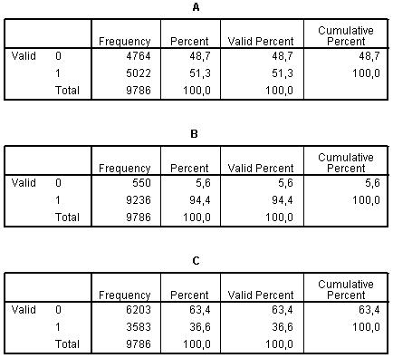

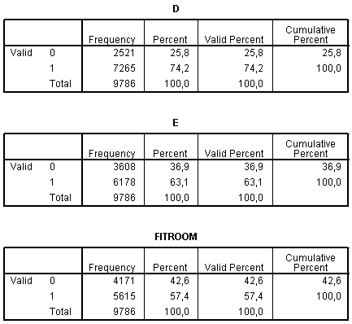
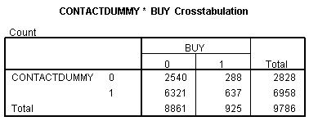

http://www.aroundknowledge.com/
http://www.aroundknowledge.com/products.php
Source deleted due to the brands’ wishes to remain anonymous
http://www.aroundknowledge.com/about-us.php
http://www.mitportugal.org/latest/innovation-and-entrepreneurship-initiative-grand-finale-winner-announced.html
http://www.aroundknowledge.com/images/products/bips-technology.pdf
http://www.ats.ucla.edu/stat/spss/webbooks/reg/chapter2/spssreg2.htm
http://www.ats.ucla.edu/stat/mult_pkg/faq/general/psuedo_rsquareds.htm
http://www.ats.ucla.edu/stat/sas/seminars/sas_logistic/logistic1.htm
Weighted average = ∑ (purchasing likelihood Xijk * frequency of approaches Xijk) / Total frequency ijk (where X represents the seconds for (i) too early, (j) optimal or (k) too late approaches)
Source deleted due to the brands’ wishes to remain anonymous
EUR 130M * 0,711 * 0,1111 = EUR 10,62M

