Thesis Erasmus University Rotterdam
Supervisor: Dimitrios Tsekouras

Online Information Search: How Does Content Presentation influence User Satisfaction?
Research on website characteristics that influence user satisfaction on content-based websites

Gijs Koopman, 305091
2012

Keywords: Content-based Websites, User Satisfaction, Information Load, Website Aesthetics, Perceived User Effort

Table of Contents
1. Introduction 3
2. Literature Background 5
2.1 Content-based Websites 5
2.2 User Satisfaction 8
2.3 Information Load 9
2.4 Website Aesthetics 11
2.5 Perceived User Effort 15
2.6 Conceptual Framework 18
3. Methodology 19
3.1 Measures 19
3.2 Control Variables 20
3.3 Procedure 21
3.4 Statistical Analysis 22
4. Results 24
4.1 Factor Analysis 24
4.2 Multiple Regressions 25
4.3 Mediation Analysis 28
5. Discussion 32
5.1 General Discussion 32
5.2 Academic Implications 34
5.3 Managerial Implications 34
5.4 Limitations and Future Research 35
Acknowledgements 37
Appendix A 42
Appendix B 44
Appendix C 45
Appendix D 46
Appendix E 47
Appendix F 48
Appendix G 49

“The Internet is about freedom of information, to go out, search and find information.”
(Dan Neary, Vice President Skype)

1. Introduction
Internet is everywhere. Internet provides an almost limitless storage for information in different virtual locations that is always available and accessible from almost any point on the planet. Internet possesses furthermore the powerful capacity for efficiently and effectively searching, organizing, and distributing this enormous bulk of information. The quest for information on the Internet has been described as useful, fun, exciting, entertaining, challenging, and even mind-boggling (Atkinson & Kydd 1997). An increasing number of consumers are engaging in information search and transactions in the online environment (Maity, Hsu, & Pelton 2012). While TV is the most common way for people to watch sports, the Internet is the most popular way for both men and women (36.1 and 32.7% respectively) to get sports news and information (Burst Media 2009). This same study found that men and women of all ages are active consumers of sports content online. Sports news sites are content-based. The offered information is the main value component of the websites (Huizingh 2000). Content-based websites’ revenues are based on advertising. In the online world, content-based websites can leverage a loyal customer base to increase readership and therefore advertising revenues (Ansari & Mela 2003).
Today’s consumers face richer information environments than ever before. Consumers have access to excessive amounts of information. Typically, most of the information that consumer’s access, is not satisfying their specific information need (Duan et al. 2009). Now, in the age of the Internet, developing and understanding of how information-rich environments affect consumer decision-making is of crucial importance.
Given the different ways in which information can be presented to consumers and the high potential for information overload in online environments, research into information load and content presentation is important (Lurie 2004). If content-based websites would know what would be the optimal way of offering the content on their website, then the websites could improve user satisfaction. Greater search effectiveness is likely to lead to a higher level of user satisfaction towards using the website and higher retention rate. In an online information context, the perceived usefulness and effectiveness of a website is related to the extent to which the website can help consumers retrieve and understand the information they are looking for (Jiang & Benbasat 2007).
Research that takes the different dimensions of content presentation into account is relevant from a managerial point of view. Content-based websites have a business model that is based on revenue from advertisers. When content-based websites have an increased understanding of what factors are the main determinants of user satisfaction it could increase user satisfaction for their websites which in turn influences intention to revisit. Moreover content-based websites could learn how the different characteristics of a website work together to influence user satisfaction. Advertisers will be willing to pay more when user satisfaction is high (Mittal and Shawney 2001).

Main Research Question:
- How do the proposed website characteristics work together on content-based website to influence user satisfaction?

The study contributes to the existing literature by aiming to retrieve academic insights on how different website characteristics work together and consequently create a more optimal distribution of these different characteristics that together make a website.
This study commences with a literature study on content-based websites, user satisfaction, information load, website aesthetics, and perceived user effort to provide a comprehensive understanding of the key elements. Resulting from the literature review come the hypotheses followed by the methodology of the study. The results of the research are then analyzed and presented. After the results the implications of the results are discussed. Finally the limitations for this research and recommendations for future research are presented.

2. Literature Background

2.1 Content-based Websites
Huizingh (2000) proposed a framework to identify the relevant aspects of websites. This framework focuses on two main website characteristics: content and design. Content refers to the information, features, or services that are offered in the website. Design refers to the way the content is made available for website users. Figure 1 displays the distinction graphically.

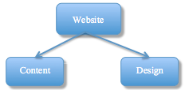
FIGURE 1: Website characteristics (Huizingh 2000)
________________________________________________________________________________

________________________________________________________________________________
Mithas et al. (2007) conceptualize the business domains of websites along three dimensions: domain (informational or transactional), ownership (government or commercial), and product offering (goods or services). For this study the main interest is in the dimension domain. The distinction for this dimension is made upon the degree to which websites support commercial transactions or deliver information. The main purpose of transactional websites (i.e. online stores) is to persuade website visitors to purchase offerings. Informational websites (i.e. newspapers, government departments) are content-based. The users’ main purpose of visit is to obtain information on a topic of interest from the website. On transactional websites, the offered information serves as a facilitator for a future purchase of a product. On informational websites the acquired information is the actual end product. Literature refers to informational websites as ‘content-based websites’. For this study a content-based website is more precisely being defined as “an online provider with the business purpose of providing information to its visitors.” On content-based websites the offered information is considered to be the main value component of the websites (Huizingh 2000). For consumers a key objective of online information search on such websites is to learn more about a certain topic. The content that is accessed during the online information search strongly determines the perceived quality of the website (Castañeda et al. 2007).
The business model of content-based websites is strongly based on advertising. A content-based website is interested in increasing usage among consumers because increased usage, in most instances, results in increased revenues. For content-based websites there are typically three classes of revenue models being used to specify the revenue model: free-based access (annual fee), e-tailing (profit from lock-in) and free access (no fee). Websites that apply the free access model generate revenues by charging fees to firms placing banner ads, links and so forth on their website (Mittal and Sawhney 2001). The free access model is the revenue model that is being applied by the content-based websites that are subject for this study. It is generally in content-based websites’ best interest to pursue a long-term relationship with the user (Goldenberg, Oestreicher-Singer, and Reichmann 2011). The larger customer base and higher usage for each customer enables content-based websites to attract advertisers and charge higher advertising fees (Mittal and Shawney 2001).

Two types of Internet-based consumer information search behavior
Users visit websites not only for information, but also for entertainment. Hoffman and Novak (1996) used six dimensions to characterize two types of Internet-based consumer information search behavior that fit these different search goals. Their study distinguishes between ‘specific information search’ and ‘general information search’. The search for specific information results from a goal-directed need, whereas surfing the Internet for other purposes is the result of the experiential need of users (Huang 2003). Another key difference between the two types of information search behavior is the difference that exists in the motivation for its use. Davis et al. (1992) found that Internet user behavior will vary when for motivations for usage vary. They presented their findings in the Motivational Model. In general, the literature distinguishes between two types of motivation for Internet usage: extrinsic and intrinsic motivation. Internet users use extrinsic motivation when the purpose of their website visit is other than mere surfing. In this case users will focus their evaluation of the website primarily on its functional aspects (Castañeda 2007). An extrinsically motivated user expects some utilitarian benefit external to the system-user interaction in return for the visit (Brief and Aldag 1977). An intrinsically motivated user on the other hand is mainly driven by benefits derived from the interaction with the system itself (Brief and Aldag 1977). Intrinsic motivation is based on performing an activity purely for the enjoyment of the activity itself (Atkinson and Kydd 1997). This implies that the use of the website is an end in itself, and that the user’s behavior will be mainly driven by hedonistic aspects (Castañeda 2007). These motivations may vary with individuals and use conditions. Typically the motivations are related to the different types of website. For the use of an e-commerce website the primary motivation is extrinsic and for an entertainment site motivation is mainly intrinsic. On an informational website both motivations will occur (Castañeda 2007). We assume for this study that the research domain football websites serve the sole purpose of enjoyment, since football for most of the people is a hobby and is not about utilitarian aspects of their lives. For this study we will therefore focus on the entertainment site. Figure 1 provides a schematic overview of the two different types of information search behavior. The boxes connected by the yellow line indicate the fields of interest for this study.

FIGURE 2
Two types of Internet Search Behavior (Hoffman & Novak 1996; Atkinson & Kydd 1997; Van der Heijden 2004)
________________________________________________________________________________
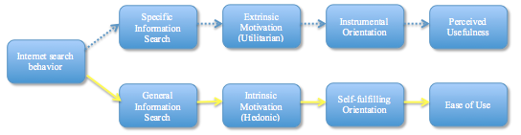________________________________________________________________________________

Figure 1 introduces ‘perceived usefulness’ and ‘ease of use’. The two notions were first used in Davis’ Technology Acceptance Model (TAM) in 1989. Wixom and Todd (2005) provided preliminary evidence that technology acceptance and user satisfaction can and should be integrated The TAM model posits that user acceptance can be explained by these two beliefs. Perceived usefulness is the degree to which a person believes that using a particular system would enhance his or her job performance (Davis 1989). Perceived ease of use is “the degree to which a person believes that using a particular system would be free of effort (Davis 1989).” Ease of use relates to an individual’s intrinsic motivation to access websites (Atkinson and Kydd 1997). Ease of use relates to the cognitive effort required in using a website (Agarwal and Venkatesh 2002).
Consumer behavior literature distinguishes furthermore between utilitarian and hedonic Internet-based information search behavior. The term utilitarian indicates a motivation of website usage that is productivity-oriented. Utilitarian search behavior is related to the ‘performance perception of usefulness, value, and wisdom and aims to provide instrumental value to the user’ (Batra & Athola 1991; Van der Heijden 2004). Instrumentality indicates that the interaction between user and system serves an external objective. The term hedonic derives from the word hedonism; a term used “to denote the doctrine that pleasure or happiness is the chief good in life” (Merriam-Webster 2003). Hedonic search behavior relates to the assessment by users regarding the amount of fun, playfulness, and pleasure they experience from the site (Huang 2003). The main value of a hedonic system is that the user experiences fun or enjoyment when using the system. Hedonic information systems aim to provide self-fulfilling value to the user. In its purest form, interacting with a hedonic system is designed to be an end in itself (Van der Heijden 2004). Important tactics that providers of hedonic content employ are the inclusion of hedonic content, animated images and aesthetically appealing visual layouts. The dominant design objective is to encourage prolonged use, since it is in their best interest to engage with the user for a longer period of time. For this study, focus will be laid upon hedonic information search behavior. Since visitors of football websites do so mainly out of hedonic believes, the ‘ease of use’ belief will be applied for research. In general, a content-based website performs well in the hedonic aspect when users perceive the site to enjoyable in its own right, apart from any performance consequences that may be anticipated (Huang 2003).

2.2 User Satisfaction
Lindgaard & Dudek (2003) referred to user satisfaction as an ‘evasive beast’ because of the broad array of interpretations that existing literature provides. An evasive beast may be exaggerated; truth is that user satisfaction is not simply captured by a single element. The quality of content is for example one determinant of user satisfaction. Since the informational content of content-based websites is the main value component that the website offers, it is clearly important to capture the user’s evaluation of the content they have accessed. Among the many existing definitions of satisfaction two are being highlighted for the purpose of this study. Anderson & Sullivan (1993) defined satisfaction as “an affective consumer condition that results from a global evaluation of all the aspects that make up the consumer relationship. Satisfaction shows a favorable attitude of the consumer.” Lindgaard & Dudek (2003) stated that satisfaction is “a person’s feelings or attitudes in a given situation toward a variety of factors affecting that situation.” They conclude that satisfaction is a broad term applicable in various situations. The term ‘user satisfaction’ plays a prominent role in Human Computer Interaction (HCI), yet it remains evasive (Lindgaard & Dudek 2003). Research into parameters that influence levels of Internet consumer satisfaction has only recently taken off and is still scarce (Chen & Wells 2001). Regardless of whether users are forced to interact with computers at work or whether they choose to do so at their leisure, it could be assumed that the overall user experience has to include some sense of satisfaction. Wixom et al. (2005) examined the contextual gap between user acceptance and user satisfaction of information systems. The study provides an outstanding overview of parameters for the measurement of user satisfaction. This summary highlights various useful definitions and constructs that can be applied in this study to capture the user satisfaction for the respondents of this study. An overview of the satisfaction parameters of the Wixom study is included in Appendix B.

2.3 Information Load
When studying content-based websites the structure of content is a main topic of interest (Lurie 2002). The content of a website is a key parameter that influences users’ attitudes toward the website. ‘Content is king’ is a slogan that is often heard when applied for websites (Huizingh 2000). Years before Internet played the vital role in every day lives it does today, Daft and Lengel (1986) argued from a media richness perspective that structural characteristics of information play a dominant role in the effective adoption and utilization of information. Literature that refers to the structure of information and the amount of information that a site offers is perceived to offer is extensive (e.g., Lurie 2004; Lee & Lee 2004; Bailey and Pearson 1983). It appears that terms referring to structural elements of websites as information load, information structure, and complexity relate to similar definitions. For example, Lurie (2002) defines structure of information as “the amount of information provided to consumers.” For this study we elaborate on information load. This term refers to the variety of stimuli to which a receiver of information must attend (Jacoby 1977). Literature also mentions complexity as a notion to define structural elements of information. “Complexity refers to the amount of information that a site is perceived to offer, including aspects such as the number of alternatives, the number of attributes, and the variation in the information provided by the attributes” (Berlyne et al. 1963; Donovan & Rossiter 1982). In an online context, attributes are features or aspects of a website. Website users perceive websites as a bundle of attributes with varying capacities to satisfy their needs. The user’s perception is further influenced by the range of topics and the structural properties of a website. Sites that offer a very broad range of text and graphics in a multidimensional format are considered to be complex (Huang 2003). Lurie (2002) stated that in a world of unlimited data and limited human information processors, the structure of information is a key construct.

Information overload
Based on the notion of limited human processing capacity Bettman (1979) and Streufert & Driver (1965) wondered if consumers are provided with too much information at a given time, such that it exceeds the amount they are able to adequately process. Both studies found that information overload occurs when information exceeds processing limits. Eventually research found that the main idea on which ‘the information-load paradigm is based that consumers have finit limits to absorb and process information during any given unit of time’ (Malhotra 1982). Information overload leads to poorer decision-making and dysfunctional performance (Lee & Lee 2004). The information-rich nature of the online environment can easily create occasions for information overload to occur. More and more consumers become part of the Internet population and add content to the web. Websites have emerged as the key carrier of information for business transactions and marketing communication (Lee and Lee 2004). Several researchers (e.g., Jacoby, Speller, and Kohn Berning 1974; Keller and Stealin 1987; Malhotra 1982; Scammon 1977) have found that increasing the number of alternatives or attributes in a choice set leads to a decline in the quality of consumers’ choice. It has been demonstrated that as the number of alternatives increases, consumers have more information to process, which will negatively affect the quality of their decisions (Jacoby el al. 1974). Lurie (2004) found that when a choice set contains more information per element, fewer acquisitions are made, more time is spent per acquisition, and consumers are more selective in their information acquisition. Lurie moreover found that a change in information structure that increases the amount of information in a choice set could lead to a decline in decision quality. Other research found that as information load increases, decision-making first increases, then reaches an optimum and ultimately decreases (Streufert et al. 1967). Streufert et al. (1967) further found with great consistency across different investigations that an information load of ten is regarded as the optimum (Malhotra 1982). By varying the amount of information via the number of alternatives in the choice set, the effect of information load on decision-making performance was examined. Decision effectiveness first increases and then decreases as the amount of information available increases, holding fixed the average quality level of the informational environment (Keller and Staelin 1987). Such a relationship is called an inverted-U-shaped relationship. Other studies (Jacoby et al. 1974a, 1974b) presented convincing results ascertaining the influence of the amount of information on consumers’ ability to make correct decisions among many different alternatives. Therefore, it was concluded that after a certain optimum of offered information is reached, more information tends to decrease the quality of consumer decision performance (Lee & Lee 2004).
Cognitive overload occurs “when the processing demands evoked by the presented information exceeds the processing capacity of the cognitive system (Mayer and Moreno 2003).” Throughout the cognitive overload literature it is generally assumed that a decision maker would like to behave rationally, but cannot do so because of cognitive limitations that trouble the complete and accurate assessment of available information (Todd and Benbasat 1999). The amount of offered information can vary and therefore focused content that decreases the information load can contribute to a better perception of the information users (Jacoby et al. 1974; Malhotra 1982). Based on the literature study we expect information overload to occur on content-based website. We will therefore hypothesize that according to the findings in the various studies the following:

Hypothesis 1. There is an inverted-U-shaped relationship between the information load and user satisfaction.

2.4 Website Aesthetics
A website consists of the elements design and content. Design refers to the way the content is made available for website visitors (Huizingh 2010). For the evaluation of interactive systems usability has always had a great impact. There has been a recent shift where interactive systems are no longer evaluated from a functional vision (computers as tools for cognition) but increasingly from an experiential vision (interactive systems as a medium for emotions and pleasure). Increasing importance is now given to the interface “look and feel” and the capability to engage with the user (De Angeli et al. 2006). The design of the website is the first impression a visitor will have when visiting a website. Research has indicated that the website design was used a cue when evaluating the website’s credibility (Fogg et al. 2002). Website aesthetics are is an important attribute of the design. The American Heritage Dictionary of the English Language refers to aesthetics as “an artistically beautiful or pleasing appearance”. The concept of aesthetics (from the Greek ‘aisthanesthai’ - ‘to perceive’) is also referred to as “the philosophy of beauty” (Lavie and Tractinsky 2004). The notions aesthetics and beauty are often interchangeable (Tractinsky and Lowengart 2007). People are affected by the aesthetics of nature and of the environment (e.g. Porteous 1996; Schroeder 2002). As a result of the great importance aesthetics has in life in general, numerous definitions of aesthetics exist. Tractinsky and Lowengart (2007) have created a schematic overview that represents the different meanings of aesthetics. The schematic overview in figure 3 provides a cut clear distinction. The yellow line represents the definition this study follows when referring to aesthetics, which is distinguished from potential interpretations represented by the dotted line.

FIGURE 3: Meaning of “aesthetics" in this study (Tractinsky and Lowengart 2007)
________________________________________________________________________________
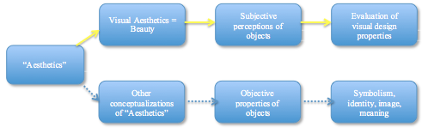
________________________________________________________________________________

Aesthetics in a digital environment are conveyed mainly through the website’s interface, which serves as the website’s facade (Hooper 1986). In a content-based website context, a referral to the front-page of a newspaper is more striking.
Schenkman and Jönsson (2000) categorized aesthetics into the factors ‘formal’ and ‘appeal’. In their study a factory analysis grouped order, legibility and simplicity at the high end of formal aesthetics. Overall impression, beauty and meaningfulness were grouped at the high end of appealing aesthetics. Other studies apply similar ‘aesthetic formality’ and ‘aesthetic appeal’ categorizations (Wang et al. 2011). The outcomes of Schenkman and Jönsson’s factor analysis are in line with findings of more recent studies. Lavie and Tractinsky (2003) found sub dimensions of similar nature in aesthetic environments in other contexts. They showed that online users perceive two high-level, aesthetic sub dimensions. They termed the first sub dimension “classical” aesthetics. Classical aesthetics are associated with clean and orderly design and with user perceptions of the website’s ease of use. The similarity with Schenkman and Jönsson (2000) aesthetic formality is apparent. This dimension is related to the utilitarian, economic and practical properties of design. The second sub dimension is termed “expressive”. Expressive aesthetics represent designs perceived by users to be original and creative. This dimension makes a website unique. Accordingly, the term expressive aesthetics corresponds strongly with aesthetic appeal. This dimension reflects the hedonic, attractive, and recreational attributes of design. For this study we will apply the distinction of the Schenkman and Jönsson study and use it for the research design. Figure 4 depicts the distinction graphically.

FIGURE 4: Classification of Web Aesthetics (Schenkman & Jönsson 2000)
________________________________________________________________________________
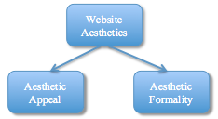
________________________________________________________________________________

Tractinsky and Lowengart (2007) contribute to the literature by adding suggestions for segmentation. Content-based websites that target specific age groups could benefit from their findings. They assert that heterogeneity exists between different age groups with respect to aesthetics. In their study they propose that a younger consumer is likely to respond more open to new forms of expression because youngsters are being exposed to more contemporary cultural and societal activities and are therefore more likely to appreciate expressive aesthetics. Older consumers, in contrary, will be less responsive to explicit expressiveness. They are likely to appreciate higher levels of classical aesthetics more than youngsters, because of their disposition to value more traditional and clear design.
Various researches suggest that website aesthetics are correlated with user satisfaction (Lindgaard and Dudek 2002; Tractinsky et al. 2000). Lindgaard and Dudek (2002) found that satisfaction of website visits comes from highly appealing websites, regardless of the usefulness of the website. Valnai-Yavetz and Rafaeli (2006) have shown that the aesthetics of a so-called “virtual servicescape” was also positively related to satisfaction and attitudes towards the service provider. Therefore, when considering the design of websites in general, high priority should be given to aesthetic considerations. Lohse and Spiller (1999) point to the influence of website design on the degree of Internet consumer satisfaction. They found that higher aesthetic appeal leads to higher consumer satisfaction. Higher aesthetic appeal of a website may also result for higher perceived pleasure for people who randomly surf the web, because aesthetic advancement can be linked to intrinsic human preference (Maslow 1970; Wang et al. 2011). For this study we hypothesize that though aesthetic appeal may not guarantee consumer satisfaction it does have a direct influence.

Hypothesis 2A. Aesthetic appeal has a direct and positive influence on user satisfaction.

As for aesthetic formality we can conclude that recent studies on the online environment support revealed that perceived complexity of a website has a negative impact on pleasure (Huang 2003; Vilnai-Yavetz and Rafaeli 2006). Where simplicity, order and legibility are closely related to aesthetic formality, we can assume that aesthetic formality has an opposite and thus positive effect on user satisfaction. Furthermore, the ease of use that results from high aesthetic formality has been positively related to website satisfaction by several researchers (Crisp et al. 1997; Chen & Wells 1999). Ease of use is an important belief when considering information search in a hedonic context. The relationship between the two notions has been elucidated in ‘Figure 2: Two types of Internet Search Behavior’. Bellman & Rossiter (2004) hypothesized that “when an individual has a congruent website schema, there should be a transfer of positive affect from perceived ease of navigation to a more favorable attitude toward the site.” Since aesthetic formality refers to organization, clearness, and symmetry we assume that website users will be able to assess content-based websites better. Therefore we hypothesize that that aesthetic formality directly influences user satisfaction.

Hypothesis 2B. Aesthetic formality has a direct and positive influence on user satisfaction.

Based on the above-mentioned studies we conclude that the influence of website aesthetics on user satisfaction is evident. For this study we aim to increase relevance by means of studying interaction effects. For aesthetic appeal past research has found that aesthetics and professionalism work together to influence customer satisfaction. Vilnay-Yavetz and Rafaeli (2006) proposed that the pleasant feelings that are evoked by aesthetics produce satisfied customers. They add that there are variables that refer tot structural aspects of content are at play that help to determine user satisfaction. Dion et al. (1972) showed in their classic study that more positive traits were assigned to more attractive (i.e., more aesthetically appealing) individuals. In general, literature describes to this phenomenon as the ‘halo effect’. The halo effect is defined as ‘the influence of global evaluation on evaluations of individual attributes’ (Nisbett and Wilson 1977). Reeves and Nass (1996) elaborated on these findings by demonstrating that the halo effect also applies for users’ perceptions of images displayed on computers. From this perspective we hypothesize that increased aesthetic appeal will increase the positive effect an decrease the negative effect of information load on user satisfaction.

Hypothesis 3A. The information load will have a more positive and less negative effect on the relationship with user satisfaction when aesthetic appeal of a website is high.
Aesthetic formality relates to the utilitarian, economic, and practical properties of design (Wang et al. 2010). Aesthetic formality refers also to order, structure, and symmetry. De Angeli et al. (2006) conducted a study where website evaluation was described for two websites with the exact same content but different interface styles. They categorized one website with an expressive (appeal) aesthetic interface, and the other website with a classical (formal) aesthetic interface. The study revealed that perception of information quality is affected by the different interface styles. She found that websites with higher formality are perceived as providing better content. Gerosa et al. (2001) studied information systems with a large volume of information. They proposed that communication tools must be adapted in a way, which facilitates and organizes the content so that information overload could be reduced. They found that structuring the information and supplying simple and representative pieces of information about the messages’ contents, in a way that helps the identification of their relevance and context could result in a reduction of information overload. In that study, more structure equals less information overload. In the De Angeli study, more structure equaled better information perception. Summarizing, we assume for this study that website users will be able to assess a larger information load better. Therefore we expect a moderating effect of aesthetic formality on the information load, where information load is evaluated more positive when aesthetic formality is high.
Hypothesis 3B. The information load will have a more positive and less negative effect on the relationship with user satisfaction when aesthetic formality of a website is high.

2.5 Perceived User Effort
Effort is an important construct in decision-making (Häubl & Trifts 2000). This study is predominantly about finding the best way to offer information. A website user exerts a certain amount of effort in his attempt to retrieve the information of his interest. The effort that consumers exert to acquire the information should be kept at a certain minimum. User effort includes the physical, mental (or cognitive), and financial resources expended to obtain a product or information (Cardozo 1965). In this research focus is laid on the cognitive aspect of the effort. In choosing a strategy, decision makers try to maintain a balance or make a tradeoff between their effort, which they wish to minimize, and expected accuracy, which they wish to maximize (Bechwati and Xia 2003). For content-based websites it is the best of their interest the content in such a manner that cognitive effort is minimized to a certain extent. Effort should explicitly not be zero, since consumers believe that effort increases the likelihood of making a good choice (Johnson & Payne 1985: Kahn & Baron 1995). In product decision-making Decision Support Systems (DSS’s) offer help by offering consumers aid in their search for information. A DSS attempts to understand decision maker’s preference function and makes recommendation based on understanding of preference structure. Previous research has shown that consumers believe that electronic aids exert less effort but save them an equal level of effort. It is also shown that consumers’ satisfaction with the search process is positively associated with their perception of effort saved for them by electronic aids. Consumers can use more information in their decision making while relying on work performed by electronic processors (Bechwati and Xia 2003). Findings of research studies support a negative relationship between one’s own effort and satisfaction with the decision process (Huppertz et al. 1978; Kennedy & Thirkell 1983).
An interesting approach that has been addressed by some researchers is how consumers react to effort exerted by others, that is, the impact of others’ effort versus one’s own effort on satisfaction with the decision process. Findings imply that because consumers seek accuracy but are cognitive misers, they are likely to welcome effort expended by others to help them decide (Mohr & Bitner 1995; Bechwati and Xia 2003). Hence, in online environments, consumers rely mostly on others’ effort rather than on their own effort (Bechwati & Xia 2003). In a content-based environment this could signify that indications pointing out exerted effort by others may increase the decision quality and might consequently increase satisfaction. Another approach could be that for content-based websites an increasing amount of page views or comments signal an increased effort exerted by others. This indication might reduce effort and thus prove helpful in the information search process. Häubl and Trifts (2000) suggest that interactive tools designed to assist consumers in the initial screening of available alternatives in an online environment may have strong favorable effects on both the quality and the efficiency of online decision-taking. Other research has shown the beneficial impact of online decision aids on reducing the cognitive effort in terms of time spent. Figure 1 illustrated that for content-based websites that offer hedonic content ease of use is a dominant belief for website visitors. Greater search effectiveness and lower effort are likely to lead to a lower level of perceived user effort for using the website.
However, recent studies have added interesting new views to existing literature on effort. Lustria (2007) argued that a certain level of interaction and involvement functions as a main driver of a user’s attitude towards a website. Arbaugh & Benbunan-Fich (2007) proposed that higher levels of active interaction with a system result in higher levels of satisfaction with the website. Website users are likely to feel more committed to a website when a website creates such an experience that they are challenged to create a more refined perception of a website (Jiang and Benbassat 2007). Decreasing the website user’s effort is not beneficial and leads to less positive attitudes towards the website. In this study “Perceived User Effort” is introduced as an independent variable. We follow the line of the above-mentioned studies that the effort that results from involvement is beneficial for the user’s website experience and ultimately for the user’s website evaluation. We assume that a certain exertion of effort is required to experience the online content that is made available. We expect that the perceived user effort will positively mediate the direct effects hypothesized for this study. We therefore hypothesize the following mediating effects of perceived user effort on the direct effects of information load, aesthetic appeal, and aesthetic formality on user satisfaction.

Hypothesis 4A. Perceived user effort mediates the inverted-U shape effect of information load on user satisfaction.

Hypothesis 4B. Perceived user effort mediates the positive effect of aesthetic appeal on user satisfaction.

Hypothesis 4C. Perceived user effort mediates the positive effect of aesthetic formality on user satisfaction.

2.6 Conceptual Framework
The literature study is graphically summarized in the conceptual framework in figure 5. The conceptual framework is used for the examination of the relationship between the presentation of content and user satisfaction on content-based websites. The following dimensions are distinguished for the research. Central in this study is the effect that information load has on user satisfaction. Furthermore, the relationship between two dimensions of web aesthetics and user satisfaction is being examined. Perceived user effort is introduced as a mediating variable, where higher perceived effort mediates in the relationship of the independent variables on the dependent variable.

FIGURE 5: Conceptual framework for the effect of content presentation on User Satisfaction
________________________________________________________________________________

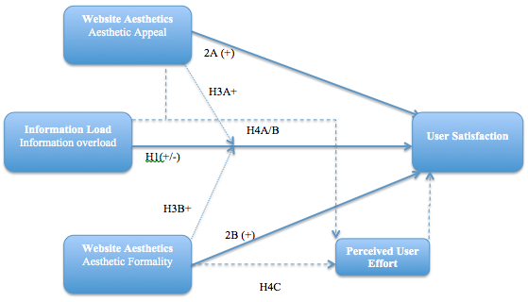

________________________________________________________________________________

3. Methodology

3.1 Measures
To test the hypotheses a survey was designed to capture the effect the three independent variables information load, aesthetic appeal and aesthetic formality have on the dependent variable user satisfaction. The variable perceived user effort was introduced as a mediating variable to test for the mediating effect of perceived user effort on the relationship of the three independent variables with the dependent variable. These hypothesized effects are included in the research framework. The measures that were used to quantify the variables were adopted from key literature that was used for the literature study. The classification data gender and age were collected at the end of the survey. Common sense teaches us that men are generally more attracted to and involved with football than women. Age is being collected because younger people are typically more involved with websites than older people (Schenkman & Jonsson 2000). For this study two Dutch football websites provided purpose as a research domain. Reason why football websites were chosen originates from personal interest and involvement from the researchers with this specific domain. The two most popular football websites in terms of page views, Vi.nl and Voetbalzone.nl, were ultimately selected. Vi.nl is listed 45th and Voetbalzone.nl is listed 49th in the top 100 of best-visited Dutch websites (alexa.com 2012) and are respectively the 1st and 2nd in the category sports websites. In order to make the survey more appealing and striking, we chose to redirect the respondents to the page that contains information on the 2012 UEFA European Football Championship, commonly referred to as Euro 2012. These tournaments typically have a huge impact in the Netherlands with TV-ratings sky-rocketing to an astonishing 10 million on a 16.6 million population (de Volkskrant, 11th June 2012). We assumed that offering Euro 2012 content would result in an increased willingness to participate with the survey. Vi.nl and Voetbalzone.nl varied strongly in the way they presented the Euro 2012 content. Typically Vi.nl showed fewer headlines and more illustrations whereas few pictures and predominantly headlines characterized Voetbalzone.nl. For an artist impression screenshots are included in Appendix A. During the period of research screenshots were taken on a daily basis to assure that respondents would encounter similar websites. Throughout the survey period (25th of June until 6th of July) screenshots were taken on a daily basis. The screenshots taught us that no significant changes were noticeable on the websites, apart from obviously the differing news items.
Appendix B provides an extensive summary of quality literature that has been used to assess information (Wixom & Todd 2005). Appendix C provides an overview of all the measurement constructs with corresponding literature that were used for this study. Five items measured the perception of information load with a seven-point Likert type scale. The measures were adopted from two studies (Baily and Pearson 1983; Ives et al. 1983). For the aesthetic dimensions measurement constructs were adopted from Lavinsky and Tractinsky (2004). Previous studies have validated that these items reflect the two perceived aesthetics dimensions adequately. Five items measured aesthetic appeal: original, sophisticated, fascinating, creative, and pleasant and five items measured aesthetic formality: clean, clear, orderly, symmetrical, and organized. The items were measured with 100-point ‘slider scale’. By means of sliding a bar from left to right respondents could rate the aesthetic dimensions of the website with value 0 being the lowest and value 100 being the highest value. Depicting ‘strongly disagree’ above value 0 and ‘strongly agree’ above value 100 validated this. Three items were used to measure the mediating variable perceived user effort (Bechwati & Xia 2003). A seven-point semantic differential scale was used once, twice a seven-point Likert type scale. Finally, five items that describe consumers’ immediate feelings about a website measured the dependent variable user satisfaction. Three pairs of opposite adjectives were used: pleased versus displeased, contented versus frustrated and pleasant versus unpleasant (Wang et al. 2010). Two items that measure intention to revisit and likelihood of recommendation were adopted from Mithas et al. (2007).

3.2 Control Variables
To assure the validity of this study control variables were included in the research framework. The control variables aimed to control for external variables that might influence the user satisfaction and can therefore harm the validity of the study. The following variables are included: familiarity, involvement, and content accuracy.
Familiarity
Familiarity plays an important role in the relationship between a website user and a website. In this context, familiarity is being defined as ‘an understanding based on previous interactions and experiences and learning of what, why when, where and when other do what they do’ (Gefen 2000). Familiarity with a website would be that a user would be able to retrieve the information that is of his specific interest more efficiently. This complexity-reduction mechanism leads to an increased ease of use. A website user is consequently more likely to be more satisfied with a visit of the website. Therefore we include ‘familiarity’ as a control variable for this study.
Involvement
Past studies have extended the involvement concept to websites (Hwang and McMillan 2002). When consumers process content on a website, they can be in a state of involvement with the website. This study adapts the revised Personal Involvement Inventory (PII) developed by Zaichkowsky (1994) to measure website involvement. The scale finds its origin in advertising research. Earlier studies have proven that it is still highly applicable to involvement with websites. More importantly, the PII was adapted in several past studies to measure website involvement (Hwang and McMillan 2002; Wu 1999), suggesting the suitability for this study. Each component of involvement is measured on seven-point semantic differential scale (see Appendix D).
Content Accuracy
Wixom and Todd (2005) suggest that four dimensions shape content quality: completeness, accuracy, format and currency (or: novelty from Huang 2003). Completeness refers to the degree to which the system provides all necessary information; accuracy represents the user’s perception that the information is correct; format represents the user’s perception of how well the information is presented; and currency represents the user’s perception of the degree to which the information is up to date. These dimensions determine the user’s perception of the quality of the information included in the system (Wixom and Todd 2005). Wixom asserts furthermore that information quality beliefs shape attitudes about information satisfaction. To be useful to an Internet audience, each site must deliver entertainment or knowledge, or improve the way its audience accomplishes some important task (Agarwal and Venkatesh 2003). Today’s consumers face richer information environments than ever before. Accuracy of content makes a website more credible. Users are likely to value the quality of information more highly than the quantity of information. Outdated and irrelevant information is likely to mislead and confuse users (Duan et al. 2009). Websites differ in their ability to offer content of superior quality, depending on the extent to which they can provide accurate and updated information of high quality to consumers. Websites with constantly updated, fresh, and relevant content are more likely to attract and retain users. Previous research on scale development for website content and its validity has reported a positive and significant relationship between content and success (Mithas et al. 2007). Therefore we include the control variables for content accuracy en content reliability. The measurement constructs are included in Appendix D.

3.3 Procedure
For this study a survey was designed to obtain data. The manipulation for the survey was based on content presentation. The survey was first launched on Monday the 25th of June, one day after the fourth quarterfinal match England – Italy. It was of critical importance that the necessary amount of responses was collected before Euro 2012 ended. If this would not have been the case, the offered content would differ too radically amongst respondents and this would hurt validity. Gladly, before the 6th of July 168 respondents took the survey, and 137 surveys were completed. The initial aim was 100 complete surveys. The survey was distributed via a hyperlink on Facebook, LinkedIn and through the somewhat more conventional means of e-mail. The survey consisted out of 37 questions. The first two questions concerned general Internet usage behavior. The following questions related to the involvement with football in general, and more specifically football websites. In order to compare two major football websites of interest, one website should be higher in information load and lower in aesthetic appeal and the other website should be lower in information load and higher in aesthetic appeal. Vi.nl and Voetbalzone.nl met these criteria. Screenshots of the respective websites can be found in Appendix A. The website that was used for constructing the survey, Qualtrics.com, enabled adding randomization to the design. The randomization helped to determine which website each respondent would have to evaluate, because the survey would have been too extensive if respondents were asked to evaluate both websites. Consequently, respondents were asked to browse through either Vi.nl or Voetbalzone.nl. Respondents were asked to make sure they had a sufficient impression of the website so that they were able to evaluate the website. If respondents felt confident, they were asked to return to the survey. They were then asked to evaluate the information load and the web aesthetics. Respondents also had to give an indication on how much effort they had put into the information search process. Finally 5 questions about their satisfaction helped to determine the overall evaluation. The required data was collected within 10 days. The data needed to be cleaned before it was suitable for analyzing purposes. Three reverse variables were recoded so that they could be interpreted for analysis.

3.4 Statistical Analysis
SPSS was used for analyzing the data. From the 168 respondents that took the survey, 137 actually completed the survey. Before the remaining data was ready for analyzing purposes, four reverse variables were recoded. Information load was squared to capture the hypothesized negative effect. The following formula was used to measure the hypothesized effects on user satisfaction:

User Satisfaction = Information load + (Information Load) ² + Aesthetic Appeal + Aesthetic Formality + [Information Load ×(Information Load) ² x Aesthetic Appeal] + [Information Load x (Information Load) ² x Aesthetic Formality] + ε

Firstly, a factor analysis was conducted to check the 137 complete surveys for reliability. In general, a factor analysis is used to describe variability among observed, correlated variables in terms of lower unobserved variables called factors (Conrady & Jouffe 2011). The factors were checked for internal consistency and reliability on Cronbach’s alpha. This is a common measure that is typically used when multiple Likert scale questions are subject to analysis and the reliability of these scales needs to be determined (Cronbach 1951). For “Information Load” we hypothesized that there would be an inverted-U relationship with “User Satisfaction”. To capture that effect we created a second “Information Load” variable, where “Information Load” was squared. We named this variable “Information Load²”. The five factors that resulted from the factor analysis were used as variables for the regression analysis. Regressions are typically used to evaluate the relationship between a set of independent variables and a dependent variable (Hariharan 2011). In total, four regression models were conducted to capture the regression effects. For all models the R² and adjusted R² were monitored. R² is a statistical measure of how well a regression line approximates real data points. First the direct effects of “Information Load”, “Aesthetic Appeal”, and “Aesthetic Appeal” on “User Satisfaction” were regressed to check for Hypothesis 1, 2A, and 2B. In the second model the interactions were included to check for Hypothesis 3A and 3B. To enhance significance for the interactions, the interactions were regressed under ceteris paribus conditions. To make sure that external factors did not influence the above-mentioned hypotheses, control variable were introduced in the third and fourth model.

4. Results

4.1 Factor Analysis
Typically, a factor analysis proves to be more insightful when certain criteria’s are met. The Kaiser-Meyer-Olkin (KMO) measure expresses the sampling adequacy. For the main sample, the KMO score was .794, were a score of .6 is regarded as minimum score for a sample to be suitable for further analysis (Kaiser 1970). The Bartlett’s Test of Sphericity proved significant at .000. The factor analysis showed five factors with eigenvalues exceeding 1. After consulting the scree plot there was decided to retain these five factors. The six factors explained 68,04% of the total variance. After these results a varimax rotation was performed to obtain a rotated component matrix, which enables a better interpretation of the factor analysis outcome. The results of the rotated component matrix are in the table below.

TABLE 1: Rotated Component Matrix
________________________________________________________________________________

Variables | Factor 1 | Factor 2 | Factor 3 | Factor 4 | Factor 5
Variables | User Satisfaction | Aesthetic Formality | Aesthetic Appeal | Information Load | Perceived User Effort
General - Contented | .897
General - Pleased | .880
General - Pleasant | .839
Pleasant | .641
Orderly |  | .779
Organized |  | .769
Clear |  | .740
Clean |  | .726
Symmetrical |  | .460
Creative |  |  | .860
Fascinating |  |  | .817
Original |  |  | .681
Sophisticated |  |  | .612
Information: Redundant |  |  |  | .847
Information: Too much |  |  |  | .737
Information: Unnecessary |  |  |  | .666
Not exert lot of effort (R) |  |  |  |  | .832
Lot of effort searching |  |  |  |  | .755
Much exerted effort |  |  |  |  | .641
Cronbach's Alpha | 0.931 | 0.844 | 0.758 | 0.703 | 0.674
The table only shows coefficients larger than 0.4 (Hooper 2012). Based on the coefficients that loaded the various variables into the specific factors, factors were assigned to specific variables from the research framework. One remark has to be made. Based upon the initial measuring constructs we decided to drop the constructs ‘I would like to assess more information’ and ‘the information this website offers is insufficient’. These constructs were initially adopted as reverse variables to measure “Information Load”. However, when reasoning from the respondents’ point of view a low score on either on these variables does not necessarily indicate information overload. A low score could also indicate that the amount of information that is offered is precisely adequate. The vast majority of variables however did load in the factors that we had expected them to load, based on the literature review. Ideally there had not been variables with close loadings in different factors, because this indicates that a variable assesses more than one construct. However, the rotated component matrix does show variables that load in two or even three factor. Consequently, a selection had to be made based upon this outcome. The bottom line of Table 1 shows 5 values for Cronbach’s alpha. The Cronbach’s alpha coefficient helped to determine which variables should be dropped. The variable ‘Pleasant’ had loaded strong in the factor ‘User Satisfaction’. Based on the literature review we would have expected that ‘Pleasant’ would have loaded in the factor “Aesthetic Appeal”. When checking Cronbach’s alpha for “Aesthetic Appeal” it points out that the internal consistency would be higher when Pleasant is being dropped. When checking Cronbach’s alpha for Aesthetic Formality it appears that the measure ‘Symmetrical’ should be dropped. Ultimately, for Perceived User Effort the measure construct ‘how much effort did you exert’ was dropped. For an overview of the Cronbach’s alpha statistics please refer to Appendix F. In general, a Cronbach’s alpha coefficient that is equal to or greater than 0.6 is considered a minimum acceptable level, although it is being argued by some authorities that a stronger standard of at least 0.7 should be adopted (Klassen 2003). For this study, four out of five Cronbach’s coefficients meet the 0.7 criterion, whereas all coefficients meet the 0.6 requirement.

4.2 Multiple Regressions
The factors that resulted from the rotated component matrix were used to conduct multiple regressions. Model I captured the direct effect of the three independent variables on the dependent variable. The results of the regression can be found in Table 2. The model proves significant with p < .000. The independent variables “Information Load” and “Aesthetic Formality” prove significant. For Model I we see in table 2 on the next page that three out of four independent variables are significant. The “Information Load” coefficients indicate that “Information Load” at first is positive. With one unit of “Information Load” increase, “User Satisfaction” increases with .361. The squared “Information Load” variable shows that after a certain maximum “Information Load” becomes negative and actually results in decreased “User Satisfaction” of .067 for every one unit increase of “Information Load”. The decrease in “User Satisfaction” as “Information Load” increases is called Information Overload. The optimum information load level can be determined by comparing the effect of the positive and negative slope. By calculating the total effect for each level of “Information Load” the optimum can be ascertained. The formula that is used for the comparison is as follows:

Total effect = Coefficient Information Load 1*N + Coefficient Information Load²*N*N
N represents the level of Information Load, varying from 1-7. This results in the following outcomes. The total effects for each level of Information Load are depicted on the left of figure 6. The outcomes are plotted in the graph on the right.

FIGURE 6: Inverted-U relationship between “Information Load” and “User Satisfaction”
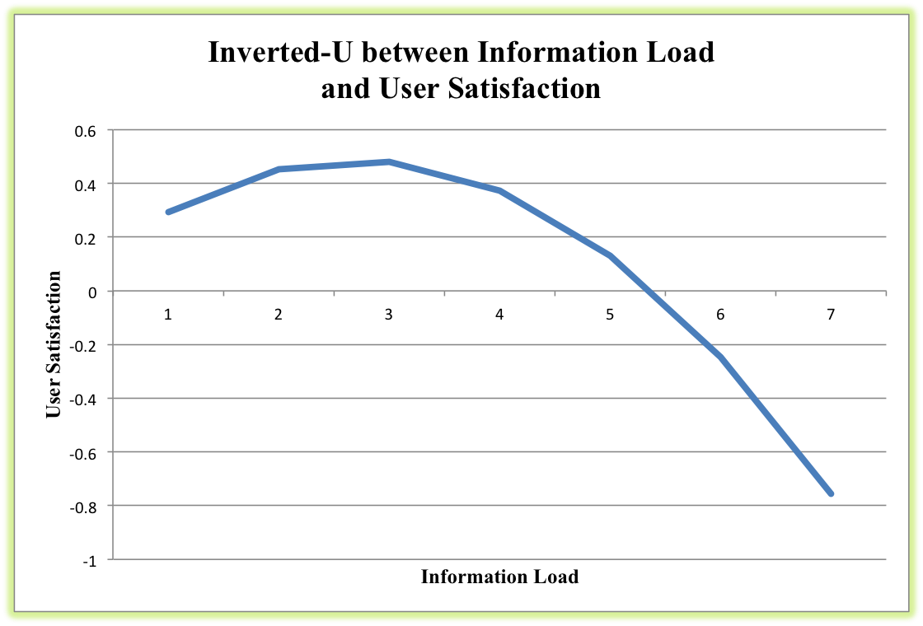
________________________________________________________________________________

 | Total Effect
Info Load 1 | 0.294
Info Load 2 | 0.454
Info Load 3 | 0.48
Info Load 4 | 0.372
Info Load 5 | 0.13
Info Load 6 | -0.246
Info Load 7 | -0.756

________________________________________________________________________________

The shape of the graph on the right shows the inverted-U shape that we hypothesized for this study. What is noteworthy is that the negative effect of “Information Load” is stronger than the positive effect. Based on the results in in Model I and the outcomes depicted in figure 6 we can accept Hypothesis 1. For every increase in “Aesthetic Formality” with one, “User Satisfaction” increases with .026. Both aesthetic dimensions were measured on a 100-point scale; therefore the coefficient is smaller then for “Information Load”. When averaging the effect, a simple calculation learns that the marginal effect of aesthetic formality on a 7-point scale would have been (100/7) x .026 = .371. The positive effect is stronger than for Information Load. Based on the significant positive results we can accept Hypothesis 2B. “Aesthetic Appeal” proves insignificant and accordingly we reject Hypothesis 2A.
Model II was used to test both the direct effects and the hypothesized interaction effects of both aesthetic dimensions with “Information Load”. However, whilst treated separately in ceteris paribus conditions, no significant interaction effects were found. If the results had proven significant, then the results would have shown such marginal effects that an interaction effect would have been negligible. Moreover, the sign for the “Aesthetic Appeal” interaction showed negative, so Hypothesis 3A would not have been accepted. Summarizing, both interaction hypotheses are rejected for this study. Based upon the outcomes of this study we can therefore not conclude that a more aesthetically appealing website or a more aesthetically formal website has a positive effect on the relationship between the “Information Load” and “User Satisfaction”. We have to reject Hypothesis 3A as well as Hypothesis 3B.
Model III shows the direct effects with controlled for the effect of the control variables. We see the same three independent variables with a significant outcome. In addition to the outcomes of Model I we see an increased significance for the effect of the variable “Information Load”. Moreover the effect of the “Information Load” on the relationship with “User Satisfaction” is more intense. The positive effect increases to 0.795. This indicates that for every one increase in “Information Load”, “User Satisfaction” increases with .795. The negative effect of too much “Information Load” increases to -.114. Two control variables prove significant, “Age” and “Familiarity”. “Familiarity” shows a positive effect, what indicates that the more familiar a user is with the website the more satisfied he or she will be. Based on the literature review we had expected a positive influence. The negative relationship between the control variable “Age” and “User Satisfaction” indicates that the older a user is the less satisfied the user is with the website. It should be noted is that the control variable “Survey” does not prove significant. This indicates that no significant difference in “User Satisfaction” can be perceived based upon the two websites.
Model IV includes the control variables for the interactions. Both “Information Load” variables and “Aesthetic Formality” prove significant. In contrary to what we had expected based on the literature, the results for the interaction prove again insignificant. Two control variables show significance, “Age” and “Familiarity”. The main difference with Model II with respect to the interactions is that the sign for the interaction with “Information Load” and “Aesthetic Appeal” is now positive. However, the results for both interactions do not show significant and thus this change is not noteworthy and actually worthless. Based on Model IV we would still need to reject Hypothesis 3A and 3B.

TABLE 2: Multiple Regressions
_______________________________________________________________________________________
 |  | Model I | Model II | Model III | Model IV
Constant |  | 2.854*** | 4.771** | 1.640** | 2.036**
Information Load |  | 0.361* | 0.302 | 0.795*** | 0.705**
Information Load^2 |  | -0.067* | -0.073 | -.114*** | -.113**
Aesthetic Appeal |  | 0.002 | 0.004 | 0.000 | 0.003
Aesthetic Formality |  | 0.026*** | 0.021* | 0.025*** | 0.018*
Perceived User Effort |  | 0.096*** | 0.094* | -0.005 | -0.008
[Inf. Load x Inf. Load^2 x Aest. Appeal] |  |  | -0.001 |  | 0.000
[Inf. Load x Inf. Load^2 x Aest. Formality] |  |  | 0.000 |  | 0.000
Information Reliability |  |  |  | -0.149 | -0.174
Information Accuracy |  |  |  | 0.316 | 0.344
Familiarity |  |  |  | 0.156*** | 0.145**
Involvement |  |  |  | 0.078 | -0.013
Gender |  |  |  | 0.137 | 0.088
Age |  |  |  | -0.013*** | 0.040***
Survey (1=Voetbalzone.nl, 0=Vi.nl) |  |  |  | -0.026 | 0.019
Level of Significance:
***: p < .000 | R^2 | 0.324 | 0.326 | 0.530 | 0.533
**: p < .05 | Adjust R^2 | 0.298 | 0.289 | 0.492 | 0.487
*: p < .10
________________________________________________________________________________

4.3 Mediation Analysis
The regression table does not yet provide the results to either accept or decline the hypothesized mediating effect from “Perceived User Effort” on the relationships between the independent variables “Information Load”, “Aesthetic Appeal”, and “Aesthetic Formality” with dependent variable “User Satisfaction”. In order to do so we need to establish three conditions to determine whether mediation has occurred.
The Baron & Kenny 3-step mediation analysis was conducted on the three hypothesized interactions (Baron & Kenny 1986). The Baron & Kenny analysis consists of the following steps:
- Regress the independent variable on the mediator variable
- Regress the independent variable on the dependent variable without the mediator variable.
- Add the mediator variable in the regression.
Mediation has occurred when the independent variable influences the mediator; the independent variable influences the dependent variables but becomes insignificant when the mediator is included. Sobel’s test was performed to check for the significance of the mediation. The mediations are graphically depicted in ‘Figure 6’ to provide more insight into the relationships and which relations are significant and where significance is lacking. The letter A depicts the regression from the independent variable on the mediator variable (Baron & Kenny: step 1). The letter B depicts the regression from the independent variable on the dependent variable without the mediator variable (step 2) and the letter C depicts the regression from the independent variable on the dependent variable with the mediator variable (step 3). For the relationships between “Information Load” with “User Satisfaction” and “Aesthetic Appeal” with “User Satisfaction” no significant mediation for “Perceived User Effort” was found. None of the three steps proved significant for either variable. For “Aesthetic Formality” the A, B, and C did show significance. However, for Baron & Kenny to be satisfied “Aesthetic Formality” had to become insignificant when including the mediator variable and this did not occur. Moreover the Sobel’s test score also showed an insignificant outcome. Concluding, the mediation results did not have the significant effect that we hypothesized for this study. However, there is literature available that provides outcome and enables a more broad interpretation of the notion mediation. Zhoa, Lynch, & Chen (2010) contributed to the model of Baron & Kenny by proposing that the outcome of the mediation analysis can be interpreted in several ways. We included their suggestions to give additional relevance to the mediation results. When consulting their ‘Decision Tree’ (see Appendix G) it appears that “Perceived User Effort” mediates the relationship between “Aesthetic Formality” and “User Satisfaction”. The type of mediation is being referred to as ’Complementary Mediation’. This means that both a mediated effect and a direct effect exist and that they point at the same (positive) direction. Reasoning from the Zhoa et al. perspective we conclude that mediation has occurred. This signifies that “Perceived User Effort” plays a significant role in governing the relationship between “Aesthetic Formality” and “User Satisfaction”.

FIGURE 7: Mediation Relationships
_______________________________________________________________________________
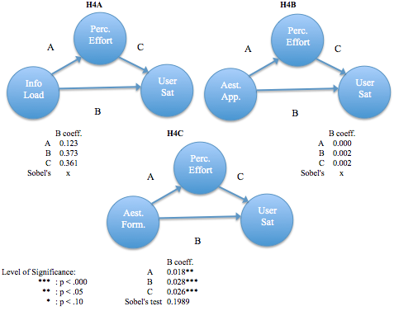
________________________________________________________________________________

We have seen all the results. Multiple regressions and mediation analyses were conducted to analyze the data. Additional analysis was performed on the mediation relationships. The following hypothesis overview summarizes the main findings for this study.

TABLE 3: Hypothesis Overview
________________________________________________________________________________
 | Model | Accept
Hypothesis 1 | I | Yes
There is an inverted U-shape relationship between Information Load and User | II | No
Satisfaction | III | Yes
 | IV | No
Hypothesis 2A. | I | No
Aesthetic Appeal has a direct and positive influence on user satisfaction on | II | No
User Satisfaction | III | No
 | IV | No
Hypothesis 2B. | I | Yes
Aesthetic Formality has a direct and positive influence on User Satisfaction | II | Yes
 | III | Yes
 | IV | Yes
Hypothesis 3A. | I | No
Information Load will have a more positive and less negative effect on User | II | No
Satisfaction when Aesthetic Appeal is high | III | No
 | IV | No
Hypothesis 3B. | I | No
Information Load will have a more positive and less negative effect on User | II | No
Satisfaction when Aesthetic Formality is high | III | No
 | IV | No
Hypothesis 4A.
Perceived user effort mediates the effect of Information Load on User Satisfaction
Baron & Kenny 3-step Mediation Analysis |  | No
Applicable for Zhoa et al. Decision Tree |  | No
Hypothesis 4B.
Perceived user effort mediates the effect of Aesthetic Appeal on User Satisfaction
Baron & Kenny 3-step Mediation Analysis |  | No
Applicable for Zhoa et al. Decision Tree |  | No
Hypothesis 4C.
Perceived user effort mediates the effect of Aesthetic Formality on User Sat.
Baron & Kenny 3-step Mediation Analysis |  | No
Applicable for Zhoa et al. Decision Tree |  | Yes
________________________________________________________________________________

5. Discussion

5.1 General Discussion
For this study we have examined how presentation of content influences user satisfaction. We have studied the two main characteristics that together make a website: content and design. We disentangled the design part of the equation into aesthetic appeal and formality. We then narrowed the scope of the website to content-based websites. We finally added an extra layer of segmentation by focusing on websites that typically fulfill a hedonic search need.
The main purpose for the study was to examine how the three different dimensions influence user satisfaction. Moreover, based on the literature study we hypothesized that the separate characteristics would work together through interaction to ultimately influence user satisfaction. One of the main constructs that were used to assess the content was information load. Based on limited human processing capacity (Bettman 1979) and in line with the hypothesis, information load significantly showed to lead to an increase in user satisfaction. After an optimum was reached, higher information load subsequently led to significant lower user satisfaction. This phenomenon is called ‘Information Overload’. We have seen that the negative effect of Information Load was stronger than the positive effect. This could indicate that the offered information was too abundant in general or that respondents were not interested in the content that they were exposed to. Another explanation could have been that the site that the respondents were exposed to contained Euro2012 news. At the moment that we started with distributing the survey the Dutch football team was already eliminated from the Euro2012 tournament. This potentially negatively impacted interest and respondents were possibly more prone to information overload.
Results became more significant after they were controlled for familiarity and age. This implies that the more familiar a user is with the website the more satisfied he or she will be with the website. Based on the literature review we had expected this positive influence. The negative relationship between the control variable age and user satisfaction indicates for this that the older a user is the less satisfied the user is with the website. Young people are likely to have a more open comprehensive understanding of websites in general and this could therefore bias user satisfaction (Jones & Fox 2009). Tractinsky and Lowengart (2007) proposed that a younger consumer is likely to respond more open to new forms of expression because youngsters are being exposed to more contemporary cultural and societal activities. The results from this study validate their findings.
The second finding for the study relates to aesthetic appeal. Based on the findings for this study we cannot conclude that aesthetic appeal significantly influences user satisfaction on content-based websites. This is in contrary to what we hypothesized for this study. Although the measurement constructs have proven to be highly validated (Lavie & Tractinsky 2004), no significant effects have been found. This is remarkable, since aesthetic appeal has influenced satisfaction since the ancient Greek and remains to do so today (Lindgaard and Dudek 2002; Tractinsky et al. 2000). An explanation could be that football websites in general are more focused on content and that this aspect is predominantly determining user satisfaction. Voetbalzone.nl for one is mainly communicating lines of plain text. Another explanation could be that because of the domain that was chosen for the study, football websites, respondents were merely focused on the actual content and while doing so subconsciously were not affected nor appealed by the aesthetics.
A third finding of the study concerns the formal part of aesthetics. Throughout the different regression models, aesthetic formality consistently showed to have the most significant positive effect on user satisfaction. We can therefore conclude that when assessing information on content-based websites the respondents for this survey valued structure of the content significantly. It makes sense that when the content that you’re accessing is the actual main value component that an orderly and structured representation of that content is valuable. Based on the higher marginal effect aesthetic formality has compared to information load, we could conclude that not information load but aesthetic formality is the dominant determinant of user satisfaction for this study.
The hypothesized interaction effects for this study did not show significance. The inclusion of control variables to exclude the influence of external variables did not enhance significance for either interaction. Since aesthetic appeal does not have a significant direct effect on user satisfaction it is conceivable that the interaction effect also proves insignificant. Since aesthetic formality has consistently shown to significantly influence user satisfaction, we would have expected results that showed stronger positive significance for the aesthetic formality interaction. An explanation for the insignificant results could be that the websites provided purpose as research domain were not showing extreme values on the various variables. Significance could possibly have been higher if the research domain would have carried more extreme (higher of lower) values on the proposed variables. Another explanation could be that the survey was not that extensive. It took respondents typically 5-6 minutes to complete the survey. De Angeli et al. (2006) argued that interaction to aesthetic appeal and structural elements of information mainly occurs when the context is less serious. When the task would have been more complex and the information load would have been higher, it could very well be that the amount of structure has a more significant effect on the relationship between information load and user satisfaction. Based on these findings we have to conclude that for this study we did not manage to show that the different website characteristics work together to influence user satisfaction significantly.
Finally, perceived user effort was introduced as a mediating variable. We hypothesized that a website user needs to exert a certain amount of effort in order to become satisfied with the website. For information load and aesthetic appeal the mediating effect did not show significance. This implies that effort does not play a significant role in governing the significant relationship between information load and user satisfaction. When applying the Baron and Kenny three-step analysis for aesthetic formality we initially also did not find a mediating effect. However, we found a mediating effect by applying the Decision Tree proposed by Zhoa et al. (2010). This signifies that perceived user effort serves to clarify the nature of the positive effect of aesthetic formality (the structure of the website) on user satisfaction. Aesthetic formality has a more significant effect on user satisfaction when users perceive more effort. We consequently conclude that users that perceive more effort experience a more significant relationship between aesthetic formality and user satisfaction. More structure on a website has a more beneficial effect on user satisfaction won users that perceive more effort.

5.2 Academic Implications
Traditionally transaction-based websites have been of more interest to researchers than content-based websites. Past studies have often been entirely focused on the direct sales function of websites (Huizingh 2000). Based on the literature that was reviewed for this study a gap existed in how content should ideally be made available in a content-based context. In general, literature referring to this domain is not widely spread (Mithas et al. 2006). This study aimed to contribute to that specific field of research.
A main contribution that this study aimed make is to further examine how different website characteristics work together. A better understanding on how website characteristics work together could consequently result in more optimal distribution of these different website characteristics (De Angeli et al. 2006). The combination of website aesthetics and information load on content-based websites has to our knowledge not been studied in previous research. However, more extensive academic research could provide more comprehensible insights in how website characteristics work together to optimize user satisfaction.
The study further showed that it is indeed useful to classify website aesthetics in two different categories since they influence user satisfaction in separate ways. The outcomes of this study contribute to the information overload literature. The inverted-U relationship that exists between information load and user satisfaction is once more confirmed.

5.3 Managerial Implications
Managers of content-based websites like ‘Voetbalzone.nl’ or ‘Vi.nl’ could benefit from findings from this study. In the online world, content-based websites can leverage a loyal customer base to increase readership and therefore advertising revenues (Ansari & Mela 2003). This study showed that users of content-based websites experience information overload. Information overload decreases user satisfaction. Based on these findings online content providers should be well aware that more information is not always desirable in website user’s perception. In general applies that online content providers should be aware of the negative consequences of information overload and should consequently be increasingly selective in the amount of information they offer to their visitors. Especially ‘Voetbalzone.nl’ does not seem to be accounting for this effect, since the website offers extensive amounts of content.
The study furthermore showed the positive effect of familiarity on user satisfaction (for measures please refer to Appendix D). The more familiar a user is with a website the more a user is satisfied with the website. Managers could benefit from this findings that people who are more familiar with their website can be provided with more content. This could include news about seemingly lesser relevant news items (e.g., a player from a 3rd Dutch division scored a hattrick against a local rival). Users who are less familiar with the website should in that sense be confronted with a more general headline overview. This could be executed through controlling for IP-address or via cookies.
Furthermore content-based websites should consider that structural aspects of the content they are offering are a strong determinant of user satisfaction. The same validated items that were used for this study (Lavie & Tractinsky 2004) can provide more insights in how individual websites perform on the measures. Content-based websites should score high on these measures, since increased structure reduces information overload (Gerosa et al. 2001). However, an optimal distribution of the characteristics differs per context and topic (De Angeli et al. 2006) and requires therefore further research.

5.4 Limitations and Future Research
When designing and conducting a study, limitations are at stake that eventually could harm the relevance and generalizability of the study. Two elements of the survey were dominant for the survey: Website visit and football. Validity for the study might have been increased if websites were introduced that the majority of respondents were unfamiliar with. Perhaps respondents would have been more open to the specific constructs that were designed if they had not known the website. On the other hand, based on the positive feedback respondents evidently had a good time while filling in the survey.
Two control variables that showed significant, “Age” and “Familiarity” can be explained through dominant aspects. Age determined familiarity with Internet and more specific Internet usage. A well-known concern in master thesis in general is the one-sided distribution of age in respondents. Young people are likely to have a more open comprehensive understanding of websites in general and this could therefore bias user satisfaction. Conducting a survey with a more evenly distributed age population could increase validity. Older people are likely to consult more old-fashioned media like newspapers and T.V. to satisfy their needs for sports news. The fact that the websites that were used for the questionnaire were about football made it a very dominant aspect of the study. Football was perhaps not that prone to information overload, since it was during the Euro 2012 and people are generally more interested in football. More generic information on for example garden hoses or shoestrings would make a more valid research entity, because respondents are less prone to bias.
Two less similar, or more opposite websites would probably have increased significance. It would be an ideal scenario to design two websites with extreme scores values on information load, aesthetic appeal and aesthetic formality. For example create one Wikipedia like format, where information load and aesthetic formality are the dominant variables. And additionally create a website that has very high loadings in the aesthetic appeal domain.
The study tried to capture more effects then that could be robustly formulated based upon the literature review. The introduction of Effort was a nice try but in hindsight it was too farfetched and perhaps too ambitious. Literature that has supported these hypotheses was not widely spread. More research on this relationship should provide more insights. Subsequently more study on how different website characteristics influence each other should enhance knowledge on the optimal distribution. For research to be relevant, research domains should be very well defined since the optimal distribution of the characteristics differs per context and topic (De Angeli et al. 2006).

Acknowledgements
First and foremost I would like to express my gratitude towards the supervisor for this study, Dimitrios Tsekouras. From the beginning of the process Dimitrios has proven to be extremely committed, dedicated and involved with the project. He has boosted the process enormously by providing feedback that was as accurate as it was timely. After a stiff start from the author’s point of view his involvement really made me committed to the process. Furthermore I would like to thank my roomies. I exerted a lot of effort in writing the thesis and finalizing the master. However they were always there to put a smile on my face when I arrived home exhausted at 11 p.m. Finally, I would like to thank my parents, my brother, and my cousin Annerie for their unconditional love and for being there. Oh yeah, before I forget. I would like to thank late Steve Jobs for inventing the MacBook (oh my lord does this machine work perfect) and the guys at Qualtrics.com for answering all my questions.

Cheers,

Gijs,

July 2012
Reference list

Abdinnour-Helm, S.F., Chaparro, B.S., & Farmer, S.M. (2005). Using the End-User Computing Satisfaction (EUCS) Instrument to Measure Satisfaction with a Website. Decision Sciences 36 (2), 341-364.
Alexa, the Web Information Company (2012). The Top 500 Sites in Netherlands. Retrieved July 22nd, 2012, from http://www.alexa.com/topsites/countries;1/NL
Agarwal, R., & Venkatesh, V. (2002). Assessing a Firm’s Web Presence: A Heuristic Evaluation Procedure for the Measurement of Usability. Information System Research, 13 (2), 168-186. doi:1047-7047/02/1302
Anderson, E.W., & Sullivan, M.W. (1993). The Antecedents and Consequences of Customer Satisfaction for Firms. Marketing Science, 12 (2). 125-143. doi:102307/184036
Ansari, A., Mela, & C.F. (2003). E-customization. Journal of Marketing Research, 40 (2), 131-145.
Arbaugh, J.B., & Benbunan-Fich, R. (2007). The Importance of Participant Interaction in Online Environments. Decision Support Systems 43 (3), 853-865
Atkinson, M.A., & Kydd, C. (1997). World Wide Web Use: An Empirical Study of Playfulness and Motivation. ACM SIGMIS Database, 28 (2), 53-62. doi:10.1145/264701.264705
Bailey, J.E., & Pearson, S.W. (1983). Development of a Tool for Measuring and Analyzing Computer User Satisfactoin. Managements Science 29 (5), 530-545.
Baron, R.M., & Kenny, D.A. (1986). The Moderator-Mediator Variable Distinction in Social Psychological Research: Conceptual, Strategic, and Statistical Considerations. Journal of Personality and Social Psychology, 51 (6), 1173-1182.
Batra, R., & Ahtola, O.T. (1991). Measuring the Hedonic and Utilitarian Sources of Consumer Attitudes. Marketing Letters 2 (2), 159-170. doi:10.1007/BF00436035
Bechwati, N.N., & Xia, L. (2003). Do Computers Sweat? The Impact of Perceived Effort of Online Decision Aids on Consumers’ Satisfaction With the Decision Process. Journal of Consumer Psychology, 13 (1&2), 139-148. doi:10.1207/S15327663JCP13
Bellman, S., & Rossiter, J.R. (2004): The Website Schema. Journal of Interactive Advertising, 4 (2), 8-48.
Berlyne, D.E., Craw, M.A., Salapatek, & P.H., Lewis, J.L. (1963). Novelty, complexity, incongruity, extrinsic motivation, and the GSR. Journal of Experimental Psychology, 66 (6), 560-567. doi:10.1037/h0045767
Bettman, J.R. (1979). An Information Processing Theory of Consumer Choice. Reading, MA: Addison-Wesley Publishing Co.
Brief, A.P., Darden, W.R., & Griffin, M. (1994). Work and/or Fun: Measuring Hedonic and Utilitarian Shopping Value. Academy of Management Review, 2 (3), 496-500.
Cardozo, R.N. (1965). An Experimental Study of Customer Effort, Expectation, and Satisfaction. Journal of Marketing Research, 2 (3), 244-249. doi:10.2307/3150182
Castañeda, J.A., Muñoz-Leiva, & F., Luque, T. (2007). Web Acceptance Model (WAM): Moderating Effects of User Experience. Information & Management, 44 (4), 384-396. doi:10.1016/JIM2007.02.003
Chen, Q., & Wells, W.D. (1999). Attitude Toward the Site. Journal of Advertising Research, 39 (5), 27-37.
Crisp, C.B., Jarvenpaa, S.L., & Todd, P.A. (1997). Individual Differences and Internet Shopping Attitudes and Intentions. Access: informationR.net/ir/12-2/Crisp.html.
Cronbach, L.J., (1951). Coefficient alpha and the internal structure of test. Psychometrika, 3 (16). 297-334. doi:10.1007/BF02310555
Daft, R.L., & Lengel, R.H. (1986). Organizational Information Requirements, Media Richness and Structural Design. Management Science, 32 (5), 554-571. doi:10.2307/2631846
Davis, F.D. (1989). Perceived Usefulness, Perceived Ease of Use and User Acceptance of Information Technology. MIS Quarterly, 13 (3), 319-340.
Davis, F.D., Bagozzi, R.P., & Warshaw, P.R. (1992). Extrinsic and Intrinsic Motivation to Use Computers in the Workplace. Journal of Applied Social Psychology, 22 (14), 1111– 1132.
Dion, K., Berscheid, E., & Walster, E. What Is Beautiful Is Good. Journal of Personality and Social Psychology 24, 285-290.
Doll, W.J., & Torkzadeh, G. (1988). The Measurement of End-User Computing Satisfaction. MIS Quarterly 12 (2), 259-274.
Donovan, R.J., & Rossiter, J.R. (1982). Store Atmosphere: An Environmental Psychology Approach. Journal of Retailing, 58 (1), 34-57. doi:10.1101/gad/1502407
Duan, W., Gu, B., & Whinston, A.B. (2009). Informational Cascades and Software Adoption on the Internet: An Empirical Investigation. MIS Quarterly, 33 (1), 23-48.
Fogg. B.J., Soohoo, C., Danielson, D., Marable, L., Stanford, & J., Tauber, E.R. (2002). How do People Evaluate a Web Site’s Credibility? Computer and Information Science, 15, 1-105. doi:10.1.1.125.8137
Gerosa, M.A., Fuks, H., Pereira de Lucena, C.J. (2001). Use of Categorization and Structuring of Messages in Order To Organizae the Discussion and Reduce Information Overload in Asynchrous Textual Communication Tools. Proceedings of the Seventh International Workshop on Groupware, 136-141.
Goldenberg, J., Oestricher-Singer, & G., Reichman, S. (2010). The Quest for Content: How User- Generated Links Can Facilitate Online Exploration. Journal of Marketing Research. doi:10.1509/JMR.11.0091
Grant, R., Clarke, R.J., & Kyriazis, E. (2007). A Review of Factors that Influence Online Consumer Search Behavior from an Information Value Perspective. Journal of Marketing Management,23 (5-6), 519-533. doi:10.1362/026725707X212801
Häubl, G., & Trifts, V. (2000). Consumer Decision Making in Online Shopping Environments: The Effects of Interactive Decision Aids. Marketing Science 19 (1), 4-21.
Hoffman, D.L., & Novak, T.P. (1996). Marketing in Hypermedia Computer-Mediated Environments: Conceptual Foundations. Journal of Marketing, 60 (3), 50-68. doi:10.2307/1251841
Hooper, K. (1986). Architectural Design: An Analogy. In User Centered System Design. Eds. Norman, D.A. and S.W. Draper. Lawrence Erlbaum, London.
Huang, M.H. (2003). Designing Website Attributes to Induce Experiential Encounters. Computers in Human Behavior, 19 (4), 425-442. doi:10.1016/S0747-5632(02)00080
Huizingh, E. (2000). The content and design of web sites: an empirical study. Information & Management, 37 (3), 123-134. doi:10.1016/S0378-7206(99)00044-0
Huppertz, J.W., Arenson, S.J., & Evans, R.H. (1978). An Application of Equity Theory to Buyer- Seller Exchange Situations. Journal of Marketing Research, 15 (2), 250-260.
Ives, B., Olson, M. H. & Baroudi, J. J. (1983). The Measurement of User Information Satisfaction. Communications of the ACM, 26 (10), 785-793.
Jacoby, J. (1977). Information Load and Decision Quality: Some Contested Issues. Journal of Marketing Resarch, 14 (4), 569-573. doi:102307/3151201
Jacoby, J., Speller, D.E., & Kohn Berning, C.A. (1974). Brand Choice Behavior as a Function of Information Load: Replication and Extension. Journal of Consumer Research, 1 (1), 419- 430.
Jiang, Z.J., & Benbasat, I. (2007). The effects of Presentation Formats and Task Complexity on Online Consumer’ Product Understanding. MIS Quarterly, 31 (3), 475-475.
Jones, S., & Fox, S. (2009). Generations online in 2009. Pew Internet & American Life Project.
Keller, K.L., & Staelin, R. (1987): Effects of Quality and Quantity of Information on Decision Effectiveness. Journal of Consumer Research, 14 (2), 200-213. doi:2489411
Kennedy, J.R., & Thirkell, P.C. (1983). Consumer Satisfaction As a Function of Search, Experience, Individual Differences and Circumstances of Use. Papers from the Seventh Annual Conference on Consumer Satisfaction, Dissatisfaction, and Complaining Behavior, The University of Tennessee, Knoxville, Tennessee.
Lavie, T., & Tractinsky, N. (2004). Assessing Dimensions of Perceived Visual Aesthetics of Websites. International Journal of Human-Computer Studies, 60 (3), 269-298. doi:10.1016/j.ijhcs.2003.09.002
Lee, B.K., & Lee, W.N. (2004). The Effect of Information Overload on Consumer Choice Quality in an On-Line Environment. Psychology & Marketing, 21 (3), 159-183. doi:10.1002/mar.20000
Lindgaard, G., & Dudek, C. (2003). What is this evasive beast we call user satisfaction? Interacting with Computers, 15, 429-452. doi:0953-5438/03/$
Lohse, G.L., & Spiller, P. (1999). Internet Retail Store Design: How the User Interface Influences Traffic and Sales. Journal of Computer-Mediated Communication, 5 (2), 0. doi:10.1111/j.1083-6101.1999.tb00339.x
Lurie, N.H. (2002). Decision Making in Information-Rich Environments: The Role of Information Structure. Advances in Consumer Research, 29, 91-92.
Lurie, N.H. (2004). Decision Making in Information-Rich Environments: The Role of Information Structure. Journal of Consumer Research, 30 (3), 473-486. doi:10.1086/380283
Lustria, M.L.A. (2007). Can Interactivity Make a Difference? Effects of Interactivity on the Comprehension of and Attitudes Toward Online Health Content. Journal of the American Society for Information Science and Technology 58 (6), 766-776. doi:10.1002/asi.20557
Maity, M., Hsu, M.K., & Pelton, L.E. (2012). Consumers' Online Information Search: Gen Yers'
Finding Needles in the Internet Haystack. Journal of Marketing Channels, 19 (1), 49-76.
Malhotra, N.K. (1982). Information Load and Consumer Decision Making. Journal of Consumer Research, 8 (4), 419-430. doi:2489029
Maslow, A.H. (1970). Motivation and Personality. New York, NY: Harper & Row, Publishers, Inc.
Mayer, R.E., & Moreno, R. (2003). Nine Ways to Reduce Cognitive Load in Multimedia Learning. Educational Psychologist 38 (1), 43-52. doi:10.1207/S15326985EP3801_6
Merriam-Webster’s collegiate dictionary (11th ed.). (2003). Springfield, MA: Merriam-Webster.
Mittal, V., & Sawhney, M.S. (2001). Learning and Using Electronic Information Products and Services: A Field Study. Journal of Interactive Marketing, 15, 2-12. doi:10.1002/1520- 6653.
Mithas., S., Ramasubbu, N., Krishnan, & M.S., Fornell., C. (2007). Designing Web Sites for Customer Loyalty Across Business Domains: A Multilevel Analysis. Journal of Management Information Systems, 23 (3), 97-127. doi:10.2753/MIS0742-1222230305
Mohr, L.A., & Bitner, M.J. (1995). The Role of Employee Effort in Satisfaction with Service Transactions. Journal of Business Research, 32 (3), 239-252. doi: 10.1016/0148- 2963(94(00049-K
Nisbett, R.E., Wilson, T.D. (1977). The Halo Effect: Evidence for Unconscious Alteration of Judgements. Journal of Personality and Social Psychology 35 (4), 250-256.
Porteous, J.D. (1996). Environmental Aesthetics. London: Routledge.
Scammon, D.L. (1977). Information Load and Consumers. Journal of Consumer Research, 4, 148- 155.
Schenkman, B.N., & Jönsson, F.U. (2000). Aesthetics and Preferences of Web Pages. Behavior and Information Technology, 19 (5), 367-377. doi:10.1080/014492900750000063
Schroeder, J.E. (2002). Visual Consumption. London: Routledge.
Streufert, S., & Driver, M.J. (1965). Conceptual Structure, Information Load, and Perceptual Complexity. Psychonomic Science, 3, 249-250.
Todd, P., & Benbasat, I. (1999). Evaluating the Impact of DSS, Cognitive Effort, and Incentives on Strategy Selection. Information Systems Research, 10, (4), 356-374. doi:10.1287/isre.10.4.356
Tractinsky, N., & Lowengart, O. (2007). Web-Store Aesthetics in E-Retailing: A Conceptual Framework and Some Theoretical Implications. Academy of Marketing Science Review, 11 (1), 1-19.
Van der Heijden, H. (2004). User Acceptance of Hedonic Information Systems. MIS Quarterly, 28 (4), 695-704. doi:10.2307/25148660
Vilnai-Yavetz, I., & Rafaeli, A. (2006). Aesthetics and Professionalism of Virtual Servicescapes. Journal of Service Research, 8 (3), 245-259. doi:10.1177/1094679595281665
Wang, Y.J., Minor, S.M., & Wei, J. (2011). Aesthetics and the Online Shopping Environment: Understanding Consumer Responses. Journal of Retailing, 87 (1), 46-58. doi:10.1016/j.jretai.2010.09.002
Wixom, B.H., & Todd, P.A. (2005). A Theoretical Integration of User Satisfaction and Technology Acceptance. Information Systems Research, 16 (1), 85-102. doi:10.1287/ISRE.1050.0042
Zaichkowsky, J.L. (1994). The Personal Involvement Inventory: Reduction, Revision, and Application to Advertising. Journal of Advertising, 23 (4), 59-70. doi:10.2307/4188951
Zhoa, X., Lynch Jr., J.G., & Chen, Q. (2010). Reconsidering Baron and Kenny: Myths and Truths about Mediation Analysis. Journal of Consumer Research (37) 2, 197-206. doi:10.1086/651257
Zmud, R.W. (1978). An Empirical Investigation of the Dimensionality of the Concept of Information. Decision Sciences 9 (2), 187-196.

Appendix A
These are screenshot of http://www.vi.nl/EKthm and http://www.voetbalzone.nl/ek2012. The screenshots for both websites were taken on Monday June 25th 2012 and Friday July 6th 2012.

Vi.nl on Monday June 25th 2012 on 12:14. Lower Information Load, higher Aesthetics.


Friday July 6th 2012 on 14:20.

Voetbalzone.nl on Monday June 25th 2012 on 12:34. Higher Information Load, lower Aesthetics.

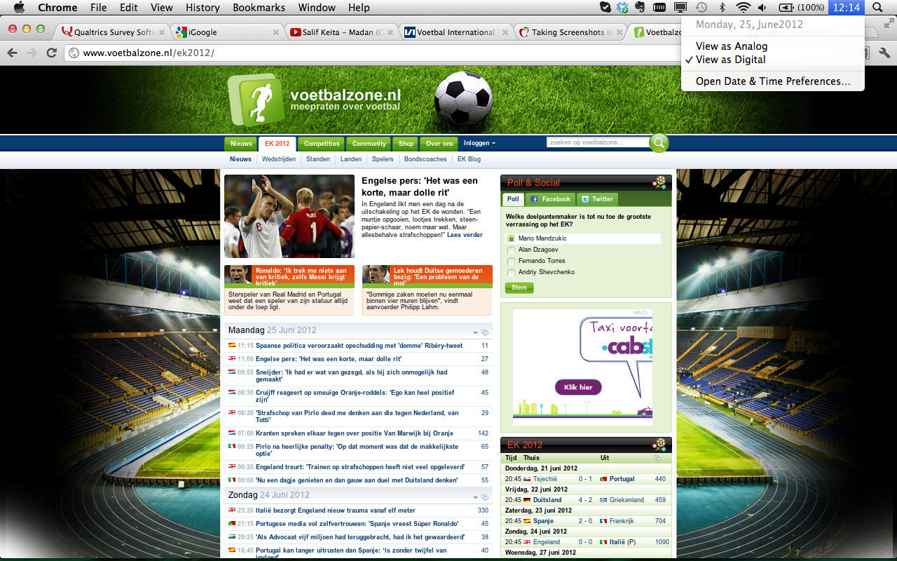
Friday July 6th 2012 on 14:19.

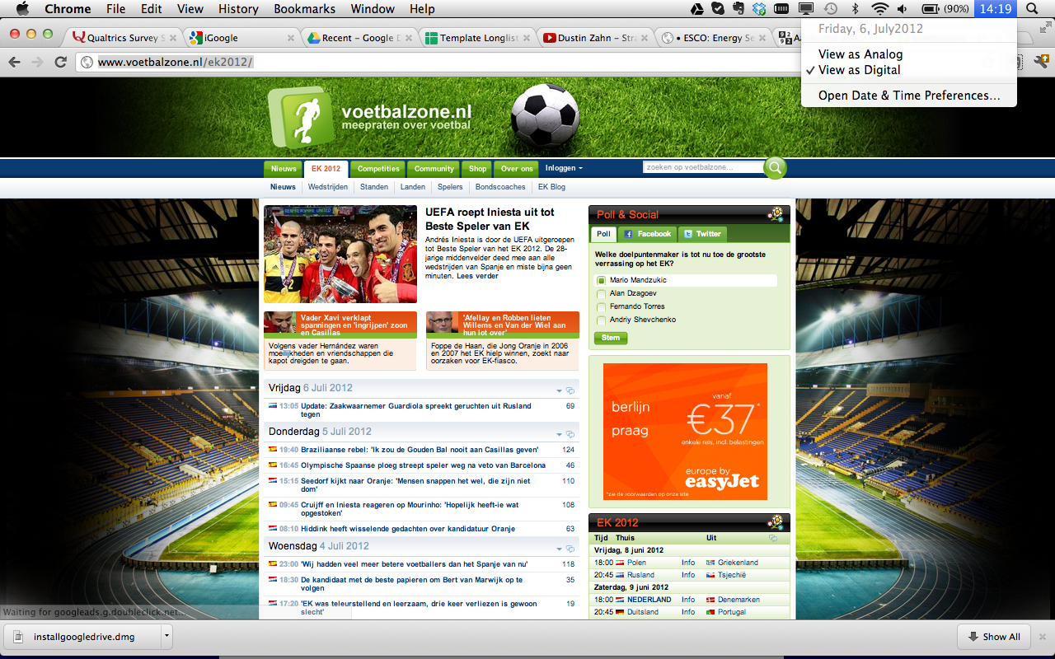

Appendix B

Satisfaction Surveys and Constructs
External Variables | Instrument characteristics |  | Bailey and Pearson (1983) | Ives et al. (1983) | Baroudi and Orlikowski (1988) | Doll and Torkzadeh (1988)
Information Quality | Accuracy |  | X | X | X | X
 | Precision |  | X | X | X | X
 | Reliability |  | X | X | X | X
 | Currency |  | X | X |  | X
 | Completeness |  | X | X | X | X
 | Format |  | X
 | Volume |  | X | X
Usefulness | Usefulness |  | X | X |  | X
 | Relevancy |  | X | X | X | X
Ease of use | User Friendly |  |  |  | X
 | Easy to use |  |  |  |  | X

Appendix C
Appendix C contains the measurement constructs that were used to measure the variables.
Measured Variables
Information Load  (Bailey & Pearson 1983;  Ives et al 1983) | Seven-point Likert Scale: Strongly Disagree to Strongly Agree  This website offers:  - Too much information  - Unnecessary information  I would like:  - To assess more information on this website  The amount of information this website offers is:  - Redundant  - Insufficient
Aesthetic Appeal  (Lavie & Tractinsky 2004) | 100-point slider scale.  Please consider the following statements and judge them for the website:  - Original  - Sophisticated  - Fascinating  - Creative  - Pleasant
Aesthetic Formality  (Lavie & Tractinsky 2004) | 100-point slider scale.  Please consider the following statements and judge them for the website:  - Clean  - Clear  - Orderly  - Symmetrical  - Organized
Perceived User Effort  (Bechwati & Xia 2003) | Seven-point Likert Scale: Strongly Disagree to Strongly Agree  - I put a lot of effort into searching for information on the website  - I did not exert a lot of effort searching for information on the website (R)  - How much effort did your information search require before you found information that was of use? (A lot less than I expected – A lot more than expected)
User Satisfaction | Seven-point semantic differential scale  How do you feel about this website:  - Frustrated to Contented  - Displeased to Pleased  - Unpleasant to Pleasant

Appendix D
Appendix D contains the measurement constructs that were used to measure the control variables.
Control Variables
Involvement  (Zaichkowsky 1994;  Jiang et al. 2010) | Seven-point Likert Scale: Strongly Disagree to Strongly Agree  - I like football  This website is:  - Important  - Means nothing to me (R)
Familiarity | Seven-point Likert Scale: Strongly Disagree to Strongly Agree  - I often use the Internet to check football news  - I know the website I just visited well  - I am familiar with this website or similar football news websites  - I often visit this website or similar football news websites
Content Accuracy  (Abdinnour-Helm et al., 2005; (Doll and Torkzadeh, 1988; Zmud, 1978) | Seven-point Likert Scale: Strongly Disagree to Strongly Agree  The information I found:  - Accurate  - Reliable
Likelihood to Recommend | Seven-point Likert Scale: Unlikely to Likely  - How likely are you to recommend the website?
Intention to Revisit | Seven-point Likert Scale: Unlikely to Likely  - How likely are you to revisit the website?
Demographics  (Illustration: www.wiebetaaltwat.nl) | - Where do you go to:    - What is your age? Please answer in years.

Appendix E
For the completeness of the study, the general descriptive statistics are included in this appendix.

Gender
 |  | Frequency | Percent | Valid Percent | Cumulative Percent
Valid | Male | 110 | 80.3 | 81.5 | 81.5
Valid | Female | 25 | 18.2 | 18.5 | 100.0
Valid | Total | 135 | 98.5 | 100.0
Total |  | 137 | 100.0

Age
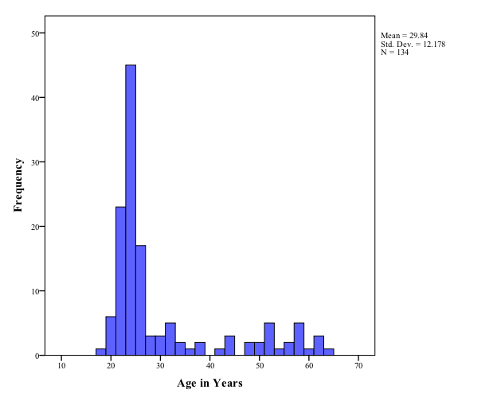

Appendix F
This Appendix contains the Cronbach’s alpha statistics for the five factors. The constructs that were dropped are indicated with an *.

Factor 1: User Satisfaction
Cronbach's alpha: 0.931 | If deleted
General - Pleased | 0.895
General - Contented | 0.859
General - Pleasant | 0.865
Factor 2: Aesthetic Formality
Cronbach's alpha: 0.844 | If deleted
Clean | 0.797
Clear | 0.788
Orderly | 0.753
Organized | 0.751
Symmetrical* | 0.844
Factor 3: Aesthetic Appeal
Cronbach's alpha: 0.758 | If deleted
Original | 0.698
Sophisticated | 0.713
Fascinating | 0.625
Pleasant * | 0.758 | :
Creative | 0.629
Factor 4: Information Load
Cronbach's alpha: 0.703 | If deleted
The website offers too much information | 0.701
The amount of information the website offers is redundant | 0.511
Voetbalzone.nl offers unnecessary information | 0.625
Factor 5: Perceived User Effort
Cronbach's alpha: 0.674 | If deleted
I put a lot of effort into searching for information | 0.477
How much effort did your information search require? * | 0.674
I did not exert a lot of effort searching for information | 0.412

Appendix G
This Appendix contains an overview of the ‘Decision Tree for establishing and understanding types of mediation and non-mediation’ (Zhoa et al. 2010 p. 210). The letters in the figure refer to the same relationship as used in Figure 6. The yellow line indicates the mediation effect of Perceived User Effort on the relationship between Aesthetic Formality and User Satisfaction.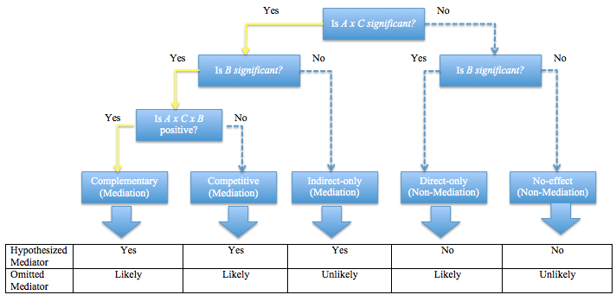

General descriptive statistics of the research population for this study can be found in Appendix E

