

Erasmus University Rotterdam
Erasmus School of Economics

Marketing Master Thesis

Gender differences in adoption and persuasiveness of collaborative filtering in an online apparel store

Author: Christos Makris
Student number: 344936
Academic year: 2011 - 2012
Department: Marketing
Supervisor: Dr. Jordana Folle de Menezes Liberali

Rotterdam, 2012

“The Internet is no longer a niche technology – it is mass media and an utterly integral part of modern life. As our lives become more fractured and cluttered, it isn’t surprising that consumers turn to the unrivalled convenience of the Internet when it comes to researching and buying products.”

Jonathan Carson, President, International, Nielsen Online

Acknowledgements

This research project constitutes my Master Thesis for the Master’s in Economics and Business with specialization in Marketing at the Erasmus University Rotterdam. It would not have been possible to write this thesis without the assistance, guidance and support of a number of kind people around me.

Above all, I would like to thank Dr. Jordana Folle de Menezes Liberali, my supervisor, for all her help and critical guidance during the writing of my thesis, and all the professors from the Marketing program for the overall knowledge and inspiration they offered me. Furthermore, I would like to thank my parents and my brother for all their support throughout my academic life.

Last but not least, I have to thank my friends Loukia, Andreas, Marco, Georgios and Zoi for all their patience and support during this academic year.

After all, the process of writing this thesis has been a pleasurable ‘journey’ filled with a lot of effort but also satisfaction. I hope everyone enjoy reading my thesis, much as I did writing it.

Christos Makris

Rotterdam, July 2012

ABSTRACT
The purpose of this study is to investigate gender differences in the adoption and the persuasiveness of a collaborative filtering agent in an online apparel store. The dichotomous nature of this agent as an information system and a marketing tool demanded a considerable body of literature from different scientific fields for building the theoretical framework of this study. The technology acceptance model (Davis, 1989) and the Reardon’s persuasiveness theory (Reardon, 1991) have been used in order to study the agent’s adoption and persuasiveness. The impact of the easiness of use and the usefulness of the agent on its adoption were examined based on gender in the first model, and the agent’s appropriateness, consistency and effectiveness in the latter. Another variable regarding the agent’s persuasiveness that was studied is the customer’s fashion involvement.
An online experiment was run in this study, providing quantitative data regarding the perceived values for adopting the agent and its persuasiveness to make online customers purchase any recommended products. A total of 212 participants (i.e. 106 males and 106 females) were involved.
Different analyses were conducted in order to tests the hypotheses. The results from the analyses revealed that although both easiness of use and usefulness of the agent have significant impact on its adoption, this impact does not differ across the genders. Furthermore, the gender cannot predict the adoption of the agent, since both genders will equally adopt the collaborative filtering agent in their purchases. Regarding the persuasiveness of the collaborative filtering agent, although all three variables (i.e. appropriateness, consistency and effectiveness) have individually significant impact on the persuasiveness, only effectiveness has a stronger impact on the persuasiveness for female shoppers. Furthermore, the level of the fashion involvement of the customer appears to have a significant impact on the persuasiveness of the agent, with higher involved consumers being more persuaded by the agent.
The findings of this study provide insights for practical applications in online apparel stores. At the end, thoughts and topics for further research in this area are offered.

Table of Contents
Acknowledgements 3
ABSTRACT 4
LIST OF TABLES AND FIGURES 7
1. INTRODUCTION 8
2. THEORETICAL FRAMEWORK AND MAIN HYPOTHESES 10
2.1 DIFERRENT TYPES OF RECOMMENDATION AGENTS 10
2.2 COLLABORATIVE FILTERING 11
2.3 BACKGROUND RESEARCH ON RECOMMENDATION AGENTS 14
2.4 RESEARCH QUESTION 16
2.5 GENDER, TECHNOLOGY AND ONLINE SHOPPING 17
2.6 TECHNOLOHY ACCEPTANCE MODEL AND ACE THEORY 20
2.7 FASHION INVOLVEMENT 27
3. METHOD 31
3.1 QUESTIONNAIRE 33
3.2 SAMPLE AND SURVEY DISTRIBUTION 40
4. RESULTS 41
4.1 RELIABILITY 41
4.2 HYPOTHESES TEST 42
5. CONCLUSIONS 57
5.1 DISCUSSION 57
5.2 LIMITATIONS 61
5.3 MANAGERIAL IMPLICATIONS 63
5.4 FURTHER RESEARCH 65
LIST OF REFERENCES 67
APPENDICES 74
Appendix I: SPSS output-Reliability test 74
Appendix ii: SPSS output-Descriptive and box plots 75
Appendix iii: SPSS output-Analysis results per hypothesis 82
Appendix iv: Output post-hoc power analysis with G* Power 3 99
Appendix v: Online Experiment and Questionnaire 108

LIST OF TABLES AND FIGURES

Figure 1: Research Model 30
Figure 2: Error bar chart: mean adoption per gender 47
Figure 3: Error bar chart: mean fashion involvement per gender 53
Figure 4: Error bar chart: mean persuasiveness per gender 55
Figure 5: Distribution of the variables across gender 77
Figure 6: Distribution of the variables across gender 80

Table 1: Statements used to form the variables 38
Table 2: Number of items per variable 41
Table 3: Reliability test - Cronbach's alpha coefficients 42
Table 4: Mean of the variables 43
Table 5: Mean of the variables across gender 43
Table 6: Means of the variables 44
Table 7: Means of the variables across gender 44
Table 8: Stratified regression analysis with dependent variable: adoption, independent variable: easiness of use and stratification variable: gender 45
Table 9: Stratified regression analysis with dependent variable: adoption, independent variable: usefulness and stratified variable: gender 46
Table 10: Multiple regression analysis with interaction term, dependent variable: adoption and independent variables: usefulness, gender and usefulness*gender 47
Table 11: Stratified regression analysis with dependent variable: persuasiveness, independent variable: appropriateness and stratified variable: gender 48
Table 12: Multiple regression analysis with interaction term. Dependent variable: persuasiveness and independent variables: appropriateness, gender and appropriateness*gender 49
Table 13: Stratified simple regression analysis with dependent variable: persuasiveness, independent variable: consistency and stratification variable: gender 50
Table 14: Stratified regression analysis with dependent variable: persuasiveness, independent variable: effectiveness and stratified variable: gender 51
Table 15: Multiple regression analysis with interaction term, dependent variable: persuasiveness and independent variables: effectiveness, gender and effectiveness*gender 52
Table 16: Multiple regression analysis with dependent variable: persuasiveness and independent variables: fashion involvement and gender 54
Table 17: Overview of Hypotheses Test 56

1. INTRODUCTION

The Internet is nowadays an essential tool as we are going through the “Information or Knowledge-based era”. It provides its users with the benefit to access a great amount of information that is available online. The entrepreneurs soon enough realized the importance of the Internet and how it could be used for commercial purposes. Existing retailers expanded their business into the Internet, creating online web stores to implement their traditional retail activity (i.e. brick-and-mortar), while other entrepreneurs exploited all possibilities that the Internet offered and created exclusively online retail shops (i.e. pure click) (Swaminathan & Tayur, 2003).
The increase of online retailers is equivalent to the increase of Internet users who shop online. Online shopping can be fun while at the same time it is quite effortless. One can search through a huge variety of products and services and do the purchase from the comfort of their home. More and more consumers choose to shop online for a number of reasons such as: it is less time consuming, there is a greater variety of available products and access to a great amount of information, prices are lower etc. According to a global survey conducted by Nielsen Company, over 85 percent of the world’s online population has used the Internet to make a purchase, and more than half of the Internet users are regular online shoppers, making online purchases at least once a month. (Global Nielsen consumer report, 2008)
Online shops provide large product assortments offering numerous choices to the consumers (Haubl & Trifts, 2000). Most online stores have an interactive interface with many photos and videos of the products with zoom capability or even 3D representation. All these features exist to assist the consumer to gain a clearer view of the product via the screen. These huge product assortments may offer more choices to but can make the consumers’ task more difficult. The consumer could be overwhelmed by the affluence of the products and thus become unable to choose the right product that meets his/her needs or preferences. In the traditional retail shops, salespeople are present to assist the consumer to make the best decision, but in an online retail store such communication is not feasible. In order for online retailers to overcome these difficulties, they exploited the power of technology to provide the best possible experience and assistance to their customers. Interactive decision aids are widely used to help online shoppers overcome the overload of information and make better decisions (Haubl & Trifts, 2000).
There are two types of interactive decision aids, the recommendation agents (RAs) and the comparison matrix (CM). The first one enables the consumers to easily screen the alternatives available in an online web store, while the later is designed to assist the consumers to make comprehensive comparisons among the preferred alternatives (Haubl & Trifts, 2000). RAs could be classified in two categories; the first one consists of rule-based recommendation engines, in which the consumer has to choose aspects or weigh attributes, and the second one is the collaborative filtering which uses other consumers’ preference database to predict products that a new consumer might like, based on matching criteria (ibid). The later is the one that I will focus my research on.

2. THEORETICAL FRAMEWORK AND MAIN HYPOTHESES

2.1 DIFERRENT TYPES OF RECOMMENDATION AGENTS
“Recommendation agents are software agents that elicit the interest or preferences of individual users for products […] and make recommendations accordingly” (Xiao & Benbasat, 2007: 137). RAs have been used in different areas on the web (e.g. education), but mainly applied in e-commerce. According to Spiekermann (2001) a basic distinction among the different RAs used in e-commerce is that between the RAs of product brokering (i.e. the RAs that assist a shopper to find the product that better suits to his/her preferences) and the RAs of merchant brokering (i.e. the RAs that assist a user to find the suited retailer). In my study I will focus on the product brokering RAs that assist the users to choose the suited product out of a number of available products.
After narrowing down the RAs to two broad categories based on their functionality (i.e. product brokering and merchant brokering), a classification of the different types of product brokering RAs is needed at this point. Based on the Xiao and Benbasat (2007) categorization, the product brokering RAs can be classified into six different types: “content-filtering, collaborative filtering, compensatory RAs, non-compensatory RAs, feature-based and needs-based RAs” (Xiao & Benbasat, 2007: 146)
The most commonly used RAs in online commerce are the filtering based methods (i.e. content-filtering and collaborative-filtering). A notable example of a website that is currently using content-filtering RAs is MySimon.com and one using collaborative-filtering is amazon.com. It has been argued that the application of RAs to assist users to purchase suited products influences their decision-making in two levels; during the process of both the decision-making and the outcome as well, as consumers benefit better from decision quality and less from decision effort. (Xiao & Benbasat, 2007; Haubl & Trifts, 2000). Due to the large assortments that online stores offer, the consumers’ choice of the product that fits to their needs and preferences turns to be a complex task, and RAs are the engines that reduce this complexity by assisting the consumers in a two-stage decision-making process as discussed later on this paper (Payne, 1982; Haubl & Trifts, 2000). While recommendation agents enable online shoppers to reduce the decision-making effort, they also constitute a product of information technology and some shoppers might not be aware of their usage and not acknowledge their assistance. In my study I will focus on the latter type of filtering based RA, which is commonly used in many online shops.

2.2 COLLABORATIVE FILTERING
Collaborative filtering is the process of rating items based on other people’s ratings or opinions. Although collaborative filtering counts not many years and follows the development of online shopping, the concept behind collaborative filtering is routed in a well-practiced and essential activity that humans are engaged to as members of social circles, which is no other than sharing opinions with other individuals (Schafer et al., 2007). This fact gives collaborative filtering a social context. Individuals as members of a society and members of wider or narrower social circles like family, colleagues etc, express their opinions and share their thoughts regarding a wide range of matters including also products and services. When one expresses his/her preference for a product, he/she functions as a word-of-mouth ambassador for this product and this preference is translated into a recommendation of this product to the audiences. Most consumers acknowledge that there are certain people with whom their preferences match, and their recommendations help them decide the best product for them among a number of alternatives. This is the concept that collaborative filtering agents follow.
Based on a number of algorithms, collaborative filtering agents generate a list of recommended products based on what other people think of these products, mimicking “word-of-mouth” tradition in the digital environment as Xiao and Benbasat (2007) argue, or “word-of-web” as Vezina and Militaru (2004) suggest. Yet, collaborative filtering agents go a step further as they do not recommend products based on what the larger community thinks of these products, but on what the most appropriate in each case people, with the same taste, the same aesthetic and preferences with the user, think of these products providing in this manner truly personalized recommendations individually to each user (Schafer et al., 2007). The ratings of each product may be collected in three different ways; through “explicit means, through implicit means or both” (Schafer et al., 2007: 293). Explicit ratings are gathered by asking the individuals to rate in a specific scale and provide their opinion on a product. This is a very common technique that many web sites use (e.g. amazon.com, americanapparel.net, imdb.com) in order to collect data regarding the preferences of their users. The second method refers to implicit ratings, which are not gathered by directly asking the users to express their opinion and rate a product, but the users are monitored and the data are collected from their actions. In this manner when a user arrives in a product page within a website and checks a specific product, then probably he/she has an interest for this product; based on the clicks of the user and on previous purchases that he/she has completed, collaborative filtering creates the user’s profile about his/her preferences. The third method of rating combines the two previously mentioned methods and in this way the collaborative filtering agent generates recommendations from explicit and implicit ratings, as amazon.com does (Schafer et al., 2007).
Collaborative filtering agents assist the users in their process of decision-making by enabling them to be aware of what other like-minded people think about a product. This fact gives online shopping a more social aspect providing the opportunity to the users to interact with the agent, which actually represents the preferences of other users. Some online web stores (e.g. amazon.com) have recently provided their users with the opportunity to further interact with the agent by enabling them to find out why the agent recommends to them these products based on whose ratings the agent generated the recommendations. Furthermore, the users are able to provide more information regarding their preferences or needs, in order to qualify the agent to provide them with the best possible fitted recommendations (i.e. amazon.com). The value of collaborative filtering agent lies on the fact that for each user there are other users with similar taste and needs and that the user bases his/her decision on recommendations of others. If a user has such unique preferences that do not fit with the preferences of other users, or if he/she overlooks other users’ opinion, then collaborative filtering might not be that valuable to this user (Schafer et al., 2007).
The representation of the recommended products that the agent generates for each user can be located in different spots on a product page and follow different configurations depending on the web store. Most commonly the recommended lists are located underneath the product that the user checks (e.g. amazon.com, americanapparel.net) or on the right top spot of the product page, right after the description of the product and the purchase and shipping information (e.g. nordstrom.com). The recommendation lists are easily distinguishable by the customer as they are entitled “Customers who viewed this item also viewed” (i.e. amazon.com), or “You might also like” (i.e. americanapparel.net), or “Suggested for you” (i.e. nordstrom.com).
In the case of the amazon.com, six recommended products are listed in each configuration and the customer can further check recommended products by clicking on ‘next’ page with six more recommendations. The number of the total recommendations depends on the product and the recommendations that the agent generated for this. In the case of nordstrom.com, the agent suggests and exposes two recommended products and the customer can further explore recommendations by clicking the ‘show more’ button. Then the configuration changes, and the agent exposes more recommended products from the recommendation list generated for the customer. In general the recommendation agents and more specifically the collaborative filtering agents are user friendly and designed in a manner to demand low effort from the customer in order to use them and receive the information they are searching for. The practitioners pay considerable attention to the possibilities that collaborative filtering has to offer, and as Linden et al. (2003) from the amazon.com group argue, collaborative filtering is an effective tool for targeted marketing by providing personalized recommendations for each individual customer and the application of recommendation algorithms is expected to further increase in the online retail industry.

2.3 BACKGROUND RESEARCH ON RECOMMENDATION AGENTS
There is a considerable body of literature examining the RAs in e-commerce. RAs have a twofold nature and can be seen on the one hand as an information system and on the other hand as a marketing tool (Vezina & Militaru, 2004). A great part of the existing literature focuses on technical features of the RAs, such as comparing the effectiveness of different methods of collaborative filtering (i.e. traditional collaborative filtering, cluster model, search based methods) (Linden et al., 2003; Montaner et al., 2003;Sarwar et al., 2000; Schafer et al.2001) or on the analysis of the predictive algorithms that can be used for collaborative filtering (Breese et al., 1998; Huang et al., 2007), or even evaluating collaborative filtering concerning the datasets being used for prediction quality (Herlocker et al., 2004).
From a pure marketing perspective much research related to RAs has been done as well. Haubl and Trifts (2000) conducted a research on how interactive decision aids (i.e. recommendation agents and comparison matrix) influence consumers’ decision-making and purchase behavior. Following a two-stage decision-making process (i.e. in the first stage consumers screen a large set of available alternatives and then identify a subset of the most promising alternatives, then they move to the second stage in which they evaluate in more depth the latter subset performing relative comparisons of attributes and finally make the purchase decision) and hypothesizing that consumers’ shopping behavior in an online environment is fundamentally different from that in a traditional retail store, they acknowledge the important role that interactive decision aids hold in consumers’ decision-making. This view is further supported by Haubl and Murray (2003), who acknowledge the tendency of consumers to rely on RAs recommendations in order to choose products by reducing the amount of effort needed to make a purchase decision. In their findings, Haubl and Trifts (2000) conclude that interactive decision aids have a positive impact on their decision quality with less cognitive effort.
Komiak and Benbasat (2004) investigate the trust and adoption of RAs. More specifically, the two authors empirically examine the effects of personalization and familiarity on cognitive and emotional trust and how these reflect on the intention to adopt a RA. Although previous research has examineded the connection between trust and IT adoption, Komiak and Benbasat’s (2004) research is the first to examine the role of emotional trust in IT acceptance, basing their research on the Theory of Reasoned Action (TRA). They actually found out that a RA’s perceived personalization and a customer’s familiarity with the RA increases the customer’s intention to adopt the RA by increasing cognitive and emotional trust. This finding plays an important role regarding the acceptance of the RAs from the consumers who purchase online.

2.4 RESEARCH QUESTION
So far, RAs are defined as a product of information technology as they are considered an important innovative technology used on e-commerce to deliver value to the consumers by assisting online shoppers to choose the best option that better fits their preferences or needs among a number of available products. However, RAs apart from providing customers with accurate and on-time information about the available products, they could also be seen as a means for the online vendors to achieve more sales, as Postma and Brokke (2002) argue. According to Leavitt (2006), RAs are used by online businesses on the one hand, in order to assist customers to make optimal choices and on the other hand in order to improve marketing and increase their sales. Under this perspective it is very important to study the acceptance of RAs by the online shoppers, but also the RAs persuasiveness in order to motivate shoppers to purchase recommended products. Furthermore, as Gefen and Straub (1997) proposed, future researches “should include gender in IT diffusion models along with other cultural effects” (Gefen & Straub, 1997: 389). This is a very interesting insight for further research and highlights the need to include the gender factor when researching the acceptance of RAs by consumers, as it has not been studied extensively so far. Therefore, the main research of this study is to explore the potential differences in the adoption and the persuasiveness of the collaborating filtering, a commonly used RA, in an online apparel store. Consequently, the research question could be formed as such:
To what extend is collaborative filtering adopted by online shoppers and persuade them to buy recommended products, under the spectrum of the gender?
The terms adoption and acceptance will be used interchangeably throughout the paper.
The reason I chose the apparel industry lies on the fact that clothing/accessories/ shoes, along with the books are the most popular purchases online from the Internet consumers (Global Nielsen consumer report, 2008). In this sense, more of my respondents might have a previous experience of online shopping in this web store category.
In order to answer my research question, I will focus on the adoption of collaborative filtering for both genders based on the technology acceptance model (Davis, 1989), and the persuasiveness of collaborating filtering adopting the Appropriateness-Consistency-Effectiveness theory (Reardon, 1991). Before I proceed to the analysis of the models and how they will be used in my study, a brief review of literature related to gender and technology acceptance and gender and online shopping is needed, as it will provide an insight on potential gender differences on these two concepts and will help to summarize the findings on the RA’s research to base the hypotheses on.

2.5 GENDER, TECHNOLOGY AND ONLINE SHOPPING
In general, gender differences in the acceptance of IT do exist. These differences are either affiliated to the traditional gender role stereotypes (Van Slyke et al., 2002) or the “disposition toward masculine attitudes and behavior (MAS)” (Gefen & Straub, 1997: 391). All these stereotypes of men as radical thinkers looking at the future, earlier adopters of new technologies etc, might actually reflect on the perception of women regarding online shopping and the adoption of RAs. This argument is further supported both by Dholakia and Chiang (2003), and Alreck and Settle (2002). Dholakia and Chiang’s (2003) findings from their study on consumers’ gender stereotypes of online shoppers, suggest that respondents of both genders associate the female online shoppers with the same characteristics of a woman shopper in non-web based environment. As a result, the associations that the respondents have for female online shoppers are that they are considered to be “less technical, less spontaneous and more reliable” (Dholakia & Chiang, 2003: 171), no matter the outlet type or the purpose of the purchase. An important factor though that “feeds” these perceptions is the product category since women are perceived to buy less technology-intensive or expensive products online (e.g. DVD player).
Online shopping and its acceptance have been studied intensively under two different but intertwined perspectives: the consumer and the technology view (Zhou et al., 2007). This can be explained by the fact that online shopping is related to technology, as in order to proceed to an online purchase a computer connected to the internet or even a mobile phone with internet access in recent years is essential. A great amount of academic research has been done regarding how Internet users accept and adopt online shopping, but also researches more customer oriented, examining the online consumer behavior based on demographics (Brown et al., 2003) or examining the cognitive characteristics that influence the online consumer behavior (Hoffman & Novak, 1996; Novak et al., 2000) or the perceived risks and benefits of online shopping from the users’ side (Bhatnagar & Ghose, 2004; Featherman & Pavlou, 2003). Other factors, have also been studied such as gender differences in the processing of information, and how this is reflected on male’s and female’s consumer behavior (Chiu et al., 2005). Furthermore, as Meyers-Levy & Sternthal (1991) argue, women compared to men are more conscious of any relevant online information during their decision-making process, indicating that purchase intentions online may as well vary according to gender.
Regarding the study of the adoption of online shopping, a number of different models have been used so far such as Technology Acceptance Model (TAM) (Chiu et al., 2005), the extended TAM (Gefen & Straub, 1997), the Theory of Planed Behavior (Pavlou 2003) the Theory of Reasoned Action and the Online Shopping Acceptance Model (OSAM) (Zhou et al., 2007). Zhou and colleagues (2007) implemented all these factors in their model based on a number of previous both consumer and technology oriented researches. Chiu et al. (2005) in their study propose a modified technology acceptance model structured around four elements to study the purchase intensions toward online shopping: personal awareness of security, personal innovativeness, perceived ease of purchasing and perceived usefulness of purchasing. The findings of their study regarding the perceived easiness and perceived usefulness indicate that, in general, the influence that the perceived usefulness has toward the purchase intensions online is the same for both genders, while for the perceived easiness, the influence is much stronger for the female customers than for the males.
According to Van Slyke and colleagues’ (2002) research on gender differences on the perceptions of web-based shopping, gender is a significant predictor of web usage. Furthermore, they argue that women tend to be more “rational catalog shoppers” (Van Slyke et al., 2002: 85) and tend to enjoy the social aspects of shopping and demonstrate their purchases and thus online shopping might be viewed less favorably (Van Slyke et al., 2002). The fact that women enjoy the social aspects of shopping is further supported by Evans et al. (1996) arguing that women participate in the shopping process as an activity of the social norms related to their own identity and role as shoppers, while looking for approval from their family and social circles (McCall, 1997). Van Slyke et al. conclude that men’s perceptions of online shopping are more favorable than women’s; men consider web-based shopping more trustworthy and less complex than women, and therefore men are more likely to use the Internet to make purchases (Van Slyke et al., 2002). The fact that men are more favorable towards online shopping is further supported by Arleck and Settle (2002.) Their findings of their comparative study on gender effects are supported by three different shopping modes: the Internet, catalogue and store shopping. Their findings suggest that, firstly, women in general are more favorable toward shopping, and secondly that “women more often employ a value optimizing shopping strategy than do men” (Arleck & Settle, 2002: 158) (i.e. shoppers that adopt optimizing shopping strategies are those who stand more favorably toward shopping and they further perceive shopping as rewarding). Once again, product category is an important factor, as women are shown to be more favorable towards specific product categories like apparel, accessories and gifts. Although in general these results apply to catalogue and store shopping, things are different in online shopping, where men seem to be more favorably predisposed towards using the Internet to purchase products.
As it is obvious from the above, the stereotypes of men as being more technology conscious and more familiar with its use are confirmed and this technology expertise also reflects on the online shopping acceptance, with males being simultaneously the majority of online shoppers and the more favorably predisposed towards online shopping. This gender difference towards technology acceptance might influence accordingly the adoption of collaborative filtering and the extent to which the agent persuades online shoppers of both genders to buy recommended products. In order to study this argument I will support my research, as it has been already mentioned, on the technology acceptance model (Davis, 1989) and the appropriateness-consistency-effectiveness theory (Reardon, 1991).

2.6 TECHNOLOHY ACCEPTANCE MODEL AND ACE THEORY
The technology acceptance model, proposed by Davis (1989), has been extensively used in studying the adoption of information technology products and information systems by researchers (Pavlou, 2003; Koufaris, 2002; Dabholkar & Bagozzi, 2002; Gefen & Straub, 1997; Venkatesh & Morris, 2000). Other theories and models have also been widely used to study technology acceptance and online consumer behavior such as the Theory of Reasoned Actions developed by Fishbein and Ajzen (1975) (e.g. Liker & Sindi, 1997; Wu, 2033; Komiak & Benbasat, 2006; Hansen et al., 2004) and its improved concept, the Theory of Planed Behavior developed by Ajzen (1991) (e.g. Harisson et al., 1997; Lynne et al., 1995, Morris & Venkatesh, 2000). According to Liao and Shim (2008), ACE provides a new insight into the research in IS for it explains the factors that affect the behavior of an IS user or a customer in this case. Given the importance to study the adoption of collaborative filtering from the users but also the agent’s persuasiveness, which means persuading the users to purchase one of the recommended products, I will use both models in an integrated framework for the completion of my study and verification of my results. A presentation of the two models follows below.
The aim of the technology acceptance model is to interpret and predict the adoption of new technologies by the users. As Davis (1989) argues, the two most important reasons that lead the users to accept or to reject a new technology are the perceived usefulness and the perceived ease of use. The first one refers to the extent to which users believe that the use of this technology will assist them to better perform their task, while the second one refers to how easy they believe the use of the new technology is and weather the benefits of its use offset its required effort. According to Davis’ (1989) definitions, perceived usefulness is “the degree to which a person believes that using a particular system would enhance his or her job performance”, while the perceived ease of use refers to “the degree to which a person believes that using a particular system would be free of effort” (Davis, 1989: 320). From the perspective of collaborative filtering the perceived usefulness for adopting it (i.e. make use of the agent and check the recommended products) could be defined as the user’s personal belief that by using collaborative filtering he/she will complete his/her task (i.e. to find and purchase the best fitted product) more effectively. As for the perceived ease of use of collaborative filtering agent, it refers to the degree to which the users expect the use of the agent to check the recommended products is of low effort or not.
Gefen and Straub (1997), extending the technology acceptance model (Davis, 1989), conducted a research on the gender differences in the perception and use of emails. They included in their model socio-cultural aspects, different beliefs and use of regarding computer-based media and they adopted the view that gender is a profound aspect of culture, which can result in different behaviors on the adoption of an IT between males and females. Their findings showed that males and females have different perception regarding the adoption of the email, but they do not differ in the actual use of this IT system.
According to Venkatesh and Morris (2000), the influence of the perceived ease of use on the intention to adopt a technology is stronger for females than for males. This could be due to females’ lower technology expertise and suggests a greater impact of the perceived ease of use on adopting collaborative filtering for females than for males. This is further supported by Komiak and Benbasat’s (2006) argument that customer’s familiarity with the RA increases the customer’s intention to adopt the RA. According to Dholakia and Chiang’s (2003) argument that female shoppers are less technical than male shoppers, one could argue that female shoppers would find it more difficult to use the recommendation agent. This argument could be further enforced by the fact that women are less favorable towards online shopping and actually fewer women choose web shops to purchase products (Van Slyke et al., 2002; Arleck & Settle, 2002.) As a result women are less familiar with the agent and the impact of the perceived ease of use on the adoption of collaborative filtering will be greater for females. Collaborative filtering though is an online recommendation agent that does not require much cognitive effort by its user as mentioned before. It uses other consumers’ preferences with matching profiles in order to propose any additional products that a customer might like (Schafer et al., 2007.) For that purpose collaborative filtering requires only to locate it within the product page and click on the recommended products. This implies a relatively simple and easy operation of the agent. Even the less experienced with online shopping can easily locate and check the recommended products. Hence, I argue that the perception of easiness of use will not differ between male and female shoppers and the impact that the easiness of use has on the adoption of the collaborative filtering agent will be not significant both for females and males.

Regarding the usefulness of the agent, as indicated by Chiu et al. (2005), men rate practical advancement higher regarding the completion of a task efficiently, suggesting that usefulness in terms of practicality, is more influential for the adoption of technology for males. In other words, the influence of perceived usefulness of collaborative filtering on its adoption intentions is stronger for male users than for females. Nevertheless I expect that the perceived usefulness will be a significant factor for the agent’s adoption for both genders. This is based on a number of factors. First, the nature and functionality of CF have a positive impact on the decision quality of the shoppers with less cognitive effort (Haubl & Trifts, 2000.) Second, female shoppers are less spontaneous (Dholakia & Chiang, 2003) and more “rational catalogue shoppers” (Van Slyke et al. 2002). This means that women are prone to spend more time before choosing a product among a number of alternatives. However, female online shoppers will grade higher the usefulness of collaborative filtering. Regardless the fact that males are more familiar with technology and online shopping, in the case of collaborative filtering as built on previous argumentation, I expect that:
H1: The easiness of use of the agent will not have a significant impact on its adoption either for male or for female online shoppers.
H2a: The usefulness of collaborative filtering will have a significant impact on its adoption for both genders.
H2b: The usefulness of the agent will have a stronger impact on its adoption for female online shoppers rather than for males.
It has already been argued before that gender can modify the adoption of an information system. However, I expect that for collaborative filtering, gender cannot determine the adoption of the agent by the online shoppers. Consequently,
H3: The collaborative filtering agent will be equally adopted by both genders.

“Persuasion, a concept originated from of psychology and communication, attempts to guide people toward the adoption of some behavior, belief, or attitude preferred by the persuader through reasoning or emotional appeals” (Liao & Shim, 2008: 66). Reardon (1991) explains that the Appropriateness-Consistency-Effectiveness (ACE) model consists of three stimuli that contribute to the persuasion on the adoption of a new behavior. Namely, appropriateness, consistency and effectiveness are the three criteria that individuals tend to use in order to decide whether they will be persuaded by an argument or not. “Appropriateness refers to the extent to which the idea is approved of by important others or whether it is the right thing in the situation at hand” (Komiak & Benbasat, 2004: 432); consistency indicates the identification of an idea or proposed action of an individual with the idea or proposed action of another person who has thought or behaved similarly in the past, while effectiveness exemplifies the level of the success of an idea or an action to lead to the desired goals. (Komiak & Benbasat, 2004).
More specifically, in this study appropriateness refers to the extent to which the proposed recommendations of collaborative filtering and the action to purchase one of the recommended products are approved by important others. Based on the nature of collaborative filtering, which is ‘customer expertise’-based (Schafer et al., 2007), the proposed recommendations hold a degree of appropriateness. According to Komiak and Benbasat (2004), appropriateness is actually similar to the subjective norms of the Theory of Reasoned Action by Fisshbein and Ajzen (1975). Indeed, subjective norms formulate an individual’s belief in terms of what a particular person or a group of individuals considered to be important think about whether this individual should or should not proceed to a specific behavior (Fisshbein & Ajzen, 1975). In this case, subjective norms express the same as appropriateness, the extent to which the proposed recommendations of collaborative filtering and the action of the shopper to purchase one of the recommended products are both approved by important others. I expect therefore that for female shoppers the appropriateness of the agent will be an important factor regarding its persuasiveness. This I base on the fact that women seek approval from their social circle and family regarding their purchases (McCall, 1977) and the fact that women enjoy the social aspects of the whole shopping experience (Van Slyke et a., 2002; Evans et al., 1996). Another considerable fact is the social context of the collaborative filtering concerning the way it functions in order to generate recommendations (i.e. what the most appropriate in each case people think of the products that the agent recommends) (Schafer et al., 2007). Hence,
H4a: The appropriateness will have a significant effect on the persuasiveness of the agent for both genders.
H4b: The appropriateness of the collaborative filtering agent will have a stronger impact on its persuasiveness for female rather than for male online shoppers.
Consistency examines the extent to which the recommended products of collaborative filtering are those products that other people with the same taste, aesthetic, would view or buy from the current web store. Given the function of collaborative filtering as mentioned before, which groups like-minded people and recommends products according to those consumers’ clicks, rates or purchases, the collaborative filtering agent appears to have a high degree of consistency. My argument is that females value the consistency of this agent, regarding its persuasiveness, higher than men. This is established upon a) the reasons why women enjoy the social and demonstrative aspects of shopping (Van slyke et al., 2002) and b) the way collaborative filtering generates recommendations based on like minded people functioning as a «word-of-mouth» mimic (Xiao & Benbasat, 2007; Vezina & Militaru, 2003). Therefore:
H5: The consistency will have a significant effect on the persuasiveness of the agent for female shoppers and not for males.
Effectiveness assesses the user’s benefits from the recommended products of the collaborative filtering in order to meet his/her goals. The consumer’s goals in this case are to look at products that he/she actually likes and think that fit his/her needs and realise that the recommendations are actually helpful when deciding for the best fitted alternative. So, effectiveness could be seen as the perceived benefits of using the collaborative filtering agent in order to choose a product. This was proposed by Aksoy et al. (2006) in their study regarding the effectiveness of different forms of recommendation agents on the quality of consumer’s choices, examining the similarity between a consumer and an agent. Collaborative filtering holds also a degree of effectiveness as it generates recommendations, which are personalized and customised on each user’s preferences. The degree of effectiveness for each user depends on the degree to which the recommended products meet their preferences, and probably the effectiveness is lower if a user has such unique preferences that do not fit with the preferences of other users, or if the user does not consider the other users’ opinion important (Schafer et al., 2007). Women are more conscious of any relevant information they might receive online during their decision-making (Meyers-Levy & Sternthal, 1991.) They also tend to consider other people’s opinions, mirrored here in the virtual advice they take from the collaborative filtering suggestions. My next argument is that for women the impact of the effectiveness on the persuasiveness of the agent will be stronger compared to men. Consequently,
H6a: The effectiveness will have a significant effect on the persuasiveness of the agent for both genders.
H6b: The effectiveness of the collaborative filtering agent will have a stronger impact on its persuasiveness for female shoppers than for males.

2.7 FASHION INVOLVEMENT
Since RAs are an integral part of online shopping, these two concepts are inextricably studied together. In this current study, regarding the persuasiveness of collaborative filtering, there might be other factors influencing the persuasiveness, which are not related to collaborative filtering itself. Studying behavior based on a model can be quite restricted, and a number of external variables can be implemented in order to capture the influence of other factors and help the researcher predict behaviors, such as past behavior, past experiences or involvement (Bagozzi et al, 2000). By using the ACE theory in this research project, I intend to study the persuasiveness of the collaborative filtering starting from the aforementioned perceived appropriateness, consistency and effectiveness. However, the persuasiveness of the agent can be influenced by a wide variety of factors that cannot be considered all together in this study. According to Robertson et al. (1984), purchase intentions are fundamentally guided by consumers’ perceptions towards a product or service (Belleau et al., 2007 APUD Robertson et al., 1984) while product category is an important factor as well, as women tend to favour specific product categories like apparel, accessories and gifts (Arleck & Settle, 2002).
I argue that the persuasiveness of collaborative filtering in this study is influenced by the fact that the respondents are asked to fill in a survey and interact with an agent that refers to an online apparel store. The products that the collaborative filtering agent recommends to the respondents are clothes given that fashion clothing is a field that consumer involvement holds an important role as seen in a number of previous studies (Tigert et al., 1987; Belleau et al., 2007). According to O’Cass (2000), product related activities demand a considerable amount of time and money, which is an important aspect for many people’s lives. This means that people’s everyday life is correlated to their involvements towards products or product-related situations such as purchase decision and consumption. The concept of involvement in studying behavior has been acknowledged by a number of researchers and defined as “a person’s perceived relevance of the object based on inherent needs, values, and interests” (Zaichkowsky, 1985: 342). The importance of studying the involvement issue lays on the fact that different involvement levels might guide to different consumer responses. Researchers have developed a number of scales to measure involvement according to a number of involvement factors (Tigert et al., 1976; Bloch, 1981; O’Cass, 2000). More specifically, fashion involvement has been used in a number of studies that are related to fashion industry products (i.e. apparel, accessories, shoes etc) and consumer behavior (Belleau et al., 2007; O’Cass, 2000; Bloch, 1982). Belleau et al. (2007) studied the buying behavior of the young generation regarding the emu leather fashion items using the theory of reasoned action. They enhanced their model by adding the fashion involvement as the involvement of the respondents with fashion influence their purchase intentions of emu leather products. Moreover, in his study regarding the purchasing and consumption behavior of individuals regarding their involvement in fashion clothing, O’Cass (2000) designed a measurement of four types of involvement that occur in fashion clothing. Upon these four types of fashion clothing involvement, “(a) product involvement; (b) purchase decision involvement; (c) advertising involvement and (d) consumption involvement” (O’Cass, 2000: 545), he measured the fashion involvement of the respondents (O’Cass, 2000). The importance of the consumer involvement in the decision-making process is underlined by Petty and Cacioppo (1984) in their elaboration likelihood model of persuasion, used to study how attitudes and behaviors are formed and changed. The authors argue that different levels of consumer involvement affect in a different way the decision-making of the consumers.
All the above considered, I argue that the involvement of the respondent regarding fashion clothing will influence his/her perceptions towards collaborative filtering and the extent to which he/she will be persuaded to purchase one of the recommended products. A highly involved to fashion respondent will be more favorable towards collaborative filtering in the online apparel store rather than one who is not involved.
Regarding fashion involvement and gender, a number of studies indicate that women are more involved in fashion clothing and its purchase and generally more fashion-conscious than men (O’Cass, 2000.) The hypotheses are now summarized as:
H7a: Female consumers will be higher fashion-involved than male.
H7b: The persuasion to buy a recommended product listed by the collaborative filtering agent will be higher for highly fashion-involved consumers.
H8: More women than men will be persuaded to purchase a recommended product by the agent.

Figure 1: Research Model
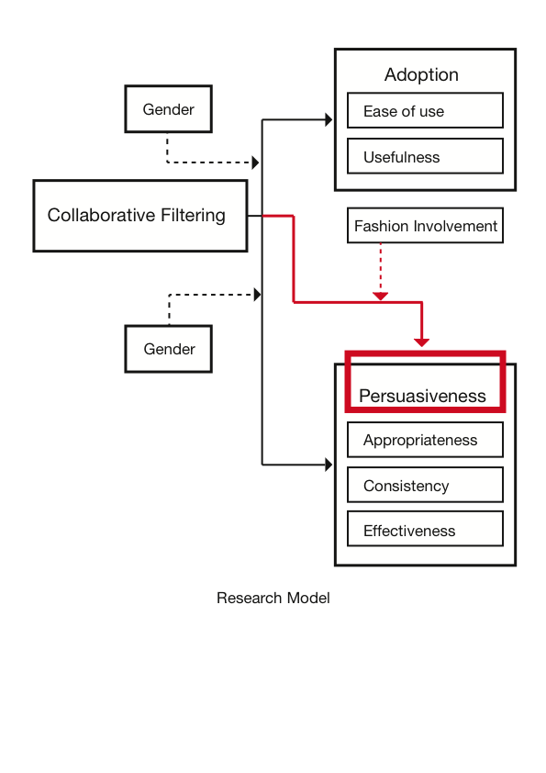

3. METHOD
Concerning the method used to answer the main research question of this study as well as verify the hypotheses, an online experiment were chosen as a useful tool to provide the opportunity to gather the data needed in order to accomplish this research project. The experiment not only will provide quantitative data regarding the perceived values for adopting collaborative filtering and its persuasiveness in order to buy recommended products, but it will also provide with the opportunity to gain insight between the differences of males and females by distributing two different formats, one corresponding to males and one to females. Due to the fact that not all the participants of the experiment have the same experience with online shopping, and since the purpose of this research is to study the adoption and the persuasiveness of collaborative filtering, providing the respondents with the ability to experience an online shopping environment and interact with the recommendation agent offers more valid results.
The participants of this study, who voluntarily participated, were asked prior to filling in the questionnaire to visit the amazon.com clothing and accessories department. In order to make it easier and less time consuming for the respondents I provided two web links that by clicking, the respondents were directly transferred to the latter web page. One web link corresponds to male respondents (i.e. they were transferred to the male clothes departments) and the second web link to females (i.e. who were accordingly transferred to the women clothes department). Thereafter, the participants were asked to put themselves in a situation where they are interested in buying a pair of trousers and were further asked to search the store in order to find a product that they like and that they would actually consider of buying. During their search process for the products they were instructed to check the recommended products that the collaborative filtering had generated for them. As expected, not all the respondents had the same degree of familiarity with online shopping and not all of them were expected to be aware of the term collaborative filtering. For this reason the participants received instructions on how to locate the agent which is indicated as: “Customers who viewed this item also viewed”. Furthermore, the respondents received a brief description of how collaborative filtering functions and how it generates the personalized recommendations. The description is brief and accurate in an attempt not to favorably affect the respondents towards the agent.
Finally, the respondents were asked to return back to the survey after they had found the product they liked and would purchase and indicate the product of their choice by copying the link of the product page and pasting it to the questionnaire. This process serves to ensure that all the respondents followed the instructions and completed the tasks of the experiments before they proceeded to the questionnaire. This is an important parameter of the validity of their responses and all the links were checked when I was organizing the data. Responses that did not meet the criteria, such as responses that did not refer to a pair of trouser but to another product or respondents that are not residents of EU, were considered invalid and removed. The following step was the questionnaire, which was comprised of 14 questions, as it is described latter on.
As Matthews and Ross (2010) argue, a survey enables the researcher to collect data in order to analyze and draw conclusions from a number of different respondents. Moreover, an online survey has many advantages and provides opportunities that paper based surveys do not. As Archer (2003) supports, a web-based survey is easier in terms of execution, while it has lower distribution costs as well, as there is no need for the questionnaire to be printed and delivered to the respondents. With a web-based survey the researcher can access respondents who are far away and do not belong to his social or professional circles, while it makes it easier to analyze the data collected from an online survey due to the fact that it facilitates the researcher to easily transfer the data collected into a data analysis and statistical software.
Taking into account all the advantages that a web-based survey has to offer and the fact that the sample responds to Internet users, an online survey was chosen as the most appropriate research method in order to collect the data needed. The fact that the respondents were asked to interact with a collaborative filtering agent in an online apparel store before they filled in the questionnaire, as argued before, increases the probability that the respondents have previously purchased clothes from an online vendor and have prior experience. Furthermore, fashion-clothing products is a product category that is engaged to consumers’ involvement with these products. As the involvement of the consumers with the products that the agent recommends, and in this case fashion-involvement, is a variable that might have impact on the persuasiveness of collaborative filtering, locating the agent in an online apparel store seemed to be the appropriate testing environment. As a consequence, a questionnaire with two different formats was created, one corresponding to males and one to females, in accordance with the previous research and modified in order to provide me with adequate data to answer the research question of my study.

3.1 QUESTIONNAIRE
The questionnaire was created online through Qualtrics, a software to collect data online. The two first questions are the same for both questionnaires, the one that corresponds to males and the one that corresponds to females. In the first question, the respondents were asked to answer by choosing yes or no on whether they ever purchase apparel online. The reason for asking this question from the beginning is to find out whether the respondent is at least familiar with the online shopping of clothes or not, whether he/she has ever used at least once the internet in order to buy an apparel product or not. Regarding the second question, the respondent is asked to answer whether he/she has ever bought a pair of trousers from amazon.com, the web-store specifically used for the purposes of this research. Then the respondents clicked on their gender. Although each questionnaire was sent targeted to both male and female respondents, I included this question in order to verify that the respondent of each questionnaire fill in the questionnaire that correspond to his/her gender, as each questionnaire contains an appropriate web link for each case.
Right after the first three questions the experiment as described above follows. Right after their interaction with the agent, the respondents were asked to return back to the questionnaire and grade a number of statements in a 7-point Likert scale in order to measure how much they agree with the statements from 1 (strongly disagree) to 7 (strongly agree) used to measure the variables.
The second section of the questionnaire refers to their perception towards the usefulness and the ease of use of collaborative filtering. This section gave me data for the dependent variable of collaborative filtering adoption by the online shoppers, as perceived usefulness and perceived ease of use constitute the independent variables. In the first part where I intend to study the perceived usefulness, I adapt the statements used by Pavlou (2003), in his study regarding the acceptance of e-commerce, and Koufaris (2002), who had previously adapted the statements by Venkatesh and Davis (1996). As I have already mentioned the respondents graded the statements in a 7-point Likert scale, from 1 (strongly disagree) to 7 (strongly agree.) The statements examined whether the respondents:
- consider the recommendation agent to be useful or valuable
- think it is functional
- think that the recommendations generated by the agent are useful for them
- believe that the use of the agent increases their shopping productivity.
In the second part I intend to study the perceived ease of use of collaborative filtering and once more I adapt the statements as used by Koufaris (2002) in his previously mentioned research. The statements provide data about whether the interaction with the agent is clear and understandable and whether according to the respondents it demands low mental effort or not. Furthermore, the respondents were asked to grade in the same 7-point scale whether the collaborative filtering is easy to use and the information that the user needs from the agent easy to receive. The last part of the second section gives data regarding the adoption of the collaborative filtering which is the dependent variable. The statements used in this case depend on the interaction that the respondents had with the agent in the amazon.com clothing store that the survey provided, but also counting previous experience they had had with collaborative filtering. As the experiment was to a certain degree manipulated by asking the participants to use the recommendation agent during their search of products (i.e. forced adoption), the adoption is measured for future purchases and past purchases of the respondents. As a consequence, the respondents used a 7-point scale to grade statements regarding whether a) they would use the agent in their future online purchases, b) they had already used it before or c) they usually take the advice of the agent during their decision-making process.
The third section of the questionnaire refers to the dependent variable persuasiveness of the collaborative filtering agent. It consists of three parts and each part represents one of the three independent variables that the persuasiveness will be studied: appropriateness, consistency, and effectiveness.
In the first part of the third section I intend to measure the appropriateness of collaborative filtering as it is perceived by the respondents. Furthermore, as it has been explained, appropriateness is by definition similar to the subjective norms of the theory of reasoned action (Komiak & Benbasat, 2004) and therefore in order to measure appropriateness, I will use the measurement of subjective norms based on the latter theory. Consequently, I adapt the statements used by Bagozzi et al. (1992) in their study on the usage of super market coupons incorporating the theory of reasoned action. In the manner of Bagozzi et al. (1992), I measure appropriateness with two items, both rated on 7-point scales. These are: “Other people like me think that I should definitely buy a product recommended by collaborative filtering, as the recommendations are based on my preferences” and “Other people like me probably consider my action to purchase a recommended product by this recommendation agent to be wise”.
The second part of this section refers to the measurement of the consistency of collaborative filtering. The consistency of the agent is an important factor to motivate/persuade online shoppers to buy recommended products by the agent. It also refers to the degree that the respondents think that the recommendations of the agent are those products that other people with the same taste or needs with the respondent would choose to check out or purchase. The respondents were asked to grade in a 7-point scale how much they agree or disagree with statements regarding their belief that other people with similar taste or needs would buy one of the recommended products and how motivated the respondents were to buy one of the recommended products based on the agent’s function that proposes product that other people with similar profile with the respondent had checked or purchased.
The third part of this section refers to the measurement of the effectiveness of collaborative filtering. It is already clear that effectiveness refers to the extent to which the online shoppers think that the recommendation agent through the listing of the recommended products helps them choose the best fitted product based on their preferences and needs. The respondents were once more asked to grade five statements with the same 7-point scale. The statements are retrieved and adapted from Aksoy et al. (2006) and refer to the respondents’ beliefs regarding the quality of the recommended products, whether they fit their preferences and help them choose the most fitted among the alternatives. In the final part of this section the respondents were asked whether they would buy one of the recommended products or not (i.e. based on the interaction they had had with the agent for the needs of this survey), or whether they have purchased products that the collaborative filtering has proposed (i.e. based on past purchases online). These two items were used in order to measure the persuasiveness of collaborative filtering, which makes the dependent variable.
In the fourth section of the questionnaire I intend to measure the fashion involvement of the respondents. Fashion involvement is supposed to influence online shoppers’ decision to buy a recommended product or not (i.e. persuasion), once the under research recommendation agent is located in an online apparel store. In order to measure the respondents’ fashion involvement a number of statements adapted from O’Cass (2000) were adapted combining two factors of fashion involvement; the fashion product involvement and the fashion products purchase decision involvement. Twelve items in total were used to measure fashion involvement as exhibited in Table 1.
The fifth and last section of the survey consists of three questions related to demographic data (i.e. age, level of education level completed and monthly income of the respondent). Although this data is not directly connected to the hypothesis of this study, it will be studied in case there is any notable finding on how it is related to the main research of the study.
Before the distribution of the survey, there was pilot for 3 days during which 16 respondents filled in the questionnaire. The pilot was distributed to friends and colleagues who were asked to send me feedback regarding the questionnaire in terms of how clear the statements were, how understandable, what was the effort needed to comprehend the message of the statements and the time demanded to fill it in and complete it, including the experiment. The average time needed to complete the survey was estimated to 7 minutes including the primary search in the web store while the respondents’ feedback led to some syntactical and semantic changes, aiming at greater precision and concision.

Table 1: Statements used to form the variables
Variables | Statements
Ease of use | - Checking the recommended products that collaborative filtering proposes is simple and easy.  - Interacting with this recommendation agent does not require a lot of mental effort.  - I find this recommendation agent easy to use.  - I find it easy to receive the assistance that I need in order to decide which product to buy from collaborative filtering.
Usefulness | - I think that collaborative filtering is valuable to me.  - The content of collaborative filtering is useful to me.  - This recommendation agent is functional.  - Overall, I find the collaborative filtering agent useful.  - Checking the products that collaborative filtering agent recommends to me can increase my shopping productivity.
Adoption | - I will check the alternatives that collaborative filtering recommends to me in my future online purchases.  - I have used collaborative filtering agent in the past to check the recommended products.  - I usually check the recommendations that collaborative filtering proposes to me.
Appropriateness | - Other people like me think that I should definitely buy a product recommended by collaborative filtering, as the recommendations are based on my preferences.  - Other people like me, probably consider my action to purchase a recommended product by this recommendation agent to be wise.
Consistency | - Based on the recommendations that the agent generated, I think that other people with common taste to mine would definitely buy one of the recommended products.  - The fact that other people who viewed the product of my interest, viewed also the recommended products that the agent proposes, motivates me to buy one of them.  - I think that purchasing one of the recommended products will add to my social acceptance by being in fashion.
Effectiveness | - I believe that the listing of alternative products generated by the agent is designed to help me make the best decision possible.  - I believe that the listing of alternative products generated by the agent is designed to help me avoid making a poor choice.  - I believe that the listing of alternative products generated by the agent provides an unbiased reflection of how other consumers feel about the product.  - The recommended products generated by the agent fit my preferences.
Persuasiveness | - I like the products that the agent recommends and I would buy one of the recommended products.  - In the past I have purchased products that collaborative filtering recommended.
Fashion Involvement | - Fashion clothing means a lot to me.  - Fashion clothing is a significant part of my life.  - For me personally fashion clothing is an important product.  - I am very interested in fashion clothing.  - I can really identify with fashion clothing.  - I am very much involved with fashion clothing.  - Making purchase decisions for fashion clothing is significant to me.  - I think a lot about my choices when it comes to fashion clothing.  - I place great value in making the right decisions when it comes to fashion clothing.  - I like being involved in making purchases of fashion clothing.  - As I like being involved in the process of choosing and buying fashion clothing, I think that collaborative filtering can help me to make the best purchase decision when buying clothes online.  - I think that collaborative filtering recommends fashion-clothing products to me that fit with my preferences and for this reason I would buy an item from the recommendations.

3.2 SAMPLE AND SURVEY DISTRIBUTION
The number of surveys started was 149 for females, but 118 completed. Out of these, 106 were found valid after checking the links from the product pages that the respondents provided. Respectively, for males 116 out of 136 were completed. Out of these 106 surveys were considered valid and the overall number of surveys reached a total of 212 in 20 days for both males and females.
Since the study is related to the collaborative filtering in an online apparel store, only Internet users that reside in Europe should be reached. The survey was distributed via email, and twitter messages, but also two facebook groups were created, one including the link for males and the other one for females. The members of the facebook groups were able to add more people from their network to the groups. The survey reached 285 European citizens (and some outside EU whose responses were considered invalid) from 12 European countries (i.e. the Netherlands, Italy, Greece, United Kingdom, Romania, Austria, Spain, Germany, France, Portugal, Bulgaria and Ireland).

4. RESULTS
This chapter presents the analysis of the data and the test of the study hypotheses. As it has been already mentioned (i.e. in the methodology chapter), a number of items/statements have been used to measure the variables (for further information regarding the statements refer to Table 1). Each variable has been created using the SPSS by transform and compute software’s function, which compute the mean of all the different scales that are used for each variable. An overview of the number of items used in order to form each variable follows in the table below.
Table 2: Number of items per variable
Variable | Number of items
Ease of use | 4
Usefulness | 5
Adoption | 3
Appropriateness | 2
Consistency | 3
Effectiveness | 4
Persuasiveness | 2
Fashion involvement | 12

4.1 RELIABILITY
In this research the variables that are studied have been developed from summated scales (i.e. 7-point Likert scales from 1-totally disagree to 7-totally agree). For the measurement of the reliability of the scales used to form the variables, Cronbach’s alpha (Cronbach, 1951) was considered the most appropriate tool. Chronbach’s alpha is an effective tool for such measurements as it “determines the internal consistency or average correlation of items in a survey instrument to gauge its reliability” (Santos, 1999:1). Cronbach’s alpha has been calculated for all the eight variables and all of them show a relatively good internal consistency as the table below shows. The alpha coefficient can take values from 0 to 1 and the higher the score is the more reliable the scales that have been used to measure the variable. In the case of the variable persuasiveness, the alpha coefficient is lower than 0.7, which is considered to be the minimum that an alpha coefficient should score in order for the scale to be reliable (Santos, 1999 APUD Nunnaly, 1978; Al-maghrabi et al., 2010 APUD Hair et al., 2005), but a lower threshold can also be accepted as Santos (1991) argues.
The high scores of Cronbach’s alpha were expected, as the items used to measure the variables have been adapted from previous researches.
Table 3: Reliability test - Cronbach's alpha coefficients
Variable | Cronbach’s Alpha | N of items
Adoption | 0.83 | 3
Ease of use | 0.88 | 4
Usefulness | 0.85 | 5
Persuasiveness | 0.52 | 2
Appropriateness | 0.82 | 2
Consistency | 0.73 | 3
Effectiveness | 0.73 | 4
Fashion involvement | 0.94 | 12

4.2 HYPOTHESES TEST
As it has been already mentioned before, a total of 106 males and 106 females were involved in the study. In the first part of the analysis a number of different methods (i.e. two stratified regression analyses, one multiple regression analysis with interaction and one ANOVA analysis) were used in order to test the hypotheses. When a regression analysis is conducted the coefficient of determination R² is reported, which measures how well this model can predict future outcomes. R² values range from 0 to 1, where 1 indicates perfect model and 0 inadequate model. Consequently, when the model can explain more variability of the dependent variable, the better the ability of the model for future predictions. The distribution of the variables is summarized in Table 4. The mean adoption is 5.09 ranging from 1 to 7. Easiness of use has the maximum mean score in the seven-point Liker scale followed by usefulness. The range of the scores differs across the variables. Table 5 presents the distribution of the variables in males and females. These results are illustrated graphically in Figure 5 (appendix ii).
Table 4: Mean of the variables
Variable | Min. | Max. | Mean | Std.
Easiness of use | 2.75 | 7.00 | 5.67 | 0.92
Usefulness | 1.60 | 7.00 | 5.17 | 0.95
Adoption | 1.00 | 7.00 | 5.09 | 1.13

Table 5: Mean of the variables across gender
 | Variable | Min. | Max. | Mean | Std.
Male | Easiness of use | 2.75 | 7.00 | 5.59 | 0.94
 | Usefulness | 2.20 | 6.60 | 4.95 | 0.88
 | Adoption | 1.33 | 7.00 | 4.99 | 1.01
Female | Easiness of use | 2.75 | 7.00 | 5.74 | 0.89
 | Usefulness | 1.60 | 7.00 | 5.39 | 0.97
 | Adoption | 1.00 | 7.00 | 5.20 | 1.24

In the second part of the analysis different methods (i.e. one multiple regression analysis, two multiple regression analyses with interaction term, three stratified regression analyses and two one-way ANOVA analyses) were used as well in order to test the hypotheses. The distribution of the variables is summarized in Table 6. The mean persuasiveness is 4.43 ranging from 1 to 7. Effectiveness has the maximum mean score in the seven-point Liker scale followed by fashion involvement, appropriateness and consistency. The range of the scores is similar in all variables. Table 7 presents the distribution of the variables in males and females. These results are illustrated graphically in Figure 6 (appendix ii). The statistical significance of all the results was evaluated using a 5% significance level in both analyses.

Table 6: Means of the variables
Variable | Min. | Max. | Mean | Std.
Appropriateness | 1.00 | 7.00 | 4.43 | 1.30
Consistency | 1.00 | 7.00 | 3.98 | 1.26
Effectiveness | 1.75 | 7.00 | 4.65 | 0.97
Persuasiveness | 1.00 | 7.00 | 4.43 | 1.30

Table 7: Means of the variables across gender
 | Variable | Min. | Max. | Mean | Std.
Male | Appropriateness | 1.00 | 6.00 | 3.89 | 1.05
 | Consistency | 1.33 | 6.00 | 3.70 | 1.09
 | Effectiveness | 1.75 | 6.00 | 4.39 | 0.85
 | Persuasiveness | 1.00 | 7.00 | 4.18 | 1.17
Female | Appropriateness | 1.00 | 7.00 | 4.56 | 1.31
 | Consistency | 1.00 | 7.00 | 4.26 | 1.36
 | Effectiveness | 1.75 | 7.00 | 4.89 | 1.02
 | Persuasiveness | 1.00 | 7.00 | 4.68 | 1.38

H1: The easiness of use of the agent will not have a significant impact on its adoption either for male or for female online shoppers.

In order to test the first hypothesis, a stratified regression analysis was applied with adoption as the dependent variable, easiness of use as the independent variable and gender as the stratification variable to adjust for the confounding of gender on the association between easiness of use and adoption. Confounding is a major concern in the analysis because it leads to biased estimates. Stratification is a statistical ‘correction’ method that reduces confounding and assures that the confounders will no longer bias the estimates. Table 8 presents the results from the stratified regression analysis. The R² for male group is 15.9% and for female group is 19.6% (appendix iii). The easiness of use of the collaborative filtering agent has a significant positive impact on its adoption (i.e. future adoption, refer to the method chapter) in both genders (B males: 0.43, B females: 0.62, P-value 0.00 < 0.05). Consequently, the first hypothesis is not supported, as easiness of use of the collaborative filtering agent has a significant positive impact on its adoption by the shoppers of both genders. Post-hoc power analysis was conducted to examine the success in detecting the effect of interest. In this case the analysis used to test the first hypothesis has succeeded in detecting the effect of interest with great power of 0.99 for both males and females (as stratified regression was conducted), (refer to the appendix iv for the graph power vs. sample).
Table 8: Stratified regression analysis with dependent variable: adoption, independent variable: easiness of use and stratification variable: gender
Variable |  | Coeff. B | Sig.
Male | Easiness of use | 0.43 | 0.00
Female | Easiness of use | 0.62 | 0.00

H2a: The usefulness of collaborative filtering will have a significant impact on its adoption for both genders.
In testing the hypothesis 2a, a stratified regression analysis was applied again with adoption as the dependent variable, usefulness as the independent variable and gender as the stratification variable. Table 9 presents the results from the stratified regression analysis. The R² for male group is 39.7% and for female group is 38.2% (appendix iii). The usefulness of the collaborative filtering agent has a significantly positive impact (B males: 0.72, B females: 0.79) on its adoption (i.e. future adoption) in both genders, since for both genders P-value is 0.00< 0.05. Accordingly, the 2a hypothesis is supported, as the usefulness of the collaborative filtering has a significant positive impact on its adoption by both male and female online shoppers. The post hoc power analysis indicated a power of 1.00 for both males and females in this case (see appendix iv).

Table 9: Stratified regression analysis with dependent variable: adoption, independent variable: usefulness and stratified variable: gender
Variable |  | Coeff. B | Sig.
Male | Usefulness | 0.72 | 0.00
Female | Usefulness | 0.79 | 0.00

H2b: The usefulness of the agent will have a stronger impact on its adoption for female online shoppers rather than for males.
In order to test this hypothesis, a multiple regression with an interaction term was conducted, with adoption as the dependent variable and gender, usefulness and the interaction between usefulness and gender as independent variables. The interaction term was introduced in order to study whether the effect of the usefulness of the agent on the adoption differs by gender. Before conducting the regression, centering of the usefulness was implemented by subtracting the mean from each case to improve the interpretation of the results. Table 10 shows the results of the multiple regression analysis after introducing the interaction term. The R² is 39.4% (appendix iii). The interaction between usefulness and gender is not significant (P-value 0.61>0.05), indicating that an increase (coefficient B of the interaction term: 0.07) in usefulness score will not have statistically significant different impact on the adoption of the agent between the two genders. Consequently, the hypothesis 2b is not supported, as there is not enough evidence for greater impact of the usefulness of the agent on its adoption for females rather than for males. The post hoc power analysis indicates a power of 1.00 for the testing of this hypothesis (see appendix iv).

Table 10: Multiple regression analysis with interaction term, dependent variable: adoption and independent variables: usefulness, gender and usefulness*gender
Variable | Coeff. B | Sig.
Usefulness | 0.72 | 0.00
Gender | -0.12 | 0.33
Usefulness*gender | 0.07 | 0.61

H3: The collaborative filtering agent will be equally adopted by both genders.
In order to test this hypothesis, a one-way ANOVA analysis was conducted with the adoption of the collaborative filtering agent as the dependent variable and gender as a factor, to investigate whether there is any difference in the mean of the adoption score between males and females. On average the adoption does not differ significantly between males and females according to ANOVA (mean: 4.99 and 5.20 respectively, P-value 0.17>0.05) (Figure 2). As a result, the third hypothesis is supported, as the adoption of the collaborative filtering agent is fairly equal between the male and the female online shoppers. The post hoc power analysis indicates a power of only 0.26, indicating that detecting the effect of interest was not succeeded adequately (see appendix ii).

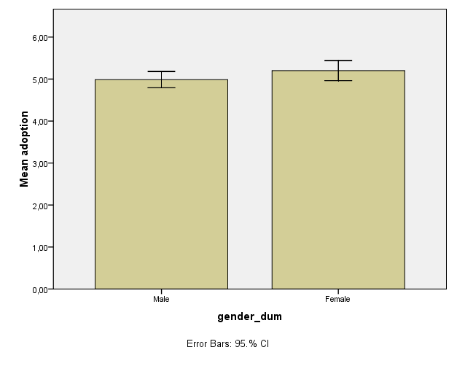
Figure 2: Error bar chart: mean adoption per gender

H4a: The appropriateness will have a significant effect on the persuasiveness of the agent for both genders.
In order to test this hypothesis a stratified regression was applied with persuasiveness as the dependent variable, appropriateness as the independent variable and gender as the stratification variable. The results from the stratified regression analysis are presented in Table 11. The R² for male group is 17.9% and for female group is 40.1% (appendix iii). Appropriateness has a statistically significant positive impact on the persuasiveness both for males and females (B: 0.47 and 0.67, respectively, P-value 0.00<0.05 for both genders). Specifically, for every point the appropriateness’ score increases, the persuasiveness’ score increases by 0.47 and 0.67 for males and females respectively. As a result the hypothesis 4a is supported, since appropriateness has a significant (positive) effect on the persuasiveness of the agent for both genders. The post hoc power analysis indicates a great power of 0.99 for both genders (see appendix iv).

Table 11: Stratified regression analysis with dependent variable: persuasiveness, independent variable: appropriateness and stratified variable: gender
Variable |  | Coeff. B | Sig.
Male | Appropriateness | 0.47 | 0.00
Female | Appropriateness | 0.67 | 0.00

H4b: The appropriateness of the collaborative filtering agent will have a stronger impact on its persuasiveness for female rather than for male online shoppers.
In order to test this hypothesis, a multiple regression with interaction term was conducted, with persuasiveness as the dependent variable and gender, appropriateness and the interaction between the two latter as independent variables. The interaction term was introduced in order to study whether the effect of appropriateness on the persuasiveness differs by gender or not. Before conducting the regression, centering of the appropriateness was implemented by subtracting the mean from each case to improve the interpretation of the results. Table 12 shows the results of the multiple regression model after introducing the interaction term. The R² is 33.4%. The interaction between appropriateness and gender is not significant (Β: 0.19, P-value 0.12>0.05), indicating that an increase in appropriateness score will not have statistically different impact on the persuasiveness of the agent between the two genders. As a result, the hypothesis 4b is not supported, as there is not enough evidence for greater impact of appropriateness on the persuasiveness for females rather than for males. The post hoc analysis indicated power of 1.00 in this case (see appendix iv).

Table 12: Multiple regression analysis with interaction term. Dependent variable: persuasiveness and independent variables: appropriateness, gender and appropriateness*gender
Variable | Coeff. B | Sig.
Appropriateness | 0.48 | 0.00
Gender | 0.12 | 0.45
Appropriateness*gender | 0.19 | 0.12

H5: The consistency will have a significant effect on the persuasiveness of the agent for female shoppers and not for males.
To test the fifth hypothesis, a stratified regression analysis was applied with persuasiveness as the dependent variable, consistency as the independent variable and gender as the stratification variable. Table 13 presents the results from the stratified regression analysis. The R² for male group is 33.8% and for female group is 58% (appendix iii). The consistency of the collaborative filtering agent has a significant positive impact on its persuasiveness in both males and females (B: 0.36 and 0.59, respectively, P-value 0.00<0.05 for both genders). The larger regression coefficients in the females may be an indication that the persuasiveness of the agent increases more roughly in females that hit larger consistency scores. The fifth hypothesis is not supported, as consistency has a significant (positive) impact on the agent’s persuasiveness for both genders. The post hoc analysis indicated a power of 0.99 and 1.00 in this case for males and females respectively (see appendix iv).

Table 13: Stratified simple regression analysis with dependent variable: persuasiveness, independent variable: consistency and stratification variable: gender
Variable |  | Coeff. B | Sig.
Male | Consistency | 0.36 | 0.00
Female | Consistency | 0.59 | 0.00

H6a: The effectiveness will have a significant effect on the persuasiveness of the agent for both genders.
This hypothesis is tested by applying a stratified regression with persuasiveness as the dependent variable, effectiveness as the independent variable and gender as the stratification variable. Results from the stratified regression analysis are presented in Table 14. The R² for male group is 6.6% and for female group is 34.8% (appendix iii). The effectiveness of the agent has significant positive impact on the persuasiveness both for males and females (B: 0.35 and 0.80, respectively, P-value 0.00< 0.05 for both genders), as for males and females, each one point increase in the score for effectiveness results in 0.35 and 0.80 increase, respectively, in the score for the persuasiveness of the agent. That is, those with higher scores in effectiveness tend to be more persuaded by the agent, as well. It seems that the hypothesis 6a is supported with effectiveness having a significant positive effect on the persuasiveness of the agent for both genders. The post hoc power analysis indicates a power of 0.95 and 1.00 for males and females respectively (see appendix iv).

Table 14: Stratified regression analysis with dependent variable: persuasiveness, independent variable: effectiveness and stratified variable: gender
Variable |  | Coeff. B | Sig.
Male | Effectiveness | 0.35 | 0.00
Female | Effectiveness | 0.80 | 0.00

H6b: The effectiveness of the collaborative filtering agent will have a stronger impact on its persuasiveness for female shoppers than for males.
This hypothesis is tested by conducting a multiple regression with an interaction term, with dependent variable the persuasiveness of the agent, gender, effectiveness and their interaction as the independent variables for studying whether the effect of effectiveness on the persuasiveness differs by gender. Prior to conducting the regression, the effectiveness was centered with the method described before (refer to H4b). The R² is 25.9% (appendix iii). The interaction between effectiveness and gender is statistically significant (B: 0.45, P-value 0.01 < 0.05) (Table 15); an increase in effectiveness score by one point increases the persuasiveness score by 0.45 points in females compared to males. As a result, the difference in the persuasiveness score between a male and a female shopper with the same effectiveness score depends on the value of the effectiveness score; the higher the effectiveness score, the greater the expected difference in persuasiveness score between a man and a woman. The hypothesis 6b is supported, as the effectiveness of the collaborative filtering agent has a positive stronger impact on its persuasiveness for female rather for male online shoppers. The post hoc power analysis indicates a great power of 1.00 (see appendix iv).

Table 15: Multiple regression analysis with interaction term, dependent variable: persuasiveness and independent variables: effectiveness, gender and effectiveness*gender
Variable | Coeff. B | Sig.
Effectiveness | 0.35 | 0.01
Gender | 0.21 | 0.18
Effectiveness*gender | 0.45 | 0.01

H7a: Female consumers will be higher fashion-involved than men.
In order to test this hypothesis, a one-way ANOVA analysis was conducted with fashion involvement of the consumer as the dependent variable and gender as the factor, to examine whether there is any difference in the mean of the fashion involvement score between males and females. On average fashion involvement differs significantly between males and females according to ANOVA (P-value 0.000<0.05) (appendix iii). Specifically, females tend to hit higher scores in fashion involvement than males, 5.12 and 4.03 respectively (Figure 3). As a result, the hypothesis 7a is supported, with women being more fashion involved than men. The post hoc power analysis indicates a great power of 1.00 (see appendix ii).

Figure 3: Error bar chart: mean fashion involvement per gender
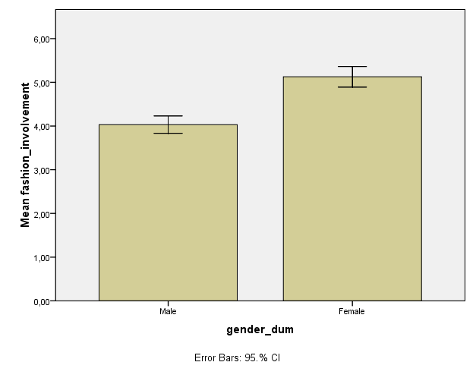

H7b: The persuasion to buy a recommended product listed by the collaborative filtering agent will be higher for highly fashion-involved consumers.
In order to test this hypothesis a multiple regression was conducted with persuasiveness as the dependent variable and fashion involvement and gender as the independent variables in order to examine the impact of the fashion involvement on the persuasiveness inserting the gender variable in the model. The inclusion of the gender variable in the regression model is necessary to control its impact on the relationship between persuasion and fashion. The results from the multiple regression analysis are presented in Table 16. The R² is 21.6% (appendix iii). Fashion involvement has statistically significant positive impact on the persuasiveness for both genders (B: 0.49, P-value 0.00<0.05). Specifically, for both males and females, each one point increase in the score of fashion involvement results, on average, in a 0.49 increase in the score for persuasiveness. As a result the hypothesis 7b is supported, since higher fashion involved consumers are more persuaded to buy a recommended product by the collaborative filtering agent for both genders. The post hoc power analysis indicates also in this case a great power of 1.00 (see appendix iv).
Table 16: Multiple regression analysis with dependent variable: persuasiveness and independent variables: fashion involvement and gender
Variable | Coeff. B | Sig.
Fashion Involvement | 0.49 | 0.00
Gender | -0.04 | 0.84

H8: More women than men will be persuaded to purchase a recommended product by the agent.
In order to test this hypothesis, a one-way ANOVA analysis was conducted with persuasiveness of the agent as the dependent variable and gender as the factor, to examine whether there is any difference in the mean of the persuasiveness score between males and females. On average persuasiveness differs significantly between males and females according to ANOVA (P-value 0.01<0.05) (appendix iii). Specifically, females tend to hit higher scores in persuasiveness than males, 4.68 and 4.18 respectively (Figure 4). As a result, the eighth hypothesis is supported, with more women being more persuaded to purchase a recommended product by the agent. The post hoc power analysis indicates a power of 0.81 (see appendix iv).

Figure 4: Error bar chart: mean persuasiveness per gender

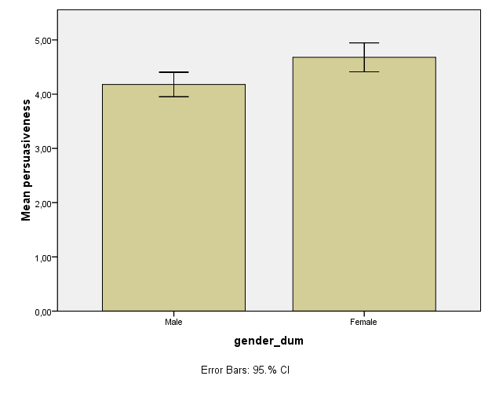

In the table below, an overview of the hypotheses test is presented.
Table 17: Overview of Hypotheses Test
Hypothesis | Outcome
H1: The easiness of use of the agent will not have significant impact on its adoption either for male or for female online shoppers. | Not supported
H2a: The usefulness of collaborative filtering will have a significant impact on its adoption for both genders. | Supported
H2b: The usefulness of the agent will have a stronger impact on its adoption for female online shoppers rather than for males. | Not supported
H3: The collaborative filtering agent will be equally adopted by both genders. | Supported
H4a: The appropriateness will have a significant effect on the persuasiveness of the agent for both genders. | Supported
H4b: The appropriateness of the collaborative filtering agent will have a stronger impact on its persuasiveness for female rather than for male online shoppers. | Not supported
H5: The consistency will have a significant effect on the persuasiveness of the agent for female shoppers and not for males. | Not supported
H6a: The effectiveness will have a significant effect on the persuasiveness of the agent for both genders. | Supported
H6b: The effectiveness of the collaborative filtering agent will have a stronger impact on its persuasiveness for female shoppers than for males. | Supported
H7a: Female consumers will be higher fashion-involved than men. | Supported
H7b: The persuasion to buy a recommended product listed by the collaborative filtering agent will be higher for highly fashion-involved consumers. | Supported
H8: More women than men will be persuaded to purchase a recommended product by the agent. | Supported

5. CONCLUSIONS
In this chapter a discussion based on the results of the hypotheses testing will follow. Thereafter, as in every research, the limitations of this study will be discussed before moving to the managerial implications. At the end ideas for further research in this area are offered.

5.1 DISCUSSION
In this study not all the initial hypotheses are supported by the data analysis. To begin with, the first hypothesis that the easiness of use of collaborative filtering do not have significant impact on its adoption for both genders is not supported. Previous research on the technology adoption using the TAM (Venkatesh & Morris, 2000) indicated that the easiness of use of the new technology has stronger influence on the intention to adopt it for females than for males, probably because of the males’ familiarity and expertise with the technology. This argument is further supported by Komiak and Benbasat (2006), who argue that customers’ familiarity increases the adoption and as females are less familiar with online shopping and accordingly less familiar with using a RA, the ease of use could be an important factor for them to decide if they will adopt it or not. Despite this, based on the way that collaborative filtering functions and taking into account the amount of effort needed for a customer to make use of the collaborative filtering agent, which is low, I assumed that the easiness of use of the agent do not have a significant impact on its adoption. The analysis of the data though indicated the opposite, that the easiness of use is important for both males and females in order to adopt the recommendation agent.
Continuing to the second hypothesis, which is partially supported, we see that the usefulness of the collaborative filtering agent has a significant impact on its adoption for both genders; however, the impact of the usefulness of the agent on its adoption seems to be the same for both males and females, since the H2b is not supported. Despite Chiu and colleagues’ (2005) argument that the influence of usefulness in terms of practicality on the adoption of a technology is stronger for males than for females, I assumed that, since women are less spontaneous shoppers and more rational catalogue shoppers than men, and the collaborative filtering can have a positive impact on the consumers’ decision quality, the usefulness would have a stronger affect on the adoption of the agent for females. It seems that Chiu and colleagues’ (2005) argument can be applied in the case of collaborative filtering, as well.
Regarding the third hypothesis which refers the extent to which each gender adopts collaborative filtering, it seems that both males and females adopt the agent to the same extend. Despite the fact that gender can modify the adoption of an IT and based on Gefen and Straub (2007) findings that males and females differ in their perception regarding the adoption and use of email, but do not differ in the actual use of this IT system, I assumed that, regarding collaborative filtering, gender cannot determine its adoption and that both males and females will adopt it to the same extend. As the results from the data analysis show this hypothesis is supported as both genders will adopt the usage of collaborative filtering to the same extend in their future online purchases (i.e. given that the respective web-store provides this option to its users).
Reardon’s (1991) persuasiveness theory that was used studying the persuasiveness of the collaborative filtering agent, helped form the three next hypotheses of this study based on gender. From the analysis it seems that the appropriateness of the collaborative filtering agent, has a significant impact on the agent’s persuasiveness for both genders. However, the data analysis does not give enough evidence to support the argument that for female online shoppers the appropriateness has a stronger impact on the adoption. This was expected for a number of reasons, extensively analyzed before (i.e. women engage in approval-seeking behavior and enjoy the social aspect of shopping, taking into account the social context of how collaborative filtering generates the recommendations, as well. Apparently, the approval-seeking shopping behaviour of women and the enjoyment of the social aspects of the shopping experience are also applied to the context of purchasing products online and more specifically products proposed by a recommendation agent.
Regarding the impact of the consistency of the agent on its persuasiveness, it seems that its impact is strong both for males and females. Despite the fact that women tend to enjoy more the social and demonstrative aspects of shopping (Van Slyke et al., 2002), showing their purchases and taking into consideration the collaborative filtering agent’s functioning as a «word-of-mouth» mimic (Xiao & Benbasat, 2007; Vezina & Militaru, 2003), it is worth stating that male online shoppers’ belief that the products that the agent proposes are those products that people with similar taste with them would purchase from the current web store has a strong impact in order to be persuaded to buy recommended products. It might be the digital environment that changes genders’ purchasing behavior.
Based on the sixth hypothesis that is supported, the effectiveness of the collaborative filtering agent has a significant positive impact on its adoption for both genders, and moreover, this impact is stronger for female than for male online shoppers. It seems that women’s willingness to search more in a web-store to find the best fitted product and their higher consciousness to the relevant information they receive online during their decision-making process (Meyers-Levy & Sternthal, 1991) fit with the effectiveness of the collaborative filtering agent which is the customer’s benefits to receive recommendations with products that actually like and fit her needs. Although for both genders the effectiveness has significantly positive effect on the agent’s persuasiveness, a similar increase of the effectiveness in both genders increases the persuasiveness more in females compared to males.
The seventh hypothesis is also supported indicating that female consumers are higher fashion-involved than men. Based on previous researches (O’Cass, 2000) women appear to be more fashion involved than men, and in this research this finding is also supported. The reason of testing this is to enable me to move on the next hypothesis that the level of fashion involvement has a positive impact on the persuasion of the recommendation agent (taking into account that the agent in the experiment refers to an apparel store), with higher involved consumers to be more persuaded. The concept of involvement has been used when studying attitudes and behaviors of consumers as different involvement levels guide to different consumer responses, a view that is supported in this study. Since persuasion intend to change attitudes and behaviors, it was considered that different levels of fashion-involvement would have different impacts on the persuasiveness of collaborative filtering. According to the analysis, a higher fashion involved customer is more persuaded to buy one of the recommended product. Product involvement (i.e. fashion clothing) was found to be a significant factor for the persuasiveness of collaborative filtering, in contrary to Liao and Shim’s (2008) outcome in their study on the persuasiveness of different recommendation agents that product involvement was found not significant. This is an interesting finding on the basis of which different applications regarding collaborative filtering can be applied by the practitioners (refer to chapter 5.3, Managerial Implications for examples).
The last hypothesis refers to the extend that consumers of the two genders are persuaded to purchase one of the recommended products by the agent, and as in the case of hypothesis 3 it constitutes a self report measurement. The data analysis supported the hypothesis that more women than men are persuaded to purchase one of the recommended products by the agent, indicating directions and implications for the practitioners (refer to chapter 5.3, Managerial Implications for examples).

Overall the findings of this study suggest that the adoption of collaborative filtering is equal for both genders, but the persuasiveness of collaborative filtering, which means the agent to persuade the online consumers to buy one of the recommended products, is higher for female online shoppers. The effectiveness of the agent has different impact on its persuasiveness based on the gender, with females to score higher. An important effect on the persuasiveness of the collaborative filtering has the level of the fashion involvement of the customer, with higher involved consumers to be more persuaded by the agent.

5.2 LIMITATIONS
As most studies, limitations in this research also exist. The initial theoretical framework that forms the foundation of this study derives from a number of different fields. These theoretical concepts used may significantly be applied in marketing, both in theory and in practice, yet more specified studies are needed. Another limitation of this research is the estimation of the dependent variable of persuasiveness. Although all the rest variables score higher than 0.7 on Cronbach’s alpha coefficients, which is the threshold in order for a summated variable to be reliable according to Nunnaly (1978) (Santos, 1999 APUD Nunnaly, 1978), the variable of persuasiveness scored 0.517. Despite Santos’ (1991) argument that values lower than 0.7 can be accepted as reliable, the measurement of persuasiveness is not the most precise. Changing the items used to form the variable of persuasiveness and conducting the survey again was not possible though due to time limitations. Therefore all the analysis and the results obtained are based on this measurement of persuasiveness.
Secondly, as mentioned before, the measurement of the adoption of collaborative filtering refers to a self-reported future adoption intention. In order to have more precise answers from the respondents it has been considered necessary that all respondents experience an interaction with the collaborative filtering agent, no matter if they had had previous experience or not. For this reason, the respondents prior to filling in the questionnaire were instructed to visit the amazon.com clothing department and simulate a search and a possible purchase of a pair of trousers. During this process the participants of the experiment were asked to interact with the agent by checking the products that the agent recommended to them until they find the product of their interest. Unavoidably, the adoption of the agent was manipulated since the participants were asked to use it. For this reason, and the avoidance of misleading results, the measurement of the adoption refers to future online purchases based on the interaction that the participants had had for the purpose of this experiment as well as their previous experience with the agent, and not to the adoption of the agent based on this occasion.
The study of collaborative filtering was conducted within an online apparel store and the persuasiveness of the agent has been studied in relation to the fashion involvement of the consumers, which has an important effect. Higher fashion involved consumers are more persuaded to purchase recommended products by the agent. Consequently, the results derived regarding the persuasiveness of collaborative filtering cannot be applied in different kinds of web stores. Furthermore, as collaborative filtering is one form of recommendation agent, the results of this study cannot be applied in different types of recommendation agents (e.g. content filtering, feature-based recommendation agents etc).
A final limitation of this study, which might have resulted also into the failure of some hypotheses to be supported, is the way that this study deals with gender. The term ‘gender’ was used to refer to biological sex (i.e. male/female). But gender is a socially constructed identity differentiated from sex and can be conceptualized as a mental construction (Bem, 1981). Gender consists of characteristics of masculinity and femininity (Ann-Maree Nobelius, 2004) characteristics of which might exist in both sexes. In the literature review for the gender differences in technology acceptance, Internet shopping, different consumer responses of each gender, etc, gender was mainly referred to biological sex, attributing feminine or masculine characteristics to each sex. The current study proved for example that females are more fashion involved, as other researchers in the past have. Fashion involvement may be a feminine characteristic, but it is not impossible for males to possess it as well. Concluding, It should be firmly stated that the analysis and results follow the identification of gender with biological sex and their applications are considered under this scope.
Despite these limitations though, the findings of these study do not lose their significance, but instead they offer incentives for further research in this area.

5.3 MANAGERIAL IMPLICATIONS
Based on the results of this study, several noteworthy outcomes have emerged, some of which hold a degree of practical applications for the online apparel retailers. Given that this study explores the differences on the adoption and persuasiveness of the collaborative filtering agents in online apparel store between the male and female customers, it provides some insights on how online retailers can better customize the recommendations of the agent in the case the recommendations may refer to either men or women. Despite the fact that the adoption of the agent could not be determined by gender and that both males and females adopt the usage of the agent to the same extend, noteworthy differences concerning the agent’s persuasiveness exist.
With the rapid growth of online shopping and the huge number of online apparel retailers, a web shop should provide the most pleasurable experience to the consumers and keep them satisfied in terms of practicality, easy navigation within the website, easy search of products and customized communication with each customer individually. Engines that help consumers search through the large assortments and find the best-fitted product within their preferences and needs can make a web store more competitive. The collaborative filtering agents are a very useful tool for online retailers to achieve these.
As the effectiveness of the collaborative filtering agent consist an important factor for consumers of both genders and even more for women, to be persuaded to purchase products that the agent recommends, online retailers should be updated with the best possible technology and algorithms to make agents generate recommendations that best fit with the individual customer preferences. With women being more willing to search in a web store for the best fitted product, a task in which collaborative filtering seems to effectively assist them, online apparel retailers addressing women should adopt collaborative filtering agents, adding to the increase of their sales and the firm’s profits.
The involvement of the customer to a product, and more specifically the fashion involvement, has a positive impact on the agent’s persuasiveness in online apparel stores. According to the results of the analysis higher fashion-involved customers are more persuaded to purchase one of the recommended products, and it is women who tend to be more fashion-involved. Based on the fact that highly involved customers are an important market segment for each firm, being more engaged with the firm’s product but also more regular users of the product, online apparel retailers should motivate their customers to become more involved with the clothes. Both female and male customers should be targeted with different means to achieve greater fashion involvement. This could be realised with peripheral means not directly connected to the collaborative filtering agent, but by motivating customers to become members of an online community related to fashion clothing or actively contribute to an asynchronous discussion board (forum) within the web store. Engaging the customer with the product (i.e. fashion clothing) or even with the online retail shop adds to the customer’s fashion involvement, and a higher fashion-involved customer will be more persuaded to buy a product from the collaborative filtering agent which is translated to an increase of the sales and the profits. I speculate that an online apparel retailer would only profit from creating a form of a social network within the web store which would motivate its customers to interact with and choose to follow other members and the recommendations that the agent generates processing mainly each customer’s chosen profiles. This would add to the agent’s persuasiveness because it would further engage the customers and increase their fashion involvement and also strengthen the appropriateness of the agent once the recommended products are approved by important others, the costumers has chosen.
Generally, collaborative filtering offers vast opportunities to online retailers and the practitioners acknowledge this by paying considerable attention to its possibilities. As Linden et al. (2003) have argued, collaborative filtering is an effective tool for targeted marketing as it provides personalized recommendations to each individual customer, and this study has added a small contribution to how the collaborative filtering agents could further improve their efficiency as tools seen from the perspective of the customer’s gender.

5.4 FURTHER RESEARCH
This study provides incentives and directions for further research on the collaborative filtering. Regarding the adoption, it would be very interesting and useful for the practitioners to study the actual adoption of collaborative filtering from the Internet users with different expertise on online shopping. For this research to be realised and give conclusions an experiment in a lab is demanded. Computers equipped with the necessary eye-tracking technology should be available in the lab when the participants simulate an online purchase. In such case, the eye-tracking machine would inform the researcher about whether or not each participant checked the recommendations that the collaborative filtering agent generated without actually forcing the participants to use it. This would make the actual adoption of the agent feasible to be measured.

Regarding the adoption and the persuasiveness of collaborative filtering, it would be of great importance for the online retailers to study the extent of the agent’s adoption and capacity to persuade users from different European countries to buy recommended products, as the Internet usage and online shopping experience vary greatly from country to country (Internet World Stats, 2010). The Netherlands and Denmark come first on the list with 89.5 % and 89% of their populations using the Internet, while Greece and Romania only reach 46.9% and 39.2% respectively (Internet World Stats, 2011). These differences might respond to a different adoption and persuasiveness of collaborative filtering by the customers. Online merchants can thus differentiate their approach to customers, present and customise their recommendations for each country appropriately.
While this study has examined the variable of fashion involvement regarding the persuasiveness of collaborative filtering and showed that fashion involvement has a positive impact on the persuasiveness, with higher fashion involved consumers being more persuaded to purchase a recommended product, it would be interesting to study whether or not the consumers’ involvement with another product category has a positive impact on the agent’s persuasiveness as well. Another direction for further research would also be to include different variables that could affect the persuasiveness of collaborative filtering, such as trust (i.e. trusting that the agent generates truly personalized recommendations) or the level of the online shopper’s experience.
.
.
.

LIST OF REFERENCES
Ajzen, I. (1991) The theory of planned behavior, Organizational Behavior and Human Decision Processes, 50:179–211.
Aksoy, L., Bloom, P., N., Lurie, N., H., and Cooil, B. (2006) Should Recommendation Agents Think Like People?, Journal of Service Research, 8 (4): 297-315.
Al-maghrabi, T., Dennis, C., and Halliday, S., V. (2010) Adapting TAM and ECT: Continuance Intention of E-shopping in Saudi Arabia, European and Mediterranean Conference on Information Systems 2010, Abu Dhabi.
Alreck, P., and Settle, R., B. (2002) Gender effects on Internet catalogues and store shopping, Journal of Database Marketing, 9 (2): 150-162.
Bagozzi, R., P., Wong, N., Abe, S., and Bergami, M. (2000) Cultural and Situational Contingencies and the Theory of Reasoned Action: Application to Fast Food Restaurant Consumption, Journal of Consumer Psychology, 9 (2): 97-106.
Bagozzi, R., P., Baumgartner, H., and Yi, Y. (1992) State versus Action Orientation and the theory of Reasoned Action: An application to Coupon Usage, Journal of Consumer Research, 18 (4): 505-518.
Belleau, B., D., Summers, T., A., Xu, Y., and Pinel, R. (2007) Theory of Reasoned Action: Purchase Intention of Young Consumers, Clothing and Textiles Research Journal, 25 (3): 244-257.
Bem, S., L. (1981) Gender Schema Theory: A Cognitive Account of Sex Typing, Psychological Review, 88 (4): 354-364.
Bhatnagar, A., and Ghose, A. (2004) Online information search termination patterns across product categories and consumer demographics, Journal of Retailing, 80 (3): 221-228.
Bloch, P., H. (1982) Involvement beyond the purchase process: Conceptual issues and empirical investigation, Advances in Consumer Research, 9: 413-417.
Breese, J., Heckerman, D. and Kadie, C. (1998). Empirical Analysis of Predictive Algorithms for Collaborative Filtering, Uncertainty in Artificial Intelligence: Proceedings of the 14thConference, San Francisco.

Brown, M., Pope,.N., and Voges, K. (2003) Buying or browsing?: An explorations of shopping orientations and online purchase intention, European Journal of Marketing, 3 (11&12): 1666-1684.

Chiu, Y., B., Lin, C., P., and Tang, L., L. (2005) Gender differs: assessing a model of online purchase intentions in e-tail service, International Journal of Service Industry Management, 16 (5): 416-435.
Cronbach, L., J. (1951) Coefficient alpha and the internal structure of tests, Psychometrika, 16 (3): 297-334

Dabholkar, R., A., and Bagozzi, R., P. (2002) An Attitudinal Model of Technology-Based Self-Service: Moderating Effects of Consumer Traits and Situational Factors, Journal of the Academy of Marketing Science, 30 (3): 184-201.
Davis, F., D., (1989) Perceived Usefulness, Perceived Ease of Use, and User Acceptance of Information Technology, MIS Quarterly, 13 (3): 319-340.
Dholakia, R., R., and Chiang, K., P. (2003) Shoppers in Cyberspace: Are They From Venus or Mars and Does It Matter?, Journal of Consumer Psychology, 13 (1&2): 171-176.
Evans, R., K., Christiansen, T., and Gill, D., J. (1996) The Impact of Social Influence and Role Expectations on Shopping Center Patronage Intentions, Journal of the Academy of Marketing Science, 24 (3): 208-218.
Faul, F., Erdfelder, E., Buchner, A., & Lang, A., G. (2009) Statistical power analyses using G*Power 3.1: Tests for correlation and regression analyses, Behavior Research Methods, 41: 1149-1160.
Featherman, M., S., and Pavlou, P., A. (2003) Predicting e-service adoption: a perceived risk facets perspective, International Journal of Human-Computer Studies, 59 (4): 451-474.
Fishbein, M., and Ajzen., I. (1975) Belief, Attitude, Intention, and Behavior: An Introduction to Theory and Research, Addison-Wesley, Reading, MA.
Gefen, D., and Straub, D., W. (1997) Gender Differences in the Perception and Use of E-mail: An Extension to the Technology Acceptance Model, MIS Quarterly, 21 (4): 389-400.
Hansen, T., Jensen, J., M., and Solgaard, H., S. (2004) Predicting online grocery buying intention: a comparison of the theory of reasoned action and the theory of planned behavior, International Journal of Information Management, 24 (6): 539-550.
Hair, J., F., Black, W., C., Babin, B., J., Anderson, R., E., and Tatham, R., L. (2005) Multivariate Data Analysis, (6th) Pearson Education.

Harrison, D., A., Mykytyn, P., P., and Riemenschneider, C., K. (1997) Executive Decision About Adoption of Information Technology in Small Business: Theory and Empirical Tests, Informational Systems Research, 8 (2): 171-195.
Häubl, G., and Murray, K., B. (2003) Preference Construction and Persistence in Digital Marketplaces: The Role of Electronic Recommendation Agents, Journal of Consumer Psychology, 13(1&2): 75–92.
Häubl, G., and Trifftes, V. (2000) Consumer Decision Making in Online Shopping Environments: The Effects of Interactive Decision Aids, Marketing Science, 19 (1): 4-21
Herlocker, J., L., Konstan, J., A., Terveen, L., G., and Riedl, J.,T. (2004) Evaluating Collaborative Filtering Recommender Systems, ACM Transactions on Information Systems, 22 (1): 5–53.
Hoffman, D., L., and Novak, T., P. (1996). Marketing in Hypermedia Computer-Mediated Environments: Conceptual Foundations, Journal of Marketing, 60(3) 50–68.
Huang, Z., Zeng, D., and Chen, H. (2007) A Comparison of Collaborative-Filtering Recommendation Algorithms for E-commerce, Intelligent Systems, IEEE, 22 (5): 68-78.
Komiak, S., and Benbasat, I. (2004) Comparing Persuasiveness of Different Recommendation Agents As Customer Decision Support Systems in Electronic Commerce, Decision Support in an Uncertain and Complex World: The IFIP TC8/WG8.3 International Conference 2004 (pp.430-435).
Komiak, S., X., Y., and Benbasat, I. (2006) The effects of Personalization and Familiarity on Trust and Adoption of Recommendation Agents, MIS Quarterly, 30 (4): 941-960.
Koufaris, M. (2002) Applying the Technology Acceptance Model and Flow Theory to Online Consumer Behavior, Information Systems Research, 13 (2): 205-223.

Leavitt, N. (2006) Recommendation technology: will it boost e-commerce?, IEEE Computer, 39 (5): 13-16.
Liao, Q., and Shim, J., P. (2008) Persuasiveness of Online Recommendations: A Comparison Study, Working Papers, Mississippi State, MS, USA: Mississippi State University.
Liker , J., K., and Sindi, A., A. (1997) User acceptance of expert systems: a test of the theory of reasoned action, Journal of Engineering and Technology Management, 14 (2): 147-173.
Linden, G., Smith, B., and York, J. (2003) Amazon.com recommendations: Item-to-item collaborative filtering, Internet Computing, IEEE, 7 (1): 76-80.
Lynne, G., D., Casey, C., F., Hodges, A., and Rahmani, M. (1995) Conservation technology adoption decisions and the theory of planned behavior, Journal of Economic Psychology, 16 (4): 581-598.
Matthews, B., and Ross, L. (2010) Research Methods: A practical guide for the social sciences. Pearson Education Limited.
McCall, S., H. (1977) Meet the ‘Workwife’, Journal of Marketing, 41: 55-65.
Meyers-Levy, J., and Sternthal, B. (1991) Gender Differences in the Use of Message Cues and Judgments, Journal of Marketing Research, 28 (1): 84-96.
Montaner, M., Lopez, B., and De la Rosa, J., L. (2003) A Taxonomy of Recommender Agents on the Internet, Artificial Intelligence Review, 19 (4): 285-330.
Morris, M., G. and Venkatesh, V. (2000) Age Differences in Technology Adoption Decisions: Implications for a Changing Work Force, Personnel Psychology, 53 (2): 357-403.
Nielsen (2008) Trends in Online Shopping: A global Nielsen consumer report.
Nobelius, A. (23 June 2004) What is the difference between sex and gender?, Monash University, online (http://www.med.monash.edu.au/gendermed/sexandgender.html)

Novak, T., P., Hoffman, D., L., and Yung, Y., F. (2000) Measuring the customer experience in online environments: A structural modeling approach. Marketing Science, 19 (1): 22–42.
Nunnaly, J. (1978) Psychometric theory. New York: McGraw-Hill.
O’Cass, A. (2000) An assessment of consumers product, purchase decision, advertising and consumption involvement in fashion clothing, Journal of Economic Psychology, 21 (5): 545-576.
Pavlou, P., A. (2003) Consumer Acceptance of Electronic Commerce: Integrating Trust and Risk with the Technology Acceptance Model, International Journal of Electronic Commerce, 7 (3): 101-134.
Payne, J. W. (1982) Contingent Decision Behavior, Psychological Bulletin 92(2): 382- 402.
Petty, R., E., and Cacioppo, J., T. (1984) Source Factors And The Elaboration Likelihood Model Of Persuasion, Advances in Consumer Research, 11: 668-672.
Petty, R., E., Kasmer, J., A., Haugtvedt, C., P., and Cacioppo, J., T. (1987) Source and message factors in persuasion: a reply to Stiff's critique of the elaboration likelihood model, Communications Monogrpaghs, 57: 233-249.
Postma, J., O., and Brokke, M. (2002) Personalization in practice: the proven effects of personalization, Journal of Database Marketing, 9 (2): 137-142.

Reardon, K., K. (1991) Persuasion in Practice. California: SAGE Publications, Inc.

Robertson, T., S., Zielinski, I., J., and Ward, S. (1984) Consumer Behavior, Glenview, IL: Scott, Foresman.
Sarwar, B., Karypis, G., Konstan, J., and Riedl, J. (2000) Application of Dimensionality Reduction in Recommender System – A Case Study, Technical Report, Minessota: Minnesota University Minneapolis Department of Computer Science.
Schafer, J., B., Frankowski, D., Herlocker, J., and Sen, S. (2007) The Adaptive Web: Methods and Strategies of Web Personalization, Heidelberg: Springer Berlin. (chapter: Collaborative Filtering Recommender Systems)
Spiekermann, S. Online Information Search with Electronic Agents: Drivers, Impediments, and Privacy Issues, doctoral dissertation, Humboldt University Berlin, Berlin, 2001.
Straub, D. W. (1994) The Effect of Culture on IT Diffusion: E-mail and FAX in Japan and the U.S, Information Systems Research, 5 (1): 23-47.
Swaminathan, J., M., and Tayur, S., R. (2003) Models for Supply Chains in E-Business, Management Science, 49 (10): 1387-1406.
Thomas, L. (1997) Retrospective Power Analysis, Conservation Biology, 11 (1): 276-280.
Tigert, D., Ring., L., and King, C. (1976) Fashion involvement and buying behavior: A methodological study, Advances in Consumer Research, 3: 46-52.
Van Slyke, C., Comunale, C.,L., and Belanger, F. (2002) Gender Differences in Perceptions of Web-based Shopping, Communications of the ACM, 45 (7): 82-86.
Venkatesh, V., and Davis, F., D. (1996) A model of the antecedents of perceived ease of use: Development and test, Decision Science, 27 (3): 451-481.
Venkatesh, V., and Morris, M., G. (2000) Why Don’t Men Ever Stop to Ask for Directions? Gender, Social Influence, and Their Role in Technology Acceptance and Usage Behavior, MIS Quarterly, 24 (1): 115-139.
Vézina, R., and Militaru, D. (2004) Collaborative Filtering: Theoretical Positions And A Research Agenda In Marketing, International Journal of Technology Management, 28(1):31-45.
Wu, I., L. (2003) Understanding senior management’s behavior in promoting the strategic role of IT in process reengineering: use of the theory of reasoned action, Information & Management, 41 (1): 1-11.
Xiao, B., and Benbasat, I. (2007) E-commerce Product Recommendation Agents: Use, Characteristics, And Impact, MIS Quarterly, 13 (1): 137-209.
Zaichkowsky, J., L. (1985) Measuring the Involvement Construct, Journal of Consumer Research, 12 (3): 341-352.
Zhou, L., Dai, L., and Zhang, D. (2007) Online shopping acceptance model – a critical survey of consumer factors in online shopping, Journal of Electronic Commerce Research, 8 (1): 41-62.
Internet sources:
- Internet World Stats (2010) Usage and Population Statistics: European Union Internet Stats. At: http://www.internetworldstats.com/eu/eu.htm
Internet World Stats (2011) European Union Internet Users, December 32. At: http://www.internetworldstats.com/stats9.htm
Archer, T., M. (2003) Web-based surveys, Journal of Extension, Vol. 41, August, online (http://www.joe.org/joe/2003august/tt6.php).
Santos, J. R. A. (1999) Cronbachs’ alpha: A tool for assessing reliability of scales, Journal of Extension, 37(2), online
( http://www.joe.org/joe/1999april/tt3.php?ref=Klasistanbul.com)

Websites:
http://www.qualtrics.com/
http://www.amazon.com/
http://www.mysimon.com/
http://www.imdb.com/
http://www.americanapparel.net/
http://shop.nordstrom.com/
http://en.wikipedia.org/wiki/Emu
http://www.emufacts.com/emu-leather.shtm

APPENDICES

Appendix I: SPSS output-Reliability test
Reliability test – Cronbach’s alpha
Scale: Alpha ease_of_use
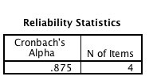
Scale: Alpha usefulness
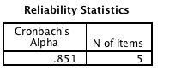
Scale: Alpha adoption
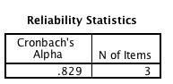
Scale: Alpha appropriateness
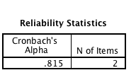

Scale: Alpha consistency
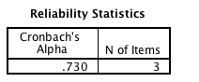

Scale: Alpha effectiveness
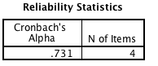
Scale: Alpha persuasiveness
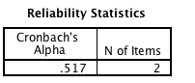
Scale: Alpha fashion_involvement
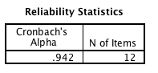

Appendix ii: SPSS output-Descriptive and box plots
Descriptive and box plots model 1
Mean of the variables
Descriptive Statistics
 | N | Minimum | Maximum | Mean | Std. Deviation
usefulness | 212 | 1.60 | 7.00 | 5.1698 | .95343
adoption | 212 | 1.00 | 7.00 | 5.0943 | 1.13330
ease_of_use | 212 | 2.75 | 7.00 | 5.6663 | .91706
Valid N (listwise) | 212

Mean of the variables across gender
Descriptive Statistics
gender_dum |  | N | Minimum | Maximum | Mean | Std. Deviation
Male | usefulness | 106 | 2.20 | 6.60 | 4.9472 | .88126
Male | adoption | 106 | 1.33 | 7.00 | 4.9874 | 1.00678
Male | ease_of_use | 106 | 2.75 | 7.00 | 5.5920 | .94196
Male | Valid N (listwise) | 106
Female | usefulness | 106 | 1.60 | 7.00 | 5.3925 | .97470
Female | adoption | 106 | 1.00 | 7.00 | 5.2013 | 1.24270
Female | ease_of_use | 106 | 2.75 | 7.00 | 5.7406 | .88971
Female | Valid N (listwise) | 106

Box plots
Figure 5: Distribution of the variables across gender
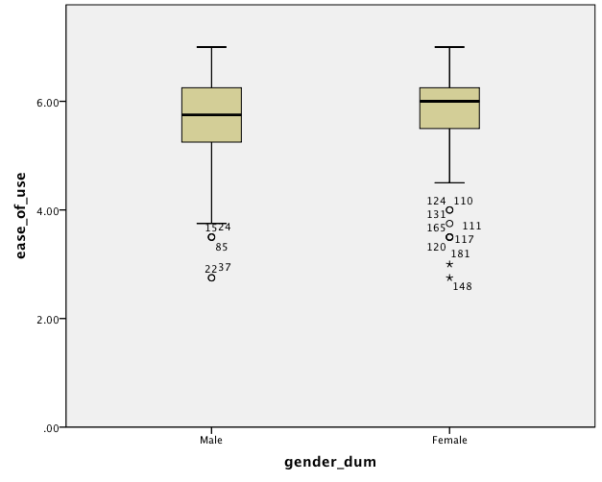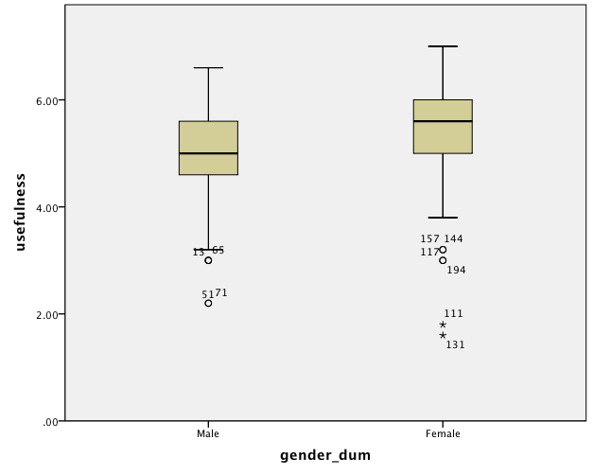
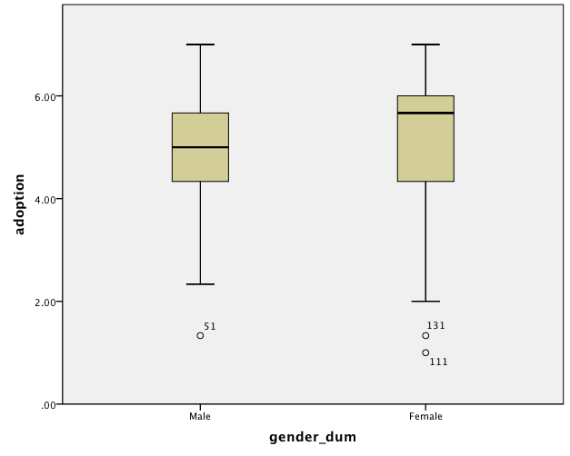

Descriptive and box plots model 2
Means of the variables
Descriptive Statistics
 | N | Minimum | Maximum | Mean | Std. Deviation
persuasiveness | 212 | 1.00 | 7.00 | 4.4292 | 1.30427
appropriateness | 212 | 1.00 | 7.00 | 4.2217 | 1.22780
consistency | 212 | 1.00 | 7.00 | 3.9843 | 1.26223
effectiveness | 212 | 1.75 | 7.00 | 4.6462 | .97137
fashion_involvement | 212 | 1.25 | 7.00 | 4.5794 | 1.25348
Valid N (listwise) | 212

Means of the variables across gender

Descriptive Statistics
gender_dum |  | N | Minimum | Maximum | Mean | Std. Deviation
Male | persuasiveness | 106 | 1.00 | 7.00 | 4.1792 | 1.17349
Male | appropriateness | 106 | 1.00 | 6.00 | 3.8868 | 1.04718
Male | consistency | 106 | 1.33 | 6.00 | 3.7044 | 1.09479
Male | effectiveness | 106 | 1.75 | 6.00 | 4.3962 | .85417
Male | fashion_involvement | 106 | 1.75 | 6.08 | 4.0322 | 1.03226
Male | Valid N (listwise) | 106
Female | persuasiveness | 106 | 1.00 | 7.00 | 4.6792 | 1.38390
Female | appropriateness | 106 | 1.00 | 7.00 | 4.5566 | 1.30625
Female | consistency | 106 | 1.00 | 7.00 | 4.2642 | 1.35827
Female | effectiveness | 106 | 1.75 | 7.00 | 4.8962 | 1.01996
Female | fashion_involvement | 106 | 1.25 | 7.00 | 5.1266 | 1.21956
Female | Valid N (listwise) | 106

Box plots
Figure 6: Distribution of the variables across gender
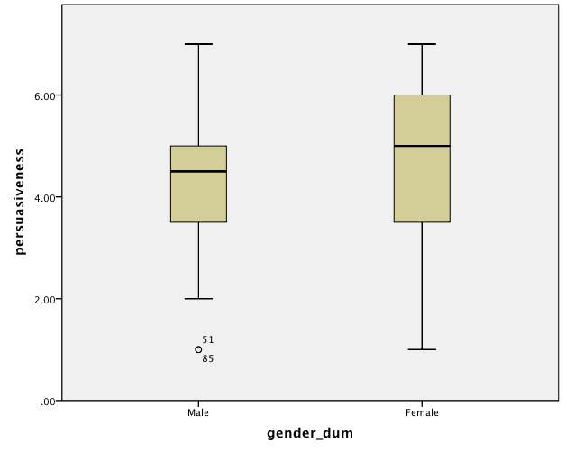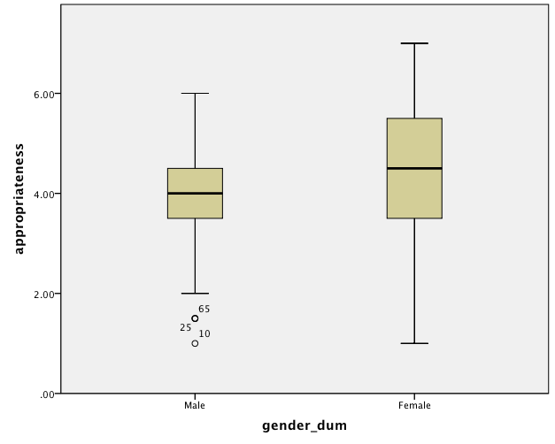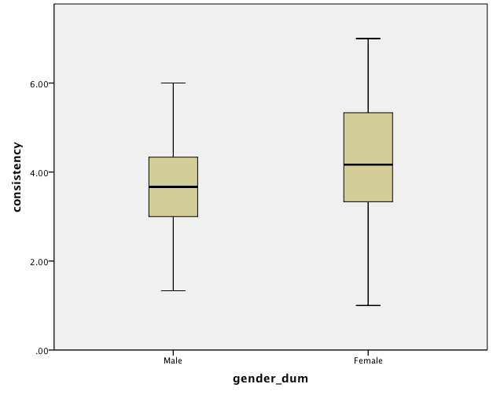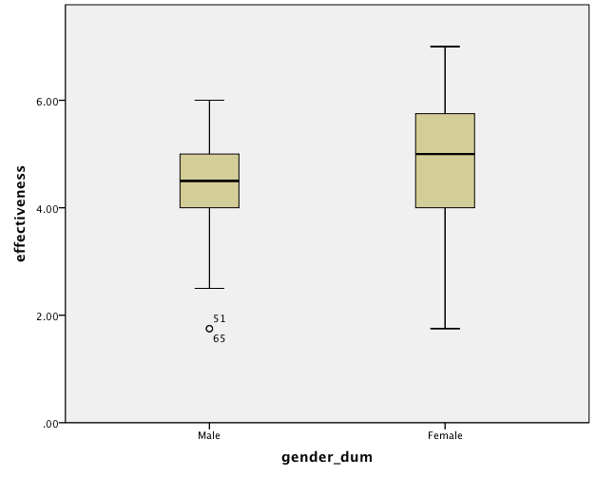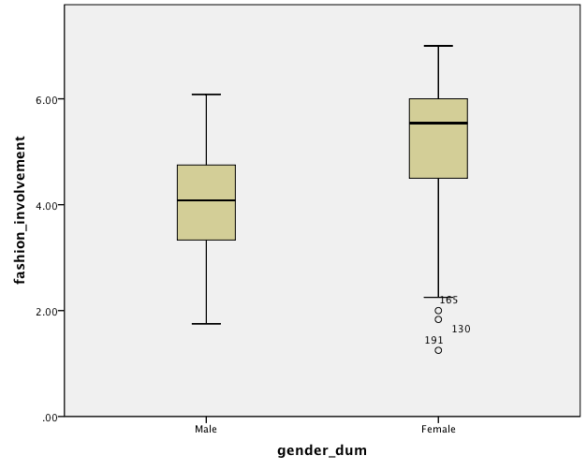

Appendix iii: SPSS output-Analysis results per hypothesis
Hypothesis 1: Stratified simple regression analysis
Model Summary
gender_dum | Model | R | R Square | Adjusted R Square | Std. Error of the Estimate
Male | 1 | .399ª | .159 | .151 | .92770
Female | 1 | .442ª | .196 | .188 | 1.11977
a. Predictors: (Constant), ease_of_use

Coefficientsª
gender_dum | Model |  | Unstandardized Coefficients |  | Standardized Coefficients | t | Sig.
gender_dum |  |  | B | Std. Error | Beta | t | Sig.
Male | 1 | (Constant) | 2.604 | .545 |  | 4.779 | .000
Male | 1 | ease_of_use | .426 | .096 | .399 | 4.434 | .000
Female | 1 | (Constant) | 1.653 | .713 |  | 2.318 | .022
Female | 1 | ease_of_use | .618 | .123 | .442 | 5.032 | .000
a. Dependent Variable: adoption

Hypothesis 2a: Multiple regression analysis

Model Summary
gender_dum | Model | R | R Square | Adjusted R Square | Std. Error of the Estimate
Male | 1 | .630ª | .397 | .392 | .78526
Female | 1 | .618ª | .382 | .376 | .98144
a. Predictors: (Constant), usefulness

Coefficientsª
gender_dum | Model |  | Unstandardized Coefficients |  | Standardized Coefficients | t | Sig.
gender_dum |  |  | B | Std. Error | Beta | t | Sig.
Male | 1 | (Constant) | 1.424 | .437 |  | 3.260 | .002
Male | 1 | usefulness | .720 | .087 | .630 | 8.282 | .000
Female | 1 | (Constant) | .951 | .538 |  | 1.766 | .080
Female | 1 | usefulness | .788 | .098 | .618 | 8.021 | .000
a. Dependent Variable: adoption

Hypothesis 2b: Multiple regression analysis with interaction term
^{Model Summary}
^{Model} | ^{R} | ^{R Square} | ^{Adjusted R Square} | ^{Std. Error of the Estimate} | ^{Change Statistics}
 |  |  |  |  | ^{R Square Change} | ^{F Change} | ^{df1} | ^{df2} | ^{Sig. F Change}
¹ | ^{,627a} | ^{,394} | ^{,385} | ^{,88878} | ^{,394} | ^{45,024} | ³ | ²⁰⁸ | ^{,000}
a. Predictors: (Constant), use_gend, gender_dum, use_cent
b. Dependent Variable: adoption

Parameter Estimates
Parameter | B | Std. Error | 95% Wald Confidence Interval |  | Hypothesis Test
Parameter | B | Std. Error | Lower | Upper | Wald Chi-Square | df | Sig.
(Intercept) | 5.148 | .0882 | 4.975 | 5.321 | 3404.777 | 1 | .000
useful_cent | .720 | .0975 | .529 | .911 | 54.577 | 1 | .000
[gender_dum=1.00] | -.122 | .1244 | -.366 | .122 | .961 | 1 | .327
[gender_dum=.00] | 0ª | . | . | . | . | . | .
[gender_dum=1.00] * useful_cent | .068 | .1314 | -.190 | .326 | .268 | 1 | .605
[gender_dum=.00] * useful_cent | 0ª | . | . | . | . | . | .
(Scale) | .775^{b} | .0753 | .641 | .938
Dependent Variable: adoption
Model: (Intercept), useful_cent, gender_dum, gender_dum * useful_cent

Hypothesis 3: ANOVA analysis

Descriptives
Adoption
 | N | Mean | Std. Deviation | Std. Error | 95% Confidence Interval for Mean |  | Minimum | Maximum
 |  |  |  |  | Lower Bound | Upper Bound | Minimum | Maximum
Male | 106 | 4.9874 | 1.00678 | .09779 | 4.7935 | 5.1813 | 1.33 | 7.00
Female | 106 | 5.2013 | 1.24270 | .12070 | 4.9619 | 5.4406 | 1.00 | 7.00
Total | 212 | 5.0943 | 1.13330 | .07784 | 4.9409 | 5.2478 | 1.00 | 7.00

ANOVA
Adoption
 | Sum of Squares | df | Mean Square | F | Sig.
Between Groups | 2.423 | 1 | 2.423 | 1.895 | .170
Within Groups | 268.579 | 210 | 1.279
Total | 271.002 | 211

Means Plot

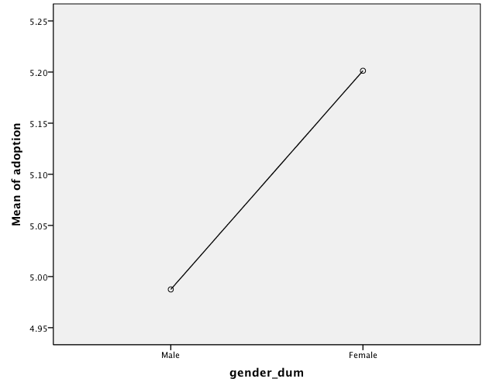

Hypothesis 4a: Stratified regression analysis
Model Summary
gender | Model | R | R Square | Adjusted R Square | Std. Error of the Estimate | Change Statistics
 |  |  |  |  |  | R Square Change | F Change | df1 | df2 | Sig. F Change
Male | 1 | ,424ª | ,179 | ,172 | 1,06813 | ,179 | 22,736 | 1 | 104 | ,000
Female | 1 | ,633ª | ,401 | ,395 | 1,07634 | ,401 | 69,580 | 1 | 104 | ,000
a. Predictors: (Constant), appropriateness

ANOVA^{b}
gender | Model |  | Sum of Squares | df | Mean Square | F | Sig.
Male | 1 | Regression | 25,940 | 1 | 25,940 | 22,736 | ,000ª
Male | 1 | Residual | 118,655 | 104 | 1,141
Male | 1 | Total | 144,594 | 105
Female | 1 | Regression | 80,609 | 1 | 80,609 | 69,580 | ,000ª
Female | 1 | Residual | 120,485 | 104 | 1,159
Female | 1 | Total | 201,094 | 105
a. Predictors: (Constant), appropriateness
b. Dependent Variable: persuasiveness

Coefficientsª
gender | Model |  | Unstandardized Coefficients |  | Standardized Coefficients | t | Sig. | 95,0% Confidence Interval for B
gender |  |  | B | Std. Error | Beta | t | Sig. | Lower Bound | Upper Bound
Male | 1 | (Constant) | 2,334 | ,401 |  | 5,828 | ,000 | 1,540 | 3,129
Male | 1 | appropriateness | ,475 | ,100 | ,424 | 4,768 | ,000 | ,277 | ,672
Female | 1 | (Constant) | 1,623 | ,381 |  | 4,259 | ,000 | ,867 | 2,378
Female | 1 | appropriateness | ,671 | ,080 | ,633 | 8,341 | ,000 | ,511 | ,830
a. Dependent Variable: persuasiveness

Hypothesis 4b: Multiple regression analysis with interaction term
Model Summary^{b}
Model | R | R Square | Adjusted R Square | Std. Error of the Estimate | Change Statistics
 |  |  |  |  | R Square Change | F Change | df1 | df2 | Sig. F Change
1 | ,578ª | ,334 | ,324 | 1,07225 | ,334 | 34,733 | 3 | 208 | ,000
a. Predictors: (Constant), appro_gend, gender_dum, appro_cent
b. Dependent Variable: persuasiveness

Parameter Estimates
Parameter | B | Std. Error | 95% Wald Confidence Interval |  | Hypothesis Test
Parameter | B | Std. Error | Lower | Upper | Wald Chi-Square | df | Sig.
(Intercept) | 4.337 | .1083 | 4.125 | 4.550 | 1603.920 | 1 | .000
appro_cent | .475 | .0990 | .281 | .669 | 22.996 | 1 | .000
[gender_dum=1.00] | .116 | .1519 | -.182 | .414 | .584 | 1 | .445
[gender_dum=.00] | 0ª | . | . | . | . | . | .
[gender_dum=1.00] * appro_cent | .196 | .1269 | -.053 | .445 | 2.390 | 1 | .122
[gender_dum=.00] * appro_cent | 0ª | . | . | . | . | . | .
(Scale) | 1.128^{b} | .1096 | .932 | 1.365
Dependent Variable: persuasiveness
Model: (Intercept), appro_cent, gender_dum, gender_dum * appro_cent
a. Set to zero because this parameter is redundant.
b. Maximum likelihood estimate.

Hypothesis 5: Stratified simple regression analysis

Model Summary
gender_dum | Model | R | R Square | Adjusted R Square | Std. Error of the Estimate
Male | 1 | .338ª | .114 | .106 | 1.10966
Female | 1 | .580ª | .336 | .330 | 1.13272
a. Predictors: (Constant), consistency

ANOVA^{b}
gender_dum | Model |  | Sum of Squares | df | Mean Square | F | Sig.
Male | 1 | Regression | 16.535 | 1 | 16.535 | 13.428 | .000ª
Male | 1 | Residual | 128.060 | 104 | 1.231
Male | 1 | Total | 144.594 | 105
Female | 1 | Regression | 67.656 | 1 | 67.656 | 52.730 | .000ª
Female | 1 | Residual | 133.439 | 104 | 1.283
Female | 1 | Total | 201.094 | 105
a. Predictors: (Constant), consistency
b. Dependent Variable: persuasiveness

Coefficientsª
gender_dum | Model |  | Unstandardized Coefficients |  | Standardized Coefficients | t | Sig.
gender_dum |  |  | B | Std. Error | Beta | t | Sig.
Male | 1 | (Constant) | 2.837 | .382 |  | 7.426 | .000
Male | 1 | consistency | .362 | .099 | .338 | 3.664 | .000
Female | 1 | (Constant) | 2.159 | .364 |  | 5.931 | .000
Female | 1 | consistency | .591 | .081 | .580 | 7.262 | .000
a. Dependent Variable: persuasiveness

Hypothesis 6a: Multiple regression analysis

Model Summary
gender | Model | R | R Square | Adjusted R Square | Std. Error of the Estimate | Change Statistics
 |  |  |  |  |  | R Square Change | F Change | df1 | df2 | Sig. F Change
Male | 1 | ,257ª | ,066 | ,057 | 1,13937 | ,066 | 7,383 | 1 | 104 | ,008
Female | 1 | ,590ª | ,348 | ,342 | 1,12254 | ,348 | 55,588 | 1 | 104 | ,000
a. Predictors: (Constant), effectiveness

ANOVA^{b}
gender | Model |  | Sum of Squares | df | Mean Square | F | Sig.
Male | 1 | Regression | 9,584 | 1 | 9,584 | 7,383 | ,008ª
Male | 1 | Residual | 135,010 | 104 | 1,298
Male | 1 | Total | 144,594 | 105
Female | 1 | Regression | 70,045 | 1 | 70,045 | 55,588 | ,000ª
Female | 1 | Residual | 131,049 | 104 | 1,260
Female | 1 | Total | 201,094 | 105
a. Predictors: (Constant), effectiveness
b. Dependent Variable: persuasiveness

Coefficientsª
gender | Model |  | Unstandardized Coefficients |  | Standardized Coefficients | t | Sig. | 95,0% Confidence Interval for B
gender |  |  | B | Std. Error | Beta | t | Sig. | Lower Bound | Upper Bound
Male | 1 | (Constant) | 2,624 | ,583 |  | 4,502 | ,000 | 1,468 | 3,780
Male | 1 | effectiveness | ,354 | ,130 | ,257 | 2,717 | ,008 | ,096 | ,612
Female | 1 | (Constant) | ,758 | ,537 |  | 1,412 | ,161 | -,307 | 1,823
Female | 1 | effectiveness | ,801 | ,107 | ,590 | 7,456 | ,000 | ,588 | 1,014
a. Dependent Variable: persuasiveness

Hypothesis 6b: Multiple regression analysis with interaction term
Model Summary^{b}
Model | R | R Square | Adjusted R Square | Std. Error of the Estimate | Change Statistics
 |  |  |  |  | R Square Change | F Change | df1 | df2 | Sig. F Change
1 | ,509ª | ,259 | ,248 | 1,13099 | ,259 | 24,204 | 3 | 208 | ,000
a. Predictors: (Constant), effec_gend, gender_dum, effec_cent
b. Dependent Variable: persuasiveness

Parameter Estimates
Parameter | B | Std. Error | 95% Wald Confidence Interval |  | Hypothesis Test
Parameter | B | Std. Error | Lower | Upper | Wald Chi-Square | df | Sig.
(Intercept) | 4.269 | .1136 | 4.046 | 4.492 | 1413.337 | 1 | .000
effect_cent | .354 | .1280 | .103 | .605 | 7.637 | 1 | .006
[gender_dum=1.00] | .213 | .1595 | -.099 | .526 | 1.785 | 1 | .182
[gender_dum=.00] | 0ª | . | . | . | . | . | .
[gender_dum=1.00] * effect_cent | .447 | .1669 | .120 | .774 | 7.171 | 1 | .007
[gender_dum=.00] * effect_cent | 0ª | . | . | . | . | . | .
(Scale) | 1.255^{b} | .1219 | 1.037 | 1.518
Dependent Variable: persuasiveness
Model: (Intercept), effect_cent, gender_dum, gender_dum * effect_cent
a. Set to zero because this parameter is redundant.
b. Maximum likelihood estimate.

Hypothesis 7b: Multiple regression analysis
Model Summary
Model | R | R Square | Adjusted R Square | Std. Error of the Estimate
1 | .465ª | .216 | .208 | 1.16052
a. Predictors: (Constant), fashion_involvement, gender_dum

ANOVA^{b}
Model |  | Sum of Squares | df | Mean Square | F | Sig.
1 | Regression | 77.458 | 2 | 38.729 | 28.756 | .000ª
1 | Residual | 281.481 | 209 | 1.347
1 | Total | 358.939 | 211
a. Predictors: (Constant), fashion_involvement, gender_dum
b. Dependent Variable: persuasiveness

Coefficientsª
Model |  | Unstandardized Coefficients |  | Standardized Coefficients | t | Sig.
 |  | B | Std. Error | Beta | t | Sig.
1 | (Constant) | 2.206 | .307 |  | 7.179 | .000
1 | gender_dum | -.036 | .177 | -.014 | -.201 | .841
1 | fashion_involvement | .489 | .071 | .470 | 6.905 | .000
a. Dependent Variable: persuasiveness

Hypothesis 7a: ANOVA analysis

Descriptives
fashion_involvement
 | N | Mean | Std. Deviation | Std. Error | 95% Confidence Interval for Mean |  | Minimum | Maximum
 |  |  |  |  | Lower Bound | Upper Bound | Minimum | Maximum
Male | 106 | 4.0322 | 1.03226 | .10026 | 3.8334 | 4.2310 | 1.75 | 6.08
Female | 106 | 5.1266 | 1.21956 | .11845 | 4.8917 | 5.3614 | 1.25 | 7.00
Total | 212 | 4.5794 | 1.25348 | .08609 | 4.4097 | 4.7491 | 1.25 | 7.00

ANOVA
fashion_involvement
 | Sum of Squares | df | Mean Square | F | Sig.
Between Groups | 63.472 | 1 | 63.472 | 49.725 | .000
Within Groups | 268.053 | 210 | 1.276
Total | 331.525 | 211

Means Plot

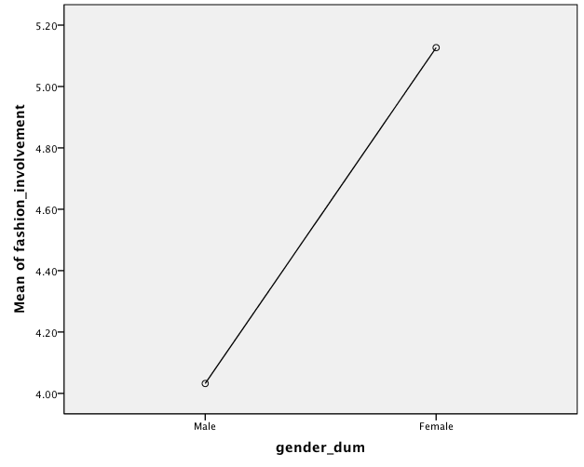

Hypothesis 8: ANOVA analysis

Descriptives
persuasiveness
 | N | Mean | Std. Deviation | Std. Error | 95% Confidence Interval for Mean |  | Minimum | Maximum
 |  |  |  |  | Lower Bound | Upper Bound | Minimum | Maximum
Male | 106 | 4.1792 | 1.17349 | .11398 | 3.9532 | 4.4052 | 1.00 | 7.00
Female | 106 | 4.6792 | 1.38390 | .13442 | 4.4127 | 4.9458 | 1.00 | 7.00
Total | 212 | 4.4292 | 1.30427 | .08958 | 4.2527 | 4.6058 | 1.00 | 7.00

ANOVA
persuasiveness
 | Sum of Squares | df | Mean Square | F | Sig.
Between Groups | 13.250 | 1 | 13.250 | 8.049 | .005
Within Groups | 345.689 | 210 | 1.646
Total | 358.939 | 211

Means Plot

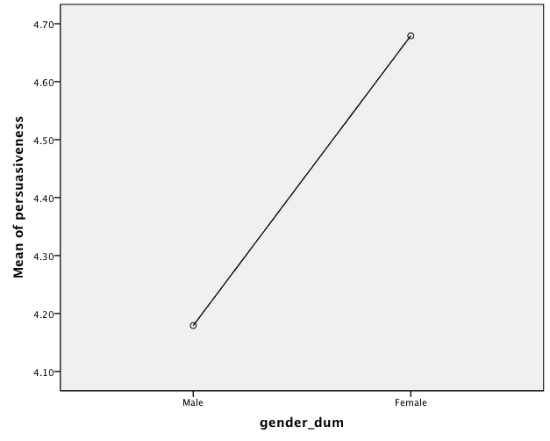

Appendix iv: Output post-hoc power analysis with G* Power 3
The free software G* Power 3 from the Heinrich Heine University Dusseldorf was used to conduct post-hoc power analysis (Faul et al., 2009). The post-hoc power analysis is applied after the conduction of the study to determine its power assuming that the estimated effect size in the sample is equal to the true effect size in the population. The higher the power the higher the probability that the test finds significant evidence that does exist. A power of at 80% is considered to be adequate (Thomas, 1997).
Post-hoc power analyses indicate that all tests applied have succeeded in detecting the effect of interest with great power ranging from 0.81 to 1.00 apart from hypothesis H3 that has power 0.26.

H1: The easiness of use of the agent will not have significant impact on its adoption either for male or for female online shoppers.
- Males
Power = 0.99
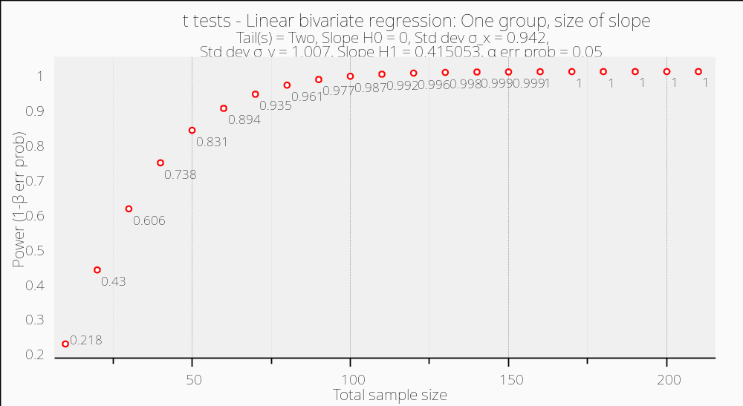

- Females Power = 0.99
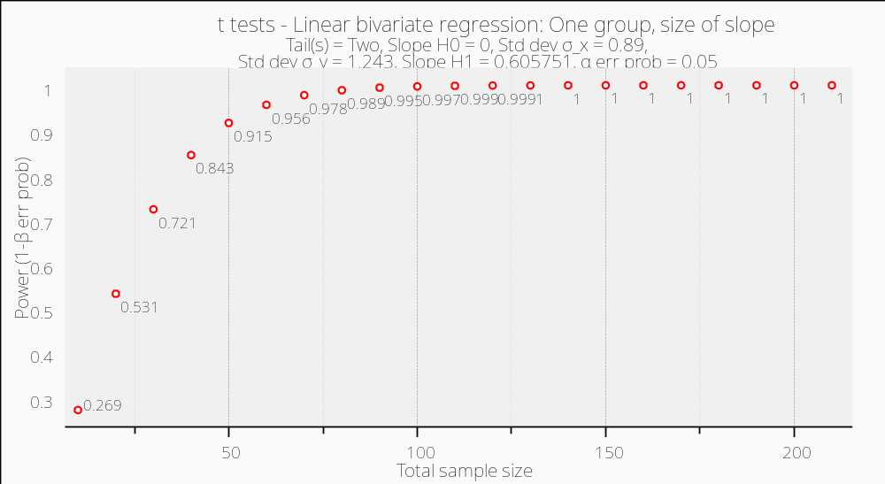

H2a: The usefulness of collaborative filtering will have a significant impact on its adoption for both genders.
- Males Power = 1.00
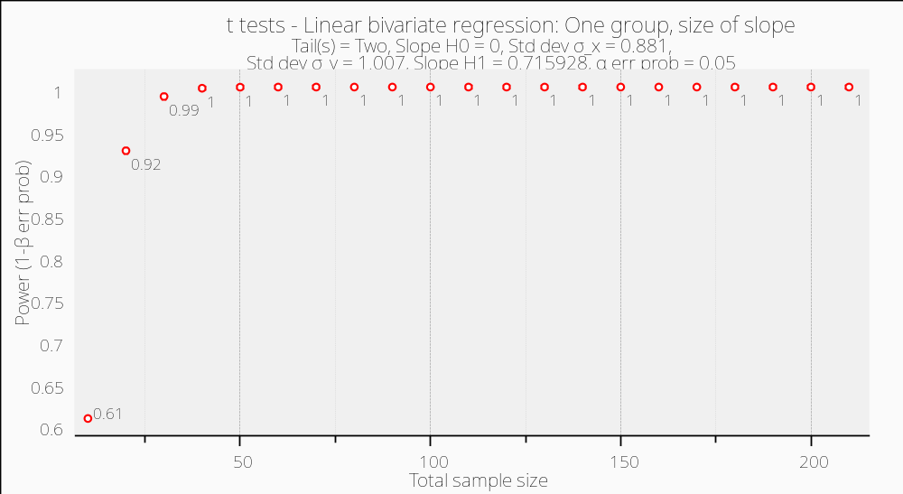
- Females Power = 1.00
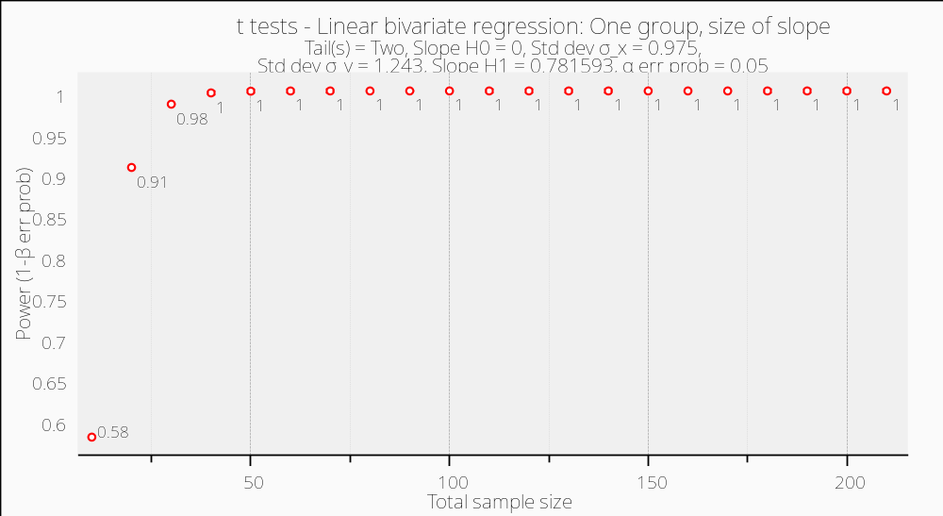

H2b: The usefulness of the agent will have a stronger impact on its adoption for female online shoppers rather than for males.
Power = 1.00
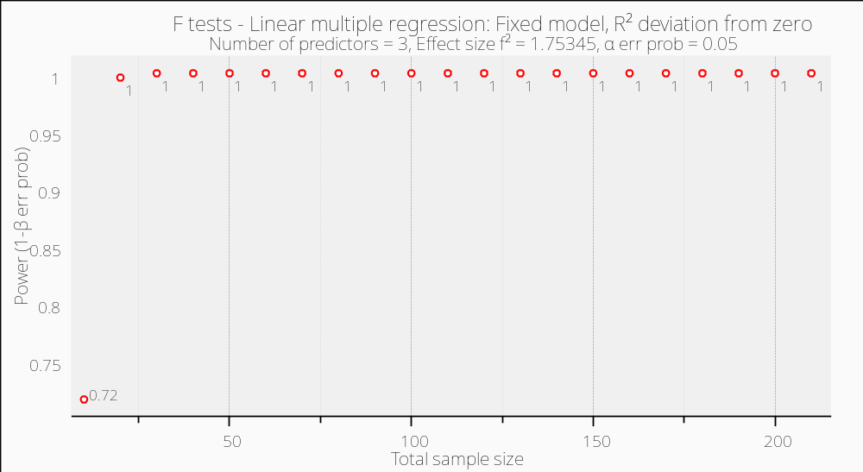
H3: The collaborative filtering agent will be equally adopted by both genders.
Power = 0.26
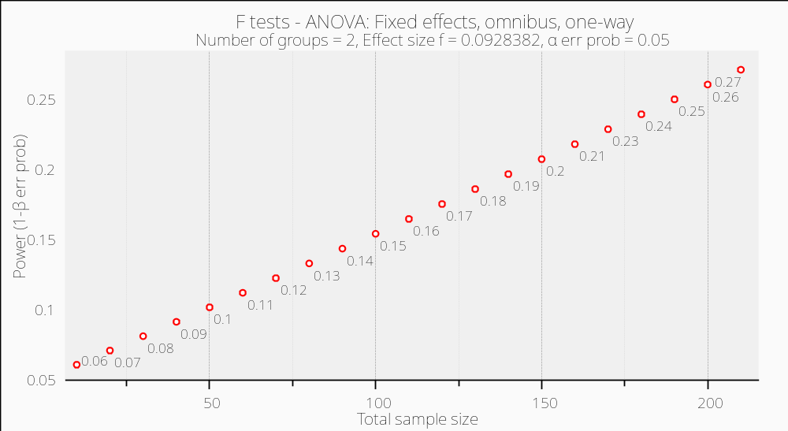
H4a: The appropriateness will have a significant effect on the persuasiveness of the agent for both genders.
- Males Power = 0.99
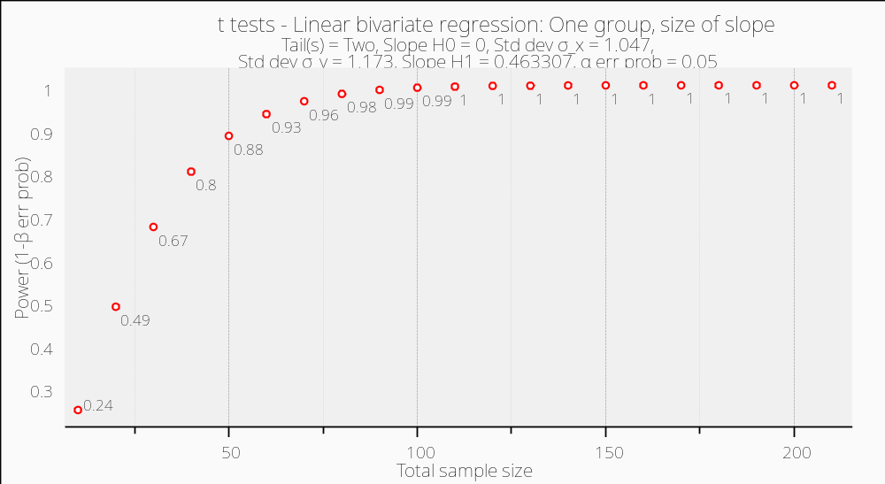

- Females Power = 0.99
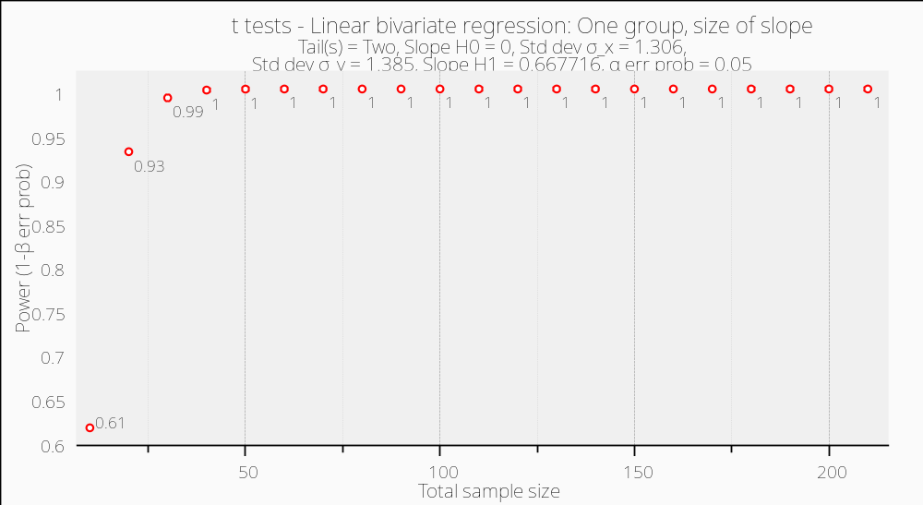

H4b: The appropriateness of the collaborative filtering agent will have a stronger impact on its persuasiveness for female rather than for male online shoppers.
Power = 1.00
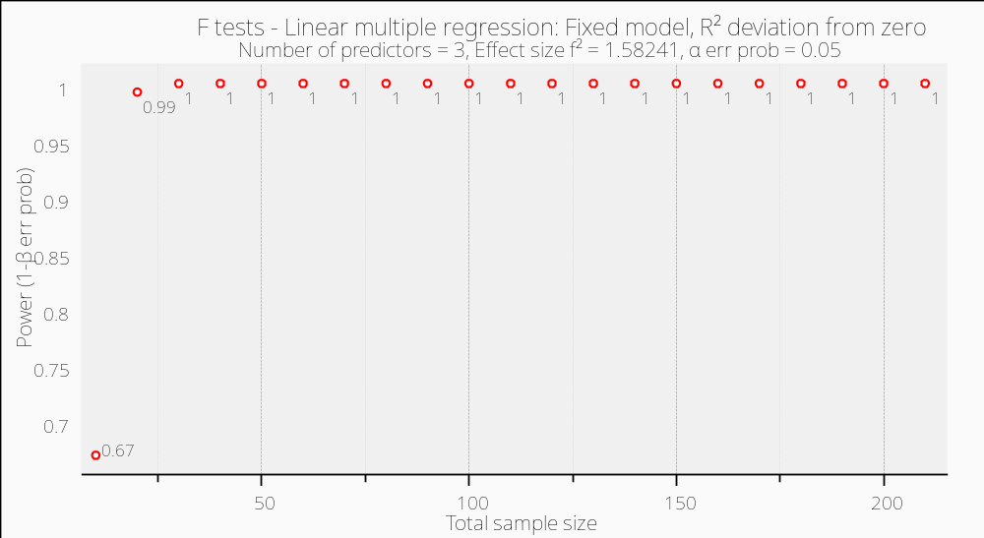

H5: The consistency will have a significant effect on the persuasiveness of the agent for female shoppers and not for males.
- Males Power = 0.99
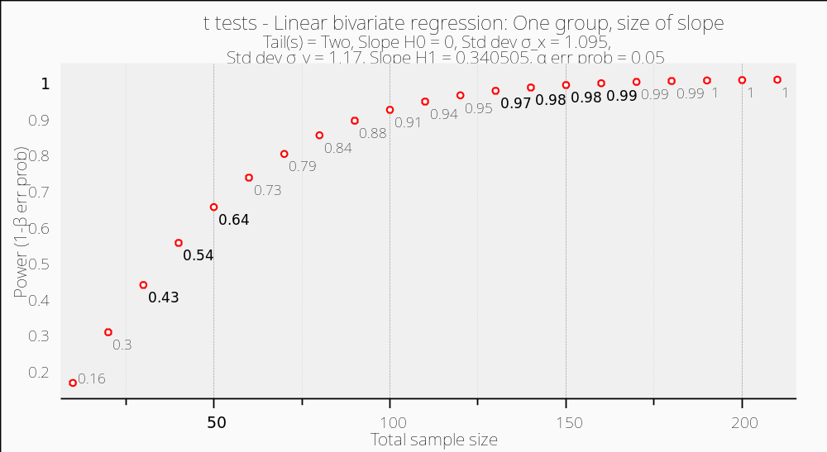

- Females Power = 1.00
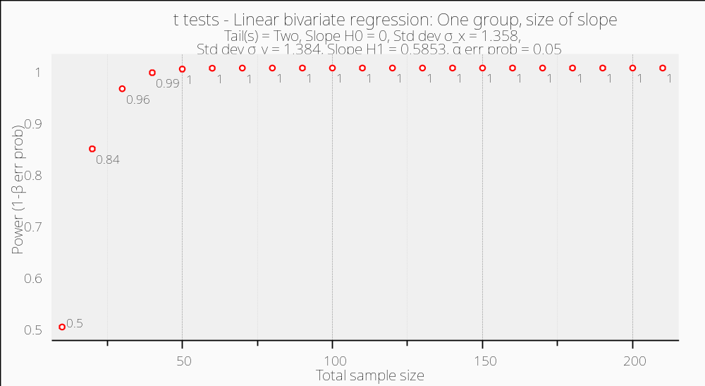
H6a: The effectiveness will have a significant effect on the persuasiveness of the agent for both genders.
- Males Power = 0.946
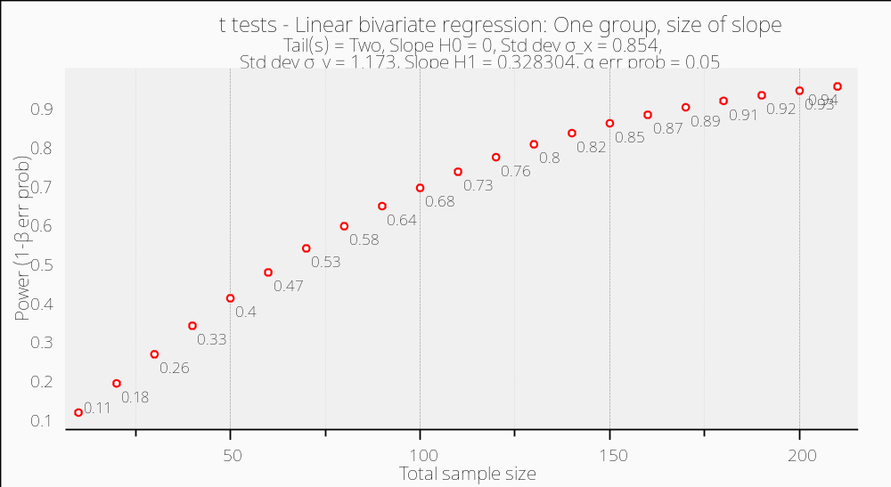

- Females Power = 1.00
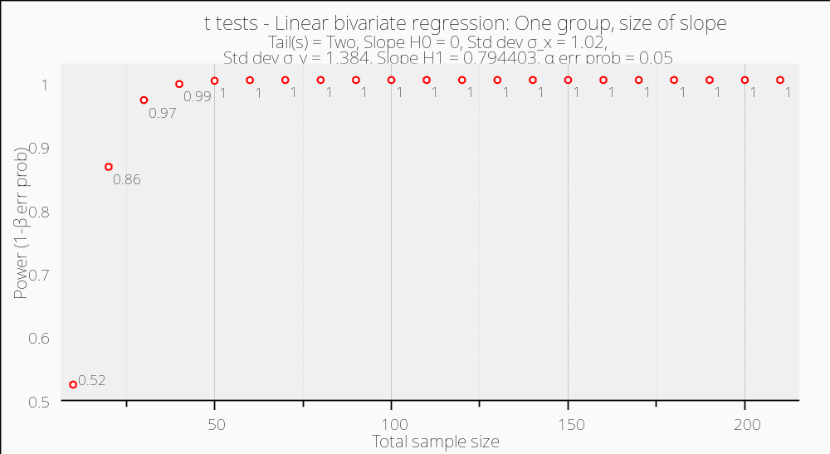
H6b: The effectiveness of the collaborative filtering agent will have a stronger impact on its persuasiveness for female shoppers than for males.
Power = 1.00
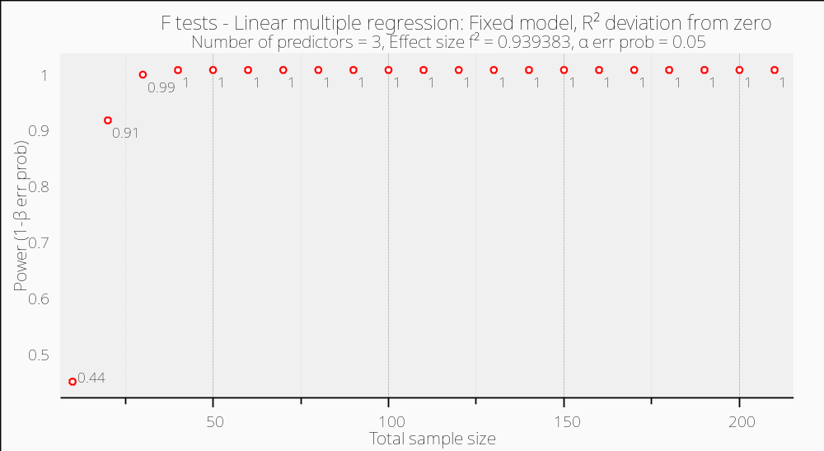

H7a: Female consumers will be higher fashion-involved than men.
Power = 1.00
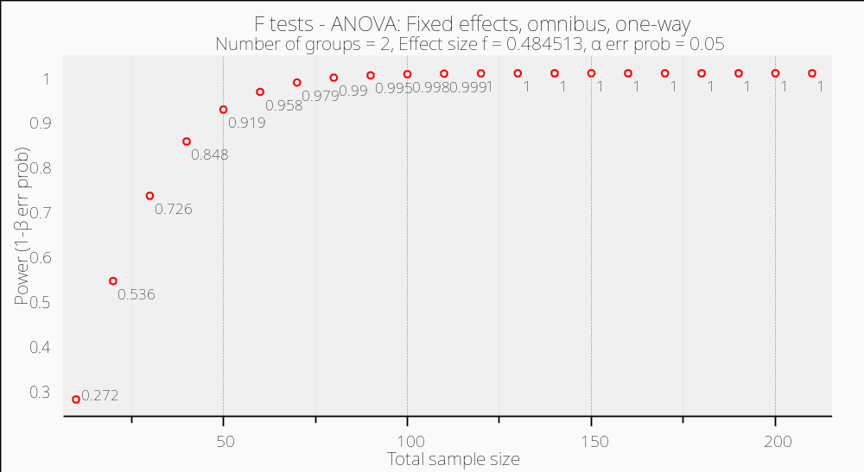
H7b: The persuasion to buy a recommended product listed by the collaborative filtering agent will be higher for highly fashion-involved consumers.
Power = 1.00
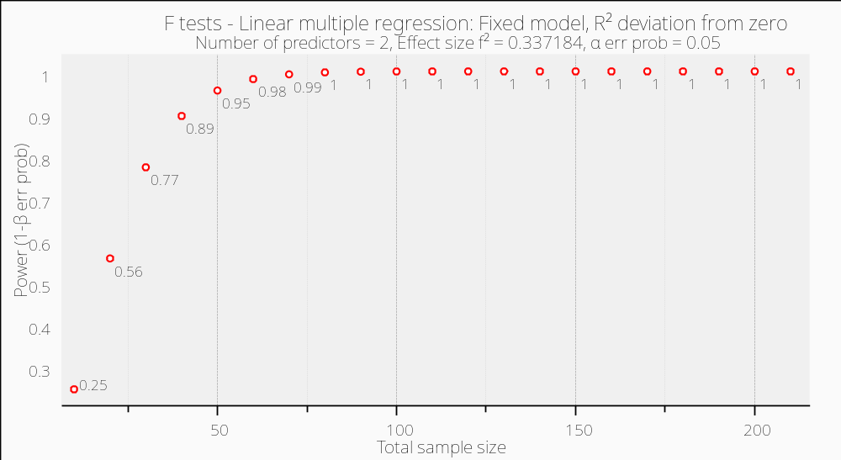
H8: More women than men will be persuaded to purchase a recommended product by the agent.
Power = 0.81
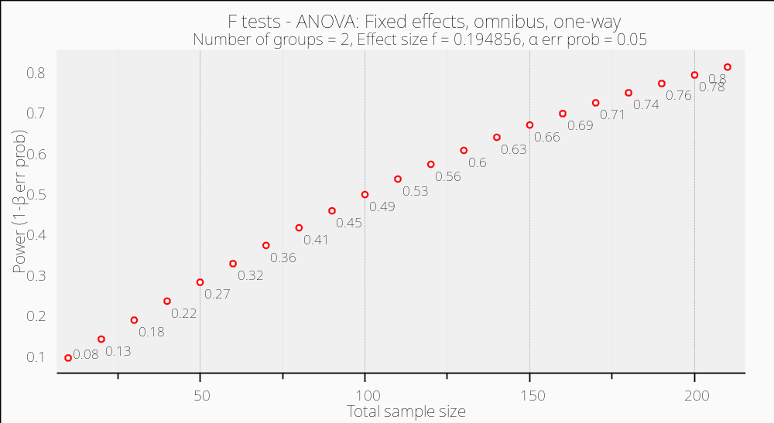

Appendix v: Online Experiment and Questionnaire

The only difference between the two forms of the questionnaire (male/female) is the web link provided.
Male:
http://www.amazon.com/Men-Clothing/b/ref=clo_h_ln_men?ie=UTF8&node=1040658&pf_rd_m=ATVPDKIKX0DER&pf_rd_s=merchandised-search-leftnav&pf_rd_r=59BE2B16F710478DA8F8&pf_rd_t=101&pf_rd_p=1367439162&pf_rd_i=1036592

Female:
http://www.amazon.com/Women-Clothing/b/ref=clo_h_ln_wom?ie=UTF8&node=1040660&pf_rd_m=ATVPDKIKX0DER&pf_rd_s=merchandised-search-leftnav&pf_rd_r=59BE2B16F710478DA8F8&pf_rd_t=101&pf_rd_p=1367439162&pf_rd_i=1036592


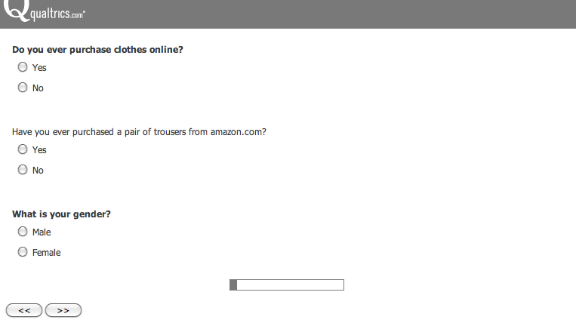

Male:
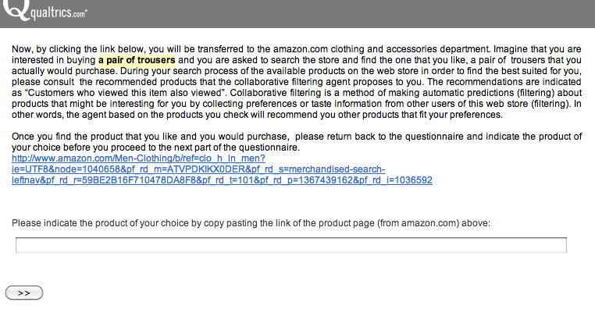
Female survey:
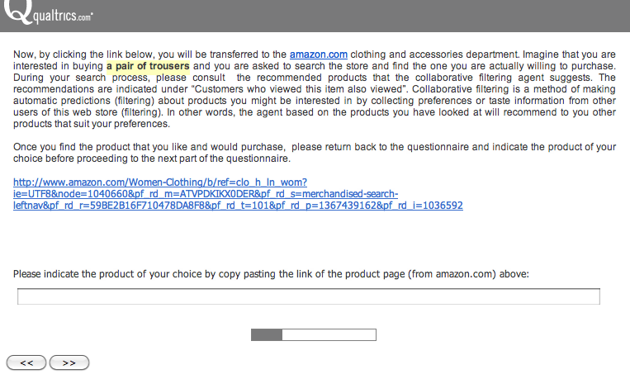
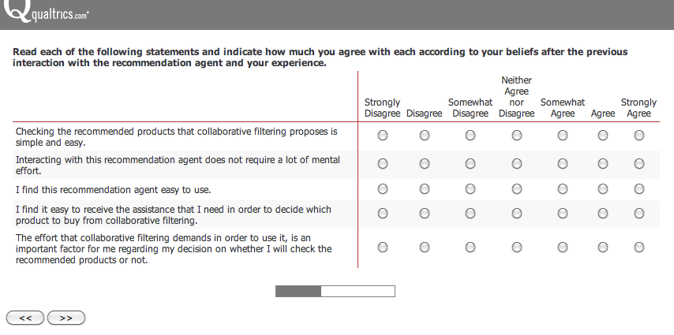
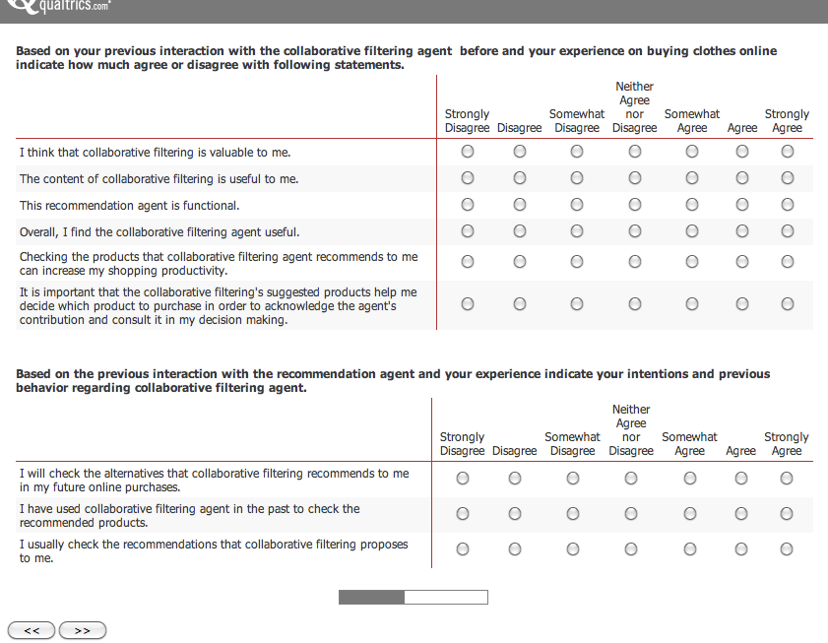

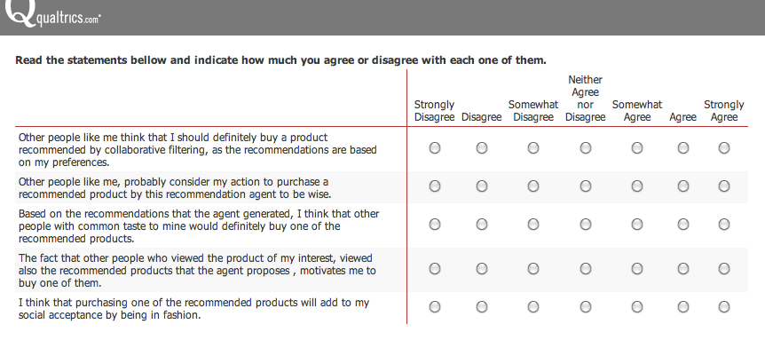
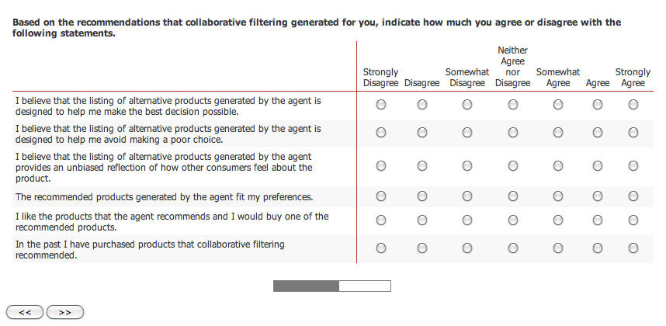
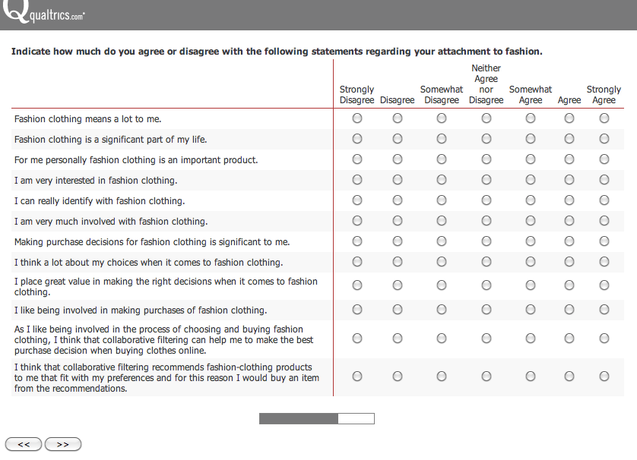
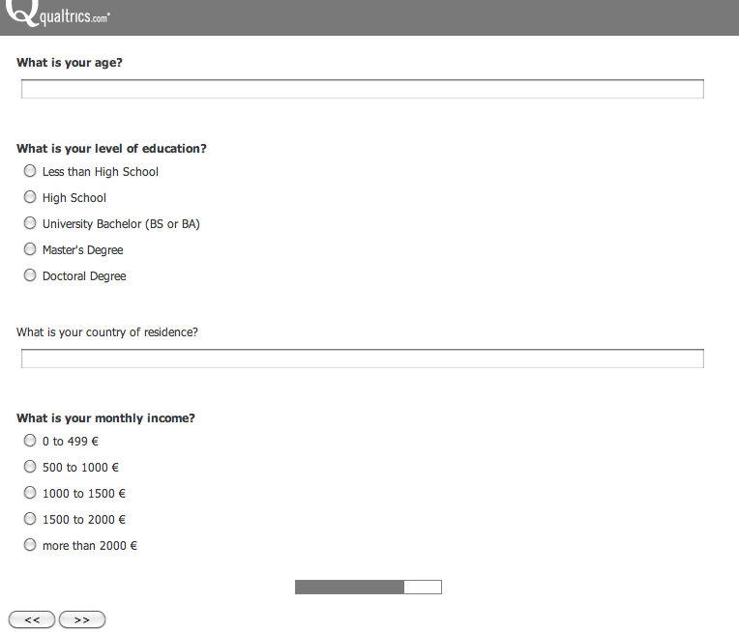


The Emu is a native bird in Australia, which is relative to the ostrich. Its leather is used for the production of apparel, handbags, shoes and other accessories and it is considered to be of exceptional quality.

