

Master Thesis Msc Marketing

“The influence of brand engagement in Social Network on the intention of consumers’ to purchase a product regarding its brand equity”

Student: Markopoulou Anastasia 345623
Supervisor : Feray Adiguzel

Management Summary

This research tries to identify how brand equity affects the intention of users to engage in Social Media activities of a brand and if this engagement leads to intention to purchase. A questionnaire survey was constructed based on the theories of brand equity, ideal self concept, brand engagement and intention to purchase. A specific industry (clothes) and two brands were chosen (Gucci and H&M) to identify whether or not brand equity affects intention to participate in Social Media activities and if this engagement can interpret into intention to purchase. The analysis of the gathered data revealed that brand equity affects positively the intention to engage with brand’s activities in Social Media and engagement also affects positively the intention to purchase a product from this brand. As proved in this study, the higher the engagement in a brand’s Social Media activities, the higher the company will increase its sales as the intention of consumers to purchase a product from that brand will increase. These results are of paramount importance since they can be applied in companies and be helpful for managers. Undoubtedly, profits are the main goal of all firms and companies regardless of equity, size and type of business should implement a social media strategy. Managers should understand Social Media and promote their products via them but be careful and keep the exposure to Social Media aligned with their goals. This study is the proof that companies should not be afraid of spending money in social Media activities and that they should find clever ways and creative tools to make users engage with such activities. Companies can give some promotions or contact very active social media users of their brand to involve them more in their activities and talk more about their brand in social media (i.e. make them brand advocates). Since brand engagement prove to be a partial mediator between brand equity and intention to purchase, a combination of a high equity brand with a significant use of Social Media that will lead to the engagement of the consumers will prove to be successful for companies.

Acknowledgements

It would not be possible this research to have been finished without the support and the help of several people. In this part of my thesis I would like to deeply thank these people. First of all, sincerely thanks to my supervisor, Dr Feray Adiguzel because due to her precious help and advices, she guided me to successfully accomplish this project. Furthermore, I would like to thank my family who supported me and gave me the opportunity to attend this master programme. Moreover, I would like to thank from the bottom of my heart all of my friends and especially Fay Panagopoulou and my neighbor Kostas Koutsikos for being understanding and patient which eventually helped me to remain calm and reach my goals. Last but not least, I would like to thank all the participants of this survey, who spent their time to help me with my research.

Markopoulou Anastasia

Table of Contents

Introduction………………………………………………………………………..1
1.1 General Information…………………………………………………………...1
1.2 Research Question and Subquestions……………………………….................1
1.3 Scientific Relevance…………………………………………………………...4
1.4 Managerial Relevance…………………………………………………………5
1.5 Overview of the chapters………………………………………………………6

Literature Review…………………………………………………………………8
2.1 Introduction…………………………………………………..………………..8
2.2 Social Media………………………………………………………..…………8
2.2.1 Types of Social Media…………………………………………………...9
2.2.2 Reasons for using Social Media……………………………..................11
2.2.3 Social Media Activities……………………………………..………….13
2.3 Brand engagement in Social Media……………………………..……………13
2.3.1 Motivations for brand engagement in Social Media……..…………….14
2.4 Brand Equity……………………………………………….………………...15
2.4.1 Brand Equity Elements……………………………….………………...15
2.4.2 The Brand Equity Pyramid ………………………….……....................16
2.4.3 High and Low Brand Equity…………………………………………...17
2.5 Brand Equity and Brand Engagement in Social Network…………………….18
2.6 Self Concept and Brand Engagement…………………………………………19
2.7 Brand Engagement in Social Network and Intention to Purchase……………20
2.8 Summary……………………………………………………………………...22
Conceptual Map and Hypotheses…………………………………..………….......23

Methodology…………………………………………………………..……..........24
3.1 Introduction……………………………………………………….…………...24
3.2 Research Technique…………………………………………………………...24
3.3 Data Collection Method……………………...……………………..…………25
3.4 Questionnaire Design………………………………………………………….26
3.4.1 Explaining the purpose of the questionnaire…………………….……..26
3.4.2 The design of individual questions………………………………..........26
Questionnaire Summary table……………………………………….…….28
3.5 Sampling…………………………………………………………………........31
3.6 Pilot Study……………………………………………………………………...31
3.7 Primary Data Collection………………………………………………………..32
3.8 Validity and Reliability………………………………………………………...33
3.9 Data Analysis…………………………………………………………….…….33
Methodology Summary table……………………………………………....37
3.10 Summary……………………………………………………………………...38

Results……….………………………………………………………………..……39
4.1 Introduction…………………………………………………………………..39
4.2 Descriptive statistics………………………………………………………….39
4.3 Factor Analysis and Reliability Tests………………………………………...42
4.4 Hypotheses Testing…………………………………………………………..46
4.4.1 Brand Engagement in Social Network……..…………………………..46
4.4.2 Ideal Self Concept……………………………………………………...47
4.4.3 Intention to Purchase…………………………………………………...48
4.4.4 Brand Engagement as a mediating effect………………………………49
4.5 Additional Analysis…………………………………………………………..52
4.5 Summary……………………………………………………………………..53

Conclusion and Discussion………………………………….….……...............54
5.1 Conclusion…………………………………………………..……………….54
5.2 Discussion………………………………………………..………………….55
5.3 Managerial Implications……………………………………………………..58
5.4 Limitation of the Research…………………………………………………..59
5.5 Recommendations for Future Research…………….……………………….61

References................................................................................................................63
Appendix………………………………………………………..…………...…….67
Appendix 1: Questionnaire………………………………....................................67
Appendix 2: Demographics…………………………………………….………..77
Appendix 3: Factor Analyses and Reliability Tests……………………………..79
Appendix 4: Regression Analyses…………………………………….................91

CHAPTER 1
INTRODUCTION

1.1 General Information
The advent of the Internet has significally changed the media landscape. One of the fastest growing arenas of the Internet is the reputed Social Media. This modification is essential due to the fact that the means by which information for a product or a service is transmitted is of paramount importance for marketers (Wright, 1974). Nowadays, marketers have a plethora of ways to communicate with consumers apart from the traditional media (television, newspapers, magazines etc). Our century is facing an explosion of messages conveyed through Social Media and firms should take advantage of this kind of exposure.
Social Media such as Facebook, Twitter, You Tube, Weblogs and many others is a new trend of communication not only between customers but also between firms and customers. Moreover, according to comScore Media Metrix (2011), ”today” 89 million people only in U.S will watch 1.2 billion videos on line. More and more people gravitate towards Social Media year over year and integrate them in their everyday life. In a real sense, these users are also customers as they expose to advertising while using these websites.

1.2 Research Question and Subquestions
Social Media is changing the way brands and consumers communicate. It is getting obvious that the prevailing market research will change a lot with the advent of Social Media and insights about peoples’ preferences and intentions will be acquired through Social Media. For instance, Cobb-Walgren et al (1995) claim that brand equity increases the purchase intention. However, does this also apply to Social Media? We try to investigate how brand equity affects the intention of users to engage in Social Media and how this affects real life purchase.
In the opinion of Schau & Gilly (2003) in Social Media users have the opportunity to present themselves in the way they desire, even if that image is not true in reality. As a result, we assume that ideal self concept will play an important role in the intention of users to engage in brand’s Social Media activities. Being a high equity brand may increase the chances for a user to post a positive comment about the brand, to upload a video related to the brand, to be member of a fan page of a brand or just “like” the brand as he/she wants to be associated with the brand by other users.
Nonetheless, does engagement also means that the user has actually the intention to purchase the brand? Through Social Media consumers have the ability to literally associate themselves with brands, which may in their lives be unable to own due to financial difficulties (Schau & Gill, 2003). On the contrary, low equity brands may decrease the possibility for a user to post a positive comment about the brand, to upload a video related to the brand, to be member of the fan page of a brand or just “like” the brand as he/she does not want to be associated with the brand by other users, yet the user may actually buy the brand because it is in an affordable price. Hence, the key question is if such activities in Social Media are related to consumers’ purchase intentions or not.
The aim of this study is to identify how brand equity effects people actions in Social Media and if engagement in brand’s Social Media activities has a positive effect on consumers’ real life intention to purchase.
Nielsen.com report that minutes spent in Social Networking Sites (SNSs) have increased 83% per year, while only in Facebook the spending minutes arise from 1.7 billion minutes in April 2008 to 13.9 billion minutes in April 2009. Consequently, Facebook will be used for this research as it is one of the most representative example of Social Media. Furthermore, according to comScore Media Metrix (2011), almost thirty percent of all online advertisements are placed on Facebook. As its founder, Mark Zuckerberg, stated “Facebook is an ad-supported business” and it is the most popular Social Network Site (SNS) with more than 845 million active users.
Both high and low equity brands create their own Facebook pages and try to get in touch with consumers. Consumers can start their online interaction with brands by just “liking” them. One high equity brand page (e.g Gucci) and one low equity brand page (e.g H&M) will be used in order to track peoples’ preferences and Social activities intentions and also their real intentions to purchase the products will be measured.
In order a study to be conducted there has to be a research question and subquestions that will be researched and will help to illustrate and enhance our existing knowledge about the examined topic. The research question of this study is:
“What is the effect of brand equity on consumers’ brand engagement in Social Media (brand related Social Media activities) and real life intention to purchase?”
There are plenty of sub questions concerning this study. The predominant are juxtaposed below:
- Is brand equity positively or negatively affects the intention of consumers’ to engage in Social Media activities of a brand?
- Does engagement in Social Media also means that the user has also the intention to purchase the brand?
- Why do consumers involve with brand engagement Social Media activities?
- What is the role of brand equity on consumers’ engagement with brand related Social Media activities?
- What is the role of ideal self-concept on the relationship between brand equity and brand engagement at social media?
The statement of the research question and subquestions will aid the study to lead smoothly in the results and conclusions that will eventually demonstrate the purpose of this research. The aforementioned research question and subquestions are the most important evidence of the purpose and the direction of this study.

1.3 Scientific Relevance
Despite the fact that Social Media is a hotly debated issue and a burgeoning topic, theories about their use is still in their infancy. On the report of Cobb-Walgren et al (1995) brand equity increases the consumer’s intention to purchase a product. However, this research does not include Social Media engagement and it compares services (hotels) with products (household cleaners). In this research two brands with similar products will be used (apparels) and also Social Media engagement will be tested.
Furthermore, as maintained by Schau & Gill (2003), users in Social Network Sites have the potential to present themselves as they like. They can build their image regardless their real life activities. This research will attempt to measure if users engage in brand’s Social Media activities to enhance their prestige or because they are loyal supporters of the brand. For this reason, ideal self concept will be used as a moderator effect between brand equity and brand engagement in Social Media. We expect that people with high ideal self concept will have higher engagement for high equity brands comparing to low equity brands since they want to be associated with them.
Finally, Hoffman & Novak (1996), focus on the engagement of consumers in Social Media in order to make online purchases. They argue that consumers engage in Social Network to obtain information and obtain opinions. That means that users may engage with the activities of a brand in Social Media to gain information for this brand and participate in contest that may increase their intention to purchase. However, Hoffman & Novak’s research focus on online purchase while this research pays special attention to purchase intention in general not only via the web.
To the best of my knowledge and after extensive research that has been conducted, an academic article about the role of brand equity in the engagement of users in brand’s Social Media activities and the role of this engagement to the real life intention to purchase does not exist. There is no research exploring if Social Media engagement is a mediating effect between brand equity and intention to purchase. Besides, the role of self-concept on the relationship between brand equity and brand engagement at social media will also be controlled. This void will be filled with this study.

1.4 Managerial Relevance
As Social Media becomes an integral part of people’s everyday life it is vital for marketers to understand Social media activities, the engagement of consumers in them and if these actions in Social Media can be a predictor for consumers’ purchase intentions. Marketers seek to understand how users’ interpret Social Media activities in order to use them for their benefits. Both high and low equity brands strive to make people engage in their Social activities so as to influence their intention to purchase.
Although researches on Social Media are at an early stage it is obvious that Social Media is not a trend of the season but a new tool for marketers that will not be obsolete as time passes. This research will help marketers working on brands to use this new tool efficiently and understand the role of brand equity not only to consumers’ intention to engage in brand’s Social Media activities but to their real life intention to purchase a product as well.
Researching the influence of brand equity on the engagement of consumers with the brand’s Social activities companies have the opportunity to discover if brand equity plays a critical role on consumers’ intention to engage with the brand in its Social network. If this statement is true companies should pay attention to build their brand with equity and make people engage in their Social activities. Moreover, if the research shows that Social Media activities have a positive impact on consumers’ intention to purchase, companies should use Social Media in their marketing communication strategy.
Last but not least, if the research demonstrates that high equity brands with higher brand engagement in Social Media imply higher intention to purchase it will mean that brand engagement is a mediating effect between brand equity and intention to purchase and that demonstration will provide strong evidences to companies to use Social Media in their marketing strategy.
1.5 Overview of the chapters
As mentioned above the purpose of this paper is to examine how brand equity affects users’ wish to engage in a brand’s social network and if this engagement can be translated into intention to real life purchase. The paper is divided in four main chapters: the literature review, the methodology chapter, the results chapter and the conclusion and discussion of the findings chapter.
The second chapter focuses on the literature review that is related with the research topic. The definitions of Social Media and Brand Engagement are given and the types of Social Media are described thoroughly (Kaplan & Haenlein, 2010). In addition, a great emphasis is given on the reasons which lead users to engage with brand related Social Media activities. These reasons are of major importance for understanding the great effect of Social Media and pschycoanalyze potential customers. Self concept is analyzing as a moderator effect between brand equity and brand engagement in Social Media. The association of such activities to user’s actual desire to purchase the brand is examined. Moreover, brand equity is defined and brands are separated to high equity brands and low equity brands, which is the examined factor of a brand for this research. Furthermore, the conceptual model and the hypotheses are formulated at the end of the literature review chapter. Based on the theories of Social Media, brand equity, engagement in Social Media activities and real life intention to purchase the hypotheses and the conceptual model are formed and presented.
The third chapter focuses on the methodology that the research follows in order to investigate how brand equity affect users’ intention to engage with a brand through Social Media and if that leads to the purchase of the brand’s product. Furthermore, the approaches and the philosophy that dominate the research are stated and the methods used to collect both primary and secondary data are mentioned. In particular, the reasons that the questionnaire method was chosen in order to collect the data are explained and more details are given about the survey.
In the fourth chapter of this study, all the data that were gathered through the questionnaires are analyzed. The results will clarify if the hypotheses are going to be rejected or accepted.
The last chapter of this study contains a further discussion of the findings of the data. The causes that led to the rejection or the acceptance of the hypotheses are discussed extensively. In addition, based on the results of this study the managerial implications are cited so as to be used by multinational firms in order to encourage them understand how they can gain a competitive advantage from the powerful tool that called Social Media. Additionally, the limitations of the study are also mentioned.
To sum up, the aim of this study is to understand how brand equity influences the intention of a user to engage in Social Media activities related to a brand and if that action also leads to a real life intention to purchase the brand.

CHAPTER 2
LITERATURE REVIEW

2.1 Introduction
The main purpose of this chapter is to illustrate the salient theories that concern Social Media, brand equity, Social Media activities and brand engagement in Social Media activities. Through the literature review, it will be possible to formulate the hypotheses that will be used as a basis in order to conduct the survey and ultimately answer the research question. In addition, the definition and the types of Social Media will be presented, as well as the definition of brand equity. This chapter will assist to understand what Social Media and Social Media activities are and why do consumers involve with such brand related Social activities. Moreover, brand engagement and buying behaviors will be indicated. Self concept and its effects on brand engagement will also be examined. Finally, a number of hypotheses will be developed according to the goals and aims of study, and a conceptual map will also be designed.

2.2 Social Media
Before the advent of modern technology, marketers used to promote their products through traditional media such as TV, radio, newspapers, magazines and outdoor activities. Sales promotion, direct marketing, promotion and personal selling were also ways of communication between firms and customers. Alongside with the presence of the Internet, Social Media was added to the marketing toolkit. This media “describes a variety of new sources of online information that are created, initiated, circulated and used by consumers intent on educating each other about products, brands, services, personalities and issues” (Blackshaw & Nazzaro, 2004, p.2). The term Social Media was first introduced in the middle of 1990 with the appearance of the first weblogs. The evolution of Social Media continued 13 years later with the creation of social media sites and more specific MySpace (in 2003) and Facebook (in 2004). (Kaplan & Haenlein, 2010). It is crucial to separate Web 2.0 Social Media from Web 1.0. The key difference between them is that in Web 2.0, users are creators of the content while in Web 1.0 they just consume it (Cormode & Krishnamurthy, 2008, p.2). According to Winer (2009) there are two features that discern Social Media of Mass media: interactivity and digital. Shankar and Hollinger (2007) have sorted Social Media into three categories, in which different types of Social Media are included:
- Intrusive media: this type of Social Media has the potential to intrude upon a viewer without he or she paying particular attention. Examples of intrusive media are: products placement in video games and M-commerce. (Winer, 2009; Pruppers, 2011)
- Non-Intrusive media: in this type of Social Media consumers are aware that they are exposure to advertising. Examples of non-intrusive media are: social networking sites. (Winer, 2009)
- User generated media: in this type of Social Media consumers not only are aware of advertising but somehow they also cocreate it. Examples of user generated media are: blogs, YouTube etc. (Winer, 2009)
2.2.1 Types of Social Media
From 1950 until now different types of Social Media have developed. Kaplan and Haenlein (2010) focused in six types of Social Media:
- Blogs
As mentioned in the beginning of this chapter, weblogs- later renamed as “blogs” when a user truncate “weblog” to “we blog” for fun- are the first type of Social Media that appeared in Social Media landscape. Blogs are usually generated by one person, who is called “blogger” and he/she gives to other people the opportunity to interact with each other, making comments, stating opinions and share information and experiences. Blogs are like personal diaries, which present observations chronologically and are usually updated daily. Blogs content has a large variety: they might include personal experiences, opinions about specific topics or descriptions of individual links. However, blogs face many risks from a company perspective. Consumers, who feel dissatisfied with a firm may express their dissatisfaction through blogs and affect other’s people opinions. (Park et al, 2010; Johnson & Kaye, 2004; Kaplan & Haenlein, 2010).
- Social Networking Sites
In the last years, social networking sites (SNSs) have become tremendously popular in all over the world. Facebook, Twitter, My Space and Linkedin are some examples of SNSs. Compete.com (2011) reported that Facebook (founded by Mark Zuckerberg) is the largest social networking site with 750 million unique visitors per month. The second one is Twitter with 250 million unique visitors per month. In Social Network Sites people construct a personal profile, which encompass user’s personal information, images, videos interests and preferences of books or movies. Users have their own network of “friends” and they interact with them by making comments to the status of users or to their photos and by chatting and sending messages to each other. Profile holders acquire new friends by sending them requests to be added as friends. (Kaplan & Haenlein, 2010; Trusov et al 2009).
- Content Communities
In contrast to social networking sites, in content communities it is not necessary to create a personal profile. This type of Social Media enables users to share contents such as books (e.g BookCrossing), videos (e.g YouTube), music (e.g Jamendo.com), photos (e.g Flickr), presentations (e.g Slideshare) or even content with assistance (e.g Piczo.com). (Mangold & Faulds, 2009; Kaplan & Haenlein,2010). YouTube (founded in 2005) is one of the most popular website on which users can upload and view videos, and it is estimated that its videos exceed the 100 million per day. As a result, this high visitation of content communities gives firms the opportunity to use them in order to allure customers. (Kaplan & Haenlein, 2010).
- Collaborative projects
These websites are a typical example of user generated content. Users create contents that they upload in order other people to be able to see them. The most common illustration of this type of Social Media is the website Wikipedia. Wikipedia launched in 2000 and now consists of 20 million articles, created by online users , and they are available on 283 languages. This website offers users the chance to collaborative and write articles. In addition, anyone is able to modify the content of the website. This opportunity, albeit holds the prospect of inaccuracy of information. As Kaplan & Haenlein state users seem to overcome this risk and their faith to Wikipedia increases over the years: “not everything written on Wikipedia may actually be true, it is believed to be true by more and more people”. Companies should take into account that collaborative projects tend to become or have already become the main source of information for customers. (Kaplan & Haenlein, 2010).
- Virtual Game Worlds
These games are an online community, which constitute a 3D environment in which people interact as they would do in their real life as personalized avatars. Users choose an appearance and interact to one another based on the rules of the game. They may take the form of a warrior or a dragon and fight for a purpose. Self presentation is eliminated by the existence of the rules of the game. The most obvious example of Virtual game worlds is “World of Warcraft”. Virtual games provide an unparalleled combination of social existence and media richness and that are the reasons that they have characterized as “the ultimate manifestation of Social Media” (Kaplan & Haenlein, 2010).
- Virtual Social World
In this form of Social Media users have more freedom to interact and make decisions regarding their real life personality. As in virtual game worlds they also interact in a three dimensional environment as avatars. However, the main argument of Virtual Game Worlds from Virtual Social World is the lack of rules in the game. Undoubtedly, the most typical example of this type of Social Media is “Second Life” where people create and sell their products to each other. (Kaplan & Haenlein, 2010).
In this research, significant attention will be given to Social Network Sites (SNSs) and especially to “Facebook” as it is one of the most visited Social Media. As Nielsen.com refers the minutes spent in Facebook grew from 1.7 billion minutes in April 2008 to 13.9 billion minutes in April 2009.
2.2.2 Reasons for using Social Media
The reasons might vary from person to person regarding his/her personal characteristics, interests and preferences; albeit in this research the predominant reasons will be quoted. It is vital to understand these reasons in order to clarify the possible reasons to engage in Social activities. People might use Social Media for:
- Entertainment – seeking: entertainment is the most prominent motive of using Social Media. People seek pleasure through Social Media either by playing on-line games, or by sharing links and photos in social network sites or even by exchange opinions and experiences to blogs. (Lin & Lu, 2011; Sledgianowski & Kulviwat, 2009; Park et al 2010)
- Information-seeking: people use Social Media in order to gather information for specific issues. Blogs provide information and users often consider them as more credible than traditional sources (Johnson & Kaye, 2004; Park et al, 2010). The same happens also with social network sites; people trust other people’s opinions about their experience with a product more than the allegation of companies because they lack the desire for profits. Social Medial tends to become the main source of information for the 21st century.
- Efficiency Seeking: people also use Social Media to save time and effort for achieving a specific task. Via interaction with other users people ask questions, get answers and discuss finding a solution to their tasks (Park et al, 2010).
- Communication-seeking: through Social Media users have the opportunity to interact with people they know or with people they do not know. That offers an opportunity to know other people and improve their social network. (Sledgianowski & Kulviwat, 2009; Lin & Lu, 2011)
- Numbers of Peers: some people might use Social Media because it simply is “in fashion”. Due to the fact that people are surrounded by users of Social Media and many others that are anticipated to use them in the future, they will also follow the trend. (Lin & Lu, 2011).
- Presenting themselves: users express themselves in Social Media through their comments to other peoples’ ideas, their “likes” in a page, the videos that they share or even the communication of their own ideas. (Viegas, 2005)
This last argument has extensive importance for this research because as Schau & Gilly (2003) claim in Social Media users have the opportunity to present themselves in the way they want, even if that image is far from reality. That means that people can use Social Media to promote a particular character; the one that they would like to convey to others and not their real one. As a result, people may share videos, “like” pages, writing positive comments and be members of fan pages on purpose, just because they want to create a certain image and not in accordance with their true beliefs. Hence, if in fact people behave differently than they do in their activities in Social Media, these activities cannot be considered credible and be used as predictors for their real life behavior.
2.2.3 Social Media Activities
As maintained by Trusov et al (2010) with regard to social network sites, users accomplish two kinds of activities: create a new content or consume content created by others. Users create a new content when they add photos and images to their profiles, share or upload videos, write negative/positive comments, become a fan of a brand page or even when they “like” something. In other words, when they revise their profiles. On the other hand, users consume others’ people content by downloading videos and music, reading other messages and blocks or by looking others’ people profiles –their comments, information or pictures.
In this research, significant attention will be given on the creation of new content by users, as it implies their involvement in brand related Social Media activities such as writing a comment about the brand, posting or sharing a video about the brand, being a member of brand’s fan page and “like” the page of the brand or its products.

2.3 Brand Engagement in Social Media
Brand engagement in traditional Media is “the willing of consumers to invest time, money, energy and other resources in the brand beyond those expended during the purchase or consumption of the brand” (Pruppers, 2011). For instance, engaged consumers choose to join a brand’s fan club or receive updates and information about a brand’s news. Marketers seek to engage consumers and presently they interpret Social Media as a way to achieve it. Marketing in Social Media desires to engage consumers in on line locations where they spend much time per day.
However, engagement in Social Media is a different concept than engagement in traditional media. The difference lies in participation; customers convert from viewers to participants, Social Media enhance collaboration and not just exposure and impression (Evans, 2010). The engagement of a user to a brand in Social Media is related with “like” a brand and its products, being a member of brand’s Facebook page, write a comment about the brand and post or share a video about it. The customer becomes a member of a brand’s marketing team as what he/she share, post, “like” and write with other users becomes part of a brand’s marketing campaign.
2.3.1 Motivations for brand engagement in Social Media
It is an undeniable fact that media landscape has changed a lot over time. Firms switch from segmenting customers to building customers’ communities (Cova, 1997). The advent of the internet and in particular of Social Media played a crucial role for this shift. Brands attempt to engage customers through Social Media activities and create communities which deliver consumer-to-consumer value. Due to the fact that one of the main reasons that consumers surf the internet is to find information and that they will trust more the opinion of a peer rather than the company’s position, brand communities are of paramount importance for brands. Online communities are organized around brands (Muniz & O’Guinn, 2001), social media analysis and strategies of users to present themselves and form an image in the network (Schau & Gilly, 2003).
Most of the times users become members of a brand community just by “liking” the page of the brand in Facebook. The reasons that users become members vary from user to user. The most common reasons are to obtain information, to share knowledge with other users and build social relationships (Mathwick et al, 2008). All these motivations to engage in brand’s Social Media activities are accomplished through conversations in Social Media. Shang et al (2006) have also claimed that seeking for information is the main reason for customers’ involvement. Moreover, they argue that involvement leads to information seeking because individuals are associated with certain brands in order to establish an identity (Schau & Gilly, 2003). As believed by Bickart & Schindler (2001) this engagement may influence customers’ purchase decisions , and this is the main reason that brands strive for customers’ participation in Social Media.
Furthermore, as maintained by Muniz & O’Guinn (2001), users receive some benefits from their participation in Social Media activities, which may also be seen as motivations to engage in brand’s activities. The first benefit is that consumers have a stronger voice when they form a community than when they are isolated. Secondly, brand communities can establish a tremendous information resource for customers. Last but not least, brand communities and communal interaction provide ample social advantages to its members.
As aforementioned the reasons for participation in Social Media vary. Some users may “like” a brand page, post a positive comment and upload a video just to share their knowledge and experiences with other users or because they build their network identity with this way or simply because they want to develop social connections. That depends on the character of the user and his incentives.

2.4 Brand Equity
The concept of brand equity has proliferated into several meanings. As believed by Park and Srinivasan (1994) “brand equity is the incremental utility or value added to a product by its brand name”. In the opinion of Yoo et al (2000) “brand equity is the difference in consumer choice between the focal branded product and an unbranded product given the same level of product features”. This definition compares two products that are the same but with different brand name.
2.4.1 Brand Equity elements
According to Aaker (1996) brand equity consists of brand loyalty, perceived quality, brand awareness, brand associations. In order to fully understand brand equity, these concepts should be analyzed.
- Brand loyalty: is “a deeply held commitment to rebuy or repatronize a preferred product or service consistently in the future, despite situational influences and marketing efforts having the potential to cause switching behavior” (Oliver, 1997, p392). A customer who is brand loyal tends to repeat his/her purchase, be consubstantial to the brand and refuse to replace it with another brand even if it is less beneficial.
- Perceived quality: as Zeithaml (1988, p3) stated, it is “the consumer’s (subjective) judgment about a product’s overall excellence or superiority”. The perceived value differs from consumer to consumer because it is connected with the unique needs of each customer that the product fulfils. In addition, the degree that these needs satisfy varies between consumers. Regarding this level of satisfaction brand equity may increase if the perceived quality is high or may decrease if the perceived quality is low.
- Brand awareness: is the ability of a consumer to identify the brand among different brands and under different conditions. The more associations the consumer has with the brand the more awareness he/she acquires.
- Brand associations: is “anything linked in memory to a brand” (Aaker, 1996, p.109). A consumer can make his/her association with the brand regarding his/her experiences with the brand, his/her knowledge about the brand and his/her exposure to the brand.
High brand equity connotes that consumers will have strong and positive associations with the brand (Yoo et al, 2000), whereas low brand equity implies weak and neutral or negative associations related to the brand. Positive associations may lead consumers to be more willing to participate in activities related to the brand in Social Media comparing to negative associations.
2.4.2 The Brand Equity Pyramid
A brand is not just a product or a service, it is more than that. A strong brand should create strong emotional bonds with customers. Brand equity can be characterized as a form of strong relations between brands and customers. There are certain steps that must be followed before a consumer characterized as brand loyal and build strong associations and attachment with the brand; these steps are fully illustrated in the brand equity pyramid (Figure 1).

Figure 1: The brand equity pyramid
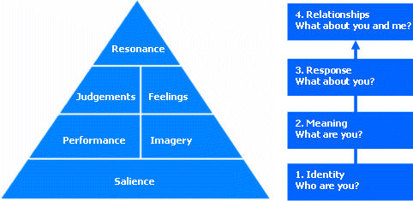

The consumers that have accomplished all these steps can be characterized as brand loyal with the perception that the brand they support, is considered as high equity. These consumers will also be more willing to engage in the brand’s activities and buy brand’s products.

2.4.3 High and Low Brand Equity
It is complicated to distinguish high equity brands to low equity brands because the concept of brand equity itself is difficult to be defined as it depends on consumers’ thoughts and feelings toward the brand. Hence, brand equity differs from consumer to consumer and what may be considered as high brand equity by some people may be characterized as low equity by others. As believed by Yoo et al (2008) high prices, high investments in advertising and distribution in selected stores with a good image in great intensity are some activities that enhance brand equity.
There is a possibility that some consumers will interpret low prices as cutting costs, made by the quality of the product. Frequent use of coupons, price deals and discounts may also be considered by consumers as signals of lower quality. Moreover, consumers usually appreciate the quality of the product, not by the product itself but from the reputation of the store that they can find the product. The frequency of advertisements and the high investments of money for them can increase brand equity as well.
Taking everything into account as high equity brand can be characterized a brand that has high prices, distribute its product in stores with a respectable image and reputation, invests a lot of money for advertising its products in a regular base and does not follow strategies of rebates and price deals oftenly.
On the contrary, as low equity brand can be characterized a brand that has low prices, distribute its product in stores with neutral or poor image and reputation, invest a small amount of money to advertise its product and has a policy of using discounts and special offers frequently.
Taking all the above mentioned into consideration for the purpose of this research two identical products of high and low brand equity should be used. We assume that Gucci will be perceived by participants in the survey as high equity brand while H&M will be characterized as a low equity brand. This assumption is based on the fact that both brands focus on apparel but with differences in price, advertising campaigns and stores.

2.5 Brand equity and brand engagement in Social Network
As mentioned previously in paragraph 2.4.1 high brand equity implies that consumers will have strong and positive associations related to the brand (Yoo et al, 2000), whereas low brand equity implies weak and neutral or negative associations towards the brand. Hence, positive associations may prompt consumers to engage in Social Media brand’s activities comparing to negative or neutral associations.
Furthermore, if we also take into consideration the opinion of Schau & Gilly (2003) that users introduce themselves in Social Media in the way they desire and build their image regardless if it is real or not, we assume that users will be more willing to “like” a high equity brand page, to write a positive comment, to share a video or being a member of the fan page of the high equity brand in comparison to low equity brands because he/she prefers to be associated with the high equity brand to low equity brand by other users. The user will be more willing to engage with the high equity brand and spend time and energy to brand’s Social Media activities. Therefore, we expect that high equity brands will have a higher engagement in brand’s related Social activities.
Hypothesis 1: Higher the brand equity, higher the brand engagement in Social Media.

2.6 Self concept and brand engagement
Self concept is “the totality of the individual’s thoughts and feelings having reference to himself as an object” (Rosenberg, 1979; p.7, Sirqy, 1982; p.287). Self concept is a multidimensional term and consists of actual self, ideal self and social self. In the opinion of Rosenberg (1979) actual self is the way that a person perceives himself/herself, ideal self is the way that he/she would like to consider himself/herself and social self is the way a person presents himself/herself to others. Social self image depends on the individual’s willingness to disclose information about himself/herself and regarding the nature of the information he/she reveals it can be characterized as ideal.
Social self image denotes that a person reveals factual information about himself/herself while ideal social self image means that a person may reveal certain information, hides other or just create fake one in order to create a particular impression to others. Ideal social self image derives from the need of people to manage other people’s impressions about them.
As claimed by Goffman (1959) people want to control the impressions that make on other people in any kind of social interaction. That is what psychologists refer to as self-presentation which is a very complex but interesting topic in social psychology. On the authority of Leary and Kowalski (1990), self presentation (also called impression management) refers to “the process by which individuals attempt to control the impressions others form of them”. Self presentation is of paramount importance for people especially when they want to achieve a goal such as obtaining positive feelings as sympathy, improve their relationships or affect other people to create a positive attitude towards them. Regarding the fact that perception of others about a person affect the way they may treat to him/her people may behave in a certain way to obtain a satisfying treatment.
As maintained by Schau & Gilly (2003), one of the predominant reasons that users choose to create a personal webpage on cyberspace is the desire to express themselves on the internet. Facebook profile is associated with self presentation as it is a contemporary type of social interaction and personal information and actions such as “like” a page or upload a video can be seen by others. When creating personal webpage users disseminate information that is consistent with the impression they would like to make (Kaplan & Haenlein, 2010). In addition, users may engage in brand’s Social Media activities in order to improve their ideal social self image. As a result, it can be assumed that the theory of Rosenberg (1979) about social self image and ideal social self image can also be applied in Social Media and specific to Facebook.
Taking everything into account, in this research, we assume that people who like to control his/her expressive behavior for managing a desired impression to others-in other words people who create an ideal social self image- will be more willing to engage in Social Media activities for a high equity brand as they prefer to be associated with this brand rather than a low equity brand. However, this engagement does not necessarily mean actual intention to purchase.
On the contrary, people who are less interested in managing the impression that other people form for them, they may engage in Social Media activities of a brand regardless the strength of its equity or they may not engage in brand’s Social Media activities at all.
Hypothesis 2: Higher the ideal self concept, higher the positive effect of brand equity on the intention of the user to engage in Social Network.

2.7 Brand engagement in Social Network and Intention to Purchase
Social Media is changing the way brands and consumers used to communicate. From one way communication it has turned to two-ways communication. This is not the only change; the traditional market research will also change a lot with the advent of Social Media and insights about peoples’ preferences and intentions will be acquired through Social Media. Social Media will become a tool for firms to understand the consumer’s desire to buy their products. As Cobb-Walgren et al (1995) claim brand equity increases the purchase intention. This research will try to investigate if Cobb-Walgren et al (1995) statement also applies in Social Media activities where the probability of self-presentation in a desired way also plays a critical role and may impede firms from making the right conclusions.
Brand equity evokes strong feelings and associations with the brand and perhaps a higher involvement in the brand’s Social Media activities. Empirical evidences have shown that involvement influences positive consumer’s responses (Mc Millan et al, 2003). In addition, Fortin and Dholakia (2005) maintain that involvement may be used as a predictor for buying behavior. The interaction with the brand through Social Media engagement may influence consumer’s preference or purchase decisions toward the brand (Bickart & Schindler, 2001). Moreover, ideas and opinions communicated through Social Media between users may be a type of Word Of Mouth (WOM) (Bickart & Schindler, 2001; Hennig-Thurau et al, 2004). As Buttle (1998) stated Word of Mouth is of paramount importance for affecting consumers buying behavior. Consequently, it can be inferred that brand participation in Social Media will have a positive effect on actual buying behavior and especially on purchase intention.
Hypothesis 3: Higher the brand engagement in Social Media, higher the intention to purchase.
When a consumer perceived the brand as high equity, he/she becomes brand loyal and spends time and effort in its Social activities which may lead to intention to real life purchase (Bickart & Schindler, 2001). As a result, high equity brands with higher brand participation in Social Media will have a higher desire to purchase a product from this brand than from a lower one. Therefore, it can be implied that brand engagement in social Media has a mediating role between brand equity and intention to purchase.
Hypothesis 4: Brand engagement in Social media is a mediating effect between brand equity and intention to purchase.
2.8 Summary
In the view of the media landscape changes, researches and firms strive to understand Social Media and receive benefits from them. Moreover, a vast number of researches have studied brand equity and its effects in the real purchase. But can these conclusions for traditional media also used for Social Media? Does brand equity affect the intention of consumers to engage in brand’s Social Media activities? Does this engagement also affect consumers’ intention to purchase? The following chapters will try to provide answers to these questions through the research that will be conducted.

Conceptual Map & Hypotheses
As stated earlier, brand equity may affect the user’s intention to engage in brand’s Social Media activities. Moreover, self concept may also be a moderator between brand equity and engagement in Social Media. This engagement may be a predictor of consumer’s intention to purchase the product. Figure 2 illustrates these hypotheses.
Figure 2: Conceptual Map
Self Concept

H2

Brand Equity
High/Low
Brand Engagement in Social Network

Actual buying Behavior:
Intention to Purchase
H3
H1

H4

Hypotheses:
H1: Higher the brand equity, higher the brand engagement in Social Network.
H2: Higher the ideal self concept, higher the positive effect of brand equity on the intention of user to engage in Social Network.
H3: Higher the brand engagement in Social Network, higher the intention to purchase.
H4: Brand engagement in Social Network is a mediating effect between brand equity and intention to purchase.
CHAPTER 3
METHODOLOGY

3.1 Introduction
The main goals of this chapter are to describe the research method that will be followed and also the data collection method. The set of hypotheses that were formulated in the previous chapter will be examined while the logic behind the sample choice will be explained. Moreover, the way that the questionnaire was created will also be illustrated as well as the pilot study and the changes that this has induced. Through the methodology chapter, the validity and reliability of the findings will be discussed, and the method that the primary data were collected will also be analyzed.

3.2 Research Technique
As Cooper & Schindler (2003) stated, exploratory research is more appropriate in cases where data are narrowed and flexibility is needed to assess new phenomena. On the other hand, as claimed by Saunders et al (2009), the emphasis on the explanatory research is to examine a problem or a situation by focusing on the relationships developed between different variables. From the aforementioned definitions, it can be assumed that this research is an explanatory research.
According to Saunders et al (2009), a deductive approach “involves the development of a theory that is subjected to a rigorous test”. Furthermore, deductive approach is usually associated with surveys. It is clear that this research has more characteristics of a deductive approach than an explanatory one. Robson (2002) suggested five steps for the development of deductive studies:
- Formulate a hypothesis from theory: In this research, whether brand equity can affect the engagement of consumers in Social Media activities and the relationship between the engagement and the actual intention to purchase.

- Suggest a relationship between variables: In this research, brand equity, Social Media engagement, ideal self concept as a moderator effect between brand equity and engagement and real life intention to purchase.

- Test the hypothesis: In this research by using questionnaires.
- Analyze the results of the survey: In this research by using SPSS
- Modify the theory if necessary.
To sum up, it is clear that this research is following a deductive approach.

3.3 Data Collection Method
A survey strategy is the most common method to use when primary data need to be gathered with a deductive approach. As Saunders et al (2009) stated surveys are commonly used due to the fact that they enable the collection of a vast amount of data in an economic way. People also perceived survey strategy as authoritative and so it is easy to be explained and be understood. Moreover, using a survey strategy gives researcher more control over the process especially when sampling is used, because there is the opportunity to make general conclusions from a representative sampling for the whole population. Besides, since the investigation of whether there is a relationship or not between dissimilar variables is a major objective of this study the selection of survey strategy is very reasonable.
One of the most common means of conducting a survey is questionnaires. As defined by DeVaus (2002) questionnaire is “all the techniques of data collection in which each person is asked to respond to the same set of questions in a predetermined way”. Therefore, for collecting the necessary data for the research, a questionnaire was designed in which participants had to answer a number of questions regarding the perception of themselves, their opinion about brand equity, their desire to engage in brand’s Social Media activities and their real intention to purchase a product. The designed questionnaire for this research was uploaded on Facebook.
Furthermore, relevant information used for this research, was gathered through electronic books, journals and articles. Moreover, books, journals and articles from the university’s library have also been used.

3.4 Questionnaire Design
The questionnaire’s design is of paramount importance as not only the reliability but also the validity of the data depends on it. As Foddy (1993) stated “the question must be understood by the respondent in the way intended by the researcher and the answer given by the respondent must be understood by the researcher in the way intended by the respondent”. Therefore, the questions designed for this study were composed carefully and the language used for the questionnaire was English that is the most widely used language worldwide, thus the most comprehensible from all other languages. Its construction has been done through an online survey program named Qualtrics and participants were recruited through a social network site, partiular via Facebook.
3.4.1 Explaining the purpose of the questionnaire
All the questionnaires need to be accompanied by an introduction that describes the purpose of the research and why participants should fill in the questions. Therefore, the questionnaire that was designed for this research had in its first page an introduction indicating the goal of this study and reassuring participants that their responses will be kept confidential. Moreover, at the end of the survey a conclusion existed that was kindly thanked participants for cooperating.
3.4.2 The design of individual questions
The questionnaire included close-ended questions because that was the easier and more effective way for participants to fill it in. Most of the questions were based on previous studies and also from the Marketing Scales Handbook (1998) and respondents had to rate their agreement or disagreement on a five point Likert scale from “strongly disagree” to “strongly agree” to give their opinion. The main reason for borrowing the scales from Marketing Scales Hanbook (1998), was that they have already been checked for their validity and reliability. Since the scales are valid and reliable, they also expected to be a significant source of data collection. The questionnaire consisted of questions divided in five sections.
- Section 1: Demographics
The first section of the questionnaire contained demographic questions, like the gender, the age, the nationality and the amount of income. These questions were useful to make general conclusions and further understand the consumers’ responses.
- Section 2: Ideal Self concept
The second section consisted of five questions regarding self presentation, measured on a five point Likert scale. Ideal Self concept a moderator between brand equity and brand engagement in Social Network. According to Bearden & Netemeyer (1999) the self-concept scale consisted of three questions and two questions were added to the scale by Walther et al (2001). The Bearden & Netemeyers’ questions were associated with self concept in general while the added questions were associated with self presentation in Social Media. Since the study is related with Social Network, the questions seemed appropriate for the research.
- Section 3: Brand Equity
In the third part of the questionnaire, brand equity was the dependent variable of the research. To measure brand equity four five point Likert scale statements were used based on Yoo et al (2000) with a composite reliability 0.93. The scale measures the value of a specific brand to a consumer in comparison with other brands due to the name regardless features and quality. The four statements referred to the brand Gucci and they were repeated for the brand H&M. In this way, the perception of respondents about the two brands (high or low brand equity) would be verified. As a result, we were then able to make conclusions on how brand equity affects the intention of consumers to engage in brand’s Social Media activities.

- Section 4: Brand engagement in Social Network
The fourth section of the questionnaire contained questions interwoven with brand engagement in Social Media, which was the dependent variable in this section. Since there is no previous study measuring the brand engagement in Social Media the scale was self-made, indicating the presence of a) “like” the Facebook page, b) being a member of a fan page, c) write a positive comment about the brand or d) post or share a video about the brand. The participants were kindly asked to press a link and be transferred to the official Facebook page of Gucci. After seeing the page, they were returning to the questionnaire to continue answering questions. Regarding the answer in the question whether they were or not members of the Gucci’s official Facebook page they had to answer different questions. If the answer was “yes”, seven questions would have followed about their engagement with the brand in Social Media. The answers were either yes or no. If the answer was “no”, five questions would have followed about their desire to engage with the brand after seeing the Facebook page of the brand. The answers were measured on a five point Likert scale from “Very Unlikely” to “Very Likely”. This separation occurred because we wanted to check if the respondents that were already members of the Facebook pages of the brands were highly engaged in their Social Media activities or not. For participants that were not members we wanted to observe whether or not they had the intention to engage in brands’ Social Media activities. The same procedure was also followed for H&M. The Facebook pages of Gucci and H&M have similarities in the construction and the potential activities of users, and this was one of the main reasons that these two brands were selected.
- Section 5: Intention to purchase
In the last part of the questionnaire, intention to purchase was the dependent variable and respondents had to rate their agreement or disagreement on a five point Likert scale from “strongly disagree” to “strongly agree” for four statements. The statements were in accordance with Coyle et al (2001) with an alpha of 0.83. Putrevu et al (1994) have also used them with an alpha of 0.91. Respondents have to answer them for both Gucci and H&M. Consequently, we were able to conclude about the real life intention of the respondents, to purchase either a Gucci or an H&M product in the future.

Questionnaire Summary Table
The following table illustrates a scale overview:
Variable | Source | Questions | Reliability (α)
Ideal Self Concept | Walther et al (2001)  Bearden & Netemeyer (1999) | 1. Social media allows me to present myself in a favorable way.  2. I think I have made a good impression on others through social media.  3. It is my feeling that if everyone else in group is behaving in a certain matter, this must be the proper way to behave.  4. If I am the least bit uncertain as to how to act in a social situation, I look to the behavior of others for cues.  5. It is important for me to fit in to the group I am with.
Brand Equity | Yoo et al (2000) | 1. It makes sense to buy ………instead of any other brand, even if they are the same.  2. Even if another brand has the same features as……, I would prefer to buy……..  3. If there is another brand as good as………. I prefer to buy ……….  4. If another brand is not different from ………in any way, it seems smarter to purchase………… | 0.93
Brand Engagement | Self-made | If they were member of the official Facebook page :  1. Have you ever written a comment about Gucci at Social Media?  2. Have you ever written a comment about Gucci at online community/forum?  3. Have you ever written a comment about Gucci at Video Channel like YouTube?  4. Have you ever read a comment about Gucci at Social Media?  5. Have you ever read a comment about Gucci at online commun ity/forum?  6. Have you ever read a comment about Gucci at Video Channel like YouTube?  7. Have you ever uploaded or shared a video about Gucci at Social media?  If they were Not members of the official Facebook page:  1. Would you "like" (i.e. press the "like" button at facebook) the Facebook page of Gucci?  2. Would you upload or share a video about Gucci at Social Media?  3. Would you write a comment about Gucci at Social Media?  4. Would you read a comment about Gucci at Social Media?  5. Would you become a member of the Facebook page of Gucci?
Intention to Purchase | Coyle et al (2001)  Putrevu et al (1994) | 1. It is very likely that I will buy ……..  2. I will purchase ……..the next time I need a ………  3. I will definitely try……  4. I will recommend…… to my friends. | 0.83  0.91

3.5 Sampling
In a survey, in order the sampling to be chosen two techniques can be followed: the probability or representative sampling and the non probability or judgmental sampling (Saunders et al, 2009). The probability samples include all the conditions that can occur within a population while non probability samples consist of the most appropriate sample in the opinion of the researcher. Additionally, we did not have a chance to get a sampling frame for the probability sampling. Therefore, a non probability sample has been used for this survey.
More precisely, a self-selection sampling was used for the goals of this research. For this purpose, social network approach has been used. The questionnaire and the purpose of the research were published in Facebook and individuals were kindly asked to participate. The choice of whether they wanted to participate or not was made individually by them. Since the sample was self-selected all of the members, respondents or not were considered to be a representative sample.
The questionnaire was posted both in the group of “Master Marketing 2011” and in another group called “Master Thesis survey: Markopoulou Anastasia” that was created in Facebook specifically for this purpose. Participants were Internet and Social Media users so as to measure efficiently the Social Media brand engagement. In the group “Master Marketing 2011” members were mostly international students of the Erasmus University of Rotterdam in the field of Marketing. In the group “Master Thesis survey: Markopoulou Anastasia” members were selected not only with the condition of being users of Social Media but also based on their ability to understand the questions in order the results to be more reliable.
This research has 4 main variables in its analysis: brand equity, self concept, brand engagement and intention to purchase. A sample size of at least 100 participants would be sufficient in order this study to has meaningful statistical results.

3.6 Pilot Study
Before the publication to the participants, the questionnaire was pilot-tested. In this way, it could be ensured that respondents would experience no problems understanding the questions or any kind of difficulties when conducting the survey. Fifteen pilot participants were asked to fill in the pilot questionnaire in order to give opinions and provide a feedback. The pilot participants were kindly asked to fill in the questionnaire and pay attention to the questions and their meanings and the easiness of the answers.
All fifteen responses were extremely helpful to improve the final version of the questionnaire. The main problem accrued from the pilot study was that the links of Gucci and H&M’s Facebook page did not work properly. When participants were pressing the link to be transferred in the Facebook pages, instead the links to be opened automatically in a new tab or window they were opened in the same page. As a result, participants did not have the opportunity to return to the questionnaire and they had to start over again. After emailing Qualtrics, the problem was solved by a certain default that should have been chosen so as to automatically open the links to a different tab. Consequently respondents could continue the questionnaire properly after clicking the links.
After correcting the links and some spelling mistakes, the layout of the questionnaire was finalized and some pictures were added (i.e. the logo of the university and pictures of Gucci and H&M). After the necessary alterations, the final version of the questionnaire was uploaded to Facebook for the chosen sample.

3.7 Primary Data Collection
The questionnaire and the purpose of this research were announced in the Social Network Site, Facebook in two different groups “Master Marketing 2011” and “Master Thesis survey: Markopoulou Anastasia”. Members of these groups had the opportunity to participate in the research and fill in the questionnaire if they wish. After one week, 127 questionnaires were gathered but only 115 of them were complete and appropriate for further analysis, giving a response rate around 91%.

3.8 Validity and Reliability
As Jensen (2007) stated, it is essential to pay particular attention to the validity and reliability of the results of the survey in order to reduce the likelihood of incorrect outcomes. The main purpose of a research is to gather valid and reliable data so as to explain the phenomena as realistic as possible.
The validity of the research can be assessed in many ways such as face validity, internal validity and external validity (Iacobucci & Churchill, 2010). Face validity is the most common method for assessing validity and represents the probability that the participants may not fully understood the meaning of the questions. With the pilot survey, the face validity had been evaluated because the final form of the questionnaires had been pretested. Furthermore, as Iacobucci and Churchill claimed external validity is “the extent to which the effect can be generalized”. Unfortunately, since the survey has chosen a non-probability sample technique the outcomes of the survey can be represent only the research’s sample and cannot be generalized. In addition, in order the validity of multi-item scales to be checked factor analysis will be conducted. By conducting a factor analysis we will be assured about the convergent and discriminant validity.
In the opinion of Saunders et al (2009), the reliability represents whether the data collection will conclude in reliable results or not. In this research, the reliability of the outcomes will be tested with Cronbach’s alpha.

3.9 Data Analysis
Primary data collection is being followed by data analysis. In order the collected data to be analyzed SPSS; a computer program that helps surveys to interpret the results, was used. The data analysis will show whether the hypotheses will be rejected or accepted and will help to make conclusions. The hypotheses are restated bellow:
Hypotheses:
H1: Higher the brand equity, higher the brand engagement in Social Network.
H2: Higher the ideal self concept, higher the positive effect of brand equity on the intention of the user to engage in Social Network.
H3: Higher the brand engagement in Social Network, higher the intention to purchase.
H4: Brand engagement in Social Network is a mediating effect between brand equity and intention to purchase.

The variables that needed to be measured were four: brand equity, ideal self concept, brand engagement and intention to purchase. However, we had two different brands (Gucci and H&M) that we had to check their effect on these variables. Since Gucci and H&M were categorical variables and could not be measured on a quantitative scale, a dummy variable was constructed with values 1 for Gucci and 0 for H&M. The brand dummy variable was constructed to access the difference in the estimated means of Gucci and H&M. As Iacobucci and Churchill (2010) defined it, “a dummy or binary variable takes on one of two values, 0 or 1. They are flexible; they can provide a numerical representation of attributes or characteristics that are not essentially quantitative”. For this research, dummy variable is extremely important as it will help us to distinguish the effect of Gucci from the effect of H&M and make conclusions about the role of brand equity. Once the brand dummy variable was created, the other variables were combined by simply adding the columns of Gucci and H&M.
The demographics were analyzed by using descriptive statistics, which allow the researcher to understand and describe the general characteristics of the sample.
Moreover, the three first hypotheses of the study were tested through regression analyses. For hypothesis 1, the dependent variable was the brand engagement in Social Media while the independent was the brand equity and the brand dummy variable. A regression was conducted in order to find whether brand equity affects the intention of consumers to engage in Social Media activities.
In addition, in hypothesis 2, the dependent variable was the brand engagement and the independent variables were the brand equity, the ideal self concept, their interaction and the brand dummy variable. Ideal self concept was a moderator. In general terms, a moderator is a variable that affects the direction and/or the strength of the relation between the dependent and the independent variable (Baron & Kenny1986). In this research, ideal self concept is a moderator between brand equity and brand engagement. A regression analysis was carried out to understand the effect of ideal self concept on the brand equity and its affect on brand engagement in Social Media.
Hypothesis 3 was also tested with a regression analysis where the dependent variable was the intention to purchase, and the independent variables were the brand engagement in Social Media and the brand dummy.
Hypothesis four tests whether brand engagement in Social Network is a mediating effect between brand equity and intention to purchase. Hence, Hypothesis four presents a mediating relationship. As Baron & Kenny (1986) claimed, in order to test the mediating effect four steps have to be followed. We have to conduct three simple regressions to test:
- The effect of brand equity on brand engagement.
- The effect of brand equity on purchase intention.
- The effect of brand engagement on purchase intention
These 3 steps establish that zero-order relationships exist between the variables. All of them have to be significant to move to the fourth step. If one of these regressions proved to be insignificant then we cannot test the fourth relationship and we conclude that mediation is not possible. In the fourth step we have to conduct a multiple regression to test:
- The effect of both brand engagement and brand equity on purchase intention
Mediating effects can be partial or full. Full mediation means that the independent variable does not have an effect on the dependent variable with the existence of the mediating variable. On the other hand, partial mediation suggests that not only the independent variable but the mediating variable as well have an effect on the dependent variable with the existence of the mediating variable. Thus, in this research if the coefficient of brand equity on purchase intention is still significant in step four then we have partial mediation. If brand equity is not significant anymore then brand engagement is a full mediatior.

Conclusively, the methods that will be used and the regression equations are illustrated below:
Y1: Intention to purchase, X1: Brand equity, X2: Brand engagement, X3: Ideal Self Concept, X4= Brand dummy (1= Gucci, 0= H&M)
H1: X2= b0+b1×X1+b4×X4+ error
H2: X2= b0+b1×X1+b2×X3+b3×(X1×X3)+b4×X4+error
H3: Y1=b0+ b2×X2+ b4×X4+error
H4: a) X2= b0+b1×X1+ b4×X4+error (already tested for H1)
b) Y1=b0+b1×X1+ b4×X4+error
c) Y1=b0+ b2×x2+ b4×X4+error (already tested for H2)
d) Y1=b0+b1×x1+b2×x2 + b4×X4+error

Methodology Summary Table
Hypotheses | Dependent Variable | Independent Variable | Method
Hypothesis 1:  Higher the brand equity, higher the brand engagement in Social Network. | Brand Engagement | Brand Equity | Regression Analysis:  X2= b0+b1×X1+ b4×X4+ e
Hypothesis 2:  Higher the ideal self concept, higher the positive effect of brand equity on the intention of the user to engage in Social Network. | Brand Engagement | Brand Equity  Ideal Self Concept | Regression Analysis:  X2=b0+b1×X1+b2×X3+b3×(X1×X3)+ b4×X4+e
Hypothesis 3:  Higher the brand engagement in Social Network, higher the intention to purchase. | Intention to Purchase | Brand Engagement | Regression Analysis:  Y1=b0+ b2×x2+ b4×X4+e
Hypothesis 4:  Brand engagement in Social Network is a mediating effect between brand equity and intention to purchase. | Intention to purchase | Brand Engagement  Brand Equity  Ideal Self Concept | Mediating effect: Multiple Regression Analysis:  a)X2= b0+b1×x1+ b4×X4+e  b)Y1=b0+b1×X1+ b4×X4+error c)Y1=b0+b2×x2+b4×X4+e Y1=b0+b1×x1+b2×x2 + b4×X4+error

3.10 Summary
In the methodology chapter, the research methods and techniques were presented and explained. The reasons for adopting a deductive approach and questionnaires as a survey method were analyzed. Based on the deductive approach four hypotheses were formulated which will be rejected or accepted in the following chapter. Furthermore, in this chapter the pilot survey is mentioned as well as the changes that this pilot study has induced. The pilot study was useful in the inspection of the understandability and the clarity of the questions by the participants. Moreover, the chosen sample technique and its argumentation were stated in this chapter and the methods used to analyze the collected data were highlighted.

CHAPTER 4
RESULTS

4.1 Introduction
In this chapter the gathered data from the selected questionnaires will be analyzed in order the researcher to be able to make conclusions. The chapter consists of two main parts. The first part represents the demographics data, some descriptive statistics, the factor analysis and the reliability test as well. In the second part of the chapter the hypotheses are tested and the steps that followed in order to examine them are being presented. The hypotheses will be either rejected or accepted and after that we will be able to draw conclusions.

4.2 Descriptive Statistics
As mentioned in the previous chapter, the questionnaires were published in the social network site-Facebook in two groups which contained different kind of consumers. A total of 127 questionnaires were collected but finally 115 questionnaires were used for further analysis. The sample was almost equal in gender consisted of 56 males respondents (48.7%) and 59 female respondents (51.3%). In addition, while analyzing the demographics data, different age groups were found. A percentage around 3.5 % was between the ages of 18 years old to 21 years old. Most of the respondents were between 22 years old and 30 years old (82.5%) and around 14% was more than 30 years old. The average respondent was 25 years old. Moreover, another characteristic of the sample was the nationality. A small heterogeneity among the country of respondents existed. Although most of the respondents were mainly from Greece; 80 Greek respondents (69.6%), there were also 15 Dutch respondents (13%), 2 Albanians (1.7%), 2 Brazilians (1.7%), 2 Bulgarian (1.7%), 1 Cypriot (0.9%), 1 German (0.9%) , 1 Italian (0.9%) , 3 Romanians (2.6%), 1 Palestinian (0.9%) , 4 Spanish (3.5%), 1 Russian (0.9%) and 2 Swedish (1.7%). Furthermore, as mentioned in the previous chapter a question concerning the level of respondent’s monthly income existed. Most of the respondents; 85 out of 115 (73.9%) had a monthly income up to 1.000 euro. 24 participants (20.9%) had indicated that their monthly income is between 1.001 and 2.000 euro, only 4 of the respondents (3.5 %) had an income between 2.001 and 3.000 and just two of the 115 participants (1.7%) had more than 3.001 euro. Table 4.1 summarizes the demographic characteristics.
Table 4.1: Demographic Characteristics
Question | N | Answers | Statistics
Gender | 115 | Male  Female | 48.7%  51.3%
Age | 115 | Minimum  Maximum  Average | 18 years old  55 years old  25 years old
Nationality | 115 | Greek  Dutch  Spanish  Romanian  Albanian  Brazilian  Bulgarian  Swedish  Cypriot  German  Italian  Palestinian  Russian | 69.6%  13%  3.5%  2.6%  1.7%  1.7%  1.7%  1.7%  0.9%  0.9%  0.9%  0.9%  0.9%
Income  (per month) | 115 | 0-1000 euro  1.001-2.000 euro  2.001-3.000 euro  3.001 and more | 73.9%  20.9%  3.5%  1.7%

Last but not least, all of the respondents (100%) of the 115 questionnaires were Social Media users which was of major importance since the research is dealing with the brand engagement in Social Media. In the questionnaire participants had to answer a certain question about being a member of Gucci’s and H&M’s Facebook pages. The results of members and non members as well as the mean and standard deviation are illustrated in table 4.2 bellow:
Table 4.2 Members/Non members of Facebook pages
 | Members | Non members | Total
Number of respondents  Gucci:  H&M: | 7  10 | 108  105 | 115
 | Mean/ Std.Deviation | Mean/  Std. Deviation | Mean/  Std. Deviation
Brand Equity*  Gucci:  H&M: | 4.07/1.25  3.48/1.08 | 2.19/0.98  2.48/0.84 | 2.77/1.04  2.57/0.90
Self Concept*  Gucci:  H&M: | 3.10/0.70  3.07/0.98 | 2.86/0.81  2.85/0.83 | 2.87/0.84  2.87/0.84
Brand Engagement**  Gucci:  H&M: | 1.51/0.27  1.46/0.29 | 2.45/0.88 ª  2.33/0.89 ª | 2.39/1.00  2.56/1.09
Intention to Purchase*  Gucci:  H&M: | 3.48/1.23  3.98/1.26 | 2.77/0.95  3.80/0.93 | 2.39/1.00  3.81/0.96
* indicates: 1 strongly disagree and 5 strongly agree, ** indicates: 1 very unlikely and 5 very likely
a For nonmembers, brand engagement is measured as “intention to engage” ( see the questionnaire in the appendix)
It is obvious that the sample did not include many members of the Facebook pages of either Gucci or H&M. However, we can observe some interesting results. We conducted two independent sample t-tests, each for Gucci and H&M to see the difference of brand equity for Gucci and H&M between members and non-members. The Levene's Test for Equality of Variances showed that we have similar variances in the two groups, as Sig. value was more than 0.05 for both Gucci (Sig= 0.916) and H&M (Sig= 0.519). As a result, we used “Equal Variance assumed” row to make conclusions. Looking this row we observed that the group means are significantly different as the Sig, (2tailed) for both Gucci and H&M is 0.001<0.05. From the table 4.2 we can conclude that, the difference in brand equity between members and non members are higher for Gucci (4.07-2.19= 1.88) which is a high equity brand comparing to H&M (3.48-2.48 =1) which is a low equity brand. That probably means that for high equity brands is more important to engage their customers in Social Media comparing to low equity brands.

4.3 Factor Analysis and Reliability Tests
In the opinion of Iacobucci and Churchill (2010) “factor analysis simplifies data analysis by taking advantage of the correlations among p variables- extracting that overlapping information and reducing the problem down to just a few core factors”. As mentioned in the Methodology chapter the validity will be checked with the factor analysis and the reliability with Cronbach’s alpha. In order the results of the factor analysis to be used, the KMO and the Bartlett’s test are done to assure that items correlate with the variable and that the factor analysis is appropriate. Kaiser Meyer Olkin (KMO) measure of sampling adequacy tests whether or not the correlation among variables are large enough and Bartlett’s test of sphericity tests if the correlation matrix is an identity matrix which means if the factor model is appropriate or not. If the KMO value is greater than 0.5 and the significance level of the Bartlett’s test is smaller than 0.05 then a satisfactory factor analysis can be proceed. Moreover, factors should also have a level of Cronbach’s alpha more than 0.6 in order to be used.
The variables that needed to be tested were: Ideal Self Concept, Brand Equity and Intention to purchase. Five factor analysis and reliability tests were conducted. For Ideal Self Concept the factor analysis showed a KMO value of 0.640 (>0.50), Bartlett’s test was significant (0.00) and Cronbach’s alpha was 0.691 (>0.60). For Brand Equity concerning Gucci, KMO value was 0.778 (>0.50), Bartlett’s test was significant (0.00) and had an α= 0.903 (>0.60). Furthermore, for Brand Equity regarding H&M, KMO value was 0.796 (>0.50), Bartlett’s test was also significant (0.00) and Cronbach’s alpha was 0.897 (>0.60). Intention to purchase was also tested for both Gucci and H&M separately. For Gucci, KMO value was 0.823 (>0.50), Bartlett’s test was significant (0.00) and had α=0.915 (>0.60). Finally for H&M, KMO value was 0.805 (>0.50), Bartlett’s test was also significant (0.00) and Cronbach’s alpha was 0.916 (>0.60). Therefore, it can be assumed that the factor models were appropriate and correlations between the variables were sufficient. Table 4.2 shows the correlation between the items and the factors:
Table 4.3: Factor Analysis of all Variables
Variable | Item | Component | Cronbach’s alpha
Ideal Self Concept | 1.Good Impression  2.Present myself  3.Looking for cues  4.Fit in the group  5.Proper Behavior | .669 - .579  .685 -.570  .659 .357  .713 .367  .628 .447 | .691
Brand Equity | 1. Buy a Gucci.  2. Same feature as Gucci.  3. As good as Gucci.  4. Smarter to buy Gucci.  5. Buy an H&M.  6. Same feature as H&M.  7. As good as H&M.  8.Smarter to buy H&M. | .875  .927  .840  .879  .818  .921  .918  .856 | .903  .897
Intention to purchase | 1.Purchase Gucci  2. Strong likelihood to purchase Gucci.  3. Consider purchasing Gucci.  4.Recommend Gucci to friends  5.Purchase H&M  6. Strong likelihood to purchase H&M.  7. Consider purchasing H&M.  8. Recommend H&M to friends. | .918  .920  .882  .853  .918  .926  .856  .872 | .915  .916

However, the aforementioned table shows that the items “Good Impression” and “Present Myself” have low communalities. This outcome is normal considering that combining different items from different scales can be expected to have low communalities. Hence, it can be assumed that the self concept construct is problematic. That indicates that the variable is not valid. To determine whether the items should be deleted or not, a reliability test has been used. We decided to delete these two items because they had low communalities. Additionally, although Cronbach’s alpha was 0.73 (>0.60) Cronbach’s alpha if item deleted was for both items negative, meaning a negative average covariance among items which violates reliability model assumption.
Cronbach’s alpha determines if different items that were believed to measure the same construct produce similar scores. As previously stated, the minimum accepted value for Cronbach’s alpha is 0.60 so as the scale to be reliable.
Table 4.4: Reliability Test for Ideal Self Concept
Variable | Cronbach’s alpha (α) | Cronbach’s alpha (α) if items deleted
Ideal Self-Concept | .691 | Good Impression .647  Present myself .646

The Cronbach’s alpha as depicted in the table above shows that even after deleting the two double loaded items the scale will have an α above 0.60, thus the “Good Impression” and “Present myself” can be deleted.
After deleting the two items a new factor analysis was conducted again included only the three other items: “Looking for cues”, “Fit in the group” and “Proper Behavior”. The new factor analysis had a KMO value of 0.652 (>0.50), the Bartlett’s test was significant (0.00) and had a Cronbach’s alpha equal to 0.661 (>0.60) which shows that the correlations between the variables are sufficient. The new results of factor analysis and reliability test are illustrated below:
Table 4.5: New Factor Analysis for Ideal Self Concept
Variable | Item | Component | Cronbach’s alpha
Ideal Self Concept | 1.Looking for cues  2.Fit in the group  3.Proper Behavior | .755  .807  .756 | .661

After deleting the two items all Factor analysis and Cronbach’s alpha show that variables are both valid and reliable.

4.4 Hypotheses Testing
4.4.1 Brand Engagement in Social Network
The first hypothesis was developed to test the relationship between the brand equity and the brand engagement in Social Network. In order this relation to be measured, a regression analysis was conducted. The table 4.6 illustrates the results. First of all, the model was significant (0.00<0.05) so we could further analyze the results. The R square level is 0.087 which showed that 8.7% of intention to engage is explained by the brand equity and brand dummy. The regression analysis showed a significant effect of brand equity on the intention of consumers to engage with social media activities (Sig= 0.00 > 0.05). That means that brand equity has a positive effect on the intention of consumers to engage with brand’s social media activities. Moreover, B value shows that coefficient is 0.306 which means that the effect is positive and if brand equity increases with one unit, then brand engagement in social media will increase with 0.306 (ceteris paribus).The brand dummy variable is no significant (0.089>0.05), so this variable does not contribute to the model’s explanatory power. That means that for both brands higher brand equity results in higher brand engagement. From table 4.2 we can see that H&M consumers engage more (10 out of 108) than Gucci (7 out of 108), albeit this effect is not significant (0.089> 0.05).

Table 4.6: Results Brand Engagement
 | R square |  | Sig.
Model | 0.087 |  | 0.000
 | B | Beta | t | Sig.
Constant | 1.772 |  | 8.937 | 0.000
Brand Equity | 0.306 | 0.286 | 4.490 | 0.000
Brand dummy | -0.227 | -0.109 | -1.706 | 0.089
Dependent Variable: Brand Engagement
The analysis of the data showed that brand equity has a positive effect on consumers’ intention to engage in brand’s Social Media activities. As a result, hypothesis 1: “Higher the brand equity, higher the brand engagement in Social Network” is accepted.
Furthermore, while trying to identify for which brand (Gucci or H&M) the effect of brand equity on brand engagement is higher we did an additional analysis adding the interaction between brand equity and the brand dummy. The equation was: X2= b0+b1×X1+b4×X4+b2(X1×X4)+error. However, the results were no significant.
4.4.2 Ideal Self Concept
In hypothesis 2, ideal self concept is being added in the relationship of brand equity and brand engagement as a moderator effect. As depicted in table 4.7, the model is significant (0.00<0.05) so we can move to the analysis of the results. The R square level is 0.089 which shows that 8.9% of intention to engage is explained by the brand equity and the ideal self concept. However, the regression analysis revealed that all the coefficients were no significant (>0.05), so we cannot make any conclusions for the effect of ideal self concept on brand engagement as a moderator.
Table 4.7: Results Brand Engagement/Self Concept
 | R square |  | Sig.
Model | 0.089 |  | 0.000
 | B | Beta | t | Sig.
Constant | 1.883 |  | 3.248 | 0.001
Brand Equity | 0.198 | 0.186 | 0.850 | 0.396
Self Concept | -0.023 | -0.019 | -0.125 | 0.901
Interaction | 0.031 | 0.122 | 0.431 | 0.667
Brand dummy | -0.226 | -0.108 | -1.690 | 0.092
Dependent Variable: Brand Engagement
Consequently, hypothesis 2: “Higher the ideal self concept, higher the positive effect of brand equity on the intention of user to engage in Social Network” is rejected.
Additionally, we also constructed a different scale measuring the self presentation using only the two questions “Present myself” and “Good Impression” to observe if the results will be any different. Nonetheless, the results were still insignificant and we could not make conclusions for the effect of self presentation on brand engagement.
4.4.3 Intention to Purchase
In order the relation between brand engagement in Social Network and intention to purchase to be tested the third hypothesis was constructed. A regression analysis was conducted and the results are presented in table 4.8.
Table 4.8: Results Intention to Purchase
 | R square |  | Sig.
Model | 0.291 |  | 0.000
 | B | Beta | t | Sig.
Constant | 3.064 |  | 17.884 | 0.000
Engagement | 0.293 | 0.283 | 5.047 | 0.000
Brand dummy | -0.948 | -0.438 | -7.814 | 0.000
Dependent Variable: Intention to purchase
The model was significant which allowed us as to move to the analysis. Additionally, the R square level is 0.291 which shows that 29.1% of intention to engage is explained by brand engagement and the brand dummy variable. The regression analysis showed a significant effect of brand engagement on the intention of consumers to purchase a product (Sig= 0.00 < 0.05). That means that brand engagement has a significant effect on the intention of consumers to buy a product from the brand that he/she is related with in Social Media. Moreover, B value shows that coefficient is 0.293 which means that the effect is positive and if brand engagement increases with one unit, then the intention of consumer to purchase will increase with 0.293 (ceteris paribus).
Additionally, the brand dummy variable is also significant (0.000<0.05), so this variable does contribute to the model’s explanatory power. Nevertheless, the B value was negative (-0.948) which shows that the effect of brand dummy on intention to purchase is negative. For Gucci, X=1 the equation was Y1=b0+ b2×X2+ b4×X4+error and for H&M, X=0 the equation was Y1=b0+ b2×X2+error. As a result, for the same level of engagement with a brand, consumers have a lower intention to purchase a Gucci product (2.39) than an H&M product (3.81).
Taking all the above mentioned into consideration, hypothesis 3: “Higher the brand engagement in Social Network, higher the intention to purchase” is accepted although we have different effects for Gucci and H&M.
4.4.4 Brand Engagement as a mediating effect
Hypothesis four is trying to investigate if brand engagement in Social Network is a mediating effect between brand equity and intention to purchase. In order the mediating effect to be tested the four steps of Baron & Kenny (1986) had to be followed.
- Step 1: Test the effect of brand equity on brand engagement.
This effect has already been tested for hypothesis one. It was found that brand equity has a significant and positive effect on brand engagement. Step 1 was supported, so step 2 followed.
- Step 2: Test the effect of brand equity on purchase intention.
The model was significant (0.00<0.05) so we can further analyze the results. The R square level is 0.414 which shows that 41.4% of intention to purchase is explained by the brand equity and brand dummy. The regression analysis showed a significant effect of brand equity on the intention of consumers to purchase a product (Sig= 0.00 > 0.05). Moreover, B value is 0.500 which means that the effect is positive and if brand equity increases with one unit, then purchase intention will also increase with 0.500 (ceteris paribus).
In addition, the brand dummy variable is also significant (0.000<0.05), so this variable does contribute to the model’s explanatory power. However, the B value was negative (-1.100) which shows that the effect of brand dummy on intention to purchase is negative. For Gucci, X=1 the equation was Y1=b0+b2×X2-b4×X4+error and for H&M, X=0 the equation was Y1=b0+ b2×X2+error. As a result, for the same level of brand equity, consumers have a lower intention to purchase a Gucci product (2.39) than an H&M product (3.81).
Table 4.9: Results Intention to purchase/ Brand Equity
 | R square |  | Sig.
Model | 0.414 |  | 0.000
 | B | Beta | t | Sig.
Constant | 2.530 |  | 15.368 | 0.000
Equity | 0.500 | 0.057 | 8.841 | 0.000
Brand dummy | -1.100 | -0.508 | -9.944 | 0.000
Dependent Variable: Intention to Purchase

After supported Step 1 and 2, test 3 was to be tested

- Step 3: Test the effect of brand engagement on intention to purchase.
This effect has already been tested for hypothesis three. We found that brand engagement has a significant and positive effect on purchase intention.
Since steps 1, 2, 3 were supported we moved to step 4.
- Step 4: Test the effect of brand engagement and brand equity on purchase intention.
In order to test the effects of brand equity and brand engagement on intention to purchase a multiple regression analysis was conducted included both brand equity and brand engagement. Table 4.10 presents the results of the regression.
Table 4.10: Results Intention to purchase/ Brand Equity and Brand Engagement
 | R square |  | Sig.
Model | 0.439 |  | 0.000
 | B | Beta | t | Sig.
Constant | 2.222 | 0.188 | 11.845 | 0.000
Brand Equity | 0.447 | 0.058 | 7.726 | 0.000
Brand  Engagement | 0.174 | 0.054 | 3.219 | 0.001
Brand dummy | -1.061 | 0.109 | -9.721 | 0.000
Dependent Variable: Intention to purchase

Initially, the model is significant (Sig. 0.000) with an R square of 0.439. That means that 43.9% of intention to purchase is explained by brand equity, brand engagement and the brand dummy variable. The regression analysis showed a significant effect of brand equity on the intention of consumers to purchase a product (Sig= 0.00 > 0.05). So, brand equity has a significant effect on the intention of consumers to purchase a product. Moreover, B value shows that coefficient is 0.447 which means that the effect is positive and if brand equity increases with one unit, then intention to purchase will also increase with 0.447 (ceteris paribus). In addition, brand engagement is significant (Sig= 0.00 > 0.05) and has a positive effect on intention to purchase. Since B value is 0.174, if brand engagement increases with one unit, then intention to purchase will also increase by 0.174 (ceteris paribus).
As we can see, the effects of brand equity and brand engagement on intention to purchase are still significant in Step 4. As we have already mentioned in the methodology chapter, partial mediation suggests that not only the independent variable but the mediating variable as well have an effect on the dependent variable with the existence of the mediating variable. Therefore, we can conclude that brand engagement is a partial mediator between brand equity and intention to purchase. Brand engagement at social media is a partial mediating effect between brand equity and purchase intention, because the effect of brand equity decreases, but still significant (beta=0.447, α= 0.000) when we add the mediating effect “brand engagement in Social Media” into the regression (without the mediating effect, this effect obtained as beta=0.500, α= 0.000).
As a result, hypothesis 4: “Brand engagement in Social Network is a mediating effect between brand equity and intention to purchase” is accepted.
From the results depicted on table 4.10 we can also compare which of the three: brand, brand equity or brand engagement, has a higher effect on the intention of consumers to purchase a product. For this, we looked standardized beta values. Brand dummy has highest standardized beta value (0.109), than brand equity (0.058), and finally brand engagement (0.054). Brand name is the most important variable to explain purchase intention, then brand equity and finally brand engagement at social media. Interestingly, the effect of brand engagement in Social Media on purchase intention is almost as similar as brand equity variable which indicates the importance of engaging consumers at social media for companies.

4.5 Additional Analysis
In order to test whether or not there is a significant difference between the effect of brand engagement on purchase intention for H&M and Gucci we conducted some further analysis. An equation was constructed including the interaction of brand engagement with the brand dummy and the regression was executed. The results are depicted on table 4.11.
Table 4.11: Results Effect of Brand Engagement on intention to purchase for H&M and Gucci
 | R square |  | Sig.
Model | 0.306 |  | 0.000
 | B | Beta | t | Sig.
Constant | 3.367 |  | 15.478 | 0.000
Brand Engagement | 0.174 | 0.168 | 2.225 | 0.027
Brand dummy | -1.584 | -0.732 | -5.119 | 0.000
Interaction | 0.258 | 0.331 | 2.231 | 0.027
Dependent Variable: Intention to purchase

Firstly, the model was significant (0.00<0.05) so we can further analyze the results. The R square level is 0.306 which shows that 30.6% of intention to purchase is explained by the brand engagement, the brand dummy and their interaction. Secondly, all the variables were significant, so they contributed to the model’s explanatory power. The regression analysis showed a significant effect of brand engagement on the intention of consumers to engage in Social Media (Sig= 0.027 < 0.05). Moreover, B value is 0.174 which means that the effect is positive and if brand engagement increases with one unit, then purchase intention will also increase with 0.174 (ceteris paribus).
In addition, the brand dummy variable is also significant (0.000<0.05). However, the B value was negative (-1.584) which shows that the effect of brand dummy on intention to purchase is negative. Although the interaction between the brand dummy and brand engagement is positive it is not high enough and if we consider the equations: For Gucci: X=1, Y1=b0+b2×X2-b4×X4+b5(X2×X4)+error and for H&M: X=0, Y1=b0+ b2×X2+error for Gucci intention to purchase is still lower. As a result, for the same level of brand engagement, consumers have a lower intention to purchase a Gucci product than an H&M product.

4.6 Summary
In this chapter, the analysis of the data was demonstrated. The regressions and he results that were interpreted were juxtaposed. Furthermore, the reasons of either rejected or accepted the hypotheses were highlighted. In conclusion, hypothesis 1, 3 and 4 were accepted and hypothesis 2 was rejected. Moreover, Additional analysis has been conducted which showed that brand equity has a higher effect than brand engagement on intention of consumers to purchase a product. In the following chapter the outcomes of the analysis will be discussed.

Chapter 5
Conclusion and Discussion

5.1 Conclusion
The aim of this study was to examine the effect of brand equity on the intention of users to engage in Social Media and the effect of this engagement on the actual intention to purchase. This examination occurred through a survey and was able to answer the research question that was formulated in the introduction: “What is the effect of brand equity on consumers’ brand engagement in Social Media (brand related Social Media activities) and real life intention to purchase?”
In the literature review chapter, theories about Social media and Social Media activities were presented. The six types of Social Media according to Kaplan and Haenlein (2010) were demonstrated. These were blogs, Social Networking Sites, content communities, collaborative projects, virtual game world and virtual social world. Moreover, the reasons for using Social Media were highlighted as well as the Social Media activities and the motivation for participation in such activities of a brand.
Furthermore, the term of brand equity was also explained and brand equity elements were mentioned. According to Aaker (1996) brand equity consists of brand loyalty, perceived quality, brand awareness, brand associations. These elements help to clarify the meaning of brand equity since it is a complex term. The brand equity pyramid was also presented and illustrated the steps that consumer should accomplished in order to be characterized as brand loyal. Moreover, the term of self concept was developed and we tried to present its connection with brand engagement in Social Media because as supported by Schau & Gilly (2003), one of the main reasons that users engage with Social Media activities is the desire to express themselves on the internet as they desire.
In the last part of the literature review, the relations between brand equity, ideal self concept, brand engagement and intention to purchase were presented and the four hypotheses were formulated.
A questionnaire survey was conducted using two brands (Gucci and H&M) and one type of Social Media (Facebook). This survey examined the perception of the respondents about the equity of these brands, their intention to engage with either or both brands and their actual intention to purchase a product of these brands. The clothe industry was chosen in order to specify the products and help participants to answer the questions. We chose clothes because we assume that people will find it easier to recall how they behave with these products and will answer the questions honestly so as the results to be more reliable. Mainly students were chosen as a sample for this survey because most of them are Social Media users and are familiar with the two brands. A questionnaire was constructed divided in five distinct sections in order to examine the demographic characteristics of the sample, their ideal self presentation, their perception about brand equity, their intention to engage with a brand in Social Media and their intention to purchase a brand’s product. To make sure that the questions were clear and understandable a pilot test was conducted and after some final changes the questionnaire was uploaded on Facebook. A total of 115 respondents were used to make conclusions.
The results of the data analysis showed that brand equity has a positive effect on brand engagement in Social Media. That means that higher the equity of a brand, higher the intention to engage in brand’s Social Media activities. Moreover, brand engagement has also a positive effect on consumers’ intention to purchase which indicates that higher the brand engagement in Social Media, higher the intention to purchase. Our results did not confirm that self concept is a moderating effect between brand equity and brand engagement in Social Media.
To sum up, both the literature review and the survey conclude that brand equity affect brand engagement and brand engagement affect the intention of consumer to purchase the product of the brand that he/she is engaged with in Social Media.

5.2 Discussion
“Higher the brand equity, higher the brand engagement in Social Network. “
The first hypothesis that was tested was whether there was a relation between brand equity and brand engagement. The coefficient of brand equity was both significant and positive showing that brand equity positively affects the intention of consumers to engage with the brand’s Social Media activities. This indicates that when the equity is high, the more the consumers are willing to engage with a brand in Social Media. These results support the theory of Yoo et al (2000) that with high equity brands consumers create strong and positive associations and they are more willing to spend time and money for it comparing to a low equity brand which its associations are weak.

“Higher the ideal self concept, higher the positive effect of brand equity on the intention of user to engage in Social Network.”
The second hypothesis tested the moderator factor ideal self concept and how it operates in the relation of brand equity on the intention of consumer to participate in Social Media activities. We expected that ideal self concept would increase the effect of brand equity on the intention of users to engage in Social Network. Our expectations were based on the theory of Schau & Gilly (2003) that users present themselves to others in a favorably way. As a result we assumed that users would be more willing to engage with a high equity brand comparing to a low one, because that would enhance their image. In addition, Schau & Gilly (2003) mentioned that ideal self concept is only one factor for a person’s intention. Factors such as income could impede a person’s willingness to present himself/herself in a desired way. Our results did not support that self concept influences the effect of brand equity on brand engagement in Social Media. Certain reasons might be caused this result. Self-concept is the only scale with problematic items. Perhaps the items of the scale were not the appropriate for measuring ideal self concept regarding Social Media. Moreover, participants may have replied different if two other brands were chosen that they could feel they are more associated with them. Additionally, another reason that may caused this result is the characteristics of the sample. Most of the respondents were young and Greeks. There is a possibility that if respondents were from different ages and nationalities the outcomes will be different.
To sum up, apparently people do engage with company’s Social Media sites but without self concept motivations.

“Higher the brand engagement in Social Network, higher the intention to purchase.”
The third hypothesis tested the effect of brand engagement on intention to purchase. The regression showed a positive effect of brand engagement on intention to purchase. The hypothesis met our expectation and was accepted. The theory of Bickart & Schindler (2001) that the interaction with the brand through Social Media may influence consumers purchase decisions was supported. Moreover, our assumption was based on the logic that Social Media participation is a type of Word of Mouth and as Buttle (1998) stated WOM affects consumer purchase intentions.

“Brand engagement in Social Network is a mediating effect between brand equity and intention to purchase.”
In hypothesis four we tested the mediating effect of brand engagement on the effect of brand equity on the intention to purchase. We conducted four regressions for this reason. We found that brand equity has a positive effect on brand engagement and brand engagement has a positive effect on purchase intention. Furthermore, we also revealed a positive effect of brand equity on purchase intention as Cobb-Walgren et al (1995) claimed. Although Cobb-Walgren et al (1995) tested this effect on mass media we also found that it is supported for Social Media as well. Then, we tested the effect of both brand engagement and brand equity on purchase intention and we found both relations positive and significant. Thus, the fourth hypothesis was supported and brand engagement was proved to be indeed a partial mediator. In additional analysis we also found that H&M had a higher intention to purchase than Gucci. We can conclude that brand engagement in Social Media is more useful for H&M than Gucci, although brand engagement is higher for Gucci comparing to H&M. An explanation for this may be that intention to purchase is also connected with the level of income and since 85 out of 115 respondents (73.9%) had an income between 0-1000 that may be a reason for not indenting to buy a Gucci product. That can be proved considering that 58.3% of the respondents (67 out of 115) answered that if they had more income they would purchase a Gucci product. H&M products are not expensive comparing to Gucci products, so they are more easily to purchase. Moreover, the sample is mainly consisted of students who are logical to afford buying an H&M product and not a Gucci product. Moreover, since most of them are from Greece which faces the economic crisis and has an uncertain future it is not surprising that H&M had a higher intention to purchase comparing to Gucci. Last but not least, the purchasing power of the respondents was low to afford buying a Gucci product maybe if two other brands were chosen we would have different results.

5.3 Managerial Implications
Companies strive to use Social Media in their advertising campaign without really know how Social Media works, what users think about them and how they can be motivated to use them .Social media is a powerful, low cost tool that if used wisely, can ensure that a brand will increase its awareness. There is a vast number of different social media platforms, each having advantages and disadvantages. Managers should be sure about the goals they want to achieve, their target group and about the message they want to convey and choose optimally. Managers will inform themselves about the different types of Social Media and the reasons that users use them so as to understand what is the proper Media to use. Social media can be a great way to advertise and promote products and services but mainly is about reaching customers and make them to engage with a brand’s Social Media activities. As proved in this study, the higher the engagement in a brand’s Social Media activities, the higher the company will increase its sales as the intention of consumers to purchase a product from that brand will increase. Since profits is the main goal of all firms, companies regardless of size and type of business should implement a social media strategy. They can use it to research the market, learn about new trends, obtain valuable feedback and also to increase their sales. As a result managers should not only keep an open-mind and eye to the market, using social media to listen to what consumers talk about and how they perceive their brand but they should also expand their network.
Brand equity plays also an important role both for brand engagement and intention to purchase. This is the reason why firms should “build” on the equity of their brands and to do so they should follow the suggestions of Yoo et al (2008). Yoo et al (2008) supported that high prices, high investments in advertising and distribution in selected stores with a good image are some activities that enhance brand equity.
Since brand engagement is a partial mediator between brand equity and intention to purchase, a combination of a high equity brand with a significant use of Social Media that will lead to the engagement of the consumers will prove to be successful for companies. However, a firm should be prepared to lose some control over their brand; some companies avoid engaging in social media because of that but consumers are going to discuss about anything or anyone, regardless of an online presence. Therefore, companies have just to make sure to be consistent with their positioning, have a brand of high equity, choose the appropriate Social Media, implement a strategy that is aligned with the brand and embrace even negative comments, since they could result in great improvements.
In conclusion, based on this research companies should pay significant attention to the equity of the brand because it affects both brand engagement and intention to purchase and they should also find ways to engage consumers in their Social Media activities. According to our results, brand engagement is as important as brand equity to explain purchase intention. Therefore, we recommend companies to spend money on their Social Media activities and find creative tools to involve their customers in such activities. They should try to make active Social Media users, advocates of their brands by providing them with some promotions or other offers or contact them more and make them talk more about their brand in Social Media. Companies should not be suspicious about spending money for Social Media since this study is the proof that companies worth to spend money for Social Media activities because eventually engagement will lead to purchase.

5.4 Limitations of the research
Every research that is being conducted has specific limitations. There are a number of limitations concerning this study that are juxtaposed in this part of the chapter.
First of all, one of the main limitations of this research is using “purchase intention” instead of “actual purchase behavior”. Purchase intention does not have the same meaning as actual purchase behavior. Buying behavior could be measured as whether or not consumers purchase any product of this brand, when was the last time purchased, how often purchased and how much spend for this brand. On the other hand, intention to purchase is whether or not consumers have the intention to purchase the product. In this research we measured intention to purchase but buying behavior should have more accurate results because it means actual purchase.
Secondly, the self-concept scale that was used proved to be problematic. That means that with a better scale we may be able to have different results for hypothesis 2 and be able to make conclusions for the role of self concept on the intention of consumers to engage in Social Media activities.
Thirdly, the time that the research was conducted and the size of the sample were limited. The questionnaires were uploaded for only one week and due to the restricted available resources the size of the sample that it was finally used was 115 respondents. Unfortunately, the sample size was not as large as it should be so as to represent the whole population. These issues may affect the outcomes of the study.
Fourthly, most of the respondents were from Greece (69.6%) which may not be a representative sample for intention to purchase, since Greece is characterized at the moment by economic instability and Greek people have to confront the crisis. Moreover, their level of income is not high and that may also be a reason for affecting their purchase choices. The sample was also consisted mainly of students. Student sample has limited budget and we expected that they have already prefer to purchase H&M compare to Gucci. Instead of selecting Gucci -high equity and luxurious brand, another high equity but not luxurious one could be selected.
Fifthly, one of the most significant limitations of this study is the fact that we choose to focus on a specific industry (clothes industry) taking into consideration two specific brands (Gucci and H&M). We cannot generalize the results of the research for other products or brands as well because maybe the results would not be the same if we had chosen another industry or other brands.
Last but not least, another important limitation is that although the research was about brand engagement in Social Media, we examine only brand engagement concerning Facebook and not as far as any other Social Media is concerned such as blogs or Twitter. Of course, Facebook was chosen as the most visited Social Media example but still results may be different for other Social Media.

5.5 Recommendations for Future Research
In this part of the chapter some recommendations for further research will be discussed.
The main suggestion for future researchers is to investigate other factors that may influence intention to purchase except brand engagement and brand equity such as previous experience with the brand, age or income. They can also conduct studies based on how the social, psychological and cultural factors affect the intention of consumers to engage in Social Media and their real life intention to purchase. Factors such as nationality may also play a significant role for consumers’ perception about purchase. For instance, in some countries consumers purchase more or have a higher intention to purchase luxury products compare to the others (i.e. conspicious consumption). The findings of this research could be different if this study would have conducted in a cross-country context.
Furthermore, another important recommendation for researches in the future is that they can include a better self-concept or self presentation scale and add to their questionnaires also questions about actual purchase behavior. As a result, researchers will be able to measure actual buying behavior instead of intention to purchase and they will be able to have findings about the role of ideal self concept on brand engagement in Social Media activities.
Moreover, future researchers can also use other types of Social Media instead of Facebook or in combination with it. For example, they can investigate the effect of brand engagement on the intention to purchase from a mix of Social Media such as Facebook, Twitter, blogs and YouTube. By this way they will gain a more comprehensive image of brand engagement in Social Media and they will be more capable of making more accurate conclusions of how it affects the intention of consumers to buy a product.
Finally, for more valid results of how brand engagement affects the intention of consumers to purchase a product, future researchers are strongly recommended to focus on different industries so as to be able to compare the acquired results.

REFERENCES

Aaker, D. (1996). "Measuring Brand Equity". California Management Review.38 (3), p102-120.
Baron, R. M. & Kenny, D. A., (1986), “The Moderator-Mediator Variable Distinction in Social Psychological Research – Conceptual, Strategic, and Statistical Considerations”, Journal of Personality and Social Psychology, 51(6), p. 1173–1182.
Bearden, W.O. & Netemeyer, R.G., (1999), “Handbook of Marketing Scales: multi-item measures for marketing and consumer behavior research”. 2nd ed. California, USA: SAGE publications inc.

Bickart, B & Schindler, R,M. (2001). "Internet Forums as Influential Sources of Consumer Information". Journal of Interactive Marketing. 15 (3), p31-40.
Blackshaw, P & Nazzaro, M.(2004).”Consumer-Generated Media (CGM) 101: Word-of –mouth in the age of the Web-fortified consumer”. www.nielsenbuzzmetrics.com
Bruner, G, Hensel, P & James, K (1998). "Marketing Scales Handbook : A Compilation of Multi-Item Measures for Consumer Behavior & Advertising". 4th ed. Chicago, Illinois USA: Thomson.
Buttle, F, A. (1998). "Word of Mouth: understanding and managing referral marketing". Journal of Strategic Marketing. 6, p241-254.
Cobb-Walgren, C, Ruble, C & Donthu, N. (1995). “Brand Equity, Brand Preference, and Purchase intent”. Journal of Advertising. 24 (3), p25-40.
Cooper, D.R & Schindler, P.R (2003). "Business Research Methods". New York: McGraw-Hill Irwin.
Cormode, G & Krishnamurthy, B. (2008). "Key differences between Web1.0 and Web2.0", p1-30.
Cova, B. (1997). "Community and Consumption: Towards a Definition of the 'Linking Value' of Product or Services". European Journal of Marketing. 31, p297-316.
Coyle, James, R & Thorson, E . (2001). "The Effects of Progressive Levels of Interactivity and Vividness in Web Marketing Sites". Journal of Advertising. 30 (Fall), p65-77.
De Vaus, D.A (2002). "Surveys in social research". 5th ed. London: St. Leonards, NSW : Allen and Unwin.
Evans, D with McKee, J (2010). "Social Media Marketing: the next generation of business engagement". Indianapolis: Wiley Publishing. p 1-377.
Foddy, W (1993). "Constructing questions for interviews and questionnaires". Cambridge: Cambridge University Press. p1-147.
Fortin, D & Dholakia, R R. (2005). "Interactivity and vividness effects on social presence and involvement with a web-based advertisement". Journal of business Research. 58, p387-396.
Goffman, E (1959). "The presentation of self in everyday life". New York: The Overlook Press.
Hennig-Thurau, T, Gwinner, K.P, Walsh, G & Gremler, D.D. (2004). "Electronic word-of-mouth via consumer-opinion platforms: what motivates consumers to articulate themselves on the Internet". Journal of Interactive Marketing. 18 (1), p38-52.
Hoffman, D.L & Novak, T.P. (1996). "Marketing in Hypermedia Computer-Mediated Environments:Conceptual Foundations" . Journal of Marketing. 60 (3), p1-38.
Iacobucci, D & Churchill, G.A (2010). "Marketing Research Methodological Foundations". 10th ed. Canada: South-Western.
Jensen, K.B (2007). “A handbook of media an communication research: Qualitative and Quantitative methodologies”. 3 rd ed. New York: Routledge.
Johnson, T & Kaye, B. (2004). "Wag the blog: How reliance on traditional media and the Internet Influence Credibility Perceptions of Weblogs among blog users". J&MC Quarterly. 81 (3), p622-642.
Kaplan, A & Haenlein, M. (2010). "Users of the world, unite!The challenges and opportunities of Social Media". Business Horizons. 53 (0), p59-68.
Leary, M. R & Kowalski. (1990). "Impression Management: A Literature Review and Two-Component Model". Pschycological Bulletin. 107 (1), p34-47.
Lin, K.Y & Lu, H.P. (2011). "Why people use social networking sites: An empirical study integrating network externalities and motivation theory". Computers in Human Behavior. 27, p1152-1161.
Mangold, G & Faulds,D. (2009). "Social Media: The new hydrid element of the promotion mix". Business Horizons. 52, p357-365.
Mathwick, C, Wiertz, C & Ruyter, K.D. (2008). "Social Capital Production in a Virtual P3 Community. Journal of Consumer Research. 34, p832-849.
McMillan, S, Hwang, J-S & Lee, G. (2003). "Effects of Structural and Perceptual Factors on Attitudes toward the Website". Journal of Advertising Research. 43 (4), p400-409.
Muniz, A.M & O'Guinn, T.C. (2001). "Brand Community". Journal of Consumer Research. 27 (4), p412-432.
Oliver, R (1997). "Satisfaction: A Behavioral Perspective on the Consumer". 2nd ed. New York: McGraw-Hill. p1-390.
Park, B, Ahn, S & Kim, H. (2010). “Blogging: mediating impacts of flow on motivational behavior”. Journal of Research in Interactive Marketing. 4 (1), p6-29.
Park, Chan Su and V. Srinivasan. (1994), “A Survey-Based Method forMeasuring and Understanding Brand Equity and Its Extendibility”. Journal of Marketing Research, 31, p271-288.
Pruppers, R (2011) compilled by him. "Brand Management and Marketing Communication". Pearson. p1-687.
Putrevu, Sanjay & Kenneth, R.L . (1994). "Comparative and Noncomparative Advertising: Attitudinal Effects Under Cognitive and Affective Involvement Conditions" . Journal of Advertising. 23 (June), p77-90.
Robson, C (2002). “ Real World Research”. 2 nd ed. Oxford: Blackwell.
Rosenberg, M (1979). "Conceiving the Self". New York: Basic Books.
Saunders, M, Lewis, P & Thornhill, A (2009). Research methods for business students". 5th ed. Harlow, England: Pearson Education Limited. p1-614.
Schau, H. J.,& Gilly, M. C. (2003). “We are what we post? Selfpresentation in personal web space”. Journal of Consumer Research, 30(3), p385-404.
Shang, R-A, Chen, Y-C & Liao H-J. (2006). "Emerald Article: The value of participation in virtual consumer communities on brand loyalty". Internet Research. 16 (4), p398-418.
Shankar, Venkatesch (2008), “ Strategic Allocation of Marketing Resources: Methods and Managerial Insights”. Marketing Science Institute Report, p8-20.and Hollinger, M (2007), “Online Advertisng: Current Scenario and Emerging Trends”. Marketing Science Institute Report, pP7-206.
Sigry, J.M. (1982). "Self-Concept in Consumer Behavior: A Critical Review". Journal of Consumer Research. 9 (3), p287-301.
Sledgianowski, D & Kulviwat, S (2009), “Using Social Networking Sites: The effects of playfulness, critical mass and trust in a hedonic context”. Journal of Computer Information Systems, 49, p74-83.
Trusov, M, Bucklin, R & Pauwels, K. (2009). "Effects of Word-of-Mouth Versus Traditional Marketing: Findings from an Internet Social Networking Sites". Journal of Marketing. 73 (0), p90-102.
Trusov, M., Bodapati, A.V. & Bucklin, R.E., (2010), “Determining influential users in internet social networks”, Journal of Marketing Research, 47, p643-658.
Viegas, F.B. (2005), “Bloggers‟ expectations of privacy and accountability: an initial survey”, Journal of Computer-Mediated Communication, 10 (3), Article 12.
Walther, J.B., Slovacek, C.L. & Tidwell, L.C., (2001), “Is a picture worth a thousand words? Photographic images in long-term and short-term computer-mediated communication”, Communication Research, 28(1), p. 105-134.
Winer, R.S. (2009). "New Communications Approaches in Marketing: Issues and Research Directions”. Journal of Interactive Marketing. 23, p108-117.
Wright, P. (1974). "Analyzing media effects on advertising responses". The Public Opinion Quarterly. 38 (2), p192-205.
Yoo, B, Donthu, N & Lee, S. (2000). "An examination Marketing Mix Elements and Brand Equity". Journal of the Academy of Marketing Science.28 (2), p195-211.
Yoo, Boonghee, Donthy, N & Lee, S. (2000). "An Examination of Selected Marketing Mix Elements and Brand Equity". JAMS. 28 (2), p195-211.
Zeithaml, V. (1988). "Consumer Perceptions of Price, Quality, and Value: A Means-End Model and Synthesis of Evidence". Journal of Marketing. 52 (3), p2-22.

APPENDIX

Appendix 1: Questionnaire
Introduction

- Section 1: Demographics


- Section 2: Ideal Self Concept

- Section 3: Brand Equity Gucci
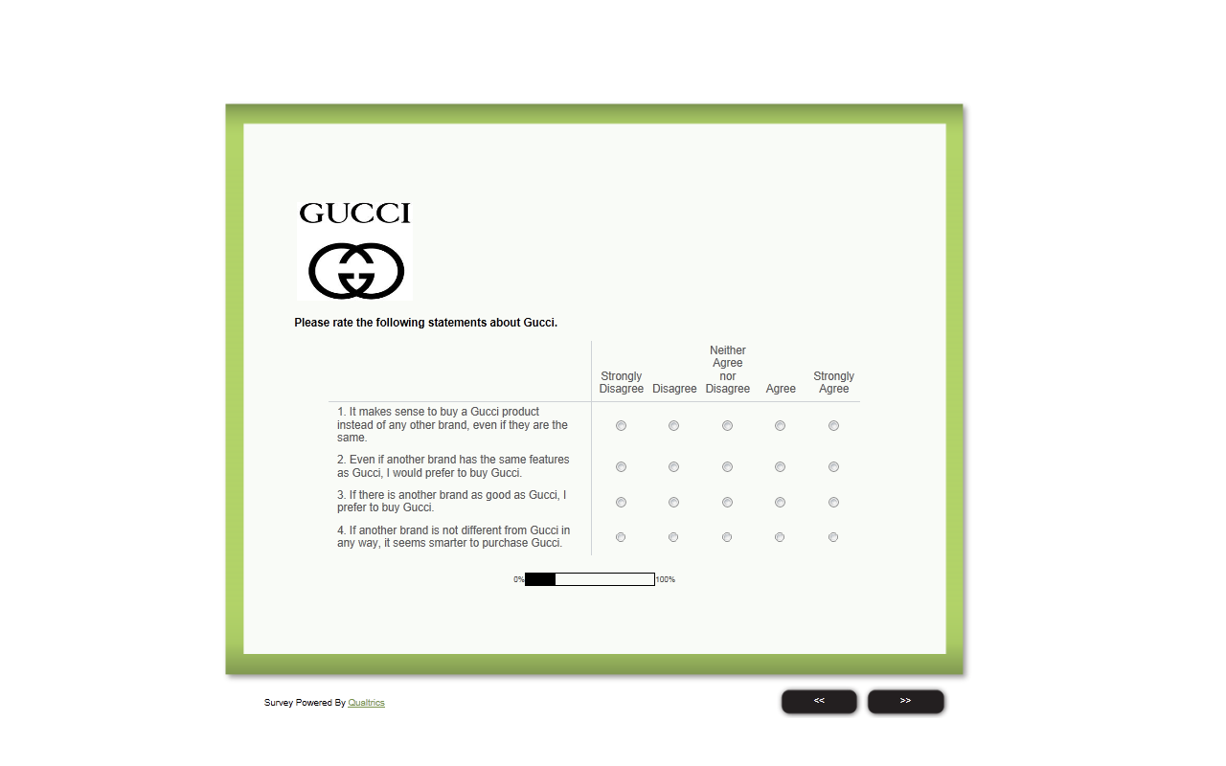

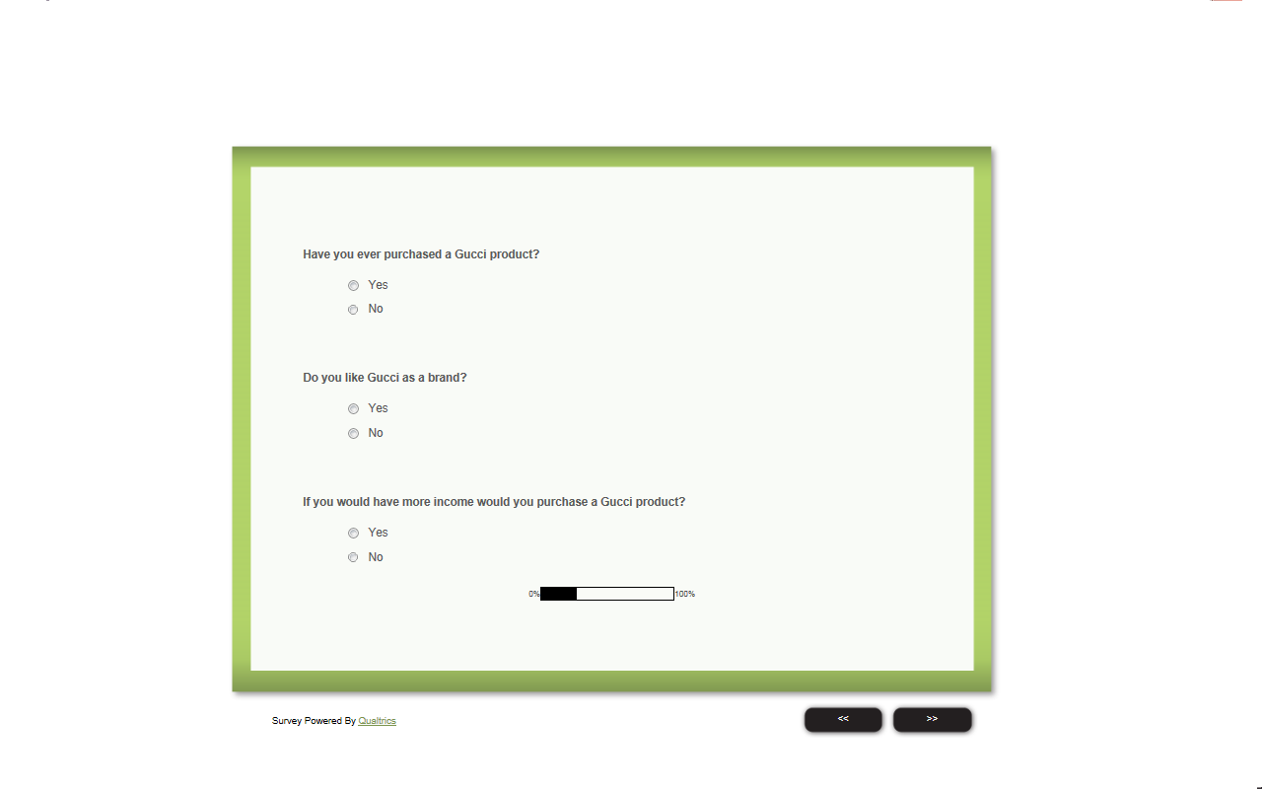
- Section 4 : Brand Engagement Gucci


Gucci Facebook page
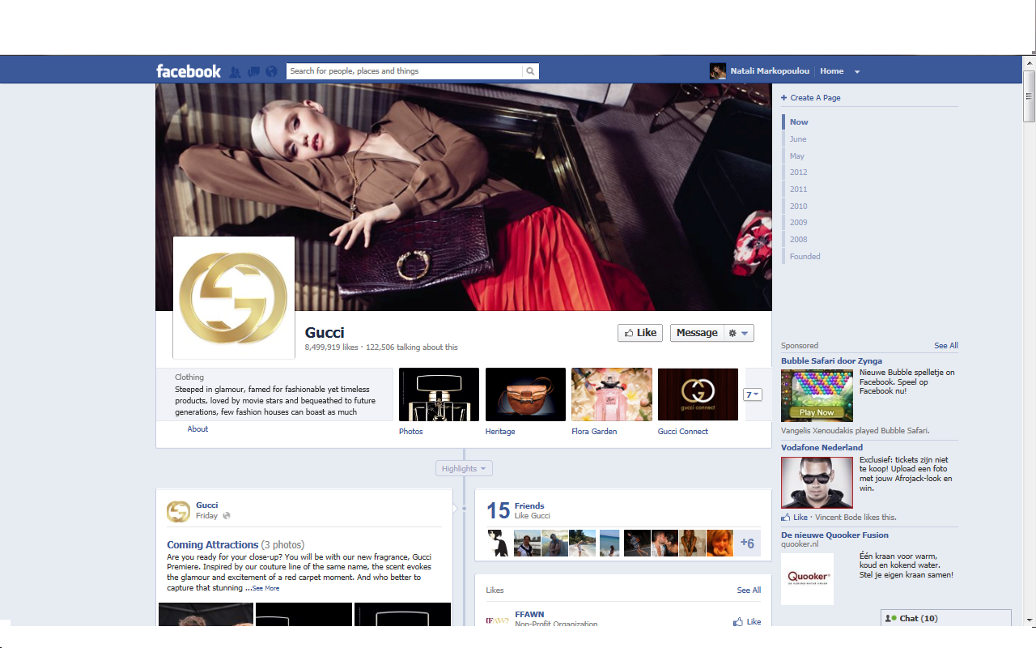

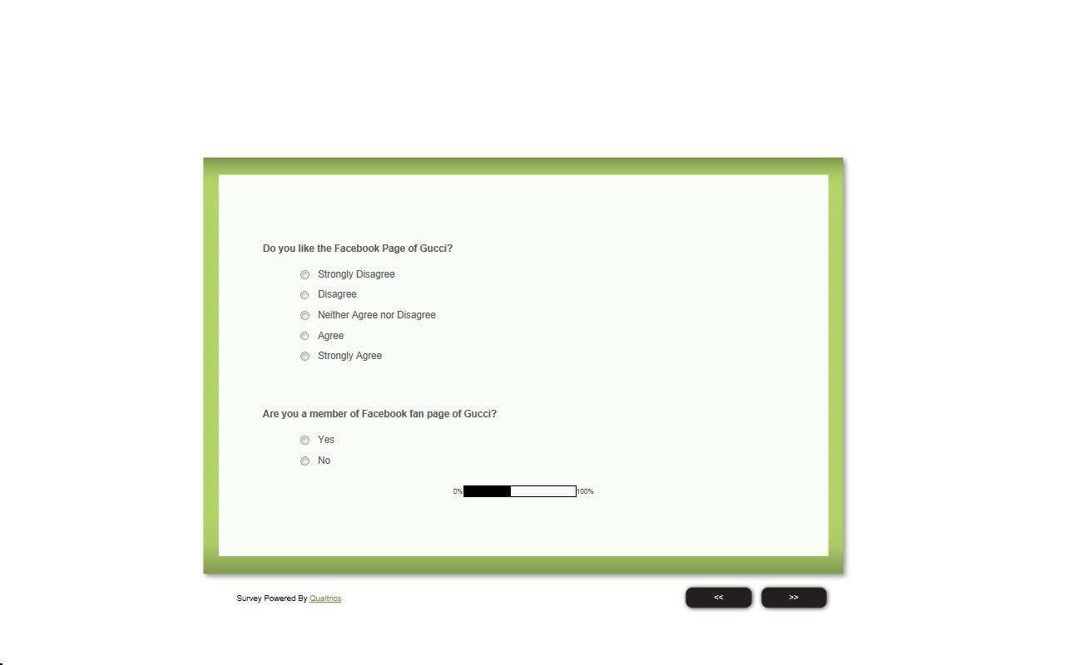

Brand Engagement Gucci, if already member


Brand Engagement Gucci, if not member



- Section 5: Intention to purchase Gucci

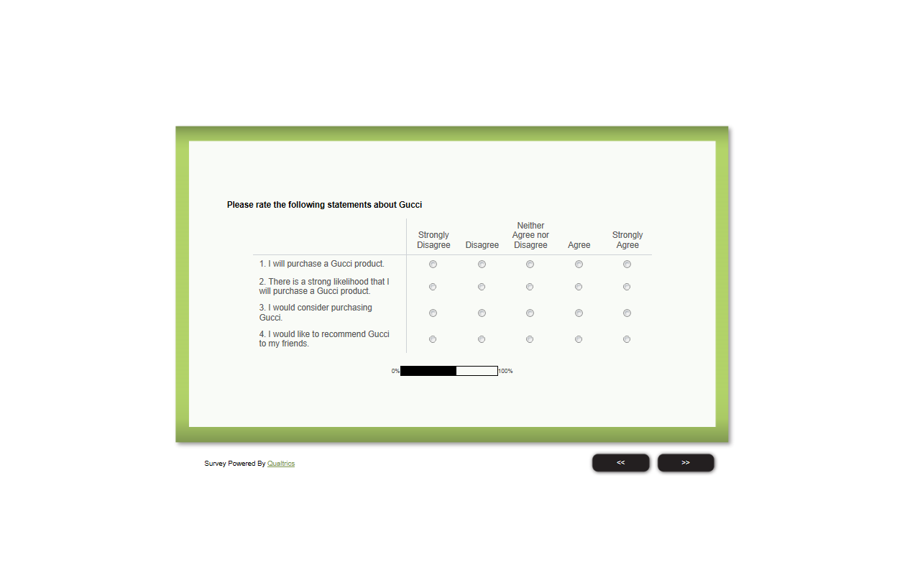
- Section 3: Brand Equity H&M

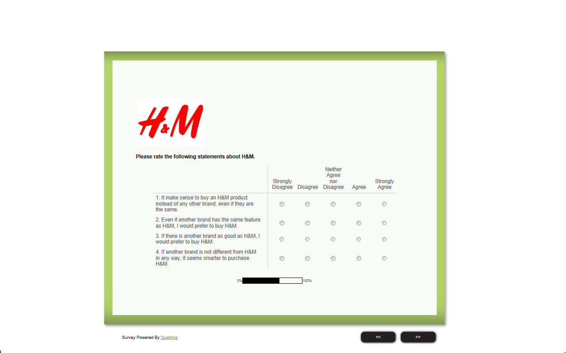

- Section 4 : Brand Engagement H&M


Facebook Page H&M
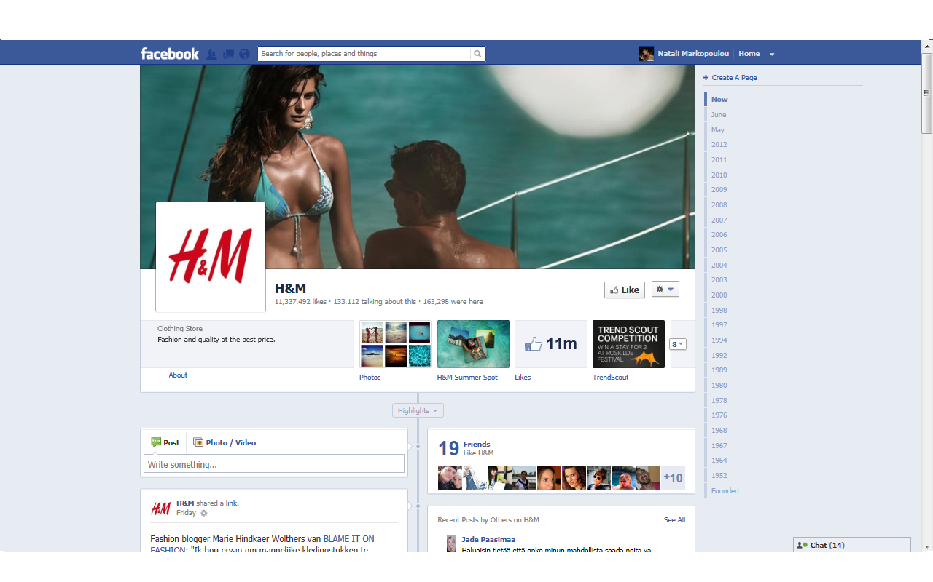


Brand Engagement H&M, if already member



Brand Engagement H&M, if not member


- Section 5: Intention to purchase H&M


Conclusion


Appendix 2: Demographics

Are you Male or Female?
 |  | Frequency | Percent | Valid Percent | Cumulative Percent
Valid | Male | 56 | 48.7 | 48.7 | 48.7
Valid | Female | 59 | 51.3 | 51.3 | 100.0
Valid | Total | 115 | 100.0 | 100.0

What is your nationality?
 |  | Frequency | Percent | Valid Percent | Cumulative Percent
Valid | Albanian | 2 | 1.7 | 1.7 | 1.7
Valid | Brazilian | 2 | 1.7 | 1.7 | 3.5
Valid | Bulgarian | 2 | 1.7 | 1.7 | 5.2
Valid | Cypriot | 1 | .9 | .9 | 6.1
Valid | Dutch | 15 | 13.0 | 13.0 | 19.1
Valid | German | 1 | .9 | .9 | 20.0
Valid | Greek | 80 | 69.6 | 69.6 | 89.6
Valid | Itally | 1 | .9 | .9 | 90.4
Valid | Palestinian | 1 | .9 | .9 | 91.3
Valid | Romanian | 3 | 2.6 | 2.6 | 93.9
Valid | Russian | 1 | .9 | .9 | 94.8
Valid | Spanish | 4 | 3.5 | 3.5 | 98.3
Valid | Swedish | 2 | 1.7 | 1.7 | 100.0
Valid | Total | 115 | 100.0 | 100.0

What is your age?
 |  | Frequency | Percent | Valid Percent | Cumulative Percent
Valid | 18 | 1 | .9 | .9 | .9
Valid | 21 | 3 | 2.6 | 2.6 | 3.5
Valid | 22 | 4 | 3.5 | 3.5 | 7.0
Valid | 23 | 12 | 10.4 | 10.4 | 17.4
Valid | 24 | 22 | 19.1 | 19.1 | 36.5
Valid | 25 | 19 | 16.5 | 16.5 | 53.0
Valid | 26 | 13 | 11.3 | 11.3 | 64.3
Valid | 27 | 7 | 6.1 | 6.1 | 70.4
Valid | 28 | 6 | 5.2 | 5.2 | 75.7
Valid | 29 | 7 | 6.1 | 6.1 | 81.7
Valid | 30 | 5 | 4.3 | 4.3 | 86.1
Valid | 31 | 3 | 2.6 | 2.6 | 88.7
Valid | 32 | 5 | 4.3 | 4.3 | 93.0
Valid | 33 | 1 | .9 | .9 | 93.9
Valid | 34 | 2 | 1.7 | 1.7 | 95.7
Valid | 35 | 1 | .9 | .9 | 96.5
Valid | 38 | 1 | .9 | .9 | 97.4
Valid | 42 | 1 | .9 | .9 | 98.3
Valid | 55 | 2 | 1.7 | 1.7 | 100.0
Valid | Total | 115 | 100.0 | 100.0

Please indicate the level of your monthly income.
 |  | Frequency | Percent | Valid Percent | Cumulative Percent
Valid | 0-1000 | 85 | 73.9 | 73.9 | 73.9
Valid | 1000-2000 | 24 | 20.9 | 20.9 | 94.8
Valid | 2001-3000 | 4 | 3.5 | 3.5 | 98.3
Valid | 3001 and more | 2 | 1.7 | 1.7 | 100.0
Valid | Total | 115 | 100.0 | 100.0

Appendix 3: Factor Analyses and Reliability Tests
- Brand Equity Gucci

KMO and Bartlett's Test
Kaiser-Meyer-Olkin Measure of Sampling Adequacy. |  | .778
Bartlett's Test of Sphericity | Approx. Chi-Square | 315.257
Bartlett's Test of Sphericity | df | 6
Bartlett's Test of Sphericity | Sig. | .000

Communalities
 | Initial | Extraction
Please rate the following statements about Gucci.-1. It makes sense to buy a Gucci product instead of any other brand, even if they are the same. | 1.000 | .765
Please rate the following statements about Gucci.-2. Even if another brand has the same features as Gucci, I would prefer to buy Gucci. | 1.000 | .859
Please rate the following statements about Gucci.-3. If there is another brand as good as Gucci, I prefer to buy Gucci. | 1.000 | .705
Please rate the following statements about Gucci.-4. If another brand is not different from Gucci in any way, it seems smarter to purchase Gucci. | 1.000 | .773
Extraction Method: Principal Component Analysis.

Component Matrixª
 | Component
 | 1
Please rate the following statements about Gucci.-1. It makes sense to buy a Gucci product instead of any other brand, even if they are the same. | .875
Please rate the following statements about Gucci.-2. Even if another brand has the same features as Gucci, I would prefer to buy Gucci. | .927
Please rate the following statements about Gucci.-3. If there is another brand as good as Gucci, I prefer to buy Gucci. | .840
Please rate the following statements about Gucci.-4. If another brand is not different from Gucci in any way, it seems smarter to purchase Gucci. | .879
Extraction Method: Principal Component Analysis.
- 1 components extracted.

Reliability Statistics
Cronbach's Alpha | N of Items
.903 | 4

- Brand Equity H&M

KMO and Bartlett's Test
Kaiser-Meyer-Olkin Measure of Sampling Adequacy. |  | .796
Bartlett's Test of Sphericity | Approx. Chi-Square | 310.202
Bartlett's Test of Sphericity | df | 6
Bartlett's Test of Sphericity | Sig. | .000

Communalities
 | Initial | Extraction
Please rate the following statements about H M.-1. It make sense to buy an H&M product instead of any other brand, even if they are the same. | 1.000 | .670
Please rate the following statements about H M.-2. Even if another brand has the same feature as H&M, I would prefer to buy H&M. | 1.000 | .848
Please rate the following statements about H M.-3. If there is another brand as good as H&M, I would prefer to buy H&M. | 1.000 | .842
Please rate the following statements about H M.-4. If another brand is not different from H&M in any way, it seems smarter to purchase H&M. | 1.000 | .733
Extraction Method: Principal Component Analysis.

Component Matrixª
 | Component
 | 1
Please rate the following statements about H M.-1. It make sense to buy an H&M product instead of any other brand, even if they are the same. | .818
Please rate the following statements about H M.-2. Even if another brand has the same feature as H&M, I would prefer to buy H&M. | .921
Please rate the following statements about H M.-3. If there is another brand as good as H&M, I would prefer to buy H&M. | .918
Please rate the following statements about H M.-4. If another brand is not different from H&M in any way, it seems smarter to purchase H&M. | .856
Extraction Method: Principal Component Analysis.
a. 1 components extracted.

Reliability Statistics
Cronbach's Alpha | N of Items
.897 | 4

- Intention to Purchase Gucci

KMO and Bartlett's Test
Kaiser-Meyer-Olkin Measure of Sampling Adequacy. |  | .823
Bartlett's Test of Sphericity | Approx. Chi-Square | 335.658
Bartlett's Test of Sphericity | df | 6
Bartlett's Test of Sphericity | Sig. | .000

Communalities
 | Initial | Extraction
Please rate the following statements about Gucci-1. I will purchase a Gucci product. | 1.000 | .842
Please rate the following statements about Gucci-2. There is a strong likelihood that I will purchase a Gucci product. | 1.000 | .846
Please rate the following statements about Gucci-3. I would consider purchasing Gucci. | 1.000 | .777
Please rate the following statements about Gucci-4. I would like to recommend Gucci to my friends. | 1.000 | .727
Extraction Method: Principal Component Analysis.

Component Matrixª
 | Component
 | 1
Please rate the following statements about Gucci-1. I will purchase a Gucci product. | .918
Please rate the following statements about Gucci-2. There is a strong likelihood that I will purchase a Gucci product. | .920
Please rate the following statements about Gucci-3. I would consider purchasing Gucci. | .882
Please rate the following statements about Gucci-4. I would like to recommend Gucci to my friends. | .853
Extraction Method: Principal Component Analysis.
a. 1 components extracted.

Reliability Statistics
Cronbach's Alpha | N of Items
.915 | 4

- Intention to Purchase H&M

KMO and Bartlett's Test
Kaiser-Meyer-Olkin Measure of Sampling Adequacy. |  | .805
Bartlett's Test of Sphericity | Approx. Chi-Square | 341.446
Bartlett's Test of Sphericity | df | 6
Bartlett's Test of Sphericity | Sig. | .000

Communalities
 | Initial | Extraction
Please rate the following statements about H M-1. I will purchase an H&M product. | 1.000 | .844
Please rate the following statements about H M-2. There is a strong likelihood that I will purchase an H&M product. | 1.000 | .857
Please rate the following statements about H M-3. I would consider purchasing H&M. | 1.000 | .732
Please rate the following statements about H M-4. I would like to recommend H&M to my friends. | 1.000 | .761
Extraction Method: Principal Component Analysis.

Component Matrixª
 | Component
 | 1
Please rate the following statements about H M-1. I will purchase an H&M product. | .918
Please rate the following statements about H M-2. There is a strong likelihood that I will purchase an H&M product. | .926
Please rate the following statements about H M-3. I would consider purchasing H&M. | .856
Please rate the following statements about H M-4. I would like to recommend H&M to my friends. | .872
Extraction Method: Principal Component Analysis.
a. 1 components extracted.

Reliability Statistics
Cronbach's Alpha | N of Items
.916 | 4

- Ideal Self Concept

KMO and Bartlett's Test
Kaiser-Meyer-Olkin Measure of Sampling Adequacy. |  | .640
Bartlett's Test of Sphericity | Approx. Chi-Square | 111.683
Bartlett's Test of Sphericity | df | 10
Bartlett's Test of Sphericity | Sig. | .000

Communalities
 | Initial | Extraction
Please rate the following statements.-1. I think I have made a good impression on others through social media. | 1.000 | .782
Please rate the following statements.-2.Social media allows me to present myself in a favorable way. | 1.000 | .794
Please rate the following statements.-3. If I am the least bit uncertain as to how to act in a social situation, I look to the behavior of others for cues. | 1.000 | .561
Please rate the following statements.-4. It is important for me to fit in to the group I am with. | 1.000 | .643
Please rate the following statements.-5. It is my feeling that if everyone else within a group is behaving in a certain matter, this must be the proper way to behave. | 1.000 | .594
Extraction Method: Principal Component Analysis.

Component Matrixª
 | Component
 | 1 | 2
Please rate the following statements.-1. I think I have made a good impression on others through social media. | .669 | -.579
Please rate the following statements.-2.Social media allows me to present myself in a favorable way. | .685 | -.570
Please rate the following statements.-3. If I am the least bit uncertain as to how to act in a social situation, I look to the behavior of others for cues. | .659 | .357
Please rate the following statements.-4. It is important for me to fit in to the group I am with. | .713 | .367
Please rate the following statements.-5. It is my feeling that if everyone else within a group is behaving in a certain matter, this must be the proper way to behave. | .628 | .447
Extraction Method: Principal Component Analysis.
a. 2 components extracted.

Reliability Statistics
Cronbach's Alpha | N of Items
.691 | 5

Item-Total Statistics
 | Scale Mean if Item Deleted | Scale Variance if Item Deleted | Corrected Item-Total Correlation | Cronbach's Alpha if Item Deleted
Please rate the following statements.-1. I think I have made a good impression on others through social media. | 12.07 | 9.083 | .442 | .647
Please rate the following statements.-2.Social media allows me to present myself in a favorable way. | 12.14 | 8.472 | .435 | .646
Please rate the following statements.-3. If I am the least bit uncertain as to how to act in a social situation, I look to the behavior of others for cues. | 12.72 | 8.413 | .444 | .642
Please rate the following statements.-4. It is important for me to fit in to the group I am with. | 12.23 | 7.953 | .509 | .613
Please rate the following statements.-5. It is my feeling that if everyone else within a group is behaving in a certain matter, this must be the proper way to behave. | 13.20 | 8.161 | .413 | .659

- Factor Analysis and Reliability Test after deleting problematic items

KMO and Bartlett's Test
Kaiser-Meyer-Olkin Measure of Sampling Adequacy. |  | .652
Bartlett's Test of Sphericity | Approx. Chi-Square | 48.658
Bartlett's Test of Sphericity | df | 3
Bartlett's Test of Sphericity | Sig. | .000

Communalities
 | Initial | Extraction
Please rate the following statements.-3. If I am the least bit uncertain as to how to act in a social situation, I look to the behavior of others for cues. | 1.000 | .570
Please rate the following statements.-4. It is important for me to fit in to the group I am with. | 1.000 | .651
Please rate the following statements.-5. It is my feeling that if everyone else within a group is behaving in a certain matter, this must be the proper way to behave. | 1.000 | .571
Extraction Method: Principal Component Analysis.

Component Score Coefficient Matrix
 | Component
 | 1
Please rate the following statements.-3. If I am the least bit uncertain as to how to act in a social situation, I look to the behavior of others for cues. | .421
Please rate the following statements.-4. It is important for me to fit in to the group I am with. | .450
Please rate the following statements.-5. It is my feeling that if everyone else within a group is behaving in a certain matter, this must be the proper way to behave. | .422
Extraction Method: Principal Component Analysis.
Rotation Method: Varimax with Kaiser Normalization.
Component Scores.

Reliability Statistics
Cronbach's Alpha | N of Items
.661 | 3

Appendix 4: Regression Analyses

- Results Brand Equity

Model Summary
Model | R | R Square | Adjusted R Square | Std. Error of the Estimate
1 | ,295ª | ,087 | ,079 | 1,00439
a. Predictors: (Constant), dummy, EquityGucciHM_mean

ANOVA^{b}
Model |  | Sum of Squares | df | Mean Square | F | Sig.
1 | Regression | 21,877 | 2 | 10,938 | 10,843 | ,000ª
1 | Residual | 228,997 | 227 | 1,009
1 | Total | 250,874 | 229
a. Predictors: (Constant), dummy, EquityGucciHM_mean
b. Dependent Variable: EngagementGucciHM_mean

Coefficientsª
Model |  | Unstandardized Coefficients |  | Standardized Coefficients | t | Sig.
 |  | B | Std. Error | Beta | t | Sig.
1 | (Constant) | 1,772 | ,198 |  | 8,937 | ,000
1 | EquityGucciHM_mean | ,306 | ,068 | ,286 | 4,490 | ,000
1 | dummy | -,227 | ,133 | -,109 | -1,706 | ,089
a. Dependent Variable: EngagementGucciHM_mean

- Results Ideal Self Concept

Model Summary
Model | R | R Square | Adjusted R Square | Std. Error of the Estimate
1 | ,295ª | ,087 | ,079 | 1,00439
a. Predictors: (Constant), dummy, EquityGucciHM_mean

ANOVA^{b}
Model |  | Sum of Squares | df | Mean Square | F | Sig.
1 | Regression | 21,877 | 2 | 10,938 | 10,843 | ,000ª
1 | Residual | 228,997 | 227 | 1,009
1 | Total | 250,874 | 229
a. Predictors: (Constant), dummy, EquityGucciHM_mean
b. Dependent Variable: EngagementGucciHM_mean

Model Summary
Model | R | R Square | Adjusted R Square | Std. Error of the Estimate
1 | ,299ª | ,089 | ,073 | 1,00765
a. Predictors: (Constant), Dummy, SelfConceptGucciHM_mean, EquityGucciHM_mean, InteractionSelfEquityGucciHM_mean

ANOVA^{b}
Model |  | Sum of Squares | df | Mean Square | F | Sig.
1 | Regression | 22,418 | 4 | 5,605 | 5,520 | ,000ª
1 | Residual | 228,456 | 225 | 1,015
1 | Total | 250,874 | 229
a. Predictors: (Constant), Dummy, SelfConceptGucciHM_mean, EquityGucciHM_mean, InteractionSelfEquityGucciHM_mean
b. Dependent Variable: EngagementGucciHM_mean

Coefficientsª
Model |  | Unstandardized Coefficients |  | Standardized Coefficients | t | Sig.
 |  | B | Std. Error | Beta | t | Sig.
1 | (Constant) | 1,883 | ,580 |  | 3,248 | ,001
1 | EquityGucciHM_mean | ,198 | ,233 | ,186 | ,850 | ,396
1 | SelfConceptGucciHM_mean | -,023 | ,185 | -,019 | -,125 | ,901
1 | InteractionSelfEquityGucciHM_mean | ,031 | ,071 | ,122 | ,431 | ,667
1 | Dummy | -,226 | ,134 | -,108 | -1,690 | ,092
a. Dependent Variable: EngagementGucciHM_mean

- Results Intention to Purchase

Model Summary
Model | R | R Square | Adjusted R Square | Std. Error of the Estimate
1 | ,540ª | ,291 | ,285 | ,91694
a. Predictors: (Constant), dummy, EngagementGucciHM_mean

ANOVA^{b}
Model |  | Sum of Squares | df | Mean Square | F | Sig.
1 | Regression | 78,414 | 2 | 39,207 | 46,632 | ,000ª
1 | Residual | 190,857 | 227 | ,841
1 | Total | 269,272 | 229
a. Predictors: (Constant), dummy, EngagementGucciHM_mean
b. Dependent Variable: PurchaseGucciHM_mean

Coefficientsª
Model |  | Unstandardized Coefficients |  | Standardized Coefficients | t | Sig.
 |  | B | Std. Error | Beta | t | Sig.
1 | (Constant) | 3,064 | ,171 |  | 17,884 | ,000
1 | EngagementGucciHM_mean | ,293 | ,058 | ,283 | 5,047 | ,000
1 | dummy | -,948 | ,121 | -,438 | -7,814 | ,000
a. Dependent Variable: PurchaseGucciHM_mean

- Results Mediating Effect

Model Summary
Model | R | R Square | Adjusted R Square | Std. Error of the Estimate
1 | ,643ª | ,414 | ,408 | ,83402
a. Predictors: (Constant), Dummy, EquityGucciHM_mean

ANOVA^{b}
Model |  | Sum of Squares | df | Mean Square | F | Sig.
1 | Regression | 111,372 | 2 | 55,686 | 80,056 | ,000ª
1 | Residual | 157,899 | 227 | ,696
1 | Total | 269,272 | 229
a. Predictors: (Constant), Dummy, EquityGucciHM_mean
b. Dependent Variable: PurchaseGucciHM_mean

Coefficientsª
Model |  | Unstandardized Coefficients |  | Standardized Coefficients | t | Sig.
 |  | B | Std. Error | Beta | t | Sig.
1 | (Constant) | 2,530 | ,165 |  | 15,368 | ,000
1 | EquityGucciHM_mean | ,500 | ,057 | ,452 | 8,841 | ,000
1 | Dummy | -1,100 | ,111 | -,508 | -9,944 | ,000
a. Dependent Variable: PurchaseGucciHM_mean

Model Summary
Model | R | R Square | Adjusted R Square | Std. Error of the Estimate
1 | ,663ª | ,439 | ,432 | ,81734
a. Predictors: (Constant), EquityGucciHM_mean, Dummy, EngagementGucciHM_mean

ANOVA^{b}
Model |  | Sum of Squares | df | Mean Square | F | Sig.
1 | Regression | 118,294 | 3 | 39,431 | 59,025 | ,000ª
1 | Residual | 150,977 | 226 | ,668
1 | Total | 269,272 | 229
a. Predictors: (Constant), EquityGucciHM_mean, Dummy, EngagementGucciHM_mean
b. Dependent Variable: PurchaseGucciHM_mean

Coefficientsª
Model |  | Unstandardized Coefficients |  | Standardized Coefficients | t | Sig.
 |  | B | Std. Error | Beta | t | Sig.
1 | (Constant) | 2,222 | ,188 |  | 11,845 | ,000
1 | Dummy | -1,061 | ,109 | -,490 | -9,721 | ,000
1 | EngagementGucciHM_mean | ,174 | ,054 | ,168 | 3,219 | ,001
1 | EquityGucciHM_mean | ,447 | ,058 | ,404 | 7,726 | ,000
a. Dependent Variable: PurchaseGucciHM_mean

- Results Additional Analysis

Model Summary
Model | R | R Square | Adjusted R Square | Std. Error of the Estimate
1 | ,554ª | ,306 | ,297 | ,90901
a. Predictors: (Constant), InteractionEngagemantDummy, EngagementGucciHM_mean, Dummy

ANOVA^{b}
Model |  | Sum of Squares | df | Mean Square | F | Sig.
1 | Regression | 82,528 | 3 | 27,509 | 33,292 | ,000ª
1 | Residual | 186,744 | 226 | ,826
1 | Total | 269,272 | 229
a. Predictors: (Constant), InteractionEngagemantDummy, EngagementGucciHM_mean, Dummy
b. Dependent Variable: PurchaseGucciHM_mean

Coefficientsª
Model |  | Unstandardized Coefficients |  | Standardized Coefficients | t | Sig.
 |  | B | Std. Error | Beta | t | Sig.
1 | (Constant) | 3,367 | ,218 |  | 15,478 | ,000
1 | EngagementGucciHM_mean | ,174 | ,078 | ,168 | 2,225 | ,027
1 | Dummy | -1,584 | ,309 | -,732 | -5,119 | ,000
1 | InteractionEngagemantDummy | ,258 | ,115 | ,331 | 2,231 | ,027
a. Dependent Variable: PurchaseGucciHM_mean

http://www.comscore.com/Products_Services/Product_Index/Media_Metrix_Suite/Media_Metrix_Core_Reports
http://www.nielsen.com/content/corporate/us/en.html

