
Master Thesis
Georgios Panagos – 355847


Master Thesis
Georgios Panagos – 355847

Supervisor - Dr. Vijay Ganesh Hariharan

Erasmus School of Economics
MSc Economics & Business
Master Specialization Marketing

The effect of online toolkit attributes on a person’s willingness to buy a customized product

Acknowledgments

Since this Master Thesis is over, the final step to my graduation has been made. Almost one year has passed and I am full of experiences, feelings and pictures that I will never forget. This program was a great trip, which I hope to continue, but there were some people that actually stood by me.
Firstly, I would like to express my sincere gratitude and appreciation to my supervisor Vijay Ganesh Hariharan, who provided me with invaluable suggestions and had the patience to hear and discuss whatever was puzzling me.
Secondly, I am extremely grateful to my parents, Dana and Vasilis, because without their help and support, I could not be able to study abroad and complete my master studies.
Additionally, I would like to thank Fay, for all the support and the nights that stayed awake, just to ensure that I had company, when I was studying.
Last but not least, I owe a huge thanks to all my friends in Rotterdam and in Greece for being always there for me. Special thanks to Makis, for his unlimited photoshop knowledge and to Nikos and Christos for all the constructive discussions and for helping me move out, during an exam period.
Each and every one of these people knows my love about this thesis topic and I have to express my gratefulness to the professor, Dimitris Tsekouras, who introduced me to the concept of co-creation and mass customization.

Abstract

Mass customization is an essential and a considerably promising concept in the marketing area, since it helps consumers find a product or service that completely satisfies their needs. Toolkits are the indispensable means, by which a product or serviced can be customized. This study focuses on the principles of mass customization and investigates the effect that a toolkit’s attributes have on a consumer’s willingness to purchase a personalized product. Furthermore, this study examines the moderating role of customization expertise, gender and product category to the outcome variable.
The findings indicate that the utilitarian attributes have a greater effect on the willingness to buy, than the hedonic attributes, as far as the general population is concerned, while they affect negatively the female user’s willingness to purchase a customized product. Moreover, utilitarian attributes are the strongest predictor for experienced users, whereas hedonic features are of the greatest importance, concerning consumers with medium levels of expertise. Finally, the study states that people are going to be affected mostly by the hedonic attributes of an online toolkit, if they perceive that the product offers sensual pleasure.

Keywords and phrases: mass customization, online co-design, toolkit, utilitarian attributes, hedonic attributes, expertise, gender, product category, willingness to buy

Table of Contents
Acknowledgments 3
Abstract 4
1. Introduction 7
1.1 Understanding Key Concepts of the Study 7
1.2 Research Questions and Relevance of the Study 9
1.3 Organization of the Study 10
2. Literature review and Hypotheses 11
2.1 Introduction in co-creation 11
2.2 Mass Customization 11
2.2.1 Benefits and Drawbacks of Mass customization 14
2.2.2 Forms of Mass Customization 14
2.3 Toolkits 16
2.3.1 Reasons of Toolkit Existence 16
2.3.2 Toolkit Operational Requirements 17
2.4 Theoretical Framework 18
2.4.1 Utilitarian vs. Hedonic 18
2.4.2 Utilitarian Toolkit Attribute 20
2.4.3 Hedonic Toolkit Attributes 23
2.4.4 Gender 25
2.4.5 Mass Customization Experience 26
2.4.6 Utilitarian and Hedonic Products 27
2.6 Conceptual Model 28
3. Methodology 29
3.1 The survey 29
3.2 The websites 30
3.2.1 The pcspecialist toolkit 30
3.2.2 The nikeid toolkit 30
3.3 The structure 31
3.3.1 Introduction 31
3.3.2 Questions regarding toolkits 31
3.3.3 Expertise 35
3.3.4 Demographics and e-mail 35
4. Analysis 36
4.1 Data information and preparation 36
4.1.1 Scaling Check 36
4.1.2 Reliability Check 37
4.2 Demographics 37
4.3 Factor Analysis 38
4.4 Regression Analysis 40
4.4.1 Expertise and Product Category as moderators 41
4.4.2 The Effect of Utilitarian and Hedonic Attributes 42
4.4.3 Gender as a moderator 43
4.4.4 Further Analysis 44
4.5 Hypotheses Testing Summary 48
5. Discussion and Implications 50
6. Limitations and future research 53
6.1 Limitations 53
6.2 Future Research 54
7. References 55
Appendix 61

1. Introduction

The primal purpose of the first chapter is to make an introduction and explain the organization of the study. The first part is going to provide a basic understanding of the essential concepts of the study. The following part will present the research questions and the managerial contributions, while the final part will explain the way that this paper was organized.

1.1 Understanding Key Concepts of the Study

Ideally, if every person in the society had the same needs, then it would be easy for everyone to be satisfied, to maximize his or her utility or the general social welfare. People’s growing and heterogeneous needs have been puzzling companies, ever since. Country of origin, age and lifestyle are only a few concepts that create and affect consumer’s personal and social needs. Firms have incorporated an abundance of tools, trying to meet those preferences, but some of them cannot survive, due to the extremely competitive environment. A necessity of innovation and creativity has been created, since both are indispensable features that enable a product or service to stand out.
An essential way to acquire those concepts is to activate consumers and give them control. A fast growing number of companies abandon their data mining tools and cooperate with consumers in order to produce a co-designed product; this operation is called co-creation. In that way, firms save costs from trying to explore customers’ needs, by tracking data on consumers’ behavior and tracing patterns of their responses to the products. Furthermore, consumers also benefit from this shift. They get more efficient results, due to the co-created products tailored to their needs. What is more, they feel a sense of belonging in a group, which provides them pleasure and self-esteem. But the most essential thing about co-creation is that they help other people find products that meet their needs, because the new items can serve other consumers’ preferences (Franke and Piller, 2004).
As covered by numerous researchers (Davis, 1987; Pine, 1993; Tseng and Jiao, 2001; Piller, 2004), the ability to create products that meet individual needs is called mass customization. With mass customization, customers are incorporated into a design process, where they have the power to modify and configure any possible feature of the product, regarding their personal preferences. The whole idea of the current research is about those two concepts, co-creation and mass customization that are always interrelated.
The third construct that has a strong connection with the previously mentioned concepts is the online toolkits. Von Hippel (1998), Von Hippel (2001) and Von Hippel and Katz (2002) have conducted an extensive research concerning toolkits. Those user friendly coordinated tools are the means by which consumers achieve mass customization. The whole interface, with help and configure options that assist people personalize a product, according to their needs, is provided by toolkits. Consequently, it is apparent that a toolkit’s features will influence customers’ evaluations, regarding the process, the product and their behavior.
A progressively prominent number of companies, in nearly every industry, have started to design toolkits and incorporate consumers in the supply chain. Brunswick, from the sporting equipment sector, allows consumers to design their own pool, by choosing the quality of the materials, the colors the legs and the pockets. Another example is Heineken that provides a toolkit where people can create their personalized bottle of beer. Moreover, Ralph Lauren has a customization section that allows users to design their own clothes. Even in automobile industry, there companies like Alfa Romeo and Bugatti, which ask the consumers to incorporate their individualized needs in default products.
Additionally, those brands have helped academics conduct their research by providing their toolkits. Dellaert and Stremersch (2005) and Randall et al. (2005) have indicated the example of Dell, a computer company where consumers could choose their preferable characteristics, from a predefined set of modules. In the current study, the Nikeid and PCspecialist toolkits were used in order to help for the outcome of the research.

1.2 Research Questions and Relevance of the Study

The aim of the study is to investigate the effects of specific toolkit’s attributes on the consumer’s willingness to buy an item that he or she designed. Thus, the problem statement is: How do the attributes of an online toolkit affect a customer’s willingness to buy a customized product?
In order to answer to the above statement the following sub-questions have been formulated:
- What impact does the hedonic and the utilitarian attributes, of an online toolkit, have on the consumer’s willingness to buy a customized product?
- Which of the toolkit attributes have the strongest effect on the willingness to buy?
- Is the dominant toolkit feature the same for utilitarian and hedonic products, as they are perceived by customers?
- Is the dominant toolkit feature the same for male and female users of the online platform?
- Is the willingness to buy a customized product affected more by utilitarian or hedonic attributes, concerning people with ample experience in the customization process?
- Which is the dominant type of attribute for non-experienced users?
Those relationships have not been extensively explored in the recent literature, as far as online toolkits are concerned. So, another target of this study is to extend the existing literature and provide useful directions for companies and marketers that are related with the concept of mass customization.
The managerial contribution of the current study is threefold. Firstly, it will provide firms with indispensable information, concerning the optimal design of the toolkit’s interface. Companies will adjust or create new toolkits, by knowing which kind of attributes drives consumer’s purchase intentions. Secondly, this study will indicate the factors determining the consumer’s willingness to buy a customized product, depending on the fact that it is a utilitarian or a hedonic one. So, firms, offering a specific type of product, will promote the correct features on their toolkits. Finally, the third contribution of the study could assist firms deal with customers, having different levels of customization expertise.

1.3 Organization of the Study

The study is organized in six chapters:
- Introduction: The first chapter presents the topic, the research questions, the significance and the organization of the study.
- Literature Review and Hypotheses: The second chapter explains the key concepts, analyses the testing hypotheses and renders the conceptual model of the study.
- Methodology: The aim of this chapter is to provide the structure of the questionnaire and present the measurement scales for each question.
- Analysis: The key objective of this chapter is to provide and explain the analysis of the data gathered through the survey.
- Discussion and Implications: This chapter discusses the results from the data analysis and provides valuable managerial implications.
- Limitations and Future Research: The final chapter presents the limitations of the study and recommends possible future research opportunities.

2. Literature review and Hypotheses

The main objective of this chapter is to provide an introduction into the general concept of co-creation and mass customization and a comprehensive description of all the attributes that are going to be researched in this paper. The first part gives extended explanations about key terms of the customization process, in accordance with past and relevant literature. The second section focuses on the utilitarian and hedonic toolkit attributes and on the analysis and argumentation of the hypotheses. The last part of this chapter renders the conceptual model of the thesis, a graphical representation of the whole model.

2.1 Introduction in co-creation

The term co-design, also known as co-creation, is clarified as the cooperation between consumers and manufacturers during the configuration process of a customized product (Franke and Piller, 2003, 2004). It is apparent that customers have heterogeneous needs; different customers require different products, depending on their preferences, personality, lifestyle or origin. Those needs are expensive and difficult to communicate and if so, they become almost impossible for the firms to interpret (Von Hippel, 1994). In that way, firms put customers in charge by incorporating them into all aspects of the supply chain. As a result, they activate consumers’ knowledge and they produce products according to their needs, but they also enhance value creation, since other people will benefit from the result of this cooperation. Consumer becomes a co-creator to exploit the company’s capabilities and expertise and designs his or her own tailor made product, while experiencing an enjoyable and interesting situation (Piller and Tseng, 2003).

2.2 Mass Customization

Mass customization has captured the interest of numerous academics, marketers and firms; that is why there is a huge variety of definitions in the literature. Mass customization was first defined by Davis (1987) as the ability to provide individually designed products and services to each consumer through high process agility, flexibility and integration. Pine (1993) expressed the meaning of the term, taking the customer’s perspective: “Customers do not want choice. They want exactly, what they want”. It is obvious that customers do not need to search for a standardized product that captures their needs and firms do not need to unravel customers’ preferences. Mass customized products have a high degree of customer input and a big scale of production, whereas mass produced products do not emphasize on customer specific needs. The transference from mass production to mass customization was a gradual and smooth process. There are two key reasons that contributed to this shift. Firstly, consumers were dissatisfied with the standardized products and wanted to express their individual need (Firat and Schultz, 1997; Pine, 2003). Secondly, individualization and digitization demanded active individual contributions in the long run, with the intense help of technology (Beck and Beck-Gernsheim, 2002). Individualization and digitization gave power and made consumers more demanding on tailored value creation under the intensified worldwide competition.
According to Piller (2004) “Mass customization refers to a customer co-design process of products and services, which meet the needs of each individual customer with regard to certain product features. All operations are performed within a fixed solution space, characterized by stable, but still flexible and responsive processes”. Solution space refers to “the pre-existing capability and degrees of freedom built into a given manufacturer’s production system” (Von Hippel, 2001). A stable solution space and the value created within it is the most essential difference between mass customization and craft customization. This space provides the variety of options and standardized components that consumers use to co-design (Pine, 1995). So, it can be easily inferred that the size of the solution space depends on the type of products and the options which are provided. For instance, solution space can have a vast size since customization possibilities for digital goods are infinite, whilst it can be small for physical components.
Furthermore, Randall et al, (2005) recommended five principals of use design of customized products and some actions to problems that may occur, concerning these principals. According to them, firms firstly should customize the customization process. That means that the interface should not provide only standardized processes with a limited amount of options, but it should encompass customized processes, depending on each consumer and a vast variety of choices. To accomplish this, firms have to choose between a parameter-based interface and a needs-based interface. In the latter novice consumers can express their needs over the product, whereas in the former expert customers can take an active part in the design of a product, since it is annoying for them to communicate their needs. The second principle is called provide multiple starting points. People have different preferences on which stage of customizing they should intervene. For example, some of them prefer to start designing a product from scratch, while others want to add only colors to standardized products. A firm should provide customers the luxury to personalize a product in every stage of the design process, as it will cover completely their needs. Furthermore, companies ought to support incremental refinement. Customers tend to compare products and see the interaction between the attributes, if one of them changes. That is a difficult task for online shopping and that is why the writers suggest that the firms provide the possibility for customers to save their customized products and look for alternatives. What is more, dimension and attribute comparison should be allowed and short-cuts for automatic options have to be established as well. The fourth dimension concerns prototypes to avoid surprises. Every customized product is singular and that is why customers cannot feel or see the experience or the attributes of this product. According to Randall et al. (2005) “prototypes can help overcome the natural hesitation of the user to purchase a product they have not yet experienced and to help the manufacturer to create a product that better matches the user needs”. In order for firms to avoid that kind of surprises they need to provide full detailed information about the product or even photos or videos that can function as a digital prototype. The last principle is called teach the consumer and it refers to consumers who have no symmetric information about the product attributes and the design parameters. Firms should provide help options, during the process, to encourage customers ask and learn about unknown features or parts of the process. Moreover, companies ought to explain the properties of each attribute, how it is connected with the design parameters and provide recommendation agents to show the preferences of other consumers.

2.2.1 Benefits and Drawbacks of Mass customization

By incorporating the mass customization strategy, a firm can be in a strong position as it gains numerous advantages. As Tseng and Jiao (2001) claimed, “in the mass customization concept, goods and services are produced to meet individual customer’s needs with near mass production efficiency”. It becomes clear that a company deserts its attempts to understand what a customer needs (Von Hippel, 2001) and lets him or her express their preferences. As a result the major advantage for a company is that it does need to spend time-consuming and monetary resources to uncover constomer needs. Although, high performing firms, in order to reach great standards, should adopt all kinds of strategies, Duray (2002) found that mass customization companies have a better financial performance, as far as market share and profits are concerned, compared to those who do not adopt this strategy. It makes sense since distribution inventories and manufacturing costs are much lower (Ahlstrom and Westbrook, 1999) and a vast majority of people is willing to pay a premium, so as to customize a product (Piller and Muller, 2004).
On the other hand, mass customization must not be considered as a panacea. Piller and Muller (2004) noticed that investment costs, the architecture, planning and control of a product can be serious disadvantages. What is more, higher raw material costs, delayed deliveries lower product quality (Ahlstrom and Westbrook, 1999) and the fact that firms implementing mass customization processes and continuous improvement required totally different organizational structures and training techniques (Selladurai, 2004) can constitute great drawbacks.

2.2.2 Forms of Mass Customization

In his paper, Selladurai (2004) presents five ways which a company can incorporate the mass customization construct into reality. These methods are Part Standardization, Process Standardization, Product Standardization, Partial Standardization and Procurement Standardization and they are depicted in figure 1. If a company uses common parts or components for different products, it gains in terms of cost, inventory and forecasting. Part standardization is used in companies with machinery products that use the same components in different product lines. As for process standardization, the author claims that it is used when companies delay the customization to the latest scales of the supply chain, in order to benefit themselves from the economies of scale. A critical example of this method is Hewlett-Packard and the components of its printers. The third way is called product standardization and it concerns firms that ‘”advertise a wide variety of products but stock only a few of the (standardized items)” (Selladurai, 2004). When a customer orders an item, which is not in stock, the firm should either produce that item or deputize it with one of higher functionality or speed; it is a common strategy in the car rental industry What is more, procurement standardization refers to businesses, which get common components, when they produce a large assortment of products. In that way, those businesses aim to profit from the reduced costs of common equipment acquisition. Lastly, partial standardization is adopted by firms that keep their products standardized, while providing narrow alternatives for their customers. A classic example of the current form is in computer industry, where consumers have to pick between some standardized types of processors or operating RAMs.
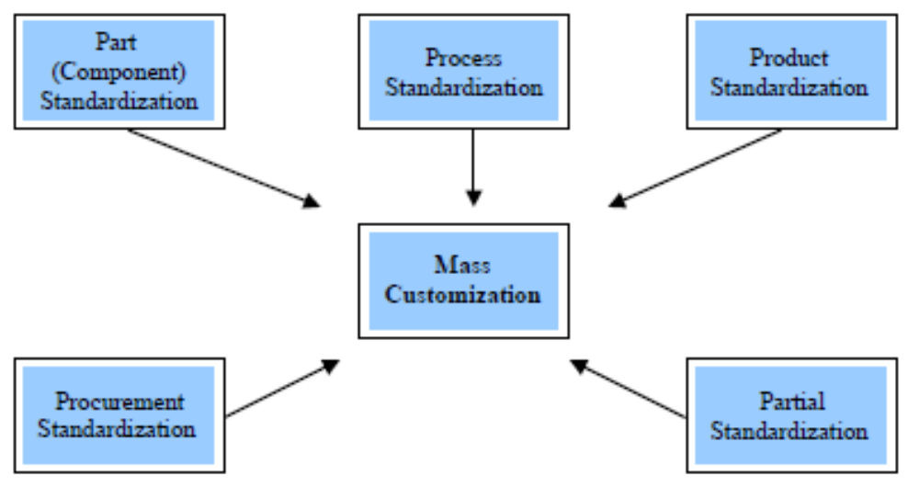

Figure 1: Methods to Achieve Mass Customization (Selladurai, 2004, p.296)

2.3 Toolkits

In some cases, consumers do not possess the information or cannot communicate them and as a result they are going to face difficulties during the co-creation process. The solution to these problems are “coordinated sets of ‘use-friendly’ design tools that enable users to develop new product innovations for themselves” or else the so-called toolkits (Von Hippel and Katz, 2002). Toolkits, also known as coordinators, choice boards or design systems (Piller et al., 2004), are a technology which enables people to design an innovative product through trial-and-error circles and communicates instant feedback on the result of their product designs (Von Hippel, 2001). There are two key benefits of toolkits: firstly they lower the cost of learning by feedback and trial-and-error experimentation for novel products and secondly they can be easily linked to the manufacturer’s product specifications (Von Hippel, 2001; Von Hippel and Katz, 2002). Franke and Piller (2004) mentioned that the product, which was designed via a toolkit, will better fit the customer’s needs, increase satisfaction and as a result the willingness to pay (WTP) for the customized product.

2.3.1 Reasons of Toolkit Existence

From the firms’ perspective, companies confide innovation in consumers via toolkits, once it is a cost saving strategy. There are three main reasons for this delegation; firstly, it is costly for them to obtain circumstantial consumer information and as a result they empower customers to express their needs on the customized products. Secondly, it is extremely difficult, as far as production is concerned and financially expensive for them to produce unique products for each customer. With toolkits, users have the possibility to create their own, unique products even with different functional characteristics. For instance, in a website with customized laptops, consumers can have the same laptop with different color, size and even CPU or graphics card. A toolkit is a “one-time cost”; since it is developed, manufacturers will give their positions to users, who will create unique, custom products (Von Hippel, 2001). Finally, without toolkits, it becomes very costly for the firm to communicate its credibility and performance (Von Hippel, 1998).
As for customers, according to Von Hippel (1998), they accept to participate in the design of novel products, because it is costly for them to observe the company’s performance in making the right product and it is easy for them to participate and try out new solutions. But, the primary reason is that it becomes highly expensive to communicate their needs to the firm. This is related with the stickiness of information, which is defined as the expenditure that is required to transfer information in a form usable by the firm (Von Hippel, 2005). Expenditure and stickiness are connected through a positive relationship; when expenditure is low information “stickiness” is low as well. Information can be “sticky” because consumer information often involves tacit knowledge. Moreover, user information is extremely detailed and many times can be unstable. That is why the expenditure of encoding this kind of information is pretty high. However, a way to “unstick” this information is the toolkit for the design of a novel product. There are “learn-by-doing” processes (Thomke, 1998) or trial-and-error experimentation circles (Von Hippel and Katz, 2002), through which innovative products are developed. It is apparent that those procedures decrease the expenditure and alleviate the “stickiness” problem.

2.3.2 Toolkit Operational Requirements

As stated by Von Hippel (2001) and Von Hippel and Katz (2002), an effective toolkit for user innovation should comprise five main elements. First, “they enable users carry out complete circles of trial and error learning”. Those trial and error circles follow the sequence of (1) designing the product, (2) testing the designed item and (3) evaluating it. If the evaluation shows that there is more room for improvement, then the circle is repeated, until reaching to an optimal outcome with no more melioration. The evaluation step exists as for the customer to understand and define better his or her own needs. This learning-by-doing process will end when the customer is absolutely satisfied with the result. An interesting example is in the computing industry; some firms provide standardized choices to consumers for building a computer. But, the consumer does not know how a computer part will affect the performance or completely cover his or her needs. With trial and error, there could be an online toolkit to provide a simulation and show how a change in X particle by Y gigabyte increases the speed by Z seconds. In that way the consumer could try, via the simulation and reach to a conclusion.
Second, toolkits for use innovation contain a “solution space”, which provides users with designs they can create. Its size varies and has a positive correlation with the design freedom that a toolkit may offer. A large solution space is concerning co-creators, who combine basic or general operations. For instance, automated machinery can produce products with many different shapes out of any raw material. A small solution space refers to user who can only change a few special options, such as customized laptops, where the consumers is mainly restricted, due to the absence of a variety of options.
Third, toolkits should be “user-friendly”; when using a toolkit, people should use their own skills, without having to be trained or know the design process. Users do not have to be experts or know in-depth details over a subject to be able to customize. They seek for functionality and the toolkit will translate their needs into an input and as a result into a functional product. For example, consumers want to select a color from a pattern, but it is not necessary to know the name of every special color.
Forth, a toolkit contains libraries of commonly used modules that enable users to focus on creating their unique design. Consumers do not always come up with innovative ideas and that is why there are libraries with standardized ideas. They can choose a default design and modify this starting point by incorporating their ideas.
The final element that a toolkit should have is to ensure that the customized item can be produced without undergoing revisions, by the manufacturer. If the product that a user designed is not the one that will be produced, then the whole meaning of toolkit’s role and customizing would be lost.

2.4 Theoretical Framework

2.4.1 Utilitarian vs. Hedonic

There are several studies in the literature, which take into consideration the hedonic and utilitarian dimensions. Some of them show the impact of hedonic and utilitarian motivations on purchase intentions, whilst others measure the effect of those motivations on search intention. Furthermore, there are papers which try to categorize products into these two attribute dimensions, but the literature seems to be scarce when it comes to toolkit attributes and their effect on the consumer’s willingness to buy a customized product.

2.4.1.1 Utilitarian and hedonic motivations

Customers are dichotomized regarding their motivations as either “problem solvers” or “fun, enjoyment and excitement seekers” (Hirschman and Holbrook, 1982). According to Batra and Ahtola (1991), “hedonic component is related to sensory attributes and focuses on consummatory affective gratification; the utilitarian component is related to functional and non-sensory attributes and focuses on instrumental expectations”. Apparently there are numerous motivations that consumers may have, however in order to comprehend consumer shopping behavior, utilitarian and hedonic are needed, since they have been characterized as primal in capturing consumption phenomena (Babin et al., 1994; Childers et al., 2001). Babin et al. (1994), in their paper, proved the existence of hedonic and utilitarian value and showed their impact on the consumer shopping behavior. They argued that hedonic value affects spontaneous shopping behavior more than utilitarian value does and there are others studies that reach to the same conclusion like To et al.(2007, p. 785). What is more, Bridges and Florsheim (2008) claimed that hedonic value includes feelings associated with adventure, joy and arousal, which raises the probability for a consumer to search for hedonic value. On the other hand, Dhar and Wertenbroch (2000) and Okada (2007) examined utilitarian and hedonic motivation and their impact on the customer decision making. They stated that when a consumer has a dilemma over a functional item and a product that provides enjoyment they would tend to select the former.

2.4.1.2 Utilitarian and Hedonic motivations in an online shopping environment

Consumers, who use to shop online, do not access a website only to gain information about the products and purchase them, but they seek to satisfy aesthetic and emotional needs. Consequently, online shoppers have both utilitarian and hedonic motivations (Huang, 2003). To et al. (2007) studied the effect that both motivations have on search and purchase intention. They claimed that customers, who search or purchase a product online, incline to be more practical and are driven by utilitarian motivations. This conclusion is in accordance with studies of Alba et al. (1997), Keeney (1999) and Blake et al. (2005). Davis et al. (1992) connected the web performance with utilitarian and hedonic values. So, a website and its attributes can be considered as hedonic by the consumer, only if he or she perceives it as enjoyable, without taking into consideration any performance or outcome. On the other hand, when the user visit the webpage mostly for its essentiality and less for recreation then the website can be characterized as utilitarian.

2.4.2 Utilitarian Toolkit Attribute

Usefulness

Perceived usefulness is one of the specific behavioral beliefs in Technology Acceptance Model (TAM), which was introduced by Davis (1989). Davies et al. (1989) defined perceived usefulness as the level to which a person believes that he or she will amend their performance, by using a new type of technology. In the current study the new technology refers to toolkits and co-designers perceive the technology’s usefulness to improve their performance, in customization. Well-constructed webpages, which contain positive computer factors, may facilitate processes and increase perceived usefulness (Hausman and Siekpe, 2009). Perceived usefulness has a strong and positive impact on a person’s attitude towards the website (Hausman and Skiekpe, 2009; Childers et al., 2001) and it is a key determinant of people’s intention to use the new technology (Davis et al., 1989) and buy the product. Since the attitude for the website is increased, it raises the probability that the consumer will visit this kind of website to purchase personalized items, in the future; as a result, we can conclude that the usefulness (as a utilitarian attribute) a person perceives for an online toolkit, has a positive effect on the willingness to buy a customized product.

Control

Dellaert and Dabholkar (2009) indicated three main interface characteristics that affect a person’s willingness to use a mass customization website. Apart from complexity and perceived enjoyment, the third element that Dellaert and Dabholkar (2009) introduced is perceived control and the authors define it as “the extent to which consumers believe they are able to determine the outcome of the mass customization process”. It can be related with solution space, one of the essential objectives of a toolkit, which was studied by Von Hippel (2001), and Von Hippel and Katz (2002). The solution space varies in terms of size (extend) and the design freedom (outcome determination) will be in accordance with this size. Moreover, Dellaert and Dabholkar (2009) claimed that when there is uncertainty about the product or the process of on-line mass customization, the perceptions of control will be decreased. Moreover, Bridges (2007), who considered control as a part of flow, argued that it affects the utilitarian online motivations, which leads to a higher probability of an online purchase. Dabholkar (1996) stated that for technology-based self-service, the decreased perception of control may preclude consumers from customizing their own products. Additionally, the author found that people, who feel in control during a process, create positive association for the process and increase their intentions to use the self-service option. It becomes apparent that perceived control is vital for mass customization and has a positive impact on the user’s willingness to buy a customized product.

Convenience

Purchasing products online can be cost saving regarding time and effort and simplifies the process of finding products and services. Online products are available every time each day, providing limitless possibilities to the consumers (Burke, 1997). In the same sense, Childers et al. (2007) claimed that “This convenience in interactive shopping increases search efficiency through the ability to shop at home, by eliminating such frustrations as traffic and looking for a parking space, and avoiding long check-out lines. Szymanski and Hise (2000) studied the factors that drive online satisfaction and they found that convenience was a significant determinant of satisfaction. What is more, To et al. (2007) realized that convenience had the strongest positive effect on Utilitarian motivation that influences greatly customer’s intention to search for a website. As a consequence a customization website with a convenient toolkit will affect the intention to search as well as the satisfaction and so the willingness to buy a customized product.

Navigation

Customers have to move inside a store in order to attain their goals and this process is known as wayfinding; the act of wayfinding online is called navigation (Dailey, 2004). Hoffman and Novak (1996) define navigation as “the process of self-directed movement through a hypermedia computer-mediated environment”. They also state that this process offers consumers freedom of choice such as video-on-demand and online customization, control and can be compared with the navigation of traditional media, like television. In a website environment navigation clues, such as “next” and “previous” links or navigation bars, can be found and they can be considered utilitarian design cues (Eroglu et al., 2001). Although, those navigating tools can be characterized as restrictive to the consumer (Hoffman and Novak, 1996), an efficient navigability of a toolkit can be indispensable. As mentioned before, circles of trial and error and libraries of commonly used modules are two of the main objectives of a toolkit (Von Hippel, 2001; Von Hippel and Katz, 2002) and without a proper and a flexible navigability the design of the product and the variation of the various starting points cannot function. Thus, navigation is absolutely essential for a toolkit and it has a positive impact on the customer’s intention to visit the website and purchase the customized product, since its absence would incommode the customization process.

According to the previously mentioned arguments and relevant studies the first hypothesis is formulated as follows:

H₁: The utilitarian attributes of a toolkit (usefulness, control, convenience and navigation) have a positive effect on the consumer’s willingness to buy a customized product.

2.4.3 Hedonic Toolkit Attributes

Ease of Use

Perceived ease of use is the second belief, apart from the previously mentioned perceived usefulness, related to TAM and the acceptance of the new technology. It concerns the degree of the user’s perception that the specific system is effortless and easy to use (Davies, 1989; Davies et al., 1989). It is thought to be related with intrinsic motivations (Atkinson and Kydd, 1997) and it refers to the process of the online purchase experience, in contrast with perceived usefulness, which is connected with the outcome (Childers et al., 2001). Furthermore, ease of use is connected with the “user-friendly” objective that Von Hippel (2001) introduced and it is the opposite of the “complexity” that was studied by Dellaert and Dabholkar (2009). A user-friendly toolkit declares the functionality of the process or the outcome and it does not require expertise or effort as far as the user is concerned. So, if a person does not put effort and has an efficient outcome, he or she may perceive the toolkit as easy to use. Complexity is the exactly opposite, as it refers to the level of a user’s perception that the on line mass customization process is complicated (Dallaert and Dabholkar, 2009). Childers et al. (2001) argued that ease of use was a strong predictor in the consumer’s attitude towards the site and as a result towards the online product. Thus we can suppose that it will increase the customer’s willingness to buy a customized product.

Enjoyment

Dellaert and Dabholkar (2009) indicated three main interface characteristics that affect a person’s willingness to use a mass customization website. The first two of the interface characteristics that Dellaert and Dabholkar (2009) indicated, complexity and control were mentioned previously; the former as the opposite of ease of use and the latter as a utilitarian attribute. According to the authors, the third antecedent for consumer’s intention to use mass customization is perceived enjoyment and is defined as “the consumer’s perception of the pleasure associated with the experience of using on-line mass customization”. Customers are in favor of a “technology-based self-service option”, –such as a toolkit- once it will offer an enjoyable experience (Dabholkar, 1996). Enjoyment is a significant and strong predictor of the attitude towards the new media and the online shopping (Childres et al., 2001). Furthermore, Davis et al. (1992) argued that fun and enjoyment plays an essential role in people’s decision to start using a new technology to produce novel products. Dabholkar (1996) found that enjoyment of the self-service option enhances consumers’ evaluation and raises their willingness to use the option, if the waiting time is relatively small. Therefore, we conclude that enjoyment increases the user’s online shopping value and their intention to use the toolkit.

Design

Osborne (1968) claimed that “ if a thing is made to function well, if its construction is well suited to the job it has to do, then that thing will be beautiful” (in Lavie and Tractinsky, 2004). Incorporating this to a toolkit, it becomes clear that a toolkit, which is functional for a customization process, ought to have appealing graphical illustrations in its design; perceived online aesthetics or atmospherics. Atmospherics refer to the extent to which environmental cues affect consumer decision making regarding the time and the way to purchase products (Eroglu et al., 2001). It is obvious that these characteristics defer in an online shop, since senses like taste and smell cannot be activated instantly, but colors, pictures and graphical elements can be visually intriguing. Nielsen (2000) underlined that a website can be designed from the artistic more aesthetic point of view and an engineering, more useful one. What is more, there are studies which found that interesting and beautiful interface design creates positive associations and raises the interest of visiting the webpage (Schenkman and Jonsson, 2000). Also, De Wulf et al. (2006) found that design, as part of organization, relates to pleasure for the website, which affects positively the commitment between the user and the webpage. We can conclude that this commitment leads design of a website to an increase in customer’s willingness to buy a customized product.

Therefore the following hypothesis can be presented:

H₂: Hedonic effects of a toolkit (ease-of-use, enjoyment, design) have a positive effect on the consumer’s willingness to buy a customized product.

2.4.4 Gender

As stated in the hypotheses, utilitarian and hedonic attributes can affect a person’s willingness to purchase a customized product. However, people, depending on their sex, can be affected by different features. According to Cyr and Bonnani (2005), men found a utilitarian website more appealing and able to satisfy their needs, unlike women, who evaluated a similar website as hard to navigate, since they were attracted by the colors and the design of the online page. In the same sense, Diep and Sweeney (2008, p.402) claimed that “men are more utilitarian in their value responses than women and are more likely to give utilitarian evaluation”. Moreover, female users are more prone to hedonic responses concerning the environment of a purchase place, whereas males emphasize on the ability of the store to satisfy their preferences (Ibid). The fact that consumers are willing to pay a premium price to customize their own products (Piller, 2004) and that women create a sentimental bond with the selling place-website (Diep and Sweeney) indicates that female users can be frustrated by features that confuse them. As a result, utilitarian attributes of a toolkit might ruin this emotional attachment and affect them negatively. Thus the hypotheses are:

H₃: Gender has a moderating effect on the importance of the attributes of a toolkit, as determinants of the consumer’s willingness to buy a customized product.
H_{3a}: The effect of utilitarian attributes of a toolkit on the consumer’s willingness to buy a customized product is significantly more negative for female users.
H_{3b}: The effect of hedonic attributes of a toolkit on the consumer’s willingness to buy a customized product is significantly more positive for female users.

2.4.5 Mass Customization Experience

There are two main different online explorations behaviors: exploratory and goal directed; exploratory is related to intrinsic, ritualized and hedonic motivations, whereas goal-directed refers to extrinsic, instrumental and utilitarian motivations. The experience of the consumer is a significant factor that explains those online behaviors (Hoffman and Novak, 1996). According to the authors, more experienced users aim for more specific content and purpose, whilst beginners’ intentions concern general exploration. Castaneda et al. (2007) argued that a feature, like perceived ease of use, plays a more important role for inexperienced users, while an attribute, such as perceived usefulness, had more effect on the intention to revisit a website, for experienced consumers. In the same sense, Koufaris et al. (2002) indicated that people with abundant experience evaluate a system, such as a website, taking usefulness into consideration, compared to novice users, who paid more attention to ease-of-use. Additionally, Overby and Lee (2006), claimed that the more experience online shoppers get the, the less likely they are affected by visual appeals and existential attributes of the website. As a result, co-designers with an experience in the online customization of a product will be affected more by the utilitarian, rather than hedonic attributes of the toolkit. So, the hypotheses will be:

H₄: User’s experience has a moderating effect on the importance of the attributes of a toolkit, as determinants of the consumer’s willingness to buy a customized product.
H_{4a}: The effect of utilitarian attributes of a toolkit on the consumer’s willingness to buy a customized product is significantly higher in users with more experience.
H_{4b}: The effect of hedonic attributes of a toolkit on the consumer’s willingness to buy a customized product is significantly higher in users with less experience.

2.4.6 Utilitarian and Hedonic Products

The benefits of a product can be rather functional such as water and it is characterized as utilitarian, but a product can also offer sensual pleasure, like Coca-Cola and as a result it is called hedonic (Dhar and Wertenbroch, 2000). It is obvious that many products can combine functional and enjoyment avails, a car for instance and they are treated as both hedonic and utilitarian. According to Okada (2007), customers are more likely to pay a higher premium for a utilitarian good, while they are willing to spend more time for a hedonic product.
In the current study sports shoes (SS) and personal computers (PC) will be studied as two different product categories. Both of them can be considered both utilitarian and hedonic, since SS can be used either for leisure or for professional athleticism and PC products are considered as job items or video game consoles. A pretest was conducted as an incentive and showed that SS are considered hedonic and PC are thought to be utilitarian. Therefore the hypotheses are:

H₅: Product category has a moderating effect on the importance of the attributes of the toolkit, as determinants of the consumer’s willingness to buy a customized product.
H_{5a}: The effect of utilitarian attributes of a toolkit on the consumer’s willingness to purchase a customized product is significantly higher for utilitarian products and lower for hedonic items.
H_{5b}: The effect of hedonic attributes of a toolkit on the user’s willingness to buy a customized product is significantly lower for utilitarian products and higher for hedonic items.

2.6 Conceptual Model

Gender

Mass Customization experience
Utilitarian Attributes
- Usefulness
- Control
- Convenience
- Navigation
H3b
H3a

H1
H4b
H4a
Willingness to Buy a Customized Product

H5a
Hedonic Attributes
- Ease of Use
- Enjoyment
- Design
H5b
H2
Product Category

3. Methodology

The purpose of this chapter is to elaborate on the methodology, which was used to test the given hypotheses that were mentioned in the previous chapter. It discusses the structure of the questionnaire along with the measurement scales used for each question.

3.1 The survey

The online survey software, known as “Qualtrics”, was used for the design of the questionnaire. The survey was saved into a hyperlink, which was posted on a Facebook group and sent via e-mail. That way was completely inexpensive and time saving, since the software and the distribution channels required no costs and there was no need for the questionnaires to be printed.
The survey is entirely connected with mass customization and online co-design process, so respondents needed to have at least an idea about the function of an online toolkit that helps them individualize their own products. Thus, two hyperlinks were located into the survey, which redirected people to online co-design websites, in order, even for totally inexperienced users, to feel and learn how a toolkit for customizing products works. The websites ought to refer to products which were attractive and could be considered as either utilitarian or hedonic, depending on their use. After an extensive search on the Internet and numerous trials of configurators the selected products, which fulfilled all the criteria, were shoes and PCs/Laptops; the toolkits that were chosen are “http://nikeid.nike.com/” and “http://pcspecialist.co.uk/”, respectively to the above mentioned items. It should be mentioned that the respondents were given an extra incentive of winning, through a lottery, one pair of their own designed pair of shoes.

3.2 The websites

3.2.1 The pcspecialist toolkit

The specific toolkit gave consumers the possibility to personalize their own laptop, desktop or an all-in-one pc. The website has numerous hedonic and utilitarian attributes and there was no suspicion of forcing the consumer to characterize the product as only utilitarian or hedonic. What is more, it uses a parameter-based interface (Randall et. al, 2005) with many help options, in every part of the process and an explanation about the way that product parameters match with each other. A particular example is that if the user chooses three graphics cards and a low processor, the toolkit would present some objections and of course not proceed to the purchase procedure. Moreover, the website lets the user bookmark his or her work (ibid) and has a mass variety of every component and service, from the case of the pc to the build time of the product. Finally, it required a four step procedure, in order to achieve the desired result, which saved time and as a result made it more pleasant to the respondent.

3.2.2 The nikeid toolkit

The nikeid toolkit enables the users to design their own footwear, in terms of colors and materials. It provides multiple access and starting points (ibid), so as the consumers could intervene in every step of the customization process. For instance, a user could start from scratch or customize other prototypes. Furthermore, the website has a mass variety of products gratifying any possible desire and it has a connection with the nike community, where consumers could see reviews about the product, upload their design and discuss about it. Additionally, users had the possibility to save their customized products, share it on social media and write their personal id on the shoe, which instantly makes it unique. Finally, the co-creation process is composed of seven quick steps, which helps the consumer spend a small amount of time using the toolkit.

3.3 The structure

The questionnaire consists of 5 parts, which are introduction, questions about the pcspecialist toolkit, questions about the nikeid toolkit, expertise, demographics and e-mail for the lottery. In fact, the questions for pcspecialist were exactly the same with those for nikeid and as a result order effects could be reasoned. However, the questionnaire was not split in two versions, because it is my firm belief that the responses of pcspecialist items do not affect the ones of nikeid items. Furthermore, the answering to the questions was not obligatory, since it is understood that a group of people could be sensitive about their personal opinions. A screenshot sequence of the entire questionnaire can be found in Appendix 2.

3.3.1 Introduction

The aim of the first part is to acquaint the respondent with the researcher and the concept of mass customization, so as for them to understand their role and get a general idea of the topic. Thus, there was a brief paragraph concerning the researcher and the purpose of this survey. Furthermore, a statement was introduced with the definition of mass customization and online toolkit. Finally, the introduction informed the participant about the incentive of the survey, which was the chance of winning a pair of their own designed shoes.

3.3.2 Questions regarding toolkits

At first respondents were provided a hyperlink, for the pcspecialist and at a later stage for the nikeid website. There, participants were asked to act like designers and configure their own pc or laptop and footwear, according to their preferences; after finishing the customization process they were asked to return to the survey and answer some questions. Those questions were the determinants of the independent, control and dependent variables, needed for the analysis. Namely, they are the following: usefulness, control, convenience, navigation, ease-of-use, enjoyment, design, product category and willingness to buy the customized product.

3.3.2.1 Usefulness

In order to assess the degree, to which users perceive the selected toolkit as useful, the respondents were given four statements to point out how much they agree with them. The agreement was measured with a 7-point Likert-scale ranging from strongly disagree to strongly agree and the statements originate from the technology acceptance model of Davis (1989). The questions in full detail are: “Using this toolkit can improve my online customizing performance”, “Using this toolkit can increase my online customizing productivity”, “Using this toolkit can increase my online customizing effectiveness” and “I find using this toolkit useful”.

3.3.2.2 Control

One of the variables that determine the Utilitarian attributes is control. The amount of control respondents perceived, during the customization process, was measured by means of a 7-point Likert scale, taken from Dellaert and Dabholkar (2009). The formulation consists of two questions, which are: “I am satisfied with the amount of control I have over the customization process” and “The customization process, will give me control over designing my own PC/shoes”.

3.3.2.3 Convenience

As far as convenience is concerned, the respondents’ agreement on the level of the online toolkit’s convenience was measured by a scale based in Eastlick and Feinberg (1999). The scale was adapted from a 5-point Linkert scale to a 7-point one, so as to get a greater variance in the responses. The items in full detail were: “With the toolkit I find what I want in least time”, “With the toolkit I save effort searching”, “With the toolkit I save time searching” and “With the toolkit I can customize and purchase the product whenever I want”.

3.3.2.4 Navigation

Six items were used to determine the respondents’ perceptions, concerning the navigation of the online toolkit. The 7-point Linkert scale, ranging from strongly disagree to strongly agree, was taken from Childres et al. (2001). The exact formulation of the statements was: “Using the toolkit would allow flexibility in tracking down information”, “Use of the toolkit would allow me to explore the environment in a variety of ways”, “There is no set path I would have to follow in accessing information or customizing products using the toolkit”, “Finding products and information using the toolkit would require a lot of exploring”, “Use of the toolkit would offer a very free environment which I could navigate as I saw fit”, “Use of the toolkit would allow navigation through the environment” and “Using the toolkit would allow me to move fluidly through the customizing environment”.

3.3.2.5 Ease of Use

In order to assess the degree, to which users perceive the selected toolkit as easy to use, respondents were given four statements to point out how much they agree with them. The agreement was measured with a 7-point Linkert scale, which was originated by Davis (1989), in the technology acceptance model. The items used were: “Learning to operate the toolkit was easy for me”, “I find the toolkit to be flexible to interact with”, “It was easy for me to become skillful at using the toolkit” and “I find the toolkit easy to use”.

3.3.2.6 Enjoyment

A 7-point Likert scale, taken from Dellaert and Dabholkar (2009), was used to measure the level of respondents’ perceived enjoyment. The scale ranged from totally disagree to totally agree and the items were adapted from Dabholkar (1996). In full detail the statements are the following: “Being able to customize your PC as you did before was interesting/ was entertaining/ was not fun/ was enjoyable”.

3.3.2.7 Design

The last determent of hedonic attributes is website design. Participants were asked to state their level of agreement on statements regarding website design and specifically toolkit design. The degree of the agreement was measured with a 7-point Linkert scale, taken from De Wulf et al. (2006) and the five used items are: “The layout (colors, pictures) of the web site- toolkit is visually comforting”, “It is fun watching the colors and pictures in the website-toolkit”, “The website-toolkit looks nice”, “The graphical elements (colors, pictures) in the website-toolkit are beautiful” and “The graphical illustrations (colors, pictures) in the website-toolkit are visually appealing”.

3.3.2.8 Product Category

In order to measure the participants’ perception of the product category, respondents were given a statement and had to declare if they would categorize the product as utilitarian or hedonic. Because, the definitions of hedonic and utilitarian products are not a perquisite, an brief explanation was provided as well. Thus, the formulated question was “As far as you are concerned, PCs/laptops are mostly utilitarian or hedonic products? In other words, do they offer more functional benefits (utilitarian) or do they tender mainly sensual pleasure (hedonic)?

3.3.2.9 Willingness to buy

The last question for the toolkits was about the dependent variable. So as to measure the respondents’ willingness to buy the PC and the shoes, a 7-point Linkert scale was used, originated from Dodds et al. (1991). The scale was adapted to the specific situation and ranged from strongly disagree to strongly agree. The exact statements were: “The likelihood of purchasing this specific PC/pair of shoes is high”, “If I was going to buy this PC/ pair of shoes, I would consider buying this model at the price shown”, “At the price shown, I would consider buying the customized PC/pair of shoes”, “The probability that I would consider buying the customized PC/shoes is high” and “My willingness to buy the customized PC/shoes is high”.

3.3.3 Expertise

To assess the control variable expertise, participants had to declare their level of agreement with four statements on a 7-point Linkert scale, found in Franke et al. (2008), ranging from strongly disagree to strongly agree. The items in full detail were: “I am involved in design in my professional activities”, “I had already designed a product myself before this questionnaire”, “I had already designed shoes, PC or a similar product before this experiment” and “I would call myself a designer”.

3.3.4 Demographics and e-mail

Respondents were asked to give personal information regarding their gender, their age and their nationality, as part of the demographic information. Additionally, participants had the possibility to enter their e-mail address, in order to participate in the draw for a pair of customized shoes, of their own design.

4. Analysis

The main aim of this chapter is to provide a detailed analysis of the data, which was gathered through a survey, and to present the interpretations of several coefficients needed for the hypothesis testing. The first part is associated with initial information concerning the dataset and the preparation of the data. The second part is connected with a brief summary of the demographics analysis, while the third subchapter concerns the factor analysis. The following section shows the results of the regression analyses and the hypotheses testing. Finally, a brief additional analysis will be introduced.

4.1 Data information and preparation

During the 14 days of data collection, there were 188 participants, who responded to the questions of the survey. Nevertheless, 23 questionnaires reported with numerous missing values and as a result 165 were taken into account. Two possible reasons for those missing responses are the size of the questionnaire and the fact that the participants had to customize their own products. Fortunately, out of the 165 questionnaires, no missing values were reported.

4.1.1 Scaling Check

Concerning the questions, four of them were negatively stated and as a result the 7-point Likert scale should be inversed, so as to match with the others. Otherwise, the Cronbach's Alpha value would be negative. Namely the questions are: “Finding products and information using the toolkit would require a lot of exploring” and “Being able to customize your PC as you did before was not fun”. Those questions are associated with the pcspecialist toolkit, whilst the same questions were inversed from the questionnaire section of the Nikeid toolkit.

4.1.2 Reliability Check

The value of Cronbach’s Alpha in almost every group of questions is greater than 0.7, which can be characterized as at least acceptable. For the questions regarding navigation of the website, the Cronbach's Alpha value ranges between 0.6 to 0.7, which can be questionable and so an inter-item correlation matrix was needed to check the ones that have a small correlation with the others. The result is that the item 4 for navigation (Finding products and information using the toolkit would require a lot of exploring) had an extremely small correlation with the fellow items and as a consequence, it was deleted. A summary of the reliability check results follows, regarding the questions for both pcspecialist and Nikeid toolkit.

Variable’s Name | Number of Items | Cronback’s Alpha (PCspecialist) | Cronback’s Alpha (Nikeid)
Usefulness | 4 | 0.927 | 0.957
Control | 2 | 0.809 | 0.863
Convenience | 4 | 0.876 | 0.876
Navigation | 6 (7) | 0.830 (0.696) | 0.850 (0.693)
Ease of Use | 4 | 0.957 | 0.953
Enjoyment | 4 | 0.805 | 0.804
Design | 5 | 0.949 | 0.941
Willingness to Buy | 5 | 0.916 | 0.907
Expertise | 4 | 0.811 | 0.811
Table 1: Reliability check

4.2 Demographics

The survey was conducted in an online environment, so the respondents originate from various countries, but most of them are Greek. Specifically, Greeks account for the 73.9% of the participants, while the number of Dutch participants equals 21 (12.7%). As far as the gender is concerned, 58.8% of the 165 respondents are men, whereas 68 female users account for the 41.2% of the participants. Lastly, 87.3% of the people, who participated in the study, are fairly young with 87.3% of them being younger than 30 years old. The dominant level of age though is 24 years old, since 41 respondents of this age took part in the survey. The tables concerning more elaborate demographic results can be found in the Appendix 1.

4.3 Factor Analysis

Factor analysis is a variable reduction technique, which helps in reducing the number of observed variables that are correlated with each other, to a smaller number of components (factors) that explain the variance of the observed variables.
The factor analysis, in this study, was used not to confirm or reject a research hypothesis, but to show that the tested variables can be split into two dimensions, specifically the utilitarian and hedonic factors. For this reason, the variables used were the following: usefulness, control, convenience, navigation, ease of use, enjoyment and design. Those predictors were created by computing the average of the values of their respected questions. For example, the respondents answered to four questions about usefulness; the average of the values of their responses provided the “usefulness” variable.
The first step of the factor analysis was to check the Bartlett’s test of Sphericity and the Kaiser-Meyer-Olkin measure of sampling adequacy (KMO). The need for the former is to reach statistical significance (sig. value has to be equal or smaller than 0.05), whereas the value of the latter should be greater than 0.06, in order to characterize the factors as reliable and the analysis as appropriate. Both factor analyses concerning the PCspecialist and the Nikeid toolkit met those criteria. Specifically, the results are shown in the Appendix 1:
There are two widely known criteria that determine the exact number of factors that should be extracted; the Kaiser’s criterion, where extracted components should have an eigenvalue of 1 or more and the scree plot.
Principal component analysis, for the PCspecialist toolkit, showed that only one factor exceeds the value of 1, explaining 62.3% of the variance. However, the second factor possesses an eigenvalue of 0.86, explaining 12.2% of the variance, which is a high percentage. What is more, a review of the scree plot uncovers a clear break that can be easily seen after the second component. As a result the final decision was to extract 2 components that explain a total variance of 74.5%. In order to help the interpretability of those 2 factors, an oblimin rotation was used, since there is a correlation between the components. In that way, there is a number of strong loadings, with all the variables loading in one component, minimizing the loadings on the other factor. Following are the results of the pattern and the structure matrices, while the total variance explained table and the scree plot are shown in the Appendix 1. The structure matrix represents the correlation between the variables and can be seen as the factor loading matrix. On the other hand, pattern matrix contains coefficients and shows the lineal combination of the variables.
 | Pattern Components |  | Structure Components
 | 1 | 2 | 1 | 2
usefulness_pc | ,828 | ,072 | ,866 | ,511
control_pc | ,913 | -,174 | ,820 | ,309
convenience_pc | ,712 | ,299 | ,871 | ,677
navigation_pc | ,669 | ,215 | ,784 | ,570
easeofuse_pc | ,338 | ,633 | ,673 | ,812
enjoyment_pc | ,163 | ,787 | ,580 | ,873
design_pc | -,117 | ,939 | ,381 | ,877

Table 2: Pattern and structure components for pcspecialist toolkit

As expected, the analysis concerning the Nikeid toolkit unraveled similar results. Again, only one factor has an eigenvalue greater than 1 explaining 67.1% of the variance. The second factor’s value equals 0,745 with a percentage of 10.6% of the total variance. For the exact same reasons that were previously mentioned for the PCspecialist factor analysis, the extracting components are 2. The pattern and structure matrices are followed in full detail.

 | Pattern Components |  | Structure Components
 | 1 | 2 | 1 | 2
usefulness_pc | ,697 | -,265 | ,864 | -,704
control_pc | ,568 | -,363 | ,796 | -,721
convenience_pc | 1,018 | ,153 | ,921 | -,489
navigation_pc | ,768 | -,095 | ,828 | -,580
easeofuse_pc | ,187 | -,750 | ,661 | -,869
enjoyment_pc | -,116 | -1,001 | ,515 | -,928
design_pc | ,130 | -,776 | ,620 | -,859

Table 3: Pattern and structure components for nikeid toolkit

As it can be easily seen from the factor analyses, usefulness, control, convenience and navigation load in the first factor, while ease of use, enjoyment and design load in the second one. The variables in the first component are dimensions of utilitarian attributes of an online toolkit, whilst the others are associated with a hedonic entity. Thus, the name of the first factor is “Utilitarian attributes”, whereas the second factor is called “Hedonic attributes”.

4.4 Regression Analysis

The regression analysis indicates how well an independent or a set of independent variables is able to predict a dependent variable and which one of those predictors have the greatest effect on the outcome.
In the particular study, the two main predictors are “Utilitarian” and “Hedonic” attributes. In order to form them, the average of the observed variables was computed. Specifically, due to the factor analyses, the observed variables were split into two factors. An average was calculated by the values of the ones, which load in the “Utilitarian attributes” factor and another mean was computed from the remaining three observed variables. Those averages constitute the main predictors used in the regression analysis. Because of the fact that this procedure occurred for both toolkits, it was a necessity to restructure the data and rearrange them into groups of related cases, in a different dataset. Also, a categorical variable was created, to help in distinguishing the values for each toolkit. The new variable equals 1 or 2, when the value refers to PCspecialist or Nikeid, respectively.

4.4.1 Expertise and Product Category as moderators

A standard multiple regression is also needed to assess the ability of the interaction of expertise and product category with the attributes to predict the consumer’s willingness to purchase a customized product. Firstly, it would be useful to create a correlation matrix to check the inter-correlations among the variables and see if there is a true relationship between the predictor variables and the dependent.
Variables | Wtb | Utilitarian | Hedonic | Expertise | Expertise x Utilitarian | Expertise x Hedonic | Category | Category x Utilitarian | Category x Hedonic
Wtb | 1 | 0.582** | 0.578** | 0.167** | 0.323** | 0.360** | 0.307** | 0.281** | 0.294**
Utilitarian | 0.582** | 1 | 0.719** | -0.004 | 0.259** | 0.235** | 0.217** | 0.233** | 0.204**
Hedonic | 0.578** | 0.719** | 1 | -0.002 | 0.196** | 0.342** | 0.373** | 0.313** | 0.362**
Expertise | 0.167** | -0.004 | -0.002 | 1 | 0.958** | 0.926** | 0.133* | 0.128* | 0.132*
Expertise x Utilitarian | 0.323** | 0.259** | 0.196** | 0.958** | 1 | 0.964** | 0.201** | 0.195** | 0.193**
Expertise x Hedonic | 0.360** | 0.235** | 0.342** | 0.926** | 0.964** | 1 | 0.271** | 0.240** | 0.260**
Category | 0.307** | 0.217** | 0.373** | 0.133* | 0.201** | 0.271** | 1 | 0.826** | 0.850**
Category x Utilitarian | 0.281** | 0.233** | 0.313** | 0.128* | 0.195** | 0.240** | 0.826** | 1 | 0.981**
Category x Hedonic | 0.294** | 0.204** | 0.362** | 0.132* | 0.193** | 0.260** | 0.850** | 0.981** | 1
**Correlation is significant at the 0.01 level (2-tailed)
*Correlation is significant at the 0.05 level (2-tailed)
Table5: Correlation matrix

As the matrix shows, the relationships of the predictors with the dependent are all significant at the 0.01 level. However, the correlations between the interactions are extremely high (0.964, 0.981) and as a result they cannot be incorporated in the regression analysis. Otherwise, the VIF indicator, would suggest high levels of collinearity (VIF>10). The correlations are too strong and not even a transformation would make any significant difference. Since, it is difficult to derive conclusions from the interactions a further analysis is conducted to test the hypotheses.

4.4.2 The Effect of Utilitarian and Hedonic Attributes

In order to test the first two hypotheses, a standard multiple regression analysis had to be conducted, with willingness to buy as the dependent variable and utilitarian and hedonic attributes as the independent ones. In that way, the direct effect of the predictors on the outcome willingness to buy will be unraveled.
The results of the analysis show that the model explains 39.2% of the variance of willingness to buy (R²=0.392). Moreover, the effect of the independent variables on willingness to buy is statistically significant (F=105.205, p<0.05) and as a result the null hypothesis can be rejected, to wit coefficients do not equal 0.
The coefficients table (Appendix 1) assesses the result of the regression analysis. Both, the independent variables are statistically significant (p<0.05), while the constant does not play a significant role in the model. Furthermore, the table presents the unstandardized and standardized betas. The formers show the individual contribution of the predictors to the model, whilst the latter express the magnitude of the independents’ effect on the outcome. So, it can be seen that utilitarian attributes have a positive effect on the dependent and if they increase by one unit, the willingness to buy a customized product will also increase by 0.539, when the other variable remains constant. The hedonic attributes of an online toolkit have a positive effect as well and if they increase by one unit, then dependent variable will be raised by 0.405. Hence, the Hypotheses 1 and 2, which suggest that both attributes of an online toolkit have a positive effect towards the willingness to buy a customized product, can be confirmed. Moreover, the results indicate that the utilitarian attributes have a greater effect than hedonic attributes on the willingness to buy (0.345> 0.330).

4.4.3 Gender as a moderator

A multiple regression was performed to assess the role of gender as a moderator on the customer’s willingness to purchase a customized product. It showed that the explained variance of the willingness to buy is 41.7% (R²=0.417) and the F-test proved that the effect of the independent variables to the outcome is significant (F=46.353, p<0.05) and that the partial coefficients do not equal with zero.

Regarding the independent variables (utilitarian_attributes, hedonic attributes), which are statistically significant (p<0.05), the results are in accordance with the previous sub-chapter about their effect on the outcome variable. As for the interactions, both the interaction between gender and utilitarian attributes and the interaction between gender and hedonic attributes are significant at a 95% confidence level (p<0.05). From the econometric perspective, when gender equals 1, the utilitarian attributes of a toolkit decrease the consumer’s willingness to buy a customized product, by 0.639, in ceteris paribus conditions. This means that female users not only are affected by utilitarian features, but their existence diminishes their willingness to buy a product. On the other hand, when the value of gender is 1, then hedonic attributes raises the females’ willingness to buy, by 0.592, while all the other variables remain constant. The last two findings come in accordance with the hypotheses (H_{3a}, H_{3b}) and so we can derive the moderating role that gender plays in a user’s willingness to buy a customized product. The following table summarizes the results of the regression analyses conducted as far, whereas the full output tables are located in the Appendix 1.

4.4.2 Regression (R²=0.392)

Willingess_to_buy = β₀ + β₁*Utilitarian_attributes + β₂* Hedonic_attributes + ε₁

Independent Variables | Unstandardized Coefficients | Standardized Coefficients
Constant | -0.279
Utilitarian_attributes | 0.539*** | 0.345***
Hedonic_attributes | 0.405*** | 0.330***
4.4.3 Regression (R²=0.417)

Willingess_to_buy =β₀ + β₁*Utilitarian_attributes + β₂*Hedonic_attributes + β₃*Gender + β₄*Interaction_gender_utilitarian + β₅*Interaction_gender_utilitarian + ε₂

Independent Variables | Unstandardized Coefficients | Standardized Coefficients
Constant | -0.136
Utilitarian_attributes | 0.708*** | 0.454***
Hedonic_attributes | 0.219** | 0.178**
Gender | 0.131 | 0.048
Interaction_gender_utilitarian | -0.639*** | -1.270***
Interaction_gender_hedonic | 0.592*** | 1.202***
Table 4: Summary of regressions ***Significance at the 0.01 level
for parts 4.4.1 and 4.4.2 **Significance at the 0.05 level
*Significance at the 0.1 level

4.4.4 Further Analysis

As noted earlier, in section, 4.4.1, the correlations, between perceived product category and expertise with utilitarian and hedonic attributes, are too high to allow a regression analysis. Consequently, groups could be derived from the moderators (expertise and perceived product category), so as the dataset is split. Concerning this solution, expertise is a continuous variable and could be turned into a categorical one, to define groups of high and low expertise. A method called median split can be used for this recoding, but there are several concerns in the literature, regarding this method and the dichotomization of continuous variables (Irwin and McClelland, 2003). Nevertheless, in order for the hypotheses to be tested, expertise will not be dichotomized, but recoded into a categorical variable that takes three values (1=low expertise, 2=medium expertise and 3=high expertise) and the cut points for each group will be defined from the descriptive statistics of the variable. What is more, a regression will be conducted for each one of these groups.

Expertise Statistics
N | Valid | 330
N | Missing | 0
Mean  Median  Mode  Minimum  Maximum |  | 3.3283
 |  | 3.2500
 |  | 2.00
 |  | 1.00
 |  | 7.00
Percentiles | 33.33 | 2.25
Percentiles | 66.67 | 4.00

Table 6: Discriptive statistics for expertise

4.4.4.1 Expertise as a moderator

The models for low, medium and high expertise explain 22.9%, 54.6% and 49.2% of the variance of willingness to buy respectively. Moreover, the null hypothesis that coefficients equals zero can be rejected in all of the models (F_{low} = 17.360, F_{med} = 64.398, F_{high}= 46.974, p<0.05).

For people with low expertise in the customization process, utilitarian_attributes and hedonic_attributes can be characterized significant (sig= 0.007 and sig=0.016, respectively) at the 5% level. Both the predictors have a positive effect on the willingness to buy a customized product, but utilitarian_attributes has a higher effect on the dependent than the one that hedonic_attributes has, since its standardized beta value is greater that the beta of the latter variable. Consequently, the sub hypothesis H_{4b} cannot be confirmed, once it suggests that hedonic attributes’ effect on the consumer’s willingness to buy is significantly higher for novice users. The failure of rejecting the sub hypothesis may be due to the low variance explained by the specific model. Also, it may be attributed to the fact that respondents, with low levels of expertise, paid high attention to utilitarian attributes, such as navigation and usefulness, which are directly associated with the online environment. Hence, a novice user may found navigating through the toolkit more essential than getting enjoyment. Another reason could be that the majority of the participants are young adults and their familiarity with the Internet and the PCs make them more functional. As a result, a young person, who is an expert in computers, but a novice user in customization process, could be attracted and influenced by attributes like navigation and convenience much more than ease of use.

As far as people with high expertise are concerned, both utlilitarian_attributes and hedonic_attributes play a statistically significant role (p<0.05). If the utilitarian_attributes value increases by one unit, then the willingness_to_buy raises by 0.805, while the other predictor remains constant. Also, if hedonic_attributes increases by a unit, it will have an increasing effect towards willingness_to_buy, by 0.354. Moreover, by examining the standardized coefficients column, an indispensable conclusion can be drawn; utilitarian_attributes beta is higher than the one of hedonic_attributes and as a result utilitarian attributes have a greater effect on the dependent variable. This conclusion is in accordance with hypothesis H_{4a} and so this hypothesis can be confirmed. In other words, the effect of utilitarian attributes of a toolkit on the willingness to buy a customization product is significantly higher in users with more experience. Furthermore, one important finding that derives from the table is that for more experienced respondents, the constant can be characterized as quite significant (sig.=0.08) at the 10% level. This means that when the effects of all other predictor variables are negated, the willingness_to_buy equals the value of the constant, to wit -1.261. So, experienced users are unwilling to buy a customized product, without being affected by the toolkit’s attributes.

Lastly, for consumers, who had experienced the concept of co-creation in the past, but cannot be named as experts, hedonic attributes have a greater effect on their willingness to buy the item. More specifically, hedonic_attributes’s standardized beta equals 0.450 and is higher than the one of utilitarian_attributes.

4.4.4.2 Product Category as moderator

Again a standard multiple regression is used to assess the ability of the two predictors (utilitarian_attributes, hedonic_attributes) to measure the customer’s willingness to buy a customized utilitarian or hedonic product. In the same sense with the models in the expertise section, the dataset will be sort regarding the product category and it will be split, so as a regression can be conducted for both groups.

The model, concerning the utilitarian products as perceived by customers, explain 36.8% of the variance of the outcome variable (R²=0.368), whereas the model for the hedonic attributes explain a smaller variance of 29.5% (R²=0.295). For both models, coefficients do not equal zero (F_{util}=52.662, F_{hed}=29.869, p<0.05) and as a result the null hypothesis can be rejected.

In both models, predictor variables are significant (sig. <0.05) and have a positive effect towards the dependent variable. As for users, who perceived the product as utilitarian, utilitarian_attributes has a greater impact on the consumer’s willingness to buy a customized product, than the variable hedonic_attributes does. The standardized beta for the former variable equals 0.424 and is greater than the beta of the latter variable (0.219). However, for respondents that perceived the product as hedonic, there are opposite results. Although, the unstandardized beta of utilitarian_attributes is higher, hedonic_attributes has a greater effect, since 0.318 is greater than 0.291. Therefore, the sub hypotheses are completely confirmed and so is hypothesis 5 (H₅). Product category has a moderating effect on the importance of the attributes of the toolkit, as determinants of the willingness to buy a customized product. Specifically, the effect of utilitarian attributes of a toolkit on the willingness to buy is significantly higher for utilitarian products, while the effect of hedonic attributes plays an essential and greater role for hedonic products. Following is a table that summarizes the results of the two separate regressions, whilst the output tables are in the Appendix 1.

 | Dependent Variable: Willingess_to_buy
4.4.4.1 | Regression (R²_{low}=0.229, R²_{med}=0.546, R²_{high}=0.492)
Level of Expertise | Independent Variables | Unstandardized Coefficients | Standardized Coefficients
Low expertise | Constant | 0.194
Low expertise | Utilitarian_attributes | 0.473*** | 0.281***
Low expertise | Hedonic_attributes | 0.354** | 0.251**
Medium expertise | Constant | -0.177
Medium expertise | Utilitarian_attributes | 0.436*** | 0.329***
Medium expertise | Hedonic_attributes | 0.492*** | 0.450***
High expertise | Constant | -1.261*
High expertise | Utilitarian_attributes | 0.805*** | 0.457***
High expertise | Hedonic_attributes | 0.354*** | 0.296***
4.4.4.2 | Regression (R²_{util}=0.368, R²_{hed}=0.295)
Perceived Product Category | Independent Variables | Unstandardized Coefficients | Standardized Coefficients
Utilitarian product | Constant | -0.374
Utilitarian product | Utilitarian_attributes | 0.659*** | 0.424***
Utilitarian product | Hedonic_attributes | 0.275** | 0.219**
Hedonic product | Constant | 0.542
Hedonic product | Utilitarian_attributes | 0.423*** | 0.291***
Hedonic product | Hedonic_attributes | 0.405*** | 0.318***
Table 7: Summary of regressions ***Significance at the 0.01 level
for further analysis **Significance at the 0.05 level
*Significance at the 0.1 level

4.5 Hypotheses Testing Summary

The main goals of the analysis are to test the hypotheses derived from the literature review and to draw essential conclusions and implication. This section provides a summary of the hypotheses and whether they were confirmed or not.

H1 | The utilitarian attributes of a toolkit have a positive effect on the consumer’s willingness to buy a customized product | Confirmed
H2 | The hedonic effects of a toolkit have a positive effect on the consumer’s willingness to buy a customized product | Confirmed
H3 | Gender has a moderating effect on the importance of the attributes of a toolkit, as determinants of the consumer’s willingness to buy a customized product. | Confirmed
H_{3a} | The effect of utilitarian attributes of a toolkit on the consumer’s willingness to buy a customized product is significantly more negative for female users. | Confirmed
H_{3b} | The effect of hedonic attributes of a toolkit on the consumer’s willingness to buy a customized product is significantly more positive for female users. | Confirmed
H4 | User’s experience, in the customization process, has a moderating effect on the importance of the attributes of a toolkit, as determinants of the willingness to buy a customized product | Partially Confirmed
H_{4a} | The effect of utilitarian attributes of a toolkit on the willingness to buy a customized product is significantly higher in users with more experience | Confirmed
H_{4b} | The effect of hedonic attributes of a toolkit on the willingness to buy a customized product is significantly higher in users with less experience | Rejected
H5 | Product category has a moderating effect on the importance of the attributes of the toolkit, as determinants of the willingness to buy a customized product | Confirmed
H_{5a} | The effect of utilitarian attributes of a toolkit on the willingness to buy a customized product is significantly higher for utilitarian products | Confirmed
H_{5b} | The effect of hedonic attributes of a toolkit on the willingness to buy a customized product is significantly higher for hedonic products | Confirmed
Table 8: Hypotheses summary

5. Discussion and Implications

The analysis chapter highlighted the results of the study and in the current chapter those results are going to be discussed, along with their implications for marketers and companies, related with mass customization.
The study results concerning the nature of the effect of utilitarian and hedonic attributes of an online toolkit are in accordance with the assumptions met in the literature review. Both of them affect positively the customer’s willingness to buy a customized product. Regardless of the nature or the category of the product, which is designed in the online platform, functional and visual attributes are a perquisite. However, users pay greater attention to attributes like usefulness, control, convenience and navigation and as a result an online toolkit ought to be characterized by such benefits. For this reason, companies that cannot describe their products as strongly utilitarian or mainly hedonic should incorporate chiefly utilitarian features to their customization toolkit, as they will instantly increase customers’ willingness to purchase the product.
Furthermore, the fifth hypothesis was confirmed by the results of the analysis. In the current study, respondents had the opportunity to experience the customization of both types of products in totally different toolkits, offering both utilitarian and hedonic attributes. Consumers, who customize products offering sensual pleasure, are most affected by the ease of use, the design or the enjoyment that the toolkit offers, during the co-creation process. On the other hand, users of the toolkit, who personalize a product that covers their functional needs, will be greatly affected by the utilitarian features. From the previous findings that tested the first hypothesis, utilitarian attributes dominate the interest of the consumers and are the greater determinant of their willingness to buy the product. But, when a customized item serves aesthetic purposes, then the users of the toolkit will be primarily affected by the hedonic features of the coordinated tools. So, after defining and categorizing their products, firms should design the toolkit in accordance with the nature of the product. They ought to incorporate as many features as possible that fit with the category, in order to induce in a greater extend the consumer’s willingness to purchase their products.
What is more, the forth hypothesis tested the moderating role of people’s customization experience in their willingness to buy a personalized product. Regarding respondents with ample expertise in the procedure, utilitarian attributes influence more than other features the consumer’s purchase intentions. This conclusion comes in agreement with the existing literature and the 4a sub hypothesis. Although, the findings lead to the same induction for novice users, 4b sub hypothesis should be rejected, because it does not come along with relevant studies. Additionally, low experienced participants might needed more information to function the toolkit, because they struggled to understand the process or they might have over evaluated utilitarian attributes, like navigation, due to the online environment. Also, they might be intimidated by the fact that it was an unknown procedure and the hedonic attributes of the specific toolkits did not provide sufficient guidance. Nevertheless, the rejection of the sub hypothesis along with the findings concerning medium experienced users can be extremely helpful and valuable for marketers. Marketers ought to create two versions of their toolkits depending on the experience of their customers. Particularly, the first toolkit should be mainly aesthetically appealing, easy to use and fun to function for novice and mid-experienced users, while the second one has to integrate more utilitarian features for experts. In that way, when consumers log into the website to customize their products, companies will know their level of expertise and redirect them to the appropriate toolkit. As a result, the consumers’ willingness to buy the product will certainly increase, without any inconvenience.
A worth mentioned observation is the role of gender as a mediator to the model. The examination of the analysis showed that in contrast to the male users, women are negatively affected, by the utilitarian attributes of an online toolkit. The value of those attributes was negative, whilst hedonic features are a strong predictor of their willingness to purchase a customized product. It seems rather legitimate and logical that female consumer are influenced mostly from the aesthetic and sensual benefits of a technology, but the fact that functional attributes does not contribute in a positive way to their willingness to buy the customized product is interesting. Companies that offer customization for feminine products can benefit from the above finding. They should incorporate only hedonic features to their toolkits to increase to drive their consumers’ purchase intentions. As a result, they can save cost from the deletion of utilitarian attributes and focus to those that actually motivate female users to buy the customized products.
Finally, the results can be useful for the firms, whose toolkits were used for this study. If it is assumed that the sample represents the population and concerning the low values of expertise (mean=3.33, median=3.25) PCspecialist should integrate more hedonic attributes in their toolkit. Users with low experience levels are affected chiefly by those features and in that way they will enjoy more the customization of a functional product. As far as Nikeid is concerned, they ought to incorporate more utilitarian attributes on their toolkit. Although, sports shoes are considered as a hedonic product, 23% of the respondents evaluate it as functional and according to the results, should the Nikeid toolkit have an increased utilitarian dimension, the consumers’ willingness to purchase the shoes would be much greater.

6. Limitations and future research

After discussing the findings derived from the data analysis and providing practical managerial implications, limitations of the study and suggested future research opportunities are going to be discussed.

6.1 Limitations

This study has several limitations, which have to be taken into consideration, before applying its results to marketers and companies.
Firstly, the sample may not be representative of the population of the online co-creators. The questionnaire was to acquaintances and friends; this is why 73.9% of the respondents originated from Greece. Furthermore, one consequence of the channels of survey distribution (e-mail, Facebook) is that they are addressed to the younger population and as a result 87.3% of the respondents were younger than 30 years old.
A second limitation is that the questionnaire was written in English, and so there was no possibility for non-English speakers to participate in the survey. What is more, people, who did not know about the concept of mass customization, would be intimidated or unwilling to participate; as novice users with limited experience in co-creation would provide valuable responses for the study.
Another limitation is that participants were just respondents and not actual customers of the products. There have been respondents who are really clients of the brand (either PCspecialist or Nikeid), but the low levels of expertise show that most of them were unaware of the mass customization.
Moreover, some participants might have attitudinal attachment with one of the brands and as a result their responses would be in favor of the specific brand. It would be different if the toolkits were self-designed or they would concern brands with limited brand awareness. However this could also be a matter of further research.
Despite the limitations, this study can serve as an initial point for further research in the field of marketing and especially in mass customization.

6.2 Future Research

Initially, it would be interesting and useful to expand the current study in a more international level. As mentioned before, 73.9% of the respondents were Greek, while the remaining participants were from various parts of Europe and Asia. It would be better to extend the study in regions or countries, where mass customization flourishes and examine the differences with the current one.
Furthermore, future researchers can study the effect of the attributes of an online toolkit along with the effects of a person’s psychological attributes or even extend the features of the toolkit to greater dimensions than the ones proposed in this research. A new dimension can be the attributes that are characterized as both hedonic and utilitarian.
In addition, researchers can also examine product and Internet experience along with customization expertise. In that way, they can see the relationships between the different experiences and how they do correlate with each other and with the online toolkit attributes.
Finally, future research should be conducted in cooperation with other brands for more and different products. This diversification will lead to interesting results, such as the effect of toolkit attributes and personal characteristics for various product categories, not necessarily utilitarian or hedonic.

7. References

- Ahlstrom, P. and Westbrook, R., (1993). “Implications of Mass Customization for Operations Management: An Exploratory Survey,” International Journal of Operations and Production Management, 19, 3, 262–274
- Alba, J., Lynch J., Weitz, B., Janiszewski, C., Lutz, R., Sawyer, A., & Wood, S. (1997). “Interactive home shopping: consumer, retailer, and manufacturer incentives to participate in electronic marketplaces”. Journal of Marketing, 61 (3), 38–53.
- Atkinson, MaryAnne and Kydd, Christine (1997), “Individual characteristics associated with world wide web”, the database for advances in Information Systems, 28, 2, 53-62
- Babin, B. J., Darden, W. R., and Griffin M., (1994). “Work and/or Fun: Measuring Hedonic and Utilitarian Shopping Value,” Journal of Consumer Research, 20, 4, 644–656
- Baron, Reuben M. and David A. Kenny (1986), "The Moderator-Mediator Variable Distinction in Social Psychological Research: Conceptual, Strategic, and Statistical Considerations," Journal of Personality and Social Psychology, 51, 6, 1173-1182.
- Batra, Rajeev and Ahtola, Olli T. (1991), “Measuring the hedonic and utilitarian sources of consumer attitudes”, Marketing letters, 2, 2, 159-170
- Beck, Ulrich, Beck-Gernsheim, Elisabeth, (2001), “Individualization”, Sage Publications
- Blake, Brian F., Neuendorf, Kimberly A. and Valdiserri, Colin M. (2005), “Tailoring new websites to appeal to those most likely to shop online”, Tavhnovation, 25, 1205-1214
- Bridges, Eileen and Florsheim, Renee (2008), “Hedonic and utilitarian shopping goals: The online experience”, Journal of Business Research, 61, 309-314
- Burke, Raymond R. (1997), “Do you see what I see? The future of virtual shopping”, Journal of Academy of Marketing Science, 25, 4, 352-360
- Castaneda, Alberto J, Munoz-Leiva, Francisco and Luque, Teodoro, (2007), “Web Acceptance Model (WAM): Moderating effects of user experience”, Information and Management, 44, 384-396
- Childers, T., Carr, C.L., Peck, J., Carson, S. (2001) “Hedonic and utilitarian motivations for online retail shopping behavior”, Journal of Retailing 77(4), 511–536.
- Cyr, Dianne and Bonanni, Carole, (2005), “Gender and website design in e-business”, International Journal of Electronic Business, 3, 6, 565-582.
- Dabholkar, Pratidha A. (1996), “Consumer evaluations of new technology-based self-service options: An investigation of alternative models of service quality,” International Journal of Research in Marketing, 13, 1, 29–51.
- Dailey, Lynn (2004), “Navigational web atmospherics explaining the influence of restrictive navigation cues”, Journal of Business Research, 57, 795-803.
- Davis, F.D. (1989), “Perceived usefulness, perceived ease of use, and user acceptance of information technology”, MIS Quarterly 13 (3), 319–340.
- Davis, Fred D, Bagozzi, Richard P. and Warshaw, Paul R, (1992),” Extrinsic and intrinsic motivation to use computers in the workplace”, Journal of Applied Social Psychology 22 (14), 1111–1132.
- Davis, Fred D, Bagozzi, Richard P. and Warshaw, Paul R. (1989), “User Acceptance of Computer Technology: A Comparison of Two Theoritical Models”, Management Science, 35, 8, 982-1003
- Davis, S., (1987). “Future Perfect,” Reading
- De Wulf, Kristof, Schillewaert, Niels, Muylle, Steve and Deva Rangarajan (2006), “The role of pleasure in web site success”, Information and Management, 43, 434-446
- Dellaert, Benedict G. C and Pratidha Dadholkar (2009), “Increasing the Attractiveness of Mass Customization: The role of Complementary On-line Services and Range of Options”, International Journal of Electronic Commerce, 13, 3, 43-70
- Dellaert, Benedict G. C and Stefan Stremersch (2005), “Marketing mass-customized products: Striking a balance between utility and complexity,” Journal of Marketing Research, 42, 219-227.
- Dhar, Ravi and Klaus Wertenbroch (2000), “Consumer Choice Between Hedonic and Utilitarian Goods”, Journal of Marketing Research, 37 (February), 60-71
- Diep, Vien Chau Stephanie and Sweeney, Jillian C., (2008), “Shopping trip value: Do stores and products matter?”, Journal of Retailing and Consumer Services, 15, 399-409
- Dodds, William B., Monroe, Kent B. and Grewal Dhruv (1991), “Effects of Price, Brand, and Store Information on Buyers' Product Evaluations”, Journal of Marketing Research, 28, 3, 307-319
- Duray, R. (2002). Mass customization origins: mass or custom manufacturing? International Journal of Operations & Production Management, 22(3), 314-328.
- Eastlick, Mary Ann and Feinberg, Richard A. (1999), “Shopping Motives for Mail Catalog Shopping”, Journal of Business Research, 45, 281-290
- Eroglu S.A, Machleit K.A, Davis L.M (2001) “Atmospheric qualities of online retailing: a conceptual model and implications”, Journal of Business Research, 54,177–84.
- Firat, A. F. and Schultz, C. J. (1997). “From segmentation to fragmentation”, European Journal of Marketing, 31, 183.
- Franke, N.; Piller, F. (2002), “Key Research Issues in User Interaction with Configuration Toolkits in a Mass Customization System”, International Journal of Technology Management, 26, 578-599.
- Franke, Nikolaus and Frank T. Piller (2003), “Key research issues in user interaction with configuration toolkits in a mass customization system,” International Journal of Technology Management, 26, 578–599.
- Franke, Nikolaus and Frank T. Piller (2004), “Configuration Toolkits for Mass Customization: Setting a Research Agenda,” The International Journal of Flexible Manufacturing Systems, 16, 313–334
- Franke, Nikolaus and Frank T. Piller (2004), “Toolkits for user innovation and design: an exploration of user interaction and value creation,” Journal of Product Innovation Management, 21:6, 401-415.
- Franke, Nikolaus, Keinz, Peter and Schreier, Martin (2008) “Complementing Mass Customization Toolkits with User Communities: How Peer Input Improves Customer Self-Design”, Journal of Product Innovation Management, 25, 546-559
- Hausman, Angela V. and Siekpe, Jeffrey Sam (2007), “The effect of web interface features on consumer online purchase intentions”, Journal of Business Research, 62, 5-13
- Hoffman, D. L. & Novak, T. P. (1996). “Marketing in hypermedia computer-mediated environments: conceptual foundations”, Journal of Marketing, 60 (Winter), 50–68.
- Holbrook, Morris B. and Hirschman, Elizabeth C. (1982), “The Experiential Aspects of Consumption: Consumer Fantasies, Feelings, and Fun”, Journal of Consumer Research, 9, 2, 132-140
- Huang, Ming-Hui (2003), “Designing website attributes to induce experiential encounters”, Conmuters in Human Behavior, 19, 452-442
- Irwin, Julie R. and McClelland, Gary H. (2003), “Negative Consequences of Dichotomizing Continuous Predictor Variables”, Journal of Marketing Research, XL, 366-371
- Keeney, R., (1999) “The value of Internet commerce to the customer” Management Science 45, 533–542.
- Koufaris, M. Kambil, A. LaBarbera, P.A. (2002), “Consumer behavior in web-based commerce: an empirical study”, International Journal of Electronic Commerce 6 (2), 115–138.
- Lavie, Talia and Tractinskt, Noam (2004), “Assesing dimensions of perceived visual aesthetics of web site”, International Journal of Human-Computer Studies, 60, 269-298
- Nielsen, J., (2000), “Designing Web Usability: The Practice of Simplicity”, New Riders Publishing.
- Okada, Erica Mina (2005), “Justification on Consumer Choice of Hedonic and Utilitarian Goods”, Journal of Marketing Research, 4, 1, 43-53
- Overby, Jeffrey W and Lee, Eun-Ju (2006), “The effects of utilitarian and hedonic online shopping value on consumer preference and intentions”, Journal of Business Research, 59, 1160-1166
- Piller, F., Moeslein, K. and Stotko, C., (2004), “Does mass customization pay? An economic approach to evaluate customer integration”. Production Planning & Control, 15(4), 435–444
- Piller, Frank T and Mitchell M. Tseng (2003) “The Customer Centric Enterprise: Advances in Mass Customization and Personalization,” New York / Berlin: Springer.
- Piller, Frank T and Muller, Melanie (2004), “A new marketing approach to mass customization”, International Journal of Computer Integrated Manufacturing, 17, 7, 583-593
- Piller, Frank T. (2004), “Mass Customization: Reflections on the State of the Concept”, International Journal of Flexible Manufacturing Systems, 16, 313-334
- Pine, B. J. II, (1993). “Mass Customization”, Harvard Business School Press, Boston
- Pine, B. J., (1995). “Challenges to Total Quality Management in Manufacturing,” in The Quality Yearbook, James W. Cortada and John A. Woods (Eds.), New York, 69–75
- Randall, T., Terwiesch, C., and Ulrich, K.T. (2005). “Principles for User Design of Customized Products”. California Management Review, 47, (4), 68–85.
- Schenkman, BO N and Jonsson, Fredrik U. (2000), “ Aesthetics and preferences of web pages”, Behaviour and Information Technology, 19, 5, 367-377
- Selladurai, R. S. (2004), “Mass customization in operations management: oxymoron or reality?” Omega, 32(4), 295.
- Szymanski, David M. and Hise, Richard T. (2000), “e-Satisfaction: An Initial Examination”, Journal of Retailing, 76, 3, 309-322
- Teo, T.S.H. Vivien, K.G.L. Raye, Y.C.L., (1999), “Intrinsic and extrinsic motivation in Internet usage”, Omega, International Journal of Management Science 27 (2), 25–37.
- Thomke, Stefan. (1998.) “Managing experimentation in the design of new products”. M anagement Science, 44(6) 743-762.
- To, Pui-Lai, Liao, Chechen and Lin, Tzu-Hua (2007), “Shopping motivations on Internet: A study based on utilitarian and hedonic value”, Technovation, 27, 774-787
- Tseng, M. and Jiao, J., (2001). “Mass Customization,” Handbook of Industrial Engineering, Gaviel Salvendy (Ed.), 3rd edition, Wiley, New York
- Von Hippel, E. (1998), “Economics of product development by users: the impact of sticky local information”, Management Science, 44, 629-644.
- Von Hippel, E. (2001),”User Toolkits for Innovation”, The Journal of Product Innovation Management, 18, 247-257.
- Von Hippel, E. and Katz, R. (2002), “Shifting Innovation to Users via Toolkits”, Management Science, 48, 821-833.
- Von Hippel, E., (1994). “Sticky Information and the Locus of Problem Solving,” Management Science, 40, 4, 429–439

Appendix

Appendix 1: Statistic Tables and Plots
- Pretest results table
Participant/Product | PC | Sports Shoes
1 | Utilitarian | Hedonic
2 | Hedonic | Hedonic
3 | Utilitarian | Hedonic
4 | Utilitarian | Utilitarian
5 | Utilitarian | Hedonic
6 | Utilitarian | Hedonic
7 | Utilitarian | Hedonic
8 | Utilitarian | Hedonic
9 | Utilitarian | Hedonic
10 | Utilitarian | Utilitarian

- Demographics
Statistics
gender
N | Valid | 165
N | Missing | 0
Mean |  | 1,41
Median |  | 1,00
Mode |  | 1
Std. Deviation |  | ,494
Variance |  | ,244
Skewness |  | ,360
Std. Error of Skewness |  | ,189
Kurtosis |  | -1,893
Std. Error of Kurtosis |  | ,376
Minimum |  | 1
Maximum |  | 2
Sum |  | 233
Percentiles | 25 | 1,00
Percentiles | 50 | 1,00
Percentiles | 75 | 2,00

gender
 |  | Frequency | Percent | Valid Percent | Cumulative Percent
Valid | Male | 97 | 58,8 | 58,8 | 58,8
Valid | Female | 68 | 41,2 | 41,2 | 100,0
Valid | Total | 165 | 100,0 | 100,0

age
 |  | Frequency | Percent | Valid Percent | Cumulative Percent
Valid | 21 | 2 | 1,2 | 1,2 | 1,2
Valid | 22 | 5 | 3,0 | 3,0 | 4,2
Valid | 23 | 15 | 9,1 | 9,1 | 13,3
Valid | 24 | 41 | 24,8 | 24,8 | 38,2
Valid | 25 | 37 | 22,4 | 22,4 | 60,6
Valid | 26 | 23 | 13,9 | 13,9 | 74,5
Valid | 27 | 8 | 4,8 | 4,8 | 79,4
Valid | 28 | 11 | 6,7 | 6,7 | 86,1
Valid | 29 | 2 | 1,2 | 1,2 | 87,3
Valid | 30 | 7 | 4,2 | 4,2 | 91,5
Valid | 31 | 4 | 2,4 | 2,4 | 93,9
Valid | 32 | 4 | 2,4 | 2,4 | 96,4
Valid | 33 | 2 | 1,2 | 1,2 | 97,6
Valid | 35 | 2 | 1,2 | 1,2 | 98,8
Valid | 39 | 1 | ,6 | ,6 | 99,4
Valid | 40 | 1 | ,6 | ,6 | 100,0
Valid | Total | 165 | 100,0 | 100,0

nationality
 |  | Frequency | Percent | Valid Percent | Cumulative Percent
Valid | Brazilian | 1 | ,6 | ,6 | ,6
Valid | Bulgarian | 3 | 1,8 | 1,8 | 2,4
Valid | Chinese | 5 | 3,0 | 3,0 | 5,5
Valid | Cypriot | 2 | 1,2 | 1,2 | 6,7
Valid | Dutch | 21 | 12,7 | 12,7 | 19,4
Valid | Greek | 122 | 73,9 | 73,9 | 93,3
Valid | Indonesian | 1 | ,6 | ,6 | 93,9
Valid | Italian | 3 | 1,8 | 1,8 | 95,8
Valid | Moldova | 1 | ,6 | ,6 | 96,4
Valid | Romanian | 3 | 1,8 | 1,8 | 98,2
Valid | Roumanian | 2 | 1,2 | 1,2 | 99,4
Valid | Russian | 1 | ,6 | ,6 | 100,0
Valid | Total | 165 | 100,0 | 100,0

- Factor Analysis for PCspecialist

- KMO and Bartlett's Test for PCspecialist Factor Analysis
Kaiser-Meyer-Olkin Measure of Sampling Adequacy. |  | ,870
Bartlett's Test of Sphericity | Approx. Chi-Square | 680,287
Bartlett's Test of Sphericity | df | 21
Bartlett's Test of Sphericity | Sig. | ,000

Total Variance Explained
Component | Initial Eigenvalues |  |  | Extraction Sums of Squared Loadings |  |  | Rotation Sums of Squared Loadings
Component | Total | % of Variance | Cumulative % | Total | % of Variance | Cumulative % | Total
1 | 4,362 | 62,319 | 62,319 | 4,362 | 62,319 | 62,319 | 3,729
2 | ,859 | 12,265 | 74,584 | ,859 | 12,265 | 74,584 | 3,331
3 | ,528 | 7,550 | 82,134
4 | ,490 | 6,999 | 89,132
5 | ,323 | 4,609 | 93,741
6 | ,257 | 3,675 | 97,416
7 | ,181 | 2,584 | 100,000
Extraction Method: Principal Component Analysis.
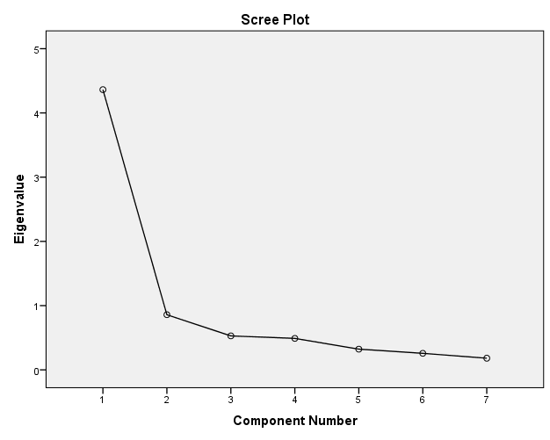

- Factor Analysis for Nikeid

KMO and Bartlett's Test for Nikeid Factor Analysis
Kaiser-Meyer-Olkin Measure of Sampling Adequacy. |  | ,870
Bartlett's Test of Sphericity | Approx. Chi-Square | 795,553
Bartlett's Test of Sphericity | df | 21
Bartlett's Test of Sphericity | Sig. | ,000

Total Variance Explained
Component | Initial Eigenvalues |  |  | Extraction Sums of Squared Loadings |  |  | Rotation Sums of Squared Loadings
Component | Total | % of Variance | Cumulative % | Total | % of Variance | Cumulative % | Total
1 | 4,703 | 67,192 | 67,192 | 4,703 | 67,192 | 67,192 | 4,001
2 | ,745 | 10,637 | 77,829 | ,745 | 10,637 | 77,829 | 3,943
3 | ,504 | 7,199 | 85,027
4 | ,368 | 5,256 | 90,284
5 | ,273 | 3,897 | 94,180
6 | ,240 | 3,435 | 97,615
7 | ,167 | 2,385 | 100,000
Extraction Method: Principal Component Analysis.

- Regression Analyses

Model Summary
Model | R | R Square | Adjusted R Square | Std. Error of the Estimate
1 | ,626ª | ,392 | ,388 | 1,06206
a. Predictors: (Constant), Hedonic_attributes, Utilitarian_attributes

ANOVAª
Model |  | Sum of Squares | df | Mean Square | F | Sig.
1 | Regression | 237,337 | 2 | 118,669 | 105,205 | ,000^{b}
1 | Residual | 368,848 | 327 | 1,128
1 | Total | 606,185 | 329
a. Dependent Variable: Willingness_to_buy
b. Predictors: (Constant), Hedonic_attributes, Utilitarian_attributes

Coefficientsª
Model |  | Unstandardized Coefficients |  | Standardized Coefficients | t | Sig. | Collinearity Statistics
 |  | B | Std. Error | Beta | t | Sig. | Tolerance | VIF
 | (Constant) | -,279 | ,373 |  | -,749 | ,454
 | Utilitarian_attributes | ,539 | ,097 | ,345 | 5,562 | ,000 | ,483 | 2,069
 | Hedonic_attributes | ,405 | ,076 | ,330 | 5,316 | ,000 | ,483 | 2,069
a. Dependent Variable: Willingness_to_buy

- Expertise as a moderator

Model Summary
expertise_categorical | Model | R | R Square | Adjusted R Square | Std. Error of the Estimate
Low expertise | 1 | ,478ª | ,229 | ,216 | 1,26699
Medium expertise | 1 | ,739ª | ,546 | ,538 | ,85734
High expertise | 1 | ,701ª | ,492 | ,482 | ,96230
a. Predictors: (Constant), Hedonic_attributes, Utilitarian_attributes

 | ANOVAª
 | expertise_categorical |  | Model |  |  | Sum of Squares |  | df |  | Mean Square |  | F |  | Sig.
 | Low expertise |  | 1 |  | Regression | 55,735 |  | 2 |  | 27,867 |  | 17,360 |  | ,000^{b}
 |  |  |  |  | Residual | 187,817 |  | 117 |  | 1,605
 |  |  |  |  | Total | 243,552 |  | 119
 | Medium expertise |  | 1 |  | Regression | 94,669 |  | 2 |  | 47,334 |  | 64,398 |  | ,000^{b}
 |  |  |  |  | Residual | 78,648 |  | 107 |  | ,735
 |  |  |  |  | Total | 173,317 |  | 109
 | High expertise |  | 1 |  | Regression | 86,999 |  | 2 |  | 43,500 |  | 46,974 |  | ,000^{b}
 |  |  |  |  | Residual | 89,824 |  | 97 |  | ,926
 |  |  |  |  | Total | 176,824 |  | 99
 | a. Dependent Variable: Willingness_to_buy
 | b. Predictors: (Constant), Hedonic_attributes, Utilitarian_attributes
 | Coefficientsª
expertise_categorical |  | Model |  |  |  |  | Unstandardized Coefficients |  |  |  | Standardized Coefficients |  | t |  | Sig.
 |  |  |  |  |  |  | B |  | Std. Error |  | Beta
Low expertise |  | 1 |  | (Constant) |  |  | ,194 |  | ,799 |  |  |  | ,243 |  | ,808
 |  |  |  | Utilitarian_attributes |  |  | ,473 |  | ,173 |  | ,281 |  | 2,732 |  | ,007
 |  |  |  | Hedonic_attributes |  |  | ,354 |  | ,145 |  | ,251 |  | 2,433 |  | ,016
Medium Expertise |  | 1 |  | (Constant) |  |  | -,177 |  | ,460 |  |  |  | -,385 |  | ,701
 |  |  |  | Utilitarian_attributes |  |  | ,436 |  | ,141 |  | ,329 |  | 3,093 |  | ,003
 |  |  |  | Hedonic_attributes |  |  | ,492 |  | ,116 |  | ,450 |  | 4,230 |  | ,000
High expertise |  | 1 |  | (Constant) |  |  | -1,261 |  | ,713 |  |  |  | -1,768 |  | ,080
 |  |  |  | Utilitarian_attributes |  |  | ,805 |  | ,186 |  | ,457 |  | 4,339 |  | ,000
 |  |  |  | Hedonic_attributes |  |  | ,354 |  | ,126 |  | ,296 |  | 2,812 |  | ,006
a. Dependent Variable: Willingness_to_buy

- Product Category as moderator

Model Summary
perceived_product_category | Model | R | R Square | Adjusted R Square | Std. Error of the Estimate
Utilitarian | 1 | ,607ª | ,368 | ,361 | 1,16469
Hedonic | 1 | ,543ª | ,295 | ,285 | ,88973
a. Predictors: (Constant), Hedonic_attributes, Utilitarian_attributes

ANOVAª
perceived_product_category | Model |  | Sum of Squares | df | Mean Square | F | Sig.
Utilitarian | 1 | Regression | 142,872 | 2 | 71,436 | 52,662 | ,000^{b}
Utilitarian | 1 | Residual | 245,527 | 181 | 1,357
Utilitarian | 1 | Total | 388,399 | 183
Hedonic | 1 | Regression | 47,291 | 2 | 23,645 | 29,869 | ,000^{b}
Hedonic | 1 | Residual | 113,203 | 143 | ,792
Hedonic | 1 | Total | 160,493 | 145
a. Dependent Variable: Willingness_to_buy
b. Predictors: (Constant), Hedonic_attributes, Utilitarian_attributes

Coefficientsª
perceived_product_category | Model |  | Unstandardized Coefficients |  | Standardized Coefficients | t | Sig.
perceived_product_category |  |  | B | Std. Error | Beta | t | Sig.
Utilitarian | 1 | (Constant) | -,374 | ,492 |  | -,759 | ,449
Utilitarian | 1 | Utilitarian_attributes | ,659 | ,140 | ,424 | 4,698 | ,000
Utilitarian | 1 | Hedonic_attributes | ,275 | ,113 | ,219 | 2,424 | ,016
Hedonic | 1 | (Constant) | ,542 | ,629 |  | ,863 | ,390
Hedonic | 1 | Utilitarian_attributes | ,423 | ,126 | ,291 | 3,355 | ,001
Hedonic | 1 | Hedonic_attributes | ,405 | ,111 | ,318 | 3,665 | ,000
a. Dependent Variable: Willingness_to_buy

- Gender as a moderator

Model Summary
Model | R | R Square | Adjusted R Square | Std. Error of the Estimate
1 | ,646ª | ,417 | ,408 | 1,04438
a. Predictors: (Constant), interaction_gender_hedonic, Utilitarian_attributes, Hedonic_attributes, gender, interaction_gender_utilitarian

ANOVAª
Model |  | Sum of Squares | df | Mean Square | F | Sig.
1 | Regression | 252,790 | 5 | 50,558 | 46,353 | ,000^{b}
1 | Residual | 353,395 | 324 | 1,091
1 | Total | 606,185 | 329
a. Dependent Variable: Willingness_to_buy
b. Predictors: (Constant), interaction_gender_hedonic, Utilitarian_attributes, Hedonic_attributes, gender, interaction_gender_utilitarian

Coefficientsª
Model |  | Unstandardized Coefficients |  | Standardized Coefficients | t | Sig.
 |  | B | Std. Error | Beta | t | Sig.
1 | (Constant) | -,136 | ,559 |  | -,243 | ,808
1 | Utilitarian_attributes | ,708 | ,119 | ,454 | 5,951 | ,000
1 | Hedonic_attributes | ,219 | ,093 | ,178 | 2,354 | ,019
1 | gender | ,131 | ,748 | ,048 | ,175 | ,861
1 | interaction_gender_utilitarian | -,639 | ,207 | -1,270 | -3,091 | ,002
1 | interaction_gender_hedonic | ,592 | ,163 | 1,202 | 3,639 | ,000
a. Dependent Variable: Willingness_to_buy

Appendix 2: Questionnaire and Toolkits Interfaces
1. The Questionnaire

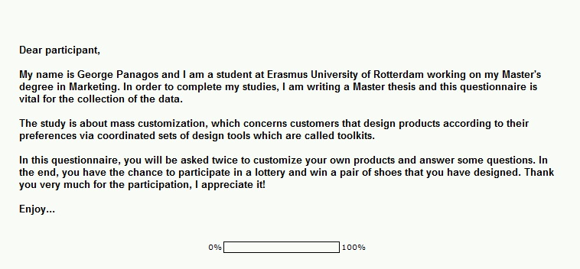
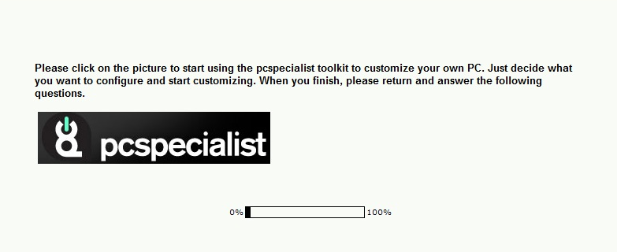

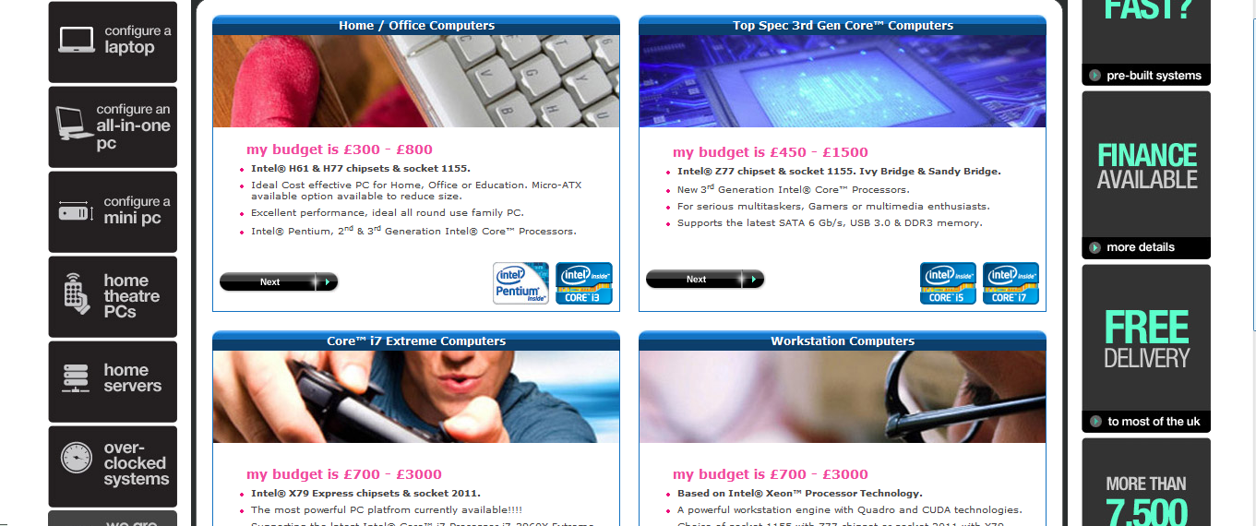

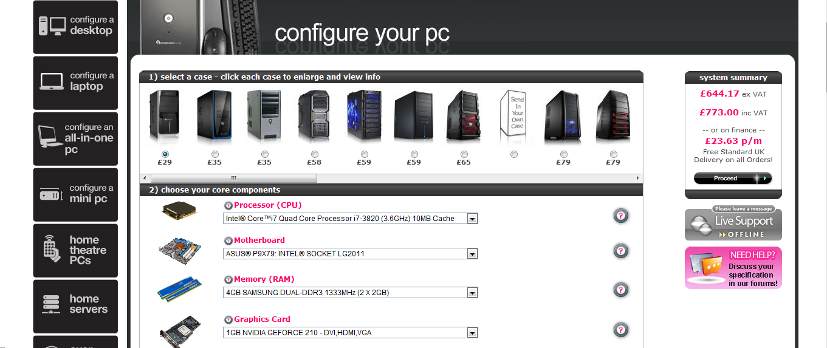

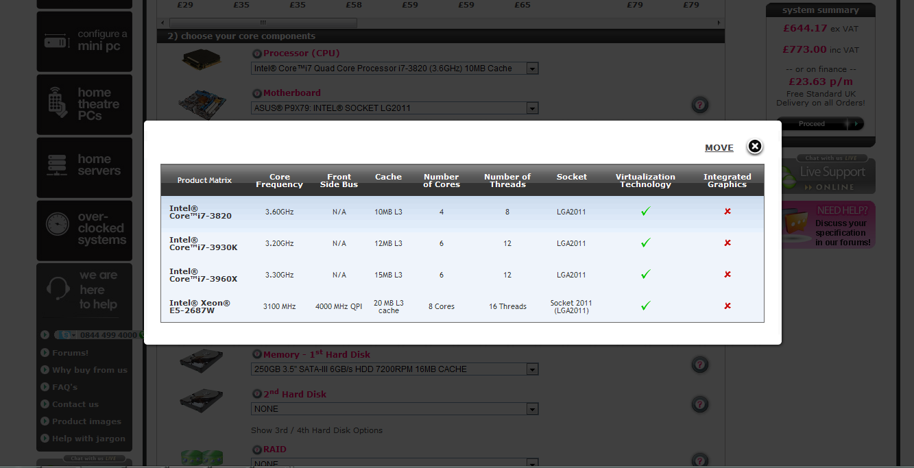

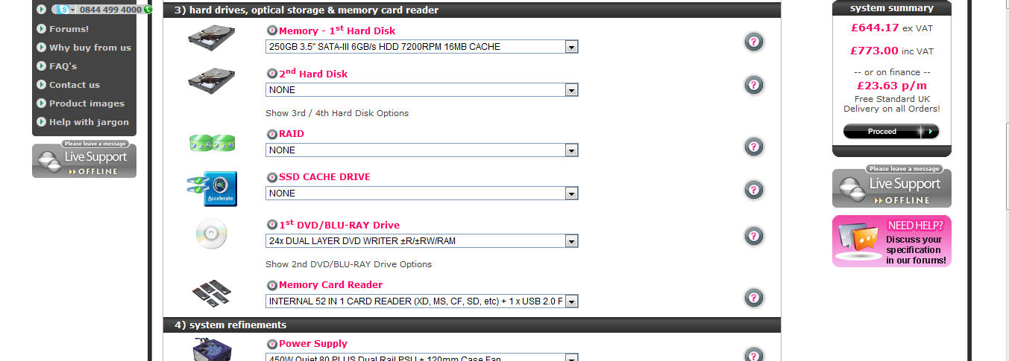

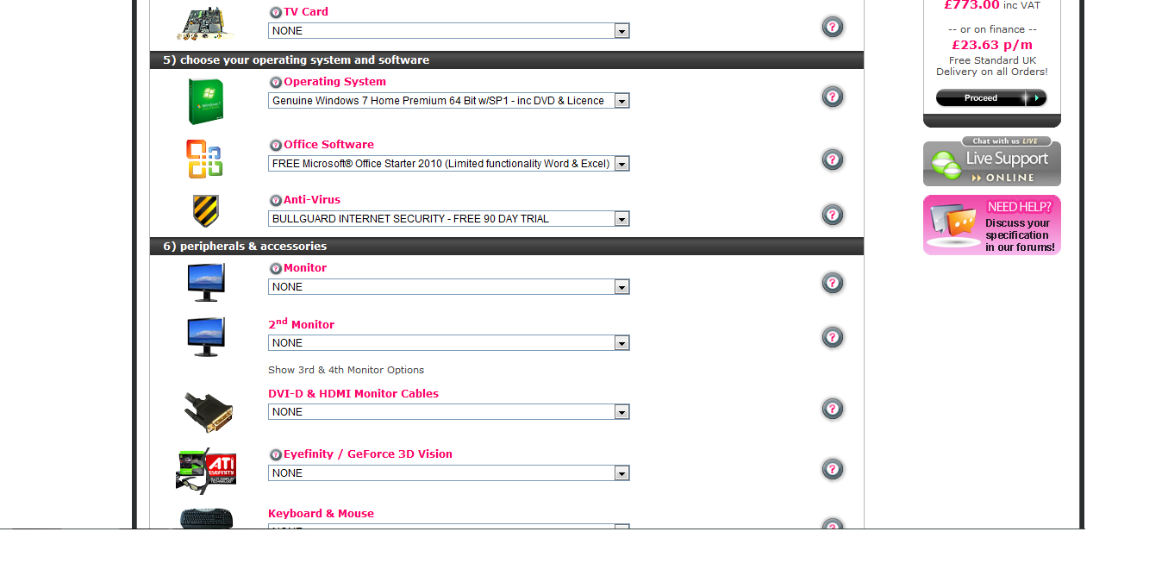

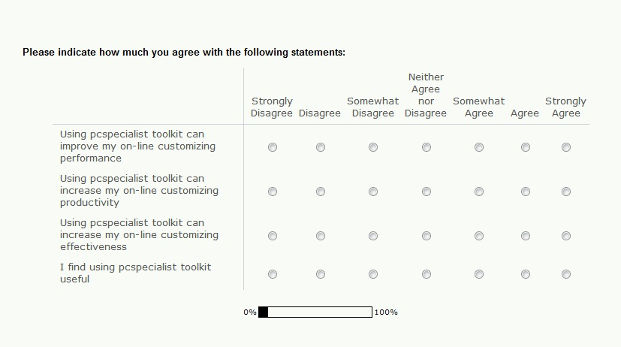

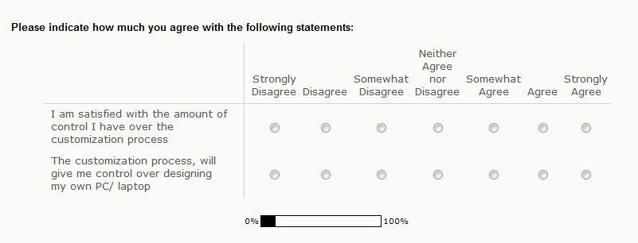

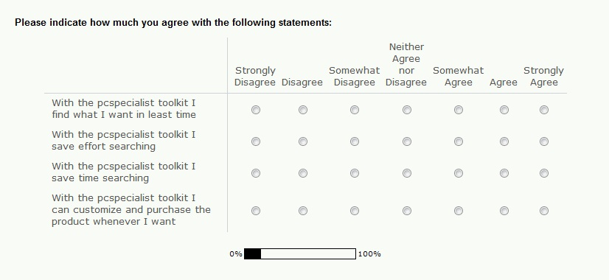
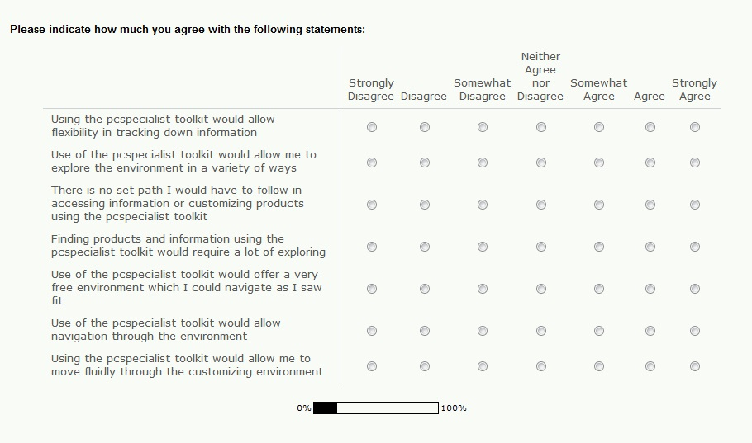
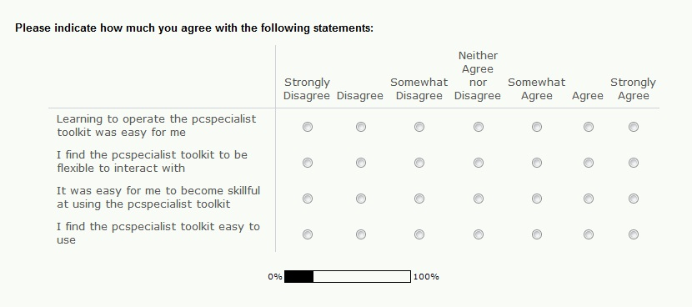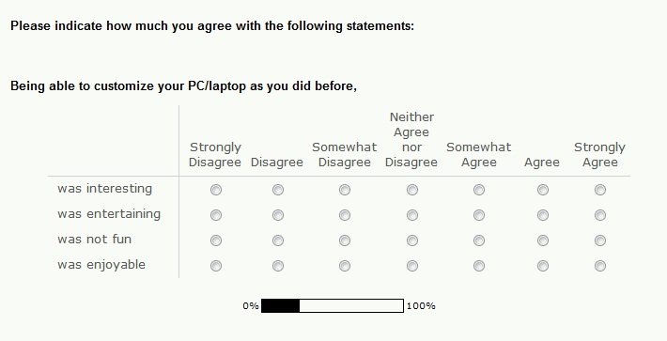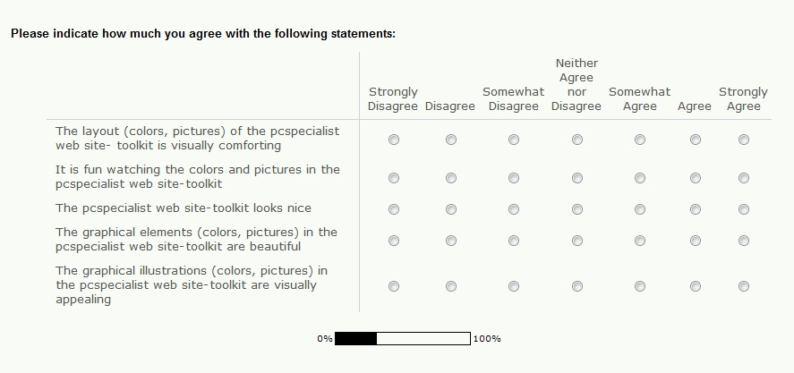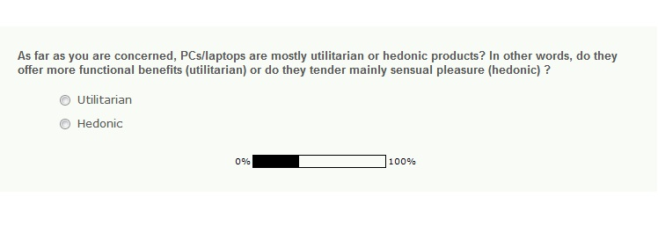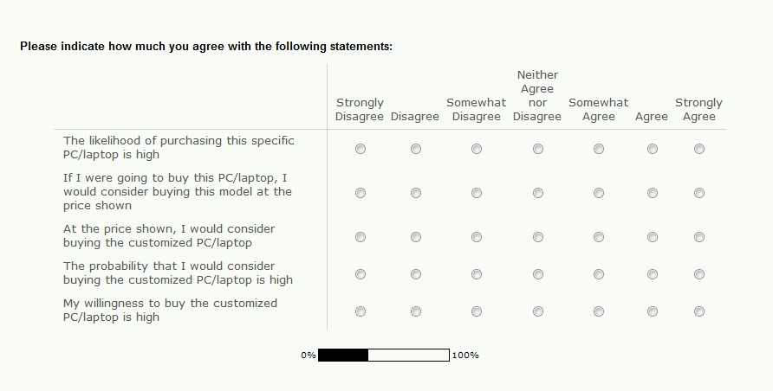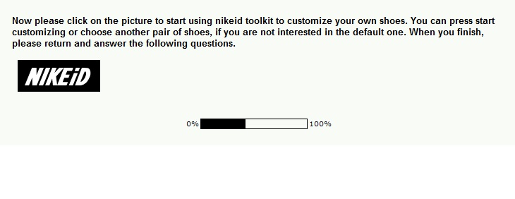
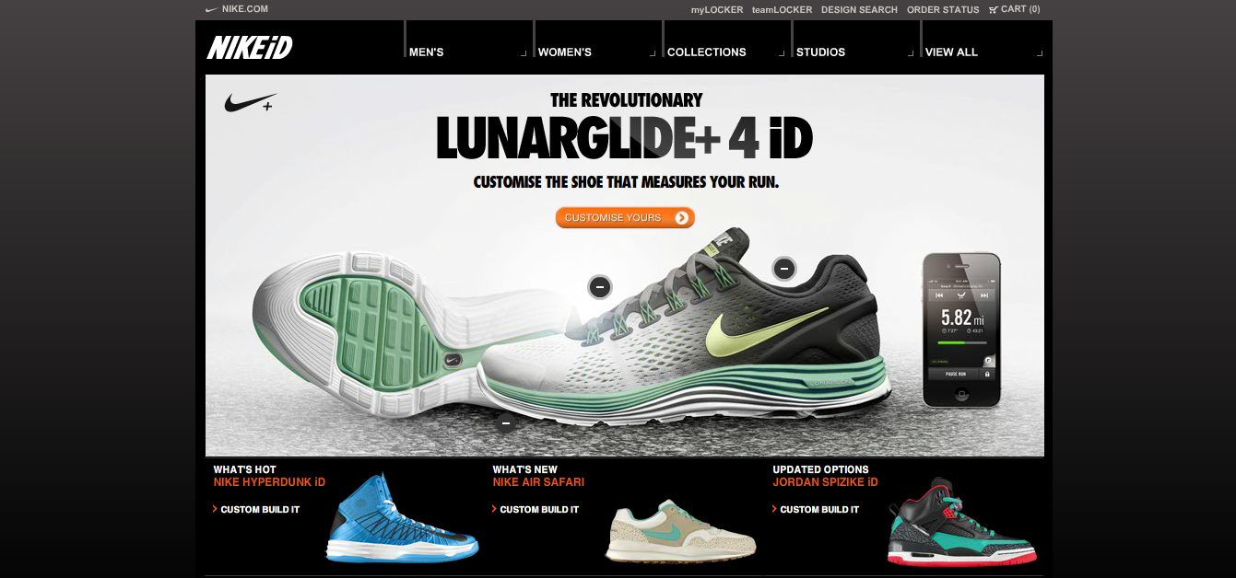
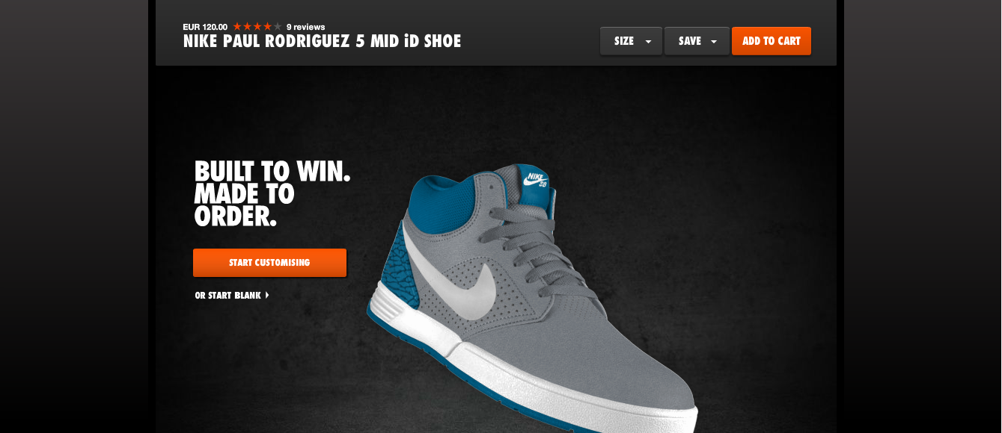
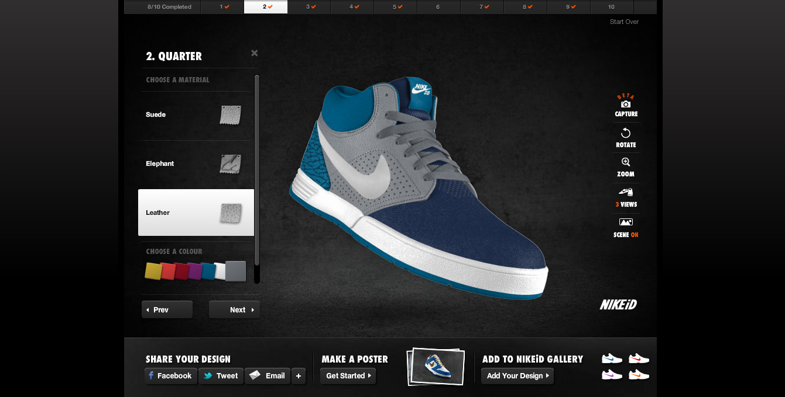
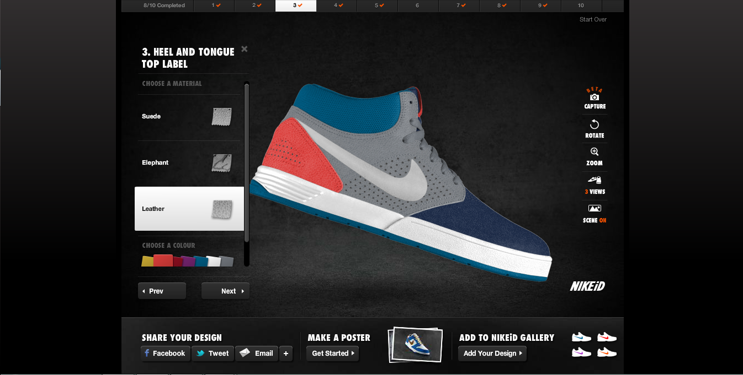
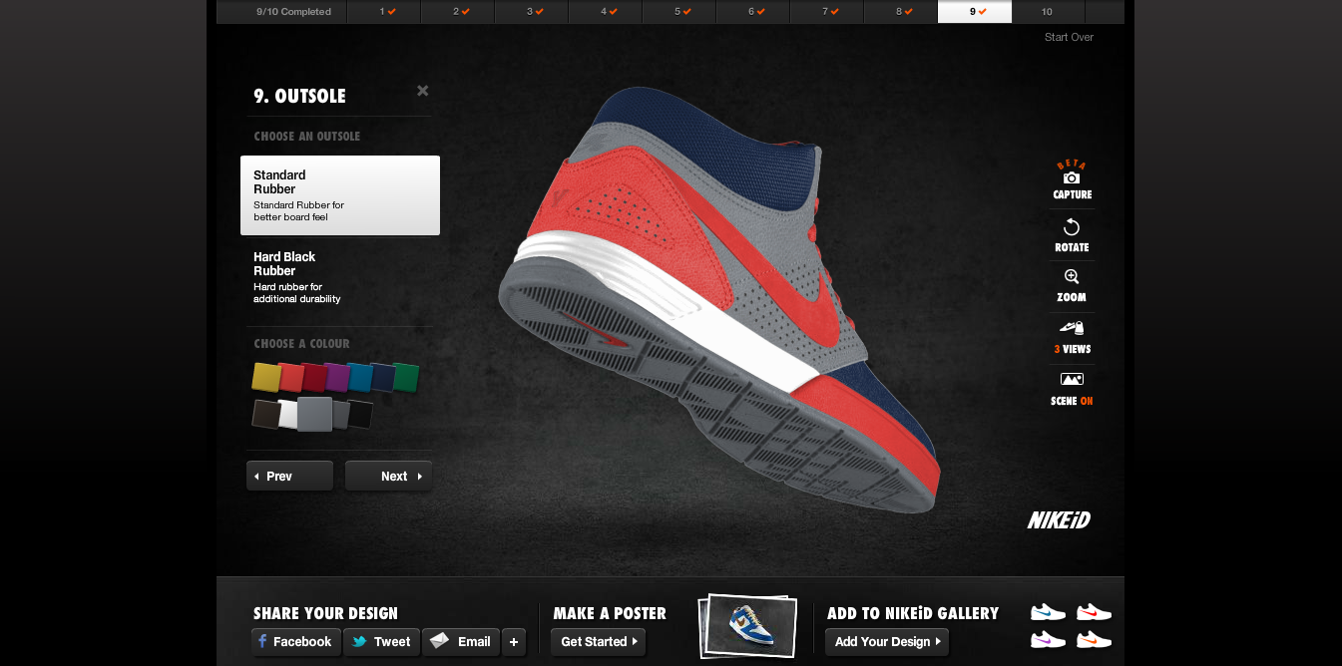
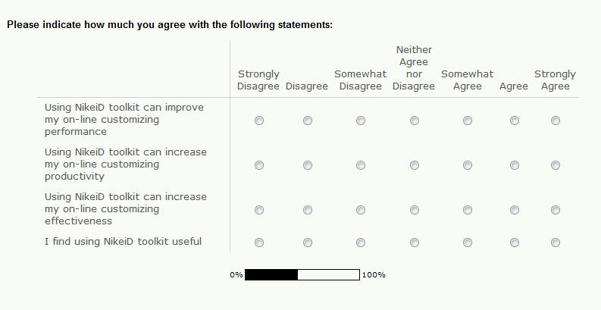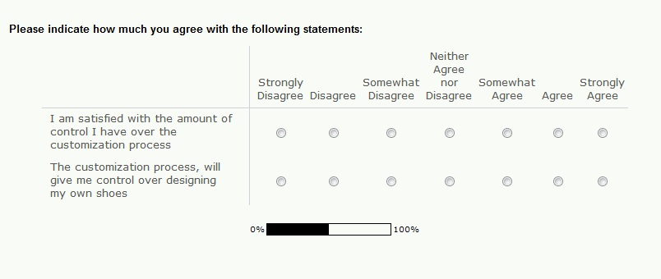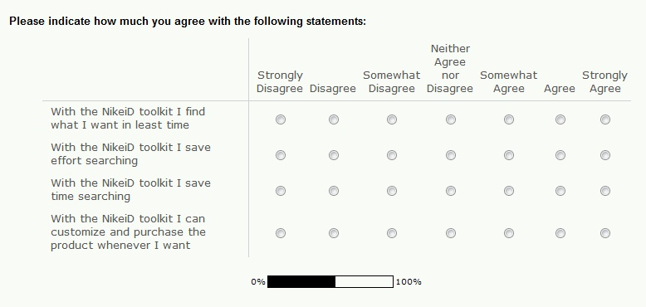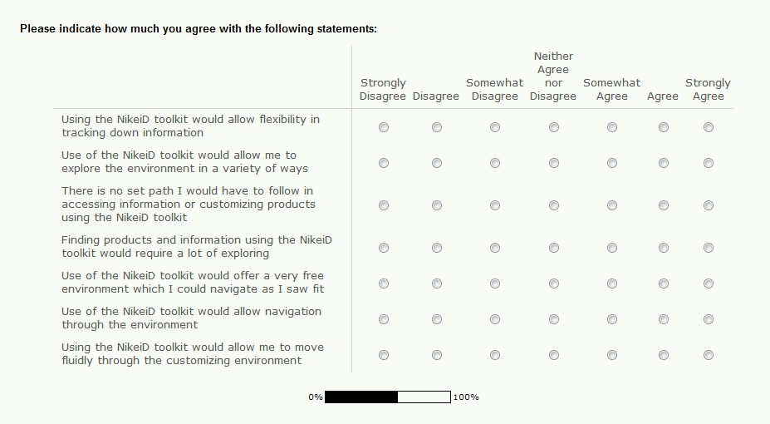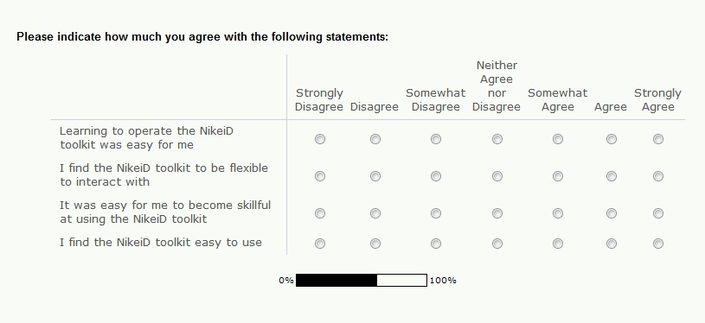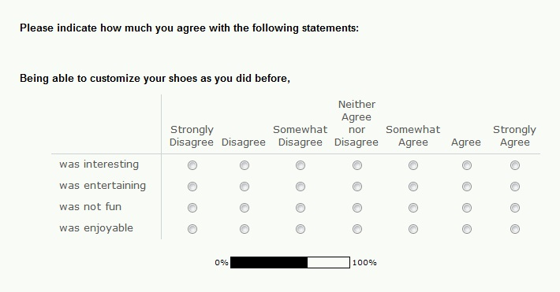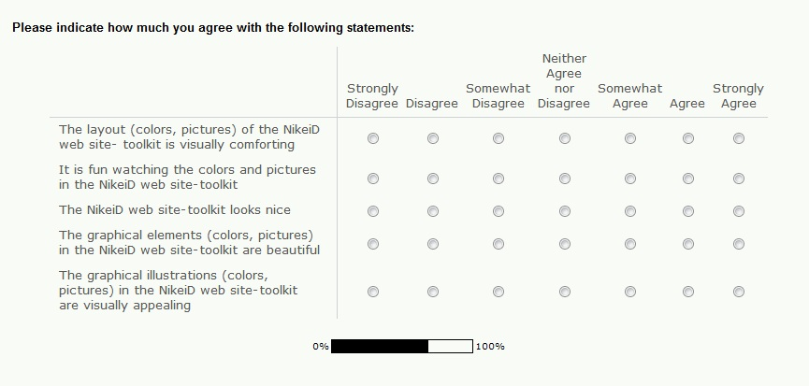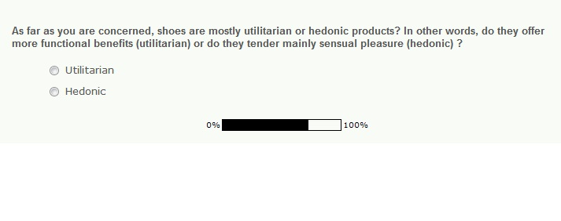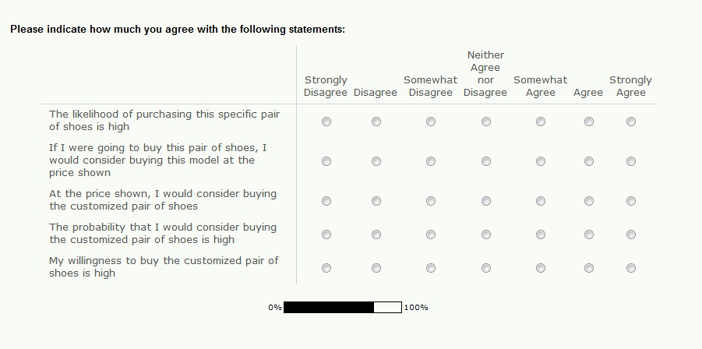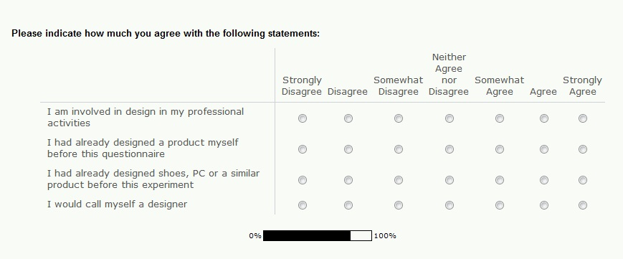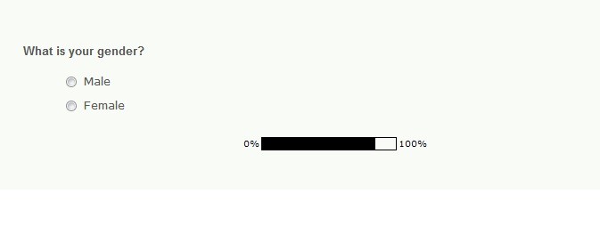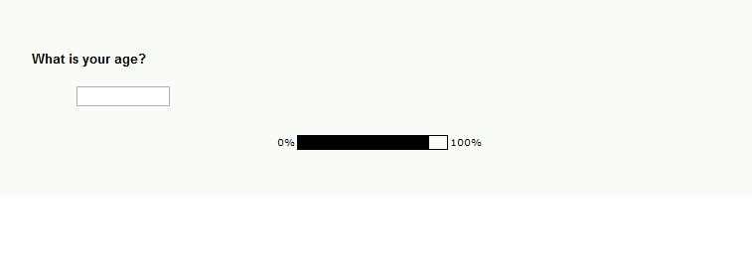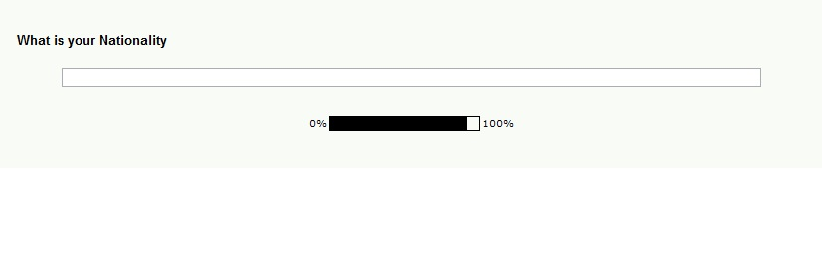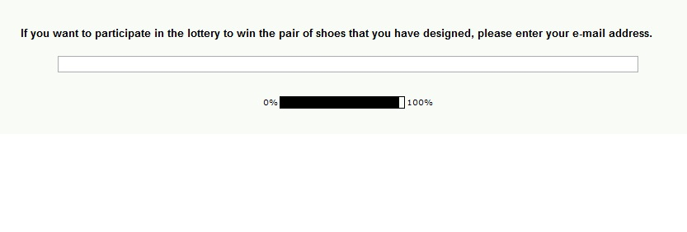

Other identical terms are: self-design and adaptive customization
I will use “customers” and “consumers” interchangeably, within the whole paper
Panacea comes from the Greek word “πανάκεια” and refers to a medicine which treats every disease (literally) or to a solution to every problem (metaphorically). Nostrum can be considered as a synonym.
CPU (Central Processing Unit) is the brains of a computer where most calculations take place. In other words, it is the most indispensible part of the system. Definition by www.webopedia.com
A graphics card or video card is an expansion card which generates a feed of output images to a display. Definition by www.wikipedia.org
Computer factors can be considered as utilitarian characteristics of a website, according to the authors. Those are: indication of security, clear display of page content, presence of clear menu items, presence of shopping cat, up-to-date information, un-do button, assurance of privacy, payment options, purchase tracking services, company logo, consistent web page design, declaration of intended use, logical webpage information offers order confirmation and product images as thumbnail (Hausman and Siekpe, 2009, p. 11)
Mentioned in 2.3.2
Mentioned in 2.3.2
Mainly connected with hedonistic features (Teo et. al., 1999)
In mass customization nearly the whole website is the toolkit that enables users to personalize a product.
Ten respondents took part on a pretest to determine which product is considered as Utilitarian and Hedonic. The results of this test are shown in the Appendix 1.
"A qualitative or quantitative variable that affects the direction and/or strength of the relation between an independent and dependent or criterion variable" (Baron and Kenny, 1986, p. 1174).

