Erasmus University of Rotterdam
Erasmus School of Economics

Store Atmospherics & Retail Brand Personality
in different Price Levels:
The case of Scent

Thesis for the requirements of the degree
Master of Science in Business and Economics,
specialisation in Marketing

by
Orestis-Anastasios Foteinias
Student number 356305

Supervisor : Vijay Ganesh Hariharan

Rotterdam, 2012

Thesis Acknowledgements

It is a personal pleasure to thank all those who made this thesis possible. First of all, I could not have wished for a better supervisor. Professor Vijay Ganesh Hariharan was a tireless support all over my thesis writing from the beginning, with inspiration and insights about the topic, till the end, with guidance about the statistical analysis. I could say that he took care of my text as it was his Phd dissertation text. I would also like to thank my parents and my brother for their endless love and my friends for the relaxing moments during the writing. Last but not least, I want to thank my friend Marios Michaelidis for offering me a second opinion on my analysis.

Table of Contents
INTRODUCTION 4
LITERATURE 5
SCENT MARKETING 5
Scent as a marketing tool 5
Ambient scent of a store & the model of its influence 6
Scent memory 8
The effects of an ambient scent 8
Ambient Scent & Brand Issues 11
BRAND PERSONALITY 12
Definition & the symbolic meaning 12
Understanding Brand Personality from existing studies 14
Brand Personality of a Store: the concept 15
Retail Brand Identity 15
Definition 16
Studies on Retail Brand Personality 18
Measuring Brand Personality 19
Aaker’s model-1997 19
Scales only for stores 21
HYPOTHESIS 21
DATA DESCRIPTION 24
The questionnaire 24
Retail Brand Personality Scale 24
Manipulation Check 25
Price Perception Question 26
Real World Experiment 26
Laboratory Experiment 28
METHODOLOGY 29
RESULTS 31
Research Question H1 31
Real World Experiment Results 31
Laboratory Experiment Results 34
Research Question H2 36
MANAGERIAL IMPLICATIONS 37
DISCUSSION, LIMITATIONS & FUTURE RESEARCH 38
REFERENCE LIST 43
Brand Personality References 43
Scent Marketing References 48
APPENDIX 52
Real World Experiment Questionnaire 52
Laboratory Experiment Questionnaires 54
Photos from the experiments 63
SPSS Tables 64

INTRODUCTION

It is obvious that nowadays the stiff competition in the markets has made brands’ differentiation and managers’ role in this extremely difficult and demanding. Additionally, the economic crisis makes this situation even harder since the market pie and market players’ share tends to decrease. Thus, retailers who want to stand out and gain loyalty or awareness should find innovative marketing techniques to attract consumers’ attention and satisfaction. Consumers, also, are even more demanding than they used to be while they ‘judge’ services by taking into account every kind of cue.

Atmospherics and in-store experience is a thoughtful solution for them (retailers). More specifically, the consumption is more affective in high aesthetic environments since consumers, as poly-sensorial entities, are looking for more emotional and sensorial stimulation during their purchase process. ‘Retailtainment’ is the new term that tries to explain the above by combining retail and entertainment. Sensory marketing is a science that has recently started to expand and motive retailers to play the marketing game with new tactics as atmospherics enhancement.

Even though 75% of our emotions are generated by the smell (Lindstrom, 2005) companies and researchers have not investigated extensively this field compared to other ambient atmospherics like music or colors (Goldkuhl and Styven, 2007). This study extends the work of Magnini and Thelen (2008) on atmospherics who researched the relationship between the ambient music and the retail brand personality but also the studies that have been done about the retail brand personality and store’s elements with symbolic meaning.

Stores are believed to have a personality that shoppers use as a mean for self-expression or differentiation from others via emotional tying with store’s symbolic attributes. Despite researches that support linkage between the retail brand personality and the store’s interior atmosphere (Orth et al., 2012) or brand personality with store’s atmospherics (Martineau, 1958;Brengman and Willems, 2009), the relationship between the retail brand personality and the ambient scent of a store has not been yet investigated.

LITERATURE

SCENT MARKETING

In our modern way of life, buying a product is a complicated process that requires more things than assessing actual tangible attributes. In most of the cases a purchase is supported by the appropriate service, guarantees, promotional and advertising activities, images and others (Kotler, 1973-1974). When a marketer decides about the marketing mix of a new product, s/he should critically think about the place, which is one of the P’s of the marketing mix. What competition has gradually created is a big investment and evolution in the characteristics of the place. For this reason it is believed that the atmosphere of a store is an important part of the products consumption since it affects consumers’ intentions and feelings. One ingredient of a store’s atmosphere is the ambient scent of the store. How a store smells is the olfactory dimension of the store that can be used as a marketing tool to affect purchase decision.

Scent as a marketing tool

The application of a smell as a marketing tool can be categorized in three cases. The first one has to do with the general trend of using a smell for a product. This means that a smell could be a positive attribute of a product if, in general, a specific smell is used for each kind of products. For example, dishes detergent would be more effective if it smelled lemon instead of coconut. The second application of scent marketing refers to the ‘scent strips’ or ‘scratch and sniff’ strips in magazines and newspapers which is a marketing tactic that still attracts consumers’ attention a lot. Last but not least, a third implementation of scent marketing does not have to do with the actual or indirect attributes of a product but with the background information during its purchase. Namely, a scent can be linked to the external environment of a product and help in creating an attractive and affective store atmosphere (Mitchell, 1994).

Retail scent marketing and a proper ambient smell can be used as a useful tool for tangibilising, enhancing and differentiating services, which in turn can help retailers build a strong competitive advantage (Goldkuhl&Styven, 2007). However, Goldkuhl and Styven (2007) highlighted that important factors, like fitting the scent with the service or its pleasantness, is something that marketing managers should take into account.

Ambient scent of a store & the model of its influence

What marketing researchers have already found about ambient scent of a store have given a great insight in the field. The general admission that the smell of store can influence a product’s evaluation was the main conclusion of Belk (1975), Donovan&Rossiter (1982) and Grossbart et al. (1990) while Gulas&Bloch (1995) found that a scented store is potentially more affective than a scented product since it facilitates the better evaluation of items that can not be scented (e.g. furniture). From increasing gambling in casino’s slot machines (Hirsch, 1992a) to lingering time in stores (Lipman, 1990) smell can play a different role according to the process in which it affects consumers. For this process Gulas&Bloch (1995) highlighted that it is not only about the ambient scent but also about the perceived ambient scent that should affect consumers. Perceived ambient scent has a lot to do with the characteristics of the shopper but also with the scented ‘level’ in the store. So, age, sex, health problems, smoking or not are factors that are crucial in order to perceive a scent. Characteristically, Doty et al. (1985) found that women’s ability to detect scents is stronger than in men. Moreover, preference is also an issue when marketing has to cope with scent tactics. There are some generally admitted pleasant and unpleasant smells (Moncrief, 1970), which usually derive from our instinct for safety, but also preference has to do with age, gender, generation (Hirsch, 1992b) and psychological factors (Kirk-Smith&Booth, 1987). Gulas&Bloch (1995) concluded that even if a scent is perceived and prefered by a consumer, there should be a proper fit between the smell and the features of the environment in order to create the wanting responses, like willingness to stay and spend more in a store (Bitner, 1992) or prettifying consumers’ mood. Gulas&Bloch (1995) summarized the process of a scent in retailing in the graph below.

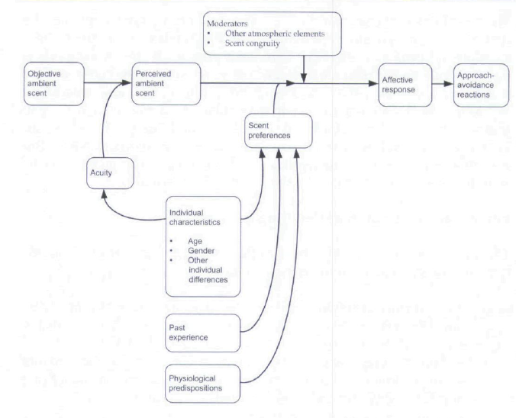
Model of the Influence of Ambient Scent on Consumer Responses
(Gulas&Bloch, 1995)

Davies et al. (2003), seeing smell as “place-maker”, elaborated the above model by adding also conscious and unconscious factors in the process of the perceived ambient scent (PAS) except for individual characteristics and acuity. Consciousness increases the possibility of pre-attention which can be linked to the hedonic quality of the smell (perceived character) that affects also attention, the holistic impression of the environment and consumers’ responses. Pre-attentive scent (without noticing) does not distract consumers from other environmental cues (e.g. visual promotions). What else the authors commented about the use of a scent as a “place-maker” is that scent memory plays an important role to this because when the evoked emotions from the memories are pleasant, a strong bond between the consumer and the store can be created. This leads to a differentiation advantage. Furthermore, Davies et al. (2003) refered to cultural factors and other environmental stimuli that can influence consumers’ holistic perception about the retailer and the scented environment.

Scent memory

As mentioned above, scent memory is what connects scent stimuli to consumers’ emotions. Remembered emotions evoked by a smell, pleasant or unpleasant, are coded in the amygdala which is the centre of emotions and the hippocampus (the memory center) and linked with the reception of smell via the limbic system (Halloway, 1999). Whenever someone smells a known scent his scent memory is activated and he recalls memories of emotions or events which are perceived as more accurate than other memories because of their emotional quality (Larkin, 1999). What is impressive about the quality emotions is that they last for many years and can be remembered even in details (Aggleton and Waskett, 1999).

The effects of an ambient scent

Inoffensive ambient scent and how it affects consumers’ perception about the in-store experience and their behavior towards it and the products sold in it was a topic that Spangenberg et al. (1996) researched. Specifically, they found that a scented environment is a beneficial factor for evaluating more positive a store, a store’s environment and its merchandise but also affects positively their behavior making them more willing to visit the store again while reduces their perceived time spent in the store (not the actual). Better evaluation was also received for less pleasing items of the store but when consumers’ view was already positive or negative then the scent did not really affect their perception about them. Even though the authors did not find significant differences in the evaluation of the stores and merchandise among the different inoffensive scents that they used (nature, intensity), they proposed to store managers that a distinct, congruent and cost-efficient scent is an inexpensive and easily implemented tool for enhancing in-store experience and consumers’ responses to it. The findings of Spangenberg et al. (1996) were also partially tested by Schifferstein and Blok (2002) who tried to see the effects of the ambient scent of a store to consumers’ product judgement and specifically to sales. By matching the ambient odour with the product’s nature, the sales of which they wanted to examine, they found that sales of the thematically congruent product are not affected by the scent since those who want or do not want to buy a product, they will do it in any case. Only these who illustrate interest in the product may be affected importantly by the scent.

In 1999, Bonne and Ellen raised some doubts on the findings in the literature about the scent marketing and the use of scents for affecting consumers’ intention, calling the existing knowledge “conventional wisdom”. By summarizing the existing researches, they explained that firstly the presence of a smell affects consumers’ behavior but the effect on shoppers evaluative behavior was moderated while the actual time spent for searching within a store was not importantly different. At the same time, the pleasantness of a smell could affect consumers’ mood but again their motivation for further evaluation of products or the environment was limited. Moreover, the effects of the fitting between the scent and the environment/objects on the elaboration of the information received in a retail store were weak (Bonne&Ellen, 1999). The authors agreed that a pleasant smell could help the elaboration of the desired information that a marketer want to create for a product and this could be more intensive when the smell is congruent with the particular case/store but judgements might not been boosted if the odour only repeats the existing information. Furthermore, the conclusions of Spangenberg et al. (1996) are criticized also as weak since only one out of three products seemed to be affected positively in their evaluation due to the smell. Concerning moderators in the existing papers, the authors highlighted that the gender is indeed an important issue while not directing the attention of the respondents about the scent gives a more holistic perception about the object in a survey.

Similar findings said that the perception of consumers about a service store (satisfaction, pleasure, store environment etc) is the holistic view of atmospheric cues than only the scent (Matilla and Wirtz, 2001). In other words, it was shown that when the arousal levels of scent of a retail store is matched with the ambient music background then consumers evaluate more positive their consumption experience. More specifically, lavender scent together with slow tempo music have better results than when this scent was combined with fast tempo music. The former could be combined with the scent of grapefruit in order to be more effective and enhance a coherent store atmosphere. Thus, designing holistically these two environmental cues, within a congruent environmental atmosphere, could strengthen engendered environment’s qualities, which leads to better differentiation, and consumers’ shopping behavior. Cue congruency in retail stores was also an issue supported by Spangenberg et al. (2005) who claimed that scent and music of a store can create more positive evaluations about the store, its merchandise and its environment (arousal, pleasure, dominacne) if the are combined consistently while the willingness for visiting the store again is affected positively. On the other hand incongruent music and scent can have neutral or negative effects on the above attributes. Characteristically, Christmas scent was unlikely to create favorable evaluations or had less favorable effects if combined with non-Christmas music (Spangenberg et al., 2005). About congruency again, Haberland et al. (2010a) added that a moderately incongruent with the product smell can still have an important effect on behaviors and sales in contrast to an incongruent smell.

Scent marketing can also be used as a tool for affecting customers level of satisfaction. Adding a scent in the area while they are waiting for a service can importantly enhance their perception of waiting time; the perceived queing time was less than the actual one (McDonnell, 2002).

A congruent, light and pleasing ambient scent is able to arouse consumers and affects their mood which in turn enhances their perception about the environment of a store and the quality of the products in it (Chebat&Michon, 2003). This was explained by the approach/avoidance theory (Gulas&Bloch, 1995) however it was found that even though better perception of the atmosphere increases spendings of all products (Gulas&Bloch, 1995), products’ better quality perception does not have the same results on spendings (Chebat&Michon, 2003). Chebat and Michon (2003), who did their research in a real world case (mall), explained that product’s quality perception is “a necessary but not sufficient” factor for its sales.

Except for pleasantness, familiarity and congruency, Haberland et al. (2010b) evaluated another ingredient of olfactory stimuli that is important for marketing strategies, the simplicity. They showed that simple or fluent odors are better than the complex ones since they can significantly affect purchase behaviors and increase spending in a store in comparison with the no-scent or complex smells that did not enhance sales.

Ambient Scent & Brand Issues

Concerning brand aspects and the scent marketing, Morrin and Ratneshwar (2003) illustrated that there is also a connection between the ambient scent of a store and the brand memory as it can enhance brand recall and recognition of familiar and unfamiliar brands. Firstly, a pleasant ambient scent leads to increased attention in the store, even if it is not congruent with the products (same results with congruent), and this can be explained by the longer time consumers spend (approach behavior) in the aromatized store. Moreover, it was found that a pleasant ambient scent is crucial for memory’s performance (brand recognition and recall) only during the encoding period (the first ‘meeting’ with brand) than when consumers try to remember the brand.

It was also found that consumers are not consciously aware of the scented in-store environments but its presence affects their perception about the store and its things (Ward et al. 2007; Orth&Bourrain, 2005; Turley&Milliman, 2000). Additionally, Ward et al. (2007) found that smell, when it is not directly attended, affects perception as a «totality»; the retailer’s brand image is considered more positive in a scented store while the whole in-store experience is enhanced with the use of an odour. Behavior and dwell time were not importantly affected by the odoured environment but a store could gain extra qualitative attributes (“more stimulating, busier, more formal, more inviting”) with a fragranced interior. Concluding Ward et al. (2007) proposed a thoughtful positioning of the scent machine in the store and the variety of smells that will be used so as congruity will be assured since smell is a contributing factor in people’s memory and experience.

About the smell’s congruency with the brand, Hehn and Silberer (2010) found that a congruent scent has stronger impact on the brand perception than an incongruent while the effect is higher when respondents decide subjectively and not emotionally. Specifically, a congruent scent had significant effect on brand attitudes while the brand image was considered more novel and unique when it was aromatized.

Concerning the relation between the ambient scent of a retail store and its brand personality, no research has examined this yet. However, as it has been already mentioned (Lindstrom, 2005), music stimuli is a part of the store’s atmosphere that has been far more intensively. Magnini and Thelen (2008) found that ambient music influences consumers’ perception about the brand personality of the store. Specifically, ambient music in fine-dining restaurants had an “reinforcing” effect on their personality.

BRAND PERSONALITY

Definition & the symbolic meaning

“The set of human characteristics associated with a brand” is the definition that Aaker gave in her famous study (1997) for the personality of a brand.

Brand personality is one of the most important contributors to the symbolic meaning of a brand (Zentes et al., 2008). The reason for brand’s symbolic meaning probably derives from consumers’ trend to give human characteristics to brand (animism; Gilmore, 1919). Characteristically many of them are used to considering brands as celebrities or famous historic persons (Rook, 1985). Sirgy (1982) claimed that the stronger and more positive a brand personality is, the higher consumers’ preference is while identification between brand personality and human personality increases the preference. The symbolism of a brand personality and its effect to the brand-consumer relationship plays an important role for emotional attachment, as well, since brand personality increases consumers’ emotions (Biel, 1993) and trust (Fournier, 1998). More importantly, a unique brand personality differentiates the brand from competition by creating distinctive and favorable associations in consumers’ mind which leads to the building of brand equity (Keller, 1993). Taking into account the incredibly rough competition that globalization has brought to businesses, brand personality is one of the tactics that could help consumer choose emotionally among brands with the same functional attributes.

These emotional benefits that derive from the experience or use of brand create feelings which make the ties with the brand deeper and more valuable (Rathnayake, 2008). It was shown that brand personality as a symbolic mean creates feelings of excitement, security and warmth when it is strongly structured as a sincere personality while on the other hand competent and sophisticated personalities engender safe and respectful customers (Rathnayake, 2008).

D.Aaker (1995) interpreted these ties between consumers and the brand personality with three behavioral models highlighting that consumers perceive brand personality as a status enrichment or self expression mean. Moreover, it is possible that this tie works as a relationship between friends which is built with trust and reciprocity while another interpretation could be that consumers enrich their perception about the functional superiority of the brand due to their affection by the personality.

Understanding Brand Personality from existing studies

Brand personality has an important role in the maintenance and strength of the relationship between consumers and brands (Aaker et al., 2004). Relationships with Sincere brand personalities seem like strong friendships which get seriously damaged by transgressions while relationships with Exciting brand personalities look like a trajectory of short-lived fling”, able to recover from a transgression.

Another study based on Aaker’s (1997) work found that brand personality stands for the idea “we are what we wear” and consumers can facilitate their personal impression management by wearing brands with specific personalities (Fennis and Pruyn, 2007). The brand personality, as a causal agent, affects what consumers perceive about the user of the brand (transfer effect). Thus, a sophisticated brand personality make the user seem more sophisticated. On the other hand, Fennis et al. (2005) underscored the opposite idea, namely that brand personality can affect the impression that someone has for himself (self-perception) even when he uses the brand occasionally.

Brand personality even for services (restaurants) is a strong tool for affecting consumers’ choice, loyalty and world-of-mouth (Kim et al., 2011). Characteristically, perceived quality of a brand used to be formatted by price, guarantees, brand name etc but now brand personality is proved to be a successful mean to boost quality when it is consistent with the positioning, the image and the concept of the brand (Ramaseshan and Tsao, 2007).

Furthermore, no matter in which dimension/attribute the personality of a brand has the highest score, if the brand personality is strong and favorable then occurs what they call the brand personality effect, namely better and enduring brand evaluations which leads to sustainable competitive advantage and brand equity (Freling and Forbes, 2005). In addition, brand personality is not stable over time but the challenge for brand builders is to sustain favorite associations while this is a key to differentiation when the positioning can not stand out, as for example in bottled water (Freling and Forbes, 2005). Thus, none brand happens to have no personality and if a «zero» personality exists for a brand then it is because of a wrong or unclear strategic management (Moser, 2003) .

Brand Personality of a Store: the concept

Retail Brand Identity

Brand Personality is one of the three pillars that build the brand identity of a retailer (Ko Floor, 2006). A strong brand identity is a necessary mean for a retailer to differentiate his store from competition. Brand positioning, the first pillar is the promise, the tangible or functional attributes that a retailer offers to his customers. Brand personality is defined as the emotional (symbolic benefits;Keller, 1993), intangible traits of the brand from which emotional benefits derive. “Positioning is what you get;personality is what you feel” which makes retail brand personality a stronger ‘weapon’ for building emotional bonds with consumers since they can not be copied as the functional characteristics. Finally, brand communication, as it is shown below, is the third pillar that makes positioning and personality obvious to consumers.

Concerning the applicability of brand principles on brand personality, however, it is important to know that whatever was refered in the previous sector is also valid for stores, too. Ailawadi and Keller (2004) claimed that product brand management can be the same for retail brands, which are more multi-sensory than product brands, and most importantly, that retail brand can play an important role in consumers’ store choice, loyalty and opinion about the retailer. Retailers construct their store image in a different way than product brands (dimensions: access, in-store atmosphere, price&promotion, cross-category service assortment, within-category brand assortment) which contribute to their competitive advantages and brand equity (Ailawadi and Keller, 2004).

(Store Brand Identity;Ko Floor, 2006)

Definition

Brand Personality of a store is a topic that has concerned marketing researchers since decades now. In 1958, Martineau first refered to a store’s brand personality as one of the main factors that make consumers buy from a specific store. Without ignoring the importance of the price, the quality, the location, the merchandise and other economic factors of a store, he defined the personality similar to the image of store;‘‘the way in which the store is defined in the shoppers’ mind, partly by its functional qualities and partly by an aura of psychological attributes”. He claimed that consumers identify a store in their mind by unconsciously answering to questions like what is the status of the store. Moreover, he outlined personality factors as those who affect a store’ s image, namely factors like store’ s architecture and layout, symbols and colors (odor was included here), advertising, sales employees and other.

Zentes et al. (2008) made clear that brand personality should be refered as «retail brand personality» and not «store brand personality» because the former may be confusing when consumers think about the private labels of a store while characteristically defined a retail brand as “a group of the retailer’s outlets which carry a unique name, symbol, logo or combination thereof”.

Even though brand personality and brand image are used in a similar way (Plummer, 1985), brand image is a more abstract term that includes associations with the users of the brand, expectations of the consumer, past reputation (Gensch, 1978) and general characteristics and emotions for the brand (Reynolds and Gutman, 1984). Batra et al. (1993), by noticing the importance of advertising to the brand personality creation, suggested that a brand personality is built gradually and continuously being inspired by the whole marketing mix of the brand (price, packaging, store, promotion etc). Moreover, they also separated brand personality from brand image as the mental imprint of a store on dimensions that outline an individual’ s personality. Brand image is defined as “the set of associations linked to the brand that consumers hond in memory” (Keller, 1993). These associations characterized as possibly short and tactical (Aaker and Joachimsthaler, 2000) while brand personalitity’s associations are more memorable, lasting and emotionally powerful (Temporal, 2001). About that, Freling and Forbes (2005) highlighted that brand personality is one of many associations that build brand image and in turn part of the brand identity.

Either way the process of offering a product is different than the actual product but both things could be defined as brands in a different taste (Davies, 1993). The retailer can differentiate himself from the products he sells while his existence is clearly independent from the brands sold in his store. Last but not least the retail brand is viewed as a branded experience (Davies, 1993) which is actually something more intangible. Even shopping centers can be described with brand personality terms and branding techniques can be used for this reason while it is highlighted that the “power has shifted from manufacturers’ brand towards retailers” (Dennis et al., 2002). More importantly, stores that do not have a distinctive or specific personality, that are unable to seduce any segment of the market seem like a person with dull personality (Martineau, 1958).

Studies on Retail Brand Personality

Congruency between consumer self-image and store’ s brand personality is the first step to consumption. Stores’ personalities similar to consumers’ ones, includes the stores in the consideration set of the consumers. Acceptable and attractive stores’ images is the first factor to be noticed before a customer decides to check economic characteristics (Martineau, 1958). Brand personality is one aspect of these branding principles which means that retail personality can stand as a symbolic device which boosts the metaphor fit through the personalities’ congruency (Caprara et al., 2001).

When it comes to income and status issues, personality also plays a crucial role. It seems that store’ s atmospherics and other elements of a store with symbolic meaning appeal more to upper-status shoppers while low-status consumers look for more functional attributes, that reflect their need for practical and economic merchandise (Martineau, 1958). Not all store images attract all consumer segments. Thus, atmospherics and odors, part of a store’ s brand personality (Martineau, 1958) probably would be more attractive to costumers who look for prestige and expensive lifestyle brands.

Specifically, about the symbolic meaning of a retail brand personality, it was, also, proven that a clear and well-defined brand personality positively affects store loyalty while the fitting between the store personality and the self-concept of the target group is “relevant” for engendering store loyalty (Morscett et al., 2008). Moreover, Morschett et al. (2008) proposed that Aaker’s dimension Competence, Sincerity and Excitement should be boosted independently on which the shoppers are, since they all seem helpful for loyalty development.

Store personality is linked, also, significantly with the type of store’s interior while store managers should decide upon the desirable personality for their environment to attract and retain customers (Orth et al., 2012).

Measuring Brand Personality

Aaker’s model-1997

The most popular so far method for measuring brand personality has been without doubt the scale that Jennifer Aaker created in 1997. She mainly followed what psychologists did and came up with five dimensions of a brand personality similar to the Big Fie Model of human personality that psychology uses. Excitement, Sincerity, Sophistication, Ruggedness and Competence consist these five dimensions that actually derive from a lexical approach and are measured by a multidimensional scale of 15 facets and 42 items, valid, reliable and generalizable. Even though culture-specific scales are more precise for measuring brand personality, Aaker’s (1997) scale is a reliable tool, as well, in most countries (Zentes et al. 2008). It is a proper mean for capturing the symbolic meaning of a brand personality when it measures brands in a specific category and remains the most reliable and comprehensive tool for brand personality measure (Elkinci and Hosany, 2006).

Even though the brand personality scale of Aaker (1997) still constitute the most popular tool for brand personalities, the criticism against it can not be ignored.

Azoulay and Kapferer (2003) mentioned that Aaker’ s definition is too wide concerning the construct validity and that it measures larger concepts than only the personality including elements from brand identity, too. Furthermore, they proposed that marketing should be aligned with psychology and thus brand personality scale, which derives from it, not to include intellectual abilities, gender or social class that Aaker’s scale measures. Finally, they redefined brand personality as “the unique set of human personality traits both applicable and relevant to brands”. Big Five Model needs revision and adjustment every time it is used since not all factors are suitable for each brand while adjectives not only mean something different for different brands (brand-adjective interaction) but also locate in different factors when describe different brands (concept-scale interaction) (Caprara et al., 2001).

The cross-cultural validity of Aaker’s brand personality scale (1997) is also an issue under investigation. So did Milas and Mlacic (2007) who, after creating a 90-item scale for croatian brands in a similar to Big Five Model’s way, concluded that brand personality researchers should develop brand personality taxonomy as human personality taxonomists do based each time on the specific characteristics of their environment. The cross-culture issues made other researchers in other countries to develop scales based on their national environment, as well. Characteristically, Bosnjak et al. (2007) created a scale for german brands and Smit et al. (2002) for dutch ones. Aaker’s scale (1997) is unable to be used cross-culturally since not all the five dimensions of the personality are found in other studies (Azoulay and Kapferer, 2003). Aaker et al. (2001) found that in Japan only Sincerity, Excitement, Competence and Sophistication are the dimensions that can be used for brand personalities while a new dimension revealed in this country, namely Peacefulness. On the other hand, in Spain only three dimensions confirmed and a new one was born (Passion), making Aaker’ s scale (1997) most suitable for american brands. Finally, Sincerity, Excitement and Sophistication seem to be the three dimensions more suitable for cross-cultural measurements (Aaker et al., 2001).

Additionally, Austin et al. (2003) criticized Aaker’ s framework generalizability since in her study she aggregated the data over all categories without any sun-aggregate analysis. Thus, all within brand variance was lost and the scale can not be generalized to individual consumers measurements nor to individual brands within one product category. Aaker’ s scale (1997) measure brand personality with items that might mean something totally different for products in different categories (Caprara et al., 2001). Researchers should be careful when they use the scale (Aaker’ s, 1997), being aware of “from what to what the brand personality is generalized” (Austin et al., 2003).

Scales only for stores

Even with this criticism, Aaker’s scale (1997) is still a reliable tool for measuring the personality of a store, too. Based on Ailawadi and Keller (2004) study, Zentes et al. (2008) proved that Aaker’ s scale (1997) can be applied for stores’ brand personality, too and they recommended the scale for future research due to its comparability across the countries and products but its generalizability for stores is limited only in Germany.

Service providers’ brand personality was calculated for banks, hotels and others. Characteristically, Back and Lee (2003) used Aaker’s (1997) scale to prove that four of the five dimension are applicable for hotel industry while Siguaw et al. (1999) highlighted the meaning of a brand personality even for restaurant and hospitality industry.

However it is claimed that the perfect scale has not been found yet while researcher should check the dimensionality of descriptors when they measure brand personalities by picking out words that transfer to respondents the most characteristic traits of the brand they study (Caprara et al., 2001). D’ Astous and Levesque (2003) extent this idea by claiming that even though Aaker’ s measures included companies/stores expect for brands and thus her scale should be applicable for stores, too, the construction of a store personality is different than a brand’s. The overlap between the brand personality’s ingredients and the store personality’s ingredients and, also, the only-positive items of Aaker’ s scale (1997) made them create a new 34-item, reliable scale for measuring store personality which illustrated consistency with self congruency theories. The five dimensions were enthusiasm, sophistication, genuineness, solidity and unpleasantness.

HYPOTHESIS

Taking into account how an scented ambient environment affects the process of purchasing in a store, we expect that a scented atmosphere will also boost the perception of consumers about the personality of a store. As it was proven by previous studies a smell is able to differentiate and enhance services (Goldkuhl&Styven, 2007), influence a product’ s or store’ s evaluation (Spangenberg et al., 1996), create environmental qualities (Matilla and Wirtz, 2001) while when it comes to branding, a congruent retailer’ s scent can facilitate brand recall and recognition, in-store experience (Morrin and Ratneshwar, 2003) and more importantly it can make retailer’ s brand image look more positive (Ward et al., 2007), novel and unique (Hehn and Silberer, 2010). This is followed by the desired competitive advantage of the retailer.
On the other hand, a strong and unique retail personality increases consumers’ preference while it boosts the emotional attachment of consumer with the brand (Biel, 1993). This emotional attachment creates feelings (Rathnayake, 2008) and better brand evaluations (Freling and Forbes, 2005). A retail personality consists a multi-sensory brand which is affected by dimensions as in-store atmosphere (Ailawadi and Keller, 2004) while Martineau (1958) refered clearly to odour as a factor that contributes to the formation of a store’ s personality. Concluding a retail brand personality can lead to the creation of strong ties between the store and the consumer which in turn creates what is most wanted, namely loyalty (Morschett et al., 2008) and brand equity (Keller, 1993).

The emotional bonds that a retail brand personality creates between the store and the consumer could be linked with the emotions that derive from a smell. 75% of our emotions are generated by the smell (Lindstrom, 2005) while the positive effects of a scented environment, mentioned above, could also boost the better evaluation of the retail personality. Ambient music was proved to reinforce the brand personality of restaurants (Magini and Thelen, 2008), so it is expected that the ambient scent of a store will affect positively the retail brand personality of the store. Moreover, store’s atmosphere is one of the most important and dominant cues for the formation of a fashion retail brand personality measured by d’ Astous and Levesque scale (Brengman and Willems, 2009).

H1: When a store’s atmosphere is scented, consumers’ perception about its brand personality is higher than when the store’s atmosphere is not scented.

What is happening when it comes to price issues, though? Do all stores meet the same positive effects from a scented atmosphere? The symbolic use of retail brand personality can be an explanatory factor for the difference between a relatively cheap and a relatively expensive store. Brand personality attributes in consumers’ mind work as human symbols that help them simplify their decision as a decision heuristic during an uncertain situation (Stern et al., 2001). So if retailers can form a retail personality that is perceived as congruent by the store’s target group then it seems the attraction of the store and the loyalty is higher (Zentes et al., 2008). What influences the formation of these retail personality attributes are factors like the store name, quality, atmosphere (Martineau, 1958) and all marketing mix efforts of the retailer but there are also cues that cannot be controlled by the retailer (e.g. shoppers in the store, d’ Astous and Levesque, 2003). Moreover, Merrilees and Miller (2001) found that store’s atmosphere has a positive impact on Aaker’s dimension ‘competence’ while pricing and merchandising on ‘sincerity’. That means that retail format has signature attribute associations that affect the retail personality. For example the typical customer is a person-related factor while merchandising is a product-related factor that influence the retail format (Willems and Swinnen, 2011). Thus, hard discounters are less associated with symbolic attributes and score less in brand personality dimensions than value retailers does while there is an obvious difference between soft discounters and value retailers in the dimensions of store personality (measured with d’ Astous and Levesque’s scale, 2003) and specifically sophistication (Willems and Swinnen, 2011). Willems and Swinnen (2011) explained this by finding that retail personality congruency concept (and its symbolic functionality) is greater at value retailer than discounters. Decades earlier, Martineau (1958) claimed additionally that atmospherics and brand personality of a store is more attractive to consumers who looks for prestige and expensive lifestyle brands while low-status are interested in more functional attributes. Thus,

H2: Scenting a retail store increases the retail brand personality of an expensive store more than it increases the brand personality of a cheap store.

DATA DESCRIPTION

The questionnaire

To confirm or reject the hypothesis we collected primary data with a questionnaire. We mainly focused on fashion stores and we measured the store personalities of apparel stores since consumers normally spend notable time in such stores while apparel brands most of the times ‘are consumed’ publicly. Thus, it is more possible that respondents would be able to notice and memorize experiences within the stores or retrieve memories from the past. Furthermore, answering questions about the personality of an apparel brand would be easier since “consumers are what they wear” (Fennis and Pruyn, 2007), understanding the symbolic meaning of an apparel brand as the causal agent that leads to the brand personality effect (Freling and Forbes, 2005). The questionnaire consisted of 4 parts, namely a scale that measured the retail brand personality, a manipulation test to check the perception of the smell, a price image perception question and a part with demographics.

Retail Brand Personality Scale

As it has already been mentioned in the literature the perfect scale for measuring brand personality has not been found yet (Caprara et al., 2001). A retail environment and all different type of ambient cues contribute to the formation of the retail personality. However when it comes to Aaker’s scale (1997) someone can not see facets or items with negative meaning (d’ Astous and Levesque, 2003). This argument gives validity to d’ Astous and Levesque (2003) scale which includes for example the dimension ‘unpleasantness’ to describe store’s personality. In our study, where a brand personality of a cheap store is measured, adjectives that illustrate irritation may be appropriate. Discounters, who mainly focus on price, could characterized as unpleasant retailers in contrast to value retailers who care mainly about a pleasant shopping experience (Willems and Swinnen, 2011). Moreover, the perceived smell as we saw in the literature, can be influenced by many different factors. It would be helpful in this survey to understand if the implementation of a scent changed the negative dimensions of a personality, something that with Aaker’ s scale (1997) can not be seen clearly.
The selection of d’ Astous and Levesque (2003) scale has, also, to do with the actual items that measure the brand personality. The dimensionality of the scale must be aligned to the brand that is measured (Caprara et al., 2001). Researchers should select scales with items that fit with the measured brand. In our cases we did not want to influence the answers of the respondents by asking them to rate the store personality as rugged, western or masculine (ruggedness dimension) as part of Aaker’s (1997) 5-dimension scale. Thus, avoiding gender-oriented items (Azoulay and Kapferer, 2003) the research could be more synchronized to the psychology field. Moreover, the fact that half of the research was done in real world conditions required a somehow short scale that together with the other questionnaire’s items would not be too long or tiring for the participants. Thus, d’ Astous and Levesque (2003) reduced scale, which has already proved valid and proclaimed generalizable across retail settings (Brengman and Willems, 2009), seems an appropriate tool for this research. Consisting of 20 items and 5 dimension, d’ Astous and Levesque (2003) scale measures a retail personality with items like welcoming, dynamic, chic, stylish, annoying, loud, reliable and reputable which seem suitable for characterizing apparel stores’ personalities.

Manipulation Check

In order to rule out reasons why a smell failed, or not, to influence the retail brand personality we employed a manipulation check in the end of questionnaire. In that way we did not affect the answers about the brand personality but we also checked if the experimental conditions were as they were meant to be, namely if respondents realized the ambient smell of the store when the store was scented and whether, indeed, they did not smell anything under the non-scented condition. Thus, the question “Did you notice any smell in the store?” helped to find out that kind of answers.

Price Perception Question

Similarly to the manipulation check of the smell, it was crucial to confirm that the experiments’ conditions facilitated the proper process. Thus, we had to ensure that the stores that took part in the experiments reflected a relatively expensive and a relatively cheap store. To confirm the hypothesis we had to measure the personality of a cheap and an expensive store and to see any significant differences. So after measuring the retail brand personality, we employed a second manipulation check by asking “Compared to other stores of similar products, is the store a high-priced, average-priced or low-priced store?”. This question belongs to the work of Dickson and Sawyer (1990) and measures the store price image.

The primary data was collected with two experiments. The first one took place in real world conditions, namely it took place in a retail store and the second one took place in a laboratory. More specifically, Aristotle University of Thessaloniki, School of Economics was willing to offer its labs for our research.

Real World Experiment

In order to confirm or reject the first research question H1 and see if there is any difference in consumers’ perception about a retail brand between a scented and a non-scented store, we run a real world experiment.

We proposed only to Greek stores that have an average-small size so that they can be scented properly as the literature claims, namely light and pleasingly (Chebat&Michon, 2003). We, also, followed the definition of Zentes et al. (2008) that a retail brand is “a group of the retailer’s outlets which carry a unique name, symbol, logo or combination thereof”, so that the participants would be able to think about and answer questions based on brand personality of the store. The introductory question “Imagine that the store X is a person...” could fit only to chains and store brands that are really well positioned and have a clear identity in consumers’ mind. For that reason we chose to cooperate and run the experiment in a MED store (www.med.com.gr).

MED is an underwear, lingerie and swimming wear brand, with a large number of flag stores within greek boundaries. The experiment took place in the second largest city of Greece, Thessaloniki at Tsimiski 51 street within 2 days, namely 14th and 15th of June 2012.

MED was really willing to help the research. The researcher was offered to wear a MED t-shirt so that he would be integrated in the atmosphere of the store and could fit with the brand. Moreover, the management team of MED prepared a big number of gifts (MED strings) that were given to each participant, motivating them to take part in the experiment.

During the first day of the experiment we collected the control sample-data of the research. MED uses a signature scent all over its stores, a mixture of bubble gum and talc. Starting 3 days before the experiment, the store manager took out the scent machine so that on Thursday 14th of June the ambient scent of the store would be neutral without any sense of a specific perfume. Salespersons were asked not to use any kind of deodorant or perfume during that day, as well. To be sure that the perfume, which is already used by the store, fits the brand we run a pre-test (pre-test for the scented-atmosphere experiment) by asking the participants, after the main questionnaire, whether they believe that the specific smell (bubble gum&talc) is congruent with the brand or not (proper fit;Gulas&Bloch, 1995). “Imagine that the MED store is a person. Do you think that this perfume fits with it?” was the question for that reason.
Sixty-one (61) were the total responses that were collected the first day.

During the second day, the store was sprayed with the signature scent. We tried to keep the level of its intensity in a normal level. Since the signature smell is not simple as it should be (Haberland et al., 2010b) we focus more on issues like how light, pleasing and congruent it should be. At this day, the responses were sixty (60) in total.

Last but not least, we removed the price perception question from the questionnaire since we could not find another retailer in the same category willing to take part in the research and help us compare the results of MED store with another cheap one. Additionally, we asked the respondents whether they bought something from the store and if yes, how much they spent for that.

Laboratory Experiment

The second experiment took place in the lab of Aristotle University, School of Economics and specifically in the laboratory of the MBA and Master in Logistics Building, HELEXPO, pavilion 1, 1st floor.

The primary data of this experiment helped us to answer mainly the second research question, H2. In other words, we wanted to test whether there is a difference in the effect of the olfactory atmospherics of a store on the retail brand personality perception. Thus, we created an on-line questionnaire through the web site www.qualtrics.com. There, we asked the respondents to evaluate the store personality of two stores, a relatively expensive and relatively cheap one, by watching photos of the stores. The photos depicted the instore environment, products sold in it, salespersons, cashiers, the layout of the store and, generally, typical pictures of what someone can meet when s/he visits a store. Moreover, for those who did not know the brand, we included a video that illustrated a commercial of the brand, which was followed by a relevant question that tested whether the respondents watched the video or not. Advertizing is important for the creation of brand personality (Batra et al., 1993).

The two stores that were selected to be subject of the survey were the H&M store and the Prada store. We believe that H&M is positioned clearly as a cheap brand. «Fashion and quality at the best price» is one of its slogan while the big number of H&M stores all over the world shows its mass orientation. On the other hand, Prada is a high fashion (haute couture) brand, something that is reflected to its prices, as well. Compared to H&M, it has definitely a different target group and it is an expensive store.

The experiment lasted for almost two weeks, from 16th of June till 29th of June. During the first period and after the end of the on-line survey participants were asked to choose one of three possible perfumes that would fit the store if it was a person. “Imagine that the store H&M/Prada is a person. Which one of these three perfumes would best fit with it?” was the exact question (pre-test for proper fit;Gulas&Bloch, 1995). The three possible perfumes should be simple (Haberland et al., 2010b), inoffensive (Spangenberg et al., 1996), light and pleasing (Chebat&Michon, 2003) so we followed what previous researches did and proposed citrus, lavender and vanilla as the three possible congruent smells. At this phase we collected, thirty (30) responses for the H&M store and thirty-two (32) responses for the Prada store.

During the second period, we sprayed the ambient atmosphere of the laboratory with the chosen odorant before the participants came into the building. We tried to keep the intensity of the smell in a medium, light level to avoid direct mentioning from the participants. Thirty-one (31) were the responses for the H&M store and thirty-four (34) for the Prada store.

METHODOLOGY

The depended variable in this research is the store’s brand personality. We measured this variable with d’ Astous and Levesque (2003) reduced, 5-likert scale. More specifically, this scale consists of five dimensions, namely unpleasantness, genuineness, sophistication, solidity and enthusiasm that after been analyzed with reliability analysis and factor analysis, formed the personality of store. This variable is continuous with a range from 1 to 5.

Scent is an independent variable that is dummy. When Scent’s value is zero (0), it means that the ambient atmosphere of the store is not scented and the respondent perceives neutral or no specific perfume in the store or in the laboratory. When Scent’s value is 1 it means that the laboratory or the store of the experiment is scented with the congruent aroma and participants do understand that something different and pleasing smells during the experiment.

The second independent variable is the Price that is, also, a dummy variable. Zero (0) means that the store is cheap or the retailer is a discounter and one (1) means that the store is considered a relative expensive store.

This study examines the relationship between RETAIL BRAND PERSONALITY and SCENT and the difference in this relationship when PRICE ‘appears’. The models for examining the above relationships are the followings. For the research question one H1:
PERSONALITY= β₀ + β_{scent}*(SCENT) + ε_{h}

and for the research question two H2:
PERSONALITY=
βο + βscent*(SCENT) + βprice*(PRICE) + βinteraction(SCENT)*(PRICE)+ εh

Moreover, the differences in retail brand personality between a non-scented store and scented store or between a relatively cheap and a relatively expensive store could be checked with independent-sample T-tests.

RESULTS

Research Question H1

Real World Experiment Results

Concerning the real world experiment in the MED store, here are the most noteworthy points:

Brand Personality Variable

Regarding the structure of the dependent variable, retail brand personality, and the dimensions that form the variable, we analyzed our field experiment data through a reliability analysis and a confirmatory factor analysis.

The reliability analysis showed that the data fits mediocre with the initial structure of the scale (Cronbach’s Alpha=0.509), thus the 5 dimensions of the scale has medium internal consistency with this sample. Further, removing the dimensions Unpleasantness and Solidity would lead to a better reliability (See Appendix-Table 1 for Results)
Analysing the dimensionality of the dependent variable with a factor analysis, showed that not all factor are included in the same factor. In details, Enthusiasm, Sophistication, Genuineness and Solidity fall into the first factor that explains the most of the variance while Unpleasantness consists a second factor alone (see the following table 2).

Table 2- Rotated Component Matrix
 | Component
 | 1 | 2
Enthusiasm | ,853 | ,080
Sophistication | ,837 | ,189
Unpleasantness | -,019 | ,955
Genuineness | ,488 | -,184
Solidity | ,364 | -,163

Taking into account the above results, we run the models described in the Methodology part with dependent variable the Retail Brand Personality consisted of the average of only the four dimensions Enthusiasm, Sophistication, Genuineness and Solidity since the dimension Unpleasantness loaded in different factor and is not highly similar to the others.

The Non-Scented or Control Sample

The participants that answered the questionnaire during the first day of the experiment, when the MED store was not scented, were sixty-one. One of them answered that he realized a specific aroma during his dwell time and was taken out of the sample. Finally, the control sample consisted of sixty respondents (see the Appendix-Table 3).
The majority of them found that the signature perfume of MED (talc and bubble gum) is congruent with the brand and fits the ‘MED person’. Only 3 out of 61 (5%) did not find the perfume suitable for the MED personality.
96.7% of them were female and only seven of them (11.7%) bought a product (swimming wear, underwear or lingeries), which costed from 19.90 euros to 79.90 euros. Here it should be mentioned that these purchases were not only for females but a big percentage of the female respondents bought male products as well, proving that men’s apparel is influenced a lot by their women (mothers, spouses etc).
Furthermore, the control sample seems well educated since 86.7% of it belongs to the academic education group and no one to the basic level group while most of them are young between 18 and 30 years old (53.3%). Last but not least, when it comes to income issues, all of the respondents earn from zero to thousand euros monthly.

Scented or Experiment Sample

During the second day of the experiment, when the MED store was scented with its signature perfume, sixty responses were collected but five (5) of them did not smell anything during their visit in the store. Thus, the experiment sample consisted of fifty-five (55) responses (see Appendix-Table 4).
Only 7.3% of them bought a product spending from 23 to 60 euros while the sample was female-oriented, again, with 94.5% female participants. Most of them 85.5% were academically educated and young (70.9% were between 18-30) while the majority belongs to the lowest income group.

Putting together the two samples and comparing them with SPSS proved that there is a statistically significant difference in the way that the two samples evaluate the store’s brand personality (see Appendix-Table 5). Specifically, the experiment sample, in a scented store, perceived that the store’s personality is more enthusiastic (p=0.000), more sophisticated (p=0.000) and more genuine (p=0.035). On the other hand, no statistically significant difference was found between the two groups concerning the dimensions of the store’s personality ‘Solidity’ (p=0.969). All in all, the MED store brand personality was higher when the store was scented (p=0.000) as respondents rated it with 3,8307 while in a non-scented atmosphere the personality was 3,4115

Running the first model that was described in the ‘Methodology’ part , it is shown that the model fits the data quite well (R-square 0.318) and the dummy variable SCENT is a significant predictor of the dependent variable PERSONALITY (p=0.000, b=0.419). That means that when the atmosphere of the MED store is scented (SCENT=1) with its signature scent, the perception of the customers about the store’s brand personality is higher by 0.419, ceteris paribus. When the store is not scented (SCENT=0) then the PERSONALITY equals the constant 3,411 ceteris paribus (see the following table 6).

Table 6 - Model 1 (Field Experiment Data)
R=0.564 | R²=0.318 | Adjusted R²=0.312 |  | Std.Error of the Estim=0.30922
Coefficients
 | B | Std. Error | Std. Beta |  | t | Sig.
Constant | 3,411 | 0,040 |  |  | 85,458 | 0,000
SCENT | 0,419 | 0,058 | 0,564 |  | 7,263 | 0,000
Predictor: SCENT, Dependent: PERSONALITY

Laboratory Experiment Results

Brand Personality Variable

Concerning the structure of the data taken from the lab sample, we found a mediocre internal consistency (Cronbach’s Alpha=0.437). Only the dimension Unpleasantness, if deleted, would lead to better reliability since Cronbach’s Alpha would be 0,560 (see Appendix-Table 8 for the results).
The principal component analysis, also, showed that the structure here does not follow the initial scale’s structure. The dimensions Enthusiasm, Sophistication and Genuineness fall into the first factor and explain the highest amount of variance while Unpleasantness and Solidity fall into the second factor (see the following table 9).

Table 9- Rotated Component Matrix
 | Component
 | 1 | 2
Enthusiasm | ,817 | ,003
Sophistication | ,758 | ,020
Unpleasantness | -,217 | ,810
Genuineness | ,630 | ,036
Solidity | ,295 | ,718

Considering the results mentioned above, we run the methodology and the models based on a dependent variable y that is formed by the average of the dimensions Enthusiasm, Sophistication and Genuineness which seem highly similar dimensions for the Retail Brand Personality variable.

Non-scented or Control Sample

- H&M: All thirty (30) respondents did not realize any specific perfume in the lab and smelled something usual or common (see Appendix-Table 10). 93.3% of them believe that H&M is a relatively low-priced store while only 2 of them perceive it as an average-priced store. All of them have visited at least once in the past an H&M store and concerning their demographics 56.7% are males while the majority (87.6%) is young between 18 and 30 years old and academically educated (90%). Moreover, sample’s income was mostly between 0-1000 Euros per month (63.3%). Only 2 out of 30 answered wrongly the commercial-related question. Last but not least, the participants chose citrus (13/30) as the most congruent perfume for H&M against vanilla (10/30) and lavender (7/30).

- Prada: The Prada’s control sample consisted of 32 valid responses, mainly males (62.5%), between 18-30 (84.4%), academically educated (93.8%) while the majority (65.6%) belongs to the lowest income group (see Appendix-Table 11). Only 10 out of 32 have visited before a Prada Store while the majority (90.6) thinks that Prada is a high-priced store. Last but not least, 30 out of 32 answered correctly on the commercial video about Prada while they chose vanilla as the congruent perfume of the Prada store (vanilla 19/32, lavender 6/32, citrus 7/32).

Scented or Experiment Sample

- H&M: The experiment sample of H&M, taken from the scented laboratory, consisted of 31 valid responses (see Appendix-Table 12). Everyone has visited an H&M store in the past; all of them saw the commercial and answered correctly the relevant question while the majority (80.6%) believes that H&M is a relatively low-priced store. Concerning their demographics, the sample is high educated, young and earns mostly between 0-1000 Euros while 51.6% of them are women.

- Prada: The experiment sample of Prada seems in a better economic situation (see Appendix-Table 13) but still the majority (67.6%) belongs to the lowest income group. Only 20.6% of them have visited a Prada store before; 33 out of 34 total responses answered correctly the commercial question and all of them perceive Prada as a high-priced store. Additionally, 85.3% were young (18-30) while the majority is well educated (academically) and earns from 0 to 1000 Euros per month.

Running independent-sample t-tests for each store and comparing the control samples with the experiment samples showed different results than those found in the real world experiment.
Concerning the H&M data, only in the dimension GENUINENESS there is a statistically significant difference (p=0.031) when citrus is sprayed in the lab and participants see the H&M store as more honest or true (see the Appendix-Table 14).
As far as the Prada Store concerns, there is no statistically significant difference in participants’ opinion on the store’s personality within a scented or within a non-scented lab (see Appendix-Table 15).

Using the data of the lab experiment to answer the research question 1, we found that SCENT is also an important predictor of the dependent variable PERSONALITY of the two stores H&M and Prada (see the following table 7). More specifically, the model fits the data quite mediocre (R Square=0.034) while the p-value of the SCENT is 0.037, thus significant (<0,05). Comparing this effect to the main effect of the SCENT in the field experiment (table 6, page 33), we see that the ambient scent of a store is more effective when it interacts within a totality of ambient cues and store atmospherics which illustrates the importance of researching scent marketing in real world settings.

Table 7- Model 1 (Lab Experiment Data)
R=0.185 | R²=0.034 | Adjusted R²=0,027 |  | Std.Error of the Estim=0,47883
Coefficients
 | B | Std. Error | Std. Beta |  | t | Sig.
Constant | 3,452 | 0,061 |  |  | 56,759 | 0,000
SCENT | 0,179 | 0,085 | 0,185 |  | 2,108 | 0,037
Predictor: SCENT, Dependent: PERSONALITY

Research Question H2

For the research question H2 we run a laboratory experiment. By asking the participants to evaluate H&M and Prada’s stores’ personality in a scented and in a non-scented lab, we checked if there is any significant difference between a cheap and an expensive store. In other words, we tested what is the role of a store’s price image in the relationships between the olfactory atmospherics and retail brand personality.

Merging the two data sets and running the second model described in the “Methodology” part showed that neither scent nor price are significant predictors of the store’s brand personality. Recoding the variable Price_Image to a dummy variable and keeping only the High-Priced (as 1) and the Low-Priced (as 0) responses illustrated that PRICE does not affect the relationship between SCENT and PERSONALITY. The model did not fit the data well (R Square= 0.087) while no one of the dummies or the their interaction were significant independent variables (see the following table 16).

Table 16 - Model 2
R=0.295 | R²=0.087 | Adjusted R²=-0.063 |  | Std.Error of the Estim=0.48296
Coefficients
 | B | Std. Error | Std. Beta |  | t | Sig.
Constant | 3,333 | 0,091 |  |  | 36,521 | 0,000
SCENT | 0,153 | 0,133 | 0,154 |  | 1,154 | 0,251
PRICE | 0,178 | 0,128 | 0,179 |  | 1,392 | 0,167
PRICE*SCENT | 0,064 | 0,180 | 0,059 |  | 0,354 | 0,724
Predictors: SCENT, PRICE, (PRICE*SCENT), Dependent: PERSONALITY

However, running an independent-sample t-test and comparing the means of the retail brand personality with grouping variable the variable PRICE (0=low-priced, 1=high-priced) proved that participants generally perceived Prada as more sophisticated (p=0.000, mean 3.625) than H&M (see Appendix-Table 17).

MANAGERIAL IMPLICATIONS

Even though not all initial hypothesis were confirmed, the findings of this study proved that ambient scent of a fashion retail store does influence the perception of the customers about the store’s personality. Store’s brand personality contributes to creation of emotional benefits with the store (Ailawadi and Keller, 2004) which in turn leads to loyalty enhancement, preference influence and other brand personality’s effects. The retail brand personality is boosted by the ambient scent which finally could drive to the most wanted target of brand management, namely competitive advantage and brand equity increase.

Retail brand personality, as a more multi-sensory construct than that of a single brand’s, which includes atmospherics and ambient scent in it (Martineau, 1958), creates more memorable, lasting and powerful brand associations (Temporal, 2001) which maintains and strengthens the relationship between consumers and brand (Aaker et al., 2004).

Ambient scent, thus, can facilitate retailers in the ‘Retailtainment’ process and satisfy the poly-sensorial consumers with high aesthetic environments and intangible branded experiences (Davies, 1993). These olfactory experiences can stand as “place-makers» (Davies et al., 2003) for the store and facilitate service differentiation (Goldkuhl&Styven, 2007) via the formation of brand personality perception.

Concluding marketing managers or store managers must see scent atmospherics as an efficient, easily implemented and relatively inexpensive tool to enhance in-store experience and create emotions for the brand. Allergies, congruency, intensity and other factors should be always taken into account.

DISCUSSION, LIMITATIONS & FUTURE RESEARCH

The real world experiment proved that an ambient scent can boost the perception of customers about the personality’s dimension of the store ‘Enthusiastic’, ‘Sophistication’ and ‘Genuineness’. On the other hand, the dimension of ‘Solidity’ seem unchanged between the control and the experiment sample. Doing the same in a laboratory showed that only the dimension ‘Genuineness’ is boosted in one of the stores that took part in the experiment when odor is sprayed in the lab. The rest personality’s dimensions stayed statistically unchanged in both H&M and Prada store.

The partial confirmation of the research question H1 and the differences found in the two different experiments could be explained by exploring all the factors that contributed to the results.

First of all, dimensionality is an issue of discussion since not all dimensions are suitable for each brand. Big Five Model, the base for the retail brand personality structure needs revision for brand-adjective interactions and concept-scale interactions every time it is used (Caprara et al., 2001). From our research where we could interact with the participants during the real world experiment, we could understand that not all items seem “appropriate” to the participants. For example when the questionnaire came to items of the dimension Solidity (solid, hardy) we faced reaction like “Hmm, I don’t know…” or “Hardy, I can’t get it…”. Similarly when the questionnaire came to items of the dimension Unpleasantness (irritating, annoying, loud etc) the common reaction was to rate them with “surely one". These could be an explanation for the weak results in the real world experiment and the non-significant results for the dimension “Solidity”. Factor analysis also confirmed that the five-dimension structure of the scale did not fit well for this study.

Important explanation could also be the findings of Bregman and Willems (2009) that claims that for a fashion store personality ‘Solidity’, ‘Unpleasantness’ and ‘Genuineness’ do not seem well suited dimensions while ‘Enthusiasm’ and ‘Sophistication’ fit well to the context. Additionally, when a customers’ view is already positive or negative, the scent does not affect their perception (Spangenberg et al., 1996). Thus, that is maybe why some dimensions remain statistically unchanged.

Scent congruency is, also, an important factor in the research since a congruent scent has a stronger impact on the brand perception (Hehn and Silberer, 2010). Concerning MED store the congruency question has to do only with the signature scent of the stores and whether it fits the store while in the lab experiments the congruency question was a multiple choice. More specifically, only 5% of MED sample did not find the MED signature scent as congruent while in the lab experiment, even though the samples decided which of the three perfumes was the most congruent, the winning perfume did not show high preference. For example in H&M store citrus was chosen with 13 votes against 10 of vanilla and 7 of lavender.

Moreover, the weak lab results might happen due to the big difference in gender-moderator (Spangenberg et al., 1996) since women’s ability to detect scents is stronger (Doty et al., 1985). In the MED experiment the participants were almost female (96.7%) while these that took part in the lab experimented where mixed with 52.8% males and 47.2% females.

Additionally, pre-attention is a topic under investigation since a big percentage of participants who took part in the lab experiment noticed a sense of perfume while entering the lab. Students who were used to smelling a specific or normal type of odor when they attended classes for example, immediately did comments when they entered the lab, like “it smells nice!”, which probably influenced the other participants and gave a less holistic perception about the stores in the survey (Spangenberg et al., 1996;Ward et al., 2007).

A last but important reason for the difference between the lab and field experiment probably has to do with the brand personality congruency (Caprara et al., 2001). Participants in the MED store first entered the store because they wanted to buy from it (purchase intention) and then answered the questionnaire. That means that probably there is a self-concept or self-image similar or congruent to the image or personality of the MED. On the other hand, in the lab experiment participants were asked to evaluate a store that maybe has not got any congruency with their personalities or would not help them in boosting their self-perception.

Concerning the second research question, it was proved that the second research model was rejected by the data collected in the lab. Scent and Price together were not approved as significant predictors of Store’s Brand Personality. However, participants perceived the relatively high-priced Prada store as more sophisticated than the relatively low-priced H&M store while SCENT alone, in the lab experiment as well, proved that can be a significant predictor of fashion store brand personality.

The data for answering the second research question had low degrees of freedom which is a data limitation and one of the main reason why the hypothesis was not confirmed.

We could also guess that the lab atmosphere played an important role in the weak results. The perception of consumers about a service store is the holistic view of atmospheric cues than only the scent (Matilla and Wirtz, 2001). Thus, only the viewing of some pictures and videos combined with a pleasing scent atmospheric may not affect the perception of the respondents about the price image of the stores.

When it comes to past experience, we also see a big difference in the two-store samples. All H&M respondents have visited at least once an H&M store while only 25.8% of Prada respondents have been in a Prada store before. Since a pleasing scent is more crucial when customers first meet a brand than when they try to remember it (Morrin and Ratneshwar, 2003), the two-sample answers may not be equal weighted. For Prada sample brand personality structure seems more as an impression while for H&M sample as a perception.

Another reason for the weak results might be the sample composition. Most of the participant in the lab experiment were young (83.5%), academically educated (92.9%) but not financially wealthy (66.9% belongs to the lowest income level). The psychology or mentality of greek population may, also, be in a strange, ‘in-crisis’ situation to make atmospherics and other elements with symbolic meaning (like brand personality) appeal to them who probably look for more economic or functional merchandise (Martineau, 1958).Moreover, the big participation of students might be a reason for further research.

Further research could, also, be done to see how the scent of a store influences the personnel’s behavior and productivity. Testing more than one ambient atmospheric cue with retail brand personality is another issue that could be raised. Colors or music combined with scent might be significant predictors of a store’s personality. Concerning the relatively low-priced store, another research could employ a real hard discounter and not only just a relatively cheap one. Similarly, conclusions about atmospherics and brand personality for apparel fashion retail stores might have generalization problem for retail stores in general since our survey took part in a single category. Thus, as a new research avenue, exploring the same hypothesis in different retail formats would be interesting. Last but not least, other brand elements with symbolic meaning might be affected by the implementation of scent marketing. Brand feelings (Keller, 2004) could be one of these.

All in all, ambient Scent is one of the atmospherics that stimulates consumers to form a holistic perception about a store. This holistic impression about the atmosphere is connected with the retailer’s identity, part of which is the retail brand personality.
It was proven that a congruent scent could influence consumers’ perception about brand personality of a fashion store. By boosting personality’s dimensions, ambient scent is a clever and powerful mechanism to change shoppers’ perception. However, further research is needed to test the applicability of the findings to different retail categories.
Concerning price image and its role in the relationship between ambient scent and retail brand personality, scent does enhance some attributes of the high-priced store more than of the low-priced store but price was not a significant moderator.
Concluding, ambient scent influences customers’ experience and stimulate their emotions and memories. Signature retail store’s scent must be a weapon for every marketing manager or store manager who wants to trigger costumers’ loyalty and associations with the brand. Congruency with the brand, allergies and costs are also factors that should be taken into consideration when scent marketing is implemented in stores.

REFERENCE LIST

Brand Personality References

Aaker, L.,J. (1997) Dimensions of brand personality, Journal of Marketing Research

Aaker, D. & Joachimsthaler, E. (2000) Brand Leadership, New York, NY: The free press

Aaker J., Fournier S., Brasel S. A. (2004) ‘’When good brands do bad’’, Journal of Consumer Research

Aaker, J. L., Benet-Martinez, V., & Garolera, J. (2001). Consumption of symbols as carriers of culture: A study of Japanese and Spanish brand personality constructs. Journal of Personality and Social Psychology, 81, 492−508.

Azoulay, A., & Kapferer, J. N. (2003). Do brand personality scales really measure brand personality? Brand Management, 11, 143−155

Ailawadi, K.L., and K.L. Keller. 2004. Understanding retail branding: conceptual insights and research priorities. Journal of Retailing 80: 331–342

Austin, J. R., Siguaw, J. A., & Mattila, A. S. (2003) A re-examination of the generalizability of the Aaker brand personality measurement framework, Journal of Strategic Marketing, 11, 77−92.

Batra, R., Lehmann, D. R., & Singh, D. (1993). The brand personality component of brand goodwill: Some antecedents and consequences. In D. A. Aaker & A. Biel (Eds.), Brand equity and advertising. (pp. 83–96). Hillsdale, NJ: Erlbaum

Back K and Lee K (2003) Brand Personality and its Impact on Brand Loyalty in the Upper-Upscale Hotel Industry. Conference Proceedings of the First Asia-Pacific CHRIE Conference, Seoul, Korea: International Council on Hotel, Restaurant, and Institutional Education, pp. 205-215

Brengman M. and Willems K. (2009) Determinants of fashion store personality: a consumer perspective. Journal of Product & Brand Management Vol.18, Number 5, 346–355

Biel A (1993), “Converting Image Into Equity”, in Aaker D A and Biel A (Eds.), Brand Equity and Advertising, pp. 67-82, LawrencenErlbaum Associates, Hillsdale, NJ.

Bosnjak, M., Bochmann, V., & Hufschmidt, T. (2007). Dimensions of brand personality attributions: A person-centric approach in the German cultural context. Social Behavior and Personality, 35(3), 303−316.

Caprara, G.V., Barbaranelli, C., Guido, G. (2001) Brand Personality: How to make the metaphor fit?, Journal of Economic Psychology, 22: 377-395

D’ Astous, A. & Levesque M. (2003) A scale for measuring store personality, Psychology and Marketing Vol. 20(5): 455-469

Davies Gary (1993) The two ways in which retailers can be brands. International Journal of Retail & Distribution Management. Vol. 20

Dennis, C., Murphy, J., Marsland, D., Cockett, T. And Patel, T. (2002) Measuring image: Shopping Centre case studies. The International Review of Retail, Distribution and Consumer Research, 12:4, 355-373

Dickson, P. R. and Sawyer Al. G. (1990) The price Knowledge and Search of the Supermarket Shoppers. Journal of Marketing, 54, 3 pg. 42

Ekinci Y and Hosany S (2006), “Destination Personality: An Application of Brand Personality to Tourism Destinations”, Journal of Travel Research, Vol. 45, pp. 127-139

Fennis M., B. & Pruyn Ad., Th. (2007) You are what you wear: Brand influences on consumer impression formation, Journal of Business Research, 60, 634-639

Freling, H.,T. & Forbes, P., L. (2005) An empirical analysis of the brand personality effect, Journal of Product & Brand Management, Vol. 14 (7), 404-413

Fournier S (1998), “Consumers and Their Brands: Developing Relationship Theory in Consumer Research”, Journal of Consumer Research, Vol. 24, No. 4, pp. 343-373

Fennis M.B., Pruyn Ad.Th., Maasland M. (2005) Revisiting the malleable self: brand effects on consumer self-perceptions of personality traits. In: Menon G, Rao A, editors. Advances in Consumer Research, vol. 32. Provo, UT: Association for Consumer Research

Gensch, D.H. (1978) Image-measurement segmentation, Journal of Marketing Research, 15(3), 384-394

Gilmore George W. (1919) Animism, Boston: Marshall Jones Company

Keller, K. L. (1993) Conceptualizing, measuring and managing customer-based brand equity, Journal of Marketing, 57, 1-22

Keller K. L. (2004) Strategic Brand Management: Building, Measuring, and Managing Brand Equity, Prentice Hall, India.

Ko Floor (2006) Branding a Store: How to build successful retail brands in a changing marketplace, publ. Kogan Page Limited, London and Philadelphia

Martineau, P. (1958) The personality of the retail store, Harvard Business Review, 36 (1), 47-55

Milas G.& Mlacic B.(2007) ‘’Brand personality and human personality: Finding from ratings of familiar Croatian brands, Journal of Business Research

Merrilees, B., and D. Miller. 2001. Antecedents of brand-personality in Australian retailing: An exploratory study. In Proceedings of the ANZMAC conference 2001, ed. S. Chetty, and B. Collins, Australian & New Zealand Marketing Academy. http://smib.vuw.ac.nz:8081/WWW/ANZMAC2001/anzmac/AUTHORS/pdfs/Merrilees1.pdf (accessed March 15, 2011)

Moser Mike (2003) “United we brand. How to create a cohesive brand that’s seen, heard, and remembered’’, Harvard Business School Press, Boston, Massachusetts

Morschett, D., Schramm-Klein, H., Halsig, F. and Jara, M. (2008) The Influence of Self-Congruity, Brand Personality and Brand Performance on Store Loyalty. European Advances in Consumer Research, Volume 8

Plummer, Joseph T. (1985), ‘’Brand Personality: A Strategic Concept For Multinational Advertising’’ in Marketing Educators’ Conference. New York: Young&Rubicam

Orth, Ul.,R., Heinrich, F. and Malkewitz, K. (2012) Service interior design and consumers personality impression. Journal of Services Marketing, Vol. 26 Iss:3, pp. 194-203

Opoku, R., An., Abratt, R., Bendixen, M. and Pitt, L. (2007) Communicating brand personality: are the web sites doing the talking for food SME?. Qualitative Market Research: An International Journal, Vol. 10 Iss:4, pp. 362-374

Ramaseshan, B. & Tsao H.,Y. (2007) Moderating effects of the brand concept on the relationship between brand personality and perceived quality. Journal of Brand Management, 14, 458-466

Rathnayake C.V. (2008) Brand Personality and its impact on brand feelings: A study among young television viewers, South Asian Journal of Management Vol.15

Reynolds, T.J. & Gutman, J.O. (1984) Advertising is image management, Journal of Advertising Research, 24 (1), 27-37

Rook, Dennis, W. (1985), ‘’The ritual Dimension of Consumer Behaviour’’, Journal of Consumer Research

Smit, E. G., van den Berge, E., & Franzen, G. (2002). Brands are just like real people! The development of SWOCC's brand personality scale. In F. Hansen, & L. B. Christensen (Eds.), Branding and Advertising (pp. 22−43). Copenhagen: Copenhagen Business School Press.

Sirgy, Joseph (1982) Self-concept in Consumer Behaviour: A critical Review, Journal of Consumer Research

Sigauw, J.A., Mattila, A.S., Austin, J.R. (1999) The brand personality scale: an application for restaurants. Cornell Hotel and Restaurant Administration Quarterly, 40, 48-55

Stern, B., G.M. Zinkhan, and J. Anupam. 2001. Marketing images. Construct definition, measurement issues, and theory development. Marketing Theory 1, no. 2: 201–24

Temporal, P. (2001) Brand in Asia: The creation, development and management of Asian brands for the global market. John Wiley&Sons (Asia) Pte.Ltd, Singapore

Willems, K. & Swinnen, G. (2011) Am I cheap? Testing the role of store personality and self-congruency in discount retailing. The International Review of Retail, Distribution and Consumer Research, 21:5, 513-539

Zentes, J., Morschett, D. and Schramm-Klein, H. (2008) Brand Personality of retailers – an analysis of its applicability and its effect on store loyalty, The International Review of Retail, Distribution and Consumer Research, Vol. 18, No.2, 167-184

Scent Marketing References

Aggleton, J. P. and Waskett, L. (1999). The ability of odours to serve as state-dependent cues for real-world memories: Can Viking smells aid the recall of Viking experiences? British Journal of Psychology (1999), 90, 1-7

Bitner, Mary Jo (1992). Service-capes: The impact of physical surroundings on customers and employees. Journal of Marketing, 56, 57-71.

Bone, P.F. and Ellen, P.S. (1999), “Scents in the marketplace: explaining a fraction of olfaction”, Journal of Retailing, Vol. 75 No. 2, pp. 243-62.

Belk, R. W. (1975). Situational variables and consumer behavior. Journal of Consumer Research, December, 157-164.

Chebat, J.-C. and Michon, R. (2003), “Impact of ambient odors on mall shoppers’ emotions, cognition, and spending: a test of competitive causal theories”, Journal of Business Research, Vol. 56 No. 7, pp. 529-39.

Davies, B.J., Kooijman, D. and Ward, P. (2003), “The sweet smell of success: olfaction in retailing”, Journal of Marketing Management, Vol. 19 Nos 5/6, pp. 611-27.

Doty, R. L., Applebaum. S., Zusho, H., & Settle, R. G. (1985). Sex differences in odor identification ability." A cross-cultural analysis. Neuropsychologia, 23(5), 667672

Donovan, R. J., & Rossiter, J. R. (1982). Store atmosphere: An environmental psychology approach. Journal of Retailing, 58(1), 34-57.

Goldkuhl L. And Styven M. (2007): Sensing the scent of service success. European Journal of Marketing pp. 1297-1305

Grossbart, S., Hampton, R., Rammohan, B., & Lapidus, R. S. (1990). Environmental dispositions and customer response to store atmospherics. Journal of Business Research, 21, 225-241.

Gulas, S.C., & Bloch, H. P., (1995). Right under our nose: Ambient scent and consumer responses. Journal of Business and Psychology, Volume 10, pp.87-98

a. Haberland, Friederike, David E. Sprott, Andreas Herrmann, and Eric R.
Spangenberg, (2010a) “Scents that Make Sense: The Influence of Moderately Incongruent Product Ambient Scents on Buying Behavior in a Retail Store,”
b. Haberland, Friederike, David E. Sprott. Jan R. Landwehr, Andreas Herrmann, and Eric R. Spangenberg, (2010b)“Processing Fluency and the Effects of Olfactory Cues on Sales: The Power of Scent Simplicity,”
Dissertation of Haberland F., The power of scent: Empirical field studies of olfactory cues on purchase behavior. University of St. Gallen.

Halloway, M. (1999) The ascent of scent. Scientific American, 99 (281)

Hirsch, A. R. (1992a). Effect of an ambient odor on slot machine usage in a Las Vegas casino. Unpublished report: Smell & Taste Treatment and Research Foundation, Ltd.

Hirsch, A. R. (1992b). Nostalgia: A neuropsychiatric understanding. Advances in Consumer Research (pp. 390-395). Provo, UT. Association for Consumer Research.

Hehn, P. And Silberer, G. (2010): Branding and Product Differentiation by Scent-Possibilities and limitations with non-olfactive brands. Abstract EMAC 2010

Hehn, P. And Silberer, G.: Scent impact on brand perception (Duftwirkungen auf die Markenwahrnehmung). Germany-Universität Göttingen-Paper 06

Kotler, P. (1973). Atmospherics as a marketing tool. Journal of Retailing, 49(4), 48-64.

Lipman, J. (1990). Scents that encourage buying couldn't smell sweeter to stores. The Wall Street Journal January 9, b 5.

Larkin, M. (1999)Sniffing out memories of holidays past. The Lancet, Vol. 354 No. 9196, p. 2124.

Mattila, A. S. & Wirtz, J. (2001): Congruency of scent and music as a driver of in-store evaluations and behavior. Journal of Retailing. 77 237-289

Magnini, P. V. & Thelen, T. S. (2008): The Influence of Music on Perceptions of Brand Personality, Décor, and Service Quality: The Case of Classical Music in a Fine-Dining Restaurant, Journal of Hospitality & Leisure Marketing, 16:3, 286-300

Moncrief, It W. (1970). Odours, London: William Heinemann Medical Books

Kirk-Smith, M. D., & Booth, D. A. (1987). Chemoreception in human behavior: Experiment~analysis of the social effects of fragrances. Chemical Senses, 12(1), 159-166.

Morrin, M. and Ratneshwar, S. (2000), “The impact of ambient scent on evaluation, attention, and memory for familiar and unfamiliar brands”, Journal of Business Research, Vol. 49 No. 2, pp. 157-65.

Mitchell D.J, Temple University, For the Smell of It All: Functions and Effects of Olfaction in Consumer Behavior, Advances in Consumer Research Volume 21, ©1994

McDonnell, J., (2002). Sensorial Marketing for those who can wait non longer. Paper School of Advertising, marketing and public relations, Queensland University of Technology

Orth UR, Bourrain A (2005) Optimum stimulation level theory and the differential impact of olfactory stimuli on consumer exploratory tendencies. Adv Consum Res 32:613 619

Schifferstein, H.N.J. and Blok, S.T. (2002), “The signal function of thematically (in)congruent ambient scents in a retail environment”, Chemical Senses, Vol. 27 No. 6, July, pp. 539-49.

Spangenberg, E.R., Crowley, A.E. and Henderson, P.W. (1996), “Improving the store environment: do olfactory cues affect evaluations and behaviors?”, Journal of Marketing, Vol. 60, April, pp. 67-80.

Spangenberg, E.R., Grohmann, B. and Sprott, D.E. (2005) ‘It’s beginning to smell (and sound) a lot like Christmas: the interactive effects of ambient scent and music in a retail setting’. Journal of Business Research p.1583-1589

Turley L, Milliman R (2000) Atmospheric effects on shopping behavior: A review of the experimental evidence. J Bus Res 44(2):193–211

Ward, P., Davies, B.J. and Kooijman, D. (2003), “Ambient smell and the retail environment: relating olfaction research to consumer behavior”, Journal of Business and Management,Vol. 9 No. 3, pp. 289-302

APPENDIX

Real World Experiment Questionnaire

A.

Imagine that the store MED is a person and rate its following attributes from 1 to 5.
1= not at all descriptive
5= extremely descriptive

Φιλόξενο (Welcoming) | 1 | 2 | 3 | 4 | 5
Ενθουσιώδες (Enthusiastic) | 1 | 2 | 3 | 4 | 5
Ζωντανό (Lively) | 1 | 2 | 3 | 4 | 5
Δυναμικό (Dynamic) | 1 | 2 | 3 | 4 | 5
Σικ (Chic) | 1 | 2 | 3 | 4 | 5
High class (High-Class) | 1 | 2 | 3 | 4 | 5
Καλαίσθητο (Elegant) | 1 | 2 | 3 | 4 | 5
Μοντέρνο (Stylish) | 1 | 2 | 3 | 4 | 5
Ενοχλητικό (Annoying) | 1 | 2 | 3 | 4 | 5
Εκνευριστικό (Irritating) | 1 | 2 | 3 | 4 | 5
Θορυβώδες (Loud) | 1 | 2 | 3 | 4 | 5
Επιπόλαιο (Superficial) | 1 | 2 | 3 | 4 | 5
Ειλικρινές (Honest) | 1 | 2 | 3 | 4 | 5
Τίμιο (Sincere) | 1 | 2 | 3 | 4 | 5
Αξιόπιστο (Reliable) | 1 | 2 | 3 | 4 | 5
Αληθινό (True) | 1 | 2 | 3 | 4 | 5
Σκληραγωγημένο (Hardy) | 1 | 2 | 3 | 4 | 5
Σταθερό-Ατόφιο (Solid) | 1 | 2 | 3 | 4 | 5
Ευυπόληπτο (Reputable) | 1 | 2 | 3 | 4 | 5
Ακμάζων (Thriving) | 1 | 2 | 3 | 4 | 5

B.

Did you buy something from the store?
- Yes
- No

If yes how much did you spend? ..................

C.

Did you notice any smell/scent in the ambient atmosphere of the store?

- Yes
- No

D.

Gender:
- Male
- Female

Education:
- Less than High-School (Basic Education)
- Less than University (Secondary Education)
- Bachelor or more (Academic Education)

Age:
- 18-30
- 30-40
- 40-50
- 50-more

Income (Monthly):
- 0-1000
- 1000-2000
- 2000-3000
- >3000

Laboratory Experiment Questionnaires

Store Personality- H&M

Dear participant,

This questionnaire has to do with the evaluation of an H&M store. You will see some pictures of the store and then you will rate some of its attributes. The whole process will take no more than 5 min. Your answers will remain anonymous. In the end of the experiment you will have the chance to win a 20 euros Gift Card for Public Stores (www.public.gr), so please fill in your email address if you wish to take part in the lottery:
Have you ever been in an H&M Store?
- Yes (1)
- No (2)

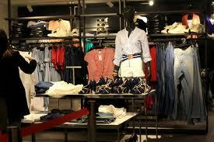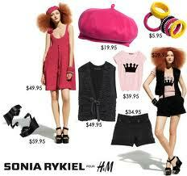

- 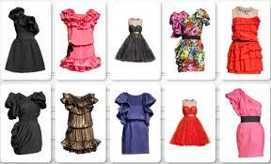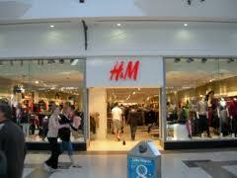

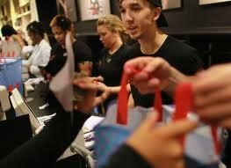

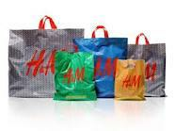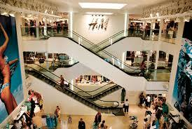

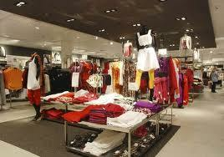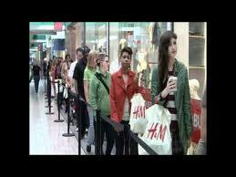

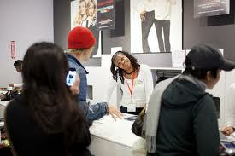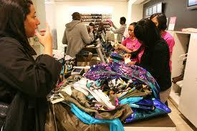

Watch the following video and answer the following question: http://www.youtube.com/watch?v=SdaYkZR4gq4

What is the price of the cardigan (πλεκτή ζακέτα)?
- E 29.90 (1)
- E 19.90 (2)
- E 23.90 (3)
Imagine that the store H&M that you have just seen is a person! Evaluate this person with the following attributes: 1: not at all descriptive 2: extremely descriptive
 | 1 (1) | 2 (2) | 3 (3) | 4 (4) | 5 (5)
Welcoming (φιλόξενο) (1)
Enthusiastic (ενθουσιώδες) (2)
Lively (ζωηρό) (3)
Dynamic (δυναμικό) (4)
1: not at all descriptive 2: extremely descriptive
 | 1 (1) | 2 (2) | 3 (3) | 4 (4) | 5 (5)
Chic (κομψό-σικ) (1)
High Class (υψηλής κατηγορίας) (2)
Elegant (καλαίσθητο) (3)
Stylish (μοντέρνο) (4)
1: not at all descriptive 2: extremely descriptive
 | 1 (1) | 2 (2) | 3 (3) | 4 (4) | 5 (5)
Annoying (ενοχλητικό) (1)
Irritating (εκνευριστικό) (2)
Loud (θορυβώδες) (3)
Superficial (επιπόλαιο) (4)
1: not at all descriptive 2: extremely descriptive
 | 1 (1) | 2 (2) | 3 (3) | 4 (4) | 5 (5)
Honest (τίμιο) (1)
Sincere (ειλικρινές) (2)
Reliable (αξιόπιστο) (3)
True (αληθινό) (4)
1: not at all descriptive 2: extremely descriptive
 | 1 (1) | 2 (2) | 3 (3) | 4 (4) | 5 (5)
Hardy (σκληραγωγημένο) (1)
Solid (σταθερό-ατόφιο) (2)
Reputable (ευυπόληπτο) (3)
Thriving (ακμάζων) (4)
Compared to other stores of similar products, do you think that this store is :
- High-Priced (1)
- Average-Priced (2)
- Low-Priced (3)
Did you notice any smell in the ambient atmosphere?
- Yes (1)
- No (2)
Sex:
- Male (1)
- Female (2)
Age:
- 18-30 (1)
- 30-40 (2)
- 40-50 (3)
- >50 (4)
Education:
- Basic Education (1)
- Secondary Education (2)
- Academic Education (3)
Income:
- 0-1000 (1)
- 1000-2000 (2)
- 2000-3000 (3)
- >3000 (4)

Store Personality- Prada

Dear participant,

This questionnaire has to do with the evaluation of a Prada store. You will see some pictures of the store and then you will rate some of its attributes. All this process will take no more than 5 min. Your answer will remain anonymous. In the end of the experiment you will have the chance to win a 20 euros Gift Card for Public Stores (www.public.gr) so please fill in your email address if you wish to take part in the lottery:

Have you ever been in a Prada Store?

- Yes (1)
- No (2)
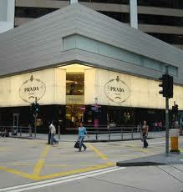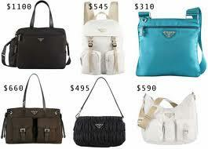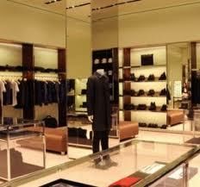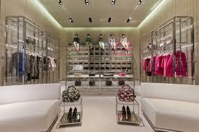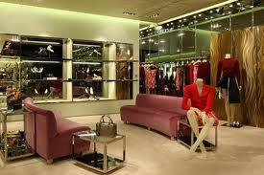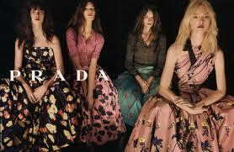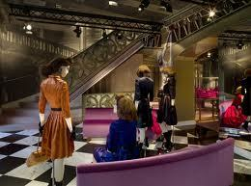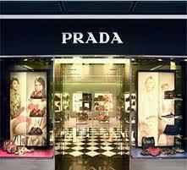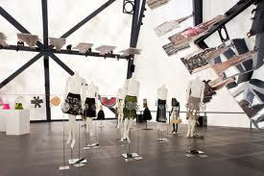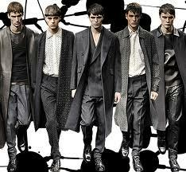
Watch the following video and then answer the question:
http://www.youtube.com/watch?v=nm0oYjZi9Hs

What is not shown in the video?

- Men Clothes (1)
- Women Shoes (2)
- Women shirt (3)
Imagine that the store Prada that you have just seen is a person! Evaluate this person with the following attributes: 1: not at all descriptive 2: extremely descriptive
 | 1 (1) | 2 (2) | 3 (3) | 4 (4) | 5 (5)
Welcoming (φιλόξενο) (1)
Enthusiastic (ενθουσιώδες) (2)
Lively (ζωηρό) (3)
Dynamic (δυναμικό) (4)
1: not at all descriptive 2: extremely descriptive
 | 1 (1) | 2 (2) | 3 (3) | 4 (4) | 5 (5)
Chic (σικ-κομψό) (1)
High Class (υψηλής κατηγορίας) (2)
Elegant (καλαίσθητο) (3)
Stylish (μοντέρνο) (4)
1: not at all descriptive 2: extremely descriptive
 | 1 (1) | 2 (2) | 3 (3) | 4 (4) | 5 (5)
Annoying (ενοχλητικό) (1)
Irritating (εκνευριστικό) (2)
Loud (θορυβώδες) (3)
Superficial (επιπόλαιο) (4)
1: not at all descriptive 2: extremely descriptive
 | 1 (1) | 2 (2) | 3 (3) | 4 (4) | 5 (5)
Honest (τίμιο) (1)
Sincere (ειλικρινές) (2)
Reliable (αξιόπιστο) (3)
True (αληθινό) (4)
1: not at all descriptive 2: extremely descriptive
 | 1 (1) | 2 (2) | 3 (3) | 4 (4) | 5 (5)
Hardy (σκληραγωγημένο) (1)
Solid (σταθερό-ατόφιο) (2)
Reputable (ευυπόληπτο) (3)
Thriving (ακμάζων) (4)

Compared to other stores of similar products, do you think that this store is :
- High-Priced (1)
- Average-Priced (2)
- Low-Priced (3)
Did you notice any smell in the ambient atmosphere?
- Yes (1)
- No (2)
Sex:
- Male (1)
- Female (2)
Age:
- 18-30 (1)
- 30-40 (2)
- 40-50 (3)
- >50 (4)
Education:
- Basic Education (1)
- Secondary Education (2)
- Academic Education (3)
Income:
- 0-1000 (1)
- 1000-2000 (2)
- 2000-3000 (3)
- >3000 (4)

Photos from the experiments
The store (inside and outside), the gifts for the participants, the researcher

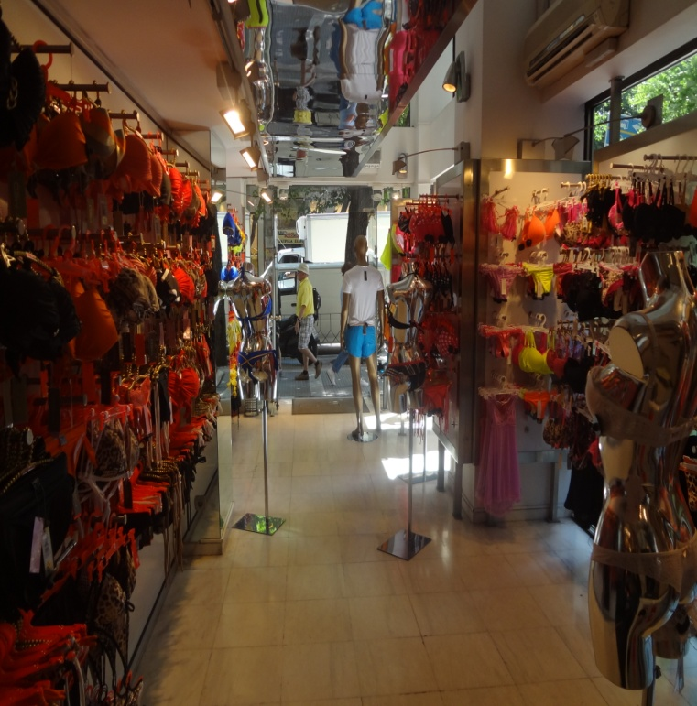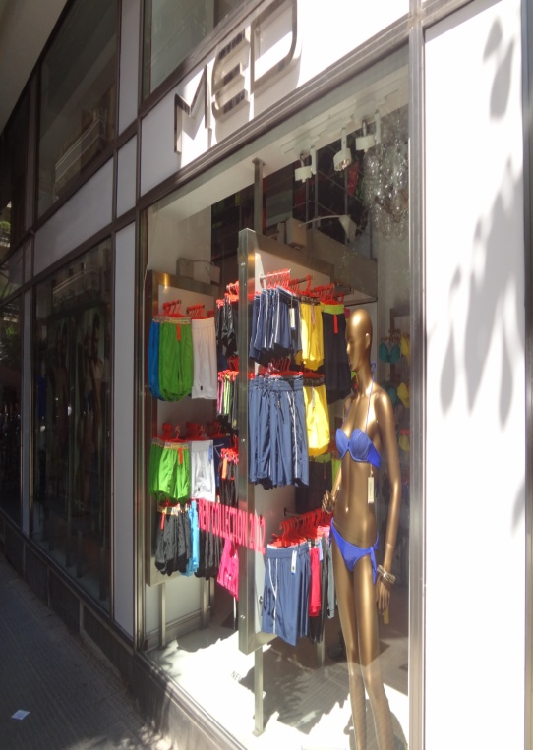
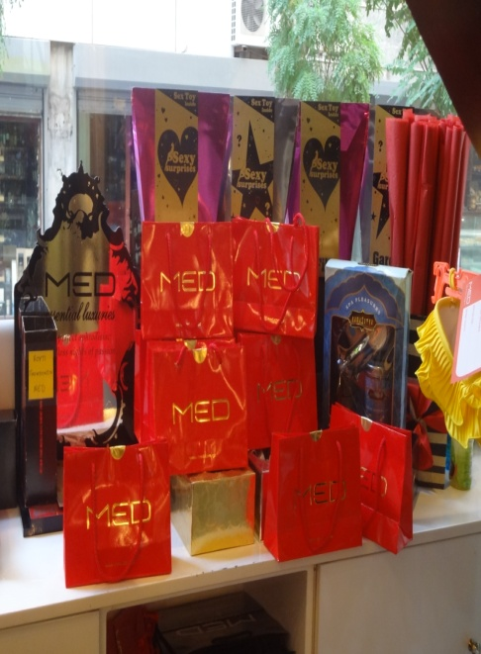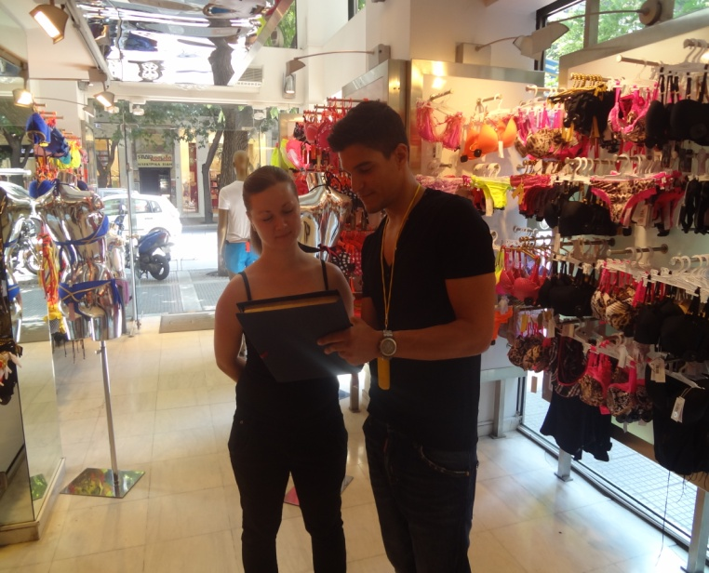

SPSS Tables

Real World Experiment

Table 1:
Reliability Analysis Results

Reliability Statistics
Cronbach's Alpha | N of Items
,509 | 5

Item-Total Statistics
 | Scale Mean if Item Deleted | Scale Variance if Item Deleted | Corrected Item-Total Correlation | Cronbach's Alpha if Item Deleted
ENTHUSIASM | 11,7804 | 1,407 | ,527 | ,279
SOPHISTICATION | 12,0000 | 1,157 | ,485 | ,275
UNPLEASANTNESS | 14,4478 | 2,224 | ,022 | ,562
GENUINENESS | 11,8783 | 1,613 | ,216 | ,508
SOLIDITY | 12,1283 | 2,057 | ,162 | ,513

Table 3 and 4:
Demographics of MED data

Table 3-Control Sample of MED
Buy Or  Not |  | Euro  Spent |  | Gender |  | Education |  | Age |  | Income
(in thou-
sands)
Yes | 11.7% | 19.90 | 1 | Male | 3.3% | Basic | 0% | 18-30 | 53.3% | 0-1 | 100%
 |  | 24.00 | 1
 |  | 25.00 | 1
No | 88.3% | 29.90 | 1 | Female | 96.7% | Secondary | 13.3% | 30-40 | 43.3% | 1-2 | 0%
 |  | 34.00 | 1
 |  | 39.90 | 1
 |  | 79.90 | 1 |  |  | Academic | 86.7% | 40-50 | 3.3% | 2-3 | 0%
Sample of 60 responses |  |  |  |  |  |  |  |  |  | >3 | 0%

Table 4-Experiment Sample of MED
Buy Or  Not |  | Euro  Spent |  | Gender |  | Education |  | Age |  | Income
(in thou-
sands)
Yes | 7.3% | 23.00 | 1 | Male | 5.5% | Basic | 1.8% | 18-30 | 70.9% | 0-1 | 87.3%
 |  | 39.90 | 1
 |  | 49.90 | 1
No | 92.7% | 60.00 | 1 | Female | 94.5% | Secondary | 12.7% | 30-40 | 27.3% | 1-2 | 12.7%
 |  |  |  |  |  | Academic | 85.5% | 40-50 | 1.8% | 2-3 | 0%
Sample of 55 responses |  |  |  |  |  |  |  |  |  | >3 | 0%

Table 5:
Independent t-tests for comparing MED ‘s Brand Personality in a non-scented and in a scented environment. Group Statistics follow.

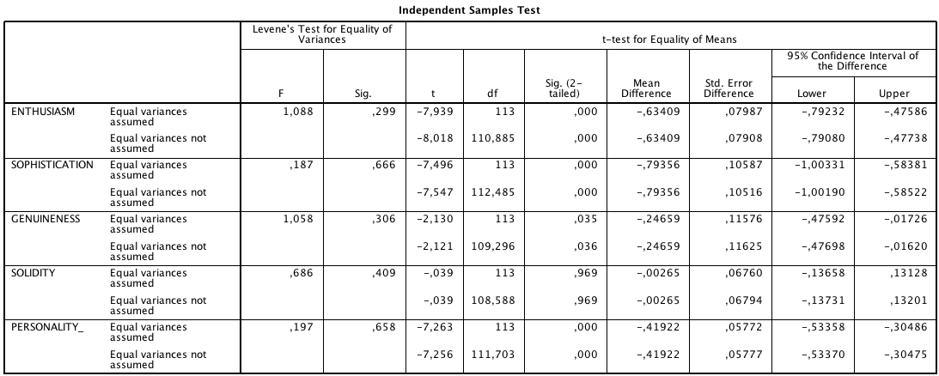

Group Statistics
 | SCENT | N | Mean | Std. Deviation | Std. Error Mean
ENTHUSIASM | No | 60 | 3,4750 | ,47098 | ,06080
ENTHUSIASM | Yes | 55 | 4,1091 | ,37504 | ,05057
SOPHISTICATION | No | 60 | 3,1792 | ,60732 | ,07840
SOPHISTICATION | Yes | 55 | 3,9727 | ,51969 | ,07007
GENUINENESS | No | 60 | 3,5625 | ,59058 | ,07624
GENUINENESS | Yes | 55 | 3,8091 | ,65079 | ,08775
SOLIDITY | No | 60 | 3,4292 | ,34164 | ,04411
SOLIDITY | Yes | 55 | 3,4318 | ,38326 | ,05168
PERSONALITY_ | No | 60 | 3,4115 | ,30625 | ,03954
PERSONALITY_ | Yes | 55 | 3,8307 | ,31242 | ,04213

Laboratory Experiment

Table 8:
Reliability Analysis Results

Reliability Statistics
Cronbach's Alpha | Cronbach's Alpha Based on Standardized Items | N of Items
,437 | ,456 | 5

Item-Total Statistics
 | Scale Mean if Item Deleted | Scale Variance if Item Deleted | Corrected Item-Total Correlation | Squared Multiple Correlation | Cronbach's Alpha if Item Deleted
ENTHUSIASM | 11,8681 | 2,342 | ,355 | ,277 | ,290
SOPHISTICATION | 12,2106 | 2,391 | ,323 | ,215 | ,314
UNPLEASANTNESS | 13,7677 | 2,918 | -,006 | ,062 | ,560
GENUINENESS | 12,2402 | 2,479 | ,274 | ,134 | ,350
SOLIDITY | 12,5118 | 2,487 | ,254 | ,088 | ,364

Table 10,11,12,13:

Table 10-Control Sample of H&M
Past  Experience |  | Commercial  Check |  | Price  Image |  | Gender |  | Education |  | Age |  | Income
(in thou-
sands)
Yes | 100% | Right | 93.3% | Low | 93.3% | Male | 56.7% | Basic | 0% | 18-30 | 86.7% | 0-1 | 63.3%
No | 0% | Wrong | 6.7% | Average | 6.7% | Female | 43.3% | Secondary | 10% | 30-40 | 6.7% | 1-2 | 20%
 |  |  |  | High | 0% |  |  | Academic | 90% | 40-50 | 6.7% | 2-3 | 10%
Sample of 30 responses |  |  |  |  |  |  |  |  |  |  |  | >3 | 6.7%

Table 11-Control Sample of Prada
Past  Experience |  | Commercial  Check |  | Price  Image |  | Gender |  | Education |  | Age |  | Income
(in thou-
sands)
Yes | 31.3% | Right | 93.8% | Low | 0% | Male | 62.5% | Basic | 0% | 18-30 | 84.4% | 0-1 | 65.6%
No | 68.8% | Wrong | 6.2% | Average | 9.4% | Female | 37.5% | Secondary | 6.3% | 30-40 | 15.6% | 1-2 | 15.6%
 |  |  |  | High | 90.6% |  |  | Academic | 93.8% | 40-50 | 0% | 2-3 | 15.6%
Sample of 32 responses |  |  |  |  |  |  |  |  |  |  |  | >3 | 3.1%
Table 12-Experiment Sample of H&M
Past  Experience |  | Commercial  Check |  | Price  Image |  | Gender |  | Education |  | Age |  | Income
(in thou-
sands)
Yes | 100% | Right | 100% | Low | 80.6% | Male | 48.4% | Basic | 0% | 18-30 | 77.4% | 0-1 | 71%
No | 0% | Wrong | 0% | Average | 16.1% | Female | 51.6% | Secondary | 6.5% | 30-40 | 19.4% | 1-2 | 29%
 |  |  |  | High | 3.2% |  |  | Academic | 93.5% | 40-50 | 3.2% | 2-3 | 0%
Sample of 31 responses |  |  |  |  |  |  |  |  |  |  |  | >3 | 0%

Table 13-Experiment Sample of Prada
Past  Experience |  | Commercial  Check |  | Price  Image |  | Gender |  | Education |  | Age |  | Income
(in thou-
sands)
Yes | 20.6% | Right | 97.1% | Low | 0% | Male | 44.1% | Basic | 0% | 18-30 | 85.3% | 0-1 | 67.6%
No | 79.4% | Wrong | 2.9% | Average | 0% | Female | 55.9% | Secondary | 5.9% | 30-40 | 14.7% | 1-2 | 23.5%
 |  |  |  | High | 100% |  |  | Academic | 94.1% | 40-50 | 0% | 2-3 | 5.9%
Sample of 34 responses |  |  |  |  |  |  |  |  |  |  |  | >3 | 2.9%

Table 14:
H&M Personality Independent t-tests in a scented and non-scented laboratory. Group Statistics follow.
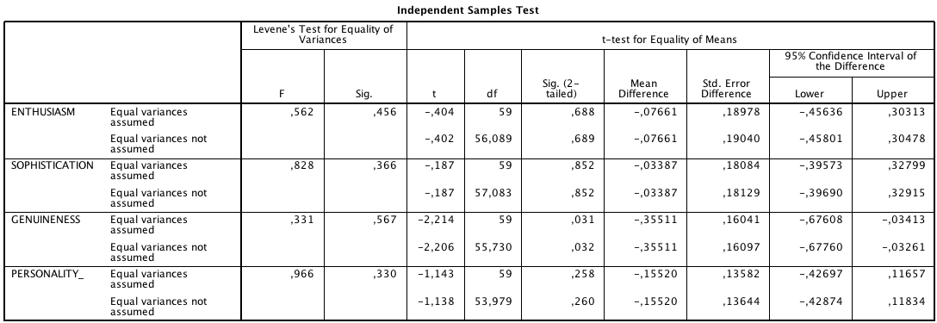
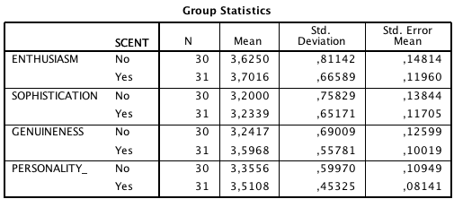

Table 15:
Prada Personality Independent t-tests in a scented and non-scented laboratory. Group Statistics follow.

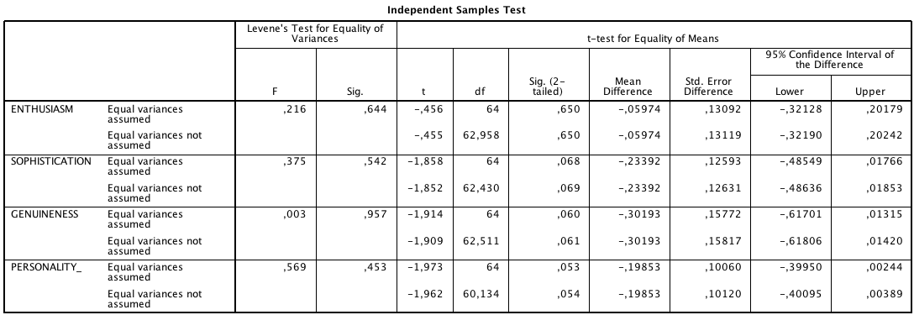

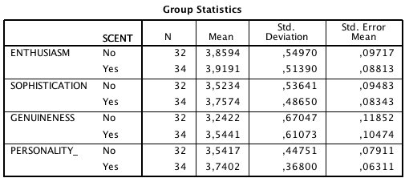

Table 17:
Personality Independent t-tests between H&M and Prada. Group Statistics follow.

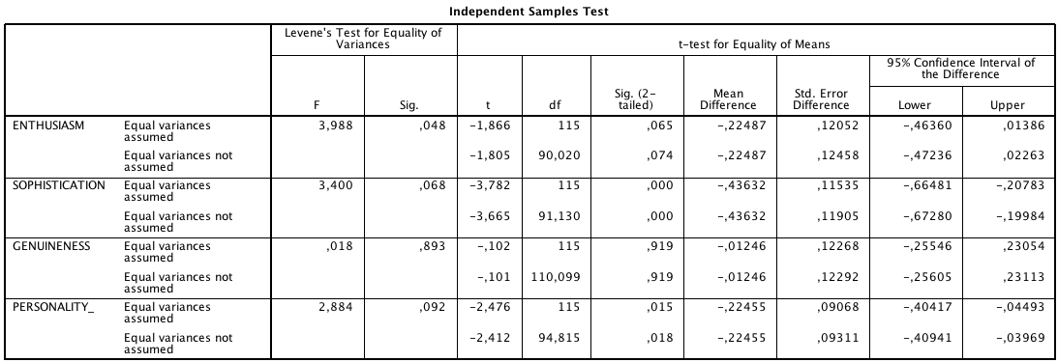

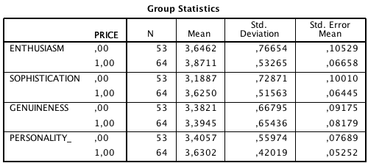

Inoffensive is the scent that is not unpleasant for the majority of people; neutral or pleasant (Spangenberg et al., 1996)
citrus scent here is considered light and pleasing
The Big Five Model describes human personalities categorizing adjectives in five dimensions, namely Extroversion, Agreeableness, Conscientiousness, Emotional Stability, Openness .

