3-in-1 Project in Westland
A cost-benefit analysis

By: Tim van Kester (331724)
Supervisor: Peran van Reeven
Erasmus University Rotterdam
Bachelor thesis Urban, Port and Transport Economics
August 2012
___________________________________________

The Westland region has one main driver of its economy: Horticulture. The export of flowers and plants requires a lot of truck transport. Together with commuting and other transport, roads around the area become congested. Congested infrastructure is one of the big threats for the region. The municipalities of Westland and Rotterdam and the province of Zuid-Holland decided to update the local infrastructure. This report will evaluate whether this project has a positive effect on the society in Westland on the long term.

Preface
The following report is written to finish the bachelor programma at the Erasmus University in Rotterdam. During this bachelor programme, I made the decision to follow the direction of Urban, Port and Transport economics. I chose to write this report about the 3-in-1 project, because it has a connection with the direction I’m heading in economics and the place where I grew up. This was a good chance to bring what I learned the past three years a bit closer to home.
I want to thank Peran van Reeven for being my supervisor during the writing of this report. To actually start writing a report can be considered as the hardest part of the whole process and he helped me with really starting it.

Honselersdijk, July 2012

Tim van Kester

Table of Contents
Preface 2
Executive summary 4
Introduction 6
Chapter 1: Accessibility in Westland 8
1.1: Introduction 8
1.2: The case 8
1.3: The three different projects 11
1.3.1: Extended Veilingroute 11
1.3.2: Second access road Hoek van Holland Problems with the current situation 13
1.3.3: Reorganization of Westerlee - Maasdijk connection 14
1.4: Conclusion 16
Chapter 2: Discussion of theories 17
2.1: Introduction 17
2.2: Conditions for economic growth 17
2.3: Cost-benefit analysis and Multi-criteria analysis 18
2.4: Overview Effects Infrastructure (OEI) 19
2.4.1: Introduction to OEI 19
2.4.2: Components of OEI 19
2.4.3: Different types of effects 21
Chapter 3: Application of theory on Westland-case 25
3.1: Introduction 25
3.2: Does the region meet the conditions for economic growth? 25
3.3.1: Direct costs 26
3.3.2: Travel time profit and excise tax 29
3.3.3: Total direct Effects 31
3.4: External effects 32
3.4.1: Noise pollution 32
3.4.2: Air pollution 33
3.4.3: Safety 35
3.5: Indirect effects 36
3.6: Conclusion 37
Conclusion 39
Reference list 40
Appendix 44

Executive summary
For a region that relies on the export of its products, a good accessibility is crucial. The same counts for Westland, a region famous for its horticulture. Bottlenecks in the infrastructure affect the area’s accessibility. For this reason, a project is started to improve the local infrastructure. This project is called the ‘3-in-1 project’. The main question for this report is based on this project, namely: ‘Is the 3-in-1 project beneficial for the society over the long term?’. This report offers a cost-benefit analysis to see whether the project will increase the economy of Westland or not.
The answer on the research question is based on the results of a cost-benefit analysis, a method to determine whether a project will be worth the investment. Before this method will be executed, the case is discussed. What are the main problems of the current infrastructural network? What are the suggested solutions? After that, the framework of the cost-benefit analysis is shown. This includes the several effects that show up with infrastructure projects, but also reasons for overestimations of the outcomes in general.
The 3-in-1 project aims at improving infrastructure in Westland. Westland is a region that creates a large part of its wealth with horticulture, the cultivation of plants and flowers on a large scale. These plants are auctioned on Flora Holland, which also creates big parts of the traffic that go through the bottlenecks. Also, traffic going to and coming from Hoek van Holland, which belongs to the municipality of Rotterdam, makes use of the same infrastructural bottlenecks.
Three projects were formed to reduce the pressure on some of the highly congested roads. New roads will be constructed (Extended Veilingroute, for example, an extension of the original Veilingroute that supports Flora Holland), junctions will be reconstructed (Westerlee, where many large traffic flows cross) and some existing roads will be made safer.
Not all projects are accepted by everybody. Some are afraid that the new infrastructure will be outdated too soon, leading to new traffic jams. Others were afraid that their village would be separated from the rest of Westland. None of the critiques lead to changes.
Before analysing the project with the cost-benefit analysis, the region and project have to meet certain conditions (Banister and Berechman, 2001). These include economic, investment and political conditions. Because infrastructure only facilitates economic growth, the economic situation must be healthy enough to make the investment useful. The 3-in-1 project seems to meet these conditions for the larger part. Only the investment conditions are difficult, because of the recent Euro crisis.
The type of cost-benefit analysis in this report follows a guideline made by the Dutch government called OEI. It aims at lowering the number of mistakes made in earlier analyses, painfully made clear by Flyvbjerg in several of his researches. Costs tend to be underestimated, because many project leaders are overconfident.
The effects discussed in OEI contain direct effects (effects on the user and initiator of the project), external effects (effects on nature and third parties like local residents) and indirect effects (effects on employment, foreign firms). These effects are determined for at least two scenarios: One in where the project will be executed and one in where a different or no project is executed.
Then, the analysis on the 3-in-1 project is made. A time horizon of ten years is used, because it’s possible that new projects will be formed in the coming years, for example to improve capacity on the original Veilingroute.
Travel time profit is a large benefit for the project. It compensates for the several factors. Safety and noise pollution are the two strongest external effects that influence the outcome. Especially safety has a large potential effect, but this effect is quite uncertain. Overall, the results are positive. There is a chance that the project will not be beneficial for the society over the first ten years, but the chance that the outcome is positive seems to be at least as large.
It is therefore concluded that the decision to start the project has been a good, or at least defendable, decision.

Introduction
A good accessibility is crucial for a well-functioning economic area. In these times, where transport of goods brings low costs, the velocity of transport is of great importance. This is an issue for the Westland region, a region in the most economically active part of the Netherlands, the Randstad (CBS, 2008). A region that relies on the export of flowers and vegetables. Congestion at the important Westerlee junction and on the Maasdijk have affected the accessibility of the Westland region, even after the opening of the ‘Veilingroute’ (N222), an access road for the important ‘Flora Holland’ flower auction house, in 1998.
Because accessibility can have such an impact on economic strength of a region, the municipality of Westland and the Zuid-Holland province decided to improve infrastructure on the critical points. This is the so-called ‘3-in-1 project’. This report investigates whether this project is the right way to solve the accessibility problems of the region.
Several types of changing infrastructure are possible to improve the accessibility to an area. The already present roads can be modernized, expanded with more driving lanes or have different restrictions in terms of , e.g., speed or overtake rules. Junctions can be restructured. There is also the possibility of adding completely new roads to the network.
The designers of the new infrastructural network chose not to just expand the capacity of existing roads, but to construct new roads and connections. The plans lead to questions from e.g. people involved with Flora Holland about the long term capacity. Will the new roads and junctions be able to handle traffic growth? Shouldn’t there be a larger budget? Shouldn’t the existing roads also be expanded?
Also resident groups gave their critique about the plans. Why reconstruct a junction for the third time? This report will discuss the thought behind the project, why the planners think these components are the best way to support the economic activities of the region.
Before the theories are explained, the case where the report is based on, the 3-in-1 project, will be explained. Here, the economic status of Westland will be shown. It will explain why an improvement of the infrastructural network is essential for the region. All three projects will be explained.
The next part is based on theories concerning infrastructure projects. Systems to evaluate (infrastructural) projects will be elaborated. This will contain background information about cost-benefit analyses and OEI-systematics (Overview Effects Infrastructure) specifically.
The third part is where the first two pieces come together. The OEI-systematics will be used to analyse the 3-in-1 project. Several effects, mentioned by the OEI report, will be discussed and determined.
At last, a conclusion will be drawn. It will show whether the project has a positive effect or not, and if some of the effects have the possibility to deviate strongly from the calculated values. After this discussion, it will be said whether the decision to start the project was right or not.
The problem statement for the report is defined as follows: Is the 3-in-1 project beneficial for the society over the long term?
To help answering this research question, three parts are formed. These three parts are:
1. Accessibility in Westland.
2. Discussion of theories.
3. Application of theory on Westland-case.
These three chapters will be used to answer the research question in the conclusion.
Chapter 1 will be mainly based on zoning plans made public by the (local) involved governments. These tell about the problems of the current infrastructure and the new plans. The second chapter contains information from the OEI guideline (OEEI, 2000), research about over-and underestimation of benefits and costs (Flyvbjerg) and about conditions that have to be met to facilitate economic growth (Banister and Berechman, 2001). Chapter 3 will be based for a large part on the same information sources as the first two chapters plus information by, e.g., CBS (Statistics Netherlands).

Chapter 1: Accessibility in Westland
1.1: Introduction
In this part, the case of the ‘3-in-1 project’ will be described. Before explaining the different parts of this project, the problems leading to these infrastructural improvements will be elaborated. After that, the main points of each project will be named, followed by the critiques and difficulties some projects experienced. In the end, a short conclusion will be drawn.
1.2: The case
The case that will be described, is the 3-in-1 project in the Westland municipality. Before forming a municipality in 2004, it was just the name of a region. This region lies in the western part of the Zuid-Holland province in the Netherlands. It is situated in between the Den Haag (The Hague) region and the Rotterdam region.
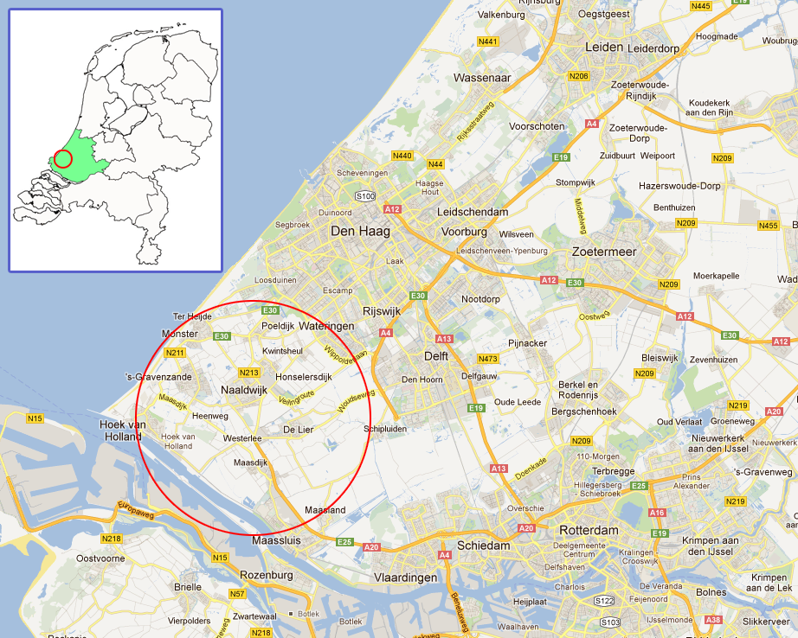
Figure 1: The location of the Westland region (source: Google Maps).
The region is well-known for its horticulture, a form of agriculture where greenhouses are used to create an ideal climate for plants, fruits and vegetables. In Westland, more than 50% of the gross added value is attributed to this sector. An important part in this, is the distribution of the products. This is mainly facilitated by large auction houses. Horticulturists bring their products to these auction houses, from where they are distributed to the buyers. In 2010, the flower auction house ‘Flora Holland Naaldwijk’ achieved a turnover of €796 million. This is a decrease compared to 2007 (€895 million), mainly due to the crisis of 2007. It is also a rise compared to 2009 (€771 million), showing a slight recovery from the crisis (Flora Holland, 2009/2011).
This turnover growth also brings problems which the municipality of Westland and the Zuid-Holland province need to solve. A decreasing turnover doesn’t necessarily mean that the number of trucks visiting Flora Holland also decreases. Many prices fell due to increasing competition and thus high supply (Flora Holland, 2011)(Vakblad voor de Bloemisterij, 2009). Infrastructure needs to be reliable and have a sufficient capacity to handle the increasing traffic to and from Westland. Because the closest railway connection to Westland is at Maassluis (in figure 1, right below the red circle), mainly trucks visit the region. For this reason, road infrastructure has to handle almost all transport to Westland.
For Westland, two main ports need to be accessible: Schiphol Airport in Amsterdam and the Port of Rotterdam. Schiphol is very close to Flora Holland Aalsmeer, one of the four other Flora Holland auction centres in the Netherlands. This location has a relatively short connection via the original Veilingroute, a road running from Flora Holland to Wateringen, which is well connected to the A4. The other main port, the Port of Rotterdam, is closer to Westland, but shows more accessibility problems. The route from Flora Holland Naaldwijk, over the Burgemeester Elsenweg, through Westerlee, to Rotterdam has serious congestion problems. Especially the junction at Westerlee is a bottleneck. This is not only caused by trucks driving to and from the auction house, but also due to commuting. Experts expect an increase in traffic that uses this junction, leading to a completely congested access road of the region in short term (Gemeente Westland, 2011).
Another infrastructural problem in the Westland region is the Maasdijk (N220), the road that connects Hoek van Holland to Rotterdam. Hoek van Holland is part of the municipality of Rotterdam and lies in the south-west corner of the Zuid-Holland province. It contains a ferry connection to England, which is used for passenger and freight transport. In the summer, it’s also a popular place for tourists. A large part of the traffic to and from this location uses the N220.
Some problems with this road are:
- The low capacity, because there is only one lane per direction.
- The safety. Because the road is constructed on a dike, the outer edges of the road are sloped. They also do not contain guard rails.
- Heenweg and Maasdijk, two villages in very close proximity to the road, experience negative effects due to high quantity of trucks driving on the Maasdijk road.
All these problems led to the following three projects (in short):
1. ‘Extended Veilingroute’. A connection between the original Veilingroute (running between Naaldwijk and Wateringen) and the Burgemeester Elsenweg in Naaldwijk. The new P. Struijkweg will also connect the Galgeweg with the Burg. Elsenweg.
2. ‘Second access road Hoek van Holland’. A new road that first runs along the water, then bends of in the direction of a new junction near the Maasdijk village. Already completed and open for traffic since April 2011, but the connection with the Maasdijk is temporary until the reorganization between Westerlee and Maasdijk (next project) is done.
3. ‘Reorganization of Westerlee - Maasdijk connection’. The intersection at Westerlee will be reconstructed (in figure: middle section, right crossing). Also, to the west of this point, a new intersection and a new connection will be shaped.
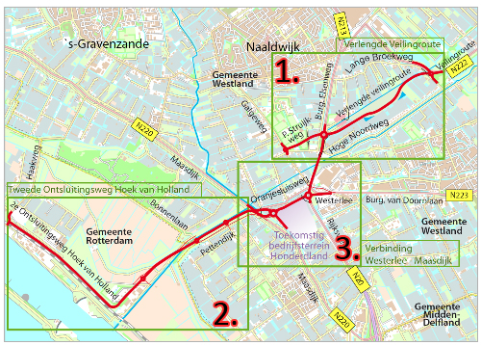
Figure 2: The three parts of the 3-in-1 project (Kamer van Koophandel, 2012).
On September 7th, 2011, the 3-in-1 project officially started. In 2013, the project is expected to be finished. Next, the future plans for each project will be discussed.

1.3: The three different projects

1.3.1: Extended Veilingroute
Problems with the initial situation
Flora Holland, the flower auction house in Naaldwijk, is the main reason for many trucks to enter Westland. This has led to a large increase of traffic in the area. Accessibility suffered from this development.
The first time these accessibility problems were combated, was with the Veilingroute in 1998 (visible in figure 3 below). It functioned as an important road to and from Flora Holland Naaldwijk (in figure 3: above the pink circle). It connects Westland with regions like Den Haag (The Hague) and Amsterdam, both situated northeast of Westland. The capacity increased, even though it only offered one driving lane per direction. A big advantage was that small villages would suffer less from large flows of trucks, increasing the quality of life.
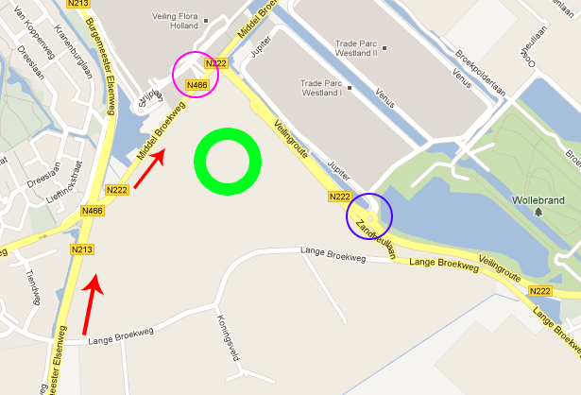
Figure 3: Initial route for trucks from the south (Rotterdam region) (source: Google Maps).
However, capacity seemed to be too small after just a few years. Congestion returned, partially due to expansion of the surface of Flora Holland south-eastwards (in figure 3 above: the two grey areas above the blue circle). It attracted more business and thus more trucks to the area. In 2012, Flora Holland acquired new ground to expand even further (in figure 3: green circle).
This expansion has a good connection with the original Veilingroute. Trucks don’t have to take a lot of turns to enter the expansion at the blue circle or the main part of Flora Holland at the pink circle.
Trucks coming from the Rotterdam-region generally follow the route shown in the figure above. Before the reach the first red arrow, traffic already passed the busy Westerlee-junction. After that, they come at the junction between the two arrows, which is congested at peak hours. This junction handles trucks, but also commuting traffic and other traffic that just stays inside the borders of Westland. From here, the busy Middel Broekweg (N466) is the latest problem. This last part of the whole route delays the trip too much. Traffic needs to be distributed better to make the traffic flows more fluently.
The new plans
The project will connect the Burgemeester Elsenweg (N213) and original Veilingroute (N222) with each other (see figure 4). Goal is to divide traffic in two groups. Traffic heading to the expansions of Flora Holland has a shorter trip with the new road, called Extended Veilingroute (EVR). Traffic going to the main part of Flora Holland will choose between the old and new route. This way, all traffic is distributed more efficiently. The connection at the Veilingroute will be a roundabout, also making a connection with the ‘Kasteelweg’ (south of Veilingroute). Here, also a bicycle tunnel will be constructed.
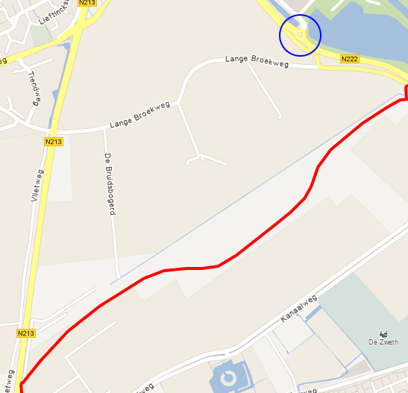
Figure 4: New Extended Veilingroute (red line) (source: Google Maps).
At N213, running west of the EVR, another roundabout will be built to connect the Extended Veilingroute with this N213. This one will be called ‘Vlietpolderplein’. On the other side of this roundabout, another new road will be constructed. This road, the Piet Struijkweg, will connect the N213 with the Galgeweg. Because this road will cross a recreational area (sports fields) and greenhouses, relocation of the sports fields is required.
Critical response
There is also some negative response to this project. The problem of crossing the N466 won’t be solved completely (Algemeen Dagblad, 2008). When trucks avoid this busy junction, the congested Burg. Elsenweg is the only option left to leave Westland.
Experts also estimated a yearly traffic growth of 1,5% on the Veilingroute. With this increase in traffic, the extension of the Veilingroute westwards won’t raise capacity enough for the long term. Expanding the original Veilingroute would be a possibility to increase capacity, but because this route is not the most important reason for the congestion at Westerlee, it wouldn’t solve all problems.

1.3.2: Second access road Hoek van Holland
Problems with the current situation
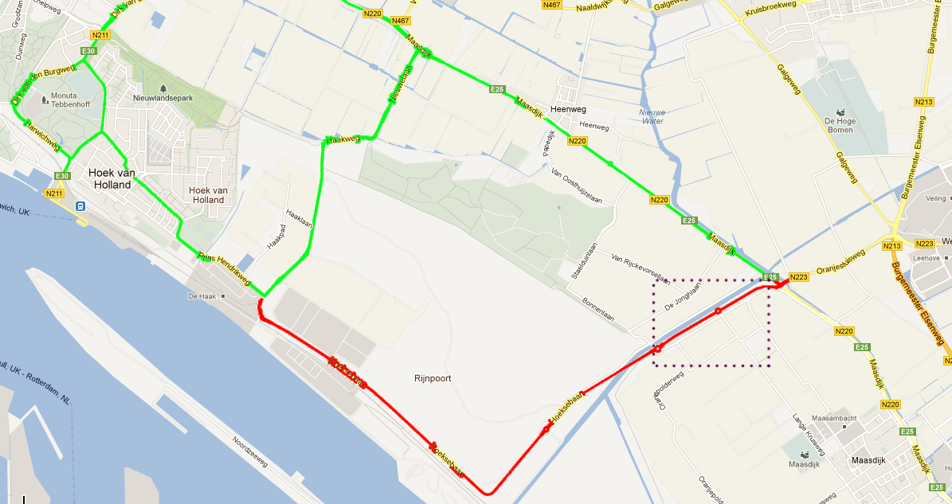
Figure 5: Already present (green) and new (red) roads around Hoek van Holland (source: Google Maps).
In the figure above, the green routes are the roads which were already present, while the red lines are the new project. All green roads around Hoek van Holland that lead to the south (where the Rotterdam-region is located), connect with the Maasdijk. This Maasdijk is congested and dangerous, especially on summer days when many tourists (60.000 visitors on good days) visit Hoek van Holland. Because the Maasdijk handles a lot of economical traffic for Westland, reduction of the pressure is needed. Traffic to and from the Stenaline terminal in Hoek van Holland also demands a smooth flow of transport.

The new plans
The red route on the figure above shows the project. It is a completely new road, not a replacement or expansion. ‘Hoeksebaan’ will be the name of this road with one driving lane per direction. There haven’t been any roads in this location that could handle even a small capacity of traffic, so it almost doubles the traffic capacity to and from Hoek van Holland.
The road will connect to a new junction, which is also part of the 3-in-1 project. This project will be discussed later on. It will bring the Hoeksebaan together with the Maasdijk (N220) and is close to the Westerlee junction.
A possibility for reaching more efficient traffic flows from and to Hoek van Holland, is dividing this traffic to and from Hoek van Holland on busy days. It is also possible to let tourists use the Maasdijk and trucks the Hoeksebaan. Another way to make the traffic more dynamic is by using information panels to show people which road is currently able to handle more traffic. In this evaluation, this plan is not taken into account. This plan isn’t implemented yet and is also not officially planned.
Problems with the project
The construction of the new road finished in 2007, but the municipality of Westland wasn’t pleased about the capacity of the Pettendijk (circled in figure above). This postponed the opening of the new road. After all, the road opened in April 2011 after some adjustments close to connection with the Maasdijk.

1.3.3: Reorganization of Westerlee - Maasdijk connection
Problem of the current situation
The junction at Westerlee is one of the biggest bottlenecks for the Westland region. It handles almost all traffic between Westland and the Rotterdam region (Rotterdam, Schiedam, Vlaardingen), traffic to and from Hoek van Holland and some traffic to Delft. The two previously discussed projects (Extended Veilingroute and Second access road Hoek van Holland) will generate extra traffic flows. Because these flows will most likely make use of the Westerlee junction, a revision is necessary.
New plans
To increase the flow, a new design was made. The (economically) most important aspects of the project:
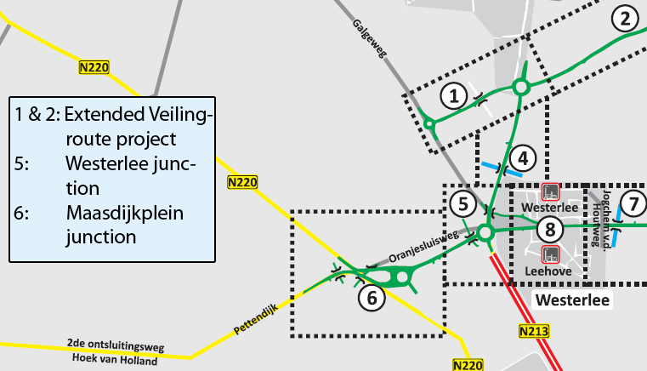
Figure 6: The Westerlee – Maasdijk connection. Points 3, 4, 7 and 8 are not visible or not included in 3-in-1 project (source: Gemeente Westland).
- Instead of a junction with traffic lights, a roundabout will be constructed at Westerlee (5).
- A new roundabout on the southwest of Westerlee, at Maasdijk, also connected to a new business park called Honderdland (6).
- Galgeweg will only be connected to the old Oranjesluisweg and the Burgemeester Elsenweg (part of the Verlengde Veilingroute-project) (1 & 5).
- Several tunnels for cyclists, e.g. to connect Galgeweg with business Honderdland.
- Several tunnels for other, slower traffic to connect roads around the Westerlee junction that are not directly connected.
Resistance against the plans
The current design was made in 2007. An interest group proposed an alternative design, but the municipal council of Westland saw no reason to change the plans. This group contained residents of the Maasdijk village, who were afraid that they would be separated from the rest of Westland.
These plans would have led to two extra construction years and millions of extra investments, while the return would not be sufficient (Westlanders.nu, 2010).
1.4: Conclusion
An improvement of the infrastructural network between Flora Holland Naaldwijk and Westerlee is necessary to keep the Westland region accessible for traffic. Because the economy of Westland depends so much on horticulture and the export of its products, and the gateways to the area are getting more and more congested, reconstruction and expansion of capacity are essential to keep Westland healthy.

Chapter 2: Discussion of theories

2.1: Introduction
In this first chapter, theories for the evaluation of the 3-in-1 project will be explained. This part will mostly contain the cost-benefit analysis form called ‘Overview Effects Infrastructure’ (OEI), which will be used in chapter three. Before discussing the type of analysis that is going to be used later on in this report, the link between transport and economic growth will be discussed briefly.

2.2: Conditions for economic growth
Banister and Berechman set a small framework of conditions a region has to match before infrastructure projects will be effective towards economic growth. Two premises are the base for these conditions.
(1) ‘In developed countries - where there is already a high-quality transport infrastructure – further investments in that infrastructure will not on its own generate economic growth.’ ;
(2) ‘Transport infrastructure investments act as a complement to other more important underlying conditions, which must also be met if further economic development is to take place.’ (Banister and Berechman, 2001). This basically means that new infrastructure in developed countries (like the Netherlands) only has influence on the regional or national economic growth when several conditions are met, because infrastructure only facilitates economic activity.
The following necessary conditions are mentioned:
- Economic conditions: This contains a high-quality labour force, dynamic labour market, agglomerations, etc.
- Investment conditions: The investment in the project itself must be of importance. How large is the project? Will it fit in the already present network? Is this the right moment to invest in a project?
- Political conditions: The political environment must not counter the infrastructural investment, but support the plans. It includes the level of governmental support (local, national, etc.), laws, taxes, etc. Like all conditions, the other conditions must be present to make growth possible.

2.3: Cost-benefit analysis and Multi-criteria analysis
To evaluate a project, in this case an infrastructure project, cost-benefit analysis (CBA) is a popular method. It is used in many different fields. The main reason for this, is that costs and benefits are relatively easy to compare. Because (almost) every aspect is expressed in monetary values, a positive or negative balance can say whether the project should go on or not (Robinson, 1993). Also, a CBA can tell what could be the risks of the project.
A disadvantage is the expressing of effects in monetary value itself. Many effects are very much linked to money, like the investment or creation of jobs. Effects on the environment, or safety, are much harder to express in money. Some of these will not always be given a price, but will be discussed on a governmental level. This will make it hard to compare.
Multi-criteria analysis (MCA) is a type of analysis where every effect is expressed in its own unit. For example, CO² emissions will not be converted to money, but will always be expressed in, e.g., CO² tonnes/m². However, comparing the effects is what makes this kind of analysis difficult.
A problem with both CBA and MCA is that costs are underestimated. In 9 out of 10 projects, costs tend to be higher than the actual planned budget. On average, actual costs are 28% higher than the forecasted costs and 20% for road infrastructure specifically (Flyvbjerg et al., 2003). Ex-ante analyses were untrustworthy in too many cases. Also benefits are overestimated in several occasions. Flyvbjerg et al. (2002) linked this to the following reasons:
- Technical reasons: Technology doesn’t always work as planned or expected. For example, drilling for the construction of a tunnel could lead to collapsing buildings, while the executors expected their equipment to be more safe. Also, data could be less accurate than expected.
- Economic and political reasons: When stakeholders or local governments need money to finance a project, they have the incentive to make the project look more interesting to invest in by lowering the expected costs and/or raising the predicted benefits. This leads to a higher benefit-to-costs ratio.
- Psychological reasons: These mainly rise when promoters of projects are too optimistic. They don’t believe they will make the same mistakes as in previous projects. Forecasters should be able to learn from these mistakes, but they apparently don’t.
For making a CBA, these are points to think about. Is there a strong reason for promoters to show lower costs, e.g. because the project takes a very long time to start and they want to speed it up? Another way to make predictions more accurate is Reference Class Forecasting, where it’s expected that current projects will perform the same as comparable projects in the last two decades (Flyvbjerg, 2008).

2.4: Overview Effects Infrastructure (OEI)

2.4.1: Introduction to OEI
A specific type of analysis for infrastructure projects is OEI, Overview Effects Infrastructure. The system is based on CBA, as effects are expressed in money instead of their initial unit of measurement. It is a guidance, resulting from a research by the Dutch Ministry of Economic Affairs and the Ministry of Infrastructure and the Environment. The goal of this project was to come up with a more transparent and more accurate way to analyse infrastructure projects.
In chapter 2.3, it was shown that many predictions concerning the costs of projects are inaccurate. Through this guideline, effects of certain projects should be more clear and be predicted more accurate.
The majority of this subchapter will be based on the main report on OEI-systematics ‘Evaluatie van grote infrastructuurprojecten; Leidraad voor kosten-baten analyse’, initiated by the Dutch Ministries of Economic Affairs and of Infrastructure and the Environment. This project is called ‘Onderzoeksprogramma Economische Effecten Infrastructuur’ and will from now be cited as (OEEI, 2000).
2.4.2: Components of OEI
OEI, but also different cost-benefit analyses, have standard components which are required to make the analysis clear and strong. Some of these aspects require some explanation to make fully understandable why they are included.
Integral and partial CBA
One of the most notable differences between Dutch analyses and that of most other countries is that a Dutch analysis requires a view on the impact on the total economy (integral CBA), while in other countries most analyses show the effects on directly involved parties or sectors. This is called a partial CBA. The partial CBA is for the largest part based on the difference between transporters doing the same as before the project, transporters changing their route after the project is finished and effects on third parties (e.g. residents). Integral CBA will also make the distinction in this second group. With this distinction, it is possible to see whether a subgroup will have a small or large indirect effect.
Zero alternative
The effects of the projects are always relative. For example, the number of trucks on a road will grow compared to a different scenario. This is not a scenario where just nothing will change, but the most plausible (and therefore the best) alternative scenario. This scenario is called the zero alternative. What this scenario is, differs for every project. In many cases, the zero alternative is the scenario where no project is executed, i.e. where the budget of the project is invested against a risk-free interest rate of (for example) 4%. Where the project has gains in the form of better traffic flows, the zero alternative has gains in the form of interest and the retaining of the budget.
For some projects, different projects are compared to each other. For example, a government that has to decide between two types of bridges will compare those two projects with each other and with a scenario where no project is executed.
The zero alternative generally has an outcome of 0. This way, it’s easy to compare the projects to this scenario. Outcomes below 0 are not likely to be executed, while outcome above 0 are beneficial.
Risks
The long term provides risks. OEI handles this in the following way. The factors that could critically influence the future (factors of success) are used to create several possible scenarios. Because it’s never sure which scenario will happen, a possible cost or benefit interval could be the outcome instead of one value. It is not correct to choose the desirable outcome, because this scenario is not always very likely to happen. However, this scenario could be used to determine an interval.
Also, projects with high risk will require a higher return on investments than lower-risk projects. This could mean that the 4% risk-free investment mentioned under ‘Zero alternative’ will be raised to a higher percentage.
An important note is that risk on a certain moment could lead to a postponing of the project, or a part of this project. Many projects deliver a capacity expansion which won’t be maximally used for a given time. Postponing (or phasing) a part of a project could lower the risk by investing the remaining budget in something else for a couple of months.

2.4.3: Different types of effects
To give the analysis a bit more structure, there is a distinction between certain types of effects. Each of these groups will be discussed in this subparagraph. The description of (possible) effects is probably the larger part of the cost-benefit analysis. These effects are classified into groups.
Direct effects and traffic forecasts
Many effects of the project are greatly influenced by the change in traffic that is achieved after completing the project. This group of effects contains direct effects. Predicting the change in traffic is basically one of the most important aspects of the analysis. To make a forecast about the future traffic flows, the behaviour of the final users must be predicted. Travellers make the consideration which place they want to travel to and thus what infrastructural network they want to use.
A great problem with these traffic forecasts is the very common overestimation of demand. For large infrastructure projects, the difference between forecast and reality is often between 20% and 60% (Skamris and Flyvbjerg, 1997).
Direct effects also contain the reaction of competitors. In most of the cases, this is a competition between two modes of transport, for example road transport and rail transport. It is important to keep in mind whether other transport companies can come up with ways to avoid the new infrastructure and use cheaper alternatives.
The decision made by transporters and travellers to choose a certain road is strongly influenced by the accessibility. This accessibility can be determined with the I/C-ratio, which is calculated by dividing the intensity of a certain road (sometimes in a certain time period) by the capacity of the same road. Ratios under 0,7 have no serious problems. Between 0,7 and 1 leads to traffic jams in certain peak hours and ratios above 1 lead to traffic jams also outside peak hours.
For the determination of the travel time profit, it is usual to apply the ‘rule of half’. New users of the road never all gain the same utility of new infrastructure. In the figure below, this is explained. The initial situation has p0 (price before project) and q0 (number of users, or quantity, before project). After execution of the project, price falls to p1, because it became easier to travel from point X to destination Y. Also, more people will use the road, which declares the increase of q0 to q1. Now, the area ‘B’ is the increase in utility for the users of the road.
Some people would decide to use roads with a price just lower than the original price (p0, q0), while other people would only change to the new roads when the price of using the road is just above their willingness to pay (p1, q1). The average price users want to pay, is exactly in the middle. Therefore, the extra utility is determined by multiplying the price change with the quantity change, multiplied by 0,5 (rule of half). Multiplying with 0,5 is the way to calculate the size of a triangle, such as shown in figure 7 with area B.
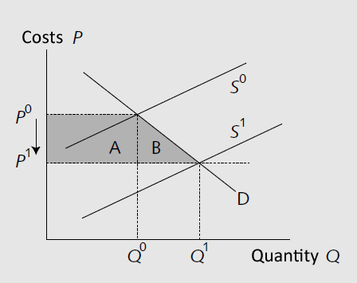
Figure 7: Visual representation of the ‘rule of half’ (OEEI, 2000).
Indirect effects
When the (dis)advantage of a project flows not only to the direct user, but also to sectors that are influenced by this user, there is an indirect effect. In other words: When something is influenced by one of the project’s direct effects, it’s an indirect effect. Indirect effects contain e.g. increasing ground prices (change in wealth), but also a changing competitive advantage to other countries and regions (redistribution).
Indirect effects can have a positive or a negative character. When a foreign company builds a factory in the new project’s country, this is a positive effect in terms of more competition and more supply of products. On the other hand, ground prices will rise.
Indirect effects are not only influencing the country where the project is situated. For example, when a distributional company takes advantage of an improved infrastructural network and this makes the company able to trade with foreign countries more, then the effect flows abroad and becomes an indirect effect. Not only is the national company better off, but maybe also the foreign countries. This could lead to interesting situations. When foreign countries come into play, the projects benefits could for a large part end up abroad.
An example of an indirect effect is employment. A more efficient infrastructural network could lead to a higher demand for products, which demands a higher production. In many cases, more labour is needed to produce and distribute these products.
Methods to determine the indirect effects are: Macro-production approach (which is not applicable for determining the effect of specific projects), surveys, case studies and models.
External effects
Effects on the environment and safety are two examples of extern effects. These are the effects which are hard to valuate in monetary terms. There is no standard formula or law that can be used to determine these costs. Because there is no market for a bad air quality or polluted water, no person who lives in close proximity to the project can exactly tell what pollution is worth to him.
There are two, well-functioning methods to determine the external effects. The first one is using a survey. Directly involved individuals are asked to complete the survey. A problem with this method is that residents are not able to make a good estimation of how much influence externalities could have on their lives. It is difficult to value noise pollution when you have no idea how much it affects your daily life. However, it directly involves third parties in the decision-making process.
Another method is using the costs of reducing externalities to a certain, pre-arranged level. Before the project starts, a maximum level of pollution is set. The amount of disturbance after the completion will be predicted. When this amount exceeds the desirable level, investments should be done to reduce it back to this maximum level.
Compensation can happen in several ways. One is subsidising families or companies to invest in, e.g., air filters or double glazing. Another way is investing in public ways to decrease externalities. This could be done with tunnels, noise barriers, etc.
Distribution of effects and benefits
The above mentioned effects all have a different effect on the society. Some have a negative effect on residents, others have a positive effect. The power of these effects is hard to determine, especially when it’s about pollution and disturbance. To provide some insight in involved groups, OEEI set the following list:
1. Users (the group that will make use of infrastructure after the project is finished)
2. Residents (people who don’t necessarily use the infrastructure, but will take disadvantage of negative externalities and advantage of positive effects)
3. Regions (because infrastructure projects may also change the accessibility of other regions and the attractiveness of settling in these regions)
4. Collaboration between private and public sector
This last group needs some more explanation. Infrastructure projects are almost always initiated by (local) governments. It is important that the final design of the project matches the demands of the private sector, which will eventually use the infrastructural network.
Overview of effects
The classification of the above mentioned effects is mainly done on the basis of five questions. Will it affect the Netherlands or a foreign country? Is there a (possible) market that makes pricing possible? Does it lead to a redistribution or will it increase national welfare (efficiency)? Is it a direct or an indirect effect? Who will benefit or pay the costs of the project?
These questions lead to the creation of table 1, giving an overview of the classification. The original version by OEEI merged the external effects with the direct effects. Here, they are separated.
Welfare  Causality |  | Netherlands |  |  |  | Foreign countries
 |  | Priced |  | Non-priced
 |  | Redistribution | Efficiency | Redistribution | Efficiency
Direct effects | Operators
Direct effects | Users
Indirect effects
External effects
Table 1: Overview on different types of effects, edited by author (Source: OEEI, 2000).

Chapter 3: Application of theory on Westland-case

3.1: Introduction
In this final part, chapters 1 and 2 will come together. The theories, explained in the first part, will be used to evaluate the ‘3-in-1 project’ which is discussed in chapter 2. First, the conditions for economic growth will be tested. Then, the costs of every project will be discussed. These costs contain the construction budget for each project. After that, every group of effects will be discussed in its own subparagraph. The 3-in-1 project consists of three smaller projects, but because they are very related to each other, the effects will be determined separately and added up together afterwards.
Some remarks about the analysis must be made beforehand. A time horizon of ten years will be used, starting in 2013 (when the project is supposed to be finished) and ending in 2022. This is a relatively short time horizon, because the effects of this project may still be visible in thirty or forty years. However, it is very plausible to think that in the next ten years, an additional infrastructural project will be planned and/or needed. For example, the Original Veilingroute opened only 14 years ago and already becomes congested.
Also, there is some difference between the results in the appendix and the results in the report. This is due to rounding, which also functions as some sort of risk factor. For this reason, most costs will be higher than in the calculations in the appendix.
3.2: Does the region meet the conditions for economic growth?
In chapter 2.2, two premises and three necessary conditions were mentioned. The region where the infrastructure project is executed needs to meet these conditions.
First, the political conditions. The municipality of Westland and Rotterdam both are initiators of the project. Assuming that they make sure every part of the project does not break any of their own laws and policies, these conditions are met.
Second, the economic conditions. These conditions require, for example, a high quality labour force. Firms like Flora Holland constantly try to be inventive and dynamic. People from the region also become highly skilled in nearby universities (TU Delft, Erasmus Rotterdam) (Van der Tak, 2010). The main driver of the local economy, the horticulture and the distribution, is agglomerated and has strong connections with main ports.
Third and last, the investment conditions. These are met a bit less convincing. The economic situation isn’t very positive at the moment the project starts (2012), due to the Euro crisis. However, the
project is aimed at some of the most important bottlenecks in the region and thus could be a very effective investment.
So, overall, the conditions are more or less met. During the crisis, it may not be the best moment to invest, but waiting any longer would only make the congestion far worse.
3.3: Direct effects
3.3.1: Direct costs
First, the monetary costs for the project will be discussed. The costs for each project are predicted in the zoning plans. Every project’s budget will be shown in a table and is discussed below.
Extended Veilingroute
Part of project | Budget (€)
Extended Veilingroute | 43,5 million
P. Struijkweg | 7,9 million
Connection Veilingroute – Kasteelweg + bicycle tunnel | 7,5 million
Total | 58,9 million
Table 2: Budgeted costs of Extended Veilingroute-project (source: Damen, 2010).
For the budget in table 2, construction of the new roundabouts is also included in the three amounts.

Second Access road Hoek van Holland
Part of project | Budget (€)
Westland | 12 million
Rotterdam | 17 million
Missed interest | 3,29 million
Total | 32,29 million
Table 3: Budgeted costs for Second Access road-project (sources: Streng et al, 2009 ; Noordtzij, 2004).
The Second Access road Hoek van Holland has two different budgets. The construction of the part that lies inside the borders of the municipality of Westland received a budget of €12 million (Streng et al., 2009). The other part, that lies in Rotterdam’s territory, got an estimated budget of €17 million (Noordtzij, 2004). The part of the Second Access road that lies in Rotterdam’s territory was ready for use in 2006 and wasn’t opened until April 2011 due to a conflict with the municipality of Westland about its capacity. This means that the investment did not give a return for 4,5 years. Because this €17 million could have been invested risk-free for 4% for 4,5 years longer, the municipality of Rotterdam missed out approx. €3,29 million of interest. These will be added up as opportunity costs. With this added up to the €29 million of the initial budget, the costs for this project are approx. €32,29 million.

Westerlee-Maasdijk connection
Part of project | Budget (€)
Total | 39,1 million
Table 4: Budgeted costs for Westerlee-Maasdijk connection-project (source: Streng et al., 2009).
The third project, the Westerlee – Maasdijk connection, did not show its budget in the zoning plans. However, the zoning plan of the ‘Second Access road Hoek van Holland’ mentions a total budget for the 3-in-1 project of €127 million. This means that the third project will have a budget of approx. 39,1 million.

Total budgeted investment costs
Part of project | Budget (€)
Extended Veilingroute | 58,9 million
Second Access road Hoek van Holland | 32,29 million
Westerlee – Maasdijk connection | 39,1 million
Total | 130,29 million
Table 5: Total budgeted costs for 3-in-1 project.

Maintenance costs
For the maintenance costs, an estimate is used from a different cost-benefit analysis. Ecorys made an analysis for a different project quite close to the 3-in-1 project, also containing new junctions and expansion of road capacity. It was estimated that the yearly costs for maintenance would be approx. 2% of the initial investment. This estimate will also be used for this cost-benefit analysis. Because the initial investment is more or less €127 million, yearly maintenance costs will be estimated at €2,6 million. For the total time period, estimated maintenance costs will be €20,8 million.
Year | Maintenance costs (€), discounted to 2012
2013 | 2,5 million
2014 | 2,4 million
2015 | 2,3 million
2016 | 2,2 million
2017 | 2,1 million
2018 | 2,0 million
2019 | 1,9 million
2020 | 1,9 million
2021 | 1,8 million
2022 | 1,7 million
Total | 20,8 million
Table 6: Estimated maintenance costs for 3-in-1 project.

Total direct costs
Type of costs | Costs (€)
Budgeted costs | 130,3 million
Maintenance costs | 20,8 million
Total | 151,1 million
Table 7: Total direct costs of 3-in-1 project.
Adding up everything leads to an estimation of total direct costs of just over €151 million. This includes the budget of constructing the new roads, reconstruction of current infrastructure and maintenance of these roads.
Zero alternative
The alternative for investing in the 3-in-1 project, is receiving a risk-free annual interest rate of 4% on the total budget of €127 million. Because all costs and benefits will be discounted to 2012, the present value of the budget remains €127 million.

3.3.2: Travel time profit and excise tax
The biggest and probably most important type of effect of the project. To calculate this effect, the road sections that will show strong changes in traffic will be used. After choosing these sections, the accessibility of this road will be used to determine the possible travel time profit. Next, some decisions will be explained.
For determining the daily traffic intensity with the given peak hour intensities, two scenarios are used. Because of certain road sections only the peak hour intensity is known, it is not clear how many vehicles will use the road on a daily basis. Therefore, a minimum and a maximum border will be used. In the end, the direct effects will be shown as a range instead of only one number. The road sections that do also show a daily intensity, generally have a peak hour intensity between 10% and 15% of the daily intensity. In the first scenario, the peak hour intensity therefore is 15% (minimum level) of the estimated traffic for one day. The second scenario shows the peak hour intensity as 10% (maximum level) of the estimated traffic flows in one day.
There are some roads included that don’t show strong changes, but are included to make the comparison with the new roads more clear. For example, the Second Access road in Hoek van Holland is mainly a new alternative for the Maasdijk road. For this reason, not including the Maasdijk from start to Westerlee seemed irrational, while not all parts of that road show strong changes.
The capacity of the Extended Veilingroute will be comparable with the original Veilingroute, since it has very alike characteristics. Both have one driving lane per direction, do not have strong bends, haven’t got many connections and lie in the same type of area. It is also not possible to pass other vehicles.
For the Second Access road Hoek van Holland, the difference on the Maasdijk between the autonomous development (zero alternative) and the sober alternative will be used as the traffic intensity on this new road. The difference between the autonomous and sober situation in 2010 is, according to the EIA (Environmental Impact Assessment), approx. 490 vehicles per hour. This number of vehicles will probably choose to use the Second Access Road of Hoek van Holland. A plausible explanation for this is that most truck transport to and from the terminal in Hoek van Holland will choose this new infrastructure, because this road connects to the already present roads quite close to the terminal.
The percentage of trucks in total transport that will use this road is not shown in previous reports about the Second Access road, which will make the calculation of the capacity a bit more difficult. What we can say, is that it will be a relatively high percentage. A high percentage of trucks has a negative effect on the capacity, because average speed will be lower. For example, cars take a roundabout faster than a large and heavy truck.
For the proportion of trucks and cars compared to the total traffic, the acoustical research by TNO will be used (TNO, 2009). When this report does not show the distribution of specific roads, an estimate will be made based on other, nearby roads and the national average percentages.
The indicators for travel time profit, released by Rijkswaterstaat, make a distinction between commuting traffic, business traffic and other traffic. For the determination of the distribution of these types of traffic, the Mobiliteitsbalans 2009 (Mobility balance 2009) by the ‘Kennisinstituut voor Mobiliteitsbeleid’ will be used. This report shows a estimation of the total mobility for several motives, including the three used here. Approximately 45 billion kilometres belong to commuting traffic, about 13 billion kilometres are driven for business purposes and around 91 billion kilometres are other traffic. This totals up to 149 billion. The percentages per group that come out of this are: 30,2% for commuting; 8,72% for business and 61,07% for other traffic.
The number of rush hours used in the calculation of the direct effects is five hours per workday. Two hours in the morning (7:00 – 9:00) and two in the afternoon/evening (16:30 – 18:30). To compensate for bad weather, accidents, etc., another hour is added. Because also the weekends are taken into account, 25 rush hours over a total of 168 hours in a week is used.
Results
1 | 2 | 3 | 4 | 5 | 6
Peak hour int. | Daily int. | Yearly int. | Yearly km. | Yearly hours | Value of hours
Table 8: Calculation of travel time profit.
For every road section that shows a notable difference between autonomous development and the sober alternative, the calculation of the travel time profit is (in short) like table 8 above. First, the peak hour intensity is converted to daily intensity, based on the 15% and 10% scenarios. Then, this daily intensity is converted to the yearly intensity.
For step 4, the length of every road section was used to determine the total distances travelled. Then, the free travel time plus an extra factor based on the I/C factor (recall from chapter 2) are used to estimate the number of hours travelled on the roads. At last, the value is calculated.
Below, in table 9, the basic outcomes, without excise taxes and fuel costs are given. The 15% and 10% scenario are compared with the zero alternative. A more extensive presentation of the results is in the appendix (1-4).
 | 15% scenario | 10% scenario
Travel time profit | €232 million | €348 million
Excise taxes | €18 million | €26 million
Fuel costs | -€30 million | -€45 million
Total | €220 million | €329 million
Table 9: Results of scenarios, compared to zero alternative, for period 2013-2022.
In table 9 above, the results of the travel time profit are shown. Both outcomes will be used as the minimum and maximum borders for the overall results of the analysis.
The excise taxes are calculated with an estimated cost per kilometre of 4,6 and 15,84 eurocents for respectively cars and trucks, expressed in 2012 price level. The extra fuel costs are based on the current gas prices and the current distribution of vehicles driving on diesel or gas (CBS, 2012).
Zero alternative
In the zero alternative, the numbers for the autonomous development are used. There is a side note that has to be placed here. Besides the higher travel time profit for the sober alternative, it is also possible that people will avoid the Westland region when congestion becomes out of control. So not only is it important to remember the difference in money that is calculated before, but also that firms could ignore the region in the future.
3.3.3: Total direct Effects
The direct effects are calculated by subtracting the costs from the benefits. Both numbers are determined in chapters 3.3.1 and 3.3.2. The results of the total direct effects are shown in table 10 below.
 | 15% scenario | 10% scenario
Benefits | €220 million | €329 million
Costs | -€151,1 million | -€151,1 million
Total | €68,9 million | €177,9 million
Table 10: Total direct effects of 3-in-1 project, over the period 2013-2022, discounted to 2012.
The direct effects are clearly positive for both scenarios. The minimum border of approx. €69 million is already larger than the zero alternative, which is set to 0 here.
3.4: External effects
One of the more difficult groups of effects to valuate, is the group of external effects. However, with ratios, it’s possible to give an economic value to these externalities. When the pre-arranged level is exceeded, the costs for bringing it back to this level will be used as external effect.
The following effects will be taken into account for this analysis: Noise pollution, air pollution, soil and water quality and safety. The project takes place outside the built-up area. There are different ratio’s for inside and outside the built-up area, where a kilogramme of PM10, SOx or NOx is given a lower value outside this area than inside. However, the project also has an effect on road sections inside the built-up area. For this reason, values in between both values (for inside and outside the built-up area) will be used.
3.4.1: Noise pollution
In 2000, the EIA for the 3-in-1 project made an estimate about how many homes would be affected by noise pollution. An important note is that this assessment assumed that the projects would be executed in or before 2010.
A preferred value of 48 dB was set. With this value in mind, value higher than 48 dB will be labelled as unpleasant and thus considered for noise pollution.
This EIA used the main bottlenecks on Westland’s infrastructure to determine how many houses and residents were experiencing noise pollution close to these bottlenecks. This number of houses is divided in four groups (dB ranges), based on their dB rating. To give a monetary value to these values, the average of each dB range will be taken. This minus the preferred value of 48 dB gives the exceedance. Multiplying this exceedance with the number of residents and the monetary value of 1 extra dB (Rijkswaterstaat, 2011) should give an estimation of the costs of noise pollution in 1998. This number will be slightly higher to convert it from 2010 to 2013. A table containing this calculation for the year 2013 is in appendix 5-6.
The difference between the two scenarios in the first year is approx. €800.000, meaning that the execution of the project would bring along €800.000 extra noise pollution costs for 2013.

For the period 2013-2022, the costs in both scenarios are as shown in table 11 below.
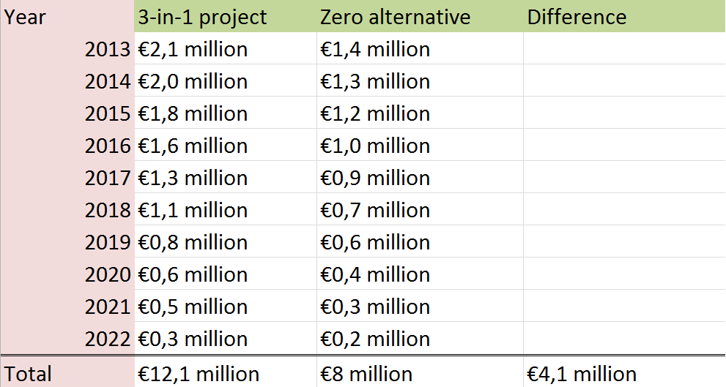
Table 11: Total estimated noise pollution costs for period 2013-2022, discounted to 2012.
These results show that the project would bring along an extra cost of just above €4 million, compared to the zero alternative of not changing the infrastructure.
3.4.2: Air pollution
Valuating air pollution can be done several ways. The preferred value could again be used to look whether the project will lead to certain road sections ending up above this value. However, the EIA shows a calculation of the total emissions in Westland with and without the 3-in-1 project (Plan MER, 2000). First, the emission factors for both passenger and freight transport.
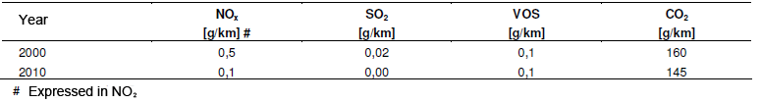
Table 12: Emission factors for passenger transport of NO_{x}, SO₂, VOS and CO₂ (source: Mulder and Buijn, 2000).
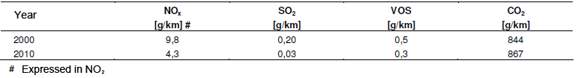
Table 13: Emission factors for freight transport of NO_{x}, SO₂, VOS and CO₂ (source: Mulder and Buijn, 2000).
These factors are used to determine the total mission in the area for three scenarios.
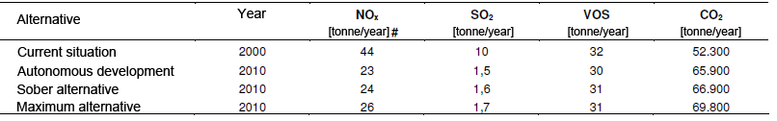
Table 14: Total (forecasted) emission in Westland for situation in 2000 and three scenarios in 2010 (source: Mulder and Buijn, 2000).
Of these four outcomes, the autonomous development will be compared to the sober alternative. First, both scenarios will be adjusted to 2013. This will be an adjustment of the traffic, using the yearly growth rate of 1,5%. The emission levels are multiplied with monetary values, collected by Rijkswaterstaat (2011). The results are in the table below and explained more extensively in appendix 7-8.
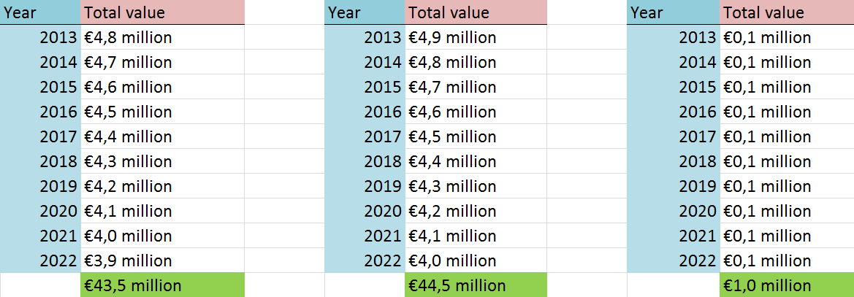
Table 15: Total and difference in air pollution costs per year, discounted to 2012.
The autonomous development would lead to a present value of the costs between 2013 and 2022 of air pollution of approx. €43,5 million. The sober alternative would have slightly higher costs, approximately €44,5 million. Executing the 3-in-1 project would lead to extra air pollution costs in the first 10 years of €1 million, an increase of only 2,3%.
For a period of 10 years, this is not a very large cost difference. On one hand, the traffic increase in Westland would increase the pollution a lot. On the other hand, the flow of traffic becomes much better. Less traffic jams will be formed. During traffic jams, vehicles emit while not driving a large distance.
Effect on soil and water
The Environmental Impact Assessment shows that the surface and water quality in the whole area will only be affected marginally. It shows that water quality already is of moderate quality and no valuable soil type is present (Damen, 2010). For this reason, this type of pollution gets a value of 0 in this analysis.
3.4.3: Safety
The last external effect is the safety. First, the positive effects. The Extended Veilingroute and Piet Struijkweg are allowed to handle transport of dangerous substances. On one hand, this could increase the danger on these road sections. On the other hand, dangerous transport would just be handled on different roads if the Extended Veilingroute and Piet Struijkweg would not be allowed to handle transport of dangerous substances. The better distribution could even make the new situation a bit more safe. More flows of trucks, with and without dangerous substances, will use the more safe routes instead of smaller roads through villages.
Also, the Maasdijk, which is a dangerous road, will be under less pressure. Emergency services will be able to arrive on their destination in less time than before.
Also, the construction of bicycle tunnels will increase safety. In the old situation, cyclists had to cross roads which were, due to low capacity, quite crowded. The new bicycle tunnels will separate motor vehicles and cyclists.
These points are hard to express in money, but will have a positive effect on the total effect of safety.
The benefits of safety will be negatively influenced by the number of victims in accidents. It is estimated that the project will bring along more victims. This is visible in the table below.
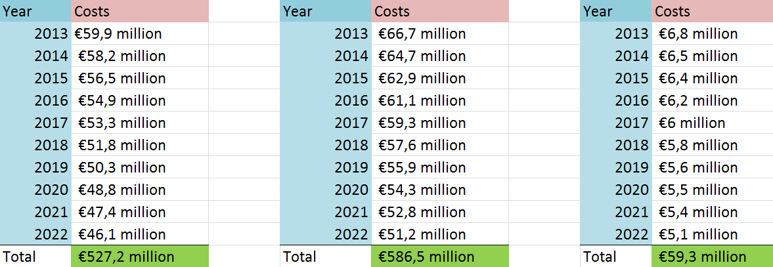
Table 16: Total and difference in costs of safety with and without 3-in-1 project, in period 2013-2022, discounted to 2012.
The additional safety costs for the sober alternative are approx. €59,3 million. Because the positive aspects of the project are not expressed in money and the negative aspects are, it is difficult to give a value to the overall effect on safety. Therefore, like the travel time profit, a range will be used in the evaluation. This range for the sober alternative will be the difference between the autonomous development and the sober alternative, i.e. €527,2 million to €586,5 million (or €0 to €59,3 million)
3.5: Indirect effects
At last, the indirect effects. Recall that these effects are ‘influenced’ by the direct effects and are also traced into foreign countries. This makes them quite hard to estimate. Also, effects on the real estate market are likely to be partly included in the direct effects (OEEI, 2000). The main effects for the project are the change in employment and the price changes. For example, more truck drivers will be needed for the transport between Flora Holland and its suppliers and customers. The same counts for the sea terminal in Hoek van Holland. Price changes may be introduced, because of larger supply and demand of flowers.
The indirect effects in this report will be mainly based on a case study, one of the methods that is mentioned in the OEI guidance report (OEEI, 2000).
Decisio determined that the additional indirect effects for infrastructural projects on regional infrastructure are not likely to be more than 10% of the total direct effects (Decisio, 2011). Besides this research, other projects aimed at changing road infrastructure will be used to make an estimate of the indirect effects for this project.
What is compared among different reports is the ratio determined by dividing the indirect effects by the total direct effects, or direct benefits. Most studies used a range in their estimations, so that will also be done here. The average minimum border gives a ratio of 0,0977, or 9,77%. The maximum border is 0,1142, or 11,42%.
The 10%, determined by Decisio, falls exactly in this range. To be a bit more safe, this report will show a range of 5%-10% of total direct effects. The total direct effects will be calculated by subtracting the investment (budgeted costs), the missed interest and the maintenance costs from the direct benefits (travel time profit plus excise taxes and minus fuel costs).
The minimum border (15% scenario) has a total direct effect of €68,9 million. A range of approx. 5% to 10% is used. Because of inclusion of a small risk factor, the range is set at €3,5 million to €7 million.
The maximum border (10% scenario) is calculated with a direct effect of €177,9 million. Here, the range will be €9 million to €18 million.
Scenario | Direct effects | Indirect effects range  Minimum border | Indirect effects range  Maximum border
15% | €68,9 million | €3,5 million | €7 million
10% | €177,9 million | €9 million | €18 million
Table 17: Ranges for indirect effects for both 10% and 15% scenarios, for period 2013-2022.
3.6: Conclusion
All the effects that are mentioned in the above subchapters will be summed up. This will show whether the project is a beneficial investment for the longer term. When a break-even result falls inside the range, it will be difficult to make a decision. The likelihood of certain effects will need to be discussed in more detail.
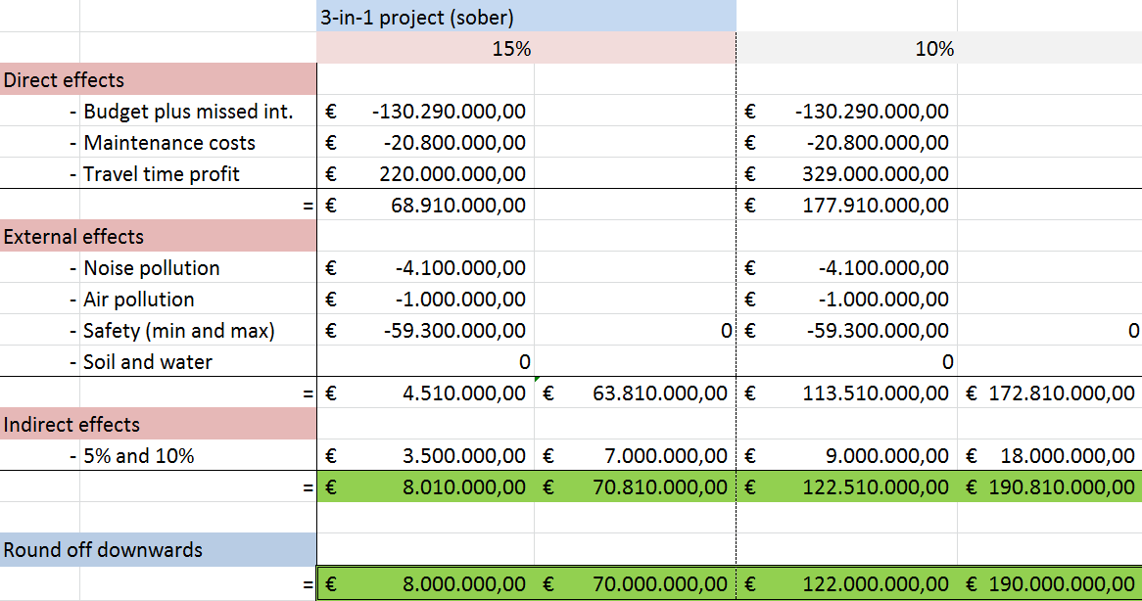
Table 18: Overall results of cost-benefit analysis on 3-in-1 project.
Because every effect is calculated in comparison to the zero alternative, which is when there just won’t be a 3-in-1 project, the zero alternative isn’t shown in table 18 above.
The table above quite clearly shows that the 3-in-1 project gives a strong boost to the local economy. Even the least positive scenario shows a positive outcome (€8 million). The highest estimated outcome is €190 million, a yearly return of almost €20 million. The large difference between these two outcomes is mainly caused by the safety and the travel time profit. These two will be discussed below.
Because of the recent Euro crisis, export of flowers may be lower than expected ten years ago. For this reason, it may be good to choose the 15% scenario as the most plausible. In this scenario, total traffic is lower than in the 10% scenario. This is also a more safe decision.
The safety is difficult to estimate. In the EIA, it was predicted that the yearly number of injured and deaths would rise after the project is finished. It also mentioned that the methods that were used did not involve the argument that traffic would shift from unsafe, smaller roads to the bigger, more safe infrastructure (Mulder and Buijn, 2000). This would probably lower the costs of safety.
Another effect to watch are the direct costs. As Flyvbjerg showed in 2003, actual costs tend to be higher in 9 out of 10 cases. On average, they are 20% higher in reality. This would lead to additional estimated costs of €26 million, pushing the ‘least positive’ scenario from positive to negative outcome (-€18 million).
At last, it’s important to take a look at the future and the zero alternative. In the future, even with this project, the roads will still tend to congest. High I/C ratios show a returning congestion problem (appendix 11 and 12). Another infrastructural project will probably be essential in the future. However, this doesn’t retain that a revision of the infrastructure network in Westland is essential. Without execution of the project, intensity on roads will be too high much faster.
So, overall, it seems to have been a good decision to execute the plans of the 3-in-1 project. There is a chance that in the first 10 years, the net present value will still be negative. But this is just the most negative scenario, and not even the most positive scenario’s show fairly large positive numbers.

Conclusion
The goal of this report is to answer the research question ‘Is the 3-in-1 project beneficial for the society over the long term?’. Three chapters were used and will be summarized and concluded below.
At first, the case of Westland was discussed. Westland is a region close to both Rotterdam and The Hague and its economy leans on the export of horticultural products. It has problems with handling the increasing traffic flows to and from the area. Especially accessibility from the south is a huge problem. Therefore, the local governments decided to improve local infrastructure with the ‘3-in-1 project’. The project contains three connected projects, mainly consisting of the construction of new roads and junctions.
To test whether the project is beneficial or not, a cost-benefit analysis was performed. The second chapter was based on theories linked to this method. Berechman and Banister set a list of conditions regions and their projects have to meet to support economic growth. Westland meets these requirements for the largest part. A guideline by the Dutch government, OEI (OEEI, 2000), explains the use and calculation of the main effects. Also, Flyvbjerg (et al.) show(s) in several researches that the outcomes of many cost-benefit analyses are overestimated.
In the last part of the report, a cost-benefit analysis for the 3-in-1 project is executed. It shows strong direct effects, especially in the scenario where peak hour traffic is 10% of total daily traffic (10% scenario). The travel time profit is used as a range. The external effects aren’t all that strong. Only safety has a potentially strong effect, but is difficult to determine precisely. At last, the indirect effect is estimated as a percentage of the direct benefits. This effect therefore is only strong when the direct effects are also large.
Because of recent crises, the direct benefits are more likely to be a bit closer to the minimum border than to the maximum border. Demand is probably lower than what was expected several years ago. Also, with keeping Flyvbjerg’s research in the back of the head, benefits could be overestimated. In that case, the outcome could become negative, with €-18 million as least positive outcome.
As a conclusion, the 3-in-1 project is very likely to have a positive effect on the (local) society. Infrastructure would be very bad without the execution of the project and it also has a very good chance to be beneficial in the longer term.

Reference list

Algemeen Dagblad. (2003). Zuinige provincie baart Westlander zorgen. AD, June 3.
---. (2008). Verdubbel de Veilingroute. AD, April 28.
Bal, G. (2008). De Kracht van het Westland, jubileumeditie 2008. Den Haag/Naaldwijk: Kamer van Koophandel/Rabobank.
Banister, D., and Y. Berechman. (2001). Transport investment and the promotion of economic growth. Journal of Transport Geography. 9, 209-218.
CPB. (2000). Kosten-batenanalyse van HSL-Oost infrastructuur. Den Haag: Ministerie van Verkeer en Waterstaat.
CBS. (2008). De Randstad behoort tot grootste economische regio’s van Europa. http://www.cbs.nl/nl-NL/menu/themas/macro-economie/publicaties/artikelen/archief
/2008/2008-2443-wm.htm [Accessed in May 2012].
---. (2011). Bromfietsen naar soort voertuig, leeftijd en regio op 1 januari. Den Haag/Heerlen: CBS.
Damen, J.L. (2010). Bestemmingsplan Westland; N223 Westerlee-Maasdijk. Rotterdam: RBOI.
--. (2010). Bestemmingsplan Westland; Verlengde Veilingroute en Zuidelijke Randweg Naaldwijk. Rotterdam: RBOI.
Decisio. (2005). Kosten-batenanalyse op hoofdlijnen voor de Planstudie Schiphol-A’dam-Almere. Haarlem: Rijkswaterstaat Noord-Holland.
---. (2011). Indirecte effecten. Een verkenning naar indirecte effecten in Maatschappelijke Kosten-baten-analyses. Den Haag: Gemeente Rotterdam.
Ecorys. (2012). Kosten-batenanalyse MIRT Haaglanden: Toelichting en uitkomsten. Den Haag: Projectorganisatie MIRT verkenning Haaglanden.
Flora Holland. (2009). Flora Holland: Kengetallen 2008. http://www.floraholland.com/nl/
overfloraholland/Cooperatie/Documents/KengetallenNL.pdf [Accessed in May 2012].
---. (2011). FloraHolland Naaldwijk: Voorzichtig herstel in 2010 en inspirerend ondernemen in 2011. http://www.floraholland.com/nl/OverFloraHolland/Pers/201PagesJaarcijfersNaaldwijk
.aspx. [Accessed in May 2012].
---. (2011). Flora Holland Jaarverslag 2010. http://www.floraholland.com/nl/overfloraholland
/Cooperatie/Documents/FloraHollandJaarverslag2010.pdf [Accessed in May 2012].
Flora Holland. (2011). FloraHolland maandbericht oktober 2011. http://www.floraholland.com/nl/
overfloraholland/Pers/2011/Pages/FloraHollandmaandberichtoktober2011.aspx [Accessed in May 2012].
Flyvbjerg, B. (2008). Curbing optimism bias and strategic misinterpretation in planning: reference class forecasting in practice. European Planning Studies. 16 (1), 3-21.
Flyvbjerg, B., M.K. Skamris Holm, and S.L. Buhl. (2002). Underestimating costs in public works projects: Error or lie?. Journal of the American Planning Association. 68 (3), 279-295.
---. (2003). How common and how large are cost overruns in transport infrastructure projects?. Transport Reviews. 23 (1), 71-88.
Gemeente Rotterdam. (2008). Bestemmingsplan Tweede Ontsluitingsweg Hoek van Holland. Rotterdam: Gemeente Rotterdam.
Gemeente Westland. 3-in-1 project. (-). http://www.gemeentewestland.nl/Smartsite.shtml?id=125
848 [Accessed in May 2012].
---. (2011). Ontwerp bestemmingsplan N223 Westerlee Maasdijk. http://www.gemeentewestland.nl/Smartsite.shtml?id=138414 [Accessed in May 2012].
---. Verbinding Westerlee – Maasdijk. http://www.gemeentewestland.nl/Smartsite.shtml?id=138414 [Accessed in May 2012].
Kamer van Koophandel. (2008). De Kracht van het Westland 2008. Den Haag: Kamer van Koophandel.
---. 3 in 1 project Westland. http://www.kvk.nl/lokale-informatie/den-haag/bereikbaarheid/3-in-1-project-westland/ [Accessed in May 2012].
Kats, S., J.P. Kors. (2006). Kentallen KBA Dimensionering Ramspolbrug: Brughoogte, wegprofiel en bedieningsregime. Den Haag: Rijkswaterstaat.
Kennisinstituut voor Mobiliteitsbeleid. (2012). Kosten-batenanalyse bij integrale gebiedsverkenningen; toepasbaarheid van de OEI-systematiek. Den Haag: Ministerie van Infrastructuur en milieu.
---. (2009). Mobiliteitsbalans 2009. Den Haag: Kennisinstituut voor Mobiliteit.
Meurs, A. (2007). Bereikbaarheid van grote evenementen en publiekstrekkers. Verkeerskunde DVM-congres 2007. Rotterdam: Gemeente Rotterdam.
Mulder, P.T.W., H.R. Buijn. (2000). Planstudie/MER Westland-Hoek van Holland. Den Haag: Provincie Zuid-Holland.
Noordtzij, H. (2004). Aanleg 2de ontsluitingsweg snel van start. http://www.hoekvanholland
.pvda.nl/general/Archief/Aanleg+2de+ontsluitingsweg+snel+van+start.html [Accessed in June 2012].
NZ Transport Agency. (2006). Travel time estimation procedures. Land Transport NZ’s Economic evaluation manual (1).
OEEI. (2000). Evaluatie van grote infrastructuurprojecten; Leidraad voor kosten-baten analyse. Den Haag: Ministries of Economic Affairs and Infrastructure and the Environment.
Provincie Zuid-Holland. (2010). Verbinding Westerlee-Maasdijk. Den Haag: Provincie Zuid-Holland.
---. (2011). Tweede Ontsluitingsweg Hoek van Holland. http://www.zuid-holland.nl/overzicht_alle_themas/c_e_thema_verkeer-vervoer/c_e_thema_verkeer-wegverkeer
/content_3-in1project/c_e_thema_verkeer-tweede_ontsluitingsweg_hoek_van_holland.htm [Accessed in May 2012].
---. (2012). 3-in-1 project. http://www.zuid-holland.nl/overzicht_alle_themas/c_e_thema_ver
keer-vervoer/c_e_thema_verkeer-wegverkeer/content_3-in1project.htm [Accessed in May 2012]
Ravensbergen, G.J. (2009). Notitie akoustische effecten uitstralingsgebied i.v.m. verlengde veilingroute. Naaldwijk: Gemeente Westland.
Rijkswaterstaat. (2011). MKBA-kengetallen voor omgevingskwaliteiten: aanvulling en actualisering. http://www.rijkswaterstaat.nl/images/HoofdtabelKengetallen
MKBA_tcm174-311267.pdf [Accessed in May 2012].
---. (2010). Kader OEI bij MIRT-verkenningen. Den Haag: Projectdirectie Sneller & Beter.
Rijkswaterstaat Oost-Nederland. (2005). Quick netwerkscan A15/A12: Verkeerskundige samenhang tussen de doortrekking A15 Ressen-Duiven/Zevenaar en de A12 in Gelderland (verkeerstechnische beschrijving). Arnhem: Provincie Gelderland
Robinson, R. (1993). Cost-benefit analysis. BMJ. 307 (6909), 924-926.
Skamris, M.K., B. Flyvbjerg. (1997). Inaccuracy of traffic forecasts and cost estimates on large transport projects. Transport Policy. 4 (3), 141-146.
Streng, J., M. Houwen, and W. Egberts. (2009). Tweede Ontsluitingsweg Hoek van Holland, gedeelte Pettendijk. Rotterdam: Gemeente Rotterdam.
Van der Tak, S. (2010). De Kracht van het Westland. http://www.agrobusinessclubwestland.nl/
PresentatieTak1.pdf [Accessed in May 2012].
TNO. (2009). Akoestisch onderzoek Verlengde Veilingroute. Naaldwijk: Gemeente Westland.
Vakblad voor de Bloemisterij. (2009). Prijzen zakken nog verder weg. Vakblad voor de Bloemisterij, July 10.
WeetMeer. (2012). Gemiddelde huishoudensgrootte in Westland. http://data.weetmeer.nl/module.php?ID=68561 [Accessed in June 2012].
Westlanders.nu. (2010). Protestactie Maasdijkers voor het gemeentehuis. http://westlanders.nu
/index.php/nieuws/26-nieuws/2973-protestactie-maasdijkers-voor-gemeentehuis [Accessed in May 2012].

Appendix
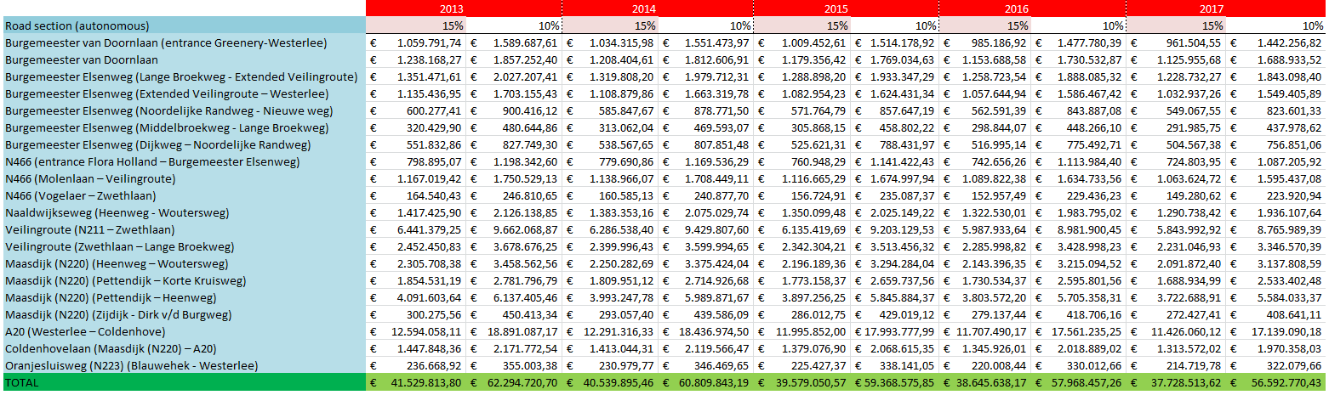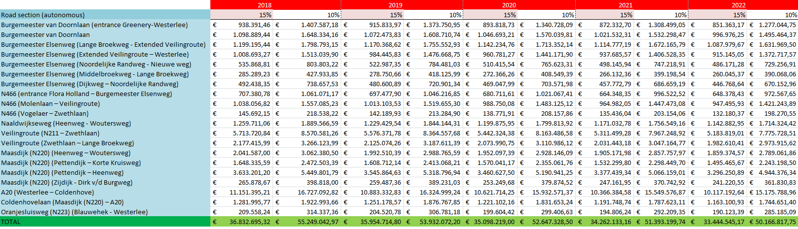
Appendix 1: Value of travel time for 10% and 15% scenarios without 3-in-1 project, discounted to 2012, for period 2013-2022.
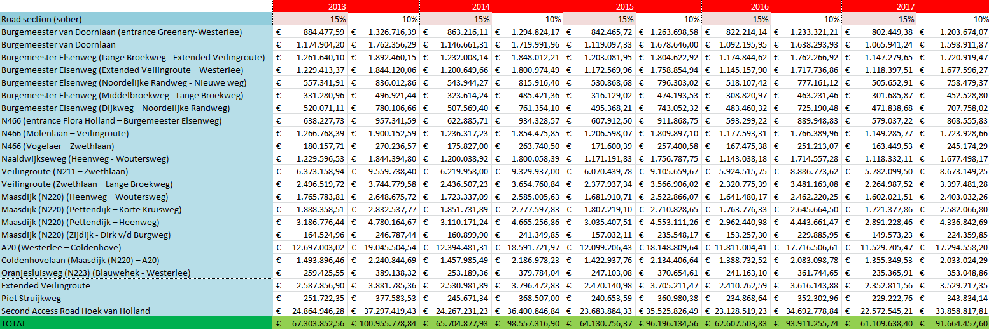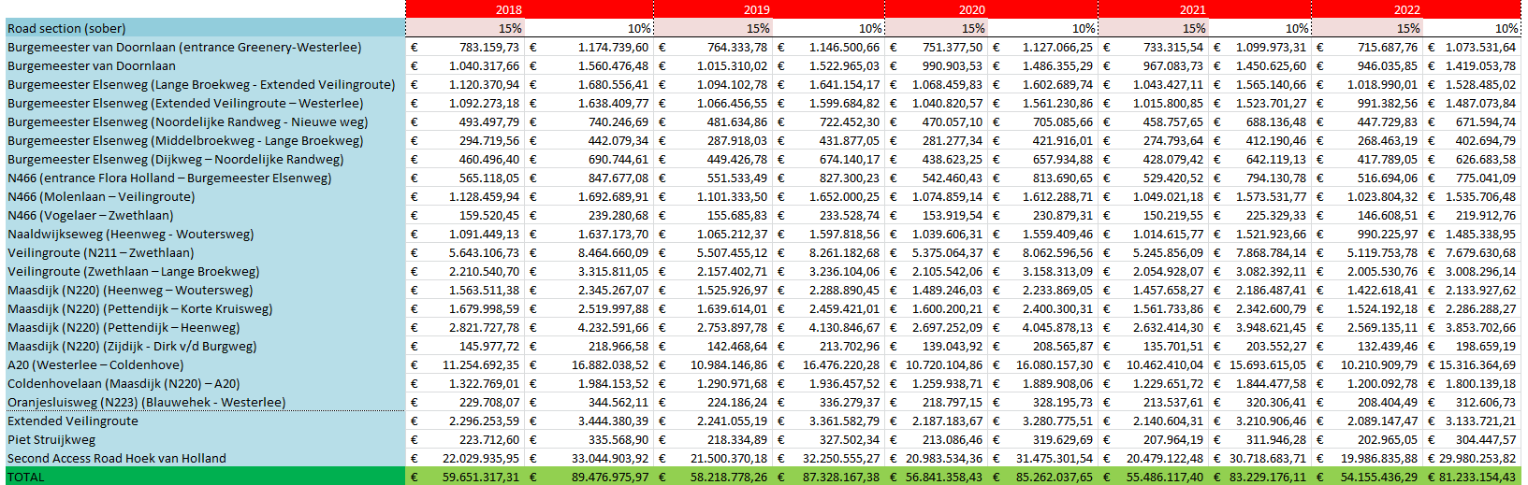
Appendix 2: Value of travel time for sober alternative (with 3-in-1 project), for period 2013-2022, discounted to 2012.
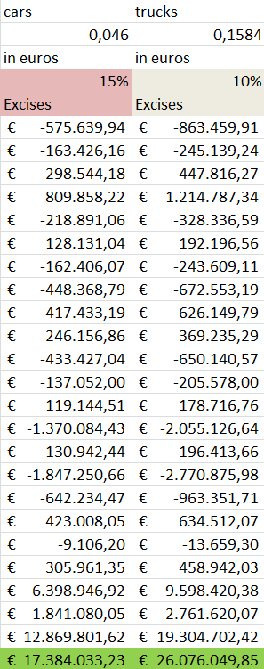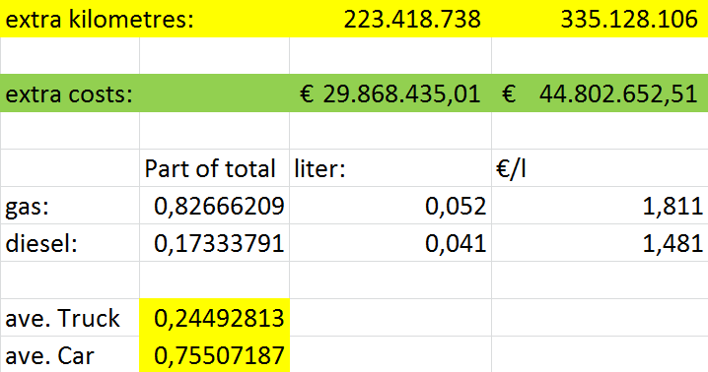
Appendix 3: Excise taxes for every chosen road Appendix 4: Calculation of extra fuel costs,
section, for period 2013-2022, discounted to based on extra kilometres driven on chosen
2012. road sections, period 2013-2022, discounted to 2012.

dB range | 50–55 (52,5) | 55–60 (57,5) | 60–65 (62,5) | 65–65 (65) | Total
Total houses | 2.022 | 729 | 140 | 4 | 2.895
Total residents | 4.651 | 1.677 | 322 | 9 | 6.659
× (dB – 48) | 4,5 | 9,5 | 14,5 | 17 | -
= | 20.929,5 | 15.931,5 | 4.669 | 153 | 41.683
× €27,97 = | €585.398,12 | €445.604,06 | €130.591,93 | €4.279,41 | €1.165.873,51
× 1,2 = |  |  |  |  | €1.399.048,21
Appendix 5: Calculation of noise pollution costs in 2013 without 3-in-1 project (source: Mulder and Buijn, 2000)
dB range | 50–55 (52,5) | 55–60 (57,5) | 60–65 (62,5) | 65–65 (65) | Total
Total houses | 3.158 | 1.262 | 381 | 38 | 4.839
Total residents | 7.263 | 2.903 | 876 | 87 | 11.129
× (dB – 48) | 4,5 | 9,5 | 14,5 | 17 | -
= | 32.683,5 | 27.578,5 | 12.702 | 1.479 | 74.443
× €27,97 = | 914.157,50 | 771.370,65 | 355.274,94 | 41.367,63 | €2.082.170,72
× 1,04 = |  |  |  |  | €2.165.457,55
Appendix 6: Calculation of noise pollution costs in 2013 with execution of 3-in-1 project (source: Mulder and Buijn, 2000)
The number of affected houses is multiplied with the average number of residents per household. Then, this number of residents is multiplied with the average dB exceedance. At last, the monetary value per dB (Rijkswaterstaat, 2011) times the total dB exceedance leads to the outcome. The last row in both tables is de adjustment factor of 2010 to 2013.
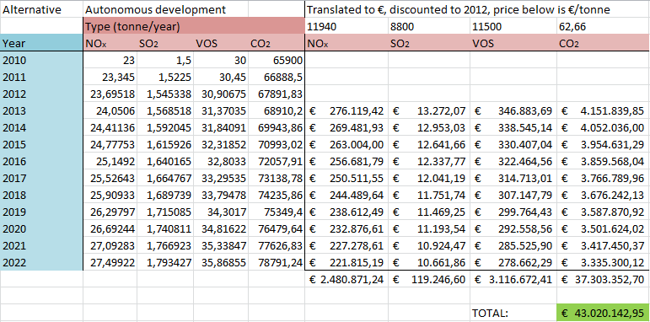
Appendix 7: Total costs of air pollution without 3-in-1 project (source: prices by Rijkswaterstaat, 2011).
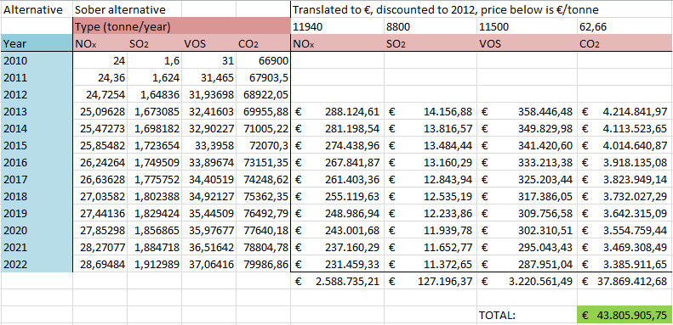
Appendix 8: Total costs of air pollution with 3-in-1 project (source: prices by Rijkswaterstaat, 2011).
All types of air pollution (NOx, SO₂, VOS and CO₂) are adjusted to each year in the period 2013-2022. Then, these amounts are multiplied with the estimated value for the society per tonne (Rijkswaterstaat, 2011). At last, each year is discounted to 2012.
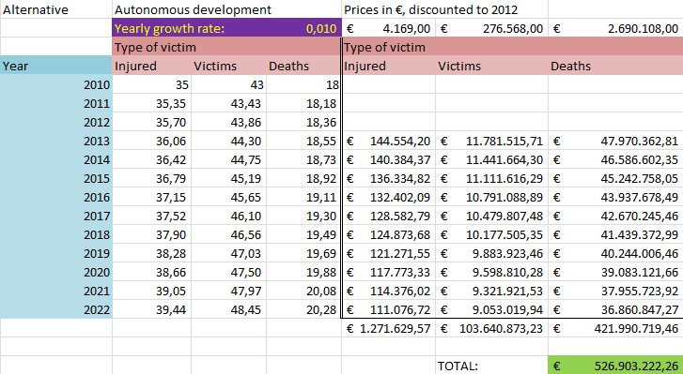
Appendix 9: Costs of safety without execution of the 3-in-1 project (prices by Rijkswaterstaat, 2011).
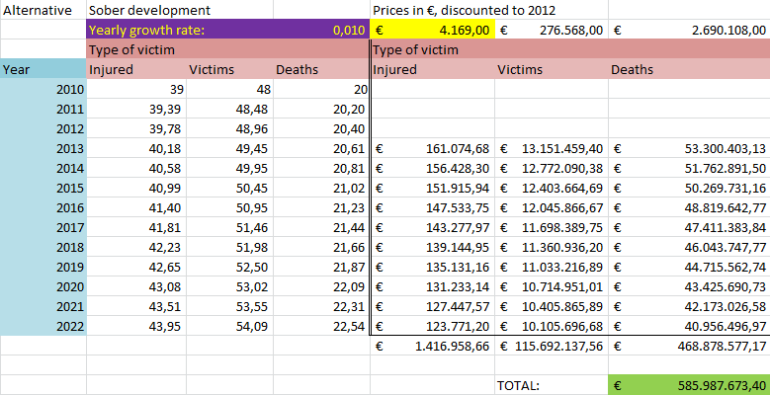
Appendix 10: Costs of safety with execution of the 3-in-1 project (prices by Rijkswaterstaat, 2011).
The number of victims, injured and deaths for 2010 is adjusted to 2013 (growth rate of 1%) and thereafter to the following years. Then, the value to society per injured, victim and death is used to determine the total costs for society of accidents. All costs are discounted to 2012.

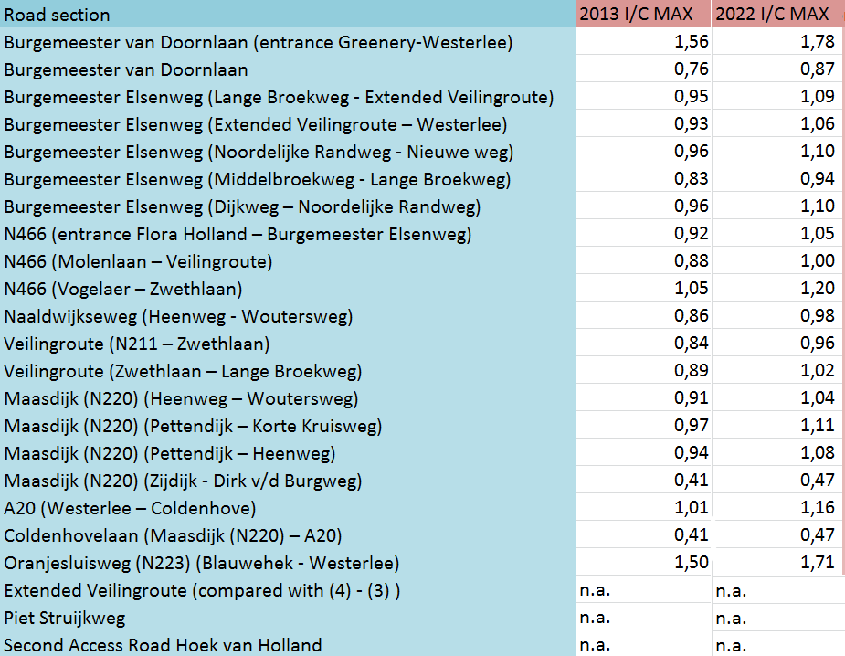
Appendix 11: I/C ratios for zero alternative, 2013 and 2022 (source for 2013: Mulder and Buijn, 2000)
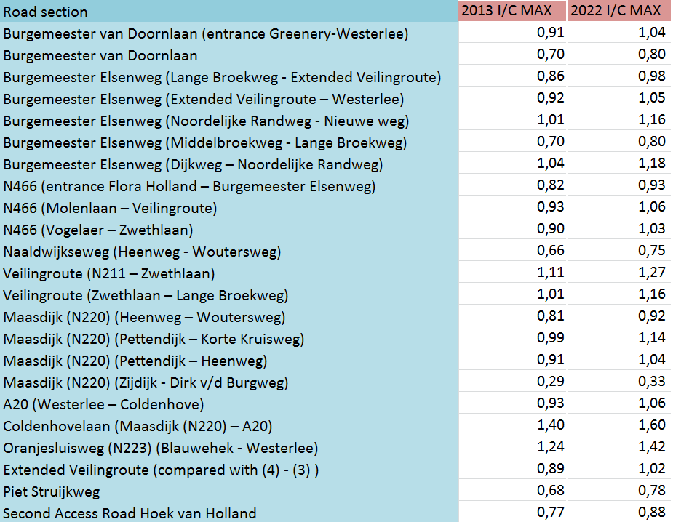
Appendix 12: I/C ratios for scenario with execution 3-in-1 project, for 2013 and 2022 (source for 2013: Mulder and Buijn, 2000)

In 2007, total gross added value was €2,8 billion (Kamer van Koophandel, 2008)
Commuting is the daily travel between an individual’s home and work or study.
The sober alternative is chosen due to budgetary restrictions.
Which is around the time some of the models were made.
1,2 is roughly based on the traffic growth rate of 1,5% over 15 years.
1,04 is roughly based on the traffic growth rate 1,5% over 3 years. Note that this 3 is not the exponent.

