The impact of FDI and Financial markets on growth | [2012]
We analyze the link between FDI, financial markets and economic growth for the period 1990-2010. By analyzing variables relating to a country’s credit and stock market, we assess the impact of financial markets on growth. Our results suggest that stock markets trigger growth, while credit markets do not. |  | Comparing OECD- with Latin American economies

Table of Contents
1. Introduction 3
2. Empirical review 4
2.1 The effects of FDI on economic growth 4
2.2 The effects of financial markets on growth 5
3. Empirical estimation 6
3.1 Data 6
3.1.1 Descriptive statistics 8
3.2 Methodology 9
4. Results 11
4.1 The impact of FDI and financial markets on growth 11
4.2 Controlling for endogeneity 14
4.3 Limitations and recommendations 15
5. Conclusion 17
6. Literature list 19
7. Appendix 21
7.1 Dataset of countries 21
7.2 Multicollinearity 22

Introduction
Foreign direct investment (FDI) has been a hot topic for many years. Theory suggests that FDI is characterized as a supplement for low domestic saving rates, and that the inflow of these foreign capitals trigger economic growth. These foreign capital inflows will also cause a rise in domestic productivity, which in turn will lead to a higher level of economic activity and growth. According to the government of Australia, FDI also raises household income, since it creates new job opportunities- higher household income also leads to higher economic activity and growth.
In addition to investigating the impact of FDI on growth, this paper also tests the link between financial markets and growth. The recent financial crisis has put financial markets in the spot light, highlighting how they are interconnected with one another. Advanced economies have proper credit and stock markets, while emerging and less-developed economies do not have a proper financial market in place yet. One of the regions which benefitted largely from FDI inflow recently has been Latin America, as has been suggested by Rivera-Batiz (2003). However, Latin American countries do not have well-developed financial systems in place, which can limit the impact of FDI on growth. According to the IMF (2007), financial markets positively affect economic development, as has been the case for OECD-countries. Therefore, our paper studies this link by focusing on the following question, ‘Does the impact of FDI and financial markets differ between OECD and Latin American countries?’ By comparing these two groups of countries, we attempt to give a brief conclusion on how financial market and FDI affect growth.
This paper is divided into different sections. Section 2 discuses the most influential findings in the literature and compares the results, after which section 3 focuses on our dataset and on our estimations. Section 4 discuses our main findings, while concluding remarks will be presented in section 5.

Empirical review
This section covers some of the most influential findings in the literature. We start by looking at some findings relating to the impact of FDI on growth, after which we discuss the impact of financial markets on growth. The World Bank classifies FDI as the sum of foreign capital investments, as percentage of a country’s GDP, if these foreign investments are meant to obtain a lasting management interest of at least 10%.

The effects of FDI on economic growth
We start by analyzing the findings of Borenzstein et al. (1998). They study the impact of foreign direct investment on growth, based on data of 69 less developed economies covering the period 1970-1998, and they reported that FDI promotes technology transfers amongst countries. Also, Bengoa and Sanches-Robles (2003) report that FDI positively affect growth for Latin American countries, by using a two-step approach. First, they test the link between economic freedom and FDI inflow, after which they test for the link between FDI inflow and growth. Also relating to the impact of FDI in Latin American countries are the findings of Bosworth and Collins (1999). They documented that FDI positively affects economic development- their models were based on cross-country data. In addition, Barel and Pain (1999) documented the positive impact of FDI on economic development. Their analysis was based on four European countries receiving foreign investments originating from the USA. Furthermore, Balasubramanyam et al.’s findings (1996) also support the notion that foreign direct investments trigger economic growth. However, for FDI to positively affect growth, countries should have exceeded a threshold level of human capital, as has been proposed by Keller (1996). Similar results have been documented by Xu (2000). The findings of Blalock and Gertler (2005) suggest that FDI facilitates the transfer of technology from developed countries to developing countries. In addition to meeting a minimum threshold level of human endowment, countries should also invest in their social capacity. This has been proposed by Abramovitz’s findings (1986), where he suggested that the term social capacity represents economic stability, human capital and infrastructure. By providing proper infrastructure, governments can convince multinational to invest in their economy.
On the other hand, the findings of Bos et al. (1974) suggest that FDI negatively affects growth. They studied FDI flows relating to the US market and documented a negative link between FDI and growth. Similar conclusions have been proposed by Prebisch (1968). As the findings in the literature suggest, the impact of FDI on growth is not exactly clear and straightforward.

The effects of financial markets on growth
One of the other topics which have been thoroughly analyzed is the impact of financial markets on growth. Some influential findings are the works by Grossman and Miller (1988), where they reported that financial markets positively affect economic development. King and Levine (1993) reported similar findings, suggesting that financial markets are significant on growth. Some authors documented that financial markets revolve around three aspects. Firstly, financial markets and financial intermediaries often disclose information regarding investment opportunities. This has been proposed by the findings of Kashyap et al. (1998). Financial intermediaries can provide this information at lower costs, which leads to more economic activity. Secondly, financial markets promote corporate governance on behalf of investors. Dow and Gordon (1997) suggest that financial markets can provide a culture to cultivate proper corporate governance. Finally, financial markets also perform risk management through diversification. Acemoglu and Zilibotti (1997) reported that diversification of risk leads to lower risk, which also promote economic growth. Lower risk promotes more economic activity which will lead to higher economic growth rates. Villegas-Sanches (2009) reported that FDI exert economic growth only if the host country has a well-developed financial market in place.
Also, Neusser and Kugler (1998) studied the impact of financial markets on growth for OECD countries, and reported that financial markets positively affect growth. To test this link, they use a granger causality test based on time series observations. Shabbier (1997) also tested the link between financial markets and growth and documented that well-developed financial markets promote growth. More specifically, Scott-Baier and Dwyer analyzed the impact of introducing a stock market, and reported that introducing a stock market into the economy positively affects economic development. However, Azman-Saini et al. (2010) documented that for FDI to have a positive impact on growth, countries’ financial markets should exceed a threshold level.

Empirical estimation

Data
To test the link between FDI, financial markets and growth, we have constructed a cross-section database. This section thoroughly discuses our dataset and the databases we have used to obtain our dataset.
We have collected data reporting annual GDP growth rates from the World Development Indicators (WDI) over the period 1990 to 2010. Data on one of our main variables, which is the net inflow of foreign direct investments, have been obtained from the World Bank.
Analyzing countries’ financial markets is an extremely complicated mission, since there is no one particular method of measuring this. Luckily, by analyzing different characteristics of a country’s financial market, our models are able to gain better insight into the link between financial markets and growth. Theory suggests that financial markets can be divided into credit markets and stock markets. These two submarkets however, are closely linked with one another. Fortunately, the World Bank Financial Structure Database collects data on several variables explaining the working of the credit and the stock market. Our models include two variables explaining the work of the credit market, and two variables relating to the work of the stock market.
We start by introducing our first variable relating to the working of the credit market, which is the Liquid liabilities of the financial market over GDP. This is denoted as LL throughout our models. According to the World Bank Financial Structure Database, this variable relates to the sum of all currency in circulation plus any interest-bearing liabilities of commercial banks and financial intermediaries. As Alfarro et al. (2004) suggest that the variable LL provides a loose measure of the overall credit market size in an economy. Our second variable used as proxy for the credit market variable is the total amount of private credit which is available in an economy. The official variable’s name is the Private credit by deposit money banks and other financial institutions over GDP, as is denoted as PC throughout our models. Levine et al. (2000) suggest that this variable assesses a country’s banking sector efficiency, while Beck (2000) reported that countries with higher amount of private credit will also experience higher growth rates.
The first variable relating to the stock market which we include in our models is the Total value of stocks traded on the stock market over GDP, which will be denoted as TVS throughout our analysis. This variable measures the overall size of a country’s stock market. The second variable relating to the stock market is a country’s Stock market turnover ratio, denoted as SMT throughout our analysis.
Also, our models control for several factors which also affect growth. Our models control for initial GDP per capita values, since this also affects growth rates. Initial GDP per capita has been measured as the log of constant 2000 US Dollar. Openness to trade has also been included in our models, since the findings of Baldwin (2003) suggest that openness to trade positively affect economic development. Inflation rates are also included in our models, as these proxy government abilities to stir an economy. Higher prices diminish the purchasing power of agents in the economy, which will harm economic development. We also include population growth rates, central government’s expenditure as percentage of GDP and domestic investment rates as additional control variables. Data on GDP per capita, trade openness, inflation rates, population growth, government expenditure and domestic growth rates have been obtained from the WDI. Moreover, we have also included a Latin American dummy in our models to compare the impact of financial market on growth between OECD and Latin American countries. Finally, our models also account for the impact of education on growth. Barro (1997) documented that education positively affects economic development, which is why we also account for this. The average years of schooling has been used as a proxy for measuring education levels, and data has been obtained from the Barro-Lee database.

Descriptive statistics
We start our analysis by looking at the distribution of our data. Table 1 reports the results of our descriptive statistics. Our results indicate that net FDI inflow and inflation rates show the most fluctuations in our dataset, since their standard deviations compared to their respective means are the largest. The country with the lowest and the highest net FDI inflow are Japan and Luxembourg, with values of 0.10% and 214.79%, respectively. Also, Brazil and Japan experienced the highest and the lowest inflation rates during the period 1990-2010, with values of 530.21% and 0.58% respectively. As our results suggest, Portugal and Finland had the lowest and the highest GDP per capita values in 1990, respectively. Moreover, we also conduct a correlation test on our data. The results are reported in table 2.
Table 1: Descriptive statistics
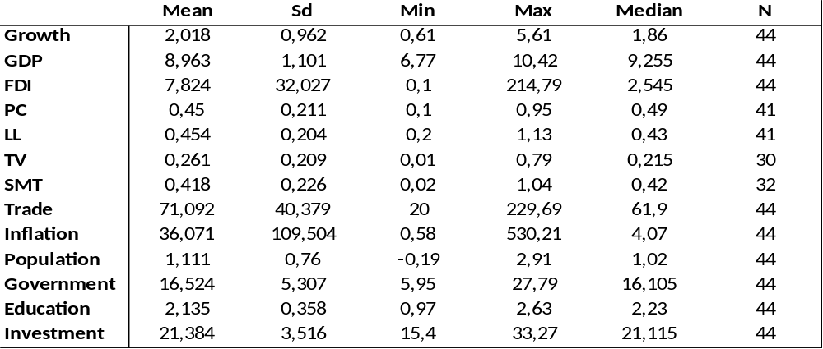
The variables Growth, FDI, Trade, Inflation, Population, Government and Investments are all measured in percentages, while the variables GDP, Education, PC, LL, TV and SMT are all measured as ln(1+’value’).
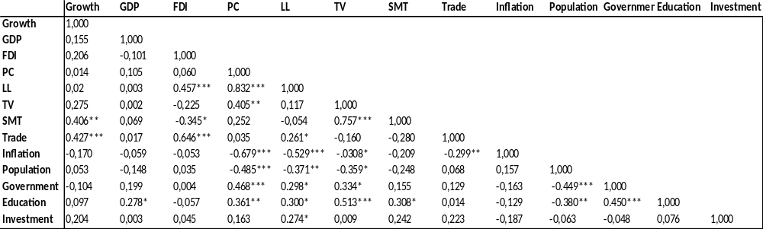
Table 2: Correlation matrix
- *, ** and ***Indicate significance levels of 10%, 5% and 1%, respectively

Methodology
This section covers the methodology used throughout our analysis. We start by plotting the financial variables on average GDP per capita growth rates over the period 1990-2010. Figure 1 illustrates the relationship between financial variables and GDP growth. The results suggest that LL does not appear to have a clear relationship, while PC, SMT and TV could have a positive relationship with growth. However, in order to be able to verify this link, econometric estimations are executed.
Figure 1: scatter plots financial markets and growth 1990-2010

Source: own estimations
To empirically assess the link between FDI, financial markets and growth, we calculated averages for each variable over the period 1980-2010. By using averages, we follow a similar approach as Alfarro et al. (2004) and King and Levine (1993). Based on these averages, we test the following estimation:
${GROWTH}_{i}={{β_{0}+β}_{1}GDP}_{i }+ {β_{2}{FDI}_{i}+ β_{3}{financal markets}_{i}+ β_{4}{Controls}_{i}}_{ }+ ε_{i}$,
where Growth denotes average GDP growth over the period 1990-2010, FDI denotes net FDI inflow, Financial Market denotes a variable relating to a specific working of the financial market, while GDP represents initial GDP per capita values in 1990 and Control denotes a vector of control variables. One of our control variables, trade, represents a country’s openness to trade, whereas inflation and population represents a country’s inflation rates and a country’s population growth, respectively. Government denotes central government’s consumption, whereas education denotes a country’s level of human capital, and investment represent domestic investment rates. Finally, LA represents our Latin American dummy, while i denotes countries in our models.
Based on previous findings in the literature, we expect FDI, Financial Market, trade and education to positively affect growth, while initial GDP per capita, inflation rates, population growth and government consumption are expected to negatively affect growth. Finally, domestic investment rates are also expected to positively affect growth. However, our models may be biased due to endogeneity issues. Financial markets and FDI affect growth, while economic growth also affects financial markets and net FDI inflow. To correct for this issue, we implement an instrumental variable test to assess the validity of our models. We use FDI values of 1989 as instruments when performing our instrumental variable tests.

Results

The impact of FDI and financial markets on growth
This section covers the results of our estimations. We start by looking at the results of the impact of FDI and financial markets on growth, afterwards we will re-examine our models by controlling for any endogeneity issues.
Table 3: Determinants on GDP growth over 1990-2010
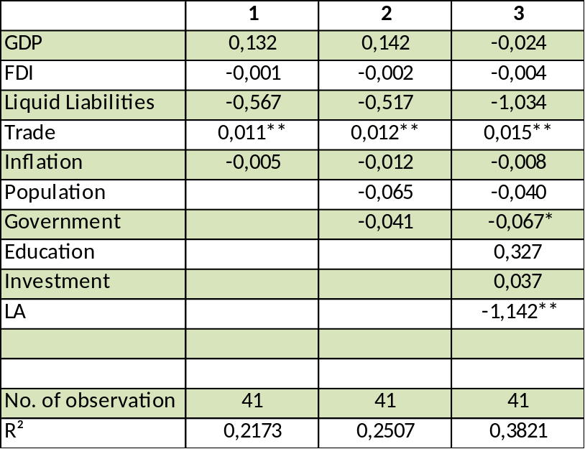

All of our models include a constant term. *, ** and ***Indicate significance levels of 10%, 5% and 1%, respectively

Table 3 reports the results of FDI and LL on growth. We first start by analyzing the impact of LL and FDI on growth in model 1, while only controlling for a country’s openness to trade and inflation rates. Model 1 is based on 41 observations and covers the period 1990-2010. We expand model 1 by introducing some additional control variables. The results are presented in model 2, which also suggest that only trade is significant on growth- it also has the expected sign. Moreover, table 3 reports the outcome of our third estimation. Model 3 indicate that none of our main variables, which are FDI and LL, have a significant impact on growth. The main result of table 3 is that, while trade and government spending affect growth, nor FDI nor the overall credit market size in an economy affect growth. Our results also suggest that the impact on growth significantly differs between OECD countries and Latin American countries.
After analyzing the impact of the credit size on economic growth, we assess the impact of private credit availability on growth. The results are reported in table 4. For consistency reasons, the same methodology has been applied as table 3. Model 1 in table 4 indicates that, once again, only trade positively affect growth. Similar results are also presented in model 2, where only trade has an impact on growth. Moreover, the results regarding the impact of PV and FDI on growth appears to be robust. Model 3 suggest that only trade and the Latin American dummy appear to be significantly affecting growth. Our results relating to the impact of trade on growth are similar to the findings of Dollar and Kraay (2002), which reported that trade positively affect growth.
Table 4: Determinants on GDP growth over 1990-2010
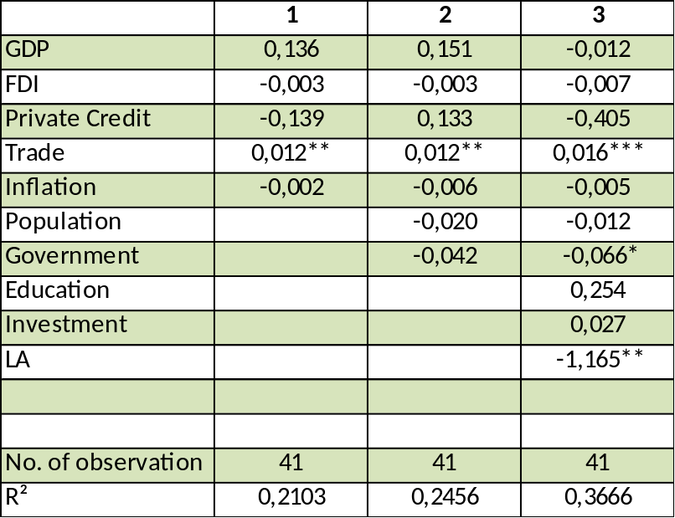

All of our models include a constant term. *, ** and ***Indicate significance levels of 10%, 5% and 1%, respectively

After testing the variables relating to the working of the credit market on growth, our analysis shifted towards the impact of stock market on growth. We start by analyzing the impact of a country’s stock market size over GDP on its development. Table 5 reports our results. Model 1 suggests that the overall size of a country’s stock market does contribute to growth. After controlling for some additional factors, the results of model 2 suggest that TV still positively affect economic growth. Models 1 through 3 in table 5 were based on 30 observations, and the results also suggest that there is a significant difference between OECD-member countries and Latin American countries. In addition, domestic investment rates positively affect growth. Our results suggest that, on average, the size of a country’s stock market affects growth.
Table 5: Determinants on GDP growth over 1990-2010
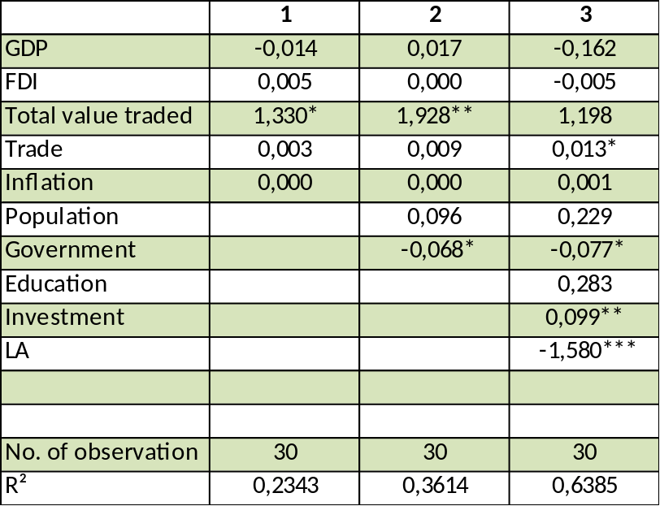

All of our models include a constant term. *, ** and ***Indicate significance levels of 10%, 5% and 1%, respectively

Finally, we also test the impact of FDI and stock market turnover ratio on economic growth. These tests are based on only 32 observations and cover the period 1990-2010, which is mainly due to the availability of data. As our results in model 1 suggest, stock market turnover ratio is highly significant, while having the expected sign. The impact of stock market turn over ratio is pretty robust across our models, suggesting that liquid stock markets promote growth. Surprisingly, the impact of FDI on growth has not been significant in any of our models. Liquid stock markets promote short term investments, which in turn will lead to economic growth. Liquid stock markets promote the buying and selling of stocks, since investors can exploit short term investment opportunities. Short term investments tend to have a lower risk compared to long term investments.
Table 6: Determinants on GDP growth over 1990-2010
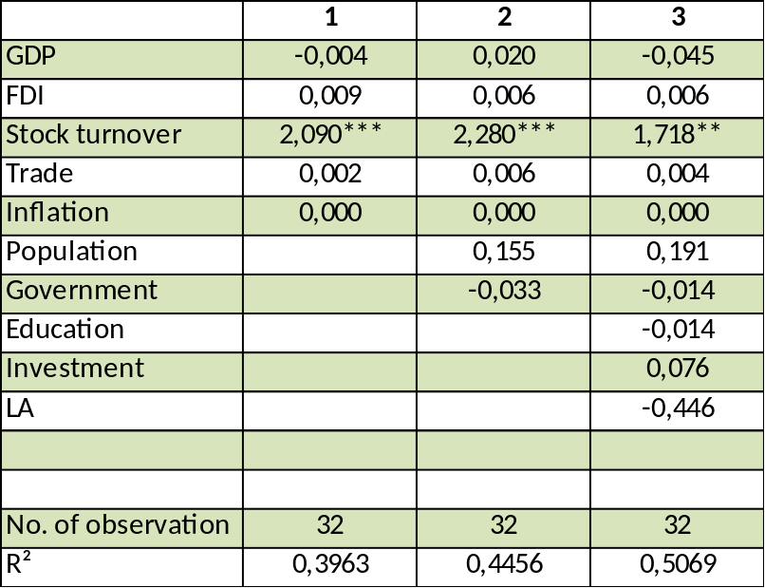

All of our models include a constant term. *, ** and ***Indicate significance levels of 10%, 5% and 1%, respectively

One main conclusion of all our models is that FDI has not contributed to economic growth. In addition, the variables relating to the working of a country’s credit market, namely LL and PC, are also not significant. However, the variables relating to the working of the stock market, which are TV and SMT, did have a positive and significant impact on economic growth.

Controlling for endogeneity
As previously mentioned, since our models are based on long term averages, we have to control for any misspecification in our models. Since FDI and financial markets affect growth, while growth also affects FDI and financial markets, we use an instrumental variable approach to correct for this in our estimations. We use 1 period lagged FDI values, since the findings of Wheeler and Mody (1992) suggest that a country’s actual FDI stock also affects current foreign investments. So, FDI data of 1989 has been used in order to obtain the results reported in table 7.
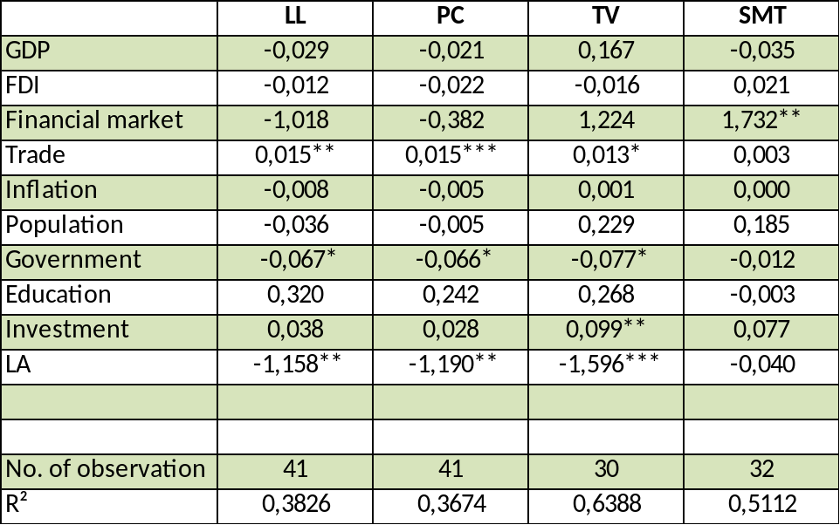
Table 7: Determinants on GDP growth over 1990-2010- IV results

All of our models include a constant term. *, ** and ***Indicate significance levels of 10%, 5% and 1%, respectively. FDI represent 1989 FDI values in order to control for any endogeneity issue.

Table 7 contains 4 models controlling for any endogeneity problems in our models. Model 1 assesses the impact of LL on growth, while model 2 studies the link of PC on growth. As the results of model 1 and model 2 suggest, the workings of the credit market do not have an impact on growth. The results of model 7 are similar to those of table 3 and table 4. Furthermore, model 3 and 4 analyzes the impact of the overall size of the stock market and the stock market liquidity on growth, respectively. Also, looking at the results of the Latin American dummy, we observe that the difference between OECD and Latin American countries is highly significant.

Limitations and recommendations
Although we have tried to analyze the link between FDI, financial markets and growth thoroughly, we have identified some limitations of our analysis. First and foremost, we did not control for the quality of any of the institutions. Poor institutions cause inefficiencies on the impact of foreign capital. Appropriate institutions positively affect the growth, since it limits fraud and excessive red-tape. Because most of our observations are OECD-members, we assumed that these countries have proper institutions in place. However, future studies could control for this as well. Moreover, we only analyzed a small number of countries, pertaining to the OECD and Latin America. By including more countries into the estimations, future studies can assess the link between FDI, financial markets and growth more thoroughly. Also, as our models suggest, human capital does not appear to significantly affect economic growth, while the literature is filled with findings suggesting a positive relationship. One explanation could lie with the variable we choose to proxy human capital. By using a different measurement to proxy for human capital, future research could better test the link between countries’ education levels and its economic growth. Finally, even though we did not find any significant impact of credit market on growth, future studies could use a larger number of variables relating to the working of a country’s credit market in their analysis. Finally, in order to assess the validity of our results, future studies could use a Granger-causality approach, based on time series rather than cross-section, to test the link between financial markets, FDI and growth for OECD countries.
Based on our results, we now discus some recommendations relating to a country’s stock market. Countries should constantly review their stock market structure in order to keep up with changes in the stock market. Countries should invest in making their stock markets more efficient, by implementing standards to guarantee investors their investments are safe. Since our results suggest that liquid stock markets trigger growth, implementing standards in the stock market ensures investors are protected against fraud and against firms withholding information. As the recent financial crisis indicates, even when financial markets are constantly under review, the complexity of financial markets still impacts growth.

Conclusion
The impact of financial market and FDI on growth has been a hot topic for decades. Some authors suggest that financial markets are essential to economic development, while others suggest that financial markets play no significant role in causing growth. Moreover, the impact of net foreign capital inflow on growth has also been comprehensively discussed in the literature. This paper contributed to the findings in the literature by analyzing the impact of financial markets and FDI on growth, while focusing on OECD-member countries and Latin American countries. Our estimations were based on average values over the period 1990 to 2010, and contained 4 different variables relating to a country’s financial market. Out of these four financial variables, two variables related to the workings of the credit market and two variables were related to the workings of the stock market of a country. The variables relating to the workings of the credit markets are the Liquid liabilities of the financial market over GDP and Private credit by deposit money banks and other financial institutions over GDP, while the variables relating to the stock markets are the Total value of stocks traded on the stock market over GDP and the Stock market turnover ratio. Our models also account for the impact of several other factors, such as inflation rates, trade openness, education levels, population growth, central government consumption, domestic investment rates and initial GDP per capita.
Surprisingly, our results suggest that FDI did not have a significant impact on growth- this outcome was quite robust across our models. When looking at the results of our financial market variables, our models indicate that while the variables relating to the credit market did not have any significant impact on growth, the variables relating to the stock market positively affected economic growth. Mainly, the stock market turnover ratio, which represents the liquidity of the stock market, proofed to have a large impact on economic growth. Similar results have been obtained by Scott-Baier and Dwyer (2003), suggesting that countries’ stock markets are essential in triggering growth. Besides the liquidity of a stock market, the overall size of the stock market also affects growth. Given the importance of stock markets on growth, countries should constantly evaluate the changes in the stock markets in order to guarantee investors, which is extremely important for the working of a stock market. We also identified some aspects on which future research can build to assess the validity of our results.

Literature list

Alfaro, L., Chanda, A., Kalemli-Ozcan, S., Sayek, S. (2004) ‘FDI and Economic Growth: The Role of Local Financial Markets’, Journal of International Economics, Vol. 64, pp. 89-112
Azman-Saini, W., Law, S., Ahmad, A. (2010). ‘FDI and Economic Growth: New Evidence on the Role of Financial Markets’
Baldwin, R.E. (2003). ‘Openness and Growth: What’s the Empirical Relationship?’
Barrell, R., Pain, N. (1997) ‘Foreign Direct Investment, Technological Change, and Economic Growth within Europe’, The economic journal, Vol. 107 No. 445, pp. 1770-1786
Bengoa, M., Sanchez-Robles, B. (2003) ‘Foreign Direct Investment, Economic Freedom and Growth: New Evidence from Latin America’, European Journal of Political Economic, Vol. 19, pp. 529-545
Blalock, G., Gertler, P. (2005). ‘Welfare Gains from Foreign Direct Investment through Technology Transfer to Local Suppliers’
Blomström, M., Sjöholm, F. (1999) ‘Technology Transfer and Spillovers: Does Local Participation with Multinational Matter?’ European Economic Review, Vol. 43, pp. 915-923
Borensztein, E., De Gregorio, J., Lee, J-W. (1998) ‘How Does Foreign Direct Investment Affect Economic Growth? ’, Journal of International Economics, Vol. 45, pp. 115-135
Brainard, L. (1993). ‘An Empirical Assessment of the Factor Proportions Explanation of Multinational Sales’. NBER Working Paper No. 4583
Dollar, D., Kraay, A. (2002). ‘ Growth is Good for the Poor’. Journal of Economic Growth, Vol. 7, pp. 195-225
Dow, J., Gorton, G. (1997). ‘Stock Market Efficiency and Economic Efficiency: Is There a Connection?’ Journal of Finance, Vol. 52, pp. 1087-1129
Filer, R.K., Hanousek, J., Campos, N.F. (1999). ‘Do Stock Markets Promote Economic Growth?’ Working paper No. 267
Grossman, S., Miller, M. (1988). ‘Liquidity and Market Structure’. Journal of Finance, Vol. 43, No. 3, pp. 617-637
Hanson, G. (2001). ‘Should Countries Promote Foreign Direct Investment?’ UNCTAD, G-24 Discussion Paper Series
Hermes, N., Lensink, R. (2003). ‘Foreign Direct Investment, financial development and economic growth’. Journal of Development Studies, Vol. 40, pp. 142-163
King, R., Levine, R. (1993a). ‘Finance and Growth: Schumpeter Might Be Right’. Quarterly Journal of Economics, Vol. 108, pp. 717-737
Levine, R., Loayza, N., Beck, T. (2000) ‘Financial Intermediation and Growth: Causality and causes’, Journal of Monetary Economics, Vol. 46, pp. 31-77
Levine, R. (1998). ‘Stock Markets, Banks, and Economic Growth’. American Economic Review, Vol. 88, pp. 537-558
Neusser, K., Kugler, M. (1998). ‘Manufacturing Growth and Financial Development: Evidence from OECD countries’. Review of Economics and Statistics, Vol. 80, pp. 638-646
Noorbakhsh, F., Paloni, A., Youssef, A. (2001). ‘Human Capital and FDI inflows to developing countries: new empirical evidence’. World Development, Vol. 29, pp. 1593-1610
Nunnenkamp, P., Spatz, J. (2004) ‘Transnational Corporations: FDI and Economic Growth in Developing Economies: How Relevant are Host-Economy and Industry Characteristics’. UNCTAD, Vol. 13 No. 3, pp. 52-86
Rivera-Batiz, F. (2003). ‘Foreign Direct Investment in Latin America: Current Trends and Future Prospects
Rodriquez-Clare, A. (1996). ‘Multinationals, Linkages, and Economic Development’. The American Economic Review, Vol. 86, No. 4, pp. 852-873
Sachs, J., Warner, A. (1995). ‘Economic Reform and the Process of Global Integration’. Brookings Papers on Economic Activity, Vol. 1, pp. 1-118
Saggi, K. (2002). ‘Trade, Foreign Direct Investment, and International Technology Transfer: A Survey’
Scott Baier, G., Dwyer, R. (2003). ‘Does Opening a Stock Exchange Increase Economic Growth?’ Federal Reserve Bank of Atlanta, Working Paper 2003-36
Shabbir, T. (1997) ‘Financial Intermediation and Growth: Theory and Some Cross-Country Evidence’, The Department Development Review, Vol. 36, No. 4, pp. 855-862

Appendix

Dataset of countries
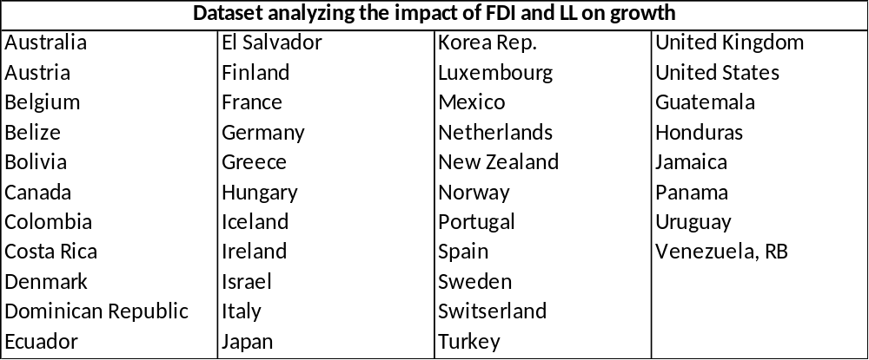

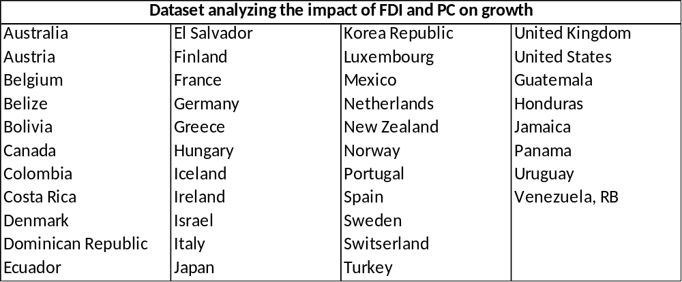

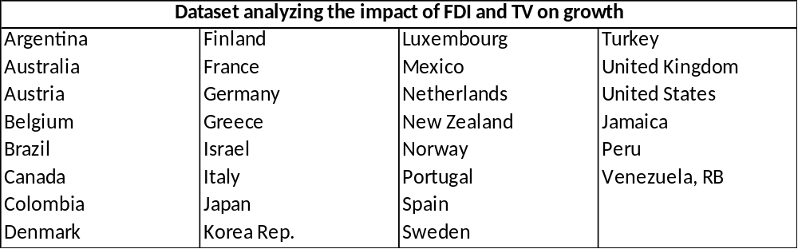
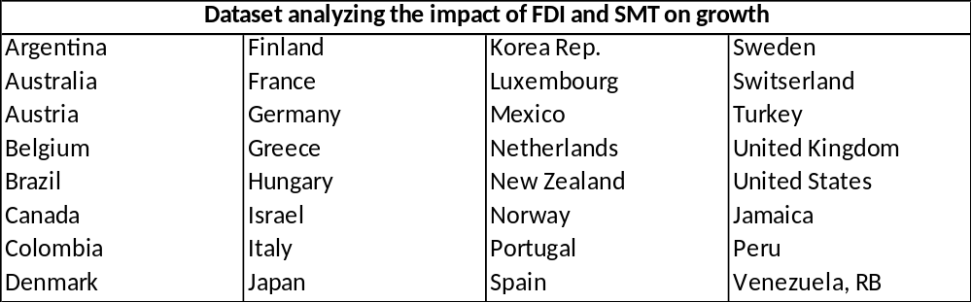

Multicollinearity
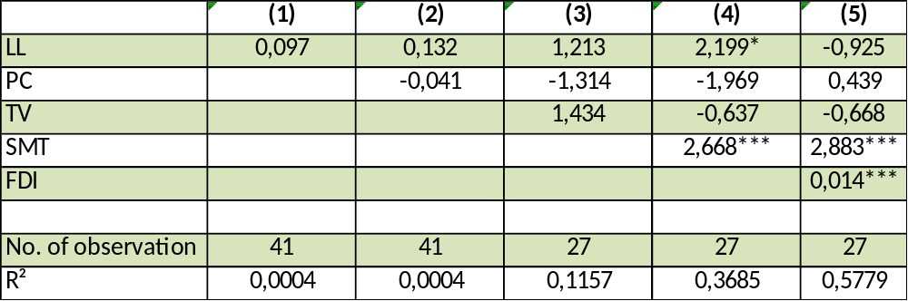

By including our main variables one by one and keeping track of the change in R-square we state that there is no multicollinearity present in our models.

