Erasmus universiteit rotterdam
The Flight Tax
The Impact of the Flight Tax on the Demand for Air Transportation
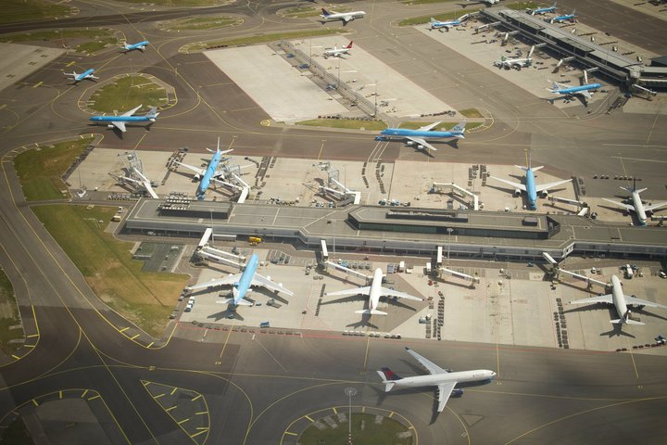
J.S. Kammeraat
22-8-2012
Final Version
Supervisor: Dr. P.A. van Reeven
This thesis examines the impact of the flight tax on the amount of passengers at Amsterdam Schiphol Airport. The flight tax was a Dutch ecotax, started in 2008 to discourage air traveling in order to release pressure on the environment, to make the environment more sustainable in the future. In this paper, a panel study is executed under five major European airports to obtain the real impact of the flight tax. GDP functions as a controlling variable. The outcome of the analysis should provide information to be able to assess whether the flight tax is a legitimate fiscal instrument.

Contents

1. Introduction 3
2. Background of the flight tax 5
3. Determinants for demand 9
4. Method and control group 12
4.1 Method 12
4.2 Controlling airports 14
5. Data analysis 15
6. Conclusions, limitations and recommendations 19
Bibliography 21
Appendix 22

Introduction
On the first of July 2008, the Dutch government introduced a new tax measure in the air travel sector. This “vliegtaks”, as it is called in the Netherlands, is a tax levied on tickets of origin and destination (o&d) flights departing from domestic airports. Air travelers paid an additional tax of € 11,25 for flights within Europe and € 45,00 for tickets to destinations outside Europe. (Staten Generaal, 2007)
This flight tax was part of governmental plans to reduce pressure on the environment. The government wanted to protect the environment, and as a part of reaching this, the flight tax was made to reduce the number of flights. Tax revenues should then be allocated to environmental projects. Large resistance against the flight tax rose before and during 2008. Exactly one year later, on the first of July 2009, application of the flight tax was discontinued. (Vliegtaksvrij, 2009) Many parties claimed that due to the flight tax, the number of passengers declined significantly. This deteriorated the competitive position of domestic airline operators and airfields, causing poor financial results and higher unemployment rates in the sector.
The flight tax was blamed for the decline in passengers, but the question is whether the flight tax really was the cause of this. In 2008 the financial crisis started, which made people more careful and less able to spend money on travelling. This could also be a major cause in the decline in passengers. In order to make a fair judgment about the flight tax, an investigation of its impact on passenger numbers must be undertaken.
From a societal point of view it is important to research the true impact of the flight tax, in order to assess whether this tax rule is a legitimate instrument to create a more sustainable environment. (Khandker, Koolwal, & Samad, 2010) When it proves to be a legitimate instrument, it can be implemented in the future in order to protect the environment. It could also be that the flight tax has little impact, creating the possibility that no effect is caused during further implementation. Then there would be no decline in the number of flights, meaning no difference for the environment. In the meantime there will be a welfare loss due to tax distortion, which is disadvantageous. The implementation of a flight tax is also a very relevant issue in 2012. Germany started levying a flight tax in 2011. (Travelvalley, 2010) Also the European Union is working on a flight tax for all EU member countries. Evaluation of the flight tax in the Netherlands could yield valuable information in upcoming discussions.
The main question in this paper is; what is the impact of the flight tax on the amount of passengers at Schiphol airport? In order to get to an answer this paper is divided in three parts. The first part is a literature study that provides insights on the background and the characteristics of the flight tax. In this part, the reasons of the government to implement the flight tax become clear. The second part also contains a literature study in which a number of relevant determinants for demand for air transportation are explained. This part is very important for the research design, it provides knowledge needed to choose independent variables in the analysis. Also chapter shows what should be researched, so it helps to see the boundaries of the analysis. There will be explained how the determinants influence the demand curve and also if the determinants are useful in the third part. The third part is the analysis of passenger transport numbers on several European airports during the last decade. This analysis should provide information to answer the main question in this paper. It is split up in two chapters. First, the method and control group are discussed, the second chapter is the analysis itself.
The paper contains six chapters, starting with this introduction. Chapter 2 describes the background of the flight tax. Chapter 3 is about the determinants for demand. Chapter 4 focuses on the method and the control group. Chapter 5 contains the actual analysis of the data. Finally in chapter 6, the conclusions, limitations and recommendations for further research will be given.

Background of the flight tax
During the fourth Balkenende cabinet, the coalition partners had a strong focus on the environment. The environment was considered as a very precious thing that should be protected against demolition and depletion. Their philosophy was; not only current energy supply and climate should be provided, but this should also be sustained and secured in the long run. Therefore, the government wants to improve our energy consumption and environment today, so that future generations are not paying the bill. The government argued that some forms of consumption come with high ecological costs. These costs are often not allocated in the prices of the goods, because these costs are external costs. Producers set their prices in such a way that they cover their costs and make a certain profit. They don’t raise the price in order to compensate for the damage caused to the environment. (Staten Generaal, 2007)
The Dutch government started implementing environmental friendly instruments in the fiscal plans for 2008. Ecological taxes (Ecotaxes) where created as instrumental fiscal policy to incorporate the damage to the environment into prices. A few of this taxes where; the “Slurptaks” for large automobiles which consume a lot of fuel, the “Verpakkingstaks” for sealing materials used to pack consumables, and the “Vliegtaks” for air transportation.
A lot of these eco taxes are levied on actions that have the consumption of oil and the emission of CO2 in common. Oil is a fossil fuel and the provision of it is ending. A certain amount of oil is available and the more we use, the scarcer it becomes. It is not known exactly how much oil the earth holds. The discovery of new oil fields gives a temporary extra supply possibility, causing the price to drop. But in general, we know that with consuming, the moment that there is no oil available anymore comes closer. Of course, this is a very abstract thought. (Perman, Ma, McGilvray, & Common, 2003)
Also, the emission of CO2 is a serious concern. High concentrations of CO2 are contributing to an increased greenhouse effect in the earths atmosphere. Too much CO2 causes the earth to warm up to much, and slight increases in temperature could cause entire ecological systems to shift in an unfavorable way or even extinct. (Weizsäcker, 1992) Some researchers estimate that the pollution of the earths atmosphere is a greater threat to human life than the depletion of oil supplies. (Perman, Ma, McGilvray, & Common, 2003)
In the past decades, air travelling has become cheaper and cheaper. Strong competition created an air travel market in which tickets can be bought for very low prices. Sometimes, tickets are sold below cost price. The prices of flight tickets are not determined simply by naively adding all the fixed and variable costs to fly from point A to point B and dividing them by the number of seats in the plane. Pricing schemes in the air travel sector are created through a process of supply and demand. This is a very complex system which is so sophisticated and based on so many different variables, that this work needs to be done by computers. This way, it is possible that during a certain flight, there are no two people on board that paid the exact same ticket fair and some people bought tickets below private marginal costs. (Devlin, 2002)
In order to make a certain flight, an aircraft uses a lot of fuel and emits a lot of CO2. This impact on the environment is the main reason why the government wants to control the amount of flights. The Dutch government considers that with the current ticket prices in the Netherlands, the ecological damage is not incorporated in the prices. From a social view, this causes overconsumption and a tax is needed to decrease the amount of flights. This led to the flight tax, which is basically a Pigouvian tax. Pigouvian taxes were suggested by the British economist Arthur Pigou during the 1930s. This tax levied at the polluter represents the external costs of polluting. The marginal external damage curve is added up to the marginal private cost curve. This creates a new curve, the marginal social cost curve. In order to reach the social desired quantity of pollution, the tax must be equal to the marginal external damage in the social optimum. This causes a shift along the demand curve. The height of the tax multiplied with the quantity in the social optimum make up the total Pigouvian tax revenue. The figure below gives a graphical representation of a Pigouvian tax. (Rosen, 2005)
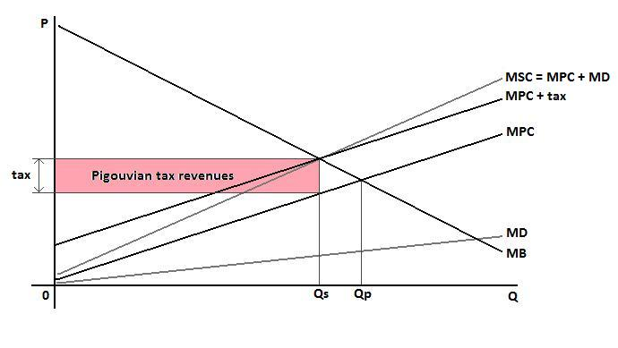
Figure 1
Implementing a Pigouvian tax can be difficult. It is hard to measure external costs, making it a challenge to create a marginal external cost curve and to calculate the right tax. In general, this approach assumes that it is known who does the pollution and in what quantities. This assumption might not always lead to external damage and tax levels that exactly fit objective reality, but it can be an improvement over the status quo, or the best alternative compared to other tax instruments. (Rosen, 2005)
This information can be applied to study the flight tax. The statutory incidence of the flight tax lies at the producers of the flights, the airline operators. They are responsible for the collection of the tax and the payment of the tax to the government. The airline operators add this tax directly on the ticket fairs. This causes the economic incidence of the flight tax to hit the consumer, the passengers who bought the tickets. The marginal cost of the tickets are now the marginal social cost. A new equilibrium will appear where the marginal private benefit equals marginal social cost. The new quantity of flight tickets will be more socially efficient. In the case of a tax, the social optimum is always lower than the private optimum. Without the tax, there would be overprovision.
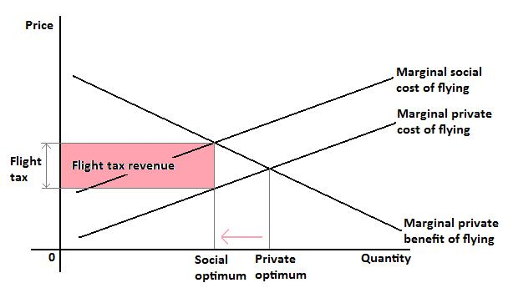
Figure 2
As mentioned, the economic incidence of the flight tax lies at the air travelers, but this does not mean that the airline operators aren’t economically hit by the tax. The new social optimum level of tickets is lower than before, causing lower revenues for the airline operators.
A decrease in the number of flights will release the pressure on the environment, by using less fossil fuel and creating less polluting CO2. This was one of the goals of the government in relieving pressure on the environment. The collected flight tax money was meant to be invested in environmental projects.
During the application of the flight tax, resistance against the flight tax rose under airline operators and airports. Although the Dutch Ministry of Finance calculated that the flight tax would yield an annual 350 million tax revenues, ANVR calculated in her own research that this would not be feasible. There would be fewer passengers due to the higher cost of travelling and many passengers would divert to other airports in neighboring countries. (Grotenhuis, 2007) They were right about the latter statement. Dusseldorf and Brussels got respectively 62% and 74% more Dutch travelers to process. Not only passengers left the Dutch airports, also the airline operators quit flying to destinations in the Netherlands. Ryan air quit flying to Maastricht, Volare Airlines no longer flew to the Netherlands and EasyJet made plans to cut the number of flight to Schiphol Airport. (z24.nl, 2007) (nu.nl, Ryanair verlaat Maastricht om vliegtaks, 2008)
An urgent letter was send to Prime minister Balkenende in February 2009, calling for an immediate discontinuance of the flight tax. This letter was send by the Dutch Chamber of Commerce, travel organizations and cargo companies. (Tourpress.nl, 2009) Air-France KLM calculated that the flight tax had cost 900.000 passengers. (nu.nl, Pleidooi voor herziening vliegtaks, 2009) During spring 2009, the flight tax was reconsidered and after new demonstrations it was finally stopped in July.

Determinants for demand
This chapter gives an overview of several different determinants that influence the demand for air transportation. These determinants come from general transport economics. (Mallard & Glaister, 2008) In this chapter, there will be determined to what extend the determinants apply to air transportation and if it is relevant to control for these determinants in the analysis of the flight tax.
The first and most important determinant of demand is price. For normal goods and services holds, that when the price goes up, the demand for it will go down. The amount in which this demand goes down is given by the price elasticity. Price elasticity in transportation is relatively low, because this demand is basically a derived demand. The utility people derive from transportation is largely determined by the destination, rather than the trip itself. The flight tax causes a shift in price for the consumers, so the price as a determinant for demand is the most important subject in this analysis. It is also important to mention that the determinant price distinguishes itself from the other determinants, because a shift in price creates a shift along the demand curve. The other determinants create a shift of the entire demand curve (see figure 1). In the previous chapter, the figure of the Pigouvian tax showed a shift along the demand curve due to the tax.
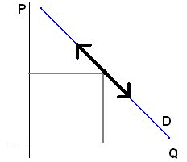
Figure 3
The flight tax creates different price increase for continental flights, than for intercontinental flights. For intercontinental flights, the tax is four times as large, so a larger drop in demand could be expected. But with taxes, you should take the size of the initial price of the good, on which the tax is levied, in account. Because intercontinental tickets are much more expensive than continental flights, the ratio between the tax and the ticket price is quite the same for both types of flights. Therefore the shift in demand will not be automatically four times larger for intercontinental passengers.
Another import determinant is income. When people have more income, they are able to spend more of that income on leisure and travel. This will create more demand for transportation. The income elasticity shows the relative shift in demand in comparison with the shift in income. Income growth will shift the entire demand curve outward (see figure 2). GDP is related to the income a country has available. Therefore income is an important determinant that must be taken into account in the analysis.
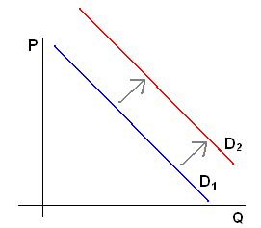
Figure 4
Price, quality and availability of substitutes is a third important determinant. When ticket prices in the Netherlands were growing due to the flight tax, then this makes the substitutes relatively cheaper. When the price of substitutes declines relatively, the demand for transport will decline. This determinant is important to keep in mind when choosing control airports. To make the analysis not too complicated, it is better to analyze airports that are no attractive substitutes of each other. A diverting passengers does not only create a decline in passengers in one land, but also create an increase in passengers in other lands. This way, the effect of a flight tax could be calculated to high by statistical software. Airports as Dusseldorf and Brussels, which are located just outside the Dutch border, are examples of attractive substitutes. They are in fact influenced by the flight tax, but in the opposite direction. In the meantime, they would be treated as ‘untreated by flight tax’ in the analysis. So, the analysis would become very biased.
Population size is a determinant that can shift the entire demand curve in- and outwards. An increase in population will increase the demand for transportation, shifting the demand curve outwards, and vice versa. This determinant should not be used when total GDP is used. Total GDP is the sum of all individual incomes of the population. Therefore, population will not be taken into the analysis, because it is already integrated in GDP. Besides that, there are no quarterly population statistics present for the foreign countries.
Speed and safety are two determinants that have an effect on the demand for transportation. They also play an important role in the demand for air transportation. Demand for air transportation declined after the 9/11 attacks, because people perceived flying temporarily as unsafe. (Notis, 2005) In this research, there will be no correction for safety because there have been no significant shifts in real or perceptive safety around 2008. Speed also determines demand, because higher speed can save travelers time, making it more profitable to choose for faster modes of transportation than slower ones. Since there have been no major changes in the speed of airliners in the past decade, it is not relevant to incorporate speed in the analysis.

Method and control group
For this research a panel study is made. Using a panel study is a suitable way to study variables over time on multiple identities. In this thesis the identities are airports. In this case, a longitudinal study of GDP and passenger numbers is set up between several different airports over time. This chapter is divided in two parts, the first part describes the method which is used to analyze the data. In the second part the specifications for other airports are discussed and on that basis, five airports are selected.

Method
The dependent variable studied in this panel study is the number of passengers. Linear regression analysis will be executed for different categories of pax, these will be discussed later in this chapter. The independent variables used, are GDP and the presence of a flight tax. The variable GDP represents the income determinant and tax represents the price determinant, these are discussed in the previous chapter. Quarterly data is used for all the variables because quarters are the smallest time spans for which data was available. This way a lot of data points can be found. Also, the incorporation of the variable flight tax was easy due to the fact that it starts and ends at July. The time series starts at 2003, two years after the 9/11 attacks on the WTC, to rule out big effects of safety on demand. It ends in 2010, the most recent year for which all the necessary data was available. All data on passenger numbers and GDP come from Eurostat, this is a large database from the European Commission. (European Commision)
The data is analyzed with Stata software. The first step is to convert all the variables into logarithmic variables. This way, the variables are easy comparable and the changes in variables are directly shown as an elasticity. Before each analysis, a unit root test is executed for each variable. It is important to check if there are any unit roots present in the data. Data can be non-stationary due to unobserved variables, for example population growth. If this is the case, this should be corrected for. When there are no unit roots present, the data is stationary and it can be used freely. (Stata) After that, regression analysis can be executed. Fixed Effects are expected in the data, so this will be taken into the regression analysis.
First the effect of GDP and flight tax on the total passengers will be analyzed. This regression analysis is a very rough one because it contains a lot of passengers who do not pay a flight tax. For example, all the transfer passengers are also taken into the regression. Because the flight tax has no influence on them, they will lower the actual impact of the flight tax in the results of the analysis. If it is still possible to obtain significant impact of the flight tax, it could be expected that on o&d passengers, the impact is larger. Unfortunately, data for a quarterly split between o&d and transfer passengers was not present for all airports.
After that, the effect of GDP and flight tax on the arriving passengers, followed by the effect of GDP and flight tax on the departing passengers. Due to the fact that most travels come with an arrival and a departure, these two depending variables are complementary. Therefore, no great differences are expected in the impact of the flight tax on these two variables. Each passenger is a departing passenger and at a certain future point he will become an arriving passenger.
Then, the impacts of the flight tax on the continental and the intercontinental passengers are researched. On international flights, the flight tax is four times as high as on continental flights. Theory tells us that demand will decline more on intercontinental then on continental flights. This effect could be erased by the fact that intercontinental flight tickets are more expensive. The height of the flight tax in relation to the ticket price can therefore be quite similar for both types of journeys.
After each analysis, a Hausman test is executed. This test shows if there are fixed effects present at each airport. Fixed effects are expected because of the different characteristics of the airports. All regressions will be executed with fixed effects. Otherwise differences in passenger numbers will be only allocated to the constant and the variables, biasing the effect of the variables. When there are no fixed effects, the regression will be executed again with random effects. In the figure below, there is simply shown how the total effect at two different airports, after treatment on one of the airports, should be split into fixed effects and treatment effects.
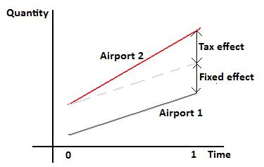
Figure 5
With the results of the regression analysis, the independent variables can be judged on impact and significance. With this, economical interpretations and conclusions can be drawn.

Controlling airports
A number of other airports will function as a control group. It is not easy to compare airports, because of the many economical and logistic characteristic aspects that they have. To obtain a few good airports, the following criteria are used.
The airport should be in the top 5 largest airports in Europe. It must be the largest airport, by passenger numbers, in its country. It should have a significant amount of transfer passengers. This indicates that the airport functions as a hub in a hub and spoke network, just like Schiphol airport. Finally, the airport should not be located in close proximity of the Dutch border, to cancel out the effect of diverting passengers.
Rank | Airport | Total Pax | Top 5 (y/n) | Largest in Country (y/n) | % Transfer pax | % Transfer pax > 20 % (y/n) | Distance to NL border (km) | Distance to NL > 100 km (y/n) | Selected (y/n)
1 | LONDON HEATHROW airport | 66.015.300 | y | y | 35 | y | 265 | y | y
2 | PARIS-CHARLES DE GAULLE airport | 59.000.770 | y | y | 52 | y | 260 | y | y
3 | FRANKFURT/MAIN airport | 53.283.191 | y | y | 54 | y | 200 | y | y
4 | MADRID/BARAJAS airport | 49.830.841 | y | y | ? | y | 1350 | y | y
5 | AMSTERDAM/SCHIPHOL airport | 45.286.976 | y | y | 42 | y | ? | x | y
6 | ROMA/FIUMICINO airport | 36.719.611 | n | y | ? | ? | 1110 | y | n
7 | MUNCHEN airport | 34.796.167 | n | n | ? | ? | 500 | y | n
8 | LONDON GATWICK airport | 31.407.256 | n | n | ? | ? | 255 | y | n
9 | BARCELONA airport | 29.198.094 | n | n | 14 | n | 1090 | y | n
10 | PARIS/ORLY airport | 25.568.208 | n | n | ? | ? | 295 | y | n
Table 1
The following Airports have been chosen from the table above; Frankfurt Airport, Paris-Charles de Gaulle Airport, London Heathrow Airport and Barajas Airport. The results in the table are quite easy interpreted. The column “largest in country” is in fact unnecessary in this case, because the five largest airports are all situated in different countries, making them automatically the largest in that country. The percentage of transfer passengers was selected from data of 2009 to 2011, depending on the availability. No significant difference can be expected in this data from year to year.

Data analysis
After the logarithmic variables were made, the Levin-Lin-Chu unit-root test could be performed. This was done for all the variables. The Null-hypotheses, that the panels contain unit roots, was tested and for all variables holds that the p-value was smaller than 0,05. Therefore, the null-hypothesis could be rejected for all the variables. No further corrections where needed on the data and the regression analysis could be executed. The table below show the results of the Levin-Lin-Chu unit-root test, followed by the five regression analysis.
Result Levin-Lin-Chu unit-root test
Ho: | Panels contain unit roots |  |  | Number of panels |  | = | 5
Ha: | Panels are stationary |  |  | Number of periods |  | = | 32
Variable |  | Adjusted T* statistic | P-value | Hypothese
lngdp |  | -2,7154 | 0,0033 | Ha: | Panels are stationary
lnpax_tot |  | -14,8532 | 0,0000 | Ha: | Panels are stationary
lnpax_arr |  | -14,7081 | 0,0000 | Ha: | Panels are stationary
lnpax_dep |  | -15,0690 | 0,0000 | Ha: | Panels are stationary
lnpax_con |  | -11,0707 | 0,0000 | Ha: | Panels are stationary
lnpax_int |  | -11,5382 | 0,0000 | Ha: | Panels are stationary
Table 2
lnpax_tot | lngdp | tax
Coefficient | 0,80 | -0,07
t | 3,47 | -3,26
P>|t| | 0,03 | 0,03
R-squared | 0,22
lnpax_arr | lngdp | tax
Coefficient | 0,79 | -0,07
t | 3,44 | -2,99
P>|t| | 0,03 | 0,04
R-squared | 0,23
lnpax_dep | lngdp | tax
Coefficient | 0,81 | -0,07
t | 3,48 | -3,51
P>|t| | 0,03 | 0,03
R-squared | 0,22

lnpax_con | lngdp | tax
Coefficient | 0,57 | -0,05
t | 1,82 | -1,98
P>|t| | 0,14 | 0,12
R-squared | 0,00
lnpax_int | lngdp | tax
Coefficient | 1,16 | -0,09
t | 3,84 | -3,25
P>|t| | 0,02 | 0,03
R-squared | 0,22
Table 3
Next come the results of the Hausman test, which determines whether fixed effects are present. For lnpax_tot, lnpax_arr, lnpax_dep and lnpax_con, the Hausman test gives fixed effects. The null-hypothesis, that difference in coefficients is non systematic, can be rejected. This means that there are fixed effects present and these should be taken into the regression analysis. No fixed effects where found in the lnpax_int data. This means that random effects are used in the regression analysis. The results of the Hausman test can be found in the appendix.
The Hausman test results are quite consistent and expected, except for intercontinental passengers. The fact that there are no fixed effects present could indicate that for intercontinental flights, unique characteristics of airports fade away. A possible explanation for this could be that the percentage of transfer passengers is higher among intercontinental flights than on continental flights. Because over longer journeys, transfer movements occur more often. The fixed effects that create initial differences between airports can then be less relevant. For example, Madrid Barajas airport is situated next to a city with approximately 3,3 million residents, while Schiphol airport lies next to Amsterdam, which has around 800,000 residents. A fixed effect could then be that Barajas has a fixed advantage with respect to the amount of o&d travelers using the airport. But, for transfer passengers, the airport is only used as a hub, making this backland population statistic less relevant.
The regression analysis on the intercontinental passengers had to be executed again, with random effects instead of fixed effects.
lnpax_int | lngdp | tax
Coefficient | 1,12 | -0,08
t | 3,65 | -3,11
P>|t| | 0,00 | 0,00
R-squared | 0,22
Table 4
Starting with the effect of lngdp and the tax on lnpax_tot. The coefficient for lngdp is positive with 0,80 and its p-value is significant. The presence of a flight tax is represented in the negative coefficient of -0,065. This coefficient is significant. This means that the presence of the flight tax create a significant decline in total passenger numbers at Schiphol airport.
For the distinction between arriving and departing passengers, no great differences where expected because these two types of passengers are complementary. The results confirm these expectations. For arriving passengers, the coefficient of lngdp is 0,79 and significant. The tax coefficient is
-0,06 and also significant. For departing passengers, these results are respectively 0,81 and -0,07 and also significant. These numbers are quite similar to the results for arriving passengers. Looking back at the results for total passengers, it can be seen that the results of the arriving and departing passengers analysis are quite close to the total passengers analysis.
Finally, the distinction between continental and intercontinental passengers have been analyzed. The coefficient for gdp is 0,57, but this is not significant. Also the coefficient of the flight tax, which is
-0,05 is not significant. This means that gdp and the flight tax don’t have any significant impact on the number of flights people make. This can be explained by the fact that price and income elasticity of flying can be relatively low. This is reflected in theory on elasticity of demand for transport, that says that transport has a derived demand. People care much more about the utility they derive from the destination than the trip itself.
An other explanation can be that the effect of the flight tax is to low because transfer passengers are taken into the analysis. But this would also hold for the total passenger statistics, which do show significant flight tax effects. Due to the fact that R-squared is very low, in contrast with all the other analysis, this regression has virtually no explanatory power. Therefore it is not useful to do any statements about the independent variables in the first place. Further research should be done to explain this outlying result.
The results of the intercontinental passenger analysis are more like the first three analysis. GDP is very significant and has a relatively large coefficient of 1,12. Also the tax is very significant with a coefficient of -0,08. Both coefficient are larger than all the others. This could indicate that on longer flights, income en prices play a stronger role in the amount of passengers. What also counts is that this regression was done without fixed effects.
Finally, it can be seen that the average between the coefficients of the arriving and the departing passengers are almost identical to the total passenger coefficients. The average between the coefficients of continental and intercontinental passengers are a bit further away from the coefficients of total passengers, but this can be explained by the fact that the variable pax_int was regressed with random effects instead of fixed effects.

Conclusions, limitations and recommendations
The demand for air transportation is determined by the price of flying, a tax raises the price and this could influence demand negatively. In the analysis, this was incorporated as the variable tax. Income has a positive effect on demand and in the analysis GDP represented this determinant.
Population has a positive effect on the demand, when a population grows, the demand for air travelling will increase. Speed and safety are also determinants that influence demand positively. These three determinants are not used in the analysis.
Based on the results of the Stata analysis on the passenger data, it is possible to conclude that the flight tax really has an impact on the amount of passengers on Schiphol. When looking at total passengers, the flight tax causes a significant decline in passengers of 6,5 percent. Schiphol had 58 % o&d passengers during 2008, so within the o&d passengers numbers, there was a decline of 6,5 / 58 % = 11,2 %. This is a very primitive estimation, and the percentage was for 2008, so not exactly the lifetime of the tax.
As expected, the effect on the arriving and departing passengers should be roughly the same, because those types of flights are complementary. The flight tax causes 6 percent decline in arriving and 7 percent decline in departing passengers.
On the continental passengers the flight tax plays no significant role. Further investigation of these results is important, also the very low R-squared is notable. The flight tax does play a significant role in the number of intercontinental passengers; application of the tax causes a decline in passengers of more than 8 percent. Interesting to see is that with regard to the intercontinental passengers, there are no fixed effects in the coefficients. This is very interesting and further research could help to discover why this variable has different statistical characteristics. One explanation is that intercontinental flights transport more transfer passengers, for which local characteristics of an airport are not relevant. This could cause the fixed effects to decrease.
This research is limited in a few ways. It was not possible to run a regression analysis on the most relevant type of passenger, the departing o&d passenger at Schiphol. Simply, because it was not possible to obtain this particular data. A split between transfer and o&d passengers was only obtainable as an annual percentage for some airports.
The executed analysis all contain data for irrelevant passengers. The split between arriving and departing passengers contained transfer passengers, lowering the impact of the flight tax. The distinction between continental and intercontinental passengers contained not only the transfer passenger, but also arriving and departing passengers where summed. So for all outcomes of the impact can be argued, that with more data on a specific type of passenger, the impact of the flight tax should be even more significant.
Germany recently came up with his own flight tax. Within two years, data on passenger numbers will be available. This research could be rehearsed for Germany. Basically, the same table can be used and for Germany the tax dummy variable can be set to one. It is interesting to compare the impact of that flight tax, with the results of the Dutch flight tax, to check if there is consistency in the effect of different flight taxes across Europe. Also the European Union is working on a European flight tax. Also assessment of this tax is relevant, although probably a new research design has to be made, because it is not possible to make a control group within the same economic union when all countries levy a flight tax.
With the results of this research, the flight tax can be kept accountable for the decline in passengers during 2008 and 2009. A flight tax will function as an instrument to lower the demand for air traveling, and with that, the amount of flights. But it is questionable if it is wise to do so during a decline in economic performance, because it causes unemployment and deterioration of the competitive position of the flight sector.

Bibliography
Devlin, K. (2002, September). The crazy math of airline ticket pricing. www.maa.org.
European Commision. (n.d.). Eurostat. Retrieved from www.eurostat.com
Grotenhuis, A. (2007, September 10). ANVR vecht tegen vakantiebelasting. NRC.
Khandker, S., Koolwal, G., & Samad, H. (2010). Handbook on Impact Evaluation. Washington D.C.: The World Bank.
Mallard, G., & Glaister, S. (2008). Transport Economics: Theory, Application and Policy. Palgrave Macmillan.
Notis, K. (2005, November 1). Bureau of Transportation Statistics. Retrieved from http://www.bts.gov/publications/special_reports_and_issue_briefs/issue_briefs/number_13/html/entire.html
nu.nl. (2009). Pleidooi voor herziening vliegtaks.
nu.nl. (2008, November 20). Ryanair verlaat Maastricht om vliegtaks.
Perman, R., Ma, Y., McGilvray, J., & Common, M. (2003). Natural Resource and Environmental Economics. Pearson Education Limited.
Rosen, H. S. (2005). Public Finance. New York: McGraw-Hill.
Stata. (n.d.). Stata. Retrieved 2012, from www.stata.com
Staten Generaal. (2007). Wijziging van enkele belastingwetten 2008. 's-Gravenhage: Sdu.
Tourpress.nl. (2009). Brandbrief: 'stop onmiddellijk met vliegbelasting'.
Travelvalley. (2010, september 2). Retrieved june 5, 2012, from Travelvalley: http://www.travelvalley.nl/Vliegen/846
Vliegtaksvrij. (2009). Retrieved juni 7, 2012, from Vliegtaksvrij: www.vliegtaksvrij.nl
Weizsäcker, E. U. (1992). Ecological tax reform. Zed Books.
z24.nl. (2007, September 6). EasyJet verhuist om vliegtax.

Appendix
