‘Physician-leaders and hospital performance: Is there an association?’
An empirical study about expert leadership

Erasmus University Rotterdam
Erasmus School of Economics
Department of Economics

Supervisor: Josse Delfgaauw

Name: Hylke Stelpstra
Exam number: 333695
E-mail address: stelpstra@ese.eur.nl
Date: 23-08-2012

- Abstract -
The central question in this thesis is whether health care professionals are more effective than general managers without medical training in leading a hospital. Earlier literature on this question is inconclusive. There are theoretical arguments in favor of both types of managers. Empirical evidence is scarce. In this thesis, I conduct an empirical cross-sectional study in the Netherlands on hospital performance and the educational background of the members of the executive board. Statistical analysis makes clear that there is no significant correlation between the quality of a hospital and the educational background of the CEO or the executive board of a hospital.
1. Introduction
The health care sector in the Netherlands has become increasingly important over the last decades. Health care expenditures have been growing very rapidly from around 11 percent of GDP in 1990 to around 15 percent of GDP in 2010 (CBS, 2011). The same upward trend is observable in many other OECD countries. Given rapid ageing of the population, this fraction is likely to continue growing over the next decades. In recent years many policy changes have been implemented by the government aimed at controlling the health care expenditures. Health care organizations face the challenge to pursue the dual goals of offering high quality health care at affordable prices.
Bloom, Propper, Seiler and Van Reenen (2010) found that management quality is associated with better financial outcomes and health care quality in the English health care sector. Leaders play an import role in a health care organization. In the past hospitals were led by physicians. This has changed. The percentage of hospitals that are physician led had been declining and stands now at an all-time low (Gunderman and Kanter, 2009). In 1935 35% of the U.S. hospitals were led by physicians. In 2008 fewer than 4% of the U.S. hospitals were managed by a physician. In 2011 52% of the Dutch hospitals were led by physicians. The question raised is whether health care professionals are more effective than general managers without medical training in leading a hospital.
Although this question is discussed many times in practice, it has not been fully addressed in the current management literature. There are arguments in favor of both types of managers. Schultz (2004) found out in a computer simulation that it does not make a difference in terms of organizational outcomes whether a physicians or a manager leads a hospital. Goodall (2012) argues the opposite in a new ‘theory of expert leadership’ (TEL). This theory suggests that organizations perform more effectively when led by experts compared with generalists. Goodall (2011) performs a cross-sectional study on the top-100 U.S. hospitals in 2009 and finds a strong positive association between the ranked quality of a hospital and whether the CEO is physician.
In this thesis, I conduct an empirical cross-sectional study in the Netherlands on hospital performance and the educational background of the members of the executive board to test which view is backed by empirics. The central question throughout the thesis is: Do health care organizations perform more effectively when they are led by individuals with a medical education? The performance of a health care organization is determined by the quality of the health care and the financial performance. These two organizational outcomes will be linked in three ways with the educational background of executive board of the hospital. The analysis covers the educational background of the most import decision maker, the CEO. Because many decisions are made by executive board as a whole, the situation where at least one of the members of the executive board is a physician and the average expertise of the executive board will also be taken into account.
This thesis aims to provide a valuable contribution to one of the most challenging questions in current management literature about which type of managers should lead a health care organization. The structure of this thesis is as follows. The related literature with an emphasis on the mechanics behind the relationship between leadership and organizational outcomes is discussed in section 2. Section 3 covers information about the data and methodology. The main analysis is found in section 4. Section 5 discusses the limitations and shortcomings of the analysis. Finally, section 6 concludes.

2. Literature Review

The Theory of Expert Leadership
As mentioned before, the issue whether an expert or manager is the most effective leader has not been systematically examined in the management literature. Goodall (2012) made a valuable contribution by combining a theoretical framework with empirical evidence. In her ‘theory of expert leadership’ (TEL) organizational performance can be thought as a function of inherent knowledge (IK), industry experience (IE) and leadership capabilities (LC) (figure 1). Each of these three components are strongly (positive) related with the core business and the performance of the organization. Core business is defined as the most import or primary activity of an organization. The core business in hospitals is the practice of medicine.
EL = f (IK, IE, LC)
Figure 1. Theory of Expert Leadership
The first and main component Inherent Knowledge (IK) largely determines the quality of a leader. Inherent knowledge can be described as expertise acquired through education and practice combined with high ability in the primary activity. Individuals with technical knowledge and high ability in the health care sector are physicians. TEL suggests that the most import decision maker - the CEO - should be among the best experts in the field. Organizations will perform less well if leaders are generalists (e.g. managers). Although the second and third component play a role, they are less important according to Goodall.
The second component Industry Experience (IE) means the time spent in the core-business sector. This suggests that organizations led by leaders who have spent most of their career in the same sector outperform those organizations who are led by leaders who have less experience in the core-business sector. The third component Leadership Capabilities (LC) focuses on the leadership- and management skills of the leader. These skills can be acquired through experience, education, training or can be innate. Bloom and Van Reenen (2007) found that management and leadership skills are positively associated with organizational performance but they assign relatively more weight to the importance of this component compared with Goodall. They emphasize the value of good management practices. The impact of management practices on productivity was investigated in a management field experiment on large Indian textile firms. Free consulting was provided to randomly chosen plants. Adopting these management practices raised productivity by 17 percent in the first year (Bloom, Eifert, Mahajan, McKenzie and Roberts, 2012).

Mechanics behind the Theory of Expert Leadership
Salas, Rosen and DiazGranados (2010) bring together the concepts of intuition and expertise. Intuition can in this context be described as a process of unconscious thinking based on expertise and heuristics. Expertise is high levels of skill or knowledge in a specific domain related to the core business. These two concepts are related to the first (Inherent Knowledge) and second (Industry Experience) component of TEL. Expert performance relies on specific intuition developed through practice and experience. Experts base their decisions not purely in deliberation or purely in intuition, but a mixture of both. Rapid and effective decisions are rooted in specific knowledge, pattern recognition and automaticity. Both systems are interacting in complex ways. Baylor’s U-shaped curve (2001) describes the development of intuition influenced by an individual's level of expertise. Early stages of intuition are qualified as immature intuition which corresponds with low levels of expertise. The availability of intuition decreases as the individual develops knowledge. In the later stages of intuition, intuition draws on accumulated knowledge and is qualified as mature intuition. This type is referred to as expertise-based intuition. Intuition is most likely to be effective when the situation is time-pressured and complex.
Goodall (2012) argues that the first component (Inherent Knowledge of the core-business) may improve the organizational performance in five ways. Expert leaders are better able to identify opportunities and challenges. Their preferences and the decision they made are reflections of their own values and cognitions and are prioritized throughout their career. Thus the preferences of an expert leader as a former practice expert are more in line with the core business, than the preferences of a generalist without any practical experience.
An expert leader is easier able to enforce a certain quality standard in an organization, because he as a standard bearer has met the standard that is to be imposed. The quality standard is automatically raised when an outstanding expert is hired. Expert leaders have an advantage in selecting new people. Individuals tend to hire to ‘reproduce themselves’ by hiring new people (Kanter, 1977). Outstanding experts will attract new outstanding experts; less talented workers will attract new less talented workers. Furthermore individuals find it hard to hire others who are better (i.e. more talented) than themselves.
Expert leaders are viewed as more credible by core workers and also by a wider audience, because they have met a certain quality standard. This signals that the leader understands the organization in every aspect and this will extend their influence.
Experts leaders can better understand the culture, incentives and motivations of the workers, because they have been ‘one of them’. They are compared with generalists more able to create the right work environment that is conducive to high performance because of their knowledge of the field. Career satisfaction in the medical profession is deteriorating over the last decades, while the number of hospitals with physician chief executive officers (CEO) is declining. A 2002 survey of physicians showed that six of the top seven sources of physicians’ dissatisfaction are influenced by the leaders of health care organizations. These include lack of autonomy for making medical and organizational decisions (Gunderman and Kanter, 2009). Creating greater autonomy for physicians encourages innovation. Mumford, Scott, Gaddis and Strange (2002) argued that the leadership of creative people requires expertise. This is related with the first component of TEL (Inherent Knowledge). Creative work occurs on complex and ill-defined problems. Leaders prove to be more effective if they involve early in projects so they are able to reduce ambiguity and structure the problem in organizational needs. An expert is more likely to engage actively in the initial phase. Organizations led by experts are according to this reasoning more innovative. Barnowe (1975) found out that the leader technical skill was the best predictor of innovation, with respect to four other leadership characteristics. The health care sector is with its notoriously expensive, inefficient and consumer unfriendly service in need of innovation (Herzlinger, 2006).
In general, it takes a long time to become an expert. It takes for instance up to eight years to become a fully proficient surgeon. Once they are experts, they have to continue education to stay abreast of up to date knowledge. Unlike physicians, managers do not need a formal education. Although many managers obtain a MBA, it is not a requirement for becoming a manager. There is also no obligation for managers to stay current in their field (Khurana and Nohria, 2008). Therefore experts are considered to be more intrinsically motivated compared with generalists who are considered to be more extrinsically motivated. Barker and Mueller (2002) emphasize the importance of intrinsically motivated leaders. Intrinsically motivated leaders are likely to adopt a long-term strategy and invest more in new technologies and Research & Development. Although investments in new technologies are expensive, risky and take some time to become profitable, they contribute essentially to organizational performance in the long-term. Barker and Mueller (2002) showed that leader tenure is positively related with R&D expenditures. Non-expert leaders (i.e. managers) have a more short-term view and are less likely to invest in R&D.

Empirical support of the Theory of Expert Leadership
The hypothesis that organizations perform most effectively when they are led by expert leaders has been studied within different contexts. Goodall, Kahn and Oswald (2011) showed that a person’s level of technical attainment in a preceding period determines success in a subsequent period based on data on U.S. professional basketball. There exists a correlation between brilliance as a basketball player and the success (i.e. winning percentage) of that person as a basketball coach.
In another study, this time using U.S. university data (Goodall, 2006), a leader’s level of scholarship correlated with the position of their university in a global ranking. Top-universities were most likely led by outstanding scholars.
The same question was examined in the U.S. health care sector. A strong positive association was found between the ranked quality of a hospital and whether the CEO is physician (p<0.001). The cross-sectional study was based on a dataset on the top-100 U.S. hospital in 2009 in the three specialties of cancer, digestive disorder and heart surgery (figure 2).
Figure 2. Mean Index of Hospital Quality Score of Hospitals Led by Physician CEOs and Manager CEOs in Three Specialty Fields

Boundaries of the Theory of Expert Leadership
Goodall’s Theory of Expert Leadership has been criticized in various ways in the literature. Janis (1983) suggests that experts have a narrow perspective of the world. Being overly focused or being self-conceit might stifle the decision process. People who are expert in a particular field may overemphasize their abilities in other fields. Prasad (2009) developed an agency model of job assignment in research organizations. Based on a variety of data sources, he suggests that job assignment depends on relative ability and the breadth of tasks. Management can be seen as a multiple task job with tasks related to an individual's area of expertise and tasks related to supervisory skills. Generalists get assigned to multiple tasks and experts are given incentives to perform a single task. According to this model general managers are the most able leaders. Lazear (2005) considers a two period model in which an individual invests in knowledge in period 1, which alters skills in period 2. Ability is found to be negatively related to specialization. For low ability individuals, it is better to specialize. High ability people are more likely to be generalists because they encounter problems from varied areas. They are attracted to industries that have the highest variance in outcomes because their value added is highest in those industries. The theory that leaders should be generalist is tested using data from the alumni of the Stanford Graduate School of Business. The data show that the best leaders are generalists.
The focus in the Theory of Expert Leadership on inherent knowledge of the core business activity over the other two components (industry experience and leadership capabilities) has been criticized by Bloom and Van Reenen (2007). Goodall (2012) suggests that the size of the inherent knowledge on the organizational performance may be between 15-20 percent based on their analysis in various sectors. Bloom, Eifert, Mahajan, McKenzie and Roberts (2012) emphasize the importance of good management practices. Their view is backed by empirics. They observed a productivity increase of 17 percent in one year in their field experiment after providing free consulting to large Indian textile firms. This result supports the importance of leadership capabilities. Experts may also be slower in adopting modern management practices compared with managers. Goodall’s view that leaders benefit relatively more from one ‘input’ than the other ‘inputs’ is therefore questionable. Being an expert is not a sufficient but might only be a necessary condition for effective leadership.
Critics contend that Goodall's Theory of Expert Leadership is lacking in empirical evidence. Schultz (2004) conducted a computer simulation to test whether there exists a relation between education of the manager and organizational performance. It has been suggested that dual performance goals exist within a health care organization. Medically-educated managers might be more focused on the needs of the patients and therefore make decisions that benefit the quality of the health care and managerially-educated managers might give more attention to financial issues. In a computer simulation medically-educated and managerially-educated senior managers from large health care organizations were instructed to make resource allocation decisions to pursue the dual goals of maximizing net income and improving customer satisfaction. The results of the study suggest that there is no significant difference between medically-educated and managerially-educated senior managers in their ability to make strategic decisions. No statistically significant correlation appeared between education and the areas of customer satisfaction and net income. Other independent variables such as work- and management experience were found to be unrelated with organizational performance. According to Schultz (2004), the debate between physicians and managers is misdirected. Other characteristics beyond educational background may play a decisive role.
We observe contrasting results in the literature and empirics. There are arguments in favor of both types of managers. The question is raised if and to what extent the theory of expert leadership can be applied. Even if the theory of expert leadership might be true in a particular setting, it does not prove that experts are more effective in other types of setting. The boundaries of the theory of expert leadership should be established empirically. The next sections describe an empirical cross-sectional study in the Netherlands on the hospital performance and the educational background of the members of the executive board.

3. Data and Methodology
The health care sector in The Netherlands consists in 2011 of 109 hospitals. This number is subject to change due to new start-ups, mergers and acquisitions. Hospitals can roughly be divided into three types: general hospitals, specialist hospitals and academic medical centers. These three types’ hospitals are in various ways different. Academic medical centers are related with a university and are specialized in high-risk surgeries. Specialist hospitals are small health care organizations with a focus on a particular treatment (e.g. cataract surgery or breast cancer). These major differences between the types of hospitals make comparison difficult and forced to distinguish in the analysis between the different types of hospitals.
The Dutch Health Care Inspectorate (IGZ), part of the Ministry of Health, Welfare and Sports promotes public health through the effective enforcement of the quality of care. The Inspectorate has designed in cooperation with physicians standards and guidelines to ensure high quality health care. Virtually all reports produced by the inspectorate are made public. Two hospital rankings are partly based on this data: Elsevier the Best Hospitals 2011 and the AD Hospital top-100 2011. Although both rankings cannot be viewed as entirely reliable measures of quality; they give a useful insight in the performance of a hospital. Elsevier did in association with consultancy firm SiRM extensive research to the performance of the hospitals in the areas medical care (safety and efficiency) and patient orientation (waiting lists, service and information provision). More than 174 indicators have been used. The score of a hospital is expressed in one to four dots. The dots do not reflect an absolute score, but indicate how the hospital scores on the selected indicators compared with the average in the Netherlands (Elsevier, 2011). The AD Hospital top-100 is less extensive and is based on 38 criteria of which 33 related to medical quality of the hospital. The other 5 criteria are related with factors such as service and information provision. A hospital can obtain maximum 65 points. The percentage points obtained of the maximum achievable number of points determines the ranking (Algemeen Dagblad, 2011). Because of the Elsevier research is more extensive and provides more information about the methodology than the AD research, it will be used as the main indicator for the quality of a hospital.
Health care organizations in The Netherlands are obliged to publish an annual report. The Ministry of Health, Welfare and Sports collects this data, aggregates it and publishes it online. This dataset (DigiMV) covers financial and organizational data on 2010. The dataset is used to correct the findings for potentially relevant factors such as number of beds, total revenue, operating profit, number of employees, number of medical specialists, etc. The fact that this data is based on 2010 and the performance data is based on 2011 would not cause significant mismatch, because factors such as number of beds and number of employees are not subject to wide fluctuations over a short time period.
Data were manually collected on the educational background of each member of the executive board of a hospital. Each person was classified into one of two categories; physicians or non-physicians. Those who have been trained in medicine are classified as a physician. Hospitals’ websites, personal LinkedIn pages and on some occasions e-mail contact with hospitals have been used as a data source. Goodall (2011) classified the hospital in two categories: those with a physician CEO and those with a non-physician CEO. This analysis covers also the situation where at least one of the members of the executive board is a physician. The average expertise of the executive board was also taken into account as independent variables in the analysis.

4. Basic Results
Only the hospitals which provided full information on all three areas (hospital performance, educational background members of executive board and hospital characteristics) haven been taken into account. 23 out of 109 hospitals did not provide full information on all these three areas and are therefore eliminated of the analysis. The remaining 86 out of 109 hospitals are eligible for the analysis (table 1). Because of the Elsevier research is more extensive and provides more information about the methodology than the AD research, it will be used as the main indicator for the quality of a hospital. The results for similar analysis based on the AD research can be found in the appendix.
Variables | Minimum | Maximum | Mean | Std. Deviation
Elsevier Total Score | 1,00 | 4,00 | 2,6279 | 1,02952
AD Score | 54,59 | 87,33 | 70,7274 | 6,18506
Medical expertise (CEO) | ,00 | 1,00 | ,4884 | ,50280
Medical expertise (average of the executive board) | ,00 | 1,00 | ,4531 | ,30515
Medical expertise (at least one in the executive board) | ,00 | 1,00 | ,7907 | ,40920
Total operating revenues (millions) | 18,39 | 1192,61 | 213,0968 | 208,20187
Operating profit (millions) | -9,93 | 19,65 | 3,3027 | 4,26350
Number of available beds at end of the year | 16,00 | 1320,00 | 486,2706 | 264,12557
Number of medical specialists at end of the year | 24,00 | 732,00 | 172,3765 | 138,32191
Number of employees employed excluding medical specialists at end of the year | 390,00 | 11031,00 | 2564,9524 | 2026,42810
Number of observations: 86

Table 1. Descriptive Statistics Dataset

The CEO is considered as the most important decision maker within an organization. Goodall (2011) found a strong positive association between the ranked quality of a hospital and whether the CEO is physician based on a cross-sectional study on the top-100 U.S. hospitals in 2009. Using the same methodology as Goodall (2011), we do not observe an association between the quality of a hospital and whether the CEO is a physician. There does not appear a significant difference in quality between the hospitals with a physician or with a non-physician as CEO in the Netherlands (see figure 2).
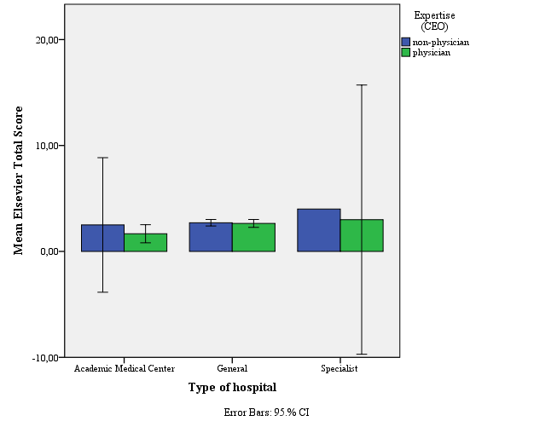

Figure 2. Bar chart with on the y-axis: Quality (Elsevier Total Score) and on the x-axis: Type of hospital with Error Bars: 95%.

Statistical analysis confirms the view of figure 2. The coefficient of expertise (CEO) is not significant. Relevant hospital characteristics that may affect hospital performance are included in the analysis. Total operating revenues (in millions); operating profit (in millions), number of medical specialists; number of employees employed excluding medical specialists are not significant. The number of available beds varies from 16 to 1320 and is significant given the other factors (table 2).
Variables | Coëfficiënt | Std. Error | p-value
(Constant) | 2,175 | ,290 | ,000
Expertise (CEO) | -,131 | ,227 | ,566
Total operating revenues (millions) | -,002 | ,003 | ,527
Operating profit (millions) | ,040 | ,027 | ,142
Number of available beds at end of the year | ,002 | ,001 | ,013
Number of medical specialists at end of the year | ,001 | ,003 | ,684
Number of employees employed excluding medical specialists at end of the year | ,000 | ,000 | ,505
Number of observations: 86 R²: 0,153
Table 2. Coefficients from Linear Regression with Dependent Variable: Elsevier Total Score
Although the CEO is the main decision maker, he leads the hospital together with other members of the executive board. 66 out of 86 hospitals have an executive board that consists of more than one member. Because the executive Board as a whole generally makes decisions, it might be useful to link the hospital performance with the average expertise of the executive board. Figure 4 provides a general impression of the results. The scatter plot does not show a clear relationship between the average expertise of the executive board and the quality of a hospital. Statistical analysis confirms this impression.
Figure 4. Scatter plot with on the y-axis: Quality (Elsevier Total Score) and on the x-axis: Expertise (average).

Many hospitals have at least one physician in their executive board (68 out of 86 hospitals). Those hospitals with an executive board of more than one member are likely to have at least one physician in their executive board (59 out of 66 hospitals). Figure 5 shows no significant difference in quality between the hospitals with no physician in the executive board and the hospitals with at least one physician in the executive board. Only general hospitals are covered in this analysis, because academic medical centers and specialist hospitals without at least one physician in the executive board do not exist.
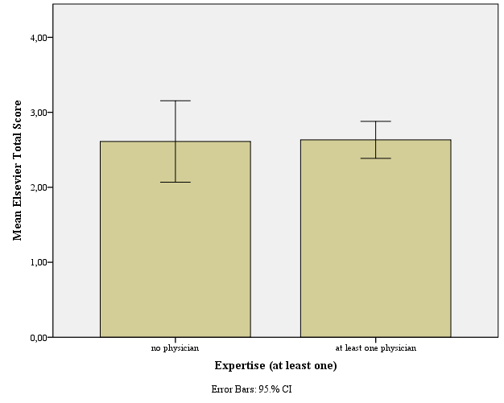

Figure 5. Bar chart with on the y-axis: Quality (Elsevier Total Score) and on the x-axis: Expertise (at least one of the members of the executive board is a physician) with Error Bars: 95%.

These findings summarized in table 3 do not provide empirical support of the Theory of Expert Leadership, but are more line with Schultz (2004). Based on the cross-sectional study in the Netherlands on the hospital performance and the educational background of the members of the executive board, we cannot conclude that health care organization perform more effectively when they are led by individuals who have inherent knowledge of the core business activity. The appendix contains the extended analysis including the control variables.
Model | Variables | Coëfficiënt | Std. Error | p-value | R²
1 | (Constant) | 2,727 | ,155 | ,000 | 0,010
1 | Expertise (CEO) | -,203 | ,222 | ,363 | 0,010
2 | (Constant) | 2,772 | ,200 | ,000 | 0,009
2 | Expertise (average) | -,318 | ,366 | ,388 | 0,009
3 | (Constant) | 2,611 | ,244 | ,000 | 0,000
3 | Expertise (at least one) | ,021 | ,275 | ,939 | 0,000
Number of observations: 86

Table 3. Coefficients from Linear Regression with Dependent Variable: Elsevier Total Score .
Every row constitutes a separate regression.
As mentioned before many hospitals have at least one physician in their executive board. The opposite is true as well. Many hospitals have at least one non-physician in their executive board (75 out of 86 hospitals). Those hospitals with an executive board of more than one member are likely to have at least one non-physician in their executive board (64 out of 66 hospitals). This indicates the existence of dual performance goals. Hospitals might focus on the quality of health care and the financial performance. We define financial performance in this context as operating profit. Table 4 makes clear that no relation exists between expertise of the executive board and financial performance of the hospital. We can conclude that hospitals without any medically-educated managers in their executive board, thus with only managerially-educated managers do not have significantly better financial performance (table 4; model 3). The appendix contains the extended analysis including the control variables.
Model | Variables | Coëfficiënt | Std. Error | p-value | R²
1 | (Constant) | 3,510 | ,646 | ,000 | 0,002
1 | Expertise (CEO) | -,423 | ,924 | 648 | 0,002
2 | (Constant) | 3,898 | ,828 | ,000 | 0,009
2 | Expertise (average) | -1,313 | 1,518 | ,389 | 0,009
3 | (Constant) | 3,646 | 1,010 | ,00 | 0,002
3 | Expertise (at least one) | -,434 | 1,136 | ,703 | 0,002
Number of observations: 86

Table 4. Coefficients from Linear Regression with Dependent Variable: Operating profit (millions).
Every row constitutes a separate regression

5. Discussion
These results are based on a cross-sectional dataset. This means that they have important limitations. 86 hospitals are covered in the dataset of which eight academic medical centers and only three specialist hospitals. The small number of specialist hospitals makes it difficult to draw conclusions about a certain type of hospital. In recent years many hospitals have decided to cooperate with each other. This trend has resulted in several mergers between hospitals. Hospital organizations are ranked as whole, what possibly creates biases in the results. For instance the acquisition of a poorly performing hospital decreases the over-all quality of the health care organization.
The findings do not satisfy the conditions for causality (Antonakis, Bendahan, Jacquart and Lalive, 2010). Well-performing hospitals might be more likely to hire a physician than a general manager for a leadership position, or exactly the opposite. It might also the case that physicians are better able to determine the quality of a hospital. Once a hospital performs well, they decide to become part of the executive board. The same might be true for general managers. This strategic behavior cannot be tested on this dataset. Cross-sectional data does not give insight in the mechanics behind the relationship between leadership and organizational outcomes.
The usefulness of hospital rankings is doubtful. Rothberg, Morsi, Benjamin, Pekow and Lindenauer (2008) compared rankings of local hospitals for four diagnoses. The rankings did not use consistent definitions or reporting periods and even when they used the same metric they failed to agree on hospital rankings. The weighting of different components is very subjective. It is hard to rank a hospital as a whole. Poor performance on one medical unit may harm the reputation of other well performing medical units within the same hospital. Patients in need for medical treatment of a well performing medical unit are misled by a poor performing medical unit within one hospital. The definition of financial performance in this thesis is questionable. Focusing on operating profit in a particular year might give a narrow view of the financial reality. A variable that covers not only the profitability but also the liquidity, leverage and efficiency may give a more reliable view.
The quality of the results might improve when other important factors such as tenure and the level and number of years of experience, could be included. Collecting this data is very time consuming.

6. Conclusion
This thesis does not provide evidence for the ‘theory of expert leadership.’ Based on the cross-sectional study in the Netherlands, we cannot conclude that health care organization perform more effectively when they are led by individuals who have inherent knowledge of the core business activity. Statistical analysis makes clear that there is no significant correlation between the quality of a hospital and the educational background of the CEO or the executive board of a hospital.
Further research is necessary to establish a clear relationship between hospital performance and the educational background of the hospital leaders. Data has to be collected over a time period and should include other relevant factors which are missing in this analysis, to draw reliable conclusions about the validity of the ‘theory of expert leadership.’

7. References
Algemeen Dagblad. 2011. AD Ziekenhuis Top 100
Antonakis, J., Bendahan, S., Jacquart, P. & Lalive, R. (2010), On making causal claims: A review and recommendations. Leadership Quarterly, 21 (6): 1086–1120.
Barker, V. L. & Mueller, G. C. 2002. CEO characteristics and firm R&D spending. Management Science, 48 (6): 782-801
Baylor, A. 2001. A U-shaped model for the development of intuition by level of expertise. New Ideas in Psychology, 19: 237-244.
Bloom, N., & Van Reenen, J. 2007. Measuring and explaining management practices across firms and countries. Quarterly Journal of Economics, 122 (4) 1351-1408.
Bloom, N., Eifert, B., Mahajan, A., McKenzie, D., & Roberts, J. 2012. Does management matter? Evidence from India.
Bloom N, Propper C, Seiler S, Van Reenen J. 2010. The impact of competition on management quality. CEP Discussion Paper nº 983. Londen: Centre for Economic Performance; 2010.
CBS. 2011. Gezondheid en zorg in cijfers 2011
Dwyer, A. J. 2010. Medical managers in contemporary healthcare organisations: a consideration of the literature. Australian Health Review, 34: 514-522.
Elsevier. 2011. Toelichting bij het onderzoek Elsevier’s De beste ziekenhuizen 2011, Oktober 2011
Goodall, A.H. 2006. Should top universities be led by top researchers, and are they? Journal of Documentation, 62, 388-411.
Goodall, A.H. 2011. Physician-leaders and hospital performance: Is there an association?’ (Social Science & Medicine 73 (4): 535-539 August 2011
Goodall, A.H., Kahn, L.M. & Oswald, A.J. 2011. Why do leaders matter? A study of expert knowledge in a superstar setting. Journal of Economic Behavior & Organization, 77: 265–284.
Goodall, AH. 2012. A Theory of Expert Leadership, May 2012. Working Paper
Gunderman, R., & Kanter, S. L. 2009. Educating physicians to lead hospitals. Academic Medicine, 84:1348–1351.
Huntington J, Gillam S, Rosen R. 2000. Clinical governance in primary care: organisational development for clinical governance. BMJ 2000; 321: 679–82.
Herzlinger, E. Regina. 2006. Why Innovation in Healt Care Is So Hard, Harvard Business Review.
Janis, I. 1972. Victims of groupthink. Boston: Houghton Mifflin.
Kanter, R. 1977. Men and women of the corporation. New York: Basic Books,
Khurana, R. & Nohria, N. 2008. It’s time to make management a true profession, Harvard Business Review, 86 (10): 70–77.
Lazear E.P., 2005. Entrepreneurship. Working paper 2005; n. 9109; NBER.
Mumford, M.D., Scott, G.M., Gaddis, B., Strange, J.M. 2002. Leading creative people: Orchestrating expertise and relationships. Leadership Quarterly, 13 (6): 705-750.
Prasad, S. 2009. Task assignment and incentives: generalists versus specialists. RAND Journal of Economics. 380-403.
Rothberg, Michael B. Morsi, Elizabeth. Benjamin, Evan M.. Pekow, Penelope S. and Lindenauer, Peter K. 2008. Choosing The Best Hospital: The Limitations Of Public Quality Reporting. Health Aff November 2008 vol. 27 no. 6 1680-1687
Salas, E., Rosen M.A. & DiazGranados, D. 2010. Expertise-based intuition and decision making in organizations. Journal of Management, 36: 941.
Schneller ES, Greenwald HP, Richardson ML, Ott J. 1997. The Physician Executive: role in the adaptation of American medicine. Health Care Manage Rev 1997; 22(2): 90–6.
Schultz FC, Pal S, Swan. DA. 2004. Who should lead a Healthcare organisation: MDs or MBAs? J Healthc Manag 2004; 49(2): 103–16.

8. Appendix
Variables | Coëfficiënt | Std. Error | p-value
(Constant) | 68,616 | 1,776 | ,000
Expertise (CEO) | -,244 | 1,380 | ,860
Total operating revenues (millions) | -,004 | ,016 | ,797
Operating profit (millions) | ,022 | ,165 | ,895
Number of available beds at end of the year | ,005 | ,005 | ,329
Number of medical specialists at end of the year | ,008 | ,021 | ,699
Number of employees employed excluding medical specialists at end of the year | ,000 | ,002 | ,860
Number of observations: 86 R²: 0,035

Table 2AD. Coefficients from Linear Regression with Dependent Variable: AD Score

Model | Variables | Coëfficiënt | Std. Error | p-value | R²
1 | (Constant) | 70,663 | ,938 | ,000 | 0,011
1 | Expertise (CEO) | ,134 | 1,351 | ,921 | 0,011
2 | (Constant) | 71,378 | 1,204 | ,000 | 0,005
2 | Expertise (average) | -1,438 | 2,206 | ,516 | 0,005
3 | (Constant) | 72,041 | 1,458 | ,000 | 0,012
3 | Expertise (at least one) | -1,666 | 1,642 | ,313 | 0,012
Number of observations: 86

Table 3AD. Coefficients from Linear Regression with Dependent Variable: AD Score
Every row constitutes a separate regression

Variables | Coëfficiënt | Std. Error | p-value
(Constant) | 2,063 | ,330 | ,000
Expertise (Average) | ,070 | ,377 | ,854
Total operating revenues (millions) | -,002 | ,003 | ,400
Operating profit (millions) | ,042 | ,027 | ,133
Number of available beds at end of the year | ,002 | ,001 | ,013
Number of medical specialists at end of the year | ,002 | ,003 | ,578
Number of employees employed excluding medical specialists at end of the year | ,000 | ,000 | ,526
Number of observations: 86 R²: 0,150
Table 5. Coefficients from Linear Regression with Dependent Variable: Elsevier Total Score

Variables | Coëfficiënt | Std. Error | p-value
(Constant) | 68,930 | 2,024 | ,000
Expertise (Average) | -,826 | 2,264 | ,716
Total operating revenues (millions) | -,004 | ,015 | ,805
Operating profit (millions) | ,020 | ,164 | ,903
Number of available beds at end of the year | ,005 | ,005 | ,366
Number of medical specialists at end of the year | ,008 | ,021 | ,708
Number of employees employed excluding medical specialists at end of the year | ,000 | ,002 | ,878
Number of observations: 86 R²: 0,036
Table 5AD. Coefficients from Linear Regression with Dependent Variable: AD Score

Variables | Coëfficiënt | Std. Error | p-value
(Constant) | 1,850 | ,334 | ,000
Expertise (At least one) | ,315 | ,266 | ,240
Total operating revenues (millions) | -,002 | ,003 | ,356
Operating profit (millions) | ,042 | ,027 | ,122
Number of available beds at end of the year | ,002 | ,001 | ,010
Number of medical specialists at end of the year | ,002 | ,003 | ,581
Number of employees employed excluding medical specialists at end of the year | ,000 | ,000 | ,531
Number of observations: 86 R²: 0,166
Table 6. Coefficients from Linear Regression with Dependent Variable: Elsevier Total Score
Variables | Coëfficiënt | Std. Error | p-value
(Constant) | 69,464 | 2,047 | ,000
Expertise (At least one) | -1,248 | 1,611 | ,441
Total operating revenues (millions) | -,004 | ,015 | ,797
Operating profit (millions) | ,019 | ,164 | ,908
Number of available beds at end of the year | ,005 | ,005 | ,357
Number of medical specialists at end of the year | ,009 | ,021 | ,668
Number of employees employed excluding medical specialists at end of the year | ,000 | ,002 | ,862
Number of observations: 86 R²: 0,042
Table 6AD. Coefficients from Linear Regression with Dependent Variable: AD Score

Variables | Coëfficiënt | Std. Error | p-value
(Constant) | 1,900 | 1,073 | ,080
Expertise (CEO) | -,926 | ,897 | ,305
Number of employees employed excluding medical specialists at end of the year | ,002 | ,001 | ,057
Number of medical specialists at end of the year | -,027 | ,013 | ,035
Number of available beds at end of the year | ,003 | ,003 | ,431
Number of observations: 86 R²: 0,144
Table 7. Coefficients from Linear Regression with Dependent Variable: Operating profit (millions)

Variables | Coëfficiënt | Std. Error | p-value
(Constant) | 2,094 | 1,243 | ,096
Expertise (average) | -1,195 | 1,506 | ,430
Number of employees employed excluding medical specialists at end of the year | ,002 | ,001 | ,055
Number of medical specialists at end of the year | -,027 | ,013 | ,037
Number of available beds at end of the year | ,002 | ,003 | ,521
Number of observations: 86 R²: 0,139
Table 8. Coefficients from Linear Regression with Dependent Variable: Operating profit (millions)

Variables | Coëfficiënt | Std. Error | p-value
(Constant) | 1,969 | 1,311 | ,137
Expertise (at least one) | -,595 | 1,104 | ,591
Number of employees employed excluding medical specialists at end of the year | ,002 | ,001 | ,064
Number of medical specialists at end of the year | -,026 | ,013 | ,042
Number of available beds at end of the year | ,003 | ,003 | ,467
Number of observations: 86 R²: 0,135

Table 9. Coefficients from Linear Regression with Dependent Variable: Operating profit (millions)

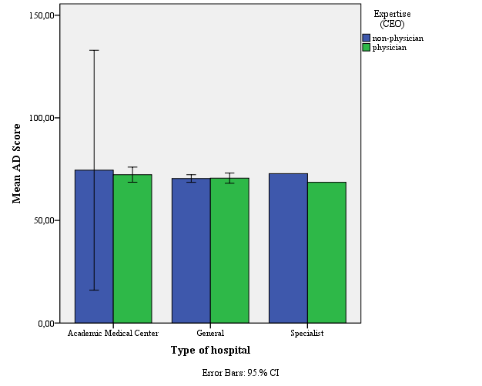

Figure 3AD. Bar chart with on the y-axis: Quality (AD Score) and on the x-axis: Type of hospital with Error Bars: 95%.
Figure 4AD. Scatter plot with on the y-axis: Quality (AD Score) and on the x-axis: Expertise (average).

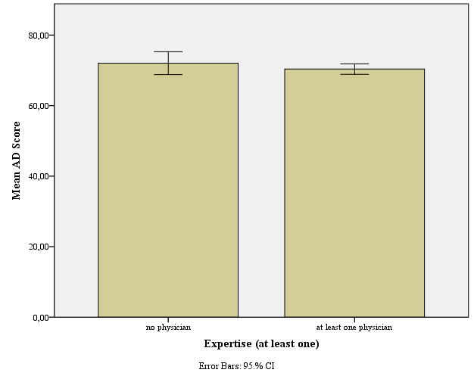

Figure 5AD. Bar chart with on the y-axis: Quality (AD Score) and on the x-axis: Expertise (at least one of the members of the executive board is a physician) with Error Bars: 95%.

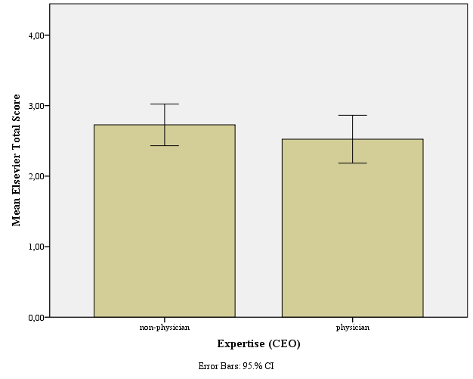

Figure 6. Bar chart with on the y-axis: Quality (Elsevier Total Score) and on the x-axis: Expertise (CEO) with Error Bars: 95%.

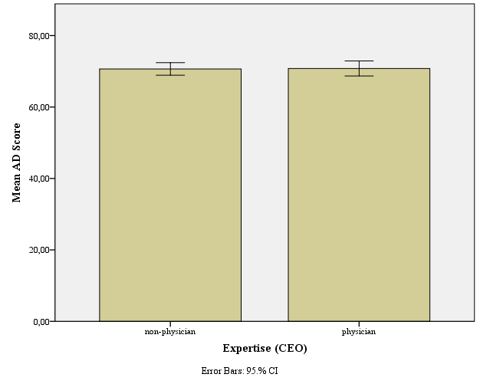

Figure 6AD. Bar chart with on the y-axis: Quality (AD Score) and on the x-axis: Expertise (CEO) with Error Bars: 95%.

Inspectie voor de Gezondheidszorg (IGZ).
VWS Ministerie van Volksgezondheid, Welzijn en Sport (VWS)
Elsevier De Beste Ziekenhuizen 2011.
AD Ziekenhuis Top 100 - 2011.
Strategies in Regulated Markets (SiRM).
LinkedIn is an online social network for professionals with more than 150 million users in 200 countries.

