Dutch football clubs
An analysis of image effects

By: Vincent Leijh (328468)
Supervisor: Erik Braun
Erasmus University Rotterdam
Bachelor thesis Urban, Port and Transport Economics
August 2012
___________________________________________

Increasingly, cities use sport to improve or redesign their image. The aim of this paper is to examine the effect on the city’s image of the presence of professional football club in small and medium-sized Dutch cities. This paper takes a look at how the image of cities is formed and why cities use sport reimaging. To research if cities are right to think that football/sports can improve the image of the city they play in, a questionnaire was conducted among 118 people studying in Rotterdam. It is tested if there is a relation between strong associations with football clubs and the image of the cities they play in.

Executive summary
The last decades cities are trying to improve their image by using sport. They invest large amounts of money in stadiums and in knowledge about organizing big sport events. These investments make it possible to accommodate big professional sport teams or organizing big sport events. But to see if these investments are justifiable with regard to the claimed advantages for the image, the following research question was formulated: Does the presence of a city-based professional football club have a positive influence on the image of the city?
In order to answer the research question, the research question was divided into three sub questions. The first is about what image is and the way image is formed. The second sub question addresses why cities use sport for sport reimaging. The third and last sub question addresses the question if there is a relation between a strong association with a football club and the image of small and medium-sized Dutch cities.
It is commonly accepted that image is what we think and how we feel about something. Image is very important in our lives and for researchers, because it has a big influence on the decisions we people make. We make our decisions based on the images we have. This also bears truth for how the image of places is formed.
City governments use sport reimaging in an attempt to alter the existing overall image people have about their city. It is not only an attempt to alter the existing image of the people living in the city itself, but also as a way to improve the city’s image for outsiders. The use of sport reimaging certainly has its advantages, but its effectiveness has also been criticized. So it isn’t entirely clear how successful sport reimaging is.
In order to discover if there is a relation between strong associations with football clubs and the image of small and medium-sized Dutch cities a questionnaire has been conducted. The questionnaire has been distributed among 118 students, who are studying in Rotterdam. This group encompasses both students from the university and from the higher professional education.
The results of the questionnaire showed that the football clubs were (among) the best known associations for all four cities, further supported by the fact that the means were among the highest, which means that the respondents often ranked them among their first associations. So it seems that football clubs are strong associations for the medium-sized cities. However, the results from the regressions show that the football associations don’t have a significant effect on the image of the cities. This means that the results of the questionnaire don’t show an image effect for the researched football clubs in their respective cities.
The results of the questionnaire are also used to answer the research question. The conclusion from the results is that for the chosen Dutch cities the presence of a city-based professional football club leads to a strong association between the city and the football club, but this association doesn’t lead to a positive influence on the image of the city.
After first talking about the limitations of this paper, finally recommendations for further research are given.

Inhoudsopgave
Executive summary 2
Chapter 1: Introduction 5
Background and motive 5
Problem Statement 5
Methods 6
List of Chapters 6
Chapter 2: What is image? And why do cities use sport for city reimaging? 7
Image 7
Sport Reimaging 13
Chapter 3: Research approach 19
Chapter 4: Is there a relation between a strong association with a football club and the image of small and medium-sized Dutch cities? 23
Regression Analysis of the football cities 23
Chapter 5: Conclusion 39
Limitations 40
Recommendations 40
Reference list 41
Appendix 43
Appendix 1: Correlations between the last three questions separately for every city 43
Appendix 2: Effects of independent variables on impression of cities divided for male/female 47
Appendix 3: Descriptive statistics and regression for non-football sport associations. 55
Appendix 4: Shapiro-Wilk test for football cities 64
Appendix 5: Scatterplots, testing homogenity of variance 66
Appendix 6: The questionnaire 81

Chapter 1: Introduction

Background and motive
In the last decade a large number of football clubs have been given financial support by the government of the municipality in which they are based. Municipalities are forbidden by law to directly support the teams, so this financial support is officially for the stadiums the clubs play in, as it is only allowed that the money goes to the multi functionality of the stadium. However, the fact that these cities give this financial support illustrates the importance of the club to the city. The underlying argument is that the presence of the club would lead to benefits to the city and the people which are larger than the amounts of financial support given by the government of the municipality. One of the arguments is that the presence of the club would be good for the image and the awareness of the city. And the residents may feel more connected to their local football club. So there are multiple effects of the presence of football clubs, but this paper will focus on the awareness and image effect of football clubs. An awareness effect means that people have heard about smaller cities because of the presence of a football club, while they might haven’t know about of the existence of this city if there wasn’t a football club located there. It is however not likely that people move to a city because of the presence of a football club. Still, it might be that the presence of the club leads to a better image for the city, that’s what we will call the image effect. But not to forget, there are of course also other factors why municipalities find it worthwhile to help football clubs in distress..
Football is however not the only sport for which cities think is important for their image. An increasing number of cities around the world, but especially in the USA and the UK want to use sport to redesign and improve their image. Examples of these cities are Sheffield and Manchester in the UK and Indianapolis in the USA. Large investments are done into sports infrastructure to make it possible to accommodate big professional teams or to organise big sports events, like the Olympic Games. The process where sport is integral to the new image of the city is called sport reimaging. The questions raised by the financial support of football clubs by municipalities and the use of sports for the reimaging of cities lead to the following research- and sub questions

Problem Statement
Research question:
Does the presence of a city-based professional football club have a positive influence on the image of the city?
Sub questions:
In order to answer this question, a set of sub questions need to be addressed first.
- What is image?
- Why do cities use sport for city reimaging?
- Is there a relation between a strong association with a football club and the image of small and medium-sized Dutch cities?

Methods
The aim of this paper is to evaluate if it is warranted for municipalities to financially support football clubs. To get an answer to this aim, this paper will start with a literature study. This literature study consists of two parts. The first part will be about how image itself and the image of places is being formed. The concept of image in this chapter is based on the writing of Boulding and in order to use this concept in research the theoretical framework made by Baloglu and McCleary has been adopted. The second part of the literature study will be about cities using sport for city reimaging. To get to know why cities use this strategy and if this strategy works, for example works of Smith, Gratton and Schimmel will be used.
Based on the theory from the second chapter, a questionnaire has been created to investigate whether smaller municipalities in the Netherlands are foremost known thanks to their professional football clubs and if it would be wise to use this association to improve their image. When it is likely that the awareness about this cities is foremost caused by the presence of the football clubs, this might be a good reason why municipalities financially support their football clubs. When the football club is in trouble, this support can for example consist of the buy of the training grounds of the club by the municipality. In this way the football club gets money, while the support from the municipality is legally allowed.
The questionnaire is carried out under students from the Erasmus University Rotterdam and the Rotterdam University of Applied Sciences. Students were asked to fill in the questionnaire during lectures and in the coffee corners at the university. Students of those Universities were also approached through the internet after also making a digital version of the questionnaire. In total 118 students have completed the questionnaire.

List of Chapters
In chapter 2 a literature study will be used to lay an theoretical foundation. The first part of the chapter will be focused on how image is being formed and the second part will be focused on cities using sport as a reimaging strategy. In chapter 3 there will be an explanation of how the questionnaire has been created. In chapter 4 the results of the questionnaire will be evaluated and in chapter 5 conclusions will be drawn and recommendations for further research will be given. The limitations of the questionnaire will also be discussed in this chapter.

Chapter 2: What is image? And why do cities use sport for city reimaging?

In recent years, multiple city-governments have launched programs to improve the image of their city and to increase their awareness. The cities use these programs to attract more tourists and businesses/entrepreneurs to the city. Some of these cities emphasize their favorable geographical location or their cultural wealth, others emphasize their rich history. However, there are cities that make use of something else to improve their image, they use sport. Those cities prefer not to use "ordinary" sport, but professional sports. This chapter will take a look at how the image of a city is determined and what factors are important in that process. After that we see how sport can influence the image of a city and why cities chose sport to regenerate the image of the city. And if these cities are right to chose this kind of strategy.

Image
But first we’ll talk about image on its own. Image is very important in our lives, we have projections of everything we see and hear around us. We have images about ourselves, our parents, our friends, classmates, colleagues. But we also have images about people that we don’t know, for example people you see, but don’t know while walking on the street. Images are formed of people working at banks who receive bonuses, about people working in the construction sector, about people that believe in the free market or people that still are communists, or about artists, bohemians, and scientists. And, too, about people who are husbands, wives and children and of fathers and mothers, we have images what’s the right thing to do when being a husband, or when raising a child. (Boulding,1956)

The images we have are not only about people, they are also about our beliefs, our ideologies, our job, our education, the nation we live in, the European Union we live in, but also about other nations in- and outside of the European Union. Everyone has his own images about what is the right or wrong behaviour, what is the normal thing to do and how to act reasonably. These images are not images like paintings or photo’s, but they are inside of us. They are not fixed, they can change. They change because of new things we learn, because we get older, meet new people. But also because the world around us changes continually. Another important factor for the change of image are marketing and public relations men. They try to influence our images about cities, brands, products and more. They try to convince you that you need their product, by providing you an image of the product that is as positive as possible and with which people can identify themselves with. They persuade the masses to buy their product, because it will be product of the future, you can’t live without it. So image is not only important for us, but it’s also very important for cities and companies.(Boulding, 1956)

Every individual has different images, even though marketers often try to distribute the same image about their product to everyone. This means that everyone reacts differently to the information we people get. It is a good thing that we all can have our own images. Because what would happen if scientists by analysing existing imaging would be able to predict and control social processes to change the images everyone has till the same images for everyone? The freedom people have to have their own images, to make their own choices, these are very important for our democratic government system. The government deciding for everyone what kind of images they have to have, that doesn’t fit in with our rights of freedom. A government that wants to take control of the images people have, could control the minds of people via the public and private school system, the public health care, the newspapers, television and other media. The images this government would try to distribute are the images that the leaders of this government have. This on its own is already not a good thing and if these people use this to carry out their own ideas, the results can be terrible.(Boulding, 1956)

Image has been a popular subject for scientists to research, especially in the last forty years. This was also a result of the work done by Boulding in 1956, which stimulated researchers to dig deeper into the subject of image. A lot of research has been done to try to get to know what the role of image is in the decision making process of people. But what do people mean when they speak about image? The concept of image has been described by many researchers, that all slightly differ. To give some examples of definitions of image given by researchers the last forty years:
- -“General characteristics, feelings or impressions people have about something.”(Jain and Etgar,1976, cited in Ferrand and Pages, 1999),
- -“image are the ideas or conceptions held individually or collectively of the destination”(Alhemoud and Armstrong, 1996)
- -“image is an total impression which is formed as a result of the evaluation of individual attributes which may contain both cognitive and emotional content”(Oxenfeldt,1975, cited in Baloglu and McCleary, 1999)
- -“a set of associations generally organised in a significant way”(Aaker, 1991, cited in Ferrand and Pages, 1999)
- -“a set of beliefs, ideas, and impressions that people have of a place or destination”(Crompton, 1979, cited in Baloglu and McCleary, 1999)
- -“Image is the total perception of a product that is formed by processing information from various sources over time”(Asseal,1984, cited in Baloglu and McCleary, 1999)
- -“a place’s image is the sum of beliefs, ideas and impressions that people have of a place.”(Kotler et al, 1999)
And the above quotations are just some examples. Image has been a popular subject for researchers in a lot of different fields. However one can see that the definitions aren’t too dissimilar, they are more about the perceptions the authors have of image.

In summary, image is what we think and how we feel about something. When we for example speak about the image of a place, we generally give our feelings about, our thoughts on, and our attitude towards this place. But what makes image so important? According to Boulding(1956) human behaviour is dependent upon image rather than objective reality. The work of Boulding and his contempary researchers led to the “image theory” which states that “the world is a psychological or distorted representation of objective reality residing and existing in the mind of the individual.” (Myers 1968, cited in: Baloglu&McCleary,1999) People act according to the image they have. They make their decisions to buy products as a result of the image they have of that product, while this image may not be correct. Thanks to the different images people have, some people buy and some don’t buy one product and chose adversely for another product. Researchers are very interested in trying to explain why people have the kind of images they have and if it would be possible to predict how people will react to attempts to change their images about products or places. But not only researchers are interested in this, companies and cities are of course also very interested in why consumers or tourists have certain images and accordingly make the decisions they make. And if it would be possible to change the images of people the way they would like to change it.

But for researchers to get to know why people have the images they have, they first must know what forms the images of people. Still, despite all the research that was done on the subject of image, the first twenty years most research wasn’t focused on image itself, but on how it was related to other things, like the impact of previous visitation of a place and the image people had about that place. Until the beginning of the 90’s, little empirical study was done on how image actually is being formed by people or how image is formed about places where people haven’t been yet. Therefore Browak noted in 1990 that: “Before image can be used to influence behavior, it is important to understand what influences image.” This opinion was shared by other researchers and they all started to try to find out what influences image. However, they discovered this wasn’t an easy task, their studies were being criticized for lacking a theoretical framework. To deal with these critics and help to identify what influences image development, a theoretical framework was developed. The goal of this framework was to design a structure that could study the forces influencing the formation of destination image and that proposes relationships for the perceptual/cognitive and the affective evaluations within its structure as well as the elements determining these evaluations. (Baloglu and McCleary, 1999).

“It is commonly accepted by researchers that image is mainly formed by two forces. These forces are the personal and the stimulus factors.”(Baloglu and McCleary, 1999, p. 870) The personal factor comes from how a person is, it’s about his characteristics. They are influenced by what the person thinks is normal, what his or her norms and values are. The personal factors are also divided in two: the psychological and social factors. Psychological factors are values, motivations and personality, so they are from inside of us people. Some people are fonder of going out and party all night, while others are fonder of other things to do. This is influenced by the psychological factors that differ between people. Social factors are age, education and marital status. The fact that we get older, that we get more educated or that we get married are all influencing our image of things. Some things we liked as young people, we won’t do anymore as we get older. While some things we can’t imagine we will like when we get older, we will do when we get older.
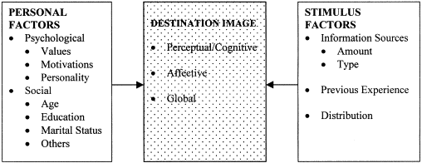
Fig. 1 (Baloglu and McCleary, 1999)
Stimulus factors are factors that influence our image by giving stimulus from outside and by our previous experiences. For example, the information we get about a certain city from people around us and which the city itself gives us, influence our opinion and therefore image of that particular city. It is likely that your image of a city is more positive when you hear enthusiastic stories about it, than when everything you hear about that city is negative. The amount of information is also from influence, when you get more information about a place, you will be better informed and therefore your opinion becomes more founded. When you hear two positive stories about a place and one negative, you won’t be too positive about the place, while if you get ten positive stories and one negative, you will be much more positive, despite the negative story. Previous experiences are also of importance, because when your first visit to a city was nice, your image of that city is much better than when you had a day in that city that you’d rather forget. But most importantly is that you all see it for yourself, that you experience it yourself. It is likely that your own experiences are the ones that are the most dominant in our own memories and therefore are very important for the image a person has about a place.
But what do these personal and stimulus factors do? They influence the perceptual/cognitive and the affective evaluations. And these two types of evaluations make the overall image of a place. Perceptual/cognitive evaluation means that it refers to the things people know and believe about an object. The affective evaluation is about the feelings people have about that object. According to Genereux, Ward and Russel in 1983 “the perceptual/cognitive component is the knowledge about the place's objective attributes whereas the affective counterpart is knowledge about its affective quality.” While according to another researcher “ Affective meaning refers to the appraisal of the affective quality of environments while perceptual/cognitive quality refers to the appraisal of physical features of environments” (Hanyu, 1993, p.161, cited in Baloglu and McCleary, 1999). It has to be said however that until that time studies always were focused on the one or the other, but never together. In the years to follow, that changed. Recent studies try to study both parts. There are also other interpretations from other researchers. Images of place can also be seen as visual(Mackay and Fesenmaier, 1997, cited in Baloglu and McCleary, 1999) or social phenomena(Selwyn, 1996, cited in Baloglu and McCleary, 1999). These other interpretations stem from different philosophical positions, but this doesn’t mean that these interpretations can’t coexist. But for now only the theoretical framework as given by Baloglu and McCleary will be used.
To illustrate how their theory works, Baloglu and McCleary made the following path model, of course based on the literature previously published:

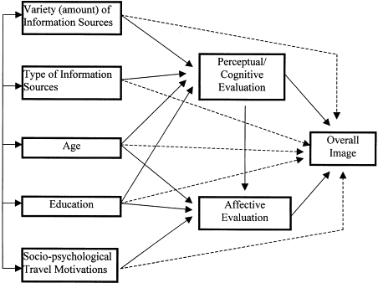

Fig 2: (Balolgu and McCleary, 1999)
At the left side of the figure, we see some factors that we already saw in figure 1. There are the stimulus factors variety (amount) of information sources and type of information sources and the personal factors age, education and socio-psychological Travel Motivations. In the middle are the perceptual/cognitive and the affective evaluation just spoken about. At the right side is the overall image. In this path model it is possible to see what factors influence what kind of evaluation and that all factors have an influence on the overall image. The solid line stands for the relations that Balolgu and McCleary tested, the dotted line for the relations they assume to exist, but they haven’t tested yet.
Some factors in the model influence are only perceptual/cognitive, some are only affective and some factors have an influence on both evaluations. As can be seen the first two factors, the ones that are about information, influence only perceptual/cognitive evaluation. The higher amount of different kinds of sources people get their information from, the better informed they are and thus the better their perceptual/cognitive evaluation is. Age influences both perceptual/cognitive and affective evaluation. I already mentioned earlier that some things change when you get older, this has to do with the fact that how older you get, the more information you have received. Because of this and the fact that older people have experienced more than younger people, they are also believed to be better in the expression of their feelings than young people. This leads in the model to a relation between the factor age and the affective evaluation.
Like age, education is supposed to have an influence on both perceptual/cognitive and affective evaluation. If the amount of education increases, so does the amount of knowledge a person has about places, so this is an example of the influence of education on the perceptual/cognitive evaluation. The influence of education on affective evaluation is a consequence of the fact that when people get more educated, they are better equipped to express their own opinion. The last of the five factors seen in the path model are the sociodemographic variables. With sociodemographic variables we mean things like the living environment and the norms and values people have. These are of influence on the affective evaluations of people.
As already said, your own experiences are very important for the image you have about a city. However, there is no one in our world who has visited every city or even country on the world. But still we’ve got images of the places we haven’t been to. It speaks for itself that these images have been formed in a different way than for the places one has visited. Because these differences are acknowledged by researchers, there has been a lot of research about the influences on image existing when someone hasn’t yet been to that city. In these researches it was discovered that in this situation there are three major factors at work: tourism motivations, sociodemographics, and various information sources. The tourism motivations and sociodemographics are consumer characteristics. Thus these are personal factors, while the various information sources are stimulus factors, talked about earlier. It is agreed among researchers of different fields that the formation of image indeed has both perceptual/cognitive and affective evaluations. In the absence of a visit to a place are perceptual/cognitive evaluations linked to the beliefs or knowledge about a destination’s attributes, while affective evaluation is linked to feelings/attachment people have to the place. The leading opinion among researchers is that the affective feelings are a result of the cognitive evaluation of a place. They are formed after the perceptual evaluation. This relation can also be seen in the path model by Baloglu and McCleary, they have tested and found there’s a relation from the perceptual/cognitive evaluation to the affective evaluation. The combination of perceptual/cognitive and affective evaluation leads to the overall image we have about a place.
After explaining how image is been formed, let’s take a quick look at the target group for which the city tries to get their image as good as possible. There are four groups of customers for a city. Those four are the following: residents, companies, visitors and investors. All these four groups are important for a city. In this paper we focus on the visitors. With visitors we mean the tourists that pay the city a visit, it is their destination only for a limited period of time. They search an attractive visiting environment. This means a place to stay and the opportunity to visit attractions, facilities and other cities nearby. Factors that are important in that regard, are for example the kind of accommodation, the culture of the city, the public transport, the weather, whether one wants to stay in the centre of the city or more at the outside and many more. Every person has another preference concerning these factors. Some want to go shopping, some want to visit historical places, while another also wants to visit the cities and villages surrounding the city. But there are also people that visit a city because they are going to a sports game, for example trips to games in the Engels Premier League and games of FC Barcelona are very popular. Or people don’t go to a game, but they do visit Camp Nou, the stadium when in Barcelona or Wembley Stadium when in London. So every visitor chooses to visit what he wants, while acknowledging also the things that could be seen, but where they don’t go to.(Braun, 2008)

Sport Reimaging
Now that we know how the images of places originate, we turn to how sports and especially football clubs may change the image of a city. In the last decades an increasing number of cities around the world are trying to change and/or improve their image by using sports. But why do these cities use sport to enhance their image? The directors and marketing people must be convinced that sport can improve the image of a city. The process of doing this is called sport reimaging. In most big cities, sport is already a part of the image of the city, but in sport reimaging there is used a more specific approach, where the intention is that sport really takes center stage in the new image. Kurtzman has given us two examples. Perth in Australia distributed a reputation as "City of Sporting Events" and Lake Placid in the U.S. tried to present itself as the "Winter Sports Capital of the United States" (Kurtzman, 2001)There are however also such examples in Europe. In England, several cities including Sheffield, described themselves in their new marketing campaigns as "National Cities of Sport."
In the process of sport reimaging one thing stands out in particular, most of the cities use besides the usual marketing resources, something else to work on their image. They make themselves available for organizing major sporting events. These events are by tourism researchers defined as "special" events. Another well-known definition comes from Ritchie, which reads as follows: “major one-time or recurring events of limited duration, developed primarily to enhance the awareness, appeal, and profitability of the host location” (1984, p.2) This goal can also be seen with the organization of the Olympic Games. These are being held in London, an already well-known world city. Yet they wanted to organize the Games very much. They obviously do their utmost to make everything as good as possible, but what also stands out is that they are trying to position the Games as the greenest and the most environmentally friendly Olympics of all. This is because environmental friendliness is an important issue and London can improve its own image this way.
But not only major sporting events, but also large football clubs may be important for the image of a city. Smith(2005) shows in his study that people in England see Manchester as a real sports city what is mainly due to the presence of the top football clubs Manchester United and Manchester City. The city has in recent decades employed initiatives to get a sports image. They have also done two (unsuccessful) attempts to organize the Olympic Games. Despite this and the start of a National Cycling Centre in the city, research shows that the association of sport with the city of Manchester is still mainly made by the football clubs. (Smith, 2005)
Besides for sport evens and football clubs, sports stadiums also can be used for sport reimaging. They can in itself be as architectural feats, such as a sign of modernity (Nielsen 1995, cited in Smith, 2005) or as a sign of progress (Rowe 1995, cited in Smith, 2005), or as a characteristic of a particular event. For example, the Olympic Stadium in Berlin still reminds of the Olympic Games of 1936.
The question is whether cities are right if they think that the organization of large, special sport events or that having a professional football club leads to a more positive image. Most of the cities trying to use sports as a mean to reimage the city are cities that were known for their manufacturing economies. But thanks to the shift of factories to low wage countries, these cities got into trouble. To stop the decline of the city, they were searching for a way to bring their city back to life again. Examples are cities like Sheffield and Manchester in the UK and Indianapolis in the USA. In Indianapolis the goal was to redevelop the city’s downtown area by expanding the service-sector economy. To achieve this, they thought sport could serve as a catalyst. Between 1974 and 1984 1.7 billion dollars were invested by the city and private parties in inner city construction.(Schimmel, 2001, cited in Gratton, Shibli and Coleman, 2005)) A majority of the money was invested in sporting infrastructure. There were investments in sports facilities to attract professional team sports to the city, but they also invested in getting to host major sports events. This lead to the hosting of 330 events between 1977 and 1991 by Indianapolis. To illustrate the success of this strategy, Davidson (1999, cited in Gratton, Shibli and Coleman, 2005) estimated that the total economic contribution of sport organisations, facilities and events in Indianapolis in 1991 to be 133 million dollars. Other studies showed that there were also non-economic benefits of the new strategy, like an increase in sports participation by young people, increased pride in the city and an improved image of the city that lead to more tourism. The success of the strategy in Indianapolis lead other cities, especially in the UK, to follow their example and started using sport events as a mean to reimage the city.
Cities that followed this strategy in the UK are Glasgow, Sheffield, Birmingham and Manchester. The first three have used sport as their first priority to stimulate urban regeneration and therefore were awarded the status of National City of Sport. They focused on the investment in sport facilities so they are all able to organise mega sport events. But they don’t only invest in the facilities, they also invest in a supporting structure of expertise in event bidding and management in order to secure the greatest chance to get the organisation of events and to organise them as successful as possible. Another important thing is that these cities are also involved in the developing of sport in the city and the local community, so that they too benefit from the investments in sport infrastructure. The cities of Manchester and Birmingham also submitted bids to organise the Olympic Games. While their bids weren’t successful, it contributed to the building of an sporting image.(Smith, 2005)
Despite the success of the innovative strategy in Indianapolis, the cities that followed its lead didn’t use the exact same strategy. It is striking to see that cities in the USA use a different approach and therefore strategy than cities in Europe and especially the UK. As told above, in the UK the cities invest in the sport facilities to make it possible to host major events. The economic and non-economic benefits that are the result of organising these big events are one of the arguments to take this approach to redevelop the image of the city. But not only the money is important, it is also important that the local communities benefit from the investments in sport infrastructure. The approach of most cities in the USA is a bit different. A lot of cities have invested huge amounts of money in sports stadium, an investment validated by the argument that this will lead to economic benefits for the city. But the stadium aren’t build for the hosting of major sport events, but to be attractive to professional sport teams participating in the major American sports baseball, basketball, ice hockey and American Football. It is much more usual for American sports teams to move from one city to another than it is in the European sports world. American cities build new stadiums to give teams a bigger incentive to move, because then they can play in a new modern stadium instead of one ten to twenty years old. However the city where the teams plays at the moment, doesn’t want it to move and must also build a new stadium. The teams therefore have the chance to choose the best offer, while the cities invest lots of money, but maybe without result. According to Baade 71% of the money invested in the stadiums is public money, that’s worth of 13,6 billion dollars.(2003) To justify this amount of public money spent on stadiums an economic argument is used. This argument is that it is a worthwhile investment as long as the economic impact generated by having a major professional sports team resident in the city is sufficiently great. Economic impact refers to the total amount of additional expenditure generated within a host city (or area) which could be directly attributable to the staging of a particular event. In this respect, an home game of the team that plays in this city can be seen as a particular event. Only people who come to the city because of the event they are visiting are included in the calculations of the economic impact, people who already live in the city are not included. It is believed that they would spend this money in the city, regardless of the event.(C. Gratton, S. Shibli and R. Coleman, 2005)
Researchers, however, haven’t found evidence that there is a significant economic impact on the host city from this kind of stadium development.(Baade, 1996) Crompton argues that the economic impact of this kind of stadium development while using public money has been enormously exaggerated. He does however admit that there may be other benefits to the city than economic, like an improvement in the image of the community, mental income to city residents from having a professional team in the city and the development of for example shops and restaurants in the neighbourhood of the stadium. The improvement in the image and the establishment of shops etc. in the surroundings of the stadium may lead to additional investment in the host city, which may also generate benefits to the economic impact of the stadium for the city. Psychic income relates to the social and psychological benefit local residents may feel by identifying with the resident professional team. But there is a problem with these kind of benefits for researchers. It is very difficult to measure these kind of effects. But according to them these benefits aren’t high enough to explain the amount of public money used for the professional sport teams. In an attempt to explain why this happens, Quirk and Fort(1999) suggest that this is caused by a difference in the demand and the supply of professional sport teams. Thanks to the excess demand, the cities that are hosting teams are pressured to keep their stadiums up to date in order to keep these teams. This is paid for by the taxpayer. This system however doesn’t work well for the economic regeneration by sport. Luckily, some cities like Denver, Philadelphia and Cleveland have followed the example of Indianapolis and have taken a broader approach to use sport as a mean of economic regeneration. (C. Gratton, S. Shibli and R. Coleman, 2005)
For the cities in the UK there isn’t very much research done about the long term benefits of organising sport events, but for the shorter term there is. There is a report of the Sport Industry Research Centre about 16 sport events that took place in the aforementioned cities. The results in this report show that major sport events have the potential to achieve significant economic benefits for the cities that host them.( UK Sport, 2004). The benefits were smaller for the junior events, because these events attract less spectators than the events in which the best athletes of the world participate in. An interesting note is that the results suggest that not the spending by the organisers of an event contributes to the majority of any additional expenditure, but the spending of the visitors of the event is the most important. Further research showed that there was a strong correlation between the number of spectators and the absolute economic impact of an event, showing that the number of spectators is het most important driver for economic benefit.
Not everyone is positive about using sport for economic regeneration, though. Besides the earlier stated huge amounts of public money needed to invest in stadiums while not knowing if these investments are worthwhile, there are other complaints. The benefits of the strategy are not redistributed efficiently, so problems that already existed aren’t solved. In Indianapolis social problems that already existed weren’t solved by this new approach. (Schimmel,1995) Another problem is the popularity amongst cities to use sport for urban redevelopment. It gets very difficult to establish an new, fresh image by using sport, because of the amount of cities trying to show themselves. As a result, cities look even more like each other instead of less. But perhaps the biggest criticism is that by some events, like the Olympic Games of 1996, not the local community development is the most important, but the image of big companies. The Games created more publicity for big companies like Coca-Cola than for Atlanta. When the involvement of the private sector is too much, the image benefits don’t always lead to community benefits (Whitelegg, 2000), it sometimes even means that the image benefits go more towards the political and commercial businesses than the host city. (Jennings, 1996)
In 2005 Smith published his research about reimaging the city, investigating the value of sport initiatives. His aim was to evaluate whether and how sport can provide a valuable reimaging theme for city destinations. He tried to evaluate if sport initiatives really influence the image of tourists about cities. To research this he analysed the reimaging strategies used by three of the UK cities spoken about earlier, namely Sheffield, Birmingham and Manchester. Interestingly, there were three research areas investigated. They tried to establish if the initiatives employed by the city are known by tourists, if those initiatives adopted in the three case study cities had affected city images and thirdly they wanted to find more information about what people think about urban sport initiatives. The last of those three was of importance to get to know of those people think that sport reimaging is a good way to change image or that they don’t think it is a good idea. They used interviews and questionnaires to get their answers.
Some of the conclusions of Smiths research are positive, but some are negative too. The fact that a majority of potential tourists are aware of the sport events and facilities indicate that sport can be used as an effective promotional tool. It also becomes clear that the new initiatives have the potential to influence images in more than one way. This can be seen in the sporting reputation of the cities that are analyzed, which the interviewees see as sporting cities. And the pervading positive interpretation of urban sport means that some wider symbolic effects are also evident. The combination of already existing images and the new image are also evidence that sport can be used for reimaging. However, the research identifies also some problems with sport reimaging. Cities can’t really control the image people have. Another problem is that sometimes the existing sport links are better known than the new initiatives. And a big problem for all cities using sport as a way to reimage, a large number of tourist doesn’t exactly know what is meant with a “city of sport”.
In Smiths research the results about Manchester are very interesting. Besides the city’s bids for the Olympic Games of ’96 and 2000, there has also been the construction of the National Cycling Centre and the Manchester Evening News Arena. The city wasn’t chosen to organise the Olympic Games, but they did get to organise the Commonwealth Games in 2002. With the reservation that most of the interviews were conducted before those games by Smith, the results show that the interviewees know about the bids for the Olympic Games and the Construction of the new sport centres. However the best known associations are with football and thus with the two Manchester football clubs, United en City. Three fourths of the respondents associated Manchester with sports, but analysis of other questions showed that this also was largely a result of the city’s link with football. This image couldn’t only be seen in the questionnaires, but also in the interviews. Most people said that their first association with Manchester was football. (It may be that this has even increased in the years since then, because of the growth of football club Manchester City. Thanks to the money of a sheikh, City is trying to equal the stature of United.) Positive for all the initiatives done by the city however is that the interviewees see the bids for the Olympic Games as positive. And that they think that the image of the city has been positively influenced by the initiatives and that according to them, the initiatives have resulted in the psychical regeneration of Manchester.
This chapter spoke about image and the way image is formed. While there are different definitions, all researchers agree on the fact that image is what we think and how we feel about something. Image is important, because it has a big influence on the decisions we people make. If we for example have a positive image of a country, it is more likely that we’ll go on holiday to that country. In this chapter it also became clear how the image of places is formed. People use perceptual/cognitive and affective evaluations to form their image of places. In an attempt to actively alter the existing image of a city, city governments use sport reimaging as a way to improve their image. The use of sport reimaging has its advantages according to researchers, but its effectiveness has also been criticized by researchers. It is expected that there is a positive relation between sport and image. Whether this is true and to what extent is the main question to address during the rest of the paper.

Chapter 3: Research approach
The first part of chapter 2 addressed the issue of image and how people form an image of places, even if they haven’t seen those places. In the second part is was said that cities try to reimage their selves by using sport and it is pointed out that many researchers aren’t entirely convinced that this strategy works. In order to test the assumptions of re-imaging through sports a questionnaire has been created and why these questionnaire questions are used.
In order to discover if there is an publicity effect for football clubs in small Dutch municipalities a questionnaire has been conducted. The questionnaire has been distributed among students, who are studying in Rotterdam. This group encompasses both students from the university and from the higher professional education. The questionnaire has been distributed in both paper form and as an internet questionnaire. The questionnaire was titled “Research on the image of smaller municipalities”, to avoid that the respondents already knew that the research was about the sport associations and therefore would give socially desirable answers.
The questionnaire has been build up as followed. Eight midsize cities in the Netherlands were chosen as representatives and four of them have a professional football club. Mid size cities were chosen because the football clubs Ajax and Feyenoord, which are established in the big cities Amsterdam en Rotterdam, are with a vast difference the most famous clubs of the Netherlands. Almost every Dutch resident knows those about those two clubs. Another reason why these cities are omitted in the questionnaire is that these cities are so big that people can have a large number of associations with these cities and these can’t all be included in the questionnaire. The questionnaire begins with five general questions and then there are seven questions which are repeated for the different cities.
The municipalities included in the questionnaire are the following: Almelo, Heerenveen, Heerlen, Hengelo, Sittard, Sneek, Waalwijk, Zutphen. In Almelo plays the football club Heracles Almelo, in Heerenveen plays SC Heerenveen, In Sittard plays Fortuna Sittard and in Waalwijk plays RKC Waalwijk, Interestingly is that all four football clubs include the name of the city in the club name. Heracles, Heerenveen and RKC play in the Dutch Eredivisie, the Dutch first division. Fortuna plays in the Jupiler league, the Dutch second division. The other four municipalities don’t have a professional football club, but are included as measure to prevent biases. If the respondents know the questionnaire researches the relation between football clubs and the image of cities, he isn’t unbiased anymore. For every municipality with a football club, there is one comparable control municipality, with about the same size of inhabitants and if possible in the neighborhood of a municipality with football club, without a football club. The sets of comparable cities are Sneek and Heerenveen, Heerlen and Sittard, Almelo en Hengelo and Waalwijk and Zuthpen.
In some of the chosen municipalities there are also other sports associations than football included. In Heerenveen there is the ice skating stadium Thialf, one of the best known ice skate stadiums of the world. In Hengelo the Fanny Blankers Koen games are being held every year, named after the great Dutch athlete Fanny Blankers Koen, who won four gold medals at the Olympics of 1948. In Heerlen plays the table tennis club MF Services/Furst, however it is not likely that many people know this club. Much better known than the table tennis club is the Elfstedentocht. The Elfstedentocht is an ice skating tour going through eleven cities in the province of Friesland, which only can be held when there has been a hard winter. One of this eleven cities is Sneek, so therefore people can associate the Elfstedentocht with Sneek. It might be that people do not only have strong associations with football for these municipalities, but also for other sports. It will be interesting to see if this effect can be seen in the results.
But why were these associations chosen? For every municipality there was searched for five associations that people could have with this municipality. Of course the sport associations were very easy. But for the other associations more work was needed, these associations were associations that I have myself with this municipality. Then my own associations were mixed with those of some other people and with internet sources about these municipalities. There was also made use of search engine Google to find the associations with the most search enquiries. There is always some uncertainty as to the best associations to include, so to control if there were no associations missing, the following control question was added:”Did you miss an association in the question before? If so, which one? The question before is the following: “What is the first association you have with ..(municipality)?” With the 5 associations given per municipality that the respondents can have with that municipality. To order the associations the respondents had to give the associations a number from 1 till 5, whereby the 1 stands for the first association that comes to mind through 5 the association that comes to mind the last. When they didn’t associate one of the given associations with the municipality, then that association gets a 0, because the respondents still gives his judgment.
The first questions in the questionnaire are questions meant to know if the respondents is a man or a woman, where they live at the moment and where they lived before they started studying. The question about if the respondent is a man or a woman may not seem very important, but it might be that there’ll be a difference in the associations between men and women. It is generally assumed that men find sport more important than women. The next question concerns whether the respondents do have family and / or friends in the area of the municipality. And the last general question is about the number of visits the respondents have made in their lives to the municipalities of the questionnaire. The response options for this questions are: never/rarely/occasionally/often/very often. People who have visited a municipality more often may have a different order of associations than people who have never visited that municipality.
To measure the overall image, for every municipality there are the same questions about the overall image of that specific municipality. The first question about the municipalities is a statement about how much the respondents knows about the municipality. The statement is that the respondent knows much about the municipality and to rate this there is an range from strongly disagree/disagree/neutral/agree/strongly agree. The second question is about where the respondent gets his information about the municipality from. The information sources the respondent can choose from are: television & newspapers/my surroundings/internet/books & magazines/tourist agency. From the literature of Baloglu and McCleary we learned that information and personal characteristics are of influence on our image forming.
After those first two questions come the two questions about associations already spoken about. Then there is a question posed as a statement about if the respondent has an positive impression of the municipality. To rate this statement there is an range from strongly disagree/disagree/neutral/agree/strongly agree. This question is about how the respondent feels about the municipality. The last two questions are about visiting the municipality. The first question is about if the respondent is planning to make a recreational visit to the municipality. The range of answers of this question stretches from in a month/in half a year/in a year/in 5 years/never. The last question is if the respondent would advise other people to visit the municipality. Those last two questions are questions about the overall image. The question about making a recreational visit to the municipality says something about the overall image the respondents have about the municipality because when respondents have an positive image about the municipality it is more likely that they’ll pay the municipality a recreational visit than when they have an negative image about the municipality. The same applies to the last question, when someone has a positive image of the municipality he’ll give others the recommendation to visit the municipality, while if he has an negative image he’ll dissuade people to pay the municipality a visit. From the work of Smith we adopted the use of associations to measure the effects of (sport)associations on image, the decision to make a recreational visit to a city and the decision of giving a positive advice to others about visiting a city.
In order to analyse the data from the questionnaire, the data have to put in to the statistics program SPSS. In order to get a relation between the different variables, it was necessary to define the scale. For questions which were answered with a range of 1-5 or with a range of strongly disagree-strongly agree an ordinal scale was inserted. This means that the answers of these questions indicate a hierarchy, also known as a order. The mutual differences aren’t important, it’s all about the order. In the case of yes/no questions, a nominal scale was inserted.
Some parts of the data had to be recoded. All questions that had an ordinal scale had to have the same order, namely from negative to positive. This meant that the answers of the associations and that of the question about bringing a visit to the city had to be turned around. So when the respondents don’t ever want to visit a city their answer now will be coded as a 1 instead of as a 5. For the regression analysis of the effects of the independent variables on the dependent variables there is chosen for a significance level of 0,1, because of the small number of respondents.

Chapter 4: Is there a relation between a strong association with a football club and the image of small and medium-sized Dutch cities?
Chapter 3 gave an explanation of how the questionnaire was being build up and why certain questions were used. This chapter will speak about the results of the questionnaire. In order to discover if the presence of a professional football club has a positive influence on the image of the city, regression analysis has been used.
The questionnaire ended for every city with the same three questions. These are, in the example of Heerenveen:
- “Statement: I have a positive impression of Heerenveen. How would you rate this statement? Strongly disagree/disagree/neutral/agree/strongly agree
- “Are you planning on bringing a recreational visit to Heerenveen? Within a month/within half a year/within a year/within 5 years/never.
- “Would you advise other people positively to visit Heerenveen? Yes/no
These questions will later be used for the regression analysis. So in order to check if the questions are not too closely correlated to each other, their correlation has been measured first. One can see the questions about bringing a recreational visit to the city and if they would advise others to visit that city, are significantly correlated for all eight cities. The two questions about the positive impression of the city and about paying a recreational visit are significantly correlated for some cities, but not for all. They are significantly correlated for Heerenveen, Heerlen, Hengelo, Sneek and Waalwijk, but not for Almelo, Sittard and Zutphen. The questions about the positive impression and the advise to other people are also significantly correlated for some cities, but not for all of them. These questions are significantly correlated with each other for the cities of Heerenveen, Heerlen, Sneek, Waalwijk, Zutphen, but for none extremely high.(Appendix 1)

Regression Analysis of the football cities
The first thing we want to know by using regression analysis is if there’s an effect of the sport associations on the impression that the respondents have of the cities. We are also interested if there are other variables that have a significant influence on the respondents’ impression. To determine the effects the following regression is made. The impression the respondents have of the city is made the dependent variable, the respondents have answered on a scale of 1-5 if they agree with the statement that they have an positive impression of the city, where 1 mean that they strongly disagree and 5 that they strongly agree. The independent variables, the variables that influence the dependent, chosen are the five associations people can have with the city, the statement about how much the respondents think to know about the city and how much visits they made to the city. Those last two questions are control variables. To measure the effects of the associations on the impression of the city these two have to be included, because they individually also effect the impression the respondents have of the city.
Secondly, we use regression analysis to see what variables influence people to pay a visit to one of the chosen cities. To measure this, the following regression has been made. The dependent variable is: “Are you planning to make a recreational visit to (for example) Almelo? The independent variables are the statements about the impression of the city and the knowledge of the city, the amount of visits made to the city and the football association. It will be interesting to see if the sport associations will be of influence. In this regression the impression of the city, the knowledge of the city and the amount of visits made to the city are control variables. To measure the effects of the football associations on this decision these control variables have to be included, because they also individually effect the decision about making a recreational visit to the city.
The dependent variable for the third regression will be “would you advise other people to visit Almelo?” The third regression is linked to the second, as evidenced by the correlation between the dependent variable of the second regression and that of the third regression, which is significant for all chosen cities. To measure the effects, the same independent variables will be used as for the second regression. This also means that the same variables serve as control variables, because they also individually effect the decision about giving other people a positive advice of visiting the city.
To test if the dependent variables are normally distributed, a Shapiro-Wilk test can be performed. The test results show that the dependent variables for all four cities with football associations are not normally distributed. This can be caused by the small sample size of the research.(Appendix 4)
Before we go to the results of the regressions, first we’ll take a look at the means of the associations and how many of the respondents had associations with the associations given.
 | Herman Finkers | Heracles Almelo | Vroegere textielstad | Protestantse Grote Kerk | Stadsmuseum Almelo
Association | 78 | 98 | 54 | 42 | 42
No association | 40 | 20 | 64 | 76 | 76

Descriptive Statistics
 | Mean | Std. Deviation | N
Stelling: Ik heb een positieve indruk van Almelo | 3,10 | ,638 | 114
Hoe vaak bent u in uw leven in Almelo geweest? | 1,38 | ,696 | 114
Stelling: Ik weet veel over Almelo. | 1,46 | ,706 | 114
Herman Finkers | 2,53 | 2,079 | 114
Heracles Almelo | 3,38 | 1,984 | 114
Vroegere textielstad | 1,50 | 1,801 | 114
Protestantse Grote Kerk | ,94 | 1,524 | 114
Stadsmuseum Almelo | ,92 | 1,581 | 114

As can be seen, of the respondents most have an association with football club Heracles Almelo. The means of the associations also show that the mean of Heracles is the highest, what would mean that Heracles is the strongest association of the five according to the respondents. But does this also mean that Heracles Almelo has an significant positive effect on the image of Almelo? The regressions made shows that this isn’t the case. The effect of Heracles on the image isn’t significant. As stated in chapter 3, for an effect to be significant, the sig. in the table has to be lower than 0,1. Variables that have a significant effect on the impression of Almelo are the statement about the knowledge of Almelo and Herman Finkers. When people have more knowledge about Almelo, the more positive they are. And when they think about Herman Finkers the respondents are also more positive about Almelo.

Model Summary^{b}
Model | R | R Square | Adjusted R Square | Std. Error of the Estimate | Durbin-Watson
1 | ,350ª | ,122 | ,064 | ,617 | 1,963
a. Predictors: (Constant), Stadsmuseum Almelo, Stelling: Ik weet veel over Almelo. In hoeverre bent u het met ..., Heracles Almelo, Hoe vaak bent u in uw leven in Almelo geweest?, Herman Finkers, Vroegere textielstad, Protestantse Grote Kerk
b. Dependent Variable: Stelling: Ik heb een positieve indruk van Almelo In hoeverre ben...

Coefficientsª
Model |  | Unstandardized Coefficients |  | Standardized Coefficients | t | Sig. | Collinearity Statistics
 |  | B | Std. Error | Beta | t | Sig. | Tolerance | VIF
1 | (Constant) | 2,633 | ,184 |  | 14,286 | ,000
1 | # bezoeken Almelo | ,097 | ,089 | ,106 | 1,089 | ,279 | ,870 | 1,150
1 | Stelling: Ik weet veel over Almelo | ,205 | ,086 | ,227 | 2,375 | ,019 | ,904 | 1,106
1 | Herman Finkers | ,056 | ,030 | ,182 | 1,845 | ,068 | ,850 | 1,176
1 | Heracles Almelo | -,030 | ,031 | -,093 | -,968 | ,335 | ,891 | 1,122
1 | Vroegere textielstad | -,009 | ,045 | -,025 | -,196 | ,845 | ,519 | 1,928
1 | Protestantse Grote Kerk | ,051 | ,072 | ,122 | ,708 | ,480 | ,280 | 3,574
1 | Stadsmuseum Almelo | -,050 | ,063 | -,124 | -,789 | ,432 | ,337 | 2,971
a. Dependent Variable: Stelling: Ik heb een positieve indruk van Almelo In hoeverre ben...

To see if the effects are different when dividing the effects for men and women, we’ll now take a look at the effects separately. For men there only stays a significant positive effect for the knowledge of Almelo, for women all significant effects disappear. (Appendix 2)
Now we go to the second regression. Here we deduce that the plans of the respondents to visit Almelo are significant positively affected by their knowledge of Almelo and how many visits people have already made to Almelo. Football club Heracles however doesn’t have a significant effect. According to the third regression the only variable that has a significant effect on the decision to give others a positive or negative advice to visit Almelo is the amount of visits the respondents already made to Almelo. Again Heracles doesn’t have a significant effect.
Model Summary^{b}
Model | R | R Square | Adjusted R Square | Std. Error of the Estimate | Durbin-Watson
1 | ,452ª | ,204 | ,175 | ,510 | 1,762
a. Predictors: (Constant), Stelling: Ik heb een positieve indruk van Almelo In hoeverre ben..., Heracles Almelo, Hoe vaak bent u in uw leven in Almelo geweest?, Stelling: Ik weet veel over Almelo. In hoeverre bent u het met ...
b. Dependent Variable: Bent u van plan een recreatief bezoek te brengen aan Almelo?

Coefficientsª
Model |  | Unstandardized Coefficients |  | Standardized Coefficients | t | Sig. | Collinearity Statistics
 |  | B | Std. Error | Beta | t | Sig. | Tolerance | VIF
1 | (Constant) | ,587 | ,259 |  | 2,272 | ,025
1 | # bezoeken Almelo | ,266 | ,073 | ,330 | 3,655 | ,000 | ,898 | 1,113
1 | Stelling: Ik weet veel over Almelo. | ,152 | ,073 | ,191 | 2,078 | ,040 | ,866 | 1,155
1 | Stelling: Ik heb een positieve indruk van Almelo | ,058 | ,079 | ,065 | ,733 | ,465 | ,914 | 1,094
1 | Heracles Almelo | -,030 | ,024 | -,104 | -1,215 | ,227 | ,989 | 1,011
a. Dependent Variable: Bent u van plan een recreatief bezoek te brengen aan Almelo?

Model Summary^{b}
Model | R | R Square | Adjusted R Square | Std. Error of the Estimate | Durbin-Watson
1 | ,222ª | ,049 | ,013 | ,243 | 1,790
a. Predictors: (Constant), Stelling: Ik heb een positieve indruk van Almelo In hoeverre ben..., Heracles Almelo, Hoe vaak bent u in uw leven in Almelo geweest?, Stelling: Ik weet veel over Almelo. In hoeverre bent u het met ...
b. Dependent Variable: Zou u andere mensen aanraden Almelo te bezoeken?

Coefficientsª
Model |  | Unstandardized Coefficients |  | Standardized Coefficients | t | Sig. | Collinearity Statistics
 |  | B | Std. Error | Beta | t | Sig. | Tolerance | VIF
1 | (Constant) | -,140 | ,128 |  | -1,096 | ,276
1 | # bezoeken Almelo | ,066 | ,035 | ,184 | 1,855 | ,066 | ,914 | 1,094
1 | Stelling: Ik weet veel over Almelo. | -,014 | ,035 | -,040 | -,396 | ,693 | ,875 | 1,143
1 | Stelling: Ik heb een positieve indruk van Almelo | ,046 | ,038 | ,118 | 1,198 | ,234 | ,921 | 1,086
1 | Heracles Almelo | -,002 | ,012 | -,017 | -,184 | ,855 | ,991 | 1,009
a. Dependent Variable: Zou u andere mensen aanraden Almelo te bezoeken?

When we look at Heerenveen, it can be seen that most respondents think of Friesland when asked about their associations with Heerenveen, but football club SC Heerenveen en ice skating stadium Thialf are also well-known. This can also be seen in the means for especially Friesland and SC Heerenveen. But what effects are found in the regression? In the regression we discover that the following variables have an significant effect on the impression of Heerenveen: the knowledge about Heerenveen and ice skating stadium Thialf lead to a positive significant effect. This would implicate that people think more positive about Heerenveen thanks to Thialf and their own knowledge of Heerenveen.
 | Thialf | Friesland | Skutjessilen | Nuchtere mensen | SC Heerenveen
Association | 92 | 107 | 68 | 71 | 102
No association | 26 | 11 | 50 | 47 | 16

Descriptive Statistics
 | Mean | Std. Deviation | N
Stelling: Ik heb een positieve indruk van Heerenveen | 3,45 | ,750 | 116
Hoe vaak bent u in uw leven in Heerenveen geweest? | 1,44 | ,738 | 116
Stelling: Ik weet veel over Heerenveen. | 2,02 | ,978 | 116
Thialf | 2,70 | 1,790 | 116
Friesland | 3,61 | 1,548 | 116
Skutjessilen | 1,47 | 1,552 | 116
Nuchtere mensen | 1,48 | 1,557 | 116
SC Heerenveen | 3,30 | 1,809 | 116

Model Summary^{b}
Model | R | R Square | Adjusted R Square | Std. Error of the Estimate | Durbin-Watson
1 | ,504ª | ,254 | ,206 | ,668 | 2,140
a. Predictors: (Constant), SC Heerenveen, Nuchtere mensen, Thialf, Hoe vaak bent u in uw leven in Heerenveen geweest?, Friesland, Skutjessilen, Stelling: Ik weet veel over Heerenveen. In hoeverre bent u het ...
b. Dependent Variable: Stelling: Ik heb een positieve indruk van Heerenveen In hoeverre...

Coefficientsª
Model |  | Unstandardized Coefficients |  | Standardized Coefficients | t | Sig. | Collinearity Statistics
 |  | B | Std. Error | Beta | t | Sig. | Tolerance | VIF
1 | (Constant) | 2,739 | ,221 |  | 12,404 | ,000
1 | # bezoeken Heerenveen | -,155 | ,100 | -,152 | -1,554 | ,123 | ,721 | 1,387
1 | Stelling: Ik weet veel over Heerenveen. | ,339 | ,077 | ,442 | 4,382 | ,000 | ,679 | 1,472
1 | Thialf | ,081 | ,037 | ,193 | 2,189 | ,031 | ,891 | 1,122
1 | Friesland | -,013 | ,042 | -,027 | -,313 | ,755 | ,901 | 1,110
1 | Skutjessilen | ,064 | ,047 | ,132 | 1,360 | ,177 | ,728 | 1,374
1 | Nuchtere mensen | -,066 | ,045 | -,137 | -1,455 | ,149 | ,776 | 1,289
1 | SC Heerenveen | ,025 | ,037 | ,060 | ,676 | ,501 | ,877 | 1,140
a. Dependent Variable: Stelling: Ik heb een positieve indruk van Heerenveen In hoeverre...

To see if the effects are different when dividing the effects for men and women, we’ll now again take a look at the effects separately. For women we see that there is a significant positive effect for the knowledge about Heerenveen and a significant negative effect for the “sensible” people of Heerenveen. For men we see a significant positive effect for Thialf and the knowledge about Heerenveen. In the second and third regression, not only football club Heerenveen is included, but also ice skating stadium Thialf, because it’s also a sport association. The second regression shows that the plans of people to visit Heerenveen are significantly influenced by the amount of visits already made to Heerenveen, the knowledge of Heerenveen, the impression of Heerenveen and by Thialf. The first three have a big positive effect, while Thialf has a small negative effect.(Appendix 2)
When advising people to visit Heerenveen two variables have a significant effect, the knowledge and the impression of Heerenveen have a positive influence on the advice people give. So we notice that the football club Heerenveen doesn’t have a significant effect on this decisions.
Model Summary^{b}
Model |  | R | R Square | Adjusted R Square |  | Std. Error of the Estimate |  | Durbin-Watson
1 |  | ,699ª | ,489 | ,465 |  | ,673 |  | 1,636
a. Predictors: (Constant), Stelling: Ik heb een positieve indruk van Heerenveen In hoeverre..., Hoe vaak bent u in uw leven in Heerenveen geweest?, SC Heerenveen, Thialf, Stelling: Ik weet veel over Heerenveen. In hoeverre bent u het ...
b. Dependent Variable: Bent u van plan een recreatief bezoek te brengen aan Heerenveen?
Coefficientsª
Model |  |  |  | Unstandardized Coefficients |  |  | Standardized Coefficients |  | t | Sig. |  | Collinearity Statistics
 |  |  |  | B | Std. Error |  | Beta |  | t |  |  | Tolerance | VIF
1 | (Constant) |  |  | -,367 | ,317 |  |  |  | -1,156 | ,250
1 | Stelling: Ik weet veel over Heerenveen. |  |  | ,385 | ,083 |  | ,409 |  | 4,667 | ,000 |  | ,605 | 1,653
1 | Thialf |  |  | -,073 | ,037 |  | -,143 |  | -1,995 | ,049 |  | ,908 | 1,101
1 | SC Heerenveen |  |  | -,021 | ,037 |  | -,042 |  | -,582 | ,562 |  | ,902 | 1,109
1 | Stelling: Ik heb een positieve indruk van Heerenveen |  |  | ,278 | ,096 |  | ,227 |  | 2,906 | ,004 |  | ,765 | 1,307
1 | # bezoeken Heerenveen |  |  | ,397 | ,098 |  | ,318 |  | 4,064 | ,000 |  | ,761 | 1,314
a. Dependent Variable: Bent u van plan een recreatief bezoek te brengen aan Heerenveen?

Model Summary^{b}
Model | R | R Square | Adjusted R Square | Std. Error of the Estimate | Durbin-Watson
1 | ,434ª | ,189 | ,152 | ,411 | 1,968
a. Predictors: (Constant), Stelling: Ik heb een positieve indruk van Heerenveen In hoeverre..., Hoe vaak bent u in uw leven in Heerenveen geweest?, SC Heerenveen, Thialf, Stelling: Ik weet veel over Heerenveen. In hoeverre bent u het ...
b. Dependent Variable: Zou u andere mensen aanraden Heerenveen te bezoeken?
Coefficientsª
Model |  | Unstandardized Coefficients |  | Standardized Coefficients | t | Sig. | Collinearity Statistics
 |  | B | Std. Error | Beta | t | Sig. | Tolerance | VIF
1 | (Constant) | -,482 | ,194 |  | -2,486 | ,014
1 | Stelling: Ik weet veel over Heerenveen | ,107 | ,050 | ,236 | 2,129 | ,036 | ,605 | 1,654
1 | Thialf | ,024 | ,022 | ,099 | 1,089 | ,279 | ,909 | 1,101
1 | SC Heerenveen | ,003 | ,022 | ,013 | ,148 | ,883 | ,902 | 1,109
1 | Stelling: Ik heb een positieve indruk van Heerenveen | ,121 | ,058 | ,204 | 2,070 | ,041 | ,767 | 1,304
1 | # bezoeken Heerenveen | ,029 | ,060 | ,047 | ,478 | ,633 | ,760 | 1,316
a. Dependent Variable: Zou u andere mensen aanraden Heerenveen te bezoeken?

For Sittard we can notice that Fortuna Sittard is the most well-known of the associations. This is supported by the amount of respondents that have an association with Fortuna and by the mean of Fortuna, that is much higher than the means of the other associations. However the regression shows that there are no significant effects. But when looking at the effects for men and women separately we see something else, we see that there is a significant positive response from male respondents for the knowledge about Sittard. For women we see that there is a significant positive effect for Sittard and a significant negative effect for DSM. (Appendix 2)
 | Fortuna Sittard | DSM | Historische markt | Basiliek O.L.V. v/h H.H. | Mijnen
Association | 85 | 47 | 25 | 28 | 48
No association | 33 | 71 | 93 | 90 | 70
Descriptive Statistics
 | Mean | Std. Deviation | N
Stelling: Ik heb een positieve indruk van Sittard. | 2,71 | ,798 | 108
Hoe vaak bent u in uw leven in Sittard geweest? | 1,21 | ,454 | 108
Stelling: Ik weet veel over Sittard | 1,58 | ,763 | 108
Fortuna Sittard | 3,44 | 2,106 | 108
DSM | 1,48 | 1,887 | 108
Historische markt | ,66 | 1,382 | 108
Basiliek van Onze lieve vrouw van het heilig hart | ,82 | 1,605 | 108
Mijnen | 1,51 | 1,872 | 108

Model Summary^{b}
Model | R | R Square | Adjusted R Square | Std. Error of the Estimate | Durbin-Watson
1 | ,208ª | ,043 | -,024 | ,807 | 1,926
a. Predictors: (Constant), Mijnen, Stelling: Ik weet veel over Sittard. In hoeverre bent u het met..., Fortuna Sittard, Hoe vaak bent u in uw leven in Sittard geweest?, Basiliek van Onze lieve vrouw van het heilig hart, DSM, Historische markt
b. Dependent Variable: Stelling: Ik heb een positieve indruk van Sittard. In hoeverre bent u het m...

Coefficientsª
Model |  | Unstandardized Coefficients |  | Standardized Coefficients | t | Sig. | Collinearity Statistics
 |  | B | Std. Error | Beta | t | Sig. | Tolerance | VIF
1 | (Constant) | 2,283 | ,265 |  | 8,608 | ,000
1 | # bezoeken Sittard | ,062 | ,188 | ,035 | ,329 | ,743 | ,831 | 1,203
1 | Stelling: Ik weet veel over Sittard. | ,186 | ,113 | ,177 | 1,646 | ,103 | ,823 | 1,215
1 | Fortuna Sittard | ,029 | ,040 | ,077 | ,728 | ,468 | ,859 | 1,165
1 | DSM | -,024 | ,051 | -,056 | -,465 | ,643 | ,669 | 1,495
1 | Historische markt | ,048 | ,096 | ,082 | ,493 | ,623 | ,343 | 2,917
1 | Basiliek van Onze lieve vrouw van het heilig hart | -,020 | ,080 | -,040 | -,249 | ,804 | ,369 | 2,708
1 | Mijnen | -,013 | ,052 | -,030 | -,246 | ,806 | ,648 | 1,544
a. Dependent Variable: Stelling: Ik heb een positieve indruk van Sittard. In hoeverre bent u het m...

The second regression shows that the plans of people to visit Sittard are significant positively influenced by the knowledge about Sittard. People who know more about the city are more likely to pay Sittard a visit. So we see that football club Fortuna doesn’t influence this decision. From the third regression we learn that Fortuna Sittard however has a significant positive effect on the advice for others to visit Sittard. This effect is not very big though.

Model Summary^{b}
Model | R | R Square | Adjusted R Square | Std. Error of the Estimate | Durbin-Watson
1 | ,357ª | ,127 | ,093 | ,495 | 1,831
a. Predictors: (Constant), Stelling: Ik heb een positieve indruk van Sittard. In hoeverre bent u het m..., Hoe vaak bent u in uw leven in Sittard geweest?, Fortuna Sittard, Stelling: Ik weet veel over Sittard. In hoeverre bent u het met...
b. Dependent Variable: Bent u van plan een recreatief bezoek te brengen aan Sittard?

Coefficientsª
Model |  | Unstandardized Coefficients |  | Standardized Coefficients | t | Sig. | Collinearity Statistics
 |  | B | Std. Error | Beta | t | Sig. | Tolerance | VIF
1 | (Constant) | ,581 | ,213 |  | 2,724 | ,008
1 | # bezoeken Sittard | ,060 | ,109 | ,053 | ,553 | ,581 | ,928 | 1,077
1 | Stelling: Ik weet veel over Sittard. | ,186 | ,067 | ,272 | 2,782 | ,006 | ,885 | 1,130
1 | Stelling: Ik heb een positieve indruk van Sittard. | ,061 | ,061 | ,094 | 1,002 | ,319 | ,961 | 1,041
1 | Fortuna Sittard | ,023 | ,024 | ,094 | ,979 | ,330 | ,922 | 1,084
a. Dependent Variable: Bent u van plan een recreatief bezoek te brengen aan Sittard?

Model Summary^{b}
Model | R | R Square | Adjusted R Square | Std. Error of the Estimate | Durbin-Watson
1 | ,262ª | ,068 | ,031 | ,336 | 2,068
a. Predictors: (Constant), Stelling: Ik heb een positieve indruk van Sittard. In hoeverre bent u het m..., Hoe vaak bent u in uw leven in Sittard geweest?, Fortuna Sittard, Stelling: Ik weet veel over Sittard. In hoeverre bent u het met...
b. Dependent Variable: Zou u andere mensen aanraden Sittard te bezoeken?

Coefficientsª
Model |  | Unstandardized Coefficients |  | Standardized Coefficients | t | Sig. | Collinearity Statistics
 |  | B | Std. Error | Beta | t | Sig. | Tolerance | VIF
1 | (Constant) | -,064 | ,147 |  | -,437 | ,663
1 | # bezoeken Sittard | -,083 | ,074 | -,111 | -1,113 | ,268 | ,932 | 1,073
1 | Stelling: Ik weet veel over Sittard. | ,006 | ,046 | ,013 | ,125 | ,901 | ,890 | 1,123
1 | Stelling: Ik heb een positieve indruk van Sittard. | ,069 | ,042 | ,162 | 1,642 | ,104 | ,961 | 1,040
1 | Fortuna Sittard | ,030 | ,016 | ,180 | 1,794 | ,076 | ,928 | 1,077
a. Dependent Variable: Zou u andere mensen aanraden Sittard te bezoeken?

When looking at Waalwijk, we see that theme park the Efteling, RKC Waalwijk and North Brabant are the best known associations. From these three RKC has the highest mean. However the regression shows that RKC does not have a significant effect on the impression of Waalwijk. Variables that do have a significant effect on the impression of Waalwijk are the earlier visits made to Waalwijk, the Efteling and the association with North-Brabant. All three have a positive effect on the impression of Waalwijk. When one looks at the effects of men and women separately, for men the significant effects are the knowledge of Waalwijk and the association with North- Brabant. Those are both positive. For women there is a significant positive effect for the amount of visits they have made to Waalwijk, while there is a significant negative effect for the fact that Waalwijk in earlier days was a shoe leather city. (Appendix 2)

 | Efteling | RKC Waalwijk | Mandemakers | schoenenstad/schoen- en ledermuseum | Noord-Brabant
Association | 82 | 81 | 51 | 30 | 82
No association | 36 | 37 | 67 | 88 | 36

Descriptive Statistics
 | Mean | Std. Deviation | N
Stelling: Ik heb een positieve indruk van Waalwijk. | 3,05 | ,712 | 105
Hoe vaak bent u in uw leven in Waalwijk geweest? | 1,43 | ,705 | 105
Stelling: Ik weet veel over Waalwijk. | 1,81 | ,833 | 105
Efteling | 2,90 | 1,904 | 105
RKC Waalwijk | 3,14 | 2,040 | 105
Mandemakers | 1,42 | 1,680 | 105
Vroegere schoenenstad/Tegenwoordig het schoen- en ledermuseum | ,69 | 1,375 | 105
Noord-Brabant | 2,65 | 1,770 | 105

Model Summary^{b}
Model |  | R | R Square | Adjusted R Square |  | Std. Error of the Estimate |  | Durbin-Watson
1 |  | ,441ª | ,195 | ,136 |  | ,662 |  | 2,039
a. Predictors: (Constant), Hoe vaak bent u in uw leven in Waalwijk geweest?, Noord-Brabant, schoenenstad/ schoen- en ledermuseum, RKC Waalwijk, Efteling, Stelling: Ik weet veel over Waalwijk. In hoeverre bent u het met..., Mandemakers
b. Dependent Variable: Stelling: Ik heb een positieve indruk van Waalwijk. In hoeverre bent u het ...
Coefficientsª
Model |  |  |  | Unstandardized Coefficients |  |  | Standardized Coefficients |  | t | Sig. |  | Collinearity Statistics
 |  |  |  | B | Std. Error |  | Beta |  | t |  |  | Tolerance | VIF
1 | (Constant) |  |  | 2,264 | ,206 |  |  |  | 11,001 | ,000
1 | # bezoeken Waalwijk |  |  | ,198 | ,105 |  | ,196 |  | 1,883 | ,063 |  | ,769 | 1,301
1 | Stelling: Ik weet veel over Waalwijk. |  |  | ,117 | ,091 |  | ,137 |  | 1,285 | ,202 |  | ,735 | 1,360
1 | Efteling |  |  | ,075 | ,038 |  | ,200 |  | 1,989 | ,049 |  | ,820 | 1,220
1 | RKC Waalwijk |  |  | -,036 | ,036 |  | -,103 |  | -1,013 | ,313 |  | ,803 | 1,246
1 | Mandemakers |  |  | ,033 | ,048 |  | ,078 |  | ,680 | ,498 |  | ,637 | 1,571
1 | Vroegere schoenenstad/ Tegenwoordig het schoen- en ledermuseum |  |  | -,082 | ,055 |  | -,158 |  | -1,478 | ,143 |  | ,730 | 1,369
1 | Noord-Brabant |  |  | ,073 | ,038 |  | ,182 |  | 1,918 | ,058 |  | ,918 | 1,090
a. Dependent Variable: Stelling: Ik heb een positieve indruk van Waalwijk. In hoeverre bent u het ...
In making the decision to pay a visit to Waalwijk, respondents are greatly influenced by their impression of Waalwijk and the amount of visits they made earlier. The regression shows that these effects are significantly positive. In advising other people to visit Waalwijk they are only influenced by their impression of Waalwijk, the amount of visits no longer a significant effect. We again see that the football club RKC doesn’t have an influence on either of those decisions.

Model Summary^{b}
Model | R | R Square | Adjusted R Square | Std. Error of the Estimate | Durbin-Watson
1 | ,528ª | ,279 | ,250 | ,774 | 2,205
a. Predictors: (Constant), Stelling: Ik heb een positieve indruk van Waalwijk. In hoeverre bent u het ..., RKC Waalwijk, Hoe vaak bent u in uw leven in Waalwijk geweest?, Stelling: Ik weet veel over Waalwijk. In hoeverre bent u het met...
b. Dependent Variable: Bent u van plan een recreatief bezoek te brengen aan Waalwijk?

Coefficientsª
Model |  | Unstandardized Coefficients |  | Standardized Coefficients | t | Sig. | Collinearity Statistics
 |  | B | Std. Error | Beta | t | Sig. | Tolerance | VIF
1 | (Constant) | -,344 | ,357 |  | -,963 | ,338
1 | # bezoeken Waalwijk | ,353 | ,121 | ,279 | 2,918 | ,004 | ,797 | 1,254
1 | Stelling: Ik weet veel over Waalwijk. | ,000 | ,104 | ,000 | ,003 | ,998 | ,783 | 1,277
1 | Stelling: Ik heb een positieve indruk van Waalwijk. | ,473 | ,113 | ,379 | 4,196 | ,000 | ,895 | 1,118
1 | RKC Waalwijk | ,007 | ,038 | ,016 | ,182 | ,856 | ,962 | 1,040
a. Dependent Variable: Bent u van plan een recreatief bezoek te brengen aan Waalwijk?

Model Summary^{b}
Model | R | R Square | Adjusted R Square | Std. Error of the Estimate | Durbin-Watson
1 | ,500ª | ,250 | ,219 | ,392 | 2,174
a. Predictors: (Constant), Stelling: Ik heb een positieve indruk van Waalwijk. In hoeverre bent u het ..., RKC Waalwijk, Hoe vaak bent u in uw leven in Waalwijk geweest?, Stelling: Ik weet veel over Waalwijk. In hoeverre bent u het met...
b. Dependent Variable: Zou u andere mensen aanraden Waalwijk te bezoeken?

Coefficientsª
Model |  | Unstandardized Coefficients |  | Standardized Coefficients | t | Sig. | Collinearity Statistics
 |  | B | Std. Error | Beta | t | Sig. | Tolerance | VIF
1 | (Constant) | -,709 | ,186 |  | -3,811 | ,000
1 | # bezoeken Waalwijk | ,085 | ,061 | ,137 | 1,404 | ,164 | ,815 | 1,227
1 | Stelling: Ik weet veel over Waalwijk. | ,001 | ,052 | ,001 | ,010 | ,992 | ,807 | 1,239
1 | Stelling: Ik heb een positieve indruk van Waalwijk. | ,276 | ,058 | ,445 | 4,802 | ,000 | ,899 | 1,112
1 | RKC Waalwijk | ,002 | ,020 | ,008 | ,089 | ,929 | ,973 | 1,028
a. Dependent Variable: Zou u andere mensen aanraden Waalwijk te bezoeken?

In order to see if the non-football sports associations have more effect on the impression of the cities they established themselves in, a quick look on them will now follow.(Appendix 3) The first sport association is Table tennis club MF Services/Furst. It is not likely that this association has a positive effect, because table tennis is not a very important sport in the Netherlands. This is supported by the mean and the regressions. It’s mean is the lowest of the five associations of Heerlen. And the regressions show that MF Services/Furst has a significant negative effect on the impression of Heerlen. It also has a significant negative effect on the decision the respondents make about visiting Heerlen, albeit this effect is small. It has not a significant effect on the advice respondents will give other people about visiting Heerlen.
The Fanny Blankers Koen Games are the second sport association. The mean isn’t very high. We also see in the regression that the FBK Games have a significant negative effect on the impression of Hengelo. They don’t have a significant effect on the decision about visiting Hengelo or on the advice the respondents would give to other people about visiting Hengelo. The third association is the Elfstedentocht. The mean of the Elfstedentocht is among the highest of the associations of Sneek. However it doesn’t have a significant effect on the impression the respondents have of Sneek or on the decision the respondents make about visiting Sneek and it has a significant negative effect on the advice the respondents will give other people about visiting Sneek.(Appendix 3)
All regressions done in this chapter were also tested for mulitcollinearity. When the variance inflation factor(VIF) is higher than 5, multicollinearity is high. However there were no important independent variables with a VIF higher than 5, so there are no problems with multicollinearity. The assumption that the errors are independent should be met, which can be tested with the Durbin-Watson test. This test statistics is not disturbing if it ranges between one and three. For every regression made in this research, the value ranged between the one and three, so the errors are independent.
In analysing all the results some interesting conclusions can be drawn. First of all, it could been seen that the football clubs were (among) the best known associations for all four cities, further supported by the fact that the means were among the highest, which means that the respondents often ranked them among their first associations. However the results from the regressions show that this doesn’t mean that the football associations have a significant effect on the impression of the city or that the respondents now are more likely to pay the city a visit because of the football club or that they now are more likely to give a positive advice about visiting the city. So it seems that football clubs are strong associations for the medium-sized cities, but the results show that this doesn’t necessarily mean that the image of the city is positively influenced by those football clubs. This means that there is no relation between these strong associations and the image of the cities.

Chapter 5: Conclusion
The aim of this paper was to answer the following research question “Does the presence of a city-based professional football club have a positive influence on the image of the city?” But before answering the research question, the sub questions will be answered first.
What is image?
We spoke about image and the way image is formed. Image is what we think and how we feel about something. Image is important in our lives and for researchers, because it has a big influence on the decisions we people make. If we have a positive image of a place, it is more likely that we’ll pay a visit to that place. To form their image of places people use perceptual/ cognitive and affective evaluations. Those evaluations lead to the overall image that people have of a place.
Why do cities use sport for city reimaging?
Cities use sport reimaging in an attempt to actively alter the existing image people have of the city. Results of researches show that sport reimaging can have good effects, however researchers still aren’t entirely convinced about the effectiveness of sport reimaging in the attempt of cities to improve their image.
Is there a relation between a strong association with a football club and the image of small and medium-sized Dutch cities?
To see if there is a positive relation between sport and city image, as expected, a questionnaire was constructed. Before talking about the results of the questionnaire and the conclusions that can be drawn following the results, it is of importance to keep in mind that the questionnaire has its limitations. Some interesting conclusions were drawn from analysing the results of the questionnaire. First of all, football clubs were (among) the best known associations for all four cities. The awareness of the presence of these football clubs was further supported by the fact that their means were among the highest of the associations, which means that the respondents often ranked them among their first associations with the respective cities.
However, the results from the regressions show that the football associations don´t have a significant effect on the impression of the city. Neither do they have a significant effect on the decision to pay the city a visit or on the decision about giving a positive advice about visiting the city. So while it seems that football clubs are strong associations for medium-sized cities, the results show that this doesn’t necessarily mean that the image of the city is also directly positively influenced by those football clubs. This means that the questionnaire shows that despite the strong associations with the football clubs, this doesn’t lead to an image effect for the city.
So to answer the research question, the questionnaire shows that for the chosen Dutch cities the presence of a city-based professional football club leads to a strong association between the city and the football club, but this association doesn’t necessarily leads to a positive influence on the image of the city.

Limitations
As stated earlier in the conclusion, it is important to keep in mind that the questionnaire and the research do have their limitations.
Due to limited time and resources the number of respondents is not very high, with only 118. Much stronger conclusions can be drawn when the number of respondents is much higher. Another limitation regarding the respondents is that all respondents are students studying in Rotterdam. There are students studying in many other cities than Rotterdam and students are of course only a small part of society. They are for example generally better informed about the world than some other groups in society.
Another limitation is that it was possible in the internet questionnaire to rank two associations with the same number. The purpose was to get a hierarchy, but now some respondents gave two associations the same number.
Due to limited time and knowledge I have used only basic statistics. Therefore, for example, the analysis lacks logistic regression, which would have been better than the linear regression now used given the categorical character of the data.

Recommendations
For research in the future it is of course recommended that it solves the limitations this paper has, in order to draw better conclusions on the effects of sport reimaging. Another recommendation would be to choose cities that are using sport reimaging to improve their image, in that way it would be better possible to see if sport reimaging works. Another proposal would be to make a combination with qualitative research for more in-depth answers as to ‘what is the image of a certain city’. This could be done with interviews, which when conducted several times through several years also make it possible to keep track of changes through the years.

Reference list
Alhemoud, A., and E. Armstrong, (1996) Image of Tourism Attractions in Kuwait. Journal of Travel Research Spring 1996: 76–80.

Asseal, H. (1984) 1984 Consumer Behavior and Marketing Action. Boston: Kent.

Baade, R. A. (1996) Professional sports as catalysts for economic development, Journal of Urban Affairs, 18(1), pp. 1–17.

Baade, R. A. (2003) Evaluating subsidies for professional sports in the United States and Europe: a public sector primer, Oxford Review of Economic Policy, 19(4), pp. 585–597

Baloglu, S. & McCleary, K.W. (1999) Annals of Tourism Research, Vol. 26, No. 4, pp. 868-897

Boulding, K. (1956), The Image of the Future. San Francisco. Elsevier Scientific Publishing Company.

Braun, E. (2008) City marketing, towards an integrated approach. Rotterdam. ERIM.

Crompton, J.L. (1979) An Assessment of the Image of Mexico as a Vacation Destination and the Influence of Geographical Location Upon That Image. Journal of Travel Research 17(4):18-23.

Davidson, L. (1999) Choice of a proper methodology to measure quantitative and qualitative effects of the impact of sport, in: C. JEANREAUD (Ed.) The Economic Impact of Sport Events, pp. 9–28. Centre International d’Etude du Sport (CIES), Neuchatel.

Ferrand, A. and Pages, M. (1999),"Image management in sport organisations: the creation of value", European Journal of Marketing, Vol. 33 Iss: 3 pp. 387 – 402

Genereux, R. L., L. M. Ward, and J. A. Russel (1983) The Behavioral Component in the Meaning of Places. Environmental Psychology 3:43-55.

Gratton, C., Shibli, S. and Coleman, R. (2005) Urban Studies, Vol. 42, Nos 5/6, 985–999.

Hanyu, K. (1993) The Affective Meaning of Tokyo: Verbal and Nonverbal Approaches. Journal of Environmental Psychology 13:161-172.

Jain, A.K. and Etgar, M. (1976), ``Measuring store image through multidimentional scalling of free responses data'', Journal of Retailing, Vol. 52 No. 2, pp. 23-32.

Jennings, A.1996 The New Lords of the Rings: Olympic Corruption and How to Buy Gold Medals. London: Pocket Books.

Kotler, P., Asplund, C., Rein, I. & Haider, D.H., 1999. Marketing Places Europe. London: Pearson Education Ltd.

Kurtzman, J. (2001) Economic Impact: Sport Tourism and the City. Journal of Sport Tourism 6(3) <http://www.tandf.co.uk/journals/online/1447-5085.asp>.

Mackay, K., and D. Fesenmaier 1997 Pictorial Element of Destination in Image Formation. Annals of Tourism Research 24:537–565.

Myers, J. G.(1968) Consumer Image and Attitude. Berkeley: Institute of Business and
Economic Research, University of California, Berkeley.

Nadeau, J., Heslop, L., O’Reilly, N. and Luk. P. (2008) Destination in a country image context. Annals of Tourism Research, Vol.35, No.1, pp. 84-106.

Nielsen, N. (1995) The Stadium in the City: A Modern Story. In The Stadium and the City, J. Bale and O. Moen, eds., pp. 21–44. Keele: Keele University Press.

Oxenfeldt, A.R. (1974-75) Developing a Favorable Price-Quality Image. Journal of Retailing 50(4):8-14, 115.Aaker, D.A. (1991) Managing Brand Equity: Capitalizing on the Value of a Brand Name, The Free Press, New York, NY.

Quirk, J. and Fort, R.(1999) Hard Ball: The Abuse of Power in Pro Team Sports. Princeton, NJ: Princeton University Press.

Ritchie, B. (1984) Assessing the Impact of Hallmark Events: Conceptual and Research Issues. Journal of Travel Research 23(1):2–11.

Rowe, D. (1995) Popular Cultures: Rock Music, Sport and the Politics of Pleasure.
London: Sage.
Schimmel, K.S. (1995). Growth politics, urban development, and sports stadium construction in the United States: a case study. In J. Bale and O. Moen (ed.).
Schimmel, K. S. (2001) Sport matters: urban regime theory and urban regeneration in the late capitalist era, in: C. GRATTON and I. P. HENRY (Eds) Sport in the City: The Role of Sport in Economic and Social Regeneration, pp. 259–277. London: Routledge.

Selwyn, T., ed. 1996 The Tourist Image: Myth and Myth Making in Tourism. Chichester: Wiley.

Smith, A. (2005) Annals of Tourism Research, Vol. 32, No. 1, pp. 217–236.
UK SPORT (2004) Measuring success 2: the economic impact of major sports events. London.

Whitelegg, D. 2000 Going for Gold: Atlanta’s Bid for Fame. International Journal of Urban and Regional Research 24:801–817.

Appendix

Appendix 1: Correlations between the last three questions separately for every city

Correlations
 |  | Stelling: Ik heb een positieve indruk van Almelo In hoeverre ben... | Bent u van plan een recreatief bezoek te brengen aan Almelo? | Zou u andere mensen aanraden Almelo te bezoeken?
Stelling: Ik heb een positieve indruk van Almelo In hoeverre ben... | Pearson Correlation | 1 | ,179 | ,137
 | Sig. (2-tailed) |  | ,055 | ,149
 | N | 116 | 116 | 113
Bent u van plan een recreatief bezoek te brengen aan Almelo? | Pearson Correlation | ,179 | 1 | ,420**
Bent u van plan een recreatief bezoek te brengen aan Almelo? | Sig. (2-tailed) | ,055 |  | ,000
Bent u van plan een recreatief bezoek te brengen aan Almelo? | N | 116 | 116 | 113
Zou u andere mensen aanraden Almelo te bezoeken? | Pearson Correlation | ,137 | ,420** | 1
Zou u andere mensen aanraden Almelo te bezoeken? | Sig. (2-tailed) | ,149 | ,000
Zou u andere mensen aanraden Almelo te bezoeken? | N | 113 | 113 | 114
**. Correlation is significant at the 0.01 level (2-tailed).
Correlations
 |  | Stelling: Ik heb een positieve indruk van Heerenveen In hoeverre... | Bent u van plan een recreatief bezoek te brengen aan Heerenveen? | Zou u andere mensen aanraden Heerenveen te bezoeken?
Stelling: Ik heb een positieve indruk van Heerenveen In hoeverre... | Pearson Correlation | 1 | ,391** | ,340**
 | Sig. (2-tailed) |  | ,000 | ,000
 | N | 116 | 116 | 115
Bent u van plan een recreatief bezoek te brengen aan Heerenveen? | Pearson Correlation | ,391** | 1 | ,495**
 | Sig. (2-tailed) | ,000 |  | ,000
 | N | 116 | 116 | 115
Zou u andere mensen aanraden Heerenveen te bezoeken? | Pearson Correlation | ,340** | ,495** | 1
Zou u andere mensen aanraden Heerenveen te bezoeken? | Sig. (2-tailed) | ,000 | ,000
Zou u andere mensen aanraden Heerenveen te bezoeken? | N | 115 | 115 | 115
**. Correlation is significant at the 0.01 level (2-tailed).

Correlations
 |  | Stelling: Ik heb een positieve indruk van Heerlen In hoeverre be... | Bent u van plan een recreatief bezoek te brengen aan Heerlen? | Zou u andere mensen aanraden Heerlen te bezoeken?
Stelling: Ik heb een positieve indruk van Heerlen In hoeverre be... | Pearson Correlation | 1 | ,241** | ,381**
 | Sig. (2-tailed) |  | ,009 | ,000
 | N | 117 | 117 | 114
Bent u van plan een recreatief bezoek te brengen aan Heerlen? | Pearson Correlation | ,241** | 1 | ,490**
 | Sig. (2-tailed) | ,009 |  | ,000
 | N | 117 | 117 | 114
Zou u andere mensen aanraden Heerlen te bezoeken? | Pearson Correlation | ,381** | ,490** | 1
Zou u andere mensen aanraden Heerlen te bezoeken? | Sig. (2-tailed) | ,000 | ,000
Zou u andere mensen aanraden Heerlen te bezoeken? | N | 114 | 114 | 114
**. Correlation is significant at the 0.01 level (2-tailed).

Correlations
 |  | Stelling: Ik heb een positieve indruk van Hengelo In hoeverre be... | Bent u van plan een recreatief bezoek te brengen aan Hengelo? | Zou u andere mensen aanraden Hengelo te bezoeken?
Stelling: Ik heb een positieve indruk van Hengelo In hoeverre be... | Pearson Correlation | 1 | ,322** | ,135
 | Sig. (2-tailed) |  | ,001 | ,174
 | N | 108 | 108 | 103
Bent u van plan een recreatief bezoek te brengen aan Hengelo? | Pearson Correlation | ,322** | 1 | ,406**
 | Sig. (2-tailed) | ,001 |  | ,000
 | N | 108 | 108 | 103
Zou u andere mensen aanraden Hengelo te bezoeken? | Pearson Correlation | ,135 | ,406** | 1
Zou u andere mensen aanraden Hengelo te bezoeken? | Sig. (2-tailed) | ,174 | ,000
Zou u andere mensen aanraden Hengelo te bezoeken? | N | 103 | 103 | 103
**. Correlation is significant at the 0.01 level (2-tailed).

Correlations
 |  | Stelling: Ik heb een positieve indruk van Sittard. In hoeverre bent u het m... | Bent u van plan een recreatief bezoek te brengen aan Sittard? | Zou u andere mensen aanraden Sittard te bezoeken?
Stelling: Ik heb een positieve indruk van Sittard. In hoeverre bent u het m... | Pearson Correlation | 1 | ,158 | ,175
 | Sig. (2-tailed) |  | ,102 | ,074
 | N | 108 | 108 | 105
Bent u van plan een recreatief bezoek te brengen aan Sittard? | Pearson Correlation | ,158 | 1 | ,385**
 | Sig. (2-tailed) | ,102 |  | ,000
 | N | 108 | 108 | 105
Zou u andere mensen aanraden Sittard te bezoeken? | Pearson Correlation | ,175 | ,385** | 1
Zou u andere mensen aanraden Sittard te bezoeken? | Sig. (2-tailed) | ,074 | ,000
Zou u andere mensen aanraden Sittard te bezoeken? | N | 105 | 105 | 105
**. Correlation is significant at the 0.01 level (2-tailed).

Correlations
 |  | Stelling: Ik heb een positieve indruk van Sneek. In hoeverre ben... | Bent u van plan een recreatief bezoek te brengen aan Sneek? | Zou u andere mensen aanraden Sneek te bezoeken?
Stelling: Ik heb een positieve indruk van Sneek. In hoeverre ben... | Pearson Correlation | 1 | ,548** | ,434**
 | Sig. (2-tailed) |  | ,000 | ,000
 | N | 108 | 108 | 106
Bent u van plan een recreatief bezoek te brengen aan Sneek? | Pearson Correlation | ,548** | 1 | ,526**
Bent u van plan een recreatief bezoek te brengen aan Sneek? | Sig. (2-tailed) | ,000 |  | ,000
Bent u van plan een recreatief bezoek te brengen aan Sneek? | N | 108 | 108 | 106
Zou u andere mensen aanraden Sneek te bezoeken? | Pearson Correlation | ,434** | ,526** | 1
Zou u andere mensen aanraden Sneek te bezoeken? | Sig. (2-tailed) | ,000 | ,000
Zou u andere mensen aanraden Sneek te bezoeken? | N | 106 | 106 | 106
**. Correlation is significant at the 0.01 level (2-tailed).

Correlations
 |  | Stelling: Ik heb een positieve indruk van Waalwijk. In hoeverre bent u het ... | Bent u van plan een recreatief bezoek te brengen aan Waalwijk? | Zou u andere mensen aanraden Waalwijk te bezoeken?
Stelling: Ik heb een positieve indruk van Waalwijk. In hoeverre bent u het ... | Pearson Correlation | 1 | ,453** | ,481**
 | Sig. (2-tailed) |  | ,000 | ,000
 | N | 105 | 104 | 102
Bent u van plan een recreatief bezoek te brengen aan Waalwijk? | Pearson Correlation | ,453** | 1 | ,645**
 | Sig. (2-tailed) | ,000 |  | ,000
 | N | 104 | 104 | 101
Zou u andere mensen aanraden Waalwijk te bezoeken? | Pearson Correlation | ,481** | ,645** | 1
Zou u andere mensen aanraden Waalwijk te bezoeken? | Sig. (2-tailed) | ,000 | ,000
Zou u andere mensen aanraden Waalwijk te bezoeken? | N | 102 | 101 | 102
**. Correlation is significant at the 0.01 level (2-tailed).

Correlations
 |  | Stelling: Ik heb een positieve indruk van Zutphen. In hoeverre bent u het m... | Bent u van plan een recreatief bezoek te brengen aan Zutphen? | Zou u andere mensen aanraden Zutphen te bezoeken?
Stelling: Ik heb een positieve indruk van Zutphen. In hoeverre bent u het m... | Pearson Correlation | 1 | ,125 | ,308**
 | Sig. (2-tailed) |  | ,209 | ,002
 | N | 104 | 103 | 101
Bent u van plan een recreatief bezoek te brengen aan Zutphen? | Pearson Correlation | ,125 | 1 | ,653**
 | Sig. (2-tailed) | ,209 |  | ,000
 | N | 103 | 103 | 100
Zou u andere mensen aanraden Zutphen te bezoeken? | Pearson Correlation | ,308** | ,653** | 1
Zou u andere mensen aanraden Zutphen te bezoeken? | Sig. (2-tailed) | ,002 | ,000
Zou u andere mensen aanraden Zutphen te bezoeken? | N | 101 | 100 | 101
**. Correlation is significant at the 0.01 level (2-tailed).

Appendix 2: Effects of independent variables on impression of cities divided for male/female

Model Summary^{b,c}
Model | R |  | R Square | Adjusted R Square | Std. Error of the Estimate | Durbin-Watson Statistic
Model | Bent u een man of een vrouw? = man (Selected) | Bent u een man of een vrouw? ~= man (Unselected) | R Square | Adjusted R Square | Std. Error of the Estimate | Bent u een man of een vrouw? = man (Selected) | Bent u een man of een vrouw? ~= man (Unselected)
1 | ,433ª | ,196 | ,188 | ,090 | ,667 | 1,787 | 1,689
a. Predictors: (Constant), Stadsmuseum Almelo, Stelling: Ik weet veel over Almelo. In hoeverre bent u het met ..., Herman Finkers, Heracles Almelo, Hoe vaak bent u in uw leven in Almelo geweest?, Vroegere textielstad, Protestantse Grote Kerk
b. Unless noted otherwise, statistics are based only on cases for which Bent u een man of een vrouw? = man.
c. Dependent Variable: Stelling: Ik heb een positieve indruk van Almelo In hoeverre ben...
Coefficients^{a,b}
Model |  | Unstandardized Coefficients |  | Standardized Coefficients | t | Sig. | Collinearity Statistics
 |  | B | Std. Error | Beta | t | Sig. | Tolerance | VIF
1 | (Constant) | 2,439 | ,318 |  | 7,678 | ,000
1 | # bezoeken Almelo | ,106 | ,119 | ,113 | ,893 | ,375 | ,873 | 1,146
1 | Stelling: Ik weet veel over Almelo. | ,368 | ,149 | ,323 | 2,476 | ,016 | ,824 | 1,214
1 | Herman Finkers | ,042 | ,042 | ,125 | 1,003 | ,320 | ,909 | 1,100
1 | Heracles Almelo | -,029 | ,050 | -,073 | -,585 | ,561 | ,902 | 1,109
1 | Vroegere textielstad | -,014 | ,072 | -,032 | -,188 | ,851 | ,478 | 2,094
1 | Protestantse Grote Kerk | ,108 | ,137 | ,225 | ,787 | ,434 | ,171 | 5,846
1 | Stadsmuseum Almelo | -,098 | ,129 | -,213 | -,761 | ,450 | ,179 | 5,578
a. Dependent Variable: Stelling: Ik heb een positieve indruk van Almelo In hoeverre ben...
b. Selecting only cases for which Bent u een man of een vrouw? = man

Model Summary^{b,c}
Model |  | R |  |  | R Square |  | Adjusted R Square |  | Std. Error of the Estimate |  | Durbin-Watson Statistic
 |  | Bent u een man of een vrouw? = vrouw (Selected) | Bent u een man of een vrouw? ~= vrouw (Unselected) |  |  |  |  |  |  |  | Bent u een man of een vrouw? = vrouw (Selected) |  |  | Bent u een man of een vrouw? ~= vrouw (Unselected)
1 |  | ,263ª | ,308 |  | ,069 |  | -,094 |  | ,569 |  | 1,970 |  |  | 1,710
a. Predictors: (Constant), Stadsmuseum Almelo, Stelling: Ik weet veel over Almelo. In hoeverre bent u het met ..., Heracles Almelo, Hoe vaak bent u in uw leven in Almelo geweest?, Vroegere textielstad, Herman Finkers, Protestantse Grote Kerk
b. Unless noted otherwise, statistics are based only on cases for which Bent u een man of een vrouw? = vrouw.
c. Dependent Variable: Stelling: Ik heb een positieve indruk van Almelo In hoeverre ben...
Coefficients^{a,b}
Model |  |  |  | Unstandardized Coefficients |  |  |  | Standardized Coefficients |  | t |  | Sig. | Collinearity Statistics
 |  |  |  | B |  | Std. Error |  | Beta |  |  |  | Sig. | Tolerance |  | VIF
1 | (Constant) |  |  | 2,876 |  | ,235 |  |  |  | 12,261 |  | ,000
1 | # bezoeken Almelo |  |  | ,003 |  | ,155 |  | ,004 |  | ,020 |  | ,984 | ,719 |  | 1,391
1 | Stelling: Ik weet veel over Almelo. |  |  | ,091 |  | ,105 |  | ,137 |  | ,866 |  | ,392 | ,925 |  | 1,081
1 | Herman Finkers |  |  | ,070 |  | ,053 |  | ,256 |  | 1,320 |  | ,194 | ,619 |  | 1,615
1 | Heracles Almelo |  |  | -,039 |  | ,047 |  | -,155 |  | -,828 |  | ,413 | ,664 |  | 1,507
1 | Vroegere textielstad |  |  | ,005 |  | ,060 |  | ,020 |  | ,091 |  | ,928 | ,500 |  | 2,002
1 | Protestantse Grote Kerk |  |  | ,014 |  | ,088 |  | ,041 |  | ,157 |  | ,876 | ,338 |  | 2,955
1 | Stadsmuseum Almelo |  |  | -,023 |  | ,072 |  | -,071 |  | -,322 |  | ,749 | ,473 |  | 2,114
a. Dependent Variable: Stelling: Ik heb een positieve indruk van Almelo In hoeverre ben...
b. Selecting only cases for which Bent u een man of een vrouw? = vrouw

Model Summary^{b,c}
Model | R |  | R Square | Adjusted R Square | Std. Error of the Estimate | Durbin-Watson Statistic
Model | Bent u een man of een vrouw? = man (Selected) | Bent u een man of een vrouw? ~= man (Unselected) | R Square | Adjusted R Square | Std. Error of the Estimate | Bent u een man of een vrouw? = man (Selected) | Bent u een man of een vrouw? ~= man (Unselected)
1 | ,560ª | ,360 | ,313 | ,233 | ,701 | 2,217 | 2,024
a. Predictors: (Constant), Hoe vaak bent u in uw leven in Heerenveen geweest?, Nuchtere mensen, Thialf, Friesland, SC Heerenveen, Stelling: Ik weet veel over Heerenveen. In hoeverre bent u het ..., Skutjessilen
b. Unless noted otherwise, statistics are based only on cases for which Bent u een man of een vrouw? = man.
c. Dependent Variable: Stelling: Ik heb een positieve indruk van Heerenveen In hoeverre...

Coefficients^{a,b}
Model |  | Unstandardized Coefficients |  | Standardized Coefficients | t | Sig. | Collinearity Statistics
 |  | B | Std. Error | Beta | t | Sig. | Tolerance | VIF
1 | (Constant) | 2,764 | ,364 |  | 7,600 | ,000
1 | # bezoeken Heerenveen | -,062 | ,165 | -,047 | -,376 | ,708 | ,740 | 1,351
1 | Stelling: Ik weet veel over Heerenveen. | ,430 | ,114 | ,463 | 3,774 | ,000 | ,759 | 1,318
1 | Thialf | ,102 | ,054 | ,211 | 1,893 | ,063 | ,926 | 1,080
1 | Friesland | -,111 | ,069 | -,184 | -1,598 | ,115 | ,863 | 1,158
1 | Skutjessilen | ,018 | ,064 | ,035 | ,275 | ,784 | ,699 | 1,432
1 | Nuchtere mensen | -,022 | ,064 | -,043 | -,347 | ,730 | ,736 | 1,359
1 | SC Heerenveen | ,019 | ,062 | ,037 | ,306 | ,761 | ,766 | 1,306
a. Dependent Variable: Stelling: Ik heb een positieve indruk van Heerenveen In hoeverre...
b. Selecting only cases for which Bent u een man of een vrouw? = man

Model Summary^{b,c}
Model | R |  | R Square | Adjusted R Square | Std. Error of the Estimate | Durbin-Watson Statistic
Model | Bent u een man of een vrouw? = vrouw (Selected) | Bent u een man of een vrouw? ~= vrouw (Unselected) | R Square | Adjusted R Square | Std. Error of the Estimate | Bent u een man of een vrouw? = vrouw (Selected) | Bent u een man of een vrouw? ~= vrouw (Unselected)
1 | ,568ª | ,324 | ,322 | ,204 | ,603 | 2,187 | 1,836
a. Predictors: (Constant), Hoe vaak bent u in uw leven in Heerenveen geweest?, SC Heerenveen, Friesland, Nuchtere mensen, Thialf, Skutjessilen, Stelling: Ik weet veel over Heerenveen. In hoeverre bent u het ...
b. Unless noted otherwise, statistics are based only on cases for which Bent u een man of een vrouw? = vrouw.
c. Dependent Variable: Stelling: Ik heb een positieve indruk van Heerenveen In hoeverre...

Coefficients^{a,b}
Model |  | Unstandardized Coefficients |  | Standardized Coefficients | t | Sig. | Collinearity Statistics
 |  | B | Std. Error | Beta | t | Sig. | Tolerance | VIF
1 | (Constant) | 2,720 | ,261 |  | 10,402 | ,000
1 | # bezoeken Heerenveen | -,108 | ,126 | -,144 | -,857 | ,396 | ,604 | 1,657
1 | Stelling: Ik weet veel over Heerenveen. | ,233 | ,105 | ,390 | 2,230 | ,031 | ,554 | 1,804
1 | Thialf | ,037 | ,049 | ,108 | ,747 | ,460 | ,811 | 1,233
1 | Friesland | ,062 | ,052 | ,165 | 1,194 | ,240 | ,889 | 1,125
1 | Skutjessilen | ,121 | ,072 | ,267 | 1,671 | ,103 | ,662 | 1,510
1 | Nuchtere mensen | -,148 | ,065 | -,345 | -2,294 | ,027 | ,749 | 1,336
1 | SC Heerenveen | ,045 | ,049 | ,127 | ,929 | ,359 | ,908 | 1,102
a. Dependent Variable: Stelling: Ik heb een positieve indruk van Heerenveen In hoeverre...
b. Selecting only cases for which Bent u een man of een vrouw? = vrouw

Model Summary^{b,c}
Model | R |  | R Square | Adjusted R Square | Std. Error of the Estimate | Durbin-Watson Statistic
Model | Bent u een man of een vrouw? = man (Selected) | Bent u een man of een vrouw? ~= man (Unselected) | R Square | Adjusted R Square | Std. Error of the Estimate | Bent u een man of een vrouw? = man (Selected) | Bent u een man of een vrouw? ~= man (Unselected)
1 | ,365ª | . | ,133 | ,021 | ,909 | 1,889 | ,631
a. Predictors: (Constant), Mijnen, Stelling: Ik weet veel over Sittard. In hoeverre bent u het met..., Fortuna Sittard, Hoe vaak bent u in uw leven in Sittard geweest?, DSM, Basiliek van Onze lieve vrouw van het heilig hart, Historische markt
b. Unless noted otherwise, statistics are based only on cases for which Bent u een man of een vrouw? = man.
c. Dependent Variable: Stelling: Ik heb een positieve indruk van Sittard. In hoeverre bent u het m...

Coefficients^{a,b}
Model |  | Unstandardized Coefficients |  | Standardized Coefficients | t | Sig. | Collinearity Statistics
 |  | B | Std. Error | Beta | t | Sig. | Tolerance | VIF
1 | (Constant) | 1,512 | ,413 |  | 3,658 | ,001
1 | # bezoeken Sittard | ,219 | ,257 | ,124 | ,853 | ,397 | ,764 | 1,309
1 | Stelling: Ik weet veel over Sittard. | ,280 | ,161 | ,237 | 1,739 | ,088 | ,865 | 1,156
1 | Fortuna Sittard | ,061 | ,066 | ,128 | ,919 | ,362 | ,823 | 1,215
1 | DSM | ,024 | ,074 | ,049 | ,321 | ,749 | ,679 | 1,473
1 | Historische markt | ,089 | ,149 | ,125 | ,601 | ,550 | ,368 | 2,716
1 | Basiliek van Onze lieve vrouw van het heilig hart | -,078 | ,126 | -,126 | -,625 | ,535 | ,397 | 2,519
1 | Mijnen | -,011 | ,075 | -,023 | -,145 | ,886 | ,658 | 1,521
a. Dependent Variable: Stelling: Ik heb een positieve indruk van Sittard. In hoeverre bent u het m...
b. Selecting only cases for which Bent u een man of een vrouw? = man

Model Summary^{b,c}
Model | R |  | R Square | Adjusted R Square | Std. Error of the Estimate | Durbin-Watson Statistic
Model | Bent u een man of een vrouw? = vrouw (Selected) | Bent u een man of een vrouw? ~= vrouw (Unselected) | R Square | Adjusted R Square | Std. Error of the Estimate | Bent u een man of een vrouw? = vrouw (Selected) | Bent u een man of een vrouw? ~= vrouw (Unselected)
1 | ,487ª | . | ,238 | ,097 | ,424 | 2,164 | 1,555
a. Predictors: (Constant), Mijnen, Stelling: Ik weet veel over Sittard. In hoeverre bent u het met..., Fortuna Sittard, Hoe vaak bent u in uw leven in Sittard geweest?, DSM, Basiliek van Onze lieve vrouw van het heilig hart, Historische markt
b. Unless noted otherwise, statistics are based only on cases for which Bent u een man of een vrouw? = vrouw.
c. Dependent Variable: Stelling: Ik heb een positieve indruk van Sittard. In hoeverre bent u het m...

Coefficients^{a,b}
Model |  | Unstandardized Coefficients |  | Standardized Coefficients | t | Sig. | Collinearity Statistics
 |  | B | Std. Error | Beta | t | Sig. | Tolerance | VIF
1 | (Constant) | 2,987 | ,240 |  | 12,465 | ,000
1 | # bezoeken Sittard | -,114 | ,212 | -,087 | -,536 | ,595 | ,768 | 1,302
1 | Stelling: Ik weet veel over Sittard. | ,064 | ,100 | ,108 | ,645 | ,523 | ,717 | 1,395
1 | Fortuna Sittard | ,063 | ,031 | ,312 | 2,036 | ,049 | ,857 | 1,166
1 | DSM | -,121 | ,044 | -,505 | -2,754 | ,009 | ,596 | 1,677
1 | Historische markt | ,003 | ,080 | ,009 | ,033 | ,974 | ,279 | 3,583
1 | Basiliek van Onze lieve vrouw van het heilig hart | -,004 | ,063 | -,014 | -,056 | ,955 | ,330 | 3,035
1 | Mijnen | ,049 | ,045 | ,198 | 1,085 | ,285 | ,603 | 1,657
a. Dependent Variable: Stelling: Ik heb een positieve indruk van Sittard. In hoeverre bent u het m...
b. Selecting only cases for which Bent u een man of een vrouw? = vrouw

Model Summary^{b,c}
Model | R |  | R Square | Adjusted R Square | Std. Error of the Estimate | Durbin-Watson Statistic
Model | Bent u een man of een vrouw? = man (Selected) | Bent u een man of een vrouw? ~= man (Unselected) | R Square | Adjusted R Square | Std. Error of the Estimate | Bent u een man of een vrouw? = man (Selected) | Bent u een man of een vrouw? ~= man (Unselected)
1 | ,488ª | ,301 | ,238 | ,133 | ,723 | 2,234 | 1,757
a. Predictors: (Constant), Hoe vaak bent u in uw leven in Waalwijk geweest?, Vroegere schoenenstad/Tegehwoordig het schoen- en ledermuseum, Efteling, Noord-Brabant, Stelling: Ik weet veel over Waalwijk. In hoeverre bent u het met..., RKC Waalwijk, Mandemakers
b. Unless noted otherwise, statistics are based only on cases for which Bent u een man of een vrouw? = man.
c. Dependent Variable: Stelling: Ik heb een positieve indruk van Waalwijk. In hoeverre bent u het ...

Coefficients^{a,b}
Model |  | Unstandardized Coefficients |  | Standardized Coefficients | t | Sig. | Collinearity Statistics
 |  | B | Std. Error | Beta | t | Sig. | Tolerance | VIF
1 | (Constant) | 1,676 | ,372 |  | 4,508 | ,000
1 | # bezoeken Waalwijk | ,175 | ,147 | ,162 | 1,186 | ,241 | ,796 | 1,256
1 | Stelling: Ik weet veel over Waalwijk. | ,244 | ,126 | ,266 | 1,944 | ,057 | ,798 | 1,253
1 | Efteling | ,074 | ,056 | ,173 | 1,311 | ,196 | ,861 | 1,161
1 | RKC Waalwijk | ,039 | ,063 | ,088 | ,627 | ,533 | ,752 | 1,330
1 | Mandemakers | ,003 | ,064 | ,007 | ,048 | ,962 | ,713 | 1,403
1 | Vroegere schoenenstad/het schoen- en ledermuseum | ,014 | ,086 | ,024 | ,168 | ,868 | ,746 | 1,341
1 | Noord-Brabant | ,098 | ,058 | ,216 | 1,695 | ,096 | ,918 | 1,089
a. Dependent Variable: Stelling: Ik heb een positieve indruk van Waalwijk. In hoeverre bent u het ...
b. Selecting only cases for which Bent u een man of een vrouw? = man

Model Summary^{b,c}
Model | R |  | R Square | Adjusted R Square | Std. Error of the Estimate | Durbin-Watson Statistic
Model | Bent u een man of een vrouw? = vrouw (Selected) | Bent u een man of een vrouw? ~= vrouw (Unselected) | R Square | Adjusted R Square | Std. Error of the Estimate | Bent u een man of een vrouw? = vrouw (Selected) | Bent u een man of een vrouw? ~= vrouw (Unselected)
1 | ,550ª | ,231 | ,303 | ,174 | ,562 | 2,126 | 1,807
a. Predictors: (Constant), Hoe vaak bent u in uw leven in Waalwijk geweest?, Mandemakers, Noord-Brabant, RKC Waalwijk, Efteling, Stelling: Ik weet veel over Waalwijk. In hoeverre bent u het met..., Vroegere schoenenstad/Tegehwoordig het schoen- en ledermuseum
b. Unless noted otherwise, statistics are based only on cases for which Bent u een man of een vrouw? = vrouw.
c. Dependent Variable: Stelling: Ik heb een positieve indruk van Waalwijk. In hoeverre bent u het ...

Coefficients^{a,b}
Model |  | Unstandardized Coefficients |  | Standardized Coefficients | t | Sig. | Collinearity Statistics
 |  | B | Std. Error | Beta | t | Sig. | Tolerance | VIF
1 | (Constant) | 2,582 | ,234 |  | 11,030 | ,000
1 | # bezoeken Waalwijk | ,288 | ,145 | ,321 | 1,987 | ,054 | ,703 | 1,423
1 | Stelling: Ik weet veel over Waalwijk. | -,069 | ,143 | -,091 | -,478 | ,635 | ,502 | 1,993
1 | Efteling | ,059 | ,055 | ,192 | 1,084 | ,285 | ,587 | 1,705
1 | RKC Waalwijk | -,018 | ,049 | -,062 | -,372 | ,712 | ,669 | 1,496
1 | Mandemakers | ,128 | ,087 | ,316 | 1,472 | ,149 | ,399 | 2,505
1 | Vroegere schoenenstad/ het schoen- en ledermuseum | -,218 | ,089 | -,524 | -2,441 | ,019 | ,398 | 2,511
1 | Noord-Brabant | ,061 | ,051 | ,184 | 1,206 | ,235 | ,785 | 1,275
a. Dependent Variable: Stelling: Ik heb een positieve indruk van Waalwijk. In hoeverre bent u het ...
b. Selecting only cases for which Bent u een man of een vrouw? = vrouw

Appendix 3: Descriptive statistics and regression for non-football sport associations.
Descriptive Statistics
 | Mean | Std. Deviation | N
Stelling: Ik heb een positieve indruk van Heerlen | 2,79 | ,772 | 117
# bezoeken Heerlen | 1,32 | ,680 | 117
Stelling: Ik weet veel over Heerlen. | 1,52 | ,805 | 117
Tafeltennisclub MF Services/Furst | ,76 | 1,552 | 117
Het hart van Heerlen, met o.m. het Glaspaleis en de Pancratiuskerk | ,97 | 1,774 | 117
Schelmentoren | ,83 | 1,550 | 117
Schachtgebouw Oranje Nassau I | ,96 | 1,724 | 117
Mijnen | 1,79 | 2,208 | 117

Model Summary^{b}
Model | R | R Square | Adjusted R Square | Std. Error of the Estimate | Durbin-Watson
1 | ,347ª | ,121 | ,064 | ,747 | 1,944
a. Predictors: (Constant), Mijnen, Stelling: Ik weet veel over Heerlen. In hoeverre bent u het met..., Hoe vaak bent u in uw leven in Heerlen geweest?, Tafeltennisclub MF Services/Furst, Schachtgebouw Oranje Nassau I, Het hart van Heerlen, met o.m. het Glaspaleis en de Pancratiuskerk, Schelmentoren
b. Dependent Variable: Stelling: Ik heb een positieve indruk van Heerlen In hoeverre be...

Coefficientsª
Model |  | Unstandardized Coefficients |  | Standardized Coefficients | t | Sig. | Collinearity Statistics
 |  | B | Std. Error | Beta | t | Sig. | Tolerance | VIF
1 | (Constant) | 2,861 | ,198 |  | 14,421 | ,000
1 | # bezoeken Heerlen | -,197 | ,115 | -,174 | -1,716 | ,089 | ,789 | 1,267
1 | Stelling: Ik weet veel over Heerlen. | ,117 | ,092 | ,122 | 1,276 | ,205 | ,879 | 1,138
1 | Tafeltennisclub MF Services/Furst | -,234 | ,076 | -,470 | -3,059 | ,003 | ,341 | 2,931
1 | Het hart van Heerlen, met o.m. het Glaspaleis en de Pancratiuskerk | ,133 | ,090 | ,305 | 1,480 | ,142 | ,191 | 5,249
1 | Schelmentoren | ,030 | ,122 | ,060 | ,245 | ,807 | ,135 | 7,409
1 | Schachtgebouw Oranje Nassau I | ,094 | ,069 | ,210 | 1,367 | ,174 | ,343 | 2,912
1 | Mijnen | -,027 | ,037 | -,078 | -,745 | ,458 | ,730 | 1,369
a. Dependent Variable: Stelling: Ik heb een positieve indruk van Heerlen In hoeverre be...

Model Summary^{b}
Model | R | R Square | Adjusted R Square | Std. Error of the Estimate | Durbin-Watson
1 | ,412ª | ,170 | ,129 | ,327 | 1,916
a. Predictors: (Constant), Stelling: Ik heb een positieve indruk van Heerlen In hoeverre be..., Stelling: Ik weet veel over Heerlen. In hoeverre bent u het met..., Hoe vaak bent u in uw leven in Heerlen geweest?, Tafeltennisclub MF Services/Furst
b. Dependent Variable: Bent u van plan een recreatief bezoek te brengen aan Heerlen?

Coefficientsª
Model |  | Unstandardized Coefficients |  | Standardized Coefficients | t | Sig. | Collinearity Statistics
 |  | B | Std. Error | Beta | t | Sig. | Tolerance | VIF
1 | (Constant) | ,090 | ,204 |  | ,440 | ,661
1 | # bezoeken Heerlen | ,281 | ,070 | ,324 | 4,020 | ,000 | ,922 | 1,085
1 | Tafeltennisclub MF Services/Furst | -,056 | ,030 | -,148 | -1,899 | ,060 | ,991 | 1,009
1 | Stelling: Ik weet veel over Heerlen. | ,226 | ,060 | ,308 | 3,796 | ,000 | ,910 | 1,099
1 | Stelling: Ik heb een positieve indruk van Heerlen | ,155 | ,060 | ,202 | 2,577 | ,011 | ,972 | 1,028
a. Dependent Variable: Bent u van plan een recreatief bezoek te brengen aan Heerlen?

Model Summary^{b}
Model | R | R Square | Adjusted R Square | Std. Error of the Estimate | Durbin-Watson
1 | ,299ª | ,089 | ,044 | ,286 | 1,981
a. Predictors: (Constant), Stelling: Ik heb een positieve indruk van Heerlen In hoeverre be..., Stelling: Ik weet veel over Heerlen. In hoeverre bent u het met..., Hoe vaak bent u in uw leven in Heerlen geweest?, Tafeltennisclub MF Services/Furst
b. Dependent Variable: Zou u andere mensen aanraden Heerlen te bezoeken?

Coefficientsª
Model |  |  | Unstandardized Coefficients |  |  | Standardized Coefficients |  |  | t | Sig. | Collinearity Statistics
 |  |  | B |  | Std. Error | Beta |  |  | t | Sig. | Tolerance | VIF
1 | (Constant) |  | -,491 |  | ,120 |  |  |  | -4,098 | ,000
1 | # bezoeken Heerlen |  | ,072 |  | ,041 | ,156 |  |  | 1,755 | ,082 | ,920 | 1,087
1 | Tafeltennisclub MF Services/Furst |  | -,006 |  | ,017 | -,028 |  |  | -,333 | ,740 | ,991 | 1,009
1 | Stelling: Ik weet veel over Heerlen |  | ,064 |  | ,035 | ,163 |  |  | 1,827 | ,070 | ,907 | 1,102
1 | Stelling: Ik heb een positieve indruk van Heerlen |  | ,149 |  | ,035 | ,364 |  |  | 4,224 | ,000 | ,973 | 1,027
a. Dependent Variable: Zou u andere mensen aanraden Heerlen te bezoeken?
Descriptive Statistics
 |  | Mean |  | Std. Deviation |  |  | N
Stelling: Ik heb een positieve indruk van Hengelo In hoeverre be... |  | 2,91 |  | ,691 |  |  | 108
Hoe vaak bent u in uw leven in Hengelo geweest? |  | 1,33 |  | ,710 |  |  | 108
Stelling: Ik weet veel over Hengelo. In hoeverre bent u het met... |  | 1,66 |  | ,845 |  |  | 108
Twents Techniekmuseum |  | ,81 |  | 1,579 |  |  | 108
Fanny Blankers Koen games |  | 1,34 |  | 1,991 |  |  | 108
Vroegere textiel en technische industrie(Stork) |  | 1,21 |  | 1,835 |  |  | 108
Sint Lambertusbasiliek |  | ,80 |  | 1,563 |  |  | 108
Tukkers |  | 3,08 |  | 2,276 |  |  | 108

Model Summary^{b}
Model | R | R Square | Adjusted R Square | Std. Error of the Estimate | Durbin-Watson
1 | ,364ª | ,132 | ,072 | ,666 | 1,986
a. Predictors: (Constant), Stelling: Ik weet veel over Hengelo. In hoeverre bent u het met..., Twents Techniekmuseum, Tukkers, Fanny Blankers Koen games, Hoe vaak bent u in uw leven in Hengelo geweest?, Vroegere textiel en technische industrie(Stork), Sint Lambertusbasiliek
b. Dependent Variable: Stelling: Ik heb een positieve indruk van Hengelo In hoeverre be...

Coefficientsª
Model |  |  |  | Unstandardized Coefficients |  |  |  | Standardized Coefficients | t | Sig. |  | Collinearity Statistics
 |  |  |  | B |  | Std. Error |  | Beta | t |  |  | Tolerance | VIF
1 | (Constant) |  |  | 2,543 |  | ,169 |  |  | 15,007 | ,000
1 | # bezoeken Hengelo |  |  | ,012 |  | ,126 |  | ,013 | ,099 | ,922 |  | ,521 | 1,921
1 | Stelling: Ik weet veel over Hengelo. |  |  | ,220 |  | ,107 |  | ,269 | 2,048 | ,043 |  | ,504 | 1,984
1 | Twents Techniekmuseum |  |  | ,085 |  | ,075 |  | ,194 | 1,124 | ,264 |  | ,291 | 3,433
1 | Fanny Blankers Koen games |  |  | -,083 |  | ,038 |  | -,239 | -2,175 | ,032 |  | ,718 | 1,392
1 | Vroegere textiel en technische industrie(Stork) |  |  | ,047 |  | ,050 |  | ,124 | ,939 | ,350 |  | ,494 | 2,023
1 | Sint Lambertusbasiliek |  |  | -,050 |  | ,069 |  | -,114 | -,730 | ,467 |  | ,356 | 2,809
1 | Tukkers |  |  | ,003 |  | ,032 |  | ,011 | ,104 | ,918 |  | ,769 | 1,301
a. Dependent Variable: Stelling: Ik heb een positieve indruk van Hengelo In hoeverre be...
Model Summary^{b}
Model |  | R | R Square |  | Adjusted R Square |  | Std. Error of the Estimate |  | Durbin-Watson
1 |  | ,584ª | ,342 |  | ,308 |  | ,434 |  | 2,197
a. Predictors: (Constant), Hoe vaak bent u in uw leven in Hengelo geweest?, Fanny Blankers Koen games, Stelling: Ik heb een positieve indruk van Hengelo In hoeverre be..., Stelling: Ik weet veel over Hengelo. In hoeverre bent u het met...
b. Dependent Variable: Bent u van plan een recreatief bezoek te brengen aan Hengelo?

Coefficientsª
Model |  |  |  | Unstandardized Coefficients |  |  |  | Standardized Coefficients |  | t |  | Sig. |  | Collinearity Statistics
 |  |  |  | B |  | Std. Error |  | Beta |  |  |  |  |  | Tolerance |  | VIF
1 |  | (Constant) |  | ,321 |  | ,186 |  |  |  | 1,719 |  | ,089
 |  | #bezoeken Hengelo |  | ,146 |  | ,074 |  | ,207 |  | 1,977 |  | ,051 |  | ,614 |  | 1,630
 |  | Stelling: Ik weet veel over Hengelo. |  | ,196 |  | ,063 |  | ,330 |  | 3,093 |  | ,003 |  | ,588 |  | 1,701
 |  | Stelling: Ik heb een positieve indruk van Hengelo |  | ,134 |  | ,063 |  | ,184 |  | 2,137 |  | ,035 |  | ,902 |  | 1,108
 |  | Fanny Blankers Koen games |  | -,026 |  | ,021 |  | -,103 |  | -1,214 |  | ,227 |  | ,930 |  | 1,076
a. Dependent Variable: Bent u van plan een recreatief bezoek te brengen aan Hengelo?
Model Summary^{b}
Model | R | R Square | Adjusted R Square | Std. Error of the Estimate | Durbin-Watson
1 | ,219ª | ,048 | -,001 | ,281 | 1,845
a. Predictors: (Constant), Hoe vaak bent u in uw leven in Hengelo geweest?, Fanny Blankers Koen games, Stelling: Ik heb een positieve indruk van Hengelo In hoeverre be..., Stelling: Ik weet veel over Hengelo. In hoeverre bent u het met...
b. Dependent Variable: Zou u andere mensen aanraden Hengelo te bezoeken?
Coefficientsª
Model |  |  | Unstandardized Coefficients |  |  |  | Standardized Coefficients |  | t |  | Sig. |  | Collinearity Statistics
 |  |  | B |  | Std. Error |  | Beta |  |  |  |  |  | Tolerance |  | VIF
1 | (Constant) |  | -,116 |  | ,130 |  |  |  | -,888 |  | ,377
1 | #bezoeken Hengelo |  | ,016 |  | ,052 |  | ,038 |  | ,302 |  | ,763 |  | ,599 |  | 1,668
1 | Stelling: Ik weet veel over Hengelo. |  | ,073 |  | ,045 |  | ,210 |  | 1,630 |  | ,106 |  | ,576 |  | 1,736
1 | Stelling: Ik heb een positieve indruk van Hengelo |  | ,028 |  | ,044 |  | ,066 |  | ,638 |  | ,525 |  | ,903 |  | 1,107
1 | Fanny Blankers Koen games |  | -,008 |  | ,015 |  | -,052 |  | -,514 |  | ,609 |  | ,932 |  | 1,072
a. Dependent Variable: Zou u andere mensen aanraden Hengelo te bezoeken?

Descriptive Statistics
 | Mean | Std. Deviation | N
Stelling: Ik heb een positieve indruk van Sneek. | 3,49 | ,912 | 108
Hoe vaak bent u in uw leven in Sneek geweest? | 1,61 | ,926 | 108
Stelling: Ik weet veel over Sneek. | 2,23 | 1,165 | 108
Elfstedentocht | 3,30 | 1,423 | 108
Sneekweek | 3,15 | 2,064 | 108
Friesland | 3,35 | 1,537 | 108
Gaastra | 1,41 | 1,647 | 108
De Waterpoort | 1,29 | 1,675 | 108

Model Summary^{b}
Model | R | R Square | Adjusted R Square | Std. Error of the Estimate | Durbin-Watson
1 | ,578ª | ,334 | ,287 | ,770 | 1,824
a. Predictors: (Constant), Hoe vaak bent u in uw leven in Sneek geweest?, Friesland, Gaastra, Sneekweek, Elfstedentocht, De Waterpoort, Stelling: Ik weet veel over Sneek. In hoeverre bent u het met d...
b. Dependent Variable: Stelling: Ik heb een positieve indruk van Sneek. In hoeverre ben...

Coefficientsª
Model |  | Unstandardized Coefficients |  | Standardized Coefficients | t | Sig. | Collinearity Statistics
 |  | B | Std. Error | Beta | t | Sig. | Tolerance | VIF
1 | (Constant) | 1,930 | ,272 |  | 7,105 | ,000
1 | # bezoeken Sneek | ,215 | ,107 | ,218 | 2,014 | ,047 | ,570 | 1,755
1 | Stelling: Ik weet veel over Sneek. | ,216 | ,087 | ,277 | 2,478 | ,015 | ,535 | 1,869
1 | Elfstedentocht | ,078 | ,062 | ,122 | 1,273 | ,206 | ,721 | 1,387
1 | Sneekweek | ,062 | ,039 | ,140 | 1,571 | ,119 | ,841 | 1,189
1 | Friesland | ,059 | ,058 | ,100 | 1,019 | ,311 | ,694 | 1,441
1 | Gaastra | ,081 | ,054 | ,147 | 1,504 | ,136 | ,698 | 1,433
1 | De Waterpoort | -,027 | ,054 | -,049 | -,493 | ,623 | ,682 | 1,467
a. Dependent Variable: Stelling: Ik heb een positieve indruk van Sneek. In hoeverre ben...
Model Summary^{b}
Model | R | R Square | Adjusted R Square | Std. Error of the Estimate | Durbin-Watson
1 | ,678ª | ,459 | ,438 | ,725 | 1,782
a. Predictors: (Constant), Stelling: Ik heb een positieve indruk van Sneek. In hoeverre ben..., Elfstedentocht, Hoe vaak bent u in uw leven in Sneek geweest?, Stelling: Ik weet veel over Sneek. In hoeverre bent u het met d...
b. Dependent Variable: Bent u van plan een recreatief bezoek te brengen aan Sneek?

Coefficientsª
Model |  | Unstandardized Coefficients |  | Standardized Coefficients | t | Sig. | Collinearity Statistics
 |  | B | Std. Error | Beta | t | Sig. | Tolerance | VIF
1 | (Constant) | -,063 | ,311 |  | -,202 | ,840
1 | # bezoeken Sneek | ,190 | ,101 | ,181 | 1,877 | ,063 | ,561 | 1,782
1 | Stelling: Ik weet veel over Sneek. | ,235 | ,081 | ,283 | 2,907 | ,004 | ,553 | 1,808
1 | Elfstedentocht | -,075 | ,051 | -,111 | -1,468 | ,145 | ,917 | 1,090
1 | Stelling: Ik heb een positieve indruk van Sneek. | ,371 | ,091 | ,350 | 4,090 | ,000 | ,716 | 1,396
a. Dependent Variable: Bent u van plan een recreatief bezoek te brengen aan Sneek?

Model Summary^{b}
Model | R | R Square | Adjusted R Square | Std. Error of the Estimate | Durbin-Watson
1 | ,570ª | ,325 | ,298 | ,420 | 2,104
a. Predictors: (Constant), Stelling: Ik heb een positieve indruk van Sneek. In hoeverre ben..., Elfstedentocht, Hoe vaak bent u in uw leven in Sneek geweest?, Stelling: Ik weet veel over Sneek. In hoeverre bent u het met d...
b. Dependent Variable: Zou u andere mensen aanraden Sneek te bezoeken?

Coefficientsª
Model |  | Unstandardized Coefficients |  | Standardized Coefficients | t | Sig. | Collinearity Statistics
 |  | B | Std. Error | Beta | t | Sig. | Tolerance | VIF
1 | (Constant) | -,211 | ,185 |  | -1,143 | ,256
1 | # bezoeken Sneek | ,108 | ,059 | ,200 | 1,815 | ,072 | ,563 | 1,778
1 | Stelling: Ik weet veel over Sneek | ,058 | ,047 | ,136 | 1,227 | ,223 | ,556 | 1,799
1 | Elfstedentocht | -,063 | ,031 | -,175 | -2,020 | ,046 | ,911 | 1,098
1 | Stelling: Ik heb een positieve indruk van Sneek. | ,167 | ,053 | ,306 | 3,144 | ,002 | ,717 | 1,395
a. Dependent Variable: Zou u andere mensen aanraden Sneek te bezoeken?

Appendix 4: Shapiro-Wilk test for football cities

Tests of Normality
 | Kolmogorov-Smirnovª |  |  | Shapiro-Wilk
 | Statistic | df | Sig. | Statistic | df | Sig.
Stelling: Ik heb een positieve indruk van Almelo In hoeverre ben... | ,358 | 113 | ,000 | ,722 | 113 | ,000
Bent u van plan een recreatief bezoek te brengen aan Almelo? | ,463 | 113 | ,000 | ,463 | 113 | ,000
Zou u andere mensen aanraden Almelo te bezoeken? | ,539 | 113 | ,000 | ,257 | 113 | ,000
a. Lilliefors Significance Correction
Tests of Normality
 | Kolmogorov-Smirnovª |  |  | Shapiro-Wilk
 | Statistic | df | Sig. | Statistic | df | Sig.
Stelling: Ik heb een positieve indruk van Heerenveen In hoeverre... | ,248 | 115 | ,000 | ,808 | 115 | ,000
Bent u van plan een recreatief bezoek te brengen aan Heerenveen? | ,287 | 115 | ,000 | ,741 | 115 | ,000
Zou u andere mensen aanraden Heerenveen te bezoeken? | ,458 | 115 | ,000 | ,554 | 115 | ,000
a. Lilliefors Significance Correction
Tests of Normality
 | Kolmogorov-Smirnovª |  |  | Shapiro-Wilk
 | Statistic | df | Sig. | Statistic | df | Sig.
Stelling: Ik heb een positieve indruk van Sittard. In hoeverre bent u het m... | ,420 | 105 | ,000 | ,689 | 105 | ,000
Bent u van plan een recreatief bezoek te brengen aan Sittard? | ,439 | 105 | ,000 | ,600 | 105 | ,000
Zou u andere mensen aanraden Sittard te bezoeken? | ,519 | 105 | ,000 | ,401 | 105 | ,000
a. Lilliefors Significance Correction
Tests of Normality
 | Kolmogorov-Smirnovª |  |  | Shapiro-Wilk
 | Statistic | df | Sig. | Statistic | df | Sig.
Stelling: Ik heb een positieve indruk van Waalwijk. In hoeverre bent u het ... | ,319 | 101 | ,000 | ,785 | 101 | ,000
Bent u van plan een recreatief bezoek te brengen aan Waalwijk? | ,323 | 101 | ,000 | ,707 | 101 | ,000
Zou u andere mensen aanraden Waalwijk te bezoeken? | ,459 | 101 | ,000 | ,552 | 101 | ,000
a. Lilliefors Significance Correction

Appendix 5: Scatterplots, testing homogenity of variance
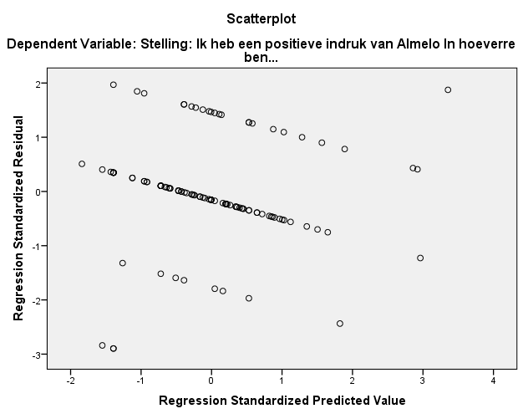

Mannen
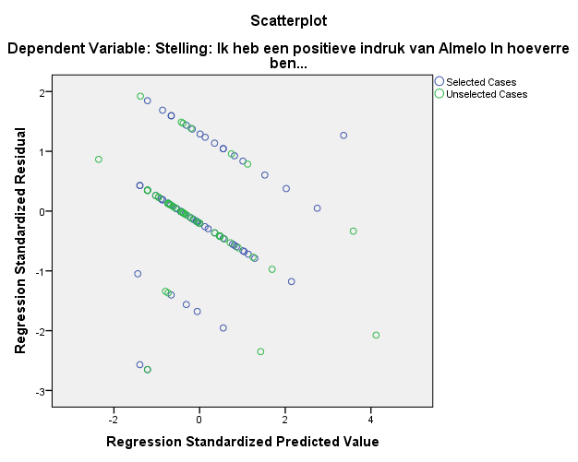
Vrouwen
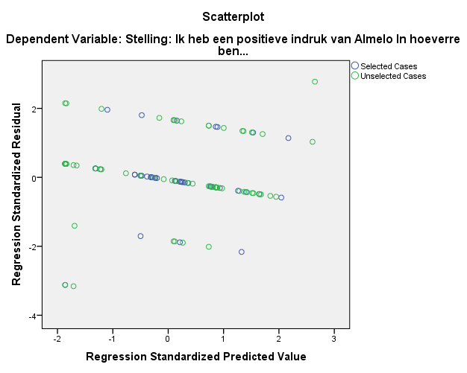
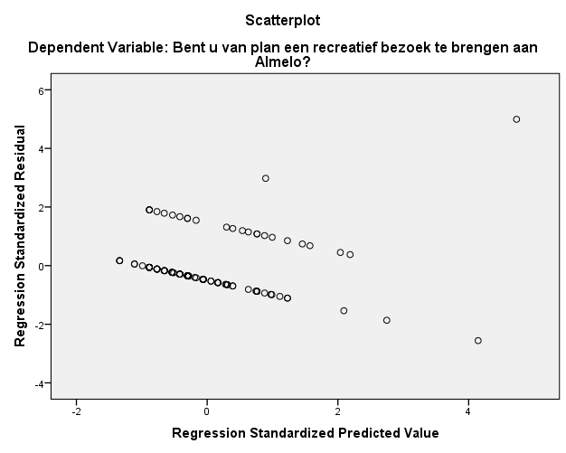

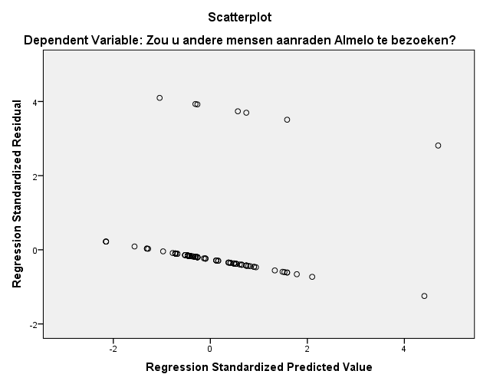
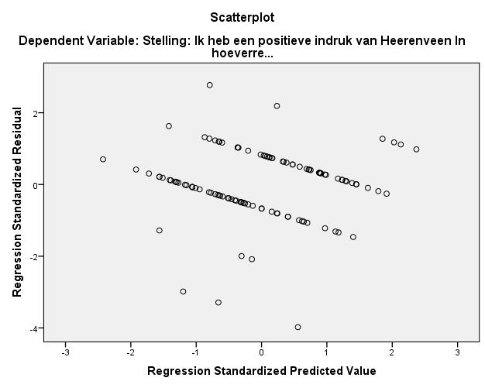

Mannen
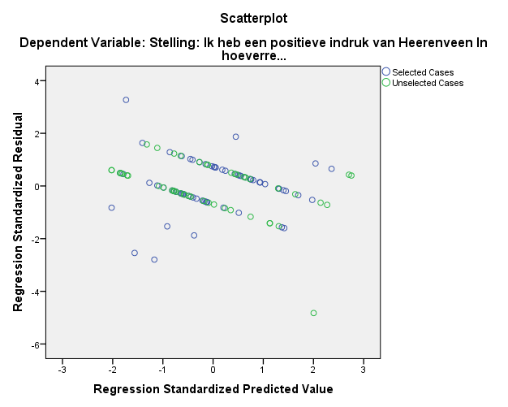
Vrouwen
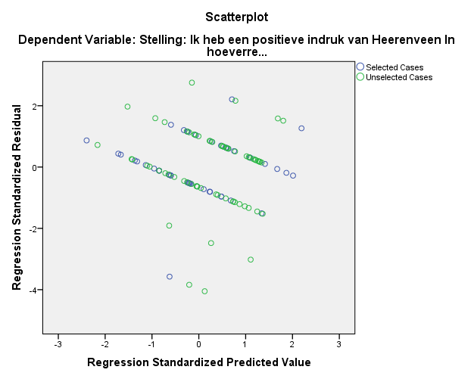

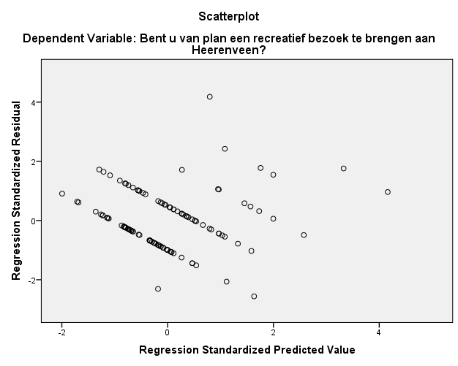

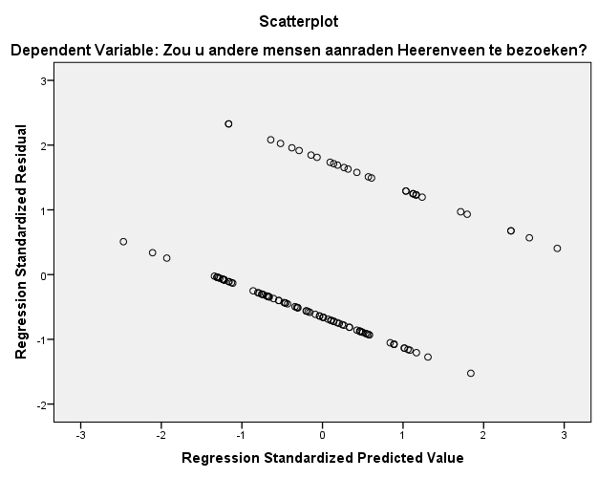

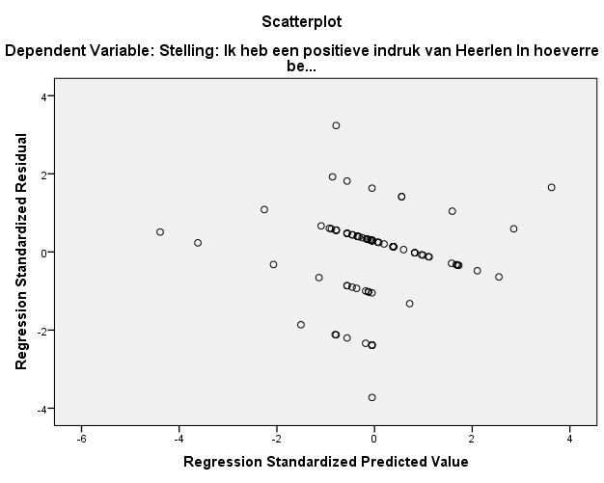

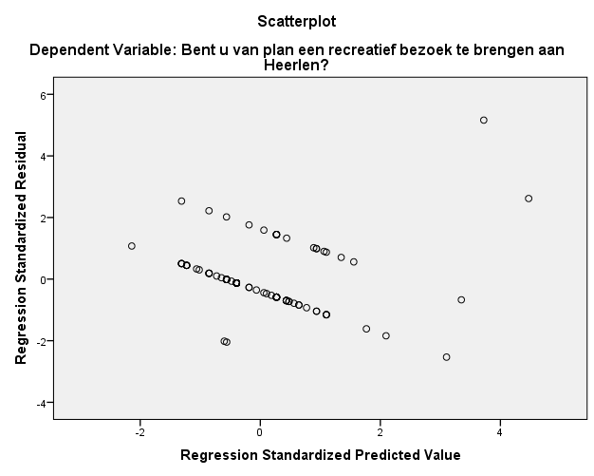

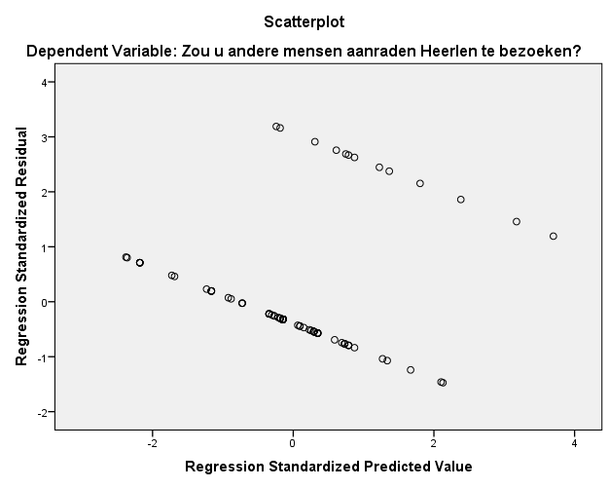
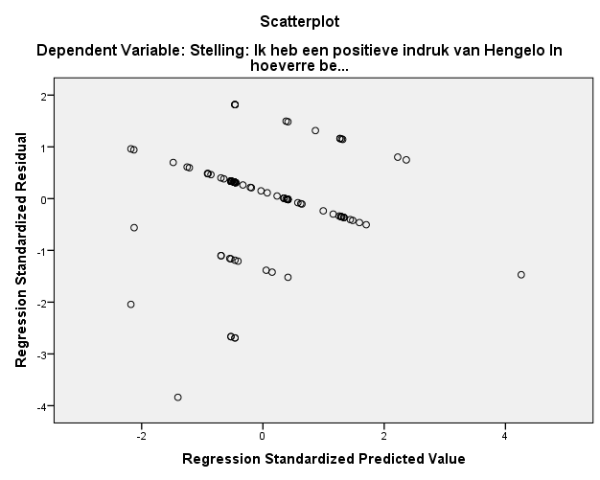

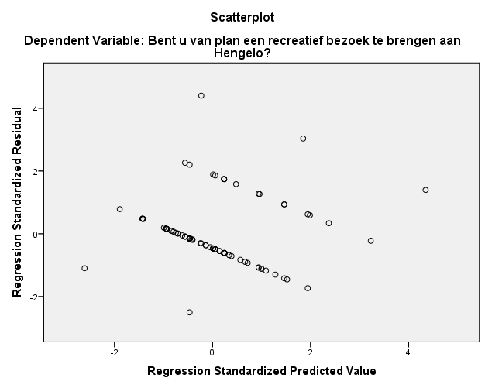

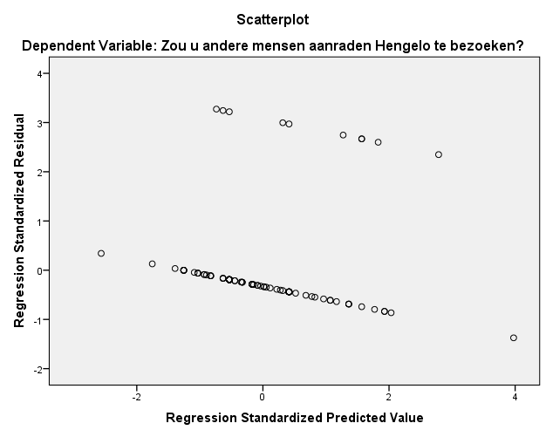

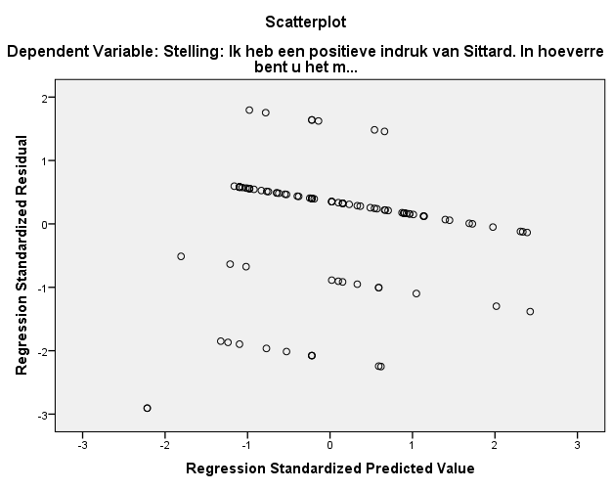

Mannen
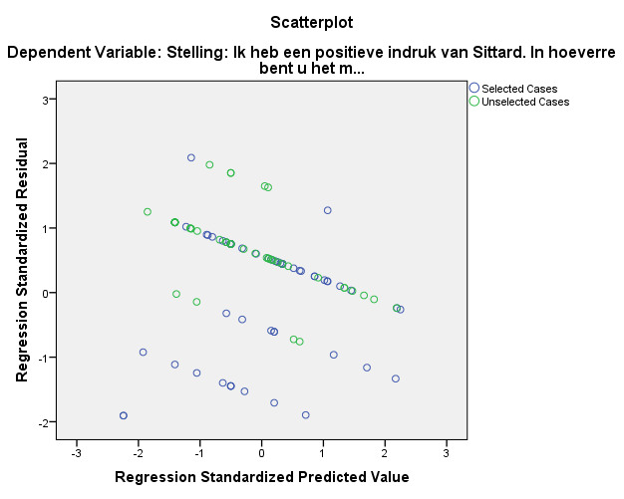

Vrouwen
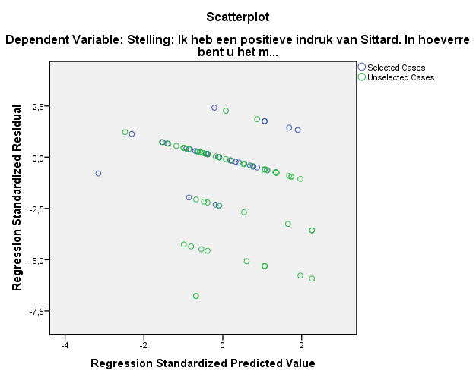
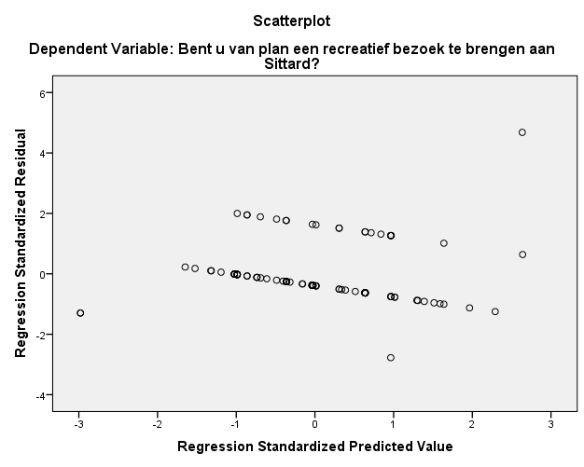

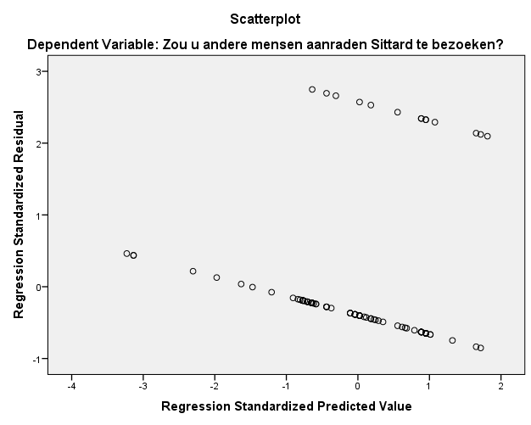

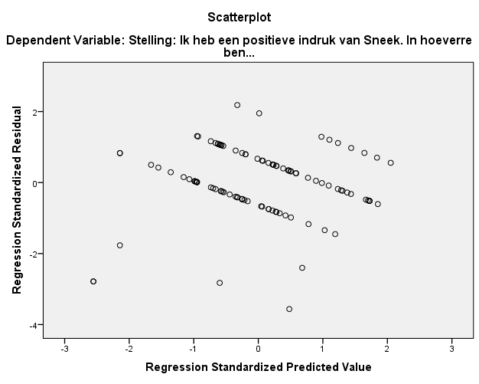

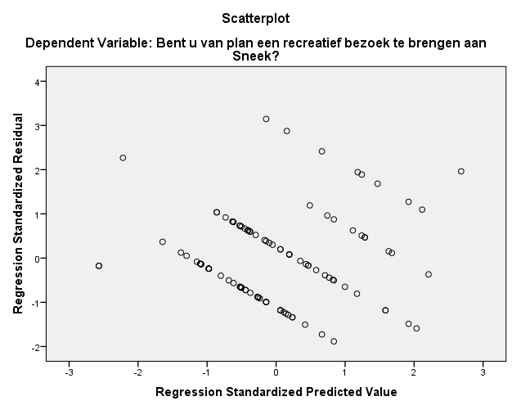

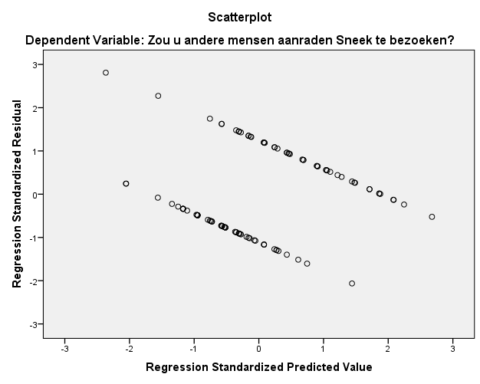

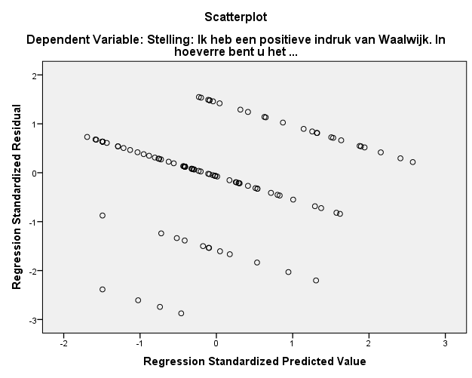
Mannen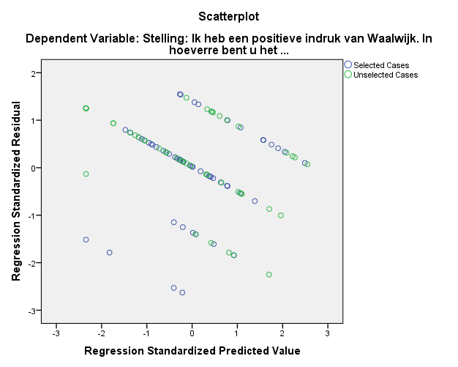

Vrouwen
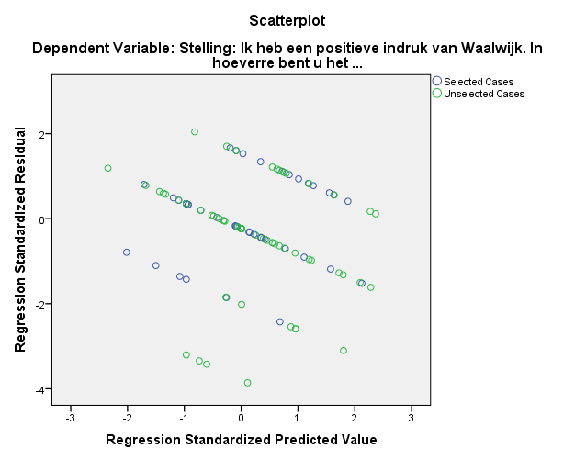

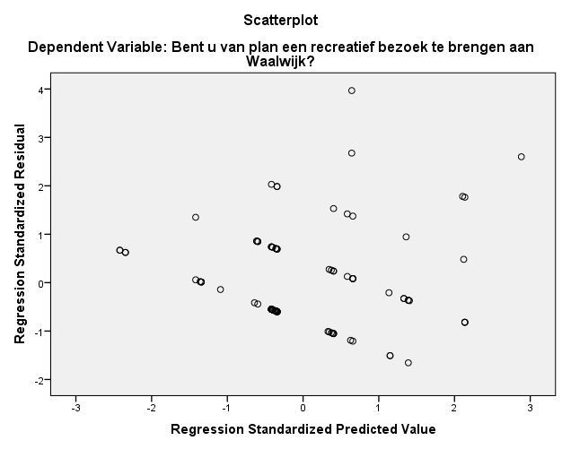

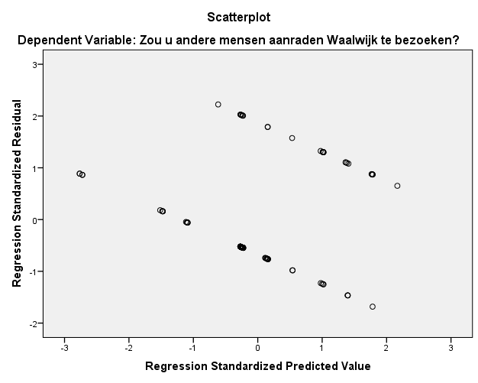

Appendix 6: The questionnaire
Imago onderzoek kleine gemeenten
Voor mijn bachelorscriptie doe ik een onderzoek naar het imago van een aantal kleine gemeentes in Nederland. Ik wil te weten komen of deze gemeentes bekend zijn bij Rotterdamse studenten en waar jullie bij die gemeentes het eerste aan denken.
Algemene vragen:
Bent u een man of een vrouw?
Waar woont u?
Waar woonde u voor uw studietijd?
Wonen er familieleden/vrienden van u in of in de omgeving van?
Almelo ja/nee
Heerenveen ja/nee
Heerlen ja/nee
Hengelo ja/nee
Sittard ja/nee
Sneek ja/nee
Waalwijk ja/nee
Zutphen ja/nee
Hoe vaak bent u in uw leven in .. geweest?
Almelo nooit/zelden/af en toe/vaak/zeer vaak
Heerenveen nooit/zelden/af en toe/vaak/zeer vaak
Heerlen nooit/zelden/af en toe/vaak/zeer vaak
Hengelo nooit/zelden/af en toe/vaak/zeer vaak
Sittard nooit/zelden/af en toe/vaak/zeer vaak
Sneek nooit/zelden/af en toe/vaak/zeer vaak
Waalwijk nooit/zelden/af en toe/vaak/zeer vaak
Zutphen nooit/zelden/af en toe/vaak/zeer vaak

Vragen over de gemeentes:
Stelling: Ik weet veel over Almelo.
In hoeverre bent u het met deze stelling eens?
Zeer oneens/oneens/neutraal/eens/zeer eens
Het merendeel van mijn informatie over Almelo komt van?
Tv&kranten/mijn omgeving/internet/boeken&tijdschriften/VVV
Wat is de eerste associatie die u heeft bij Almelo? (Rangschik deze associaties op bekendheid van 1-5, 1 staat voor datgeen waar u het eerst aan denkt, 5 voor het laatste. Let op! Rangschik alleen deze associaties die u kent. Dus als u nog nooit gehoord heeft van bijvoorbeeld het stadsmuseum van Almelo, hoeft u daar geen cijfer bij te zetten. )
- Herman Finkers
- Heracles Almelo
- Vroegere textielstad
- Protestantse Grote Kerk
- Stadsmuseum Almelo
Heeft u een associatie gemist in de voorgaande vraag? Zo ja, welke?
Stelling: Ik heb een positieve indruk van Almelo
In hoeverre bent u het met deze stelling eens?
Zeer oneens/oneens/neutraal/eens/zeer eens
Bent u van plan een recreatief bezoek te brengen aan Almelo?
Binnen een maand/Binnen een half jaar/Binnen een jaar/Binnen 5 jaar/Nooit
Zou u andere mensen aanraden Almelo te bezoeken?
Ja /Nee
Stelling: Ik weet veel over Heerenveen.
In hoeverre bent u het met deze stelling eens?
Zeer oneens/oneens/neutraal/eens/zeer eens

Het merendeel van mijn informatie over Heerenveen komt van?
Tv&kranten/mijn omgeving/internet/boeken&tijdschriften/VVV
Wat is de eerste associatie die u heeft bij Heerenveen? (Rangschik van 1-5, 1 staat voor datgeen waar u het eerst aan denkt, 5 voor het laatste. Let op! Rangschik alleen deze associaties die u kent.)
- Thialf
- Friesland
- Skutjessilen
- Nuchtere mensen
- SC Heerenveen
Heeft u een associatie gemist in de voorgaande vraag? Zo ja, welke?
Stelling: Ik heb een positieve indruk van Heerenveen.
In hoeverre bent u het met deze stelling eens?
Zeer oneens/oneens/neutraal/eens/zeer eens
Bent u van plan een recreatief bezoek te brengen aan Heerenveen?
Binnen een maand/Binnen een half jaar/Binnen een jaar/Binnen 5 jaar/Nooit
Zou u andere mensen aanraden Heerenveen te bezoeken?
Ja /Nee
Stelling: Ik weet veel over Heerlen.
In hoeverre bent u het met deze stelling eens?
Zeer oneens/oneens/neutraal/eens/zeer eens
Het merendeel van mijn informatie over Heerlen komt van?
Tv&kranten/mijn omgeving/internet/boeken&tijdschriften/VVV
Wat is de eerste associatie die u heeft bij Heerlen? (Rangschik van 1-5, 1 staat voor datgeen waar u het eerst aan denkt, 5 voor het laatste. Let op! Rangschik alleen deze associaties die u kent.)
- Tafeltennisclub MF Services/Furst
- Het hart van Heerlen, met o.m. het Glaspaleis en de Pancratiuskerk
- Schelmentoren
- Schachtgebouw Oranje Nassau I
- Mijnen
Heeft u een associatie gemist in de voorgaande vraag? Zo ja, welke?
Stelling: Ik heb een positieve indruk van Heerlen
In hoeverre bent u het met deze stelling eens?
Zeer oneens/oneens/neutraal/eens/zeer eens
Bent u van plan een recreatief bezoek te brengen aan Heerlen?
Binnen een maand/Binnen een half jaar/Binnen een jaar/Binnen 5 jaar/Nooit
Zou u andere mensen aanraden Heerlen te bezoeken?
Ja /Nee
Stelling: Ik weet veel over Hengelo.
In hoeverre bent u het met deze stelling eens?
Zeer oneens/oneens/neutraal/eens/zeer eens
Het merendeel van mijn informatie over Hengelo komt van?
Tv&kranten/mijn omgeving/internet/boeken&tijdschriften/VVV
Wat is de eerste associatie die u heeft bij Hengelo? (Rangschik van 1-5, 1 staat voor datgeen waar u het eerst aan denkt, 5 voor het laatste. Let op! Rangschik alleen deze associaties die u kent.)
- Twents Techniekmuseum
- Fanny Blankers Koen games
- Vroegere textiel en technische industrie(Stork)
- Sint Lambertusbasiliek
- Tukkers
Heeft u een associatie gemist in de voorgaande vraag? Zo ja, welke?
Stelling: Ik heb een positieve indruk van Hengelo
In hoeverre bent u het met deze stelling eens?
Zeer oneens/oneens/neutraal/eens/zeer eens
Bent u van plan een recreatief bezoek te brengen aan Hengelo?
Binnen een maand/Binnen een half jaar/Binnen een jaar/Binnen 5 jaar/Nooit
Zou u andere mensen aanraden Hengelo te bezoeken?
Ja /Nee
Stelling: Ik weet veel over Sittard.
In hoeverre bent u het met deze stelling eens?
Zeer oneens/oneens/neutraal/eens/zeer eens
Het merendeel van mijn informatie over Sittard komt van?
Tv&kranten/mijn omgeving/internet/boeken&tijdschriften/VVV
Wat is de eerste associatie die u heeft bij Sittard? (Rangschik van 1-5, 1 staat voor datgeen waar u het eerst aan denkt, 5 voor het laatste. Let op! Rangschik alleen deze associaties die u kent.)
- Fortuna Sittard
- DSM
- Historische markt
- Basiliek van Onze lieve vrouw van het heilig hart
- Mijnen
Heeft u een associatie gemist in de voorgaande vraag? Zo ja, welke?
Stelling: Ik heb een positieve indruk van Sittard
In hoeverre bent u het met deze stelling eens?
Zeer oneens/oneens/neutraal/eens/zeer eens
Bent u van plan een recreatief bezoek te brengen aan Sittard?
Binnen een maand/Binnen een half jaar/Binnen een jaar/Binnen 5 jaar/Nooit
Zou u andere mensen aanraden Sittard te bezoeken?
Ja /Nee
Stelling: Ik weet veel over Sneek.
In hoeverre bent u het met deze stelling eens?
Zeer oneens/oneens/neutraal/eens/zeer eens
Het merendeel van mijn informatie over Sneek komt van?
Tv&kranten/mijn omgeving/internet/boeken&tijdschriften/VVV
Wat is de eerste associatie die u heeft bij Sneek? (Rangschik van 1-5, 1 staat voor datgeen waar u het eerst aan denkt, 5 voor het laatste. Let op! Rangschik alleen deze associaties die u kent.)
- Sneekweek
- Friesland
- Gaastra
- Elfstedentocht
- De Waterpoort
Heeft u een associatie gemist in de voorgaande vraag? Zo ja, welke?
Stelling: Ik heb een positieve indruk van Sneek
In hoeverre bent u het met deze stelling eens?
Zeer oneens/oneens/neutraal/eens/zeer eens
Bent u van plan een recreatief bezoek te brengen aan Sneek?
Binnen een maand/Binnen een half jaar/Binnen een jaar/Binnen 5 jaar/Nooit
Zou u andere mensen aanraden Sneek te bezoeken?
Ja /Nee
Stelling: Ik weet veel over Waalwijk.
In hoeverre bent u het met deze stelling eens?
Zeer oneens/oneens/neutraal/eens/zeer eens
Het merendeel van mijn informatie over Waalwijk komt van?
Tv&kranten/mijn omgeving/internet/boeken&tijdschriften/VVV
Wat is de eerste associatie die u heeft bij Waalwijk? (Rangschik van 1-5, 1 staat voor datgeen waar u het eerst aan denkt, 5 voor het laatste. Let op! Rangschik alleen deze associaties die u kent.)
- Efteling
- RKC Waalwijk
- Mandemakers
- Vroegere schoenenstad/schoen- en ledermuseum
- Noord-Brabant
Heeft u een associatie gemist in de voorgaande vraag? Zo ja, welke?
Stelling: Ik heb een positieve indruk van Waalwijk
In hoeverre bent u het met deze stelling eens?
Zeer oneens/oneens/neutraal/eens/zeer eens
Bent u van plan een recreatief bezoek te brengen aan Waalwijk?
Binnen een maand/Binnen een half jaar/Binnen een jaar/Ooit/Nooit
Zou u andere mensen aanraden Waalwijk te bezoeken?
Ja /Nee
Stelling: Ik weet veel over Zutphen.
In hoeverre bent u het met deze stelling eens?
Zeer oneens/oneens/neutraal/eens/zeer eens
Het merendeel van mijn informatie over Zutphen komt van?
Tv&kranten/mijn omgeving/internet/boeken&tijdschriften/VVV
Wat is de eerste associatie die u heeft bij Zutphen? (Rangschik van 1-5, 1 staat voor datgeen waar u het eerst aan denkt, 5 voor het laatste. Let op! Rangschik alleen deze associaties die u kent.)
- Torenstad
- Historische binnenstad
- Monumentenstad
- Zutphense Librije
- Stedelijk Museum Zutphen
Heeft u een associatie gemist in de voorgaande vraag? Zo ja, welke?
Stelling: Ik heb een positieve indruk van Zutphen
In hoeverre bent u het met deze stelling eens?
Zeer oneens/oneens/neutraal/eens/zeer eens
Bent u van plan een recreatief bezoek te brengen aan Zutphen?
Binnen een maand/Binnen een half jaar/Binnen een jaar/Binnen 5 jaar/Nooit
Zou u andere mensen aanraden Zutphen te bezoeken?
Ja /Nee

Like poverty and unemployment

