Online consumer behavior
Master thesis
Erasmus University Rotterdam
Erasmus School of Economics


Bobby Doorduyn
Student number: 296447
brainbob@planet.nl
12-08-2012
Master thesis in Marketing
Supervised by Dr. Bas Donkers
Abstract
The origination of the internet created an entire new experience for consumers regarding gathering information, comparing products or prices and the possibility of purchasing on the internet.
Therefore consumer behaviour on the internet is an important factor for marketers. To predict consumer behaviour on the internet marketers need to understand how, where and why consumers behave online. This study aims to explore what online channels consumers use when they are in a particular stage of the buying decision process (BDP). This study will also explore the ‘Theory of Planned Behaviour’ (TPB) and the ’Technology Acceptance Model’ (TAM) to explain consumer behaviour on the internet.

With use of a snowball sampling method a questionnaire was sent over the internet. A total of 115 respondents have answered the questionnaire. By analyzing the data with a one-way ANOVA and Regression analysis the following results were achieved;
The results show that consumers in the stage ‘information search’ of the BDP process do not use information websites as the only way to obtain information, they also use other channels to obtain information. Also consumers in the stage ‘pre-purchase of evaluating alternatives’ do not limit themselves to only using comparison websites to compare products, they also use other channels to obtain information.
Other results of this study implicate that there is no relation between the attitude of consumers towards ‘information seeking and comparing products’ and ‘the likelihood of purchasing a product online’. There is however a positive effect between ‘the attitude of consumers towards information seeking and comparing products’ and ‘the attitude of consumers towards price-comparison websites’. The latter attitude has also a positive effect on the likelihood of purchasing online. Finally a high self-efficacy has a positive effect on the attitude towards information seeking and comparing products of consumers.

To summarize; this research gives insights in the selected channels consumers choose during their BDP and gives better understandings about the behaviour of consumers online. The recommendations can help marketers optimize their marketing strategy.

Table of Contents

1. Introduction 1
1.1. Managerial Background 2
1.2. Relevant Research 3
1.3. Research Questions 4
2. Theoretical Background and Hypotheses 5
2.1. Websites 10
2.2. Demographic Variables 11
2.3. Conceptual Framework 12
3. Methodology 13
3.1. Data Collection 13
3.2. The Questionnaire 14
4. Results 18
4.1. Descriptives 18
4.2. Factor analysis 20
4.3. Reliability test 24
4.4. One-way ANOVA 25
4.5. Regression Analysis 30
4.6. Demographic variables 37
4.7. Independent-samples T Test 38
5. Discussion 49
5.1. Demographic Variables 52
5.2. Further Discussion 53
5.3. Limitations 56
6. Conclusions and Recommendations 57
6.1. Theoretical Contributions 58
6.2. Managerial Implications 58
6.3. Further Research 60
7. References 61
8. Appendices 65

Introduction
With the introduction of the personal computer a whole new component entered the lives of many. When later on the internet was invented the way people live changed indefinitely. At first the internet was only used for communication purposes; sending out information and gathering information. In 2010, about 550 billion documents can be found on the internet. Those documents are searched by more than 2 billion internet users in 2010 (Reuters, 2010). These facts indicate that the internet increasingly influences the way people live. The internet changed the way of live.

The Nobel Prize winner of 2008 (Krugman, 1991) argued that we, as a society, moved on to globalization 2.0. This is due to the fact that information and communication technologies (ICT) are much more developed than in the early days. Because of these developments people can get information much easier, cheaper and faster. This shifts the whole economy to a new kind of economy; globalization 2.0 or the information (internet) economy. Some economists (Ghosh, 1999) state that firms can no longer avoid the internet. In 2002 about 53 percent of the American internet users used the internet to make a purchase (Horrigan, 2002). In 2010 about 85 percent of American consumers have purchased a product on the internet (Nielsen, 2010) and these numbers are continuing to grow.

The rise of the era of the information economy has an impact on many aspects of people’s lives. It has not only influenced the social level but also the business-, political- and economic levels. Every aspect of life has changed with the emergence of the information economy.
This new era is created by a set of evolvements. These evolvements are, discussed by many authors (Butler & Peppard, 1998; Malone, Yates, & Benjamin, 1997; Yoffie, 1996) and include rapid technological convergence, greater connectivity, enhanced interactive capacity and increased organizational co-ordination capability. Computers and the internet are the aids for consumers to participate in this information economy.

Internet as a medium does not only provide information but can also be used to communicate and purchase products. The internet is an environment for conducting a transaction and a channel to deliver the product or service to the buyer (Angehrn, 1997).
With online shopping consumers can buy products without an intermediary service.

Managerial Background
The changing role of the internet and the corresponding websites has a significant impact on companies. Consumers can make their opinions and experiences about products available on the internet (Dellarocas, 2003). In 2009 (Trendstream, 2009) 85 percent of global internet users had searched for information about products. Another study (Razorfish, 2008) showed that 61 percent of global internet users take internet reviews about products into account when they are in their buying decision process.
These results mean that consumers are using the internet ore and more during their buying decision process. It is therefore important for companies to gain more knowledge about the behaviour of consumers on the internet.
The growing e-commerce and internet as information-channel makes it necessary for companies to know the behaviour of their customers on the internet (Lohse, Bellman, & Johnson, 2000). Marketers could perform better if they understand and know their customers well. It is necessary for marketers to understand the decisions consumers make and how online consumers go through their decision process.

Relevant Research
Numerous economic studies focus mainly on specific areas such as product design, quality and strategy. These studies are all about marginalization. However another theory suggests (Lehmann, 1999) a broader perspective and building on more general theories is needed. This broader perspective can contribute more in a problem-oriented field such as marketing. In this research a more general context of the consumer behaviour is used. This study uses the model of consumer’s buying decision process (Blackwell, Miniard, & Engel, 2006).

There are various studies (Butler & Peppard, 1998; Gupta, Su, & Walter, 2004; Häubl & Trifts, 2000) that show the general behaviour of consumers when they are searching and buying products. Another study (Li, Kuo, & Rusell, 1999) shows the attitude of consumers towards particular channels.
Other studies (Reibstein, 2002; Heijden van der, Verhagen, & Creemers, 2003) examined only the ‘purchase’ stage of consumers during their entire buying decision process (BDP).
There is however no research done about the channels consumers use during a particular stage of their BDP. This study will contribute to getting more insights in what channels consumers use when they are in a particular stage of the BDP.

As stated before many studies investigated the overall behaviour of consumers on the internet. On the contrary there are studies (Peterson & Merino, 2003) that investigated the particular behaviour when searching for information and buying products online. Another example is a study (George, 2002) about pairing this behaviour with the Theory of Planned Behaviour (Ajzen, 1991) and the Technology Acceptance Model (Davis, 1986). But this connection was only regarding privacy and trust.
Regarding this topic the contribution of this study will lie in the fact that the behaviour of consumers on the internet will be paired with the Theory of Planned Behaviour and the Technology Acceptance Model regarding using certain internet channels. With this connection it is possible to know if particular consumers use certain channels.

Research Questions
This study will create more understanding about why and how online consumers go through their BDP. This research can attribute to more efficient marketing strategies and more effective websites. In this study a more general context of the consumer behaviour is used. This research will be about the stages of the consumer’s buying decision process (BDP) in the context of online channels. The Theory of Planned Behaviour (TPB) and Technology Acceptance Model (TAM) will also be implemented in this study. The following research questions are defined:

How do consumers behave on the internet and how are TPB and TAM affecting the behaviour of consumers on the internet?

Sub questions:
- Are consumers in the ‘search for information’ stage of the decision process using ‘information websites’ significantly more than other channels to find information?
- Are consumers in the ‘pre-purchase evaluations of alternatives’ stage of the decision process using ‘comparison websites’ significantly more than other channels to compare products?
- Does a positive attitude towards information seeking on the internet have a positive effect on the likelihood of purchasing a product in an online store?
- Does a high self-efficacy have a positive effect on the attitude towards information seeking on the internet?
- Does a high self-efficacy have a positive effect on the attitude towards the comparison of attributes of different products on the internet?
- Does a positive attitude towards information seeking on the internet have a positive effect on the attitude towards price-comparison websites?
- Does a positive attitude towards price-comparison websites have a positive effect on the likelihood of purchasing a product in an online store?

Theoretical Background and Hypotheses
One of the most important models in the field of marketing is the Consumer’s Buying Decision Process. This consumer behaviour model (Blackwell et al, 2006) contains the decision making processes a consumer goes through regarding a potential market transaction. This can be before the purchase of a product but also during and after the transaction. The Buying Decision Process (BDP) consists of seven stages a consumer goes through before making a final purchase decision of a product (Appendix A). The seven stages, in the right order, are need recognition, search for information, pre-purchase evaluation of alternatives, purchase, consumption, post-consumption evaluation and divestment. In every stage the consumer will act and react differently. If a company desires to understand the decisions of consumers it needs to take the BDP model into account. Therefore, the BDP model with its seven stages will be the foundation of my framework.

A section of this study discusses how consumers behave on the internet during the BDP. The first stage of the behaviour of consumers is ‘need recognition’. This stage will be activated when a consumer perceives a difference between a person’s ideal and actual situation. Theory states (Kotler & Keller, 2006) that there needs to be substantial dissimilarity to create a need or want. This can be an empty bottle of soda when or can be activated by marketing efforts. This stage will be triggered by a need or want. Needs are things that consumers have to buy and use in order to survive. Wants are about products consumers would like to have. Wants can be triggered by marketing efforts. This study is about how consumers use their online channel during their BDP and this stage is about how consumers can be influenced (or triggered) and what their needs are. Therefore this study does not need to use this stage.

The second stage of the BDP model is ‘search for information’. This stage is started by the consumer when there is a need to obtain information prior to a purchase. Consumers are searching (Blackwell et al, 2006) for available products and their features. A consumer can obtain information through internal search and external search.
During internal search consumers are obtaining information through their memory to recall previous experiences with products or brands. External search is obtained through online or offline channels. Thus searching for information on the internet is external search.
There are personal sources (family, friends), public sources (newspapers, television, radio, magazines) and commercial sources (advertising, retailers, dealers, salespeople). There are also different kinds of websites which contain information. To name a few there are corporate websites, review websites, internet forums and social media and all-in-one websites. Study has shown (Bailey, 2010) that consumers use review websites for reassurance of their already acquired information. As stated above the BDP showed that consumer behaviour in the information search stage consist of searching for available products and their features.
Thus the following hypothesis about the search for information on the internet is expected to hold:

Hypothesis 1:
Consumers in the ‘search for information’ stage of the decision process are using ‘information websites’ more than other channels to find information.

The third stage of the BDP is the ‘pre-purchase evaluation of alternatives’ stage. In this stage of the decision process consumers are comparing the product they had in mind with alternative solutions (Butler & Peppard, 1998). Traditional offline sources for evaluation of alternatives include consumer groups, marketing communications, word-of-mouth and past experiences. Consumers are frequently unable to evaluate all alternatives thoroughly. To overcome this problem consumers use a two-stage process to evaluate alternatives (Häubl & Trifts, 2000). In the first stage, consumers screen a large set of products and select the best alternatives. Subsequently consumers evaluate the best alternatives in-depth and perform comparisons across the products features and specifications. With the aid of the internet, consumers (Butler & Peppard, 1998) need less effort to perform an in-depth evaluation. On the internet websites can be found that contain almost every product of a particular product-category. These ‘comparison’ websites contain not only the available products but also their features and specifications. So if consumers are evaluating for alternatives in this stage of the BDP they will use primarily comparison websites.
Thus the following hypothesis about the evaluations of alternatives on the internet is expected to hold:

Hypothesis 2:
Consumers in the ‘pre-purchase evaluations of alternatives’ stage of the decision process are using ‘comparison websites’ more than other channels to compare products.

Consumers behave in their own particular course of action. A theory (Fishbein & Ajzen, 1975) about this matter is the theory of reasoned action. The theory of reasoned action (TRA) suggests that a person’s behaviour is determined by his intention to execute this particular behaviour. The intention is driven by the attitude towards the behaviour and the subjective norm. Attitude is the positive or negative thoughts towards the behaviour. The subjective norm consists of the interaction with the social network. The subjective norm is the person’s perception of what ones friends and family think about if he or she should perform a particular behaviour. Later on a new component to the TRA is introduced known as perceived behavioural control (Ajzen, 1991). With this new component the theory of reasoned action was extended and designed the Theory of Planned Behaviour. The new component behavioural control (or self-efficacy) was created to also take the non-volitional behaviour into account for predicting actual behaviour. Later, (Bandura, 2002) stated that self-efficacy is ‘‘the belief in one’s capabilities to organize and execute the courses of action required to produce given attainments’’. The higher someone’s self-efficacy towards a behavior is, the higher the chances are a person will execute that behaviour.
In this case the TPB can be applied to consumer behaviour on the internet and online shopping. If someone has a positive attitude towards the internet as a channel for knowledge and information there is a significant probability that person has a preference for online shopping over offline shopping.
Therefore the following hypothesis will apply on consumer behaviour:

Hypothesis 3:
A positive attitude towards information seeking on the internet has a positive effect on the likelihood of purchasing a product in an online store.

One of the variables of the TPB is the behavioural control. This variable determines (together with attitude and subjective norm) the intention to search for information and compare different products. The TPB model states that self-efficacy is a behavioural control variable. Another study (Bandura, 1990) states that if one has a high self-efficacy, one also has a high believe in his or her ability to succeed in certain behaviour. This is influenced by the fact that such a person sees fewer aspects which prevent him to act in that particular behaviour. This can also be translated to the behaviour of consumers on the internet.
Self-efficacy can be translated to the internet into two parts; ‘web-specific self-efficacy’ and ‘general internet self-efficacy’ (Hsu & Chiu, 2004). ‘Web-specific self-efficacy’ is one’s perception of his self-efficacy in using a particular internet application. ‘General internet self-efficacy’ is one’s perception of his self-efficacy in using the internet as a whole. So self-efficacy as a behavioural control variable can be applied on the intentions of consumers on the internet.
With the above stated it is likely that a person with high-efficacy about knowledge of the internet is more likely to search on information websites. This is because that person belief his knowledge of the internet is high enough to succeed to search for information. It is also likely that a person with high-efficacy in knowledge is better in comparing attributes of different products because of better understanding on how to compare products.
Therefore the following hypotheses about self-efficacy are expected to hold:

Hypothesis 4a:
High self-efficacy towards the internet has a positive effect on the attitude towards information seeking on the internet.
Hypothesis 4b:
High self-efficacy towards the internet has a positive effect on the attitude towards the comparison of attributes of different products on the internet.

Another theory about consumers and their behaviour towards the internet is the Technology Acceptance Model (Davis, 1986). Technology acceptance model (TAM) is an extension of TPB and indicates that the behavioural intention of using a technology is derived from the attitude towards that particular technology. TAM suggests that there are a few factors influence consumers decision if and how they will use a new technology.
TAM is further improved in TAM 2 (Venkatesh & Davis, 2000) and TAM 3 (Venkatesh & Bala, 2008). The factors described in TAM are perceived usefulness (PU) and Perceived ease-of-use (PEOU) (Davis, 1989). PU is defined as ‘the degree to which a person believes that using a particular system would enhance his or her job performance’. PEOU is defined as ‘the degree to which a person believes that using a particular system would be free from effort’. This can easily be applied to consumers and their relation with the internet. In this theory PU can be explained as a performance enhancer of the price-comparison websites for searching and purchasing online, instead of searching and purchasing products in physical stores. The ‘system’ of price-comparison websites creates a useful tool for consumers in their BDP.
Whereas PEOU is the connection between comparing prices online and immediately purchasing the product at an online store with the desirable price. This behaviour consists of less effort compared to going through the same behaviour in physical stores.
Another theory suggests (Faulkner, 1992) that consumers want to purchase a product as inexpensive as possible. Consumers are price sensitive (note not all consumers have the same price sensitivity) and will search for the most desirable price in combination with their effort for searching for that particular price. Consumers have to make an effort to search for the most desirable price and searching on price-comparison websites will take less effort (Lieber & Syverson, 2011) than going to every local physical store to compare prices. Also prices (Lieber & Syverson, 2011) in online channels are usually lower than in offline channels. Therefore it is expected that consumers who accept the internet (see TAM and self-efficacy) as information channel likewise will use price-comparison websites to search for the most desirable price. Additionally it is expected that consumers who receive a positive usefulness and ease of use towards price-comparison websites buy their products in an online store as well. With both the TAM theory and the theories above the following hypothesis is expected to hold:

Hypothesis 5a:
A positive attitude towards information seeking on the internet has a positive effect on the attitude towards price-comparison websites.
Hypothesis 5b:
A positive attitude towards price-comparison websites has a positive effect on the likelihood of purchasing a product in an online store.

Websites
There are many different websites on the internet consumers can access to find information and compare products. A number of websites are important for online marketing. Earlier in this study during the construction of hypothesis 1 and 2 a distinction had been made between information websites, comparison websites and other channels. These websites will now be discussed briefly for clarification.

Information websites can be divided into two categories; corporate websites and review websites. Both Corporate websites and Review websites are primarily made for providing information about products on the internet.

A review website is a website where consumers can place their experiences about a particular product, service or brand. There are two different review websites.
There are review websites that contain reviews from normal users of the particular product. The second kind of review websites are websites with reviews from ‘experts’. These reviewers have an expertise in the particular field of the product.

A corporate website is an informational website operated by a business. The corporate website is not primarily about selling the product online but about sharing information. A corporate website can provide information about the company, the brand and their products.

Comparison websites are the only websites which are primarily made for comparing products online. These days a comparison website contains all available specifications of a product and also has a list of prices of both online stores and physical stores where consumers can buy the particular product. Consumers can compare specifications of different products and compare different stores on prices.

Demographic Variables
The TPB states that that a person’s behaviour is determined by his intention to execute this particular behaviour. This intention is also influenced by the person’s demographic background. Income is an aspect of the demographic background. A person with a low income is generally more price sensitive than a wealthy person. A person with a low income will generally search harder for a lower price.
Another aspect is age. Elderly people did not grow up with computers and the internet. On the opposite, younger people learn to use computers at school. Therefore computers (and internet) are more involved in their lives. As a result their attitude, subjective norm and behavioural control towards the internet are different. Last, gender is also a demographic variable. Study (Hu & Stoel, 2004) shows that a female person has a higher innovativeness than a male person. These demographic variables will also be tested during this research in order to check whether these demographic backgrounds have an influence on the intention and attitude of consumers.

Conceptual Framework
Based on all the hypotheses stated in the previous paragraph a conceptual framework is created. This framework contains the BDP as base and the attitudes and self-efficacy are positioned around the BDP. Attitude towards information seeking is expected to have a positive effect on the likelihood of purchasing online (H3) and on the attitude towards price-comparison websites (H5a). Self efficacy is expected to have a positive effect on the attitude towards information seeking (h4a) and on the attitude towards comparing products (H4b). Finally the attitude towards price-comparison websites is supposed to have a positive effect on the likelihood of purchasing online (H5b).
The demographic variables will give better insight in the influence of the demographic backgrounds regarding the overall subject.

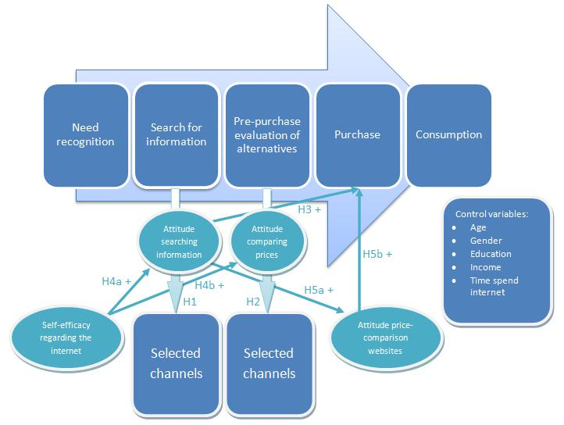

Methodology
To examine the hypotheses data needs to be collected. With this data the hypotheses can be tested. How this data is collected is important for their reliability and accuracy (Merriam, 1998). With the questions in the questionnaire and their corresponding data an acceptable analysis can be accomplished.

Data Collection
According to CBS (Central Bureau of Statistic of The Netherlands) 94 percent of all households (Appendix B) in The Netherlands in 2011 have access to the internet. Income might be a dependent factor of internet access. However CBS states that 87 percent of all households (Appendix C) with the lowest weighed income have access to the internet. Internet access does also not depend on gender. With these numbers it can be assumed that it is not necessary to construct a target group for the questionnaire in terms of income nor gender and education.

Another focus point of this research concerns buying decisions and purchasing products on the internet. The focus in terms of age lies above 15 years. People under the age of 15 generally don’t buy products without their parents. Also, they generally don’t own money but get an allowance from their parents. Therefore the first age group respondents can select is from 16-20 years. The last age group is 50 years and older. There is no limit in age in terms of buying decisions and use of the internet.

The questionnaire was distributed in The Netherlands and was send through the internet. When we take a look at Europe we can see that The Netherlands is a country with a relatively high amount of households with internet access (Appendix D). This implies that the internet is very well integrated in the lives of the people living in the Netherlands.
Various people received an email with the questionnaire. The email states not only the internet address but also the request to forward the address to the questionnaire to people above the age of 15. This request ensures fast answers to the questionnaire. This method is called ‘the snowball-sampling method’ (Goodman, 1961).
The questionnaire was distributed through the internet. Communication resources are becoming more and more popular on the internet (Nie & Hillygus, 2002) and therefore also questionnaires on the internet. The internet is a good alternative for conducting questionnaires because this way data can be collected faster than oral surveys or hand-filled questionnaires (Wright, 2005). The collected data is also already on a computer so analyses can be done much easier and faster.
The data of the questionnaire was collected using the website www.thesistools.com. The questionnaire was written in Dutch. The reason for this was to avoid miscommunications in terms of language. The appendix of this research contains a translated questionnaire in English for the interest of clarity.

The Questionnaire
As stated before the questionnaire was created Dutch and afterwards translated to English (Appendix E). The questionnaire consists of 40 questions and statements. There are two basic goals when creating a questionnaire. The first goal is to acquire relevant information for the particular research and secondly this information needs to be reliable and valid (Wilcox, 1999).
The first question ‘Are you planning to buy a product within the next 6 months?’ was created so the respondents could better empathize with the situation the questionnaire created. By creating a situation for respondents it is important to ensure respondents can relate to the situation. Hereby respondents can reflect to the situation just as if it is a real situation. Therefore the data should be more reliable and valid (Rosen & Olsen, 2006).
The second and third central questions have a 7 point Likert-scale with no chance (1) to a 100 percent change (7). Research (Symonds, 1924) has shown that the optimal scale for reliability and the level of comprehensiveness for respondents is a 7 point scale. Subsequent studies have studied this topic and found no improved point scale (Matell & Jacoby, 1972). The two questions are about the chance the respondent uses a certain website during their decision process.
The first three questions were created to test, with a one-way ANOVA, the average usage of a certain channel.
The fourth central question to the seventh central questions also uses a 7 point Likert-scale but with completely disagree (1) to completely agree (7) as answers. To test the hypotheses in this framework the attitude and self-efficacy of consumers’ needs to be tested. This behaviour cannot be surveyed with only one question. Therefore multiple questions are asked regarding the same behaviour during the questionnaire.
The following behaviour needs to be tested for the framework and will now be briefly explained.

Attitude towards information seeking on the internet
The questions ‘I think searching for information on the internet about products is a good way to obtain information.’ and ‘I prefer the internet for searching for information above all other media when searching for information.’ were created to measure the attitude of the respondent towards information seeking on the internet. For these questions a prior study about internet behaviour (Hu & Stoel, 2004) was used. The first question was created to measure how respondents think about information seeking on the internet whereas the second question was created to measure to what extend respondents use the internet to find information.

Likelihood of purchasing a product in an online store
The questions ‘I prefer buying my desired product in a physical store instead of buying the product in an online store.’, ‘After I have obtained all the information I need about my desired product through the internet, I would also buy the product on the internet (Assuming an online store offers the best price).’ and ‘When I use price-comparison websites I often purchase the product online (Assuming the online store offers the best price).’ were created to measure the possibility of purchasing a product in an online store. The first question was deliberately asked as if a physical store is desired to not create a bias that could be created by the subject of the questionnaire. The subject of the questionnaire is consumer behaviour on the internet. With this question respondents were now situated as if the questionnaire was about physical stores. The other two questions were constructed to create different situations to measure their effect on the likelihood of purchasing a product in an online store. These two questions were created for the completeness of the measured behaviour.
Self-efficacy regarding the internet
The questions ‘I think it’s easy to find information about products on the internet.’, ‘I think it’s easy to compare different products on the internet.’, ‘I think I have enough knowledge about computers and the internet to be able to find information about products on the internet.’ and ‘I think I have enough knowledge of computers and the internet to be able to compare products on the internet.’ were created to measure the self-efficacy of the respondent regarding the internet. The questions were created with the assistance of prior research (Maurer & Pierce, 1998). The first two questions were created to measure the difficulties respondents experience during their internet usage. The last two questions were invented to measure how well respondents think they can cope on the internet.

Attitude towards comparing products on the internet
The questions ‘I think product comparison websites are a good way to compare products.’ and ‘I use product comparison websites to compare products, so I can find the product that best suits my needs.’ were created to measure the attitude of the respondents towards comparing products. Just as ‘Attitude towards information seeking on the internet’ these questions were created with the assistance of a prior study (Hu & Stoel, 2004). The first question was created to measure the attitude respondents have towards the possibility of comparing websites on the internet whereas the second question was created to measure to what extend respondents use the internet to compare products.

Attitude towards price-comparison websites
The questions ‘I think price-comparison websites are useful to find the best (web)store where I can buy my desired product.’, ‘I use price-comparison websites to find the best price in (web)stores.’, ‘I prefer to use price-comparison websites, instead of other aids, to find the best price for my desired product.’, and ‘I am able to find the best price for my desired product through the use of price-comparison websites.’ were created to measure the attitude of the respondents towards price-comparison websites. The first question was created to measure how respondents think about the possibility of comparing prices on the internet. The second question was created to measure to what extend respondents use the internet to compare prices.
The third and fourth questions were designed to measure the popularity of price-comparison websites and how easy respondents find it to compare prices on the internet.

The last part of the questionnaire contains a set of questions that have a demographic nature. The questions were given with a set of given selections. The first question was about age. Age was divided into 5 groups namely 16-20, 20-29, 30-39, 40-49 en 50+. Gender has two choices, male and female. Highest education has 7 choices of the most common degrees and one answer to be filled in. Income has been divided in 4 groups from no income (student) to above 40000€. Between those 2 options lies the groups less than 25000€ and 25000€-40000€. The last question was about internet usage. Usage was divided into 5 groups consisting of less than 1 hour a week, 1 to 3 hours a week, 3 to 7 hours a week, 7 to 14 hours a week and more than 14 hours a week. The number of hours was carefully chosen so the respondent could easily divide the hours by the number of days in a week.

Results
A total of 115 people responded to the questionnaire. 10 questionnaires were not fully completed or the data showed the same answers for every question (e.g. always completely agree or disagree). These questionnaires were not included in the final results. Also 2 questionnaires were missing one answer. These missing values were replaced by the mean score of that particular question. A final amount of 105 questionnaires were used for this research.

Descriptives

age
 |  | Frequency | Percent | Valid Percent | Cumulative Percent
Valid | 20-29 | 50 | 47,6 | 47,6 | 47,6
Valid | 30-39 | 31 | 29,5 | 29,5 | 77,1
Valid | 40-49 | 15 | 14,3 | 14,3 | 91,4
Valid | 50+ | 9 | 8,6 | 8,6 | 100,0
Valid | Total | 105 | 100,0 | 100,0
gender
 |  |  | Frequency |  |  | Percent |  |  | Valid Percent |  |  | Cumulative Percent
Valid | male |  | 61 |  |  | 58,1 |  |  | 58,1 |  |  | 58,1
Valid | female |  | 44 |  |  | 41,9 |  |  | 41,9 |  |  | 100,0
Valid | Total |  | 105 |  |  | 100,0 |  |  | 100,0
income
 |  |  |  | Frequency |  |  | Percent |  |  | Valid Percent |  |  | Cumulative Percent
Valid | none |  |  | 21 |  |  | 20,0 |  |  | 20,0 |  |  | 20,0
Valid | < 25000 |  |  | 21 |  |  | 20,0 |  |  | 20,0 |  |  | 40,0
Valid | 25000 - 40000 |  |  | 27 |  |  | 25,7 |  |  | 25,7 |  |  | 65,7
Valid | > 40000 |  |  | 36 |  |  | 34,3 |  |  | 34,3 |  |  | 100,0
Valid | Total |  |  | 105 |  |  | 100,0 |  |  | 100,0
highest_level_education
 |  |  |  |  | Frequency |  |  | Percent |  |  | Valid Percent |  |  | Cumulative Percent
Valid |  | HAVO |  |  | 5 |  |  | 4,8 |  |  | 4,8 |  |  | 4,8
 |  | VWO |  |  | 13 |  |  | 12,4 |  |  | 12,4 |  |  | 17,1
 |  | MBO |  |  | 14 |  |  | 13,3 |  |  | 13,3 |  |  | 30,5
 |  | HBO |  |  | 32 |  |  | 30,5 |  |  | 30,5 |  |  | 61,0
 |  | WO bachelor |  |  | 10 |  |  | 9,5 |  |  | 9,5 |  |  | 70,5
 |  | WO master |  |  | 31 |  |  | 29,5 |  |  | 29,5 |  |  | 100,0
 |  | Total |  |  | 105 |  |  | 100,0 |  |  | 100,0

The tables above show a fairly nice distributed respondent group regarding gender and education. Age and education are slightly biased with more respondents from younger people and higher educated people.
61 respondents are male and 44 are female. Of all these respondents 47,6 percent are between age 20 and 29 and 29,5 percent are between 30 and 39 years old. The highest completed education of the respondents is a HBO degree (30,5 percent) with a university master’s degree (29,5 percent) close behind. Income is fairly distributed with the highest percentage (34,3 percent) given to over €40000 annual. Not one of the respondents spends less than one hour a week on the internet. Most respondents spend over 14 hours a week on the internet.

The questionnaire consists of 40 questions and was filled in by 105 respondents. In order to test the framework and the corresponding hypotheses further analysis must be made. For the first and second hypotheses the data will be recoded so a one-way ANOVA test can be performed. With a one-way ANOVA the variance of the different channels can be analyzed. The third, fourth, fifth hypotheses and the demographic variables will be tested with a regression analysis. This regression analysis can only be done if the data of the 40 questions is reduced to fewer variables. A method of reducing the variables for analysis is factor analysis. After reducing the variables with the factor analysis the reduced variables will be entered in a regression analysis. But before the reduced variables can be used for the regression analyses they need to be tested for reliability. This will be done by using the Cronbach Alpha.
First the factor analyses for the third, fourth and fifth hypotheses will be explained.

Factor analysis
Factor analysis is a method of reducing variables by combining the original data of each question into clusters. These clusters or groups of variables identity the correlated variables and reduces the size of all the data without compromising the original information (Field, 2005). This research will use the principal component analysis. The principal component analysis is technologically not a factor analysis but it is less complex and yield often the same results.

The framework showed that this research needed five different factors. The intention was that the questionnaire was composed in such a way that these five factors would emerge. The first factor is about the attitude of consumers towards information seeking on the internet. The second factor is about the attitude of consumers towards comparing products on the internet. The third factor concerns the self-efficacy of consumers regarding the internet as a whole. The fourth factor deals with the likelihood of consumers purchasing products on the internet. The fifth, and last, factor is about the attitude of consumers towards price-comparison websites. The demographic variables gender, age, education, income, time spend on the internet, location internet access and the first three question of the questionnaire were not included in the factor analysis because the structures of these answers are already included in one question.

To compose the factors the principal component analysis is used. To prove reliability and distinctive factors of the principal component analysis multiple measuring tests can be used. The Kaiser-Meyer-Olkin measure of sampling adequacy (KMO) and Bartlett’s test of sphericity is used to determine reliability. KMO is a value between 0 and 1 and shows if the patterns of correlations are compact so that the factor is distinct and reliable. KMO tests need to have a greater value than 0,5 (Kaiser, 1974) to be acceptable. Values above 0,7 can be seen as good and values above 0,8 are referred as great.

KMO and Bartlett's Test
Kaiser-Meyer-Olkin Measure of Sampling Adequacy. |  | ,796
Bartlett's Test of Sphericity | Approx. Chi-Square | 1370,099
Bartlett's Test of Sphericity | df | 105
Bartlett's Test of Sphericity | Sig. | ,000

This KMO test achieved a value of 0,796 which is good and fairly close to great (0,8).
The Bartlett’s test of sphericity (BTS) tests an imagined null hypothesis. This null hypothesis states that the original correlation matrix is an identity matrix. Identity matrix means that there is no relation between questions (variables). To create a factor there needs to be a relation between variables. Therefore in factor analysis it is necessary that there is no identity matrix. To assure this the BTS needs to be significant (p < 0.001) so we can reject the null hypothesis. In this research BTS is significant (0,001) so the null hypothesis is rejected.

With the factor analysis it is possible to determine the quantity of factors. This can be accomplished by using eigenvalues. Eigenvalues compute the variation in the total amount of data calculated by each factor. Factors can only be used if the eigenvalue is greater than 1 (Kaiser, 1974).

In the table ‘Total Variance Explained’ on the next page it is clear that there are four factors with eigenvalues greater than 1.
The quantity of factors can also be found by using a scree plot (Appendix F). This graphical presentation shows the eigenvalues in a graphic. The best quantities of factors are shown at the point of inflection of the curve in the scree plot. The scree plot also shows four factors with eigenvalues greater than 1. Those four factors explain 80,484 percent of the total variance. The framework of this research showed that five factors would emerge. Unfortunately the scree plot and eigenvalues of the factor analyses showed four. This problem will be displayed later in this chapter.

Total Variance Explained
Component | Initial Eigenvalues |  |  | Extraction Sums of Squared Loadings |  |  | Rotation Sums of Squared Loadings
Component | Total | % of Variance | Cumulative % | Total | % of Variance | Cumulative % | Total | % of Variance | Cumulative %
1 | 6,583 | 43,889 | 43,889 | 6,583 | 43,889 | 43,889 | 3,686 | 24,574 | 24,574
2 | 2,341 | 15,608 | 59,497 | 2,341 | 15,608 | 59,497 | 3,562 | 23,744 | 48,318
3 | 2,087 | 13,916 | 73,414 | 2,087 | 13,916 | 73,414 | 2,694 | 17,960 | 66,278
4 | 1,061 | 7,070 | 80,484 | 1,061 | 7,070 | 80,484 | 2,131 | 14,206 | 80,484
5 | ,655 | 4,367 | 84,851
6 | ,500 | 3,333 | 88,184
7 | ,461 | 3,074 | 91,258
8 | ,319 | 2,129 | 93,387
9 | ,252 | 1,678 | 95,066
10 | ,206 | 1,372 | 96,437
11 | ,173 | 1,156 | 97,594
12 | ,139 | ,929 | 98,522
13 | ,096 | ,641 | 99,163
14 | ,075 | ,497 | 99,661
15 | ,051 | ,339 | 100,000
Extraction Method: Principal Component Analysis.

With a sample size of 105 respondents, factor loadings above 0,5 are acceptable (Field, 2005). There are no questions with lower than 0,5 factor loadings with all factors. There are only two questions with lower than 0,5 factor loadings (‘I prefer the internet for searching for information above all other media when searching for information.’ and ‘I prefer to use price-comparison websites, instead of other aids, to find the best price for my desired product.’) but these factor loading are with factors it should not be in. In other words these questions should not be measuring that particular factor (behaviour of consumers). These factor loadings can be ignored.
There will now be a briefly explanation of the four factors that emerged from the factor analyses (Appendix G).

Component 1 contains the questions ‘I think it’s easy to find information about products on the internet.’, ‘I think it’s easy to compare different products on the internet.’, ‘I think I have enough knowledge about computers and the internet to be able to find information about products on the internet.’ and ‘I think I have enough knowledge of computers and the internet to be able to compare products on the internet.’. All of these questions were created to measure the Self-efficacy regarding the internet. It can be concluded that these questions measuring the same. Therefore it can be assumed that the self-efficacy regarding the internet is successfully measured through these questions. Additional, the question ‘I think searching for information on the internet about products is a good way to obtain information.’ is also measuring the same. This was not intentional and is therefore not included in this factor during the regression analysis.

Component 2 include the questions ‘I think price-comparison websites are useful to find the best (web)store where I can buy my desired product.’, ‘I use price-comparison websites to find the best price in (web)stores.’, ‘I prefer to use price-comparison websites, instead of other aids, to find the best price for my desired product.’, and ‘I am able to find the best price for my desired product through the use of price-comparison websites.’ All of these questions were created to measure the Attitude towards price-comparison websites. Therefore it can be assumed that the attitude towards price-comparison websites is successfully measured through these questions.

Component 3 include the questions ‘I prefer buying my desired product in a physical store instead of buying the product in an online store.’, ‘After I have obtained all the information I need about my desired product through the internet, I would also buy the product on the internet (Assuming an online store offers the best price).’ and ‘When I use price-comparison websites I often purchase the product online (Assuming the online store offers the best price).’ All of these questions were created to measure the Likelihood of purchasing a product in an online store. It can be assumed that the likelihood of purchasing a product in an online store is successfully measured through these questions.

Component 4 contains the questions ‘I think searching for information on the internet about products is a good way to obtain information.’, ‘I prefer the internet for searching for information above all other media when searching for information.’, ‘I think product comparison websites are a good way to compare products.’ and ‘I use product comparison websites to compare products, so I can find the product that best suits my needs.’, These four questions should, according to the framework, measure two different attitudes of consumers. These two attitudes are Attitude towards information seeking on the internet and Attitude towards comparing products on the internet. The first two questions should measure the former and the last two questions the latter. Instead of measuring two different attitudes the factor analysis clearly shows that the questions measure the same. In this research these two different attitudes will combined and measure the attitude towards both information seeking and comparing products on the internet. For the continuation of this research it cannot be concluded whether attitude towards information seeking or attitude towards comparing products causes certain effects.

Reliability test
Now that the factor analysis is completed another important part of the research is necessary. It is important to test the reliability of the questions. This means if the data reflect the question it should measure. The most frequently used method for this is the Cronbach’s Alpha. The scores of Cronbach’s Alpha are between 0 and 1 with 1 being perfectly reliable. The Cronbach’s Alpha needs to be measured for each factor and values above 0,7 needed to accept the reliability of the questions (Field, 2005).
The four different factors are tested for their reliability (Appendix H). The first factor ‘Self-efficacy of consumers regarding the internet as a whole’ has a value of 0,927 which results in a reliable factor. The factor ‘attitude towards price-comparison websites’ has a Cronbach Alpha of 0,931. This means that the factor is highly reliable and each question tests the same issue. The factor ‘likelihood of purchasing a product in an online store’ with a Cronbach Alpha of 0,880 is like the other factors reliable. The last (combined) factor of ‘attitude towards information seeking on the internet’ and ‘attitude towards comparing products on the internet’ is also reliable with a Cronbach Alpha of 0,789.

All the scores on the Cronbach’s Alpha tests results in values well above 0,7 so all factors can be considered reliable. After all these tested there is enough data to support the use of factor analysis and the corresponding four factors.

One-way ANOVA
In order to test the hypotheses 1 and 2 and their framework a one-way ANOVA must be performed. With a one-way ANOVA or one-way analysis of variance, the means between different groups can be measured and compared. The test shows if there is a significant difference between the means of the different groups. With this difference the hypotheses can be confirmed or rejected.
In order for the hypotheses to be tested two questions were asked to the respondents. For hypothesis 1 the question ‘Imagine that you want to buy the product you named in question 1. How likely is it that you will use the media mentioned below? (If you did not specify a product in question 1, then please pretend that you are looking for a digital photo camera)’ is asked. To answer this question, respondents were given nine different channels for acquiring information. These channels were physical stores, telephonic information services, corporate websites, comparison websites, review websites, internet forums and social media, all-in-one websites, friends and family and catalogs and folders. As stated before in this research corporate websites and review websites are seen as information websites.

If the channels corporate websites and review websites have significant higher means than the other channels the hypothesis ‘Consumers in the ‘search for information’ stage of the decision process are using ‘information’ websites more than other channels to find information’ can be accepted.

ANOVA
Probability of consumers using a certain channel for information seeking
 | Sum of Squares | df | Mean Square | F | Sig.
Between Groups | 1085,120 | 8 | 135,640 | 37,911 | ,000
Within Groups | 3348,876 | 936 | 3,578
Total | 4433,996 | 944

First of all the significance of the one-way ANOVA needs to be determined. As shown in the table above the significance is 0,001. This means that there is a significant difference between the channels thus there is a significant difference between the probability of using a channels for searching for information.

Descriptives
Probability of consumers using a certain channel for information seeking
 | N | Mean | Std. Deviation | Std. Error | 95% Confidence Interval for Mean |  | Minimum | Maximum
 |  |  |  |  | Lower Bound | Upper Bound | Minimum | Maximum
physical stores | 105 | 4,30 | 1,766 | ,172 | 3,96 | 4,65 | 1 | 7
telephonic information services | 105 | 1,58 | 1,239 | ,121 | 1,34 | 1,82 | 1 | 7
corporate websites | 105 | 4,64 | 1,871 | ,183 | 4,28 | 5,00 | 1 | 7
comparison websites | 105 | 4,60 | 2,115 | ,206 | 4,19 | 5,01 | 1 | 7
review websites | 105 | 4,17 | 2,322 | ,227 | 3,72 | 4,62 | 1 | 7
Internet forums and social media | 105 | 2,88 | 1,930 | ,188 | 2,50 | 3,25 | 1 | 7
all-in-one websites | 105 | 4,01 | 2,017 | ,197 | 3,62 | 4,40 | 0 | 7
friends and family | 105 | 3,85 | 1,634 | ,159 | 3,53 | 4,16 | 1 | 7
Catalogs and folders | 105 | 3,95 | 1,928 | ,188 | 3,58 | 4,33 | 1 | 7
Total | 945 | 3,78 | 2,167 | ,071 | 3,41 | 4,14 | 0 | 7

Multiple Comparisons
Dependent Variable: probability of consumers using a certain channel for information seeking
 | (I) channel | (J) channel | Mean Difference (I-J) | Std. Error | Sig. | 95% Confidence Interval
 |  |  |  |  |  | Lower Bound | Upper Bound
 | corporate websites | physical stores | ,667 | ,261 | ,208 | -1,48 | ,14
 | corporate websites | telephonic information services | 3,057* | ,261 | ,000 | 2,25 | 3,87
 | corporate websites | comparison websites | ,038 | ,261 | 1,000 | -,77 | ,85
 | corporate websites | review websites | ,467 | ,261 | ,691 | -,34 | 1,28
 | corporate websites | internet forums and social media | 1,762* | ,261 | ,000 | ,95 | 2,57
 | corporate websites | all-in-one websites | ,629 | ,261 | ,281 | -,18 | 1,44
 | corporate websites | friends and family | ,210 | ,261 | ,997 | -1,02 | ,60
 | corporate websites | catalogs and folders | ,686 | ,261 | ,177 | -,13 | 1,50
 | review websites | physical stores | -1,133* | ,261 | ,001 | -1,94 | -,32
 | review websites | telephonic information services | 2,590* | ,261 | ,000 | 1,78 | 3,40
 | review websites | corporate websites | -,467 | ,261 | ,691 | -1,28 | ,34
 | review websites | comparison websites | -,429 | ,261 | ,781 | -1,24 | ,38
 | review websites | internet forums and social media | 1,295* | ,261 | ,000 | ,48 | 2,11
 | review websites | all-in-one websites | ,162 | ,261 | 1,000 | -,65 | ,97
 | review websites | friends and family | ,676 | ,261 | ,192 | -1,49 | ,14
 | review websites | catalogs and folders | ,219 | ,261 | ,996 | -,59 | 1,03
*. The mean difference is significant at the 0.05 level.
Above is a reduced version of the multiple comparisons between individual means and the descriptives with the means of every channel. This table only shows the important channels for this hypothesis. To accept the hypothesis the means of corporate websites and review websites must be significant higher than the means of the other channels. As shown above multiple means are not significant different than the means of the information websites. Therefore hypothesis 1 is rejected.
To test hypothesis 2 the question ‘Assume the following; you have found the right product after using the media from question 2. However you are not sure if this product is the best in its category. What are the chances of you using the media below to find the additional information?’ is asked. To answer this question, respondents were given the same nine channels for comparing products. As stated before in the theoretical background comparison websites are seen as websites for comparing products. If the channel comparison websites have significant higher means than the other channels the hypothesis can be accepted.

ANOVA
Probability of consumers using a certain channel for comparing products
 | Sum of Squares | df | Mean Square | F | Sig.
Between Groups | 1077,621 | 8 | 134,703 | 36,156 | ,000
Within Groups | 3487,200 | 936 | 3,726
Total | 4564,821 | 944

As shown in the table above the significance of the one-way ANOVA is 0,001. This means that there is a significant difference between the channels thus there is a significant difference between the probability of using a channels for comparing products.

Descriptives
Probability of consumers using a certain channel for comparing products
 | N | Mean | Std. Deviation | Std. Error | 95% Confidence Interval for Mean |  | Minimum | Maximum
 |  |  |  |  | Lower Bound | Upper Bound | Minimum | Maximum
physical stores | 105 | 5,28 | 1,757 | ,171 | 4,94 | 5,62 | 1 | 7
telephonic information services | 105 | 1,51 | 1,178 | ,115 | 1,29 | 1,74 | 0 | 6
corporate websites | 105 | 3,72 | 1,959 | ,191 | 3,34 | 4,10 | 0 | 7
comparison websites | 105 | 4,56 | 2,236 | ,218 | 4,13 | 4,99 | 0 | 7
review websites | 105 | 4,22 | 2,295 | ,224 | 3,77 | 4,66 | 1 | 7
internet forums and social media | 105 | 3,06 | 2,084 | ,203 | 2,65 | 3,46 | 1 | 7
all-in-one websites | 105 | 3,30 | 1,996 | ,195 | 2,92 | 3,69 | 0 | 7
friends and family | 105 | 3,90 | 1,746 | ,170 | 3,57 | 4,24 | 1 | 7
catalogs and folders | 105 | 3,51 | 1,892 | ,185 | 3,15 | 3,88 | 1 | 7
Total | 945 | 3,67 | 2,199 | ,072 | 3,31 | 4,03 | 0 | 7

Multiple Comparisons
Dependent Variable: probability of consumers using a certain channel for comparing products
 | (I) channel | (J) channel | Mean Difference (I-J) | Std. Error | Sig. | 95% Confidence Interval
 |  |  |  |  |  | Lower Bound | Upper Bound
 | comparison websites | physical stores | -,714 | ,277 | ,316 | -1,61 | ,18
 | comparison websites | telephonic information services | 3,048* | ,247 | ,000 | 2,25 | 3,85
 | comparison websites | corporate websites | ,838 | ,290 | ,141 | -,10 | 1,78
 | comparison websites | review websites | ,343 | ,313 | 1,000 | -,67 | 1,35
 | comparison websites | Internet forums and social media | 1,505* | ,298 | ,000 | ,54 | 2,47
 | comparison websites | all-in-one websites | 1,257* | ,292 | ,001 | ,31 | 2,20
 | comparison websites | friends and family | ,343 | ,277 | 1,000 | -1,24 | ,55
 | comparison websites | catalogs and folders | 1,048* | ,286 | ,011 | ,12 | 1,97
*. The mean difference is significant at the 0.05 level.

To accept hypothesis 2 the mean of comparison websites must be significant higher than the means of the other channels. As shown above multiple means are not significant different than the means of the information websites. Therefore hypothesis 2 is also rejected. This means that the chance comparison websites are used for comparing products is not higher than another channel for the same purpose.

Regression Analysis
After the factor analysis the framework for hypothesis 3, 4a, 4b, 5a and 5b can be tested. This will be done by a regression analysis. With a regression analysis one can predict a dependant variable from one or multiple predictor variables. To test the framework of this research a regression analysis is made for each hypothesis. For each hypothesis the model fit will be analyzed. With this model fit it is possible to find out how much the predictor variable accounts for the outcome of the dependant variable. The fit of a model is referred to as R² value.
With the regression analysis the hypothesis can be accepted or rejected by looking at the significance. This will be done with ANOVA. A hypothesis can be accepted when the probability of being right lies above 95 percent. This means that the significance must be lower than 0,05 percent (Fisher, 1991). So If ANOVA indicates a significance of below 0,05 the overall model can be accepted. If the particular Beta coefficient of the predictor variable has a significance of below 0,05 the hypothesis can be accepted.

According to hypothesis 3 the likelihood of purchasing a product in an online store is expected to be positively influenced by the attitude of consumers towards information seeking on the internet.

Model Summary^{b}
Model | R | R Square | Adjusted R Square | Std. Error of the Estimate
1 | ,268ª | ,072 | ,014 | ,984
- Predictors: (Constant), time_spend_internet, Attitude towards information seeking on the internet/Attitude towards comparing products, highest_level_education, income, gender, age
- Dependent Variable: Likelihood of purchasing a product in an online store
ANOVA^{b}
Model |  | Sum of Squares | df | Mean Square | F | Sig.
1 | Regression | 7,244 | 6 | 1,207 | 1,246 | ,290ª
1 | Residual | 93,971 | 97 | ,969
1 | Total | 101,215 | 103
- Predictors: (Constant), time_spend_internet, Attitude towards information seeking on the internet/Attitude towards comparing products, highest_level_education, income, gender, age
- Dependent Variable: Likelihood of purchasing a product in an online store
The model has a R² value of 0,072. This means that only 7,2 percent of the likelihood of purchasing a product in an online store is accounted by the attitude towards information seeking on the internet. This is relatively low. Also ANOVA shows a significance of 0,290.

Coefficientsª
Model |  | Unstandardized Coefficients |  | Standardized Coefficients | t | Sig.
 |  | B | Std. Error | Beta | t | Sig.
1 | (Constant) | -,379 | ,841 |  | -,451 | ,653
1 | Attitude towards information seeking on the internet/Attitude towards comparing products on the internet | -,063 | ,105 | -,059 | -,600 | ,550
1 | age | -,220 | ,131 | -,216 | -1,678 | ,097
1 | gender | -,028 | ,214 | -,014 | -,130 | ,897
1 | highest_level_education | -,032 | ,068 | -,049 | -,467 | ,642
1 | income | ,091 | ,112 | ,105 | ,816 | ,417
1 | time_spend_internet | ,177 | ,127 | ,158 | 1,388 | ,168
a. Dependent Variable: Likelihood of purchasing a product in an online store
The coefficient for the attitude towards information seeking on the internet has a significance of 0,550. Both these significances (both ANOVA and Beta coefficient) are well above the needed significance (0,05) to accept the hypothesis. So Hypothesis 3 cannot be confirmed and is therefore rejected.

Hypothesis 4a and hypothesis 4b are tested differently as the framework indicated. As stated before in the factor analysis section there was no difference between the attitude towards information seeking and the attitude towards comparing products. Therefore these hypotheses cannot be tested separately and are tested as one hypothesis.

Model Summary
Model | R | R Square | Adjusted R Square | Std. Error of the Estimate
1 | ,486ª | ,237 | ,229 | ,758
- Predictors: (Constant), time_spend_internet, Self-efficacy regarding the internet, highest_level_education, age, gender, income
- Dependent Variable: Attitude towards information seeking on the internet/Attitude towards comparing products on the internet

ANOVA^{b}
Model |  | Sum of Squares | df | Mean Square | F | Sig.
1 | Regression | 17,065 | 6 | 2,844 | 2,161 | ,000ª
1 | Residual | 127,695 | 97 | 1,316
1 | Total | 144,760 | 103
a. Predictors: (Constant), time_spend_internet, Self-efficacy regarding the internet, highest_level_education, age, gender, income
b. Dependent Variable: Attitude towards information seeking on the internet/Attitude towards comparing products on the internet

The model fit of this model has a R² value of 0,237. So 23,7 percent of the attitude of information seeking and comparing products is explained by the self-efficacy of consumers. ANOVA shows a significance of 0,001. This means the model can be accepted.

Coefficientsª
Model |  | Unstandardized Coefficients |  | Standardized Coefficients | t | Sig.
 |  | B | Std. Error | Beta | t | Sig.
1 | (Constant) | 6,838 | ,980 |  | 6,977 | ,000
1 | age | -,327 | ,153 | -,269 | -2,132 | ,036
1 | gender | -,152 | ,250 | -,063 | -,606 | ,546
1 | highest_level_education | -,031 | ,080 | -,040 | -,386 | ,700
1 | income | ,106 | ,132 | ,102 | ,802 | ,425
1 | time_spend_internet | -,027 | ,149 | -,020 | -,179 | ,858
1 | Self-efficacy regarding the internet | ,444 | ,079 | ,486 | 5,623 | ,000
a. Dependent Variable: Attitude towards information seeking on the internet/Attitude towards comparing products

The coefficient for self-efficacy regarding the internet is 0,444 and has a significance of 0,001. This significance is well below the needed significance (0,05) to accept the hypothesis. It is notable that the coefficient is positive. This implies a positive effect of self-efficacy on the attitude towards information seeking and comparing product. If the self-efficacy is increased by one unit the attitude is increased by 0.444 unit.
Hypothesis 4a and hypothesis 4b can be accepted but keep in mind that self-efficacy has a positive effect on both the attitude of comparing products and the attitude of searching for information on the internet.

H5a states that a positive attitude towards information seeking has a positive effect on the attitude towards price-comparison website.

Model Summary
Model | R | R Square | Adjusted R Square | Std. Error of the Estimate
1 | ,382ª | ,146 | ,094 | 1,760
- Predictors: (Constant), time_spend_internet, Attitude towards information seeking on the internet/Attitude towards comparing products on the internet, highest_level_education, income, gender, age
- Dependent Variable: Attitude towards price-comparison websites

ANOVA^{b}
Model |  | Sum of Squares | df | Mean Square | F | Sig.
1 | Regression | 51,866 | 6 | 8,644 | 2,789 | ,015ª
1 | Residual | 303,696 | 98 | 3,099
1 | Total | 355,562 | 104
- Predictors: (Constant), time_spend_internet, Attitude towards information seeking on the internet/Attitude towards comparing products on the internet, highest_level_education, income, gender, age
- Dependent Variable: Attitude towards price-comparison websites

As shown in the graphic above this model has a R² value 0,146. This means that 14,6 percent of the attitude towards price-comparison websites is explained by the attitude towards information seeking on the internet and the attitude towards comparing products on the internet. ANOVA shows a significance of 0,015 which is well below the 0,05 significance needed.

Coefficientsª
Model |  | Unstandardized Coefficients |  | Standardized Coefficients | t | Sig.
 |  | B | Std. Error | Beta | t | Sig.
1 | (Constant) | 1,086 | 1,739 |  | ,624 | ,534
1 | Attitude towards information seeking on the internet/Attitude towards comparing products on the internet | ,633 | ,172 | ,360 | 3,689 | ,000
1 | age | ,075 | ,235 | ,039 | ,319 | ,750
1 | gender | -,283 | ,380 | -,076 | -,746 | ,458
1 | highest_level_education | ,109 | ,122 | ,090 | ,889 | ,376
1 | income | ,081 | ,200 | ,049 | ,403 | ,688
1 | time_spend_internet | -,080 | ,233 | -,038 | -,343 | ,732
a. Dependent Variable: Attitude towards price-comparison websites
The coefficient for the attitude towards information seeking on the internet and towards comparing products is 0,633 and has a significance of 0,001. Both these significances (both ANOVA and Beta coefficient) are well below the needed significance (0,05) to accept the hypothesis. So Hypothesis 5a is accepted.

H5b states that a positive attitude towards price-comparison websites has a positive effect on the likelihood of purchasing a product in an online store.
Model Summary
Model | R | R Square | Adjusted R Square | Std. Error of the Estimate
1 | ,339ª | ,115 | ,060 | ,961
- Predictors: (Constant), time_spend_internet, Attitude towards price-comparison websites, highest_level_education, income, gender, age
- Dependent Variable: Likelihood of purchasing a product in an online store
ANOVA^{b}
Model |  | Sum of Squares | df | Mean Square | F | Sig.
1 | Regression | 11,662 | 6 | 1,944 | 2,105 | ,059ª
1 | Residual | 89,553 | 97 | ,923
1 | Total | 101,215 | 103
- Predictors: (Constant), time_spend_internet, Attitude towards price-comparison websites, highest_level_education, income, gender, age
- Dependent Variable: Likelihood of purchasing a product in an online store
As shown in the graphic on the previous page this model has a R² value of 0,115. This means that 11,5 percent of the likelihood of purchasing on the internet is explained by the attitude towards price-comparison websites. ANOVA shows a significance of 0,059 which is just above the 0,05 significance needed. According to Fisher Criterion (Fisher, 1991) a significance below 0,05 is needed to accept the model but the model can be accepted with a moderate significance. So although ANOVA shows a probability of the hypothesis not being true of above 5 percent (5,9 percent) the overall model can be accepted with a moderate significance. This means the model can be accepted but the risk of the model not being true (afflicting real behaviour) is higher than with significance below 0,05.

Coefficientsª
Model |  | Unstandardized Coefficients |  | Standardized Coefficients | t | Sig.
 |  | B | Std. Error | Beta | t | Sig.
1 | (Constant) | -,831 | ,845 |  | -,983 | ,328
1 | age | -,209 | ,128 | -,206 | -1,632 | ,106
1 | gender | ,001 | ,209 | ,000 | ,004 | ,997
1 | highest_level_education | -,037 | ,067 | -,058 | -,563 | ,575
1 | income | ,085 | ,109 | ,098 | ,784 | ,435
1 | time_spend_internet | ,152 | ,125 | ,136 | 1,218 | ,226
1 | Attitude towards price-comparison websites | ,117 | ,052 | ,220 | 2,272 | ,025
a. Dependent Variable: Likelihood of purchasing a product in an online store
The coefficient for the attitude towards price-comparison websites is 0,117 and has a significance of 0,025. This significance is well below the needed significance (0,05) to accept the hypothesis. So Hypothesis 5b is accepted.

Demographic variables
The five demographic variables, gender, age, income, education and time spend on the internet are all tested with the regression analysis. Only one of the demographic variables has a significant effect on one of the dependant variables.
Coefficientsª
Model |  | Unstandardized Coefficients |  | Standardized Coefficients | t | Sig.
 |  | B | Std. Error | Beta | t | Sig.
1 | (Constant) | 6,838 | ,980 |  | 6,977 | ,000
1 | age | -,327 | ,153 | -,269 | -2,132 | ,036
1 | gender | -,152 | ,250 | -,063 | -,606 | ,546
1 | highest_level_education | -,031 | ,080 | -,040 | -,386 | ,700
1 | income | ,106 | ,132 | ,102 | ,802 | ,425
1 | time_spend_internet | -,027 | ,149 | -,020 | -,179 | ,858
1 | Self-efficacy regarding the internet | ,294 | ,123 | ,235 | 2,385 | ,019
a. Dependent Variable: Attitude towards information seeking on the internet/Attitude towards comparing products
Age has a significance of 0,036. Age has a negative effect on the attitude towards information seeking and comparing products on the internet. The coefficient of -0,327 states that one extra unit of age reduces the value of attitude with 0,327.

Coefficientsª
Model |  | Unstandardized Coefficients |  | Standardized Coefficients | t | Sig.
 |  | B | Std. Error | Beta | t | Sig.
1 | (Constant) | -,379 | ,841 |  | -,451 | ,653
1 | Attitude towards information seeking on the internet/Attitude towards comparing products on the internet | -,063 | ,105 | -,059 | -,600 | ,550
1 | age | -,220 | ,131 | -,216 | -1,678 | ,097
1 | gender | -,028 | ,214 | -,014 | -,130 | ,897
1 | highest_level_education | -,032 | ,068 | -,049 | -,467 | ,642
1 | income | ,091 | ,112 | ,105 | ,816 | ,417
1 | time_spend_internet | ,177 | ,127 | ,158 | 1,388 | ,168
a. Dependent Variable: Likelihood of purchasing a product in an online store
Age has also a negative effect on the likelihood of purchasing a product in an online store. This effect has significance of 0,097 so it has a moderate significance. If age is increased by one value the likelihood of purchasing online decreases with 0,220 unit.

Independent-samples T Test
Because information websites and comparison websites are not significantly more used than other channels it is possible that consumers nowadays using a broad set of channels to obtain information. To test if the desirable product has an influence on the selected channels another test is done.
This test is created to investigate whether there is a difference between the product chosen by the respondents in question 1 and the chance of using a particular channel for gathering information and comparing products. First the data is recoded to the correct values. The data of question 1 is recoded into two variables. The first variable are products which are objectively comparable and with distinct specifications (e.g. camera’s and their megapixels). The second variable are products that have no specifications or only subjectively comparable (e.g. clothing). Respondents who have answered no to question 1 were asked to continue the questionnaire as if they were in the process of searching for a digital camera. These ‘no’ answers were added to the first variable.
After recoding the values an independent-samples T test between the different products and chance of using channels was performed. With this T test the relation between the type (with or without distinctive specifications) of product and the use of each channel can be examined.

With the T test the relation between the mean of using a channel and the type of product can be tested. The independent-samples T Test contains of two segments. The first segment (Appendix I) contains the means of the different channels between the two product groups and the second segment contains the undependable-samples T test.

First Levene's Test for Equality of Variances significance must be tested. If this test gives a significance below 0,05 the row ‘equal variances not assumed’ must be used (Field, 2005). If the significance is above 0,05 the row ‘equal variances assumed’ must be used. Below is a summary of this test for each channel.

Independent Samples Test - physical store
 |  | Levene's Test for Equality of Variances |  | t-test for Equality of Means
 |  | F | Sig. | t | df | Sig. (2-tailed) | Mean Difference | Std. Error Difference | 95% Confidence Interval of the Difference
 |  |  |  |  |  |  |  |  | Lower | Upper
physical store | Equal variances assumed | 5,332 | ,023 | -3,108 | 103 | ,002 | -1,225 | ,394 | -2,007 | -,443
physical store | Equal variances not assumed |  |  | -3,647 | 50,244 | ,001 | -1,225 | ,336 | -1,900 | -,551
The significance of the Levene’s Test is 0,023. Therefore the significance of equal variances not assumed must be used. This 2-tailed significance is 0,001. The means of the two different product groups are significantly different.

Independent Samples Test - telephonic information services
 | Levene's Test for Equality of Variances |  | t-test for Equality of Means
 | F | Sig. | t | df | Sig. (2-tailed) | Mean Difference | Std. Error Difference | 95% Confidence Interval of the Difference
 |  |  |  |  |  |  |  | Lower | Upper
telephonic information services | Equal variances assumed | 6,489 | ,012 | 1,693 | 103 | ,093 | ,483 | ,285 | -,083 | 1,049
telephonic information services | Equal variances not assumed |  |  | 2,401 | 80,116 | ,019 | ,483 | ,201 | ,083 | ,883
The significance level of Levene’s Test is 0,012. The 2-tailed significance for telephonic information services is 0,19. The means for the two different product groups are significantly different.

Independent Samples Test - corporate websites
 | Levene's Test for Equality of Variances |  | t-test for Equality of Means
 | F | Sig. | t | df | Sig. (2-tailed) | Mean Difference | Std. Error Difference | 95% Confidence Interval of the Difference
 |  |  |  |  |  |  |  | Lower | Upper
corporate websites | Equal variances assumed | ,292 | ,590 | ,162 | 103 | ,871 | ,071 | ,437 | -,796 | ,938
corporate websites | Equal variances not assumed |  |  | ,161 | 37,103 | ,873 | ,071 | ,442 | -,824 | ,966
Levene’s Test for corporate websites is not significant. Also the 2-tailed significance of equal variance assumed is not significant. It is therefore not to conclude that there is a different mean between the two different product groups.

Independent Samples Test - comparison websites
 | Levene's Test for Equality of Variances |  | t-test for Equality of Means
 | F | Sig. | t | df | Sig. (2-tailed) | Mean Difference | Std. Error Difference | 95% Confidence Interval of the Difference
 |  |  |  |  |  |  |  | Lower | Upper
comparison websites | Equal variances assumed | 1,510 | ,222 | 4,613 | 103 | ,000 | 2,074 | ,450 | 1,182 | 2,966
comparison websites | Equal variances not assumed |  |  | 4,247 | 33,708 | ,000 | 2,074 | ,488 | 1,081 | 3,067
Levene’s Test shows a significance of 0,222 for comparison websites. The 2-tailed significance of equal variance assumed is 0,001. This means that there is significant no difference between the means of the two different product groups.

Independent Samples Test - review websites
 | Levene's Test for Equality of Variances |  | t-test for Equality of Means
 | F | Sig. | t | df | Sig. (2-tailed) | Mean Difference | Std. Error Difference | 95% Confidence Interval of the Difference
 |  |  |  |  |  |  |  | Lower | Upper
review websites | Equal variances assumed | ,851 | ,358 | 4,606 | 103 | ,000 | 2,275 | ,494 | 1,295 | 3,254
review websites | Equal variances not assumed |  |  | 4,955 | 42,443 | ,000 | 2,275 | ,459 | 1,349 | 3,201
The significance level of Levene’s Test is 0,358. The 2-tailed significance of equal variance assumed is 0,001. This means that there is significant no difference between the means of the two different product groups.

Independent Samples Test - internet forums and social media
 | Levene's Test for Equality of Variances |  | t-test for Equality of Means
 | F | Sig. | t | df | Sig. (2-tailed) | Mean Difference | Std. Error Difference | 95% Confidence Interval of the Difference
 |  |  |  |  |  |  |  | Lower | Upper
internet forums and social media | Equal variances assumed | 16,846 | ,000 | 3,849 | 103 | ,000 | 1,622 | ,421 | ,786 | 2,458
internet forums and social media | Equal variances not assumed |  |  | 5,180 | 69,817 | ,000 | 1,622 | ,313 | ,997 | 2,246
Levene’s Test shows a significance of 0,001. Therefore the significance of equal variances not assumed must be used. This 2-tailed significance is also 0,001. The means of the two different product groups are significantly different.

Independent Samples Test - all-in-one websites
 | Levene's Test for Equality of Variances |  | t-test for Equality of Means
 | F | Sig. | t | df | Sig. (2-tailed) | Mean Difference | Std. Error Difference | 95% Confidence Interval of the Difference
 |  |  |  |  |  |  |  | Lower | Upper
all-in-one websites | Equal variances assumed | 1,681 | ,198 | ,601 | 103 | ,549 | ,282 | ,470 | -,650 | 1,215
all-in-one websites | Equal variances not assumed |  |  | ,560 | 34,270 | ,579 | ,282 | ,504 | -,741 | 1,306
Levene’s Test for all-in-one websites is not significant and the 2-tailed significance of equal variance assumed is not significant.

Independent Samples Test - friend and family
 | Levene's Test for Equality of Variances |  | t-test for Equality of Means
 | F | Sig. | t | df | Sig. (2-tailed) | Mean Difference | Std. Error Difference | 95% Confidence Interval of the Difference
 |  |  |  |  |  |  |  | Lower | Upper
friend and family | Equal variances assumed | 3,147 | ,079 | 3,329 | 103 | ,001 | 1,207 | ,363 | ,488 | 1,926
friend and family | Equal variances not assumed |  |  | 2,891 | 31,511 | ,007 | 1,207 | ,417 | ,356 | 2,058
With the channel friend and family Levene’s Test shows a significance of 0,079. The 2-tailed significance of equal variance assumed is 0,001. This means that there is significant no difference between the means.

Independent Samples Test - catalogs and folders
 | Levene's Test for Equality of Variances |  | t-test for Equality of Means
 | F | Sig. | t | df | Sig. (2-tailed) | Mean Difference | Std. Error Difference | 95% Confidence Interval of the Difference
 |  |  |  |  |  |  |  | Lower | Upper
catalogs and folders | Equal variances assumed | ,616 | ,434 | -,618 | 103 | ,538 | -,278 | ,450 | -1,169 | ,614
catalogs and folders | Equal variances not assumed |  |  | -,630 | 38,846 | ,532 | -,278 | ,441 | -1,169 | ,614
Levene’s Test for catalogs and folders is not significant. Also the 2-tailed significance of equal variance assumed is with a significance of 0,538 is not accepted.

The analysis above is also done for channels used for comparing products (Appendix J). Below is just as before a summary for each channel for comparing products.

Independent Samples Test - physical store
 | Levene's Test for Equality of Variances |  | t-test for Equality of Means
 | F | Sig. | t | df | Sig. (2-tailed) | Mean Difference | Std. Error Difference | 95% Confidence Interval of the Difference
 |  |  |  |  |  |  |  | Lower | Upper
physical store | Equal variances assumed | ,853 | ,358 | -1,109 | 103 | ,270 | -,452 | ,408 | -1,261 | ,357
physical store | Equal variances not assumed |  |  | -1,001 | 32,918 | ,324 | -,452 | ,452 | -1,371 | ,467
The significance of the Levene’s Test is 0,358. The 2-tailed significance of equal variances assumed is 0,270. The means of the two different product groups are not significantly different.

Independent Samples Test - telephonic information services
 | Levene's Test for Equality of Variances |  | t-test for Equality of Means
 | F | Sig. | t | df | Sig. (2-tailed) | Mean Difference | Std. Error Difference | 95% Confidence Interval of the Difference
 |  |  |  |  |  |  |  | Lower | Upper
telephonic information services | Equal variances assumed | 6,723 | ,011 | 1,457 | 103 | ,148 | ,397 | ,272 | -,143 | ,936
telephonic information services | Equal variances not assumed |  |  | 1,805 | 56,772 | ,076 | ,397 | ,220 | -,043 | ,837
The significance level of Levene’s Test is 0,011 but the 2-tailed significance for telephonic information services is not significant. The means are therefore not significantly different.

Independent Samples Test - corporate websites
 | Levene's Test for Equality of Variances |  | t-test for Equality of Means
 | F | Sig. | t | df | Sig. (2-tailed) | Mean Difference | Std. Error Difference | 95% Confidence Interval of the Difference
 |  |  |  |  |  |  |  | Lower | Upper
corporate websites | Equal variances assumed | 5,327 | ,023 | ,044 | 103 | ,965 | ,020 | ,457 | -,887 | ,927
corporate websites | Equal variances not assumed |  |  | ,039 | 32,770 | ,969 | ,020 | ,509 | -1,015 | 1,055
Levene’s Test for corporate websites is significant with 0,023. The 2-tailed significance of equal variance not assumed is on the other hand not significant and therefore rejected.

Independent Samples Test - comparison websites
 | Levene's Test for Equality of Variances |  | t-test for Equality of Means
 | F | Sig. | t | df | Sig. (2-tailed) | Mean Difference | Std. Error Difference | 95% Confidence Interval of the Difference
 |  |  |  |  |  |  |  | Lower | Upper
comparison websites | Equal variances assumed | 1,179 | ,280 | 2,846 | 103 | ,005 | 1,431 | ,503 | ,434 | 2,428
comparison websites | Equal variances not assumed |  |  | 2,737 | 35,667 | ,010 | 1,431 | ,523 | ,370 | 2,491
Levene’s Test is not significant for comparison websites. The 2-tailed significance of equal variance assumed is 0,05. Because a significance below 0,05 is needed this T test is not significant.

Independent Samples Test - review websites
 | Levene's Test for Equality of Variances |  | t-test for Equality of Means
 | F | Sig. | t | df | Sig. (2-tailed) | Mean Difference | Std. Error Difference | 95% Confidence Interval of the Difference
 |  |  |  |  |  |  |  | Lower | Upper
review websites | Equal variances assumed | 4,153 | ,044 | 2,518 | 103 | ,013 | 1,310 | ,520 | ,278 | 2,342
review websites | Equal variances not assumed |  |  | 2,844 | 46,461 | ,007 | 1,310 | ,461 | ,383 | 2,237
The significance level of Levene’s Test is 0,044. The 2-tailed significance of equal variance assumed is 0,007. This means that there is significant difference between the means of the two different product groups.

Independent Samples Test - internet forums and social media
 | Levene's Test for Equality of Variances |  | t-test for Equality of Means
 | F | Sig. | t | df | Sig. (2-tailed) | Mean Difference | Std. Error Difference | 95% Confidence Interval of the Difference
 |  |  |  |  |  |  |  | Lower | Upper
internet forums and social media | Equal variances assumed | 11,220 | ,001 | 2,806 | 103 | ,006 | 1,316 | ,469 | ,386 | 2,247
internet forums and social media | Equal variances not assumed |  |  | 3,527 | 58,732 | ,001 | 1,316 | ,373 | ,570 | 2,063
Levene’s Test shows a significance of 0,001. This 2-tailed significance is also 0,001. The means of the two different product groups are significantly different.

Independent Samples Test - all-in-one websites
 | Levene's Test for Equality of Variances |  | t-test for Equality of Means
 | F | Sig. | t | df | Sig. (2-tailed) | Mean Difference | Std. Error Difference | 95% Confidence Interval of the Difference
 |  |  |  |  |  |  |  | Lower | Upper
all-in-one websites | Equal variances assumed | 1,416 | ,237 | 1,441 | 103 | ,153 | ,665 | ,461 | -,250 | 1,580
all-in-one websites | Equal variances not assumed |  |  | 1,353 | 34,543 | ,185 | ,665 | ,492 | -,333 | 1,663
Both Levene’s Test and the 2-tailed test are not significant.

Independent Samples Test - friend and family
 | Levene's Test for Equality of Variances |  | t-test for Equality of Means
 | F | Sig. | t | df | Sig. (2-tailed) | Mean Difference | Std. Error Difference | 95% Confidence Interval of the Difference
 |  |  |  |  |  |  |  | Lower | Upper
friend and family | Equal variances assumed | 1,101 | ,296 | 1,570 | 103 | ,119 | ,633 | ,403 | -,166 | 1,432
friend and family | Equal variances not assumed |  |  | 1,464 | 34,247 | ,152 | ,633 | ,432 | -,245 | 1,511
With the channel friend and family there is no significance for both the Levene’s Test and the T test.

Independent Samples Test - catalogs and folders
 | Levene's Test for Equality of Variances |  | t-test for Equality of Means
 | F | Sig. | t | df | Sig. (2-tailed) | Mean Difference | Std. Error Difference | 95% Confidence Interval of the Difference
 |  |  |  |  |  |  |  | Lower | Upper
catalogs and folders | Equal variances assumed | 1,763 | ,187 | -,325 | 103 | ,746 | -,144 | ,442 | -1,019 | ,732
catalogs and folders | Equal variances not assumed |  |  | -,352 | 42,967 | ,726 | -,144 | ,408 | -,966 | ,679
Levene’s Test for corporate websites is not significant. Also the 2-tailed significance of equal variance assumed is with a significance of 0,746 is not accepted.

Discussion
How do consumers behave during their BDP on the internet regarding the selection of online channels? To what extend is this behaviour influenced by TPB and TAM? These are the questions this thesis tried to answer. Based on the results these questions will be answered with the support of the hypotheses.

Hypothesis 1: | Result:
Consumers in the ‘search for information’ stage of the decision process are using ‘information’ websites more than other channels to find information. | Not supported

Hypothesis 1 is rejected and therefore not supported. With this result it can be concluded that information websites (corporate websites and review websites) are not significantly more used than other channels in the search for information. There is no reason to assume consumers use only information websites for their information. Instead it is possible that consumers nowadays are using a broad set of channels to obtain information.
A closer look at the data shows that corporate websites and review websites are significantly more used than telephonic information services, internet forums and social media for gathering information. These findings are corresponding with the hypothesis but all other channels are not significantly used less than information websites.
Another interesting result is that physical stores are significantly used more for gathering information than review websites.
From the research can also be concluded that comparison websites are used more for gathering information than review websites. This could mean consumers are using comparison websites for more than just comparing products.

Hypothesis 2: | Result:
Consumers in the ‘pre-purchase evaluations of alternatives’ stage of the decision process are using ‘comparison websites’ more than other channels to compare products. | Not supported

Hypothesis 2 is also not supported. This means that comparison websites are not significantly more used than other channels to compare products. There is no reason to assume that consumers are using comparison websites as their primary channel for comparing products. A better look at the data shows that the channel with the highest mean for comparing products is physical stores. That could mean that consumers are leaning more towards comparing products in physical stores than on comparison websites. Unfortunately this cannot be concluded because the higher mean of physicals stores is not significantly different when it is compared to the mean of comparison websites.
Comparison websites are significantly more used for comparing products than the channels telephonic information services, internet forums and social media, all-in-one websites and catalogs and folders. This could mean that comparison websites are one of the most used channels by consumers to compare products.

Hypothesis 3: | Result:
A positive attitude towards information seeking on the internet has a positive effect on the likelihood of purchasing a product in an online store. | Not supported

Hypothesis 3 is not supported. The attitude towards gathering information and comparing products on the internet has apparently no effect on the likelihood of purchasing a product online. This could mean the process of searching for information and comparing products and the process of purchasing a product are independent factors. A reason for this could be that consumers are searching for information and comparing products online (because of e.g. the easiness and accessibility) but have a preference for buying products in a physical store (Verhoef, Neslin, & Vroomen, 2007). This could be due to the uncertainties (e.g. credit card fraud) of buying in an online store (Bhatnagar, Misra, & Rao, 2000).

Hypothesis 4a & 4b: | Result:
High self-efficacy has a positive effect on the attitude towards information seeking on the internet.  High self-efficacy has a positive effect on the attitude towards the comparison of attributes of different products on the internet. | Supported  Supported

Hypothesis 4a and 4b are tested as one hypothesis because during the factor analysis it was not possible to create a difference between the two different kinds of consumer attitude. This means that the hypothesis that is tested is ‘high self-efficacy has a positive effect on the attitude towards information seeking and the comparison of attributes of different products on the internet. This hypothesis is supported. High self-efficacy has a positive effect on the attitude towards gathering information and comparing products on the internet. These results could be explained by the fact that there is some knowledge needed to use a computer and use the internet. A customer needs that knowledge to manage the internet well. If that knowledge is missing one could be less likely to use the internet for their BDP.

Hypothesis 5a & 5b: | Result:
A positive attitude towards information seeking on the internet has a positive effect on the attitude towards price-comparison websites.  A positive attitude towards price-comparison websites has a positive effect on the likelihood of purchasing a product in an online store. | Supported  Supported

Hypothesis 5a is supported. The attitude towards ‘gathering information and comparing products on the internet’ has a positive effect on the ‘attitude towards price-comparison websites’. This could have two different reasons. The first reason for this could be that when consumers are searching for information and comparing products on the internet simultaneously compare prices. This could be easily done at comparison websites and all-in-one websites because these websites currently show prices as well. The second reason could be that the same self-efficacy that has a significantly effect on the attitude also has an effect on the attitude towards price-comparison websites.
Hypothesis 5b is just like the previous hypothesis supported. The attitude towards price-comparison websites has a positive effect on the likelihood of purchasing on the internet. This conclusion could be explained in several ways. For instance if a customer is price sensitive and the lowest price is found on the internet the chance of purchasing online could be higher. This is however not tested and could be tested in further research. Purchasing online could also be time saving and convenient (Bhatnagar et al, 2000) after comparing prices on the internet. Another reason could be that consumers already made their decision if they are buying a particular product online or in a physical store before entering the process of comparing prices. If consumers chooses to buy the product in a physical store it might be that they do not compare prices online and go directly to a physical store.

Demographic Variables
The demographic variables showed that an older person has a lower attitude towards using the internet for information gathering and comparing prices. This is could be because younger people grew up with computers and the internet. It is well known that younger people tend to learn faster and easier than older people (Zandri & Charness, 1989). If they mastered the internet better than older people they could have a higher attitude because they understand the internet better.
Age has also a negative moderate-significant effect on the likelihood of purchasing a product in an online store. This means that an older person is less likely to purchase a product online. Just as the effect of age on the attitude this is could be due to the fact that younger people grew up with computers and the internet. Because younger people grew up with the internet they can be more familiar with it and tend to have less uncertainty about the internet.
All other variables (gender, income, education and time spend on the internet) have no significant effect on all dependent variables.

Further Discussion
Because information websites and comparison websites are not significantly more used than other channels it is possible that consumers nowadays are using a broad set of channels to obtain information. To examine this further another test was done to see whether there is a difference between the product chosen by the respondents and the chance of using a particular channel for gathering information and comparing products. The following is a conclusion per channel regarding this analysis.

Physical stores
The mean for products without distinctive specifications is higher. Thus it can be assumed that people searching for these products are more likely to use physical stores to gather information. This conclusion can be explained by the fact that subjective attributes (e.g. if the colour of clothing is desirable) are easier to evaluate in physical stores. Furthermore there are no results that implicate that consumers are more likely to use physical stores to compare products without distinctive specifications.

Telephonic information services
Telephonic information services are used more for products with distinctive specifications. This could be because subjective attributes are more difficult to transfer over the phone than objective attributes. All in all telephonic information services are not used very often (low mean). On the other side telephonic information services are not used more for products with distinctive specifications. This could be because telephonic information services are generally not used to compare products but only to gather information about one product. Products that are comparable (such as mortgages) are more often compared on appointment with an expert than over a telephone connection.

Corporate websites
Consumers who search for products with distinctive specifications are not significantly more likely to use corporate websites. This could be due to the fact corporate websites have more information about their products and brand than just specifications.
Consumers who compare products with distinctive specifications are also not significantly more likely to use corporate websites. This could have the same reason as with the gathering information process. Therefore other attributes can be used to compare products. An example for this could be whether a company is environmentally friendly. This could be important for both types of products.

Comparison websites
Consumers who search for information and comparing products with distinctive specifications are not significantly using comparison websites more than consumers searching for products without distinctive specifications.
This is rather a rather unexpected outcome because comparison websites are created to compare products that are easy to compare due to their distinctive specifications. Apparently comparison websites are equally used between the two different products. A reason for this could be that consumers tend to use comparison websites more for reviews and the related experiences rather than comparing specifications.

Review websites
Review websites are not significantly more used for gathering information about a specific product group. This could be due to the fact that there are many review websites nowadays. Review websites for e.g. clothing are created and made public. These websites are focused not on specifications but on for instance durability and fit which could be important for e.g. clothing.
On the other side, review websites are significantly more used for comparing products about a specific product group. The likelihood of consumers using review websites is higher for products with distinctive specifications. This could be due to the fact that a review about objective attributes is easier to compare than reviews with subjective attributes because subjective reviews could be different per person.

Internet forums and social media
It can be assumed that people searching for information about products with distinctive specifications are more likely to use internet forums and social media. Normally internet forums and social media are used by consumers to share their opinion. For instance; the experiences with a product or brand can be easily discussed at these kinds of websites.
Apparently consumers tend to use opinions about products that can be objectively measured more than products that are measured more subjectively. This could mean that consumers do not trust opinions about products like clothing. The same results are founded with comparing products.

All-in-one websites
Consumers who search for products with distinctive specifications are not significantly more likely to use all-in-one websites. This could be due to the fact that consumers use these kinds of websites not for gathering information but only for purchasing their desirable product.
Consumers who compare products with distinctive specifications are not significantly more likely to use all-in-one websites. This could have the same reason as above.

Friends and family
There is no significant difference between the two different product groups and the channel friend and family. This could be explained by the fact that consumers value the opinions of the people they care about, regardless of the product.

Catalogs and folders
Consumers who search for information and comparing products without distinctive specifications are not significantly more likely to use catalogs and folders. This could be due to the fact that catalogs and folders are randomly sent to people’s houses. The barrier to use this channel is therefore reasonable low. This could be the reason why consumers tend to use catalogs and folders in the same amount for different kind products.

Limitations
As with every study, the results are limited in several ways.
First of all the questionnaire was sent through the internet and could only be filled in on the internet. Therefore people without a computer and internet are not included in this research. The questionnaire was also sent to other respondents through the use of a snowball effect. This could be a good way to distribute the questionnaire but could also have limitations. With this snowball effect there is a chance that many respondents have the same demographic background. This was however prevented by sending the questionnaire to people with different backgrounds.

This study is based on data from a questionnaire rather than data from real life behaviour of consumers. Real life behaviour could give better insight in the way consumers behave.

Some hypotheses cannot be confirmed because of insufficient data. The regression analysis also showed some low R² values which means that only a small amount is explained by the predictor variable.

Another point is that the attitude towards information seeking and comparing products could not be separated. Therefore it could not be determined whether the dependent variable is affected by the attitude towards information seeking or comparing products. It would have been more favorable if the questions about these subjects were more different from each other to generate two different factors.

Conclusions and Recommendations
The results of this study show some insight in the behaviour of consumers on the internet.

This study shows that consumers who are in the ‘search for information’ stage of the BDP do not primarily use information websites. Consumers who are in the ‘pre-purchase of evaluations of alternatives’ stage of the BDP do not primarily use comparison websites. Physical stores are used most often for comparing products.

The attitude towards gathering information and comparing products on the internet has apparently no effect on the likelihood of purchasing a product online. High self-efficacy, on the other hand, positively affects the attitude towards information seeking and attitude towards the comparison of attributes of different products on the internet.
Also the attitude towards gathering information and comparing products on the internet has a positive effect on the attitude towards price-comparison websites and the attitude towards price-comparison websites has a positive effect on the likelihood of purchasing on the internet.

Physical stores are used more for gathering information about products without distinctive specifications whereas telephonic information services, internet forums and social media are used more for products with distinctive specifications. For comparing products only review websites and internet forums and social media are used more for products with distinctive specifications.

Theoretical Contributions
The conclusion of this study gives a better understanding of the behaviour of consumers on the internet. With this study it was found that consumers not solely use information websites and comparison websites for gathering information and comparing products.

This study also contributed to extend the TPB (Ajzen, 1991; Ajzen, 2002) in an online BDP. Summarized, it means that self-efficacy regarding the internet is positively affecting the attitude towards using the internet for the BDP. The attitude subsequently has a positive effect on the attitude towards price-comparison websites and finally the attitude towards price-comparison websites has a positive effect on the likelihood of purchasing online.
These results give better insight in how consumers behave on the internet and can therefore be used in future research.

Managerial Implications
With the emergence of the internet the entire BDP of consumers has changed. Internet has become an important channel in this process. A brand and its marketers must respond to this change of the consumer’s BDP. They need to understand the consumer behaviour on the internet in order to operate effectively.

This research showed that consumers use a broad variety of channels during their search for information and comparing products. Therefore it is wise for marketers to not target only one channel for their marketing campaign. The results also have shown the importance of a physical store. Consumers tend to use physical stores more than other channels to compare products. Therefore it is important for a brand to, in addition to an online store, also have a physical store (Jin, Park, & Kim, 2010).

Another important point the results have demonstrated is the positive effect of self-efficacy on the attitude towards information seeking and comparing products on the internet. Attitude subsequently has a positive effect on the attitude towards price-comparison websites. Finally the attitude towards price-comparison websites has a positive effect on the likelihood of purchasing a product online. The likelihood of a consumer purchasing a product online could therefore be translated back to the importance of self-efficacy. This could be important for marketers. If marketers know the self-efficacy of their customers they could calculate the attitude of these customers and the likelihood of purchasing in their online store as well. By doing this marketers could get a better insight of the behaviour of consumers.
By using this information, marketers of a company could open up a new channel for selling products, namely an online channel. This channel should be used next to their physical store(s). Those marketers should not try to make all their customers switch to the new online channel unless these customers have enough self-efficacy. If the customers don’t have enough self-efficacy they have to maintain their offline channels.

Age has a negative effect to the attitude of consumers. A physical store which sells primarily to older people could have a more difficult task to set up an online store. Marketers can then take this into account.

Between the various channels only internet forums and social media are more used for products with distinctive specifications. Marketers could respond to this by advertising these kinds of products on these kinds of websites. This could be done by banners but also by registering as a user (expert) and post messages. For comparing products only review websites and internet forums and social media are used more for products with distinctive specifications. As stated before about internet forums and social media marketers could register to post messages. Marketers should keep an eye on review websites for reviews about their products. If it is a review where their product is not reviewed as a good product they could do something to decrease the poor publicity. They could for instance post some positive messages in the comments section of the review.

Further Research
This study did not only answer questions, but also gave light to some unseen factors and questions that need to be answered in order to understand consumer behavior on the internet.
This study is based on data from a questionnaire rather than data from real-life behaviour of consumers. This study could be done by examining real-life behaviour for better results.

Further research could be done on what channels are used per different product. This way there could be a better insight in what channels consumers use in the search for particular products.

While hypothesis 3 was not supported for further research it is interesting to study whether the stages ‘search for information’ and ‘pre-purchase of evaluation of alternatives’ of the BDP are related at all to the ‘purchase’ stage. In other words if consumers who are searching for information and comparing products on the internet are more likely to purchase the product on the internet compared to consumers who do not search and compare products on the internet.

For marketers is it also interesting to examine if they could increase the self-efficacy of their customers to enhance their attitude towards information seeking, attitude towards comparing products and attitude towards purchasing online.

References
Ajzen, I. (2002). Perceived behavioral control; self-efficacy; locus of control; and the theory of planned behavior. Journal of Allied Social Psychology, 32(1), 665-683.
Ajzen, I. (1991). The theory of planned behavior. Organizational behavior and human decision process, 50(2), 179-211.
Angehrn, A. (1997). Designing mature internet business strategies: The ICDT model. European Management Journal, 15(4), 361-369.
Bailey, A. A. (2010). Consumer awereness and use of product websites. Journal of Interactive Advertising, 6(1), 68-81.
Bandura, A. (1990). Perceived self-efficacy in the exercise of control over AIDS infection. Evaluation and Program Planning, 13(1), 9-17.
Bandura, A. (2002). Social foundations of thought and action: A social cognitive theory. In D. F. Marks, The health psychology reader (pp. 94-106). London: SAGE Publications.
Bhatnagar, A., Misra, S., & Rao, H. R. (2000). On risk, convenience, and internet shopping behavior. Communications of the ACM, 43(11), 98-105.
Blackwell, R. D., Miniard, P. W., & Engel, J. F. (2006). Consumer behavior. Mason: The Thomson Corporation.
Butler, P., & Peppard, J. (1998). Consumer purchasing on the internet: Processes and prospects. European Management Journal, 16(5), 600-610.
Centraal Bureau voor de Statistiek. (2011, October 25). Retrieved 4 13, 2012, from CBS Statline: http://statline.cbs.nl
Davis, F. D. (1986). A technology acceptance model for empirically testing new end-user information systems: Theory and results. Massachusetts: Massachusetts Institute of Technology.
Davis, F. D. (1989). Perceived usefulness, perceived ease of use, and end user acceptance of information technology. MIS Quarterly, 13(1), 318-339.
Dellarocas, C. (2003). The digitization of word-of-mouth: Promise and challenges of online reputation mechanisms. Management Science, 49(10), 1407-1424.
Eurostat. (2011). Industry, trade and services. Eurostat, 1.
Faulkner, D. (1992). Generic strategies and congruent organisational structures: Some suggestions. European Management Journal, 10(4), 494-500.
Field, A. (2005). Discovering statistics using SPSS. London: SAGE Publications.
Fishbein, M., & Ajzen, I. (1975). Belief, attitude, intention and behavior: An introduction to theory and research. London: Addison-Wesley.
Fisher, R. A. (1991). Statistical methods, experimental design, and scientific inference. Oxford: Oxford University Press.
George, J. F. (2002). Influences on the intent to make internet purchases. Internet Research, 12(2), 165-180.
Ghosh, S. (1999). Making business sense of the internet. In W. A. Sahlman, H. H. Stevenson, M. J. Roberts, & A. Bhidé, The entrepreneurial venture (pp. 101-120). Cambridge: Harvard Business School Publishing.
Goodman, L. A. (1961). Snowball sampling. The Annals of Mathematical Statistics, 32(1), 148-170.
Gupta, A., Su, B.-c., & Walter, Z. (2004). An emperical study of consumer switching from traditional to electronic channels: A purchase-decision process perspective. International Journal of Electronic Commerce, 8(3), 131-161.
Häubl, G., & Trifts, V. (2000). Consumer decision making in online shopping environments: The effects of interactive decision aids. Marketing Science, 19(1), 4-21.
Heijden van der, H., Verhagen, T., & Creemers, M. (2003). Understanding online purchase intentions: Contributions from technology and trust perspectives. European Journal of Information Systems, 12(1), 41-48.
Horrigan, J. B. (2002, March 3). Retrieved April 12, 2012, from http://www.pewinternet.org: http://www.pewinternet.org
Hsu, M.-H., & Chiu, C.-M. (2004). Internet self-efficacy and electronic service acceptance. Decision Support Systems, 38(1), 369-381.
Hu, Y., & Stoel, L. (2004). Internet apparel shopping behaviors: The influence of general innovativeness. International Journal of Retail and Distribution Management, 32(8), 377-385.
Jin, B., Park, J. Y., & Kim, J. (2010). Joint influence of online store attributes and offline operations on performance of multichannel retailers. Behaviour & Information Technology, 29(1), 85-96.
Kaiser, H. F. (1974). An index of factorial simplicity. Psychometrika, 39(1), 31-36.
Kotler, P., & Keller, K. L. (2006). Marketing management. New Jersey: Pearson Education, Inc.
Krugman, P. (1991). Increasing returns and economic geography. The Journal of Political Economy, 99(3), 483-499.
Lehmann, D. R. (1999). How do customers and consumers really behave? Journal of Marketing, 63(4), 14–18.
Li, H., Kuo, C., & Rusell, M. G. (1999). The impact of perceived channel utilities, shopping orientations, and demographics on the consumer's online buying behavior. Journal of Computer-Mediated Communication, 5(2), 0.
Lieber, E., & Syverson, C. (2011). Online vs. offline competition. In M. Peitz, & J. Waldfogel, Oxford handbook for the digital economy (pp. 189-223). New York: Oxford University Press.
Lohse, G. L., Bellman, S., & Johnson, E. J. (2000). Consumer buying behavior on the internet: Findings from panel data. Journal of Interactive Marketing, 14(1), 15-29.
Malone, T. W., Yates, J., & Benjamin, R. I. (1997). Electronic markets and electronic hierarchies. Communications of the ACM, 30(6), 484-497.
Matell, M. S., & Jacoby, J. (1972). Is there an optimal number of alternatives for Likert-scale items? Journal of Applied Psychology, 56(6), 506-509.
Maurer, T. J., & Pierce, H. R. (1998). A comparison of Likert scale and traditional measures of self-efficacy. Journal of Applied Phychology, 83(2), 324-329.
Merriam, S. B. (1998). Qualitative research and case study applications in education. San Francisco: Jossey-Bass Publishers.
Nie, N. H., & Hillygus, D. (2002). The impact of internet use on sociability: Time-diary findings. IT & Society, 1(1), 1-20.
Nielsen. (2010). Global trends in online shopping. New York: The Nielsen Company.
Peterson, R. A., & Merino, M. C. (2003). Consumer information search behavior and the internet. Psychology & Marketing, 20(2), 99-121.
Razorfish. (2008, October 2008). Retrieved 4 13, 2012, from Razorfish: http://feed.razorfish.com/
Reibstein, D. J. (2002). What attracts customers to online stores, and what keeps them coming back? Journal of the Academy of Marketing Science, 30(4), 465-473.
Reuters. (2010, October 19). Retrieved 4 12, 2012, from www.reuters.com: http://www.reuters.com
Rosen, T., & Olsen, J. (2006). The art of making questionnaires better. American Journal of Epidemiology, 164(12), 1145-1149.
Symonds, P. M. (1924). On the loss of reliability in ratings due to coarseness of the scale. Journal of Experimental Psychology, 7(1), 456-461.
Trendstream. (2009, October 26). Retrieved 4 13, 2012, from Trendstream: http://globalwebindex.net/thinking/
Venkatesh, V., & Bala, H. (2008). Technology acceptance model 3 and a research agenda on interventions. Decision Sciences, 39(2), 273-315.
Venkatesh, V., & Davis, F. D. (2000). A theoretical extension of the technology acceptance model: Four longitudinal field studies. Management Science, 46(2), 186-204.
Verhoef, P. C., Neslin, S. A., & Vroomen, B. (2007). Multichannel customer management: Understanding the research-shopper phenomenom. International Journal of Research in Marketing, 24(1), 129-148.
Wilcox, A. J. (1999). The quest for better questionnaires. American Journal of Epidemiology, 150(2), 1261-1262.
Wright, K. B. (2005). Researching internet-based populations: Advantages and disadvantages of online survey research, online questionnaire authoring software packages, and web survey services. Journal of Computer-Mediated Communication, 10(3), 00.
Yoffie, D. (1996). Competing in the digital age. Cambridge: Harvard Business School Publishing.
Zandri, E., & Charness, N. (1989). Training older and younger adults to use software. Educational Gerontology, 15(6), 615-631.

Appendices

Appendix A: The consumer’s Buying Decision Process
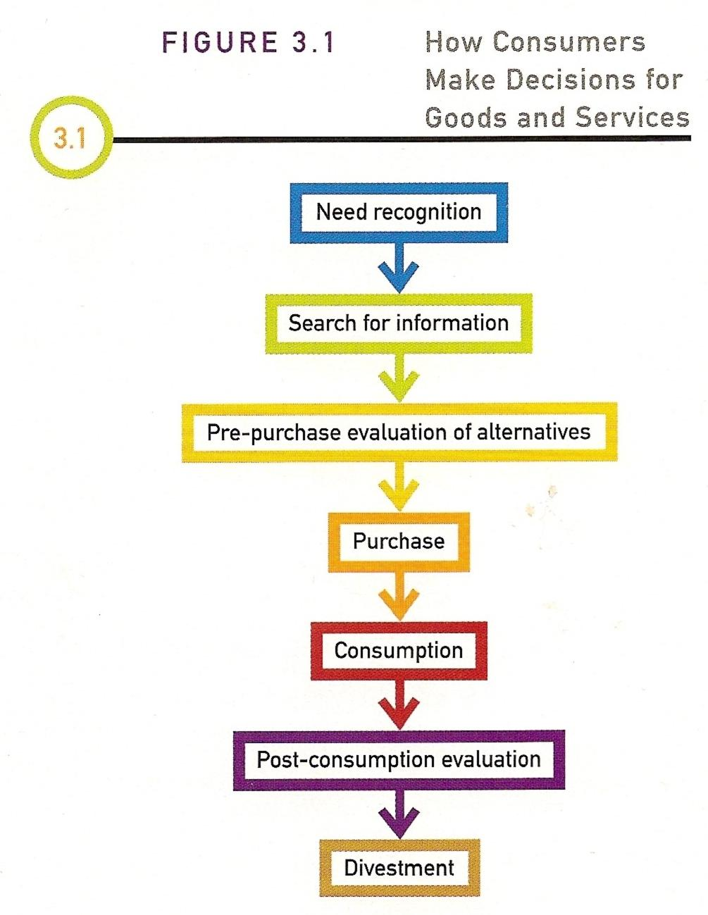
(Blackwell, Miniard, & Engel, 2006)

Appendix B: Households in The Netherlands with internet access
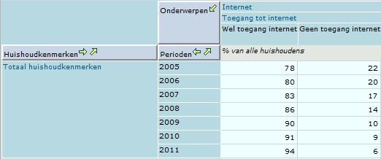
(Centraal Bureau voor de Statistiek, 2011)

Appendix C: Households with the lowest weighted annual income in The Netherlands with internet access
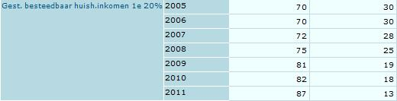
(Centraal Bureau voor de Statistiek, 2011)

Appendix D: Individuals in Europe who used the internet at least once a week
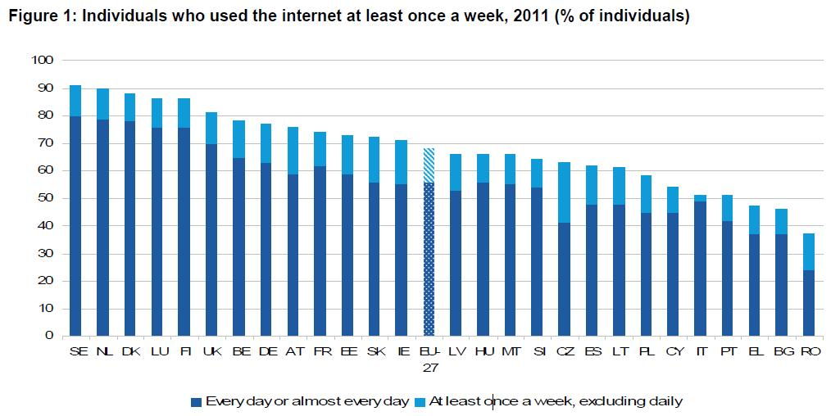
(Eurostat, 2011)

Appendix E: Questionnaire
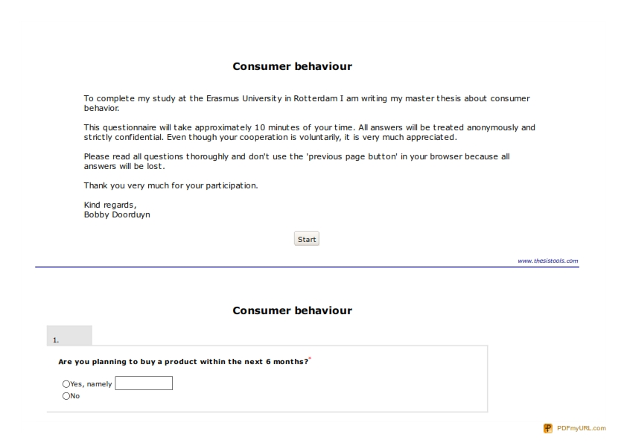
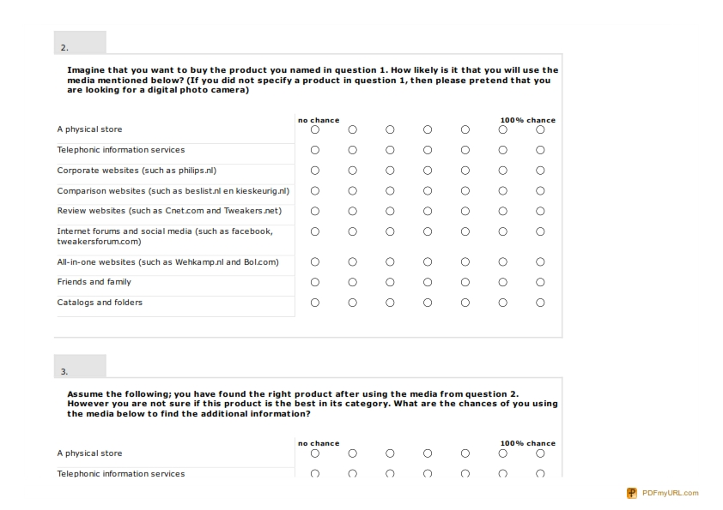
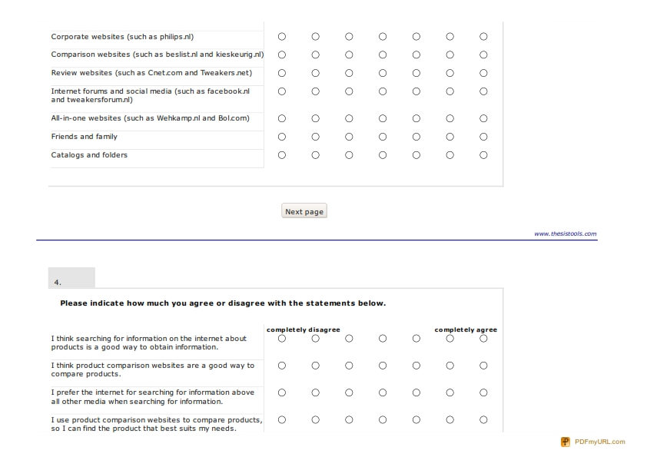
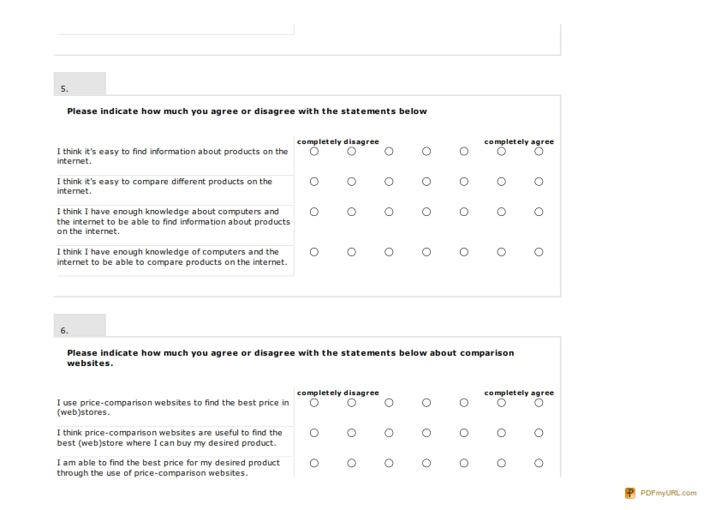
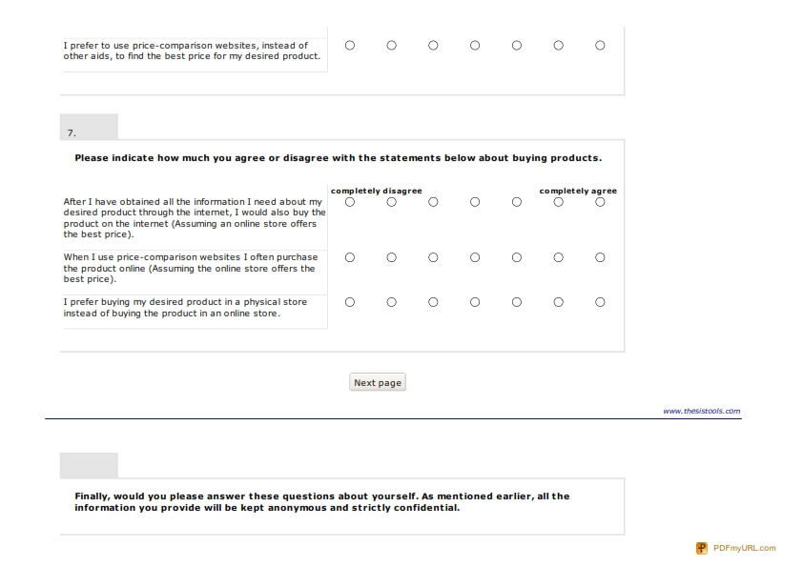
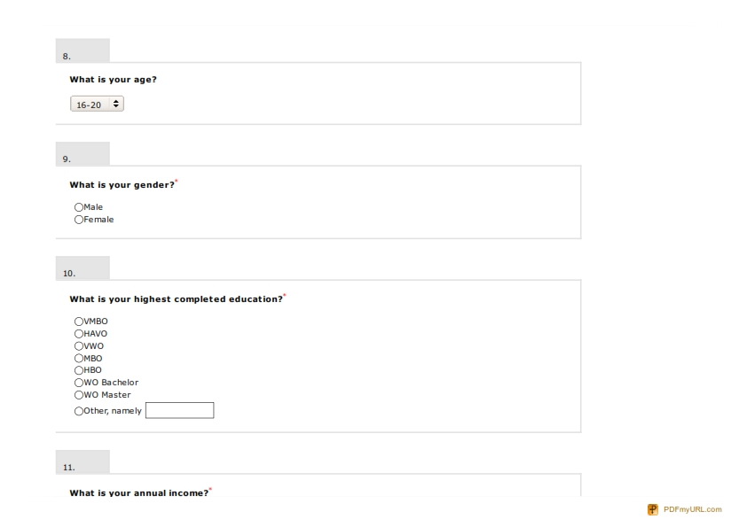
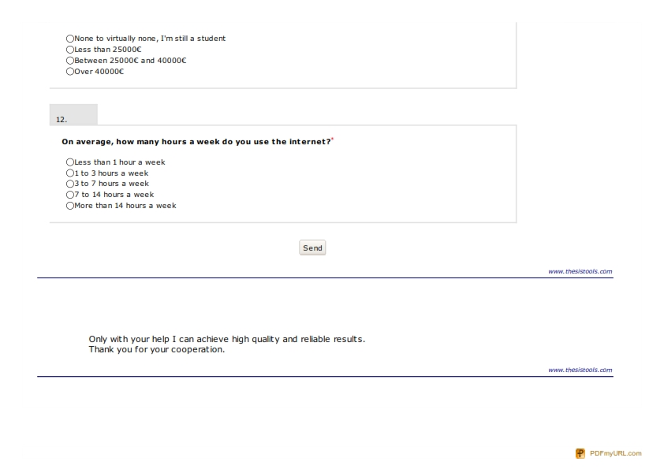
Appendix F: Scree Plot
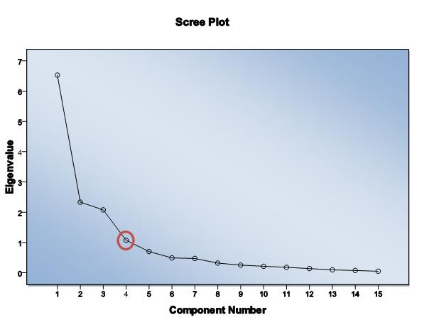
Appendix G: The four factors that emerged from the factor analysis
Rotated Component Matrixª
 | Component
 | 1 | 2 | 3 | 4
I think I have enough knowledge about computers and the internet to be able to find information about products on the internet. | ,919
I think I have enough knowledge of computers and the internet to be able to compare products on the internet. | ,895
I think it’s easy to find information about products on the internet. | ,881
I think it’s easy to compare different products on the internet. | ,769
I use price-comparison websites to find the best price in (web)stores. |  | ,918
I think price-comparison websites are useful to find the best (web)store where I can buy my desired product. |  | ,893
I am able to find the best price for my desired product through the use of price-comparison websites. |  | ,852
I prefer to use price-comparison websites, instead of other aids, to find the best price for my desired product. |  | ,818
After I have obtained all the information I need about my desired product through the internet, I would also buy the product on the internet (Assuming an online store offers the best price). |  |  | ,912
When I use price-comparison websites I often purchase the product online (Assuming the online store offers the best price). |  |  | ,881
I prefer buying my desired product in a physical store instead of buying the product in an online store (RECODED) |  |  | ,820
I prefer the internet for searching for information above all other media when searching for information. |  |  | ,481 | ,544
I think product comparison websites are a good way to compare products. |  |  |  | ,852
I use product comparison websites to compare products, so I can find the product that best suits my needs. |  | ,452 |  | ,750
I think searching for information on the internet about products is a good way to obtain information. | ,568 |  |  | ,586

Appendix H: Reliability
Attitude of consumers towards information seeking on the internet/
Attitude of consumers towards comparing products on the internet
Reliability Statistics
Cronbach's Alpha | Cronbach's Alpha Based on Standardized Items | N of Items
,789 | ,806 | 4

Attitude towards price-comparison websites
Reliability Statistics
Cronbach's Alpha | Cronbach's Alpha Based on Standardized Items | N of Items
,931 | ,932 | 4

Self-efficacy regarding the internet
Reliability Statistics
Cronbach's Alpha | Cronbach's Alpha Based on Standardized Items | N of Items
,927 | ,928 | 4

Likelihood of ordering a product in an online store
Reliability Statistics
Cronbach's Alpha | Cronbach's Alpha Based on Standardized Items | N of Items
,880 | ,881 | 3

Appendix I: Channels used for gathering information
Group Statistics
 | product_chosen | N | Mean | Std. Deviation | Std. Error Mean
physical store | Products with distinctive specifications | 81 | 4,02 | 1,789 | ,199
physical store | Products without distinctive specifications | 24 | 5,25 | 1,327 | ,271
telephonic information services | Products with distinctive specifications | 81 | 1,69 | 1,348 | ,150
telephonic information services | Products without distinctive specifications | 24 | 1,21 | ,658 | ,134
corporate websites | Products with distinctive specifications | 81 | 4,65 | 1,872 | ,208
corporate websites | Products without distinctive specifications | 24 | 4,58 | 1,909 | ,390
comparison websites | Products with distinctive specifications | 81 | 5,07 | 1,863 | ,207
comparison websites | Products without distinctive specifications | 24 | 3,00 | 2,167 | ,442
review websites | Products with distinctive specifications | 81 | 4,69 | 2,183 | ,243
review websites | Products without distinctive specifications | 24 | 2,42 | 1,909 | ,390
internet forums and social media | Products with distinctive specifications | 81 | 3,25 | 1,972 | ,219
internet forums and social media | Products without distinctive specifications | 24 | 1,63 | 1,096 | ,224
all-in-one websites | Products with distinctive specifications | 81 | 4,07 | 1,961 | ,218
all-in-one websites | Products without distinctive specifications | 24 | 3,79 | 2,226 | ,454
friend and family | Products with distinctive specifications | 81 | 4,12 | 1,452 | ,161
friend and family | Products without distinctive specifications | 24 | 2,92 | 1,886 | ,385
catalogs and folders | Products with distinctive specifications | 81 | 3,89 | 1,949 | ,217
catalogs and folders | Products without distinctive specifications | 24 | 4,17 | 1,880 | ,384

Appendix J: Channels used for comparing products
Group Statistics
 | product_chosen | N | Mean | Std. Deviation | Std. Error Mean
physical store | Products with distinctive specifications | 81 | 5,17 | 1,672 | ,186
physical store | Products without distinctive specifications | 24 | 5,63 | 2,018 | ,412
telephonic information services | Products with distinctive specifications | 81 | 1,60 | 1,252 | ,139
telephonic information services | Products without distinctive specifications | 24 | 1,21 | ,833 | ,170
corporate websites | Products with distinctive specifications | 81 | 3,73 | 1,871 | ,208
corporate websites | Products without distinctive specifications | 24 | 3,71 | 2,274 | ,464
comparison websites | Products with distinctive specifications | 81 | 4,89 | 2,127 | ,236
comparison websites | Products without distinctive specifications | 24 | 3,46 | 2,284 | ,466
review websites | Products with distinctive specifications | 81 | 4,52 | 2,335 | ,259
review websites | Products without distinctive specifications | 24 | 3,21 | 1,865 | ,381
internet forums and social media | Products with distinctive specifications | 81 | 3,36 | 2,164 | ,240
internet forums and social media | Products without distinctive specifications | 24 | 2,04 | 1,398 | ,285
all-in-one websites | Products with distinctive specifications | 81 | 3,46 | 1,930 | ,214
all-in-one websites | Products without distinctive specifications | 24 | 2,79 | 2,167 | ,442
friend and family | Products with distinctive specifications | 81 | 4,05 | 1,680 | ,187
friend and family | Products without distinctive specifications | 24 | 3,42 | 1,909 | ,390
catalogs and folders | Products with distinctive specifications | 81 | 3,48 | 1,956 | ,217
catalogs and folders | Products without distinctive specifications | 24 | 3,63 | 1,689 | ,345

