

Marketing Master Thesis

The Different Impacts

between “Made in EU” and “Made in Specific Country” on the Customer Choice
“From the differentiation perspective”
Abstract
Product differentiation is a strategy which capitalizes on perceived uniqueness of a product in order to increase brand equity and drive sales. This thesis begins with a cursory examination of differentiation as a strategy, its theoretical underpinnings and a number of settings that show this strategy not only to be viable but also to be the most appropriate. In the second stage, this thesis examines specific description of origin versus a generic description of origin of wine as measure of differentiation. Subjects in both China and Europe have filled out a questionnaire. Taking account into previous experiments and literature, findings of this thesis indicate that: when marketing to an individualist culture, using a specific designation of origin is effective for normal wine products. When marketing to a collectivist culture, using a specific designation of origin is the best approach for both normal and luxury wine products.

Author: XUN YU (359228)
Supervisor: Kloosterman L.P.O.
Contents
Introduction 3
Norms and Concepts 4
2.1 Corporate Strategy 4
2.2 Cost-leadership Corporate Strategy 6
2.3 Corporate differentiation strategy 6
2.4 Corporate Strategy and Business Strategy 11
2.5 Customer Perception 12
2.5.1 Customer’s Perception and Purchase Possibility 12
2.5.2 Mean-End Chains Model 13
2.6 Differentiation and Marketing Communication 15
2.7 Product Value & Brand Value 18
2.8 Summary of Key Concepts 21
Problem Statement. 22
Literature Review 23
4.1 Fundamental Country of Origin Effects Research to Cognitive Path 23
4.2 Multi-attributes and Facets Assessment of Country of Origin 27
4.3 Generalizable and Practical Research 33
4.4 Cultural Variations in Country of Origin Effects: Individualist Culture versus Collectivist Culture 36
4.5 Conclusion of Literature Review 39
Methodology 39
5.1 Conceptual Model 39
5.2 Overview & Basic Information 41
5.3 Dependent Variables 44
5.4 Hypotheses 44
Analysis and Results 45
6.1 Perceived Product Quality 45
6.2 Perceived Brand Equity 47
6.3 Potential Purchase Possibility 49
6.4 Comparison of “Made in EU” strategy & “Made in EC” strategy 53
Conclusions & Recommendations 54
Appendix: 56
Reference List: 58

Introduction
This thesis is intended for marketing specialists who wish to leverage the competitive advantage of product differentiation to contend with the current economic downturn in Europe combined with the increasing threat from emerging economies.
Differentiation is a strategy which capitalizes on perceived uniqueness of a product or brand in order to increase brand equity and drive sales. Differentiation is a strategic choice made by corporate management, which has direct effect on marketing strategy. By the same token, business strategies pertaining to R&D, purchasing, sales and marketing strategy reinforce a strategy of differentiation.
Apple is a company which has successfully employed this strategy to ensure commercial success. In a word, consumers are prepared to pay a premium for products they perceive as unique. Whether European entrepreneurs leverage this simple truth to ensure their survival at the current economic ebb in the EU, is a worthwhile question.
The economies of many developed European countries are in the doldrums. Current expectations are that this situation is not going to improve very soon. For the next 2 years zero or even negative growth is forecast. One of the consequences of the current economic climate is decreased consumer spending, partly on account of decreased disposable income, partly on account of lingering insecurity about the future.
Many European households are forced to reconsider their spending patterns. They purchase less and spend a smaller amount per purchase. This is potentially problematic for manufacturers in developed countries in Europe, in view of the fact they are tied to some very self-evident business truths regarding cost and profit. Price decreases in step with these economic times are therefore limited.
Many emerging economies have reached a point where they are able to manufacture products that satisfy expectations from consumers in developed countries in regard to quality, while maintaining a low price point. In addition, these emerging economies dispose of a mature logistics network which enables them to bring their products to market on their own terms.
The combined effect of these two trends is that manufacturers in developed countries in Europe are increasingly unable to compete for cost-leadership with manufacturers of similar products from emerging economies. Yet, in that very statement lies the key to a solution for their predicament. Differentiation is key to creating market share and making competitors irrelevant.
The survey uses the wine industry as an example, because wine product is regarded as the most differentiated of all agriculturally-based consumer products, which means consumers perceive the difference of quality in different areas of the origin and that perceived distinctive quality made customers pay premium price (Felzensztein, Hibbert and Vong, 2008). Meanwhile, in 1998, Thode and Maskulka have demonstrated that country of origin and “place-based” marketing strategies may help agricultural products to compete in the global market place giving a signal of superior features. Brookes also mentioned in 1993 that wine has a relative strong country of origin effect that can be promoted in this way.
A survey was conducted in the first half of 2012 in the EU and in China. Respondents had the option to fill out either a digital or a paper questionnaire. The results of the survey were analyzed using SPSS regression. Furthermore relevant previous studies have been taken into account.

Norms and Concepts
Before advancing to the problem statement of this thesis, a number of key concepts will be discussed briefly. It is important to understand how corporate strategy has a direct and appreciable effect on a corporations marketing efforts.

2.1 Corporate Strategy
Figure 2.1 indicates the relationships between the corporate strategy and the business strategy. This chart begins with an essential element called corporate strategy.
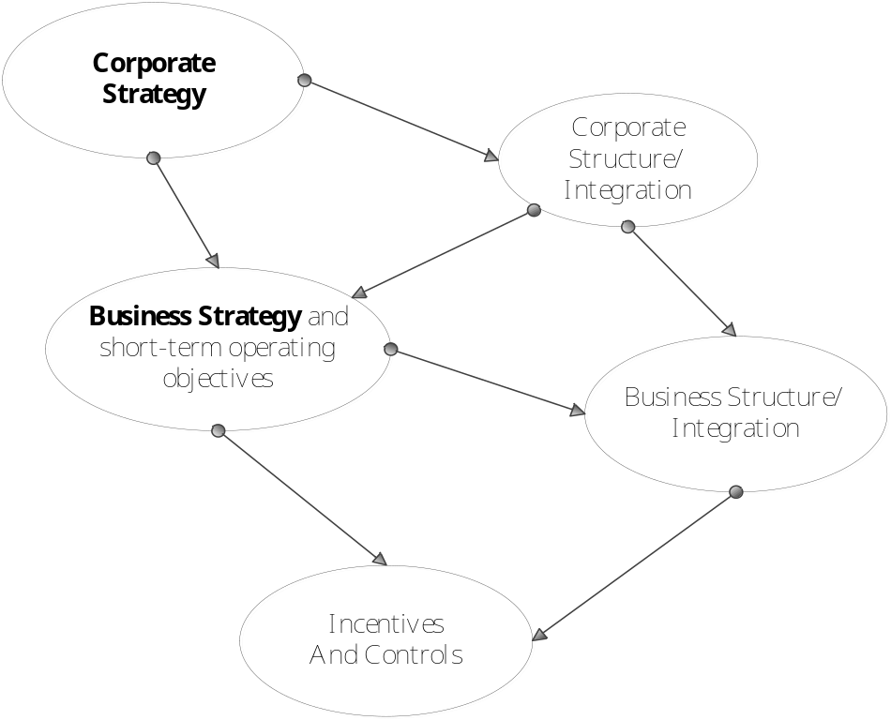
Figure 2.1 Executing Strategy: Key Decisions and Actions
Corporate strategy defines in which industry and market a firm competes, as opposed to business strategy which defines how a firm competes in a particular industry and market (Grant, 2008). Since it concerns the entire organization, Hrebiniak (2010) demonstrates in his book Making Strategy Work that corporate strategy should focus on the portfolio management, diversification, vertical integration, acquisitions and resource allocations across businesses or operating units for the whole enterprise.
Corporate strategy influences the entire organization & corporate structure, corporate culture, resource allocation and industries in which that corporation will enter (Grant, 2008). According to Porter, whose ideas will be discussed in greater detail below, there are two typical corporate strategies which are cost-leadership and differentiation.

2.2 Cost-leadership Corporate Strategy
The term “Cost-leadership” was first used in 1968 by the Boston Consulting Group (BCG) and published in “Perspectives in Experience”. The article analyzed the relationship between cost and accumulated experience, with regard to cost analysis and the experience curve. It became one of the most influential concepts in strategic management. Cost-leadership uses cost advantage as its core value to compete in a low cost market of similar products.
Cost-leadership is a dominant strategy used in emerging economies since they cannot compete on brand equity. For instance, the Romanian automobile manufacture Dacia Duster uses a cost-leadership strategy in competition with established European brands, such as Volkswagen.

2.3 Corporate differentiation strategy
In 1985, Porter argued that it could be more valuable for a company “when it provides something unique that is valuable to buyers beyond simply offering a low price” (p120). Differentiation strategy creates perceived uniqueness of a product or brand as its core advantage in order to charge price premium and compete with competitors (Hrebiniak, 2010).
According to Grant (2008), “Porter’s Five Forces of competition framework views the profitability of an industry (as indicated by its rate of return on capital relative to its cost of capital) as determined by five sources of competitive pressure” (p71). This analysis contains an assessment of industry competitors, potential threat of new entrants, bargaining power of suppliers, bargaining power of buyers and threats of substitute products (Porter, 1998).
The competition from substitutes determines the price elasticity of demand. Emblematic of this view was a book written in 2008 by Grant that the existence of close substitutes means that customers will switch to substitutes in response to price increases for a given product. In the current European business recession, entrepreneurs have to confront two issues with regard competition from substitutes. Firstly, due to the negative economic performance, EU customers’ purchasing power is decreasing, which means customers may choose cheaper products instead of expensive high quality commodities. However, since companies from emerging economies enjoy the advantage of relatively low labour cost advantage as well as a mature logistics network, European firms are suffering in competition and losing the price war, on common products, such as the shoes, clothes and other daily products. Secondly, only if these European firms can offer really innovative products to customers at a relatively high price, they can gain sufficient profits, owing to a rapid improvement in technology in emerging countries.
iPhone and iPad are excellent examples since both combine the multiple technologies. The iPhone can be used as a normal mobile phone and a simple computer. The iPad can be used as a laptop and a notebook. Therefore, even though they are more expansive than other mobile phones (Nokia or Blackberry), customers still will purchase them. Therefore, innovation is the best strategy for European companies to gain sufficient profit in comparison to a cost-leadership strategy if the risk of competition from substitutes is considered.
A potential threat of new entrants means companies inside industry build “[…]barriers to entry in order to help them create a stronghold by offering products or services that are difficult to displace in the eyes of customers based on apparently unique features.” (Pearlson & Saunders, 2006, p43). In general, such barriers refer to capital requirements, economies of scale, absolute cost advantages, product differentiation, access to distribution channels and government and legal barriers (Porter, 1998). Concerning the European business environment, the potential threat of new entrants is very low for innovative companies but high for cost-leadership companies. Developed European countries do not have strict regulations for registering or operating a company. For instance, advanced tax system enables entrepreneurs from other countries to build up their business with ease in those developed European countries.
Meanwhile, the emerging countries’ firms have already gained sufficient capital through the global trade; have achieved the economies of scale for their production, enjoy relative cost advantages from the low labour cost and comprehensive distribution networks. European companies which have adopted a cost leadership approach are suffering as a result of their competition with entrepreneurs from emerging countries. However, the innovative companies do not need to confront a high potential threat of new entrants. Firstly, the core value of those companies creates the product differentiation, which also implies low customer switching rates. Secondly, using differentiation strategy grants these companies the capacity to constantly innovative capacity, which means competitors have difficulties keeping pace.
In 2008, Porter mentioned in Harvard Business Review that powerful customers can receive more value through forcing down prices, requiring better quality or services, which increases the competition within the industry and increases competition at the expense of profitability of the industry. The bargaining power of buyers is rising dramatically on current European business climate. On the one hand, customers have much more choices than before, which allow them to pick the best option. For instance, customers can purchase computers from American, Chinese and European companies. On the other hand, the dreadful economy forces customers to choose the cheapest commodities that meet their standard.
At the same time, European companies are facing strong bargaining power of suppliers, which can reduce a firm’s profitability (Pearlson & Saunders, 2006). More importantly, Pearlson and Saunders (2006) also indicate that the force of supplier’s bargaining power is strongest “when a firm has few suppliers from which to choose, the quality of supplier inputs is crucial to the finished product, or the volume of purchases is insignificant to the supplier” (p44). In general European businesses favour long term relationships with a small, and hence manageable group of suppliers.
Many European companies have off-shored their manufacturing activates to countries with low labour costs. However, since the cost of offshoring in China and other emerging countries is increasing rapidly, off-shoring to these countries is not as attractive to be. Moreover
European companies need to solve address non-financial issues with their suppliers, related to for instance labour conditions or environmental problems. At the same time, those third world suppliers have already gained the capacity to manufacture low technology products to European standards, which means those suppliers can be the competitors to their European counterparts, at a lower cost.
The last element in Porter’s Five Forces is competition from within the industry. “Rivalry among the firms competing within an industry is high when it is expensive for a firm to leave the industry, the growth rate of the industry is declining, or products have lost differentiation” (Pearlson & Saunders, 2006, p45). As mentioned above, the current economic downturn, new competitors from emerging countries, declining customers’ purchasing capacity, increasing cost are troubling the European companies, especially those in which use the cost-leadership corporate strategy.
Companies that use the differentiation strategy can keep their comparative advantages through product differentiation. Furthermore, a competitive climate analysis indicates that the competition within most industry has risen (T. Grundy, 2006) (appendix 1). Since the implementation of internet and social networks, customers and competitors have more channels to effect marketing and brand communication. Meanwhile, customers can compare prices and find substitute products online much easier than before. Moreover, in the export industry, since the majority of products exported from EU are commodities with high added value, export companies that use the differentiation strategy can keep a relatively high profit and low competition. Therefore, according to Porter’s Five Forces analysis (appendix 2), current European companies should use the differentiation strategy as their corporate strategy.
The core issue is how EU entrepreneurs can use the differentiation strategy effectively to achieve comparative advantages. There are many studies on differentiation or innovation from a technology or a production perspective. Differentiation and innovation are not limited to the field of technology. As a corporate strategy, differentiation needs many business strategies in order to foster. Differentiation from a marketing perspective entails creating perceived uniqueness to increase brand equity and thus drive sales. Even a tiny differential can contributed to the perceived uniqueness of brand value by customers, which can raise brand value and hence consumption.
Thus, the target of this dissertation is to analyze whether the variance of product origin, especially the variance of a generic designation of origin compared to a specific designation of origin, can change perceived uniqueness, product value, create higher brand value and increase potential consumption, reinforcing the success of a corporate differentiation strategy.
Kim and Mauborgne (2005) argued that using a differentiation strategy coupled with the constant low cost is the key element to create an environment in which competition is negligible. Porter combined cost-leadership and differentiation in a “series” of thought experiment. These resulting hybrid strategies led him to believe that both of they are mutually exclusive, which means a company using both will get “stuck in the middle” (Appendix 3):
The firm stuck in the middle is almost guaranteed low profitability. It either loses the high-volume customers who demand low prices or must bid away its profits to get this business from the low-cost firms. Yet it also loses high-margin business - the cream – to the firms who are focused on high-margin targets or have achieved differentiation overall. The firm that is stuck in the middle also probably suffers from a blurred corporate culture and a conflicting set of organizational arrangements and motivation system (Porter, 1980, p42).
Differentiation contains two dimensions: tangible differentiation and intangible differentiation. Tangible differentiation is concerned with the observable features of a product or service, which are relevant to customers’ preferences and choice processes (Grant, 2008). For instance, size, shape, color design, material, technology, reliability, consistency, taste, durability and safety are all elements of tangible differentiation. Intangible differentiation is also important since the choice and perception of products by customers are not exclusively relying on the tangible elements (Grant, 2008). Culture, social norms, psychology and emotion will also influence the choice processes.

2.4 Corporate Strategy and Business Strategy
As illustrated in Figure 2.1, corporate differentiation strategy needs the appropriate business strategies as support. Figure 2.2 indicates the level of influence and correlation between corporate strategy, business strategy and strategy within businesses.
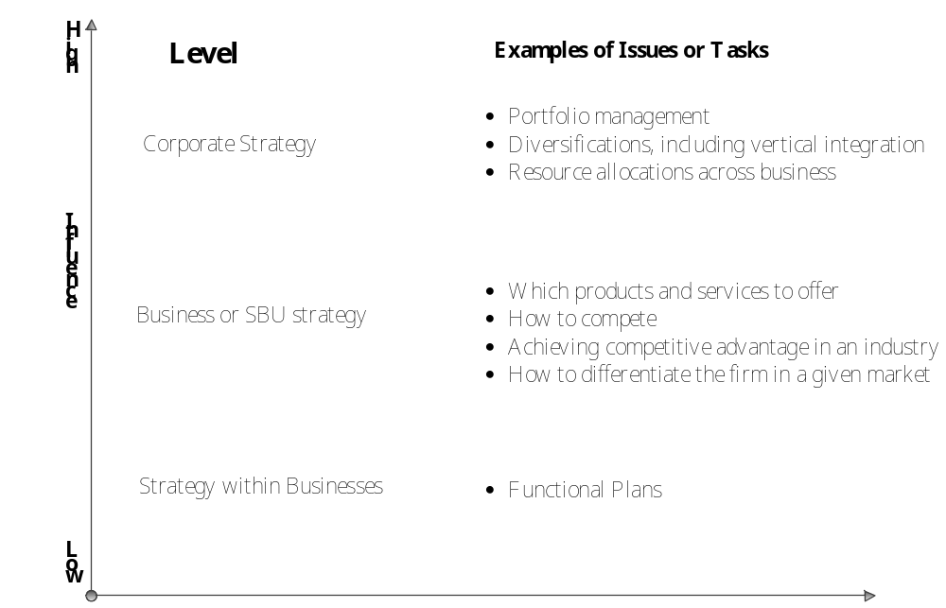
Figure 2.2 The levels of strategy and associated tasks
Corporate strategy has most influence at the highest level of strategic management of a company. Corporate strategies determine the industry and the scope of business. While corporate strategy exerts its influence at a higher organizational level than business strategy, it needs to be supported by strategic plans for at business or strategic business unit (SBU) strategy, which decide the comparative advantage of the company in competition. Strategy within the businesses, such as the function plans, including marketing plan, business plan and etc., make up the final operational stage.
Companies need to translate their corporate strategy into several operational business strategies, such as marketing strategy, technology innovation strategy and others, and then translate their individual business strategies into short-term operating objectives for execution. (Hrebiniak L. G., 2010) The corporate strategy has been carried successfully if and when those operating objectives are achieved.

2.5 Customer Perception

2.5.1 Customer’s Perception and Purchase Possibility
According to Solomon, Marshall and Stuart (2006), a successful business strategy needs to identify the current competition. At microenvironment view, there are two types of competition, which are product competition and brand competition. Product competition means that firms offer different products to compete each other in order to satisfy the needs and wants of the same customer. Brand competition means that firms offer similar products to compete based on the brand’s reputation and perceived benefits. Thus, regardless of a company is involved in product competition or brand competition, understanding customer perception of product value and brand value is a high priority issue.
“Perception is the process by which people select, organize, and interpret […] sensations” (Solomon, 2008, P78). Sensations are the instant responses of our sensory receptors, such eyes, nose, skin, to basic stimuli, such as light, colour and sound. Therefore, changing stimuli can influence customers’ perceptions of the same product or brand. This knowledge is widely used in marketing strategies. For instance, the text or the color on the label can affect the customers’ perception of the uniqueness and quality of the same product.
According to Gestalt psychology, three major principles relating to how an individual’s brain organizes stimuli (Solomon, 2008). The principle of similarity of Gestalt psychology is that people group pictures or other objectives with similar physical characteristics, which already exist in their mind. For instance, a new product made in China will be categorized as a cheap acceptable product. The figure-ground principle states that individuals will recognize the figure as the dominant stimulus while other parts recede into the background (appendix 8), such as the size or position of brand’s logo. Thus, the different expression of stimuli, such as shape, color, size, position and literal or graphic, can influence customers’ perception of the same thing. If a change of perception increases perceived product value or brand value, then the strategy to change the expression of stimuli in order to achieve the change of that perception is a good strategy, which can reinforce the corporate strategy.

2.5.2 Mean-End Chains Model
Another important theory used regard to perception aspect is the Means-End Chain Model. The Means-End Chain Model depicts the relationship between product attributes and the higher-order benefits and values, which can satisfy particular needs (cf., Gutman, 1982; Olson and Reynolds, 1983). Meanwhile, Means-End Chains have been used for the product and brand perceptions by customers (cf., Walker et al. 1987). Figure 2.3 illustrates the process of Means-End Chain.
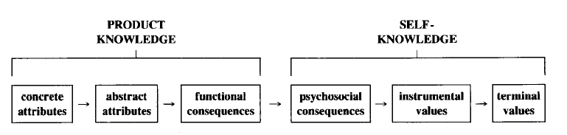
Figure 2.3 Means-End Chains connect product knowledge to self-knowledge
Its abstract attributes, such as the product origin, works as stimuli to customers, who assess those stimuli with their self-knowledge to create a final perception of the products. For instance, some customers want the high quality wine products. As soon as they see the label, made in France, they will assess the quality of that wine as good since France stands for the high quality wine products in their self-knowledge. Cultural differences can exert a strong influence on the outcome Means-End Chain Model hugely. Figure 2.4 indicates how Danish customers, English customers and French customers have different association with the consumption of vegetable oil products when the Means-End Chain Model is applied.
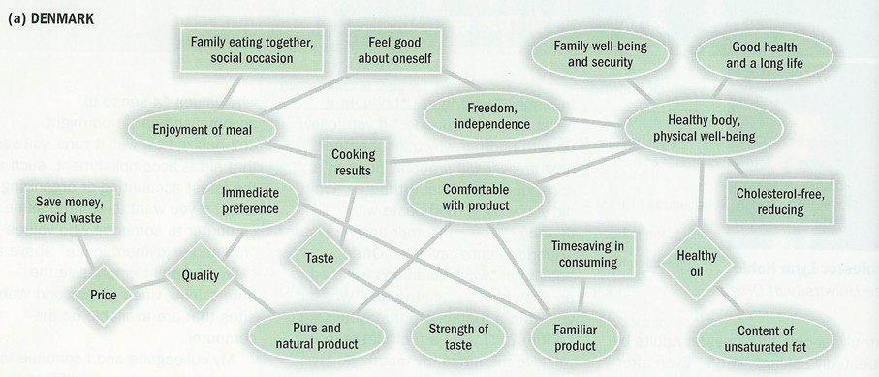
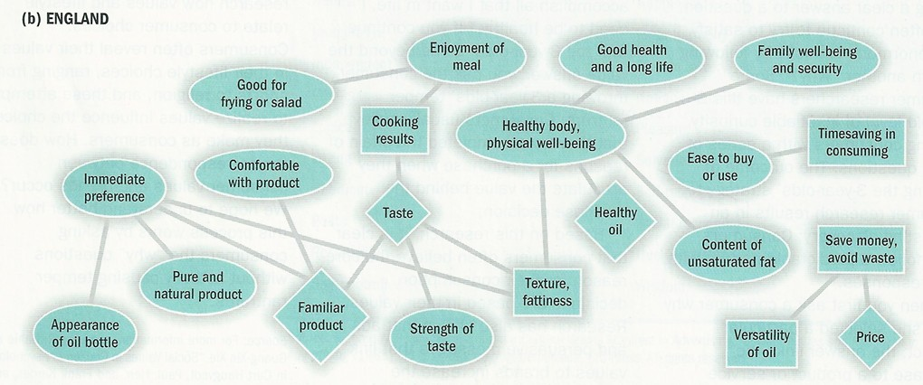
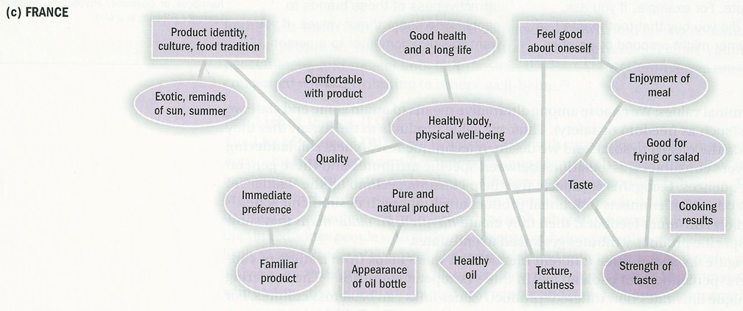
Figure 2.4 Hierarchical Value Maps for Vegetable Oil in Three Countries

2.6 Differentiation and Marketing Communication
Therefore, in order to achieve a successful corporate differentiation strategy, entrepreneurs should make up correct business strategies to guarantee appropriate tangible and intangible differentiation.
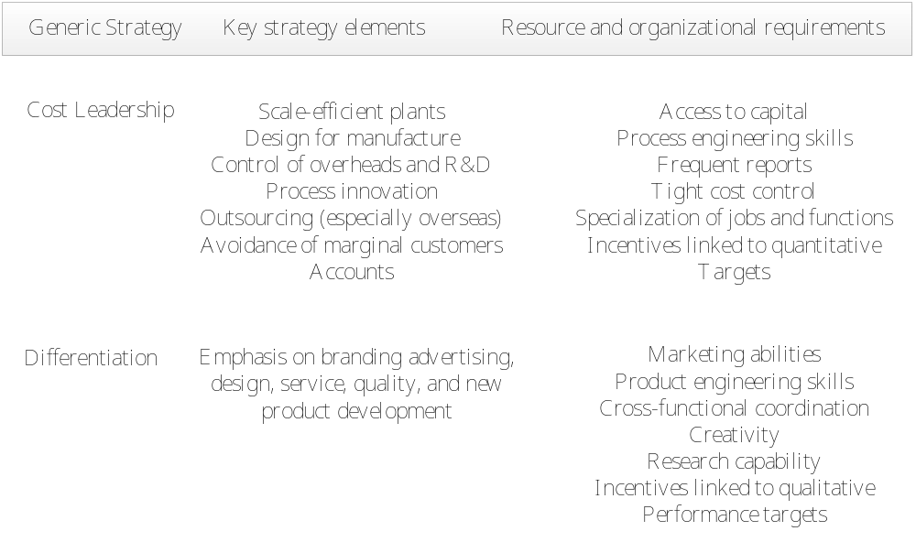
Figure 2.5 Features of cost leadership and differentiation strategies
As illustrated in figure 2.5, differentiation does not merely refer to the technology innovation, but also the innovation in marketing, operation and other respects. For instance, a marketing business strategy that uses creative advertising in order to increase perceived uniqueness of brand image can support the corporate differentiation strategy perfectly.
Corporate differentiation strategy makes perceive the unique value of entrepreneurs’ products and brands (Hrebiniak L. G., 2010). Since customers will use the product knowledge and self-knowledge to make an assessment, entrepreneurs should use the appropriate attributes in their strategy to inform customers in order to reach their desire and expectation. Furthermore, different attributes should be created according to the unique cultural background as indicated in Figure 2.5. Culture or social norms, in themselves, are attributes to customers. Those attributes can generate more correlating attributes in customers’ perceptions as stated in Gestalt psychology. Thus, a good marketing strategy should make target use of attributes to attract customers’ attention and make them aware of the differentiation of products or brands (Solomon, 2008).
In addition to customers’ perception, marketing strategy should address other variables that can influence customers’ choice process.
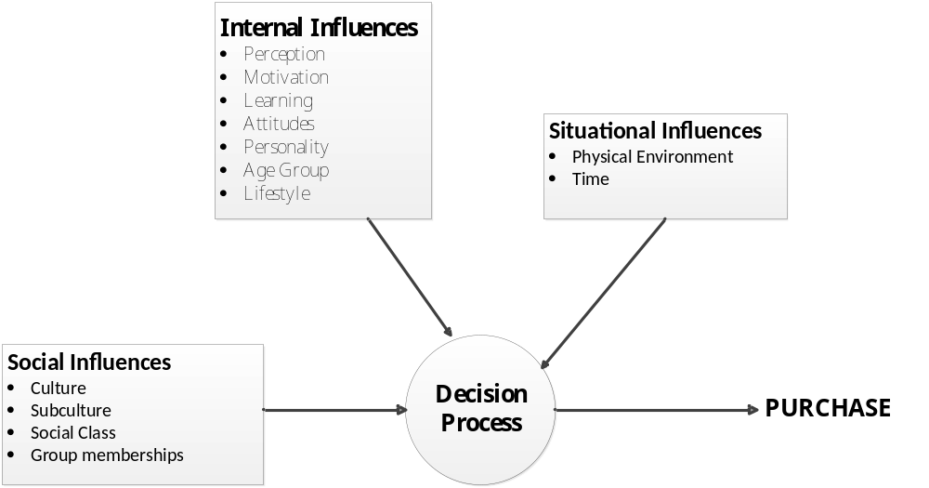
Figure 2.6 Influences on Consumer Decision Making
Figure 2.6 illustrates all variables that influence the consumer decision-making process. Marketers can use different attributes, marketing research and marketing promotion to affect customers’ decisions. For instance, advertising campaigns using celebrities is a common method used in the marketing strategies in order to manipulate internal influences which can accelerate final purchase process. Social influences are another important factor. Marketers should create perceptions according to individual culture and social norms.
As members of a large society, such as the United States, people share certain cultural values, or strongly held beliefs about the way the world is structured. Members of subcultures, or small groups within the culture, also share values… The growth of the web has created thousands of online consumption communities where members share opinions and recommendations about anything…(Solomon, 2008)

2.7 Product Value & Brand Value
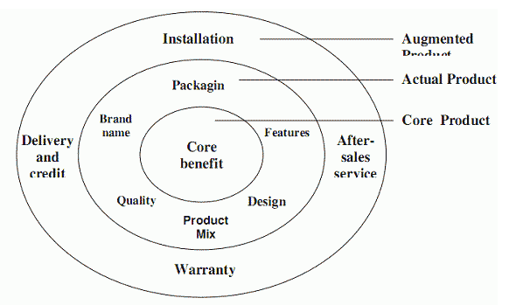
Figure 2.7 Layers of the Products
A product is everything that customers receive, including the core value, actual value and augmented value (Solomon M.R., Marshall G.W. and Stuart E.W., 2008, p239). As illustrated in figure 2.7, core value is created by R&D. The core benefit of a car for customers is transport. The actual benefit is the most important tool for marketers to create perceived uniqueness and differentiation. For instance, the packaging, label and design of a product can be attributes to customers, who will remember the design and packaging. Those attributes will transfer to a significant unique signal for customers, which can establish the perceived product uniqueness and high brand value in order to enhance the corporate differentiation strategy. Finally, marketers offer customers an augmented product, which is the sum of an actual product plus supporting features, such as warranty.
Customers use the evaluative criteria to judge the merits. In their judging process, Solomon (2007) found that a product that differs markedly from that of a competitors gain more weight in the decision process than products which are similar. Therefore, marketers really need to care about the determinant attributes, which are the features that distinguish it from other products. Figure 2.7 illustrate that even a small element, such as the product origin, can influence customers’ choices hugely.
In 1993, Keller K.L. created the customer-based brand equity (CBBE) as the differential effect, which means the effect that brand knowledge has on customer response to the marketing of that brand. CBBE is an important concept since it provides a unique point of view about the brand equity and how it can be built, measured and managed. Based on the CBBE, two elements are crucial for the brand equity. One is points of parity and another one is points of difference. However, Kotler and Keller mentioned in 2006 that the challenge for marketers is that many attributes or benefits to create points of parity or points of difference are negatively correlated.
Meanwhile, Anderson, Narus and Rossum (2006) demonstrated that customers use three ways for the value proposition, which are all benefits, favourable points of difference, and resonating focus. Marketers should find the points of difference, associations that are strong and favourable as well as uniqueness in order to create high and unique brand equity (Keller, Sternthal and Tybout, 2002).
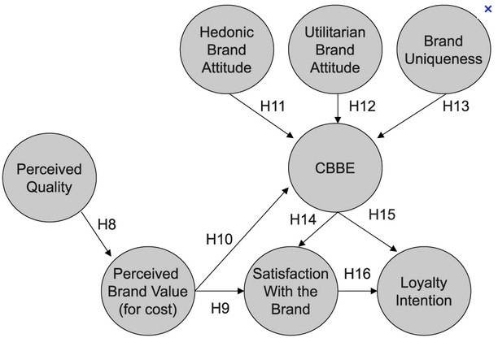
Figure 2.8 CBBE Process Model in Financial Services
From the argument of Hunter, Lindberg and Taylor (2007), Customers’ perceived product value can enhance their perceived brand value, which is positively correlated with CBBE. Meanwhile, the uniqueness, brand associations and brand attitudes can also enhance the CBBE. Ultimately, the CBBE reflects high satisfaction with the brand from customers and create true customer’s loyalty. Therefore, that high and positive CBBE can not only build high brand equity by itself, but also increase the potential purchase possibility and loyalty.
In summary, the variables that can influence the CBBE and the points of difference are crucial for marketers to control. One indirect approach to build brand equity (CBBE) is leveraging secondary brand knowledge of the brand. In 2003, Keller K.L. mentioned secondary brand knowledge for creating strong, favorable and unique associations or positive responses to enhance the brand equity.
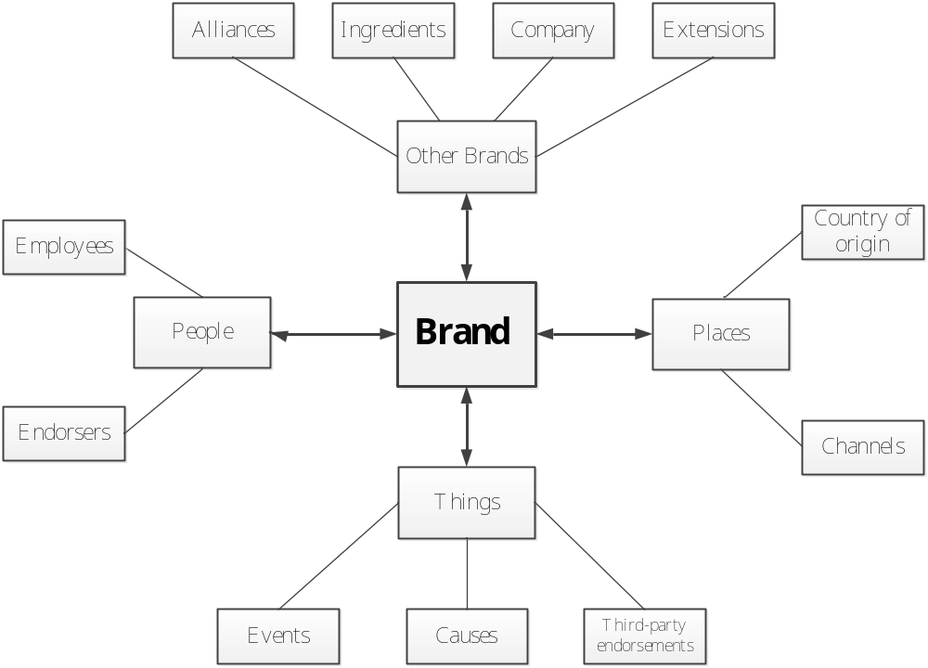
Figure 2.9 Secondary Source of Brand Knowledge
Figure 2.9 illustrates four major variables that influence the brand equity and each variable contains several elements. For instance, the element country of origin can affect the value of places variable that will influence the perceived brand equity. This thesis will focus on the element country of origin. It has been explored in the fifth literature review chapter.

2.8 Summary of Key Concepts
In the beginning of this chapter, Porter’s Five Forces analysis has led to the conclusion that European entrepreneurs should use the differentiation as their corporate strategy. Subsequently, this thesis has explored the knowledge of corporate strategy, business strategy and the correlation between both strategies. This exploration gives rise to the belief that business strategy should achieve several operating objectives, which can reinforce the execution of corporate strategy. Thus, in our thesis, the high perceived product quality, high brand equity and high potential purchase possibility are three operating objectives. Relying on the analysis of variance of those objectives, we can define that whether a specific designation of origin rather than a generic designation of origin is the appropriate business strategy for entrepreneurs in order to achieve and reinforce the corporate differentiation strategy.
In the second section of this chapter, the consumers’ decision process, perception creation, product value and brand value have been analysed. It has illustrate that a small change of stimuli can affect customer’s perception of a product or brand hugely. Meanwhile, marketers can achieve the required differentiation through changing a particular stimulus.
In the section on product value and brand value, this thesis set out how customers evaluate the value of a product or a brand. This analysis also shows that marketers can fulfill the corporate differentiation strategy by using appropriate marketing methods, which enhance the high product quality, brand equity and potential consumption possibility. Furthermore, through the analysis of consumer’s perception, product value and brand value, country of origin has been determined to be the most important element to research since this element can change or increase all those three variables. For instance, a marketing strategy that leverages the country of origin effects can create high product quality, brand equity and potential consumption possibility.

Problem Statement.
To what extent a generic designation of origin(“Made in EU”) or a specific designation of origin (“Made in specific European country”) as an appropriate business strategy can reinforce differentiation corporate strategy through increasing perceived product quality, brand equity and potential consumption possibility.

Literature Review

4.1 Fundamental Country of Origin Effects Research to Cognitive Path
According to Wang and Lamb (1983), country of origin effects are intangible barriers to enter new markets in terms of negative consumer bias in import & export industry.
Johansson et al. (1985) and Ozsomer and Cavusgil (1991) define country of origin as the country where corporate headquarters of the company is located. Bilkey and Nes (1982), Cattin et al., (1982), Han and Terpstra (1988), Lee and Schaninger (1996), Papadopoulos (1993) and White (1979), define the product’s country of origin as “the country of manufacture or assembly”. It refers to the final point of manufacture which can be the same as the headquarters for a company. While, Bannister and Saunders (1978), Chasin and Jaffe (1979) and Nagashima (1970, 1977) used the term “made in——” to define the country of origin of the product.
Defining country of origin became a complicated task in the modern marketplace. The growth of multinational companies, assessment of hybrid products and raising of developing countries have in many cases blurred accuracy or validity of “made in ___” labels (Baker and Michie, 1995; Baughn and Yaprak, 1993; Chao, 1993; Yaprak and Baughn, 1991).
Systematic research on the country-of-origin (COO) effect began with the publication of Schooler's (1965) Product Bias in the Central American Common Market in the Journal of Marketing Research. He concluded that a product’s country of origin variable has an effect on a consumer’s perception of that product. In 1967, Reierson indicated that consumers’ attitudes toward a nation’s product are not too intense, “consumers’ attitude may be made significantly more favourable by even slight exposure to communication and promotional devices” (p. 386).
In 1988, Yaprak investigated purchase intentions from multinational aspect, which is among US and Turkish business executives for specific brands “made in” Germany, Japan and Italy. “The major findings of the study were that both general country and product attributes, and specific product attributes were statistically significant in affecting purchase intentions” (p. xii).
Furthermore, some researches illustrated that in some situations it appears that the country cue may not affect attitude directly, but rather it affects the consumer's beliefs about specific physical attributes of the product (Erickson, Johansson, and Chao, 1984). In 1993, Papadopoulos and Heslop mentioned that country of origin of a product that is especially operationalize or communicated by “made in ____” phrase is an extrinsic product cue and an intangible product attribute. This attribute differs with a physical product characteristic or intrinsic attribute. Thus, it is similar to price, brand name, or warranty that neither of them is directly bear on product performance.
Not matter through either direct influence or indirect way, country of origin does affect the customer’s perceptions. Substantial research has provided evidence of country-of-origin effects on product evaluations (for a review, see Bil-key and Nes 1982; also see Erickson, Johansson, and Chao 1984; Johansson, Douglas, and Nonaka 1985). In 1988, Han and Terpstra claimed “It has been found that all products originating in foreign countries are subject to country-of-origin [image] effects." (p. 236).
However, most evidence is based on single cue research that means country of origin is the only information cue available to respondents (Bilkey and Nes, 1982). Meanwhile, the cognitive process study rarely mediates country of origin effects on product assessment, which has been considered either empirically or theoretically (Hong and Wyer, 1989). Thus, Hong and Wyer (1989) created an empirical research that tested the cognitive process in which country of origin is presented along with specific product attribute information. They believe country of origin has two functions, which are direct and indirect. From a direct aspect, country of origin may activate concepts and knowledge of the product in order to affect the interpretation of other attribute information. Meanwhile, country of origin may simply be regarded as a feature of the product, which is similar to other attributes, to enhance customer’s evaluation process. From an indirect aspect, country of origin may work as a heuristic basis for customers to infer product’s quality without concerning other attributes. Furthermore, it may also influence customer’s attention of other attribute information in order to affect the impact of those attributes information (Hong and Wyer, 1989).
Four hypotheses have been explored in their research. The firstly, the encoding hypothesis (Bargh, 1984; Hig-gins and King, 1981; Kardes, 1986; Sujan, 1985; Wyer and Srull, 1981). Secondly, the heuristic hypothesis (Bodenhausen, 1987; Boden-hausen and Lichtenstein, 1987; Bodenhausen and Wyer, 1985). Thirdly, the primacy-recency hypothesis (cf. Anderson and Hubert, 1963; Dreben, Fiske, and Hastie, 1979; Lichtenstein and Srull 1985, 1987), and finally, the cognitive elaboration hypothesis.
Performances of two groups of subjects have been analyzed in the research. One is the comprehension group that individuals try to understand, evaluate and clarify the attributes objectively. Another is the impression formation group that subjects from the impression according to the product attribution subjectively. Meanwhile, the order of information sets present is different. The first set of information is country of origin and then shows other unimportant variables. The second set of information contains two parts, one is information that is ambiguous regarding with its implication and the other one is information about either desirable or undesirable attributes. Two groups will face two set of information in the four hypotheses conditions. Table 4.1 shows the result of Hong and Wyer’s result.
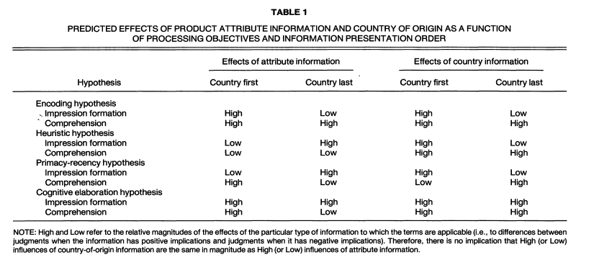
Table 4.1 Research Result of Hong & Wyer’s Country of Origin Analysis
According to the Table 4.1, Hong and Wyer mentioned that the cognitive elaboration hypothesis is the most appropriate. This hypothesis illustrates that a product’s country of origin stimulates customer’s interest of the product and leads them to think more extensively about more variables. Meanwhile, it occurs spontaneously when customers do not have a priori reason to evaluate this product, such as the conditions of impression formation group. However, when customers are positive to evaluate the product, such as in the comprehension group, customers will evaluate the product’s information regardless of whether country of origin exists.
Therefore, Hong and Wyer concluded that in the cognitive process, it could be appropriate that country of origin may stimulate interest on other information about the product, but the central construct of product’s impression is formed primarily by evaluation of implications of individual attributes of the product. Country of origin works as one variable (attribute) instead of a fundamental or organizational function.
However, Hong and Wyer’s research has many limitations. Firstly, even though they use multivariable in their research, however, they regarded the country of variable itself as one cue (facet). Secondly, they ignored the nationality, culture, brand, product category and many other factors that may influence the evaluation on country of origin. The personality and geographic factors are missed in the research as well.

4.2 Multi-attributes and Facets Assessment of Country of Origin
In 1985 Johansson, Douglas and Nonaka created a multiple attributes model to analyze country of origin through a new methodological perspective, even though the result has been tested and approved by Hong and Wyer’s research. However, this research takes a form of multi-attribute attitudinal model that is analyzed by means of simultaneous equations. In the analysis, age, sex, two-income household, car own situation and other variables have been contained. Furthermore, Johansson, Douglas and Nonaka used the car from American, Japan and Germany to instead of direct made in concept.
Huber and McCann (1982) and Olson (1974) mentioned that variables such as price, country of origin may serve as a proxy variable if other product information is lacking. Thus, the approach of this research created a possible examination of impact from other variables as well as country of origin through customer’s evaluation. Meanwhile, the effect of familiarity and knowledge of product have also been taken into account.
Johansson, Douglas and Nonaka collected respondents from U.S. and Japan. Individuals assessed automobiles from three countries, which are the United States, Japan and Germany. The equation has been used for analyzing country of origin for the first time.
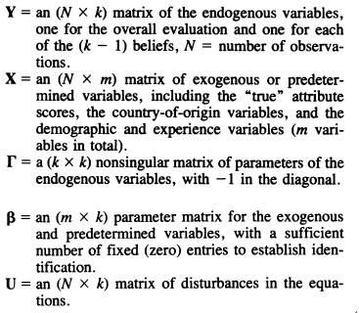
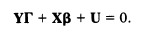
Equation 4.1: Multi-attribute Attitudinal Model of Country of Origin by simultaneous equations
Researchers found that most variables have a positive effect on the overall rating. Country of origin has no direct effect on the final performance, but it influences the perception of specific attributes by customers. Meanwhile, the home-country origin variable does not affect the evaluation. For instance, American respondents tend to rate Japanese automobiles more positively than Japanese respondents, but they evaluate German automobiles negatively.
Therefore, Johansson et al. (1985) concluded that “Country-of-origin effects may be less significant than has generally been believed, and they may occur predominantly in relation to evaluation of specific attributes rather than overall evaluations.” (p395).
Nevertheless, Johansson, Douglas and Nonaka’s research does not concern the price influence, and the competitive context is also missed.
In 1991, Victor V.C. argued that competitive context and price both can affect the country of origin’s performance. Thus, he did a deeper analysis in the multi-variable aspect. Three factors have been included in Victor’s research. The first factor is competitive context in which the country cue occurs. The second factor is price level within product category and the last factor is overall financial risk of the product category.
The research suggested that country of origin effects from less developed countries (LDC) will decrease if customer’s personal financial risk increases. Meanwhile, country of origin is found to be more important for a high end product than a low end product. Country’s differences may be more important to the” big spender” than to “economy customers”.
Therefore, Victor concluded that preference or purchase of LDC products is price insensitive at the high end category. This kind of customer may prefer an upper boundary product that even while it is from LDCs, it is hard to increase the size of that customer set though price maneuvering.
Even though Victor has addressed this product category in his research, Roth and Romeo (1992) have done a deeper analysis of correlation between product category and the country of origin.
Past research about country of origin regarded country quality as a summary construct, rather than as a defined set of dimensions that inferred to the product’s quality (e.g., Crawford and Garland (1988), Hong and Wyer (1989), Howard (1989)). There are only few papers indicating country image is really a multidimensional construct until now (Cattin, Jolibert and Lohnes (1982), Jaffe and Nebenzahl (1984), Han and Terpstra (1988), Johansson and Nebenzahl (1986), Nagashima (1970, 1977), Narayana (1981), White (1979)). However, Roth and Romeo (1992) thought that country quality perceptions, which were seemed as summary construct, may vary across product categories. For instance, Japanese electronic products received higher perceived quality evaluation than one of Japanese food products (Kaynak and Cavusgil, 1983). Eroglu and Machleit also indicated in 1989 that country of origin effects vary by product class, such as typewriter product received stronger effect than one of beer.
Therefore, in 1992 Roth M.S. and Romeo J.B. did their research to examine the extent of fitness in terms of country of origin between country image perception and product categories. The purpose of this research is to determine why purchase intentions differ between product categories, which are from a particular country of origin. The implication is that managers can use the correlation between the product categories and countries to predict and evaluate customers’ purchase intensions in order to increase the country of origin effective performance.
In the first step, this paper developed a four-item country of origin image scale, which contains innovativeness, design, prestige and workmanship, as shown in figure 4.1 and figure 4.2.
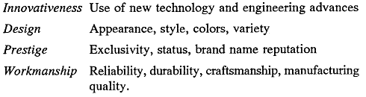
Figure 4.1, Four-item Country of Origin Image Scale
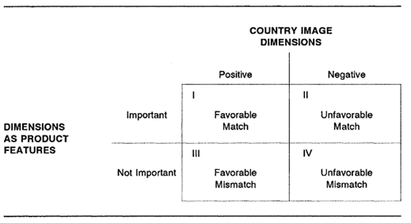
Figure 4.2, Country and Product Category Dimension Matches and Mismatches
In their second step, their research used six variables as product categories, which are auto, watch, bicycle, leather shoe, crystal and beer. Meanwhile, six products were produced from ten countries. Since country of origin may affect consumers from various countries differently (cf. Cattin et al., 1982), therefore, three groups of individuals worked as respondents, from Ireland, Mexico and U.S. In the beginning, Roth and Romeo tested the correlation between the perception of country image and product categories (Appendix 4). The second test is willingness to buy products analysis (Appendix 5). In the end, the correlations between country image and willingness to buy foreign products have been assessed, shown in Table 4.2.
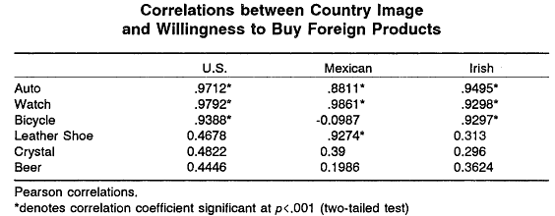
Table 4.2: Correlations between Country Image and Willingness to Buy Foreign Products
According to their research, when the perceived advantage of a country relates to the product characteristics, a product-country match occurs (Roth and Romeo, 1992). A strong positive match would exist if a country can be regarded as strong in the area, which is also an important feature for a product category. Thus, Roth and Romeo concluded that perceptions of country of origin is very depending on the correlation between perceived country’s production and marketing strengths and the product category. In figure 3.4, authors have indicated the country of origin’s implication of their result according to the product-country matches.
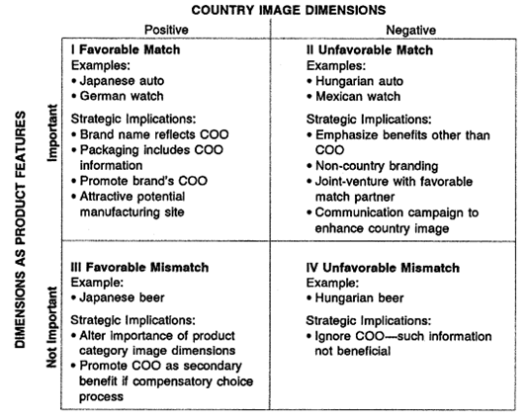
Figure 4.3: Product-Country Matches and Mismatches: Examples and Strategic Implications
Nevertheless, one of drawbacks of Roth and Romeo’s research may be that they only concerned one facet. Other researchers have treated country of origin image between two to five facets (Cattin, Jolibert, and Lohnes 1982; Johansson and Nebenzahl 1986; Nagashima 1977; Narayana 1981; Papadopoulos, Heslop, and Bamossy 1989; Yaprak and Parameswaran 1986).

4.3 Generalizable and Practical Research
After review the researches from Bilkey and Nes (1982), Johansson (1989), Papadopoulos, Heslop, Graby, and Avlonitis (1987), and Wall, Liefeld and Heslop (1991), Obermiller and Spangenberg (1989) wrote that "no firm conclusions can be drawn on the pervasiveness or the strength of country-of-origin (CO) global effects." (p. 484). Meanwhile, Ozsomer and Cavusgil (1991) updated Bilkey and Nes’s article and concluded that "most of the recent country-of-origins studies provide us with little generalizable knowledge" (p. 274). Thus, a fundamental question has been asked that how generalizable is the country of origin effect?
Before 1995, there was only one published research that used a systematic and quantitative analysis to investigate in generalizable country of origin effects (Liefeld, 1993). However, Peterson and Jolibert (1995) indicated that Liefeld’s research was limited for two reasons. Firstly, only small number of country of origin effects has been analyzed. Secondly, the study characteristic is less than two dozen experiments. Therefore, in 1995, they used the Meta analysis method to investigate in the generalizable of country of origin effects. The following is the omega-squared equation used in their research.
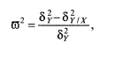
Equation 4.2: Meta-Analysis of Country of Origin Effects
Using the equation to test the previous studies, the result demonstrated that “the effect size of quality/reliability perceptions have been consistently larger than effect size for purchase intentions.” (Peterson & Jolibert, 1995, p.894). The result corroborates Lim, Darley and Summers’s empirical research in 1994. A purchase intention has higher influencing antecedents than as direct an evaluation as a quality/Reliability perception (Peterson & Jolibert, 1995).
Finally, Peterson and Jolibert concluded that country of origin effect is only somewhat generalizable. Meanwhile, through the quantitative analysis, verbal product description has higher country of origin effect sizes than one of an actual product description. Moreover, single-cue studies generated higher country of origin effect sizes than one of multiple cues studies.
In 1996, Bruning used multivariable (gender, income, occupation, flying frequency) and other variables) as the independent variables to analyze the country of origin effects on the national loyalty specialized in the airline industry. Since Peterson and Jolibert (1995) mentioned that the generalizable of country of origin effect somewhat exists. More studies start to analyze country of origin in one industry/product category but researchers do not give up the multi-industry and generalizable analysis. Bruning’s research is an example. Furthermore, one benefit of Bruning’s research is that he included the price and national loyalty into one analysis process.
The study confirmed the importance of national loyalty as a component of the country of origin effect. At the same time, the most important independent variable is the price since Bruning (1996) demonstrated price variable dominates all other attributes regarding with the relative importance, and country of origin is the second one.
Another important research is about the correlation between the brand name and country of origin, analyzed by Chao and Rajendran in 1993. They assumed that essentially, customers may use the brand name as an implicit country of origin surrogate within the product evaluation process no matter whether the product is in fact made in that specific country, with which the brand is closely associated. In the end, they found that country of origin did influence the customer’s evaluation process even without concerning of brand name. In another word, country of origin itself can effect customer’s evaluation and perceptions.

4.4 Cultural Variations in Country of Origin Effects: Individualist Culture versus Collectivist Culture
In general, those studies above have demonstrated that favorable country perceptions can lead to favorite inference, which can enhance the favorable evaluation and perceptions (Hong and Wyer, 1990; Maheswaren, 1994). However, recent research suggests that the favorite extent given to country of origin during the evaluation process may not be universal (Bozell-Gallip, 1996; Klein, Ettenson and Morris, 1998). For instance, several researches proved that Japan’s as a country of origin leads to favorite perception of high product quality (Maheswaran, 1994). Nevertheless, Chinese customers in Nanjing might not purchase Japanese products due to the animosity towards Japan (Klein, Ettenson and Morris, 1998).
In 1998, the research groups of Asker and Williams as well as Klein, Ettenson and Morris concluded that cultural differences may influence consumer behavior. In 1996, Bozell-Gallup published his research that found considerable differences of perception exist between different cultures. For example, European consumers regard Germany as the quality leader, but Japan has been considered the quality leader in Asia. In 1994, Maheswaran mentioned that a systematic examination based on theoretical framework for exploring country of origin effects through different cultures is lacking.
Canli and Maneswaran (2000) created a model to analyze the country of origin effects through the cultural aspects, which are individualism and collectivism. The individualism/collectivism framework is a useful basis for testing cultural differences (Triandis, 1995). Individualists and collectivists have significant difference in self-expression and social relationships, which influences the efficacy of marketing strategies (Han and Shavitt, 1994).
In their research, Canli and Maneswaran separated individualists and collectivists into four groups, which are vertical individualists, horizontal individualists, vertical collectivists, and horizontal collectivists. Vertical individualists are regarded as hierarchical and striving high status, achievable by competition within the group. Horizontal individualists stand for distinctive and unique compared with other group members, as well as emphasizing self-reliance. Horizontal collectivists are interdependent and share common goals within the group. Vertical collectivists are committed to and accept the superiority of the group over the individual. Triandis and Gelfand (1998) demonstrated vertical collectivists that they often sacrifice personal benefits to further the group interest.
Four group subjects received superior or inferior attribute about a mountain bike, which is made in either the United States or Japan. The purpose of the research is to examine the extent to which cultural orientation influences country of origin effects during the evaluation process in two countries (Japan and U.S.). Table 4.3 shows one of research findings.
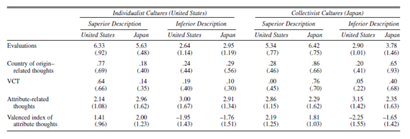
Table 4.3: Evaluations (Standard Deviations) and Thoughts as A Function of Culture, Country of Origin and Product Description
The research found that Japanese respondents evaluated product that was made in the home country (compare with foreign country) more favourably regardless of product superiority. However, American respondents evaluate product that was made in the home country more favourably only when the product had superior attributes to compete. The final result was shown in the figure 4.4.

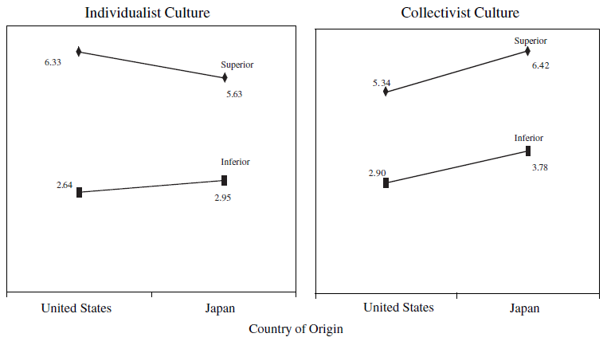
Figure 4.4: The Effect of Country of Origin, Product Description and Cultural Orientation on Evaluation
As shown in the figure 4.4, Canli and Maheswaran (2000) concluded that “country of origin effects vary across cultures on the basis of the diverse cultural patterns present in different countries.” (p.315). Meanwhile, the evaluations and the cognitive responses showed that individualists evaluated the home country product more favorably only when the superior appeared. However, collectivists evaluated the home country product more favorably regardless of its superiority.
Furthermore, the research result against the finding of Shimp and Sharma (1987) that consumer ethnocentric scale (CETSCALE) that shows that groups threatened by import display more favorable home country bias. In the research of Canli and Maheswaran, found that the significant level of ethnocentrism is 0.57, which means the term is insignificant. Therefore, they concluded that ethnocentrism did not moderate the country of origin effect in the evaluation process.

4.5 Conclusion of Literature Review
Even though there are many studies about the country of origin effects and they establish the validity of this term, few of them have systemically addressed the cultural variable (individualist & collectivist cultures), gender effect, brand effect and price effect. More importantly, most of the studies are only based on the country view. However, besides the country concept, there also exists the union concept. For instance, the difference on evaluation and perception analysis of “Made in EU” and “Made in specific European countries” is absent. Therefore, in this thesis, all those variables will be concerned to create a new “made in ___” model.

Methodology

5.1 Conceptual Model
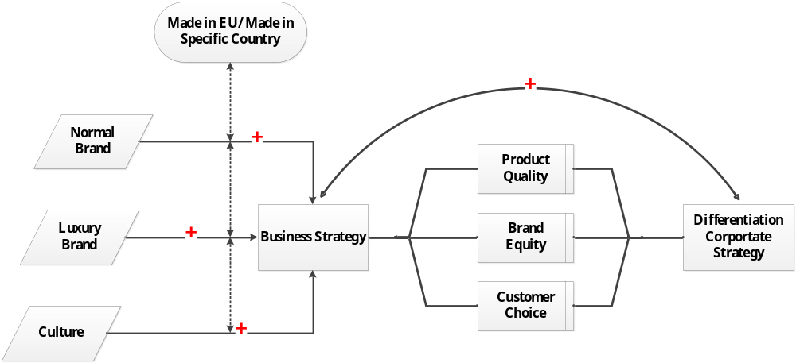
Figure 5.1 Conceptual Model
To enhance the application of corporate strategy, the priority issue of the highest priority is to choose appropriate business strategies. The business strategy in this dissertation is which country of origin is the best option for a given industry. “Economic integration within the European Union (EU) has led to changing patterns of production and specialization among European countries. Some countries have become more specialized in their manufacturing production, and a large proportion of manufacturing industries have become more geographically concentrated” (Amiti, 1998). Thus, some manufacturers want to use the advantage from geographical concentration to increase own brands’ uniqueness, which increase brand equity in order to reinforce the differentiation strategy. Furthermore, country of origin is an extremely important variable in the perception of difference. As Keller said, the world is becoming a “cluster bazaar” where consumers can choose or purchase brands or brands that come or made from different countries, based on their beliefs about the quality of certain products from those countries (Keller, 2008).
Perceived high product quality, brand equity and customer choice are important elements in marketing strategy. A good marketing strategy should achieve high perceived quality of the product, high brand value/ equity assessed by clients and high consumption activities. The right section of our conceptual model relates to this specific topic. In the second and third chapter, this thesis has shown that a sound business strategy will achieve the high perceived product quality, high brand equity and high purchase possibility. Moreover, that sound business strategy can reinforce corporate strategy if those three objectives are met. Furthermore, it has also been explained why the complement of those three objectives can prove that business strategy in order to enhance the corporate strategy.
The left part of our conceptual model is our exploratory research. The survey sets out to explore that whether the label “made in EU” or the “made in[ specific European countries]” can increase the product perceived quality, brand equity and possibility to consumption. If the label “made in EU” can complete those targets, then using “made in EU” should be a right marketing (business) strategy. The same applies mutatis mutandis, to the strategy that label “made in specific European countries”.

5.2 Overview & Basic Information
A study was designed to determine whether “made in EU” or “made in specific European country” is an appropriate and effective business strategy for the implication of corporate differentiation strategy.
After reading several literature materials and pruning several statements, the final questionnaire was constructed. The questionnaire consists of three sections. The first and second sections measure customers’ perceived brand equity and product quality. The third section measures the potential purchase possibility. In most questions, subjects responded on 7 points scales (1= very low and 7= very high).
Data was collected cross-nationally through three channels: online, email and paper. A total of 786 questionnaires were distributed randomly. After one month, 467 (59.41%) results were collected. From the responses, 365 (78.16%) results were usable data for analysis and 102 results were discarded because they were incomplete.
The study incorporated a 2×2×2×3 factorial design. Respondents were assigned to two groups according to their culture background. The first group represented an individualist culture (mainly the Netherlands). The second group represented a collectivist culture (mainly China). Respondents were given two product origins, which are the “made in EU” and the “Made in Specific European Country”. Meanwhile, they needed to evaluate two different categories of wine products: a normal brand and a luxury brand. There is no certain definition of normal brand and luxury brand in the survey. The benefit is that there is no bias of perceived brand level since the survey used the concept purely relied on the customer’s own perception. Under two conditions, subjects evaluated the perceived product quality, brand equity and the potential purchase possibility. Table 5.1 illustrates the information of respondents.
Collected data was processed through statistical research. Firstly, factor analysis was used to ensure the reliability of the data. Then, linear regression analysis was used to explore coefficient and causal relationships between variables. The correlation between “made in EU”/ “made in specific European country” and perceived product quality and brand equity were determined by regression analysis. In the end, the means of survey’s section three are used as KPI to measure the potential purchase possibility through the lean management aspect.
Table 5.1 Respondent Geo-demographics
 |  | Response (%)
Gender
Female |  | 50.41
Male |  | 49.59
Age Group
19-24 years |  | 25.75
25-28 years |  | 16.16
29-34 years |  | 14.52
35-40 years |  | 13.97
41-45 years |  | 18.08
46-54 years |  | 7.12
55+ years |  | 4.38
Educational Status
Middle School |  | 13.42
HBO |  | 25.21
Bachelor's Degree |  | 36.44
Master's Degree |  | 22.47
Doctorate Degree and Above |  | 2.47
Personal Income (before taxes)
<€20,000 |  | 62.47
€20,001 to €30,000 |  | 14.79
€30,001 to €50,000 |  | 13.42
>€50,000 |  | 9.32
Cultural Background
Individualist |  | 31.78
Collectivist |  | 68.22
Nationality
China (North) |  | 35.89
China (South) |  | (Continued)  31.23
Germany |  | 0.27
Greece |  | 2.19
Indonesia |  | 0.27
Japan |  | 0.27
Romania |  | 0.27
Singapore |  | 0.55
the Netherlands |  | 28.49
United States of America |  | 0.55
Occupation Industry
Service
Students |  | 32.05
Finance |  | 20.55
Professional and Technology |  | 10.41
Agriculture & Food |  | 10.14
Education |  | 7.12
Manufacture |  | 7.12
Trade and Business Related |  | 5.21
Consulting |  | 4.66
Others |  | 1.64
 |  | 1.10
Frequency of Shopping in Supermarket
0-2 times/week
3-4 times/week |  | 58.63
4-5 times/week |  | 25.48
more than 5 times/week |  | 7.95
 |  | 7.95
Number of Children in Family
0
1 |  | 47.67
2 |  | 39.18
3 |  | 10.14
>3 |  | 2.74

5.3 Dependent Variables
Perceived Product Quality. A scale method was used to evaluate product quality by subjects. Respondents used 1 (very low) to 7 (very high) to make quality judgments. This dependent variable is inclusive, which means respondents do not need to consider the difference between a normal wine brand and a luxury wine brand. However, the evaluations were made in two separate groups, which are indicated above.
Perceived Brand Equity. Two groups of respondents were told to evaluate the brand equity under two conditions. Firstly, subjects needed to assess the brand value of normal wine brand and then they needed to assess the brand value of luxury wine brand. A 7-scale method was used as well as in the product quality variable.
Potential Purchase Possibility. Respondents used 10 scores to evaluate their purchase possibility of the wine products. In this situation, the brand equity and the product quality have been given. Respondents only used the “made in EU” and “Made in specific European country” (such as made in France) as the indicators to make a final decision for both conditions, i.e. normal wine products and luxury wine products.

5.4 Hypotheses
H1: In collectivist cultures, “Made in Specific European Country” (Made in EC) generates higher perceived product quality than “Made in EU” does.
H2: In individualist culture, there is no difference between “Made in EC” and “Made in EU” for customers to evaluate the product quality.
H3: In collectivist cultures, “Made in EC” generates a higher perceived brand equity than “Made in EU” does, under both NORMAL and LUXURY brand conditions.
H4: In individualist culture, there is no difference between “Made in EC” and “Made in EU” for customers to evaluate the brand equity of NORMAL brand wine products.
H5: In individualist culture, “Made in EC” generates a higher perceived brand equity than “Made in EU” does, under LUXURY brand condition.
H6: In collectivist cultures, “Made in EC” generates higher potential purchase possibility than “Made in EU” does, under NORMAL and LUXURY brand condition.
H7: In individualist culture, there is no difference between “Made in EC” and “Made in EU” for customer’s potential purchase possibility of NORMAL brand wine products.
H8: In individualist culture, “Made in EC” generates higher potential purchase possibility than “Made in EU” does, under LUXURY brand condition.
H9: In collectivist cultures, “Made in EC” is a better strategy than “Made in EU” in both NORMAL and LUXURY brand conditions.
H10: In individualist culture, there is no difference between “Made in EC” strategy and “Made in EU” strategy under the NORMAL brand condition.
H11: In individualist cultures, “Made in EC” is a better strategy than “Made in EU” under the LUXURY brand conditions.

Analysis and Results

6.1 Perceived Product Quality
An analysis of variables by regression analysis on the measure of four within-subject factors (i.e., made in EU) and two between-subject factors (i.e., correlation variable between made in EU and brand influence) between the collectivist group and the individualist group was conducted. The R square of the collectivist culture sample is 25.8%, which is lower than the individualist culture (38%). The perceived product quality result is shown in Table 6.1.

Table 6.1
Correlations between Perceived Product Quality and “Made in EU”/ “Made in EC”
Strategy under Two Cultural Conditions
Collectivist Culture Individualist Culture
(R²=25.8%) (R²=38.0%)
Band Influence 1.012*** 0.268
Made in EC 0.797** 0.282
Made in EU 0.160** -0.446
Coefficient (EC & Brand Influence) -0.070* -0.064
Coefficient (EU & Brand Influence) -0.065* 0.101
*p<.05
**p<.01
***p≤.001

In the collectivist culture, both “made in EU” and “made in EC” variables are significant so that either strategy implies positive influence on the perceived product quality. Keeping all other variables constant, “Made in EC” generates 0.797 value for customer’s perception of quality, which is much higher than one of “Made in EU” (0.160). Therefore, in collectivist culture, “Made in EC” generates significantly higher perceived product quality than “made in EU” does, which is same as the first hypothesis predicts.
In the individualist culture, both “made in EU” and “made in EC” variables are non-significant. That means neither “Made in EC” strategy nor “Made in EU” strategy can influence customer’s perceived product quality. The reason of this phenomenon maybe that customers are much more familiar with the concepts of EU or specific European country since the majority of individualist cultural respondents are Dutch people. Thus, even though the influence levels of “made in EC” and “made in EU” are zero, it still proves the second hypothesis that there is no difference between those two strategies for customers to evaluate the product quality in individualist culture.
Comparing the results of the collectivist culture with those of the individualist culture, “made in EU” and “made in EC” have much more effects in the collectivist background market. Meanwhile, “made in EC” is a better business strategy than “made in EU” to influence customers’ perception in a collectivist environment, which respect to product quality.

6.2 Perceived Brand Equity
Four regression models were implied to analyze the different perceived brand equity of two group respondents under two conditions. Subjects needed to evaluate how “made in EU” and “made in EC” influence their perceptions of the normal brand equity and the luxury brand equity. Meanwhile, under normal and luxury two conditions, either “made in EU” or “made in EC” is more appropriate has been explored.
In the collectivist culture, respondents firstly assessed variables under the normal brand condition. In this condition, “made in EU” is non-significant but “made in EC” is significant with a coefficient of 0.222, which means “made in EC” generates 0.222 value for customer’s perceived brand equity, keeping all other variables constant. Thus, “made in EC” can increase the perceived brand equity of normal wine products for collectivist customers, while “made in EU” has no effect on brand equity for those customers.
Secondly, under the luxury brand condition, “made in EU” is also non-significant and “made in EC” generates 0.375 positive value on the perceived brand equity, keeping all other variables constant. This amount of positive influence is even higher than one (0.222) in the normal brand condition. Therefore, no matter in the normal brand condition or in the luxury brand condition, “made in EC” is a better strategy for collectivist customers’ perceived brand equity than “made in EU” does. The finding is same as the third hypothesis predicts.
In the individualist culture, “made in EU” is non-significant but “made in EC” is significant with a coefficient of 0.308, under the normal brand condition. In the luxury brand condition, both of “made in EU” and “made in EC” are significant. “Made in EU” generates 0.319 positive influence that is higher than one of “made in EC” (0.259), keeping all other variables constant. Therefore, even though both strategies can generate positive influence on the customers’ perceived luxury brand value, “made in EU” is a better option than “made in EC”. This finding is contradicts the prediction of hypothesis 7.
Considering normal brand condition, “made in EU” generates no influence on the perceived brand equity for both collectivist and individualist culture customers, but “made in EC” generates positive influence for customers from either culture. Meanwhile, “made in EC” is more important for individualist culture customers since their influence level (0.308) is higher than the customers from the collectivist culture (0.222). Therefore, under the normal brand condition, marketers should choose “made in EC” strategy for both collectivist and individualist culture customers.
Considering luxury brand condition, “made in EU” works for the individualist culture customers to generate higher perceived brand equity. It has no influence on the collectivist culture customers. However, “made in EC” works for both customers segments, especially for collectivist culture customers. Comparing the influence level to individualist culture customers, “made in EU” is better than “made in EC”. Therefore, under the luxury brand condition, marketers should use “made in EU” strategy to individualist culture customers and “made in EC” strategy to collectivist culture customers. Table 6.2 and Figure 6.1 indicates the
Table 6.2
Evaluation of Perceived Brand Equity under Two Brand Level Conditions and cultures

Collectivist Culture Individualist Culture
Normal Brand Luxury Brand Normal Brand Luxury Brand
Made in EU 0.004 -0.087 0.132 0.319 (0.942) (0.107) (0.140) (0.000)
Made in EC 0.222 0.375 0.308 0.259
(0.01) (0.000) (0.006) (0.007)
Price 0.097 0.137 0.199 0.213
(0.100) (0.016) (0.049) (0.025)

Figure 6.1
Evaluation of Perceived Brand Equity under Two Brand Level Conditions and cultures

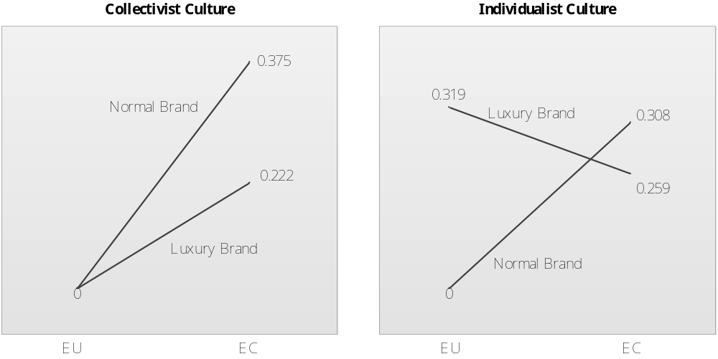

6.3 Potential Purchase Possibility
The mean method was used to evaluate the potential purchase possibility comparison. Given the quality and brand value variables, respondents in two groups need to rate the purchase possibility (range from 1 to 10) of normal wine products or luxury wine products, according to the different designations of product origin. For instance, customers may give 7 to the “made in EU” wine product purchase possibility while giving 9 to wine labeled “made in France”.
Different origin is regarded as Key Performance Indicator (KPI). In the questionnaire, the origin includes EU, France, Germany, Spain, the Netherlands, Italy, Greece and Other European countries. Those KPIs make up the column chart and the spider net. The benefit of this method is that marketers do not only know whether “made in EC” is a good strategy, but also can choose which specific country can be used as origin. Figure 6.2 and Figure 6.3 indicate the result.

Figure 6.2 A
Evaluation of Purchase Possibility in Collectivist Culture

In the collectivist culture, luxury wine product received higher grade than normal wine products. Meanwhile, “Made in France” received the highest purchase possibility in both normal and luxury brand conditions. Furthermore, “made in EU” generates higher potential purchase possibility than ones of “Made in the Netherlands”, “Made in Greece” and “Made in other countries” in both normal and luxury brand conditions. Therefore, no matter in normal brand condition or luxury brand condition, “made in EU” is a better option than “made in EC” if the country of EC has no correlation with the product attributes. For instance, since customers do not have the correlation between wine and the Netherlands, thus using “Made in EU” is better than “Made in the Netherlands”. Nevertheless, since Spain has the positive and strong correlation with wine product, “made in Spain” is a better strategy than “made in EU”.

Figure 6.2 B
Evaluation of Purchase Possibility in Collectivist Culture

In the individualist culture, “made in EU” received higher grade in normal brand condition than it did in luxury brand condition. Meanwhile, “made in EU” had higher grade than “Made in the Netherlands”, “Made in Greece” and “Made in other countries” in normal brand condition but received lower grade than ones of “made in Greece and Other Countries” in luxury brand condition. This means that “made in EU” is not effective to be used in luxury wine products for individualist customers. In normal brand condition, the value of “made in EU” was almost same as “made in Germany”. However, in luxury condition, the value of “made in EU” was only higher than “made in the Netherlands” with a slightly difference (0.02). Therefore, “made in EU” is better to be used than “made in EC” in normal brand condition for individualist customers if the country of EC has no positive or strong correlation with wine attributes. However, it is better to use “made in EC” in the luxury condition for individual customers.

Figure 6.3 A
Comparison of Purchase Possibility under Two Cultures
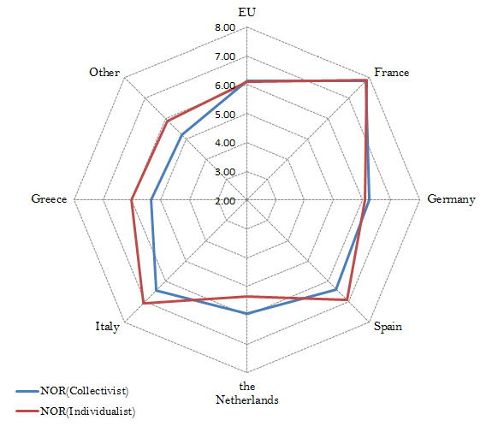
In the normal brand condition, “Made in France”, “Made in EU” and “Made in Germany” received similar grade from two cultural groups. However, there is a large difference of purchase possibility in other origins, especially in the Netherlands. This finding also proved that in the collectivist society, marketers should use “made in EU” strategy instead of “made in EC” if the country of EC has no high positive correlation with the wine attributes.

Figure 6.3 B
Comparison of Purchase Possibility under Two Cultures
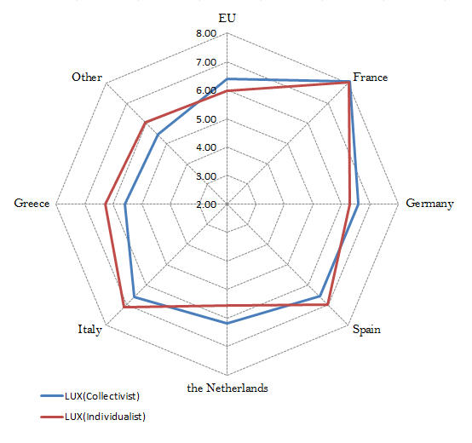
In the luxury brand conditions, there is a different purchase possibility of “made in EU” wine products between collectivist and individualist culture. Collectivist customers returned a higher score than individualist customers did. Meanwhile, except “Made in EU” and “Made in Germany”, all other origins received higher purchase possibility score from individualist than collectivist customers. Therefore, “Made in EC” is the best strategy for individualist customers from aspect of purchase possibility, under luxury brand condition.

6.4 Comparison of “Made in EU” strategy & “Made in EC” strategy
Considering the total effects from a perspective of product quality, of brand equity and of potential purchase possibility effects, the marketing strategy of “made in EU” or “made in EC” can be summed up in the following four scenarios.
In the normal brand condition and collectivist cultural background, “Made in EC” can generate the higher product quality, brand equity and the somewhat higher product purchase possibility than “made in EU” does. Therefore, “made in EC” is the better strategy in normal brand marketing activities to collectivist customers.
In the luxury brand condition and collectivist cultural background, “made in EU” generates a similar rating as a normal brand condition. Therefore, “made in EC” is the better strategy in luxury brand marketing activities to collectivist customers.
In the normal brand condition and individualist background, “made in EC” is a better strategy in some extent since it increases the perceived brand equity and somewhat increases product purchase possibility.
In the luxury brand condition and individualist background, it is hard to determine which is the better strategy since “made in EU” can enhance the brand equity but “made in EC” somewhat increases somewhat product purchase possibility.

Conclusions & Recommendations
This thesis contains two sections. In the first section, corporate strategy, business strategy and correlation between two strategies have been explained. According to Porter’s Five Forces, European entrepreneurs should use differentiation as corporate strategy to compete with emerging countries’ entrepreneurs. A corporate strategy needs support from appropriate business strategies, such as marketing strategy. In addition, business strategies are also needed to translate into operating objectives for implementation. If those objectives can be reached, then that business strategy is an appropriate one that can reinforce corporate strategy. In the thesis, higher product quality, brand equity and potential purchase possibility are three operating objectives. Meanwhile, a generic designation of origin (“Made in EU”) and a specific designation of origin (“Made in specific European country) are evaluated by operating objectives in order to choose the best business strategy to reinforce differentiation.
After reading much research, the research statement and the methodology of this thesis have been created. The second part is to use empirical research to analyze above variables. According to the result of this research and regarding to the problem statement, the following has become clear.
- When marketing to a collectivist culture, using a specific designation of origin is the best approach for both normal and luxury wine products. The implication of this finding suggests that the export of wine products to collectivist markets such as China would benefit from a specific designation policy. China is probably the largest new market for both European normal wine products and luxury wine products. Moreover, China is culturally prepared to accept these products. In addition, increasing Chinese affluence points to a growth-market.
- When marketing to an individualism culture, using specific designation of origin is effective for normal wine products.
- Countries which have a strong correlation with wine production can capitalize on the consumer perception of this correlation, when marketing luxury wine products to individualist cultures.
Even though this study is exploratory in nature, it contributes to pay better understanding of country of origin effects and implication for marketing managers. Considering the attributes of wine as a commodity, the result of this survey may well be applicable to other products that are similarly technologically neutral, culturally accepted and generally available in a large range of prices and qualities. A larger scale survey could provide more conclusive data and also incorporate questions to gauge the relative importance of price over country-of-origin effect, if any.

s

Appendix:
Appendix 1: the Competition Climate Analysis
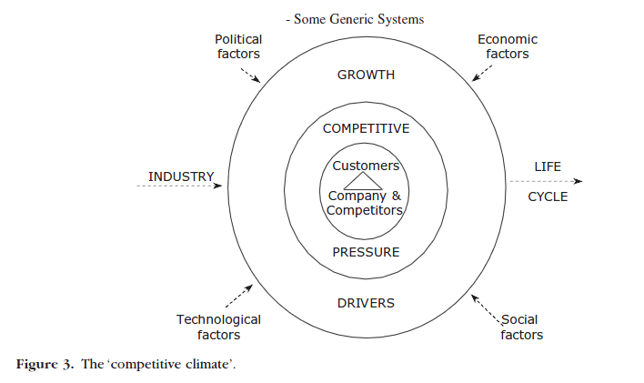
Appendix 2: Porter’s Five Forces Analysis
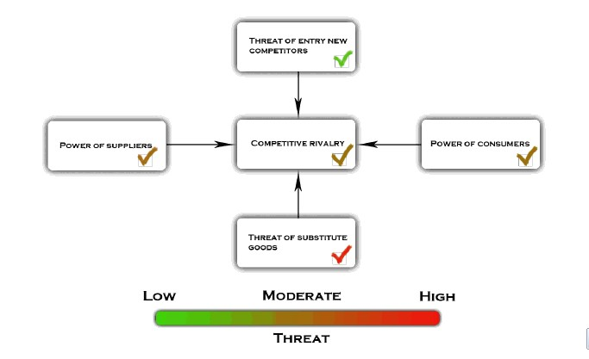
Appendix 3: Porter’s Generic Advantage Model
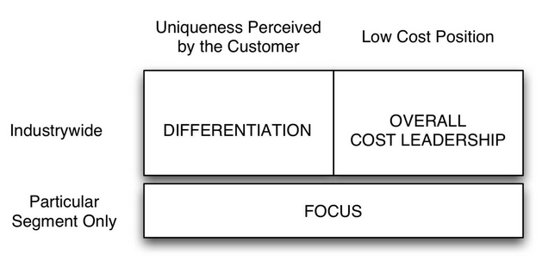
Appendix 4 correlation between the perception of country image and product categories
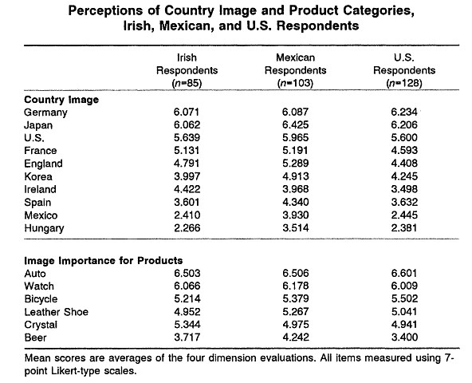
Appendix 5 willingness to buy products analysis

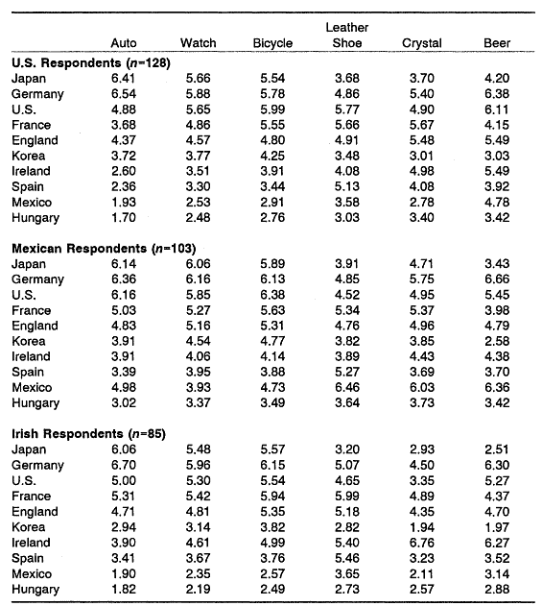

Reference List:
Ahmed, S.A. and d’Astous, A., 1993,"Cross-national Evaluation of Made-in Concept Using
Multiple Cues", European Journal of Marketing, Vol. 27 Iss: 7 pp. 39 - 52

Al-Sulaiti, K.I. and Baker, M.J., 1998, "Country of origin effects: a literature review", Marketing
Intelligence & Planning, Vol. 16 Iss: 3 pp. 150 - 199

Amiti, M., 1998, “New Trade Theories and Industrial Location in the EU: A Survey of Evidence”, Oxford Review of Economic Policy, Vol.14, No.2

Anderson J.C., Narus J.A. and Rossum W.V., 2006, “Customer Value Propositions in Business Markets”, Harvard Business Review, Mar.2006

Anderson, J.C., Narus, J.A. and Rossum, W.V, 2006, “Customer Value Propositions in Business Markets”, Harvard Business Review, Mar, 2006, Prod. #. R0603F-PDF-ENG

Barney, J.B., 2002, “Strategic Management: From Informed Conversation to Academic Discipline”, the Academy of Management Executive (1993-2005), Vol. 16, No. 2, Theme: Achieving Competitive Advantage (May, 2002), pp. 53-57

Bruning, E.R., 1997, "Country of origin, national loyalty and product choice: The case of international air travel", International Marketing Review, Vol. 14 Iss: 1 pp. 59 - 74

Canli Z.G. & Maheswaran D., 2000, “Cultural Variations in Country of Origin Effects”, Journal of Marketing Research, Vol. XXXVII
Chao, P. and Rajendran, K.N., 1993, “Consumer Profiles and Perceptions: Country-of-origin Effects", International Marketing Review, Vol. 10 Iss: 2

Chen, J.C.H., Chong, P.P. and Chen Y.S., 2001, “Decision Criteria Consolidation: A Theoretical Foundation of Pareto Principle to Porter’s Competitive Forces”, Journal of Organizational Computing and Electronic Commerce, 11:1, pp. 1-14

Churchill, I. and Iacobucci, D., 2010, Marketing Research Methodological Foundations, Canada: Nelson Education Press

Cordell, V.V., 1991, “Competitive Context and Price as Moderators of Country of Origin Preferences”, Journal of the Academy of Marketing Science, Vol.19, No.2, 1991, pp. 123-128

Felzensztein, C., Hibbert, S. and Vong, G., 2004, “Is the Country of Origin the Fifth Element in the Marketing Mix of Imported Wine?”, Journal of Food Products Marketing, 10:4, pp. 73-84

Friedman, T.L., 2005, The World is Flat, New York: Farrar, Straus and Giroux Press

Grant, R.M., 2008, Contemporary Strategy Analysis, Oxford: John Wiley & Sons Press

Grundy, T., 2006, “Rethinking and reinventing Michael Porter’s Five Forces Model”, Published online in Wiley InterScience (www.interscience.wiley.com) DOI: 10.1002/jsc.764

Gurhan-Canli, Z. and Maheswaran, D., 2000, “Cultural Variations in Country of Origin Effects”, Journal of Marketing Research: Vol. 37, No. 3, pp. 309-317

Han C.M. & Terpstra V., 1988, “Country-of-origin effects for Uni-national and bi-national products”, Journal of International Business Studies, summer 1988

Harzing, A.W. and Sorge, A., 2003, “The Relative Impact of Country of Origin and Universal Contingencies on Internationalization Strategies and Corporate Control in Multinational Enterprises: Worldwide and European Perspectives”, Organization Studies, 2003, 24:187

Hong, S.T. and WyerJr, R.S., 1989, “Effects of Country-of-Origin and Product-Attribute Information on Product Evaluation: An Information Processing Perspective”, Journal of Consumer Research, Vol.16, No.2, pp. 175-187

Hrebiniak L.G., 2005, Making Strategy Work, Wharton Business School, pp. 35

Hu, X. and Watkins, D., 1999, "The evolution of trade relationships between China and the EU since the 1980s", European Business Review, Vol. 99, Iss: 3, pp.154 - 161

Johansson, J.K., Douglas, S.P. and Nonaka, I., 1985, “Assessing the Impact of Country of Origin on Product Evaluations: A New Methodological Perspective”, Journal of Marketing Research, Vol.22, No.4, Nov. 1985, pp. 388-396

Johnson, R. and Bruwer, J., 2007,"Regional brand image and perceived wine quality: the consumer perspective", International Journal of Wine Business Research, Vol. 19 Iss: 4 pp. 276 - 297

Lawrence. R.Z. and Edwards, L., 2012, “Shattering the Myths about U.S. Trade Policy”, Harvard Business Review, March 2012

Loken, B., Ross, I. and Hinkle, R.L., 1986, “Consumer ‘Confusion’ of Origin and Brand Similarity Perceptions”, Journal of Public Policy & Marketing, Vol.5, 1986, pp. 195-211

Keller K.L., 2002, Strategic Brand Management: Building, Measuring and Managing Brand Equity, Pearson Education Limited, pp. 280

Keller K.L., Sternthal B. And Tybout A., 2002, “Three Questions You Need to Ask About Your Brand”, Harvard Business Review, Vol. 80, No.9, Sep. 2002, pp. 80-90

Kotler P. & Keller K.L., 2006, Marketing Management, Upper Saddle River, NJ: Prentice-Hall

Nielsen N.A. & Grunert K.G., 1998, “Consumer Purchase Motives and Product Perceptions: A Laddering Study on Vegetable Oil in Three countries”, Food Quality and Preference, Vol.9, No.6, 4th Qtr. 1998, pp. 455-466

Obermiller C. & Eric R.S., 1989, “Exploring the effects of country –of-origin labels: An information processing framework”. Advances in consumer research

Ozsomer A. & Cavusgil S.T., 1991, “Country-of-origin effects on product evaluations: A sequel to Bilkey and Nes review”. Press: Proceeding of the American Marketing Association, pp. 269-277

Parameswaran, R. and Pisharodi, R.M., 1994, “Facets of Country of Origin Image: An Empirical Assessment”, Journal of Advertising, Vol.23, No.1, International Advertising, pp. 43-56

Pearlson, K.E. and Saunders, C.S., 2006, Managing & Using Information Systems, Hoboken: John Wiley & Sons Press.

Peterson, R.A. and Jolibert, A.J.P., 1995, “A Meta-Analysis of Country-of-Origin Effects”, Journal of International Business Studies, Vol.26, No.4, 4th Qtr. 1995, pp. 883-900

Porter, M.E., 1980, Competitive Advantage, New York: Free Press, pp. 42

Porter, M.E., 1985, Competitive Advantage, New York: Free Press, pp. 120

Pruppers, R., 2008, Brand Management and Marketing Communication, Harlow: Pearson Education Limited

Reierson C., 1967, “Attitude Changes Towards Foreign Products”, Journal of Marketing Research, Nov. 1967, pp. 285-387

Roth, M.S. and Romeo, J.B., 1992, “Matching Product Category and Country Image Perceptions: A Framework for Managing Country-Of-Origin Effects”, Journal of International Business Studies, Vol.23, No.3, pp. 477-497

Rumbaugh, T., Blancher, N. and Prasad, E., 2004, “China: International Trade and WTO Accession”, IMF Working Paper, Asia and Pacific Department, March 2004

Solomon, M.R., 2009, Consumer Behavior, New Jersey: Pearson Prentice Hall Press

Solomon, M.R., Marshall, G.W. and Stuart, E.W., 2008, Marketing, New Jersey: Pearson Prentice Hall Press

Taylor, S.A., Hunter, G.L. and Lindberg, D.L., 2007,"Understanding (customer-based) brand equity in financial services", Journal of Services Marketing, Vol. 21 Iss: 4 pp. 241 - 252

Thode, S.F. and Maskulka, J.M., 1998,"Place-based marketing strategies, brand equity and vineyard valuation", Journal of Product & Brand Management, Vol. 7 Iss: 5 pp. 379 - 399

Walker, B.A. and Olson, J.C., 1991, “Means-end Chains: Connecting Products with Self”, Journal of Business Research, Vol.22, Iss.2, pp. 111-118

Yaprak A., 1988, “Formulating a Multinational Marketing Strategy: A deductive Cross-national Consumer Behaviour Model”, PhD dissertation, Georgia State University

Source: International Monetary Fund (IMF) outlook, 2012, pp. 31-57
Source: Hrebiniak L.G., Making Strategy Work, Press: Wharton Business School, (2005), pp. 35
Source: Porter M.E., Competitive Advantage, Press: Free Press, (1985)
Source: Porter M.E., Competitive Advantage, Press: Free Press, (1985), pp. 120
Source: Grant R.M., Contemporary Strategy Analysis, Press: Oxford: John Wiley & Sons Press, (2008), pp71
Source: Pearlson K.E. & Saunders C.S., Managing & Using Information Systems, Press: Hoboken: John Wiley & Sons Press, (2006), pp. 43
Source: Pearlson K.E. & Saunders C.S., Managing & Using Information Systems, Press: Hoboken: John Wiley & Sons Press, (2006), pp. 44
Source: Pearlson K.E. & Saunders C.S., Managing & Using Information Systems, Press: Hoboken: John Wiley & Sons Press, (2006), pp. 45
Source: Porter M.E., Competitive Advantage, Press: Free Press, (1980), pp. 42
Source: Hrebiniak L.G., Making Strategy Work, Press: Wharton Business School, (2005), pp. 37
Source: Solomon M.R., Consumer Behavior, Press: New Jersey Pearson Prentice Hall Press, (2009), pp.78
Source: Walker B.A. & Olson J.C., Means-End Chains: Connecting Products with Self, Press: Journal of Business Research 22, (1991), pp. 111-118
Source: Nielsen N.A. & Grunert K.G., Consumer Purchase Motives and Product Perceptions: A Laddering Study on Vegetable Oil in Three countries,Press: Food Quality and Preference 9 (6), (1998), pp. 455-466
Source: Grant R.M., Contemporary Strategy Analysis, Press: Blackwell Publishing Ltd, (2008), pp. 219
Source: Solomon M.R., Marshall G.W. and Stuart E.W., Marketing: real people, real choices, Pearson Education Inc, 147, (2008), pp. 147
Source: Source: Solomon M.R., Marshall G.W. and Stuart E.W., Marketing: real people, real choices, Pearson Education Inc, 147, (2008), pp. 239
Source: Source: Solomon M.R., Marshall G.W. and Stuart E.W., Marketing: real people, real choices, Pearson Education Inc, 147, (2008), pp. 239
Source: Taylor S.A., Hunter G.L. and Lindberg D.L., Understanding (customer-based) brand equity in financial service, Press: Journal of Services Marketing, Vol. 21 (2007), pp. 241-252
Source: Keller K.L., Strategic Brand Management: Building, Measuring and Managing Brand Equity, Press: Pearson Education Limited, (2002), pp. 280
Source: Reierson C., Attitude Changes Towards Foreign Products, Press: Journal of Marketing Research, (1967), pp. 285-387
Yaprak A., Formulating a Multinational Marketing Strategy: A deductive Cross-national Consumer Behaviour Model, PhD dissertation, Georgia State University, (1988), pp. xii
Han C.M. & Terpstra V., Country-of-origin effects for uni-national and bi-national products, Journal of International Business Studies, Summer, (1988), pp. 236
Source: Hong S.T. & Wyer R.S., Effects of country-of-origin and Product-Attribute Information on Product Evaluation: An Information Process Perspective, Journal of Consumer Research, Vol. 16, No. 2 (1989), pp. 175-187
Johansson J.K., Douglas S.P. and Nonaka D.I., Assessing the Impact of Country of Origin on Product Evaluation: A New Methodological Perspective, Journal of Marketing Research, VOL. 22, No. 4, Table 4, (Nov., 1985) , pp. 194
Johansson J.K., Douglas S.P. and Nonaka D.I., Assessing the Impact of Country of Origin on Product Evaluation: A New Methodological Perspective, Journal of Marketing Research, VOL. 22, No. 4, , (Nov., 1985)
Johansson J.K., Douglas S.P. and Nonaka D.I., Assessing the Impact of Country of Origin on Product Evaluation: A New Methodological Perspective, Journal of Marketing Research, VOL. 22, No. 4, pp. 395
Source: Roth M.S. & Romeo J.B., Matching Product Category and Country Image Perceptions: A Framework for Managing Country-of-origin Effects, Journal of International Business Studies, Vol. 23, No. 3, , (1992), pp. 480
Source: Roth M.S. & Romeo J.B., Matching Product Category and Country Image Perceptions: A Framework for Managing Country-of-origin Effects, Journal of International Business Studies, Vol. 23, No. 3, , (1992), pp. 483
Source: Roth M.S. & Romeo J.B., Matching Product Category and Country Image Perceptions: A Framework for Managing Country-of-origin Effects, Journal of International Business Studies, Vol. 23, No. 3, , (1992), pp. 492
Source: Roth M.S. & Romeo J.B., Matching Product Category and Country Image Perceptions: A Framework for Managing Country-of-origin Effects, Journal of International Business Studies, Vol. 23, No. 3, , (1992), pp. 495
Source: Obermiller C. & Eric R.S., Exploring the effects of country –of-origin labels: An information processing framework. Press: Advances in consumer research, (1989), pp. 484
Source: Ozsomer A. & Cavusgil S.T., Country-of-origin effects on product evaluations: A sequel to Bilkey and Nes review. Press: Proceeding of the American Marketing Association, (1991), pp. 274
Source: Peterson R.A. & Jolibert A.J., A Meta-Analysis of Country-Of-Origin Effects, Journal of International Business Studies, Vol. 26, No. 4, (1995), pp887
Source: Canli Z.G. & Maheswaran D., Cultural Variations in Country of Origin Effects, Journal of Marketing Research, Vol. XXXVII, (2000), pp314.
Source: Canli Z.G. & Maheswaran D., Cultural Variations in Country of Origin Effects, Journal of Marketing Research, Vol. XXXVII, (2000), pp314.
Source: Canli Z.G. & Maheswaran D., Cultural Variations in Country of Origin Effects, Journal of Marketing Research, Vol. XXXVII, (2000), pp315.
Source: Amiti M., New Trade Theories and Industrial Location in the EU: a Survey of Evidence, journey: Oxford Review of Economic policy, Vol. 14, No. 2, (1998),
Source: T. Grundy, Rethinking and Reinventing Michael Porter’s Five Force Model, (2006)

