The Liberalized Postal Service

A study of the effects of liberalization on
postal service employment and working conditions

Master thesis | Annemieke Bervoets


The Liberalized Postal Service

A study of the effects of liberalization on
postal service employment and working conditions



Erasmus University Rotterdam
Faculty of Social Sciences
Department of Public Administration
Master International Public Management and Policy

Annemieke Bervoets
Student number: 321414

Supervisor: Dr. S. Van de Walle
2nd Reader: Dr. M. Haverland
Date: 13 July 2012
Word count: 29.848

Abstract

This thesis researches the effect of liberalization on postal sector employment and working conditions between 1990 and 2010 in ten EU member states. The five legally liberalized countries used in this thesis are Sweden, Finland, United Kingdom, Germany and the Netherlands. The non-liberalized countries used are Denmark, Belgium, Luxembourg, Ireland and Austria. Three indicators have been used to determine the extent of liberalization, namely entry regulation, the presence of postal competitors and state ownership. Moreover, two control variables have been introduced in order to avoid automatically associating any difference to liberalization. These two control variables are the digital age and labour market flexibility. Indicators for the digital age are internet usage and letter mail volume. The indicator for labour market flexibility is hiring and firing regulations. This research has shown that all assessed variables cannot explain the developments in employment and working conditions in the postal sector. More characteristics of liberalization turned out not to be related to more precariousness in postal sector employment and working conditions. Indeed, also countries without liberalization present in the postal sector showed increased precariousness in employment and working conditions. Also correlation between the control variables and postal sector employment and working conditions could not be proven. Based on the results and arguments presented in this research, it is likely that liberalization has not had a significant effect on employment and working conditions in the postal sector.

Acknowledgements

I would like to thank several people for supporting me during the process of writing this thesis. First, my thanks go out to my thesis supervisor, Steven van de Walle, and my second thesis supervisor, Markus Haverland, for their useful comments that have helped improving this thesis. Also, many thanks go out to my family for their support throughout this process and their unconditional love and faith in me. I would like to thank my mother for listening to me when I felt frustrated, my father for motivating me when I wanted to give up and my brother Siebe for making me laugh when I felt like crying. Without them, this process would have been much harder. Special thanks also go out to Ies en Riet, for their never ending interest in me and the wonderful Sunday afternoons that helped me relax during the most stressful weeks. Lastly, I would like to thank anyone that has showed interest and support during the completion of this project.

List of contents

Abstract 2
Acknowledgements 3
List of contents 4
1. Introduction 7
1.1 Research Question 8
1.2 Purpose statement 8
1.2.1 Societal relevance 9
1.2.2 Theoretical relevance 9
1.3 Chapter overview 9
2. Theoretical Framework 11
2.1 Deregulation, Privatisation and Liberalization 11
2.1.1 Deregulation 11
2.1.2 Privatisation 12
2.1.3 Liberalization 13
2.1.4 Policies of Deregulation, Privatisation and Liberalization 14
2.2 Liberalization in the postal sector 15
2.2.1 The European postal service market 15
2.2.2 The postal directives 16
2.3 Liberalization and Employment 18
2.3.1 Changing labour relations in the postal service sector 18
2.3.2 The need for re-regulation 20
2.4 Liberalization: from theory to practice 21
2.5 Hypotheses 22
3. Structure of the analysis 24
3.1 Unit of analysis 24
3.2 The countries included in this research 24
3.3 Specification of the variables 25
4. Operationalization and measurement 26
4.1 Dependent variable: Employment 26
4.1.1 Indicators 26
4.2 Dependent variable: Working conditions 27
4.2.1 Indicators 27
4.3 Independent variable: Liberalization 29
4.3.1 Indicators 29
4.4 Independent variable: Digital Age 30
4.4.1 Indicators 30
4.5 Independent variable: Labour market flexibility 31
4.5.1 Indicator 31
4.6 Conceptual model 32
4.7 Conclusion 32
5. Research design 34
5.1 Co-variational design 34
5.2 Data sources 35
6. Liberalization 36
6.1 Entry regulation 36
6.2 Postal competitors 37
6.3 Public ownership 39
6.4 Conclusion 41
7. The Digital Age 43
7.1 Internet usage 43
7.2 Letter mail volume 44
7.3 Conclusion 46
8. Labour market flexibility 48
8.1 Hiring and firing regulations 48
8.2 Conclusion 50
9. Employment in the postal sector 51
9.1 Developments in postal sector employment 51
9.2 Analysis of the results 55
9.2.1 Effect of liberalization on postal employment 55
9.2.2 Effect of the digital age on postal employment 57
9.2.3 Effect of labour market flexibility on postal employment 59
9.2.4 Effect of the independent variables on postal employment 60
10. Working conditions in the postal sector 62
10.1 Developments in postal sector working conditions 62
10.2 Analysis of the results 66
10.2.1 Effect of liberalization on working conditions 67
10.2.2 Effect of the digital age on working conditions 68
10.2.3 Effect of labour market flexibility on working conditions 70
10.2.4 Effect of the independent variables on working conditions 71
11. Remarks regarding the hypotheses and research question 73
11.1 Summary of the findings 73
11.2 Answer to the main research question 73
12. Conclusion 75
12.1 Research limitations 75
12.2 Recommendations for further research 76
Bibliography 77

1. Introduction

The creation of a single market in the European Union (EU) can be described as one of the core activities in the EU. As highlighted in the Lisbon strategy, it is necessary “to make the European Union the most competitive and dynamic economic area in the world – an economic area which is able to link sustainable economic growth with more and better jobs and a stronger social cohesion” (Brandt and Schulten, 2009: 37). Even though it seems that the recent economic and financial crisis and the challenges with respect to the Eurozone have taken the specific focus on the single market away, according to Řiháčková (2011: 1) it is generally still perceived as one of the key aspects for achieving more competitiveness and a better performance of the EU economy. The promotion of liberalization as the way to achieve such a single market, and thus more competitiveness and a better performance, was very popular as an EU policy in the 1980s and 1990s. Liberalization in this context can be described as the “relaxation of previous government restrictions, in areas of social or economic policy or political organization” (Bull et al. 2006: 3). Liberalization was introduced to enhance competitiveness by introducing a gradual abolishment of public sector monopolies. This renewed competition would lead to improved service quality, productivity and efficiency. Especially the introduction of liberalization reforms in the telecommunication, energy and postal sector are illustrative examples of this phenomenon. After fully liberalizing the telecommunication and energy sectors at the beginning of the 21st century, the postal sector is currently being liberalized. Before 2011, only six countries had fully liberalized their postal sectors. On 1 January 2011, eleven more countries liberalized their postal sectors. The ten member states left have to liberalize their countries in 2013 (FFPI, 2010: 1).

This thesis examines the liberalization process of the European postal service sector. It draws a comparison between the postal sector in five liberalized and five non-liberalized EU member states before 2011, specifically focussing on the effects of liberalization on employment and working conditions. The scope of interest for this particular playing field is based on the small amount of research that has been done on employment and working conditions after full market liberalization. The majority of research on liberalization concentrates on financial aspects, such as costs and revenues, or on customer satisfaction. This study aims to contribute to the knowledge on liberalization effects, using a fairly different approach.

Considering the trend of liberalization in the postal sector, this study focusses on the effects of this process on employment and working conditions. In order to differentiate an effect, both liberalized and non-liberalized countries are assessed. The five fully liberalized countries used in this thesis are Sweden, Finland, United Kingdom, Germany and the Netherlands. The non-liberalized countries used are Denmark, Belgium, Luxembourg, Ireland and Austria.

1.1 Research Question

This research assesses the effects of liberalization on employment and working conditions in the postal sector. Based on this research purpose, the following research question can be formulated:
What is the effect of liberalization on employment and working conditions in the postal service sector?

1.2 Purpose statement

The postal service sector is considered as one of the services of general economic interest (SGEI). It is a vital part of national infrastructure for both consumers and commercial users, since postal services provides a connection between both governments and citizens, and businesses and customers (European Commission, 2012a; Okholm et al. 2010a: 120). The postal service market is also of significant economic and social importance, as expressed in an EU technical memo on the postal sector (European Union, 2012). When examining 2009 data, the overall EU sector, including letter post, express and parcel services, was responsible for 72 billion euros in revenues, which is approximately 0,62 per cent of the total EU GDP. The letter post market was responsible for the largest part of these revenues with 56 per cent. The high labour intensity of the postal sector represents the social importance. Again based on 2009 data, the total employment of the postal sector in the EU was approximately 1,5 million. This represents about 0,72 per cent of total employment in the EU.

Besides these arguments on economic and social importance of the postal service sector in the EU, it is important to note that postal services invade people’s everyday life. The most used feature with respect to this service is obviously sending and receiving mail, but also collecting stamps, first day covers and postcards are related to the postal sector. Furthermore, despite the rise of information and communication technologies, the postal sector still provides a physical link between two people. For instance, when a product order is placed on the internet, it is still the postal service which delivers the product at the doorstep and hence forms the physical link between the buyer and the seller. It is still the postal service which delivers the ballot paper during elections and forms the physical link between the government and the citizen (UPU, 2010: 3).

The societal and theoretical relevance of this research on the relationship between liberalization of the postal sector and employment, including working conditions, is explained in the next two paragraphs.

1.2.1 Societal relevance
According to Lehnert et al. (2007: 25-27), societal relevance is primarily about whether people care. “Socially relevant research furthers the understanding of social and political phenomena which affect people and make a difference with regard to explicitly specified evaluative standards”. The postal service sector, as mentioned before, employs a great amount of people and is responsible for approximately 0,62 per cent of the GDP in the EU. This implies first of all that changes in the postal sector such as liberalization become visible in the EU GDP and the employment rate. This affects obviously the postal service employees, as well as the customers, employers and labour unions. Moreover, liberalization and associated concepts such as competition, the abolishment of public sector monopolies and increasing efficiency affects also important humanitarian aspects, including job allocation, service quality, work intensity and wealth distribution.

1.2.2 Theoretical relevance
As defined by Lehnert et al. (2007: 23), “Theoretically relevant works helps us to arrive at a better understanding of the phenomena that we study theoretically or empirically”. First, this research aims to contribute to the knowledge on the relationship between liberalization and employment. As Flecker and Hermann (2011: 525) highlight in their study, research on liberalization and public service market reforms is primarily focussed on changes in prices and efficiency, as well as the impact on user satisfaction and costs. There has been little research on the consequences of liberalization for employment and working conditions, even though these are also important indicators when assessing how public service providers react to liberalization. This research contributes to this general knowledge. Second, this research compares differences in employment and working conditions in several liberalized and non-liberalized countries. Most research within the scope of postal service employment is entirely focussed on liberalized countries, while especially the comparison between liberalized and non-liberalized countries makes the effects of liberalization visible. This research could therefore also be considered as innovative.

1.3 Chapter overview

This research can be split in two part. The first part represents the theoretical part of this thesis and consists of preliminary information which provides the base for the actual research. Chapter two is devoted to the theoretical framework. It examines the concept of liberalization broadly regarding the postal sector, employment and working conditions and identifies three hypotheses based on the provided theoretical insights. Chapter three introduces the most important concepts of this thesis. It states the unit of analysis, after which the countries of this thesis get further examined. Chapter four identifies the dependent and independent variables and provides indicators for each of them. The next chapter states the research design which is used for answering the main research question. Also, the reasons for choosing this design are discussed, as well as the external and internal validity of the design. Moreover, the data sources, which are already briefly introduced in chapter three, are further discussed as well.
The second part of this thesis focusses on the empirical part of this research. Chapter six is dedicated to the assessment of the first independent variable liberalization. Chapter seven and eight focus on the other two independent variables, respectively the digital age and labour market flexibility. The examination of the first dependent variable is in chapter nine. This chapter also includes an explanatory analysis of the employment trends, based on the evidence examined in earlier chapters. Chapter ten is dedicated to the assessment of the second dependent variable working conditions. Also this chapter has an explanatory analysis based on earlier examined evidence of the developments in postal sector employment conditions. Chapter eleven answers the research question and test the hypothesis. After that, the conclusion is formulated, containing limitations of this research and options for further research.

2. Theoretical Framework

Based on the previously described contours of the creation of a single EU letter market, it can be stated that the reform of the postal sector has been a long process with distinctive theoretical patterns. The various postal markets throughout the European Union have evolved for decades before becoming the liberalized markets they have (recently) become or will become soon. The formation of a liberalized postal market is often done simultaneously with or is preceded by processes of deregulation and privatisation of the market. Even though often used as synonyms, these theoretical concepts certainly differ from each other and require further explanation as they are important in widening the understanding of postal sector liberalization. The literature associated with these concepts, defining and explaining them, is broad and diverse. This chapter consists solely of a review of the relevant theoretical insights, in order to provide a better understanding of the broad phenomena described in this thesis. Despite the fact that the topic of this particular thesis concentrates specifically on the liberalization in the postal sector, it seems right to also focus on the broader concept of liberalization and the general processes of privatisation and deregulation. This framework will often refer to the situation in Europe or the European Union, as according to the ambit of this thesis. The first part of this theoretical framework consists of the general concepts on deregulation, privatisation and liberalization. The second part provides an overview of liberalization in the postal sector. It introduces the postal sector structures and highlights particularly the postal market opening in the European Union. The third part concentrates on the relationship between liberalization and employment, especially focussing on shifts in working conditions. It also provides some more practice oriented insights. Finally, the hypotheses of this research are introduced, based on the theoretical insights provided in this chapter.

2.1 Deregulation, Privatisation and Liberalization

As noted before, the concepts of privatisation, deregulation and liberalization are often wrongly used as synonyms. This paragraph distinguishes the differences between these concepts and introduces their effects on (inter)national policies, in order to use this as a guideline for the next paragraph when the relationship between liberalization and employment gets assessed.

2.1.1 Deregulation
The general idea behind deregulation is the neo-liberal view that real competition is only possible in fully deregulated markets (Rothenberger et al., 2001: 1). According to Mitnick (1978: 350), deregulation should here be explained using the concept of regulation. Regulation can be defined as “the intentional restriction of a subject’s choice of activity by an entity not directly involved in performance of the activity”. This indicates that a broad definition of deregulation would simply be “the removal of such a choice restriction” or “a process of organizational reduction”. These definitions are fairly broad and too unclear to be used throughout this study. Hence, a more delineated term is provided by Rothenberger et al. (2001: 1-2), who define deregulation as “the abolishment of certain rules in the economic structure of a society, which enables the respective companies to act with more freedom, according to their entrepreneurial spirit”. The main reason for deregulation are inefficient results in the regulated sectors, as a lack of autonomy on the management level often leads to political decisions based on other objectives. The primary purpose of deregulation is therefore to increase overall efficiency, capital investment, customer service and reduce political interference. Herman (1976: 224) distinguishes two common sets of interest when it comes to deregulation. The first set of interests is often represented by the industry and involves the removal of government obstacles to profit making, such as health and safety at the workplace, pollution control and hiring and firing practices. The second set of interests are generally represented by economists and associates deregulation with the removal of governmental and other obstacles to price competition, such as the protection of monopolies, cartels and charters.

Deregulation is often used as a synonym for privatisation. However, deregulation implies that there is a direct change in the market structure and market outcome, while privatisation can be seen as a form of deregulation where public authorities withdraw from services and hand them over to the private sector. There are several forms of deregulation and specifically privatisation. The most used forms are: outsourcing of services/tasks which were previously undertaken by the public sector, full sale of public firms to the private sector and enabling third party access, inset appointments and free customer choice (Rothenberger et al. 2001: 2). The following part focusses specifically on this matter.

2.1.2 Privatisation
Poole and Fixler (1987: 612) highlight in their study that the concept of privatisation began as an implicit policy after World War II, when local governments started with contracting general support and services as housekeeping outside their own organization. It can be defined as “the transfer of assets and service responsibility from the public to the private sector”. Starr (1988: 16-17) claims that the concept of privatisation involves a number of different practises. First, there is an implicit form of privatisation. This involves the disengagement of government from specific types of responsibilities and public programs. Second, there is an explicit form of privatisation. This includes the transfer of public assets to private enterprises by leasing or selling public land, firms or infrastructures. In the third form, the government finances private services, but is not directly involved in producing services. Finally, privatisation can be the result of the deregulation of public services.

Privatisation has evolved over the years since its first use in World War II, as it now includes a variety of other methods besides contracting out, such as vouchers, volunteers, franchisers and service shedding. It has also grown tremendously since its introduction (Poole and Fixler, 1987: 612-613). According to Boycko et al. (1996: 309) privatisation has actually “swept the world”, as thousands of state enterprises around the world have become private firms. A reason for this move towards more privatisation is the poor performance of public enterprises, as they address the objectives of politicians instead of maximizing efficiency. Indeed, politicians benefit from employment: they care about being re-elected and have to keep labour unions satisfied, whom have significant influence on political parties.

Vickers and Yarrow (1991: 111-112) go deeper into this concept by distinguishing three types of privatisation. The first type is privatisation of competitive firms. This involves the transfer of state-owned firms operating in competitive product markets without substantive market failures to the private sector. The second type involves privatisation of monopolies. This can be characterized as the transfer of state-owned enterprises with substantial market power to the private sector. A distinction can be made between natural monopolies, where the monopoly implies technological conditions and artificial monopolies, where competition is possible, but gets prevented by anticompetitive policies. The last type is contracting out of publicly financed services. This refers to the transfer to the private sector of publicly financed services, initially performed by public sector organizations. The difference between the first and second type is that when monopoly power or other types of market failures are present (type two), governments often remain some rights of regulatory control.

2.1.3 Liberalization
A broad process of liberalization got introduced in the 1980s, particularly used as a framework for the promotion of competition. Bull et al. (2006: 3) defines it as “any relaxation of previous government restrictions, in areas of social or economic policy or political organization”. Hermann and Flecker (2009: 87) claim that essentially, liberalization is about competition. According to their study, the main argument in favour of liberalization is that competition forces new and liberalized competitors to improve productivity and service quality. Also other scholar have argued that the necessity to have competition in a market is one of the most important reasons for liberalization. Krajewski (2003: 10) claims that liberalization is particularly based on the assumption that the opening of a market and allowing competition can achieve many common goods. Moreover, he argues that government interference with the market often leads to welfare losses. Baker and Dodgson (2002: 121) add to this view that when markets are not competitive, there will be few incentives to put a price at a level which merely covers the costs. If there is only a monopolist in the market, prices will most certainly be set above the level of covering the costs.

Furthermore, Hermann and Verhoest (2009: 7) point out that in a competitive market structure, the several providers should compete with each other on an easily accessible and integrated market. This type of market structure needs market concentration at a low level only, because when providers have a large market share there is a possibility they will introduce entry barriers for new competitors. Introducing these entry barriers could be done by manipulating prices or the quality of services. As liberalization aims to enhance competition, it is to be expected that there will be a substantial increase in the amount of competitors in the newly liberalized public service sectors. This is certainly the case in most of the countries and sectors where before market opening only one provider, a monopolist, was present. However, a fully competitive market has not or only partially been achieved in most sectors. Therefore, Hermann and Flecker (2009: 87) argue that liberalization has mixed effects. Furthermore, Streeck and Thelen (2005: 3-4) highlight that time and pathways of liberalization strongly differ between countries, as liberalization is always developed within a society with specific traditions. Indeed, some countries advance liberalization, while others continue to delegate state functions to civil society.

Streeck and Thelen (2005: 4), also describe the liberalization process as a necessity both in terms of economic adjustment and as a political strategy. Liberalization as a political strategy can be used when the pressure on governments to fulfil increasingly differentiated demands becomes too high. The economic adjustment refers to the inevitable pressure to growing markets in organized political economies. Besides these broad, commonly used political and economic types of liberalization, more specific forms of liberalization can be distinguished, such as trade liberalization and capital market liberalization. Based on the scope of this study, the specific form of liberalization used throughout this thesis is market liberalization. Market liberalization can be defined as: “all forms of government initiatives to break the state monopoly in the market, free price controls, reduce entry barriers, and privatize state-owned enterprises” (Park et al., 2006: 128).

Newbery (1997: 358) argues that liberalization differs from privatisation as it involves a broader concept. Privatisation is primarily about ownership instead of control. Firms can be remarkably similar under public and private control. Liberalization however, involves the introduction of market forces and can induce substantial changes in performance – more than privatisation alone. Furthermore, Cooke Jr. (2001: 2-3) argues that liberalization also differs from deregulation, as “liberalization generally removes the operating restrictions on an industry, but it is different from deregulation, which simply changes the rules.”

2.1.4 Policies of Deregulation, Privatisation and Liberalization
Flecker and Hermann (2011: 523-524) state that the period after World War II in Europe gets characterized by public firms that had the exclusive right to supply services domestically or internationally. There was only one postal service or only one electricity provider. Other services, such as public transport and health care, were run by local or regional governments. Largely absent in this model were private firms or any type of competition. This has changed however drastically, especially over the last two decades, as processes of deregulation, privatisation and liberalization in these public services have ‘swept the world’. Most of these processes were initiated nationally, but also on the European level abolition of public service monopolies was enforced. As a result, pointed out by Clifton et al. (2008: 23), “the policies of privatisation, liberalisation and deregulation introduced by most governments around the world have profoundly affected the ownership, management and the overall raison d’être of these public service providers”.

Thierstein and Abegg (2003: 174) claim that the introduction of market elements has affected the reactions in the public sector in varying degrees. The policies of privatisation, liberalisation and deregulation shaped the degree of competition and the main elements for structural reform for the public service providers. The monopoly of service providers has been relaxed and split off from public control. Especially liberalization can easily trigger both competition and the abolition of monopolies, even though former monopolies still often dominate the market. Domestic producers often have strategic advantages in the market, such as a dominant market position. The stage of liberalization and the degree of competition are important indicators for the impact on the market, company reactions and the organizational structure of public service providers (OECD, 1995: 38; Flecker and Hermann, 2011: 526). Following the logic of a more market-driven public service, there is a strong orientation towards increasing efficiency and productivity (Thierstein and Abegg, 2003: 174).

2.2 Liberalization in the postal sector

One of the ideas behind the creation of the European Union was the creation of a common EU market with unified conditions for all member states. The end of the 20th century and the beginning of the 21th century marked the unification of the member states by developing rules for market competition (Dobrinić et al., 2009: 1,5). Morton (2011: 3) explains that specifically the ratification of the Maastricht Treaty in 2003 brought a widening of the single market in the EU and can be seen as the introduction of liberalization. The introduction of liberalization reforms in the TENs sectors (telecoms, transport, postal and energy sectors) can be described as the start of the breakup of the dominating established public monopolies in these sectors. Liberalization does not occur overnight; it is often a gradual process that lasts for years. Liberalizing the EU postal sector is not an exception. This chapter provides an introduction to the postal sector and an overview of the liberalization process, focussing on both the legal concepts and the alleged consequences.

2.2.1 The European postal service market
The postal market can be described, according to Dobrinić et al. (2009: 3-4), as “the barometers of the social activities”, based on their historical development. The sector has evolved from one of the simplest form of satisfying the basic need of having long-distance communication into a communication structure that is deeply intertwined with several other economic activities. It can be seen as the source of communication market development. A specific characteristic is the strong integration with both private and business communication, logistic and the financial market, even though it is hard to draw a clear line between them. The logistic market is and the postal sector are connected through the development in the express and package services. The postal services and the financial market are intertwined through the circulation of goods, such as goods from television and catalogue sales, which are followed by monetary flows. As a result, the postal sector unifies the satisfaction of all users in these sectors.

Zanker (2007: 3) considers some factors that have driven liberalization in the postal sector. He first explains that the political ground for liberalization was created in the 1980s, when a neo-liberal approach became dominant. The idea behind this new policy was to replace the influence of the state on the economy by a free market with competition. The state could serve as a supervisor and regulator on the market. Besides the role of the European Union as a promoter of the Single Market and the member states, also the OECD, the IMF and the World Bank were the driving forces behind postal liberalization. The reduction of trade barriers and the introduction of competition is of cross-border importance. In some countries, privatisation of the postal service monopolies was an important condition for liberalization in order to react flexibly to the market opening and the coming competition. Many member states split their public service monopolies in postal and telecommunication firms, often under the pressure of the need to increase efficiency, productivity and the quality of service.

Furthermore, the rise of electronic media and other types of information and communication technologies has had a considerable impact on the global communication structures. These technologies are widely available and affect the way individuals, businesses and other components of society communicate with each other. It has opened the world and made communication easier, as it offers free access to all sorts of information, products and people (UPU, 2010: 5). New forms of communication can change the postal sector to a point that it gets substituted. The stagnation in the postal flow becomes more and more visible, as technology is constantly improving and becomes widely available at lowered prices. Reforms became a necessity in order to save the sector from even greater losses. The process of liberalization of the postal sector leads to market opening, in which the market has to transform to the demands of the usual market laws. The traditionally organized postal market, led by the protection of the state and its institutions, will largely disappear (Dobrinić et al., 2009: 5). Especially, as the postal sector has never before had to compete on their service performance (Zanker, 2007: 2).

2.2.2 The postal directives
The European Commission (2012) describes that the purpose of an internal market for postal services is to ensure, using an appropriate regulatory framework, efficient, reliable, affordable and good-quality postal services throughout the EU to all its citizens. In order to achieve this, reform of the postal sector, among other public sectors, was necessary. It was emphasised that after the reforms, the new public sector model had a lot of elements of the model of governance and employment as used in the private sector. Hence, the main elements of this new model including:

- The redrawing of boundaries between the public and private sector, by transferring services from public to private ownership or processes of outsourcing.
- The restructuring of large, bureaucratic organizations into smaller, independent units. This was firms are closer to react to citizens demands and are more transparent with respect to costs and results.
- The shift from management by hierarchy to more contract styles of management, using market like mechanisms of governance into the provision of public services.
- The strengthening of the power of managers and management techniques as used in the private sector.
- The reform of labour and personnel relations.

What lies underneath these main elements of reform is the attempt to change the constraints, controls, incentives and opportunities used in the public sector, to reduce the difference between the public and the private sector and to promote the governance of labour policies close to the private sector model (EFILWC, 2007: 16-17).

The start for the creation of a common internal postal market began already in the late 1980s, when the European Commission held a survey of the delivery service sector in the EU member states. The results were published in “Postal Green Paper” of 1992. The Green Paper concluded that the postal services in the EU member states varied widely in quality and efficiency and that postal service providers often produced significant losses, particularly due to the extensive and unnecessary public monopolies (Dieke et al., 2008: 6). In addition, Campbell Jr. (2002: 21-22) points out that this paper proposed an European policy framework for postal services after analysing the aspects of the different postal policies.

A first step was taken towards implementation of the Green Paper objectives with the 1997 postal Directive 97/67/EC. The Postal Directive provides a roadmap for the gradual opening of the EU postal market, in which each step represents a significant but controlled reduction of the domestic monopoly, while the quality of service can be assured (Eccles and Kuipers, 2006: 323). It also formulates a minimum definition of universal postal services and provides a maximum scope for the various postal monopolies in the EU member states. It obliges all governments of all member states, rather than specific postal service providers, to ensure universal service (Dieke et al., 2008: 6). According to the European Commission (2012) this regulatory framework included common rules for the development of an internal market for postal services and the improvement of service quality. More specifically, it defines the minimum characteristics of each service in the EU member states, it sets a timetable for further, gradual and controlled liberalization, it governs the setting of service quality standards and it requires the creation of national regulatory authorities to act independently from the postal service providers.

This postal directive got amended in 2002, and as a result the new Directive 2002/39/EC got formally adopted. It defined further steps into the gradual and controlled market opening process, including setting a possible date of 1 January 2009 as a deadline for the full accomplishment of an internal postal service market, to be confirmed or changed by using the co-decision procedure. Moreover, the directive described the further planned reductions of the domestic ‘reserved area’, in which letter mail under certain weight and cost limitations can only be handled by postal providers providing universal services within domestic boundaries. As pointed out by Eccles and Kuipers (2006: 321), the 2002 Postal Directive reduces the reserved area for letter weight to 50 grams instead of the prior 100 grams. The price threshold is reduced from 3 times to 2,5 times the price for standard mail items. Furthermore, the monopoly status of the incumbent in most member states should be reduced in line with the earlier mentioned requirements and timescale. These gradual reductions should eventually lead to full market opening.

The final amendment of the initial Postal Directive was initiated in 2008. This resulted in the formal adoption of the new Directive 2008/06/EC. The directive defines 2010 and for some member states 2012, as the final step of the liberalization process. It also states that all member states must abolish their remaining reserved areas by 2010, with a possibility for some member states to postpone these elements of full liberalization with a maximum of two years (European Commission, 2012).

Geradin (2006: 10-12) recapitulates that the Postal Directive represents three different, but equally important, pillars in order to accomplish full postal liberalization. First, the Directive has to remove the exclusive rights valid for only certain companies. This measure often involves complex political compromises, as not all member states were equally enthusiastic about liberalization. Second, the directive has to establish a regulatory framework. This framework contains of substantive obligations, such as the creation of universal service. Furthermore, it imposed the creation of independent regulatory authorities by the member states. These independent authorities, often organized as agencies, are responsible for the creation of a level playing field and to avoid conflicts between incumbents and new competitors. Third, the directive has to compose a set of competition rules that can be used to support the process of market opening.

Nevertheless, as pointed out by Dieke et al. (2008: 20), some important remarks should be made. First, even though the Postal Directive promotes competition, it also imposes the obligation to ensure a universal postal service in the member states. The member states must impose a Universal Service Obligation (USO) on one or several Universal Service Providers (USP), in order to make sure that the entire national territory is ensured of an available and affordable postal service. Second, the criteria mentioned in the Postal Directive can be considered as minimum criteria with respect to the delivery requirements, access conditions and quality of service. This implies that there is considerable freedom for the member states to design and shape their own postal service market. As a result, the degree of market opening can vary, sometimes significantly, between member states during the liberalization process.

2.3 Liberalization and Employment

As mentioned before, liberalization of public services has been promoted actively in the European Union, especially during the 1990s. The reason for this promotion has been the expectation that the creation of new liberalized markets would lead to more efficiency, advanced social wealth and economic growth. As one of the most advanced projects, liberalization has also become a core element of the Lisbon strategy, which is: “to make the European Union the most competitive and dynamic economic area in the world – an economic area which is able to link sustainable economic growth with more and better jobs and a stronger social cohesion” (Brandt and Schulten, 2009: 37).

2.3.1 Changing labour relations in the postal service sector
The public sector, especially in the EU member states, has always been known for providing stable, decent jobs for low- and medium-skilled workers (Flecker and Hermann, 2011: 530). For the postal service sector, providing these decent jobs was possible because of the historically benefited position of the postal service providers. The postal service providers traditionally received financial and legislative support provided by the domestic government and were able to operate in a non-competitive and monopolistic environment. However, changes such as globalisation, popularity of deregulation, privatisation and liberalization, new technology and changing customer needs have demanded major changes in the postal sector. This has not only affected the postal products and services, but also the fundamental way of functioning of these postal firms. This has strained the relationship between employer and employee, but also increased job insecurity, dissatisfaction and conflict among the workforce (Giga et al., 2003: 1-2).

Brandt and Schulten (2009: 38-39) add to this view by arguing that the changes in the postal sector have had far-reaching consequences for traditional labour relations. The transformation of former public monopolies into profit-oriented services and the creation of new liberalized markets resulted in significant pressure of competition on companies, which has affected the nature and stability of the labour relationship. Many employees in the public sector had the status of a civil servant, and because a civil servant traditionally can only get fired under very exceptional circumstances, the labour relationship was primarily long-term. However, whereas in the traditional labour relationship employees were treated as an equal, homogenous workforce, employees within the former public monopoly were often divided between ‘old’ and ‘new’ employees. This continuous as some long-term employees are still civil servants with the associated statutes, while new employees are hired as private sector employees covered by private sector employment statutes. This distinction not only often lead to lower job security, but also lower salaries and working conditions for the same work.

Furthermore, Brandt and Schulten (2009: 41-42) point out that the extent to which liberalization lead to competition on wages and labour costs, which could lead to potentially negative effects on working and employment conditions, depends basically on the degree of real competition on the market.

Despite the claims that liberalization would lead to productivity gains, the growth of the entire market and eventually higher employment (Jefferys et al., 2009: 50), many providers of public services have responded to the process of liberalization by cutting back on the number of employees (Flecker and Hermann, 2011: 530-531). This reduction is especially felt in the way work is carried out. These lower staff levels often result in work intensification, which may undermine the quality of the job (pp. 536). The introduction of competition in these formerly protected markets is named as one of the most important reasons for this cutback. The sectors and companies affected by liberalization have been under increasing pressure to reduce labour costs, because of increasing competition. Brand and Schulten (2009: 37) argue that there are many different types of competition, but liberalized public service providers often choose to follow one of these two strategies: competition on quality and innovation or competition on labour costs. The first strategy concentrates on elements such as high service quality, innovative products and an efficient and productive organisation. It is mainly an innovation and quality-driven competition model that follows a high-road strategy to gain success. The second strategy involves the lowering of wages, extending working hours or using special lower labour costs forms of employment, such as self-employed workers or subsidized employees. It can be characterized as a low-road economic survival strategy, using a downward spiral of lowering wages and working conditions.

However, not only liberalization has affected the shift within employment relations. Other global changes, such as labour market flexibility and technological progress, could have had an major impact as well. Changes in the economic environment enhanced the need of more flexibility of the labour market. Flexibility became necessary in order to accommodate to be resistant to shocks and internal market changes (CPB, 2011: 9). This resulted in a decline of hiring permanent employment and enhanced the fragmentation of the labour relation. Not only was there a distinction between ‘old’ and ‘new’ employees, it also created a distinction between contracted employees and self-employed employees.

A study by Flecker and Hermann (2011: 531) shows that this is also the case when it comes to technological progress. Nevertheless, even though a large part of employment reductions are affected by technological progress, the study also indicates that this process has been advanced by liberalization. Studies by Jefferys et al. (2009) show that during the period after liberalization productivity growth was particularly based on a decline in employment, instead of the aimed expansion of output. Moreover, innovation often increased work pressure instead of releasing employees from an increasing workload (Flecker and Hermann, 2011: 536).

2.3.2 The need for re-regulation
Brandt and Schulten (2009: 46-49) advocate in their study for social re-regulation after processes of liberalization to avoid competition at the expense of employees. As pointed out before, processes of deregulation cleared the road for liberalization by enabling companies to act with more freedom. However, this deregulation at the national level is often followed by regulation at the European level, to regulate the amount of freedom provided by liberalization to establish and maintain a common European market (Majone, 2009: 11). Re-regulation can hence be defined as “the introduction of new regulations in a deregulated area” (Krajewski, 2003: 8).

Because the process of liberalization has both a major impact at the domestic and at the EU level, Brandt and Schulten (2009: 46-49) advocate for social regulation policies at both levels. First, some strategies to achieve better work conditions and better services at the national level are highlighted. In order to create a sector-wide social regulation, it could be helpful when the state extends collective agreements and determines sector minimum wages and standards. Another strategic point might be the creation of policies for regulatory agencies, in order to strengthen social regulation and provide fair competition. At the EU level it is mainly important that the EU and its policies does not undermine the role of the national representatives for the creation of social regulation. Furthermore, it could be helpful to introduce a monitoring framework to check the impact of liberalisation on labour relations and working conditions in the EU member states. De Bijl et al. (2006: 160) point out that the creation of a monitoring framework has to be in coherence with the general principles of EU law. Hence, the framework should be adequate: “the regulatory remedy must address the problem which was identified” and the framework should comply with the principle of proportionality: “the regulatory remedy must be likely to remove the problem identified, must not restrict the freedom of firms more than is necessary to achieve its aims and must be in proportion to the problem in question”.

2.4 Liberalization: from theory to practice

Full liberalization of the postal market is not only a theoretical concept. It is a wide-spread practice oriented idea that has affected postal service providers, employees and customers directly in the field. This paragraphs aims to put the theoretical insights into perspective by making the concept of postal liberalization more tangible. Examples from the actual postal field are used to enhance the understanding of this versatile concept.

This theoretical framework has introduced some theoretical concepts and insights that can be directly linked to a more practical context. One of these theoretical insights was highlighted by Streeck and Thelen (2005: 3-4), claiming that time and pathways of liberalization strongly differ between countries, as liberalization is always developed within a society that has its own, specific traditions. When considering the countries within the scope of this thesis, Sweden and Finland fully liberalized their postal sectors in the early 1990s. This process towards liberalization was established way before any other European country or before any type of EU regulation or postal directive. Furthermore, the UK, Germany and the Netherlands fully liberalized their postal sectors also before EU regulations required full liberalization (Mallinder, 2007). Other countries follow the time path given by the European Union, while Luxembourg requested exemption of the 2011 deadline and got full liberalization postponed until 2013. This shows that the time path for implementing full liberalization of the postal sector certainly differs between countries.

A comparative study by UNI Postal and Logistics (2009: 8-9), shows that the pathways of postal sector liberalization differs highly between countries as well. For instance, Germany channelled its liberalization process through four different stages between 1989 and 2008. This way the national incumbent was given the time to adapt to the new environment. On the contrary, the UK liberalized their postal sector much faster, using only two stages between 2003 and 2006. Furthermore, the process of postal liberalization progresses rather chaotically in the Netherlands. Full market opening got announced and postponed several times within several years. In addition, UNI Postal and Logistics (2009: 9) points out that privatisation of the national postal operator in most cases occurred before full liberalization of the postal market. However, there are two exceptions. In Sweden the processes of privatisation and liberalization occurred simultaneously, while in the UK the national incumbent Royal Mail is still a state-owned company.

Furthermore, the theoretical insights in this thesis have identified some of the foreseeable challenges of full liberalization of the postal sector for both the postal service providers and the postal employees. These challenges include decreasing employment, lowering working conditions, changing labour relations and a lower density of labour unions. The challenges were often widely reported in the press, fuelled by evidence presented in governmental reports, studies from labour unions, conferences and testimonies from liberalized countries around the world. As a result, massive strikes and protests afflicted the countries (soon to be) affected by postal liberalization.

In 2009, tens of thousands Belgian postal workers protested against their working conditions, the closure of post offices, privatisation and the future job losses. The result was a three day strike, specifically focussed on claims that the replacement of full-time staff by temporary workers with lower wages would threaten the position of the postal worker (Euronews, 2009).
2009 was also the year in which about 25.000 UK postal workers began a series of strikes against job losses and modernisation. Two years earlier, the postal workers had their first 24 hour strike following the breakdown of talks over pay and modernisation plans of the incumbent Royal Mail (BBC, 2009). A year later, in 2010, the Dutch postal workers held a series of strikes – as often as three times a month. One of the longest strikes was the three day strike in December, following the 11.000 dismissals at incumbent TNT Post, which were the result of “increasing competition in the shrinking postal market” (RNW, 2010).

These strikes were not just incidents in a few countries, but could actually be described as a wave of resistance against postal liberalization throughout the European Union. This became particularly evident in 2010, when a protest was organized outside the European Parliament (EP) in Strasbourg. About two hundred postal workers from throughout Europe were joined by Members of the European Parliament (MEPs) and national members of parliament (MPs) to demonstrate against plans for further liberalization in the postal sector (SP International, 2010).

It remains questionable if these protests and demonstrations by postal workers have had any effect. However, it seems that a majority of the actors involved in the process of postal market liberalization have come to the conclusion that liberalization did not have the predicted positive effects, including a better value for money, more choice for the customers and better quality of the services. For instance, an independent study of the UK postal sector points out that liberalization of the postal service has had “no significant benefits” for either households or small businesses (BBC, 2008). In the Netherlands, the parliamentary state secretary Henk Bleker recently claimed that there has been “absolutely no success” when it comes to opening up the postal market and that liberalization of the postal market can be described as a “complete failure” (Post & Parcel, 2012). Also a quarter of all MEPs have major concerns when it comes to postal liberalization. The MEPs represented the five biggest groups within the European Parliament. They signed a written declaration, expressing the need to review some major points of the “problematic” liberalization process in the postal sector (UNI Global Union, 2011).

2.5 Hypotheses

This chapter has provided several theoretical insights regarding liberalization and related concepts, liberalization in the postal service sector and the relationship between liberalization and employment. Unquestionably, the concept of liberalization is broad and diverse. Brandt and Schulten (2009) have pointed out in their study that liberalization has seriously affected employment and the labour relations in the public sector. The traditional labour relationship, characterized by informal and centralized bargaining processes, the strong influence of labour unions, equality and stability, disappeared. The newly liberalized labour relationship is characterized by a distinction between ‘old’ and ‘new’ employees, a low density of labour unions and a fragmented bargaining structure. According to the theory, this resulted in a downward spiral of lowering working conditions and employment reductions. The first hypothesis refers to this downward spiral.

Hypothesis 1:
The more characteristics of liberalization, the more precariousness in employment and working conditions

Nevertheless, in order to avoid associating any difference in employment or working conditions automatically to liberalization, two other concepts are also examined. First, this framework has also focussed on the rise of electronic media. These new forms of communication, such as e-mail and text messaging, affected the way individuals, businesses and other components of society communicate with each other and has had an impact on the traditional ways of communication. This phenomenon is referred to as the digital age or the digital revolution. According to the theory, this led to more and more stagnation of the postal flows. This stagnation has its effect on employment and working conditions. Obviously, when less letter post is processed and delivered each year, the amount of turnover decreases and savings are necessary. According to the theory, these savings also affected employment and working conditions. Hence, the advent of the digital age will also be examined in this thesis, as this trend is present in all member states and could also be responsible for changes or developments in employment and working conditions. The second hypothesis refers to this.

Hypothesis 2:
The more characteristics of the digital age, the more precariousness in employment and working conditions

Furthermore, changes of the general labour market have occurred over the last decades as well. Changes in the economic environment, such as globalization and organisational changes, have affected the general labour market. The general increase in labour market flexibility has affected, according to the theory, employment and working conditions as well. Labour market flexibility refers to the necessity of the labour market to be resistant to shocks and internal market changes. This flexibility resulted in a decrease in the use of long-term contracts and a decrease in the strict protection of employment. Hence, this general wave of more flexibility in the labour market will also be examined in this thesis, as this trend is visible throughout the entire EU labour market and could also be responsible for changes or developments in employment and working conditions. The third hypothesis refers to this phenomenon.

Hypothesis 3:
The more characteristics of labour market flexibility, the more precariousness in employment and working conditions

3. Structure of the analysis

This chapter introduces the different concepts that are important before the actual research and the results are presented. In particular, this chapter focusses on the unit of analysis, the countries included in this research and the identification of the dependent and independent variables.

3.1 Unit of analysis

The unit of analysis can be described as the entity or type of actors being studied in this research (Buttolph et al., 2007: 77). This thesis assesses the effect of liberalization on employment and working conditions, by comparing the postal service sector labour market in five liberalized and five non-liberalized EU member states. Hence, the unit of analysis of this research is countries. More specifically, the unit of analysis involves countries that are a member of the European Union.

3.2 The countries included in this research

The five fully liberalized countries used in this thesis are Sweden, Finland, United Kingdom, Germany and the Netherlands. The full liberalization of the postal sector in these countries varies from the early 1990s until the late 2000s. Even though a sixth country was also already liberalized before 2011, Estonia, this country will not be part of this thesis. This decision is based on the geographical position of Estonia, as it is the only eastern European country, and its EU membership, as it is the only country that has just recently joined the EU (2004). The non-liberalized countries used are Denmark, Belgium, Luxembourg, Ireland and Austria. These countries are chosen based on their geographical, historical and postal sector similarities.

Sweden was actually the first county to fully liberalize their postal sector in 1993, after the first steps towards liberalization were already taken in 1992. This example was followed by Finland in 1994, after the first steps towards liberalization dated from 1991. Both countries were back then not part of the EU yet, which happened in 1995 (Zanker, 2007: 7). It is fair to say that the example set by these Scandinavian countries did not attract a lot of followers soon after completing the liberalization process. Even though the concept of liberalization was already highly relevant during the 1990s on the European level, as the first Postal Directive dates from 1997, it was not until 2006 before a third country, the United Kingdom, fully liberalized its postal market (ibid). Germany and the Netherlands fully liberalized their postal market respectively in 2008 and 2009 (Petkantchin, 2010: 1).

The full liberalization process of these countries was already fulfilled before the deadline set by the EU. However, most countries have followed the time path of the EU, which is 2011 for most member states and for some member states 2013. Five of these member states are examined in this thesis. They are Austria, Belgium, Denmark, Ireland and Luxembourg. The first four countries have opened their postal markets on January 1st 2011. Luxembourg was allowed to delay its full liberalization until 2013 because of its “small population and limited geographical size” (EurActiv, 2007). Even though Austria, Belgium, Denmark and Ireland have actually liberalized their postal markets for over a year, this thesis threats them as non-liberalized countries. The main reason for this is the lack of information available from the short period of time these countries have been liberalized. The time scope of this thesis ends therefore in 2010 and begins in the early 1990s. Nevertheless, this time path may vary per variable or indicator, depending on the available information.

3.3 Specification of the variables

Based on our research question, two dependent variables can be found. A dependent variable can be described as “the phenomenon thought to be influenced, affected or caused by some other phenomenon” (Buttolph et al., 2007: 87). The first dependent variable in this research is employment. The second dependent variable is working conditions.

What is the effect of liberalization on employment and working conditions in the postal service sector?

As far as the independent variables are concerned, they are estimated based on the scan of the most relevant literature and expressed in the hypotheses of this research. According to Buttolph et al. (2007: 87), an independent indicator can be defined as “the phenomenon thought to influence, affect, or cause some other phenomenon”. The independent variables in this research are liberalization, the digital age and labour market flexibility.

The more characteristics of liberalization, the more precariousness in employment and working conditions

The more characteristics of the digital age, the more precariousness in employment and working conditions

The more characteristics of labour market flexibility, the more precariousness in employment and working conditions

4. Operationalization and measurement

This chapter concentrates on the operationalization and measurement of the variables in this research. First, the operational definitions of the dependent variables and the independent variables are presented, after which the indicators for these variables are introduced. Second, the validity and reliability of the indicators is stated. Lastly, this chapter provides some concluding remarks on both the measurement validity and the reliability of this research, as well as the different relations between the presented variables and the indicators.

4.1 Dependent variable: Employment

The first dependent variable is employment. The operational definition used in this thesis for employment is based on a definition presented by the International Labour Office (ILO, 2012a) and involves “the total supply of labour for the production of goods and services”. In order to measure employment, two indicators are presented in the following paragraph. Because this research concentrates specifically on employment in the postal sector, references towards this sector are already made.

4.1.1 Indicators
The first indicator involves the amount of full-time staff in the postal sector. This concept represents the amount of established or unestablished staff under contract of the Post and performing their functions during normal working hours. This data is collected annually by the International Bureau from member designated operators of the Universal Postal Union (UPU) and part of their large international statistical database. The UPU is an established department of the United Nations (UN) and collects the international data using questionnaires. The database provides an overview of approximately 100 indicators from over 200 countries or territories (UPU, 2012). According to Kellstedt and Whitten (2009: 92), the operationalization of a concept is considered reliable as it is repeatable or consistent, that is when identical results are produced when using the same measurement rules to the same case or observation. The indicator for employment can be described as relatively reliable, because the statistical data used by the UPU is consistent, can easily be repeated and is not affected by any type of interpretation bias of the researcher. However, the data of this research is collected by questionnaires in English or French. As this is not the first language of most countries in this thesis, data may suffer from some interpretation or language barriers. Also missing data and overlapping data may affect the reliability of these indicators. The second important feature of measurement is validity. A valid measure represents the measurement of the concept it is supposed to measure (Kellstedt and Whitten, 2009: 94). This data measures the amount of full-time staff and part-time staff in the postal sector, which is according to the scope of this research. However, the use of only one source of data, or the lack of triangulation, affects the internal validity of this indicator.

The second indicator involves the amount of part-time staff in the postal sector. This represents the amount of staff working less than the regular number of hours worked by the full-time staff. This data is also collected by the UPU database. As noted before, this database is a reliable source of information, as statistical data can be easily repeated and is a consistent source. Moreover, it lacks the need of interpretation by a researcher and therefore reduces the chance of biased results. As for validity, it is widely accepted that part-time employment is part of the total amount of employment. This indicator measures therefore what it should measure according to the scope of this research, but overall validity is again limited as only one source of data is used.

The total amount of staff, or the total supply of labour, in the postal sector is calculated as the sum of both the number of full-time and part-time staff and is therefore a ratio variable. This indicates the total amount of physical persons employed in the postal sector and should not be confused with the total amount of posts filled in ftes (full-time equivalents). This calculation is used to increase comparability between countries, as not all data for all countries make a distinction between full-time and part-time employees. Both indicators are measured between 1990 and 2010.

4.2 Dependent variable: Working conditions

The second dependent variable is working conditions. The concept is often referred to as employment conditions or labour conditions, which are synonyms. Even though related to employment, this concept concentrates on different aspects of labour. Working conditions can be defined as “the working environment and aspects of an employee’s terms and conditions of employment” (Eurofond, 2012a). As working conditions can cover several elements, a variety of indicators is presented in the following paragraph. The indicators earnings and precarious work are measured between 1990 and 2010. Employment status is measured in 2009.

4.2.1 Indicators
The first indicator used to measure working conditions is earnings. This concept represents the amount of financial reward received for labour. This reward can either be in euros per (contract)hour or euros per item delivered. The first type of earnings, per contract hour, includes more financial security, as earnings are not dependent on letter volumes. This data is collected using a database from the International Labour Office (ILO), complemented with EU studies. The earnings may vary per type of work in the postal sector, hence in order to ensure comparability, the earnings of a postman are used. A postmen gets defined by the ILO (2012b) as: a person that “sorts mail and parcels for delivery along route in street and house-to-house delivery order; delivers letters, printed matter, small packages and other articles sent through the mail service both registered and unregistered; completes delivery forms where necessary; collects money for cash-on-delivery packages and obtains signatures for delivery of registered or other recorded mail; receives and records payments of carriage letters without sufficient postage paid, and money orders.” The EU studies are provided by the Copenhagen Economics, which is funded by the European Commission. This fragmentation in data collection is the only option for data collection, as there is no comprehensive overview of minimum wages in the ten member states used in this research. The reliability of this indicator is questionable, as repetition of the data gathering can be difficult because of the amount of fragmentised data used. However, the data is coming from official bodies of government and/or EU representatives and is based on decent research. Overall, the reliability of this indicator is somewhat low. Nevertheless, it can be described as a valid indicator, as the minimum wage is part of every employee’s terms and working conditions and the use of several data sources gives the opportunity to check if the data is truly valid.

The second indicator is employment status. This indicator refers to the distinction made by Brandt and Schulten (2009: 38-39) between ‘old’ and ‘new’ employees within the same workforce. The employment status in this thesis refers to the distinction between employees with a civil servant status and a private sector employee status. Data for this indicator will be found the European study performed by Okholm et al. (2010b). The data is measured only in one point in time, which may affect the reliability of this indicator, even though when using repetition, it is plausible that the same result will be found. As for the validity, it is difficult to prove causality when using qualitative data. It is however likely that employment status may predict certain advantages, which affects the quality of work (Eurofound, 2012b) and therefore also the working conditions.

The third indicator involves precarious work. This indicator involves a variety of elements. Precarious work can be defined as a variety of factors that contribute to whether some type of employment involves employment instability, a lack of regulatory protection and economic vulnerability (Rodgers, 1989: 1). More specifically, this involves data on the certainty of employment, representation by unions and benefits such as annual holiday entitlement. Data for this indicator will be found in union reports, newspaper articles and websites of political parties and other postal organizations. Gathering data from newspapers and websites is often not reliable, as it is can contain biased information that is for the most part not written by experts or scholars. However, as official sources of data are not available and for time limitations other data cannot be collected, these providers of information are used. It is also important to note that when comparing several counties, some different definitions or gradations of precarious concepts may be used. This affects the reliability of the comparison and should therefore be restricted as much as possible. When using different concepts, this will be clearly stated. The validity of this indicator is rather limited, as again qualitative data is used. Moreover, whether work is presented as precarious or not is often subject to bias of the researcher. It is therefore of importance to state these considerations clearly throughout this research.

4.3 Independent variable: Liberalization

The first independent variable of this research is liberalization, which can be characterized as a nominal variable. As already mentioned in the theoretical framework, liberalization can be defined as “any relaxation of previous government restrictions, in areas of social or economic policy or political organization” (Bull et al. 2006: 3). The following paragraph describes the several indicators used to measure liberalization.

4.3.1 Indicators
The first indicator used to measure liberalization is entry regulation. This indicator is extracted from the ETCR (regulation in energy, transport and communications) indicators used by the OECD (OECD, 2006: 10). It involves the presence of legal systems which allow new entrants. More specifically, this legal system can be described as the implementation of the Postal Directive 2008/06/EC. This directive forms the final legal step in the liberalization process of the EU postal service sector. It ends the reserved letter post area for the universal service provider and other domestic boundaries to competition. According to the time path of this thesis, implementation of the Directive has to be taken place between 1990 and 2010, in order for a member state to be classified as fully liberalized. The implementation of the Postal Directive is set at the EU level and this data can be found in both EU documents and domestic legislation. This is a reliable indicator, as it is a fact when a country implements the EU directive and the data comes from official sources. This indicator is also valid, as the Postal Directive is especially designed to enhance and shape the postal liberalization process in the EU. Measuring entry regulation will therefore also measure the existence of liberalization in the member states.

The second indicator is the presence of postal competitors. This can be explained as the existence of an activity or event in which postal enterprises compete on a market. It indicates the amount of market share new entrants have at the postal market and therewith measures to what extent liberalization has truly let to a competing market. In order to do so, postal competitors have to be competing on the entire letter market, including the former reserved area up to 50 grams. The presence of postal competitors can be described as a reliable indicator for liberalization. Data is collected from a variety of sources, including EU studies, governmental studies, labour union documents and newspapers. The EU studies include again studies provided by the PIQUE research project. The combined variety of data sources and the factual information with regards to the presence of postal competitors makes this indicator reliable. As noted before by Hermann and Flecker (2009: 87), liberalization is mainly about competition and new competitors. This indicator is therefore a valid indicator for liberalization.

The third indicator used to measure liberalization is public ownership. This indicator is also one of the ETCR indicators used by the OECD (OECD, 2006: 10). The concept can be defined as the holding of company shares by the state or government. More specifically, this refers to the national postal operators that are still under governmental ownership. According to Genoud and Varone (2002: 232) and Bergman et al. (1998: 42), public ownership is an important element of the liberalization of the postal sector and generally all public service providers. It is often characterized as a contradiction to the new liberalized market which is open to competition and a potential danger to optimize the regulatory framework. Data for this indicator is collected from official sources, such as governmental documents, EU studies and reports from the universal service provider or the former monopolist postal enterprises. The shares of government in a postal enterprise is an unquestionable fact and is found in official documents, which are reliable sources. As noted before, public ownership is linked to liberalization according to this causal theory that public ownership contradicts the competition desired by liberalization and is a threat to the regulatory framework. Therefore, this indicator can also be described as a valid indictor.

4.4 Independent variable: Digital Age

The second independent variable is the digital age. The digital age or the digital revolution can be defined as “the application of computer technology as a tool that enhances traditional methodologies” (Reith et al., 2002: 1). More specifically, it involves the rise of the electronic media that have affected the traditional ways of communication. As the postal sector can be described as one of these traditional ways of communicating, this revolution could have affected the postal service sector and eventually the employment and working conditions in this sector. In order to measure an alleged effect of the digital age, the following paragraph contains several indicators. All indicators are measured between 1990 and 2010.

4.4.1 Indicators
The first indicator is internet usage. This can be described as the amount of people that have access to the internet. This amount can be expressed in either absolute numbers or percentages of a population. In this thesis, internet usage is measured by statistical data provided by the World Bank. As the data is provided by an official, widely acknowledged source, it can be described as a reliable source. It can be easily repeated because of its numerological characteristics. In order to increase the comparability, internet usage is expressed as a percentage of the total population of the country mentioned. Furthermore, this indicator can be described as a valid indicator for the digital age, since the data measures exactly what it should measure, namely the amount of people that have access to the internet.

The second indicator is letter mail volume. This concept involves the amount of letter post processed per year. The digital age leads to new types of communication, such as e-mail and text messaging. This is thought to have a negative effect on the amount of letter post sent every year, as there are indeed other, easier, cheaper and faster ways of communicating. This could have an effect on employment and working conditions in the postal sector. The data for this indicator is extracted from statistical data from the UPU. This data concentrates on the total volume of letter post mail provided by the domestic service. In this database, letter post items involve priority items, non-priority items, letters, postcards, printed papers, literature for the blind, commercial papers and small packets up to two kilogrammes. Again, in order to increase the comparability, total letter mail volume is expressed as a percentage of the total population. This indicator can be described as reliable, as the statistical data is presented by an official source, namely an UN agency, and statistical data can easily be repeated and provides consistent results. The validity of this indicator is also high. The digital age is linked to new type of communication forms, which will have a negative effect on the traditional ways of communicating, such as sending mail. According to this mechanism of causality, this indicator can be seen as a valid indicator of the digital age.

4.5 Independent variable: Labour market flexibility

The last independent variable is labour market flexibility. Labour market flexibility refers to the degree to which employment adjust to economic changes (Cazes and Nesporova, 2004: 25). More specifically, labour market flexibility refers to the necessity of the labour market to be resistant to shocks and internal market changes. Changes in the labour market are obviously related to employment and working conditions. In order to measure the alleged effect of labour market flexibility, the next paragraph introduces one indicator for labour market flexibility. This indicator is measured between 1990 and 2009.

4.5.1 Indicator
In order to measure labour market flexibility, the indicator hiring and firing regulations is used. This concept involves how the hiring and firing of workers is regulated. Most countries have laws and regulations that govern the employment relationship between employers and employees. These laws and regulations can be written in labour codes, current regulations or norms set by collective agreements (Pierre and Scarpetta, 2004: 3). The OECD refers to hiring and firing regulations as employment protection (OECD, 2012). In this thesis, hiring and firing regulations are measured by the annual Economic Freedom of the World report (Gwartney et al. 2011). The research report contains data of 141 countries. The ordinal scale used varies from a high degree of regulations, or low flexibility, to a low degree of regulations, or high flexibility. Their dataset for this indicator is based on the question: “The hiring and firing of workers is impeded by regulations (= 1) or flexibly determined by employers (= 7).” This indicator is not very reliable. Even though the data can easily be repeated and is consistent, this indicator is not specific for the postal sector, but measures the entire domestic trend. Moreover, the use of an indicator at an ordinal level of measurement may be difficult, as it is not very specific. This indicator can be described as fairly valid, as labour market flexibility is primarily about how easily labour markets can respond to shocks and internal changes. The hiring and firing regulation measure how easy employment can change when responding to changes. This involves both the degree of easily hiring employees during periods of economic growth and the degree of easily firing employees during periods of economic crimp. As this indicator measures what it aims to measure, this indicator can be labelled as fairly valid.

4.6 Conceptual model

A conceptual model can be described as a visual model of the research topic of this thesis. It aims to delineate the research topic and to enhance the clarification of the often complex relationships between variables in a distinct and structured way. Figure 1 presents the conceptual model of this research.

Figure 1. Conceptual Model

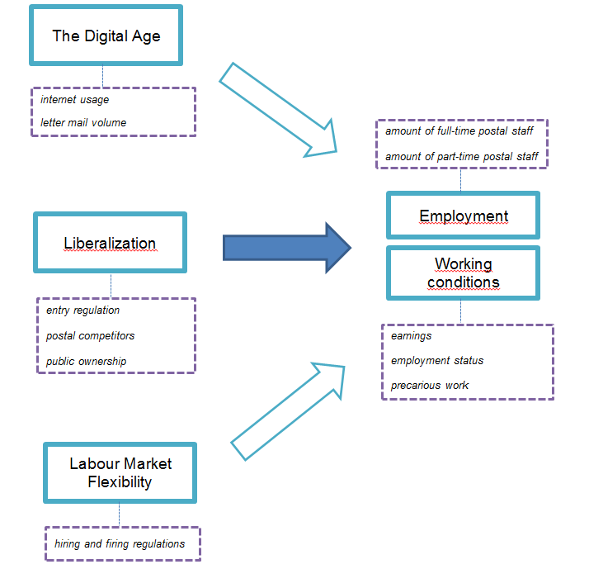

4.7 Conclusion

Based on the earlier provided explanation of the important variables of this thesis, this research can be described as factor-centric. According to Gschwend and Schimmelfennig (2007: 8), factor-centric research is primarily focussed on the explanatory power of causal factors. It aims to estimate the direction and causal effect of one or more independent variables on the dependent variable. This research contains two dependent variables, employment and working conditions, and three independent variables, liberalization, the digital age and labour market flexibility. At least in theory, the independent variables have an effect on the dependent variables.

When it comes to liberalization, entry regulation leads to market opening and more competition. This should lead to more postal competitors and a lower amount of public ownership. The causality here is, that the more competition leads to more pressure on labour costs. In order to reduce labour costs and stay competitive, there has to be when it comes to employment either a shift from full-time to part-time employment or a reduction in total employment. As for working conditions, there has to be a reduction or a lack of increase when it comes to earnings, fewer civil servants with fewer benefits are present and/or more characteristics of precarious work have to become visible.
When it comes to the digital age, the use of new, cheaper, easier and faster types of communication leads, at least in theory, to a reduction of classic forms of communication. This should, more specifically, to an increase in internet usage and a decrease in letter mail volume. The causality here is that the more characteristics of the digital age will lead to less need of postal employees. This may reduce the amount of postal workers or a shift become visible towards more part-time employment. As for working conditions, a reduction or a lack of increase when it comes to earnings is an obvious result, employment status might change and/or more characteristics of precarious work will become visible.

When it comes to labour market flexibility, the need for a more flexible market that can accommodate to changes and shocks easier and faster than the traditional labour market, should in theory lead to a low degree of hiring and firing regulations. The low degree of regulations and the high degree of flexibility affect employment and working conditions. According to the theory, the need for flexibility decreases the amount of full-time employees and a shift should become visible towards more part-time workers. Labour market flexibility can also affect working conditions, as the work will become more insecure and offers less regulatory protection, due to the lack of full-time contracts.

Besides the relationship between the earlier mentioned variables and indicators, also the reliability and validity of these concepts have been discussed. In most social science research, the reliability and validity of the variables and indicators is often questioned. This is due to the fact that the concepts used in this type of research are primarily abstract, and lack a precise and shared meaning. This creates several uncertainties with respect to the measurement of the concepts (Buttolph et al. 2005: 82). It is therefore important that the concepts are explained precisely and accurate. The earlier discussed concepts have been defined as precise and accurate as possible, in order to achieve shared agreement about their meaning. The reliability and validity of the variables and indicators have been extensively discussed in the previous paragraphs. Based on these separate examined features of reliability and validity, can be concluded that the overall measurements in this research are reliable and valid.

5. Research design

This chapter introduces the research design chosen for this thesis and the reasons for choosing this specific design. After that, the internal validity and the external validity will be mentioned. Finally, the sources and collection of data, which are already briefly discussed in the previous chapter, will be discussed thoroughly.

5.1 Co-variational design

This thesis uses the co-variational design to structure this research. According to Blatter and Haverland (2012) the co-variational analysis or co-variational design is one of the main approaches for studying small-N studies. It presents empirical evidence of the existence of co-variation to infer causality between the dependent and independent variables. One of the most important concepts of this research design is the selection of cases. In order to guarantee the internal validity of this research, it is important to not randomly select cases, as random selection may result in the use of cases that are not varying on the selected independent variable. Hence, case selection should cope with two criteria. First, the cases should be chosen based on variation with regard to the independent variable of interest. In this thesis, the independent variable of interest is liberalization, and the control variables are the digital age and labour market flexibility. The cases, the ten EU member states, are selected based on their differences in liberalization and their similarities on the two control variables. As described in the introduction, five of these ten member states were liberalized before 2011, while the other five are not liberalized yet or have liberalized in 2011. The first criteria of case selection is therefore met. Second, the cases must be similar with regard to the control variables. This criterion is also met, as the trends of the digital age and labour market flexibility are present in all countries used in this research. As these control variables are fairly similar in all countries, a comparison can easily be made. This way can the causality between postal market liberalization and more precariousness with regards to employment and working conditions be tested. To put it differently, the cases are selected by maximum variation on the concept of liberalization and minimum variation on the control variables digital age and labour market flexibility.

When choosing a research design, it is also of importance to assess the internal and external validity of the design chosen. According to de Vaus (2001: 176), internal validity refers to the unambiguous choice for one explanation over another explanation, based on the logic and structure of the design. To put it differently, internal validity refers to the cause-effect relationship between the independent variable and the dependent variable. Specifically for this thesis, the question is if liberalization has an effect on employment and working conditions. As earlier explained, this research does not randomly select cases, but the cases are selected on as much variation on the central independent variable liberalization and as little variation on the control variables digital age and labour market flexibility. The use of this ‘Most Similar Systems Design' enhances the internal validity, as the causality can be made as plausible as possible.

External validity refers to the generalization of results obtained to a wider population than the sample initially meant to represent (de Vaus, 2001: 184). The external validity of this research is rather low, as the cases are not chosen randomly. Generalization is only possible when other cases share the same characteristics and existing differences as the one used in this thesis. Moreover, this research involves only a small-N, or a limited amount of cases. The lack of external validity will limit the conclusions to the member states in this thesis and will feature only limited general conclusions on the causal effect between liberalization and employment and working conditions.

5.2 Data sources

Yin (2003: 85-86) distinguishes six major data sources: documentation, archival records, interviews, direct observations, participant-observation and physical artifacts. This thesis uses two of these data sources, namely documentation and archival records. Documentation consists mainly of formal studies, newspaper clippings, written reports of events and progress reports. Archival records consists mainly of organizational records, such as budgets, survey data and personal records. The use of documentation and archival records has several strengths. First, documentation is a stable source of data as it can be reviewed repeatedly. Second, it is an exact data source. Documentation often contains exact names, references and details of specific events. Third, documentation has a broad coverage, as it covers multiple settings and events over a long span of time. Nevertheless, the use of documentation and archival records also has some weaknesses, such as access problems and bias from the author. The use of a variety of data sources should keep these weaknesses under control.

Information sources are generally organized in two categories: primary data and secondary data. Primary sources are original materials on which other research is based. This data is in its original form, without interpretation of the researcher or other writers and are written in the time period close to the presence of the concept examined (James Cook University, 2012). The primary sources in this thesis are the statistical data collected and organized by the Universal Postal Union, EU studies, domestic studies, government documents and annual studies of the postal service providers. Secondary sources are not easily defined, as a strict distinction between primary and secondary sources, as well as secondary and tertiary sources is sometimes difficult. A very general definition of secondary sources are those data sources that simplify the process of finding and evaluating primary literature. Newspaper articles can hence be besides a primary source, also a secondary source, as it analyses and assesses certain events. Overall, secondary sources tend to reinterpret, reorganize, analyse, comment, summarize or ‘add value’ in any way to the information provided by primary literature (ibid.). The secondary sources in this research are newspaper articles and websites, which are primarily used for background information and contextual remarks.

6. Liberalization

This chapter presents the first results of this research and is devoted to the description of empirical evidence. It specifically focusses on liberalization, the first independent variable. It presents the findings regarding liberalization by assessing the earlier presented indicators, namely entry regulation, postal competitors and public ownership.

6.1 Entry regulation

The first indicator used to measure liberalization is entry regulation. Entry regulation specifically involves the presence of legal systems which allow new postal entrants. For the EU, this legal system is represented by the Postal Directive 2008/06/EC. As this research involves only EU countries, entry regulation is therefore measured by the implementation of the Postal Directive 2008/06/EC.

As of December 31st 2010, sixteen EU countries had implemented the Postal Directive 2008/06/EC. Nine of these sixteen countries are of importance in this research, namely Austria, Belgium, Denmark, Finland, Germany, Ireland, the Netherlands, Sweden and the UK. Eleven member states have an extended deadline till December 31st 2012, including Luxemburg, the last country of this research (Okholm et al., 2010a: 53). However, as noted before, not all countries opened their markets to full liberalization at the same time. Before the transposition of the EU Postal Directive, five countries had already transposed national laws to complete full liberalization. They are Finland, Germany, the Netherlands, Sweden and the UK. Table 1 shows the moment of entry regulation regarding full market opening in the member states of this thesis.

Table 1. Entry regulation in the postal sector.
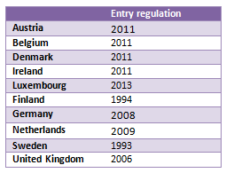

As the scope of this thesis is limited to the period 1990-2010, the countries that have fully liberalized their postal market before or at January 1st 2010 are characterized as liberalized countries. Hence, as seen in table 1, Finland, Germany, the Netherlands, Sweden and the United Kingdom fulfil these requirements. The other countries, Austria, Belgium, Denmark, Ireland and Luxembourg are characterized as non-liberalized countries.

6.2 Postal competitors

The presence of postal competitors is the second indicator used to measure liberalization. It can be described as the existence of competition on the domestic postal market. It shows the amount of market share new entrants have and therewith measures to what extent liberalization has truly lead to a competitive market. In order to do achieve a competitive postal market, postal competitors have to be competing on the entire letter market, including the former reserved area up to 50 grams.

Particularly this last note is of importance, as the reserved area for letters up to 50 grams gets lifted in the Postal Directive 2008/06/EC. This indicates that competition according to the definition of this indicator can only take place in countries that have implemented the Directive and hence have coped with the conditions set by the prior indicator. Again, these countries are Finland, Germany, the Netherlands, Sweden and the United Kingdom. Nevertheless, this does not mean that competition is absent from the other countries. For instance, the Austrian national postal operator Österreichische Post AG got some minor competition (less than 2%) on the advertising and media segment of the postal market, which included newspapers, magazines and unaddressed advertising folders, by Redmail, a joint venture of Styria Media Group and the Dutch TNT Post (Winkelmann et al., 2009: 7; Redmail, 2012). There has also been competition in Luxembourg, mainly from the national postal operators from neighbouring countries, such as Deutsche Post and La Poste (Okholm, 2010b: 163). Also was competition present on the express, parcel and cross-border markets in all countries. However, it was not possible for new competitors to enter the entire letter market, because of the legal reserved area.

The countries that used national legislation to open their postal market have lifted the reserved area much earlier. The presence of postal competitors within all segments of the postal market is therefore in these countries more likely. When assessing the first country of this research that fully opened its market to competition, Sweden, it becomes clear that there is only limited competition on the Swiss postal market. The Swiss national postal operator PostNord AB (was Posten AB) had in 2008 a market share of 89 per cent in the domestic letter market (Okholm et al., 2010b: 248). Although there were around 30 postal competitors in Sweden, the only significant competitor was Bring Citymail which had a share of around 9 per cent in the 2008 domestic letter market (PTS, 2009). The share of Bring Citymail has gone up to around 11 per cent of the total letter market in 2009 and 2010 (PTS, 2011: 13), but remains still a small source of competition for incumbent PostNord AB. In the Netherlands the situation has been stable as well. There are only two competitors for national postal operator PostNL (was TNT Post) since opening of the market, namely Sandd and Selekt Mail. Annual reports of PostNL (2009, 2010) show that in both 2009 and 2010, after fully opening the postal market, the overall market share of national postal operator PostNL remained stable at around 86 per cent. As for the United Kingdom, the domestic letter market has been fully open to competition since 2006. Ever since that time, the competition in the letter mail segment has emerged faster than expected. In 2008, there were 19 companies competing with national postal operator Royal Mail (Hooper et al., 2008: 19-20). According to the Royal Mail Group (2010: 68) these competitors had together a share of about 35 per cent of the letter market. The main element of competition for Royal Mail takes place before delivery, as competitors collect and pre-sort mail while Royal Mail performs the final sorting and delivery (Okholm et al. 2010c:31). In 2009 and 2010, Royal Mail lost even more of their market share on the letter market. About 55 per cent of the letter mail market was then in hands of the Royal Mail competitors. The most important of these competitors for Royal Mail are TNT Post, DHL and UK Mail. It appears that the German incumbent Deutsche Post AG was one of the companies most opposite to full market opening. In 2008, the year the market got actually fully opened, Deutsche Post AG implemented a sector wide minimum wage in the postal sector in order to frustrate the attempts of competitors to enter the market. This failed, and several competitors entered the letter market. TNT Post and PIN AG can be seen as two of the most important competitors on the letter market. However, the presence of these competitors has hardly affected the market share of Deutsche Post AG. In 2008 and 2009, the market share was about 88 per cent (Okholm et al., 2010b: 88; Deutsche Post AG, 2008: 53). In 2010, this market share dropped a bit to 86,6 per cent (Deutsche Post AG, 2010: 51), but Deutsche Post AG remained the largest postal operator in Germany. Nevertheless, Finland seems the largest exception of these five countries. Competition on the domestic letter market is possible for over 17 years now, but no new competitors have entered the market dominated by the national postal operator Itella Posti Oy (FICORA, 2010: 2). Table 2 summarizes the presence of the postal competitors in all countries.

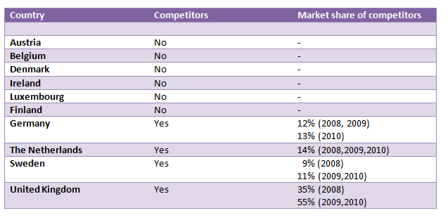
Table 2. Presence and market share of postal competitors.

Clearly, there are four countries with a competitive postal market, namely Germany, the Netherlands, Sweden and the United Kingdom. Despite Finland being one of the first countries to fully open their postal market, it shows no type of postal competition whatsoever. The United Kingdom is the country that faces the most competition, with the market share of incumbent Royal Mail decreasing rapidly from 100 per cent before market opening in 2005 to only 45 per cent in 2010. Nevertheless, also the national postal operators of the other countries show a decrease in market share. The market share of Dutch incumbent PostNL remained the most stable after full market opening with about 86 per cent. The German national postal operator Deutsche Post AG was firmly against competition, but did lose only around 13 per cent of its market share to competitors. Finally, Sweden shows the lowest loss of market share of all countries with a competitive postal market. The Swedish national postal operator PostNord AB lost about 10 per cent of their market share to its single competitor Bring Citymail.

6.3 Public ownership

The third and last indicator for liberalization is public ownership. Public ownership can be defined as the holding of company shares by the state or government. This particularly refers to the national postal operators that are still under governmental ownership. Public ownership is often seen as a contradiction towards creating a fully open liberalized postal market. It can therefore be noticed that the less public ownership in the postal sector, the more characteristics of full postal liberalization in a country.

Table 3 presents the amount of state ownership of the national postal operator in the ten EU member states. The numbers are based on data of 2010 (Okholm et al., 2010b: 32). There are six national postal operators where the state controls 100 per cent of the national postal operator’s stock: Post Danmark (Denmark), An Post (Ireland), P&T Luxembourg (Luxembourg), Itella Posti Oy (Finland), Posten AB (Sweden) and Royal Mail (United Kingdom).

Table 3. National Postal Operator and State ownership (2010).
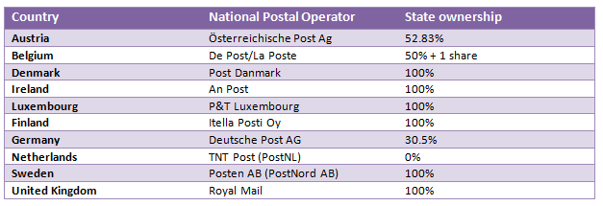

It is important to notice that despite the 100 per cent control by the state, these companies are not considered state-owned enterprises. Post Danmark, An Post, P&T Luxembourg, Itella Posti Oy and Posten AB can all be considered public limited companies, while Royal Mail is a limited company (Okholm et al., 2010b: 31-32). A public limited company (PLC) is characterized by the presence of company stocks, which can be freely traded or sold. Hence, 100 per cent state ownership means that the government owns 100 per cent of the stocks of a company. A limited company (LC) as Royal Mail differs from a public limited company as the stocks are not open to be publicly traded or sold. This transformation from state-owned enterprise towards a PLC of LC have taken place in almost all EU member states, even though this type of ownership restructuring was not part of the EU postal reform (ibid).

Besides the six EU member states that have the stocks of their national postal operator fully controlled by the state, there are four national postal companies with significant less state control. As shown in table 2, these companies are: Österreichische Post AG (Austria), De Post/La Post (Belgium), Deutsche Post AG (Germany) and TNT Post (the Netherlands). All of these countries are considered public limited companies with limited state ownership (ibid).

The less state ownership is present in the Netherlands. TNT Post (now PostNL) can be seen as a fully privatised company. It was the first to start this process of privatisation in 1989, when the Dutch postal and telecommunications administration was transformed into a private company ‘Koninklijke PTT Nederland (KPN). At that time, KPN was for 100 per cent in hands of the Dutch government. In 1994 was KPN listed on the Dutch stock market and the government sold 30 per cent of it shares in the company. A year later, they sold another 25 per cent of KPN. In 1998, KPN separated their postal and telecommunication activities and the new postal company was named TNT Post Group N.V. (TPG). This company got fully privatised in 2006, when the Dutch government sold all their shares. After the full privatisation, the company used the new name TNT N.V. (Dieke et al., 2008: 12-13). In 2011, TNT separated their mail and express services. The mail division received the new name PostNL (Spring Global Mail, 2012). It is important to notice even though privatisation is not prescribed by the European Union, this is in accordance with the aims of full postal liberalization.

As for Germany, less than a third of the shares of national postal operator Deutsche Post AG is owned by the state. The process of postal privatisation in started, just as in the Netherlands, in 1989. The German government separated the postal and telecommunications administration into three departments under control of the Post and Telecommunications Ministry. The postal department is called the Deutsche Bundespost Postdienst. In 1994, the Deutsche Bundespost Postdienst got corporatized into the joint stock company Deutsche Post AG. A year later, the company got organized under the same corporate law as a private country with the German government as the only shareholder. In 2000, the government started to reduce its ownership in Deutsche Post AG and sold 29 per cent of their shares. This gradual reduction of shares led to 31 per cent state-ownership of Deutsche Post AG when Germany fully opened the postal market in 2008 (Dieke et al., 2008: 43). Hence, it seems that the reduction of state-owned shares has stabilized since full market opening in 2008.

In contrast to the Netherlands and Germany, the governments of Austria and Belgium have both a share of more than 50 per cent in the national postal company. Starting with Belgium, national postal operator De Post/La Poste was given the statue of autonomous state company in 1991 and became independent from the Belgian state. Despite this move towards autonomy, a commission appointed by a minister from the Belgian government was responsible for controlling all activities of De Post/La Poste. Also the management contract and the financing of the company were still under state control, which suggest that the influence of the Belgian state was still high. The first real move towards privatisation began in 2000, when the company became a public limited company, but the Belgian government remained the only shareholder. It was not until 2005 that other shareholders were allowed. However, two restrictions were included in the statues of the company when it comes to ownership of De Post/La Poste. First, the Belgian government has to retain most of the shares in the national postal company. This means that De Post/La Poste will always retain for more than 50 per cent controlled by the state. Second, the state-owned shares represent more than 75 per cent of the votes and mandates in the company, even though other shareholders are present (Verhoest and Sys, 2006: 8). As shown in table 3, the Belgian government has retained their majority position with 50% of the shares plus 1 share.

When it comes to Austria, the process towards privatisation started in 1996. That year, the Post and Telegraph Administration was transformed into the private limited company Post und Telekom AG. Three years later, the postal and telecommunication administrations got separated and Österreichische Post AG was created. The Austrian government remained control over the company for 100 per cent and was controlled by the Ministry of Finance through the Austrian Industrial Holding Company (ÖIAG). The ÖIAG can be seen as a privatisation agency and holding company. It was particularly the Ministry of Finance and the ÖIAG that searched for a suitable privatisation process for Österreichische Post AG in 2002. In 2006, the Austrian government sold 49 per cent of their shares in the national postal company and remained the residual 51 per cent (Hofbauer, 2006: 10-11). The 52,8 per cent that Austrian state holding ÖIAG held in 2010 (see table 2) is due to a decrease in the total number of shares (Österreichische Post AG, 2010). Hence, the Austrian government remains the majority shareholder of Österreichische Post AG.

As noted before, public ownership is often seen as a contradiction towards creating a fully open liberalized postal market. This paragraph has shown that there are six countries which have the shares of the national postal operator completely controlled by the state. They are Denmark, Ireland, Luxembourg, Finland, Sweden and the United Kingdom. These countries contradict with the aims and values of a liberalized postal market and therefore show less characteristics of liberalization than the four countries with national postal operators not fully controlled by the state. Austria (Österreichische Post AG), Belgium (de Post/la Poste), Germany (Deutsche Post AG) and the Netherlands (TNT Post) have all national postal operators that are partly state-owned or not state-owned at all. Of these four enterprises, Österreichische Post AG is the company with the most state-owned shares. TNT N.V. (now PostNL) has the least state-owned shares, as the Dutch government has sold all their shares in the company in 2006. Austria shows therefore less characteristics of liberalization than the Netherlands, while Belgium and Germany are in between the two countries. Nevertheless, all four countries can be considered as more liberalized than the six countries earlier mentioned.

6.4 Conclusion

This chapter has examined liberalization, the first independent variable, by assessing three indicators, namely entry regulation, postal competitors and public ownership. Starting with entry regulation, research has shown that during the period 1990-2010 five of the ten countries examined in this thesis have fully implemented the Postal Directive 2008/06/EC. Sweden (1993) and Finland (1994) were the first to fully open up their postal markets, even before they were EU member states. After that, the United Kingdom (2006), Germany (2008) and the Netherlands (2009) followed. These countries are considered liberalized countries, as the implementation of the Postal Directive is one characteristic of liberalization. The other countries, Austria, Belgium, Denmark, Ireland and Luxembourg are characterized as non-liberalized countries.

The second indicator is the presence of postal competitors. An assessment of this indicator has shown that the five countries labelled as legally non-liberalized by the prior indicator, also do not have any postal competition on the domestic letter market. Furthermore, also the postal market of Finland has no postal competitors, despite having a fully opened market since 1994. The other four countries, Sweden, United Kingdom, Germany and the Netherlands, have competition present at their domestic letter markets. Measured between 2008 and 2010, the most competition is present in the United Kingdom. Competitors have taken over more than 50 per cent of the market dominated by incumbent Royal Mail. The other countries show a level of competition around 10 per cent. Based on these numbers, the United Kingdom shows the most characteristics of liberalization, as the letter market presents the most competition. Furthermore, it is important to notice that in most of the examined EU member states the national postal operator is still market leader and significant competition is hardly present.

The third and last indicator used to determine the variable liberalization is public ownership. Public ownership is considered to contradict with the aims and values of a liberalized postal market. Hence, less public ownership represents more characteristics of liberalization. Data from 2010 has shown that there are six national postal operators where the state controls 100 per cent of the national postal operator’s shares, namely Post Danmark (Denmark), An Post (Ireland), P&T Luxembourg (Luxembourg), Itella Posti Oy (Finland), Posten AB (Sweden) and Royal Mail (United Kingdom). In the other four national postal operators, government shares vary from no state ownership in TNT (the Netherlands), 30 per cent ownership in Deutsche Post AG (Germany) to over 50 per cent ownership in De Post/La Poste (Belgium) and Österreichische Post AG (Austria). Based on these numbers, the Netherlands can be considered as having the most characteristics of liberalization.

Overall can be noticed that three countries show no characteristics of liberalization whatsoever, namely Denmark, Ireland and Luxembourg. They have not implemented the Postal Directive, have a non-competitive domestic postal market and the national postal operators are fully owned by the state. The following three countries show only limited characteristics of liberalization. Austria and Belgium have not implemented the Postal Directive, nor do they have a competitive postal market. They do, however, have limited state ownership of the national postal operator and show therefore one characteristic of liberalization. Also Finland shows a liberalization characteristic, as it has implemented the Postal Directive 2008/06/EC, but lacks postal competition and its national postal operator is still fully controlled by the state. Furthermore, the United Kingdom and Sweden show two characteristics of liberalization, as they both have implemented the Postal Directive and have a competitive domestic postal market. The two countries left, the Netherlands and Germany, can be considered as fully liberalized. Indeed all characteristics of liberalization are present in these postal markets.

7. The Digital Age

This chapter presents the empirical evidence of the second independent and control variable: the digital age. The findings with regards to this variable are based on the assessment of the indicators which are set out in chapter 4, namely internet usage and letter mail volume.

7.1 Internet usage

The first indicator used to measure the digital age is internet usage. This can be described as the number of people that have access to the internet. As most indicators, internet usage is measured between 1990 and 2010, and is in order to increase comparability between nations expressed in percentages of the population. The higher the percentage of internet users in a country, the higher the presence of the digital age in that country.

Figure 2 presents a summary of the internet usage in the ten EU member states of this thesis measured between 1990 and 2010. The figure shows that internet usage has increased strongly in all countries, especially during the period 2000-2010. The Netherlands, Luxembourg, Sweden and Denmark show the highest percentage of internet users with respectively 90.7 per cent, 90.08 per cent, 90.02 per cent and 88.77 per cent in 2010. These results may be no surprise for the Netherlands and Sweden, as they were back in 1990 already among the highest percentage of internet users in the ten countries of this thesis. Luxembourg and Denmark, however, show one of the lowest percentages of internet usage in the early 1990s. It was not until the early 2000s before a strong, but equable increase became visible in these countries.

On the contrary, Ireland, Austria and Belgium show the lowest percentage of internet usage in their countries with respectively, 69.77 per cent, 72.73 per cent and 73.73 per cent in 2010. Especially during the period 2002-2010 these countries seem to have fallen behind the rest of the countries. The relatively low percentage of Belgium seems to be due to a more gradual period of increasing internet usage between 2003 and 2007, after a strong increase in the years before that. Austria appears to be suffering from a decrease in internet users in 2001 and 2002, as well as a period of stagnation from 2007 to 2010. Ireland seems to be completely fallen behind on the internet usage with respect to the other countries, but shows nevertheless a relatively stable increase between 1990 and 2010. The other countries, Finland, Germany and the United Kingdom, show also a relatively stable increase in the percentage of internet usage and are close to the four countries with the highest scores.

Figure 2 presents an overall stable and strong increase in the amount of internet users between 1990 and 2010. The Netherlands, Luxembourg, Sweden and Denmark show the highest percentage of internet usage in their country and present therefore an important characteristic of the digital age. As Ireland, Austria and Belgium are falling behind on this percentage, they show less presence of the digital age in their countries.

Figure 2. Internet usage as a percentage of the population (1990-2010).

7.2 Letter mail volume

The second and last indicator used to determine the digital age is letter mail volume. Letter mail volume can be described as the amount of letter post processed per year. The digital age often leads to new types of communication. This is assumed to have a negative effect on the amount of letter post sent every year. Hence, declining letter mail volumes indicate a rising digital age.

Table 4 presents the total amount of letter mail volume between 1990 and 2010 in the ten EU member states of this research. At first sight, the numbers of Luxembourg stand out. The country shows only a small increase of 20 per cent over the past twenty years when it comes to the amount of letter mail, while the last indicator has shown that the internet usage has increased vastly during the same period. This indicates that the claim that more internet usage has a negative effect on the amount of letter mail is not true in this case. When examining the other countries, quite some differences become visible. Ireland shows an increase of the number of letter mail items. Between 1991 and 2010, this increase is almost 54 per cent. This increase is very gradual and the data shows hence no extraordinary numbers. Austria shows an increase during the period 1990-2010 of 113 per cent. This increase is however less gradual than in Ireland. Particularly between 2006 and 2010 letter mail volume increased significantly, with about 46 per cent. Also Germany shows also an increase in the number of letter mail items. Between 1990 and 2010, letter mail volume had grown with 30 per cent. However, both 2009 and 2010 show some decline, which may suggest a decreasing trend in the number of letter mail items. The same goes for the United Kingdom. Mail volume has increased during the period 1990-2010 with about 25 per cent. Nevertheless, between 2007 and 2010, a decline is visible. This may also suggest that letter mail volumes may drop even further in the years to come.

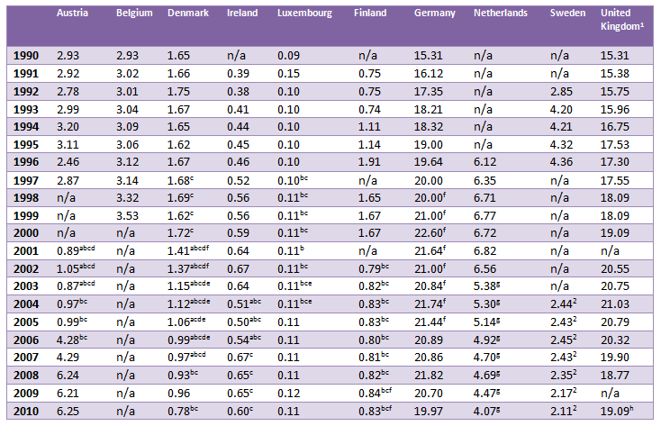
Table 4. Number of domestic letter mail items in billions (1990-2010).

Source: (UPU Database)
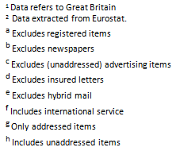



Belgium and Finland show an increase as well. However, due to the missing data for Belgium between 2000 and 2010, this data cannot be used properly, especially as the digital age has strongly evolved during these years. The reliability of the data for Finland is also difficult to determine, as the total increase in letter mail volume between 1991 and 2010 of about 10 per cent may very well be due to the exclusion of newspapers and advertising items during the period 2002-2010. Hence, the data for Belgium and Finland are considered as not reliable and this indicator will therefore not be used to determine the digital age in these countries.

The Netherlands shows a decrease in the number of letter mail items. The total decline between 1996 and 2010 is 33 per cent. Table 3 shows a gradual decline of the Dutch letter mail volume from 2002 onwards. Before that time, the total amount of letter mail was still rising. However, it is important to notice that the data for the period 2003-2010 only includes addressed items. This may affect the outcomes and makes it less reliable when comparing data from this period with data from before 2003, which includes all letter mail items. Hence, also data for the Netherlands will not be used to determine the digital age in this country.

On the contrary, Denmark and Sweden show a more reliable decrease in the number of letter mail items. Starting with Denmark, a steady decline in the letter mail volume is visible. Nevertheless, as also these numbers are affected by some excluded items, data from 1990 and 2009 are being compared. This comparison shows that the total decline is about 42 per cent. Data for Sweden shows an increase in letter mail volume during the period 1992-1996, while between 2004 and 2010 the number of letter mail items has declined. Between these two periods, no information is available. The total decline between 1992 and 2010 is 26 per cent.

Based on the information provided in table 4 can be noted that most of the ten countries of this thesis show an increase in the total letter mail volume. Luxembourg, Germany and the United Kingdom are the first countries that show an increase with respectively, 22 per cent, 25 per cent and 30 per cent. Ireland shows an even larger increase with 54 per cent, while Austria’s letter mail volume has increased tremendously with 113 per cent during the period 1990-2010. It is important to note that Ireland and Austria were also among the countries with the smallest growth in internet usage. Decreasing mail volumes were found in Denmark and Sweden. For Denmark the decline was about 42 per cent, while Sweden showed with 26 per cent a smaller decline in letter mail volume. Data for Belgium, Finland and the Netherlands seemed not reliable enough to be used in this research.

7.3 Conclusion

This chapter has examined the second independent variable of this research, the digital age, by assessing two indicators, namely internet usage and letter mail volume. Starting with internet usage, data on this indicator has shown that in all ten countries internet usage has grown fast. Particularly during the period 2000-2010 internet usage increased fast. The Netherlands, Luxembourg, Sweden and Denmark show the highest percentage of internet users in 2010, while, on the contrary, Ireland, Austria and Belgium show the lowest percentage of internet usage in the same year. As the more internet usage in a country reflects an important characteristic of the digital age, this indicates that in the Netherlands, Luxembourg, Sweden and Denmark the digital age is more present than in Ireland, Austria and Belgium.

The second examined indicator is letter mail volume. An assessment of this indicator has shown some differences between countries. An increase in the number of letter mail items was visible in Luxembourg, Germany, the United Kingdom, Ireland and Austria. Particularly the numbers for Austria stood out, as they showed an increase of 113 per cent in letter mail volume between 1990 and 2010. On the other hand, Denmark and Sweden showed both a decline in letter mail volume for the same period. Data for Belgium, Finland and the Netherlands are considered as unreliable and therefore data on the number of letter mail items is not used to assess the digital age in these countries.

Based on the assessment of these two indicators can be concluded that Sweden and Denmark score the most characteristics of the digital age, as both countries have a high percentage of internet usage in their country and experience declining letter mail volumes. Austria and Ireland have the least characteristics of the digital age, as both countries are among the countries with the lowest internet usage and have increasing letter mail volumes. The other countries are in the middle. Luxembourg, Germany and the United Kingdom show average in internet usage and letter mail volume. Belgium, Finland and the Netherlands are only judged on their scores for internet usage. Hence, Belgium is among the countries with the lowest internet usage and shows therefore few characteristics of the digital age. Finland and the Netherlands, however, show very high rates of internet usage. This indicates that the digital age is very present in these countries.

8. Labour market flexibility

This chapter presents the third and last independent and control variable of this research, namely labour market flexibility. In order to measure labour market flexibility, the single indicator hiring and firing regulations is examined.

8.1 Hiring and firing regulations

The indicator used to assess labour market flexibility is hiring and firing regulations. This concept involves how the hiring and firing of employees is regulated. The dataset used for this indicator is based on the question: “The hiring and firing of workers is impeded by regulations (= 1) or flexibly determined by employers (= 7).” While this original data is on a 1 to 7 scale, all of the components used in table 4 are on a 0-10 scale. Hence, the original data is transformed into a 0 to 10 scale, using the standard formula: (x-1)/6*10, where x is the original data with the 1 to 7 ranking.

Figure 3 presents the domestic hiring and firing regulations in 1990 and 1995 separately and the more recent period 2000-2009. There are quite some differences visible between countries and within countries, as the domestic hiring and firing regulations have changed over time. Hence, all countries will be first discussed individually, after which they will get compared with each other.

Starting with Austria, the numbers of this country differ slightly over time, but remain focused around 4. In 1990 and 1995, no differences are visible. The number remains stable at 4.8, the highest of the entire period 1990-2009. This number indicates that there is a certain balance between regulations and flexibility for employers. During the period 2000-2009, the numbers increase slightly, but remain stable at around 4. It is therefore fair to conclude that there is a domestic trend in favour of regulation.

As for Belgium, the data shows a more fluctuated chart. In 1990, 1995 and 2000, a relatively stable trend towards regulation is visible. In 2002, the hiring and firing of workers is even further regulated with a score of 1.5. This number increases towards around 3 again in the following years, but overall the Belgian trend shows fairly regulated hiring and firing practices. Also Sweden shows a bit more fluctuation in the chart. Overall can be seen that regulation has been very important. This has been particularly the case between 2000 and 2006, when scores were below 3. During the 1990s, the scores were at their highest with 3.9 and also during the period 2007-2009 scores increased a bit. Nevertheless, the hiring and firing of workers in Sweden is still very much impeded by regulations.

On the contrary, Denmark shows a chart with much higher numbers. This indicates that the hiring and firing of employees is very flexible. Despite a slight move towards more regulation during the period 2000-2006, flexibility remains very important. Both in 1990 and 1995, as well as between 2007-2009, the score for Denmark is 8 or above. Data for Finland shows also a trend towards more flexibility for employers to determine hiring and firing practices, even though the Finnish scores are way below the Danish scores. In the 1990s, the hiring and firing of workers was primarily impeded by regulations, as the score of 3.9 shows. In the 2000s scores went up to 4 and above towards 5, which indicates that recently there has been a trend towards more flexibility for the employer. This has led to almost a balance between regulation and flexibility.

Figure 3. Scores of hiring and firing regulations (1990-2010)
Source: (Economic Freedom of the World report 2011)

The hiring and firing of Irish employees have become more dominated by regulations between 1990 and 2009. Ireland starts in the 1990s with a score of 5.5, which indicates that there is a balance between regulations and flexibility for employers, with a slightly trend towards flexible hiring and firing practices. During the 2000s this score has dropped and it is fair to say that there has been a move towards more regulation. The United Kingdom presents also an increase in the number of regulations during the period 1990-2009. In 1990 and 1995 the employer had the most flexibility of hiring and firing policies of all countries examined with scores of 7.4. However, during the 2000s these scores decreased, leaving a score of 5.4 in 2009. It can therefore be stated that in the United Kingdom, regulations have become more important during the 2000s.

Also for Luxembourg the scores have decreased somewhat. After remaining fairly stable above a score of 4 in the 1990s and the early 2000s, scores decreased towards more regulation for the hiring and firing of employees, particularly between 2004 and 2009. Germany shows a decreasing chart as well, which shows the importance of regulation in the country. Already in the 1990s, the hiring and firing of employees was impeded by regulations. The early 2000s show nevertheless a strong decrease with a score of around 1.5. During the period 2003-2009 the scores have increase slightly, but regulations remain the most important step when handling hiring and firing practices.
As for the Netherlands, despite a slight increase visible during the period 1990-2009, the trend has always been towards regulation, with scores varying from 2.6 to 3.7. However, 2009 shows one of the highest scores, which indicates that there might be a turning point towards a more flexible hiring and firing of workers in the country determined by the employer. This may indicate that more flexibility for the employer could be possible soon.

Based on this individual analysis can be noted that there is only Denmark is dominated by flexibility for the employer. All other countries have scores below or around five, which indicate that regulation is by far most important when it comes to the hiring and firing of workers. Nevertheless, the scores have changed in all countries between 1990-2009. Most of the countries show scores that have decreased with more than 0.5, including Austria, Belgium, Ireland, Luxembourg, Germany, Sweden and the United Kingdom. Nevertheless, the United Kingdom and Ireland are presenting some of the highest scores in 2009. Denmark shows only a small decrease of 0.1 between 1990 and 2009, while the scores of Finland and the Netherlands have increased and these two countries are the only countries in which the hiring and firing of employees has become more flexible.

8.2 Conclusion

This chapter has examined the variable labour market flexibility by assessing the indicator hiring and firing regulations. Research on this indicator has shown that the hiring and firing of workers in the majority of the countries is still very much impeded by regulations. The majority of the countries examined score below or around five, which shows that regulations are still very important. Only Denmark presents flexibility for the employer as the dominant view considering the hiring and firing of workers. During the period 1990-2009, the majority of the countries show scores that have decreased with more than 0.5, including Austria, Belgium, Ireland, Luxembourg, Germany, Sweden and the United Kingdom. This indicates that regulations are not only important when comparing countries, also within countries regulations have become more important over time. Finland and the Netherlands are the two exceptions, as these countries present a trend towards more flexibility. This is particularly the case in Finland, where scores have increased with almost one point.

Based on this assessment can be concluded that the labour market is most flexible in Denmark. This country scores way above the other nine countries of this research. The United Kingdom, Ireland and Finland score around 5 and balance between regulation and flexibility. However, out of these three countries only Finland present an increase in the amount of flexibility. Hence, Finland is moving towards a more flexible labour market, while other countries stay behind. Particularly Germany, Sweden and Belgium have the hiring and firing of workers strictly impeded by regulations. This indicates that labour market flexibility is fairly low in these countries.

9. Employment in the postal sector

This chapter presents the results of the first dependent variable, employment, and states the employment trends in the ten countries of this research between 1990 and 2010. Furthermore, it provides an explanatory analysis of these trends, based on the earlier provided empirical evidence of the independent variables liberalization, digital age and labour market flexibility. The results presented in this chapter will be used later in this research to specifically answer the main research question and test the three hypotheses.

9.1 Developments in postal sector employment

To assess employment in the postal sector, two indicators are used. The number of full-time employees in the postal sector and the number of part-time employees in the postal sector are used to assess the developments in postal sector employment. Table 5 reports the evidence concerning the first indicator for this variable, namely the number of full-time employees in the postal sector. The findings are presented per year, between 1990 and 2010.

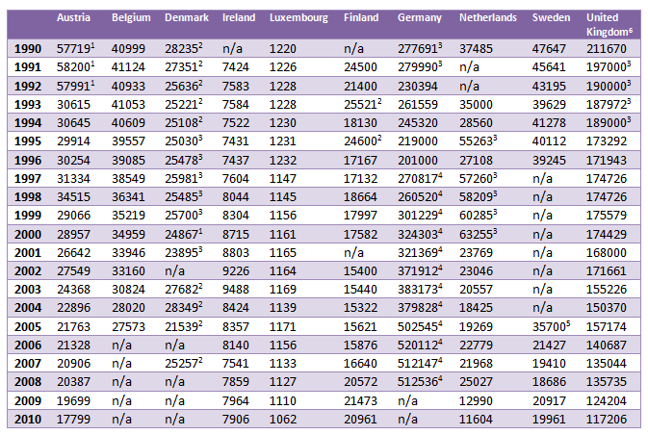
Table 5. The number of full-time employees in the postal sector (1990-2010).

Source: (UPU Database)

Table 5 shows that in all countries, except Ireland and Germany, the amount of full-time staff in the postal sector has decreased between 1990 and 2010. Austria, Belgium and Luxembourg show a relatively stable diminution of the amount of full-time postal employees. Denmark presents a slightly more fluctuated figure, with a relatively stable number of employees in the 1990s, a decrease in 2000-2001 and an increase in 2003-2004, followed by another decrease in the year after. However, all numbers for Denmark include part-time staff, which may influence the results and the comparability. Ireland is the only non-liberalized country that shows a slight increase in the total amount of full-time employees in the postal sector, despite an eight year decrease after the employment peak in 2002. As for the liberalized countries, both Sweden and the UK show a stable decrease of the amount of full-time postal employees. Finland shows strong fluctuation between 1990 and 1995, after which a decrease is present until 2007, which is followed by an increase until 2010. However, despite this recent increase, the overall trend in Finland shows a decrease of the amount of full-time postal sector employees. Also the Netherlands shows strong fluctuations before having a liberalized postal sector, but after liberalizing its postal sector in 2009 a strong decrease of the amount of full-time employees becomes visible. Germany can be seen as the exception, as it is the only liberalized country with a large increase in the number of postal sector employees. Until 1998 some fluctuations are visible, after which a strong increase is noticeable. Particularly after 2004 the amount of staff has increased significantly. According to the UPU database, this is partially due to acquisitions. However, just like Denmark, all numbers for Germany include part-time staff, which may influence the results and the comparability.

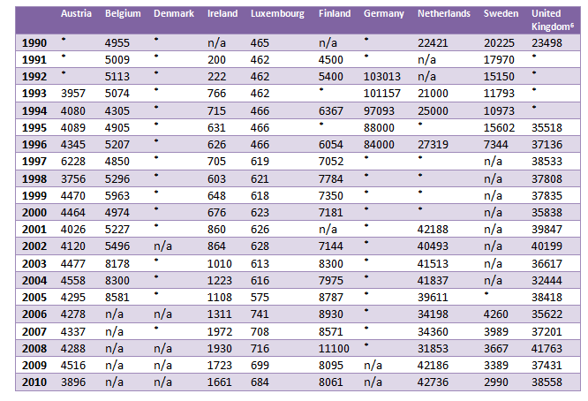
Table 6. The number of part-time employees in the postal sector (1990-2010).


Source: (UPU Database)
Table 6 and table 7 show the results of the second indicator used to measure postal sector employment, namely the number of part-time staff in the postal sector. Table 6 presents the amount of part-time postal workers as an absolute number, while table 7 gives an overview of part-time employment as a percentage of total employment. The total amount of postal employees in absolute numbers can be found in table 8.

For the legally non-liberalized countries, table 6 shows that both Ireland and Luxembourg show a gradual increase in the number of part-time postal employees. Both countries also show a minor diminution in the number of part-time employees after 2008. Belgium shows a more fluctuated trend, but the amount of part-time postal workers increased suddenly fast after 2002. Austria shows a rather stable trend, although there are some minor fluctuations. Only in 1997 the amount of part-time employees is suddenly very high, but this seems a single outlier. As for the liberalized countries, Finland, the Netherlands and the United Kingdom show fluctuation in the results leading to an overall increase in the amount of part-time employees in the postal sector. However, after 2008, the Netherlands shows a strong increase in the number of part-timers, while in Finland and United Kingdom this number actually drops. Sweden seems the exception, as the number of part-time postal workers decreased with more than 85 per cent during the period 1990-2010.

Table 7 shows that the share of part-time postal employment as a share of total employment in the postal sector increases in all countries, besides Germany and Sweden. Between 1990 and 2010 decreases the amount of part-time workers as a share of total employment with over 56 per cent. Data on Germany is only available between 1992 and 1996 and shows a relatively small decrease of 4.6 per cent. However, it is not possible to say anything about part-time employment more recently.

Table 7. Part-time postal employment as a share of total employment in the postal sector (1990-2010).
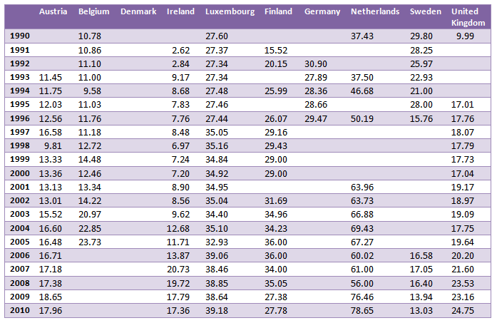

The tables show also that Denmark has not made a distinction in full-time and part-time postal sector employees. Data for Germany is very limited, as no numbers are available for the last ten years. To increase comparability, table 6 shows the total number of employees in the postal sector. Furthermore, table 7 provides an insight in the percentage change of the total amount of postal sector employees during the period 1990-2010 for all countries involved.

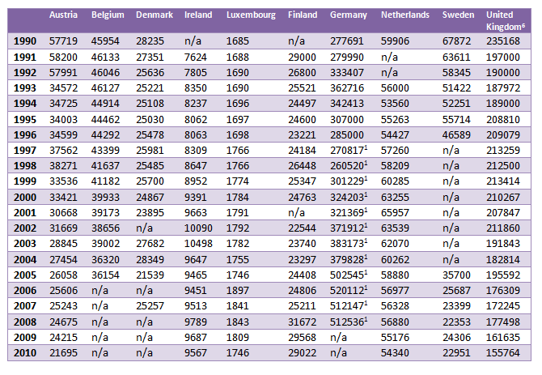
Table 8. The total number of employees in the postal sector (1990-2010).


Source: (UPU Database)

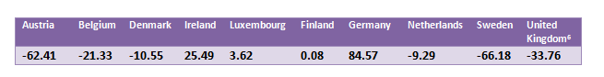
Table 9. The percentage change of the total number of employees in the postal sector (1990-2010).

Table 8 and table 9 show that there are large differences between the ten countries when it comes to postal sector employment. Sweden and Austria show the largest decrease in postal sector employment, while particularly Germany shows a strong increase in the number of postal employees. The following paragraph aims to explain these different trends between single countries and more general between the liberalized and non-liberalized countries. The earlier presented results regarding the independent variables, liberalization, the digital age and labour market flexibility, are used for this explanatory analysis.

9.2 Analysis of the results

The previous paragraph has presented the results for the first dependent variable ‘employment’, using the number of full-time and part-time employees in the postal sector between 1990 and 2010 as indicators. The results vary significantly between countries and this paragraph aims to assess to what extent liberalization, the digital age and labour market flexibility have affected postal sector employment.

9.2.1 Effect of liberalization on postal employment
The first explanation for the changes in postal sector employment can be liberalization. The assessment of the three indicators, entry regulation, the presence of postal competitors and public ownership, in chapter 6 showed that not all elements of liberalization were present in the ten EU countries of this research. These differences between countries regarding liberalization may explain the differences in postal employment. Hence, this sub-paragraph features a comparison between the presence of characteristics of liberalization and developments in employment.

The first indicator of liberalization is entry regulation. The implementation of a European policy framework for postal services, the Postal Directive 2008/06/EC, ensures legally full liberalization of the postal sector. According to the theory, entry regulation leads to a liberalized market that is open to competition. This should lead to more postal competitors and a lower amount of public ownership. More competition leads to more pressure on labour costs. In order to reduce labour costs and stay competitive, it is necessary to shift from full-time to part-time employment, with fewer benefits for employees and costs for employers, or to reduce total employment. This indicator has been used to assess whether a country can be classified as liberalized. Based on this assessment, Finland, Germany, the Netherlands, Sweden and the United Kingdom are considered liberalized countries. These countries have all implemented the Postal Directive before 2010. However, before it is possible to determine whether liberalization affected postal sector employment, it is necessary to assess the other two indicators, the presence of postal competitors and public ownership. The presence of postal competitors indicates if the aim of liberalization to introduce competition in the postal market has succeeded. The third and last indicator is public ownership. According to the theory is less public ownership a sign of more liberalization.

Figure 4 presents the characteristics of liberalization present in the ten member states of this research, compared to the percentage change of total postal employment between 1990 and 2010. Based on this figure, three countries present no characteristics of liberalization, namely Denmark Ireland and Luxembourg. Austria, Belgium and Finland all have one characteristic of liberalization, while Sweden and the United Kingdom show two characteristics. Finally, the last two countries, Germany and the Netherlands, show all liberalization characteristics.

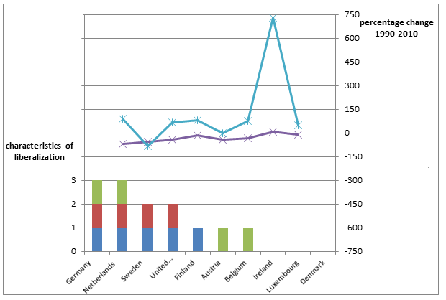
Figure 4. The percentage change of employment in the postal sector compared to the characteristics of liberalization (1990-2010)
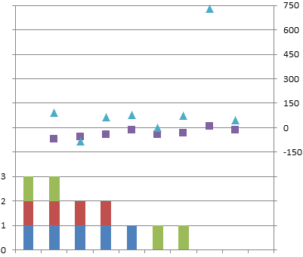



According to the reasoning in the theory, the more characteristics of liberalization should lead to decreasing employment in the postal sector. This means that the two countries with all characteristics of liberalization present, Germany and the Netherlands, should have the biggest decreasing amount of postal employees. The figure shows that this is not the case for the Netherlands. For Germany, no data was present for full-time and part-time employment, but according to the results in the previous paragraph, total employment has increased significantly. This country shows hence results opposite to the theory. Instead of decreasing employment, employment has increased. Sweden and the United Kingdom present with two characteristics of liberalization. However, Sweden presents a decrease in both full-time and part-time employment, while in the United Kingdom only full-time employment declines. These decreases are even higher than in the Netherlands, despite having all characteristics of liberalization present. This indicates that the more characteristics of liberalization do not lead to higher decreases in full-time employment, nor higher increases in part-time employment.

Overall can be stated, based on the evidence presented in figure 4, that the more characteristics of liberalization does not lead to a decrease, or more precariousness, in employment.

9.2.2 Effect of the digital age on postal employment
A second explanation for the changes in postal employment can be found in the digital age. The assessment of the two indicators, internet usage and letter mail volume, has shown some differences between countries, which can explain the changes in postal sector employment. This sub-paragraph is therefore dedicated to analyse the relationship between the digital age and developments in postal employment.

The two indicators of the digital age are internet usage and letter mail volume. The examination of these indicators has shown that internet usage increased in all countries, particularly between 2000 and 2010. However, there are some differences in the percentage changes of internet usage between countries. As for letter mail volume, differences are even bigger. The same goes for employment. Hence, figure 5 compares the percentage changes of internet usage, letter mail volume and postal sector employment.

Figure 5. The percentage change of internet usage, letter mail volume and employment in the postal sector (1990-2010)
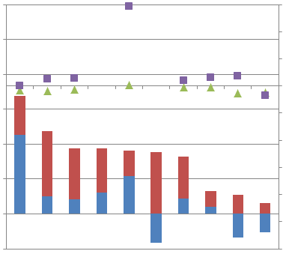
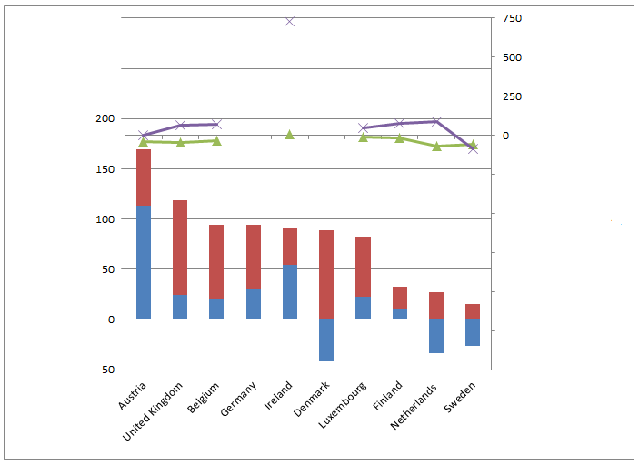

According to the theory, the availability of the digital age should lead to increasing internet usage. This increase should lead to a decrease in letter mail volume, which would result in less employment in the postal sector. This indicates that the bigger the increase in internet usage, the bigger the decrease in letter mail volume should be, and postal employment should be declining along with this trend.

Starting with Denmark, this country presents a high increase in internet usage and a high decrease in the number of letter mail. As there is no information available on full-time and part-time employment, it is not possible to relate this development to full-time and part-time employment. However, the previous paragraph has shown that total employment has decreased with 10.55 per cent. It is therefore very well possible that the digital age has influenced the developments in Danish postal employment. Also the Netherlands and Sweden show results in coherence with the theory. The Netherlands and Sweden have relatively low increases in internet usage and declining letter mail volumes. This results in declining postal employment. For Sweden this number is larger than in the Netherlands. This is mainly due to the high amount of part-time employees in the Dutch postal sector. The relatively low increase in internet usage may seem as incoherent with the theory, but this relatively low number may be enough to cause the decline in letter mail volume.

The other countries show quite different results. Austria shows an average increase in internet usage, but also a high increase in the number of letter mail. Even though both full-time and part-time employment show a decline, it is not very likely that this is caused by the digital age, as the increase in internet usage and the high increase in letter mail volume are signs that the digital age has not affected the postal sector much in Austria. Belgium shows quite similar results on the digital age. Internet usage increased significantly, but also letter mail volume increased between 1990 and 2010. However, full-time employment decreased, while part-time employment increased. There is a shift towards part-time employment, but is not likely that this is caused by the digital age, as the number of letter mail has grown. Ireland and Luxembourg also present increasing letter mail volumes. Ireland shows a relatively small increase in internet usage. This indicates that the digital age is not very present in Ireland, which could very well explain the increase in letter mail volume. This may have resulted in an increase in the number of, particularly part-time, postal employees. Luxembourg shows an average increase in internet usage and a small increase in letter mail volume. These increases could have caused the small increase in total employment between 1990 and 2010. Numbers for Finland show that the internet usage in the country has increased relatively low, while letter mail volume has increased a bit as well during the same period. This may have caused the increase in employment, but this is obviously not in coherence with the reasoning in the theory. Germany presents increasing internet usage and letter mail volumes, which results in a high increase in postal employment. According to the theory, increasing internet usage should lead to decreasing letter mail volume. This is not the case, however, the increasing in letter mail volume of 30.44 per cent can also not explain the increase of 84.57 per cent in total employment. Hence, the digital age cannot explain the differences in German postal employment. The United Kingdom shows the highest increase in internet usage of all countries of this research. Nevertheless, also letter mail volume have increased. As the high increase in internet usage has not caused a decrease in the number of letter mail volume, it is unlikely that the digital age can explain the fact that overall postal employment in the UK has decreased with over 33 per cent.

Overall can be noted that the digital age can in most cases not explain the differences in postal sector employment and that therefore the effects of the digital age on postal sector employment are small. Only the figures of the Netherlands and Sweden seem in coherence with the reasoning of the theory. As data for Denmark is not specified, is not possible to examine the relationship between the digital age and postal employment thoroughly. However, it is likely that the increase in internet usage may have caused the decrease of letter mail volume, which resulted in a decrease of total postal employment.

9.2.3 Effect of labour market flexibility on postal employment
A third and last explanation for the changes in postal employment can be found in labour market flexibility. The assessment of the indicator of this variable, hiring and firing regulations, has shown that regulations are still very common, even though some differences between individual countries are visible. This sub-paragraph is therefore dedicated to analyse the relationship between the labour market flexibility and developments in postal employment.

The presence of labour market flexibility represents more flexibility for the employer regarding the hiring and firing of workers. According to the theory, the need for flexibility decreases the amount of full-time employees and a shift should become visible towards more part-time workers. An increase in labour market flexibility should therefore lead to an increase in part-time employment.

Labour market flexibility is measured using the indicator hiring and firing regulations. The examination of this indicator in chapter 8 has shown the importance of regulations in the postal sector. Figure 6 presents the developments in hiring and firing regulations and compares these developments with changes in postal sector employment. An increase in flexibility is visible when the percentage change of hiring and firing regulations is above zero per cent. The reasoning in the theory assumes that the bigger the increase in the flexibility regarding the hiring and firing of workers, the bigger the decrease in full-time employment and the bigger the increase in part-time employment.

When examining the hiring and firing regulations in figure 6, it becomes clear that in almost all countries flexibility has decreased and regulations have become more important. Only in the Netherlands and Finland have hiring and firing regulations become more flexible between 1990 and 2009. The Netherlands shows an increase in flexibility of 8.82 per cent. During the same period, full-time employment decreased with 69.04 per cent, while part-time employment increased significantly with 90.61 per cent. This is coherent to the reasoning of the theory and indicates that it is very likely that labour market flexibility has affected postal employment in the Netherlands. Finland presents similar results. Flexibility has increased with 23.08 per cent between 1990 and 2009. During the same period, full-time employment decreased with 14.44 per cent. Part-time employment increased with 79.13 per cent. Hence, also Finland follows the reasoning in the theory.

Figure 6. The percentage change of hiring and firing regulations compared to full-time and part-time employment in the postal sector (1990-2010)

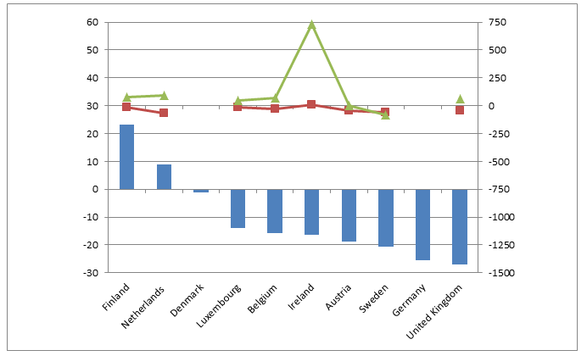
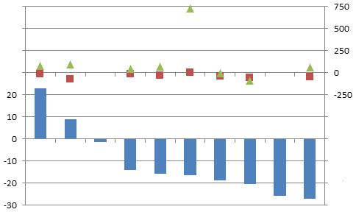



In the other countries, the labour market has become less flexible between 1990 and 2010. Denmark appears to be the country that has the least decrease in flexibility, but as data on full-time and part-time employees is not specified, it is not possible to assess the effects of this small change in hiring and firing regulations. The other countries show a trend towards more regulation, as flexibility in these countries decreased significantly. Belgium, Luxembourg and the United Kingdom present an increase in part-time employment and a decrease in full-time employment just like the Netherlands and Finland. Nevertheless, labour market flexibility decreased considerably, which makes it very unlikely that any increase in part-time employment combined with a decrease in full-time employment can be linked to labour market flexibility.

Overall can be noted that labour market flexibility cannot explain the differences in postal sector employment. Therefore, the effects of the digital age on postal sector employment are small. Only the figures of the Netherlands and Finland seem in coherence with the reasoning of the theory.

9.2.4 Effect of the independent variables on postal employment
The examination of the developments in part-time and full-time employment has shown that most countries present a decrease in full-time employment and an increase in part-time employment. The different sub-chapters have assessed to what extent the independent variables liberalization, the digital age and labour market flexibility have affected postal employment. Table 10 presents a summary of the results.

Countries with both a decrease in full-time employment and an increase in part-time employment are considered as presenting precariousness in employment. The reasons for this shift can be the need to reduce labour costs and stay competitive (liberalization), the less need of postal employees due to digitalization (the digital age) or the need for more flexibility (labour market flexibility).

Table 10. Summary of the effects of the independent variables liberalization, the digital age and labour market flexibility on postal employment (1990-2010).

 | Extent of liberalization | Extent of digital age | Extent of flexibility | Decrease of full-time employment | Increase of part-time employment
Austria | Medium | Medium | Low | Yes | No
Belgium | Medium | Medium | Low | Yes | Yes
Denmark | Low | High | Low | n/a | n/a
Ireland | Low | Medium | Low | No | Yes
Luxembourg | Low | Medium | Low | Yes | Yes
Finland | Medium | Medium | High | Yes | Yes
Germany | High | Medium | Low | n/a | n/a
Netherlands | High | High | High | Yes | Yes
Sweden | Medium | High | Low | Yes | No
United Kingdom | Medium | Medium | Low | Yes | Yes

Countries are considered highly liberalized with all characteristics of liberalization present. Medium reflects one or two characteristics and low reflects no characteristics of liberalization.
Countries are considered to score high on the digital age when internet usage increases and letter mail volume decreases. Medium reflects an increase in both internet usage and letter mail volume.
Countries are considered to have a highly flexible labour market when regulations have become less important. A low extent of flexibility reflects the trend towards more regulations.

Starting with liberalization, a decrease in full-time employment and an increase in part-time employment is visible in countries with a low, medium and high extent of liberalization. Liberalization can therefore not explain precariousness in postal employment.

As for the digital age, a decrease in full-time employment and an increase in part-time employment is visible is countries with both a medium and high extent of the digital age. It is therefore unlikely that the digital age can explain precariousness in postal employment.

As for labour market flexibility, a decrease in full-time employment and an increase in part-time employment is visible in countries with both labour markets that have a high extent of flexibility and labour markets with a low extent of flexibility. Therefore, also labour market flexibility cannot explain precariousness in postal employment.

10. Working conditions in the postal sector

This chapter presents the results of the second dependent variable, working conditions. The variable working conditions focuses on the working environment and the terms and conditions of employment. This variable is also are measured between 1990 and 2010. Moreover, this chapter provides an explanatory analysis of the development in working conditions, based on the earlier provided empirical evidence of the independent variables liberalization, digital age and labour market flexibility. These results will be used later on in this research to answer the main research question and test the hypotheses.

10.1 Developments in postal sector working conditions

To assess working conditions in the postal sector, three indicators are used. First, earnings are examined. Table 11 reports the evidence concerning this first indicator for working conditions. The findings are presented per year, between 1990 and 2010. The other two indicators are employment status and precarious work. Evidence for these indicators is presented in table 12 and table 13.

The data on earnings is very fragmented, as there is not an universal source for all EU member states that collects the average wage of postmen. This indicator is therefore suffering from missing data or differences in measurement. Unless stated otherwise, data represents the number generated from the Universal Postal Provider.

Starting with Austria, the ILO has collected data on postmen earnings between 1990 and 2001. The numbers present a steady increase in the average hourly wage of a postman. The next number available is from 2007, which shows that the minimum wage is €9,50. This indicates, based on the increase in the hourly wages the years before, that the average hourly wage is even higher. Also Belgium shows a minimum wage of €9,50 in 2007, but because of missing data it is not possible to link this number to any previous trends. The minimum hourly wage of a postman in the other countries is however significantly higher. Particularly Ireland and Luxembourg have high hourly wages with respectively €21,80 and €33,00 in 2009. According to Okholm et al. (2010a: 158) this is due to the relatively high share of civil servants. As no more data on postman earnings is available for Ireland, this average hourly wage cannot be compared to previous numbers. Luxembourg, on the other hand, has some more data available. The numbers for 1995, 2002 and 2009 present an increase in the average hourly wage. Specifically between 2002 and 2009 this number rose significantly with 61 per cent. The Netherlands presents an average hourly wage of €15,00 in 2009. However, according to Okholm et al. (2010c: 161), Dutch incumbent TNT Post has different contract types with different minimum wages. The TNT Post postal worker, the former civil servant, earn the minimum of €15,00. The newly hired postal deliverers earn significantly less, with a minimum wage of €8,71, while the self-employed deliverers only earn €7,00. This indicates that the average minimum earnings for Dutch postmen may be below the 15 euros presented in table 9. Finland and the United Kingdom show a steady increase in the average hourly wages for postmen. In both countries some small discrepancies are visible. As for Finland, the year 2004 shows a peak, but this is corrected the next year. As for the United Kingdom, a decrease is visible in 2002, but also this is an one-off difference. Finally, Sweden and Germany show a steady increase as well, although the average hourly wages for postmen in Sweden are almost €2,00 less than in Finland and €1,00 less than in the UK. On the contrary, the minimum wages in Germany are higher than in Finland and the UK. As the numbers of these countries are average earnings, while in Germany they are minimum earnings, which indicates that the average earnings in Germany are in practice even more.

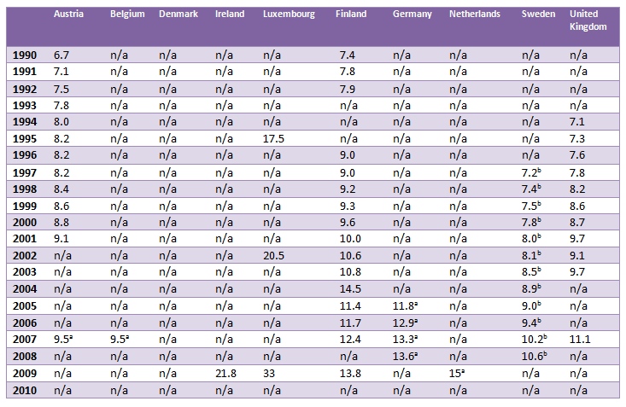
Table 11. The average hourly wages for a postman in euro (1990-2010)

(Source: ILO Database; Okholm et al. 2010a; Okholm et al. 2010c)
ª Minimum hourly wage
^{b} Average of Posten AB and Bing CityMail

The second indicator of working conditions is employment status. The results for this indicator are presented in table 12. It is important to notice that employment status is only measured in 2009, because of a lack of data. Only Austria and Germany have collected data on employment status over a longer period of time. The lack of data from other countries may be because for years it was very common that all postal employees had the status of civil servant.

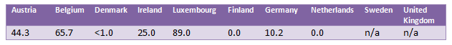
Table 12. Share of civil servants in the postal sector (2009)

(Source: Okholm et al. 2010b)
Table 12 shows that the postal service sector in Luxembourg employs the largest amount of civil servants. Up to 89 per cent of the postal employees is a civil servant. This also explains the high average wage in Luxembourg, as the status of civil servant holds several (financial) benefits. Also in the Belgian postal sector a high number of civil servants is present. Almost two third of all postal employees still have the civil servant status and benefits. In Austria and Ireland these numbers are lower, respectively 44.3 per cent and 25 per cent, but civil servants are still well represented in the postal sector. The share of civil servants in Germany has decreased considerably since 1996. Data from the annual reports of Deutsche Post between 1996 and 2009 has shown that the amount of civil servants has decreased with almost 60 per cent to 10.2 per cent in 2009. The least civil servants are found in Denmark, Finland and the Netherlands. In these countries (almost) no civil servants are present in the postal sector.

Table 13 presents the third and last indicator for working conditions: precarious work. This indicator involves a variety of factors that contribute to whether some type of employment involves employment instability, a lack of regulatory protection and economic vulnerability. Data for this indicator cannot be presented statistically and differs therefore from the rest of the data used in this research. Table 10 presents an overview of precarious work in eight countries, as data for Ireland and Denmark was not available.

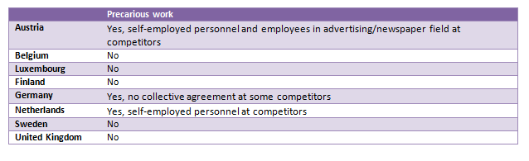
Table 13. Precarious work in the postal sector (1990-2010).

(Source: Okholm et al. 2010c; Eurofond 2007a; Eurofond 2007b; Eurofond 2008; Finnish Post and Logistics Union 2010)

Austria presents some precariousness in the postal sector. Particularly competitors regarding non-addresses mail of national postal operator Österreichische Post AG are hiring employees under precarious conditions. Mainly self-employed workers are confronted with precarious work. Moreover, employees in advertising mail and the delivery of newspapers cannot rely on any regulatory framework, as there is no collective agreement. This lack of regulatory protection can be seen as a factor of precariousness (Eurofond, 2007a). Hence, Austria shows signs of precarious work.

As for the Netherlands, some precariousness can be found when comparing the postal deliverers, which is the largest group in the Netherlands, and the postal employees of national postal provider TNT Post. The postal deliverers have less annual vacation days and have lower pension benefits. However, precarious work is particularly identified at the new postal competitors. According to Okholm et al. (2010c: 24-25), 99.5 per cent of the employees hired by these new competitors is self-employed personnel. This group of employees is confronted with some working factors that can be considered precarious. For instance, there is no collective agreement that applies for all self-employed deliverers. The collective agreement applies to only 0.5 per cent of the self-employed deliverers. Without a collective agreement, the terms and conditions of the employees are not regulated. This makes the position of the self-employed deliverer quite vulnerable and increases employment instability. Moreover, the self-employed employees are paid per postal item and are therefore very dependent on mail volume. This results in economic vulnerability: decreasing mail volumes directly affect the earnings of the employee. This is not the case for regular postal employees and postal deliverers of incumbent TNT Post, as they get paid per hour. Also the general benefits that are common for regular postal employees and postal deliverers, such as social benefits, are non-existing for the self-employed deliverers. This group has no pension benefits, holiday allowance, social benefits, social insurance and is not protected against dismissal. Hence, the Netherlands shows several signs of precarious work in the postal sector.

As for Germany, there can be found one sign of precarious work. There are no indications that national postal operator Deutsche Post AG changed factors that would lead to job instability or vulnerability of the employee. Annual vacation, compensation schemes, provision of training and weekly working hours have not changed since 2000. Also a collective agreement at the company level is applied since that time. Within the company, only a slight shift is visible from full-time to part-time employment. However, since full liberalization, several postal competitors have entered the market. The only sign of precariousness for postal employees is found at these competitors, as not all competitors have a collective agreement (Okholm et al. 2010c: 20-21). This indicates that there is a lack of regulatory protection for some postal workers in Germany and can be seen as a sign of precariousness.

On the contrary, Sweden presents no signs of precarious work. One year after full market opening in 1993, Swedish national postal operator Posten AB changed the public sector collective agreement in a private sector collective agreement. This change towards a private sector agreement meant for newly hired employees that their employment conditions were adapted to private sector standards. This meant inter alia that the age of retirement increased and the annual vacation days decreased. Even though the difference between old and new employees became bigger with this shift in agreement, this is no sign of more precariousness. All employees are namely covered by an agreement and therefore legally protected. Other changes in working conditions has mainly concerned changes in work-time flexibility between national incumbent Posten AB and competitor Bing CityMail. All employees of Posten AB were working eight hours per week, while the employees at CityMail had to deal with an arrangement of ‘over-time’ and ‘under-time’ until 2007. This meant that employees could work more than eight hours a day for one day and less than eight hours the next day, without extra compensation. The hours of ‘over-time’ were simply set off against the hours of ‘under-time’ (Okholm et al. 2010c: 11-12). This indicates precariousness in working conditions, but as this arrangement is abolished in 2007, the indication of precariousness is abolished as well. Hence, precariousness is not present in the Swedish postal sector.

As for the United Kingdom, Okholm et al. (2010c: 32-33) explains that national postal service provider Royal Mail has to cope in a fully liberalized market since 2006. In order to remain competitive, Royal Mail is using more part-time staff, introduced a bonus system that links pay to efficiency and have wages set at a market-based level. Also, the trade union representing the postal workers of Royal Mail argue that the basic wages are set at such a low level that workers have to rely on large amounts of overtime. Nevertheless, all Royal Mail employees still benefit from favourable working hours, pension benefits and annual vacation. Even though these non-wage benefits are less favourable by the competitors of Royal Mail, they are still above the minimum level. Also the wage level of competitors is comparable with similar sectors and higher than the statutory minimum. Differences between postal enterprises on the UK postal market are mainly due to differences in workforce composition. Besides these small differences on the market after full liberalization, no signs of precarious work could be found.

Finnish national postal operator Itella Posti Oy has no competitors and therefore precariousness can only be present within this company. According to the Finnish Post and Logistics Union (2010), precarious work is not present in Finland as Itella Posti Oy and future competitors have to follow the collective agreement with standardized (social) benefits. Also Luxembourg shows no signs of precarious work. National incumbent P&T Luxembourg is the only postal company and has attractive social benefits and working conditions. The relatively good social benefits are mainly due to the high share of civil servants that are regulated by the civil service staff regulations. The postal employees of P&T Luxembourg are also protected by the collective labour agreement, which indicates that there is no employment instability or lack of regulatory protection (Eurofound, 2008). Therefore also Luxembourg presents no sign of precarious work in the postal sector. Belgium shows as well no signs of precariousness in the postal sector. According to a report by Eurofond (2007b), the Belgian working conditions and collective agreement in the postal sector are still based on collective bargaining in the public sector. This public sector agreement indicates that certain benefits, particularly for civil servants, are still very profitable. Signs of instability or vulnerability of workers could not be found.

The following paragraph aims to explain these differences in working conditions between single countries and more general between the liberalized and non-liberalized countries. The earlier presented results regarding the independent variables, liberalization, the digital age and labour market flexibility, are used for this explanatory analysis

10.2 Analysis of the results

The previous paragraph has presented the results for the second dependent variable ‘working conditions’, using earnings, employment status and precarious work as indicators. The results vary between countries and this paragraph aims to assess to what extent liberalization, the digital age and labour market flexibility have affected working conditions in the postal sector.

10.2.1 Effect of liberalization on working conditions
The first explanation for the changes in postal sector working conditions can be liberalization. The earlier examination of the three indicators, entry regulation, the presence of postal competitors and public ownership, will be linked to the differences in working conditions in the postal sector. Hence, this sub-paragraph features a comparison between the presence of characteristics of liberalization and developments in postal sector working conditions.

Figure 7 presents the comparison of the indicators of liberalization, with two indicators of working conditions, namely earnings and employment status. According to the reasoning in the theory, the more characteristics of liberalization leads to the more precariousness in working conditions. For the two indicators presented in this figure, this means that more liberalization would lead to a reduction or lack of increase of the earnings and less civil servants in the postal sector. As a reduction of earnings in twenty years is not very likely, the average earnings between 1990 and 2010 are measured for each country and compared with one another. The countries with the most characteristics of liberalization should present lower earnings than the countries with no or only one characteristic of liberalization.

Figure 7. The share of civil servants and earnings in € compared to presence of liberalization in the postal sector (1990-2009).
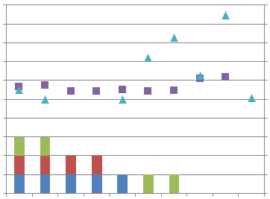
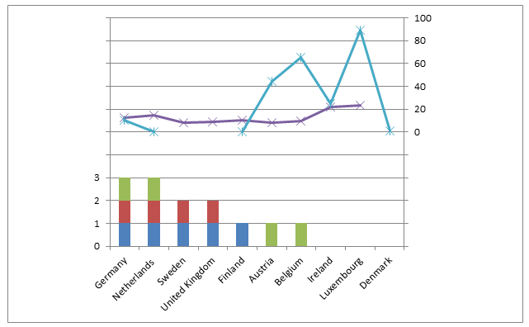

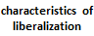

The comparison between liberalization and the first two indicators of working conditions, earnings and employment status, shows differences between the indicators. The chart regarding earnings presents much less fluctuation than the chart for employment status. The countries with the most characteristics of liberalization, Germany and the Netherlands, can be considered average when it comes to earnings. However, data for these countries consist of minimum hourly earnings, which indicates that the average earnings are higher than the ones presented in this figure. This means that earnings for the Netherlands and Germany are definitely not below the earnings in countries with less characteristics of liberalization. Also the earnings of Sweden and the United Kingdom, both with two characteristics of liberalization, are not below the earnings of Austria and Belgium, both with only one characteristic of liberalization. Therefore can be noted that after comparing countries with a different number of characteristics of liberalization, more characteristics of liberalization do not lead to lower earnings.

As for employment status, data varies much more between countries. The share of civil servants is zero in the Netherlands and Finland, and almost zero in Denmark. Despite these similar numbers regarding civil servants, the countries show significant differences when it comes to liberalization. As noted before, the Netherlands presents all characteristics of liberalization, while Finland only has one characteristic. Denmark has no characteristics of liberalization at all. This shows that the more liberalization does not lead to less civil servants in the postal sector, as also non-liberalized countries present a very low share of civil servants.

An assessment of the third indicator, precarious work, in the previous paragraph has shown that precariousness in postal sector working conditions is present in Austria, Germany and the Netherlands. These countries all have some characteristics of liberalization. Germany and the Netherlands are considered fully liberalized, while Austria shows a decrease in public ownership, which is one factor of liberalization. Even though the countries differ in the level of liberalization, they all have liberalization present in their postal sector. This could be an indication that liberalization may affect precariousness in working conditions. Nevertheless, as other countries with characteristics of liberalization do not present signs of precariousness, the effect of liberalization on precarious work is low.

Overall can be noted that liberalization has not proven to have an effect on working conditions in the postal sector.

10.2.2 Effect of the digital age on working conditions
A second explanation for the developments in postal sector working conditions can be found in the digital age. The digital age is assessed using the indicators internet usage and letter mail volume. This sub-paragraph is therefore dedicated to analyse the relationship between the digital age and developments in working conditions.

The comparison of these indicators is presented in figure 8. According to the reasoning in the theory, the more characteristics of the digital age leads to the more precariousness in working conditions. For the two indicators presented in this figure, this means that more internet usage would lead to a reduction in letter mail volume and lack of increase of the earnings and less civil servants in the postal sector. Hence, the countries with the highest amount of internet users and the biggest decease in letter mail volume should present lower earnings and a lower amount of civil servants than the countries with no or only one characteristic of the digital age.

Figure 8. The share of civil servants and earnings in € compared to presence of the digital age in the postal sector (1990-2010).
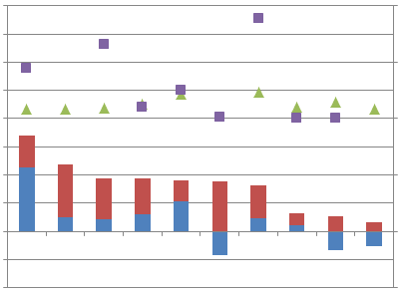
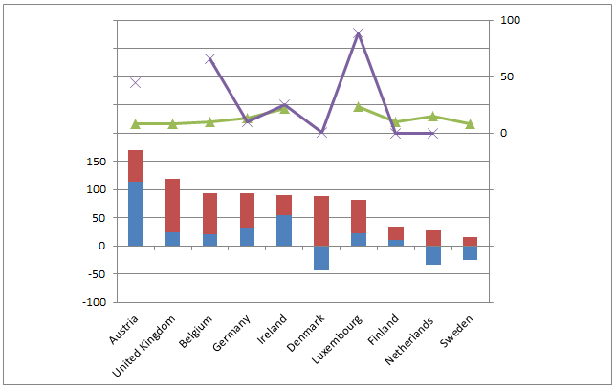

The comparison of the two indicators of the digital age and two indicators of postal sector working conditions in figure 8 shows that three countries present a trend in coherence with the reasoning in the theory. Denmark presents one of the highest increases in internet usage and the highest decrease in letter mail volume. According to the theory, this should lead to a decrease in the share of civil servants and lower amount of average earnings compared to the other countries. Unfortunately, data on earnings is not available for this country, but the amount of civil servants in the Danish postal sector is one of the lowest of the countries of this research. This indicates that the digital age can be an explanation for the low share of civil servants in Denmark. The other two countries, the Netherlands and Sweden, present similar results. The Netherlands presents an increase in internet usage and a decrease in letter mail volume. It is also among the countries with the lowest share in earnings, even though it is important to notice that the number of the Netherlands only represents the year 2009 and is a minimum wage. The share of civil servant is zero. This indicates that the digital age can be an explanation for the precariousness in the Dutch postal sector working conditions. Also Sweden has an increase in internet usage and a decrease in letter mail volume. Nevertheless, this numbers are smaller than in Denmark and the Netherlands. Data on employment status are unavailable, but average earnings are relatively low.

The other countries show that earnings and the amount of civil servants are relatively higher in countries that present an increase in letter mail volume. Ireland and Luxembourg are striking examples for this trend. Internet usage, letter mail volume, earnings and the amount of civil servants are all increasing, which is incoherent with the reasoning in the theory. Austria, Belgium and Germany present also higher numbers in the share of civil servants than the number of civil servants in countries with decreasing mail volumes. Finland, however, seems the exception. This country shows an increase in both internet usage and letter mail volume, but there are no civil servants present in the postal sector.

The third indicator, precarious work, is present in Austria, Germany and the Netherlands. The Netherlands has hence all three indicators of precariousness in working conditions presents. It is therefore very likely that the digital age in the Netherlands has influenced the working conditions in the postal sector. For Austria and Germany, however, precarious work is the only indicator that increases precariousness of postal sector working conditions.

Overall can be noted that the digital age can explain the differences in postal sector working conditions in the Netherlands. Even though there seems a relation between a higher share of civil servants and an increase in letter mail volume and internet usage, the digital age cannot explain all differences in working conditions in the postal sector.

10.2.3 Effect of labour market flexibility on working conditions
A third and last explanation for the changes in postal sector working conditions can be labour market flexibility. Labour market flexibility is assessed using hiring and firing regulations as an indicator. This sub-paragraph is therefore dedicated to analyse the relationship between the labour market flexibility and developments in postal sector working conditions.

Figure 9 presents the comparison between the first two indicators of working conditions and labour market flexibility. According to the reasoning in the theory, the more flexibility of the labour market leads to the more precariousness in working conditions. For the hiring and firing regulations presented in this figure, this means that more flexibility for the employer would first lead to a lack of increase of the earnings, because of a switch to more flexible workers such as self-employed personnel or part-time workers. This would also lead to a decrease in the number of civil servants. Hence, the countries with the most labour market flexibility should present lower earnings and a lower amount of civil servants than the countries with more labour market regulations.

The comparison between labour market flexibility and the first two indicators of working conditions, earnings and employment status, presents on first sight no correlation between the two variables. More flexibility of the hiring and firing of workers is present in Finland and the Netherlands. These countries have no civil servants in the postal sector, but earnings are not particularly low when compared to the other countries. Moreover, Denmark has a very low share of civil servants, but flexibility has decreased between 1990 and 2009. Also Germany presents a lack of correlation between labour market flexibility and working conditions. Flexibility in this country has decreased with over 25 per cent, which is almost the largest decrease of the examined countries. However, the share of civil servants is relatively low and the average earnings are in the middle. This evidence indicates that correlation between labour market flexibility and earnings and employment status is not present.

Figure 9. The share of civil servants and earnings in € compared to labour market flexibility in the postal sector (1990-2010).

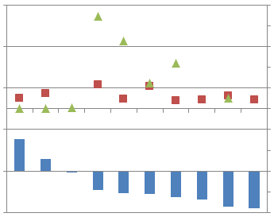
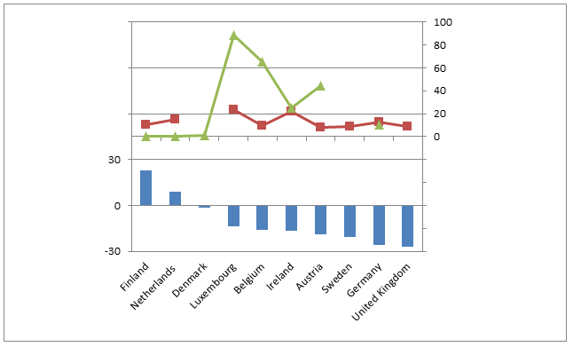

In addition, the assessment of the indicator precarious work has shown that precariousness is present in Austria, Germany and the Netherlands. These countries show all very different results when it comes to hiring and firing regulations. Decreases of flexibility are present in both Austria and Germany, but these countries differ greatly when it comes to working conditions. The share of civil servants is much higher in Austria, while earnings are lower than in Germany and the Netherlands.

Overall can be noted that labour market flexibility cannot explain the differences in postal sector working conditions. Even though both Finland and the Netherlands have gain more flexibility for the employer and the share of civil servants is zero, average earnings are not lower than in the other countries used in this assessment. The reasoning in the theory does not fully match the results presented in figure 9 and hence the effect of labour market flexibility on postal sector working conditions is small.

10.2.4 Effect of the independent variables on working conditions
The examination of the developments in postal sector working conditions has shown that there are some differences between countries regarding earnings, employment status and precarious work. According to the theory, countries should present relatively low earnings, a low share of civil servants in the postal sector and several characteristics of precarious work. The different sub-chapters have assessed to what extent the independent variables liberalization, the digital age and labour market flexibility have affected the postal sector working conditions. Table 14 presents a summary of the results.
Table 14. Summary of the effects of the independent variables liberalization, the digital age and labour market flexibility on postal sector working conditions (1990-2010).

 | Extent of liberalization | Extent of digital age | Extent of flexibility | Average earnings | Share of civil servants | Presence of precarious work
Austria | Medium | Medium | Low | Low | Medium | Yes
Belgium | Medium | Medium | Low | Low | High | No
Denmark | Low | High | Low | n/a | Very Low | No
Ireland | Low | Medium | Low | High | Medium | No
Luxembourg | Low | Medium | Low | High | High | No
Finland | Medium | Medium | High | Medium | Very Low | No
Germany | High | Medium | Low | Medium | Low | Yes
Netherlands | High | High | High | Medium | Very Low | Yes
Sweden | Medium | High | Low | Low | n/a | No
United Kingdom | Medium | Medium | Low | Low | n/a | No

Countries are considered highly liberalized with all characteristics of liberalization present. Medium reflects one or two characteristics and low reflects no characteristics of liberalization.
Countries are considered to score high on the digital age when internet usage increases and letter mail volume decreases. Medium reflects an increase in both internet usage and letter mail volume.
Countries are considered to have a highly flexible labour market when regulations have become less important. A low extent of flexibility reflects the trend towards more regulations.
Average earnings are considered low when earnings are lower than €10, medium between €10 and €20, high above €20.
The share of civil servants is considered very low when it is below 1%, low when between 1 and 25%, medium when between 26% and 50% and high above 50%.

Countries with relatively low earnings, few civil servants and characteristics of precarious work are considered to have precariousness in postal sector working conditions. However, table 14 shows that there is no country that follows that reasoning. In order to still make a statement about the relationship between the independent variables and the dependent variable working conditions, countries with medium average earnings or a medium share of civil servants are considered to follow the reasoning in the theory.

Starting with liberalization, low/medium average earnings, a low/medium share of civil servants and characteristics of precarious work are present is countries with both a medium and high extent of liberalization. It is hence unlikely that liberalization can explain precariousness in working conditions.

As for the digital age, low/medium average earnings, a low/medium share of civil servants and characteristics of precarious work are present is countries with both a medium and high extent of the digital age. The more digital age leads hence not to more precariousness in working conditions. The digital age can therefore not explain precariousness in working conditions.

As for labour market flexibility, l low/medium average earnings, a low/medium share of civil servants and characteristics of precarious work are present is countries with both a low and high extent of flexibility. Therefore, also labour market flexibility cannot explain precariousness in postal sector working conditions.

11. Remarks regarding the hypotheses and research question

This research has focused on the examination of the effects of liberalization, the digital age and labour market flexibility in the postal sector on employment and working conditions. This chapter will test the hypotheses of this research and answer the main research question.

11.1 Summary of the findings

After the examination of the empirical results and analysis on the relationship between the dependent and independent variables, the hypotheses can be tested. All hypotheses are related to the theory presented in the theoretical framework and the variables are all examined in the empirical part of this thesis. This paragraph tests if the hypotheses are true according to the findings in the ten cases of this research.

The first hypothesis is linked to liberalization and states: “the more characteristics of liberalization, the more precariousness in employment and working conditions”. Research has shown that precariousness in employment is visible in countries with a low, medium and high extent of liberalization. Precariousness in working conditions is visible in countries with both a medium and high extent of liberalization. Hence, more characteristics of liberalization does not lead to more precariousness in employment and working conditions. This hypothesis is considered false.

The second hypothesis is linked to the digital age and states: “the more characteristics of the digital age, the more precariousness in employment and working conditions”. This research has presented that precariousness in both postal sector employment and working conditions is visible in countries with both a medium and high extent of the digital age. This indicates that the more characteristics of the digital age does not cause more precariousness in employment and working conditions. Hence, this hypothesis is considered false.

The third and last hypothesis is linked to labour market flexibility and states: “the more characteristics of labour market flexibility, the more precariousness in employment and working conditions”. The results of this research have shown that precariousness in postal sector employment is present in countries with both a high and low extent of labour market flexibility. Also precariousness in working conditions is visible in countries with both a decrease and an increase in flexibility. Hence, more characteristics of labour market flexibility does not lead to more precariousness in employment and working conditions. This hypothesis is considered false as well.

11.2 Answer to the main research question

This research has concentrated on answering the main research question: “What is the effect of liberalization on employment and working conditions in the postal service sector?”. Besides the examination of the effects of liberalization in the postal sector, two other concept are examined as well. This has been done to avoid associating any difference in employment or working conditions automatically to liberalization. The variables of this research are liberalization, the digital age and labour market flexibility.

Different characteristics of liberalization have been implemented in several of the ten member states used in this research. Five countries are considered legally liberalized, as these countries have implemented the Postal Directive and fully opened their market to competition, but also some of the other countries presented characteristics linked to liberalization. A mere three countries presented no signs of liberalization in the postal sector at all. Nevertheless, more characteristics of liberalization turned out not to be related to more precariousness in postal sector employment and working conditions. Indeed, also countries without liberalization in the postal sector showed precariousness in employment and working conditions. Also the control variables the digital age and labour market flexibility proved not to have increased precariousness in the postal sector. In fact, no relation could be found between the independent variables liberalization, the digital age and labour market flexibility and increased precariousness in employment and working conditions in the postal sector.

Taking into account the results and arguments presented in this research, can be concluded that it is likely that liberalization has not had a significant effect on employment and working conditions in the postal sector. The two control variables can also not explain the developments in postal sector employment and working conditions. Hence, all three variables examined in this research cannot explain the changes in employment and working conditions. More research is necessary to explain the changes in postal sector employment and working conditions.

12. Conclusion

This research has concentrated on employment and working conditions in the postal sector of ten EU member states. The specific focus of this thesis was the concept of liberalization in the postal sector. Without a doubt, liberalization is a broad and diverse concept. In this research, the concept is delineated to “any relaxation of previous government restrictions, in areas of social or economic policy or political organization”.

The first signs of liberalization in the postal sector leads us back to the early 1990s, when the European Commission suggested the creation of an European policy framework for postal services. However, full liberalization of the European postal sector was still largely unachieved in 2010, as only six countries had implemented the necessary Postal Directive. Five of these six countries, namely Finland, Germany, the Netherlands, Sweden and the United Kingdom, have been examined in this research regarding the effects of liberalization on postal sector employment and working conditions. In order to ensure comparability, five EU member states without a fully liberalized postal market have been selected, namely Austria, Belgium, Denmark, Ireland and Luxembourg. Moreover, to avoid automatically associating any difference between the two groups of countries to liberalization, the control variables digital age and labour market flexibility were selected. Increased digitalization and flexibility on the labour market are trends visible in all EU member states and can also have an effect on postal sector employment and working conditions. The variables have been examined between 1990 and 2010.

However, an assessment of the results for each individual member state has presented that there seems no correlation between liberalization and the dependent variables. There turned out to be no relation between liberalization and postal sector employment and working conditions Liberalization has not led to a decrease in employment or more precariousness in working conditions, as both liberalized and non-liberalized countries show increased precariousness in employment and working conditions. The two control variables can also not explain the developments in postal sector employment and working conditions during the period 1990-2010. This indicates that not one out of the three variables considerably affected the changes in employment and working conditions.

12.1 Research limitations

During this research, various difficulties were encountered. First and most of all, the availability of the data caused problems. Particularly data on working conditions was very fragmented. Data on earnings suffered from a lack of data, differences in definition and currency differences. Own calculations were necessary to convert earnings before 2002 from the national currency to euros. It was also necessary to convert monthly or weekly earnings to average hourly wages. Unfortunately, data on average hourly wages was not available for all countries, which made it necessary to use minimum hourly wages for some countries. It was therefore sometimes hard to find a way to increase and ensure comparability between countries. Apart from that, data on employment status could only be measured during one point in time, which made it impossible to present a trend between 1990 and 2010 as has been done for all other indicators. Furthermore, data on employment caused some difficulties as well. Both Denmark and Germany have not made a distinction between full-time and part-time employment, which made it necessary to add a table on total employment. Also, definitions on employment for all countries was not equal. Some data on full-time staff included part-time staff, but was converted into full-time staff. Other data included only statistics from the national postal operator or included data on the total telecommunications sector. Finally, a general difficulty regarding employment was that data for the United Kingdom referred to Great Britain. This may also affected the results for this country.

12.2 Recommendations for further research

The limited scope of this thesis and the earlier encountered limitations make it possible to come up with some recommendations for further research. First of all the variables examined in this thesis, liberalization, the digital age and labour market flexibility have proven not to have significantly affected the developments in employment and working conditions. It is therefore recommended to choose different variables in order to assess their effects on postal sector employment and working conditions. Variables that can be used in further research are the use of more technology and innovation in the postal sector, increasing automation, the economic and financial crisis and increasing labour costs.

A second recommendation for further research is the inclusion of more EU member states. The use of 10 member states in this thesis is partially based on the availability of data and time for this research. However, the use of only 10 member states makes it impossible to generalize the results to the entire EU postal sector. Using all 27 EU member states would provide more insight in the development in total postal sector employment and working conditions in the EU.

This research has stated the various dimensions of liberalization several times. It could therefore be useful to assess more aspects of liberalization. This would provide more insight in the various aspect of liberalization in different countries. An example could be the social objectives of liberalization. Further research can assess the differences in the social aspects of competitiveness, such as decreasing prices. However, it can also highlight differences regarding the concern about job losses and political responses to liberalization.

Finally, a last recommendation for further research is the influence of labour unions. In the theoretical framework, the importance of labour unions has been pointed out. Labour unions can have significant influence on companies, but also on politicians. The influence on a political level can be of particular importance in postal companies that are completely state-owned. Moreover, particularly working conditions can benefit from the presence of labour unions during the collective bargaining process. The aspect of labour unions and other groups representing postal employees and postal employers have been completely left out of this research, while this can affect the results as presented in this research.

Bibliography

Armstrong, M. and Sappington, D.E.M. (2006). Regulation, Competition, and
Liberalization. Journal of Economic Literature, Vol. XLIV, pp. 325–366.

Baker, S. and Dodgson, J. (2002). Market Definition in Postal Services. In: Géradin, D. (2002). The Liberalization of Postal Services in the European Union. Kluwer Law International. The Netherlands.

BBC. (2008). 'Few benefits' from mail shake-up. [http://news.bbc.co.uk/2/hi/7385044.stm]. Last accessed 15 May 2012.

BBC. (2009). Postal workers' strike announced. [http://news.bbc.co.uk/2/hi/uk_news/8149463.stm]. Last accessed 14 May 2012.

Bergman, L., Brunekreeft, G., Doyle, C., Fehr, von der, N. H., Newbery, D. M., Pollit, M. and Régibeau, P. (1998) Europe’s Network Industries: Conflicting Priorities, Monitoring European Deregulation 1: Telecommunications. London. CEPR.

Bijl, de P.W.J., Damme, van E. and Larouche, P. (2006). Regulating Access to Stimulate Competition in Postal Markets? In: Crew, M.A. and Kleindorfer, P.R. (2006). Progress Toward Liberalization of the Postal And Delivery Sector. Springer Science Business Media.

Blatter, J. and Haverland, M. (2012). Designing Case Studies. Palgrave Macmillan.

Boycko, M., Shleifer, A., and Vishny, R.W. (1996). A Theory of Privatisation. The Economic Journal, Vol. 106, No. 435, pp. 309-319.

Brandt, T. and Schulten, T. (2009). The Impact of Liberalisation and Privatisation on Labour Relations. In: Privatisation of Public Services and the Impact on Quality, Employment and Productivity (PIQUE). (2009). Summary report of the project: Privatisation of Public Services and the Impact on Quality, Employment and Productivity.

Bull, B., Jerve, A. M., and Sigvaldsen, E. (2006). The World Bank’s and the IMF’s use of
Conditionality to Encourage Privatization and Liberalization: Current Issues and Practices. Report prepared for the Norwegian Ministry of Foreign Affairs as a background for the Oslo Conditionality Conference.

Buttolph, J., Reynolds, H.T. and Mycoff, J.D. (2007). Political Science Research
Methods. CQ Press. Washington DC.

Campbell Jr., J.I. (2002). The Evolution of Terminal Dues and Remail Provisions in European and International Postal Law. In: Géradin, D. (2002). The Liberalization of Postal Services in the European Union. Kluwer Law International. The Netherlands.

Cazes, S. and A. Nesporova. (2004). Labour Markets in Transition: Balancing Flexibility and Security in Central and Eastern Europe. International Labour Office, Geneva.

Centraal Plan Bureau (CPB) Netherlands Bureau for Economic Policy Analysis (2011). Labour Market Flexibility in the Netherlands; The role of contracts and self-employment.

Clifton, J., Comín, F. and Díaz-Fuentes, D. (2007). Transforming Public Enterprise in Europe and North America: Transnationalisation, Networks and Integration. Palgrave Macmillan. London and New York.
Cooke. Jr., E.D. (2001). A Private Perspective on Privatization in the Airline Industry in Africa.

Deutsche Post AG. (2008). Annual Report 2008.

Deutsche Post AG. (2010). Annual Report 2010.

Dieke, A.K., Niederpruem, A. and Campbell, J.I. (2008). Universal Service and Postal Monopoly in Other Countries. Study on Universal Postal Service and the Postal Monopoly. George Mason University.

Dobrinić, D., Dvorski, S. and Trlek, T. (2009). De-regulation of the postal market of EU and its influence on the postal market of Croatia. 7th International conference Economic integrations, competition and cooperation.

Eccles, R. and Kuipers, P. (2006). Postal Services Regulation In Europe. A Comparative Study of the UK, the Netherlands, Belgium, France, Germany, Italy and Sweden. In: Crew, M.A. and Kleindorfer, P.R. (2006). Progress Toward Liberalization of the Postal And Delivery Sector. Springer Science Business Media.

EurActive. (2007). Postal services liberalisation – Full liberalisation in 2009, 2011 or 2013. [http://www.euractiv.com/transport/postal-services-liberalisation/article-161377] Last accessed 15 May 2012.

Eurofound European Industrial Relations Observatory (EIRO) (2007a). Industrial relations in the postal sector — Austria. [http://www.eurofound.europa.eu/eiro/studies/tn0704018s/at0704019q.htm] Last accessed 24 June 2012.

Eurofound European Industrial Relations Observatory (EIRO) (2007b). Industrial relations in the postal sector — Belgium. [http://www.eurofound.europa.eu/eiro/studies/tn0704018s/be0704019q.htm] Last accessed 24 June 2012.

Eurofound European Industrial Relations Observatory (EIRO) (2008). Representativeness of the European social partner organisations: Post and courier services – Luxembourg. [http://www.eurofound.europa.eu/eiro/studies/tn0712017s/lu0712019q.htm] Last accessed 24 June 2012.

Eurofound EU agency (2012a). Working conditions. [http://www.eurofound.europa.eu/areas/industrialrelations/dictionary/definitions/WORKINGCONDITIONS.htm]. Last accessed 23 April 2012.

Eurofound EU agency (2012b). Employment status.
[http://www.eurofound.europa.eu/areas/employmentstatus/index.htm]. Last accessed 16 May 2012.

Euronews. (2009). Belgium postal workers strike. [http://www.euronews.com/2009/03/02/belgium-postal-workers-strike/] Last accessed 14 May 2012.

European Commission (2012a). Postal services.
[http://ec.europa.eu/internal_market/post/index_en.htm]. Last accessed 16 April 2012.

European Commission (2012b). EU Postal Legislation. [http://ec.europa.eu/internal_market/post/legislation_en.htm]. Last accessed 13 April 2012.

European Foundation for the Improvement of Living and Working Conditions (EFILWC). (2007). Industrial relations in the public sector.

European Union (EU). (2012). Technical MEMO on the Postal Sector accompanying the state aid decisions regarding Deutsche Post / Belgian Post (BPost)/ French La Poste / Hellenic Post (ELTA).

Finnish Communications Regulatory Authority (FICORA). (2010). Market review 4a/2010 – Postal services market review 2010.

Finnish Post and Logistics Union (2010). The Liberalisation of Postal Services –The Current Situation in Finland. [http://www.postdirektivet.no/wp-content/uploads/Finland-PAU-uttalelse-2010-03-05.pdf] Last accessed 24 June 2012.

Flecker, J. and Hermann, C. (2011). The liberalization of public services: Company reactions and consequences for employment and working conditions. Economic and Industrial Democracy, Vol. 32, No. 3, pp. 523-544.

Free and Fair Post Initiative (FFPI). (2010). White Paper on Postal Liberalisation.

Genoud, C. and Varone, F. (2002). Does Privatization Matter? Liberalization and regulation: The case of European electricity. Public Management Review. Vol. 4, No. 2, pp. 231-256.

Geradin, D. (2006). The liberalization of network industries in the European Union: where do we come from and where do we go? Globalisation Challenges for Europe and Finland Project.

Giga, S.I., Hoel, H. and Cooper, C.L. (2003). Violence and stress at work in the postal sector. Working Paper, International Labour Office, Geneva.

Gschwend, T. and Schimmelfennig, F. (2007) Introduction: Designing Research in Political Science - A Dialogue between Theory and Data. In: Gschwend and Schimmelfennig (Ed.). Research Design in Political Science.

Gwartney, J., Lawson, R. and Hall, J. (2011). Economic Freedom of the World: 2011 Annual Report. Fraser Institute. Vancouver.

Herman, W.R. (1976). Deregulation: Now or Never! (Or Maybe Someday?). Public Administration Review, Vol. 36, No. 2, pp. 223-228.

Hermann, C. and Flecker, J. (2009). The Impact of Employment, Productivity and Service Quality. In: Privatisation of Public Services and the Impact on Quality, Employment and Productivity (PIQUE). (2009). Summary report of the project: Privatisation of Public Services and the Impact on Quality, Employment and Productivity.

Hermann, C. and Verhoest, K. (2009). Varieties and Variations of Public Service Liberalisation and Privatisation. In: Privatisation of Public Services and the Impact on Quality, Employment and Productivity (PIQUE). (2009). Summary report of the project: Privatisation of Public Services and the Impact on Quality, Employment and Productivity.

Hofbauer, I. (2006). Liberalisation, privatisation and regulation
in the Austrian postal services sector. Privatisation of Public Services and the Impact on Quality, Employment and Productivity (PIQUE) Project.

Hooper, R., Hutton, D.D. and Smith, I.R. (2008). The challenges and
opportunities facing UK postal services. UK Governmental report to the Secretary of State for Business, Enterprise and Regulatory Reform.

International Labour Office (ILO). (2012a). Employment and unemployment. [http://www.ilo.org/global/statistics-and-databases/statistics-overview-and-topics/employment-and-unemployment/lang--en/index.htm]. Last accessed 23 April 2012.

International Labour Office (ILO). (2012b). Description of the occupations – 127. Postmen. [http://laborsta.ilo.org/applv8/data/to1ae.html#127]. Last accessed 17 May 2012.

Internet World Stats (2012a). Internet World Stats. [http://www.internetworldstats.com/]. Last accessed 24 April 2012.

James Cook University. (2012). Primary, Secondary & Tertiary Sources. [http://www-public.jcu.edu.au/libcomp/assist/training/JCUPRD_030412]. Last accessed 29 April 2012.

Jefferys, S., Pond, R., Kilicaslan, Y, Tasiran, A.C., Kozek, W., Radzka, B. and Hermann, C. (2009). Privatisation of Public Services and the Impact on Employment and Productivity. In: Privatisation of Public Services and the Impact on Quality, Employment and Productivity (PIQUE). (2009). Summary report of the project: Privatisation of Public Services and the Impact on Quality, Employment and Productivity.

Krajewski, M. (2003). National Regulation and Trade Liberalization and Services. Kluwer Law International. The Netherlands.

Kellstedt, P.M. and Whitten, G.D. (2009). The Fundamentals of Political Science Research. Cambridge University Press. New York.

Lehnert, M., Miller, B., & Wonka, A. (2007). Increasing the relevance of research questions:
considerations on theoretical and societal relevance in political science. In T. Gschwend, & F. Schimmelfennig (2007). Research design in political science: How to practice what they preach (pp. 21‐33). Basingstoke: Palgrave Macmillan.

Levi-Faur, D. (2003). The politics of liberalisation: Privatisation and regulation-for competition in Europe’s and Latin America’s telecoms and electricity industries. European Journal of Political Research, Vol. 42, pp. 705–740.

Majone, G. (2009). Liberalization, Re-Regulation, and Mutual Recognition: Lessons from Three Decades of EU Experience. Scottish Jean Monnet Centre Working Paper Series,
Vol. 1, No. 1.

Mallinder, L. (2007). Post liberalisation...in a big country. [http://www.europeanvoice.com/article/imported/post-liberalisation-in-a-big-country/57602.aspx]

Mitnick, B.M. (1978). Deregulation as a Process of Organizational Reduction. Public Administration Review, Vol. 38, No. 4, pp. 350-357.

Morton, A. (2011). European Union Competition policy and the Liberalisation of Postal Services. European Public Service Briefings 1. European Services Strategy.
Newbery, D.M. (1997). Privatisation and liberalisation of network utilities. European Economic Review, Vol. 41, pp. 357-383.

Niederprüm, A., Dieke, A.K., Junk, P., Lucidi, S., Schäfer, R. and Schwab, R. (2011). Developments in the Dutch Postal Market. WIK-Consult. Study for the Ministry of Economic Affairs, Agriculture and Innovation, Directorate-General for Energy, Telecom and Markets The Netherlands.

Okholm, H.B., Winiarczyk, M., Möller, A. and Kastberg Nielsen, C. (2010a). Main Developments in the Postal Sector (2008-2010) Final Report. Copenhagen Economics.

Okholm, H.B., Winiarczyk, M., Möller, A. and Kastberg Nielsen, C. (2010b). Main Developments in the Postal Sector (2008-2010) Part B: Country Fiche Appendix. Copenhagen Economics.

Okholm, H.B., Kastberg Nielsen, C., Möller, A. and Hedlund, H. (2010c). Wages and Employment Conditions in Liberalised Postal Markets. Copenhagen Economics.
Organisation for Economic Co-operation and Development (OECD). (1995). Deregulation and Privatisation in the Service Sector. OECD Economic Studies, No. 25.

Organisation for Economic Co-operation and Development (OECD). (2012). OECD Indicators of Employment Protection. [http://www.oecd.org/document/11/0,3746,en_2649_37457_42695243_1_1_1_37457,00.html] Last accessed 17 June 2012.

Österreichische Post AG (2010). Österreichische Post AG Annual Report 2010.

Park, S.H, Li, S. and Tse, D.K. (2006). Market liberalization and firm performance during China's economic transition. Journal of International Business Studies, Vol. 37, pp. 127–147.

Petkantchin, V. (2010). The re-regulation of the postal sector in the European Union. IEM’s Economic Note.

Pierre, G. and Scarpetta, S. (2004). Employment regulations through the eyes of employers - do they matter and how do firms respond to them? Policy Research Working Paper Series 3463, The World Bank.

Poole W. R., Jr. and Fixler E. P. Jr. (1987). Privatization of Public-Sector Services in Practice: Experience and Potential. Journal of Policy Analysis and Management, Vol. 6, No. 4, pp. 612-625.

PostNL. (2009). TNT Annual Report 2009.

PostNL. (2010). TNT Annual Report 2010.

Post & Parcel. (2012). Call for ministers to intervene in Dutch postal market. [http://postandparcel.info/46614/news/companies/call-for-ministers-to-intervene-in-dutch-postal-market/]. Last accessed 15 May 2012.

PTS Swedish Post and Telecom Agency. (2009). Local postal operators in Sweden - PTS-ER-2009:20. [http://www.pts.se/en-gb/Documents/Reports/Post/2009/Local-postal-operators-in-Sweden---PTS-ER-200920/]. Last accessed 06 June 2012.

PTS Swedish Post and Telecom Agency. (2011). Service and competition 2011 the postal services market in Sweden. [http://www.pts.se/upload/Rapporter/Post/Service%20and%20competition%202011.pdf]. Last accessed 06 June 2012.

Radio Netherlands Worldwide (RNW). (2010). Dutch postal workers start three-day strike. [http://www.rnw.nl/english/bulletin/dutch-postal-workers-call-three-day-strike]. Last accessed 14 May 2012.

Redmail. (2012). Company. [http://www.redmail.at/englisch/content.php?id=70]. Last accessed 6 June 2012.

Reith, M., Carr, C. and Gunsch, G. (2002). An Examination of Digital Forensic Models. International Journal of Digital Evidence. Vol. 1, No. 3, pp. 1-10.

Řiháčková, V. (2011). The EU Single Market – An Agenda of Consensus for the Polish
Presidency? EUROPEUM. Institute for European Policy.

Rodgers, G. (1989). Precarious Work in Western Europe: The State of the Debate. In Rodgers, G. & Rodgers, J. eds., Precarious Jobs in Labour Market Regulation: The Growth of Atypical Employment in Western Europe.

Rothenberger, D., Truffer, B. and Markard, J. (2001). Deregulation in Water Management – Cross-country Comparison and Lessons Learned from the Electricity Sector. Globalization and water resources management: the changing value of water, University of Dundee, International Speciality Conference.

Royal Mail Group. (2010). RMG’s view on market definitions. Annex 2- A response to the Postal Services Commission’s May 2010 consultation document. [http://www.royalmailgroup.com/sites/default/files/Annex2_RMGs_view_of_market_definition_0.pdf] Last accessed 7 June 2012.

Socialist Party International (SP International). (2010). Postal Workers in Protest Against Liberalisation as European Parliament Votes for Enquiry Into Effects. [http://international.sp.nl/bericht/46978/100909-postal_workers_in_protest_against_liberalisation_as_european_parliament_votes_for_enquiry_into_effects.html] Last accessed 14 May 2012.

Spring Global Mail. (2012). TNT Post have become PostNL. [http://www.springglobalmail.co.uk/en/PostNL/]. Last accessed 10 June 2012.

Starr, P. (1988). The Meaning of Privatization. Yale Law & Policy Review, Vol. 6, No. 1, pp. 6-41.

Streeck, W. and Thelen, K. (2004). Introduction: Institutional Change in Advanced Political Economies in Beyond Continuity – Institutional Change in Advantaged Political Economies edited by Streeck, W. and Thelen, K. (2004). Oxford University Press.

Thierstein, A. and Abegg, C. (2003). The Impact of the Liberalisation of Public Services on the Competitiveness of Firms in the Alpine Regions of Switzerland. In: Monnesland, Jan (eds.): Regional Public Finances. European research in regional science, Vol. 13. London: Pion. S. 173-190.

UNI Global Union. (2011). ¼ of the Members of European Parliament have major concern with postal liberalisation. [http://www.uniglobalunion.org/Blogs/ProtectOurPost.nsf/dx/07042011101145CBEBME.htm]. Last accessed 15 May 2012.

UNI Postal and Logistics. (2009). What has postal liberalisation delivered? A Study by UNI Post & Logistics on the Liberalisation of the Postal Sector.

Universal Postal Union (UPU). (2010). ICTs, new services and transformation of the Post.

Universal Postal Union (UPU). (2012). About postal statistics. [http://www.upu.int/en/resources/postal-statistics/about-postal-statistics.html] Last accessed 23 April 2012.

Vaus, de, D. (2001). Research design in social research. London: Sage Publications.

Verhoest, K. and Sys, J. (2006). Liberalisation, privatisation and regulation
in the Belgian postal services sector. Privatisation of Public Services and the Impact on Quality, Employment and Productivity (PIQUE) Project.

Vickers, J. and Yarrow, G. (1991). Perspectives on Privatization. The Journal of Economic Perspectives, Vol. 5, No. 2, pp. 111-132.

Winkelmann, M., Schönershoven, T., Lauerbach, E., Dihel, O., Ulrich, T., Niederprüm, A., Dieke, A. and Junk, P. (2009). European Postal Market since 1997 – Annex Country Fiches. ITA Consulting and WIK-Consult.

Yin, R. (2003). Case study research: design and methods. London: Sage Publications.

Zanker, C. (2007). Universal service, jobs and competition in liberalized postal markets – experiences, problems and prospects. Contribution for the 2nd UNI Postal Global Union World Conference, Athens, Greece.

