
Erasmus University Rotterdam
Erasmus School of Economics
MSc Economics and Business
Master Financial Economics

Investigating the relation between
past trading volume and future returns

Author: Sigrid Sophie Michielsen
Student number: 307088
Thesis supervisor: L. A. P. Swinkels
Co-reader: Mike Mao
Date: August 16th 2012
Table of Contents

- Introduction ……………………………………………………………………………………………………….. 4

- Literature review ………………………………………………………………………………………………... 6
  - Trading volume ................................................................................................................................... 6
    - Introduction to trading volume ................................................................................... 6
    - Trading volume and information ................................................................................ 7
    - Trading volume and momentum ................................................................................. 9
    - Trading volume, liquidity and liquidity risk ........................................................... 9
  - Asset pricing ........................................................................................................................................ 12
    - Capital asset pricing model .......................................................................................... 13
    - Fama-French three-factor model ............................................................................... 13
    - Four-factor pricing model ............................................................................................. 14

- Data …………………………………………………………………………………………………………………… 15
  - Portfolio data ……………………………………………………………………………………………….. 15
    - Sample selection ................................................................................................................ 15
    - Composition of the dataset ........................................................................................... 16
  - Risk Factors …………………………………………………………………………………………………. 17
    - Fama-French three-factor model ............................................................................... 17
    - Four-factor pricing model ............................................................................................. 18
    - Pástor & Stambaugh’s market wide liquidity factor ……………………………. 19
    - Sadka’s aggregate liquidity factor ………………………………………….…………… 19

- Methodology ............................................................................................................................................... 20
  - Testing the relation between past trading volume and future returns …………….. 20
    - Hypotheses ………………………………………………………………………………………. 20
    - Formation of the portfolios ……………………………………………………………….. 21
    - T-test ……………………………………………………………………………………………….. 22
  - Testing the liquidity motive ........................................................................................................ 23
    - Hypotheses .......................................................................................................................... 23
    - Asset pricing regressions............................................................................................... 23

- Results ........................................................................................................................................................... 25
5.1. Past trading volume and future returns ………………………………………………………………. 25
5.1.1 1989-2008 …………………………………………………………………………………………………. 25
5.1.2 1989-1998 & 1999-2008 …………………………………………………………………………….. 27
5.2 Asset pricing regressions …………………………………………………………………………………….. 29
5.2.1 1989-2008 …………………………………………………………………………………………………. 29
5.2.2 1989-1998 …………………………………………………………………………………………………. 32
5.2.3 1999-2008 …………………………………………………………………………………………………. 34

- Conclusion and Discussion …………………………………………………………………….…………….. 37
References ………………………………………………………………………………………………………………... 39
Appendix A ……………………………………………………………………………………………………………….. 43

1. Introduction

Fundamental shocks to the economy drive both the supply and the demand of assets, and therefore influence their prices. Thus, any asset-pricing model which is attempting to determine a structural link between the prices and the underlying economic factors, is also trying to establish a link between prices and quantities. Therefore the construction and empirical implementation of an asset-pricing model should involve both price and quantities as key elements. And also the joint behaviour of price and quantities reveals more information than information of prices alone.
Although, the asset-pricing literature centred more on prices and much less on quantities (trading volume), trading volume has been a subject of research among academics for many years. However, little consensus is reached on what valuable information the statistical “trading volume” contains. Especially in relation with future returns. And, if any, how these insights should be handled and interpreted. Karpoff (1987) is one of the first who concludes a positive relation between past trading volume and absolute price changes (volatility) in a variety of financial markets.
Nevertheless, ongoing research on this topic suggests that trading volume can be a proxy for three factors: information, momentum and liquidity. Moving forward on the last proxy, liquidity meaning the ease of which a financial instrument can be traded in the market without touching the market price. Amihud & Mendelson (1986) already investigated the link between liquidity (proxied by the bid-ask spread) and future returns, concluding when liquidity was low (higher bid-ask spread) higher future returns are required. Datar et al. (1998) indicated the same relationship, only here liquidity is proxied by trading volume (ratio numbers of shares traded divided by the total number of shared outstanding).
The aim of my thesis is trying to validate the usefulness of the widely available market statistics trading volume for portfolio selection: investigating the role trading volume has in predicting future return and reveal more about the information which it might contain. Here especially focussing on the liquidity motive of trading volume strategies. Also investigating to period 1989-2008, which includes a more recent dataset than many other researchers use for examining this topic, is interesting. During this period the relative and absolute amount of trading volume has increased explosively because of the rise of the internet and the information which became available, the decrease of the tick sizes and the advanced computer systems implemented on the stock exchanges.
This will lead to my two main research questions: “Is there a relationship between past trading volume and future returns?” and “Can this relationship be explained by liquidity?”.
The remainder of my thesis is organized as follows. In the next chapter, literature about trading volume, and for which this statistic can be a proxy is discussed. Also the topic asset pricing is covered here. Chapter three describes the data and the criteria used when selecting the sample. The methodology, including the elaboration of the main research questions, is presented in chapter four. In the fifth chapter, the results from the analysis will be discussed. Chapter 6 includes the conclusion, in which also the discussion is enclosed.

2. Literature review

2.1 Trading volume
As the aim of my thesis is to validate the usefulness of trading volume for portfolio selection, this chapter can be divided in two parts. First a literature review is given about trading volume, which starts with a more general introduction. Then the informative content trading volume might have is discussed, also with respect to its relationship to future returns. Secondly, the topic asset pricing is reviewed.
2.1.1 Introduction to trading volume
In general, there are two directions in which one can trade. The first motive is information; an information-based investor trades because he thinks the information will change the outlook for a company, therefore the incremental impact of the market price of a share. Because the information is worthless when totally discounted in the market price, therefore this investor is always in a hurry. The motive of a value-based transactor is value; he trades whenever a discrepancy exists between the market price and what the investor thinks it’s worth. He is willing to wait when the price provides a sufficient buffer, so this type of investor has little interest in time, Treynor (1981).
Trading Volume is a remarkable aspect of financial markets. For instance, in 2008, the New York Stock Exchange (NYSE) reported a share turnover rate of over 100%. Meaning that the listed, more than 800 billion, shares on average are at least traded once a year. Imagine the corresponding transaction costs, where billions of dollars were paid to trade. Trading activity is high in the stock market and also increased significantly over the past few years. This increase is evident across the world, for example in London, Tokyo and New York. When looking at the NYSE, the value-weighted average monthly share turnover increased from 5% in 1993 to 26% at the end of 2008. This higher turnover has been associated with more frequent smaller trades. That’s why the number of transactions per day increased with factor 90. A substantial decline in transaction costs, because of advanced computer systems, also contributed significantly to the increase in trading activity. But also larger trades are much easier to accommodate because of those advanced computers. In this period the tick sizes, the minimum step of fluctuation of which a financial instrument can move, also decreased, causing the bid-ask spreads to drop (which makes it more at ease to trade: increasing liquidity). This significantly increase in trading volume is accompanied by an increase in market efficiency, so less volatility, because information-based trading increased, Chordia et al. (2011).
The definitions volume, trading volume, turnover can all be used to describe the trading activity of financial instruments. Trading volume is treated as the number of transactions between buyers and sellers who are randomly paired in a specific period, Karpoff (1986). Sometimes this is used in the absolute manner, meaning the total amount of instruments traded. But it can also be used in the relative way, expressed as a ratio: amount of shares traded divided by the total amount of shares outstanding.
Little consensus is reached in past research on what information (and to which extend), if any, is reflected from volume data and how it should be interpreted. For instance, a lot of empirical research assumes away heterogeneity. But there is active trading in financial markets, meaning that investors are heterogeneous (investors assign different values to an asset) and operate in a changing environment. In general, existing literature suggests that trading volume can be a proxy for three factors: information, momentum and liquidity.
2.1.2 Trading volume & Information
The important role trading volume might play in financial markets has long been a subject of empirical research. Karpoff’s (1987) article on trading volume can be considered as the starting point of accelerating research in this area. He reviewed all previous research regarding to this topic and concludes a positive relation between volume and absolute price changes (volatility) in a variety of financial markets, including the equity and futures market. There’s no consistent theoretical explanation for this conclusion and it’s not clear how this pattern will evolve in the future.
Amongst others, information can cause trading volume of a financial instrument to increase. When investors receive confirming public information, they will get overconfident, which causes the trading activity to increase, and therefore on the short-term make prices to increase as well, Daniel et al. (1998). Another explanation, of which can be traced to the common ties of information flows is the “sequential arrival of information hypothesis”. Copeland (1976, 1977) constructed this model in which information is distributed to one trader at a time, which implies a correlation between volume and absolute price changes, because it generates both trading volume and price movements. Also another explanation for the relation between volume and absolute price changes is the “mixture of distributions hypothesis”, meaning that daily price changes and volume are both driven by the same underlying information flow or news process. The arrival of unexpected “good news” results in a price increase and vice versa. Both those events are accompanied by above-average trading activity as a result of adjusting to a new equilibrium.
Gallant et al. (1992) extended the prior work regarding the volume-volatility relation which is consistent with Karpoff (1987). When taking account for heterogeneity and nonnormalities, a positive correlation between price volatility and trading volume is concluded.
As mentioned earlier, there is little consensus about the information, if any, which can be retrieved from trading volume. Also when looking to the relation between volume and future return, which has different outcomes. Chordia and Swaminathan (2000) conclude that stocks with high absolute trading volumes outperform to daily or weekly returns with low trading volumes. Additional tests conclude that this effect is related to high volume stocks because they respond more rapid to market wide information in contradiction to low volume stocks. Thus, trading volume here plays a significant role in the distribution of market wide information, consistent with Karpoff (1987). This is a character of market inefficiency, but the reason why this is not arbitraged away is because transaction costs are likely to be larger than the potential profit.
The informational aspect of trading volume is also the topic of Blume, Easly and O’Hara (1994). They show that volume provides information on the quality of information signals that cannot be deduced from the price statistic, which emphasizes the importance of trading volume itself. Traders who use the information captured in the market statistics earn higher returns than traders who don’t employ this.
And therefore technical analysis pays off. This is contrary to the findings of Campbell, Grossman and Wang (1993), which stated that traders cannot learn from volume itself, but is only interesting for its correlation with other variables, for instance in correlation with stock returns.
When you cannot learn from volume, Subrahmanyam (2008) found that increasing volume experienced in the markets can be caused by learning. When relatively inexperienced investors enter the market, they do not yet precisely know which source of information is best in forecasting the future value of an asset. While being active in the market, they learn (by trial and error) and thus the portfolios will be adapted and therefore the volume is boosted. Another reason which is consistent with the explosive growth of trading volume is the larger amount of (heterogonous) information sources which have become available on the internet. Another justification given here is that risk-sharing among investors and portfolio-rebalancing due to systematic risk leads to higher volumes.
Gervais et al. (2001) investigated the role of trading activity in terms of the informational content it has about future prices. A high-volume return premium is found when unusual large trading activity is observed relative to their usual trading volume. These individual stocks in a specific period tend to experience large returns in the following month and vice versa. Several motives for this relation have been tested (for instance firm announcements) however they all come up short in explaining. This relationship found in Gervais et al. (2001) is consistent with the “investor recognition hypothesis” described by Merton (1987). Meaning that stock returns are positively related with the recognition of investors. When the interest of a specific stock shifts, the stock’s visibility changes as well. As it gets more attention, in turn the demand and prices will increase, this will subsequently be followed by their returns. So trading volume will indicate whether visibility increases. Small caps are more entitled to this. Levis 2002 confirms this, with the outperformance of small companies’ returns.
Lee & Swaminathan (2000) show that low (high) volume firms earn significantly higher (lower) future returns. Explanation here is related to the misperception of investors about future returns. They forecast lower future returns for low volume stocks.
2.1.3 Trading volume & momentum
Many patterns in average stock returns were identified by researchers. For instance, DeBondt & Thaler (1985) find a reversal in long-term returns (holding periods 3-to-5 years). Stocks which perform poorly in the past tend to have higher future returns. However, the interpretation of these results is still under heavy debate. On contrary, Jegadeesh & Titman (1993) document the momentum anomaly in which stocks are bought which have performed well in the past and sell stocks with low average stock returns in that same period. This results in significantly positive returns over 3- to 12-month holding period. But this effect significantly reverses over longer periods, larger than 3 years. This momentum effect evidence is consistent with delayed price reactions to firm-specific information.
As the prior is related to momentum, Lee & Swaminathan (2000) concludes that trading volume is linked with the momentum strategy. The interaction between both can predict cross-sectional returns. Past trading volume predicts the persistence, and to what extent, momentum is displayed. High volume winners (double sort of both volume and momentum portfolios) and low volume losers are characterised with faster momentum reversals. This shows that information which is contained in trading volume can be used in explaining future returns.
2.1.4 Trading volume, liquidity and liquidity risk
Keynes wrote that an asset is more liquid than another “if it is more certain realisable at short notice without loss” (1930, vol. 2 p.67). This suggests that the degree of liquidity can be measured along 2 axes. First, the riskiness of the final value of an asset (as mentioned earlier, the value of an asset as a motive to trade), or along the second axis: the availability on the market to absorb transfers without substantial price changes. With respect to this second dimension, this suggests a relationship between asset liquidity and market depth. The deeper the market, the easier it is to trade large quantities without any substantial price changes.
Bessembinder and Seguin (1993) find a strong positive relationship between volume and volatility in futures markets. They also find the impact of an unexpected volume change on the volatility is between two and 13 times greater than the effect of changes in anticipated volume. Meaning that there are more opportunities to buy cheap and sell overpriced. So higher volume, and therefore more risk is involved, requires higher returns. They also examined the relation between price volatility and open interest, which is used as a proxy for market depth. Market depth describes the size of an order to make the market move a given amount. This is closely related to liquidity, because it indicates the ease of which a trading partner can be found. Open interest is the total number of outstanding contracts (only applicable in futures markets), held by participants at the end of the day. An increasing number means that there is new money flowing into the market, a declining number means that the market is liquidating and that the prevailing price trend is coming to an end. The relation found is that volatility is negatively related with open interest, and therefore is negatively related with liquidity. Besides the fact that the “efficient market hypothesis” (EMH) predicts that the security prices reflect all publicly available information, one should also be able to sell (or buy) large blocks of stocks without putting pressure on the price.
In financial markets, investors tailor their portfolios to fit their liquidity objectives for a given investment horizon. Liquidity gives information about the ease of settling a transaction. (Il) liquidity can be measured by the cost of immediate execution, at the current bid-ask spread. The quoted ask price includes a premium for immediate buying, where the quoted bid price includes a concession for immediate sale. So the bid-ask spread can be seen as the proxy for liquidity, because it is the sum of the selling concession and the buying premium. Trading opportunities can arise because potential buyers and sellers revise their demand prices prior to the market period according to unsystematic liquidity desires, Karpoff (1986). He also shows that trading volume decreases when the bid-ask spread increases.
From earlier research, other indicators for liquidity were for instance trading volume and the number of shareholders. Also a negative relation between those factors and the bid-ask spread was found. In addition, Amihud and Mendelson (1986) show a negative relation between the bid-ask spread and future returns. Indicating that the more liquid (less liquid) a stock is, the less (more) return is expected in the future. After controlling for firm size, the relation still exists. Concluding, liquidity-increasing financial policies can reduce the firm’s opportunity cost of capital, so that lower yields need to be paid to the shareholders. As a consequence, the firm value might increase.
Datar et al. (1998) come up with an alternative of Amihud and Mendelson (1986), using not the bid-ask spread but trading volume as a proxy for liquidity. Evidence indicates that liquidity plays a significant role in explaining the variation in stock returns, and therefore is consistent with the findings of Amihud and Mendelson (1986) with the notion of an available illiquidity premium in the market. The more risk with respect to liquidity you accept, the more you should get paid in the form of an illiquidity premium, contained in the return. After controlling for firm-size, book-to-market ratio and the firm beta, the effect is still evident. Another advantage of using trading volume as a proxy for liquidity instead of bid-ask spread, is the fact that the former information is much easier to obtain.
Amihud & Mendelson (1986) discussed that illiquidity explains differences in future returns across stocks. Amihud (2002) takes this broader and provides evidence, that over time a higher expected illiquidity level (measured by the daily ratio of absolute stock return to dollar volume) positively affects the required return. This means that in the excess return of a stock (Rm-Rf: market rate minus risk free rate) also partly captures a compensation for bearing liquidity risk; “illiquidity premium”. However, when unexpected illiquidity is obtained, this causes a negative relation with expected returns. This is because when higher illiquidity is realized, the expected part of liquidity raises as well. That in turn increases the expected return. However this means higher expected returns, but such an increase can only be realized when stock prices decline first. When controlling for firm size, it’s evident that smaller firms are more affected by illiquidity than larger firms, implying that the effects of both expected and unexpected illiquidity are stronger on the return on portfolios with smaller firms. Levis (2002) describes, as a characteristic of small capitalized firms they carry higher risk than larger capitalized firms, since they carry a higher mortality rate, higher short-term borrowings, higher volatility of earnings and lower liquidity when compared to their larger counterparts.
But not only liquidity level per se seems to be priced (Amihud 2002), so is liquidity risk (Pástor and Stambaugh 2003). Illiquidity is risky and varies over time for both the individual stocks and for the market as a whole. They focus on systematic liquidity risk in returns, and they find that stocks of which their returns are more sensitive (higher liquidity beta) to market wide liquidity fluctuations require higher expected return. The liquidity measure they use is constructed by the weighted average of the liquidity measures of individual stocks. Even after controlling for the firm size and value factors of Fama and French (1993) and momentum factors, stocks with higher sensitivity to aggregate liquidity, have significantly higher expected returns. Differences in stock returns can be explained to the sensitivity of aggregate liquidity. The smaller the stock, the more sensitive it is for aggregate liquidity, the more risky (illiquid) it is. So market wide liquidity is indeed priced. In addition to market wide liquidity, Sadka (2006) makes his own market wide liquidity factor which is based on price impact induced from trades. The same logic as Pástor & Stambaugh (2003) applies, as the higher the sensitivity to the liquidity factor is, the higher returns are required.
In addition to Pástor and Stambaugh (2003), Amihud and Mendelson (1986) and Amihud (2002), Acharya and Pedersen (2005) combined all those three conclusions (sensitivity to market liquidity is priced, average liquidity is priced and liquidity predicts future returns) in a liquidity-adjusted capital asset pricing model, which explains the data better than the normal CAPM. So liquidity risk is correlated with all the 3 betas. Another result emerging from Acharya et al. (2005) is that also illiquid stocks have high sensitivities with liquidity risk, meaning that a given security cannot be traded quickly enough in the market to prevent a loss. This is consistent with “flight to liquidity”, in times of down market when investors sell all their less liquid assets and purchase more liquid assets instead. This can cause panic in the market and therefore lead to a crisis. A good example of this is the credit crunch, started in September 2008.
Illiquidity in positive relation with stock returns, is caused by the fact that privately informed investor create significant illiquidity costs for uninformed investors (Brennan and Subrahmanyam 1996), forcing the required return on the investment to increase. Illiquidity here measured transactions data. Primary cause of illiquidity is adverse selection which arises from privately informed traders.
2.2 Asset pricing
Analysis, based on historic data, has long been a pervasive activity in financial markets. Technical analysts believe that price and volume data can reveal indicators of future price movements. By examining this data, information may be extracted from the fundamentals (price and volume), driving those returns.
If markets are efficient, so when the prices include all information in the market immediately, then this exercise will be useless. But when prices do not reflect all information, or do not reflect all information immediately; markets are not efficient. Then market statistics may include information which is not yet fully incorporated into the current market price.
2.2.1 Capital asset pricing model
Friedman (1953) was the first who proposed a view that capital markets are efficient, known as the “Efficient Market Hypothesis” (EMH). In its strongest form, all information is incorporated so no arbitrage possibilities.
However a lot of empirical research is done which rejected the EMH. Sharpe (1964) developed the CAPM (Capital Asset Pricing Model), while in the same period Lintner (1965) was also investigating the market betas. This well-known asset-pricing model builds on Markowitz’s (1952) mean-variance framework, which stated that there is a relation between expected return and the risk. Using the CAPM, it is possible to price an individual asset or portfolio in equilibrium. Based on this model, expected returns and asset prices can be estimated as a function of risk. The model presumes that only systematic (market) risk is priced, and that all unsystematic (firm specific) risk can be diversified away. Formula (1) provides the equation of the CAPM, which is also known as the Security Market Line (SML). This expresses the relation between expected return and systematic risk. Assets who have higher (lower) systematic risk, and therefore have a higher (lower) beta, should generate higher (lower) expected returns.
E (R_{i}) = R_{f} +β_{i} (E (R_{m}-R_{f})) (1)
E (R_{i}) is the expected return of asset i, R_{f} is the risk-free rate and R_{m} is the return on the market. Which means E (R_{m}-R_{f}) is the market premium, β_{i} is the indicator of systematic risk of asset i defined by Cov (R_{i}, R_{m})/ Var (R_{m}).
2.2.2 Fama-French three-factor model
During the 80’s and 90’s, many researchers have identified all kind of patterns which alone are significant in explaining average stock return. These patterns, anomalies, were not captured in the market beta from the CAPM. Anomalies like firm size (market equity: stock price times number of shares), leverage, book-to-market ratio and earnings-to-price ratio (E/P) ratio of a common stock are not captured in CAPM. Banz (1981) verifies the size effect: stocks from with firm with low market capitalization on average generate higher risk-adjusted returns than firms with higher market capitalization. Bhandari (1988) shows a positive relation between risk-adjusted returns and leverage (D/E) and Basu (1983) provides evidence for the positive relation between E/P ratio and risk-adjusted returns. Fama and French (1992) provided evidence for a positive B/M ratio and returns, which were not captured by market beta.
Fama and French (1993, 1996) claim that their three-factor model includes the many related to average return anomalies of the CAPM related to the stock market.
E (R_{i})- R_{f} = b_{i} (E (R_{m}-R_{f})) + s_{i} E (SMB) + h_{i} E (HML) (2)
So the expected excess return on a portfolio E (R_{i})- R_{f} is explained by the sensitivity of the following three factors: the excess of a market portfolio (R_{m}-R_{f}) (1), firm size expressed as a function of returns from small companies minus returns of big companies (SMB) (ranked at market capitalization)(2) and book-to-market ratio expressed as returns from firms with high B/M ratio minus returns from firms with low B/M ratio (HML). The factor sensitivities represented by b_{i,} s_{i} and h_{i} are the slopes in the following time-series regression:
R_{i} – R_{f} = α_{i} + b_{i} (R_{m} – R_{f}) + s_{i}SMB +h_{i}HML + ε_{i} (3)
The coefficient α_{i} (intercept), also called Jensen’s alpha (Jensen 1968), is the measure of risk adjusted excess return on portfolio i.
2.2.3 Four-factor pricing model
Fama French (1996) agree with the fact that the anomaly of the continuation of short-term returns, documented by Jegadeesh and Titman (1993), is not captured in equation (2). In addition to the Fama-French three-factor model, Carhart (1997), amongst others, included a fourth risk factor, which captured the Jegadeesh and Titman’s one-year momentum anomaly (1993) which is positively related with return. PR1YR (or called in other research WML (winners minus losers) or UMD (up minus down) are the equal-weighted average of firms with 30 percent highest returns minus the equal-weighted average of firms with the lowest 30% returns.
R_{i} - R_{f} = α_{i} + b_{i} (R_{m} – R_{f}) + s_{i}SMB +h_{i}HML + p_{i}PR1YR + ε_{i} (4)

3. Data
In this chapter, the data used for my research will be discussed. A distinction is made between data needed to form portfolios based on trading volume and data related to the Fama-French three-factor model and the four-factor pricing model, and in addition to the market wide liquidity variables of Pástor-Stambaugh and Sadka.
3.1 Portfolio data
3.1.1 Sample selection
Data needed to form portfolios of stocks were extracted from the Center for Research in Security Prices (CRSP) database, accessed via Wharton Research Data Services (WRDS). All the necessary monthly stock data was collected to build portfolios, based on trading volume, to measure their performance in 40 semi-annual holding periods between January 1989 until December 2008. Data from the following variables were obtained:
- Number of shares outstanding: number of publicly held shares at the last day of the month.
- Volume: the total number of shares of a stock traded in a month.
- Holding period return: the change in the total value of an investment of a common stock in a month, per dollar of initial investment. In case of adjustments in the number of shares outstanding for a particular stock (for example because of stock split or because of the offering of new shares), this will be taken into account when returns are calculated.
- Price: the closing price of the day, meaning here the last day of the month.
The following set of criteria was used:
- Data from the New York Stock Exchange (NYSE), American Stock Exchange (AMEX) and NASDAQ is used.
- Stocks with a price smaller than $2 and larger than $500 are excluded.
- Focus only on commonly traded shares, so excluding certificates, shares of Beneficial Interest (SBI’s) and American Depository Receipts (ADRs).
- Excluding firms from the sample which are a prime, a closed-end fund, a real estate investment trust (REIT) or a foreign company.
- The 40 semi-annual holding periods take place between January 1989 until December 2008. But to be in the sample, 7 months of prior data must be available for each holding period. So only shares with an actively trading status (“A”) during the formation period are selected, meaning excluding halted and suspended stocks. When in the holding period a stock is not traded anymore on the exchange, then the average monthly return from the remaining traded stocks of the sample (sample includes 1000 largest stocks) for a specific month is used, to prevent survivorship bias.
3.1.2 Composition of the dataset
In table 1 the composition of the dataset is presented for the holding periods. An increasing trend is found in trading volume. Both the shares traded (increased with factor 10 from 1989 to 2008) as well as the shares outstanding increased (with factor 20 over the years). This is in line with Chordia et al. (2011), which also shows an increasing trend of trading volume over the years, as a result of decreasing tick sizes, more information available because of the internet and the use of more advanced computer systems which all makes it easier to trade. The other rows, representing the portion of each exchange in the sample, show that as technology speeded up during the 90’s, the increase in the NASDAQ portion of the sample can be explained.
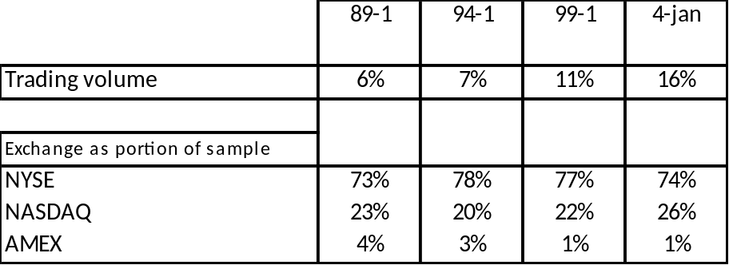
Table 1: Composition of the dataset.
The upper row of this table quantitatively describes the dataset with respect to average trading volume. The other rows depict how the portions of the different exchanges are distributed throughout the years. It gives an indication how much stocks of each exchange are included in the sample. The periods correspond to the holding periods.

3.2 Risk factors
3.2.1 Fama-French three- factor model
The data for the Fama-French three-factor model (market excess return, size factor (SMB) and book-to-market factor (HML)) were extracted from the WRDS database. On the website from Kenneth French more information is given about the construction of these variables. The “market excess return” is the return on the market, which is value-weighted on all NYSE, AMEX and NASDAQ stocks, minus the return the 1-month Treasury bill rate (risk free rate). To build a 6-month proxy, the equal-weighted average of monthly data is taken.
Small Minus Big (SMB) and High Minus Low (HML) are both constructed with the help of the six value-weight portfolios. On the one axis a distinction is made with respect to size (market equity: ME): small or big. On the other side, a three-way deviation is made regarding their book equity to market equity ratio (BE/ME): value, neutral, growth. Value stocks, characterised with high BE/ME ratios, have higher returns than growth stocks, characterised with low BE/ME ratios. The BE/ME breakpoints for the portfolios are the 70th and 30th NYSE percentiles at the end of each month. The size breakpoint is the NYSE median market equity at the end of each month. See figure 1 for the complete overview.
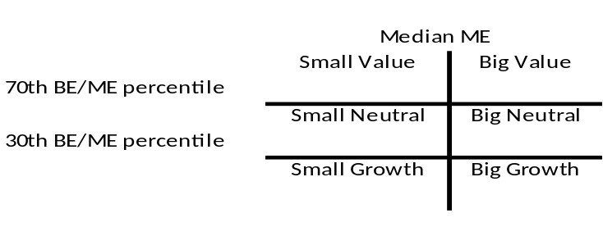
Figure 1: The six value-weight portfolios of Fama & French.
The variable Small Minus Big (SMB) is the average return on the three small portfolios minus the average return on the three big portfolios
SMB= 1/3 (SmallValue + SmallNeutral + SmallGrowth) –
1/3 (BigValue + BigNeutral + BigGrowth) (5)
The factor High Minus Low (HML) is the average return on the two value portfolios minus the average return on the two growth portfolios:
HML = 1/2 (SmallValue +BigValue) – 1/2 (SmallGrowth + BigGrowth) (6)
3.2.2. Four-factor pricing model
In order to construct the fourth risk factor, which contains the momentum factor, the variable Up Minus Down (UMD, but also sometimes referred as MOM) is used. This data were obtained via the WRSD database. This variable is constructed with the help from six value-weight portfolios using independent sorts on size and prior returns, using all stocks on the NYSE, AMEX and NASDAQ.
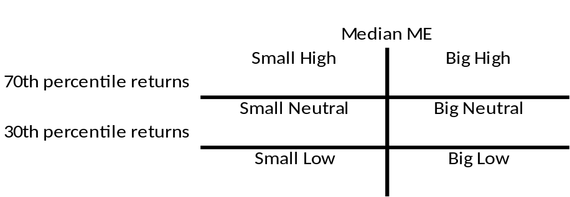
Figure 2: The six value-weight portfolios of factor Up Minus Down (UMD).
UMD is the average of the returns on two big (big and small) high prior return portfolios; minus the average of the returns on the two (big and small) low prior return portfolios. The breaking point of split on size is, like the earlier mentioned six value-weight portfolios, the NYSE median market equity. Prior return is measured from month -12 to -2. , here the split is based on NYSE percentiles. Below the 30th percentile, portfolios are called low return portfolios, above the 70th percentile, the portfolios are named high return portfolios. To build a 6-month proxy, the equal-weighted average of monthly data is taken.
UMD = 1/2 (SmallHigh +BigHigh) – 1/2 (SmallLow+ BigLow) (7)
So UMD is the average return on the two high prior return portfolios minus the average return on the two low prior return portfolios.

3.2.3 Pástor & Stambaugh’s market wide liquidity factor
Pástor & Stambaugh (2003) investigated that market wide liquidity is important for asset pricing, as they show that systematic liquidity is indeed a priced risk factor. Stocks with higher sensitivities to fluctuations in aggregate liquidity (as the indicator for liquidity risk), have substantially higher expected returns. For example, when a trader faces a solvency constraint, in order to raise cash he must liquidate a portion of his assets. When holding assets with higher sensitivities to aggregate liquidity, it’s more likely that shares cannot be traded quickly enough to prevent a loss (higher liquidity risk). This means that liquidity is low and as a result higher returns are requested to compensate the risk. Even when controlled for size, value and momentum, this positive relationship between liquidity risk and future returns exists. The Pástor & Stambaugh measure of aggregate liquidity focuses on the aspect of liquidity which corresponds to the price fluctuations induced by the order flow. The Pástor & Stambaugh data used in this research were extracted via WRDS.
3.2.4 Sadka’s aggregate liquidity factor
Just as Pástor & Stambaugh (2003), Sadka (2006) also focussed on market-wide liquidity as an undiversified risk factor. Here the same expectation hold as for Pástor & Stambaugh’s liquidity factor, that high liquidity risk implies more illiquidity and therefore requesting higher future returns. The liquidity measure is described as the price-impact induced by trades. These stock specific estimates were aggregated into this market wide estimate. The WRDS database is used to retrieve monthly data for this measure of liquidity risk.

4. Methodology
In this chapter I present the methodology of my thesis. As mentioned in earlier, a lot of research is done about trading volume, however little consensus is reached how to interpret and handle this widely available market statistic. Therefore, with a more recent dataset, my aim is to establish a link between past trading volume and future returns and trying to validate the liquidity motive. First I will elaborate more on the first main research question by adding sub questions and explain the variables and statistical techniques used. Then, the same is done for the second main research question.
4.1. Testing the relation between past trading volume and future returns.
4.1.1 Hypotheses
Relating to the first research question stated in the introduction, “Is there a relationship between past trading volume and future returns?”, I have made several sub questions to guide to a more detailed response to answer this. As I expect trading volume to be a proxy for liquidity, low volume stocks earn higher returns than high volume stocks because they need to be compensated for holding those riskier stocks. Liquidity refers to the simplicity of which an asset can be sold. Amihud & Mendelson (1986) indicate a positive relationship between the bid-ask spread (as a proxy for liquidity) and future returns. Datar et al. (1998) continue on this research, being one of the first using trading volume as a proxy for liquidity. They conclude a negative relationship between past trading volume and future returns. Meaning that they both conclude the same; less (more) liquid stocks earn higher (lower) returns. The difference between those two articles is the way they measure liquidity; respectively the bid-ask spread and trading volume.
To test whether or not volume based strategies hold (and whether or not they pay off in the future) the following alternative hypotheses are made:
H1: The combined volume portfolio (P1-P10) outperforms the market.
H2a: Low volume portfolio P1 earns higher returns than the market.
H2b: High volume portfolio P10 earns lower returns than the market.

4.1.2 Formation of portfolios
In this framework, 40 holding (performance measurement) periods, of each a half year are created from January 1989 until December 2008. Condition here is that 7 months of prior data is available before the start of the holding period. At the formation date (at the end of formation period) the largest 1000 firms of the sample of the NYSE, AMEX and NASDAQ stocks are selected based on market capitalization (price of stock at formation date * number of stocks outstanding/publicly held). To avoid potential microstructure biases, a one-month lag between the end of the portfolio formation period and the beginning of each holding period (K) is imposed.
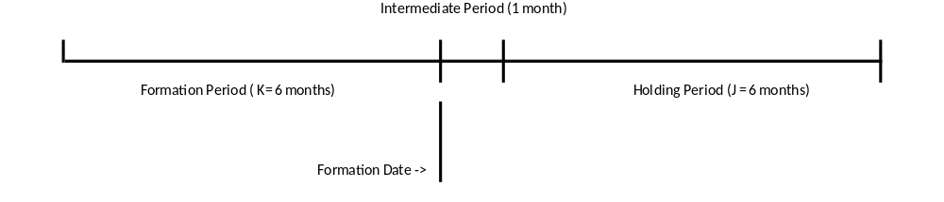
Figure 3: Representation of formation- and holding period.
When the selection of the 1000 largest firms is made, the creation of volume based portfolios can take place. All 1000 stocks are sorted based on their previous 6 (J) months trading volume and divided in 10 equal-weighted portfolios. P1 represents the portfolio of stocks with the lowest trading volume ratio, when stocks which relatively the most are positioned in P10.
Trading volume is calculated as followed:
Trading Volume = volume / number of shares outstanding (8)
Here trading volume is measured as the ratio of the total shares of a stock traded in a specific period divided by the total number of shares outstanding for a specific period. In order to account for the fact that NASDAQ volume is calculated differently than on the NYSE and AMEX, a correction was made. Historically, trading volume for NASDAQ stocks has been overstated when comparing to NYSE and AMEX. The discrepancy between these markets exists because NASDAQ is a dealer market and the NYSE/AMEX are both auction markets. The latter meaning that most transactions take place between the actual buyers and sellers, in which a market maker is selected for each firm’s stocks who oversees the market. In contradiction, a dealer market in which on each side of the transaction there is a dealer. So, as a rule of thumb, NASDAQ trading volume is double-counted compared with the NYSE/AMEX. Therefore the statistic trading volume for NASDAQ stocks is corrected and divided by 2 to provide a comparable base between the markets.
4.1.3 T-test
First a t-test (X) is performed to get an indication whether or not a relation between past statisticals and future returns exists.
T =( x⁻ - μ₀)/( s/√(n)) (9)
Where xˉ stands for the sample mean, μ₀ represents the expected value; s is the sample standard deviation which is a result of the estimation of the standard deviation in the data and n stands for the number of observations. The t-distribution has n-1 degrees of freedom.
When trying to establish if there is a relationship between past trading volume and future return, it is expected that because of a premium paid for low volume (illiquid) stocks they earn higher return. To test the relationship between the returns of volume based portfolios and future returns, the following hypotheses will be tested:
H1₀ : μ_{p1-p10} = 0 (10)
H1_{a} : μ_{p1-p10} > 0 (11)
As I expect that low volume portfolio P1 will outperform the market, and P10 will earn lower returns than the market, the following hypotheses will be tested as well.
H2₀: μ_{p1-}μ_{rm} = 0 (12)
H2_{a}: μ_{p1-}μ_{rm} > 0 (13)

H3₀: μ_{rm} –μ_{p10} = 0 (14)
H3_{a}: μ_{rm} –μ_{p10} > 0 (15)
These tests will be performed within a time span of 1989-2008. However, as the descriptive statistics made clear earlier, there is an increasing trend in both the absolute and relative amount shares were traded. Therefore, after looking at the period as a whole, the time span will be divided in two to check whether or not between 1989-1998 and 1999-2008 there are different outcomes visible.
4.2 Testing the liquidity motive
4.2.1 Hypotheses
“Can this relationship between past trading volume and future returns be explained by liquidity” is the extended version of the second main research question to test whether liquidity is a motive for the relationship between past trading volume and future returns. I expect liquidity risk to be priced in an asset pricing model. In this thesis the usage of market wide liquidity factors of Pástor & Stambaugh (2003) and Sadka (2006) in asset pricing models are tested, to validate if these liquidity risk factors are priced when explaining volume based portfolio returns. First this is done when testing:
H4: Do the factors of the multiple factor models (Fama-French, and Four-factor mode) indicate a liquidity motive.
Then the additional factors of Pástor & Stambaugh and Sadka are being investigated. The difference between those two factors is that Pástor & Stambaugh’s liquidity factor focuses more on the fluctuations of aggregate liquidity and is a proxy for liquidity risk. The higher the liquidity risk (so the higher sensitivity to this measure), the more difficult it becomes to trade your stock quickly enough to prevent a loss, the more illiquid the market is and as a result a higher return is requested to compensate this for this risk.
H5: Pástor & Stambaugh’s liquidity factor is priced when explaining the return on the combined volume portfolio P1-P10.
Sadka’s liquidity factor is defined as the price-impact implied by trades. These stock specific estimates are aggregated into this market wide estimate, which is a proxy for liquidity risk as well. Here the same expectation holds as for the Pástor & Stambaugh’s liquidity factor; high liquidity risk implies higher illiquidity and therefore requesting higher future returns.
H6: Sadka’s liquidity factor is priced when explaining the return on the combined volume portfolio P1-P10.

4.2.2 Asset pricing regressions
Building towards a model with liquidity risk factors, as a starting point the CAPM is taken:
R_{it} – R_{ft} = α + β_{i} (R_{mt} – R_{ft}) + ε_{it} (Regression 0)
Then, the other Fama-French risk factors are added:
R_{it} – R_{ft} = α + β_{i} (R_{mt} – R_{ft}) + s_{i}SMB_{t} + h_{i}HML_{t} + ε_{it} (Regression 1)
Where R_{it} is the average monthly return on portfolio i at time t, R_{ft} is the risk-free interest rate at time t, R_{mt} is the rate of return on the market portfolio at time t. SMB is the difference between the return on a portfolio composited with small minus the return on a portfolio of large stocks at time t and HML_{t} is the discrepancy between the return on a portfolio with high BE/ME ratio stocks minus the return on a portfolio with low BE/ME ratio stocks at time t.
Adding factor UMD(up minus down) to regression (A) will lead to the four factor regression (B). Where UMD_{t} is the difference of return on a portfolio with past winners minus the return on a portfolio with past losers at time t.
R_{it} – R_{ft} = α + β_{i} (R_{mt} – R_{ft}) + s_{i}SMB_{t} + h_{i}HML_{t} + u_{i}UMD_{t} + ε_{it} (Regression 2)
Adding the Pástor & Stambaugh liquidity factor or the liquidity factor of Sadka to regression B, this will lead to testing respectively hypothesis 4 and 5. In regression (C), the aggregate liquidity factor of Pástor &Stambaug is used, which is the aggregate liquidity factor. Sadka’s liquidity factor is added in regression (D), where SAD_{t} is liquidity factor at time t.
R_{it} – R_{ft} = α + β_{i} (R_{mt} – R_{ft}) + s_{i}SMB_{t} + h_{i}HML_{t} + u_{i}UMD_{t} + p_{i}P&S_{t} + ε_{it} (Regression 3a)
R_{it} – R_{ft} = α + β_{i} (R_{mt} – R_{ft}) + s_{i}SMB_{t} + h_{i}HML_{t} + u_{i}UMD_{t} + v_{i}SADt + ε_{it} (Regression 3b)
Like the T-test, these tests are done for the period 1989-2008, and the separate periods 1989-1998 and 1999-2008.

5. Results

The results of my research will be presented in this chapter. As my research is split in two parts, I will first discuss my results regarding the relationship between past trading volume and future returns. Then, the results with respect to the asset pricing models will be shared.
5.1 Past trading volume and future returns
5.1.1 1989-2008
In this section I discuss the results for volume-based strategies. In table 2, the average monthly returns are depicted. When looking at the combined portfolio P1-P10, the average monthly return is 1.09%. The t-statistic shows the returns of P1 significantly differ from P10. Evidence is found that the combined volume portfolio outperforms the market; H1₀ is rejected. Therefore implying that past trading volume of a stock is linked with its future returns. However, this does not tell anything about the underlying motive(s) and the persistence of this relationship. Focussing on P1, this portfolio outperforms the market, so H2₀ is rejected. H3₀ is not rejected, because no significance evidence is found that P10 earn lower returns than the market. When looking at all the portfolios, a linear decreasing trend is observed when looking at the average monthly returns; P1 has the highest returns and P10 the lowest.
Table 2 also provides information about how some variables of the portfolios in the formation period look like; in terms of size rank, volume and price. Size rank represents the median size portfolio. Firms placed in portfolio 1 are the smallest firms based on market capitalization, portfolio 5 showing the largest firms. Because the low volume portfolio is expected to be more illiquid, smaller firms are expected in this portfolio (and vice versa). However a mixed trend is observed and no evidence is found to confirm the former expectation.
Therefore implying only an illiquidity premium needs to be paid for the low volume portfolio. No discounts are given to high volume portfolios. But by putting the two relations P1 and P10 together, a portfolio can be created which outperforms the market even more than only focussing at P1.

 | 1989-2008
 | Portfolio |  |  |  | Returns
 | J=6 | Volume | Size Rank | Price | K=6
 | P1 | 0,05 | 2,52 | 39,8 | 1,38%
 |  |  |  |  | 1,93**
 | P2 | 0,06 | 3,11 | 38,5 | 1,21%
 |  |  |  |  | 1,41
 | P3 | 0,06 | 3,29 | 39,1 | 0,99%
 |  |  |  |  | 0,74
 | P4 | 0,07 | 3,27 | 38,8 | 0,92%
 |  |  |  |  | 0,47
 | P5 | 0,08 | 3,25 | 39,8 | 0,93%
 |  |  |  |  | 0,40
 | P6 | 0,10 | 3,14 | 38,9 | 0,86%
 |  |  |  |  | 0,17
 | P7 | 0,11 | 3,03 | 40,0 | 0,51%
 |  |  |  |  | -0,92
 | P8 | 0,14 | 2,93 | 39,5 | 0,64%
 |  |  |  |  | -0,48
 | P9 | 0,18 | 2,82 | 39,8 | 0,50%
 |  |  |  |  | -0,79
 | P10 | 0,32 | 2,65 | 42,3 | 0,29%
 |  |  |  |  | -1,11
 | P1-P10 |  |  |  | 1,09%
 |  |  |  |  | 2,43*

Table 2: Returns to trading volume portfolios: 1989-2008.
This table represents the average monthly returns for trading volume portfolios involving NYSE, AMEX and NASDAQ stocks, for 40 semi-annual holding periods (K) from January 1989 to December 2008. From December 1988, each half year stocks are divided into different portfolios based on their previous (J=6) months’ relative trading volume. P1 represents the portfolio with the lowest trading volume and P10 represents the portfolio with the highest trading volume. Return is the monthly average return for a specific portfolio. Volume is the relative measure of the total numbers of shares traded divided by their total number of outstanding shares. Size Rank represents a proxy for size, meaning the median portfolio of market capitalization (the portfolios run from 1 to 5). Price is the median average stock price for a certain portfolio in U.S. Dollars ($). The values within parentheses are t-statistics. * Indicates a significance level of 5%, ** denotes a significance level of 10%.
5.1.2 1989-1998 & 1999-2008
Because of the increasing trend of both absolute and relative trading volume, the total time span is split in two. Table 3 confirms that those two periods show different scenarios. In the first period, the average monthly returns across the portfolios are all within the same range resulting that no excess return regarding the market rate can be made when making a combined portfolio. None of the volume based portfolios earn significant differently returns when comparing to the market.
When looking at the second period, P1 and P1-P10 do earn significantly higher returns than the market. Both being in line with the illiquidity premium. Returns of P10 are not significant, so no underperformance compared to the market is measured. Meaning this portfolio will move along with the dynamics of the market; no discount is being given to high volume portfolios.

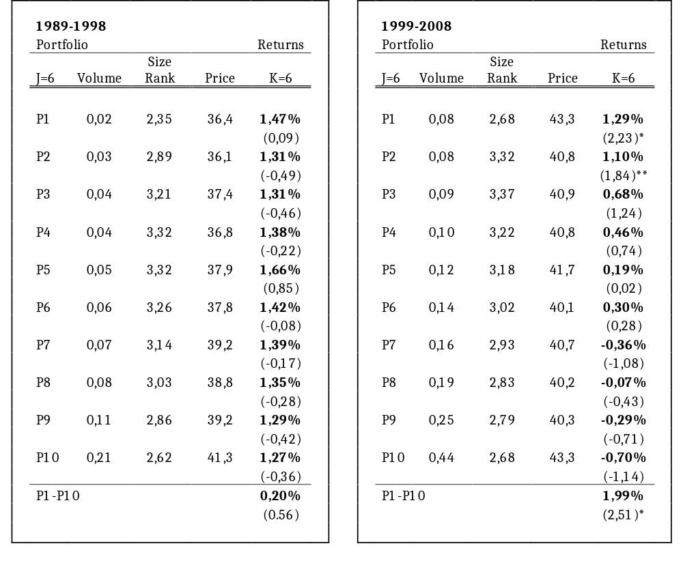

Table 3 : Returns to trading volume portfolios.
This table represents the average monthly returns for trading volume portfolio involving NYSE, AMEX and NASDAQ stocks, where section A represents the 20 semi-annual holding periods (K) between 1989 and 1998, as section B is covering the same for the period 1999 to 20008. From December 1988, each half year stocks are divided into different portfolios based on their previous (J=6) months’ relative trading volume. P1 represents the portfolio with the lowest trading volume and P10 represents the portfolio with the highest trading volume. Return is the monthly average return for a specific portfolio. Volume is the relative measure of the total numbers of shares traded divided by their total number of outstanding shares. Size Rank represents a proxy for size, meaning the median portfolio of market capitalization (the portfolios run from 1 to 5). Price is the median average stock price for a certain portfolio in U.S. Dollars ($). The values within parentheses are t-statistics; test is performed whether or not the average monthly return is different from the risk free rate. * Indicates a significance level of 5%, ** denotes a significance level of 10%.

5.2 Asset pricing regressions
5.2.1 1989-2008
Table 4 represents the results of the asset pricing regressions performed on the combined volume portfolio P1-P10 for the period 1989-2008. Over the whole range of regressions almost every beta (coefficient of excess market return) has a significant negative relation with the market, except for regression 3a. Trying to explain this negative sign of the beta, this is investigated further when looking at the portfolios P1 and P10 separately, see table 5. There the negative sign of the coefficient of the excess market return for the combined portfolio (P1-P10) can be explained by the fact that this factor is not priced for low volume stocks as it is for high volume stocks.
Focussing on the estimated coefficients for the HML factor, valid for all regressions, a significant positive relation between monthly average returns and HML is observed. Here low volume stocks (P1) have much more positive effect on HML than high volume stocks (P10). It seems that low volume stocks behave more like value stocks (high BE/ME ratio) than high volume stocks, as they are undervalued with respect to their book market, higher returns are expected. High volume stocks (P10) do not have significant coefficient for the HML factor. A possible explanation could have been hat low volume firms (illiquid firms) are characterised with small firm size as not all available information is incorporated (yet) in the stock prices. Therefore those stocks can be undervalued. However, looking at the size factor SMB this explanation is not underpinned.
In theory, the insignificance of the SMB was not expected. As mentioned in the literature, liquidity and market capitalization are linked. But as it also became clear from the descriptive variables from table 2, a wide spread of size rank was found across all portfolios, therefore already indicating an insignificant sensitivity to SMB. Concluding that differences in trading volume have no explanatory power for a stock’s sensitivity to firm size. But because the sample includes only the 1000 largest firms, this can provide an explanation of the insignificance of the coefficient of SMB.
When moving from the Fama-French three-factor model, to the four-factor model, R² slightly increases, however the addition of UMD is not significant. Also across low and high volume portfolios, no sensitivity to past winners and losers is observed. Though, the liquidity factors are added to the four factor model, and not to the Fama-French three-factor model, because of the higher explanatory power of the variables (R²) when UMD is included.

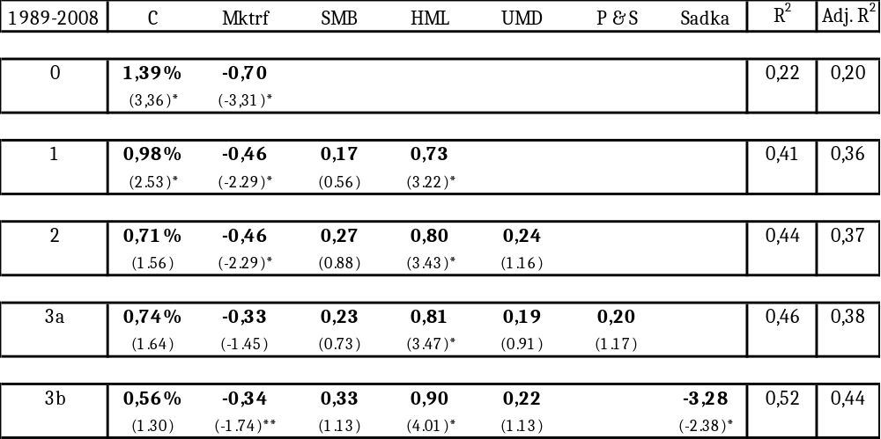
Table 4: Asset pricing regressions on average monthly returns of combined volume portfolio P1-P10.
This table summarizes the multiple regressions performed on average monthly returns of combined volume portfolio P1-P10 for (J=6, K=6). J represents the months before the portfolio formation date; K represents the amount of months on which the performance measurement period is. The results in this table correspond to the coefficients in relation with the factors mentioned in the first row. This table contains the 40 semi-annual performance measurement periods from January 1989 to December 2008. * and ** indicate respectively the significance levels of 5% and 10%. Between the parentheses, the t-statistics are stated.

The coefficient with respect to market wide liquidity factor of Pástor& Stambaugh is not significant. This does not validate the expectation that the factor should be priced when trying to explain the portfolios’ return. When looking at Sadka’s liquidity factor, this outcome is stating that when liquidity risk decreases (the more liquid the market is) higher returns are earned on the combined portfolio. This runs counter the expectation that liquidity is the motive between the found relationship between past trading volume and future returns.

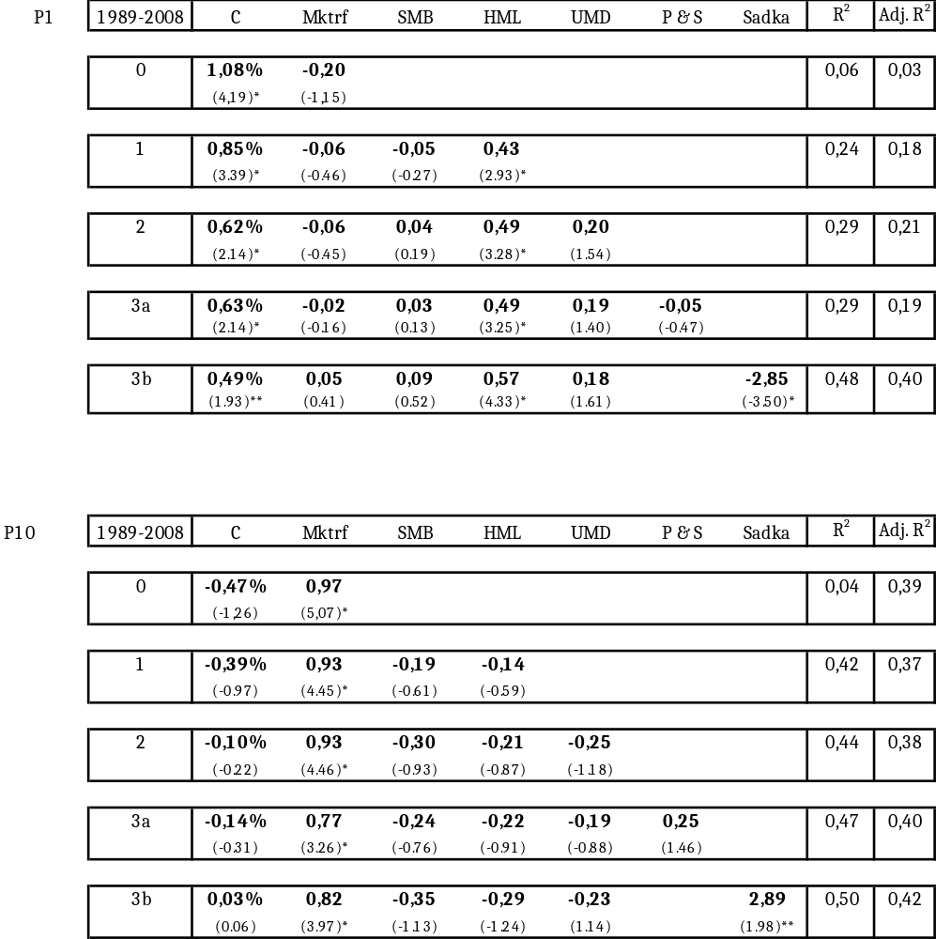

Table 5: Asset pricing regressions on average monthly returns of volume portfolios P1 and P10.
This table summarizes the multiple regressions performed on average monthly returns of respectively P1 (low volume stocks) and P10 (high volume stocks) for (J=6, K=6). J represents the months before the portfolio formation date; K represents the amount of months on which the performance measurement period is. The results in this table correspond to the coefficients in relation with the factors mentioned in the first row. This table contains the 40 semi-annual performance measurement periods from January 1989 to December 2008. * and ** indicate respectively the significance levels of 5% and 10%. Between the parentheses, the t-statistics are stated.

When taking a look at the two portfolios separately, table 5, for the low volume stocks (P1) only the factors HML and Sadka are priced. HML for low volume stocks (P1) have more value characteristics than high volume stocks (P10). As just mentioned, this might be in favour that liquidity is a proxy of trading volume. However for both portfolios, the signs of the coefficient of Sadka’s risk factor run counter to a liquidity motive; the results indicate that when liquidity risk decreases (increases), the returns earned are increasing (decreasing). Nevertheless, the opposite was expected.
5.2.2 1989-1998
As shown in the earlier results (table 3: sections A and B) another insight is given when dividing the portfolios in two period of 10 years. Where earlier was shown (table 3, section A) that the first hypotheses with respect to the under- and outperformance of portfolios with respect to the markets were rejected, this should not result saying that multiple factors are not priced. Table 6 shows the results of the regressions for 1989-1998. However the tested risk factors are not priced for this period. Indicating that the monthly average returns of the combined volume portfolio cannot be explained by the risk factors below. The R² of the regressions is much lower than looking at the whole period

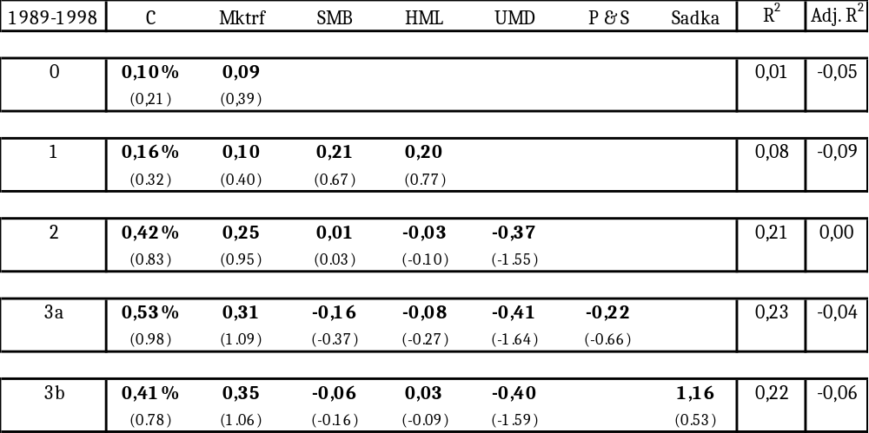
Table 6: Asset pricing regressions on average monthly returns of combined volume portfolio P1-P10 for the period 1989-1998.
This table summarizes the multiple regressions performed on average monthly returns of combined volume portfolio P1-P10 for (J=6, K=6). J represents the months before the portfolio formation date; K represents the amount of months on which the performance measurement period is. The results in this table correspond to the coefficients in relation with the factors mentioned in the first row. This table contains the 40 semi-annual performance measurement periods from January 1989 to December 1998. * and ** indicate respectively the significance levels of 5% and 10%. Between the parentheses, the t-statistics are stated.

5.2.3 1999-2008
In general, almost the same pattern of the whole period is also perceived, as shown in table 9, for the second sub-period for the combined portfolio. A higher explanatory power of the variables is measured among the regressions. When looking at all regression except 3b, a negative sign of the coefficient of excess market return is depicted. In the next section, this will be further investigated. Also for this period, evidence for a liquidity motive when looking at the HML factor is provided.
When only focussing at regression 3b, where only the HML factor is in favour of a liquidity motive, and Sadka’s factor is running against.
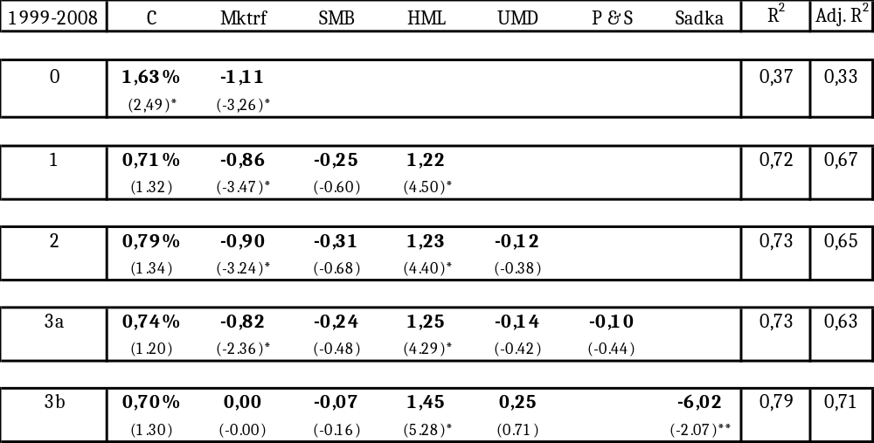
Table 7: Asset pricing regressions on average monthly returns of combined volume portfolio P1-P10 for the period 1999-2008.
This table summarizes the multiple regressions performed on average monthly returns of combined volume portfolio P1-P10 for (J=6, K=6). J represents the months before the portfolio formation date; K represents the amount of months on which the performance measurement period is. The results in this table correspond to the coefficients in relation with the factors mentioned in the first row. This table contains the 40 semi-annual performance measurement periods from January 1999 to December 2008. * and ** indicate respectively the significance levels of 5% and 10%. Between the parentheses, the t-statistics are stated.

Table 8 shows the results for the separately for both portfolios. For both portfolios excess market return is priced. Low volume stocks have a negative relation with excess market return. This might imply that in “good times”, when excess market return increases, an illiquidity premium is not applicable as this has a negative effect on the return of the portfolio. The other way around also holds, meaning that in “bad times” (negative excess market return) higher returns are measured. This provides evidence for a possible illiquidity premium.
However, as the excess market factor is priced in the opposite way for P10. However if this is because the existence of a possible “liquidity discount” is not plausible. Table 5 shows no underperformance of the return of high volume portfolio P10 when compared to the market.

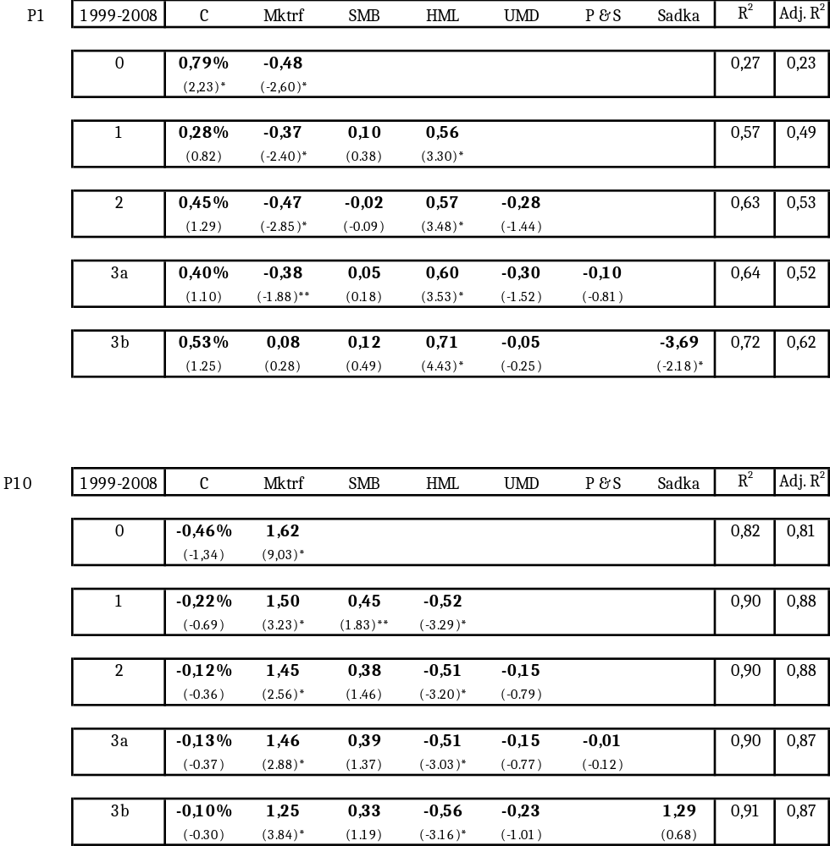

Table 8: Asset pricing regressions on average monthly returns of combined volume portfolio P1 & P10 for the period 1989-1998.
This table summarizes the multiple regressions performed on average monthly returns of combined volume portfolio P1-P10 for (J=6, K=6). J represents the months before the portfolio formation date; K represents the amount of months on which the performance measurement period is. The results in this table correspond to the coefficients in relation with the factors mentioned in the first row. This table contains the 40 semi-annual performance measurement periods from January 1999 to December 2008. * and ** indicate respectively the significance levels of 5% and 10%. Between the parentheses, the t-statistics are stated.
6. Conclusion and Discussion
Little consensus among academics is reached about how to interpret and to handle the market statistic trading volume. Therefore the aim of my thesis was trying to validate the usefulness of the widely available market statistics trading volume for portfolio selection, especially focussing on the possible underlying liquidity motive. In short, a negative relation between past trading volume and future returns is found, however this cannot be explained by liquidity risk.
With respect to the relationship between past trading volume and future returns, a negative relationship was found for the whole time-span. This found relationship is consistent with Datar et al. (1998). Low volume stocks outperform high volume stocks, which is in favour of the expectation regarding the existence of an illiquidity premium. But when looking at the first ten years separately, the earlier perceived results do not apply here, as the returns of P1 and P10 do not significantly differ from each other.
When trying to underpin the liquidity motive, this is first done by looking at risk factors of the Fama-French three-factor model and the four-factor pricing model. For the whole time-span, the factors excess market return and HML are priced. The negative sign of the coefficient of excess market return (for P1-P10) indicating that in times of positive (negative) excess market return, lower (higher) liquidity risk is observed, therefore a discount (premium) is given. This provides evidence for the liquidity motive, as it the premium is being recognized.
Looking at the HML risk factor, portfolios P1 and P1-P10 behave more like value stocks. This could have been providing evidence for the existence of an illiquidity premium, as low volume stocks (as literature stated that illiquid stocks are characterised with small firm size) react more slowly to available information. However this is not underpinned because of the insensitivity found for SMB factor. Then looking at Pástor & Stambaugh’s liquidity factor; this does not validate the liquidity motive, as the sensitivity to market wide liquidity is not significantly different from zero. When referring to the outcomes of Sadka’s liquidity factor, this runs counter to the liquidity motive as it suggests that lower liquidity risk implies higher returns. When looking at the first ten years, barely none of the outcomes mentioned above were found. Then focussing on the second ten years, in general the same outcomes with respect to the sign of the coefficients of the risk factors apply.

As a suitable explanation for the obtained results throughout the years is lacking and further research is necessary to clarify this. Future research might take in consideration different sets of formation and holding periods, to get a more detailed view on the relationship between past trading volume and future returns. Also expanding the sample period might gain additional insights between volume and returns.
With respect to size, the literature provides evidence for the fact that size and liquidity are related with each other. However, this thesis only selects the 1000 largest firms across the NYSE, AMEX and NASDAQ. By expanding the sample to more firms, more difference between large and small firms might be obtained. So this can lead to other insights with respect to the relationship between past trading volume and future returns.

References

Acharya, V.V. and Pedersen, L.H. 2005, “Asset pricing with liquidity risk”, Journal of Financial Ecnomics, vol. 77, no. 2, pp. 375-410.
Amihud, Y. 2002, “Illiquidity and stock returns: cross-section and time-series effects”, Journal of Financial Markets, vol. 5, no. 1, pp. 31-56.
Amihud, Y. and Mendelson, H. 1986, “Asset pricing and the bid-ask spread”, Journal of Financial Economics, vol. 17, no. 2, pp. 223-249.
Anderson, A.-M. and Dyl, E.A. 2005, “Market structure and trading volume”, The Journal of Financial Research, vol. 28, no. 1, pp. 115-131.
Banz, R.W. 1981, “The relationship between return and market value of common stocks”, Journal of Financial Economics, vol. 9, no.1, pp. 3-18.
Basu, S. 1983, “The relationship between earnings yields, market value and return for NYSE common stocks: further evidence, Journal of Financial Economics, vol. 12, no. 1, pp. 129-156.
Bessembinder, H. and Seguin, P.J. 1993, “Price volatility, trading volume, and market depth: evidence from futures markets”, Journal of Financial and Quantitative Analysis, vol. 28, no. 1, pp. 21-39.
Bhandari, L.C. 1988, “Debt/equity ratio and the expected common stock returns: empirical evidence, The Journal of Finance, vol. 43, no. 2, pp. 507-528.
Blume, L., Easley, D. and O’Hara, M. 1994, “Market statistics an technical analysis: the role of volume”, The Journal of Finance, vol. 49, pp. 153-181.
Brav, A., Geczy, C. and Gompers, P.A. 2000, “Is the abnormal return following equity instances anomalous?”, Journal of Financial Economics, vol. 56, no. 2, pp. 209-249.
Brennan, M.J. and Subrahmanyam, A. 1996, “Market microstructure and asset pricing: on the compensation for illiquidity in stock returns”, Journal of Financial Economics, vol. 41, no. 3, pp. 441-464.
Brown, J.H., Crocker, D.K. and Foerster, S.R. 2009, “ Trading volume and stock investments”, Financial Analysts Journal, vol. 65, no. 2, pp. 1-18.
Campbell, J.Y., Grossman, S.J., Wang, J. 1993, “Trading volume and serial correlation in stock returns”, The Quarterly Journal of Economics, vol. 108, no. 4, pp. 905-939.
Carhart, M.M. 1997, “On persistence in mutual fund performance”, The Journal of Finance, vol. 52, no.1, pp. 57-82.
Chordia, T. and Swaminathan, B. 2000, “Trading volume and cross-autocorrelations in stock returns”, The Journal of Finance, vol. 55, no.2, pp. 913-935.
Chordia, T., Roll, R. and Subrahmanyam, A. 2011, “Recent trends in trading activity and market quality”, Journal of Financial Economics, vol. 101, no. 2, pp. 243-263.
Copeland, T.E. 1976, “ A model of asset trading under the assumption of sequential information arrival”, The Journal of Finance, vol. 31, no. 4, pp. 1149-1168.
Copeland, T.E. 1976, “ A probability model of asset trading”, Journal of Financial and Quantitative Analysis, vol. 12, no. 4, pp. 563-578.
Datar, V.T., Narayan, Y.N. and Radcliffe, R. 1998, “Liquidity and stock returns: an alternative test”, Journal of Financial Markets, vol. 1, no. 2, pp. 203-219.
Daniel, K., Hirshleifer, D. and Subrahmanyam, A. 1998, “Investor psychology and security market under- and overreactions”, The Journal of Finance, vol. 53, no. 6, pp. 1839-1885.
DeBondt, W.F.M. and Thaler, R.H. 1985, “Does the stock market overreact?”, The Journal of Finance, vol. 40, no. 3, pp. 793- 805.
Fama, E.F. and French, K.R. 1992, “The cross-section of expected stock returns”, The Journal of Finance, vol. 47, no. 2, pp. 427-465.
Fama, E.F. and French, K.R. 1993, “Common risk factors in the returns on stocks and bonds”, Journal of Financial Economics, no. 33, pp. 3-56.
Fama, E.F. and French, K.R. 1996, “Multifactor explanations of asset pricing anomalies”, The Journal of Finance, vol. 51, no. 1, pp. 55-84.
Fama, E.F. and French, K.R. 1998, “Value versus growth: the international evidence”, The Journal of Finance, vol. 53, no. 6, pp. 1975-1999.
Friendman, M. 1953, “Essays in positive economics”, Chicago: University of Chicago Press.
Gallant, A.R., Rossi, P.E. and Tauchen, G. 1992, “Stock prices and volume”, The Review of Financial Studies, vol. 5, no. 2, pp. 199-242.
Gervais, S., Kaniel, R., Mingelgrin, D.H. 2001, “The high-volume return premium”, The Journal of Finance, vol. 56, no. 3, pp. 877-919.
Jegadeesh, N. and Titman, S. 1993, “Returns to buying winners and selling losers: implications for stock market efficiency, The Journal of Finance, vol. 48, no. 1, pp. 65-91.
Jegadeesh, N. 2000,m “Long-term performance of seasoned equity offerings: benchmark errors and biases in expectations”, Financial Management, vol. 29, no. 3, pp. 5-30.
Jensen, M.C. 1968, “The performance of mutual funds in the period 1945-1964”, The Journal of Finance, vol. 23, no. 2, pp. 389-416.
Harris, L. and Gurel, E., “Price and volume effects associated with changes in the S&P 500 list: new evidence of price pressures”, The Journal of Finance, vol. 41, no. 4, pp. 815-829.
Karpoff, J.M. 1986, “A theory of trading volume”, The Journal of Finance, vol. 41, no. 5, pp. 1069-1087.
Karpoff, J.M. 1987, “The relation between price changes and trading volume: a survey”, Journal of Financial and Quantitative Analysis, vol. 22, no. 1, pp. 109-126.
Keynes, J.M. 1930, “Treatise on Money” (London: Macmillan, 1930).
Lee, C.M.C. and Swaminathan, B. 2000, “ Price momentum and trading volume”, The Journal of Finance, vol. 55, no. 5, pp. 2017-2069.
Levis, M. 2002, “The record on small companies: a review of evidence”, Journal of Asset Management, vol. 2, no. 1, pp. 368-397.
Liew, J. and Vassalou, M, 2000, “Can book-to-market size and momentum be risk factors that predict economic growth?”, Journal of Financial Economics, vol. 57, no. 2, pp. 221-245.
Litner, J. 1965, “The valuation of risk assets and the selection of risky investments in stock portfolios and capital budgets”, Review of Economics and Statistics, vol. 47, no.1, pp. 13-37.
Luu, J.C. and Martens, M. 2002, “Testing the mixture of distributions hypothesis using “realized” volatility”, Journal of Futures Markets, vol. 23, no. 7, pp. 661-679.
Merton, R.C. 1987, “A simple model of capital market equilibrium with incomplete information”, The Journal of Finance, vol. 42, no. 3, pp. 483-510.
Pagano, M. 1989, “Trading volume and asset liquidity”, The Quarterly Journal of Economics, vol. 104, no. 2, pp. 255-274.
Pástor, L. and Stambaugh, R.F. 2003, “Liquidity risk and expected stock returns”, Journal of Political Economy, vol. 111, no. 3, pp. 642-683.
Sadka, R. 2006, “Momentum and post-earnings-announcement drift anomalies: the role of liquidity risk”, Journal of Financial Economics, vol. 80, no. 2, pp. 309-349.
Schneider, J. 2009, “A rational expectations equilibrium with informative trading volume”, The Journal of Finance, vol. 64, no. 6, pp. 2783-2805.
Sharpe, W.F. (1964), “Capital asset prices: a theory of market equilibrium under conditions of risk”, The Journal of Finance, vol. 19, no. 3, pp. 425-442.
Subrahmanyam, A. 2008, “Learning from experience and trading volume”, Review of Financial Economics, vol. 17, no. 4, pp. 245-260.
Treynor, J.L. 1981, “What does it take to win the trading game?”, Financial Analysts Journal, vol. 37, no. 1, pp. 55-60.
Weil, P.O. 2008, “Liquidity premia in dynamic bargaining markets”, Journal of Economic Theory, vol. 140, no. 1, pp. 66-96.

Appendix A

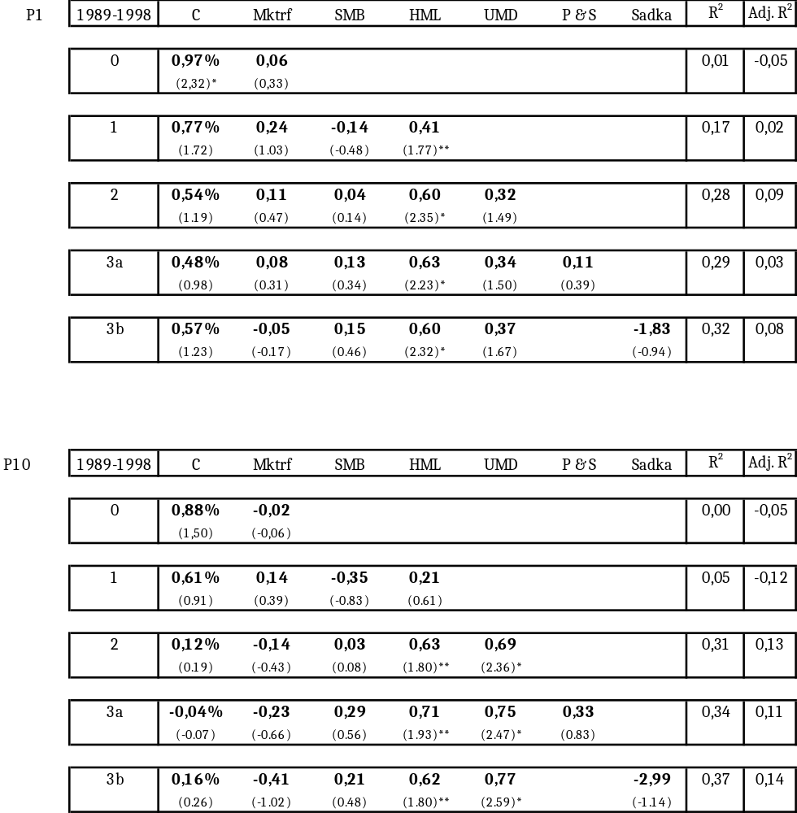

Table 9: Asset pricing regressions on average monthly returns of combined volume portfolio P1 & P10 for the period 1989-1998.
This table summarizes the multiple regressions performed on average monthly returns of combined volume portfolio P1-P10 for (J=6, K=6). J represents the months before the portfolio formation date; K represents the amount of months on which the performance measurement period is. The results in this table correspond to the coefficients in relation with the factors mentioned in the first row. This table contains the 40 semi-annual performance measurement periods from January 1989 to December 1998. * and ** indicate respectively the significance levels of 5% and 10%. Between the parentheses, the t-statistics are stated.

Pagano (1989).
Brav et al. (2000), Jegadeesh (2000) and Liew and Vassalou (2000).
Wharton Research Data Services: http://wrds-web.wharton.upenn.edu/wrds.
NYSE/ AMEX data is rounded to the nearest ten-thousand, NASDAQ data is not rounded.
Like Lee& Swaminathan (2000), pp. 2022.
Website Kenneth French: http://mba.tuck.dartmouth.edu/pages/faculty/ken.french.
Fama & French 1998.
Carhart (1997).
^{&10} Website Kenneth French: http://mba.tuck.dartmouth.edu/pages/faculty/ken.french.
Anderson & Dyl (2005).
Fama-French three-factor model (1993, 1996).
Fama & French (1996).
Carhardt (1997).
Pástor & Stambaugh (2003).
Consistent with Amihud (2002).
Consistent with the findings of Lee & Swaminathan (2000).
Levis (2002): small firms have characteristics which imply illiquidity.
Appendix A show the results of the regression for P1 and P10 separately.
For instance Levis (2002), which stated that illiquid firms are characterized with small firms.

