Effectiveness of Development Aid

Erasmus University Rotterdam
Erasmus School of Economics
Department of Economics

Supervisor: Yvonne Adema

Name: Emile Cammeraat
EXAM Number: 331591
E-mail address: emilecammeraat@hotmail.com

Effectiveness of Development Aid
By Emile Cammeraat, 331591
Abstract
This paper surveys whether aid is effective both in terms of economic growth as in terms of the outcomes of the Millennium Development Goals. Besides giving an elaborated overview of the existing literature, this paper gives a regression analysis on 21 countries covering the period 1990 to 2006. When lagged aid is used as aid variable in the analysis of OLS or the instrumental variable lagged aid is used in TSLS, a small positive insignificant effect of aid on economic growth is found. When a TSLS regression with instrumental variable lagged aid is used, a small positive significant effect of aid on undernourishment and child mortality is found. Besides a negative significant effect from aid on school enrollment is found. The conclusion that more development aid leads to more undernourishment and child mortality is in contrast with expectations and former literature, therefore further research on endogeneity and policy conditions is necessary before conclusions can be drawn.

Table of Contents

- Introduction pg. 3

- Literature survey pg. 5

- Data pg. 12

- Methodology pg. 14

- Results pg. 16

- Conclusion pg. 20

- References pg. 22

- Appendix pg. 24

- Introduction
Nowadays the effectiveness of Official Development Aid (ODA) is highly debated. For this reason even a country with a good reputation in the area of international development and cooperation, as the Netherlands, cut their budget for Development Aid from 0.8 to 0.7% of GDP between 2010 and 2012. Because of the large influence this cut may have on millions of extremely poor people, it would be necessary to measure the consequences of the effectiveness of Development Aid before more cuts will be executed by the Western World. This study contributes to this debate by researching the effectiveness of ODA in a specific area where a lot of development aid goes to, Sub Saharan Africa. The aim of this study is to examine if Official Development Assistance is effective, both in terms of economic growth as in terms of the Millenium Development Goals.
Although a broad range of research in the field of development aid already exist, there is no general conclusion about the effectiveness. The reason for this is that most surveys come with totally different outcomes. By surveying the effectiveness of Development Aid in a certain poor area ‘sub-Saharan Africa’, this survey can give specific conclusions about the effectiveness of ODA for a large part of the Bottom Billion. By surveying countries with a similar culture, climate and circumstances we can draw a more robust conclusion about effectiveness of ODA than studies that compare countries as China and India with Sub Saharan Africa countries. In this survey we define effectiveness as ‘economic growth’ on one hand and ‘good outcomes on the Millennium Development Goals’ on the other hand. The value of this research is that we survey the effect of Official Development Aid (ODA) not only on economic growth but also on the outcomes of the Millennium Development Goals in the specific continent Africa. The Millennium Development Goals were established by a consortium of experts from the UN in consultation with the IMF, the World Bank, and other specialized agencies of the UN system. The MDG is a framework of eight goals, 18 targets, and 48 indicators to measure world progress towards the implementation of these goals.
The eight Millennium Development Goals include:
- Eradicate extreme poverty and hunger
- Achieve universal primary education
- Promote gender equality and empower women
- Reduce child mortality
- Improve maternal health
- Combat HIV/AIDS, malaria, and other diseases
- Ensure environmental sustainability
- Develop a Global Partnership for Development.
The purpose and nature of this research is to help decision makers in a better understanding of the effectiveness of Official Development Aid. This will contribute to a better decision making, because ODA should be used differently when it is not working effectively. On the other hand if Official Development Aid is effective it might help decision makers to expand on ODA to eradicate extreme poverty even sooner.
First, we will research and describe the large amount of literature available on this topic. We start with the theories, followed by the main findings. After this we will discuss different methods, the effect of other variables, the long run effect and endogeneity problems. Finally we will elaborate on the Millennium Development Goals.
After the Literature survey, we will research the effect of Net Official Development Aid on the independent variable economic growth and some of the Millennium Development Goals. we will focus on the first 6 MDG’s, because for the last two of the MDG’s it is really hard to measure or to get data of them. We will take economic growth and measures for the first 6 MDG’s as the variable for the left side of the regression equation. On the right side of the equation we will take the variable ODA and squared ODA because squared ODA makes it possible to measure wether the effect of ODA is linear or not. Next to ODA and squared ODA we will add lagged aid to observe what the long term effect of ODA is. Besides ODA, squared ODA and Lagged ODA, we will add control variables of a neoclassical economic growth model and a Keynesian model. Another variable we will add in agreement with the literature is workers remittance to compare this variable with aid. These control variables are consumption, savings, government spending, imports, export, FDI, Remittances and population growth. These control variables will make it possible to measure how ODA affects the different parts of the aggregate demand. Because it may be possible that it is not ODA that affects the left side of the equation but it may be an indirect effect by one of the control variables that affect the left-hand side of the equation.
Now, only one problem concerning this research is left. The likelihood of endogeneity is quite large because we may expect that it is not only ODA that affects economic growth and the outcomes of the MDG’s but that it is also the case that poor countries with less progress get more Official Development Aid. We try to control for this endogeneity by using the lagged aid as instrumental variable in a Two-Stage Least Square regression.

- Literature survey
In the literature survey we will discuss the theory of aid(2.1), the main findings of the literature(2.2), the different methods used(2.3), other variables, long run effect and endogeneity issues(2.4) and finally we will elaborate on the Millenium Development Goals(2.5).
2.1 Theory of aid
Aid can affect growth in many ways. It may lead to higher incomes of the local population, which will lead to a higher domestic demand and capital accumulation. A second way aid can positively influence growth is the fact it might make it possible to import inputs that increase productivity and thus improve production and wealth. Aid can also help to finance structural and institutional reforms which may increase efficiency or resource and factor productivity. For example a better education system may lead to more human capital and thus to higher factor productivity of labor. Another positive effect of aid may be caused by insurance against macroeconomic fluctuations thus improving inter-temporal resource allocation. Aid may also lead to market friendly reforms, especially when there are some policy conditions for receiving aid .
Next to the general growth theories, “the poverty trap” is another theory in the development debate. As Jeffrey Sachs (2005) puts it: “The problem of the poor is that they are too poor to invest, which means that they are in a poverty trap”. People can overcome the poverty trap by Development Aid if there is enough aid, according to Jeffrey Sachs (2005). This theory says that poor people are not able to save and to invest because they have barely enough money to survive, while savings and investments are necessary for capital accumulation and economic growth. This leads for instance to impoverishing of large groups of people because they eat all their yields to stay alive and do not have enough yields to invest in fertilizers and good seeds.
Besides the theory how aid can support economic growth there are also a lot of theories why aid would not work. They argue that aid leads to fiscal mismanagement, rent seeking activities, increased government consumption and bad investments. Furthermore aid will lead to the so-called Dutch disease problem. The Dutch disease problem means that the value of the exchange rate becomes too high because of the larger demand for national currency. This can lead to a worse competition position which will have a negative effect on export and thus on the economy. It is called Dutch disease because the high exchange rate can be caused by natural resources like gas in The Netherlands, but development economists like Paul Collier argue that it is also caused by aid inflow. The last argument why aid will be ineffective is that aid will keep the same (often corrupt) government controlling the country. This may not only lead to more corruption but may also cause that necessary but painful reforms to accelerate growth are not being made.
  - Main findings literature
A lot of research is done in the field of aid effectiveness. In most researches a cross sectional country comparison is done over time, with the least development countries all over the world included. Unfortunately much less research is done on Africa with its unique history and culture in the developing world. Even less research is done on the effect on ODA (official development assistance) on the outcome of the Millennium Development Goals. For this reason the literature study below mainly focuses on the effect of ODA on economic growth, with a small elaboration on the research done on the effect of ODA on the outcomes of the MDG’s in Africa.
Useful summaries of aid effectiveness on economic growth are to be found in Burnside and Dollar (2000), White (1992) and, more recently, in Hansen and Tarp (2000) and Hermes and Lensink (2001). Of these papers, the paper ‘Aid, Policies, and Growth’ by Burnside and Dollars (2000) is by far the most influential one, and is used in most of the follow-up studies. They investigated the interaction effects among foreign aid, economic policies and growth. They conclude that aid on its own has little impact on growth, but the effect of aid on growth becomes considerable when there is a good policy environment. This effect goes beyond the direct impact that the policies themselves have on growth. They draw this conclusion on the basis of a substantial significant interaction effect that is higher than the effect of a good policy environment on its own.
The summaries mentioned above confirm that there is no consensus about the effectiveness of development aid. The different outcomes of various studies are largely caused by different specifications, samples and estimation methods. But also papers that use the same samples and estimation methods often come to different conclusions. We can classify the surveys in roughly three kinds of research outcomes: (i) aid has a positive growth effect, (ii) aid has no significant growth effect and (iii) aid has a negative growth effect.
The category of positive growth effects can be divided in the two subcategories ‘conditional’ and ‘unconditional’. Several studies using different methodologies and samples find a growth effect regardless of any institutions. Gyimah-Brempong, Racine and Gyapong (2010) as well as Hansen and Tarp named a few of them. “An example from this group is Dalgaard et al (2004) who provide a survey of empirical analyses from the last 30 years that make use of cross-country regressions in assessing the effectiveness of foreign aid. Based on 31 of them a consistent pattern appears: (i) aid increases aggregate savings, although not by as much as the aid flow, (ii) aid increases investment, (ii) aid has a positive effect on the growth rate whenever growth is driven by capital accumulation” (Hansen and Tarp, 2000, p.549).
Another group of studies conclude that aid has a positive growth effect only if recipient countries pursue the ‘right’ policies or provide the ‘right’ policy environments (Burnside and Dollar, 2000).These groups of studies come to the conclusion that aid has a positive effect on economic growth if certain policy conditions are satisfied. This conditional research has generated a debate about the measurement of good policies and raise the question if good policies are the same for every country. Another raised question is whether aid does not have a positive effect on its own? And if effectiveness depends on policy, should aid be divided among countries with good policies?
The second category does not give a significant positive effect of aid on growth, and say that the previous category is not robust to model specification, data, income level or sample size.
The third category comes to a negative effect from aid on growth. Although this category is by far the smallest category, it is probably the most well-known outcome in the public debate due to a lot of attention in the media. We elaborate on the reasons why there could be a possible negative effect below.
2.3 Research methods literature
There are different types of evaluations of effectiveness of aid possible. The first distinction is made between studies on the microeconomic and macroeconomic level. Working on a micro basis by the ‘marginal approach’ is mainly defended by Easterly (2009), whereas studies on the macro level with much more contradictory results are used by Sachs (2005) and his companions to defend the ‘transformational approach’. According to the transformational approach a larger integral approach instead of a few projects is needed. The studies on the microeconomic level are analyses of aid funded projects, whereas the macro studies survey the effects of aid on growth, savings, investment, governments spending and so on.
Easterly (2009) prefers the marginal approach because he is convinced that a lot of aid works counter effective. For that reason he wants to measure the effect of all different projects on the micro-scale to ensure that development aid will be used in an effective way. Even if a project works, it is not possible to draw the conclusion that these projects will also work in other development countries, or even in other places in the same country, because the circumstances may differ according to Easterly (2009).
In contrast to Easterly’s view, defenders of the transformational approach are convinced that aid is effective in general. They are convinced that we have to invest much more if we want to eradicate extreme poverty as soon as possible. Most of them think it is possible to eradicate extreme poverty much sooner if a lot of investments take place. For this reason they mainly research the effect of aid on the macro-economic level to measure the overall effect of aid on economic growth.
In this paper I will focus on the transformational approach because I want to survey the effect of total official development aid (ODA) on economic growth and the outcomes of the MDG’s, which are also measured on the macro level.
Debate on linearity
In the 1990s a generation of people who were skeptical about aid came up. Boone (1994,1996) showed in a panel study with a sample of more than 90 countries covering 20 years that aid did not have any effect on growth. These results are doubtful, because other studies including Burnside and Dollar (2000) showed a positive link between aid and growth. The reason for this difference was that Boone (1994) treats the aid-growth relation as linear, whereas other studies include aid squared as regressor. The main motivation for a squared variable is (absorptive) capacity constraints. (Absorptive) capacity constraints can cause a squared relation because with too less aid it is possible that people cannot work effectively because the requisite networks are not available. And with too much aid it is possible that development countries do not know what to do with the large amount of aid, which may lead to ineffective ways of using aid and bureaucracy. Next to (absorptive) capacity constraints, Dutch disease problems and inappropriate technology are also good reasons to assume a squared relation between aid and economic growth. Dutch disease problem because the positive effect of development aid need to overcome the negative effect of a higher currency, which means that development aid needs to reach a certain level of effectiveness which might not be possible under a certain level. Inappropriate technology for the reason that it might be the case that before reaching a certain level of technology it will be hard to reach an effective way of development assistance.
Gyimah-Brempong et al. (2010) examined this squared relationship using panel data from 77 developing countries, two measures of aid, and a dynamic panel data estimator to investigate the effects of aid on economic growth. They found a quadratic relationship between aid and income growth. Further did they find a certain threshold in aid effectiveness. They find a significant positive effect of aid when the ratio of aid to gross national income (GNI) reaches a threshold of between 6.6 and 14 per cent.
Policy variable
Besides reasons to add an aid squared variable, capacity constraints and inappropriate technology are also causal mechanisms that can be interpreted as ways in which economic policy impacts aid effectiveness. Hence it is a good argument to include a policy variable as well.
Burnside and Dollar (2000) showed a positive correlation between effectiveness of aid and the quality of policy. The difficult question is how to define the quality of a policy. Burnside and Dollar (2000) include the following variables as elements of the policy variable ‘P$it$’. First they used a dummy variable for trade openness developed by Sachs and Warner (1995). Following Fischer (1993) they took inflation as a measure of monetary policy. Finally they took the fiscal variable budget surplus, relative to GDP suggested by Easterly and Rebelo (1993). Government consumption was also suggested in the literature but was strongly negatively correlated with budget surplus, and because it was not marginally significant when both variables were included, they choose to drop it from their analysis.
These policy variables were defined in almost the same way by Sachs and Warner (1995). During the time these variables were supplemented by a number of other political and institutional indicators to capture political instability and government bureaucracy. Like the state of the financial system provided by M2 relative to GDP, ethnolinguistic fractionalization, assassinations and a measure of institutional quality . As explained above there are some papers that come to the conclusion that there is a positive robust effect of aid regardless of the policy environment (Gyimah-Brempong et al, 2010), whereas other papers come to the conclusion that a good policy environment is a condition for aid effectiveness. Nevertheless there is a broad consensus that a good policy environment has a positive effect on economic growth. However, some researchers argue that economic growth will also have a positive effect on policy environment (Sachs,2005).
The policy implications that different research papers give is to give the countries with relatively good policy conditions more aid. This will not only lead to higher effectiveness of aid but it will also be an extra incentive for countries with poor policy quality to reform the public sector, become a more open economy and fight bureaucracy to improve their policy quality.

2.4 Effect by other variables, long run effect and endogeneity issues
Effect on investment
Also the effect on investment is highly debated in the literature. The debate is mainly about the question if the positive investment effect surpasses the negative effect of a higher exchange rate. Gyimah-Brempong, et al. (2010) come to the conclusion that there exists a positive and significant relationship between aid and physical capital investment. Controlling for indirect effects through investment, they find a positive effect on growth at all levels of aid. These results are robust to the measurement of aid, the policy environment, income levels and region. Also Yasin (2005) comes to the result that bilateral official development assistance has a significant and positive influence on foreign direct investment flows. These results also show that trade openness, growth rate in the labor force, and low exchange rates have a positive and significant effect on foreign direct investment flows. But multilateral development assistance, the growth rate in GDP per capita, the country’s composite risk level, and the index for political freedom and civil liberties do not have a statistically significant effect on foreign direct investment flows. Two policy implications can be drawn from this research. First, we see that bilateral aid flows do have a positive significant effect on the investment, whereas multilateral aid flows do not have a positive effect. This means that bilateral aid flows may be more effective than multilateral aid flows. The second policy implication is that the recipient countries need to formulate policies that improve their economic relationships with the donor countries in order to attract greater foreign direct investment flows from the multilateral corporations located in these countries. This conclusions are based on the results that many more variables are decisive in generating foreign direct investment than aid alone.
Long term effect aid.
Another technical issue concerns the estimation method. Hansen and Tarp (2000) include all the aid regressors as lagged one period. This extension leads to a higher R². A higher R²-value means a higher explanatory power and thus is a lagged aid regressor a better variable to use than an aid regressor of the same year as growth. This can be explained by the theory that it takes some time until social investment pays itself back. For example investment in human capital will improve labor productivity after finishing a study and mostly not during a study. The same can be said about fertilizers. If aid makes it possible to improve productivity in the agricultural sector by promoting and supporting fertilizers, it takes some time until the plants that have grown with the support of fertilizers can be harvested. However there can be a problem by adding both aid as lagged aid because these variables may be highly correlated with each other. For this reason it is preferable to use only lagged aid because this variable typically has the largest explanation power.
Endogeneity
The hardest thing we have to deal with in aid effectiveness research is endogeneity. Not only aid has an effect on growth and the outcome of the Development Goals, but the effect works also in the opposite direction. If the amount of aid depends on the level of income or the level of growth, it cannot be exogenous with respect to growth as traditionally assumed in ols regressions. Burnside and Dollar (2000) test for endogeneity of aid using the Durbin-Wu-Hausman (DWH) test. The test statistics reveal that ordinary least squares estimates do not deviate significantly from instrumental variable estimates in the growth regressions when the aid regressors are treated as endogenous variables. Further does the DWH test not reject the null hypothesis of equality of the OLS and the IV estimates. This means that there is no significant difference between using OLS estimates and instrumental variables estimates, given that the aid regressors are treated as endogenous variables.
However there were a number of assumptions which leads to this outcome. First of all the assumption that none of the exogenous variables is correlated with the error term in the model. Moreover any significant correlation between policy variables and unobserved country specific effects would also lead to inconsistency of the IV estimators since the policy indicators are used as instrument.
Burnside and Dollar(2000) do not correct for endogeneity because there is no significant difference between OLS estimates and IV estimates. This means that they don’t work with an instrumental variable. Other studies suggest to use the size of a country as instrumental variable, because there is some bias in de division of aid. Small countries get relatively more aid than larger countries. By taking the instrumental variable, we have a variable that influences the amount of aid (x variable) but which further does not influence the economic growth per capita (y variable). On the other hand it is questionable if the size of a country does not have influence on economic growth. It may be possible that larger countries have more corruption because the distance between politics and large parts of the population is much larger. On the other hand we see that there are much more small countries next to the sea, whereas bigger countries in Africa are overrepresented in landlocked countries. Collier (2008) gives being landlocked as one of the most important reasons for failing states. For this reason it is questionable if the size of countries is a good instrumental variable to use to control for endogeneity.Because this instrumental variable is doubtful,we choose lagged aid as instrumental variable to control for endogeneity.
2.5 Millenium Development Goals

Economic growth does not necessarily imply poverty reduction. This can be explained by the richer elite part of the population becoming richer, whereas the poorest part does not profit from the economic growth. Therefore it is useful to research other elements of poverty reduction than economic growth alone. Arlene L. Garces-Ozanne (2011) conclude that there is a general lack of correlation between real GDP growth and other aid effectiveness measures. This means that GDP growth often have no effect on other aid effectiveness measures as we will use in our empirical study below. Some research is done to investigate if the Millennium Development Goals will be realized. The goals speak about improvements between the years 1990 and 2015. Ahmed and Cleeve(2004) conclude that the goals are far from being realized. For example “the proportion of people in SSA whose income is less than 1 dollar a day was 48 per cent in 1990. To meet the first poverty target in 2015 this proportion should reduce to 24 per cent. In 2002, however, the proportion was 47.5 per cent. Just 0.5 per cent below the 1990 level. The second poverty target is to reduce the proportion of people who suffer from hunger with fifty percent. For SSA countries this proportion stood at 32 per cent in 1990 and 31 per cent in 2002” (Ahmed and Cleeve, 2004, pg 21). Also the MDGs on education and health are far from being realized. Ahmed and Cleeve (2004) give as conclusion that a lot has to be done to meet the goals in 2015. They plea for higher domestic savings, loans and investment, market incentives, openness to trade and good governance, but they also notice that it is equally important that the international community delivers its promises and commitments to Africa on debt relief, generous aid, opening markets for wider trade opportunities, and increasing investment. In the empirical part of this paper we will elaborate on this by researching the correlation between the amount of aid a country received and to what extent this affects the outcomes of the MDG’s.
Garces-Ozanne (2011) concludes that the effect of aid on economic growth is negative. However, aid has a negative significant effect on the poverty gap ratio, the average share of the poorest quintile in national consumption or income and on the prevalence of undernourished children. This means that aid is able to improve the quality of life in aid-receiving countries, as measured by the MDG indicators. She comes also to the conclusion that human capital and good economic policies do not have a significant effect on their own. However, when human capital interact with aid it gets a significant negative effect on the outcomes of the MDG’s. Whereas economic policies in interaction with aid leads to a significant positive effect on the outcomes of the MDGs.
Next to the Millennium Development Goals we have the Human Development Index (HDI). Oluyele Akinkugbe (2011) did research on the relation between technical assistance and the HDI. Technical Assistance is defined as a technical process involving the simple transfer of knowledge or organizational models from the developed to developing countries.The result of his analysis is that the relationship is positive but in most cases insignificant. His research outcome also makes clear that some reforms are necessary to get a real effect from technical assistance to the outcome of the Human Development Index. The reform he proposes can be divided in four policy implications: “putting recipient countries in the lead, giving them the freedom to choose their own development path, mutual accountability between donors and recipients and country specificity” (Akinkugbe, 2011, pg. 239). Moreover he suggested that more studies on the human development impact of aid, as opposed to the current practice of investigating the overall growth effect of aggregate aid are necessary. The aim of our study is to be a part of this further research by elaborating on the relationship between development aid and the outcomes social indicators, like the ones in the Millennium Development Goals.

- Data
For the empirical research part we needed a lot of quantitative data. We found this data in the database of the World Bank, which is freely available on www.worldbank.org. Initially we found data for 49 Sub-Saharan African countries for the period 1970 till 2011. Unfortunately, a lot of data were missing which made it hard to conduct a good research. For this reason we selected the last 17 years, i.e. from 1990 until 2006, for which much more data were available. After selecting these 17 years, we selected the 21 countries for which the most data were available in the database. The selected countries are: Benin, Botswana, Burkina Faso, Cameroon, Chad, Cote d’ Ivoire, Gabon, Guinea, Kenya, Lesotho, Madagascar, Mali, Mauritius, Mozambique, Namibia, Senegal, South Africa, Sudan, Swaziland, Togo and Zambia. It is possible that there is a bias in the selection of the countries. This bias can be caused by lack of data for a certain type of countries. The reason for lack of data could be war or extreme poverty. If this leads to the selection of a certain type of countries, for example richer countries, this will cause a bias in this research.
The first part of this research focuses on the effect of development aid on economic growth. For growth we used the indicator GDP growth (annual%) and for development aid we used the indicator net official development assistance and official aid received (current US$)/GDP (current US$), see Table 1.2 in the Appendix. We notice that the average GDP growth is 3.76% a year. The maximum growth is 33.63% a year, the minimum -15.71% and the standard deviation 4.30. For aid we see that on average selected countries get 9.38% development aid (in % of GDP). The maximum is 74.12% and the minimum -0.25%. This means that we notice a lot of differences for both the growth as the aid variables between the different countries.
Furthermore we added the control variables household final consumption expenditure (annual % growth), gross domestic savings (% of GDP), general government final consumption expenditure (% of GDP), imports of goods and services (% of GDP), exports of goods and services (% of GDP), foreign direct investment net inflows (% of GDP), workers' remittances and compensation of employees, received (% of GDP), population growth (annual %), see Table 1.3 in the Appendix. These control variables are based on neoclassical growth model and the Keynesian model of aggregate demand and correspond with the literature. After the country and time selection there were only a few missing values left. Because these missing values were ignorable we filled the missing values by supposing a trend or an average, depending on the variable. For example when there was a clear observable trend for both export and import, we supposed a trend. However with variables like government final consumption expenditure, where there was no clear observable trend, we supposed an average to fill in the missing values. The average household final consumption expenditure growth is 3.84% a year. Gross domestic savings is on average 11.83% of GDP, which is low if we compare it with developed countries. This is one of the often used explanations for underinvestment and thus poverty in Africa. The general government final consumption expenditure is 14.89% of GDP. The imports of goods and services are 41.45% and the exports 32.25% of GDP. This implies a deficit on the trade balance of the balance of payments, which might be an indicator for higher debts, inflation and devaluation. This causation can be explained by a deficit on the current account which needs to be compensated on the capital and financial account. Further we see that the average foreign direct investment net inflows is 2.53% of GDP and the average worker remittances and compensation of employees is 4.56% of GDP. The average population growth in the selected countries is 2.46% a year.
The second part of this research focuses on the effect of development aid on different outcomes of the Millennium Development Goals. We will focus on the first 6 goals because better measurement instruments are available for those.
The first goal: Eradicate extreme poverty and hunger. We will measure the outcomes of this goal by the indicators: Poverty headcount ratio at $1.25 a day (PPP) (% of population), Poverty headcount ratio at $2 a day (PPP) (% of population), Prevalence of undernourishment (% of population), Malnutrition prevalence and weight for age (% of children under 5). Unfortunately, the data available for these indicators are limited, because countries measure these indicators only once in a few years depending on the country. In total only 50 data points are available for Poverty headcount ratios, 63 for prevalence of undernourishment and 57 for malnutrition for children under the age of 5. we will explain the effects of these limited data later in the results. The mean of the poverty headcount ratio at $1.25 a day (PPP) is 50.33% of the population, the mean of the poverty headcount ratio at $2 a day (PPP) is 69.46% of the population, see Table 1.4 in the Appendix. The mean for undernourishment is 24.48% of population. The mean for malnutrition prevalence is 22.90% for children under the age of 5.
The second goal: Achieve universal primary education. we measure this goal with the indicator: School enrollment, primary (% net). Here the amount of observations available is 203 divided over 21 countries. The mean for school enrollment, primary is 68.95%, see Table 1.4 in the Appendix.
The third goal: Promote gender equality and empower women. The indicator we used for this goal is: Labor participation rate, female (% of female population ages 15+). For this indicator 314 observations are available. The mean for labor participation rate for female is 59.66% of female population ages 15+, see Table 1.5 in the Appendix.
The fourth goal: Reduce child mortality. For this goal we used the indicator: Mortality rate, under-5 (per 1,000 live births). 314 observations are available for this indicator. The mean for mortality rate for children under 5 is 129.23 per 1000 live births, see Table 1.5.
The fifth goal: Improve maternal health. For this indicator we used maternal mortality ratio (modeled estimate, per 100,000 live births). 63 data points divided over 21 countries are available for this indicator. The mean for this indicator is 550.29 per 100.000 live births, see Table 1.5.
The sixth goal: Combat HIV/AIDS, malaria, and other diseases. With this goal we focus on aids by using the indicator: Prevalence of HIV, total (% of population ages 15-49). For this indicator 314 observations are available. The mean for HIV prevalence in the selected countries is 6.22% of population ages 15-49, see Table 1.5.
For more details on the data see Table 1.2 in the Appendix for the variables aid and growth, Table 1.3 for the control variables and table 1.4/1.5 for the data on the variables for the outcomes of the MDG’s. In these tables you can also find the median, maximum, minimum and standard deviation for all the variables.

- Methodology
Before we can find the effect of aid on economic growth we need to know the theory behind growth. One of the most used growth theories is the neoclassical growth model, also known as the Solow–Swan growth model or exogenous growth model. This is a class of economic models of long-run economic growth set within the framework of neoclassical economics. Neoclassical growth models attempt to explain long run economic growth by looking at productivity, capital accumulation, population growth and technological progress.
The counterpart of the neoclassical growth model is the Keynesian model that looks at the demand side of the economy. The aggregate demand function is given by:
AD = C + I + G + (X-M)
C= consumption
I = investment
G= government spending
X = export
M = imports

In accordance with these two models the control variables consumption, savings, government expenditure, import, exports, FDI, remittances and population growth will be added. These control variables are added to measure to what extent the economic growth is due to ODA and to what extent it is due to other parts of the aggregate demand or due to savings, remittances or population growth.
As discussed in the literature survey, there are a lot of different methods that can be used to do an aid-growth regression. In this research we will see the different outcomes on the left-hand side variable growth when we use the different right-hand side variables: aid, lagged_aid and aid^2 with Ordinary Least Squares (OLS). Besides the different variables for aid we add the control variables as given above at the right hand side of the equation.
Besides we will look if a different result appears when we implement the instrumental variable Lagged aid by using the method of Two-Stage Least Squares. The method of instrumental variables can be used to allow consistent estimation when the explanatory variables are correlated with the error terms of a regression relationship. Such correlation may occur when the dependent variable (growth) has an effect on at least one of the independent variables (aid). In our research, countries with low economic growth rates get more development aid, because mostly there is a reason for the low economic growth rates like war or famine. Such phenomena will lead to more aid. An instrumental variable needs to meet three conditions:
- IV causes the independent variable (in this case aid)
- IV affects the dependent variable, if at all, only through the independent variable.
- IV is not itself caused by the dependent variable or by a factor that also affects the dependent variable.
Instrumental variable Lagged aid causes the independent variable aid, as given in correlation Table 1.1 in the Appendix. We can conclude this based on the really high correlation of 0.84, which indicates that lagged aid might cause aid. For this reason it is impossible that aid causes lagged aid, because that would mean that the future causes the past. Regarding the second condition, it is questionable if lagged aid does not have an effect on its own on the dependent variables, because it might need some years before the effect of aid is realized. The third condition is met, because it is not possible that current economic growth has an effect on lagged aid, as explained above. Although we might question if the second condition is met, lagged aid is the best instrument we can find as instrumental variable to control for endogeneity.
We consider the control variables as exogenous and thus add them as instrumental variables to keep them in the regression. After this we will check if there is autocorrelation using the Durban Watson test. If there is autocorrelation we have to interpret the results carefully. Finally we will check if the error term follows a normal distribution by doing a Jarque – Bera test. We have already controlled for heteroskedasticity by putting the coefficient standard error from Ordinary to White (diagonal).
For all equation estimations we set effects specification on cross-section Fixed and period also on fixed. We do this because introducing country fixed effects and time fixed effects makes the results more robust.
Besides the aid-growth regressions we do regressions with the different outcomes of the MDG’s as left hand side variables instead of growth. The right-hand variables for aid and the control variables can stay the same. We can still assume endogeneity with the same argument as for economic growth. It is possible that countries with more problems on the outcomes of the MDG’s get more aid to be able to reach them.

5. Results
5.1 Aid-Growth regressions
Ordinary Least Squares regressions
The first regression we regress is the effect of aid on growth without the control variables. As shown in Table 2.1 in the Appendix, there is a small negative insignificant effect of aid on growth of -0.04 in Model 1. The standard deviation is 0.06 and the regression has a small explanation power because the value of R² is only 0.23.
This small negative effect remains when we add the control variables: consumption, savings, government expenditure, imports, export, fdi, remittances and population growth, see Table 2.1 Model 2. Further we see that consumption, savings, and population growth have a positive significant effect on economic growth at a significance level of 1%. Imports have a positive significant effect on economic growth at a 10% significance level. The other control variables are not significant. We notice that the explanation power is bigger than in model 1 with an R² of 0.38 instead of 0.23.
However, when we add aid squared corresponding to the literature, aid becomes positive with a coefficient of 0.06 but this effect still is insignificant.The effect of aid squared has a coefficient of 0.00 and is insignificant, see Table 2.1 Model 3.
When we use lagged aid as variable for aid corresponding to the literature, aid has a positive insignificant effect on economic growth, see Table 2.1 Model 4. When we add squared lagged aid in this regression the coefficient of squared lagged aid is 0.00 as shown in Table 2.2 Model 5.
We notice that the control variables consumption, savings and population growth have a significant positive effect with a significance level of 5% in all 4 models. And imports have at least a positive significant effect in the models 2, 4 and 5.
Two-Stage Least Squares
In Table 2.2, we introduce the Instrumental Variable lagged aid and do a Two-Stage Least Squares regression where we regress aid on growth, with the same control variables as above. We can see that aid becomes positive but insignificant with a coefficient of 0.12. With this outcome we can argue that there is indeed an endogeneity problem with aid. Because adding the instrumental variable lagged aid changes the negative insignificant coefficient of Table 2.1 in a positive insignificant coefficient in Table 2.2. This means that we cannot draw the conclusion that more aid lead to less economic growth. Because the causation also runs in the opposite direction, less economic growth will leads to more development aid. For the other variables we notice that consumption, savings and population growth still have a positive significant effect on economic growth. Whereas the effect of imports , which have a positive significiant effect in Table 2.1, has no significant effect anymore.
However, when we add aid squared, the positive insignificant coefficient of aid remains but declines to 0.10. The coefficient for aid squared is zero and insignificant, see Table 2.2 Model 7.
When we use aid(-1) again as aid variable and aid(-2) as instrumental variable, We notice an insignificant coefficient of zero, see Table 2.3 Model 8.
As stated above, there are a lot of combinations of aid-growth regressions possible with different variables for aid. In our research we took aid, lagged aid and aid squared as aid variables. As we have shown in Table 2.2 Model 6, some proof for endogeneity exists. For this reason it is best to use the Two-Stage Least Square method or use lagged aid instead of aid as aid-variable in OLS, see Table 2.1. In both cases we come to a small positive but insignificant effect of aid on growth.
The last thing we did to make the correct tables is testing for heteroskedasticity, autocorrelation and test wether the error terms are normally distributed.
The data in Table 2.2. and Table 2.3 are already corrected for heteroskedasticity by taking the coefficient standard error from Ordinary to White (diagonal).
For autocorrelation we use the Durban-Watson test. Because we have done a panel study, the critical values of the DU and DL values are different (Bhargava, 1982). In Table 4.1 made by Bhargava (1982), we can find the values for DU and DL if we have the time dimension (T), cross section dimension (H) and the amount of regressors (N). In the models 1- 8 we have dealt with an amount of periods included between 15 and 17 and an amount of cross sections included of 21. We will use the DL and DU values in Table 4.1 that come out if we fill in H and T as close as possible to our time and cross section dimension. For this reason we take the table of T = 10 rather than T = 6 and choose the smallest value of H which is 50. In this row the values of DL are between 1.85 for one regressor and 1.79 for fifteen regressors. The values for DU are between 1.86 for one regressor and 1.92 for fifteen regressors. The value of the Durban-Watson test for model 1 is 1.85 which is equal to DL (1.85). This means that we have to interpret the results carefully. For the models 2-8 the values for the Durban Watson test are above 1.97, see table 2.2. 1.97 is higher than the highest value of DU (1.92). This means that the null hypothesis (H0) of no autocorrelation will not be rejected and thus we can conclude that there is no autocorrelation in the models 2 up to and including 8.
To test for normal distribution we use a Jarque- Bera test. We see in Table 2.2 that the zero-hypothesis of normal distribution is rejected with probability 0.000 for all models. On the other hand we see in the Graphs 2.1 – 2.8 that the models have the shape of a normal distribution. We are not correcting for it, because it would be really hard to correct for lack of normal distribution and the shape in the graphs seems close to a normal distribution.
5.2 Millennium Development Outcome regressions
After surveying the effects of aid on growth, we will regress the effects from development aid on the different outcomes of the MDG’s. We will do Ordinary Least Square and Two-Stage Least Squares regressions with country fixed effects and time fixed effects for all regressions. We will do both OLS as TSLS regressions to show how the result changes if we add the instrumental variable lagged aid. It is even more likely that more aid goes to countries which do worse based on the MDG’s than to countries which perform worse with economic growth. For this reason we expect endogeneity.
For the first and second regression we take the Poverty headcount ratio at $1.25 a day (PPP) (% of population) as left- hand side variable. For the third and fourth regression we take the Poverty headcount ratio at $2 a day (ppp) (% of population) as left-hand side variable. As we show in Table 3.1 we find a positive insignificant effect of aid on the Poverty headcount ratio’s. The insignificant effect is probably caused by a lack of data, because only 50 observations were available for this regressions. Further we notice that all control variables are insignificant as well. The positive sign of the effect indicates that more aid would lead to more people that live below the poverty line of $1.25 a day and $2.00.
For the 5th and 6th regression we take Prevalence of undernourishment (% of population) as left- hand side variable. For the 7th and 8th regression we take Malnutrition prevalence, weight for age (% of children under 5) as left-hand side variables, see Table 3.2. We find a positive significant effect of aid on undernourishment with a coefficient of 0.15 for OLS which grows to 0.29 for TSLS, see Table 3.2. This effect is significant at a 10% level both in LS as TSLS. This means that more aid leads to more prevalence of undernourishment. This is an unexpected effect, which raises the question how aid can lead to more undernourished people. Further do we see that only 63 observations were available which might be a cause for this unexpected effect. More research is necessary to survey if there is indeed a significant positive effect and on the explanation for a possible negative effect. Of the control variables, only consumption has a significant effect with a coefficient of -0.23. Which means that more consumption will leads to less undernourishment, which is consistent with the expectations.The effect of aid on Malnutrition prevalence, weight for age (% of children under 5) is positive insignificant for OLS and becomes negative insignificant when we add the instrumental variable lagged aid. This insignificant effect can probably also be caused by lack of data, because only 64 observations were available.
For the 9th and 10th regression we take School enrollment, primary (% net) as left-hand side variable. We find a negative significant effect at a 5% level of aid on school enrollment in the LS regression. This negative significiant effect becomes larger and even more significant in the TSLS regression with a coefficient -0.78, see Table 3.3. This positive significant sign indicates that more development aid would lead to less school enrollment.
For the 11th and 12th regression we take the Labor participation rate, female (% of female population ages 15 as left-hand side variable. We find a small positive significant effect of aid on labor participation of women, with the coefficient of 0.03 in the LS regression. This effect grows to 0.06 but becomes insignificant when we add the instrumental variable lagged aid in the TSLS regression, see Table 3.3. Further we see that government expenditure have a positive significant effect on labor participation of women and government consumption and exports have a negative significant effect on labor participation of women.
For the 13th and 14th regression we take the Mortality rate, under-5 (per 1,000 live births) as left-hand side variable. We find a positive significant effect of aid on mortality rate, under-5 with a significance level of 1% and a coefficient of 0.45 for LS, see Table 3.4. This effect becomes larger with a coefficient of 1.10 when we add the instrumental variable lagged aid in the TSLS regression. The effect stays significant at a 1% level. This is also against expectations and further research is necessary to find an explanation for this outcome. Perhaps there exists a bias or there is an underlying reason for this result. Further we notice that export and FDI also have a positive significant effect on the mortality rate. Whereas savings, imports, remittances and population growth have a negative significant effect on child mortality, which means that they lead to less child mortality.
For the 15th and 16th regression we take Maternal mortality ratio (modeled estimate, per 100,000 live births) as left-hand side variable. We find a positive insignificant effect of aid on maternal mortality ratio, see Table 3.4.
For the 17th and 18th regression we take HIV as left-hand side variable. We find a positive significant effect of aid on HIV with a significance level of 10% with a coefficient of 0.04. When we add the instrumental variable lagged aid in the TSLS model this effect becomes larger with a coefficient of 0.09 but insignificant. This sign indicates that more aid will lead to more HIV, but we can not prove this because the coefficient is insignificant in our more reliable TSLS model. Further do we see that consumption, export and FDI have a positive significant effect on HIV. Whereas savings, imports, remittances and population growth do have a negative significant effect on HIV.
We did all regressions with coefficient standard error on White (diagonal) to correct for possible heteroskedasticity.
For autocorrelation we use again the Durban-Watson test. We see in Table 3.1 – 3.5 that the values for the Durban Watson test are less than 1 for all regressions exept for Malnutrion 5 were the Durban Watson test is 7.86 for LS and 6.75 for the TSLS regression. As given in Table 4.1 The DL value is never lower than 1 and the DU value is never higher than 2. For this reason we reject the null hypothesis of no autocorrelation in all the regressions exept for the Malnutrition regressions for which we can not reject the null hypothesis. This means that there is a positive autocorrelation in all regressions exept the malnutrition5 regressions. This means that we have to interpret the results carefully because we have not corrected for positive autocorrelation in our regressions.
To test for normal distribution we use a Jarque- Bera test. We see in Table 2.2 that the null-hypothesis of normal distribution is rejected for the school, labor participation, Mortality 5 and HIV regressions. The null-hypothesis of normal distribution is not rejected for headcountratio 1 and 2, undernourishment, malnutrition5 and maternal mortality. We see in all graphs that the models have the shape of a normal distribution. We are again not correcting for it, because it would be really hard to correct for lack of normal distribution and the shape of the graphs 3.1-3.18 seems close to a normal distribution.
In short we find a positive significant effect from aid on undernourishment and child mortality and a negative significant effect on school enrollment in the TSLS models. These results are against expectations and the literature. First of all we tried to find a theory to explain our results. Although there are theories that explain negative effects of aid on growth, it is really hard or even impossible to find a theory which explains a positive significant effect of aid on undernourishment and child mortality. Perhaps the instrumental variable is is not enough to control for all endogeneity. Maybe because more aid goes to countries that have had large problems for many years, this would mean that lagged aid is not a sufficient instrument to control for all endogeneity.

- Conclusion
This paper has been an exercise in finding out whether or not aid is effective in both improving real GDP as in terms of achieving the Millenium Development Goals. We find in the literature that there does not exist any consensuses about the effect of aid on growth. There are theoretical and empirical arguments in favor of both sides. Different studies, using different methods and samples, come to different conclusions. By researching the methods we discovered a huge debate between Sachs and Easterly about micro versus. macro studies. Furthermore we noticed that the majority of the literature is in favor of using aid squared and introduce lagged aid to measure a long-term effect. Besides we found in the literature that aid has a positive indirect effect via investment, because of the positive effect of aid on investment.
Because of the controversial outcomes it is hard to draw general conclusions. But a large majority of the research papers come at least to a small positive significant effect from aid on economic growth when recipient countries pursue the ‘right’ policies or provide the ‘right’ policy environments. And some of them also find this significant positive effect without controlling for this policy environment. This speaks in favour of aid effectiveness but it is still hard to draw hard conclusions on the basis of the literature.
Further we saw that most papers appoint endogeneity as the big problem to measure aid effectiveness. They argue that it is not only aid that affects growth but that it is also growth that determines the amount of aid. It is hard to address this problem and there are no papers that come to an undisputed solution for this. Nevertheless some papers argue that using an instrumental variable lagged aid or the size of a country could control for this endogeneity. We have done an attempt with introducing the instrumental variable lagged aid in the empirical part.
Besides a literature study, we investigated the effect of aid on growth and on 9 indicators from the first 6 goals of the MDG’s. We came to the conclusion that aid has a small positive insignificant effect on growth. Besides we found that aid has a positive significant effect on undernourishment and the mortality rate, under the age of 5 and a negative significant effect on school enrollment. This three significant outcomes are against expectations and in contrast with Garces- Ozanne (2011), where the logarithm of aid is used as a variable. It is very unlikely that aid leads to more undernourishment, more child mortality and less school enrollment. This outcome is unlikely because an important part of aid focusses on improving these three indicators. This result raises the question if a TSLS regression with instrumental variable lagged aid is a sufficient instrument to control for the endogeneity problems. This result puts also further questionmarks behind the endogeneity issue in the growth discussion. If the instrument is not enough to control for endogeneity the coefficient of aid on growth is probably larger and more significant in reality than in the outcomes of this paper. Further research is necessary to find out if aid really has a negative impact on the outcomes of some of the MDG’s. Underlying reasons for this effect needs to be found and if further research confirms these findings, it needs to be checked if the instrumental variable is able to control for all endogeneity in further research. Besides, a policy variable can be introduced as control variable to measure if the policy conditions make the difference corresponding to the majority of the literature.
In short, the answer to the problem statement ‘ is Official Development Assistence effective?’ is ambiguous. The literature study signs in the direction that Official Development Assistence is effective, especially under the condition of good policy. But in the empirical study we did not find any evidence for effective Official Development Assistence. The effect of aid on growth was positive but insignificant and the effect of ODA on the Millennium Development Goals was even negative for undernourishment and mortality rate, under 5 and positive on school enrollment.

References
Ahmed, A., Cleeve, E. 2004. “Tracking the Millennium Development Goals in sub-Saharan Africa,” International Journal of Social Economics, Vol.31, pp. 12-29.
Akinkugbe, O. 2011. “Technical Cooperation Flows to Sub-Saharan Africa: An Exploratory Analysis of Development Impact,” The Business Review, Vol.18, pp. 230-240.
Bargava, A., Franzini, L, Narendranathan, W. 1982. “Serial Correlation and the Fixed Effects Model,” The Review of Economic Studies, Vol.49, pp. 533-549.
Burnside, C., Dollar, D. 2000. “Aid, Policies, and Growth,” The American Economic Review, Vol.90, pp. 847-868.
Boone, P. 1996. “Politics and the effectiveness of foreign aid,” European Economic Review, Vol.90, pp. 847-868.
Boone, P. 1994. “The Impact of Foreign Aid on Savings and Growth,”Unpublished paper, London School of Economics: London.
Collier,P. 2008. The Bottom Billion. New York: Oxford University Press.
Dalgaard C.J., Hansen, H., Tarf, F. 2004. “ On the emperics of foreign aid and growth,” The Economic Journal, Vol.114, pp. 191-216.
Easterly, W. 2009. “Can the west save Africa?,” Journal of Economic Literature, Vol. 47, pp. 373-447.
Easterly, W. Rebelo, S. 1993. “Fiscal Policy and Economic Growth: An Empirical Investigation.”Journal of Monetary Economics,Vol. 32, 417-458.
Fischer, S. 1993. “The Role of Macroeconomic Factors in Growth,”Journal of Monetary Economics, Vol.32, pp. 485-512.
Garces- Ozanne, A. 2011. “The Millennium Development Goals: Does Aid Help?,” The Journal of Developing Areas, Vol. 24, pp. 27-39 .
Gyimah-Brempong, K., Racine, J.S., Gyapong, A. 2010. “Aid and Economic Growth: Sensitivity Analysis,”Journal of International Development, Vol.24: pp. 17-33.
Hansen, H., Tarp. F. 2000. “Aid and Growth regressions,” Journal of Development Economics, Vol.64, pp. 547-570.
Hermes, N., Lensink, R. 2001. “ Changing the conditions for development aid: a new paradigm?,” Journal of Development Studies, Vol. 37, pp. 1-16.
OECD. 2006. “The Development Dimension, Aid for Trade, Making it Effective,” OECD publishing.
Sachs, J., Warner, A. 1995. “Economic Reform and the Process of Global Integration,” Brookings Papers on Economic Activity, Vol. 1,pp. 1-118.
Sachs, J. 2005. The end of poverty. London: Penguin Books Ltd.
White, H. 1992. “What do we know about aid’s macroeconomic impact? An overview of the aid effectiveness debate,” Journal of International Development, Vol. 4, pp. 121-137.
Yasin, M. 2005. “Official Development Assistance and Foreign Direct Investment Flows to Sub-Saharan Africa” African Development Bank.

Appendix
Table 1.1
 | AID
AID | 1.000000
LAGGED_AID | 0.844190

Table 1.2 (Growth/Aid)
 | Growth | Aid
Mean | 3.76 | 9.38
Median | 3.92 | 7.62
Maximum | 33.63 | 74.12
Minimum | -15.71 | -0.25
St. Dev. | 4.30 | 9.62
Source: World Development Indicators Database
Table 1.3 (control variables)
 | Consumption | Savings | Government | Imports | Exports | FDI | Remittances | Pop. growth
Mean | 3.84 | 11.83 | 14.89 | 41.45 | 32.25 | 2.53 | 4.56 | 2.46
Median | 3.92 | 10.61 | 13.28 | 34.36 | 27.36 | 1.29 | 1.27 | 2.58
Maximum | 65.52 | 58.35 | 42.95 | 147.65 | 100.95 | 46.49 | 79.12 | 6.10
Minimum | -35.87 | 56.64 | 4.84 | 7.07 | 3.34 | -8.59 | 0.01 | 0.13
Std. Dev. | 8.29 | 16.75 | 7.52 | 24.60 | 17.77 | 5.25 | 11.51 | 0.84
Source: World Development Indicators Database

Table 1.4 (MDG’s)
 | Headcount1 | Headcount2 | Undernourishment | Malnutrition | School
Mean | 50.33 | 69.46 | 24.48 | 22.90 | 68.95
Median | 55.67 | 75.63 | 22.00 | 21.20 | 71.68
Maximum | 92.55 | 98.54 | 60.00 | 40.90 | 97.18
Minimum | 4.84 | 19.59 | 5.00 | 8.00 | 24.86
Std.Dev. | 21.92 | 19.33 | 13.45 | 8.27 | 18.11
Source: World Development Indicators Database

Table 1.5 (MDG’s)
 | Maternal Mortality | Labor participation | HIV | Mortality5
Mean | 550.29 | 59.66 | 6.22 | 129.23
Median | 530.00 | 63.20 | 3.30 | 126.40
Maximum | 1200.00 | 87.90 | 26.30 | 255.40
Minimum | 28.00 | 25.90 | 0.10 | 15.70
Std.Dev. | 273.60 | 15.67 | 7.17 | 51.09
Source: World Development Indicators Database

Table 2.1 OLS Aid/Growth

Model | 1 | 2 | 3 | 4 | 5
C | 4.11***  (0.59) | -3.34  (2.46) | -3.98*  (2.31) | -3.35  (2.62) | -3.21  (2.51)
Aid | -0.04 (0.06) | -0.07  (0.05) | 0.06  (0.11)
Aid^2 |  |  | -0.00  (0.00)
Aid(-1) |  |  |  | 0.04  (0.04) | 0.02  (0.12)
(aid(-1))^2 |  |  |  |  | 0.00  (0.00)
Consumption |  | 0.15***  (0.05) | 0.14***  (0.05) | 0.14***  (0.05) | 0.14***  (0.05)
Savings |  | 0.19***  (0.06) | 0.17**  (0.07) | 0.20***  (0.07) | 0.20***  (0.07)
Government |  | -0.06  (0.08) | -0.07  (0.08) | -0.05  (0.08) | -0.05  (0.08)
Imports |  | 0.09*  (0.05) | 0.08  (0.05) | 0.09**  (0.04) | 0.09**  (0.05)
Exports |  | -0.05  (0.06) | -0.04  (0.06) | -0.04  (0.06) | -0.04  (0.06)
FDI |  | 0.03  (0.07) | 0.04  (0.07) | 0.02  (0.06) | 0.0  (0.07)
Remittances |  | 0.11  (0.08) | 0.10  (0.08) | -0.01  (0.08) | -0.01  (0.08)
Population Growth |  | 1.30***  (0.47) | 1.33***  (0.47) | 0.88**  (0.40) | 0.87**  (0.39)
R^2 | 0.23 | 0.38 | 0.39 | 0.38 | 0.38
Durban Watson | 1.85 | 1.97 | 1.97 | 1.99 | 1.98
Jarque Bera probability | 0.00 | 0.00 | 0.00 | 0.00 | 0.00

***= significant at a 1% level
**= significant at a 5% level
*= significant at a 10% level

Table 2.2 TSLS Aid/Growth

Model | 6 | 7 | 8
C | -3.59  (2.69) | -3.49  (2.67) | -4.26*  (2.70)
Aid | 0.12  (0.13) | 0.10  (0.33)
Aid^2 |  | 0.00  (0.00)
Aid(-1) |  |  | -0.00  (0.10)
Consumption | 0.14***  (0.05) | 0.14**  (0.06) | 0.14***  (0.05)
Savings | 0.19***  (0.07) | 0.19**  (0.09) | 0.22***  (0.07)
Government | -0.06  (0.08) | -0.06  (0.08) | -0.05  (0.09)
Imports | 0.07  (0.05) | 0.08  (0.06) | 0.11**  (0.05)
Exports | -0.03  (0.06) | -0.03  (0.07) | -0.04  (0.06)
FDI | 0.03  (0.07) | 0.03  (0.07) | 0.02  (0.07)
Remittances | -0.01  (0.08) | -0.01  (0.08) | -0.00  (0.10)
Population Growth | 0.91**  (0.41) | 0.91**  (0.40) | 1.02**  (0.47)
R^2 | 0.34 | 0.34 | 0.39
Durban Watson | 1.98 | 1.98 | 2.02
Jarque Bera probability | 0.00 | 0.00 | 0.00

***= significant at a 1% level
**= significant at a 5% level
*= significant at a 10% level

Table 3.1

Model | 1 | 2 | 3 | 4
 | Headcount 1 LS | Headcount 1 TSLS | Headcount 2 LS | Headcount 2 TSLS
C | 26.62  (26.53) | -227.42  (1767.74) | 46.75  (21.61) | -179.97*  (1579.21)
Aid | 1.30  (0.77) | 29.09  (202.41) | 1.13  (0.69) | 25.93  (180.64)
Consumption | 0.91**  (0.37) | 5.06  (30.72) | 0.47  (0.30) | 4.17  (27.43)
Savings | 0.75  (0.72) | 8.06  (52.89) | 0.41  (0.62) | 6.94  (47.24)
Government | 1.03  (0.92) | 12.91  (85.42) | 0.53  (0.73) | 11.14  (76.21)
Imports | -0.03  (0.50) | -5.35  (40.04) | -0.00  (0.47) | -4.75  (35.70)
Export | -0.91  (0.52) | -5.73  (34.80) | -0.42  (0.44) | -4.72  (31.05)
FDI | 4.91**  (2.05) | 15.33  (74.87) | 2.81  (1.64) | 12.10  (66.68)
Remittances | 0.38  (0.83) | -13.23  (101.64) | -0.01  (0.72) | -12.16  (90.75)
Population Growth | -0.81  (3.80) | 28.39  (206.91) | 0.84  (2.88) | 26.89  (184.75)
R^2 | 0.97 | -3.29 | 0.97 | -3.39
Durban Watson | 0.35 | 0.08 | 0.78 | 0.07
Jarque Bera probability | 0.16 | 0.64 | 0.03 | 0.67

***= significant at a 1% level
**= significant at a 5% level
*= significant at a 10% level

Table 3.2

Model | 5 | 6 | 7 | 8
 | Under-nourishment  LS | Under-nourishment  TSLS | Mal-nutrition 5  LS | Mal-nutrition 5  TSLS
C | 30.04***  (7.05) | 29.92***  (7.55) | 30.60***  (10.60) | 17.09  (18.04)
Aid | 0.15*  (0.08) | 0.29*  (0.16) | 0.12  (0.16) | -0.48  (0.78)
Consumption | -0.23*  (0.12) | -0.23*  (0.13) | -0.02  (0.10) | 0.05  (0.17)
Savings | -0.18  (0.29) | -0.12  (0.18) | -0.55**  (0.24) | -0.27  (0.51)
Government | -0.08  (0.29) | -0.04  (0.30) | -0.44  (0.37) | 0.08  (0.76)
Imports | -0.03  (0.09) | -0.06  (0.10) | -0.27  (0.18) | 0.15  (0.54)
Export | 0.16  (0.16) | 0.13  (0.18) | 0.31**  (0.14) | 0.10  (0.34)
FDI | -0.26*  (0.13) | -0.23  (0.15) | 0.52  (0.66) | -0.52  (1.58)
Remittances | -0.65**  (0.30) | -0.64  (0.31) | 0.42  (0.33) | 0.09  (0.61)
Population Growth | -1.22  (0.85) | -1.26  (0.85) | 0.59  (2.17) | 1.75  (2.87)
R^2 | 0.97 | 0.96 | 0.93 | 0.89
Durban Watson | 0.82 | 0.84 | 7.86 | 6.75
Jarque Bera probability | 0.67 | 0.59 | 0.34 | 0.43

***= significant at a 1% level
**= significant at a 5% level
*= significant at a 10% level

Table 3.3

Model | 9 | 10 | 11 | 12
 | School  LS | School  TSLS | Labor- participation  LS | Labor- participation  TSLS
C | 56.13***  (5.80) | 56.01***  (7.60) | 60.34***  (0.95) | 59.99***  (0.59)
Aid | -0.34**  (0.12) | -0.78***  (0.15) | 0.03*  (0.02) | 0.06  (0.05)
Consumption | 0.03  (0.05) | -0.00  (0.06) | -0.02*  (0.01) | -0.02**  (0.01)
Savings | 0.27***  (0.09) | 0.25**  (0.11) | 0.05  (0.03) | 0.06***  (0.02)
Government | 0.11  (0.17) | 0.17  (0.20) | -0.09**  (0.04) | -0.08***  (0.02)
Imports | 0.26***  (0.07) | 0.32***  (0.08) | 0.03*  (0.02) | 0.03*  (0.02)
Export | -0.21**  (0.10) | -0.21**  (0.11) | 0.07**  (0.03) | -0.07***  (0.02)
FDI | -0.15  (0.10) | -0.22**  (0.10) | 0.02  (0.03) | 0.02  (0.02)
Remittances | 0.48***  (0.12) | 0.47***  (0.15) | 0.06  (0.05) | 0.06  (0.05)
Population Growth | 1.71  (1.69) | 2.38  (2.56) | 0.16  (0.16) | 0.14  (0.18)
R^2 | 0.91 | 0.91 | 0.99 | 0.99
Durban Watson | 0.36 | 0.70 | 0.12 | 0.17
Jarque Bera probability | 0.00 | 0.00 | 0.00 | 0.00

***= significant at a 1% level
**= significant at a 5% level
*= significant at a 10% level

Table 3.4

Model | 13 | 14 | 15 | 16
 | Mortality5  LS | Mortality5  TSLS | Maternal_ Mortality LS | Maternal_ Mortality TSLS
C | 136.26***  (7.03) | 1.33.16***  (7.32) | 816.64***  (94.81) | 765.54***  (113.48)
Aid | 0.45***  (0.12) | 1.10***  (0.37) | 2.74  (2.03) | 6.89  (4.38)
Consumption | 0.06  (0.07) | 0.08  (0.08) | -1.50  (1.79) | -0.64  (2.41)
Savings | -0.73***  (0.12) | -0.82***  (0.14) | 0.75  (2.42) | 1.69  (2.70)
Government | 0.32  (0.22) | 0.15  (0.23) | -2.30  (3.07) | -8.41  (5.19)
Imports | -0.73***  (0.13) | -0.94***  (0.18) | -5.35**  (2.56) | -3.25  (3.07)
Export | 0.91***  (0.13) | 1.04***  (0.14) | 2.76  (3.41) | 0.94  (3.15)
FDI | 0.46***  (0.17) | 0.61***  (0.19) | -3.29  (4.15) | -6.59  (4.05)
Remittances | -0.46*  (0.25) | -0.30  (0.27) | -6.25*  (3.33) | -4.77  (4.43)
Population Growth | -2.34**  (2.14) | -0.30  (0.27) | -38.87  (25.78) | -20.60  (39.77)
R^2 | 0.96 | 0.96 | 0.93 | 0.95
Durban Watson | 0.20 | 0.48 | 0.75 | 0.65
Jarque Bera probability | 0.00 | 0.00 | 0.96 | 0.94

***= significant at a 1% level
**= significant at a 5% level
*= significant at a 10% level

Table 3.5

Model | 17 | 18
 | HIV  1 LS | HIV  2 TSLS
C | 10.48***  (1.79) | 9.80***  (1.82)
Aid | 0.04*  (0.02) | 0.09  (0.07)
Consumption | 0.02  (0.02) | 0.03*  (0.02)
Savings | -0.10***  (0.04) | -0.08**  (0.04)
Government | 0.02  (0.07) | 0.01  (0.07)
Imports | -0.16***  (0.04) | -0.17***  (0.05)
Export | 0.23***  (0.04) | 0.22***  (0.04)
FDI | 0.16***  (0.05) | 0.16***  (0.06)
Remittances | -0.25***  (0.08) | -0.21**  (0.09)
Population Growth | -1.56  (0.47) | -1.35***  (0.51)
R^2 | 0.87 | 0.88
Durban Watson | 0.19 | 0.23
Jarque Bera probability | 0.00 | 0.00

***= significant at a 1% level
**= significant at a 5% level
*= significant at a 10% level

Table 4.1
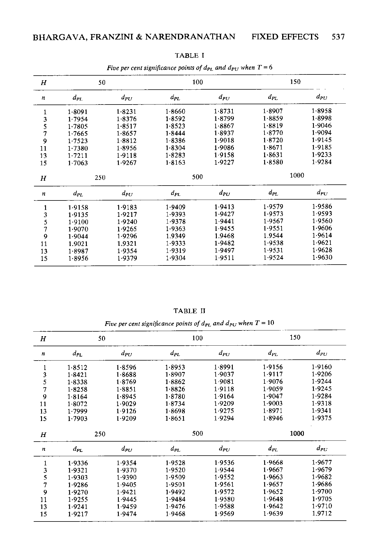
Source: Bargava, A., Franzini, L, Narendranathan, W. 1982. “Serial Correlation and the Fixed Effects Model,” The Review of Economic Studies, Vol.49, pp. 533-549.
Model 2.1 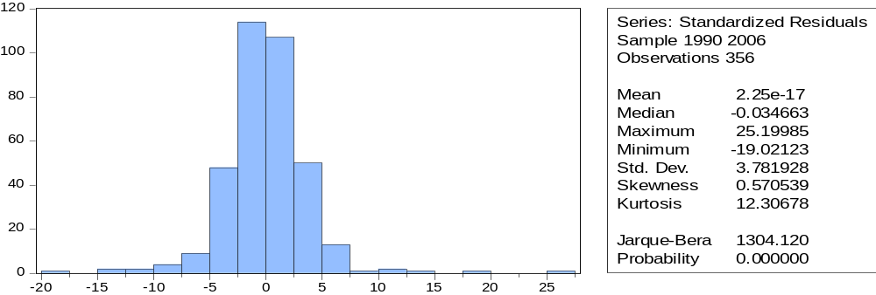
Model 2.2
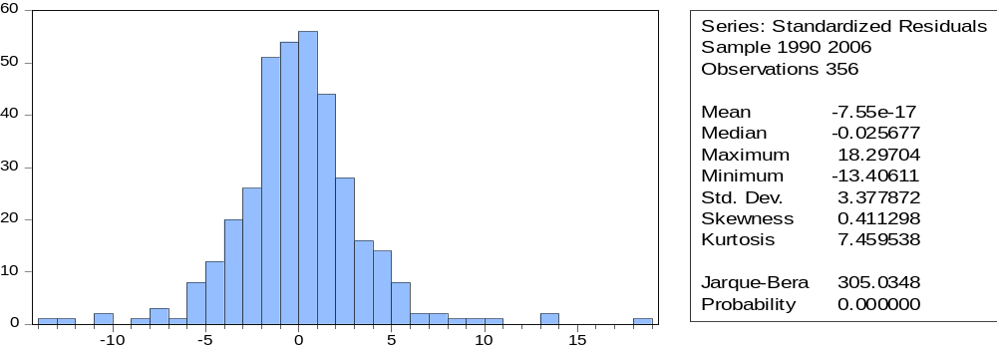Model 2.3
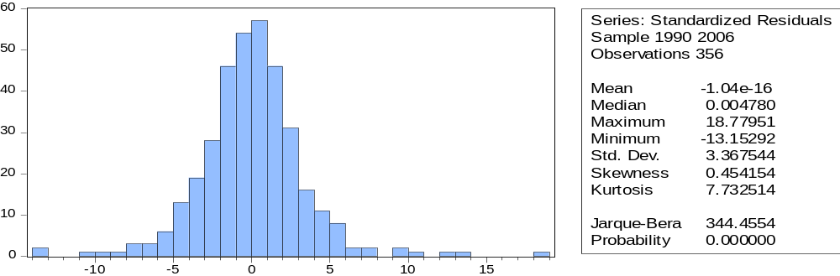
Model 2.4 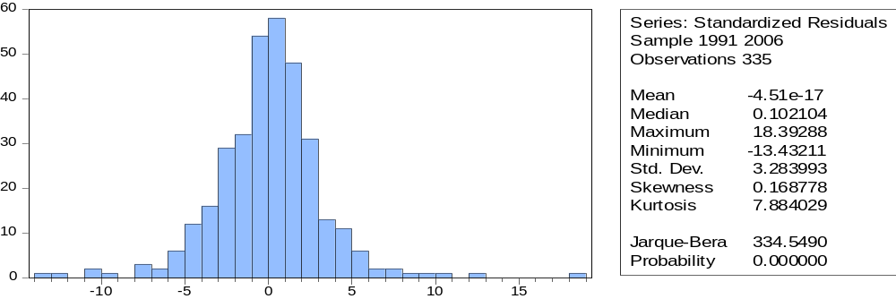
Model 2.5
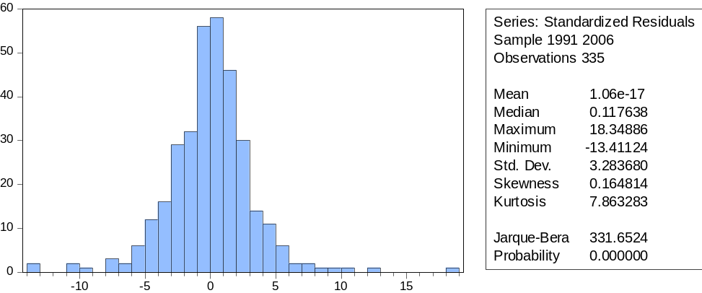
Model 2.6
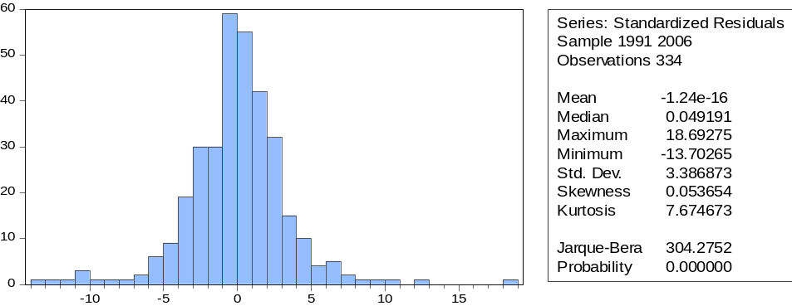
Model 2.6
7 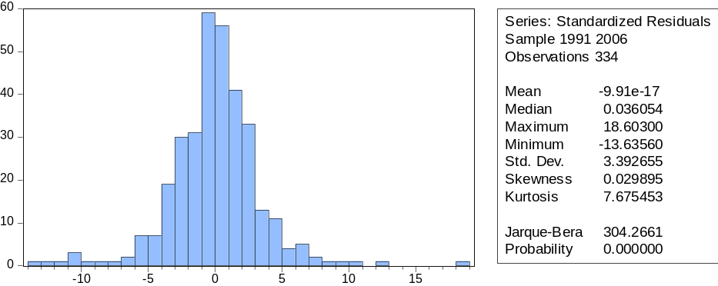
Model 2.8
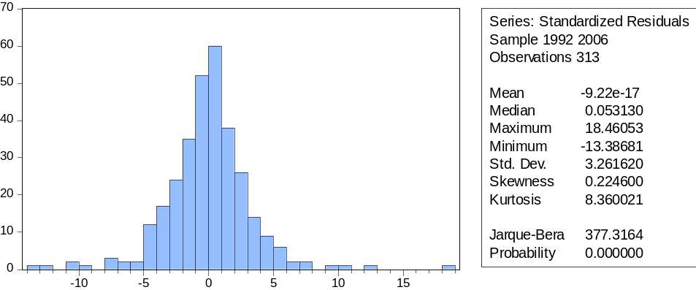

Millenium Development Regressions
Model 3.1 (LS Headcount ratio 1)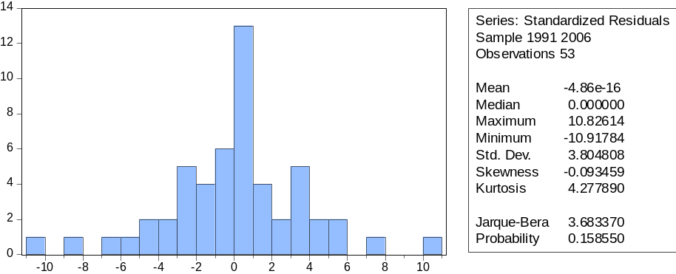
Model 3.2 (TSLS Headcount ratio 1)

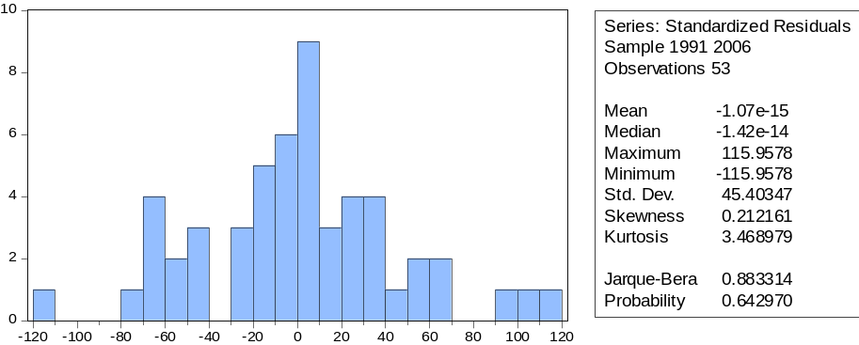
Model 3.3 (LS Headcount ratio 2)
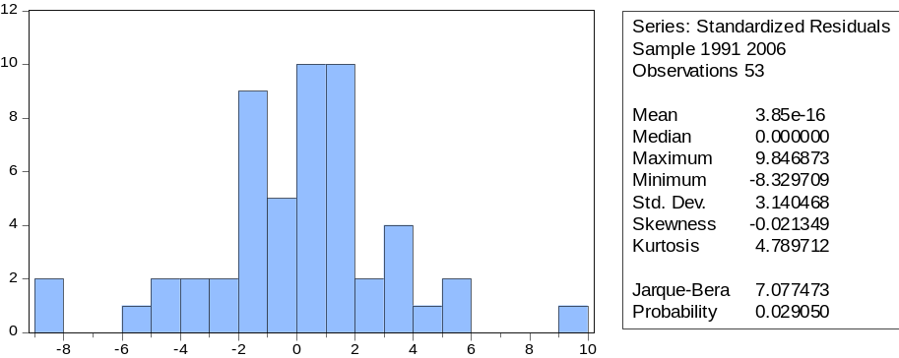
Model 3.4 (TSLS Headcount ratio 2)
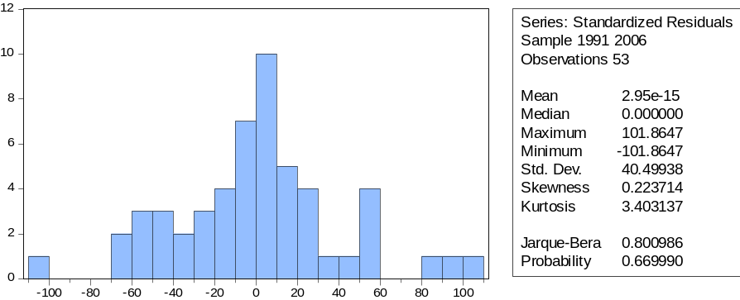
Model 3.5 (LS Undernourishment)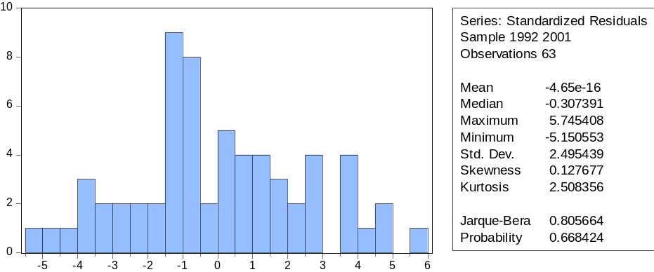

Model 3.6 (TSLS Undernourishment)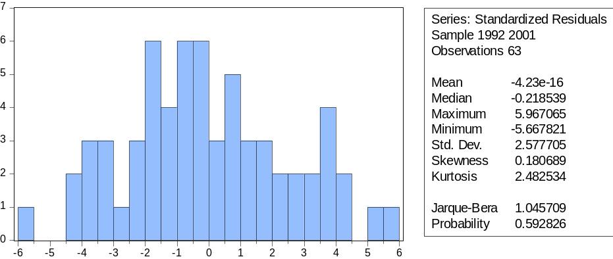
Model 3.7 (LS Malnutrition 5)
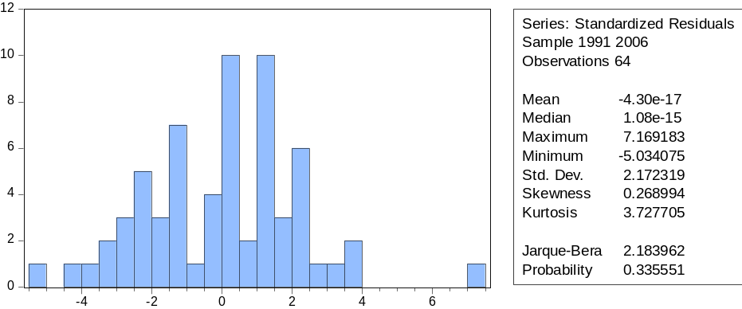
Model 3.8 (TSLS Malnutrition 5)
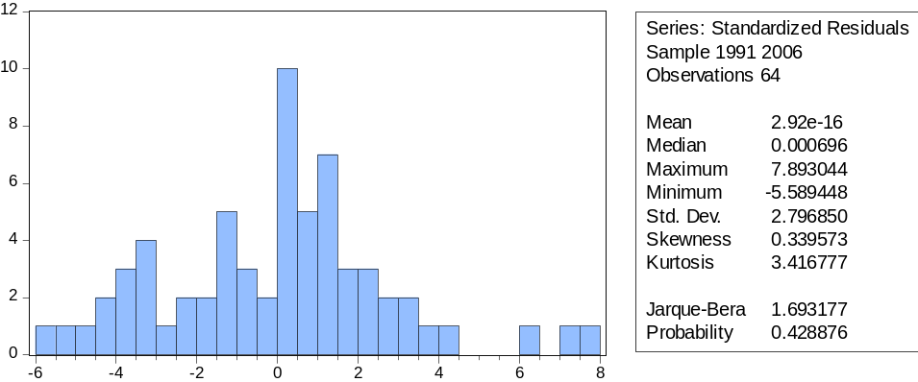
Model 3.9 (LS School)
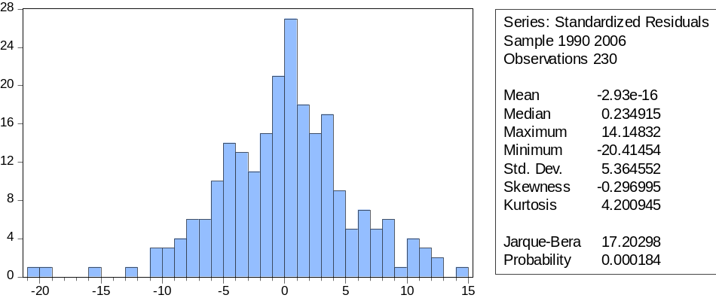
Model 3.10 (TSLS School)
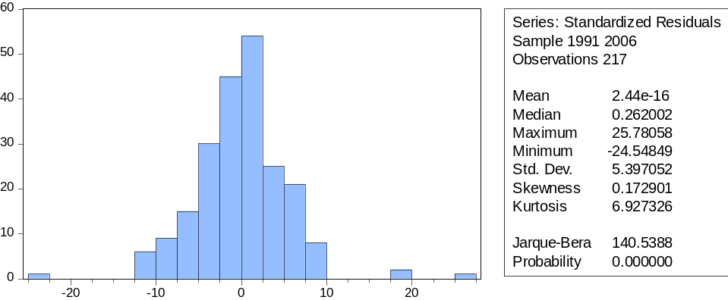
Model 2.11 (LS Labor participation woman)
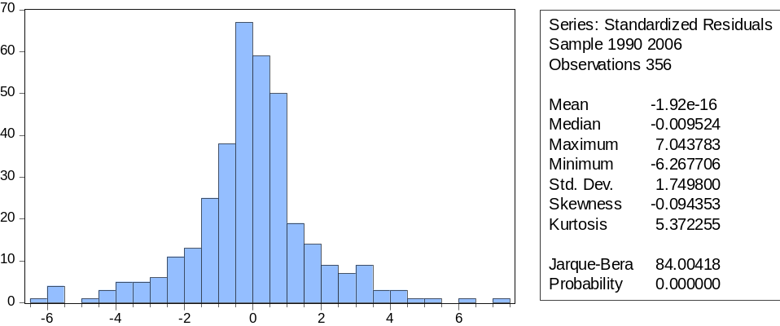

Model 3.12 (TSLS Labor Participation Woman)
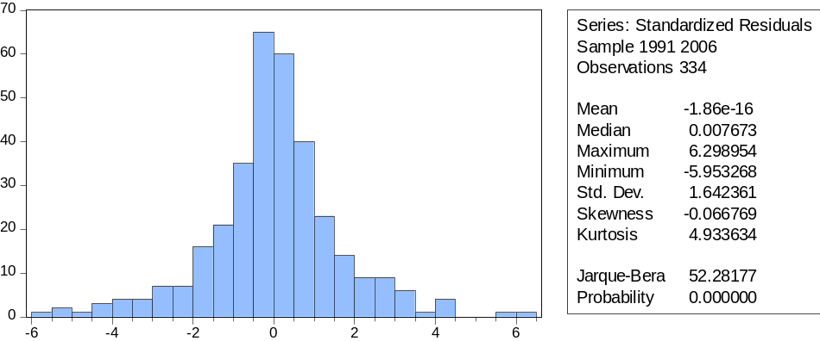
Model 3.13 (LS mortality 5)
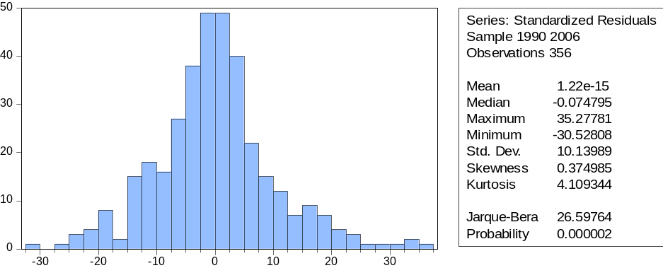
Model 3.14 (TSLS mortality 5)
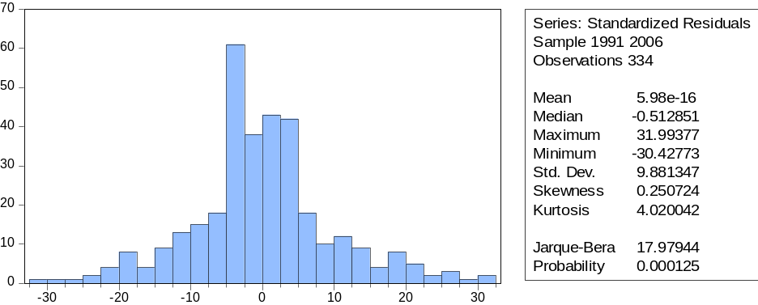
Model 3.15 (LS Maternal mortality)
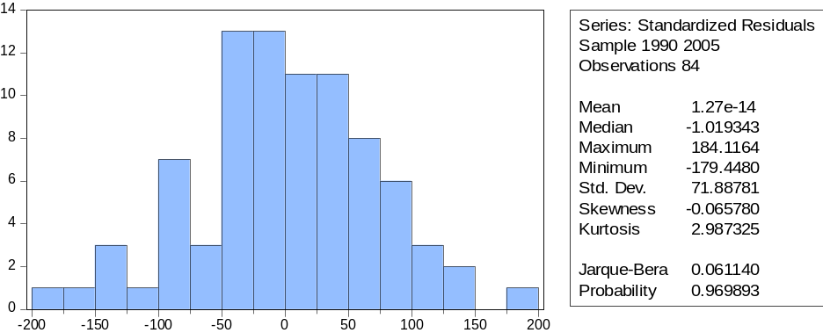
Model 3.16 (TSLS Maternal mortality)
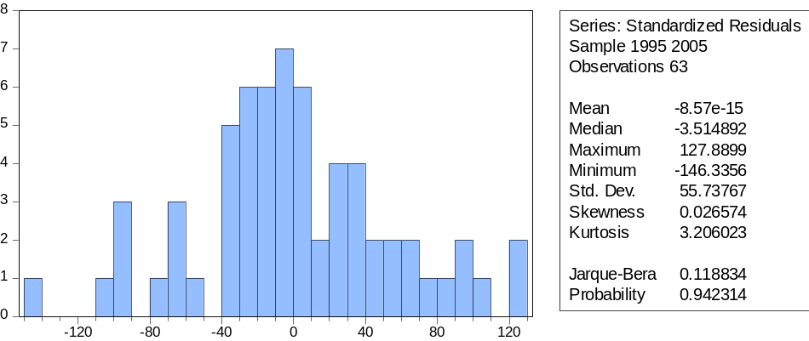
Model 3.17 (LS HIV)
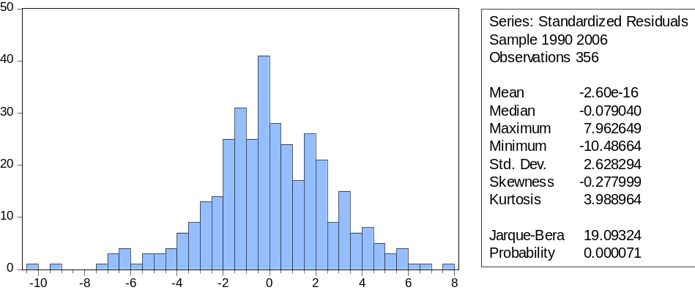
Model 3.18 (TSLS HIV)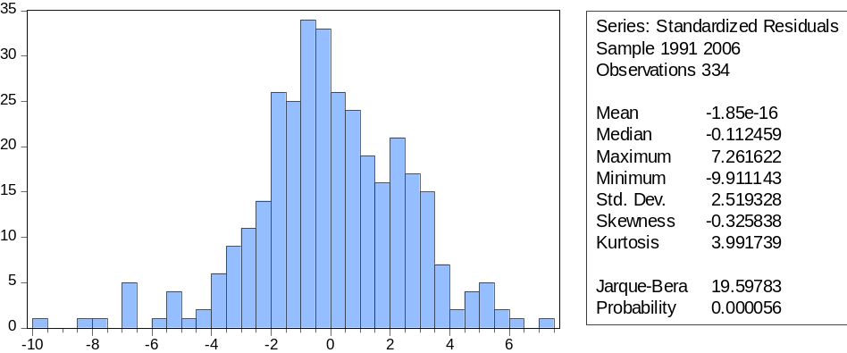

Collier, Paul. 2008. The Bottom Billion. New York: Oxford University Press. The Bottom Billion are the one Billion people that live in an extremely poor country with no perspective on a better future. Most of these Bottom Billion countries are Sub-Saharan African countries.
The main papers from the three categories are given in the paper Aid and Economic Growth: Sensitivity Analysis (2010) by Gyimah-Bermpong, K., Racine, J.S., and A. Gyapong.
The Human Development Index (HDI) is a composite statistic of life expectancy, education, and income indices to rank countries into four tiers of human development. It was created by economist Mahbub ul Haq, followed by economist Amartya Sen in 1990, and published by the United Nations Development Programme

