Erasmus University Rotterdam
Erasmus School of Economics

Master:
Economics and Business
Specialization Urban, Port and Transport Economics

THE EFFECT OF THE REVISED1999/32/EC DIRECTIVE ON THE LINER SERVICE DESIGN IN CONTAINER SHIPPING MARKET

Master Thesis
Author: Charis Chrysopoulos
Supervisor: Dr. Michiel Nijdam
November 2012
UNIVERSITY
Erasmus University Rotterdam
Erasmus School of Economics

MASTER
Economics and Business
Master’s Specialization in Urban, Port and Transport Economics

STUDENT
Charis Chrysopoulos
Student no: 358752
charalamposchrysop@gmail.com

SUPERVISOR
Dr. Michiel Nijdam

TITLE
The effect of the revised 1999/32/EC Directive on the liner service design in container shipping market

DATE
November 2012, Rotterdam

Abstract
The revised sulphur Directive 1999/32/EC aims to transpose new and stricter requirements agreed by the International Maritime Organization (MAPROL ANNEX VI), into the EU law. The sulphur cap in Emission Control Areas will be lowered from 1,5% to 0,1% by the beginning of 2015. Outside the Emission Control Areas the sulphur cap will be lowered from the current 4,5% to 0,5% in 2020. This paper analyzes the effect of the upcoming European legislation on the liner service design in container shipping market. This paper assesses the importance of the bunker costs on the liner service design of container shipping on the North Europe – East Mediterranean route. With respect to the available options that shipping lines have in order to comply with the Directive, the paper develops a cost model to simulate the impact of bunker cost changes on the operational costs of the specific route. The cost model presents that deploying an extra vessel in times of overcapacity and slowing down in terms of speed, will create great economic and managerial benefits.

Preface
After 5 months of intensive research, I am finishing with this thesis the Master on Economics and Business with specialization in Urban, Port and Transport Economics.
First of all, I would like to state my gratitude to my supervisor Dr. Michiel Nijdam for his patience and his highly valuable supervision and guidance, during the entire effort to finalize my thesis .
I dedicate my thesis to my family, who has always supported me to all my decisions and endeavors, despite the adverse economic circumstances.

Charis Chrysopoulos
Rotterdam
November 2012

Table of Contents
Abstract 3
Preface 4
List of abbreviations 6
Chapter 1- Introduction 7
1.2 Methodology 9
Chapter 2 – Legislation 11
2.1 Legislation Background 11
2.2 Proposed sulphur content limits 13
Chapter 3 - Possible actions by shipping lines 15
3.2 Replacement of heavy fuel 15
3.2.1 Development of bunker fuels 16
3.2.2 Fuel Surcharges 19
3.3 Emission abatement methods 22
3.3.1 Fresh water Scrubbers 23
3.3.2 Sea Water Scrubbers 24
3.3.3 Dry Scrubbers 24
3.4 Alternative fuels 25
Chapter 4 – Implications on container services 27
4.1 Short-sea shipping background 27
4.2 Development stages of container market 30
4.3 Issues that have been raised by the sulphur caps 36
Chapter 5 – Options for the North Europe – East Mediterranean route 40
5.1 Liner service design 40
5.2 Analysis of the North Europe – East Mediterranean route 42
5.3 Cost model for liner service design 43
5.4 Technical constraints and drawbacks 52
Chapter 6 – Conclusion 54
References 56
Annex I- Estimation of fuel consumption per km 60
Annex II – Estimation of the day-to-day running costs at different speeds and fuel types 61

List of abbreviations
% m/m = Mass percentage
EC= European Commission
ECSA = European Community Ship owners’ Associations
ELLA = European Liner Affairs Association
EPA = Environmental Protection Agency
EU = European Union
IFO = Intermediate Fuel Oil
IMO = International Maritime Organization
MDO = Marine Diesel Oil
MGO = Marine Gas Oil
NECA = NO_{x} Emission Control Area
PM = Particulate matter
SECA = SO_{x} Emission Control Area
SSS = Short-sea shipping
TEU = Twenty-foot equivalent unit

Chapter 1- Introduction
Clean air concerns EU’s citizens (Special Eurobarometer, 2007). Air pollution has important impacts on people’s health and environment. As a result, such issues are in the scope of the EU and IMO policies.
Ships’ emissions are a major contributor to the concentration of atmospheric pollutants and greenhouse emissions over most of the world’s oceans (Dalsøren et al. 2008). Before the 1980s the emissions from ships were not considered to be a crucial issue because the main actors that were forming the maritime sector were focusing more on developing reliable and economic solutions for the transportation of freight cargo. In 2010 in the EU (EU27), 3.6 billion tones of goods were handled through sea with a growth rate of 5.7% compared to 2009 (Eurostat). Port activity in most of the EU’s ports increased, with Poland, Estonia, Belgium, Finland and The Netherlands as pioneers. In contrast to this, decreases in port activity were recorded in Greece (-8.2%), Denmark (-3.9%), Latvia (-2.3%) and France (-0.6%).
Transport industry is one of the few industrial sectors which continues to increasingly pollute and constitutes 26% percent of the global CO₂ (Chapman 2007). The upcoming great growth of maritime transportation, even if this stays the friendliest way to transport commodities and passengers, it will exceed the advantages. As a result of these trends, maritime sector enhances its contribution to the atmospheric pollution and greenhouse emissions. Emissions such as sulphur, nitrogen oxides and particulate matter (SO_{X,} NO_{x} and PM) by the shipping industry had a significant increase in the last decades. The main compound of sulphur oxide that is identified by researchers is the sulphur dioxide (SO₂), a toxic gas with erosive characteristics and negative impacts on human health.
- Karle and Turner supported that sulphur dioxide emissions “can be held responsible for increased annual mortality in Europe by the World Health Organization”’ (SKEMA 2010).
- Corbett’s and Winebrak’s (2007) results indicate that “shipping PM emissions are responsible for approximately 60,000 cardiopulmonary and lung cancer deaths annually, with most deaths occurring near coastlines in Europe”.
Consequently this alarmed the global responsible authorities and a need for tackling maritime emissions emerged. The 1980s was the peak period of global sulphur dioxide emissions and has decreased gradually mainly due to the decrease of land-based emissions (Smith et al., 2004).
The application of environmental legislation in maritime sector has so far, fallen behind in contrast with the land-based emissions sources. According to the European Commission (EC), reducing the pollution from the maritime sector is the most cost-efficient way to demote NO_{2,} SOx and particle pollution in the EU, in comparison with the land-based emissions. In addition, the EC assessed that unless further action is taken, the emissions from maritime shipping will exceed the total emissions from land-based sources in the EU by 2020, despite the fact that the transport sector constitutes less than the 5% of EU’s GDP (European Commission, 2011). This will out-weight the whole progress that Europe has achieved until now as well as its efforts to improve air quality. As a result, the need for policy action to reduce maritime emissions is no longer dubious. Policy makers need to be careful, consider issues such as available technologies, geopolitical characteristics of the Member States, fuel availability and economic efficiencies. After all, the puzzle of transport and harmful emissions is complex and constitutes part of a bigger challenge, the challenge of sustainable growth.
In the literature, there is plethora of studies which investigate ships’ emissions in relation to policy strategies (Eyring et al., 2007, Wang et al., 2009, Psaraftis and Kontovasa 2010). The critical conclusions that derive from these studies are that although technological improvements help at a certain point to reduce maritime emissions, they are not enough as they constitute a long-term solution. Policy strategies are necessary for short term solutions.
Part of the environmental legislation of maritime sector is the establishment of sulphur caps in ships’ fuels. The existence of sulphur in the marine fuels enhances environmental pollution because when sulphur in fuel is burnt, it creates SO_{x} which is a major pollutant to the environment (ECSA, 2010). According to the relative literature about bunker fuels and SSS (short-sea shipping), the fuel cost is considered as the most important criterion affecting the cost structure and the final price of SSS (Ministry of Transport and Communications Finland 2009, Grosso et al. 2009).
The success of SSS depends on the competitiveness of the intermodal services in terms of cost, timing, flexibility, reliability, risk of damage, type of goods and frequency (Grosso et al. 2009). The compliance of SSS to the proposed limits through the available options, affect considerably the cost efficiency and the competitiveness of SSS against other modes of transport in the intermodal services. Hence shipping lines need to change their liner service design and their policies in order to mitigate or reduce the negative economic impacts on the shipping line industry.
This paper deals with the impact of the upcoming legislation referring to the sulphur content of marine fuels on the configuration of the liner services on the North Europe- East Mediterranean container trade. It is based on the assumption that reducing the sailing speed cannot lead to higher fuel bills even when additional ships are required and the same applies to emission externalities as they are proportional to the fuel consumption (Psaraftis and Kontovasa 2010). The aim of the paper is to assess the way that shipping lines try to deal with the continuous rising of bunker costs in times of economic recession and at the same time with an undergoing process of penalizing the air pollution from ships, through legislation. It focuses on a number of vessels in a route and on the route optimization of container vessels as they are the largest maritime emitters. Their commercial speed (23-25 knots) in contrast with tankers or bulk carriers (14-15 Knots) makes them transmitting more emissions (Psaraftis and Kontovasa 2010).

1.2 Methodology
In view of the main aim of assessing the impact of the revised Directive 1999/32/EC on short-sea shipping in Europe’s boarders, the paper is structured as follows.
In the second chapter of the paper, the policy background of the current and the upcoming legislation relative to the sulphur content of marine fuels, it is addressed. Moreover it presents the actual proposal of the European Commission as it was delivered for confirmation to the Council and the European Parliament.
The third chapter focuses on the permitted actions by the shipping lines in order to achieve the reduction of the sulphur content. Bunker fuels and their prices for the last two years are analyzed as they are the necessary precondition to comply with the legislation. Further than that it also presents how shipping lines try to deal with the increasing bunker prices and mitigate the negative impacts.
The fourth chapter of the paper describes in the beginning the development of short-sea shipping as a concept, especially in Europe, while at the same time highlights the strengths and the weaknesses of short-sea shipping. In addition to that, it presents the environment of container market, how it has been developed through the years and what are the main forces of the business-operating environment that characterize the container market. On top of this, the chapter also summarizes the main implications of the related legislation about sulphur content in marine fuels as they are addressed by ten impact assessments from various organizations and Member States of Europe.
In the fifth chapter of the paper, the focus is on the main research question: “What is the expected effect of the revised Directive 1999/32/EC on the liner service design in container shipping market?” The approach which is used in order to answer the research question starts with the description of the rationalization that shipping companies follow in order to establish and organize a liner service. In advance, the fifth chapter analyzes a container liner service from North Europe to East Mediterranean and develops a detailed cost model while proposes possible actions for better optimization of the liner service with main focus to the bunker costs.
The aim is to provide a detailed picture for the impacts of the new stricter low sulphur emission requirements, on the container liner service design.
.

Chapter 2 – Legislation

2.1 Legislation Background
Although shipping remains the most environmentally friendly mode of transport for cargos and a moderate contributor of emissions, a global approach is needed in order to improve further its energy efficiency and consequently reduce the emissions of air pollution and greenhouse emissions. The role for a global approach is undertaken by the International Maritime Organization (IMO) and by extension by the European Union.
The International Maritime Organization is an agency of the United Nations with the aim of promoting the maritime safety. In 1997 the IMO included the Annex VI in the MARPOL convention which entered into force in 2005. The “Regulations for the prevention of air pollution from Ships” (which is the full official name of the Annex VI) addresses SO_{X} and NO_{x} limits on ship emissions and forbids deliberate emissions of ozone depleting substances. It includes a global cap of 4.5% m/m (expressed in terms of % m/m – that is by weight) on the sulphur content of fuel oil and enhances the worldwide monitor of the average sulphur content of fuel. In addition, IMO defined mandatory technical and operational energy efficiency measures through the so-called Tier I.
In October 2008 a revised Annex VI was adopted with significant tighter emissions limits. The revised Annex VI entered into force in July of 2010 and Tier II and III were introduced. The revised Annex VI distinguishes the sea areas in two parts, the Emission Control Areas (ECA) and the rest sea areas. Emission Control Areas are designated areas which need particular environmental protection with stricter emission requirements. These sea areas are proposed by IMO based on the proposal from the surrounding countries. In 2006 the first SO_{x} Emission Control Area (SECA), which is the Baltic Sea, was introduced by IMO and limited the sulphur content of marine fuel oil to 1.5% per mass. Following that, North Sea Area and English Channel were characterized as SECAs in November 2007. It is expected in the long-term, that new SECA areas are going to be adopted not only for SO_{x} but also for NO_{x} restrictions and they will be called NECAs.
In SECA areas the sulphur content of fuel was reduced further from 1.5% (2008) to 1% in July 2010 and is projected to decrease to 0.1% from the beginning of 2015. For the rest sea areas outside of the ECAs, the accepted sulphur content of fuel was 4.5% until December 2011 which decreased to 3.5% from 1st January 2012 and from 2020 onwards the new limit will be 0.5% (Table 1).
Promoting a more environmentally friendly, competitive and resource efficient growth, is the main strategy of Europe 2020 (European Commission, 2010). The EU follows the IMO’s steps and in April 1999 the Directive 1999/32/EC was adopted. It mandates the reduction of the sulphur content of certain fuels that are used in the Community. The Directive 1999/32/EC calls for the European Commission to consider and respond, with measures related to the reduction of the contribution of combusted marine fuels, to acidification. The Directive does not include measures to regulate ship emissions of NO_{x} or PM. The Directive was treated as the first step in an ongoing process to reduce maritime emissions.
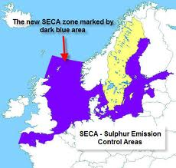
Fig. 1 SECA areas in Europe
In 2005 the implementation of the Directive 2005/33/EC which largely mirrors the MARPOL Annex VI, although it differs to the implementation dates, entered into force. The Directive is in respect to the sulphur content of marine fuels which was introduced by the MARPOL Annex VI. In addition to the above limits, it activates the 0.1% sulphur requirement for fuels used by ships at berth in EU ports from 2010 if they do not use shore-side electricity. The amendment of the Directive 2005/33/EC is under evaluation at the time.
In July 2011 a need for further reduction of marine emissions is proposed by the EC and a need for an update of limit requirements related to sulphur content emerged. The main aims of the revised Directive is to a) align the Directive with the IMO rules on fuels standards, in and out the SECAs, b) align the Directive with IMO rules on the emission abatement methods, c) introduce the fuel standards for passenger ships operating inside (0.5% from 2020) and outside (at the moment 1.5%) the SECAs, d) enhance EU monitoring and imposition bodies and e) provide a high level protection for human life and environment (European Commission 2011).

2.2 Proposed sulphur content limits
After almost one year of discussion and research, EC delivered the compromise proposal confirmed by the Council and the European Parliament.
The Commission’s proposal transposes into the EU law (Sulphur Directive 1999/32/EC) the IMO’s limit values for sulphur. The core of the current proposal is to update these values in order to align them with the new IMO requirements from 2008:
Table 1
Permitted sulphur contents
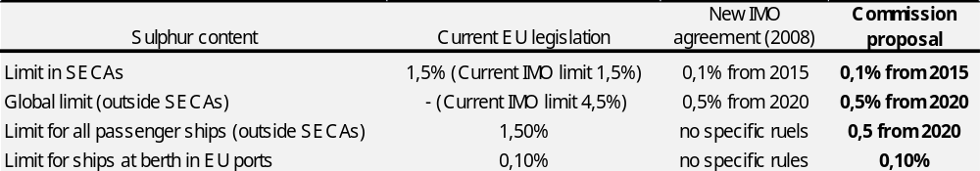
The Commission proposal also transposes other IMO provisions into the EU law, including the possibility to achieve the reductions with equivalent abatement methods, i.e. measures which achieve the same reduction without changing the content of the fuel. The Commission also proposes to maintain the established link in the current Directive, between the limits applicable in the SECAs and the specific limit for passenger ships in regular traffic in the entire EU. In other words this means that passenger ships in the whole EU would have to apply the 0,5% limit. This goes beyond IMO rules, but it would have a longer transition period (to 2020). The proposal in addition tightens the rules on reporting and implementation by the Member States. The Commission foresees that investments in new infrastructure and the new technologies could be financed through existing EU financing programs, by the European Investment Bank and by the Member States. Additional measures to support the shipping industry are included in the form of a ‘’Sustainable Waterborne Transportation Toolbox“ for 2012.
The updated proposal does not differ from the original except from an important change. This change was the limit of sulphur content for passenger ships which will now be 0.5% m/m from 2020 (instead of 0,1% in 2015 as originally proposed). The original limit would impact negatively on passenger shipping sector with significant distortions for the market (frequency-operating, costs-increased price fares).
The following chapter describes the possible options available to the shipping lines, in order for them to comply with the legislation.

Chapter 3 - Possible actions by shipping lines
The sulphur content of the fuel and the effectiveness of the sulphur abatement methods are the main determinants of the SOx emissions. In real terms the reduction of the sulphur content in marine fuels can be achieved with the following means:
  - Replacement of heavy fuel oils currently used in ships with refined fuels, in practice diesel fuel (most expensive option, but the only one which is currently widely available).
  - Emission abatement methods - "scrubbers", i.e. technologies that can remove SO2 from exhaust gases.
  - Replacement of heavy fuel oils with alternative fuels such as liquefied gas (LNG).

3.2 Replacement of heavy fuel
Before the 1974 (oil shock) the main focus of ship designers was to increase the engine output in order to meet the demand for greater power, as the ship size was increasing (EPA 2008). After the energy crisis (1979), ship designers shifted their focus to improve fuel efficiency. Although the new design of engines reduced the fuel consumption, the improvements in terms of SOx emissions were modest beyond the reduction of fuel consumption (EPA 2008). The relation between SOx emissions and the sulphur content of fuels is linear (EPA 2008) and eventually the reduction of such emissions can be achieved by reducing the sulphur content of burned fuels.
Thus SO₂ emissions depend on the sulphur content of marine fuels that ships use. Ships in most of the cases use heavy fuel oil (HFO) or intermediate fuel oil (IFO) which also belongs to the heavy fuel category. The auxiliary engines mostly use marine diesel oil (MDO) or marine gas oil (MGO). Both MDO and MGO in contrast with HFO and IFO, have lower sulphur content and they belong to the distilled fuels. Refined/distilled fuels are more expensive than heavy fuel. In 2009 shipping companies were asked in what proportion they use heavy fuel and distilled fuel grades in their vessels and the results showed that 95% of the used fuels were HFO and only 5% MDO or MGO (Ministry of Transport and Communications Finland 2009).
Before 2010 shipping companies that operated in SECAs were allowed to use fuels with maximum sulphur content of 1,5%; such fuels were usually a mix of high sulphur fuel with slightly lower sulphur content fuel. From 2010 onwards the permitted sulphur was reduced to 1% and shipping lines had to change the proportions in the mix. Using a mix of different fuel grades may cause engine problems because of an unstable blend (Ministry of Transport and Communications Finland 2009). By the time that the maximum sulphur content in marine fuels will be 0,1% (2015) in SECAs area the mix fuel grades will not be an option anymore. Shipping lines will be forced to switch to MDO which is the only available option for Europe.
A shift from high sulphur fuels to low sulphur fuels in the main engines requires changes in the lubricating oil systems and the on-board pretreatment of the bunker fuels. The lubricating oils balance the acidity in the combustion chamber through the alkaline additives that contain. Thus low sulphur fuels require specific lubricant oils and the base number (BN) of the lubricant oil must be matched with the sulphur content of the bunker fuel. Any mismatch between the BN and the sulphur content of the fuel will lead to technical problems (MAN B&W 2005). To continue, the pretreatment of the low sulphur fuels differs from the high sulphur fuels. This is because low and high sulphur fuels have different viscosity. MAN B&W (2005) stated that the fuel treatment systems vary depending on the fuel oil system.
An interesting point is that ship-owners will be benefit in terms of technical costs. Distilled fuels have higher thermal value which means less frequent maintenance and lower fuel consumption (ECSA 2010). Moreover distilled fuels have higher energy content, lower density and produce less sludge. In other words, distilled fuels have higher quality. These benefits will partially relief the shipping lines from maintenance and waste disposal costs.

3.2.1 Development of bunker fuels
Bunker fuel by definition is any type of fuel oil which is used for ships of all flags, including warships and fishing vessels (International Energy Agency). Bunker prices are driven by the cost of crude oil but the market forces of supply and demand play their role as well. Although the development of bunker prices is in line with crude oil prices, we can distinguish price differences between ports. This can be explained by the differences of fiscal policies across countries. There are many variables which are involved to bunker fuels’ fluctuation and this makes the prediction of future bunker prices even more difficult.
The sulphur content in bunker fuels depends on the sulphur content of the crude oil were they are produced from. Thus the crude oil which does not exceed the 0,5% (sulphur content) is called “sweet” crude oil. Heavy fuel oil (HFO) constitutes 80% of the total bunker fuels (ECSA 2010). HFO is a distillate residual oil and it is derived from the remaining of crude oil when refineries produce light fuel oils. In summary, residual oil is the heaviest fraction of the distillation of crude oil with high viscosity and concentration of pollutants (high sulphur). Moreover, the special treatment of residual oils, such as specific temperature for storage and pumping, makes the HFO the cheapest liquid fuel. IFO 380 (380 CST) and IFO 180 (180 CST) belong to the intermediate fuel oil category. Intermediate fuel oils are mixtures of residual and distillate oils with maximum sulphur content at 4,5%. More specifically, IFO 380 is a mix of 98% of residual oil and 2% of distillate oil. On the other hand IFO 180 is a mix of 88% of residual oil and 12% of distillate oil. The more the amount of the distillate fuel is in the mixture, the more expensive it is. Other bunker fuels are the marine diesel oil (MDO) and the marine gas oil (MGO). Marine diesel oil mainly consists of distillate oil, with the lower sulphur content (max-0,5%) compared to IFO 380 and IFO 180. Marine gas oil is pure distillate oil and has the lowest sulphur content (0,1%) among all the bunker fuels.
Figure 2 reveals the development of the main bunker fuels’ prices and the price differences between IFO 380, MDO and MGO from January 2011 until September 2012. According to T. Notteboom (2011) the price differences between IFO 380 and MDO for the period 1990-2008 had fluctuated strongly throughout time from 40% to 190% with a long term average of 87%. In the period 2011-2012 according our calculations, the fluctuation was more moderate with an average of 41%. To continue, the price difference of IFO 380 with MGO for the period 1990-2008 was also fluctuating more violently, 30% to 250% price difference (Notteboom 2011, ECSA 2010) in contrast to the period 2011-2012 where it had an average difference of 57% according our calculations. In general, the costs of distillate fuel are 44% to 57% more expensive than intermediate fuels, due to the cost of desulphurization process and the increasing demand.

Fig. 2 Price development of bunker fuels in USD per ton
The upcoming revision of the Directive 1999/32/EC will increase further the bunker costs for shipping lines. The overall effect of the revised Directive 1999/32/EC will
be costly for the shipping industry. These costs will be incurred at that moment in time, that the ships will have to switch from intermediate fuels such as IFO 380 with a world average sulphur content of 2,67 % to marine distillate fuels with world average sulphur content at 0.65% ( Exxon Mobil Marine 2006)
A closer look to a cost-comparison difference is provided in Table 2. During the months of June, July and August 2012, the gap between the IFO 380 and distillate fuels (MDO and MGO) has increased. Although a shift from IFO 380 to MDO has a significant implication on the bunker costs, a shift from IFO 380 to MGO has much larger consequences on bunker costs. This trend makes shipping operators feeling even more unsafe and skeptical for the future margin profits of the container shipping lines.
Table 2 Recent bunker price differences
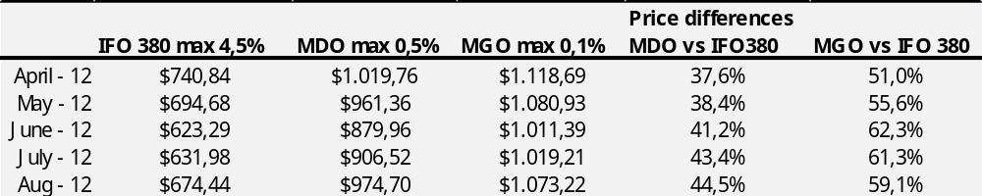Source: own calculation
Overall, the mandatory shift from intermediate oil to distillate fuels for 2015 in SECAs, with a maximum sulphur content of 0,1% or outside SECAs (2020) with a maximum sulphur content of 0,5%, would lead to a significant increase of bunker costs for container shipping lines. The next chapter describes the method of how liner shipping companies try to deal with the evolution of bunker prices.

3.2.2 Fuel Surcharges
For liner shipping companies and not only for container shipping, bunker cost is a very important expense (COMPASS 2010, Ministry of Transport and Communications Finland 2009, Notteboom and Vernimmen 2008, Grosso et al. 2009). With fuel prices of 2006, fuel costs account for 54% of the total daily operating costs (Ministry of Transport and Communications Finland 2009). According to our calculations with fuel prices of September 2012, the fuel costs account from 51% to 77% of the total daily costs (Table 3). In order to reduce the risk from the fluctuation of bunker costs and mitigate the impact on freight rates, shipping lines charge shippers with fuel surcharges. According to T.Notteboom (2008) “Shipowners are using fuel surcharges to recoup some of the increased costs in an attempt to pass the costs on to the customer through variable charges”. The name of this fuel surcharge is the Bunker Adjustment Factor, the so called BAF.
BAF surcharge is excluded from all container freight rates and it is adjusted as a separate charge which is in line with the fluctuations of bunker oil prices and the exchange rate (USD). The first time when the BAF surcharge was introduced, was in 1974 because of the oil crisis: it was then that the bunker prices rose 120% in three months. In theory, shipping lines cover the bunker costs until a certain level of bunker prices. When bunker prices exceed this certain level, the fuel surcharge is introduced to the market.
As we will mention later, shipping lines were setting common tariffs in liner conferences. One of these tariffs was the BAF surcharge and it was calculated in their own way. This surcharge applied on the first day of each month and it depended on the final price of IFO 380 in Rotterdam on the last day of the week of the previous

Table 3
Bunker costs as a percentage of total costs (4.000 TEU) for different speeds and fuel types
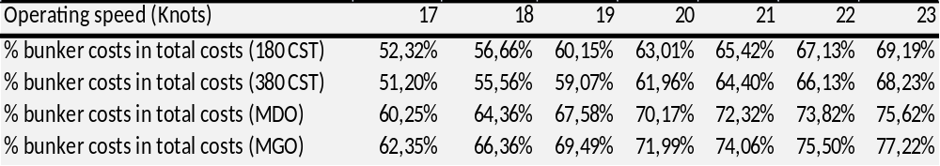Source: Own calculations
month. The USDs were converted into Euros according to the exchange rate of London on the same day (Notteboom and Vernimmen 2008). The controversial level was 140 Euros per ton: Below this price fuel surcharges were withdrawn. The table 4 below indicates the BAF surcharges for different price levels of IFO 380.
Shipping lines have argued in the past that in short time the fuel surcharges mitigate only partially the increase of bunker costs and in long term the increase of bunker prices affect negatively their earnings. On the other hand, shippers blame the way that shipping lines determine the BAF and accused them of using the fuel surcharges as an element of revenue-making. This is because the bunker prices remained confidential for a long time and eventually the customers characterized the whole determination of the BAF, as opaque and without uniformity (Notteboom and Carriou 2009).

Table 4 BAF surcharge percentage for bunker price classes 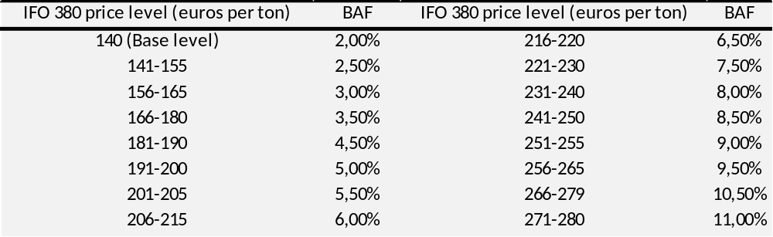Source: Notteboom T. and Carriou P., (2009)

Researches by the Meyrick et al., 2008, European Shippers’ Council and other Associates in 2008 supported the shippers’ opinion and concluded that the BAF fuel surcharge includes a significant element of revenue making. All the above took place for as long as the conferences were considered to be legal and acceptable. On 18th of October 2008, the EU outlawed the European conferences due to the EU competition law. After the ban of shipping conference activities, shipping lines were still able to apply fuel surcharges, but they could do that individually.
After the liner conference era, Notteboom and Carriou (2009) tested the nature of the BAF formulas used by shipping lines before and after the European banish of conferences. They were driven to important conclusions regarding the fuel surcharges. First they verified that BAF includes an element of revenue making. Such occasions were less significant on intra-European feeder routes and on traffic relations to the Far East, India/Pakistan and Oceania. Differences among the various BAF prices are mainly due to the differences between shipping lines. Moreover, the relation of freight rate and BAF was characterized as weak and finally the correlation between the base freight rate and the difference between BAF and the actual fuel costs was typically low. However the hypothesis that low freight rates would motivate the shipping lines to increase the revenue making, was not verified.
The current situation is that shipping lines negotiate the fuel surcharges individually with their customers, while the European Commission is closely monitoring and ensures there is no collusion. Shipping lines are not allowed to exchange confidential information such as freight volumes, market shares, and prices with other shipping lines. Any discussion about freight rates and other surcharges is forbidden. The only legal exchange of trade data was undertaken by the European Liner Affairs Association (ELLA, 2003). ELLA was an industry lobby group which transformed to a trade association managing the exchange of information between shipping lines (Notteboom and Carriou 2009). On 1st July 2010 ELAA officially transferred its responsibilities to the World Shipping Council.
The conclusion derived from the above is that BAF surcharge is still an issue between shipping lines and shippers. The principal way which shipping lines use in order to mitigate the impacts of the rising fuel prices on their customers is a powerful tool which provides them with the advantage of transferring “all of the increasing bunker costs” to the shippers (Wang et al., 2011). Shipping lines tend to prefer to apply BAF surcharges rather than reducing the vessels’ speed and cut down the fuel consumption (Wang et al., 2011).

3.3 Emission abatement methods
The European Commission’s proposal incorporates into the EU law IMO’s provisions, including the potential to achieve the reductions with equivalent emission abatement methods (Directive 2005/33/EC, Article 4c). Equivalent emission abatement methods are measures which can achieve equal reduction without replacing the fuels. The usage of scrubbers to energy plants on land is already well known (from 1930s) and there is plenty experience but the installment of scrubbers in ships is not so advanced.
The sulphur scrubbers can be installed in new vessels and in existing vessels but on certain conditions. An investigation in 2008 by the Odense Steel Shipyard Ltd showed that the installment of a scrubber technology requires extra space in the engine room, the container will lose 114 TEU positions and its weight increases by 900 tons. The needed space in vessels for the installment of sulphur scrubbers is the greatest challenge. The cleaning efficiency of the scrubbers is proportionate to its size (Ministry of Transport and Communications Finland 2009). This challenge in some cases may make the installment impossible. By an economic perspective the installment of scrubber in existing vessels is more expensive and complex compared to the new vessels. For new vessels, the installment of sulphur scrubber technology can be optimized in terms of lost container positions and weight changes. In addition the installment and the use of sulphur scrubber will create additional costs for the shipping lines or the ship-owners such as maintenance, monitoring equipment, capital expenditures and an increasing fuel consumption of some 1-3%. Such costs cannot be estimated with accuracy because the number of scrubbers which are currently in operation is still small.
Unfortunately, despite the encouraging stance of studies in favor of using abatement emission methods, such as scrubbers, in the future, this is in contrast with experts from the shipping industry. Peter Hinchliffe who is the Secretary General of the International Shipping Federation (ISF) and its sister organization, the International Chamber of Shipping (ICS) verified to us that scrubbers are not ready for commercial usage and they are not going to be in the near future. The development of scrubbers for ships is at an early stage and it is still not clear whether the costs for the use of scrubbers are competitive in comparison to the use of expensive low sulphur fuels. Additional factors undermining the future exploitation of scrubbers are the disposal waste streams and space issues of the existing fleet, which are serious drawbacks. As a result, the switch from heavy fuel oil to light fuels is currently, the only option for shipping operators to comply with the regulation..
According to the available sulphur abatement methods, this study focuses only on the use of exhaust scrubbers. Having in mind the assumption that in future the price differentiation between high sulphur (>1.5% sulphur content) and low sulphur (0.5%-0.1% sulphur content) fuels will increase because of the growing demand, exhaust scrubbers will gain attention. On top of this, it is stated that there is net CO₂ benefit from using high sulphur fuel oil and scrubbers compared to the use of low sulphur fuel oil as it is considered that the refining process for low sulphur fuel oil will also emit CO₂ (ECSA 2010, Corbett 2008). Scrubber gives the possibility to ships to use fuels with sulphur content over 1.5% even in SECAs (Ministry of Transport and Communications Finland 2009).
There are three types of exhaust scrubbers suitable for ships: the fresh water scrubber, the sea water scrubber and the dry scrubbers. All of them are based on absorptive processes. The Table 5 below gives the indicative investment costs for fresh water and sea water scrubber but the prices are only for guidance and cannot be used for further analysis.

Table 5 Indicative investment costs of Fresh water and Sea water Scrubber
Cargo Ship (about 20MW) | Fresh water Scrubber | Sea water Scrubber
New build | 1,9 M € | 2,1 M €
Retrofit | 2,4 M € | 2,4 M €
Source: EMSA 2010

3.3.1 Fresh water Scrubbers
The fresh water scrubber’s operation is based on the ability to clean and neutralize sulphur oxides by maintaining the water’s pH. It uses a lye solution and the neutral pH of the wash water which is in a closed loop in order to keep its neutrality and converts the sulphur oxides into harmless sulphates. These sulphates end to the sea through the wash water and the pH of the final wash water is neutral and hardly differs from the sea water’s pH. The quality of the seawater is independent from the effectiveness of the cleaning operation (Ministry of Transport and Communications Finland 2009).
However the fresh water scrubbers may pose environmental risks if the pH of the wasted wash water differs from that of the sea water. In narrow and shallow waterways such as ports, river deltas, channels and archipelagos a commercial use of fresh water scrubbers may have negative impacts on the environment. Thus the IMO and the EU have specified quality criteria of the wasted wash water which falls to the sea. Another important issue of the process’s derivatives is the sludge; it is similar with the sludge from the main engine and has to be disposed in the appropriate way in the ports. Eventually ports have to prepare to receive wastes from vessels’ sulphur scrubbers.

3.3.2 Sea Water Scrubbers
The sea water scrubber relies on the process of passing the exhaust gas through sea water. The seawater’s alkalinity which is less in salty seas such as the Baltic Sea, will need larger amounts of sea water to achieve the desulphurization of the exhaust gases. The relationship between water volumes and sulphur removal is not linear as the needed water volume to scrub the exhaust gases of 3% sulphur fuel to 0,5%, is the same amount of water to reduce it to 1,5% (SKEMA 2010).The sea water scrubbers, except from the extraction of the sulphur compounds from the exhaust gases, can also absorb other impurities such as particulate matter and heavy metals (Ministry of Transport and Communications Finland 2009). The sulphur wastes are extracted to the sea along with the wash water.
In 1960s the sea water scrubbers have been successfully installed to scrub exhaust gases from boilers. The first installment of a sea water scrubber on a marine engine was 1991 (SKEMA 2010). Early trials of sea water scrubbers in marine engines had very promising results in terms of SO₂ reduction from exhaust gases. As we mentioned before for the wastes of fresh water scrubbers, the wastes from sea water scrubbers may also be harmful for the ecosystem.

3.3.3 Dry Scrubbers
Little information has been provided for the dry scrubber which is the only one that does not use water for its desulphurization process. Although, as we mentioned before, it is possible to use water as an absorbing agent, dry scrubbers use calcium hydroxide granulate. This is because the solubility of SO₂ in water is low and decreases as the water’s pH is lowering, which makes water to lose its alkalinity. The calcium hydroxide granulate is available at many lime production plants and by this material the desulphurization of the exhaust gases is achieved. During this process, the sulphur is normally converted into gypsum and can subsequently be disposed on land (Hombravella et al., 2011).

3.4 Alternative fuels
Except from the use of low sulphur fuel oil (MGO) and abatement methods, SO_{x} emissions can also be reduced by the use of alternative fuels such as LNG. The obtained information for LNG as alternative fuel for ships was derived mainly by the EMSA (2010) study.
Natural gas is characterized by many people as the future of energy and its growth in terms of reserve discovery the last 25 years is impressive. The global LNG reserves are larger in terms of volumes than the oil reserves and the main producers are Russia, USA, Iran and Qatar. From the demand side LNG is contesting the coal’s second place as a source of primary energy (Tamvakis 2010). This is why LNG still does not threat the oil seriously. The prices of LNG are significant cheaper than MGO. For instance, in 2008 (June-September) which was the peak price period for MGO, the LNG price was more than half cheaper. The low prices of MGO are partially explained by the increased production which counteracts with reduced demand for LNG, due to the global economic downturn.
The environmental benefits of LGN option are impressive. There is a complete reduction of sulphur dioxides and particulate matter, a 90% reduction of NO_{x} and a 20% reduction in CO₂ emissions compared to oil products. Another advantage is that it does not produce sludge and visible smoke. However, it produces the so-called ‘methane ship’ which is non-combusted methane and LNG engine manufacturers are trying to reduce it. The usage of LNG does not affect the operational side (speed) of the vessels but requires some additional technical changes and the special training of the vessel’s crew.
Although LNG sounds as a very attractive solution for shipping companies there are technical complexities for the onboard storage and a lack of appropriate infrastructures for bunkering LNG to ships. Hence the usage of LNG by ships is not applicable to all ships.
More specifically, LNG requires different (cylinder format) fuel tanks. Cylinder fuel tanks require more space; it is estimated that it requires up to 3-5 times more space than for oil. The space challenge for containerships can be solved by the sacrifice of 2-4% of the carrying capacity as the LNG fuel tanks can be placed in containers. The LNG engine characteristics are very similar to diesel engines and require less intervention. It is suggested that LNG is more suitable option for new vessels because of the technical restrictions.
The main challenge of LNG for ships occurs from the supply side. Although the existence of LNG terminals along the Europe’s coastline is increasing, the appropriate infrastructures for bunkering ships with LNG outside of Norway, are very few. The main reason for this is that LNG bunkering infrastructure has not received much investment until now. LNG projects are extremely capital intensive and require billions of funds (Tamvakis 2010). Moreover, additional issues such as lack of safety regulation for transfers of LNG between ships and bunkering while passengers are onboard are limiting the potentials of LNG as marine fuel. According to the aforementioned constraints, LNG is an option for complying with the legislation but it is not yet available for the whole Europe. As a result, it cannot be used as an option for further analysis although there is a promising future for LNG as energy recourse.

Chapter 4 – Implications on container services

4.1 Short-sea shipping background
The main idea of SSS is based on the development of a more sustainable transport network with the least negative impacts by the transport modes (Musso et al., 2010). At European policy level, the European Commission (EC) references SSS for the first time in the 1992 (European Common Transport Policy) as a potential mean of attracting freight from the already congested roads and in 1997 EC started to promote SSS. Unfortunately SSS was delayed to receive an equal public support compared to roadway and railway, due to the mistaken assumption by policy makers that the sea way is a free highway. Congested road networks, environmental impacts and external costs which amount to €80 billion per year, almost 1% of EU’s GDP (Medda 2010), are the reasons that highlighted the need for a more energy efficient and environmentally friendly model of transport.
Globalization, management strategies like just-in-time, door-to-door deliveries and divided production chains, enhanced environmental negative impacts of freight transport because of the boost that land transport received thanks to its superior flexibility and low prices. In the EU, transport sector has the fastest growth of energy consumption (Medda 2010). It is argued that the enhancement of SSS is critical for environmental and economical reasons. This kind of transport mode is characterized by high energy efficiency and environmental performance. Developed and developing economies depend on the efficient flow of freight by transport modes. SSS is considered by the European Commission as a unique option of transport modes which is able to respond to the rapid economic growth of the EU. In addition, it has the potential to reduce road congestion and to improve competitiveness of transport mode. Almost 90% of the EU external freight trade is conducted through sea (European Commission 2011). SSS in 2011 forms 40% of intra-EU exchanges in terms of ton-kilometers, but there are still issues left to tackle.
Although there are a lot of attempts in the literature (Marlow et al., 1997, Stopford 1997, Bjornald 1993, Papadimitriou 2001,Bagchups and Kuipers 1993, Paixao and Marlow 2002) to specify a common definition of SSS, the debate is on-going. The authors (Marlow et al., 1997) presented
‘’ SSS as a seaborne flows of all kinds of freight performed by vessels of any flag from the EU Member States to whichever destination within the territory embracing Europe, the Mediterranean and Black Sea non-European countries’’ .
Francesca Medda and Trujillo (2010) address the existence of four classification criteria which primarily focus on operational aspects of SSS: (1) geographical, based on route length, (2) supply approach, based on type size containers, (3) commercial criteria or demand, distinguishing between ‘feeder traffic’, intraregional traffic and nature of load and (4) legal approaches depending on ports of the same state. Although SSS is considered to be global, it is much more related to Europe. The reason for this is that it operates in a large-scale in the European borders and by European shipping companies. The remarkable variety of definitions for SSS leads to confusion, unclear statistics and conflict debates.
The definition which is used for this paper and is officially adopted by the European Commission is:
“The movement of cargo and passengers by sea between ports situated in geographical Europe or between those ports situated in non-European countries having a coastline on the enclosed seas bordering Europe’’
Despite all the efforts of EU to promote SSS, the attraction of cargo volumes from roads to sea is far from being real. This is probable because the weaknesses of SSS outweigh the strengths. The strengths derive from the nature of maritime transportation. The main strengths are divided in four groups: geographical advantages, financial advantages, knowledge/skills-based/human advantages and environmental advantages.
The geographical advantages of SSS are based on the long coastline of Europe which is more than 67.000 km (European Commission 1995). The 60%-70% of all European industrial centers are located within 150-200 km from the coast and there is a long network of 25.000 km of inland waters. The 12.000 km are part of the combined transport road network (Paixao and Marlow 2002). Such geographical characteristics can help SSS to be integrated into the economic development of these European areas.
The financial advantages lie on the ability of SSS to exploit economies of scale because of the high capacity of vessels. Shipping lines can exploit the current overcapacity that exists in the shipping industry without creating immediately a high investment need for additional vessels. Shipping business in general is highly capital intensive which gives the shipping lines the advantage of not facing new entrants into their business. In addition to this, as they own the most expensive assets in intermodal freight transport they have a good position to develop transport systems (Paixao and Marlow 2002). Moreover the capacity of sea is unlimited and as a result there is no need in terms of costs to built sea lines except from superstructures which in some cases are required for the safety navigation. Additional financial advantages occur by the lower port maintenance and investment costs, compared to rail and road infrastructure whose external costs are increasing (Paixao and Marlow 2002).
Important strengths are also arising from the environmental friendliness of SSS in terms of energy efficiency, less harmful emissions and lower external costs. SSS has included the external costs into the freight rates which is very important for sustainable operation and unfortunately this does not apply for surface modes of transport. Another reason which makes SSS environmentally friendlier than the other modes is the less intervention in the natural environment. Rail and road networks require expensive investments for railway lines, roads, tunnels and bridges. This of course does not mean that further improvements are not required in terms of vessels’ engines.
Although there are great advantages and potentials for SSS, the sector needs to overcome several weaknesses whose significance exceeds the positive qualitative characteristics of SSS (Paixao and Marlow 2002) that we have mentioned so far. SSS as being a part of a whole transport chain it needs the collaboration of other modes of transports such as train and road modes in order to collect and deliver the freight before and after the sea leg. In addition SSS requires support by dedicated terminals and a well established network of inland terminals. Thus in most of the cases SSS is unable to provide individually door-to-door services. Although important steps towards the integration of SSS have been made, especially through developing policies by the EC for necessary infrastructure, these are not enough. The integration of seaborne and surface modes of transport in general but also in terms of information technology and information system, is required. This lack makes SSS lagging behind road modes of transport in terms of flexibility.
Another weakness is the absence of a common playing field for all modes of transport. Maritime transport has internalized its external costs in contrast to other modes, which creates an important cost difference in terms of freight rates between SSS and other modes of transport. Paixao and Marlow in 2002 stated that shippers are willing to revise their perception for SSS if the freight rates (including land rates) were 35% less than the cost of road modes. A common playing field would reduce the 35% cost difference at a great extend.
Paper work or the so called documentation procedures for SSS are considerably more than for road transport. There are five categories of documentation that a vessel needs every time that enters or exits from a port (Paixao and Marlow 2002). Moreover there is heterogeneity in the documentation process between different trade sea routes in Europe which enhances the amount of bureaucracy.
Ports are major factors for stimulating SSS. Ports need to plan their activities is such way that all operations are handled in the smoothest and most efficient way possible. Doubling handling due to inefficient operation, lack of capacity in terms of quay length or number of berths, lack of adequate cargo handling equipment or misuse and complex hierarchical structure of ports result in lower performance of SSS (Paixao and Marlow 2002). Thus the aforementioned weaknesses, from a marketing point of view, undermine the reliability and the image of shipping operations, in the eyes of the customers.
Adding to all the above a passive behavior of shipping companies for new marketing strategies, innovation, contractual alliances with companies from other transport modes, the age of vessels which are used in SSS and the absence of a compatible info structure (Paixao and Marlow 2002), enhance the difficulties. The weaknesses can be grouped in five categories: port operations, corporate culture and structure, innovation, information technology and systems, and marketing.

4.2 Development stages of container market
Container shipping is a prime transport mode of international trade. Container shipping lines and ports are changing due to the globalization trend and the large–scale adoption of the container utilization since 1960s. According to Dr. Jean-Paul Rodrigue from Hofstra University of New York, container market passed through the following stages:
The Introduction period (1958-1970) was a period of consideration by the maritime transportation actors. The container technology was an unproven technology with sparse investments. The first commercial services started in the late 1950s and modified bulk vessels or tankers with capacity up to 1.000 TEU composed the first generation of containerships in the 1960s. In 1970s the utilization of containers created an increase of 22 per cent of the world container throughput (Song et al., 2005).
The Adoption period (1970-1990) is characterized by the acknowledgement of the container as a way of transportation and liner shipping companies faced a high growth. In this period the growth of world container throughput growth diminished with an average positive growth of 9.6 per cent (Song et al., 2005). The consequent growth resulted to the construction of container port terminals and dedicated containerships (cellular containerships) as the risk of the investments reduced and commercial opportunities emerged. In 1980s, economies of scale encouraged the increase of vessels’ size in terms of capacity. The share of containerships in the world’s fleet in 1980 was 1.6 per cent (United Nations, 2011). The third generation of containerships which are known as Panamax standard with a capacity up to 4.000 TEU, appeared in 1985.
The next period is the Growth period (1990-2008). Containerization impacted significantly on global trade patterns and logistic services. Container shipping market globalized. During this period even larger containerships were constructured and the new class of Post Panamax with capacity that reached 6.600 TEUs (fourth generation) became dominant in container services. These kinds of investments on bigger vessels represent a market risk as they required substantial volumes of cargo in order to operate efficiently. Soon the Post Panamax threshold reached full utilization and the fifth generation (Post Panamax Plus) followed with capacities of 8.000 TEUs. It is recognized that the vessels after the third generation include risks in terms of network configuration as bigger vessels need high efficient but costly terminals and additional level of ports’ depth. Eventually these ships experience a reduced number of ports that can berth. From 2006, Maersk, a shipping operator, introduced the sixth generation of containerships with capacity up to 14.500 TEU which was divided in two specifications. The first is the New Panamax which is fitting exactly in the locks of the expanded Panama canal (2014) and the second one is the Post New Panamax(18.000 TEU) category which is bigger and cannot fit in Panama’s Canal. The desire of fuel efficiency through economies of scale justifies the continuous increase of vessel size.
The final period is the period of Maturity (2008-). In this period we observe container traffic congestion and factors such as high energy prices, trade imbalances, limitations of comparative advantages and technical limits to economies of scale in both sides (sea and land), affecting containerized traffic. It is more likely that container maturity is more linked to economic reasons (economic recession of 2008) rather than technical ones. Despite the maturity, manufactured products continue to be containerized and the containership fleet increased its share in the world fleet to over 13% in 2011 (United Nations, 2011).
While observing the last decades’ developments in the maritime transportation, it is profound that there are some main driving forces that shaped the business operating environment of container market. These forces are called the 4Cs and they are; (1) containerization, (2) concentration, (3) collaboration and (4) competition (Lun 2009). These 4 main forces will help us understand and describe the container business environment.
The main force of containerization started since the introduction of containers in transportation. The uniformity and the ease of handling the containers lead to the low transport cost of containerized cargo. The impact on sea transport operations was tremendous. The economic growth of developed and developing economies is strongly relying on container transportation as containerships displaced less efficient modes of transport and boosted production and distribution all over the world. Containerization has contributed significantly to the reduction of transportation costs of manufactured goods, faster transport time and higher security. As a result, all transport modes adopted in their operating systems, technologies to handle containers.
The next main driving force is concentration. Maritime transportation is a very capital intensive industry and requires expensive and dedicated investments which vary depending on the type of cargo. In addition, the continuous increase of container vessel size should be followed by the increase of ports’ depth and the width of channels. All these constraints involve big financial risks due to the need of huge capitals and the necessary time to be completed. Eventually, container shipping operators try to be advantaged and reduce risks through economies of scale. Economies of scale and concentration are complementary to each other and generate value for the operators. Consequently, container shipping operators increase the number of their vessels in order to raise the market coverage but it is remarkable that the increase of vessels’ size is more significant (Slack et al., 2002). This is explained by the concept of concentration and the benefits that operators reap by them. The concentration ratio (CR) is an indicator which denotes the relative size of the firms in relation to the industry as a hole. The table below shows the 10 biggest container operators, their total TEU capacity from 2000 to 2012 and their market share on 2012. The first 3 operators count for almost 37% of the total market share which proves the high concentration of the container transportation.
To continue, the next driving force is the collaboration. International liner shipping has been characterized a long time ago, by collusive agreements (Sjostrom 2010). Throughout the years, collaboration agreements between container shipping lines took different shape; in the beginning as conferences and more recently as alliances. Each main sailing route had its own conference with tasks such as establishing regulations, setting common tariffs and employing agencies. Conferences have been
Table 6
Development of container capacity for the 10 biggest container operators from 2000 to 2012
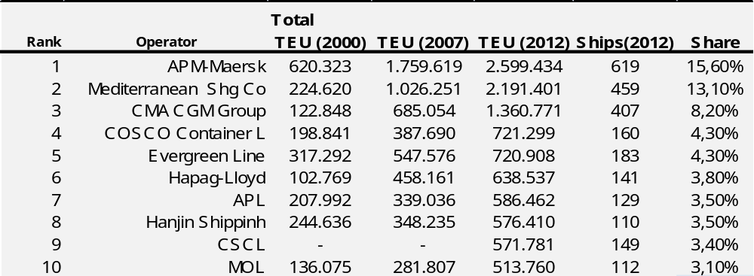Source: © Alphaliner 1999-2012
used until 1970s but because of the antitrust feeling of the European Community towards the conferences and their monopolistic behavior, they have been replaced by consortia and alliances. The main reason for these collusive agreements was the risk reduction of new investments, as alliances were sharing slots in the same vessels and in this way they could achieve higher economies of scale. Another reason was that shipping lines, as they were sharing slots in the same vessels, they were reducing the risk by diversifying into multiple routes and protected themselves against bankruptcy and job losses. Collaboration partially explains the increase of containerships’ size. The average size of containerships was increased more than double in the last 20 years (ISL 2011). Alliances reduce costs and raise capacity utilization (Sjostrom 2010). Although the alliances declined in the last decade, it is very likely to witness in the coming years the rising strength of the alliances through mergers and this is because of the need to generate enough cargo for even bigger vessels.
The final driving force is competition. The competition between container shipping lines is intense and this derives from the cost characteristics of container shipping (high level of fixed costs), the imbalance between supply and demand, and the ease and high adaptability of container’s transshipment which forces shippers to transport containers through specific and dense transport network. In addition to the above, the differentiation of the services is not big enough as most of the container shipping lines provide similar services, and thus it is eventually difficult to develop competitive advantages. Moreover, we observe a similar reaction by the competitors when for instance a mega carrier announces an order of larger vessels. Figure 4 shows that when APM-Maersk announced an increase of 5,4% of its fleet, 5 out of 9 followers tried to increase their fleets by the same ratio, proportionally. The rest 4 followers tried to increase their fleet even further but this can be explained by their differentiation in terms of policy decisions and fleet characteristics. On the other hand, such decisions

Fig.3 Development of containerships
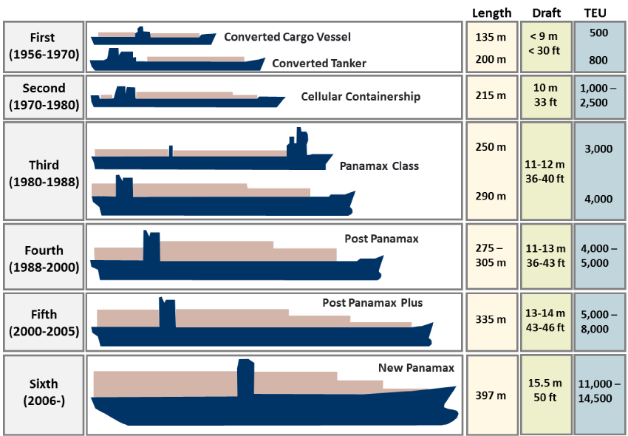
should be accompanied by rationalization in order to secure that the new vessels will be completely filled. As the competition increases, container shipping lines are trying to focus more and more on the customers’ needs and provide flexible and quick solutions by owning their own terminals rather than relying on third parties. Another reason of why shipping lines own terminals through minority shareholdings or joint ventures, is to reduce the risk of ports’ congestion. This kind of customer orientation in terms of speed and reliability though, has the drawback of loosing operational flexibility.
Fig.4 Existing fleet and the 2012 order book of the 10 biggest container operators

Source: © Alphaliner 1999-2012
As far as global container capacity is concerned, according to Alphaliner this will continue to grow. In 2007 the total capacity of containership fleet was 10.467.496 TEU and in 2012 the total capacity exceeds the 16 millions TEU, a growth of 65%. About 2,1 million TEU capacity will be added only from the 2012 ordered vessels of the first 10 operators (Alphaliner)

4.3 Issues that have been raised by the sulphur caps
This section of the paper focuses on the issues that have been raised during the last years on the cap of sulphur content of marine fuels. These issues have been addressed mainly by 10 impact assessment studies commissioned by Member States, organizations and the European Commission (Table 7).
Table 7 Impact assessment studies
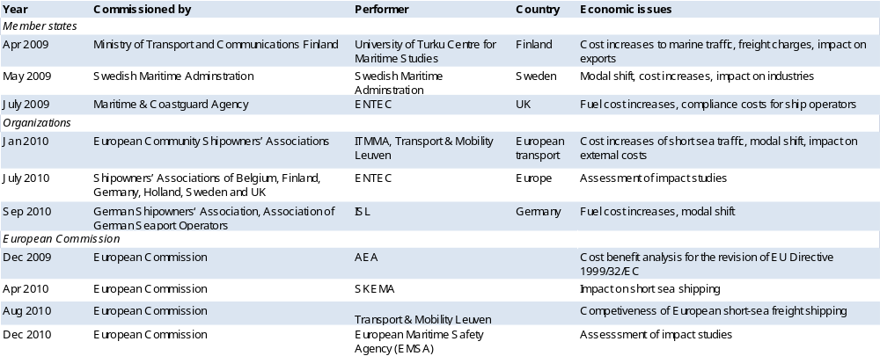
The aforementioned impact assessments are investigating the impacts of sulphur caps on the shipping industry that were set up not only by the EU but also by the IMO (MAPROL Annex VI). A common assumption of the studies is that the 0,1% sulphur limit in SECAs will mainly be achieved by the use of distilled fuels and more specific by the use of marine gas oil.
Only the findings which are relevant to the operation part of liner shipping services and SSS are going to be presented. Environmental and health benefits are not in the paper’s scope nor are the impacts on the refining industry, thus they will not be addressed. But it is important to mention that the main purpose of the new fuel requirements is to minimize the environmental and health risks from ships and it must not be forgotten because of the impacts on the shipping industry.
A common conclusion of all the impact assessments is that prices of low sulphur fuel grades are and will be higher than the price for heavy fuel oil. They therefore suggest that a distortion of the supply and demand for low sulphur marine fuels will occur. Whether the European refining industry will be able to refine the necessary volumes of low sulphur fuels in order to meet the increasing demand, remains to be seen. Although some studies declare that the increased demand will push the prices up, the final report of 2010 for the European Commission DG Environment (COMPASS) states that it is possible for the prices to decrease due to the increased demand that will create economies of scale in the refinery capacity. Contrary, the UK study (ENTEC 2009) supports that by 2020 when the limit of 0,5% enters into force it is likely that the increased cost from the refining process will be passed to the ship operators as a fuel premium.
The obligatory compliance of the shipping operators with the Directive 1999/32/EC will increase significantly the fuel and vessels’ running costs, especially for those operating in the Baltic Sea, the North Sea and the English Channel. Hence all studies tried to estimate the future bunker prices within SECAs but the differences between the estimations are significant. On top of this, the papers of SKEMA and COMPASS estimated the price of MGO for 2015 at USD 850 which we believe is very optimistic as the current price of MGO has climbed above USD 1.000. In addition, the global navigation will also be affected when a global switch to fuel with 0,5% sulphur content in 2020 takes place, due to the new IMO standards.
A common conclusion among the studies is that the impact of reducing the sulphur content of marine fuels on shipping industry will be costly. It is generally accepted that the increased fuel costs will be incorporated in due time in sea freight costs, which means a significant increase of sea freight rates. Thus industries, such as metal and forest industries in Finland which are oriented towards exports or imports by the sea, will be strongly affected with an expected increase of freight rates from 25% to 35% per ton (ECSA 2010).
The increase of freight rates is very likely to lead to potential modal shifts from sea to road (SKEMA 2010, COMPASS 2010, Swedish Maritime Administration 2009 and ECSA 2010). A comparison of shipping with trucking shows that the impact of oil prices on bunker costs is more direct than for the truck case. Also trucking industry is more flexible when it comes to the changes of emission rules as the lifecycle of trucks is the 1/8 of the lifecycle of shipping vessels and can be renewed easier (ECSA 2011). Although it is expected from a ship-design perspective to create more fuel efficient vessels, a certain profit margin is required to support the future investments (ECSA 2010). In the case of shipping markets, where profit margins are small due to the internal competition and the competition from other modes of transport, the investments are limited. Eventually, the increase of bunker costs will slow down the investments and SSS will lose its competitiveness in comparison to the truck option.
Logistics industry is very sensitive to the price of fuels and consequently to the price charges of the freight rates. At the same time, the major recession in economic activity makes the logistic industry even more sensitive. The results of the ECSA study suggests that the length of the sea route affects the prospects of a modal shift and that higher rate increases (overall average 18%) appeared for long and medium range routes. The SKEMA and the German (ISL 2010) studies seem to support the previous conclusion but also mention that a percentage of the lost traffic will not be absorbed from rail or road transport but from other short-sea shipping routes. For short-sea ship services already facing competition by truck or train, especially when it comes to those of medium range, a modal shift is expected. Even a small shift from sea to road for specific short-sea services may lead to an unattractive market environment. Traffic losses for a short-sea shipping operator mean smaller capacity vessels, smaller frequency, higher operational costs and even worse, if the operator cannot guarantee a minimum service frequency, it is likely to lead to the closure of the line. The SKEMA and the COMPASS studies highlighted the importance of the mode/route utilization as it has a significant impact on the overall costs and eventually to the competitiveness among modeled routes (i.e. short-sea shipping might lose volumes of cargo from deep sea vessels with higher utilization and hence lower costs per unit of cargo).
The impact of the increased fuel costs is multidimensional and affects the key elements of SSS competitiveness. It should be taken into consideration that the key determinants of the SSS success are strongly related: A distortion of one determinant such as cost will affect more than one of the other determinants such as time, frequency, reliability and flexibility. No doubt, the design of the whole liner service in shipping industry will eventually face changes due to the skyrocketing of fuel prices. Adding to this the upcoming revision of the Directive 1999/32/EC will enhance the aforementioned situation. Shipping lines need to reconsider the design of liner services, take advantage of the existing overcapacity and reduce the negative economic impacts.

Chapter 5 – Options for the North Europe – East Mediterranean route

5.1 Liner service design
The main commitment of liner shipping companies is to satisfy their customers’ needs for freight transport, through a regular schedule. The crucial issue that they have to manage, in order to provide this kind of services, is to organize and utilize their fleet and their route in the optimum way. This is because the daily operating costs and the needs for capital investments are huge in maritime transportation, thus optimizing the route and the schedule will result in economic savings. Shipping lines are becoming more efficient as they optimize their routes. Container liner service is defined as a fleet of containerships sailing to and from a network of ports, on a time schedule of at least once a week.
There are some factors that an operator has to take under consideration in order to start planning the regular container service. First he has to decide which market he wants to serve and the distribution of service demand (Notteboom and Vernimmen, 2008). Apart from the traditional services, shipping operators gradually extend their service scope to a wider range of services such as dedicated private terminals and added value logistics services. Once these decisions have been made, the operator can design the regular container service.
Firstly, the desired service frequency: In order to be commercial, shipping lines are trying to establish at least a weekly frequency. This element mainly determines the number of vessels that are needed for a weekly service but also influences the size of the vessels. Here there is a trade-off between frequency and ship size. Bigger vessels absorb bigger amounts of cargo and as a result fewer vessels are required but at the same time the frequency is reduced. Smaller vessels can increase the frequency which is positive for the shippers as they are in favor of lower transit times but operators cannot benefit from economies of scale. The complex logistics trends led the cargo owners to demand high scheduled frequencies. Higher frequency improves the market coverage and attracts sufficient volumes of cargo (Lun, 2009). On the other hand, higher frequency increases the operating costs. Eventually operators have to find the right balance between these two and benefit from economies of scale until the point that allows them to reduce the costs per container. Finally as Fagerholt addressed in his paper in 2004, route and scheduled design is a strategic planning problem.
The second element is the number of port calls: Port selection and the number of port calls are essential elements for the successful performance of the container liner shipping companies, as they influence capacity utilization and revenues. Reducing the number of ports, leads to decreasing the round voyage time. This allows more roundtrips per year and eventually fewer required vessels. In addition, fewer ports lead to smaller market coverage and poorer cargo accessibility. On the other hand, inserting more ports in a loop generates more value but this is not certain as it depends on whether the additional cost from adding extra ports is less than the revenue growth (Notteboom and Vernimmen 2008).
All ports are not an eligible choice as they have to fulfill specific characteristics to fit with the route’s characteristics. In general, for a highly efficient shipping system, it is suggested to start and end its liner ship route from a central or a hub port (Fagerholt 2004). Hub ports usually have a well organized feeder system from other ports which provides flexibility and are well connected with the market through different transport modes (road, rail, inland waterway). Except from the amount of profitable cargo that a port can generate, technical characteristics such as efficient handling terminals, computerized operations, sufficient depth and stacking areas for containers are essential. Moreover, the port should be located in a strategic point in relevance with its hinterland dynamic (captive and contestable). Furthermore low port charges (terminal handling charges, storing charges, availability of terminals) are attractive for shipping lines as they constitute an important part of vessels operating costs. Facilities for fuel provision and ship repairs are also considered as a plus for a port.
The third element is the fleet mix: The fleet mix decision includes the required number of vessels, the type of the vessels and their size. The vessels’ size relies on cargo availability but it also depends on the first element. Furthermore, economies of scale offer more benefits to the operators as the distance increases. For long distances it is common to deploy bigger vessels for the aforementioned reason (Notteboom and Vernimmen 2008). Moreover the vessels’ size depends on the ports’ characteristics such as their depth and the size of lockers or canals. It is a usual phenomenon for shipping lines to take decisions in terms of fleet mix jointly with their partners, in a cooperation scheme known as an alliance.
Taking into consideration all the above, it is concluded that it is very important to design a route not only according to what is convenient for the operator but also in relevance to the customer’s demand. Shippers usually demand direct routes but by excluding ports, the possibility for other shipping lines to fulfill these market gaps, is increased.

5.2 Analysis of the North Europe – East Mediterranean route
For the purpose of this paper we have chosen a container liner service from North Europe to the East part of the Mediterranean with eight port calls, four of them in North Europe and four in East Mediterranean. The port of Piraeus is included two times as the vessels stop there in both ways. It would be useful for later on to mention that the principal European ports from La Havre until Hamburg are facing congestion in their terminals and quays (Wang et al., 2007). This route started to operate from February 2012 by one of the biggest container shipping lines. The total roundtrip T_{r} for this route is 21.88 days of which 8.92 days are port time (Table 8). The maximum allowable roundtrip time for 3 deployed vessels (S=3) and with frequency of one call per week (F=1) is 21 days. This implies that the schedule cannot be followed and schedule delays are an inevitable phenomenon for this route.
With a total port time of 8,92 days and 3 vessels, the operator cannot achieve the maximum allowable roundtrip time, even if it operates the 3 deployed vessels at a full speed which is 23 knots. Eventually there is a lack of commitment on the side of the operator to comply with the schedule. Managing the schedule commitment is an important issue in liner service. Port congestion is a negative effect and creates waiting times and delays which put pressure on schedule reliability; but schedule unreliability costs money to shipping lines and shippers.
A potential change of the number of the port calls and more specifically a reduction of the number of port calls may reduce the port time by a few days. Unfortunately we do not have access to the cargo flow from each port and as a result we cannot go deeper and propose a rational reduction of port calls. Although a decrease of the number of port calls will reduce the port time, in real terms fewer port calls mean more time of handling the cargo in the other ports. In addition to this, the impact of a potential reduction of the number of port calls, is modest on vessels’ speed reduction.
Table 8 Port time
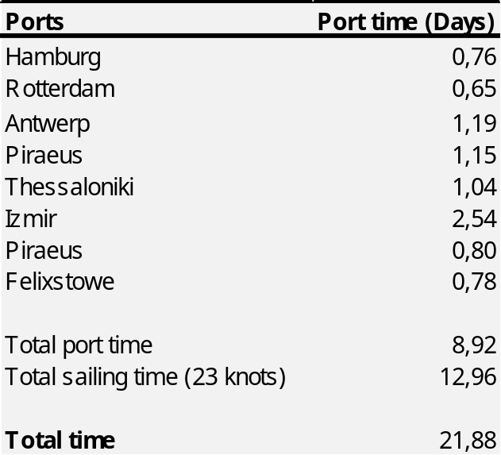
Source: Own calculations based on Lloyd’s List Intelligence data
As a result we will investigate the increase in the number of deployed vessels. Such an option has a bigger impact on vessels speed reduction. This is very interesting because our main focus is on bunker costs. If the shipping line would decide to deploy one more vessel on the loop, then the maximum allowable roundtrip time would be 28 days instead of 21. This would allow it to decrease the sailing speed at 17 knots and at the same time it leaves almost 2 days for time buffers, in order to manage delays or disruptions. From a cost perspective, deploying one more vessel creates more significant costs compared to a reduction of port calls. The next section will examine the cost implications of changes in the liner service configuration, focusing on the bunker costs.

5.3 Cost model for liner service design
With the objective to structure a more detailed analysis, we developed a cost model with the following cost elements:
- Operating costs: these include manning, insurance, repair and maintenance, stores and lubes, administration and port charges.
- Capital costs: these include the expenses associated with the purchase of containership.
- Bunker costs: these include the costs of ship’s fuel.
The cost model includes costs that are related only with the maritime operation and do not include inland transport costs or inter zone repositioning costs. Operating and capital costs were collected carefully by various researches which include such costs, for similar containerships’ characteristics.
In order to calculate the bunker costs, we first estimated the fuel consumption according to the characteristics of the vessels that operate in this route. Table 9 shows the used variables for the fuel consumption calculation. Boilers’ fuel consumption is not included, as the 3 deployed vessels use composite and exhaust gas boilers.
Table 9 Fuel Consumption per Day
A | Main Engine Load Factor At-Sea
B | Average Main Engine Power Rating (kW)
C | Hours of Transit per Day
d=a*b*c | Energy per Day (kW-hr)
E | Specific Fuel Consumption (g/kWh)
F | Grams per Metric Ton
g=d*e/f | Main Engine Metric Tons of Fuel per Day at Sea
H | Auxiliary Engine Power Usage at Sea (kW)
i=c*e*h/f | Auxiliary Engine Metric Tons of Fuel per Day at Sea
j=g+i | Total Fuel Consumption per Day at Sea (metric tons)
Ea | Specific Fuel Consumption for Auxiliary Engine (g/kWh)
K | Auxiliary Engine Power Usage at Berth (kW)
I=c*ea*k/f | Auxiliary Engine Metric Tons of Fuel per Day at Berth
Source: AECOM 2012
Composite boilers use exhaust gases from the auxiliary engines and only if this is not enough they use fuel as a backup. Exhaust gas boilers do not burn fuel at all. Eventually boilers constitute a very small part of the total fuel consumption.
The bunker consumption at specific vessel’s speed (17-23 knots) and bunker prices (IFO 180, IFO 380, MDO, MGO) were calculated from the available data on three different sites (Lloyds list intelligence, bunker index and axs marine). The different main engine load factors at sea, were determined for different speeds which differ according to the cubic law (Rattenbury 2008). Specific fuel consumption was estimated based on the paper of IMO (Prevention of Air Pollution from Ships 2008). The specific fuel consumption depends on engine size, age and fuel energy density and it is calculated by empirical formulas which are developed by the ship engines manufacturers. The specific fuel consumption is a measure of fuel efficiency and it shows the fuel consumption of an engine for a kWh mechanical power output (Rattenbury 2008). According to our vessels’ characteristics (two stroke-slow speed engines) the specific fuel consumption of main and auxiliary engines are 173 g/kWh and 220 g/kWh respectively.
The total roundtrip distance is 7153 nm in accordance with the axs marine distance table. However, the sailing distance does not have any impact on the fuel consumption per km (ECSA 2010). The number of ports is 8 (Piraeus port is called two times in the loop). Three vessels are deployed, with capacity of 4133 TEU, 3424 TEU and 4545 TEU. The average port time of the vessels is estimated using the history movement and berthing data of these specific vessels, on these specific ports from February 2012 (Lloyd’s list intelligence). The option to estimate the port time based on the average moves per crane, moves per ship call, number of cranes per vessel size and port access time, was unfortunately unavailable because of data shortage.
After the determination of all the required variables, we calculated the fuel consumption of the containerships operating to the specific route. The comparison of the results (figure 5) with a previous study (Notteboom and Carriou 2009) shows that our results are higher. This is mainly explained by the fact that Notteboom’s and Carriou’s estimation is based on a sample of 459 vessels instead of ours which is based on these 3 specific containerships. In addition, they used lower specific fuel consumption compared with this study because of different engine characteristics (age, size). The average age of their sample was 6,5 years whereas ours is 14,6 years. Also they have included one additional variable, the sea margin, which considers the weather conditions.

Fig.5 Fuel consumption at sea in metric tons for different speeds
In order to have a better opinion of the percentage of the bunker costs we estimated the day-to-day running costs of the vessels (Annex II). The cost factors that are included are proportional to the vessels’ type and size. The fuel costs which are included in the diagram are calculated according to the vessels in this specific case. It is seen from the diagram that fuel costs account the largest share of the vessel costs, for every speed (fuel prices as at September 2012).
Fig.6 Distribution of costs at different speeds for vessels operating between North Europe and South East Mediterranean
Changes of the fuel prices or the shift to other more expensive fuels (MDO or MGO) will affect the cost structure. If vessels switch to distilled fuels, the running costs will increase and as a result the share of the fuel costs as a percentage of the day-to-day running costs, will also increase. It should be noted that speed affects a lot the fuel consumption. As it was also stated before, at lower speeds the consumption is less and the fuel costs account for a smaller percentage. In our case, the vessels cannot reduce their speed without affecting the schedule, unless there is a reduction of the number of port calls or by deploying an extra vessel.
The average port time is 1,12 days at eight port calls. A reduction of the number of port calls from 8 to 7 calls, would in theory reduce the port time to 7,8 days. This would allow the operator to reduce the speed from 23 to 22 knots and save annually from $1,9 million (IFO 180) to $3 million (MGO) per vessel, depending on the fuel type (Table 10).
The table below (page 51) summarizes the results of the cost model and will help us to derive important conclusions. According to our calculation and with bunker prices as they were in the beginning of September 2012, our container vessels sailing at 23 knots, account a bunker cost that represents 68% of the total daily ship costs, while

Table 10 Daily fuel costs (USD) per vessel at different speeds and different fuel types
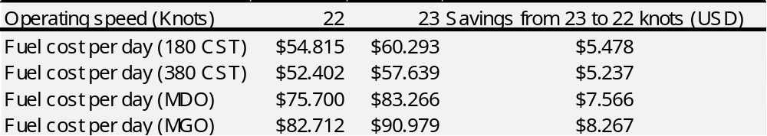 Source: own calculations
using IFO 380. If the vessels were burning MGO, the bunker costs would increase due to the more expensive fuel and represent almost 77% of the total daily ship costs. The high percentages of bunker costs on the total daily ship costs are higher than in other reports but we suppose that this is mainly because of the skyrocketing of the fuel prices during the last years. Notteboom and Vernimmen in 2008 estimated the bunker costs for container vessels 4.000-5.000 TEU, to be 51% of the total ship costs (bunker cost 450 USD per ton) and as they stated in their paper, Dynamar reported in 2007 that bunker costs accounted for the two-thirds of voyage operating costs.
Moreover, the results reveal that the deployment of an extra vessel would allow the operator to reduce the speed at 17 knots while reducing the fuel costs, following the schedule on time, improving its frequency and of course leaving time for potential disruptions or delays. More specifically: from the moment that overcapacity exists because of the economic recession, a deployment of an extra vessel with similar characteristics to the other three vessels, would reduce the percentage of bunker costs in the total daily ship costs at 51% (IFO 380). This reduction is translated into USD 29.477 savings per day for IFO 380. For vessels that use MGO the reduction of bunker costs means even bigger savings (USD 46.527 per day). The additional costs for the extra deployed vessel are less than the savings from all the already deployed vessels.
Figure 7 verifies that deploying a fourth vessel and reducing the speed at 17 knots has less fuel costs compared with three deployed vessels operating at 23 knots. A good indication is the daily vessels’ consumption per km. Sailing at 23 knots creates a consumption of 0,14 ton per km while sailing at 17 knots creates a fuel consumption of 0,09 ton per km (Annex I). Figure 8 shows in more detail the relation between bunker prices and bunker costs per roundtrip. The figures uncover an attractive solution for shipping lines, to deploy an extra vessel and reduce speed, when fuel prices are high. Although the impact of the number of port calls on bunker costs is modest (Notteboom and Vernimmen, 2008) the deployment of an extra vessel impacts significantly on bunker costs, especially for bunker prices higher than USD 450 per ton. The current bunker prices of marine fuels have exceeded the rate of USD 650 per ton (USD 695 for IFO 380, USD 1090 for MGO), which means that the cost gap has become even more significant.

Fig.7 Daily fuel costs (USD) at different speeds (17-23 knots) for 3 and 4 vessels

Fig.8 Bunker costs (USD) at different prices per metric ton for a roundtrip
The concept of slow steaming started as result of the financial crisis of 2008-2009, when international trade and container shipping demand reduced while at the same time the order book boom of the previous years for new capacity, was delivered to the shipping lines (Notteboom and Carriou, 2009). Eventually shipping lines started to switch from normal speeds (20-25 knots) to slow steaming speeds (17-20 knots).With slow steaming, vessels’ engines operate with lower engine load factor in order to save fuel consumption having as a consequence, additional travel time. In 2011 more than 50% of the global capacity was operating under the slow steaming conditions (Rodrique 2012). The main reasons for adopting such speeds are cost cutting reasons. Environmental reasons such as lower maritime emissions are used from shipping lines to vindicate further the lower speeds. It is remarkable why shipping lines did not adapt the slow steaming speeds earlier than 2008.
There are many thoughts on why they did not apply the slow steaming earlier. First, shipping lines are characterized by inactivity in adapting changes in their liner services. Even though bunker prices were high enough from 2007 to convince shipping lines to change their liner services, it is probable that they were inactive because they were waiting for the then big cost gap, to become even more significant. Notteboom and Vernimmen in 2008 interviewed representatives from shipping lines which stated that they did not expect the fuel prices to remain in such high levels, for a long time. Eventually, the first years of high bunker costs were considered as a not permanent situation.
Second, shipping lines because of their customer orientation towards high frequency and short transit times, were in favor of normal speeds which were a major demand of their customers. Slow steaming, as it is stated before, affects negatively the transit time and more specifically in our analysis, the reduction from 23 knots to 17 knots extended the roundtrip 4,57 days. Port congestion and potential disruptions of the liner service put schedule’s reliability under pressure and very often the time savings of normal speeds are counterbalanced by the port delays. Time is money and especially in a competitive market, like maritime transportation, every USD counts. It has started to become straightforward that shipping lines prefer a bit higher longer transit time, with high schedule reliability, instead of low transit time, with low schedule reliability.
Third, shipping lines’ customers are not in favor of having often and many changes in the liner service schedule. Shipping lines’ customers organize in advance their operations such as production, supplies and orders according to the schedule of liner services. Thus, shipping lines in order to maintain a reliable and regular schedule, avoid changes that may occur because of short term changes such as high bunker prices. This perception is likely to lead to a reluctant behavior by the perspective of shipping lines, to adapt changes that may benefit the liner service. Until a certain point, this reluctance is justified because of the advanced booking of containers based on the advertised schedule of the liner service.
Fourth, shipping lines as they stated to Notteboom’s and Vernimmen’s interview in 2008, started to realize that schedule unreliability causes additional bunker costs. When there is an unexpected delay, such as port congestion, which is increasing the last couple of years, technical problems or weather disruptions, shipping lines are trying to get the vessel back on schedule. During this effort, to get the vessel back on schedule, additional bunker costs emerge as a result of the increased speed of vessel in order to follow the schedule. However, the increase of speed is not the only way to deal with delays. Shipping lines have a range of different ways to increase their schedule’s commitment by reordering the ports in the liner service, by canceling one or more port calls or by adding an extra vessel, as we have argued before.

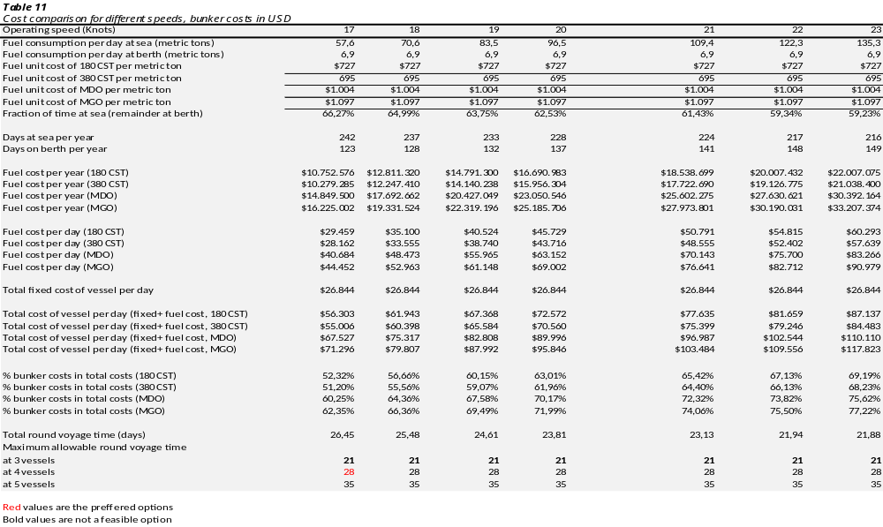
Until now we have mainly highlighted the benefits from slow steaming, which are very interesting in terms of economic savings. The next chapter will present in summary the drawbacks and the necessary technical modifications of vessels’ engine, in order to operate at lower speeds.

5.4 Technical constraints and drawbacks
For shipping companies, the main message is that fuel prices will be uncertain. Relying on this, the concept of slow steaming can be achieved in two ways. The first way involves the ship designers and it means building ships with smaller engines, in order to sail with 17 knots instead of 25. This option is irreversible and may create additional fuel consumption and emissions when the vessel will attempt to sail at higher speeds or maintain the speed in bad weather, compared to having a more powerful engine (Odense Steel Shipyard Ltd. 2008). Moreover, it would be very risky to design a vessel for specific fuel price levels.
The second way is to reconfigure the engine, in order to perform correctly under reduced loads of engine. The main engines of ships are designed for optimal combustion when the rated power is exploited near the maximum level. Reducing the speed leads to a non-optimal combustion and increases the specific fuel consumption (Fader et al., 2012). Although, at slow steaming vessels, the consumption fuel is less in total, the vessel consumes more fuel per unit of power. If a vessel is going to be operated at slow steaming continuously, it can and it has to be de-rated, in order to maintain the optimal specific fuel consumption.
All of our research is based on the assumption that the hull and the propulsion system will maintain their efficiency at slow steaming. There are some factors that shipping lines need to take under consideration in order to ensure that the hull and the propulsion systems perform well, under slow steaming and avoid long term damages of the main engine. These factors were derived from the paper of Rattenbury 2008:
- Possible fouling and loss of effectiveness of heat recovery systems
- Loss of turbocharger efficiency and matching to low engine powers
- Loss of propeller efficiency
- Fouling of hull and propellers due to reduced speed through water
- Increased fuel consumption for auxiliary engines to supplement loss of heat recovery
- Increased lubricating oil consumption
- Possible increased vibration levels and detrimental effects
- Increased voyage duration and running hours for machinery
Most of the above factors which can also be characterized as disadvantages, can be solved by retrofits (Fader et al., 2012). Some of the above disadvantages are more important than others. For instance the loss of turbo charger may lead to a serious safety issue and it has to be solved. A counterexample would be the loss of propeller efficiency but this does not mean that the propeller will be damaged. Thus, it is possible to be neglected as it does not limit the vessel’s operations. In general, the technical constraints are few for slow streaming and they are solvable.
From an environmental point of view, non-optimal combustion because of slow steaming, generates higher emissions of pollutants such as particulate matter (PM) and Nitrous Oxides (NO_{x}), which as we mentioned in the beginning, except from the negative effect on ozone, they are also very harmful for human health (Fader et al., 2012). Carbon dioxide and sulphur oxides are reduced in line with the fuel consumption. In general, the slow steaming with the appropriate technical reconfigurations, has important environmental benefits.
To continue, from a broader point of view, slow steaming requires more ships and crew and extents the supply chain in terms of time. Contrary, lower air pollutant and GHG emissions, more reliable schedule, better use of the fleet and lower marine transport costs are some of the important benefits of slow steaming.

Chapter 6 – Conclusion
This paper aimed at analyzing the potential impact of the revised Directive 1999/32/EC referring to the new lower sulphur requirements, on the container liner service design in the European boarders. The paper focused on the research question: What is the expected effect of the revised 1999/32/EC Directive on the liner service design in container shipping market?
In regards to the research question, the effect of the revised Directive 1999/32/EC is likely to be very costly to the shipping lines and more particularly to container shipping lines. Taking into consideration that the implementation of the environmental legislation in maritime sector is no longer dubious and on top of this, the skyrocketing of the bunker prices in the last decade, these force the shipping lines to be strict with fuel consumption. Hence, shipping lines have to comply with the legislation and reconsider their operational strategies, due to the negative economic impacts on the profit margins.
Based on the available options that shipping lines have, in order to achieve the legislation’s requirements, we concluded that the only current and feasible way is to switch from the currently used heavy fuel oils (IFO 380/IFO 180) to the refined fuels (MDO or MGO). Regarding the rest of the options for complying with the legislation, emission abatement methods such as exhaust scrubbers, although are a promising technology which has interesting results as shown by the tests, they are not ready for commercial use. Alternative fuels such as LNG, require an expansion of the appropriate facilities for bunkering ships with LNG, throughout Europe. Hence, political intervention is necessary in order to overcome a number of financial and legal key barriers, while promoting a clean source of energy.
Apart from the potential implications that have been addressed already by several impact assessments due to the sensitivity of the logistics industry to the price of fuels, changes in liner service design are required. The replacement of heavy fuel oils with refined fuels, will force shipping lines to adapt their liner service design in terms of fuel efficiency. With the upcoming legislation, it is no longer possible for vessels to operate with heavy fuel oils (high sulphur) or fuel blends.
Based on the cost model, in the last part of the paper it is demonstrated that bunker costs with the current bunker prices have a significant impact (for this specific liner service) on the daily costs of a 4.000 TEU containership. The model showed that the use of refined fuels will increase the share of the bunker costs, on the total operating costs of a container vessel, around 7,4% to 9%, which means USD 9,4 million to USD 12,1 million more costs per year, for each vessel. This is mainly explained by the fact that refined fuels MDO and MGO are 44% and 57% respectively more expensive than the heavy fuel oils.
As the paper is focused on bunker costs and on liner service design, we argue through the cost model that by deploying an extra vessel on the liner service, will give the chance to shipping lines to reduce vessels’ speed, reduce the fuel consumption, lower volumes of harmful emissions, improve the schedule’s reliability, while having cost savings and almost 2 days to manage potential delays. The existing overcapacity on container market is a strong operational incentive for slow steaming. However, longer transit times will occur but no lower frequencies. A potential reduction of the number of port calls, will also allow shipping lines to lower the speed but with a modest result on vessels’ speed reduction. A more detailed analysis requires the knowledge of cargo flow from each port.
Until now, the available literature which describes the relationship of fuel consumption and liner service design, is not very broad. However, bunker costs concern very much the shipping lines. This paper mainly derives results from the specific route. The present study can be extended by analyzing the fuel costs for different container liner services or even to other sectors, such as liquid or bulk liner services. Future research can also present the overall environmental impact of the slow steaming concept, while comparing the total emissions before and after the extra deployed vessels. Another potential extension could be a deeper analysis on the optimization of the number and the type of the port selection.

References
© Alphaliner 1999-2012. Available from www.axsmarine.com.
AEA, 2009 : Cost Benefit Analysis to Support the Impact Assessment accompanying the revision of Directive 1999/32/EC on the Sulphur Content of certain Liquids Fuels, prepared for the EU Commission.
AECOM, 2012 NC Maritime strategy Vessel Size vs Cost, Prepared for the North Carolina Department of Transportation in association with URS.
Bangchus, R.C. and Kuipers, B., 1993. “Autostrada del mare”, in European Short sea shipping. Proceedings from the First European Research Round Table Conference on Short sea Shipping, Delft, 26-27 November 1992, N. Wijnolst, C. Peeters and P. Liebman (eds.) (London, Lloyd’s of London Press), pp. 52-65.
Bjornald, D. 1993. The importance of Short-sea shipping in European transport, Short-sea shipping (Paris, OECD/ECMT), pp.59-93.
Chapman, L., 2007. Transport and climate change. Journal of Transport Geography performed by Transport & Mobility Leuven, 15, pp. 354–367.
COMPASS, 2010 : The COMPetitiveness of EuropeAN Short sea freight Shipping
Corbett, J. J., Winebrake, J. J., Green, E.H., Kasibhatla, P., Eyring, V. and Lauer, A., 2007. Mortality from Ship Emissions: A Global Assessment. Environ. Sci. Technol. 2007, 41, pp. 8512-8518.
Corbett, J.J., Winebrake, J.J., (2008) Emissions Tradeoffs among Alternative Marine Fuels: Total Fuel Cycle Analysis of Residual Oil, Marine Gas Oil, and Marine Diesel Oil Air & Waste Manage. Assoc. 58:538 –542.
Dalsøren, S.B., Elde, M.S.., Endresen, O., Mjelde, A., Gravir, G. and Isaksen, I.S.A. 2008, Update on emissions and environmental impacts from the international fleet of ships. The contribution from major ship types and ports, Atmospheric Chemistry and Physics (ACP), 8, 18323–18384.
EMSA, 2010: The 0.1% sulphur in fuel requirement as from 1 January 2015 in SECAs – An assessment of available impact studies and alternative means of compliance (EMSA, December 2010)
Environmental Protection Agency (EPA), 2008. Global Trade and Fuels Assessment -Future Trends and Effects of Requiring Clean Fuels in the Marine Sector. Assessment and Standards Division Office of Transportation and Air Quality U.S. Environmental Protection Agency, EPA Contract No. EP-C-05-040.
European Commission, 1995. The Development of Short Sea Shipping in Europe: Prospects and Challenges. Communication from the Commission to the Council to the European Parliament the Economic and Social Committee and the Committee of the Regions Office Luxembourg, COM (95) 0317 Final.
European Commission, 2006. Greenhouse Gas Emissions for Shipping and Implementation Guidance for the Marine Fuel Sulphur Directive. Solutions for environment, economy and technology, Delft, CE Delft (P.n.: 06.4103.61) December 2006
European Commission, 2008, Attitudes of European citizens towards the environment, Special Eurobarometer (295/ Wave 68.2) – TNS Opinion & Social
European Commission, 2009. Technical support for European action to reducing Greenhouse Gas Emissions from international maritime transport. Delft, CE Delft (P.n.: 09.7731.798) December 2009
European Commission, 2010. A strategy for smart, Sustainable and inclusive growth, Communication from the Commission Europe 2020, Brussels COM (2010) 2020 final.
European Commission, 2011. Impact assessment: Proposal for a Directive of the European Parliament and of the Council amending Directive 1999/32/EC as regards the sulphur content of marine fuels, Brussels {COM(2011) 439 final},/{SEC(2011) 919 final}
European Commission, 2011. Proposal for a Directive of the European Parliament and of the Council amending Directive 1999/32/EC as regards the sulphur content of marine fuels, Brussels (COM(2011) 439 final SEC(2011) 919 final).
European Community Shipowners’ Associations (ECSA), 2010. Analysis of the Consequences of Low Sulphur Fuel Requirements, performed by University of Antwerp, Institute of Transport and Maritime Management Antwerp (ITMMA).final – 29 January 1010
Fader, J., Nelissen, D., Hon, G., Wang, H. and Tsimplis, M., 2012. Regulated slow steaming in Maritime Transport: An assessment of options, Costs and Benefits. CE Delft
Fagerholt, K., 2004. Designing optimal routes in a liner shipping problem, Maritime Policy & Management: The flagship journal of international shipping and port research, 31:4, pp.259-268.
Hombravella, A., Kılıçaslan, A., Péralès, J. and Rüß, C., 2011. Study of Exhaust Gas Cleaning Systems for vessels to fulfill IMO III in 2016, European Project Semester 2011
http://ec.europa.eu/transport/maritime/index_en.htm European Commission 2011
International Maritime Organization (IMO), 2007. Revision of Maprol Annex VI and the NO_{X} the technical Code. BLG 12/INF.10 December 2007
ISL Institute of Shipping Economics and Logistic, 2011, Shipping Statistics and Market Review, Statistical Publications volume 55 No 5/6.
Lun, Y.H.V. and Browne, M., 2009. Fleet mix in container shipping operations, Int. J. Shipping and Transport Logistics, Vol. 1, No. 2, pp.103–118.
MAN B&W Diesel A/S (MAN B&W). 2005. Operation on Low Sulphur Fuels: Two-Stroke Engines. Published November 26, 2005.
Maritime Coast Guard Agency 2009: Impact Assessment for the revised Annex VI of MARPOL, performed by ENTEC
Maritime Coast Guard Agency, 2009: Impact Assessment for the revised Annex VI of MARPOL, performed by ENTEC.
Marlow, P.B., Pettit, S.J. and Scorza, A.D., 1997. Short sea shipping in Europe: Analysis of the UK and Italian Markets. Cardiff, Department of Maritime Studies and International Transport Vol.42 pp.62-67.
Medda, F. and Trujillo, L., 2010. Short-sea shipping: an analysis of its determinants. Maritime Policy and Management, 37:3, pp.285-303
Ministry of Transport and Communications Finland, 2009. Sulphur content in ships bunker fuel in 2015 A study on the impacts of the new IMO regulations on transportation costs. Helsinki: Publications of the Ministry of Transportation and Communications (ISSN 1795-4045).
Musso, E. and Marchese, U., 2002. Economics of short sea shipping. In: C. Th. Grammenos, eds. Handbook of Maritime Economics and Business, London: Lloyd’s of London, pp. 280–304.
Notteboom T.E. and Vernimmen B., 2008. The effect of high fuel costs on liner service configuration in container shipping. Journal of Transport and Geography, xxx, pp.xxx-xxx.
Notteboom, T.E., 2011. The impact of low sulphur fuel requirements in shipping on the competitiveness of roro shipping in Northern Europe, World Maritime University: Journal of Maritime Affairs, Vol.10 pp.63-95.
Odense Steel Shipyard Ltd ,Bent Ørndrup Nielsen and Senior Mech. Engineer B.Sc., 2008. 8500 TEU Container Ship Green Ship of the Future Concept study. GSF Container Ship Concept Study , Project: 4-4383.
Paixao, A.C. and Marlow, P.B., 2002.Strengths and weaknesses of Short-sea shipping, Marine policy, 26(3), pp.167-178.
Papadimitriou, S., 2001. Short sea shipping in Europe: Experience and prospects, Short sea shipping (Paris, OECD/ECMT), pp.8-19.
Psaraftis H. and Kontovasa C., 2010. Balancing the economic and environmental performance of maritime transportation. Transportation Research Part D, pp.458–462.
Rattenbury, N., 2008. Is slow speed operation a panacea for reliable ship operation? In: Tozer D., eds. Container ship speed matters. London Lloyds Register pp. 11-12.
Rodrique, J.P., 2012. Dept of Global Studies & Geography [online] Copyright1998-2012, Hofstra University, New York, USA. Available from: http://www.people.hofstra.edu/geotrans/.
Sjostrom, W., 2010 Competition and cooperation in liner shipping In: C. Th. Grammenos, eds. Handbook of Maritime Economics and Business, London: Lloyd’s of London, pp.433 – 477.
SKEMA, 2010. Impact Study of the future requirements of Annex VI of the MARPOL Convention on Short Sea Shipping. Periodic Study, European Commission: Directorate-General for Energy and Transport, Tak-2 of 3
Slack, B., Comtois, C. and McCalla, R., 2002. Strategic alliances in the container shipping industry: a global perspective. Maritime Policy Management, Vol. 29, No. 1, pp.65–76.
Smith, S.J., Andres, R., Conception, E. and Lurz, J., 2004. HistoricalSulfur Dioxide Emissions 1850-2000: Methods and Results. Pacific Northwest National Laboratory, U.S. Department of Energy, Baltimore, January 2004
Song, D., Zhang J., Carter, J., Field, T., Marshall, J., Polak, J., Schumacher, k., Sinha-Ray, P., & Woods, J., 2005. ‘On cost-efficiency of the global container shipping network’, Maritime Policy & Management: The flagship journal of international shipping and port research, 32:1, 15-30.
Stopford, M. 1997: Maritime Economics (London Routledge).
Swedish Maritime Administration, 2009. Consequences of the IMO’s new marine fuel sulphur regulations. supported by EU Commission through DG ENV.0601-08-03406.
Theo E Notteboom, T.E., 2004. Container Shipping And Ports: An Overview, Review of Network Economics Vol.3, Issue 2 – June 2004.
Theo E Notteboom, T.E., 2006. The time factor in Liner Shipping Services, Maritime Economics and Logistics, Vol. 8, pp.19-39.
United Nations Conference on Trade and Development (UNCTAD), 2011. ‘Structure ownership and registration of the world fleet’, Review of maritime transport, Chapter 2. Report by the UNCTAD secretariat.
Wang, D.H., Chen, C.C., and Lai, C.S., 2011. The rationale behind and effects of Bunker Adjustment Factors. Journal of Transport Geography 19 (2011) pp. 467–474.
Wang, J., Olivier, D., T. Notteboom and B. Slack (2007), Ports, cities, and global supply chains, London: Ashgate.

Annex I- Estimation of fuel consumption per km
For the calculation of the daily fuel consumption per km of the specific vessels first we estimated the daily distance (nm) at sea for two different speeds (23 knots and 17 knots).The daily distance sailing at 23 knots and 17 knots is 552nm and 408nm respectively. Then we converted the nautical miles into km (1nm=1.852m).
Knowing the daily fuel consumption for different speeds it is easy to estimate the fuel consumption per km.

Annex II – Estimation of the day-to-day running costs at different speeds and fuel types
The cost breakdown of the three vessels has the following elements. Manning and capital costs were estimated according to these specific vessels. All the other elements have been chosen from several papers which include these kind of costs for vessels with an average capacity of 4.000 TEU.
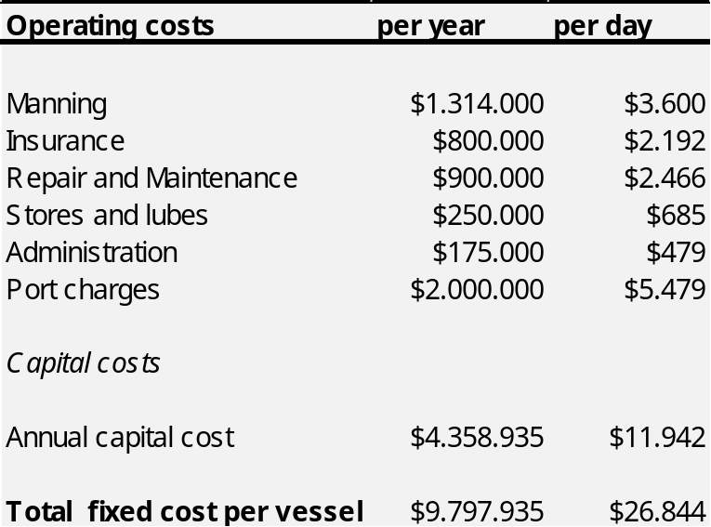
The table below indicates the bunker costs at different speeds for four different fuel types.
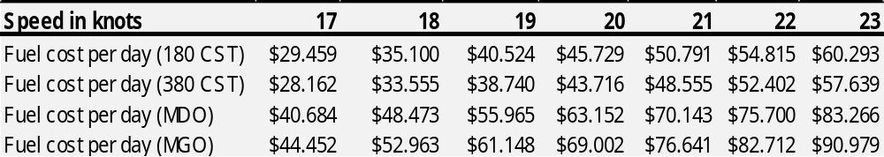
The results of the cost structure of the day-to-day running costs of the vessels are displayed in the following three diagrams.

