The Price effect and Beta changes of stocks added to or deleted from the MSCI Emerging Markets Index

  - Masters’ thesis at the Erasmus University Rotterdam
  - Merilin J. Simons
  - Supervised by Laurens Swinkels, PhD
  - November 14, 2012


Preface

First of all I would like to thank my family and my loved ones for supporting me not only during the time that I made my thesis, but also in all the years of studying for my masters’ degree Economics & Business.
I have always had trouble focusing on just one thing, because of my broad interests. Not only did I want to know all about Accounting, Auditing and Control, Finance on an investment level always drew my attention! This thesis was my chance to really challenge myself on this topic. It felt like a journey through the unknown, it was new, it was scary, it was exciting and most of all it was heuristic and educational.
I have chosen to do a study on Emerging Markets, because I could feel the connection as being a child, born in Surinam, who grew up in the Caribbean. I’m proud to see that these countries are working on their economies and have growing investment markets where investors can now become part of their economies.
Many thanks go to all my colleagues at the Robeco who were always willing to help, especially Cornelis Vlooswijk who initiated this topic, Bart van der Grient, Weili Zhou and Jornt Beetstra for their highly appreciated research tips.
A special thanks goes to my thesis supervisor Laurens Swinkels, I really appreciated his useful comments and advices. He pushed me to a new level of research on investments.
Thank you all for your support.
Contents

Chapter 1: Introduction 4
Chapter 2: Literature 6
2.1 Theories on price effects 6
2.2 Theories on co-movement 6
2.3 Price effects 7
2.4 Co-Movement effects 19
Chapter 3: Data of the research 25
3.1 Introduction 25
3.2 The MSCI 25
3.3 Overview of QIR and SAIR 29
3.4 Sample 33
3.5 Exclusions from the data 34
Chapter 4: Methodology 36
4.1 Methodology 36
Chapter 5: Results 39
5.1 The results on the price effects on additions 40
5.2 Results on deletions 48
5.3 Results on the Beta change 55
Chapter 6: Summary of results and Conclusions 62
References 65
Appendices 67

Introduction

The impact of stock prices of companies newly added or deleted from Morgan Stanley Capital International Emerging Markets Index (MSCI EM Index) is something that active and passive investors would like to know when investing in the emerging markets equities.

What are indices?
As Levy and Post (2005) described in their book on Investments, indices such as the Dow Jones, NASDAQ, S&P 500 or AEX are often mentioned on the news. These are examples of indices just like the MSCI EM. They mentioned that indices are used to measure historical rates of return across several securities. And noted that the importance of an index is that it measures the performance of a certain set of stocks just like the CPI measures its consumer prices. Each index represents a different set of stocks or other types of instruments. Levy and Post (2005) summarized these differences as follows:
- The methodology to calculate the index
- The type of securities are added to the index
- The size of the universe
- Index changes and adjustments over time on a security and or country level
The Dow Jones Industrial Average (DJIA) represents industrial companies, The National Association of Securities Dealers Automated Quotation (NASDAQ) focuses on IT companies, S&P 500 is a basket of 500 of the largest companies that are listed on New York Stock Exchange (NYSE). Amsterdam Exchange (AEX) is a basket of 25 most liquid companies and the MSCI Emerging Markets is a combination of an estimated 850 companies from 21 Emerging countries all around the world. These indices are just a small example of all indices that are available nowadays. Levy and Post (2005) mention the importance of indices as follows:
- Stock indices measure the general performance of a stock market. If an economy is growing and rising most likely the indices will do so too.
- Stock indices are a tool to measure investors’ expectations about future performance of a stock market. (A tool for making estimates instead of historical data).
- Investors and analysts use indices to evaluate the overall direction of the market.
- Indices can be used as a benchmark to determine the performance of investment managers.
- Indices can be used as a guideline for passively managed mutual funds.

The objective of this study
The reason for choosing to study the price effect and beta changes of stocks added to or deleted from the MSCI Emerging Markets is to investigate if it makes sense for investors in Emerging Markets to timely buy or sell stocks that will enter or disappear from the index.
Previous studies from for example Zhou (2011), Chen et al (2003) and Doeswijk (2007) on price effects on index reviews have shown that a stock that is included in the index because of an index review experience a statistically significant and permanent price increase upon inclusion into the index. Deleted stocks from the index show an opposite effect.
Secondly, for this study it was decided to investigate the change in beta on stocks added to and stocks deleted from the Emerging Markets index. When an index reviews its stocks, some stocks may be down-weighted while others may be increased, newly added or deleted from the index. In theory under the efficient markets view, these changes should not have an impact on the prices of these stocks. Studies from Green and Sosner (2002) Barberis et al. (2002) and Vijh (1994) have shown an increase upon addition and a decrease of beta upon deletion from the index. These results were not in line with theory of the efficient markets view. This brings us to the research questions.
First research question:
- What is the impact of stock prices on stocks newly added to or deleted from MSCI Emerging Markets Index? Meaning that there should be zero price effect on additions to and deletions from the MSCI Emerging Markets index after index review changes have been implemented, because index reviews contain no news about fundamentals of a stock.
Second research question:
- Is there a change in beta of added or deleted stocks when measured before and after the implementation of the index review changes to the MSCI Emerging Markets Index? Meaning that there should be zero change in beta before and after the index implementation because an index review contains no news about the fundamentals of a stock.
Chapter 2 will focus on results of previous studies; Chapter 3 will give more details on the data that were used for this study. Chapter 4 will elaborate on the methodology, Chapter 5 will explain the results found in this study and the closing Chapter 6 provides a summary and conclusion.

Literature

Theories on price effects
Over the past years a number of studies have been done around additions and deletions of stocks from US market indices such as the S&P. One of the first to research and examine published information on announcements from Standard & Poor’s is Jain (1987). Most of the evidence from these studies shows that price reactions occur when an index review announcement is made of stocks that will enter or exit that index. In general, these studies also show that when a stock enters the index, a permanent price increase takes place; but when the stock gets deleted the stock price is only temporary hammered, and recovers after a few days. Harris and Gurel (1986) attribute to the price changes around S&P 500 inclusions to an increase in demand from index funds. They also found that, after the announcement date, the trading volume of revised companies increases. Shleifer (1986) found that newly added stocks earned significantly positive excess returns upon announcement of inclusion in the S&P500 and states that those returns are positively related to buying by index funds. Hacibedel (2007) has looked at price effect of additions and deletions on the MSCI Emerging Market index and links the price changes to the information effect. Beneish and Whaley (1996) claim that the price effect of a stock reaches a new equilibrium when included in the index. Another phenomenon that contributes to a price effect is the increased awareness of investors that are following stock inclusions by Chen et al. (2003). Investors’ awareness is based on the model of asset pricing with imperfect information.

Theories on co-movement
The second research question focuses on the co-movements and beta change in the MSCI EM index when stocks are added to or deleted from the index. Traditionally investors traded because of news and changes on fundamental value of companies. An example of a reason for trading that does not come from fundamental news is an index review.
When an index reviews its securities, some securities might be down-weighted and others might be increased in the index. Or there might be securities added newly to or deleted from the index. In theory under efficient markets view these changes should not have an impact on the correlation of prices of these securities because there has been no new fundamental information on the value of these stocks. Co-movement is analyzed by comparing the beta of a stock added to (or deleted from) the index, before and after the inclusion (or deletion) from the index.
Most of the research has been done on the S&P and other developed markets, where findings show a significant increase in stock betas after inclusion. The results show that index beta should increase after inclusion of a stock and that the same pattern should happen for a deleted stock, but then in the opposite direction. Prior work done on the S&P 500 by Vijh,( 1994) has shown different results than the outcome one would expect based on the efficient market theory. The effects should be even stronger in more recent data as more passive trackers follow the index. Naming Barberis et al.(2002), Greenwood and Sosner (2002) who have done this research for the Nikkei index and came up with evidence too on increased betas for stocks that were added to the Nikkei Index. Pindyck and Rotemberg (1993) showed in their research that co-movement of returns can be found and is mainly explained by company size and the degree of institutional ownership.
Less work was found on Emerging Markets indices. However, Parthasarathy (2011) studied the co-movement on the Emerging Indian Stock Market, the asymmetric results for additions and deletions of his research did not support the “category” view of co-movement of Barberis et al. (2002). The category view argues that investors make their portfolio decisions by first grouping their assets into categories, such as large- cap stocks, or sectors or corporate bonds, and then allocate assets to these different categories.

Price effects
To get an view on prior research done on price effects, a table is made that compares the results of five different researchers who have done their research on different markets, naming the AEX, S&P 500, TSE 300, S&P CNX Nifty, and MSCI EM.

Amsterdam Exchange Index
The Amsterdam Exchanges index (AEX) is annually reviewed. The adjustments take place after market close on the third Friday in February in 1994 which changed in 2001 to the first trading day in March to reduce pressure on the market and its systems due to index revision- related trading of February option expiration. Doeswijk (2007) did his research on AEX and analyzed a total sample 214 stocks (double counted) on changes in the index. The CAR was calculated for two buy and hold portfolios that anticipated on the index review. One portfolio with stocks that would increase (added to) and one with stocks that would decrease (deleted from) in the index. The portfolios were calculated based on two methods, naming the equally weighted and the change weighted method. Equally weighted portfolio is a simple portfolio policy with equal weight stocks. And the change-weighted method constructs the portfolio with weights that are in proportion with the anticipated change of the index weight.
With the equally weighted portfolio he evidenced on average a 3.5% outperformance (excess return) relative to the market in the 34 day prior to the implementation day. With a significant outperformance level at 5%, these results were not significant. The results after the implementation day also showed an insignificant result of 1.7% outperformance remaining over the whole test period of 67 days. Doeswijk compared his results to those of the previous research from Shleifer (1986) who had 3% cumulative outperformance for stocks added to S&P 500 in the period of 1981-1983. Results from Noronha et al.(2003) came up with a similar result around that period, between 1976 ant 1989 they came up with an outperformance of 3.2%( with a significant level of 1%). The decreases (deletions) were unaffected by the index review the CAR was slightly positive with 0.1%. Doeswijk did a second test but then with a change- weighted portfolio, which is in proportion with the anticipated changes of the index weights. These results were much more impressive with an outperformance of 7.4% relative to the market in the 34 days prior to the implementation day. The day after the implemented changes showed a result of -3.1% resulting in an overall result from 33 days prior to the implementation day until 34 days afterwards a outperformance relative to the market of 4.1%. The decrease (deletion) portfolio remains insignificant with an underperformance of -0.7% for the period before implementation and -0.9% for the period before and after implementation.

Standard & Poors
One of the popular indices on which research on price effects is done within the Standard & Poors family, is the Standard & Poor 500 (S&P 500). The price results of Chen et al.(2003) and Zhou (2011) who had done research on the S&P 500 will be elaborated on. The S&P differs from the AEX regarding its methodology on announcement days and implementation day. Where AEX had its annual reviews, the S&P did not. In the period of July 1962 to August 1976 no announcements were made at all, because indexing was not popular and wasn’t seen important at the time. From the period of September 1976 till September 1989 changes were announced after close of the market around 4:30 pm and became effective the next day. In October 1989 S&P started with pre-announcing its index changes. The period between announcement day and effective day can still vary between 1 day to 1 month.
Chen et al. (2003) analyzed the S&P500 and divided their sample period in three intervals naming the first from 07-1962 till 08-1976 with a final sample of 279 stocks, the second interval was 09-1976 till 09-1989 and had a final sample of 263 stocks. The last interval was of the period 10-1989 till 12-2000 and had a final sample of 218 stocks. Chen et al. (2003) claim that their results reveal that additions to the index and deletions from the index do not have symmetric effects. This asymmetric price response to index additions and deletions is not totally consistent with the downward sloping demand curve certification and trading volume- related liquidity hypotheses. The price of stocks that have a short- term downward sloping demand curve, should be temporarily affected by a demand shock due to indexing, but that effect should disappear once the excess demand is fulfilled. The excess return is permanent, if a stock has a long-term downward sloping demand curve.
In their research Chen et al. (2003) reported their abnormal return results on additions, over the period of the first trading day after the announcement day of additions to the index and abnormal returns based on interval between the announcement day after the implementation day. The period of announcement day to the day of implementation into the index were done for intervals of 20 days and 60 days after the index changes were made effective. In the period from 1962-1976 they concluded that the excess return for the additions to the S&P500 was not significantly different from zero, with results of -0.05% (with a significance level of 1%) on the announcement day. Their most positive result after 60 days of inclusion of 0.59% also remained insignificant. The period between 1976 and 1989 was different, for this period they did report significant results that were excess returns of 3.2% to 3.6% after 60 days. The last period between the year 1989 and 2000 had even greater significant excess returns naming the 5.45% at announcement date and 8.9% in the interval of announcement date to implementation date, which could point out to the presence of price pressure until the stock is included in the index. After the year 1976, price changes after a stock was included in the index, permanently remained. This is inconsistent with the price pressure hypothesis.
With respect to the deletions Chen et al. (2003) named three observations. The first one is increased reaction at announcement date, showing insignificant results before 1976 of -0.41% continuing in the next years with results of -1.2% to a significant result of -8.5% in the period between 1989 and the year 2000. Another observation was that deleted stocks lost an additional 6% during the interval of announcement date to the implementation date for the period between 1989 and 2000 (For previous periods the implementation day was on the next day of the announcement or not mentioned at all). Last but not least Chen et al.(2003) noticed that deletions are not associated with a permanent negative excess return. The negative effect of the deletion seems to disappear after 60 days. Before 1976 the results after 60day became a positive 2.2%, the period after that the decline stayed at -1.7% and in the last period 0.4%. These results are not significantly negative.
Another example of research done on the price effects of the S&P 500 is by Zhou (2011). He states that Asymmetric stock revaluations among subgroups of additions are due to asymmetric changes in investors’ recognition. He makes a distinction between the price revaluation for pure additions and new entry additions. Pure additions are stocks (companies) added to the S&P index family, including the S&P 500, for the first time. New- entry additions are stocks added to the S&P500 for the first time. Zhou (2011) states that the price revaluations for pure and new-entry additions are greater and permanent owing to significant changes in investors’ recognition, whereas those for upward additions and reentry additions are weaker and temporary owing to insignificant changes in investors recognition. He states that previous studies have generally examined the price effects of S&P additions or deletions as a group and have ignored unique characteristics among subgroups of additions and deletions. Many additions to the S&P are transferred from lesser-known S&P indices whereas some stocks are added to the S&P500 more than once. Zhou (2011) shows that stock revaluation for pure-additions and new-entry additions is permanent. He states that price increases for upward additions (companies moved to the S&P 500 from three lesser-known S&P indices) and re-entry additions (companies previously deleted from and later re-added to the S&P500) are temporary. For stocks deleted from the S&P he finds that price effects for both pure deletions (companies removed from the S&P family altogether) and downward deletions (companies moved to a lesser-known S&P index) are temporary. Zhou (2011) divided his results in pure additions, upward additions, new-entry additions and re-entry additions. The results will be explained categorized based on these different types of additions, on the announcement day, the implementation day and for the period of 20 or 60 days after the implementation of stocks in the index have taken place.
His findings were that on the day of announcement, the pure additions had a excess return of 4.9% while the upward additions had a excess return of 3.8%. Although both results were significant (at a 1% level) there remained a difference of a bit more than one percent excess return. The new-entry additions with an excess return of 1.9% and the re-entry additions with 1.3% excess return scored far less then the previous two, but were still a significant result (with a percentage level of one percent). The average stock price continued to increase from the announcement day to the implementation day, the pure additions had the highest excess return of 9.6%, the excess return on the implementation day itself was 2.9%. The upward additions had 4.4% for period between announcement and implementation day, while the new-entry’s had 7.2% and the re-entries also a significant result of 4.3%. After the implementation day the rising trend of the stock prices stopped. Zhou (2011) compared several dates with intervals starting on announcement day and continued until 10, 20,40 and 60 days after the implementation day. To be able to compare likewise periods, in this study was chosen to only look at the results after 20 and 60 days. Looking at the results for the period of announcement until 20 and 60 days afterwards, the excess return for pure additions was still very high at 7.6% after 20 days and respectively 7.2% after 60 days. In Zhou (2011) research the pure additions kept most of their excess return after 60 days, this suggests a permanent price effect. This permanent price effect was also seen in Chen et al (2003) results in the period of 1989-2000 with 6.4% excess return after 20 days and 6.2% after 60 days. Continuing with Zhou (2011) results on the upward additions these numbers that showed an excess return of 1.1% based on 20 days after the implementation of the index changes and 0.6% for 60 days after the implementation day. Zhou (2011) also studied the new-entry additions these excess returns were 1.8% after 20 days of the index implementations and increased to an statistically significant excess return of 2.6% after 60 days had past (with a significance level of 1 percent). Zhou (2011) last distinction between additions was the re-entry additions. Here he found a significant excess return of 2.5% after 20 days that decrease to an insignificant excess return of 0.6% after 60 days. The excess returns for upward, new-entry and re-entry additions were significantly high, but after 60 days after the implementation of the stocks into the index, these excess returns almost evaporated, suggesting that there is no permanent price effect.
With respect to the deletions Zhou (2011) made a distinction between pure deletions (companies removed from the S&P index family altogether) and downward deletions (companies moved to lesser known S&P indices). The excess loss for the pure deletions was -9.7% and for the downward deletions -4.1% ( at a significance level of 1 percent). This excess loss worsened in the period between the announcement day and implementation day to -15.9% and -7.4%. Although these numbers are quite significant, after the implementation period of 20 days the negative excess return for the pure deletions had already changed into a positive excess return of 1.6%. The downward deletions remained negative at -2.5% after 20 days, but also showed a recovery with a excess return of 2.7% after 60 days. The pure deletions showed an excess return of 11.9% after 60 days suggesting only temporary negative price effect for both types of deletions. These findings are also consistent with the price effects shown by Chen et al.(2003).

TSE 300
Masse et al. (2000) researched the effect of additions to and deletions from the TSE 300 index on Canadian share prices. The TSE 300 index had its reviews on a yearly basis, usually around Spring. (The TSE300 index has been replaced by the S&P/ TSX Composite index since May 1, 2002.) The Canadian Markets are known to be not as efficient as the US markets. The TSE was less strict on requirements for inclusions than the S&P500, but similar. For example the TSE300 had companies that were financially weaker, and that had less liquidity than companies in the S&P. The weights of sectors between the S&P and TSE are also different for these two indices. Masse et al. (2000) studied the additions and deletions in the period of 1984 till 1994. In the period between 1984 and 1988 the event date and the inclusion date of a stock was the same. After 1988 an announcement was done 5 days prior to the inclusion day, similar to the S&P. Masse et al. (2000) found that in the period between 1984 and 1988 the market positively reacts to an inclusion and negatively to a deletion. On the announcement/ inclusion day the index outperformed the market with a cumulative abnormal return of 4.75% . The daily abnormal return on that day was 0.45% and the first day after the inclusion, the largest effect happened, the daily abnormal return was 1.52% and a CAR of 6.27%. For both of these days, the numbers were significant. In the second period from 1989 till 1994 when the announcement happened five days prior to the implementation day they found that the daily abnormal return was extremely high at 1.58% and significant on the announcement day, the cumulative abnormal return until that day was 2.56%, and was not statistically significant. Five days after the announcement the daily abnormal return was slightly negative at -0.31% and the cumulative abnormal was 2.57%. Since the announcement happened a few days before the implementation of the stocks into the index, the market should already know the information. And therefore a market reaction should be unlikely, according to the efficient market hypothesis. Masse et al. (2000) did find a net market reaction to inclusion even though there was no new information. Their results support the hypothesis of Shleifer (1986) that the actual indexing causes demand to increase because of purchasing by index managers who have a tracking error to stick to. Further more Masse et al. (2000) state that the increase demand happens before the actual inclusion, this is to be expected since arbitrageurs have an in advance notice on which changes will take place. In years prior to 1989 announcement and implementation happened at the same time, and arbitrageurs had no advanced notice. Masse et al.(2000) find that the inclusions have a net positive effect regardless of when the announcement takes place. Regarding the deletions at first the deletions happened before the announcement was made. Prior to the deletion day the deleted stocks underperformed the market with 2.87%, but this number was not significant. Indicating no signs of anticipation of de-indexing before the actual exclusion of the stocks happened. On the deletion day the abnormal return is -1.03% and significant. The first and second day after the deletion, are insignificant. The third day is significant with an amount of -0.98%. The cumulative abnormal return of the days between day 10 and day 20 is also negative and significant, after day 20 the cumulative abnormal return recovers slightly (not shown in the table). In the period where the announcement occurs before or on the deletion day Masse at al.(2000) found a considerable volatility in returns, but concluded that after all, the deletions seem to have no effect. The announcement day had a negative daily abnormal return of -1.35%, continuing with a negative daily abnormal return on the first day of -0.99% and a positive abnormal return on the second day of 0.80%. The surprising series of positive daily abnormal returns cause the cumulative abnormal return to trend upward. By day 30 the CAR climbs to 4.78%, but is not statistically significant.
Their results are not consistent with the hypothesis that the price will decrease, when a stock is deleted from the index, as a result of sales by index fund managers. Their findings also do not support the new information hypothesis where the market reacts negatively to bad news such as a deletion from the index. Their conclusion is that the actual deletion has no significant effect regardless of when the announcement takes place.

NSE S&P CNX Nifty
The S&P CNX Nifty represents a portfolio of 50 large and most liquid stocks of the National Stock Exchange (NSE) and is maintained by the India index services and products since May 1998. Parthasarathy (2010) researched the price effects on additions on the Indian S&P CNX Nifty for the period of 1999 till 2010. He looked at the period as a whole and also split it into the period 1999 until 2006, and the period 2007 until 2010. The study focused on two issues naming the permanent effect and the information content of index additions. The study shows that the additions are characterized by permanent abnormal returns created by an announcement and or inclusion in the S&P CNX Nifty index. This result is similar as in developed markets. Parthasarathy (2010) found that the first three days after the announcement day had a return of 2.94% that was statistically significant. In the first period this result was 1.67% and the second period it was 5.11%. He finds that these results are comparable with those of the S&P 500. Furthermore his results show that after 30 and 60 days from the announcement the cumulative abnormal return is still statistically significant at 4.70% and 4.63%. In anticipation window, in the period of 10 days before the announcement day, the CAR was negative -1.93% which suggested that there was no anticipation prior to the announcement. The run up window, 4 days after the announcement until 1 day before inclusion showed a CAR of 0.20% which was not a significant number, but in the period of 1999 till 2006 the CAR was 1.41% (also not significant) and for 2007 till 2010 it was -2.39% this showed a quite a difference within the periods. Parthasarathy (2010) compared his result to Lynch and Mendelhall (1997), who states that a positive and significant run-up CAR is consistent with the Downward Sloping Demand Curve hypothesis, which is not the case here. The implementation day of the additions had a statistically significant excess return of 1.92%( significant at 1% level), for the period of 1999 till 2010. The sub period of 1999-2006 showed an excess return of 2.03% (significant at a 5% level) and an excess return of 1.73% for the 2007 till 2010 (at significant at a 10% level). The first (four) days after the inclusion of the additions called, the release ending day had an abnormal return of -0.89% for the complete period and -0.89% for the first period and -0.88% for the second period. These numbers are not statistically significant and important to make a statement on the price pressure hypothesis. For the long run window, that is the period from the inclusion day until 60 days after, suggests that the excess returns of 4.70% for the complete period are increasing, but are not statistically significant. The results for the days after the announcement (AD window) for stock inclusions and implementation day (ED) are similar to those in developed markets. However the period shortly after implementation of the stocks into index, and sixty days after is not significant. This is not consistent with the results of developed markets.

MSCI Emerging Markets
The MSCI Emerging Markets is part of MSCI Standard indices family. The methodology from the MSCI on index reviews differs from AEX and the S&P. The MSCI holds its index reviews on a quarterly and half year basis. Prior research on the price effects of stocks that have been added to or deleted from the MSCI Emerging Markets index has been done by Hacibedel (2007). She found that the price effects for Emerging Markets stocks are smaller than in studies reported from the S&P500. She reported a result of 0.6% in the period between announcement day and implementation day of the additions. In a timeline of 20 days before implementation of an addition into the MSCI EM index and 20 days after there was an excess return of 1.9% (with a significance level of 5%). In a timeline of 20 days before inclusion of a stock in the index until 60 after, the excess return was 2.4%. Hacibedel (2007) findings on the deletions were more inline with those of the developed markets indices. The exclusions had a sharper and larger effect on the stock price, within the period after the announcement but before the inclusion there was a negative excess return of -2.2% (with a significance level of 1 %). In the timelines of 20 days before implementation of the index changes and 20 after the negative excess return worsened and became -3.4%. For the timeline of 20 days before the implementation and 60 days after, she saw a recovery with a negative excess return of -1.0% instead of -3.4% of 40 days earlier. Yet this is no price reversal as seen for example by the deletions for the S&P 500 index. Hacibedel (2007) explains these results with a price change upon inclusion or deletion should not result from new information, a potential explanation could be the change in investors’ awareness around the index review events. She mentions the presence of market segmentation in the Emerging Markets saying that the existing information may not be visible all investors, naming especially the foreign investors.

Developed Markets versus Emerging Markets
Hacibedel (2007) and Parthasarathy(2011) found that the excess return in emerging markets is smaller than in developed market. Also important difference between developed and emerging markets is that the price increase after the addition into the index is not significant anymore in emerging markets Parthasarathy(2010). With regard to the deletions Hacibedel (2007) found that for the stock deletions from the emerging markets there is no complete price reversal as seen in developed markets.
The reason Hacibedel (2007) and Parthasarathy(2010) give for these differences in price effect is changes in investors awareness, little information available for foreign investors. Stocks included in the index are financially stronger, and exposed to more regulations than stocks that are not included in the index. Others reason that were named were more transaction costs and higher information costs, less transparency in emerging markets than in developed.

Price pressure hypothesis
Parthasarathy (2010) states that on the day of implementation the excess returns on stock inclusions are expected to be significantly positive, due to the action of index funds. Therefore only the stocks with a positive abnormal return are considered for testing the price pressure hypothesis in the Indian stock market. This is more appropriate because price pressure hypothesis suggests complete reversion of positive abnormal returns of the additions after implementation into the index, once the temporary excess demand of the index is satisfied.
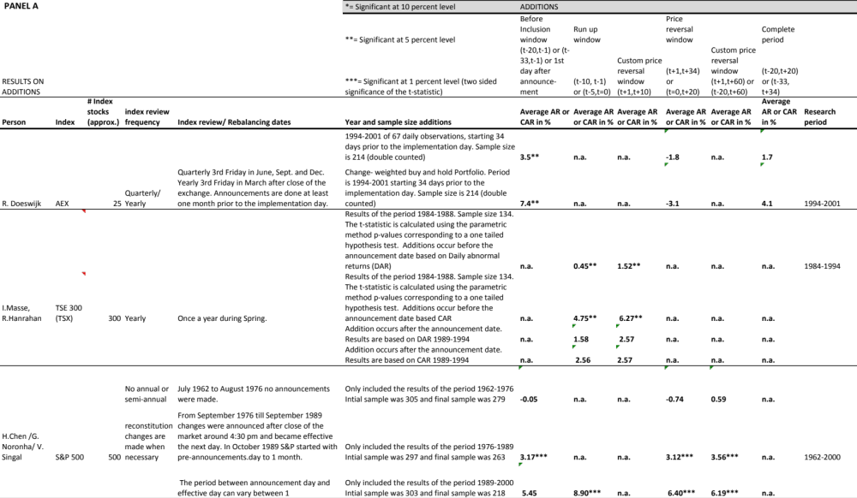
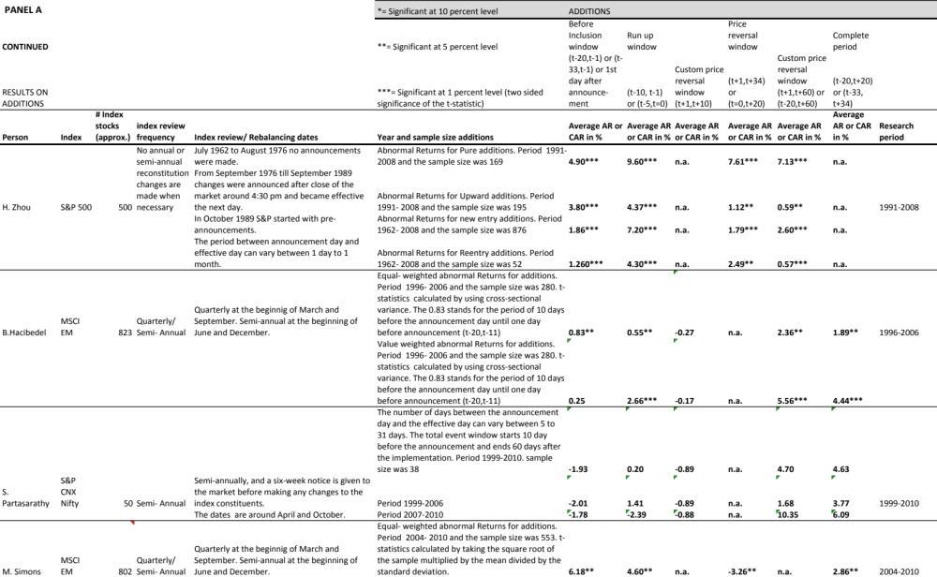
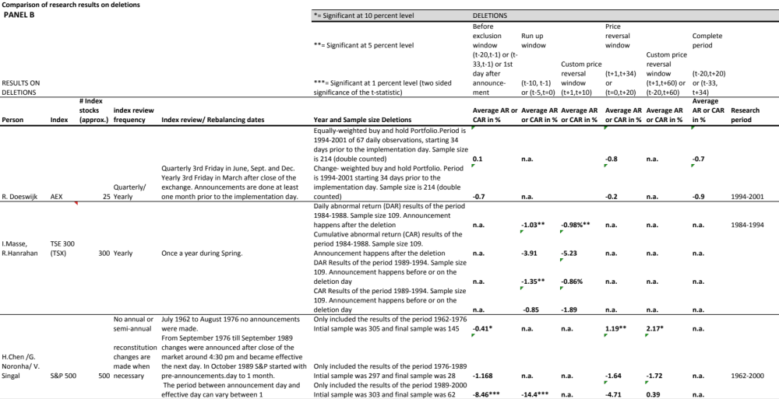
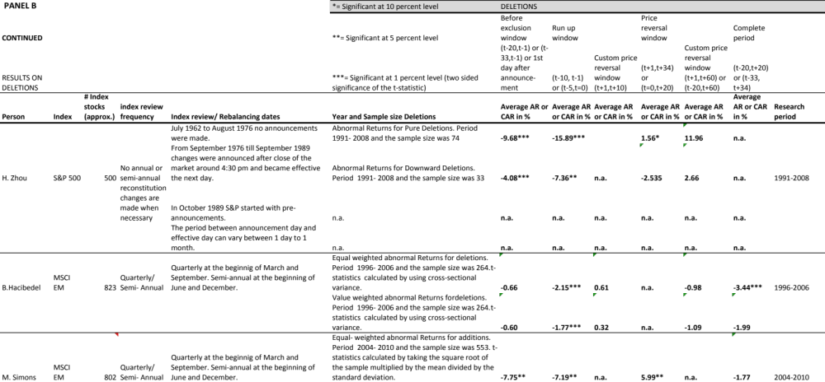Source: table_overzichtindexen compleet.xlsx

Co-Movement effects
Prior research done on the structure of asset returns has shown numerous patterns on co-movement, this paragraph highlights some of the researches done on the co-movement of additions to and deletions from the index. At the end of this paragraph a table is presented that recapitulates the different results of five different researchers who have done their research on different markets, naming the S&P 500, Nikkei, S&P CNX Nifty and the MSCI Emerging Markets.

Standard and Poor’s
Barberis et al.(2002) distinguishes three models of co-movements of traded securities. Naming the Traditional based, Category-based and Habitat-based. The Traditional based model explains the co-movement of stocks through positive correlation in news about fundamental values, such as companies’ cash flows. The model relates co-movement to rapid incorporation of information in benchmark index stocks, compared to other stocks due to market frictions. Category based model happens when investors define different types of asset classes, such as sectors, equity or bonds and move their capital from one asset class into the other. Trading flows created by Category based model cause return co-movement, this means that additions to the S&P 500 will co-move more with other stocks in the index after inclusion into the index. Habitat-based co-movement occurs when a group of investors is restricted to a certain sub set of assets or stocks in which they operate and move in and move out of them together due to transaction cost, trading restrictions or lack of information. The Category based and Habitat based models indicate that the increased co-movement is (partly) caused by trading actions of index funds.
In their study Barberis et al. (2002) focussed on the changes in patterns of co-movement of newly added stocks with stocks already in the S&P 500 index. They found that additions in to the index begin to co-move with other stocks into the index and less with stocks that are not included into the index. The opposite takes place when a stock is deleted from the index. Barberis et al. found that the beta of stocks included into the S&P 500 increases and that the beta of stocks that are deleted from this index decrease. They based their research on 455 inclusions between September 1976 till December 2000 and 76 deletions for that same period. Their findings confirmed that stocks added to the S&P 500 experience a statistically significant increase in the daily and weekly betas and $R^{2}$. In the complete sample of the additions, the average increase in daily beta was 0.151 and for the weekly data the average increase was 0.11.
Barberis et al. (2002) split their data set into different years. The first interval was of the year 1976 till 1987, the beta increase for this year was a significant 0.067 (at a level of 1%). The second interval of 1988 till 2000 had also a significant (at 1% level) beta increase of 0.214. For the deletions they found a beta decrease of -0.087 at a significance level of 10%. These results were interpreted as to be inconsistent with the Traditional based model of co-movement and to be supportive of the interpretation that excess co-movement comes from investors demand.

A different approach then the model based from Barberis et al. (2002), is from Vijh (1994) who examined the relationship between betas and trading activity to understand if their results support the price pressure hypothesis and or the nonsynchronous trading hypothesis. The price pressure hypothesis predicts that, a newly added stock in to index will cause an increase in the covariance with the market returns. This reaction causes the beta of individual stocks to increase regardless of what the trading volume does. The non-synchronous trading hypothesis predicts that the increase in a stock’s beta following its inclusion in to the index, will depend on the before and after trading volumes.
Vijh(1994) studied the changes in betas of 329 stocks that were added to the S&P 500 index from 1975 till 1989. The daily and weekly betas were measured by using the Center for Research in Security Prices (CRSP) value weighted index returns as a proxy for market returns. Vijh studied the price effects of ongoing trading in the S&P 500 stocks as part of a basket, and not in the one-time flow, that is caused by initial purchases by index funds after the additions. Furthermore he excluded the first two days because of their typically sharp increase in trading volume shortly after the additions, possibly resulting from index funds initial purchases. He calculated the pre-inclusion betas over a 250 day period ending 3 days before the inclusion date.
During the period of 1975 till 1989 Vijh found that the daily beta significantly increased with 0.08 after inclusion into the index. Different than the results from the prior period, the beta showed a significant decrease of -0.07 during the sub period 1975 till 1979. The sub period of 1980-1984 showed increase of 0.08 and the period 1985 till 1989 had an even higher increase of 0.21, both of these numbers were statistically significant. During 1975-1979 the decreases outnumbered the increases by 68 versus 39, whereas increases outnumbered decreases by 90 versus 34 in the period of 1985 till 1989. The increase on beta from 1986 and the years after, have been significantly positive on a yearly basis.
By using a model of Scholes and Williams (1977) which predicts that betas should remain unchanged or decrease, Vijh(1994) tried to abstract from the effect of reduced nonsynchroneity of the S&P 500 prices. The results revealed an increase by an average of 0.11. This evidence suggests that the S&P 500 trading strategies may lead to price pressure that can persist for a few days.
The price pressure hypothesis says that the large S&P trading volume causes similar and ongoing price pressures in the S&P 500 stocks, and results from short-term imbalances in demand and supply. Large trading volumes in the index can affect prices simply because of (large) buy or sell transactions caused by investors, who follow their investment strategies, within the limitations of market liquidity.
Both Barberis et al. and Vijh who researched additions and deletions of the S&P 500 experienced a beta increase on additions into the index and a beta decrease on deletions from the index. Vijh found that the estimated S&P500 stock betas over all windows have increased and the estimated non-S&P500 stock betas have decreased in the recent years of active S&P 500 trading. Increased betas are caused by increased trading frequency in stocks of the S&P 500. Barberis et al stated that inclusions in the index contain no news about fundamentals, and therefore the co-movement should be supported by the category base and habitat base models. These models are related to trading activities, due shifts in demand and supply.

The Nikkei index
Greenwood and Sosner (2002) studied a change in the trading pattern of 255 stocks, due to the redefinition of the Nikkei 225 index in Japan. In April 2000, the rules governing index membership were changed, that caused the replacement of 30 stocks in the Nikkei 225 index. This change caused a significant change in co-movement of returns and turnover for the substituted stocks. Greenwood and Sosner measured the betas of the returns of the additions and deletions against the returns of stocks that remained in the Nikkei index after the redefinition. The central assumption of their model is the existence of a group of irrational investors who trade only in index stocks in proportion to index weights without taking the fundamentals in concern. Their model predict that returns of stocks included in to the index should co-move more with the return of stock that remain in the Nikkei index. In their research they focussed on the slope coefficient or beta, in the regression of a stock’s return on the equally weighted return of stocks that remain in the index. The second measure is the $R^{2}$ of the just named univariate regression. The model creates additional testable predictions for the changes in autocorrelations and cross-serial correlations of stocks returns when included in to or deleted from the index.
Their pre-event window includes returns from 100 trading days between November 26, 1999 and April 13, 2000. The post event window includes returns from 100 trading days between May 1, 2000 and September 15, 2000. The beta increase was a significant 0.6; this was almost a double of the initial pre event beta level. The beta decrease of the deletions was also statistically significant with 0.71. The same test was done over again, where the pre-event window and post- event window were based on 250 days instead the previous 100 days. The results on the beta change continued to be significant for as an increase for additions and a decrease for deletions in this longer window. The increase for the additions was this time 0.46, and the deletions showed a decrease from -0.62 at a significance level of 1%. On the short run, these numbers show that the change in co-movement continues and that there is little evidence of a price correction. And therefore Greenwood and Sosner (2002) results support those found by Barberis et al (2002) and Vijh (1994) on the S&P500.

NSE S&P CNX Nifty
The Standard and Poor’s CNX Nifty stands a stock index endorsed by Standard & Poor’s and consists of fifty of the largest and most liquid stocks found on the National Stock Exchange (NSE) of India. The CNX stands for Credit Rating Information Services of India Limited (CRISIL) and the National Stock Exchange of India. CRISIL and NSE together own and manage the index within a joint venture called the India index services and Products that was set up in May 1998. Parthasarthy (2011) did a study on the co-movement around the S&P CNX Nifty index for the period of 1999 till 2010 on index reviews for the Indian stock market. Parthasarthy based his research on 41 additions and 30 deleted stocks from the Nifty index during the period of 1999 till 2010.
He used several models, naming those of Baberis et al.(2002) to conduct his research. According to the Category bases co-movement, an addition of a stock into the index should experience a beta increase. A stock deleted from the index should experience a beta decrease. The stocks that were added to the Nifty index experienced a statistically significant positive increase in the betas (slope co-efficient) post inclusion. The average beta change for the complete period is 0.14. After splitting his data set into different intervals, the interval of 1999-2006 had an increase in beta was 0.13 and the interval of 2007-2010 he noticed an increase beta of 0.15. The beta increase for both of these intervals was significant.
For stocks deleted from the Nifty index Parthasarthy (2011) found an increased beta change, meaning that there was no evidence of decreased co-movement between deleted stocks and the Nifty index. In his research he used different methodologies naming those Vijh (1994), Barberis et al. (2002) to compare his results to. The deletions experienced a beta increase of 0.05, instead of a beta decrease. This, number was not statistically significant. The deletions were also divided into the same intervals as the additions, the results of these intervals were a beta increase of 0.07 for the first and 0.002 for the second interval. Again these numbers were not statistically significant, but surely different than the expected beta decrease such as in developed markets. Due to asymmetric response to additions and deletions the category view from Barberis et al. (2002) is not supported. Parthasarathy (2011) suggests that the Fundamental based model explains the Nifty index changes in the emerging Indian Stock market. The increased (decreased) co-movement may be either due to trading strategies of institutional investors post inclusion, or due to fundamental reasons. Parthasarathys results are more in line with the results of Chen et al (2003) who explains the beta increase due to investors awareness.

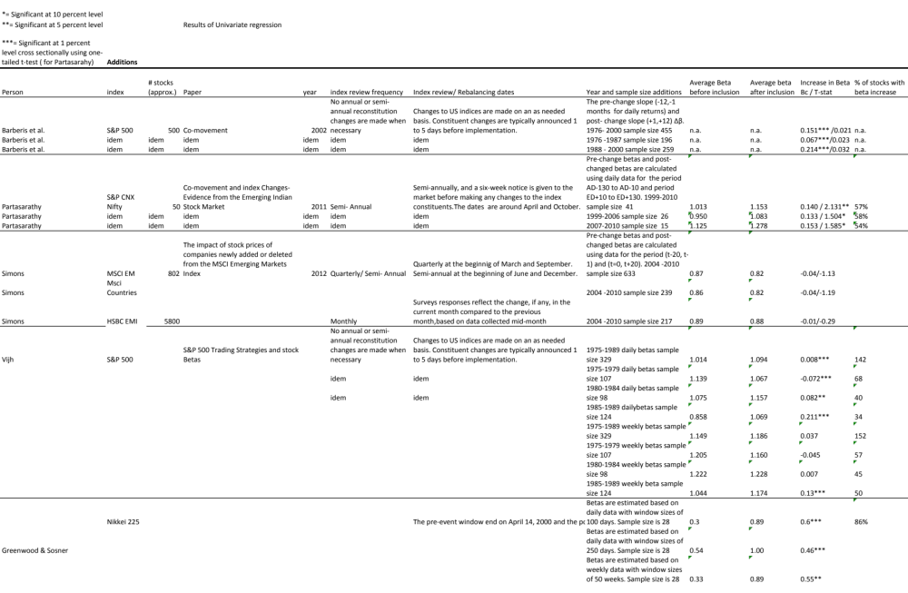
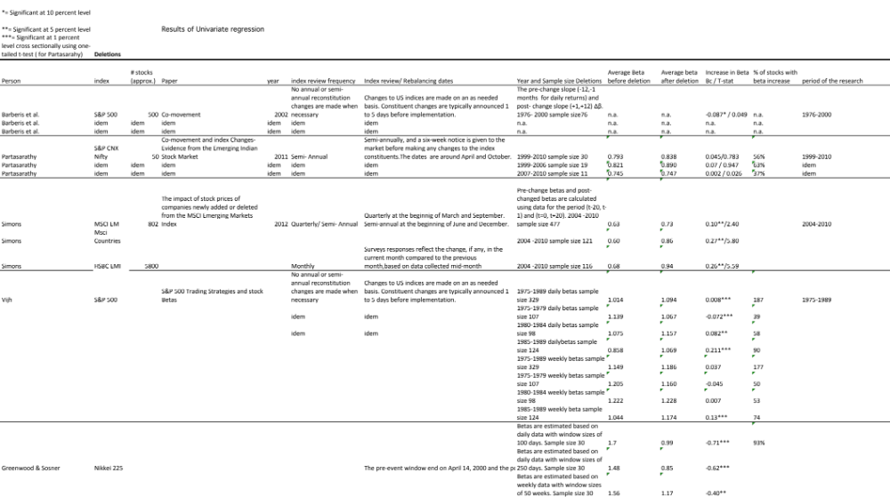

Data of the research

Introduction
The sample is of the period between January 2004 and December 2010. Since the past years a lot has been changed for MSCI methodology. Certain requirements to which a company must commit in order to be a candidate to enter the MSCI Global Standard Index have emerged. Also, different requirements have to be met in order to stay in the index. If these requirements are not met, the stock might be deleted or downgraded to a smaller Index. This report will mention the key requirements that need to be met in order to enter or stay in the MSCI Index. Note that this paper will not enter into detailed calculations and reasons on why a stock was added in or deleted from the index.
The focus in the study is on stocks that were added and deleted in the MSCI Emerging Markets Index during SAIR and QIR from 2004 till 2010. Furthermore to calculate the betas, also data from other indices like MSCI Brazil, India, China and Turkey and from the HSBC Brazil, India, China and Turkey were used. HSBC stands for Hong Kong and Shanghai Banking Corporation.

The MSCI
Each index uses its own method for reclassifying stocks in that index, and has different review dates to implement these changes. For example the S&P 500 and the AEX index each have their own distinct methodology and their own Index Review dates. This is why it is important to understand how the MSCI Global investable is constructed. This Chapter will explain in detail the methodology of the MSCI Global Investable, the guidelines and principles mentioned in this chapter are taken from the published information that was found on the MSCI.com website. The table 3.2.1 below shows an overview of different indices, with their review data and frequencies and methodology. This is just to give an idea of the difference between the indices.
Table 3.2.1 Index Overview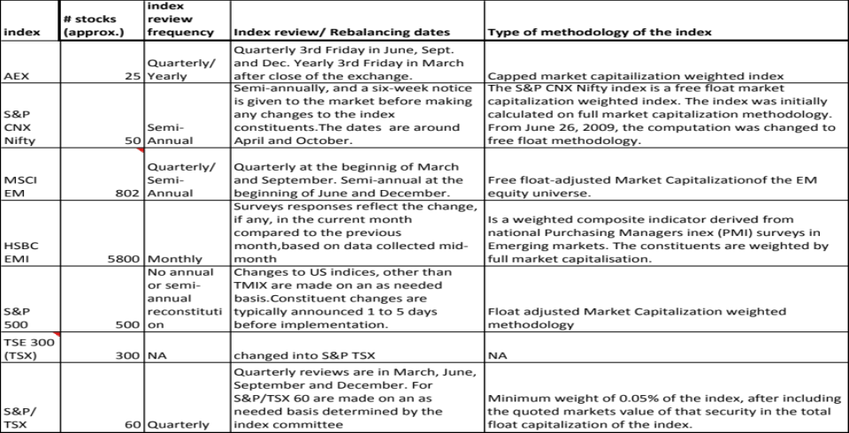
Source: overzichtindexen_compleet.xlsx

About the MSCI Global Investable
For the past years the MSCI global investable has made some drastic changes in their methodology in order to meet their objective to construct and maintain its global equity indices in such a way that they may contribute to the international investment process.

Their goal is:
- To deliver relevant and accurate performance benchmarks,
- To be the basis for asset allocation and portfolio construction across geographic markets, size segments, style segments and sectors
- To be an effective research tool
- And to be the basis for investment vehicles

The MSCI Global Market includes updates for all markets under MSCI’s coverage. The MSCI Global Market stands for Developed, Emerging, Frontier and Standalone Markets. The MSCI BARRA index covers 21 Emerging markets next to the 24 developed and 26 Frontier markets.
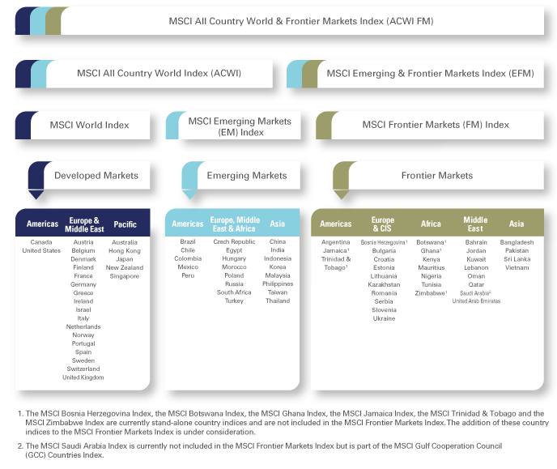
Source:www.Msci.com
In May 2008, MSCI enhanced its standard index methodology by moving from a sampled multi cap approach to an approach targeting exhaustive coverage with non-overlapping size and style segments. The MSCI standard and MSCI small cap indices, along with the other MSCI equity indices based on them, form the Global Investable Market indices.
To understand which method to use, it is important to know that the MSCI uses the Determining Market Capitalization size segments for each market. The MSCI Global investable Market indices use the free float adjusted Market Capitalization weighting method. In contrast, the Standard & Poor’s 500 uses a market value weighted index, while the Dow Jones Industrial average includes a price- weighted average.
Furthermore the MSCI is composed of companies’ representative of the market structure of developed and emerging market countries in the Americas, Europe / Middle East and Asia Pacific regions. The price return and total return versions are both available in USD and local currencies.
MSCI Barra offers a number of Multi Market Indices, usually comprised of indices from different countries and designed to represent multiple security markets. Multi-market indices may represent multiple national markets, geographical regions, economic development groups and sometimes the entire world.
MSCI Barra classifies countries along 2 dimensions, naming the level of economic development and geographical region.
Regarding the geographic region there are three regions namely Americas, Europe with Africa and Asia with Pacific.
MSCI Barra also provides country specific indices for each of the developed and emerging market countries within its multi-market indices.
MSCI Barra periodically reviews the market classifications of countries in its indices for movements from frontier markets to emerging markets and from emerging markets to developed markets and reconstitutes the indices accordingly.
Based on objective and transparent rules, the Global Investable Market Indices are intended to provide:
- Exhaustive coverage of the investable opportunity set with non-overlapping size and style segmentation
- A strong emphasis on investability and replicability of the indices through the use of size and liquidity screenings
- Size segmentation designed to achieve an effective balance between the objectives of the global size integrity and country diversification
- An innovative maintenance methodology that provides a superior balance between index stability and reflecting changes in the opportunity set in a timely way
- A complete and consistent index family with standard, large cap, mid cap, small cap and investable Market indices
Next to the innovations that were just mentioned, the MSCI Global Investable Market Indices methodology also kept many features of the original methodology, such as:
- The use of a building block approach to permit the creation and calculation of meaningful composites
- The creation of sector industry indices using the Global Industry Classification Standard (GICS)
- The creation of value and growth indices using the current MSCI Value and Growth Methodology
- Minimum free float requirements for eligible and free float- adjusted capitalization weighted to appropriately reflect the size of each investment opportunity and facilitate the replica ability of the indices
- Timely and consistent treatment of corporate events and synchronized rebalancing, globally
In order to construct the MSCI Global Investable market indices the following steps should be taken:
- Starting with defining the Equity Universe
- Determining the market investable equity universe for each market
- Determining market capitalization size segments for each market
- Applying index continuity rules for the standard index
- Creating style segments within each market
- Classifying securities under the global Industry Classification Standard (GICS)
The investability screens that the MSCI uses several requirements in order to determine their investable equity universe in each market. The screenings that happen on a security level are:
- Equity universe minimum size requirement
- Equity Universe minimum free float adjusted market capitalization requirement
- Emerging markets minimum liquidity requirement
- Global minimum Foreign Inclusion Factor requirement (FIF)
- Minimum length of trading requirement
Please revert to the appendix for detailed information on requirements in order to determine the investable equity universe.

Rebalancing
Rebalancing refers to the weights of the constituent securities in the index. To maintain the weight of each security consistent with the index weighting method, the index provider rebalances the index by adjusting the weights of the constituent securities on a regularly scheduled basis. Rebalancing dates are usually on a quarterly base. Rebalancing is necessary because the weights of the constituent securities change as their market price change.

Reconstitution
Is the process of changing the constituent securities in an index. And is similar to a portfolio manager deciding to change the securities in his or her portfolio. Reconstitution is part of the rebalancing cycle. The reconstitution date is the date that index providers review the constituent securities and reapply the initial criteria for inclusion in the index and select which securities to add, remove or retain. If constituent securities no longer meet certain criteria, they will be replaced with securities that do meet these criteria. Once the revised list of constituent securities is determined, the weighting method is reapplied. Indices are reconstituted to reflect changes in the target market (bankruptcies, de-listings, mergers, acquisitions, etc.) and or to reflect the judgment of the selection committee.
Reconstitution creates turnover in a number of different ways, particularly for market capitalization weighting indices. When one security is removed and another one is added, the index provider has to change the weights of the other securities, in order to maintain the market capitalization weighting of the index. The frequency of reconstitution is a major issue for the widely used indices and their constituent securities.

Maintaining the MSCI
The MSCI global investable Market indices are maintained with the objective of reflecting the evolution underlying equity markets and segments on a timely basis, where they are seeking to achieve index continuity, continues investability of constituents and replicability of the indices and index stability with low turn over.
Important for this study is the maintenance that involves the quarterly index reviews (QIRs) and semi-annual index reviews (SAIRs). These reviews are the moments of which the data is gathered for this research.
During the semi annual reviews which happen in May and November, the MSCI EM index updates on the basis of a fully refreshed equity universe. The index maker takes multiple factors into account, naming for example: buffer rules that are taken into consideration for migration of securities across size and style segments. Updating Foreign Inclusion Factors (FIF) and the number of shares (NOS).
The Quarterly index reviews are in February and August of each year. During the quarterly reviews smaller changes are made during the review, for example such as IPO’s that enter, since they were not available for an earlier inclusion. Also companies within the size-segments indices use wider buffers than in the SAIR. And reflect the impact of significant market events on FIFs and updating NOS.

Overview of QIR and SAIR

MSCI index reviews and announcements
The MSCI Barra website publishes the Quarterly Index Reviews (QIRs) and Semi-annual index reviews (SAIRs) and that this paper will focus on. For this paper the MSCI Global standard Indices data was used. Because MSCI EM is part of this Category within the MSCI Global investable.
The objective of QIRs and SAIRs is to systematically reassess the various dimensions of the equity universe for all markets on a fixed quarterly and semi-annual timetable. Whether it is a quarterly or a semi-annual review will determine which rules for updating will be taken into account and which reclassifications will take place.
In order to understand why the MSCI implement these changes and their methodology, an elaboration will follow.
The MSCI Barra announces the QIR in March and August and the SAIR in May and November. The QIR contains changes on stock level and the semi-annual index reviews are broader and also contains country reviews. This study will focus on the stock additions and deletions from quarterly and semi-annual reviews during the period January 2004 until December 2010.
To get an impression of the number of QIR and SAIR for the research period, a chart is made showing the MSCI Emerging markets index movements and all Quarterly and Semi-annually index reviews in this period.
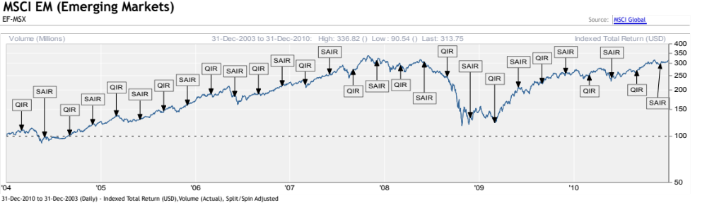source: Factset and MSCI Global/ MSCI EM TOTAL RETURN QIRSAIR2004_2010
Before the actual implementation of the changes in the index, The MSCI has two moments of announcing that changes will follow and will be implemented in de index. It is not certain which changes will be implemented, until shortly after the second announcement day, that usually happens ten days after the first announcement day. So in order to get the days right, the return data selections starts 20 day before implementation day and ends 20 days after the implementation day.
This data is considered to be public information because shortly after the MSCI announcement, this data is also distributed to and published Reuters and Bloomberg sites. The next table shows an overview of exact dates on all QIR and SAIR from 2004 till 2010 that is used for this study. Of each event the number of additions and deletions is displayed.

Table 3.3.1
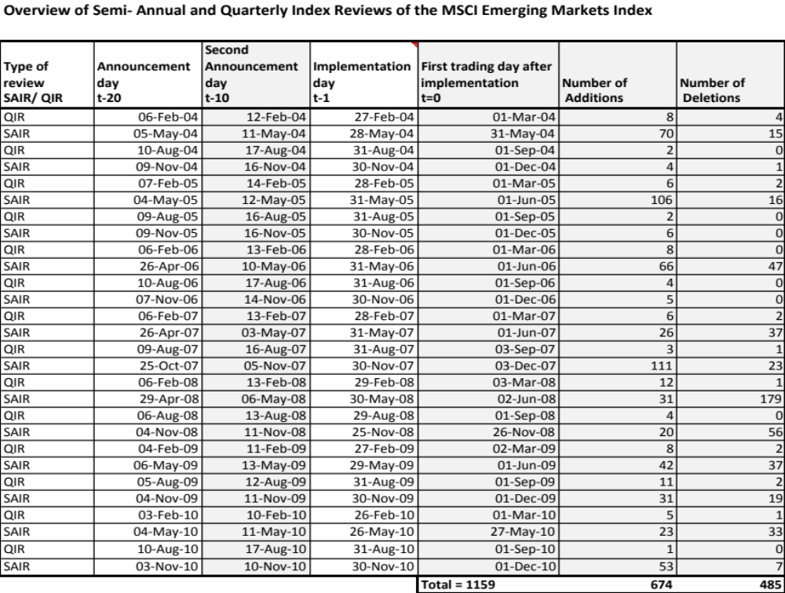
source:indexreviewtable20120818_new.xlsx//dataanalysisofficial20120218.xlsx
The table shows an overview of the exact dates on
- Announcement day t-20 (Period before implementation)
- Second Announcement day t-10 (Announcement day)
- The Implementation day t-1 (MSCI Implementation day)
- First trading day after implementation t=0
Ad1.The announcement usually takes place in the first week of February, May, August and November of each year.
Ad2. In the second week, usually 5 working days after the pre-announcement, MSCI BARRA posts the index review announcement list of additions and deletions after 11:00pm CET on their website, mentioning how many securities will be added or deleted. Shortly thereafter a summary of the announcement will be made available on Bloomberg and Reuters. This announcement also mentions the date as of which the implementations will take place.
Ad3. Day “t=-1” is after the close of the market (at 11pm CET), the night before the implementation of the index changes occur.
Ad4. Day “t=0” is the first trading day after the changes have become effective.

Data event window for this study
For this study the following six event windows will be taken into account, as displayed in the timeline event window chart. These event windows are:
- Before inclusion (exclusion) window (t-20, t=-1): stands for before announcement day until one day before the index review changes are implemented.
- Run up window ( t-10,t-1): Stands for the period after the announcement but before the inclusion or exclusion from the index
- Day before implementation in the index (t-1): Changes not yet effective
- Day of implementation into the index (t=0) : First day that changes have become effective
- Price reversal window (t=0, t+20): Period of twenty days after the index change has taken place.
- Complete period (t-20, t+20): The complete period starting before the announcements had taken place until twenty days after the changes have taken place.

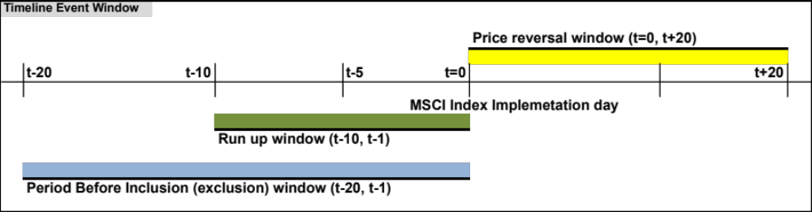Source: Timeline Event Window20120811.xlsx
For the calculations on the beta change, the before inclusion window (number 1) and price reversal window (number 5) were used.

Comparison with index data
For the MSCI EM Index and the different MSCI and HSBC country indices, a daily total return overview data set collection with 20 days before and 20 day after the implementation day of the changes in the index is selected. This data will be compared with the daily total returns of the companies, in order to calculate the abnormal returns (AR) and cumulative abnormal returns (CAR).

Sample
The breakdown of raw data set containing all additions and deletions for all countries of the MSCI Emerging Markets were in total 1363, and have been split up as follows:
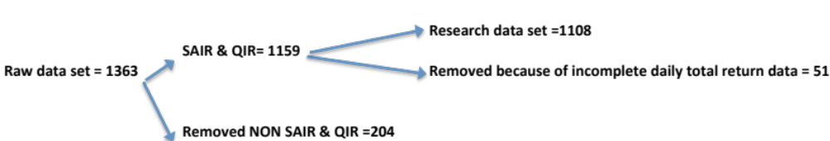
The MSCI EM data set contains data of all countries that were included in index during the period of 2004 until 2010, including Argentina, Pakistan and Israel.
The research data set consists of daily total return data on 1108 companies for 41 days. In this sample 674 companies have entered the index and 485 companies were deleted from the index. The remaining 51 stock observations of SAIR & QIR sample (1159) had incomplete daily total return data and were not used for this research.
For each stock a maximum of 41 daily total return observations are used .
For the beta research I have reduced the sample to 4 countries in the MSCI Index and HSBC Index. Originally the beta calculations were made based on the BRIC countries (Brazil, Russia, India, China). However, during the analysis Russia had very little daily return data, because of a change from RTS index to Moscow Interbank Currency Exchange. Therefore, it was decided to swap this country for another EMEA country. EMEA stands for Europe, Middle East and Africa. Turkey had the largest sample from the EMEA countries that is still in the index.

A summary of the data set is as follows:
Universe for price effects: MSCI Emerging Markets, MSCI Brazil, MSCI China, MSCI China, MSCI India, MSCI Turkey
Universe for co-movements: MSCI Emerging Markets, MSCI Brazil, MSCI China, MSCI India, MSCI Turkey. HSBC Brazil, HSBC China, HSBC India, HSBC Turkey
MSCI EM Index review frequency: On a quarterly and semi-annual base changes within the Index are announced. Changes outside of the quarterly announcements are not taken into account.
Sample period: March 2004 and ending in December 2010
Event studies: Twenty days before and twenty days after the entering or exiting of a stock to or from the Index
Return data: MSCI EM/ FACTSET 2004-2010 on a daily frequency

Table 3.4.1 Overview Additions and Deletions per Country
This table illustrates a breakdown of all additions (A) and deletions (D) for all countries of the MSCI Emerging Markets for the period of 2004 till 2010. Furthermore the table gives an indication on a country level of removed data on A or D from sample used for this study. 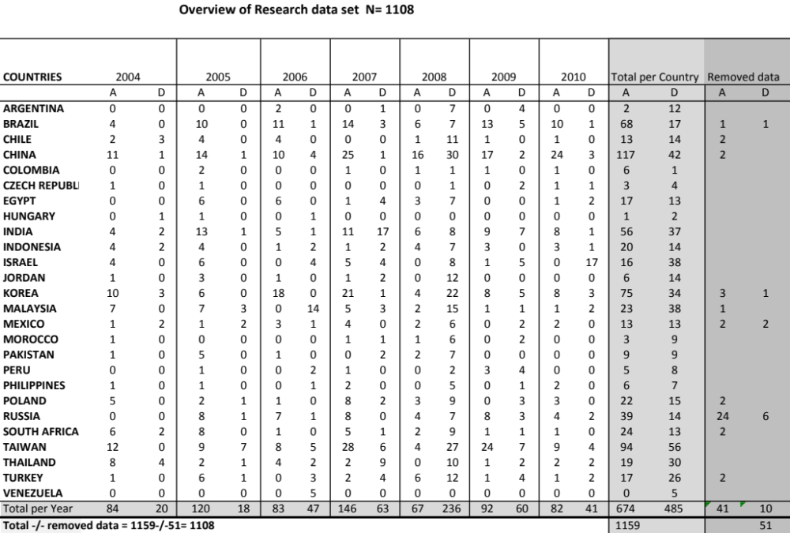Source:indexreviewtable20120818_new.xlsx

Exclusions from the data

Exclusion and exceptions from the data set
Additions and deletions that happened outside of the quarterly and semi- annual review dates were excluded from this research; often acquisitions, spinoffs or mergers triggered these additions or deletions. These changes are excluded of the data set because these situations usually occur because of a change in cash flow. A change in cash flow is a fundamental change for a company and therefore not representative for this study.
MSCI Russia had lots of incomplete total return data because the price source was changed from Russian Trading System (RTS) to the Moscow Interbank Currency Exchange (MICEX). Therefor 24 additions and 6 deletions were removed from the research data set. The missing return data was in the years 2005 (3), 2006 (5), 2007 (4), 2008 (8) and 2009 (10).
HSBC countries also coped with unavailable total return data for the individual country indices. The HSBC index data was used to calculate the beta of a stock against the country indices. Unavailable return data has been removed and the beta is calculated based on the actual number of available “n”.
Semi annual reviews also contain country changes, this information is not in the scope of this study, but there have been some country changes in the period between 2004 and 2010. These changes have no impact on the data set used for this research. The country changes for the MSCI EM were:
- Venezuela exited the MSCI EM index in May 2006 and became a stand alone country index
- Pakistan exited the MSCI EM index in December 2008 and also became a stand alone country index
- Argentina left the MSCI EM index for Frontier Markets index in May 2009
- Israel went from MSCI EM index to MSCI Developed Market index in May 2010

Methodology

Methodology

Event study
Information on the price changes can be gathered by making an event study on the additions and deletions that happen during an index review. By creating different timelines the return performance can be calculated and analyzed. Event studies give an insight in the price development of stocks around these review events and provide an overall understanding of how financial markets work.
In this study the research will be done through an event study methodology. The index changes that will be studied are based on daily average abnormal returns. This method is based on the method of Fama, Fisher, Jensen and Roll (1969) and Sar (1998). Both papers show the importance of return performance in different timelines, such as in this paper occurs, naming the event before inclusion, and the period after the event.

Calculating Abnormal Returns
Abnormal returns (AR) are differences between the expected return of a security and the actual return over a set period of time. The study will calculate abnormal returns on securities added to and deleted from the index.
The Abnormal Returns are calculated as follows:
${AR}_{i,t}=R_{i,t}-{\overline{R}}_{M,t}$
Where :
-The i stands for the stock and (i=1,..,N, where N stands for the number of stocks in the sample population)
-The t stands for day (period with respect to event-day)
- $R_{i,t}$ stands for total daily returns of stock i on day t.
-And ${\overline{R}}_{M,t}$ stands for average total daily return of the Market M on day t.
This equation represents the level of excess return from stock i during day t. This is the difference in return that would not have happened on a normal day outside of the event-period.

Calculating Cumulative Abnormal Returns
The Cumulative Abnormal Returns (CAR) is the sum of all abnormal returns calculated over a certain period. In this case the CAR will be calculated 20 days before index review changes are implemented and 20 days after the implementation day. The CAR is used as evidence to show that compounded daily abnormal returns could create bias in research results.

The CAR can be calculated by using the AR data. The CAR is calculated by
$${CAR}_{(t1,t2)}= \sum_{t=t1}^{t2}{{AR}_{t}}$$
Where:
- ${AR}_{t}$ stands for abnormal return on day t.
-${CAR}_{(t1,t2)}$ stands for cumulative abnormal return on day t1 and t2.${CAR}_{t}$ is the sum of ${AR}_{t-1+t}$.
Continued the average abnormal return (AAR) is calculated.
${AAR}_{t=}\frac{1}{N} \sum_{i=1}^{N}{{AR}_{i,t}}$
Where:
- ${AAR}_{t}$ stands for average abnormal return on day t.
Using these ARs, I have calculated the average abnormal return for day t, with the implementation day being on day t=0. The cumulative abnormal returns have been tested for the significance of ARs in each sub –event window.

Calculation of the Test Statistic
A test statistic is a calculated quantity, based on a sample, whose value is the basis for deciding whether or not to reject the null hypothesis. It is the basis for the significance drawn in event studies, naming the ratio of the average excess return to its estimated standard deviation. This study uses simulation procedures by using actual stock return data to investigate the distribution of excess returns and the empirical properties of the test statistics.
The statistical significance of the event windows excess return is calculated. The null hypothesis that will be tested is, if the average day ‘0’ excess is equal to zero. This concerns the average affect of an event on returns of stocks. The test statistics is the ratio of the day ‘0’ mean excess return to its estimated standard deviation. The standard deviation is estimated from the event window of average excess returns. The test statistic for any event day t, where in this case t=0 is:

$T-stat=\sqrt{N}*\frac{μ}{σ}$
Where :
-The $\sqrt{N}$ stands for the square root of the sample population
-The $μ$ stands for mean
-And $σ$ stands for the standard deviation

Calculating Co-movements
For the calculation of the co-movement or beta, the univariate model is used.
For each stock the beta is separately calculated for the event window of before the stocks inclusion to (exclusion from) the index has taken place. For the second window, the beta is calculated from the inclusion (exclusion) day till 20 days after. The beta will be calculated based on the stock return against the index return.
The univariate model (also named market model):
$$R_{i,t}=a_{i}+b_{i}R_{MI,t}+u_{i,t}$$
Where:
-The $R_{i,t}$ stands for the return on stock i for day t
-The $a_{i}$ stands for part of the stock return with a fixed character
- $b_{i}R_{MIt}$stands for slope coefficient times Return on Market index on day t. The $b_{i}$ reflects the sensitiveness of the return on stock i for the market index and is also known as β (beta) risk.
- u,t stands for the error term
To calculate the beta on a country level, the same formula is used on Market data of the MSCI EM index, MSCI Countries index and the HSBC Countries index. For each index a separate formula has been made, but the interpretation stays the same, and therefore will not be explained separately again.
R,i,t = αj + β* R MSCI EM,t + υi,t
Ri,t = αj + β* R MSCI Country,t + υi,t
Ri,t = αj + β* R HSBC Country,t + υi,t

Results

The purpose of this research is to find out if there is and impact on the price effect of stocks that enter or exit the MSCI Emerging market index, when an index review by the MSCI BARRA is held.
In this research the null hypothesis states that:
Research question 1
-“ there is zero effect on the price of the stock, when this stock is included into (or excluded from) the MSCI EM index during an index review “
Research question 2
-“ there is no change in beta of added or deleted stocks when measured before and after the implementation of the index review changes to the MSCI EM“
The alternative hypothesis is defined as:
-“ a change in the stock price that is not equal to zero.”
-“ a change in beta of added or deleted stocks when measured before and after the implementation of the index review changes to the MSCI EM that is not equal to zero.”
Paragraph 5.1 will elaborate on the price effect of additions in to the index. This paragraph elaborates on the results on the main research question, which are the results on additions to MSCI Emerging Market. Next the results that focus on the additions from Brazil, Turkey, India and China will be explained.
Paragraph 5.2 will focus on the deletions from the MSCI EM, which is the second part of the main research question. Followed by the results on the countries named in paragraph 5.1
Paragraph 5.3 will concentrate on the second research question, where in the first part emphasis lies on the MSCI Emerging Market index, continued with explanation on the beta changes on the four countries, based on MSCI and HSBC indices.
All T-statistic calculations in this chapter are based on a significance level of five percent.

The results on the price effects on additions

Data collection and analysis
To determine the correct days of each index review event, data on the index review dates were collected from the MSCI website.
The return data on all companies that entered and exited the index during the index reviews from the year 2004 till 2010 was collected from Factset. Furthermore a download on the total return data of the MSCI Emerging markets, and MSCI Brazil, MSCI Turkey, MSCI India and MSCI China index was made over the same period.
The Index review days were then put next to the same index days to determine the correct index dates in order to compute the excess return of the stocks against the MSCI EM index. In order to calculate the excess return for the sub question on price effects, the return of the stocks was held against the MSCI Country index.
As mentioned in chapter 3, six different event windows were made, and of these six event windows, two events were a one day event, naming the period t-1 and t=0. For these two event days only the Abnormal Return was calculated. For the remaining four event windows the both the abnormal return and cumulative abnormal return were calculated.
The abnormal return was computed on a stock level by deducting the return of the index on dayt from the total return of day t of the stock. This was done for all stocks of all countries on the additions to the index as well as the deletions from the index.
Stock additions (deletion) effect is studied by analysing the abnormal returns around the announcement date and the inclusion (exclusion) date. The daily abnormal returns are calculated as the stocks excess return on day t over the index return.
The abnormal return, was then computed on a total level for the MSCI Emerging market and on the different country levels. This was done using the equation:
$${AR}_{i,t}=R_{i,t}-{\overline{R}}_{M,t}$$
Where :
-${AR}_{i,t}$stands for abnormal return
$R_{i,t}$ stands for the stock return and ${\overline{R}}_{M,t}$ for MSCI index return on day t.
First the results on the price effect for MSCI Emerging Markets will be elaborated on, followed by price effect results done on four emerging markets countries.

The results on additions
The table 5.1.1 and chart 5.1.1. below show the results on the price effect of additions into the MSCI Emerging Markets index.
Table 5.1.1. Additions to the MSCI EM
All T-stat calculations are based on a significance level of 5%. The sample size is based on all additions of all countries within the MSCI Emerging Markets from 2004 till 2010. The t stands for number of days, or a time line between different days. AR average is Average abnormal return of the event window. CAR is the cumulative abnormal return of the event window. The CAR of all sample stocks are combined and averaged over the event window to calculate the overall CAR for the complete sample.

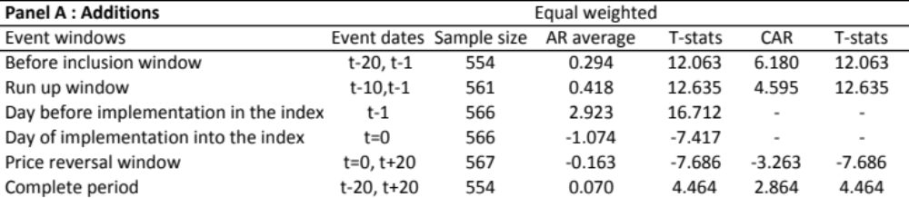
Chart 5.1.1. Additions to the MSCI EM
The chart is based on the complete sample size is of all additions of all countries within the MSCI Emerging Markets from 2004 till 2010. The t stands for number of days. CAR is the cumulative abnormal return of the complete event window, starting 20 days before the inclusion and 20 days after. The CAR of all sample stocks are combined and averaged over the event window to calculate the overall CAR for the complete sample. On t=0 all index review implementations are included in the MSCI EM index. T-Stat is based on the CAR. The y-axis stands for the excess return in percentages, x-axis stands for days in time.
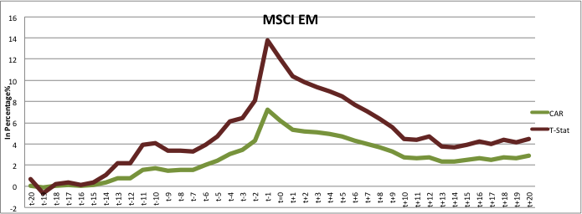 Source: data analyse table additions msci em20120715 gecorrigeerd t-1 20120817.xlsx
Starting with chart 5.1.1 that shows the impact on the price of stocks that are included into the MSCI EM index, shows a spike around t-1 of a cumulative abnormal return of more than 6%.
The null hypothesis in this paragraph means that the price effect on a stock that is included in the MSCI EM index does not have a significant impact and therefore should not be significantly different from zero.
As shown in table 5.1.1 of this research, “before inclusion window” stands for the period before the inclusion of the stock into the index. The “Complete period” stands for whole period of 41 days beginning 20 days before the inclusion, and ending 20 days the inclusion. These two events showed an excess return of 6.2% before the inclusion of the stock and excess return of 2.8% for the complete period, both of these returns are significantly positive. This means that the Efficient Market Theory (EMT) does not apply with the scope of this specific case. Because, the implementation of the index changes caused an abnormal return that is greater than zero and can be assumed that the market is semi-strong inefficient. Therefore the null hypothesis, that says that there is zero effect on the price of a stock, should be rejected. This research is also based on a short term price effect, not taking inconsideration what might happen to the price effect in 60 days, or with test cases where there might be differences in risk factors between stocks that are included in to the index.
The second result is the run up window and stands for the period between the announcement day and the inclusion of the stock in to the index. The days after the announcement day of t-10 and before inclusion of stocks into the index have a significant cumulative abnormal return of 4.6%. As you can clearly see in the chart the announcement day (after t-10) shows an increasing line and spiking around t-1, which is the day before the inclusion of the stocks into the MSCI Emerging index. On the inclusion day the decrease starts and reaches its new equilibrium around ten days after the implementation the additions into the index. After the inclusion of the stock into the index a decrease of -3.3% happens, although number is significant, the new price level remains above zero.
The chart shows in the interval of day t-20 until t-15, a cumulative abnormal return that is close to zero, this suggests that there was no anticipation of investors prior to the announcement day. The slightly increase in excess return around t-14 and t-13, could indicate leakage of information before the official announcement, but in this research is it caused by the announcement day happening 13 days prior to the inclusion day of the index changes. Most of the official announcement days within this research happened between 10 and 13 day prior to the inclusion day. The exception of 19 days and 18 days prior to the inclusion day, were on semi-annual index review of three December 2007 when the index had 111 inclusions, and the 18 days happened on the semi-annual index review of June second 2008 when there were 179 deletions from the index. A possible reason could be to give investors more time to implement these changes and reduce the price impact caused by this.
The results of this study are consistent with the findings of previous research, where in general is shown that if a stock enters the index a permanent price increase occurs. But as Shleifer (1986) mentions in his research that the announcement date also plays an important role that (partly) contributes to significantly positive excess returns of stocks that are included into the S&P 500. In Chen et al. (2003) research it is also mentioned that the announcement date starts playing an important role in the S&P 500, what impacts the excess return of a stock positively. Chart 5.1.1. clearly shows a positive movement in the excess return starting around t-10, which stands for the announcement date of the MSCI. On this day the MSCI publishes which securities will be included into the index, after this announcement the positive price effect starts.
After the inclusion a reversal of the price takes place, but remains with a significant price increase of 2.9% twenty days after the inclusion. As mentioned in chapter two, as well for developed markets as emerging markets the cumulative abnormal returns were significant when a stock was entered into the index. These results were inline with Doeswijk (2007) on the AEX and Chen et al. (2003) on the S&P 500 for the years after 1976. Zhou (2011) concluded somewhat the same in his research on the S&P 500. Masse et al.(2000) who studied TSE300 also experienced a net positive result regardless of when the announcement takes place.
When comparing these results to prior research done on Emerging markets from Hacibedel (2007) and on the Indian index from Parthasarathy (2010), although both researches show a positive price effect, the results from this research show a far more positive impact.

MSCI EM additions between 2007 and 2010
Table 5.1.2. Additions to the MSCI EM between 2007 and 2010
All T-stat calculations are based on a significance level of 5%. The sample size is based on all additions of all countries within the MSCI Emerging Markets from 2007 till 2010. The t stands for number of days, or a time line between different days. AR average is Average abnormal return of the event window. CAR is the cumulative abnormal return of the event window. The CAR of 363 sample stocks are combined and averaged over the event window to calculate the overall CAR for the complete sample.
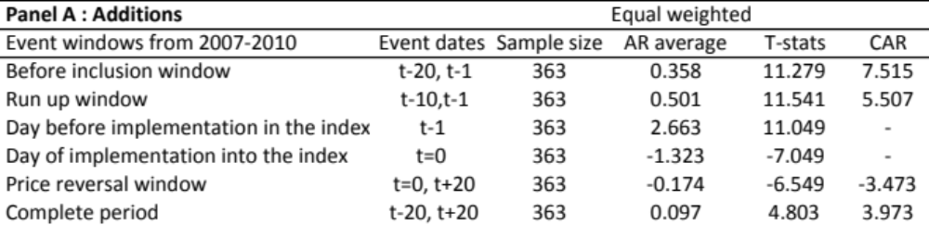
Source: data analyse table additions msci em 20121103_2007-2010.xlsx
Table 5.1.2. Shows the cumulative abnormal returns of stocks added to the MSCI Emerging Markets during the year 2007 till 2010. Even though the world financial crisis is not in the scope of this study, this table was made to get a view of the price effects that happened around the period started in (July) 2007 till the end of 2010. This table is in line with the results of the table 5.1.1 and shows an even stronger positive cumulative abnormal return.
Parthasarathy (2010) who did his research on S&P CNX Nifty index also found similar results as in the developed markets, but when he made different intervals in his data set he concluded that excess return for the run up window was negative with -2.4% in the period between 2007 and 2010. These results are not supported by this study. With the data set brought inline with that of Parthasarathy the results remained significantly positive for the MSCI Emerging Markets index with 5.5% for the run up window and 7.5% cumulative excess return for the period before inclusion of stocks into the index. After the inclusion the excess return remained significantly positive with almost 4%.

Results on additions to the MSCI Countries
To get an impression on how the price effect was on a country level, four countries were selected for this Paragraph. The selection was based on the BRIC countries, but because of insufficient data on Russia, Turkey was chosen to replace Russia as an alternative due to the same geographical location of EMEA.
The MSCI country indices belong to the MSCI Index family and therefore were seen as a representative example to see how these additions react to the local indices. This test is done to see if there is a price effect.
The next tables show the results on additions into a MSCI Country index. These additions are the same as from the MSCI Emerging markets, but this time only Brazil was filtered out of the complete sample and then put next to the MSCI Brazil index. This was done to get an impression on a country level of what the impact is on stocks that were added to index. The same procedure was then repeated for Turkey, India and China.
The charts show the price effect of the additions into the MSCI Emerging Markets versus the price effect of the additions into the MSCI Country. As if the stock would be included into this country index.
Table 5.1.3. Additions to the MSCI BRAZIL
All T-stat calculations are based on a significance level of 5%. The sample size is based on additions of only Brazil within the MSCI Brazil 2004 till 2010. The t stands for number of days, or a time line between different days. AR average is Average abnormal return of the event window. CAR is the cumulative abnormal return of the event window. The CAR of all sample stocks are combined and averaged over the event window to calculate the overall CAR for the complete sample.
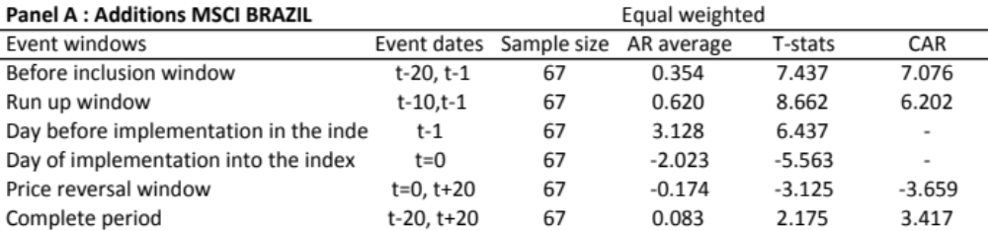
source: Copyof Price effect_data analyse CAR_Brazil20121014.xlsx
Chart 5.1.2. Additions to the MSCI BRAZIL
The chart is based on the complete sample size is of all additions of Brazil within the MSCI Emerging Markets from 2004 till 2010. The t stands for number of days. CAR is the cumulative abnormal return of the complete event window, starting 20 days before the inclusion and 20 days after. The CAR of all sample stocks are combined and averaged over the event window to calculate the overall CAR for the complete sample. On t=0 all index review implementations are included in the MSCI EM index. T-Stat is based on the CAR. The y-axis stands for the excess return in percentages, x-axis stands for days in time

The results on additions to the MSCI Brazil in the period before the inclusion of the stocks into the index , show a cumulative abnormal return of 7.1% and is mostly in line with the previous results from the MSCI EM of 6.2%. Slightly different is the steep decline on the inclusion day, that shortly recovers after the second day after inclusion of the stock had taken place. This could show signs of new demand that impact the price of the stocks positively. Overall the additions experiences a decrease in excess return of -3.7% after the inclusion day. Over the complete period price effect on the additions to MSCI Brazil have reached a significant cumulative abnormal return of 3.4 %, while the additions on the MSCI EM was 2.8% but also significant.

Table 5.1.4. Additions to the MSCI TURKEY
All T-stat calculations are based on a significance level of 5%. Please revert to the table of Brazil for additional explanation about the table.
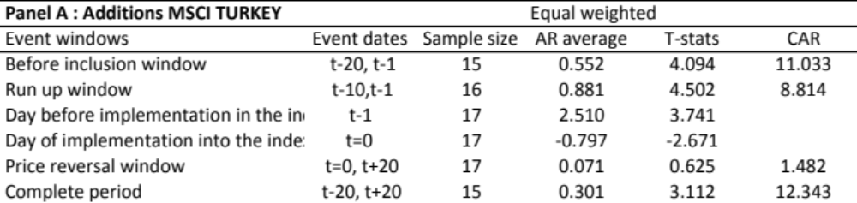source: Copy of Price effect_data analyse CAR_Turkey Plot20121104.xlsx
Chart 5.1.3. Additions to the MSCI Turkey

MSCI Turkey shows a somewhat different chart than prior example of the MSCI Brazil, of course the smaller sample size of -/+ 15 companies should be taken into account. Still the differences with the MSCI EM remain great.
Chart 5.1.4. Plot: addition Turkish companies t-20, t-1
The y-axis stands for the daily abnormal return and x-axis stands for the sample size (number of Turkish companies). For the “Before Inclusion window “event window.

source: Copy of Price effect_data analyse CAR_Turkey Plot20121104.xlsx
The plot chart gives an indication of the daily abnormal returns for the period of before the different Turkish companies were included into the index. The six outliers cause results to sharply increase.
The results on additions to the MSCI Turkey in the period before the inclusion of the stocks into the index, show a cumulative abnormal return of 11.0% which is almost a double of the previous 6.2% from the MSCI EM. Although the MSCI Turkey decreases after the inclusion day, with a significant negative daily abnormal return of -0.8%, the chart shows that with a cumulative abnormal return of 12.3%, a permanent price increase has occurred over the complete period versus the 2.8% of the MSCI EM.
Table 5.1.5. Additions to the MSCI INDIA
All T-stat calculations are based on a significance level of 5%. Please revert to the table of Brazil for additional explanation about the table
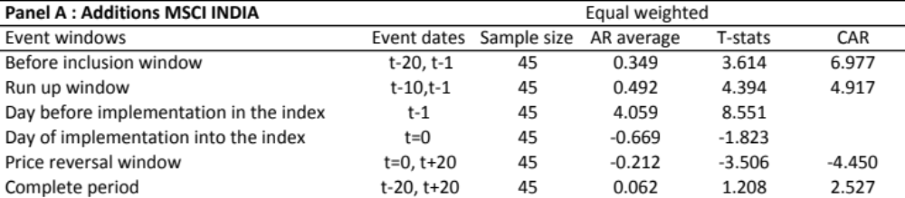
source: Copyof Price effect_data analyse CAR_India20121028.xls
Chart 5.1.5. Additions to the MSCI INDIA

The results on additions to the MSCI India in the period before the inclusion of the stocks into the index , show a cumulative abnormal return of 7.0% which is almost similar tot the excess return of 7.1% from the MSCI Brazil and in line with the results from the MSCI EM of 6.2%. The results show more activity after the announcement period, but before the inclusion of stocks into the MSCI India. Partasarathy (2010) had like wise results in his research on the Indian Nifty index. He came 3.8% in the period of 1999-2006 and 5.1% between 2007-2010.The cumulative abnormal return decreased after the stocks had been included into the index. Different than the prior results found of Brazil and Turkey, here the new price equilibrium for the complete period of twenty days before the inclusion day until 20 days after. This was respectively a cumulative abnormal return of 2.5%, which was not significant versus the significant cumulative abnormal return of 2.8% from the MSCI EM.
Table 5.1.6. Additions to the MSCI CHINA
All T-stat calculations are based on a significance level of 5%. Please revert to the table of Brazil for additional explanation about the table
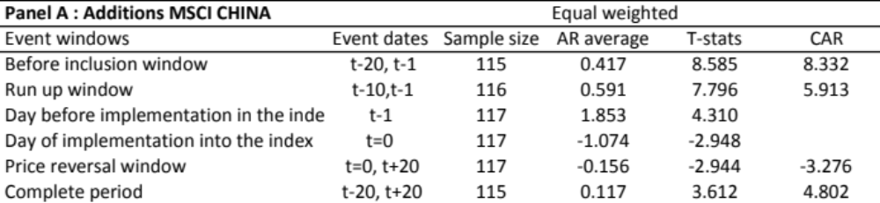
source: Copy of Price effect_data analyse CAR_China20121028.xlsx
Chart 5.1.6. Additions to the MSCI CHINA

The results on additions to the MSCI China in the period before the inclusion of the stocks into the index , show a cumulative abnormal return of 8.3% which is a bit higher than the results from the MSCI EM of 6.2%. The decrease on the inclusion day of -1.1% is the same for both the additions to the MSCI China as to MSCI EM. Although the silhouette of these two lines appear the same, the decrease of cumulative abnormal return stayed limited for the MSCI China with -3.3% again, same as 3.3% from the MSCI EM. A possible reason for these same outcomes is because of the sample size of the companies of China that were included into the index. Last but not least is aexcess return over the complete period for China, where this table shows a cumulative abnormal return of 4.8% versus the 2.8% of the MSCI EM, both of these amounts were s significant.
Overall the results of these four countries were inline with those of developed markets and prior research from Hacibedel (2007) on emerging markets and Parthasarathy (2010) on the Indian index.

Results on deletions
Next to the additions, this research also looked at the price effect on deletions from the MSCI Emerging index.
The Hypothesis on the deletions for this study states that: “The null hypothesis for the price effect on a stock that is deleted from the MSCI EM index does not have a significant impact and therefore should not be significantly different from zero. “
Table 5.2.1. and chart 5.2.1. show the results on the price effect of deletions from the MSCI Emerging Market index. The event windows on the deletions are analysed following the same methodology as for the additions.
Table 5.2.1 Deletions from the MSCI EM
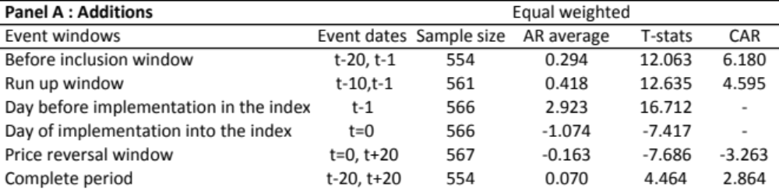
Source: data analyse table additions msci em20120715 gecorrigeerd t-1 20120817.xlsx
Chart 5.2.1. Deletions from the MSCI EM
Source: data analyse table additions msci em20120715 gecorrigeerd t-1 20120817.xlsx
The first window, called “before deletion window” shows a significant negative abnormal return of -7.8% before the exclusion of a stock from the MSCI EM index. And ends with a not significant negative excess return of -1.8% for the complete period. This result for the complete period is inline with prior results from Hacibedel (2007) who also found that for the stocks deleted from the MSCI Emerging Markets, no complete price reversal takes place. These results are also inline with research from Zhou (2011) and Chen et al. (2003) on deletions from the S&P500 from developed markets.
The results of this research, that showed of -7.8% in period before the deletion of the stocks from the MSCI EM index,
A significant negative excess return of -7.2% happened after the announcement day of the deletions were made but before the actual exclusion day. On the actual exclusion day, day zero, the stocks immediately started to recover with a significant positive daily abnormal return of 1.6%. The next 20 days kept showing a recovery of which resulted an insignificant negative excess return of -1.8%. Meaning that even though the stocks were hammered in the period after announcement but before deletion from the index, the price effect of these stocks almost fully recovered after twenty days after these stocks had exited the MSCI EM index. The results from Chen et al (2003) on the S&P500 experienced also significant negative result of -8.5 % before exclusion from index, in their research from the period between 1989 and the year 2000.
Chen et al. (2003) also noticed that the negative effect of the deletions disappeared after 60 days. In their results the decline stayed at -1.7% which is in line with the results of this paper. Zhou (2011) who also researched the S&P500, made a distinction between pure deletions, which stands for stocks that are deleted from the S&P Family altogether, and downward deletions that stand for stocks that are downgraded to a lesser known S&P index. In his research Zhou noticed that the pure deletions which had a negative excess return of -15.9% changed into a positive 1.6% after 20 days after the index exclusion. The downward deletions had a negative excess return of -7.4% between announcement day and exclusion day. The results remained negative at -2.5% after 20 days. These downward deletion results were more inline with the results of this paper and of those from Chen et al.(2003).
A slightly smaller impact on the price effect of deletions, were from Doeswijk (2007) and Masse et al. (2000). Doeswijk (2007) found a small negative excess return of -0.7% on the change-weighted portfolio (and 0.1% for the equal weighted portfolio) of the stocks before exclusion from the AEX index. Also the results from Masse et al.(2000) on the TSE 300 were less extreme, than the negative excess return of -7.8% mentioned in this paper. Masse et al.(2000) had a negative daily abnormal return of -1.35% on the announcement day, and negative cumulative abnormal return of -2.34% before the day of exclusion from TSE300. After the exclusion of the stock from the TSE300 index the negative excess return reversed and became a positive cumulative abnormal return of 4.8 % after 30 days. In the period after the deletion of the stock from the index, an insignificant negative result of -0.9% (and -0.7% on the equal-weighted portfolio) was found in Doeswijk ‘s research.
Although the results of this study are more less in the same direction than previous research done on the MSCI Emerging Markets by Hacibedel (2007), the price impact after the announcement in this study was much more severe with -7.2% versus -2.2% from Hacibedel, both results were significant. Also the results on the complete period were different. This study showed almost a complete recovery of the price effect where the negative abnormal return recovered from significant -7.8%, to a insignificant -1.8%. While Hacibedel results still showed a significant negative abnormal return for the same period of -3.4%. Her long run event window which stands for the period of twenty days before the exclusion and sixty days after the exclusion day showed an insignificant negative cumulative abnormal return of -1.0%. Meaning that in the period of 1996 till 2006 the price of a deleted stock almost also completely recovered, but after sixty days instead of twenty.
Concluding that over the years the results on deletions from the MSCI Emerging Markets are taking shape towards the results of developed markets, when translating these results into the null hypothesis mentioned earlier in this chapter and study. The Efficient Market Theory (EMT) would not apply in the period between the announcement day and the day of exclusion, because of the significant negative abnormal returns. When looked at the complete period of before the announcement was done until twenty days after the exclusions haven taken place, the price effect is insignificant. This is also not inline with the market expectations assuming that when a stock is removed from the index its price should drop.

Results on deletions from the MSCI Countries
As previously done for the additions, this paragraph shows the price effect on exclusions from the index, on a country level, for Brazil, Turkey, India and China.
The next tables show the results on deletions from a MSCI Country index. The charts show the price effect of the deletions from the MSCI Emerging Markets versus the price effect of the deletions from the MSCI Country indices.
Table 5.2.2. Deletions from the MSCI BRAZIL
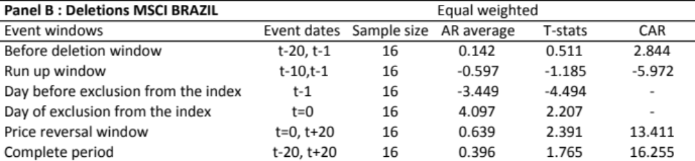source: Copyof Price effect_data analyse CAR_Brazil20121014.xlsx
Chart 5.2.2. Deletions from the MSCI BRAZIL

The results on deletions from the MSCI Brazil in the period before the exclusion of the stocks from the index , show a positive cumulative abnormal return of 2.8% which is actually odd, since the results from the MSCI EM showed a significant negative cumulative abnormal return of -7.8%. Due to the small sample size a plot was made get a better view on the positioning of the different stocks in the period before they were excluded from the index.
Chart 5.2.3a. Plot: deletion Brazilian companies t-20, t-1
The y-axis stands for the daily abnormal return and x-axis stands for the sample size (number of Brazilian companies). For the “Before Deletion “event window.

Chart 5.2.3b. Plot: deletion Brazilian companies t=0, t+20
The y-axis stands for the daily abnormal return and x-axis stands for the sample size (number of Brazilian companies). For the “Price reversal window “event window.

source: Copy of Price effect_data analyse CAR_Turkey Plot20121104.xlsx
The plot 5.2.3a clarifies the results and shows, that 3 companies had an extreme positive result, which caused the cumulative abnormal return for stocks deleted from Brazilian index to become positive. Most of the companies’ results have a negative cumulative daily abnormal return between zero and -1%.
The price reversal window shows a recovery with a significant positive cumulative abnormal return of 13.4%, indicating almost results of as stocks added to the instead of being deleted. Although there is one extreme outlier shown in plot 5.2.3b, most of the stocks had a positive daily abnormal return that was higher than 0.22% for the MSCI EM. These results might indicate that that investors investing in the local market might think differently of the price of Brazilian stocks that are deleted from the MSCI EM index, which causes a price increase for the deletions instead of the expected price decrease.
For the complete period the price effect on deletions from MSCI Brazil have reached an insignificant positive cumulative abnormal return of 16.3%, while the MSCI EM had an insignificant negative cumulative abnormal return of -1.8% on the stock deletions.

Table 5.2.3. Deletions from the MSCI TURKEY
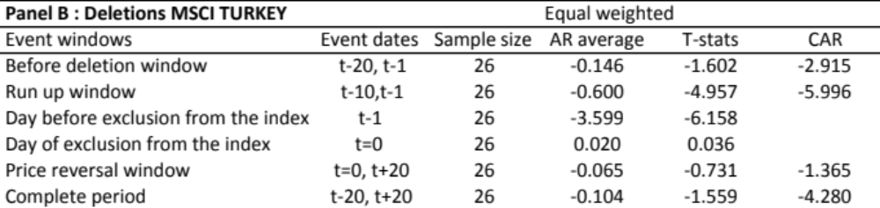source: Copyof Price effect_data analyse CAR_Turkey20121028.xlsx
Chart 5.2.3. Deletions from the MSCI TURKEY

Different than as seen with results on Brazil, Turkey shows a more in line trend with the results on deletion from the MSCI EM. For the period before the exclusion from the index, the deletions on the MSCI EM showed a negative cumulative abnormal return of -7.8%, this number was much smaller with -2.9% and was not significant. The run up window results on both indices showed a significant negative cumulative abnormal return of -6.0% and respectively -7.2% for the MSCI EM. While the price reversal window showed a significant positive excess return of 6.0% for the stocks that were deleted from the MSCI EM, the return on stocks that were deleted from the MSCI Turkey lagged and reached an insignificant negative return of -1.4%. Both indices had a insignificant cumulative abnormal return for the complete period, naming -4.3% fro the stocks deleted from the MSCI Turkey and -1.8% for stocks excluded from the MSCI EM. Where most of the researches indicate signs of a price recovery after the deletion of the stock, this hardly the case for Turkish stocks that lagged on recovery after the deletion. A possible reason could be the absence of information transparency as mentioned by Hacibedel(2007) in het research, which incentivize investors to sell and keep away from stocks that are deleted from the index. Turkey has a small weight of 1.5% in the index, this might make it un attractive to be followed by analysts and other investors. (please revert to the appendix for table of MSCI Emerging markets weights on a country level.)

TABLE 5.2.4. Deletions from the MSCI INDIA
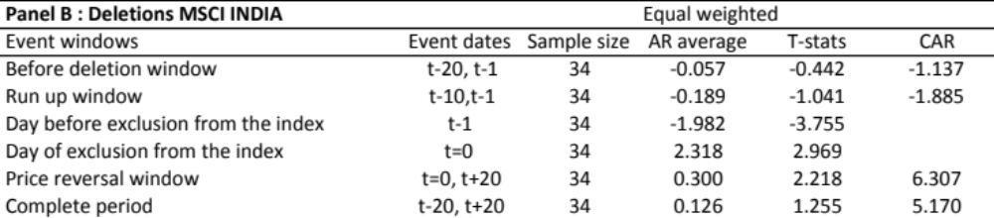source: Copy of Price effect_data analyse CAR_India20121014.xlsx
Chart 5.2.4. Deletions from the MSCI INDIA

Starting with before deletion window, the deletions from the MSCI India show an insignificant negative abnormal return of -1.1% versus a significant-7.8% from the MSCI EM index. Although the run up window had a small insignificant negative abnormal return of -1.9% for stocks deleted from the MSCI India, the daily abnormal return -2.0% versus a -3.6% from the MSCI EM, did reach a significant level on the day before exclusion from the index. For the complete period an insignificant positive cumulative abnormal return of 5.2%was found for stocks deleted from the MSCI India index versus an insignificant negative cumulative abnormal return of -1.8% from stocks deleted from the MSCI EM.
This indicates that the price for deletions from the MSCI India index do recover after twenty days. This was not the case for stocks deleted from the MSCI Turkey index.
TABLE 5.2.5. Deletions from the MSCI CHINA
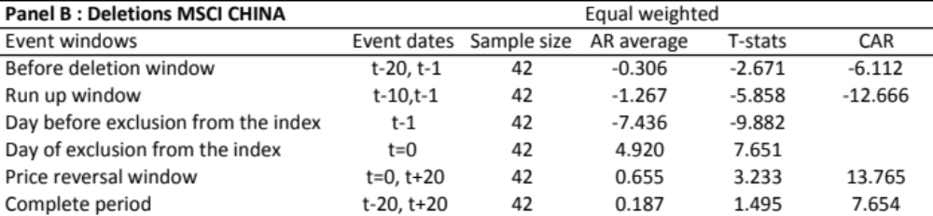
source: Copyof Price effect_data analyse CAR_China20121028.xlsx
Chart 5.1.5. Deletions from the MSCI CHINA

Again overall the results on the MSCI China are inline with the results from the MSCI EM. For both indices stocks show a significant negative cumulative abnormal return of -6.1% versus -7.8% for stocks deleted from the MSCI EM. As for the run up window an the day before the exclusion Chinese stocks experience a significant price drop, where negative cumulative abnormal returns reach a level of -12.7%, and a negative daily abnormal return of -7.4% for the MSCI China. The MSCI EM also reached significant levels of -7.2%, respectatively-3.6%. for the same events. Continuing with the price reversal window, where stocks deleted from the MSCI China were significantly positive with an excess return of 13.8% versus a significant 6.0% from the MSCI EM. Last but not least table 5.2.5 shows a insignificant cumulative abnormal return of 7.6% for the deletions from MSCI China index, versus an insignificant -1.8%, indicating that while the stocks from MSCI China fully recovered, those deleted from the MSCI almost recovered.
A surprising result is that from the larger and most popular countries such a Brazil, India and China the price effect of the deleted stock does show a complete recovery. The slightly negative results for the deletions on the MSCI Emerging Markets index, could indicate on less positive for excess returns for the rest of the (smaller) countries from the MSCI EM which are held outside of the scope of this MSCI Country research.
These MSCI country results show a bit more resemblance with the results of developed markets then the MSCI EM index.

Results on the Beta change
The second research studies the beta change of the additions to and deletions from the index. Assuming that null hypothesis expects no beta change.
The alternative hypothesis predicts that stocks that will enter the index will co-move more with other stocks from the index after the inclusion of the index. For the deletions this would mean that when a stock is removed from the index it would co-move less with other stocks from the index after the moment of exclusion from the index.
The study includes stocks that are added to and deleted from the MSCI Emerging Market index from January 2004 till December 2010.
The MSCI Emerging markets additions and deletions are compared to different indices, such as MSCI India index and a HSBC India index regardless of their own index reviews.
For the univariate regression model, two columns were made, in order to examine the difference between the moment “before the inclusion or deletion” period and “after the inclusion to or deletion” from the index. For each stock the beta before inclusion and the beta after inclusion is calculated. This has also been done for the exclusions from the index. The beta of the “before inclusion” window includes the returns of 20 days and the “after inclusion” window consists of 21 days.
The next tables in this paragraph show basic tests of significance of the change in beta of the additions and deletions.
TABLE 5.3.1. Beta results on the MSCI EM
All T-stat calculations are based on a significance level of 5%. The sample size is based on all additions of all countries within the MSCI Emerging Markets from 2004 till 2010. The beta inclusion stands for the average beta of all stocks for the time-line of 20 days before till one day before the index review change takes place. The beta after inclusion stands for the first day after the implementation of the index changes have taken place. The beta change stands for the difference between Beta before inclusion and Beta after inclusion. Idem for the Beta Deletions in Panel B.
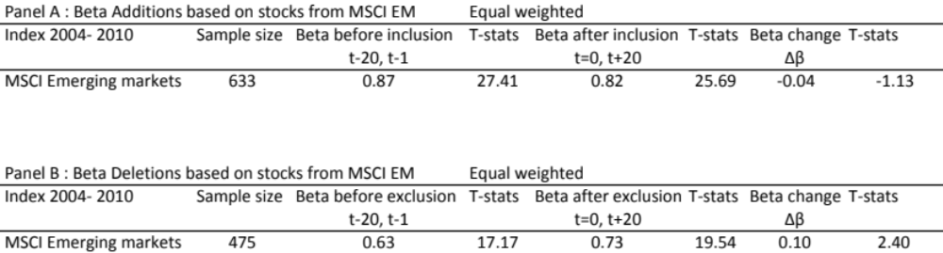Source: Bet MSCI EM_latest version.xlsx
The results from table 5.3.1. are based on the complete sample of 633 stock additions that entered the index in the period of 2004 till 2010. These 633 additions are the sum of all stocks of all countries that were added to the MSCI EM due to index review between 2004 and 2010.
The beta change on additions to the MSCI Emerging Markets showed a decrease of -0.04, although this result is not significant, they do not support the results found in prior research done on S&P 500 and Nikkei 225 index.
Panel B in the same table shows the results on all deletions from the MSCI Emerging markets for the period from 2004 till 2010. The beta change shows a significant increase of 0.10 for the deletions. These results are dissimilar to those of Barberis et al (2002) and Vijh (1994) who both experienced a beta decrease for stocks that were deleted from the index.
The beta decrease on the additions to the MSCI Emerging Markets was a surprising outcome. This could indicate that there are no signs of a Category based or Habitat based model from Barberis et al.(2002), were increased co-movement could be caused by trading actions of index funds. Since this study did not analyze the trading volume of the days around the index reviews this answer is only an assumption.
A possible reason for the increased beta changes for deleted stocks is the investors’ awareness explained by Hacibedel (2007). She mentions that the information transparency for Emerging markets is much less than for developed markets. If a stock enters the index is becomes visible to investors. Stocks entering the MSCI Emerging markets or other indices must comply with certain rules and regulations. A stock deleted from the index might then not necessarily be a bad stock, the decrease of market cap of a stock might already be a reason based on regulations and rules, to remove the stock from the index. For some investment strategies this stock might still be an attractive investment opportunity, or a stock to keep in their portfolio.
Next to the results on change in beta for the MSCI Emerging markets index this study also studied the beta change of the same four individual countries that were mentioned the previous paragraph.

Beta Change on Additions for Brazil, Turkey, India and China
In this paragraph the beta of stocks from before the inclusion in to the index will be compared with the beta of stocks after the inclusion in to index. Different than in the previous paragraph the sample size of the added stocks comes from one country. Meaning that each table only consists of stocks related to Brazil or Turkey or India or China. The time line for the pre-event and a post event window remains the same.
The next table shows the results on the beta changes from Brazilian stocks, based on the additions from index review from the MSCI BARRA. These Brazilian additions are compared to the MSCI Emerging Markets index, MSCI Brazil index and the HSBC Brazil index. This comparison is made to determine if it makes a difference, when investors focus on different indices. The Beta results on Emerging markets index in the next tables, is not the same sample size as for the original research done in the prior paragraph.
TABLE 5.3.2. Beta results on a Country level
All T-stat calculations are based on a significance level of 5%. The sample size is based on stock additions from Brazil from 2004 till 2010. The beta inclusion stands for the average beta of all stocks for the time-line of 20 days before till one day before the index review change takes place. The beta after inclusion stands for the first day after the implementation of the index changes have taken place. The beta change stands for the difference between Beta before inclusion and Beta after inclusion. The Brazilian, Turkish, Indian or Chinese additions are compared against, index data from the MSCI Emerging Markets, MSCI Country index and the HSBC Country index
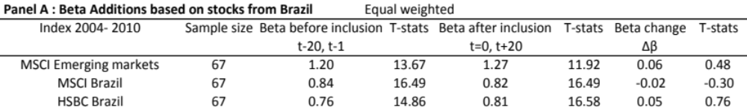
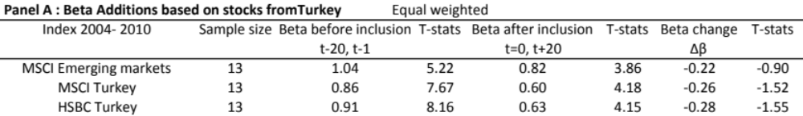
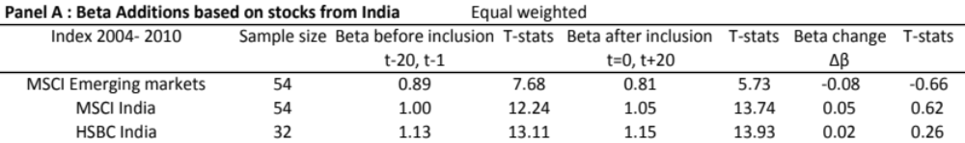
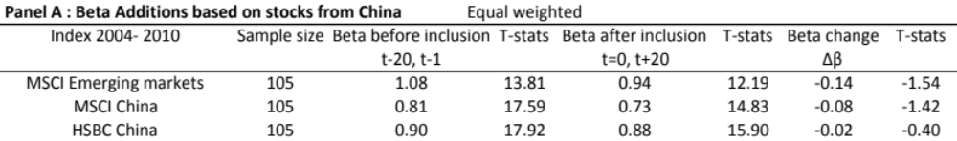 Source: Beta_BR_IN_CN_TR_20121110.xlsx
Brazil
A total amount of 67 Brazilian stocks was added to the MSCI Emerging market index during the period of 2004 till 2010.
For Brazilian stocks compared to the MSCI Emerging Markets, the beta change showed an insignificant increase of 0.06. When the same additions were then compared to the MSCI Brazil index, the beta showed a decrease of -0.02. The comparison with the HSBC index showed a beta increase of 0.05, which was in line with the results of the MSCI Emerging Markets index.
Turkey
The Turkish stocks showed an insignificant decrease in beta of around -0.20 for all three indices, indicating to be inline with the results as shown in table 5.3.1 from the on all additions compared to the MSCI Emerging markets index.
India
For the Indian stocks compared to the MSCI Emerging Markets, the beta change showed an insignificant decrease of -0.08. After comparing the same additions to the MSCI India index, the beta change showed an increase of 0.05. This positive result was supported by the results of the HSBC India index that also showed positive beta change of 0.02. The positive beta change from the MSCI India index and HSBC India, although not significant, support the results of Parthasarathy’s (2011) study on the S&P CNX Nifty index.
China
The beta change of Chinese stocks compared over the period before they were included and after the inclusion showed for all three indices decrease of respectively -0.14 for the MSCI EM, -0.08 for the MSCI China and -0.02 for the HSBC China. These results were although not significant, inline with the results showed in table 5.3.1. on the MSCI Emerging Markets index. The result on China and Turkey experienced both a decrease for on all indices.

Beta change on deletions from Brazil, Turkey, India and China
To calculate the beta change of the deletions on a country level, the same methodology as for the additions was used.
TABLE 5.3.3. Beta results on deletions on a Country level
All T-stat calculations are based on a significance level of 5%. The sample size is based on stock deletions from Brazil from 2004 till 2010. The beta exclusion stands for the average beta of all stocks for the time-line of 20 days before till one day before the index review change takes place. The beta after exclusion stands for the first day after the implementation of the index changes have taken place. The beta change stands for the difference between Beta before exclusion and Beta after exclusion. The Brazilian, Turkish, Indian, or Chinese deletions are compared against, index data from the MSCI Emerging Markets, MSCI Country index and the HSBC Country index.
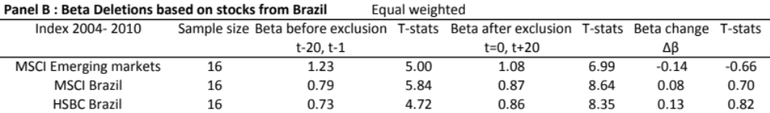
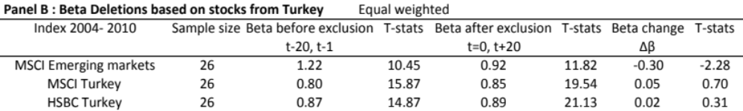
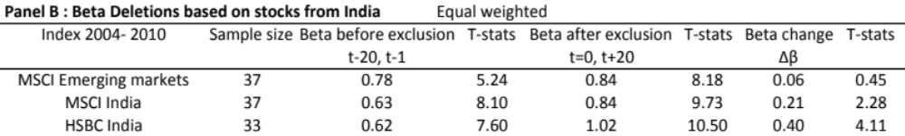
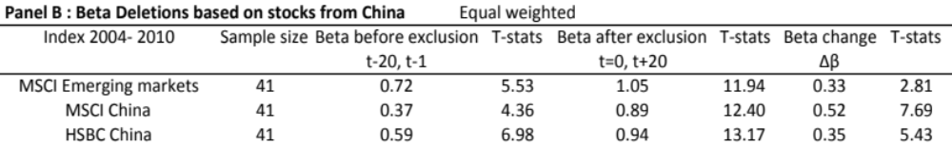Source: Beta_BR_IN_CN_TR_20121110.xlsx
Brazil
A total amount of 16 Brazilian stocks was deleted from the MSCI Emerging Markets index during the period of 2004 till 2010.
The beta change compared to the MSCI Emerging Markets, showed an insignificant decrease of -0.14. The beta compared to the MSCI Brazil index, showed an increase of 0.08. And for the HSBC Brazil index a beta increase of 0.13 was found. The results of the MSCI Brazil and HSBC Brazil were in line with the original results (of the complete deletion sample) of the MSCI Emerging Markets index of table 5.3.1.
Turkey
The beta change of the Turkish stocks for the window before they were excluded from the index and window after the exclusion from the index, showed mixed results.
The MSCI Turkey showed a beta increase of 0.05 and the HSBC Turkey showed an increase of 0.02. Both of these results were insignificantly positive and inline with the results showed in table 5.3.1. on the MSCI Emerging Markets index.
However if the calculation is made only with Turkish stocks compared to MSCI EM index, the prior positive beta increase turns into a significant beta decrease of -0.30.
India
For the deleted Indian stocks, no evidence on a decreased beta was found. Instead the deletions experienced a beta increase. Both MSCI India index as HSBC India Index had significant beta increase of 0.21 and 0.40. These results are also supported by Parthasarathy’s (2011) study on the S&P CNX Nifty index.
China
Again, no evidence of a decreased beta between deleted stocks and MSCI EM, MSCI China or HSCB China was found. The beta increase of 0.33 for the MSCI EM, 0.52 for the MSCI China and 0.35 for the HSBC China were all significantly positive.
At last analysis was done on the average beta calculated on the four countries. Were all additions (deletions) were summed.

TABLE 5.3.4. Beta results averaged of Brazil, Turkey, India, China
All T-stat calculations are based on a significance level of 5%. The sample size is based on the sum of stock additions from Brazil, Turkey, India and China from 2004 till 2010. The beta inclusion stands for the average beta of all stocks for the time-line of 20 days before till one day before the index review change takes place. The beta after inclusion stands for the first day after the implementation of the index changes have taken place. The beta change stands for the difference between Beta before exclusion and Beta after exclusion. The Brazilian deletions are compared against, index data from the MSCI Emerging Markets, MSCI Brazil and the HSBC Brazil. Idem for the Beta deletions in panel B.
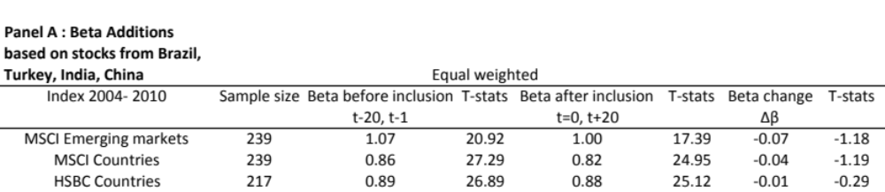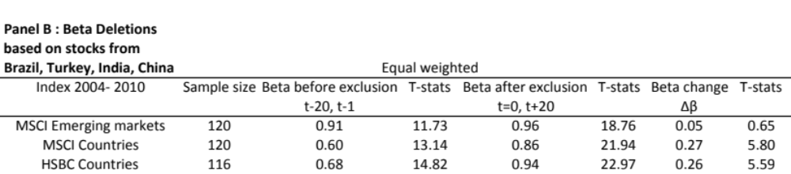 Source: Beta_BR_IN_CN_TR_20121110.xlsx
Starting with the additions, a beta decrease was revealed instead of a beta increase. Although not significant, the decrease was in line with the earlier findings of this study on the additions to the Emerging Markets index. These findings are not in line with prior research done from developed markets.
Further more an increased beta between deleted stocks and MSCI EM, MSCI Countries and HSBC Countries was found. Again this was in line with the prior findings on deletions from the MSCI Emerging markets index.

Summary of results and Conclusions

Price effect
Prior studies have all have shown that a positive price impact is created when a stock is added to the index. Doeswijk (2007) on the AEX, Chen et al ( 2003) and Zhou (2011) on the S&P 500 and Masse et al on the former TSE300 agreed on these positive price effect results.
It’s a different story when it comes to stocks that are deleted from the index. The results from indices from developed markets showed a price decrease on stocks that were deleted from the index, or downgraded to a smaller index, and a price that (almost) fully recovered after a short period of time. Indices from emerging markets however showed a price decrease, where the price was not fully recovered to its initial price of before the index exclusion. Hacibedel (2007) revealed these results on the Emerging Markets index and Parthasarthy (2010) showed the lagging price recoveries on deletions on the Indian stock market.
The purpose of this study was to find out if there is an impact on the price effect when a stock enters or leaves the MSCI Emerging Markets index. This study included stocks that were added and deleted due to index reviews from the MSCI Emerging Markets index from January 2004 till December 2010 and reflects a period of twenty days before the inclusion (exclusion) and twenty days after the inclusion (exclusion) from the index.
The results on this study showed that indeed there is a positive price effect on additions into the MSCI Emerging markets index. The study of Hacibedel (2007) showed an insignificant price increase of 1.9% on the short term, this study proved to have a statistically significant positive excess return of 2.8% on the short term for additions to the index.
Next to additions, I investigated the price effect on deletions from the MSCI Emerging Markets. Stocks that were deleted from the index showed a statistically significant negative excess return of -7.8% after the announcement day of the deletion. This decrease partly recovered to an insignificant underperformance of -1.8% in the next twenty days after the exclusion from the MSCI Emerging Markets index. The negative excess return experienced after the announcement was in line with findings from Chen et al (2003) and Zhou (2011) who did their study on the S&P 500. Although both researches that were done on the MSCI Emerging Markets showed similar results, Hacibedel’s (2007) found that negative excess returns on stocks deleted from the index, worsened within twenty days after the exclusion was implemented, whereas this study in that same timeframe experienced a recovery. In a time frame of 60 days after the implementation of deletion Hacibedel (2007) negative excess return became statistically insignificant at -1.0%.
I also chose to study the price effect of additions and deletions from the index on a country level. The reason for this is to determine if the outcome on the price effects of the MSCI EM is also representative for the underlying countries in MSCI EM. I focussed on the more popular countries of the Emerging Markets, naming Brazil, India, China and less popular Turkey. The results on the price effect on additions into the index were all statistically significant positive for the complete period of t-20, t+20 studied, except for India which ended with an insignificant positive excess return after the inclusion. Overall, the popular countries outperformed the excess returns that were achieved by stocks that were added to the MSCI Emerging Markets index.
A surprising result comes from the larger and more popular countries as Brazil, India and China that experienced a complete price recovery on the deleted stocks after the exclusion from index. The slightly negative excess return of deletions from MSCI Emerging Markets comes from the presence of more countries such as Turkey, that do not show a price recovery of stocks deleted from the index. For example due to a smaller marketcap weight of the in country in the index, or less coverage on a certain country by analyst.

Beta change
Traditionally, investors traded because of changes on fundamental value or because of news that newly entered the market. An example of a reason for trading that does not come from fundamental news is an index review.
Analysis of the co-movement behind index changes is done by comparing the beta of an inclusion (exclusion) of a stock before and after entering or exiting the index. Most of the research such as Barberis et al.(2002) and Vijh(1994) has been done on the S&P and other indices from developed markets, where findings show a statistically significant increase in stock betas after inclusion and stock betas decrease after a stock is excluded from the index. Vijh(1994) mentioned the price pressure hypothesis in his study. This hypothesis predicts that newly added stocks cause an increase in covariance with the market returns. This reaction causes the beta of individual stocks to increase regardless of what the trading volume does. Both researchers experienced that increased betas from inclusions are caused by increased trading frequency of stocks in the S&P 500 due to shifts in demand and supply.
The results of this study showed a statistically insignificant beta decrease of -0.04. Although this number is not significant, it differs from prior research done on other index reviews mainly on developed markets. The outcome on deletions from the index also showed an opposite effect than was experienced in developed markets. For the deleted stocks from the index a statistically significant beta increase of 0.10 was determined.
Furthermore this study also analyzed the beta results on four countries that were highlighted in the price effect study. The beta changes were calculated based on the additions or deletions of separate countries, which were set against MSCI and HSBC Country indices.
Based on the analysis MSCI Country index, Brazil, China and Turkey showed a beta decrease of -0.02, -0.08 and -0.26 for stocks that were added to index. This result was in line with the analysis on additions for MSCI Emerging Markets. India experienced a result of an increased beta of 0.05. Although this number was not statistically significant, it has more characteristics of a positive beta change of developed markets instead of emerging markets.
The analysis on beta change for deletions on the MSCI Country level showed a positive beta increase for all four countries. The beta change for deleted stocks from China and India was statistically significant with an increase of 0.52 and 0.21. The positive results of an increased beta of 0.08 for Brazil and 0.05 for Turkey were insignificant. Again, these results do not support prior research done on indices of developed markets, where a deletion from the index results in a significant beta decrease instead of the beta increase that was found in this study.
Returning to the two research questions that were analyzed in this study, this study did find a price effect of additions and or deletions from index, and experienced a opposite beta change for emerging markets indices versus developed markets indices.

Possible future research
Suggestions for further research on this topic would be linking these price effects to the trading volume of the stocks that are added to or deleted from the index based on the models from Vij(1994) and Barberis et al. (2002). This could determine whether these price effects were initiated by excessive trading of index funds during the announcement day, and inclusion/exclusion day.
Another suggestion would be to make a distinction between stocks that enter the index for the first time and stocks that make a reentry into the Emerging Market index. Prior research from Zhou (2011) on the S&P 500 has shown that that newly added stocks experience a much greater permanent price increase than re-entered stocks.

References

Beneish, Messod D., and Robert E. Whaley. 1996. “An Anatomy of the ‘S&P Game’ : the effects of Changing the Rules.” Journal of Finance, vol.51, no.5 (December): 1909-1930
Barberis,B., Shleifer, A., Wurgler J., 2002, Co-movement, Working Paper 8895, National Bureau of Economic Research
Brown, Stephen J., and Jerold B. Warner, 1985, Using Daily Stock returns: The case of Event studies, Journal of Financial Economics 14, 3-31
Chen, Honghui, Gregory Noronha, and Vijay Singal. 2003. “ The price response to S&P 500 Index Additions and Deletions: Evidence of Asymmetry and a New Explanation.” Journal of Finance, vol. 59, no. 4 (August): 1901-1930
Corrado, Chales J.,1989, A Nonparemetric Test for Abnormal Security-Price Performance in Event Studies, Journal of Financial Economics 23, 385-395
Doeswijk, R. (2007). “Ape or Art – Investment Strategies”, Alblasserdam
Greenwood,R., and N. Sosner (2002), “Where Do Betas Come From?”, Working Paper, Harvard University
Fama, Eugene F., Lawrence Fisher, Michael C. Jensen and Richard Roll. 1969.”The adjustment of stock prices to new Information.” International Economic Review, vol.10, no. 1 (Feb.): 1-21
Hacibedel, Burcu “Why Do Index Changes Have Price Effects?” (Not published)
Harris, Lawrence and Eitan Gurel. 1986.”Price and Volume effects Associated with changes in the S&P 500 list: New Evidence for the Existence of Price Pressures.” Journal of Finance, vol.41, no. 4 (September): 815-829
Hegde Shantaram P. and John B. Mc Dermott. 2003, The Liquidity Effects of Revisions to the S&P500 Index: An Empirical Analysis, Journal of Financial Markets, 6(3), 413-459
Jain, Prem C. 1987. “ The effect on Stock price of Inclusion in or Exclusion from the S&P500.” Financial Analysts Journal, vol.43 no.1 (January/ February) 58-65
Levy, Haim and Thierry Post. 2005. “Investments” Pearson Education Limited, England, 177-178
Lynch, Anthony W., and Richard R.Mendenhall.1997.” New Evidence on Stock Price Effects Associated with Changes in the S&P 500 Index.” Journal of Business, vol. 70, no. 3 (July): 351-383

Masse, Isidore, Hanrahan, Robert, Kushner,Joseph and Martinello, Felice. 2000. “ The effect of additions to or deletions from TSE300 Index on Canadian share prices.” Canadian Journal of Economics, Vol. 33, no2 ( May)
Merton, Robert C. 1987. “A Simple Model of Capital Market Equilibrium with Incomplete Information.” Journal of Finance, Vol. 42, no3 ( July):483-510
Parthasarathy, Srikanth. 2010 “Price and Volume Effects Associated with Index Additions: Evidence from the Indian Stock Market” Asian Journal of Finance & Accounting, Vol. 2, no2: E4
Parthasarathy, Srikanth. 2011 “Co-Movement and Index Changes- Evidence from The Emerging Indian Stock Market” Asian Journal of Finance & Accounting, Vol. 3, no1:E12
Pindyck, Robert S. and Rotemberg Julio J.1993. “The Co-movement of Stock Prices” The Quarterly Journal of Economics, Vol. 108,No.4 (Nov) :1073-1104
Sar, Nico L. van der. 1998. “ Event-Studies: Methodologische Aspecten.” Vakgroep Financiering en Beleggingen, Erasmus Universiteit Rotterdam
Scholes, Myron and Williams, Joseph. 1977. “ Estimating Betas from Nonsynchronous Data.” Journal of Financial Economics, 5, 309-327
Shankar, S. Gowri, and James M.Miller.2006.”Market Reaction to Changes in the S&P SmallCap 600 Index.” Financial Review, vol.41, no. 3 (August): 339-360
Shleifer, Andrei. 1986.” Do Demand Curves for Stocks Slope Down?” Journal of Finance, 41 (3), 579-590
Vijh, A. (1994), “S&P500 Trading Strategies and Stock Betas,” Review of Financial Studies 7, 215-251
Zhou, Haigang. 2011 “Asymmetric Changes in stock prices and Investor Recognition around Revisions to the S&P 500 Index.” Financial Analysts Journal, vol. 67, no. 1 (January): 72-84

http://en.wikipedia.org
http://www.investopedia.com
http://www.msci.com
http://www.hsbc.com
http://www.tmx.com
http://www.standardandpoors.com

Appendices

Appendix MSCI

Investability screens from the MSCI
The investability screens that the MSCI uses several requirements in order to determine their investable equity universe in each market. The screenings that happen on a security level are:
- Equity universe minimum size requirement
- Equity Universe minimum free float adjusted market capitalization requirement
- Emerging markets minimum liquidity requirement
- Global minimum Foreign Inclusion Factor requirement (FIF)
- Minimum length of trading requirement

Ad 1. Equity universe minimum size requirement
A requirement is that the company must have minimum full market capitalization. Minimum full market capitalization is referred to as the equity universe minimum size requirement. This is applied as follows:
The companies are sorted in descending order of full market capitalization and the cumulative coverage of the free float-adjusted market capitalization of the EM equity universe is calculated at each company. Each company’s free float-adjusted market capitalization is represented by the aggregation of the free float-adjusted market capitalization of the securities of that company in the universe.
Secondly, when this cumulative free float- adjusted market capitalization coverage of 99% of the sorted EM equity universe is achieved, the full market capitalization of the company at that point defines the equity universe minimum size requirement.
At last the rank of the company by descending order of full market capitalization with in the EM equity universe is noted and will be used in determining the equity universe minimum size requirement at the next rebalance.
The equity universe minimum size requirement is reviewed and when needed revised at the semi-annual index reviews. Companies with a full market capitalization below the USD 150 million are not included in the investable equity universe.

Ad 2. Equity Universe minimum free float adjusted market capitalization requirement
In order to be taken into account for inclusion in the EM market investable equity universe a security must have a free float adjusted market capitalization equal to or higher than 50% of the equity universe minimum size requirement.

Ad 3. Emerging markets minimum liquidity requirement
The screening of a minimum liquidity happens on individual security level. The liquidity is measured by a twelve-month and three-month Annual Traded Value Ratio (ATVR). Followed by a three-month frequency of trading.
Requirements for a company in the Emerging Market investable equity universe needs to have a minimum liquidity level of 15% of 3 month ATVR and 80% of 3 month frequency of trading. This has to be over the last four consecutive quarters as well as 15% of 12 month ATVR is required for the inclusion of the company.
A special note is made for Russian liquid ADR’s, which may be considered for inclusion in the market investable equity Universe despite trading in a different time zone.

Ad 4. Global minimum Foreign Inclusion Factor requirement (FIF)
Screening for global minimum Foreign Inclusion Factor (FIF) requirements is done on security level. To be qualified for inclusion in the EM investable equity market a securities Foreign Inclusion Factor must reach a certain threshold. The Foreign Inclusion Factor of a security is defined as the proportion of shares outstanding that is available for purchasing in the public equity markets by international investors. This proportion accounts for the available free float and or the foreign ownership limits applicable to a specific company. In general a company must have a FIF equal to or larger than 0.15 to be eligible for inclusion factor requirement.

Ad 5. Minimum length of trading requirement
The last requirement is the minimum length of trading. A new issue such as a IPO must have started trading at least 4 months before the implementation of the initial construction of the index or at least three months before implementation of a semi-annual index review. This requirement also applies to small new issues in all markets.
Large IPO’s are not subject to minimum length of trading requirement and may be included in a market investable equity standard index outside of a quarterly or semi-annual index review.

Rebalancing
Rebalancing refers to the weights of the constituent securities in the index. To maintain the weight of each security consistent with the index weighting method, the index provider rebalances the index by adjusting the weights of the constituent securities on a regularly scheduled basis. Rebalancing dates are usually quarterly) Rebalancing is necessary because the weights of the constituent securities change as their market price change.
Example:
Equal weighted index: If the equal weight of the securities should be 20, then the stocks above 20 should decrease and the stocks below 20 should increase. So rebalancing creates turnover within an index.
Price weighted index: Are not rebalanced because the price of each constituent security is determined by price.
Market Capitalization weighted indices: Rebalancing is less of a concern because these indices largely rebalance themselves. Market Capitalization weights are only adjusted to reflect mergers, acquisitions, liquidations or other corporate actions between rebalancing dates.

Appendix charts MSCI Countries

A comparison of the total return of the MSCI Countries versus the Indexed total return of these countries.

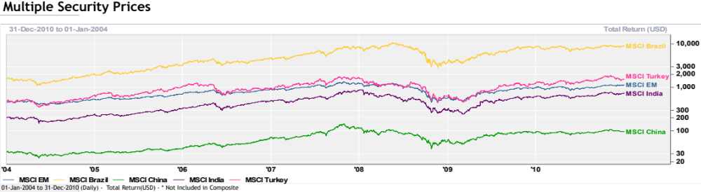

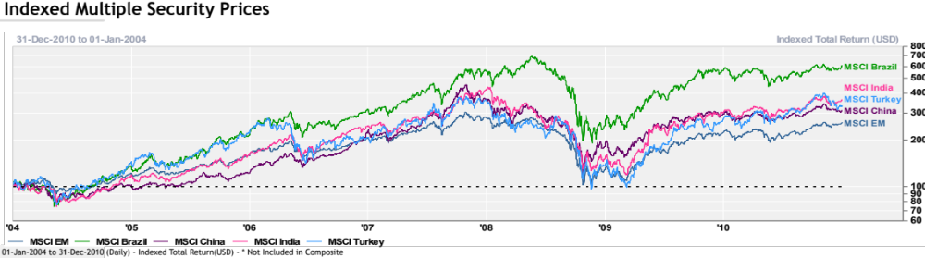

Appendix table MSCI Emerging Markets index weight
All countries that were in the MSCI Emerging Markets on 31 December 2010, with their number of stocks and index weight.

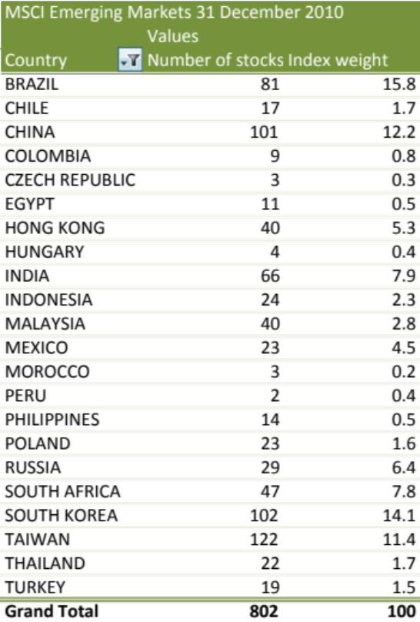

Appendix charts HSBC Countries

A comparison of the total return of the HSBC Countries versus the Indexed total return of these countries.

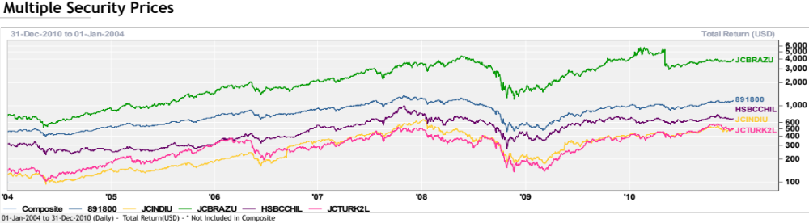

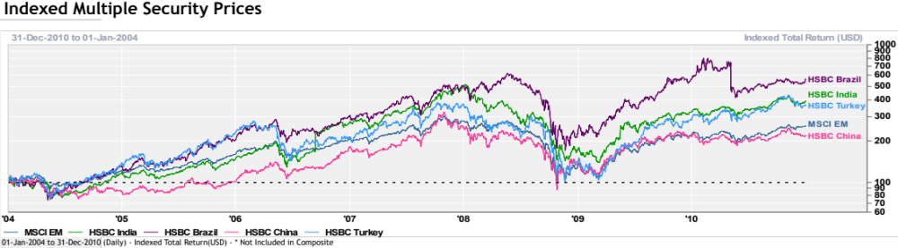

Definitions

Market Capitalization weighting
MSCI uses the Market Capitalization weighting. In Market Capitalization weighting or value weighting, the weight on each constituent security is determined by dividing its market capitalization by the total market capitalization (sum of the market capitalization) of all the securities in the index. Market capitalization or value is calculated by multiplying the number of shares outstanding by the market price per share.

Float- Adjusted Market Capitalization Weighting
In float adjusted market capitalization weighting, the weight on each constituent security is determined by adjusting its market capitalization for its market float. Typically, market float is the number of shares of the constituent security that are available to the investing public. In addition to excluding shares, held by controlling share holders, most float- adjusted market- capitalization weighted indices also exclude shares held by other corporations and governments. And excluding shares that are not available to foreigner investors. Index providers revert to these indices as free float adjusted market capitalization weighted indices.
Float adjusted market capitalization weighted indices reflect the shares available for public trading by multiplying the market price per share by the number of shares available to the investing public (=float adjusted market capitalization), rather than the total number of shares outstanding (= total market capitalization)
Currently, most market capitalization weighted indices are float adjusted. Meaning that market capitalization” weighting” refers to float adjusted Market Capitalization weighting. The advantage of this method is that constituent securities are held in proportion to their value in the target market. A disadvantage is that the constituent securities whose prices have risen the most or fallen the most, have greater or lower weight in the index. For example, as a security price rises relative to other securities in the index, its weight increases and as its price decreases in value relative to other securities in the index, its weight decreases. This weighting method leads to overweighting stocks that have declined in price and may be undervalued now.

Correlation Coefficient
Correlation coefficient varies between -1 and 1. If the correlation coefficient is positive it means that, in the case that 2 stock markets, an upward or downward movement in one tends to be accompanied by an upward or downward movement in the other. A negative correlation coefficient means that the upward or downward movement in the other. A negative correlation coefficient means that 2 markets tend to move in opposite directions.

MSCI
Morgan Stanley Capital International, a company that constructs a variety of indices covering many different asset classes, countries and regions

MSCI Index
Morgan Stanley Capital International index serves to measure the relatively risky emerging global markets equity performance, consisting of indices in 26 emerging economies around the world. Emerging markets are effected by economies, politics and currency fluctuations, and can be included as part of overall investment portfolio as a way of diversifying risk. These emerging economies are considered to be extremely risky with the potential for either large profits or large losses.

HSBC
HSBC stands for Hong Kong and Shanghai Banking Corporation. It is a public banking institution, which was originally established to assist with financial needs related to trading between China and Europe.

