Administrative effects of the modernization of Dutch long stay Healthcare
Model for measuring administrative costs in healthcare



P. van der Linden (student number 268956)
Thesis supervisor; Drs. T.P.M. Welten
Co-reader; Prof. Dr. E.A. de Groot
Erasmus University Rotterdam
Erasmus School of Economics
Master Thesis Accounting & Finance
Rotterdam, Augustus 2012

Preface

A country with a healthcare system financed through collective means will always have a tension between the availability of healthcare and the cost of this system for its residents. Due to this tension decision-makers have a need for information to obtain a balance. The economical impact of obtaining this information also needs to be in balance with the benefits to the healthcare system.
In order to preserve the Dutch healthcare system for the future, the cost will have to be bearable and the system has to guarantee good quality healthcare to its population. The reduction of the cost to maintain and control this system can contribute to the availability and sustainability of this healthcare system now and in the future. Savings on overhead costs can relieve pressure on healthcare budgets. For some countries this can also mean that the reduction of overhead costs can be used to finance benefits for the uninsured (Thorpe, 1992).

Contents

Preface 1
Contents 2
Abstract 4
Chapter 1 Introduction 5
Introduction healthcare system 5
Problem description 9
Research-questions 9
Methodology 10
Relevance of research 10
Motivation Topic 11
Structure of the thesis 11
Chapter 2 Healthcare reforms 13
Dutch Healthcare system 14
Exceptional Medical Expenses Act (AWBZ) 15
Ensuring a proper regulation of market conditions 18
Adaptation of law and regulations 20
New instruments for cost control 22
Social Support Act 24
Health Insurance Act 24
International context 25
Management Control System of health care organizations 26
Conclusion chapter 2 27
Chapter 3 Administrative costs 28
Effects of modernization AWBZ for healthcare organizations 29
Defining administrative costs? 31
Analysing definitions of administrative cost 36
Conclusion chapter 3 39
Chapter 4 Cost measurement model 41
Measuring administrative costs 42
Model measuring administrative costs 47
Analysing cost measurement models 54
Conclusion chapter 4 56
Chapter 5 Theoretical Conclusion 57
Chapter 6 Methodology 66
Collection of data 67
Selection of data 68
Reliability and validity 68
Research design 71
Chapter 7 Results 72
Analysis selected healthcare sectors 73
Cost measurement model 74
Statistical testing 77
Chapter 8 Conclusions and recommendations 81
Conclusions and recommendations 82
Answers to the research questions 86
Appendix 1; Categories expenses healthcare organizations; Woolhandler and Himmelstein (1997) 89
Appendix 2; Administration in Health Care: A plan for cross-national comparisons; Glaser (1993) 90
Appendix 3; Literature 93
Appendix 4; Abbreviations 97
Appendix 5; Reducing administrative burdens; Commission De Beer 99
Appendix 6; Analysis Organizational- and Financial overview AWBZ control costs 101
Appendix 7; Data collection 103
Appendix 8; Results 111

Abstract

In 1999 and 2000 a number of reports were published by the Ministry of Health, which described the problems of the AWBZ. The conclusion of these reports was that the AWBZ in the late 1990's was no longer sustainable in the future. In order to overcome these problems the entire healthcare sector was reorganized, through a modernization program. The healthcare reforms imposed a large number of changes to the stakeholder of the AWBZ, including the healthcare organizations. Although the effects of the modernization of the AWBZ are clearly visible in the current healthcare system, the administrative effects of the modernization are not evident. The Ministry of Health has attempted to reduce the administrative burdens in the Dutch healthcare sector, but the effects do not correspond to the perception of administrate burdens by healthcare professionals.

In this thesis the administrative costs of the AWBZ are measured and used to analyse the administrative effects of the modernization of the Dutch Exceptional Medical Expenses Act (AWBZ). Through literature review a model for measuring administrative costs was selected. This model, introduced by Plexus and BKB (2010), uses a broad definition of administrative costs, in order to give an integral understanding of administrative costs. In order to align this model to the AWBZ adaptations to the model were made. The cost measurement model consists of three main components; control costs, overhead costs and costs of administrative activities by healthcare professionals.
The cost measurement model is used to perform a measurement of administrative costs in the Dutch AWBZ system and to measure the effects of the modernization of the AWBZ. For this study public databases have been used, primarily from the Dutch Central Bureau of Statistics (CBS) and publications of the Dutch Government. The measurement of administrative costs indicates that 18.61% of the total cost of the AWBZ in 2010 was spent on administrative costs. This does not include the costs of administrative activities by healthcare professionals. Reliable data for this component is not available.
A close correlation between the administrative costs, measured through the cost measurement model and the total costs of AWBZ financing was established. This study did not establish a significant change in the administrative costs before and during the modernization program.

Keywords: healthcare system, long stay, AWBZ, administrative costs, cost measurement model

Chapter 1 Introduction

This chapter will give an introduction to modernization of the Exceptional Medical Expenses Act (AWBZ). Subsequently the problem is described and the problem definition and research questions that will be addressed in this thesis are stated. In the last section of this chapter the outline of the thesis is described.

Introduction healthcare system
In recent years the Dutch healthcare system has undergone a large number of profound changes. These changes were deemed necessary to modernize healthcare in the Netherlands, in order to reflect the changing society and to keep this system controllable and affordable in years to come. These changes were implemented by the Ministry of Health under the project “Modernization of the AWBZ”. The AWBZ was first introduced in 1967 and provides inpatient long-term care, mental healthcare and disability services. The Dutch society can be characterized as a welfare state, where services are regulated through the Government and the financing is based on solidarity. This is also the case with the Dutch healthcare system. The AWBZ is a social insurance which is financed mainly through income-dependant contributions, and therefore dependant upon the Gross Domestic Product (GDP). Since the introduction of the Modernization AWBZ the cost of healthcare has increased on a yearly basis. The main reason for this rise in cost is the increased demand by the people who are entitled to care under the AWBZ. The costs of healthcare are predominantly made for people of older age (CPB, 2012), as can be seen in figure 1.

Figure 1: Cost of care by age (* € 1.000) (source: CPB, 2012)
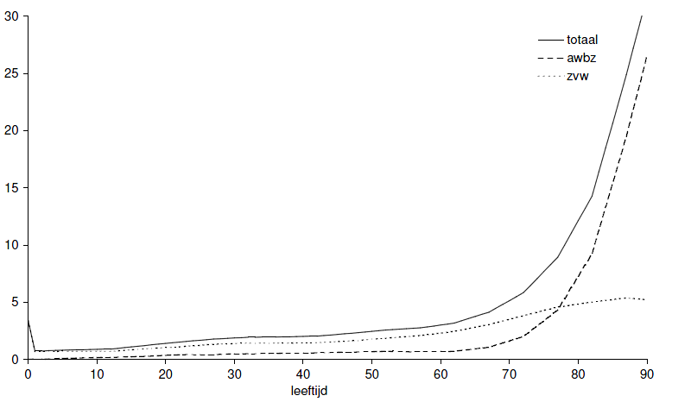
With the coming changes in demographic composition of the Dutch population an ever lager part of this population will shift to the far right of figure 1, this effect is commonly referred to as the baby-boom generation. This will result in a significant increase of the total cost of care, especially the AWBZ.
The second effect of the changing demographic composition of the Dutch population can be seen in the ratio between the labour force and the number of elderly people. According to the Netherlands Bureau for Economic Policy Analysis (CPB) this demise will last until 2040. The reduction of the labour force will have consequences for the income-related premiums which are the basis for the financing of the AWBZ. The impact of the AWBZ on the GDP is considerably larger than other compartments of the Dutch health system, for instance the Health Insurance Act (ZVW), because of the large dependency on income-related financing (CPB, 2005) and the occurrence of cost mainly in the last years of someone's life (Yang, Norton and Stearns, 2003). The increase in cost of healthcare will place an ever greater demand on the solidarity principle that is the base of the AWBZ, as the working population will have to finance the ever growing cost of healthcare.

In the past, the costs of the AWBZ were limited by controlling the supply of healthcare (Schut & Van de Ven, 2005). Through this mechanism the Ministry of Health could prevent the cost becoming too expensive to bear by the Dutch population. This had a number of negative side-effects, such as the creation of waiting lists for patients entitled to receive AWBZ care, at the end of the 1990's. Through the implementation of the project Modernization of the AWBZ the traditional control mechanism has been replaced by a healthcare marked through which the cost should be kept within acceptable boundaries through competition and price negotiations. The boundaries for the modernized AWBZ healthcare sector are not yet fully known, as these are dependant upon a large number of variables, like the average age of people in the Netherlands in the coming decades and the development of the GDP (CPB, 2005).

The modernization of the AWBZ was introduced in an effort to transform healthcare from a supply-driven system to a demand-driven system (CPB, 2004). The AWBZ demonstrates the changes that had taken place in the Dutch society and the public's view on healthcare in the 1990's. The implementation of the modernization of the AWBZ took the better part of the last decade. Within this timeframe a large number of profound changes were made to the entire health system in the Netherlands.
Because of the rising cost of healthcare during the last years a growing interest to the causes of this rise has developed. The main question is, whether this increase in cost of healthcare can be sustained in the future. The modernization of the AWBZ has resulted in a complete system change, through the changing of rights and responsibilities of the various stakeholders and adjusted regulations.

The diminishing labour force causes an additional problem for the future of sustainable healthcare, besides the financing of healthcare. It is estimated that through the increase in care, the share of people working in healthcare in the Netherlands will increase from roughly 13% in 2010 to over 20% in 2020 (SER, 2008). Furthermore the AWBZ care is a very labour-intensive sector, where productivity is difficult to improve. This causes an effect of less productivity growth than in other sectors of the Dutch economy, while wages are adjusted to the overall increase of wages in the economy (Baumol, 1967). Through this effect the cost of the labour force increases more than its productivity, and results in a relative increase of the cost of healthcare. According to Lindbeck (2006) the Baumol effect is the largest threat to the financing of the welfare state. This is especially true for the care covered by the AWBZ, as it is largely labour-intensive. The increase in the demand for care will also have to be supplied by the Dutch labour force. This will place an extra strain on the solidarity principle of the AWBZ.

The focus of the Dutch healthcare marked changed through the modernization of the AWBZ from a supply-driven market to a demand-driven market. The healthcare market was also introduced to a regulated form of competition among health organizations, under the control of the Regional Care Offices (RCO's). In order to control the healthcare expenses in the new AWBZ, rules and responsibilities for all stakeholders were changed and the cost of healthcare needed to be monitored on a national, regional and an individual level. The primary source for the need for information is the organizations which provide the healthcare. Therefore, the healthcare organizations have implemented new measures in order to comply with these new responsibilities. It is unclear what the cost of controlling the healthcare system are, and which part of this is due to the modernization of the AWBZ. The demand for controlling the healthcare system by monitoring the cost comes at a price. Knowing the effect of the modernization of the AWBZ on the administrative responsibilities of healthcare organizations and its productivity can give valuable information to decision-makers in order to further adjust and possibly increase the efficiency of the healthcare system in future.

The changes in society and the effects to the healthcare system are not unique to the Netherlands. According to Schut & Van de Ven (2005) changes to the healthcare systems in many countries can be divided in three faces. These phases consist of a first face ensuring universal coverage for the population, a second phase focused on the containment of cost and a third phase focused on incentives within the healthcare system and competition.
In 1991 Hurst published a study to the healthcare reforms in seven European countries of the Organization for Economic Cooperation and Development (OECD). In his study Hurst (1991) stated that the problems faced by these countries were quite similar through the last decades. This was for instance the case with the rapid increase of healthcare costs in the 1970's due to the expansion of healthcare coverage and the cost containment policies of the healthcare systems in the 1980's. In a number of countries, including United-Kingdom and Germany, a form of managed competition was introduced in the late 1980's in order to increase the efficiency of the healthcare system. According to Hurst (1991) the healthcare policies of OECD countries suggest that they pursue the same goals, although with sometimes different priorities. These goals relate to; adequate and equal access to healthcare, healthcare expenditure in relation to the GDP, freedom of choice for patients, patient satisfaction, income protection for patients and autonomy for providers.
The World Health Organization (WHO) stated in a report in 2002 that the increase in healthcare spending in countries of the OECD during the 1990's could be explained by the ageing populating, the labour-intensity of healthcare, the innovation in technology and rising public expectations. Of these explanations the ageing population may lead to the largest increase in expenditure of long term healthcare costs and the need to make changes to the current healthcare systems.

Problem description
As stated above the predicted increase of cost for the AWBZ due to the baby-boom generation, combined with a declining labour force could cause a problem for the financing of the AWBZ in years to come. It is very much in question whether the current AWBZ system can be maintained in the future (SER, 2008).
Through the implementation of the Modernization of the AWBZ the orientation of this system has been changed completely, and with it the measures for control. The lack of insight regarding the cost and quality of care is recognized by the Ministry of Health and underlined by the Netherlands Bureau for Economic Policy Analysis (2008) in their advice regarding the future of the AWBZ. The problem which is addressed in this thesis is the effects of the modernization of the AWBZ on the administrative costs of healthcare organizations. The problem is defined as;

How can the administrative costs of healthcare organizations be measured and what are the effects of the modernization program of the AWBZ on the administrative costs of healthcare organizations?

Research-questions
In order to measure the administrative costs of healthcare organizations and the effects of the modernization of the AWBZ the following research questions will have to be answered;

- What is the content of the modernization program of the AWBZ?
- Are there effects of the modernization of the AWBZ for administrative costs of healthcare organizations?
- Can the administrative costs of healthcare organizations be measured uniformly?
- What are the administrative costs of healthcare organizations?
- Is a significant difference in the administrative costs of healthcare organizations observable before and after the implementation of the modernization program of the AWBZ?

Methodology
Through a literature review the contents of the modernization program of the AWBZ and the effects for administrative costs of healthcare organizations will be analysed. Based on the conclusions a cost measurement model will be selected and used for the measurement of administrative costs.
In order to answer the research questions, regarding the administrative costs and the changes in administrative costs after the implementation of the AWBZ, quantitative research methods will be used. Data will be gathered regarding cost of healthcare organizations which supply care under the AWBZ Act. Data is needed for the period before and during the introduction of the modernization of the AWBZ. This data will be analyzed and compared, using statistical tests. For this study existing databases will be used, this can be classified as a desk research.

Relevance of research
Due to the changing demographic composition of the Dutch population during the next decades the healthcare system will come under increasing pressure regarding financing and available personnel to supply this care. This will be especially true for the AWBZ as this part of the healthcare system is based on solidarity, by which the cost are to be paid by (predominantly) the working class of the population. Research by the Netherland Bureau for Economic Policy Analysis (CPB, 2011) shows that the spending for public healthcare will increase from 9.8% in 2011 to 18.4% of the Gross Domestic Product (GDP) in 2030.
Besides the increasing cost of healthcare due to the ageing population, the demographic composition of the Netherlands will at the same time lead to a diminishing labour force. Not only will the cost increase, but the cost will have to be borne by fewer people. Besides the cost aspect of the equation of the financing of the AWBZ there will also be less people that can pay for this healthcare system and can provide the workforce needed to provide care. This can work as a lever through which the AWBZ could become unsustainable in its current form.
Reducing administrative costs is one way through which the rising cost of the AWBZ can be limited in the future. Also the reduction of the administrative costs can increase the productivity of healthcare professionals. Insight in the administrative effects of the healthcare system in the Netherlands can help stakeholders with decision-making regarding the impact of changes on the cost of healthcare. It can also give insight in the possible reduction of cost of healthcare, through savings on administrative costs, without affecting the quality and quantity of care provided.

Motivation Topic
As a controller for a healthcare organization, I have a personal interest in the topic of my thesis. In this position I have seen many changes during recent years in the way healthcare is organized in the Netherlands and the effects of these measures for the stakeholders in this line of business. As a controller I can often comprehend and appreciate these effects from an economical point of view, but often wonder if these measures are necessary in a regulated market as the Dutch healthcare market and what effects these measures have on healthcare itself.

Structure of the thesis
In order to answer the research-questions the components of these questions are incorporated in a schematic overview, as can be seen in figure 2. This conceptual framework will be used in each of the chapters of this thesis. The framework starts with the reforms of the modernization program of the AWBZ.

Figure 2: conceptual framework
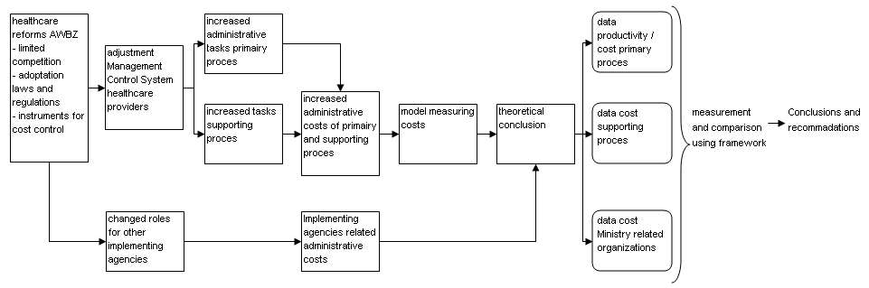

In chapter 2 the Dutch healthcare system is described along with the modernization program, which has been implemented by the Ministry of Health throughout the better part of the last decade. This chapter also describes the scientific view on these reforms and the impact of the reforms to the management control systems of healthcare organizations. In chapter 3 the administrative costs of the Dutch healthcare system are described as is the system through which the Ministry of Health controls and measures these costs. This is offset against the knowledge from scientific studies performed, mostly in North-America, to analyse the measurements which have been carried out by the Ministry of Health. This chapter ends with a definition of administrative costs which is best suited to objectively and fully capture these costs. In chapter 4 a model for measuring administrative costs is discussed. This is done by the analysing existing models and research in the field of administrative costs in healthcare. This model is needed to perform a complete and objective measurement of the administrative costs of the Dutch healthcare system before and after the modernization program of the AWBZ. As chapter 2, 3 and 4 are focus on the theory; these chapters will end with a conclusion. The cost measurement model chosen in chapter 4 will be elaborated in chapter 5. A number of changes will be made to this model in order to adjust this model to measure the administrative costs of due to the modernization of the AWBZ. Chapter 6 gives a description of the data collected for this study, and the methodology used. The data is analysed to be used in the cost measurement model. In chapter 7 the output of the measurements is presented. The conclusions and recommendations are stated in chapter 8. In this chapter the research-questions will also be answered.

Chapter 2 Healthcare reforms

In this chapter the Dutch healthcare system is described, to give a better understanding of the background of the problem description of this thesis. The effects of the modernization of the Dutch healthcare sector are explained, as are the most important stakeholders which are involved in the execution of healthcare system in the Netherlands. This chapter ends with a conclusion regarding the effects of the healthcare reforms for the administrative costs.

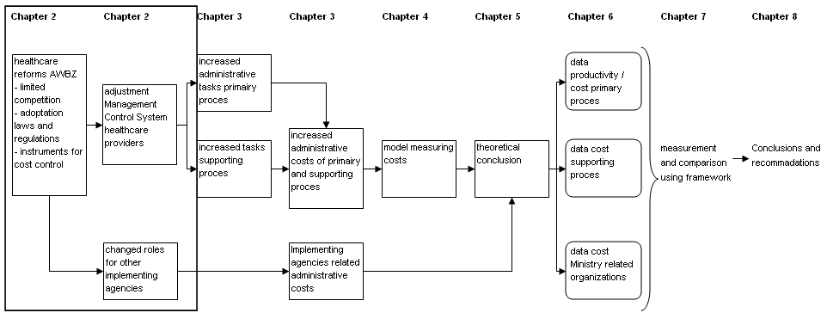

Dutch Healthcare system
The Dutch healthcare system consists of two main compartments. This is the Exceptional Medical Expenses Act (AWBZ) for healthcare due to prolonged illness and the Health Insurance Act (ZVW) for immediate care. The first component is a Social Security Scheme (SSS), the second a mandatory Private Health Insurance (PHI). Due to both the social and private funding component of the system, the Dutch healthcare system can be described as a hybrid system (Grit & Dolfsma, 2002). The total expenditure for healthcare in the Netherlands in 2010 was € 87.6 billion, which amounted to 14.8% of the GDP in 2010, or € 5.272 per captiva (CBS, 2011).

Figure 3: healthcare expenses in 2010 * € 1.000.000 (source: CBS)
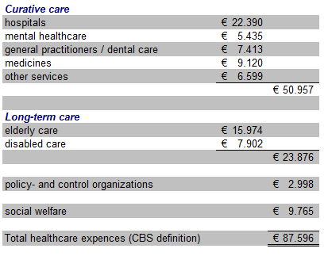

Besides the cost of care which are recorded the hidden costs of healthcare in the Netherlands, known as informal care, is estimated to be the same magnitude as the formal care, implicating that the real cost of care would double when the informal care will be supplied by professionals (Meerding, Bonneux, Polder and Koopmanschap, 1998).
The Dutch Government, through the Ministry of Health and a number of implementing agencies, is responsible for the execution of the healthcare system in the Netherlands, in order to provide quality healthcare to the population at acceptable cost. The providers of healthcare, for example hospitals and nursing homes, are mostly privately owned (not for-) profit institutions.

Exceptional Medical Expenses Act (AWBZ)
The Exceptional Medical Expenses Act (AWBZ) was introduced in 1967. It is one of four social insurances that every resident of the Netherlands is entitled to. This Act regulates the medical care for all residents of the Netherlands due to prolonged illness or disability. The AWBZ and the other social insurances are based on the principle of solidarity, whereby the costs are financed through general means.
The creation of the AWBZ was the result of a discussion in the 1960’s when it became clear that a large majority of the population could not bear the burden arising from prolonged illness. It also became clear that a solution would not arise through private initiative. The possible risks involving prolonged illness were not sufficiently insurable. The then Minister of Social Affairs and Health introduced a provision with the character of a social insurance in the form of a national insurance. The coverage by the AWBZ is described in the AWBZ Act and a number of related legislations.
Since its introduction in 1967 many changes have been made to the original Act. These changes can be divided in several different phases. These phases can also be observed in a large number of other countries (Schut & Van de Ven, 2005). In the first years after its introduction the emphasis laid on increasing the quality of healthcare. Gradually the focus shifted from the basic quality of healthcare to the expansion of healthcare covered by the AWBZ. In the 1970’s the care covered by the AWBZ expanded in order to strengthen the cohesion between the different care facilities. During the 1980's, due to a rising unemployment and a stagnating economy (Schut & Van de Ven, 2005), the Government tried to limit the cost of healthcare. In 1986 a commission (Commission Dekker) was installed and given the task to design a new healthcare system with more efficiency. Because of the lack of necessary conditions which were not feasible at this time, this new healthcare system did not materialize.
In the 1990's the expansion of the coverage of the AWBZ from the 1970's was counteracted when the AWBZ was focused more on its original objective, namely the medical care due to prolonged illness (Social Economical Council; SER, 2008). Many of the expansions which had taken place were redirected to the regular (private) medical insurance. The cause of the measures of the 1990's laid in the increasing cost of healthcare in the Netherlands. The AWBZ was predominantly supply-driven in the 1990's. The Ministry of Health determined the number of care organizations, the budgets and the activities which were covered by the AWBZ. Through control of the supply of care, the budget control was largely guaranteed.

Figure 4: healthcare expenses in % GDP 1998-2010 (source: CBS, 2011)
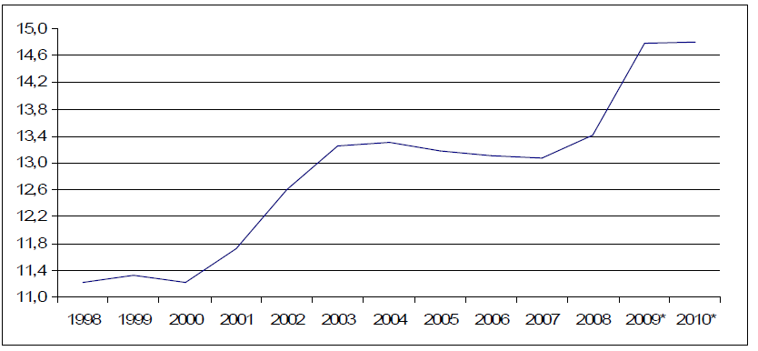

According to Schut & Van de Ven (2005) the policy of the Dutch Government had a twofold goal from 1980 up to 2000. The first was the containment of the cost of care. The cost control was implemented through the replacement of the open-end reimbursement system by a budgeting system for expenses in 1983 and 1984. The other goal was the introduction of incentives into the health system, in order to improve efficiency.
The cost containment goal, through the introduction of limited budget systems, worked for the Dutch healthcare sector in achieving a limited, but controlled rise of cost. As the demand for care did not diminish, the effect of these measures was the unavoidable creation of waiting lists. During the end of the 1990's the pressure to abolish the waiting lists grew and eventually led to a number of judicial decisions were the right for care was confirmed. The main reason for this was the fact that people were entitled to care under the AWBZ Act. The control of cost by the Ministry of Health was not a legitimate reason to restrict access to healthcare. This meant that the limitations to the supply of care could not be maintained. From 2000 on budget control through supply-side control was no longer a feasible mechanism for the AWBZ, and the limitations through supply-side of care were abandoned. This leads in 1999 up until 2002 to a considerable rise of the cost of healthcare. At the end of the 1990's it proved impossible to contain the cost of healthcare through supply-side limitations and budgetary controls, and let to proposals to reform the healthcare sector in the Netherlands (Schut & Van de Ven, 2005). In the coalition agreement of 1998 the modernization of the Dutch health system and the AWBZ was introduced as a priority for the Ministry of Health. This agreement set the outlines of the changes which needed to be made to the system. This consisted of the introduction of a demand-driven healthcare system, more uniformity between the different sectors of healthcare and the abolishment of uniform budget rates.

In 1999 the Dutch Ministry of Health published a paper with the title “View on healthcare” ("Zicht op Zorg"). This paper described the problems faced by the stakeholders of the AWBZ and outlined the urgently needed modifications to this Act. The AWBZ Act was outdated and would not be able to cope with the changes within the Dutch population. The basic principle of the modernization was to centralize the needs of the patient in the healthcare system. This would be achieved by changing the AWBZ from a supply-driven to demand-driven healthcare system and would need to facilitate a better control of the cost, so that healthcare could be provided efficiently. The main problems of the old AWBZ came down to the following items (Ministry of Health, 1999);
- an ever increasing budget to finance the AWBZ care,
- an increasing demand for care,
- inefficient budget system for healthcare organizations,
- inefficient alignment between the demand and supply of care,
- the needs of the recipients of the care were not the primary focus of the system,
- boundaries within the AWBZ regulations for the various stakeholders,
- lack of information for decision-makers.

In order to overcome these problems and to make the AWBZ future-proof the modernization of the AWBZ had four major goals (Ministry of Health, 1999);
- the recipient of care would be the focus of the AWBZ,
- care would have to be tailored to the needs of the customers,
- the care would have to meet the needs of the changing society,
- efficiency would have to play a much larger role than it did in the old system.

The Ministry of Health is responsible for the healthcare system in the Netherlands and ensures the interest of all stakeholders in healthcare; it is responsible for the accessibility, quality and efficiency of the healthcare system (Grit & Dolfsma, 2002). Ministry of Health realized that small changes to the existing AWBZ would not be sufficient to realize the change from a supply-driven system to a demand-driven system. The AWBZ offered little room for flexibility to meet the changes required. In addition, the rules and regulations of the AWBZ posed an obstacle for the effective functioning of the AWBZ (Ministry of Health, 1999). In order to keep this system operating, while these changes would take place, new measures would be implemented gradually and in coordination with one and the other to minimize the effects of the reforms to the stakeholders. These changes were made on three main topics (Ministry of Health 2000);
  - ensuring a proper regulation of market conditions,
  - adaptation of law and regulations,
  - new instruments for cost control.

Although the modernization of the AWBZ started in the first years of the last decade, the completion of this project is not jet achieved. In the current coalition agreement the healthcare reforms are continued.

Ensuring a proper regulation of market conditions
The Ministry of Health expected the cost of the AWBZ to rise through the introduction of the demand-driven focus of the system (Ministry of Health, 2000). This would have to be compensated through a larger effectiveness of the AWBZ in the future. The introduction of competition as the primary mechanism to coordinate supply and demand replaced the previous coordination mechanism of governmental regulation. This competition would be enabled by the Ministry of Health, but would be effected by the (regional) stakeholders of the healthcare sector. Both the Regional Care Offices (AWBZ) and the Private Health Insurers (ZVW) will protect the interests of their clients and form a counterweight to the healthcare provides in the negotiations of tariffs and quantity.
The market mechanism which was introduced by the Ministry of Health only allowed a regulated form of competition. The term regulated competition refers to the rules which have been introduced by the Ministry of Health and the implementing agencies of the Ministry of Health. This was done to counteract the possible negative side-effects of the competition as much as possible, in order to protect the public function of the healthcare sector, while at the same time promoting competition for components of the system were efficiency can be achieved.

Figure 5: Organizational overview of the Dutch healthcare system (Nivel, 2010)
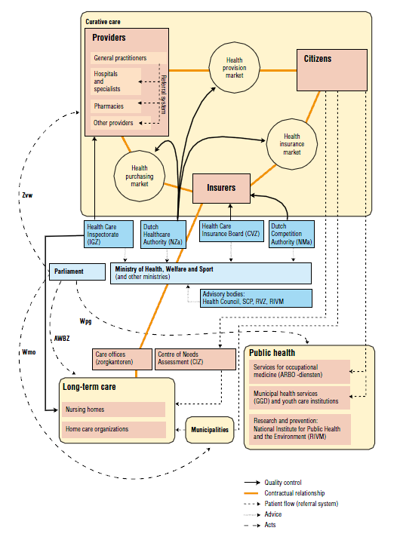
The Ministry of Health would, also in a demand-driven healthcare system, have a considerable power to influence and adjust the competition amongst stakeholders. This power could be used through determining the regulations of the healthcare system, the contents of the entitlements of the AWBZ and the basic medical insurance of the ZVW and controlling the instruments to intervene on the healthcare market (Maarse, 2011).
In order for the Ministry of Health and its implementing agencies to perform the function of policymaker and regulator (Maarse, 2011) they will have a considerable need for information. This is also observed by Porter & Teisberg (2004) who analysed the competition in the United States' healthcare system. According to Porter and Teisberg (2004) information is an integral part of competition and of the utmost importance in order to let a market operate successfully.

Adaptation of law and regulations
The adaptations of law and regulations were necessary on a number of subjects. These changes would provide the patients of the AWBZ and the Regional Care Offices (RCO's) with a good position in the negotiations with the healthcare organizations.

In the AWBZ system the recipient of care is not charged directly for the care received as the financing or the healthcare providers is performed by the AWBZ. The patients receive the care which they are entitled to, but are often not aware of the cost. This also means that the choice of patients for a specific care organization or the type of care is rarely cost motivated. In order to overcome this possible inefficiency, the Personal Care Budget (PGB) was introduced. Through this arrangement the patient receives a budget, based on the care that the patient is entitled to, and can make choices in which way the budget is spend. This way the budget can be spend more efficiently and in accordance with the desires of the patient. In general a PGB budget amounts to 75% of a standard budget. The reduced budget of 25% is applied because there is no need for overhead costs by healthcare organizations. If a person with an AWBZ consent chooses a PGB, the Regional Care Office provides a budget. The PGB recipient has its own responsibility regarding the budget and the accountability for this budget. In order for the patient to make decisions regarding the type of care and the care providers, there is a need for adequate information regarding cost, quality and availability of care.

The old entitlements for care under the AWBZ were strictly defined in terms of type of healthcare sector needed by the patients, for example nursing home or mental healthcare. This gave the healthcare organization little flexibility to customize the care to the needs of the patients. In order to put the needs of the clients of the AWBZ central, it was needed to be more flexible in the care which could be received as a client. In 1987 the commission Dekker laid the foundation for this significant change of the AWBZ. Although these changes were not used at the time, a number of changes was implemented years later through the modernization of the AWBZ. The entitlements of the AWBZ would be defined as functions.
The care as a total package would be replaced by care that could be received in several individual components. The care recipients are no longer dependant on a specific type of healthcare organizations, as different types of healthcare organizations could give parts of the total care required. There are seven different functions which relate to accommodation, condition of the client or the ability to be independent in the society. Each function is expressed in a range of hours of care.
This change was paramount because a client was no longer automatically linked to a healthcare sector and possibilities of the healthcare market were increased enormously. Through the implementation of this change the barriers between the different care sectors largely disappeared.

In the old budget structure a health organization received part of the yearly budget based on the number of clients which were treated. There was no or very little differentiation between the budgets for a patient, despite the sometimes very different need for care. Starting from 2007 the consent of the patient, which was needed to receive care under the AWBZ Act, was based on the different functions, called Care Intensity Packages (ZZP's). The Care Intensity Packages would determine the budget for the healthcare organization. Through this measure the budget of a health organization and the care needed and provided to the client became more differentiated. All declarations of the care, provided for by the healthcare organizations, are based on the Care Intensity Packages. The patients are assessed by the Centre for Healthcare Consents (CIZ) and receive a consent for the AWBZ. When the intensity of care needed by a patient changes, the consent for the AWBZ has to be re-evaluated. The risk for incorrect consents lies with the healthcare organizations, as it may not be fully compensated for the care provided to the patient.

One of the most important changes of the modernization of the AWBZ concerned the responsibilities of the Regional Care Offices (RCO's). These regional care offices would play a larger role in the new AWBZ, especially regarding the efficiency of the new healthcare system. Cost control through efficiency is a determining factor in the approach of the modernized AWBZ. The Regional Care Offices would have to control the cost at a regional level. In order to reform the role of the Regional Care Offices, from administrative institutions to a policymaker at a regional level, the capacity of the Regional Care Offices would have to be increased. Due to the changed role between the Ministry of Health and the Regional Care Offices this would also lead to a decrease of capacity at the central level, with the Ministry of Health.
The most important task for the RCO's in the modernized AWBZ is to contract sufficient AWBZ care in a certain region. The RCO is obligated to provide care for the AWBZ insured. The RCO is free to contract care from care providers in the region and to negotiate about price and quality. The execution of the tasks of the RCO will, in general, be granted to the largest private health insurance company in a certain region. They can obtain a consent to exploit the AWBZ during a limited number of years.
In order to receive care under the AWBZ a person must have a consent of the CIZ. The RCO has a responsibility in guaranteeing sufficient care for patients, but cannot and may not be able to influence the consents which give a patient the right for care under the AWBZ. This should be done by an independent organ. This consent can be obtained through the Centre for Healthcare Consents (CIZ), which is a nationwide organization. Through the introduction of a nationwide organization for the access to the AWBZ, the consents would become uniform for all AWBZ insured. This would also improve quality and efficiency. The CIZ is financed by the Ministry of Health. Through the uniform procedures the CIZ is an important source of information for the Ministry, to monitor the developments of the AWBZ and analyze the effects for the future.

New instruments for cost control
In the old AWBZ the care organizations, which had a concession of the Ministry of Health, were entitled to a budget. This budget was largely fixed and not based on the production of care for the AWBZ. The Regional Care Offices had no choice to contract these organizations, as this was obligated under the AWBZ. The budget of healthcare organizations before the modernization of the AWBZ consisted of three main components;
- Capital costs; these costs were budgeted based on a concession of the healthcare organization with the Ministry of Health. This part of the budget was predetermined and could not be negotiated by the healthcare organization or the Regional Care Office.
- Capacity-based costs; this budget was determined based on the capacity of a health care organization and also could not be negotiated.
- Standard operating costs; the third and final component of the budget was based on the production by a health care organization. This component was subject of negotiation, but on a limited scale.

When the budget right of the healthcare organizations was abolished, the Regional Care Offices could take the price and quality of care by the individual care organizations into account, when the yearly budget contracts would be discussed. The care could be delivered by the best performing and most cost-effective care organizations. This would create a better negotiating position of the Regional Care Office and ultimately lower cost for the AWBZ.

Figure 6: Financial flowchart of the healthcare system in the Netherlands (Nivel, 2010)
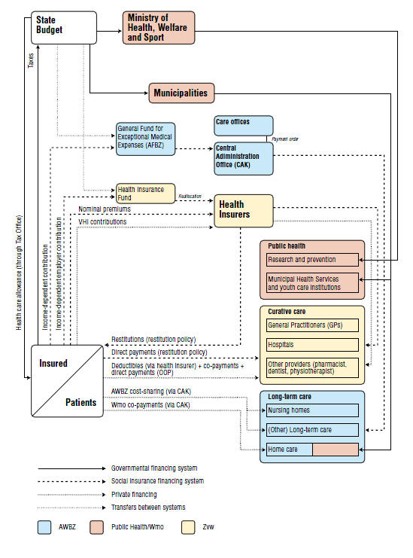

In the old AWBZ system the healthcare organizations were compensated for the capital costs of investments which were approved by the Ministry of Health. This meant that both the healthcare organization and the financing agency (often a bank) were almost excluded from risk on these investments- and financing projects. The Ministry of Health guaranteed the loans, but could decide on the investment projects of individual healthcare organizations. In order to facilitate the new role of the Ministry of Health and the healthcare organizations both the freedom for the investment projects and the risk which is involved in financing these projects is delegated to the healthcare organizations. They will have to asses the financial feasibility of these projects and have a banking institution finance these projects based on economic reasons.

Social Support Act
With the introduction of the Social Support Act (WMO) in 2007, tasks were converted from the AWBZ Act to a separate Act which would be executed by the municipalities. The tasks which were converted regard to home care. The municipalities purchased the home care from care providers through tenders. Many municipalities have their own rules regarding the accountability of home care. Through the decentralization, the Social Support Act could be adjusted and implemented at a regional level, in order to customize the needs to the local population. This meant that the uniformity in declaration and registration decreased.

Health Insurance Act
One of the measures taken within the context of the Modernization of the AWBZ is the implementation of the Health Insurance Act (ZVW) in 2006. The Health Insurance Act covers all medical care, which includes hospital care and general physicians. The Health Insurance Act (ZVW) for curative care replaced the system of the Private Health Insurance and Social Health Insurance. The coverage of this Act consists of a basic coverage determined by the Government, which is standard for all insurers, and optional additional coverage, which can be adjusted by the insurance companies. A person is free to choose, or and which additional coverage he or she wants. Insurance companies are obligated to insure anyone who wishes a health insurance.
Although the introduction of the ZVW has led to a universal insurance for all Dutch residents and stimulated competition between insurance companies, this Act has not reduced health care expenditures. The annual increase of cost of the ZVW was at an average 5% annually (Okma, Marmor and Oberlander, 2011). According to Okma et al. (2010) the efforts to increase competition also increased administrative costs, due to the complexity of the system. The freedom to choose an insurance company under the ZVW did not bring about a large shift in the insurance field as people after 2006, at the initial launch of this Act, largely stayed with the same insurance company. Also, since the introduction of the ZVW, the number of insurance companies dropped from 57 in 2006 to 29 in 2010 (Maarse 2011). The four largest private health insurance companies have a combined market share of 90%.
The funding of hospitals consists of two segments. In the A-segment prices are regulated, while in the B-segment the price-setting is led to the market. Maarse (2011) also points out that the hybrid system contributes to huge administrative complexity. Although the ZVW has brought about a number of positive effects, for example shorter waiting list and increased competition among health insurers there is no evidence of savings of the total cost. As a result of the increased competition health insurance companies incurred losses on the basic healthcare package.

International context
The reforms to the healthcare system are not contained to the Netherlands alone. Many countries have used the last decades to modernize their healthcare system. These countries often experienced the same cycle of healthcare spending as the Netherlands, as described by Schut & Van de Ven (2005). The models of the healthcare systems used (Social Security Schemes and Private Health Insurance) can be quite different among countries. In a study performed by the OECD (2003) the reform experiences of different countries were studied. A number of countries studied by the OECD in 2003 have reformed their healthcare market in order to create quasi markets. According to the OECD (2003) the enlarged independence and responsibility of healthcare providers, resulted in efficiency gains. However "Gains in efficiency in the hospital sector have been partly offset by the greater need for information both as a basis for effective management and to fulfil the oversight requirements of the funders and purchasers". This was also concluded with the healthcare reforms in the United Kingdom and New Zealand. The OECD (2003) writes about the efficiency gains due to the healthcare reforms: "These small successes in New Zealand and the United Kingdom need to be seen against a significant increase in administrative costs".
In the United Kingdom the healthcare system in the 1990's was introduced to market reforms, based on a limited form of competition. Despite of the increase of administrative costs due to the market reforms (Le Grand, 1999) the efficiency of the healthcare system improved. The rise in administrative costs was due to the accounting procedures introduced. According to Le Grand (1999) the administrative costs rose from 8% in 1991-1992 to 11% in 1995-1996 and the administrative staff increased by 15% from 1990 to 1995. The cost of senior and general managers increased by 133%.

Management Control System of health care organizations
In order to change the focus of the Dutch healthcare system a number of measures were introduced on the subjects of laws and regulations, instruments for cost control and the introduction of managed competition. These measures to reform the AWBZ can be seen as an example of the environmental uncertainty (Merchant & Van der Stede, 2007), as part of the situational factors, the other factors being organizational strategy and multinationality. Organizational strategy defines how an organization chooses to compete in its market and tries to achieve a competitive advance related to its competitors. The Multinationality refers to organizations that operate in more than one country (Merchant & Van der Stede, 2007).

Merchant & Van der Stede (2007) describe environmental uncertainty as; "the broad set of factors that, individually and collectively, make it difficult or impossible to predict the future in a given area". According to Merchant & Van der Stede (2007) the uncertainty can stem from; regulators, competitors, customers and suppliers (labour).

The healthcare organizations are influenced directly by the Government as a regulator, but are also influenced indirectly by the Government through the introduction of managed competition. Through this measure the healthcare organizations became competitors, influencing each other. Otley (1994) (cited in Kloot, 1997) stated that "only those organizations which match their capabilities to the changing needs of the marketplace and other stakeholders will survive".

Healthcare organizations need to take the changes in the environment into account, to access whether it should have an impact on their organization. These organisations would have to adjust their Management Control Systems (MCS) in order to adapt to the changes. Management Control Systems can be defined as "everything managers do to help ensure that their organization's strategies and plans are carried out or, if conditions warrant, that they are modified" Merchant & Van der Stede (2007).

Conclusion chapter 2
In the 1990's the Dutch Government realised that the healthcare system would not suffice in the future, due to the increased cost of healthcare. In order to maintain a qualitative good and affordable healthcare system, the focus would have to switch from a supply-driven to a demand-driven system. In order to switch the focus changes were made to laws and regulations, creating market conditions and implementing instruments for cost control, in order to increase the efficiency of the system. Despite the new measures the cost of healthcare over the last decade still rose considerable from 11,2% in 2000 to 14,8% of the GDP in 2010.

The changes to the laws and regulations, market conditions and the instruments for cost control forced healthcare organisations to play their new role within this system. The external changes can be seen as environmental uncertainty and were translated to adaptations of the Management Control Systems and implemented within the healthcare organizations, in order to fulfil the new possibilities and responsibilities.

The introduction of the Health Insurance Act (ZVW) has had effects on the administrative costs for private insurance companies. It seems logic that a similar effect can be seen in the AWBZ, as managed competition was introduced in this component of the Dutch healthcare system. Competition and changing responsibilities brings a natural need for information. International research has shown that healthcare reforms, through the introduction of competition on the healthcare market, can lead to an increase of the administrative costs for the healthcare system.
From this it can be concluded that there is a strong indication that the changes to the AWBZ can lead to the increase of administrative costs of healthcare organizations. The effects of the modernization of the AWBZ for Dutch healthcare organizations will first have to be analysed, so this can be used as input for the measurement of the effects of administrative costs due to the healthcare reforms. The description of the effects will be the starting point of chapter 3.

Chapter 3 Administrative costs

In this chapter effects of the reforms to the Dutch healthcare system on the administrative activities will be addressed. These effects need to be measured in the following chapters in order to quantify the effects for the administrative costs of healthcare organizations. In the second paragraph the different views on the definition of administrative costs in healthcare are addressed and compared. A definition of administrative costs will be selected which will be used in the selection of a cost measurement model and to perform the measurement of administrative costs.

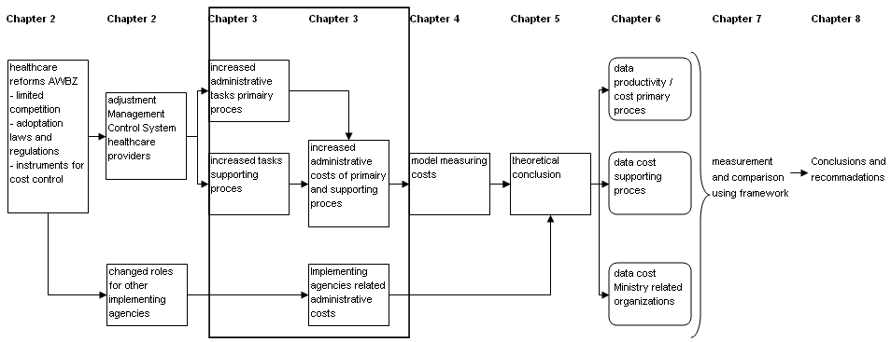

Effects of modernization AWBZ for healthcare organizations
With the introduction of the modernization of the AWBZ, a shift has occurred in the execution of the laws and regulations regarding the financing of healthcare. This is especially true for the changes to the AWBZ, the introduction of the Health Insurance Act (ZVW) in 2006 and the Social Support Act (WMO) in 2007. With the introduction of the Social Support Act healthcare organizations were faced with three different financing arrangements, in order to receive payment for the care they provided. Each of the three legislations has its own rules regarding accountability, declaration and financing of the care provided to patients. According to the study performed by Plexus and BKB (2010) the cooperation between the different financiers of the healthcare system, after the introduction of the modernization of the AWBZ, is difficult as each of the financiers is trying to protect their own arrangement in the healthcare system from possible mixing with other arrangements. The method used in trying to safeguard the financing arrangement is often through the implementation rules and regulations regarding declaration of care given to patients. The Social Support Act grants the delivery of care to healthcare organizations, on the basis of a tender. This places additional rules and regulations to the healthcare organizations.

The execution of the legislations also meant additional control costs. This is especially true for the Social Support Act, where each municipal set its own regulations regarding this Act. Due to the relatively limited economy of scale of most municipalities the execution of this Act is less efficient (Plexus and BKB, 2010), than previously performed by the Regional Care Offices.
There is also a lack of standardization regarding information exchange, tenders and declaration with many of the municipals. Also due to the regional expansion of many healthcare organizations, these organizations now operate in several municipalities and are faced with different requirements regarding registration and accountability for the same care which is delivered. The control costs rose during the period 2000-2008 from € 1,7 billion to € 2,3 billion, but as a percentage of the total healthcare expenses over this period the control costs decreased from 5,0% in 2000 to 4,2% in 2008 (Plexus and BKB, 2010).

Another important example of instruments for cost control is the deregulation of the reimbursement of capital costs. Because the capital costs are no longer automatically reimbursed, as a fixed budget, healthcare organizations will have to make investment decisions as they now bear the full risk of the investment. In order to perform this new addition to the control of the organization additional information is required.

Since the introduction of the modernization of the AWBZ there has been a focus on instruments for cost control. With the change of the healthcare system from a supply-driven system to a demand-driven system, the declaration of the care supplied to patient was based on individual patients. One important component of the healthcare reforms is the introduction of the Care Intensity Packages (ZZP's). These intensity packages were introduced to align the budget of the healthcare organizations to the amount of care needed by the patients. Instead of receiving a uniform rate per patient, the intensity of care became leading for the funding. A study commissioned by the Ministry of Health (2011) showed that a majority of healthcare organisations agreed with the perused objectives of the implementation of the Care Intensity Packages. In the same study conducted by HHM, Casemix & Q-talent (2012) showed that 82% of the healthcare professionals experienced more administrative activities due to the implementation of the Care Intensity Package's (ZZP's), as a measure of the modernization of the AWBZ.

The administrative activities by healthcare providers can also have an effect on the cost of healthcare through the diminishing productivity of healthcare professionals. By implementing procedures regarding registration of client-bound information, as a result of the adaptation of the management control system of healthcare organizations, the administrative costs can be influenced by a loss of productivity of healthcare processionals. According to Goudriaan, Hauten and Bartelings (2005) there are four important factors which determine labour productivity. These factors are;
- Technical and organizational development; for example care-related innovations which enable growth in productivity,
- Scale of the production; which can be measured by production or capacity,
- Development of the environment; these are external factors as changes in society and environmental changes or law and regulations,
- Efficiency of the production.

Productivity can be defined as the relation between the production and the quantity of labour which is needed to achieve this production (Dell & Vandermeulen, 2005). Production can be classified in total production, which incorporates all production factors (capital, labour and intermediate consumption) and added value, which only incorporates the production factor labour. In order to obtain the added value, the total production needs to be corrected for the other production factors. The production of healthcare is diversified by a large number of products and services which prohibits a straightforward measurement of productivity, also due to the differences in intensity of care given to patients the output of the healthcare process is not homogeneous (Kleijn, Campagne, Paagman and Smit, 2006). This requires the production to be translated to a common denominator standard which can be measured (Dell & Vandermeulen, 2005). A similar problem which effects the measurement of the output of the healthcare process is also present when measuring the input (labour) of the healthcare process. The labour is also heterogeneously composed, namely different professions and skill levels of healthcare employees. These effects can be corrected as a factor of input, but can also be seen as a factor of output. By using the last method the differences in skill level and professions can be measured and analyzed as an effect on the productivity.

Defining administrative costs?
The term administrative costs will be a familiar concept to most people, but in order to measure and compare these costs, the term administrative costs will have to be made explicit. The Ministry of Health only includes administrative costs if the Government is politically responsible for the expenses. The Ministry defines the administrative costs as;

"the costs for companies and citizens which are necessary to comply with information requirements arising from law and Governmental regulations"

Administrative costs, according to this definition, relate to the cost in order to collect, record, store and to make the information available. This definition includes both the Government and other organizations as receivers of information. By using this definition the possible administrative costs made by many stakeholders in the healthcare system are excluded from the equation, as are the (administrative) costs of implementing these laws and regulations.
The administrative costs, according to the definition of the Ministry can decline while the overall administrative costs of the healthcare organizations can increase, due to the regulations of other stakeholders. The potential benefit by one of the stakeholders can be more than offset by the disadvantages by other stakeholders, whereby it could lead to a negative-sum game. In figure 7 an overview is given of the various stakeholders for the administrative processes of a healthcare system. These stakeholders could potentially be influenced by the redistribution of responsibilities and tasks of the healthcare reforms.

Figure 7; Health insurance administration-related activities of other actor's (source: Nicolle & Mathauer, 2010)
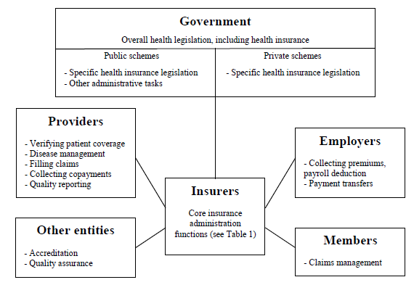

During the implementation of the modernization of the AWBZ it became clear to the Ministry of Health that their view towards administrative costs was not broadly shared among stakeholders in the healthcare sector. The Ministry only regarded costs as administrative costs if they were caused by a law or regulation by the Government. Regulations by other stakeholders, often an implementing agency of the Ministry of Health, were not included in this definition.

Healthcare professionals did not recognize the outcome of the measurement of administrative costs, as used by the Ministry of Health. In order to better connect to a definition of administrative costs, as interpreted by other stakeholders in healthcare, a survey by PWC (2006) was conducted to the perception of administrative burdens by healthcare providers. In this survey the definition of administrative costs as applied by the Ministry of health was adjusted to also include the administrative burdens caused by other stakeholders than the Government and the definition also included the implementation of rules and not just the execution of rules itself (PWC, 2006). One of the findings of this research was that less than half the experienced administrative burdens were caused by the execution of rules and regulations and the majority was caused by other factors, such as the method of introduction of new rules and regulations.
PWC (2006) approach the concept of administrative burdens as;

"activities which are time-consuming and complicated and were healthcare providers do not see the benefit of"

This definition connected more closely to the manner at which the administrative burdens were experienced by the professionals in healthcare organisations and not just the manner in which the administrative burdens could be measured objectively. The researchers classified the administrative burdens and concluded that many of the subjects with the highest scores of administrative burdens were subjects which were recently implemented in the healthcare system (PWC, 2006). Throughout the different healthcare sectors of the AWBZ the findings of administrative burdens were remarkably similar.

In 2010 a study was performed on a number of subjects regarding the Dutch healthcare system. One of the studies was conducted to the administrative costs of healthcare and received the title "more time for patients". This study described the current situation on the administrative burdens in healthcare and aimed to give a number of opportunities on this subject. The following definitions of administrative costs were used in this study;
- narrow definition of administrative costs; this is the definitions as used by the Ministry of Health,
- compliance costs; costs which are made in order for an organization to confirm to law- and regulations,
- supervisory costs; costs incurred by healthcare organizations to confirm to disclosure obligations,
- administrative activities; these are the costs related to the administrative processes, despite of the source form which these activities originated,
- perceived burdens; this is the subjective experience of administrative actions by healthcare professionals and patients,
- control costs; this are the costs made by healthcare insurers, implementing agencies of the Ministry of Health and governance costs in order to execute the healthcare system,
- overhead costs; this are the cost of the supporting processes in healthcare.

As the focus of this study was aimed at the available time for patients of the healthcare system, this study advocated a broadly defined concept of administrative costs in order to relate to the understanding of administrative costs by healthcare professionals and the public. The study showed that the compliance costs for healthcare organizations due to law and regulations by the Ministry of Health, which is the base for the definition of administrative costs by the Ministry of Health, is very limited (Plexus and BKB, 2010).

In the scientific literature a number of studies have been performed regarding the definition of administrative costs and the risks regarding ill-defined administrative costs. According to Thorpe (1992) a number of implicit assumptions are made when comparing administrative costs of healthcare plans or between countries by various researches. The most critical assumption is the comparability of administrative functions of health systems. In order to compare the administrative functions objectively he classifieds the administrative costs in four functions; transactions-related, benefits management, selling and marketing and regulatory/compliance.

According to Folland, Goodman & Stano (2007) administrative costs are all costs in excess of benefits payments. This definition does not attempt to identify the components of administrative costs, but tries to eliminate the costs of the primary function of a healthcare insurance within a Private Health Insurance system (PHI). The costs which remain, after deducting benefit payments, may also include profits, taxes and reserve payments and could be categorized as non-benefit costs, according to Zycher (2007).

In a study by Woolhandler and Himmelstein (1997), a comparison was made between the cost of care and the administrative costs of for-profit hospitals in the United States, using a classification of administrative costs. This definition was used earlier in a study published in 1991 regarding the efficiency of the U.S. healthcare system. The classification of the costs was derived from the data published by Medicare. They classified the following components as administrative costs;
- administrative and general,
- nursing administration,
- central services and supply,
- medical records and library,
- employee benefits department (salary costs only),
- administrative and general - home health,
- skilled-nursing facility utilization review.

Besides the possible definitions of administrative costs which have originated from literature in the field of healthcare, the definition can also be derived from economic literature in general. Administrative costs, in production companies are often defined as;

"costs that are associated with management, clerical and general functions within an organization that cannot be directly applied to some expense category related to operation"

This definition looks at the administrative costs as a part of the supporting processes of a organization. This definition emphasis de relationship between the cost made and the production of an organization. For healthcare organizations this production can be seen as the production the direct care provided to its patients.

Despite the claims of some researchers regarding the difficulty of implementing a definition and framework of administrative costs for different healthcare systems and countries on behalf of measurement and comparison, there is a number of organizations which have collected data regarding administrative costs of healthcare systems. One of which is the OECD (Organization for Economic Co-operation and Development). The OECD consists of most of the industrialized countries of the world. The OECD developed the System of Health Accounts (SHA). The SHA provides a standard in classifying expenditure for healthcare spending. The SHA is an integrated system of comprehensive and internationally comparable accounts and provides a uniform framework of basic accounting rules and a set of standard tables for reporting health expenditure data (OECD, 2004). The SHA defines health administration and health insurance as (OECD, 2000);

"activities performed by private insurers and by central, regional and local authorities including social security funds"

This includes the cost from activities due to planning, management, regulation and collection of funds and handling of claims of the delivery system. The administrative costs of healthcare organizations are excluded from this definition and treated as part of the service functions provided to the patients. The administrative costs of healthcare organizations are seen as directs costs of healthcare and not as indirect costs.

Analysing definitions of administrative cost
The definition of administrative costs is the base for the selection of the cost measurement model in chapter 4 and the measurement of administrative activities. The definition needs to identify the components of administrative costs in order to properly measure its components. This information can facilitate management to improve efficiency by controlling the cost of overhead (Horngren, Foster and Data, 2000).
Administrative costs not only consist of the wages and salaries of administrative and management personnel, but also include the operational costs which are needed to perform the administrative activities. In addition to administrative personnel, some of the administrative tasks can also be performed by healthcare professionals (Woolhandler and Himmelstein, 2003). These tasks also need to be taken into account in order to measure the total administrative costs. The administrative activities by healthcare professionals, in the context of delivering care, need to be excluded from the measurement as these activities can be directly linked to providing healthcare to patients. This elaboration addresses the cost tracing (direct costs) and cost allocation (indirect costs) of cost calculation.

In order to select a definition for the measurement of administrative costs, this definition needs to be able to incorporate the various aspects of the healthcare reforms. One of the elements of the modernization of the AWBZ is the redistribution of responsibilities and tasks of the different stakeholders involved with the healthcare system. This advocates a definition which can be used broadly. The effects for healthcare organizations also need to be captured in this definition, in order to measure the possible cost effect within the primary and supporting processes of healthcare organizations.

The definition as used by the Ministry of Health imposes large restrictions to the concept of administrative costs, based on the stakeholders that initiated the administrative tasks. This distinction should not be taken into account as this is not relevant for costs of administrative activities. In order for a definition of administrative costs to be effective in measuring these costs, the definition needs to incorporate the total costs of administrative activities, despite of the stakeholder who initiated these cost.
Also, by defining the administrative costs broader than "arising from law and Governmental regulations" decision-makers could use the outcome to reduce the administrative costs in different areas than just the laws and regulations by the Ministry. This is a basis for the facilitation of management in their decision-making processes.

The definition of administrative costs used by PWC (2006) cannot be measured objectively, as the extent of the administrative costs is dependant upon the opinion of the healthcare professional and their insight of what is beneficial to healthcare. A lack of insight by the healthcare professional in the processes of a healthcare organization could also play a role in the definition of these costs.

The definitions by Thorpe (1992), Folland, Goodman & Stano (2007) and Zycher (2007) are based on the processes of American Private Health Insurers. The components of administrative costs have little conformity with the structure of the AWBZ as a Social Security Scheme, as is described in chapter 2 (see figure 5 and 6). This severely limits the usefulness of these definitions for other healthcare plans, as the processes are organized according different functions and principles.

According to the definition SHA of the OECD all expenses of healthcare providers are regarded as direct costs and not seen as administrative costs. The administrative costs only occur from regulatory authorities. This seems improbable as in any organization, with the exception of a single-product manufacturer there will be a distinction between direct and indirect costs and an allocation of costs to the products produced. This definition can only give limited insight in the total administrative costs as a large component is excluded from the measurement in advance.

The definition by Woolhandler and Himmelstein (2003) and the definition of administrative costs according to general economic literature both make a distinction between direct and indirect costs. This can also be seen in a number of definitions of administrative costs by Plexus and BKB (2010), especially regarding overhead costs and administrative activities. This distinction in all three definitions is made on the base of the allocation of costs to healthcare products, and better reflects the management accounting view on administrative costs. These definitions are not affected by the restrictions imposed in some of the other definitions.
The definition by Woolhandler and Himmelstein gives a clear distinction of administrative and other expense categories and summarizes the expense categories which are regarded as administrative. Although this definition has a distinction between direct- and indirect costs, the interpretation of Woolhandler and Himmelstein can severely limit the choice for a cost measurement model in chapter 4.

The definition from general economic literature has a distinction between the primary and supporting processes, which is consistent with a management accounting view of administrative costs. It defines the administrative costs broadly and thereby overcoming the restrictions of administrative costs of some of the definitions. This will be beneficial when selecting a cost measurement model to perform the measurement of administrative costs. The administrative costs in this thesis will therefore be defined as;

"costs that are associated with management, clerical and general functions within an organization that cannot be directly applied to some expense category related to operation"

Conclusion chapter 3
In this chapter a number of effects of the modernization of the AWBZ on the administrative costs of healthcare organizations is described. These effects consist of changes to the composition of healthcare packages under the AWBZ, the instruments for cost control and changes regarding the financing of healthcare. The effects indicate consequences for the administrative costs for both the primary and supporting processes of healthcare organizations. Before the effects of these changes can be measured a cost measurement model needs to be selected in chapter 4. This model will be used to perform the measurement of administrative costs.

In order to select a model, it should be clear what this model needs to measure. For this reason several definitions of administrative costs are described in the second paragraph and analysed in the third paragraph of this chapter.
The public at large and healthcare professionals see administrative burdens much broader, than defined by the Ministry of Health. This is concluded by PWC (2006) from a study of the administrative burdens by healthcare organizations and healthcare professionals. By defining the administrative costs broader than "arising from law and governmental regulations" decision-makers could use the outcome to reduce the administrative costs in different areas than laws and regulations by the Ministry. By applying the definition of administrative burdens too narrow, it is very well possible that measures of reducing administrative costs will be overlooked. It can therefore be advocated to interpret administrative costs broadly. By applying the definition too narrow health professionals and healthcare organizations can no longer identify themselves with the conclusions and measures taken to reduce administrative costs by the Ministry.

The definition should be able to capture the effects of the healthcare system reforms form the perspective of the healthcare providers and be able to measure the administrative costs from a management accounting point of view. Restrictions in the definitions of administrative costs should be prevented as much as possible. This allows for a wider range of cost measurement models for healthcare to be chosen from in chapter 4, and is suitable for quantitative methods to be used. For this reason the administrative costs in this study will be defined as;

"costs that are associated with management, clerical and general functions within an organization that cannot be directly applied to some expense category related to operation"
This definition can also capture the costs from administration which is done by personnel in the primary processes and not just overhead personnel. The definition forms the basis for the selection of a cost measurement model in chapter 4.

Chapter 4 Cost measurement model

In order to measure the effects of the modernization of the AWBZ on administrative costs of healthcare organizations, a model is needed to measure and compare the administrative costs. The model needs to ensure that the selection of data and the comparison can be objective and complete in order to draw the correct conclusions. The comparison of administrative costs can lead to a number of mistakes through wrong or incomplete assumptions. The cost measurement model needs to prevent these mistakes from occurring.

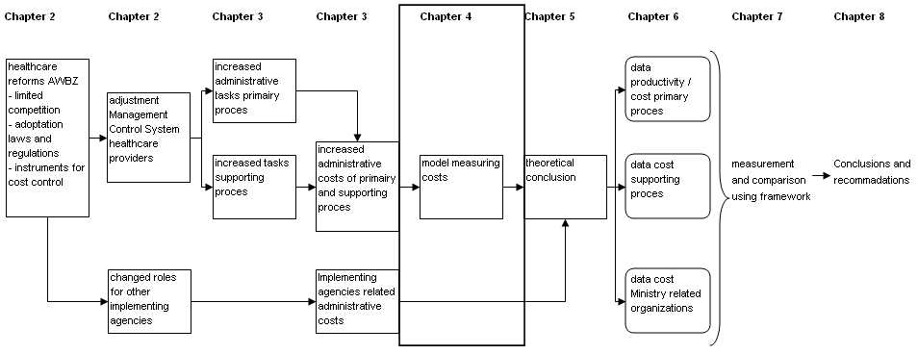

Measuring administrative costs
Research done in the field administrative costs in healthcare is primarily based on the North-American healthcare systems, according to Mathauer and Nicolle (2011). In 1991 Woolhandler and Himmelstein published a study based on the comparison of the American and Canadian administrative costs of the healthcare systems. They found large differences in overhead costs between the two countries, with 19.3% to 24.1% of the health budget spent on administration in the United Stated, while Canada only spent between 8.4% and 11%. For the United States this came down to a cost for administration between $ 400 and $ 497 per capita. The administrative costs of the US healthcare system were 60% higher than that in Canada. This research showed considerable differences is the administrative costs of the different healthcare systems used by the two countries, a mainly private insurance market in the United States versus a national health program in Canada.
Although a number of substantiated assumptions was made in this research, this led nevertheless to a number of profound questions raised by other researchers based on the methods used and the conclusions drawn.
Woolhandler and Himmelstein (1997) also performed a study to the difference in administrative costs between for-profit and not-for-profit hospitals in the United States. The conclusion of this study was that the for-profit hospitals spent on average 23% more on administration than comparable not-for-profit hospitals.

Danzon (1992) addresses the subject of hidden costs in the research done by Woolhandler and Himmelstein. The hidden costs are related to the different functions of the healthcare systems which are used by the two countries. In the private insurance market in the United States a portion of the administrative costs is caused by the collection of the healthcare premiums. These costs are not clearly visible in a national health program, where the premiums are collected by the tax authorities. These costs were not taken into account. The cost of raising one US dollar through taxes is estimated to be between $ 0.17 and $ 0.50. If only the administrative costs of the healthcare system are taken into account, and not the functions which are performed by other institutions, on behalf of the healthcare system, the comparison will not be made on the same functions which can be distinguished. The United States' National Health Accounts estimates the overhead of private insurance companies at 10.5% of premiums paid or 11.7% of the benefits paid for 1987.
According to Danzon (1992) it would be logical that overhead costs in a competitive market, as the U.S. private health insurance market, would be lower than under a monopoly public healthcare system as the Canadian. This is caused by stronger incentives to maximize efficiency. He states that his framework confirms that the overhead costs of the Canadian public healthcare system, with the addition of hidden costs, is higher than the private healthcare insurers in the United States.

The American Medical Association (AMA) also gave its view on the results of the study performed by Woolhandler and Himmelstein. In their view the study had a number of shortcomings which related to the hidden costs Danzon (1992) reported earlier. Also the approach taken to make the calculations had serious drawback according to the AMA. In the recommendations regarding the administrative costs the AMA supports the development of a consistent format for defining, measuring and reporting administrative costs. The AMA believes that the subject of administrative costs can give a better understanding to policy-makers about approaches to the healthcare reforms in the United States, when the discussions are based on evidence, instead of incomplete data.

The comparison of the administrative costs of the healthcare systems of the United States and Canada shows the difficulty to identify and estimate these costs and make a comparison between two different healthcare systems, according to Aaron (2003). It shows that a purely accounting approach to the administrative costs issue can have large consequences for the conclusions drawn. Aaron (2003) also questions the calculations methods used by Woolhandler and Himmelstein, arguing that a different approach will give a large difference in the outcome of the calculations.

In his study Glaser (1993) described the healthcare systems of 4 countries; Germany, Canada, England and the United States. The US healthcare system consists of multiple public and private health insurance schemes, often with its own guidelines and reimbursement procedures. According to Glaser the United Stated had significantly higher administrative costs, than the other countries in his research. The reason for the higher administrative costs laid in the complexity of the US healthcare system and the magnitude of different rules and regulations.
The Canadian healthcare system consists of a governmental funded system with only a very limited private healthcare sector. The healthcare is provided free of charge and is reimbursed by the decentralized provincial healthcare organizations. Through the governmental funded system some functions, which are provided in the United States, are not found in the Canadian system and therefore do not lead to additional administrative costs. The cost of reimbursement of the care given by healthcare organizations to patients are kept to a minimum through standardized declaration procedures.
The National Health Service (NHS) in England owns most of the hospitals in the country and employ's healthcare professionals. Only a limited number of hospitals and nursing homes are privately owned. According the Glaser the NHS system is administratively the least complex of the countries examined in his research.
In Germany the government has a limited role in the healthcare system and mostly creates the conditions for the system to function properly. The German system is predominantly managed on a regional level. There are multiple sickness funds (healthcare insurers) and regional associations of healthcare providers. According to Glaser the administrative costs are primarily found with the sickness funds and the regional associations of healthcare providers. Based on his research Glaser made a number of generalizations regarding the administrative costs of healthcare systems;
- Some of the healthcare functions can be seen in every healthcare system and are unlikely to change or disappear through healthcare reforms,
- The administrative costs associated with organizations with healthcare responsibilities appear to approximate the organization's role in the healthcare system. More responsibilities usually require larger organizations with usually require more administration,
- The healthcare reforms which have introduced more market-oriented systems, have led to more autonomy for various stakeholders. This has led to more decentralization of the healthcare system and would be expected to increase the administrative costs of these organizations.

In 2003 Woolhandler and Himmelstein conducted new research to the differences in administrative costs between the United States and Canada's healthcare system. This research gave similar conclusions as their earlier study of 1991.
In this study a number influential assumptions were made, in order to obtain their conclusions. On of these assumptions was related to the time spent by nurses and physicians on administrative tasks. They did not differentiate between time spent by nurses and physicians on administrative tasks, but used the outcomes of a study to the administrative time spent by physicians to calculate the administrative time of nurses. This assumption could have a large impact on the conclusions made, as the tasks of the two professions can differentiate largely.

The government controlled Medicare in the United States claims to have only a 2% cost for administration. Under the Medicare plan the people over 65 years of age are insured for hospital care and prescription drugs. One of the reasons that Medicare can report a minor 2% of administrative costs, besides the method used to calculate the portion of administrative costs, is the earlier discussed hidden costs, as reported by Danzon (1992).
Matthews (2006) gives a number of arguments as to why the administrative costs of Medicare have to be considerably lower than the administrative costs of private insurance company. Medicare does not raise its own funds, as these are obtained through the tax-authorities. Also, a number of functions which are a part of the regular operations of a commercial organization, like raising capital, do not have to be performed by Medicare. Another important point in comparing the Medicare system to the private insurer's system is the economy of scale. Through the larger numbers of insured under the Medicare plan it can achieve an economy of scale, where its operating costs does not rise in the same proportion as its medical costs. This gives a relatively lower percentage of administrative costs in comparison to some smaller private insurance companies. Some of the large private insurance companies do achieve similar benefits through economy of scale according to Matthews (2006). In his research Matthews estimates the administrative costs for Medicare to be 5.2%, while the administrative costs of private health insurers are 8.9%.
The Medicare system is a healthcare system for elderly people. The healthcare costs of the Medicare system per insured will by considerably higher than the healthcare costs of younger people, according to Matthews (2006). By dividing the administrative costs per person through the medical costs of elderly people the outcome will be considerably lower than when the medical costs of younger people is used.

The OECD (Organization for Economic Co-operation and Development) collects data on the cost of healthcare systems around the world, based on a uniform model. This model (SHA; System of Health Accounts) has been used for a large number of years to collect data. As stated in chapter 3 the definition of administrative costs used by the SHA only takes the costs into account which were made by private insurers and central, regional and local authorities. This does not include the administrative costs of healthcare organizations, but reports these costs as direct costs of healthcare. This could also account for the low administrative costs of the Dutch healthcare system, according to the OECD. The administrative costs of the public healthcare system of the Netherlands from 2001-2007 amounted to 2.9% to 4% of the total insurance expenditure, while the administrative costs of the private health insurance amounted 9.5% to 17.7% between 1995 and 2008.

The World Health Organization (WHO) published a rapport in 2010 regarding the administrative costs of health insurance schemes of 58 countries. The study aimed to make a comparison between counties of cost incurred for overhead and find explanations for the differences between these countries. The WHO classifies the data according to their National Health Accounts. According to the WHO the administrative costs are often overlooked in healthcare expenditure. The reasons for differences in administrative costs of healthcare systems can be divided in four groups; different methodologies applied, different administrative functions undertaken, country context variables and insurance design aspects. Without a uniform base for registration, an unbiased comparison without hidden costs or a large number of assumptions will be almost impossible.
The collection of data used by the WHO was compared in a study by Mathauer and Nicolle (2011) who concluded that due to the differences of healthcare systems between countries the use of aggregate data is inadequate to make a correct comparison. More detailed information about the factors which contribute to these differences could also gives a better analysis of the causes for the fluctuations in administrative costs between countries and healthcare systems.

Model measuring administrative costs
With the outcome of the study by Woolhandler & Himmelstein (1991) a number of other papers also provided a framework, in order to overcome the problem of ill comparison of the administrative costs of healthcare systems. In this paragraph a several models, used to measure administrative costs, are described.

Woolhandler & Himmelstein (1997) classified the cost of the US healthcare system in a number of categories. This is the same model as used in their 1991 study. Although the data used was quite extensive, a number of assumptions were made in order to make a valid comparison between the different components. This is for instance the case with the administrative costs of nursing homes.

Figure 8; Classification of costs (Source: Woolhandler & Himmelstein 1997)
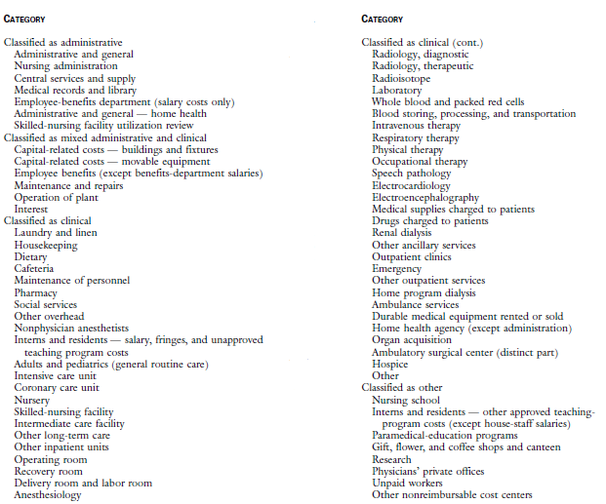
These costs were not available from Medicare and were derived from a study to the administrative costs of nursing homes in the State of California and used as a reference for the nationwide administrative costs of nursing homes.
The costs were classified into four groups; administrative, clinical, mixed administrative and clinical and other costs. With this classification some costs which were classified as mixed administrative and clinical, for instance fixed costs, were allocated to the different groups. The model uses three steps in order to measure and compare the administrative costs;
- dividing the healthcare system is sectors (hospitals, nursing homes etc.),
- estimate and allocate administrative expenditure for each sector, based on the available data,
- measure and compare the data.

In his article "the black box of administrative costs", Thorpe (1992) presented a framework to classify the different administrative functions within the American healthcare system. Thorpe (1992) regarded the uniform comparison of the administrative functions of health plans as the most critical assumption regarding the administrative costs. The administrative functions are classified in four categories; transactions-related costs, benefits management, selling and marketing and regulatory / compliance.

Figure 9; Administrative costs by function and sector of the US Health Care System (Source: Thorpe, 1992)
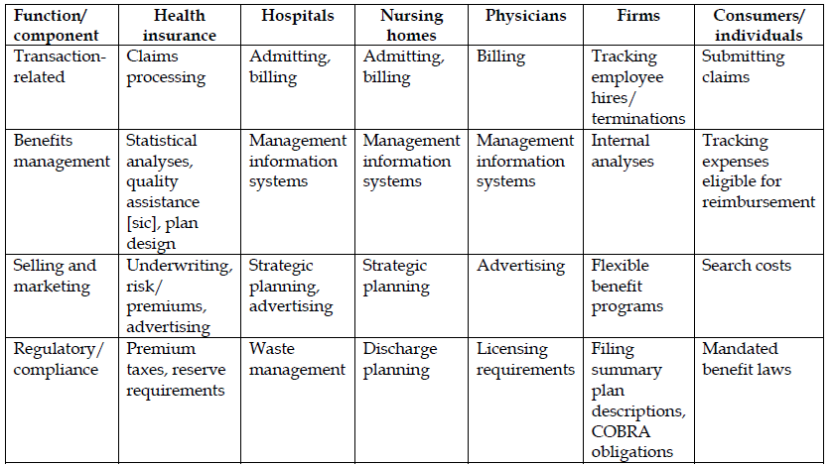

The administrative costs, according to Thorpe (1992), are used to produce administrative services to deliver healthcare, and should not just be regarded as wasteful. Because the classification of the framework of Thorpe is aimed at the U.S. healthcare market the usefulness of this framework for other countries is limited (U.S. Congress, Office of Technology Assessment, 1994).

Hahn (1993) (cited in OTA, 1994) suggests two adaptations to the model developed by Thorpe (1992) to make it applicable to other countries. He suggests to expand the functions with a new category, named oversight (fifth function), which is primarily used in social security healthcare systems. This function should incorporate the cost due to budget setting, negotiations about prices with providers etc. This function is not found in the US private health insurance system. Another adaptation that he suggested, is the inclusion of a category "production functions" when these functions perform administrative activities. This could also be a difference between countries. For instance in one country the administrative functions are performed by nurses or other production personnel, while in other countries these functions are performed by clerical staff. Due to the differences in execution of these functions the cost can be classified differently, through which a good comparison is no longer possible.

Glaser (1993) (cited in OTA, 1994) developed a bottom-up model to measure and compares the administrative costs of any country's healthcare system. According to his definition of administrative costs, which is also based on the different functions, it included; transaction-related costs, regulatory, compliance and coordination. This classification is a distinction between functions which can be identified, but also included administrative costs other than purely compliance costs. The administrative activities should be identified and the costs of each activity, through, for example, the use of FTE's (Full Time Equivalents) should be measured. Due to the extent of the model, the full framework, designed by Glaser, is included in Appendix 2.

The Ministry of Health uses a Standard Cost Model (SCM) to measure the costs due to administrative burdens. The SCM is used within the departments of the Dutch Government as the standard model to measure and compare administrative costs. This model is also used by a large number of other countries and governmental agencies. The model uses activity based data on a detailed level, in order to measure the administrative costs for businesses. The data is obtained through a bottom-up approach of the administrative activities.

Figure 10; Standard Cost Model; Interdepartmental Project Management administrative burdens (2004)
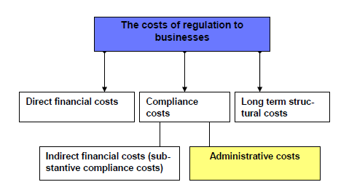
Not all cost relating to regulations for businesses are regarded as administrative costs, only the costs derived from the compliance to laws and regulations, which are made for the registration and or transfer of information, are considered administrative costs.
The administrative costs can be sub-divided even further, into administrative burdens and administrative activities. This distinction is made on the base of the usefulness of the registration by businesses. This could be useful information in determining the effects of abolishing the measure by the Government for the administrative costs by businesses.

Figure 11; Standard Cost Model; Interdepartmental Project Management administrative burdens (2004)
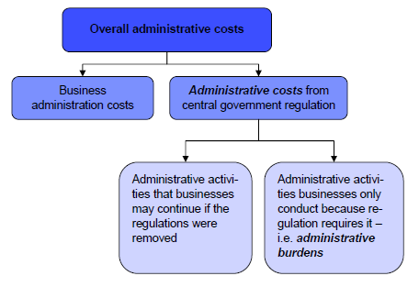
According to the SCM network it is very labour intensive to asses the administrative burdens and the administrative costs of organizations. In order to measure the administrative costs the administrative activities first need to be identified, based on the definition of administrative costs used. In the case of the Standard Cost Model the definition consists of the activities due to laws and regulations executed, as required by the Ministry. These activities are measured (time) and multiplied with the cost of the employees who performs these activities. Based on the number of organizations which perform these activities and the frequency, the total cost per law or legislation can be calculated.

In the 2010 study "more time for patients" which was conducted to the administrative costs of the Dutch healthcare system, the administrative costs were classified in a number of different categories. This study was commissioned by the Ministry of Health and performed by Plexus and BKB in 2010. The results of the study by Plexus and BKB were used for a number of sessions regarding possible solutions for the problems faced by the Dutch healthcare system. This specific model was used for the problem regarding the available time of for patients and was published in a study named "more time for patients".
The classification used a broad definition of administrative costs, in order to connect to the perceived administrative costs by healthcare organizations and the public. The classification consists of four indicators, as can be seen in figure 12.

Figure 12; Cost measurement model (Plexus and BKB, 2010)
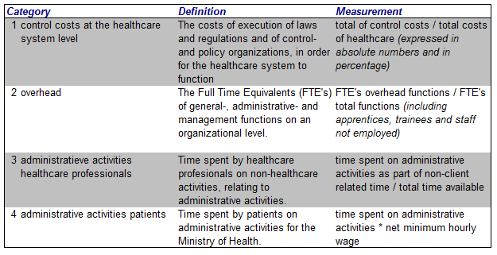

The four categories give an overall picture of the extent of administrate costs in healthcare. An important assumption of the model is that the categories are interrelated, whereby the effects of an increase or reduction in one category can influence the administrative costs in another category. An example of this is that the use of good qualified overhead personnel can lead to a reduction of administrative activities by healthcare professionals.

1. Control costs at the healthcare system level
The control costs at the healthcare system level are made by various stakeholders. These stakeholders are defined by the Dutch Central Bureau of Statistics (CBS), under the category; "costs for policy and control organizations". The control costs consist of the following categories;
- costs made for the execution of the AWBZ, the Social Health Insurance Act and the Health Insurance Act (ZVW),
- operating costs for the Social Health Insurers / Private Health Insurers (ZVW),
- operating costs for private health insurance,
- operating costs for supplementary health insurance,
- personnel- and operating costs for the execution of the Social Support Act (WMO),
- costs of the Ministry of Health, both personnel- and operating costs,
- costs of advisory boards and the Netherlands Bureau for Economic Policy Analysis (CPB),
- the total costs of the Dutch Healthcare Authority (NZa).

2. Overhead
Overhead is the time spent by overhead personnel. This consists of general-, administrative-, and management functions on a sector level. This category is measured in time spent by overhead personnel (FTE's) and compared to the total FTE's employed in the various healthcare sectors. The classification of overhead clearly distinguishes overhead personnel from other supporting personnel, related to hotel- and building-related functions. The FTE's of healthcare employees are classified according;
- client-related function; healthcare professionals,
- overhead functions; general-, administrative- and management functions,
- facilitating functions; hotel functions, terrain- and building-related functions.

3. Administrative activities healthcare professionals
The Administrative activity of healthcare professionals is the time spent by healthcare professionals on non-healthcare activities, relating to administrative activities. The total time spent by professionals is divided in;
- direct client-related time; time spent by the healthcare professional with a patient (face-to-face time),
- indirect client-related time; time spent by a healthcare professional for a client, without the client being present e.g. updating personal care file,
- not client-related time; remaining time spent by a healthcare professional which cannot be allocated to a patient or group of patients e.g. team meetings.

4. Administrative activities patients
The administrative activities of patients is the time spent by patients on administrative tasks for the Ministry of Health, regarding their healthcare. This consists of administration for Personal Care Budget (PGB), obtaining prescriptions etc.

The OECD (Organization for Economic Cooperation and Development) developed a System of Health Accounts (SHA). The SHA can be used to compare the healthcare spending of different counties consistently; despite of the way the healthcare system is designed or financed. The SHA takes all healthcare spending into account, despite the public or private financing of funds. The healthcare spending is expressed in a percentage of the Gross Domestic Product (GDP). The healthcare expenses are classified from three different perspectives, namely the functions of healthcare (HC), the healthcare service providers (HP) and the sources of funding of healthcare (HF). In this classification the administrative costs consists of all costs which can be classified under Healthcare function (HC) and health provider (HP);
- HC 7.1.2 Administration, operation and support of security funds,
- HC 7.2 Health administration and health insurance; private,
- HP 6.2 General administration and insurance - Social security funds,
- HP 6.3 General administration and insurance - Other social insurance,
- HP 6.4 General administration and insurance - Other (private) insurance.

Analysing cost measurement models
The cost measurement model should be consistent with the definition of administrative costs, as analysed in chapter 3. The selection of the definition was made on the ground for a measurement which would incorporate the various effects of the modernization of the AWBZ, due to the reforms of the Dutch healthcare system. The effects of the modernization of the AWBZ featured the redistribution of responsibilities and tasks of the different stakeholders, the instruments for cost control and changes regarding the financing of care. Management accounting principles also need to be incorporated in the cost measurement model in order to measure the possible effects within the primary- and supporting processes of healthcare organizations.

The frameworks developed by Thorpe (1992) and Glaser (1993) (cited in OTA, 1994) identify the functions of a healthcare system. These functions are based on the processes of the system of Private Health Insurance in the United States. It is very much in question whether these frameworks can be used successfully for healthcare systems based on a Social Security Scheme, as the Dutch AWBZ, which clearly has a different structure and processes.

Even with the adjustments made by Hahn (1993) (cited in OTA, 1994), in order to make the model of Thorpe (1992) usable for other countries, by adding the function oversight, the basic functions which are incorporated in the model still show large anomalies from the structure of a Social Security Scheme. This would seriously complicate the measurement of administrative costs by adding a large number of assumptions, while at the same time making the conclusion of this measurement less usable. This risk has been clearly analysed by Danzon in his study of 1992. Due to the fact that the functions in the framework of Woolhandler & Himmelstein (1991) were not aligned with the processes of the Canadian healthcare system, the measure showed a number of anomalies which were named hidden costs by Danzon (1992). The remarks made by Danzon have been supported by a number of other studies regarding the results of Woolhandler & Himmelstein.

The model of Woolhandler & Himmelstein (1991) offers a distinction between direct and indirect costs as the administrative costs are categorized in administrative costs, mixed costs and costs of healthcare. Due to the difficulties of this model in detecting hidden costs, as it is based on Private Insurance Schemes it is less applicable for Social Security Schemes as the Dutch AWBZ.

The framework used by the OECD (System of Health Accounts) provides an overall framework to cover the costs of the entire healthcare system, but does not differentiate the cost of healthcare organizations in the cost of primary care and overhead costs. This is consistent with the definition of administrative costs which is used by the OECD.
It seems illogical from a management accounting point of view that administrative costs could only originate with the regulatory organizations and not within healthcare organizations. The SCM does offer a distinction between administrative costs and other costs, but is based on a narrow definition of administrative costs, which was not adopted, based on the literature review in chapter 3.

The model used by Plexus and BKB in the 2010 study "more time for patients" is well suited for the definition of administrative costs, as chosen in chapter 3, were a distinction of administrative costs on the basis of direct and indirect costs is made. This distinction can be seen in the different components of administrative costs which is the base of this model. These components can be measured separately and used to analyse the administrative costs of these components in conjunction with each other. This is an advantage for the measurement of the effects of the modernization of the AWBZ as it is not fully clear where these effects, within a healthcare organization, will be visible.
The Plexus and BKB model is based on the Dutch Social Security Scheme. This can be an advantage when trying to identify and measure hidden costs, as addressed by Danzon (1992). This model is most suited to perform the measurement of administrative costs in the Dutch AWBZ sector.

Conclusion chapter 4
In the first paragraph of this chapter a number of relevant studies is described in the field of measuring administrative costs in healthcare. These studies are primarily based upon the North-American healthcare systems. From these studies it can be concluded that the measurement of administrative costs is subjected to the assumptions made and models used by researchers. These assumptions can have a large impact on the conclusions. This is described by Danzon (1992) who addressed the subject of hidden costs in response to the study by Woolhandler & Himmelstein (1991). From this literature review it can be concluded that a model to measure administrative costs needs to be tailored to the structure of the processes within a healthcare system, in order to measure the full extent of the administrative costs.

In the second paragraph several cost measurement models are analysed. In order to measure the administrative costs of the Dutch healthcare system, a model needs to be selected which is able to capture the costs of the components of this system. This model needs to be able to measure the administrative costs defined in chapter 3.
The definition of administrative costs was chosen in order to capture the full extend of administrative costs; regardless of the stakeholder that initiated the administrative activities and the organizational level at which these activities are performed. The model also needs to take the management accountings' view into account in order to identify the administrative costs separate from the direct costs of the supply of care. This means, for example, that administrative tasks, performed by healthcare personal also needs to be taken into account when measuring the effects of the modernization of the AWBZ.

The cost measurement model by Plexus and BKB (2010) complies with the structure of the Dutch healthcare system. This should partially eliminate the risk of hidden costs. Also the model uses a distinction between direct and indirect cost, by including both the cost of overhead and the cost of healthcare professionals spent on overhead tasks. This gives the possibility to measure the total administrative costs and takes into account the changes that have taken place through the modernization of the AWBZ.

The model by Plexus and BKB (2010) will be used as a basis for the measurement of administrative costs in this thesis. In chapter 5 the cost measurement model will be elaborated and adapted to better align this model to the AWBZ.

Chapter 5 Theoretical Conclusion

In this chapter the cost measurement model, chosen in chapter 4, will be explored in more detail. The components of this model will be elaborated to gain a better understanding of its workings and limitations. Also a number of adjustments to the cost measurement model will be made to better align this model to the AWBZ.

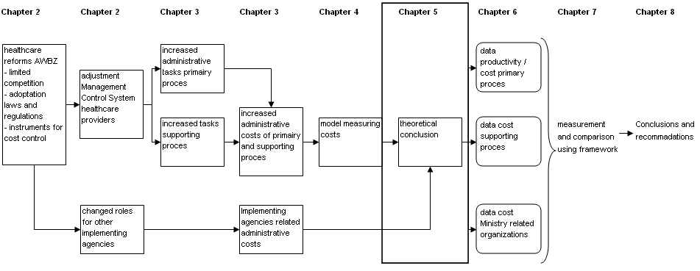

The basis for the measurement and the comparison of the administrative costs in healthcare is the cost measurement model by Plexus and BKB (2010), as is described in chapter 4. This model was developed on behalf of the Ministry of Health, as a method to measure the results of Dutch healthcare policies. The basic model consists of 4 categories, as can be seen in figure 13. The model uses the control costs at the healthcare system level as a starting point, thereby connecting to the definition of administrative costs as is used by the Ministry of Health. A number of additional sources of administrative costs is added, in order to come to a integral picture of administrative costs in healthcare.

Figure 13; Cost measurement model (Plexus and BKB, 2010)

The model developed by Plexus and BKB (2010) was designed to perform a study to the administrative costs of the entire Dutch healthcare system. As this study is focused on the administrative costs of the AWBZ, a number of adaptations are required.
- The description of the model, through the available literature omits a sufficient level of detail in order to gather specific data and perform a measurement of administrative costs of the AWBZ. This necessitates a further operationalization of the cost measurement model.
- The model omits operating costs, which are required from a management accounting point of view to perform a measurement to the administrative costs. The relevant cost categories will be added to the model.
- In order to overcome the possible danger of "hidden costs" the process of operationalization will be tailored to the financial- and organizational flowchart of the healthcare system in the Netherlands (Nivel, 2010), as can be seen in figure 5 and 6, in order to align the model to the structure of the AWBZ.

In this paragraph the categories of the model will be addressed and adapted when necessary. Adaptations will be kept to a minimum in order to keep the as much validity of the original cost measurement model as possible.

1. Control costs
The control costs consist of the costs of a number of organizations involved with the execution of the Dutch healthcare system. As the control costs in the Plexus and BKB model are related to the entire healthcare system, a number of adoptions need to be made, as only the AWBZ-related control costs need to be measured and compared for this study.
The AWBZ related control costs will be defined as costs made on behalf of the AWBZ Act and related laws and regulations.

Although the control costs at a healthcare level are not the primary focus of this study, these costs can be a useful indicator of the administrative costs and effects of the modernization of the AWBZ. As described in chapter 2 and 3 several changes were made to the tasks and responsibilities of the stakeholders of the healthcare system. As the control costs are financed through public means, these costs are relevant for the problem of financing the healthcare system in the future. It is therefore important to include these costs in this study as an indicator of administrative costs.
Besides the organizations which perform activities solely for the AWBZ, there will also be a number of organizations which perform activities for the AWBZ and other components of the healthcare system. These costs have to be allocated to the AWBZ and other components.

The control costs which have to be included are the costs of AWBZ-related activities which were financed through the AWBZ at the introduction of the modernization program. This includes the changes which were made to the system since 2001. The timeframe of the modernization program of the AWBZ which is selected in this thesis is the period from 2001 until 2010. The control costs, as described in the model of Plexus and BKB (2010), will be analysed in order to align this component of the cost measurement model to the control costs of the AWBZ. The situation regarding the AWBZ in the year 2000 is the base of the analysis. The control costs of the cost measurement model consist of the following components;

- Costs made for the execution of the AWBZ, the Social Health Insurance Act and the Health Insurance Act (ZVW);
The control costs made for the execution of the AWBZ need to be included in the measurement of the control costs. The control costs of the Social Health Insurance Act and the Health Insurance Act are not an element of the AWBZ and need to be excluded. The costs made for the execution of the AWBZ are financed through the "Regulation management costs AWBZ". This is a yearly established budget by the Ministry of Health and used to cover the costs of the AWBZ-related activities of the RCO's and the CAK-BZ. The costs for the execution of the AWBZ will be measured through the "Regulation management costs AWBZ".

- Operating costs for the Social Health Insurers / Private Health Insurers (ZVW);
These costs need to be excluded from the measurement, as these costs are not financed under the AWBZ Act, but are related to the ZVW.

- Operating costs for Private Health Insurance;
These costs need to be excluded from the measurement, as these costs are not financed under the AWBZ Act, but are related to the ZVW.

- Operating costs for supplementary health insurance;
These costs need to be excluded from the measurement, as these costs are not financed under the AWBZ Act, but are related Private Health Insurance.

- Personnel- and operating costs for the execution of the Social Support Act (WMO);
One of the changes made during the modernization of the AWBZ was the introduction of the Social Support Act (WMO) in 2007. This Act meant that the coordination and financing of a number of care functions were transferred from the RCO's to the municipalities. The costs of implementing and execution of this Act by the Municipalities will have to be included in the measurement. These costs are financed through the WMO budget.

- Costs of the Ministry of Health, both personnel- and operating costs;
The cost of the Ministry of Health consists of both personnel- and operating costs. These costs can be obtained through the yearly budget of the Ministry. The cost will be allocated to the AWBZ and other components of the Healthcare system.

- Costs of advisory boards and the Netherlands Bureau for Economic Policy Analysis (CPB);
The advisory boards consists of Council for Social Development, Council for Health and Care, Health Board and the Board for Health Research. These boards, in conjunction with the CPB, provide services to the healthcare system. These costs will be measured, based on their yearly budget, and allocated to the AWBZ.

- The total costs of the Dutch Healthcare Authority (NZa);
The NZa performs activities on behalf of the entire healthcare system. These costs will be measured, based on the yearly budget, and related to the AWBZ.

From the original model of Plexus and BKB (2010) the control- and policy agencies have been addressed. In order to reduce the possibility of hidden costs, the organizational- and financial overview of the Dutch healthcare system are adapted for the AWBZ and compared to the cost measurement model. This comparison is shown in figure 14.

Figure 14; comparison AWBZ organizational- and financial overview and the Plexus and BKB model (2010)
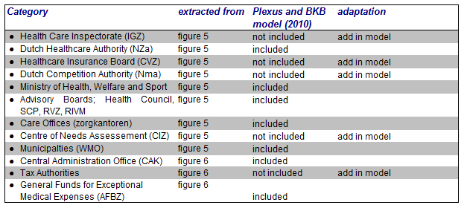

From the comparison it can be concluded that a number of organizations, for example the Centre for Healthcare Consents (CIZ) and the Tax authorities, are not included in the Plexus and BKB model. These costs will be added to the model and measured through their yearly budget and related to the AWBZ. The costs of the Tax authorities will be included in a separate category. The other organizations will be included in the category "implementing agencies". The adjusted model for measuring control costs can be seen in Figure 15.

Figure 15; AWBZ control costs at healthcare system level (based on the Plexus and BKB model, 2010)
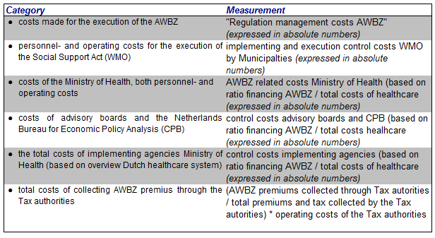

Overhead and administrative activities by healthcare professionals
Categories 2 and 3 of the Plexus and BKB model are based on the cost structures of healthcare organizations. As this thesis is focussed on the administrative costs of the AWBZ, only AWBZ funded organisations need to be taken into account. Other healthcare providers will be excluded from this study. In this study the healthcare organizations will be included when they are predominantly AWBZ funded (over 75%). When the share of the AWBZ funding is 75% or more, it is very likely that the healthcare organization is predominantly influenced by the laws and regulations of the AWBZ.

2. Overhead
The model of Plexus and BKB defines overhead as the FTE's of general-, administrative- and management functions at an organizational level in relation to the total FTE's in the healthcare sectors. The FTE's are related to the costs of wages and social security charges of overhead personnel; this does not include operating costs of overhead in the measurement. The operating costs consist of all costs not related to payroll. The operating costs are necessary in order to fulfil the supporting activities of overhead personnel. These costs are excluded in the cost measurement model of Plexus and BKB, but could influence the development of overhead costs. In order to measure the full extend of the overhead, the operating costs will be added to this category in the cost measurement model.

The uniform ledger (Prismant, 2004) for health organizations consists of a number of cost categories, regarding to the function of the costs. The category general costs consist of; administrative consumption costs, IT costs, banking costs, third party administrative services, accountants- and consultancy costs. These costs are closely related to overhead activities. The cost category general costs will be added to the costs measurement model as a component of overhead costs.

Figure 16; Overhead AWBZ healthcare organizations (based on the Plexus and BKB model, 2010)
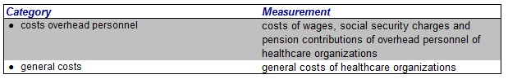

3. Administrative activities by healthcare professionals
According to the Plexus and BKB model the administrative activities of healthcare professionals should also be included in the measurement of administrative costs. This is in accordance with the definition of administrative costs, as chosen in chapter 3. These activities are associated with the management-, clerical- and general functions, performed by healthcare professionals. These functions need to be distinguished from providing healthcare to patients. According to the Plexus and BKB model the time spent by healthcare professionals can be divided in three categories;
- Direct client-related time; this time is spend directly to the treatment of patients regardless of the treatment given. This time is not covered by cost measurement model by Plexus and BKB.
- Indirect client-related time; this time can be allocated to individual patient, but the patient does not have to be present when these activities are performed. This time includes the travel time to and from a client, administrative activities for clients, consultation on clients, etc. This time is not covered by cost measuring model by Plexus and BKB.
- Non client-related time; time which is necessary for the organization and the supply of care, but cannot specifically be allocated to an individual client. This includes training, general meetings, management tasks, other general- and administrative activities (for example time-registration) etc. This time component is included in the model of Plexus and BKB, when the time spent relates to administrative activities.

Figure 17; Administrative activities by healthcare professionals (based on the Plexus and BKB model, 2010)
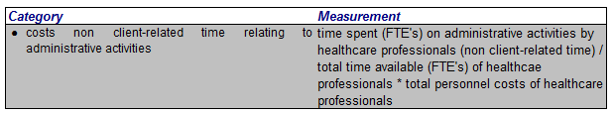

4. Administrative activities by healthcare patients
The time spent by healthcare patients is the fourth indicator of the cost measurement model by Plexus and BKB. The time spent by patients on the administrative tasks for AWBZ is not financed through collective means or individual premiums, nor is it a component of the administrative costs for healthcare organizations. This indicator is not taken into account in this study to administrative costs.

Based on the elaboration of the cost measurement model, the model is adapted on a number of issues in order to optimize this model for this study. This model can be seen in figure 18. This model will be used to select and process data in chapter 6 and perform the measurements in chapter 7.

Figure 18; Adjusted Cost measurement model administrative costs AWBZ
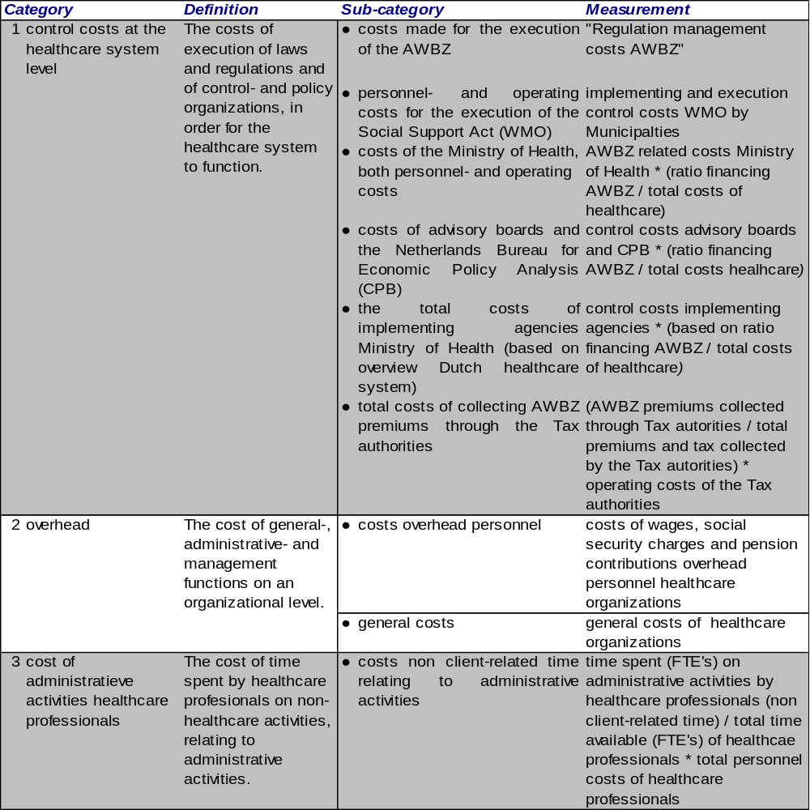

Chapter 6 Methodology

In this chapter the methodology of this thesis is described. This study is aimed at the measurement of the administrative costs of healthcare organisations and the effects of the modernization of the AWBZ on the administrative costs. In order to answer the research questions quantitative research methods will be used.
The data is described and a selection of data is made, according to the cost measurement model. Also the validity and reliability of the data are addressed as are the statistical measurements that will be performed in order to obtain the results.

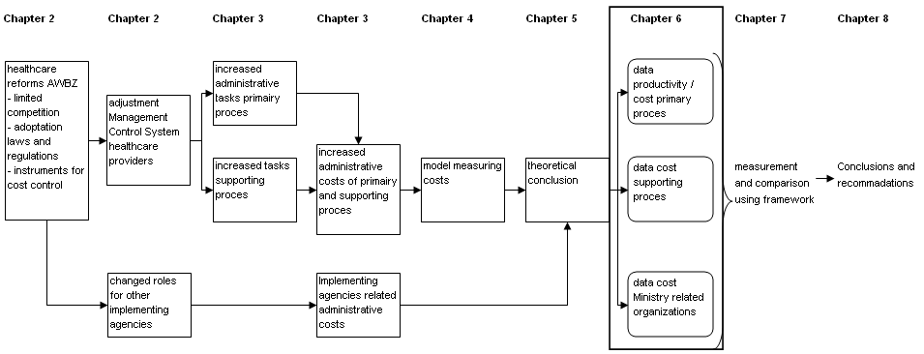

This study is aimed at the measurement of administrative costs of healthcare organizations through the use of quantitative research methods. This study can be classified as an evaluating research, were the impact of an intervention is measured over time (Babbie, 2004). Evaluating research refers to the purpose of the study and not to the methods used.
The data for this research will be obtained through the use of public databases; this can be classified as a desk research. This method has the advantage that a large amount of data can be processed in a relatively short amount of time. The use of public databases enables other researchers to perform similar studies. The disadvantage of this method is the dependence on secondary data, collected by others.

Collection of data
Data regarding the control costs of the implementing agencies of the Ministry of Health will be obtained through the website of the Government of the Netherlands (www.rijksoverheid.nl/) and the central access point of information about the Dutch Government at the website (www.overheid.nl/). These websites contain a complete archive of official documents and publications of the Dutch Government and its Ministries. The website of the Association of Dutch Municipalities (www.VNG.nl/) will also be used.

The data regarding the cost of healthcare organizations will be obtained form the Dutch Central Bureau of Statistics (CBS), through the use of the public electronic databank (www.Statline.cbs.nl/). The electronic databank contains information on the subject of healthcare (financing) from the late 1990's to 2010 (most recent year of which the data is available). This period covers the timeframe before and during the modernization of the AWBZ.

The CBS database contains data of all healthcare organizations in the Netherlands; this data is aggregated on a sector level. This data will be used to perform the measurements for the administrative costs of healthcare organizations per sector. A selection of healthcare sectors will be made, based on the classification of organizations, according to the Standard Industrial Classification (SBI) of the Dutch Central Bureau of Statistics. The SBI has a standard format in which all organizations are labelled, according the type of goods and services they provide. A healthcare organization can be a group, consisting of several legal entities. A group can be seen as the level at which the financial decisions are taken for several legal entities of healthcare organizations.

The data of the CBS database consists of data regarding the profit and loss accounts, the balance sheets, data regarding personnel and data regarding capacity and production of healthcare organizations.
For this study existing data is used. Babbie (2004) describes the possible problems when using existing data and states two characteristics which are used in science for the possible problems of existing data; this consists of logical reasoning and replication. This can be done by monitoring the data in the course of time. If deviations are detected an additional source of data will be used if possible, in order to cross-check the data.

Selection of data
The data of the CBS regarding healthcare is classified according to the Standard Industrial Classification (SBI) of the Dutch Central Bureau of Statistics. The healthcare sectors, according to the SBI '93 classification, with a predominantly AWBZ funding (over 75%) in 2000, will be selected. As the AWBZ was the principal financier of the selected healthcare sectors the effects of the measures taken in the context of the modernization of the AWBZ can be seen with these sectors.

Reliability and validity
In order for the measurement and conclusions of this study to be credible, it needs to be plausible that the cost measurement model is capable of measuring the administrative costs. Also the measurement should be able to be performed repeatedly and similar results obtained consistently. In this paragraph the issue of reliability and validity will be addressed. This study uses a quantitative research method, through the use of existing public databases. This means that the data used, was gathered by others. The method used needs to have both validity and reliability, in order to determine if the model measures what it is supposed to measure and if this is done consistently.

Reliability
Reliability refers to the consistency of the outcome of a measurement. A measurement is reliable if a technique, which is repeated to the same object, gives the same result each time (Babbie, 2004). This study is performed through the use of quantitative research methods. Quantitative research methods are in general more reliable than qualitative methods. Reliability does however not guarantee that the measurement is valid, but if the measurement is not reliable it can never have validity.

For this research existing public databases, mostly the CBS database, are used. The CBS can be regarded as a reliable source for data. The data of the CBS is obtained from the yearly financial statements of healthcare organizations and supplemented with data from additional sources and surveys of the CBS. Much of the financial data of healthcare organizations is audited by an external accountant before it is published. The size of the observation consists of the entire population of healthcare organizations which are fully or partly funded by the ZVW and or AWBZ. There is a degree of non-response which causes an unreliability margin. This is counteracted by the CBS, by analysing the data for plausibility and after possible adjustment has been found acceptable. The data relating to healthcare sectors will be compared to data of the AWBZ funded healthcare in the Netherlands, to measure the extent of AWBZ sectors that are included in the data.

The issue of bias is related to the reliability of the measurement. Bias means that those selected are not representative of the full population and can have a large effect on the reliability of the measurement. By using the data of the entire population the risk of bias is largely reduced.
The AWBZ healthcare sectors are selected upon the criteria of a minimum of 75% funding by the AWBZ. In order to minimize the change of bias, a sensitivity analysis will be performed, were the results are compared and analysed when an AWBZ funding percentage of 60% and 90% is used. Through the use of the sensitivity analyses the impact of the applied criteria for AWBZ sectors can be measured.

Validity
The term validity refers to how accurate the measurement is able to measure the concept what is claims to measure (Babbie, 2004). Although the ultimate validity cannot be proven, the validity can be made plausible (Babbie, 2004). Validity can be categorized in internal- and external validity.

The internal validity is the extent to which the dependant variable is explained through the independent variable. In chapter 5 a number of adjustments has been made to the standard model of Plexus and BKB (2010) in order to better align the model to the subject of this study. This relates to the internal validity of the study.
The measurement is divided in three indicators of administrative costs, namely; control costs, overhead costs and administrative costs of healthcare professionals. These indicators will be measured independently and multiple results will be obtained. The results of these measurements, in relation to each other, can give an indication of the internal validity of this study.
External validity refers to the generalization of the results of the measurement to a wider population. Although the cost measurement model can be adopted for other sectors, especially sectors which are heavily regulated by the Government, the results can be generalized only limited. The cost measurement model is adapted for the AWBZ healthcare, which causes restrictions in the external validity of the results. The cost measurement model and the results could be generalized to other healthcare sectors for instance the hospital sector, which have also been confronted by large reforms of laws- and regulations.

In order to substantiate the validity four criteria can be used (Babbie, 2004), these are; face validity, criterion-related validity, construct validity and content validity.
- Face validity; this criteria of validity looks at whether is seems logical that we measure what we want to measure.
- Content validity; this criteria is used to analyse whether the entire concept of the study is included in the measurement. For this study the administrative costs are defined, based on a broad definition, in order to measure the full extent of administrative costs. This is an advantage for the content validity.
- Criterion-related validity; this relates to the predictive value of the measurement. This validity criterion will be tested using a regression analyses in chapter 7. Through the regression analyses the extent of the dependant variable can be predicted from the value of the independent variable.
- Construct validity; this criteria is used in order to assess whether the measurement is a good indicator for the concept of the study. The concept of modernization of the AWBZ is not observed directly in this study, but is measured through the total financing of the AWBZ as a result of the healthcare reforms.

Research design
The problem description of this study consists of two components. The first component is the measurement of administrative costs of healthcare organizations. This measurement can be conducted though the use of the cost measurement model. This model, by Plexus and BKB (2010) is described in chapter 4 and adapted in chapter 5, in order to align this model to the AWBZ. This model will be used in chapter 7 to measure the administrative costs.

The second component of the problem description is formed by the effects of the healthcare reforms on the administrative costs of healthcare organizations. This will be measured through the administrative costs of healthcare sectors, in relation to the financing of the AWBZ. The results will be used to perform a number of statistical measures in order to asses whether and how the independent variable (modernization of the AWBZ) has an effect on the dependant variable (administrative costs).
A simple linear regression will be applied to the data, to measure the relation between the modernization of the AWBZ on the administrative costs of healthcare organizations. The variables of the model are both scale variables.
The data will be split in two series. The first series contains the data up to and including the year 2000, which will be used as the measurement of the pre-modernization period. The second series contains data from 2001-2010 and will be used for the modernization period. A statistical function will be used in order to express the relation between the variables, using the following equation;

Υ¡ = α + βX¡ + ε¡

The intercept will be formed by α, the slope by β and ε¡ will be used for the "error". The ε¡ will be used in the model, because the relationship will not be exactly linear. The model has a number of assumptions, one of which is that ε¡ is independent of βX¡. This implies that they are unrelated.
In order to measure the strength of the association between the two variables the correlation coefficient (R²) will be used. The correlation can be used to asses the predictive value of the equation.
Chapter 7 Results

In this chapter the results of the measurement are presented. The results are obtained through the selected data, as described in chapter 6, and the cost measurement model, as described in chapter 5. The data was used to measure the administrative costs and to test if a significant change has occurred in the administrative costs before and during the modernization of the AWBZ.

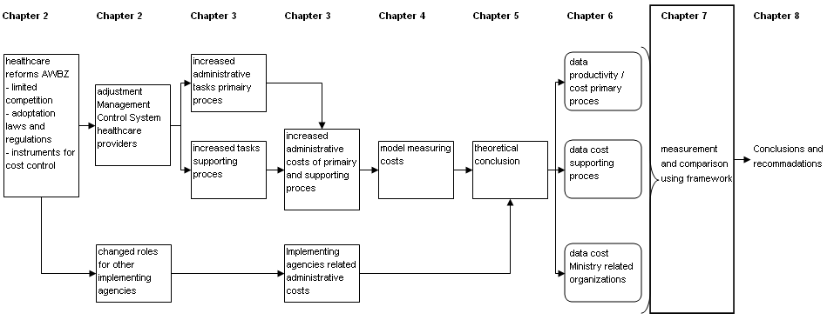

Analysis selected healthcare sectors
The healthcare sectors, which are included in this study, are selected on the basis of their AWBZ funding. The healthcare sectors selected need to be predominantly AWBZ financed. The year 2000 is the base year for the distinction of the pre-modernization AWBZ timeframe and the modernization AWBZ timeframe. The data of the year 2000 is used to select the healthcare sectors which have to be included in this study. Based on the accountability report of the Health Care Insurance Board (CVZ) the AWBZ financing in 2000 was used for the following components;

Figure 19; Use of AWBZ resources 2000, according to CVZ
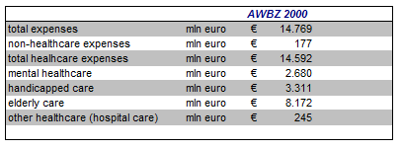
In order to make the selection of healthcare sectors for this study, the use of AWBZ resources needs to be compared to the budgets of the healthcare sectors which receive (partial) funding through AWBZ means. In figure 20 the budgets of the AWBZ sectors are compared to the AWBZ funding in 2000.

Figure 20; Comparison AWBZ resources 2000 compared to costs healthcare sectors
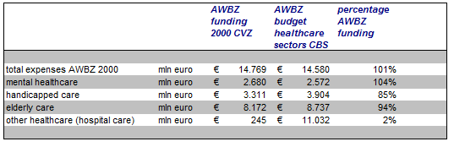
In figure 20 the sector mental healthcare seems to have received more AWBZ funding, than the total costs of healthcare. This seems unlikely. This is probably caused by the use of different slightly definitions by the CVZ and the CBS and or the use of different data.

In chapter 6 a criteria of a minimum of 75% AWBZ financing was stated, in order for a healthcare sector to be included in this study. Based on the data of figure 20 the sectors mental healthcare, handicapped care and elderly care are predominantly financed through the AWBZ. These sectors match the SBI '93 classification; 85115 mental healthcare, 85311 nursing homes, 85312 handicapped care, 85313 residential care homes and 85324 home care.
A change of the criteria of 75% funding by the AWBZ to 60% funding would not have a consequence for the selected healthcare sectors. The change of the criteria to 90% would exclude the handicapped care sector from the selection. As the AWBZ financing of the mentally handicapped sector of 85% is well within the selected 75% criteria, this sector is included in this study. The healthcare sectors selected amount to 96% of the total AWBZ budget spent on healthcare, which gives a good representation of the entire AWBZ financed healthcare. By excluding the handicapped care sector from this study the share of the AWBZ financing included in this study would decrease to 73%.

Cost measurement model
The cost measurement model consists of three main components; 1.) Control costs, 2.) Overhead costs and 3.) Costs of administrative activities by healthcare professionals. For all three components data was obtained in order to measure the full extend of administrative costs of the AWBZ and the change of administrative costs before and after the introduction of the modernization program of the AWBZ. The measurement of administrative costs is performed for 2010.

1. Control costs
The control costs of the AWBZ consist of 6 components. These components are based on the costs measurement model of Plexus and BKB (2010) and the adaptations made to this model in chapter 5. The adaptations were based on the financial- and organizational overview of the AWBZ. The data of these components was gathered using available information from official documents of the Dutch Government and electronic databases of the CBS.

Figure 21; Control costs of the AWBZ 2010
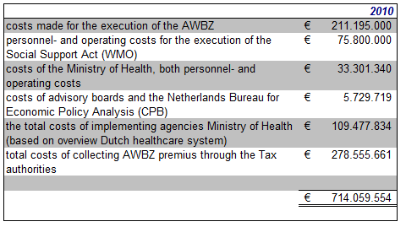
The control costs related to the AWBZ are calculated at € 714.059.554. This amounts to 2.95% of the total AWBZ financing in 2010.

2. Overhead costs
The overhead costs of healthcare organizations consist of two components. This data was gathered through the website of the Dutch Central Bureau of Statistics (CBS), through the use of the electronic databank (www.Statline.cbs.nl/).

Figure 22; Overhead costs of the AWBZ sectors
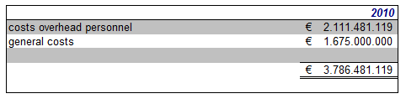
The total costs of overhead of AWBZ healthcare organisations amounts to € 3.786.481.119. This amounts to 15.66% of the total AWBZ financing in 2010.

3. Cost of administrative activities by healthcare professionals
The cost of administrative activities by healthcare professionals is measured through the time spent by healthcare professionals on administrative tasks in relation to the total time available by these employees. The result of this measurement is multiplied by the total personnel costs of healthcare professionals.
The total financing of the AWBZ in 2010 was € 25 billion. This amounts to 40% of the total financing of the AWBZ in 2010.
Data regarding the administrative activities of healthcare professionals was obtained though a number of studies, for example Roodbol (2005). This data was based on case studies to specific groups of healthcare professionals and during a limited timeframe. The results could not be generalized for this study. This implies that no costs for this category are included in the cost measurement model.

Cost measurement model AWBZ 2010
The total administrative costs of the AWBZ in 2010, which were measured through the cost measurement model, amount to € 4.500.540.673, as can be seen in figure 23. This amounts to 18.61% of the total AWBZ financing for 2010.

Figure 23; Total administrative costs of the AWBZ in 2010
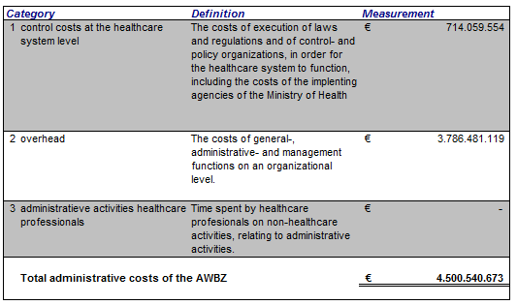

Statistical testing
The adjusted cost measurement model was used to collect data of the administrative costs of the AWBZ from 1997 until 2010. The data of the earlier years could not be obtained, due to incomplete registrations and the unavailability of some of the data. The data was obtained for each of the sub-categories of the control costs and overhead costs. The data regarding the time spent by healthcare professionals on administrative activities could not be used for this study. Some studies, mostly case studies, were performed on this subject, but the results of these studies could not be generalized for the healthcare sectors selected for this study. A description of the data is included in Appendix 7 "data collection".

The budget of the AWBZ is also used for control- and overhead costs, which are included in the measurement. When comparing the control- and overhead costs to the total financing the AWBZ, these costs are also compared to itself. In order to eliminate the dependence of the total financing of the AWBZ from the control- and overhead costs, these costs first have to be eliminated from the total AWBZ financing. Figure 24 shows the total financing of the AWBZ and the elimination of the control- and overhead costs, in order to perform the measurements.

Figure 24: Total financing of the AWBZ (1997 - 2010)
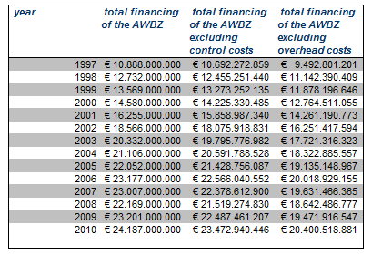

Control costs
The data of the control costs from 1997 to 2010 indicates a strong correlation between the control costs and the adjusted financing of the AWBZ, with an adjusted R² of 96.26%. The adjusted R² is slightly lower than the R² (96.55), but takes the sample size into account. The correlation between the adjusted total financing of the AWBZ and the AWBZ related control costs, according to the cost measurement model, can be seen in figure 25. The regression-line shows a strong correlation.

Figure 25; Regression output control costs (1997 - 2010)
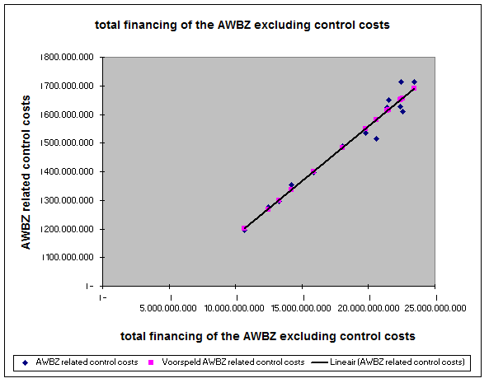

The F-value of the AWBZ-related control costs is only 3.89E-10 (0.0000000389%), which is extremely low. The results of the measurement can be accepted as reliable. Based on the output of the measurement the following equations can be derived for the control costs;

Control costs AWBZ (Υ¡) = -209.477.365 + 0.038 * adjusted AWBZ Financing

In order to determine whether the control costs have changed significantly since the introduction of the modernization of the AWBZ the data from 1997 - 2000 and 2001 - 2010 can be compared.
The analysis of the data from 1997 - 2010 does not imply a strong deviation from the linear regression. Also the unavailability of data before 1997 limits the number of data points available. Any conclusions, based on the available data before and during the modernization program, can only be based on 4 years (1997-2000). A comparison of statistical significant change will not be applied to this data.

Overhead costs
The data regarding the overhead costs has a strong correlation between the total financing of the AWBZ and the overhead costs. The adjusted R² amounts to 88.52%. The adjusted R² takes the sample size into account, in contrast to the R² (89.40%). The output of the regression analysis, as shown in figure 26, shows a good fit between the actual overhead costs and the predicted overhead costs, in relation the total financing of the AWBZ.
The overhead costs of the highest total AWBZ financing appears to be slightly higher than the predicted regression output, while the total AWBZ financing between € 15.000.000.000 and € 18.000.000.000 seems to be somewhat lower than the predicted regression output.

Figure 26; Regression output overhead costs (1997 - 2010)
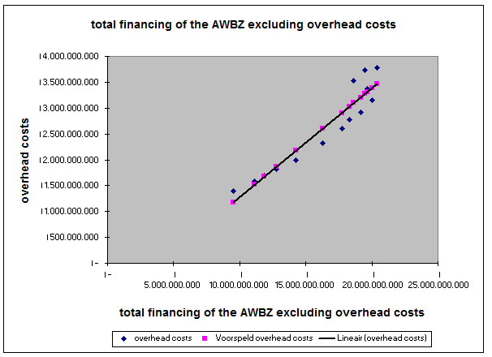

The F-value of the AWBZ overhead costs is also very low, with a value of 3.35E-07 (0.0000335%). The results of the measurement can be accepted as reliable. Based on the output of the measurement the following equations can be derived for the overhead costs;

Overhead costs AWBZ (Υ¡) = -824.393.428 + 0.2105 * adjusted AWBZ Financing

In order to determine whether the overhead costs have changed significantly since the introduction of the modernization of the AWBZ the data from 1997 - 2000 and 2001 - 2010 can be compared. The analysis of the data from 1997 - 2010 does not imply a strong deviation from the linear regression. Also the availability of data before 1997 limits the number of data points available. Any conclusions, based on the available data before and during the modernization program, can only be based on 4 years (1997-2000). A comparison of statistical significant change will not be applied to this data.

Chapter 8 Conclusions and recommendations

In chapter 7 the results of the measurements, using the cost measurement model, have been presented. In this chapter the results will be interpreted and conclusions will be drawn. Also, based on the experience of this study, recommendations for further research will be stated. This chapter ends with the answering of the research questions, as stated in the first chapter of this thesis and an overall conclusion.

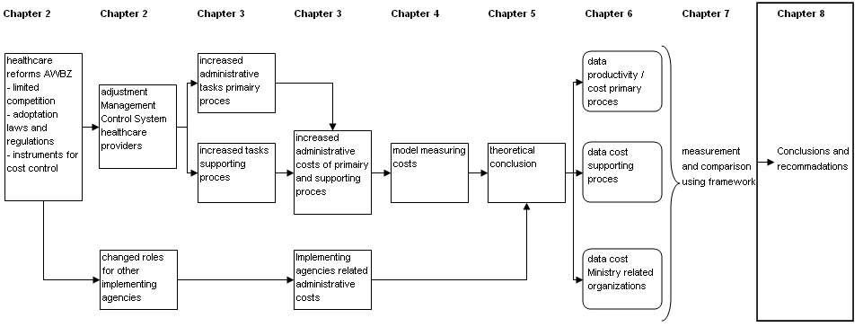

Conclusions and recommendations
This thesis is aimed at the measurement of the administrative costs in the Dutch healthcare sector. Data was collected and measured, through the use of a cost measurement model. Data was collected for the period 1997 up to 2010.

Cost Measurement Model
In this study a cost measurement model for administrative costs is used, consisting of three main components; control costs, overhead costs and administrative costs of healthcare professionals. The data for the control costs and the overhead costs was gathered through the use of public databases and publications of the Dutch Government.
The total administrative costs measured with the cost measurement model amount to € 4.5 billion in the year 2010. This consists of € 0.7 billion control costs and € 3.8 billion overhead costs. The administrative costs in 2010 represent 18.61% of the total financing of the AWBZ (2.95% control costs and 15.66% overhead costs).
Due to insufficient data for the component administrative costs of healthcare professionals, this category could not be included in the measurement of administrative costs. A number of studies has been performed on this subject, but these studies lacked the popper conditions to generalize the outcomes for this study. The studies were limited to a single or a small number of healthcare organizations and often aimed at a specific group of healthcare professionals, also the time period of these studies was very limited.

Unfortunately the costs of administrative activities by healthcare professionals could not be measured. This component could give valuable insight regarding the perception of healthcare professionals on the subject of administrative burdens and the costs which are associated with these burdens. From the literature review is it clear that indications exist that the administrative activities by healthcare professionals have increased since the introduction of the modernization of the AWBZ.
The personnel costs of healthcare professionals are the single largest cost category of the AWBZ, with 40% of the total AWBZ financing (over € 10 billion in 2010) spend on this category. Any changes in this category can have a large impact on the administrative costs.
Some explorative studies show that the administrative activities by healthcare professionals are quite substantial. A study performed by Roodbol (2005) indicates that 10.6% up to 14.1% of the available time of healthcare professionals is spent on administrative activities. This would increase the total administrative costs of the AWBZ with € 1.1 to € 1.4 billion and increase the share of the administrative costs from 18.61% to 23.1% up to 24.6% of the total financing of the AWBZ in 2010. These numbers are very similar to other research on this subject. The study of Woolhandler and Himmelstein (1991) obtained administrative costs from 19.3% up to 24.1% for the U.S. healthcare system.
From the experience of this study it is recommended that data on the subject of time spent by healthcare professionals, including administrative activities, is measured in order to obtain the full picture of administrative costs in the Dutch healthcare system. The data of time spent by healthcare professionals could also give valuable insight regarding the perception of healthcare professionals that the administrative activities have increased in recent years.

Through the literature review in this study it has become clear that a mismatch exists between the perception of administrative burdens by healthcare professionals and the measurement of administrative costs by the Ministry of Health. The measurement of administrative costs, as performed by the Ministry, only includes the administrative costs when the Ministry is responsible for these costs. The outcome of these measurements is widely publicized, but not recognized by healthcare professionals.
Based on the publication of the administrative costs by the Ministry of Health, the administrative costs declined from 5.0% in 2000 to 4.2% in 2008 (Plexus and BKB, 2010). The data gathered in this study, using the cost measurement model, shows that the administrative costs of the AWBZ rose during the same period from 14.88% to 18.84%, which is almost a 4% increase. Not only are the administrative costs substantially higher in this study, than measured through the definition of the Ministry of VWS, the administrative costs in this study show an increase by almost 4%, in stead of a decline of 0,8%.
Based on the results of this study, and the available literature, it is very much in question whether the definition of administrative costs, used by the Ministry of Health is capable to make statements of the administrative costs of the AWBZ or the Dutch healthcare sector. The measurement of administrative costs, based on a definition which only incorporates a limited part of the total administrative costs could potentially lead to sub-optimalization, when decisions are based on this measurement. It is recommended that a more integral definition of administrative costs is used for the Dutch healthcare sector, which is accepted by the most important stakeholders. A definition, based on management accounting principles will be well suited for this purpose.

Measurement of effects
For the measurement of the effects on the administrative costs, due to the modernization of the AWBZ, data was collected from 1997 up to and including 2010. The data consists of the total financing of the AWBZ and the administrative costs. A single linear regression was used to analyze this data.
The data showed a strong correlation between the administrative costs and the adjusted total financing of the AWBZ, with an adjusted R² ranging from 96.26% for the control costs to 88.52% for the overhead costs.
Especially the smaller amounts of AWBZ financing and the lower amounts of control costs correlate very well. This correlation seems somewhat less as the financing of the AWBZ and the control costs increases.
The F-values of both the control costs (F=3.89E-10) and the overhead costs (F= 3.35E-07) indicate that there is only a minute probability that the regression output is due to change. From this it can be concluded that the results of the measurement are reliable.

Although a high correlation exists between the administrative costs and the total financing of the AWBZ, the equations obtained from the statistical testing showed that the fixed administrative costs of both the control costs and the overhead costs are negative when the total financing of the AWBZ is zero.
The fixed control costs in the equation are € 209.477.365 negative and the fixed overhead costs are € 824.393.428 negative. This implies that, based on the data available, the linear regression calculates the control costs and the overhead costs in the lower ranges of the total AWBZ financing as negative, when the total AWBZ financing becomes close to zero. This does not seem logical. The control costs and overhead costs probably will be close to zero, when the total financing of the AWBZ becomes zero, but cannot become negative. The linear regression does not seem a good predictor for lower ranges of the AWBZ related control costs. The data for the lower ranges of the total AWBZ financing are the earliest years of the data of this study. The data of the control costs and overhead costs before 1997 is not complete; therefore this relationship cannot be obtained from existing data. The equations can therefore only be used form the earliest data available (1997).
The variable component of the control costs- and overhead costs equations indicate that for every amount spent on non-administrative expenses in the AWBZ 3.8% is spent on control costs and 21% is spent on overhead costs.

In order to test whether a significant change has occurred in the administrative costs due to the modernization of the AWBZ, the data could be split into two groups and compared to each other. The first group containing the data up to and including the year 2000 and the second group containing the data from 2001-2010.
Due to the unavailability of data before 1997 the number of data points is limited. Any conclusions, based on the available data before the introduction of the modernization program, can only be based on 4 years (1997-2000). This is a very limited base for conclusions, especially in combination with the very high correlation between the overhead costs and the total AWBZ financing over the period 1997 - 2010.
A comparison whether a statistical significant change has occurred, has not been applied to this data. Based on the data for this study a statistically significant change in the administrative costs before and during the modernization of the AWBZ could not be established. The data showed a strong correlation, but did not indicate a statistically significant deviation of the predicted regression equation.

In this study the administrative costs were used as numerator in the equation and the total financing of the AWBZ was used as the denominator.
From the literature review it is evident that the financing of the AWBZ in the future will increase considerably. This could raise questions for the use of the total financing of the AWBZ as a good comparison for the administrative costs. In the comparison of the healthcare systems in the United States (Medicare and the Private Health Insurers), the average administrative costs of Medicare were considerably lower than the administrate costs of the Private Health Insurers. This conclusion was partly based on the higher average cost of Medicare, in comparison to that of the Private Health Insurers. As the total financing of the AWBZ continues to rise in the future, the comparison to the administrative costs could even lead to the conclusion that the administrative costs diminish.
In order to compare the administrative costs of the AWBZ and the healthcare system, the measured administrative costs should be compared to a denominator which is not influenced by the growth rate of the AWBZ, due to the expected increase of the number of patients. This could be established by using the financing of the AWBZ of a certain year as a fixed base and increasing this amount only with a yearly indexation. This would adjust the total costs of the AWBZ to the inflation of costs (as the administrative costs are also adjusted for inflation), without being influenced by the increase of the total financing of the AWBZ due to the increasing number of patients.

Answers to the research questions
In the first chapter of this thesis 5 research questions have been stated, in order to measure the administrative costs of healthcare organizations and the effects of the modernization of the AWBZ. Based on the study performed the research questions will be addressed.

What is the content of the modernization program of the AWBZ?
The modernization program of the AWBZ started in the first years of the last decade and consists of a large number of changes to the AWBZ. The goal of the modernization program was to change the AWBZ from a supply-driven system to a demand-driven system. The content of the modernization program relates to three main components (Ministry of Health, 2000); ensuring a proper regulation of market conditions, adaptation of law and regulations and new instruments for cost control. The modernization program is not completed and is still being carried out.

Are there effects of the modernization of the AWBZ for administrative costs of healthcare organizations?
The modernization program implemented a large number of changes to the AWBZ, the effects of a number of which can be observed with healthcare organizations. This is for instance the case with the introduction of the Social Support Act (WMO) and the introduction of the Care Intensity Packages (ZZP's). There is little literature available on the subject of effects for the administrative costs due to the modernization of the AWBZ.
The effects of the changes due to the modernization of the AWBZ have an impact on the supporting processes, for example due to changes in the financing of the healthcare organizations and on the primary processes, for example due to the introduction of the Care Intensity Packages. There are effects of the modernization of the AWBZ for the healthcare organizations and it is plausible that these effects influence the administrative costs.

Can the administrative costs of healthcare organizations be measured uniformly?
The measurement of the administrative costs is dependant upon the definition of administrative costs used, and the model for measuring administrative costs which is applied. In this study a broad definition of administrate costs is used. This definition makes a distinction between primary- and supporting processes, so administrative costs will be included in the measurement, despite of the place in the organization where these costs originate.
Based on the literature review it can be concluded that a number of models exist for measuring administrative costs uniformly. Only a few of these models include the administrative costs of healthcare organizations from both the primary and supporting processes. The cost measuring model of Plexus and BKB (2010) was selected to perform the measurement in this study. This model is based on the structure of the Dutch healthcare system, which reduced the risk of hidden costs. This model, although suited for the Dutch healthcare sector, still needed a number of adaptations in order to align this model to the AWBZ, which is the focus of this study. This was done through a comparison of the financial- and organizational structure of the AWBZ with the cost measurement model.

What are the administrative costs of healthcare organizations?
The administrative costs of healthcare organizations consist of the overhead costs and the costs of time spent by healthcare professionals on administrate activities.
The overhead costs consists of the personnel costs of overhead employees and the operating costs of overhead functions. The operating costs are operationalized through the general costs of healthcare organizations. The overhead costs amount to € 3.8 billion, which is 15.66% of the total financing of the AWBZ in 2010.
The costs of time spent by healthcare professionals on administrative activities could not be measured due to the lack of data.

Is a significant difference in the administrative costs of healthcare organizations observable before and after the implementation of the modernization program of the AWBZ?
In this study the available data for the administrative control- and overhead costs was analysed using simple linear regression. The data showed that the administrative costs are closely correlated to the total adjusted financing of the AWBZ, but did not give an indication for a significant change in the administrative costs before and during the modernization of the AWBZ. This research question has to be answered negative; the administrative costs of healthcare organizations did not change significantly as a result of the implementation of the modernization of the AWBZ, based on the measurements performed in this study.
As an answer to the problem description and overall conclusion it can be stated that the administrative costs of healthcare organizations can be measured through the use of a cost measurement model, in conjunction with a definition of administrative costs which is consistent with the cost measurement model. A significant change due to the modernization program of the AWBZ on the administrative costs of healthcare organizations was not established.

Appendix 1; Categories expenses healthcare organizations; Woolhandler and Himmelstein (1997)

Appendix 2; Administration in Health Care: A plan for cross-national comparisons; Glaser (1993)

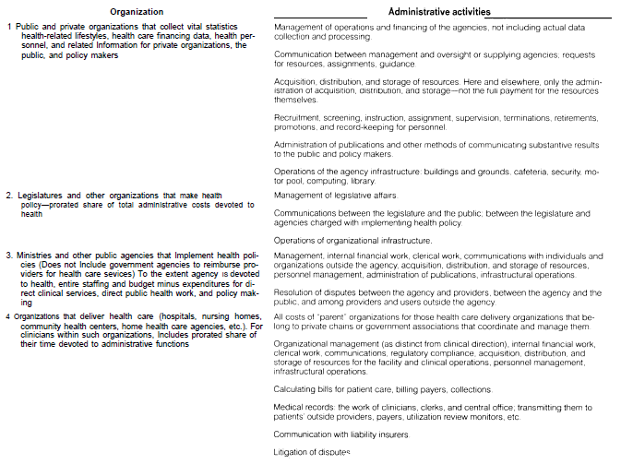

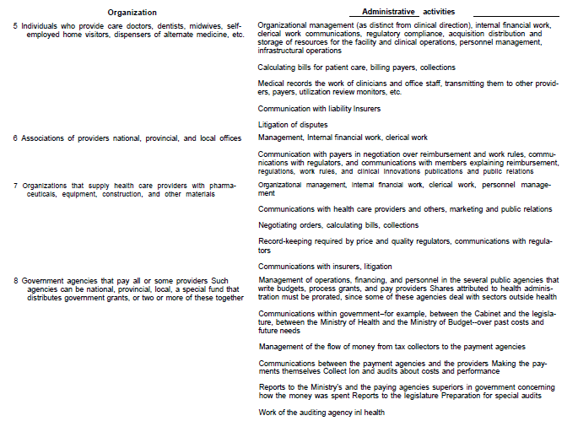

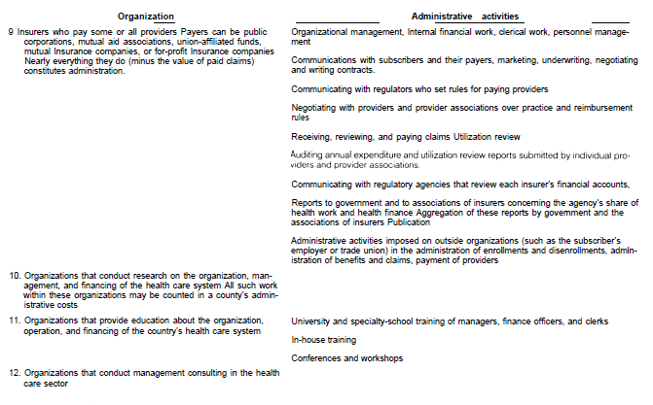

Appendix 3; Literature

- Aaron, H. J. (2003). The costs of health care administration in the United States and Canada--questionable answers to a questionable question. [Comment Editorial]. N Engl J Med, 349(8), 801-803. doi: 10.1056/NEJMe030091
- Babbie, E. (2004). The practice of social research. San Francisco, CA: Wadsworth.
- Baumol, W.J., (1967). Macroeconomics of Unbalanced Growth: The Anatomy of Urban Crisis. The American Economic Review, Vol. 57, No. 3 (Jun., 1967), pp. 415-426.
- Carrin, G., & Hanvoravongchai, P. (2003). Provider payments and patient charges as policy tools for cost-containment: How successful are they in high-income countries? Hum Resour Health, 1(1), 6. doi: 10.1186/1478-4491-1-6
- CBS (Dutch Central Bureau of Statistics). (2011). Uitgaven aan zorg groeien minder snel [Healthcare expenditure grows less rapidly]. [press release PB11-038]. Retreived from http:// http://www.cbs.nl/nl-NL/menu/themas/gezondheid-welzijn/publicaties/artikelen/archief/2011/2011-038-pb.htm
- CPB (Netherlands Bureau for Economic Policy Analysis). (2004). Moment opname van de AWBZ; Een analyse van de sterke en zwakke punten [Snapshot of the AWBZ; An analysis of the strength and weaknesses]. (Paper No. 54). The Hague, The Netherlands.
- CPB (Netherlands Bureau for Economic Policy Analysis). (2005). Can we afford to live longer in better health? (Paper No. 85). The Hague, The Netherlands.
- CPB (Netherlands Bureau for Economic Policy Analysis). (2011). Health spending and public finance; what will bring the future [PowerPoint slides]. Rotterdam.
- CPB (Netherlands Bureau for Economic Policy Analysis). (2012). Decompositie van de zorguitgaven, 1972-2010 [Decomposition of healthcare expenses, 1972-2010].
- CVZ. (n.d.) CVZorgcijfers 2000-2005. Retrieved from http://www.ggzbeleid.nl/pdfmacro/CVZorgcijfers2000_2005.pdf
- Danzon, P. M. (1992). Hidden overhead costs: is Canada's system really less expensive? [Comparative Study]. Health Aff (Millwood), 11(1), 21-43.
- Dell, M.W., & Vandermeulen, L.J.R. (2005). Arbeidsproductiviteit in de zorg. [Labour productivity in healthcare]. OSA-publication ZW 63, ISBN 9065663827. Retrieved from http://www.uvt.nl/osa
- Goudriaan, R., Hauten, M., Bartelings, H. (2005). Arbeidsmarkt, arbeidsproductiviteit en vergrijzing: Internationale ervaringen met oplossingen voor personeelstekorten in de zorgsector [labour market, labour productivity and ageing: international experiences with solutions for labour shortages in the healthcare sector]. Den Haag, The Netherlands; Ministerie van VWS.
- Grit, K. & Dolfsma, W. (2002). The Dynamics of the Dutch Health Care System - A Discourse Analysis. Review of Social Economy, 60:3, 377-401.
- HHM. (2007). Tijdsbestedingsonderzoek behandelaars sector V&V [Survey time allocation healthcare professionals elderly care]. Enschede, The Netherlands.
- HHM, Casemix & Q-talent. (2012). Werken met ZZP's; inventarisatie ondersteuningsbehoefte [Working with ZZP's; inventory supporting requirements]. Retrieved from http://www.invoorzorg.nl/ivzweb/Overzichten-In-Voor-Zorg!/map-literatuur/Rapportage-Inventarisatie-ondersteuningsbehoefte.html
- Horngren, C. T., Foster, G. & Data, S.M. (2000). Cost Accounting. A Managerial Emphasis. New Jersey: Prentice-Hall.
- Hurst, J. W. (1991). Reforming health care in seven European nations. [Research Support, Non-U.S. Gov't]. Health Aff (Millwood), 10(3), 7-21.
- De Kleijn, E., Campagne, A. E., Paagman, H. R., & Smit M. (2006). Slimmer werken in de zorg [Working smarter in healthcare] (Report number R0623009/018-31030.01.02). Hoofddorp, The Netherlands: TNO.
- Kloot, L. (1997). Organizational learning and management control systems: responding to environmental change. Management Accounting Research, 8, 47-73.
- Le Grand, J. (1999). Competition, cooperation, or control? Tales from the British National Health Service. Health Aff (Millwood), 18(3), 27-39.
- Lindbeck, A. (2006). Prospects for the welfare state. Seminar paper No. 755. Stockholm University, Stockholm, Sweden.
- Maarse, H. (2011). Dutch health care reform at the crossroads. Article. Health Care Cost Monitor, The Hastings Center.
- Maarse, H. (2011). Markthervorming in de zorg. Een analyse vanuit het perspectief van de keuzevrijheid, solidariteit, toegankelijkheid, kwaliteit en betaalbaarheid [Market reform in healthcare. An analysis from the perspective of freedom of choice, solidarity, accessibility, quality and affordability]. Maastricht, The Netherlands.
- Mathauer, I., & Nicolle, E. (2011). A global overview of health insurance administrative costs: what are the reasons for variations found? [Review]. Health Policy, 102(2-3), 235-246. doi: 10.1016/j.healthpol.2011.07.009
- Matthews, M. (2006). Medicare's Hidden Administrative Costs: A comparison of Medicare and the Private Sector. The Council for Affordable Health Insurance.
- Meerding, W. J., Bonneux, L., Polder, J. J., Koopmanschap, M. A., & van der Maas, P. J. (1998). Demographic and epidemiological determinants of healthcare costs in Netherlands: cost of illness study. [Research Support, Non-U.S. Gov't]. BMJ, 317(7151), 111-115.
- Merchant, K.A. & Van der Stede, W.A. (2007). Management Control Systems; Performance Measurement, Evaluation and Incentives. Harlow, England: Pearson Education Limited.
- Ministerie van Volksgezondheid, Welzijn en Sport (Ministry of Health, Welfare and Sports). (1999). Zicht op Zorg, Plan van aanpak Modernisering AWBZ [View of Health, Modernisation Plan AWBZ]. The Hague, The Netherlands: Ministerie van Volksgezondheid, Welzijn en Sport.
- Ministerie van Volksgezondheid, Welzijn en Sport (Ministry of Health, Welfare and Sports). (2000). De ontvoogding van de AWBZ, Rapport van de MDW-werkgroep AWBZ [The emancipation of the AWBZ, Report of the workgroup AWBZ].Ministerie van Volksgezondheid, Welzijn en Sport.
- Ministerie van Volksgezondheid, Welzijn en Sport (Ministry of Health, Welfare and Sports). (2002). Minder regels, Meer zorg [Less rules, More care]. The Hague, The Netherlands: Ministerie van Volksgezondheid, Welzijn en Sport.
- Ministerie van Volksgezondheid, Welzijn en Sport (Ministry of Health, Welfare and Sports). (2004-2005). Toekomst AWBZ; Eindrapportage van de werkgroep Organisatie romp AWBZ [Future AWBZ; Final report of the workgroup Organizational body AWBZ] (IBO 2004-2005, nr. 4).
- Ministerie van Volksgezondheid, Welzijn en Sport (Ministry of Health, Welfare and Sports). (2006). Een kwestie van vertrouwen; Over transparantie en verantwoording in de zorg en het terugdringen van administratieve lasten [A matter of trust, transparency and accountability in healthcare and the reduction of administrative costs]. The Hague, The Netherlands: VWS-commissie administratieve lasten in de zorg.
- Mossialos, E., Dixon, A., Figueras, H., Kutzin, J. (2002). Funding health care: options for Europe. Buckingham, Philadelphia; World Health Organization.
- Nicolle, E., Mathauer, I. (2010). Administrative costs of health insurance schemes: Exploring the reasons for their variability. Geneva, Switzerland; World Health Organization.
- Nivel, (2010). Health care system in transition, The Netherlands Health System Review, Vol. 12 No. 1 2010.
- Okma, K. G., Marmor, T. R., & Oberlander, J. (2011). Managed competition for Medicare? Sobering lessons from The Netherlands. N Engl J Med, 365(4), 287-289. doi: 10.1056/NEJMp1106090
- Organization for Economic Co-operation and Development. (2000). A system of health accounts; Health. Cedex, France.
- Organization for Economic Co-operation and Development. (2003). Health-Care Systems: Lessons from the Reform Experience. Cedex, France.
- Organization for Economic Co-operation and Development. (2004). SHA-Based National Health Accounts in Thirteen OECD Countries. Cedex, France.
- Plexus and BKB & Ministerie van Volksgezondheid, Welzijn en Sport (Ministry of Health, Welfare and Sports). (2010). Meer tijd voor de Cliënt [More time for patients], Breukelen, Amsterdam.
- Porter, M. E., & Teisberg, E. O. (2004). Redefining competition in health care. Harv Bus Rev, 82(6), 64-76, 136.
- Price Waterhouse Coopers, Prismant, NOZW & Customers Choice. (2005). Testbenchmark gehandicaptenzorg 2004 [Benchmark test handicapped sector 2004]. Utrecht, The Netherlands.
- Price Waterhouse Coopers. (2006). Reduceren administratieve lasten: meer dan schrappen van regelgeving [Reducing administrative costs; more than just abolishing rules and regulations]. Utrecht, The Netherlands.
- Prismant (2004). Rekeningschema voor zorginstellingen [Ledger accounts for healthcare organizations; basic ledger]. Utrecht
- Roodbol, P. F. (2005). Dwaallichten, struikeltochten, tolwegen en zangsporen; onderzoek naar de taakherschikking tussen verpleging en artsen [Research to the reallocation of tasks between nurses and physicians] (Doctoral dissertation, University of Groningen, 2005). Retrieved from http://dissertations.ub.rug.nl/faculties/management/2005/p.f.roodbol/?pLanguage=en&pFullItemRecord=ON
- Sociaal Economische Raad (Social and Economic Council of the Netherlands). (2008). Landurige zorg verzekerd: Over de toekomst van de AWBZ [Long stay care assured: The future of the AWBZ]. The Hague, The Netherlands: Sociaal-Economische Raad.
- Schut, F. T., & Van de Ven, W. P. (2005). Rationing and competition in the Dutch health-care system. [Review]. Health Econ, 14(Suppl 1), S59-74. doi: 10.1002/hec.1036
- SCM Network. (2004). International Standard Cost Model Manual. Measuring and reducing administrative burdens for businesses.
- Thorpe, K. E. (1992). Inside the black box of administrative costs. [Research Support, Non-U.S. Gov't]. Health Aff (Millwood), 11(2), 41-55.
- U.S. Congress, Office of Technology Assessment (OTA). (1994) International Comparisons of Administrative Costs in Health/Care. BP-H-135. Washington DC, United States; U.S. Government Printing Office.
- Woolhandler, S., & Himmelstein, D. U. (1991). The deteriorating administrative efficiency of the U.S. health care system. [Comparative Study]. N Engl J Med, 324(18), 1253-1258. doi: 10.1056/NEJM199105023241805
- Woolhandler, S., & Himmelstein, D. U. (1997). Costs of care and administration at for-profit and other hospitals in the United States. [Comparative Study]. N Engl J Med, 336(11), 769-774. doi: 10.1056/NEJM199703133361106
- Woolhandler, S., Himmelstein, D. U., Angell, M., & Young, Q. D. (2003). Proposal of the Physicians' Working Group for Single-Payer National Health Insurance. [Guideline]. JAMA, 290(6), 798-805. doi: 10.1001/jama.290.6.798
- Yang, Z., Norton, E. C., & Stearns, S. C. (2003). Longevity and health care expenditures: the real reasons older people spend more. [Research Support, U.S. Gov't, P.H.S.]. J Gerontol B Psychol Sci Soc Sci, 58(1), S2-10.

Appendix 4; Abbreviations

- AMA: American Medical Association
- AFBZ (Algemeen Fonds Bijzondere Ziektekosten): General Fund for Exceptional Care
- AWBZ (Algemene Wet Bijzondere Ziektekosten): the Exceptional Medical Expenses Act
- CAK-BZ (Centraal Administratie Kantoor - Bijzondere Ziektekosten): Central Administration Office Exceptional Medical Expenses
- CBS (Centraal Bureau voor de Statistiek): Dutch Central Bureau of Statistics
- CBZ (College Bouw Ziekenhuisvoorzieningen): Agency for Building affairs Healthcare organizations
- COTG (Central Orgaan Tarieven Gezondheidszorg): Central Agency for Healthcare Tarrifs; predecessor of the CTG
- CSZ (College Sanering Zorginstellingen): Agency for the Restructuring of Healthcare organizations
- CTG : (College Tarieven Gezondheidszorg): Authority Healthcare Tarrifs; predecessor of the NZa
- GDP : Gross Domestic Product
- CIZ (Centrum Indicatiestelling Zorg): Centre for Healthcare Consents
- CPB (Centraal Plan Bureau): Netherlands Bureau for Economic Policy Analysis
- CVZ (College voor Zorgverzekeringen): Healthcare Insurance Board
- FTE: Full Time Equivalent
- MCS: Management Control System
- NHA: National Health Accounts
- NHS: National Health Service
- NZa (Nederlandse Zorgautoriteit): Dutch Healthcare Authority
- OECD: Organization for Economic Cooperation and Development
- RCO (Regionaal Zorgkantoor): Regional Care Office
- RIO (Regionaal Indicatie Oraan): Regional Indication Agencies; predecessor of the CIZ
- SBI (Standaard Bedrijfsindeling): Standard Industrial Classification
- SCM: Standard Cost Model
- SER (Sociaal Economische Raad): Social Economical Council
- SHA: System of Health Accounts
- SSS: Social Security Schemes
- PGB (Persoonsgebonden Budget): Personal Care Budget
- PHI: Private Health Insurance
- VNG (Vereniging Nederlandse Gemeenten): Association of Dutch Municipalities
- WHO: World Health Organization
- WMO (Wet Maatschappelijke Ondersteuning): Social Support Act
- WTG (Wet Tarieven Gezondheidszorg): Healthcare Tariffs Act
- WTZ (Wet op de Toegang tot Ziektekostenverzekeringen): Act for the Access to Health Insurance.
- WZV (Wet Ziekenhuisvoorzieningen): Hospital services Act
- ZVW (Zorgverzekeringswet): Health Insurance Act
- ZFW (Ziekenfondswet): Social Health Insurance Act
- ZBO (Zelfstandig Bestuursorgaan): Independent Administrative Authority
- ZZP (Zorgzwaartepakket): Care Intensity Package

Appendix 5; Reducing administrative burdens; Commission De Beer

In January 2002 commission De Beer presented its findings regarding the administrative burdens of the Dutch healthcare system to the Ministry of Health. The commission focused on administrative costs due to unnecessary rules and double registrations. The study focused on the major information gathering Acts regarding healthcare. In total € 300 million of savings were identified on a total administrative cost of € 1 billion.
The commission gave a number of reasons as to why the Dutch healthcare system has the tendency to accumulate large administrative burdens. According to the commission one of the causes was that the healthcare sector was faced with a large demand for information for control of legitimacy of care, rather than efficiency (Ministry of Health, 2006). In various fields of policy, for example; finance, information and annual reporting specific measures were identified and possible solutions stated. In the conclusion of the report the commission also stated that a further reduction of administrative costs was also possible for subjects which were not investigated.

In November 2002 the Ministry of Health adopted the findings of the commission and set about the implementation of the proposed solutions. In 2003 the Cabinet decided to reduce the administrative costs and every Ministry conducted a baseline measurement. This baseline was conducted through a Standard Cost Model (SCM), which measured the administrative costs resulting from laws and regulations by the Ministry of health.
Through the baseline measurement 1.700 laws and regulations were identified from which 600 lead to administrative costs. The administrative costs were classified in national and European origin. The Ministry of Health calculated the total administrative costs in 2002 at € 3.2 billion. A large portion of the administrative costs had an origin in the European rules and regulations. This accounted for 60% of all administrative costs caused by the Ministry of Health. The total of € 3.2 billion administrative costs accounts to 5.46% of the total healthcare costs of the Netherlands in 2002 (source: www.Statline.cbs.nl).

Figure 27; Administrative costs 2002 according to definition Ministry of Health (Ministry of Health, 2004)
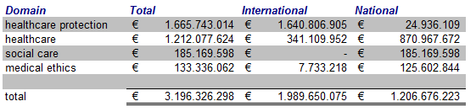

In 2004 a commission was installed to reduce the administrative costs arising from laws and regulations introduced by the Ministry of Health. The Ministry aimed to reduce the administrative costs by 25% through the years 2003 until 2007 (with the majority of the reductions being achieved in the years 2006 and 2007). Special attention would be paid to new legislation were the assessment of the administrative effects would be an integral part of the legislative processes.

According to the Ministry of Health a reduction of 22% was realized during the period 2003 - 2007. In 2008 the Cabinet set a goal to reduce the administrative costs even further with an additional 25%. This would result in a decrease of the administrative costs, due to governmental laws and regulations, by € 452 million.

Appendix 6; Analysis Organizational- and Financial overview AWBZ control costs

In Chapter 2 figures 5 and 6 were introduced to give a schematic overview of the Dutch healthcare system. Figure 5 gives an organizational overview of the healthcare system and figure 6 gives a financial overview. These overviews were analysed and compared to the control costs of the model of Plexus and BKB (2010) in order to extract all organizations, relevant for the functioning of the AWBZ, which need to be included in this category. This led to the adjustment of figures 5 and 6, which can be seen in figure 28 and 29.

Figure 28: Organizational overview of the AWBZ (Nivel, 2010)
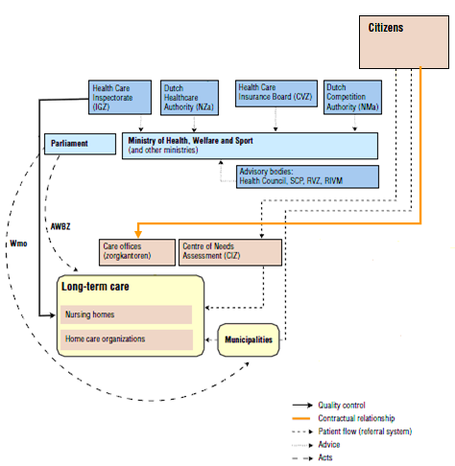

Figure 29: Financial flowchart of the AWBZ in the Netherlands (Nivel, 2010)
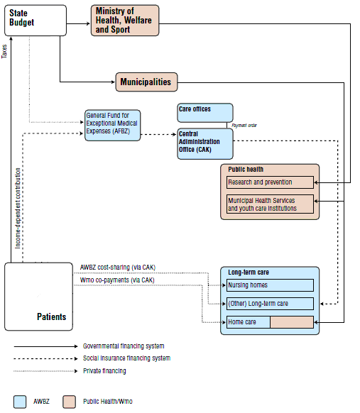

Appendix 7; Data collection

The cost measurement model, designed by Plexus and BKB (2010) was used to gather data to perform a measurement of administrative costs of the AWBZ healthcare organisations. Based on the adaptations to this model in chapter 5, three components of administrative costs were selected. For all three components data was gathered, through public databases and information available on the websites of the Dutch Government. A number of assumptions was made in order to make this data suitable for the measurement.

Control costs
The control costs consist of the costs of execution of laws and regulations and control- and policy organizations (implementing agencies) of the AWBZ, in order for the healthcare system to function. For this study only the AWBZ-related control costs need to be included in the measurement. The data of the control costs could not be retrieved through the databank of the CBS, because the control costs are not differentiated for the AWBZ and other components of the Dutch healthcare system. The data is obtained through publications of the Ministry of Health and the websites of the Dutch Government. The control costs consist of six components.

1. Cost made for the execution of the AWBZ
A number of implementing agencies of the Ministry of Health, namely the RCO's and the CAK-BZ is financed through the "Regulation management costs AWBZ".

Figure 30: Cost "Regulation management costs AWBZ" (1997 - 2010)
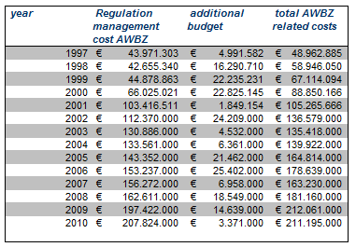
This is a yearly established budget by the Ministry of Health and used to cover the cost of the AWBZ-related activities of the RCO's and CAK-BZ. This budget is financed through the AFBZ.

2. Personnel- and operating costs for the execution of the Social Support Act (WMO)
One of the measures taken during the modernization of the AWBZ was the introduction of the Social Support Act (WMO) in 2007. This Act meant that the execution of a number of care functions was transferred from the RCO's to the municipalities. The WMO started in 2007, but the implementing costs for this legislation were made in 2005 and 2006. The initial introduction of the WMO was planed in 2006, but was postponed to 2007. This caused additional implementing costs in 2006. The data was gathered through the municipalities' circulars 2006 - 2010.

Figure 31: Implementing and execution costs WMO (1997 - 2010)
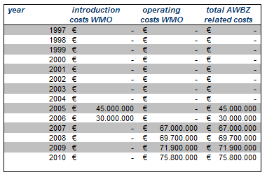

3. Costs of the Ministry of Health, both personnel- and operating costs
The Ministry of Health has a yearly budget. This budget is used for a number of policy areas and the operating costs of the Ministry. The operating costs have been gathered through the annual financial reports of the Ministry of health. The total operating costs of the Ministry of Health have been allocated to the AWBZ by the ratio of the AWBZ financing in relation to the total financing of the Dutch healthcare system.

Figure 32: Costs Ministry of Health related to the AWBZ (1997 - 2010)
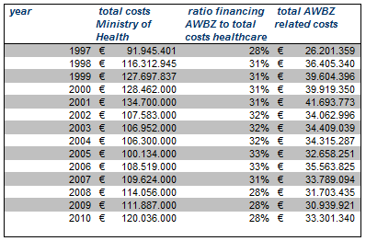

4. Costs of advisory boards and the Netherlands Bureau for Economic Policy Analysis (CPB)
A number of advisory boards is linked to the Ministry of Health. These advisory boards perform activities on behalf of the entire healthcare system. The costs of these boards are allocated to the AWBZ, based on the ratio of the AWBZ financing in relation to the total budget of the Dutch healthcare system, for the relevant year.
For a number of years (1997 - 2001) the specific costs of some advisory boards were not specified. The total costs of these boards was retrieved and presented under the category "Advisory Boards". The data is obtained through the annual financial reports of the Ministry of Health and the annual budget reports of the Ministry of Health over the years 1997-2010.

Figure 33: Costs of advisory boards related to the AWBZ (1997 - 2010)
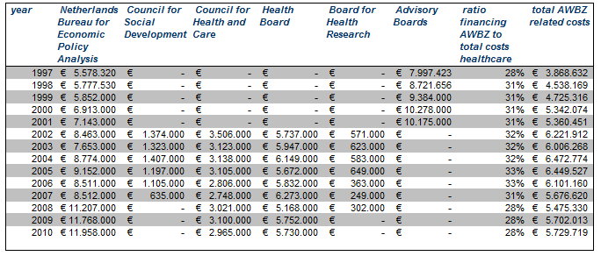

5. The total cost of implementing agencies Ministry of Health
The implementing agencies of the Ministry of Health are also taken into the measurement of administrative costs. These agencies operate under the name of "Independent Administrative Authorities" (ZBO's; Zelfstandige Bestuurs Organen), which are financed through a separate budget of the Ministry of Health.
The "Independent Administrative Authorities" perform activities for the AWBZ and other components of the Dutch healthcare system. The costs are allocated to the AWBZ based on the ratio of the AWBZ financing in relation to the total budget of the Dutch healthcare system, for the relevant year.

Figure 34: Costs of implementing agencies Ministry of Health related to the AWBZ (1997 - 2010)
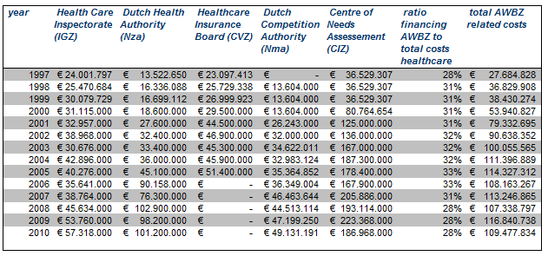
Remarks regarding data figure 34;
- Data was obtained through the annual financial reports of the Ministry of Health 1997 - 2010 and the annual budget of the Ministry of Health 1997 - 2010 (if data was not available through the annual financial reports),
- The costs of the NZa and the CVZ from 2006 - 2010 are not specified for each agency. The costs of both implementing agencies were only available as a cumulated amount. The NZa was first established in 2006. From 1997 until 2005 the costs of the CTG (from 2000 - 2005) and its predecessor COTG (1997 - 1999), the CSZ (Agency for the Restructuring of Healthcare organizations) and the CBZ (Agency for Building affairs Healthcare organizations) were taken into account. The CVZ was known until 1998 under the name Board for Social Health Insurance (Ziekenfondsraad).
- The CIZ was installed in 2005 as one of the measures of the modernization of the AWBZ. Form 1997 until 2004 the CIZ were known as the RIO's (Regional Indication Agencies). The costs of these RIO's from 1997 until 2004 are stated as costs of the predecessor of the CIZ. The RIO's were first established in 1997. For the year 2000 an assumption was made for the total costs of the RIO's, based on the average costs of 1999 and 2001. Data was not available for 2000. The costs for 1997 - 1999 were based on documents of the Association of Dutch Municipalities (VNG).
- The NMa was first established in 1998. The operating costs were obtained from the annual financial reports. The operating costs for 1998 and 1999 were not available and were based on the operating costs of 2000.

6. Total costs of collecting AWBZ premiums through the Tax authorities
The premiums of the AWBZ are collected through the Tax authorities. The operating costs of the Tax authorities are allocated to the AWBZ premiums received. The data was gathered from the national budget of the Dutch Government of the years 1997- 2010).

Figure 35: Costs of collecting AWBZ premiums through Tax authorities (1997 - 2010)
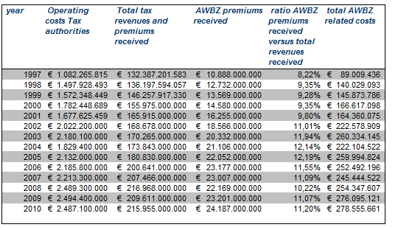

Overhead costs
The overhead costs of healthcare organizations were obtained through the public databases of the CBS. The electronic database of the CBS has a number of data collections regarding healthcare in the Netherlands. These collections consist of both financial data (profit and loss accounts, balance sheets etc.) and non-financial (production) information. The data is available from 1993 until 2010. The databases are based on the SBI '93 classification used to select the healthcare sectors for this study.

7. Overhead costs
The overhead costs were obtained through the public database (www.Statline.cbs.nl) of the CBS. The data was combined from a number of reports. Assumptions were regarding the overhead costs for a number of years, based on the data available. The assumptions are described in the remarks regarding this component of administrative costs.

Figure 36: Overhead costs of healthcare sectors (1997 - 2010)
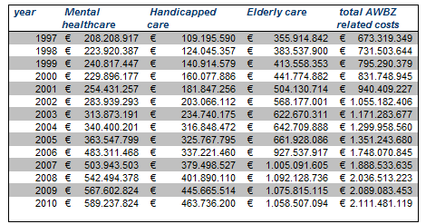
Remarks regarding data figure 36;
- The data of administrative- and general personnel costs of mental healthcare from 1997 - 2005 is based on the ratio administrative personnel costs versus total personnel costs from 2006 and 2007 and the total personnel costs of 1997 - 2005.
- The data of administrative- and general personnel costs of handicapped care from 1997 - 2000 is based on the change of personnel costs of general and administrative functions in 2001 - 2003.
- The data of administrative- and general personnel costs of handicapped care from 2001 - 2005 is calculated on the ratio of general and administrative FTE's versus the total FTE's of this sector in the years 2001 - 2005 and the total personnel costs of these years.
- Elderly care consists of nursing care, home care and residential care homes.
- The data of administrative- and general personnel costs of nursing homes from 1997 - 2004 is calculated on the ratio of general and administrative FTE's versus the total FTE's of this sector in the years 1997 - 2004 and the total personnel costs of these years. The costs of administrative- and general personnel costs of nursing homes in 2005 is calculated based on the change of the costs of administrative- and general personnel between 2002 -2004.
- The data of administrative- and general personnel costs of residential care homes from 1997 - 2005 is calculated on the ratio of general and administrative FTE's versus the total FTE's of this sector in the years 1997 - 2005 and the total personnel costs of these years.
- The data of administrative- and general personnel costs of home care from 1997 - 2005 is calculated on the ratio of general and administrative FTE's versus the total FTE's of this sector in the years 1997 - 2005 and the total personnel costs of these years.

8. General costs
The general costs were obtained through the public database (www.Statline.cbs.nl) of the CBS. The data was combined from a number of reports. Assumptions were made regarding the general costs for a number of years, based on the data available. This is described in the remarks regarding this component of administrative costs.

Figure 37: General costs of overhead of healthcare sectors (1997 - 2010)
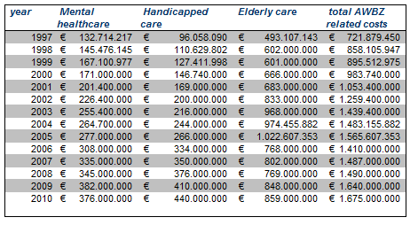
Remarks regarding data figure 37;
- The data of general costs of mental healthcare from 1997, 1998 and 1999 was not available. This data was obtained through the change of costs from these years, and the available data of general costs from 2000.
- The data of general costs of handicapped care 1997 - 2000 was not available. This data was obtained through the change of costs from these years, and the available data of general costs from 2001.
- Elderly care consists of nursing care, home care and residential care homes.
- The data of general costs of nursing homes for 2004 and 2005 was not available. This data was obtained from the costs change of the total costs of 2004 and 2005 and the available data of general costs from 2003.
- The data of general costs of nursing homes from 1997 was not available. This data was obtained through the change of costs from this year, and the available data of general costs from 1998.
- The data of home care consists of personnel- and operating costs. The operating costs are not specified to general- and other costs. The full operating costs are taken into account in the measurement of general costs. This probably causes a sharp fall of general costs in 2006 - 2010. From 2006 - 2010 the specification of general costs was available.

Costs administrative activities by healthcare professionals
The costs of administrative activities by healthcare professionals are measured through the time spent by healthcare professionals on administrative activities and the personnel costs of these professionals. The data of the CBS includes the costs of healthcare professionals. Unfortunately the time spent on administrative activities for the healthcare sectors selected is not available for this study. The administrative costs of administrative activities by healthcare professionals are not included in the measurement, due to the incompleteness of the data.

Appendix 8; Results

The administrative costs are compared to the total financing of the AWBZ. In the total financing of the AWBZ, the control- and overhead costs are also included. In order to prevent comparing the control- and overhead costs partly to itself, these costs are eliminated from the total financing of the AWBZ. This data is used to perform a linear regression.

Control costs
The control costs are compared to the total financing of the AWBZ. The measurement consists of data from 1997 until 2010. The data is analysed using single linear regressing in Microsoft Excel.

Figure 38: Data measurement control costs of AWBZ (1997 - 2010)
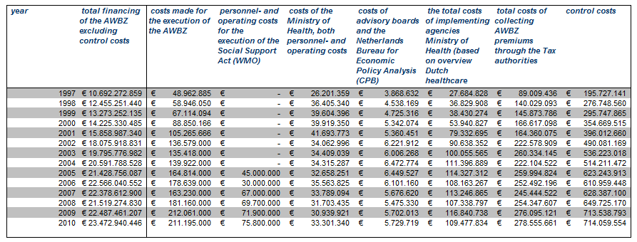

Figure 39: Output measurement control costs (1997 - 2010)
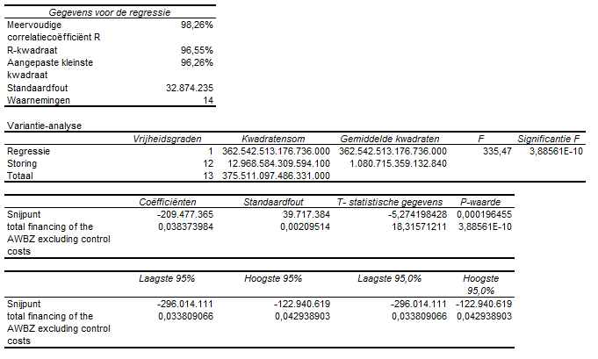
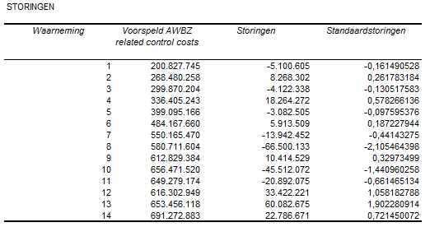

Figure 40: Residual output control costs (1997 - 2010)
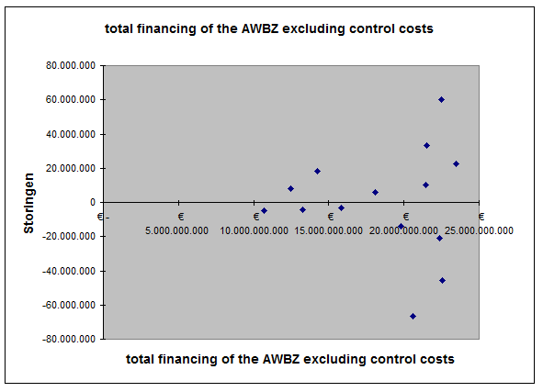

Figure 41: Output measurement control costs (1997 - 2010)

Overhead costs
The overhead costs are compared to the total financing of the AWBZ. The measurement consists of data from 1997 until 2010. The data is analysed using single linear regressing in Microsoft Excel.

Figure 42: Data measurement overhead costs healthcare sectors AWBZ (1997 - 2010)
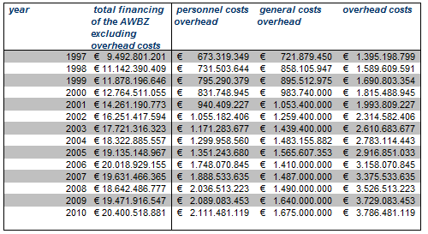

Figure 43: Output measurement overhead costs (1997 - 2010)
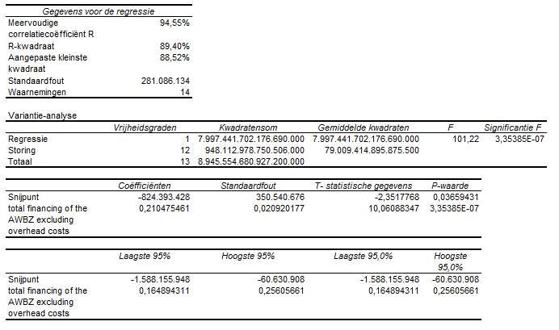
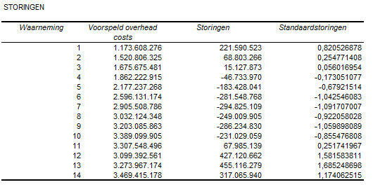

Figure 44: Residual output overhead costs (1997 - 2010)
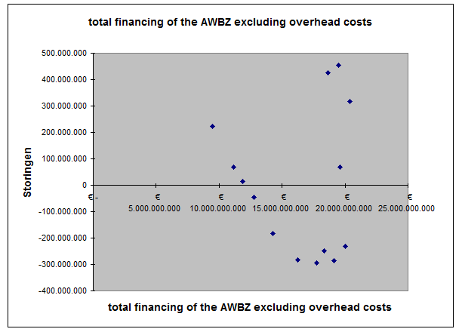

Figure 45: Output measurement overhead costs (1997 - 2010)

The Ministry of Health is an abbreviation of The Ministry of Health, Welfare and Sports.
The income-dependant contribution consists of taxation through wages and personal contributions.
Due to the increase in the quality of healthcare the life expectancy has increased considerably. This causes the cost of care due to ageing to occur later in life, but this does not change the cost of care itself (CBS, 2010), Roos et al. (1987).
Between 2010 and 2035, the ratio between people over 65 compared to people between 20 and 64 will increase from 25% over 40% (CPB, 2008).
The grow of labor productivity in the market sector between 1970-2003 was on average 2% per year, while the productivity grow in the healthcare sector totaled at 0,3% on average.
The number of people over 65 will increase from 2,3 million in 2005 to 4 million in 2040 (SER, 2008).
The third compartment consists of private expenses, but is relatively small compared to the other compartments.
The Health Insurance Act was introduced in 2006.
Of the total expenses on healthcare 68% was financed through collective means.
According to Schut & Van de Ven (2005) these phases consist of a first face ensuring universal coverage, a second phase focused on the containment of cost and a third phase focused on incentives within the healthcare system and competition.
The final figures of the years which are marked with * are preliminary.
During the 1980’s the Dutch Government was faces with an increasing unemployment through a stagnation of the economy.
Cabinet Rutte - Verhagen.
In 2002 Commission De Beer presented a report regarding the administrative costs of rules and regulations in the Dutch healthcare sector. A comprehensive description of the findings of the Commission and the effects of this rapport is included in this thesis under Appendix 5.
The means of the AWBZ are financed through the General Fund for Exceptional Care (AFBZ), which are obtained mainly though payroll taxation.
There are 27 Regional Care Offices in total.
According to Schut & Van de Ven (2005) these phases consist of a first face ensuring universal coverage, a second phase focused on the containment of cost and a third phase focused on incentives within the healthcare system and competition.
The control costs are the costs made by healthcare insurers, implementing agencies of the Ministry of Health and governance cost in order to execute the healthcare system.
This study was published under the name "Werken met ZZP's; inventarisatie ondersteuningsbehoefte" and conducted by HHM, Casemix and Q-talent.
The professionals included in this study are physicians and paramedics.
Under the term productivity is meant labour-productivity.
Healthcare institutions are equated to companies.
Survey was conducted by PWC, IT Cares and M&I/Kompas in 2006 and was given the title "Reducing administrative costs: more than abolishing of regulations.
This study (Meer tijd voor de client; Rapportage werken aan zorg) was performed by Plexus and BKB in 2010 and was commissioned by the Ministry of Health.
The information of the research done by Folland, Goodman & Stano (2007) is based on a publication by Nicolle & Mathauer (2010); see Appendix 3; Literature).
The information of the research done by Zycher (2007) is based on a publication by Nicolle & Mathauer (2010); see Appendix 3; Literature).
In Appendix 1 the full classification of costs into different categories is shown.
The total administrative cost of the US healthcare system in 1987 was estimated between $96.8 and $120.4 billion.
The interval is based on estimations made by the Woolhandler and Himmelstein (1991).
The information of the research done by Glaser (1993) is based on a publication by the U.S. Congress, Office of Technology Assessment (1994); see Appendix 3; Literature).
This calculation does not take commissions, taxes and profit into account, as these components are not used in the Medicare system.
In comparison to private health insurers the medical cost of Medicare was $6,600 per person per year (senior citizens), while the average medical cost of private health insurance was $2,700 per person per year (people under 65 years of age). Through the higher cost per person form medical care the average cost of administrations are lower (Matthews 2006).
This was based primarily on the data from Medicare 1994.
The information of the research done by Hahn (1993) is based on a publication by the U.S. Congress, Office of Technology Assessment (1994); see Appendix 3; Literature.
The information of the research done by Glaser (1993) is based on a publication by the U.S. Congress, Office of Technology Assessment (1994); see Appendix 3; Literature).
Meer tijd voor de cliënt; Rapportage werken aan zorg.
In 2000 the commission De Beer was installed to specifically address the issue of administrative costs in healthcare. A description of the results of this commission is included in this thesis in Appendix 5.
This includes the costs for the department of Sports, as part of the Ministry of Health.
The advisory boards consists of Council for Social Development, Council for Health and Care, Health Board and the Board for Health Research.
Nurses are also considered as healthcare professionals.
The definition of the time format is not further elaborated in the model by Plexus and BKB. The definitions are obtained from a study by HHM (Hoeksma, Homas & Menting) conducted to activities of healthcare professionals in 2007; "Tijdsbestedingonderzoek behandelaars sector V&V).
The organizational and financial overview of the Dutch healthcare system can be seen in figure 5 and 6.
The elaboration of the Plexus and BKB model is based upon the description of this model in the background documentation of the study conducted, named "data more time for patients data rapport "Plexus and BKB (2010).
These organizations have previously been referred to as implementing agencies of the Ministry of Health.
The organizations that perform AWBZ-related activities can be seen in figure 5 and 6.
Regeling besteedbare middelen beheerskosten AWBZ.
These Private Health Insurances are an addition to the Health Insurance Act (ZVW). The choice for these insurances is made voluntarily by people insured for the ZVW.
In Appendix 6 the schematic overviews of the organizational- and financial structures of the AWBZ are included.
In order to measure the impact of this definition of AWBZ organisations, an analysis will be performed with a percentage AWBZ funding of 60% and 90%, in order to analyse the possible deviation of the results due to the definition.
This basic ledger ("ledger accounts for healthcare organizations") is drafted by Prismant and is directly related to the yearly financial statement of healthcare organizations.
The definition of the time format is not further elaborated in the model by Plexus and BKB. The definitions are obtained from a study by HHM (Hoeksma, Homas & Menting) conducted to activities of healthcare professionals in 2007; "Tijdsbestedingonderzoek behandelaars sector V&V).
From 2006 the data from several different tables (personnel data, profit and losses etc.) is combined in a new integral table.
The SBI index is based on the classification of the European Union (NACE) and the classification of the United Nations (ISIC).
This consists of data from the NZa (Dutch Healthcare Authority) and CAK-BZ (Central Administration Office Exceptional Medical Expenses).
The healthcare organizations cannot be observed as individual organisations, but are aggregated by SBI-number. The number of healthcare organisations (groups) is included in the data and can be used to asses the consistency of the data.
The plausibility analysis is performed on the basis of time series analysis, ratio between variables and comparison of the data with other sources.
This division is consistent with the introduction of the modernization of the AWBZ.
The data of the AWBZ funding 2000 CVZ is obtained through the website; http://www.ggzbeleid.nl/pdfmacro/CVZorgcijfers2000-2005.pdf
The data of the AWBZ budget healthcare sectors CBS is obtained through the electronic database of the CBS; http://www.statline.cbs.nl.
Elderly care consists of; nursing homes, home care and residential care homes.
The specifications of the data collected are included in Appendix 7.
The year 2010 is the most recent year of which data is available.
In Appendix 8 the complete output from Excel is included.
The financing of the AWBZ is adjusted for the overhead costs.
In Appendix 8 the complete output from Excel is included.
The healthcare sectors which are included in this study are selected on the criteria that they are predominantly AWBZ financed (over 75%). If this criteria would be raised to 90% the handicapped sector would not be included in this study, as the AWBZ funding of this sector amounts to 85%. This could influence the outcomes of this study. A change of the criteria to 60% would not influence the outcome of the measurement.
Other studies e.g. PWC (2005) do not state the time of administrative activities by healthcare professionals, but measure these activities through the category; non client-related time. PWC (2005) estimates this category to amount to 19,2% - 30% of the total time of healthcare professionals in the handicapped sector.
These figures are based on the entire Dutch healthcare system.
These figures do not include the administrative costs of time spent by healthcare professionals on administrative activities.
For this measurement the total financing of the AWBZ was adjusted, because the total financing of the AWBZ was also used for the administrative costs. By eliminating the administrative costs in the total financing of the AWBZ it is prevented that the administrative costs are partly compared to itself.
This consisted of the ZFW, AWBZ, WTG, WZV and the WTZ.
In order to measure the effects of the measures a baseline assessment was conducted by EIM.
The Standard Cost Model (SCM) is a framework to measure and compare the administrative costs due to laws and regulations of the Government during a certain time period.
The Ministry of Health defines the administrative burdens as the costs for companies and citizens which are necessary to comply with information requirements arising from law and Governmental regulations. Other administrative costs are not included in this definition.
The baseline of this reduction was the administrative cost on 31-12-2002.
The publications used are the annual financial statements of the Ministry of Health and other Ministries.
Regeling besteedbare middelen beheerskosten AWBZ.
The municipalities' circulars were obtained through the website http://www.rijksoverheid.nl/documenten-en-publicaties/circulaires.
The annual financial reports of the Ministry of Health were obtained through the website http://www.rijksbegroting.nl.
This data was obtained through the website of the CBS http://www.statline.cbs.nl.
The costs for the execution of the AFBZ (General Fund for Exceptional Medical Expenses) are included in the operating costs of the CVZ.
The national budgets of the Dutch Government were obtained through the website http://www.rijksbegroting.nl.
This data was obtained through the website of the CBS http://www.statline.cbs.nl.
This data was obtained through the website of the CBS http://www.statline.cbs.nl.

