

The effect of consumer expertise on consumer behavioral intentions
The role of Involvement and online consumers’ reviews

Marketing Master Thesis 2012
Evangelia Makri (347524)
Supervisor: Gui Liberali

Contents
1. Introduction: 6
1.1 Background and context 6
1.2 Research Problem 8
1.3 Research method 11
1.4 Research structure 11
2. Theory: 13
2.1 Literature review 13
2.1.1 Consumer’s Expertise 13
2.1.2 Product Involvement 15
2.1.3 Online consumer reviews 17
2.1.4 Purchase intention 19
2.1.5 Perception of risk 19
2.1.6 Perceived informativeness 21
2.1.7 Attitude towards the product 22
2.2 Hypothesis development 23
2.2.1 The relationship of consumer’s expertise and type of reviews affecting the dependent variables 23
2.2.2 The relationship between Product Involvement, attitude towards the product and purchase intention: 26
2.2.3 The relationship between Product Involvement and Perception of risk 27
2.2.4 The cognitive fit effect on the dependent variables, the moderating role of involvement 28
3. Methodology 31
3.1 Conceptual Model 31
3.2 Experimental design 33
3.3 Stimuli Development 34
3.3.1 Involvement Scenarios 34
3.3.2 Type of online reviews 35
3.3.3 Experimental Product 37
3.4 Sampling design and procedure 38
3.5 Construct measurement 38
3.5.1 General questions 39
3.5.2 Consumer’s expertise 39
3.5.3 Perceived informativeness 40
3.5.4 Attitude towards the product 40
3.5.5 Purchase intention 41
3.5.6 Perception of risk 41
3.5.7 Manipulation checks 41
3.5.8 Control variables 42
3.5.9 Demographics 43
3.5.10 Pre-test 43
3.6 Questionnaire design 44
4. Data: 46
4.1 Data Cleaning 46
4.1.1 Demographics 46
4.1.2 Descriptive statistics 48
4.2 Validity and reliability of constructs 51
4.3 Manipulation checks and Control variables 52
5. Results 53
5.1 Results of the two-way ANOVAs 54
5.1.1Informativeness 54
5.1.2 Purchase Intention 56
5.1.3 Attitude towards the product 58
5.1.4 Perceived risk 59
5.2 Results of the three way ANOVAs 61
5.2.1 The cognitive fit and the effect of Involvement on informativeness 61
5.2.2 The cognitive fit and the effect of Involvement on purchase intention 64
5.2.3 The cognitive fit and the effect of Involvement on attitude towards the product 66
5.2.4 The cognitive fit and the effect of Involvement on perceived risk 68
5.3 Summary of results 71
6. Discussion 73
6.1 Informativeness 73
6.2 Purchase Intention 74
6.3 Attitude towards the product 75
6.4 Perceived risk 76
7. Conclusions 78
7.1 General conclusions and main findings 78
7.2 Managerial Implications 79
7.3 Limitations and future research 81
8. References: 82
Appendices: 93
APPENDIX A 93
APPENDIX B 99
APPENDIX C 102
APPENDIX D 103
APPENDIX E 103
APPENDIX F 106
APPENDIX G 113
APPENDIX H: 124

Introduction:

1.1 Background and context

According to the product life cycle theory, every product progresses through the various stages of the product life cycle. Introduction, growth, maturity and decline are the four major stages that a product has to go through (Day, 1981). However many products fail to enter most of the stages of the product life cycle. Moreover a significant number of products fail even to enter the introduction stage (Cooper, 1979).
Marketers in their effort to avoid product failure, try to apply different marketing mix strategies in each of the stages of the product life cycle in order to ensure the success of their products. Consumers who are the direct receivers of the outcome of these marketing strategies have different informational needs for each stage of the cycle.
To be more specific, according to the diffusion of innovations theory, developed by Everett Rogers (2003), consumers are divided into five adopter categories: innovators, early adopters, early majority, late majority and laggards. Every category has its own informational needs and unique characteristics. According to Park & Kim, innovators need more attribute oriented information due to the fact that their interest is focused on technical information. Consumers, who find themselves in the following categories such as early majority, need information that is more benefit oriented due to the fact that they have a lower level of knowledge about the product.
For marketers it is a difficult task to recognize and adapt their marketing strategies in order to satisfy the informational needs of each category. Moreover, creating advertisements that have both benefit centric and attribute centric information can be both time-consuming and costly.
According to Maheswaran and Sternthal (1990) when presenting both types of information, it is much less effective than focusing on providing information that is either benefit-centric or attribute-centric.
In order to resolve this problem word-of-mouth can be a very successful tool for marketers in their effort to overcome the difficulties that are related to the informational needs of each consumer. To be more specific, word-of mouth has been defined by Westbrook as: “All types of informal communications directed at other consumers about the ownership, usage, or characteristics of particular goods and services and/or their sellers”. In the Internet era, word-of-mouth has been successfully
implemented in the World Wide Web with the form of electronic word of mouth. Electronic word of mouth is consistent of various types of communication media such as: blogs, reviews, forums, ratings etc. and is defined by Dellarocas (2003) as “the ability to exchange opinions and experiences online”. Most of these types of communication are usually generated by users. Many researchers have shown that electronic word of mouth is an effective tool for marketing strategies. More specifically, electronic word of mouth can increase product sales (Chevalier and Mayzlin, 2006), affect consumers purchase intentions (Peng Zou, Bo Yu and Yuanyan Hao, 2011), affect consumer’s based brand equity (Bambauer-Sachse and Mangold 2011) and consumers’ information adoption (Cheung, Lee & Rabjohn 2008). Also past research has shown that consumers accept and rely on electronic word of mouth (Henning-Thurau and Walsh 2004) In accordance to the previously discussed problem, electronic word of mouth provides usually product information and recommendations from the user perspective and they can be positively or negatively valenced. The users who write these reviews are most of times former users at any given stage of the product life cycle. Thus, their reviews can be attribute or benefit centric and satisfy the informational needs of potential consumers. Electronic word of mouth spreads faster than traditional word-of-mouth and that is why consumers can have an easier access to this type of information. From the marketers’ perspective, electronic word of mouth can be measured, controlled and evaluated much easier than traditional word of mouth.
Figure 1: “A conceptual model of Word-of-Mouth”
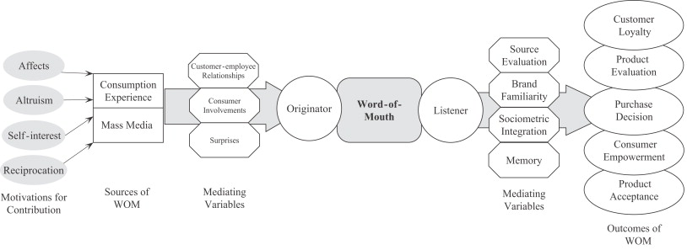

Source: www.sciencedirect.com

1.2 Research Problem

According to the aforementioned, consumers in different categories of the diffusion of adoption theory have different informational needs and different levels of expertise concerning a specific product. Besides according to the cognitive fit theory, every consumer has a unique way of processing or analyzing information. Nevertheless when the consumers’ individual characteristics are provided with a type of information that fits their cognitive style of thinking then a cognitive fit emerges. When this cognitive fit emerges then a consumer can resolve a problem more efficiently and effectively (Vessey & Galleta, 1991).
According to the elaboration likelihood model (Petty and Cacioppo, 1984), consumers follow two different routes to persuasion, when an argument or information is provided to a consumer: the peripheral route and the central route. Central route is mostly preferred when the conditions of the elaboration likelihood are high. Because the situation requires a lot of effort and thought in order to process the message. Hence, the central route is more effective. On the other hand the peripheral route does not require extensive cognitive processing of the argument’s parts or message presented. Persuasion is mainly affected by the environmental characteristics of the message, like the perceived credibility of the source or the popularity of the message writer. Thus, irrelevant cues are used to affect the information process in the peripheral route.
Moreover in the article “The Effects of Involvement on Responses to Argument Quantity and Quality: Central and peripheral routes to persuasion”, Petty and Cacioppo (1984) found that consumer’s personal involvement with an issue or a product may significantly affect the way that this particular consumer processes information which is relevant to this product or issue.
Considering the importance of electronic word of mouth, the implementation of the ELM theory and the cognitive fit theory in the world –wide-web, the aim of this study is to provide more insight in the relationship between consumer’s expertise and the way that a consumer processes information which is relevant to a product, in different product involvement situations. More specifically, in this research the type of information provided will be online consumer reviews. Product involvement will be dichotomized according to two different involvement scenarios, one for high involvement and one for low. The experimental product will be a tablet pc. Once this relationship is researched then, the effect of this relationship on consumer’s purchase intention, perceived informativeness, attitude towards the product and perception of risk will be analyzed. Thus, in order to research all the above factors the following question will be answered in this study:
“How do different levels of consumer’s expertise, product involvement (high vs. low), and different types of online consumer reviews (benefit centric online consumer reviews vs. attribute centric online consumer reviews) will affect consumer’s purchase intention, attitude toward the product, perception of risk and perceived informativeness of online consumers’ reviews?
The first thing that should be researched is the existence of a cognitive fit between expertise and type of review. This relationship is quite important since previous literature has not yet come into a consensus about the relationship of expertise and electronic word-of-mouth:
Q₁: For which consumer (experts vs. novices) is the effect of online consumer reviews stronger on perceived informativeness?
Q_{2:} Which type of online consumer review (attribute-centric vs. benefit centric) fits consumers with a low (or high) level of expertise?
Q_{3:} For which consumer (experts vs. novices) is the effect of online consumer reviews stronger on purchase intentions?
Another important aspect that should be examined in order to give an answer to the research question is the relationship between involvement (high vs. low) and type of reviews. According to the ELM theory in a high involvement situation consumers show a greater preference towards attribute-centric messages. However, this relationship has not been examined in previous literature with the usage of electronic word-of mouth messages.
Q_{4:} How does the main effect of type of review (attribute-centric vs. benefit centric), the main effect of involvement (high vs. low) and their interaction affects purchase intention?
Q_{5:} How does the main effect of type of review (attribute-centric vs. benefit centric), the main effect of involvement (high vs. low) and their interaction affects attitude towards the product?
Moreover, the relationship of perceived risk, involvement and type of reviews is considered one of the most complex relationships due to the nature of perceived risk. This relationship will be analyzed extensively in the literature review chapter but in order to answer the research question, the following sub-question will be used as a guide in an effort to examine this complexity.
Q₆: How does the main effect of type of review (attribute-centric vs. benefit centric), the main effect of involvement (high vs. low) and their interaction affects perception of risk?
As it has already been mentioned one of the main goals of this study is to establish the fact that a cognitive fit exists between expertise and type of review. Nevertheless it is quite interesting to investigate how this cognitive fit becomes stronger or weaker depending on levels of either high or low involvement.
Q_{7:} Does the effect of cognitive fit become stronger (or weaker) on perceived informativeness in a high (or low) involvement condition?
Q₈: Does the effect of cognitive fit become stronger (or weaker) on purchase intention in a high (or low) involvement condition?
Q₉: Does the effect of cognitive fit become stronger (or weaker) on attitude towards the product in a high (or low) involvement condition?
Q₁₀: Does the effect of cognitive fit become stronger (or weaker) on attitude towards the product in a high (or low) involvement condition?

1.3 Research method

The research method that is used in this study aims at answering the research question and sub questions that were analyzed in the previous section. Research method is implemented by following a number of steps. The first step is to review all the existing literature that is relevant to the variables and their effects, which will be examined in this study. The second step is to develop a several number of hypotheses. These two steps constitute the conceptual framework.
A 2 x 2 between subject factorial experimental design was applied so as to test each of the hypotheses. One manipulation check was used in this experiment, concerning involvement. An online questionnaire was developed in order to measure the dependent variables. It is important to notice that two different scenarios of involvement were created in order to measure the effects of different involvement situations on the dependent variables. Besides, two different types of reviews were used in the experiment. Four conditions in total were created. The questionnaire was assigned randomly to every participant of this experiment. The data obtained from the questionnaire were analyzed by the usage of statistical software (SPSS). Several techniques were used so as to analyze every effect and combination. Factor analysis was used in order to examine the reliability and validity of the constructs. In addition cluster analysis was implemented in order to create clusters which contain consumers with higher and lower expertise. Finally two-way and three-way ANOVAs were conducted so as to examine the significance level of the effects of the independent variables on the dependent variables.

1.4 Research structure

The first chapter aims at describing the research problem and the research method which will be applied to this study.
The second chapter is divided into two sections. The first section describes and gives the definition for each variable that will be examined in this study. Seven variables will be examined, namely: consumer’s expertise, situational product involvement, type of review, purchase intentions, informativeness, attitude towards the product, and perceived risk. The second section will use as a basis, existing literature in order to formulate a number of hypothesis.
The third chapter focuses on the methodology of this study. Specifically after describing the conceptual model, experimental design and stimuli development, the construct measurement along with the questionnaire design will be analyzed.
After collecting the data, the fourth chapter aims at giving more insight to the demographics and the validity and reliability of the constructs applied in the current experiment by the usage of factor analysis.
The fifth chapter focuses on the results. Specifically every hypothesis is tested by applying a number of factorial ANOVAs.
Chapter six includes the discussion of the results acquired from chapter five. Each dependent variable is discussed separately.
Finally in chapter seven, the conclusion, managerial implications, and limitations are presented along with some recommendations for future research.

Theory:

In this chapter the definitions of each variable will be given. It is important to explain and understand each variable based on the existing literature. Once all the variables are described then several hypothesis will be formulated based on previous similar researches.

2.1 Literature review

2.1.1 Consumer’s Expertise

According to the early existent literature, consumer’s knowledge has been researched as a one-dimensional variable (Alba and Hutchinson, 1987). Most researchers refer to consumer’s knowledge as consumer’s product familiarity or prior knowledge. Alba and Hutchinson (1987), in their effort to investigate the notion of consumer’s knowledge, they propose two dimensions of consumer’s knowledge: expertise and familiarity. In their article, they argue that familiarity is considered as the multiple experiences that a consumer has gathered over the years for a specific product while expertise is considered as “the ability to perform product related tasks with success”. According to Brucks (1985), knowledge may be further analyzed into objective and subjective knowledge. Subjective knowledge refers to the self-perceived consumer’s knowledge while objective knowledge refers to the actual knowledge that is stored in a consumer’s memory.
Kleiser and Mantel (1994), in their effort to develop a scale measuring consumer’s expertise, they adopted the multidimensional view of Alba and Hutchinson (1987). As a result they divided the notion of consumer’s expertise into five different dimensions, namely: cognitive effort, cognitive structure, analysis, elaboration and memory.
In the most recent literature Petty et. Al (2009) found that the level of product knowledge determines the level of consumer’s expertise. Park and Kim (2004), in their experiment, used subjective knowledge measurements and objective knowledge measurements in order to determine the level of consumer’s expertise.
Although consumer’s knowledge may have many dimensions or categories, most researchers have found significant differences between the ways that a consumer of high product related expertise and a consumer of low product related expertise processes information. To be more specific, Bettman and Sujan (1987) have reported that high-knowledge consumer’s may likely analyze information by using “decision criteria” that are stored in one’s memory and may also use more effort and thought in order to process information. On the contrary low-knowledge consumers prefer to use more empirical and emotional related cues in order to process information.
Chingching Chang (2004) found that when creating advertisements that include statements leading to rational expectations in relevance to the product’s performance then it is more likely for high-knowledge consumers, that this type of advertisement is more effective and reduces negative effects. On the other side of the spectrum, when low-knowledge consumers are overwhelmed with advertising claims, that cannot be easily processed and analyzed, then these advertisements may have a positive effect on these types of consumers.
There are also contradictory studies referring to the relationship of expertise and information processing. Johnson and Russo (1984) support the idea that expertise and learning new information is positively related. Also Pujn and Staelin (1986) state that consumers who have acquired specific product knowledge are less likely to search for further information by engaging to an external search while consumers with general product-class knowledge may engage to further external search. Moreover, Bloch, et al., (1986) indicate that ongoing research by a consumer may be influenced more by “hedonic benefits” rather than simple “informational motives”. In accordance, Gilly et al. (1998) report a negative relationship between WOM and expertise. Finally Park and Kim (2008) state that there is a cognitive fit between consumer’s expertise and the type of the online review provided, which leads to affect positively the purchase intention of the consumer.
By taking into consideration the entire aforementioned, consumer’s expertise is a variable that needs further investigation, especially in relevance with the way that an expert or a novice consumer processes information. In this study consumer’s expertise will be considered as a moderator variable while the source of information will be online consumer reviews. Subjective knowledge is tested in this study in an effort to determine the level of consumer’s expertise in continuance to Park and Kim’s research.

2.1.2 Product Involvement

Involvement has been examined by many different perspectives in existing literature. Researchers have measured involvement in relation to purchase decisions (Clarke and Belk, 1978), advertisements (Krugman, 1982) and products (Howard and Sheth, 1969). Every one of these different correlations may lead to different effects for a consumer. For instance when involvement is examined in relation to purchase decisions, research has shown that consumers engage more actively to seek information and spend more time to make a purchase decision that will satisfy their needs (Clarke and Belk, 1978). Moreover when involvement is correlated with advertisements, consumers create arguments opposed to the claims of an ad (Wright, 1974). In addition, when involvement is studied in relation to the product, Howard and Shelth (1969) have indicated that a consumer maybe led to higher engagement to the brand choice, and perceive better the product’s attribute differences as well as the product’s importance.
In accordance, several studies have examined product involvement as enduring or situational (Richins and Bloch, 1986; Parkinson and Schenk, 1980). Before elaborating on the differences between situational and enduring involvement, it is important to notice that product involvement affects consumers’ behavior and cognitive (M.Dholakia, 2001). According to Dholokia, product involvement is defined as “an internal state variable that indicates the amount of arousal, interest or drive evoked by a product class”. As far as it concerns enduring involvement, this concept is correlated with the fact that a consumer is interested for a specific product class and generally engages in tasks that are related to this product class. Consumer’s interest is constant and not affected by a specific purchase situation. This interest arises by his/her own personal beliefs, values, and ego (Richins and Bloch, 1986). On the other side of the spectrum, situational involvement refers to a situation whose variables are driving the consumer to perceive temporarily a product as an important asset in order to reach “extrinsic goals that may derive from the purchase and/or usage of the product”(Bloch and Richins, 1983).
There is also another study that suggests that involvement can be researched under three different dimensions: product-centered which is actually the aforementioned product involvement, subject centered and response centered (Finn 1983). Subject centered refers to its consumer’s individual level of involvement and response centered refers to involvement as an information processing characteristic.
Researchers may have varied in the ways that they have measured involvement depending on its different dimensions; however they all come to a certain consensus: the level of its consumer’s involvement (high or low) can affect many different aspects of consumer’s behavior. More specifically, involvement may affect consumer’s search behavior, decisions (Hoyer 1984), expectations, disconfirmation (Patterson, 1993), post-purchase evaluation (Gronhaug 1977), attitude formation toward the brand (Assael, 1987), perception of risk (Dholokia, 2001), information search and information processing. (Broderic and Mueller 1999; Foxall and Bhate, 1993).
As far as it concerns the latter, Park and Lee (2007) found that involvement has a moderating role on online word-of-mouth message processing. More specifically, when consumers find themselves in a situation of high involvement, they are more willing to process additional product information form online consumer reviews and do not seem to care about the product’s popularity. The exact opposite effects are related to consumers in a low involvement situation.
In continuance to Park and Lee’s, (2008) research, in this study product situational involvement will be considered as an independent variable for analysis. There are three reasons for selecting situational involvement over enduring involvement: First, the personal characteristics of each consumer can affect the way that each individual perceives involvement for the same product. Second, according to Park and Lee (2008), when using two different products for an experiment, compounding effects may appear due to this difference (e.g. toilet paper vs. tablet PC). Third, according to Mittal (1995), situational involvement of a consumer’s purchase decision can have stronger effects about the variance in consumer’s involvement. These effects are considered to be greater than product class involvement.
Specifically, the effect of situational involvement on consumers message processing (where the message will be online consumer reviews), perception of risk, attitude towards the product and purchase intentions is investigated.

2.1.3 Online consumer reviews

According to B. Strauss (2000), in the pre-internet era, consumers used to share their product related experiences with their families, relatives and friends. This has been known as the traditional Word of mouth. Nowadays, with the advance of technology consumers have various ways of sharing their experiences through the internet. Electronic word of mouth has grown rapidly through the years and is considered as a social phenomenon that has intrigued the attention of many researchers (Dellarocas, 2003). E-WOM has expanded in so many different areas that has the potential to even affect the profits of a company (Samson, 2006). Therefore, marketer’s and companies need to take the advantage of controlling the E-WOM communication channel and use it as an important asset for their revenues (Dellarocas, 2003). In accordance with the existing literature, consumers are influenced by word of mouth when a high level of involvement exists in the purchase decision (Beatty & Smith, 1987), when consumer’s expertise is low about a specific product category (Furse, et al., 1984; Gilly et al., 1998), when perception of risk about a particular purchase decision is high (Bansal & Voyer, 2000) or when the nature of the product includes intangible attributes that cannot be easily pre-evaluated by the consumer (Arndt, 1967; Webster, 1991). As far as it concerns the marketer’s perspective, word of mouth is a powerful tool that is difficult to control for formulating strategies and applying it on a large basis, in other words companies have yet been able to implement it on their marketing strategy mix (Woodside & Delozier, 1976).
Online consumer reviews is considered to be one type of E-WOM communication (Park & Kim, 2008). The content of these reviews is user-generated. The term User generated content is relatively new and the earliest article that has used this term is dating back to 1995 (Halbert D., 2008). According to Halbert (2008), this term begun to be more actively used in 2005 and 2006. Nowadays, user generated content can be found everywhere on the Internet: in Wikipedia articles, Facebook, YouTube, e-bay, Twitter, virtual communities, on pirate websites, on product evaluation websites, ratings for products or sellers and many more places yet to be described.
In this study, the main focus will be online consumer reviews that are related to product recommendations and evaluations. According to the existing literature, online consumer reviews that include product evaluations and/or recommendations have a significant impact on consumer’s purchase intentions, purchase decisions, brand attitudes, information adoption, awareness and many more. (Park & Kim, 2008; Chevalier & Mayzlin, 2006; Senecal & Nantel, 2004; Cheung et al. 2009; Davis & Khazanchi 2008). It is also stated by existing literature, that this impact may sometimes be even greater than marketer-generated information (Chiou & Cheng, 2003). Researchers have indicated in many cases that consumers often have a high perception of persuasiveness towards online consumer reviews due to the fact that the content is not commercial oriented. Consumers who write these reviews are independent of any company profits and thus the content of their reviews is considered more useful, helpful and trustworthy by the readers than marketing-generated content. (Ha, 2002; Herr, Kades & Kim 1991; Bickart & Schindler 2001).
In this study, the influence of the online reviews will be tested in relevance to the level of the perceived informativeness. Deutsch and Gerard (1955) have discerned two types of influence for online consumer reviews: normative influence and informational influence. Normative influence refers to a situation where a consumer abides to the expectations of another person or group of persons while informational refers to a situation where a consumer perceives the information provided as an indicator of reality such as an indicator of quality for a product.
Many studies have also been made on the different attributes of online consumer reviews and their influences on various aspects of consumer’s behavior. These attributes are associated with online reviews valence (positive and negative online consumer reviews), volume (the number of reviews that are written for a specific product), source expertise, review type (attribute-centric and benefit centric reviews) (Park and Lee, 2009, 2008; Boush & Kahle 2001; Cheung, Lee & Rabjohn, 2008)
Moreover, in this research, a special approach towards this variable will be adopted. To be more specific, attribute-centric and benefit-centric online consumer reviews will serve as a review type. This approach is an adaptation of Park and Lee’s research in their article “The effects of consumer knowledge on message processing of electronic word-of-mouth via online consumer reviews.” In these article, the authors use attribute-centric and benefit centric reviews as a stimuli in order to see the differential effects on consumer purchase intention. This variable will be further analyzed in the next chapter.

2.1.4 Purchase intention

Purchase intention is a term referring to a consumer future behavior and is actually a subjective judgment of a consumer in relevance to his/hers willingness to purchase a product in the future. Purchase intention does not necessarily involve the concept of the actual purchase. In the existing literature there are many studies that focus on the relationship of online consumer reviews and consumer’s purchase intention. It is important to examine this relationship in order to see how consumers formulate their purchase intention based on information provided in online consumer reviews. Park and Kim (2007) found a positive relationship between online reviews, consumers expertise and purchase intention. Many studies also suggest that negative word of mouth has a stronger influence on consumers purchase intentions than positive word of mouth (Brown and Reingen, 1987; Weinberger et al., 1981).Moreover, Park and Lee (2008) found a positive relationship among perceived popularity of a product (indicated by the number of reviews available for this product), perceived informativeness of the review and purchase intention for consumers in different involvement situations. In this study, purchase intention will be examined from the perspective of formulating a future behavior dependent on the information provided by a review and the perceived informativeness of this review.

2.1.5 Perception of risk

Bauer (1960) was one of the first researchers to introduce the concept of risk in the literature of consumer behavior. According to his findings, risk is constituted by two categories: objective risk and subjective risk. Objective risk is measured and evaluated by using accurate historical data, while subjective risk affiliates to the limited information that a consumer has about a product or purchase decision and the semi reliable constructs of one’s memory. A few years later, Cox and Rich (1964) defined perceived risk as “the nature and amount of risk perceived by a consumer in contemplating a particular purchase decision”.
There is a general consensus in the literature and especially among consumers’ psychologists that perceived risk results when different types of potential negative consequences may arise (Dholakia, 2001). According to consumer psychologists, five different dimensions of risk have been conceptualized. More specifically, these dimensions are related to financial, social, performance, physical and psychological risk. (Jacoby & Kaplan, 1972). The combination of two or more of these dimensions of risk may provide consumer’s overall perception of risk.
In accordance to the aforementioned, Bettman (1973) used a different approach into explaining the concept of risk. The researcher suggested two different components of risk: inherent risk and handled risk. According to Bettman, inherent risk can be defined as “the risk a product class holds for a consumer-the innate degree of conflict the product class is able to arouse”. Handheld risk “is the amount of conflict the product class is able to arouse when the buyer chooses a brand from product class in his usual buying situation”. To be more specific, inherent risk will drive the consumer to the action of acquiring information so as to reduce the perceived inherent risk and the end-result of this process is the handled risk.
Many researchers have shown that the perception of risk can be reduced by acquiring information related to the product. To be more specific, the research of Engel et al. (1995) in the hospitality industry have shown a consumer’s need for reducing risk through external information search due to the fact that services provided in the hospitality industry include many intangible aspects that are difficult for the consumers to pre-evaluate. Since word of mouth is considered to be a source of information, Murray (1991) proposed that word of mouth can serve as a risk reducer and may have a large impact on consumers’ behavior due to its informative nature and its interactive feedback capabilities. Still et al (1984), Harvir and Voyer (2000), showed the significance of online word of mouth in situations that involved high risk.
In this study, the effects of online consumer reviews on consumer’s perceived risk will be examined, specifically in a situation where a consumer has to make a purchasing decision.

2.1.6 Perceived informativeness

As it is mentioned in the previous sections of this study, electronic word of mouth is a source of information. Moreover and according to the aforementioned, information acquired by the consumer about a product or service, has the ability to reduce perception of risk and aid the consumer in order to reach a purchase decision. However, the quality of the information provided is very important. McKinney et al. (2002) developed a web satisfaction model in order to measure consumer’s satisfaction. In this article it is argued that information quality maybe examined under three major dimensions: understandability, reliability and usefulness of information.
Dickinger (2010), in his article about the trustworthiness of online channels examined the source trustworthiness and stated that this variable is composed by four dimensions: informativeness, integrity benevolence and ability. Moreover Venkatesh and Davis (1996, 2000) defined perceived usefulness of the information as the consumer’s personal evaluation of the likelihood that the information will improve consumer’s purchase decision. In order to gain more insight of the perceived usefulness, information was examined as being informative, valuable and instrumental. Besides, Park and Kim (2007) in their effort to examine the effect of word of mouth on consumer’s purchase intention measured perceived informativeness under the spectrums of informativeness, usefulness and helpfulness. In a similar research, Park and Lee (2008) argued that online consumer reviews have an “informant role”. Thus, consumers perceived informativeness (“defined as how much useful information all the review provides) depends on reviews quality, quantity and involvement”.
In this study the definition of Park and Lee for perceived informativeness will be adopted and examined under the dimension of informativeness, usefulness and helpfulness.

2.1.7 Attitude towards the product

Many theories have been developed in order to explain consumer’s attitudinal change towards a product. In the consumer’s behavior theory, attitude towards the product is defined as consumer’s negative or positive predisposition towards a product, which has been created as the consumer ages. There are three major theories that explain consumer’s attitude towards a product: the elaboration likelihood model, the theory of cognitive dissonance and, the Attribution Theory. In short, according to the ELM (Petty and Cacioppo, 1986), consumer’s attitude change is dependent of the level of involvement and the information provided to the consumer about this product. In the theory of cognitive dissonance (Festinger, 1957), when a consumer has to make a high-involving decision, usually finds himself in a situation of conflicting thoughts and feelings. This discomfort is actually defined as cognitive dissonance. This state of uneasiness may occur in pre and post purchase situations. Consumers in their effort to reduce this discomfort, they usually change their attitude towards the product and their behavior so that both are in a state of agreement. Finally, according to the attribution theory (Heider, 1958; Hewstone, et al., 1983), consumer’s behavior is dependent by the fact that people are prone to assign causality to events, on the basis of their own behavior or behavior of others. The attitudinal change occurs due to the consumer’s judgment of his/hers own behavior and experiences.
After taking into consideration all the above theories, in this study, attitude towards the product will be examined under the effects of involvement, message processing and consumer’s expertise.

2.2 Hypothesis development

2.2.1 The relationship of consumer’s expertise and type of reviews affecting the dependent variables

There is a plethora of contradictory studies regarding the relationship of consumer’s expertise and word of mouth. Specifically, Wagenheim and Bayon (2004) mention that, a research gap exists among the interactions of word of mouth, the characteristics of the communicator (“such as expertise or similarity”) and the service category (“such as perceived risk”). Based on the existing literature, Brucks (1985) also claims that there is a number of studies supporting the existence of a negative relationship between the level of expertise of an information seeker and the degree to which the consumer engages into an external search for information. Meaning that when the consumer has a high level of expertise about a specific product, he/she will probably spend much less time into searching for information about the product, since he/she thinks that acquires already a considerable amount of information, in order to make an accurate purchase decision. (Bloch, et al. 1986)
However, there are studies that support the fact that prior knowledge leads to external search of information but due to the fact that the consumer possess already high levels of knowledge about the product, the process of this extra information can be conducted faster and easier. The opposite applies for consumers with low level of prior knowledge (Johnson and Russco 1984; Punj and Staelin, 1983). Gilly et al. (1998) mentioned as well a negative relationship between product expertise and search for information. In addition, Furse, Punj and Stewart (1984) stated that consumers with low levels of expertise and experience are overwhelmed with lack of confidence about making correct product choices that satisfy their needs.
All the aforementioned studies are focused on the field of traditional word of mouth. Nevertheless, Park and Kim (2008) examined the relationship of online word of mouth and consumers expertise. Due to the fact that online word of mouth is easily traceable and measurable the examination of its effects is much easier than traditional word of mouth. In continuance to Parks and Kim’s research, this study will try to add more insight in the inconsistent relationship between consumer’s expertise and type of the review message. Using as a basis the cognitive fit theory, a link will be created between expetise and online word of mouth.
According to the cognitive theory, a consumer is able to process an information provided more effectivly and efficiently when the provided information can be analysed by using the appropriate cognitive process (Vessey and Galleta, 1991). When the information processing strategy of a consumer matches the information type provided then the cognitive effort is diminished and the decision making task will be enhanced (Hong, Thong and Tam, 2004). As Park and Kim have stated (2008), consumers with different levels of expertise will look for different types of information that probably fit their cognitive style. To be more specific, consumers with high level of expertise will seek attribute centric information about a product while consumers with low level of expertise will seek information that is easy to understand and focuses mainly of the beneficial aspects of a product (Walker et al. 1987).
Online consumer review may include information that is either attribute centric or benefit centric. An online consumer’s review usually contains evaluation and recommendations about a product. In this study only evaluation parts will be used. The evaluation part of the review will be positively valenced and it will be divided into attribute centric and benefit centric information. More specifically the attribute centric reviews will include technical attributes of the experimental product that are based on objective data ,while the benefit centric reviews will contain statements that express the beneficial aspects of the experimental product and will be based on subjective judgements. Therefore, taking into consideration that a review contains information about the same aspect of a product , an assumption can be made that the cognitive strategies of experts will fit attribute centric reviews while the cognitive strategies of novices will fit benefit centric reviews. This assumption will be verified if the perceived informativenes of the review, is higher for consumers who have a cognitive fit between the information provided and their level of expertise.
Hypothesis 1a: Perceived informativenes is higher for consumers with high level of experitse when provided with reviews framed as attribute centric than reviews framed as benefit centric. (Cognitive fit hypothesis )
Hypothesis 1b: Perceived informativeness is higher for consumers with low level of expertise when provided with reviews framed as benefit centric than reviews framed as attribute centric. (Cognitive fit hypothesis )
Moreover many researchers have examined the relationship of online reviews and consumer’s purchase intentions. For example, Forman et al. (2008), found that online product sales increase when the consumers are provided with online reviews that include descriptive information about the products. Another study suggests that consumers pay attention to review scores as well as to other contextual information in order to reach their purchase decision (Hu et al., 2008). Finally there is a study that contradicts the positive relationship of online reviews and purchase intention. Duan et al. (2008) support the idea that although there is a significant influence of the volume of online reviews on product sales, the persuasive effects of online reviews on consumers purchase intention appears to be insignificant. In this research, the effect on purchase intention will be examined from the perspective of the cognitive theory. In continuance to the aforementioned, when a cognitive fit emerges between consumer’s expertise and information provided, consumers are able to reduce their problem-solving effort. According to Park & Kim (2008) this cognitive fit is able to have a positive relationship with purchase intentions.
Hypothesis 2a: For consumers with high expertise reviews framed as attribute-centric have a stronger effect on the purchase intention than reviews framed as benefit centric.
Hypothesis 2b: : For consumers with low expertise reviews framed as benefit-centric have a stronger effect on the purchase intention than reviews framed as attribute centric.

2.2.2 The relationship between Product Involvement, attitude towards the product and purchase intention:

According to Petty and Cacioppo (1984), product involvement has a moderating effect on information processing. To be more specific, the ELM supports the idea that a consumer may process the same information in different ways depending on the consumer’s product involvement. When involvement increases, then consumers are more motivated towards understanding the most important parts of a message and tend to produce complex thoughts during the comprehension stage (Johnson and Eagly, 1989). On the other side of the spectrum, when the levels of involvement decrease then consumers tend to focus on peripheral cues associated for instance, with the reviews positiveness. Other studies, which have been based on the ELM, suggest that, product relevant attributes information is more influential under conditions of high involvement while peripheral cues are more influential under low involvement conditions (Petty & Cacioppo 1983; Chaiken S., 1980). Moreover, since the ELM model refers to attitude’s change, the quality of an argument that leads to this change is of crucial importance. Low involvement consumers prefer messages with simple recommendations and subjective judgments by other consumers. However, high involvement consumers will try to search for high quality reviews that contain objective data. Considering the fact that attribute centric reviews contain mostly objective data while benefit-centric reviews contain subjective judgments the following hypotheses can be formulated:
Hypothesis 3a: In the high involvement condition, the impact of attribute centric reviews on purchase intention is greater than the impact of benefit centric reviews
Hypothesis 3b: In the low involvement condition, the impact of benefit centric reviews on purchase intention is greater than the impact of attribute centric reviews
Hypothesis 3c: In the high involvement condition, the impact of attribute centric reviews on attitude towards the product is greater than the impact of benefit centric reviews.
Hypothesis 3d: In the low involvement condition, the impact of benefit centric reviews on attitude towards the product is greater than the impact of attribute centric reviews

2.2.3 The relationship between Product Involvement and Perception of risk

Product involvement and perception of risk are considered to be, according to the existing literature, highly correlated variables. Barber and Venkatraman (1986), in their study, refer to high involvement and characterize it as a situation that involves some type of problem solving behavior. This behavior occurs when the purchase decision has high personal relevance for the consumer and is overwhelmed with high amounts of risk.
As far as it concerns situational product involvement, which is the dimension of involvement that will be tested in this study, according to the existing literature, consumers experience this type of involvement when he/she has to make a purchase decision for a high-risk product (Richins and Bloch, 1986). In addition, Gilles and Kapferer (1985), mention that when consumers perceive high amounts of risk in a specific situation then situational involvement occurs. Situational involvement is associated also with certain behaviors such as information search (internal or external), seeking for WOM more actively and creating more extensive brand evaluations. All the aforementioned behaviors of a consumer contribute to the fact of reducing perception of risk for a specific purchase decision. (Richins and Bloch, 1986; Celsi and Olson 1988).
While existing literature accepts the differentiation of situational involvement and perceived risk, there are several contradictory theories regarding this relationship. To be more specific, Bloch (1981) supports the fact that perceived risk is an antecedent of involvement. On the other hand, Laurent and Kapferer (1985) support the fact that perceived risk is the result of situational involvement. Finally Rothschild (1979), reports that perceived risk is a dimension of situational involvement. In this study, perceived risk will be considered the outcome of situational involvement just like Laurent and Kapferer have proposed.
Moreover, as it is already stated online word of mouth is considered to be a useful source of information. According to Bansal and Voyer (2000), consumers in their effort to reduce their perception of risk, usually refer to word of mouth for attaining information relevant to the product or service of their interest.
In the previous chapter, the role of involvement in the Elaboration likelihood model was discussed. According to the aforementioned, consumers in high involvement will search for objective and accurate data (attribute centric reviews) in order to make a purchase decision. This is due to the fact that in a high involvement situation perception of risk is usually high; hence consumers will try to reduce risk by acquiring information. Consumers in low involvement situation will be satisfied with information that is elicited by peripheral cues (benefit centric reviews). All things considered certain hypothesis can be developed:
Hypothesis 4a: Attribute centric reviews will lower the effect of perceived risk in the high involvement situation than benefit centric reviews
Hypothesis 4b: Benefit-centric reviews will lower the effect of perceived risk in the low involvement situation than attribute centric reviews.

2.2.4 The cognitive fit effect on the dependent variables, the moderating role of involvement

As it has been already mentioned, the focus of this study is to examine the cognitive fit between consumer’s expertise and the type of online review provided. Since involvement affects significantly the information process strategy of a consumer, it is expected to find different results for the two different involvement situations. According to Oliva et al. (1995), consumers under conditions of high involvement tend to be more stable to their preferences than consumers under conditions of low involvement situation. Hence, consumers that have a cognitive fit with the type of review will have more significant effects in a high involvement situation than consumers in a low involvement situation. Park and Lee (2008) also mention that when positive review information is processed by consumers that have a cognitive fit, then it is likely that these consumers will create “a number of favorable associations to its advocacy”. This behavior will probably render the consumer to have a more favorable attitude towards the product.
In accordance with all the aforementioned in this chapter the following hypothesis can be formulated:
Hypothesis 5a: The effect of cognitive fit on informativeness is greater for the high involvement condition than the low involvement condition
Hypothesis 5a1: Experts provided with attribute-centric reviews in a high involvement condition will have a stronger impact on informativeness than in a low involvement condition.
Hypothesis 5a2: Novices provided with benefit-centric reviews in a high involvement condition will have a stronger impact on informativeness than in a low involvement condition.
Hypothesis 5b: The effect of cognitive fit on purchase intention is greater for the high involvement condition than low involvement condition
Hypothesis 5b1: Experts provided with attribute-centric reviews in the high involvement condition will have a stronger impact on purchase intention than in the low involvement condition.
Hypothesis 5b2: Novices provided with benefit-centric reviews in the high involvement condition will have a stronger impact on purchase intention than in the low involvement condition
Hypothesis 5c: The effect of cognitive fit on attitude towards the product is greater for the high involvement condition than the low involvement condition
Hypothesis 5c1: Experts provided with attribute-centric reviews in the high involvement condition will have a stronger impact on attitude towards the product than in the low involvement condition
Hypothesis 5c2: Novices provided with benefit-centric reviews in the high involvement condition will have a stronger impact attitude towards the product than in the low involvement condition
Hypothesis 5d: The effect of cognitive fit on perceived risk is greater for the high involvement condition than the low involvement condition.
Hypothesis 5d1: Experts provided with attribute-centric reviews in the high involvement condition will have a lower impact on perceived risk than in the low involvement condition
Hypothesis 5d2: Novices provided with benefit-centric reviews in the high involvement condition will have a lower impact on purchase intention than in the low involvement condition

Methodology

Conceptual Model
MODERATOR
Consumer’s expertise

Perceived informativeness
Type of reviews
(attribute-centric vs. benefit centric)
Purchase Intention

Perception of risk
Attitude towards the product
Involvement
(High vs. low)

The summary of the hypotheses to be examined as argued in the literature review are proposed as the following:
Hypothesis 1a: Perceived informativeness is higher for consumers with high level of expertise when provided with reviews framed as attribute centric than reviews framed as benefit centric. (Cognitive fit hypothesis)
Hypothesis 1b: Perceived informativeness is higher for consumers with low level of expertise when provided with reviews framed as benefit centric than reviews framed as attribute centric (Cognitive fit hypothesis)
Hypothesis 2a: For consumers with high expertise reviews framed as attribute-centric have a stronger effect on the purchase intention than reviews framed as benefit centric.
Hypothesis 2b: For consumers with low expertise reviews framed as benefit-centric have a stronger effect on the purchase intention than reviews framed as attribute centric.
Hypothesis 3a: In the high involvement condition, the impact of attribute centric reviews on purchase intention is greater than the impact of benefit centric reviews
Hypothesis 3b: In the low involvement condition, the impact of benefit centric reviews on purchase intention is greater than the impact of attribute centric reviews
Hypothesis 3c: In the high involvement condition, the impact of attribute centric reviews on attitude towards the product is greater than the impact of benefit centric reviews.
Hypothesis 3d: In the low involvement condition, the impact of benefit centric reviews on attitude towards the product is greater than the impact of attribute centric reviews
Hypothesis 4a: Attribute centric reviews will lower the effect of perceived risk in the high involvement situation than benefit centric reviews

Hypothesis 4b: Benefit-centric reviews will lower the effect of perceived risk in the low involvement situation than attribute centric reviews.
Hypothesis 5a: The effect of cognitive fit on perceived informativeness is greater for the high involvement condition than the low involvement condition (Hypothesis5a1, 5a2).
Hypothesis 5b: The effect of cognitive fit on purchase intention is greater for the high involvement condition than the low involvement condition (Hypothesis5b1, 5b2).
Hypothesis 5c: The effect of cognitive fit on attitude towards the product is greater for the high involvement condition than the low involvement condition (Hypothesis5c1, 5c2).
Hypothesis 5d: The effect of cognitive fit on perceived risk is greater for the high involvement condition than the low involvement condition (Hypothesis5d1, 5d2).

3.2 Experimental design

For this research a 2 x 2 between subjects factorial experimental design was implemented. Every participant was exposed to one of the four conditions of the experiment. The two factors of the experimental design are, namely: Product situational involvement (high vs. low) and type of online consumer reviews (attribute-centric vs. benefit-centric). The following figure demonstrates all the possible combinations.
Figure 3:
Involvement
Type of reviews | High Involvement | Low Involvement
Attribute | 1 | 2
Benefit | 3 | 4

3.3 Stimuli Development

3.3.1 Involvement Scenarios

As it has been mentioned before, situational involvement is manipulated in this study. In order to create the manipulation, two different situational involvement scenarios were developed, one for high involvement and one for low. The scenarios were different in a basis of goal directedness. Goal directedness refers to a situation where the respondent has a specific task to complete and needs to be motivated and focus in order to complete this task. According to Petty and Cacioppo (1981), consumers will process the information provided in a goal directed situation completely differently than a non-goal directed situation.
There are many researchers that have used goal directedness as a method of creating conditions of high and low involvement. More specifically, Maheswaran and Sternal (1990) in their experiment, they developed a situation where they told their subjects that “they were among a small and selected group of people whose opinions were being solicited by the manufacturer of a new personal computer to be launched shortly. They were also told that their opinions were highly relevant and weighted heavily in the eventual fate of the product.” Park and Lee (2008) also created two different involvement situations based on goal directedness. In the high involvement scenario subjects were informed that they should imagine themselves being employees of a multimedia company and had to purchase the experimental product for their business. However, the low involvement scenario was completely stripped of any goal. Subjects were supposed to just browse through an Internet shopping site for fun. In this study, it is important to ensure the validity of the scenarios that will be implemented; this is why existing literature has been used for their development. The following scenario is used for the high involvement situation and aims at creating a condition where the respondents have to be focused on the experimental product related issues.

Scenario 1:
Imagine yourself working for a multimedia company and you need to make a purchase of a tablet in a short period of time. Your decision will be important as the tablet will aid you in executing your tasks more efficiently. Please read the following product characteristics and online consumers’ reviews and answer the following questions:
The low involvement scenario is completely stripped of any goal task so that the respondent will not necessarily use any effort into processing the information related to the experimental product.
Scenario 2:
Imagine yourself wanting to buy a tablet PC for fun. Please read the following product characteristics and online consumer reviews and answer the following questions:

3.3.2 Type of online reviews

The effects of two different types of online consumer reviews are examined in this study. Two different sets are developed and each of these sets is randomly assigned to each type of involvement scenario. Both sets contain evaluations concerning the experimental product. The evaluation part is different in terms of type. Specifically the first set contains attribute centric information about the experimental product. The second set of information emphasizes on the beneficial aspects of the product. In order to ensure the validity of this experiment, the attribute centric reviews were selected so as to demonstrate attribute levels represented by a numerical value (Park and Kim 2008, Xia and Bechwati, 2008). For example, in the first attribute centric evaluation review, the writer indicates the capacity of the tablet by mentioning numerical values such as: “250 GB of HDD”. On the other hand, the benefit centric evaluation review is completely stripped of any numerical values and the writer only mentions the fact that he/she thinks that the capacity is “awesome” followed by a brief explanation about why this is beneficial.
Each set of reviews contains five evaluations. This number is considered to be small and its aim is to encourage the respondents to read through all the provided reviews without being frustrated about the number. Concerning the selected number of reviews, according to Park and Kim (2008), in their experiment they used as well two different sets of online reviews, each set containing two evaluations and three recommendations, this number was considered in their study as a small number. In addition, Maheswaran and Sternthal (1990) used three evaluation messages in their experiment. This is why for this study the optimal number of evaluation reviews is five. As far as it concerns the length of each review, two or three sentences will constitute each review. In order to collect the reviews that will be used in this experiment a certain process had to be taken. First, reviews concerning the experimental product were collected by using various websites that provide online consumer’s reviews, for example: Amazon.com, testfreaks.com, consumerreports.org. Since most online consumer’s reviews contain information mentioning both the advantages and disadvantages of the experimental product, the reviews had to be edited so as to contain information that would be positively valenced. The table containing both types of sets of reviews can be found in the following figure (also Appendix B):
Figure 4: Reviews used in the experiment

ATRRIBUTE CENTRIC REVIEWS | BENEFIT CENTRIC REVIEWS
“Nice tablet, with a single core processor at 1000Mhz helps a lot at multitasking” | “Multitasking is so fast in this little tablet. I can watch videos, upload data and browse through the internet without any delays.
“Battery was a major factor when I bought this tablet. The li-Polymer type allows me to play music for 36 hours or watch videos for 7 hours which is pretty good” | “The battery life is absolutely great. I can play music for two days straight without recharging!! I can even watch 2 to 3 movies and the battery is still alive. Now I have something to do during my long trips ”
“Yesterday just got it in my hands. It has 250GB of HDD and a Micro-SD slot so I can store 53 DVD quality movies as well as various different playback formats. Recommended for all you heavy downloaders!!! | “Let me just cut to the chase. The capacity of this tablet is awesome. I can store unlimited number of movies .I already have 30+ movies and it’s not even half filled”
“It has perfect picture quality for a 7’’ TFT LCD monitor generating 16 million colors and high resolution of 800x480 pixels.” | “I love the picture quality in this tablet. So bright, sharp and I can watch a movie in direct sunlight, no problems there”
“The variety of the audio playback is good. You can playback mp3’s, WAV, ACC, OGG and even FLAC which is really uncommon for tablets” | “Guys thump up for the playback formats. So far I have tried any type of music format I have. It just plays everything. Top quality!!!”

3.3.3 Experimental Product

The experimental product for this experiment is the tablet PC. Tablet Pc’s are included into the category of search goods. According to Ford et al. 1990 and Klein 1998 search goods and experience goods have different effects on consumers’ interpersonal communications. Besides, tablet pc is a technological oriented product for which many online reviews exist in various websites. Moreover the history of the tablet pc and its current popularity makes it, a quite interesting technological product. Specifically, Microsoft in 2000 introduced the Microsoft tablet pc under the concept of a mobile computer for field work in business. However the product did not do well as far as it concerns the sales volume, due to the high price and some usability problems. Nevertheless the tablet pc was re-introduced under the umbrella of Apple’s products in 2010. This re-introduction has sparked a new market and many manufacturers so far have launched their own tablets (Samsung, Motorola, Archos etc.). Currently, 31% of the United States internet users were reported to have a tablet.
As far as it concerns this experiment, the concept of the experiment product was to examine a product that would aid the classification of expert and novice consumers. There should be a substantial variation in the knowledge about the product. In addition the product had to be sufficiently familiar to the respondents of this experiment so that even respondents with low levels of expertise would be able to understand and comprehend at least some parts of the information provided. Table pc is likely to satisfy these criteria. In the questionnaire a picture of the product appears accompanied by its product characteristics. The brand and the price of the product are not included so as to avoid any brand or price effects. The actual tablet pc is a 7’’ Archos Internet tablet. The picture of the product and its product characteristics can be found in the appendix section (Appendix C).

3.4 Sampling design and procedure

Since this study is focused on electronic word of mouth, the most natural environment to conduct this research is via the Internet. The structured questionnaire is considered to be the best choice to collect data since this research has a quantitative nature. In addition, it is an affordable and fast way of collecting information (Creswell, 2003). The questionnaire used in this study can be found in the appendix section. The distribution of the questionnaires was based on different types of social media websites. The researcher of this study selected the respondents for this experiment. This selection included researcher’s friends, family members, peers and colleagues who were contacted via e-mails, Facebook, Twitter and Linked-in. Then this group of respondents was asked to forward this questionnaire to their friends and acquaintances. A link was provided to every respondent that redirected them to the internet address of the questionnaire. Thesistools hosted the questionnaire since it has the option to distribute four different questionnaires in random. Moreover, the questionnaire contained a short cover letter which explained the topic, outline briefly the academic purposes of this study, thank and encourage people to complete it and forward it. Besides, participants were assured that all their personal data would remain confidential and would be used only for this study’s results.
The research focuses on people above the age of eighteen, who have consulted at one point in their life an online consumer review. In addition, respondents who have owned in the past a tablet personal computer will be accepted.

3.5 Construct measurement

As it has already been mentioned the instrument used in this research to collect data is the structured questionnaire. In order to ensure the validity and accuracy of the results, proven construct measurements from the existing literature were used. More specifically the construct measurements for general questions, consumer’s expertise, effect of e-WOM, perceived informativeness, perception of risk, attitude towards the product, purchase intention and demographics have been chosen as follows. In addition one manipulation check was performed for the independent variable, situational involvement. Finally three control questions were asked, one for the review’s positiveness, one for general credibility towards online reviews and one for general susceptibility towards online reviews.

3.5.1 General questions

The questionnaire begins with a bipolar question (yes or no) in order to test whether the respondent has ever owned a table pc. Respondents who answer yes will continue to question 2, but for those who answer no the questionnaire will end. The second question is a unipolar question referring to respondents’ usage of online consumers’ reviews. Specifically, respondents are asked on average how often they read online consumer reviews before they purchase a product. The answers range from Never, Rarely, Quite often, Always. The purpose of this question is to include respondents who have at least read once in their life an online consumer review and have some level of familiarity with online reviews. For respondents who answer Never, the questionnaire will end.

3.5.2 Consumer’s expertise

Question three measures consumers' expertise. Specifically the scale that was used to measure this variable is called consumer expertise and it is known by the existing literature to have been used by Kleiser and Mantel (1994). The scale was developed after the creators’ adoption of Alba and Huchinson’s (1987) view of consumer expertise. The original scale is constituted of five different dimensions of consumer’s expertise: a. cognitive effort, b. cognitive structure, c. analysis, d. elaboration and e. memory.
For the purpose of this research only two dimensions were examined namely, analysis and elaboration. A minor adjustment has been made to the third item of the elaboration dimension where the original scale states: “I use my knowledge on (product category) to verify that advertising claims are in fact true”. Specifically, the words advertising claims have been replaced with online consumer reviews since the aim of this study is to correlate expertise and online consumers’ reviews. The Cronbach’s alpha estimates of internal consistency were .72 and .89 for the analysis and elaboration dimensions, respectively. The correlation between elaboration and analysis was estimated at .864 by Kleiser and Mantel (1994).
All items are scored on a 7-point Likert type scales from strongly disagree to strongly agree. The following items were presented at the respondents:
Analysis items:
- I enjoy learning about tablets
- I will search for the latest information on tablets before I purchase a brand
- I keep current on the most recent developments in tablets
Elaboration items:
- I consider myself knowledgeable on tablets
- My knowledge of tablets helps me understand very technical information about this product.
- I use my knowledge on tablets to verify that information from online consumer reviews is in fact true.

3.5.3 Perceived informativeness

Questions nine and ten measure the effects of the attribute centric or the benefit centric online consumers’ reviews on perceived informativeness. Question nine contains a scale developed by Maheswaran and Sternal (1990) and was used for measuring the level of informativeness of the advertisement messages that were provided to the respondents. The scale was adopted by Park and Kim (2008) and two more items were added. The answers are measured on three 7-point bipolar adjectives and the Cronbach’s α reported by Park and Kim (2008) is .83. The adjectives of this scale are: informative/not informative, useful/not useful, and helpful/not helpful.

3.5.4 Attitude towards the product

Question eleven aims at measuring respondents’ attitude towards the experimental product after reading the online consumers’ reviews. The scale composes of seven-point bipolar items, namely: dislike/like, bad/good, unfavorable/favorable, low quality/high quality, useless/useful. This scale was used by Park (2008) and the internal validity was reported to be Cronbach’s α=0.97

3.5.5 Purchase intention

Question twelve asks the respondents about their purchase intentions regarding the experimental product. More specifically the scale is composed of three items and the measurement is using seven-point Likert-type scales. The reported Cronbach’s alpha by Xia et al. (2008) is .95 for search goods. The items presented to the respondents are as follows: “It is very likely that I will buy the tablet pc”, “If I have to decide now, I probably will buy the tablet pc”, “The likelihood that I will buy the tablet pc is high”.

3.5.6 Perception of risk

Question thirteen measures respondents’ perception of risk. The scale’s name is “Riskiness of the purchase” and aims at measuring “consumers’ levels of perceived risk associated with the purchase of a specified product” (www.marketingscales.com). The scale was developed by Eroglu and Machleit (1990) and consists of four items measured on a Likert type scale. The reported Cronbach’s α is .86 and the items of the scales are as following: “The product I was shopping for is an expensive product”, “I don’t have much experience in purchasing this product”, “The decision to purchase this product involved high risk”, and “This is a technologically complex product”. For the purpose of this research the first item of this scale was not be used, since price effects on consumers’ perceived risk will not be analyzed.

3.5.7 Manipulation checks

In order to ensure the validity of this experiment one manipulation check was performed. The situational involvement manipulation is checked by the usage of a three seven point scale. This scale has been used by Martin and Marshall (1999). The items of the scale are as following: not interested/highly interested, not involved/highly involved, found the information not relevant/ found the information extremely relevant. The answers of the respondents in the high involvement scenario were expected to have an inclination towards the strongly agree indicator, while respondents’ answers in the low involvement scenario are expected to have an inclination towards the strongly disagree indicator.

3.5.8 Control variables

In this study, no control groups exist. The reason for not using control groups was mainly due to the lack of an adequate sample size, since the number of participants was expected to be approximately 120. The bare minimum sample size for examining the four experimental groups is approximately 100 respondents. By the implementation of two control groups (one for controlling involvement and one for type of review) the sample size should be at least 150 respondents. Nevertheless, in an effort to control for extraneous factors that may affect this experiment the following procedures were followed: To avoid brand effects, the brand of the product is hidden. To avoid price effects the price of the product is also hidden. The presentation of the information, regarding the picture of the experimental product, the product’s characteristics and the online consumer reviews, is created with the order that they would appear at an actual website. The number of the reviews remains constant for all the experimental conditions. The attribute-centric reviews differ from the benefit-centric review only in the way that the information is presented. To be more specific, each set of review is referring to same notion but this notion is expressed in the attribute-centric reviews by the usage of numerical attributes while in the benefit-centric reviews it is expressed by the beneficial aspects (see figure 4). Besides, respondents are randomly assigned to each experimental condition. Three control questions are used in order to control the effect of general credibility towards online reviews, general susceptibility towards online reviews and review’s positiveness.
General susceptibility and credibility towards online consumer reviews were measured with two scales. If differences existed among the experimental groups in these factors, they would be included in the data analysis as covariate variables. The general credibility measurement consists of two items: “I think that online product reviews are credible”, “I trust product reviews provided by other consumers”. The susceptibility to online product reviews measurement consists of five items: “ I often read other consumers’ online product reviews to what products/brands make good impressions on others”, “ To make sure I buy the right product/brand, I often read other consumers’ online product reviews”, “I often consult other consumers’ online product reviews to help choose the right product/brand”, “I frequently gather information from online consumer product reviews before I buy a certain product/brand”. The items are measured by the usage of seven-point rating scales ranging from 1=totally disagree to 7=totally agree. The measurements are developed by Bambauer-Sachse and Mangold (2011) after a minor adaptation of the original scale developed by Bearden et al. (1989). The Cronbach’s alphas for general credibility and susceptibility are .82 and .92 respectively. Finally, since all the online consumers’ reviews used in this experiment have a positive valence, it is important to control the fact that the respondents realize the positiveness of the reviews. In case that, respondents do not perceive the reviews as positively valenced then they would be excluded from the experiment. One 7-point item was used for this question: “Overall the reviews were positive towards the product. The scale was also used by Park and Kim (2008) in order to control for the same effect.

3.5.9 Demographics

The last section of the questionnaire contained questions regarding the demographics for each respondent. Five questions were asked concerning the respondents’ gender, age, level of education, nationality and monthly income.

3.5.10 Pre-test

In order to optimize the results acquired from the distribution of the questionnaire a pre-test was conducted. The pre-test was conducted among thirteen participants. The main purpose of the pre-test was to ensure that all the items included in the questionnaire were comprehended and that the structure motivated the participants to answer the questions as well as to test the cohesion among the questions. Results indicated that the high-involvement scenario was too complicated and frustrated the respondents. The scenario was altered into a much simpler and clear content. Moreover, the number of the reviews included in the questionnaire was quite satisfying in terms of informativeness and no changes had to be done. Besides, two construct measurements had been used initially so as to measure participants’ expertise: one measuring the objective knowledge (created by the author after implementing the instructions by Park and Kim, 2008) and one measuring the subjective knowledge (developed by Kleiser and Mantel, 1994). The two different construct measurements revealed contradictory results concerning expertise. For instance, participants who believed that had high-expertise (subjective knowledge) scored quite low in the objective expertise scale. The opposite applies as well. In order to avoid misinterpretation of the results, the objective knowledge scale was dropped and only the subjective knowledge scale was used, due to the fact that it was judged to have higher validity and reliability according to the Cronbach’s alphas reported in the previous section.

3.6 Questionnaire design

The questionnaire begins with a short introduction referring to the academic purposes of this research and assuring the respondents about the confidentiality of their answers. The first section of the questionnaire contains two screening questions. The second section measures respondents’ subjective knowledge. In addition, two general questions regarding the credibility and susceptibility towards online consumer reviews were asked. The third section contains the treatment: Initially the respondent is asked to read the involvement scenario (high involvement or low involvement) as well as the following information. A picture of the experimental product appears accompanied by the product’s characteristics and the online consumer reviews (benefit-centric or attribute centric). The fourth section contains one control check, which will refer to the reviews’ positiveness. Also one manipulation check will be performed concerning the situational involvement scenario. The fifth section refers to the measurement of the dependent variables. One question measures perceived informativeness, one question attitude towards the product, one question purchase intention and one question the perception of risk. The final section contains several questions concerning the demographics: gender, income, age, educational level and nationality.
The following figure demonstrates the flow of the questionnaire. Each section is divided in different blocks representing the construction of the questionnaire. Also the entire questionnaire used in this research can be found in Appendix A.

Figure 5: Flow of the questionnaire
Introduction

Screening questions

Questions measuring consumer’s expertise
- Self-perceived consumer expertise

Questions measuring control variables
- Susceptibility towards online consumer reviews
- Credibility towards online consumer reviews
Treatments
Manipulation and control checks:
- Involvement manipulation check
- Review positiveness (control)

Questions measuring Dependent variables
- Perceived informativeness
- Attitude towards the product
- Purchase intention
- Perception of risk
Demographics

Data:

In this chapter, the first part of the empirical results will be demonstrated. The first section represents the data cleaning process along with the demographics. In the second section the reliability of each construct is tested. The third section presents the manipulation tests.

Data Cleaning

During the period of 16-09-2012 until 1-10-2012, a total number of 219 questionnaires were completed and collected by various social media websites. Due to the fact that some of the questionnaires had missing answers, 63 of the total were excluded from further analyses. Also, in accordance with the screening questions 13 participants answered that they have never owned a tablet PC and 5 participants answered that they had never read an online consumer review. Due to the fact that this research focuses on previous or current owners of tablet PCs as well as people who read online consumer reviews, these 18 questionnaires were also excluded. Finally 148 were left for analysis. Figure 6 represents the number of respondents that participated in each experimental condition.
Involvement
Figure 6:
Type of reviews | High Involvement | Low Involvement
Attribute | n=40 | n=33
Benefit | n=34 | n=41

Demographics

At the end of the questionnaire, five questions concerning the demographics were asked. More specifically gender, educational level, monthly income, nationality and age were measured. Among the 148 participants, 76 were male (51,4%) and 72 were female (48,6%). Concerning age, measurements ranged from 18 to over 50. The majority of the participants were at the age of 18 to 30 (122 out of 148 respondents, 82,4%), 22 respondents were at the age range between 31 and 50 (14,9%) and only 2 participants were over 50 years old (1,4%). As far as it concerns nationality, the majority of the participants were Greeks with a total number of 95 respondents (64,2%), while the second larger group were Dutch respondents who accounted for 25 participants (16,9%). The third larger group were Italians with a total number of 14 respondents (9,5%). German, Spanish and other nationalities were represented by 5 (3,4%), 2 (1,4%) and 6 (4,1%) respondents respectively. Measurements regarding monthly income varied between below 500 euros and over 2501 euros. The majority of the participants were aggregated in the 501-1000 range and accounted for 79 participants (53,4%) while the second larger group was clustered in the below 500 euros range (26 respondents, 17,6%). In the ranges of 1001-1500 euros, 1501-2000 euros, 2001-2500 euros and over 2501 euros, 11 (7,4%), 12(8,1%), 6 (4,1%) and 7 (4,7%), participants were observed, respectively. Finally as far as it concerns educational level, the majority of the participants was divided between master students or graduates with a total number of 70 (47,3%) and University graduates with a total number of 64 (43,2%) respondents. School graduates and Ph.D. graduates or students were 9 (6,1%) and 3(2%) , respectively.
Table 1: Demographics
 | Description | Frequency | Percentage
Gender | Male | 76 | 51,4%
 | Female | 72 | 48,6%
Education Level | School graduate | 9 | 6,1%
 | University graduate | 64 | 43,2%
 | Master | 70 | 47,3%
 | Ph.D. | 3 | 2%
 | Not Applicable | 2 | 1,4%
Nationality | Dutch | 25 | 16,9%
 | German | 5 | 3,4%
 | Greek | 95 | 64,2%
 | Italian | 14 | 9,5%
 | Spanish | 2 | 1,4%
 | Other | 6 | 4,1%
 | Not Applicable | 1 | 0,7%
Age | 18-30 | 122 | 82,4%
 | 31-50 | 22 | 14,9%
 | Over 51 | 2 | 1,4%
 | Not Applicable | 2 | 1,4%
Monthly Income (in euros) | <500 | 26 | 17,6%
 | 501-1000 | 79 | 53,4%
 | 1001-1500 | 11 | 7,4%
 | 1501-2000 | 12 | 8,1%
 | 2001-2500 | 6 | 4,1%
 | >2501 | 7 | 4,7%
 | Not Applicable | 7 | 4,7%

Descriptive statistics

The following table demonstrates the means, standard deviation and variance of the moderator variable consumer’s expertise, the control variables, and all the dependent variables.
Table 2: Descriptive statistics
 |  | Mean | Std. Deviation | Variance
Moderator: | Consumer’s expertise | 4.41 | 1.41 | 1.99
Control: | Review’s Positiveness | 6.10 | 0.95 | 0.99
 | General Credibility towards e-WOM | 4.97 | 1.19 | 1.41
 | Susceptibility towards e-WOM | 4.90 | 1.27 | 1.61
Dependent: | Informativeness | 4.36 | 1.41 | 2.00
 | Purchase intention | 4.01 | 1.63 | 2.67
 | Attitude towards the product | 4.82 | 1.26 | 1.61
 | Perceived risk | 3.90 | 1.58 | 2.51

The following histograms aim at showing the normal distribution among the observations.
Figures 7-15: Histograms indicating the normal distribution
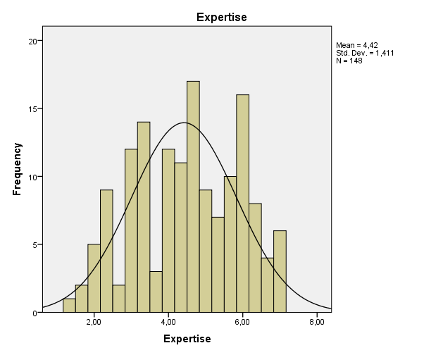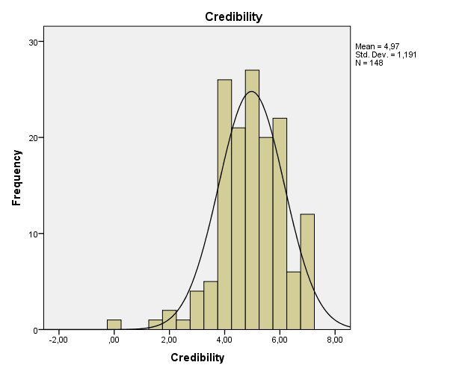
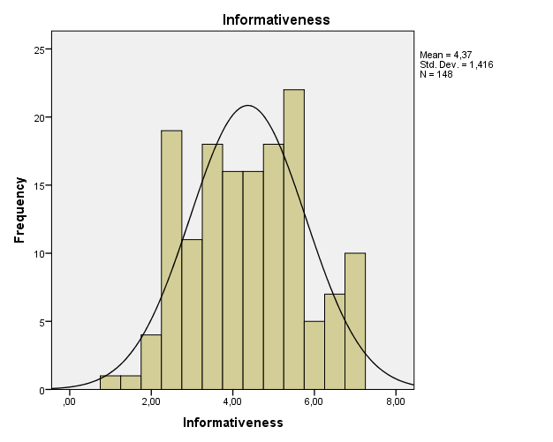
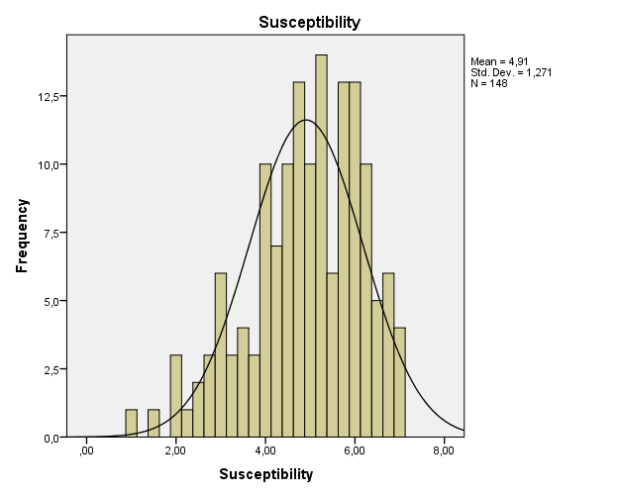

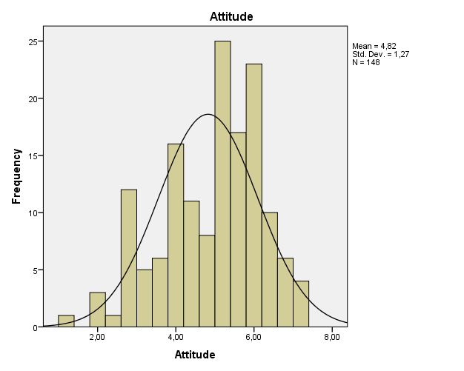
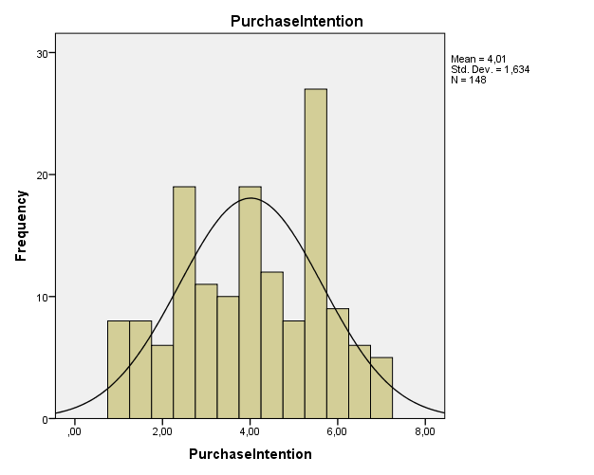

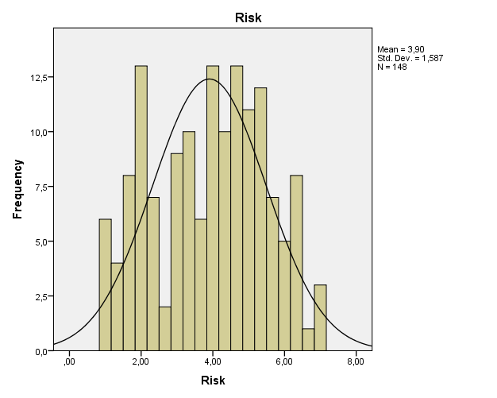
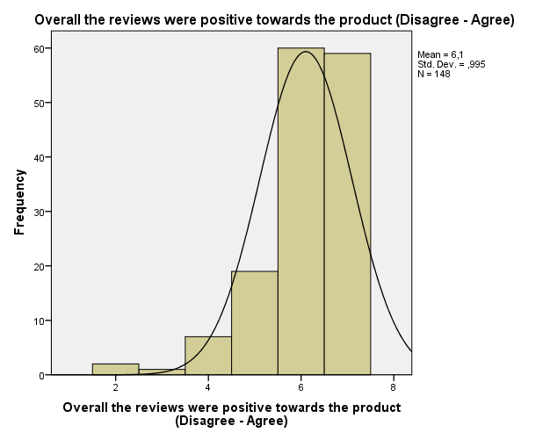

4.2 Validity and reliability of constructs

Despite the fact that in the previous chapters, the proven, validity and reliability of the constructs measurement has been discussed, in order to ensure the validity of this research it is of utmost importance to perform factor analysis. To be more specific, this technique is applied to the data in order to assure the fact that every respondent comprehended the underlying constructs of each measurement as well as to avoid problems of multicollinearity (Field, 2008). Moreover reliability analysis for each scale is performed so as to test the overall consistency of the applied measurements.
Factor analysis was performed by the usage of the Principal Components analysis with the Varimax rotation. The communalities of each item were close to 1 and the factor loadings for this sample were above the value of 0.512 which is an accepted value according to Stevens (1992) for samples between the ranges of 100 to 200. Moreover, the Kaiser-Meyer-Olkin measure of sampling adequacy had a value of 0.856 which is great according to Hutchenson and Sofroniou (1999) meaning that factor analysis can yield distinct and reliable factors. The Bartlett’s Test of sphericity (p<0.01, χ²=3109.677) showed that factor analysis is suitable for this sample. Seven variables were tested with factor analysis: consumer’s expertise, credibility of E-WOM, susceptibility of E-WOM, informativeness, attitude towards the product, purchase intention and perceived risk. Seven factors were calculated with eigenvalues greater than 1(Kaiser, 1960). The factor loadings, of each variable are demonstrated in table 2 along with the cumulative explained variance.
In addition, reliability analysis was performed. Cronbach’s alpha ranged between the values of 0.777 and 0.939. All values exceed the acceptable limit of 0.70, with credibility of E-WOM having the lowest value of 0.777. However, the item to total correlation for this variable showed that the Cronbach’s alpha cannot be improved by deleting any of the remaining items. All the other variables proved to be reliable for further analysis (see also APPENDIX E).

Table 3: Factor and reliability analysis
Factor | Item | Factor loading | Item-to-total Correlation | Explained Variance | Cronbach’s  α
Consumer’s Expertise | CE1 | 0.860 | 0.723 | 17.987% | 0.924
 | CE2 | 0.851 | 0.636
 | CE3 | 0.850 | 0.838
 | CE4 | 0.840 | 0.851
 | CE5 | 0.792 | 0.852
 | CE6 | 0.730 | 0.796
Credibility E-WOM | CRE1 | 0.839 | 0.636 | 35.063% | 0.777
 | CRE2 | 0.814 | 0.636
Susceptibility E-WOM | SE1 | 0.859 | 0.621 | 46.849% | 0.876
 | SE2 | 0.852 | 0.789
 | SE3 | 0.834 | 0.768
 | SE4 | 0.760 | 0.774
Informativeness | IF1 | 0.808 | 0.858 | 57.347% | 0.934
 | IF2 | 0.803 | 0.899
 | IF3 | 0.799 | 0.836
Attitude towards the product | AT1 | 0.888 | 0.850 | 66.184% | 0.939
 | AT2 | 0.875 | 0.855
 | AT3 | 0.871 | 0.891
 | AT4 | 0.851 | 0.801
 | AT5 | 0.824 | 0.790
Purchase Intention | PI1 | 0.808 | 0.837 | 74.435% | 0.919
 | PI2 | 0.803 | 0.837
 | PI3 | 0.799 | 0.848
Perceived risk | RK1 | 0.909 | 0.854 | 80.612% | 0.860
 | RK2 | 0.893 | 0.781
 | RK3 | 0.850 | 0.758

4.3 Manipulation checks and Control variables

One manipulation check was performed during the experiment. The manipulation for Involvement (high versus low) was successful. Specifically, the effect of involvement was significant, F (1,146) =8.987, p <0.001, respondents in the high involvement condition scored on average M= 5.14 while respondents in the low condition scored M=4.58. At this point it is important to mention that the differences among the experimental groups were expected to be much higher. For example, respondents in the low involvement condition were expected to score closer to 2 while respondents in the high-involvement condition were expected to score closer to 6. Review positiveness was examined as a control variable. No significant difference was shown among respondents in every condition, F (3,146) = 1.396, p= 0.239 with the grand mean at 6.094 indicating that respondents perceived reviews as intended. Credibility and susceptibility of E-WOM were also examined as control variables. No significant differences were found among the respondents for credibility (F (3,144) =2.073, p= 0.106) and susceptibility of E-WOM (F (3,144) = 2.966, p=0.257). Hence, these variables are excluded from further analysis. Appendix H contains the ANOVA tables regarding the manipulation checks along with the control checks.

Results

In this chapter, hypothesis testing is performed according to the data collected by the experiment. According to the experimental design of this study, two independent variables were systematically manipulated by assigning people to different conditions (Field, 2009). For these reason factorial ANOVA was chosen in order to analyse and test the formulated hypothesis. Several two-way ANOVAs and three-way ANOVAs were conducted in order to test the main and interaction effects of each independent variable on the four dependent variables. Moderating effects of consumer’s expertise are also analyzed. Besides for every significant main effect, the estimated marginal means are used so as to check the direction of the effect.
For every significant interaction, simple effects tests are performed in order to check the direction of the effect. Specifically, pairwise comparisons with the Bonferroni method were chosen since this method is more conservative and aims at producing more accurate results (Field, 2008). The F-value produced by the pairwise comparisons tests the simple effect of an independent variable within each level combination of the other independent variable. These tests are based on the linearly independent pairwise comparisons among the estimated marginal means.
For every dependent variable a summary of the ANOVA table is reported in the following sections containing the F-ratio values, the df values, the p-values and the df error values. Also in case of performing simple effects test, the Univariate tests table is reported. Finally, Appendix F and G contain all the ANOVA tables for every dependent variable along with the estimated marginal means and the pairwise comparisons tables.

Results of the two-way ANOVAs

5.1.1Informativeness

Since perceived informativeness is examined under the effects of type of review and the moderating role of consumer’s expertise, in order to check for moderating effects the method proposed from Baron and Kenny (1986) was adopted. Specifically respondents were divided into Experts and Novices by the method of hierarchical clustering. This method of clustering was chosen due to the fact that provides “good results when using a small dataset” and “gives better results compared to k-means clustering when using random dataset” (Abbas,2008).
Table 4: Descriptive statistics of Informativeness
Attribute vs Benefit | Expert vs Novices | Mean | N
Attribute-centric | Novice | 2,0868 | 25
Attribute-centric | Expert | 5,7396 | 48
Attribute-centric | Total | 4,4886 | 73
Benefit-centric | Novice | 5,7143 | 35
Benefit-centric | Expert | 2,0500 | 40
Benefit-centric | Total | 3,7600 | 75
Total | Novice | 4,2028 | 60
Total | Expert | 4,0625 | 88
Total | Total | 4,1194 | 148

Table 4 demonstrates all the means’ differences of informativeness after the effect of type of review and the moderating effect of consumer’s expertise. By giving a first look at the table, there is a great difference for each score that experts and novices have given at each level of the type of review. However, the total scores of expertise do not seem to vary significantly. On the other hand the total scores of the type of review appear to have an important difference. In order, to assure that these differences are statistically significant, it is important to perform an analysis of variances. The results of this test are summarized in table 5.
Table 5: Results of the two-way ANOVA for informativeness
 | df | F | Sig.
TypeofReview | 1 | 0.041 | 0.839
Expertise | 1 | 0.001 | 0.970
TypeofReview * Expertise | 1 | 574.956 | 0.000
Error | 144
R Squared = ,807 (Adjusted R Squared = ,803)

According to table 5, the main effect of type of review on informativeness is non-significant, F (1,144) =0.041, p=0.839. Also, the main effect of expertise on informativeness is non-significant, F (1,144) =0.001, p=0.970. On the other hand there is a significant interaction effect between type of review and expertise, F (1,144) =574.956, p<0.001. More specifically, in the attribute-centric reviews condition, novices scored M=2.087 on informativeness, while experts scored M=5.740. In the benefit-centric condition, novices scored M=5.714 while experts scored M=2.050 Simple effects tests revealed that experts score higher on informativeness when provided with attribute centric-reviews than benefit-centric reviews, F (1,144) =269.470, p<0.001, while novices score higher when provided with benefit-centric reviews rather than attribute centric reviews, F (1,144) =307.929, p<0.001. Hence hypothesis 1a and 1b are supported.

Table 6: Univariate tests for informativeness
Attribute vs Benefit |  | df | F | Sig.
Attribute-centric | Contrast | 1 | 269.470 | 0.000
Attribute-centric | Error | 144
Benefit-centric | Contrast | 1 | 307.929 | 0.000
Benefit-centric | Error | 144

5.1.2 Purchase Intention

Table 7: Descriptive statistics of purchase intention
Attribute vs Benefit | Expert vs Novices | Mean | N
Attribute-centric | Novice | 1,7400 | 25
Attribute-centric | Expert | 5,8854 | 48
Attribute-centric | Total | 4,4658 | 73
Benefit-centric | Novice | 6,2000 | 35
Benefit-centric | Expert | 1,8000 | 40
Benefit-centric | Total | 3,8533 | 75
Total | Novice | 4,3417 | 60
Total | Expert | 4,0284 | 88
Total | Total | 4,1554 | 148

Table 7 represents the descriptive statistics of purchase intention after the effect of type of review and the moderating effect of consumer’s expertise. There a quite interesting differences of the scores given from experts and novices on each level of type of review. Also the total differences of the means between attribute and benefit centric reviews seems to be quite important. Finally the total scores provided from consumer’s expertise do not seem to vary much. Table 8 aims at testing this differences on a significance level with a p-value <0.05.

Table 8: Results of two-way ANOVA for purchase intention
 | df | F | Sig.
TypeofReview | 1 | 1.056 | 0.306
Expertise | 1 | 0.488 | 0.486
TypeofReview * Expertise | 1 | 549.795 | 0.000
Error | 144
R Squared =0.797 (Adjusted R Squared =0.793)

Both the main effect of type of review (F (1,144) =1.056, p=0.306) and the main effect of expertise (F (1,144) =0.488, p=0.486) in non-significant on purchase intention. On the other hand, there was a significant interaction effect between type of review and expertise, F (1,144) =549.795, p<0.001. Specifically, in the attribute-centric condition experts scored quite higher than novices on purchase intention (M_{experts}=5.885 vs. M_{novices}= 1.740). Additionally, in the benefit-centric condition novices seemed to be more affected by this type of reviews than experts (M_{novices}= 6.2 vs. M_{experts}=1.8) Simple effects tests revealed that for attribute centric reviews, experts scored higher on purchase intention than benefit centric reviews, F (1,144) =243.318, p<0.001 while for benefit centric reviews, novices scored higher on purchase intention than attribute-centric reviews, F (1,444) =361.387, p< 0.001. Hence hypothesis 2a and 2b are supported.

Table 9: Univariate tests for purchase intention
Attribute vs Benefit |  | df | F | Sig.
Attribute-centric | Contrast | 1 | 243.318 | 0.000
Attribute-centric | Error | 144
Benefit-centric | Contrast | 1 | 311.280 | 0.000
Benefit-centric | Error | 144

Since purchase intention was also examined under the effects of Involvement and type of review, table 10 shows the descriptive statistics for this tests. It should be mentioned that the means’ differences for attribute centric reviews at each level of involvement do not seem to have the significant differences. The exact opposite applies for the benefit centric reviews at each level of involvement. Moreover, both the differences between the total scores of type of review and involvement appear to have an interesting difference.
Table 10: Descriptive statistics of purchase intention
Attribute vs Benefit | High vs Low Involvement | Mean | N
Attribute-centric | High Involvement | 4,8250 | 40
Attribute-centric | Low Involvement | 4,0303 | 33
Attribute-centric | Total | 4,4658 | 73
Benefit-centric | High Involvement | 4,1176 | 34
Benefit-centric | Low Involvement | 3,6341 | 41
Benefit-centric | Total | 3,8533 | 75
Total | High Involvement | 4,5000 | 74
Total | Low Involvement | 3,8108 | 74
Total | Total | 4,1554 | 148

The two-way ANOVA, summarized in table 11, reveals that the aforementioned differences are not significant.
Table 11: Results of two-way ANOVA on purchase Intention
 | df | F | Sig.
TypeofReview | 1 | 2.021 | 0.157
Involvement | 1 | 2.711 | 0.102
TypeofReview *Involvement | 1 | 0.161 | 0.689
Error | 144
R Squared =0.036 (Adjusted R Squared = 0.016)

The main effect of Type of review on purchase intention is non-significant, F (1,144) =2.021, p=0.157. Moreover, the main effect of Involvement on purchase intention is also non-significant, F (1,144) =2.711, p=0.102. Finally, the interaction effect between type of review and involvement is non-significant as well. Thus, hypothesis 3a and 3b are not supported.

5.1.3 Attitude towards the product

Table 12: Descriptive statistics of attitude towards the product
Attribute vs Benefit | High vs Low Involvement | Mean | N
Attribute-centric | High Involvement | 4,7375 | 40
Attribute-centric | Low Involvement | 4,6727 | 33
Attribute-centric | Total | 4,7082 | 73
Benefit-centric | High Involvement | 4,3882 | 34
Benefit-centric | Low Involvement | 4,0878 | 41
Benefit-centric | Total | 4,2240 | 75
Total | High Involvement | 4,5770 | 74
Total | Low Involvement | 4,3486 | 74
Total | Total | 4,4628 | 148

Table 12 represents the descriptive statistics of attitude towards the product after the effects of involvement and type of review. It is obvious from the table that no great differences among the means exist for each examined relationship. However, an ANOVA test may reveal that some of these differences may be significant.

Table 13: Results of two-way ANOVA on attitude towards the product
 | df | F | Sig.
TypeofReview | 1 | 2.117 | 0.148
Involvement | 1 | 0.324 | 0.570
TypeofReview *Involvement | 1 | 0.135 | 0.714
Error | 144
R Squared =0.019 (Adjusted R Squared = -0,002)

According to table 13, the main effect of type of review on attitude towards the product in non-significant, F (1,144) = 2.117, p = 0.148. Also, the main effect of involvement on attitude towards the product is non-significant, F (1,144) = 0.324, p = 0.570. Finally the interaction effect between type of review and involvement is non-significant, F (1,144) = 0.135, p =0.714. Consequently, hypothesis 3c and 3d are rejected.

5.1.4 Perceived risk

Table 14: Descriptive statistics for perceived risk
Attribute vs Benefit | High vs Low Involvement | Mean | N
Attribute-centric | High Involvement | 3,4807 | 40
Attribute-centric | Low Involvement | 2,6869 | 33
Attribute-centric | Total | 3,1218 | 73
Benefit-centric | High Involvement | 4,0294 | 34
Benefit-centric | Low Involvement | 1,7805 | 41
Benefit-centric | Total | 2,8000 | 75
Total | High Involvement | 3,7328 | 74
Total | Low Involvement | 2,1847 | 74
Total | Total | 2,9587 | 148

Table 14 demonstrates the descriptive statistics of perceived risk under the effects of involvement and type of review. It should be mentioned that the means of involvement differ significantly for each level of type of review. Besides, the total scores of type of review and the total scores of involvement seem to have great differences. In an effort to certify that these differences are significant the following table summarizes all the ANOVA results.

Table 15: Results of two-way ANOVA on perceived risk
 | df | F | Sig.
TypeofReview | 1 | 0.406 | 0.525
Involvement | 1 | 29.375 | 0.000
TypeofReview *Involvement | 1 | 6.718 | 0.011
Error | 144
R Squared = 0.208 (Adjusted R Squared = 0.191)

Concerning table 15, the main effect of type of review on perceived risk is non-significant, F (1,144) =0.406, p =0.525. It is quite interesting the fact that the main effect of Involvement on perceived risk is significant, F (1,144) =29.375, p<0.001.Specifically, respondents in the high involvement condition gave higher scores on perceived risk than respondents in the low involvement condition (M_{high- involvement}=3.755 vs. M_{low-involvement}=2.234. Moreover, there was a significant interaction effect between type of review and involvement, F (1,144) = 6.718, p<0.05. Specifically, participants who received attribute-centric reviews in the high involvement condition had lower risk perception than those who received benefit centric reviews (M_{attribute-centric}=3.481 vs. M_{benefit-centric}=4.029). On the contrary in the low involvement condition benefit centric reviews seemed to lower the effects of risk perception (M_{attribute-centric}=2.687 vs. M_{benefit-centric}=1.780). Simple effects revealed that the effect of attribute-centric reviews was lower on perceived risk for the high involvement condition than the effect of benefit centric reviews, F (1,144) = 3.944, p<0.05. On the other hand, the effect of benefit-centric reviews on perception of risk is lower for the low involvement condition than the effect of the benefit-centric reviews, F (1,144) =32.543, p<0.001. Hence, Hypotheses 4a and 4b are supported.

Table 16: Univariate tests for perception of risk
Attribute vs Benefit |  | df | F | Sig.
Attribute-centric | Contrast | 1 | 3.944 | 0.049
Attribute-centric | Error | 144
Benefit-centric | Contrast | 1 | 32.543 | 0.000
Benefit-centric | Error | 144

Results of the three way ANOVAs

5.2.1 The cognitive fit and the effect of Involvement on informativeness

Table 17: Descriptive statistics of informativeness
Attribute vs Benefit | Expert vs Novices | High vs Low Involvement | Mean | N
Attribute-centric | Novice | High Involvement | 2,0121 | 14
Attribute-centric | Novice | Low Involvement | 2,1818 | 11
Attribute-centric | Novice | Total | 2,0868 | 25
Attribute-centric | Expert | High Involvement | 6,0962 | 26
Attribute-centric | Expert | Low Involvement | 5,3182 | 22
Attribute-centric | Expert | Total | 5,7396 | 48
Attribute-centric | Total | High Involvement | 4,6667 | 40
Attribute-centric | Total | Low Involvement | 4,2727 | 33
Attribute-centric | Total | Total | 4,4886 | 73
Benefit-centric | Novice | High Involvement | 5,7895 | 19
Benefit-centric | Novice | Low Involvement | 5,6250 | 16
Benefit-centric | Novice | Total | 5,7143 | 35
Benefit-centric | Expert | High Involvement | 1,7000 | 15
Benefit-centric | Expert | Low Involvement | 2,2600 | 25
Benefit-centric | Expert | Total | 2,0500 | 40
Benefit-centric | Total | High Involvement | 3,9853 | 34
Benefit-centric | Total | Low Involvement | 3,5732 | 41
Benefit-centric | Total | Total | 3,7600 | 75
Total | Novice | High Involvement | 4,1870 | 33
Total | Novice | Low Involvement | 4,2222 | 27
Total | Novice | Total | 4,2028 | 60
Total | Expert | High Involvement | 4,4878 | 41
Total | Expert | Low Involvement | 3,6915 | 47
Total | Expert | Total | 4,0625 | 88
Total | Total | High Involvement | 4,3536 | 74
Total | Total | Low Involvement | 3,8851 | 74
Total | Total | Total | 4,1194 | 148

Table 17 demonstrates the descriptive statistics of informativess under the effects of involvement, type of review and consumer’s expertise. For the attribute-centric condition it is important to mention that the mean scores given by the novices do not differ either in the low or the high involvement condition. However the scores given by the experts seem to have an important difference depending on the involvement condition. The total scores of high and low involvement have some small differences. Moreover, what seems to be interesting is that the means’ differences between experts and novices for the attribute-centric condition are quite big.
For the benefit-centric condition, it should be noticed that the means’ scores differences for the novices are quite unsubstantial at each level of involvement. On the contrary, experts show important differences between the high and low involvement condition. Furthermore, the total scores between experts and novices in the benefit centric condition appear to have significant differences. On the other hand the total scores of high and low involvement condition include minor differences. However, unless a three-way ANOVA is performed no assumptions can be made about the significance level of these differences.

Table 18: Results of the three-way ANOVA for informativeness
 | df | F | Sig.
TypeofReview | 1 | 0.153 | 0.696
Expertise | 1 | 0.154 | 0.696
Involvement | 1 | 0.127 | 0.722
TypeofReview * Expertise | 1 | 604.014 | 0.000
TypeofReview *Involvement | 1 | 2.826 | 0.095
Expertise * Involvement | 1 | 0.140 | 0.709
TypeofReview * Expertise * Involvement | 1 | 7.842 | 0.006
Error | 140
R Squared = 0.824 (Adjusted R Squared = 0.815)

The main effect of type of review on informativeness is non-significant, F (1,140) =0.153, p=0.696. Accordingly both the main effect of expertise (F (1,140) =0.154, p=0.154) and the main effect of involvement (F (1,140) =0.127, p=0.722) are non-significant. Regarding the simple interactions, the interaction effect between expertise and involvement is non-significant (F (1,140) = 0.140, p=0.709).
Besides the simple interaction effect between type of review and involvement is non-significant, F (1,140) =2.826, p=0.095. On the other hand, the simple interaction effect between type of review and expertise is significant, F (1,140) =604.014, p<0.001. For the attribute-centric condition experts scored M=5.707 while novices scored M=2.097. For the benefit-centric condition, experts scored M=1.980 while novices scored M=5.7.Moreover the three way interaction is significant, F (1,140) =7.842, p<0.01. Specially experts who received attribute-centric reviews in the high-involvement condition scored much higher than the low-involvement condition (M _{high-involvement} =6.096 vs. M _{low-involvement} =5.318. Additionally, novices who received benefit-centric reviews scored much higher in the high-involvement condition than in the low-involvement condition (M _{high-involvement} =5.789 vs. M _{low-involvement} =5.625).
The simple effects tests revealed that when experts are provided with attribute-centric reviews in the high involvement condition scored higher on perceived informativeness than in the low involvement condition, F (1,140) =199.255, p<0.001 On the other hand, when novices are provided with benefit-centric reviews in the high involvement condition, scored higher on perceived informativeness than in the low involvement condition, F (1,140) =184.033, p<0.001.Hence hypotheses 5a, 5a1 and 5a2 are supported.

Table 19: Univariate tests on Informativeness
Attribute vs Benefit | High vs Low Involvement |  | df | F | Sig.
Attribute-centric | High Involvement | Contrast | 1 | 199.255 | 0.000
Attribute-centric | High Involvement | Error | 140
Attribute-centric | Low Involvement | Contrast | 1 | 94.700 | 0.000
Attribute-centric | Low Involvement | Error | 140
Benefit-centric | High Involvement | Contrast | 1 | 184.033 | 0.000
Benefit-centric | High Involvement | Error | 140
Benefit-centric | Low Involvement | Contrast | 1 | 145.024 | 0.000
Benefit-centric | Low Involvement | Error | 140

5.2.2 The cognitive fit and the effect of Involvement on purchase intention

Table 20: Descriptive statistics of purchase intention
Attribute vs Benefit | Expert vs Novices | High vs Low Involvement | Mean | N
Attribute-centric | Novice | High Involvement | 1,6786 | 14
Attribute-centric | Novice | Low Involvement | 1,8182 | 11
Attribute-centric | Novice | Total | 1,7400 | 25
Attribute-centric | Expert | High Involvement | 6,5192 | 26
Attribute-centric | Expert | Low Involvement | 5,1364 | 22
Attribute-centric | Expert | Total | 5,8854 | 48
Attribute-centric | Total | High Involvement | 4,8250 | 40
Attribute-centric | Total | Low Involvement | 4,0303 | 33
Attribute-centric | Total | Total | 4,4658 | 73
Benefit-centric | Novice | High Involvement | 6,2895 | 19
Benefit-centric | Novice | Low Involvement | 6,0938 | 16
Benefit-centric | Novice | Total | 6,2000 | 35
Benefit-centric | Expert | High Involvement | 1,3667 | 15
Benefit-centric | Expert | Low Involvement | 2,0600 | 25
Benefit-centric | Expert | Total | 1,8000 | 40
Benefit-centric | Total | High Involvement | 4,1176 | 34
Benefit-centric | Total | Low Involvement | 3,6341 | 41
Benefit-centric | Total | Total | 3,8533 | 75
Total | Novice | High Involvement | 4,3333 | 33
Total | Novice | Low Involvement | 4,3519 | 27
Total | Novice | Total | 4,3417 | 60
Total | Expert | High Involvement | 4,6341 | 41
Total | Expert | Low Involvement | 3,5000 | 47
Total | Expert | Total | 4,0284 | 88
Total | Total | High Involvement | 4,5000 | 74
Total | Total | Low Involvement | 3,8108 | 74
Total | Total | Total | 4,1554 | 148

By looking at table 20, several differences exist among the experimental groups on purchase intention. However, due to the complexity of comparing each mean at each level of each of the three variables namely, expertise, involvement and type of review and their combinations a three-way ANOVA test can reveal more distinctly the differences among these means and their significance levels.
Table 21: Results of three-way ANOVA for purchase intention
 | df | F | Sig.
TypeofReview | 1 | 0.928 | 0.337
Expertise | 1 | 0.365 | 0.245
Involvement | 1 | 0.193 | 0.277
TypeofReview * Expertise | 1 | 628.414 | 0.000
TypeofReview *Involvement | 1 | 6.501 | 0.012
Expertise* Involvement | 1 | 0.861 | 0.355
TypeofReview * Expertise * Involvement | 1 | 12.476 | 0.001
Error | 140
R Squared = 0.831 (Adjusted R Squared = 0.823)
The main effect of type of review on purchase intention is non-significant, F (1,140) = 0.928, p= 0.337. Accordingly both the main effect of expertise on purchase intention (F (1,140) =0.365, p=0.245) and the main effect of involvement on purchase intention (F (1,140) =0.193, p=0.277) are not significant. The simple interaction between type of review and involvement (F (1,140) = 6.501, p<0.05) is significant. Respondents who received attribute-centric reviews in the high-involvement condition found the online reviews much more informative than those who received benefit-centric reviews (M_{attribute-centric}=4.099 vs. M_{benefit-centric}=3.828).The exact opposite effect seems to apply for the low-involvement condition where benefit-centric reviews were considered to be more informative than attribute-centic reviews (M_{attribute-centric}=3.477 vs. M_{benefit-centric}=4.077). Moreover, the simple interaction of type of review and expertise is significant, F (1,140) = 628.414, p<0.001.Specifically experts who received attribute-centric-reviews scored much higher on informativeness than when received benefit centric reviews (M_{attribute-centric}=5.828 vs. M_{benefit-centric}=1.713). Novices, on the other hand, who received benefit-centric-reviews scored much higher on informativeness than when received attribute centric reviews (M_{attribute-centric}=1.748 vs. M_{benefit-centric}=6.192). As far as it concerns the simple interaction between expertise and involvement is non-significant, F (1,140) = 0.861, p=0.355. Finally, the main three-way interaction is significant, F (1,140) = 12.476, p<0.05. Simple effects tests revealed that when experts are provided with attribute-centric reviews in the high involvement condition scored higher on purchase intention than in the low involvement condition, F (1,140)= 214.1, p<0.001, M_{high-involvement}=6.519 vs. M _{low-involvement}=5.136. On the other hand, when novices are provided with benefit-centric reviews in the high involvement condition, scored higher on purchase intention than in the low involvement condition, F (1,140)= 203.966, p<0.001, M_{high-involvement}=6.289 vs. M _{low-involvement}=6.094.Hence hypotheses, 5b, 5b1 and 5b2 are supported.
Table 22: Univariate tests on purchase intention
Attribute vs Benefit | High vs Low Involvement |  | df | F | Sig.
Attribute-centric | High Involvement | Contrast | 1 | 214.100 | 0.000
Attribute-centric | High Involvement | Error | 140
Attribute-centric | Low Involvement | Contrast | 1 | 81.071 | 0.000
Attribute-centric | Low Involvement | Error | 140
Benefit-centric | High Involvement | Contrast | 1 | 203.966 | 0.000
Benefit-centric | High Involvement | Error | 140
Benefit-centric | Low Involvement | Contrast | 1 | 159.390 | 0.000
Benefit-centric | Low Involvement | Error | 140

5.2.3 The cognitive fit and the effect of Involvement on attitude towards the product

Table 23: Descriptive statistics of attitudes towards the product
Attribute vs Benefit | Expert vs Novices | High vs Low Involvement | Mean | N
Attribute-centric | Novice | High Involvement | 1,9143 | 14
Attribute-centric | Novice | Low Involvement | 2,5455 | 11
Attribute-centric | Novice | Total | 2,1920 | 25
Attribute-centric | Expert | High Involvement | 6,2577 | 26
Attribute-centric | Expert | Low Involvement | 5,7364 | 22
Attribute-centric | Expert | Total | 6,0188 | 48
Attribute-centric | Total | High Involvement | 4,7375 | 40
Attribute-centric | Total | Low Involvement | 4,6727 | 33
Attribute-centric | Total | Total | 4,7082 | 73
Benefit-centric | Novice | High Involvement | 6,3158 | 19
Benefit-centric | Novice | Low Involvement | 5,9250 | 16
Benefit-centric | Novice | Total | 6,1371 | 35
Benefit-centric | Expert | High Involvement | 1,9467 | 15
Benefit-centric | Expert | Low Involvement | 2,9120 | 25
Benefit-centric | Expert | Total | 2,5500 | 40
Benefit-centric | Total | High Involvement | 4,3882 | 34
Benefit-centric | Total | Low Involvement | 4,0878 | 41
Benefit-centric | Total | Total | 4,2240 | 75
Total | Novice | High Involvement | 4,4485 | 33
Total | Novice | Low Involvement | 4,5481 | 27
Total | Novice | Total | 4,4933 | 60
Total | Expert | High Involvement | 4,6805 | 41
Total | Expert | Low Involvement | 4,2340 | 47
Total | Expert | Total | 4,4420 | 88
Total | Total | High Involvement | 4,5770 | 74
Total | Total | Low Involvement | 4,3486 | 74
Total | Total | Total | 4,4628 | 148

Table 23 contains all the means that are being compared in table 24 by conducting a three-way ANOVA. As it has already been mentioned, due to the complexity of comparing every set of means, descriptive statistics are not sufficient in order to reach a result that can verify, if the proposed hypothesis are supported or not.
Table 24: Results of three-way ANOVA for attitude towards the product
 | df | F | Sig.
TypeofReview | 1 | 2.537 | 0.113
Expertise | 1 | 0.141 | 0.708
Involvement | 1 | 2.850 | 0.094
TypeofReview * Expertise | 1 | 1353.854 | 0.000
TypeofReview *Involvement | 1 | 1.314 | 0.254
Expertise * Involvement | 1 | 0.252 | 0.616
TypeofReview * Expertise * Involvement | 1 | 38,292 | 0.000
Error | 140

According to table 15, the main effect of type of review on attitude towards the product is non-significant, F (1,140) =2.537, p=0.113. Also both the main effect of expertise on attitude (F (1,140) = 0.141, p=0.708) and the main effect of involvement on attitude is non-significant (F (1,140) = 2.850, p=0.094).The simple interaction between expertise and type of review is significant, F (1,140) =1353.854, p<0.001. Specifically, experts scored much higher on attitude towards the product when provided with attribute-centric reviews than benefit-centric reviews (M_{attribute-centric}=5.997 vs. M_{benefit-centric}=2.429) while novices scored much higher when received benefit-centric reviews (M_{attribute-centric}=2.230 vs. M_{benefit-centric}=6.120) Also the main three-way interaction is significant. Simple effects testing revealed that when experts are provided with attribute-centric reviews in the high involvement condition scored higher on attitude towards the product than in the low involvement condition, F (1,140) =488.920, p<0.001, M_{high-involvement}=6.258 vs. M _{low-involvement}=5.736.On the other hand, when novices are provided with benefit-centric reviews in the high involvement condition, scored higher on attitude towards the product than in the low involvement condition, F (1,140) = 160.013, p<0.001, M_{high-involvement}=6.316 vs. M _{low-involvement}=5.925.Hence hypotheses 5c,5c1 and 5c2 are supported.
Table 25: Univariate tests for attitude towards the product
Attribute vs Benefit | High vs Low Involvement |  | df | F | Sig.
Attribute-centric | High Involvement | Contrast | 1 | 488.920 | 0.000
Attribute-centric | High Involvement | Error | 140
Attribute-centric | Low Involvement | Contrast | 1 | 212.650 | 0.000
Attribute-centric | Low Involvement | Error | 140
Benefit-centric | High Involvement | Contrast | 1 | 455.712 | 0.000
Benefit-centric | High Involvement | Error | 140
Benefit-centric | Low Involvement | Contrast | 1 | 252.238 | 0.000
Benefit-centric | Low Involvement | Error | 140

5.2.4 The cognitive fit and the effect of Involvement on perceived risk

Table 26: Descriptive statistics for perceived risk
Attribute vs Benefit | Expert vs Novices | High vs Low Involvement | Mean | N
Attribute-centric | Novice | High Involvement | 6,5400 | 14
Attribute-centric | Novice | Low Involvement | 4,4242 | 11
Attribute-centric | Novice | Total | 5,6091 | 25
Attribute-centric | Expert | High Involvement | 1,8333 | 26
Attribute-centric | Expert | Low Involvement | 1,8182 | 22
Attribute-centric | Expert | Total | 1,8264 | 48
Attribute-centric | Total | High Involvement | 3,4807 | 40
Attribute-centric | Total | Low Involvement | 2,6869 | 33
Attribute-centric | Total | Total | 3,1218 | 73
Benefit-centric | Novice | High Involvement | 5,5439 | 19
Benefit-centric | Novice | Low Involvement | 2,1042 | 16
Benefit-centric | Novice | Total | 3,9714 | 35
Benefit-centric | Expert | High Involvement | 2,1111 | 15
Benefit-centric | Expert | Low Involvement | 1,5733 | 25
Benefit-centric | Expert | Total | 1,7750 | 40
Benefit-centric | Total | High Involvement | 4,0294 | 34
Benefit-centric | Total | Low Involvement | 1,7805 | 41
Benefit-centric | Total | Total | 2,8000 | 75
Total | Novice | High Involvement | 5,9665 | 33
Total | Novice | Low Involvement | 3,0494 | 27
Total | Novice | Total | 4,6538 | 60
Total | Expert | High Involvement | 1,9350 | 41
Total | Expert | Low Involvement | 1,6879 | 47
Total | Expert | Total | 1,8030 | 88
Total | Total | High Involvement | 3,7328 | 74
Total | Total | Low Involvement | 2,1847 | 74
Total | Total | Total | 2,9587 | 148

Table 27: Results of the three-way ANOVA for perceived risk

Source | df | F | Sig.
Involvement | 1 | 177.012 | 0.000
TypeofReview | 1 | 51.141 | 0.000
Expertise | 1 | 603.231 | 0.000
Involvement *TypeofReview | 1 | 16.176 | 0.000
Involvement * Expertise | 1 | 118.721 | 0.000
TypeofReview * Expertise | 1 | 53.213 | 0.000
Involvement * TypeofReview * Expertise | 1 | 3.046 | 0.083
Error | 140

Since the main interaction effect among involvement, type of review and expertise is non-significant, F (1,140) = 3.046, p=0.083, hypotheses 5d, 5d1 and 5d2 are not supported. However, it is important to report that there is a significant main effect of involvement on perceived risk, F (1,140) = 177.012, p<0.001.The means revealed that high-involvement conditions create higher perceptions of risk than low-involvement conditions (M_{high-involvement}=4.007 vs. M _{low-involvement} =2.480). Also the main effect of type of reviews is significant on perceived risk, F (1,140) =51.141, p<0.001.It is important to mention at this point that attribute-centric reviews created higher conditions of perceived risk in relation to benefit-centric reviews (M_{attribute-centric}=3.654 vs. M_{benefit-centric}=2.833). Moreover, the main effect of expertise was significant on perceived risk, F (1,140) =603.231. Especially for novices the levels of perceived risk were much higher than those of experts (M_{experts}=1.834 vs. M_{novices}= 4.653). In addition, both the simple interaction between involvement and expertise (F (1,140) =118.721, p<0.001) and the simple interaction between type of review and expertise was significant but only for the novices, (F (1,140) =53.213, p<0.001). Specifically, regarding the simple interaction between involvement and expertise, novices both in high and low involvement conditions had higher levels of perceived risk than experts. The means related to novices where as follows: M_{high-involvement}=6.042 vs. M _{low-involvement} =3.264. Additionally the variance of means related to experts for both involvement conditions remained almost the same, M_{high-involvement}=1.972 vs. M _{low-involvement} =1.696. Finally, regarding the simple interaction effect between expertise and type of review, experts who received reviews framed as attribute centric scored almost the identical levels of perceived risk (M_{attribute-centric}=1.826 vs. M_{benefit-centric}=1,842). On the other hand, novices had significant differences between attribute and benefit-centic conditions (M_{attribute-centric}=5.482 vs. M_{benefit-centric}=3.824). This last finding is quite interesting due to the fact that the cognitive fit theory does not apply when examing perceived risk. Further discussion, regarding this finding will be presented in the following section.

Summary of results

Table 18: Summary of all the hypotheses tested
Hypothesis 1a: Perceived informativeness is higher for consumers with high level of expertise when provided with reviews framed as attribute centric than reviews framed as benefit centric. (Cognitive fit hypothesis) | Supported
Hypothesis 1b: Perceived informativeness is higher for consumers with low level of expertise when provided with reviews framed as benefit centric than reviews framed as attribute centric (Cognitive fit hypothesis) | Supported
Hypothesis 2a: For consumers with high expertise reviews framed as attribute-centric have a stronger effect on the purchase intention than reviews framed as benefit centric. | Supported
Hypothesis 2b: For consumers with low expertise reviews framed as benefit-centric have a stronger effect on the purchase intention than reviews framed as attribute centric. | Supported
Hypothesis 3a: In the high involvement condition, the impact of attribute centric reviews on purchase intention is greater than the impact of benefit centric reviews | Not supported
Hypothesis 3b: In the low involvement condition, the impact of benefit centric reviews on purchase intention is greater than the impact of attribute centric reviews | Not supported
Hypothesis 3c: In the high involvement condition, the impact of attribute centric reviews on attitude towards the product is greater than the impact of benefit centric reviews | Not supported
Hypothesis 3d: In the low involvement condition, the impact of benefit centric reviews on attitude towards the product is greater than the impact of attribute centric reviews | Not supported
Hypothesis 4a: Attribute centric reviews will lower the effect of perceived risk in the high involvement situation than benefit centric reviews | Supported
Hypothesis 4b: Benefit-centric reviews will lower the effect of perceived risk in the low involvement situation than attribute centric reviews. | Supported
Hypothesis 5a: The effect of cognitive fit on perceived informativeness is greater for the high involvement condition than the low involvement condition (Hypothesis5a1, 5a2). | Supported
Hypothesis 5b: The effect of cognitive fit on purchase intention is greater for the high involvement condition than the low involvement condition (Hypothesis5b1, 5b2). | Supported
Hypothesis 5c: The effect of cognitive fit on attitude towards the product is greater for the high involvement condition than the low involvement condition (Hypothesis5c1, 5c2). | Supported
Hypothesis 5d: The effect of cognitive fit on perceived risk is greater for the high involvement condition than the low involvement condition (Hypothesis5d1, 5d2). | Not supported

Discussion

In this chapter, results of all the tested hypotheses will be discussed. The section is divided according to the dependent variables examined in this research.

Informativeness

As far as it concerns perceived informativeness, results showed that expertise moderates the relationship between the type of review provided and informativeness. Specifically, when experts are provided with attribute-centric reviews, they tend to have a better understanding of the message provided in terms of informativeness, usefulness and helpfulness. Accordingly, novices show a greater preference towards benefit-centric reviews in their effort to comprehend the message provided. These results are in line with the cognitive fit theory. As it has been mentioned in previous chapters, experts prefer attribute-centric reviews against benefit centric reviews due to the fact that they are more objective and are constructed by strong arguments. On the other hand, novices who lack prior knowledge regarding a specific product find it hard to assess messages that use more technologically-oriented arguments. They tend to focus more on messages that promote the beneficial aspects of the product.
Perceived informativess was also examined under the spectrum of involvement. Specifically after establishing the existence of a cognitive fit between expertise and type of the review provided, the experiment tested how this cognitive fit becomes stronger or weaker in conditions of either high or low involvement. Results showed that the cognitive fit becomes stronger particularly in conditions of high involvement. This finding is opposing the theory of the elaboration likelihood model. More specifically, Petty and Cacioppo (1986) argue that consumers in a high involvement situation tend to seek messages that are more informative and are constituted by accurate and objective arguments. According to this theory, novices were expected to perceive attribute-centric reviews more informative than benefit centric reviews, in conditions of high involvement. However, the results revealed that the opposite effect occurred. A possible explanation for this finding is the fact that since novices do not acquire the specific level of knowledge needed in order to comprehend attribute-centric messages, in situations where they have a goal oriented task they seek information that matches more their cognitive style.

Purchase Intention

As expected expertise moderates the relationship between types of review provided and purchase intention. Experts showed higher purchase intentions when they were provided with attribute-centric reviews rather than benefit-centric reviews. Novices also showed higher purchase intentions when they were provided with benefit centric reviews rather than attribute centric reviews. However when purchase intention was examined under the spectrum of involvement and type of review, no significant results were found neither for the main effects nor for the interactions. It is important to mention that the reason for testing these hypotheses(3a,3b) was to examine the effects on purchase intention without taking into consideration the existence of a cognitive fit, in other words to test the effects on purchase intention regardless of the moderating effects of expertise. According to the ELM, these relationships should be significant, and actually respondents were expected to show a greater preference towards attribute-centric reviews in the high-involvement condition. Accordingly, respondents were expected to show a greater preference towards benefit-centric reviews in the low-involvement condition. One could speculate, since the results were not as expected, that the number or length of both types of reviews was not enough in order to affect purchase intentions. It is not possible to speculate something similar for involvement since the manipulation check proved that differences exist among the experimental groups. Nevertheless, it should be noted that these differences were not as high as expected. But what seems to be more interesting is that when the same relationship was tested including the moderating effects of expertise, results were completely different. Specifically, results showed that when experts are provided with attribute centric reviews the impact on purchase intention is higher in high involvement conditions rather than low involvement conditions. Similarly, novices when provided with benefit centric reviews have higher purchase intentions in a high involvement condition rather than in a low involvement condition. These results reveal that what drives respondents the most in different involvement conditions was the cognitive fit that emerged. Thus when they were highly involved in a specific situation they tended to fix their attention mostly on the reviews that match their cognitive style so as to make a purchase decision. In low involvement situations the cognitive fit is still existent but weaker possibly due to the fact that they do not have a goal oriented task so they do not need to fix their attention to the message provided. Thus their purchase intentions are not as strong as in a high involvement condition. At this point it is important to note that hypothesis 3a and 3b which were not supported were formulated according to the ELM. On the contrary, hypothesis 5b, 5b1 and 5b2 were formulated according to the cognitive fit theory. What seems to be interesting about this experiment is that the cognitive fit theory seems to be more efficient than the ELM theory.

6.3 Attitude towards the product

Results revealed that there no significant relationship between type of review, involvement and attitude towards the product when consumer expertise is not moderating this relationship. These results are quite similar to the results of purchase intention when this variable was also examined under the effects of involvement and type of reviews. Since there was no manipulation check regarding the type of review, one can speculate that the number or size of reviews were not sufficient so as provoke an attitudinal change towards the product. Another fact that could have affected the attitude towards the product is the picture of the experimental product. To be more specific, although the reviews may have been informative by creating an overall positive attitude towards the product (the overall positive attitude was controlled, see chapter 5), the design of the product may not have been appealing to the experimental groups. However when expertise is moderating this relationship, the results acquired were completely different. The effect of these three variables, expertise, involvement and type of review, have a significant interaction effect on attitude towards the product. The direction of this relationship is the same as the direction observed for perceived informativeness and purchase intention when these dependent variables were examined under the spectrum of involvement, expertise and type of review. The cognitive fit of the respondents was stronger in high involvement conditions rather than low involvement condition. One can speculate that for those who scored high in purchase intention, it is expected that the direction of the effect would be similar for the attitude towards the product. However, since this research has not performed any tests for mediation of attitude towards the product between type of review, involvement and purchase intention, this speculation cannot be supported by this research.

6.4 Perceived risk

The effect of involvement was quite significant for this particular dependent variable. Specifically respondents in the high involvement condition gave higher scores on perceived risk than in the low involvement condition. Also when the interaction of type of review and involvement was tested, results showed that for respondents who were provided with attribute-centric reviews in the high involvement condition perception of risk was lower than when they were provided with benefit-centric reviews. On the other hand respondents who were provided with benefit centric reviews on the low involvement condition gave lower scores on perceived risk than when they were provided with attribute-centric reviews. These findings are in line with the elaboration likelihood model theory.
However when perceived risk was examined under the effect of involvement, expertise and type of review the results were quite contradictory to what was expected. Results regarding the hypothesis that the cognitive fit lowers the levels of perceived risk depending on different involvement situations were not significant. In an effort to analyze this contradictory result the first step would be to examine the simple interaction between type of review and expertise. By examining the simple interaction between type of review and expertise, it is obvious that a significant relationship exists. However, by taking a closer look at the direction of the effect (see section 5.2.3), the direction is not in line with the cognitive fit theory. Although novices seem to have lower perceptions of risk when provided with benefit centric reviews rather than attribute-centric reviews, experts seem to have the same level of perception of risk regardless of the type of review. If a cognitive fit existed, then it would be possible that hypotheses 5d, 5d1, and 5d2 could be supported. The question is why a cognitive fit does not exist. One possible answer is in relation to the complexity of the nature of perceived risk. Regarding the nature, perceived risk is a variable with a number of dimensions (Jacoby & Kaplan, 1972). In this research, perceived risk was examined under the spectrum of riskiness in the purchase (Eroglu and Machleit , 1990). There is a possibility that if more dimensions were examined then it is probable that the results would be more accurate and would give a more detailed presentation of the effect. Another possible answer lies on the way that perceived risk is examined. To be more specific, Bloch (1981) supports that perceived risk is an antecedent of involvement. By extending this theory, an assumption can be made: There is a possibility that experts have specific levels of perceived risk which exist prior to the treatment. Additionally, these levels are probably low due to the fact of their general prior knowledge towards the product. Engel et al. (1995) has supported this idea in his research especially regarding the fact that people who generally collect information about a specific product(s) and have higher knowledge about this product(s) usually have lower perceptions of risk. As a result, experts retain the same levels of risk regardless of involvement or type of reviews. But the same does not apply for novices who seem to change their opinion by taking into consideration the type of review.
Moreover, results revealed the existence of some unexpected relationships. Specifically the main effect of expertise on perceived risk revealed that novices have high perceptions of risk while experts have low perceptions of risk. One explanation for this outcome could be the fact that experts acquire the specific knowledge needed in order to assess any kind of message (either attribute or benefit centric) regardless of the involvement condition and thus comprehension leads them to lower levels of perceived risk. Another important finding was the fact that experts have low levels of risk both in high and low involvement situations. On the other hand, novices are much more affected by involvement than experts. Specifically in high involvement conditions, novices gave much higher scores on perceived risk than in low involvement conditions.

Conclusions

General conclusions and main findings

The main purpose of this research was to give more insight to the effect of involvement, type of online review provided and expertise in relationship to various behavioral consumers’ intentions, such as informativeness, purchase intentions, attitude towards the product and perception of risk. Moreover, this paper aimed at giving more insight to the cognitive fit theory applied in messages provided by electronic word of mouth as well as to the elaboration likelihood model from the perspective of situational involvement.
Besides, one of the main goals of this research was to give more insight to the inconsistent relationship between consumer’s expertise and electronic word of mouth. The findings of this research are in line with the cognitive fit theory regarding informativeness and purchase intentions (Vessey and Galleta, 1991). Moreover, these findings are in line with previous researchers who have supported the idea that expertise moderates the relationship between the types of online consumer reviews provided and perceived informativess as well as purchase intention (Park and Kim, 2008; Zou et al. 2011). Another important finding to mention is that involvement has a significant role in the cognitive fit theory. According to the elaboration likelihood model, involvement has a moderating effect on information processing. To be more specific a consumer processes information depending on the level of their involvement towards a specific product or situation. Results in this research showed that the cognitive fit is stronger when respondents felt that they were highly involved specifically for the dependent variables of informativeness, purchase intention and attitude towards the product. Finally the findings concerning perceived risk were quite interesting. In the literature review it is mentioned that scientists have not come to a consensus regarding the relationship of perceived risk and involvement. In this research the proposal of Laurent and Kapferer (1985) was adopted in order to examine this relationship. The findings revealed that involvement plays a critical role towards the perception of risk. Also expertise and the type of online consumer reviews provided is important regarding this specific variable. Given these outcomes, it can be concluded that consumer’s expertise, type of review and involvement are very important factors on consumer’s behavioral intentions.

Managerial Implications

As it has been mentioned in the beginning of this research, marketers find it difficult to provide messages in alignment with the stage of the life-cycle that the targeted product resides. Especially for technological products such as tablets or laptops different strategies must be applied according to the profile of each potential consumer. This necessity emerges from the fact that early adopters usually have higher levels of expertise in comparison to early majority and late majority. According to the findings of this research it is important for marketers to take into consideration both the level of expertise for each consumer as well as the level of involvement of their targeted product. Although in real-life this segmentation is not quite challenging, in the world of internet certain difficulties arise. Specifically e-sellers should give special attention towards online consumer reviews and the way of the representation of these messages.
On the Internet consumer reviews are written freely depending on the experiences that a consumer has about a specific product. Some of these reviews maybe more attribute-centric while others more benefit centric. Since this study supports the idea that a cognitive fit emerges between expertise and type of review, e-sellers should find a way in order to provided information that cognitively fits their consumers. However, caution should be applied towards the implementation of this suggestion. For instance, e-sellers or website developers should not create any standard review format for consumers who write reviews regarding their products, because this would bias the freedom of speech that these consumers have.
What would be more effective is to categorize the existing reviews into attribute-centric and benefit-centric with the aid of a data mining process. According to Meng and Wang (2009) “review mining and summarization aims to extract users’ opinions towards specific products from reviews and provide an easy-to-understand summary of those opinions to potential buyers”. Kantardzic (2011) reports, that there are numerous companies that have implemented successfully data mining techniques. These techniques have also improved the customer relationship management (CRM) programs that these companies have. One should be cautious however due to the fact that data mining techniques are costly and time-consuming so one should execute careful planning in order to ensure that such an investment will return profit.
Another important aspect that an e-seller should take into consideration is the level of expertise of his/hers potential buyers, especially for technological products which incorporate difficult technologically-oriented terms. One solution in order to distinguish between consumers with high levels of expertise and low levels of expertise is to develop a strong online CRM program. One example of a company who has successfully implemented such a program in the world of internet is undeniably Amazon.com. A strong CRM program can aid in the process of categorizing each consumer, according to their product preferences, their reviews preferences, and their activity through the website even according to their experiences regarding a specific product.
Finally, one should not forget the role of involvement although extensive research needs to take place regarding this factor since it has many different interpretations due to the fact that it is not a one-dimensional factor (Richins and Bloch, 1986). Nevertheless in this research situational product involvement was examined. Regarding technological products, situational involvement can examined from the perspective of the consumer as the reason for purchasing a specific product. For instance a customer who wants to buy a tablet for business purposes has different informational needs that a customer who wants to buy a tablet for fun. As a result the e-seller or web-developer can provide to the customer the online consumer reviews that will aid him/her most at reaching a specific purchase decision. However the review should match the cognitive style of the consumer as well. Another interesting solution to the aforementioned tasks is cloud CRM technologies. Cloud CRM is actually the evolution of traditional CRM. Instead of having all the information regarding a customer and his/her needs stored in a hardware server which can be accessible only by the IT department of a company, cloud CRM makes information available through the internet offering real-time solutions to e-retailers, managers, executives etc..
Finally it is important to mention that all the aforementioned solutions should take place after careful planning and execution.

7.3 Limitations and future research

Concerning this paper, there is a number of limitations that should be reported as well as some suggestions for future research.
Regarding the sample size, there were a limited number of 148 respondents. Most of them indicated as country of nationality, Greece. Considering these two facts, the generalization of this paper’s findings cannot be performed to other populations. Accordingly as far as it concerns the type of review, in this paper the online consumer reviews used in the experiment were edited so as to contain only benefit-centric or attribute-centric messages. In the Internet however, it is rare to read comments that are exclusively attribute-centric or benefit-centric. Thus it would be interesting for future research to create an experiment that would provide messages that have mixed content. Also brands were excluded so as to avoid any type of brand effects. Future research should examine how brand effects affect the relationships examined in this study. It should be crucial also for future research to have more manipulation checks especially for the type of review.
Regarding involvement, in this study only situational involvement was examined from the perspective of goal oriented tasks. Future research may reveal different findings if enduring product involvement is also examined. Accordingly the experimental product was a search product. Different findings may apply to different product categories such as services or experience products (e.g. movies, travelling).Another aspect that should be mentioned is the creation of a control group so as to have a better baseline in order to compare the results. Finally due to the fact that findings regarding perceived risk and involvement where somewhat different from initial expectations, this relationship needs to be given more insight by future researchers.

References:

Abbas Abu Osama, “Comparisons between data clustering algorithms, The International Arab Journal of Information Technology, Vo. 5, No. 3, July 2008

Anderson, Ronald D, Jack L. Engledow, and Helmut Becker (1979), "Evaluating the Relationships Among Attitude Toward Business Product Satisfaction, Experience, and Search Effort," Journal of Marketing Research, 16 (August), 394-400.

Arndt, J., (1967), Word of Mouth Advertising: A Review of the Literature, Advertising Research Foundation, Inc., New York

Assael, H. (1987). Consumer behaviour and marketing action (3rd ed.). PWS Kent Publishing Coy.

Astrid Dickinger (2010), “The Trustworthiness of Online Channels for Experience- and Goal-Directed Search Tasks”, Journal of Travel Research 2011 50: 378 originally published online 16 June 2010.

Bansal, H. S., & Voyer, P. A. (2000), ’Word-of-Mouth Processes within a Services Purchase Decision Context’, Journal of Service Research, Vol.166, No.3, pp. 166-177

Barber, M. B., & Venkatraman, M. (1986). The determinants of satisfaction for a high involvement product: Three rival hypotheses and their implications in the health care context. In R. J . Lutz (Ed.), Advances in consumer research (Vol. 13, pp. 316-320). Ann Arbor, MI: Association for Consumer Research

Baron M. Reuben & David A. Kenny (1986), The moderator-mediator variable distinction in social psychological research: conceptual, strategic and statistical considerations, Journal of Personality and Social Psychology, Vol.51, No.6, 1173-1182

Bauer, R. (1960), “Consumer behavior as risk-taking”, in Hancock, R. (Ed.), Dynamic Marketing for a changing Word, Proceedings of the 43rd Conference of the American Marketing Association, American Marketing Association , Chigago, IL, pp. 389-98

Bearden, W.O., Netemeyer, R.G., Teel, J.E., 1989. Measurement of consumer susceptibility to interpersonal influence. Journal of Consumer Research 15 (4), 473–481.

Beatty, S.E., & Smith, S.M. (1987), ’External Search Effort: An Investigation across Several Product Categories’, Journal of Consumer Research, Vol.14, No.1, pp. 83-93

Bettman, J.R. (1973), “Perceived risk and its components: a model and empirical test” , Journal of Marketing Research, Vol. 10, May, pp. 184-90

Bettman, James R., and Mita Sujan (1987), "Effects of Framing on Evaluation of Comparable and Noncom parable Alternatives by Expert and Novice Consumers," journal of Consumer Research, 14 (September), 141-154

Bickart, B., & Schindler, R. M. (2001). Internet forums as influential sources of consumer information. Journal of Interactive Marketing, 15(3), 31–40.

Bloch, P.H. (1981), “An exploration into the scaling of consumer’s involvement in a product class”, in Monroe , K.B. (Ed.), Advances in Consumer research, Vol 8., Association for Consumer Research, Ann Arbor, MI, pp. 61-5

Bloch, P.H. and Richins, M.L. (1983), “A theoretical model for the study of product importance perception”, Journal of Consumer Research, Vol.47, Summer, pp.69-81

Bloch, Peter, Daniel Sherrell, and Nancy Ridgway (1986), “Consumer Search: An Extended Framework” Journal of Consumer Research, 13 (June), 119-26

Broderic, A., and R. Mueller (1999), “ A Theoretical and Empirical Exegesis of the Consumer Involvement Construct: The Psychology of the Food Shopper”, Journal of Marketing Theory and Practice 7(4):97–108.

Brett Martin, Roger Marshall, (1999),"The interaction of message framing and felt involvement in the context of cell phone commercials", European Journal of Marketing, Vol. 33 Issue: 1 pp. 206 - 218

Brown Jacqueline Johnson, Reingen Peter H, “ Social ties and word-of-mouth referral behavior”, Journal of Consumer Research 1987;14(December):350–62.

Brucks, Merrie (1985), “The Effects of Product Class Knowledge on Information Search Behavior,” Journal of Consumer Research, 12 (June), 1-16.

C. Forman, A. Ghose, and B. Wiesenfeld, “Examining the relationship between reviews and sales: The role of reviewer identity disclosure in electronic markets”, Information Systems Research, vol. 19, no. 3, pp. 291-313, Sept, 2008.

Celsi, R. and Olson, J.C. (1988), “The role of involvement in attention and comprehension processes”, Journal of consumer research, Vol.15, September1988,pp. 210-24

Celsi, R., and J. Olson 1988 The Role of Involvement in Attention and Comprehension Processes. Journal of Consumer Research 15:210–224.

Chaiken, S. Heuristic versus systematic information processing and the use of source versus message cues in persuasion. Journal of Personality and Social Psychology, 39, 5 (1980), 752–766

Cheung, C. M. K., Lee, M. K. O., & Thadani, D. R. (2009). The Impact of Positive Electronic Word-of-Mouth on Consumer Online Purchasing Decision. In M. D. Lytras, E. Damiani, J. M. Carroll, R. D. Tennyson, D. Avison, A. Naeve, A. Dale, P. Lefrere, F. Tan, J. Sipior & G. Vossen (Eds.), Lecture Notes in Computer Science (Lecture Notes in Artificial Intelligence) (Vol. 5736, pp. 501-510): Springer-Verlag Berlin Heidelberg.

Cheung, M., Luo, C., Sia, C. & Chen, H. (2009). Credibility of Electronic Word-of-Mouth: Informational and Normative Determinants of On-line Consumer Recommendations. International Journal of Electronic Commerce, 13(4), 9.

Chevalier, J. A., & Mayzlin, D. (2006). The effect of word of mouth on sales: Online book reviews. Journal of Marketing Research, 43, 345–354.

Chingching Chang (2004), The Interplay of Product Class Knowledge and Trial Experience in Attitude Formation, Journal of Advertising, Vol. 33, No. 1 (Spring, 2004), pp. 83-92

Chiou, J.-S., & Cheng, C. (2003). Should a company have message boards on its Web sites? Journal of Interactive Marketing, 17(3), 50–61.

Clarke, Keith and Russell W. Belk (1978), "The Effects of Product Involvement and Task Definition On Anticipated Consumer Effort," in Advances In Consumer Re-search, Vol. 5, ed. H. Keith Hunt, Ann Arbor, MI: Association for Consumer Research, 313-318
.
Creswell, J.W., (2003), “Research Design: Qualitative, Quantitative and Mixed Method Approaches”, California: Sage Publications

D. Maheswaran, B. Sternthal, The effects of knowledge, motivation, and type of message on ad processing and product judgments, Journal of Consumer Research 17 (1) (1990) 66–73.

Davis, A. & Khazanchi, D. (2008). An Empirical Study of Online Word of Mouth as a Predictor for Multi-product Category e-Commerce Sales. Electronic Markets,18(2), 130
Day, G. (1981) The product life cycle: Analysis and applications issues, Journal of Marketing, vol 45, Autumn 1981, pp 60–67

Dellarocas, C. (2003), ’The Digitization of Word of Mouth: Promise and Challenges of Online Feedback Mechanisms’, Management Science, Vol.49, No.10, pp.1407-1424

Do-Hyung P., Sara Kim (2008), “The effects of consumer knowledge on message processing of electronic word-of-mouth via online consumer reviews.” Electronic Commerce Research and Applications 7 (4): 399-410 (2008)

Do-Hyung Park, Jumin Lee(2007), “eWOM overload and its effect on consumer behavioral intention depending on consumer involvement” Electronic Commerce Research and Applications 7 (2008) 386–398

Do-Hyung, P, "The Cognitive Fit Between the Representation Format of Online Consumer Reviews and the Level of Consumer Involvement" (2008). ECIS 2008 Proceedings. Paper 78.

Donald F. Cox and Stuart U. Rich, “Perceived Risk and Consumer Decision-Making: The Case of Telephone Shopping”, Journal of Marketing Research, Vol. 1, No. 4 (Nov., 1964), pp. 32-39

Durairaj Maheswaran and Brian Sternthal (1990), “The Effects of Knowledge, Motivation, and Type of Message on Ad Processing and Product Judgments”, Journal of Consumer Research, Vol. 17, No. 1 (Jun., 1990), pp. 66-73

Engel, James Frederick, Roger D. Blackwell, and Paul W. Miniard. (1995). Consumer Behavior. Fort Worth, TX: Dryden

Eroglu, Segin A. and Karen A. Machleit (1990), "An Empirical Study of Retail Crowding: Antecedents and Consequences," Journal of Retailing, 66 (Summer), 201-21.
Everett M. Rogers, August 2003, Diffusion of Innovations, 5th Edition, 576 pages
F.V. Wangenheim, T. Bayon, The effect of word of mouth on services switching: measurement and moderating variables, European Journal of Marketing 38 (9/10) (2004) 1173–1185

Festinger, L. (1957). A theory of cognitive dissonance. Stanford, CA: Stanford University Press.

Field, Andy (2009) Discovering statistics using SPSS: (and sex and drugs and rock 'n' roll). Introducing Statistical Methods, publications SAGE

Finn, D. 1983 Low Involvement isn’t Low Involving. In Advances in Consumer Research, R. Bagozzi and A. Tybout, eds., pp. 419–424. Ann Arbor MI: Association for Consumer Research.

Ford, G.T., Smith, D.B. and Swasy, J.L. “Consumer Skepticism of Advertising Claims: Testing Hypotheses from Economics of Information”, The Journal of Consumer Research (16:4), 1990, pp. 433-441

Foxall, G., and S. Bhate 1993 Cognitive Styles and Personal Involvement as Explicators of Innovative Purchasing of “Healthy Food Brands”. European Journal of Marketing 27(2):5–16.

Furse, David, Girish Punj, and David Stewart (1984), “A Typology of Individual Search Strategies among Purchasers of New Automobiles,” Journal of Consumer Research, 10 (March), 417-31

Gilles Laurent and Jean-Noël Kapferer (1985), “Measuring Consumer Involvement Profiles”, Journal of Marketing Research, Vol. 22, No. 1 (Feb., 1985), pp. 41-53

Gilly, M, C., Graham, J. L., Wolfinbarger, M. F., & Yale, L. J. (1998) , ’A dyadic study of interpersonal information search’, Journal of the Academy of Marketing Science, Vol.26, No.2, pp.83−100

Gronhaug, K. (1977). Exploring consumer complaining behaviour: A model and some empirical results. In W. D. Perrault (Ed.), Advances in consumer research (Vol. 4, pp. 159-165). Atlanta, GA: Association for Consumer Research

Ha, H.-Y. (2002). The effects of consumer risk perception on pre-purchase information in online auctions: Brand, word-of-mouth, and customized information. Journal of Computer-Mediated Communication,8(1)

Harvir, S., B., Peter, A.,V. (2000) “Word-of-Mouth Processes Within a Services Purchase Decision Context” Journal of Service Research, Volume 3, No. 2, 166-177

Heider, F. (1958). The psychology of interpersonal relations. New York: Wiley

Henning-Thurau, T. and Walsh, G. (2004) ‘Electronic Word of Mouth: Motives for and Consequences of Reading Customer Articulations on the Internet’, International Journal of Electronic Commerce, 8(2), 51-74.

Hewstone, Fincham, Jaspars. “Attribution Theory and Research: Conceptual Developmental and Social Dimensions”. Academic Press, 1983

Hong, W., Thong, J.Y.L., and Tam, K.Y. "The effects of information format and shopping task on consumers' online shopping behavior: A cognitive fit perspective," Journal of Management Information Systems (JMIS), 21, 3 (2005), pp. 151-188.

Howard, John A. and Jagdish N. Sheth (1969), The Theory, of Buyer Behavior, New York: John Wiley.

Hoyer, W.D. (1984). An Examination of Consumer Decision Making for a Common Repeat Purchase Product. Journal of Consumer Research, 11(December), 822-829.

Hutcheson, G. & Sofroniou. N. (1999), The multivariate social scientist, London: Sage

Jacob and Wayne D. Hoyer (1982), "Viewer Miscomprehension of Televised Communication: Selected Findings," Journal of Marketing, 46 (Fall), 12-26.

Jacoby J. and Kaplan, L. (1972), “The components of perceived risk”, in Venkatesan, M. (Ed.), Proceedings of the 3rd Annual Conference, Association for consumer Research, Champaign, IL, pp. 382-93.

Jeon SY, Park HJ. (2003), “The influence of information characteristics on word-of-mouth effect,” Journal of Consumer Study, Vol. 14, pp. 21-44, 2003.

Johnson, B.T., and Eagly, A.H. The effects of involvement on persuasion: A meta-analysis. Psychological Bulletin, 106, 2 (1989), 290–314.

Johnson, E. and J. E. Russco (1984), “Product Familiarity and Learning New Information,” Journal of Consumer Research, 11 (June), 542-50.

Joseph W. Alba and J. Wesley Hutchinson (1987) “ Dimensions of Consumer Expertise”, Journal of Consumer Research, Vol. 13, No. 4 (Mar., 1987), pp. 411-454

Kaiser H. F. (1960), The application of electronic computers to factor analysis, Educational and Psychological Measurement, 20, 141-151

Kantardzic Mehmed (2011), Data mining: Concepts, models, methods and algorithms, 2nd Edition, Institute of electrical and electronics engineers

Klein, L. R. “Evaluating the Potential of Interactive Media through a New Lens: Search versus Experience Goods”, Journal of Business Research (41:3), 1998, pp. 195-203.

Kleiser, Susan and Susan Powell Mantel (1994), “The dimensions of consumer expertise: A scale development”. In Ravi Achrol and Andriew Mitchell (Eds.), AMA Summer Educator’ Proceedings (Vol. 5, pp. 20-26). Chigago: American Marketing Association

Krugman, Herbert E. (1962), The Impact of Television Advertising: Learning Without Involvement," Public Opinion Quarterly, 29 (Fall), 349-356.

L. Richins and Peter H. Bloch (1986), “ After the New Wears off: The Temporal Context of Product Involvement”, Journal of Consumer Research, Vol. 13, No. 2 (Sep., 1986), pp. 280-285

Lan Xia, Nada Nasr Bechwati (2008), “Word of mouse: the role of cognitive personalization in online consumer reviews”, Journal of Interactive Advertising, Vol 9 No 1 (Fall 2008), pp. 3‐13.

Meng Xinfan & Wang Houfeng “Mining user reviews: from specification to summarization, Proceedings of the ACL-IJCNLP 2009 Conference Short Papers, pages 177–180,Suntec, Singapore, 4 August 2009

Mittal, B. “A comparative analysis of four scales of consumer involvement”. Psychology & Marketing, 12, 7 (1995), 663–682.

Murray, Keith B. (1991), “A Test of Service Marketing Theory: Consumer Information Acquisition Activities,” Journal of Marketing, 55 (January), 10-15

N. Hu, L. Liu, and J. Zhang, “Do online reviews affect product sales? The role of reviewer characteristics and temporal effects”, Information Technology &Management, vol. 9, no. 3, pp. 201-214, 2008.

Oliva, T.A., Oliver, R.L., and Bearden, W.O. “The Relationships among Consumer Satisfaction, Involvement, and Product Performance: A Catastrophe Theory Application,” Behavioral Science (40), 1995, pp. 104–132.

Parkinson, T.L. and Schenk. C.T. (1980), “An empirical investigation of the s-o-r paradigm of consumer involvement”, in Olson, C.J. (Ed.), Advances in Consumer Research, Vol. 7, Association for Consumer Research, Ann Arbor, MI, pp. 696-9

Paul G. Patterson (1993), Expectations and Product Performance as Determinants of Satisfaction for a High-Involvement Purchase, Journal of Psychology & Marketing, Vol. 10(5): 449-465 (September/October 1993)

Peng Zou, Bo Yu, Yuanyuan Hao (2011), “Does the valence of online consumer reviews matter for consumer decision making? The moderating role of consumer expertise”, Journal of computers, Vol.6, NO3, March 2011

Petty R.E.., Cacioppo J.T., Schumann D. (1983), “Central and peripheral routes to advertising effectiveness: The moderating role of involvement”, Journal of consumer research, Volume 10, September 1983

Petty, R. E., & Cacioppo, J. T. (1984), “The effects of involvement on responses to argument quantity and quality: Central and peripheral routes to persuasion”, Journal of personality and social psychology 1984, Vol.46, No.69-81

Petty, R. E., & Cacioppo, J. T. (1986), “Communication and Persuasion: Central and Peripheral Routes to Attitude Change. New York: Springer-Verlag.

Petty, R. E., Brinol, P., & Priester, J. R. (2009). Mass media attitude change: Implications of the elaboration likelihood model of persuasion. In J.Brayant & M.B. Oliver (Eds), Media effects: Advances in theory and research (3rd ed, pp. 125-164). New York: Routledge

Punj, G. N. and R. Staelin (1983), “A Model of Consumer Information Search Behavior for New Automobiles,” Journal of Consumer Research, 9 (March), 366-80.

R.G. Cooper, The dimensions of industrial new product success and failure, Journal of Marketing 43 (3) (1979) 93–103

Richins, M.L. and Bloch, P.H. (1986),”After the new wears off: the temporal context of product involvement”, Journal of Consumer Research, Vol. 13 No.2, pp.280-5

Robert N. Stone, Kjell Grønhaug, (1993) "Perceived Risk: Further Considerations for the Marketing Discipline", European Journal of Marketing, Vol. 27 Iss: 3, pp.39 – 50

Rothschild, M.L.(1979), “Advertising strategies for high and low involvement inventory in marketing”, in Mahoney, J. and Silverman, B. (Eds), Attitude research plays for high stakes, American Marketing Association, Chicago, IL, pp.74-93

Samson, A. (2006): Understanding the buzz that matters: negative vs. positive word of mouth, International Journal of Market research, vol. 48,pp. 647-657

Senecal, S., & Nantel, J. (2004). The influence of online product recommendations on consumers’ online choices. Journal of Retailing, 80, 159–169.

Silke Bambauer-Sachse , SabrinaMangold (2011), “ Brand-equity dilution through negative online word-of-mouth communication”, Journal of Retailing and Consumer Services 18 (2011) 38–45

Stevens. J. P. (1992). Applied multivariate statistics for the social sciences (2nd edition),
Hillsdale, NJ: Erlbaum.

Still, Richard R., James H. Barnes Jr., and Mark E. Kooyman (1984), “Word-of-Mouth Communication in Low-Risk Product Decisions,” International Journal of Advertising, 3, 335-45

Utpal M. Dholakia, (2001),"A motivational process model of product involvement and consumer risk perception", European Journal of Marketing, Vol. 35 Iss: 11 pp. 1340 – 1362

Venkatesh, Viswanath, Fred D. Davis (1996) A model of the antecedents of perceived ease of use: Development and test. Decision Science. 27(3) 451–481.

Venkatesh, Viswanath, Fred D. Davis (2000). A theoretical extension of the technology acceptance model: Four longitudinal field studies. Management Sci. 46(2) 186–204.

Vessey, D. Galletta, Cognitive fit: an empirical study of information acquisition, Information System Research 2 (1) (1991) 63–84.

W. Duan, B. Gu, and A. B. Whinston, “Do online reviews matter? An empirical investigating of panel data”, Decision Support Systems, vol. 45, no. 4, pp.1007-1016, Nov. 2008.

Webster, C. (1991), “Influences upon consumer expectations of services”, The Journal of Services Marketing, Vol.5, No.1, p.5–17

Weinberger Marc G, Allen Chris T, Dillon William R. Negative information: perspectives and research directions. In: Monroe Kent, editor. Advances in Consumer Research. Ann Arbor, MI: Association for Consumer Research; 1981. p. 398–404.

Westbrook, R. A. (1987) ‘Product/consumption-based Affective Responses and Postpurchase Processes’, Journal of Marketing Research 24(3): 258–70.

William O. Bearden, Richard G. Netmeyer, cop. 1999, Handbook of marketing scales: multi-item measures for marketing and consumer behavior research, 2nd edition

Woodside Arch G. & Delozier M. Wayne (1976), “ Effects of Word of Mouth Advertising on Consumer Risk taking, Journal of advertising, 5, 12.

Wright, Peter (1973), "Cognitive Processes Mediating Acceptance of Advertising," Journal of Marketing Research, 10 (February), 53-62.

Xia Lan, Bechwati Nasr Nada (2008), “Word of mouse: the role of cognitive personalization in online consumer reviews”, Journal of Interactive Advertising, Vol.9 No1, (Fall 2008), pp.3-13

Yoon, K., Zahedi., (2002). “The Measurement of Web-Customer Satisfaction: An Expectation and Disconfirmation Approach”. Information Systems Research; 13, 3; pg. 296

Appendices:

APPENDIX A

This is the questionnaire used in this research. The four questionnaires differ only in the involvement scenario (high vs. low) and the type of reviews (attribute centric vs. benefit-centric).

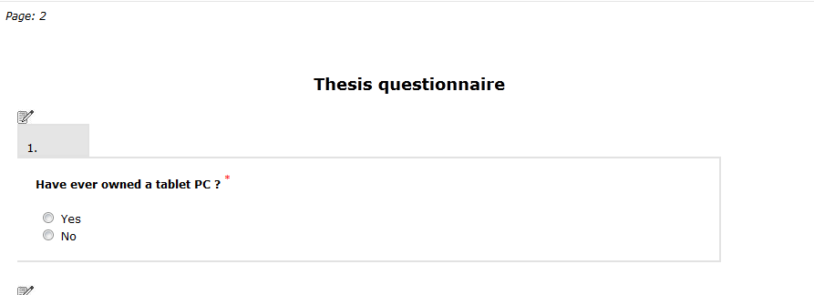
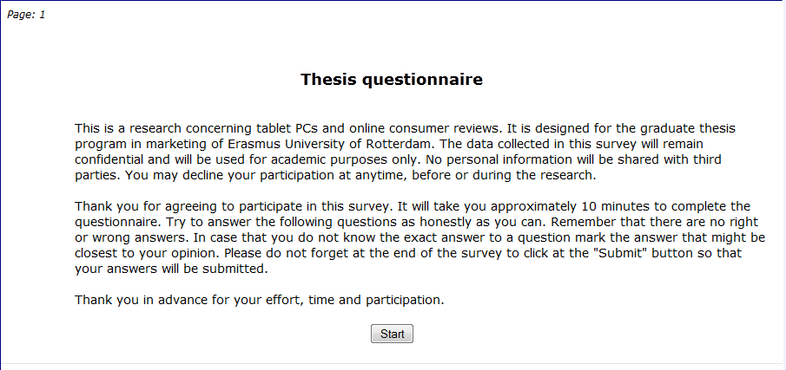
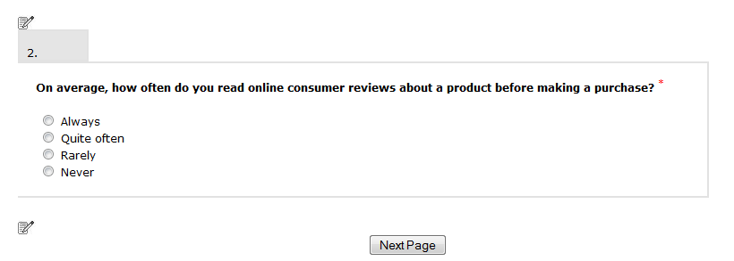

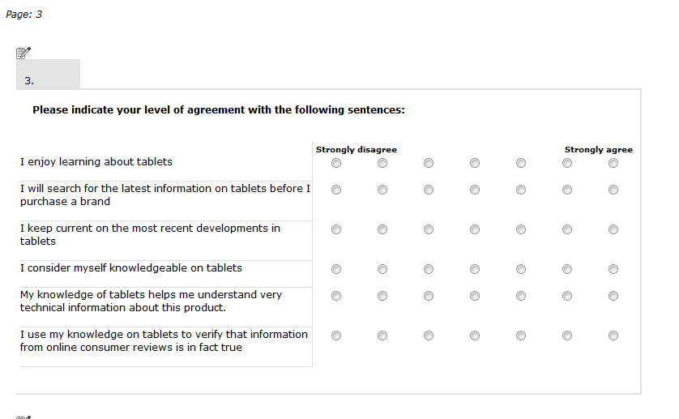

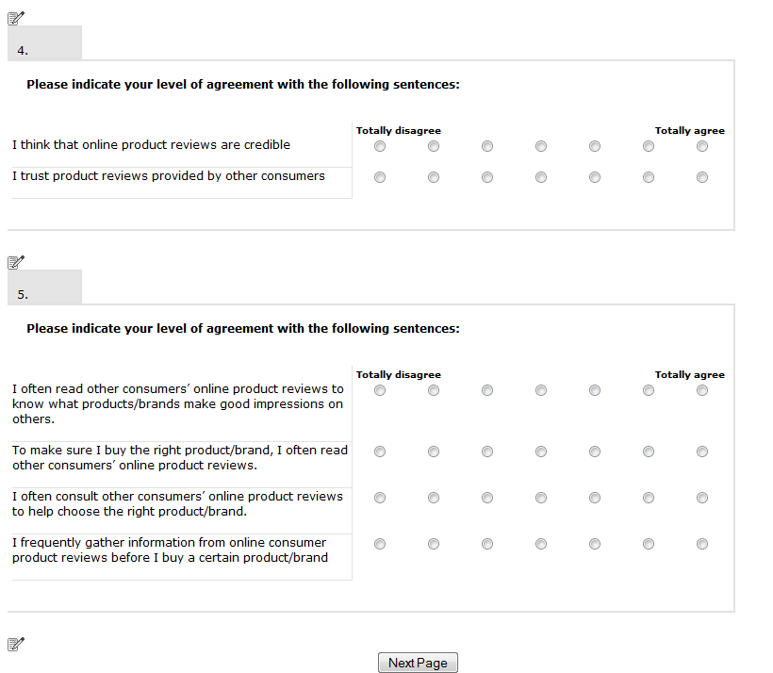

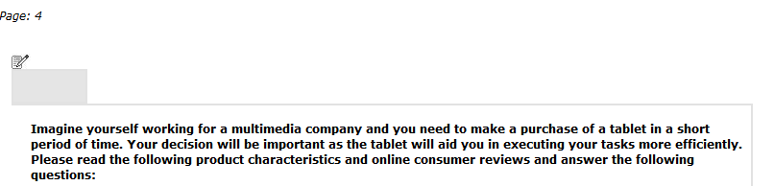

Experimental product screenshot
Product characteristics screenshot



Online consumer reviews screenshot
(Attribute centric reviews or benefit-centric reviews)



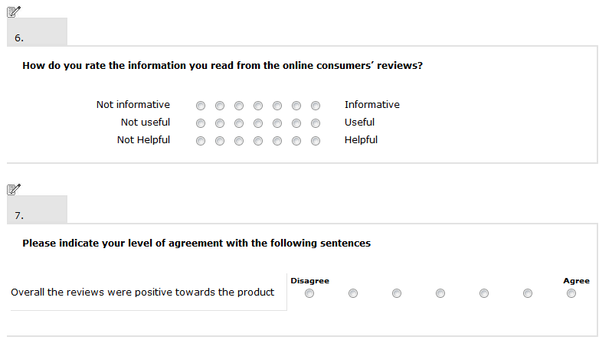
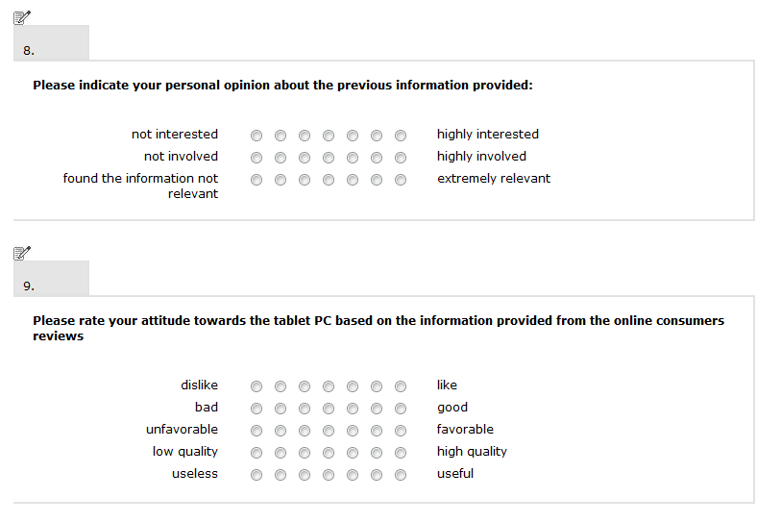

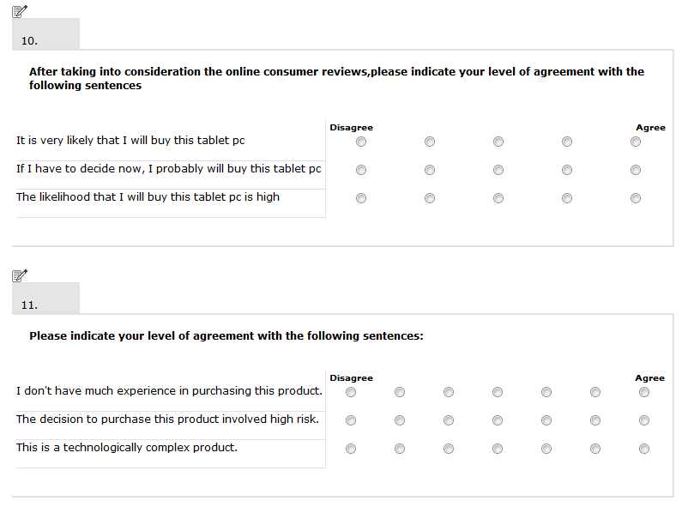
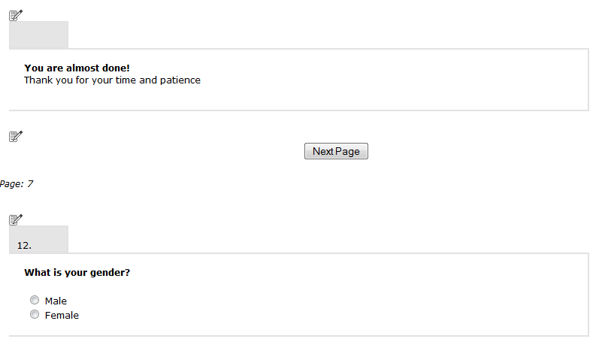

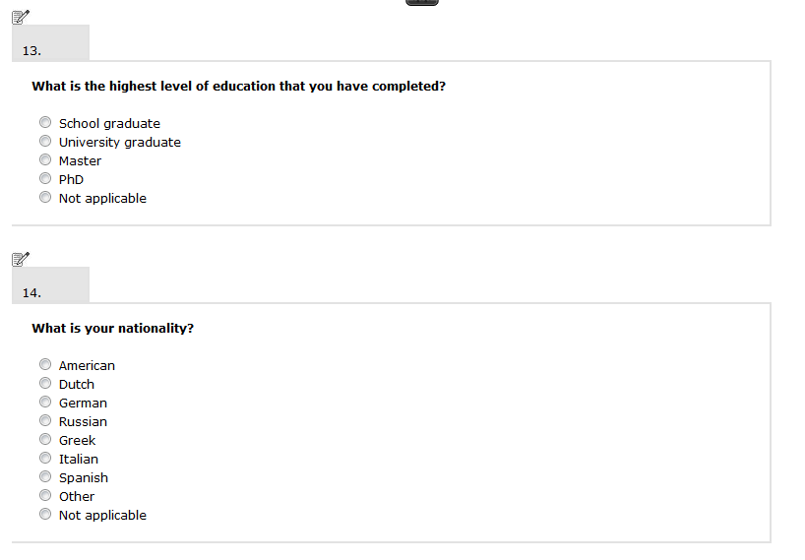
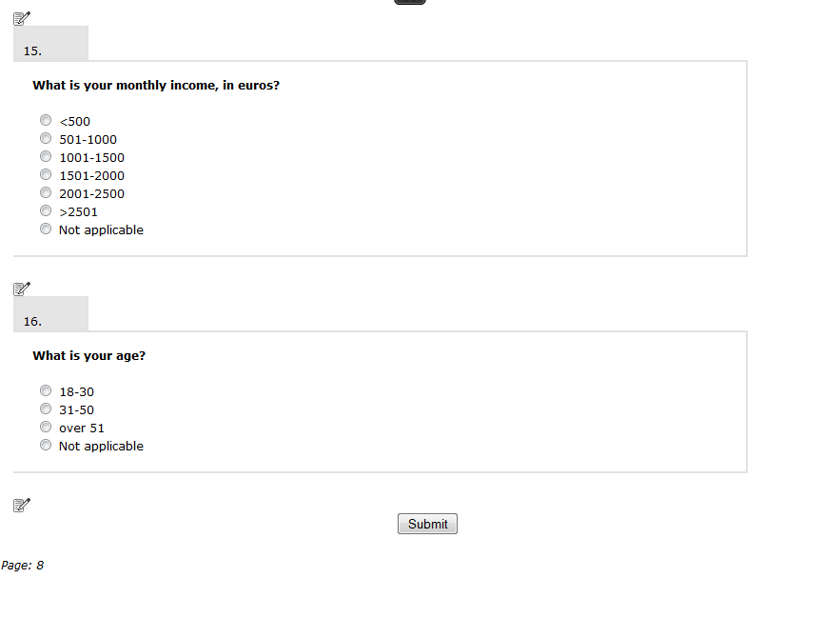

APPENDIX B

The following images are the actual images of the attribute-centric reviews that were used in the experiment:

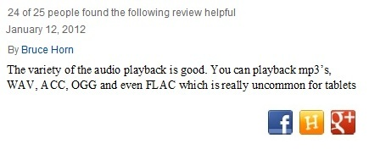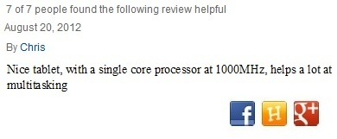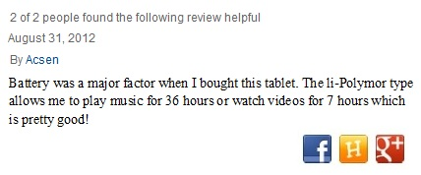
The following images are the actual images of the benefit-centric reviews that were used in the experiment:





APPENDIX C

Experimental product’s image and technical characteristics
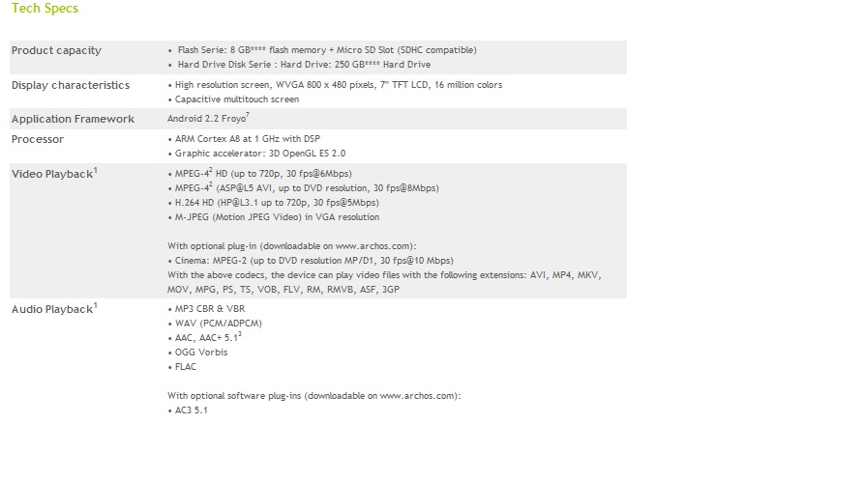
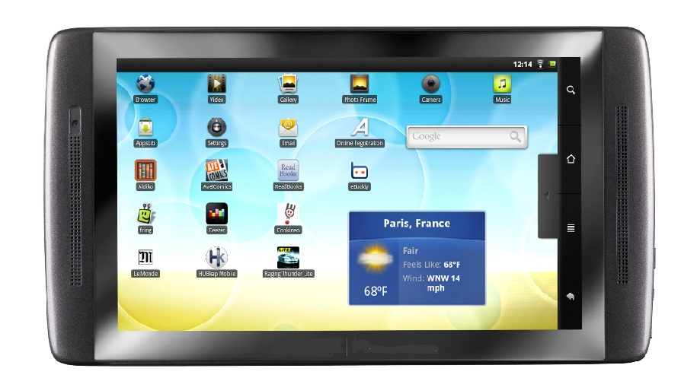

APPENDIX D

Involvement scenarios screenshots:
1. High Involvement scenario
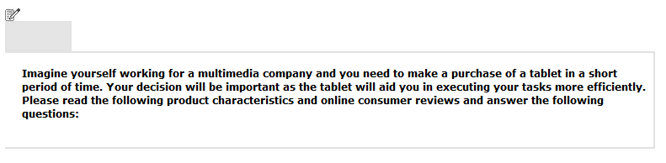
2. Low Involvement scenario
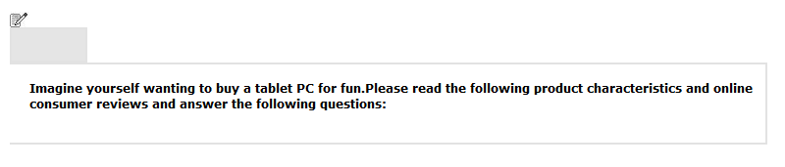

APPENDIX E

Factor loadings for the variables tested in this study, Kaiser-Meyer-Olkin test and Bartlett’s test of sphericity:

KMO and Bartlett's Test
Kaiser-Meyer-Olkin Measure of Sampling Adequacy. |  | ,856
Bartlett's Test of Sphericity | Approx. Chi-Square | 3109,677
Bartlett's Test of Sphericity | df | 325
Bartlett's Test of Sphericity | Sig. | ,000

Rotated Component Matrixª
 | Component
 | 1 | 2 | 3 | 4 | 5 | 6 | 7
I keep current on the most recent developments in tablets/laptops (Strongly disagree - Strongly agree) | ,860
I use my knowledge on tablets/laptops to verify that information from online consumer reviews is in fact true (Strongly disagree - Strongly agree) | ,851
I consider myself knowledgeable on tablets/laptops (Strongly disagree - Strongly agree) | ,850
My knowledge of tablets/laptops helps me understand very technical information about this product. (Strongly disagree - Strongly agree) | ,840
I enjoy learning about tablets/laptops (Strongly disagree - Strongly agree) | ,792
I will search for the latest information on tablets/laptops before I purchase a brand (Strongly disagree - Strongly agree) | ,730
unfavorable - favorable |  | ,888
bad - good |  | ,875
dislike - like |  | ,871
low quality - high quality |  | ,851
useless - useful |  | ,824
To make sure I buy the right product/brand, I often read other consumers’ online product reviews. (Totally disagree - Totally agree) |  |  | ,859
I frequently gather information from online consumer product reviews before I buy a certain product/brand (Totally disagree - Totally agree) |  |  | ,852
I often consult other consumers’ online product reviews to help choose the right product/brand. (Totally disagree - Totally agree) |  |  | ,834
I often read other consumers’ online product reviews to know what products/brands make good impressions on others. (Totally disagree - Totally agree) |  |  | ,760
Not useful - Useful |  |  |  | ,910
Not informative - Informative |  |  |  | ,907
Not Helpful - Helpful |  |  |  | ,868
If I have to decide now, I probably will buy this tablet pc (Disagree - Agree) |  |  |  |  | ,808
The likelihood that I will buy this tablet pc is high (Disagree - Agree) |  |  |  |  | ,803
It is very likely that I will buy this tablet pc (Disagree - Agree) |  |  |  |  | ,799
The decision to purchase this product involved high risk. (Disagree - Agree) |  |  |  |  |  | ,854
I don't have much experience in purchasing this product. (Disagree - Agree) |  |  |  |  |  | ,781
This is a technologically complex product. (Disagree - Agree) |  |  |  |  |  | ,758
I think that online product reviews are credible (Totally disagree - Totally agree) |  |  |  |  |  |  | ,839
I trust product reviews provided by other consumers (Totally disagree - Totally agree) |  |  |  |  |  |  | ,814
Extraction Method: Principal Component Analysis.
Rotation Method: Varimax with Kaiser Normalization.
a. Rotation converged in 6 iterations.

APPENDIX F

Presentation of the two-way ANOVA results for all the dependent variables. The estimated marginal means and the pairwise comparisons are reported only when the main or interaction effects are significant.
Informativeness:
- Two way ANOVA results.

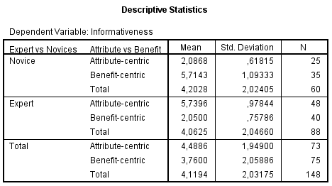
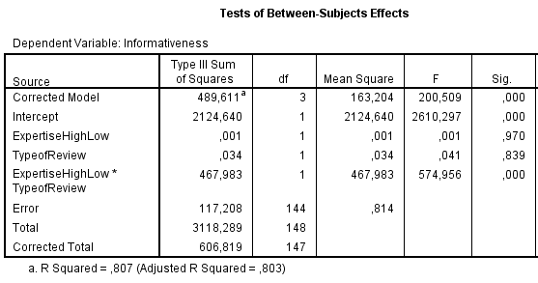

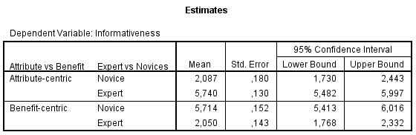
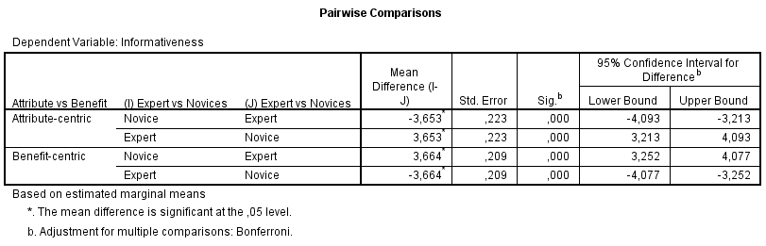

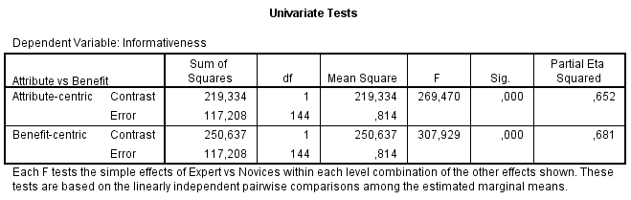

Purchase Intention:

- Two-way ANOVA results , independent variables type of review and expertise

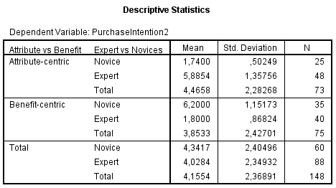
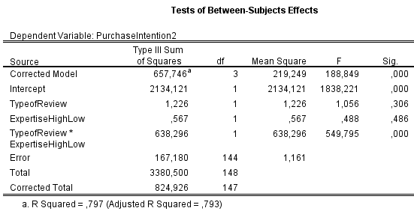

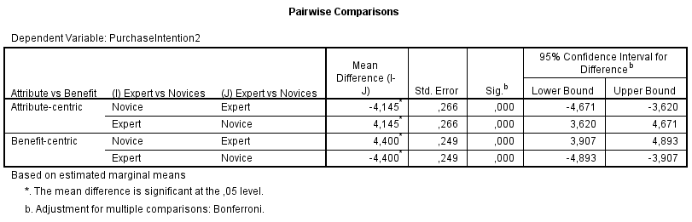
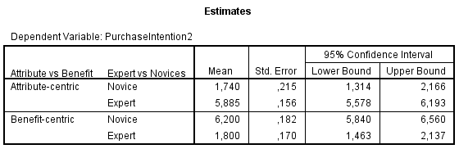
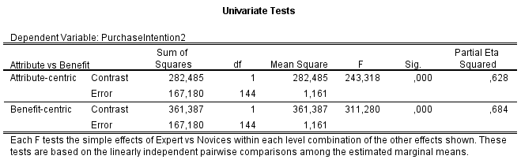

- Two-way ANOVA results , independent variables type of review and involvement

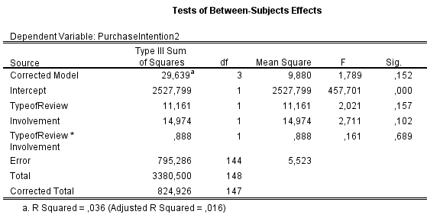

Attitude towards the product:
- Two-way ANOVA results

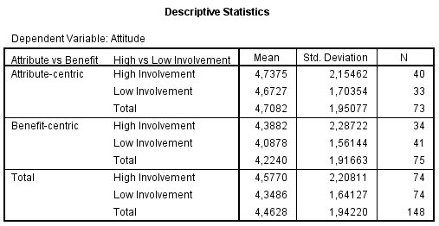

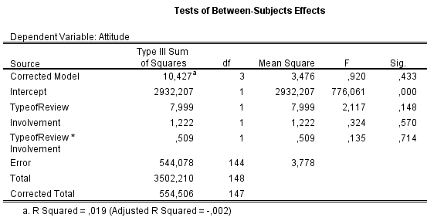

Perceived risk:
- Two-way ANOVA results

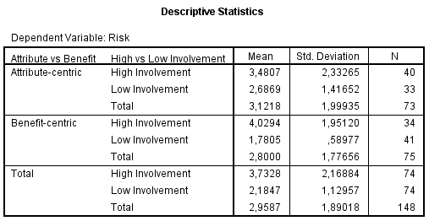

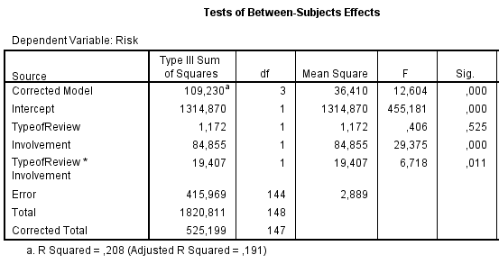
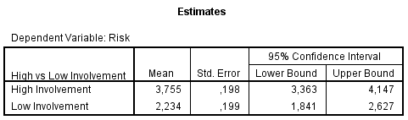
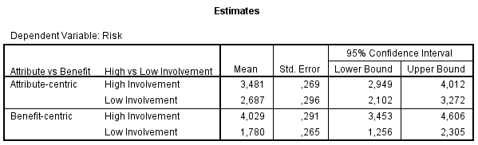
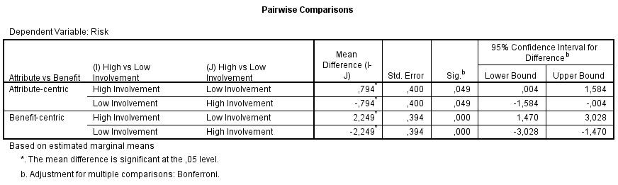
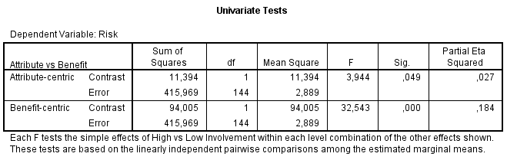

APPENDIX G

Presentation of the three-way ANOVA results for the dependent variables. The estimated marginal means are reported only when the main or interaction effects are significant. The pairwise comparisons are reported only when the interactions are significant (only for the main interactions not the simple ones).
Informativeness:
- Three way ANOVA results

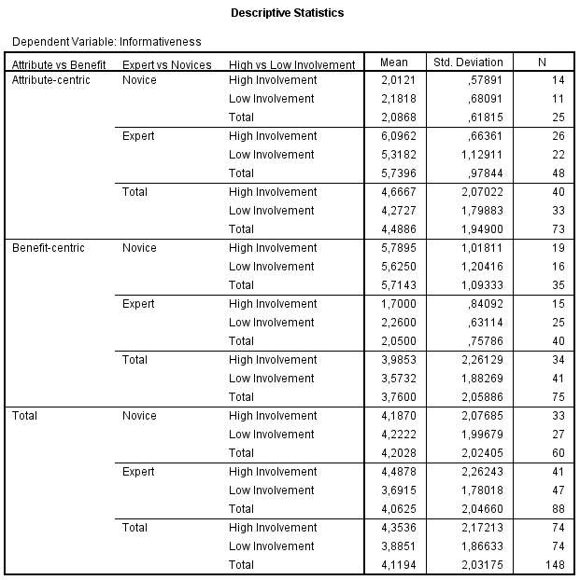
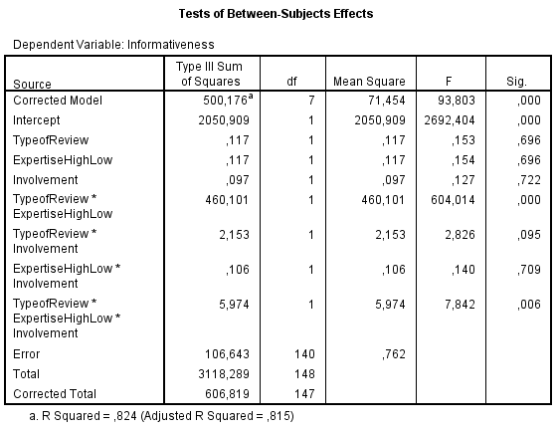
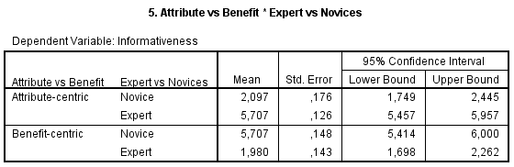
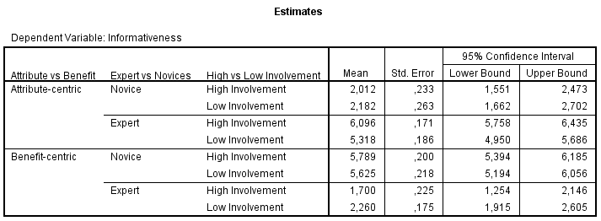

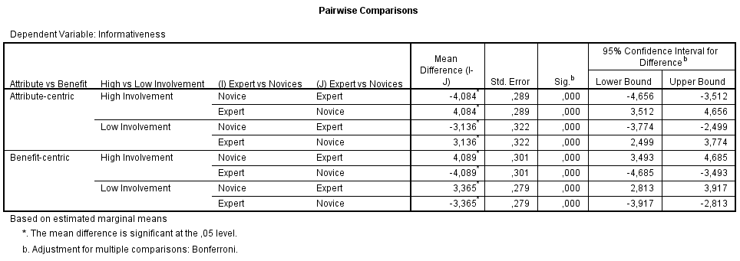
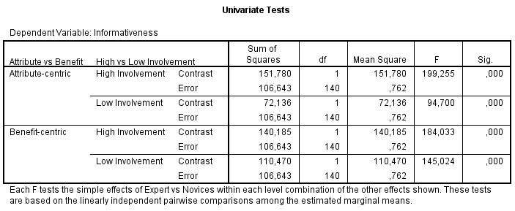

Purchase Intention:
- Three way ANOVA results

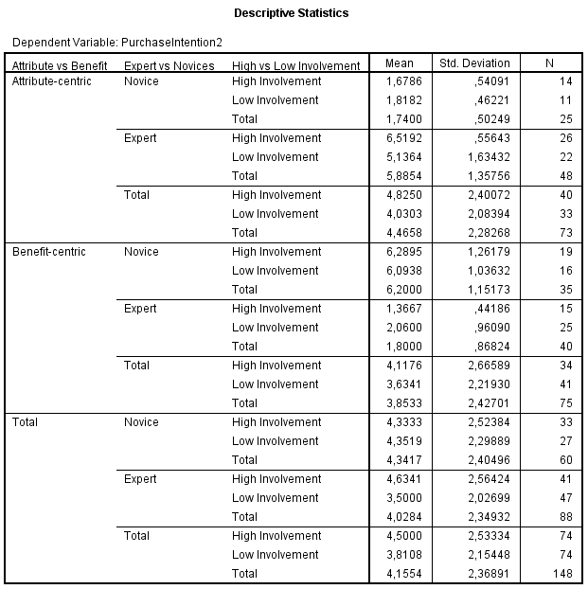
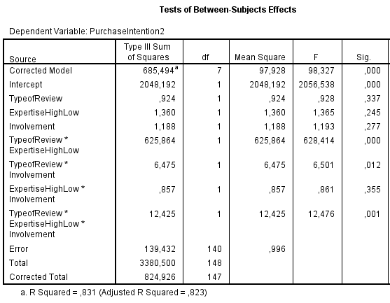
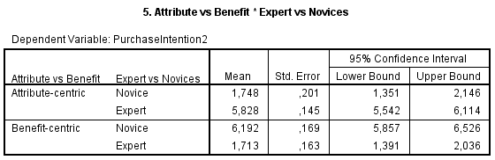

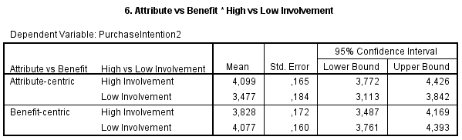

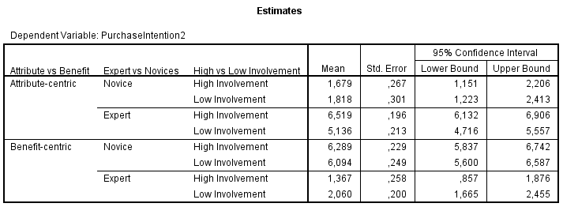
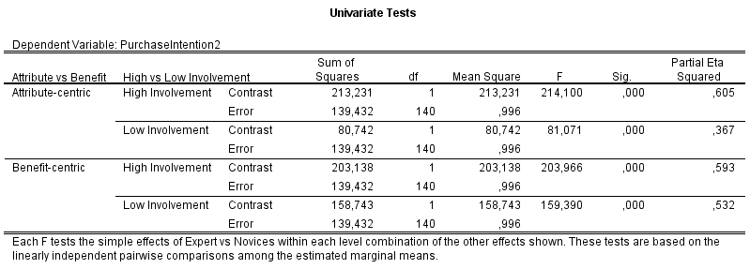
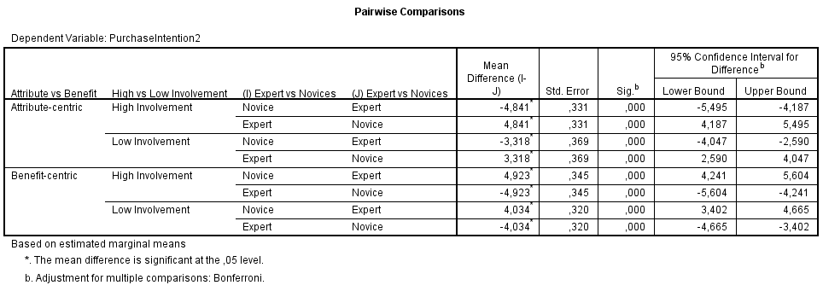

Attitude towards the product:
- Three way ANOVA results

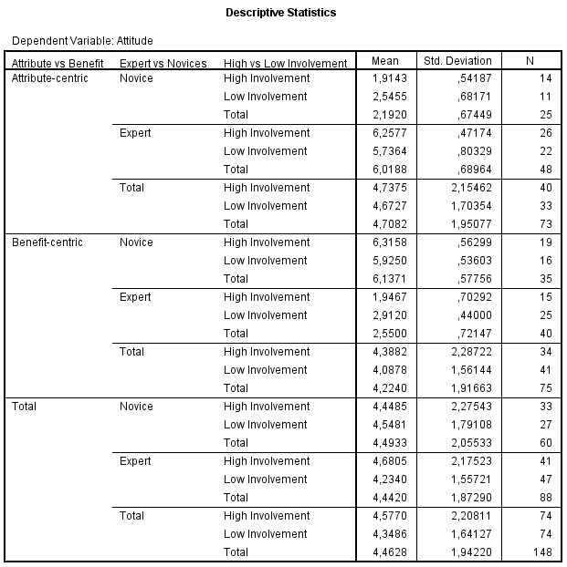

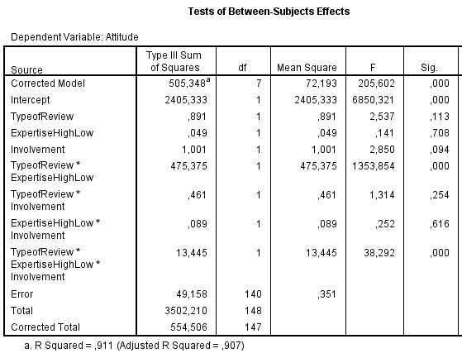
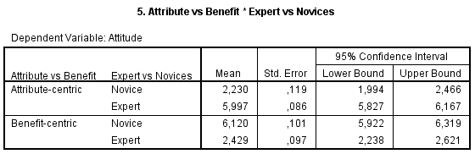
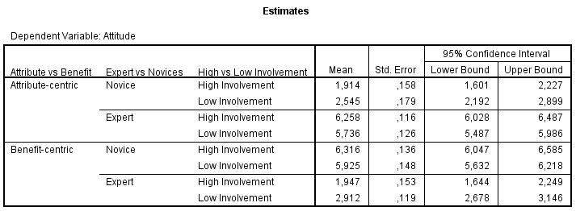

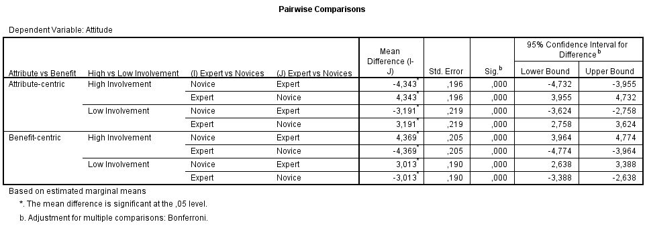

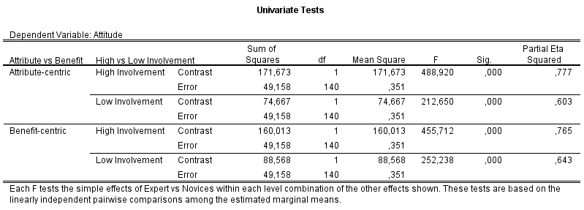

Perceived Risk:
- Three way ANOVA results

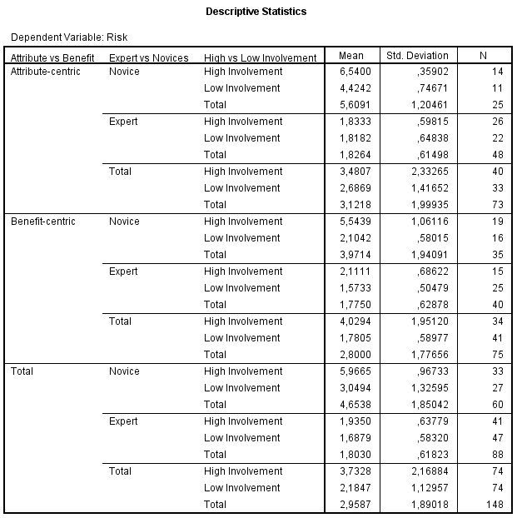

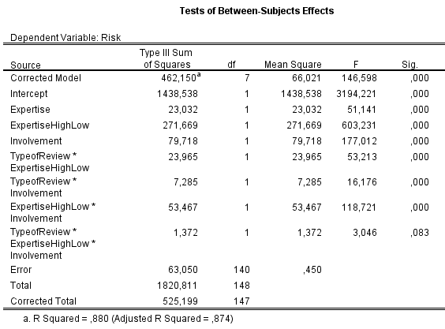
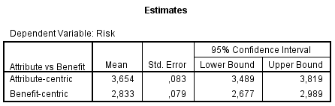
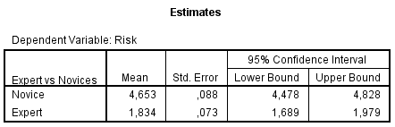
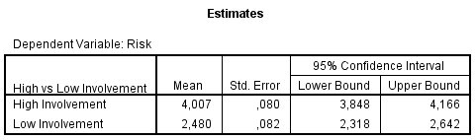

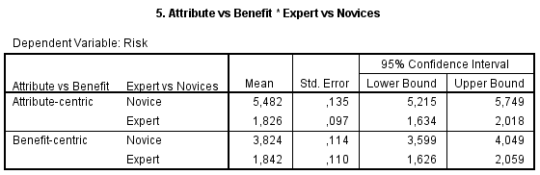

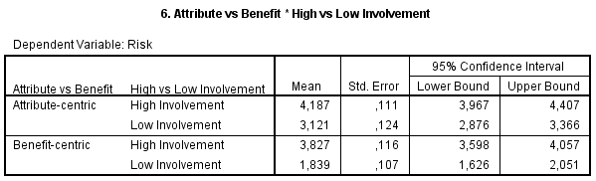
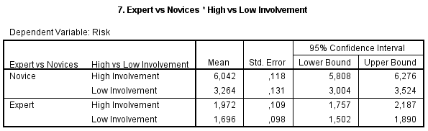

APPENDIX H:

Manipulation check for Involvement
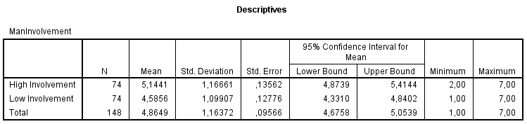

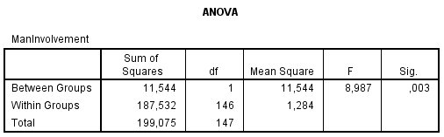

Control check for review positiveness:
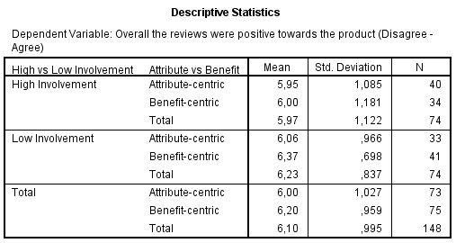
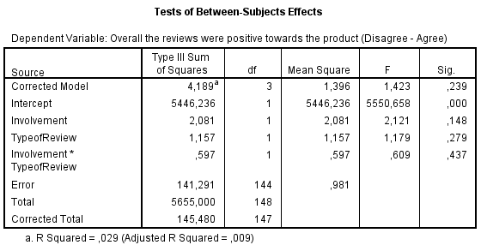

INTERACTIVE ADVER. BUREAU, PLATFORM STATUS REPORT: USER GENERATED CONTENT, SOCIAL MEDIA, AND ADVERTISING – AN OVERVIEW 1-5 (2008)
Editors PC Magazine. “Definition of: tablet computer”, PC magazine, April 17,2010
31 percent of U.S. Internet Users Own Tablets, Angela Moscaritolo, PC Magazine, June 18,2012
Source: http://www.tmcnet.com/channels/cloud-crm/articles/186855-what-cloud-crm.htm

