ERASMUS UNIVERSITY ROTTERDAM



The effect of online consumer reviews on the leading brand of the laptop industry

Marketing Master’s Thesis

Stavros Karaververis
2012

Supervisor: Gui Liberali
Student number: 344790

Table of Contents
1. INTRODUCTION 5
1.1 Background and content 5
1.2 Introducing the target market 7
1.3 Introducing the target product 9
1.4 Research problem 10
1.5 Research method 12
1.6 Research structure 13
2. LITERATURE REVIEW 13
2.1 Valence 13
2.2 Volume 15
2.3 Consumer based brand equity 16
2.4 Purchase intentions 18
2.5 Attitude towards brand 19
2.6 Moderator variable 19
2.6.1 Prior product knowledge 19
2.7 Control variable 20
2.7.1 Persuasiveness of online reviews 20
3. HYPOTHESES AND EXPERIMENTAL DESIGN 21
3.1 Purchase intentions and online reviews 22
3.2 Consumer based brand equity and online reviews 24
3.3 Attitude towards the brand and online reviews 26
3.4 Experimental design 27
4. METHODOLOGY 28
4.1 Conceptual model 28
4.2 Respondents Criteria 31
4.3 Stimuli and manipulation of the independent variables 31
4.4.1 Pretest 32
4.4.2 Manipulation of review valence 33
4.4.3 Manipulation of volume 36
4.5 Sampling design and procedure 37
4.6 Construct measurements 37
4.7.1 Screening questions 37
4.7.2 Prior product knowledge 38
4.7.3 Persuasiveness of online reviews 38
4.7.4 Consumer based brand equity 39
4.7.5 Attitude towards the brand 39
4.7.6 Purchase intentions 39
4.7.7 Manipulation checks 40
4.7.8 Demographics 40
4.8 Questionnaire design 40
5. DATA 42
5.1 Data cleaning 43
5.2 Demographics and screening questions 43
5.3 Dependent, moderator and control variables descriptive statistics 45
5.4 Validity and reliability of construct measurements 46
5.5 Manipulation checks and control variable 49
6. ANALYSIS AND RESULTS 50
6.1.1 Results and hypotheses testing for Purchase intentions 52
6.1.2 Results and hypotheses testing for consumer based brand equity 54
6.1.3 Results and hypotheses testing for attitudes toward the brand 56
6.2 Moderating effects 58
6.3 Mediation effects 60
6.4 Hypotheses testing summary 61
7. DISCUSSION 63
7.1 Purchase intentions 63
7.2 Consumer based brand equity 64
7.3 Attitudes toward the brand 64
8. SYNOPSIS, MANAGERIAL IMPLICATIONS AND LIMITATIONS 65
8.1 Managerial implications 65
8.2 Limitations and future research 66
9. REFERENCES 68
10. APPENDICES 78
Appendix A 78
Appendix B 83
Appendix C 91
Appendix D 105
Appendix E 107
Appendix F 110
Appendix G 116
Appendix H 117

1. INTRODUCTION

1.1 Background and content

Word of mouth (WOM) as defined by Arndt (1967, p.3) is the “Oral, person to person communication between a receiver and a communicator whom the receiver perceives as non-commercial, regarding a brand, a product or a service”. WOM communication has been used in extend the past decades, from researchers which they have been testing almost all of the aspects and effects of WOM ever since. The findings of those researches showed that WOM is eligible to affect various aspects of the consumer behavior and attitudes towards a brand, a product or service (Herr et al., 1991; Weinberger and Dillon, 1980), brand awareness (Sheth, 1971), expectations (Westbrook, 1987) as well as purchase intentions (Richins and Root-shaffer, 1988). It is considered to have even greater effect on consumers than the traditional marketing communication, like advertisements (Gruen et al., 2006) and editorial recommendations (Trusov et al., 2009). This occurs due to the fact that WOM is considered to be a consumer to consumer communication, totally liberated from promotion purposes, which results in a credible form of communication (Richins, 1983) influencing the consumers. Although traditional WOM is an influential and persuasive source of information it lacks the attribute of high spread among the consumers.

With the introduction of the Internet Protocol Suite (TCP/IP) in 1982, widely known as Internet, to the public, a new era begun for WOM called online word of mouth (E-WOM). Henning-Thurau et al. (2004, p.39) defines E-WOM as “any positive and negative statement made by potential, actual or former customers about a product or company, which is made available to a multitude people and institutions via the internet”. This new form of communication came to bridge the gap between the traditional WOM and the low reach, providing greater accessibility, high reach and becoming eventually more effective than WOM (Chatterjee, 2001). Additionally, E-WOM is considered to be a persuasive medium of information due to great perceived credibility and trustworthiness (Godes and Mayzlin, 2004).

E-WOM consists of emails, forums, reviews, social networks, chat and blogs (Hennig – Thurau et al., 2004). E-WOM, either negative or positive, is eligible to have a large influence on consumer’s behavior (Chevalier and Mayzlin, 2006) forming consumers’ purchase intension (Zhang and Tran, 2009) and affect consumers’ purchase behavior (Reigner, 2007).

A plethora of opinions exists among the studies on WOM concerning the valence of the message (Positive versus Negative message). Several studies found that the negative messages are considered to be more persuasive than the positive messages (Arndt, 1967; Chevalier and Mayzlin, 2006; Laczniak et al. 2001). On the other hand, researchers have found exactly the opposite results as the one stated before. To be more clear, the results showed that consumers consider the positive messages being more persuasive than the negative ones (Gershoff, 2003; Sen and Lerman, 2007). Especially, the positive WOM is a powerful tool for the marketers as it has been implemented in many marketing strategies, namely, buzz marketing (Rosen, 2000), grassroots marketing (Deal and Abel, 2001) and viral marketing (Kelly, 2000).

In this study E-WOM will be examined under the spectrum of consumer generated content defined as the content created by consumers and distributed via the Internet.
Positively and negatively valenced WOM are going to be examined independently. Meaning that, the respondents of this study will either face only positive or only negative WOM. There will be no mixed messages combining positive and negative aspects of WOM. The reason for using online reviews is due to the fact that this communication source grows rapidly over the last years (Reinger, 2007) and additionally because no ties do exist between the involved parties (Weiss et al,. 2008).

1.2 Introducing the target market
Several markets have flourished by merchandising products with ongoing growth rates and high revenues. One of those markets with continuous growth through the years is the portable PC market or in other words, Laptop. Figure 1 is providing a clear image of the adoption that laptop had. Starting from 1996 laptop industry grows rapidly in unit sales until 2001 where it has been a declination of sales volume. This occurs due to the recession of 2000; however, sales started to increase again generating profits for the specified market.
Figure 1 shows the unit sales of PC’s worldwide including desktop PC’s as well as laptops. In order to have a better understanding of the size of laptop industry Figure 2 is quoted. From Figure 2 we can derive that 61% of the global pc market in units comes from laptops and the remaining 39% for desktop computers. According to the forecasts of IDC the gap between laptops and desktops computers will continue to grow in the future and this gives a clear image for the direction of this specific market.
Figure 1
Laptops and desktops worldwide unit sales
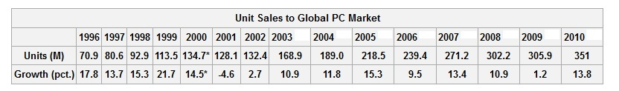
Source : • ^ http://www.gartner.com/it/page.jsp?id=1893523

Figure 2
PC Shipments by Region and Form Factor, 2011-2016 (Shipments in millions)
Region | Form Factor | 2011 | 2012* | 2013* | 2014* | 2015* | 2016*
Emerging Markets | Desktop PC | 91.2 | 93.0 | 98.2 | 102.5 | 105.4 | 108.2
Emerging Markets | Portable PC | 110.0 | 122.3 | 140.4 | 164.2 | 189.2 | 214.7
Emerging Markets | Total PC | 201.2 | 215.4 | 238.6 | 266.7 | 294.5 | 322.9
Mature Markets | Desktop PC | 52.8 | 51.6 | 51.7 | 50.7 | 50.2 | 48.8
Mature Markets | Portable PC | 99.4 | 104.1 | 116.2 | 128.2 | 139.0 | 146.6
Mature Markets | Total PC | 152.1 | 155.7 | 167.8 | 178.9 | 189.1 | 195.4
Worldwide | Desktop PC | 144.0 | 144.6 | 149.9 | 153.2 | 155.6 | 157.0
Worldwide | Portable PC | 209.4 | 226.4 | 256.6 | 292.4 | 328.2 | 361.3
Worldwide | Total PC | 353.3 | 371.1 | 406.4 | 445.6 | 483.6 | 518.3
Source: IDC Worldwide Quarterly PC Tracker, February 2012
* Forecast data
In this paper, an examination of the effects of E-WOM on consumer’s purchase intentions, consumer based brand equity and attitude towards the brand will be made. In order to do so the respondents have to be familiar with the internet usage and laptop usage. To be more specific, internet access because is the only mean that provides E-WOM information and laptop in order to acquire this information.

1.3 Introducing the target product
Figure 3 shows the top five laptop manufacturers in terms of shipments globally. Shipments do not stand for sales but a very clear image can be derived of the market leader in units from the figure. Hewlett Packard had maintained the leadership of the industry, despite of losing 16% in one year. Actually HP has been the leader of this market for several years as figure 4 shows. Additionally, from Figure 4 it is obvious that no other brand is stabilized to a certain ranking position in terms of market share. Thus, the brand that will be selected for the experiment is HP as a clear leader in the industry. Figure 5 is providing additional information by demonstrating the best global green brands and HP is ranked fifth among those brands, making it clear that has a high degree of awareness worldwide.

Figure 3
Top 5 Vendors, Worldwide PC Shipments, Fourth Quarter 2011 (Preliminary) (Units Shipments are in thousands)
Rank | Vendor | 4Q11  Shipments | Market  Share | 4Q10  Shipments | Market  Share | 4Q11/4Q10  Growth
1 | HP | 15,123 | 16.31% | 17,989 | 19.37% | -15.93%
2 | Lenovo | 13,012 | 14.04% | 9,514 | 10.25% | 36.77%
3 | Dell | 11,970 | 12.91% | 11,156 | 12.01% | 7.30%
4 | Acer Group | 9,790 | 10.56% | 10,643 | 11.46% | -8.02%
5 | ASUS | 6,243 | 6.73% | 4,944 | 5.32% | 26.29%
 | Others | 36,564 | 39.44% | 38,615 | 41.58% | -5.31%
 | All Vendor | 92,702 | 100.00% | 92,861 | 100.00% | -0.17%

Source: IDC Worldwide Quarterly PC Tracker, January 11, 2012
Figure 4
Global PC market share by units
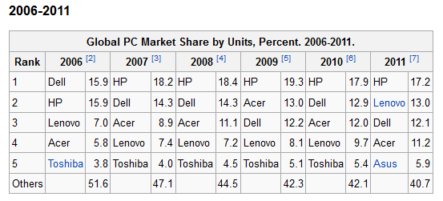
Source: http://en.wikipedia.org/wiki/Market_share_of_leading_PC_vendors

Figure 5
Interbrand 2012 rankings
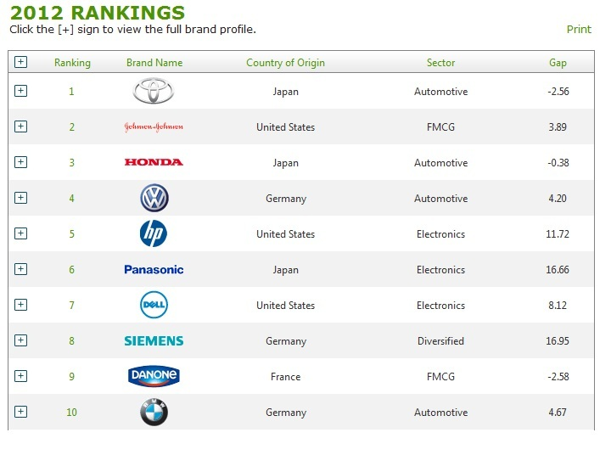
Source:http://www.interbrand.com/en/best-global-brands/Best-Global-Green-Brands/2012-Report/BestGlobalGreenBrandsTable-2012.aspx

1.4 Research problem
Since WOM became online, consumers were able to share their experiences, attitudes, opinions and feelings about brand and products, without the need of their physical presence. Face to face interactions were restraining the consumers’ general opinions in a very limited spread, composed of their social environment. E-WOM gave the opportunity to consumers to broader their opinions’ reach globally. This situation has not been unnoticed from the marketers seeing the number of consumers increasing in a daily basis. This increase is not only due to the likeability of the internet but as well as due to the anonymity the internet offers to the consumers. Even shy consumers can freely state their opinion without the fear of a direct criticism on their judgments. Marketers are aware of all the different aspects affected from E-WOM and trying to maximize the benefits coming from this mean of communication.

This study is contributing to the existing literature by providing additional information concerning branded products due to the fact that E-WOM has different results on the consumers, on different product categories (Herr et al., 1991). In addition, the prior knowledge of the consumer about the product category is going to be tested for the reason that Herr et al. (1991) proved that the effect of E-WOM on consumers is different for those with favorable brand impressions than those with unfavorable brand impressions. Furthermore, the antecedent researchers of E-WOM suggest that E-WOM is a persuasive source of communication. In the authors’ knowledge, it is impossible for the consumers to seek and study all the available comments for the product/brand of their interest because they are willing to spent limited effort and time to satisfy their informational needs. Thus, most of the consumers are searching for E-WOM through credible, for them, web sites and more often from trustworthy reviewers. A reviewer can become trustworthy through the reputation tag. In this study the online reviews that are going to be used will be without the reputation level of the reviewer in order to avoid bias or to direct the respondents to specific comments. Finally, this study is investigating three highly important variables for both marketers and researchers, testing the effects of E-WOM not only for purchase intentions but as well as for consumer based brand equity and attitude towards the brand.

According to the aforementioned a research question can be formulated as follows:

“How does the valence of the online reviews, the volume of the online reviews and the different level of prior product knowledge affect the purchase intentions, consumer based brand equity and the attitude towards the brand?”

At first the main effects of valence and volume of online reviews will be tested so as to investigate the effects of the independent variables on purchase intentions, consumer based brand equity and attitudes toward the brand. In continuance the interaction effects of volume and valence on the dependent variables will be examined and lastly the moderation effect of prior product knowledge is going to be tested.

1.5 Research method

All related literature will be gathered and reviewed so as to give a better insight to the definitions of all the variables that will be used. The importance of this step is crucial in an effort to understand the concept of each variable and then formulate a number of hypotheses. Both the literature and hypotheses will compose this research conceptual framework.

In order to test these hypotheses an experimental design of 2 x 2 will be implemented. The applied manipulations will be: valence of online reviews (positive vs. negative) and volume of online reviews (high vs. low). An online questionnaire will be developed so as to measure the effects of the independent variables on the dependent variables which are namely: purchase intentions, consumer based brand equity and attitude toward the brand. All the effects will be measured using proven measurement scales from the existing literature.

The product category of this experiment is the portable personal computer, in other words laptop and the brand will be HP as the leader brand in this product category.

During the online experiment, pre-measurements of the dependent variables will take place and after the treatment post-measurements will be examined so as to have a more accurate perspective of the effects. Prior product knowledge as a moderating variable and persuasiveness of online reviews as a control variable will be also measured before the treatment.
The data obtained by the questionnaire will be analyzed by using various statistical techniques. First factor analysis will be used in order to test the reliability of each construct. Then analysis of covariance (ANCOVA) will be implemented with the purpose of measuring the effects of the independent variables on the dependent variables.

1.6 Research structure

This research paper is divided into eight chapters. Chapter one refers to the target market and product of this study. Besides the research problem is presented as well as the research method. Chapter two strives to give more insight to the existing literature regarding the variables which are examined in this research. In chapter three, according to the existing literature a number of hypothesis will be formulated. The final section of this chapter will present the experimental design of this study. In chapter four an analytical presentation of the methodology will take place. Specifically, the conceptual model, respondents criteria, stimuli development, manipulation of the independent variables, pretest results as well as construct measurements will be analyzed. Chapter five will include the first part of the data analysis. Specifically the data’s validity and reliability will be examined along with the manipulation checks. Chapter six will aim at exploring the data more analytically in order to test the formulated hypothesis. Moderation and mediation effects will be examined as well. In chapter seven , results of the experiment will be discussed more extensively. Finally chapter eight will include the synopsis, managerial implications, limitations as well as recommendations for future research.

2. LITERATURE REVIEW

2.1 Valence

Review valence is, the communication direction, positive or negative, (Benedicktus and Andrews, 2006) which is one of the most focused dimensions of online reviews. As stated by Dellarocas et al. (2004) valence is the predictor that overwhelms all the other WOM attributes as a predictor of sales. For this reason it is considered that valence is one of the most critical variables in this study. Valence has many definitions but all of them come to a certain consensus. All of the theories describing valence agree that valence is the positive or negative nature of the WOM. According to Liu (2006), “valence measures the nature of the WOM message and whether it is positive or negative”. The above definition of valence comes to full agreement with the notion that WOM can be positive or negative (Buttle, 1998). Although, all the previous researchers agreed for the definition of valence, it is easy to realize that they have come with totally mixed results concerning the effect of valence of online reviews in their studies. As it is stated from the bibliography, valence of online reviews has been used in many studies and in several markets with different products or services. To be clearer, a quotation of studies will be made in order to have a better insight of the WOM valence, studies that have been used and markets that have been tested. According to Anderson, (1998) it is uncertain if positive valence of online reviews leads to sales growth. Additionally, Amblee and Bui, (2007) stated that the source expertise, meaning that the poster of the review is either expert or non-expert (user), has significant results in the prediction of sales volume, however valence is not a worthy predictor for sales. Moreover, Davis and Khazanchi (2008) tested valence of online reviews in fifthteen (15) product categories and three hundred twenty eight (328) unique products and their finding was that valence is not a predictor of sales. In accordance with the previous studies, Liu (2006) and Duan et al. (2005) using online user reviews posted on Yahoo, found that valence is not generating revenues for the movie companies the period before the release of a movie or during the first week the motion picture has been released. Finally, in a total different market, Chen et al. (2004) found that valence does not have any effect on the sales of books.

On the contrary with the previous studies, East, Hammond and Lomax (2008), propose that positively valenced reviews have a greater impact on consumers’ purchase intentions. In their experiment, they showed that 64% of their respondents were affected by positive online reviews while 48% were affected by negative online reviews in reference to their purchase decisions. In a more recent research by Floh et al. (2009), they found that intense positive reviews have a greater impact than strong negative online reviews. On the other hand moderately valenced reviews had no significant effect on consumers’ purchase intentions. Finally Ahluwalia (2002) tested consumer responses when consumers are provided with either negative or positive online reviews for familiar and unfamiliar brands. The results are quite interesting since for unfamiliar brands, negative reviews were highly considered by consumers. On the other hand, the differences of the impact for either negative or positive reviews for familiar brands were insignificant.
Due to the fact that valence is a highly contradictive variable in terms of results, in the studies that has been tested, it is crucial to include the valence of online reviews in this study in order to contribute an additional paper to the existing literature. Thus, in this paper positively and negatively valenced reviews will be used to test the effect that valence has on the laptop industry.

2.2 Volume
Volume measures the total amount of WOM interactions (Liu, 2006). In other words volume is the number of the reviews provided to a consumer. Based on the existing literature WOM affects many aspects of the consumers. Thus, more reviews have high probability in increasing the perceived usefulness than fewer reviews and as a result to increase in total the usefulness of the contribution (Constant et al. 1996). Additionally, E-WOM increases the awareness towards a product (Godes and Mayzlin, 2004) and can alter the attitude towards a product (Alvarez et al. 2007). Meaning that, when the volume of E-WOM is high for a product it is more likely that the consumer will be informed about the product more thoroughly. On the contrary, when the volume of E-WOM is low then the consumer is more likely to be less informed about the product. Furthermore, many studies do exist, proving that the high volume of WOM positively correlates with product sales (Zhang et al. 2004, Liu 2006, Awad and Zhang 2006) and consumer’s behavior (Amblee and Bui, 2007).

The volume of reviews and the effect it has on sales have been tested in several markets. According to Duan et al. (2005) volume of the E-WOM affects the motion picture revenues. In the same marketplace Dellarocas et al. (2004) have stated that “the early volume of online reviews provides an excellent proxy of early box office sales”. Finally, Clemons et al. (2006) and Chevalier and Mayzlin (2006) found that the volume is a good predictor for beer sales and book sales respectively.

2.3 Consumer based brand equity

Although, brand equity is a notion that has been studied extensively by many researchers, still no unanimous definition of brand equity exists among the researchers. As stated by Berthon et al. (2001), “The only thing that has not been reached with regard to brand equity is a conclusion” Thus, an in depth analysis of all the previous literature has to be made, in order to have a clear understanding of the brand equity notion. Based on the existing literature, brand equity can be looked at two different perspectives. The first perspective is the financial assets intangible value of the brand. In some cases, as Kamakura and Russell (1991) describes, the brand assets can reach ninety percent (90%) of the total price for a brand, referring to the acquisition of the Hires and Crush product lines from Cardbury-Schweppes. The second perspective of brand equity is the consumer based brand equity referring to the response of the consumers to the brand name (Keller, 1993) or the behavioral intentions, attitudes and brand beliefs consumers have towards a brand ( Keller and Lehmann, 2006) or as brand strength and brand value (Srivastava and Shocker, 1991). This paper focuses on the second perspective of consumer based brand equity. The decision to include only the consumer based brand equity has been taken for three reasons. First, since this paper is focused on the marketing field, accounting methods for the calculation of the consumer based brand equity such as proposed by Farquhar et al. (1991) will not be implemented. Second, for the calculation of the consumer based brand equity, corporate data has to be used but this information rarely becomes public by the companies (Rego et al., 2009). Third, the financial measurement of brand equity is only used for accounting purposes, and do not provide the required guidance a manager needs in order to implement strategies that are helpful to increase brand equity. On the contrary, consumer based brand equity is eligible to assist managers in the appraisal and promotion of their strategies.

Brand equity has been studied extensively in numerous researches having various definitions. For instance, as the differential effect of brand knowledge on consumer response to the marketing of the brand (Keller, 1993), as a set of assets (and liabilities) linked to a brand’s name and symbol that adds to (or subtracts from) the value provided by a product or service to a firm and/or that firms customers, the major assets categories are the brand awareness, associations, loyalty, perceived quality (Aaker, 1991) and as the enhancement in the perceived utility and desirability a brand name confers on a product. It is the consumers’ perception of the overall superiority of a product carrying that brand name when compared to other brands (Lassar et al., 1995). As Lassar et al. (1995) propose brand equity consists of five dimensions, including Performance, Social image, value, trustworthiness and attachment. Additionally, researchers have found that brand equity composes from several other dimensions such as, brand loyalty, brand image (Shocker and Weitz 1988) and favorable impressions (Rangaswamy et al, 1993).

According to the literature, brand equity is eligible to affect the majority of the marketing aspects (Aaker. 1991; Keller, 1993). Moreover, high levels of brand equity can affect the stock prices (Simon and Sullivan, 1993) the willingness of the consumers to pay high prices for the brand (Pope, 1993), consumer preferences and purchase intention (Cobb-Walgren et al. 1995), as well as to increase the firms’ revenues (Srivastava and Shocker, 1991). Additional, as stated by Farqual (1989) high levels of brand equity can create successful brand extensions and create barriers to competitive entry.

Among all the previous definitions a certain agreement can be distinguished in relevance to the fact that brand equity is the added value a product gains because of its brand name or as Farquhar (1989) proposed “the financial value endowed by the brand to the product”.

In this paper the brand equity notions will be faced as proposed by Lassar et al. (1995) for two main reasons. Firstly, Lassar et al. not only gave a definition for the brand equity but they also formulated a scale measuring all the dimension of brand equity and secondly, the definition of the brand equity from Lassar et al. serves the scope of this experiment due to the fact that a leading brand will be tested. Leading brands have to outperform the follower’s brands in all or several aspects of the dimensions Lassar et al. proposed, namely, performance, social image, value, trustworthiness and attachment.

2.4 Purchase intentions
Purchase intentions are widely used by the marketers with the purpose of forecasting the actual purchase behavior of the customers that will take place in the future. Marketers are interested on measuring the purchase intentions of the consumers in order to take important decisions concerning the products such as to introduce a new product in the market, change the price of the product, increase/decrease the production level and to withdraw or create extensions of the product. Thus, purchase intentions is needed both for existing and new products. For new products, marketers are using the purchase intentions of the customers with the aim of making a successful launch of the product, targeting specific markets and segments (Urban and Hauser, 1993). For existing products it is used to predict the future demand (Morrison, 1979). Additionally, purchase intentions are used for the measurement of the purchase behavior of the consumers (Schlosser, 2003).

In this point a specific peculiarity about the purchase intentions has to be noted. That is, the fact that purchase intentions are not tantamount with the actual purchase. Consumers who state orally or verbally that have the intentions to buy a product are making a prediction of their future behaviors. Those behaviors are not at all certain because many factors can affect them (economic factors, information factors, trends etc.). In other words, the time difference between the response and the purchase affects the actual purchase. Furthermore, two different scenarios can be identified; first, the purchase intention does not end up to the actual purchase and second the intention not to purchase results to the actual purchase. The aforementioned are confirmed by the founding of the study of Longman (1968) on the automobile market, where sixty percent (60%) of the consumers who had stated that they will purchase a car truly purchased it and seven teen percent (17%) of those who stated that they will not purchase the car finally purchased it.

In this paper being fully aware to the fact that purchase intentions are not equal to actual purchase, an adaptation of the theory of Morrison (1979) will be used due to the fact that the laptop brand is an existing brand. The focus will be mainly on creating prediction for future demand.

2.5 Attitude towards brand

“Brand attitude is defined as a predisposition to respond in a favorable or unfavorable manner to a particular brand after the advertisement stimulus has been shown to the individual. Prior brand attitude is defined as the individual’s response to the brand before exposure to the advertising stimulus” (Phelps and Hoy, 1996). According to the Hierarchy model of advertising effects the stimuli created by an advertisement will drive a consumer to formulate an attitude toward this advertisement and as a consequence an attitude toward the brand (Lavidge and Steiner, 1961). This chain will eventually move the consumer closer on formulating a purchase decision. Furthermore, the attitudes towards the advertisement have been studied by the researchers due to the fact that influences the attitude towards the brands as well as the purchase intentions (Moore and Hutchinson, 1983).

Since this study is not going to use advertisements, a similar variable, in terms of affecting the attitudes toward the brand, has to be found. According to Herr et al. (1991) WOM has the power to affect the attitudes of the consumers. Additionally, WOM is much more eligible in affecting the attitudes of the consumers than advertisements (Buttle, 1998). Advertisements contain several claims or statements, in other words messages that are relevant to the product characteristics, from the sender to the receiver. E-WOM also contains messages that refer to the products attributes but one main difference is that these messages can be either positively or negatively valenced, while advertisement does not commonly include negative messages about the product. As a result WOM messages affect attitudes towards the brand similarly to the way that advertisements affect consumers’ attitudes. The above theory is in accordance with Schlosser (2011) arguing that traditional WOM communication is different in multiple ways than advertisement, stating that “with computer-mediated communication, many of these differences are eliminated”.

2.6 Moderator variable

2.6.1 Prior product knowledge
In past studies prior product knowledge used to be examined under the spectrum of familiarity (Park and Lessig, 1981), expertise (Brucks, 1985) and experience (Marks and Olson 1981), considered to influence all the stages of the consumers decision process (Bettman and Park, 1980). However, according to Alba and Hutchinson (1987) prior consumer knowledge consists from two dimensions, familiarity and expertise. Familiarity is defined as the number of product-relate- experiences accumulated by a consumer, and expertise is the ability to perform product related tasks successfully (Alba and Hutchinson, 1987; Rao and Monroe, 1988). The order of those two dimensions is not random. At first the consumer has to be familiar with the product and as a consequence of the familiarity to become expert. It is impossible the consumer to become expert before becoming familiar because as stated by Alba and Hutchinson (1987) familiarity is the first level of learning and expertise is the last level of learning.

The conceptualization of product knowledge is defined in three types of knowledge. The first type is called objective knowledge and represents the amount of information about a product class, or as stated by Brucks (1985) “an actual knowledge construct as measured by some sort of test”. The second type is called self-assessed or subjective knowledge and represents the consumer beliefs about the amount of information the consumer has, in other words what the consumer thinks he or she knows. The third type is called experience referring to the experience a consumer has with the product (Flynn and Goldsmith, 1999).

For this study the dimension of the self-assessed knowledge has been chosen for the following reasons. According to Park and Lessig (1981) self-assessed knowledge is an indicator of objective knowledge as well as a self-confidence indicator. Additionally, Meeds (2004) has found that subjective knowledge offers a better insight to the attitudinal evaluations than the other types of knowledge.

2.7 Control variable

2.7.1 Persuasiveness of online reviews

According to McGuire (1978) the persuasiveness of the communicator consists of five components: source, message, channel, receiver and destination. In addition, Bearden and Etzel (1982) have credited the persuasiveness of traditional WOM to the characteristics of the communicator, such as credibility and attractiveness. In the E-WOM communication due to the fact that there is no social bond between the source and the receiver (Dubrovsky et al., 1991), the evaluation of the message has to be made through the message itself. The content of almost all online reviews consists of “an overall product evaluation (i.e., the rating) and a written explanation for this evaluation” (Schlosser, 2011). As proposed by Crowley and Hoyer (1994), the message in terms of persuasion can either be a two-sided persuasion or one-sided persuasion. The two-sided persuasion message consists of both positive and negative characteristics for the product and the one-sided persuasion message consists of only positive or only negative product characteristics. In accordance with the results from Schlosser (2011) study, stating that “the results indicate that two-sided arguments are not necessarily more persuasive than one-sided arguments in the context of peer reviews”, in this study only one –sided arguments are going to be used.

3. HYPOTHESES AND EXPERIMENTAL DESIGN

This thesis has been designed to evaluate the hypotheses that the different level of prior product knowledge, different valence of reviews and different volume of online reviews affects the costumers on their purchase intentions, consumer based brand equity and attitudes toward the brand in a specific market, which is, the laptop industry.

In an effort to give a better insight of the variables that are going to be used in the survey, a brief definition of each variable will be provided.
Dependent variables are specified as follows:
- Purchase intentions: It measures the degree to which a consumer means to buy, or at least try, a specified brand in the future.

- Consumer based brand equity: It measures the enhancement in the perceived utility and desirability a brand name confers on a product.

- Attitude towards the brand: It measures a consumer attitude towards a brand and the category of products it represents.

Independent variables are specified as:
- Review valence: Valence measures the nature of the WOM message and whether it is positive or negative

- Volume of reviews: The number of reviews provided to a consumer.

Moderator variable is specified as:
- Prior product knowledge: It measures the degree of familiarity and expertise a consumer has on a specified product.

3.1 Purchase intentions and online reviews

Strong beliefs are held by consumers for various brands. Those beliefs have been generated by numerous factors, such as: advertisement, WOM, prior experience, prior knowledge etc. The easement of the information seeking the internet provides has the ability of forming impressions on consumer minds, for example not many consumers own a Rolex watch but they have positive impressions for this brand. As a result, it is understandable that prior impressions do exist on consumers’ minds. According to Herr et al., (1991) positive brand impressions consumers have, are difficult to be changed by negative WOM. On the other hand, positive WOM can be beneficial, for consumers with higher brand commitment (Ahluwalia et al., 2000). Marketers are fully aware about the beneficial effects of positive WOM on several aspects of consumers’ behaviors and for that reason they are posting positive reviews for their brands, disguised as consumers in order to affect the consumers in a positive manner, towards the brand of interest. Consumers are aware of the above tactic and for this reason they discount the persuasiveness of the positive valenced reviews and they are influenced more from the negatively valenced reviews (Chevalier and Mayzlin, 2006). Although it is clear that the findings concerning the nature of the review (positive vs. negative) are controversial, Sen and Lerman (2007) found that consumers are greatly influenced by E-WOM regardless the fact that the message can be either positive or negative. Additionally, according to Laczniak et al. (2001) there is a main difference between well-known brands and not well known brands in terms of WOM persuasion. It is likely for well-known brands to discount the persuasion of negative valenced WOM due to the fact that prior brand impressions are difficult to change.
According to the abovementioned, the following hypotheses can be developed:

H1a: Negative valenced reviews will affect purchase intentions.

H1b: Positive valenced reviews will affect purchase intentions.

H1c: Prior product knowledge moderates the relationship between valence of online reviews and purchase intentions. The relationship between valence and purchase intentions will change depending on the prior product knowledge the consumer has.
As already stated in the literature review, volume of online reviews is a good predictor of sales. In addition, as the volume of reviews increases for a brand the possibility for a consumer to read these reviews is also increased, resulting in increased awareness (Godes and Mayzlin, 2004) which leads in the increase of product sales (Davis and Khazanchi, 2008). Furthermore, prior product knowledge moderates the effect of volume concerning the purchase intentions, because if the consumer believes that his/hers subjective knowledge about a product is greater than the knowledge of the reviewers then he/she will not be affected by the amount of reviews posted. Moreover, the degree of persuasion a consumer shows to reviews is subjective and in case the consumer does not trust the reviewers then the behavior of the consumer towards the product will be stable.
As a result the following hypotheses can be formulated:
H2a: There is a positive relationship between the number of reviews read by the consumers and consumer purchase intentions.

H2b: The lower the number of reviews read by consumers the lower the purchase intentions.

H2c: Prior product knowledge moderates the relationship between the volume and the purchase intentions. The relationship between volume and purchase intentions will change depending on the prior product knowledge consumer has.

3.2 Consumer based brand equity and online reviews

As already stated in previous section consumer based brand equity is “the financial value endowed by the brand to the product” (Farquhar, 1989). But what will happen if the consumers are facing opposing information that contradicts their initial judgments? According to Pham and Muthukrishnan, (2002) when a consumer faces information opposed to his/hers prior evaluations; at first he/she will try to defend the prior evaluations hold in mind. Furthermore, consumers tend to spend more time when evaluating information that is different from their opinion than those who seem to agree with. Additionally, according to the search and alignment theory, when a consumer is receiving negative attribute specific product information opposing to his/hers positive predisposition towards the product then his/hers final judgment will be, to adopt the information provided and alter his/her predisposition towards the product (Bambauer-Sachse and Mangold, 2011). However, according to Pham and Muthukrishnan, (2002) “Attitudes have been found to be more resistant to challenges (new information) when (1) the initial attitude is based on a large amount of pro attitudinal information (e.g ., Wood, 1982), (2) the pro attitudinal information has been mentally rehearsed (McGuire, 1964), (3) the pro attitudinal information has been elaborated on (Haugtvedt and Wegener, 1994), and (4) the pro attitudinal information has been learned without interference (Muthukrishnan et al., 2001)”.
In this study HP brand will be attributed with negatively and positively valenced reviews. It is assumed that since HP is the leader in the industry the consumers favor and hold positive feelings for this brand. In addition, according to Rezvani et al. (2012) valence is affecting some of the consumer based brand equity dimensions. Specifically, brand awareness and brand associations are being affected by the valence, while the perceived quality and loyalty has not been confirmed to be affected. In their study brand awareness has been affected negatively by the valence and brand associations affected in a positive way by valence. According to the above the following hypotheses can be developed:

H3a: Positively valenced reviews will have a greater impact on consumer based brand equity than the negatively valenced reviews.

H3a1: Positively valenced reviews will have a positive effect on consumer based brand equity.

H3a2: Negatively valenced reviews will have a negative effect on consumer based brand equity.

H3b: Prior product knowledge moderates the relationship between the valence and the consumer based brand equity. The relationship between valence and consumer based brand equity will change depending on the prior product knowledge consumer has.

According to “herding” theory, people generate imitative behavior by observing other people actions, by obtaining information from them and finally by rejecting their initial opinion and following the actions of the vast majority (Avery and Zemsky, 1998). The same stands for consumers, as when they are searching information through the internet they will face a wide range of information and it is likely that consumers will imitate the actions of other consumers (Bonabeau, 2004). Thus, consumers who are provided with a large amount of either positive or negative reviews will follow the direction of these reviews. Accordingly, Rezvani et al. (2012), found that volume of reviews has excessive impact on consumer based brand equity. As they stated “we can conclude that volume plays a substantial positive role on creating consumer based brand equity”

H4a: The effect of the online reviews volume on the consumer based brand equity is correlated with the amount of reviews read by the consumer.

H4b: Prior product knowledge moderates the relationship between the volume and the consumer based brand equity. The relationship between volume and consumer based brand equity will change depending on the prior product knowledge consumer has.

3.3 Attitude towards the brand and online reviews

People are forming attitudes towards a brand as a result of their experiences. Meaning that, attitude seen by the perspective of consumer behavior, can be considered as a result of either direct experience with a product or by receiving information from different communications sources, such as, mass media, internet and other direct marketing techniques (Banyte et al. 2007). For marketers consumer attitude towards a brand is of crucial importance. In their effort to influence these attitudes they strive by using multiple promotional tools into changing consumers negative attitudes into positive and to strengthen consumers positive attitudes as well as make them even more favorable for the brand. As proposed by Solomon et al (2002) consumer attitudes can be altered by: 1. emphasizing the relative advantages of a brand, 2. Strengthen conceivable relationship of the product and its attributes, 3. by introducing new attributes to the brand and 4. changing the opinion about the competitors. As already described into previous sections of this study, E-WOM is capable of altering consumers attitudes by providing evaluations and recommendations of consumers past experiences with products (Park and Kim, 2008). Thus, online consumer reviews can change the attitude towards the brand of a consumer. Additionally, the elaboration likelihood model developed (ELM) by Petty and Cacioppo (1984) is an explanatory model about the way that consumers process information and the different routes that they follow (Central and peripheral route) to reach persuasion. Through the process of persuasion, consumers change attitudes. This procedure is influenced by consumers’ individual characteristics, arguments quality, arguments number and the level of consumers’ personal relevance to an issue and a product. The attitudinal change begins from the moment that a consumer receives stimuli (message, advertisement claim, etc.) where in this case will be consumer online reviews. According to Lee et al., (2009) online reviews are eligible to change attitudes towards a brand. To be more precise, positive online reviews are enhancing the attitudes toward a brand and negative online reviews are diminishing the attitude towards a brand. Additionally, the same study showed that extremely positive and extremely negative reviews are resulting differently, in terms of influence, towards a brand. Extremely negative reviews have higher influence than extremely positive reviews on attitudes towards the brand. Since this study is using one sided arguments for both positively and negatively valenced reviews, the following hypotheses can be made:

H5a: Positive online reviews will have a positive relationship with attitude toward the brand.

H5b: Negative online reviews will have a negative relationship with attitude towards the brand.

H5c: The effect of the online reviews volume on the attitudes toward the brand is correlated with the amount of one sided reviews read by the consumer.

H5d: Prior product knowledge moderates the relationship between the volume and the attitude toward the brand. The relationship between volume and attitude toward the brand will change depending on the prior product knowledge consumer has.

3.4 Experimental design

In this experiment two factors will be manipulated each of them having two levels. To be more precise the factors and their levels are, namely, review valence (positive vs. negative), review volume (high vs. low). According to the aforementioned, a 2 x 2 between-subject factorial design has been chosen. The decision to implement a between-subject design has been taken because each participant has to contribute only a single score to the overall analysis, representing one combination of the independent variables (Lawrence et al., 2006 p.290). A total of four experimental conditions will be tested as figure 6 indicates.

Respondents will be randomly assigned to one of the four different experimental manipulations. The randomization of this study will be performed by thesistools online survey software which will host the field experiment. The first experimental condition will include only negative valenced reviews and high volume of reviews. The second experimental condition will include negative online reviews and low volume of reviews. The third experimental condition will include only positive valenced reviews and high volume of reviews. Finally, the fourth experimental manipulation will include positive valenced reviews and low volume of reviews.

Figure 6 Experimental Design
EG1 | R | O1 | X1 (Negative, High) | O2
EG2 | R | O3 | X2 (Negative, Low) | O4
EG3 | R | O5 | X3 (Positive, High) | O6
EG4 | R | O7 | X4 (Positive, Low) | O8

EG: An experimental group
R: Random assignment of test units and experimental treatments to groups
O1, 3, 5, 7: Pre measurements
O2, 4, 6, 8: Post measurements
X: Treatment or experimental manipulation

4. METHODOLOGY

4.1 Conceptual model
In the previous section all of the hypotheses that are going to be tested have been formulated. Hypotheses are representing verbally the relationship between the variables that this paper is using. To provide a better understanding of all the hypotheses a visual representation is provided below.

Figure 7 Conceptual model

MODERATOR:
Prior product knowledge

Consumer based brand equity

Valence of online consumer reviews (positive vs. negative)

Purchase intentions

Volume of online consumer reviews (High vs. Low)
Attitude towards the brand

The following hypotheses will be examined in this study, as it has been mentioned in the previous section:

H1a: Negative valenced reviews will affect purchase intentions.

H1b: Positive valenced reviews will affect purchase intentions.

H1c: Prior product knowledge moderates the relationship between valence of online reviews and purchase intentions. The relationship between valence and purchase intentions will change depending on the prior product knowledge the consumer has.

H2a: There is a positive relationship between the number of reviews read by the consumers and consumer purchase intentions.

H2b: The lower the number of reviews read by consumers the lower the purchase intentions.

H2c: Prior product knowledge moderates the relationship between the volume and the purchase intentions. The relationship between volume and purchase intentions will change depending on the prior product knowledge consumer has.

H3a: Positively valenced reviews will have a greater impact on consumer based brand equity than the negatively valenced reviews.

H3a1: Positively valenced reviews will have a positive effect on consumer based brand equity.

H3a2: Negatively valenced reviews will have a negative effect on consumer based brand equity.

H3b: Prior product knowledge moderates the relationship between the valence and the consumer based brand equity. The relationship between valence and consumer based brand equity will change depending on the prior product knowledge consumer has.

H4a: The effect of the online reviews volume on the consumer based brand equity is correlated with the amount of reviews read by the consumer.

H4b: Prior product knowledge moderates the relationship between the volume and the consumer based brand equity. The relationship between volume and consumer based brand equity will change depending on the prior product knowledge consumer has.

H5a: Positive online reviews will have a positive relationship with attitude toward the brand.

H5b: Negative online reviews will have a negative relationship with attitude towards the brand.

H5c: The effect of the online reviews volume on the attitudes toward the brand is correlated with the amount of one sided reviews read by the consumer.

H5d: Prior product knowledge moderates the relationship between the volume and the attitude toward the brand. The relationship between volume and attitude toward the brand will change depending on the prior product knowledge consumer has.

4.2 Respondents Criteria

The respondents have to fulfill two basic criteria, in order to be accepted for this survey. The first criterion is to answer positively to the screening question: Have you ever owned a laptop? As this survey is for the laptop industry, only respondents that own a laptop are going to be included. Another important reason for making this selection is the fact that current owners of laptops have at least some level of prior product knowledge which is a variable that was measured in this experiment. Besides current owners were dichotomized into two categories depending on the level of their prior product knowledge.
The second criterion is to clearly comprehend the valence of the online reviews. For example, a respondent of the 1st stimuli (Only negative valenced reviews and high volume) has to understand that the reviews are negative towards the brand. Thus, respondents of the 1st stimuli who will recognize the reviews as positive are going to be excluded from the survey.

4.3 Stimuli and manipulation of the independent variables

For the purpose of this research, certain criteria were set in order to choose the experimental product category. Firstly, products that are considered of being familiar to the respondents have been chosen. Moreover, a number of online reviews should exist in various websites that refer to this product category. In addition, the product category should create conditions of high-involvement because it has been argued that high involvement products are usually commented on online consumer reviews (Ha 2002). In order to give more insights to the latter, it is considered that consumers that deal with high involvement products usually are prone to search for detailed product related information which can be provided in online consumer reviews and write online consumer reviews as well.
For all the above mentioned conditions, the laptop product category was judged to be the most optimal choice. More specifically since the effects of a leading brand are examined, Hewlett Packard was the brand chosen for this experiment.
According to the experimental design, four different conditions will be implemented each different in terms of stimuli. All four conditions will be accompanied by a scenario that was developed for the purposes of this research. The respondents will imagine being in a situation where they want to buy a laptop in a short period of time. Based on their knowledge and general experience on laptop product category, they have decided to seek for consumer online reviews in order to acquire additional information. After some research they have made on several opinion platforms they will be presented with a number of online consumer reviews.

4.4.1 Pretest
Before the distribution of the questionnaire, a pre-test was conducted among 15 people. The purpose of the pre-test was to identify if all items were comprehended and if the flow of the questionnaire did not evoke any frustration. Accordingly, the questionnaire was tested in terms of duration. Results showed that the duration of completing the questionnaire was measured to be approximately 9 minutes. In terms of comprehension, the items included in the scale measuring attitudes towards the brand were miscomprehended by a number of respondents. Thus it was altered into a different scale with new items. More specifically the initial scale was developed by Marin and Steward (2001), based on measurements used by Park et al., (1991) and Shavitt (1989) and it was altered to the scale created by Cho, Lee, and Tharp (2001).
Another important aspect of conducting the pre-test was to find an optimal number for the provided online consumers’ reviews. During the pre-test respondents were provided with eight reviews. A question was developed with the aim of asking the respondents, the number of reviews they had read. The results indicated that the maximum online reviews respondents read were 6 online reviews. Thus this number of reviews was judged to be the optimal number of maximum reviews a respondent may read. Accordingly, the same procedure was followed to determine the minimum number of online reviews. Results showed that the optimal number was 2 online reviews.

4.4.2 Manipulation of review valence

At first, various opinion platforms web sites have been visited so as to collect the consumers online reviews required for this study, such as www.amazon.com, www.testfreaks.com, www.pcworld.com, www.resellerratings.com, www.mouthshut.com. The reviews that have been selected for this study are from reviewers with high reputation and reviews that the web sites listed in their top five under the tag “most helpful reviews”. Due to the fact that this study is using only one-sided arguments for the manipulation of the review valence variable, some parts of the reviews have been extracted in order to acquire one-sided argument reviews. To further enhance the validity of this research several sentiment analysis tests were performed. More specifically, all the online reviews used in this experiment (12 in total) were analyzed so as to check the valence of the content. The sentiment analysis test website is developed by Scott Piao for the School of computer science at University of Manchester, UK. The program generates scores that are dependent of a specific threshold. When the scores are above the threshold the overall sentiment is considered positive while when the scores are below the threshold the overall sentiment is considered negative. The scores vary from -1.0 (indicating completely negative sentiments) to +1.0 (indicating completely positive sentiments). Scores close to 0 are considered to be neutral in terms of overall sentiment.
Figure 8 Sentiment analysis for negatively valenced reviews
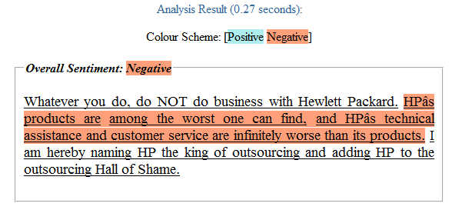
Score: - 1.0

Figure 9 Sentiment analysis for positively valenced reviews
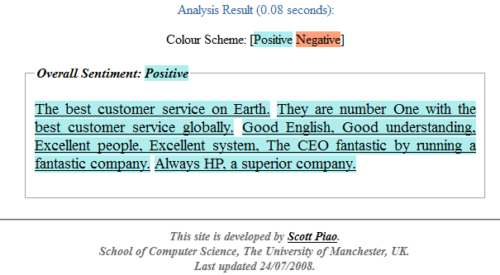

Score: + 0.75

Concerning the negative valenced reviews, minor changes have been made to the content. As far as it concerns the positive valenced online consumer reviews a different procedure was followed. Specifically after acquiring the negative reviews, in order to create the positive reviews, the method suggested by Lee et al. (2009) was followed. Both versions of positive and negative reviews remained similar in most aspects. However, the “varying combinations of valence and extremity of the review were altered” (Lee et al. 2009). More specifically a list of semantic differential adjectives developed by Myers and Warner (1968) was implemented. The aim of this implementation was to replace every negative valenced adjective or phrase, included in the negative valenced online reviews, with its exact opposite meaning from a list of 50 evaluative adjectives. For instance, adjectives such as “worst” were replaced for the positive review with the adjective “best”, “always” was replaced with “never”. The list with all the adjectives can be found in the appendix H section. The following figures 10 and 11 demonstrates the result of the aforementioned procedure.

Figure 10 Original negative online review
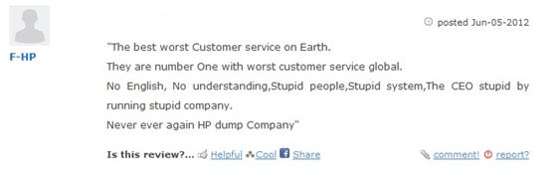
Figure 11 Positive online review created:



For the creation of the positive reviews adobe Photoshop software was used. Additionally, in order to avoid bias, the reputation of the reviews as well as the ranking position of the review will not be visible from the respondents. Also the font size, the resolution and size of the image as well as the number of words were kept almost identical. Furthermore, the order of the reviews will be assigned randomly. To be more specific, most web sites are placing on the top of the page the most helpful reviews, as a result; consumers are used to look at first those reviews. For this reason the order of the reviews will be shuffled.
Figure 12 indicates all the online reviews that have been used in this experiment and their sentiment analysis scores. The images of those reviews that have been implemented in the questionnaire can be found on the Appendix B section.

Figure 12
List of the online reviews and sentiment analysis scores
Negatively valenced reviews | Score
Whatever you do, do NOT do business with Hewlett Packard. HP’s products are among the worst one can find, and HP’s technical assistance and customer service are infinitely worse than its products. I am hereby naming HP the king of outsourcing and adding HP to the outsourcing Hall of Shame. | -1.0
The best worst Customer service on Earth.  They are number One with worst customer service global.  No English. No understanding. Stupid people. Stupid system, The CEO stupid by running stupid company. Never ever again HP dump Company | -1.0
The worst. With all the products out there do not purchase any HP products. Their support is horrible, the products poor and your frustration great. Buy another brand. | -1.0
HP is the worst of the worst company I have ever dealt with in the world.  The brand new laptop I bought from HP died suddenly in two months. | -1.0
So I needed a laptop for my business. I was looking for high performance and stability since I work as a graphic designer. I decided to go with HP and until now I am completely unsatisfied. The laptop edits everything remarkably poorly and slowly, the outcome of every task is terrible. | -1.0
I bought an HP laptop recently. From my experience the company let me down on my expectations, very untrustworthy. The laptop performs horribly and the customer service is very impolite and has remarkably poor knowledge. I do not recommend you buy HP. | -1.0
Positively valenced reviews
Whatever you do, do business with Hewlett Packard. HP products are among the best one can find, and HP’s technical assistance and customer service are excellent. I am hereby naming HP the king of laptop brands and adding HP to the Hall of Fame. | +0.75
The best customer service on Earth. They are number One with the best customer service globally. Good English, Good understanding, Excellent people, Excellent system, The CEO fantastic by running a fantastic company. Always HP, a superior company. | +0.75
I have been buying HP laptops for years. From my experience the company has never let me down, very trustworthy. Every laptop I have bought performs excellent and the customer service is very polite and has extremely good knowledge. I recommend you to buy HP. | +0.66
So I needed a laptop for my business. I was looking for high performance and stability since I work as a graphic designer. I decided to go with HP and until now I am completely satisfied. The laptop can edit everything remarkably good and fast, the outcome of every task is superb. | +0.75
HP is the best of the companies I have dealt with in the world. The brand new laptop I bought from HP operates exceptionally good. | +0.5
The best. With all the products out there purchase any HP products. Their support is superb, the products remarkably good and no signs of frustration. Buy HP brand. | +0.875

4.4.3 Manipulation of volume
According to other papers, in similar experiments the minimum reviews a consumer reads before purchasing a high involvement product is 1, the normal is 3 to 4, and the maximum is 8 (Park and Kim, 2008; Bambauer-Sachse and Mangold, 2011). However, according to the pre-test the optimal number of online consumer reviews for the high volume condition is six online consumer reviews. Accordingly for the low volume condition 2 reviews were chosen as the optimal number.

4.5 Sampling design and procedure
As it was mentioned before, a structured questionnaire was chosen to be conducted in order to gather suitable data. One questionnaire with four different conditions has been formulated and it is considered that it would be better to be distributed via Internet. As the research topic refers to E-WOM and the way it is communicated among internet users, consumers’ sample has to be derived from this particular population. Online questionnaires will be sent to young people aged from 18 to 37 living in Europe. This age range belongs today to what is called Generation Y or Millennials (Neuborne and Kerwin, 1999). Generation Y is thought to be internet orientated and familiar with E-WOM communication. They are using emails, forums, reviews, social networks, chat and blogs in their activities and this is the reason for choosing this particular population.
The questionnaire will be hosted on www.thesistools.com and will be also distributed via social networks, (such as LinkedIn, Twitter, and Facebook) and E-mails.

4.6 Construct measurements
To assure the validity of this experiment, proven construct measurements from the existing literature have been used so as to measure all the required variables. Measurements of prior product knowledge, persuasiveness of online reviews, consumer based brand equity, attitude towards the brand and purchase intentions were made. Pre-Post measurements for all three depended variables, namely, consumer based brand equity, attitude towards the brand and purchase intentions were made before and after the treatment, with the purpose of measuring the change due to the treatment.

4.7.1 Screening questions
Respondents who are willing to participate to this experiment have to fill in a randomly assigned to them questionnaire. The questionnaire begins with three screening questions. The first question is a bipolar (yes/no) question asking “before purchasing a high tech product, do you read online reviews about this product”. This question indicates if the respondent is using this source of information or not. In case the answer is yes, the respondent is directed to the second question asking “how much time do you spend reading online reviews before purchasing a high-tech product” if the answer is no the respondent is directed to question three asking “Have you ever owned a laptop”. The second question has six possible answers (<30/ 30 – 1 hour/ 1 – 2 hours/ 2 – 3 hours/ 3 – 4 hours/ >4 hours) indicating the amount of time a consumer spends on reading online reviews. It is assumed that respondents with high prior product knowledge will spend less time reading online reviews than respondents with low prior product knowledge. The third question has two possible answers, Yes or No, if the answer is yes the respondent will continue into the next section of the questionnaire, if the answer is no the respondent will be thanked for the participation in the experiment and the session will close, as this experiment focuses on laptop users.

4.7.2 Prior product knowledge
Question 4 is measuring the Prior product knowledge of the respondents. The scale that was used to measure the prior product knowledge is developed by Smith and Park (1992), and measures the self-assessed knowledge of the respondents. Self-assessed knowledge is an indicator of objective knowledge as well as a self-confidence indicator. This 4-item scale consists of the following questions: “I feel very knowledgeable about laptops”, “I can give people advice about different brands of laptops”, “I only need to gather very little information in order to make a wise decision” and “I feel confident about my ability to tell the difference in quality between different brands of laptops”. The Cronbach α for this scale is 0.77. Respondents have to indicate their level of agreement for each item of the scale, on a 5-point Likert scale ranging from 1: Strongly disagree to 5: Strongly agree.

4.7.3 Persuasiveness of online reviews
Question 5 is measuring the persuasiveness the respondents have on online reviews. The scale consists of two items, “Online product reviews have an impact on my purchase decisions” and “Before making important purchase decisions, I go to product review websites to learn about other consumers opinions” developed by Bambauer-Sachsen and Mangold, (2011) after adaptation of indicators that Bearden et al. (1989) proposed for measuring the susceptibility to interpersonal influence. This scale is a 7-point Likert scale ranging from 1: totally disagree to 7: totally agree and the Cronbach α for this scale is 0.82.

4.7.4 Consumer based brand equity
Questions 6 and 11 are measuring the consumer based brand equity. The same scale is used twice in order to estimate the change of the consumer based brand equity due to the treatment. The scale was developed by Walfried et al., (1995) it is a 7point Likert scale ranging from 1: strongly disagree to 7: strongly agree. This scale examines four dimensions of the consumers based brand equity, namely, performance, social image, trustworthiness and attachment. Items measuring performance are “From brand, I can expect superior performance”, “During use, brand is highly unlikely to be defective”, “Brand is made so as to work trouble free”, “brand will work very well”. Items measuring social image are “brand fits my personality”, “I would be proud to own a brand”, “Brand will be well regarded by my friends”, “In its status and style, brand matches my personality”. Items measuring trustworthiness are “I consider the company and people who stand behind brand to be very trustworthy”, In regard to consumer interest, this company seems to be very caring”, “I believe that this company does not take advantage of consumers” and for attachment are “After watching brand, I am very likely to grow fond of it”, “For brand, I have positive personal feelings”, “With time, I will develop a warm feeling towards brand”.

4.7.5 Attitude towards the brand
Questions 7 and 11 are measuring consumer’s attitude towards a brand. The scale consists of 3 items, 5-point Likert scale and it was developed by Lee et al. (2001). The Cronbach alpha of the scale is .92 and the items that constitute this scale are “I like brand”, “brand is satisfactory”, “brand is desirable”

4.7.6 Purchase intentions
Questions 8 and 12 are measuring the purchase intentions of the consumers towards a brand. The scale has been developed by Putrevu and Lord, (1994) and it consists of five items, ranging from strongly disagree to strongly agree, on a 7-point Likert scale. The items that constitute this scale are “It is very likely that I will buy brand laptop”, “I will purchase brand the next time I need a laptop”, “I will definitely try brand”, “Suppose that a friend called you last night to get your advice in his/her search for a laptop. Would you recommend him/her to buy a brand laptop”. The Cronbach alpha of this scale is .91.

4.7.7 Manipulation checks
After the eighth question, respondents are exposed to the consumers online reviews. In continuance, the respondents have to answer two screening questions. The first question has been developed by Peng et al., (2001) concerning the WOM valence and consists of 1 item, 5-point Likert scale, ranging from completely negative to completely positive. The question testing the WOM valence is “What is the overall attitude of these reviews toward the brand”. Respondents, who recognize positive reviews as neutral or negative, will be thanked for the participation on the experiment and the session will close. The same stands for respondents who recognize negative reviews as neutral or positive. Finally, a question asking the respondents to indicate the number of reviews they have read was made. Respondents will have to provide a numerical value of the reviews they have read.

4.7.8 Demographics
The last section of the questionnaire (questions 13 to 17) asks the participants to fill in five demographics questions concerning their gender, age, educational level, nationality and monthly income in euros. After the completion of the questionnaire the respondents will be thanked for their participation and they will be informed that the collected data will be used for the purposes of this study only.

4.8 Questionnaire design

Respondents who are willing to participate will be randomly assigned to one of the four experimental conditions. The questionnaire begins with a brief introduction about this research and its content. Thereafter, 3 questions concerning online reviews and laptop ownership will be provided to the participants. Consequently, the respondents will be asked to indicate their level of agreement with sentences concerning their product knowledge and the persuasion they show on online reviews. Afterwards pre measurements of the consumer based brand equity, attitudes toward the brand and purchase intentions will be made. The consumer based brand equity items were asked first then attitude towards the brand and purchase intentions in order to “reduce the halo effect common to multi attribute attitude models, in which subjects distort their perceptions when expressing their overall attitudes before they evaluate details that contribute to the attitudes” (Beckwith and Lehmann, 1975; Cooper, 1981; Yoo and Donthu, 2001). The next section of the questionnaire is the treatment and the success of the treatment will be made by two manipulation check questions concerning the WOM valence and the number of reviews read by the participants. In the final section of the questionnaire post measurements of the consumer based brand equity, attitudes toward the brand and purchase intentions are made, to test the change of these variables due to the treatment and the questionnaire finishes with five questions concerning demographics.

Figure 13 Questionnaire design
Introduction

Screening questions

Questions related to moderating and control variables
Prior product knowledge
Persuasiveness of online product reviews

Pre-measurements on dependent variables
Consumer based Brand Equity
Attitude towards the brand
Purchase intentions

Treatment

Control Question
WoM Valence
Volume of reviews

Post measurements on dependent variables
Consumer based Brand Equity
Attitude towards the brand
Purchase intentions

Demographics

5. DATA
In this chapter the description of the procedures that have been used for the data cleaning are going to be analyzed. Additionally, descriptive statistics and demographics of the respondents will be provided. Finally, reliability checks will be performed for every construct measurement that has been used for the experiment as well as manipulation checks for the independent variables to test if they have been manipulated successfully.

5.1 Data cleaning
A questionnaire has been distributed via the internet between 13/09/2012 and 04/1012012 and 293 respondents had participated in the experiment. The participants of the first experimental conditions (Negative High) were 83, for the second experimental condition (Negative Low) were 70, for the third (Positive High) were 71 and for the fourth (Positive Low) were 69. Out of the 293 participants that filled in and submitted the questionnaire, 209 respondents have been certified as valid for the data analysis. The 84 respondents have been excluded from the data analysis for the following reasons: 24 participants have never owned a laptop, 6 participants perceived the positively valenced reviews as negatively valenced, while 2 participants perceived the negatively valenced reviews as positively valenced reviews. Additionally, 9 participants perceived the valence of the online reviews as being neutral and 12 participants gave extreme answers (ranging from 12 until 41.096 reviews read) in the question: “Please indicate the number of reviews you have read”. Finally, 31 questionnaires were incomplete or they were missing values important for the further analysis.

5.2 Demographics and screening questions
At the beginning of the questionnaire, respondents had to answer some screening questions concerning their intentions on reading online reviews before making a purchase and the amount of time they are spending reading those reviews. As it can be seen from the Table 1, the vast majority of the participants (93.8%) are reading online reviews before making a purchase and most of the respondents (34%) are dedicating 1 to 2 hours reading online reviews before purchasing a high tech product.

Table 1
Screening questions
 | Description | Frequency | Percentage (%)
Before purchasing a high-tech product, do you read online reviews about this product? | Yes | 196 | 93,8
 | No | 13 | 6,2
How much time do you spend reading online reviews before purchasing a high-tech product? | Less than 30 minutes | 18 | 8,6
 | 30 – 1 Hour | 52 | 24,9
 | 1 – 2 Hours | 71 | 34,0
 | 2 – 3 Hours | 31 | 14,8
 | 3 – 4 Hours | 14 | 6,7
 | More than 4 hours | 13 | 6,2
 | I am not reading online reviews | 10 | 4,8

In the last section of the questionnaire respondents had to answer five questions measuring participants’ demographics information. Table 2 summarizes the result of the demographic questions. The sample consists of 124 males (59.3%) and 85 females (40.7%). Regarding age measurement 45.9% of the respondents are in the range of 25 to 30 years old followed by 26.3% in the range of 19 to 24. Regarding education 43.1% are university graduates followed by 37.3% of Master graduates. The majority of the respondents are Greek (60.7%) followed by Dutch (13.8%) and most of the participants (30.1%) have a monthly income in the range of 1001 to 1500 euros, followed by participants (23.4%) with a monthly income to the range of 1501 to 2000 euros.
Table 2
Demographics
 | Description | Frequency | Percentage (%)
Gender | Male | 124 | 59,3
 | Female | 85 | 40,7
Age | Below 18 | 0 | 0
 | 19 – 24 | 55 | 26,3
 | 25 – 30 | 96 | 45,9
 | 31 – 35 | 53 | 25,4
 | Above 36 | 5 | 2,4
Education | School graduate | 35 | 16,7
 | University graduate | 90 | 43,1
 | Master | 78 | 37,3
 | PhD | 5 | 2,4
 | Not applicable | 1 | 0,5
Nationality | Albanian | 8 | 3,8
 | Bulgarian | 6 | 2,8
 | Dutch | 29 | 13,8
 | English | 6 | 2,8
 | French | 5 | 2.3
 | German | 8 | 3,8
 | Greek | 127 | 60,7
 | Hungarian | 6 | 2,8
 | Israeli | 1 | 0,4
 | Italian | 12 | 5,7
 | Polish | 1 | 0,4
Monthly income, in Euros | <500 | 19 | 9,1
 | 501 – 1000 | 40 | 19,1
 | 1001 – 1500 | 63 | 30,1
 | 1501 – 2000 | 49 | 23,4
 | 2001 – 2500 | 22 | 10,5
 | >2501 | 11 | 5,3
 | Not applicable | 5 | 2,4

5.3 Dependent, moderator and control variables descriptive statistics
As table 3 indicates there is a slight decrease on all the measurements made after the treatment when compared with the measurements before the treatment. The mean comparison designates that the negative valenced reviews have stronger effects on the dependent variables than the positively valenced. Moreover, the prior product knowledge (Μ = 3,035, SD = 1,138) of the respondents can be defined as mediocre and the persuasiveness of online reviews can be characterized as relative high (M = 5.019, SD = 1,470).

Table 3
Mean comparison for the dependent variable before and after the treatment and means for moderator and control variable
 | M | σ | σ²
PreCBBE | 3.889 | 1.463 | 2.142
PostCBBE | 3.730 | 1.604 | 2.574
PreAttitudes | 3.103 | 1.161 | 1.350
PostAttittudes | 2.939 | 1.121 | 1.464
PrePurchase | 4.095 | 1.878 | 3.592
PostPurchase | 3.909 | 1.845 | 3.406
Prior Product Knowledge | 3.035 | 1.138 | 1.296
Persuasiveness of reviews | 5.019 | 1.470 | 2.163

5.4 Validity and reliability of construct measurements
All the scales that have been used in this study have been confirmed to be valid and reliable. Description, origin, reliability and validity of every scale has been quoted in the previous chapter but due to the fact that all scales are written in English, it is important to consider that 97,2% of the sample population are not native English speakers. Thus, factor analysis is in fact crucial to examine how participants perceived each underlying construct, in other words to test if the scales are indeed measuring what they are supposed to measure.
The statistical analysis has been performed by the usage of the SPSS software. Certain criteria’s had to be fulfilled for factor and reliability analysis so as to acquire valid results. First, factors with eigenvalues greater than 1.0 will be retained (Kaiser, 1960). Second, Communalities have to be close to 1 and no lower than 0.30 (Field, 2009). Third, according to Stevens, (1996) for sample sizes greater than 200 the factor loadings must be >0.364. Fourth, KMO measure of sampling adequacy must have a value close to 1 and no lower than 0.5 in order to acquire distinct and reliable factors (Field, 2009; Hutcheson and Sofroniou, 1999,pp. 224-225). Fifth, Bartlett’s test of sphericity must have a p value <.001 (Field, 2009).
For every scale that has been used in this study, factor and reliability analysis has been performed. In total 8 factor analyses and 8 reliability analyses have been made and the results are summarized in table 4.

Table 4
Factor and reliability analysis results
Factor | Item | Factor loading | Item to total correlation | Explained Variance | Cronbach’s α
Prior product knowledge | PRK1 | 0.907 | 0.830 | 81.056 | 0.920
 | PRK2 | 0.910 | 0.831
 | PRK3 | 0.875 | 0.783
 | PRK4 | 0.908 | 0.833
Persuasiveness of online reviews | POR1 | 0.926 | 0.717 | 85.840 | 0.835
 | POR2 | 0.926 | 0.717
Consumer based brand equity before treatment | CBBEB1 | 0.865 | 0.841 | 77.715 | 0.977
 | CBBEB2 | 0.736 | 0.700
 | CBBEB3 | 0.921 | 0.905
 | CBBEB4 | 0.895 | 0.875
 | CBBEB5 | 0.838 | 0.816
 | CBBEB6 | 0.894 | 0.877
 | CBBEB7 | 0.860 | 0.839
 | CBBEB8 | 0.856 | 0.835
 | CBBEB9 | 0.931 | 0.916
 | CBBEB10 | 0.914 | 0.896
 | CBBEB11 | 0.882 | 0.859
 | CBBEB12 | 0.917 | 0.901
 | CBBEB13 | 0.931 | 0.917
 | CBBEB14 | 0.884 | 0.863
Attitudes toward the brand before treatment | ATBB1 | 0.940 | 0.858 | 85.875 | 0.916
 | ATBB2 | 0.940 | 0.855
 | ATBB3 | 0.900 | 0.783
Purchase intentions before treatment | PIB1 | 0.973 | 0.950 | 91.071 | 0.967
 | PIB2 | 0.944 | 0.901
 | PIB3 | 0.957 | 0.923
 | PIB4 | 0.943 | 0.898
Consumer based brand equity after treatment | CBBEA1 | 0.918 | 0.903 | 82.864 | 0.984
 | CBBEA2 | 0.822 | 0.796
 | CBBEA3 | 0.928 | 0.916
 | CBBEA4 | 0.931 | 0.919
 | CBBEA5 | 0.894 | 0.877
 | CBBEA6 | 0.916 | 0.902
 | CBBEA7 | 0.913 | 0.898
 | CBBEA8 | 0.909 | 0.895
 | CBBEA9 | 0.919 | 0.904
 | CBBEA10 | 0.922 | 0.907
 | CBBEA11 | 0.903 | 0.885
 | CBBEA12 | 0.929 | 0.917
 | CBBEA13 | 0.944 | 0.934
 | CBBEA14 | 0.891 | 0.872
Attitudes toward brand after treatment | ATBA1 | 0.933 | 0.849 | 88.400 | 0.934
 | ATBA2 | 0.961 | 0.907
 | ATBA3 | 0.926 | 0.837
Purchase intentions after treatment | PIA1 | 0.968 | 0.941 | 88.758 | 0.957
 | PIA2 | 0.941 | 0.894
 | PIA3 | 0.945 | 0.900
 | PIA4 | 0.913 | 0.849

Principal components analysis method has been used to acquire the results showed in Table 4. Varimax or other rotation method was not possible due to the fact that there was only one main factor with eigenvalue above 1 in each of the 8 separate factor analyses. The eigenvalue was 3,242 for the prior product knowledge scale, 1,717 for the persuasiveness of online reviews scale, 10,880 for the consumer based brand equity scale before the treatment, 2,576 for the attitudes toward the brand scale before the treatment, 3,643 for the purchase intentions before the treatment, 11,601 for the consumer based brand equity scale after the treatment, 2,652 for the attitudes toward the brand scale after the treatment and 3,550 for the purchase intention scale after the treatment. Moreover, all scale item communalities are above the critical limit of 0.3, ranging from .542 to .973. Additionally, all the normalized factor loadings are way above the .364 value. Furthermore, the values of the KMO measure of sampling adequacy are greater than 0.5 and the p values for Bartlett’s test of sphericity are lower than .001.
Cronbach’s α has been used in order to measure the internal consistency of the scale items included in the questionnaire. The results are indicating that the scales have a high level of consistency ranging from .835 for the persuasiveness of online reviews scale to .984 for the consumer base brand equity scale.
Although, the Cronbach’s alpha values are relatively high for all scales it was judged necessary to delete an item from the consumer based brand equity scale before the treatment (During use, HP is highly unlikely to be defective) for three reasons. First, if the specified item is deleted the Cronbach alpha value will slightly increase from 0.977 to 0.978. Second, the item to total correlation value for the item discussed is .700 which is an acceptable value, however in comparison to the other items of this scale the value seems to be quite low. Third, taking a closer look at the data it seems that participants who gave high scores for this scale indicated a quite low score for this specific item (the opposite applies as well). To be more specific, respondents who had a general positive opinion regarding all the other items of the consumer based brand equity scale, scored surprising low in the specific item. Thus, it is speculated that respondents misunderstood the meaning of this item. Taking into consideration all the mentioned reasons, the item “During use, HP is highly unlikely to be defective” of the consumer based brand equity scale was deleted and it is not going to be used for any further analysis. For the exact same reasons the item was deleted from the consumer based brand equity scale after the treatment.
The full SPSS output concerning factor and reliability analysis can be found in the appendix C section.

5.5 Manipulation checks and control variable
Two items have been included to the questionnaire in order to check whether the valence of online reviews and the volume of the online reviews have been manipulated successfully. Two, one way ANOVA’s have been conducted for testing the manipulation of valence and volume. The one way ANOVA for valence item (What is the overall attitude of these user reviews towards this product?) shows significant difference between the experimental groups (negative vs. positive), F (1,207) =1359.155, p <0.001, M_{negative} =1.46, M_{positive} =4.40 and the one way ANOVA for the volume item (Please indicate the number of reviews you have read) shows significant difference between the experimental groups (High vs. Low), F (1,207) =291.324, p < .001, with a mean for the high volume condition at 4.54 reviews read and for the low volume condition at 2.00 reviews read. Hence, both review valence and volume have been manipulated successfully.
Persuasiveness of online reviews was examined as a control variable. No significant differences were found among the experimental groups F (3,205) = 0.109, p = .955. Thus, no further analysis can be made.
SPSS output for the manipulation checks and control variable can be found in the appendix D section.

6. ANALYSIS AND RESULTS
In this chapter the data analysis and the hypothesis testing are going to be performed and checked. Various statistical methods can be used to analyze the data gathered from a pre-post experiment, such as Analysis of variance (ANOVA) on the gain scores, Analysis of variance on residual scores, Analysis of covariance (ANCOVA) and repeated measures ANOVA. All the above statistical methods are using the pretest scores so as to reduce the variance error, generating better results, in comparison to the experimental designs that do not use pretest data (Stevens, 1996). For the purpose of selecting the best method for the data analyses, a brief description of each method will be made.

ANOVA on gain scores: The Gain score represent the difference between post-measurements and pre- measurements results. After its calculation, the gain score is used as the dependent variable in the ANOVA and for this reason has been criticized that the difference between scores is leading to much less reliable scores than the actual scores of the pre and post measurements (Cronbach and Furby, 1970; Linn and Slindle, 1977; Lord, 1956).

ANCOVA: ANCOVA method is using the pre-measurements scores as covariate in order to decrease the variance error and to eliminate systematic bias. ANCOVA will generate the same results as ANOVA only if the regression slope equals to 1. In case the regression slope is <1 (which consider to be the most common scenario) ANCOVA will generate more powerful test than the ANOVA (Cahen and Linn, 1971)

ANOVA on residual scores: In comparison with ANCOVA, ANOVA on residual scores is less powerful (Maxwell and Manheimer, 1985).

Repeated measures ANOVA: Due to the fact that with repeated measures ANOVA pre-measurements scores are not affected by the treatment, this method can lead to misrepresentative results (Huck and McLean, 1975; Jennings, 1988).

According to the aforementioned, analysis of covariance seems to be the most powerful analysis method and it will be used for the data analysis in this study. Moreover, regarding ANCOVA with the aim of optimizing the acquired data, the post-measurements are going to be used as the dependent variable, the treatment as the design factor and the pre- measurements as the covariate. Before conducting the two way ANCOVA several assumptions underlying ANCOVA that affect the interpretation of the results, such as assumption of independence, assumption of normality and test of homogeneity of regression, have to be tested.
All the assumptions tests underlying ANCOVA have been made and the results showed that the ANCOVA can be conducted. Regarding the assumption of the homogeneity of regression there is an insignificant relationship between the independent variables and the covariate, F(1,202) = 0.349, p =0.555 and as for the assumption of independence the Durbin-Watson value is 2.047. The SPSS outputs regarding the assumptions can be found in the Appendix E section.

6.1.1 Results and hypotheses testing for Purchase intentions

Table 5
PRE-POST measurements mean comparison among the experimental groups for purchase intentions
Review Valence  Review Volume | Negative reviews | Positive reviews | Total
High volume | Mpost (3.429) – Mpre (4.353) = Gain score (-0.924)  (n=53) | Mpost (4.322) – Mpre (3.894) = Gain score (0.427)  (n=52) | 0.675
Low volume | Mpost (3.500) – Mpre (4.076) = Gain score (-0.576)  (n=52) | Mpost (4.394) – Mpre (4.052) = Gain score (0.341)  (n=52) | 0.458
Total | 0.750 | 0.384
The above values are representing the gain scores (Post – Pre)
The minus sign (-) shows that the post measurements are lower than the pre measurements

Several T-tests have been performed so as to compare the participants scores before the treatment(Mpre) and after the treatment(Mpost) and calculate the gain scores. Since there was no time interval between the pre and post measurements of the dependent variables, any significant change on the post measurements can be attributed due to the treatment. T-test results for purchase intentions are summarized at table 5, showing the difference of the post measurements minus the pre measurements. The results presented in table 5 show that the contact with high volume of negative online reviews causes a significant decrease (M = -0.924, SE = 0.104, t(52) = -8.869, p < .001) on purchase intentions. The same applies when participants were exposed to low volume of negative online reviews (M = -0.576, SE = 0.109, t(51) = -5.277, p < .001. On the contrary, positive online reviews had a significant increase on purchase intentions either with high volume (M = 0.427, SE = 0.110, t(51) = 3.870, p < .001) or low volume of online reviews(M = 0.341, SE = 0.095, t(51) = 0.532, p = .001) Additionally, according to table 5 participants of the first experimental group (Negative valence, High volume) scored significantly lower after the treatment (M = 3.429, SE = 0.218) than before the treatment (M = 4.353, SE = 0.246, t(52) = -8.869, p < .001). The smallest change on purchase intentions comes from the fourth experimental group (Positive valence, Low volume) where participants scored significantly greater after the treatment ( M =4.394, SE = 0.273) compared to their scores before the treatment (M = 4.052, SE = 0.267, t(51) = 3.588, p = .001).

Table 6
Effect of the valence of consumer reviews on purchase intentions
Dependent Variable: PostPurchase
Negative vs. Positive | Mean | Std. Error | 95% Confidence Interval
Negative vs. Positive | Mean | Std. Error | Lower Bound | Upper Bound
Negative valence | 3,360ª | ,071 | 3,220 | 3,499
Positive Valence | 4,465ª | ,071 | 4,325 | 4,605
a. Covariates appearing in the model are evaluated at the following values: PrePurchase = 4,0957.

At this point, it has to be tested which level of valence (Negative Vs. Positive) has greater effect on purchase intentions. Table 6 gives the adjusted values of the group means of valence for each level. The covariate (PrePurchase) has a value of 4.095, the greater the distance from the pre-measurements the greater the effect on the purchase intentions. Negative valenced reviews have a greater distance (M_{covariate}(4.095) – M_{negative valence}(3.360) = 0.735) compared to positively valenced reviews (M_{covariate} (4.095) – M_{positive valence} (4.465) = -0.37).
According to table 5 and table 6 it can be concluded that the negatively valenced reviews had a greater effect on purchase intentions than the positively valenced reviews.
Table 7
Results of two way ANCOVA for the Purchase intentions
Dependent Variable: PostPurchase
Source | df | F | Sig.
PrePurchase | 1 | 1067,111 | ,000
Valence | 1 | 121,264 | ,000
Volume | 1 | 1,513 | ,220
Valence * Volume | 1 | 3,592 | ,059
Error | 204
a. R Squared = ,849 (Adjusted R Squared = ,846)

Based on the ANCOVA results (Table 7) the covariate Pre-purchase intentions (PrePurchase), is significantly related to Post purchase intentions (PostPurchase), F(1,204) = 1067.111, p < .001. Additionally, the main effect of valence on PostPurchase, after controlling for the effect of PrePurchase is also significant, F(1,204) = 121.264, p < .001. Furthermore, the main effect of volume is insignificant, F(1,26) = 1.513, p >.05 and the interaction of the volume and the valence is also insignificant F(1,26) = 3.592, p > .05.
Taking into consideration all the above, Hypothesis H1a and H1b are both supported and Hypothesis H2a and H2b are not supported.

6.1.2 Results and hypotheses testing for consumer based brand equity

Table 8
PRE-POST measurements mean comparison among the experimental groups for consumer based brand equity
Review Valence  Review Volume | Negative reviews | Positive reviews | Total
High volume | Mpost (3.233) – Mpre (3.847) = Gain score (-0.614)  (n=53) | Mpost (4.144) – Mpre (3.875) = Gain score (0.269)  (n=52) | 0.441
Low volume | Mpost (3.384) – Mpre (3.932) = Gain score (-0.548)  (n=52) | Mpost (4.228) – Mpre (3.982) = Gain score (0.245)  (n=52) | 0.396
Total | 0.581 | 0.257
The above values are representing the gain scores (Post – Pre)
The minus sign (-) shows that the post measurements are lower than the pre measurements

Table 8 provides the results of the T-tests performed on the post and pre measurements regarding consumer based brand equity, as well as the gain scores of that difference. The largest change comes from the first experimental group (Negative valence, High volume), where participants scored significantly lower after the treatment (M = 3.233, SE = 0.200) compared to participants scores before the treatment (M = 3.847, SE = 0.190, t(52) = -7.175, p < .001). The second larger change comes from the second experimental group (Negative valence, Low volume) in which the participants scored significantly lower after the treatment (M = 3.384, SE = 0.198) than before the treatment(M = 3.932, SE = 0.198, t(51) = -7.073, p < .001)

Table 9
Effect of the valence of consumer reviews on consumer based brand equity
Dependent Variable: PostCBBE
Negative vs. Positive | Mean | Std. Error | 95% Confidence Interval
Negative vs. Positive | Mean | Std. Error | Lower Bound | Upper Bound
Negative valence | 3,315ª | ,056 | 3,204 | 3,426
Positive Valence | 4,150ª | ,057 | 4,039 | 4,262
a. Covariates appearing in the model are evaluated at the following values: PreCBBE = 3,8896.

Taking into consideration the results of table 9 it can be easily comprehended that the effect of negatively valenced reviews on consumer based brand equity (M_{covariate} (3.889) – M_{negative valence} (3.315) = 0.574) is more powerful than the effect of positively valenced reviews(M_{covariate} (3.889) – M_{positive valence} (4.150) = -0.261).

Table 10
Results of two way ANCOVA for the consumer based brand equity
Dependent Variable: PostCBBE
Source | df | F | Sig.
PreCBBE | 1 | 1278,323 | ,000
Valence | 1 | 109,155 | ,000
Volume | 1 | ,053 | ,819
Valence * Volume | 1 | ,211 | ,646
Error | 204
a. R Squared = ,873 (Adjusted R Squared = ,870)

The covariate consumer based brand equity before the treatment (PreCBBE), is significantly related to consumer based brand equity after the treatment (PostCBBE), F(1,204) = 1278.323, p < .001. Additionally, the main effect of valence on the post measurement of consumer based brand equity is significant, F(1,204) = 109.155, p < .001 but the main effect of volume on the consumer based brand equity after the treatment is not significant, F(1,204) = 0.053, p > .05. Furthermore, there is a non-significant interaction between the valence and the volume on the consumer based brand equity after the treatment, F(1,204) = 0.211, p > .05.
Taking into consideration all the above, it can be inferred that the negative valenced reviews have a greater impact on the consumer based brand equity compared to positively valenced reviews. Due to the fact that the effect has an opposite direction than the one expected, H3a is not supported (reverse). Furthermore, H3a1 and H3a2 are both supported and H4a is rejected.

6.1.3 Results and hypotheses testing for attitudes toward the brand

Table 11
PRE-POST measurements mean comparison among the experimental groups for attitudes toward the brand
Review Valence  Review Volume | Negative reviews | Positive reviews | Total
High volume | Mpost (2.559) – Mpre (3.169) = Gain score (-0.610)  (n=53) | Mpost (3.173) – Mpre (2.929) = Gain score (0.243)  (n=52) | 0.426
Low volume | Mpost (2.647) – Mpre (3.173) = Gain score (-0.525)  (n=52) | Mpost (3.384) – Mpre (3.141) = Gain score (0.243)  (n=52) | 0.384
Total | 0.567 | 0.243
The above values are representing the gain scores (Post – Pre)
The minus sign (-) shows that the post measurements are lower than the pre measurements

Table 11 shows the means and the gain scores from the T-tests that had been performed on the participants scores before and after the treatment. As for the previous two dependent variables the highest gain score comes from the first experimental group (Negative High). Post measurements are significantly lower (M = 2.559, SE = 0.148) than the pre measurements (M = 3.169, SE = 0.153, t(52) = -9.732, p < .001) on attitudes toward the brand. Moreover, the smallest gain score derives from both third (Positive valence, High volume) and fourth (Positive valence, Low volume) experimental group. The mean gain score for the participants exposed to high volume of positive online reciews is M = 0.243, SE = 0.062, t(51) = 3.919, p < .001 and for the participants who came in contact with low volume of positive online reviews is M = 0.243, SE = 0.078, t(51) = 3.112, p < .001.

Table 12
Effect of the valence of consumer reviews on attitudes toward the brand
Dependent Variable: PostAttitudes
Negative vs. Positive | Mean | Std. Error | 95% Confidence Interval
Negative vs. Positive | Mean | Std. Error | Lower Bound | Upper Bound
Negative valence | 2,543ª | ,053 | 2,439 | 2,648
Positive Valence | 3,340ª | ,053 | 3,235 | 3,444
a. Covariates appearing in the model are evaluated at the following values: PreAttitudes = 3,1037.

From table 12 it can be concluded that negatively valenced reviews (M_{covariate} (3.103) – M_{negative valence} (2.543) = 0.56) have a greater effect on attitudes toward the brand compared to positively valenced reviews (M_{covariate} (3.103) – M_{positive valence} (3.340) = -0.237).

Table 13
Results of two way ANCOVA for the attitudes toward the brand
Dependent Variable: PostAttitudes
Source | df | F | Sig.
PreAttitudes | 1 | 750,862 | ,000
Valence | 1 | 112,815 | ,000
Volume | 1 | ,524 | ,470
Valence * Volume | 1 | ,166 | ,684
Error | 204
a. R Squared = ,804 (Adjusted R Squared = ,800)

The covariate attitudes toward the brand before the treatment (PreAttitudes), is significantly related to attitudes toward the brand after the treatment (PostAttitudes), F(1,204) = 750.862, p < .001. Moreover, the main effect of valence on attitudes toward the brand is significant, F(1,204) = 112.815, p < .001. The main effect of volume on the attitudes toward the brand is insignificant, F(1,204) = 0.524, p > .05 and the interaction between valence and volume on the attitudes toward the brand is also insignificant, F(1,204) = 0.166, P > .05.
According to the aforementioned, it can be apprehended that the negatively valenced reviews have a greater impact on the attitude toward the brand than the positively valenced reviews. Thus, hypotheses H5a and H5b are supported and hypothesis H5c is rejected.
ANCOVA results and T-test results can be found in the appendix F section.

6.2 Moderating effects

Moderation ensues when the interaction of two variables depends on a third variable. In this study there is one moderating variable, the prior product knowledge. To test the relationship between the moderating variables and the dependent variables, factorial ANOVA had to be conducted. Before the factorial ANOVA and in order to provide an improved interpretation of the moderating effects, cluster analysis had to be made for the moderator. Hierarchical cluster analysis has been performed, creating two clusters for the moderating variable, dichotomizing prior product knowledge to high and low prior product knowledge.
Results from the factorial ANOVA shows that there is no significant interaction between volume and prior product knowledge for purchase intentions or consumer based brand equity. Accordingly, no significant interaction existed for the valence and prior product knowledge on the purchase intentions and attitudes toward the brand. On the contrary, as table 14 indicates there is a marginally significant interaction between valence and prior product knowledge on consumer based brand equity, F(1,205) = 3.454, p = .065.
Table 14
Moderating effect of prior product knowledge on valence and consumer based brand equity
Dependent Variable: PostCBBE
Source | df | F | Sig.
Valence | 1 | 16,365 | ,000
PriorKnowledge2 | 1 | 7,004 | ,009
Valence * PriorKnowledge2 | 1 | 3,454 | ,065
Error | 205
a. R Squared = ,119 (Adjusted R Squared = ,106)

As table 15 and figure 14 indicate, in the negative valence condition, the means’ differences between the groups with high (M = 3.209) and low prior product knowledge (M = 3.374) do not seem to have important differences. On the contrary, when positive valenced reviews were provided to the respondents the low prior product knowledge group seems to score a lot higher (M = 4.615) when compared to the high prior product knowledge group (M = 3.668). From the results it can be concluded that respondents with high prior product knowledge are less affected by online reviews compared to respondents with low prior product knowledge, especially when provided with positively valenced online reviews.

Table 15
Descriptive statistics
Dependent Variable: PostCBBE
Negative vs. Positive | PriorKnowledgeCluster | Mean | Std. Deviation | N
Negative valence | High Prior Knowledge | 3,2092 | 1,71210 | 50
Negative valence | Low Prior Knowledge | 3,3748 | 1,17633 | 55
Negative valence | Total | 3,2960 | 1,45137 | 105
Positive Valence | High Prior Knowledge | 3,6688 | 1,73413 | 49
Positive Valence | Low Prior Knowledge | 4,6154 | 1,42009 | 55
Positive Valence | Total | 4,1694 | 1,63833 | 104
Total | High Prior Knowledge | 3,4367 | 1,72971 | 99
Total | Low Prior Knowledge | 3,9951 | 1,43975 | 110
Total | Total | 3,7306 | 1,60438 | 209

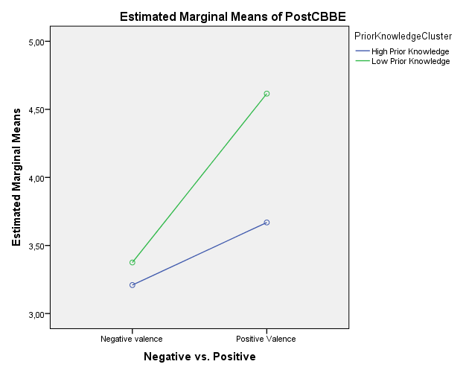
Figure 14

According to the aforementioned hypotheses H1c, H2c, H4b, H5d are not supported and hypothesis H3b is marginally supported.
The SPSS outputs regarding the moderating effect of prior product knowledge can be found on the appendix G section.

6.3 Mediation effects
Since prior product knowledge is marginally moderating the relationship between the review valence and the consumer based brand equity, it has been considered necessary to check for moderating effects of prior product knowledge on the relationship of valence and consumer based brand equity. According to Baron and Kenny, (1986) when testing for mediating effects, several regressions models have to be estimated, “First, regressing the mediator on the independent variable; second, regressing the dependent variable on the independent variable and third, regressing the dependent variable on both the independent variable and on the mediator”. In order for mediation effect to occur, the independent variable has to affect the mediator (Baron and Kenny, 1986). Based on the insignificant results of the regression between the mediator and the independent variable (p = .191) combined with the guidelines from Baron and Kenny, (1986), it can be concluded that there is no mediation effect of prior product knowledge and no further analysis can be made.

6.4 Hypotheses testing summary
Figure 15 summarizes all the hypotheses that have been tested.

Figure 15 Hypothesis testing summary
H1a: Negative valenced reviews will not affect purchase intentions. | Supported
H1b: Positive valenced reviews will affect purchase intentions. | Supported
H1c: Prior product knowledge moderates the relationship between valence of online reviews and purchase intentions. The relationship between valence and purchase intentions will change depending on the prior product knowledge the consumer has. | Not Supported
H2a: There is a positive relationship between the number of reviews read by the consumers and consumer purchase intentions. | Not Supported
H2b: The lower the number of reviews read by consumers the lower the purchase intentions. | Not Supported
H2c: Prior product knowledge moderates the relationship between the volume and the purchase intentions. The relationship between volume and purchase intentions will change depending on the prior product knowledge consumer has. | Not Supported
H3a: Positively valenced reviews will have a greater impact on consumer based brand equity than the negatively valenced reviews. Not supported reverse | Not Supported  (reverse)
H3a1: Positively valenced reviews will have a positive effect on consumer based brand equity. | Supported
H3a2: Negatively valenced reviews will have a negative effect on consumer based brand equity. | Supported
H3b: Prior product knowledge moderates the relationship between the valence and the consumer based brand equity. The relationship between valence and consumer based brand equity will change depending on the prior product knowledge consumer has. | Marginally Supported
H4a: The effect of the online reviews volume on the consumer based brand equity is correlated with the amount of reviews read by the consumer. | Not Supported
H4b: Prior product knowledge moderates the relationship between the volume and the consumer based brand equity. The relationship between volume and consumer based brand equity will change depending on the prior product knowledge consumer has. | Not Supported
H5a: Positive online reviews will have a positive relationship with attitude toward the brand. | Supported
H5b: Negative online reviews will have a negative relationship with attitude towards the brand. | Supported
H5c: The effect of the online reviews volume on the attitudes toward the brand is correlated with the amount of one sided reviews read by the consumer. | Not Supported
H5d: Prior product knowledge moderates the relationship between the valence and the attitude toward the brand. The relationship between valence and attitude toward the brand will change depending on the prior product knowledge consumer has. | Not Supported

7. DISCUSSION
In the previous chapter the statistical analysis of the gather data has been made. In this chapter the interpretation of the results will be presented for each dependent variable.

7.1 Purchase intentions
As it has already been mentioned in the literature review, valence and volume of reviews have halved the academic society by providing contradictory results. Based on the developed hypotheses, it was expected that the main effect of valence and the main effect of volume of reviews, would have a significant effect on purchase intentions. Concerning volume of reviews and based on the results of the previous chapter, it can be concluded that volume does not have a significant effect on purchase intentions. Although the results show that there is a difference between the experimental groups who were provided with high volume of reviews compared with the groups who were provided with low volume of reviews, this difference is not significant.
Regarding valence of the reviews, it was expected that valence has a significant effect on purchase intentions. In agreement with the results, valence, either positive or negative, has a significant effect on purchase intentions. The results have shown that negatively valenced reviews have a greater effect on purchase intentions compared to the positively valenced reviews. This outcome is in line with Chevalier and Mayzlin, (2006) who according to their interpretation, consumers are discounting the authentication of the positive reviews, believing that it has been written by marketers and for this reason, consumers are more influenced by the negatively valenced reviews because they consider the source of the reviews more trustworthy. Additionally, the effect of valence on purchase intentions was greater in comparison to the effect that valence caused on the other two dependent variables (Consumer based brand equity and attitudes toward the brand).
The interaction of valence and volume on purchase intentions was insignificant, showing that independently of the amount of reviews a consumer reads, valence is what matters.
Regarding the moderating variable prior product knowledge results showed that there is no moderating effect between valence and purchase intentions, since there is no significant interaction effect between valence and prior product knowledge. Also, prior product knowledge does not moderate the relationship between volume and purchase intentions.

7.2 Consumer based brand equity
As it was expected, valence has a significant effect on consumer based brand equity. Negative valenced reviews have a greater effect on consumer based brand equity than the positive valenced reviews. Volume was also expected to affect consumer based brand equity but the results showed that volume has insignificant effect on consumer based brand equity. Concerning the interaction between valence and volume on consumer based brand equity, results showed an insignificant effect. According to the aforementioned it can be concluded that only the valence of the online reviews has an effect on consumers based brand equity.
To further investigate the relationship between the valence and the consumer based brand equity, a moderating variable have been included in the experiment. Regarding prior product knowledge, results revealed a marginally moderating effect (p = .065). Respondents with high prior knowledge who have been provided with negatively valenced reviews were slightly more affected in comparison with the low prior knowledge group. On the contrary, when the high prior product knowledge group had been provided with positively valenced reviews, they were affected less than the low prior knowledge group. A plausible explanation is that people with high prior product knowledge are discounting the content of the online reviews, relying on their prior knowledge and believing that the source of the review is either untrustworthy or not informative.

7.3 Attitudes toward the brand
Concerning attitudes toward the brand, analysis results indicate that the main effect of valence has a significant effect on attitudes toward the brand, however volume has not. As it has occurred to the previous two dependent variables, regarding valence, the effect of negative reviews is greater on attitudes toward then brand when compared to the effect of positive online reviews. Additionally, the interaction effect of valence and volume is not significant for attitudes toward the brand. Hence, valence of online reviews is the variable that matters, concerning attitudes toward the brand.
Regarding the moderating variable, results indicated that there is no significant effect of valence and prior product knowledge on attitudes toward the brand.

8. SYNOPSIS, MANAGERIAL IMPLICATIONS AND LIMITATIONS

The primary objective of this research was to test and understand the influence of the e-WOM on consumers’ purchase intentions, consumer based brand equity and attitudes toward the brand. In order to do so, valence and volume of online reviews have been selected as the main variables of this survey. All the online reviews that have been used for this study have been derived from online opinion platforms and only minor adjustments have been made to the content of the reviews. The selection of actual online reviews created a simulation of real life conditions.
The contribution of this study to the existing literature is that this study extends the prior research by including the consumer based brand equity as an outcome variable. Although, purchase intentions and attitudes toward the brand have been examined under the spectrum of valence and volume, for consumer based brand equity only one study exists (Bambauer-Sachse and Mangold, 2011), in the authors’ knowledge, and it has examined only the aspect of negatively valenced reviews.
The findings of this research are indicating that negative valenced online reviews had a greater effect on all dependent variables compared with the positive valenced online reviews.
Regarding volume of online reviews, results showed that it is not affecting any of the dependent variables and in this point a question emerges, which is, why volume is a good predictor of sales for movies (Duan et al. 2005; Dellarocas et al. 2004), beers (Chevalier and Mayzlin 2006) and books (Clemons et al. 2006) and in this study is not? A possible explanation can be that all the aforementioned products/services are considered to be low involvement products, in contrast with laptops which are considered to be high involvement products.

8.1 Managerial implications

According to Chatterjee, (2001) marketers are encouraging the consumers to write positively valenced reviews, so as to enhance their product/brand. The results of this survey showed not only that the positive reviews are enhancing all the dependent variables but also that the effect of the negative reviews is more powerful. This outcome is in accordance with the findings of Chevalier and Mayzlin, (2006), Pavlou and Dimoka, (2006) and Ba and Pavlou, (2002). Although the number of positive reviews is much greater than negative reviews (Resnick and Zeckhauser, 2002; Mulpuru, 2007) managers should focus their attention towards negative reviews due to their influential effects. Marketers should try to prevent consumers from posting negative online reviews concerning their brand and encourage them to write positive reviews towards to their brand (Basuroy et al., 2003). Additionally, many of the negatively valenced reviews used in this study were about the bad customer service of HP brand. Marketers have to be aware of this fact and they should try effectively to deal with this problem, in order to provide an improved customer service support.
This study focused on the effects of online consumer reviews on a leading brand and the outcome revealed that even the consumer based brand equity has been affected by those reviews. Thus, it can be concluded that even leading brands with high awareness, high image/associations and high loyalty can be affected by online reviews. Marketers should not rest assured believing that consumers based brand equity will be maintained in higher levels. They should be constantly monitoring the ratio of positive versus negative reviews on several well-known/important opinion platforms and proceed with the appropriate marketing strategies in case that the ratio turns towards the negative reviews. Finally, it is recommended for marketers to use sentiment analysis tools which will aid them into categorizing online consumer reviews more efficiently.

8.2 Limitations and future research
Despite the validity of the results found in this research, a number of limitations exist.
First, only one sided reviews have been used. Future research should include two sided reviews in order to test if there is a greater effect on the relationships examined in this study, in case the reviews contain both positive and negative content. It is possible that the participants will perceive the content of a two sided review to be more influential towards their brand perceptions. Moreover, concerning this study, it should be mentioned that no control group was included in the experimental design. It is speculated that in this experiment since there was no time interval between the pre and post-tests, any change from the pre to the post results will be due to the treatment. The above speculation would be more valid if a control group has been included in the experiment, in an effort to give better insight towards the differentiation of the manipulated groups. Third, only extremely negative or extremely positive reviews have been used. Future research can be made by including moderate negative and positive reviews. Additionally, an important limitation should be mentioned concerning a number of respondents who were excluded from the data analysis. To be more specific, as it has already been mentioned respondents who were provided with positive reviews and indicated that the valence of those reviews were negative were excluded. The opposite applies as well. It is important to consider that future researches should include these respondents as well, so as to have more validity in their results. Although an attempt was made to include those respondents in the final results with the purpose of comparing them with the existing results, the software that was used to collect the data was set to exclude respondents who gave such answers. Furthermore, this study is focused on laptop owners only, future research should include potential buyers as well. Moreover, a relative small sample of 209 respondents have participated in the experiment, future research with a greater number of participants may provide more accurate and valid results. In addition, findings of this study are limited to only one leading brand. Future studies will want to include several different leading brands in different market categories.

9. REFERENCES

Aaker, D.A., 1991. Managing Brand Equity: Capitalizing on the Value of a Brand Name. The Free Press, New York.

Aaker, D.A. (1996) Building Strong Brands. Free Press, New York

Ahluwalia, R. (2002, September), “ How prevalent is the negativity effect in consumer environments?”Journal of Consumer Research, 29, 270−279.

Ahluwalia, Rohini, Robert E. Burnkrant, and H. Rao Unnava. 2000. “Consumer Response to Negative Publicity: The Moderating Role of Commitment.” Journal of Marketing Research 37 (May): 203-214.

Alba, Joseph W. and J. Wesley Hutchinson (1987), “Dimensions of Consumer Expertise,”Journal of Consumer Research, 13 (March), 411-54.

Alpert, H and Kamins, Michael. “An Empirical Investigation of Consumer Memory, Attitude, and Perceptions toward Pioneer and Follower Brands”. Journal of Marketing, Vol. 59, No. 4 (1995), 34-45.

Alvarez, L. S., Martı´n, A. M. D. and Casielles, R. V. (2007) ‘Relationship Marketing and Information and Communication Technologies: Analysis of Retail Travel Agencies’, Journal of Travel Research 45(4): 453.

Amblee, N. and Bui, T. (2007) ‘Freeware Downloads: An Empirical Investigation into the Impact of Expert and User Reviews on Demand for Digital Goods’, Americas Conference on Information Systems, Keystone, Colorado.

Amblee, N. and Bui, T. (2007) ‘The Impact of Electronic-Word-of-Mouth on Digital Microproducts: An Empirical Investigation of Amazon Shorts’, 15th European Conference on Information Systems, St Gallen, Switzerland.

Anderson, E. W. (1998) ‘Customer Satisfaction and Word of Mouth’, Journal of Service Research 1(5): 5–17.

Arndt, J., (1967), Word of Mouth Advertising: A Review of the Literature, Advertising Research Foundation, Inc., New York.

Arne Floh, Monika Koller and Alexander Zauner, (2008), “The impact of perceived valence, perceived information credibility and valence intensity of online reviews on purchase intentions”, The 9th International Conference on Electronic Business, Macau, November 30 - December 4, 2009

Avery, Christopher and Peter Zemsky, “Multi‐Dimensional Uncertainty and Herd Behavior in Financial Markets,” American Economic Review, 1998, 88, 724–748.

Awad, N. F. and Zhang, J. (2006) ‘A Framework for Evaluating Organizational Involvement in Online Ratings Communities’, 1st Midwest United States Association for Information Systems Conference (MWAIS–01), Grand Rapids, Michigan.

Ayn E. Crowley and Wayne D. Hoyer, An Integrative Framework for Understanding Two-Sided Persuasion, Journal of Consumer Research, Vol. 20, No. 4 (Mar., 1994), pp. 561-574.

Ba S., P.A. Pavlou, Evidence of the effect of trust building technology in electronic markets: price premium and buyer behavior, MIS Quarterly 26 (3) (2002) 243–268.

Bambauer-Sachse, Silke and Mangold, Sabrina. “Brand equity dilution through negative online word-of-mouth communication”. Journal of retailing and consumer services 18 (2011) 38 – 45.

Baron Reuben M. and David A. Kenny, The moderator-mediator variable distinction in social psychological research: conceptual, strategic and statistical considerations, Journal of Personality and Social Psychology 1986, Vol. 51, No. 6, 1173-1182

Basuroy, Suman, Subimal Chattejee, and Abraham Ravid (2003), “How Critical Are Critical Reviews? The Box Office Effects of Film Critics, Star Power, and Budgets,” Journal of Marketing, 67 (October), 103-117.

Bearden, W., & Etzel, M. J. (1982, September). Reference group influence on product and brand purchase decisions. Journal of Consumer Research, 9, 183–194.

Beckwith NE, Lehmann DR. The importance of halo effects in multi-attribute attitude models. Journal of Marketing Research 1975;12(August):265- 75.

Berthon, J.P., Capon, N., Hulbert, J., Murgolo-Poore, N.J., Pitt, L. & Keating, S. (2001)
Organizational and Customer Perspectives on Brand Equity: Issues for Managers and Researchers. Auckland: ANZMAC, Massey University.

Bettman, James R. and C. Whan Park (1980), “Effects of Prior Knowledge and Experience and Phase of the Choice Process on Consumer Decision Processes: A Protocol Analysis,” Journal of Consumer Research, 14 (September), 141-54.

Bonabeau, E., 2004. The perils of the imitation age. Harvard business review, 82(6), 45-54.

Boonghee Yoo and Naveen Donthu, (2001), “Developing and validating a multidimensional consumer-based brand equity scale”. Journal of Business Research 52 (2001) 1- 14.

Brucks, Merrie (1985), “The Effect of Product Class Knowledge on Information Search Behavior,” Journal of Consumer Research, 12 (June), 1-16.

Buttle, F. A. (1998) ‘Word of Mouth: Understanding and Managing Referral Marketing’, Journal of Strategic Marketing 6(3): 241–54.

Cahen I.S. and R.L. Linn, Regions of significant criterion difference in aptitude- treatment interaction research, American Educational Research Journal 8 (1971), 521–530.

Cautela, J. R., & McCullough, L. (1978). Covert conditioning: A learning theory perspective on imagery. In J. L. Singer & K. S. Pope (Eds.), The power of human imagination (pp. 227–250). New York: Plenum.

Chatterjee, P., 2001. Online reviews: do consumers use them? Advances in Consumer Research 28 (1) 129–133.

Chen, P. S., Wu, S. and Yoon, J. (2004) ‘The Impact of Online Recommendations and Consumer Feedback on Sales’, 25th International Conference on Information Systems, Washington, DC.

Chevalier, J. & Mayzlin, D., (2006) ‘The Effect of Word of Mouth on Sales: Online Book Reviews’, Journal of Marketing Research, Vol. 63, pp. 345-354.

Chevalier, J. and Mayzlin, D. “The Effect of Word of Mouth on Sales: Online Book Reviews,” Journal of Marketing Research (4:3), 2006, pp. 345-354.

Cho, Chang-Hoan, Jung-Gyo Lee, and Marye Tharp (2001), “Different Forced-Exposure Levels to Banner Advertisments,” JAR, 41 (July-August), 45-46.

Cho, Chang-Hoan, Jung-Gyo Lee, and Marye Tharp (2001), “Different Forced-Exposure Levels to Banner Advertisements,” JAR, 41 (July-August), 45-46.

Chwen-Yea Lin, Kwoting Fang and Chien-Chung Tu, “Predicting consumer repurchase intentions to shop online,” Journal of Computers, VOL. 5, NO. 10, pp.1527-1533, 2010.

Clemons, E.K., Gao, G. and Hitt, L.M. “When Online Reviews Meet Hyper differentiation: A Study of the Craft Beer Industry”, Journal of Management Information Systems (23:2), 2006, pp. 149-171.
Cobb-Walgren, C. J., Ruble C. A., & Donthu N. (1995) Brand equity, brand preference, and purchase intention. Journal of Advertising 24: 25-4.

Constant, D., Sproull, L. and Kiesler, S. “The Kindness of Strangers: The Usefulness of Electronic Weak Ties for Technical Advice,” Organization Science (7:2), 1996, pp. 119-135.

Cooper WH. Ubiquitous halo. Psychol Bull 1981;90(2):18-44.

Cronbach L.J. and L. Furby, How should we measure change - or should we? Psychological Bulletin 74 (1970), 68–80

Davis, Alanah and Khazanchi, Deepak (2008) 'An Empirical Study of Online Word of Mouth as a Predictor for Multi-product Category e-Commerce Sales', Electronic Markets, 18:2, 130 — 141.

Deal, Marianna and Pete Abel. 2001. “Grass Roots: The Exponential Power of One.” Brandweek, February 26, 30.

Dellarocas, C., “The Digitization of Word of Mouth: Promise and Challenges of Online Feedback Mechanisms,” Management Science, Vol. 49, No. 10, pp.1407-1424, 2003.

Dellarocas, C., Awad, N. F. and Zhang, X. (2004) ‘Exploring the Value of Online Reviews to Organizations: Implications for Revenue Forecasting and Planning’, 25th International Conference on Information Systems (ICIS–25).

Dellarocas, C., Awad, N.F. and Zhang, X. (2004) “Exploring the Value of Online Product Ratings in Revenue Forecasting: The Case of Motion Pictures,” in Proceedings of the 25th International Conference on Information Systems (ICIS 2004), Washington, D.C., 2004, pp. 379-386.

Do-Hyung Park; Sara Kim (2008),“The effects of consumer knowledge on message processing of electronic-word-of-mouth via online consumer reviews”, Electronic commerce research and applications 7 (2008) 399-410.

Duan, W., Gu, B. and Whinston, A. B. (2005) ‘Do Online Reviews Matter? An Empirical Investigation of Panel Data’, working paper, Austin, TX: University of Texas.

Dubrovsky, V. J., Kiesler, S., & Sethna, B. N. (1991), The equalization phenomenon: Status effects in computer-mediated and face-to-face decision making groups. Human–Computer Interaction, 6, 119–146.

East, R., Hammond, k., and Lomax, W. "Measuring the Impact of Positive and Negative Word of Mouth on Brand Purchase Probability," International Journal of Research in Marketing, 25, 2008, pp. 215-224

Esther Tang, Gerald E. Fryxell and Clement S.F. Chow, “ Visual and verbal communication in the design of Eco-label for green products”, Journal of International Consumer Marketing, Vol. 16(4) 2004

Fang, X. and Salvendy, G. (2003), “Customer-centered Rules for Design of e-Commerce Web Sites”, Communications of the ACM 46(12): 332–36.

Farquhar PH, Han JY, Ijiri Y. Recognizing and measuring brand assets. Working Paper Series, Report Number 91-119. Cambridge, MA: Marketing Science Institute, 1991.

Farquhar, P.H., 1989. Managing brand equity. Marketing Research 1 (3), 24–33.

Farquhar, P.H., Han J.Y and Ijiri Y. (1991), Recognizing and Measuring Brand Assets. Marketing Science Institute, Cambridge, MA.

Field, Andy (2009) Discovering statistics using SPSS: (and sex and drugs and rock 'n' roll). Introducing Statistical Methods

Flynn, Leisa, R. and Goldsmith, Ronald E. (1999) A Short, Reliable Measure of Subjective Knowledge, Journal of Business Research, 46 (September), pp: 57-66. Freedman, H. (1999). Chinese.
Gershoff AD, Mukherjee A, Mukhopadhyay A. Consumer acceptance of online agent advice: extremity and positivity effects. Journal of Consumumer Psychology, 2003;13(1&2):161–70.

Godes, D. and Mayzlin, D. (2004) ‘Using Online Conversations to Study Word-of-mouth Communication’, Marketing Science 23(4): 545–60.

Gruen, T. W., Osmonbekov, T., & Czaplewski, A. J. 2005. How e-communities extend the concept of exchange in marketing: An application of the motivation, opportunity, ability (MOA) theory. Marketing Theory, 5(1): 33-49.

Gruen, T. W., Osmonbekov, T., & Czaplewski, A. J. 2006. eWOM: The impact of customer to- customer online know-how exchange on customer value and loyalty. Journal of Business Research, 59(4): 449-456.

Guenther, K., Klatzby, R., & Putnam,W. (1980). Commonalities and differences in semantic decisions about pictures and words. Journal of Verbal Learning and Verbal Behavior, 19, 54–74.

Ha, 2002. The effects of consumer risk perception on pre-purchase information in online auctions: brand, word-of-mouth, and customized information. Journal of Computer-Mediated Communication vol. 8.

Hennig-Thurau, T., Qwinner, K.P., Walsh, G., Gremler, D.D. (2004), ‘Electronic word-of mouth via consumer-opinion platforms: what motivates consumers to articulate themselves on the Internet?’, Journal of Interactive Marketing, Vol.18, No.1, pp.38-52.

Herr, P., Kardes, F. & Kim, J. (1991) ‘Effects of Word-of-Mouth and Product-Attribute Information on Persuasion: An Accessibility-Diagnosticity Perspective’, Journal of Consumer Research, Vol. 17, pp. 454-462.

Huck S.W. and R.A. McLean, Using a repeated measures ANOVA to analyze data from a pretest-posttest design: A potentially confusing task, Psychological Bulletin 82 (1975), 511–518.

Hutcheson, G. & Sofroniou. N. (1999), The multivariate social scientist, London

Jennings E., Models for pretest-posttest data: repeated measures ANOVA revisited, Journal of Educational Statistics 13 (1988), 273–280.

Jūratė Banytė ; Eglė Jokšaitė ; Regina Virvilaitė. Relationship of Consumer Attitude and Brand: Emotional Aspect, Journal of Engineering Economics (2007) Vol: 2 pp. 65-77.

Kaiser H. F. (1960), The application of electronic computers to factor analysis, Educational and Psychological Measurement, 20, 141-151

Kamakura, W.A. and Russell, G.J. (1991), Measuring Consumer Perceptions of Brand Quality with Scanner Data: Implications for Brand Equity, Report Number 91-122, Marketing Science Institute, Cambridge, MA.

Kaplan, S., Kaplan, R. and Sampson, J. R. (1968). Encoding and arousal factors in free
recall of verbal and visual material. Psychonomic Science, 12, 73-74.

Keller, K.L. (1993), “Conceptualizing, measuring, and managing customer-based brand equity”, Journal of Marketing, Vol. 57, January, pp. 1-22.

Keller, K.L., Lehmann, D.R., 2006. Brands and branding: research findings and future priorities. Marketing Science 25 (6), 740–759.

Keller, Kevin. “Brand Synthesis: The Multidimensionality of Brand Knowledge”. Journal of Consumer Research, Vol. 29, No. 4 (2003), 595-600.

Kelly, Erin. 2000. “This is One Virus You Want to Spread.” Fortune, November 27, 297-300.

Kim, J. and Moon, J. Designing towards emotional usability in customer interfaces—trustworthiness of cyber-banking system interfaces. Interacting with Computers 10 (1998), 1–29.

Krider, Robert E., Tieshan Li, Yong Liu, and Charles B. Weinberg (2005), “The Lead-Lag Puzzle of Demand and Distribution: A Graphical Method Applied to Movies,” Marketing Science, 24 (Fall), 635–45.

Laczniak, R.N., DeCarlo, T.E., Ramaswami, S.N., 2001. Consumers’ responses to negative word-of-mouth communication: an attribution theory perspective. Journal of Consumer Psychology 11 (1), 57–73.

Lassar, Walfried. “Measuring customer-based brand equity”. Journal of Consumer Marketing, Vol. 12 Iss: 4 (1995) 11 – 19.

Lawrence S. Meyers, Glenn Gamst, A. J. Guarino, (2006), Applied Multivariate Research: Design And Interpretation.

Lieberman, L. R. and Culpepper, J. T. (1965). Words versus objects: Comparison of free verbal recall. Psychological Reports, 17, 983-988.

Linn L. and J.A. Slindle, The determination of the significance of change between pre- and posttesting periods, Review of Educational Research 47 (1977), 121–150

Liu, Y. (2006) ‘Word of Mouth for Movies: Its Dynamics and Impact on Box Office Revenue’, Journal of Marketing 70: 74–89.

Longman, K.A. Promises, Promises, in Adler, L. and Crespi, L. (eds.) “Attitude research on the rocks”, American Marketing Association, 1968, pp. 28-37.

Lord F.M., The measurement of growth, Educational and Psychological Measurement 16 (1956), 421–437.).

Lutz, K. A. and Lutz, R. J. (1978). Imagery-Eliciting Strategies: Review and Implication
of Research, Advances in Consumer Research, 5, 611-620.

Ma et al. Lip-Reading Aids Word Recognition Most in Moderate Noise: A Bayesian Explanation Using High-Dimensional Feature Space. Baylor College of Medicine. "Visual Cues Help People Understand Spoken Words." ScienceDaily, 6 Mar. 2009. Web. 18 Jul. 2012.

MacInnis, D., & Price, L. (1987). The role of imagery in information processing:
Review and extension. Journal of Consumer Research, 13, 473–491

Marks, Lawrence J. and Jerry C. Olson (1981), “Towards a Cognitive Structure Conceptualization of Product Familiarity,” in Advances in Consumer Research, 8, ed. Kent B. Monroe, Ann Arbor, MI: Association for Consumer Research, 145-50.

Martin, Ingrid M. and David W. Steward (2001), “The differential impact of goal congruency on attitudes, intentions and the transfer effect of brand equity,” Journal of Marketing Research, 38 (November), 471-484.

Maxwell S., H.D. Delaney and J. Manheimer, ANOVA of residuals and ANCOVA: Correcting an illusion by using model comparisons and graphs, Journal of Educational Statistics 95 (1985), 136–147.

McGuire, W. J. (1 978). An information-processing model of advertising effectiveness. In H. L. Davis & A. J. Silk (Eds.), Behavioral and management sciences in marketing (pp. 156-180). New York, NY Wiley.

Meeds, R. (2004) Cognitive and Attitudinal Effects of Technical Advertising Copying: the Roles of Gender, Self-assessed and Objective Consumer Knowledge, International Journal of Advertising, 23(3), pp. 309-335.

Mehran Rezvani, Hamid Khodadad Hoseini, Mohammad Mehdi Samadzadeh, (2012). Investigating the role of word of mouth on consumer based brand equity creation in Iran’s cell-phone market. Journal of Knowledge Management, Economics and Information Technology Issue 8, pp. 1-15.

MICHEL TUAN PHAM and A.V. MUTHUKRISHNAN, 2002. Search and Alignment in Judgment Revision: Implications for Brand Positioning, Journal of Marketing Research Vol. XXXIX (February 2002). 18-30.

Minjeog, Kim and Sharron Lennon, “Attitudes and Purchase Intentions in Internet shopping”, Psychology & Marketing, Vol. 25(2): 146–178 (February 2008)

Mira Lee Ph.D., Shelly Rodgers Ph.D. & Mikyoung Kim MA (2009): Effects of Valence and Extremity of eWOM on Attitude toward the Brand and Website, Journal of Current Issues & Research in Advertising, 31:2, 1-11

Moore, D.L. & Hutchinson, J.W. (1983) The Effects of Ad Affect on Advertising Effectiveness. Advances in Consumer Research, Vol. 10, Ann Arbor: Association for Consumer Research pp. 526-531.

Morrison, D.G. (1979). Purchase Intentions and Purchase Behavior, Journal of Marketing, 43, 65-74.

Mitchell, A. A., & Olson, J. C. (1981). Are product attribute beliefs the only mediator of advertising effects on brand attitudes? Journal of Marketing Research, 18, 318–332

Mulpuru S., How damaging are negative customer reviews? Forrester Research, January 10, 2007. <http://www.forrester.com/Research/ Document/Excerpt/0,7211,40649,00.html>.

Myers James H. and W. Gregory Warner, Semantic properties of selected evaluation adjectives “Journal of Marketing Research”, Vol. 5, No. 4 (Nov., 1968), pp. 409-412

Neuborne E, Kerwin K. (1999). Generation Y. Business Week, pp.46-50, 15February 1999

Park, C. Whan and V. Parker Lessig (1981), “Familiarity and Its Impact on Consumer Decision Biases and Heuristics,” Journal of Consumer Research, 8 (September), 223-30.

Paul Martin Lester, “Syntactic Theory of Visual Communication,” California State University at Fullerton, 1994–1996.

Pavlou P.A., A. Dimoka, The nature and role of feedback text comments in online marketplaces: implications for trust building, price premiums, and seller differentiation, Information Systems Research 17 (4) (2006) 391–412.

Petty, R.E. Cacioppo, J.T., Schumann, D. “Central and peripheral routes to advertising effectiveness: the moderating role of involvement”. Journal of Consumer Research 10 (2) (1983) 135–146.

Phelps, J. E. & Hoy, M. G. (1996). The Aad-Ab-PI Relationship in children: the impact of brand familiarity and measurement timing. Psychology & Marketing, Vol. 13(1). 77 101.

Pope, K. (1993), “Computers: they’re no commodity”, The Wall Street Journal, October 15, p. B1.

Putrevu, S., & Lord, R. K. (1994). “Comparative and noncomparative advertising: Attitudinal effects under cognitive and affective involvement conditions”. Journal of Advertising, 23(2), 77-90.

Rangaswamy A, Burke R, Oliva TA. “Brand equity and the extendibility of brand names”. Int J Res Mark 1993;10 (March):61- 75.

Rao, Akshay and Kent B. Monroe (1988), “The Moderating Effect of Prior Knowledge on Cue Utilization in Product Evaluations,” Journal of Consumer Research, 15 (September), 253-64.

Ray L. Benedicktus, Melinda L. Andrews “Building Trust with Consensus Information: The Effects of Valence and Sequence Direction”, Journal of Interactive Advertising, Vol. 6 No 2 spring 2006, pp.15-25.

Rego, L., Billet, L., Morgan, M.T., Neil, A., 2009. Consumer-based brand equity and firm risk. Journal of Marketing 73 (6), 47–60.

Reigner, C. (2007), ’Word of Mouth on the Web: The impact of Web 2.0 on consumer purchase decisions’, Journal of Advertising Research, December.

Resnick P., R. Zeckhauser, Trust among strangers in Internet transactions: empirical analysis of eBay’s reputation system, in: M.R. Baye (Ed.), The Economics of the Internet and E-Commerce. Advances in Applied Microeconomics, JAI Press, Greenwich, CT, 2002.

Richins, M. L. (1983, Winter). Negative word-of-mouth by dissatisfied consumers: A pilot study. Journal of Marketing, 47, 68-78.

Richins, M.L., Root-Shaffer, T (1988), ’The role of involvement and opinion leadership in consumer word of mouth: an implicit model made explicit’, Advances in Consumer Research, Vol.15, p.32-36.

Robert C. Lavidge and Gary A. Steiner, "A Model for Predictive Measurements of Advertising Effectiveness,"Journal of Marketing, 25 (October 1961), 59-62.

Rosen, Emanuel. 2000. The Anatomy of Buzz: How to Create Word-of- Mouth Marketing. New York: Doubleday/Currency.

Schlosser, A.E. (2003). Experiencing Products in the Virtual World: The Role of Goal and Imagery in Influencing Attitudes versus Purchase Intentions, Journal of Consumer Research, 30, 184-198.

Schlosser, E.Ann (2011) Can including pros and cons increase the helpfulness and persuasiveness of online reviews? The interactive effects of ratings and arguments, Journal of consumer Psychology 21. Pp. 226-239.

Sen S, Lerman D. Why are you telling me this? An examination into negative consumer reviews on the web. Journal of Interactive Marketing 2007;21(4):76–94.
Sheth, J.N. (1971), ’Word of mouth in low risk innovations’, Journal of Advertising Research, Vol.11, p.15–18.

Shocker AD, Weitz B. A perspective on brand equity principles and issues. In: Leuthesser L, editor. Report Number 88-104. Cambridge, MA: Marketing Science Institute, 1988. pp. 2 -4.

Shouming Chen and Jie Li, “Examining Consumers’ Willingness to Buy in Chinese Online Market,” Journal of Computers, VOL. 5, NO. 5, pp. 815-824, 2010.

Simon CJ, Sullivan MW. The measurement and determinants of brand equity: a financial approach. Mark Sci 1993;12(Winter):28-52.

Smith, D.C. and Park, C.W. (1992) The Effects of Brand Extensions on Market Share and Advertising Efficiency, Journal of Marketing Research, 29(3), August, pp. 296-313.

Solomon, M. Consumer Behaviour. A Europien Perspective /M. Solomon, G. Bamossy, S. Askegaard. Prentice Hall, 2002, p.126-153.

Srivastava R, Shocker AD. Brand equity: a perspective on its meaning and measurement. Working Paper Series, Report Number 91-124. Cambridge, MA: Marketing Science Institute, 1991.

Staats, A., & Lohr, J. (1979). Images, language, emotions and personality: Social behaviorism’s theory. Journal of Mental Imagery, 3, 85–106.

Stevens J., Applied multivariate statistics for the social sciences 3rd ed., Lawrence Erlbaum, Mahwah, NJ, 1996

Thriving in Academe: A Rationale for Visual Communication,” National Education Association Advocate Online, December 2001.

Trusov, M., Bucklin, R.E., Pauwels, K., 2009. Effects of word-of-mouth versus traditional marketing: findings from an Internet social networking site. Journal of Marketing 73 (5), 90–102.

Urban, G.L. & Hauser, J.R. (1993). Design and Marketing of New Products (2nd Edition), Englewood Cliffs, NJ: Prentice-Hall.

Walfried Lassar, Banwari Mittal, Arun Sharma, (1995),"Measuring customer-based brand equity", Journal of Consumer Marketing, Vol. 12 Iss: 4 pp. 11 – 19.

Wang Alex , Darrel D.Mueling, “The effects of audio-visual and visual-only cues on consumers’ responses to co-branded advertising” Journal of Marketing Communication, Vol.16, No.5, December 2010, 307-324

Weinberger, M.G., Dillon, W.R., 1980. The effect of unfavorable product rating information. Advances in Consumer Research 7 (1), 528–532.

Weiss, A. M., Lurie, N. H., & Macinnis, D. J. (2008), ’Listening to Strangers: Whose Responses Are Valuable, How Valuable Are They, and Why?’, Journal of Marketing Research, Vol.45, No.4, p.425-436.

Westbrook, Robert A. (1987), "Product/Consumption-Based Affective Responses and Post-purchase Processes," Journal of Marketing Research, 24 (August), 258-270.

Zhang, R., Tran, T., 2009. Helping e-commerce consumers make good purchase decisions: a user reviews-based approach. In: Babin, G., Kropf, P., Weiss, M. (Eds.), E-technologies: Innovation in an Open World. Springer, Berlin, pp. 1–11.

Zhang, X. and Dellarocas, C. “The Lord of the Ratings: How a Movie’s Fate is Influenced by Reviews?”, in Proceedings of the 27th International Conference on Information Systems (ICIS 2006), Milwaukee, WI, 2006, pp. 1959-1978.

Zhang, X., Dellarocas, C. and Awad N.F. “Estimating Word-of-Mouth for Movies: The Impact of Online Movie Reviews on Box Office Performance,” Paper presented at the 2004 Workshop on Information Systems and Economics (WISE 2004), College Park, MD, 2004.

Zhu, F. and Zhang, X. (2006) ‘The Influence of Online Consumer Reviews on the Demand for Experience Goods: The Case of Video Games’, 27th International Conference on Information Systems (ICIS–27), Milwaukee, WI.

Zou, Peng et al. “Does the Valence of Online Consumer Reviews matter for Consumer Decision Making? The Moderating Role of Consumer Expertise”, Journal of Computers, VOL. 6, NO. 3, (2011). 484 – 488.

10. APPENDICES

Appendix A

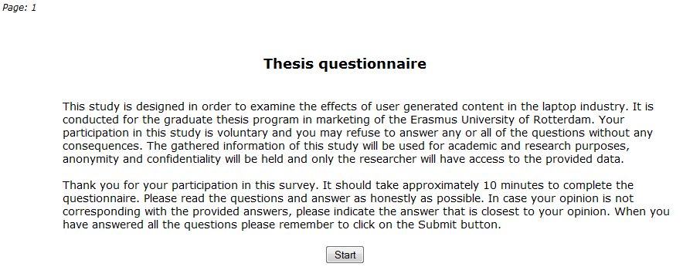

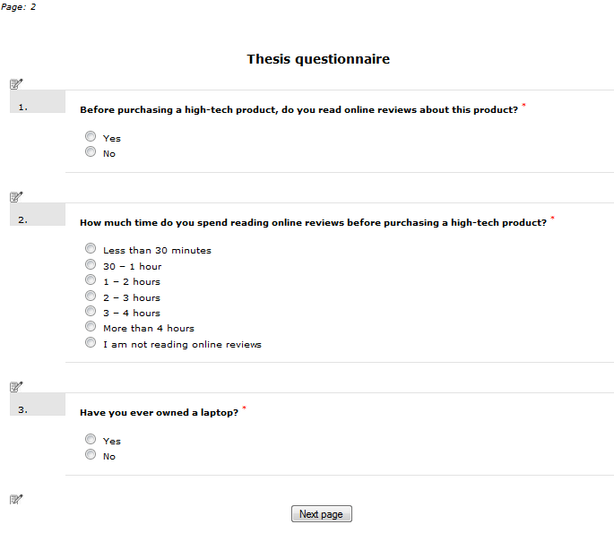

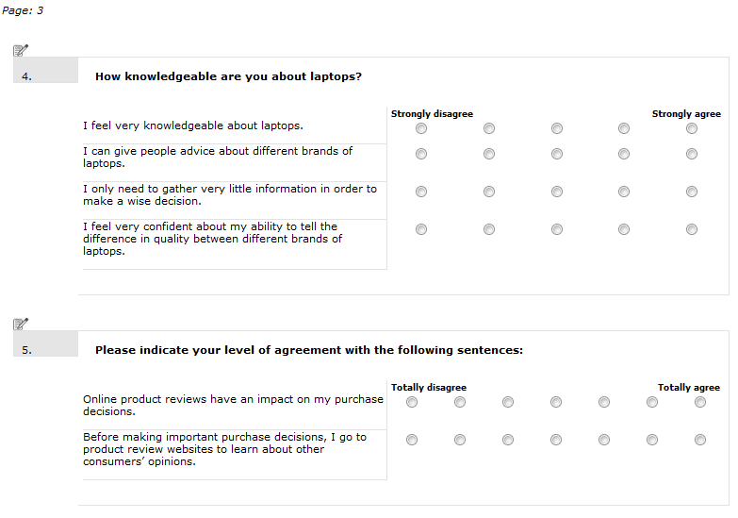
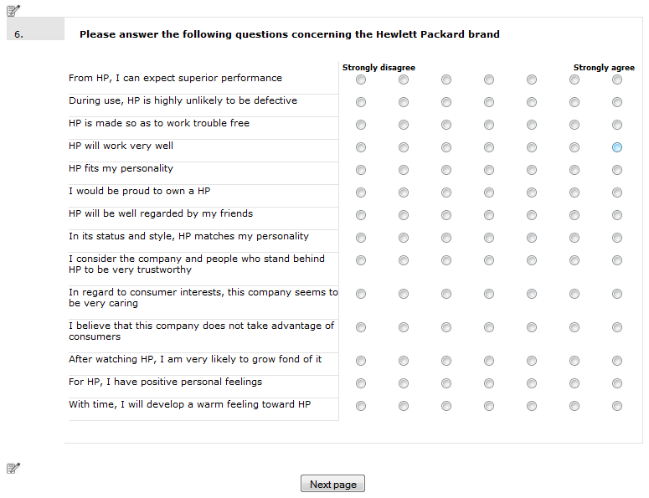

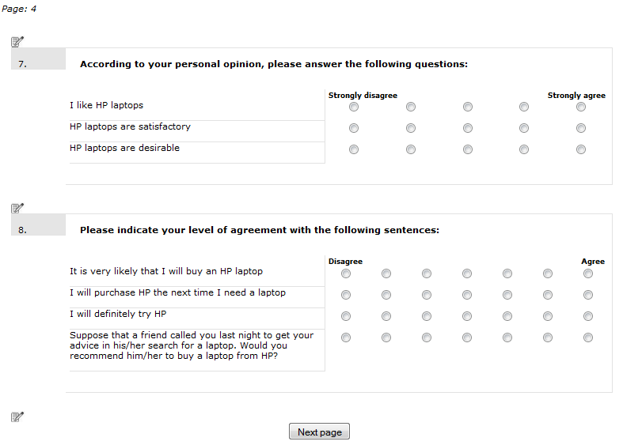

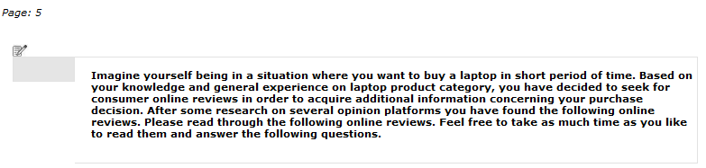

TREATMENT



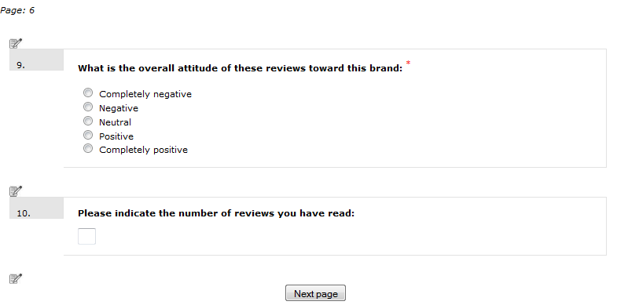
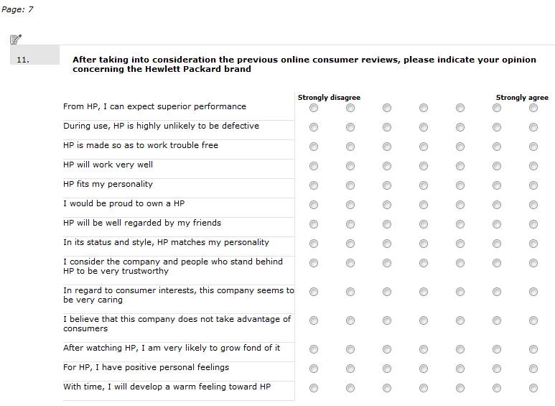
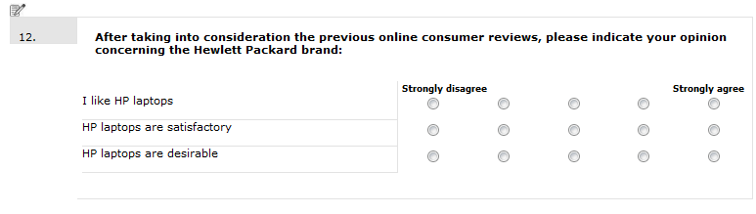

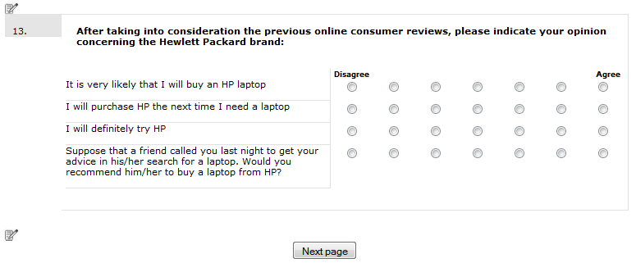
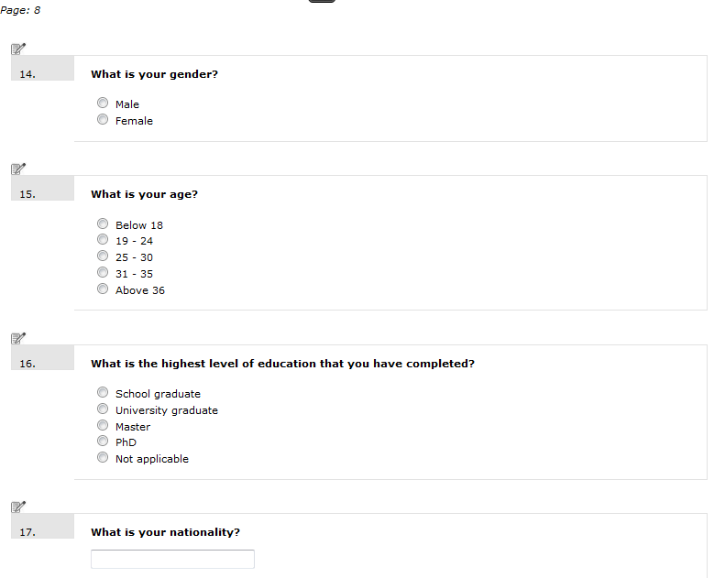
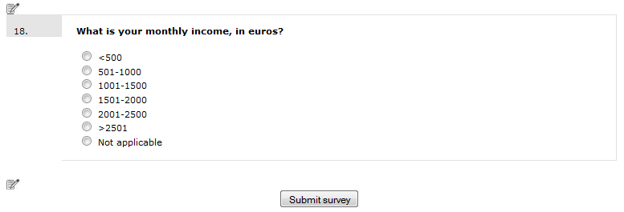

Appendix B
Online consumer reviews.
Negative Hewlett Packard online consumer reviews

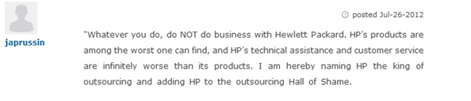
Score: -1.0

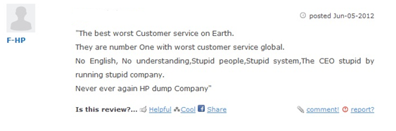
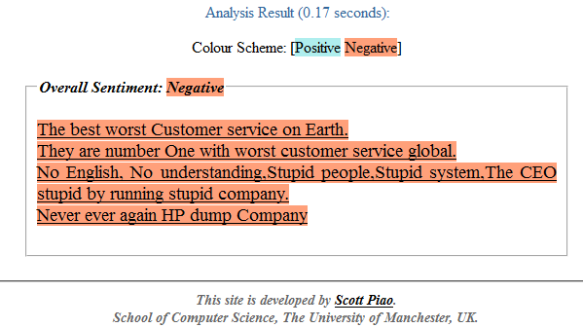
Score: -1.0

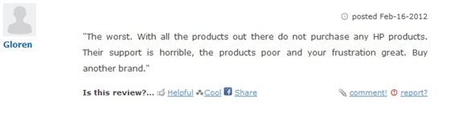
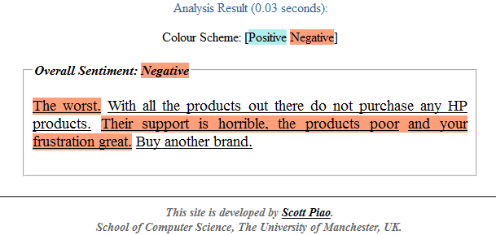
Score: -1.0

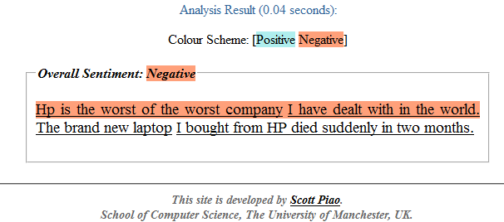

Score: -1.0

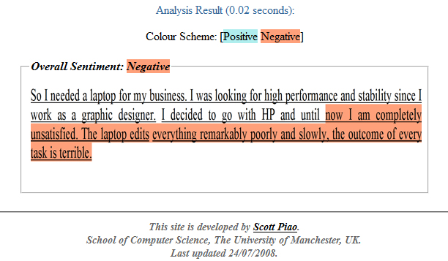
Score: -1.0

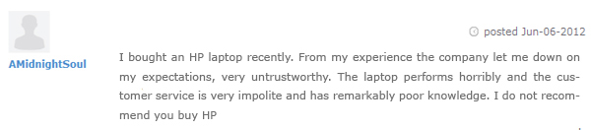

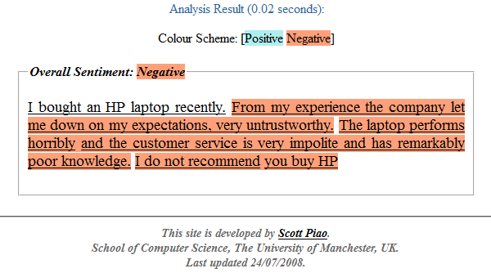
Score: -1.0

Positive Hewlett Packard online consumer reviews:


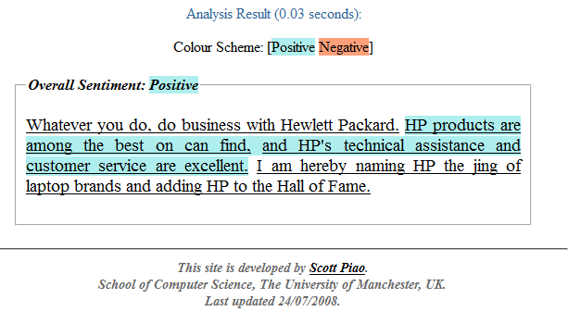
Score: + 0.75

Score: + 0.75



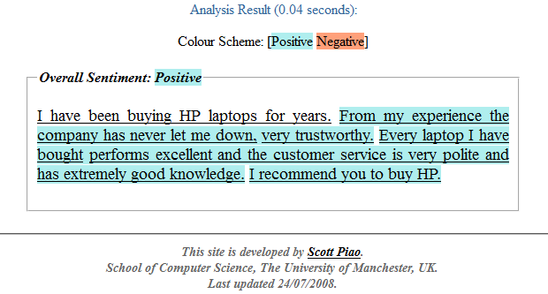
Score: + 0.66


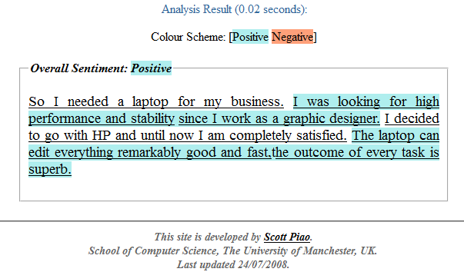
Score: + 0.75



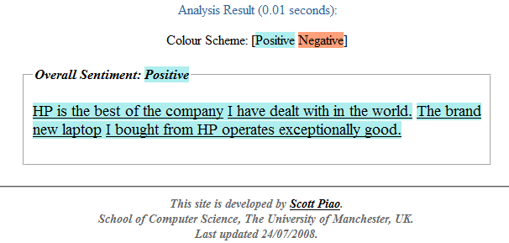
Score: + 0.5

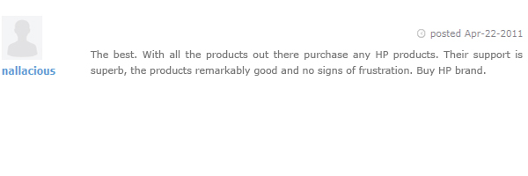

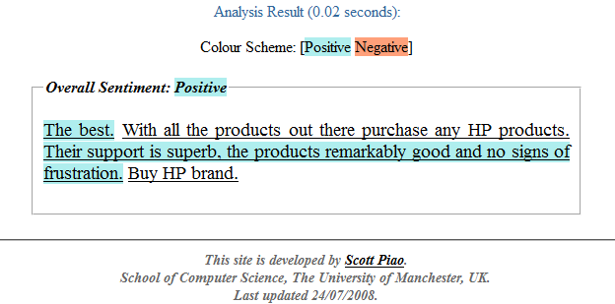
Score: + 0.875

Appendix C
Factor and reliability analysis

Prior product Knowledge
KMO and Bartlett's Test
Kaiser-Meyer-Olkin Measure of Sampling Adequacy. |  | ,845
Bartlett's Test of Sphericity | Approx. Chi-Square | 623,655
Bartlett's Test of Sphericity | df | 6
Bartlett's Test of Sphericity | Sig. | ,000

Total Variance Explained
Component | Initial Eigenvalues |  |  | Extraction Sums of Squared Loadings
Component | Total | % of Variance | Cumulative % | Total | % of Variance | Cumulative %
1 | 3,242 | 81,056 | 81,056 | 3,242 | 81,056 | 81,056
2 | ,333 | 8,331 | 89,387
3 | ,230 | 5,761 | 95,148
4 | ,194 | 4,852 | 100,000
Extraction Method: Principal Component Analysis.

Component Matrixª
 | Component
 | 1
I feel very knowledgeable about laptops. | ,907
I can give people advice about different brands of laptops. | ,910
I only need to gather very little information in order to make a wise decision. | ,875
I feel very confident about my ability to tell the difference in quality between different brands of laptops. (Strongly disagree - Strongly agree) | ,908
Extraction Method: Principal Component Analysis. a. 1 components extracted.
Persuasiveness of online reviews:
KMO and Bartlett's Test
Kaiser-Meyer-Olkin Measure of Sampling Adequacy. |  | ,500
Bartlett's Test of Sphericity | Approx. Chi-Square | 148,913
Bartlett's Test of Sphericity | df | 1
Bartlett's Test of Sphericity | Sig. | ,000

Total Variance Explained
Component | Initial Eigenvalues |  |  | Extraction Sums of Squared Loadings
Component | Total | % of Variance | Cumulative % | Total | % of Variance | Cumulative %
1 | 1,717 | 85,840 | 85,840 | 1,717 | 85,840 | 85,840
2 | ,283 | 14,160 | 100,000
Extraction Method: Principal Component Analysis.

Component Matrixª
 | Component
 | 1
Online product reviews have an impact on my purchase decisions. | ,926
Before making important purchase decisions, I go to product review websites to learn about other consumers’ opinions. (Totally disagree - Totally agree) | ,926
Extraction Method: Principal Component Analysis.
a. 1 components extracted.

Consumer based brand equity Before treatment

KMO and Bartlett's Test
Kaiser-Meyer-Olkin Measure of Sampling Adequacy. |  | ,960
Bartlett's Test of Sphericity | Approx. Chi-Square | 4019,090
Bartlett's Test of Sphericity | df | 91
Bartlett's Test of Sphericity | Sig. | ,000

Total Variance Explained
Component | Initial Eigenvalues |  |  | Extraction Sums of Squared Loadings
Component | Total | % of Variance | Cumulative % | Total | % of Variance | Cumulative %
1 | 10,880 | 77,715 | 77,715 | 10,880 | 77,715 | 77,715
2 | ,864 | 6,173 | 83,888
3 | ,470 | 3,360 | 87,248
4 | ,346 | 2,471 | 89,719
5 | ,277 | 1,976 | 91,695
6 | ,199 | 1,423 | 93,118
7 | ,193 | 1,378 | 94,496
8 | ,163 | 1,161 | 95,657
9 | ,140 | ,997 | 96,654
10 | ,125 | ,896 | 97,550
11 | ,099 | ,705 | 98,255
12 | ,091 | ,649 | 98,904
13 | ,087 | ,621 | 99,525
14 | ,067 | ,475 | 100,000
Extraction Method: Principal Component Analysis.

Component Matrixª
 | Component
 | 1
PRE From HP, I can expect superior performance | ,865
PRE During use, HP is highly unlikely to be defective | ,736
PRE HP is made so as to work trouble free | ,921
PRE HP will work very well | ,895
PRE HP fits my personality | ,838
PRE I would be proud to own a HP | ,894
PRE HP will be well regarded by my friends | ,860
PRE In its status and style, HP matches my personality | ,856
PRE I consider the company and people who stand behind HP to be very trustworthy | ,931
PRE In regard to consumer interests, this company seems to be very caring | ,914
PRE I believe that this company does not take advantage of consumers | ,882
PRE After watching HP, I am very likely to grow fond of it | ,917
PRE For HP, I have positive personal feelings | ,931
PRE With time, I will develop a warm feeling toward HP | ,884
Extraction Method: Principal Component Analysis.
a. 1 components extracted.

Attitudes toward the brand Before treatment

KMO and Bartlett's Test
Kaiser-Meyer-Olkin Measure of Sampling Adequacy. |  | ,743
Bartlett's Test of Sphericity | Approx. Chi-Square | 465,890
Bartlett's Test of Sphericity | df | 3
Bartlett's Test of Sphericity | Sig. | ,000

Total Variance Explained
Component | Initial Eigenvalues |  |  | Extraction Sums of Squared Loadings
Component | Total | % of Variance | Cumulative % | Total | % of Variance | Cumulative %
1 | 2,576 | 85,875 | 85,875 | 2,576 | 85,875 | 85,875
2 | ,278 | 9,267 | 95,142
3 | ,146 | 4,858 | 100,000
Extraction Method: Principal Component Analysis.

Component Matrixª
 | Component
 | 1
PRE I like HP laptops | ,940
PRE HP laptops are satisfactory | ,940
PRE HP laptops are desirable | ,900
Extraction Method: Principal Component Analysis.
a. 1 components extracted.

Purchase intentions Before treatment

KMO and Bartlett's Test
Kaiser-Meyer-Olkin Measure of Sampling Adequacy. |  | ,868
Bartlett's Test of Sphericity | Approx. Chi-Square | 1089,640
Bartlett's Test of Sphericity | df | 6
Bartlett's Test of Sphericity | Sig. | ,000

Total Variance Explained
Component | Initial Eigenvalues |  |  | Extraction Sums of Squared Loadings
Component | Total | % of Variance | Cumulative % | Total | % of Variance | Cumulative %
1 | 3,643 | 91,071 | 91,071 | 3,643 | 91,071 | 91,071
2 | ,151 | 3,776 | 94,847
3 | ,142 | 3,542 | 98,390
4 | ,064 | 1,610 | 100,000
Extraction Method: Principal Component Analysis.

Component Matrixª
 | Component
 | 1
PRE It is very likely that I will buy an HP laptop | ,973
PRE I will purchase HP the next time I need a laptop | ,944
PRE I will definitely try HP | ,957
PRE Suppose that a friend called you last night to get your advice in his/her search for a laptop. Would you recommend him/her to buy a laptop from HP? | ,943
Extraction Method: Principal Component Analysis.
a. 1 components extracted.

Consumer based brand equity After treatment

KMO and Bartlett's Test
Kaiser-Meyer-Olkin Measure of Sampling Adequacy. |  | ,955
Bartlett's Test of Sphericity | Approx. Chi-Square | 4784,402
Bartlett's Test of Sphericity | df | 91
Bartlett's Test of Sphericity | Sig. | ,000

Total Variance Explained
Component | Initial Eigenvalues |  |  | Extraction Sums of Squared Loadings
Component | Total | % of Variance | Cumulative % | Total | % of Variance | Cumulative %
1 | 11,601 | 82,864 | 82,864 | 11,601 | 82,864 | 82,864
2 | ,588 | 4,202 | 87,066
3 | ,450 | 3,215 | 90,281
4 | ,286 | 2,041 | 92,322
5 | ,211 | 1,506 | 93,828
6 | ,173 | 1,237 | 95,065
7 | ,154 | 1,103 | 96,168
8 | ,116 | ,832 | 96,999
9 | ,100 | ,718 | 97,717
10 | ,084 | ,598 | 98,315
11 | ,071 | ,506 | 98,821
12 | ,068 | ,486 | 99,307
13 | ,051 | ,365 | 99,672
14 | ,046 | ,328 | 100,000
Extraction Method: Principal Component Analysis.

Component Matrixª
 | Component
 | 1
POST From HP, I can expect superior performance | ,918
POST During use, HP is highly unlikely to be defective | ,822
POST HP is made so as to work trouble free | ,928
POST HP will work very well e) | ,931
POST HP fits my personality | ,894
POST I would be proud to own a HP | ,916
POST HP will be well regarded by my friends | ,913
POST In its status and style, HP matches my personality | ,909
POST I consider the company and people who stand behind HP to be very trustworthy | ,919
POST In regard to consumer interests, this company seems to be very caring | ,922
POST I believe that this company does not take advantage of consumers | ,903
POST After watching HP, I am very likely to grow fond of it | ,929
POST For HP, I have positive personal feelings | ,944
POST With time, I will develop a warm feeling toward HP | ,891
Extraction Method: Principal Component Analysis.
a. 1 components extracted.

Attitudes toward the brand After treatment

KMO and Bartlett's Test
Kaiser-Meyer-Olkin Measure of Sampling Adequacy. |  | ,740
Bartlett's Test of Sphericity | Approx. Chi-Square | 543,215
Bartlett's Test of Sphericity | df | 3
Bartlett's Test of Sphericity | Sig. | ,000

Total Variance Explained
Component | Initial Eigenvalues |  |  | Extraction Sums of Squared Loadings
Component | Total | % of Variance | Cumulative % | Total | % of Variance | Cumulative %
1 | 2,652 | 88,400 | 88,400 | 2,652 | 88,400 | 88,400
2 | ,231 | 7,694 | 96,094
3 | ,117 | 3,906 | 100,000
Extraction Method: Principal Component Analysis.

Component Matrixª
 | Component
 | 1
POST I like HP laptops | ,933
POST HP laptops are satisfactory | ,961
POST HP laptops are desirable | ,926
Extraction Method: Principal Component Analysis.
a. 1 components extracted.

Purchase intentions After treatment

KMO and Bartlett's Test
Kaiser-Meyer-Olkin Measure of Sampling Adequacy. |  | ,855
Bartlett's Test of Sphericity | Approx. Chi-Square | 969,790
Bartlett's Test of Sphericity | df | 6
Bartlett's Test of Sphericity | Sig. | ,000

Total Variance Explained
Component | Initial Eigenvalues |  |  | Extraction Sums of Squared Loadings
Component | Total | % of Variance | Cumulative % | Total | % of Variance | Cumulative %
1 | 3,550 | 88,758 | 88,758 | 3,550 | 88,758 | 88,758
2 | ,224 | 5,589 | 94,347
3 | ,151 | 3,780 | 98,127
4 | ,075 | 1,873 | 100,000
Extraction Method: Principal Component Analysis.

Component Matrixª
 | Component
 | 1
POST It is very likely that I will buy an HP laptop | ,968
POST I will purchase HP the next time I need a laptop | ,941
POST I will definitely try HP | ,945
POST Suppose that a friend called you last night to get your advice in his/her search for a laptop. Would you recommend him/her to buy a laptop from HP? | ,913
Extraction Method: Principal Component Analysis.
a. 1 components extracted.

Consumer based brand equity Without the item “During use, HP is highly unlikely to be defective”, Before treatment.

KMO and Bartlett's Test
Kaiser-Meyer-Olkin Measure of Sampling Adequacy. |  | ,957
Bartlett's Test of Sphericity | Approx. Chi-Square | 3855,452
Bartlett's Test of Sphericity | df | 78
Bartlett's Test of Sphericity | Sig. | ,000

Total Variance Explained
Component | Initial Eigenvalues |  |  | Extraction Sums of Squared Loadings
Component | Total | % of Variance | Cumulative % | Total | % of Variance | Cumulative %
1 | 10,363 | 79,714 | 79,714 | 10,363 | 79,714 | 79,714
2 | ,785 | 6,037 | 85,751
3 | ,402 | 3,091 | 88,842
4 | ,281 | 2,160 | 91,003
5 | ,199 | 1,533 | 92,536
6 | ,194 | 1,491 | 94,027
7 | ,163 | 1,250 | 95,277
8 | ,140 | 1,080 | 96,357
9 | ,126 | ,966 | 97,323
10 | ,102 | ,787 | 98,110
11 | ,091 | ,698 | 98,809
12 | ,088 | ,676 | 99,485
13 | ,067 | ,515 | 100,000
Extraction Method: Principal Component Analysis.

Component Matrixª
 | Component
 | 1
PRE From HP, I can expect superior performance | ,860
PRE HP is made so as to work trouble free | ,917
PRE HP will work very well | ,892
PRE HP fits my personality | ,844
PRE I would be proud to own a HP | ,900
PRE HP will be well regarded by my friends | ,865
PRE In its status and style, HP matches my personality | ,862
PRE I consider the company and people who stand behind HP to be very trustworthy | ,931
PRE In regard to consumer interests, this company seems to be very caring | ,912
PRE I believe that this company does not take advantage of consumers | ,880
PRE After watching HP, I am very likely to grow fond of it | ,918
PRE For HP, I have positive personal feelings | ,934
PRE With time, I will develop a warm feeling toward HP | ,886
Extraction Method: Principal Component Analysis.
a. 1 components extracted.

Consumer based brand equity Without the item “During use, HP is highly unlikely to be defective”, After treatment.

KMO and Bartlett's Test
Kaiser-Meyer-Olkin Measure of Sampling Adequacy. |  | ,950
Bartlett's Test of Sphericity | Approx. Chi-Square | 4542,952
Bartlett's Test of Sphericity | df | 78
Bartlett's Test of Sphericity | Sig. | ,000

Total Variance Explained
Component | Initial Eigenvalues |  |  | Extraction Sums of Squared Loadings
Component | Total | % of Variance | Cumulative % | Total | % of Variance | Cumulative %
1 | 10,946 | 84,201 | 84,201 | 10,946 | 84,201 | 84,201
2 | ,558 | 4,295 | 88,496
3 | ,344 | 2,644 | 91,139
4 | ,282 | 2,170 | 93,309
5 | ,176 | 1,350 | 94,659
6 | ,155 | 1,190 | 95,850
7 | ,117 | ,898 | 96,748
8 | ,100 | ,773 | 97,521
9 | ,084 | ,644 | 98,165
10 | ,072 | ,551 | 98,716
11 | ,068 | ,523 | 99,239
12 | ,053 | ,407 | 99,646
13 | ,046 | ,354 | 100,000
Extraction Method: Principal Component Analysis.

Component Matrixª
 | Component
 | 1
POST From HP, I can expect superior performance | ,914
POST HP is made so as to work trouble free | ,922
POST HP will work very well e) | ,927
POST HP fits my personality | ,897
POST I would be proud to own a HP | ,919
POST HP will be well regarded by my friends | ,916
POST In its status and style, HP matches my personality | ,912
POST I consider the company and people who stand behind HP to be very trustworthy | ,921
POST In regard to consumer interests, this company seems to be very caring | ,924
POST I believe that this company does not take advantage of consumers | ,904
POST After watching HP, I am very likely to grow fond of it | ,931
POST For HP, I have positive personal feelings | ,946
POST With time, I will develop a warm feeling toward HP | ,895
Extraction Method: Principal Component Analysis.
a. 1 components extracted.

Reliability analysis

Prior product knowledge

Reliability Statistics
Cronbach's Alpha | Cronbach's Alpha Based on Standardized Items | N of Items
,920 | ,922 | 4

Persuasiveness of online reviews

Reliability Statistics
Cronbach's Alpha | Cronbach's Alpha Based on Standardized Items | N of Items
,835 | ,835 | 2

Consumer based brand equity, before treatment

Reliability Statistics
Cronbach's Alpha | Cronbach's Alpha Based on Standardized Items | N of Items
,977 | ,978 | 14

Attitudes toward the brand, before treatment

Reliability Statistics
Cronbach's Alpha | Cronbach's Alpha Based on Standardized Items | N of Items
,916 | ,918 | 3

Purchase intentions, before treatment

Reliability Statistics
Cronbach's Alpha | Cronbach's Alpha Based on Standardized Items | N of Items
,967 | ,967 | 4

Consumers based brand equity, after treatment

Reliability Statistics
Cronbach's Alpha | Cronbach's Alpha Based on Standardized Items | N of Items
,984 | ,984 | 14

Attitudes toward the brand, after treatment

Reliability Statistics
Cronbach's Alpha | Cronbach's Alpha Based on Standardized Items | N of Items
,934 | ,934 | 3

Purchase intentions, after treatment

Reliability Statistics
Cronbach's Alpha | Cronbach's Alpha Based on Standardized Items | N of Items
,957 | ,958 | 4

Consumer based brand equity Without the item “During use, HP is highly unlikely to be defective”, Before treatment.

Reliability Statistics
Cronbach's Alpha | N of Items
,978 | 13

Consumer based brand equity Without the item “During use, HP is highly unlikely to be defective”, After treatment.

Reliability Statistics
Cronbach's Alpha | N of Items
,984 | 13

Appendix D
Manipulation checks

Descriptives
What is the overall attitude of these reviews toward this brand:
 | N | Mean | Std. Deviation | Std. Error | 95% Confidence Interval for Mean |  | Minimum | Maximum
 |  |  |  |  | Lower Bound | Upper Bound | Minimum | Maximum
Negative valence | 105 | 1,46 | ,572 | ,056 | 1,35 | 1,57 | 1 | 3
Positive Valence | 104 | 4,40 | ,583 | ,057 | 4,29 | 4,52 | 3 | 5
Total | 209 | 2,92 | 1,585 | ,110 | 2,71 | 3,14 | 1 | 5

ANOVA
What is the overall attitude of these reviews toward this brand:
 | Sum of Squares | df | Mean Square | F | Sig.
Between Groups | 453,680 | 1 | 453,680 | 1359,155 | ,000
Within Groups | 69,096 | 207 | ,334
Total | 522,775 | 208

Descriptives
Please indicate the number of reviews you have read:
 | N | Mean | Std. Deviation | Std. Error | 95% Confidence Interval for Mean |  | Minimum | Maximum
 |  |  |  |  | Lower Bound | Upper Bound | Minimum | Maximum
High Volume | 105 | 4,54 | 1,507 | ,147 | 4,25 | 4,83 | 1 | 9
Low Volume | 104 | 2,00 | ,197 | ,019 | 1,96 | 2,04 | 1 | 3
Total | 209 | 3,28 | 1,667 | ,115 | 3,05 | 3,50 | 1 | 9

ANOVA
Please indicate the number of reviews you have read:
 | Sum of Squares | df | Mean Square | F | Sig.
Between Groups | 337,847 | 1 | 337,847 | 291,324 | ,000
Within Groups | 240,057 | 207 | 1,160
Total | 577,904 | 208

Control Variable (Persuasiveness of online reviews)

Descriptive Statistics
Dependent Variable: PersuasivenessOfReviews
Negative vs. Positive | High vs. Low | Mean | Std. Deviation | N
Negative valence | High Volume | 4,9340 | 1,62030 | 53
Negative valence | Low Volume | 5,0962 | 1,42814 | 52
Negative valence | Total | 5,0143 | 1,52299 | 105
Positive Valence | High Volume | 5,0385 | 1,47810 | 52
Positive Valence | Low Volume | 5,0096 | 1,38086 | 52
Positive Valence | Total | 5,0240 | 1,42342 | 104
Total | High Volume | 4,9857 | 1,54493 | 105
Total | Low Volume | 5,0529 | 1,39854 | 104
Total | Total | 5,0191 | 1,47075 | 209

Tests of Between-Subjects Effects
Dependent Variable: PersuasivenessOfReviews
Source | Type III Sum of Squares | df | Mean Square | F | Sig.
Corrected Model | ,717ª | 3 | ,239 | ,109 | ,955
Intercept | 5265,577 | 1 | 5265,577 | 2403,001 | ,000
Valence | ,004 | 1 | ,004 | ,002 | ,965
Volume | ,232 | 1 | ,232 | ,106 | ,745
Valence * Volume | ,477 | 1 | ,477 | ,218 | ,641
Error | 449,206 | 205 | 2,191
Total | 5715,000 | 209
Corrected Total | 449,923 | 208
a. R Squared = ,002 (Adjusted R Squared = -,013)

Appendix E
Homogeneity of regression assumption
Consumer based brand equity

Tests of Between-Subjects Effects
Dependent Variable: PostCBBE
Source | Type III Sum of Squares | df | Mean Square | F | Sig.
Corrected Model | 460,921ª | 6 | 76,820 | 235,286 | ,000
Intercept | ,230 | 1 | ,230 | ,706 | ,402
Valence | 1,469 | 1 | 1,469 | 4,499 | ,035
PreCBBE | 415,815 | 1 | 415,815 | 1273,566 | ,000
Valence * PreCBBE | ,881 | 1 | ,881 | 2,699 | ,102
Valence * Volume * PreCBBE | ,114 | 1 | ,114 | ,349 | ,555
Volume | ,137 | 1 | ,137 | ,418 | ,519
Volume * PreCBBE | ,111 | 1 | ,111 | ,339 | ,561
Error | 65,952 | 202 | ,326
Total | 3458,173 | 209
Corrected Total | 526,874 | 208
a. R Squared = ,875 (Adjusted R Squared = ,871)

Attitudes toward the brand

Tests of Between-Subjects Effects
Dependent Variable: PostAttitudes
Source | Type III Sum of Squares | df | Mean Square | F | Sig.
Corrected Model | 246,264ª | 6 | 41,044 | 142,207 | ,000
Intercept | ,984 | 1 | ,984 | 3,409 | ,066
Valence | 1,334 | 1 | 1,334 | 4,621 | ,033
Volume | ,655 | 1 | ,655 | 2,270 | ,133
Valence * Volume * PreAttitudes | ,057 | 1 | ,057 | ,197 | ,658
Valence * PreAttitudes | ,845 | 1 | ,845 | 2,927 | ,089
Volume * PreAttitudes | ,539 | 1 | ,539 | 1,869 | ,173
Error | 58,302 | 202 | ,289
Total | 2110,333 | 209
Corrected Total | 304,566 | 208
a. R Squared = ,809 (Adjusted R Squared = ,803)

Purchase intentions

Tests of Between-Subjects Effects
Dependent Variable: PostPurchase
Source | Type III Sum of Squares | df | Mean Square | F | Sig.
Corrected Model | 603,402ª | 6 | 100,567 | 193,249 | ,000
Intercept | 4,318 | 1 | 4,318 | 8,298 | ,004
Valence | 4,223 | 1 | 4,223 | 8,114 | ,005
Volume | ,177 | 1 | ,177 | ,340 | ,561
Valence * Volume * PrePurchase | 1,172 | 1 | 1,172 | 2,252 | ,135
Valence * PrePurchase | 1,810 | 1 | 1,810 | 3,477 | ,064
Volume * PrePurchase | ,672 | 1 | ,672 | 1,292 | ,257
Error | 105,121 | 202 | ,520
Total | 3902,250 | 209
Corrected Total | 708,523 | 208
a. R Squared = ,852 (Adjusted R Squared = ,847)

Assumption of independence of errors. Durbin – Watson
Consumer based brand equity

Model Summary^{b}
Model | R | R Square | Adjusted R Square | Std. Error of the Estimate | Durbin-Watson
1 | ,279ª | ,078 | ,069 | 1,53578 | 2,047
a. Predictors: (Constant), High vs. Low, Negative vs. Positive
b. Dependent Variable: PostCBBE

ANOVAª
Model |  | Sum of Squares | df | Mean Square | F | Sig.
1 | Regression | 40,999 | 2 | 20,500 | 8,691 | ,000^{b}
1 | Residual | 485,874 | 206 | 2,359
1 | Total | 526,874 | 208
a. Dependent Variable: PostCBBE
b. Predictors: (Constant), High vs. Low, Negative vs. Positive

Attitudes toward the brand

Model Summary^{b}
Model | R | R Square | Adjusted R Square | Std. Error of the Estimate | Durbin-Watson
1 | ,287ª | ,082 | ,073 | 1,16491 | 1,923
a. Predictors: (Constant), High vs. Low, Negative vs. Positive
b. Dependent Variable: PostAttitudes

ANOVAª
Model |  | Sum of Squares | df | Mean Square | F | Sig.
1 | Regression | 25,018 | 2 | 12,509 | 9,218 | ,000^{b}
1 | Residual | 279,547 | 206 | 1,357
1 | Total | 304,566 | 208
a. Dependent Variable: PostAttitudes
b. Predictors: (Constant), High vs. Low, Negative vs. Positive

Purchase intentions

Model Summary^{b}
Model | R | R Square | Adjusted R Square | Std. Error of the Estimate | Durbin-Watson
1 | ,244ª | ,059 | ,050 | 1,79874 | 2,009
a. Predictors: (Constant), High vs. Low, Negative vs. Positive
b. Dependent Variable: PostPurchase

ANOVAª
Model |  | Sum of Squares | df | Mean Square | F | Sig.
1 | Regression | 42,015 | 2 | 21,008 | 6,493 | ,002^{b}
1 | Residual | 666,508 | 206 | 3,235
1 | Total | 708,523 | 208
a. Dependent Variable: PostPurchase
b. Predictors: (Constant), High vs. Low, Negative vs. Positive

Appendix F
ANCOVA for Purchase intentions

Descriptive Statistics
Dependent Variable: PostPurchase
Negative vs. Positive | High vs. Low | Mean | Std. Deviation | N
Negative valence | High Volume | 3,4292 | 1,59354 | 53
Negative valence | Low Volume | 3,5000 | 1,72354 | 52
Negative valence | Total | 3,4643 | 1,65157 | 105
Positive Valence | High Volume | 4,3221 | 1,90029 | 52
Positive Valence | Low Volume | 4,3942 | 1,97431 | 52
Positive Valence | Total | 4,3582 | 1,92857 | 104
Total | High Volume | 3,8714 | 1,80048 | 105
Total | Low Volume | 3,9471 | 1,89809 | 104
Total | Total | 3,9091 | 1,84563 | 209

Tests of Between-Subjects Effects
Dependent Variable: PostPurchase
Source | Type III Sum of Squares | df | Mean Square | F | Sig.
Corrected Model | 601,555ª | 4 | 150,389 | 286,810 | ,000
Intercept | 3,736 | 1 | 3,736 | 7,125 | ,008
PrePurchase | 559,540 | 1 | 559,540 | 1067,111 | ,000
Valence | 63,585 | 1 | 63,585 | 121,264 | ,000
Volume | ,793 | 1 | ,793 | 1,513 | ,220
Valence * Volume | 1,884 | 1 | 1,884 | 3,592 | ,059
Error | 106,967 | 204 | ,524
Total | 3902,250 | 209
Corrected Total | 708,523 | 208
a. R Squared = ,849 (Adjusted R Squared = ,846)

Estimates
Dependent Variable: PostPurchase
Negative vs. Positive | Mean | Std. Error | 95% Confidence Interval
Negative vs. Positive | Mean | Std. Error | Lower Bound | Upper Bound
Negative valence | 3,360ª | ,071 | 3,220 | 3,499
Positive Valence | 4,465ª | ,071 | 4,325 | 4,605
a. Covariates appearing in the model are evaluated at the following values: PrePurchase = 4,0957.

ANCOVA for Consumer based brand equity

Descriptive Statistics
Dependent Variable: PostCBBE
Negative vs. Positive | High vs. Low | Mean | Std. Deviation | N
Negative valence | High Volume | 3,2322 | 1,45947 | 53
Negative valence | Low Volume | 3,3609 | 1,45438 | 52
Negative valence | Total | 3,2960 | 1,45137 | 105
Positive Valence | High Volume | 4,1243 | 1,62845 | 52
Positive Valence | Low Volume | 4,2145 | 1,66280 | 52
Positive Valence | Total | 4,1694 | 1,63833 | 104
Total | High Volume | 3,6740 | 1,60196 | 105
Total | Low Volume | 3,7877 | 1,61254 | 104
Total | Total | 3,7306 | 1,60438 | 209

Tests of Between-Subjects Effects
Dependent Variable: PostCBBE
Source | Type III Sum of Squares | df | Mean Square | F | Sig.
Corrected Model | 467,290ª | 4 | 116,822 | 349,911 | ,000
Intercept | ,152 | 1 | ,152 | ,455 | ,501
PreCBBE | 426,786 | 1 | 426,786 | 1278,323 | ,000
Valence | 36,443 | 1 | 36,443 | 109,155 | ,000
Volume | ,018 | 1 | ,018 | ,053 | ,819
Valence * Volume | ,071 | 1 | ,071 | ,211 | ,646
Error | 68,108 | 204 | ,334
Total | 3444,107 | 209
Corrected Total | 535,398 | 208
a. R Squared = ,873 (Adjusted R Squared = ,870)

Estimates
Dependent Variable: PostCBBE
Negative vs. Positive | Mean | Std. Error | 95% Confidence Interval
Negative vs. Positive | Mean | Std. Error | Lower Bound | Upper Bound
Negative valence | 3,315ª | ,056 | 3,204 | 3,426
Positive Valence | 4,150ª | ,057 | 4,039 | 4,262
a. Covariates appearing in the model are evaluated at the following values: PreCBBE = 3,8896.

ANCOVA for Attitudes toward the brand

Descriptive Statistics
Dependent Variable: PostAttitudes
Negative vs. Positive | High vs. Low | Mean | Std. Deviation | N
Negative valence | High Volume | 2,5597 | 1,08165 | 53
Negative valence | Low Volume | 2,6474 | 1,12297 | 52
Negative valence | Total | 2,6032 | 1,09788 | 105
Positive Valence | High Volume | 3,1731 | 1,24458 | 52
Positive Valence | Low Volume | 3,3846 | 1,21427 | 52
Positive Valence | Total | 3,2788 | 1,22814 | 104
Total | High Volume | 2,8635 | 1,19980 | 105
Total | Low Volume | 3,0160 | 1,22133 | 104
Total | Total | 2,9394 | 1,21007 | 209

Tests of Between-Subjects Effects
Dependent Variable: PostAttitudes
Source | Type III Sum of Squares | df | Mean Square | F | Sig.
Corrected Model | 244,885ª | 4 | 61,221 | 209,266 | ,000
Intercept | ,876 | 1 | ,876 | 2,995 | ,085
PreAttitudes | 219,666 | 1 | 219,666 | 750,862 | ,000
Valence | 33,004 | 1 | 33,004 | 112,815 | ,000
Volume | ,153 | 1 | ,153 | ,524 | ,470
Valence * Volume | ,049 | 1 | ,049 | ,166 | ,684
Error | 59,681 | 204 | ,293
Total | 2110,333 | 209
Corrected Total | 304,566 | 208
a. R Squared = ,804 (Adjusted R Squared = ,800)

Estimates
Dependent Variable: PostAttitudes
Negative vs. Positive | Mean | Std. Error | 95% Confidence Interval
Negative vs. Positive | Mean | Std. Error | Lower Bound | Upper Bound
Negative valence | 2,543ª | ,053 | 2,439 | 2,648
Positive Valence | 3,340ª | ,053 | 3,235 | 3,444
a. Covariates appearing in the model are evaluated at the following values: PreAttitudes = 3,1037.

T-tests for the first experimental group (Negative High)

Paired Samples Statistics
 |  | Mean | N | Std. Deviation | Std. Error Mean
Pair 1 | PostCBBE | 3,2332 | 53 | 1,46218 | ,20085
Pair 1 | PreCBBE | 3,8477 | 53 | 1,38958 | ,19087
Pair 2 | PostAttitudes | 2,5597 | 53 | 1,08165 | ,14858
Pair 2 | PreAttitudes | 3,1698 | 53 | 1,11827 | ,15361
Pair 3 | PostPurchase | 3,4292 | 53 | 1,59354 | ,21889
Pair 3 | PrePurchase | 4,3538 | 53 | 1,79572 | ,24666

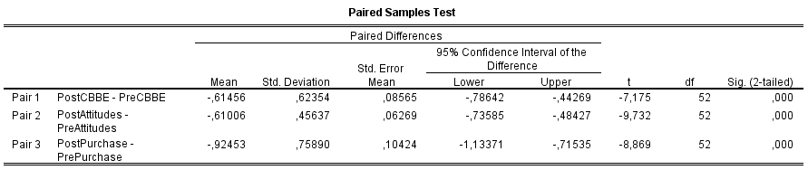

T-tests for the second experimental group (Negative Low)

Paired Samples Statistics
 |  | Mean | N | Std. Deviation | Std. Error Mean
Pair 1 | PostCBBE | 3,3846 | 52 | 1,43257 | ,19866
Pair 1 | PreCBBE | 3,9327 | 52 | 1,43398 | ,19886
Pair 2 | PostAttitudes | 2,6474 | 52 | 1,12297 | ,15573
Pair 2 | PreAttitudes | 3,1731 | 52 | 1,16314 | ,16130
Pair 3 | PostPurchase | 3,5000 | 52 | 1,72354 | ,23901
Pair 3 | PrePurchase | 4,0769 | 52 | 1,84878 | ,25638

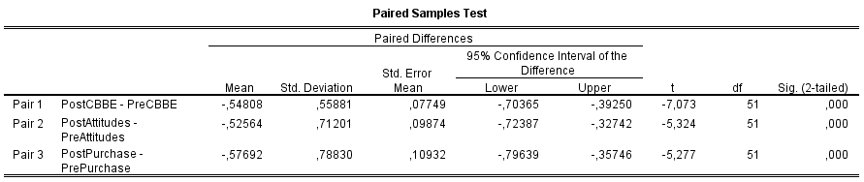

T-tests for the third experimental group (Positive High)

Paired Samples Statistics
 |  | Mean | N | Std. Deviation | Std. Error Mean
Pair 1 | PostCBBE | 4,1442 | 52 | 1,59829 | ,22164
Pair 1 | PreCBBE | 3,8750 | 52 | 1,43972 | ,19965
Pair 2 | PostAttitudes | 3,1731 | 52 | 1,24458 | ,17259
Pair 2 | PreAttitudes | 2,9295 | 52 | 1,18696 | ,16460
Pair 3 | PostPurchase | 4,3221 | 52 | 1,90029 | ,26352
Pair 3 | PrePurchase | 3,8942 | 52 | 1,96123 | ,27197

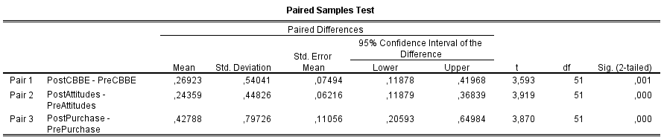

T-tests for the fourth experimental group (Positive Low)

Paired Samples Statistics
 |  | Mean | N | Std. Deviation | Std. Error Mean
Pair 1 | PostCBBE | 4,2280 | 52 | 1,65502 | ,22951
Pair 1 | PreCBBE | 3,9821 | 52 | 1,54101 | ,21370
Pair 2 | PostAttitudes | 3,3846 | 52 | 1,21427 | ,16839
Pair 2 | PreAttitudes | 3,1410 | 52 | 1,19430 | ,16562
Pair 3 | PostPurchase | 4,3942 | 52 | 1,97431 | ,27379
Pair 3 | PrePurchase | 4,0529 | 52 | 1,93037 | ,26769

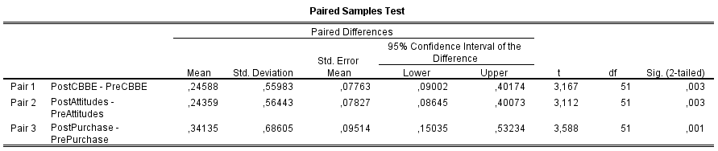

Appendix G

Moderating effect of Prior product knowledge between valence and Consumer based brand equity

Tests of Between-Subjects Effects
Dependent Variable: PostCBBE
Source | Type III Sum of Squares | df | Mean Square | F | Sig.
Corrected Model | 63,797ª | 3 | 21,266 | 9,244 | ,000
Intercept | 2879,487 | 1 | 2879,487 | 1251,682 | ,000
Valence | 37,648 | 1 | 37,648 | 16,365 | ,000
PriorKnowledge2 | 16,113 | 1 | 16,113 | 7,004 | ,009
Valence * PriorKnowledge2 | 7,946 | 1 | 7,946 | 3,454 | ,065
Error | 471,601 | 205 | 2,300
Total | 3444,107 | 209
Corrected Total | 535,398 | 208
a. R Squared = ,119 (Adjusted R Squared = ,106)

Moderating effect of Prior product knowledge between valence and Purchase intentions

Tests of Between-Subjects Effects
Dependent Variable: PostPurchase
Source | Type III Sum of Squares | df | Mean Square | F | Sig.
Corrected Model | 60,866ª | 3 | 20,289 | 6,422 | ,000
Intercept | 3162,853 | 1 | 3162,853 | 1001,124 | ,000
Valence | 40,385 | 1 | 40,385 | 12,783 | ,000
PriorKnowledge2 | 17,067 | 1 | 17,067 | 5,402 | ,021
Valence * PriorKnowledge2 | 2,114 | 1 | 2,114 | ,669 | ,414
Error | 647,657 | 205 | 3,159
Total | 3902,250 | 209
Corrected Total | 708,523 | 208
a. R Squared = ,086 (Adjusted R Squared = ,073)

Appendix H
SEMANTIC PROPERTIES OF SELECTED EVALUATION ADJECTIVES

MEANS AND STANDARD DEVIATIONS FOR FOUR RATING GROUPS"

Item Housewives Executives Graduate business students |  |  |  | Undergraduate business students | Range of means
Superior | 20.12 (1.17) | 18.22 (2.82) | 19.45 (1.78) | 18.96 (1.67) | 1.90
Fantastic | 20.12 (0.83) | 18.69 (3.68) | 20.15 (1.37) | 19.20 (1.87) | 1.46
Tremendous | 19.84 (1.31) | 18.67 (2.01) | 19.70 (1.18) | 18.92 (1.75) | 1.17
Superb | 19.80 (1.19) | 19.00 (2.10) | 19.40 (1.95) | 19.60 (2.42) | 0.80
Excellent | 19.40 (1.73) | 18.72 (2.25) | 19.58 (1.97) | 19.44 (1.42) | 0.86
Terrific | 19.00 (2.45) | 18.81 (2.19) | 19.08 (1.61) | 18.60 (1.63) | 0.48
Outstanding | 18.96 (1.99) | 19.31 (2.01) | 19.58 (1.26) | 19.40 (1.35) | 0.62
Exceptionally good | 18.56 (2.36) | 17.03 (4.12) | 17.68 (2.26) | 17.88 (1.72) | 1.53
Extremely good | 18.44 (1.61) | 17.33 (3.09) | 17.45 (2.26) | 18.00 (1.50) | 1.11
Wonderful | 17.32 (2.30) | 17.97 (2.35) | 18.45 (1.99) | 17.52 (2.10) | 1.13
Unusually good | 17.08 (2.43) | 16.47 (2.99) | 16.78 (2.12) | 16.20 (1.80) | 0.88
Remarkably good | 16.68 (2.19) | 17.44 (2.63) | 17.20 (2.32) | 17.08 (1.89) | 0.76
Delightful | 16.92 (1.85) | 16.61 (2.45) | 16.60 (2.24) | 16.76 (1.51) | 0.32
Very good | 15.44 (2.77) | 16.83 (2.52) | 17.00 (2.18) | 16.80 (1.44) | 1.56
Fine | 14.80 (2.12) | 15.61 (2.72) | 14.60 (3.00) | 15.32 (2.21) | 0.81
Quite good | 14.44 (2.76) | 13.69 (2.90) | 15.70 (2.08) | 15.60 (1.94) | 1.91
Good | 14.32 (2.08) | 13.81 (3.25) | 14.78 (2.27) | 14.56 (1.96) | 0.97
Moderately good | 13.44 (2.23) | 11.42 (2.99) | 12.60 (2.55) | 13.04 (1.43) | 2.02
Pleasant | 13.44 (2.06) | 13.61 (2.43) | 13.48 (2.33) | 14.48 (2.14) | 1.04
Reasonably good | 12.92 (2.93) | 11.89 (3 .37) | 13.85 (2.19) | 14.20 (1.71) | 2.31
Nice | 12.56 (2.14) | 11.44 (2.79) | 12.70 (2.65) | 13.72 (1.77) | 2.28
Fairly good | 11.96 (2.42) | 11.94 (3.84) | 12.40 (2.24) | 13.12 (2.11) | 1.16
Slightly good | 11.84 (2.19) | 10.25 (3.14) | 11.88 (2.62) | 12.32 (1.52) | 2.07
Acceptable | 11.12 (2.59) | 10.67 (3.34) | 10.72 (1.96) | 11.40 (2.02) | 0.73
Average | 10.84 (1.55) | 9.97 (2.34) | 10.82 (1.43) | 10.76 (1.05) | 0.87
All right | 10.76 (1.42) | 10.17 (3.28) | 10.95 (2.15) | 11.40 (1.26) | 1.23
O.K. | 10.28 (1.67) | 10.11 (2.48) | 10.58 (2.12) | 11.28 (1.21) | 1.17
So-so | 10.08 (1.87) | 8.81 (2.75) | 9.52 (1.47) | 10.36 (1.15) | 1.55
Neutral | 9.80 (1.50) | 9.56 (1.90) | 10.18 (2.01) | 10.52 (1.16) | 0.96
Fair | 9.52 (2.06) | 9.56 (3.67) | 9.20 (2.05) | 10.24 (2.20) | 1.04
Mediocre | 9.44 (1.80) | 8.11 (2.74) | 8.90 (2.36) | 9.36 (2.20) | 1.33
Not very good | 6.72 (2.82) | 6.47 (2.41) | 6.40 (2.05) | 7.92 (2.02) | 1.52
Moderately poor | 6.44 (1.64) | 6.83 (3 .50) | 6.28 (1.87) | 7.24 (1.59) | 0.80
Reasonably poor | 6.32 (2.46) | 6.31 (2.19) | 5.82 (1.74) | 6.16 (1.57) | 0.50
Slightly poor | 5.92 (1.96) | 7.19 (2.36) | 7.25 (2.00) | 8.48 (1.83) | 2.56
Poor | 5.76 (2.09) | 5.19 (2.86) | 4.72 (2.51) | 5.24 (1.51) | 1.04
Fairly poor | 5.64 (1.68) | 6.67 (2.81) | 6.25 (1.63) | 6.72 (1.74) | 1.08
Unpleasant | 5.04 (2.82) | 4.36 (3.02) | 4.68 (2.63) | 5.52 (2.06) | 1.16
Quite poor | 4.80 (1.44) | 4.56 (2.58) | 3.62 (1.67) | 4.56 (1.78) | 1.18
Bad | 3.88 (2.19) | 3.67 (2.54) | 3.85 (1.81) | 4.24 (1.88) | 0.57
Very bad | 3.20 (2.10) | 2.22 (2.34) | 2.70 (2.16) | 3.08 (1.50) | 0.98
Unusually poor | 3.20 (1.44) | 3.08 (1.79) | 3.48 (1.68) | 4.16 (1.57) | 1.08
Very poor | 3.12 (1.17) | 3.14 (2.39) | 3.35 (1.99) | 3.68 (1.52) | 0.56
Remarkably poor | 2.88 (1.74) | 2.75 (1.70) | 3.12 (1.70) | 3.92 (1.68) | 1.17
Unacceptable | 2.64 (2.04) | 3.53 (3.42) | 3.98 (2.79) | 5.56 (3.06) | 2.92
Exceptionally poor | 2.52 (1.19) | 3.19 (2.23) | 3.22 (1.82) | 3.52 (1.96) | 1.00
Extremely poor | 2.08 (1.19) | 2.83 (2.14) | 3.10 (1.72) | 3.24 (1.76) | 1.16
Awful | 1.92 (1.50) | 2.25 (1.46) | 2.48 (1.72) | 2.68 (1.86) | 0.76
Terrible | 1.76 (0.77) | 2.22 (2.63) | 2.05 (1.43) | 1.88 (1.24) | 0.52
Horrible | 1.48 (0.87) | 2.22 (2.51) | 1.62 (1.15) | 2.00 (1.35) | 0.70
a In each case, the first figure is the mean and the second (in parentheses), the standard deviation.

