The Mahatma Gandhi National Rural Employment Guarantee Scheme and the Women Workers in the rural Uttar Pradesh
A Research Paper presented by:
Shubhrant Kumar Shukla
India
in partial fulfilment of the requirements for obtaining the degree of
MASTERS OF ARTS IN DEVELOPMENT STUDIES
Specialization:
Public Policy and Management
PPM
Members of the Examining Committee:
Dr. R Kurian
Dr. Anirban Das Gupta
The Hague, The Netherlands
November 2012
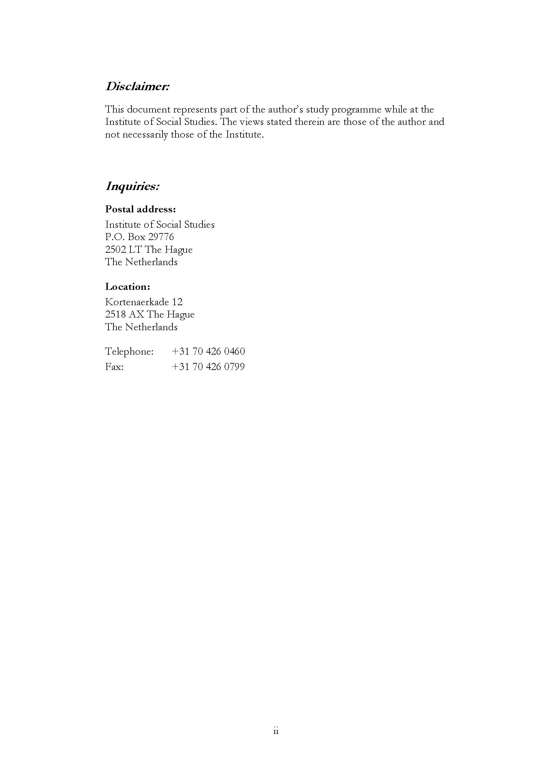
Contents
List of Tables iv
List of Figures iv
List of Maps iv
List of Appendices iv
List of Acronyms v
Abstract vi
Chapter 1 Introduction 1
Main features of the scheme 1
Organisational Structure for implementation 2
Preparation of the Labour Budget 3
Flow of funds 3
Delivery of employment 3
Profile of the state of UP 4
Women’s participation in the scheme 4
Relevance of the study 5
Objective of the research 6
Main Questions 6
Sub questions 6
Methodology of the data collection 6
Chapter 2 Social Protection and Rural Women -Employment Guarantee Programme in UP 8
The need of social protection 8
Social protection 9
Impediments 10
Remedies 11
Women in MGNREG - A case of UP 12
Progress since inception 12
Performance of the districts 13
The District of Jalaun 16
Chapter 3 MGNREGA Governance and Women’s Employment 18
Role of the institutions 18
Village Council (Gram Panchayat) 18
‘Registration’ 19
Demand Driven 19
‘Household’ 20
Gender sensitivity 20
Nature of work & Worksite facilities 21
Market wages and Gender wage gap 22
Chapter 4 Patriarchal norms and practices in the community and household and the MGNREGA 24
The Caste factor 24
Some instances 25
The Purdah system 28
Gender Division of work 28
Male Domination 29
Role of Self-Help Group 29
Chapter 5 Summary and Conclusion 30
Policy Recommendation 32
References 33

List of Tables
2:1 Percentage of Women’s Participation in MGNREGA, UP (2007-11) 12
2:2 Women’s Participation in Jalaun (2008-2011) 16
2:3 Employment Generated in 2011-12 Dist.- Jalaun 17
3:1 Descriptions of Work completed during 2011-12 Dist.- Jalaun 21
List of Figures
Figure 1.1 Women’s Participation in MGNREGA (2011-2012) 5
Figure 2.1 Women’s Participation in MGNREGA (UP) (2007-2011) 13
List of Maps
Map 1 Participation of Women in MGNREGA UP (2008-09) 14
Map 2 Participation of Women in MGNREGA UP (2009-10) 14
Map 3 Participation of Women in MGNREGA UP (2010-11) 15
Map 4 Participation of Women in MGNREGA UP (2011-12) 15
List of Appendices

List of Acronyms
MGNREGA The Mahatma Gandhi National Rural Employment Guarantee
Act
SC Scheduled Caste
ST Scheduled Tribes
OBC Other Backward Castes
NSSO National Sample Survey Organisation
PO Programme Officer
JE Junior Engineer
SHG Self Help Group
GP Gram Panchayat (village council)
NGO Non-Governmental Organisation
UP Uttar Pradesh

Acknowledgements
I am highly indebted to Dr. R Kurian for her continuous guidance and mentoring in writing this paper. Her continuous support and motivation has helped me throughout this journey. Her quick and insightful comments worked like a guiding path. I am also grateful to my second reader Dr. Anirban Das Gupta for his comments which made me to understand the problem from different perspectives.
I express my high regards for Shri Yogeshwar Ram Mishra, Special Secretary, Department of Appointment, Government of UP, who has always been a source of inspiration in studying at the ISS, the Hague, Netherlands .
I am very thankful to Shri Rajeev Kumar, Principal Secretary, Department of Rural Development and Shri Anil Garg Commissioner Rural Development UP for their continuous motivation and sharing the deep understanding of the problem.
I am also thankful to the staff at MGNREG cell Uttar Pradesh for their active co-operation in collection of the secondary data.
I express special gratitude to my mother for her continuous encouragement.
And finally I would like to thank my children Shambhavee and Sharnya and wife Sarita for their support to undergo this course and research. This would not have been possible without their support and encouragement.
Abstract
The proponents of the MGNREG Act claimed that to some extent it redresses the vulnerabilities of the rural women by fixing a quota for them in the generated employment and an equality of wages with men. A glimpse on the participation of women in aggregate at the national level testifies the claims of the proponents; however its design failed to yield desired results in certain peculiar social and economic circumstances.
Broadly two factors were found to be responsible for the poor participation of women. Firstly the imperfections in the governance mechanism and secondly the role of social and cultural practices that hindered women from accessing the guarantee under the scheme. This socio-cultural aspect forms the core problem of the low employment of the women in the scheme. The analysis indicates that the unwillingness of the women is not the causative factor for their lesser participation, but the social and environmental factors contributes in suppressing their desire for earning wages outside their traditional roles. The paper ends with the finding that in the absence of any gender sensitive mechanism of implementation and against the challenges posed by the social and cultural circumstances, the fates of the women labourers depend on the expectation of an active role of the implementing authorities.

Keywords
MGNREGA, Social Protection, and Social and Cultural Practices

Introduction
“Women in India have a background of history and tradition behind them, which is inspiring. It is true, however, that they have suffered much from various kinds of suppression and all these have to go so that they can play their full part in the life of the nation” ( Nehru, J. as cited in Desai & Thakur : 2011).
The removal of poverty and supporting the vulnerable has been an important objective of the Indian planning since the country gained its independence in 1947. The recent estimates of the Planning Commission however show that around 37% of the population is still living below poverty line (Planning Commission 2012) and 70% of the total population live in the villages. So there has been an emphasis in improving the lives of the rural poor, the majority of whom depend on agriculture for their livelihoods with few other sources of income. At the same time, the unequal distribution of land only heightens the problems of poor villagers. Under these circumstances the government has developed schemes to deal with the particular concerns of rural population in which women form an important part. The problems of these women are not only economic in nature, but it is social also. In general they are constrained by the patriarchal norms and practices in society. For example women generally have no proprietary rights in the land and conventionally their contribution in the agriculture is unaccounted. Thus due to lack of secured livelihood, and unavailability of alternative sources of income, it is impossible for rural women to get out of this poverty cycle. While many policy interventions have taken place to improve their education, health and social welfare, the outcome of these have been disappointing. Among the reasons for this situation is the poor representation of these rural women in the institutions of governance and labour market.
The prevalence of these conditions emphasised the need for mechanisms of social protection or safety nets for the rural poor. Many schemes focusing on income generation like Food for Work Programme (1977), Jawaharlal Rojgar Yojna(1989), and SGSRY(2001) were introduced. But these programmes were for a particular period. Later on, in order to recognise the right to employment, the flagship scheme known as National Rural Employment Guarantee Scheme was launched in the form of an Act of Parliament in 2005, which was later renamed as Mahatma Gandhi National Employment Guarantee Scheme. The scheme not only recognises the right of an individual but also contains specific provisions for improving the social and economic status of the rural women.

Main features of the scheme
On February 2, 2006 the landmark programme (MAHATMA GANDHI NATIONAL RURAL EMPLOYMENT GUARANTEE SCHEME) of providing employment to rural people was launched in to 200 districts of the country including 59 districts of the state of Uttar Pradesh. Later on this scheme had been extended to cover all the district of the state. The objective of MGNREGA is to enhance the livelihood security in rural areas by providing at least 100 days of guaranteed wage employment in a financial year to every household whose adult members volunteer to do unskilled manual work (The Act 2005).
The main features of the scheme includes
- Guaranteed employment of 100 days & Employment on demand.
- Manual unskilled labour & Creation of durable assets
- 1/3rd of employment for women & Equal wages for men and women
- Work to be given within 5 kms radius of the village.
- Unemployment allowance & Provision of worksite facilities for women labourers.
- Social Audit and transparency.
- For all the projects at the Gram Panchayat level, the ratio between labour and material Component should be maintained at 60:40.
- Convergence with other scheme.

Organisational Structure for implementation
The flow chart of the organisational structure for the implementation of the scheme is given as under;
Central Employment Guarantee Council (Central government)
(Ministry of Rural Development)

State Employment Guarantee Council (State government)
(Commissioner, Rural Development UP)

District Programme Co- coordinator (District level)

Programme Officer (Block level)

Village Council (Village level)

The constitution of the country is basically federal with unitary features in which both the layers of the government at the central and the state are responsible for bringing about the development at the ground. For the implementation of the scheme, the Act of 2005 specifically provides that there shall be a central employment guarantee council at the central level and a state employment guarantee council at the provincial level. Within the provinces, at the district level, The District Magistrate has been assigned the task of District Programme Co- coordinator. For the development purposes, the rural areas of the whole district are divided into several blocks and the officer at the block level has to act as Programme Officer under the scheme. And lastly at the village level, the village council (gram panchayat) is empowered for the delivery of the scheme (The operational Guidelines: 2008).

Preparation of the Labour Budget
The operational guidelines of the scheme provide that for the implementation of the scheme, the development plans for every village and consequently for the whole district are formulated. The village council is required to prepare its annual plan by the end of 2nd of October of each year. The projects for the next year are decided during the meeting of the council in which the members of the village have opportunity to express their opinion. According to the guidelines of the Act, only fourteen permissible works may be taken up which requires manual unskilled labour. Depending on the scale of the plans, each project is, then technically and financially examined and sanctioned at the appropriate level. After all the village councils have passed their annual plans, these plans are then approved at the block level. These, then are sent to the district for examination and approval. And in this way, by the end of December, development plans for the whole district is finalised. During the finalisation of these plans, the manual labour required to complete these works are assessed which is known as labour budget and on this basis grants are released from the government to the village councils. (The Operational Guidelines: 2008)

Flow of funds
The total budget required for the execution of the plan, is divided into labour and material component. As per the guidelines, the total fund required for the labour component and 75% of the material component is to be borne by the central government. And the rest 25% of the material component is the responsibility of the state government. Further disbursal of the unemployment allowance is also the liability of the state government. The guidelines prescribes that the fund from the central government will flow to the states into two trenches viz first in the month of April and the second in the month of September. Similarly, on the same pattern, the fund from the state government is directly sent to the village councils in to two trenches. With the beginning of the new financial year, the executions of the works are then taken according to the priority decided by the village council. On completion of the assigned task, the wages of the labourers are then directly sent to the bank accounts (The Operational Guidelines: 2008).

Delivery of employment
For the purposes of the implementation of the scheme, all the eligible persons are required to be registered and issued job cards according to their household. As per the provisions, no household may be given work beyond a period of 100 days. The nature of the scheme is self-targeting which means that on their demand with the village council, the labourers will be provided employment within 15 days and if the village council fails to provide them work, the job seekers will be entitled for unemployment allowance. The labourers will be given employment within 5 kilometres of their residence and it is also mandated that at least 1/3rd of total jobs be given to women (The Operational Guidelines: 2008).

Profile of the state of UP
The whole of the country is divided into 28 states and UP is the most populous state of them. According to the census of 2011, the population of the state is around 200 million which is the largest of all the states (Census of India 2011).This region has had glorious eventful culture of various historic periods which may be summarised in the words of Sir Thomas Hungerford as,
“This has been for ages the most famous part of India. In pre-historic times, it was the Central or Middle Land, the Madhya Desh of the sacred books of the Hindus and of the ancient poets, the abode of the solar and lunar races, and of the gods and heroes of the Mahabharata and the Ramayana ”( as cited in Jha : 2007).
“…This tract contains the most holy places in India, Benaras, Ayodhya, Kannauj, Mathura and many others, it is here that Buddha was born, preached and died, and it was from this centre that his creed spread over a great part of the western world”( as cited in Jha : 2007).
The flipside of this region is the incidence of poverty and unemployment prevalent in the villages. The recent report of the planning commission shows that around 37.7% of the population is living below poverty line (Planning Commission 2011).
“The reason for this poverty are low literacy rate, higher population growth, excessive dependence on agriculture coupled with a very high percentage of small holdings and lower growth rate of food grain production” (Jha : 2007).
Additionally, in general there is a lack of alternative employment opportunities in the villages, resulting in the acuteness of the problem of poverty. The whole society is classified on the basis of the caste system. The scheduled castes and scheduled tribes are the worst sufferers of the poverty. However, the conditions of the women from all the castes are pathetic. Many schemes of the social protection are being conducted in the villages like widow pension, subsidised loan for running any small enterprise, and help in destitution and provision of subsidised food grains. However the outcomes of these measures have not been successful. The women of the rural areas are surrounded by many discriminatory social and cultural practices (Desai & Thakkar: 2011:92). Amid this socio- culture environment, the employment guarantee programme was introduced in the state.

Women’s participation in the scheme
To begin with, an analysis of the data on the participation of women in the scheme at the national level has been found to be 47% during year 20011-2012. However the participation of women is not uniform. It varies from state to state. The bar chart below shows that in the year 2011-2012, the state of Kerala has recorded the maximum of 93% of female participation. Similarly the states of Tamil Nadu, Rajasthan, Himanchal Pradesh and Andhra Pradesh have registered more than 50% of the participation of women. And the percentage of participation of women in the state of Uttar Pradesh is 17%, which is lowest in the country. For further examination of the participation of women in the state of UP, the data of different years may be utilised.
Figure 1.1 Women’s Participation in MGNREGA (2011-2012)

Source: the official website of the scheme http://www.nregs.nic.in
The data of women’s participation in the last four years for the state of UP was also accessed. In 2008 it was 12%, in 2009 it was 14 %, in 2010 it was 15 %, and in 2011 it is 17 %. Thus the data shows that the participation of women in in the state under the scheme has never been according to the prescribed mandate.

Relevance of the study
In Uttar Pradesh, a sizable population of the state is still living below poverty line which largely inhabit in the villages. To wipe out the menace of poverty and insecure livelihood, the employment guarantee programme is in operation, but the scheme has so far not been successful to integrate the rural women of the state. The achievement of the state has been very poor as against the mandated target of 33%. The men in the villages are participating in the scheme, but low participation of women is a cause of concern. In contrast the neighbouring states of Madhya Pradesh, Uttrakhand, and Punjab are fulfilling the mandated target of one-third of public employment which makes this study more interesting. Thus focussing on it may find out the reasons for poor participation of women in the state.

Objective of the research
To analyse the participation of rural women worker in the MGNREG scheme in Uttar Pradesh since 2007-2012.
To examine the role of Village council and other relevant government organisations in the employment of rural women under the scheme.
To study the role of different socio economic and cultural factors that influences women’s accessing opportunities and entitlement within the scheme.

Main Questions
What have been the factors affecting the participation of women workers in the MGNREG scheme in rural Uttar Pradesh between 2007 and 2011.

Sub questions
- What were the roles of Village Council ( Gram Panchayat) and other institutions in the participation of women?
- How have the male domination ideologies and social practices influenced women’s role in rural employment and work and thus in the scheme?
- How have the market wages and gender wage gap, affected the participation of women in the scheme?
- How have the nature of work and lack of facilities at the worksites, affected the inclusion of rural women in the scheme?

Methodology of the data collection
To find the answers of the research questions, the primary and the secondary data were realized to be required in this research exercise. And for collecting the essential data, both the qualitative and the quantitative research techniques were applied. In quantitative method, the secondary data from the state and the district headquarter of Jalaun, and the statistical data from the official website of the scheme were downloaded. In qualitative method, the semi structured interviews with the village chief (Pradhan), additional programme officer (APO), junior engineer (JE) and rojgar sevak (the lowest functionary of the government) were held. Moreover, a few focus group discussions among the women of the villages were also conducted. For conducting the focus group discussion in a village, a representative sample of the men and women of these villages were identified. And for identifying the respondents, the method of cluster sampling was adopted because the research population is identified and they are living together in a small village. The women were selected on the basis of different criteria like their age, working and non- working, castes, social and economic status. A few men were also selected on the basis of their caste and social position and on the fact that women in their families were either participating or not, in the scheme.
For finding the answers to the main question of the research, firstly the data from the secondary sources i.e. the official website of the government, was analysed which factually explains the status of women’s participation in the scheme. By analysing the data obtained in the secondary sources, the villages having poor representation of women were identified. And after identifying the villages having poor participation, qualitative research techniques were applied for finding the reasons of poor participation of women in the scheme. Thus the method adopted for data collection had the potential of finding the answers to the research questions.
The official websites of the Government of India (http://www.nrega.nic.in) and the government of UP (http://www.mgnreg.up.nic.in) have been very handy in providing the required statistical data depicting the implementation of the scheme. These statistical datas were collected from the state headquarter and from the district head quarter. Moreover for finding the answers to the queries, direct data from the villages were also collected. On the basis of women’s participation, five villages of the Jalaun district were shortlisted and the interviews and focus group discussion with the target group were conducted. While collecting the direct data from the villages, it was realised that the method of focus group discussion is not very effective because not all the women were taking active participation in the discussion. Only a few were putting their view points and the rest were passive participants. It was also felt that the women participants were more concerned about their own benefits rather than in discussing all the issues related with the scheme. During the entire period of data collection, it has been ensured that neutrality or impartiality in data collection should be observed to the extent possible.

Social Protection and Rural Women -Employment Guarantee Programme in UP
In any democratic setup it has always been the objective of the state to preserve, protect and promote the welfare of its masses depending upon its economic & social conditions. In its endeavour to bridge the gap between have and have not’s, many schemes targeting poor and disadvantaged are launched from time to time. The process of globalisation and the revolutions in information & communication has put more pressure on the developing nations to take corrective steps. In some cases, physical and monetary assistance are also provided by the international institutions. Thus after taking cue from the experiences of the international community, the state devises many innovative plans of social protection and rolls it out for the masses. In the contemporary developing world, the poor and pathetic social, economic and political conditions of the women have become a tough challenge to deal with. The first part of the chapter begins with the need for ameliorating the socio-economic and political conditions of the rural women in a developing country like India and then discusses the concept of social protection admissible to them against various challenges faced in providing social assistance. The second part of the chapter displays the pattern of women’s participation in employment guarantee programme in all the districts of the state during the last four years.

The need of social protection
Patriarchal norms and practices have tended to maintain women and particularly poor women, subordinated in society (Desai & Thakkar: 2011:70). The country speaks many languages, has a long tradition of various customs and cultural practices. The majority of the society is classified on the basis of caste, class and religion. In Hindu traditions, an important saying believes in the fact that, “God abodes, where women are respected”, yet the complex social structure places them in a disadvantageous position. Traditionally she is vested with the task of discharging the care role in the society; and this contribution of her is non-monetary in nature. The confines of home and cultural traditions have limited her in accessing a larger role in the society. In the vast course of its history, these women have been denied proprietary rights, voting rights and even freedom over her body. Their poor presence in the institutions of governance and the lack of gender sensitive policies has been the hallmark of this society. An analysis of the status of the women shows that they are in disadvantageous position than men as regards their access to means of production and exercise of their natural rights are concerned. However in the long course of its history many attempts have been made to give them their due weightage, but the conditions have become from bad to worse. The poverty in a household also makes their life more miserable because now they face the economic as well as social hardships which call for tackling the both (Holmes et al.:2010:4). For this reason Moly Molyneux has categorized the need of a woman into practical gender needs and social gender needs. The practical gender needs require urgent attention to issues such as employment, health services, and water supply and the strategic gender needs focuses on issues like legal rights, gender-based division of labour and domestic violence which aims to improve their subordinated position in the life. (as cited in Visvanathan: 1997).
To date the focus has been mainly on economic risks and vulnerability such as income and consumption shocks and stresses – with only limited attention to social risks. Social risks, however such as gender inequality, social discrimination, unequal distribution of resources and power at the intra-household level and limited citizenship – are often just as important, if not more, in pushing households into poverty and keeping them there ( Holmes et al. :2010). An old saying summarizes their status in these words as, “O, women, this is your story, milk in your breast and tears in your eyes”.

Social protection
There have been three waves of thinking in development studies relating to women viz women in development (WID), women and development (WAD) and Gender and development (GAD). This third stream of thinking (GAD) emphasizes on the gender relation in both the labour force and the reproductive sphere (Visvanathan 1997). The concept of social protection seems to contain this third wave of thinking. It has been defined as the “public actions taken in response to levels of vulnerability, risk, and deprivation which are deemed socially unacceptable within a given polity or society.” (Conway & Norton as cited in Barrientos, A.: 2011). There have been two views on the scope of nature of social protection. One view supports it to cover the four aspects like preventive, protective, promotive and transformative and the other confines it to only two viz preventive and promotive. The nature of preventive is to avoid deprivation and protective is to provide relief in deprivation The promotive approach enhances the real incomes and capabilities of the people through input transfer and the transformative approach focuses on the issues such as equity, empowerment and rights (Holmes et al.: 2010). Here empowerment refers to the expansion in people’s ability to make strategic life choices in the context where this ability was previously denied to them (Kabeer as cited in Tankha & Pankaj : 2010). Again the preventive is to save people from destitution and the promotive is to lift the people out of poverty (Dreze and Sen as cited in Pellissery and Jalan:2011). However development thinkers like Devereux et al. have pointed out that it is potentially about empowerment, since it can have a transformative role too. Again, if the social protection programs need to be preventive in true spirit, it should focus on the transformation of gender relations. (Pellissery and Jalan: 2011).
“Social exclusion and structural inequalities are aggravated with the social-political-cultural environmental and regional variations across the states. Social Protection policies can still play a limited role in addressing these structural inequalities within their design, to effectively target and reach out to the vulnerable sections. Social protection policies have to be more than just preventive measures; they should also promote participation of the vulnerable sections in social and political life, contributing to growth and development” (Kabeer and Cook as cited in Vij:2011).
Influenced by this new wave of thinking, the government of India started a flagship program of providing employment to the people in the villages where there is insecurity of employment and which also contains special provision of providing 1/3rd of employment to women. Another deliverable of the scheme is the creation of durable community assets. An analysis of the features of the scheme reveals that this mode of Social Protection has built in protective and preventive mechanisms because on the one hand it provides money to the rural poor through public employment, and on the other durable assets is created which facilitates development. As a social protection programs, MGNREG scheme is able to address some vulnerability and transfer incomes to poor households as reflected in the share of employment of SC, ST, BPL households and women (Reddy et al. 2010). The scheme shows a measure of gender sensitivity in its design (Sudarshan: 2011) because it reserves 1/3rd quota of employment for women, equal wages and the work site facilities. Moreover when productive assets are created, this has many different forms of impact on the rural economy, which augment and build on one another, working together to promote livelihoods – the promotive goal of social protection – by creating new opportunities in the labor market (Hirway et al. as cited in Pellissery and Jalan:2012). This scheme also has the transformative potential in enhancing economic and social security of the people (Khera and Nayak: 2009). Thus it could be said that the Indian employment guarantee programme covers all the above discussed aspects of social protection in its ambit. Since last five years, this scheme is in operation in all the villages of the country, a brief look at its implementation and challenges may give an idea of its performance.

Impediments
In any developing economy, the prime factors responsible in the implementation of any flagship plan are the issues of finances, capacity of the implementing agency, and the availability of the required infrastructure. Apart from these, the socio cultural settings, intended and unintended consequences of the intervention have also some bearing on its output. To a limited extent the funding for any scheme could be arranged either through more taxation or through seeking external assistance. Some resources may also be utilized in improving the capacity of the implementing agency and the required infrastructure. But for successful operation in the socio-cultural environment, customized policy mechanism are needed to be in place.
With this aim, the scheme has some in built formulations for addressing the concerns of the women in India like equal wages and guaranteed opportunity of work and some facilities at worksites. Some space for them have also been created in the decision making process during implementation. However a growing body of literature enlists the challenges faced during operation of the plan. As discussed in the introduction, the data on the participation of women depicts the variation among different states of the country which have been influenced by various factors like socio cultural norm, male domination, nature of the work and the history of women’s participation in outdoor activities. (Pankaj & Tankha: 2010). In Uttar Pradesh, studies have noted the problem of elite capture and control of the programme where the village-head and local-level government officials control the flow of information to the prospective beneficiaries of the social protection programmes (Priyadarshee and Hossain as cited in Vij:2011).
Not only this, the caste of a woman also determines her ability to participate in the scheme. Particularly in rural areas, the women from the higher caste families have fewer opportunities to access work outside their home. Further the patriarchal relation between men and women also plays an important role in allowing them to work in the public employment programme. For furthering the cause of the plan to realize its full potential, these difficulties may be addressed by suitably moulding the policy framework, which requires the will and the capacity of the state. It has been found out that the social protection policies and programs are failing to reach their potential effectiveness because gender relations are either neglected altogether or relegated to a secondary concern, but where social protection initiatives have sought to include gender dimensions, they have generally reinforced traditional gender roles by targeting women in their capacities as mothers only (Jones & Holmes: 2011:46).
Social protection programs in general have very limited impact in challenging unequal divisions of labour and power imbalances between men and women (Holmes and Jones: 2011). However, it is highly unlikely that a single social protection instrument could achieve the manifold objectives of protecting household consumption, promoting asset accumulation, strengthening productive capacity and inclusion, and reducing poverty, vulnerability and inequality. The discussion should shift from single instrument to broader focus on integrated programs, or a mix of programs, capable of progressing the different objectives of social protection among the poor and poorest (Barrientos: 2011).

Remedies
To overcome the difficulties experienced in the way of Social protections through public employment, a few of the remedial steps have been tried to push the participation of women. In the state of Kerala, the responsibility of running the scheme has been handed over to the self-help group of women, and in Rajasthan the role of women mates have been found to be very successful. There has been an emphasis on increasing the registration and separate bank account for women. The women have also been given places in the planning and evaluations of the program. However excessive demands should not be placed on the social protection system because it cannot be a substitute for adequate macroeconomic, industrial or agricultural policies. Nor can it create the right quantity and quality of employment and fair distribution of income on its own. Social protection systems need to work in tandem with a number of other policies to create more equal and prosperous societies. (Razavi: 2011)

Women in MGNREG - A case of UP
This public employment scheme is in operation in all the districts of the states. Seeing the socio – economic conditions of its rural areas, the state of Uttar Pradesh, is best suited for its implementation. Moreover the scheme contains some special provisions for women; even then the participation of women has not been according to the mandated target. In this chapter an attempt has been made to trace the participation of women in the state. The first section describes the participation of women as labourers in different district of the state and as whole. The second section summarizes the data on the factors affecting women’s participation in the scheme.

Progress since inception
Earlier there were 72 districts in the state of UP, and later on 3 more districts were crafted out of these, thus raising the number of the districts to 75. But the official website displays the data for 72 districts only. The scheme was initially introduced in the year 2007 in a few selected districts of the state which now covers the whole state. The data regarding the participation of women in the scheme for the entire state has been downloaded from the official website of the government and is presented in a tabular form bellow;

2:1 Percentage of Women’s Participation in MGNREGA, UP (2007-11)
S.NO. | Year | Percentage of Women’s Participation in MGNREG(UP)
1. | 2007 | 33
2. | 2008 | 12
3. | 2009 | 14
4. | 2010 | 15
5. | 2011 | 17

Source: the official website http://www.nregs.nic.in
This table shows that except for the year 2007, the participation of women has been quite low as compared with mandated requirement of 33.3%. Contrarily, the performance of the neighbouring states of UP are better, and even in some states the participation of women is more than 50%. This highlights the dismal performance of UP as regards women’s participation in the scheme.

Figure 2.1 Women’s Participation in MGNREGA (UP) (2007-2011)

Source: official web site of MGNREGA, http://www.mgnrega.nic.in
The bar chart above shows the progress of the state in different years. In the year 2007, the participation of women is more than 33%, but the office of the state headquarter confirmed the fact that the data of only 2 districts are available on the website whereas the scheme was in operation in 59 districts of the state. Therefore the figure for the year 2007 is not depicting the complete picture. In the year 2008, the participation of women is 12%, and for the year 2009 it is 14%. Further for the year 2010, the participation of women is 15% and lastly in the year 2011, the share of women’s participation in the total man-days generated is 17%. Thus from the chart, it appears that though the participation of women is gradually increasing, yet it is still below the required target of 33.3%.

Performance of the districts
The data explaining the participation of women in the year 2008, 2009, 2010, and 2011 for all the districts of the state was downloaded from the official website of the scheme. The year wise detail for all the districts are contained in Annexure–I of this paper. Total 266762533 person days of employment were generated in the state during 2011and an analysis of the data reveals that out of the 72 districts of the state, only 7 could cross the mandated target of 33%. Further 16 districts of the state even could not cross the limit of 5% and 47 districts were lying in between 6% to 30%. A pictorial presentation of the performance of all the districts in women’s participation from 2008 to 2011 clearly shows the regions having poor performance.
Map 1 Participation of Women in MGNREGA UP (2008-09)
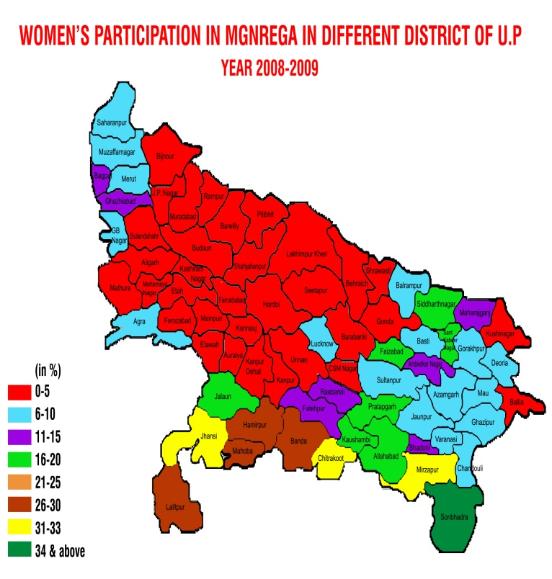
Source: official web site of MGNREGA, http://www.mgnrega.nic.in
Map 2 Participation of Women in MGNREGA UP (2009-10)
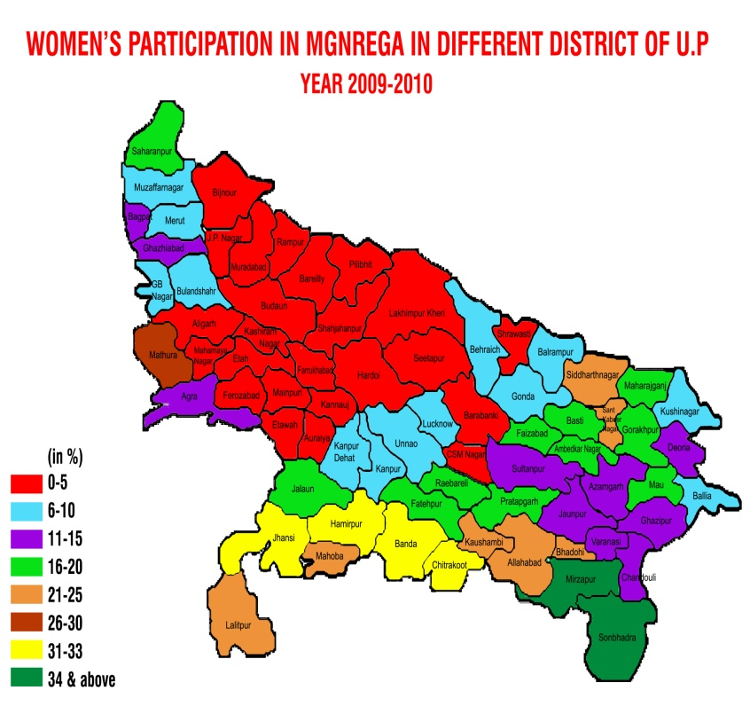
Source: the official website http://www.nregs.nic.in
Map 3 Participation of Women in MGNREGA UP (2010-11)
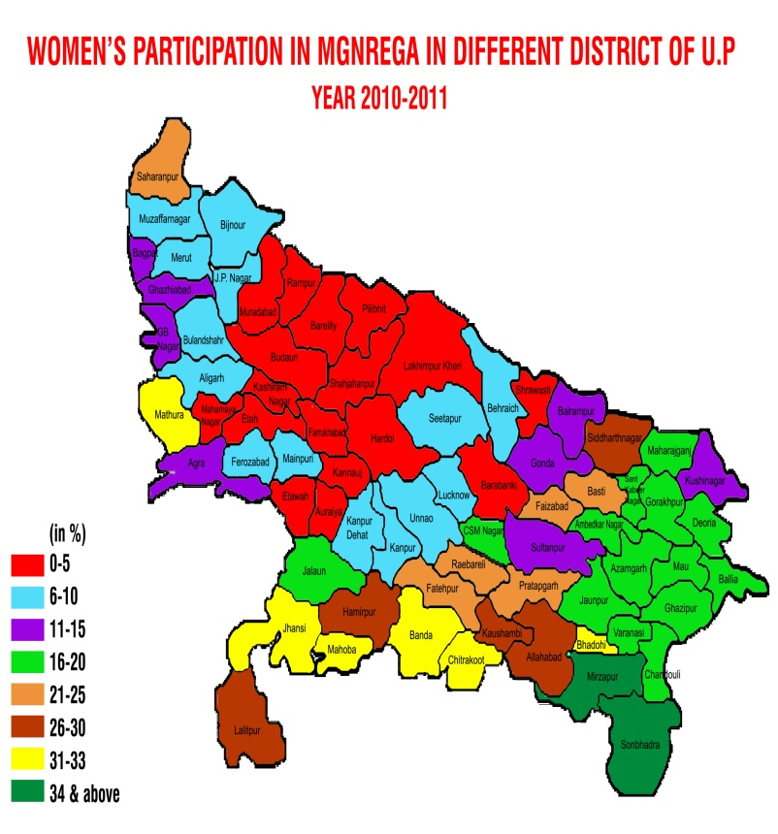Source: official web site of MGNREGA, http://www.mgnrega.nic.in

Map 4 Participation of Women in MGNREGA UP (2011-12)
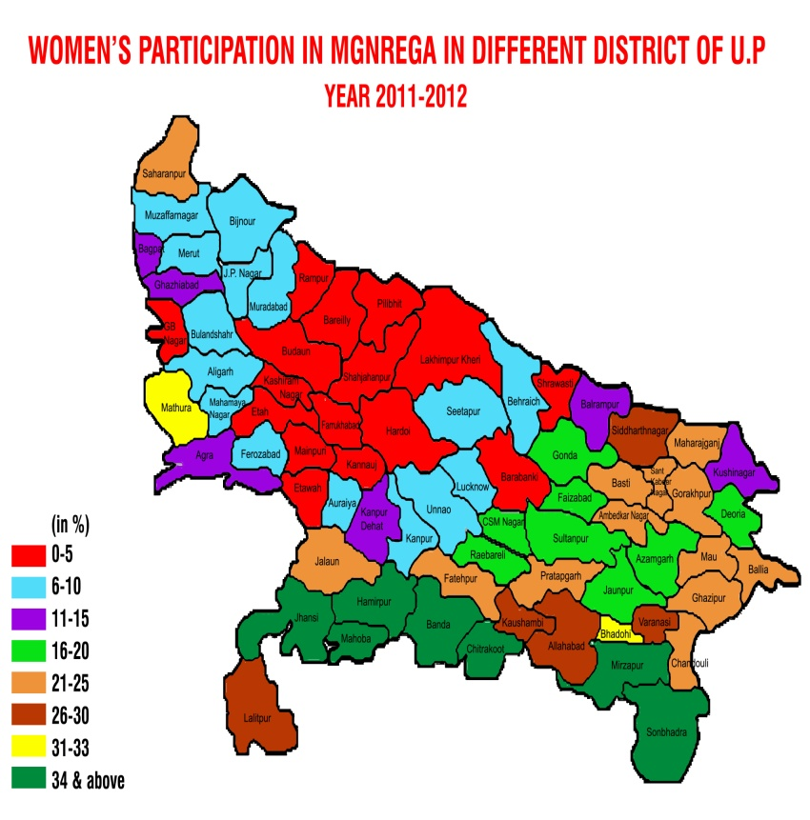
Source: official web site of MGNREGA, http://www.mgnrega.nic.in

An analysis of this data reveals that during the year 2008 when the scheme was in its initial phases almost 2/3rd of the districts were below the 5% of women’s participation. But gradually in the successive years the participation has improved and now only in 17 districts the progress is below 5%. A random glance on the maps during the last four years depicts that the central region of the state is still lagging behind in fulfilling the mandated target of 33%. During all these years the districts of Kannauj, Farrukhabad, Shajahanpur, Shraswasti, and Badaun have been very poor in the participation of women in the scheme. In contrast, in the Bundelkhand and Sonebhadra regions the mandated targets of women’s participation have always been fulfilled. The analysis of the data in the above stated manner depicts that the state of UP is the lowest in the country in the participation of women in the scheme. And within the state, the central districts are least performing.

The District of Jalaun
Amongst all the districts of the state, the district of Jalaun was selected for further analysis and the data collection. Taking the data from the Annexure-I, the progress of the district is presented in the following tabular form;
2:2 Women’s Participation in Jalaun (2008-2011)
S.NO. | Year | % of women’s participation (Jalaun)
1 | 2008 | 17
2. | 2009 | 19
3. | 2010 | 20
4. | 2011 | 22

Source: official web site of MGNREGA, http://www.mgnrega.nic.in

The data shows that the performance of the district is continuously improving, but it is still below the desired target of 33%. For the purposes of the development administration, there are 9 Blocks and 564 village councils (Gram Panchayats) in this district and as discussed earlier these blocks and village councils are responsible for the implementation of the scheme. In the district a Block represents a group of village councils. In the year 2011, the performances of all the Blocks of the District are presented in the next table;

2:3 Employment Generated in 2011-12 Dist.- Jalaun
Employment Generated Year 2011-2012, District – Jalaun
S.No | Block | Cumulative Person days generated |  |  |  |  | % of Women’s Participation
S.No | Block | SCs | STs | Others | Total | Women | % of Women’s Participation
1 | 2 | 4 | 5 | 6 | 7 | 8 | 9
1 | DAKORE | 195760 | 5369 | 485110 | 686239 | 203049 | 30%
2 | JALAUN | 240352 | 875 | 266287 | 507514 | 92819 | 18%
3 | KADAURA | 118930 | 3334 | 633471 | 755735 | 210007 | 28%
4 | KONCH | 165584 | 9770 | 392017 | 567371 | 122978 | 22%
5 | KUTHAUND | 240282 | 28 | 393375 | 633685 | 109225 | 17%
6 | MADHOGARH | 197959 | 1903 | 284645 | 484507 | 103580 | 21%
7 | MAHEVA | 132829 | 609 | 561165 | 694603 | 176824 | 25%
8 | NADIGAON | 82151 | 6204 | 599620 | 687975 | 145134 | 21%
9 | RAMPURA | 118219 | 1436 | 270111 | 389766 | 50239 | 13%
Source: official web site of MGNREGA, http://www.mgnrega.nic.in
This table shows that Block Rampura has registered the lowest percentage of 13% and Block Dakore has achieved the highest percentage of 30% in the scheme. In Annexure-II of the paper, for the year 2011, all the village councils of the district Jalaun, are arranged according to their performance in descending order. A perusal of this list shows that there are 5 village councils (Hoosepur Jagir, Gurha, Bilouha, Baghawali, and Roorasirsa) where the participation of women in the scheme is Zero and three of these councils are lying in the block of Rampura. The other two of the village councils are from the other Blocks. This list also indicates that the village council of Sekhpur Gurha has achieved the highest percentage of 58% in the whole district.
Further the analysis of the district Jalaun also reveals that the Block Rampura has the lowest percentage of participation. Again the examination of all the village councils of this Block shows that 3 village councils have zero participation of women in the scheme. Hence it could be said that the problem of poor participation is area specific which requires gender specific attention. Thus in this way, an attempt has been made to identify the villages where the participation of women in the scheme, is highest and lowest by analysing the secondary data.

MGNREGA Governance and Women’s Employment

Role of the institutions
As discussed earlier the major funding of the scheme is done by the government of India and 25% of the material component and 10% of the labour component is the responsibility of the provincial government. The flow chart clearly specifies the various levels involved in the process of its implementation. The village council or the Gram Panchayat is the lowest level to run the scheme in the villages. And the Ministry of Rural Development is the main policy laying body at the central level. At the national level, in the year 2008 the percentage of women’s participation was 47%, in the year 2009 it was 48%, in the year 2010 it was 47.73 and in the year 2011 it was 48.00%. Thus the percentage of women’s participation at the national level has always been above the required level of 33%. Probably this could be the reason that not much policy interventions have been made in this respect at the national level. Since the problem of poor participation is state specific, hence the role of the state government and the village council is very crucial for the enhancement of the women in the scheme. The State Employment Guarantee Council and District Programme Officers also play an important role in the delivery of employment in the rural areas of the state.

Village Council (Gram Panchayat)
The operational guidelines of the scheme provide that the council of the village has the responsibility of implementing the scheme in the villages. The chief (Pradhan) and the members of this body are elected from amongst the villagers on regular interval and an employee of the government is the secretary of the council. Both these persons are jointly responsible for running the affairs of the council in the village. And after coming into the effect of the 73rd amendment to the constitution, 1/3rd members of the village council and the Block council should be women. Coincidently, in none of the selected villages, the village chief is a woman. But 1/3rd of the total members of each village council were women. However in none of the village, women members were found to be active in running the affairs of the council. During the discussion it was also found that due to paucity of personnel, secretary of the council has the charge of around 3-4 villages councils. However a lot depends on the village chief because she is from the village community and she understands better the social practices and preferences of the people. At the launch of the scheme, all the village chiefs and secretaries were given extensive training about the scheme and its features. The village in which the participation of women is above 50%, it was found that the village chief was taking interest in the implementation of the scheme including women’s participation, but in other villages, the chiefs are not much interested in going against the prevalent social customs and cultural norms. Further the schedule appended to the Act, specifies that 1/3rd of the employment generated will be given to women, but the Act does not provide any kind of sanction on the Gram Panchayat for implementing this mandate. During the discussion, the village chief and the secretary also confirmed that for fulfilling this target of 1/3rd there is no formal sanction, however in weekly/monthly meeting, it is regularly emphasised. In the year 2011, it was found that in the village of Hoosepur Surai, Gurha, Bilouha and Baghawali none of the woman was given employment under the scheme. This clearly reflects the role of village council in motivating the women to work under the scheme in the absence of any kind of sanction or motivation. The concerned village chiefs also confirmed that no kind of action has been taken against the village council for their failure to fulfil the mandate.

‘Registration’
The novelty of this scheme is its self-targeting nature and the operational guideline provides that for demanding work, every household needs to be registered. From the official website of the scheme, the data regarding the status of registration of women under the scheme was downloaded. According to that, during 2011-12 on the one hand at the national level, 43.54% of the total labourers were women, on the other hand at the state level, only 19.4% of the total labourers were women. Similarly, in the same year at the district Jalaun level, 24.3% of the total labours were women. This comparison highlights that the registration of women in the scheme in the state as well as in the district is quite low as compared the indices of the national level.
The secondary data on the statuses of registration of women in the scheme in all the 4 villages were also collected and analysed. In the village Bilouha total 169 persons were registered, of this 159 were men and only 10 were women. And in the village Gurha 52 men were found to be registered, and none of the woman was registered. Moreover in the village Hoosepur Surai in total 299 persons were registered of which 262 were male and only 37 were female. These data show that in the villages where the registration of women in the scheme is low, there the participation of women is also poor. Contrary to it, in the village Sekhpur Gurha in total 423 persons were registered in the scheme and in this 226 were men and 197 were women. This clearly demonstrates that the poor registration of women leads to poor participation of women in the scheme.

Demand Driven
The nature of the scheme is demand oriented which means that when a person is asking for the work from village council, the council is under an obligation to provide the work to the asking person. To give effect to this, firstly the labourer has to apply for the work and then within 14 days the council will provide the employment and if the applicant is not provided the job within stipulated period, he/she will be entitled for the unemployment allowance. The operational guidelines provide that all the applications for the work will be registered in the office of the council and a receipt of this will be given to the intending worker. During data collection it came to the knowledge that in none of the villages the unemployment allowance were given to any worker since inception of the scheme. The village councils kept on repeating that none of the women came to ask for the job. This clearly reflects the seriousness of the village council in recognising the right of the people. During discussions and interviews it transpired that people knew about the scheme and its main features but still they do not feel that they have been empowered enough to ask for the work from the government. Since the scheme is demand driven, hence no sincere efforts could be seen on the part of village functionaries; otherwise zero participation would not have been the figure. It seems that though the right to work has been given to the people but in general people do not feel that they have been empowered enough to demand for the work. Since the nature of the scheme is demand driven, hence in the absence of any sanction the implementing authorities lack commitment in fulfilling the target of 33%.

‘Household’
The Operational guidelines of the scheme stipulate that the registration of the labourers be made according to their household. The job card is issued in the name of the head of the family in which all the eligible labourers of the family are mentioned. As per entitlements, for every household the guarantee of employment is for 100 days. However, during the data collection, none of the family was found to be completing the maximum of 100 days in any of the villages. During the focus group discussion in the village Bilouha, one woman told that when the provision of 100 days is not sufficient for all the men of household, then how a woman would get the opportunity to work. Here it seems that the distribution of entitlements among the family members is left on the decision of the family. At this juncture the power relation within the family system determines the access of women to go for the public employment. In the village Bilouha during the course of the discussion amongst women, it was highlighted that there is no need of going outside for the work when sons and husbands are working and earning the wages. It also came to the light during interviews with government functionaries that women workers are not registered separately except in cases of widows and divorcees and mostly they do not have their separate bank account. The discussions concluded that it is the male who usually head the family and decide the entitlement of the women.

Gender sensitivity
The operational guidelines contain special provision in delivering employment to women and the responsibility of implementing it is on the village council. This statutory obligation is not backed by any kind of either sanction or motivation. Thus fulfilling the target of women’s participation is left at the discretion of the implementing authorities. Not much sincere efforts in persuading women to come to work could be seen in the three villages where the participation of women was nil. However, the village secretary and the Additional Programme Officer told that in every meeting at the Block, the issue of women’s participation is discussed and instructions are issued. The progress of the state is dismal since inception, but not much policy and administrative interventions have been made at the state level. Thus it seems that due to lack of effective sanction or motivation, the village authorities are not much interested in going against the traditional norms prevailing in the village society.

Nature of work & Worksite facilities
The schedule I appended to the operational guidelines provide that under MGNREG Scheme, the permissible work includes tasks related with water conservation, irrigation canals, renovation of traditional water bodies, land development, flood control, rural connectivity to provide all weather access, and agriculture related works, livestock related works, rural drinking water related works, rural sanitation works or any other work notified by the government. Further para 7.11 of the guidelines also provides that worksite facilities (Medical aid, drinking water and shade) are to be provided at the worksite. And in case, the number of children below the age of six years accompanying the women working at any site are five or more, a crèche will need to be provided and one of such women worker shall be made to depute to look after such children. Moreover for any work, the guidelines provide that the ratio of wage costs to material costs should be no less than the minimum norm of 60:40 stipulated in the Act. It means that in any work the major component would be manual labour than the use of material and skill. The descriptions of the work executed in all the four villages during the last financial year, downloaded from the official website of the scheme are as under;

3:1 Descriptions of Work completed during 2011-12 Dist.- Jalaun
Works completed Under MGNREGA During the Financial Year 2011-2012
District | Block | Gram Panchayat | Rural Connectivity | Flood Control | Water Conservation And Water Harvesting | Drought Proofing | Micro Irrigation | Land development
District | Block | Gram Panchayat | Nos. | Nos. | Nos. | Nos. | Nos. | Nos.
District | Block | Gram Panchayat | Exp. (In Lakhs) | Exp. (In Lakhs) | Exp. (In Lakhs) | Exp. (In Lakhs) | Exp. (In Lakhs) | Exp. (In Lakhs)
District | Block | Gram Panchayat | comparison. | comparison. | comparison. | comparison. | comparison.. | comparison.
Jalaun | KUTHAUND | BAGHAWALI | 1 | 0 | 0 | 0 | 1 | 1
Jalaun | KUTHAUND | BAGHAWALI | 0.66 | 0 | 0 | 0 | 1.142 | 1.212
Jalaun | RAMPURA | BILOHA | 4 | 1 | 3 | 1 | 0 | 0
Jalaun | RAMPURA | BILOHA | 4.690 | 1.266 | 4.209 | 0.1414 | 0 | 0
Jalaun | RAMPURA | GURHA | 5 | 1 | 1 | 0 | 0 | 0
Jalaun | RAMPURA | GURHA | 2.0168 | 0.47 | 0.4008 | 0 | 0 | 0
Jalaun | RAMPURA | HUSEYPURA SURAI | 8 | 0 | 1 | 1 | 1 | 0
Jalaun | RAMPURA | HUSEYPURA SURAI | 7.8591 | 0 | 0.3024 | 0.1272 | 0.7163 | 0

Source: the official website of MGNREGA Scheme http://www.nrega.nic.in Accessed 13 September 2012
An analysis of the data presented in the table of the previous chapter, reveals that there has been an emphasis on the construction of all-weather access in rural areas and works related with water conservation and land development. It has been told that the soil of the village is black cotton and during summer it is very difficult to crack. The women in the group also discussed that generally female either work with their husband or with other male members of their family and those women who are alone, they find it difficult to work with. The officials at the block level told that the operational guidelines provide that the per day output required from men or women are the same, however in order to increase the participation of women, the state government through a Government Order in 2010, lowered the per day output from 2 cubic metre to 1.5 cubic metre with the condition that this will be applicable in those works where only women are working. Though, the government of India guidelines contain no relaxation for women in the output required for earning wages. A perusal of the permissible works shows that it requires hard manual labour and not any special skill. But contrarily, in the village Sekhpur Gurha, none of the respondents except a few, complain that the nature of the work offered is hard enough for them to complete. Another clause of operational guideline provides that the women who are demanding work will be given employment within a radius of 5 kms. During interaction in the visited villages, it was found that all the worksites were within the one kilometre of radius, therefore the worksites are not far away creating difficulties for women in accessing the employment. Thus it seems that though the works are located near the village, but it requires hard manual labour and no skill, which in normal circumstances are not attractive for rural women. Here some innovations within the parameters prescribed may be made by the village council for promoting the inclusion of women in the scheme. Some instances of innovations include, plantation project in which only the women were involved, appointment of women as mate, women dedicated sites, pairing with their husbands so that they may work in a group etc.

Market wages and Gender wage gap
The introduction of the employment guarantee scheme has increased the market wages and reduced the gender wage gap in the village. The village chiefs of all the villages told that the wages in the scheme has been able to increase the market wages to a large extent. During the collection of the data from the villages it was also confirmed by the village chiefs that the wages fixed in the scheme has had the effect of raising the market wages for the men and women workers. Further they also said that due to the increases in the market wages for men and women, the input cost of cultivation has increased. The village chief of the village Bilouha told that when the demand of the labourers are high in the market, the farmers having large land holdings asks him not to start work under the scheme so that the market wages of the labourers could be controlled. Thus it could be said that the amount of the wages under the scheme, has the effect of raising the market wages of the labourers. Unfortunately even the introduction of good rates for the work has not been successful to attract women in the scheme.
The noticeable effect of change has been on the gender wage gap i.e. the difference in the wages of men and women. Though the labourers could not give the exact details of the earlier rates and present rates but they confirmed the fact that the market wages of the women have increased and now the gender wage gap has reduced to minimum. However, even this inducement has limited effect in pushing the participation of women in the scheme in some areas where the old social norms still prevails.
In spite of the special provision for women in the public employment programme, in certain social and cultural circumstances it fails to reach the intended beneficiaries. It has been found in the analysis that the role of the village council is very crucial in the delivery of public employment to women. The policy of recognising the right to employment of the people, fails to address the situations where the intended beneficiaries lack a sense of empowerment. The families are registered according to the household and the allocations of employment for women are dependent on the power relations within a family system. Moreover the nature of work and the worksite facilities have also some influence in the access of women in the scheme. But the good market wages fails to attract the women from higher castes. This draws attention to the social factors responsible for poor participation of women.

Patriarchal norms and practices in the community and household and the MGNREGA
The socio cultural aspect forms the core problem of the poor employment of women in the scheme. The discussion in the following paragraphs showed that the unwillingness of the women is not the causative factor for their lesser participation, but the social and environmental factors contribute in suppressing their desire for earning wages outside their traditional roles. The first section analyses the role of the caste in determining the inclusion of women in the scheme and the second, third sections explains the impact of various socio cultural practices prevalent in the society. And the last section explores the role of self-help group in promoting the role of women in the scheme.

The Caste factor
The special characteristics of the Indian society is it’s caste system.
“The disparities in our hierarchical Indian society are endemic, and they become more complex as the hierarchies of gender intersect with hierarchies of class, caste, and ethnicity, in addition to the regional variations. Women and men too find themselves placed in different hierarchies which grant them power and status based on their birth and relation to the main male members of the family”(Desai & Thakkar : 2011).
The society is divided into different castes like, forward, backward, scheduled castes and Scheduled Tribes. Therefore the employment guarantee scheme has to operate in the existing social circumstances. The scheme is reaching to the poorest of poor and is of particular significance for marginalised communities such as Scheduled castes and Scheduled Tribes (Khera: 2011; 15).
In such situations, the composition of the caste in a village is an important factor. On enquiry it came to the notice that the census of forward castes (Brahmin and Kshatriya) and backward castes (Yadav, Kurmi, Lodh etc) in a village are not officially published by the government. During census operations, the castes of only scheduled castes population are counted and the data is published. However during primary data collection a rough estimate of the caste composition of the villages were taken from the villagers. In the village Bilouha, the total population is 1105 and of which the majority of people belongs to forward castes like Kshtriya and Brahmins. The backward castes population is 125 and the scheduled caste population is 107. Thus it can be said that in the village Bilouha the majority of the population is dominated by the forward castes. Similarly, in the village Gurha the total population of 700 belongs to forward castes (Khastriyas) and only one family belongs to SC and one to OBC. Again in the village Hoosepur, and Baghawali, the majority of the population is from backward castes. In these villages, none of the women worked in the scheme during the whole year. In the village Sekhpur Gurha which has registered the maximum percentage of women’s participation, entire population belongs to backward castes. During semi-structured interviews and focus group discussion in all the villages some of the instances are discussed to assess the impact of castes on the participation of women in the scheme.

Some instances

a) Village Bilouha –
The chief of this village narrated that only 7 women were registered under the scheme and they never come to work under it. He emphasised that the people from the forward community, who were registered with the scheme, were less inclined to work because of the general belief that working in the scheme lowers their social positions. Their belief is so strong that they used to say that they may commit crime for money but will not work in the scheme. Dacoity kar lenge per NREGA mein kaam nahi karenge. This could be the reason that women from these forward castes are not coming to work under the scheme. To highlight this view, the village chief gave a few examples;
i) Earlier one labourer Basant was participating under the scheme, but now he has stopped working because his sons are of marriageable age and he believes that he may not find suitable girl for his sons if he continues to work in the scheme. The reason for this disinclination is the general belief that MGNREGS work is considered to be of menial nature in his society and working in it lowers his social status. The pardhan told that earlier when he was working under the scheme he did the assigned work in the morning so that people of his community could not see him working in the scheme.
ii) Uday Singh s/o of Uggar Singh is from forward caste (kshtriya). Earlier he was working under the scheme but now he has stopped working because of the social values in his community. In interaction Mr Uday Singh said that earlier I used to get the help of my sons in our own agricultural work, but now I am alone, because my sons have migrated to the cities and it is difficult for me to work under the scheme any more.
iii) The village chief narrated another incident when on one occasion, the District Programme Officer came for inspection and he was verifying the names of the labourers working at the site. During enquiry, a person’s caste was asked and he told that he belonged to the upper caste. From the next day he stopped working in the scheme because the village chief told that he felt insulted when his caste was asked in the public where he was found to be working in the company of lower caste people. So this feeling of superiority of castes prevails in the minds of men and women both.

b) Village Hoosepur Jagir -
During focus group discussion one women labourer from backward caste narrated her experience that when she started working in this scheme, the village women commented on her character. She told that, since her husband is physically weak, she had no option except working in the scheme. In the same discussion the panchayat sevak also narrated an incident in which one woman labourer was stopped by her husband to work in the scheme. Interestingly they also discussed that when the market wages are quite high during the harvesting seasons, the women and girls from backward castes go for the work in the agricultural fields, but the women from higher castes refrain from going.

c) Village chief - Gurha
In his interview, the village chief told that population of this village is around 700. Almost all the families of the village belong to the forward (Kshatriya) caste. Though the job cards have been issued but none of the member of the Thakur family is coming to work under the scheme. They say that if they work under the scheme it will be difficult for them to get their sons and daughters married, because the NREGA work is considered to be meant for lower castes people. Village chief also told that even if Thakur families are not economically well off, they do not prefer to work under the scheme for the social taboos prevalent in their community regarding to the works in the fields.

d) Interview with Assistant Programme Officer working at Block office
Assistant Programme Officer is working at the level of Block and in his interview he told that people in the villages know about the scheme, but due to traditions, the male head of the family does not allow the female to go out for the work. This is not the case in all the villages. The villages which are remote and still feudalistic, the caste culture is predominant, the scheme has to face the social norms and traditions as obstacles in the participation of women. There is no social organisation or any kind of NGO which could motivate these women to participate in the scheme. The village chief and the members of the GP are the political persons, some of them are influential and powerful and it is difficult to convince them. Some of the village chiefs are quite helpful and cooperative. In the cases of women village chiefs, mostly it is their husbands or family members who run the affairs of the village council in the de facto manner.

e) Interview with the Junior Engineer –
The junior engineer associated with the task of implementing the scheme at the block level said,
“Due to social and cultural issues, women in some of the villages are not coming out for doing the work in NREGA scheme. In general, the villages, in which the population of the forward and backward castes are in majority, the women, are not coming out for the scheme work. In some of the remote and backward villages, still the forward castes and backward castes, considers that by working in these schemes meant for poor, they will lose their social status. There are villages in which the husband and the wife work together, and earn their wages, but due to purdah system, generally women do not go alone for working in the field. In some areas people abstain from working in the field even if they are poor, because of the social norm”.
The abovementioned instances necessarily show that the women from the higher castes are not working under the scheme due to the social norms prevalent in their society. However in cases of backward castes the response is mixed. The village Sekhpur Gurha is dominated by the backward castes population. And the participation of women is very encouraging. In this Gram Panchayat, the participation of women in the scheme is maximum i.e. 57%. In order to know the circumstances affecting the encouraging participation of women in the scheme, a focus group discussion was conducted. On request, more than 10 women came out to take part in the discussion. During focus group discussion some interesting facts were revealed.
This village was also like other backward and remote villages of the district where poverty and unsecured livelihood were the major features. The district is situated in the ravines of river Yamuna. The bandit queen (the famous dacoit) Phoolan Devi was from this village only. The majority of the people are poor and belong to backward castes. The women of the village normally work outside their home and earn wages. It was pointed out that in the year 2010, all the women of the village joined together to protest against the age old practice of making illegal liquor and gambling by the men and young boys of the village. Finally these women succeeded in wiping out this menace from their village. The women of the village later on formed a self-help group, and did some activity for a few years. When this scheme was launched in this village, they took active part in it.
The discussions of the abovementioned instances prove that the caste of a woman is one of the most predominant factors affecting her integration in the employment oriented scheme. In the field visits, it was noticed that the men and the women from the upper castes such as Brahmin, Kshatriya, and some of the backward castes were not participating in the scheme. The old age prevalent belief among the people of the villages is that working for the wages in the field is meant for lower castes people and not for the upper castes. However this belief is gradually changing but still in many pockets people do not like to work for the wages in the field though they may be poor. The village chief of Gurha told that his village is dominated by Kshatriya community people and even though some of them are poor, but they will not like to work for the wages in this scheme, because it is supposed to be meant for lower caste people. Likewise in the village Bilouha it was noticed that the upper castes people were not accepting the work being offered in the scheme. A few of the upper castes people did work in the scheme for a few years but later on due to social pressure they stopped working in it. For instance some of the upper caste people were told to be doing the assigned job in early morning because community members could not see him working in the scheme. While visiting the village Hoosepur Jagir, it was noticed that none of the upper caste women were participating in the scheme and when they were called to come for the discussion, they did not come. It means the prevalence of the caste influenced ideologies in the society, affects the participation of upper caste women in the scheme.
To draw a complete picture, the participation of SCs and STs in MGNREG scheme at the level of State was also analysed in which it was found that in the year 2011-12 in total 2703.01 lakhs of total man days of employment were generated and of which the 1396.48 lakhs of employment were given to the members of scheduled caste community which is around 51% of the total man days generated in the state (official website). Thus MGNREGA is of particular significance for marginalised community such as SCs and STs, because these make up most of the NREGA workers (Khera 2011:15). Thus it shows that the members of the forward community have more hesitation in working in the scheme than other castes. In the village Sekhpur Gurha where the majority of population is from backward castes the participation was found to be above average. So the trend about participation of women from backward castes women was found to be mixed. Thus it may be inferred that the people from the upper castes have more hesitation in working in the scheme than people from the backward castes whereas the members of the Scheduled castes are actively participating in the scheme.

The Purdah system
The cultural practice of the purdah is still common amongst the rural women of the State. During the course of the data collection, evidences relating to it were joined to assess the impact of it on their participation in the scheme. In semi-structured interviews and focus group discussion it was pointed out that normally due to the system of purdah practised by women labourers in all the villages, they prefer to work either in the group of other women or with their male family members. Usually they prefer less to work in the company of other male members. It was also mentioned that in some families where women were going outside for doing agricultural activities in their own field or for the wages, they could join the scheme easily but the women in other families where going out for wage work is a taboo; it is unthinkable that they may come to work under the scheme. In the village Gurha, the village chief told that all the families living in his village belong to forward caste (Kshatriyas), and socially it is unacceptable for women to come out of their veil, to work in the field. But in the village Sekhpur Gurha, where the participation of women is maximum in the district, the village chief told that the women labourers are less hesitant in working on the dedicated sites for them, and now they have started working with men also. However in the discussion women told that they prefer to work in the pair of their husband or other male member of their family because it allows them flexibility and adjustability during work. Thus on the basis of these facts it may be concluded that the cultural of purdah may be a limiting factor in women’s participation in the scheme which have been overcome by the group work or working with the family members.

Gender Division of work
The social structures of the examined villages are such that the primary responsibility of providing food and care to the household members lies with the women. Additionally she also looks after the domestic animals of the family and helps their male in agricultural activity. And the male members of the family are either working in the agricultural field or working for the wages in the market. In none of the discussion, the women told that the men might share some responsibility in household affairs and also men were not seen inclined to take part in household work. Thus the clear division of roles among the men and the women of a family were visible in the village society. In this way the participation of women in the scheme increases their responsibilities because her reproductive liabilities are not lessened in any way. However in none of the villages women told that working in the scheme is difficult because they have to perform the household chores. Even in the village Sekhpur Gurha where the participation of women in the scheme is maximum, not a single woman complained about her increased responsibility after working in the scheme.
It is but natural that her participation in the scheme increases the burden of work on her; however during data collection no psychological resistance to participation in the scheme was perceptible amongst the women of the villages. Thus it may be concluded that the gender division of work is not a major obstacle for the participation of women in the scheme.

Male Domination
The domination of the male in the affairs of the household is the common feature of all the villages. The data on this point were also collected during focus group discussion and interviews. The analysis of the primary and secondary data obtained in the villages shows that the guarantee of 100 days of employment is for the household but it is the men who dominate in doing the work under the scheme. There are no fix criteria of division of the limit of 100 days among the family members, and it varies from household to household. Generally men prefer to work under the scheme during slack season when they do not have much agricultural activities. In the village Sekhpur Gurha it was found that in many families where the men were working in the cities, their women found the opportunity to work in the scheme. This shows that the existence of alternative employment opportunities for men have an effect on giving more space to women for working under the scheme. However this does not hold true for the other three villages where the participation of women is zero. Even in those villages there are families where their men are working in the cities for earning their livelihood, but the women from these families are not coming to work. Also there are families which are totally dependent on the scheme for additional income; their women were found to asking for more days of work than 100. These instances give some indication of male domination in the families.

Role of Self-Help Group
The data collection exercise provided an opportunity to see how a small group of women could transform the social and economic roles of rural women. The village Sekhpur Gurha, was like all other most backward villages of the district. In 2010, a small group of women formed a group and launched a campaign against gambling and making of illegal liquor prevalent in the village and which was responsible for all sorts of crime. They succeeded in their effort of wiping out this menace from their village. Since then they started taking interest in the matters outside their traditional roles. Probably this transformation in their thinking led to their increased participation in the scheme. Thus the formation of the self-help group in the village provided the necessary impetus for the transformation in the thinking of women. This shows that persistent social and community mobilisation and a proactive role for the state can compensate for some of these social and cultural deficits. This will also be helpful in bridging the gap between work participation and process participation (Pankaj and Tankha:2010).

Summary and Conclusion
The analysis of the women’s involvement in the MGNREG Scheme in Uttar Pradesh showed that there were two main factors responsible for the poor performance. First the nature of the governance of these schemes including their manner of implementation and second was the role of social and cultural practices that hindered women from accessing the guarantee under the scheme.
To begin with, the roles of the various institutions have been found to be very crucial in limiting opportunities for woman to get the benefits of the proposed entitlements. At the apex level the central government is responsible for laying down the rules and is the chief financer of the scheme. Further the concerned State government is running the scheme at the intermediate level. Moreover the mechanism of the administration of the scheme is such that it lays greater emphasis on the lowest functionary i.e. the village council. And the concerned village council has to fulfil the required mandate amidst social and political challenges. This calls for the greater role of the village council in the delivery of employment to women. However no kind of sanction or motivation is prescribed for village council to fulfil the required mandate for women. Thus the impact of lack of complete commitment in the legislation is reflected in the three villages where the participation of women has been zero in these years. An analysis of the status of women’s registration also lends support to this argument that the village council has a crucial role in the inclusion of women in the scheme. Every right has a corresponding duty to it and the right to employment casts a duty on the village council to provide the employment to anyone seeking it. But this duty is not backed by any kind of sanction or motivation so that the village council may be pressurised to make extra efforts in including more women in the scheme.
The reason behind not providing any sanction for fulfilling the quota of women is the demand driven nature of the scheme. The qualitative data obtained from the villages indicates that though the entitlement of employment has been guaranteed by law, yet the women do not realise that they have been empowered enough to claim for the work. In this scenario the guarantee of employment becomes meaningless for those women who still lack a sense of empowerment. To address such circumstances, there must be some kind of inducement or sanction on the village council for targeting such women. However indirectly a pressure been created on the state government to give unemployment allowance in case of failure of the village council in providing the jobs to women. But in return the state government has not been given specific power to take action against the village council if it fails to fulfil the mandate of providing jobs to women. Thus this lack of essential element fails to give teeth to the special legislation.
The guidelines also specify the permissible work under the scheme. The nature of the work offered requires hard manual labour. During the qualitative data collection none of the women complain about the difficulty in executing the assigned task, however it also revealed that the difficult posed to women has been faced by working in partnership with their male counterpart or in the group. Yet some innovations in specific works for women might improve their participation.

Many research studies have confirmed that the scheme wages has had the effect of raising the market wages for men and women both (Sudarshan: 2011). This paper also comes to the conclusion that the scheme wages has reduced the gender wage gap prevalent in the market. However it operates differently for different regions. For instance the villages which are located near the large cities, it is difficult to get worker at the rates prescribed under the scheme because the market rates of wages are high as compared to scheme wages. But in far flung areas the scheme wages are at par with the market wages. However even this inducement has not been sufficient enough to attract women in certain social conditions.
Thus the analysis of the governance of the scheme brings forth the necessity of effective policy mechanism for giving due participation to women. The other dimension of the responsible factors focuses on the environmental factors having some bearing on the issue of women’s participation.
In the rural society of the state the caste is a prevalent phenomenon. It has been established in earlier research studies that a substantial share of the beneficiaries include the members of Scheduled castes and scheduled tribes. However the primary data collected in this paper from all the villages show that the women from the high caste families ( Brahmin, Kshatriyas) refrain from accessing the employment offered in the scheme. Due to the presence of their culture, even they do not go outside for market wages. And in cases of backward castes the response is mixed, because in the village Sekhpur Gurha which is dominated by backward caste the participation of women is high. Thus in the present endeavour it is found that the women from the high caste rarely comes to work under the scheme whereas the responses of the women of backward castes is mixed. And the women from scheduled caste have least hesitation in accessing the work given under the scheme.
The domination of the male prevalent in the society was also found to have an effect on the participation of women in the scheme. The qualitative data collected from the villages indicates the domination of male in giving space to women for participating in the scheme. The entitlement of 100 days is for the household and there is no quota of women within these 100 days. So the power relation within the household decides the share of women in accessing the employment.
The culture of purdah common in the women of the villages has not much impact in their accessing the employment with in the scheme. Normally either they work with their male family members or in the group of other women.
A few of the researches have pointed out that by working under MGNREGA; the women are now overburdened with work because they are not divested of their household responsibilities. But in the present study it has not been found to have an effect on the participation of women. None of woman expressed that it has some limiting effect on her participation in the scheme
Thus on the basis of the above analysis it may be concluded that the caste of a woman and the male domination in the family have an important effect on her accessing the public employment offered by the village council. Similarly the village council also plays an important role in providing work to women. Hence in the absence of any effective sanction on the village council and as against the challenges posed by the social and cultural circumstances, the fate of the women labourers depend on the expectation of an active role of the village council. Moreover some intervention by any Self – Help group, or NGO for initiating the village council in promoting women’s employment has a beneficial effect.

Policy Recommendation
The special provision of this scheme is the introduction of quota for women in the delivery of public employment. In the state of UP though it is gradually increasing but is still below the required level. To push it up a few of the recommendations may be considered as below;
- The village council and the other implementing agencies (line department) should be placed under an obligation to fulfil the quota for women.
- There should be an emphasis on the registration of women in the scheme and the bank account should also be opened separately for them.
- There should be an emphasis on women mates in the identified areas.
- There should be an emphasis on the formation of self-help group of women and the active role of NGO’s in the low performing areas.

References
Barrientos, A. (2011) ‘Social protection and poverty’, International Journal of Social Welfare 20: 240-249
Desai, N. and U. Thakkar (2011): Women in India Society: New Delhi: National Book Trust, India 147
Holmes, R. Sadana, N. and Rath, S. (2010) ‘Gendered risks, poverty and vulnerability in India: case study of the Indian Mahatma Gandhi National Rural Employment Guarantee Act(MP)’ Research Paper. London: ODI & IIDS
Jha, S (2007) Uttar Pradesh: The Land and The People: New Delhi: National Book Trust, India 64pp
Jones, N. and R. Holmes (2011) ‘Why is social protection Gender-blind? The Politics of Gender and Social Protection’: IDS Bulletin 42: 45-52
Khera, R.(2011): The Battle for Employment Guarantee : New Delhi : Oxford University Press:3pp.
Khera, R and N. Nayak (2009) ‘Women workers and perceptions of the National Rural Employment Guarantee Act in India’, paper presented at the FAO-IFAD-ILO workshop on Gaps, trends and current research in gender dimensions of agriculture and rural employment: differentiated pathways out of poverty, Rome (31 March - 2 April 2009)
Pankaj, A. and R. Tankha (2010): ‘Empowerment Effects of the NREGS on Women Workers: A study in four States’ Economic & Political Weekly XLV No 30:45-55
Pellissery, S. and S K Jalan (2011) ‘Towards transformative social protection: a gendered analysis of the employment Guarantee Act of India’, Gender & Development, (19:2): 283-294
Planning commission (2012): ‘Press Note on Poverty Estimate 2009-2010’. New Delhi: Press Information Bureau (press release,19 March 2012),
Accessed 14 September 2012 http://www.planningcommission.nic.in
Razavi, S. (2011): ‘Engendering Social Security and Protection: Challenges for making social security and Protection Gender Equitable’, Global policy and development Hiroshimastr.28, 10785 Berlin, Germany.
Reddy, D., R. Tankha, D. Upedranadh and A. N. Sharma(2010): ‘National Rural Employment Guarantee as Social Protection’: IDS Bulletin 41: 63-76
Sudarshan, R (2011) ‘India’s National Rural Employment Guarantee Act: Women’s participation and impacts in Himachal Pradesh, Kerala and Rajasthan’ CSP Research Report. Sussex: Institute of Development Studies
The Mahatma Gandhi National Rural Employment Guarantee Act 2005 (India)
The Mahatma Gandhi National Rural Employment Guarantee operational Guidelines 2008 (India)
Vij, N. (2011) ‘Collaborative Governance: Analysing Social Audits in MGNREGA in India’: IDS Bulletin 42:28-34
Visvanathan, Nalini (1997) Introduction to Part 1: in Nalini Visvanathan, et al. The Women, Gender and Development Reader, London: Zed Books, pp. 17-32. Ca 8272

