Intra-Industry Information Transfer:
The Impact of the Implementation of IFRS.

Master’s Thesis Accounting, Auditing & Control
Erasmus School of Economics
Name: Nick van Westerop
Student number: 311794
Supervisor: C.D. Knoops

Preface
Hereby I proudly present my master’s thesis I have wrote to graduate for the master study Accounting, Auditing and Control. The subject of this master’s thesis is: intra-industry information transfer, and then in special the impact of the implementation of IFRS. I want to thank some people who were of great help to me. First of all, a special thanks to my supervisor from the Erasmus University of Rotterdam, Professor C.D. Knoops. Thanks for the helpful feedback and the good communication we had during the last 4 months. It really helped me by finishing my master’s thesis on time. I also want to thank my supervisor at Ernst & Young, Quincy Berry. Thanks to him I have had four fantastic months at the office of Ernst & Young in the Hague were I have worked on my thesis during an internship. The last special thanks are to my parents off course. They have always been proud of what I did and give me the time and space to work on my thesis.

Executive Summary

This study investigates the impact of the implementation of IFRS on intra-industry information transfer. Intra-industry information transfer occurs when an earnings announcement released by a firm contains ‘industry-specific’ information which is informative to investors. Investors can use this information to speculate about the earnings of other firms operating in the same industry.
Many firms mandatory adopted IFRS in 2005. The implementation of IFRS should lead to a better comparability between financial figures of different firms what will improve the accounting quality. The increase in accounting quality and the better comparability between annual accounts makes it easier for investor to discover ‘industry-specific’ information and use this information for their investment decision. Therefore I made the assumption that the implementation of IFRS lead to a higher magnitude of intra-industry information transfer.

There are different methodologies to measure intra-industry information transfer already used in prior research. I replicate the non-directional methodology of Foster (1981) to measure the magnitude of intra-industry information transfer. This methodology takes the abnormal return variance as a proxy for intra-industry information transfer. The abnormal return variance is the abnormal return of a firms stock surrounding an earnings announcement compared to the abnormal return of the same stock at a non-announcing period. So the abnormal return variance actually shows the reaction of a stock price assignable to the earnings announcement released. To investigate if the magnitude of intra-industry information transfer increased after the implementation of IFRS two different samples are selected, a pre-IFRS period (2001-2004) and a post-IFRS period (2005-2010), which are compared to each other. To get a good insight if the magnitude of intra-industry information transfer is increased a Spearman rank correlation test is performed with the abnormal return variances in both periods. The outcomes of this test for both periods are compared with each other, and show an increase in intra-industry information transfer after the implementation of IFRS.

Table of Contents
1 Introduction 4

1.1 Information content of earnings announcements 4

1.2 Intra-Industry information transfer 4

1.3 The impact of IFRS on information quality 4

1.4 Relevance 4

1.5 Formulating research question 4

1.6 Outline of the study 4
2 Theoretical background and related literature 4

2.1 Introduction 4

2.2 Information content of earnings announcements 4

2.3 Intra-industry information transfer 4

2.4 The impact of mandatory adoption of IFRS 4

2.5 Summary 4
3 Sample Selection 4

3.1 Introduction 4

3.2 Description of selection criteria 4

3.3 Summary 4
4 Research Design 4

4.1 Introduction 4

4.2 Event Study 4

4.3 Non-directional residual methodology 4

4.4 Summary 4
5 Results 4

5.1 Introduction 4

5.2 Results non-directional residual test 4

5.3 Kolmogorov-Smirnov test 4

5.4 Spearman rank correlation test 4

5.5 Summary 4
6 Analysis of the results 4

6.1 Introduction 4

6.2 Analysis of the results of the non-directional test 4

6.3 Analysis of the results of the Spearman rank correlation test. 4

6.4 Limitations 4

6.5 Summary 4
7 Conclusion 4
8 References 4

Appendix 55

Introduction

Information content of earnings announcements
If a firm releases an official public statement about its profitability for a specific time period, this is called an earnings announcement. When a firm releases an earnings announcement, this information will be interpreted by investors and they will react on this. By looking at the reaction of investors, you can measure the information content of the earnings announcement. The change in the stock price of the announcing firm visualizes the reaction of the investors on the financial information release. By observing the abnormal returns in the stock price of the firm, the information content of the earnings information can be determined. The abnormal return is the difference between the expected return and the actual return. Stock exchange markets use a benchmark for expected return. If, after an earnings announcement, the actual return of a stock differs from the expected return according to the market, this indicates the level of information content of the earnings announcement. Prior literature finds that the information content of these earnings announcements has increased over the last decades (Landsman and Maydew, 2002).

Intra-Industry information transfer
Next to that an earnings announcement of a firm provides financial information about the firm itself, it can also provide so called ‘industry-specific’ information. This indicates that some information contained in the announcement is also applicable to other firms operating in the same industry as the announcing firm. This phenomena is called ‘intra-industry information transfer’ and the appearance of it is already investigated by multiple prior studies (e.g. Foster, 1981; Freeman and Tse, 1992; Schipper, 1990).
A way to test the response of investors on the financial information contained in an earnings announcement, is to look at the change in the stock price of the announcing firm. Investors will adapt especially the ‘new’ information contained in the earnings announcement and respond to this. Investors always have information about the operations of a firm, on which they will estimate the expected earnings of the firm. If the earnings announcement contains unexpected earnings, this implies that the earnings announcement contains financial information, which was not already known by investors. The unexpected earnings of the announcing firm should be determined, because this part of the earnings is unknown by investors before the earnings announcement, and therefore this is the information where the investors will respond to at the time the earnings information is released. To investigate the presence of ‘intra-industry information transfer’ also the reaction in the stock price of the non-announcing firms in the same industry is measured after the earnings announcement of the competitive firm.
Foster (1981) started investigating this relationship between the impact of an earnings announcement on the stock price of the announcing firm and the impact of the same announcement on the stock prices of non-announcing firms in the same industry. Foster (1981) also investigates the direction of the stock price reaction. If a firm releases positive information, this will lead to an increase in the stock price of the announcing firm, because investors will respond to the flourishing earnings figures by buying more stocks of the firm. If the ‘good’ news for the announcing firm, is also interpreted by investors as good news for the other firms in the same industry, there will be a contagion effect. A contagion effect implies that the change in the stock price has the same direction for the announcing firm as for the non-announcing firms in the same industry. But good news for the announcing firm not always has to be good news for the non-announcing firms in the same industry. If there is high competition between firms in a rigid industry, it could be that higher earnings presented by the announcing firm, indicates lower earnings for competing firms operating in the same industry. If investors interpret this in such a way, ‘good’ new released by the announcing firm, will be ‘bad’ news for the other firms in the same industry. This will lead to decreases in stock prices for the non-announcing firms. If this is the case, the competition effects apparently offset the contagion effects (Laux et al., 1998) Replicating Foster (1981), several other studies investigated intra-industry information transfers and most of them found prove that there appears to be a positive correlation between the impact of an earnings announcement on the announcing firm’s stock price and on the non-announcing firms’ stock prices operating in the same industry (Han et al, 1989; Freeman and Tse, 1992; Ramnath, 2002; Thomas and Zhang, 2008).

The impact of IFRS on information quality
In this study I examine intra-industry information transfers and the impact of the mandated adoption of International Financial Reporting Standards (IFRS) by listed firms in Europe.
The reason why I investigate the impact of the adoption of IFRS is that according to the International Accounting Standards Board (IASB), IFRS should lead to more transparent and comparable financial information, and overall the implementation of IFRS should lead to an increase in the quality of financial information (Ball, 2006; Barth et al., 2008; Armstrong et al., 2010). So the implementation of IFRS should lead to better comparability between financial information of firms which results in a more transparent market. Next to the increase in information quality, IFRS will also lead to an increase in information quantity. Firms that follow IFRS are required to disclose more information to provide a better insight in financial figures to investors (Ball, 2006). Based on the results of prior research I expect that the adoption of IFRS will result in an increase in the quality of financial information. Because firms reporting according to IFRS are required to disclose more information, I expect to find an increase in positive as well as negative effects in information transfers due to the introduction of IFRS. This because the implementation of IFRS should lead to a higher transparency of financial statements and a better comparability between the financial statements of different firms. This makes it more easy for investors to detect industry-specific information contained in an earnings announcement. Because the increase in quality and the higher amount of information which became available to investors, I expect an increase in intra-industry information transfer after the implementation of IFRS.

Relevance
The reason why firms are required to present their financial figures in an annual account is to provide an insight in the firm’s performance to stakeholders. The definition of a stakeholder is: a person, group, or organization that has direct or indirect stake in an organization because it can affect or be affected by the organization's actions, objectives, and policies. Key stakeholders in a business organization include creditors, customers, directors, employees, government (and its agencies), shareholders (investors), suppliers, unions, and the community from which the business draws its resources. Investors can use the financial information contained in the financial statements for making an investment decision. The relevance of investigating the information content of earnings announcements is the check if investors indeed respond to the financial information releases. It is interesting to investigate the existence of intra-industry information transfer in particular because the appearance of intra-industry information transfer indicates that investors use the earnings information released by firm i for their expectation of the earnings figures of other firms operating in the same industry. If there is information released by a firm which is important for the whole industry, the existence of intra-industry information transfer can be of interest for important events in a certain industry. When a firm releases a bankruptcy announcement, because of intra-industry information transfer this can have high consequences for the whole industry. Investors can interpret this bankruptcy announcement as an indication that the demand for products in the whole sector decreases, which will lead to declines in stock prices of the competitive firms in the industry. This is called the ‘contagion-effect’. It is also possible, in highly concentrated industries with low leverage, that competitor firms benefit from the difficulties of a bankrupt firm. If this is the case, we speak of a ‘competitive effect’ (Lang and Stulz, 1992). Both effects indicate that an announcement released by a firm can have big consequences for the whole industry the firm operates in, which implies that intra-industry information transfer can be debit to important events within an industry.
The reason why I made the connection between intra-industry information transfer and the implementation of IFRS, is because IFRS is implemented to increase accounting quality. Because of the better comparability of financial statements between firms after implementation of IFRS, it will become easier for investors to detect industry-specific information in earnings announcements. If this is indeed the case, than I expect to see an increase in the information content of earnings announcements and an increase in intra-industry information transfer for firms after they implemented IFRS.
While there is a lot of research done on information transfers, there is only one prior study which focuses on the effect of the adoption on IFRS on intra-industry information transfers (Kim and Li, 2010). Kim and Li (2010) took a sample which consists of observations from firms operating in countries that mandate IFRS adoption in 2005 and from countries that retain their local accounting standards over the sample period ranging from 1999 till 2007.
By investigating the impact of IFRS on intra-industry information transfer, Kim and Li (2010) are looking at firms that have adopted IFRS in 2005 and compare them to firms which retain local accounting standards. In contrast to Kim and Li (2010), I focus in this study only on European listed firms that have mandatorily adopted IFRS in 2005, and I compare the pre-IFRS period (2000-2005) with the post-IFRS period (2006-2010). This method focuses more on the transition of firms from local accounting standards to IFRS, where Kim and Li point to the impact of IFRS by showing that there is a greater increase in intra-industry information transfer for firms who adopted IFRS in 2005 in comparison with firms who retained local accounting standards in the same period. So where Kim and Li (2010) are comparing IFRS reporting firms with non-IFRS reporting firms, this study only looks at IFRS reporting firms and compares pre- and post-IFRS periods. This study is relevant, because this is another way to look at the impact of IFRS implementation on intra-industry information transfer. Therefore this study contributes to the study of Kim and Li (2010) and it might validate the results.

Formulating research question
In this study, I investigate the impact of the adoption of IFRS on intra-industry information transfers. Prior studies posit that the adoption of IFRS results in better comparability of financial information, a more transparent market and overall an increase in accounting quality (Soderstrom and Sun, 2007; Barth et al, 2008). Bearing in mind that IFRS also requires firms to increase the quantity of financial information, I assume earnings information becomes more useful to investors (Horton et al, 2010). Because more earnings information becomes available, I assume that also the industry-specific information contained in an earnings announcement will increase. Then investors can use more of this industry-specific information when the first announcing firm releases its earnings information, and use this industry-specific information to trade on the earnings figures of other firms within the same industry. Kim and Li (2010) found prove that, after switching to IFRS, investors are more likely to use earnings information of industry peers for stock valuation, and that both improved reporting quality and information comparability help explain this pattern. In line with Kim and Li (2010), I expect that after the implementation of IFRS in 2005, the financial information released in an earnings announcement becomes more useful to investors, so I expect a stronger reaction in the stock price for the announcing firm as well as the non-announcing firms operating in the same industry. Therefore the main research question of this study is:

Did the mandatory adoption of IFRS by European firms lead to an increase in intra-industry information transfer?

To come to an answer on this research question, I first select a sample which consist only of firms which adopted IFRS in 2005. The sample period I investigate includes the years 2001-2010, of which the years 2001-2004 are indicated as the pre-IFRS period and 2005-2010 as the post-IFRS period. My final sample consist of 57 firms divided over 11 industries. Per industry, I indicate the firm which first releases its earnings announcements as the first announcer. For the first announcing firm I calculate the abnormal returns by performing an event study. For the non-announcing firms in the same industry, the abnormal returns around the announcement date of the first earnings announcement are calculated by performing an equal event study as for the first-announcers. The event study calculates the abnormal returns by taking the difference between the actual return and the estimated return based on a benchmark which holds for the market. This benchmark takes into account the average return of all firms in the market, so also non-IFRS reporting firms. Then for both announcing and non-announcing firms in the sample, the abnormal return variance is calculated. This variance shows the stock return variance in the window surrounding the announcement date, scaled by the stock return variance in the ‘non-announcing’ period. So it actually shows which part of the abnormal return is assignable to the information release and is not caused by other factors. Finally a Spearman rank correlation test is performed to measure if intra-industry information transfer occurred in the selected samples, and both pre-IFRS and post-IFRS samples are compared to each other to say something about the impact of the implementation of IFRS.

Outline of the study
This master’s thesis is organized as follows. Chapter 2 gives an overview of the background and the related literature. This section is subdivided in prior literature according to the information content of earnings, intra-industry information transfer studies, and IFRS related studies. In chapter 3 the research design is discussed. Chapter 4 describes the sample selection procedure. In chapter 5, the empirical results are presented and analyzed, and I conclude with a short summary in the sixth chapter.

Theoretical background and related literature

Introduction
Market-based accounting research examines relationships between published accounting information, and share prices, stock returns, and trading volumes. There are two different perspectives to conduct market-based accounting research, which are the information perspective and the measurement perspective. The information perspective actually measures the information content. It measures the impact of new information on stock prices, stock returns and trading volumes. It is often measured in a short window surrounding an earnings announcement and is normally done by an event study. Collins, Li and Xie (2009) for example, present an event study to investigate what drives the increased informativeness of earnings announcements over time.
The measurement perspective measures the value relevance. The measurement perspective investigates if the changes in stock prices or returns are a good reflection of the underlying accounting numbers. So it is actually looking back the other way compared to the information perspective. The measurement perspective computes the association between accounting numbers and numbers from capital markets, for example the relation between earnings and returns.
This study focuses on the information perspective. This by investigating the impact earnings announcements can have on the stock price of the announcing firm itself as well as on competitive firms within the same industry.
This chapter gives an overview of the background and some prior literature related to this study. The chapter is subdivided as follows. It started with an introduction to the type of research which is done, by describing the different perspectives which can be used. The other sections in this chapter discuss some important studies divided over three different topics. Section 2.2 discusses the prior literature related to the information content of earnings announcements. Section 2.3 focuses on the prior studies trying to prove existence of intra-industry information transfer. The fourth section discusses some prior literature focusing on the implementation of IFRS and the consequences of this change in accounting standards.

Information content of earnings announcements
There is a lot of research done related to the information content of earnings announcements. The notion of information content first expressed by Kothari (2001) is: “If the level or variability of prices changes around the event date, then the conclusion is that the accounting event conveys new information about the amount, timing and/or uncertainty of future cash flows that revised the market’s previous expectations.” The information content of earnings is an issue of obvious importance and is a focal point for many measurement controversies in accounting. Beaver (1968) studied the information content of annual earnings announcements, where he established that both trading volume and return volatility increase at the time of earnings announcements. Beaver (1968) defined abnormal volume (AVOL), using the following formula:

AVOL_{it} = (V_{it} - $\tilde{V}$_{it}) / σ_{i}

Where V_{it} is the amount of shares of firm i traded during day t, t = -1, 0, +1, relative to announcement day 0 for firm i, divided by shares outstanding of firm i during day t. $\tilde{V}$_{it} and σ_{i} are the mean and standard deviation in daily trading volume for firm i in the two years surrounding the earnings announcement, i. e., t = -345 to -20 and t = +20 to +345. To investigate the information content of earnings announcements Beaver (1968) is interested in the change in trading volume surrounding the date the earnings announcement is made. He uses the window -1 till +1, to measure the impact of the earnings announcement on the trading volume. He compares this amount with the trading volume in the window -345 till +345, which he determines the average as the normal trading volume. The difference between this normal trading volume and the trading volume in the window surrounding the announcement date, is determined as the abnormal trading volume, which is attributable to information released in the earnings announcement. Beaver (1968) formulated a second equation to calculate the abnormal volatility. The definition of abnormal volatility, AVAR_{it}, used by Beaver (1968) is designed according to the following formula:

AVAR_{it} = U²_{it} / σ²_{i}

where u_{it} = R_{it} – ( α_{i} + β_{i} R_{mt} ), with R_{it} as the raw return of firm i for day t, and R_{mt} as the equal weighted return of market for day t. α_{i} and β_{i} are firm i’s market model parameter estimates and σ²_{i} is the variance of firm i’s market model adjusted returns. α_{i}, β_{i} and σ²_{i} are all calculated over the window period t = -345 to t = -20 and t = +20 to t = + 345. So the same window is used as the one which is used for calculating the abnormal volume (AVOL). The results of this study show a price as well as a volume reaction which indicates that investors indeed react directly at the earnings reported in the annual account. The results also indicate that earnings announcements occurring prior to the earnings report, such as press releases, do not entirely preempt the information content of reported earnings (Beaver, 1968).
To extend the research of Beaver (1968), Bamber (1980) uses the same research method as Beaver (1968) she only took a larger sample to examine the associations between unexpected earnings, firm size, and trading volume and tested whether such associations can be generalized across fiscal year-end dates and stock exchange listing. The results show a continuous (positive) relationship between the magnitude of unexpected earnings and trading volume. Landsman and Maydew (2002) investigated the information content of quarterly earnings announcements over the period 1972-1998. They did this by using the two metrics also used by Beaver (1968): abnormal trading volume and abnormal stock price volatility. Their results suggest an increase over time in the informativeness of quarterly earnings announcements. By increased informativeness they mean that the financial information attached in quarterly earnings announcements, became more useful for investors to estimate future earnings of the firm, and use this information as a basis for their investment decision.
While Landsman and Maydew (2002) looked at the change in information content of quarterly earnings announcements over time, Francis et al. (2002) looked at a possible explanation of this increase. They concluded that expanded concurrent disclosures in firms’ earnings announcements, especially the inclusion of detailed income statements, explains this increase. Later Collins, Li and Xie (2007) also investigate what drives the increased informativeness of earnings announcements over time. First of all they agree with Francis et al. (2002) that expanded concurrent disclosure of GAAP-based information contributes to the temporal increase in the information content of earnings announcements. But Collins, Li and Xie (2007) also came with a competing explanation for the Landsman and Maydew (2002) finding. They posit and find that the temporal increase in the intensity of the market’s reaction to Street earnings offers a competing explanation. In contrast to GAAP earnings, Street earnings typically exclude certain expenses and they are disseminated by analyst estimate clearing houses. Analyst estimate clearing houses are institutions where analyst make estimations about future earnings and returns. Street earnings are generally released concurrently with firms’ earnings announcements. So Collins, Li and Xie (2007) conclude that the market’s intensified reaction to Street earnings surprises is the dominant factor that explains the over-time increase in the information content of earnings announcements.

Intra-industry information transfer
Foster (1981) was the first to investigate the impact that a firm’s earnings announcements have on the stock prices of other firms within the same industry, better known as ‘intra-industry information transfers’. He finds prove that an earnings announcement not only has an impact on the stock price of the announcing firm, but it can also have an impact on the stock price of other firms within the same industry. In other words, investors not only interpret the earnings information as applicable for the announcing firm, but they also interpret it (partly) as industry-specific information. Information transfer actually reduces the value of the disclosed financial information contained in earnings announcements of companies that release their earnings information later than other companies in the same industry. The reason is that investors already captured the ‘industry-specific’ earnings information contained in earnings announcements made by earlier announcing firms in the same industry. The fact that investors already used the ‘industry specific’ earnings information from early announcements reduces the ‘new’ information contained in earnings announcements of later announcing firms in the same industry. Therefore it is important to consider the timing of information releases. To investigate the occurrence of intra-industry information transfer, which shows that the earnings information announcements of firm j (k,..,z) can have an impact on the share price distribution of firm i, Foster (1981) designed the following equation:

$$f\left(P_{i} | n_{i}\right)≠f(P_{i}|n_{i}, n_{j}, n_{k}, …, n_{z} )$$

where f (.) is a distribution function, Pi is the share price of firm i and n_{i} (n_{j}) is firm i’s (j’s) financial reporting system. This equation investigates if the earnings announcements of firm j (k,..,z) can be used to make inferences about the stock price distribution of firm i.
The earnings of firms can be affected by several factors, which can be subdivided into three classes, which are economy factors, industry factors and firm-specific factors. Foster (1981) focuses in his research on the last two: the industry and firm-specific factors. His expectation is that information transfers can arise because the earnings announcement of firm j can convey industry-specific information, which is also relevant for firm i. In his study, Foster (1981) describes three possible scenario’s which can occur when firm j releases a positive earnings announcement, where ‘good news’ is expressed. It could be that the earnings announcement which is favorable for firm j is also favorable for firm i, it could be that the favorable information for firm j, is unfavorable information for firm i, or the information released by firm j has no impact on firm i at all.
Foster (1981) uses two tests to investigate the occurrence of intra-industry information transfers. He starts to conduct a ‘non-directional’ test: this test examines if there is an abnormal return in the stock price of firm i at the time that firm j releases its earnings information. The non-directional test only measures if there is abnormal return behavior, it does not measure if it is favorable or unfavorable. The other test is a ‘directional’ test and this test investigates the direction of the abnormal return. So it examines the correlation between the impact of firm j’s earnings announcement on its own stock price and the impact of the same announcement on the stock price of firm i.

Foster (1981) uses a non-directional cross-sectional residual methodology. This methodology examines if there is abnormal return behavior for firm i at the time of the earnings announcement of firm j. Foster (1981) uses the market model for estimating abnormal returns:

$$U_{it}=R_{it}- (α_{i }+ β_{i }∙R_{Mt })$$

Here R_{it} is the return on asset i in period t, and R_{mt} is the return on the market portfolio in period t. In the cross-sectional methodology Foster (1981) splits up the firms within a certain industry in two groups, the ‘announcing’ group and the ‘non-announcing’ group, where the ‘announcing’ group consists of the single firm that made the earnings announcement and the ‘non-announcement’ group consists of all the other firms in the same industry which are contained in the sample. The methodology strives to calculate the abnormal returns of the two groups. To do this, first the variance of the two-day ‘abnormal return’ in periods with no earnings releases should be computed for each firm. The formula used to calculate the two-day abnormal return is: $σ^{2}(U_{it})$. The reason why the two-day period is used is because it is very difficult to specify the exact trading day that an earnings announcement becomes available to the market. An earnings announcement can be released on a day after the close of the trading. Then the earnings information is actually released prior to trading on the next day, which is the date determined as the actual announcement date. After the variances of the two-day abnormal returns in non-announcing periods are computed for each firm, Foster determines per industry which firm is the one that releases its earnings announcement first. Then the firm that releases his earnings information first is taken and the combined two-day abnormal returns is computed by calculating the following ratio for the (-1,0) period:

$$X_{it }=\frac{{\left(U_{it}\right)}^{2}}{σ^{2}(U_{it}) }$$

where U_{it} is the abnormal return of firm i at time t, and σ²(U_{it}) is the variance of the two-day ‘abnormal return’ in non-earnings report release periods of each firm. This X_{it} formula is the same as the (AVAR) formula designed by Beaver (1968). The X_{it} value displays the change in abnormal return surrounding the earnings announcement compared with the abnormal return in a non-announcement period. So the difference between the abnormal return surrounding an earnings announcement, and the abnormal return in a non-announcing period, reflects the reaction in share price caused by the earnings announcement. After computing the X_{it} ratio for the first releasing firm, the X_{it} values for all the other firms within the same industry are computed. After these calculations for the firm that releases his earnings information first, the same calculations are made for the second releasing firm (the first releasing firm is now in the non-announcers group, while the second releasing firm is the announcing-group) and so on till the last releasing firm. To test for a correlation between all the X_{it} values of the groups for the announcing and non-announcing firms, Foster (1981) used the Spearman rank correlation. These Spearman rank correlation captures cross-sectional correlations in the abnormal returns of securities in the same industry. The Spearman rank test concludes that there are information transfers occurring and that the magnitude is (among others) influenced by the impact of the announcing firm’s earnings information release on his own stock price.
Where Foster (1981) showed an impact of an earnings announcement on the stock price of the announcing firm as well as on the stock price of competitive firms within the same industry, Freeman and Tse (1992) extend this literature by examining a specific earnings-based mechanism by which firms might convey information to non-announcing firms in the same industry. They find that security prices of late announcers react significantly to the information provided by early announcers in the same industry and that the greatest reaction is associated with the first industry announcement. Freeman and Tse (1992) also looked at the relation between actual information transfers and potential information transfers. Actual information transfer is described as the “non-announcers’ price reactions to related firms’ announcements”, where potential information transfer is described as “the strength of industry earnings comovement”. The hypothesis of their research is:
The association between late announcers’ price reactions and early announcers’ news is strongest for industries with the highest earnings correlations.
Because information transfers come up when it is possible to predict late announcers’ earnings with the early announcers’ news, this leads to the following regression model of earnings changes for each firm i, which is a late announcer:
DERN_{i,q} = α₀ + α₁MSAL_{i,q} + α₂MERN_{i,q} + ε_{i,q}

In this formula:
- DERN_{i,q} is the change in earnings before extraordinary items for firm i over the period from a year ago to the current quarter, q. This change in earnings is deflated by the market value of firm i’s common stock at the end of quarter q-1.
- MSAL_{i,q} is the change in total sales relative to the same quarter one year ago for all firms in firm i’s two digit SIC industry and which announced their results before firm i did. This number is deflated by the market value of the common stock of these early announcers at the end of quarter q-1.
- MERN_{i,q} is the change in earnings before extraordinary items relative to the same quarter one year ago for all firms in firm i’s two digit SIC industry and which firms announced their results before firm i. This number is deflated by the total market value of the common stock of the early announcers at the end of quarter q-1.
- ε_{i,q} is the error term.
The existence of positive information transfer could be confirmed when α₁ and α₂ are positive. This indicates that information about (respectively) sales and earnings could explain a change in earnings of firm i. Freeman and Tse (1992) conclude that information transfers of general trends are small relative to firm specific-information and may be limited to industries with strong earnings comovement.

Together with Foster (1981) and Freeman and Tse (1992), there are a lot of other studies that examine intra-industry information transfers from earnings announcements as annual or quarterly reports. Ramnath (2002) examines the extent to which investors and analysts use the information provided by firms through earnings announcements. He evaluates whether investors and analysts fully incorporate the information provided by early announcing firms in the industry when revising the earnings expectations they made for firms which still have to release their earnings information for the period. Ramnath (2002) first computed the Pre-first-announcement forecast for all firms in a certain industry two days prior to the announcement date of the first earnings announcement. Ramnath (2002) assumes that analysts base their earnings forecast for other firms in the same industry on all the earnings announcements prior to the firm’s own earnings announcement. Let’s say that firm j is the first announcer in the industry group and firm m is the latest announcer in the industry group, and firm k and firm l release their earnings information in between. If firm j (first announcer) announces its earnings, analyst’s base their forecast for firms k,l and m on this announcement. If firm k then announces its earnings for the period, analysts will revise their forecast for firms l and m, because the forecast is now not only based on the earnings announcement of firm j but also on the announcement of firm k. If then firm l releases its earnings information, analysts again revise their forecast for firm m, which is now based on the earnings announcements of firms j, k and l. Now the predicted pre-first-announcement forecast error for late announcer m for period t, is estimated according to the following equation:

$${FREV}_{m,t}= α+ β* {PPFE}_{m,t}+ ε_{m,t}$$

In this equation, ${FREV}_{m,t}$ is the earnings forecast revision for late announcer m in period t, scaled by its stock price at the end of period t-1, and ${PPFE}_{m,t}$ is the predicted pre-first-announcement forecast error for late announcer m for period t, estimated based on the weighted average forecast error of all firms in the industry that announce their earnings at least two trading days before the last analyst forecast date (Ramnath, 2002).
Ramnath (2002) found evidence that the forecast error of the first announcing firm provides information about the error in the simultaneous earnings forecasts of other firms in the same industry, which still have to report their earnings. The result of this study shows investors and analyst under-reaction to publicly available information.
Thomas and Zhang (2008) also focus on the first-announcing firm within an industry. They show that the magnitude of intra-industry information transfer is greatest at the time the first earnings announcement in de industry is released. Because at these first announcement the amount of ‘new’ information is bigger than at later earnings announcements. They posit that investors overreact to intra-industry information transfer at early announcements, which leads to a correction of this overestimation at the time when late announcing firms disclose their earnings information.
To come to this findings Thomas and Zhang (2008) used firm’s quarterly earnings information and announcement dates. Thomas and Zhang (2008) focus on the late-announcing firms. For each late announcing firm i, they measure its reaction in share price after an early announcement of a competitive firm in the same industry, and they measure its reaction in share price after its own (late) earnings announcement. They take a three-day return period (where Foster (1981) took a two-day return period). Thomas and Zhang (2008) look at the (-1,1) period, where 0 is the day the earnings announcement is released. The first variable from firm i’s the excess return in the tree-day time period around its own earnings announcement (ARET). And the second variable for firm i’s the excess return over the same three-day time window as response on the earnings releases of competitive firms in the same industry who have already released their earnings information earlier (RESP).
The results show that the mean, at the time of the own earnings announcement (ARET), is close to zero, while in prior researches this mean was always positive, suggesting positive earnings information leads to increasing share prices. Thomas and Zhang (2008) give a possible solution for the difference in outcomes compared to prior studies. The difference in outcome with prior studies can be caused by the fact that Thomas and Zhang (2008) excluded the first-announcing firms in each industry, because they cannot react on earlier announcements. This suggests that there is a high positive correlation between the earnings announcement and the reaction in the share price for early announcing firms, and also the other firms in the same industry have a high positive share price reaction when the first firm in the industry releases its earnings information. Thomas and Zhang (2008) expect, and also find, that for the second and third earnings announcements and so on the distribution in share price becomes smaller and smaller, because almost all the industry information is already absorbed in the share prices at the time of the first earnings announcement. This can lead to even a negative correlation between the impact of the earnings announcement and the change in share price in case of the last-announcing firm.
As Thomas and Zhang (2008) posit that there was an overreaction to the information transfer from the first-announcing firm, this overreaction will be corrected at the time the last-announcing firm releases its own earnings information, which will indicate this negative correlation between the earnings announcement and the share price distribution of the last-announcing firm.
Where all the above mentioned studies focus on the relationship between earnings announcements and intra-industry transfers, there are also studies that investigate other predictions or announcements which can lead to information transfer. But if you examine information transfers from dividend announcements (Laux et al., 1998), management forecasts (Baginski, 1987; Han et al, 1989; Pyo & Lustgarten, 1990) or bankruptcy announcements (Lang and Stulz, 1992) it will always lead to the same positive relation, which is that the release of any sort of earnings related information will lead to intra-industry information transfer.

The impact of mandatory adoption of IFRS
In 2005 IFRS was implemented and this should lead to an increase in transparency and comparability of the financial information of firms across countries. Overall it should lead to an increase in the quality of the financial information (Barth et al., 2008). Ball (2006) criticizes on the statement that IFRS will lead to an increase in accounting quality just because the accounting standards across European countries are now the same. He investigates the advantages and disadvantages of the implementation of IFRS for investors. Ball concluded that the biggest advantage of the implementation of IFRS has been achieved in developing a comprehensive set of ‘high quality’ IFRS standards. As biggest disadvantage he envisage problems with the current fascination of the IASB (and the FASB) with fair value accounting. If he weight out the advantages and disadvantages against each other, he concludes that the notion that uniform standards alone will produce uniform financial reporting seems naïve (Ball, 2006).
Söderstrom and Sun (2007) conclude in their study about the quality of financial information under IFRS that accounting quality after IFRS adoption depends on three factors which are, the quality of the standards, a country’s legal and political system and financial reporting incentives. All these three factors have a direct effect on the quality of the financial information.
Landsman, Maydew and Thornock (2011) examine whether the information content of earnings announcements – abnormal return volatility and abnormal trading volume – increases in countries following mandatory IFRS adoption, and conditions and mechanisms through which increases occur. To test whether abnormal return volatility and abnormal trading volume increase following mandatory adoption of IFRS, Landsman, Maydew and Thornock (2011) formulated the following equations:

$${AVAR}_{it}= β_{0}+ β_{1}{POST}_{it}+ β_{2}{TIME}_{it}+β_{3}{SIZE}_{it}+ β_{4}{NUMEST}_{it}+ β_{5}{REPLAG}_{it}+ β_{6}{LEV}_{it}+ β_{7}{DLOSS}_{it}+ β_{8}{|UE}_{it}|+ β_{9}{DISP}_{it}+ β_{10}{ADR}_{it}+ ε_{it}$$

$${AVOL}_{it}= β_{0}+ β_{1}{POST}_{it}+ β_{2}{TIME}_{it}+β_{3}{SIZE}_{it}+ β_{4}{NUMEST}_{it}+ β_{5}{REPLAG}_{it}+ β_{6}{LEV}_{it}+ β_{7}{DLOSS}_{it}+ β_{8}{|UE}_{it}|+ β_{9}{DISP}_{it}+ β_{10}{ADR}_{it}+ ε_{it}$$

Here AVAR and AVOL are defined the same as done by Beaver (1968) and the other variables are controls which are identified by prior research as variables which can affect trading volume and return volatility. To test if a potential increase in AVAR and AVOL is greater for firms in countries where the adoption of IFRS is mandatory than for firms in non-IFRS adopting countries, an indicator variable is added to AVAR and AVOL equations described above. This results in the following formulas:

$${AVAR}_{it}= β_{0}+ β_{1}{IFRS}_{it}+β_{2}{POST}_{it}+ β_{3}IFRS* {POST}_{it}+ \sum_{k}{β_{k}}{CONTROL}_{it}^{k}+ ε_{it}$$
$${AVOL}_{it}= β_{0}+ β_{1}{IFRS}_{it}+β_{2}{POST}_{it}+ β_{3}IFRS* {POST}_{it}+ \sum_{k}{β_{k}}{CONTROL}_{it}^{k}+ ε_{it}$$

The interaction variable $IFRS* {POST}_{it}$ measures the difference-in-changes in AVAR and AVOL effectively for the group of firms which adopted IFRS mandatory relative to the non-IFRS control group. At last, Landsman, Maydew and Thornock (2011) take into account the role of legal enforcement; they do this because they expect a variation in the effect of mandatory IFRS adoption on the information content of earnings which depends on the institutional differences across countries. By using the following equation they investigate whether the information content of earnings following IFRS adoption is greater for firms in countries where they have high legal enforcement relative to firms in counties with low legal enforcement:

$${AVAR}_{it}= β_{0}+ β_{1}{DENFORCEMENT}_{it}+β_{2}{POST}_{it}+ β_{3}DENFORCEMENT* {POST}_{it}+ \sum_{k}{β_{k}}{CONTROL}_{it}^{k}+ ε_{it}$$
$${AVOL}_{it}= β_{0}+ β_{1}{DENFORCEMENT}_{it}+β_{2}{POST}_{it}+ β_{3}DENFORCEMENT* {POST}_{it}+ \sum_{k}{β_{k}}{CONTROL}_{it}^{k}+ ε_{it}$$

Where $DENFORCEMENT$ is an indicator variable for whether the level of enforcement in a country is above the sample median level.

Findings of the study of Landsman, Maydew and Thornock (2011) suggest that the information content of earnings increased in 16 countries that mandated adoption of IFRS relative to 11 that maintained domestic accounting standards, although the effect of mandatory IFRS adoption depends on the strength of legal enforcement in the adopting country. They find evidence of three mechanisms through which IFRS adoption increases information content: reducing reporting lag, increasing analyst following, and increasing foreign investment.
Where Landsman, Maydew and Thornock (2011) investigate the impact of IFRS on the information content of earnings announcements, Kim and Li (2010) examined the impact of widespread mandatory IFRS adoption in 2005 on intra-industry information transfers from earnings announcements. They took a sample of firms from 50 countries in the period from 1999-2007. They find that investors of IFRS firms react more strongly to earnings releases of other IFRS firms in the same industry after 2005, consistent with externality gains from mandatory IFRS adoption. These externality gains are the improvements in accounting quality due to the implementation of IFRS, such as more financial information disclosure, better comparability of financial information and a more transparent market. They provide evidence that, after mandatory IFRS adoption, intra-industry information transfers become stronger among firms from countries that mandate IFRS in 2005, compared to information transfers across firms from countries that do not adopt IFRS or across firms with either the announcer of the non-announcer firm residing in a non-IFRS adopting country. Kim and Li (2010) measured intra-industry information transfer using non-announcing firms’ abnormal stock return variance around the earnings announcements of first announcing firms in the same industry. Where prior studies use Standard Industrial Classification (SIC) codes to define industries (e.g. Foster, 1981), Kim and Li (2010) use 8-digit Global Industry Classification Standard (GICS) codes. Kim and Li (2010) focus on the first earnings announcements in a certain industry, because prior studies show that the first announcement contains more ‘new’ industry-specific information than later announcements and therefore has stronger impact on the earning expectations of competitive firms within the same industry (Freeman and Tse; Ramnath, 2002; Thomas and Zhang, 2008). For calculating abnormal return variance (AVAR) for non-announcing firms. Kim and Li (2010) use the formulas designed by Beaver (1968), where greater intra-industry information transfer is indicated by a higher abnormal return variance.
To examine the impact of the implementation of IFRS on intra-industry information transfers, they set up a regression, where they regress non-announcing firms’ abnormal return variance on several indicator variables and several control variables. Kim and Li (2010) set up two different regressions. The first one is to measure the impact of adopting IFRS on information transfers for firms within the same country, the second formula insert an alternative indicator, IFRS_cross, which is coded one when first-announcing firm and non-announcing are from different countries, and zero otherwise. The regression models are as follows:

$$AVAR= β_{0}+ β_{1}\left(POST\right)+ β_{2}\left(IFRS\right)+ β_{3}\left(POST*IFRS\right)+ β_{4}(Abs_UE_first)+ β_{5}(Neg_UE) + β_{6}(Abs_UE_first*Neg_UE) + β_{7}\left(Loss\right) +β_{8}\left(Size\right)+β_{9}(BM)+β_{10}\left(Lev\right)+β_{11}\left(Numest\right) +β_{12}(Lag_first)+β_{n}\left(DCountry\right)+ε$$

$$AVOL= β_{0}+ β_{1}\left(POST\right)+ β_{2}\left(IFRS_cross\right)+ β_{3}\left(POST*IFRS_cross\right)+ β_{4}(Abs_UE_first)+ β_{5}(Neg_UE) + β_{6}(Abs_UE_first*Neg_UE) + β_{7}\left(Loss\right) +β_{8}\left(Size\right)+β_{9}(BM)+β_{10}\left(Lev\right)+β_{11}\left(Numest\right) +β_{12}(Lag_first)+β_{n}\left(DCountry\right)+ε$$

Where the two indicator variables are $\left(POST\right)$,which is a dummy variable for the time period which made a distinction between the pre- and post-IFRS period, and $\left(IFRS\right)$ which indicates if both the announcing and the non-announcing firm are firms who mandatory adopted IFRS, if yes the indicator variable is 1, if no, the variable is 0. $\left(POST*IFRS\right)$ is the interaction between the two indicator variables and is the primary variable of interest in the study of Kim and Li (2010). The coefficient of this interaction term captures the change in the reactions of non-announcing firms to the earnings announcement of the first-announcer after 2005 for firms which adopted IFRS, relative to the corresponding change for the benchmark group. Here the benchmark group consist of all the firms on the market, including firms which have not adopted IFRS. The control variables included in the regression model are likely to have a correlation with the abnormal return variance of non-announcing firms. The following control variables were included in the regression model:

Abs_UE_first: The absolute value of the unexpected earnings for the first announcing firm, computed as the difference between annual earnings and the most recent mean consensus earnings forecast, scaled by the stock price at the end of the prior year. All data are from I/B/E/S;
Neg_UE: Dummy variable equal to one if the unexpected earnings of the first announcing firm is negative, and zero otherwise;
Loss: Dummy variable equal to one if the non-announcing firm experiences a loss (i.e., actual
annual earnings as reported in I/B/E/S are less than zero), and zero otherwise;
Size: The natural logarithm of the market value of equity at the end of the prior year for the non-announcing firm;
BM: The book-to-market ratio for the non-announcing firm, calculated as the book value of
equity divided by the market value of equity;
LEV: Financial leverage for the non-announcing firm, computed as the ratio of total liabilities to total assets;
Numest: The number of analyst forecasts included in the most recent I/B/E/S consensus forecast of annual earnings prior to the annual earnings announcement date for the non-announcing firm;
Lag_first: The first announcer’s reporting lag, computed as the number of days from the fiscal
year-end to the annual earnings announcement date reported in I/B/E/S; and
DCountry: Indicator variables for countries. (Kim and Li, 2010)

Overall, the outcome of the Kim and Li (2010) study is that the mandatory adoption of IFRS is associated with an externality gain, and both the quality and comparability of the financial information can be improved by this gain.

Summary

This chapter presents the most important findings of prior literature relating to information content of earnings announcements, intra-industry information transfer and the implementation of IFRS. Landsman and Maydew (2002) show that the information content of earnings announcements increased over the last three decades, which implies that investors are more and more anticipating to financial information releases. Foster (1981) found evidence for the existence of intra-industry information transfer, which implies that investors do also use the industry-specific information contained in an earnings announcement to predict financial figures of firms operating in the same industry. The reason why IFRS is implemented in 2005 is because it would lead to higher accounting quality (Barth et al., 2008; Söderstrom and Sun, 2007). Landsman, Maydew and Thornock (2011) were the first who investigated the impact of the mandatory adoption of IFRS on the information content of earnings announcements. The results of the study indicates that firms in IFRS adopting countries experience a greater increase in abnormal return volatility and abnormal trading volume than firms from countries with domestic accounting standards. Next to this they found evidence that the change in information content is greater for firms in countries with strong legal enforcement in comparison with firms from countries with low legal enforcement.
The first study which investigates the effect of the implementation of IFRS on intra-industry information transfer was the study of Kim and Li (2010). They found that there appeared to be more intra-industry information transfer between firms reporting according to IFRS in comparison to firms who report according to domestic accounting standards.

Sample Selection

Introduction

In this study I investigate the impact the implementation of IFRS by European firms can have on the magnitude of intra-industry information transfers. The sample will consist of European firms reporting according to domestic accounting standards in the period 2001-2004, and changed their accounting standard to IFRS in 2005. The total sample period taken for this study is 2001 till 2010 of which the period 2001-2004 is seen as the pre-IFRS period and 2005-2010 is taken is the post-IFRS period. A comparison between the two periods should show if the change to IFRS as accounting standard, leads to an increase in the magnitude of intra-industry information transfer.

Description of selection criteria

To investigate the appearance of intra-industry information transfer I should select a sample of firms operating in the same industry. To define industries I used the 8-digit Global Industry Classification Standard (GICS) codes. This because according to the study of Bhojraj et al. (2003) the GICS classifications perform best in terms of explaining stock return comovements, compared to other industry classifications such as Standard Industrial Classifications (SIC).

To select a sample of firms and to assign the firms to the industry they operate in based on GICS codes, I collect firm annual data out of the Compustat Global database. I focus on annual earnings announcements because quarterly earnings announcement data is very hard to find and often incomplete for European firms (Kim and Li, 2010; DeFond et al., 2007) To come to a final sample, several steps were taken:

Starting with a file from Compustat Global consisting of 204.000 observations, I started to remove observations not applicable for this study. First I restrict the sample to firms with December fiscal year-ends, this to be sure that all the firms in the sample report their financial information over the same fiscal period. This is consistent with prior studies of Kim and Li (2010), Freeman and Tse (1992) and Thomas and Zhang (2008). Then, because I only look at firms which adopted IFRS in 2005, I eliminated firms which not have the accounting standard code “DI” in 2005 and later. “DI” is the accounting standard code for IFRS in Compustat Global. I also eliminate firms which already implemented IFRS before 2005.

Second step is to allocate the firms in the sample to the GICS industry they belong to according to the Compustat Global database. For the final sample I only look at the industries consisting of at least 2 firms and maximum 12 firms. The reason why I used a minimum of 2 firms is because when there are 2 firms operating in the same industry, there can be intra-industry information transfer. The reason why I took 12 firms as a maximum is to reduce the severity of the ‘simultaneous release’ issue and to keep the data collection task manageable (Foster, 1981). The simultaneous release issue is the chance that 2 firms in the same industry release their earnings information on the same day. This results in a sample of 193 firms divided over 22 industries.

For the final sample I need to collect the announcement dates from I/B/E/S and determined per industry per year who the first-announcer was in the industry. To link the companies of the selected sample from Compustat Global with the I/B/E/S database, the I/B/E/S-tickers belonging to the companies are needed. Because these tickers cannot be obtained from the Compustat Global database, I should obtain them from the Thomson One banker database. Unfortunately not all the I/B/E/S-ticker codes for the companies in the sample are available, which result in a reduction from the sample. For 96 firms, I/B/E/S-tickers were not available at the Thompson One Banker database, which leads to a reduction of the sample to 97 firms divided over 21 industries.

For these 97 companies, the announcement dates of their annual earnings information release were obtained. By dividing the companies over the industries they belong to according to the 8-digit GICS industry codes derived from Compustat Global, unfortunately I had to conclude that for some industries there was no data available for the years before 2005. This makes it impossible to compare the pre-IFRS period with the post-IFRS period for that certain industry. By deleting the industries where a comparison between pre- and post-IFRS periods is impossible 10 industries are removed from the sample. This leads to the final sample for this study, which consist of 57 firms divided over 11 industries. The eleven industries and the number of firms in each industry are presented in table 1.

Table 1: Summary statistics on industries represented in sample.

8-digit GICS code | Industry | No. of firms
10102010 | Integrated oil and gas | 5
15101040 | Industrial gases | 3
20105010 | Industrial conglomerates | 7
25102010 | Automobile manufacturers | 6
25201010 | Consumer Electronics | 5
25201030 | Home building | 7
25504040 | Specialty stores | 4
30201020 | Distillers & Vintners | 6
35101020 | Health care supplies | 2
40402060 | Retail REIT’s | 6
45202010 | Computer hardware | 6
 | Total Sample | 57

Summary

Due to all the requirements where the firms must satisfy to be suitable for this study, the final samples became relatively small. This is not per se a problem for performing this study, because it is very detailed. If we compare this sample selection to the one designed by Foster (1981) it is not so different. The sample of Foster (1981) consist of 75 firms divided over 10 industries, where the samples in this study contain 57 firms divided over 11 industries. What makes the number of observations less in this study comparing to the study of Foster (1981) is that Foster (1981) uses quarterly earnings announcements, while I use annually earnings announcements. The reason why I use only annual earnings announcements is because of the unavailability of quarterly information data of European firms. But this makes the samples in this study at once four times smaller. Second reason why the samples in this study consist of less observations than the one used in Foster (1981) is that I only investigate intra-industry information transfer caused by the earnings announcement of the first-announcing firm in the industry. This because prior studies show that the magnitude of intra-industry information transfer is greatest at the time the first earnings announcement in de industry is released and declines for subsequent announcements. Foster considers all the firms in an industry one time as first announcer and measures the abnormal return of the other firms surrounding this announcement date. This results in more observations contained in his sample. There is a possibility of some selection bias in the sample. This because the unavailability of I/B/E/S-ticker codes of some firms contained in the sample. The firms of which the I/B/E/S-ticker was not available were excluded from the sample. Because of the unavailability of the I/B/E/S-ticker it became impossible to find the announcement dates of these firms. It could be that one of these excluded firms was the actual first-announcing firm in a certain industry, so the exclusion of these firms could be a bias in the sample selection.

Research Design

Introduction

Intra-industry information transfer can be measured in different ways. The first, and most used approach is the one where the announcing firm’s abnormal return is taken as a proxy for intra-industry information transfer. A criticism on this approach is that the information signal generally overstates the significance of the information transfer due to cross-covariation of regression disturbances. Another way to measure information transfer, which is less sensitive to assumptions about regression disturbances, is to use an approach based on direct estimation of the information signal (Frost, 1995).
In this study I will replicate the research methodology used by Foster (1981), this methodology consists of a non-directional test, which uses the announcing firm’s abnormal return as proxy for intra-industry information transfer. The abnormal returns of the first-announcing firms as well as the non-announcing firms are calculated in an event study. According to the study of Frost (1995) this type of measurement, using a firm’s abnormal return as proxy for intra-industry information transfer, can result in an overstatement of the significance of intra-industry information transfer, so the results should be interpreted with caution.

Event Study
Before I elaborate on the non-directional test methodology used in this study, it is first important to explain how the abnormal returns are calculated by means of an event study. Event studies are used to measure the effect of an economic event on the value of firms. Given rationality in the marketplace, the effects of an event, in this study the earnings announcement of the first-announcing firm in the industry, are reflected immediately in security prices (MacKinley, 1997).
The initial task of conducting is to define the event of interest and identify the period over which the security prices of the firms involved in this event will be examined, this period is called the event window. In this study I am looking at the information content of earnings with as proxy the abnormal returns. The earnings announcement of the first-announcing firm in the industry is the event, and the event window contains the days 0, which is the day of the earnings announcement, and day -1, which is the day before the earnings announcement. Because I replicate the study of Foster (1981) who also investigates the event windows ranging from (-11,-10) till (9,10) surrounding the announcement date window, I also include this two-trading-day periods in the event window. This results in an event window which starts at trading day -11 and ends at trading day +10. For calculating the ‘normal return’ of the firm in non-announcing period I selected the trading days -21 till -220, which contains the daily return data in the eleven months before the earnings announcements.
Before examining the event study I already determined the sample for this study which consists of 57 firms divided over 11 industries. For every industry-year I determined which firm was the first-announcer. For all the first-announcing firms, the return data on the days selected in the estimation window are required from the event study. The event window range from -11 till +10, and the estimation window range from -21 from -220 of which 0 is the data of the earnings release of the first announcing firm in the industry. For the non-announcing firms in the sample the same event study is performed, with the date of the earnings announcement of the first-announcer in that industry-year as estimation date 0. The output required from the event study includes the following data:
Table 2: Output Datastream event study

Data | Definition
Name | Identifier of the company.
Event Date | The entered event date (date of earnings announcement of the first-announcing firm.
Average | The average return of the stock in the estimation period.
Intercept | Alpha estimated over the estimation period in the market model.
Slope | Beta estimated over the estimation period in the market model.
RetIndEstDay1 | Return of the index at day 1 of the estimation period.
RetIndEvlDay1 | Return of the index at day 1 of the evaluation period.
MarketModelAdjRet1  (Market model adjusted return) | Stock return at day 1 of the evaluation period minus alpha minus the index return at day 1 multiplied by the stock’s beta. Stock return adjusted for the overall trend in the market.

The data required for performing the non-directional methodology are the market model adjusted returns for the event windows ranging from (-11,-10) till (9,10). These market model adjusted returns are the abnormal returns calculated according to the market model formula:

$$U_{it}=R_{it}- (α_{i }+ β_{i }∙R_{Mt })$$

Where $U_{it}$ is the abnormal return on asset i in period t, $R_{it}$ is the return on asset i in period t and $R_{Mt }$ is the return of the market portfolio in period t. To determine $R_{Mt }$ the value weighted index of all Euronext100 stocks is used. $α_{i }and β_{i }$ are estimates based on data from Datastream daily return file. These abnormal return values tell something about the information content of earnings, but to investigate intra-industry information transfers a non-directional residual test should be performed.

Non-directional residual methodology

Foster’s non-directional test uses the abnormal return of the announcing firm as a proxy for an information signal which can lead to intra-industry information transfer. To examine if there is abnormal return behavior for firm i at the time firm j (which is operating in the same industry as firm i) comes up with an earnings announcement, the market model is used to calculate abnormal returns. The market model compares the return on the asset of the non-announcing firm at the time of the earnings announcement of firm j, with the average return of the market. The difference between the return on the asset of the announcing firm and the average return of the market is the abnormal return due to the information released in the earnings announcement. The formula of the market model is the following:

$$U_{it}=R_{it}- (α_{i }+ β_{i }∙R_{Mt })$$

The $U_{it}$ values for the announcing firms as well as for the non-announcing firms are calculated by the Datastream event study.

According to Foster (1981), this non-directional cross-sectional methodology is best illustrated by giving a specific example.

If we consider the earnings announcement for the fiscal year 2006 for the 6 firms in the GICS sub-industry ‘Automobile manufacturers’ (code: 25102010), the earnings information of the 6 firms is released on the following dates:

- January 30 (Monday) - Fiat
- February 6 (Monday) - Pininfarina
- February 7 (Tuesday) - Peugeot
- February 14 (Tuesday) - Daimler Chrysler
- February 21 (Wednesday) - Volkswagen
- March 15 (Thursday) - Audi

This methodology aims at examining abnormal returns of two groups which are an ‘announcing’ group of firms, and a ‘non-announcing’ group of firms. Here the ‘announcing’ group of firms consists of all the first announcers from the eleven industries in the sample over the period 2001-2010, and the ‘non-announcing’ group consists of the abnormal returns of the non-announcing firms surrounding the date of the earnings announcement of the first announcing firm. Where Foster (1981) used this methodology to examine intra-industry information transfer over the time period: 1963-1978, I selected two periods of which I will examine the magnitude of intra-industry information transfer. By examining the magnitude of intra-industry information transfer in the pre-IFRS period (2001-2004) as well is in the post-IFRS period (2005-2010), I expect to see an increase in the magnitude of intra-industry information transfer over time.

To determine the magnitude of intra-industry information transfer the following steps were taken:

Step one: First, the variance of the abnormal return in non-announcement periods should be computed. Foster (1981), who looked at quarterly earnings announcements, assumed that the months March, June, September and December were the non-announcement periods. For this study I look at annual earnings announcements, and I consider the estimation dates -21 till -220 as the trading days in non-announcements periods. This means that I consider the period ranging from a month before the earnings announcement till a year before the earnings announcement as non-announcement period. Based on the abnormal returns in these non-announcing period, the variance of a two-day abnormal return is computed for each firm -- $σ^{2}\left(U_{it}\right).$
Step two: Now the firm which first releases its earnings information (further: the first-announcer) is taken, and for this first-announcer the combined two-day abnormal return for the period (-1,0) should be computed. Here 0 is the announcement date of the earnings release of the first-announcer and -1 is the day before the earnings announcement. In this example, Fiat is the first-announcer and the days in the (-1,0) window are January 27 and January 30 (January 28 – 29 is a weekend, and are not considered as trading days). For the (-1,0) window the ratio for the first-announcer (Fiat) should be calculated as follows:

$$X_{it }=\frac{{\left(U_{it}\right)}^{2}}{σ^{2}(U_{it}) }$$

This formula is the same as the (AVAR) formula designed by Beaver (1968), which means that the $X_{it }$ values calculated in this formula give an indication about the abnormal stock price volatility. What is actually done in this formula is that the abnormal return of firm i on day t is compared with the ‘normal’ abnormal return during the year. This should give an indication if the abnormal return surrounding the earnings announcement of the first-announcer is bigger than normal, which implies a reaction to the earnings release.
After calculating this $X_{it }$ ratio, this ratio should be classified in one of six mutually exclusive categories. The categories are named A till F and based on the $X_{it }$ value the earnings announcement of Fiat is placed in a certain category. The categories are divided as follows:

A: $X_{it }$ > 6,
B: $X_{it }$ > 4 but $≤$ 6,
C: $X_{it }$ > 3 but $≤$ 4,
D: $X_{it }$ > 2 but $≤$ 3,
E: $X_{it }$ > 1 but $≤$ 2,
F: $X_{it }$ $≤$ 1.

If we assume here that the $X_{it }$ value in the (-1,0) window = 2,5, then the earnings announcement of Fiat for January 2006 is placed in category D for the ‘announcing’ group of firms. After doing this, I will also compute the $X_{it }$ values for Fiat in the trading day periods surrounding the earnings announcement period. The two-day trading day windows surrounding the January 27-30 period for which an $X_{it }$ ratio will be computed, range from (-11,-10) till (9,10). The computed $X_{it }$ values for these windows are recorded in the same category as the $X_{it }$ value for the (-1,0) period, so in this example category D.

Step three: Now the $X_{it }$ values for the non-announcing firms should be computed. The non-announcing firms are the other firms in the same industry, in this example the group of non-announcing firms includes Pininfarina, Peugeot, Daimler-Chrysler, Volkswagen and Audi. The $X_{it }$ values for these non-announcing firms should be computed for the same windows as for the announcing firm, with the announcement date of the first announcer as day 0. The $X_{it }$ values for the non-announcing firms computed for the time windows (-11,-10) till (9,10) should be placed in the same category as the $X_{it }$ values of the first-announcing firm, so in this example in category D.

Step four: Foster (1981) also includes a fourth step in his methodology where he also investigates the reaction on the earnings announcements of the other firms in the industry. He did this by taking the firm which was the second announcer in the industry (in this example Pininfirina) and considers this firm as the first-announcer. Now steps two and three are repeated with Pininfirina as first-announcer and Fiat is included in the non-announcers group.
After repeating steps two and three for the second-announcer, he considers the third announcer as first-announcer and again repeats steps two and three. Foster (1981) did this for every firm in the industry, so the impact of every earnings announcement is measured. I only focus on the impact of the earnings announcement of the first-announcer, because according to prior studies the information transfers from first announcements have stronger implications for earnings expectations of other firms in the same industry than subsequent announcements (e.g., Freeman and Tse, 1992; Ramnath, 2002; Kim and Li, 2010).

Steps one to four are walked through for all the industry-years over the 2001-2010 period for all the 11 GICS industries described in table 1.

The abnormal return variances calculated by the non-directional test are categorized in six groups. For every firm-year observation the abnormal return variances are calculated for the two-day event window (-1,0) and for ten two-day estimation windows surrounding the announcement date. The results of the non-directional test are presented in tables 3 and 4 and are further discussed in the following chapter. To test if these abnormal return variances are normally distributed a Kolmogorov-Smirnov test is performed. This test is used to examine the distribution of X_{it} at the (-1,0) event date compared with the surrounding two-day trading periods. At the end a Spearman rank correlation test is performed. This test investigates if there is a correlation between the average abnormal return variances (X_{it}) of the announcing firms and the X_{it} values of the non-announcing firms, both in the (-1,0) event window. If the results of the Spearman rank correlation test are significant this implies that intra-industry information transfer occurs and that one determinant of their magnitude is the impact of the announcing firm’s release on its own share price. The Kolmogorov-Smirnov test and the Spearman rank correlation test are further described in the next chapter, where the results of this study are presented.

Summary

In this chapter the methodology used to measure intra-industry information transfer is described. First a datastream event study is performed for both the ‘announcing’ group of firms and the ‘non-announcing’ group of firms. The abnormal return values derived from the event study are then used to calculate the abnormal return variance. This is the amount of abnormal return surrounding the announcement date compared to the abnormal return in ‘non-announcing’ periods. A higher abnormal return variance indicates greater intra-industry information transfer. These abnormal return variances are categorized in the non-directional test. The results of the non-directional test contain the average abnormal return variances calculated for the event window (-1,0) and the surrounding estimation windows ranging from (-11,-10) till (9,10). These average abnormal return variances are tested on normality by performing a Kolmogorov-Smirnov test. At the end a Spearman rank correlation between the average abnormal return variances of the ‘announcing’ group of firms and the ‘non-announcing’ group of firms is performed. These test captures cross-sectional correlations in the abnormal returns of securities in the same industry (Foster, 1981). Results of these tests are discussed in the following chapter.

Results

Introduction
In this section the results of the non-directional test are presented. The sample of this study consists of two parts. I consider the period 2001-2004 as the pre-IFRS period and the years 2005 till 2010 are considered as the post-IFRS period. To test if the magnitude of intra-industry information transfer has increased after the implementation of IFRS, the results of both sample periods will be compared to each other.

Results non-directional residual test
The non-directional residual test investigates the abnormal return volatility of firms stock prices surrounding an earnings announcement. The abnormal return volatility of a firm’s stock is computed by the following formula:

$$X_{it }=\frac{{\left(U_{it}\right)}^{2}}{σ^{2}(U_{it}) }$$

The results pertaining to the behavior of $X_{it }$ are calculated for the announcing firms and the non-announcing firms separately. The results for the pre-IFRS period (2001-2004) are presented in table 3, and the results for the post-IFRS period (2005-2010) in table 4.
Table 3: Non-directional test of ‘abnormal returns’ surrounding the announcement date of the announcing firm; average X_{it} for single release observations of GICS industry for the PRE-IFRS period sample (2001-2004).ª
Panel 1: Announcing firms

Event time | Group A:  X_{it} : > 6 | Group B:  X_{it} : 4-6 | Group C:  X_{it} : 3-4 | Group D:  X_{it} : 2-3 | Group E:  X_{it} : 1-2 | Group F:  X_{it} : 0-1 | Groups A-F: full sample
X (-11,-10) | 2,28 | 0,04 | 0,70 | 2,10 | 0,42 | 1,00 | 1,21
X (-9,-8) | 5,44 | 2,01 | 0,06 | 0,23 | 0,02 | 0,13 | 0,78
X (-7,-6) | 1,49 | 0,24 | 0,00 | 6,59 | 0,04 | 0,89 | 1,73
X (-5,-4) | 0,66 | 0,85 | 0,05 | 7,10 | 0,16 | 1,25 | 1,98
X (-3,-2) | 2,50 | 2,37 | 0,11 | 2,96 | 0,11 | 1,49 | 1,76
X (--1,0) | 8,19 | 5,68 | 3,76 | 2,42 | 1,22 | 0,22 | 1,80
X (1,2) | 2,40 | 8,59 | 0,00 | 0,59 | 0,59 | 3,50 | 2,96
X (3,4) | 1,76 | 0,93 | 0,22 | 1,74 | 0,08 | 0,91 | 1,06
X (5,6) | 0,79 | 3,42 | 0,33 | 0,30 | 0,71 | 1,72 | 1,40
X (7,8) | 5,35 | 2,15 | 1,29 | 0,13 | 1,26 | 1,37 | 1,62
X (9,10) | 2,59 | 0,92 | 0,98 | 1,41 | 0,21 | 1,01 | 1,19
Number of observations | 4 | 2 | 1 | 6 | 2 | 24 | 39

Panel 2: Non-announcing firms

Event time | Group A:  X_{it} : > 6 | Group B:  X_{it} : 4-6 | Group C:  X_{it} : 3-4 | Group D:  X_{it} : 2-3 | Group E:  X_{it} : 1-2 | Group F:  X_{it} : 0-1 | Groups A-F: full sample
X (-11,-10) | 0,73 | 2,07 | 0,33 | 0,62 | 1,96 | 1,29 | 1,18
X (-9,-8) | 0,86 | 4,24 | 0,67 | 1,32 | 0,62 | 1,33 | 1,40
X (-7,-6) | 0,36 | 3,06 | 0,15 | 1,29 | 0,16 | 1,88 | 1,54
X (-5,-4) | 1,84 | 0,41 | 1,51 | 1,06 | 1,80 | 1,97 | 1,69
X (-3,-2) | 0,83 | 1,61 | 0,61 | 1,03 | 0,43 | 1,26 | 1,13
X (--1,0) | 1,17 | 1,27 | 2,20 | 1,09 | 0,37 | 1,87 | 1,56
X (1,2) | 0,80 | 0,94 | 0,73 | 0,78 | 0,70 | 1,64 | 1,29
X (3,4) | 0,81 | 2,85 | 0,09 | 3,79 | 4,30 | 1,49 | 1,95
X (5,6) | 3,24 | 0,32 | 1,13 | 2,59 | 1,54 | 1,62 | 1,85
X (7,8) | 3,35 | 1,07 | 1,69 | 2,57 | 2,68 | 3,01 | 2,80
X (9,10) | 2,77 | 1,89 | 0,10 | 1,34 | 2,91 | 2,02 | 1,98
Number of observations | 11 | 6 | 3 | 14 | 5 | 55 | 94
ªX_{it} is (U_{it})²/σ²(U_{it}) where U_{it} is the two-day abnormal return.

Table 4: Non-directional test of ‘abnormal returns’ surrounding the announcement date of the announcing firm; average X_{it} for single release observations of GICS industry for the POST-IFRS period sample (2005-2010).ª
Panel1: Announcing firms

Event time | Group A:  X_{it} : > 6 | Group B:  X_{it} : 4-6 | Group C:  X_{it} : 3-4 | Group D:  X_{it} : 2-3 | Group E:  X_{it} : 1-2 | Group F:  X_{it} : 0-1 | Groups A-F: full sample
X (-11,-10) | 0,85 | 1,65 | 3,31 | 0,85 | 0,13 | 0,86 | 0,97
X (-9,-8) | 2,56 | 0,89 | 4,53 | 0,26 | 0,18 | 1,78 | 1,61
X (-7,-6) | 0,37 | 2,08 | 0,90 | 0,89 | 2,87 | 1,90 | 1,59
X (-5,-4) | 1,44 | 0,39 | 0,79 | 0,74 | 0,74 | 1,15 | 1,03
X (-3,-2) | 1,66 | 0,97 | 0,06 | 0,50 | 2,39 | 0,63 | 0,89
X (--1,0) | 22,76 | 5,00 | 3,37 | 2,42 | 1,60 | 0,22 | 4,08
X (1,2) | 2,31 | 1,22 | 0,14 | 2,06 | 4,84 | 4,21 | 3,30
X (3,4) | 1,39 | 0,59 | 2,16 | 0,78 | 2,03 | 1,56 | 1,43
X (5,6) | 1,93 | 0,45 | 2,96 | 0,70 | 1,71 | 1,13 | 1,27
X (7,8) | 0,79 | 6,99 | 0,51 | 0,50 | 8,68 | 1,68 | 2,25
X (9,10) | 1,89 | 7,13 | 1,62 | 0,85 | 1,17 | 4,35 | 3,30
Number of observations | 8 | 4 | 3 | 9 | 5 | 32 | 61

Panel 2: Non-announcing firms

Event time | Group A:  X_{it} : > 6 | Group B:  X_{it} : 4-6 | Group C:  X_{it} : 3-4 | Group D:  X_{it} : 2-3 | Group E:  X_{it} : 1-2 | Group F:  X_{it} : 0-1 | Groups A-F: full sample
X (-11,-10) | 1,27 | 3,39 | 2,03 | 1,24 | 2,26 | 1,29 | 1,49
X (-9,-8) | 1,55 | 0,76 | 13,16 | 0,97 | 1,09 | 1,78 | 1,91
X (-7,-6) | 1,37 | 0,93 | 1,18 | 1,90 | 2,37 | 1,35 | 1,47
X (-5,-4) | 1,36 | 0,59 | 14,61 | 1,16 | 2,58 | 2,37 | 2,42
X (-3,-2) | 1,37 | 4,55 | 3,54 | 2,09 | 1,46 | 2,02 | 2,09
X (--1,0) | 0,82 | 2,39 | 2,02 | 1,62 | 1,31 | 1,03 | 1,20
X (1,2) | 2,35 | 1,12 | 0,88 | 3,38 | 3,17 | 1,80 | 2,09
X (3,4) | 2,64 | 1,13 | 2,61 | 0,99 | 3,64 | 1,24 | 1,60
X (5,6) | 2,11 | 1,87 | 4,52 | 2,57 | 1,40 | 1,48 | 1,79
X (7,8) | 0,89 | 2,29 | 3,02 | 1,04 | 2,60 | 2,70 | 2,28
X (9,10) | 2,29 | 1,93 | 2,04 | 1,46 | 2,73 | 2,61 | 2,40
Number of observations | 22 | 10 | 6 | 22 | 15 | 116 | 191
ªX_{it} is (U_{it})²/σ²(U_{it}) where U_{it} is the two-day abnormal return.

The X_{it} values in these tables represent the amount of abnormal return volatility. This means that is compares the abnormal return at the selected event windows surrounding the earnings announcement, with the abnormal returns in non-announcing periods. So the abnormal return volatility gives an indication of the amount of intra-industry information transfer which can be assignable to the earnings announcement released by the first-announcing firm.
The X_{it} values that are presented in the table are the averages of all the observations per group. As explained in the methodology, the X_{it} values are ranked based on the X_{it} value of the announcing firm in the (-1,0) event window. All the observations of which the X_{it} value of the announcing firm has an amount bigger than six are categorized in group A for example. At the bottom lines of the tables the number of observations contained in each group are mentioned. What can be deduced from these X_{it} values is that they almost all deviate from zero which indicates that there is intra-industry information transfer occurring which is caused by the earnings announcement of the first-announcing firm in an industry.

Kolmogorov-Smirnov test

A Kolmogorov-Smirnov test shows if the distribution as a whole is different than a comparable normal distribution. This test compares the scores in the sample to a normally distributed set of scores with the same mean and standard deviation. If the result of the test is non-significant, which means that p > 0.05, this tells us that the distribution of the sample is not significantly different from a normal distribution. At the other side, when p < 0.05, the result of the test is significant, which means that the distribution of the selected sample is significantly different from a normal distribution. Limitation of this test is that with large sample sizes you get very easy significant results from small deviations from normality, and therefore this test does not necessarily tell us whether the deviation from normality is enough to bias any statistical procedures applied to the data. In this study, as well as in the study of Foster (1981), the Kolmogorov-Smirnov one-sample test is used to examine the distribution of X_{it} at (-1,0) vis-à-vis the surrounding two-day trading periods. The X_{it} values for each firm-year are calculated for all two-day trading windows and ranked as shown in tables 3 and 4. Under the null hypothesis, which implies normal distribution, the earnings announcement should have no effect. In that case the X_{it} value at (-1,0) should have rank 1 1/11th of the time, rank 2 1/11th of the time and so on. The Kolmogorov-Smirnov test compares the actual distribution of ranks as shown in tables 3 and 4 with the theoretical distribution under the null hypothesis which assumes normal distribution, and takes the maximum difference to examine statistical significance (Foster, 1981). Summary statistics for the announcing firms of the Kolmogorov-Smirnov test are:
Table 5: Kolmogorov-Smirnov test announcing firms Pre- and Post-IFRS periods

Sample | Average X_{it} at (-1,0) for full sample | Number of observations | Significance level of Kolmogorov-Smirnov test
Pre-IFRS | 1,80 | 39 | 0,01
Post-IFRS | 4,08 | 61 | 0,01

Table 6: Non-directional test of information transfer; average X_{it} at (-1,0) for single release observations for the Pre -IFRS period.ª

Panel 1: Announcing firms Panel 2: Non-announcing firms^{b}
Groups | X_{it} at (-1,0) | % of total sample
Group A: X_{it} : > 6 | 8,19 | 10%
Group B: X_{it} : 4-6 | 5,68 | 5%
Group C: X_{it} : 3-4 | 3,76 | 3%
Group D: X_{it} : 2-3 | 2,42 | 15%
Group E: X_{it} : 1-2 | 1,22 | 5%
Group F: X_{it} : 0-1 | 0,22 | 62%
Group A-F: Full sample | 1,8 | 100%
Groups | X_{it} at (-1,0) | % of total sample
Group A: X_{it} : > 6 | 1,17* | 12%
Group B: X_{it} : 4-6 | 1,27 | 6%
Group C: X_{it} : 3-4 | 2,2 | 3%
Group D: X_{it} : 2-3 | 1,09*** | 15%
Group E: X_{it} : 1-2 | 0,37 | 5%
Group F: X_{it} : 0-1 | 1,87*** | 59%
Group A-F: Full sample | 1,56 | 100%
ª X_{it} is (U_{it})²/σ²(U_{it}) where U_{it} is the two-day abnormal return
^{b} The Kolmogorov-Smirnov test was conducted for the non-announcing firms. Those groups with significant values at (-1,0) are noted as follows: ***= 0.01 significance level, **= 0.05 significance level, *= 0.10 significance level.

Table 7: Non-directional test of information transfer; average X_{it} at (-1,0) for single release observations for the Post-IFRS period.ª

Panel 1: Announcing firms Panel 2: Non-announcing firms^{b}
Groups | X_{it} at (-1,0) | % of total sample
Group A: X_{it} : > 6 | 22,76 | 13%
Group B: X_{it} : 4-6 | 5 | 7%
Group C: X_{it} : 3-4 | 3,37 | 5%
Group D: X_{it} : 2-3 | 2,42 | 15%
Group E: X_{it} : 1-2 | 1,6 | 8%
Group F: X_{it} : 0-1 | 0,22 | 52%
Group A-F: Full sample | 4,08 | 100%
Groups | X_{it} at (-1,0) | % of total sample
Group A: X_{it} : > 6 | 0,82*** | 12%
Group B: X_{it} : 4-6 | 2,39*** | 5%
Group C: X_{it} : 3-4 | 2,02 | 3%
Group D: X_{it} : 2-3 | 1,62*** | 12%
Group E: X_{it} : 1-2 | 1,31** | 8%
Group F: X_{it} : 0-1 | 1,03*** | 61%
Group A-F: Full sample | 1,2 | 100%
ª X_{it} is (U_{it})²/σ²(U_{it}) where U_{it} is the two-day abnormal return
^{b} The Kolmogorov-Smirnov test was conducted for the non-announcing firms. Those groups with significant values at (-1,0) are noted as follows: ***= 0.01 significance level, **= 0.05 significance level, *= 0.10 significance level.

The SPSS output for the Kolmogorov-Smirnov test applied per group is attached in the Appendix. The reason why the sample deviates from normality is that each average X_{it} value is heavily weighted by a relatively small sub-set of extreme observations. This is similar to the results presented by Foster (1981). Tables 3 and 4 present in the bottom line the number of observations in each group. Here you can see that for the ‘announcing firms’ sample in the pre-IFRS period (2001-2004), 67% of the observations have X_{it} values smaller than 2. The Kolmogorov-Smirnov test only test the normality of the X_{it} values in the different groups and does not say anything more about intra-industry information transfer occurring.

Spearman rank correlation test

If we take a closer look at the results for the ‘non-announcing’ group in tables 3 and 4, it is shown that the average X_{it} values for the (-1,0) event window are not significantly different from the average X_{it} values for the other event windows. This holds for the full sample of observations, except for two outlying values in the Post-IFRS sample for the event windows (-9,-8) and (-5,-4). To measure the occurrence of intra-industry information transfer, the average X_{it} values at the (-1,0) event window of the ‘announcing’ group should be compared to the average X_{it} values at the same event window for the ‘non-announcing’ group of firms. By performing a Spearman rank correlation test on this data, it becomes clear if intra-industry information transfer occurs in the selected samples.
Spearman’s correlation coefficient is a non-parametric statistic and can be used when data has violated parametric assumptions such as non-normally distributed data. Spearman’s test works by first ranking the data, and then applying Pearson’s equation to those ranks. Pearson’s correlation is an accurate measure of the linear relationship between two variables.
For this study a Spearman rank correlation test is performed for both the pre-IFRS sample and the post-IFRS sample. The average X_{it} values at (-1,0) for groups A till F are compared between ‘announcing’ and ‘non-announcing’ firms, see the tables below:
Table 8: Average X_{it} values at (-1,0)
Pre-IFRS period (2001-2004)
 | Group A | Group B | Group C | Group D | Group E | Group F
Announcing firms | 8,19 | 5,68 | 3,76 | 2,42 | 1,22 | 0,22
Non-announcing firms | 1,17 | 1,27 | 2,20 | 1,09 | 0,37 | 1,87

Post-IFRS period (2005-2010)
 | Group A | Group B | Group C | Group D | Group E | Group F
Announcing firms | 22,76 | 5,00 | 3,37 | 2,42 | 1,06 | 0,22
Non-announcing firms | 0,82 | 2,39 | 2,02 | 1,62 | 1,31 | 1,03

The X_{it} values displayed in table 8 are adopted from tables 6 and 7. For the pre-IFRS period (2001-2004) the Spearman rank correlation between the average X_{it} values of the announcing and non-announcing groups over the groups A till F is 0,086. For the post-IFRS period (2005-2010) the Spearman rank correlation is 0,143. Both correlations are not significant. Therefore I cannot conclude that there is a significant relationship between the abnormal returns of securities in the same industry for both samples.

Summary
In this chapter the results of the non-directional test, the Kolmogorov-Smirnov test and the Spearman rank correlation test were presented. These test show positive outcomes that intra-industry information transfer occurs in both samples. Unfortunately the results are not so strong as in the study of Foster (1981). Reasons for this can be assigned to limitations in the sample selection as already explained in this chapter. The results of the test are further analyzed in the next chapter.

Analysis of the results

Introduction
In this chapter the results presented in chapter 5 are analyzed. This means that the outcomes of the non-directional test, Kolmogorov-Smirnov test and the Spearman rank correlation test are discussed. By discussing the results of the tests also some limitations of this study are discovered and cited.

Analysis of the results of the non-directional test
The results of the non-directional test (tables 3 and 4) show that there is abnormal return variance in the two-day event window (-1,0) and the selected two-days windows surrounding the announcement date. Abnormal return variance shows that there is higher abnormal return at the earnings announcement, than in ‘normal’ periods where no earnings announcements are released. This means that the existence of abnormal return variance during the event windows is attributable to the earnings announcement. The fact that also the non-announcing firms show a reaction measured in abnormal return variance, implies that intra-industry information transfer is occurring. Bearing in mind that a higher abnormal return variance indicates greater intra-industry information transfer associated with the first announcer’s earnings announcement, both sample periods should be compared to each other to investigate if there is an increase of information transfer after the implementation of IFRS. Looking at tables 3 and 4 we can see that for the ‘announcing’ group of firms most of the X_{it} values in the two-day event windows surrounding the (-1,0) event window are between 0 and 2. There are for the pre-IFRS period as well as for the post-IFRS period some outlying average X_{it} values. This could be due to the sample selection. The samples only include European firms starting to report according to IFRS in 2005. This excludes the firms which did not satisfy to these requirements. But it could be that one of the firms excluded from the samples selected in this study releases its earnings information earlier than the firm selected as ‘first-announcer’ in this study. For example, the non-directional test shows an average X_{it} value of 7,10 in the two-day event window (-5,-4) for the sample of ‘announcing’ firms in the pre-IFRS period (table 3). This high abnormal return variance amount can be attributable to an earlier earnings announcement of a firm which is operating in the same industry as the firms selected in the sample, but is excluded from the sample. This is directly also a limitation of this study.
If the results of the non-directional test are compared to the results of the non-directional test of the study of Foster (1981) they are mostly similar. One difference is that the results of Foster (1981) did not show any outliers. Next to the explanation already discussed above this can also be caused by the fact that Foster (1981) uses a bigger sample. By using a bigger sample and looking at quarterly earnings announcements he has a lot more observations in his sample what reduces the chance of outlying values. This makes the fact that I only looked at annually earnings announcements also a limitation of this study. Reason why I only studied annual earnings announcements is because my sample consist of only European firms and unfortunately the quarterly earnings announcement data for European firms is incomplete. The databases of earnings announcements of US firms is much more extensive, therefore Foster (1981) did not have this problem.
It is hard to conclude from this non-directional test if there is an increase in intra-industry information transfer in the post-IFRS period compared to the pre-IFRS period. To get a better insight if an increase is occurring a Spearman rank correlation test was performed.

Analysis of the results of the Spearman rank correlation test.

To make it easier to see if there was an increase in intra-industry information transfer in the post-IFRS period compared to the pre-IFRS period, for both periods a Spearman rank correlation test was performed. This test captures the correlation between the average X_{it} values at (-1,0) of the ‘announcing’ group of firms and the average X_{it} values at (-1,0) of the ‘non-announcing’ group of firms. The Spearman rank correlation coefficient in the pre-IFRS period is 0,086 and is not significant. For the post-IFRS period the correlation coefficient is 0,143 and is also not significant. This means that there is some correlation between the average abnormal return variances of the ‘announcing’ group of firms and the ‘non-announcing’ group of firms, which suggests that intra-industry information transfer is occurring and that one factor which has an influence on the magnitude is the impact of the earnings announcement on the announcing firm’s own share price (Foster, 1981). Where Foster could present a Spearman rank correlation of 0.94 which was significant at the 0.05 level, the results of this study are less strong. This weak results can again be caused by the fact that actual ‘first-announcer’ are excluded from the samples selected for this study. Prior studies have shown that the information content of the first earnings announcement in the industry is bigger than for subsequent earnings announcement. This because the part of ‘new’ information contained in subsequent announcements become less due to the industry-specific information already presented by earlier announcements (e.g., Freeman and Tse 1992; Ramnath 2002). If these actual first announcers are indeed excluded from the samples, this could be an explanation for the low magnitude of intra-industry information transfer presented in this study. What can be concluded from the outcome of the Spearman rank correlation test is that the correlation coefficient showed an increase in the post-IFRS period compared to the pre-IFRS period. This suggest that there has been a small increase in the magnitude of intra-industry information transfer after the implementation of IFRS in 2005.

Limitations
Some limitations are already cited in this chapter, but this section presents an overview of all the limitations of this study. Explanations why the results of this study are less strong then the results of the study of Foster (1981) can be found in some limitations this study has compared to the study of Foster (1981). This starts at the fact that this study focuses on European companies which implemented IFRS in 2005. The first limitation is that for European firms it is hard to find quarterly earnings announcements data. Where Foster (1981) focuses on US firms and was available to study quarterly announcements, I am forced to study annual earnings announcements because of the unavailability of quarterly earnings announcements data for European firms. This results in less observations for this study.
Second limitation which is assignable to the sample selection is that because I focus on European firms I had to use two different databases. To select firms and allocate them to the correct industries they operate in, the Compustat Global database was used. To find the announcement dates of all these firms another database (I/B/E/S) should be used. To find the firms selected from the Compustat Global database in the I/B/E/S database, an I/B/E/S-ticker was needed. These tickers could be requested in the Thomson One Banker database. Unfortunately not all the I/B/E/S-tickers were found by the Thomson One Banker database what made it impossible to find the announcement dates of the earnings announcements of all firms. The firms of which an announcement date could not be found were excluded from the sample. By excluding this firms from the sample it is possible that the actual first-announcer in a certain industry was among this excluded firms and is for this reason excluded from the sample. This can lead to less strong results of intra-industry information transfer because prior studies already found evidence that the magnitude of intra-industry information transfer is biggest at the first earnings announcement released in an industry (e.g., Kim and Li 2010; Freeman and Tse 1992; Ramnath 2002).
Third limitation of this study is that I only focus on the first-announcing firm in each year-industry, where Foster (1981) also take into account the subsequent announcements in each year-industry. The reason why I only focus on the first-announcements per year industry is because prior research posits that earnings announcements of first-announcers have stronger implications for earnings expectations of other firms in the same industry than subsequent announcements (e.g., Kim and Li 2010; Freeman and Tse 1992; Ramnath 2002). Again this leads to less observation in the samples of this study compared to the study of Foster (1981). But it can also be that there was a subsequent announcement in a certain industry which contains very important information concerning the whole industry. An earnings announcement which contains important industry-specific information can lead to a high magnitude of intra-industry information transfer. So information transfer can occur also due to subsequent earnings announcements only that happens less then at the time of the first announcement. By excluding the subsequent announcements in each industry, there is a possibility that some appearance of intra-industry information transfer is missed, but by relying on prior studies I assume that only looking at the first-announcers per industry can provide enough evidence for the occurrence of intra-industry information transfer.
Another limitation is that this study did not take into account other possible factors which can have an influence on the magnitude of intra-industry information transfer. Reason why other factors are not taken into account is because the objective of this study is to investigate the impact of the implementation of IFRS on the magnitude of intra-industry information transfer. I made the assumption that for both periods the conditions where the same, so all the other factors which can have an influence where assumed equal in both periods. This is a limitation in comparison to the study of Kim and Li (2010) because they also investigate the impact of the implementation of IFRS on intra-industry information transfer but they do take other factors into account.
Some other explanations why the results for the occurrence of intra-industry information transfer in this study are less strong than in the study of Foster (1981), can also be found in the characteristics of the firms selected in the sample. For example, the size of the firms can be of influence on the magnitude of intra-industry information transfer. According to Han & Wild (2000) the size of a firm is negatively correlated with the magnitude of intra-industry information transfer. This because larger firms are more followed by analysts. These analysts provide information to investors during the year, therefore the amount of unexpected earnings at the time the annual account is presented will be less for large firms. Smaller firms have less investors and are less followed by analysts. Therefore the possibility of unexpected earnings information at the time of the annual earnings announcement will be higher than for bigger firms. So it could be that the sample for this study contains more bigger firms than the sample of the study of Foster (1981) which could be a reason for the weaker results of intra-industry information transfer occurring.
It is also possible that the magnitude of intra-industry information transfer differs a lot per industry. So it could be that the industries selected in the sample of Foster (1981) are by accident industries where the occurrence of intra-industry information transfer is very strong.
Last possible explanation discussed in this paper is the dependence of country specific characteristics. Where the sample of Foster (1981) consists only of US firms, the sample of this study consists of firms operating in 10 different European countries. All these countries have different rules and regulations.
Firms are easier comparable if they have to deal with the same rules and regulations. This could be another explanation why the results of this study are less strong than the result of intra-industry information transfer occurring at the study of Foster (1981). Again these factors are no limitations for the research question of this study, because for the pre-IFRS period as well as for the post-IFRS period, the same firms are included in both samples.

Summary
In this chapter the results of the performed test are analyzed. Also the limitations of this study are discussed. Conclusion is that there are some limitations compared to the study of Foster (1981). Most of the limitations are a consequence of the fact that this study focus on European firms where Foster (1981) focuses at US firms. Other limitations are based on evidence found in prior studies performed after the study of Foster in 1981. An example of such is limitation, is that this study focuses only on the earnings announcement of the first-announcing firm in each industry, because this announcement leads to a bigger magnitude of intra-industry information transfer than subsequent announcements industry (e.g., Kim and Li 2010; Freeman and Tse 1992; Ramnath 2002).

Conclusion

The main objective of this study was to compare the magnitude of intra-industry information transfer between pre- and post-IFRS periods. Because the implementation of IFRS should lead to a better comparability between financial statements of different firms and overall to an increase in accounting quality, I expected that this will also lead to an increase in the magnitude of intra-industry information transfer. Therefore, the main research question of this study was:

Did the mandatory adoption of IFRS by European firms lead to an increase in intra-industry information transfer?

The impact of the implementation of IFRS on the magnitude of intra-industry information transfer was already investigated by Kim and Li (2010). The conclusion of their study was that the implementation of IFRS indeed has a positive influence on the occurrence of intra-industry information transfer, which implies that the better comparability of financial statements makes it easier for investors to detect industry-specific information contained in an earnings announcement.

The objective of this study was also to test the impact of the implementation of IFRS on the magnitude of intra-industry information transfer, by using another methodology as the study of Kim and Li (2010). There are several prior studies which investigate the occurrence of intra-industry information transfer, of which the one of Foster (1981) was the most famous one. Therefore, I replicate the methodology used by Foster (1981) and perform this test for the two samples selected for this study. By comparing a pre-IFRS sample (2001-2004) and a post-IFRS sample (2005-2010), I tried to show the impact of the implementation of IFRS on the magnitude of intra-industry information transfer.

The results of the non-directional test show the abnormal return variances surrounding the announcement date of the first-announcing firm. These outcomes suggest that there is indeed intra-industry information transfer occurring in both the pre- and post-IFRS periods. This because abnormal return variance indicates that there is intra-industry information transfer associated with the first announcer’s earnings announcement (Kim and Li, 2010).
To test if the average abnormal return variance over the whole sample is bigger for the post-IFRS period, than for the pre-IFRS period, what I expected, a Spearman rank correlation was performed. By knowing that higher abnormal return variance indicates greater intra-industry information transfer associated with the first announcer’s earnings announcement, the Spearman rank correlation coefficient should be higher for the post-IFRS period, than for the pre-IFRS period.
Unfortunately, the results of the Spearman rank correlation are not significant at the 0.05 level. Foster (1981) could show a Spearman rank correlation between the average X_{it} values of the six groups (A-F) for the announcing and non-announcing firms of 0.94, which is consistent with information transfers occurring and one determinant of their magnitude being the impact of the announcing firm’s release on its own share price. The Spearman rank correlation in this study is 0.086 for the pre –IFRS period and 0.143 for the post-IFRS period. Both results are not significant at the 0.05 level, which makes the results not strong. What can be concluded is that there is a small increase in the Spearman rank correlation coefficient in the post-IFRS period compared to the one in the pre-IFRS period. This can be an indication that the magnitude of intra-industry information transfer indeed has increased after the implementation of IFRS. But as already argued, the results are not strong.

Reason why the results of this study are not strong can be due to several limitations of this study. First limitation of this study is the size of the samples selected. Due to the restrictions made in the sample selection, as already described before, the samples became very small. The final samples for both periods consist of only 11 industries. It could be that these industries are accidental industries without strong intra-industry information transfer compared to the industries included in the sample Foster (1981) used. Another limitation is that this study only incorporates firms who switched in 2005 from domestic accounting standards to IFRS. Next to this fact, also only European firms are incorporated, which excludes firms operating in the US or Asia for example. Both these restrictions on the sample selection ensured that possibly the actual first-announcers in a certain industry are excluded from the samples of this study. Because there are a lot more firms operating in an industry than only the European firms reporting according to IFRS. While these other firms can also have an impact on the occurrence of intra-industry information transfer in the industry. Especially when the actual first-announcing firm is among the firms excluded from the samples, because earnings announcements of first-announcers have stronger implications for earnings expectations of other firms in the same industry than subsequent announcements (e.g., Kim and Li 2010; Freeman and Tse 1992; Ramnath 2002). So the weak results of the Spearman rank correlation can be caused by the possibility of exclusion of the actual first-announcers per industry.
A limitation in comparison to the study of Kim and Li (2010) is that this study did not take any other variables into account, which also can have an influence on the amount of intra-industry information transfer. Kim and Li take variables as the unexpected earnings of the first announcer, the size of the firm, financial leverage and other variables into account. I only compare two periods and just want to investigate the magnitude of intra-industry information transfer in both periods and not especially the factors which can have influenced the intra-industry information transfer. I assume in this study that other factors overall are similar for both periods, which makes the increase in the magnitude of intra-industry information transfer assignable to the impact of the implementation of IFRS.

As a suggestion for further research on this topic, I recommend to take into account all the limitations of the sample discussed in this study. When the problem of these limitations is solved, stronger results will be shown. It could also be interesting to perform this research for other information releases, instead of annual financial statements. Prior research show that management announcements or dividend announcements can also lead to intra-industry information transfer and could be even more informative to investors because it is ‘more prompt media’ than annual financial statements. ‘More prompt media’ means that the amount of ‘new’ information contained in the earnings announcement is higher than at the presentation of an annual financial statement (e.g., Laux et al. 1998; Baginski 1987; Pyo & Lustgarten 1990). Another possible direction for further research, also suggested by Foster (1981), could be to do this research the other way around. Instead of first selecting an earnings announcement which might lead to intra-industry information transfer, it could also be interesting to first identify significant correlations in the abnormal returns for firms operating in the same industry and then to examine which event was occurring at that time which can be accountable for this information transfer. Where this study first determines an event and then calculates abnormal return correlation, the recommended research direction first identify abnormal return correlations and then investigates what event could be held accountable for the information transfer.

References

Armstrong, C., Barth, M., Jagolinzer, A., & Riedl, E. J. (2010). Market reaction to the adoption of IFRS in Europe. The Accounting Review 85 (1) , 31-61.

Baginski, S. (1987). Intra-industry information transfers associated with management forecasts of earnings. Journal of Accounting Research 25 , 196-216.

Ball, R. (2006). International Financial Reporting Standards (IFRS): pros and cons for investors. Accounting and Business Research, papers.ssrn.com

Bamber, L. S. (1986). The information content of annual earnings releases: A trading volume approach. The Journal of Accounting Research 24 (1) , 40-56.

Barth, M., Landsman, W., & Lang, M. (2008). International Accounting Standards and accounting quality. Journal of Accounting Research 46 , 467-498.

Beaver, W. (1968). The information content of annual earnings announcments. Journal of Accounting Research 6 , 67-92.

Bhojraj, S., Lee, M., & Oler, D. (2003). What's my line? A comparison of industry classification schemes for capital market research. Journal of Accounting Research 41 (5) , 745-774.

Collins, D. W., Li, O. Z., & Xie, H. (2009). What drives the increased informativeness of earnings over time? Review Accounting Studies 14 , 1-30.

DeFond, M., Hung, M., & Trezevant, R. (2007). Investor protection and the information content of annual earnings announcements: International evidence. Journal of Accounting and Economics 43 (1) , 37-67.

Field, A. (2009). Discovering statistics using SPSS third edition. London: Sage publications ltd.

Foster, G. (1981). Intra-industry information transfers associated with earnings releases. Journal of Accounting and Economics 3 (3) , 201-232.

Francis, J., Schipper, K., & Vincent, L. (2002). Expanded disclosures and the increased usefulness of earnings announcements. The Accounting Review 77 (3) , 515-546.

Freeman, R., & Tse, S. (1992). An earnings prediction approach to examining intercompany information transfers. Journal of Accounting Research 15 (4) , 509-523.

Frost, C. A. (1995). Intra-industry information transfers: an analysis of research methods and additional evidence. Review of Quantitative Finance and Accounting 5 , 111-126.

Han, J., & Wild, J. (2000). Predisclosure information, firm capitalization and earnings information transfers. . Journal of Business Research, 49 , 273-288.

Han, J., Wild, J., & Ramesh, K. (1989). Managers' earnings forecasts and intra-industry information transfers. Journal of Accounting and Economics 11 , 3-33.

Horton, J., Serafeim, G., & Serafeim, I. (2010). Does mandatory IFRS adoption improve the information environment? Contemporary accounting, Wiley online library.

Kim, Y., & Li, S. (2010). Mandatory IFRS adoption and intra-industry information transfers. Santa Clara: Leavey School of business, Santa Clara University.

Landsman, W. R., & Maydew, E. L. (2002). Has the information content of quarterly earnings announcements declined in the past three decades? Journal of Accounting Research 40 (3) , 797-808.

Landsman, W. R., Maydew, E. L., & Thornock, J. R. (2011). The information content of annual earnings announcements and mandatory adoption of IFRS. Journal of Accounting and Economics 53 , 34-54.

Lang, L., & Stulz, R. (1992). Contagion and competitive intra-industry effects of bankruptcy announcments. Journal of Financial Economics 32 (1) , 45-60.

Laux, P., Starks, L., & Yoon, P. (1998). The relative importance of competition and contagion in intra-industry information transfers: an investigation of dividend announcements. Financial management 27 , 5-16.

MacKinlay, C. A. (1997). Event studies in economics and finance. Journal of Ecoonomic Literature 35 (1) , 13-39.

Pyo, Y., & Lustgarten, S. (1990). Differential intra-industry information transfer associated with management earnings forecasts. Journal of Accounting and Economics 13 (4) , 365-379.

Ramnath, S. (2002). Investor and analyst reactions to earnings announcements of related firms: An empirical analysis. Journal of Accounting Research 40 (5) , 1351-1376.

Schipper, K. (1990). Commentary: Information transfers. Accounting Horizons (4) , 97-107.

Soderstrom, S., & Sun, K. J. (2007). IFRS adoption and accounting quality: a review. European Accounting Review, 16:4, 675-702.

Thomas, J., & Zhang, F. (2008). Overreaction to intra-industry information transfers? Journal of Accounting Researhc 46 (4) , 909-949.

Appendix
Summary of literature related to the information content of earnings announcements

Author(s) | Object of the study | Sample | Methodology | Outcome
Beaver (1968) | The information content of annual earnings announcements. | Sample size: annual earnings announcements of 143 firms over the sample period 1961-1965. | Investigating if both trading volume and return volatility increase at the time of earnings announcements. | The results show as well a price as a volume reaction which indicates that investors indeed react directly at the earnings reported in the annual account
Bamber (1986) | The information content of annual earnings releases: A trading volume approach | Sample size: 1200 earnings announcements by 397 firms over the sample period 1977-1979. | Examine the associations between unexpected earnings, firm size, and trading volume and tested whether such associations can be generalized across fiscal year-end dates and stock exchange listing. | Results show that both magnitude and firm size where associated with the information content of earnings announcements.
Landsman and Maydew (2002) | Has the information content of quarterly earnings announcements declined over the past three decades? | Sample size: 92613 firm-quarter observations in the sample period 1972-1998. | Examining whether the abnormal volume and volatility at earnings announcement dates has declined over time. | The results suggest an increase over time in the informativeness of quarterly earnings announcements.
Francis, Schipper and Vincent (2002) | Expanded disclosures and the increased usefulness of earnings announcements. | Sample size: 2190 earnings announcements made by 30 firms in the period 1980-1999. | Investigate three explanations for prior studies' finding that the usefulness of earnings announcements, as measured by their absolute market responses, has increased over time. | No evidence that the over-time increase in the magnitude of the market reaction to the sample firms' earnings announcements is attributable to increases in the absolute amount of unexpected earnings conveyed in the announcements or to increases in the intensity of investors' average reaction to unexpected earnings.
Collins, Li and Xi (2007) | What drives the increased informativeness of earnings announcements over time? | Sample size: 114986 firm-quarter observations over the years 1985 -2000. | Investigate whether the  market’s increased reliance on non-GAAP Street earnings over time offers a  competing explanation for the increase in the information content of earnings announcements over time | They conclude that the market’s intensified reaction to Street earnings surprises is the  dominant factor that explains the over-time increase in the information content of  earnings announcements for the sample used in the study.

Summary of literature related to intra-industry information transfers

Author(s) | Object of the study | Sample | Methodology | Outcome
Foster (1981) | Intra-industry information transfers associated with earnings releases. | Sample size: 75 firms in 10 SIC industries with announcement dates from 1963 till 1978 | Analysis of the reaction of firm i’s stock price on the earnings announcement of firm j. | The direction and magnitude of the impact of a firm’s earnings release on its own stock price is a determinant of both the direction and magnitude of the impact of that release on the stock prices of other firms in that industry.
Freeman and Tse (1992) | Reaction of late announcers’ prices on early announcements. | Sample size: 10277 quarter observations. During 1979-1988 | Analysis of industry and firm news on stock returns. | Late announcers’ prices reacts best on first announcement. Information transfer is primarily positive.
Thomas and Zhang (2008) | The reaction of stock prices on intra-industry information transfers. | Sample size: 245742 quarter observations. During 1973-2005 | Analysis of stock price reactions on different announcements. | Stock price tend to overreact at first and is corrected by the firm’s own earnings announcement
Ramnath (2002) | Investor and analyst reactions to earnings announcements of related firms. | Sample size: 428 firms in 48 analyst based industry groups. 11 quarter observations from the first quarter of 1995 till the third of 1997. | Predicting the error in subsequent announcer’s forecasts. | The forecast error of the first announcing firm provides information about the error in the simultaneous earnings forecasts of other firms in the same industry, which still have to report their earnings.
Baginski (1987) | Intra-industry information transfer associated with management forecasts of earnings. | Sample size: 57 firms’ management forecasts divided over the sample period 1978-1983. | Sign and magnitude tests to prove the existence of an information transfer effect for management forecasts of earnings. | Share price of non forecasting firms are positively associated with the change in earnings expectations conveyed by a management forecast of earnings in terms of both sign and magnitude.

Summary of literature related to IFRS

Author(s) | Object of the study | Sample | Methodology | Outcome
Ball (2006) | IFRS: Pro’s and Con’s for investors | Sample size: - | The advantages and disadvantages of the implementation of IFRS for investors are described to provide an overview of the impact mandatory IFRS adoption has. | If the advantages and disadvantages are weighted out against each other, he concludes that the notion that uniform standards alone will produce uniform financial reporting seems naïve.
Söderstrom and Sun (2007) | IFRS adoption and accounting quality: A review | Sample size: - | Provide  background and guidance for researchers studying the change in accounting quality following  widespread IFRS adoption in the EU. | Argue that cross-country differences in accounting  quality are likely to remain following IFRS adoption because accounting quality is a function  of the firm’s overall institutional setting, including the legal and political system of the country  in which the firm resides.
Landsman, Maydew and Thornock (2011) | The information content of annual earnings announcements and mandatory adoption of IFRS. | Sample size: The final sample comprises 21703 firm- year earnings announcements for 6067 unique firms across 27 countries. | Comparison of information content of IFRS and non-IFRS firms in the pre- and post-adoption periods on country level as well as on firm level. | Findings from country-level and firm-level estimations indicate that firms in IFRS adopting countries experienced a greater increase in abnormal return volatility and abnormal trading volume than firms from non-IFRS adopting countries.
Kim and Li (2010) | Mandatory IFRS adoption and intra-industry information transfers. | Sample size: 31,785 firm-year observations from 33 countries that mandate IFRS adoption in 2005 and from 17 countries that retain their local accounting standards over the1999 to 2007 period. | Examine the impact of widespread mandatory IFRS adoption in 2005  on intra-industry information transfers from earnings announcements. | Results suggest that after  switching to IFRS, investors are more likely to use earnings information of industry peers for  share valuation, and that both improved reporting quality and information comparability help  explain this pattern.

Kolmogorov-Smirnov test results for non-announcing firms in the Pre-IFRS period.

Group: A
Tests of Normality
 | Kolmogorov-Smirnovª |  |  | Shapiro-Wilk
 | Statistic | df | Sig. | Statistic | df | Sig.
Group A: | ,246 | 11 | ,061 | ,799 | 11 | ,009
a. Lilliefors Significance Correction

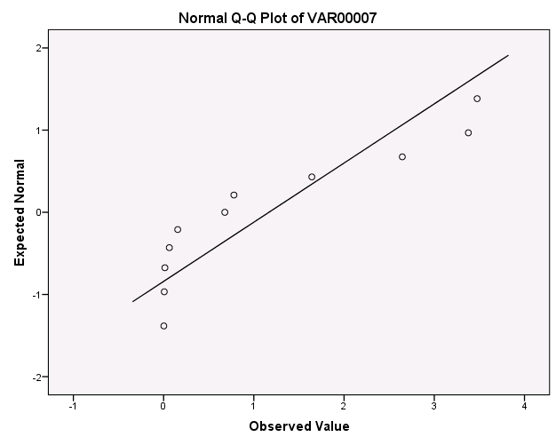

Group B:

Tests of Normality
 | Kolmogorov-Smirnovª |  |  | Shapiro-Wilk
 | Statistic | df | Sig. | Statistic | df | Sig.
Group B: | ,273 | 6 | ,184 | ,795 | 6 | ,053
a. Lilliefors Significance Correction

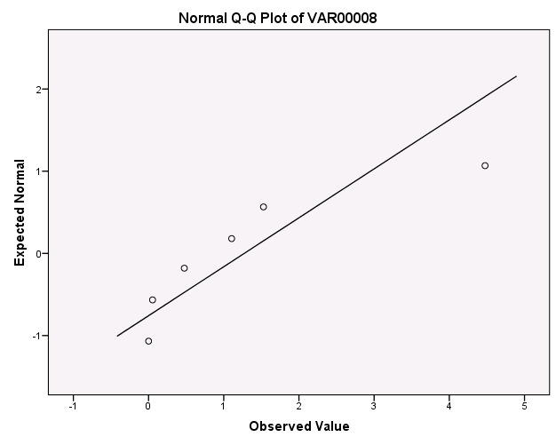

Group C:

Tests of Normality
 | Kolmogorov-Smirnovª |  |  | Shapiro-Wilk
 | Statistic | df | Sig. | Statistic | df | Sig.
Group C: | ,385 | 3 | . | ,750 | 3 | ,000
a. Lilliefors Significance Correction

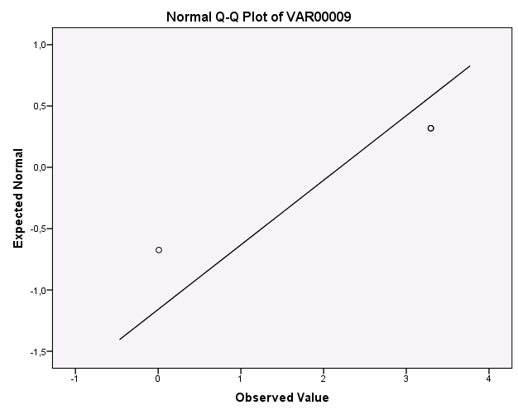

Group D:

Tests of Normality
 | Kolmogorov-Smirnovª |  |  | Shapiro-Wilk
 | Statistic | df | Sig. | Statistic | df | Sig.
Group D: | ,323 | 14 | ,000 | ,652 | 14 | ,000
a. Lilliefors Significance Correction

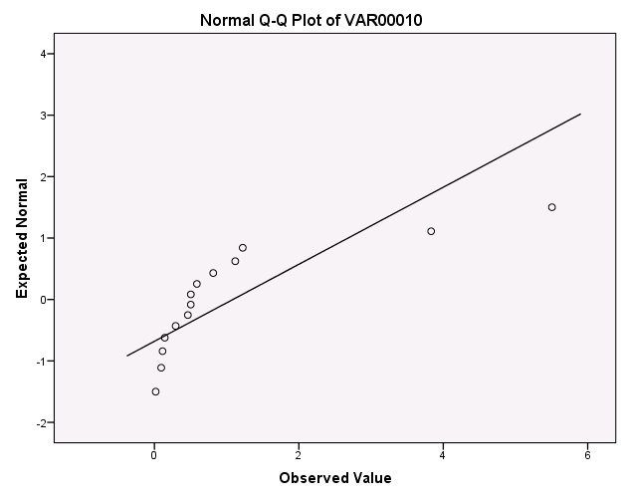

Group E:

Tests of Normality
 | Kolmogorov-Smirnovª |  |  | Shapiro-Wilk
 | Statistic | df | Sig. | Statistic | df | Sig.
Group E: | ,183 | 5 | ,200* | ,968 | 5 | ,860
a. Lilliefors Significance Correction
*. This is a lower bound of the true significance.

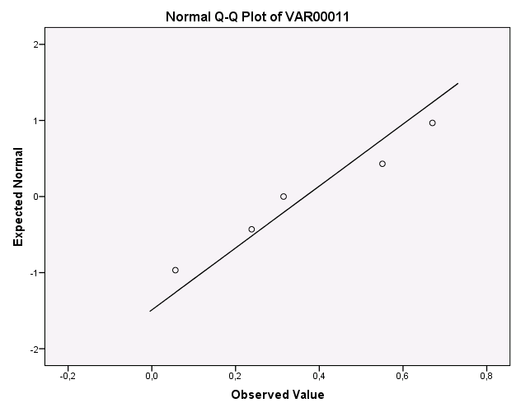

Group F:

Tests of Normality
 | Kolmogorov-Smirnovª |  |  | Shapiro-Wilk
 | Statistic | df | Sig. | Statistic | df | Sig.
Group F: | ,300 | 55 | ,000 | ,548 | 55 | ,000
a. Lilliefors Significance Correction

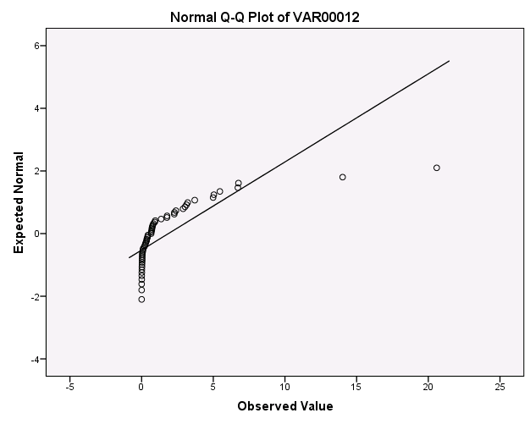

Kolmogorov-Smirnov test results for non-announcing firms in the Post-IFRS period.

Group A:

Tests of Normality
 | Kolmogorov-Smirnovª |  |  | Shapiro-Wilk
 | Statistic | df | Sig. | Statistic | df | Sig.
Group A: | ,294 | 22 | ,000 | ,675 | 22 | ,000
a. Lilliefors Significance Correction

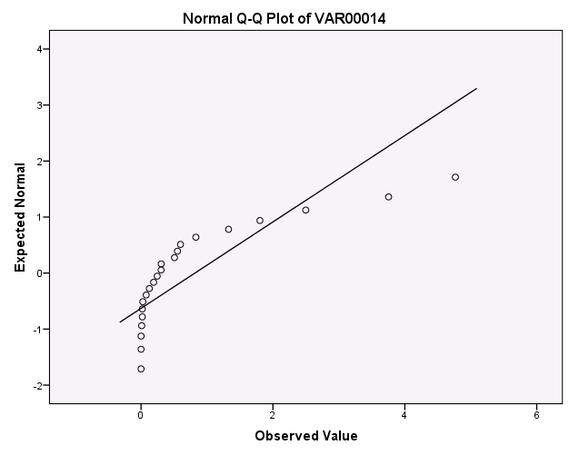

Group B:

Tests of Normality
 | Kolmogorov-Smirnovª |  |  | Shapiro-Wilk
 | Statistic | df | Sig. | Statistic | df | Sig.
Group B: | ,331 | 10 | ,003 | ,607 | 10 | ,000
a. Lilliefors Significance Correction

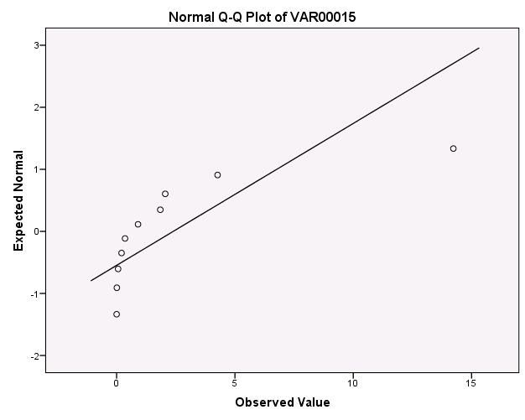

Group C:

Tests of Normality
 | Kolmogorov-Smirnovª |  |  | Shapiro-Wilk
 | Statistic | df | Sig. | Statistic | df | Sig.
Group C: | ,234 | 6 | ,200* | ,869 | 6 | ,222
a. Lilliefors Significance Correction
*. This is a lower bound of the true significance.

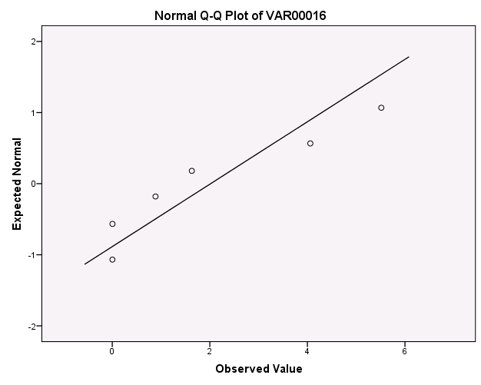

Group D:

Tests of Normality
 | Kolmogorov-Smirnovª |  |  | Shapiro-Wilk
 | Statistic | df | Sig. | Statistic | df | Sig.
Group D: | ,382 | 22 | ,000 | ,409 | 22 | ,000
a. Lilliefors Significance Correction

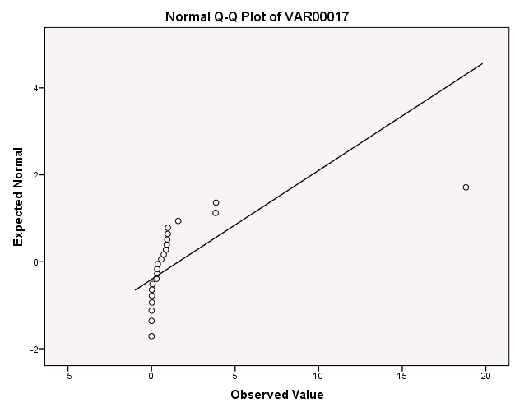

Group E:

Tests of Normality
 | Kolmogorov-Smirnovª |  |  | Shapiro-Wilk
 | Statistic | df | Sig. | Statistic | df | Sig.
Group E: | ,239 | 15 | ,021 | ,731 | 15 | ,001
a. Lilliefors Significance Correction

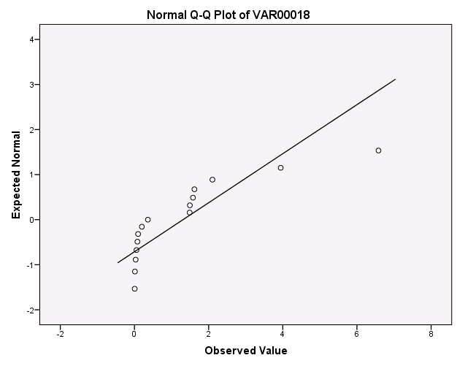

Group F:

Tests of Normality
 | Kolmogorov-Smirnovª |  |  | Shapiro-Wilk
 | Statistic | df | Sig. | Statistic | df | Sig.
Group F: | ,298 | 116 | ,000 | ,552 | 116 | ,000
a. Lilliefors Significance Correction

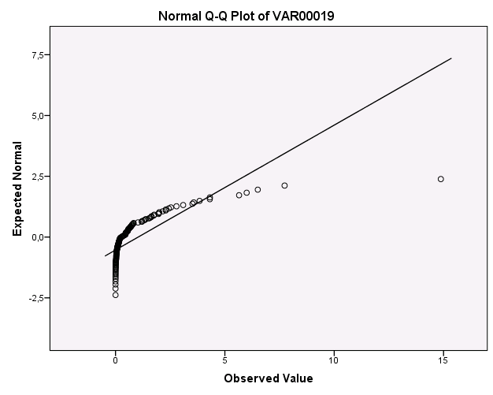

Results Spearman rank correlation

Pre-IFRS period:

Correlations
 |  |  | Announcing firms | Non-announcing firms
Spearman's rho | Announcing firms | Correlation Coefficient | 1,000 | ,086
Spearman's rho | Announcing firms | Sig. (2-tailed) | . | ,872
Spearman's rho | Announcing firms | N | 6 | 6
Spearman's rho | Non-announcing firms | Correlation Coefficient | ,086 | 1,000
Spearman's rho | Non-announcing firms | Sig. (2-tailed) | ,872 | .
Spearman's rho | Non-announcing firms | N | 6 | 6

Post-IFRS period:

Correlations
 |  |  | Announcing firms | Non-announcing firms
Spearman's rho | Announcing firms | Correlation Coefficient | 1,000 | ,143
Spearman's rho | Announcing firms | Sig. (2-tailed) | . | ,787
Spearman's rho | Announcing firms | N | 6 | 6
Spearman's rho | Non-announcing firms | Correlation Coefficient | ,143 | 1,000
Spearman's rho | Non-announcing firms | Sig. (2-tailed) | ,787 | .
Spearman's rho | Non-announcing firms | N | 6 | 6

http://www.businessdictionary.com/definition/stakeholder.html#ixzz1ympaun6F
Kim and Li (2010) decide to use GICS codes based on the study of Bojraj et al. (2003). The study of Bojraj et al. (2003) compares four different types of industry classifications in a variety of applications common to capital market research. Their results show that the GICS definition of industries is significantly better than using SIC codes at explaining stock return comovements.
The reason why computations in this paper are based on two-trading-days time periods, is because of the inability to specify the exact trading day that the earnings announcement becomes to the market. If the announcement date is for example January 30, it could be that the announcement had been released the day before during or subsequent to the close of trading.
http://www.eur.nl/edsc/nederlands/handleidingen/event_study/datastream_event_study_tool/
A. Field (2009), Discovering statistics using SPSS third edition, p. 144
A.Field (2009), Discovering Statistics using SPSS third edition, p. 180
Result statistics are included in the Appendix

