

Social Responsibility in the Fast Food Industry
Choice Based Conjoint Analysis

Master Thesis
-
ERASMUS UNIVERSITY ROTTERDAM
Erasmus School of Economics
-
R.A.J. Dijkstra
-
19-12-2012
-
Supervisor: Prof. Dr. A.C.D. Donkers

Abstract
This study provides insights on consumer preferences regarding product features that relate to social responsibility in the fast food industry, based on choice based conjoint analysis. Although the fast food industry is not known for its contribution to social responsibility, and suffers a rather unhealthy image, it could pay off for firms to exploit social responsible product features. It turns out that consumers arguably do take social responsible products attributes into consideration.

This study shows that social responsible product attributes are important factors to which consumers attach relatively most value when purchasing fast food. More specifically, consumers prefer social responsible product attributes. In particular can be stated that consumers prefer paper packaging over plastic packaging. For the use of biological potatoes however, no convincing evidence is found. Although results are mixed, limited evidence is found for an ‘information effect’. If consumers are more informed about social responsible initiatives, preferences regarding these initiatives become stronger.

Furthermore, this study explorers whether segmentation bases can be identified. The results indicate that male, older, higher educated, and more actively involved in social responsibility consumers tend to appreciate social responsible initiatives relatively more.
Table of contents
1. Introduction 5
1.1 Goal(s) 5
1.2 Relevance of the study 5
1.3 Problem statement and research question(s) 6
1.4 Process and methodology 6
1.5 Structure of thesis 7
2. Theoretical framework 8
2.1 CSR 8
2.1.1 CSR in the food and beverage industry 10
2.2 Consumer behavior 11
2.2.1 Consumer behavior with regard to CSR 13
2.3 Willingness to pay 14
3. Hypotheses and conceptual framework 15
3.1 Hypotheses 15
3.2 Conceptual framework 19
4. Methodology 20
4.1 Conjoint analysis 20
4.1.2 Choice model 22
4.2 Research design 23
4.2.1 General approach/data collection 23
4.2.2 Experimental design 24
4.2.3 Information effect 27
4.3 Methods for analysis 28
4.3.1 Relative importance 29
4.3.2 Willingness to pay 29
5. Results 31
5.1 Descriptive statistics 31
5.2 Binary logistic regression 33
5.3 Relative importance 34
5.4 Willingness to pay 35
5.5 Segmentation 36
6. Discussion 40
6.1 Relative importance 41
6.2 Willingness to pay 41
6.3 Segmentation 42
7. Conclusion 45
7.1 Limitations 46
7.2 Future research 46
References 47
Appendices 52
Appendix 1 52
Appendix 2 57
Appendix 3 58
Appendix 4 59
Appendix 5 60
Appendix 6 61
Appendix 7 62

1. Introduction
When one thinks of social responsibility in relation to fast food, unhealthiness is what often comes to mind then. Nonetheless, like in many other industries, also in the fast food industry social responsibility has gained attention. Firms not only improve the ‘healthiness’ of the assortment (e.g. responsible preparation), firms also aim on sustainable resourcing and recycling. By doing so, firms adjust to the emerging ‘green’ movement that is occurring across markets. However, knowledge about customer preferences lacks the fast food industry at this point. That is why it is valuable to gain insights about how consumers think about social responsibility in relation to the fast food industry, and to what extent this is considered when making purchase decisions. Although the research aims for a broader scope, this study will focus on one particular product in the fast food industry: fries (fried potato strips).

1.1 Goal(s)
The goal of this study is to provide insights on the consumer preferences regarding social responsibility in the fast food industry. These insights will be based on the purchase intentions of consumers, which are translated into two standards that can provide meaningful interpretations. One part aims to explore the relative importance that consumers attach to social responsible product features when buying fries. In the other part, the willingness to pay for social responsible features will be examined.

1.2 Relevance of the study
This study contributes to the literature, as well as to the fast food industry in practice. Since there does not exist a lot of research on social responsibility in the fast food industry, this specific combination contributes to the academic literature covering an open (sub) field of research. Literature exists on specific items that are incorporated in this research, for example sustainable packaging, biological products, however not in this context.

For the industry, this study provides new insights about the consumer perspective towards social responsibility. If new initiatives are about to implemented a cost benefit analysis, think of accountable marketing, is what predominates the decision making process. However, as long as the benefits are troubled, which is often the case with initiatives that relate to social responsibility, firms might be unsecure about initiating such projects. Therefore, this study contributes to the fats food industry by providing insights on the potential benefits that arise from CSR initiatives.

1.3 Problem statement and research question(s)
The problem statement is formulated as follows:

Do social responsible product features pay off in the fast food industry?

To answer this statement and provide guidance throughout the research, multiple subsequent research questions are presumed:

- What is the relative importance that consumers attach to social responsible features in their fast-food/fries buying decision, compared with other attributes.
- What price premium are consumers willing to pay for social responsible attribute levels when buying fries?
- Can segments of consumers be defined based on their preference for different fries attributes?
- To what extent are these consumer segments different in terms of demographic characteristics and personal values?

1.4 Process and methodology
This study can be typified as a choice based conjoint analysis. In order to generate the data for the analysis, a survey will be conducted. The main part of the questionnaire covers choice tasks were respondents are asked to indicate their most preferred alternative, or, the alternative that they were most likely to purchase, given the stated choice setting.

To explore the role of information provision with regard to consumer decision-making, a second questionnaire is developed. The first questionnaire does not contain any further explanation on social responsibility. The second questionnaire does contain information on social responsibility in general, and social responsible product features in particular.

The generated data than is used to estimate a binary logistic regression. The results will provide insights on the consumer preferences indicating the relative importance attached to the separate attributes. Furthermore, based on these data the willingness to pay for social responsible product features can be estimated. The last part of the analysis specifies around segmentation. The segments are On beforehand segments are composited to explore the differences between classifications.

1.5 Structure of thesis
The remainder of this thesis is divided into 6 chapters. Chapter 2 opens with an overview of the theoretical background around the most important topics, such as social responsibility and consumer behavior. Then, in chapter 3, the hypotheses are formulated. Furthermore this chapter contains a conceptual framework in order to clarify the researched relations. The methodology used is explained in chapter 4. This chapter starts with the an introduction to the type of research, choice based conjoint analysis, and then proceeds with the research design, and closes with the methodologies used for analysis. Chapter 5 displays the results that are found executing the analysis. Then in chapter 6, the results are interpreted and processed in the discussion. The research will be finalized with the conclusion in chapter 7. This chapter also pays attention to the limitations and looks at future research.

2. Theoretical framework
This chapter contains an overview of the theoretical background around the areas that are relevant to the research questions. Corporate Social Responsibility is the first concept that is illustrated, which represents the firm side in this study. Attention is paid to Corporate Social Responsibility in general as well as industry specific. Then, insights about consumer behavior are provided, representing the consumer side. The last part of this chapter is more about the methodology, willingness to pay.

2.1 CSR
Appointing Corporate Social Responsibility (CSR) for the first time, Business Social Responsibility was seen as a governmental job and not a corporate responsibility. (Levitt, 1958) Thereafter, adhering several theories like the agency theory, (Friedman, 1970) the stakeholder theory, (Freeman, 1984) the stewardship theory, (Donaldson/Davis, 1991) and the developments of CSR over time have been, and still are, a thankful topic for research.

With so many conflicting goals and objectives, the definition of CSR is not always clear. (McWilliams & Siegel, 2001) Therefore CSR has been defined in numerous ways. (Dahlsrud, 2006) Moreover, there is no standardized framework to depict CSR. As the awareness for sustainability has grown, so have the attempts to understand and apply CSR principles. Two of those attempts have a prominent role in academic literature as well as in the business environment: the CSR pyramid of Carroll (1991) and the Triple Bottom Line (TBL) approach of Elkington (1998).

The CSR pyramid of Carroll (1991) suggests that four kinds of social responsibility constitute total CSR: economic, legal, ethical and philanthropic. In the perspective of this model firms are expected to be profitable (economic), to obey the law (legal), to do what is right (ethical), and to contribute resources to the community (philanthropic). Since this model is displayed as a pyramid, a hierarchy is assumed. The basic layer of this model is the economic component being the most essential.

According to the TBL approach (Elkington, 1998) a firm should prepare three different bottom lines in order to measure the overall performance: economically, environmentally, and socially. Only then firms take into account full costs. The TBL approach is an accounting framework that has been developed to measure sustainability. Each component of the TBL includes several specific, measurable points of reference that may be useful in the pursuit of a competitive advantage.

To illustrate the transition from the model to applicable measures several clarifying examples are provided next. Economic measures include: sales, profits, return on investment, taxes paid, monetary flows, and jobs created. Environmental measures include: air and water quality, energy usage, and waste produced. Social measures include: labor practices, health and injuries, community impacts, human rights, and product safety. (Savitz et. al, 2006)

The TBL approach underlies the same fundamental principle as the Balanced Score Card (BSC) (Kaplan & Norton, 1996): that what you measure is what you get, because what you measure is what you are likely to pay attention to. Only when companies measure their social and environmental impact we will have socially and environmentally responsible organizations. (Economist, 2009)

Since profit maximization is every firm’s primary objective, (Merchant & Van der Stede, 2003) initiated CSR activities are expected to be beneficial. In an effort to assess the validity of concerns regarding a tradeoff between investment in CSR and profitability, yet a lot of research has been done. However, results are mixed and no unambiguous relation between social performance and financial performance has been identified. (McWilliams & Siegel, 2000, 2001) Despite the lack of an unambiguous relation between social and financial performance, firms do derive several benefits that contribute to firm performance. Proponents of CSR claim that it provides tangible business benefits, such as employee retention, corporate image, and brand image. (Sen & Bhattacharya, 2001)

2.1.1 CSR in the food and beverage industry
Narrowly speaking, the fast food industry could be considered an industry at its own. However, not much literature exists about this particular industry. Therefore, a somewhat broader scope is taken. To create a meaningful theoretical background the focus now lays on the food and beverage industry.

Examining CSR in the food and beverage industry, three specific characteristics can be identified. (Hartmann, 2011) First, the sector has a high impact and strongly depends on natural, human, and physical resources. (Genier et al., 2009) Second, because food is one of the basic human needs, consumers do have strong preferences for what they eat. This leads to a complex set of requirements for the food sector regarding the production of the raw materials (animal welfare), the environmental (e.g. energy and water use or waste) and social (labor conditions) conditions along the whole value chain as well as the quality, healthiness, and safety of products. (Maloni & Brown, 2006) Third, since small and large enterprises differ in their approach to CSR, potential conflicts can occur regarding CSR involvement throughout the supply chain. (Hartman, 2011)

In order to make the transition to applicable measure, recall the examples that are given in relation to the TBL approach, industry specific performance indicators can be identified. In addition to these performance indicators that are rather general for CSR, in concerning the food and beverage industry two particular categories can be identified: sourcing and animal welfare. (GRI, 2011) The sector depends on primary production, such as agriculture and fisheries for its raw materials. Obtaining raw materials directly from primary producers, brokers, commodity markets or some combination of these carries inherent material risks, which can affect food processing companies and society. (GRI, 2011)

This section concludes with a few clarifying, specific examples of the application of CSR in the food and beverage industry. One example of social responsibility in the sourcing perspective is fairtrade. Not to confuse with fair trade, fairtrade is an independent organization that empowers sustainability by supporting improved trading conditions. When a product carries the fairtrade label, it means the producers and traders have met fair trade standards. The standards are designed to address the imbalance of power in trading relationships, unstable markets, and the injustices of conventional trade. (Fairtrade, 2012)

A recent example of attention for animal welfare is the ‘plofkip’. The foundation Wakker Dier initiated a campaign because chickens that are bred for consumption suffer severely. In order to maintain low prices or even decrease prices, breeders fatten chickens to meet profit-maximizing requirements. Supermarkets now communicate whether they sell ‘plofkippen’ or not, so that consumers can take this into account. (Wakker Dier, 2012)

A striking example of a sustainable brand in the food and beverage industry, is the ‘puur&eerlijk’ brand of Albert Heijn. The products that are sold under this label are produced, grown, or purchased with extra care for people, animals, nature, or the environment. The brand is build around five social responsible categories that each refer to the origin of the product: biological, fair trade, sustainable fishing, range, and ecological. (Ahold, 2012)

2.2 Consumer behavior
Consumer behavior can be defined as activities that people undertake when obtaining, consuming, and disposing products and services, or simply stated why people buy. Consumers are making choices among products continuously. However, explaining human behavior is an even more difficult task. In order to provide insights explaining consumer behavior, this study will build upon the work of Icek Ajzen. Building on the theory of reasoned action, (Ajzen & Fishbein, 1975) the theory of planned behavior (Ajzen, 1991) has proven to be a successful framework for modeling consumer behavior.

A central factor in the theory of planned behavior is the individual’s intention to perform a given behavior. And intentions are assumed to capture the motivational factors that influence behavior, indicating how much of an effort they are planning to exert to perform the behavior. Although some behaviors may in fact meet this requirement quite well, the performance of most depends at least to some extent on such non-motivational factors as availability of requisite opportunities and resources. (Ajzen, 1985)
The theory of planned behavior postulates three conceptually independent determinants of intention. The first is the attitude towards the behavior and refers to the degree to which an individual had favorable of unfavorable evaluation or appraisal of the behavior in question. The second predictor is a social factor termed subjective norm. It refers to the perceived social pressure to perform or not to perform the behavior. The third antecedent of intention is the degree of perceived behavioral control that refers to the perceived ease or difficulty of performing the behavior and it assumed to reflect past experience as well as anticipated impediments and obstacles.

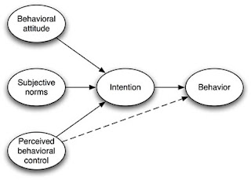
Model 2.1 - theory of planned behavior (Ajzen, 1985)

When taking a closer view on attitude formation, the definition of attitude can be expanded as a cognitive process involving positive or negative valences, feelings, or emotions. An attitude towards an object involves a stirred-up state, a positive or negative feeling or motivational component. It is an interrelated system of cognition, feelings, and action tendencies. (American Marketing Association, 2000) Because attitudes are very complex, researchers may use multiattribute attitude models to understand them. This type of model assumes that a consumer’s attitude towards a product depends on the beliefs he or she has about several of its attributes. Various attributes often constitute a single product, and liking of products depends on the composition of the product. These specific attributes are then combined to derive a measure of the consumer’s overall attitude.

Basic multiattribute models contain three specific elements (Solomon, 2010):

1. attributes – characteristics of the product.
2. beliefs – cognitions about the specific product, usually relatively to other products.
3. importance weigths – reflects the relative priority of an attribute to the consumer.

To conclude this section, the most influential multiattribute model is called the Fishbein model and its basic formula is denoted as follows:
$$A_{jk}=\sum{β_{ijk}}* I_{ik}$$
$i$ = attribute
$j$ = brand
$k$ = consumer
$I$ = the importance weight given attribute I by consumer k
$β$ = consumer k’s belief regarding the extent to which brand j possesses attribute i
$A$ = a particular consumer’s (k’s) attitude score for brand/product j

2.2.1 Consumer behavior with regard to CSR
Consumers that specifically act on the extent to which a product is social responsible can be tagged ethical consumers. Ethical consumption is that consumption which meets people’s needs without compromising the ability of other people to meet their needs, either now or in the future. There are studies that confirm the appreciation of CSR initiatives. Research suggests that there is a positive relationship between a firms CSR activities and consumers’ attitude towards that firm and its products. (Mohr et al., 2001) Consumers have become increasingly concerned about social responsible product attributes. (GRI, 2011) However, while many consumers like the idea of social responsibility, the ethical consumption remains low. Thus, a positive attitude towards CSR does not necessarily lead to actual purchase behavior.

Two main barriers to ethical consumption can be identified: the willingness to pay for it, and the information asymmetry between firms and consumers. (Etile & Teyssier, 2011) In order to make optimal choices, consumers need to be perfectly informed, hence that consumers are always better off when they have more information. (Teisl, et al., 2001) However, despite social reporting and initiated benchmarks, customers do often lack information about CSR initiatives of firms. Therefore social and environmental quality of the production process is difficult to observe. This asymmetry of information between seller and consumers implies that the latter are not able to purchase the goods that best match their preferences.

2.3 Willingness to pay
Willingness to pay (WTP) refers to the maximum price that people would pay for a given product. Knowledge about a product’s WTP on behalf of its (potential) consumers plays a crucial role in many areas like pricing decisions or new product development. As mentioned before, the WTP for a product is one of the main barriers for ethical consumption.

As a result of missing adequate knowledge of the customer’s WTP for their products, firms fail to pursue a pricing strategy that is suitable customized to their marketing environment and thus also risk ignoring valuable sources for increasing profitability of the offered product. Often adopted price strategies could be denoted as intuitively. (Breidert et al., 2006)

Moreover, Dam (2008) describes how the economics behind CSR work, and denotes why it is essential that consumers are willing to pay a certain amount for CSR. Engaging in CSR namely implies that firms restrain their own conduct, that they limit their set of production possibilities. This implies that the benefits of CSR come at a cost. In an economic equilibrium, the benefits should at least outweigh the costs. For example, if CSR is motivated through vertical product differentiation, consumers bear the costs by paying a higher price. If CSR is motived through socially responsible investment, than the investors are bearing the costs through reduced returns. However, because of altruism, it does not always have to be the case that the agent who receives the benefits also ‘pays’ for CSR.

3. Hypotheses and conceptual framework
This chapter concentrates around the hypotheses that are stated as a starting point of the research. These hypotheses follow from the research questions and the theoretical background as provided in previous chapters. Also, in order to outline the relations to be researched the conceptual framework is clarified in this chapter.

3.1 Hypotheses
In line with the goal of this study, the hypotheses are driven by the proposed research questions. The hypotheses can basically be divided into three parts. The first two hypotheses relate to the relative importance weights respondents attach to the separate attributes. The third and fourth hypotheses focus on the WTP for social responsible attribute levels. The last two hypotheses test for contingent segments based on respondents’ preferences.

Since consumers are assumed to make trade-offs between different attributes of a product based on their preferences, (Ajzen, 1991) consumers are expected to value the separate attributes of fries relatively different. This implicates that consumers would also value social responsible product features separately from other product features. However, nothing is known yet about how social responsible product attributes compare to other attributes. Based on the increased awareness for ethical consumption, the expectation increases that consumers also value social responsible product attributes in particular, which resulted in the following hypothesis is stated:

H1: Consumers do relatively attach more value to social responsible product attributes than to other attributes.

Being one of the main barriers that withhold consumers from ethical consumption is the information asymmetry that exists between consumer and seller. (Etile & Teyssier, 2011) In order to break through this barrier firms try to inform their customers properly, for which are several ways to do so. Firms can provide consumers with detailed information through texts on packaging, in store displays, or advertising. An inventive alternative is informing through labels that represent a certain statement. One example of such a label is fairtrade, which is explained in section 2.1.1. These labels are proven to effectively inform consumers. Whether it is through detailed text or labels, it is valuable to know whether the provision of information can effectively break the barrier of information asymmetry.

Therefore, to see whether CSR-related information triggers consumers to put more emphasis on CSR-related attributes when buying fries, an ‘information effect’ will be tested. Consumers that are specifically informed are expected to attach more relative importance to CSR-related attributes. This resulted in the following hypothesis:

H2: Consumers that are specifically informed about CSR (-related product features) attach more relative importance to CSR-related attributes.

The second part concentrates around the WTP for social responsible product features. When it comes to social responsible product features it is important for firms to gain insights about the WTP of potential consumers. For cost-benefit reasoning, someone has to bear the costs for CSR initiatives, (Dam, 2008) it is necessary to gain insights on the WTP for such attributes. Although WTP is known as a barrier (Etile & Teyssier, 2011) for consumers to purchase social responsible products, the increasing attention for social responsible products could encourage consumers to get involved and pay that extra mount of money. Altogether, it remains unsure and doubtful whether consumers are sincerely willing to pay an extra amount of money for CSR when buying fries. However, the following hypothesis resulted:

H3: Consumers are willing to pay a price premium for social responsible product features.

Hypothesis 4 is related to hypothesis 3 the same way as hypothesis 2 is related to hypothesis 1. Similarly, now will be tested for an ‘information effect’ on WTP. To convince customers and thus to be successful in CSR differentiation, firm must make customers fully aware of the CSR characteristics. Only then customers are willing to pay for these attributes, otherwise customers will purchase a similar product without social responsible attributes. (McWilliams & Siegel, 2001) This resulted in the following hypothesis:
H4: Consumers that are specifically informed about CSR (-related product features) are willing to pay more for social responsible product features.

As business’ desire to improve the sustainability of their products and practices, they often seek to identify consumers who will be receptive to more sustainable products and, if possible who will pay a premium. Therefore, firms divide their (heterogeneous) target market into smaller (homogeneous) segments that can be targeted more specifically. This type of study is very useful to provide insights on market segmentation. Segments are in this study divided a priori, for which separate hypothesis will be stated. These (sub) hypotheses are derived from a more general statement:

H5: Based on the derived utility that consumers derive from the attributes separately, segments can be identified.

Taking into account earlier attempts to profile the green consumer demographically, Straughan and Roberts (1999) provide several insights. The general belief is that younger individuals are likely to be more sensitive to environmental issues. The most common argument is that those who have grown up in a time period in which environmental concerns have been a salient issue at some level, are more likely to be sensitive to these issues. Most researchers argue that women are more likely than men to hold attitudes consistent with the green movement. Theoretical justification for this comes from Eagly (1987), who holds that women will, as a result of social development and sex role differences, more carefully consider the impact of their actions on others. The demographic education is expected to positively correlate to environmental issues, as that has been found fairly consistent across researches. These insights have resulted in the following (sub) hypotheses:

H5a: Women do value social responsibility more than men.
H5b: Younger consumers do value social responsibility more than older consumers.
H5c: Higher educated consumers do value social responsibility more than lower educated consumers.

Also psychographic factors are taken into account. Two multiitem scales are included in the research in order to assess the extent to which consumers are involved in social responsibility. One scale aims on the expectations that consumers have from firms, the other scale measures the active involvement of consumers in social responsibility. (Mohr & Webb, 2006) Obviously, consumers that are more involved in social responsibility are expected to value social responsible product features higher than consumers that are less involved, which resulted in the following (sub) hypothesis:

H5d: Consumers that do high expectations for firms regarding CSR do value social responsibility more.
H5e: Consumers that are more actively involved in social responsibility do value social responsibility more.

3.2 Conceptual framework
The conceptual framework outlines the approach that is used to connect all aspects as included in the research. It provides a route map that should lead throughout the research.

Demographics & personal values (H5 a-e)

- Relative importance (H1 & H2)
- WTP (H3 & H4)

utility derived from attributes

‘Fries’ attributes

Information provision on CSR activities (H2 & H4)

Model 3.1 – conceptual framework

In short, to start at the left side, consumers are asked to make choices between product profiles that are composited of changing levels of attributes of fries. From these choices, the utility for each attribute level can be derived. This utility will used to calculate the relative importance of the separate attributes (H1 & H2) and the WTP (H3 & H4). The ‘information effect’ (H2 & H4) and the identified segments (H5 a-e) are expected to affect the utility that consumers derive from the separate attributes and attribute levels.

4. Methodology
Within this chapter is explained what techniques are incorporated in the research, and how the methods of analysis contribute in generating meaningful insights. The basis for this research is choice based conjoint analysis. Being a specific type of conjoint analysis, first will be explained why this is such a suitable method. Then, specifying on the application of choice based conjoint analysis, the research design is stressed out. Last, the methods that are used for the analysis, together with related practical implications, are specified.

4.1 Conjoint analysis
Conjoint analysis more generally is any decompositional method that estimates the structure of a consumer's preferences. It estimates preference parameters such as part-worth importance weights given his or her overall evaluations of a set of alternatives that are pre-specified in terms of levels of different attributes. (Green & Srinivasan, 1978) These trade-offs can be decomposed into part-worth utilities and importance weights for each product attribute. In this way, the importance of different attributes or criteria in the consumer’s evaluation of the product can be studied. (Green, Rao, and Desarbo 1978)

Part-worth utilities thus reflect the contribution of an attribute level to the total utility. The deterministic component of a consumer’s utility for alternative $k$ will be expressed as a linear function of observed variables, the attributes of $k$. In general this is stated as:

$$v_{k}=\sum_{j∈T}{b_{jk}}x_{jk}$$
Where:
$x_{jk}^{i}$ = observed value of attribute j of alternative k for consumer i, and
$b_{jk}$ = utility weight of attribute j of alternative k.

Conjoint analysis is one of the most important tools to support product development, pricing, and positioning decisions in marketing practice. (Wittink, 1994) Therefore, conjoint analysis is a popular marketing research technique that marketers use to determine what features a new product should have and how it should be priced.

Researchers have developed different types of conjoint analysis, and consequently different techniques to estimate parameters of these different types of conjoint analysis. Several conjoint methods can be identified, broadly divided as ratings-based approaches and choice-based approaches. In ratings-based approaches respondents are asked to rate or rank a series of product profiles. Choice based conjoint requires respondents to choose between two or more alternatives. As compared to ranking or rating based conjoint approaches, choice based conjoint analysis seems to be more realistic in imitating real shopping behavior. (Natter & Feurstein, 2002)

4.1.1 Choice based conjoint analysis
Where traditional conjoint analysis consists of pairwise comparisons, in choice based conjoint analysis, also known as discrete choice analysis, respondents can be asked to choose between a set of alternative product profiles. (Louviere & Woodworth, 1983) The connection to conjoint analysis lies in the ability to decompose products into attribute levels and estimate part-worth utilities for these levels. The difference lies in the underlying estimation methods. For choice based conjoint analysis specifically the utility structure is estimated based on a choice set. Every choice can be described in terms of its attributes. The respondents are presented different alternatives and indicate which one they would actually choose. (Breidert, 2006)

A latent preference for every choice in the displayed set is assumed to exist at the aggregate level. The displayed set refers to the set of possible products or brands the respondent is currently considering in the decision process. This latent preference is estimated based on choices between different product profiles the respondents make during the analysis. For every respondent the utility value for a choice is modeled consisting of a deterministic component, that represents the latent preference structure at the aggregate level, and a random component. The random component is due to fluctuations in perceptions, attitudes, or other unmeasured factors (McFadden, 1986). (Breidert, 2006)

4.1.2 Choice model
The multinomial logit model computes the probability of choosing an alternative as a function of the attributes of all alternatives available. Although the choice tasks in this study consist of two alternatives, and thus can be typified as a binary choice model, the underlying assumptions are similar. As a choice model, the random utility model (McFadden, 1986) of consumer evaluation underlies the explanation, which Guadagni and Little (1983) briefly outline as follows:

Consider an individual, $i$, confronted with a choice from a set, $S_{i}$ , of alternatives.
Suppose that:

- Alternative $k∈S_{i}$ holds for the individual a preference or utility:

$$\left(1\right) u_{k}=υ_{k}+ ϵ_{k'}$$
Where:
$υ_{k}$ = deterministic component of $i$’s utility, to be calculated from observed variables, and
$ϵ_{k}$ = random component of $i$’s utility, varying from choice occasion to choice occasion, possibly as a result of unobserved variables

$\left(2\right)$Confronted by the set of alternatives, individual $i$ chooses the one with the highest utility on the occasion, hence, the probability of choosing $k$ is:

$$\left(2\right) p_{k}=P \{u_{k}≥ u_{j}, j∈S_{i}\}$$

Consumer choice can be stated the most important variable in marketing. Every day numerous choices are made, of which a lot are part of a purchase decision. Therefore, it is of great importance for firms to be able to fit a suitable model.

4.2 Research design
Building on the type of research, this research has been designed. This section elaborates on the actual research to conduct. After a general overview of the process is provided, the survey itself is explained more extensively. In particular the design of the choice model will be discussed into detail.

4.2.1 General approach/data collection
In order to collect meaningful data for analysis, an indirect survey is performed. The survey has been conducted through an online questionnaire. The survey basically consists of two questionnaires, questionnaire A and questionnaire B, which are mainly similar. However, questionnaire B includes extra information about CSR in order to gain insights on the effect of the provision of information. Both questionnaires are launched simultaneously.

The questionnaire can broadly be divided into three parts. In the first part, respondents will be asked for several demographics: gender, age, education, and the frequency of eating fries. The second part contains two multiitem measures to assess the extent to which respondents are concerned with the environment, socially responsible purchases, and disposal. (Mohr & Webb, 2005) Both measures contain three questions regarding social responsibility. The first three relate to the extent to which firms are expected to contribute to social responsibility. The second three relate to the social responsible behavior respondents act on themselves. Respondents indicate to what extent they agree with the statements on a five-point Likert-scale. The third part of the questionnaire incorporates the choice based conjoint analysis. Divided over multiple choice tasks, respondents are asked to indicate their preference given the displayed alternatives. In total, respondents face eight choice tasks, each comparing two alternatives. The next section elaborates on the design of the choice model.

4.2.2 Experimental design
Within the experimental design respondents are submitted eight choice tasks. Each choice task consists of two product profiles that constitute a portion of fries. Respondents are then requested to indicate what alternative, given the choice task, they prefer. Each choice task is initiated with: “Imagine that you are about to purchase a portion of fries, what alternative are you most likely to purchase. Consider all other features that are not mentioned, being equal across the options.” Within the choice tasks respondents compare product profiles that vary across attributes.

The alternatives that are included in the choice tasks are product profiles that are composited of five attributes, varying across attribute levels. The following attributes with specified attribute levels are selected:

Attribute | Levels
Brand | - non-branded  - branded (Bram Ladage)
Packaging | - plastic tray  - paper cone
Type of potato | - undefined potato  - defined potato (Bintje)  - biological potato
Price | - € 1,75  - € 2,00  - € 2,25  - € 2,50
Waiting time | - no waiting time  - 2 minutes waiting time  - 5 minutes waiting time
Table 4.1 – attributes and attribute levels

- Brand;
This study incorporated Bram Ladage to indicate the difference between non-branded and branded fries. Bram Ladage is a franchise chain that sells fresh fries. The current amount of stores is 29 in the region of Rotterdam, The Hague, and Utrecht. In and around Rotterdam, Bram Ladage scores about 100% self-declared brand awareness.

- Packaging;
Packaging plays an important role as it is a major part of the consumer experience with a product. More specifically, the packaging of fries, which is totally different when you have it served in a plastic tray or in a paper cone. A major practical concern that is often raised relates to the sauce. What is the most convenient place to put the sauce. To control for this concern, the research does not include sauce as an attribute. In this study, packaging is one of the attributes that incorporate social responsible potential. In this case we examine the consumer preference between two types of packaging of which one (the paper cone), is assumed relatively more sustainable than the other (the plastic tray).

- Type of potatoes;
The potato is the most essential ingredient for making fries, recall that fries are fried potato chips. Although it is the key ingredient, the type of potato that is used for making the fries is normally not communicated to the consumers. However, in line with the trend that consumers are interested in the origin of the product, it might be interesting to specify the type of potato towards consumers at point of sale. Within this study, when the type of potato is specified, it is exemplified by Bintjes. A Bintje is probably the most famous fries-potato, which a lot of consumers are familiar with. Beyond specification of the potato, also this attribute contains social responsible potential, namely biological potatoes. Biological potatoes are assumed to be a more sustainable choice than are unspecified or specified potatoes.

- Price;
This attribute reflects the amount of money consumers have to pay for a portion of fries. The price level as included in the model is based on the average price level in the industry.
- Waiting time;
The fast food industry implies that consumers expect to receive their food as fast as possible. Therefore the time that a consumer has to wait before his or her fries are being handed over is included in the model.

These attribute levels combine up to 144 (2x2x3x4x3) different alternatives, however respondents are not able to evaluate all these alternatives. An experimental design is used to reduce the number of alternatives that are presented to the respondents. An orthogonal design in SPSS has been performed, and reduced the amount of profiles that are included in the choice tasks to 16:

Profile | Brand | Packaging | Type of potato | Price | Waiting time
1 | non-branded | plastic tray | biological | 2.25 | 2 minutes
2 | branded | paper cone | biological | 2.00 | no waiting time
3 | branded | plastic tray | specified | 2.50 | no waiting time
4 | branded | plastic tray | unspecified | 1.75 | no waiting time
5 | branded | plastic tray | unspecified | 2.00 | 2 minutes
6 | branded | paper cone | unspecified | 2.50 | 2 minutes
7 | non-branded | paper cone | unspecified | 2.25 | no waiting time
8 | non-branded | plastic tray | unspecified | 2.00 | 5 minutes
9 | branded | paper cone | biological | 1.75 | 5 minutes
10 | non-branded | plastic tray | biological | 2.50 | no waiting time
11 | branded | paper cone | unspecified | 2.25 | no waiting time
12 | non-branded | paper cone | specified | 2.00 | no waiting time
13 | branded | plastic tray | specified | 2.25 | 5 minutes
14 | non-branded | plastic tray | unspecified | 1.75 | no waiting time
15 | non-branded | paper cone | unspecified | 2.50 | 5 minutes
16 | non-branded | paper cone | specified | 1.75 | 2 minutes
Table 4.2 – product profiles

From the fractional factorial design, that includes 16 product profiles, eight choice tasks are composited with each comparing two alternatives. Eight is thought to be the maximum amount of choice tasks to include in this study, otherwise the chance increases that respondent get bored and do not answer carefully, which would result in less meaningful data. The structure of the choice tasks is fixed across all respondents. Product profile 1 is linked to product profile 16, 2 is linked to 15, and so on. A full overview of the choice tasks is included in appendix 1. Including an opt-out option as a third alternative to the choice tasks (none of these alternatives) has been taken into consideration, to create a more realistic setting. (DeSarbo et al., 1995) However, the opt-out option is not included because this study does not aim to provide a market simulation.

An example of a choice task as included in the questionnaire is provided here, table 4.3 reflects choice task 1 as included in the questionnaire (products profile 1 vs. 16):

Alternative 1 | Alternative 2
Fries | Fries
in a plastic tray | in a paper cone
made of biological potatoes | made of Bintjes
price: € 2.25 | price: € 2.50
you have to wait 2 minutes | you have to wait 2 minutes
Table 4.3 – example choice task

4.2.3 Information effect
The difference between questionnaire A and questionnaire B is that information on social responsibility is added to questionnaire B. To test for an ‘information effect’, recall hypotheses 2 and 4, two questionnaires have been developed. The first questionnaire (questionnaire A), which be considered the base questionnaire, does not contain any extra information on CSR related product features. The second questionnaire (questionnaire B) does contain an information sheet on CSR. After the introduction to the choice tasks, respondents are informed on social responsibility in general as well on social responsible product attribute levels:

“Before you are displayed the choice tasks, you will be provided with some information about corporate social responsibility:

It is important to take into account that CSR refers to products that are produced, grown, or purchased with extra care for human, animal, nature, and environment.

In particular I would like to emphasize on two product features:
- with regard to CSR, a paper packaging is assumed to be a more sustainable way of packaging than is a plastic packaging.
- furthermore, a biological potato is assumed to be a more sustainable alternative than other types of potato.”

A copy of the questionnaire is included in appendix 1. In addition, the information sheet as displayed in questionnaire B is added in appendix 2.

4.3 Methods for analysis
A binary logistic regression will be estimated based on the collected data. Binary logistic regression is very similar to ordinary least squares regression. The difference exists in the assumption on the outcome of the dependent variable. Where the outcome in ordinary least squares regression is continuous, for logistic regression on the other hand, this is dichotomous. In this study, which comes down to the choice respondents make in the choice tasks, each choice task consists of two alternatives. Although this has implications for the mathematical form, the methods and philosophy of analysis are identical. (Lehmann et al., 1998) Mathematically, the formula that is used for analysis can be stated as follows:

$$Ln choice=α+ β_{1}*brand+β_{2}*paper cone+β_{3}*specified+β_{4}*biological+β_{5}*price+β_{6}*wating_{time}+ε$$

All analyses are performed in SPSS 20, for which now follows a summary of some practical implications. The dependent variable here is choice. Within each choice task, respondents indicate whether they prefer alternative 1 or alternative 2. For analytical reasons, choice is incorporated to the model reflecting whether the respondent does or does not choose alternative 1. This implicitly incorporates the consequences for alternative 2.

The independent variables are the attributes that are included in the choice model. For brand, packaging, and type of potato dummy variables are created. Price and waiting time are included as ratio variables, reflecting the actual value respectively in euros or in minutes. Each choice task, thus eight for each respondent, is placed on a separate row. The independent variables that are included in the analysis are computed manually to create meaningful input. Where the dependent variable, choice, indicates whether respondents prefer alternative 1, the independent variables are entered measuring $x_{1}-x_{2}$. Hence, that when choice indicates whether the respondent prefers alternative 2, the independent variables should be entered as $x_{2}-x_{1}$. The estimated coefficients that result from the binary logistic regression can be interpreted as part-worth utilities. Moreover, these estimates are the input for further calculations, in particular relative importance weights and the WTP.

4.3.1 Relative importance
The relative importance weights indicate to what extent the attributes are taken into consideration when making a buying decision. The calculation of the relative importance of an attribute is based on the range of its part-worth utility levels, the difference between the highest and lowest value. In order to calculate the relative importance on one particular attribute, the range of that attribute is divided by the sum of the ranges across all attributes. (Hair et al., 2006) The relative impact of each attribute is thus based on the size of the range of its utility have a greater impact on the calculated utility values and thus are deemed of greater importance. In this study those utilities are represented by the B-estimates that result from the binary logistic regression. The relative importance across all attributes adds up to 100%.

4.3.2 Willingness to pay
In order to measure WTP, multiple methods can be identified. Breidert et al. (2006) provide a classification based on data collection methods. On the top level of this classification methods can be distinguished whether they utilize surveying techniques (direct or indirect survey) or whether they are based on actual or simulated price-response data (market data or experiments).

The computed willingness to pay is based on the B-estimates that resulted from the binary logistic regression. The utility for price should provide guidance in the conversion from utility to WTP. In this study the utility for price reflects the amount of utility consumers derive for every monetary increase in price, the util per euro ratio. For example, if the price for fries increases with € 1.00, utility increases with the amount that is reflected as the B-estimate for price. In order to come to the WTP for an attribute level, this ratio should be converted in a euro per util ratio. Then, this ratio can be used to translate the utility scores for a certain attribute level into the WTP for this attribute level.

5. Results
After carefully preparing the study as described in the previous chapters, now the results are to be generated. This chapter shows the results of the analyses that are performed. The structure of this chapter will follow the sequence of the questionnaire. First, some descriptive are displayed, after which attention will be paid to the multiitem scales. Then, several binary logistics regression will be estimated, based on the data that is generated through the choice tasks.

5.1 Descriptive statistics
The two questionnaires were posted online and opened for respondents simultaneously. Questionnaire A has been started by 65 persons, of which 56 completed it. Questionnaire B was started and completed by 50 persons. The table below provides insights on the demographics of the respondents. Both samples are very similar regarding the distribution in all categories.

Characteristic |  | Questionnaire A |  | Questionnaire B
Characteristic |  | N (=56) | % (=100) | N (=50) | % (=100)
gender | male  female | 28  28 | 50  50 | 25  25 | 50  50
age class | 18-25  26-35  36-50  51-65  66> | 18  16  7  10  5 | 32  29  12  18  9 | 6  18  14  11  1 | 12  36  28  22  2
education | secondary school  MBO  HBO  WO | 7  15  20  14 | 12  27  36  25 | 4  15  14  17 | 8  30  28  34
Table 5.1 – descriptive statistics

The second part of the questionnaire consists of two multiitem scales regarding the respondents view on CSR. The respondents indicated the extent to which they agree with the statements that are part of the multiitem scales. Both multiitem scales consist of three statements. To include the scales in the analysis, the separate items are composited to one. The separate statements are classified by the respondents on a score from 1 to 5 (strongly disagree = 1; disagree = 2; neutral = 3; agree = 4; strongly agree = 5). The scores per multiitem scale are cumulated and divided by three (the amount of statements) to calculate the average score. These calculations resulted into one score on each multiitem scale for each individual respondent. The computed scores are now recoded into a new variable indicating from strongly disagree to strongly agree (strongly disagree = 1; disagree = 2; agree = 3; strongly agree = 4). Table 5.2 provides an indication of the scores.

Characteristic |  | Questionnaire A |  | Questionnaire B
Characteristic |  | N (=56) | % (=100) | N (=50) | % (=100)
Multiitem scale -  CSR firm | Strongly disagree  Disagree  Agree  Strongly agree | 3  26  27 | 5.4  46.4  48.2 | 2  3  19  26 | 4.0  6.0  38.0  52.0
Multiitem scale -  CSR self | Strongly disagree  Disagree  Agree  Strongly agree | 5  22  26  3 | 8.9  39.3  46.4  5.4 | 4  11  27  8 | 8.0  22.0  54.0  16.0
Table 5.2 – multiitem scores

When comparing the multiitem scales, there are a few things that come forward. First, the distribution for both multiitem scales is comparable between sample A and sample B. With regard to the multiitem scale that aims on the expectations for firms, it appears that consumers are very demanding. The largest part of the respondents (strongly) agrees (A: 46.4% + 48.2% B: 38.0% + 52.0%) to the statement that firms should pay attention to social responsibility. When taking into consideration their own contribution to social responsibility, it comes forward that most respondents actively (A: 46.4% B: 54.0%) pursue social responsibility to some extent. However, there is also a large part that does not (A: 39.3% B: 22.0%).

5.2 Binary logistic regression
The choice based conjoint analyses are performed in SPSS. Since the data was collected through two separate questionnaires, the dataset is divided into two parts. The first part is based on the answers of respondents on questionnaire A, the other part on questionnaire B. The preferences that respondents showed in the completed choice tasks are the input for the binomial logistic regression.

The B-estimates resulting from the binary logistic regression do reflect the utility that is derived from the attribute levels that are included in the model. Before the results that relate to the stated hypotheses are displayed, an overview of the main results over the total sample will be given. This overview touches upon the estimates that immediately draw attention and gives a general idea of the interpretation of the results. The results in table 5.3 are based on the complete sample, including respondent of questionnaire A as well as B. Almost all effects are significant at a 0.01 level, however the other estimates are still under a significance level of 0.05.

Attribute (level) | Utility (B)
Attribute (level) | B-estimate | Significance
branded | .961 | .000
paper cone | 1.879 | .000
specified potatoes | -1.012 | .003
biological potatoes | .577 | .024
price | 1.140 | .025
waiting time | -.426 | .000
Table 5.3 (N = 106)

The results will be indicated shortly. Respondents do derive significantly more (.961) utility from branded fries than they do from non-branded fries. Also the paper cone denotes a (significant) positive coefficient (1.879). This coefficient can be interpreted that respondents value a paper cone more than a plastic tray. The negative coefficient (-1.012) for specified potato reflects that respondents do derive more value from non-specified potatoes than from specified potatoes. The last, convincing significant (sig. < .01) attribute level in this model is waiting time. The negative coefficient (-.426) indicates that the longer consumers have to wait for their fries, the less utility they derive from their purchase. Furthermore, the two other attribute levels in the model are significant at a .05 level. The coefficients indicate that respondents do derive more value (.577) from biological potatoes than from non-specified potatoes. Concerning price, the coefficient (1.140) implies that when the price of a portion of fries is higher, the utility that respondents derive increases.

5.3 Relative importance
For the explanation of the calculations for the relative importance recall section 4.3.1. The relative importance as provided in table 5.4 are based on a binary logistic regression for both questionnaires separately. The outcomes of these binary logistic regressions are provided in appendix 4 and 5. Further calculations of the relative importance can be found in appendix 6.

Attribute | Relative importance of the attributes
Attribute | Questionnaire A (N = 56) | Questionnaire B (N = 50)
brand | 19.7% | 14.1%
packaging | 29.6% | 32.3%
type of potato | 28.9% | 26.7%
price | 12.1% | 22.6%
waiting time | 9.7% | 4.4%
Table 5.4

Derived from table 5.4, packaging (29.6%) and the type of potato (28.9%) are the most important product attributes. Respondents relatively attach the most value to these attributes when buying fries. The third attribute to which respondents pay a considerable amount of attention is brand (19.7%).

Compared to the results for questionnaire A, the relative importance weights that are calculated based on data from questionnaire B show some small shifts. However, packaging (32.3%) and type of potato (26.7%) still are the most important product attributes. In contrast to questionnaire A, it is price (22.6%) to what is paid the most attention after those two.

5.4 Willingness to pay
The results on WTP focus on the social responsible product features. For an explanation of the calculations of WTP recall section 4.3.2. The full outcomes of the binary logistic regressions that form the basis for these calculations are provided in appendix 4 and 5. Further calculations of the WTP are included in appendix 7.

The euro per utility ratio is the starting point for the calculation of the WTP. This ratio is based on the coefficient for price as estimated in the binary logistic regression, which indicates the utility per euro ratio. Table 5.5 indicates the conversion of these ratios.

Questionnaire A (N = 56) |  | Questionnaire B (N = 50)
utility (utils) | price (euro) | utility (utils) | price (euro)
.533 | 1 | 2.170 | 1
1 | 1.88 | 1 | 0.46
Table 5.5

Table 5.5 shows that resulting from this study, the derived utility is positively related to price. Which indicates that when prices go up, the derived utility increases with it. And that is contrary to what should be the case from an economic perspective. Therefore it is difficult to interpret the WTP calculations. Since WTP is largely dependent of the derived utility from the particular attribute level, that part of the results can provide some insights about consumer preferences. Table 5.6 displays the derived utility from the social responsible product features.

Attribute | Utility (B)
Attribute | Questionnaire A (N = 56) | Questionnaire B (N = 50)
paper cone | 1.302** | 3.093**
biological potatoes | .564 | .835
Table 5.6 * significant at 0.05 **significant at 0.01

The results as provided in table 5.6 reflect the derived utility of the respondents for the social responsible attribute levels. When taking these results into consideration, it comes forward that respondents significantly derive utility from a paper cone (1.302). However, no significant effect is found for biological potatoes. When consumers are more informed (questionnaire B), the results increase dramatically. The derived utility from a paper cone (3.093) almost triples compared to questionnaire A. However, the result for biological potatoes (.835) remains insignificant.

5.5 Segmentation
To examine to what extent segments can be identified, several analyses are performed on sample selections. Segments are composited on beforehand, after which the binary logistic regression is performed on these sample selections. Within this section the focus lies on gender, age, education, and the multiitem scales. To examine the differences the utility estimates resulting from the binary logistic regression are displayed in table 5.7 to 5.11.

Attribute (level) | Gender - Utility (B)
Attribute (level) | Male (N = 53) | Female (N = 53)
branded | 1.236* | .879**
paper cone | 2.837** | 1.292**
specified potatoes | -1.802** | -.494
biological potatoes | .656 | .620
price | 2.043* | .516
waiting time | -.482** | -.374**
Table 5.7 * significant at 0.05 **significant at 0.01

The first striking difference is that all values for male are higher than those for female. When it comes to the social responsible product features, only for packaging significant effect are indicated. Men do derive significantly more utility (2.837) from a paper cone in comparison to a plastic tray than do women (1.292).

Attribute (level) | Age - Utility (B)
Attribute (level) | 18 – 35 (N = 58) | 36> (N = 48)
branded | 1.019** | 1.089*
paper cone | 1.591** | 2.519**
specified potatoes | -1.332** | -.970
biological potatoes | .223 | .950*
price | 1.499 | 1.094
waiting time | -.601** | -.293**
Table 5.8 * significant at 0.05 **significant at 0.01

The most important difference between younger and older consumers is that for 36> a meaningful effect for biological potatoes (.950) is found. Furthermore an interesting difference can be identified for specified potatoes. Consumers between 18 and 35 derive significantly (-1.332) less utility from specified potatoes in comparison to unspecified potatoes.

Attribute (level) | Education - Utility (B)
Attribute (level) | Sec. school/MBO (N = 41) | HBO/WO (N = 65)
branded | 1.165* | .854**
paper cone | 2.140** | 1.720**
specified potatoes | -1.164* | -.889*
biological potatoes | .461 | .699*
price | 1.357 | .903
waiting time | -.368** | -.470**
Table 5.9 * significant at 0.05 **significant at 0.01

For education also, a difference with regard to biological potatoes can be identified. Higher educated consumers derive more significantly more utility (.699) from biological potatoes than from unspecified potatoes. For lower educated consumers no significant effect is found. When examining packaging, a significant effect is indicated for both segments. However, the lower educated segment (2.140) reports a larger effect than higher educated segment (1.720).

Besides the segmentation that is based on demographics, also classifications are made based on the multiitem scales. The segments are classified based on the frequencies as provided in table 5.2. Because the scores about the CSR expectations for firms (multiitem scale 1) turned out higher than average, segments are divided in strongly agree and ‘other’. These results are displayed in table 5.10. The scores that relate to the extent to which respondents are involved in social responsibility (multiitem scale 2) are nicely spread around average. These results are displayed in table 5.11.

Attribute (level) | CSR firm - Utility (B)
Attribute (level) | (strongly ) disagree/agree (N = 53) | strongly agree (N = 53)
branded | 1.000** | .920*
paper cone | 2.196** | 1.568**
specified potatoes | -1.515** | -.545
biological potatoes | .456 | .630
price | 1.580* | .767
waiting time | -.465** | -.417**
Table 5.10 * significant at 0.05 **significant at 0.01

The results in table 5.10 are divided over respondents who strongly agree, and respondents who agree less. The ‘strongly agree segment’ can be interpreted as the ones who are the most demanding towards CSR. Unfortunately, after scanning these results, there has to be concluded that not a lot of spectacular results come forward for the social responsible product features. Because of the skewed distribution, the segments are not very meaningful.

Attribute (level) | CSR self - Utility (B)
Attribute (level) | (strongly) disagree (N = 42) | (strongly) agree (N = 64)
branded | 1.107** | .952**
paper cone | 1.925** | 1.887**
specified potatoes | -2.175** | -.502
biological potatoes | -.237 | .870**
price | 2.299** | .729
waiting time | -.730** | -.338**
Table 5.11 * significant at 0.05 **significant at 0.01

The results in table 5.11 reflect the derived utility for segments that are based on their involvement in social responsible behavior. The segment ‘disagree’ indicates that respondents do not behave very socially responsible, on the other hand the segment ‘agree’ does. The most striking result in table 5.11 is the significant positive coefficient (.870) for biological potatoes for the actively social responsible segment.

6. Discussion
In the previous chapter the results are summarized. This chapter focuses on the interpretation of these results and how these results are meaningful in relation to the stated hypotheses. First, the results from table 5.3 are interpreted. Thereafter, the remainder of this chapter will specify on social responsible product features, particularly in relation to the hypotheses.

The preference of consumers for branded fries compared to non-branded fries encourages the firms in the industry. It turns out that branded fries appeal to consumers when it comes to buying fries. Hence, that within this study, branded refers to the retail brand.

Concerning packaging it turns out that consumers rather eat fries out of a paper cone, than from a plastic tray. Since the paper cone is a more sustainable choice than a plastic tray it seems that consumers do value sustainable packaging. However, (a part of) this preference could also be based on convenience.

Consumers prefer non-specified potatoes over specified potatoes, however not over biological potatoes. These findings are in line with recent developments where consumers are more and more interested in social responsible products. For fries it has never been common to communicate the type of potato that is used as the main ingredient. Therefore, consumers are not used to it and might prefer the way it has always been since the advantages are not obvious.

The results indicate that consumers prefer fries that are priced higher. A possible explanation for this is that price is perceived as a sign for quality. Furthermore, an effect that is rather obvious for this industry is confirmed. Consumers do not like to wait for their fries, not surprising in an industry that is supposed to serve food fast.

6.1 Relative importance
The calculations of the relative importance weights regarding the separate attributes are meant to provide guidance concerning the first and second hypothesis.

H1: Consumers do relatively attach more value to social responsible product attributes than to other attributes.

The relative importance as displayed in table 5.4 are in line with hypothesis 1. As proposed, consumers tend to attach relatively more value to social responsible product attributes than to other attributes. Although it differs a very small percentage, packaging turns out to be the attribute to which consumers relatively attach the most value.

H2: Consumers that are specifically informed about CSR (-related product features) attach more relative importance to CSR-related attributes.

It turns out that if consumers are more informed about social responsibility in general and about the specific social responsible product features, this does not lead to large shifts in relative importance. Packaging and type of potato are still the attributes to which consumers relatively attach the most value. However, the difference in percentage between these attributes increased. Packaging gained a small share, but the type of potato lost a small share in comparison to the situation where consumers are not informed. Altogether this indicates that the ‘information effect’ does not have a large impact on the relative importance consumers attach to social responsible product attributes.

6.2 Willingness to pay
This section provides insights about the WTP results. However, as indicated in section 5.4 the WTP calculations are difficult to interpret and are not appropriate to draw meaningful conclusions on. Although hypothesis 3 and 4 request for WTP interpretations, which are not generated, these hypothesis can be tested based on the utility estimates that are provided in section 5.4.

H3: Consumers are willing to pay a price premium for social responsible product features.

Since the interpretation does not include WTP, hypothesis 3 will be tested based on derived utility: Consumers do derive positive value from social responsible product features.

Consumers do significantly derive positive value from paper packaging, indicating that a paper packaging is preferred over a plastic packaging. For biological potatoes however, no significant results are found. This indicates that consumers do not prefer biological potatoes over unspecified potatoes.

H4: Consumers that are specifically informed about CSR (-related product features) are willing to pay more for social responsible product features.

For the same reason hypothesis 3 does not work out anymore, hypothesis 4 will be tested based on derived utility also: Consumers that are specifically informed about CSR (-related product features) do derive more value from social responsible product features.

When taking into consideration the ‘information effect’ mixed results are recorded. For biological potatoes, still no significant effect is found. Regarding packaging on the other hand, the derived utility increases a lot. This result indicates that consumers that are informed more specifically about CSR do derive more value from social responsible product features, in this situation paper packaging.

6.3 Segmentation
Within this section the differences between segments are discussed. The results as provided in table 5.7 to 5.11 provide guidance concerning the hypotheses 5 (a-e). The hypotheses will be discussed one by one.

H5a: Women do value social responsibility more than men.

In contrast with the expectations that women are more concerned with the green movement than are men, the results point out that men do derive twice as much utility from paper packaging than do women. This result thus corrects the statement that women would consider the impact of their actions on others more carefully.

H5b: Younger consumers do value social responsibility more than older consumers.

The results in table 5.8 show that the older segment has a stronger preference for social responsible product features than does the younger segment. On beforehand the expectation was that younger people would be more sensitive to social responsible product features. One of the reasons that older segment is the more social responsible one, might be the idea that they have to leave a world a better place for the next generations.

H5c: Higher educated consumers do value social responsibility more than lower educated consumers.

The findings partly confirm the expectation that higher educated consumers do value social responsible product features than lower educated consumers. From table 5.9 can be derived that, indeed, higher educated consumers do positively valuate biological potatoes, where lower educated consumers do not.

In order to increase the probability that significant results would be found, the segments for the multiitem scale for CSR expectations for firms had to be classified unequally and thus unbalanced. Preferably, the segments were to be classified as (strongly) disagree and (strongly) agree. However, as displayed in table 5.2, it did not make sense to stick with this distribution because then the (strongly) disagree segment would generate meaningless results in terms of significance. Therefore, no important interpretations are drawn on these results.

The multiitem scale that reflects the respondents’ involvement in social responsible behavior, on the other hand, was suitable to divide in equal (disagree vs. agree) and meaningful (significant) segments. It is very interesting to see that, in line what could be expected, consumers that are more involved in social responsible behavior do attach value to paper packaging and biological potatoes.

H5d: Consumers that do high expectations for firms regarding CSR do value social responsibility more.

H5e: Consumers that are more actively involved in social responsibility do value social responsibility more.

For consumers that are less involved in social responsible behavior, also a positive significant effect is found for paper packaging. This finding does raise the question again to what extent the effect for paper cone can be assigned to social responsibility, or that it is just convenience.

7. Conclusion
The conclusion provides an answer to the central problem statement. The problem statement is divided into research questions, which provide guidance in the research process. Based on the answers to these questions, an overall conclusion will be drawn.

The first research question relates to the relative importance weights that consumers attach to social responsible product attributes when making purchase decisions within the fast food industry. In comparison to other attributes, the social responsible product attributes turn out to be the most important when buying fries. This indicates that social responsible product features are indeed decisive in the purchase process. If consumers are more informed about social responsible initiatives, no shifts regarding the relative importance are found.

As mentioned before, no conclusion can be drawn concerning the WTP for social responsible product attributes, since these results could not be interpreted meaningful. However, results regarding the utility that consumers derive from social responsible product attributes do provide some insights. Overall can be stated that results are mixed. Namely, consumers do prefer paper packaging over plastic packaging. But, no convincing results were found for consumers to prefer biological potatoes. Furthermore, evidence is found for an ‘information effect’. If consumers are more informed about social responsible initiatives, the appreciation for social responsible product features increases.

The third part of the research questions aims at a basis for segmentation. Analysis of the segments provided interesting insights based on demographic differences and social responsibility preferences. In short, the segments that derive more value from social responsible initiatives are male, older, higher educated, and actively involved in social responsibility.

To conclude, the answer to the problem statement is formulated as follows: Although not absolutely convincing, evidence is found that engaging in social responsible initiatives within the fast food industry would pay off. Consumers do value social responsibility to a certain extent, but the research lacks insights about the WTP.

7.1 Limitations
Like in any other research there are some limitations that have to be taken into account.
The first limitation concentrates around the packaging attribute, in particular the comparison between a paper cone and a plastic tray. The findings indicate that consumers prefer a paper packaging over a plastic packaging. However, it is not perfectly clear to what extent this is based on sustainability. One important aspect that might be taken into consideration is convenience.

Although the results do not indicate that this phenomenon has struck, studies that relate to social responsibility can suffer from social desirable responsiveness (SDR). In order to counter SDR, a framework could be added to the questionnaire. However, after careful evaluation it seemed not necessary since it concerns an anonymous online questionnaire.

In addition, this study is just theoretically. The questionnaire is based on ‘what if’ questions. Although it are real-life situations, always a gap between attitude and behavior remains. Unfortunately, no meaningful results on WTP were generated, but that would have made the perfect example. The gap between what consumers are willing to pay, and what they actually pay.

Another limitation is the limited amount of responses. The higher the amount of respondents, the more significant effect are to be found. Maybe this would have provided a little more insights about introducing biological potatoes.

7.2 Future research
During the process of research a lot of additions or sidesteps are come to mind. However, the strongest recommendation for future research is to expand about the fast food industry. It shares a lot of similarities with the food industry, however it does have its own dynamics.

References
Ajzen, I. (1985). ‘From intentions to actions: a theory of planned behavior.’ Springer Series in Social Psychology, 11-39

Ajzen, I. (1991). ‘The theory of planned behavior.’ Organizational behavior and human decision processes, vol. 50, no. 2, 179-211

Ajzen, I. & Fishbein, M. (1975). Belief, attitude, intention, and behavior: an introduction to theory and research.

Breidert, C., Hahsler, M. & Reutterer, T. (2006). ‘Areview of methods for measuring willingness-to-pay.’ Innovative Marketing

Carroll, A. (1991). ‘The pyramid of corporate social responsibility: toward the moral management of organizational stakeholders.’ Business Horizons, vol. 34, no. 4, 39-48

Dahlsrud, A. (2006). ‘How corporate social responsibility is defined: an analysis of 37 definitions.’ Corporate Social Responsibility and Environmental Management, vol. 15, no. 1, 1-13

Dam, L. (2008). ‘Corporate social responsibility and financial markets.’ Proefschrift Rijksuniversiteit Groningen

DeSarbo, W., Ramaswamy, V. & Cohen, S. (2005). ‘Market segmentation with choice-based conjoint analsysis.’ Kluwer Academic Publishers, Marketing Letters 6:2, 137-147

Donaldson, L, & Davis, J. (1991). ‘Stewardship theory or agency theory: CEO governance and shareholder returns.’ Australian Journal of Management, vol. 16, no.1

Eagly, A. (1987). Sex differences in social behavior: a social interpretation.

Economist idea (2009). ‘Triple bottom line, it consists of three P’s: profit, people, and planet.’ http://www.economist.com/node/14301663

Elkington, J. (1998). Cannibals with forks: the triple bottom line of 21st century business.

Etile, F. & Teyssier, S. (2011). ‘Corporate social responsibility and the economics of consumer social responsibility.’

Friedman, M. (1970). ‘A theoretical framework for monetary analysis.’ Journal of Political Economy, vol. 78, no. 2

Genier, C., Stamp, M. & Pfitzer, M. (2009). ‘Corporate social responsibility for agro-industries development.’

Green, P., Rao, V. & DeSarbo, W. (1978). ‘Incorporating group-level similarity judgments in conjoint analysis.’ Journal of Consumer Research, vol. 5, no. 3, 187-193

Green, P. & Srinivasan, V. (1978). ‘Conjoint analysis in consumer research: issues and outlook.’ Journal of Consumer Research, vol. 5, no. 2, 103-123

Guadagni, P. & Little, J. (1983). ‘A logit model of brand choice calibrated on scanner data.’ Marketing Science, vol. 2, no. 3, 203-238

Hair, J., Black, W., Babin, B., Anderson, R. & Tatham, R. (2006). Multivariate data analysis - 6th edition.

Hartmann, M. (2011). ‘Corporate social responsibility in the food sector.’ European Review of Agricultural Economics, vol. 38, no. 3, 297-324

Hannan, M. & Freeman, J. (1984). ‘Structural inertia and organizational change.’ American Sociological Review, vol. 49, 149-164

Kaplan, R. & Norton, D. (1996). Translating strategy into action: the balanced scorecard.

Lehmann, D., Gupta, S. & Steckel, J. (1998). Marketing research.

Levitt, T. (1958). ‘ The dangers of social responsibility.’ Harvard Business Review, vol. 36, no. 5, 41-50

Louviere, J. (1988). ‘Conjoint analysis modeling of stated preferences: a review of theory, methods, recent developments, and external validity.’ Journal of Transport Economics and Policy, vol. 22, no. 1, 93-119

Louviere, J. & Woodworth, G. (1983). ‘Design and analysis of simulated consumer choice or allocation experiments: an approach based on aggregate data.’ Journal of Marketing Research, vol. 20, no. 4, 350-367

Martin, D. & Schouten J. (2012). Sustainable marketing.

Maloni, M. & Brown, M. (2006). ‘Corporate social responsibility in the supply chain: an application in the food industry.’ Journal of Business Ethics, vol. 68, no. 1, 35-52

McFadden, D. (1976). ‘Quantal choice analysis: a survey.’ Annals of Economic and Social Measurement, vol. 5, no. 4

McFadden, D. (1986). ‘The choice theory approach to market research.’ Marketing Science, vol. 5, no. 4, 275-297

McWilliams, A. & Siegel, D. (2000). ‘Corporate social responsibility and financial performance: correlation or misspecification?’ Strategic Management Journal, 603-609

McWilliams, A. & Siegel, D. (2001). ‘Corporate social responsibility: a theory of the firm perspective.’ Academy of Management Review, vol. 26, no. 1, 117-127

Merchant, K. & Stede, W. van der (2009). ‘ Management control systems: performance measurement, evaluation, and incentives - second edition.

Mohr, L. & Webb, D. (2005). ‘The effect of corporate social responsibility and price on consumer responses.’ Journal of Consumer Affairs, vol. 39, no.1

Mohr, L., Webb, D. & Harris, K. (2001). ‘Do consumers expect companies to be socially responsible? The impact of corporate social responsibility on buying behavior.’ Journal of Consumer Affairs, vol. 35, no. 1

Natter, M. & Feurstein, M. (2002). ‘Real world performance of choice-based conjoint models.’ European Journal of Operational Research, vol. 137, no. 2, 448-458

Pelsmacker, P. de, Driesen, L. & Rayp, G. (2005). ‘Doconsumers care about ethics? Willingness to pay for fair-trade coffee.’ Journal of Consumer Affairs, vol. 39, no.2

Porter, M. & Kramer, M. (2006). ‘Strategy & society: the link between competitive advantage and corporate social responsibility.’ Harvard Business Review

Sen, S. & Battacharya, C. (2001). ‘Does doing good always lead to doing better? Consumer reactions to corporate social responsibility.’ Journal of Marketing Research, vol. 38, no. 2, 225-243

Savitz, A. & Weber, K. (2006). ‘The triple bottom line: how today’s best-run companies are achieving economic, social, and environmental success - and how you can too.’
Sen, S. & Bhattacharya, C.B. (2001). ‘Does doing good always lead to doing better? Consumer reactions to Corporate Social Responsibility.’ Journal of Marketing Research, vol. 38, no. 2, 225-243

Solomon, M. (2010). Consumer behavior: buying, having, and being - ninth edition.

Straughan, R. & Roberts, J. (1999). ‘Environmental segmentation alternatives: a look at green consumer behavior in the new millennium.’ Journal of Consumer Marketing, vol. 16, no. 6, 558-575

Teisl, M., Bockstael, N. & Levy, A. (2001). ‘Measuring the welfare effects of nutrition information.’ American Journal of Agricultural Economics, vol. 83, no. 1

Appendices

Appendix 1
Questionnaire

Demographics
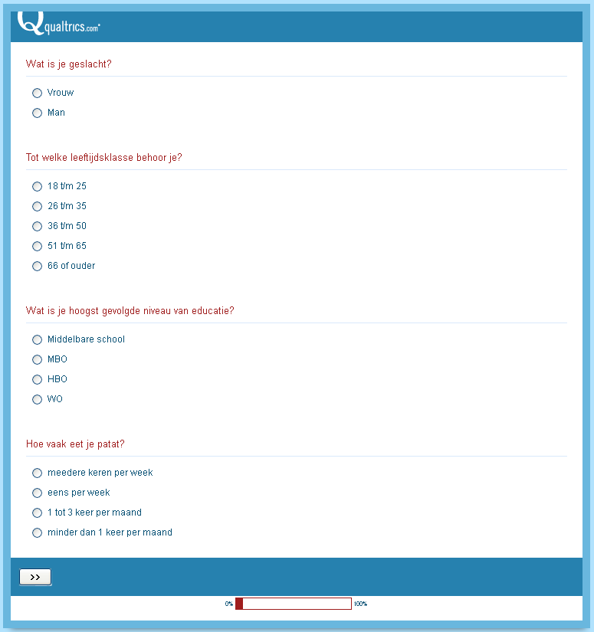

Multiitem scale 1 – firm expectations
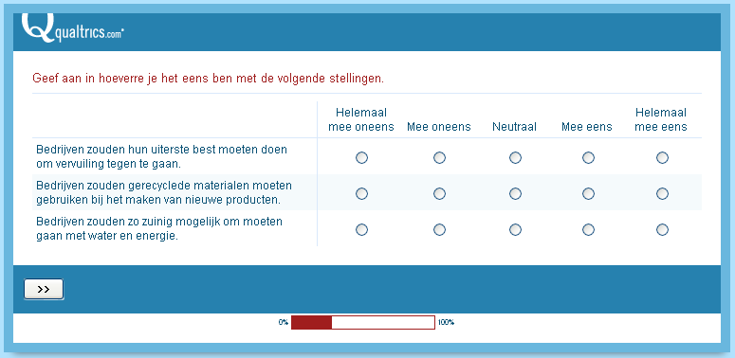

Multiitem scale 2 – social responsible behavior respondent
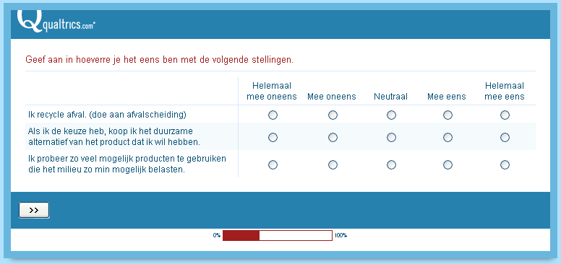

Introduction to choice tasks
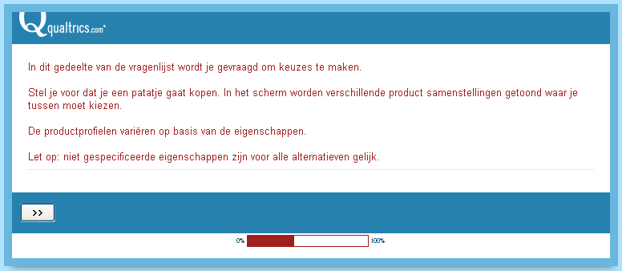

Choice task 1
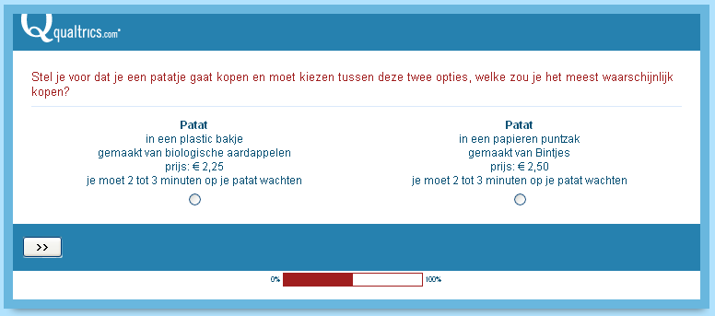

Choice task 2
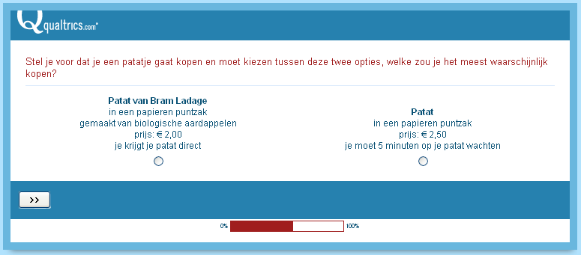

Choice task 3
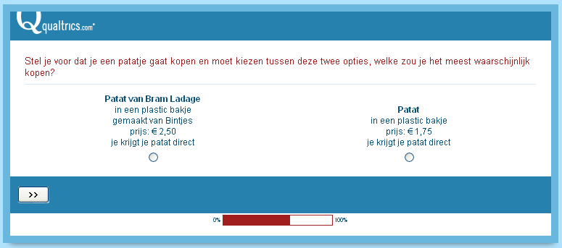

Choice task 4
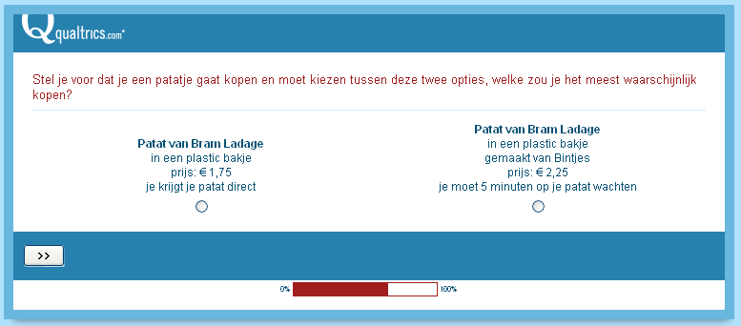

Choice task 5
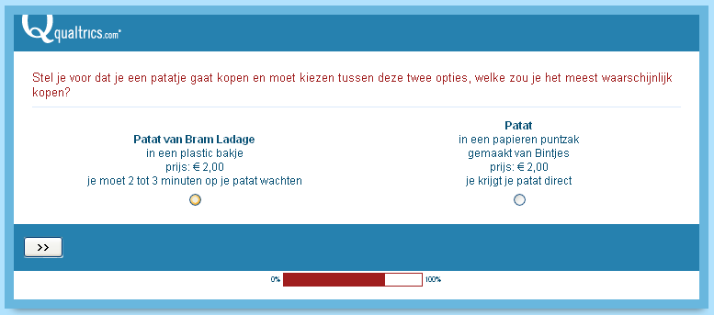

Choice task 6
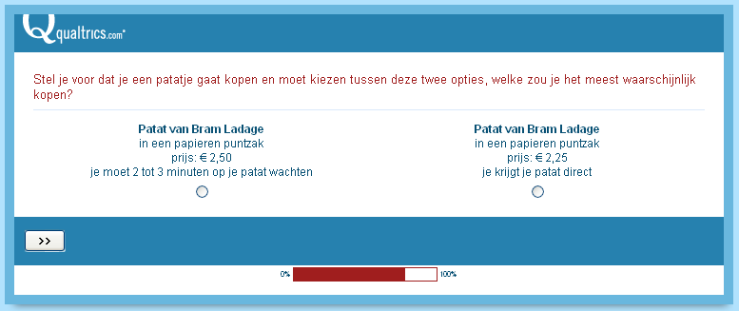

Choice task 7
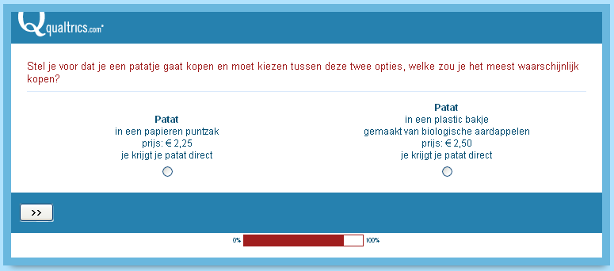

Choice task 8
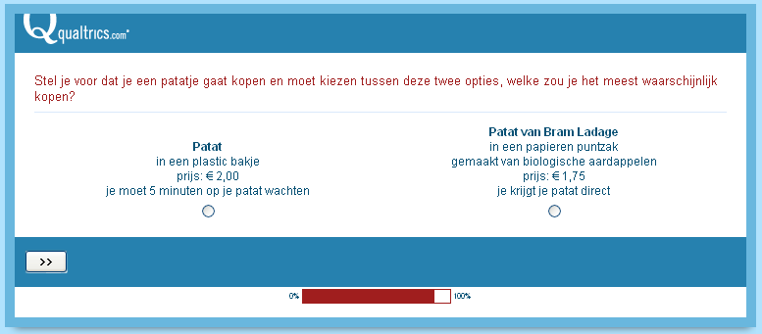

Appendix 2
Introduction to social responsibility as included in the questionnaire (B), tagged as the ‘information effect’.

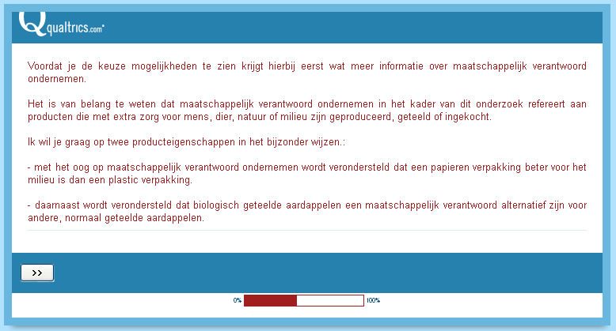

Appendix 3
Binary regression output over the total sample (questionnaire A + questionnaire B)

Omnibus tests of model coefficients
 |  | Chi-square | df | Sig.
Step 1 | Step | 355.932 | 6 | .000
Step 1 | Block | 355.932 | 6 | .000
Step 1 | Model | 355.932 | 6 | .000

Model summary
Step | -2 Log likelihood | Cox & Snell R Square | Nagelkerke R Square
1 | 809.644ª | .343 | .459
a. Estimation terminated at iteration number 6 because parameter estimates changed by less than .001.

Variables in the equation
 |  | B | S.E. | Wald | df | Sig. | Exp(B)
Step 1ª | branded | .961 | .251 | 14.637 | 1 | .000 | 2.614
Step 1ª | paper cone | 1.879 | .349 | 29.035 | 1 | .000 | 6.546
Step 1ª | specified potatoes | -1.012 | .335 | 9.109 | 1 | .003 | .364
Step 1ª | biological potatoes | .577 | .256 | 5.089 | 1 | .024 | 1.781
Step 1ª | price | 1.140 | .510 | 4.994 | 1 | .025 | 3.126
Step 1ª | waiting time | -.426 | .063 | 45.985 | 1 | .000 | .653
Step 1ª | constant | -.817 | .204 | 16.046 | 1 | .000 | .442
a. Variable(s) entered on step 1: b_x, pc_x, sp_x, bio_x, price_x, wait_x.

Appendix 4
Binary regression output over sample of questionnaire A

Omnibus tests of model coefficients
 |  | Chi-square | df | Sig.
Step 1 | Step | 182.350 | 6 | .000
Step 1 | Block | 182.350 | 6 | .000
Step 1 | Model | 182.350 | 6 | .000

Model summary
Step | -2 Log likelihood | Cox & Snell R Square | Nagelkerke R Square
1 | 433.118ª | .334 | .448
a. Estimation terminated at iteration number 6 because parameter estimates changed by less than .001.

Variables in the equation
 |  | B | S.E. | Wald | df | Sig. | Exp(B)
Step 1ª | branded | .867 | .298 | 8.452 | 1 | .004 | 2.380
Step 1ª | paper cone | 1.302 | .389 | 11.221 | 1 | .001 | 3.678
Step 1ª | specified potatoes | -.706 | .429 | 2.709 | 1 | .100 | .493
Step 1ª | biological potatoes | .564 | .349 | 2.617 | 1 | .106 | 1.758
Step 1ª | price | .533 | .710 | .563 | 1 | .453 | 1.704
Step 1ª | waiting time | -.424 | .088 | 23.431 | 1 | .000 | .655
Step 1ª | constant | -.714 | .270 | 6.980 | 1 | .008 | .490
a. Variable(s) entered on step 1: b_x, pc_x, sp_x, bio_x, price_x, wait_x.

Appendix 5
Binary regression output over sample of questionnaire B

Omnibus tests of model coefficients
 |  | Chi-square | df | Sig.
Step 1 | Step | 181.591 | 6 | .000
Step 1 | Block | 181.591 | 6 | .000
Step 1 | Model | 181.591 | 6 | .000

Model summary
Step | -2 Log likelihood | Cox & Snell R Square | Nagelkerke R Square
1 | 368.509ª | .365 | .488
a. Estimation terminated at iteration number 8 because parameter estimates changed by less than .001.

Variables in the equation
 |  | B | S.E. | Wald | df | Sig. | Exp(B)
Step 1ª | branded | 1.347 | .613 | 4.831 | 1 | .028 | 3.845
Step 1ª | paper cone | 3.093 | .970 | 10.175 | 1 | .001 | 22.049
Step 1ª | specified potatoes | -1.719 | .775 | 4.925 | 1 | .026 | .179
Step 1ª | biological potatoes | .835 | .472 | 3.126 | 1 | .077 | 2.306
Step 1ª | price | 2.170 | .922 | 5.536 | 1 | .019 | 8.755
Step 1ª | waiting time | -.417 | .093 | 19.943 | 1 | .000 | .659
Step 1ª | constant | -1.118 | .430 | 6.770 | 1 | .009 | .327
a. Variable(s) entered on step 1: b_x, pc_x, sp_x, bio_x, price_x, wait_x.

Appendix 6
Calculations of relative importance

Based on binary logistic regression over questionnaire A
Attribute | Lowest | Highest | Range | Calculation | Rel. importance
brand | 0 | .867 | .867 | .867/4.396 | 19.7%
packaging | 0 | 1.302 | 1.302 | 1.302/4.396 | 29.6%
type of potato | -.706 | .564 | 1.27 | 1.27/4.396 | 28.9%
price | 0 | .533 | .533 | .533/4.396 | 12.1%
waiting time | -.424 | 0 | .424 | .424/4.396 | 9.7%
total |  |  | 4.396 |  | 100%

Calculation = range for attribute/sum of ranges

Based on binary logistic regression over questionnaire B
Attribute | Lowest | Highest | Range | Calculation | Rel. importance
brand | 0 | 1.347 | 1.347 | 1.347/9.518 | 14.1%
packaging | 0 | 3.093 | 3.093 | 3.093/9.518 | 32.3%
type of potato | -1.719 | .835 | 2.554 | 2.554/9.518 | 26.7%
price | 0 | 2.170 | 2.17 | 2.17/9.518 | 22.6%
waiting time | -.417 | 0 | .417 | .417/9.518 | 4.3%
total |  |  | 9.518 |  | 100%

Calculation = range for attribute/sum of ranges

Appendix 7
Calculations of willingness to pay

Conversion from util per euro ratio to euro per util ratio
Questionnaire A |  | Questionnaire B
utility (utils) | price (euro) | utility (utils) | price (euro)
.533 | 1 | 2.170 | 1
1 | 1.88 | 1 | 0.46

Willingness to pay calculation based on euro per util ratio over questionnaire A
Attribute (level) | Utility | Euro/util ratio | Calculation | WTP
brand | .867 | 1.88 | .867*1.88 | 1.63
paper cone | 1.302 | 1.88 | 1.302*1.88 | 2.45
specified potatoes | -.706 | 1.88 | -.706*1.88 | -1.33
biological potatoes | .564 | 1.88 | .564*1.88 | 1.06
waiting time | -.424 | 1.88 | -.424*1.88 | -.80

Utility is derived from appendix 4

Calculation = utility*euro/util ratio

Willingness to pay calculation based on euro per util ratio over questionnaire B
Attribute (level) | Utility | Euro/util ratio | Calculation | WTP
brand | 1.347 | .46 | 1.347*.46 | .62
paper cone | 3.093 | .46 | 3.093*.46 | 1.42
specified potatoes | -1.719 | .46 | -1.719*.46 | .79
biological potatoes | .835 | .46 | .835*.46 | .38
waiting time | -.417 | .46 | -.417*.46 | .19

Utility is derived from appendix 5

Calculation = utility*euro/util ratio

Like the BSC, the TBL approach helps to translate corporate goals into underpinning measurable goals. These performance measures on the BSC are divided into four categories: financial, customers, internal business processes, and learning and growth.
96% of Europeans say that protecting the environment is important to them, ²/₃ of this group say that it is very important. Consumers in most countries are becoming more aware and willing to act on environmental concerns. (Martin & Schouten, 2012)

