Inflation in Indonesia

A Research Paper presented by:
Dino Wisnu Wardhana
(Indonesia)
in partial fulfillment of the requirements for obtaining the degree of
MASTERS OF ARTS IN DEVELOPMENT STUDIES
Specialization:
Economic of Development
(ECD)
Members of the Examining Committee:
Dr. Howard Nicholas
Dr. John Cameron
The Hague, The Netherlands
August 2012
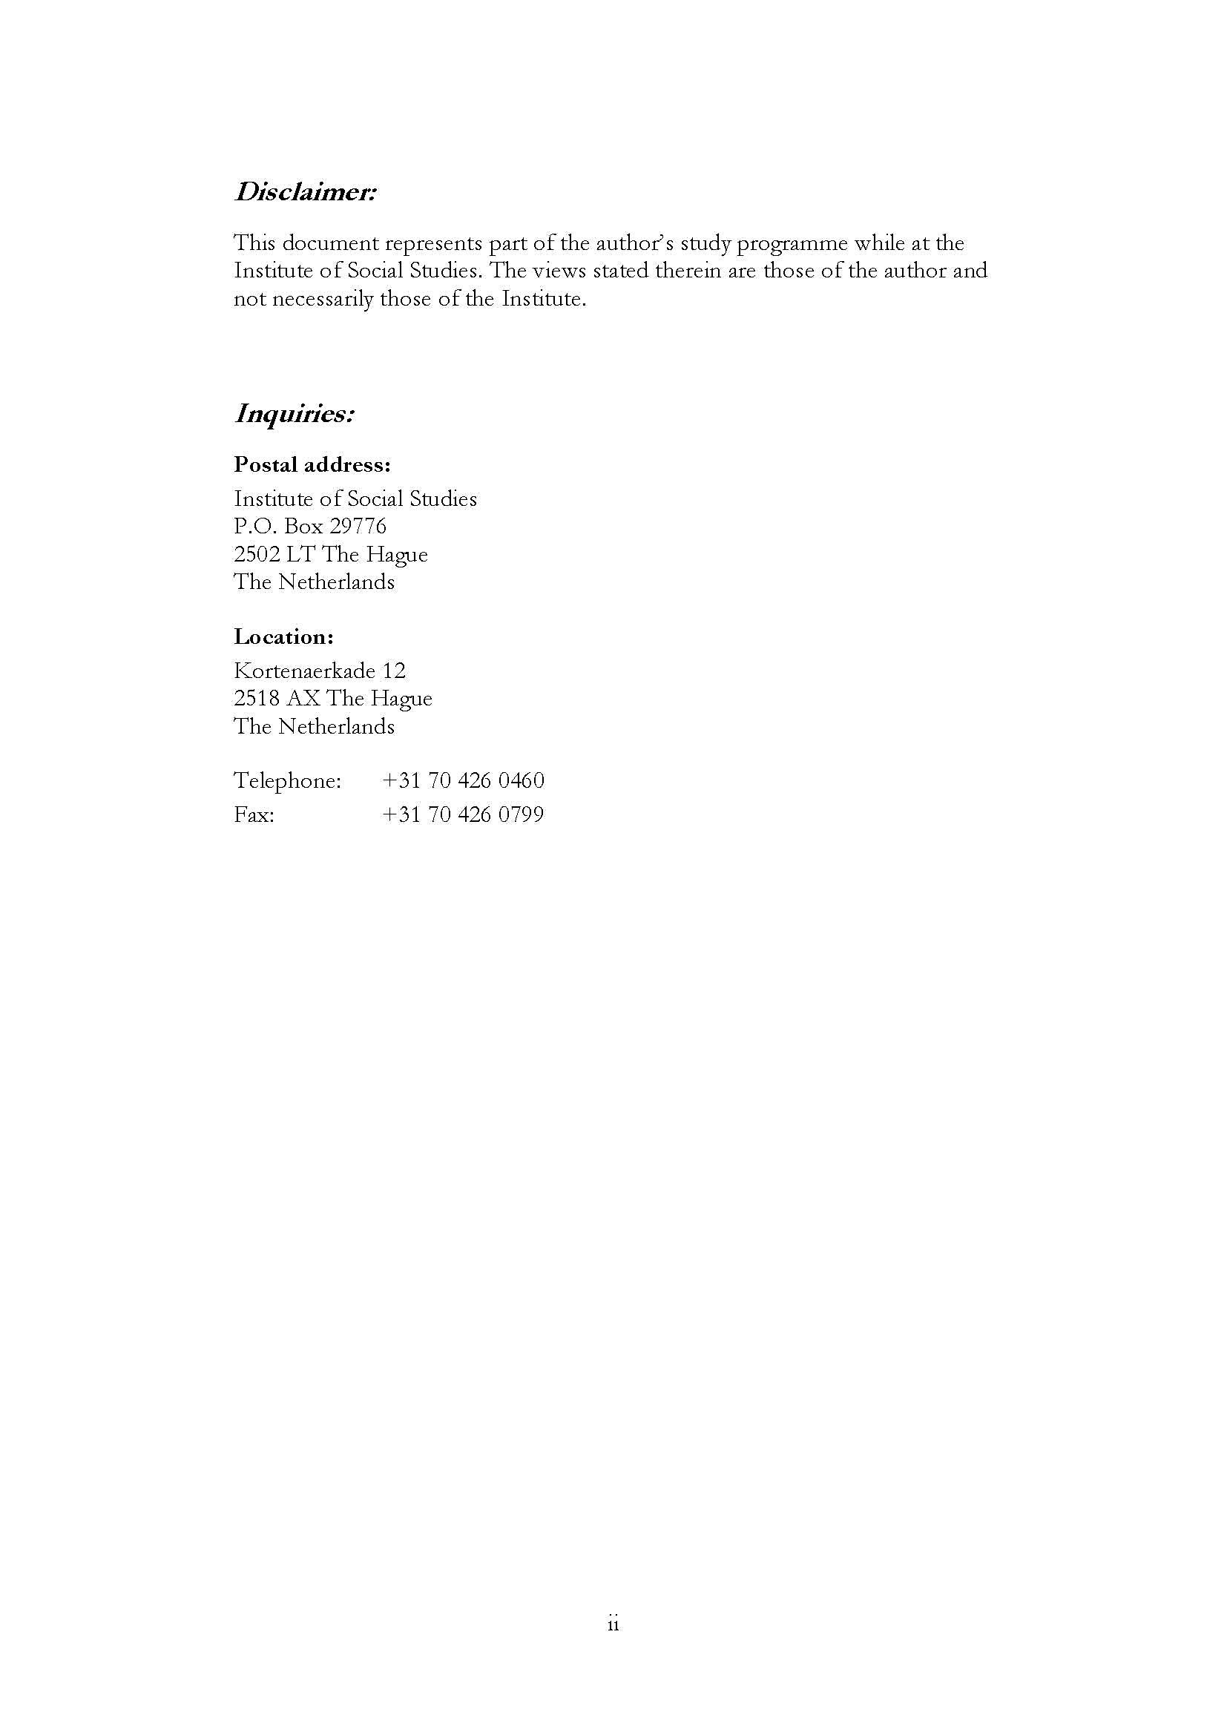
Contents
Chapter 1 Introduction 1
1.1 Background 1
1.2 Research Objectives, Question and Methodology 2
Research Objectives 2
Research Question 3
Methodology 3
1.3 Limitation of Study 3
1.4 Structure of the Paper 4
Chapter 2 Literature Reviews 5
2.1 General Theory of Inflation 5
2.1.1 Demand Pull Inflation 5
2.1.2 Cost Push Inflation 6
2.2 Empirical Studies on Inflation in Developing Countries 8
2.3 Empirical Studies on Inflation in Indonesia 9
Chapter 3 Background 11
3.1 Trend and Measure of Inflation in Indonesia 11
3.1.1 Measure 11
3.1.2 Trend of Inflation in Indonesia 13
3.2 Structure of Imports 17
3.4 Money Supply 18
Chapter 4 Inflation in Indonesia 22
4.1 Period 1970 - 1984 22
4.2 Period 1985 – 1999 26
4.3 Period 2000 – 2010 30
Chapter 5 Conclusion and Policy Implication 33
5.1 Conclusion 33

List of Tables
Table 1-1 Health status according to sex Error! Bookmark not defined.
Table 3-1 Indonesian CPI Components 12
Table 3-2 Annual CPI and GDP deflator 1970 - 1984 15
Table 3-3 Annual CPI and GDP deflator 1985 - 1997 16
Table 3-4 Annual CPI and GDP deflator 1998 - 1999 18
Table 3-5 Annual CPI and GDP deflator 2000 - 2010 19
Table 3-6 Indonesia Imports 1970 - 2010 21
Table 3-7 Budget Deficits 1970 - 2010 26
List of Figures
Figure 1-1 Inflation in Indonesia 1970 - 2010 1
Figure 3-1 Inflation in Indonesia 1970 - 1980 14
Figure 3-2 Monthly Inflation in 1998 – 1999 15
Figure 3-3 Trend of Import 1970 - 2010 (% Total Value) 18
Figure 3-4 Budget Deficits 1970 - 2010 19
Figure 3-5 Broad Money Growth and Budget Deficit 22
Figure 4-1 Inflation and Excess Liquidity 1970 - 1984 26
Figure 4-2 Inflation and Exchange Rate 1970 - 1984 27
Figure 4-3 Energy Price 1970 - 1984 28
Figure 4-4 Food Prices 1970 - 1984 29
Figure 4-5 International and Domestic Oil Price 31
Figure 4-6 Money Supply and Inflation 1985 - 1999 32
Figure 4-7 Money Supply and Inflation 2000 - 2010 33
List of Appendices
Appendix 2 World Energy Price 1970 - 2010 34
Appendix 3 World Foods Price 1970 - 2010 34
Appendix 3 World Beverages Price 1970 - 2010 35
Appendix 3 World Raw Materials Price 1970 - 2010 35
Appendix 3 World Fertilizer Price 1970 - 2010 36
Appendix 6 World Minerals Price 1970 - 2010 36

List of Acronyms
BI Bank Indonesia
BULOG Badan Urusan Logistik
CPI Consumer Price Index
FAO Food and Agriculture Organization
IMF International Monetary Funds
UNDP United Nations Development Programme
WB World Bank

Abstract
This paper tries to explore the determinants of inflation in Indonesia in 1970 – 2010 and divide the period of analysis into several periods to capture specific characteristic of inflation determinants. Based on the average of inflation there are three identified periods which are 1970 – 1984, 1985 – 1999, and 2000 – 2005. In general determinant inflation in Indonesia are excess liquidity, exchange rate and oil price.
Relevance to Development Studies
Knowing the determinants of inflation are significantly important for policy makers as when the causes of inflation are correctly specified, the appropriate policy change can be easily analysed and effectively implemented
Keywords
Indonesia, inflation, inflation determinants

Introduction

1.1 Background
There seemed to be a consensus that inflation is undesirable as its social-economic cost is great. Particularly, because it is reducing most people purchasing power which in turn decreasing welfare. As one of the phenomena in economy, inflation is an object that is often explored, especially since the source of inflation is diverse and a debate among economists.
Most of the nation’s emerging economies have sustained high and rapid economic growth in the past one or two decades leading to moderate to high inflation. Inflation has thus become an important concern for the emerging economies.
Inflation also one of indicators along with others indicators, such as economic growth and exchange rate consist Indonesian macroeconomic indicators (Bank Indonesia). As an emerging economics country, Indonesia also experiences dynamics of inflation. The figure 1-1 depicts the history of inflation in Indonesia 1970 - 2010. During the period, the trend is fluctuating and in certain years the rate of inflation reaches a peak. For example, in the early of 1970’s inflation rate hits over 40 % for as it is indicated by CPI and GDP whereas in the middle of 1980’s inflation relatively stable below 10 % until 1997 before it goes up in 1998 to almost 60 %. Looking at the trend of inflation, might bring questions, why the inflation is so fluctuating in certain decade while it is not in other period? and what is the source of the fluctuations?

Figure 1-1
Inflation in Indonesia 1970 - 2010
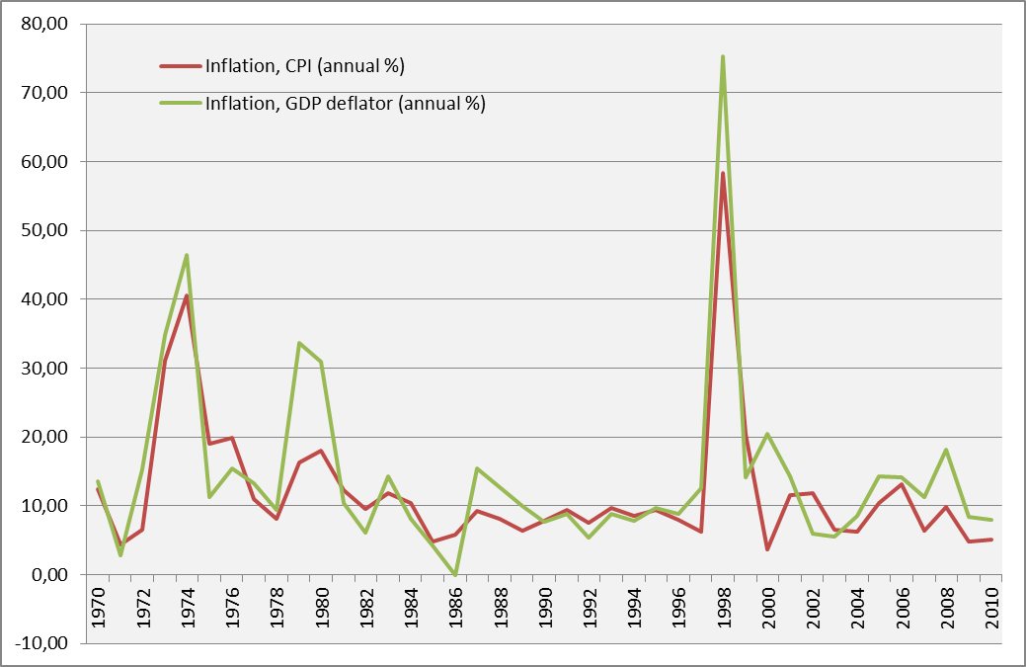
Source : Author’s own illustration based on World Bank Data

Many studies on inflation in developing countries show that inflation is not determined only by one variable, for example monetary phenomenon, but also, for example a structural phenomenon or cost-push inflation. This is because the economic structure of developing countries, in general, is still based on agrarian or not developed yet. Thus, the shocks from domestic sources, such as crop failure (due to external factors such as rapid change of seasons, natural disasters, etc.), or things that associated with foreign relations, such as deficit of trade; external debt country, and foreign exchange rates, could cause price fluctuations in the domestic market.
Furthermore, the causes of inflation might be one of the most prominent macroeconomic debates in the field economics. The main source of the debates is mainly in the underlying assumptions about the appropriate measure to control inflation among conventional views and due to the discrepancy between developed and developing countries as well. Vast empirical studies on inflation countries also give various results about the cause and sources of inflation. In addition to that, decomposing inflation into causal factors is always not easy even though using sophisticated econometric models, because the processes is dynamic and the shocks to prices are complicated. Not only macroeconomic variables but also institutional role should take into account to study of inflation.
The bulk of research on inflation in Indonesia mainly focusing on money supply (Aghevli 1977, Hosain 2005, Siregar 2005, McLeod 2007) and exchange rate (Siregar 1999, Hosain 2005, Ito 2006). Most of the studies are under of econometric framework which is somehow neglected to capture and distinguish specific character of inflation factor such as structural changes and the role of policy. Econometric analysis might be powerful but suffer from bias due to the choices of variables, forming assumptions and data adjustment. Given the variability of results in empirical studies, therefore, opens the possibility to study further about the cause of inflation in Indonesia.
This research paper hopefully can enrich the existing literatures and can be used as an input for policy makers in order to anticipate the factors that cause inflation so that the negative impact of inflation can be anticipated in the future. Knowing the determinants of inflation in Indonesia are significantly important for policy makers as when the causes of inflation are correctly specified, the appropriate policy change can be easily analysed and effectively implemented

1.2 Research Objectives, Question and Methodology

Research Objectives
Given the fact that inflation in Indonesia might be the result from interaction of several factors, such as monetary, supply and demand, etc., the author wants to understand how these factors can explain the inflation. Therefore, the objectives of this research paper are presented as follows:
- Divide inflation in Indonesia into several periods in order to capture the specific character of inflation in each period.
- Examine the trend of inflation by exploring the data and information regarding the macroeconomic situation in the period of analysis
- Analyze government policy toward inflation

Research Question
A notable economic condition changes has occurred in 1970 - 2010, such as, exchange rate devaluation, a shift to a floating exchange rate regime, the adopting of inflation targeting and changes in subsidies and administered prices policies. As a result, it is strongly suspected that inflation process probably differs in each period. Therefore to reveal the cause of inflation in Indonesia, this research paper would answer the following questions:
- Can inflation trend in Indonesia be periodised?
- What are the factors that determine the trend of inflation in Indonesia?
- What is the impact of policy toward inflation?

Methodology
In order to achieve study objectives, this study will be conducted into several broad steps. Firstly, study on official or other related published documents from government institution and other institution associated to macroeconomic policies and indicators as well as those from international institutions. Secondly, review on empirical evidences of Indonesia inflation to obtain some related data and information. Thirdly, this research paper will examine the pattern of the rate of inflation for each period.
Technically, this research paper will use exploratory data analysis (EDA). Therefore, EDA is employed because it is seen as a suitable method of answering the research questions. Most EDA techniques are graphical in nature and very useful to explore the data profoundly and enticing the data to reveal its underlying structure, and being always ready to gain some new, often hidden, profoundly understanding into the data. Another advantage of EDA is that it is useful to capture cyclical disturbance and institutional roles (Xun 2011:1).
This research paper will primarily use secondary data which is provided by national and international institutions. The main sources of data will come from:
- World Bank Data
- International Monetary Fund (IMF) and International Financial Statistics (IFS)
- World Trade Organization (WTO)
- Bank Indonesia (BI)
- Badan Pusat Statistik Indonesia/Statistic of Indonesia (BPS)
- UNCTAD
- FAO
- Other reliable sources

1.3 Limitation of Study
Unavailability of the data and the limitation of variables is one of the obstacles in this study. However, the author experiences the absence of official data needed therefore to cope with that, using un-official data obtained from related studies and internet is unavoidable. Consequently, the author recognises possible inaccuracy of the sources.

1.4 Structure of the Paper
This research paper consists of five chapters. Chapter I contains background of the research, relevance of the study and justifications, research objective, research question, and limitation of the study. Chapter II presents an extensive literature review and theoretical framework of study focusing on the general theory of inflation and empirical studies in developing countries as well as Indonesia. Chapter III delivers an overview the trend inflation in Indonesia and selected macroeconomics data. Chapter IV will bring discussions about the determinant of inflation and the relationship between the factors. Chapter V will conclude the result of the study and present policy implication.

Literature Reviews

2.1 General Theory of Inflation
Determinants and effects of inflation are discussed extensively in the economics literatures. The causes of inflation might be one of the most prominent macroeconomic debates in the field economics. The main source of the debates is mainly in the underlying assumptions about the appropriate measure to control inflation among conventional views and due to the discrepancy between developed and developing countries as well. Vast empirical studies on inflation countries also give various results about the cause and sources of inflation. To begin with, in this chapter the authors will present a literature review of basic theory of inflation mainly demand pull inflation and cost push inflation as well as empirical studies on inflation in developing countries and empirical studies in Indonesia.

2.1.1 Demand Pull Inflation
The meaning of this term is a rise in the price level attributed to excessive aggregate demand. It can increase for several reasons, for instance, increase in autonomous consumption, investment, government expenditures, net export and money supply or declining in saving or taxes. Money supply is a central concern in macroeconomic and most prominent indicator to explain the presence of inflation. Money supply can come by several means but mainly from government that printing money to finance to finance development or stimulate growth. Hence the discussion will focusing on the role of money supply and factors that causing money growth such as government deficits.

Money Supply
The quantity of money available is called money supply and control over the money supply is named monetary policy. Monetary proponents believe that the shock in money supply is responsible for most instability in the economy. In addition to that, slow and steady growth in the money supply would yield stable output, employment and prices (Mankiw :2003:394). The concept of money supply is derived from quantity theory of money to show the role of money to economy and expressed in the following equation (Mankiw 2003 : 84):
MV = PY, where M = money; V = velocity; P = price; Y = output.
The equation in the right hand side implies that how much of money (say in in dollar) exchanged in one year and left hand side implies the money used to transactions. Because Y total is also total income, V is called income velocity of money in constant term. The income velocity of money expresses the number of times a current bill enter someone’s income in certain period of time. The equation above can also defines velocity as the ratio of nominal GDP (output=PY) to the quantity of money (M). However, the assumption of constant value of Y is arguable as the velocity is dynamic. This theory explains what happen if monetary authority changes the supply of money. Because velocity is assumed constant, any change in in the supply of money leads to a proportionate change in nominal GDP. The change in nominal GDP should represent a change in the price level. Thus the quantity theory suggests the price level is proportionate to the money supply. Therefore, the theory of price level also a theory of inflation rate as inflation rate is percentage changes in price level. Hence, implicitly, the quantity of money supply theory posits that central bank/monetary authority has crucial control over inflation. If it keeps money supply being stable, the price level remains stable. On the contrary, if central bank/monetary authority increase the money supply change rapidly, the price level will rise rapidly.
Although monetary policy might have prevented economic from many fluctuations but most economists argue that is not the best possible policy rule. Steady growth in the money supply stabilizes aggregate demand only if the velocity of money is stable. But sometimes economics experiences shock, such as shift in money demand that cause velocity to be unstable (Mankiw 2003:394). Most economists believe that policy rule needs to allow money supply to adjust to various shock to the economy.
Despite the dispute of the impact of money supply, in practical M2 (money and quasi money) is widely known as an indicator and it is defined by World Bank as the sum of currency outside banks, demand deposit other than those of central government, and the time, savings, and foreign exchange deposits of resident sectors other than the central government. However, only take into account M2 as a single variable to analyse inflation would cast a doubt (Xun 2011:10) given that inflation presents when the money supply exceeds demand. Thorsten and Dieter (2005)posits that excess liquidity which is defined as the deviation of actual stock of money from an equilibrium level, is considered as useful tools to quantify future price pressures. Furthermore they said excess liquidity measures consider inflation as purely monetary phenomenon. Neither output gap nor liquidity gap induces a persistent rise in price level. Moreover, they introduce four measures of excess liquidity which are price gap, real money gap, nominal money gap, and money overhang.

2.1.2 Cost Push Inflation
Cost push Inflation or supply-driven inflation puts the responsibility for price increases on rising cost of production. As the production cost increase, the price also moves to a higher level. In term of their cost, production factors, like wages, raw materials prices, interest rates and profits, might shift the supply production function. The cause of increasing in cost can come from many places, for example in agricultural economies bad weather conditions or failure harvest would lead to a rise in price together with a fall in output.(Sach and Larrain 1993:444) , another example is increasing in raw material prices, labour wages, and higher profit setting in oligopoly environment. Unlike aggregate demand inflation, cost-push inflation has no simple prescription. Shortage in resource is difficult, if not impossible, to prevent. Resource owners such as multinational companies hard to bargain with, controlling wages, prices and other types of incomes policies do not seem work well when looked back in historical context (Riddel et.al 2005:475). Cost-push inflation implies that producers will pass cost increases on to consumers’ price. However, Sach and Larrain (1993:445) state that long and persistent inflations, in which prices continue to rise over period of several years is difficult to explain by supply alone.

Wages
Cost-push inflation formerly stems from the effect of increasing in wage in which it is enforced by labor unions and profit increases by employers. The underlying basic concept of cost-push inflation is the rise in money wages exceeds rapidly than the productivity. The unions force employers to raise their wages, which in turn will raise the cost of production. As a consequently, firm raise prices of their products. Because of higher wages workers can buy more goods than before, despite of higher prices. On the other hand, the increase in goods price induces unions to demand higher wages no keep their purchasing power. In this way, the wage-cost spiral countries, thereby, leading to cost-push or wage-push inflation.
Cost-push inflation may be further intensified by upward adjustment of wages to compensate the rising cost of living. Some sectors in the economy may be affected by increasing in money wages and prices of their goods might be rising and in many cases, their goods are used as inputs for the production of goods in other sectors. Consequently, cost of production of other sectors would rise and thus push up the prices of their products. Therefore, wage-push inflation in certain sectors of the economy might soon lead to inflationary rise in prices in the entire economy.

Adaptive Expectation and Inflation Inertia
A simple and reasonable assumption is that people form their expectations of inflation by looking at previous inflation. This assumption is often called adaptive expectation. Supposing, for illustration, people expect prices to rise this year at the same rate as they did last year. Then expected inflation is equals previous’ year inflation. Mathematically, $π^{e}= π_{-1}$. By adding the equation to a standard Phillip curve equation it can yield : $π= π_{-1}- β\left(u-u^{n}\right)+v$. That equation suggests that inflation depends on past inflation, cyclical unemployment and a supply shock. The left-hand side of the equation is inflation inertia which is moving through space. This implies that inflation keeps going until something stops it (Mankiw 2003: 361). The inertia raise because past inflation influences expectations of future inflation and such an expectation influences wages and prices as well. The role of inflation inertia is interpreted as persistent upward shift in in aggregate supply and demand model. For instance, suppose in the aggregate supply, price rising quickly, people will expect them to continue to rise quickly. Hence, aggregate supply will keep shift until some disturbances such as recession or a shock will change inflation and thereby changes expectation of inflation. The aggregate demand curve must also shift forward confirm the expectation of inflation. The movement is mainly determined by the growth of money supply. If monetary authorities suspend the growth, aggregate demand would stabilize and the upward shift in aggregate supply would lead to recession. The high unemployment in the recession would reduce inflation and causing inflation inertia to fall (Mankiw 2003: 362).

Exchange Rate
Sach and Larrain (1993: 445) suggest that an exogenous factor that affects inflation can come from exchange rate through several channels. Firstly, imported goods are likely to rise in price in proportion to exchange rate change, and many imported final goods (not primary commodities) are part of consumer price index. Exchange rate changes also seemingly affect directly to domestic prices for highly tradable commodities (such as raw materials) regardless supply and demand conditions. A third channel by which the exchange rate directly influences prices is through imported intermediate goods such as oil, feed grains for animal and primary metals – which are used in domestic production. Depreciation in exchange rate would lead to increasing the price of imported goods, which in turn will raise final output (Ibid.).

2.2 Empirical Studies on Inflation in Developing Countries
As Riddel et.al (2005:12) asserts that in developing nations inflation might be high and it have the same negative impact as in developed market economies, but to greater degree and given diversity in characteristics amongst developing countries, the determinants of inflation would be differ across nations. Most of the emerging economies have sustained high and rapid economic growth in the past one or two decades leading to moderate to high inflation. Inflation has thus become an important concern for the emerging economies. Moreover, in developing nations inflation maybe high and it have the same negative impact as in developed market economies, but to greater degree (Riddel et.al 2005). A study by Loungani and Swagel (2001) on behalf of IMF focusing on relationship between exchange regime and inflation in 53 countries shows that the sources of inflation are quite diverse in African and Asian countries, which lean towards to have low - moderate rates of average inflation. In these countries the most important sources is inertial components. Conversely, they find that many countries in South America with higher rates of inflation, fiscal variables of money growth and exchange rate changes are predominant. The contribution of fiscal components – money growth and exchange rates changes – is far more important in countries with floating exchange rate regimes than those with fixed exchange rates, where inertial factors dominate inflationary processes (Loungani and Swagel 2001: 4). Furthermore, the authors also show that shocks to the prices of oil and non-oil commodities and output gap are also matter to the inflation. Another study by Mohanty and Klau (2001) for 14 emerging market nations shows similar result that determinants of inflation vary across countries. For example money supply appears to be major determinant most Latin America but marginal in Asia. In case of Korea, Thailand, Chile and Korea wages is the main cause of inflation. Exchange rate is significant determinant for inflation volatility while contribution to its average is modest for most countries. Furthermore, supply shock variables, particularly food price shocks, have contributed significantly to inflation volatility in all countries and inflation persistence explains a large proportion of both the variation and the average inflation in all countries. Onofowora (1996), shows that money growth had significant impact to real output and inflation in four African countries. An investigation in eight MENA countries by Ali and Mim (2011)conclude that world inflation and nominal effective exchange rate, produce significant and positive effects on inflation. Their empirical findings also report a negative effect of the output gap on inflation. Their findings also reveal that effect of government spending is negative to inflation. Ryan (1994) also points out that in case for Kenya, money supply is more important along with oil price and exchange rate to determine inflation. The effect of exchange rate and money supply has also been studied by Siregar et al. (2005b). The author reveal that in case of Indonesia, Thailand and South Korea, exchange rate significant in determining inflation before and after crisis whereas money supply only significant after crisis. The role of deficit budget in affecting of inflation is discussed by by Khan (1978) that in Brazil, Colombia, Dominica and Thailand the causal relationship between present and past value of inflation and money growth is occur. As their government finances budget deficits.
It is well known that developing countries more volatile to shock on primary commodities especially oil and foods, as they heavily depends on for their consumption or as an input for production. Through various channels, both direct and indirect, an increasing international food and oil prices can lead to higher domestic inflation. A shock in oil prices has a largely indirect effect on consumer prices whereas a shock in food prices has a more direct effect. This is because oil is a productive input but food is consumed directly. As a universal input that required for producing goods and services. An increase in oil prices will push the cost of production. As food take large share in the consumption basket in developing countries, an upsurge in food prices has a substantial impact on the overall consumer price level. Though, theoretically, the transmission of the global commodity shocks to domestic consumer prices is straightforward, it is far from straightforward in practice. Jongwanich (2011) using VAR analysis, give a detail discussion for several Asian countries that the pass-through of oil prices to producer prices tends to be higher in oil-exporting countries than in oil-importing countries. Then, the pass-through tends to be lower for consumer prices than for producer prices. Furthermore, the degree of oil price pass-through consumer prices is higher for countries with limited fuel subsidies. In term of food price, pass-through to producer prices is higher in food-exporting countries and rice and wheat receive bigger impact than other kind of foods. Moreover, CPI is not affected much for countries that subsidies food prices. In case of emerging European countries, Zoli’s (2009) using VAR, reveals that changes in international commodity prices and domestic factors are significant drivers of inflation in emerging Europe with world fuel and food prices playing an important role. For example, a shock in oil prices has substantial impact on domestic energy inflation in most countries but foods are more persistent. The price shock also affect core inflation which is usually can be offset by monetary policy while exchange rate system does not have an important impact on the inflation response to world oil price and food shocks.

2.3 Empirical Studies on Inflation in Indonesia
The study of dynamic and determinants of inflation in Indonesia has been done by a number s of scholar. For instance, Aghevli (1978) points out that budget deficit increases the money supply and induces further inflationary pressures. While McLeod (1997)analyses that persistence of chronic inflation in Indonesia is due to the failure to keep the growth of base money sufficiently low relative to the demand for it. This might be caused by the role of Bank Indonesia to maintain money supply is disturbed and obscured by the process of financial reform combined with unwillingness to understand crucial rule of base money and of the role of monetary authorities in determining of inflation. The role money supply is also investigated by (2005) his finding states that there is a long-run causal relationship between money supply growth and inflation in Indonesia. Meanwhile, Siregar (2005a) in his study finds that exchange rate is the main determinant of inflation during the crisis period, while the rapid expansion of base money plays the most significant role in generating strong inflationary pressures during the post-crisis period. Furthermore, Ito et al. (2008) reveals that in the crisis, the degree of exchange rate pass-through to import prices is quite high, the pass-through to CPI significant, and two way relationship: monetary policy variables to exchange rate shocks and that of CPI to monetary policy shocks are significant. Thus, Indonesia’s accommodative monetary policy, along with the high degree of the CPI responsiveness to exchange rate changes is an important factor in the spiraling effects of domestic price inflation and sharp nominal exchange rate depreciation after the crisis.

Background

3.1 Trend and Measure of Inflation in Indonesia

3.1.1 Measure
In simple terms, inflation is understood as a persistent, on-going rise across a broad spectrum of prices. An increase in prices for one or two goods alone cannot be described as inflation unless that increase spreads to (or leads to escalating prices for) other goods. The indicator commonly used to measure the level of inflation is the Consumer Price Index (CPI). Attention in commodity prices as indicators of consumer price inflation has its ups and down along with the dynamic in commodity prices themselves (Blomberg and Harris 1995). Numerous of studies in the late 1980s were showing a strong empirical connection between commodity prices and subsequent consumer inflation. Changes in the CPI over time are indicative of price movements for packages of goods and services consumed by the public. Price statistics particularly consumer/retail price statistics are collected in order to calculate Consumer Price Index (CPI). The CPI is one of economic indicators that can reflect the inflation/deflation of goods and services prices as a whole. Since June 2008, the CPI calculation uses base year of 2007 (2007 = 100) and covers 66 cities. The previous CPI calculation only covered 45 cities and used base year of 2002 (2002=100). In order to compile the CPI in 66 cities, consumer or retail price data are obtained from these cities. The data cover 284 - 441 goods and services which are classified into seven expenditure groups namely: foodstuffs; prepared foods, beverage, cigarette and tobacco; housing, water, electricity, gas and fuel, clothing, health, education, recreation and sports; and transport, communication and financial services. Each group consists of several sub groups, and then in every sub group there are several items. Furthermore, some items have several qualities or specifications. From each city, some representative traditional and modern markets are selected to represent the prices in that city. Price data of each commodity is obtained from 3 or 4 outlets which are visited by enumerator through direct interview. The Indonesian CPI is calculated by modified Laspeyres formula. Arithmetic mean is used in calculating the average (mean) of goods and services price but for some seasonal goods and services, geometric one is used. The formula refers to the manual the World Labor Organization (International Labour Organization / ILO). Consumer Price Index is based on a grouping of international standard classifications contained in the Classification of Individual Consumption According to Purpose (COICOP) adapted to the case of Indonesia (Statistics of Indonesia). Since published for the first time in 1950, CPI has changed in term of the coverage of the city, the base year, commodity package, weighted diagram and method of computation. The changes are carried out periodically (between 5-10 years) to match the changing patterns of consumption, the new commodities that enter the market and the possibility of a long commodity that is no longer sold in the market.
The share of each component in CPI can be seen from the table 3-1 below.
Table 3-1
Indonesian CPI Components
No. | GROUP & SUBGROUP OF GOODS & SERVICES |  | Share
No. |  |  | Base Year
No. |  |  | (2002=100)
I. | FOODSTUFF |  | 25,50
 | A. | Paddies, tubers and their products | 5,80
 | B. | Meat & its products | 3,57
 | C. | Fresh Fish | 3,43
 | D. | Preservative fish | 0,75
 | E. | Eggs, Milk and their products | 2,24
 | F. | Vegetables | 2,20
 | G. | Nuts | 1,12
 | H. | Fruits | 2,21
 | I. | Seasonings (spices) | 2,18
 | J. | Fat and oil | 1,71
 | K. | Other Foodstuff | 0,29
II. | PREPARED FOOD, BEVERAGES, CIGARETTES & TOBACCO |  | 17,88
 | A. | Prepared food | 10,13
 | B. | Non-alcohol beverage | 3,26
 | C. | Tobacco & alcohol beverage | 4,48
III. | HOUSES, WATER, ELECTRICITY, GAS AND FUEL |  | 25,59
 | A. | Living Cost | 14,45
 | B. | Fuel, electricity and water | 5,84
 | C. | Households appliances | 2,08
 | D. | House hold cost | 3,23
IV. | CLOTHING |  | 6,41
 | A. | Men clothing | 1,87
 | B. | Women clothing | 2,11
 | C. | Kids clothing | 1,13
 | D. | Personal belongings and other clothing | 1,29
V. | HEALTH |  | 4,31
 | A. | Healthcare services | 1,20
 | B. | Medicine | 0,63
 | C. | Body healthcare services | 0,30
 | D. | Body healthcare and cosmetics | 2,18
VI. | EDUCATION, RECREATION & SPORTS |  | 6,04
 | A. | Education services | 3,03
 | B. | Courses & training | 0,31
 | C. | Education appliances | 0,83
 | D. | Recreation | 1,70
 | E. | Sport | 0,17
VII. | TRANSPORTATION, COMMUNICATION & FINANCIAL SERVICES |  | 14,27
 | A. | Transport | 9,41
 | B. | Communication & Delivery | 3,59
 | C. | Transportation infrastructure | 1,00
 | D. | Financial Services | 0,28
 |  | GENERAL | 100,00
Source : Statistic of Indonesia (BPS)

A disaggregation of inflation into detail components is important to capture the fundamental factors that affect inflation which also adopted by Statistics of Indonesia (BPS). A theoretical advantage of using the CPI (in preference to other measures such as the GDP deflator or the producer price index) is that it directly indicates changes in the cost of living for consumers on fixed nominal incomes (Bank Indonesia). A practical advantage is that the national statistical agency devotes more resources to obtaining reliable CPI data than to other price indices, as is also the case in other countries. CPI data are therefore of better quality and are available on a more timely basis than other price data.

3.1.2 Trend of Inflation in Indonesia
Over the past decade, Indonesia has developed into an important regional and global economy, as well as an active participant in the G20. Indonesia is characterized as an emerging economics country with average growth rate 6,2 – 6,5 in the last 5 years from 2007 – 2011, driven mainly by domestic consumptions (IMF 2012).
As an emerging economics country, Indonesia also experiences dynamics of inflation for a long time, from low to high inflation even hyperinflation in 1960’s. From the long time series data and examine the pattern we can identify the trend of inflation and generally can be divided into four main periods as it is shown by figure 3-1. In addition to that, by dividing the analysis into several periods we could capture the specific of inflation cycle which is helpful to understand the whole trends. With regard to the fluctuations, the author finds that within period has its cyclical period represented by upsurge and down surge of inflation rate.

Period of 1970 – 1984
After suffered by hyperinflation in the middle of 1960’s with the annual rate 637 % (1136 % based on IMF data) or 53 % per-month which is recorded in 1966, Indonesia finally reaches moderate two digits of inflation to 12% in 1970 (see table 3-2). The rid of hyperinflation is no doubt that the first major economic achievement of President Soeharto’s New Order government (McLeod 1997), largely driven by economic stabilization and rehabilitation program and the ability to maintain prices of goods until the middle of 1980’s. As it is shown by the table, that the average rate of inflation in this period is 15 %, therefore we can conclude this is the period of moderate inflation.
The figure 3-1 illustrates the trend of inflation (CPI) in Indonesia in the period of 1970 – 2010. It can be seen from the graph that during the period, especially in the decade of 1970’s the trend is more fluctuated than the latter periods. After it floats in low level in 1971 – 1972, the inflation rate rose sharply from around 6 % to 31 % in 1973 and reach a peak in 1974, that periods is the time when the first shock comes to the world oil price as result of OPEC’s oil embargo. The impact is likely correlated with the inflation in Indonesia even though at the time Indonesia was still an oil exporter country and member of the organization as well. There is two significant period up surge and down surge in this period which are 1972 – 1974 and 1978 – 1981. Hence, the author considers these times have two cyclical periods.

Figure 3-1
Inflation in Indonesia 1970 - 1980

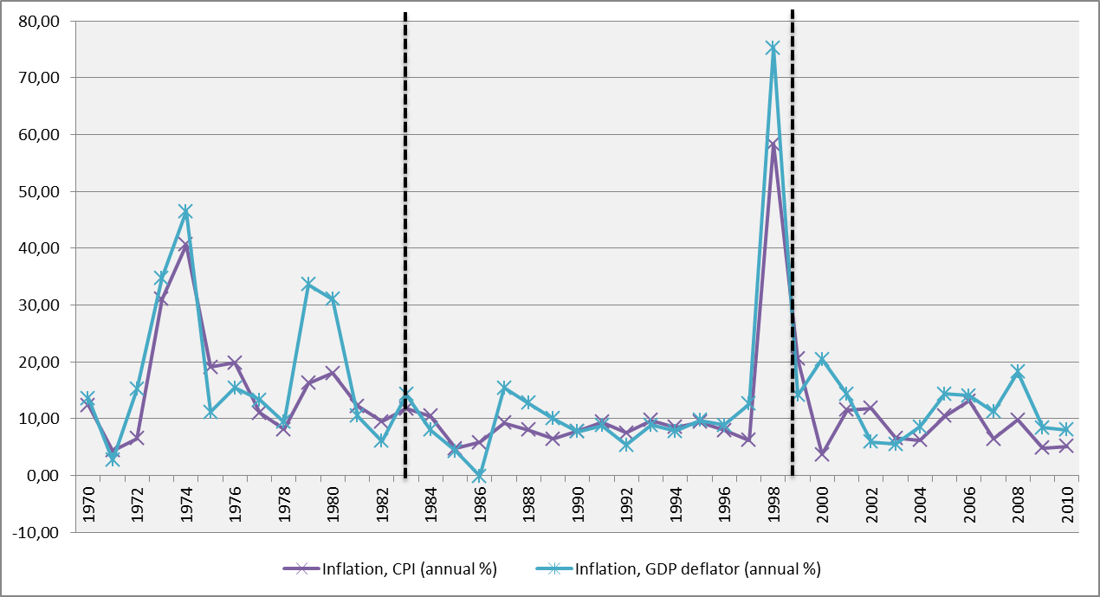

Source : Author’s own illustration based on IFS Data

After the first oil shock, inflation then falls significantly but remain high comparing to the period of prior to the shock. As is shown by the table 3-2, from 1975 – 1977 the inflation rates were nearly 20 % then it decreases significantly to 8 % in 1978. But then the inflation is bouncing back to more 10 % in 1979 and peaked 1980. That is unsurprisingly, because the world’s oil price experienced the second shock in 1979 and it seems that it affects the inflation in Indonesia.

Period 1985 - 1999
This period is considered as low inflation period because annual rates of inflation floats within 4 – 9 % as it is shown by table 3-2, except in 1998. This relatively stable condition lasts for 14 years (see figure 3-1) before the financial crisis hits in 1997. It seems that government is able to maintain macroeconomic variables, enjoys the stability and high rate of growth without external disturbance to the economy, as it is represented by single digit of inflation. After enjoyed 30 years uninterrupted economic growth Indonesia finally got hit by a major shock in 1998 and bitter experience of hyperinflation of the 1960s re-experienced by the Indonesia(Dua and Gaur 2009). The table 3-2 shows that during Asian financial crisis the annual rate of inflation in Indonesia reach a peak in 1998 at a rate of 58,39 %. It is well known that the crisis erupted in the mid of 1997. Starting with the floating of the Thai’s baht in July 1997 soon intensified pressures on the Indonesian rupiah and the authority decided to widen the exchange rate band from 8 – 12 % (IMF (2000). The Rupiah the drop by 7 % as international fund managers began to pull out of East Asia in general. Then, when it became obvious the exchange rate band would be too expensive to defend, the Indonesian authorities floated the rupiah on August 14 and almost simultaneously tightened monetary policy. What followed is a depreciation of the exchange rate that seemed almost exponential first slow, then faster, and then very fast. The value of the rupiah against the dollar fell by 10.7 % in July, 25.7 % in August, 39.8 % in September, 55.6 % in October and November, and 109.6 % in December (IMF 1998).
Figure 3-2
Monthly Inflation in 1998 – 1999
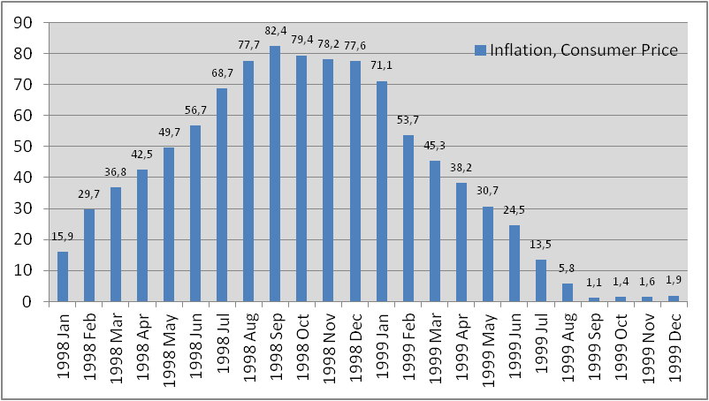
Source : Author’s own illustration based on IFS Data

IMF implies that structural weaknesses in Indonesia's financial sector and the large stock of short-term private sector external debt contributed to doubts about the government's ability to defend the currency peg. History tells that Indonesia finally ended up with IMF aid and implement recovery program under its tight direction. The effect to inflation was begin a year after; figure no 7 shows how trend in monthly basis was going in the period of crisis. The IMF’s general prescription seemed not helping as the inflation rose speedily from 15 % in January to 29 % in February 1998 and just in three months inflation reached 82 % and remained high for the next four months (October 1998 – January 1999) around 76-77 %. That situation was also caused by delaying the disbursement of the further installment of the financing package, which has prevented the government to do immediate action to hold the Rupiah from falling deeply. But since February 1999 monthly inflation dropped to 53 % and continued to fell gradually until August 1999 to around 5 %. The depreciation of exchange rate with average almost 80 % is strongly correlated with the hyperinflation.

Table 3-2
Annual CPI and GDP deflator 1970 - 2010
Years | Inflation, consumer prices (annual %) | Inflation, GDP deflator (annual %) | Years | Inflation, consumer prices (annual %) | Inflation, GDP deflator (annual %)
1970 | 12,35 | 13,62 | 1991 | 9,42 | 8,83
1971 | 4,36 | 2,74 | 1992 | 7,53 | 5,36
1972 | 6,51 | 15,21 | 1993 | 9,69 | 8,88
1973 | 31,04 | 34,79 | 1994 | 8,52 | 7,78
1974 | 40,60 | 46,47 | 1995 | 9,43 | 9,70
1975 | 19,05 | 11,20 | 1996 | 7,97 | 8,85
1976 | 19,86 | 15,42 | 1997 | 6,23 | 12,57
1977 | 11,04 | 13,27 | 1998 | 58,39 | 75,27
1978 | 8,11 | 9,43 | 1999 | 20,49 | 14,16
1979 | 16,26 | 33,61 | Average | 7,76*⁾ | 44,72
1980 | 18,02 | 30,99 | 2000 | 3,72 | 20,45
1981 | 12,24 | 10,44 | 2001 | 11,50 | 14,30
1982 | 9,48 | 6,06 | 2002 | 11,88 | 5,90
1983 | 11,79 | 14,25 | 2003 | 6,59 | 5,49
1984 | 10,46 | 8,05 | 2004 | 6,24 | 8,55
Average | 15,4 | 17,7 | 2005 | 10,45 | 14,33
1985 | 4,73 | 4,29 | 2006 | 13,11 | 14,09
1986 | 5,83 | -0,10 | 2007 | 6,41 | 11,26
1987 | 9,28 | 15,44 | 2008 | 9,78 | 18,22
1988 | 8,04 | 12,75 | 2009 | 4,81 | 8,44
1989 | 6,42 | 9,99 | 2010 | 5,13 | 8,02
1990 | 7,81 | 7,72 | Average | 8,15 | 11,73
Source : IFS Data *)Excluding 1998 - 1999

Period of 2000 – 2010
The financial crisis aftermath brings important lesson for Indonesia how to manage macroeconomics variables, as a result, some structural changes occurred after 1999, as a consequence, the latter inflation process might be differ than that of pre-crisis (Yanuarti 2007).
After the crisis period, the trend of inflation is still fluctuated but not much, in general we can say that inflation in period of 2000 - 2010 is quite steady, with some peaks in 2001-2002, 2005-2006 and 2008. (see figure 3-1). It was suspected that instability of social and political conditions in 2000 have affected expectation of inflation in 2001 - 2002 as well as the series of government policy such as reducing fuel subsidies, the cigarette tax and a surge in demand for goods and services. Other factors causing rising inflation rate in 2001 was government policy to increase fuel prices in mid-June 2001, followed by a hike in electricity tariffs and an increase in telephone rates.
In 2005, the general rise in prices flowed directly from the government’s capping of its oil price subsidy at $US8.65 billion for 2005 as a respond of 114 percent fuel international price increase in October. World Bank (2005:2) reported that despite of direct impact of rising domestic oil price, inflation is also contributed by the adjustment public transportation fares in accordance with the increase in fuel price which constitutes of 14 % in CPI calculation. World Bank also implied that the pressure on inflation also contributed by the currency, the rupiah had been under pressure throughout 2005, gradually depreciating while Bank Indonesia reserves declined. Overall imports, especially capital, grew rapidly. The rapid increase in imports was not supported by private capital inflows, perhaps due to lagging investment climate reforms, resulting in continuing pressure on the currency.
The peak on inflation in 2008 is often associated with the increasing of world commodity prices, especially foods, in which it increased dramatically in 2007 and the first and second quarter of 2008 and create a global crisis. High oil price has pushed not only imported inflation, but also brought it even further following the government decision to raise fuel prices. This event is combined with problems in supply and distribution and of primary commodities that drive inflation expectations to a high level. On the other hand, high commodity prices in energy, mining and agriculture are positive for the Indonesian economy as a whole. For example, net oil and gas exports were are growing at double digit rates. These commodities contributed to a current account surplus. But on one hand, high commodity prices also have downsides. Most immediately, high agricultural commodity prices are feeding through into domestic food prices with food inflation which might be push the inflation rate at 9,78%.

3.2 Structure of Imports
The performance of economy can be seen from the pattern trade. Despite export, import plays important roles from time to time in Indonesia economy as a consequence of embracing an open economic system. The pattern of Indonesia import can be seen from the figure 3-3

Figure 3-3
Trend of Import 1970 - 2010 (% Total Value)
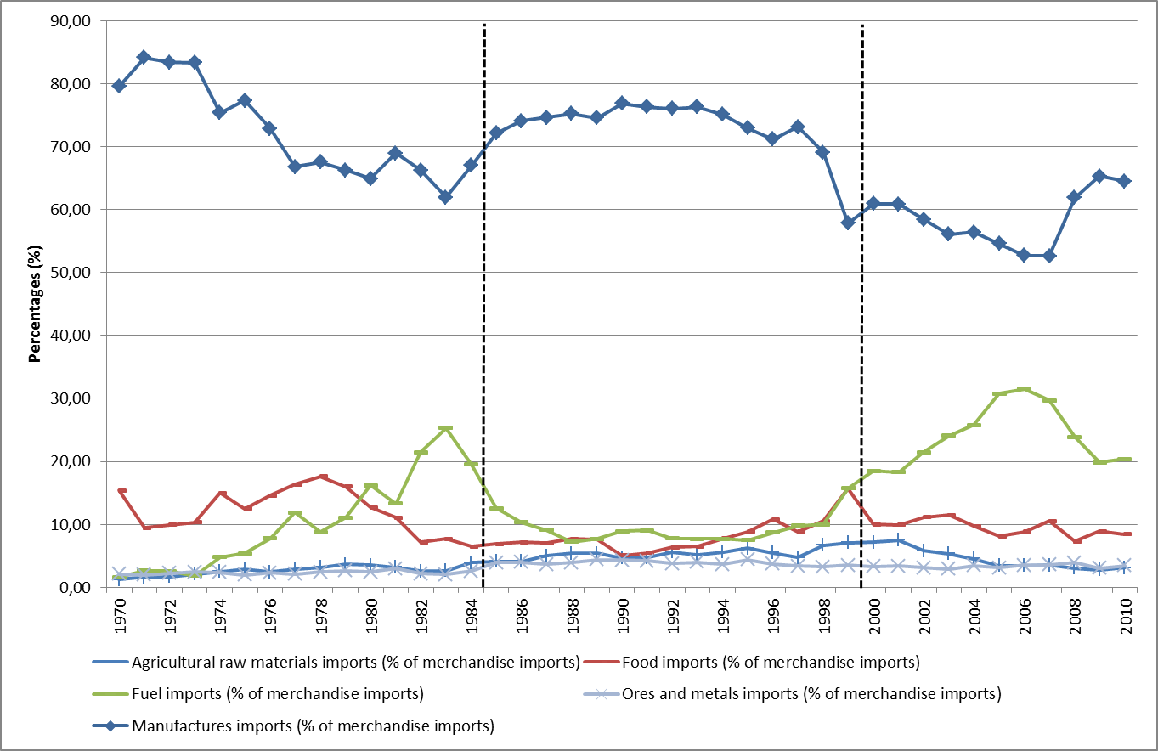Source : World Bank Data

Import structure is important to be known because it can illustrate how dependent a country of a particular imported commodity. If a certain imported commodity takes large share in calculating the CPI, it seems that the fluctuations in its international prices would correlate with the domestic inflation rate.
The figure 3-2 depicts the changes in share of import to total merchandise imported in 1970 – 1984. In general, there was a downward trend on the share of manufactures imports to GDP overtime. The highest average in share of manufactures to total imports was in 1971 – 1973 with over 80%. In the period of 1977 – 1984 the share was quite steady within 60 – 70 % to total imports. As the price of domestic oil was kept low while, on the other hand, the number of vehicles was growing, therefore oil begin to take a share in total imports. The share of oil imports tend to increase gradually especially since 1973 until 1977 and from 1978 – 1983.
Another important feature is the trend of foods import, during the period the trend is slightly fluctuated. In 1978 food imports was 15 % then decline gradually until 6,5% in 1984 as a great achievement has been made, especially in the agricultural sector; Indonesia has changed the position from the country's largest rice importer in the world in the 1970's into food self-sufficiency since 1984. Meanwhile, the shares of other commodities increase very slowly and always fewer than 10 % during the period.
In the period of 1985 – 1997 manufactures imports is still contributed the largest share and in average was 75 %. While the proportion of fuel imports has declined below 10 % along with the proportion of other commodities. Only the share of food reached slightly over 10 % in 1996. During the crisis period of 1998 – 1999, the share of manufactures declined from 70 % to 57 % as a result of depreciation in exchange rate and made imported goods became highly expensive. On the contrary, the proportion of foods and fuel has increased from 10 % - 15 %.
The share of import in the period of 2000 – 2010 can be seen from the figure 3-3 the trend for all commodities was not much fluctuated. After decline slowly from 2001 – 2007, the share of manufactures then increased significantly in 2009 (65 %). In contrast, a different pattern showed by the share fuel imports, the share increased quite steadily from 2001 until 2006 from 18 % to 31 %. The increasing of the share seems correlated with the status of Indonesia as a net oil importer in 2004. An increasing trend only showed by the share of ICT goods imports as the commodity take proportion increase from 2 % - to 10 % as the needs for telecommunication and information has grown rapidly.

3.4 Money Supply
As the basic theory suggests, that aggregate demand will shift as a result of government expenditures, which government finances through an increase in money supply and the growth in the quantity of money is main cause of inflation rate (Mankiw 2003: 286). In this section the author will present the data of money supply (M2/broad money) and budget deficit in Indonesia to bring a brief insight to examine whether such a relationship occurs in the period analysis.

Figure 3-4
Budget Deficits 1970 - 2010
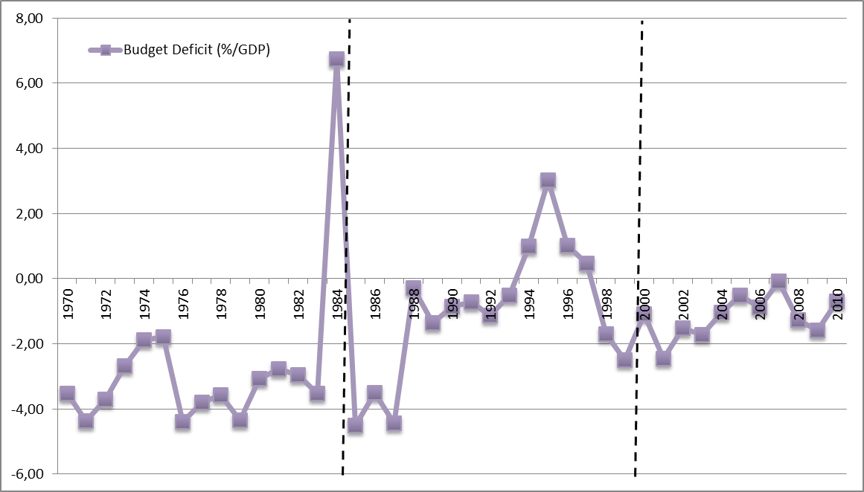
Sources :
- Author’s own calculation based on various issues of financial memorandum (for 1970 – 1987)
- http://www.tradingeconomics.com/indonesia/government-budget (for 1988 - 2010)

The root of money supply is often associated with government deficit as government need money to finance development. General perception says that the gap between government revenue and expenditure is often financed by foreign debt or printing money. According to {{73 Mankiw, N. Gregory 2003/a;}}, the choice between running deficit and surplus fiscal policies are driven at least by three points, namely stabilization devices, tax smoothing, and intergenerational redistribution. In general, most of developing and developed countries adopted a policy of budget deficits for several reasons, for examples: to accelerate economic growth, distribution of incomes, increasing low purchasing power, maintain exchange rate, anticipate global crisis, and excess expenditure due to inflation. Budget deficit policy is a condition in which total spending (government spending) exceeds of total government revenues (revenues plus grants). In case of Indonesia, annual state budget is called National Budget Revenue and Expenditure (APBN).
Since the New Order government (1967 – 1998), APBN is based heavily only on the basic macroeconomic assumptions. For instance: rate of economic growth, inflation, Indonesia’s price of crude oil exports and exchange rate against the U.S. dollar. However, in real, the national economic fundamentals are not depending solely on macroeconomic variables but more towards to the microeconomic variables. For instance, problems in the business climate, level of risk, good corporate governance. Therefore, the government has always faced criticism that the determination of the APBN assumption is not realistic given the circumstances.
State budget at that time is alleged based of the principle of a balanced budget, which means that revenue is always equal with expenditure. Although explicitly never stated that government run deficits budget, the fact discrepancies between revenue and expenditure are always there (Financial Memorandum 1969 - 1989). Therefore, basically the state budget in those days always had a budget deficit. Ideally the gap is financed by tax, but the problem, on those days tax system is not yet developed therefore the revenue from tax is marginal to finance the gap.

Table 3-3
Budget Deficits and Broad Money 1970 - 2010
Years | Budget Deficit (%/GDP) | M2 Growth  (Annual %) | Years | Budget Deficit (%/GDP) | M2 Growth  (Annual %)
1970 | -3,53 | 60,0 | 1991 | -0,71 | 19,6
1971 | -4,36 | 81,3 | 1992 | -1,13 | 24,4
1972 | -3,70 | 31,0 | 1993 | -0,52 | 19,5
1973 | -2,69 | 67,9 | 1994 | 1,00 | 19,1
1974 | -1,90 | 61,4 | 1995 | 3,02 | 31,5
1975 | -1,79 | 45,0 | 1996 | 1,02 | 32,0
1976 | -4,40 | 36,4 | 1997 | 0,47 | 23,4
1977 | -3,80 | 10,4 | 1998 | -1,69 | 72,5
1978 | -3,57 | 17,3 | 1999 | -2,50 | 9,1
1979 | -4,35 | 39,2 | 2000 | -1,08 | 11,9
1980 | -3,07 | 48,7 | 2001 | -2,46 | 3,5
1981 | -2,78 | 19,9 | 2002 | -1,52 | 4,7
1982 | -2,95 | 22,3 | 2003 | -1,72 | 6,4
1983 | -3,53 | 78,8 | 2004 | -1,04 | 6,3
1984 | 6,73 | 31,9 | 2005 | -0,52 | 18,1
1985 | -4,50 | 39,5 | 2006 | -0,87 | 12,3
1986 | -3,50 | 22,9 | 2007 | -0,08 | 16,3
1987 | -4,44 | 33,0 | 2008 | -1,26 | 19,4
1988 | -0,29 | 30,7 | 2009 | -1,6 | 13,2
1989 | -1,37 | 35,8 | 2010 | -0,7 | 15,0
1990 | -0,85 | 60,9
Sources :
- Author’s own calculation based on various issues of financial memorandum (for 1970 – 1987)
- http://www.tradingeconomics.com/indonesia/government-budget (for 1988 - 2010)
- IFS (M2)

It is worth noting that from the early of 1970’s until mid of 1980s is the period in which the budget deficit is accounted for a significantly higher in average than other periods with average 3,3 % (excluding outlier). In the first four years of 1970’s budget deficits floats between 2,6 – 4 % at the same time M2 grows quite significant between 10 – 60 % annually with the highest rate in 1971. A notable feature can also be seen in 1971 – 1974 (see figure 3-5 , although after 1971 the deficit has declined gradually but the growth of broad money increased even more and reached a peaked in 1973 with almost 50 % for which it was the highest rate. On the contrary the deficit rate is low at that year. On the rest of period budget deficit was still significant, it floated between 2,7 – 4,5 % per-year and the rate of M2 growth peaked again in 1983 (48 %).
While in the previous period budget deficits tend to increase, in the period of 1985 – 1997 there was downward trend especially after 1997. The government seems has managed to keep the deficit low. As can be seen from the figure 3-5 budget deficit decrease significantly from -4,44 % in 1987 closer to zero (0, 29 %) from GDP, in 1988 and below -2 % even surplus from 1994 – 1997. Meanwhile, money grows fairly high in 1990 with 60 %.
During the crisis period in 1998 – 1999 the budget deficit was not much changing still floated below 3 % but in term of money supply, as it is recorded with world bank data (see table 3-7), while the deficit only 1,69 % in 1998, the growth of M2 reached until 72 % from GDP then the rate declines significantly in 1999 to 9 % while the annual deficit rose to 2,5 %. In the early 2000’s until the end of 2000’s budget deficit relatively low except in 2001 and so the growth of M2, as it is shown by the graph that there is no significant fluctuation.
In general, there is not always budget deficit is accompanied by a surge in M2 growth except in 1970, 1971, 1973, 1979, and 1980. In contrast, low deficit budget sometime accompanied by high rate of M2 especially in 1974, 1990, and 1998.

Figure 3-5
Broad Money Growth and Budget Deficit
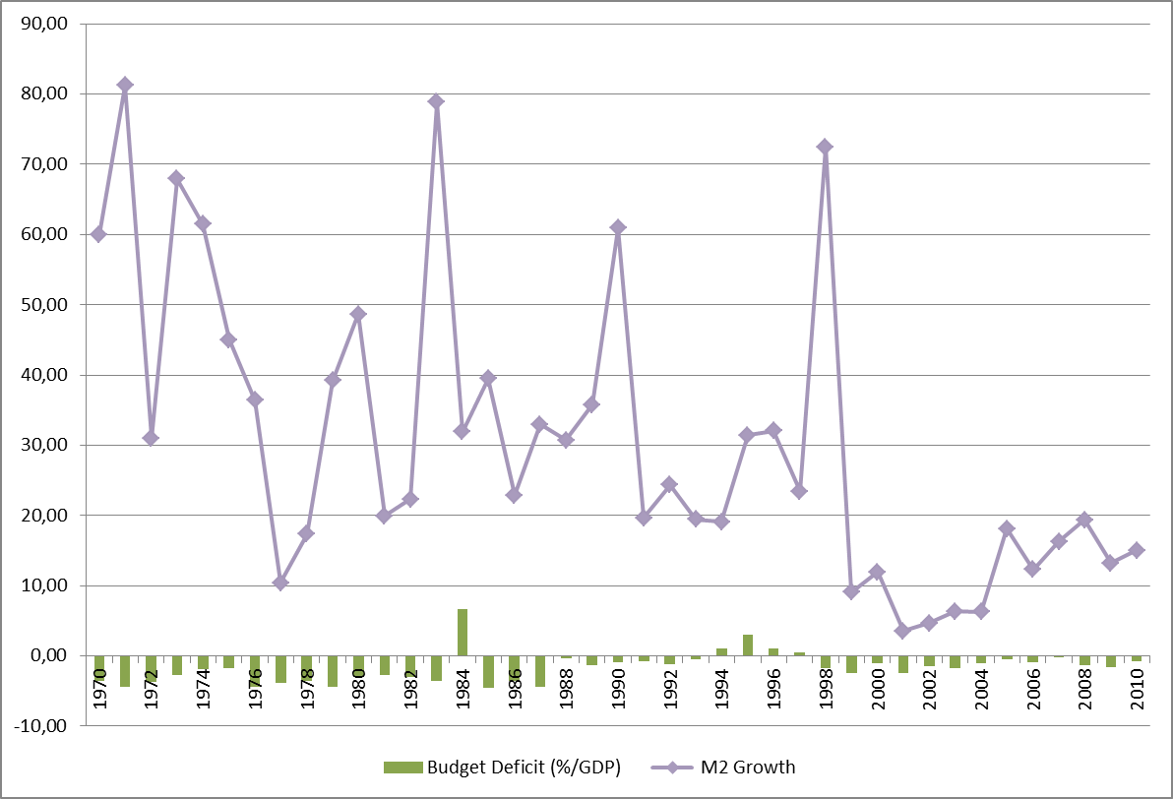
Sources :
- World Bank Data (M2)
- Author’s own calculation based on various issues of financial memorandum (for 1970 – 1987 budget deficit) and http://www.tradingeconomics.com/indonesia/government-budget (for 1988 - 2010 budget deficit)

Inflation in Indonesia
By observing the trend of inflation in Indonesia, the author identifies that dynamic of inflation in Indonesia can be divided in to four periods based on average rate of CPI. The division into several periods is important to capture the cyclical fluctuations in which it is usually neglected by econometrics frameworks. The determinants of inflation might be different each period, for instance, due to the devaluation in exchange rate, policy changes in administering goods. Yanuarti (2007) says that some structural changes occurred after crisis 1999, such as inflation targeting by monetary authorities, hence it is plausible that the latter inflation process might be different than that of prior 1999.
The author considers 1970 - 1984 as first period because in that times fluctuation is much more evident that other periods in which CPI rate is floated between 4 – 40 % (see figure 3-1). In addition to that, this period can be considered has two cyclical periods which are 1972 – 1975 and 1978 - 1980. The second period is 1985 – 1999, this period is marked by a relatively low inflation because CPI rate floated between 4 – 9 %, except in the period 1998 - 1999 (see figure 3-1). Therefore, the author considers this period has one cyclical fluctuation. Lastly, is the period of 2000 – 2010 with two cyclical (2000 – 2003 and 2004 – 2007).

4.1 Period 1970 - 1984
As mentioned before, based on the trend of inflation this period is considered has two cycles which are 1972 – 1975 and 1978 – 1981. In the first cycle, CPI increased almost fourfold 6,5 % in 1972 to 31,5 % in 1973 then reached a peak in 1974 with 40 %.

Money Supply
To examine whether inflation in this cycle is also resulted from monetary factor we should see the monetary policy as reflected by the expansion of money supply at the time. The graph shows that money supply grows over 40 % annually since 1972 – 1984 which is quite significant. It is known that since the late of 1960’s, Government of Indonesia has been running budget deficits. Although it is not explicitly announced formally, but in budget structure there is always a gap, that is expenditure side always higher than revenue. All this time the financial shortage has been resolved by foreign debt and project aid (based financial memorandum at various issues).
.
Table 4-1
Inflation and Excess Liquidity 1970 - 1984
Years | Inflation, CPI  (Annual %) | Excess Liquidity (M2 Growth - Real GDP Growth) | Years | Inflation, CPI  (Annual %) | Excess Liquidity (M2 Growth - Real GDP Growth)
1970 | 12,35 | 5,6 | 1978 | 8,11 | -45,3
1971 | 4,36 | -130,2 | 1979 | 16,26 | 67,8
1972 | 6,51 | 47,9 | 1980 | 18,02 | 20,2
1973 | 31,04 | 136,8 | 1981 | 12,24 | -55,8
1974 | 40,60 | 40,2 | 1982 | 9,48 | -16,1
1975 | 19,05 | -106,5 | 1983 | 11,79 | 79,2
1976 | 19,86 | 19,0 | 1984 | 10,46 | 1,3
1977 | 11,04 | -111,0
Source : Author’s own calculation based on IFS and World Bank Data

It is obvious that there is a relationship between money supply and inflation during the cycle of 1972 – 1975 when take a look at the figure 4-1. For example, an increasing or decreasing in inflation is followed by the dynamic of excess liquidity. The relationship between inflation and money supply is seen quite clearly in 1972 when both variables moves to the same direction but the magnitude of the change is very different. In the year of 1972 CPI increases only 2 % from the previous year, but the money supply growth quite significant 40 %) in that year.

Figure 4-1
Inflation and Excess Liquidity 1970 - 1984
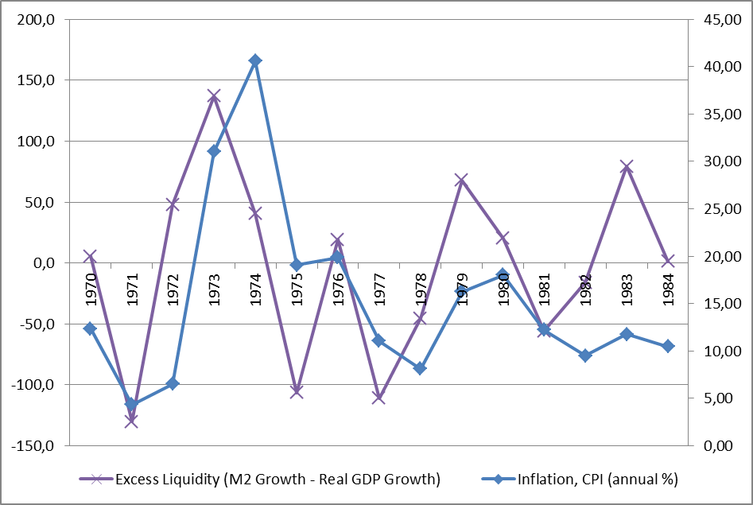
Source : Author’s own illustration based on IFS Data

The same pattern also occurs in 1973 as the two variables change quite significantly when excess liquidity changed dramatically from 47% to 136%. This drastic expansion this might push the inflation rate rise sharply from 6% in the previous year (1972) to 36 %. Meanwhile, a notable feature can be seen in 1974, in which the two variables move in the opposite direction (see figure 4-1). As it shown by the figure 4-1, the growth of excess liquidity decreased to 40%, but inflation increases even further and reach its peak with an average 40,60 %. Furthermore, regular pattern reappear in 1975, when the decline in the growth of M2 is followed by a decline in the rate of inflation. Therefore, looking at that event, inflation in in this cycle is probably cannot fully be explained by monetary factors, because the movements of inflation are not always aligned with money supply, there are other factors that contribute to the rate of inflation at that year.
In the second cycle (1978 – 1981), by close scrutiny to the figure 4-1 particularly to 1979, 1980 and 1982, would see that an increasing money supply in 1979 is accompanied by a corresponding change in CPI, on that year inflation rate is 16% while the increase of money reached 67.8%. Meanwhile, in 1980 M2 declines but CPI increase slightly. Again, in term of M2, inflation in 1980 might not be caused by money supply. In addition to that, similar relationship pattern also occurs in 1982.

Cosh-Push
As the theory would suggest that an exogenous factor that affects inflation can come from exchange rate through exchange rate channels. Exchange rate changes also seemingly affect directly to domestic prices for highly tradable commodities (such as raw materials) regardless supply and demand conditions. A channel by which the exchange rate directly influences prices is through imported intermediate goods such as oil. To clarify this we should take a look at the historical exchange rate during the period. The figure 4-2 shows that the surge in inflation rate is not accompanied by, or precede by any fluctuation in exchange rate. Indonesian Rupiah is pegged at 415 rupiah against US$ from 1972 – 1978. Therefore this occasion cast a doubt that exogenous factor or imported price determines the inflation at this cycle, except maybe for oil. This occurrence is conforming to Glick et al. (1995) as it is cited in (Siregar 1999). Their findings reveal that most targeting/pegging cases in East Asian economies prevented necessary adjustments of the real exchange rate in response to external shocks.

Figure 4-2
Inflation and Exchange Rate 1970 - 1984
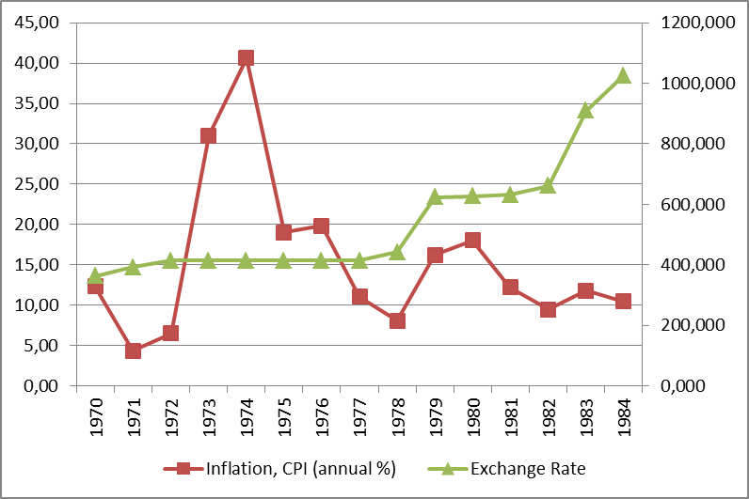
Source : Author’s own illustration based on IFS Data

It is worth noting that, in the period of 1972 – 1974 global economy is marked by an increasing in commodities price, mainly oil and food price. Oil price, and energy in general, increased from 1,82 to 2,81 US$/bbl but then increase sharply in 1974 to 10,97 US$/bbl, another important commodities also follow the same trend. With regard to increasing in world oil price government raise the domestic oil price 40 % in 1972 and 17,1 % in 1974. This likely contributes to inflation CPI since 1972 because oil as a universal input for producing goods and services
The fact that the share of foods is large in the consumption basket, an increasing in world’s foods price is seemingly affect domestic inflation. It looks obvious when looking at the trend of domestic price for important commodity at the time, for example rice, since international price started to increase almost 125 % from previous year in 1971, the domestic rice also rise almost twofold from 33,62 Rupiah/kg to 63,26 Rupiah/kg in end of year 1972 and continue to rise until 1974 (Financial memorandum 1972/1974). But since its price is being administered by government, the change in domestic price might not reflect the shocks from international price. As the largest producer as well as importer, the price of rice is regulated at the time. Any disturbance to the basic necessities will be stabilized by BULOG (Agency of Logistic Affairs) through market operation.
Furthermore, in 1978 government has devaluated Rupiah from 1 US$ = 415 Rupiah to US$ = 625 dollars because the value of the rupiah too high the price against of its actual prices in the market (overvalued). This overvalued rupiah disrupt export performance as the price of export commodities Indonesia to be expensive. Meanwhile, imports increased as prices of foreign products becoming cheaper. Therefore, to reduce negative impacts, the government devaluates the rupiah. Arndt et al. (1984) state there is one opinion which entitles that devaluation can cause domestic inflationary consequences, only if the government/authorities fail to exercise satisfactory control over the domestic money supply. The general price level cannot rise, if the money supply is held constant, and devaluation cannot raise general price tradable goods. Non-tradable must fall since total expenditure remains constant. According to this view there will be no cost-push inflation (Grenville 1979 in Arndt et al 1984:89). However, the evidence shows a contrary that there is an increase of inflation from 1978 – 1979 (from 8,11 % to 16 %).
Figure 4-3
Inflation and Commodity Indices 1970 - 1984
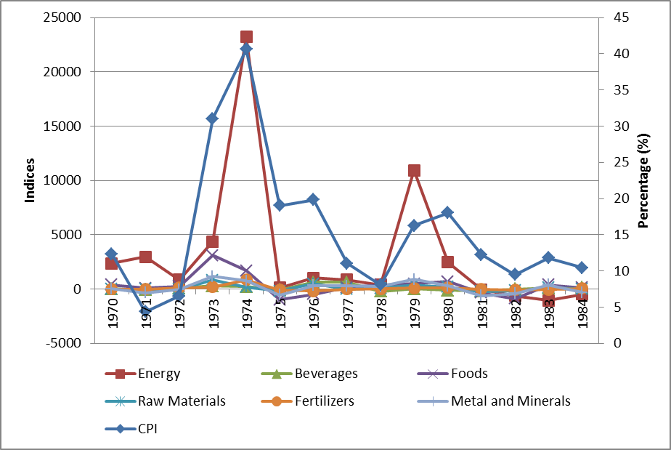
Source : Author’s own calculation based on World Dank Data

Figure 4-3 reveals that in general all energy commodities tend to increase, but the most significant evidence are for oil and coal price. As the figure shows, oil price increase in 1972, 1973, and 1974 with US$ 1,82/bbl, US$ 2,82/bbl, and US$10,97 /bbl, respectively. To be more sensible to see the impact of world commodity price, it is plausible to see the change in US$ for each commodity. For example, from 1972 to 1973 oil price increase as much as 54 % and from 1973 to 1974 it increases 291 %. We can conclude that significant increase in oil price in 1973 -1974 would give a pressure on domestic price as oil as a general input for most production of goods and services. In term of foods price, the trend for all food commodities is increased in 1972 – 1974. Based on the figure 4-3, the most evidence rise in palm oil and rice price (see appendix 1). Those two commodities increase 84 % and 124 % , respectively. Given this two commodities are important commodities; a shock in its price would give a pressure on domestic price.
With regard to the dynamic oil price the second cycle in 1978 - 1981, there is a sharp increase in nominal oil price since 1979, and goes to reach a peak 1980 with over US$ 36 per-barrel. The rate growth of oil in those years is accounted for 238 % which is very high. The nominal price continued its slow increase after the crisis ended. This caused by OPEC and Saudi Arabia that raised the price of oil several times in 1979 and 1980. Also during this time, several OPEC members significantly lowered their production levels, and accompanied by escalating tension in some oil producer countries. A high in oil price usually followed by other commodities and foods in exceptional. Based on the figure 4-4, only palm oil experiences an increase in 1979, rice in 1980-81, and sugar in 1980 (see appendix). A combination of increasing oil, food price, and currency devaluation would push domestic price.
Therefore, the determinants of inflation in this period can be concluded as excess liquidity, exchange rate and commodity price, especially oil price.

4.2 Period 1985 – 1999

Money Supply
During the 1985-1999 period, Indonesia experienced high economic growth and relatively low rate inflation (before 1997). In the 1990s, liberalization and deregulation occurs very intensively. Real sector grows relatively high, which accounted an average of 7 percent per year over the period 1990-1997 (Mardiyanti 2006). Inflation, before crisis in 1997, is always below 10 percent per year. Interestingly, the fluctuations in the money supply are not followed by inflation fluctuations. There are at least 3 times a significant growth of the money that is 1986, 1987 and 1990. In that three years, inflation has remained below 10% (see figure 4-4). Effective economic seems management to help Indonesia through ups and down of oil prices in 1970’s and 1980’s, and others economic disturbances and sustained most of the macroeconomic variables until to the beginning of the crisis in 1997 (Radelet 2000).
In the absence of significant fluctuations of inflation in 1985 - 1997, although the opposite situation is shown by the money supply, it may be inferred that the money supply has no effect on inflation before 1997.

Table 4-2
Inflation and Excess Liquidity 1985 - 1999
Years | Inflation, CPI  (annual %) | Excess Liquidity (M2 Growth –  Real GDP Growth) | Years | Inflation, CPI  (annual %) | Excess Liquidity (M2 Growth –  Real GDP  Growth)
1985 | 4,73 | -99,1 | 1993 | 9,69 | 28,8
1986 | 5,83 | 37,0 | 1994 | 8,52 | -12,7
1987 | 9,28 | 56,6 | 1995 | 9,43 | 24,1
1988 | 8,04 | -7,5 | 1996 | 7,97 | -6,7
1989 | 6,42 | -14,6 | 1997 | 6,23 | -27,3
1990 | 7,81 | 64,4 | 1998 | 58,39 | 156,2
1991 | 9,42 | 21,3 | 1999 | 20,49 | -218,8
1992 | 7,53 | -17,0
Source : Author’s own calculation based on IFS and World Bank Data

It is widely known that Asian financial crisis is prologue by a crisis in exchange rate. The discussion of excess money supply in the period of 1997 – 1999 is related closely to what is happened to the exchange rate at the times. Tremendous pressures on the Rupiah and foreign exchange reserves at the beginning of crisis, has forced the Bank Indonesia to release the intervention band and adopt free-floating exchange rate system (Syabirin 2002 in Mardiyanti 2006).Hence, the exchange rate no longer is the nominal anchor of monetary policy and let market decide its value. As a result, exchange rate becomes highly depreciate and interest rates become higher which make the weak banking system become worsen. As a consequence, public loss their confidence in banking system and begin to withdraw their money massively and rapidly. To prevent the destruction of the banking system as a whole because the customer draw most or all of their savings at the same time, Bank Indonesia was forced to play its function as the last keeper: the lender of last resort. This might led to the very rapid growth of M2 (see table 4-2) in 1997 and 1998 which in turn pushed inflation to 58,39 and 20,49 respectively. This occasion is confirm with the movement of M2 and CPI, both of them are corresponded as it shown by the figure 4-4. Siregar (2005a) also mentioned that the cause of inflation in 1998 is due to the speed increase in money supply. Meanwhile, McLeod (2001) as it is cited by {{41 Siregar, R.Y. 2005/a;}} concludes that the inflation rate obviously represents the pattern of base money growth from May 1997 to late 1999.

Figure 4-4
Money Supply and Inflation 1985 - 1999
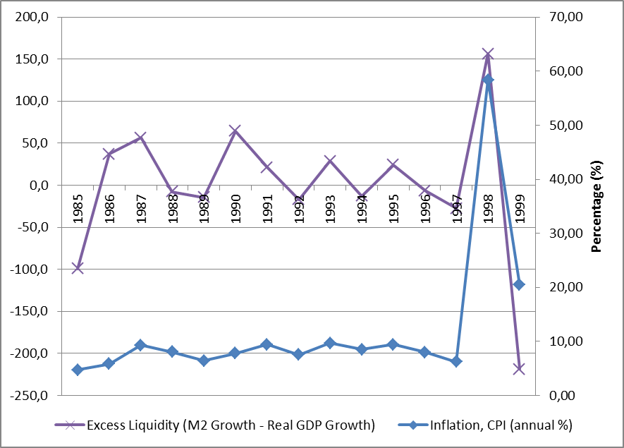
Source : Author’s own calculation based on World Dank Data

Cost Push
During the period of high growth rate, Indonesia is become a magnet for financial investor, capital flows intensively to Indonesia during the period 1995-1997 (Mardianti 2006). On the one hand, foreign fund flows is able to cover the savings-investment gap so as to encourage economic growth and national development. But on the other hand, the flow of funds raises a problem. Large and the mobility of foreign fund flows turned out to complicate the conduct of monetary policy by Bank Indonesia (BI).
Facing enormous pressure on the weakening of the exchange rate, in accordance with a managed-floating system prevailing at the time, Bank Indonesia intervened in the foreign exchange market to maintain exchange rate specified range. But the pressure is very strong and intensively to the weakening of the rupiah which is accompanied by decline in foreign reserves in high amounts, eventually forcing the government to change the prevailing exchange rate system. Furthermore, since the date of 14 August 1997, Indonesia adopted a floating exchange rate system. Soon after it is floated, rupiah depreciated very sharply to over 80 %. After depreciating over Rp/$ 16,000 in May 1998, the rupiah finally began to stabilize in the latter half of that year. In the six-month period between mid-September 1998 and mid-March 1998, the rupiah fluctuated within a (relatively) narrow band between Rp/$ 7,000 and Rp/$ 9,000. The main cause of highly depreciation according to Radelet (2000) is the lost export exchange earnings that sustain downward pressure on rupiah, furthermore he states only this factor alone can explain substantial fall in rupiah.

Figure 4-5
Inflation and Exchange Rate 1985 - 1999
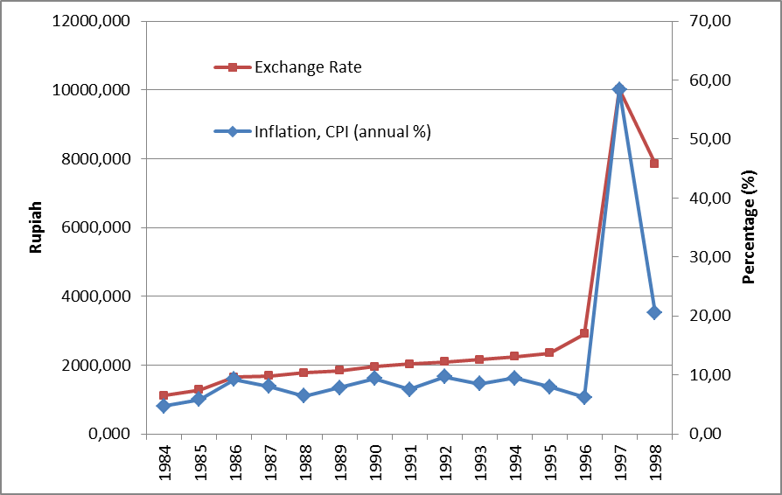
Source : Author’s own illustration based on World Dank Data

In correlation with commodity price, even though not any significant fluctuations of commodity indices during 1997 – 1998 (see figure 4-6), it is obvious that the fall of the rupiah will cause the price of imported goods to be very expensive at the time. So it can be concluded that in supply side, the price of imported goods is very significant impact in contributing to inflation.

Figure 4-6
Inflation and Commodities 1985 - 1999
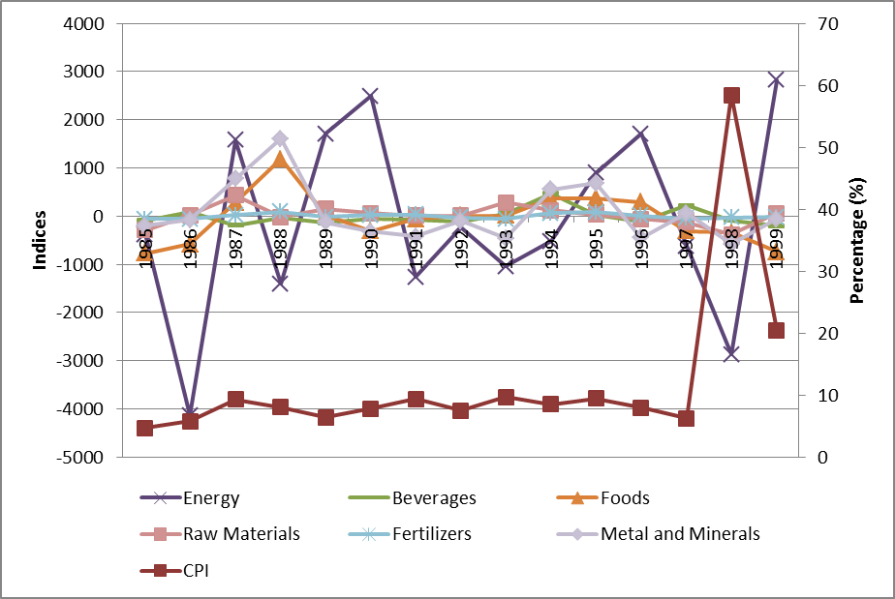
Source : Author’s own calculation based on World Dank Data

To sum up, generally the determinants of inflation in this period can be concluded as excess liquidity and exchange.

4.3 Period 2000 – 2010
As mentioned, based on the pattern of inflation as shown in Figure 4.4, it can be identified that this period had two cycles because at those pattern inflation rate is more evident. The first cycle is from the year 2000 - 2003 and the second cycle of the years 2004 – 2007.

Money Supply
After the economic crisis in 1997 - 1999, the period of the 2000s is started with a low level of inflation at a rate of 3.5% in 2000, but then it increased sharply to 11,5 in 2001 and continued to 2002 which is the average inflation in the latter two years is 11.6%. When looking at Figure 4-2 we can see that the level of excess liquidity rose sharply in 2001 is accompanied by the rising rate of inflation in which it also rising sharply. But the following year, when excess liquidity declined slightly, the inflation rate actually increased slightly. Hence, it can be concluded that excess liquidity does affect inflation in 2001 but does not in 2002. Furthermore, in the second cycle, the same pattern repeated. An increase in the inflation rate from 2004 to 2005 clearly followed by an increase in excess liquidity in the year 2004 to 2005 (see figure 4-2). By inspecting the graph we can see there is a slightly rose of inflation from 2005 to 2006 but accompanied by a small decline of excess liquidity. Therefore, inflation in 2006 might not be caused by excess liquidity.

Table 4-3
Inflation and Excess Liquidity
Years | Inflation, CPI  (annual %) | Excess Liquidity (M2 Growth –  Real GDP  Growth) | Years | Inflation, CPI  (annual %) | Excess Liquidity (M2 Growth –  Real GDP  Growth)
2000 | 3,72 | -584,1 | 2006 | 13,11 | 16,3
2001 | 11,50 | 65,2 | 2007 | 6,41 | -125,8
2002 | 11,88 | -2,5 | 2008 | 9,78 | 37,3
2003 | 6,59 | -93,0 | 2009 | 4,81 | -116,8
2004 | 6,24 | -14,0 | 2010 | 5,13 | 7,5
2005 | 10,45 | 46,0
Source : Author’s own calculation based on IFS and World Bank Data

Figure 4-7
Inflation and Excess Liquidity 2000 - 2010
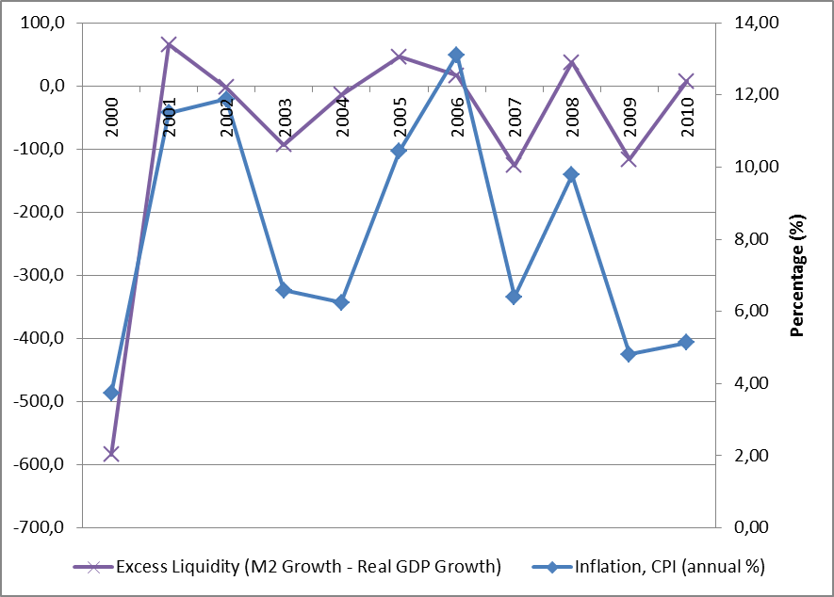
Source : Author’s own illustration based on IFS Data

Cost Push
Except for high oil prices in 2000, the indices of commodity from 2000 to 2003 does not experience fluctuation that seem could affect inflation (see figure 4-9). But with the exchange rate still depreciated on the high range between 8000 – 10000 rupiah/USS$ could lead imported goods become expensive and ultimately pushed the inflation rate. During year of 2005, oil prices soared on world markets and until August 2005 and world oil prices stay above the level of 55 US.$ / barrel.

Figure 4-8
Inflation and Exchange Rate
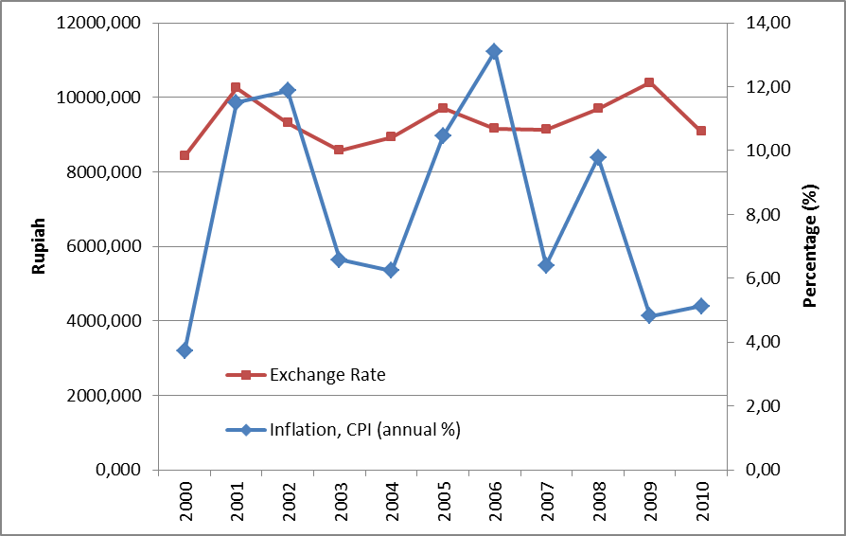
Source : Author’s own illustration based on IFS Data
Domestic situation cast that the amount of provision for subsidy listed in the budget plan is Rp 19 Billion with the assumption of world oil price is US$ 24 per barrel and the exchange rate of Rp 8600. But in the early 2005 oil prices raised high above the initial assumptions that have been set at US.$ 35 per barrel and even in the next development is always above U.S. $ 50 per barrel. As a result, realization of expenditure for subsidize is getting higher and the exchange rate depreciated to Rp. 8600 and it is feared will continue to grow higher if the domestic is not immediately be adjusted. Finally, this force government to issue a policy on fuel price adjustment in March 2005. Facing similar situation in the late of 2005, but with international oil prices actually increased around U.S. $ 68 per barrel accompanied by depreciation in the exchange to over Rp 10,000 per U.S. dollar, has pushed government to raise the domestic oil price for the second time by 120 %. These two events price push the inflation to the high rate.

Figure 4-9
Inflation and Commodities 2000 - 2010
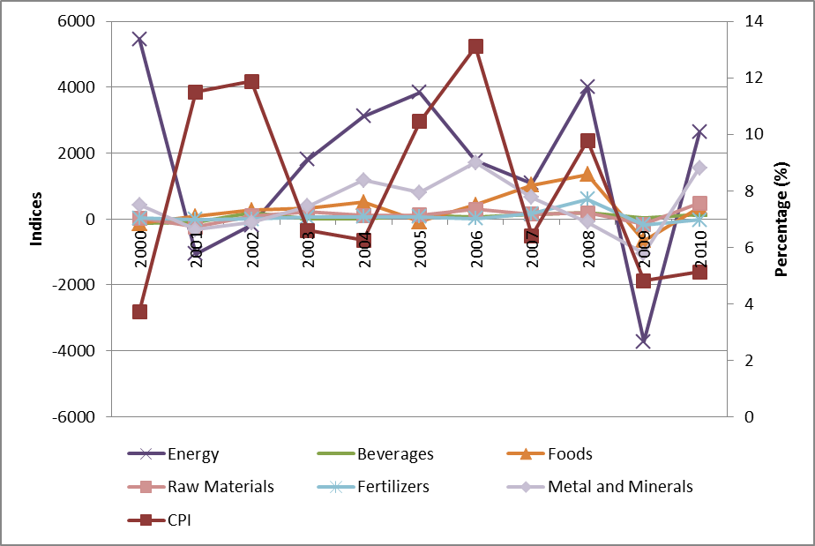
Source : Author’s own calculation based on World Dank Data

To conclude, the determinants of inflation in the period 2000 – 2010 in general can be identified as excess liquidity, exchange rate and commodity price, especially oil price.

Conclusion and Policy Implication

5.1 Conclusion
This paper tries to examine what is the determinant of inflation in Indonesia in 1970 – 2010. By dividing the period of the analysis, a specific variable that causing inflation can be captured and identified and therefore can understand a whole trend of inflation. Based on the average inflation rate the author identify several periods.
The author considers 1970 - 1984 as first period because in that times fluctuation is much more evident that other periods and conclude that the determinants of inflation in this period are excess liquidity, exchange rate and commodity price, especially oil price. The second period is 1985 – 1999, this period is marked by a relatively low inflation and the determinants of inflation are generally excess liquidity and exchange rate and this relationship is much more evident during the crisis. The third is period is 2000 – 2010, the author concludes that the determinants of inflation in this period are excess liquidity, exchange rate through imported commodity price, especially oil price.
In general, factors that determine inflation during 1970 – 2010 are excess liquidity, exchange rate and oil price.

Appendices

Appendix 1
World Energy Price 1970 - 2010
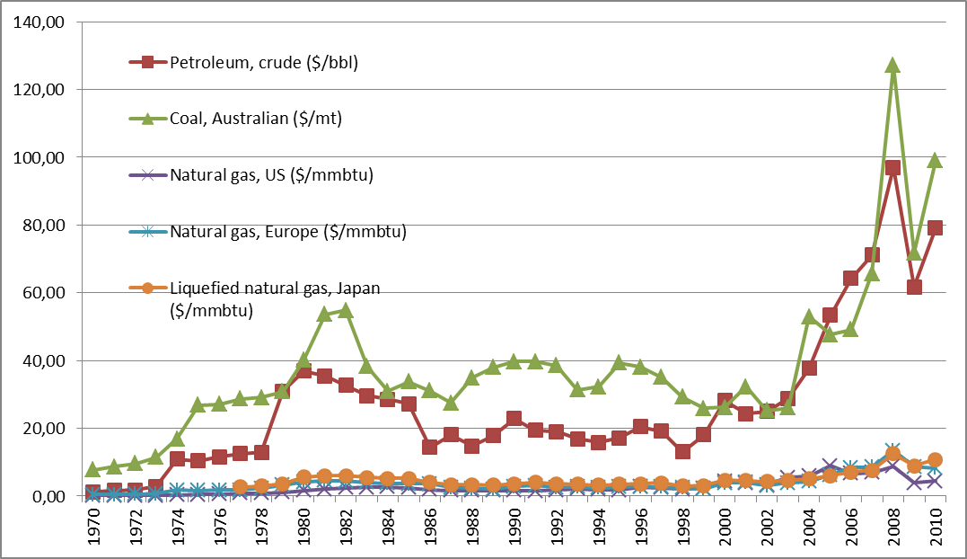
Source : Author’s own calculation based on World Bank Data

Appendix 2
World Foods Price 1970 - 2010
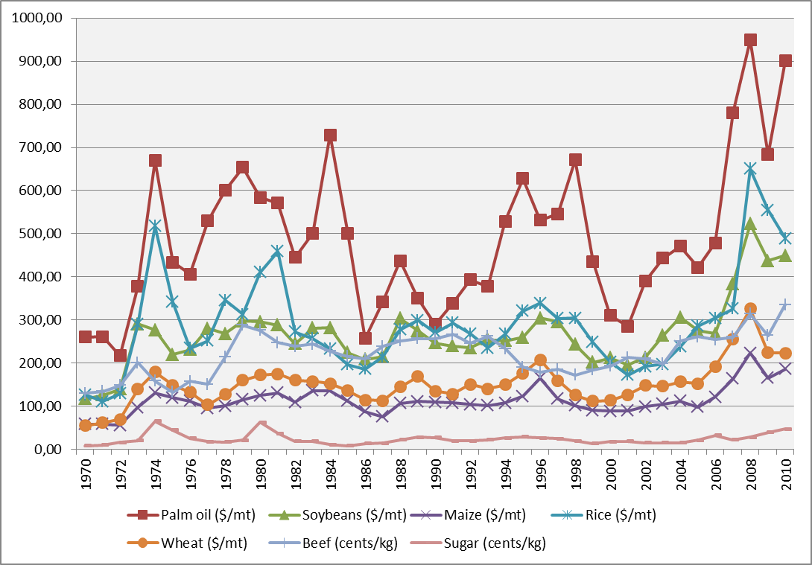
Source : Author’s own calculation based on World Bank Data

Appendix 3
World Beverages Price 1970 - 2010
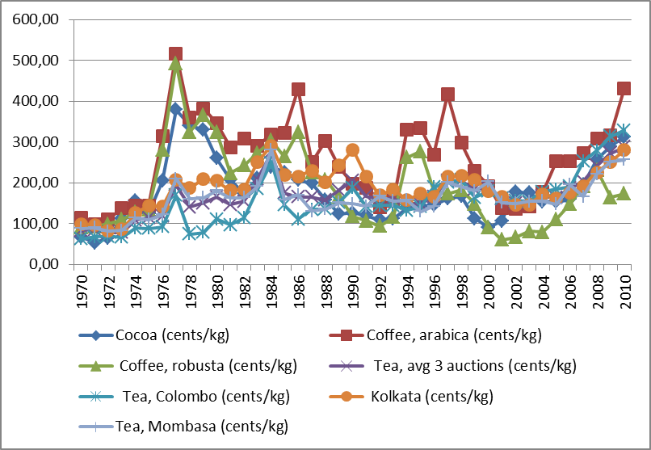
Source : Author’s own calculation based on World Bank Data

Appendix 4
World Raw Materials Price 1970 - 2010
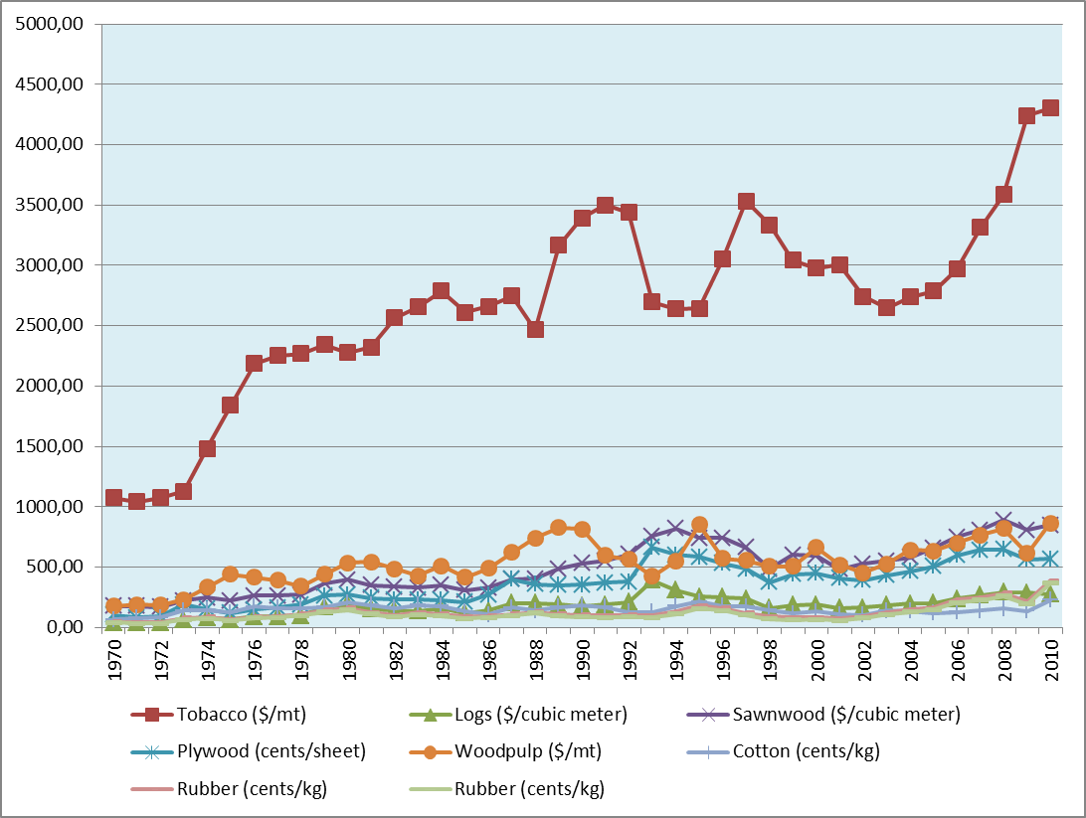
Source : Author’s own calculation based on World Bank Data

Appendix 5
World Fertilizer Price 1970 - 2010
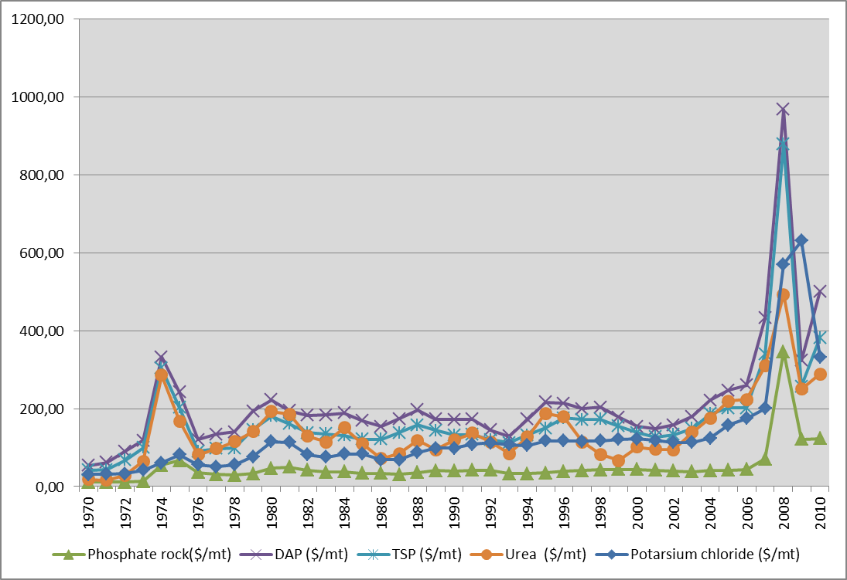
Source : Author’s own calculation based on World Bank Data

Appendix 6
World Minerals Price 1970 - 2010
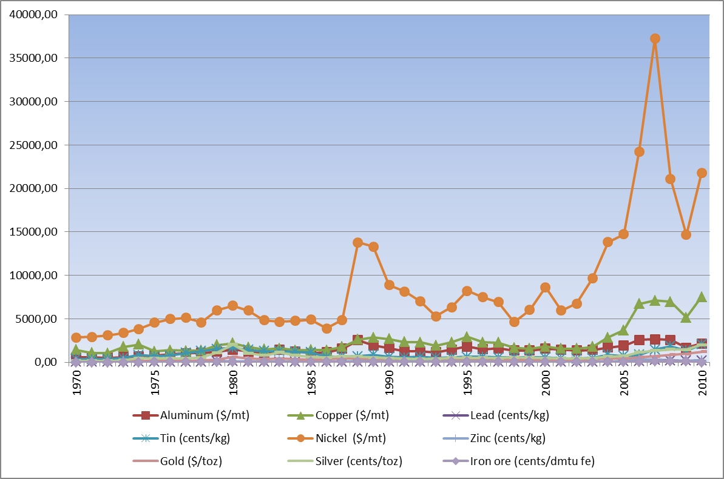
Source : Author’s own calculation based on World Bank Data

References
Aghevli, B.B. and M.S. Khan (1978) 'Government Deficits and the Inflationary Process in Developing Countries (Déficits Publics Et Processus Inflationniste Dans Les Pays En Développement)(Los Déficit Públicos y El Proceso Inflacionario En Los Países En Desarrollo)', Staff Papers-International Monetary Fund : 383-416.
Arndt, H. and R. Sundrum (1984) 'Devaluation and Inflation: The 1978 Experience', Bulletin of Indonesian Economic Studies 20(1): 83-97.
Blomberg, S.B. and E.S. Harris (1995) 'The Commodity-Consumer Price Connection: Fact Or Fable?', Federal Reserve Bank of New York Economic Policy Review 1(3).
Dua, P. and U. Gaur (2009) 'Determination of Inflation in an Open Economy Phillips Curve Framework: The Case of Developed and Developing Asian Countries', Working papers .
Hossain, A.A. (2005) 'The Sources and Dynamics of Inflation in Indonesia: An ECM Model Estimation for 1952-2002', Applied Econometrics and International Development, Vol.5, No.4, 2005 .
Ito, T. and K. Sato (2008) 'Exchange Rate Changes and Inflation in Post‐Crisis Asian Economies: Vector Autoregression Analysis of the Exchange Rate Pass‐Through', Journal of Money, Credit and Banking 40(7): 1407-1438.
Jongwanich, J. and D. Park (2011) 'Inflation in Developing Asia: Pass‐through from Global Food and Oil Price Shocks', Asian‐Pacific Economic Literature 25(1): 79-92.
Loungani, P. and P. Swagel (2001) Sources of Inflation in Developing Countries. International Monetary Fund.
Mankiw, N.G. (2003) Macroeconomics, Fifth Edition. (5 edn) New York: Worth Publisher.
Mardiyanti, N. (2006) 'Analisis Inflasi Di Indonesia Dari Sisi Permintaan Uang', Undergraduate. Bogor, Indonesia: Institute Pertanian Bogor.
McLeod, R.H. (1997) 'Explaining Chronic Inflation in Indonesia', The Journal of Development Studies 33(3): 392-410.
Mohamed Sami Ben Ali and Sami Ben Mim (2011) 'What Drives Inflation in MENA Countries?', International Journal of Economics and Finance 3(4): 119.
Mohanty, M. and M. Klau (2001) 'What Determines Inflation in Emerging Market Economies?', Modelling aspects of the inflation process and the monetary transmission mechanism in emerging market countries, BIS Papers (8): 1-38.
Onafowora, O.A. (1996) 'Inflation in Developing Countries', Applied Economics Letters 3(12): 809-814.
Polleit, T. and D. Gerdesmeier (2005) 'Measures of Excess Liquidity', HfB-Business School of Finance & Management Working Paper (65): 5.
Radelet, S. (2000) 'Indonesia: Long Road to Recovery', Weathering the storm: Taiwan, its neighbors, and the Asian financial crisis : 39.
Riddell, T., J.A. Shackelford, S.C. Stamos and G. Schneider (2005) Economics : A Tool for Critically Understanding Society. (7th edn) Boston: Pearson Addison Wesley.
Ryan, T.C.I. and W.J. Milne (1994) 'Analysing Inflation in Developing Countries: An Econometric Study with Application to Kenya', The Journal of Development Studies 31(1): 134-156.
Sachs, J.D. and B.F. Larraín (1993) Macroeconomics in the Global Economy. Englewood Cliffs, New Jersey: Prentice Hall.
Siregar, R.Y. (1999) 'Real Exchange Rate Targeting and Inflation in Indonesia: Theory and Empirical Evidence', Applied Financial Economics 9(4): 329-336.
Siregar, R.Y. and G. Rajaguru (2005a) 'Base Money and Exchange Rate: Sources of Inflation in Indonesia during the Post-1997 Financial Crisis', Journal of Economic Integration 20(1): 185-215.
Siregar, R. and G. Rajaguru (2005b) 'Sources of Variations between the Inflation Rates of Korea, Thailand and Indonesia during the Post-1997 Crisis', Journal of Policy Modeling 27(7): 867-884.
Xun, Y. (2011) 'Chinese Inflation Determinants since 1978', Master of Arts. The Hague, The Netherlands: International Institute of Social Studies.
Yanuarti, T. (2007) , Has Inflation Persistence in Indonesia Changed .
Zoli, E. (2009) 'Commodity Price Volatility, Cyclical Fluctuations, and Convergence: What is Ahead for Inflation in Emerging Europe?', IMF Working Paper No.09/41 .

