Development Banking in China
The Role of China Development Bank to China’s Economy

A Research Paper presented by:
Ying Zhang
(China)
in partial fulfillment of the requirements for obtaining the degree of
MASTERS OF ARTS IN DEVELOPMENT STUDIES
Specialization:
Economics of Development
(ECD)
Members of the Examining Committee:
Howard Nicholas [Supervisor]
John Cameron [ Reader ]

The Hague, The Netherlands
December 2012
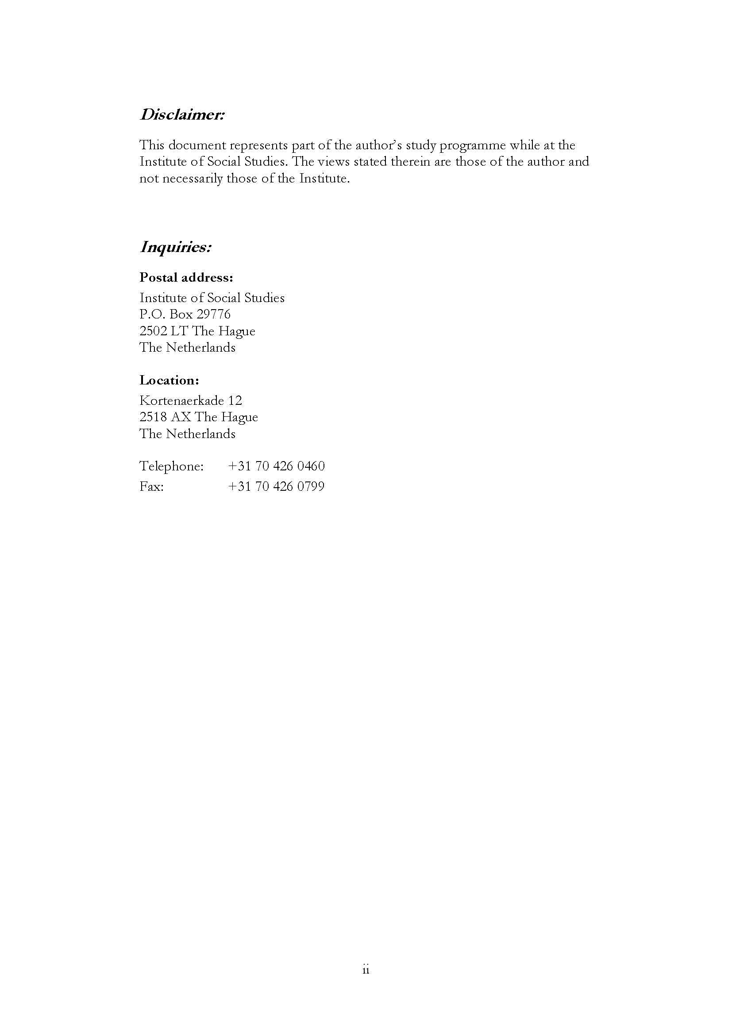

Acknowledgements
I would like to express my sincere gratitude and thankfulness to Prof. Dr. Howard Nicholas for his great and remarkable suggestions with regard to the whole writing process of my research paper as well as all the help he has offered to me. I am really pleased and grateful to have the opportunity in studying and staying with ECD group in the ISS.

I also would like to give my thankfulness to Dr. John Cameron for his great kindness and advices and all the help I have got from him.

Contents
Acknowledgements iii
List of Tables v
List of Figures v
List of Appendices v
List of Acronyms vi
Abstract vii
Chapter 1 Introduction 1
1.1. Background Information 1
1.2. Objectives 4
1.3. Hypotheses 5
1.4. Approach and Methodology 5
1.5. Chapter Outline 6
Chapter 2 Literature Review 7
2.2 Studies on China’s Economic Growth 9
2.3 Studies on Development Finance 10
Chapter 3 Background Information 12
3.2. Nature and Role of Development Banking in China’s Financial System 13
3.3 Details of China Development Bank 16
3.4. Policy towards CDB 19
3.4.1 Contribution to Trade 19
3.4.2: Provide Long- and Middle-term to National Infrastructure Construction 21
Chapter 4 Data Analysis 23
4.1 Economic Model and Econometric Model 23
4.2 Data Description and Analysis 27
4.3 Estimate the contribution of CDB to the Economy 30
4.4 Individual company case studies 32
Chapter 5 Conclusion 35
Appendices 36
References 37
List of Tables
Table 1.1 Non-performing loans, ROA and ROE indicators for Policy Banks (2002-2006) 4
Table4.2 Results of the Regression 29
Table4.3 Yearly Incremented Loans of China Development Bank (1999-2006) 32
Table 4.4 Contribution of CDB’s Loans to the Economy of China (billion Yuan) 32
List of Figures
Figure 1.1 1978-2010 China’s GDP Growth Rate (%) 1
Figure 3.1 China Development Bank 14
Figure 3.2 Lending Products Offered by DBs (%DBs offering each product)(WB,2012:P20) 15
Figure 3.3 China’s investment, exports and imports of goods and services (%) 20
Figure 3.4 China’s economic growth vs. other major economies 20
Figure 4.1 1999-2007 Growth Rate of CDB Loan Balance and GDP 27
Figure4.2 CDB Loan Balance Industry Distribution (%) 27
Figure 4.3 GDP, Credit Increments, Household Consumption, Government Expenditure and Net Export (1990-2011) 28
Figure 4.4 Industrial Distribution of CDB’s Loan Balance (2001-2004) 31
List of Appendices
Appendix 1 Exploration of ROE and ROA 36

List of Acronyms
CDB China Development Bank
ADB Agricultural Development Bank of China
Eximbank Eximport Bank of China
CCB China Construction Bank
ICBC Industrial and Commercial Bank of China
ISS Institute of Social Studies
UNDP United Nations Development Programme

Abstract
This paper discusses the history and its fundamental role of China Development Bank (CDB) in China’s economic growth. Through literature study, theoretical and empirical methods, this paper constructs an economic model to capture the mechanisms of how CDB contributes to the economic growth in China, and an econometric model to estimate how commercial and policy loans of CDB’s contributions to GDP, and calculates out the specific contribution. CDB’s new loans contribute on average 3%-4% of the total Chinese GDP. With the development of China’s economy and its financial system, China Development Bank is finding its vital role in the context.

Keywords
China’ economic growth, Development banks in China’s financial systems, CDB, Development finance

Introduction

1.1. Background Information
China’s economy has gained great success after the Reform and subsequent Opening-up in 1978; its average economic growth rate exceeds 10% per year. During which time, China has experienced Agricultural reform, Marketing oriented economic reform, Fiscal decentralization reform, Social Security System reform, and joining the WTO, and so on. Also, China’s economy is now facing a period of transition, changing from a simple and extensive style of development. When facing an economy like China, which has seen a 30-year high speed growth, people would ask that why it is China? How long would this economic miracle last? The explanation of China’s economic miracle, we have seen Demographic dividend (Cai and Wang, 2005), the advantage of latter comer (Lin and Zhang, 2005) and the welfare of market-oriented transition. To explain China’s economic miracle, there are some factors that affects, but rarely gained the attention of the researchers out of in China.

Figure 1.1 1978-2010 China’s GDP Growth Rate (%)
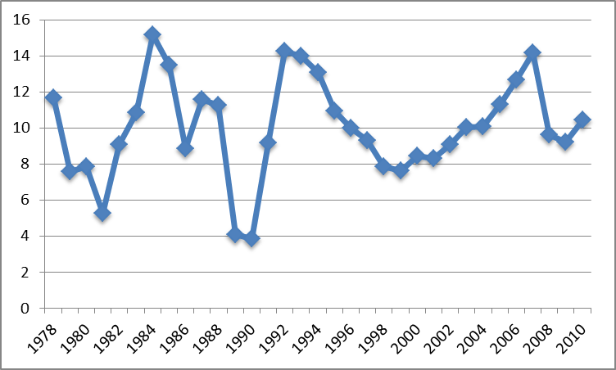Data Source: China Statistical Yearbook 2011

From 1978 to 1993, the operator of the China's policy financial services had made up the manner (<< China’s Specific Steps of Economic Planning>>, 2001), in which it was mainly undertook by the People's Bank of China and the four major commercial banks. During this period, against the background of “the four modernizations”( the sixth five-year plan (1981-1985)), and in accordance with the state policy of encouraging and stimulating the necessity for growth and development of China’s economy, policy financial business had made its progress operating in a relative large scale focusing on mainly China’s internal markets. As considered to have entered a relatively stable developing track, and to have made an irreplaceable contribution to the rapid economic development during the initial stage of the ‘four modernizations’. However, due to the influence of the “traditional planned economy system”(Tao Zhang & Heng-fu Zhou,1998), in this period, the government controlled its finance by planning instruction and thereof resulting in that the state-owned commercial banks are not determined funds according to the market capital supply and demand of “Ricardian equivalences” theory( Bernheim, and Robert Eisner, 1989) and the banking benefits, but determined based on the needs of economic growth rate, structural balance, the reform of the state-owned enterprises( SOE) and even social stability and unity. In fact, at this stage, the state-owned banks actually bear the cost of the gradual transition of China's economic system reform.
In order to keep necessary rate of growth for China’s economy, not only did reform on national macro-control economic system need to be addressed, but also a string of strategic economic policies has to be set up to embrace and deal with the changing atmosphere of world’s economic conditions imposed on developing countries, such as the capability to ensure the long- and middle-term loans and funds to the domestic productive sectors, the ability to be able to continually push the reform of state-owned commercial banks, to ensure the successful completion of the national large-scale infrastructure construction, to increase the rate of import and export trade during that the process of building the economic system. Due in large part to these national developmental pressures, in 1994, the central government set up three policy banks, China Development Bank, China Export-Import Bank and China Agricultural Development Bank. This event marks the beginning of the normalization of China's policy-oriented finance:

Development finance is a service of the national strategy for the purpose, to medium- and long- term investment and finance as a means of combining credit and marketing countries, alleviate the bottleneck of development, safeguard the country's financial stability, financial forms and methods of enhancing economic competitiveness. (CDB annual report, 2010)
In spite of all sort of mechanisms (such as incentives, long and middle-term loans, concessional loans from government guarantee, interest rates and the like) have been used by China’s Development Banks, we have to study Development Banks (DBs) themselves to get insights of how DBs have supported economic growth in China. With restrospective, in 1994, in order to implement financial sector reforms and state-directed lending, three policy banks were established, which are: China Development Bank(CDB), the Eximport Bank of China(Eximbank) and the Agricultural Development Bank of China(ADB). The mandates of policy banks are to promote policy-oriented projects and long-term investments as well as to separate policy-oriented funds from four state-owned commerical banks. The resource of grant loans by the three development banks is supposed to be derived from issue bonds in capital market, regardless of profitable or not( Joseph,1997). The assets of three policy banks combined in 2007 amounted to 8% of the market share compared with 60% of the four commercial banks. Below is a short introduction of the three policy banks:
First and foremost, the initiatives and function of China Development Bank (CDB) are to foster economic development and to promote economic growth of China’s economy. CDB is only one development bank amongst three policy banks that has ministry status and issue state bonds on behalf of People’s Bank of China (CDB, Annual Report, 2007,2009, 2010). The policy lending role of the China Construction Bank (CCB) and Industrial and Commerical Bank of China (ICBC) was taken by CDB to finance national strategic projects and initiatives in accordance with China’s development plan and industry policies (Maswana, 2008). The tageted lending groups by CDB are of construction and renovation projects in strategic economic sectors and of national infrastructure, basic industries and pillar industries. It is believed that over 90% of development funds were allocated to Hydropower, Nuclearpower Plant, road construction, railway, petro-chemical, coal mining, telecommunications, public facilities, and agriculture & related industries involved with medium and long-term loans during period of 1994-2005(CDB, 2009).
Secondly, the function of China Eximbank is to finance exports and imports of mechanic and electronic products, complete set of equipment, high and new technology products as well as offshore construction contracts and overseas investment projects (CEIB, 2009). According to Maswana(2008), China Eximbank has been taking the lead in trade finacing and allowed to extend Chinese government concessional loans with low interest rates to other developing countries, such as Sudan and Indonesia (China Eximbank Annual Report, 2003). Eximbank has also to report directly and be approved by state council. The biggest project implemented by China Eximbank is China’s ship building industry involved with several countries.
Finally, the third largest development bank is Agricultural Development Bank of China (ADB), which is concentrated on agricultural sectors in a desire to allocate funds to alleviate poverty in the rural areas and help cherish agricultural development projects (Lardy, 1998). ADB’s admistration system is somewhat different from CDB and CEIB that it is to finance agricultural products via state agency, which derived development project funds directly from the approval of state council. However, comprehensive agricultural development, poverty allevation as well as grain and cotton enterprises carried out by ADB was transferred mainly to CDB and other stated-owned commerical banks since 2003(Lardy, 1998). According to ADB annual report (2009), the ownership of stated-owned grain, cotton and edible oil enterprises will be diversified to flagship enterprises and agricultural processing enterprises. By which it indicates that agricultural reforms are further deepened and widened its operational scope.
What is more, given inefficient financial systems in China, policy banks are not exception to have suffered from high ratio of non-performing loans and poor management. The poorest performance has been conducted by ADB, which had yeilded profits on assets only amounted to 0.04% of 9-year period in 1998-2006 (The Asian Banker, 2009). Generally speaking, the policy banks were better performed than state-owned commercial banks, its non-performing loans which were differentiated substantially among the three policy banks in 2002-2006 as the table illustrated. In 2006, the non-performing ratio of ADB was at 7.57%, which is 11 times higher than NPLs ratio of CDB, whereas NPL ratio was of 3.47% in Eximbank (CEIB).

Table 1.1 Non-performing loans, ROA and ROE indicators for Policy Banks (2002-2006)
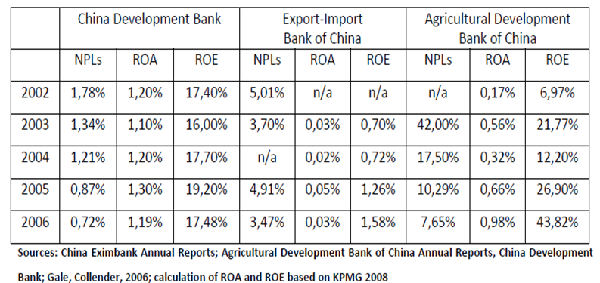

1.2. Objectives
The objective of this research paper is to dig into the purpose and the role of the China Development Bank in promotion for economic growth in China, the effectiveness of China Development Bank and appropriate institutional setting for development banking in China. In doing so, I will firstly propose some hypotheses about the history, operational situation of China Development Bank, which will be tested in chapter 4 using various methodologies and data source. Furthermore, I will try to derive the policy relevance and justification about such analysis and end up with conclusion and justifications in the end of the paper.
As far as economic growth concerned, there is little doubt that development banking sectors have been contributing to the growth of economies for the developing world at large. However, these contributions are considered substantially different according to specific country case, i.e. benefiting to countries who are able to manage banking sectors in a way in which making banking sectors adjust to and in accordance with the need of that their economy growth, such as China’ Development Bank (CDB), while less beneficial to those countries which have difficulty to manage banking sectors accordingly due to various reasons presented. Nevertheless, when concerning with specific county case, a clear picture is to be emerged from the scene of the degree of that country’s economy development. China Development Bank is one of the exact three policy banks established by People's Republic of China. The establishment of the China Development Bank has a certain amount of historical background, reflecting that financial sector reforms have to be grasped with the need of China economic growth. Understanding this historical background of the establishment of the China Development Bank will help to know China Development Bank’s current situation well from a wider range. What’s more, it will help us make the future outlook to the China Development Bank in which how CDB adjusting itself in steady and different phases to support economic growth in China.

1.3. Hypotheses
The newly-formed development banks were responsible for the policy based mission taken from the four banks, namely, ICBC, ABC, BC, and CCB. CDB was formed to provide financial support for the national approved projects involving infrastructure, basic industries and pillar industries of large and medium-sized basic infrastructure construction as well as technical transformation. CDB has played an important role in different phases of China’s economic growth. Therefore, it raises questions of how important CDB is to China’s economy. And how much has CDB contributed to China’s economy growth?
It’s clear that in the past 30 years of China’s economic growth, there were many internal and/or external factors to have affected. But for us researchers, our job is to figure out the key factors. Many have done the job of introducing and summarizing, and also draw a lot of conclusions. But research concerning the contribution of development banks to the China economy growth, which seems as if little has been done. If CDB is a key factor affecting China’s economy growth, we hope to figure out how it affects the economy, and how much it contributes to China’s economy. By the way, we have to acknowledge that in different phases of the economy development stage, key factors affecting China’s economic growth would be different.

As the country's policy banks, the China Development Bank should play the role of promoting economic growth actively at this time with infrastructure investment to consolidate the basis of long-term economic growth. Meanwhile, policy banks also have actively made substantial adjustments to themselves in supporting China economic growth targets, such as acting outwardly as platform to lend to firms implementing government “going global” policy as well as resource seeking SOEs, whereas inwardly committed as central government tools to help lagging behind regions develop and catch up with more better off regions in China. However, the purpose of this research paper is to how and to what extend the mechanisms and methodologies have been used by CDB or DBs in China so as to implement tasks by China policy-makers and central government to support and achieve long-term economic growth for China economy.

1.4. Approach and Methodology
This paper tries to answer the questions raised above. The main research methods are literature research, theoretical research and empirical research. Literature research mainly focuses on the studies relative to this research, home and abroad. Theoretical research focuses on the modeling of China’s economy in the very period, the mechanism that CDB affects the economy, and providing theoretic basis for empirical research. Empirical research focus on the impact of bank loans and government expenditure on the economy, then this paper estimate the impact of CDB on the economy.
The potential problem in the proposed research is the limited scope of prior research, both theoretically and empirically, which conducted on China Development Bank directly. Most research on CDB has been published by media and not academic papers (in fact academics has relative little say on the China development bank), which present rather poor logical thinking and data analyzing.

1.5. Chapter Outline
The research paper is divided into five parts. Chapter 2 is the literature review about impacts and purposes of development banking on economic growth both for China and developing world as a whole. And also what kind of mythology has been used by development banking with regard to incentives and interest rates in a desire to promote growth. Chapter 3 offers background information about nature and role of development banking in China’s financial system and detailed analysis in phases. Chapter 4 presents a model concerning CDB’s investment property and governmental property, which describes how CDB contributes to the economy; also this paper uses some empirical methods, and estimates CDB’s contribution to China’s economy in one of its development phase. Chapter five is to end up with conclusion and policy implications.

Literature Review
2.1 Studies on Economic Growth Theories
Economic growth and fluctuation are two main sectors of Macro-economic research. Research on economy growth theories, counting from Adam Smith, it has been more than two hundred and fifty years’ long. Generally, classical economists, like Adam Smith (1776), David Recardo (1817), Thomas Malthus (1798), Frank Ramsey (1928)、Allyn Young (1928)、Frank Knight(1944) and Joseph Schumpeter (1934), laid the foundation for the modern economic theory. Their works include division of labour, the competition, equilibrium, diminishing marginal returns, capital accumulation, population growth, technological progress and the monopoly position for technical progress incentives and so on. Our review focuses on the development and transition of the economic growth theory after the 1950s.
The most important jobs of the 1950s-economic growth theories are Solow (1956) and Swan (1956). Solow-Swan established a general equilibrium model, and put forward the new-classical production function hypothesis, namely, invariant economy of scale and diminishing marginal returns, but different factors’ substitution elasticity are non-negative, and at the same time, assumed that savings rate were exogenous given. The conclusion of the Solow-Swan model is that the economy would be conditional convergence, and in no technological progress conditions, per capita economic growth will slowly disappear. Due to the economic growth rate in per capita entirely determined by exogenous technological progress, this model faced a lot of controversial. Cass (1965) and Koopmans (1965) brought Ramsey’s consumer’s utility maximizing behaviour into the new-classical economic growth models, thus solving the problem of given savings rate in Solow-Swan model. But they still left the problem of per capita growth rate exogenous determining to the later comers. To take the technological progress into the new-classical framework is itself unrealistic, because that would contradict with the standard competitive hypothesis. Arrow (1962) and Sheshinski (1967) established the model of learning by doing since they assumed that every new invention would spread to the whole economy soon, on the basis of the non-exclusive property of knowledge. Romer (1986) proved that in this case, the competition framework can still keep, and there is a balanced technological progress rate, but the economic growth rate would no longer be parato optimal. When the technological progress is due to the particular scientific research or personal invention which will gradually spread to the popularity, in these cases, competitive framework would no longer stand.
In the 1970s, the macro-economic research mainly focused on economic fluctuation, the research on economic growth stagnated for 15 years’ long. In the late half of the 1980s, began by Romer (1986) and Lucas (1988), the research on economic growth gradually heat up. Romer (1986), Lucas (1988) and Rebelo (1991) mainly modelled on the basis of the works of Arrow (1962), Sheshinski (1967) and Uzawa (1965), but still not really solve the problem of technological progress, they just preliminary explored the endogenous growth model. In these models, per capita economic growth is no longer constrained, because they modelled human capital into the capital framework, and human capital does not have the property of diminishing marginal returns. The including of R&D and imperfect competition into the economic growth model framework begins with Romer (1987, 1990), Aghion and Howitt (1992) and Grossman and Helpman (1991). These models treat technological progress as the result of scientific research activities, and scientific research can obtain a certain period of some form of monopoly. Therefore, as long as the social innovation continues, the long-term economic growth can achieve. In this framework, long-term economic growth mainly relies on government activities, such as taxation, providing infrastructure construction, the protection of intellectual property, the regulation of international trade, financial markets and other parts of the economy.
Barro (1990) added government spending in the production function, making people started to pay attention to government spending in the long term economic growth. Barro and Sala-I-Martin, X. (2004) established a model of knowledge spill overs, by assuming that the manufacturer's technology and the industry's total capital quantity related, found that balanced market economic growth rate would be less than the growth rate of the centralized conditions. They explained by saying that the government would consider the knowledge spill over effect and government spending also had positive contribution. Their work proved the importance of government’s decision-making.
On the studies of the economic growth of developing countries, Parente and Prescoott (1994) argues that because of the existence of technical barriers, developing countries can not directly use the developed countries’ technology, thus they cannot achieve faster economic growth. Atkinson and Stiglitz (1969) first questioned the new classical technical progress model, they held the opinion that different endowment structure should correspond to different appropriate technology. Basu and Weil (1998) considered the technology progress in dynamic framework. Acemoglu and Zilibotti (2001) divided endowment structure into skilled and unskilled labour, and pointed out that technical options should be consistent with the endowment structure, put forward the idea of appropriate technology. Justin yifu Lin and ZhangPengFei (2006) developed Acemoglu and Zilibotti (2001) model, they suggest that a country's appropriate technical structure is endogenous determined by national factor endowment structure. If developing countries chose a technical structure consistent with its endowment structure, then differences of total factor productivity and per capita output between developing countries and the developed countries would become smaller, and because the developing countries faced a low cost of technological transition, the economic growth rate of developing countries can be more than developed countries, and there is a possibility of convergence.

2.2 Studies on China’s Economic Growth
For a long time, the focus of academic circles lays foundation for explaining China’s economic growth in last 30 years. Academic circles have to do a lot of discussion both at home and abroad.
The demographic dividend: Cai (2004) demonstrates the contribution of high savings rate, abundant labour supply and low raising ratio, and China's population changes to China’s high-speed economic growth since reform and opening-up. Cai and Wang (2005) used dependency ratio as a proxy, estimated the population dividend for the period 1982-2000, and found out that it contributed to 26.8% of per capita GDP growth, also they expected that the dependency ratio would stop its decline and start to rise by the year 2013, and the traditional sense of the population dividend would face a trend of disappearing for years to come.
Advantage of latter comer: Lin (2007) argued that the double system of progressive reform in China made the planning system and market system incompatible, resulting in problems like economic cycle fluctuation, vulnerable financial system and income distribution deterioration. Only finishing the reform of the traditional enterprises that lack viability, and eliminating the factors that caused the distortion in planning systems. If China is able to fully complete its transition to market economy, and make full use of the advantage of latter comer, these will be resulted in achieving the target of long term growth and fast development.
Technological progress: Chow (1993) found that in 1952-1980, China's economy did not exist with any evidence of technological progress. They pointed out that, since the reform and opening up, the technological progress might play an important role in China's economic growth. Shu and Xu(2002) tested the neoclassical growth theory and R&D type growth theory, by using 1952-1998 China's economic typical factors for growth, and found out that the China’s economy was close to AK types of growth, proving that the technological progress should not be the engine of this period’s economy, and pointed out that institutional change in China should be included in the economic growth model of this period. Wu (2000) argues that China's economic growth in the 1980s rely mainly on improvement of efficiency and increasing investment, but the period of the 1990s, technological progress is an important force to promote China's economic growth.
Investment and infrastructure investment: Démurger (2001) uses the empirical method, offering evidence of the relationship between China’s infrastructure investment and economic growth. Zhangjun (2002) argues that excessive industrialization (capital formation too fast) shall be the reason for the 1990s’ economic slowdown. Zhang (2008) points out that the 1978-1989 period’s economic growth came mainly from the agricultural reform and the development of private economy, and in the afterwards of the 1989 period when the economic growth mainly caused by investment promotion, but this had worsened the total factor productivity, and lead to regional imbalance.
Institutional Transition: Wang XiaoLu (2000) argues that acceleration of capital formation has made a great contribution to the high-speed growth of the 20 years after reform and opening up, but more important contributions came from resource reconfiguration caused by institutional transition. Chen and Li (2001) verified the effects of the structure transformation on China’s economic growth. Shen and Fu (2005) showed that fiscal decentralization can promote economic growth. Allen et al. (2005) inspected China's economic growth, found in the private sector, whose law and market norms were imperfect, economic growth faster than state-owned and listed company department. While China's law and market regulations are not as mature as the developed countries, China's economic growth is far higher than other economies. For those reasons, they pointed out that there were other institutional factors to explain China's economic growth. Holz (2008) argues that China's economic growth after the reform and opening up mainly came from institutional transition.
Financial development: Chen Gang et.al. (2006) uses 1979-2003 provincial panel data, finds that financial development has significant positive influence on China's economic growth. Fan Xuejun (2008) argues that although the banking sectors and the stock market have positive impacts on economic growth in the long run, but the stock market to economic growth has less influence than that of the banking sectors, which are appeared to have greater influence on economic growth.
Total factor productivity: Wang and Yao (2003) investigated China's human capital stock during 1952-1999, and applied it to measure the economic growth, found out that China's human capital accumulated very rapidly, and played an important role in economic growth and social welfare. Also, the total factor productivity has a positive effect on China’s economic growth after reform and opening up. Wu Yanrui (2008) found that factor inputs promoted most of the growth in China; total factor productivity growth on average explained about 27% of per capita GDP growth rate from 1993 to 2004.
In addition there are a lot of studies that have discussed on the reasons for the growth of the Chinese economy. Such as Lin and Li (2003), who estimate that 10% of foreign trade export growth basically can promote 1% of the GDP growth since the 1990s. Others (like Qiu Xiaohua et.al, 2006) summed up some factors and estimated their contributions to the economy. The first one is the increased inputs, the second is technology progress, the third is industrial structure adjustment to improve the factor productivity, and the forth is the human capital accumulation, etc.

2.3 Studies on Development Finance
It is quite common in both developed and developing countries that the government is generally to intervene with the financial markets. Studies on the topics of policy based finance and development finance are abundant. In this paper we only review some studies concerning China’s cases.
Levy-Yeyati (2004) provides two angles to evaluate the effects state banks or policy banks have on the development of economy. One is that state banks have negative effects on the economy, because they may hider financial development and improve the possibility of corruption. The other is that state banks would promote the financial development in the beginning because they are able to cushion the bad effects of the low-quality institutions (it would be worse without government intervention). Burzynska (2009) found that when policies were right about the financial system and economic development, development banks would have a positive effect on China’s economic growth.
According to the international experience and China's practice, Chen (2004b) divided China’s development financial into 3 phases. Phase one is policy based finance. In this phase, government uses fiscal methods like subsidies to heal the market failures, thus realizing its goals. Policy finance is the extension of national finance; the development banks do not pay attention to performance, thus lack market vigour. The 2nd phase is system construction. Development banks use the national credit to join the economy, and realize the government goals by market means. In the 3rd phase, development banks aim on the security of national social economic finance, and general international competitiveness, on the basis of their market performance.
Chen (2010) argues that development finance can relieve the subject of capital constraint in the process of urbanization, thus it can promote China’s growth pattern transition to domestic demand driven. Chen investigated the relationship between CDB’s investment on infrastructure and provincial economic growth, and found that per capita loans increased by 1%, the growth rate of per capita GDP would increase by 0.046%. Using the CDB Tianjin branch data, Chen (2010) found that in 2005, the CDB Tianjin branch issued infrastructure loans ￥14.866 billion Yuan, pulling Tianjin’s economic growth in 2006 about ￥27.948 billion Yuan, accounted for 6.41% of the total Tianjin economy and 42.25% of the economic increment.

Background Information
3.1. Introduction
China Development Bank is one of the exact three policy banks established, by People's Republic of China to implement financial sector reforms and state-directed lending, on March 17, 1994, namely: China Development Bank (CDB), the Eximport Bank of China (Eximbank) and the Agricultural Development Bank of China (ADB). The establishment of the China Development Bank has a certain amount of historical background, reflecting that financial sector reforms have to be grasped with the need of China economic growth. Understanding this historical background of the establishment of the China Development Bank will help to know China Development Bank’s current situation well from a wider range. What’s more, it will help us make the future outlook to the China Development Bank in which how CDB adjusting itself to support economic growth in China.
At the beginning of the founding of New China, with the transformation of private banks and banks in the confiscation of bureaucrat-capitalism, and on the basis of strong development of rural credit cooperatives, the central government established the program management of the "universal" financial system in accordance to the implementation of a highly centralized planned economic model. Therefore, there is only one national bank in China, that is, the People Bank of China, with the building of its affiliations in accordance with administrative divisions. At this stage, the division of the financial and banking imposed a principle which states that “unpaid business is owned by financial ministry but well paid business is owned by bank” (Deng, 2009:p187). At this stage, bank had obvious policy financial characteristics in which bank was limited in its operation in that it was only permitted to issue short-term liquidity loans to state-owned enterprises.
What is more, the division with that policy characteristic lasted over 20 years. From the time that the country completed its socialist transformation of capitalist industry and commerce, to the end of the Cultural Revolution, China's policy-oriented financial services under the planned economic system, are primarily allocated free of charge from finance, playing an important role in supporting the development of the national infrastructure, basic industries, and pillar industries. It is worth mentioning that, in a certain period of time, especially during the period of “the first two Five-Year Plan”, this policy has promoted the rapid development of the national economy. However, this policy also has relative disadvantages. Overall, this policy does not fully play its proper role, but stays volatile with political campaigns.
Nevertheless, as far as policy instruments are concerned, the mandates of policy banks are to promote policy-oriented projects and long-term investments as well as to separate policy-oriented funds from four state-owned commercial banks. The resource of grant loans by the three development banks is supposed to be derived from issue bonds in capital market, regardless of profitable or not (Joseph, 1997). Consequently, policy banks as a means for the government to regulating economy play an important role in promoting economic growth, stabilizing agriculture, and expanding import and export, contributing to the national economic development.
Therefore, this chapter is to show how CDB has operated its businesses under aforementioned situation, such as what role CDB is in the China’s financial system, where CDB lend its funds and how that can be realised and what the interest rate of CDB’s funds is.

3.2. Nature and Role of Development Banking in China’s Financial System
As far as policy banks in China financial system concerned, CDB is directly controlled by the State Council as a policy financial institution. The operation style of CDB is the implementation of the business model of independent insurance and independent accounting and enterprise management. At the beginning of the establishment of the China Development Bank, it accepted the guidance and supervision of the People's Bank of China and the China Banking Regulatory Commission. Also, its financial and capital matters were guided by the Ministry of Finance with management and supervision. What’s more, its capital sources came mainly from domestic and foreign bond markets.
At the inception of the China Development Bank, the Central Government had already set up the operating rules for its development. According to the documents of China Development Bank published by the Constitution of the State Department(CDB,1998), the main scope of business of the China Development Bank is as follows:
Manage the use of state appropriated budget for operating construction fund and the discount funds, issue financial bonds to domestic financial institutions, execute lending for foreign governments and international financial institutions, lend policy loans to support the projects of national infrastructure, basic industries and pillar industries, infrastructure and technological innovation, review the application for the loans of the construction project, execute consulting, guarantee business and other businesses which gets the approval of State Council. (CDB-AR, 1998:P21)
The fundamental purpose of setting up policy banks is as government tools or financial instruments to implement state policy for Chinese central government. In “the tenth five-year planning congress”, Vice Premier Wang Qishan (2008) stated that “reform carried out in CDB is new probe into and a key transformation of Chinese financial system reform; it bears great experimental and practical significances and is a tough mission.” As shown in Figure3.1, it can be clearly seen that CDB came to expand its branches only after 1997/8 when Asian crisis occurred and that impressed upon China policy-makers to make effort to reconfiguration of banking sectors as financial instruments for governments to operate financial systems. The 1997/8 is also the pivotal turning point for CDB being successfully commercialized its operation under the title of state-owned development bank.

Figure 3.1 China Development Bank
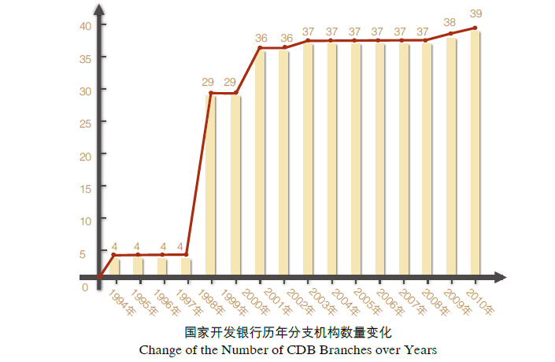
Source: CDB
What is more, after having experienced for a long period of far lagging behind economic sluggish with the exerting policy “leap forward development strategy”, which was imparted to China as whole a painful experience, which had propelled the policy-makers in China to step up to adopt (Zhicheng LIANG,2007) “a new development strategy to explore comparative advantages, improve production efficiency, and accelerate economic growth”. Despite of recent decades of well documented and substantial economic growth has taken place in China, banking sectors still have subjected to somewhat degree of soft budget constraints due either to liquidation and imperfect market or concerning issues related to investment inefficiency and resource distortion. China begun with a Dual-track reform, which enabled China’ s economy to have experienced and gone through the process and gradual experimentation approach, has successfully stimulated China’s economic growth and also has been proved to be an efficiency-enhancing and Pareto-improving approach with which no one made worse off (Lau et al., 2000).
In response to the state policy (CDB-ASRR,2010,1:204:p9) “ensure economic growth, increase domestic demands, and adjust economic structure” and the global financial crisis, in 2010, CDB played very positive role to materialize RMB 4,000 billion investment plan to sign agreements with provinces in the eastern, central and western regions on new rounds of development financial cooperation. The China development bank has also actively promoted development finance in stabilizing economic cyclical fluctuation (PAWR, 2010; China Daily 2010). As illustrated in Figure 3.2( José Carlos, 2012: p20), the long-term loans provided by the three DBs in China accounted for 90% of total loans that was closely followed by working capital loans amounted to 85% of the total loans shares. Loans for new product launch activities and intangible assets only accounted for 41% and 25% of loans shares, respectively. It is made clear that long-term loans and loans for working capital are mega parts of loans, which have been used as effective mechanisms and methodologies by the three policy banks as policy instruments to support economic growth. What is more, CDB’s key focus remained on these primary areas as fiscal spending. That was accounted for RMB 429.4 billion to lend to sectors such as coal, electricity, oil, transportation, agriculture, water resources, telecommunications and public infrastructure, accounting for 63% of its incremental loan balance. Also, the loans issued by CDB to road construction alone amounted to RMB 290.6 billion in 2011 aslo as government fiscal spending for long-term loans.

Figure 3.2 Lending Products Offered by DBs (%DBs offering each product)(WB,2012:P20)
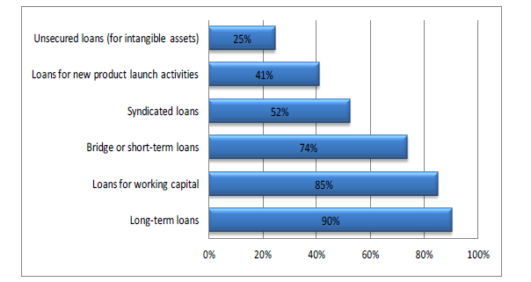
Source: World Bank

Table 3.1 Maximum Loan Term Offered by DBs
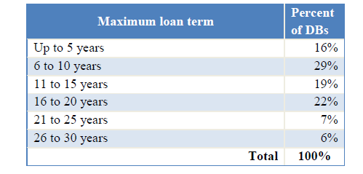
Source: World Bank

In 2011, the Bank's total assets stood at RMB 6,252.26 billion, an increase of 22.30% from the previous year. The RMB-denominated loan balance was RMB 4,251.36 billion, increased by19.90% from 2010; the foreign currency-denominated loan balance reached RMB 1,151.63 billion, up by 32.42%. CDB’s total liabilities amounted to RMB 5,807.01billion, a sharp rise up by 23.30%. Outstanding bonds issued as the primary funding source, which increased to RMB 4,476.45 billion at the end of 2011, accounting for 77.09% of total liabilities, an increase of 20.09% from the previous year. Remarkably, it is documented that CDB had $687.8 billion in loans on its books at the end of 2010, more than twice as much as the World Bank. As for all of these policy loans, which could intrigue and draw more attention concerning for its interest rate. For which i would like to quote from Bloomberg market magine, which might make some sense of how much interest rate can be for loans from CDB or DBs in China:
Huawei and ZTE “received tens of billions of dollars in export financing and low- to no-interest loans that needn’t be repaid from the Chinese government. It is all because China provides these subsidized interest-free or low-interest bank loans and provides lots of other subsidies.”( Bloomberg Market Magine, May 2, 2011)
It goes without saying that development banks as policy instruments played countercyclical role during financial crises. That was implemented by combating recessionary pressures to provide low-interest rate in terms of long and middle-term loans to firms and national strategic sectors and even individuals, who cannot access to funding from commercial banks and capital markets in the period of economic distress (Hanson, 2003 and Laporta, 2000).
Despite of low to zero interest rate has been exerted in China’s policy banks, interest rates can be universal concern to all, no matter of individuals, firms, governments and financial institutions. According to World Bank that there is over 50% of DBs use subsidized interest rates to provide credits to support nascent enterprises and directly/indirectly support long term economic growth. It is also suggested that 73% of loan guarantees provided by DBs to help offset the loss of private financial intermediaries when facing customers defaults. Government transfers accounted for 66% of these guaranteed loans, which are in the different forms of modalities in terms of coverage and pricings.
What is more, some of those DBs offered lending rates is well below market interest rates and some DBs even have nagative interest rate spread (lending rate minus deposit rate) make it impossible to survive if government subsidies were cancelled. José de Luna-Martínez and Carlos Leonardo Vicente(2012) pointed out that there is 64% of state-owned DBs which get explicitly guaranteed of debt and liabilities from the support of governments. According to World Bank, 89% of DBs can borrow from other financial institutions at lower cost or directly issue bonds, which give the reason to why DBs can provide long term loans with low interest rates and even more so do DBs in China.

3.3 Details of China Development Bank
According to Chen (2004), we separate the development of CDB into three phases: Policy Finance (1994-1998), Institutional Construction (1999-2007); and Strategic Development Finance (2008- present).

A: Policy Finance Phase (1994-1998)
CDB was founded in 1994, mainly responsible for the national fiscal finance loan businesses, thus establishing the national policy finance. By that time, CBD concentrated on the core construction projects, and paid no attention to institutional construction. There are two business patterns for the development banks: the first one is the fiscal finance based model, which the government offers large sums of free or low cost funds for the banks, using guarantee, loss subsidies, and preferential tax; the second one is the public credit based model, in which the banks finance in the market basing on national credit, fiscal finance offers guarantee and little sum of expenditures, realizing the government’s goals using rules in the market, make up for commercial Banks in long-term financing flaws, and the weakness of the capital market development. The first pattern is an extension of the public finance, it can realize some sort of goals of public policies, but it does not care about the security of the assets. The second pattern, development banks action as participants of the market, in the premise of the asset security, the banks provide continuous supports for economic development.
At the beginning of CDB’s establishment, the economy of China was in trouble, the supply was in short. The economy need to overcome the “bottleneck” type restriction of energy, transportation, communications and other infrastructure to ensure the economy’s growth. The establishment and running of CDB strongly supported the development of “two basics, and one pillar” (national infrastructure, basic industries and pillar industry). Its operation is mainly a pattern of “department designated projects, administrative debts, and proxy loans for commercial banks”. In this period, CDB took up a lot of fiscal policy tasks, did not ran according to the credit financing operation rules, and carried on a lot of bad assets which are legacies of the past system. At the end of 1997, non-performing loans of the China Development Bank has more than 170 billion Yuan and non-performing loan rate stood at 32.63%. At the same time, the role of policy-oriented finance is too single, which can only solve part of the project construction funding needs and cannot solve the problem of economic development, market building and institution building. Therefore, in 1998, the China Development Bank started the business philosophy and mode conversion, and gradually transited to the development stage of the financial to address the problem.

B: Institutional Construction Phase (1999-2007)
The year 1997 was an important turning point in China's financial development. In this year, the Asian financial crisis occurred. The crisis also shows that serious financial risks lurking in the process of economic transition, if we cannot fundamentally address such risks, they will seriously affect the overall situation of reform, development and stability. In November 1997, the CPC Central Committee held a financial work conference and set up the proposal to accelerate the reform of the financial system to rectify the financial order and prevent financial risks. As a sign, China's financial development entered a new stage of accelerated development, began to highlight the emphasis on risk control. The bank is gradually separated from the fiscal financing, further defined the commercial direction of the banking system.
At the beginning of 1998, the China Development Bank had carried out three credit reform as the core to promote infrastructure development, to prevent and to reduce risk. First credit reform proposed that it should do banking “in the market environment and within the framework of bank", clearing the core office ideas as market-oriented and risk control. Through the establishment of internal risk control mechanism, the China Development Back blocked the ordered loans and favoured loans to ensure the quality of new loans. The second credit reform focused on resolving the stock risk. The China Development Bank hired Boston Group to provide advice about institution-building and risk management, setting up the firewall review mechanism in line with market requirements, improving the management of two branches, and strengthening risk control and basic management. What’s more, the sources of repayment were harmonized by the China Development Bank. The establishment of the sinking fund accounts was also regulated by the development Bank, with the loans to local GDP ratio maintaining a certain level, which basically formed a credit management system and operation mechanism to adapt to market requirements. At the stage of the third credit reform, the China Development Bank has put forward the strategic goal of integration with the international advanced management mode and toward the world-class bank.
After three credit reforms, the asset quality and operating efficiency of the China Development Bank improved rapidly. At the end of 2002, the balance of assets achieved 1.0417 trillion Yuan. Among them, 896.2 billion Yuan attributed to RMB loans, foreign currency loans amounted to $ 17.7 billion, 860.5 billion Yuan of financial bonds outstanding. The net profit of the China Development Bank was 11.9 billion Yuan with its capital adequacy ratio of 11.58% and non-performing loan ratio and NPL growth rate dropped sharply to 1.78% and 2.54%. After these three credit reforms, the China Development Bank has gone in the forefront of the domestic banking sector in its own market performance, the market system construction and credit-building, stimulating economic growth.
At the same time of Credit reform, the debt business of the China Development Bank also carried out major reforms. In September 1998, the China Development Bank successfully issued bonds to the market at 50 billion amounts at an interest rate below the purchase by the chief. This is the first time since the founding of the China Development Bank that it broke out the command of People's Bank of China to send a single form of purchase issuing bonds, and began market bond issuance, which is an attempt of the national credit securitization. After that, the China Development Bank continued to improve the proportion of market-oriented issue bonds, to positively innovate bond varieties, and to develop the field of international capital markets. The degree of market of debt issuance in 1999 reached 96.8%. In 2000 China Development Bank had achieved a full market of debt issuance. China Development Bank gave full play to the efficient capital market and competition mechanisms through an achievement of more and more funds, of the optimization of the structure and of the cost reduction, and also from the executive to send to the market. Therefore, it formed the domestic and international bond market financing based, deposit-taking business supplement, relying on market-oriented financing mechanisms for flexible use of funds of the inter-bank market.
In July 2003, the China Development Bank proposed and fully implemented “government concentration, timely assistance, planning in advance, credit building and financing to promote “as a 20-character principle, according to the directing thought of “further consolidate and develop the advanced market performance” and on the base of years of practice to explore and experience. By 2003, 188 various types of financial cooperation agreement or development of financial cooperation agreement were signed with the local governments of 30 provinces, municipalities and autonomous regions. In fact, to sign an agreement with government to select the hot item of the government to build, to continue to regulate the financing platform, to enhance organizations’ trust, to facilitate credit building and market building, and to attract commercial finance and private capital to enter a wider range of financial cooperation, the China Development Bank had played a developers guide and vanguard role of development finance. During this period, the China Development Bank has been developing rapidly and has become a world-class development financial institution. By 2007, the total asset of China Development Bank was over 2.89 trillion Yuan, the net profit of which was 29.6 billion Yuan. What’s more, the average return on assets and the average owner's equity rate of return were 1.17% and 16.32%, and non-performing loan rate was only 0.59%.

C: Strategic Development Finance (2008- present)
In December 2008, the overall China Development Bank was restructured into the China Development Bank Co., Ltd, with the registered capital of 300 billion Yuan. Conforming to the needs of the development of the new situation, the China Development Bank has put forward new development ideas:
Stick to build the unique advantages of development finance and institutional values development according to financial market-oriented way of exploration, stand based on the bond Bank and the wholesale banking market position, take market development, credit building, planning in advance, and comprehensive management as core competitiveness, adhere to the financial and international cooperation development strategy, drive the market to finance construction, speed up economic development mode shift and better serve the economic and social development.
Accordingly, the China Development Bank optimally adjusted the internal organization, improved the modern enterprise system, strengthened the investment and loans, debt, rent, permit the strategic synergies, highlighted the leading role of the planning, built a new type of silver governance banks and enterprises, silver social relations of cooperation, and promoted China Development Bank policy financial institutions to the commercial finance transformation.

3.4. Policy towards CDB

3.4.1 Contribution to Trade
Although with Chinese-style development theory in mind, never should be able to simply consider China economic development without keeping a close eye on globalisation, China has integrated her economy into the world market and this trend has been increasingly keeping on the track, especially is the case as financial integration has been stimulated since China becomes a member of WTO. In 2011, according to data from CDB, China foreign trade balance grew by 24%, to which exports trade has become flowed closely by imports and this trend seems to be accelerated continuously since early 2000s, as shown in Figure3.3. And also, during 2008/2009 financial crisis, imports of goods and services was far gone beyond exports by 10% of the total trade balance, regardless of total investment spending still in steady up trend and reached 50% of GDP growth rate in 2009. In an effort to cope with this deteriorating current account, on one hand, “going global” policy has been promoted by Chinese government and that it has been done via mechanisms and strategies in which CDB acts as policy instrument to implement “national strategic planning, forward looking and all-round development financing projects” (Chen Yuan, 2012:p15).
Figure 3.3 China’s investment, exports and imports of goods and services (%)
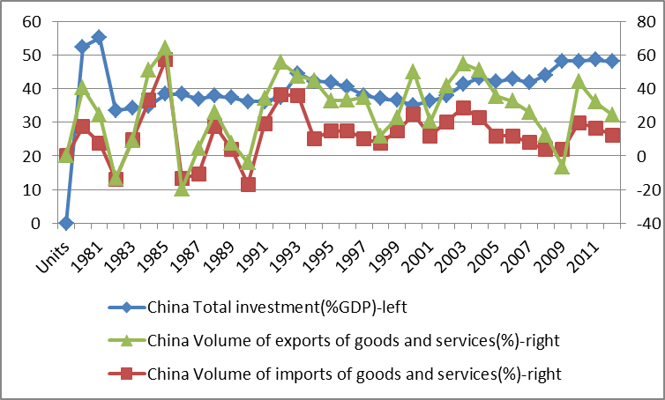
Data source: IMF WEO database
Nevertheless, China has demonstrated an efficient improvement with economic growth rate reached 9.2% of GDP in 2011, including 17.1% increase in total consumption as well as corporate profit gained a significant margin by 27 %(CDB-AR, 2012), which could make a sharp comparison with other major economies in the world during and without crisis from 2000 to 2012 as illustrated by Figure3.4.
Figure 3.4 China’s economic growth vs. other major economies
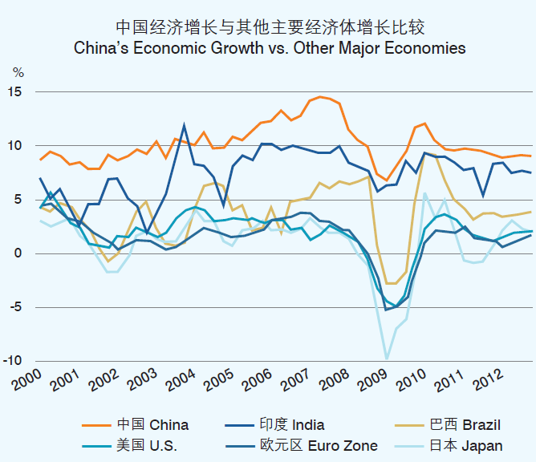
Data source: IMF(2011)
That continued GDP growth rate can either be due to the stimulate growth policy planning of the “going global” guideline, China’s outward foreign direct investment (FDI) increased by 6% and resulted in USD 60.07 billion in 2011 according to the China auditing database, or due to stimulate economic growth by massive domestic infrastructure construction as government fiscal spending strategy. All these stimulating strategies for economic growth are involved with the China Development Bank which will be further explored in the flowing section.

3.4.2: Provide Long- and Middle-term to National Infrastructure Construction
The contribution made by CDB towards China's economic construction is undeniable. One should be able to see this point via the manifestation of the constitution of the State Council to the policy banks. The China Development Bank by using medium and long-term credit and investment strategies serves for the country’s long-term development pursuits and goals. There are papers which have well documented the role of bank to provide long- and middle-term credit to entrepreneurs as a means to stimulate and sustain economic growth (Brian et al., 2003). Specifically, CDB mainly supports the development of national infrastructure, basic industries and the state key projects, including urbanization, SME financing and the “Three Rural Issues". Through funding and implementation of these projects, the China Development Bank and China's economy has close links.
Apart from the function stated above, China Development Bank also acts as a role to expand productive production. This function is mostly executed in the production of agriculture and manufacture industry. Take agriculture as an example, as early as the beginning when the China Development Bank was established, the Agricultural Credit Board of the China Development Bank attached great importance to the increasing input on large-scale agriculture, such as irrigation, fertilizer, grain production bases, comprehensive agricultural development and deep processing of agricultural products, while engaged in some small projects according to the special nature of agriculture.
According to the report of 1995, the scope and focus of agricultural policy loans of China Development Bank was the "vegetable basket" project, focusing on national planning construction of commodity grain, cotton production base, ‘vegetable basket’ project in the capital cities and industrial, mining area. Investment in agricultural infrastructure was vigorously increased and high quality and efficient agricultural production was encouraged. The specific measures were adjusting loan structure, expanding the loan proportion of large, medium and above norm projects, compressing general small projects, adjusting the geographical distribution of loans, properly increasing loan ratio of the central and western regions.
In the end of 2010, the China Development Bank issued new rural construction and county loans of 182.4 billion RMB, by which 63% of the total loans was to invest in rural infrastructure construction of rural road networks, power grids and drinking water, 16% of the total invested in leading enterprises of agricultural industrialization and county small business projects, 19% of the loans invested in housing projects in rural areas, 2% invested in the field of emergency loans and the bases for the training of migrant workers. These measures were supposed to have helped solve the problem of rural production and living, playing a crucial role in the livelihood of the people of the country.
In addition, the China Development Bank supported and participated in national economic construction in many areas, such as industrial restructuring, optimization, and upgrading (e.g. M&As), including other strategic and emerging industries, cultural industries, housing construction, education and emergency loans. These initiatives effectively promoted China's economic growth, with a role indelible in helping to build and implement national infrastructure construction.

Data Analysis
China Development Bank has contributed a lot to job creation (supporting the small and medium-sized companies and their exports), urbanization, industrialization, and foreign investment. This paper tries to visualize the mechanisms of how CDB’s loans contribute to the economy, and calculate how much the contributions they have made to the economy. The growth rate of China’s economy has seen a period of growing from 1999 to 2007. And in the same period, China Development Bank gradually finished its system preparation for the development finance. After its shareholding reform in 2008, CDB began its transition to strategic development finance, and looked more like a commercial bank with strategic tasks. But this paper’s job is not to compare which system is better; we are to calculate how much the contribution of CDB has made to support per capita GDP growth of China economy under certain period of time and certain economic contexts.
This chapter tends to hold the opinion that China Development Bank contributes to China economy through the following three ways: a) acting as finance intermediate to issue policy loans to support national strategic projects; b) offering finance support for merger and acquisition(M&A) projects abroad for large state-owned enterprises(SOE) and private corporations, or the high-tech industries, promoting the growth of China economy by supporting its technological progress; c) acting as the extension of the fiscal finance, offering policy loans to large infrastructure constructions, basic industries and pillar industries, that is, promoting the economy through government expenditure.

4.1 Economic Model and Econometric Model
Model I: the mechanisms of CBD
In the phase one of the development of China Development Bank, we assume that CDB acted as an extension of the government fiscal financial system. Our model considers only the period of the development finance system preparation. For simplicity, this model does not take the impact of CDB on technological progress into account. So, we assume that the loans of CBD can be separated in two parts, one is government expenditure, and the other is investment, that is, capital accumulation. Our model is based on the model of government expenditure according to Baro (1990), whose theory is extended to best suit for our model and so does it fit to our research framework.
Hypothesis:
A representative, infinite-lived household;
Household seeks to maximize his overall utility;
Closed economy;
A production function concerning government expenditure, which is constant returns to scale;
There’s no labor-leisure choice;
Competitive market.
Represented Household’s Utility Function:
Where is consumption per person andis the constant rate of time preference, and, so that marginal utility has the constant elasticity. Population, which corresponds to the number of workers and consumers, is constant.
Production Function:
Each household-producer has access to the production function.
= output per worker,
= capital per worker,
= government expenditure per capita, and.
Consider the situation, the households maximizes his utility, then we have:
And budget constraint:
= per capita loans of the China Development Bank;
= the tax rate, and.
The government constraint:
Then we solve the utility maximizing problem, so we have:
First order condition:
Where is the China’s economic growth rate.
We can obtain from the government’s budget constraint.
Then we have:
On the balanced growth path, we have:
When the economy is on the BGP (Balanced Growth Path), grow rate is at the same rate, so, their ratios are all constant. Combine equation (7) and (8), we can get a, which means that there exists a ratio of China Development Bank’s commercial and policy-style loans, that makes the economy grow on the BGP.
Theorem I: the loans of CDB can promote the economic growth.
From Equation (7), we can know that . There’s a subtle condition lying behind the production function and the government’s budget constraint, that is, the government’s decision on each policy shall be right. Obviously, this does not always happen in the real world, the government is not of god, he cannot do everything right, and sometime, the government’s actions even hinder the development of the economy. This coincides with the conclusion in Burzynska (2009).

Model II: Econometric Model
In the phase of institutional construction, China Development Bank joins the market in with the identity of a market participant as well as a proxy of the government. We use the GDP accounting equation to help investigate how CDB’s loans contribute to the development of the economy. The equation is as below:
China Development Bank promote the development of China’s economy through providing loans to domestic infrastructure investment, pillar industry construction, small and medium-sized enterprise, and providing financing channels for the enterprises’ foreign investment, in the forms of policy loans and commercial loans. This paper holds the opinion that, although CDB’s financial support for the economy is in the form of loans, when we take into account the types of the projects and the original intention of the loans, CDB’s contribution to the economy should be separated as commercial loans and policy loans. Here in this paper, we assume that the contribution of CDB’s commercial loans to the economy is the same as the social loans, and the policy loans, similar to the government expenditure.
According to the assumptions above, this paper takes two steps to calculate the contributions of CDB’s loans to the economy.
Step 1: we construct the econometric model to estimate the contributions of commercial loans and government expenditure to the economy.
Step 2: using the results of the first step, separate the CDB loans into commercial loans and policy loans, then calculate the contribution of CDB to the economy from 1999 to 2007.
The econometric model is as following:
Whereis the GDP in year, is the new loan and its lags of the economy, is government expenditure, is the total consumption of the economy, and is net export, and, the error term.

4.2 Data Description and Analysis
Figure 4.1 1999-2007 Growth Rate of CDB Loan Balance and GDP
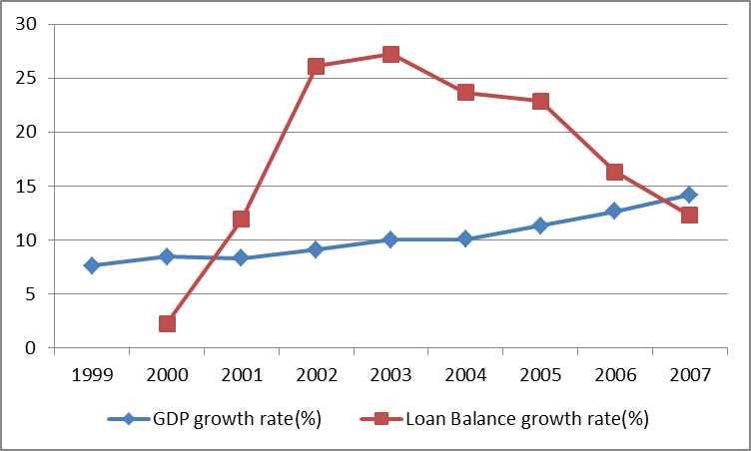
Data source: Year Report of CDB and Statistical Yearbook of China, 2011
We can figure out some messages from Figure 2. In the period of 1999-2007, the growth rate of CDB loan balance is generally higher than that of the GDP in China. But it fluctuated obviously in these years, compared to the steady growth of the GDP data. During the nine-year time period, the loan balance of CDB grew from 621.1 billion Yuan to 2261.68 billion. And the fluctuation of the loan balance growth rate indicates that loans of CDB had been exerted both for commercial and policy parts.

Figure4.2 CDB Loan Balance Industry Distribution (%)
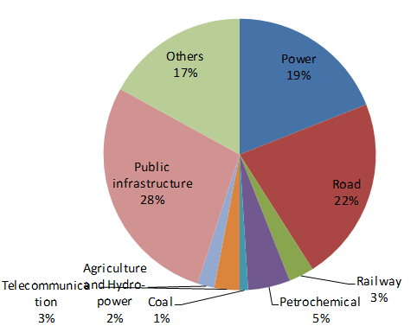
Data Source: CDB Year Report 2007

Figure 3 tells the distribution of industries of CDB’s loan balance in 2007. We can see from Figure 3 that energy, power, transportation, communication, infrastructure construction and petrochemical accounted for more than 70% of the total loan balance. At this stage, the policy loans in CDB remained relatively high proportion of its total loans combined. This paper tries to estimate the proportion of estimated annual new loans between policy loans and commercial loans according to the industry distribution of loan balance. And thereafter, according to the estimate of the proportion of the calculated distribution and the coefficients of different style of the loans, we can calculate out how much contribution CDB has made to the growth rate of China economy.

At the rest part of this section, this paper will use the data of China’s GDP, credit increment, net exports, household consumptions and government expenditure from 1990 to 2011 to estimate the contribution of the bank loans as well as government expenditure to the growth rate of real per capita GDP. Here in the econometric model, we assume that credit increment and investment are correlated. And we use the credit increment to take the place of investment in the GDP accounting equation. Because credits’ impacts on the economy may have some lag, so we add some lags of the credit increment in the regression.

Figure 4.3 GDP, Credit Increments, Household Consumption, Government Expenditure and Net Export (1990-2011)
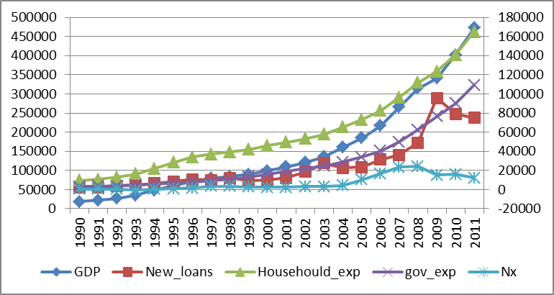Data Source: CEI data

Figure 4 exhibits data of GDP, credit increments, household consumption, government expenditure and net export from 1990-2011. We can see that GDP, household consumption and government expenditure increased steadily in this period, but credit increments (which are the same as new loans in the graph shown) and net exports faced some sort of fluctuation.

Table 4.1 Data Description
Variable | Obs | Mean | Std. Dev. | Min | Max
gdp | 22 | 152601.6 | 129952.1 | 18667.82 | 472881.6
new_loans1 | 22 | 25039.2 | 26713.56 | 2092.92 | 95768.29
new_loans2 | 21 | 22669.31 | 24890.88 | 2092.92 | 95768.29
new_loans3 | 20 | 19841.02 | 21802.29 | 2092.92 | 95768.29
new_loans4 | 19 | 15844.85 | 12830.28 | 2092.92 | 49035.87
new_loans5 | 18 | 14000.91 | 10290.61 | 2092.92 | 36336.14
househould~p | 22 | 59812.53 | 43728.02 | 9450.9 | 164945.2
gov_exp | 22 | 29125.27 | 30428.52 | 3083.59 | 109247.8
nx | 22 | 6626.968 | 7724.996 | -679.5 | 24229.4

Table 1 shows the variables used in the regression. gdp indicates the GDP of China (present value), new_loans1 indicates credit increments, loans2 is a one-year lag to loans1, and new_loans3 to new_loans5 are all lags of new_loans1; household_exp indicates the yearly consumption of households in China; gov_exp is government’s yearly expenditure; nx is yearly net export (exports-imports)of China. All of the variables’ measurement uints are 100 million Yuan. Now that we are subject to the sample capacity, we still get a reasonable result.
Table4.2 Results of the Regression
 | (1) | (2) | (3) | (4) | (5)
 | gdp | gdp | gdp | gdp | gdp
new_loans1 | -0.138 | -0.147 | 0.0175 | 0.0229 | -0.0335
 | (-1.81) | (-2.09) | (0.19) | (0.34) | (-0.38)
househould_exp | 1.490*** | 1.438*** | 1.331*** | 1.305*** | 1.274***
 | (14.37) | (13.31) | (12.34) | (12.34) | (8.24)
gov_exp | 2.050*** | 1.972*** | 1.639*** | 1.769*** | 1.946***
 | (13.21) | (11.28) | (6.62) | (8.83) | (6.86)
nx | 1.013*** | 1.136*** | 1.502*** | 1.631*** | 1.651***
 | (6.87) | (7.78) | (8.37) | (11.96) | (11.40)
new_loans2 |  | 0.168 | 0.240** | 0.233** | 0.224**
 |  | (1.98) | (3.12) | (4.13) | (3.78)
new_loans3 |  |  | 0.321* | 0.434** | 0.371*
 |  |  | (2.48) | (4.25) | (3.03)
new_loans4 |  |  |  | -0.487* | -0.417*
 |  |  |  | (-3.03) | (-2.31)
new_loans5 |  |  |  |  | -0.230
 |  |  |  |  | (-0.97)
_cons | 539.3 | 1813.2 | 4206.5 | 6223.0* | 7445.5
 | (0.26) | (0.81) | (1.80) | (2.70) | (2.10)
N | 22 | 21 | 20 | 19 | 18
t statistics in parentheses * p < 0.05, ** p < 0.01, *** p < 0.001
Our regression results are shown in table 3. We have made five regressions, each add a lag of the credit increments. Regression results are in accordance with our expectation; credit increment is a very good substitute for the investment items for income method calculation of GDP. In all of the five regressions, the household consumption, government expenditure and net export, all of which are significant in 0.001 level. For credit increments, the “new_loans1” item is not significant, but the past three years lags have a positive or negative influence on the economy, the past two years lags have a positive impact on the economy, three years lag has negative influence, and the 4 years lag is not significant. The results are to some extent in accordance with intuition, because investment for the new loans are to be completed mostly in two to three years, but along with the completion of the investment, the economy will face a reverse direction shock. The regressions also show that the government expenditure’s coefficient is 1.64 ~ 2.05, which is close to the coefficient calculated by Chen Yuan (2010), 1.88. This verifies that using government spending as a proxy of policy investment is reasonable element to support China’s economic growth.

4.3 Estimate the contribution of CDB to the Economy
The calculation function is as follows:
Where is the contribution of CBD’s loans to the economy in year; is the proportion of policy loans in CBD’s loans in year; is the proportion of commercial loans in CBD’s loans in year; is the GDP gains increased when 1 unit of Yuan’s policy loan is issued by CDB; is the GDP gains increased when 1 unit of Yuan’s commercial loan was set by CDB last year, and 2 years ago, three years ago; is the new loans of CDB in year .
If the proportions of policy loans and commercial loans are constant, then, equation (11) can be reduced to:
We use the result of the 4th group of the regression, and then we have:
According to the Year Report of China Development Bank, in 2000, 90.3% of the new loans were issued to energy, transportation, communication, urban infrastructure construction, and petrochemical of these six industries. Meanwhile more than 55% of the loan balance was issued to middle and west region of China. As far as policy loans for supporting long-term economic growth concerned, the six industries loans (90.3% of new loans) as well as the loans (55%) for supporting middle and west of lagging behind regions development that are of policy loans as a means to implement national development goal for economic growth. In 2004, only 11.68% of the new loans were issued to industries out of the six mentioned above, which supposed to be commercial loans. In 2006, the figure changed to 18% of commercial loans from 17% in 2005. By which figures, it can be seen that policy loans are still top priority for CDB as a government policy instrument to support national strategic development target for per capital GDP growth of China’s economy.

Figure 4.4 Industrial Distribution of CDB’s Loan Balance (2001-2004)
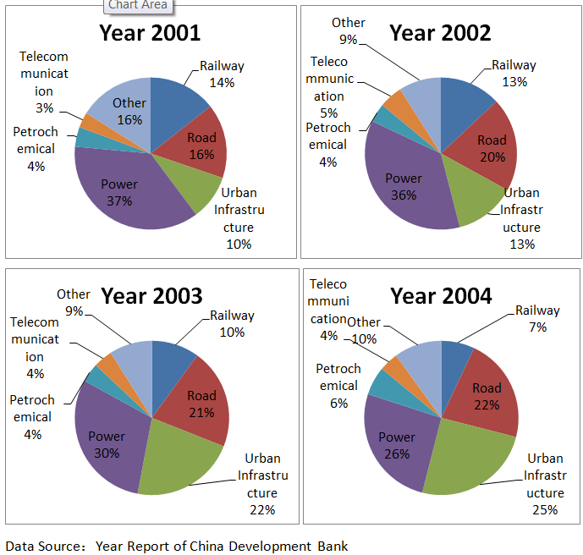

Because of the data collection constraint, we cannot get the data of industry distributions of incremental loans in year 2001 to 2003. In this paper we estimate these data on the basis of Figure 5. The industry distributions of the CDB’s loan balance in 2001 to 2004 are shown in Figure 5. We can see that the part of others, which were commercial loans issued by CDB from 2002 to 2004, fluctuated around 10% of the total loans and that this proportion kept steadily in these 3 years. As a result, it can be seen that only 10% of the new incremental loans of China Development Bank flew to other industries rather than those six mentioned above. Because we assume that loans issued out of the six industries belong to the commercial loan part, and the rest policy loan.

Table4.3 Yearly Incremented Loans of China Development Bank (1999-2006)
Year | 1999 | 2000 | 2001 | 2002 | 2003 | 2004 | 2005 | 2006
New Loans  (Billion Yuan) | 156.8 | 179.5 | 176.7 | 235.7 | 243.7 | 439.7 | 546.7 | 575.6
Data Source: Year Report of China Development Bank

Table 3 shows the yearly incremented loans of China Development Bank from 1999 to 2006. Combining the data of the proportion of commercial loans and policy loans with data of Table 3, using formula (11) the contribution of CBD’s loans to the economy, we can calculate out how many percentage of CDB’s loans to have supported per capita GDP growth of China’s economy from 2002 to 2006, as is shown in Table 4.

Table 4.4 Contribution of CDB’s Loans to the Economy of China (billion Yuan)
Year | 2002 | 2003 | 2004 | 2005 | 2006
Contribution | 379.34 | 392.7 | 694.45 | 812.93 | 862.18
Contribution  (Percent of GDP) | 3.15% | 2.89% | 4.34% | 4.39% | 3.99%
Source: Annual Report of CDB

4.4 Individual company case studies
It can be said that the China Development Bank shoulder a special mission given by the state at its establishment, which also determines that the course of development of the China Development Bank would be changed with the national macro-policy changes and the corresponding change. Since its inception, the China Development Bank achieved a substantial growth of its own performance during the time when it should also implemented state policy. As a statement relevance of the paper, I take data in 2010 as an example. In 2010, the China Development Bank seriously implemented the national macroeconomic policies, playing its advantage and its role of development finance and long-term investment and financing. On one hand, the China Development Bank is committed to infrastructure construction, industrial readjustment and upgrading, development and protection of regional coordination to improve people's livelihood; on the other hand, the China Development Bank is positively to promote and support business "going out or go global”( CDB, 2008:p23) in order to enlarge and proliferate their operating markets and be involved in the international market with a greater goal. More importantly, the China development bank which also vigorously encourages the Chinese TNCs (in China these TNCs are most of Industrial cooperation) and financial cooperation to create a sovereign wealth fund (SWF) rising its business to a new level. The China development bank also made many efforts for newly planned rural area building constructions, medium and small-sized enterprise establishment and entrepreneurs, energy conservation, low-cost housing, environment protection, education, basic universal medical health care, and other issue areas which are interlinked with the improvements if the people’s life and welfare(CDB-ASRR,2011,1:11p13). At the end of 2010, the asset size of the China Development Bank exceeded 5 trillion Yuan, the non-performing loan ratio was about 0.68%, which is controlled within 1% for 23 consecutive quarters. What’s more, its full-year net profit achieved 35.3 billion Yuan. It can be said that the China Development Bank has maintained a strong development capabilities, market innovation capability and core competitiveness. It also can be seen that the China Development Bank takes into account the national development and its own development.

SME financing
In theory from microeconomics, it is difficult for small and medium enterprise to take out a mortgage loan due to its scale and its credit compared with larger enterprises. Therefore, it is easy for SMEs to fall into financing difficulties, and policy should be carried out to support SME’s development.
Early in the phase of constructing developing financial system (1997-2003), the China Development Bank relied on the policy of the country's "two-base one-branch” (infrastructure, basic industries, pillar industries) for a loan, and to increase its efforts for small and medium enterprise business. Huang Quanxiang used the means of case studies (2007) to carry on business model and business effect analysis on the SME financing business in Mianyang City, Sichuan Province, where the China Development Bank used developing financial method from October 2004.
In October 2004, the China Development Bank and the Mianyang municipal government signed a cooperation agreement on establishing SME financing guarantee system, agreed to establish the guarantee system and the financing system for SME, in order to improve the difficult situation of SME taking loans, promote local economic and social development. This agreement relied on government credit to set up financing platform. The China Development Bank released unified loans to SME through a loan platform authorized by the municipal government, which had independent legal status and government background, and authorized agent banks to release loans to related SME case by case through borrowing platform, in which the principal and interest were unified repaid. Moreover, the China Development Bank injected capital for Tianli Credit Guarantee Company Limited of Mianyang City, providing guarantee for SME.
As for the soft loans released by CDB to Mianyang Holding Company for company capital of Tianli Credit Guarantee Company Limited, the government committed that the municipal finance arranged special funds every year, ensuring the return of the Mianyang Holding Company’s borrowing, and ensuring the exit of provincial CDB’s soft loan. Meanwhile, the municipal government committed that the municipal finance arranged for risk compensation every year in accordance with a certain percentage of guarantee liabilities, establishing compensation mechanism to the risk of issuing loans to Tianli Credit Guarantee Company Limited, thus to ensure the company’s sound operation. Tianli Credit Guarantee Company Limited implemented the counter-guarantee measures, to strengthen the control of credit risk.
The China Development Bank’s financing for SME, on one hand, provided new financing channels to the city's small and medium enterprises, on the other hand, directly increased the total SME financing. This measure combined the national credit and market, and promoted the construction of local credit by financing. Huang Quanxiang (2007) also believed that the business philosophy, business model, business behaviour in the process of CDB developing its service for SME, have been the concern of other policy banks and commercial banks, forming a certain shock effect. According to statistics, till the end of September 2006, the city's main banking financial institutions had guaranteed totally 2436 small enterprises, with an increase of 778 compared earlier that year, and with a total credit of 6616.8 billion RMB.

“Three Rural Issues”
As early as the beginning when the China Development Bank was established, the Agricultural Credit Board of the China Development Bank attached great importance to the increasing input on large-scale agriculture, such as irrigation, fertilizer, grain production bases, comprehensive agricultural development and deep processing of agricultural products, while engaged in some small projects according to the special nature of agriculture.
According to the report of 1995, the scope and focus of agricultural policy loans of China Development Bank was the "vegetable basket" project, focusing on national planning construction of commodity grain, cotton production base, "vegetable basket" project in the capital cities and industrial, mining area. Investment in agricultural infrastructure was vigorously increased and high quality and efficient agricultural production was encouraged. The specific measures were adjusting loan structure, expanding the loan proportion of large, medium and above norm projects, compressing general small projects, adjusting the geographical distribution of loans, properly increasing loan ratio of the central and western regions.
In 2010, the China Development Bank issued new rural construction and county loans of 182.4 billion RMB, of which 63% was to invest in rural infrastructure construction of rural road networks, power grids and drinking water, 16% to invest in leading enterprises of agricultural industrialization and county small business projects, 19% to invest in housing projects in rural areas, 2% to invest in the field of emergency loans and the bases for the training of migrant workers. These measures have helped to solve the problem of rural production and living, playing a crucial role in the livelihood of people of the country.
In addition, the China Development Bank supported and participated in national economic construction in many areas, such as industrial restructuring and optimization and upgrading (including mergers and acquisitions), strategic and emerging industries, cultural industries, housing construction, education and emergency loans. These initiatives effectively promoted China's economic growth, with a role indelible.

Conclusion
China Development Bank was built with historical responsibilities, and now, 18 years have passed. With the reform and development of the financial system in China, CDB is on its way of reform and rapid development. CDB is now at the phase of strategic development finance. In every stage of its development, China Development Bank has been one of the most important engines of the economy of China. Assessing the contribution of CDB to the economy, it’s far from enough just calculating how much it contributes to the GDP. Numbers does not reflect the importance of infrastructure constructions and other pillar industries to the economy. And also, they cannot tell how much CDB contributes to technological progress. We still have jobs to do.
Anyway, this paper has done a lot to visualize the contribution of China Development Bank to the economy. Through literature study, theoretical and empirical methods, this paper constructs an economic model to capture the mechanisms of how CDB contributes to the economy, and calculates out the specific contribution. CDB’s new loans averagely contribute to 3%-4% of the total GDP of China. Due to limited public data and prior research both theoretical and empirical conducted directly on China Development Bank, we leave a lot of works for future research. For example, the long term effect of CDB on the growing economy.
In current situation, the general view is that the Chinese economy may be downstream. The main reason for this down streaming is that the Chinese debts are too large. And because of the existence of inflationary pressures, the government is forced austerity. There is widespread concern that the Chinese economy will fall into serious deflation as the situation in 1998-2002. This year, 2012, we have seen weak external demand and inactive domestic demand, also, downward investments and credit increments. To drag Chinese economy out of this trap, government expenditure is important, China Development Bank, also illuminates in the gloomy atmosphere.

Appendices
Appendices 1 – Exploration of ROE and ROA
Return on equity (ROE) measures the rate of return on the ownership interest (shareholders' equity) of the common stock owners. It measures a firm's efficiency at generating profits from every unit of shareholders' equity (also known as net assets or assets minus liabilities). ROE shows how well a company uses investment funds to generate earnings growth. ROEs between 15% and 20% are generally considered good.


The return on assets (ROA) percentage shows how profitable a company's assets are in generating revenue. This number tells you what the company can do with what it has, i.e. how many dollars of earnings they derive from each dollar of assets they control.


References
Cai Fang (2004).蔡昉，“人口转变、人口红利与经济增长可持续——兼论充分就业如何促进经济增长”，《人口研究》，2004年3月第28卷第2期，2-9页。
[2] Chen Gang et.al. (2006). 陈刚，尹希果，潘杨，“中国的金融发展、分税制改革与经济增长”，《金融研究》2006年第2期，99-109页。
[3] Chen Ping and Li Guangzhong (2001). 陈平，李广众，“中国的结构转型与经济增长”，《世界经济》，2001年第3期，16-20页。
[4] Chen Yuan (2004a). 陈元，“发挥开发性金融作用 促进中国经济社会可持续发展”，《管理世界》，2004a年第7期，1-5转21页。
[5] Chen Yuan (2004b) .陈元，“改革的十年 发展的十年——开发性金融实践与理论的思考”，《求是》，2004b年第13期，40-42页。
[6] Chen Yuan (2010). 陈元，“开发性金融与中国城市化发展”，《经济研究》，2010年第7期，4-14页。
[7] Development Finance Research Group (2006). 开发性金融研究课题组，“开发性金融在市场经济体系建设中的作用及其与财政的关系研究”，《经济研究参考》，2006年第12期，2-48页。
[8] Lin Yifu and Li Yongjun (2003). 林毅夫，李永军，“出口与中国的经济增长: 需求导向的分析”，《经济学（季刊）》，2003年7月，第2卷第4期，779-794页。
[9] Lin Yifu and Zhang Pengfei (2005) 林毅夫，张鹏飞，“后发优势、技术引进和落后国家的经济增长”，《经济学（季刊）》，2005年第5卷第1期，53-73页。
[10] Lin Yifu and Zhang Pengfei (2006)林毅夫，张鹏飞，“适宜技术、技术选择和发展中国家的经济增长”，《经济学（季刊）》，2006年第5卷第4期，985-1006页。
[11] Lin Yifu (2007) 林毅夫，“李约瑟之谜、韦伯疑问和中国的奇迹——自宋以来的长期经济发展”，《北京大学学报（哲学社会科学版）》，2007年7月，第44卷第4期，5-22页。
[12] Qiu Xiaohua et al. (2006). 邱晓华，郑京平等，“中国经济增长动力及前景分析”，《经济研究》，2006年第5期，4-12页。
[13] Shen Rongkun and Fu Wenlin (2005). 沈坤荣，付文林，“中国的财政分权制度与地区经济增长”，《管理世界》，2005年第1期，31-39页。
[14] Fan Xuejun (2006). 范学俊，“金融体系与经济增长：来自中国的实证检验”，《金融研究》，2006年第3期，57-66页。
[15] Shu Yuan and Xu Xianxiang (2002). 舒元，徐现祥，“中国经济增长模型的设定：1952-1998”，《经济研究》，2002年第11期，3-11页，转63页。
[16] Wang Xiaolu (2007). 王小鲁，“中国经济增长的可持续性与制度变迁”， 《经济研究》，2007年第7期，3-15页。
[17] Wu Yanrui (2008). 吴延瑞，“生产率对中国经济增长的贡献”，《经济学（季刊）》，2008年第7卷第3期，四月，827-842页。
[18] Zhang Jun(2002). 张军，“资本形成、工业化与经济增长：中国的转轨特征”，《经济研究》，2002年第6期，3-13页。
[19] Acemoglu, Daron and Zilibotti, Fabrizio (2001). “Productivity Differences.” Quarterly Journal of Economics, vol. 116(2), May, 563-606.
[20] Aghion, Philippe, and Peter Howitt (1992). “A Model of Growth Through Creative Destruction.” Econometrica, 60 March, 323-351.
[21] Allen, Franklin, Qian, Jun, and Meijun Qian, (2005). “Law, finance, and economic growth in China.” Journal of Financial Economics, 77, 57-116.
[22] Atkinson, Anthony B. and Joseph E. Stiglitz (1969). “A New View of Technological Change.” Economic Journal, Vol. 79, No. 315, September, 573-578.
[23] Arrow, Kenneth J. (1962). “The Economic Implications of Learning by Doing.” Review of Economic Studies, 29, October, 779-800.
[24] Barro, Rober J. (1990). “Government Spending in a Simple Model of Endogenous Growth.” Journal of Political Economy, 98, October, Part II, S103-S125.
[25] Barro, Robert J. and Xavier Sala-i-Martin (2004). Economic Growth, Second Edition, MA: MIT Press.
[26] Basu, Susanto and Weil, David N. (1998). “Appropriate Technology and Growth.” Quarterly Journal of Economics, Vol. 113, No. 4, November, 1025-1054.
[27] Burzynska, Katarzyna (2009). “Financial Development and Economic Growth: The Case of Chinese Banking Sector.” Master Thesis, September, Lund University, School of Economics and Management, Department of Economics.
[28] Cai, Fang and Dewen Wang (2005). “China’s Demographic Transition: Implications for Growth”, in Garnaut and Song (eds) The China Boom and Its Discontents, Canberra: Asia Pacific Press.
[29] Cass, David (1965). “Optimum Growth in an Aggregative Model of Capital Accumulation.” Review of Economic Studies, 32, July, 233-240.
[30] Chow，Gregory C. (1993). “Capital formation and Economic Growth in China.” Quarterly Journal of Economics, Vol. 108, No.3, August, 809-842.
[31] Démurger, Sylvie (2001). “Infrastructure Development and Economic Growth: An Explanation for Regional Disparities in China?” Journal of Comparative Economics, 29, 95-117.
[32] Grossman, Gene M., and Elhanan Helpman(1991). Innovation and Growth in the Global Economy. Cambridge, MA: MIT Press.
[33] Holz, Carsten A. (2008). “China’s Economic Growth 1978-2025: What We Know Today About China’s Economic Growth Tomorrow.” World Development, Vol. 36, No. 10, 1665-1691.
[34] Knight, Frank H. (1944). “Diminishing Returns from Investment.” Journal of Political Economy, 52, March, 26-47.
[35] Koopmans, Tjalling C. (1965). “On the Concept of Optimal Economic Growth.” In The Econometric Approach to Development Planning. Amsterdam: North Holland, 1965.
[36] Lavine, Ross (1997). “Financial Development and Economic Growth: Views and Agenda.” Journal of Economic Literature, Vol. 35, No. 2. June, 688-726.
[37] Levy-Yeyati, Eduardo, Alejandro Micco, and Ugo Panizza, (2004). “Should the Government be in the Banking Business? The Role of State-Owned and Development Banks.” Paper prepared for the seminar: Governments and Banks: Responsibilities and Limits, IDB-IIC Annual Meetings, Lima, Peru.
[38] Malthus, Thomas R. (1798). “On the Mechanics of Economic Development.” Journal of Monetary Economics, 22, July, 3-42.
[39] Parente, Stephen L. and Prescott, Edward C. (1994). “Barriers to Technology Adoption and Development.” Journal of Political Economy, Volume 102, Issue 2, 298-321.
[40] Ramsey, Frank (1928). “A Mathematical Theory of saving.” Economic Journal, 38, December, 543-559.
[41] Ricardo, David (1817). On the Principles of Political Economy and Taxation. Cambridge: Cambridge University Press, 1951.
[42] Romer, Paul M. (1986). “Increasing Returns and Long-Run Growth.” Journal of Political Economy, 90, December, 1257-1278.
[43] Romer, Paul M. (1987). “Growth Based on Inreasing Returns Due to Specialization.” American Economic Review, 77, May, 56-62.
[44] Romer, Paul M. (1990). “Endogenous Technological Change.” Journal of Political Economy, 98, October, part II, S71-S102.
[45] Schumpeter, Joseph A. (1934). The Theory of Economic Development. Cambridge, Ma: Harvard University Press.
[46] Sheshinski, Eytan (1967). “Optimal Accumulation with Learning by Doing.” In Karl Shell, ed., Essays on the Theory of Optimal Economic Growth, 31-52. Cambridge, MA: MIT Press.
[47] Smith, Adam (1776). An Inquiry into the Nature and Causes of the Wealth of Nations. New York: Random House, 1937.
[48] Solow, Robert M. (1956). “A Contribution to the Theory of Economic Growth.” Quarterly Journal of Economics, 70, February, 65-94.
[49] Swan, Trevor W. (1956). “Economic Growth and Capital Accumulation.” Economic Record, 32, November, 334-361.
[50] Uzawa, Hirofumi (1965). “Optimal Technical Change in an Aggregative Model of Economic Growth.” International Economic Review, 6 January, 18-31.
[51] Wu，Yanrui (2000). “Is China’s Economic Growth Sustainable? A Productivity Analysis.” China Economic Review, 11, 278-296.
[52] Wang, Yan, and Yao, Wudong (2003). “Sourses of China’s Economic Growth 1952-1999: Incorporating Human Capital Accumulation.” China Economic Review, 14, 32-52.
[53] Young, Allyn (1928). “Increasing Returns and Economic Progress.” Economic Journal, 38, December, 527-542.
[54] Zhang, Jun (2008). “China’s Economic Growth: Trajectories and Evolving Institutions.” Research paper / UNU-WIDER, No. 2008.33.
[55] World Bank, 1995. “Macroeconomic stability in a decentralized economy.” China and Mongolia Department, World Bank, Washington D.C.
[56] World Bank 1996. The Chinese economy: “Fighting inflation, deepening re-forms”. China and Mongolia Department. World Bank, Washington D.C.
[57] “国家开发银行年度报告”2011, 国家开发银行-China Development Bank, updated on June 6th, 2012 Copyright © 2005 All rights reserved. 国家开发银行 版权所有 京ICP备05037088号
[58] “The China development bank’s cases study” 2011, In《开发性金融实践案例纲要》—“Outline of Development Finance Cases”.
[59] “The China Development Bank Annual Social Responsibility Report”2011, 1:11,P13-15 Accessed in: http://www. 国家开发银行//06/06/2012
[60] Detail statistics are from http://www.China Develop-mentBank.com.cn/web/Column.asp?ColumnId=45.
[61] World Bank, 1992. China: “Reforming intergovernmental fiscal relations”. World Bank Discussion Papers. China and Mongolia Department, Washing-ton D.C.

Subject to the data and calculating method, we can only calculate the results of 2002-2006
The impact of CDB’s infrastructure investment loans on the economy.

