Political Ecology of Slum Development:
The case of Kanyama: Zambia.
A Research Paper presented by:
Brenda Gwaba Habasonda
(Zambia)
In partial fulfillment of the requirements for obtaining the degree of
MASTERS OF ARTS IN DEVELOPMENT STUDIES
Specialization:
Environment and Sustainable Development
(ESD)
Members of the Examining Committee:
Prof. Dr. Max Spoor
Dr. Murat Arsel
The Hague, The Netherlands
December 2012
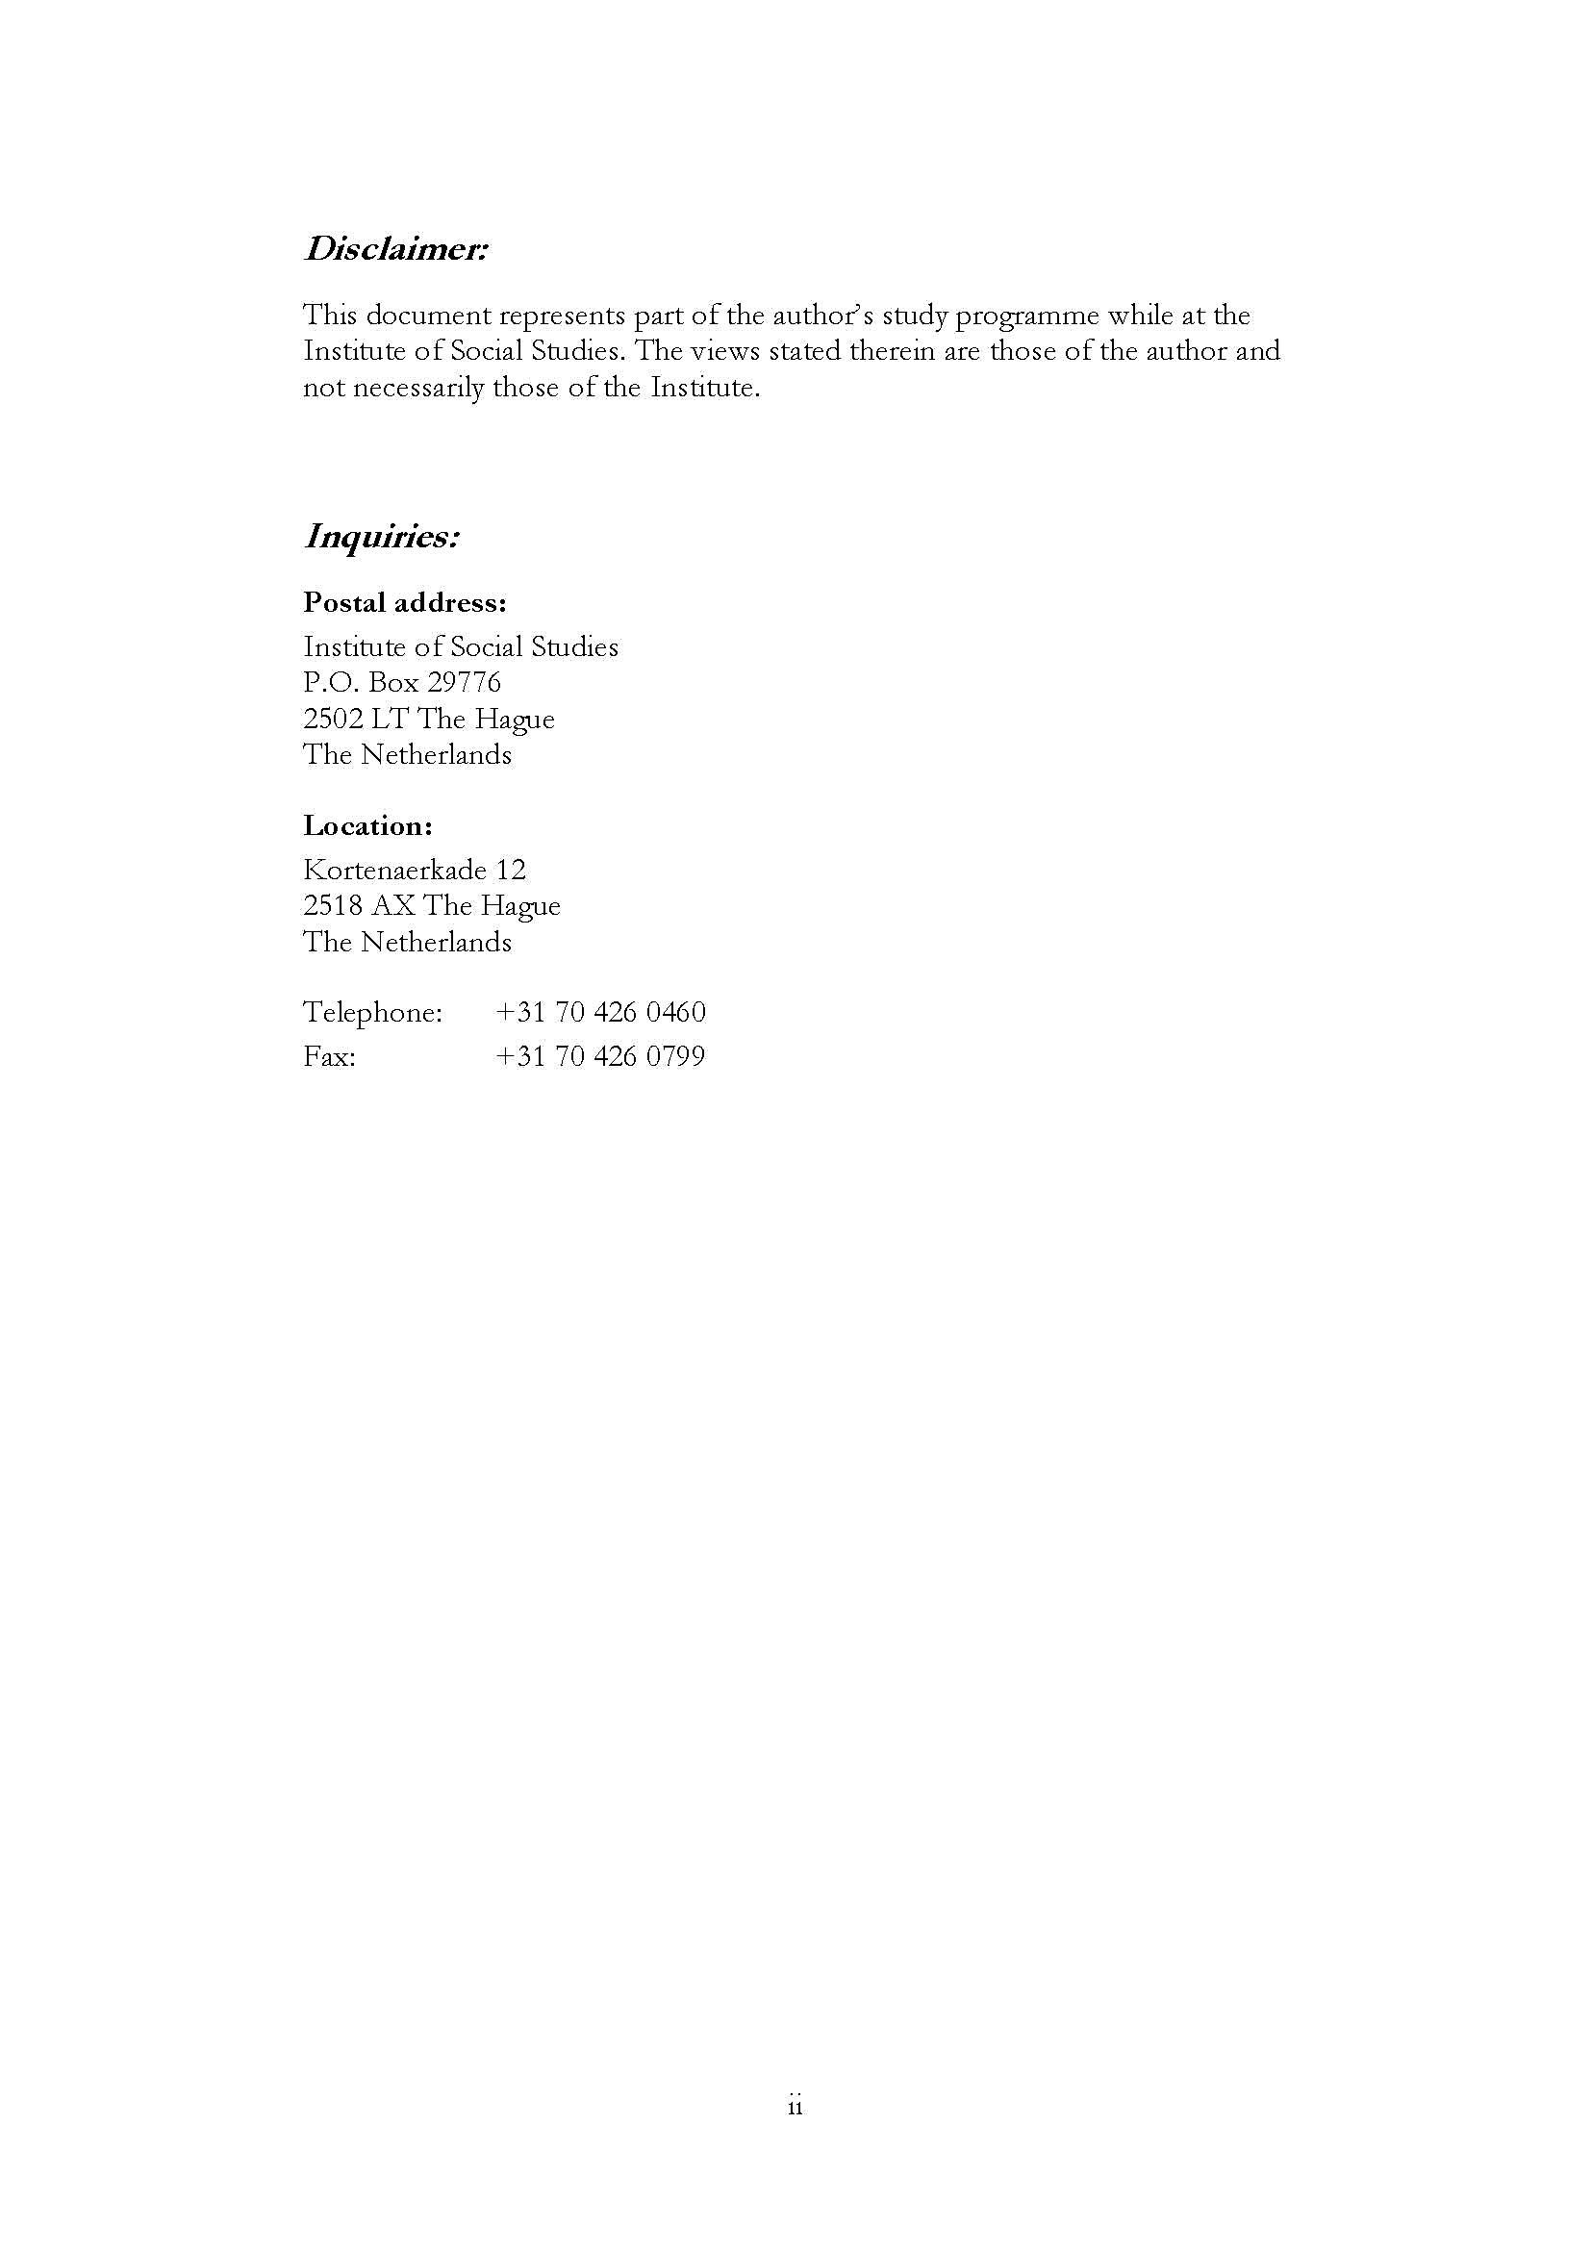
Acknowledgements
In the first place, I thank God the almighty for the many blessings that he bestows on me. His mercies are indeed new every morning.
Secondly, I wish to acknowledge the tremendous help I received from my supervisor, Prof. Dr. Max Spoor. Your support, guidance and insight, I will treasure forever. Your patience is something I have really valued. Thank you. To Dr. Murat Arsel, thank you for your encouragements, I appreciate.
To my colleagues, ESD 2011-2012, I will always remember your invaluable support and help. I once again say Thank you.

Contents
List of Tables v
List of Figures v
List of Maps v
List of Appendices v
List of Acronyms vi
Abstract vii
Chapter 1 Introduction 1
1.1 Background 1
1.2. Background to Slum development in Zambia 2
1.3 The study Area- Kanyama Compound. 4
1.3.1. Kanyama’s Problems 4
1.3.2 Kanyama – the obvious residence for the Urban Poor 6
1.3.3 Survival Strategies in Kanyama 7
1.3.4 Housing Structures in Kanyama 7
1.3.5 Kanyama as a Constituency 8
1.4 Problem Statement 9
1.5 Research Objectives and Questions 11
1.5.1 Research Objectives 11
1.5.2 Research Question 11
1.6 Research Methodology 11
1.6.1 Sampling 12
1.6.2 Data collection Techniques 12
1.7 Limitations to the Research 13
1.8 Organization of the Paper 14
Chapter 2 Conceptual Framework 15
2.1 Political Ecology (PE) 15
2.1.1 Concept of Social Capital 15
2.2 Social Movements (SM) 20
2.2.1 Definition of SM 20
2.2.2 Why SM? 21
Chapter 3 Urbanization and Environment 22
3.1 Urbanization of Kanyama 22
3.2 Environmental Degradation in Kanyama 24
3.2 Kanyama’s forms of collective action 26
Chapter 4 Factors for Persistent Flooding and Poor Waste Management in Kanyama 28
Chapter 5 Revisiting Social Capital in Kanyama 34
-The missing Link- 34
5.1 Conclusion 37
Appendices 43

List of Tables
Table 1.1: Kanyama’s Political Profile from 1968 to 2012 10
List of Figures
Figure 1.1 Kanyama Terrain with many Boulders 6
Figure 2.1: Characteristics of Social Capital in Poor Communities 17
Figure 3.1 a: Kanyama’s historical Garbage site. 23
Figure 3.2b: Kanyama’s historical Garbage site. 24
Figure 3.3 a: Kanyama’s Typical House for the Urban Poor 25
Figure 4.1: Blocked drainage 1 31
Figure 4.2: Blocked drainage 2 31
Figure 4.3: CBE throwing wastes behind Chibolya Market 34
Figure 4.4: Waste Management Unit (WMU) - refuse bin. 34
List of Maps
Map 1.0 Map of Africa Locating Zambia viii
Map 1.1: Map of Lusaka showing the location of Kanyama Constituency 8
Map 3.1: Map of Lusaka showing the location of Kanyama 20
List of Appendices
Appendix 1: Research Instrument 40

List of Acronyms
CBD Central Business District
CDF Constituency Development Fund
CSO Central Statistics Office
DMMU Disaster Management and Mitigation Unit
FGD Focus Group Discussion
FVS Flood Victim Spokesperson
HMNW Harry Mwanga Nkumbula Ward
IMJ Instant Mob Justice
JICA Japan International Corporation Agency
KW Kanyama Ward
LCC Lusaka City Council
MCA Millennium Challenge Account
MCC Millennium Challenge Corporation
MLGH Ministry of Local Government and Housing
MMD Movement for Multi-party and Democracy
MP Member of Parliament
MW Munkolo Ward
PF Patriotic Front
WDA Ward Development Account
WDC Ward Development Committee
WDF Ward Development Fund

Abstract
Lusaka, the capital city of Zambia, has about 43 unplanned settlements which host 70% of the city’s population. Most of these settlements have experienced untold forms of suffering due to regular flooding nearly every rainy season. The flooding is attributed to poor drainage once rainfall received exceeds 800mm in a season (Nchito, 2007). One such place is the Kanyama compound which has experienced flooding after heavy rains. Kanyama floods, date as far back as 1977/1978 when they left eleven people dead and thousands homeless (Baptist press, 1978; Mulwanda, 1992; Zimba, 2009). The disastrous effect of this flood led to the creation of Kanyama Flood Disaster Fund (KFDF) (Chisola, 2012) but the negative health and environmental impact of recurrent flooding continues until this very day.
On account of the resultant suffering, the residents of Kanyama have demonstrated a voting pattern which is informed by their negative experiences. Opposition politics often favoured the local politicians in contrast to the central government In every election, the residents have tended to vote for politicians who, in their judgement, would be the most likely to deliver on the drainage problem. The effect of this has been two-fold. Firstly, a new Member of Parliament (MP) is elected nearly every election and secondly, it defines the area as an opposition strong-hold for the larger part of its political history. Due to the latter reason, past ruling parties have had no incentive to resolve the problem as doing so would give credit to the opposition. At the same time, the opposition have had no means to make any meaningful change to the situation for lack of access to resources in this capacity. The outcome has been slow development and sometimes none. As a consequence, Kanyama’s flooding problem, its effects on the livelihoods of the residents and poor waste management has remained unresolved, and it also seems that the population has not resisted against this stalemate.
The focus of this paper therefore is to explore the possible reasons why the residents of Kanyama have persistently used a method that, in the past, has failed to yield them the desired results; why they have not been able to force elected politicians to resolve their problems; and why they did not organize themselves in a manner that can force changes through community or concerted action?
Relevance to Development Studies
Sustainable environments are important for the health of the citizenry and essential for their development. Disregarding the environments in which the majority of the people in a country reside is counterproductive to development of any kind, as residents in unplanned informal settlements are a key part of the urban economy and contribute to the city’s economic growth.
As the relevant authorities in developing countries are faced with a problem of providing decent housing for their people, the affected people are finding their solution in these unplanned settlements where they can build their houses according their meagre means of subsistence. A thorough understanding of the livelihoods and crucial bottlenecks in these unplanned settlements is important for the relevant authorities as they need to re-think their strategies of urban development.
The study is therefore a contribution to development studies, but also may help the relevant authorities to realize better circumstances in these marginal urban environments, which will in the end, contribute to economic growth and development of Zambia.

Keywords
Political ecology, slum development, floods, collective action, social capital

Introduction

1.1 Background
In this thesis, I will analyse environmental and health problems in a city slum in Lusaka, Zambia. Particular emphasis will be given to the continued and nearly endless problems of yearly flooding through rainfall, in combination with poor waste management and high population density in this slum neighbourhood. Furthermore, I will explore the different strategies that various stakeholders i.e. the residents, politicians, local and central governments as well as organizations have employed in alleviating the outstanding problems. Finally, I will investigate reasons for the lack of collective action in the area.
Recent statistics show that just more than half of the world’s population, today lives in urban areas. UN statistics on Sub-Saharan Africa state that 62% of its population resides in cities (UN-Habitat, 2007:2). This is a consequence of ‘urban primacy’ which concentrates investments in the single largest city, usually the capital, of the various countries (UN–Habitat, 2008).The concentration of investments in the cities acts as a magnet. The pull factors of the potential for employment, greater wealth, safer atmosphere and general well-being as a result of these investments and the push factors of poverty, drought, crop failure and poor crop prices in the rural areas are leading to a massive exodus of the poor towards the cities.
Pre- independence countries in the Sub-Saharan Africa under colonial rule practiced discriminatory tendencies based on race and class. With the philosophy of racial superiority, the white rulers kept a distance from the Africans. They resided in the best parts of the city, enjoyed better facilities like permanent structures built with durable materials to withstand wear and tear, and services like clean water and sanitation, garbage collection, clean and spacious environments. Africans lived in fragile environments on the fringes of the city, in weak and temporal structures and enjoyed none of the services of city life (Marx and Charlton, 2003; UN-Habitat, 2008). By design, the migrant workers were not expected to remain in cities upon their contracts’ expiry and neither were their families allowed in town as a way of controlling their populations (Marx and Charlton, 2003; Nchito, 2007). A differentiated workforce requiring that races other than Whites, received low wages for the jobs performed, was created to maintain the distance between the races (Napier, 2000; Marx and Charlton, 2003; Mulenga, 2003). These policies successfully created a wide gap between the poverty-stricken African population, sentenced to severe deprivations and the rich white population.
Informal settlements were characterized by high levels of poverty evidenced by the type of houses they contained, location on fragile environments, settlements in under-serviced and the menial jobs that residents engaged in for survival. Houses were made of temporary building materials. The UNCHS (1997) in Napier (2000:9) defines permanence as “…the percentage of dwelling units which are likely to last twenty years or more given normal maintenance and repair, taking into account locational and environmental hazards like floods, typhoons, mudslides, earthquakes and many more”. Houses in these settlements were made of materials like mud bricks and wattle for walls, cardboard, corrugated iron, timber, metal sheeting, tins and plastic materials and even grass for roofing (Mulenga, 2003; Marx and Charlton, 2003).
The informal settlements were located on fragile environments, on the fringes or borders of the city or within the city’s boundaries on private or state land. Fragile and unstable lands include slopes, in natural water courses and in areas where flooding is common. Located in such places, the settlements lacked basic delivery service in shelter, piped water, garbage collection, roads, street lights and drainages (Napier, 2000; Mulenga, 2003; Marx and Charlton, 2003; UN-HABITAT, 2007). The resulting consequences were that residents of the unplanned urban settlements were made vulnerable to epidemics.
Informal settlements are looked upon as homes that harbour lawless citizens engaged in vice activities for survival. Survival activities in these settlements range from petty trading of cardboards, empty glass and plastic bottles to illegal brewing and selling of opaque beer. Others quarry and crash building stones and yet others buy and pre-pack commodities such as sugar, salts, rice, flour, mealie-meal and others still engage in commercial sex. Others engage in car cleaning, begging on the street, doing piece works in the industries and commercial centres (Mulenga, 2003; UN-HABITAT, 2007).
The above characterization of the development of informal settlements in Africa is true of Zambia as it is for many other countries like Kenya, Nigeria, Senegal, and other countries in the Sub-Saharan Africa (UN-Habitat, 2008). This situation, however, became worse soon after gaining political independence. The removal of controls against migrant workers moving into cities saw more people migrate into cities. The migrant workers’ families were now able to move into town. The influx of migrant workers created pressure on the few existing houses in the suburban areas. There was an imbalance in terms of population moving into cities and the capacity of local service providers to meet the demand in housing that arose as a result. Furthermore, these areas did not have adequate access to economic opportunities and health, education and social amenities as citizens (Marx and Charlton, 2003).
In post-independence, the new government inherited the attitude of the colonial masters regarding the informal settlements. Firstly, they were perceived as hideouts for undesirable persons and therefore not well- favoured. Furthermore, their location on the periphery of the city also meant that they were on the peripheral in the local authorities’ budget. The government considered the informal settlements as outside their jurisdiction. It was the rural-urban migration and a possible elitist approach of city administrations that kept a form of “apartheid” between the city slums and the richer centre and adjacent wealthy neighbourhoods.

1.2. Background to Slum development in Zambia
In Zambia, the growth of informal settlements dates back to the administration of the country, then called Northern Rhodesia, by British, via the British South African Company (BSAC).The British constructed a railway line that ran from Cape Town in the south through to the Congo in the north, connecting all the mining territories along the way. The mining towns of the Copperbelt happened to be along this line of rail and this development in the late 1800s and early 1900s halted the migration of men to South Africa and Southern Rhodesia where they sold their labour in the mines and farms as they now sought employment in the mines on the Copperbelt. The attraction of unskilled workers to the Copperbelt led to the development of urban cities on the Copperbelt. Zambia’s capital city Lusaka, however, evolved differently (Mulenga, 2003).
Lusaka’s development as a town only commenced in 1931 when the township became the administrative centre owing to her central geographical position. The two major roads, the great north-south and the great east -west merge in the capital city and also, placing the Copperbelt within easy reach. Additionally, Lusaka had an added advantage of sufficient underground water resources which could provide the city with ample water throughout the year (Mulenga, 2003). As strictly an administrative centre, the original plan excluded other economic activities other than government administration, domestic and unskilled services. At the time of planning the town lay-out, the town planners discounted any industrial activities in the city. Consequently, a large African population was not foreseen and so was the need for their accommodation. In 1931, Lusaka’s total population was just more than 2,000 (Mulenga, 2003: 3). The few Africans living in town then stayed in the compounds on the outskirts of Lusaka. As the Africans worked on contract conditions and were expected to return to their rural homes upon expiry of the contract, they only built temporal houses using cheap building materials. As a result, not only was the influx of African population into town restricted, but there was the absence of permanent housing (Mulenga, 2003; Resnick, 2011).
Lusaka’s population annual growth rate was 15 per cent and by 1946, the population had increased to nearly 19,000. In 1948 and soon after independence, the ban restricting African movement was lifted, allowing those already working in town to reside there and live with their families, while a new stream of migrants came in. This development saw the populations of Lusaka swell to just more than 195,000 people (Resnick, 2011:145). This coincided with fall of copper prices on the world market in the mid-1970s to early 1980s, which resulted into massive job losses. Shortly afterwards between 1991 and 1998, the Structural Adjustment Program (SAP) was implemented. The implementation of SAP meant that companies and industries had to be privatized. Since the parastatal sector accounted for most of the employment outside the civil service, this translated into scaling down on the number of jobs and new employment opportunities. The loss of jobs on the Copperbelt and the implementation of SAP in the various towns of Zambia led to an internal migration with job-seekers moving to Lusaka. Another factor was a higher natural population increase because Lusaka had a very young population, with many young families starting to have children. A combination of these three factors led to a rapid population increase in Lusaka (Mulenga, 2003; Resnick, 2011; Mwanambuyu, 2011). However, the low economic status of these migrants prohibited them to be able to afford a decent accommodation in other places apart from the then already degraded and designated slums such as Kanyama.
Lusaka city covers an area of 375 square kilometres (UN-Habitat, 2007). Though small in size, it hosts the bulk of administrative, economic activities, manufacturing industries and commercial centres which attract lots of people (UNESCO Magazine, 2007). The heavy industrial activities are located on the western side of the town. The location of industries on this site has a bearing on the population density of Kanyama. The Central Statistics Office (CSO, 2010) indicates that Zambia’s population is at just more than 13 million people and out of these, 2. 2 million reside in Lusaka. With more than 43 informal settlements in the capital city, about 70 per cent of the city’s population has their residences there. And Kanyama has the bulk of the population at nearly 367,000 people (CSO, 2010).

1.3 The study Area- Kanyama Compound.
It is Tuesday, 20 September, 2011. It is elections day in Zambia and the residents of Kanyama gather en mass at the polling station, ready to cast their vote in favour of their preferred candidate, Michael Chilufya Sata, the leader of the opposition Patriotic Front party, fondly abbreviated ‘PF’. Voting is by secret ballots but residents openly declare their intentions. Clad in PF t-shirts and wrappers, they openly declare, “Kanyama is a PF strong hold, a ‘no go’ area for Movement for Multi-party Democracy (MMD)”. Then suddenly, there is commotion as a riot erupts. A man belonging to the ruling MMD is allegedly found carrying pre-marked ballot papers for national elections underway. The mob quickly administers instant justice; badly beats up the man, who is later taken to the police station (Mwansa, 2011).
Kanyama residents have depended on the silent “vote” to get their voices heard and their outstanding problems solved. The appearance of an obstacle to achieving their goal set them into motion and quickly solved the problem. They are capable of self-organizing to take care of the identified problems. What has hindered them from organizing themselves to fight against the long-decade problems of flooding and poor waste management?

1.3.1. Kanyama’s Problems
Kanyama residents have for the past four decades been let down by the political class which in their campaigns have promised to attend to their problems. To date, they have no proper roads. Poor drainage and waste disposal are chronic problems. These have resulted into regular flooding which in turn have led to outbreaks of diseases like malaria, cholera, typhoid, and dysentery. Lusaka had 4,464 cases of cholera and 73 deaths from 1 January to 28 March, 2010 (WHO, 2011). Several cases of deaths arising from drowning and diseases have been recorded, with numerous incidences of destruction to property and livelihoods (Chisola, 2012; Mafa, 2011; Changala, 2011; Nchito, 2007; Mulwanda, 1993). Politicians from different political parties have come and gone without solving these problems which form their campaign platforms (Resnick, 2011; Zulu, 2011). The area has predominantly belonged to different opposition parties, making it to be labelled an opposition strong-hold.
Since 2008, the area has been represented by PF and residents were eager that their preferred candidate retains his position (Daka, 2011). They were hopeful that should the opposition PF form government; the area might experience some positive development. One resident disclosed after elections, “I voted for the current MP because am confident that should PF emerge victorious, the MP, being a member of the winning team will be able to bring positive development” (Mwape, 2011). Against this background, the residents were not willing to let anything block their preferred candidate, M.C. Sata. In their view, Sata would deliver on his campaign promises and bring an end to their sufferings.
Before September 2011, PF was a strong opposition party to the ruling MMD government. Now that PF is in government, we are yet to see how they will fare with the issues of drainages, waste management and consequential health-related problems. The puzzle, however, is; why have the politicians failed to fulfil their campaign promises? Why have the residents been taken for granted all these years? Why has development not come to their area despite their dedication in voting for candidates who base their campaigns on people-based issues? Why have the residents not been able to demand that politicians fulfil their campaign promises?
Kanyama slum developed on the basis of a “self-help-urban housing” scheme (Mulenga, 2003). Definitions of slums are contested. They are contextual and specific-based. Marx and Charlton (2003: 6) define them as, both “erstwhile formal settlements that have degenerated to such an extent that there exists a need to rehabilitate them to acceptable levels” as well as being “loosely used to refer to informal settlements”. Mulenga (2003: 6) defines them as “early self-help housing” and “unauthorised housing”. For this particular research, the UN-Habitat’s definition is adopted. UN-Habitat (2007:2) defines informal settlements are;
Residential areas where a group of housing units have been constructed on land to which occupants have no legal claim or which they occupy illegally: An unplanned settlements and areas where housing is not in compliance with current planning and building regulations. It is identified with the poorest quality housing and the most unsanitary conditions; a refuge for marginal activities including crime, vice and drug abuse; a likely source for many epidemics that ravage urban areas; a place apart from all that is decent and wholesome.
As a planned city, Lusaka town was zoned off into two parts. Though no industrial activities were included at the planning stage, plans were modified to incorporate them at the implementation stage (Mulenga, 2003). The eastern block with deep and well drained soils was considered prime land and was allocated for agriculture and urban development. The western part with shallow soils and many boulders was generally flat, swampy and poorly drained (see figure 1.1 below). This part of the city was assigned for industrial activities. Kanyama settlement developed on the western side of the city (Mulenga, 2003; UN-Habitat, 2007).

Figure 1.1 Kanyama Terrain with many Boulders

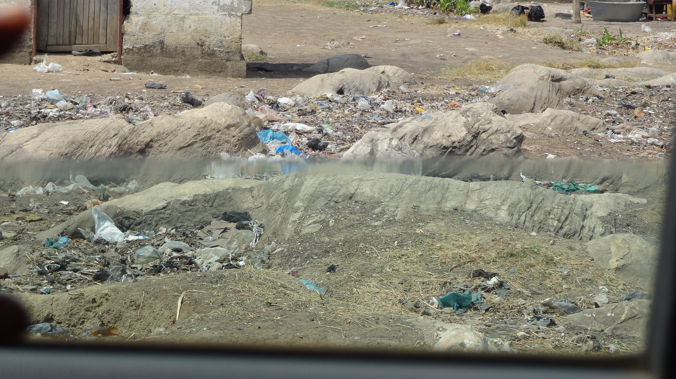
Source: Researcher collection

Kanyama’s development was a response to the housing crisis that emerged after the influx of African migrant workers into town in 1948. Before then, only Africans considered essential were allowed to remain in town and for a short while. With the restrictions on the migrant workers’ families moving into town, there was no incentive for investing into permanent houses. This resulted into few permanent houses for the African population (Mulenga, 2003). The removal of the restrictions on migration into town in 1948 created pressure on the few existing houses. And in mid-1970s to 1980s, plummeting of copper prices on the world market resulted into massive job losses. The implementation of Structural Adjustment Programs (SAP) between 1991 and 1998 increased the number of jobless in the capital city of Lusaka. Crowning this was the natural increase in population due to Lusaka’s young population that had migrated into town (Napier, 2000; Mulenga, 2003; Resnick, 2011; Mwanambuyu, 2011). In light of this problem, African migrant were allowed to build houses using unconventional building materials such as mud and wattle, plastic sheeting roofs and reused corrugated iron sheets (Mulenga, 2003:8; UN-Habitat, 2005:30). These weak and fragile structures were constructed on a terrain that couldn’t accommodate construction of proper drainages and roads because of the land that is largely rocky (Mulenga, 2003; UN-Habitat, 2007). Furthermore, Kanyama settlement was not privileged to enjoy services such as waste collection, clean water and sanitation as they were non-existent in this part of Lusaka. To date, service delivery in this informal settlement is rather chaotic, pathetic and unreliable.

1.3.2 Kanyama – the obvious residence for the Urban Poor
The above notwithstanding, Kanyama is the obvious residence for migrants for three reasons. Firstly, the settlement is a walking distance of 4.5 km to the CBD and within the proximity of the industrial areas (Mwape, 2007). It is conveniently placed for the residents who can’t afford the bus fare to and from work daily as the majority of them are dependent on the CBD and industrial areas for their livelihoods. Furthermore, a good number of them have no permanent employment, so they have to trek into town and the industrial areas in search of jobs. In this settlement, over 70 ethnic tribes of the country are represented with their different cultures and traditions. Some of the dominant groups are Luvales from the North-west, the Tongas from the south, and the Lundas from the Luapula and North-west, the Bembas from the Copperbelt, Luapula and North, the Kaondes from North-west and the Ngonis from the Eastern provinces. All these people have different values, customs, languages and traditions but these differences do not pose a problem in the area. Under the ideology, ‘One Zambia, One Nation’, residents live in harmony. There is unity in diversity (ZTB, 2008).

1.3.3 Survival Strategies in Kanyama
Secondly, the relaxed rules and regulations on construction of houses render the place the most affordable in the city both for land lords and tenants. A good number of the residents in this area are not or hardly educated. Consequently, they do not have well-paid jobs. As such, they cannot afford building in residential areas with strict adherence to rules on construction. On the other hand, even though Kanyama settlement’s houses are slightly higher in rentals, between K150, 000- K750,000 (US$ 30-150 equivalent) in comparison with other informal settlements around town, most people prefer the area to cut down on the transport costs they would otherwise incur if they stayed elsewhere. Despite the low education levels, residents engage in various economic activities to earn their living. Some sell foodstuffs at the markets, others sell second hand clothes referred to as ‘salaula’ (to mean ‘select from a pile’), others have makeshift stalls at their homes and sell groceries such as detergents, soap and other domestic household goods, others sell telephone cards, others have saloons, others ferry customers goods on wheelbarrows from one point of town to another, others have invested in a fleet of wheelbarrows for renting out and yet others have barbeque stands by the roadsides where they sell ‘muchopos’ and ‘shokaz’ to the passers- by (‘muchopos’ refers to goats’ offals, while ‘shokaz’ refers to any other type of meat). Others specialize in selling livestock like goats and pigs, and others sell poultry. The list is endless.
Most of these strategies are seasonal. During the rainy seasons, floods render the roads impassable and sometimes buildings collapse. This negatively affects people’s livelihoods.

1.3.4 Housing Structures in Kanyama
Thirdly, easy access to plots in the area (allocated by political party chairmen and cadres) has attracted a sizeable number of both retirees and others who are in wage employment to the area (LCC, 2010; Silengo and Phiri, 2010; Daka, 2011). Some residents have built their homes in this area and yet others have built houses strictly for business. In view of this, Kanyama area has a mixture of houses- some good buildings in wall fences and others that are substandard with hardly any space in between. It is not easy to tell where the boundaries for most plots in the locality are. The three identified reasons make Kanyama to be a high density area covering a big portion west of Lusaka town.

1.3.5 Kanyama as a Constituency
Lusaka city constitutes seven constituencies that comprise thirty-three wards. Kanyama constituency is composed of three wards; Kanyama Ward (KW) 10, Harry Mwanga Nkumbula Ward (HMNW) 11 and Mukolo Ward (MW) 12. Kanyama constituency shares her borders with three other constituencies; to the north is Matero constituency, to the eastern side is Kabwata and to the south east is Chawama constituency (see map.2). Locating Kanyama physically, it is bounded by Lusaka-Mongu (also known as Mumbwa) road on the northern side, Lusaka- Livingstone (Kafue) road on the eastern side and Makeni road on its south-western boundary.

Map 1.1: Map of Lusaka showing the location of Kanyama Constituency
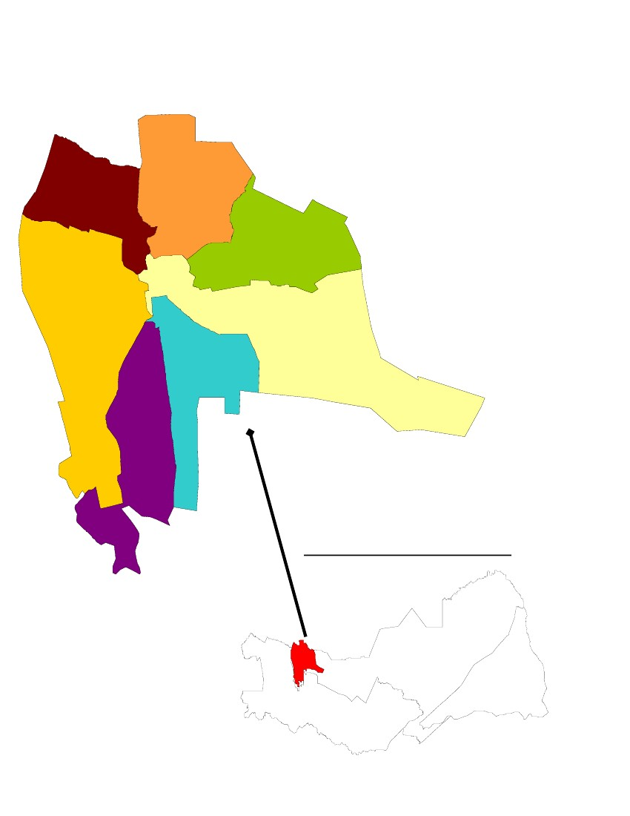

Mandevu
Matero

Munali
Kanyama
Kabwata Lusaka Central

Chawama

Source: CSO, 2010 www.zamstats.gov.zm, accessed 11.09.2012

Access to Kanyama compound is through Los Angeles road that cuts across the compound. KW 10 is located on the northern side of Los Angeles road and borders with the industrial areas. Due to the proximity to the industrial areas and the CBD, the ward is densely populated because it is within easy reach. Its population was at 169,298 and total number of households is 36,834 (CSO, 2010). A key respondent in the interviews conducted however, indicated that the population in the area had since gone up to 250,000 as per survey done later (interview, 18.07.2012). On the southern side of Los Angeles is HMN ward 11.This ward comprises two compounds, John Laing and Chibolya with a total number of households at 35,989 and a population of 166,420. MW 12 is further away from the CBD and industrial area and has the lowest population of 30,452 and total number of 6,172 households (CSO, 2010). The two wards, HMNW and KW, closest to the CBD and industrial areas and densely populated, are most prone to floods. This narrowed the geographic area for research to the two localities though to ensure balance and objectivity, data was also collected from the flood-free area.

1.4 Problem Statement
Residents of Kanyama have been instrumental in changing governments (see Table 1 below). In 1968, they helped the United National Independence Party (UNIP) under Dr. Kenneth Kaunda, to wrestle power from the African National Congress (ANC) party. But years later, they were viewed as lawless citizens and blight on the capital city (Silengo and Phiri, 2010; Resnick, 2011). Under UNIP reign, Kanyama residents experienced devastating floods. The 1977-1978 floods left 11 people dead, thousands homeless and caused damage to infrastructure estimated at US$ 195,000 (Baptist Press, 1978; Zambia Floods, 1978; APFM, 2007; Zimba, 2009). The government constructed drainage to draw water away from the locality (LCC, 2010; Chisola, 2012) but this was inadequate. In 1988-1989, Lusaka city suffered another flood disaster. About 5,000 houses collapsed leaving 50,000 people homeless and 2 dead. Most houses affected were from Kanyama (Mulwanda, 1993; APFM, 2007). The difficulties of roads and waste management were unattended to. The place was considered an illegal settlement and did not qualify for government services (Mulenga, 2003).
The residents then swerved their allegiance to the Movement for Multi-party Democracy (MMD). Under the late Dr. FTJ Chiluba, Kanyama residents helped MMD to seize power from UNIP in 1991. In 1996, Kanyama was legalized and qualified to receiving social services like clean water and sanitation, garbage collection and infrastructural developments (Silengo and Phiri, 2010; LCC, 2008). The residents started paying service charges to Lusaka City Council (LCC), though no services were delivered (Resnick, 2011). The MMD MP represented the people of Kanyama for 10 years and developed the area by having the first ever tarmac, Los Angeles road constructed (Mwape, 2011). The drainage and waste-management problems were, however, unresolved.
In their search for someone to adequately represent them, the residents voted for an MP from the opposition United Party for National Development (UPND) for the period 2001-2006. The MP did not work on the drainage project as it demanded huge sums of money. As opposition MP, there was no cooperation from the government for fear of giving credit to the opposition (Resnick, 2011). Kanyama residents suffer multiple depravities. The MP managed to sink some boreholes in some parts of the constituency. This act won him the confidence of the residents. Thus, he managed to retain his seat in the 2006-2011 elections though under another party, Patriotic Front Party (PF). In November 2007, the MP passed away. The 2008 by- elections brought in another new MP from the same opposition PF party. And Sata thanked Kanyama voters for electing the PF as their area MP (Lusaka Times, 26th February, 2008).

Table 1.1: Kanyama’s Political Profile from 1968 to 2012
Year Political Party in Charge
1968- 1991 United National Independence Party (UNIP)
1991- 2001 Movement for Multi-party Democracy (MMD)
2001- 2006 United Party for National Development (UPND)
2006- 2008 Patriotic Front (PF)
2008- 2012 Patriotic Front (PF)
Source: Adapted from Resnick (2011)

Floods hit Kanyama again in the 2008-2009 rainy seasons, destroying infrastructure, means of livelihoods and causing deaths resulting from cholera and malaria. There was disruption in the school calendar as some schools were closed for 3 months (UNOCHA, 2009; Lusaka Times, 2010; IPS, 2011). The government allocated US $ 4 million for drainage rehabilitation but only US $ 2 million was spent on the drainage. The rest of the money was not accounted for. Rehabilitation of the drainage was incomplete (UNOCHA, 2009; CSPR, 2009; IPS, 2011).
Population density contributes to the gravity of the destruction caused by the floods. The 2009-2010 floods had 200 families evacuated to the Independence stadium, some people drowned and some children swept away by the heavy rains. Zambia Vulnerability Assessment Committee (ZVAC) Rapid Assessment Report (2010) in Chisola (2012: 16) shows that; 565 houses were completely damaged, 8,423 partially damaged and 27,219 houses were completely waterlogged. 2 clinics and 5 schools were flooded and most of the roads were partly damaged (Lusaka times, 2010; Kabange, 2010; Daka, 2011; Chisola, 2012).
Kanyama residents’ unresolved problems of floods, poor waste management, resultant diseases and deaths, poverty and proximity to the CBD became a weapon that has been used against them. Various political parties use these people-based issues to woo support from the high density area of Kanyama but fail to deliver on their promises. The local authorities also fail to provide the residents with the required services despite them paying the service charges. But not all hope is lost. The residents, willing to give a chance to another politician, will not let anything stand in their way. But, what could be the possible reasons why the residents of Kanyama have persistently resorted to a method that has in the past failed to yield them the desired results? Why have they not been able to force elected politicians to resolve their perennial problems of flooding and poor waste management? Why have they not organised themselves in a manner that can force change through community or concerted action?
.

1.5 Research Objectives and Questions

1.5.1 Research Objectives
Based on the discussion above, the following research objectives were formulated:
- To investigate the persistent problems of flooding and poor waste management in the slum area of Lusaka, Zambia.
- To evaluate the roles that various stakeholders have played to resolve the problems of flooding and waste management.

1.5.2 Research Question

Main question
What are the underlying factors for the persistent flooding and waste management in Kanyama area and those that prevent its resolution?

Sub-Questions
- What factors have helped to sustain the persistent flooding and poor waste management in Kanyama informal settlement?
- How has the government responded to the problems of flooding, waste management and their impacts on health of the residents?
- What role has the local service provider played in resolving the problems of waste management and flooding in Kanyama?
- Are there any organizations, local or international, that are involved in solving the problems of waste management and flooding? What are they doing to solve the problems?
- What roles have the residents played in alleviating the problems of persistent flooding and poor waste management?

1.6 Research Methodology
The research study was carried out in the slum area of Kanyama, Lusaka. Kanyama was selected for the case study because it is one of the oldest slums in Lusaka and is located just on the edge of the city ( Mwape, 2007; Resnick, 2011). Furthermore, Kanyama is one area that has had the most frequent floods, experiences the most health problems related to floods such as cholera, malaria, dysentery and also typhoid. The location of the informal settlement near the industrial areas exposes the place to industrial pollutions. Fumes and solid waste impact negatively on the health of the residents. Ordinarily, the industries are supposed to be responsible for managing the waste they produce but this is not the case with the industries in the vicinity of Kanyama compound. Furthermore, the combination of population density and proximity to the CBD makes the place to be an easy target for the politicians who, due to its easy accessibility, use it as a vote-bank (Resnick, 2011). Within Kanyama compound, the bulk of the research was done in Kanyama and Harry Mwanga Nkumbula wards for two reasons; Firstly, they are the most flood-prone and secondly, they are closest to the CBD and industrial areas. The field work was spread out over a period of two months.

1.6.1 Sampling
Since the target group was residents of Kanyama, the local municipality, and the MPs (current and 2 former MPs), the ward councillors and an officer from Disaster Management and Mitigation Unity (DMMU) were the obvious candidates to be interviewed. A small sample of the residents was picked from the target population. Using snowball sampling, a set of criteria for the people that would qualify to participate in the Focus Group Discussions (FGDs) was selected. Some of the criteria set were (i) someone who had lived in Kanyama for at least 12 years. 12 years was the lower limit and 17+ years was the upper limit. (ii) Someone who had first- hand experience with floods, poor waste management and their effects on their lives or neighbours or relatives. (iii) Someone who was actively involved in trying to resolve the flooding and waste management issues. Snowball sampling was used to help select the group of people that had similar experiences and conversant with the topic that was being studied. Since it was not easy to know to identify these people, it required building a sample through referrals. O’ Leary (2010:170) states;
Snowball involves building a sample through referrals. Once an initial respondent is identified, you ask him or her to identify others who meet the study criteria. Each of those individuals is then asked for further recommendations. It is often used when working with populations that are not easily identified or accessed. But by using referrals, a sample can build quite quickly. Snowballing, however, does not guarantee representativeness.
In the study, the researcher used purposive sampling in the selection of the study location mainly because of the particular interest in finding out the various roles that different stakeholders played in resolving the problems of flooding and waste management. With the help of the assistant researcher, respondents in the FGDs were from the two most flood-prone areas of Kanyama and Harry Mwanga Nkumbula wards.

Sample size
The sample size were composed of 26 respondents and broken down as follows; 1 Member of Parliament (MP) for Kanyama area. Originally, the plan was to interview three area MPs, from three different political parties (MMD, UPND/PF and PF).This was to enable the researcher to understand the politics involved in fulfilling the campaign promises made to Kanyama residents. Unfortunately, both former MPs are deceased. 4 Lusaka City Council (LCC) Officials (2 from the Engineering Department and 2 from the Public Health Department), 1 officer from the Disaster Management and Mitigation Unit (DMMU), 3 Secretaries from Kanyama’s three wards, the spokes-person for the flood victims (FVS) and 15 respondents in the FGDs.

1.6.2 Data collection Techniques
The research employed three qualitative methods of data collection; semi-structured interviews, Focus Group Discussions and observation.

Semi-Structured interviews
Individual semi-structured interviews were conducted on 9 respondents for the following reasons; it is easy to make clarifications by avoiding ambiguity, it is easy to gather in-depth information by making follow ups on relevant topics and rich information is gathered more easily through observation of body gestures. However, semi-structured interviews are expensive and time-consuming, there is a danger of bias with regards to questions and responses from the researcher and the data collected is dependent on the rapport created between the interviewee and interviewer.

Focus Group Discussion
FGDs were used to compliment the results received from semi-structured interviews. The 15 respondents in the FGDs were men and women who had lived in Kanyama area for at least twelve years. The minimum twelve years period were sufficient for the residents in Kanyama to have first- hand experience and be particularly knowledgeable on the issues about the consequences of floods and poor waste management on their daily livelihood and the impact on their health and other members of their household. Prior to the group discussions, the assistant researcher briefed the respondents on the topic for discussion.
FGDs were used because of their strengths; they are inexpensive and relatively easy to assemble, they bring people of similar characteristics and experiences together. FGDs provide rich data quickly as participants are able to build on another’s response. And also, data is easily verified within the group. FGDs however, have some limitations. It produces rich data that is unstructured and therefore difficult to analyse. Findings may not represent the views of the larger segments of the group. It requires skill to handle the various types of people that are in the group such as quiets and the self-appointee spokes- person for the group. Questions that were asked among others include (i) what could be the real contributing factors to perennial flooding, poor waste management and the attendant health problems in Kanyama? (ii) What are the relevant authorities doing in resolving the problems of flooding and waste management? (iii) What roles have the residents played in overcoming the waste management and flooding in Kanyama? (iv) Are there any organizations that are helping to solve the problems of flooding and poor waste management? (See appendix 1. for the full set of questions).
Data collected during the interviews was augmented by observations made on blocked drainages used as waste dumps and heaps of waste in undesignated areas within the compound.

1.7 Limitations to the Research
The two former area MPs for Kanyama (MMD and UPND/PF) are both deceased. As a result, data on the challenges experienced in fulfilling the campaign promises as MP for the ruling party and as opposition MP could not be gotten.
The current MP was not easily available due to his tight schedule as a government official. When finally available, the interview was rushed through for lack of time at his disposal.
The interview with KW secretary was disturbed because of the teargas that wafted into the WDC offices (venue for the interviews) from the nearby police station. In July 2012, Lusaka town experienced five murders of women. The public was incensed about the killings and wanted the perpetrators to be punished. On this particular day, a man suspected to have been one of the killers was caught and when word went round, a mob gathered at the police station demanding that the man be released for people to administer instant justice. The police fired gunshots in the air to disperse the mob but to no avail. At this time, the police resorted to the use of teargas as the crowd remained undaunted. The teargas floated into the WDC offices and some people sought refuge there. The atmosphere became tense; disrupting the interview but nonetheless was a great experience to see how communities can organize “collective action”.
During the FGDs, the group leaders did the most talking while the members agreed with them. In view of this, some of the views captured are not representative of the group but of only of the few vocal people. It was a good example of how power relations work even in informal set-ups.
Both the individual interviews and group discussions were not easy to organize. The respondents kept on postponing the meeting times and dates. As a result, the postponements dragged the research period and also made it practically impossible to have three focus group discussions as originally planned.

1.8 Organization of the Paper
This paper is organized into five chapters. Chapter 1 gives a general background to urbanization and development of slums in Sub-Saharan Africa. The chapter however pays particular attention to Zambia in relation to Lusaka city and the development of slums in the capital city. Chapter 2 looks at the theoretical framework while chapter 3 focuses on Kanyama, a slum area in Lusaka, Zambia. The chapter examines factors that have led to persistent flooding and poor waste management leading to people experiencing poor health and subsequent deaths as a result. The chapter also delves into investigating the lack of collective action in the area usually manifested by the absence of social movements.
Chapter 4 is the research findings and analysis of the findings and discussions while chapter 5 is the revisiting of the theoretical framework and finally the conclusion.

Conceptual Framework
‘Disaster is a crisis situation that far exceeds the capabilities’.
-Quarentelly, 1985.

2.1 Political Ecology (PE)
In order to understand the social-ecological factors underlying the persistent flooding, poor waste management and problems of ill-health in the slum Kanyama, a Political Ecology (PE) framework is used. Rocheleau (1999) in Paulson, et al (2005:17) defines PE as “the social relations of power and the formation and functioning of ecologies and landscapes”. PE advocates a change from concentrating on disasters as a sole function of technology and environmental factors to embrace the characteristics of the human populations affected by the disasters. Its aim is a holistic understanding of the human relations among themselves; with their environment, examining how the community relates with production, interrogating access and governing over resources (Paulson, et al 2005). It requires a thorough investigation of the diverse cognitive, social and demographic qualities of the people composing that society. A comprehensive understanding of catastrophic events by directing attention towards the interactions of social and environmental factors simultaneously was therefore seen to be prudent (Donner, 2007; Paulson, et al.2005).
In view of this, Dynes (1994) and Aguirre (2000) in Donner (2007: 669) argue that “bureaucratic control and technology are not central to effective emergency response”. Approvingly, Quarantelli (1998) (ibid) conceived of “disaster” as the society’s organization and not the extent, magnitude or period of a hazard.
Human societies are capable of adjusting and handling disaster through ‘cooperation, learning and development’ (Donner, 2007). When a disaster strikes, disabling the affected individuals to meet their basic needs, society gets organized into a “complex cooperative arrangement” (CCA) with the aim of easing or removing the adverse impact of the hazard and ensuring survival of the members (Donner, 2007

2.1.1 Concept of Social Capital
Sopha, et al. (2007) identifies the CCA as a concept of social capital (SC), through which people respond to natural disasters like floods, drought, etc. SC is defined as “the features of social organization, such as trust, norms and networks that can improve efficiency of society by facilitating coordinated actions” (Sopha, et al. 2007; Nakagawa and Shaw, 2004; Putman, et al.1993). Catastrophes are catalysts that help to organize the community’s different groups in ways that unite them in easing the life of the victims of the catastrophe. Marx and Charlton (2003:20) indicate that, “SC is strong in high density population of informal settlements”. When calamity befalls, the local community is the buffer and main source of solace for the victims. Local communities’ “functional relationships” (Donner, 2007:670) provide the basic needs like shelter, food, and nursing the sick. The chief source of collective trust found in norms of exchange and links of community commitment is measured by people’s involvement in associations. Informal settlers have associations like neighbourhood watches, religious, cultural, women’s or men’s organizations etc. (Sopha et al 2007; Chisola, 2012). A thick web of associations indicates how solid the supply of social capital a society has.
In demonstrating the CCA’s strength to aid the affected, Sopha, et al (2007: 9) classifies the SC networks into three:
- Bonding SC-This embraces the strong horizontal link between family members, close friends and neighbours sharing similar demographic characteristics. Bonding reduces vulnerability by providing social safety nets. Nakagawa and Shaw (2004) show that the strong horizontal connections experienced at the community level among family members, neighbours and friends can be used to achieve social capital at a higher level.
But perhaps the authors’ assumption does not apply to all poor communities like Kanyama whose strong bonding inhibits linkages with other external groups.
- Bridging SC- This represents the weak horizontal bonds among people from different ethnic, geographical and occupational backgrounds but with similar economic status and political influence. The aspect of people being connected both internally as a community and externally with other communities generates chances for flexibility to the affected communities, and a faster way of enhancing livelihoods.
- Linking SC-This embodies the vertical ties joining community and those in positions of authority and influence in formal organizations such as banks, government agencies, schools and elected officials. Relating with affluent institutions and people enables communities to control resources for long-term investments.
Nakagawa and Shaw (2004) further clarify the qualities of each of the three categories of SC for them to bear the desired results as follows:
The bonding SC includes among others that; the community membership continuously have trust in their leader; that the membership be involved in decision making through democratic voting where the majority vote wins; that the community be actively involved in cooperative community events by regularly meeting and finally that there should be linkages between the different community-based groups, whether formal or informal.
Bridging SC involves relations of different stakeholders with various capabilities. Included in this group are academicians, community activists such as Community-Based organisations (CBOs) and Non-g-Governmental Organizations (NGOs) and other neighbour associations, all from other communities; as well as connecting various individual networks with community and next door neighbours.
Finally, the linking SC is seen as a formal alliance of the community with the government officials through engaging in community development activities jointly.
Nakagawa and Shaw (2004) further argue that both bonding and bridging SC mighty work in poor communities but as very weak safety-nets that will not shield the community from being disaster-prone. To get rid of vulnerability of livelihood and make safer sustainable environment requires the crucial role that the linking SC plays.
Vulnerable societies have very strong bonding SC, relatively strong binding SC but very weak linking SC (see figure 2:1 below).

Figure 2.1: Characteristics of Social Capital in Poor Communities

Government
NGOs
Banks
Elected Officials
DMMU
ZRCS

Different
Tribes
Family
Members
Neighbour
Diverse
Jobs
Varying
Terrain
Friends

Community A Community B
Share same demographic characteristics Share similar economic and
Political influence.

Sources: Adapted from Nakagawa and Shaw (2004) and Sopha, et al (2007)

KEY
Very strong horizontal bonding ties

Relatively weak horizontal bridging ties

Very weak vertical linking ties

However, the involvement of higher levels of community organizations like government agencies such as the Disaster Management and Mitigation Unit (DMMU) financial institutions like banks and Non- governmental organizations such as the Zambia Red Cross Society (ZRCS) may not place every one on an equal footing. This results from the interplay of two factors. Firstly, the affected communities lack commitment and unity of purpose to developmental programs meant for their area. As a result, government or any other organizations do not feel obliged to help out. Secondly, divisions in communities determine what kind of help is given to whom. Donner (2007:671) contends that; “The long-standing and deeply embedded inequalities within class, prestige, power structures of society will place certain groups of people at greater risk to environment and technological hazards”. The class, prestige and power qualities come with access to education and employment .Conversely, the bulk of the people in disaster prone areas are of low-income status, uneducated and unemployed with no access to influential individuals and institutions for financial help to rebuild and improve their lives. To this end, Sopha, et al (2007: 9) concludes;
Factors like education, employment, social class and the context in which social networks are embedded are crucial to understanding one’s access to social capital as participation in associations and networks depend largely on one’s resources and social status. Also, specific social contexts shape the forms of social capital that emerge and the direction that access is likely to take. Access to various stocks of social capital in society determines to a large extent one’s inclusion or exclusion.
Effectively, what PE does is to bring to light the interactions of different stakeholders such as the local residents, the politicians and the local and international non-governmental organizations; the local and central governments and the political, economic and social spheres of society and how these interactions either help to resolve the identified problems or work towards maintaining the status quo.
Politically, informal settlements are, cynically enough, a critical source of electoral support. Factors like population density, proximity to the CBD, poverty, illiteracy and unresolved problems of floods, poor waste management and persistent diseases give a unique but good combination rendering these places hotspots for politicians. CSO (2010: 21) shows that Kanyama constituency has a large population of 182,674 eligible voters compared to Kabwata and Chawama with 99,071 and 96,706 eligible voters respectively. The population density of Kanyama has proved to be an attraction to the various political parties who consider it a reliable source and popular vote-bank. Based on the reasons identified earlier, they politicians have used this strength to get them into political offices.
Chief among these reasons is the fact that a high share of the population in Kanyama is illiterate. Their ability to read a political system and its policies is limited. This renders them easy prey for the politicians who promise to resolve their outstanding problems even when they know that it’s not within their means to do so. Illiteracy and poverty are the two sides of the same coin. Taking advantage of the residents’ poverty, politicians engage in manoeuvres to seal their candidature like giving out wrappers, t-shirts, beer and mealie-meal. Politicians exploit unresolved problems to identify with the residents and win their confidence. Consequently, Kanyama’s political profile shows that the constituency has had the highest representation of MPs from different parties (Resnick, 2011; Zulu, 2011) as there were regularly electoral shifts in new elections. Marx and Charlton (2003: 13) conclude;
There has always been a strong identification between informal settlements and the patronage of political parties which might suggest that political parties need informal settlements more than the other way round, for constituency purpose and also because formal explicit linkages to political parties may be a proxy for more substantive forms of citizenship.
Economically, Kanyama is viable. The settlement came into existence for the purpose of accommodating people considered not essential in the economic set-up of the country (Mulenga, 2003; Resnick, 2011). This position has since changed. The bulk of Kanyama people are employed in the industries in the vicinity and positively contribute to the gross domestic product (GDP) of the country. Although some people are not engaged in wage labour, they trade in businesses that make them pay taxes indirectly. Many own makeshift stalls where they sell goods. When buying these goods, they pay Value Added Tax (VAT) which goes to the central government through the Zambia Revenue Authority (ZRA) for redistribution to all user areas, LCC included (Chisola, 2012).
PE also looks at the social inequalities that are in societies (Paulson, et al. 2005: 26). People who live in informal settlements are of low class status and suffer multiple depravities of poverty. While the bonding SC is a strong factor in the poorer societies, the weak linking SC denies them access to various stocks of SC like the financial institutions, elected politicians and government organizations that are essential not only for the betterment of the social but economic environment as well. With no access to this important linking SC, the community will never come out of their problems (Marx and Charlton, 2003; Nakagawa and Shaw, 2004; Sopha et al, 2007; Collins, 2008).
The PE framework shows that the power relations between the diverse social groups dictate an unbalanced distribution of resources and risks, with the disadvantaged getting risks (Paulson, et al 2005; Donner, 2007). Nakagawa and Shaw (2004) support the assertion and argue that, lack of strong leadership in poor communities render them vulnerable to risks such as living in fragile, unhealthy environment exposed to pollution and living in hazardous structures. Strong leadership are able to mobilize the community into collective action, against the unbecoming environmental activities. This may make the concerned authorities to be more considerate in dealing with social groups that are politically powerless. As Jagan and Chu (2010) indicate, residents take charge in solving urban life difficulties that have prohibited those enjoying liveable environments through social movements. UN-HABITAT (2005) affirms that when residents unite to fight the social ills and protect their interests, they are more likely to attract development partners in positive ventures.
Additionally, for a community to be united and be in a position to oppose established powers requires the involvement of all stakeholders. This means that local residents, private agencies and other parties interested in the development of the area form organizations that have regular meetings to provide opportunities for members to participate towards the development of the area Nakagawa and Shaw (2004).
The form of power that disadvantages some group of society could probably explain why the Kanyama area has lagged behind in having the flood problem resolved and the lack of basic social services such as piped water and sanitation and basic infrastructure like good roads. In Zambia, places that are under the opposition parties are neglected in terms of economic developments and this may be a reflection of many other African countries (UN- HABITAT, 2005; Resnick, 2011). Through PE, natural disasters are shown that while they are a natural occurrence, they are as much a structural problem in the sense that cooperating networks are required to adhere to rules, roles, procedures and precedents for mutually beneficial collective action (Nakagawa and Shaw, 2004). Questioning the dominant way of doing things, it shifts attention from top-down management strategies to collective action originating from the ground up. Doing so will present alternatives.

2.2 Social Movements (SM)
Social movement (SM) in this research is not a theoretical frame work which stands alone but arises from PE’s questioning of the prevailing way of doing things and a search for alternatives. They are a collective or group action with a focus on specific political, social or economic issues. As Bebbington (2010: 5) indicates:
SM is a form of collective action but not itself an actor: rather it is a process, sustained by a set of actions and actors, in which what prevails is an action motivated by shared grievances and senses injustice, and therefore by a vision-perhaps not specific-of the need to find another way of organizing society and thinking about development.
Christiansen (2009) identifies some characteristics of SM as being; involvement in conflictual relationships with clearly identifiable opponents, having solid connections of informal networks and sharing a discrete collective identity. Hence by their nature, SMs are a collective group, politically or socially directed (Jagan and Chun, 2010) with a goal to ‘challenge the nature and exercise of power in society’ in a bid to change elements of the political, economic and social system (Christiansen, 2009; Bebbington, 2010; Jagan and Chun, 2010). SM usually revolve around the poor or the marginalized that are denied access to the same economic opportunities as do the rich, although in other contexts SM are also widely seen in defending consumer interests, around environmental problems, labour rights etc.

2.2.1 Why SM?
SMs emerge as a response to identified challenges and grievances that affect the poor. They are a response to government failures in fulfilling its obligations to the people, such obligations as garbage collection, provision of piped water and sanitation among others. Poor people with less political resources only become a force to reckon with through collective action. Academicians indicate, “SMs give a voice to the lowest strata in society who are affected by the economic, social and political changes in the world” (Jagan and Chun, 2010).
The SM aims at changing government policy to make living conditions acceptable for many urban poor. The poor people and their interests are invisible to the ruling elites. The weak linking SC disconnects them from influential and powerful people and institutions needed for longer term benefits (Sopha, et al 2007). Napier (2000: 4) stated: “a broader set of voluntary associations to which informal settlers subscribe assist in the assimilation to urban life style”.
SM represents the poor taking responsibility to solve urban life problems (Jagan and Chun, 2010). They show substitutionary concepts and perceptions how society should be. But poor people’s inclusion in decision making can only be on the account that they have access to the linking SC. This can be achieved by getting having connections with influential people. This will help the affected people to be their own agents of change for meaningful development to be effected and sustained (Jagan and Chun, 2010). Poor people have solutions to their own problems. They should be included and consulted in programs meant for them. As it were, “the solution to the problems of the poor is not legal, it is political will”, (Jagan and Chun, 2010). Viewed in this light, SMs are, therefore, “a way to safeguard and recover threatened forms of life and social organizations” (Bebbington, 2010).
The application of PE will bring to light the different levels at which identified problems are produced, reproduced and maintained. This knowledge is particularly essential to be able to solve the problems holistically. SM on the other hand is action-oriented. Equipped with knowledge through the PE framework, SM will act to get the desired results. PE gives the SM the push or mandate to act intelligibly. Intelligible actions can only succeed if and only when actions are well-coordinated through Social Capital (SC).

Urbanization and Environment
Map 3.1: Map of Lusaka showing the location of Kanyama
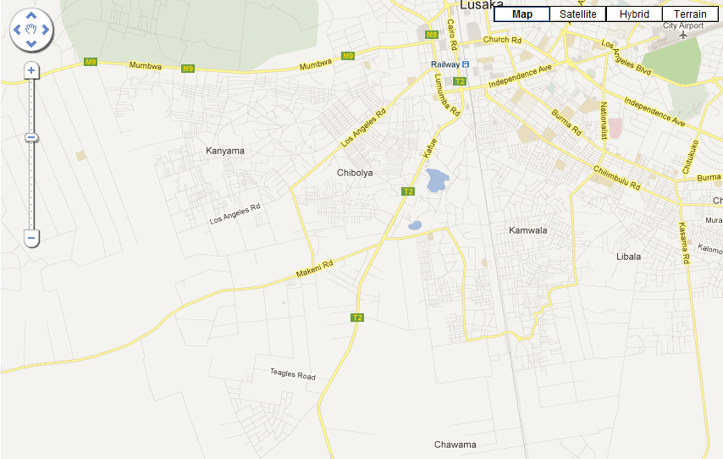
Source: From Google Earth, accessed 09.09.2012
www.maplandia.com/zambia/lusaka/lusaka-urban/lusaka/

3.1 Urbanization of Kanyama

Urbanization is defined as “the increasing share of a country’s entire population residing in urban areas” White, et al (2009:155). It can also be said to be the process by which large numbers of people are drawn into town on the prospects of finding employment, improved living standards, good education, or simply living in clean surroundings. Because urbanization concentrates people in a small space, it is a good trend for economic development. It provides cheap and easily available labour. But the large numbers of people coming into town create pressure on the few available accommodations. Too many people concentrated in a small space creates overcrowding, houses scarcity, unemployment, lack of space for construction, lawlessness, crime, drug abuse, pollution, unsanitary environment and many other vices.
Kanyama slum on the western side of the CBD is about 4.5 km (Mwape, 2011) from the city centre. It developed in an area that was originally zoned to be an industrial site. The land is rocky, and drainage very poor. On this side of town are located Chinika industries with assorted processing and manufacturing industries. Processing industries include the National and Superior millings, Tiger animal feeds, Calcite industries , Timber processing and manufacturing industries like Plascon and Zambia paints, Southern steel and many others. These various industries produce assorted types of wastes, all of which somehow find their way to Kanyama area. While the concentration of industries in this area is a “pull” factor for menial labourers, the pollution that they produce is also detrimental to the health of the residents. Kanyama is both densely populated and heavily polluted.
The industrial activities in Kanyama expose it to air, water and land pollutions, which affect the health of the residents. The industrial fumes are responsible for the respiratory infections mostly affecting children and elderly people. Untreated industrial waste water pollutes shallow water wells and is responsible for the water-borne and diarrheal related diseases. Solid waste pollution in form of plastic- carry bags, bottles, milk sachets, polythene bags; glass bottles, rubbers, and many others of non-biodegradable nature are prevalent. Apart from industrial solid waste, residents also add to the solid waste pollution from their merchandize of vegetables. Domestic and industrial solid waste is littered everywhere; on the roads, roadsides, and in the defunct drainages. Because of population density in the area, there is hardly space for waste dumps. As a result, Kanyama residents converted an unfinished building into a waste dump. The place is called “Historical Garbage Site” (see figure 3 below). There is another illegal dump site behind Chibolya market. Poverty compels the urban poor to rummage the dump sites in search for something they could recycle. Through this process the waste is scattered the more.
Figure 3.1 a: Kanyama’s historical Garbage site.
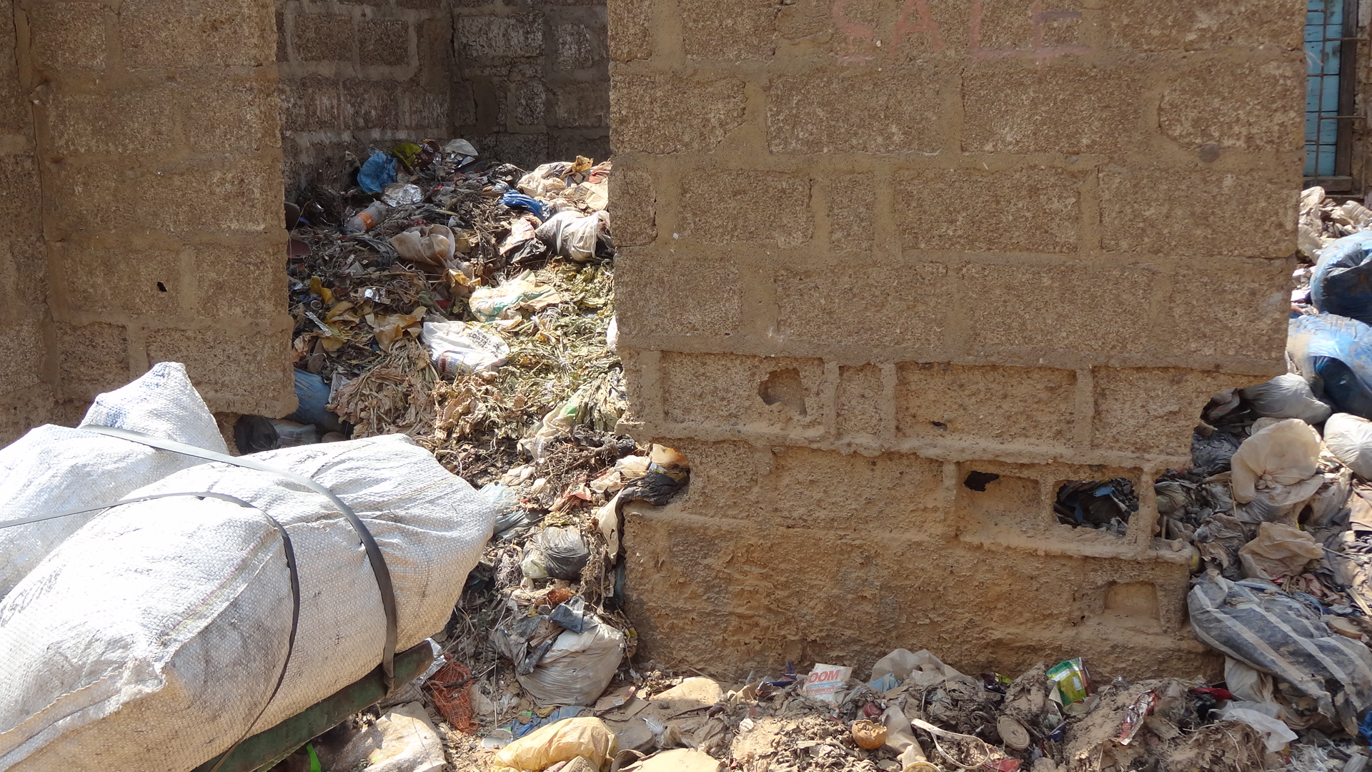
Source: Researcher collection

Figure 3.2b: Kanyama’s historical Garbage site.
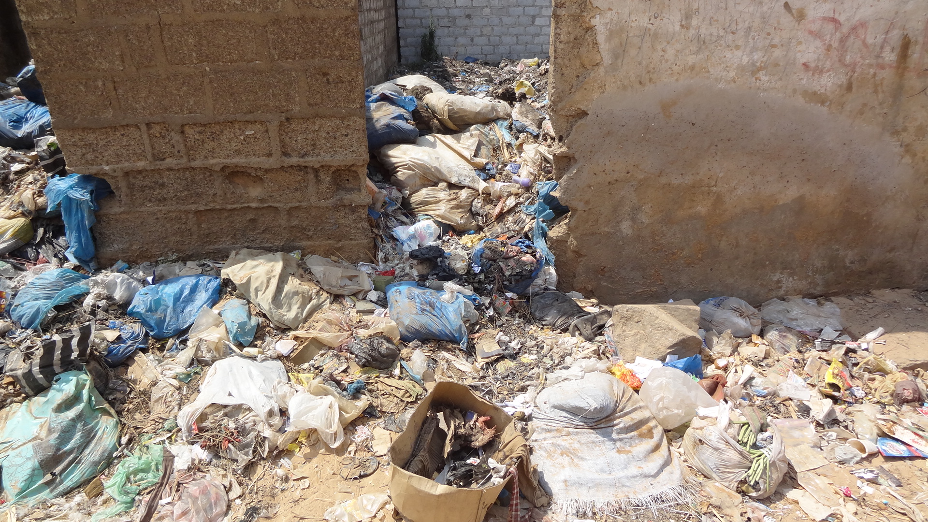
Source: Researcher collection
Urbanization, slum development and environmental degradation are intertwined. The alluring facilities of city life attract mass exodus into towns, giving rise to slums owing to acute shortage of space for housing. Consequently, areas without water supplies, drainages, and roads etc. have emerged. Subsequently, many health-related problems due to unhygienic environments have arisen. Concentration of people in kanyama inhibits the erection of dumpsites. Residents are forced to dispose their waste anywhere, sometimes even near water sources. Such unhygienic habits contaminate shallow water sources which in turn impacts on their health and eventually livelihoods. Besides, having piles of smelly garbage almost everywhere while some waste is scattered all over does not only destroy the scenic beauty of a place but gives the area a foul smell. Kanyama is very close to the CBD and as investors come into the country, such unsanitary appearance may negatively inform their confidence in the governing system.
The high poverty levels in Kanyama make some residents to scavenge the waste dumps for items that they could recycle. Unfortunately, waste dumps are also used for disposing off human waste through what is known as the ‘flying toilets’. Flying toilets are plastics that are used as toilets in the night owing to the distance between some homesteads and the toilets. In the morning, these plastic toilets are strewn onto the rubbish heaps together with other types of solid waste, hence the name ‘flying toilets’. It was revealed during research that the community had decided to clear the place to stop the vice and get rid of the awful smell that comes from the area.
In comparison, places like Mandevu and Chawama that are relatively close to the CBD and industrial area, Kanyama is highly populated as shown elsewhere by CSO (2010). Kanyama residents come from every part of the country and beyond. The larger population of the residents is either semi or unskilled, though there is also a sizeable population of retirees and others who are in gainful employment. Kanyama accommodates a wide range of people; there are businesspersons who own schools, clinics, and also poor people who live by scrounging waste dumps and heaps. The easy availability of labour makes it to be cheap. Residents who are employed either in the industrial area or CBD do not get much in terms of wages. A higher amount of what they earn is spent on food, leaving them with not enough resources to invest into good buildings. Most of the houses for the urban poor are made of scrap and therefore very fragile and hazardous to health. Nonetheless, there are some good and well-built structures owned by business people. But predominantly, housing structures are made of weak building materials as shown in figure 3.1c below. This type of structures can’t withstand any pressure. As a result, they are prone to destruction during floods and storms.
There is hardly any space which can be used for construction of essential infrastructure such as roads and drainages and toilets. Because of this, households are forced to share the toilets. And because Kanyama is in a swampy area, additional water from rain raises the already high water table, making these shallow toilets fill up quickly. This makes the toilets’ contents overflow. It also causes seepage into shallow wells thereby contaminating the water. Eventually, this leads to outbreaks of diarrheal diseases.

Figure 3.3 a: Kanyama’s Typical House for the Urban Poor
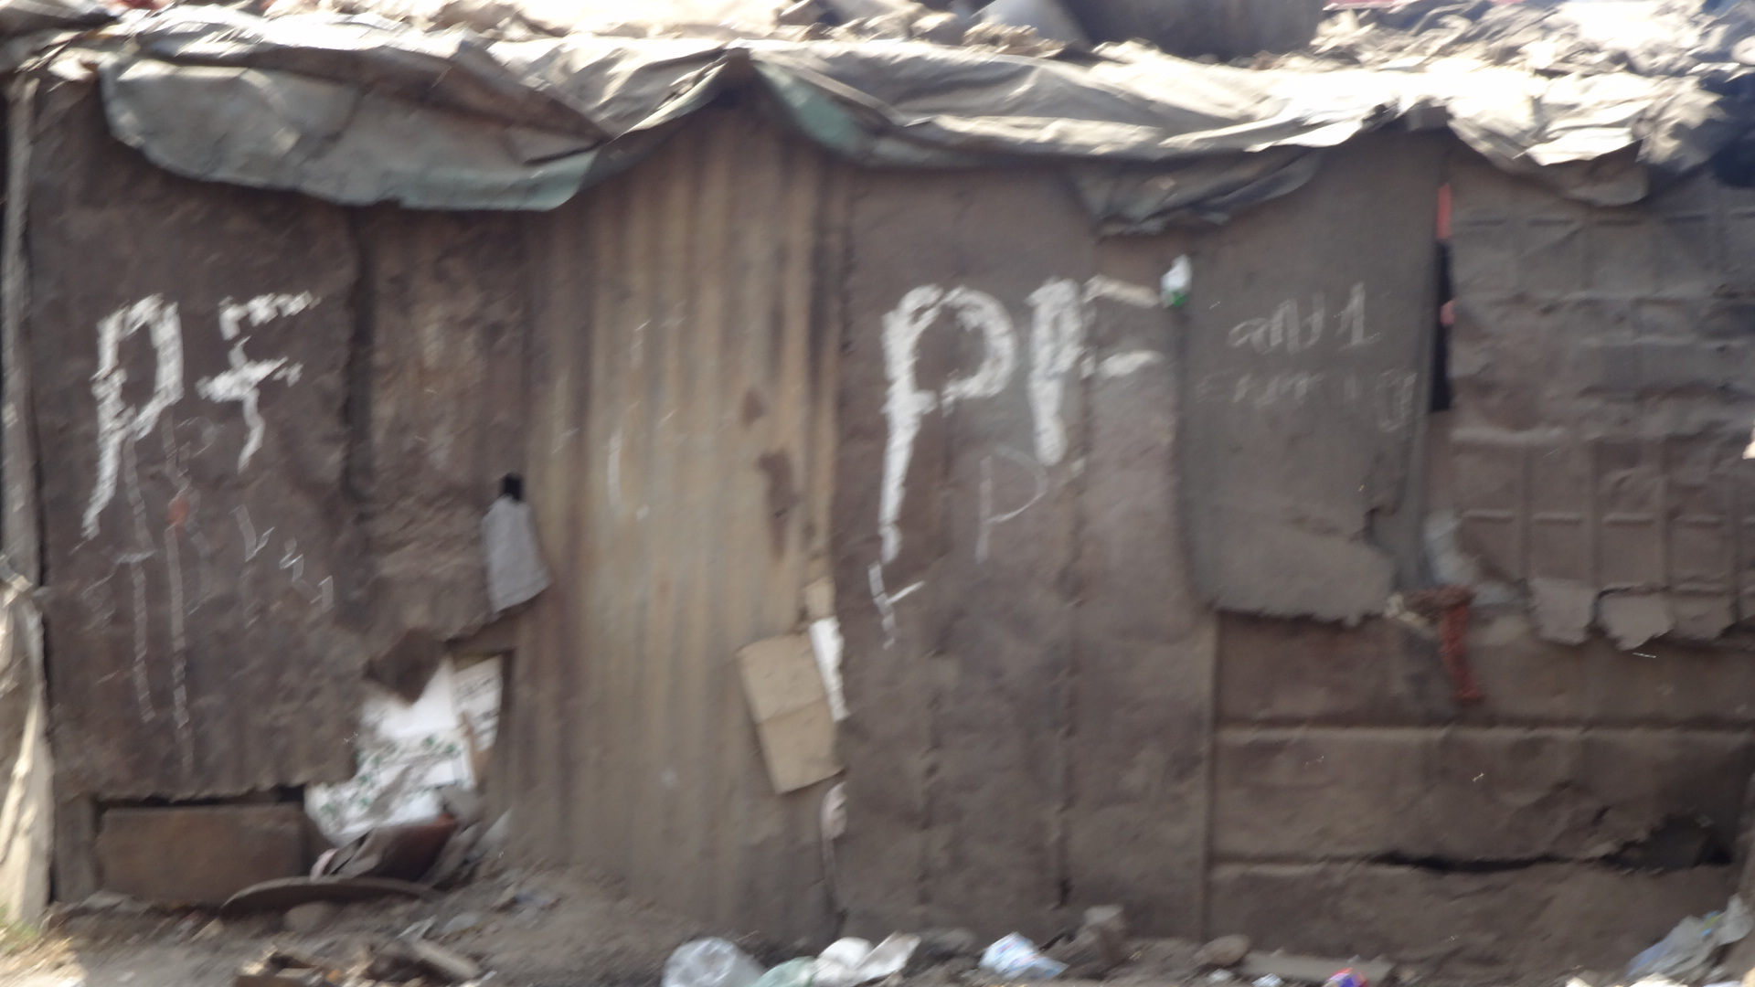
Source: Researcher collection
Most residents are not able to make any savings because of economic hardships. Lack of resources inhibits parents to send their children to school resulting in most youths being illiterate. Kanyama area’s population is largely youthful. A population of almost 183,500 is under the age of 18 years (CSO, 2010). The population notwithstanding, the area has only five government schools that offer basic education from grades one through to nine. HMN ward hosts four schools while Kanyama ward has only one school. The five schools are over-enrolled and the teacher-pupil ratio is abnormally high. This makes it challenging to teachers to give individual attention to needy pupils. Because of this, the performance of pupils is negatively affected. Apart from the five government schools, there are some private schools. However, because of the financial constraints, few parents manage to send their children there.
Kanyama area has no government high school. Pupils in higher grades attend schools either in Matero, north of Kanyama or they go to Kabwata, east of Kanyama. Because of the monetary hardships, pupils traverse the CBD on foot and sometimes without food. Because of walking long distances and leaning while hungry, the pupils’ performance is adversely affected. As a result, most of the youths stop schooling before attaining higher levels of education.
Rains disrupt the school calendar in this part of town. During the floods, schools are closed for three months either because they become inaccessible or because of cholera outbreaks. Sometimes, children drown in drainages or are swept away by the rain water but sometimes its’ psychological, parents just fear to let the children go out when it has rained heavily.
Consequently, illiteracy rate in Kanyama is high. Because of illiteracy, the youths are compelled to depend on the environment for their survival.

3.2 Environmental Degradation in Kanyama
Urbanization, though good for economic development, has negative impacts on the environment. The high concentration of people in one area makes labour easily available and thus cheap. Because labour is cheap, the wages that residents earn are very minimal, forcing them to depend on the environment for their subsistence. The residents depend on the environment in ways that pollute it and in turn, the polluted environment impacts on their health and quality of life.
Kanyama’s location near the industrial area exposes it to all forms of pollutions. Apart from the industries producing fumes that pollute the air, residents also engage in activities that produce fumes and pollute the air. Such activities are stone-quarrying. And in order to break the rocks, residents burn old tyres or use explosives. Use of explosives is not only dangerous because of the fumes produced but because they are capable of disfiguring someone. Fumes cause respiratory infections. Asthma has been identified as a respiratory problem caused by inhaling fumes.
Stone- quarrying has an impact on the environment. When the huge rocks are finally removed, they create deep ditches which fill with water during the rainy season. These pools of stagnant water become breeding grounds for mosquitoes which results into increased cases of malaria in Kanyama. During the dry season, the ditches become hiding places for criminal activities.
Unemployment is high in Kanyama. In order for Kanyama residents to subsist, they engage in a variety of survival strategies. The majority of them sell their labour in the industries but on a temporal basis, but others are entrepreneurs dealing in different kinds of businesses. Some are traders, others are tailors, others have small makeshift stalls for household goods, and yet others have restaurants. Some sell clothes, others sell footwear. Floods create employment for young men who ferry customers from one point to another. Others sell livestock and others poultry. Others sell marijuana and yet others guard customers’ vehicles in town for a token. Young and old people alike scavenge the waste dump sites for some resource to recycle. The area however, has, a sizeable number of people employed in various government departments as drivers, secretaries, and office orderlies. Some people are employed as shopkeepers in the CBD and Kamwala areas. Others are in the service industry as mechanics or plumbers. Every member of the household is engaged in some income generating activity to supplement the meagre income earned by the household head.
Crime is very rife in Kanyama with criminal activities not confined to a particular time. Some residents depend on criminal activities for survival. They take advantage of population density, unfinished buildings and the non-availability of street lights to steal items like handbags, phones and anything valuable from the unsuspecting public.
Kanyama Township is a beehive, full of activities. When night falls, prostitution becomes alive. Ladies sell their services in order to pay their rentals, feed their families and send their children to school. Consequently, HIV/AIDS is endemic in this area, increasing the number of orphans and street children.
Untreated waste water, industrial and pit latrines’ effluents pollute shallow well water. The scarcity of safe, piped water compels kanyama residents to use polluted well water for laundry, cleaning dishes and bathing. The use of contaminated water leads to cholera, dysentery, typhoid and diarrhoeal diseases. Furthermore, pools of stagnant water become breeding grounds for mosquitoes which lead to increased number of malaria cases.
Kanyama residents do not have piped water in their homes. Lusaka Water and Sewerage Company (LWSC) supplies safe water to the residents in communal standpipes. To get this water, residents pay k100 (less than 1 cent) per 20 litres container. In Kanyama, the average household size is 5-6 members and 20L for such household sizes is inadequate. To ensure that there is enough safe water for cooking and drinking, residents supplement the shortfall by using well water for cleaning dishes, laundry and bathing. The well water is usually polluted from the toilet-seepage and the waste dumps. Polluted water leads to skin infections and water- born related diseases.
Most residents use pit-latrines for lack of piped water into their homes. But toilet facilities are inadequate. Not only are they difficult to construct because of the rocky terrain, there is just no space in the yards. Households as many as 5-6 share a toilet in Kanyama. This means that some residents have to walk some distance to the nearest toilet. A resident was quoted saying;
Many of us here are renting, we do not have individual sanitation facility. Most people without sanitation facility use plastic bags to ease themselves because it is convenient than leaving the house during the night. Some toilets are up to 200m away from the house. And in the morning, the plastics are flown onto the roads or dumped on the waste heaps (Mafa, 2011).
Problems with sanitation are that toilets are shallow and overflow during the rainy season. They pollute the well water, have an offensive smell and cause disease. Water-borne diseases and malaria are common during the rainy season.
Kanyama residents experience major upswings of life. During the rainy season, there are floods, malaria, diarrheal diseases and after the rains, there are cases of cholera outbreaks. Given all the health problems that Kanyama residents experience and are exposed to, Kanyama area has only one government clinic, Kanyama referral clinic. Usually, the clinic is under stocked with medicine. But during the rainy seasons, it is mostly inaccessible because of the floods. The random construction of houses in the area leaves no room for the construction of such important infrastructure as roads. Access to the clinic is through paths that meander through the residential area. When there is a patient needing medical attention, women being their duty to take care of the sick, find a way of getting the patient to the clinic. Sometimes, patients are ferried on wheelbarrows to the clinic. Apart from this referral clinic, Kanyama has other several privately owned clinics but the ordinary people cannot access them because of the economic hardships.

3.2 Kanyama’s forms of collective action
Kanyama area is a vast constituency made up of three wards; Kanyama, Munkolo and Harry Mwanga Nkumbula. The three wards have similar demographic characteristics, same type of economic situation and political influence and even the geographical layout. The differences are that Munkolo ward is slightly on the higher ground and does not experience floods as the other two wards and being further away from the industrial areas and CBD is not so much exposed to massive solid waste. Munkolo’s major problem, like the other two wards, is lack of roads due to a very rocky terrain though the two wards share similar experiences of flooding, poor waste management and the resultant adverse poor health. The three wards have each prioritized what they think is their number one problem and are working towards solving that problem. Subsequently, there are different layers of collective actions, each working in isolation.
Upon realizing that LCC would not be able to live to its expectations, the Council, in collaboration with the community decided to form CBEs in each of the three wards. The CBEs were to help with the collection of garbage from the various zones to central locations such as markets. The WMU has refuse bins in some of the market zones where the CBEs heap the waste to be collected by LCC to Chunga, the official dumpsite. CBEs’ lack of proper transport constrains them to carry the garbage to the WMU refuse bins. As a result, they dispose the garbage at the nearest unofficial dumpsite. Besides, the official refuse bins are rarely emptied and so are overflowing with garbage. The residents and the CBEs feel at liberty to throw the refuse anywhere.
When it became clear that LCC had failed to collect the garbage, some men in Chibolya organized themselves and contracted some transporter to collect the garbage from the area to Chunga. However, when LCC heard about this, they cancelled the contract, on the pretext that LCC, as the service provider, would find some other contractor to collect the garbage. But at the time of the research (20 August, 2012), no transporter had been contracted yet (interview with FVS, 20.08.2012). And garbage was lying everywhere.
John Laing’s residents organized themselves into small groups and were engaged in different projects tailored towards averting the floods. Some men were engaged in removing the waste from the roadside to allow for free flow of water in a bid to avert the floods. Some ladies were engaged in sensitizing fellow ladies on the need for hygiene in their surroundings to prevent the outbreak of water-borne diseases associated with the rains.
Residents in Kanyama ward are equally occupied in removing the waste from the drainages in a bid to unblock the drainages. However, because the drainages have been used as waste dumps for a long time, they need proper equipment and finances to do anything meaningful. This can be availed to them if they involved the government in the project or other well-meaning organizations.
The three wards are experiencing almost similar problems. However, the three wards have failed to collaborate with each other to consolidate their efforts so that there is coherence in what they are doing. Each ward is decided on what project to work on and worse still, the wards are split into small groups, each working on individual projects. The biggest question is; what is prohibiting Kanyama residents from combining their efforts to combat the flooding, poor waste management and the attendant health problems? What is missing to make the people work as one, fighting the similar cause?

Factors for Persistent Flooding and Poor Waste Management in Kanyama
The research findings reveal a host of interlinked factors responsible for perennial flooding in the area.
The chief contributing factor identified was lack of proper drainages. This was attributed to the location of Kanyama. One respondent said, “Kanyama is located in a depression, on a rocky and swampy area. Water collects from higher grounds outside Kanyama and settles in the area. The impervious rocky base makes it difficult for water to drain off easily. To put drainage requires the blasting of rocks. Doing this requires colossal sums of money, which the government doesn’t have”, (personal interview on 16.07.2012). Poor drainage was compounded by lack of political will, population density, poor waste disposal habits and lack of planning.
Lack of political will was another factor revealed through the research. While financial constraints were attributed as a reason for non- provision of the drainages, most respondent refuted this assertion, citing two claims for their arguments. The first claim was the misappropriated US $ 4 million released by the MMD government in 2009 for drainage rehabilitation and construction. A visibly angry respondent stated, “The money was released specifically for Kanyama’s drainage problem but not the whole amount was given to LCC for the project. I made several follow- ups at the ministry to establish the truth on the disappearance of the funds but the ministry did not take any action”, (personal interview, 30.07.2012). Another claim concerns the MCA-Zambia. The government of Zambia was requested to identify an area under the Water, Sanitation and Drainage project that it would need assistance with. Kamwala, of instead Kanyama, was selected. The respondents feel that Kanyama has not received the due attention it deserves. To this end, one of the respondents lamented:
Its’ not clear whether there are hidden agendas somewhere. Programs are always put which are not fulfilled at all. During campaigns, promises are made and based on those promises, people are voted into offices. Once those people get into offices, they turn their backs on their promises (personal interviews, 20.08.2012).
Population density in the area was also identified as a contributing factor. Research findings are that Kanyama has three small, shallow drainages; Tricia, Masauko Gwira Pako and John Spy passing through the two wards nearest to the CBD and the industrial areas and drain away into Munkolo stream. These drainages are, however, not functional because of houses that have been erected on top of them. The population density in the area demands the use of every space available. This has blocked the free-flowing of water. The respondents indicated that party chairmen and cadres were responsible for the illegal land allocation and that the politicians were fully aware of it:
Politicians encourage people to get land in Kanyama as a way of winning support. They also promise monetary benefits to the cadres if they can mobilize people to vote for them. Cadres get really involved during campaigns on the promise that they will be paid. Sometimes they are beaten. But when these politicians win, they forget about the cadres. Cadres then resort to selling illegal plots to get their monetary benefits (personal interview, 20.08.2012).
Another finding related to flooding was the indiscriminate throwing of waste in the area. Kanyama’s location near Chinika industrial area exposes it to air (fumes and smoke) water (untreated waste water) and land pollution (solid waste). The solid waste is non-biodegradable and includes items mostly plastic, synthetic rubber and glass and many others. Revelations are that industries pay LCC for waste collection but the council does not collect the waste, hence the litter in Kanyama area.
Figure 4.1: Blocked drainage 1
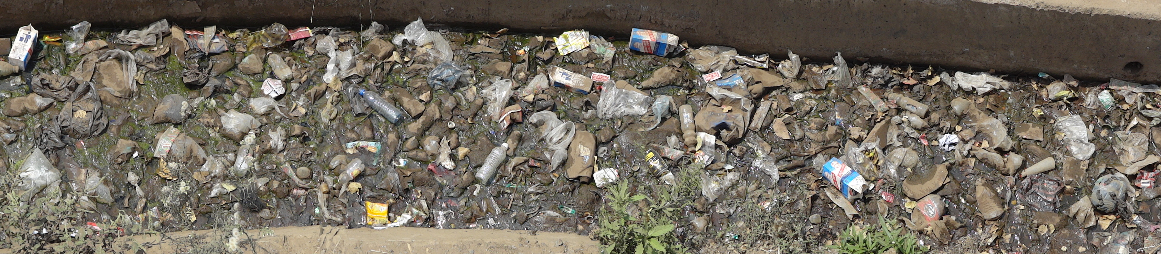
Source: Researcher Collection
Poverty makes the resident rummage the litter in search of something valuable and together with waste from their homes they dispose of their waste in the shallow and open drainages, roads and just everywhere. Littering of waste in the drainages contributes to their blocking and subsequently to the flooding problem. Residents blamed LCC for non-provision of waste collection services. The department of public health at LCC is directly in charge of waste management and is mandated to keep Lusaka and the surrounding areas clean. The Waste Management Unit (WMU) under the public health department has a slogan, “Keep Lusaka City Clean”, but due to lack of capacity, is unable to live up to its obligation. A respondent disclosed that the council had only one refuse truck for nine compounds and that it collected refuse from Kanyama compound twice per month. This was inadequate given the vastness of the compound, with a total number of 78,000 households (personal interviews, 20.08.2012)
Figure 4.2: Blocked drainage 2
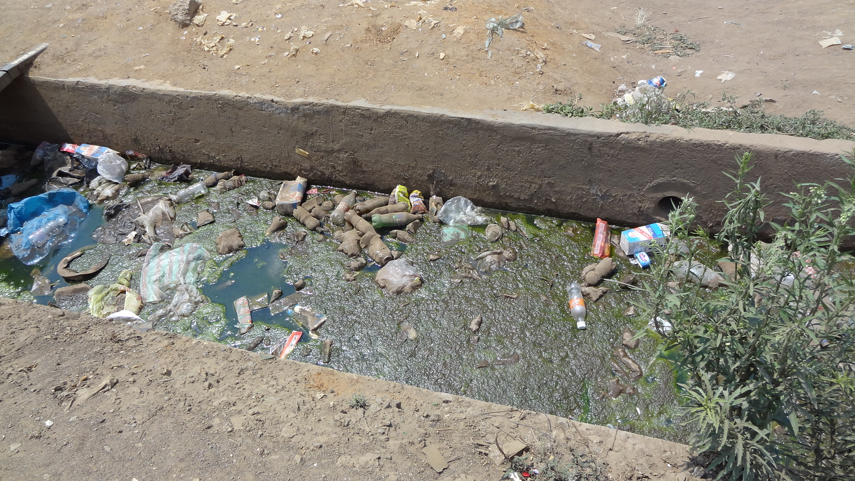
Source: Researchers collection
A key respondent disclosed that Kanyama compound was not a planned settlement. Houses were built in haphazardly manner. As a result, no provisions were left for roads and laying of drainage pipes. Furthermore, residents who constructed houses where drainage and roads are supposed to pass were unwilling to have their houses demolished to pave way for the construction of roads and drainages (personal interview, 17.07.2012).
The perennial occurrences of cholera, malaria, dysentery and typhoid were shown to be a result of poor waste disposal and flooding. Respondents in the FGDs (FGDS on 18.08.2012) related how waste disposed in the drainages, on the roads and in undesignated areas led to pools of stagnant water which became breeding grounds for mosquitoes. This resulted into high incidences of malaria and serious outbreaks of dysentery, cholera and typhoid. In fact, at the time of the interview, one of the respondents disclosed that there was an outbreak of typhoid in one part of the compound.
The FVS indicated that no international organisations were currently involved in resolving the problems of drainage in Kanyama. The organizations that had indicated willingness to help withdrew upon learning of the Lusaka Master Plan for Urban Renewal program to be implemented by Japan International Cooperation Agency (JICA) in 2016. They opted to wait and see what JICA would do in their Urban renewal program. And the industries within Chinika industrial areas were reluctant to assist financially for fear that the money would not be put to good use after the misappropriated US $ 4 million (personal interview, 20.08.2012).
LCC has tried to alleviate the flooding problems of Kanyama by relocating strategy. Research findings reveal that in 2007-2008 rain seasons, flood victims were relocated to Kanakantampa resettlement scheme in Chongwe, some 45 km east of Lusaka. They were relocated without empowering them with any capital. The key respondent (17.07.2012) related that the relocates didn’t stay but returned to Kanyama to rebuild their lives from there. The reasons advanced for their return were distance from the industrial areas and the CBD where they earned their livelihood. In another instance, the people that would be affected by the construction of roads compensated with US $ 20,000 but not allocated to land to settle. This strategy didn’t work either. People did not relocate (personal interviews, 17.07.2012).
In trying to overcome the flooding and waste management problems, the community has engaged several strategies. The first strategy is the use of the “vote”. During the reign of MMD from 1991 to 2011, the residents had three MPs from three different political parties representing them. From 1991 to 2001, MMD MP represented Kanyama people. During this period, no drainage was constructed but residents had their first tarmac road, Los Angeles, in the compound. The next five years under UPND MP from 2001 to 2006 did not yield the desired result of drainage erection. Instead, some boreholes were constructed. This development pleased the electorates who gave the MP another five year mandate though he stood under a different party-PF. The demise of the MP in 2007, made the electorates to usher in another MP from the PF in 2008. Overall, the voting in and out of MPs did not yield the desired results. The drainage and poor waste disposal problems were not solved. One of the respondents during the FGDs concluded:
Zambians are used to hand–outs. We take whatever we are given. Generally we are peace-loving people who will not revolt even when things are not going on well for us. We complain but take no action for fear of being labelled “confrontational”. As a consequence, we receive things that we do not ask for. The only thing that we know best is to cast our “votes” to show our displeasure (FGDs, 14.08.2012).
Another strategy is payment of service charges. In 1996 during MMD’s reign, Kanyama was legalized. In 2008, LCC embarked on registration of the housing units in Kanyama under the ground rate project. Under this project, houses are allocated numbers and the occupants pay US $ 2.4 ground rent and US $ 2 for service delivery. Services include provision of roads and street lighting, drainages and garbage collection. Outcome of the research, however, show that most of the residents have abandoned the service fees because LCC has not honoured its obligation. Waste collection is inadequate, roads are not provided and the drainages are non-existent. Some respondents revealed that they owe LCC up to US $ 1,000 equivalent in arrears. They question the essence of paying for the services that are poorly or not provided at all. “Paying for what? There is no incentive for paying because services are not provided. There is no need to pay the council for anything”, they state (FGDs, 14.08.2012).
Alternative approach is the use of Community Based Enterprises (CBEs). Literature shows that Kanyama experienced serious cholera outbreaks in 2004 with 6542 cholera cases reported due to poor waste management and flooding (Sasaki, et al 2008). This necessitated the LCC, through the Public Health Department, to train community members on the need for hygienic practices and through these trainings, CBEs emerged. The CBEs are contracted by LCC to collect garbage from various collection points such as markets and dispose it at Chunga, the official dump site. The council pays the CBEs from the US $ 2 and $ 4 paid by the households and businesses respectively. But lack of transport limits the effectiveness of the CBEs. They collect the garbage and dump it within the community. During the research, two CBEs were seen dumping garbage from households onto an illegal dumping place just behind one of the markets in Chibolya compound. MW secretary revealed that each of the three wards was donating US $ 18,000 from their US $ 60,000 Ward Development Fund (WDF) to purchase a refuse truck to overcome the transport constraints (personal interview, 17.07.2012).

Figure 4.3: CBE throwing wastes behind Chibolya Market
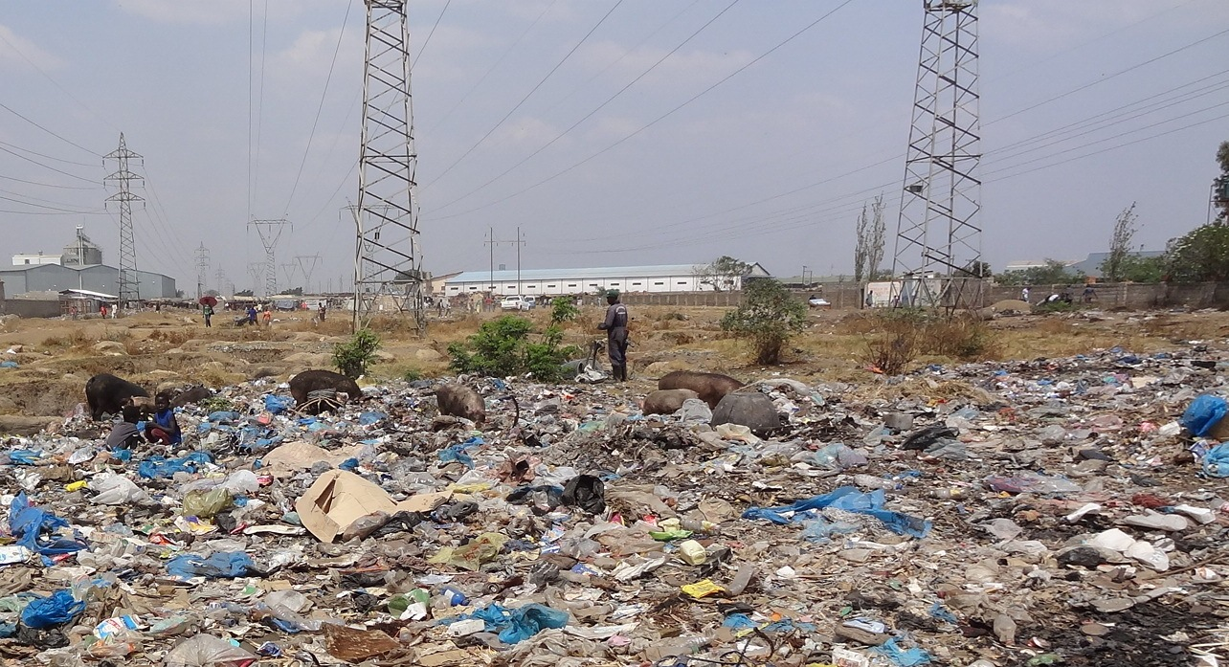
Source: Researcher collection
Seeing that the council had problems in collecting the refuse, one section of the community decided to organize a private company to collect garbage from their area. But the council, suspicious of the move cancelled the contract and decided to engage a different contractor. But at the time of research (20 August 2012), no contractor had been engaged yet and garbage was littered every-where. Residents in another area are unblocking drainages by removing waste disposed in them. This task, however, requires heavy investment in equipment and finances. In yet another area, residents on individual basis are collecting garbage from the roadsides. In some yet another instance, individuals take the initiative of sensitizing the neighbours on the need for environmental hygiene to avert the health related problems that surface as a result of flood and refuse.
Figure 4.4: Waste Management Unit (WMU) - refuse bin.
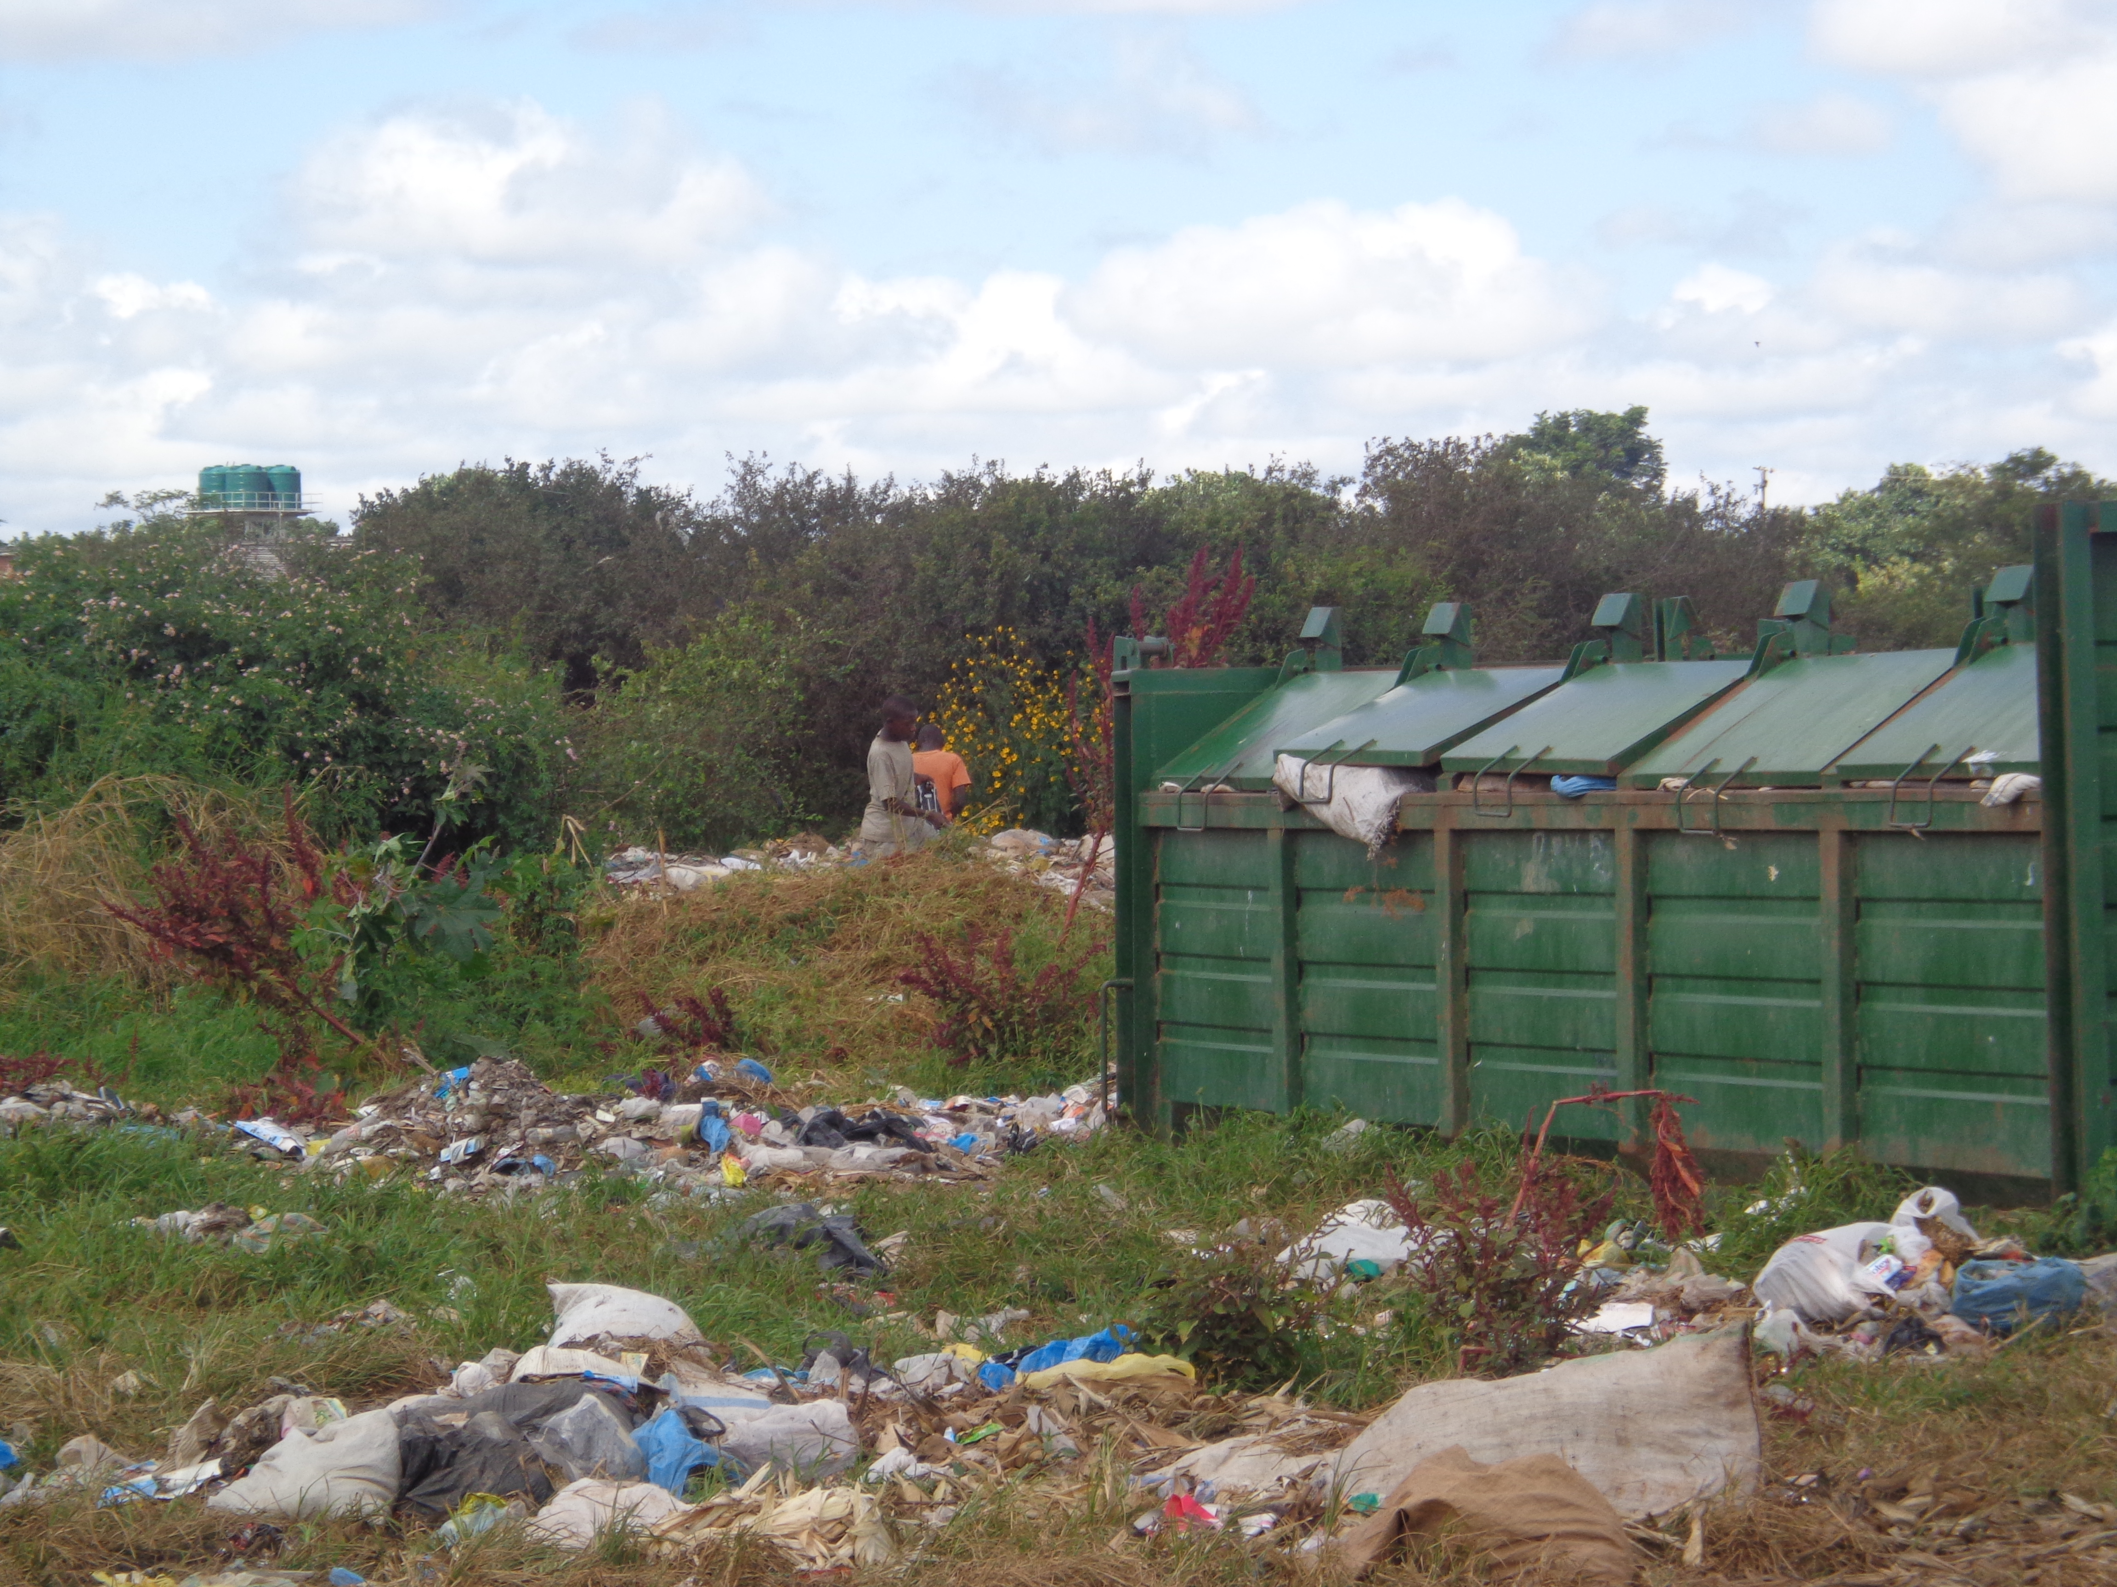
Source: Researcher Collection
Clearly, what stands out in the research is that Kanyama residents lack collaboration. This is demonstrated by the many individual groups, each trying to resolve issues of flooding and poor waste management that are massive in nature.

Revisiting Social Capital in Kanyama

‘Disaster is explained in terms of the society’s organization and not the coverage, gravity or the length of it’ (Donner, 2007).

Kanyama’s vulnerability results from the society’s social stratification which relates highly to social inequality and power relations. The different groups of the society receive different types of treatment, depending on the class, status and how influential the group is. It’s the concept of social capital (SC). SC is defined as “the features of social organization such as trust, norms and networks that can improve efficiency of society by facilitating coordinated actions”(Sopha, et al. 2007: 9; Donner, 2007: 670; Ferdinald, et al. 2012). The idea behind SC is that people’s associations with and acceptance to various groups is largely dependent on the positive contributions they make. When people have a wide range of groups they associate with, it is a sign that they have a wide cycle of alliances that they can depend on for help. These connections could be at different levels, like local, community, country or international level. Typically, alliances thrive on the assumption that the people involved are able to amass help in times of need. The concentration of links shows the dense supply of SC a society has (Sopha, et al.2007). Kanyama residents’ SC base is stronger on the two lower classifications of networks. Bonding SC is very strong. It explains how residents manage to put their lives together after a disaster and why flood victims did not want to be treated differently, whether landlord or tenant (Statehouse, 2010). As a safety net, strong internal bonding somehow reduces vulnerability but contributed to Kanyama residents’ failure to link with others different from them. This is exemplified by the many, small individual groups, each attempting to resolve the flooding and poor waste management problems. Such groups include people working to unblock the drainages, others sensitizing the neighbours on the importance of hygiene and others working on removing garbage from the roadsides for free flow of water. Poor collaboration hinders the effectiveness of community organization, resulting in some organizations becoming dysfunctional, inactive or just not proactive. They function when need arises or make plans just for the disaster season but otherwise inactive (Ferdinald, et al.2012).
The weak connections among people from different geographical and occupational backgrounds but similar economic status and political influence have worked against the residents of Kanyama. It has been difficult for them to link up and work as one community. Similarities in economic backgrounds, locality and experiences in life notwithstanding, each of the three wards is working in isolation in trying to resolve the flooding and poor waste management problems. Munkolo residents are working on their road project; Kanyama ward residents are working on the blocked drainages while Harry Mwanga Nkumbula residents are sensitizing the neighbours on the importance of hygiene. The weak connections within the community, evidenced by lack of collaboration and unity among the residents, are a hindrance to the community’s ability to enhance livelihoods and flexibility. Opportunities for such can only be created with strong bridging SC networks. This may explain the relocatees’ failure to remain in Kanakantampa, claiming lack of means of livelihoods. Ferdinald, et al (2012) define resilience as, “the ability of the system, community or society exposed to hazard to resist, absorb, accommodate and to recover from the effects of a hazard in a timely and efficient manner, through the preservation and restoration of its’ essential basic structures and functions” and show that the “real strength of resilience” lies in the level of inter- community links between various groups (Ferdinald et al, 2012).
Strong linking SC between communities and those in position of influence are a prerequisite for moving out of the dilemma that Kanyama residents find themselves in. Lack of linking SC could be a plausible explanation for Kanyama’s unchanging situation for decades. It may also explain why different MPs have come and gone without attending to the drainage problem. The relevant authorities claim that there is no money to work on the drainage system but when campaigning for elections, they promise to work on the drainage problem. Kanyama problems have persisted because residents lack the strong networks with bridging and linking SC needed for them to improve their livelihoods.
Power relations breed social inequality that restricts the livelihoods options of the poor in society, making them occupy hazardous environments (Collins, 2008). The powerful in society dictates what the poor should do, where and how they live. Higher levels of poverty, socio-economic exclusion and environmental degradation increase the vulnerability of the poor. Poverty commands that the poor construct homes using substandard materials in unsafe areas that lack strict adherence to building codes. Vulnerability “relates inevitably to power, the ability to exert control by right or threat, and can be interpreted as a loss of power in the creation of one’s future” (Collins, 2008: 24). Incidentally, “the long- standing and deeply entrenched discriminations in the prestige, class, and power structures of society that place certain groups, more so the poor, at greater risk to environmental and technological hazards” (Donner, 2007: 671). This is demonstrated by the “seemingly CCA” exhibited during disasters. Different organizations of society i.e. government, non-governmental organizations, donor communities and civic societies get involved in easing the negative impacts of the environment, but after abating the effects of the disaster life normalises, the victims remain in the same, if not worse off, situation than previously.
Vulnerabilities have historical, political, and socio-economic connotations and highly linked to the production of unequal distribution of resources among people. Historically, African residences were located in under-serviced and unregulated homeland borders, on the periphery of the urban centres. This trend has continued to this day. Slums are on the peripheral in the governments’ budgets and have continued to suffer with the results of segregation in service provision. The socio-economic results experienced today have their historical roots in the growth of economic, manufacturing, industrial and commercial activities of the past. It required that rural migrant workers labour as unskilled workers, under contracts and that they stay close to the working areas regardless of being exposed to industrial pollutions (Pelling, 1999; Mulenga, 2003; Marx and Charlton, 2003; Ferdinald, et al. 2012). Kanyama situation is no different.
Integration of the third world economies into the world economies and the implementation of the International Monetary fund (IMF) regulations of SAP are other factors explaining the vulnerability of the urban poor in the socio-economic realms (Resnick, 2011). The two have negatively affected the poor. The liberalization of the economies created markets for the rich and already established manufacturing industries. The new industries, unable to compete with the seasoned industries, had no option but privatize or close down for lack of markets for their products. Whichever option was taken, it affected the urban poor most. The removal of subsidies put farming inputs on the higher side and inaccessible for the peasant farmers. Besides, with cheaper farm products from outside the country, the local products could not fetch much. The integration of the economic activities and the implementation of the IMF regulations have forced the poor either off the land or onto very poor or insufficient land, causing them to live in the most dangerous, unhealthy and overcrowded places (Pelling, 1999). As Collins (2008:21) concludes:
The international division of labour among the rich and the poor countries, and market forces within the poor underdeveloped capitalist economies of the third world, cause the poorest of the poor to live in the most dangerous places. The process of underdevelopment is intimately linked with the control and exploitation of indigenous resources by the governing elites and outside interests. The underdevelopment forces the peasantry into a more vulnerable position, causing them to look for another source of livelihood in areas where security is less and hazard more severe or change their resource use in ways that exacerbate vulnerability.
The political shift in the vulnerability of the urban poor is demonstrated by the genuine ‘lack of political will’ to address issues as they arise. This is exhibited by the relevant authorities, in what is termed as ‘failure of governance’ (Huchzemeyer, 2009:60). Relevant authorities include the local politicians, the local and central governments. The relevant authorities seem to apply delaying tactics when implementing policies aimed at benefitting and improving livelihoods for the urban poor. Kanyama settlement was legalised in 1996 and qualified to receive social services from the government (Silengo and Phiri, 2010). However, it took 12 years for the relevant authority to come up with a service charge and user fee policy which could allow the settlers to contribute towards service provision (LCC, 2008). Through this policy, households pay US $2, while commercial houses pay US$ 4 monthly. To ensure residents pay their fees, the LCC has council offices in the compound which collect the fees from the residents. With the policy in force, implementation of quality service delivery is non-existent. As a consequence, the residents have also stopped paying the service charge (group interviews, 14.08.2012). With PF in power, we are yet to see how LCC will run, seeing that the council is dominated by the PF councillors.
Failure of governance is also exhibited in the inconsistences in the utterances of the authorities. By law, the local authority is under the central government and carries out orders of the higher authority. Unfortunately, there appears to be some discrepancies in the way programs related to the informal settlers are carried out. Recently, an article ‘PF plans to demolish Lusaka Compounds now a reality’ appeared in the Zambian Watchdog paper. The article indicated the governments’ intention to demolish some compounds, among others Chibolya in Kanyama constituency, to pave way for expansion of the city under the Lusaka Master Plan Urban Renewal program. The statement of demolition given and confirmed by an official from the LCC stated that land for resettling residents to be affected by the expansion of the city was already secured from a nearby traditional leader chief Nkomeshya though no compensation plans were in place. This statement was, however, contradicted by the government Minister who claimed ignorant of the matter. “It is news to me, as Minister I’m not aware of such plans but what I know is that the PF government is not demolishing any structure. We are busy putting in place strategies to help the Zambian people and displacing them because of demolishing is not part of the strategy”, he said (Mwansa, 2012). Traditional land under customary tenure serves as an important mechanism for semi-formal urban expansion (Napier, 2000).
Strong linkages within the community and across communities are a pre-requisite for fighting adversities and bringing about the desired change. This calls for collective action, inherently oriented towards change. This aspect has been missing in Kanyama. Instead, individuals unhappy about a social condition have each decided to take individual actions. This division does not foster unity needed for the formation of CA. AS people in similar situation discuss their problems; discontent becomes collective, harmonized and focalised. Individuals with leadership skills are identified and subsequently approach for tackling the problems are recognized. Strong linkages help SM to combine forces, be organized and strategic in their outlook. Networking helps to get necessary support. Educated and enlightened people are an asset in SM as they are a bridge between the affected and the authorities. They enlighten the affected people about their rights and the authorities’ obligations to them (Huchzemeyer, 2009; Jagan and Chun, 2010).
The knowledge about citizens’ rights is cardinal in getting the affected demand for fair treatment. Residents in legalised informal settlements pay service fees and user charges which entitles them to receiving services like garbage collection among others. Because of ignorance, the residents are not able to make the relevant authorities be accountable to them. In the same vein, ignorance has made them continue using the vote to show displeasure and dissatisfaction. While democratically allowed and right, failure to openly criticize the ailing system and politicians is responsible for the continued existence of flooding and poor conditions of living in informal settlements (Huchzemeyer, 2009).

5.1 Conclusion
This paper set out to investigate factors that could be behind the persistent flooding and poor waste management in Kanyama and also to identify the various roles that the different stakeholders have played in alleviating the problems. The various stakeholders list included the local residents; the local Member of Parliament, the local and central governments, the local and international non-governmental organization and other interested parties. Using the PE/SM/SC analysis, the paper has identified factors that have hindered the community from forming a formidable action group, able to demand for their dues from the relevant authorities, thereby putting an end to the decade-long disasters.
Until September 2011, Kanyama area had predominantly been represented by the opposition MPs. MPs act as a link between the local residents and the government. They represent the people’s needs to the government and at the same time convey to the people what developmental projects the government intends to do in the area. Even though the MPs participated and assisted the local council in planning developmental projects to be funded by the council and helped in soliciting funds from the government for the projects or influenced non-governmental organization and donor agencies to fund such projects, they could not get government to work on the presented projects by virtue of being in opposition. There was a problem of power relations. The government used its political power to disadvantage the residents by denying them economic development that they should have had. At the same time, the area MPs could not influence the Non-Governmental Organizations (NGOs) and donors to fund the projects without government approval. Huchzemeyer indicates that NGOs and donors supporting the government area bound by the rules of donor funding and cannot go against the state; but seek partnership with the state (Huchzemeyer, 2009).
A closer look at the above brings to light that the problems of flood disasters in Kanyama are structural problems. The fact that NGOs (who are supposed to offer checks and balances to government activities) and donors are not able to work without being restricted to following the laid down procedures and processes, rules and roles, just to get along with the government confirms that the problem is indeed structural and man-made. NGOs are not government organizations. They serve as a link between the government and the poor people. They speaking on behalf of the poor and oppressed and try to find ways of addressing their grievances. If they cannot work independently of the prevailing systems, then they become compromised and cannot help the poor to come out of their problems. Attending to disasters is a very expensive venture and requires colossal sums of money. Evacuating flood victims and providing for their requirements entails that some development programs are halted and this has been done on several occasions. If it were Kanyama floods are innocent natural occurrences, a lasting solution could have been found by now.
The dragging in finding a workable solution to the flooding problem results from an interplay of several factors;
The community has leadership problems. The lack of strong leadership has rendered the community vulnerable to a lot of suffering. Strong leadership helps to organize the affected community against the socially constructed ills. He/she gets the residents to be interested in the welfare of the community and this helps the community to bond very well. Strongly-bonded communities are able to show unity of purpose and commitment to a given cause. Community unity means that all the residents, private agencies, neighbour associations and any other interested parties is formed into organizations where they frequently meet to deliberate on community development. Frequent associations give chance to the residents to participate in community development. Bonding helps to attract the attention of well- meaning development partners and public agencies. With this kind of bonding, eventually the government will be forced to honour its obligations, like providing safe living environments for its citizens. When bonding SC is solid, it is possible to have strong bridging ties with dissimilar communities.
The community of kanyama has problems of getting individual groups from the different wards work together. The bridging SC ties are extremely weak. This leads to disunity. Collective action requires that individual groups come together with their different traits and when these are put together, they will form one group that will be ‘complete’ indeed. With strong bonding and weak bridging connections, it’s not possible to have strong linking connections with elected MPs, the government officials, financial institutions and influential people that are capable of helping to resolve the flooding and pollution problems. Without the linking SC, it’s not easy to get these very important elements of SC be interested in what it is happening in the community to a level of wanting to solve it. The lack of linking ties distances the elected official from the electorates. Complaining about their MP’s inaccessibility, a resident stated, “ever since the MP was elected, he has never been here. He has no time to visit us. I live two minutes away from MP’s office, but I do not even know him because I have never seen him,” (Mwape, 2012). MPs can use the time when Parliament goes on recess to visit the constituency (Nyirenda, 2011).
Collaboration is lacking among different community groups. Each group is working in isolation but hopes to achieve one goal-eradication of the flooding and poor waste management. Kanyama residents need to understanding that each one of those small groups are like the different parts of the body, which make a person to be complete. Working in isolation will not solve their problem that is massive in nature. Collaboration will make the individually identified problems be collective problems which will require a collectively sought solution. With cooperation, different capacities will be identified and these can be put together to fight the problem affecting the community. SMs that are used to help overcome economic and political problems are not composed of a single organisation, but different parts which when put together make a complete whole. When there is a strong bonding of individual groups and inter-community net-work, then it will be relatively easy to get linkages with higher organizations like NGOs, churches, student groups, etc. which need to keep the various groups together through circulation of information, funds and other resources needed to keep movements alive (Christiansen, 2009; Bebbington, 2010). NGOs and other organizations are only able to effectively work with communities that are well coordinated to fight social ills.
Strong connections with NGOs, religious groups and other organizations are key to community organization and crucial for sustained networks. Kanyama area is not connected to any organization, be it local or international. This connection is important because it helps to bring different groups together, thereby forming a critical mass which can put pressure on the relevant authorities to consult with the urban poor when making decision concerning programs that affect them. When the affected are included in seeking for solutions to problems that affect them, then such programs become people owned and will be sustainable. Programs like relocations will not be imposed on the people but they will be consulted and so that they give their views about the proposal. And because the affected are many, they cannot be ignored. Building partnerships of communities with similar interest enhances learning from one another and offers a platform for helping and supporting each other. It also affords members with an “intelligible” and “strong voice” insisting on their involvement in urban change and development (Jagan and Chu, 2010). On the contrary, CBEs as local organizations have no capacity to confront structural social problems. They need to be connected to more powerful and influential institutions and organizations.
Connections with educated people are a good way of keeping the SMs alive. These are used to raise awareness of the social ills to a level that necessitates a harmonized action across all the SMOs. Educated people understand the political policies and act as a link between the poor and the authorities. They enlighten the poor about their rights and of the government’s obligations to them. The knowledge acquired helps them have some political power needed for regular political access to political elites. This ensures that their concerns are considered by government authorities (Christiansen, 2009).

References
Associated Programme Flood Management (APFM) (2007) Strategy for Flood Management for Kafue River Basin, Zambia. Accessed: 19.09.2012 <www.apfm.info/pdf/strategy_Zambia_En.pdf>
Baptist Press (BP) (1978) ‘National Office: Missionaries Aiding Zambia Flood Victims’. Accessed: 26 September 2012.
Bebbington, A. (2010) ‘Social Movement and Poverty in Developing Countries’ in ‘Civil society and Social Movements (32). Geneva, Switzerland. Accessed: 8 September 2012. <http://www.org/80256B3C005BB128/(htppAuxPages)/532D9E490F48E957C125775334575/$File/BebbingtonWeb.pdf>
Central Statistics Office (CSO) (2010) Census of Population and Housing Zambia. Accessed: 18 May 2012. <www.zamstats.gov.zm>
Collins, T. (2008) ‘The Political Ecology of Hazard Vulnerability: Marginalization, Facilitation and the Production of Differential Risk to Urban Wild Fires in Arizona’s White Mountains’, Journal of Political Ecology 15 (1): 21-43
Changala, A. (2011) Friedrich Ebert Stiftung (FES) Urges Transparency in The use of Public Funds, The Post Newspaper, Zambia. 25 June. Accessed: 26 May2012.
<www.postzambia.com/joomla/post-print_article.php?articleld=21471>.
Chisola, O. (2012) ‘Vulnerability Reduction and Building Resilience to Floods: A case Study of Kanyama Community in Lusaka, Zambia. Accessed: 14 September 2012.
Civil Society Poverty Reduction (CSPR) (2009) Impact and Implications of Public Expenditure irregularities on Poverty Reduction in Zambia. Accessed: 15 May 2012.
Daka, Z. (2011) Residents of Kanyama, Misisi and Kuku Peri-Urban Households in Lusaka Hold a video Link for the WSF extended 2011, 9 February. Accessed: 20 May 2012.
<http://southernafricasocial forum.wordpress.com/2011/02/10/residents-of-kanyama-misisi-and kuku-peri-urban-households-in-lusaka-hold-a-video-link-for-the wsf-extended-2011/>
Donner, W. (2007) ‘The Political Ecology of Disaster: An Analysis of Factors Influencing U.S. Tornado Fatalities and Injuries, 1998-2000’, Demography, 14 (3) 669-685. Accessed: 26 September 2012. <http://www.jstor.org/stable/30053107
Ferdinand, I., O.B. Geoff, O.K. Phil and J. Jayawickrama (2012) ‘The Double Bind of Poverty and Community Disaster Risk Reduction: A Case Study from the Caribbean’, International Journal of Disaster Risk Reduction.
Huchzemeyer, M. (2009) ‘The Struggle for In Situ Upgrading of Informal Settlements: a Reflection on cases in Gauteng, Development Southern Africa, 26 (1): 59-73 <http://dx.doi.org/10.1080/03768350802640099>
Inter Press Service (IPS) (2011) Zambia: Every Year Flooding Makes this Place a Little Hell’, 1 July. Accessed: 16 May 2012. <wwww.ipsnews.net/…/Zambia-every-year-flooding-makes-this-place-a-…>
Inter Press Service (IPS) (2011) Zambia: ‘Millions Meant for the Poor Stolen or Missing’ 7 July. Accessed: 20 May 2012. <www.ipsnews.net/.../zambia-millions-meant- for-the-poor-stolen-or-m...>
Jagan, L. and Chun, A.I. (2010) ‘Asia’s Urban Movement try to Improve City Life.’ Accessed: 12 May 2012. <www.unescap.org/apuf...movements/catalyzing-movement-paper.pdf>.
Kabange, S.C. (2010) Zambia: ‘Flood Displace 800 Victims’, Africa News. 25 March. Accessed: 11 November, 2012. <www.africanews.com/site/zambia_floods_displace_800_victims_list/_message/30839>
Lusaka City Council (LCC) (2008) ‘LCC embarks on Registration of Houses in Kanyama Compound’. <www.lcc.gov.zm/index.php?option=com_content....id...>
Lusaka City Council (2010) ‘Major Causes of Floods in Lusaka’ 24 March.
Accessed: 28 May 2012. <www.lcc.gov.zm/index.php?...major-causes-of -floods-in-lusaka>.
Lusaka Times (2008) ‘Sata thanks Kanyama Voters’, 26 February. Accessed: 02 October 2012.
<www.lusakatimes.com/2008/02/26/sata-thanks-kanyama-voters/>
Mafa, C. (2011) Zambia: ‘Kanyama Sanitation Situation Appalling’ Africa News, 10 August. Accessed: 26 May 2012 <www.africanews.com/site/list_message/35309>
Marx, C. and Charlton, S. (2003) ‘Understanding Slums: Case Studies for Global Reports on Human Settlements; The case of Durban, South Africa’. London.
Millennium Challenge Account-Zambia (2012) ‘Why Water, Sanitation and Drainage?’1 (3): 1-3
<www.mcaz.gov.zm>
Mulenga, C.L. (2003) ‘The Case of Lusaka, Zambia’. Urbanafrica.net/resources/case-studies/43
Mulwanda, M.P. (1993) ‘The Need for New Approaches to Disaster Management; the floods in Lusaka, Zambia’, Environment and Urbanization 5 (2): 67-77
Mwanambuyu, D. (2011) ‘Zambia Mining: A Global Case Study of Mismanagement’, Zambian Watchdog. 10 March. Accessed: 13 September 2012. <www.zambiawatchdog.com/.../zambia-mining-a- global-case-study-...>
Mwape, S. (2011) ‘Was the people’s Voice Respected in Recent Polls?’ Bantu Watch. Accessed: 24 September 2012. <bantuwatch.wordpress.com/…/was-the-people’s-voice-respected-in-the-recent>
Mwape, S. (2007) ‘Water Becomes blue Gold in Lusaka’ In ‘The Wip’ April 9. Accessed: 15 May 2012. <http://www.thewip.net/contributors/susan_mwape.html>.
Mwansa, F. (2012) ‘PF to Demolish Lusaka Compounds Now a Reality, Zambian Watchdog. 24 May.<www.zambiawatchdog.com/2012/05/24/pf-plans-to-demolish-lusaka-compound-now-a-reality/>
Mwansa, F. (2011) ‘Mini Riot breaks out in Kanyama’, Zambia Watch dog, 20 September. Accessed 16 September 2012. <www.zambiawatchdog.com/2011/.../mini-riot-breaks-out-in-kanya...>
Mwinga, D. (1996) ‘The Role of a Member of Parliament and Vacation of Office on Defection’ in ‘National assembly of Zambia: Parliamentary Procedure’ 71 (9): 1-5. Accessed: 19 September 2012. <www.parliamentary .gov.zm/index.php?option=com_docman.>
Nakagawa, Y. and R. Shaw (2004) 'Social Capital: A Missing Link to Disaster Recovery', International Journal of Mass Emergencies and Disasters 22(1): 5-34. <http://www.scarp.ubc.ca/sisstess/default/files/NakagawaShaw.pdf>
Napier, M. (2000) ‘Informal Settlements integration, the Environment and Sustainable Livelihoods in Sub-Saharan Africa’ in ‘Understanding the Interface between the Environment and Sustainable Livelihoods in the Integration of Informal Settlements in Asia, Latin America, and Africa: A Review of Current Thinking and Practice. Accessed: 20 September 2012. <http://www.oecd.org/env/indicators/index.html>
Nchito, W.S. (2007) ‘Flood Risk in Unplanned Settlements in Lusaka’, Environment and Urbanization 19 (2): 539-551
Nkonde, F. (2012) ‘Cops Disperse Instant Justice Mob using stones…’ The Post. July 19. Accessed: 21 October 2012.
<www.postzambia.com/post- read_article.php?articleld=28671>
Nyirenda, E. (2011) ‘Zambia: Parliament’s Role Defined’, Times of Zambia. 16 April. Accessed: 19 September 2012.
<allafrica.com/stories/201104180848.html>
O’ Leary, Z. (2010) The Essential Guide to Doing Your Research Project (3rd edn) London: Sage.
Paulson, S. L.L. Gezon and M. Watts (2005) ‘Politics, Ecologies, Genealogies’, in S. Paulson and L.L. Gezon (eds) Political Ecology Across Spaces and Social Groups, pp17-37. New Brijnswick, NJ; Rutgers University Press.
Pelling, M. (1999) ‘The Political Ecology of Flood in Urban Guyana’, Geoforum 30 (3): 249-261
Resnick, D. (2011) ‘In the Shadow of the City: Africa’s Urban Poor in Opposition Strongholds’, The Journal of Modern African Studies 49 (01): 141-166.
Sasaki, S., H. Suzuki, Y. Fujino, Y. Kimura and M. Cheelo (2009) ‘Impact of Drainage Network on Cholera Outbreaks in Lusaka’, Zambia, in ‘American journal of Public Health Journal information 99 (11): 1982-1987.
Silengo, M. and A. Phiri (2010) ‘Community-based Disaster Risk Reduction/Wash’, Workshop Report. Mulungushi University, Disaster Management Training Centre: Kabwe, Zambia. Accessed: 24 May 2012. <http://www.preventionweb.net/files/24773_18557caretrainingmanualdecember2010.pdf>.
Sopha, A., O. Il and J. McAndrew (2007) ‘Understanding Social Capital Response To Floods and Droughts’, Cambodian Development Review 11 (4):9-12.
State House (2010) Flood Victims Hesitant in leaving Independence Stadium Camp. 20 June. Accessed: 15 May 2012. <www.statehouse.gov.zm/index.php/component/content/article/48-featured-items/941-flood-victims-hesitant-in-leaving-independence-stadium-camp>.
The Zambia National Commission for UNESCO Magazine (2007) ‘Manufacturing, Industry’. Accessed: 21.09.2012 <www.natcomreport.com/zambie3/business/manufacturing.html>
United Nation Office for Coordination of Humanitarian affairs (UNOCHA) (2009) ‘Cholera and Acute Watery Diarrhoea Outbreaks in Southern Africa’, Regional Update No.5 Accessed: 25 May, 2012. <ochaonline.un.org/ochaLinkClick.aspx?link=ocha&docld…>
United Nations Human Settlements Programme (UN-HABITAT) (2007) ‘Participatory Slum Upgrading Programme in Africa, Caribbean and Pacific Countries’, Zambia: Lusaka Urban Sector Profile. UN-HABITAT Regional and Technical Cooperation Division: Nairobi. <http://www.unhabitat.org>.
United Nations Human Settlements Programme (UN-HABITAT) (2008) ‘State of the World’s Cities 2008/2009: Harmonious Cities. Earthscan, London. Accessed: 12 September 2012. <www.earthscan.co.uk>
World Health Organization (WHO) (2011) Cholera Country Profile: Zambia Accessed 18 May 2012.
<http://www.who.int/cholera/countries/ZambiacountryProfile 2011.pdf>
Zambia Tourism Board (ZTB) (2008) ‘Major tribes in Zambia’. Accessed: 18 October 2012. <www.zambiatourism.com/travel/hisgeopeop/tribes.htm>
Zimba, J. (2009) ‘Climate Change: Zambia’s Doomsday’, The Post Newspapers, Zambia. 27 December. Accessed: 26 May 2012. <www.postzambia.com/post_read_articleld=3659>
Zulu, C, (2011) ‘Kanyama Constituency Faces Stiff Competition’, Times of Zambia. Accessed: 26 September 2012. <article.wn.com/…/kanyama_constituency_faces_stiff_competition/>

Appendices
Appendix 1: Research Instrument

QUESTIONNAIRE FOR LUSAKA CITY COUNCIL OFFICIALS

- As the social service providers, do you offer any services to Kanyama area?
- What kind of services do you offer?
- How easy is it to deliver services in compounds like Kanyama?
- What kind of environmental problems are in Kanyama?
- What could be the real causes of the environmental problems in the area?
- How do you get funding for the the social services that you give to the copounds?
- Do the residents of Kanyama contribute towards service provision in their area?
- What kinds of problems have you experienced (if any) in providing services in Kanyama area?
- Have you had any specific requests from Kanyama residents?
- How have you responded to their requests?
- Would you know of any organizations or locally organized groups that are working towards solving the problems in the area?
- What kinds of policies (if any) do you have for Kanyama area?
- How are you implementing them?
- What do you think ought to be done to solve the environmental problems of Kanyama area?

QUESTIONNAIRE FOR MEMBERS OF PARLIAMENT
- For how long have you been MP for Kanyama?
- Do you experience environmental problems in your area?
- What kind of problems?
- What could be the real cause of these problems?
- What can be the solution to these problems?
- As area MP, what role have you played in alleviating these problems?
- Did you make any promises during the campaigning period?
- What kind of promises?
- Have you fulfilled any of the campaign promises?
- What strategies do you have to overcome these problems?
- Are you working with any organization in solving these problems?
- What do you suggest would be the best approach to solve these problems?
- Do you know of any programs that have been put in place to help solve these problems?
- What do you think are basic human rights that you must fulfill as leaders?
FOR THE SPOKESPERSONS OF THE FLOOD VICTIMS

- What kind of environmental problems do you experience in Kanyama?
- How long have you had these problems?
- What could be the real causes of these problems?
- What do you think should be done to solve these problems?
- Who do you think would help in solving these problems?
- How is the local (if at all) community involved in solving these problems?
- Would you know of any local organization, group or movement in Kanyama that is working towards solving these problems?
- What have they done so far in solving these problems?
- How have the residents responded to the problems of the area?
- How are you involved in solving the problems of the area?
- How have you responded to these problems that affect you as residents of Kanyama?
- In your capacities, have you approached the relevant authorities regarding the problems of your area?
- Would you know of any programs or projects from the relevant authorities that are tailored towards solving these problems?
- Have any of them been fulfilled?
- What do you think hinders the authorities from solving these problems?
- What role have you played in alleviating the problems of Kanyama?
- What do you should be done to solve these problems?
- What do you think are basic human rights that you must fulfill as leaders?

FOCUS GROUP QUESTIONS:
FOR WOMEN
- What kind of environmental problems do you experience in this area?
- For how long have you had these problems?
- What do you think are the real contributing factors to these problems?
- How have you responded to these problems?
- What have you done to ease the impacts thereof?
- Have you ever tried to get help over these problems?
- Whom have you been speaking to?
- Have you ever tried to speak with the relevant authorities about the problems you experience in the area?
- Would you know of any organizations or support groups that may help in your situation?
- What kind of organizations or support groups are they?
- Do you have a representative who speaks on your behalf to the relevant authorities?
- Do you have an organization as women to look into these problems?
- Has there been change in the problems that you experience in this area?
- What do you think needs to be done to solve these environmental problems?
- What role do you think you can play to help solve these problems?
- What do you think are your basic human rights that your leaders must fulfill?

FOR MEN
- What kind of environmental problems do you experience in this area?
- For how long have you had these problems?
- What could be the real contributing factors to these problems?
- As residents, what power do you possess in order to respond to the problems that confront you?
- What role(s) have you played in alleviating the problems of environmental degradation in your area?
- As men of Kanyama area, what chance do you have of speaking to your area member of parliament about your problems?
- Do the MPs make some promises in relation to your problems during campaigns?
- What kind of promises do they make?
- Have they fulfilled any of their promises?
- Are there any organizations that are helping you solve your problems?
- How do you hope to solve these problems?
- As men of the area, what measures have you taken to solve the problems that are environmentally related?
- What measures (if there are any) are the relevant authorities taking to solve the problems in the area?
- What suggestions do you have in solving the problems of the area?
- What do you think are your basic human rights that your leaders must fulfill?

Kanyama became a PF strong-hold from 2008, after being let down by two other political parties.
The amount indicated is only related to damages at roads and bridges.
Calcite industries deals with calcium carbonate
Southern steel deals with metal steel products
Mandevu and Chawama are some of the informal settlements in Lusaka that are not very far from the CBD and industrial areas.

