Puzzling Independency in Child Migration: A Child Rights Approach to Internal Migration in Ghana
A Research Paper presented by:
Maria Jose Meza
(Costa Rica)
in partial fulfilment of the requirements for obtaining the degree of
MASTERS OF ARTS IN DEVELOPMENT STUDIES
Specialization:
Human Right, Development and Social Justice
(HDS)
Members of the Examining Committee:
Dr Kristen E. Cheney
Prof. Dr Karin Arts

The Hague, The Netherlands
December 2012

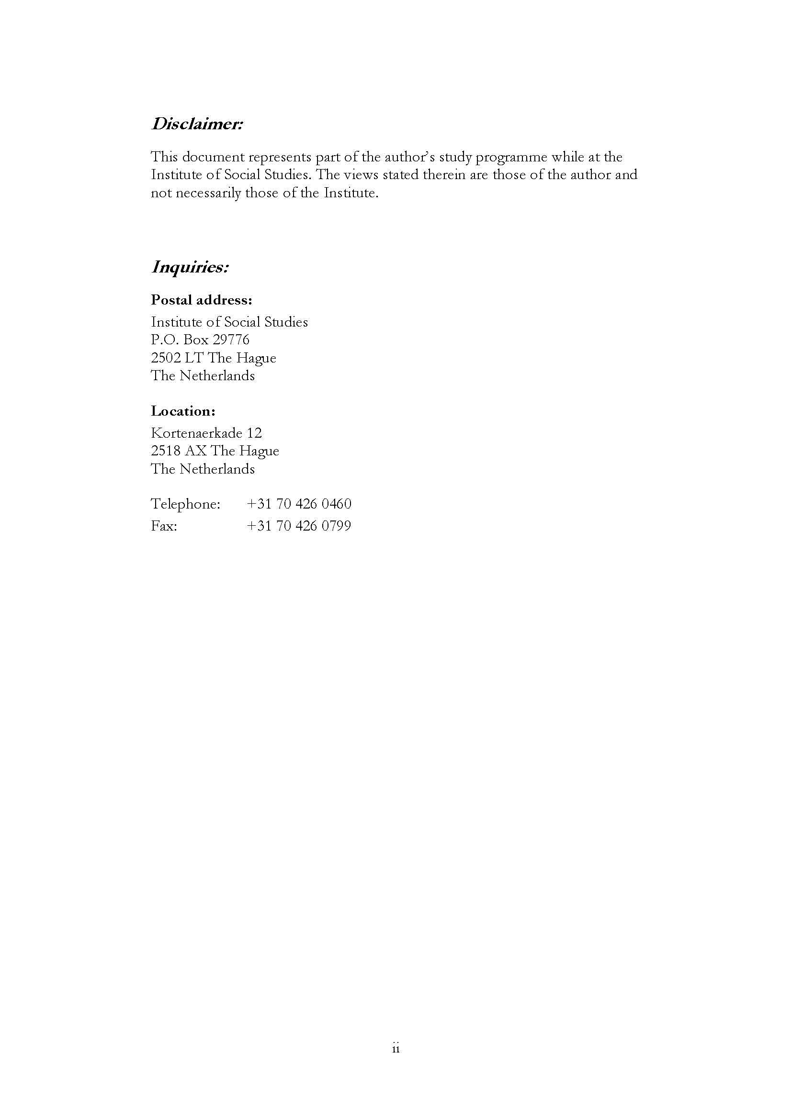
Contents
Puzzling Independency in Child Migration: A Child Rights Approach to Internal Migration in Ghana
Chapter 1 Today’s migrants: trends and figures 7
1.1 The world’s migrants: who are they and where do they go? 8
1.2 The need to merge parents and children in one migration approach 10
1.3 Ghanaian children moving south 12
Chapter 2 The same child appraised in two different approaches 14
2.1 Children being force to migrate 15
2.2 How independent can child migration be? 17
Chapter 3 ‘My daughter is in danger of moving south’ Parents’ concern for their child’s possible migration 20
3. 1 Go north!… Where people move south… 22
3. 2 ‘All about the suffering’: Economic constraints and their role in child migration. 24
Chapter 4 Contribution of a rights based approach to analyzing child migration 27
4.1 Child rights based approaches: a comprehensive child focus implementation 30
4.2 Ghana’s observance of children’s rights 32
Chapter 5 The inconsistencies of independency in children’s movement 36
References 38
Appendices 43
Appendices 1 44
Example of methodologies applied in community 44
Appendix 2 1
Name and position of people interviewed 1
Appendix 3 2
Places visits during field work 2

List of Tables
Table 3.1 Housing stock, persons per house, household and average household size, 1970-2000 24
Table 4.1 Comparison from needs-based to a human rights based approach 29

List of Figures
Figure 1.1 Status of family and children in migration process 10
Figure 1.2 Percent of migrants under 20 years of age by developing and developed countries 11
Figure 4.1 The Scope of Human Rights 28
Figure 4.1 Proximal to distal context for development according to the CRC 31

List of Maps
Map 1.1 Percent of migrants under 20 years of age 9
Map 3.1 Map of Ghana with indication of places visit during field work 22
List of Appendices
Appendices 1 Example of methodologies applied in community 44
Appendix 2 Name and position of people interviewed 48
Appendix 3 Places visits during field work 49

List of Acronyms
CRBA Child Rights Base Approach
CRC Convention on the Rights of the Child
DOVVSU Domestic Violence and Victims Support Unit
FGD Focus Group Discussion
ICM Independent Child Migration
UDHR Universal Declaration of Human Rights
ICCPR International Covenant on Civil and Political Rights
ICESCR International Covenant on Economic, Social and Cultural Rights
IOM International Organization for Development
ISS Institute of Social Studies
MoWAC Ministry of Women and Children's Affairs
NGO Non Governmental Organization
OHCHR Office of the High Commissioner for Human Right
RBA Right Base Approach
UN United Nations
UNDP United Nations Development Programme
UNFP United Nations Population Fund
UNICEF United Nations Children's Fund
UNODC United Nations Office on Drugs and Crime

Abstract
In this paper I position the current two approaches that try to explain the increase of underage migration in the world. I expose their arguments and some challenges found to each perspective. As a contra argument to the independency notion I propose an intersectional and integral perspective given by the child right base approach as the accurate way in understanding child migration.

Relevance to Development Studies
The nexus of migration and development more than drifting apart are becoming more influence by each other in many different ways. The current increasing participation of underage groups of people in migration needs to be formally address by the state according to his responsibilities to fulfil, protect and respect the international obligation assumes under the Convention of the Rights of the Child. According to this a rights base approach is need to analyze child migration and its implication to the child human development.
Keywords
Migration, Children, Youth, Child Rights Base Approach, Force Migration, Human Rights, Children Rights

Today’s migrants: trends and figures
“Everybody is leaving. It’s the talk of the town.”
(Beauchemin 1999:29)

Reviewing migration literature to choose the topic of this research, I found information connecting migration and children in two different ways. The first one had to do with children being forced to leave their families and communities by other adults, mainly in violent ways. The second presents migration as a choice taken by children where adults’ roles are passive, compared to the first option. The latter nexus of children and migration was the one that inspired this research paper.
After reading several reports and studies, I still thought there was a missing piece in both approaches. My position is that current explanations of child migration are self-centred in their own analysis, without realizing the contribution of the other. Moreover, they are not able to respond to the new realities faced by families, children and communities. For this reason, I propose reconsidering child’s migration using a rights based approach (RBA), which gives us a better starting point to connect the prevailing forced and independent discourses.
To do this, I will firstly present several facts and figures of current international migration and children’s involvement according to available statistics. Secondly, I will present the two leading debates that contest children’s involvement in migration and compare the similarities and differences between both approaches. In the third chapter, I introduce Zagyuri, a community in northern Ghana with a high propensity of child migration and where I carried out my field work. Here I interacted primarily with parents and caregivers concerning their children’s migration patterns and defining some push factors. The information given by community members made me consider how the integrality of the RBA can be more helpful in supporting children’s realities and not only unfolding the act of migration.
In the new migration scenario, the child becomes an important actor. In this new condition, human rights instruments that protect the child must prevail in consideration of wellbeing and development. For this reason, I propose to focus the RBA on the child. This concept, promoted by international cooperation agencies and developmental organizations, seeks to view children’s issues in the overall spectrum of their human rights as contained in the Convention of the Rights of the Child (1989). The use of this approach as an analytical tool for child migration in the case study of Zagyuri is developed in Chapter IV of this paper.
Foremost, the following information compiled by the Population Division of the United Nations (UN) and other international agencies provide some information about the current trends of migrant populations in the world, and specifically some indicators and characteristics of underage migration.

The world’s migrants: who are they and where do they go?

The world’s people are moving. This is not a recent issue in human behavior, as migration is considered a cause and effect of population’s history and culture. The most frequently used definition of migration is the one given by the International Organization for Migration (IOM), as being the movement of people within and across national borders (IOM 2004). Nevertheless, other authors go further in explaining how factors such as distance and spent time in the host location are also essential in the definition on who is or is not a migrant, especially within international migration where across countries, expectations tremendously differ (Castles 2000, Bell et al. 2002, Adepoju 2002).
What cannot be denied is that the numbers of migrants in the world are quickly increasing. Data from the United Nations estimated a total of 214 million international migrants in 2010. This number represents an increase of 19 million people from figures in 2005 (UN 2010). This could explain why migration has been taking over international policy debates and developmental agendas for the past years.
Some factors, identified as push elements of migration, have to do with social economical disparities between regions or countries, forced displacement, or conflict or environmental hazards, amongst others. However, national policies tend to focus more on repressive responses to migration rather than responding to the previously mentioned factors. In doing so, national authorities do not only fail to understand the real issues but also become promoters of discriminatory actions toward migrants (PICUM 2009). This could explain why the measures taken by government officials to stop and prevent people’s flows have proven to be unsuccessful.
Furthermore, migration patterns are also changing. The popular conception of south–to– north or developing–to–developed migration is becoming inaccurate as the numbers show a vast increase of migration within developing countries (Nyberg–Sørensen et al. 2002, UN 2012). Also, the actors engaged are changing; vulnerable groups such as women and children are involved in migration even more than before, and mostly related to the search for new employment opportunities.
To give statistical information about this shift, information provided by international agencies indicate that currently women represent almost half of all international migrants of the world (IOM 2012). Also equally increasing are people under the age of 20, which has reached a total of 33 million, accounting for 16 percent of international migrants in 2010 as we can see in the following Map 1.1 (UNICEF 2010, UNICEF 2012). This new trend shifts the past perception of women and children as followers, into active participants of the process which in the case of women, has resulted in the concept of the ‘feminization’ of migration (Castles 2000).

Map 1.1 Percent of migrants under 20 years of age

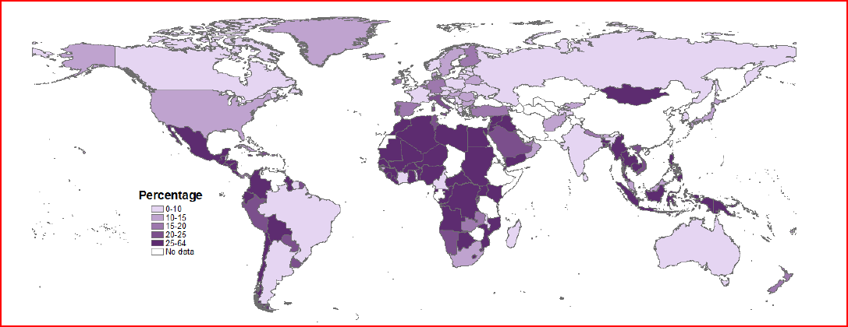
Source: (UNICEF 2010:3)

In 1993, Massey with other authors, compiled a review of four theoretical frameworks often referred to in order to comprehend the origin and nature of people’s mobility patterns. The neoclassical and the new economics explain migration at a microeconomic level, linking the increase of wages and family income as the main reasons for migration (Massey et al. 1993). On the other hand, at a macroeconomic approach, the dual market and world system theories define capitalism and other formal socio-economic relationships between countries as the underlying facilitator of immigration (Massey et al. 1993, Castles 2000).
Even with the important contributions these theories make in conceptualizing migration; all of them seem to provide unidirectional and unconvincing approaches. From the point of view of Massey et al. (1993), these hypotheses are conceived according to disciplinary boundaries, providing different concept and assumptions that differ from each other and that fall short to understand the contemporary complexities of migration. According to this author, an intersectional approach that considers persons, household and the socio-economic system as a whole could be more efficient to explain migration.
Other elements that present a challenge to the existing definition and explanatory theories around migration has to do with people’s international and internal circulation. Even if both originate from the same elements such as socio-economic factors, political instability or natural/human-made disasters, the approach in which they are understood and acted upon are different.
In international migration, the person moves in a different political unit. This imposes a ‘distinctive social process in which the container of the state has fundamentally different functions from a region or census’ (King and Skeldon 2010). For this reason, there is a distinctive classification within international migrants, that varies from irregular, refugees, and asylum seekers, among others. All these categories provide different protections, according to international human right standards. (Refer to Sphere Handbook: Humanitarian Charter and Minimum Standards in Humanitarian Response).
These complexities around the international scope can make us drift apart from the core element I want to focus on in this research, which is the different approaches to children, migration and its independency. For this reason, even if some references to cross-border migration will be done, I will try to leave behind, as much as permitted by the literature reviewed, the international debate in order to center my contribution on the internal migration of children.
The next section will explore how the three realms of children, migration, and parents or caregivers are associated within the literature and which can be f some implication according to the child rights perspective.

The need to merge parents and children in one migration approach
In reviewing secondary data on migrant children, there is a tendency to analyze the migrant child as a cluster separate from their family structures. However, parents and children are correlated in many ways when it comes to the migration process. In this section, I will present the different relations of children and parents during migration and some identified obstacles when connecting both domains.
In this aspect there are three most common ways in which families (mother, father and siblings) are linked in migration. The first one is when parents take the decision to relocate all family members to another locality. The second situation occurs when one or both parents move to other location, leaving their children behind. In this circumstance, children are usually taken care by the non-migrant parent or a family relative. The third scenario, where children take the decision, individually from their parent’s advice, to migrate alone in the search for a better quality of life though education and work. In the next diagram Hirschman (2008) makes a graphic explanation in these three forms of migration to aid the comparison.

Figure 1.1 Status of family and children in migration process
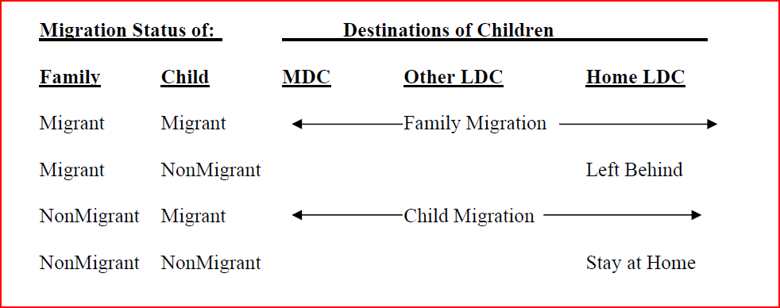

N

Note: More Develop Countries (MDC) and Less Develop Countries (LCD)
Source: (Hirschman 2008: 3)

What is implicit in these three forms of migration is that families as a whole make decisions that affect them as a group. This is considered by authors as inter-generational theory (Kabeer 2000, Whitehead et al 2007). According to this approach, the migration arrangement between children and their parents differ according to the household context and dynamics. In this sense, families have implicit contracts in which they negotiate some of the group’s decisions. On this matter, Kabeer explains that the ‘essence of the inter-generational contract is that parents look after their children when they are young and expect to be looked after by them in their old age’ (Kabeer 2000: 465).
Although this theory helps us to rethink migration as not independent from the familial context, it still does not present specific data on how negotiations take place within the family. One reason for this could be that the existing monitoring mechanisms view migrant people as a separate domain from the household. Another reason could be the defensiveness of migrants to bring up information about their families, based on fear of deportation or other consequences. Studies done by social workers in United Kingdom explain that ‘there is no indication when examining the existent literature that a great deal in known about the pre-departure stories of the asylum seekers and refugee children and young people now living in the UK’. (Kohli 2006:708)
Not only are stories hard things to obtain, but accurate statistics on how many children, parents and families are involved in migration is also hard to allocate or measure. Some limitations on the data recollection have to do with the lack of uniformity in surveys, unrecorded people, high levels of mobility of the population sample, differentiation of concepts, and time frames of inquiring information (DRC Migration 2008). Other authors have also identified that the focus on the mobility aspect from origin to host area have limited the awareness in other elements of migration such as transition possibilities, distance traveled, special inequality, and migration effects (Bell et al. 2002).
Improvements on global statistical information done by the United Nations provides an overall calculation of migrant people and some interesting patterns that show the relevance of under eighteen migration. To illustrate, it is 7% most likely that a person under the age of 20 migrates migrate to a developing country than a developed one (UNICEF 2010). Furthermore, children between the ages of 0 to 14 represents 72 percent of migrants under 20 years in developing countries and 62 percent in developed ones (UNICEF 2010). With this, we can conclude that child migrants tend more to move south-south rather than south-north.

Figure 1.2 Percent of migrants under 20 years of age by developing and developed countries
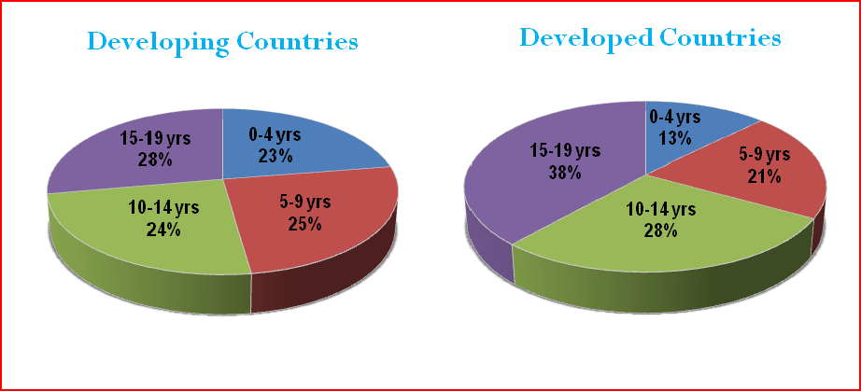
Note: Developing Countries: Africa, Asia (excluding Japan), Latin America and
the Caribbean, Melanesia, Micronesia and Polynesia
Developed Countries: Europe, Northern America, Australia/New Zealand, and Japan
It is also important to consider that cross country migration is not the only pattern of migration that is steadily increasing. Internal flows of people, or the so-called urbanization shift, has become a twentieth century issue of development and human security (UN 2006). Some studies carried out in Asia and Africa give us an overall picture of the scale of urban-rural migration in several countries, which surmount the world’s total international migration. The best example is given by India, where official estimates in 2001 indicated a total of 209 million internal migrants, and China who in 2000 had about 130 to 140 million internal migrants (DRC Migration 2008, Koser 2009).
In the case of Africa, Ghana becomes a great resource of literature relating migration movement from the northern to the southern areas. This internal flow has usually been linked to underage people seeking job or education in the Great Accra Region as we illustrate below.

Ghanaian children moving south

In Africa, Ghana has been one of the countries frequently researched on its internal migration patterns. This English speaking country in the West African region encloses high level of urban-rural migration with a high propensity of underage migration. These conditions worked favorably to the aim of this research as they gave me the opportunity to be in the origin and host area in the same field work period, and evaluate the adult perception of child migration within the same context.
Like in other African countries, migration in Ghana happens mostly off the record. Regardless of this, earlier investigations have proven the importance of migration as a livelihood strategy of Ghanaian families to improve their living standards. According to Keith Harts’ late sixties field work in Accra, he determined that 24 percent of the labor force in the capital originated from intra-regional migration (Hart 1973).
From the late seventies and approximately three more decades later, Ghana underwent economic decline and political instability that compelled high rates of emigration of Ghanaians to periphery countries and other European countries (Anarfi et al. 2003). This has been reversed by the present economic stability and good governance which has promoted industrialization and the increase of urbanized areas in the coastal regions of the country. This has encouraged internal migration from the rural areas to the capital and Kumasi (Awumbila et al. 2008).
High mobility rates are not exclusive to young adult or older people. Children as young as 10 years have been, to a great extent, studied on the why, how and where of their movement. One of these studies was carried out in 2005 with children who were living in Accra, separated from their parents. The investigation proved that 97 percent of the researched children originated from internal migration and just 1 percent arrived from other countries (Yaqub 2009).
This research can be compiled with many others that will be of further reference in this paper. All of them provide figures and case studies on the numbers, conditions and reasons why children decided to move. The two main explanations that have come across stronger than others are the forced and independent approaches. The first approach is mostly defended by human rights organizations that consider child migration that occurs separately from their parents as a violation of rights. This is closely related to the CRC (1989) conception of the family as the ‘natural environment for the growth and well being’ (CRC Preamble) of children. In many occasions this migration is considered to be forced towards children as acts of smuggling, trafficking and exploitation of labor (Save the Children 2008, Flamm 2010).
The second approach is mostly endorsed by social researchers and academics who recognize the child’s capacity to decide and take action of their life’s opportunities. Case studies following this notion demonstrate that underage people migrate from the northern rural and less developed region of Ghana to the southern districts, en route to locations such as Kumasi, Accra or other coast cities seeking economic and educational opportunities (Mitchell 2011, Hashim and Thorsen 2011, Whitehead and Hashim 2005).
One silent actor in both approaches has been the caregivers of children and their assumptions and understandings of migration. Even if much of the above research had featured some elements regarding parents’ involvement, the analysis is slight considering the issue at stake. Questions addressing the decision process and the intergenerational factors seen previously on family’s migration can be helpful elements to this debate.
Are parents part of the decision process or are they just passive observers of external factors (whether violent or not) affecting their children. Simon Turner makes this same inquiry after reviewing the book Child Migration in Africa (Hashim and Thorsen 2011), explaining that even though it is important to hear the voices of children; we should also hear the voices of the adults related to them. He follows his argument by pointing out that adult inquiring makes ‘sense in understanding the moral terrain within which these children must maneuver’ (Turner 2011:667).
Having identified this gap, I decided to carry out a six week field research in Ghana from July to September 2012. During this time, I focused my work on inquiring the caregiver’s opinions and understanding of children’s migration, using questionnaires and focus group discussion techniques. I also carried out interviews with key informants of the government and nongovernmental sector which had direct actions in the selected community. The description of results given by parents and caregivers are described in Chapter III, where I elaborate on a description of the Zagyuri community.
Spending some time in the community with the mothers, fathers and other adults helped me understand the complexity surrounding child migration. According to my findings they are many factors that contribute to a child’s movement south, which neither make children entirely independent agents of their own opportunities nor passive victims of the extreme conditions of poverty they live in. For this reason, the broader analytical elements given by the CRBA in Chapter IV will help identify all the different factors that are making families, and not just children, bet on migration as a solution to the current limitations they face.
Considering the independent and the forced approaches, Mathew Mitchell explains that even though Ghana is recognized for migration issues related to trafficking and violence, a vast majority of children’s migration is done ‘voluntarily’ and often independently of their birth parents (Mitchell 2011: 4). In the following chapter, I will describe both positions with the objective of analyzing where they distance from each other, and in which aspect they converge in explaining children’s migration.

Chapter 2 The same child appraised in two different approaches
This is the perception I get after revising the literature of child migration in Ghana. Even though there is no certainty if a same child has participated in two different researcher studies; the context and characteristics of the sample groups are highly similar in all cases. The common characteristics identified in all are: underage people, separated from both parents, living on the streets, working as sellers in the markets or the streets (kayaye), originating from the northern regions. Besides this, all studies were carried out in the same places: Accra, Kumasi, Tamale and the northern regions.
The similarity of characteristics and location makes me reflect on how many times these children have participated in research about their migration status. Regardless of the answer, what is true is that the interpretation of the children’s current situation is different, according to the author’s background and analysis. In view of this, I realized the writer’s knowledge and area of work – whether children, migration, development and human rights – define how they interpret the information received and the words used to describe child migration. In nearly every circumstance, the applied terminology is according to the author’s appraisal of circumstances surrounding the child, his families and their context (Whitehead and Hashim 2005, OHCHR 2012).
To illustrate the above are two different reports on migrant children issued in 2005. One of the perspectives presented by Hashim’s work is that “children were frequently positive about their migratory experiences as this afforded them the opportunity to develop important relationships or skills, and/or to earn an income over which they had a relative degree of autonomy” (Hashim 2005: 3). In contrast, Araba argues that “prior to a child’s employment or fosterage, some sort of agreement was generally reached between the employer and the parents, or among family members in the case of fosterage. However, in few cases were the children involved in or aware of the terms of this arrangement. Many did not know how long they were expected to remain in the house where they were working or what remuneration they were receiving” (Araba 2005: vii). These examples help identify how different an author’s perception can be from another, in issues such as child work or remuneration benefits.
Another recognized aspect is the use of concepts to define features of the migration arrangement. More often than not, the author’s use of a words is often constructed upon empirical evidence and direct research done with children in the host area. Other analyses also can be found based on secondary data and official statistics. For instance, much work in Africa has studied child migration in terms of fostering practices of families (Bredsoe 1990, Serra 2009) or as social kinship relationships (Notermans 2004). Another economic study employed the term ‘hospitality to relatives’ to define how children live with relatives or in kinship conditions (Rapoport 2004).
Some NGOs and researchers use the phrase ‘children on the move’ to combine the variety of migration possibilities (Save the Children 2009, Reale 2008, Yaqub 2009), which compares to the ‘child circulation’ concept (ti 2007, Burton 2002) and also incorporates the recent notion of the ‘independent migration of children’ (Hashim and Thorsen 2012). Also within the international humanitarian lexicon, children who are separated (temporarily or permanently) from their parents are usually referred to as ‘unaccompanied’ or ‘separated’ children (ICRC 2004, Whitehead and Hashim 2005).
The Human Rights Council also employs the terminology ‘children on the move’ to mean “…children taking an active part in the migration process, particularly at the passage and arrival stages in countries of transit and destination. They may be found, inter alia, migrating with their family members or independently, to seek opportunities at both the educational and employment levels. They may also be found entering host countries to rejoin migrant members of the family, being relocated or sent by families to stay with relatives or friends in third countries or…sent by family members to find work abroad and send part of their earnings home…” (UN 2009: 14).
The above definition is broadened by pointing out that “children may also be forcibly on the move, such as when falling prey to transnational organized crime and exploitation networks. The Special Rapporteur has received reports about growing numbers of trafficked children which in some instances is a consequence of oppressive or abusive home conditions, poverty or the absence of economic opportunities in the home region” (UN 2009: 14). The present definition brings together many of the component of a child rights based approach (CRBA) by incorporating all the range of possibilities that families have in migration.
At the end, regardless of the terminology used, the essential element to define is if migration is being forced on children or independently decided by them. The literature reviewed shows a number of similarities and distinctions in these opposing positions. For this reason, I propose the holistic view of the CRBA as a comprehensive framework that could give answers to this question. Nonetheless, before analyzing the CRBA, it is essential to have a clear understanding of the thought behind the forced and independent approaches. Therefore, I will describe some of the arguments found in the studies analyzed.

2.1 Children being force to migrate
‘It has never been my desire to get married at an early age. The young men in Sawale village took advantage of this practice of abduction and forced me into marriage. I was kidnapped by some young men he allegedly hired while I was carrying firewood home. When I was sent to Sawale village they provide me with food and water and sent a word to my parents about my whereabouts but they (my parents) did not make any follow up. I stayed there and became more confused…’
(Dery 2012: 5)

This girl’s story is one of many examples recorded of how adult impose their requests upon children, forcing them to leave their community and family behind. Girl children and women in Ghana have a higher incidence of being victims of violence. According to the Domestic Violence and Victim Support Unit (DOVVSU) in 2010, from the cases of child abuses reported, 85 percent of them corresponded to gender violence such as defilement, rape, abduction, and forced marriage (MoWAC and UNICEF 2011: 92). Considering the limited access of citizens to the national jurisdictional system this numbers can be considered moderate compared to the community’s reality.

As previously shown, forced migration usually implies a challenge to the human rights of children and their families. It stresses upon the child’s vulnerability and how can they become marginalized and discriminated in the host areas and during the difficulties and dangerous means of transportation. Along these lines, Yaqub explains that ‘age-specific limits on obtaining various documents in migration (e.g. residence permits, health permits, labor permits) and children’s information, understandings, and abilities regarding these processes might be limited’ (Yaqub 2009: 48). This situation increases the child’s chances of becoming defenseless, discriminated and abused by other older children, or adults taking advantage of their power situation.
A majority of the studies reviewed consider child migration as a result of economic downturn and social breakdown of systems which affect family structures. The lack of effective social protection systems, neglect of the provision of children’s basic needs, poverty, unemployment, as well as other socio-economic constraints turn into stimulators of irregular migration and trafficking. In these circumstances, children and families turn to mobility as the only way out solution for survival or fulfillment of the basic needs of the child. This also is exposed by Sarah Flamm (2010) in her paper on migration and child labor, where she argues that even if the money received by the child is not enough to send a remittance home, the parents are still persuaded to send their children away to decrease their household expenses.
Adult, young people, and especially children obliged to migrate, can easily be prey to traffickers and organized groups that trick them with false promises of better life and put the migrant’s life in risk on hazardous journeys (Adepoju 2002). A research done in East Africa with trafficking victims revealed that a majority of the consulted people were lured by promises of economic opportunities, education, food and shelter. Even if a majority of them got the type of jobs promised, the condition were not as expected. Those not placed in the agreed job ‘ended up [in] domestic work, prostitution, street work, and informal/illegal work’ (IOM 2008: 2).
The gender dimension of forced migration becomes very clear in human trafficking. According to the UNODC (2012) about 80 percent of the total cases of people being trafficked are related to sexual exploitation or forced labor. Women, adults and girl children, have increased their participation not only as victims but also as recruiters. The data established that women are in large proportions becoming traffickers to a point that in some countries it is more the norm than the exception.
The most notorious endorsers of the forced migration approach are law reinforcement institutions, nongovernmental organizations and human rights groups. They base their position on the legal recognition of the family unit as the main entity in society. This is consistent with Article 16.3 of the Human Rights Declaration which states that the family is the ‘natural and fundamental group unit of society’ which has the ‘primary responsibility for the upbringing and development of the child’ (Art 18.1 of the CRC). The child has the right to stay with his immediate family group in a favourable environment that can promote his development.
The state also has a crucial role to play in the child’s wellbeing. The government has the responsibility to provide for the child in the situation that the family is unable to do so. This responsibility is established in Article 20 of the CRC which reads as follows: “A child temporarily or permanently deprived of his or her family environment, or in whose own best interests cannot be allowed to remain in that environment, shall be entitled to special protection and assistance provided by the State.” By all means, state policies and programs should provide all the possibilities to families and children for their survival and development (Art 6 CRC).
Even if children’s abilities and aptitudes are acknowledged according to age and maturity (Art 12 CRC), their economic independence in the form of child labour is not agreed to be one of them. Supporters of this position consider that children’s innocence, inexperience and underage situation exposes them to violence or harmful practices. The increase enrolment in ‘3-D jobs’ (dirty, dangerous and degrading), endures discrimination and exploitation which work against the child’s wellbeing and development (United Nations 2012, Flamm 2010).

Some of the disadvantages I find in this position are the excessive emphasis on children’s vulnerabilities, without acknowledging the proactive roles they can and do play in present societies where social and economical constraints are faced daily. As Manfred Liebel points out, ‘the fact that children’s work is seen as a sort of sacrilege to the promise of the Western childhood paradigm which –under the ideologically-laden label ‘child labor’– is banned by most governments with a prohibition of these essential and economically beneficial activities’ (Leibel 2012: 203).

Furthermore, field data is increasingly providing more evidence about children’s intentions to migrate and making their own arrangements in host areas. This is substituting the violent approach – which has been promoted so far – for the independent notion that I will develop in the next section.

2.2 How independent can child migration be?

‘My friend explained that she would meet me at the border together with the employer. However, I was still worried because I had heard stories about how dangerous migration could be. I heard that people were promised nice jobs and easy work, but that they had ended up working in a karaoke bar in Thailand’.
Kongkeo, age 13, Laos
(Huijsmans 2012: 39)

This is the story of Kongkeo, a Lao girl-child, who at the age 13 quit school to start a job in the borders of Thailand. At the moment of her testimony, she was 15 years old and had already experienced two years working in various services while going to and from her origin province. The jobs she has come across have been with the help of a friend with whom she keeps in touch by telephone.
Kongkeo’s anecdote is not an exception of the encounters of today’s children with migration. Recent literature on children’s circulation practices support the notion that people under the age of 18 migrate separately from their parents or immediate caregivers in the search for better educational and training opportunities. On this matter, Hashim and Thorsen (2011) in their latest book Child Migration in Africa, claim that the child’s impulse to migrate is not an action forced or misled by a third person; however, it is voluntary and independent from their parents. According to Ensor and Gozdziak (2010) child migration (internationally and within borders) could be motivated by the child’s conceived idea of a better life elsewhere.
According to the independent approach, all the authors reviewed came to the same conclusions: children who migrate separated from their caregivers in a personal search for better opportunities of life, which are usually linked to economic circumstances. Many studies demonstrate that children view migration as an opportunity that allows them to exercise their own life choices, improve economic opportunities and sometimes earn funds for their future education. A research carried out with almost 450 migrant children in Accra and Kumasi showed that underage people define as the main reason for their movement ‘independence and money’ with 53 percent of the responses, and ‘learning a trade’ (which can be also seen as a economic reason) with 27 percent of responses (Kwankye et al. 2009:20). This makes economic reasons more than 80 percent of the responses as to why children migrate.
The independent view is linked to Amartya Sen’s concept of agency which is defined as “what a person is free to do and achieve in pursuit of whatever goals or values he or she regards as important” (Sen 1985:51 cited in Skordis-Worral 2010:2). Other definitions following Sen’s theory explain agency as ‘the actor’s capacity to reinterpret and mobilize an array of resources in terms of cultural schemas other than those that initially constituted the array’ (Sewell 1992:19). In short, under the independent approach, children’s capacities play an important role in setting what they want to do and strategizing on how to achieve it – migration being one of the ways.
Some studies carried out in Africa and Asia have demonstrated children’s agency in defining possibilities that could enhance their future life chances (Huijsmans 2008, Ensor and Gozdziak 2010, Hashim and Thorsen 2011). As in Africa, Asia provides facts and figures of children and youth migrating from Laos to Thailand who are encouraged by the idea that they can access better jobs opportunities which will help them improve their standard of living (Huijsmans 2008). Like in Kongkeo’s story, these children do not let their parent’s advice or authority impede the journey.
Apart from children’s independent decision making process, low household income and lack of social security networks emerge once again as other motivations for migration. Poverty, social exclusion and unemployment are found to be characteristic of migrant children’s households. However, in the independent child migration (ICM) approach, these factors are merely part of the context and do not define the child’s ability to choose the migration path. According to this, the child evaluates the opportunities of enhancing his wellbeing in the host area and works through his social networks (usually formed by other children and young people) to obtain information and help in the migration process (Hashim and Thorsen 2011).
Just as in forced migration, women and girl children have a higher tendency to migrate independently. As an example, in Kwankye’s (2009) study of rural to urban migration, the number of respondents by gender were 65 percent girls and 35 percent boys. Girls aged less than 10 and up to 14 years were participating considerably more than boys in migration. This gender difference was also confirmed by the local organizations during field work and by my observation of places like Tama Station where head potters were scattered in all corners selling goods.
I consider a shortcoming of this approach the partial analysis given to the context and interaction between family members as push factors of migration. Socioeconomic complexities in which children are brought up can define much of their decisions and perceptions toward life. For this reason, it needs to be considered that children’s choice is influenced by their family’s perception of the future, which compels us to reconsider the degree of the child’s independence. What is more, it has been found that a number of females in Ghana that migrate from the north ‘have followed their siblings to the city, which also indicates, to some extent, the involvement of family members in the decision to migrate’ (Kwankye 2009:19).
Moreover, little has been exposed of the bad and dangerous condition in which children live in the host area. Some of the living limitations for migrant children in the host area are poor housing conditions, and in many cases they live on the streets. In addition, poor access to healthcare services, inadequate sanitation facilities, mistreatment and harassment by other older children and adults (Baah-Ennumh et al. 2012) are also other limitations.

To conclude, I am aware of how the forced and ICM approaches confront each other and I am aware of the ways the reader recognizes the different interactions of families and children. However, I think this is just an outcome of deep socioeconomic constraints that are broadening the inequality gap and which are affecting all of society’s interactions. Leaving the argument to a debate between law inefficiency and neglect of supporting children’s opinions seems to be a limited way of analyzing such a complex situation. Along this lines, John Artur (1991) claims that to fully grasp the motivating factors that increase child migration, the study group should go further than the outlook of the child or the legal instruments, but instead center the analysis in the household as a unit.
Both approaches do convey that migration is context-specific and happens in social contexts comprised of families and children before migration takes place. Where they drift apart is in their approaches towards the child’s abilities, linked to the different debates involving children, youth and their capacities in society (Hashim and Thorsen 2011). However, how certain can we be that a child with adequate provision of services and with future job opportunities in origin areas would be willing to migrate?
In Chapter III, I present my field work in the northern region of Ghana where I visited a community with high levels of child migration and spoke to parents and caregivers about their children’s migration. According to my findings, migration is a very complex issue in which children do play an active role but also are compelled by their contextual possibilities.

‘My daughter is in danger of moving south’ Parents’ concern for their child’s possible migration
A mother asked the interpreter to write this in her questionnaire. According to the mother, her daughter had recently dropped out of school, which put the girl in a vulnerable situation of moving south. ‘She wanted you to know…’ the interpreted said to me, as if I had any power to hold back the child from moving.
I selected Ghana as the location for my field work for two main reasons. The first had to do with the previous investigations done on themes linked to this research such as forced migration, ICM, child work, kayaye, and children living on the streets. All the previous reports and studies provide enough secondary data about Ghanaian migration patterns, which became the point of departure for this research. For example, there is vast documentation produced by the researchers Whitehead and Hashim, and organizations such as UNICEF, which are used throughout this research paper.
The second reason had to do with the country’s child migration patterns, mainly from the northern to the southern regions. This gave me the possibility to do interviews in the origin and host areas. Also, as stated before, I considered that doing this same study in an international context could result in a diversion of the analysis to issues such as the state’s responsibility or international humanitarian law instead of the root causes of migration.
My field work aimed to determine if parents and caregivers’ perceptions and contexts had any influence in independent child migration. To obtain this information I used two research tools: questionnaires and focus group discussions (FGD). The surveys helped draw some general characteristics of the group in five areas: personal profile, education, income, extended family and familial migration patterns. Before applying the research tools within the community, a local researcher adjusted some words and phrases to the local context. For example, the term migration was change to the expression “moving south”, which is mostly used by Ghanaians.
For the FGD, discussions with groups of women and men were carried out separately. The aim behind this division was to identify differences of opinions according to gender roles in the family. The implementation of the FGD was supported by a young local person who helped organize the community and interpret the respondents’ answers. In support of future research, it is important to consider the high illiteracy level of the population. In my sample, 75 percent of the questionnaire sample had no formal schooling or technical training. The intentional use of short sentences, simple wording and speaking slowly made a positive difference in the interaction with the group. Also, the use of visual elements like pictures and symbols helped significantly in the development of the discussion.

Contrary to what I thought, having an assistant from the same community worked in favor of the data collection since parents felt more comfortable sharing their experience with a known person in the room. The respondents showed to be more at ease when talking to one of their own people than to the zulminga woman. Even in between translations, the fluency of the interaction in the FGD provided rich material to understand household dynamics, the expectation of parents and children’s responsibilities.
With regards to underage participation in this research, I intentionally decided not to interview children. This was considering that firstly, my white appearance called the wrong attention of children. Secondly, I could not speak any Ghanaian dialects to communicate more fluently without using a translator, and therefore losing some key messages of the children. Thirdly, due to time constraints I did not have the possibility to stay longer with them and get further acquainted with their circumstances.
For these reasons, the quotes used in this document were obtained by content analysis of secondary data as elaborated by governmental entities and grassroots organizations reports. Given that researchers and experts on migration issues have widely documented the context, opinions and perception of migrant children, there was no identified need to re-examine this group. This thereby minimizes the re-victimization of underage people in vulnerable circumstances (such as migration), which could work against their best interest.
The field research was done in six weeks, between July and September of this year. In that period, I visited three different locations in Ghana: Navrongo, Tamale, and Accra, as shown on Map 1.1. As this was my first time in Ghana, I spent the first two weeks familiarizing myself with the places, culture, and transportation, among other things. In the third and fourth week I was located in Tamale where I selected the community and applied the abovementioned research methodologies. The last two weeks were spent doing interviews with organizations working directly with migrant children in Accra.
The result of the field work was a total of 44 questionnaires effectively applied in communities, providing information on families’ characteristics and migration relationships. I conducted a total of 10 FGD, eight with women and two with men. The lower number of men’s FGD resulted from the indifference towards the activities, and men’s requests to be paid for their participation, which was ethically not an option.
Additionally, 14 institutions were visited and 20 informal interviews were made with local leaders, government workers and international aid staff (Refer to Appendix 2 for list of names and institutions). Moreover, I had the opportunity to have informal conversations with many people whom I met in different places and who very kindly shared their thoughts and concerns about child migration with me. The following findings are a recollection of all the rich material received from the community.

Map 3.1 Map of Ghana with indication of places

visit during field work

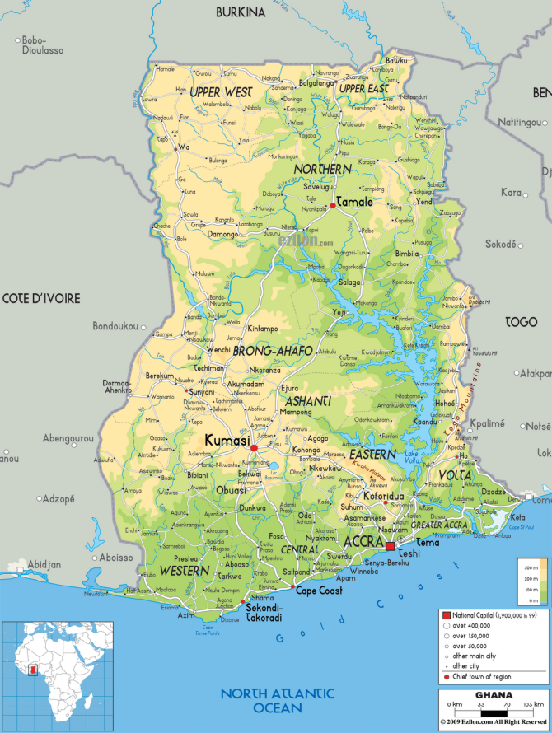
Source: http://www.geoatlas.com/en/maps/countries-4/ghana-1073

3. 1 Go north!… Where people move south…

This was the advice I received from the informal conversations with people during my first days in Accra. After this time it was clear that mobility played an important role in the social interaction of Ghanaian families. A majority of people were aware of children ‘moving south’ to explore better opportunities of life. In all conversations one element appeared to “go north, go north” – they meant the northern districts of the country – where most intra migration begins. And so I did.
Ten hours and 16 euros later I arrived in Navrongo, a city near the border of Burkina Faso, located in the upper east region of Ghana. A semi-urbanized area with main roads, hospital, schools and a university. Even thought it was almost the furthest north you could go, I was not able to find villages or communities with significant migration patterns except from one or two occasional bold travelers. After a week and some interviews with students and professors from the University of Developmental Studies, I was advised to travel back south to Tamale.
Tamale is approximately 600 km from Accra. A big hub town surrounded by numerous villages with approximately 538,000 habitants and which has developed into one of the most populous towns in northern Ghana (Ghana Statistical Service 2012). People in these areas are known to be descendants of the Dogomba ethnic group and practitioners of Islam along with some smaller groups of Christians. Its position in the centre of the northern region increases trade activities to other main cities in Ghana and surrounding countries. From the district’s 197 communities and villages, a majority of them are located in the rural areas and their main economic income comes from agricultural activities.
The rapid development of the urban areas of the district has not been lived in the same way by the rural populations. As stated by the local government, ‘rural communities still lack basic social and economic infrastructure such as good road network, school blocks, hospitals, market and recreational centers which hinder socio-economic development, poverty reduction and the general phenomena of rural urban migration of the area’ (Ministry of Local Government and Rural Development 2010:8).
These poor urban communities are the ones mostly associated with independent child migration. As official data on this matter by communities is rarely monitored, I depended mainly on the community’s recognition of the situation. I found that not all communities or villages in the north have a tendency of child migration, as it might have been concluded after reading available secondary data. There seems to be a higher correlation of child migration in communities closer to urbanized centers, which have accessibility to transportation, job information and networks.
Ultimately, Zagyuri was selected as the site for field work. A poor peri-urban located approximately 45 minutes north of Tamale city, with a total population of 4588 habitants divided into 40 percent men and 60 percent women (Ministry of Local Government and Rural Development 2011). To carry out the investigation, I had to previous obtain approval from the political authority of the community identified as the assemblyman. He also handled the selection of the interpreter and organized the community for their participation. It was further explained by my local assistant that the community would not respond to announcements done without the support of the assemblyman out of respect for his authority.
After a number of visits to the community, surveys, interviews and conversations with community members, mothers, fathers and other adults shared with me what they considered to be behind the high number of migrant children in Zagyuri. Their common answer was that it ‘is all about the suffering.’

3. 2 ‘All about the suffering’: Economic constraints and their role in child migration.

For adults in Zagyuri, the economic and social difficulties faced daily are considered to be ‘suffering’. For families living in the north of Ghana, these issues are the push factors for child migration. The research findings demonstrated that child migration is a very complex issue that is neither always imposed by adults, nor is shaped by children’s real choices. The limited social and economic possibilities of people who are living in the peripheral communities of Tamale compel the household unit to make decisions based on survival and better opportunities of children.
Here it is important to clarify the Ghanaians’ interpretation of houses, households and families. The house is the physical structure where people live. In the northern areas, the construction is usually ring-shaped, composed of a number of shacks used separately for cooking, sleeping, bathing and taking care of animals. The household is the direct family members: husband, wife, children and grandmother or other members. As you can see in Table 1, there are more households than houses, because in one house they are usually two or more households living together. The households living together usually have a blood relationship with each other. The most common example of this could be siblings living together, or a son who makes a new household within his parents’ house.

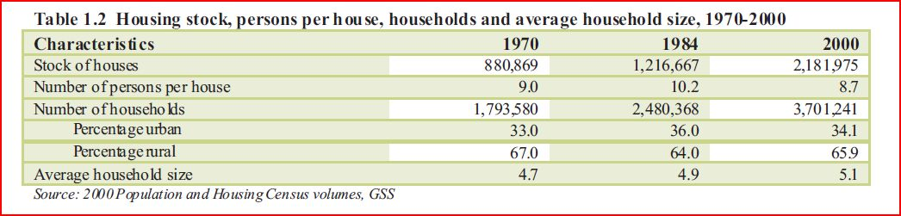
Table 3.1 Housing stock, persons per house, household and average household size, 1970-2000
Source: GLSS (2008)

What is more, Ghanaians’ conception of family needs to be seen through two different levels. The first spectrum has to do with blood-related family, which is at the same time divided into two: the members of the direct nuclear family and the extended family members such as uncles, aunts, cousins or other relatives who live in other regions. The second spectrum refers to the communal relationships. As explained in the field, all members of a community are brothers and sisters, and all older women are mothers of the younger generations. This information is important as some patterns of child migration referred to later in this document reflect this community notion of respect and support.
The portrayed characteristics found in the survey sample matches the information provided by official web sites. According to the results, 60 percent of the respondents were female (26) and 40 percent male (18). There were an almost equal number of Christians (20) and Muslims (24); however, official statistics of the northern region establish that more than 58 percent of households practice Islam (GLSS 2008:9). At the moment of the research, the majority of the people consulted lived with their spouses and generated their family income though farming activities. The number of birth children by household ranged from four to six. Half of the people at the moment of the survey had one or two children from extended family members living with them.
In the area of education, the high level of illiteracy in the community and the low value given to education was significant. Children’s disinterest on education can be a manifestation of their parents’ low levels of schooling. From the sample, 75 percent of the parents had no formal schooling or technical training at all. From the 25 percent who had some educational background, only four out of 11 had achieved senior high school level. This tendency is higher in woman than in men. From the 26 female respondents, only two had achieved junior level. As a whole, the sample showed that in Zagyuri, males have more possibilities of entering the educational system than females.
These educational difficulties are common to other communities in the northern regions. According to official data in 2009, 57 percent of school age children were attending primary school and less than 30 percent of young people were attending secondary education (MoWAC and UNICEF 2011). In an interview with the high school teacher of the community he explained that the limitations of infrastructure and materials is a huge drawback for student to attend classes (Y. Alhassan, personal communication, 9/2012). In the case of Zagyuri, the two primary schools needed major repairs. The only junior high school has three classrooms for 182 students, which is not the most effective environment to promote the learning process (D. Bansan, personal communication, 9/2012).
As for migration, 68 percent of the respondents had at present or in the past a migrant child in their household. The main reason identified by parents for this migration has to do with the poverty situation that families live in, followed by job and education opportunities (which had seven and three responses respectively). Considering the correlation between school assistance and migration from the 31 cases of migrant children in the family, 12 were studying and 17 were out of school prior to their travel. From the ones in school, 4 attended primary education and 8 were in junior high level.
Also from the respondents who had a current or past migrant child, a total of 17 (55percent] said they were aware of the migration intention of the child, compared to the 5 that said they were not aware. In the FGD and interviews, the support from parents was brought up as an important circumstance that can influence the child’s migration. In this, women play an important role in a decision-making process by providing economic resources for children’s travel to the south. In addition, there was a psychological pressure for the children to provide money or material things to support the family, or to get married.
According to tradition, a woman to be married needs to buy cooking utensils as her contribution to the new home (Bemah 2010, GNCRC 2005, Whitehead and Hashim 2005). This practice is seen as a requirement for the man’s family’s approval for marriage and is taken seriously in a society where social pressure and norms are very much followed. In communities where economic resources are scarce and the survival relies on the farming practices of men, boyfriends tend also to look sideways on the difficulties that women face when arriving south.
Another factor to consider is the African’s relationship to land, which transforms children into an investment strategy to secure a household’s farming future (Serra 2009). Male children in particular are usually considered responsible to work in the crops and increase the farming capacity of the family. However, because of economic difficulties, women seek alternative resources to support their families through the migration of older children to work and generate income to support their younger siblings (Araba 2005), or to just meet the basic needs of the migrant child.
Some authors consider this movement as a fostering practice within African societies. This deep-rooted traditional practice destined to reinforce family lineage and enhance the child’s opportunities is being altered. Children are also being placed in better-off families who can provide a better future for the child in exchange for some household chores. In these arrangements, ‘the guests (the children) are considered to be good by the head (house owner)’ (Rapoport 2004: 190).
The placement of a child into a relative’s household has been an important feature of the cultural and socialization process in West African families. For this reason, in the debate of children and migration, anthropological studies takes us back to this form of kin relation which have long existed and investigated as a traditional practice and not as forced forms of migration. Differentiated from adoption, fostering is limited in time and reversible by one or both households involved. Even if the hospitality period is extended for many years, the host family is never granted full parental right of the child involved (Serra 2009).
During the field work, I found great knowledge and acceptance of families to fostering practices. During the FGD, participants defined how families in the south were better off economically than them. According to them, they therefore had the responsibility to contribute to their relatives’ standards of living in the north. This contribution could be done by transferring economic recourses and goods to them, or by hosting one of their children (Araba 2005, Rapoport 2004).
Summing up, according to the data gathered during field work, it can be said that children’s movement to the south interconnects with various issues ranging from socioeconomic circumstances to traditional and cultural practices. More complex than independent or forced is a decision taken by the family in response to the complexities faced daily by households. The issues identified in Zagyuri reaffirm the need to have a broader scope brought by the child rights based approach which I will explain in the next chapter.

Contribution of a rights based approach to analyzing child migration
Human Rights would be fully realized if all human beings secured access to the objects of these rights…
(Pogge 2005:286)

Human Rights are a social contract established on the basis of freedom, justice and peace for all human beings. The Universal Declaration of Human Rights (UDHR) is considered to be a main legal international instrument of the human rights system and the first document that proclaimed the worth, dignity and equality of people. Composed of 30 articles which contain key aspirations, it lays out the meaning of social progress and the desired standards of living for men and women (UN General Assembly 1948).
Together with other human rights instruments, notably the International Covenant on Civil and Political Rights (ICCPR) and the International Covenant on Economic, Social and Cultural Rights (ICESCR) as well as other international human rights treaties, declarations and official documents, the UN System has expanded the notion and principles of human rights in all places. Since the proclamation of the UDHR in 1948, there has been a continuous ‘growth and proliferation in human rights norms, instruments, and declarations’ (Landman 2009:21), which can be understood as a general consensus to human rights principles. Today more than ever, people individually or in social movements proclaim the responsibilities of duty bearers (usually the State and at times other actors) in the fulfillment of human rights towards them.
Other authors are more critical about the role and action taken by the UN and other human right actors within societies. Matua (2001) for example argues that the human rights movement (consisting of governments, NGOs and human rights activists) collectively makes human rights a civilizing project of Western values towards less developed regions. According to this argument, the supposed promotion and universality of human rights principles has become in fact the widened stereotype of Western ideology analyzing abusive practices and traditions from the South.
Although the above debate is appealing, and in many elements reasonably accurate, the undeniable truth is that every day more and more people proclaim human rights principles and values as their main goal in the quest of a better quality of life. In this sense, the fulfillment of human rights converges with the human development agenda with the aim to create environments where people can fully develop their potential.
The linkage of these two conceptual frameworks is what we often refer to as the rights based approach (RBA). Some theorists such as Marks (2005) argue that sustainable human development must include human rights principles in order to be truly achieved. What this means is that the principles of non-discrimination, accountability, participation, empowerment, and others, as defined in normative international human rights standards, should be main elements that drive development work and agendas.

According to this approach, to address a complaint is in fact to repair a right that has been violated. Since states and non-state actors (with correlative obligations) are duty-bearers that work on building the capacities of those who claim and pursue human rights, the latter are called rights-holders. To achieve this, international human rights instruments have defined three different dimension of responsibility which duty bearers are compelled to act upon the existing categories of rights: civil and political and economic, social and cultural (Refer to Figure 4.1). These three dimensions of human rights are defined as follows.
- The respect of human rights which means that no action or omission will be taken by the State or its institutions which could violate the integrity and freedoms of individuals.
- To protect which refers to creating the mechanisms that can prevent human rights violations and that given a case of infringement the State’s institutions will guarantee access to all the required legal remedies.
- and to fulfil all human rights which means the enjoyment of rights at its fullest for all people. In this dimension the State is compelled to take all the necessary measurements to guarantee to all people all possible opportunities to realize human rights. This can be done by providing assistance, offering services or creating measurements that facilitate human rights. (UNFPA 2012, Landman 2009).

Figure 4.1 The Scope of Human Rights
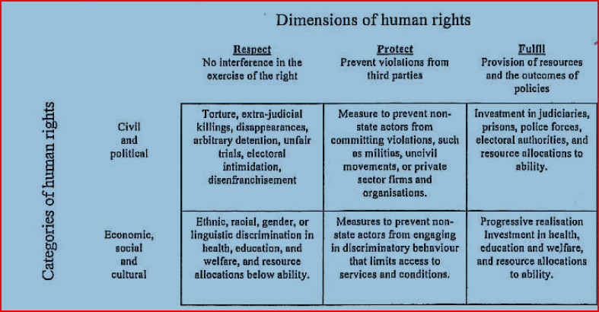
Source: (Landman 2009:23)

The overall result of the effective application of these three dimensions has become the essence and aim of the human rights based approach and a cross-cutting priority for the achievement of human development. As a result, governmental and non-governmental agencies have adapted their policies and programmatic strategies from a needs-based to a human rights based approach. In this model individuals and systems of power influence each other through a two-way accountability process in which communities are informed and participate on the decisions and governments develop capacity to the fulfilment of their commitments (UNFPA 2012). The following table helps identify the differences between both approaches.

Table 4.1 Comparison from needs-based to a human rights based approach

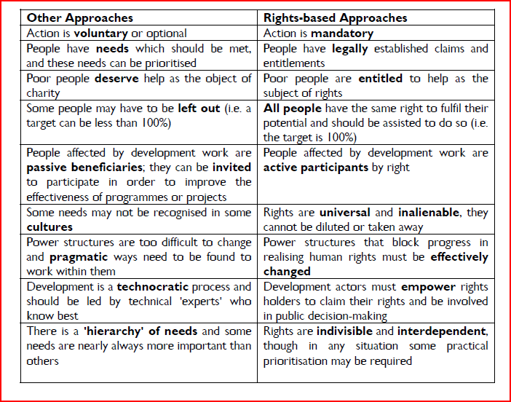
Source: (Save the Children 2006: 25)

Child rights based approaches: a comprehensive child focus implementation

The Convention on the Rights of the Child (CRC 1989) is one of the nine core international human rights treaties on which the human rights system is built. It is considered to be the most widely accepted international convention in the world. This is because of the number of states which are party to it but also because it has been the fastest process of ratification that the United Nations system has witnessed for an instrument of this nature.
Human rights organizations whose work mostly focus on children and youth issues have coined the framework of the child rights based approach (CRBA). Save the Children for example, pointed out that ‘the key components of (CRBA) all draw upon the general principle of the UN CRC, as other fundamental human rights principles’ (Save 2006:26).
Furthermore, the CRC has been recognized as one of the most comprehensive legal frameworks that relates all aspect of children’s lives in international law: civil, political, economic, social and cultural. A core element of the CRBA is the acknowledgement of children as rights holders. According to this approach, the state and the family have the responsibilities to protect and fulfil children’s rights and freedoms (Save 2006, Hodgkin and Newell 2002).
The reference to a child rights based angle to programming, policies and research means that a special emphasis on the set of rights and responsibilities as determined in the CRC need to be in place. In this way, the CRC becomes the theoretical support and common standard (UNICEF 2009) when taking a specific intervention in favour of a child’s wellbeing. To do this, there are four commonly accepted principles in which states and other stakeholders can orient their actions concerning children. This is considered the operational framework to a CRBA (As defined by K. Arts in class, 9 February 2012).
The first principle has to do with non-discrimination which is defined in CRC Article 2 as follows: “The state parties… shall respect and ensure the rights set forth in the Convention to each child within their jurisdiction without discrimination of any kind, irrespective of the child’s or his or her parent’s or legal guardian’s race, colour, sex, language, religion, political or other opinion, national, ethnic or social origin, property, disability, birth or other status.” Articulated differently, this means that all rights of all children, without exception, should be endorsed at all times.
The second principle refers to the best interests of the child. This means that all actions taken in public or private domains should always take as primary consideration what is best for the child (CRC 1989: Art 3). We should understand that family and public institutions are compelled to fulfil this responsibility in all their action and decision making process; mainly when this contests with the adults’ interest (Save 2006).
The views and thoughts of children are also considered essential for children’s base programming. Adults should encourage children, according to their age and capabilities, to form their own views with regards to the matters that affect them and support the expression of their thoughts in a responsible manner (CRC 1989: Article 12). This principle recognises children as ‘social actors both in relation to their own development and that of society’ (Save 2009: 19).
Finally, the element of survival and development which recognizes in every child the “inherent right to life’ (Article 6). Additionally, stakeholders should ensure that children can develop to their fullest at all levels and to the furthest extent. This means that all provision and efforts should be focused on making the child develop to its full potential (Save 2009).
The four principles above work in combination with the child’s capacities and his broader context. All these elements put together frame the holistic development of the child. According to the CRC and other international human rights instruments, the family and caregivers are the proximal context to the child and are the first ones responsible for creating a nourishing environment to the child’s development and survival.
However, in this creation of optimal environments and the role of parenting, families require assistance from governments. As Britto and Ulkuer (2012) argue that ‘in relationship to children, caregivers have the primary responsibility and, in turn the larger system of local community, services provider, national policymakers and international communities have responsibility toward caregivers [to provide assistance]” (Britto and Ulkuer 2012:93).

Figure 4.1 Proximal to distal context for development according to the CRC

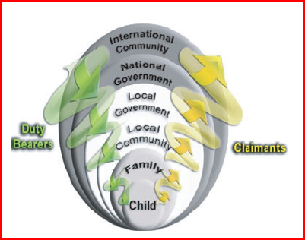
Source: Britto and Ulkuer 2012

As it can be observed in the above figure and according to the CRC, the implementation of the child rights based approach engenders obligations to the larger system surrounding the child, while the closest and most intimate setting is the family. At the same time, parents are influenced by community practices, culture and legal structures and similarly, the community is influenced by the state’s social, political, economic and legal structures. In a CRBA, each distal area has to be acknowledged as a level of influence to the fulfilment of the child’s rights.
In using CRBA to explain the causes of child migration, it is clear the many other actors apart from the child come into place. Foremost, it provides an integral approach on how migration needs to be understood and what is needed to support other possibilities for these children. In the next section I will present some socioeconomic elements identified in Zagyuri that, given the CRBA, can explain the high incidence of child migration in this community. Due to the limited time spent in community doing this research, I am aware that these are primary findings that could be expanded in future research. However, I consider them as a constructive starting point to rethink child migration within a human rights approach.

Ghana’s observance of children’s rights

The two most important national legal instruments that relate to the wellbeing and protection of children in Ghana are the 1992 National Constitution and the 560th Act of the Parliament, also known as Children’s Act 1998 (Republic of Ghana 1998, GNCRC 2005). The establishment of these documents brought Ghana in conformity with the international requirements of the CRC as a reassurance of the state’s commitment to pursue what is most favorable for Ghanaian children and their families. These policy achievements come in handy but are not the overall solution to the country’s current poverty situation, that affects mostly the poor urban communities and villages in the northern areas.
The latest reports on Ghana’s state capacity to achieve human rights have proven this to be a huge challenge for the political and economical system; within this is the ability to comply with child rights obligations (GNCRC 2005, UN 2007). Factors such as socio-cultural practices and beliefs, high levels of external debt and high poverty indicators (UN 2006) impede the effective application of laws.
The socio-economic data of specific communities are normally very difficult to obtain from official sources, given the limitations of the national statistic systems. Even though a national census was carried out in 2010/2011, none of the information collected in the communities is yet available. The most recent data provided by the Regional Statistics Office National was from the 2000 National Census.
This limitation on the collection, analysis and availability of statistics has also been referred by national and international sources as a serious shortcoming for the evaluation of programs and intervention purposes (GNCRC 2005) by governmental and non-governmental institutions. With no information on how many children really exist in each community and the main factors that cause harm to them, there are limitations in proving which programs have positive outcomes for children’s wellbeing and development.
In relation to children’s development, the information provided by the government is scarce and not up-to-date. Moreover, organizations promoting children development at the national level have identified that ‘data disaggregated by sex, age, socio-economic circumstances, ethnicity, etc. is almost non-existent in areas such as justice, migration, social welfare, etc.’ (GNCRC 2005:11). Specific rights such as protection and participation are in general not considered in governmental reports. This limitation of children’s participation in the household was also found in FGD, where caregivers defined that children do not participate in the decisions of the household. Young children aged 13 to 17 years can make decision for the younger children but not for the parents.
Most of the information provided by the government relates to the provision of health and education services. Both fields also show important delays in attaining the basic need to achieve child survival. For example, in basic levels of education, national policy obliges it to be free, compulsory and universal. Despite this, families face economic barriers such as hidden charges and rates by school authorities (GNCRC 2005), which become an influential factor for families to withdraw the child after primary education. During the interview with the school professor, I asked about the fee and cost of being in school. He explained that parent in Zagyuri pays 20 Ghanian cedes for school uniforms every year and 20 Ghana cede per month for food. Additionally, if the school needs to buy some specific materials or do any repairs, the cost is divided to all parents as an extra cost. These charges usually affect the parents’ decision to take the children out from schools and put them to help with the household chores and the family farm. This is in addition to inadequate textbooks and a curriculum that does not meet the basic requirements (GNCRC 2005).
Additionally, poor infrastructural conditions and deficiency in logistic capacity mainly found in the rural areas limit the supply of teachers in schools and high schools, and deteriorate the learning environments for children. According to the Educational Statistical Unit of Tamale, from the two primary schools available in Zagyuri, one needs major repairs and 215 double desks to provide adequate seating for children. There is no senior high school and the junior school infrastructure is lacking in books, professor’s materials, and proper seating, which makes teaching a challenge. This also affects primarily women as ‘statistics show an equal male to female ratio (1:1) in school enrolments in grade one, flopping to 2:1 by grade six, 4:1 at the secondary level, and 9:1 at the university level’ (UN 2007: Para. 41).
Besides infrastructure, other factors that affect children’s attendance in school is related to the families’ economic dependency on farming. It is likely that parents take their children out of school to go farm with them in the crop season. This action has two important components: one, the informal intergenerational education of parents’ ‘technical’ farming abilities to their siblings, and two, the lack of value of education as a possible future mode of survival for the family.
As for health services, no information was able to be obtained from the local institutions. However, in the reports provided by the University of Developmental Studies (UDS), it was found that adolescent access to information on sexual and reproductive rights is very limited and in many cases considered a taboo in the communities. This can be a grounded in rigid religious beliefs and lack of knowledge from the parents or caregivers. As a consequence, the high level of illegal abortions in teenage girls has become the major cause of death and illness in Ghana. Records disclose that from 100,000 births, 500 to 800 end in mortality due to haemorrhage and unsafe abortion procedures (WiLDAF 2006). In a discussion about kayaye girls whose parents were in the FGD, a father explained that “they get pregnant and some bring their children back and others just leave them on the streets in Accra”.
It was also found during the FGD and in almost all formal and informal interviews done in the field, that people in the south request children from the north by falsely promising schooling or training in exchange for their labour. The appeal for a child can be done by relatives or other adults considered as friends of the family. The agreed transfer of a child is usually granted upon the child’s family and the host family on the basis of respect and trust. This mirrors the northern mode of coexistence where community members collaborate and support each other (Araba 2005), and where verbal agreements are as valuable as legal ones. However, this ethical principal is not always respected by the new caregiver, who usually puts the child to work for long hours and in difficult circumstances which resemble more of servitude rather than work. For example, children working with other families (which could be non-kin, or fostering practices) tend to do about nine household chores activities per day and work continuously from approximately six in the morning until seven at night (Araba 2005).
I also found that foreign people or other Ghanaians working in the north are asked to bring children from the north to support the household chores in the south. During my field work, three people reported someone asking them to bring back a child from the north to help with the family chores and trade in the south. In the host family, women have the role to provide hospitality to the northern child in return for household work or trade (Rapoport 2004), which allows them to pursue further studies or improve the family business. In such an agreement, the child’s mother could receive money or in-kin gifts in exchange (Araba 2005). It is also argued that young migrants working in the south have become recruiters of other children in their communities. Caregivers and NGOs claim that older children usually support the younger children in finding jobs and helping them during travel.
The above practices are just some of many identified as harmful to children’s development in Ghana. Even if the National Constitution in its Article 26 defines the prohibition of all forms of dehumanizing and injurious action against the wellbeing of children, social practices differ greatly to what is established in the legal terrain. Furthermore, the Children’s Act stipulates in Article 13 that “No person shall subject a child to torture or other cruel, inhuman or degrading treatment or punishment, including any cultural practice which dehumanizes or is injurious to the physical and mental well-being of a child”. Regardless of this, the reinforcement of national laws is diminished by the lack of awareness in public workers, inefficient monitoring systems and permissive jurisdictional systems.
Different reports related to children’s right and traditional practices have identified customary practices such as early or forced marriages, betrothal, FGM, and trokosi as severe human rights violations which victimize hundreds of children from northern communities (United Nations 2006, GNCRC 2005). Here it is important to make an emphasis on the intersectionality aspect of these traditional practices, where the fewer economic resources, years of formal schooling and entitlement to resources increases the person’s vulnerability of being pushed into these practices. In Ghana’s context, women stand to lose in all the above.
Land tenure was also an important role to play in women’s economic and social disadvantages in Ghana. According to traditional systems, the allocation of land is solely granted by the customary leader, or community chief. He is the authority responsible for identifying for each house a piece of land for farms and residence. In patrilineal communities, the right of land ownership can only be granted to men (GNCRC 2005), which leaves women with little bargaining power over their future assets and family security. Not even in widowhood can a woman inherit the land rights of her husband. In this situation, the older son of the family will be one the responsible for the land. The land ownership directly affects women’s entitlement in the north of Ghana and can be a direct reason as to why women are involved in their child’s migration. With limited possibilities of taking care of the other children, women depend on the older ones to obtain some economic resources that can, to some extent, bring security to them and the other children.

Contrary to the notion of independency, my field findings demonstrated how parents and caregivers, as well as other relatives and adults, play a significant role in how children understand and engage in migration. It was explain in the FGD and later verified in interviews with UNICEF, Rains, CCFC and Action Aid, that parents and particularly mothers give economic support for the child to migrate south. It was also found that mothers pressure their older children to gain the benefits that other children have had after having migrated, comparing the items that are brought back to their families. The general notion of parents in the FGD was that they wanted to obtain the benefits from the bearing of their children. Adolescents have the ‘responsibility to clothe and feed the parents’ or ‘provide better shelter to the father’, as was expressed in all FGD.

The inconsistencies of independency in children’s movement
Throughout this paper, I have uncovered some of the existing tensions and similarities between forced and independent approaches of child migration. The overall notion seems to be that both approaches only consider one side of the coin. Despite the fact they are both grounded in empirical evidence (as shown by the examples given throughout this paper), both approaches tend to lack the full uniqueness and integrality of children’s issues.
The field work done in Ghana provided evidence to my claim that children’s individual migration (separated from the parents) does not mean that they are migrating independently from them. All the presented causes related to migration seek to support my argument that child migration is produced by a chain of causalities that affect specific regions, communities and families.
Households make a majority of their decisions based on immediate economic possibilities. Sometimes, a decision means that a member of the family (parent, children or both) has to migrate to seek economic resources to support his family in the place of origin. In this aspect, the child rights based approach, and its implied concept of engendered obligation to the larger systems that surround the child, becomes a good meeting point for the economic theories, social approaches and legal frameworks that seek to explain child migration.
The field work provided important images of the difficult context that poor rural communities face in Ghana. Traditional practices embedded in high levels of illiteracy and poverty, work against children’s life chances and opportunities. Like in Zagyuri, families proved to have concerns for each other’s wellbeing according to their understanding of care and protection: food, shelter and clothing. In this case, migration becomes a strategic decision of parents and older siblings, who have a cultural and moral responsibility to provide extra resources back to the family. These pressures become push factors within households, where its members were not always well informed of decisions taken.
A key disagreement I have with the ICM approach is that it pushes the responsibility of migration to the child (whether intentionally or not). I do not consider this as an accurate reflection of reality as the child is granted a responsibility that it legally cannot assume; the child cannot fill in official papers to obtain enrolment in school or an appointment in a hospital. It also does not clearly define the accountability of the state in this situation, which is against national and international human right instruments, as seen in Chapter 4.
Therefore, the independency argument overly focuses on the agency of the child and his ability to make the best decisions. This terminology is used to frame the child’s motivations and intentions of the decision making process as well as the migration act itself. In my position, a child cannot be responsible for a social and economical environment that not only gives him limited opportunities to decide upon, but also usually increases his vulnerability to exploitation. I consider this more an adaption to adversity than a child’s motivation. However, this does not mean that I am denying the right of the child to participation. Contrary to this, I promote an improvement of the child’s participation within his context, as well as supporting the development of his family within his community. To achieve this approach, participation should be developed within family structures, and not apart from them.
The direct correlation between child migration and work cannot be denied. However, in the child-migration nexus, I do not think the debate should be related to children’s right to work because of the consequences and impacts that work has in the development of the migrant child. In this case, the ICM approach makes a slight effort to contextualize the child’s situation in the host areas, where is most likely that work get transformed into exploitative and degrading situations for children.
As articulated by caregivers and other adults in community, child migration in Ghana increases the child’s vulnerabilities by depriving him of formal training and healthcare services. It also reproduces patterns of inequality and injustice that jeopardize the child’s future and in some cases, even his life. It goes without saying that the harmful and exploitive conditions and practices in which the child does the required jobs also violates all four principals of the CRC (child’s best interest, no discrimination, survival and participation) and therefore endangers the child’s human development. The use of a child rights based approach becomes crucial in developing an efficient and effective response to the migrant’s child wellbeing before, during, and after the migration process.
The economic and social constraints in which communities like Zagyuri live in are perceived as much suffering for families and particularly to children. The breakdown of social protective structures for families has pushed the protection and care of children to other dimensions. These root causes of child migration are based on the accessibility, distribution and good management of resources. In this matter, social actors who are interested in contributing to this issue could collaborate in actions to increase children’s safety nets. Following John Artur’s position, I think that studies and research need to move from a one-person analysis to a broader spectrum of household dynamics. The pervasive influence of economics is a valid argument, but it is not the entire explanation of the complexity of migration, labor, families and wellbeing.
In this sense, the intergenerational approach, as explained by Keeber and other authors, give a better explanation to these dynamics in which the child interacts with his family. In this sense, the use of other terminology as reviewed by authors such as ‘circulation’ or ‘movement of children’ instead of ‘migration’ can become a more positive and inclusive description of children’s situation, as they do move back and forth between the origin and host area. Again, this identified constant connection with the families challenge the notion of independency.
Finally, as a majority of secondary data has focused mainly on underage migration, I would like to propose that future investigations focus on the former child migrant – who is now a young adult. What happened in their life? Where do they live at the moment? What is their appraisal of the migration process they went though and do they consider it as a positive outcome in their life? I would really like to get to know these stories. Additionally, I strongly believe that community-based monitoring systems are crucial for an adequate estimation of the elements that work in communities with specific cultural settings. Being flexible and creative in the monitoring and evaluation techniques applied to and within communities can be helpful in developing a better awareness of migration and children.

References
Adepoju, A. (2002) Fostering Free Movement of Persons in West Africa: Achievements, Constraints, and Prospects for Intraregional Migration. International Migration, 40(2), pp. 3-28.
Anarfi J., S. Kwakye, O.M. Ababio and R. Tiemoko (eds) (2003) Migration to and from Ghana: A Background Paper Working Paper No. C4. Brighton: Development Research Centre on Migration, Globalisation and Poverty University of Sussex.
Araba, N., (2005) 'A Study of Child Domestic Work and Fosterage in Northern and Upper East Region of Ghana'. Accra, Ghana: UNICEF.
Arthur, J.A. (1991) 'Interregional Migration of Labor in Ghana, West Africa: Determinants, Consequences and Policy Intervention', The Review of Black political economy 20(2): 89-103.
Arts, K (2007) Chapter 1: General Introduction: A Child Rights-Base Approach to International Criminal Accountability in 'International Criminal Accountability and the Rights of Children. The Hague: The Hague Academic Press, 2006. pp 3-17
Awumbila, M., T. Manuh, P. Quartey, C. Addoquaye, T. Thomas and A. Bosiakoh (2008) Migration Country Paper: Ghana. Accra, Ghana: University of Ghana. Center for Migration Studies.
Baah-Ennumh, T., A. Owusu Amponsah and M. Adoma (2012) 'The Living Conditions of Female Head Porters in the Kumasi Metropolis, Ghana 'Journal of Social and Development Sciences 3 (7): pp. 229-244
Beauchemin, E. (1999) ‘The Exodus: Growing Migration of Children from Ghana’s Rural Areas to the Urban Centres’. Catholic Action for Street Children and UNICEF.
Bell, M., M. Blake, P. Boyle, O. Duke-Williams, P. Rees, J. Stillwell and G. Hugo (2002) Cross-National Comparison of Internal Migration: Issues and Measures. Journal of the Royal Statistical Society.Series A (Statistics in Society), 165(3), pp. 435-464.
Bemah, A. (2010) 'Social protection for informal migrant workers: The Case of Kayayei in Kumasi, Ghana'.
Bledsoe, C. (1990) 'No Success without Struggle': Social Mobility and Hardship for Foster Children in Sierra Leone'. Man 25(1): 70-88.
Britto, P.R. and N. Ulkuer (2012) 'Child Development in Developing Countries: Child Rights and Policy Implications', Child development 83(1): 92-103.
Burton, M. L., Nero, K. L., & Egan, J. A. (2001). The Circulation of Children through Households in Yap and Kosrae. Ethos, 29(3), 329-356.
Castles, S. (2000) International migration at the beginning of the twenty-first century: global trends and issues. International Social Science Journal, 52(3), pp. 269-269.
Denov, M. and C.Bryan (2012) Tactical Maneuvering and Calculated Risks: Independent Child Migration and Complex terrain of Flight. In A.Orgocka and Clark-Kazak (Eds.) Independent Child Migration-Insight into Agency, Vunerability and Structure. New Directions for Child and Adolescent Development, 136: 13-27
Dery, G. (2012) Abducted girls back to school-as combats wage war against abduction, Ghana News March. Tamale, Ghana. Action Aid
DRC Migration (2008) Measuring the Migration-Development Nexus: An Overview of Available Data. 13edn. Sussex, United Kingdom: Development Research Center on Migration, Globalization and Poverty.
Ensor, M.O. and E.M. Gozdziak (2010) Children and Migration: At the Crossroads of Resiliency and Vulnerability / Edited by Marisa O. Ensor and Elżbieta M. Goździak. Basingstoke: Palgrave Macmillan.
Flamm, S. (2010) 'The Linkage between Migration and Child Labor: An International Perspective' XII: 15-25.
Ghana Statistical Service (Last updated 2012) 'Census 2011' , Government of Ghana. Accessed November 10 2012 <http://www.statsghana.gov.gh/>.
GLSS (2008) Ghana living Standards Survey Report of the Fifth Round. Accra, Ghana
GNCRC (2005) 'The Ghana NGO report to the UN Committee on the Rights of the Child on the implementation of the right of the child by the Republic of Ghana'. Accra, Ghana: The Ghana NGO Coalition on the Rights of the Child
Government of Ghana (1992) The Constitution of the Republic of Ghana (last amended 1996). Accra, Ghana.
Hart, K. (1973) 'Informal Income Opportunities and Urban Employment in Ghana', The Journal of Modern African Studies 11(1): 61-89.
Hashim, I. and D.Thorsen (2011) Child Migration in Africa. 1st edn. Uppsala, Sweden: Zed Books Ltd.
Hashim, I. M. (2005). Research report on children’s independent migration from northeastern to central Ghana. Development Research Centre on Migration, Globalization and Poverty, University of Sussex, UK. Research report.
Hirschman, C. (2008) ‘The Future Research Agenda on International Migration and Children’. Seattle, USA. Accessed 10 November 2012 <http://crcw.princeton.edu/migration/files/Hirschman%20Position.pdf>
Hodgkin, R. and P. Newell (2002) Implementation Handbook for the Convention on the Rights of the Child: New York, NY. United Nations Children's Fund.
Huijsmans, R. (2008) 'Children Working Beyond their Localities: Lao Children Working in Thailand', Childhood 15(3): 331-353.
Huijsmans, R. (2012) Beyong Compartmentalizacion: A Relational Approach Towards Agency and Vulnerability of Young Migrants. In A.Orgocka and Clark-Kazak (Eds.) Independent Child Migration-Insight into Agency, Vunerability and Structure. New Directions for Child and Adolescent Development, 136: 29-45
ICRC (2004) 'Inter-Agency Guiding Principles of Unaccompanied and Separated Children', International Committee of the Red Cross, Geneva .
IOM (2004) Glossary on Migration. Switzerland: International Organization for Migration.
IOM (2008) 'Human Trafficking in Eastern Africa. Research Assessment and Baseline Information in Tanzania, Kenya, Uganda, and Burundi'. Geneva, Switzerland: International Organization for Migration.
IOM (2012) Facts and Figure. International Organization for Migration Homepage. Accessed 10 November 2012 <http://www.iom.int/jahia/Jahia/about-migration/facts-and-figures/lang/en >
Kabeer, N. (2000) ‘Inter‐generational contracts, demographic transitions and the ‘quantity–quality’ tradeoff: parents, children and investing in the future’, Journal of International Development, 12(4): 463-482.
King, R. and R. Skeldon (2010) 'Mind the Gap!' Integrating Approaches to Internal and International Migration. Journal of Ethnic and Migration Studies, 36(10), pp. 1619-1646.
Kohli, R.K.S. (2006) 'The Sound of Silence: Listening to what Unaccompanied Asylum-Seeking Children Say and do Not Say', British Journal of Social Work 36(5): 707-721.
Koser, K. (2009) 'Why Migration Matters', Current History 108 (717): 147-153.
Kwankye, S. O., J. K. Anarfi, C. A. Tagoe and A. Castaldo (2009). Independent North-South Child Migration in Ghana: The Decision-Making Process. Development Research Centre on Migration, Globalisation and Poverty, University of Sussex Working Paper T-29.
Landman, T. (2009) ‘Social Science Methods and Human Rights’, in F. Coomans, F. Grunfeld and M.T. Kamming (eds) Methods of Human Rights Research, pp. 19-44.
Leinaweaver, J. B. (2008). On moving children: The social implications of Andean child circulation. American ethnologist, 34(1), 163-180
Liebel, M. and K. Hanson (2012) Children's Rights from Below: Cross-Cultural Perspectives / Manfred Liebel; with Karl Hanson, Iven Saadi and Wouter Vandenhole. Basingstoke: Palgrave Macmillan.
Marks, S. (2005) ‘The Human Rights Framework for Development: Seven Approaches’, in A. Sengupta et al. (eds), Reflections on the Right to Development, New Delhi, Sage, Chapter I, pp. 23-60.
Massey, D., J. Arango, G. Hugo, A. Kouaouci, A. Pellegrino, J. Taylor (1993) Theories of International Migration: A Review and Appraisal. Population and Development Review, 19(3), pp. 431-466.
MESW and UNICEF (2009) Social Protection and Children:Oportunities and Challenges in Ghana. Accra, Ghana: United Nations Children's Fund and Ministry of Employment and Social Welfare.
Ministry of Local Government and Rural Development (2010) 'Medium Term Development Plan (2010-2013) ' Metropolitan Planning Coordination Unit.
Ministry of Local Government and Rural Development (2011) Tamale Metropolitan Assembly Communities in the Urban, Peri-Urban and Rural Certain with Water and Sanitation Delivery. Database .Tamale, Ghana
Mitchell, M.I. (2011) 'Child Migration in Ghana: Issues, Risks and Opportunities' Accessed 10 November 2012 <http://dspace.cigilibrary.org/jspui/bitstream/123456789/31538/3/Backgrounder%20No%20%207-Child%20Migration%20in%20Ghana%20-%20Issues,%20Risks%20and%20%20Opportunities.pdf?1>
MoWAC and UNICEF (2011) A Situation Analysis of Ghanaian Children and Women: A Call for Reducing Disparities and Improving Equity. Accra, Ghana: United Nations Children's Fund and Ministry of Women and Children's Affairs.
Mutua, M. (2001), ‘Human Rights International NGOs: A Critical Evaluation’ in NGOs and Human Rights: Promise and Performance, Welch. (ed), Pennsylvania, 2001, pp. 151-159.
Notermans, C. (2004) 'Sharing Home, Food, and Bed: Paths of Grandmotherhood in East Cameroon', Africa-London International African Institute 74: 6-27.
Nyberg–Sørensen, N., N. Van Hear and P. Engberg–Pedersen (2002) 'The Migration–Development Nexus: Evidence and Policy Options', International Migration 40(5): 49-73.
OHCHR (2012) 'Migration and Human Rights ‘, Office of the High Commissioner of Human Rights. Accessed 10 November 2012 <http://www.ohchr.org/EN/Issues/Migration/Pages/MigrationAndHumanRightsIndex.aspx>.
Parliament of the Republic of Ghana (1998) ‘Act 560: Children Act'. Accra, Ghana
PICUM (2009) Undocumented Children in Europe: Invisible Victims of Immigration Restrictions. Brussels,Belgium. Platform for International Cooperation on Undocumented Migrants. Accessed 10 November 2012. < http://picum.org/en/publications/reports/>
Pogge, T. (2005) Poverty and Human Rights. The essentials of Human Rights (eds) R. Smith and C van den Anker. London :Hodder Arnold. Pp 286-288
Powell, M. and A. Smith (2009) 'Children's Partticipation Rights in Reserach', Chilhood-A Global Journal of Child Research 16(1): 124-142.
Rapoport, B. (2004) 'Why do African Households Give Hospitality to Relatives?', Review of Economics of the Household 2(2): 179-202.
Reale, D. (2008) Away from Home: Protecting and Supporting Children on the Move. United Kingdom: Save the Children.
Save the Children (2006) Child Rights Programming: How to Apply Rights-Base Approaches to Programming- A Handbook for International Save the Children Alliance Members. London: Save the Children.
Save the Children (2008) Our Broken Dreams- Child Migration in Southern Africa. Zimbabwe: Wever Press.
Save the Children (2009) 'Regional Seminar on: Children Who Cross Borders in Southern Africa'. Johannesburg, South Africa: Save the Children.
Serra, R. (2009) 'Child Fostering in Africa: When Labor and Schooling Motives may Coexist', Journal of Development Economics 88(1): 157-170.
Sewell Jr, W. H. (1992). A theory of structure: Duality, agency, and transformation. American journal of sociology, 1-29
Skordis-Worral J., J. Montalvao et al. (2010) 'Community Mobilization and Individual Agency: Evidence from a Randomized Trial in Rural India'.
Sphere Project (2004) Humanitarian Charter and Minimum Standards in Disaster Response. Oxfam.
Turner, S. (2011) 'Child Migration in Africa', 'Child Migration in Africa', Vol. 110. pp. 666-667.
UN (2007) 'NGO Complementary Notes on the Ghana Report to the UN Committee on the Rights of the Child'. NGO Group for the Convention on the Rights of the Child
UN (2002) Protocol to Prevent, Suppress and Punish Trafficking in Persons, especially Women and Children, Supplementing the United Nations Convention Against Transnational Organized Crime (Resolution 55/25 of 15 November 2000). United Nations General Assembly
UN (2006) 'World Urbanization Prospects: The 2005 Revision'. United Nations Department of Economic and Social Affairs. New York, USA. Accessed 10 November 2012 <http://www.un.org/esa/population/publications/WUP2005/2005wup.htm>.
UN (2009) 'Promotion and Protection of all Human Rights, Civil, Political, Economic, Social and Cultural Rights, Including the Rights to Development’ Report of the Special Rapporteur on the human rights of migrants, Jorge Bustamante (A/HRC/11/7) United Nations Human Rights Council.
UN (2012) 'Migrants by Origin and Destination: The Role of South-South Migration'. United Nations Department of Economic and Social Affairs.
UN (2006) ‘Considerations of reports Submitted by States Parties Under Article 44 of the Convention. Concluding observations: Ghana. Committee on the Rights of the Child.UN Doc.CRC/C/GHA/CO/2
UN General Assembly (1948) G.A. Res. 217A (III), U.N. Doc. A/810 at 71. United Nations General Assembly
UN General Assembly (1989) Convention on the Rights of the Child, 20 November 1989, United Nations, Treaty Series, vol. 1577, p. 3. Accessed 10 November 2012. <http://www.unhcr.org/refworld/docid/3ae6b38f0.html>
UN General Assembly (2010) ‘International migration and development’ Report of the Secretary-General (A/65/203)’. New York
UNFPA (2012) The human rights-based approach. United Nations Population Fund. Accessed November 14, 2012 <http://www.unfpa.org/rights/approaches.htm>
UNICEF (2010) ‘Children Adolescents and Migration: Filling the Evidence Gap', pp. 1-7. New York, New York: United Nations Children's Fund.
UNICEF (2012)‘International Migrant Children and Adolescents. Facts and Figures (0-19 y/o)’. United Nations Children's Fund. Division of Policy and Practice. (brochure) Accessed 10 November 2012 <http://www.unicef.org/socialpolicy/index_62487.html>
UNICEF (2009). The State of the World's Children-Special Edition: Celebrating 20 Years on the Convention on the Rights of the Child. Executive Summary. United Nations Children's Fund.
UNODC (2012) 'Global Report on Trafficking in Persons', United Nations Office on Drug and Crime. Accessed 10 November 2012 <http://www.unodc.org/unodc/en/human-trafficking/global-report-on-trafficking-in-persons.html >
Whitehead, A. and I. Hashim (2005) 'Children and Migration. Background Paper for DFID Migration Team', London, Department for International Development.
Whitehead, A., I.M. Hashim and V. Iversen (2007) Child Migration, Child Agency and Inter-generational Relations in Africa and South Asia .
WiLDAF (2006) Shadow report to Ghana's third, fourth and fifth reports on the implementation of the CEDAW in Ghana. Women in Law and Development in Africa.
Yaqub, S. (2009) ‘Independent Child Migrants in Developing Countries: Unexplored Links in Migration and Development’, Innocenti Working Paper No. 2009-01. Florence, UNICEF Innocenti Research Centre.

Appendices

Appendices 1
Example of methodologies applied in community

Questionnaire to caregivers No ______

A. Personal Information
- Respondent: F or M
- Which religion you practice?
- Are you married? Y or N
- Do you live with your husband? Y or N
- How many birth children do you have?
- Do other children and family members apart from your birth children and husband live with you? Y or N. How many?
Education
- Did you go to school or other technical training? Y or N
- Up to which grade of education you attended?
Primary –Junior High School – Senior High School – Technical School (internship) Other:______
Economic
- Where does your (husband/wife/partner) work?
- Do you own land? Y or N
  - Who harvest the land in your house?
- Who does the chores in the house?
- Who takes care of the children in the house?
Extended Family
- Do you have extended family outside this community? Y and N. Who?
- Where do they live?
- What do they (do/work) for living?
- How is their life better or worse than yours? Why?

Migration
- In the current or the past; have any children or youth in your household moved to the south (migrated)? Y or N
  - IF YES. Who?

- Did you know about her/his intention to move south? Y and N
  - IF, YES. Did he/she move alone or with someone else (other peer convinces him/her or an adult in the south call for him/her?

- Did he/ she study before moving to the south? Y or N.
- Which grade he/she was attending?

- Did you support him/her to move south? Y or N
  - YES. How did you support him/her?

  - NO. Could you stop him/her from leaving?

- Where is he/she living at the moment?

- Why do you think he/she moved to the south (migrated)?

- Do you communicate with him/her? Y or N .
  - How?

- In the past has an adult member of your family moved to the south (migrated)? Y or N.
- Who?

- Why?

- Did he/she leave alone or with someone else? Who?

- Where did he (they) go?
Focus Groups activity sheet for Parents and caregivers
Time | Activity | Objective | Materials | Procedure
10 min | Introductory activity | Presentation of the facilitator and participants | Paper  Pilots  Tape  Name | 1. Thank the participants for showing up.  2. Presentation of the facilitator(s)  3. Explain why is the research being done and the use of the material. Consider their confidentiality.
15 min | My Family | Define a family concept and interactions within the households and the context. | Part A.  Flipchart Paper  Pilots  Part B.  Pictures  Flipchart Paper  Pilots | Part A.  1. Ask the participants to come together with a general definition of what they consider a family to be.  Part B.  2. Using figures or pictures define with the participant who the main individual that conform a family. (Seek for extended family patterns).  Make a scenery of the community! To locate the figures.  3. Define the responsibilities of each family member within the household.(work, study, take care of children, work land, cook, etc) and outside the household (extended family).  How makes the decision within the house hold?
20 min | Time line of responsibilities | Define the responsibilities of:  *Parents to Children  *Children to Parents  according to the child age. | Part A.  Flipchart Paper  Pilots  Part B.  Pictures  Flipchart Paper  Pilots | The group will be divided in two subgroups one for boys and one for girls.  In a chart with photographs of different age children according to gender the respondents will define what the responsibilities of children according to their age are.
30 min | Children and Migration | Get a perception on what the participants consider about the child and the migration. | Part A.  Flipchart Paper  Pilots  Part B.  Pictures  Flipchart Paper  Pilots | Let’s make a story together??  Open questions  Can you tell me the story about a migrant child you know about?  What do they need to migrate?  Who helps them arrange their migration?  Do they travel alone or with a partner?  How long will the travel for?  What do you think are the main reasons why they leave?  Who wait for them in the south?  Do parents have contact with the children after the leave? If so, how?  What do children share from their experience in the south?  What benefits do parents receive from the migrate children?  Do you know of returnee child migrant? What happened (family and peers) when they come back?
10 min | Closing Statement | Finish the activity | None. | 1. Thank the participants for coming to the activity and sharing their experiences with the facilitator.  2. Ask for final thoughts our concerns.

To consider:
Which are the terms to use to define the above concepts? What they include and exclude?
What do you need to migrate?
Translation of migration terms like move child. How is migration understood?
Community can be understood as village?
Appendix 2

Name and position of people interviewed

 | Name | Position
1 | Alhassan (past name not define) | Current Ghana ISS Student and resident from Tamale
2 | Michael Boampong | Funder of Young People We Care (YPWC) and international consultant on migration and youth
3 | Matthew Nyannube Yosah | People we Care representative
4 | Logonia Bernard Aniakwo | Bch in Computer Sc. Of the University of Development Studies (UDS).
5 | Kazzem Alagbe Gbolagade | Senior Lecture and Dean of the University of Developmental Studies (UDS).
6 | Luu Yin | Lecture and Coordinator of the Faculty of Mathematics USD
7 | Akalentera Jonas baba | Bch in Computer Sc. of the University of Development Studies (UDS)..
8 | Tijani Hardi | Executive Director. Rains Ghana
9 | Sayibu Wedadu | Programme Coordinator.Rains Ghana
10 | Director of Education Area | Director of Education Area
11 | David Bansan | Metropolitan District. Area of Statistics. Education Area of Tamale
12 | Severin Schwaiger | Brave Aurora NGO (Austria). Program Manager
13 | Yakubu Elijah Alhassan | Professor of Ghanian Language and Culture. 5 years experience
14 | Emmanuel Frimpong | Center of good news
15 | Mrs Gifty Akosua Baka | Country Director of Christian Children's Fund of Canada (CCFC)
16 | Paul Kafi Twene | Program Manager CCFC
17 | William Anim-Dakwa | Communication Manager CCFC
18 | Ruby Anang | Child Protection Officer. UNICEF
19 | William Boakye | Senior Program Officer. Child Protection and Education. Action Aid Ghana
20 | Derick Amegashie | General Coordinator. Assemblies of God. Relief and Development Project

Appendix 3

Places visits during field work

University for Developmental Studies (Navrongo Campus)
Christian Children Fund Canada. Tamale Regional Office
Metropolitan Assembly . Tamale
Catholic Relief Services. Tamale Office
Ghana Stadistic Services. District Regional Office. Tamale
Navrongo District Hospital
Education Area. Tamale Metropolitan District
Health Area. Tamale Metropolitan District
International Migration Office. Accra, Ghana
UNICEF Ghana National Office. Accra, Ghana
UNICEF Tamale Regional Office
Action Aid. Regional Office. Tamale
RAINS. Tamale Office
Assemblies of God. Relief and Development Project. Galawi

For the purpose of this document children are considered all human being below the age of eighteen years as define in Article 1 of the Convention on the Right of the Child (CRC).
Throughout the text I will refer to parents and caregivers as the immediate adult(s) responsible for the child wellbeing and development. This can be considered to be parents, grandparents or aunties of the child for this reason I will use them indistinctly in the text.
In the case of India internal migration refers to people who move within districts and states and for China the estimation captures people how move between provinces.
Name of Ghana’s capital city.
The study was done in collaboration with the University of Ghana, Anti Slavery UK and UNICEF.
Save the Children’s work on ‘children on the move’ present the two notions (forced and independent) as different forms of migration in which children are participants.
In Article 3 of the Palermo Protocol (2002) defines trafficking as “the recruitment, transportation, transfer, harbouring or receipt of persons, by means of the threat or use of force or other forms of coercion, of abduction, of fraud, of deception, of the abuse of power or of a position of vulnerability or of the giving or receiving of payments or benefits to achieve the consent of a person having control over another person, for the purpose of exploitation. Exploitation shall include, at a minimum, the exploitation of the prostitution of others or other forms of sexual exploitation, forced labour or services, slavery or practices similar to slavery, servitude or the removal of organs.”
Refer also to Article 27. 2 of the CRC
Refer to Appendices 1 for examples of the methodologies used on the field work.
Term used by the community members to define a white person.
Refer to Powell and Smith (2009) for ethical considerations on doing research with children.
According to the exchange rate on 19th of September 2012 of 1 Euro = 2.5 GHS.
The distinction of village and community is in correlation with economic and social development. A village has fewer inhabitants, less or no provision of water and electricity, and is most likely to have just a primary school infrastructure in bad conditions. On the other hand, a community has more inhabitants with services provided and some small entrepreneurship activities. As for education, it is possible to find better infrastructure up to junior high school.
Communities and villages in Ghana combine two political systems: the modern is headed by the assemblyman and the traditional is headed by a chief. Decisions taken between the two powers are organized in such way that each representative has specific responsibilities in the community.
In Ghana, each region speaks different dialects and within the communities of a same region is possible to have variations of terms and expressions.
The other nine respondents did not answer the question.
Comment by male FGD.
I refer to families that are not blood relations of the family of the child.
All States have ratified the CRC except United States, Somalia and South-Sudan.
K. Arts (2007) in the book International Criminal Accountability and the Rights of Children only considers three general principles: best interest, non discrimination and participation. She argues that survival and development is the overall objective of the CRC and for this reason it is not of the same order as the other principles.
Calculated on the basics of 1 Ghana cede per day and four weeks of give days each per month.
This information is taken from Resume of Findings Communities of the Tolon Kumbungu District (237) Field Practical Program - University of Social Studies a personal elaboration.
The persons who were asked for a child were a student researcher, a professional in the field of child protection, and a project manager.
The trokosi (or vestal virgin) is a traditional practice in which a young girl, usually under age of 10 is made a slave to a fetish shrine for offences allegedly committed by a member of the girl's family. The belief is that if someone in a family commits a crime such as murder, members of the family may begin to die in large numbers unless a young girl is given to the local fetish shrine to atone for the offence. The girl becomes the property of the fetish priest and is required to perform sexual favours (United Nations 2007: Para.141).

