Big Pharma in Mexico

ERASMUS UNIVERSITY ROTTERDAM

Faculty of Economics and Business
Marketing
Supervisor: Philip Hans Franses

Name: Egle Armonaite
Student number: 343388
E-mail address: 343388ea@student.eur.nl
Study: International Bachelor of Economics and Business Economics (IBEB)
Thesis: Bachelor

July 8th, 2013

Table of Contents
Executive Summary 3
1. Introduction 4
1.1 Problem Definition 4
1.2 Focus of the Research – Mexico 5
1.3 Methodology 6
2. Global Trends 8
2.1 Developed Markets 8
2.2 Emerging Markets 8
3. Population 9
3.1 Income and Spending 9
3.2 Diseases and Life Style 11
4. Competition 13
4.1 Counterfeit Drugs 14
4.2 Generics 15
5. Character of Domestic Competitive Environment 18
5.1 Safety Regulation 18
5.2 Government Funding of R&D 19
5.3 Price Levels 21
6. Conclusion 23
7. Limitations and Further Research 25
8. Appendix 26
8.1 Tables 26
8.2 Exhibits 28
8.3 Interviews 38
References 41

Executive Summary
Pharmaceutical industry has been one of the main drivers of economic growth in most of the nations. Big pharmaceutical companies invest huge funds into research and development of new medicine that helps extend the life expectancy of people and improve their well being; in return these investments and advancements have made pharmaceutical industry one of the most profitable sectors in the world. Nowadays big pharmaceutical companies are facing numerous challenges, including but not limited to the stiff competition all over the world and better access to generic drugs.
This thesis concentrates on Mexico – an emerging market where the pharmaceutical industry is subject to growth and prosperity in the near future. The analysis of Mexican market is split intro three parts – analysis of population, competition and character of domestic competitive environment. In order to examine the population, various literatures and WHO figures about individual spending on medicine and life style shifts are interpreted. In addition to that, expert interviews helped obtain more in-depth information about the subtleties of Mexican population. It can be concluded that the average income and spending in Mexico is increasing as well as that the population is aging very rapidly. Thus, chronic diseases are the main source of long-term profit to pharmaceuticals in Mexico. The competitive landscape of Mexico is narrowed just to two main players – counterfeit production and generic drugs. The analysis is based on interviews, discourse analysis and desk research. Last part of the analysis is dedicated to the domestic competitive environment and the role of the government in the pharmaceutical industry. Various reports are interpreted as well as OECD and WHO data. We find that Mexican government is highly influential and that it contributes substantially in shaping the environment of the pharmaceutical sector. The government discourages new developments, makes it difficult to obtain the permit to introduce a new drug and regulates the prices, which makes it hard to big international pharmaceutical companies to survive in the competitive landscape.
This thesis weights the opportunities and threats of Mexican pharmaceutical market and in the end gives valid suggestions to the companies that aim to succeed in this country.

1. Introduction

1.1 Problem Definition
Big Pharmaceutical (Big Pharma) companies were enjoying large sales, enormous profits and customer compliance all over the world during the last decades. Their considerable profits were based on the sales of their most-profitable products – blockbuster drugs. Blockbusters are defined as branded prescription drugs that generate at least $1 billion of revenue annually (Merrill, 2011). Over the past 50 years, this blockbuster-drug business model has been very successful because in case the drug is widely accepted and sold not only does it produce an effective therapy for a lot of people but also it generates immense profits for the pharmaceutical producer (Mara G. Aspinall, 2007). Huge R&D costs that were incurred in order to discover all time most profitable blockbuster-drugs such as Lipitor by Pfizer (US sales in 2011 – 7.7 billion dollars), Plavix by Bristol-Myers Squibb/Sanofi Aventis (US sales in 2011 – 6.8 billion dollars) and many others (Bartholow, 2012) (Table 1) have paid off in most profitable and biggest developed markets such as United States (US), Europe and Japan.
- However, various issues that pharmaceutical companies are facing nowadays are disturbing this tendency. Main concern is expired or soon-to-expire blockbusters’ patents that imply rapid entry of producers of generic drugs to the market. The fore mentioned patents are both protecting their medical developments from being copied and enabling them to capitalize on their investments in R&D and guarantee a steady cash flow for 20 years (U.S. Food and Drug Administration, 2012). This problem goes in line with other issues pharmaceutical giants are facing such as increasing R&D costs, competition among branded products, price and government pressure etcetera.
- It is projected that Big Pharma companies will continue to see profit erosions in 2013 – in tune of hundreds of millions of dollars – as their blockbuster drugs lose their exclusivity due to patent expiry (Marias, 2013). In the past two to three years market has already seen Big Pharma losing billions of dollars against the cheaper generics, but market observers say this trend will continue until 2021 (Marias, 2013). Mature markets that include US, Europe and Japan offer fewer opportunities for gaining more market share and boosting sales; thus, Big Pharma has turned to markets that have not been fully explored yet promise huge potential - emerging countries. Emerging market countries are expected to add 1.4 billion people to their middle classes in the next decade and account for more than 60 percent of global GDP growth between 2010 and 2016 (Accenture, 2011).
- Given the situation of Big Pharma companies in developed markets, it is clear that new ways to capture the market share and strengthen the position have to be explored. Hence, the purpose of this research is to evaluate the situation of big pharmaceutical companies at hand and investigate what further steps could be taken to defend the market position and fight numerous threats.

1.2 Focus of the Research – Mexico
IMS Health has announced that most top players of the pharmaceutical industry are under-performing in emerging markets with only a few that show a distinctive performance in the developing world. Generally, European pharmaceuticals have established better presence in emerging markets than American companies. We can notice the difference in the performances of biggest companies in Exhibit 1. Bayer (German chemical and pharmaceutical company) is the only player that is in the top right quartile of the graph indicating that first mover’s advantage is considerable in this industry as well as the fact that its strategy with regard to pharmerging markets is paying off. However, most of other top pharmaceuticals are under-performing and not catching up with the industry developments.
Pharmerging countries differ not only from developed markets but also from one another. Before one can make a decision with regard to its entry and follow-up strategies in pharmerging countries, it is of crucial importance to consider factors such as healthcare and regulatory landscape, geographic diversity, access to medicine, competitive arena that consists from both international giants and very heavily promoted local players, as well as counterfeit market. It is of note to consider the profiles of the diseases, treatment and diagnostic availability in order to make right moves when obtaining market share in these countries too.
Accordingly, this research paper will concentrate on aforementioned factors that influence the performance of Big Pharma in pharmerging countries. Given the fact that most companies under-perform in developing landscape, a thorough analysis of country specifics will be provided in this paper. Mexico is chosen as a country of focus firstly because it is one of Tier 3 pharmerging countries (more detailed elaboration on tiers can be found in Chapter 2) that promise huge growth in upcoming years (Exhibit 2). Mexico is one of the countries that were recently added to the list of seventeen pharmerging countries and not all pharmaceutical giants have entered Mexican market yet. Also, Mexico is highly influenced by American culture and economic situation due to the fact that it possesses a border with US. Although Brazil is considered to be the main driver of Latin American pharmaceutical industry, Mexico is currently showing greater pharmaceutical sales than Brazil (Exhibit 3). Therefore, it is likely that currently only Tier 3 country Mexico will rapidly climb in the table to Tier 2.
As most pharmaceutical companies do not show outstanding results in emerging markets, the purpose of this research is to analyse the opportunities and risks for pharmaceutical companies in Mexico and give suggestions what and most importantly how this market should be approached.

1.3 Methodology
- Pharmaceutical industry is closed, so detailed quantitative information about the whole industry and certain companies are limited and not widely accessible. This is the reason why this thesis is based on qualitative data. Not only are various literatures found in periodicals, journals, books and papers used but also qualitative in-depth expert interviews are conducted. Due to the fact that literature is mostly academic, people who have the knowledge and most importantly experience working in pharmaceutical companies serve as a link between theory and practice. The role of interviewees is crucial for this research since they bring practical implications in place that help to make valid suggestions with regard to strategic moves in Mexico.
- Only two professionals were interviewed due to the lack of time and resources. However, they both posses thorough knowledge and expertise on the pharmaceutical market. First interviewee is Mindaugas Malinauskas, Executive Director of ‘Entafarma’, who is the expert in distribution and delivery channels of pharmaceutical products. Elise Kocks, Senior Project Manager at ‘SKIM’ Group, is the second person who has been interviewed. She has been actively involved in doing research on Mexican pharmaceutical market; hence, she has valuable knowledge and expertise that is relevant for this thesis.
Given that global pharmaceutical companies tend to underperform in emerging markets, this thesis aims to answer the following question:
How can Big Pharma succeed in Mexico?
In order to perform analysis of the pharmaceutical market in Mexico and make valid suggestions with regard to strategic decisions of the firms, several theories and methods will be applied. Firstly, it will be concluded where in industry life cycle both developed and emerging markets stand and what, according to literature, should be done in particular stages of industry life cycle. Also, economic price theory that states that the price of a good is determined between the forces of supply and demand will be helpful. We will look at the pharmaceutical market in Mexico and see if the forces have led to fair prices in the market. The eventual conclusion of this research will be based on marketing strategies after patent expiry that are suggested by Pierre Chandon (2004) (Exhibit 4). Proposed strategies will be weighted with regard to the information obtained and one or more plausible strategies will be suggested to Big Pharma.
This research provides the reader with an analysis of main opportunities and risks in Mexican pharmaceutical market. Both present situation and future prospects are examined. We will look at the population in Mexico and how the income is spent as well as what are future projections regarding average income level. This is important for Big Pharma companies whose medication is usually priced higher due to considerable R&D costs incurred. Besides that, potential diseases and lifestyle shifts are taken into consideration, so we see what medication will be ‘on demand’ in the near future. In addition, the competitive landscape is analysed with emphasis on counterfeit and generic markets, which constitute huge portion of overall Mexican pharmaceutical industry. Furthermore, policies that are indicated as major ones shaping domestic competitive environments of pharmaceuticals in book ‘Competitive Strategies in the Pharmaceutical Industry’ edited by Robert B. Helms will be extensively covered and investigated in the context of Mexico. These policies include safety regulation, government funding of R&D and price levels.
The ultimate goal of this thesis is to give recommendations for big pharmaceutical companies with regard to Mexican market. The aim is to look at country specifics and explore what might be potential threats and opportunities in the industry. The answers to questions such as what diseases are most likely to hit the country, what medicine companies should introduce, how firm is the competition, what regulatory policies are in favour and against the pharmaceutical companies etcetera will help to draw conclusions and tackle the research question.

2. Global Trends

2.1 Developed Markets
World pharmaceutical industry is showing speedy growth and global spending on medicine is increasing rapidly. According to IMS Health Institute forecasts, spending on medicine will reach approximately $1.2 trillion annually by 2016. Although worldwide market seems to experience all time increase in demand, growth is not driven by the expansion in established markets. Contrary, developed markets, including US, Europe and Japan are expected to show a decline to 57% of global total spending on medicine while in 2006 these countries accounted for 73% of total spending (IMS Institute for Healthcare Informatics , 2012). The decline in spending in developed markets is driven by numerous reasons that can be seen in Exhibit 5. We can observe that losses of patent expiration offset the growth of the brand, which leads to a shrinking market of patented drugs in the developed world (KPMG, 2011). KPMG has also identified budget deficit driven price reductions in Europe, increasing rebates to government and third party providers in US, fierceness of early generic competition, greater restrictions, fewer product approvals and declining R&D productivity as negative factors influencing shrinkage of revenues in developed markets. Additionally, Exhibit 6 shows that the competition has increased almost four times just in the thirty-year period and by 1999 there were 90% of first-in-class medicines with a competitor in Phase II testing at the time of approval.
Fierce competition and high price pressure proves that developed markets are reaching decline stage of industry life cycle (Exhibit 7); thus, pharmaceutical companies have two possible solutions to this problem – either extend industry life cycle by introducing new revolutionary products and try to obtain further patents for them or enter developing markets that show high growth potential.

2.2 Emerging Markets
IMS has identified and ranked seventeen emerging countries that show biggest future potential with regard to their anticipated added value to the total pharmaceutical market (Exhibit 2). China is expected to form the world’s third largest pharmaceutical market by 2013; Brazil, Russia and India are classified as countries with pharmaceutical market growth of 5-15 billion. Tier 3 consists of thirteen other fast follower countries that possess a lot of potential and rich opportunities for the growth and expansion of Big Pharma companies. Not only are middle class incomes increasing in the pharmerging countries meaning that there will be more out-of-pocket money to spend on medicine but also governments cover higher healthcare costs than before. Hence, more people will be able to obtain basic medication and this improvement is expected to be the reason of all time largest pharmerging market contribution to the total pharmaceutical market spending - 30% in 2016 (IMS Institute for Healthcare Informatics , 2012). It is expected that emerging countries will account for around 14% of growth of total spending on medicine. It can also be seen from Exhibit 8 that countries that belong to Tier 3 are showing an outstanding growth in past years, and 48% growth is anticipated by 2013 (David Campbell, 2010).
When looking at industry life cycle, emerging markets are in the transition from emerging to growth stage. The curve in the growth stage is very steep (as can be seen from Exhibit 6). Thus, the whole market grows bringing in more competition and products. The main challenge for pharmaceutical firms in this stage of industry life cycle is to differentiate themselves from the others and identify the subtleties and needs of the market.
Given these facts and future projections it can be concluded that pharmerging countries need to be considered and entered (if not yet) by pharmaceutical companies, since these markets will soon have more weight on total global pharmaceutical spending than any other developed markets by now. Pharmerging markets grow at an expense of developed markets and will continue to do so in the future.

3. Population

3.1 Income and Spending
WHO has indicated in their World Health Statistics 2013 Report positive trends with regard to income growth in Latin America, including Mexico. In just over a decade about 17% of poor Mexicans have experienced an increase in their incomes and now are considered to belong to the middle class. Middle class in Mexico has shown the most rapid growth among fast growing South American countries. It even outperformed two giants of the continent – Brazil and Argentina. This trend simply means that pharmaceutical companies have a bigger audience that can finally afford medicine that beforehand was too expensive for them.
Mexico formed biggest market in 2010 with a constant around 5% growth among other emerging countries (Exhibit 9). Although it is the slowest growing market among other pharmerging economies, it is the largest market outside BRICT (Brazil, Russia, India, China, Turkey) economies. Mexico’s market size and income growth combined form promising conditions for pharmaceutical companies.
However, important factor is the out-of-pocket spending on medicine that accounts for the largest fraction of total spending on medication in Mexico. Expenditures on health are mostly funded by private funds/out-of-pocket, since the government is not allocating enough money to healthcare division. From Table 2, we can see that government expenditure on health as a percentage of total expenditure on health has increased only by 2.4% from 2000 to 2010, which was 46.6% and 49% respectively. The largest burden of healthcare costs is covered by private entities, 51% of total expenditure on health in 2010 was covered privately. More strikingly, out-of-pocket expenditures explain 92.2% of total private expenditures on health in 2010 (WHO, 2013). Out-of-pocket spending on medicine in Mexico is second highest amongst emerging countries (Exhibit 10).
Unless this tendency is disturbed by the revolutionary government fund reallocation towards healthcare sector, price will play a crucial part in the decision making of patients about what medicine to purchase. This implies that pharmaceutical companies that want to be present in Mexico need to offer cheaper medicine; otherwise they will be driven out of the market.
Cost pressure on individuals has led to remarkable popularity of generic drugs in Mexico. By definition, generics are products that are comparable to patented product and are allowed to enter the market once the patent of first-movers’ product expires. Main difference between patented and generic drugs is R&D costs. Generics do not require an initial investment of drug development, which allows generic producers to set considerably, lower prices than those of patented drugs.
Given the fact that generics already capture the largest market share in Mexico and that government is working towards promoting the use of generics (e.g. allowing only patented and certified bioequivalent generics in the country in 2010 (FirstWord, 2010)), pharmaceutical companies need to consider entering generic instead of patented drug market. However, the choice of whether to offer generic or innovative patented drugs also depends on government funding of R&D and competition. These factors will be discussed in the next chapter.

3.2 Diseases and Life Style
With the rapid development of the country, society is changing as well; consequently, we observe change of life styles that influence the trends of illnesses and diseases in Mexico.
Although Mexico is still considered being a young society with a median age of only 25 years, according to UN forecasts, median age is expected to reach 42 years and society will consist of 1/5 of the elder population by 2050 (Jackson, 2005). Aging population means an opportunity for pharmaceutical companies. The demand for treatments concerning diseases and conditions such as high blood pressure, eye diseases, high levels of cholesterol, arthritis etcetera will increase when the elder population expands.
In order to assess the risks of diseases related to age, WHO data on Mexico Health Profile is interpreted. Firstly, Exhibit 11 shows that both women and men are facing health risks throughout the time. There is an increasing tendency towards high blood pressure (33.9% of the total population face this problem) and blood glucose levels (13.1%). Blood glucose levels are increasing exponentially in all population. Cholesterol levels among women are increasing more rapidly than among men; total of almost 50% of Mexicans have raised cholesterol. Also, there is a high prevalence of hypertension (30%), diabetes (10.1%), and hypercholesterolemia (43%). Diabetes is the leading cause of death in women and the second in men (WHO, 2011). Clearly, age related diseases would be dominant in the future due to rapid expansion of the older population in the country. Studies have proved that poor health and high incidence of chronic diseases among 65+ people add significantly to higher expenditures on prescription drugs (Donald Vandegrift, 2006). This again proves that pharmaceutical companies need to take these age related diseases into account when trying to forecast what medicines are/will be most profitable and demanded in Mexico.
Since Mexico has a border with US, it is natural that US has an impact not only on the economy of Mexico but also it shapes the life styles of the population. Just like US, Mexico has reached very high obesity and overweight rates in 2008, 32.1% and 68.3% respectively (WHO, 2011). More female Mexicans are both overweight and obese than male. This tendency is subject to further expansion because of better living standards and higher disposable income. Obesity is very important factor of possible future increase in sales of prescription drugs in Mexico. The estimates show that around 8% of the increase in spending on prescription drugs in US in the end of the twentieth century is explained by the escalation of obesity (Donald Vandegrift, 2006). Given that Mexico is a developing country and is highly influenced by US, US can be taken as reference country in order to compare possibilities of development of diseases in Mexico throughout the time.
One important thing to consider is the fact that obesity and overweight in Mexico is highly concentrated in the poorest sectors (Malena Monteverde, 2010). This might cause some difficulties for Big Pharma to sell the medicine because poorest people of the society have nearly no funds to spend on healthcare. Big Pharma will cover a huge market if they introduce medicine that helps fight overweight in Mexico and this is definitely a huge opportunity for pharmaceutical companies; however, pricing strategy needs to be selected carefully because most obese and overweight people in Mexico are extremely price sensitive.
Lastly, alcohol and smoking users in Mexico form another target group for pharmaceutical companies. Let us look at alcohol consumption and smoking rates in Mexico. WHO provides detailed information about these indicators. Table 3 shows smoking trends in Mexico alone and in the world. On one hand, smoking in Mexico does not seem like a huge problem, since among all adults only 24% of males and 8% of females are smoking. This is below world median, which is 32% for males and 8% for females. On the other hand, smoking among adolescents is a huge issue because almost a third of both males and females between ages 13-15 are smoking. This is highly exceeding world average, which is 21% and 14% for males and females respectively. Furthermore, alcohol consumption in Mexico is above world median. Adults in Mexico on average consume 8.6 litres of pure alcohol per year. This number is above world median that is only 6 litres per year (Table 4).
M. Sutton and C. Godfrey have found that there was a significant association between risky behaviors, with current smokers significantly more likely to drink heavily (Matthew Sutton, 1995). As a consequence, smoking adolescents in Mexico fall in the group that is subject to increased likelihood of excessive drinking. Having said this, pharmaceutical companies should look at this specific group of people – smoking adolescents. These young people are most likely still living with their parents; thus, parents could be targeted with innovative medicine that could potentially help fight the addiction from which their children suffer.
Elise Kocks has also identified that erectile dysfunction (ED) is a huge problem among Mexican men. Around 6 million men in Mexico have ED but only mere 15% of them opt for required treatment (Villagran, 2012). The element that so many men suffer from ED makes Mexico the largest market for erectile dysfunction in the developing world, with about 200 million US dollars in sales every year. Currently, 3% of all world sales of ED medication are realized in Mexico (Sangha, 2011). Under these circumstances, Mexico is an attractive market for pharmaceuticals that can serve this need for ED medication. As for enhancing sales and strengthening the position in Mexico with ED medication, people also need to be educated, since only small fractions of patients that need treatment actually follow it. Educative programs and close relationship with physicians could enhance sales of ED drugs because people tend not to talk about it freely.

4. Competition
Competition in Mexico, just like in both developing and developed pharmaceutical markets, is very stiff. The competitive landscape of Mexico varies from small local producers to biggest pharma giants that impose harsh strategies and try to prevent further entrances of the others. The distribution chain in Mexico involves about 300 pharmaceutical companies. At the top of the distribution chain companies are mostly multinationals with the focus on both research and development of new drugs and generics (Aruvian’s R’search , 2011). In the middle we have a small number of wholesalers that are in control of the huge part of the distribution market. And at the end of the chain there are numerous retail pharmacies and drugstores where competition is very severe (Pierre Moïse, 2006). Exhibit 12 portrays the division of Mexican pharmaceutical market among local, foreign and large global pharmaceutical companies. It can be seen that over 80% of the market belongs to foreign firms, among which 55% of market share goes to global companies. Local producers possess considerably lower market share (20%) in comparison to other Latin American countries such as Brazil and Argentina (Focus Reports, 2012).
Although competitive environment varies, the focus of this section will be put on largest threat to the pharmaceutical industry in Mexico as a whole, as identified by Mindaugas Malinauskas – counterfeit products – and generic drugs that are rapidly strengthening their position in the market.

4.1 Counterfeit Drugs
Counterfeiting of medicine is trepidation for government, pharmaceutical companies and society. Not only do counterfeits sometimes damage people’s health but also they inevitably hurt pharmaceutical companies that invest huge money to research, development and of course marketing of the drugs. The harm can be expressed in monetary terms; however, in most of the cases when the counterfeit drug causes death or other serious consequences, the brand image of the company is damaged. Usually there is a significant decrease in sales observed once fake product is on the market. This decline is caused by consumers’ mistrust of the original product (Cosio, 2012).
Mexico is the biggest counterfeit medicine market worldwide, 12% of all drug sales in the country are accounted to fake products. Counterfeit drug market was estimated to be over $1.5 billion in 2008. Fake medication is mostly produced locally, with raw materials imported from developing countries such as China or India. Some ready-to-be-sold fakes are imported from other countries, typically with labels in English. Geographically, northern Mexico is the area where these imported fakes are sold due to American border near by (Shepherd, 2009). Mexican border town Tijuana is considered to be the busiest border crossing in the whole world. People not only from US but also from other countries come to this town to look for some drug alternatives that can be either not yet approved by FDA, made domestically and lacking active ingredients or smuggled from other countries and offered for considerably lower prices. Algodores, a town near by Tijuana, is named as a destination drugs that are smuggled illegally from third countries (Gonzalez, 2004). But it does not mean that this is the only area where fakes exist - locally produced counterfeits are sold throughout the whole country.
Government has taken particular actions concerning fake medicine in Mexico. Legal action was taken to identify printers involved in printing the labels. This initiative allowed the government to build an intelligence database, which eventually has led to higher fake drugs confiscation rate. Among other accomplishments is boosting the awareness among patients and especially pharmaceuticals. The latter is now required to report any discharge of pharmaceutical or labeling equipment to the authorities (Cosio, 2012).
Government actions in Mexico are not enough in order to achieve desirable results. Pharmaceutical companies need to take initiative against counterfeit products, since the market of fakes is currently very strong and sophisticated. Nowadays pharmaceuticals do not take enough precautions that prevent their medicine from being falsified. Pharmaceuticals lack control in facilities and distribution channels, disposal policies. In addition, products that are used for promotional activities sometimes are also a source of products that are forged. Expired products might not be handled accordingly and with sufficient surveillance so the medication is taken over by distributors of counterfeits (Cosio, 2012). All these leakages in the monitoring of counterfeit products by pharmaceuticals need to be under control. In Mexico it is not enough to provide patients with efficient and affordable drugs, the whole distribution channel also has to be under the supervision. This implies more expenses for pharmaceutical companies in comparison with developed markets, since it is costly to come up with a method that is effective to combat fakes (for instance, unique bar codes, which are used in Europe). Hence, pharmaceutical firms have to update their technologies constantly in order to keep up with the competition as well as strictly supervise the disposal of expired medicine and obsolete equipment.

4.2 Generics
Prior to 1990 patents were not granted on pharmaceuticals in Mexico. Local manufacturers were allowed to produce generic versions of the drugs that were approved and patented in the developed world. In 1990 new regulations with regard to patents were introduced in order to comply with international norms and obligations (Shadlen, 2009). However, in 1997 and 1998 the shortage of vital medicine and the huge drug costs encouraged government agencies of Mexico to take action. Various entities were involved, namely health activists and companies, into decision-making. The response to fast growing costs and scarcity problems of drugs was the promotion of the production and consumption of generic drugs in the country. Generic medicine was used only in social security/public-health sector before this revolution; but in late 90s generic drugs were aimed to reach a broader audience, specifically through (private) pharmacies. Although generic drugs are cheaper, legal copies of brand-name drugs, this decision to further develop and promote generics market in Mexico has provoked opposition from US and European manufacturers who had stable position in Mexico with innovative patented drugs. In fact, Novartis, Merck and Roche had a total share of 90% of the whole pharmaceutical market in Mexico in 1997 (Hayden, 2007).
It is crucial to mention that generic medicine industry in Mexico has its own history of over 60 years. Domestic generic business was made up from companies that usually imported raw material, packaged the medication and sold them to public health sector, including the Instituto Mexicano de Seguro Social (IMSS), which covers health care costs of almost half of the population (Hayden, 2007). It is no surprise that domestic companies, given their long presence in the market, dominate the industry of generics in Mexico. Generic medicine industry in the country has a wide range of participants, including but not limited to domestic and international generic firms as well as large chain retail pharmacies. The latter are progressively introducing cheap own private-label generics or cheap interchangeable generics.
In 2011 generic drugs comprised 12.1% of total drug market in Mexico. The number is not even closely approaching an immense 40% market share of generics in Brazil; nevertheless, Deloitte researchers anticipate gradual growth of Mexican generics market in the future. By 2016 generics are expected to expand to 14.8% of total drug market and rising to 17.5% by 2021. The growth of generic medicine market is driving local manufacturer revenue, thus increasing local competition (Deloitte, 2012). Exhibit 13 also shows us the division of the pharmaceutical market among generic and original brands. We can observe that generics and especially branded generics are showing growth in terms of both value and units. In contrast, original brands do not sell as good anymore and even experience a 3% decline in unit sales. Mexican firms have concentrated on production of generic medication for a long period and as a market, Mexico is not the one that challenges the world with innovative medicine. Since generic medicine is more popular due to cost savings, there is no potential for innovative treatment in Mexico in the near future. Innovation in the pharmaceutical industry in Mexico comes from multinationals that bring new products and techniques from their patent companies (Gonzalez, 2004). Generic market is likely to expand even above projected 17.5% in 2021 due to the fact that the government tries to promote local manufacturing, thus generic drugs.
Doctors and pharmacists play an important role in the distribution channel of the medicine. After 1998 reform doctors who worked in public sectors were obliged to prescribe generic medicine instead of branded alternative. As doctors working in public hospitals and clinics receive remuneration from the government, the compliance rate among the doctors was and still is quite high. However, privately working doctors mostly continue to prescribe branded drugs because the prescription decree does not apply to them. So we observe the divergence between public and private doctors in Mexico. Furthermore, it is important to look at the pharmacists and their role in the chain. Generally, physician is the ‘decision maker’ and the pharmacist is the ‘influencer’ in the selection of medication for patients (Semih Semin, 2006). Contrary to this conventional model, pharmacists in Mexico hold more power than doctors when it comes to which drug the patient is going to choose. Elise Kocks has shared her experience with doing research on the pharmaceutical market in Mexico and she confirmed that pharmacists play the most crucial role in the distribution channel of drugs. She emphasized that since Mexicans are very price sensitive and usually seek for cheaper treatments and drug alternatives, sometimes they do not comply with the prescription their doctor has issued to them. What they usually do is going to the pharmacy and solely relying on the pharmacist’s recommendation which drug is suitable. External parties, pharmaceutical companies and government influence pharmacists less; in addition to that, pharmacists also have a closer relationship with patients and they are trusted more than doctors. This relationship leads to pharmacists selling cheaper generics to patients even though their doctors prescribe them different medicine.
In the countries where direct-to-consumer advertising (DTCA) of drugs is illegal pharmaceutical companies rely on detailing – they use sales representatives to target physicians and advertise medicine (Ram Bala, 2012). Since DTCA is not allowed in Mexico, detailing takes place in the promotion stage of every new drug. Knowing that pharmacists are the key influencers, pharmaceutical companies should rather approach them than physicians. Detailing towards pharmacists would eliminate the uncertainty of what drug the patient will buy in the end. Promotion to physicians should not be terminated but it should be extended to pharmacists too in order to achieve maximum results.

5. Character of Domestic Competitive Environment
Pharmaceutical industry is highly regulated and influenced by governments all over the world; thus, it is important to look what role the government in Mexico is playing and how it influences the industry. This chapter analyses three policies that are suggested by Robert B. Helms (1996) as shaping the domestic competitive environment of pharmaceuticals. These policies are safety regulation, government funding of R&D and price levels.

5.1 Safety Regulation
There is considerable variation in the nature of safety regulations across most countries. Usually developing countries lack uniformity and legislation with regard to drug approval and control; however, Mexico is a good example of how fast developing market is setting high standards concerning regulatory environment.
Mexico has its own Federal Commission for Protection against Sanitary Risks – Comisión Federal para la Protección contra Riesgos Sanitarios (COFEPRIS). In 2012 COFEPRIS was recognized as a National Regulatory Authority of Regional Reference of medicines and Biological products by the Pan American Health Organization/World Health Organization (PAHO/WHO). An evaluation of WHO recommended functions for quality, safety and efficacy of medicines in the country was followed by recognition of PAHO/WHO and COFEPRIS commitment to further support aforementioned functions. COFEPRIS is obligated to encourage cooperation among other countries and participate in regulatory harmonization efforts within the framework of the Pan American Network for Drug Regulatory Harmonization (PANDRH) (Donna Eberwine-Villagran, 2012).
During the conducted interview Mindaugas Malinauskas emphasized that quality of medicine is a huge problem in emerging markets because regulatory environment lacks strength in detecting bad quality products and preventing market from counterfeit medication. In Mexico, contrary to most developing countries, within COFEPRIS there is a New Molecule Committee that is responsible for evaluation of the quality, efficacy and security of the drug. Hence, Mexico has an advantage with regard to other emerging markets because of its relatively advanced regulatory environment. This is crucial for pharmaceutical companies in order to achieve desired pace for introduction of new drugs to Mexican market.
Multiple stages are involved till drug is approved by COFEPRIS. Firstly, New Molecule Committee takes the drug into consideration if, and only if, drug belongs to one of the following categories:
- There are new drug substances (new in the world or new for Mexico)
- There are new combinations of drug substances (for Mexico)
- There are new indications
- Other special cases (e.g. similar bio therapeutic products)
Although the process of approval seems developed enough, there are some substantial flaws in the system. First of all, it takes around three months for a company to get an inspection for the product after all required documents are submitted (the time frame is longer than the average). Secondly, one of the obstacles for pharmaceutical companies might be language, since all documentation relevant for drug approval has to be in Spanish (English is also accepted but it has to be translated into Spanish and legalised). Also, although official time to approval is six months, the whole process usually is extended up to twelve - twenty-four months (Unknown, COFEPRIS, 2011). Recently, COFEPRIS is seeking for alignment of its instructions with the International Conference on Harmonization Guidelines (ICH), which led to over 6,000 applications for new products or renewals being delayed. Companies that faced this challenge have been extremely affected (Tilly, 2011). This is a concern for pharmaceuticals because in case of delayed application for approval, the profitability and success of new product is at risk.

5.2 Government Funding of R&D
Costs associated with drug development, marketing, distribution and other vital parts of the value chain have been growing rapidly in the pharmaceutical industry. Just 40 years ago total costs required to bring a new drug to the market were 54 million US dollars whereas in the beginning of 21st century they were already as high as 800 million US dollars (Kvesic, 2008).
Pharmaceutical industry is a leader in terms of R&D investments in comparison with any other industries in the world. As we can see from Exhibit 14, companies that are present in pharmaceutical and biotechnology industries worldwide spent almost 90 billion euros in 2010 alone on R&D. Even though Europe and US expenditures account for roughly 70% of all R&D costs, emerging markets also show increasing focus on innovation of new medicine (International Federation of Pharmaceutical Manufacturers & Associations, 2012).
There are several factors that have an impact on the level of R&D costs throughout industry. R&D costs have been rising due to increased rate of failures in clinical trials; larger firms shift their focus away from drugs from acute illnesses to chronic diseases, which are more expensive to develop because of longer and larger clinical trial; greater technological complexity that requires more resources (Congress of the United States, 2006).
Looking at Mexico and its aggregate spending on R&D we can conclude that the country is performing considerably below OECD average. Exhibit 15 depicts where Mexico stands with regard to overall R&D expenditures. Dejectedly, the country falls in the left bottom part of the graph with only 0.4% of GDP spent on R&D. Future projections are also disappointing, since the growth of R&D expenditures as part of GDP are expected to grow only 0.01% annually (Battelle, 2012).
The factors that influence innovation in the pharmaceutical industry are the availability of scientists and engineers, the amount of research conducted in the public sector, business-academic links, the degree of product competition, a high level of available financing, and access to foreign inventions (Pierre Moïse, 2006). In order to promote innovation and development of new drugs government also intervenes in the whole research and development process. Usually both companies and governments fund R&D costs. This way governments share certain risks of new drug development and assure that the industries do not stagnate but opposite – discover and introduce new superior products. Therefore, public funding of pharmaceutical R&D is of crucial importance. However, government in Mexico lacks incentive programs, which are significant for pharmaceutical companies in order to choose to innovate over serve the market with older products or generics. Health and industry authorities abandon the public procurement as a mechanism to promote the development of the local pharmaceutical industry in Mexico. Prices are considered to be more significant factor at this moment in Mexico than quality; thus this leads to the distortion of the market and absence of radical innovations in the pharmaceutical industry. Mexican market is driven by the speed and scale variables instead of quality and efficacy of the products. Pharmaceutical companies adopt the survival strategies and base their production on large volume generic drugs due to these reasons (Fernando Santiago Rodriguez, 2010).
To sum up, ‘there appear to be little or no sector-specific industrial policies to promote the pharmaceutical industry’ (Pierre Moïse, 2006) in Mexico. What this eventually means is that pharmaceutical market does not receive support from the government when it comes to new drug discovery. This entails that companies have to solely rely on their own funds and therefore incur huge costs while developing the drug. This government policy has lead to multinationals better choosing to develop medicine outside Mexico. Needless to say, lack of government intervention is one of the reasons why a generic drug market is prospering at the moment and the level of innovation in the pharmaceutical industry is at very low level in comparison to other OECD countries.

5.3 Price Levels
The availability of the products and the competition density defines prices in the market. Contrary to most markets, pharmaceutical market also contains submarkets that entail different levels of competition: there are both patented and generic drugs. Patented drugs have an advantage of monopolistic rights till the patent expires and other producers enter the market with the same or similar drug. The fact that patents create an opportunity to be the only producer of a particular drug lets innovative pharmaceutical companies keep high monopolistic prices; however, once the patent is lost, prices tend to decrease dramatically (Molina-Salazar RE, 2008). Given that price divergence is expected in the pharmaceutical industry, we will look at price levels of both patented and generic drugs in Mexico.
Exhibit 16 represents retail prices of pharmaceuticals in OECD countries. We can observe that retail pharmaceutical to economy-wide price differentials in Mexico greatly exceed OECD average. Retail prices in US are high partially due to very high subsidies for pharmaceuticals from insurance. Although US and Mexico aggregate income levels differ significantly, the fact that Mexico has a border with US is of great importance even when it comes to setting prices of medication. It is believed that high US prices may have a spill-over effect on Mexican pharmaceutical market prices, in that manufacturers are less inclined to price to market in those countries that cross-border trade with US. From Exhibit 17 we also derive that the difference between the retail price levels of the original medication and economy-wide prices was huge, retail prices exceeding the economy-wide price levels (OECD, 2008).
When looking at generic prices levels in Mexico (Exhibit 18), it can be seen that generic medication is priced more consistently to economy-wide price levels. Prices of generic drugs are substantially lower than of patented drugs and it confirms the theory of the pharmaceutical market having several submarkets and thus, facing price differences among the drugs. Robert B. Helms (1996) claims that average prices across nations vary with regard to their competitive performance; hence, countries that are economically strong and competitive (e.g. US, UK, Switzerland, Germany etcetera) tend to have higher prices than the average. In Mexico’s case we observe a paradox in the market of patented drugs, where drug prices considerably exceed the OECD average.
Prices of patented drugs in Mexico are in fact sometimes even higher than in developed world. In comparison to other Latin American countries, the prices of patented medication are highest and often not affordable to people who actually need them. Although price differences of pharmaceutical products are present in Mexico, government tries to interfere in order to suppress the power of monopolists. The government regulates prices of drugs that still have patents through pluralistic approach. This way the consumers are protected from pharmaceuticals setting the prices that are too high for relatively poor society with inelastic demand (Unknown, OECD Revives Controversy Over Drug Pricing in Mexico, 2007).
In addition to highly priced patented drugs, branded generics are also priced relatively higher than in other comparable developing countries. We can observe from Exhibit 19 that branded generic medicine in Mexico is priced almost two times more expensive than in Turkey. This is good news for pharmaceutical companies in Mexico. Firstly, knowing that demand for generics is higher than for patented drugs encourages producers to shift their production towards cheaper generics. Additionally, generics are priced actually higher than in other emerging countries so it creates a favourable environment for generic producers.

6. Conclusion
In summary, Big Pharma companies have to explore emerging markets because of their huge growth potential and future prospects. When looking at Mexican pharmaceutical market, several conclusions can be made.
Firstly, we looked at the population and the findings show that the income level of Mexicans is increasing due to economic growth of the country. People have more money to spend on various goods, including medication that is necessary to combat various diseases that were not fought in the past due to the lack of financial resources. It is clear that population in Mexico is aging very rapidly and soon chronic diseases will be among most common in the country. We have also found that disorders such as obesity, overweight and erectile dysfunction is of crucial importance to Mexican population. It can be concluded that pharmaceutical companies should concentrate on providing treatments for these diseases in order to gain biggest market share possible. Also, smoking amongst adolescents seems to be a feature of the market that needs to be considered and possibly looked at by targeting parents of smoking children with medicine that help fight addiction.
Regarding the competition, a serious threat to pharmaceutical companies is counterfeit products that so far have not been fought and still are very powerful in the market. Pharmaceutical companies need to consider that a substantial amount of money has to be spent on surveillance and detection of fake medicine in Mexico if one wants to protect the name of the company and combat the ‘black market’. Another thing to take into account is that even though the population in Mexico is becoming richer, the popularity of generic drugs is subject to increase. Government is promoting cheaper medicine; hence, prospects for innovative medication are very limited.
Important to know is that government plays a crucial role in Mexican pharmaceutical market and so far government interventions have not always been in favour of pharmaceutical companies. The procedure to obtain the permit to introduce the drug to the market in practice is way longer than in theory and the procedure needs to be completed in Spanish only. Also, government is resistant to contribute to the development of new drugs through limited funding of R&D and the prices of patented drugs are regulated, not letting innovative companies enjoy the fruits of their work.
Despite all the flaws, it would be beneficial for pharmaceutical companies to enter Mexican market. The market is growing very fast and opportunities of huge sales and immense market are promising. When looking at 5 Chandon’s proposed strategies with regard to generic drugs in the market, the strategy to divest is rejected because of obvious attractiveness of the market. Not to invest to Mexican pharma market would be imprudent because of future growth it promises. Furthermore, the strategy to innovate is not optimal because of huge R&D costs and government resistance to contribute to drug development. This strategy would entail huge costs. The approach to provide more value for money does not seem alternative because Mexican population is focused on the consumption of cheaper medication. This strategy simply does not offer desired price competition among the competitors that is relevant to survive in the market. Amongst strategies that are suitable for pharmaceutical companies in Mexico are investment in generics and price reduction. If companies decide to reduce the price and this way fight the competition, they have to be cautious about possible harm to the brand because this strategy offers least brand building opportunities. Given the popularity and promotion of generics in the country, the introduction of generic drugs seems like a straightforward and logic decision. Brands and brand recognition are very important for Mexican population, so the best strategy is to introduce branded generics to the market.

7. Limitations and Further Research
There are several limitations that concern this thesis. Firstly, due to the fact that the pharmaceutical industry is extremely closed, it was hard to obtain quantitative information. Data derived from OECD or WHO reports was often not current and sometimes it was over 4 or 5 years old. Quantitative data possibly of one (or more) Big Pharma companies could have helped in evaluating past strategic decisions of the firm and developing more valid strategic suggestions.
Also, due to financial constraints it was not possible to do field research in Mexico; so all information gathered is subject to authors’ views and previous researches. It could have been very useful to talk to one of the pharma representatives who live or work in Mexico and obtain inside information. Only two experts were interviewed because of lack of time. It would be possible to improve the results of the research by talking to more people from the pharmaceutical industry.
Regarding further research, Elise Kocks has identified the role of pharmacists and ways to target them as of special interest to pharmaceutical companies in Mexico. Further research on this topic would help identify some ways how pharmaceutical companies could improve the compliance of the patients and sell more drugs through targeting the pharmacists.

8. Appendix

8.1 Tables
- Table 1: Top 10 Products of 2011 by Total Dollars (Bartholow, 2012)
- Rank | - Product | - Manufacturer | - Sales
- 1 | - Lipitor | - Pfizer | 7,668,425,000
- 2 | - Plavix | - Bristol-Myers Squibb/Sanofi Aventis | 6,771,208,000
- 3 | - Nexium | - AstraZeneca | 6,155,770,000
- 4 | - Abilify | - Otsuka America | 5,194,026,000
- 5 | - Advair Diskus | - GlaxoSmithKline | 4,636,975,000
- 6 | - Seroquel | - AstraZeneca | 4,636,757,000
- 7 | - Singulair | - Merck | 4,592,876,000
- 8 | - Crestor | - AstraZeneca | 4,403,572,000
- 9 | - Cymbalta | - Lilly | 3,666,405,000
- 10 | - Humira | Abbott | 3,531,157,000

Table 2: Health Expenditures in year 2000 and 2010 (WHO, 2013)
Total Expenditure on health as % of gross domestic product |  | General government expenditure on health as % of total expenditure on health |  | Private exenditure on health as % of total expenditure on health |  | General government expenditure on health as % of total government expenditure
2000 | 2010 | 2000 | 2010 | 2000 | 2010 | 2000 | 2010
5.1 | 6.3 | 46.6 | 49.0 | 53.4 | 51.0 | 16.6 | 12.1

Out-of-pocket expenditure as % of private expenditure on health |  | Private prepaid plans as % of private expenditure on health
2000 | 2010 |  | 2000 | 2010
95.3 | 92.2 |  | 4.7 | 7.8

Table 3: Smoking in Mexico and in the World (WHO, 2013)
Mexico:
Prevalence of smoking any tobacco product among adults aged ≥ 15 years (%) |  | Prevalence of current tobacco use among adolescents aged 13-15 years (%)
Male | Female | Male | Female
2009 |  | 2005-2010
24 | 8 | 28 | 29

World:
Prevalence of smoking any tobacco product among adults aged ≥ 15 years (%) |  | Prevalence of current tobacco use among adolescents aged 13-15 years (%)
Male | Female | Male | Female
2009 |  | 2005-2010
8 | 1 | 3 | 2 | Minimum
32 | 8 | 21 | 14 | Median
71 | 50 | 66 | 54 | Maximum

Table 4: Alcohol Consumption among Adults aged ≥ 15 years (liters of pure alcohol per person per year) (WHO, 2013)
Mexico:
Year | Consumption
2008 | 8.6

World:
Year | Minimum | Median | Maximum
2008 | 0.0 | 6.0 | 23.0

8.2 Exhibits
Exhibit 1: Top 15 large Pharma Companies are under-performing in the Emerging Markets (David Campbell, 2010)
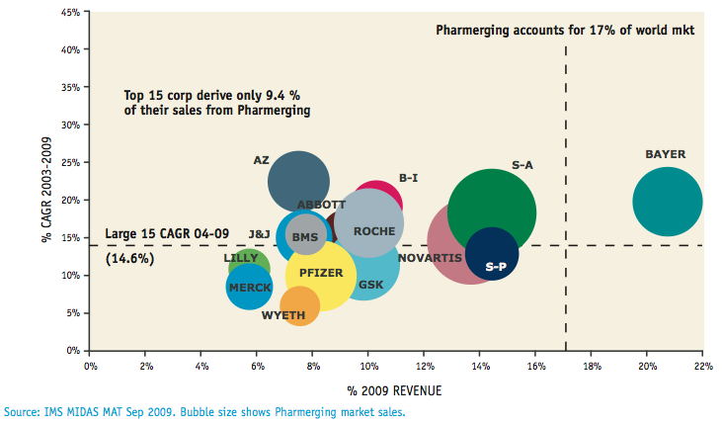

- Exhibit 2: Redefining Pharmerging Markets (David Campbell, 2010)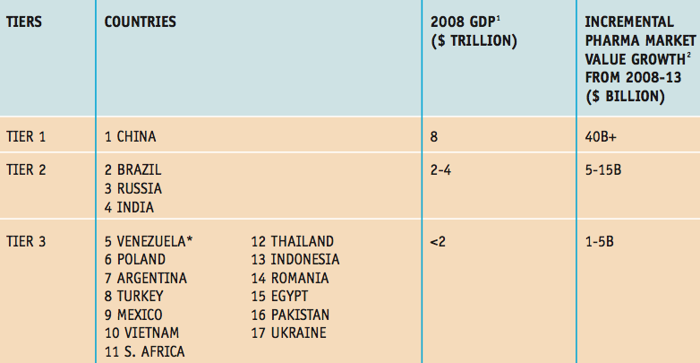

Exhibit 3: Pharmaceutical Sales from Different Latin American Countries (FirstWord, 2010)
- 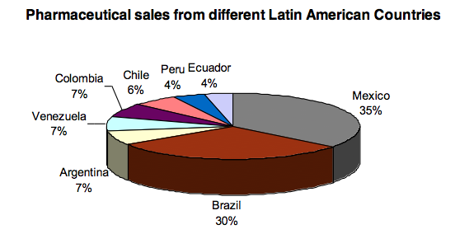

Exhibit 4: Marketing Strategies after Patent Expiry (Chandon, 2004)
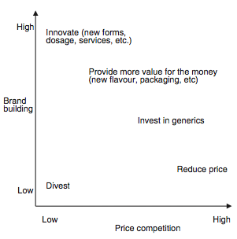

Exhibit 5: Emerging Markets are the Key Drivers of Total Spending (KPMG, 2011)
- 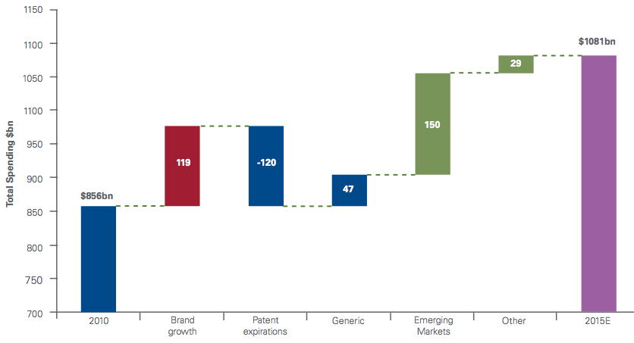

Exhibit 6: Percent of first-in-class medicines with a competitor in Phase II testing at the time of approval (KPMG, 2011)
- 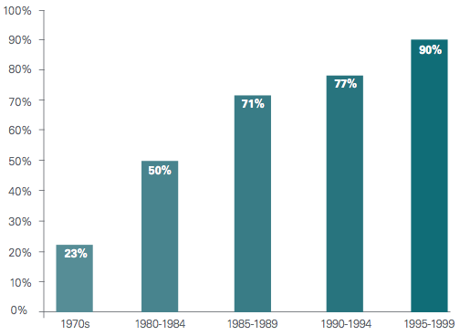
- Exhibit 7: Industry Lifecycle (Valentine, 2012)
- 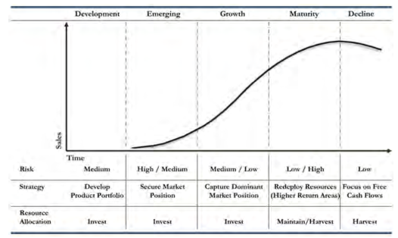

- Exhibit 8: The Pharmerging Markets will be the Biggest Contributor to Global Growth in the next Five Years (David Campbell, 2010)
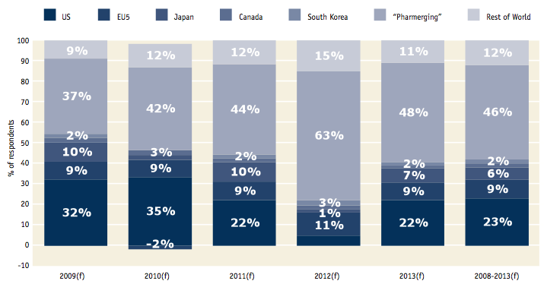
Exhibit 9: Pharmerging Markets Growth Dynamics (John P. Griffin, 2013)
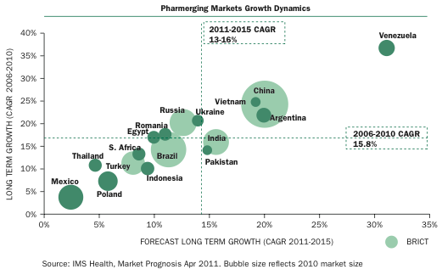

Exhibit 10: % Out-of-Pocket Healthcare Expenditure 2007 (FirstWord, 2010)
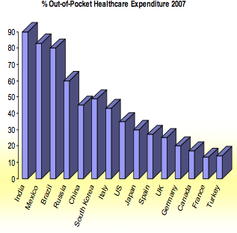

Exhibit 11: Metabolic Risk Factor Trends (WHO, 2011)
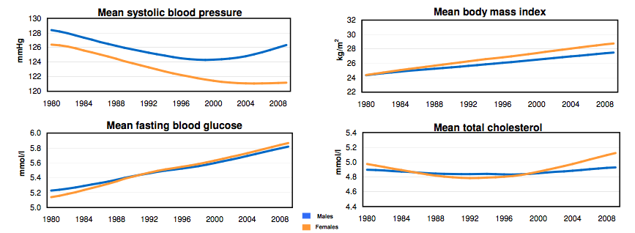

Exhibit 12: Share of Market by Company Type (Focus Reports, 2012)
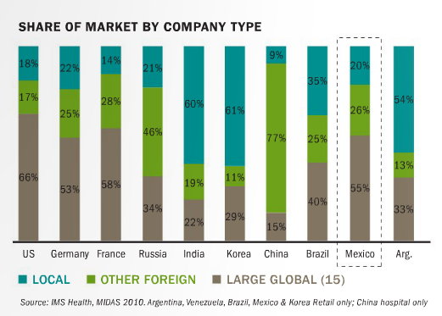

Exhibit 13: Total Pharmaceutical Market by Product Type (Focus Reports, 2012)
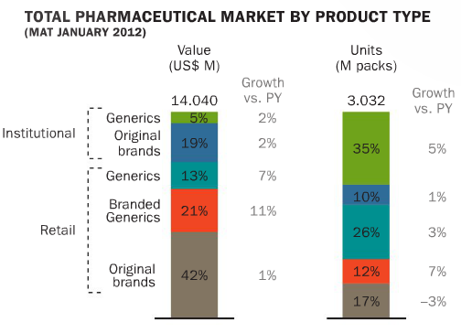
Exhibit 14: R&D investments by sector (EUR billion) (International Federation of Pharmaceutical Manufacturers & Associations, 2012)
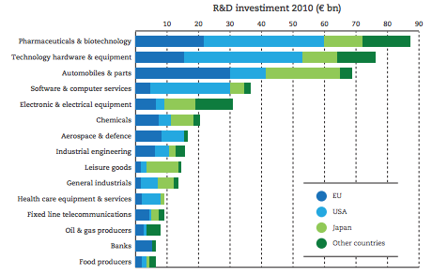

Exhibit 15: World of R&D 2012 (Battelle, 2012)
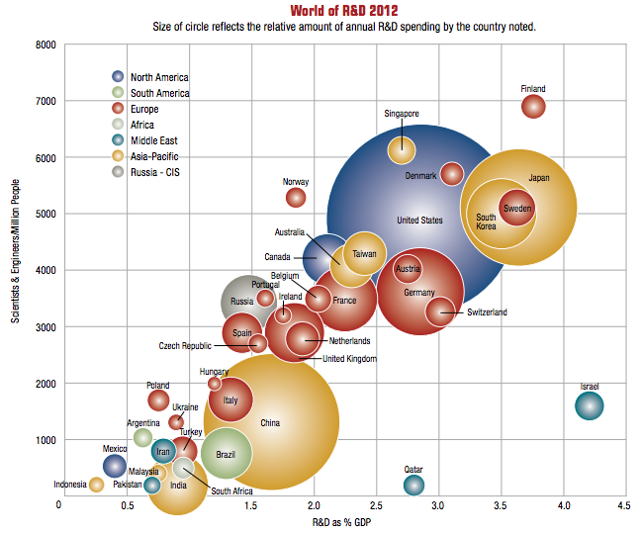
Exhibit 16: Retail Pharmaceutical Price Levels and Economy-Wide Price Levels (OECD, 2008)
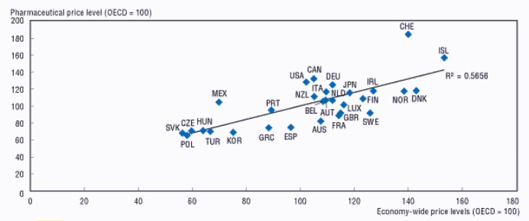
Exhibit 17: Original Pharmaceutical Price Levels and Economy-Wide Price Levels (OECD, 2008)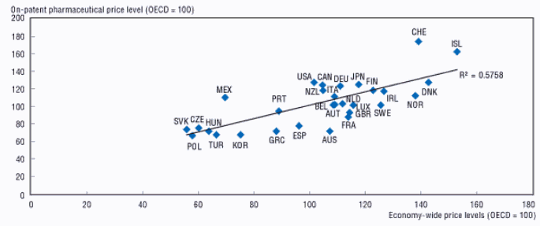
Exhibit 18: Generic Pharmaceutical Price Levels and Economy-Wide Price Levels (OECD, 2008)
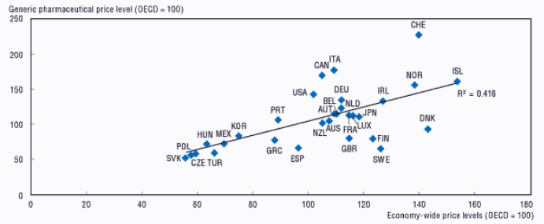
Exhibit 19: Retail Price Comparison (FirstWord, 2010)
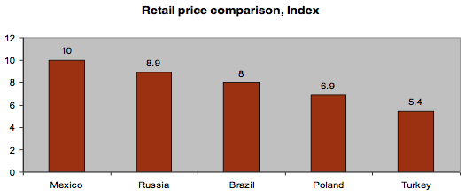

8.3 Interviews
Mindaugas Malinauskas
Position: Executive Director at ‘Entafarma’

Q1. What are the practices that pharmaceutical companies apply when facing the expiration of the patent that are, in your opinion, strategically best?
There are various examples how companies deal with patent expiration. Obviously this decision highly depends on the nature of the domestic market in which the company is competing. In my opinion, given current stagnation of the mature markets, best strategies are to try to pro-long product life cycle of the drug by introducing new features/dosage or to invest in generics. Improving the medication could help retain higher margins; however, increased generic competition makes it harder to preserve the market share. I believe that the smartest move is to invest in generics, buy generic firms or produce your own generics. The demand for cheaper medicine is so high at the moment that it would definitely be a promising investment to make.
Q2. You mentioned that mature markets are stagnating. How can pharmaceutical overcome this?
Nowadays the key to success is emerging markets. These countries have huge populations and low level of medicine, so any improved medication is very welcome and needed there. Although emerging countries offer a lot of opportunities, it should be noted that local producers in these countries have experience and knowledge of the market that might become a huge obstacle. I think that it would be best for big international companies to acquire local producers. This way they can skip the phase of adaptation and knowledge acquisition of the new market.
Q3. If Big Pharma enters emerging markets, how can they fight counterfeiters?
Counterfeit drugs in emerging markets are indeed a huge problem. There is no clear solution to this problem because the markets are usually poorly regulated. An example of Europe could be taken - there is a practice to monitor the medicine that is sold in pharmacies. Every product has its own bar code (2 of them), and when the product is scanned at the counter the database lets us check if the product with the identical bar code was already sold. This way the counterfeit product can be detected. I understand this might be hard to implement in emerging markets, but I cannot give any other possible solutions to the counterfeit problem.
Q4. What do you think about the diversification of the business of pharmaceuticals?
I am convinced that biotechnology and personalised medicine sectors are our future. Pharmaceutical companies should already look at it before big advancements are made in this field. Although biotechnology is very costly and sophisticated to proceed, it is worth to consider in the future.
Q5. What is your ultimate suggestion for Big Pharma?
I believe that the best strategy is to invest in generics by buying generic companies in emerging markets. This way companies could cover larger market, use their know-how in these markets and later implement it in all plants they acquire, lower transaction costs and the level of competition.

Elise Kocks
Position: Senior Manager at SKIM Group

Q1. What are global trends in the pharmaceutical industry?
The competition in the industry is at the record height and companies compete on various levels. Also, there is noticeable market saturation because most severe diseases are already cured or there is some medicine for them. Pharmaceuticals need huge investments to come up with something new and only small steps can be taken.
Q2. It can be found in various literatures that counterfeiting is a huge problem in the developing world. Is it the case in Mexico?
It is indeed also the case in Mexico. Counterfeit drugs account for a huge portion of overall pharmaceutical market. There are no practices known that could effectively help fight the market of counterfeits. Especially now it is becoming even harder, since over-the-counter drugs are more popular and they are hard to control.
Q3. What is the main thing that pharmaceuticals should look at in Mexican market?
Price. People in Mexico are extremely price sensitive, and if a company fails to deliver the products at low prices, huge share of the market is immediately lost.
Q4. How can pharmaceuticals adapt to Mexican market with regard to prices?
They should introduce generic drugs because they are mot popular at the moment. In addition, the government heavily promotes generics. By introducing generic drugs, companies can ensure that their drug will reach the end consumer as well as remain in the competition.
Q5. What other factors have to be taken into account when it comes to reaching the end consumer?
It is crucial to mention that different from traditional distribution channel where physicians are the ones influencing the buying decision of the patient, pharmacists are very important in Mexico. Pharmacists are key influencers because budgeting is more significant to them. They can better relate to patients who are price sensitive and are seeking for cheaper drugs. It is very common in Mexico that a patient has his regular pharmacist. Therefore, pharmacists are very trusted and their opinion is valued even more than physicians’. When a patient comes to the pharmacy with the prescription, very often pharmacist advises what medication has same active ingredients but is sold at way lower price. This ends in patient buying the drug that is different from the one prescribed initially. I think that pharmaceuticals should concentrate on using detailing on pharmacists rather than on physicians in Mexico if they want their drug to be sold.
Q6. What are most common diseases in Mexico?
From my experience, main problem in Mexico is chronic diseases such as diabetes. Also, the health of Mexican men is quite poor and a lot of men suffer from erectile dysfunction.

References
Accenture. (2011). Multichannel Management: The Key to Successful Pharmaceutical Sales and Marketing in Latin America . Accenture.
Aruvian’s R’search . (2011). Pharmaceutical Industry in Mexico. Aruvian’s R’search .
Bartholow, M. (2012, July 12). Pharmacy Times. Retrieved May 27, 2013, from www.pharmacytimes.com: http://www.pharmacytimes.com/publications/issue/2012/July2012/Top-200-Drugs-of-2011
Battelle. (2012, December). 2013 Global R&D Forecast. R&D Magazine .
Chandon, P. (2004, August 7). Innovative marketing strategies after patent expiry: The case of GSK’s antibiotic Clamoxyl in France . International Journal of Medical Marketing , 4 (1), pp. 65-73.
Congress of the United States. (2006). Research and Development in the Pharmaceutical Industry. CBO.
Cosio, R. G. (2012). The Counterfeiting of Pharmaceutical Product in Lesser Developed Countries: A Case Study of Mexico. In P. G. Albert Isaac Wertheimer, Counterfeit Medicines: Policy, Economics and Countermeasures (Vol. 1, pp. 43-51). ILM Publications.
David Campbell, M. C. (2010). Pharmerging shake-up New Imperatives in a Redefined World. IMS Health.
Deloitte. (2012). 2013 Global life sciences outlook: Optimism tempered by reality in a “new normal”.
Donald Vandegrift, A. D. (2006, October). Prescription Drug Expenditures in the United States: The Effects of Obesity, Demographics, and New Pharmaceutical Products . Southern Economic Journal , 73 (2), pp. 515-529.
Donna Eberwine-Villagran, S. M.-S. (2012, July 2). Pan American Health Organisation. Retrieved June 4, 2013, from www.new.paho.org: http://new.paho.org/hq/index.php?option=com_content&view=article&id=6967&Itemid=1926
Fernando Santiago Rodriguez, G. D. (2010). Determinants of PRO‐industry interactions in pharmaceutical R&D: the case of Mexico .
FirstWord. (2010). Branded Generics - A Gateway to Emerging Markets . Doctor's Guide Publishing Limites.
Focus Reports. (2012). Mexico Pharma Report. Focus Reports.
Gonzalez, J. S. (2004). Drugs and Pharmaceuticals. Retrieved June 13, 2013, from www.ita.doc.gov: http://ita.doc.gov/td/health/phRMA/Mexico%20Pharms%20ISA.pdf
Hayden, C. (2007, August). A Generic Solution? Pharmaceuticals and the Politics of the Similar in Mexico . Current Anthropology , 48 (4), pp. 475-495.
Helms, R. B. (1996). Competitive Strategies in the Pharmaceutical Industry. Washington, D.C.: The AEI Press.
IMS Institute for Healthcare Informatics . (2012). Advancing the responsible use of medicines. IMS Institute.
International Federation of Pharmaceutical Manufacturers & Associations. (2012). The Pharmaceutical Industry and Global Health. IFPMA.
Jackson, R. (2005). Building Human Capital in an Aging Mexico. CSIS, ITAM.
John P. Griffin, J. P. (2013). The Textbook of Pharmaceutical Medicine (Seventh ed.). Oxford: BMJ Books.
KPMG. (2011). Future Pharma: Five Strategies to Accelerate theTransformation of the Pharmaceutical Industry by 2020 .
Kvesic, D. Z. (2008). Product lifecycle management: marketing strategies for the pharmaceutical industry . Journal of Medical Marketing , 8 (4), 293-301.
Malena Monteverde, K. N. (2010, February). Obesity and Excess Mortality Among the Elderly in the United States and Mexico . Demography , 47 (1), pp. 79-96.
Mara G. Aspinall, R. G. (2007). Realizing the Promise of Personalized Medicine. Harward Business Review.
Marias, S. L. (2013, March 8). Beyond the Patent Cliff. PharmAsia .
Matthew Sutton, C. G. (1995). A Grouped Date Regression Approach To Estimating Economics And Social Influences On Individual Drinking Behavior. Health Economics , 4, pp. 237-247.
Merrill, J. (2011). The New Face of Blockbuster Drugs. In Vivo: The Business and Medicine Report.
Molina-Salazar RE, G.-M. E.-d. (2008). Competition and prices in the Mexican pharmaceutical market.
OECD. (2008). OECD Health Policy Studies Pharmaceutical Pricing Policies in a Global Market. OECD Publishing.
Pierre Moïse, E. D. (2006). Pharmaceutical Pricing and Reimbursement Policies in Mexico . Paris: OECD .
Ram Bala, P. B. (2012, January). Detailing vs. Direct-to-Consumer Advertising in the Prescription Pharmaceutical Industry. Management Science , 56 (1), pp. 148-160.
Sangha, S. (2011, May 5). Fow News Latino. Retrieved June 6, 2013, from www.latino.foxnews.com: http://latino.foxnews.com/latino/health/2011/05/05/viagra-huge-mexico-whats/
Semih Semin, S. A. (2006). Direct-to-consumer advertising of pharmaceuticals: developed countries experiences and Turkey. Health Expectations (10), 4-15.
Shadlen, K. C. (2009, October). The Politics of Patents and Drugs in Brazil and Mexico: The Industrial Bases of Health Policies . Comparative Politics , 42 (1), pp. 41-58.
Shepherd, M. (2009). Americas Quarterly. Retrieved June 4, 2013, from www.americasquarterly.org: http://www.americasquarterly.org/node/1698
Tilly, G. d. (2011). The Pharmaceutical Industry in Mexico: New Challenges, New Leaders . Mexico City: Russell Reynolds Associates, Inc. .
U.S. Food and Drug Administration. (2012, December 5). Retrieved May 9, 2013, from http://www.fda.gov/Drugs/DevelopmentApprovalProcess/ucm079031.htm
Unknown. (2011, August 25). COFEPRIS. Retrieved June 4, 2013, from www.cofepris.gob.mx: http://www.cofepris.gob.mx/Paginas/Idiomas/Ingles.aspx
Unknown. (2007, February 16). Institute for Agriculture and Trade Policy. Retrieved June 23, 2013, from www.iatp.org: http://www.iatp.org/news/oecd-revives-controversy-over-drug-pricing-in-mexico
Valentine, E. L. (2012). Trends Shaping U.S. Pharmaceutical Industry Strategies (13 ed.). Stamford: MMC Publishing.
Villagran, L. (2012, January 6). SmartPlanet. Retrieved June 23, 2013, from www.smartplanet.com: http://www.smartplanet.com/blog/global-observer/erectile-dysfunction-drug-companies-compete-for-mexican-market/2303
WHO. (2011). NCD Country Profiles.
WHO. (2013). World Health Statistics 2013. Geneva: World Health Organization.

Words ‘pharmerging’ and ‘emerging’ that aim to indicate the nature of the markets are used interchangeably in this thesis.

