What you really know and what you think you know

The influence of consumer knowledge on the pre-purchase search phase and the role of consumer knowledge calibration. A research of the consideration set size, attributes and information source types within the context of Dutch health insurances.

What you really know and what you think you know

Denise Heijstek
376445
Master thesis
Dr. J. Liberali
Master Economics and Business - Marketing
Erasmus School of Economics
Erasmus University Rotterdam
Rotterdam, August 2013

Author
Student number
Course
Supervisor
Education

The influence of consumer knowledge on the pre-purchase search phase and the role of consumer knowledge calibration. A research of the consideration set size, attributes and information source types within the context of Dutch health insurances.
Preface

The last block of the Master Business and Economics, Marketing specialization, consists of conducting research and writing a thesis. My thesis is written within the research area of my supervisor, the influence of memory on consumer judgment and decision. This report represents my Masters’ thesis that is focused on the influence of consumer knowledge on the pre-purchase information search stage of Dutch health insurances.
I could not have completed this thesis without the help and love of my friends, family and relatives. There are many people I would like to thank for their support and guidance. First of all, my supervisor dr. Jordana Liberali for her guidance and advice during the whole process. I would also like to thank some fellow students, Marieke van der Wal for her contribution of new insights and her company during the long days (and nights) of hard work, and Marloes van Poele for her encouraging words during the challenging times and her unconditional help during the collection of the data. My thanks also go to Dieneke Oostindier and Buti Isaack for their assistance during the translation process of my questionnaire. In addition I want to thank my friends for their support, special thanks goes to Heleen Voskamp whose creativity has led to the context of this thesis, Elsemieke Stout and Arienne Voskamp whose beautiful smiles and assistance during the data collection in the train have resulted in achieving a representative research sample, Alma Musinovic-Mansour for the use of her network to spread my questionnaire and to everyone who spend ten minutes of their time by answering my questionnaire. Last but not least I want to thank my family for their support with special thanks to my parents for their assistance and their unconditional love and believe in me.

Rotterdam, August 2013

Denise Heijstek

Abstract

It is currently held in current consumer behavior literature that consumers have different levels of knowledge and that consumer knowledge acquisition plays an important role in the pre-purchase information search stage. Insight in the information acquisition is a key element in order to understand consumer behavior, and more specific the information search and information processing.
In this thesis, insight is gained into the influence of consumer knowledge (objective and subjective knowledge) on the pre-purchase information search behavior and the role of consumer knowledge calibration and involvement. It is focused on the consideration set size, attributes and information source types within the context of Dutch health insurances. This is achieved with the use of a literature study (desk research) and a questionnaire (quantitative research).
For the purchase decision of a health insurance, the level of consumer knowledge positively influences the consideration set size (both objective and subjective knowledge), the amount of attributes considered to be important (only subjective knowledge), the importance of price (both objective and subjective knowledge) and the use of memory as an internal information source (only subjective knowledge). The use of impersonal information as an external information source for the purchase decision is negatively influenced by the level of consumer knowledge (both objective and subjective knowledge). The level of consumer knowledge calibration does not play a role in any of these relationships while the level of involvement with the purchase decision of a health insurance does play a role within some relationships.

Table of contents

List of tables and figures 9
List of tables 9
List of figures 10
1. Introduction 11
1.1. Background and context 11
1.1.1. Theoretical background and relevance 11
1.1.2. Managerial relevance 12
1.1.3. Theoretical motivation context 12
1.1.4. Introduction to Dutch health insurances 13
1.2. Research problem 14
1.3. Research method 14
1.4. Thesis structure 15
2. Literature review 17
2.1. Consumer choice processes 18
2.1.1. General background 18
2.1.2. Consumer decision strategies 20
2.2. Pre-purchase information search 22
2.2.1. Search costs 24
2.2.2. Perceived benefits 24
2.3. Consumer Knowledge 26
2.4. Consideration set 29
2.5. Information source types 31
3. Hypotheses development 33
3.1. Dependent and independent variables 33
3.1.1. Consumer knowledge 33
3.1.2. Consumer knowledge and consideration set size 33
3.1.3. Consumer knowledge and attributes 35
3.1.4. Consumer knowledge and information sources 38
3.2. Moderating variables 42
3.2.1. Consumer knowledge calibration 42
3.2.2. Involvement 44
3.3. Conceptual framework 46
4. Methodology 48
4.1. Sample design and procedure 48
4.1.1. Instrument 48
4.1.2. Sample 48
4.1.3. Respondent criteria 49
4.1.4. Procedure 49
4.2. Validity and reliability 52
4.2.1. Validity 52
4.2.2. Reliability 52
4.3. Constructs measurement 53
4.3.1. Consumer knowledge 53
4.3.2. Consideration set size 54
4.3.3. Attributes 54
4.3.4. Information source types 56
4.3.5. Involvement 56
4.3.6. Knowledge calibration 56
4.4. Demographics 57
4.5. Questionnaire design 57
Data and analysis 58
5. Data 60
5.1. Data cleaning 60
5.2. Demographics 61
5.3. Assumption of normality 63
5.4. Validity and reliability of constructs measurements 64
5.4.1. Validity 64
5.4.2. Reliability 66
6. Analysis and results 67
6.1. Subjective and objective consumer knowledge 67
6.2. Consumer knowledge and consideration set size 68
6.3. Consumer knowledge and attributes 70
6.3.1. Types of attributes 70
6.3.2. Amount of attributes 72
6.4. Consumer knowledge and information sources 74
6.4.1. Memory vs. external information sources 74
6.4.2. Personal vs. impersonal information sources 76
6.5. Consumer knowledge calibration 79
6.6. Involvement 85
6.7. Hypotheses testing summary 95
Discussion and conclusion 95
7. Discussion 97
7.1. Consumer knowledge and the consideration set size 97
7.2. Consumer knowledge and the amount and type of attributes 99
7.3. Consumer knowledge and information sources types 101
7.4. The role of consumer knowledge calibration 103
7.5. The role of involvement 104
7.6. General discussion 105
8. Conclusion 106
8.1. General conclusion and main findings 106
8.2. Managerial implications 108
8.3. Limitations and further research 110
References 112
Appendix I English version questionnaire 118
Appendix II Dutch version questionnaire 126
Appendix III Correct answer objective knowledge 135
Appendix IV SPSS output chapter 5 Data 137
5.2. Demographics 137
5.3. Assumption of normality 142
5.4. Validity and reliability 152
5.4.1. Validity – factor analysis 152
5.4.2. Reliability – Cronbach’s alpha 171
Appendix V SPSS output chapter 6 Analysis and results 176
6.1. Subjective and objective consumer knowledge 176
6.2. Consumer knowledge and consideration set size 177
6.3. Consumer knowledge and attributes 180
6.4. Consumer knowledge and information sources 186
6.4.1. Memory vs. external information sources 187
6.4.2. Personal vs. impersonal information sources 189
6.5. Consumer knowledge calibration 193
6.6. Involvement 209
6.7. Hypotheses testing summary 231

List of tables and figures

List of tables

Table 1 | Consumer decision strategies | Page 19
Table 2 | Translated questionnaire parts | Page 48
Table 3 | Attribute types | Page 54
Table 4 | Statements per information source type | Page 55
Table 5 | Data cleaning | Page 59
Table 6 | Kaiser-Meyer-Olkin results | Page 63
Table 7 | Descriptive analysis subjective and objective knowledge | Page 66
Table 8 | Correlation between subjective and objective knowledge and attributes | Page 69
Table 9 | Mean values information source types | Page 73

List of figures

Figure 1 | Structure literature review | Page 16
Figure 2 | Calibration matrix | Page 27
Figure 3 | Conceptual framework | Page 45
Figure 4 | Questionnaire design | Page 57
Figure 5 | Histogram age | Page 60
Figure 6 | Level of education | Page 61
Figure 7 | Boxplot consideration set size | Page 67
Figure 8 | Amount of attributes | Page 71
Figure 9 | Histogram knowledge calibration | Page 78
Figure 10 | Histogram involvement | Page 84
Figure 11 | Moderating effect involvement H8c | Page 86
Figure 12 | Moderating effect involvement H8d | Page 87
Figure 13 | Moderating effect involvement, objective knowledge and memory | Page 89
Figure 14 | Moderating effect involvement H8i | Page 91
Figure 15 | Moderating effect involvement H8l | Page 93

Introduction
This chapter introduces the research area of this thesis and the chosen context by providing the theoretical background and relevance, managerial relevance, explanation of the chosen context, research question, research method and an overview of the structure of this thesis.

Background and context
This section considers the theoretical and managerial background and relevance that lead to the choice of the research area used in this study and introduces the chosen context.

Theoretical background and relevance
Consumers have different levels of knowledge about products and services. For example, a consumer might be highly knowledgeable about a tablet but not about a washing machine. This consumer knowledge, also called expertise, plays an important role in the pre-purchase information search stage of the consumer decision-making process (Wirtz & Mattila, 2003). It can be divided into objective knowledge and self-assessed, also referred as objective, knowledge. Literature shows that “knowledge affects the entire decision process from attribute selection through search to perceived decision outcomes” (Raju, Lonial & Mangold, 1995, p.155).
During the information search stage, consumers create a set of options that they consider to purchase, also called the consideration set (Roberts, 1989). The period of searching is defined as starting when the consumer consciously begins to consider purchasing a product or service and as ending when the product or purchase is purchased. All information obtained prior to the first conscious effort is not counted as search activity (Punj & Staelin, 1983).
Previous research has found negative and positive relationships between consumer knowledge and searching information. Prior knowledge is on one hand assumed to increase consumers’ confidence in their own capabilities. On the other hand, consumers with high levels of knowledge are expected to perceive more benefits from additional information than novices. Besides this, most consumer research has focused on consumer knowledge with little attention directed at calibration and miscalibration (Alba and Hutchinson, 2000).

Managerial relevance
“Knowledge of information acquisition strategies is vital to both marketing managers and scholars because information search is an early influential stage in the pre-purchase decision process” (Murray, 1991, p. 10). It is central to the understanding of consumer behavior such as information search and information processing (Pillai & Hofacker, 2007). With insight into the information search stage and knowledge levels of consumers, companies can implement additional segmentation bases or adjust their information sources to the knowledge level of their consumers.

Theoretical motivation context
The relationship between the two knowledge constructs (subjective and objective knowledge) is less likely to be positive for nonproducts (vs. products), experience goods (vs. search goods), utilitarian (vs. hedonic) and nondurable products (vs., durable) (Carlson, Vincent, Hardesty, & Bearden, 2009).
Services appear to create particularly uncertain and risky purchase situations, it is thus logical to expect that consumers acquire information as a strategy of risk reduction in the face of this specific uncertainty. “The greater the degree of perceived risk is in a pre-purchase context, the greater the consumer propensity to seek information about the product will be” (Murray, 1991, p. 10).
The differences of the two knowledge constructs and the level of knowledge calibration are important aspects of this thesis. To gain insight into the effects of these consumer knowledge aspects, a context is chosen that meets the characteristics that are likely to cause differences between the two knowledge constructs according to Carlson et al. (2009). Dutch health insurances are chosen as the context of this thesis because:
- It is a service (nonproducts);
- It is partly nondurable (Dutch inhabitants can chose their health insurances each year);
- It is a practical service (utilitarian);
- It is a search good.

Introduction to Dutch health insurances
Healthcare is of major importance for the Dutch economy (Zorgverzekeraars Nederland, 2013). The healthcare expenditures of the Dutch government are expected to be 13% of the gross domestic product (Rijksoverheid, 2013). The costs are rising partly because of the obsolescence of the Dutch population and the increasing amount of inhabitants (Zorgverzekeraars Nederland, 2013).
Since the introduction of the health insurance act in 2006, everyone who lives or works in the Netherlands is required to have a basic health insurance. This basis health insurance covers the basic healthcare costs such as a general practitioner, hospital or pharmacy. Next to the basic health insurance, it is possible to additionally insure for costs that are not covered in the basic health insurance (Rijksoverheid, 2013).
The Dutch government decides the content of the basic health insurances. Each health insurance company is required to accept every consumer with a fixed price. Children younger than 18 years old are also required to have a basic health insurance but are exempted from payments (Rijksoverheid, 2013).
After each calendar year, people can choose a different health insurance and/or health insurance company for the coming year (Independer, 2013). There are in total 26 different health insurance companies that carry out the Dutch health insurance act (College voor zorgverzekeringen, 2013).

Research problem
The goal of this thesis is to gain insight into the influence of consumer knowledge on the pre-purchase search behavior and the role of consumer knowledge calibration and involvement. Focus is placed on the consideration set size, attributes and information source types within the context of Dutch health insurances. In order to reach the goal of this thesis the following central research question is formulated:
What is the influence of the level of subjective and objective knowledge on the pre-purchase information search phase and the role of consumer knowledge calibration for Dutch health insurances?
To answer the central research question, the following sub questions are used:
- What is the influence of the level of objective and subjective knowledge and consumer knowledge calibration on the consideration set size of Dutch health insurance companies?
- What is the influence of the level of objective and subjective knowledge and consumer knowledge calibration on the amount and type of attributes considered when choosing a Dutch health insurance company?
- What is the influence of the level of objective and subjective knowledge and consumer knowledge calibration on the types of information source accessed when deciding about purchasing from a Dutch health insurance company?

Research method
To answer the central research questions and related sub questions, a research method is chosen. First, literature review is done to gain insight into the different variables of this study and their effects. Based on the results of the literature review, various hypotheses are formulated which together form the conceptual framework.
To test the relationships such as represented in the conceptual framework, a questionnaire (quantitative research) is used to collect the data. With the use of descriptive analysis, Pearson correlation, single and multiple linear regressions, the assumed relationships are analyzed.

Thesis structure
The first chapter of this thesis gives insight into the theoretical and managerial relevance of this study, the research problem and the research method.
The second part of this thesis, the theoretical framework, consists of the literature review and hypotheses development. The first one reviews existing literature in the research area of this study. Based on the literature review, various hypotheses are formulated in the following chapter including theoretical underpinning.
In the third part of this thesis the methodology used for this study is described. It contains information about the sample design and procedure, validity and reliability measures, constructs measurements, demographics included in the questionnaire and the design of the questionnaire.
After methodology, the data and analysis is described in the fourth part of this thesis. The first chapter, data, describes results of the data cleaning, demographics, assumption of normality and validity and reliability analysis. In the following chapter, analysis and results, the results from the quantitative research are described and the hypotheses are tested.
The last part of this thesis, conclusion, contains the discussion, conclusion, limitations and further research and managerial implications based on the analysis and results.

Theoretical framework
Chapter 2 Literature review
Chapter 3 Hypotheses development

Literature review
This chapter reviews existing literature of the research area of this study. The structure of this chapter can be seen as a funnel that starts from broad general information about consumer choice processes and ends with more specific topics; consumer knowledge, consideration set and consumer information sources. Figure 1 represents the structure of this chapter in which the variables of this study are dark blue.

Figure 1 Structure literature review

Consumer choice processes
This section introduces the research area of consumer choice processes and the different consumer decision strategies. Since this is not the main focus of this study, only general information will be mentioned in order to introduce the more specified topics of this study.

General background
In consumer behavior literature, the processes of consumer choice (or decision) are of great interest to many researchers for a long time. “These processes concern the selection, consumption and disposal of products and services by consumers” (Bettman, Frances Luce & Payne, 1998, p. 187).
Traditionally, consumer decision research assumed a rational decision maker that has well-defined preferences which are not depending on specific descriptions of the options or particular methods to reveal those preferences. All the options that are considered (also called choice set) are supposed to have a utility or value depending on the option. The consumer is assumed to have certain abilities or skills that can calculate the option that maximizes the received value. This traditional approach is called the rational choice theory (Bettman et al., 1998).
As this research area was studied more and became more developed, the rational choice theory was found to be somehow incomplete (Bettman, 1979). The new approach, information-processing approach, introduces bounded rationality (Simon, 1955). This regards the idea that the capacity for processing information of decision makers is limited. Because of these limitations, information selectivity is required. The information that is selected can have a huge impact on the eventual choice (Bettman et al., 1998).
The concept of bounded rationality corresponds with the conviction that consumer preferences are mostly constructed. Most of the times, consumers do not have well-defined preferences as assumed in the rational choice theory (Bettman & Park, 1980). Preferences are often constructed when needed such as in a situation where a choice must be made (Ariely, Loewenstein, & Prelec, 2006).

The research area of consumer choice processes is very broad with multiple sub areas. Bettman et al. (1998) describe some major conclusions from consumer decision making research. Choice among options depends…
- … heavily on the goals of the decision maker;
Four of the most important goals of a decision maker are; maximizing the accuracy of the choice, minimizing the cognitive effort required to make a choice, minimizing the experience of negative emotion when making the choice and maximizing the ease of justifying the decision. The weight that is placed on the goal is influenced by importance and irreversibility of the decision and the timeliness and double meaning of the available feedback on performance (Bettman et al., 1998).
- … on the complexity of the decision task;
- … on the context;
- … on how one is asked;
- … and on how the choice set is represented.
As mentioned above, the choice among options is depending from the choice (or consideration) set. A regular consumer choice involves a set of options (or alternatives) that can be described by attributes (Bettman et al., 1998). Section 2.4 will discuss the consideration set in more detail.

Consumer decision strategies
There are several strategies used by consumers to make a decision. Bettman et al. (1998) mention different strategies which all have different advantages and disadvantages for realizing a particular goal. These advantages and disadvantages are partly influenced by the knowledge and skills of the consumer. They consider four important aspects that characterize each of the strategies; the total amount of information processed the selectivity in information processing, the pattern of processing and whether the strategy is compensatory or no compensatory. Table 1 gives an overview of the four aspects for each of their strategies.
Strategy | Amount of information processed | Selective (S) vs. consistent (C) | Attribute-based (AT) vs. alternative based (AL) | Compensatory (Yes) vs. no compensatory (No)
WADD | Extensive | C | AT | Yes
LEX | Limited | S | AL | No
SAT | Variable | S | AL | No
EBA | Variable | S | AT | No
EQW | Extensive | C | AL | Yes
MCD | Extensive | C | AT | Yes
FRQ | Variable | Variable | AL | Variable
CCM | Variable | C | AT, AL | Yes
Table 1 Consumer decision strategies
WADD= weighted adding, LEX= lexicographic, SAT= satisficing, EBA= elimination-by-aspect, EQW= equal weight, MCD= majority of confirming dimensions, FRQ= frequency of good and/or bad features, CCM= componential context model
- Weighted adding – Considering one alternative at a time, evaluating each of the attributes for that option, multiplying each attributes’ value with the importance weight and summing it up. The option with the highest total value will be chosen.
- Lexicographic – Choosing the option with the best value on the most important attribute.
- Satisficing – The value of each attribute for the option is examined to test whether it meets the cutoff level for that attribute. Whenever an attribute fails, the option is eliminated. The first option that meets the cutoff level of all attributes will be chosen.
- Elimination-by-aspect – Options will be eliminated when they do not meet the cutoff level of the most important attribute. After this, the process will be repeated for the second most important attribute and so on until only one option is left.
- Equal weight – Considering all the options and attributes for each option without weighing the attributes. The alternative with the highest total value will be chosen.
- Majority of confirming dimensions – Options will be evaluated in pairs. The attributes of the two alternatives will be compared and the one with the better attributes will be selected for further comparison with another alternative until only one option is left.
- Frequency of good and/or bad features – Based on personal cutoff levels for a good or bad attribute, the option with the best attributes will be chosen.
- Componential context model – Compare the relative advantages and disadvantages of the options and chose the one with the most advantages.

Pre-purchase information search
As mentioned before, the information processing capacity of consumers is limited which requires them to select information. This selection of information strongly influences the choice of the decision maker (Bettman et al., 1998). Therefore, in this section, the pre-purchase information search behavior is reviewed.
Punj and Staelin (1983) propose that “consumers seek information in order to make a better and more satisfying purchase decision” (p.367). Much of prior research on consumer search has focused on the psychological part but Moorthy, Ratchford and Talukdar (1997) pay attention to the economic theory of search. They claim that the most ideal search strategy is influenced by the balance between search costs and perceived benefits. The last one is determined by the uncertainty in the choice environment, importance of the product category (or involvement) and risk aversion. Relative uncertainty is the uncertainty about which brand is the best and individual uncertainty concerns the uncertainty about what each option has to offer. Various researchers pay attention to this so-called cost-benefit concept which is modified by individual-specific constructs such as specific taste and needs (Punj & Staelin, 1983). The search costs and perceived benefits are discussed in more detail in section 2.2.1 and 2.2.2.
Problem framing
Consumers’ uncertainty in the choice environment can also be called the problem framing part of the search process. The consideration set defines the choices when consumers are actively facing a search process. Each option in this consideration can be defined with several attributes and consumers face uncertainty about the true value of those attributes. Consumers can learn about those true vales by searching the option. This searching process involves a certain amount of search costs (Moorthy et al., 1997). In section 2.4, consideration sets will be discussed in greater detail.

Search process
After an option is researched, consumers must decide whether to continue the search process or stop and chose the alternative with the highest utility value so far. When a consumer decides to continue, the next alternative to be searched must be selected, the search costs needs to be paid and then the outcomes should be awaited (Moorthy et al., 1997). Weitzman (1979) introduces the optimal stopping rule that tells whether to continue searching or stop and the optimal selection rule that defines the best next alternative to research.
An important aspect of those optimal selection and stopping rules is the reservation utility. All the options in the consideration set have this reservation utility which means a summary measure of the value when information is gathered taking the costs and benefits of searching into consideration. This reservation utility must therefore be already available from earlier search processes or other options (Weitzman, 1979). Based on this concept of reservation utility, Weitzman (1979) describes that the optimal search strategy would be a direct search strategy. The goal of this strategy is to arrange all the options in the consideration set from the highest reservation utility to the lowest. If a consumer searches the first option and the utility is higher than the reservation utility of the second brand, consumers can stop the searching process (Moorthy et al., 1997).
Amount of search
The amount of search reflects the amount of information that is sought by a consumer and the time spent searching from the first time the consumer actively commits itself to the idea of purchasing until the final purchase decision is made (Punj & Staelin, 1983). According to Moorthy et al. (1997), the amount of search determinants can be classified into two groups. The first group consists of relative brand uncertainty, individual brand uncertainty and involvement. The second group concerns the search costs. With the direct search strategy, the amount of search is determined by the probability that the utility value is lower than the reservation utility of the second alternative (i.e. the search process will be continued). But also the relative uncertainty influences the amount of search. Reservation utility only matters when there is relative brand uncertainty between the highest ranked alternatives. Otherwise there will be no search process (Moorthy et al., 1997). But various other determinants of the amount of search are found by several authors such as the size of the feasible set and prior memory (Punj & Staelin, 1983).

Search costs
According to Ratchford (1982), the best a consumer can do is trying to minimize the welfare loss by optimizing the tradeoff between the quality of the choice and the costs of search which involves two choices. First, the choice of an optimal amount of information and second, the choice of a least-cost method of acquiring this information.
One way to look at information is a stock concept (Nelson, 1970). An inventory of information is used by consumers to minimize the welfare losses. The inventory can be increased by searching for information or decreased by forgetting information. Searching for information can be seen as the purchase of information units by the consumer and adding them to their inventory. An important note is that this only accounts for active search for information and not for passive search such as seeing a billboard when walking through the city (Ratchford, 1982).
Consistent with consumer research literature, Ratchford (1982) describes information searching as a production function of information which combines various inputs to produce an amount of information. These inputs are classified as advertising, store visits/inspection at the point of purchase, consultation with personal sources and consultation with non-advocate impersonal sources. All these inputs are produced by goods that are used by consumers in acquiring those information (e.g. gasoline used to visit a store) and time. The price of each medium will increase with the opportunity costs of time. As defined by Punj and Staelin (1983), “search costs are the sum total of all direct and indirect costs to participating consumers to conduct the information search” (p. 368).

Perceived benefits
Ratchford (1982) considers the potential gain from information as a function of consumer preferences and the diversity of the offerings in the class. As mentioned earlier, prior research indicates three determinants of perceived benefits, uncertainty, involvement and risk aversion. Several researches show close relationships between the three determinants.

Several researches describe perceived risk as referring to the nature and amount of risk that is perceived by a consumer that considers a purchase decision. Mostly, consumers cannot be certain that the intended purchase will result in achieving the desired purchasing goals (e.g. Cox & Rich, 1964; Dowling and Staeling, 1994). This uncertainty may come from various factors such as factors related to the product, brand, place of purchase or the mode of purchase. Because of this uncertainty, consumers perceive a level of risk which is a function of the amount at stake in the purchase decision and the consumers’ individual feeling of subjective uncertainty about the loss or win of the amount at stake. The importance of the buying goal and the costs for achieving the goal influence a consumer’s amount at stake (Cox & Rich, 1964).
Next to uncertainty, involvement also influences the perception of risk. Dowling and Staelin (1994) distinguish three types of involvement; (1) ego involvement (the relationship of a product to a person’s self-concept), (2) purchase involvement and (3) product involvement. The first one concerns the relationship of a product to a person’s self-concept while the last two focus on a product category and specific purchase occasion.
In order to reduce the risk level, consumers undertake risk-reducing strategies which affect the consumer’s buying behavior. Cox and Rich (1964) indicate two different methods for risk reduction; (1) increase the certainty of the prediction of the probable consequences of the decision or (2) reduce the amount of at stake. The first option is most likely to be undertaken by consumers first. In order to reduce the uncertainty consumers can seek information and/or rely on existing information. Dowling and Staeling (1994) have adopted this somehow into the following strategies:
- “normal” risk reduction strategies
Routinely conduction of information search to acquire general information about a product-class.
- Reduce specific perceived risk
Reduce the specific perceived risk of the particular product being considered to an acceptable level. This might be achieved by:
  - Collecting new information about the brand being considered or other available brands;
  - or modifying the selection of products in the choice set;
  - or changing the purchase goals and/or insuring against any adverse consequences.

Consumer Knowledge
Information search turned out to be an important risk-reducing strategy. Before focusing on acquiring new knowledge with information search, this section focuses on the existing or current levels of consumer knowledge.
Information processing concerns the cognitive processes that occur after a consumer is exposed to stimuli and before the response behavior to those stimuli. A highly important aspect is the information stored in memory (or prior knowledge) (Brucks, 1985). Traditionally consumer product class knowledge has been divided into three categories: subjective knowledge (an individuals’ perception of how much he or she knows), objective knowledge (amount, type or organization of what an individual actually has stored in memory) and experience (the amount of purchasing or usage experience with the product). But Brucks (1985) argues that this last one is less directly linked to consumer behavior. Her research therefore focuses on the distinction between objective and subjective knowledge and shows some evidence for a conceptual distinction.
Consumer knowledge became of more interest to different researchers and Alba and Hutchinson (1987) pay attention to the dimensions of consumer expertise. They propose two different components of consumer knowledge, familiarity and expertise. “Familiarity is defined as the number of product related experiences that have been accumulated by the consumer. Expertise is defined as the ability to perform product-related tasks successful” (p. 411). Next to this they propose that increased product familiarity would result in increased consumer expertise. This last one consists of five distinct aspects; task performance, cognitive structures, ability to analyze information, ability to elaborate on given information and ability to remember product information.
Rao and Monroe (1988) have continued on the concept of Alba and Hutchinson (1987) but state that experience is a necessary but insufficient condition for consumer knowledge. They therefore focus on prior product knowledge and this is defined as what people think they know (subjective knowledge) together with the knowledge an individual has stored in memory (objective knowledge).

More focus on the differences between objective and subjective knowledge is placed on by Park, Mothersbaugh and Feick (1994). They propose different effects of the both knowledge types on behavior such as information search and processing. They also pay attention to experience but argue this to be a judgment cue that influences knowledge assessments and mostly self-assessed (subjective) knowledge assessments. Results show that product experience is indirectly related to subjective knowledge through product class information stored in memory.
Various researchers continue on the distinction between objective and subjective knowledge and there different effects such as Alba and Hutchinson (2000), Moorman et al. (2004) and Pillai and Hofacker (2007). Altogether, consumer knowledge can be classified into two types namely, subjective knowledge and objective knowledge. Subjective knowledge can be described as the consumer’s self-beliefs about their own knowledge. Objective knowledge is a consumer’s accurate stored information. Subjective knowledge is inter alia based on expertise and experience while objective knowledge depends on ability or expertise (Carlson et al., 2009). Objective knowledge is related to the amount of attributes that will be evaluated in the search process and the search costs. For example, experts are more likely to have lower search costs because of their higher ability to analyze, interpreted, infer, remember and cognitively process information (Moorthy et al., 1997).
Consumer knowledge appears to be an important factor in the consumer search process. The influence of knowledge is described for three levels of knowledge (Moorthy et al., 1997).
- Low subjective and objective knowledge
Consumers are likely to see the product category more homogenous and have little motivation to search.
- Mediate subjective and objective knowledge
Consumers are likely to have partially differentiated brand perceptions and a greater motivation to search.
- High subjective and objective knowledge
Consumers are likely to have little uncertainty about the attributes values of individual brands and little motivation to search.

Consumer knowledge calibration
As researched by Raju et al. (1995), the different types of knowledge are often positively correlated with each other. When looking to the correspondence between the two knowledge constructs, consumer knowledge calibration becomes important. Alba and Hutchinson (2000) define the calibration of consumers’ knowledge as “the agreement between objective and subjective assessments of validity of the information, particularly used in decision making” (p. 123). More simply said, calibration refers to the match between confidence and accuracy. Accuracy reflects what we know while confidence reflects what we think we know. Research had also showed that consumers are often overconfident, i.e. consumers think that they know more than they actually do (Alba & Hutchinson, 2000). The correspondence between accuracy and confidence can be seen as a 2 x 2 matrix as shown below. This indicates four different levels of calibration (Pillai & Hofacker, 2007):
- Calibrated – subjective and objective knowledge levels correspond.
  - High confidence/high accuracy
  - Low confidence/low accuracy
- Miscalibrated – subjective and objective knowledge levels do not correspond
  - Overconfidence - level of subjective knowledge is higher than the level of objective knowledge
  - Underconfidence – level of objective knowledge is higher than the level of subjective knowledge
Confidence
High
Overconfidence
Calibration
Underconfidencee
Calibration

Low
Low High
Accuracy
Figure 2 Calibration matrix

Consideration set
As mentioned before, the consideration set is strongly related with the consumer pre-purchase information search since it determines the amount options that require information search. Therefore, this section focuses on the consideration set.
For every product category there is an amount of options that are available for purchase, the so called available set. But consumers might only be aware of a part of those options, their awareness set. From those options, another subset is considered to be acceptable for buying and this is the so called consideration set (Brown & Wildt, 1992). Howard and Sheth (1969) introduce the theory of buying behavior. They define the evoked set as the set of brands that the buyer considers acceptable for his next purchase.
When consumers are faced with a large number of brands in a purchase decision, they use a simple heuristic to screen the brands to a relevant set also called consideration set. More recent research also mention screening in relation to the consideration set. Chakravarti and Janiszweski (2003) argue that the formation of the consideration set is depending on the screening criteria of the consumer and the screening process. This screening process can be simple heuristic or more effortful, also described as elimination-by-aspects (EBA) choice rule. The second one involves information gathering about the options from memory or the environment and comparison with the cutoffs and eventually elimination of options that do not match the cutoff.
Prior research shows that “the size of the consideration set tends to be small in relation to the total number of brands that could be evaluated” (Hauser & Wernerfelt, 1990, p. 393). The concept of the consideration set is consistent with existing theories in behavioral science. It is argued by Wright (1975) that consumers have the tendency to simplify their decisions and Bettman et al. (1998) and Simon (1955) state that consumers have limited capacity for processing information.
As argued by Hauser and Wernerfelt (1990), consumers consider two decisions, (1) “the decision to evaluate a brand and (2) the decision to add a brand to the consideration set after it has been evaluated” (p.397). Evaluation considers a trade-off between the cost of evaluative search and the expected benefits from including a brand in the consideration set for all subsequent purchases. The decision to include a brand after evaluation concerns a tradeoff between the expected benefits of each consumption and the decision costs. Those trade-offs between benefits and costs are similar to the cost-benefit models mentioned in section 2.2.

Attributes
As already mentioned, each option in the consideration set can be defined by various attributes. Several researches have been done into the field of attributes in combination with consumer decision making and information search. Attributes are often described in two different types; (1) extrinsic attributes which are nonphysical and product-related (e.g. price) and (2) intrinsic attributes that consist of physical and performance attributes (e.g. memory capacity of a computer) (Rao & Monroe, 1988).
The different types of attributes and the amount of attributes that are being evaluated by consumers are often researched in relation to consumer knowledge. Rao and Monroe (1988) analyze the relationship between prior knowledge (defined as objective and subjective knowledge) and familiarity (product experience) and the different types of attributes while Raju et al. (1995) look at the relationship between consumer knowledge and the importance of the attribute types.

Information source types
After focusing on consumer knowledge and the different constructs, this section explores research on the information source types because seeking for information appeared to be an important risk-reducing strategy.
Across many studies, consumer information sources are divided into two types, internal and external information. Murray (1991) describes both types as followed:
- Internal information search
This is basically linked to the process of scanning the memory to search for useful information. This memory can be formed by past experiences en previous learning about the environment. Because of previous experience, knowledge is created and this can be used by seeking for internal information in subsequent decision situations.
- External information search
External information search concerns the motivated and conscious decision from a consumer to seek new information from the environment. Several sub sources are mentioned by various authors. But according to Murray (1991), most external information sources can be captured by personal, impersonal and direct experience information, which shows similarities with other research such as Beatty & Smith (1987) and Ratchford (1982). Various authors (e.g. Locander & Hermann, 1979; Lutz & Reilly, 1974) divide personal and impersonal information into advocate and independent sources:
- Personal information
  - Personal advocate: “asking a sales clerk’s or store manager’s opinion” (Locander & Hermann, 1979, p. 270).
  - Personal independent: “trying to remember what brand a friend or neighbor uses, asking opinions of family members, close friends, a neighbor or coworker” (Locander & Hermann, 1979, p. 270).

- Impersonal information
  - Impersonal advocate: “mass media advertising including reading ads, listening to radio commercials, viewing TV commercials or looking at a point-of-purchase” (Locander & Hermann, 1979, p. 270).
  - Impersonal independent: “checking with consumer reports or finding a technical report of the product” (Locander & Hermann, 1979, p. 270).
- Direct experience information: “asking for a demonstration, rely on personal experience, try before you buy or read information on the package” (Locander & Hermann, 1979, p. 270).
An important note is that the study from Murray (1991) focuses on information sources in the context of services and not products; this corresponds with the context of this thesis.

Hypotheses development
Based on the literature review, interesting research areas are revealed. This chapter deepens the theoretical framework to indicate expected relationships between the variables, which eventually form the conceptual framework.

Dependent and independent variables
This section will focus on the relationships between the dependent and independent variables .

Consumer knowledge
The dependent variable of this study is consumer knowledge. Based on prior research, consumer knowledge is considered consisting of two constructs; subjective and objective knowledge. This is congruous with various recent literature (e.g. Alba and Hutchinson, 2000; Moorman et. al, 2004; Pillai and Hofacker, 2007). Product or service experience is proposed to be an influencing factor of knowledge and mainly subjective knowledge, which is consistent with Park et al. (1994). Prior research show the distinct influence of subjective and objective knowledge on consumer search behavior and decision making (Park et al., 1994). Therefore the different effects of both knowledge constructs are studied.

Consumer knowledge and consideration set size
Recent research by Chakravarti and Janiszweski (2003) show that the context of the consideration set depends on two motives; (1) consumers prefer to create a consideration set of easy-to-compare alternatives and (2) consideration sets that have a high likelihood of containing their optimal alternative. The desire to simplify the choice is an often discussed aspect and motive for the consideration set formation in consumer behavior research. This implicates that the greater and complex the consideration set is, the more effort it cost for consumers to manage it. As analyzed by Punj and Staelin (1983), the more options there are in the consideration set, the more likely consumers are to conduct an extensive information search. The size of the consideration set appeared to be the third most important factor influencing the amount of search.
Carlson et al. (2009) describe the level of objective knowledge to be dependent from a consumers’ ability or expertise. This ability has often been related to objective knowledge, and has been described as the ability to process product-related tasks (Moorthy et al., 1997). Since a higher level of objective knowledge means that consumers can better encode information, it can be expected that processing new information takes less effort for them. This makes it easier for consumers to evaluate alternatives in a purchase decision. The easier consumers can evaluate alternatives, the more likely they are to evaluate more alternatives since consumers high in objective knowledge are also expected to be more willing to process new information (Nam, Wang, & Lee, 2012). Therefore, the following hypothesis is proposed:
H1a: The size of the consideration set is positively related to the level of consumers’ objective knowledge.
In the same research, Carlson et al. (2009) mention that the level of subjective knowledge concerns a consumers’ belief about what he/she knows and that this is closely related to experience. Since buying decisions are associated with certain levels of risk, product experience is likely to reduce the risk (Srinivasan & Ratchford, 1991). As described by Howard (1977), more experience indicates that consumers try and are aware of an increasing number of alternatives. It can therefore be expected that consumers with higher levels of subjective knowledge will consider more alternatives compared to consumers with lower levels of subjective knowledge. Therefore, the following hypothesis is proposed:
H1b: The size of the consideration set is positively related to the level consumers’ subjective knowledge.
But consumers are also overconfident (Alba & Hutchinson, 2000) which makes consumers with high levels of subjective knowledge, and thus experience, likely to have great confidence in their own abilities and knowledge. Since those consumers are likely to rely on their own expertise they are assumed to have less motivation to search for information of new alternatives of which they lack experience. Increasing levels of subjective knowledge will thus increase consumers’ confidence which can be assumed to be an inhibitory factor on the positive relationship between subjective knowledge and the consideration set size.
It is therefore expected that because of increased experience, more alternatives will be considered but this effect will be less positive than for the level of objective knowledge because of consumers’ tendency to be overconfident when they have a high level of subjective knowledge. Therefore, the following hypothesis is proposed:
H1c: The size of the consideration set is more positively related to the level of consumers’ objective knowledge than to the level of consumers’ subjective knowledge.

Consumer knowledge and attributes
In 1988, Rao and Monroe pay attention to the moderating effect of prior knowledge on the preference for the two different types of product attributes (intrinsic and extrinsic) for assessing the product quality. They claim that consumers with high levels of subjective knowledge have more experience with products and services and are thus more familiar with them. Because of this familiarity, consumers are likely to know more about the attributes and can distinguish more attributes. Since they are so familiar, they can focus on attributes such as the brand (extrinsic) which provides them enough information to evaluate the option.
Consumers with low levels of subjective knowledge lack this familiarity but also rely more on extrinsic attributes because they have less experience with the intrinsic attributes and therefore cannot rely on those.
As Raju et al. (1995) describe, this indicates that the importance of extrinsic attributes is quite equal for all levels of subjective knowledge, only the underlying motivation differs.
Raju et al. (1995) have found evidence that the relative importance of extrinsic attributes over intrinsic attributes for the purchase decision decreased when the levels of knowledge (in their research: subjective, objective and product experience) increased. Keeping the stable level of extrinsic attributes importance in mind, these results suggest an increasing level of importance for intrinsic attributes when the level of knowledge increases. However, these results were only significant for product experience. This could be explained by the effect of experience. The more experience consumers have, the more familiar they are with products and their attributes. Since intrinsic attributes can be seen as more functional attributes (Raju et al., 1995), experience increase awareness of that type of attributes which is expected to enlarge the preference for intrinsic attributes.
Because this study focuses on two knowledge constructs (subjective and objective) and product experience is considered to be an influencing factor of knowledge, mainly subjective knowledge (section 3.1.1.), the following hypothesis is proposed:
H2a: The relative importance of the use of extrinsic over intrinsic attributes for the purchase decision is negatively related to the level of consumers’ subjective knowledge.

As mentioned before, the tested relationship between the relative importance of the attribute types and consumer knowledge by Raju et al. (1995) is only found significant for experience and is thus expected to be applicable for subjective knowledge. Prior researched focused mostly on the relationship of the type of attribute and experience and little is known about the relationship with the objective knowledge level. However, looking at research with a different focus does provide some reasons to expect a relationship.
One of the underlying reasons for the increasing use of intrinsic attributes is the increased knowledge structure that is created by experience (Rao & Monroe, 1988). Consumers with high levels of objective knowledge have a higher ability to process information and are thus more likely to process new information accurately with less effort (e.g. Carlson et al., 2009; Moorthy, et al., 1997). Processing information about intrinsic attributes is assumed to require more effort. Consumers with a high level of objective knowledge are expected to be more willing to process new information because of their process ability advantage (Nam et al., 2012). A high level of objective knowledge is thus more likely to be related with more use of intrinsic attributes. Because of a lack of theoretic support for a relationship with extrinsic attributes only the following hypothesis is proposed:
H2b: The use of intrinsic attributes for the purchase decision is positively related to the level of consumers’ objective knowledge.
Another important aspect of attributes is the amount of attributes that are evaluated by a consumer. Consumers tend to simplify their choices as mentioned before; this applies for the consideration set formation (section 2.4) and the amount of attributes (Brucks, 1985). Similar to the relationship with the size of the consideration set, a higher level of objective knowledge enables consumers to better encode and process information which lowers the effort to process new information and thus increases the ease to evaluate attributes. Since consumers with a high objective knowledge level are expected to be more willing to process new information (Nam et al., 2012), they are expected to evaluate more attributes than consumers with low levels of objective knowledge. Therefore the following hypothesis is proposed:
H3a: The amount of attributes examined for the purchase decision is positively related to the level of consumers’ objective knowledge.

In the same research, Brucks (1985) does not found a relationship between the amount of attributes and the level of subjective knowledge. She assumes this to be caused by the theory that the amount of attributes is primarily determined by the actual memory content, thus objective knowledge level. But based on the general effects of subjective knowledge and consumers’ overconfidence and the relationship with the consideration set size, a relationship is expected.
More experienced consumers indicate that they try and are aware of an increasing number of alternatives (Howard, 1977) and thus at the same time attributes of those alternatives. A positive relationship between the level of subjective knowledge and the amount of attributes can be expected. Therefore, the following hypothesis is proposed:
H3b: The amount of attributes examined for the purchase decision is positively related to the level of consumers’ subjective knowledge.
However, as mentioned before consumers are also likely to be overconfident (Alba & Hutchinson, 2000). This is assumed to decrease the need to search information for attributes of which they lack experience. This indicates again an inhibitory effect, similar to the relationship between subjective knowledge and consideration set size, which diminish the positive relationship compared to the level of objective knowledge. Therefore, the following hypothesis is proposed:
H3c: The amount of attributes examined for the purchase decision is more positively related to the level of consumers’ objective knowledge than to the level of consumers’ subjective knowledge.

Consumer knowledge and information sources
It is agreed among researchers that the different constructs of consumer knowledge have different effects on consumers’ decision making and that it can affect the amount of information search (Park et al., 1994). But little research focused on the relationship between consumer knowledge levels and the types of information sources that are used.
Information sources can be divided by some opposites. This section focuses on the relationship between objective and subjective knowledge with each of the opposite information source types: internal vs. external and personal vs. impersonal.
Internal vs. external
When consumers are faced with a purchase decision, they first examine the information that is already available in their memory, thus internal search (Murray, 1991). As already mentioned before, the level of subjective knowledge is influenced by experience and concerns a consumers’ believe of what (s)he think that (s)he knows. Both internal search and subjective knowledge are based on experience and already existing information in the memory (Carlson et al., 2009). Alba and Hutchinson (2000) reveal the consumers’ tendency to be overconfident about their own abilities and knowledge. It is therefore likely that consumers with high levels of subjective knowledge have great confidence in their own knowledge and skills and are thus more tended to use internal search compared to consumers with low levels of subjective knowledge who do not trust their own expertise and knowledge. This is consistent with Brucks (1985), who claims that subjective knowledge increases the reliance on previously stored information. Therefore the following hypothesis is proposed:
H4: The use of memory as an internal information source is positively related to the level of consumers’ subjective knowledge.
Previous research does not indicate a relationship between the objective knowledge level and the use of memory as an internal information source. Consumers high in objective knowledge have an advantage when it comes to processing and encoding new information (Brucks, 1985). This advantage does not benefit consumers when using their memory as an internal information source. Next to this, consumers are assumed to first use their memory before using any external source (Murray, 1991). The use of memory is therefore expected to be independent from a consumers’ level of objective knowledge.

The higher the level of subjective knowledge, the more consumers think they know (Carlson et al., 2009) and the greater confidence consumers have in their own knowledge and capabilities (Alba & Hutchinson, 2000). Like mentioned before, they will first examine their memory for relevant information (Murray, 1991). Because those consumers think they know a lot and have great confidence in it, they are assumed to have less motivation to search for external information since they rely more on their internal search. This is consistent with the conclusion of Brucks (1985); “subjective knowledge increases the reliance on previously stored information” (p. 2). Consumers with a low level of subjective knowledge do not trust completely on their own knowledge after their internal search and are thus more likely to search further for external information in order to collect more information to reduce the risk of the buying decision. Therefore, the following hypothesis is proposed:
H5a: The use of external information sources is negatively related to the level of consumers’ subjective knowledge.
Brucks (1985) claims that “the level of objective knowledge facilitates deliberation and use of newly acquired information” (p. 2). Various other authors describe this advantage of processing new information as well (e.g. Moorthy et al., 1997). This indicates that consumers with high levels of objective knowledge can better encode information and this will take them less effort. Next to this, Nam et al. (2012) describe that higher levels of objective knowledge increases the willingness to process new information. Consumers with lower levels of objective knowledge are expected to have more difficulties with encoding new information and will be less willing to acquire new information. Therefore the following hypothesis is proposed:
H5b: The use of external information sources is positively related to the level of consumers’ objective knowledge.

Personal vs. impersonal
Like mentioned earlier in this section, external information is assumed to be negatively related to subjective knowledge levels. Based on prior research, a distinction in this negative relationship can be expected for personal and impersonal external information sources. Consumers are not only tented to be overconfident when they need to judge their own knowledge and capabilities (Alba & Hutchinson, 2000) but also when they judge the knowledge and capabilities of other people (Gershoff & Johar, 2006). Consumers with low levels of subjective knowledge do not trust their own capabilities (Carlson et al., 2009) and have thus more motivation to search for external information compared to consumers with higher levels of subjective knowledge. Since they have the tendency to be too confident about the knowledge of others they are expected to use more personal external information sources. From all the external sources, personal sources are more easy to use for them compared to impersonal sources, which require process capabilities they do not think they have. Therefore, the following hypotheses are proposed
H6a: The use of personal information sources is negatively related to the level of consumers’ subjective knowledge.
H6b: The use of impersonal information sources is negatively related to the level of consumers’ subjective knowledge.
H6c: The use of impersonal information sources compared to personal information sources is more negatively related to the level of consumers’ subjective knowledge.
The information from personal sources is not always as accurate as consumers might think (Gershoff & Johar, 2006). Since consumers with high objective knowledge levels are more capable to process new information (Carlson et al., 2009), and can thus judge the accurateness of the information, they are expected to have more accurate knowledge about which information people can provide them with. It is therefore expected that consumers with high levels of objective knowledge will use less personal information compared to impersonal information because they can better select the people who will provide correct information and leave out incorrect information. This is consistent with Punj and Staelin (1983) who claim that the persons who collect only relevant information and who have the skills to utilize it will perceive relatively more benefits from external search than those with fewer skills.
Impersonal sources vary in content from relative simple information with mainly benefits communicated to more complex information with intrinsic product attributes (Maheswaran & Sternthal, 1990). Only consumers with high levels of objective knowledge have a higher ability to encode more complex information (Moorthy et al., 1997). It is therefore expected that the higher the level of objective knowledge, the more impersonal external information easily can be processed. Consumers with low levels of objective knowledge will not focus on complex impersonal information since this takes too much effort and search costs. It is therefore expected that consumers with high objective knowledge levels will use impersonal sources to a greater extend compared with personal sources. Therefore, the following hypotheses are proposed:
H6d: The use of personal information sources is positively related to the level of consumers’ objective knowledge.
H6e: The use of impersonal information sources is positively related to the level of consumers’ objective knowledge.
H6f: The use of impersonal information sources compared to personal information sources is more positively related to the level of consumers’ objective knowledge.

Moderating variables
Next to the direct relationships between consumer knowledge and consideration set size, attributes and information source types, two moderating variables are expected. This section focuses on the moderation effect of consumer knowledge calibration and involvement.

Consumer knowledge calibration
Most research has focused on variables that influence the level of consumer calibration. However, little research focuses on the effects of the consumer knowledge calibration on consumers’ search behavior in decision making situations. But some acknowledgements have been made that recognize an effect of knowledge calibration. For example, Gershoff and Johar (2006) claim knowledge calibration to be an important condition for distinguishing consumers on their performance on various tasks.
Alba and Hutchinson (2000) conclude several ways in which knowledge calibration can affect consumer decision making. They expect that knowledge calibration affect the information search. Consumers usually search for information in order to reduce their uncertainty, overconfident consumers will tend to inhibit their search while underconfident consumers will increase their search. Next to this they assume subjective knowledge to be often the driver of the decision making and motivation of consumers. Those assumptions are consistent with the research of Kidwell and Hardesty (2008) who studied emotional calibration. Therefore the following hypotheses are proposed:
H7a: Consumer knowledge calibration moderates the relationship between the level of consumers’ objective knowledge and the size of the consideration set.
H7b: Consumer knowledge calibration moderates the relationship between the level of consumers’ subjective knowledge and the size of the consideration set.
H7c: Consumer knowledge calibration moderates the relationship between the level of consumers’ subjective knowledge and the relative importance of the use of extrinsic over intrinsic attributes for the purchase decision.
H7d: Consumer knowledge calibration moderates the relationship between the level of consumers’ objective knowledge and the use of intrinsic attributes for the purchase decision.
H7e: Consumer knowledge calibration moderates the relationship between the level of consumers’ objective knowledge and the amount of attributes examined for the purchase decision.
H7f: Consumer knowledge calibration moderates the relationship between the level of consumers’ subjective knowledge and the amount of attributes examined for the purchase decision.
H7g: Consumer knowledge calibration moderates the relationship between the level of consumers’ subjective knowledge and the use of memory as an internal information source.
H7h: Consumer knowledge calibration moderates the relationship between the level of consumers’ subjective knowledge and the use of external information sources.
H7i: Consumer knowledge calibration moderates the relationship between the level of consumers’ objective knowledge and the use of external information sources.
H7j: Consumer knowledge calibration moderates the relationship between the level of consumers’ subjective knowledge and the use of personal information sources.
H7k: Consumer knowledge calibration moderates the relationship between the level of consumers’ subjective knowledge and the use of impersonal information sources.
H7l: Consumer knowledge calibration moderates the relationship between the level of consumers’ objective knowledge and the use of personal information sources.
H7m: Consumer knowledge calibration moderates the relationship between the level of consumers’ objective knowledge and the use of impersonal information sources.

Involvement
Zaichkowski (1985) and Laurent and Kapferer (1985) describe involvement as a consumers’ perceived relevance of the object and is considered to be a function of (1) individual characteristics (e.g. interest), (2) situational factors (e.g. perceived risk) and (3) characteristics of the object. This perspective is similar to much other research on involvement in purchase decisions (e.g. Dawling and Staeling, 1994). Consumers with higher levels of involvement spent more time and effort with search-related activities (Bloch, Sherrel, & Ridgway, 1986). Because of this higher involvement, consumers can be expected to have a higher need for accurate information in order to make the decision that meets their goals the most. They are thus expected to have a more thorough pre-purchase information search phase. Therefore, the following hypotheses are proposed:
H8a: Involvement moderates the relationship between the level of consumers’ objective knowledge and the size of the consideration set.
H8b: Involvement moderates the relationship between the level of consumers’ subjective knowledge and the size of the consideration set.
H8c: Involvement moderates the relationship between the level of consumers’ subjective knowledge and the relative importance of the use of extrinsic over intrinsic attribute for the purchase decision.
H8d: Involvement moderates the relationship between the level of consumers’ objective knowledge and the use of intrinsic attributes for the purchase decision.
H8e: Involvement moderates the relationship between the level of consumers’ objective knowledge and the amount of attributes examined for the purchase decision.
H8f: Involvement moderates the relationship between the level of consumers’ subjective knowledge and the amount of attributes examined for the purchase decision.
H8g: Involvement moderates the relationship between the level of consumers’ subjective knowledge and the use of memory as an internal information source.
H8h: Involvement moderates the relationship between the level of consumers’ subjective knowledge and the use of external information sources.
H8i: Involvement moderates the relationship between the level of consumers’ objective knowledge and the use of external information sources.
H8j: Involvement moderates the relationship between the level of consumers’ subjective knowledge and the use of personal information sources.
H8k: Involvement moderates the relationship between the level of consumers’ subjective knowledge and the use of impersonal information sources.
H8l: Involvement moderates the relationship between the level of consumers’ objective knowledge and the use of personal information sources.
H8m: Involvement moderates the relationship between the level of consumers’ objective knowledge and the use of impersonal information sources.

Conceptual framework
Based on the expected relationships, all hypotheses can be gathered which forms the conceptual framework of this thesis as showed below.
H1a +
H1b +
H1c +
H5a -
H5b +
H6a -
H6b –
Hbc –
Hbd +
Hbe +
Hbf +
H2a -
H2b +
H3a +
H3b +
H3c +

H4 +
Consumer knowledge
-Subjective knowledge
- Objective knowledge
Consideration set size
Type of attributes
Amount of attributes
Likelihood to use internal information sources
Likelihood to use external information sources
Consumer knowledge calibration
Involvement
H7a-m
H8a-m
The goal of this thesis is to gain insight into the influence of consumer knowledge on the pre-purchase search behavior and the role of consumer knowledge calibration and involvement. The focus will be on the consideration set size, attributes and information sources within the context of Dutch health insurances. The conceptual framework consists of the following variables. :
Figure 3 Conceptual framework
- Independent variable: consumer knowledge (objective and subjective)
- Dependent variables: consideration set size, attributes (amount and types) and information source types (internal search, personal external search, impersonal external search)
- Moderating variables: consumer knowledge calibration and involvement
Methodology
Chapter 4 Methodology

Methodology
This chapter describes the methodology used to test the relationships visualized in the conceptual framework. First, the used instrumentation is discussed followed by the sample size, respondent criteria, procure, validity and reliability actions, construct measurements, demographics and the questionnaire design.

Sample design and procedure
This section contains information about the used research tool and the sample for which the tool is used. Finally the procedure of the method implementation is described.

Instrument
This study consists of both desk and field research. First, desk research is used to deepen the different variables and to formulate the hypotheses. In other words, the desk research was used for a theory testing approach. Second, field research is performed in the form of an explanatory research to study the relationships showed in the conceptual framework in section 3.3. In order to do so, a cross-sectional survey is conducted.

Sample
Every Dutch inhabitant is required by the law to have a health insurance. This obligation applies to all ages but health insurances are free to everyone younger than 18 years (Rijksoverheid, 2013). Since Dutch inhabitants younger than 18 years do not fully participate in the purchase process (no money transaction) and the choice is mostly made by their parents, they are excluded from this research. Altogether, a sample is conducted among Dutch inhabitants of 18 years and older. The total population for this study consists of 13,325,000 people (Centraal Bureau voor Statistiek, 2013).
In order to measure the results of the population with a reliability of 95% and an error margin of 5%, the sample consists of 384 respondents. This sample size is calculated with the use of the following formula (Boeije, 2005):
Explanation:
n= Sample size
N= Population (13,325,000)
Z= Standard deviation at a particular reliability (1.96 with 95% reliability)
P= Change that someone gives a certain response (50%)
F= Error (5%)

Respondent criteria
Respondents needed to fulfill two criteria in order to participate in this study. They needed to be at least 18 years old (section 4.1.2.) and chose their own health insurance. For example, students who let their parents decide for them are excluded from the survey because they do not actively participate in the purchase process. Every respondent is first asked to answer two screening questions and is redirected to the end of the questionnaire if he or she does not meet the criteria mentioned above.

Procedure
The survey is spread online via Social Media channels (Facebook and LinkedIn) and e-mail. Additionally, offline questionnaires are conducted among train passengers. Exactly the same information and questions as the online version are shown to the train passengers in order to avoid any bias. In order to reach the required sample size, the last respondents are bought with the use of an online panel.
Translation
The population of this study is Dutch inhabitants, therefore the questionnaire is written in Dutch. Table 2 shows which measurement constructs are translated into Dutch.
Construct measurement | Original | Translated to | Notes
Objective knowledge | Dutch | Inapplicable | Only the method is English, the different objective knowledge questions are conducted from Dutch sources.
Subjective knowledge | English | Dutch
Consideration set size | English | Dutch
Amount of attributes | English | Dutch
Type of attributes | English | Dutch | Only the question itself is translated. The attributes are conducted from Dutch sources.
Information sources | English | Dutch
Involvement | English | Dutch
Knowledge calibration | English | Dutch

Table 2 Translated questionnaire parts

“The applicability of instruments beyond the culture of origin may be adversely affected if the translation procedures are not rigorous” (Chia-Ting Su & Parham, 2002, p.581). In order to guarantee the validity of the Dutch questionnaire, the translation procedure of Chia-Ting Su and Parham (2002) is used as follows:
- Step 1: Cultural translation
The subject of this study is Dutch health insurances, since this is already a Dutch concept this is considered to be culturally relevant.
- Step 2: Back-translation iterative process
Four bilingual translators participated in this step. Two translators have lived in the United Kingdom for several years and are now living in the Netherlands again. Both of them received a high education level. The third translator is a Dutch student who is graduating as a teacher and therefore studied several foreign languages such as Dutch and English. The fourth translator is the author of this study, a Dutch student who is following Master Marketing in English.
Two translators translated the source (American English) into the target version (Dutch). The other two translators, called the back-translators, translated the target version (Dutch) into English. The author reviewed the back-translated versions with the source version in order to see whether differences have occurred and the meaning of the source version did not change. No errors in the meaning between the two translations were found.
- Step 3: Pretest
The purpose of the pretest is to refine the translation through input of the target population (Chia-Ting Su & Parham, 2002). This is combined with the general pretest for the duration and comprehension as described below. Based on the input of the respondents during the pretest, some words in the questionnaire were replaced to more understandable words for the target population without losing the meaning of the original version.

Pretest
Before the questionnaire is distributed among the target population, a pre-test was conducted among 27 people in order to test the duration and comprehension of the questionnaire as well as to refine the translation.
- Duration
Answering all the questions took the respondents 10 minutes on average. This information is used in the introduction text of the questionnaire.
- Comprehension
Not all questions were fully understood and therefore some adjustments have been made. Not all respondents answered the question about the consideration set size with names of health insurance companies. In order to avoid missing values in the final data, mentioning the names of health insurance companies is explicitly mentioned in the question. Next to this, the different attributes that needed to be rated were not clear to all respondents, some of them are redefined based on input of the respondents. Finally, the involvement measurement was unclear for every respondent. By changing the questioning into the form of a statement, all respondents indicated this to be clear.
The English translation of the questionnaire can be found in appendix I and the Dutch online version in appendix II.

Validity and reliability

Validity
The validity of this thesis is relevant and important because it reflects the degree to which the instrument of this study measures what it purports to measure. In order to validly measure the different constructs, a translation of the conceptual definition into an operational definition is required (Kimberlin & Winterstein, 2008). Important for the validity of this thesis is the theoretical foundation. The measurements of the different constructs in this study are based on widely used and valid measurements from prior research. The specific measurements for each construct of this study will be discussed in section 4.3.
The construct validity is warranted by evaluation of the relationship between the measurements used and the variables known to be related or theoretically related to the construct measured by the instrument. After the collection of the data, a factor analysis (section 5.4) is performed in order to gather further insight in the construct validity of this thesis.

Reliability
Important for the reliability of this thesis is the extent to which this study gives the same results on repeated trials. Different reliability measurements within this thesis are discussed (Kimberlin & Winterstein, 2008):
Equivalency reliability – Two types of surveys are used, an online version and an offline version. Both surveys are equal and are showed in the same way to all respondents. Therefore the equivalency reliability can be seen as high.
Stability reliability - This type of reliability requires measurements over time. However, this study uses a cross-sectional survey and is thus only conducted once. The stability reliability of this thesis is not relevant for this research method.
Internal consistency - In order to test the internal consistency of the survey, Cronbach’s alpha is used to measure the correlation between items measuring the same constructs. The results of the analysis can be found in section 5.4.
Interrater reliability - This study is performed by one researcher and responses to the survey do not need to be rated by the researcher. Therefore, interrater reliability is not relevant for this research method.

Constructs measurement
This section explains which measurements are used to measure the different variables in the conceptual framework.

Consumer knowledge
Subjective knowledge
Based on the valid measurement of subjective knowledge used by various researchers such as Park et al. (1994) and Brucks (1985), subjective knowledge is measured on four different aspects with the use of a 7-point Likert scale, respondents rate their…
- … knowledge of Dutch health insurances in general;
- … knowledge of Dutch health insurances compared to an average person;
- …confidence of their ability to comprehend Dutch health insurances’ information;
- …familiarity with Dutch health insurances
The total level of subjective knowledge of each respondent are indicated by the average score of the four Likert scales ranging from 1 (low) to 7 (high).
Objective knowledge
For the measurement of objective knowledge, an objective knowledge scale is used. This technique for measuring objective knowledge is used by various researchers such as Brucks (1985); Park et al. (1994); Raju et al. (1995). A set of ten items is put together that reflects important areas of Dutch heath insurances based on information from the Dutch government (2013) and the Dutch Consumer Association (2013). The number of correct answers is used as the objective knowledge index with a minimum of zero (low objective knowledge level) and a maximum of 10 (high objective knowledge level). Each correct answer results in one point. Multiple choice questions can also be rewarded with a number between zero and one depending on the answer (e.g. more than one answer possible: 3 out of 4 correct answers is rewarded with 0.75 point). An overview of the correct answers and rewarded points per answer can be found in appendix III.

Consideration set size
Based on the valid measurement of the consideration set size used by various researchers such as Brown and Wildt (1992), the consideration set size is measured by asking respondents about the health insurance companies they will consider if they need to make a purchase decision. This is similar to the second measure definition of Brown and Wildt (1992). In order to avoid any bias by providing names of health insurance companies, an open question is used. The consideration set size is not measured based on the last purchase since the other variables in this study (e.g. consumer knowledge) are also not measured before the previous purchase. The amount of health insurance companies mentioned by the respondent is used as the consideration set size.

Attributes
Amount of attributes
Attributes are closely related to the consideration set size and show similar implications; therefore the amount of attributes is measured in a similar way. Respondents are asked to name the attributes of health insurances that they would consider when needed to make a purchase decision and search for information; this method is similar to Brucks (1985). In order to avoid any bias by providing names of attributes, this open question is asked before showing the attributes for the measurement of the importance of the attribute types. The amount of attributes are also not measured based on the last purchase because the other variables in this study (e.g. consumer knowledge) are also not measured before the previous purchase.

Type of attributes
The method of Raju et al. (1995) is used for the measurement of preferences for the different types of attributes (intrinsic and extrinsic). A list of 7 attributes are conducted based on information of the Dutch Consumer Association (Consumentenbond, 2013) of which 2 are labeled extrinsic and 5 are labeled intrinsic (table 3). Respondents are asked to rate the importance of each attribute for the purchase decision of a health insurance on a Likert-scale from 1 (not at all important) to 7 (very important). An average score is used to show the preference for the two types of attributes. The relative importance of extrinsic attributes over intrinsic attributes is measured by subtracting the average of intrinsic attributes from the average of extrinsic attributes.
Attribute name | Type of attribute
Price | Extrinsic
Customer satisfaction | Extrinsic
(Free) choice of health care providers (e.g. hospital, general practitioner) | Intrinsic
Method of medical expenses claim | Intrinsic
Content additional coverage | Intrinsic
Acceptance requirements of additional health insurance (e.g. medical test) | Intrinsic
Quality policy of healthcare purchase (e.g. arrangements with hospitals) | Intrinsic

Table 3 Attribute types

Information source types
Based on the valid measurement of the use of information source types used by various researchers such as Lutz and Reilly (1974) and Murray (1991), information source types are measured by asking respondents to choose the best description of their reaction when they consider to choose a health insurance on a scale from 1 (definitely would) to 7 (definitely would not). A list of 21 statements covers the different sources of information (table 4). Direct experience as a type of external sources is excluded because for health insurances, it is not possible to experience the service before purchasing it. An additional source type is included; pick a brand, in order to allow respondents to respond without being forced to select an information source (Locander & Hermann, 1979). The preference for each information source is measured by the average response to the different statements ranging from 1 (low) to 7 (high).
Information source type | Statements
Internal information – memory | 1, 8, 13
External information – personal advocate | 3, 18
External information – personal independent | 2, 5, 12, 21
External information – impersonal advocate | 4, 6, 9, 10, 14, 16, 17
External information – impersonal independent | 7, 20
Pick a brand (no information source) | 11, 15, 19

Table 4 Statements per information source type

Involvement
Based on the valid measurement of involvement with the purchase decision developed by Zaichkowski (1985), involvement is measured based on the following definition of involvement; a person's perceived relevance of the object based on inherent needs, values, and interests. The involvement scale is a semantic differential 7-point Likert scale with 20 dichotomous variables. The level of involvement is presented by the average response ranging from 1 (low involvement) to 7 (high involvement).

Knowledge calibration
Based on the valid measurement of consumer knowledge calibration used by Pillai and Hofacker (2007), the level of knowledge calibration is measured by asking respondents how confident they are about the correctness of their answers of the objective knowledge questions on a scale from 0% to 100%. Respondents’ average confidence minus respondents’ number of correct question (accuracy) provides the level of knowledge calibration ranging from minus one (underconfidence) to one (overconfidence).

Demographics
Besides questions to measure the variables of the conceptual framework, four demographical questions are included at the end of the questionnaire:
- Gender
- Age
- Education level
- Having one or more children younger than 18 years

Questionnaire design
The questionnaire consist of 8 parts starting with the instruction where respondents are informed about the time to participate and goal of the questionnaire. Next, respondents are asked to answer the two screening questions. Third, the question about the consideration set size is asked followed by a question measuring the amount of attributes. This question is placed before asking respondents about their preferences for the seven different attributes in order to avoid any bias. The fifth part consists of the 21 statements to measure the use of the different information source types. In the sixth part, respondents are asked to answer the 20 statements about their level of involvement followed by the measurement of subjective and objective knowledge. Objective knowledge is placed at the end in order to avoid bias with questions such as consideration set size and attributes. The last part of the questionnaire consists of the four demographical questions.

Figure 4 Questionnaire design

Data and analysis
Chapter 5 Data
Chapter 6 Analysis and results
Data and analysis
Data and analysis
Chapter 5 Data
Chapter 6 Analysis and results

Data
This chapter covers the sections data cleaning, demographics, assumption of normality and the validity and reliability of constructs measurements.

Data cleaning
During the period of 28-05-2013 until 30-06-2013, 589 subjects have responded to the online or offline version of the questionnaire. As shown in table 5, 47 respondents do not meet the respondent criteria of being at least 18 years old and/or choosing your own health insurance. Another 155 respondents did not complete the questionnaire and are excluded as well. Eventually this results in 387 complete questionnaires useful for the analysis.
Total response |  |  |  | 589
 | Screening questions |  |  | 47
 |  | Younger than 18 | 3
 |  | Do not chose themselves | 38
 |  | Both | 6
 | Incomplete |  |  | 155
Total complete |  |  |  | 387

Table 5 Data cleaning

Demographics
The last part of the questionnaire consists of four demographic questions:
- Gender
- Age
- Level of education
- Amount of children
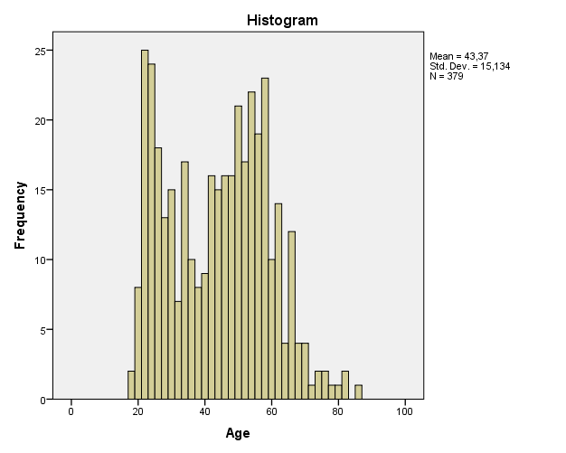
All SPSS output used for the analysis of the demographics can be found in appendix IV. Almost half of the sample size consists of males (51.3%) and a little less is represented by females (48.3%). As shown in figure 5, the most frequent ages are 23 (3.7%) and 58 (3.7%). The youngest respondent is 18 and the oldest one 86 years old but most respondents varied between 19 and 66 years old (94.8%).

Figure 5 Histogram age

Regarding to the level of education, (post) scientific education (39.9%) is most common followed by (higher general) secondary education (16.7%). Remarkable is that almost a quarter of the respondents (23%) did not want to say or did not knew their highest level of education which could be caused by the fact that this option was given as a possibility. Figure 6 shows an overview of the education levels of the respondents.

Figure 6 Chart pie level of education
Two third of the respondents do not have one or more children younger than 18 years (65.5%) compared to about one third that do have one or more children younger than 18 years (34.5%).

Assumption of normality
Before analyzing the results of the survey, the assumption of normality is examined for all construct measurements used to analyze the results. Some questions from the questionnaire or variables are excluded based on the results of the validity analysis. The assumption of normality is tested by looking at two types of graphical representation, namely histograms and scatter plots. All graphical representations can be found in appendix IV. Based on the results from the histograms and scatter plots the following measurement constructs are assumed to be normally distributed:
- Objective knowledge Subjective knowledge
- Consideration set size Amount of attributes
- Expenses claim Acceptance requirements
- Quality policy health care purchase Preference intrinsic attributes
- Relative importance extrinsic over intrinsic Use of memory
- Use external information sources Use personal information sources
- Use impersonal information sources Involvement
- Calibration
The following measurement constructs are not normally distributed:
- (Free) choice health care providers
- Content additional coverage
- Price

Validity and reliability of constructs measurements
This section covers the analysis of validity and reliability of various part of the questionnaire parts using a factor analysis and Cronbach’s alpha. All SPSS output used for the factor analysis and Cronbach’s alpha can be found in appendix IV.

Validity
Although several measures have been undertaken to ensure the validity of the questionnaire, a factor analysis is performed to provide more insight in the construct validity of the questionnaire. All questions of the questionnaire can be found in appendix I (English) and II (Dutch). Several variables are measured using different questions to measure the same construct and will be included in the factor analysis.
Five variables are tested with the use of a factor analysis; subjective knowledge, attributes preferences, information source types, involvement and knowledge confidence. A principal component analysis (PCA) is conducted with oblique rotation (direct oblimin). The Kaiser-Meyer-Olkin measure verified the sampling adequacy for the analyses and all KMO values for individual items to be above the acceptable limit of .5, also Bartlett’s test of sphericity was significant for all factor analyses as showed in table 6 (Field, 2009).
Variable | Kaiser-Meyer-Olkin | df | χ² | p
Subjective knowledge | .777 (good) | 6 | 712.649 | < .001
Attributes preferences | .750 (good) | 21 | 417.164 | < .001
Information source types | .823 (great) | 210 | 2,843.981 | < .001
Involvement | .929 (superb) | 190 | 3,752.827 | < .001
Knowledge confidence | .893 (great) | 45 | 1,235.784 | < .001

Table 6 Kaiser-Meyer-Olkin results
Subjective knowledge
None of the communalities are lower than 0.3 with a lowest value of 0.468 for ‘confidence in ability to comprehend health insurance companies’ information’ (Field, 2009). An initial analysis is run to obtain eigenvalues for each component in the data. One component has an eigenvalue over Kaiser’s criterion of 1 and explained 68.6% of the variance. Together with the results of the scree plot, this number of components is retained for the final analysis. Appendix IV shows the factor loadings after rotation. All items cluster on this one component suggesting that cluster 1 represents subjective knowledge.

Attributes preferences
None of the communalities are lower than 0.3 with a lowest value of 0.364 for ‘(free) choice health care providers’ (Field, 2009). An initial analysis is run to obtain eigenvalues for each component in the data. Two components have eigenvalues over Kaiser’s criterion of 1 and explained cumulatively 53.3% of the variance. Together with the results of the scree plot, this number of components is retained for the final analysis. Appendix IV shows the factor loadings after rotation. The items that cluster on the same components suggest that component 1 represents intrinsic attributes and component 2 extrinsic attributes. Based on the results, customer satisfaction does not belong in the cluster of extrinsic attributes and this item is therefore removed for further analysis of the data and hypotheses testing.
Information source types
None of the communalities are lower than 0.3 with a lowest value of 0.434 for ‘advice health insurance consultant’ (Field, 2009). An initial analysis was run to obtain eigenvalues for each component in the data. Six components have eigenvalues over Kaiser’s criterion of 1 and explained cumulatively 64.8% of the variance. Together with the results of the scree plot, this number of components was retained for the final analysis. Appendix IV shows the factor loadings after rotation. The items that cluster on the same components suggest that component 1 represents impersonal advocate information, component 2 pick a brand, component 3 personal independent information, component 4 personal advocate information and component 5 memory. Based on the results, not all items belong to the cluster they are supposed to belong to based on the theoretical classification. The following items are thus removed for further analysis of the data and hypotheses testing:
- Printed objective consumer information
- Written description or detailed descriptive analysis
- Available information such as printed brochure, pamphlet, etc.
- Report written by knowledgeable third party
- What previous customers had to say
Because of the second and third removed item, cluster 6 is cancelled.

Involvement
None of the communalities are lower than 0.3 with a lowest value of 0.474 for mundane-fascinating’ (Field, 2009). An initial analysis is run to obtain eigenvalues for each component in the data. Four components have eigenvalues over Kaiser’s criterion of 1 and explained cumulatively 64.9% of the variance. Together with the results of the scree plot, this number of components is retained for the final analysis. Appendix IV shows the factor loadings after rotation. The items that cluster on the same components suggest that component 1 represents the need, component 2 appeal, component 3 wanting and component 4 beneficial. Since all items are used as one in the further analysis of the data and hypotheses testing, no items are removed from the involvement scale.
Knowledge confidence
None of the communalities are lower than 0.3 with a lowest value of 0.322 for ‘confidence question 28’ (Field, 2009). An initial analysis is run to obtain eigenvalues for each component in the data. One component has an eigenvalue over Kaiser’s criterion of 1 and explained 45.2% of the variance. Together with the results of the scree plot, this number of components is retained for the final analysis. Appendix IV shows the factor loadings after rotation. All items cluster on one component suggesting that component 1 represents knowledge confidence.

Reliability
In order to ensure the reliability of the scales used in the questionnaire a Cronbach’s alpha analysis is performed.
The measure of subjective knowledge, consisting of 4 items, is found highly reliable (α = .84) even as the attribute preferences consisting of 7 items (α = .70), information source types consisting of 21 items (α = .85), involvement consisting of 20 items (α = .92) and knowledge confidence consisting of 10 items (α = .86).

Analysis and results
This chapter concerns the analysis and results of the hypotheses testing. Several analysis methods are used (Field, 2009):
- Descriptive analysis
- Pearson Correlation
- Simple regression
- Multiple regression
The results are based on the data required from quantitative research. With a sample size of the 387 respondents, the results are expected to be representative for the population from with the sample size is taken. This population is described as Dutch inhabitants with an age of 18 years or older who chose their own health insurance. All SPSS output used for this chapter can be found in appendix V.

Subjective and objective consumer knowledge
The level of subjective knowledge ranges from one to seven with a mean value of 4.3. Most respondents had a subjective knowledge level of 4.8 as showed in table 7. Respondents’ level of objective knowledge ranges from 0 to 9.8 with a mean value of 5.6. Most respondents have an objective knowledge level of 6.3.
 | Subjective knowledge | Objective knowledge
Mean | 4.35 | 6.23
Mode | 4.75 | 6.25
Minimum | 1 | 0
Maximum | 7 | 9.75

Table 7 Descriptive analysis subjective and objective knowledge

Consumer knowledge and consideration set size
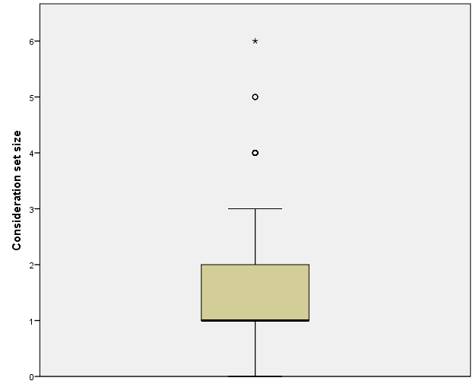
Dutch people consider zero (5.4%) to six (0.3%) health insurance companies when facing a purchase decision. But most of them consider one (53.9%) or two (25.1%) health insurance companies as is shown in figure 6.
There is a significant positive correlation between consideration set size and the use of memory. Indicating that as the use of memory increases, the consideration set size increases as well and vice versa with an effect size of 0.12.
Figure 7 Boxplot consideration set size
H1a: The size of the consideration set is positively related to the level of consumers’ objective knowledge.
With the use of Pearson correlation analysis, a significant correlation is found between the consideration set size and the level of objective knowledge, r = .11, p < .05.
Simple regression analysis is used to test if the level of objective knowledge significantly predicted the size of the consideration set. The results of the regression indicated that the predictor, objective knowledge, explained 1.1% of the variance (R² = .01, F = 4.15, p <.05). This means that 98.9% of the variation cannot be explained by the level of objective knowledge and therefore there must be other variables that have an influence as well.
It is found that the level of objective knowledge significantly predicted the size of the consideration set (β = .08, p < .05). Based on the results of the simple regression analysis, the following model is defined:
Consideration set size = 1.128 + (0.08 x objective knowledge level) + ε_{i}
This indicates that when the level of objective knowledge is zero, the model predicts the considerations set size to be 1.13. For each increase of the level of objective knowledge by one unit, the consideration set size will increase with 0.08.
Based on the results of the Pearson correlation and simple regression analysis, H1a is accepted.
H1b: The size of the consideration set is positively related to the level of consumers’ subjective knowledge.
With the use of Pearson correlation analysis, a significant correlation is found between the consideration set size and the level of subjective knowledge, r = .17, p < .01.
Simple regression analysis is used to test if the level of subjective knowledge significantly predicted the size of the consideration set. The results of the regression indicated that the predictor, subjective knowledge, explained 2.8% of the variance (R² = .03, F = 10.75, p <.01). This means that 97.2% of the variation cannot be explained by the level of subjective knowledge and therefore there must be other variables that have an influence as well.
It is found that the level of subjective knowledge significantly predicted the size of the consideration set (β = .16, p < .01). Based on the results of the simple regression analysis, the following model is defined:
Consideration set size = 0.867 + (0.164 x subjective knowledge level) + ε_{i}
This indicates that when the level of subjective knowledge is zero, the model predicts the considerations set size to be 0.87. For each increase of the level of subjective knowledge by one unit, the consideration set size will increase with 0.16.
Based on the results of the Pearson correlation and simple regression analysis, H1 is accepted.
H1c: The size of the consideration set is more positively related to the level of consumers’ objective knowledge than to the level of consumers’ subjective knowledge.
Based on the results of the previous two hypotheses, the correlation between the consideration set size and the level of subjective knowledge is lower than for the level of subjective knowledge. This indicates that the size of the consideration set is more positively related to subjective knowledge than to objective knowledge. Therefore, H1c is rejected.

Consumer knowledge and attributes
This section contains the results of the hypotheses testing for the amount and types of attributes variables with the levels of subjective and objective knowledge.

Types of attributes
Table 8 shows an overview of the importance of the different attributes for the choice of a health insurance and their correlation with the two knowledge constructs. Since ‘price’, ‘(free) choice health care providers’ and ‘content additional coverage’ are not significantly distributed; Spearman Correlation is used instead of the Pearson correlation which is used for the other variables. None of the intrinsic attributes is significantly correlated with objective knowledge or subjective knowledge. Looking at the extrinsic attribute price, a significant correlation is found with both the levels of subjective and objective knowledge.
Attribute | Subjective knowledge | Objective knowledge
Intrinsic
(Free) choice health care providers | 0.086 | -.007
Expenses claim | .050 | -.008
Content additional coverage | .034 | .079
Acceptance requirements | .023 | .011
Quality policy health care purchase | 0.029 | -0.020
Extrinsic
Price | 0.146** | 0.132*

* Significant at the .05 level
** Significant at the .01 level
Table 8 Correlation between subjective and objective knowledge and attributes
An average score is calculated for the importance of the five intrinsic attributes for the choice of a health insurance (IMPINT). Next to this the difference between IMPINT and the importance of price for the choice of a health insurance (IMPEXT) is used to measure the relative importance of extrinsic attributes over intrinsic attributes for the choice of a health insurance (RELIMP).

H2a: The relative importance of the use of extrinsic over intrinsic attributes for the purchase decision is negatively related to the level of consumers’ subjective knowledge.
With the use of a Pearson correlation analysis, a nonsignificant correlation of 0.03 (p = n.s) is found between the relative importance of the use of extrinsic attributes over intrinsic attributes for the purchase choice and the level of subjective knowledge.
Based on the results of the Pearson correlation analysis, H2a is rejected.
H2b: The use of intrinsic attributes is positively related to the level of consumers’ objective knowledge.
With the use of a Pearson correlation analysis, a nonsignificant correlation of 0.03 (p = n.s) is found between the use of extrinsic attributes and the level of objective knowledge.
Based on the results of the Pearson correlation analysis, H2b is rejected.

Amount of attributes
Dutch people consider zero (6.1%) to eight (0.3%) attributes to be important for their choice of a health insurance company. But most people consider one (26.3%), two (42.0%) or three (18.1%) attributes to be important as shown in figure 7.

Figure 8 Histogram amount of attributes
An interesting result is the significant positive correlation between the amount of attributes and the use of memory. Indicating that as the use of memory increases, the amount of attributes increases as well with 0.12 and vice versa.
H3a: The amount of attributes examined for the purchase decision is positively related to the level of consumers’ objective knowledge.
With the use of a Pearson correlation analysis, a nonsignificant correlation of 0.03 (p = n.s) is found between the amount of attributes examined and the level of objective knowledge.
Based on the results of the Pearson correlation analysis, H3a is rejected.

H3b: The amount of attributes examined for the purchase decision is positively related to the level of consumers’ subjective knowledge.
With the use of Pearson correlation analysis, a significant correlation is found between the amount of attributes examined for the purchase choice and the level of subjective knowledge, r = .12, p < .05.
Simple regression analysis is used to test if the level of subjective knowledge significantly predicted the amount of attributes examined for the purchase choice. The results of the regression indicated that the predictor, subjective knowledge, explained 1.4% of the variance (R² = .01, F = 5.27, p <.05). This means that 98.6% of the variation cannot be explained by the level of subjective knowledge and therefore there must be other variables that have an influence as well.
It is found that the level of subjective knowledge significantly predicted the amount of attributes examined for the purchase choice (β = .12, p < .05). Based on the results of the simple regression analysis, the following model is defined:
Amount of attributes examined = 1.431 + (0.122 x subjective knowledge level) + ε_{i}
This indicates that when the level of subjective knowledge is zero, the model predicts the amount of attributes examined for the purchase choice to be 1.43. For each increase of the level of subjective knowledge by one unit, the amount of attributes will increase with 0.12.
Based on the results of the Pearson correlation and simple regression analysis, H3b is accepted.
H3c: The amount of attributes examined for the purchase decision is more positively related to the level of consumers’ objective knowledge than to the level of consumers’ subjective knowledge.
Based on the results of the previous two hypotheses, a significant correlation between the amount of attributes examined for the purchase choice and the level of subjective knowledge is found but a nonsignificant correlation with the level of objective knowledge. Therefore, H1c is rejected.

Consumer knowledge and information sources
This section consists of the hypotheses testing concerning the variables information source types, subjective and objective knowledge.

Memory vs. external information sources
When looking at the average importance usage scores of each of the information source types, a top five ranking is visible with 1 being the most important information source type and 5 being the least important information source type.
- Previous involvement (mean = 5.69)
- Past personal experiences (mean = 5.58)
- Recall relevant events (mean = 4.25)
- Opinion of family member of relative (mean = 3.88)
- Opinion of friend or someone I know (mean = 3.77)
Statements that indicate that no information sources are used are ranked very low; first health insurance I found (mean=1.47), no additional information (mean=2.04), do not worry about requiring more information (mean=2.80).
When looking at the comparison between internal and external sources, the internal source (memory) is on average more important for the choice of a health insurance (table 9). Of the two types of extrinsic information sources, personal information sources scored slightly higher on average than impersonal information sources (table 9).
Information source type | Average raking
Internal | 5.174
External | 3.111
Personal | 3.170
Impersonal | 3.052

Table 9 Mean values information source types

H4: The use of memory as an internal information source is positively related to the level of consumers’ subjective knowledge.
With the use of Pearson correlation analysis, a significant correlation is found between the use of memory as an internal information source and the level of subjective knowledge, r = .14, p < .01.
Simple regression analysis is used to test if the level of subjective knowledge significantly predicted the use of memory as an internal information source. The results of the regression indicated that the predictor, subjective knowledge, explained 2.1% of the variance (R² = .02, F = 8.07, p <.01). This means that 97.9% of the variation cannot be explained by the level of subjective knowledge and therefore there must be other variables that have an influence as well.
It is found that the level of subjective knowledge significantly predicted the use of memory as an internal information source (β = .16, p < .01). Based on the results of the simple regression analysis, the following model is defined:
Use of memory = 4.493 + (0.157 x subjective knowledge level) + ε_{i}
This indicates that when the level of subjective knowledge is zero, the model predicts the use of memory as an internal information source to be 4.49. For each increase of the level of subjective knowledge by one unit, the use of memory will increase with 0.16.
Based on the results of the Pearson correlation and simple regression analysis, H4 is accepted.
The use of memory as an internal information source and objective knowledge
Although based on the literature study, no hypothesis could be drawn up between the level of objective knowledge and the use of memory, the relationship is tested. With the use of a Pearson correlation analysis, a nonsignificant correlation of -0.01 (p = n.s) is found between the use of memory as an internal information source and the level of objective knowledge.

H5a: The use of external information sources is negatively related to the level of consumers’ subjective knowledge.
With the use of a Pearson correlation analysis, a nonsignificant correlation of -0.07 (p = n.s) is found between the use of external information sources and the level of subjective knowledge.
Based on the results of the Pearson correlation analysis, H5a is rejected.
H5b: The use of external information sources is positively related to the level of consumers’ objective knowledge.
With the use of a Pearson correlation analysis, a nonsignificant correlation of -0.04 (p = n.s) is found between the use of external information sources and the level of objective knowledge.
Based on the results of the Pearson correlation analysis, H5b is rejected.

Personal vs. impersonal information sources
H6a: The use of personal information is negatively related to the level of consumers’ subjective knowledge.
With the use of Pearson correlation analysis, a significant correlation is found between the use of personal information sources and the level of subjective knowledge, r = -.13, p < .01.
Simple regression analysis is used to test if the level of subjective knowledge significantly predicted the use of personal information sources. The results of the regression indicated that the predictor, subjective knowledge, explained 1.8% of the variance (R² = .02, F = 6.98, p <.01). This means that 98.2% of the variation cannot be explained by the level of subjective knowledge and therefore there must be other variables that have an influence as well.
It was found that the level of subjective knowledge significantly predicted the use of personal information sources (β = -.16, p < .01). Based on the results of the simple regression analysis, the following model is defined:
Use personal information sources = 3.841 - (0.155 x subjective knowledge level) + ε_{i}
This indicates that when the level of subjective knowledge is zero, the model predicts the use of personal information sources to be 3.84. For each increase of the level of subjective knowledge by one unit, the use personal information sources will decrease with 0.16.
Based on the results of the Pearson correlation and simple regression analysis, H6a is accepted.

H6b: The use of impersonal information sources is negatively related to the level of consumers’ subjective knowledge.
With the use of a Pearson correlation analysis, a nonsignificant correlation of 0.03 (p = n.s) is found between the use of impersonal information sources and the level of subjective knowledge.
Based on the results of the Pearson correlation analysis, H6b is rejected.
H6c: The use of impersonal information sources compared to personal information sources is more negatively related to the level of consumers’ subjective knowledge.
Based on the results of the previous two hypotheses, a significant correlation between the use of personal information sources and the level of subjective knowledge is found but a nonsignificant correlation with use of impersonal information sources. Therefore, H6c is rejected.
H6d: The use of personal information sources is positively related to the level of consumers’ objective knowledge.
With the use of Pearson correlation analysis, a significant correlation is found between the use of personal information sources and the level of objective knowledge, r = -.11, p < .05.
Simple regression analysis is used to test if the level of objective knowledge significantly predicted the use of personal information sources. The results of the regression indicated that the predictor, objective knowledge, explained 1.1% of the variance (R² = .01, F = 4.45, p <.05). This means that 98.9% of the variation cannot be explained by the level of objective knowledge and therefore there must be other variables that have an influence as well.
It is found that the level of objective knowledge significantly predicted the use of personal information sources (β = -.10, p < .05). Based on the results of the simple regression analysis, the following model is defined:
Use personal information sources = 3.703 - (0.096 x objective knowledge level) + ε_{i}
This indicates that when the level of objective knowledge is zero, the model predicts the use of personal information sources to be 3.70. For each increase of the level of objective knowledge by one unit, the use personal information sources will decrease with 0.10.
Based on the results of the Pearson correlation and simple regression analysis, H6d is rejected.
H6e: The use of impersonal information sources is positively related to the level of consumers’ objective knowledge.
With the use of a Pearson correlation analysis, a nonsignificant correlation of 0.05 (p = n.s) is found between the use of impersonal information sources and the level of objective knowledge.
Based on the results of the Pearson correlation analysis, H6e is rejected.
H6f: The use of impersonal information sources compared to personal information sources is more positively related to the level of consumers’ objective knowledge.
Based on the results of the previous two hypotheses, a significant correlation between the use of personal information sources and the level of objective knowledge is found but a nonsignificant correlation with use of impersonal information sources. Therefore, H6f is rejected.

Consumer knowledge calibration
Respondents are a little overconfident about their knowledge of health insurances with an average confidence of 65.3% while the average number of correct questions is 5.6 on a scale from 0 to 10. Confidence in the correctness of the questions about health insurances ranges from 0 to 98.3% with 69% as the most common confidence percentage.
Knowledge calibration varies from -0.68 to 0.64 as showed in figure 8. A negative value of knowledge calibration indicates a lower level of confidence than the level of knowledge whereas a positive value indicates a higher level of confidence compared to the level of knowledge. Also illustrated in figure X are the more respondents that have positive values of knowledge calibration compared to the ones with negative values.
When looking at direct correlation effects of consumer knowledge calibration, significant results are found for the level of involvement (p = .15, s < .01), the level of objective knowledge (p = -.4, s < .01), the level of subjective knowledge (p = .23, s < .01) and the use of memory (p = .10, s < .05).
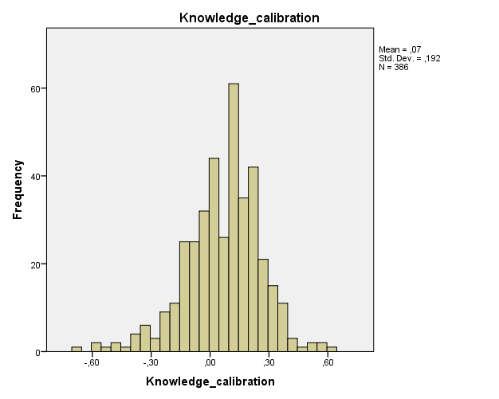
Figure 9 Histogram knowledge calibration

In order to test the moderating effect of the level of knowledge calibration, centered values of all predictors (objective knowledge, subjective knowledge and knowledge calibration) are used as well as an interaction effect between the level of knowledge, either objective or subjective, and knowledge calibration (University of Twente).

H7a: Consumer knowledge calibration moderates the relationship between the level of consumers’ objective knowledge and the size of the consideration set.
When taken into account the interaction effect of the level of knowledge calibration and objective knowledge with the use of multiple regression analysis, the variance explanation of the consideration set size nonsignificantly increases to 1.8% (R² = .02, F = 2.15, p = n.s). The interaction coefficient between the level of objective knowledge and knowledge calibration differs not significantly from zero (β = -.06, p = n.s).
Knowledge calibration does not moderate the relationship between objective knowledge and the consideration set size, thus H7a is rejected.
H7b: Consumer knowledge calibration moderates the relationship between the level of consumers’ subjective knowledge and the size of the consideration set.
When taken into account the interaction effect of the level of knowledge calibration and subjective knowledge with the use of multiple regression analysis, the variance explanation of the consideration set size nonsignificantly increases to 3.2% (R² = .03, F = 3.90, p < .01). The interaction coefficient between the level of subjective knowledge and knowledge calibration differs not significantly from zero (β = -.04, p = n.s).
Knowledge calibration does not moderate the relationship between subjective knowledge and the consideration set size, thus H7b is rejected.
H7c: Consumer knowledge calibration moderates the relationship between the level of consumers’ subjective knowledge and the relative importance of the use of extrinsic over intrinsic attributes for the purchase decision.
When taken into account the interaction effect of the level of knowledge calibration and subjective knowledge with the use of multiple regression analysis, the variance explanation of the relative importance of the use of extrinsic over intrinsic attributes for the purchase decision nonsignificantly increases to 0.8% (R² = .01, F = 1.01, p = n.s). The interaction coefficient between the level of subjective knowledge and knowledge calibration differs not significantly from zero (β = .15, p = n.s).
Knowledge calibration does not moderates the relationship between subjective knowledge and the relative importance of the use of extrinsic over intrinsic attributes for the purchase decision, thus H7c is rejected.
H7d: Consumer knowledge calibration moderates the relationship between the level of consumers’ objective knowledge and the use of intrinsic attributes for the purchase decision.
When taken into account the interaction effect of the level of knowledge calibration and objective knowledge with the use of multiple regression analysis, the variance explanation of the use of intrinsic attributes nonsignificantly increases to 1.6% (R² = .02, F = 2.09, p = n.s). The interaction coefficient between the level of knowledge calibration and objective knowledge differs not significantly from zero (β = .22, p = n.s).
Knowledge calibration does not moderates the relationship between objective knowledge and the use of intrinsic attributes, thus H7d is rejected.
H7e: Consumer knowledge calibration moderates the relationship between the level of consumers’ objective knowledge and the amount of attributes examined for the purchase decision.
When taken into account the interaction effect of the level of knowledge calibration and objective knowledge with the use of multiple regression analysis, the variance explanation of the amount of attributes examined for the purchase decision nonsignificantly increases to 0.9% (R² = .01, F = 1.12, p = n.s). The interaction coefficient between the level of knowledge calibration and objective knowledge differs not significantly from zero (β = .26, p = n.s).
Knowledge calibration does not moderates the relationship between objective knowledge and the amount of attributes examined for the purchase decision, thus H7e is rejected.
H7f: Consumer knowledge calibration moderates the relationship between the level of consumers’ subjective knowledge and the amount of attributes examined for the purchase decision.
When taken into account the interaction effect of the level of knowledge calibration and subjective knowledge with the use of multiple regression analysis, the variance explanation of the amount of attributes examined for the purchase decision nonsignificantly increases to 1.6% (R² = .02, F = 1.97, p = n.s). The interaction coefficient between the level of knowledge calibration and subjective knowledge differs not significantly from zero (β = -.18, p = n.s).
Knowledge calibration does not moderates the relationship between subjective knowledge and the amount of attributes examined for the purchase decision, thus H7f is rejected.

H7g: Consumer knowledge calibration moderates the relationship between the level of consumers’ subjective knowledge and the use of memory as an internal information source.
When taken into account the interaction effect of the level of knowledge calibration and subjective knowledge with the use of multiple regression analysis, the variance explanation of the use of memory as an internal information source nonsignificantly increases to 2.5% (R² = .03, F = 3.27, p < .05). The interaction coefficient between the level of knowledge calibration and subjective knowledge differs not significantly from zero (β = -.02, p = n.s).
Knowledge calibration does not moderates the relationship between subjective knowledge and the use of memory as an internal information source, thus H7g is rejected.
The use of memory as an internal information source and objective knowledge
Although based on the literature study, no hypothesis could be drawn up between objective knowledge and the use of memory and no direct relationship was found, the moderating effect of consumer knowledge calibration is tested.
When taken into account the interaction effect of the level of knowledge calibration and objective knowledge with the use of multiple regression analysis, the variance explanation of the use memory as an internal information source nonsignificantly increases to 1.3% (R² = .01, F = 1.62, p < n.s). The interaction coefficient between the level of knowledge calibration and objective knowledge differs not significantly from zero (β = .21, p < .n.s).
Knowledge calibration does not moderate the relationship between objective knowledge and the use of memory as an internal information source.
H7h: Consumer knowledge calibration moderates the relationship between the level of consumers’ subjective knowledge and the use of external information sources.
When taken into account the interaction effect of the level of knowledge calibration and subjective knowledge with the use of multiple regression analysis, the variance explanation of the use of external information sources nonsignificantly increases to 0.5% (R² = .01, F = .60, p = n.s). The interaction coefficient between the level of knowledge calibration and subjective knowledge differs not significantly from zero (β = .06, p = n.s).
Knowledge calibration does not moderates the relationship between subjective knowledge and the use of external information sources, thus H7h is rejected.

H7i: Consumer knowledge calibration moderates the relationship between the level of consumers’ objective knowledge and the use of external information sources.
When taken into account the interaction effect of the level of knowledge calibration and objective knowledge with the use of multiple regression analysis, the variance explanation of the use of external information sources nonsignificantly increases to 0.4% (R² = .00, F = .49, p = n.s). The interaction coefficient between the level of knowledge calibration and objective knowledge differs not significantly from zero (β = -.11, p = n.s).
Knowledge calibration does not moderates the relationship between objective knowledge and the use of external information sources, thus H7i is rejected.
H7j: Consumer knowledge calibration moderates the relationship between the level of consumers’ subjective knowledge and the use of personal information sources.
When taken into account the interaction effect of the level of knowledge calibration and subjective knowledge with the use of multiple regression analysis, the variance explanation of the use of personal information sources nonsignificantly increases to 1.8% (R² = .02, F = 2.38, p = n.s). The interaction coefficient between the level of knowledge calibration and subjective knowledge differs not significantly from zero (β = .09, p = n.s).
Knowledge calibration does not moderates the relationship between subjective knowledge and the use of personal information sources, thus H7j is rejected.
H7k: Consumer knowledge calibration moderates the relationship between the level of consumers’ subjective knowledge and the use of impersonal information sources.
When taken into account the interaction effect of the level of knowledge calibration and subjective knowledge with the use of multiple regression analysis, the variance explanation of the use of impersonal information sources nonsignificantly increases to 0.1% (R² = .00, F = .17, p = n.s). The interaction coefficient between the level of knowledge calibration and subjective knowledge differs not significantly from zero (β = .11, p = n.s).
Knowledge calibration does not moderates the relationship between subjective knowledge and the use of impersonal information sources, thus H7k is rejected.

H7l: Consumer knowledge calibration moderates the relationship between the level of consumers’ objective knowledge and the use of personal information sources.
When taken into account the interaction effect of the level of knowledge calibration and objective knowledge with the use of multiple regression analysis, the variance explanation of the use of personal information sources nonsignificantly increases to 2.1% (R² = .02, F = 2.75, p < .05). The interaction coefficient between the level of knowledge calibration and objective knowledge differs not significantly from zero (β = .08, p = n.s).
Knowledge calibration does not moderates the relationship between objective knowledge and the use of personal information sources, thus H7l is rejected.
H7m: Consumer knowledge calibration moderates the relationship between objective knowledge and the use of impersonal information sources.
When taken into account the interaction effect of the level of knowledge calibration and objective knowledge with the use of multiple regression analysis, the variance explanation of the use of impersonal information sources nonsignificantly increases to 0.5% (R² = .01, F = .69, p = n.s). The interaction coefficient between the level of knowledge calibration and objective knowledge differs not significantly from zero (β = -.31, p = n.s).
Knowledge calibration does not moderates the relationship between objective knowledge and the use of impersonal information sources, thus H7m is rejected.

Involvement
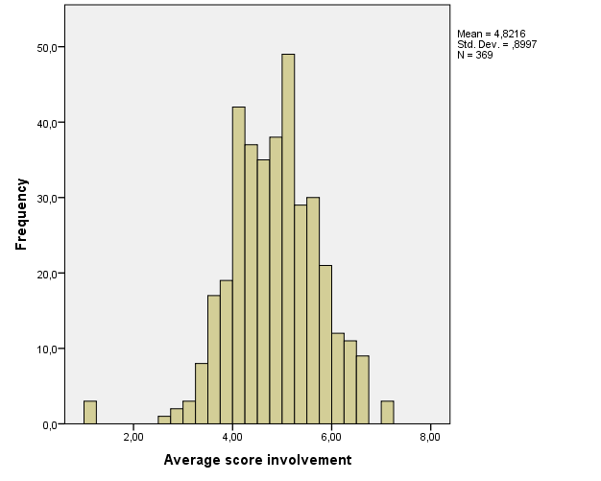
With an average involvement of 4.8 on a scale from 1 to 7, Dutch inhabitants can be described as medium involved with the purchase of a health insurance. As illustrated in figure 9, most respondents vary around the middle of the scale with 5.20 (3.8%) and 4.40 (3.5%) as the most common values of the involvement level.
Figure 10 Histogram involvement
In order to test the moderating effect of the level of involvement, centered values of all predictors (objective knowledge, subjective knowledge and involvement) are used as well as an interaction effect between the level of knowledge, either objective or subjective, and involvement (University of Twente).

H8a: Involvement moderates the relationship between the level of consumers’ objective knowledge and the size of the consideration set.
When taken into account the interaction effect of the level of involvement and objective knowledge with the use of multiple regression analysis, the variance explanation of the consideration set size nonsignificantly increases to 1.8% (R² = .02, F = 2.15, p = n.s). The interaction coefficient between the level of objective knowledge and involvement differs not significantly from zero (β = -.06, p = n.s).
Involvement does not moderate the relationship between objective knowledge and the consideration set size, thus H8a is rejected.
H8b: Involvement moderates the relationship between the level of consumers’ subjective knowledge and the size of the consideration set.
When taken into account the interaction effect of the level of involvement and subjective knowledge with the use of multiple regression analysis, the variance explanation of the consideration set size nonsignificantly increases to 3.2% (R² = .03, F = 3.90, p < .01). The interaction coefficient between the level of subjective knowledge and involvement differs not significantly from zero (β = -.04, p = n.s).
Involvement does not moderate the relationship between subjective knowledge and the consideration set size, thus H8b is rejected.

H8c: Involvement moderates the relationship between the level of consumers’ subjective knowledge and the relative importance of the use of extrinsic over intrinsic attributes for the purchase decision.
When taken into account the interaction effect of the level of involvement and subjective knowledge with the use of multiple regression analysis, the variance explanation of the relative importance of the use of extrinsic attributes over intrinsic attributes for the purchase decision significantly increases to 7.2% (R² = .07, F = 8.98, p <.001). The interaction coefficient between the level of subjective knowledge and involvement differs significantly from zero (β = .19, p < .001). The size of the effect based on the value of f² can be described as low (f² = 0.04).
With tolerance values above 0.1 and VIF values not greater than 10 (Field, 2009), there are no indicators of multicollinearity found.
Involvement positively moderates the relationship between subjective knowledge and the relative importance of the use of extrinsic attributes over intrinsic attributes for the purchase decision, thus H8c is accepted. This means that the higher the level of involvement, the more important the level of subjective knowledge becomes for the relative importance of extrinsic attributes over intrinsic attributes as showed in figure 10.

Figure 11 Moderating effect involvement H8c
H8d: Involvement moderates the relationship between objective knowledge and the use of intrinsic attributes for the purchase decision.
When taken into account the interaction effect of the level of involvement and objective knowledge with the use of multiple regression analysis, the variance explanation of the use of intrinsic attributes significantly increases to 18.5% (R² = .19, F = 27.71, p <.001). The interaction coefficient between the level of objective knowledge and involvement differs significantly from zero (β = -.05, p < .05). The size of the effect based on the value of f² can be described as low (f² = 0.01).
With tolerance values above 0.1 and VIF values not greater than 10 (Field, 2009), there are no indicators of multicollinearity found.
Involvement negatively moderates the relationship between objective knowledge and the use of intrinsic attributes for the purchase decision, thus H8d is accepted. This means that the higher the level of involvement, the less important the level of objective knowledge becomes for the use of intrinsic attributes for the purchase decision as showed in figure 11.

Figure 12 Moderating effect involvement H8d

H8e: Involvement moderates the relationship between the level of consumers’ objective knowledge and the amount of attributes examined for the purchase decision.
When taken into account the interaction effect of the level of involvement and objective knowledge with the use of multiple regression analysis, the variance explanation of the amount of attributes examined for the purchase decision nonsignificantly increases to 0.7% (R² = .01, F = .81, p = n.s). The interaction coefficient between the level of involvement and objective knowledge differs not significantly from zero (β = -.05, p = n.s).
Involvement does not moderates the relationship between objective knowledge and the amount of attributes examined for the purchase decision, thus H8e is rejected.
H8f: Involvement moderates the relationship between the level of consumers’ subjective knowledge and the amount of attributes examined for the purchase decision.
When taken into account the interaction effect of the level of involvement and subjective knowledge with the use of multiple regression analysis, the variance explanation of the amount of attributes examined for the purchase decision nonsignificantly increases to 1.1% (R² = .01, F = 1.28, p = n.s). The interaction coefficient between the level involvement and subjective knowledge differs not significantly from zero (β = -.01, p = n.s).
Involvement does not moderates the relationship between subjective knowledge and the amount of attributes examined for the purchase decision, thus H8f is rejected.
H8g: Involvement moderates the relationship between the level of consumers’ subjective knowledge and the use of memory as an internal information source.
When taken into account the interaction effect of the level of involvement and subjective knowledge with the use of multiple regression analysis, the variance explanation of the use of memory as an internal information source nonsignificantly increases to 5.9% (R² = .06, F = 7.58, p < .001). The interaction coefficient between the level of involvement and subjective knowledge differs not significantly from zero (β = -.05, p = n.s).
Involvement does not moderates the relationship between subjective knowledge and the use of memory as an internal information source, thus H8g is rejected.

The use of memory as an internal information source and objective knowledge
Although based on the literature study, no hypothesis could be drawn up between objective knowledge and the use of memory and no direct relationship was found, the moderating effect of involvement is tested.
When taken into account the interaction effect of the level of involvement and objective knowledge with the use of multiple regression analysis, the variance explanation of the use memory as an internal information source significantly increases to 7.6% (R² = .08, F = 10.01, p <.001). The interaction coefficient between the level of objective knowledge and involvement differs significantly from zero (β = -.12, p < .01). The size of the effect based on the value of f² can be described as low (f² = 0.02).
With tolerance values above 0.1 and VIF values not greater than 10 (Field, 2009), there are no indicators of multicollinearity found.
Involvement negatively moderates the relationship between objective knowledge and the use memory as an internal information source. This means that the higher the level of involvement, the less important the level of objective knowledge becomes for the use of memory as an internal information source as showed in figure 12.

Figure 13 Moderating effect involvement objective knowledge and memory

H8h: Involvement moderates the relationship between the level of consumers’ subjective knowledge and the use of external information sources.
When taken into account the interaction effect of the level of involvement and subjective knowledge with the use of multiple regression analysis, the variance explanation of the use of external information sources nonsignificantly increases to 5.3% (R² = .05, F = 6.88, p < .001). The interaction coefficient between the level of involvement and subjective knowledge differs not significantly from zero (β = -.02, p = n.s).
Involvement does not moderates the relationship between subjective knowledge and the use of external information sources, thus H8h is rejected.

H8i: Involvement moderates the relationship between the level of consumers’ objective knowledge and the use of external information sources.
When taken into account the interaction effect of the level of involvement and objective knowledge with the use of multiple regression analysis, the variance explanation of the use of external information sources significantly increases to 6,5% (R² = .07, F = 8.47, p <.001). The interaction coefficient between the level of objective knowledge and involvement differs significantly from zero (β = -.11, p < .01). The size of the effect based on the value of f² can be described as low (f² = 0.02).
With tolerance values above 0.1 and VIF values not greater than 10 (Field, 2009), there are no indicators of multicollinearity found.
Involvement negatively moderates the relationship between objective knowledge and the relative use of external information sources, thus H8i is accepted. This means that the higher the level of involvement, the less important the level of objective knowledge becomes for the use of external information sources as showed in figure 13.

Figure 14 Moderating effect involvement H8i

H8j: Involvement moderates the relationship between the level of consumers’ subjective knowledge and the use of personal information sources.
When taken into account the interaction effect of the level of involvement and subjective knowledge with the use of multiple regression analysis, the variance explanation of the use of personal information sources nonsignificantly increases to 6.4% (R² = .06, F = 8.33, p < 0.001). The interaction coefficient between the level of involvement and subjective knowledge differs not significantly from zero (β = .00, p = n.s).
Involvement does not moderates the relationship between subjective knowledge and the use of personal information sources, thus H8j is rejected.
H8k: Involvement moderates the relationship between the level of consumers’ subjective knowledge and the use of impersonal information sources.
When taken into account the interaction effect of the level of involvement and subjective knowledge with the use of multiple regression analysis, the variance explanation of the use of impersonal information sources nonsignificantly increases to 1.8% (R² = .02, F = 3.30, p < .05). The interaction coefficient between the level of involvement and subjective knowledge differs not significantly from zero (β = -.02, p = n.s).
Involvement does not moderates the relationship between subjective knowledge and the use of impersonal information sources, thus H8k is rejected.

H8l: Involvement moderates the relationship between the level of consumers’ objective knowledge and the use of personal information sources.
When taken into account the interaction effect of the level of involvement and objective knowledge with the use of multiple regression analysis, the variance explanation of the use of personal information sources significantly increases to 7.8% (R² = .08, F = 10.31, p <.001). The interaction coefficient between the level of objective knowledge and involvement differs significantly from zero (β = -.149, p < .01). The size of the effect based on the value of f² can be described as low (f² = 0.03).
With tolerance values above 0.1 and VIF values not greater than 10 (Field, 2009), there are no indicators of multicollinearity found.
Involvement negatively moderates the relationship between objective knowledge and the use of personal information sources, thus H8l is accepted. This means that the higher the level of involvement, the less important the level of objective knowledge becomes for the use of personal information sources as showed in figure 14.

Figure 15 Moderating effect involvement H8l

H8m: Involvement moderates the relationship between the level of consumers’ objective knowledge and the use of impersonal information sources.
When taken into account the interaction effect of the level of involvement and objective knowledge with the use of multiple regression analysis, the variance explanation of the use of impersonal information sources nonsignificantly increases to 3.0% (R² = .03, F = 3.81, p < .05). The interaction coefficient between the level of involvement and objective knowledge differs not significantly from zero (β = -.06, p = n.s).
Involvement does not moderates the relationship between objective knowledge and the use of impersonal information sources, thus H8m is rejected.

Hypotheses testing summary
In total, 5 of the17 hypotheses between dependent and independent variables are accepted. Of the moderating hypotheses, 4 (0 consumer knowledge calibration + 4 involvement) out of 26 (13 consumer knowledge calibration + 13 involvement) are accepted. An overview of all tested hypothesis and whether they are rejected and accepted can be found in appendix V.

Discussion and conclusion
Chapter 7 Discussion
Chapter 8 Conclusion
Discussion and conclusion
Discussion and conclusion
Chapter 7 Discussion
Chapter 8 Conclusion

Discussion
Chapter six has discussed the statistical analysis of the data with testing the different hypotheses from the conceptual framework. This chapter contains the interpretation of the results and is divided into the three different dependent focus areas; consideration set size, amount and type of attributes and information source types followed by the moderating effects of consumer knowledge calibration and involvement.

Consumer knowledge and the consideration set size
The amount of options that are considered for purchase, 1 to 2 health insurance companies, is relatively low compared to the total amount of 26 health insurance companies in the Netherlands. This is in line with Hauser and Wernerfelt (1990). A positive relationship was expected between the size of the consideration set and the levels of subjective and objective knowledge, which is confirmed by the results. The higher the level of objective and/or subjective knowledge about health insurances, the more health insurance companies are considered.
The relationship with objective knowledge can be explained by the theoretical arguments of higher expertise and willingness to process new information with increased levels of objective knowledge. For subjective knowledge this can be argued by the increased experience associated with higher levels of subjective knowledge and thus higher awareness of an increasing number of health insurance companies.
As opposed to the expectations based on prior research, the level of subjective knowledge, compared to the level of objective knowledge, is more positively related to the size of the consideration set. Results show that as the use of memory as an internal source increases, the size of the consideration set increases as well and vice versa. This relationship is not found for external information sources suggesting that the consideration set size is only related to the use of internal information sources. Memory is an important driver of the level of subjective knowledge, the use of external sources is more related to objective knowledge. This indicates that the use of memory can be an important aspect that causes the more positive relationship between subjective knowledge and the consideration set size. However, an important note is that participants could not use any external information source when answering the question about the size of the consideration set. This answer was therefore only based on respondents’ memory. In a real pre-purchase situation, consumers can use external information sources which might enlarge their consideration set size more than when only using their memory.
An important note about the results is that both the level of subjective and objective knowledge only explains a little part of the variance of the consideration set size and thus a lot is explained by other variables not found in this research.

Consumer knowledge and the amount and type of attributes
The amount of attributes that are considered to be important for the purchase decision show similar results as the consideration set size. The amount of attributes is also quite small with one and two attributes as the most common values.
In accordance with prior research and associated expectations, a positive relationship is found between subjective knowledge and the amount of attributes. However, in contrast to the expectations, no relationship is found between the level of objective knowledge and the amount of attributes. This indicates that higher levels of subjective knowledge and thus experience with health insurances increase the amount of attributes of a health insurance that are considered to be important for the choice. In the context of health insurances, increased ability associated with increased objective knowledge does not cause people to consider more attributes for their choice. However this could again be explained by the way of questioning. Respondents could not use any external information sources which might, especially likely for consumers with high objective knowledge levels, increase the amount of attributes that are considered to be important for the purchase.
The supported relationship with subjective knowledge compared to the, in this case, not found relationship with objective knowledge shows similarities with the consideration set size. Results showed that as the use of memory increases, the amount of attributes considered to be important for the choice of a health insurance company increased as well and vice versa. This does not only indicate that memory could also be in this case an important aspect that causes the positive relationship with subjective knowledge compared to the missing relationship with objective knowledge, but also indicates that the consideration set size and amount of attributes show a lot of similarities.
An important note about the results is that the level of subjective only explains a little part of the variance in the amount of attributes and a lot is explained by other variables not found in this research.

Taking a deeper look into the attributes by comparing the importance of extrinsic and intrinsic attributes, shows that none of the individual intrinsic attributes are related to the level of either subjective or objective knowledge. This could indicate that the importance of the different intrinsic attributes of a health insurance such as the content of additional coverage or the free choice of a health care provider are important to a certain level independently from how much someone knows or have experienced health insurance services. Price is however positively related to both objective and subjective knowledge suggesting that as the level of subjective and/or objective knowledge increases, the importance of price for the choice of a health insurance company increases.
As opposed to the expectations based on prior research, the relative importance of extrinsic attributes over intrinsic attributes for the choice of a health insurance company is not negatively related to subjective knowledge. This indicates that the price of a health insurance does not become less important compared to the intrinsic attributes, such as method of expenses claim or the content of additional coverage, as the level of experience and thus subjective knowledge increases. After seeing that price does relate to the level of subjective knowledge and the individual intrinsic attributes do not, it can be assumed that the overall importance of intrinsic attributes for health insurances is independent from the level of subjective knowledge.
Next to this, the use of intrinsic attributes for the choice of a health insurance company is not related to the level of objective knowledge. This could indicate that the intrinsic attributes of a health insurance do not require higher levels of objective knowledge, and thus expertise, to be evaluated for the purchase decision of a health insurance.

Consumer knowledge and information sources types
For the choice of a health insurance, the use of internal information (memory) is considered to be more important than the use of external information sources according to the results. Almost no difference was found between the usage level of personal information compared the usage level of impersonal information sources.
A positive relationship was expected and found between the use of memory for the choice of a health insurance company and the level of subjective knowledge. Consisted with prior literature, no relationship is found with the level of objective knowledge. This positive relationship with subjective knowledge and the use of memory supports the theory of various researchers such as Brucks (1985). These results indicate that as the level of subjective knowledge increases, consumers thus have more experience and will have increased confidence in their own expertise, which leads them to higher usage of their memory when facing the purchase decision of a health insurance.
However contrary to the expectations, results showed no relationship between the use of external information for the choice of a health insurance and the levels of both subjective and objective knowledge. This indicates that both the levels of expertise, associated with objective knowledge, and experience, associated with subjective knowledge; do not influence the use of the different external information sources for health insurances. This could be explained by the context of this thesis. Since people appear to use their memory more for the choice of health insurances than they use external sources, the last one might be not so important for this service and could cause the effects to be not visible in this context.
By taking a closer look at the external information sources, some relationships are found. A negative relationship was expected between the use of personal information sources and the level of subjective knowledge; the results confirm this negative relationship. Since subjective knowledge and the use of memory appeared to be very important for the choice of health insurances, this could indicate that when the experience of someone increases, the preference for the use of memory increases detriment of the use of personal information sources. The level of objective knowledge appeared also to be negatively related to the use of personal information source while a positive relationship was expected. This indicates that personal information sources are mainly used by people with low levels of subjective and objective knowledge and are considered to be relatively less important for the choice of a health insurance compared to memory.
However this does not apply for the use of impersonal information since the expected relationships with the levels of objective and subjective knowledge were not supported. The use of impersonal information sources appears to have different explanatory factors than the use of personal information sources. However, the variance of the use of both internal and personal information that is explained by the two knowledge construct levels is very low indicating that there are factors outside this research that explain a lot of the variance of the usage levels of internal and external information sources.

The role of consumer knowledge calibration
Based on the relatively small amount of existing research about the effects of consumer knowledge calibration, a moderating effect of consumer knowledge calibration was expected between the two constructs of knowledge and the consideration set size, amount and type of attributes and the information source types. However, no moderating effects were found for any of the relationships. This indicates that the calibration between accuracy and confidence does not have a moderating effect within the context of health insurances. This might be explained by the used context in which people appeared to be quite centered on the middle of the level of knowledge calibration and relatively few people have extreme values of miscalibration which could cause the effects of different levels of consumer knowledge calibration to be not visible in the results.
Looking at the direct effect of consumer knowledge calibration however reveals relationships with the level of involvement (positive), of objective knowledge (negative), the level of subjective knowledge (positive), the level and the use of memory as an information source (positive). The first one could be explained by assuming that the higher the involvement level, the more important it becomes to choose the “right” health insurance and those people could have a more realistic view of how much they know. The last two could again be explained by the context of this study since previous findings also indicate that subjective knowledge and memory are important factors for the purchase of health insurances.

The role of involvement
Since involvement is an important aspect of the perceived benefits of a search strategy (Punj & Staelin, 1983), this is expected to moderate the relationship between the levels of subjective and objective knowledge and the consideration set size, amount and type of attributes and the information source types.
As expected, the results reveal a positive moderating effect between the relative importance of extrinsic attributes over intrinsic attributes for the purchase decision of a health insurance and the level of subjective knowledge. The direct relationship between the two variables is not found. This indicates that the level of subjective knowledge becomes (more) important for relative importance of extrinsic over intrinsic attributes important when people are highly involved with the purchase decision of a health insurance. Since not much people have a very high level of involvement with the purchase of a health insurance this could explain the not supported direct relationship.
Other moderating effects are found for the relationship between objective knowledge and the use of intrinsic attributes, the use of memory and the use of external information sources. The direct relationship between the variables is not found. This indicates that the lower the level of involvement, the higher the importance of objective knowledge becomes for the use of intrinsic attributes, the use of memory and external information for the purchase decision of a health insurance. Since not much people have a low level of involvement with the purchase of a health insurance this could explain the not supported direct relationships.
The last moderating effect is found for the relationship between objective knowledge and the use of personal information. The direct relationship is also found. This indicates that the level of objective knowledge becomes less important for the use of personal information sources when people are highly involved with the purchase of a health insurance.
Opposite to the expectations, no other moderating effects are found which could indicate that the level of involvement does not have a large influence on the search behavior for Dutch health insurances. However this could also be caused by the fact that most people are medium involved which might limit the revelation of the effects of high and low levels of involvement during the data analysis.

General discussion
Looking at the total results of this study, the level of subjective knowledge is related to the size of the consideration set size, the amount of attributes that are examined for the purchase decision, the use of memory and the use of personal information of which only the last one showed a negative relationship. The level of objective knowledge proved only to be related to the size of the consideration set. This could indicate that the level of subjective knowledge is a more important driver of the pre-purchase information search stage for health insurances than the level of objective knowledge. However, if people would be low involved with the purchase of a health insurance, the level of objective knowledge would increase in importance for the use of intrinsic attributes, the use of memory and the use of external information.
Non supported relationships in this study are likely to be caused by the context of this study. Within the context of health insurances people appeared to have quite medium levels of subjective, objective knowledge, involvement and knowledge calibration which could limit the visibility of the effects for different levels.

Conclusion

General conclusion and main findings
This thesis aimed at gaining insight into the influence of the two knowledge constructs (objective and subjective knowledge) on the pre-purchase search behavior and the role of consumer knowledge calibration. Focus is given to the consideration set size, amount and type of attributes and information source types within the context of Dutch health insurances. Also the effect of the involvement level is taken into account. This section provides the final conclusion of this study by answering the central research question of this study.
The central research question of this thesis was: “What is the influence of the level of subjective and objective knowledge on the pre-purchase information search phase and the role of consumer knowledge calibration for Dutch health insurances?” This will be discussed using the three sub questions in which the central research question is defined.
What is the influence of the level of objective and subjective knowledge on the consideration set size and the role of consumer knowledge calibration for Dutch health insurance companies?
The level of objective and subjective knowledge positively influences the consideration set size of health insurances. An increased level of the knowledge constructs both results in a larger number of health insurances that are considered for purchase. However, the level of calibration between people’s confidence in and accuracy of their knowledge does not play a role in these positive relationships.
What is the influence of the level of objective and subjective knowledge on the amount and type of attributes considered and the role of consumer knowledge calibration when choosing a Dutch health insurance company?
The level of subjective knowledge positively influences the amount of attributes considered of a health insurance. Increased levels of subjective knowledge results in a larger number of attributes that are considered to be important for the purchase decision of a health insurance. However the level of objective knowledge does not influence the amount of attributes consider to be important for the purchase of a health insurance. The level of calibration between people’s confidence in and accuracy of their knowledge does not play a role.
Both the level of subjective and objective knowledge positively influences the importance of price for the purchase decision of a health insurance. Intrinsic attributes of health insurances show no relation with the two knowledge construct levels.
What is the influence of the level of objective and subjective knowledge on the information source types and the role of consumer knowledge calibration when deciding about a Dutch health insurance company?
The level of subjective knowledge positively influences the use of memory as an information source for the purchase decision of health insurances while objective knowledge does not have an influencing effect. Both the level of subjective and objective knowledge does not influence the use of external information sources for the purchase decision of health insurances. However, the levels of subjective and objective knowledge negatively influence the use of personal information as external information sources for the purchase decision of health insurances. But the use of impersonal information as external information sources is not influenced by the level of subjective and objective knowledge.

Managerial implications
This section gives insight in managerial implications that can be drawn from the results of this thesis. It can be useful for health insurance companies, objective third parties, websites that offer comparisons between health insurances and other parties that play an intermediary role.
New entrants to the market need to gain market share and since everyone is required to have a health insurance this will mainly be by gaining market share detriment of other health insurance companies. Therefore, the new entrant needs to enter the consideration set size of consumers. This can best be achieved by focusing on consumers with high levels of objective and/or subjective knowledge since they are likely to have a larger consideration set size and will be more willing to evaluate new options. The same strategy could be fruitful for existing health insurance companies aiming at customer growth. The levels of knowledge could be additional selection criteria for the strategy of a health insurance company.
Health insurances that are aiming at customer retention and loyalty should aim at the opposite: consumers with low levels of objective and/or subjective knowledge. Those consumers will consider less health insurance companies which could lower the chance of switching behavior.
Health insurance companies that are mainly focusing on price fighting should target as well customers with high levels of subjective and/or objective knowledge since this attributes is more important for those customers than customers with lower levels of knowledge and could be more crucial for those consumers during the purchase decision.
In reality consumers are not labeled with their level of the knowledge constructs which makes the above mentioned strategies complicated. This is where the communication and information become important aspects. Especially for health insurances, informing can be seen as a main goal in order to help consumers make their purchase decision. Reaching consumers with high levels of knowledge could be achieved by providing more detailed and in depth information. Consumers with low levels of knowledge would be more attracted by more simple and clear information. This thesis showed that the use of personal information sources, such as health insurance advisors and reviews of other customers, would be more successful to reach consumers with low levels of knowledge. These information sources are less important to consumers with high levels of knowledge.

Another possible option is to change the level of knowledge of current and/or potential customers. Training of employees would be extremely important in order to achieve this. Employees need to explain and “teach” consumers in order to increase their knowledge levels. Understandable and clearly explained impersonal communications will strengthen this.

Limitations and further research
This section contains the limitations of this study, which should be taken into account and provides several implications for further research. The findings of this study must be interpreted within the context of this study, Dutch health insurances. Further research of other services is required in order to investigate the generalizability of results among services.
For the measurement of objective knowledge should be taken into account that this could never be entirely objective itself. The measurement depends on some form of communication from the individual about his or her knowledge (Brucks, 1985). Next to this, the chosen questions might not be the most adequate measurement of consumers’ objective knowledge of health insurances which could limit the revelation of the consumer knowledge calibration results. Another bias that might have occurred with the chosen research method is the self-report bias. Selective retention and forgetting of respondents could reduce the validity of this thesis (Beatty & Smith, 1987).
This thesis focuses on the use of different external information source types. However no real time use of external information sources is used during the data collection. Further research that does include the use of external information sources might reveal more effects.
Based on the results of the factor analysis, not all statements about different information source types belong to the right cluster and are removed for further research. This leads to a limitation of this thesis caused by the missing information source type ‘impersonal independent’. Further research is required to find the appropriate measurement construct to test all the different types of information sources.
Another limitation of this thesis is the limited variance explanation. All effects that are found in this study only explain a little part of the variance. This provides new research areas to find other explanatory factors than objective and subjective knowledge for the remaining variance of the consideration set size, amount and type of attributes and information source types.
This thesis context consists of respondents with mostly medium levels for objective knowledge, subjective knowledge, involvement and consumer knowledge calibration. Further research is required in different context with more extreme levels in order to explore more of the effect of the knowledge constructs, involvement and knowledge calibration.

Further research is needed in order to explore the effects of consumers’ knowledge calibration in general on the pre information search phase since no effects are found in this study. Next to this, a more specific research area could be the effect of the different types of consumer knowledge calibration; underconfident, overconfident or calibrated.

References
Alba, J. W., & Hutchinson, J. W. (1987). Dimensions of Consumer Expertise. Journal of Consumer Research, 13, 411-454.
Alba, J. W., & Hutchinson, J. W. (2000). Knowledge Calibration: What Consumers Know and What They Think They Know. Journal of Consumer Research, 27, 123-156.
Ariely, D., Loewenstein, G., & Prelec, D. (2006). Tom Sawyer and the Construction of Value. Journal of Economic Behavior & Organization, 1-10.
Beatty, S. E., & Smith, S. M. (1987). External Search Effort: An Investigation Across Several Product Categories. Journal of Consumer Research, 14, 83-95.
Bettman, J. R. (1979). An Information Processing Theory of Consumer Choice. Journal of Experimental Psychology: Learning, Memory, and Cognition, 931-951.
Bettman, J. R., & Park, C. W. (1980). Effects of Prior Knowledge and Experience and Phase of the Choice Process on Consumer Decision Processes: A Protocol Analysis. Journal of Consumer Research, 7, 234-248.
Bettman, J. R., Frances Luce, M., & Payne, J. W. (1998). Constructive Consumer Choice Processes. Journal of Consumer Research, 25, 187-217.
Bloch, P. H., Sherrel, D. L., & Ridgway, N. M. (1986). Consumer Search: An Extended Framework. Journal of Consumer Research, 13, 119-126.
Boeije, H. R. (2005). Onderzoeksmethoden. Den Haag: Boom Uitgevers.
Brown, J. J., & Wildt, A. R. (1992). Consideration Set Measurement. Journal of the Academy of Marketing Science, 20, 235-243.
Brucks, M. (1985). The Effects of Product Class Knowledge on Information Search Behavior. Journal of Consumer Research, 12, 1-16.
Carlson, J. P., Vincent, L. H., Hardesty, D. M., & Bearden, W. O. (2009). Objective and Subjective Knowledge Relationships: A Quantitative Analysis of Consumer Research Findings. Journal of Consumer Research, 35, 864-876.
Centraal Bureau voor Statistiek. (2013). Bevolkingspiramide. Retrieved from CBS: http://www.cbs.nl/nl-NL/menu/themas/bevolking/cijfers/extra/piramide-fx.htm
Chakravarti, A., & Janiszewski, C. (2003). The Influence of Macro-Level Motives on Consideration Set Composition in Novel Purchase Situations. Journal of Consumer Research, 30, 244-258.
Chia-Ting Su, L., & Parham, D. (2002). Generating a Valid Questionnaire Translation for Cross-Cultural Use. The American Journal of Occupational Therapy, 56, 581-585.
College voor zorgverzekeringen. (2013, February). Overzicht zorgverzekeraars (in Nederland). Retrieved from College voor zorgverzekeringen: http://www.cvz.nl/binaries/content/documents/zinl-www/documenten/rubrieken/verzekering/1302-overzicht-zorgverzekeraars-in-nederland/1302-overzicht-zorgverzekeraars-in-nederland/Overzicht+zorgverzekeraars+%28in+Nederland%29.pdf
Consumentenbond. (2013). Zorgverzekering extra informatie. Retrieved from Consumentenbond: http://www.consumentenbond.nl/test/geld-verzekering/verzekeringen/zorgverzekeringen/extra/
Cox, D. F., & Rich, S. U. (1964). Perceived Risk and Consumer Decision-Making - The Case of Telephone Shopping. Journal of Marketing Research, 1, 32-39.
Dowling, G. R., & Staelin, R. (1994). A Model of Perceived Risk and Intended Risk-Handling Activity. Journal of Consumer Research, 21, 119-134.
Field, A. (2009). Discovering Statistics Using SPSS. London: SAGE Publications.
Gershoff, A. D., & Johar, G. V. (2006). Do You Know Me? Consumer Calibration of Friends' knowledge. Journal of Consumer Research, 32, 496-503.
Hauser, J. R., & Wernerfelt, B. (1990). An Evaluation Cost Model of Consideration Sets. Journal of Consumer Research, 16, 393-408.
Howard, J. A. (1977). Consumer Behavior: Application of Theory. New York: McGraw-Hill.
Howard, J. A., & Sheth, J. N. (1969). The Theory of Buyer Behavior. New York: Wiley.
Independer. (2013). Zorgverzekering. Retrieved from Independer: http://www.independer.nl/zorgverzekering/intro.aspx
Kidwell, B., Hardesty, D. M., & Childers, T. L. (2008). Emotional Calibration Effects on Consumer Choice. Journal of Consumer Research, 35, 611-621.
Kimberlin, C. L., & Winterstein, A. G. (2008). Validity and reliability of measurement instruments used in research. American Journal of Health-System Pharmacy, 65, 2267-2284.
Laurent, G., & Kapferer, J. N. (1985). Measuring Consumer Involvement Profiles. Journal of Marketing Research, 22, 41-53.
Locander, W. B., & Hermann, P. W. (1979). The Effect of Self-Confidence and Anxiety on Information Seeking in Consumer Risk Reduction. Journal of Marketing Research, 16, 268-274.
Lutz, R. J., & Reilly, P. J. (1974). An Exploration of the Effects of Perceived Social Performance Risk on Consumer Information Acquisition. Advances in Consumer Research Volume, 1, 393-405.
Maheswaran, D., & Sternthal, B. (1990). The Effects of Knowledge, Motivation and Type of Message on Ad Processing and Product Judgments. Journal of Consumer Research, 17, 66-73.
Moorman, C., Diehl, K., Brinberg, D., & Kidwell, B. (2004). Subjective Knowledge, Search Locations and Consumer Choice. Journal of Consumer Research, 31, 673-680.
Moorthy, S., Ratchford, B. T., & Talukdar, D. (1997). Information Search Revisted: Theory and Empirical Analysis. Journal of Consumer Research, 23, 263-277.
Murray, K. B. (1991). A Test of Services Marketing Theory: Consumerss Information Acquisition Activities. Journal of Marketing, 55, 10-25.
Nam, M., Wang, J., & Lee, A. Y. (2012). The Difference Between Differences: How Expertise Affects Diagnosticy of Attribute Alignability. Journal of Consumer Research, 39, 736-750.
Nelson, P. (1970). Information and Consumer Behavior. Journal of Political Economy, 78, 311-329.
Park, C. W., Mothersbaugh, D. L., & Feick, L. (1994). Consumer knowledge assessment. Journal of Consumer Research, 21, 71-82.
Pillai, G. K., & Hofacker, C. (2007). Calibration of Consumer Knowledge of the Web. International Journal of Research in Marketing, 24, 254-267.
Punj, G. N., & Staelin, R. (1983). A Model of Consumer Information Search Behavior for New Automobiles. Journal of Consumer Research, 9, 366-380.
Raju, P. S., Lonial, S. C., & Mangold, W. G. (1995). Differential Effects of Subjective Knowledge, Objective Knowledge, and Usage Experience on Decision Making: An Exploratory Investigation. Journal of Consumer Psychology, 4, 153-180.
Rao, A. R., & Monroe, K. B. (1988). The Moderating Effect of Prior Knowledge on Cue Utilization in Product Evaluations. Journal of Consumer Research, 15, 253-264.
Ratchford, B. T. (1982). Cost-Benefit Models for Explaining Consumer Choice and Information Seeking Behavior. Management Science, 28, 197-211.
Rijksoverheid. (2013). Rijksbegrotingsfasen. Retrieved from Rijksbegroting: http://www.rijksbegroting.nl/2013/voorbereiding/begroting,kst173930_4.html
Rijksoverheid. (2013). Zorgverzekering. Retrieved from Rijksoverheid: http://www.rijksoverheid.nl/onderwerpen/zorgverzekering
Rijksoverheid. (2013). Zorgverzekering. Retrieved from Rijksoverheid: http://www.rijksoverheid.nl/onderwerpen/zorgverzekering/vraag-en-antwoord/ben-ik-verplicht-een-zorgverzekering-af-te-sluiten.html
Roberts, J. (1989). A Grounded Model of Consideration Set Size and Composition. Advances in consumer research, 16, 749-757.
Simon, H. A. (1955). A Behavioral Model of Rational Choice. The Quarterly Journal of Economics, 69, 99-118.
Srinivasan, N., & Ratchford, B. T. (1991). An Empirical Test of a Model of External Search for Automobiles. Journal of Consumer Research, 18, 233-242.
University of Twente. (n.d.). Methodologie winkel handleidingen. Retrieved from University of Twente: http://www.utwente.nl/gw/onderzoek/m-winkel/moderator%20handleiding.pdf
Weitzman, M. L. (1979). Optimal Search for the Best Alternative. Econometrica, 47, 641-654.
Wirtz, J., & Mattila, A. S. (2003). The effects of Consumer Expertise on Evoked Set Size and Service Loyalty. Journal of Services Marketing, 17, 649 - 665.
Wright, P. (1975). Consumer Choice Strategies: Simplifying vs. Optimizing. Journal of Marketing Research, 12, 60-67.
Zaichkowski, J. L. (1985). Measuring the Involvement Construct. Journal of Consumer Research, 12, 341-352.
Zorgverzekeraars Nederland. (2013). Feiten en cijfers. Retrieved from Zorgverzekeraars Nederland: https://www.zn.nl/branche/feiten-en-cijfers/

What you really know and what you think you know

Appendices
The influence of consumer knowledge on the pre-purchase search phase and the role of consumer knowledge calibration. A research of the consideration set size, attributes and information source types within the context of Dutch health insurances.

Appendix I English version questionnaire
Welcome,

Thank you very much for your participation in this research. This questionnaire is about Dutch health insurances and is part of my graduation research for the Erasmus University of Rotterdam.
Completing this questionnaire takes approximately 10 minutes. Your answers will be anonymously and confidentially processed. The results of this study will exclusively be used for scientific purposes.

Denise Heijstek
-----------------------------------------------------------------------------------------------------------------
- Are you 18 years or older?
  - Yes
  - No
- Do you choose your own health insurance?
  - Yes
  - No
-----------------------------------------------------------------------------------------------------------------
The following questions are about the purchase of a (new) health insurance. Imagine the following before you answer the questions:
It is around November 2013 and all health insurance companies have published their prices for the coming year. You are about to chose which health insurance you will purchase for the year 2014.
- Which health insurance company(ies) would you consider for the purchase of a health insurance?
Mention the name(s) of the health insurance company(ies): …………………………………………………………………………………………
- Which aspect(s) do you consider personally relevant for your choice of a health insurance company?
………………………………………………………………………………...................
- How important do you find the following aspects for your choice if of a health insurance company?
  - Price
  - (Free) choice heath providers (e.g. hospitals or general practitioner)
  - Method of medical expenses claims
  - Content additional coverage
  - Acceptance conditions additional coverage (e.g. medical test)
  - Customer satisfaction
  - Quality policy healthcare purchase (e.g. agreements with hospitals)

- When I consider to purchase a health insurance, I would…
- think about my previous involvement with health insurance companies.
- try to remember what health insurance company my friends use.
- ask the opinion of the salesperson.
- pay attention to magazine ads about health insurance companies before buying.
- ask a member of my family or a relative for their opinion.
- pay attention to the radio commercials for health insurance companies.
- check some type of printed consumer information source for objective health insurance companies’ ratings.
- rely on past personal experience.
- consider what a magazine article may say about health insurance companies.
- pay attention to newspaper ads about health insurance companies before buying.
- simply go ahead and make a selection of a health insurance company without additional information.
- ask the opinion of a friend or some I know.
- try to recall relevant events which I can associate with health insurance companies.
- pay attention to TV commercials about health insurance companies before buying.
- buy the first health insurance company I found.
- ask the opinion of the owner or manager of the office.
- see a written description of health insurance companies or study a more detailed analysis of the insurances.
- reed available information such as printed brochure, pamphlet, point-of-purchase or other information provided by the health insurance companies
- ask the opinion of an employee of the health insurance company offering the insurance.
- be ready to make a purchase selection and not worry about acquiring more information before the purchase.
- read a report written by a knowledgeable third party.
- pay attention to what previous customers had to say about health insurance companies.

- I find the choice of a health insurance company..
- Important – unimportant
- Of no concern – of concern to me
- Irrelevant – relevant
- Means a lot to me – means nothing to me
- Useless – useful
- Valuable – worthless
- Trivial – fundamental
- Beneficial – not beneficial
- Matters to me – doesn’t matter to me
- Uninterested – interested
- Significant – insignificant
- Vital – superfluous
- Boring – interesting
- Unexciting – exciting
- Appealing – unappealing
- Mundane – fascinating
- Essential – nonessential
- Undesirable – desirable
- Wanted – unwanted
- Not needed - needed
- How much do you feel that you know about health insurance companies in general on a scale from 1(not knowledgeable) to 7 (highly knowledgeable)?
  - 1 2 3 4 5 6 7
- How do you rate your own knowledge of health insurance companies compared to an average person on a scale from 1 (one of the least knowledgeable) to 7 (one of the most knowledgeable)?
  - 1 2 3 4 5 6 7
- How much confidence do you have about your ability to comprehend health insurance companies’ information on a scale from 1 (not confident) to 7 (highly confident)?
  - 1 2 3 4 5 6 7
- How familiar are you with health insurance companies on a scale from 1 (not familiar) to 7 (highly familiar)?
  - 1 2 3 4 5 6 7
Important: do not use any external sources such as the internet or people around you for answering the following questions.
- How many health insurance companies are there in 2013?
  - Less than 15
  - 15-20
  - 20-25
  - 25-30
- How confident are you about the correctness of your given answer on the previous question on a scale from 0 to 100%?
…………………………………………………………………………………………...
- Which is the largest health insurance company concern in the Netherlands in 2012?
  - Zorg & Zekerheid
  - ONVZ
  - Eno
  - CZ
  - Achmea
  - ASR
  - DSW-SH
  - Menzis
  - VGZ
- How confident are you about the correctness of your given answer on the previous question on a scale from 0 to 100%?
…………………………………………………………………………………………...
- Which of the following statements are true?
  - A “natura” policy only covers medical expenses of contracted health providers.
  - You never need to pay in advance for medical expenses with a “restitution” policy.
  - Only statement 1 is true
  - Only statement 2 is true
  - Both statement 1 and 2 are true
  - None of the statements are true
- How confident are you about the correctness of your given answer on the previous question on a scale from 0 to 100%?
…………………………………………………………………………………………...
- Which of the following propositions is true?
  - An employer can close a collective health insurance for their employees.
  - A collective health insurance can include a health insurance contribution discount.
  - Only statement 1 is true
  - Only statement 2 is true
  - Both statement 1 and 2 are true
  - None of the statements are true
- How confident are you about the correctness of your given answer on the previous question on a scale from 0 to 100%?
…………………………………………………………………………………………...
- What was the Dutch average basic health insurance price (collective and individual) per month in 2012?
  - €50 - €75
  - €75 - €100
  - €100 - €125
  - €125-150
- How confident are you about the correctness of your given answer on the previous question on a scale from 0 to 100%?
…………………………………………………………………………………………...
- Everyone living or working in the Netherlands is required to have a basic health insurance.
  - True
  - Not true
- How confident are you about the correctness of your given answer on the previous question on a scale from 0 to 100%?
…………………………………………………………………………………………...
- Which item(s) are included in a basis health insurance? More than one correct answers possible.
  - 5th treatment hour dietary advice
  - Maternity care
  - Medicines
  - 8th IVF treatment
  - Dental surgical care and dentures
  - 1th physiotherapy treatment
  - Dental visit for someone of 28 years old
  - Staying in a hospital
- How confident are you about the correctness of your given answer on the previous question on a scale from 0 to 100%?
…………………………………………………………………………………………...
- What is in 2013 the minimum level of your own risk for medical expenses?
  - €250
  - €300
  - €350
  - €400
  - €450
  - €500
- How confident are you about the correctness of your given answer on the previous question on a scale from 0 to 100%?
…………………………………………………………………………………………...

- Since which year does the Dutch health insurance act exists?
  - 2008
  - 2007
  - 2006
  - 2005
  - 2004
  - 2003
- How confident are you about the correctness of your given answer on the previous question on a scale from 0 to 100%?
…………………………………………………………………………………………...
- Your own risk of a health insurance is income-dependent.
  - True
  - Not true
- How confident are you about the correctness of your given answer on the previous question on a scale from 0 to 100%?
…………………………………………………………………………………………...
-----------------------------------------------------------------------------------------------------------------
You almost reached the end of this questionnaire. This last part consists of 4 demographical questions.
- What is your gender?
  - Male
  - Female
- What is your date of birth?
.. - .. - ….
- Do you have one or more child(ren) younger than 18 years old?
  - Yes
  - No

- What is the highest level of education you achieved?
  - None
  - Primary education
  - Lower vocational education
  - Lower general secondary education
  - Secondary vocational education
  - (Higher general) secondary education
  - Higher education
  - (Post) scientific education
  - Don’t know/don’t want to say

Appendix II Dutch version questionnaire

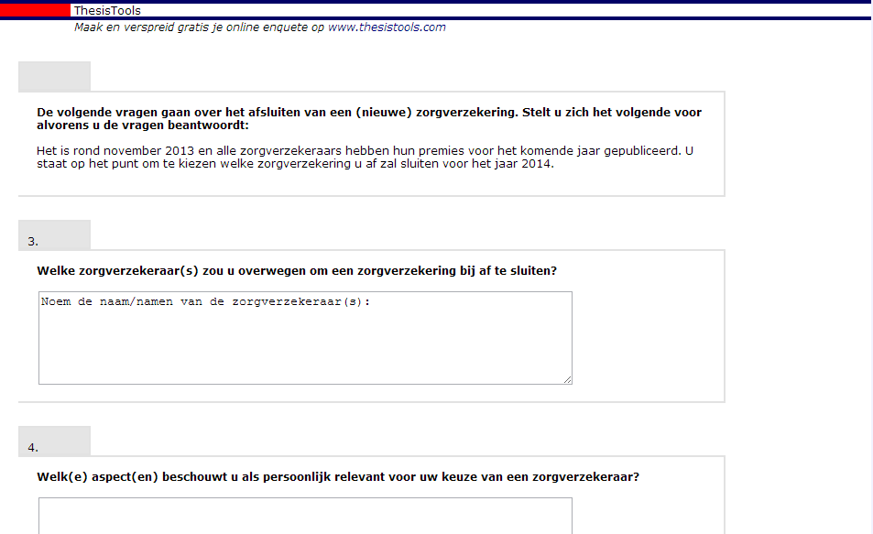
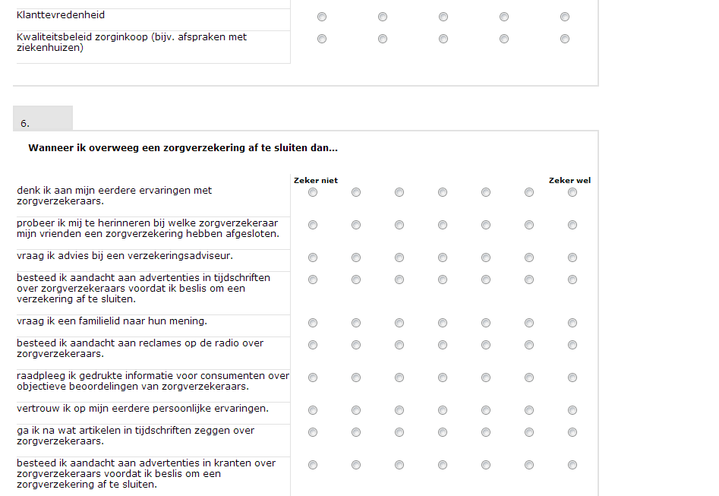
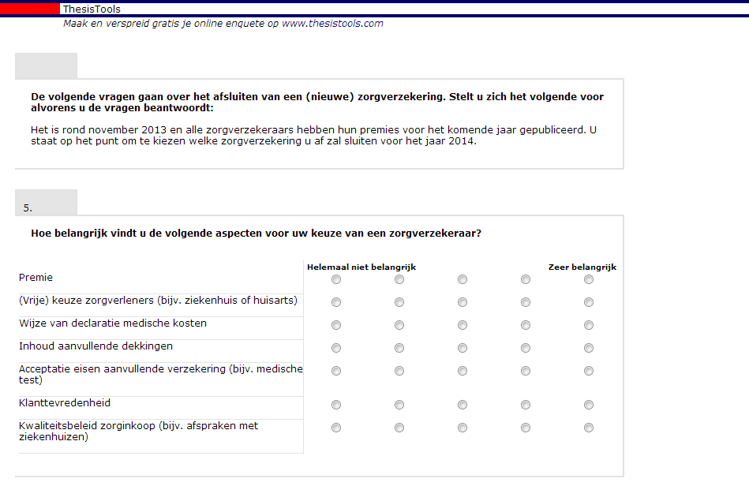
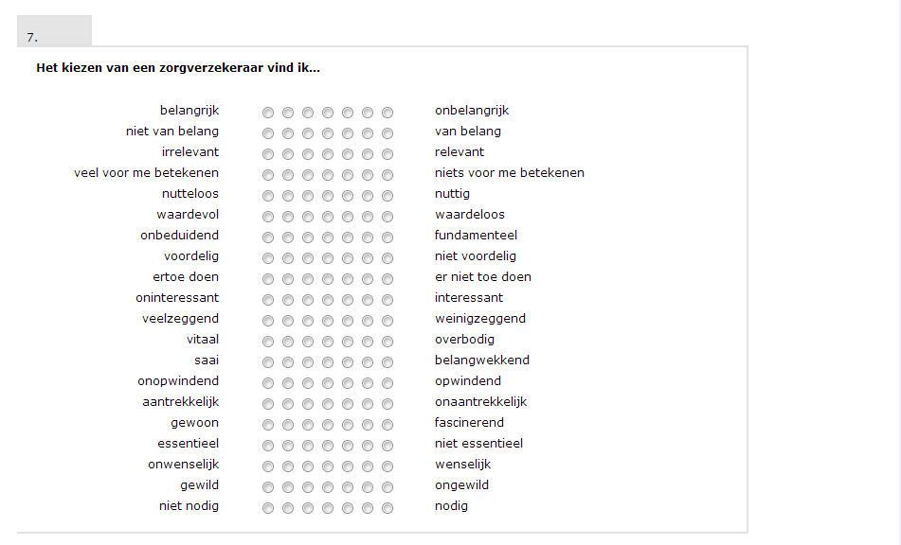
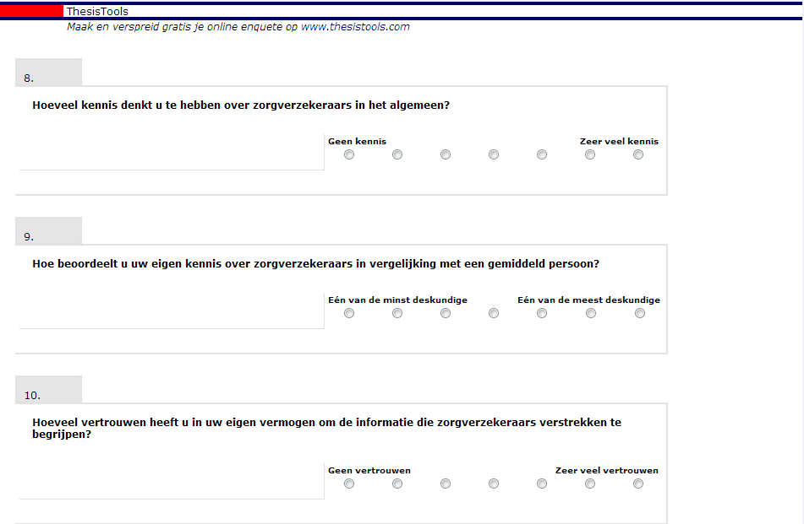
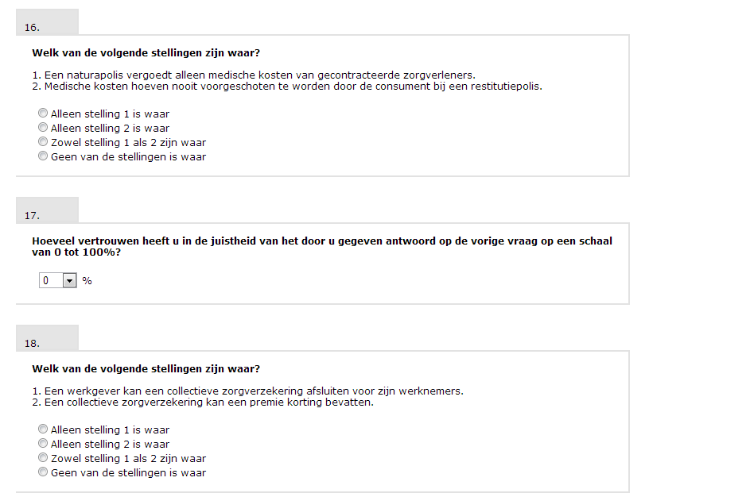
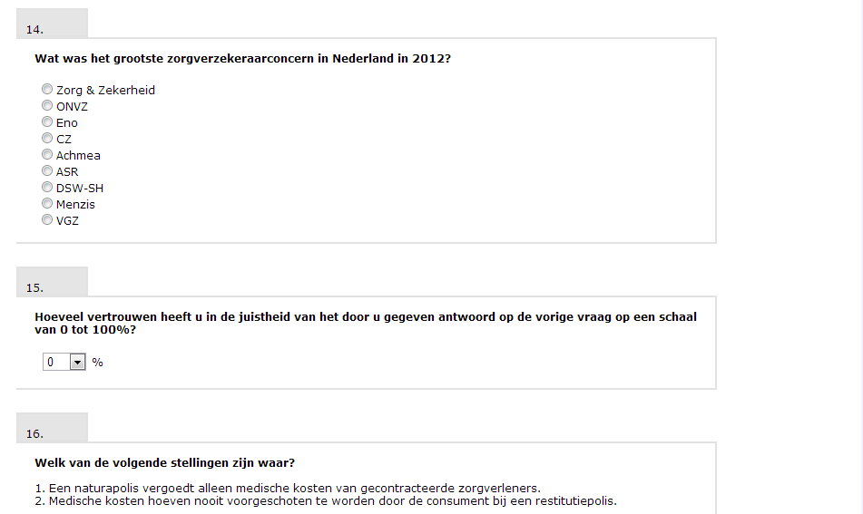
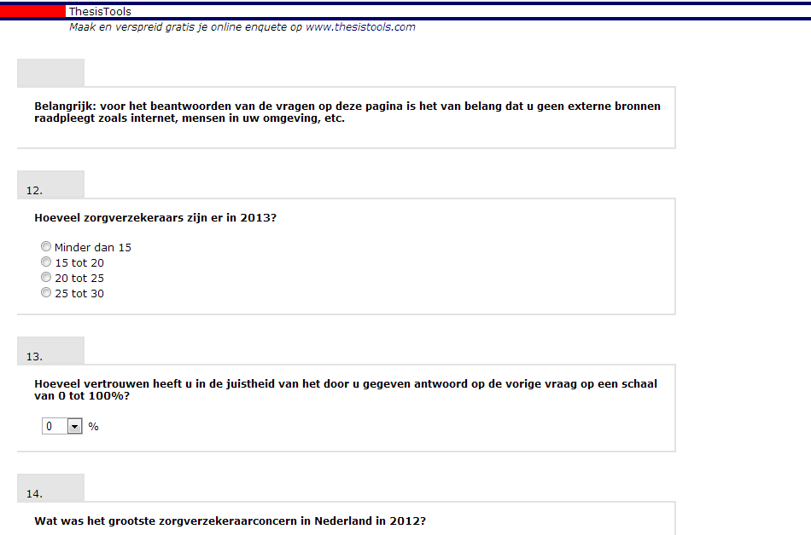
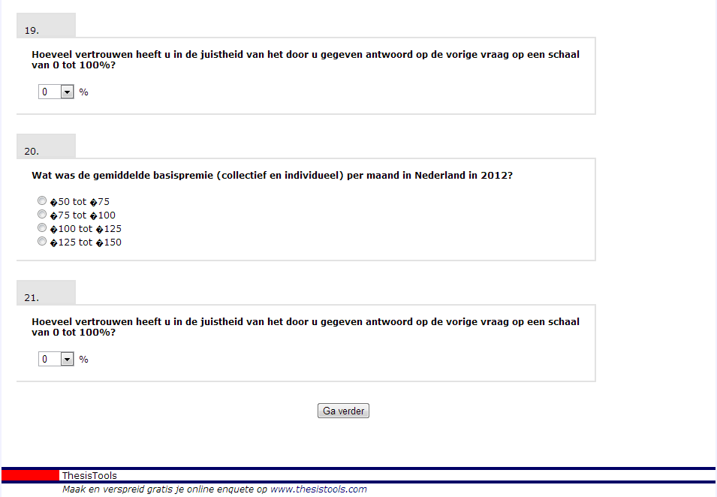
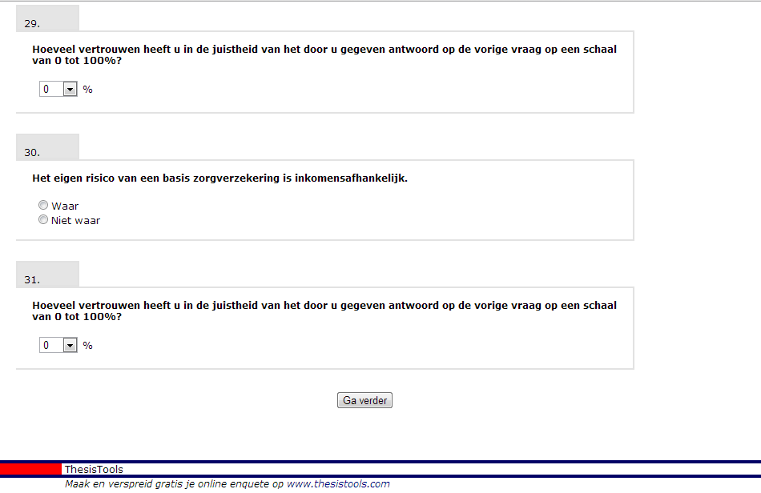
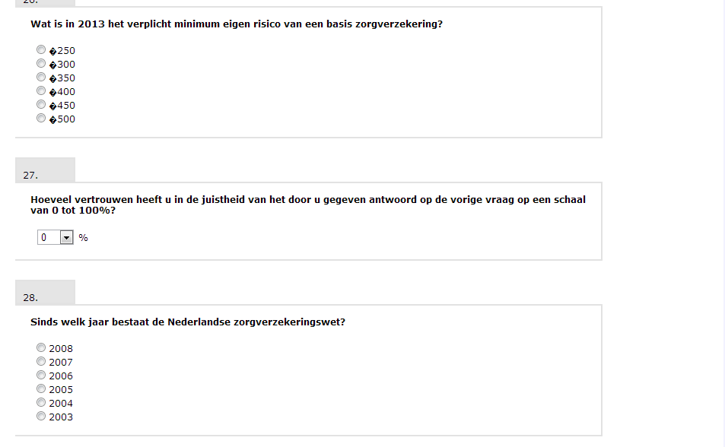
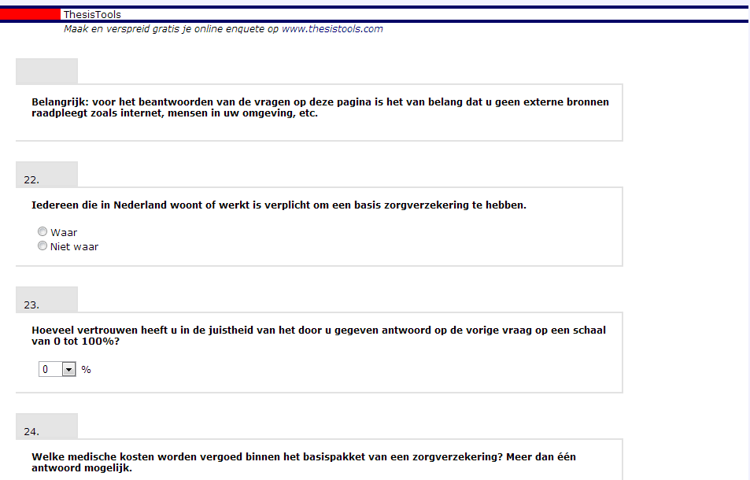
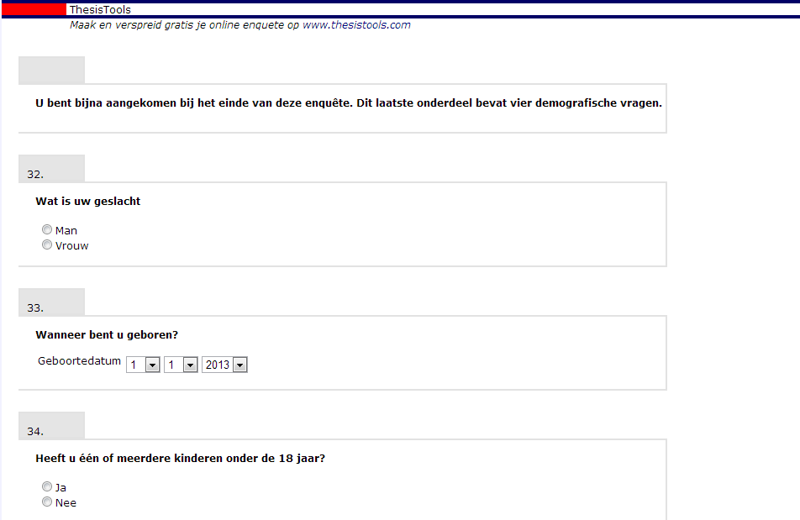

Appendix III Correct answer objective knowledge

Question | Answer options | Points
How many health Insurance companies are there in 2013? | - Less than 15  - 15 till 20  - 20 till 25  - 25 till 30 | - 0 points  - 0 points  - 0 points  - 1 point
What was the largest health Insurance concern in the Netherlands in 2012? | - Zorg & Zekerheid  - ONVZ  - Eno  - CZ  - Achmea  - ASR  - DSW-SH  - Menzis  - VGZ | - 0 points  - 0 points  - 0 points  - 0 points  - 0 points  - 1 point  - 0 points  - 0 points  - 0 points  - 0 points
Which of the following statements are true?  1. A natura policy only compensates medical expenses of contracted healthcare providers.  2. Medical expenses never have to be paid in advance by the consumer with a restitution policy | - Only statement 1 is true  - Only statement 2 is true  - Both statement 1 and 2 are true  - None of the statements is true | - 1 point  - 0 points  - 0.5 point  - 0 points
Which of the following statements are true?  1. An employer can insure his employees.  2. A collective health insurance can contain a price discount. | - Only statement 1 is true  - Only statement 2 is true  - Both statement 1 and 2 are true  - None of the statements is true | - 0 points  - 1 point  - 0.5 point  - 0 points
What was the average price for a basic health insurance (collective and individual) per month in the Netherlands in 2012? | - €50 till €75  - €75 till €100  - €100 till €125  - €125 till €150 | - 0 points  - 0 points  - 1 points  - 0 points
Everyone living or working in the Netherlands are required to have a basic health insurance. | - True  - Not true | - 1 point  - 0 points
Which medical expenses are covered by a basic health insurance? | - 5th hour diet advice  - Maternity care  - Medication  - 8th IVF treatment  - Surgical dental care and dentures  - 1 th physiotherapy treatment  - Dental visit 28 year old  - Hospital stay | - 0 points  - 0.25 point  - 0.25 point  - 0 points  - 0.25 point  - 0 points  - 0 points  - 0.25 point
What is the obligatory minimum own risk of a basic health insurance? | - €250  - €300  - €350  - €400  - €450  - €500 | - 0 points  - 0 points  - 1 point  - 0 points  - 0 points  - 0 points
Since which year does the Dutch health insurance act exists? | - 2008  - 2007  - 2006  - 2005  - 2004  - 2003 | - 0 points  - 0 points  - 1 point  - 0 points  - 0 points  - 0 points
The own risk of a basic health insurance is income dependent | - True  - Not true | - 0 points  - 1 point

Appendix IV SPSS output chapter 5 Data

Demographics
Gender, age, level of education, children younger than 18
Statistics
 |  | Gender | Age | Education level | One or more child(ren) younger than 18
N | Valid | 381 | 379 | 383 | 380
 | Missing | 6 | 8 | 4 | 7
Mean |  | 1,48 | 43,37 | 6,42 | 1,66
Median |  | 1,00 | 45,00 | 7,00 | 2,00
Mode |  | 1 | 49 | 7 | 2
Minimum |  | 1 | 18 | 2 | 1
Maximum |  | 2 | 86 | 8 | 2

Gender
 |  | Frequency | Percent | Valid Percent | Cumulative Percent
Valid | Male | 197 | 50,9 | 51,7 | 51,7
 | Female | 184 | 47,5 | 48,3 | 100,0
 | Total | 381 | 98,4 | 100,0
Missing | 999 | 6 | 1,6
Total |  | 387 | 100,0

Age
 |  | Frequency | Percent | Valid Percent | Cumulative Percent
Valid | 18 | 2 | ,5 | ,5 | ,5
 | 19 | 5 | 1,3 | 1,3 | 1,8
 | 20 | 3 | ,8 | ,8 | 2,6
 | 21 | 12 | 3,1 | 3,2 | 5,8
 | 22 | 13 | 3,4 | 3,4 | 9,2
 | 23 | 14 | 3,6 | 3,7 | 12,9
 | 24 | 10 | 2,6 | 2,6 | 15,6
 | 25 | 6 | 1,6 | 1,6 | 17,2
 | 26 | 12 | 3,1 | 3,2 | 20,3
 | 27 | 8 | 2,1 | 2,1 | 22,4
 | 28 | 5 | 1,3 | 1,3 | 23,7
 | 29 | 6 | 1,6 | 1,6 | 25,3
 | 30 | 9 | 2,3 | 2,4 | 27,7
 | 31 | 3 | ,8 | ,8 | 28,5
 | 32 | 4 | 1,0 | 1,1 | 29,6
 | 33 | 11 | 2,8 | 2,9 | 32,5
 | 34 | 6 | 1,6 | 1,6 | 34,0
 | 35 | 6 | 1,6 | 1,6 | 35,6
 | 36 | 4 | 1,0 | 1,1 | 36,7
 | 37 | 4 | 1,0 | 1,1 | 37,7
 | 38 | 4 | 1,0 | 1,1 | 38,8
 | 39 | 5 | 1,3 | 1,3 | 40,1
 | 40 | 4 | 1,0 | 1,1 | 41,2
 | 41 | 10 | 2,6 | 2,6 | 43,8
 | 42 | 6 | 1,6 | 1,6 | 45,4
 | 43 | 6 | 1,6 | 1,6 | 47,0
 | 44 | 9 | 2,3 | 2,4 | 49,3
 | 45 | 9 | 2,3 | 2,4 | 51,7
 | 46 | 7 | 1,8 | 1,8 | 53,6
 | 47 | 11 | 2,8 | 2,9 | 56,5
 | 48 | 5 | 1,3 | 1,3 | 57,8
 | 49 | 15 | 3,9 | 4,0 | 61,7
 | 50 | 6 | 1,6 | 1,6 | 63,3
 | 51 | 7 | 1,8 | 1,8 | 65,2
 | 52 | 10 | 2,6 | 2,6 | 67,8
 | 53 | 13 | 3,4 | 3,4 | 71,2
 | 54 | 9 | 2,3 | 2,4 | 73,6
 | 55 | 11 | 2,8 | 2,9 | 76,5
 | 56 | 8 | 2,1 | 2,1 | 78,6
 | 57 | 9 | 2,3 | 2,4 | 81,0
 | 58 | 14 | 3,6 | 3,7 | 84,7
 | 59 | 4 | 1,0 | 1,1 | 85,8
 | 60 | 6 | 1,6 | 1,6 | 87,3
 | 61 | 7 | 1,8 | 1,8 | 89,2
 | 62 | 7 | 1,8 | 1,8 | 91,0
 | 63 | 2 | ,5 | ,5 | 91,6
 | 64 | 2 | ,5 | ,5 | 92,1
 | 65 | 5 | 1,3 | 1,3 | 93,4
 | 66 | 7 | 1,8 | 1,8 | 95,3
 | 67 | 1 | ,3 | ,3 | 95,5
 | 68 | 3 | ,8 | ,8 | 96,3
 | 69 | 2 | ,5 | ,5 | 96,8
 | 70 | 2 | ,5 | ,5 | 97,4
 | 71 | 1 | ,3 | ,3 | 97,6
 | 73 | 1 | ,3 | ,3 | 97,9
 | 74 | 1 | ,3 | ,3 | 98,2
 | 75 | 2 | ,5 | ,5 | 98,7
 | 78 | 1 | ,3 | ,3 | 98,9
 | 79 | 1 | ,3 | ,3 | 99,2
 | 81 | 1 | ,3 | ,3 | 99,5
 | 82 | 1 | ,3 | ,3 | 99,7
 | 86 | 1 | ,3 | ,3 | 100,0
 | Total | 379 | 97,9 | 100,0
Missing | 999 | 8 | 2,1
Total |  | 387 | 100,0

Education level
 |  | Frequency | Percent | Valid Percent | Cumulative Percent
Valid | Lower vocational education | 1 | ,3 | ,3 | ,3
 | Lower general secondary education | 17 | 4,4 | 4,4 | 4,7
 | Secondary vocational education | 25 | 6,5 | 6,5 | 11,2
 | (Higher general) secondary education | 64 | 16,5 | 16,7 | 27,9
 | Higher vocational education | 35 | 9,0 | 9,1 | 37,1
 | (Post) scientific education | 153 | 39,5 | 39,9 | 77,0
 | Do not know/Do not want to say | 88 | 22,7 | 23,0 | 100,0
 | Total | 383 | 99,0 | 100,0
Missing | 999 | 4 | 1,0
Total |  | 387 | 100,0

One or more child(ren) younger than 18
 |  | Frequency | Percent | Valid Percent | Cumulative Percent
Valid | Yes | 131 | 33,9 | 34,5 | 34,5
 | No | 249 | 64,3 | 65,5 | 100,0
 | Total | 380 | 98,2 | 100,0
Missing | 999 | 7 | 1,8
Total |  | 387 | 100,0

Assumption of normality

Objective knowledge
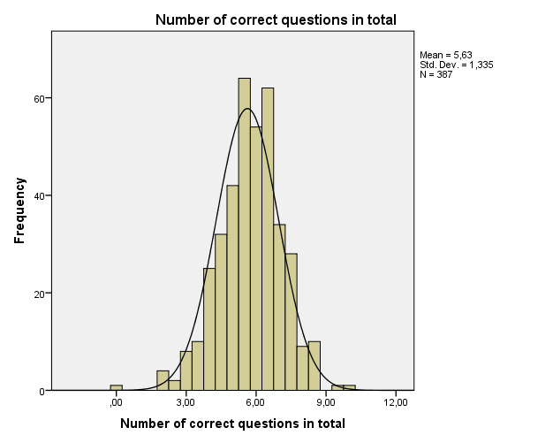
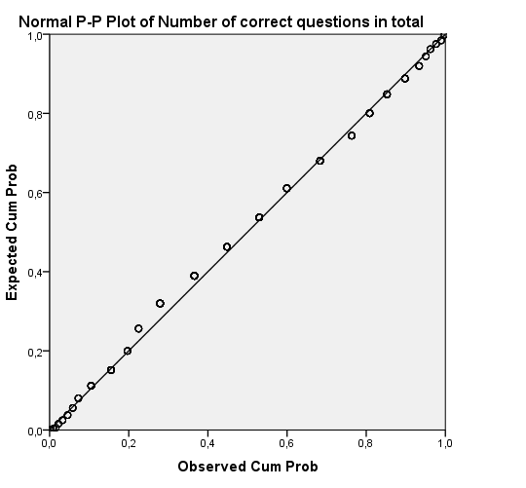
Subjective knowledge
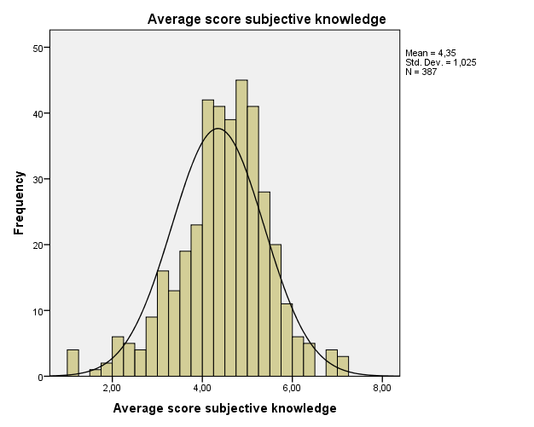
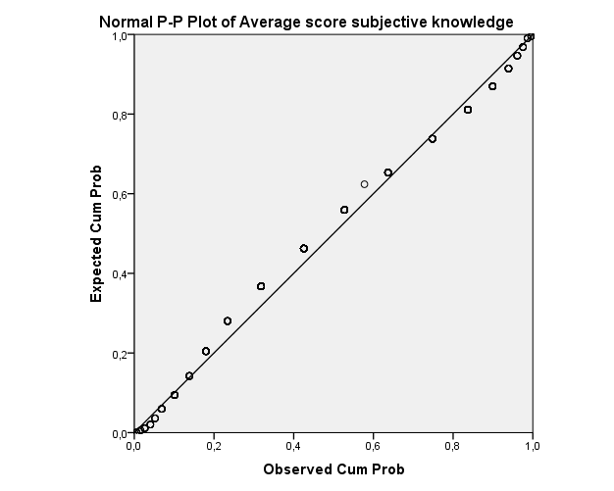

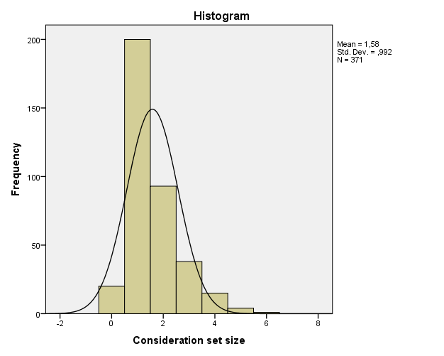
Consideration set size
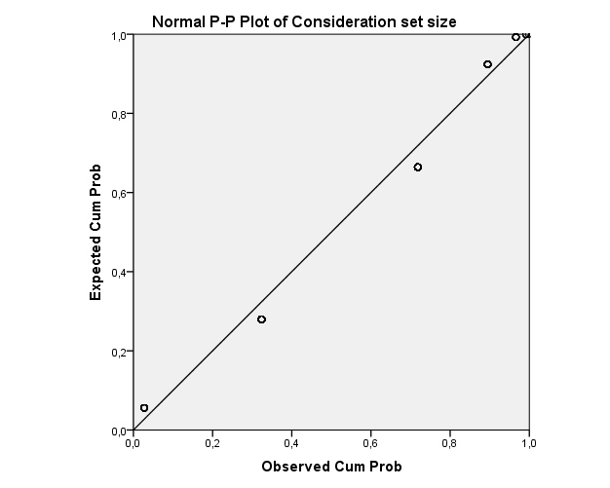
Amount of attributes
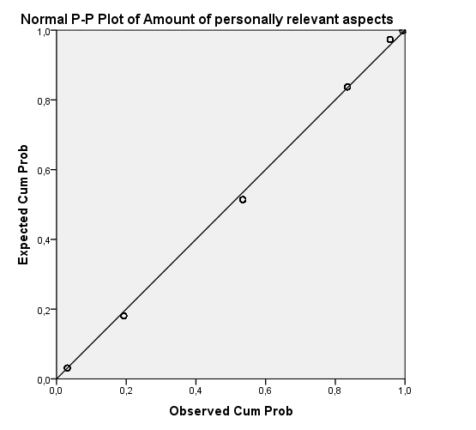
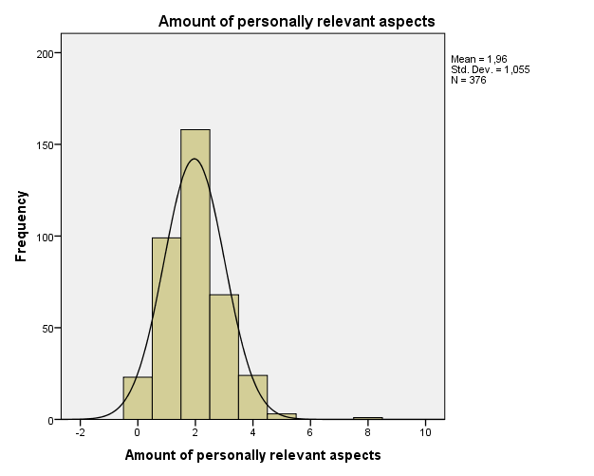

(Free) choice health care providers
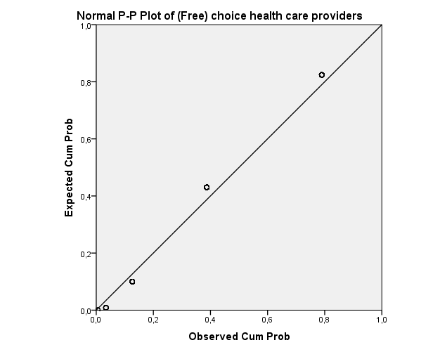
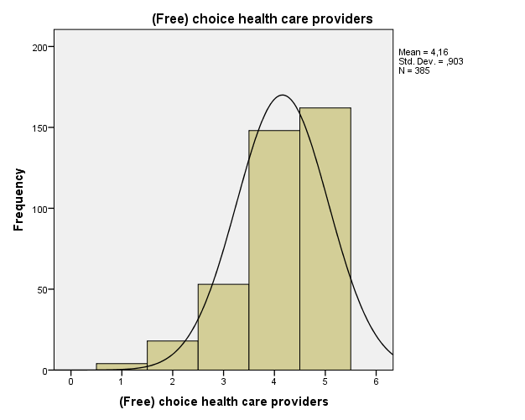

Expenses claim
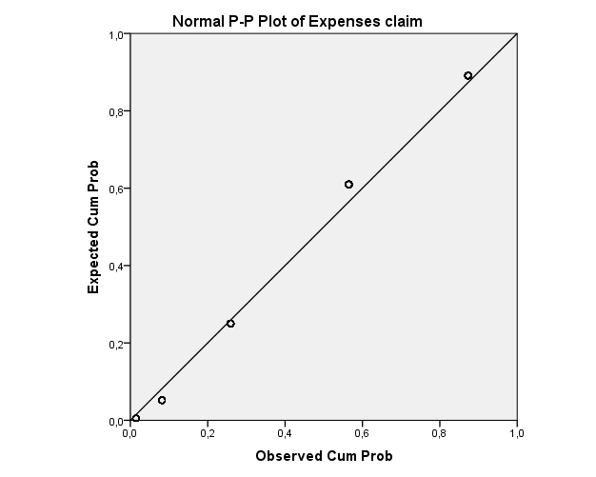
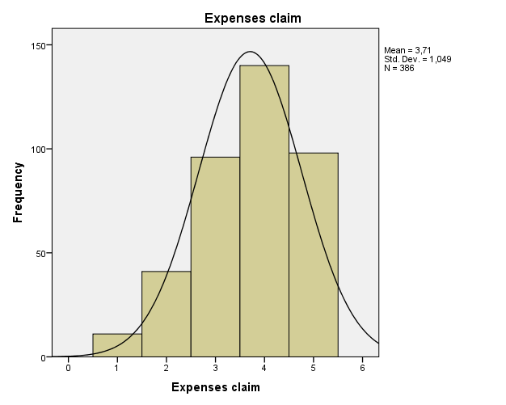

Content additional coverage
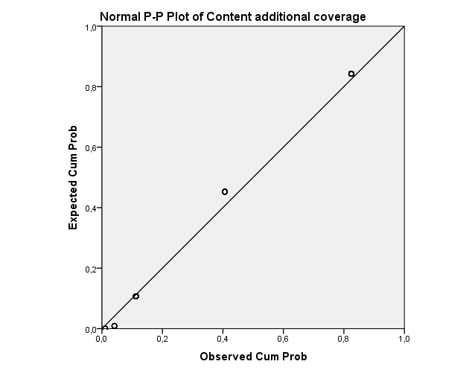
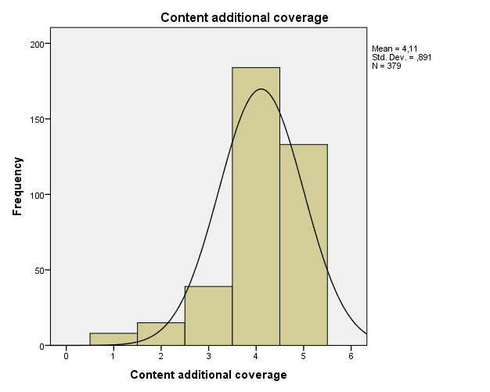
Acceptance requirements
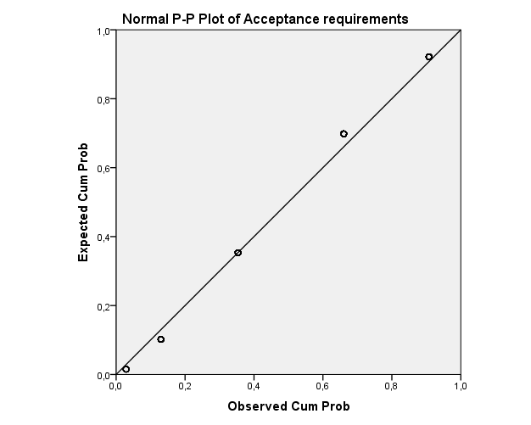
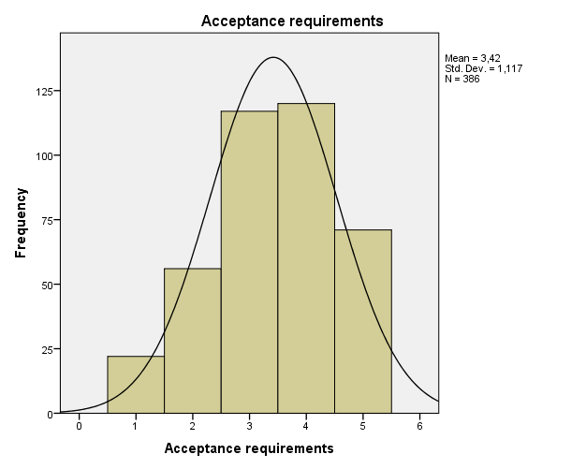

Quality policy health care purchase

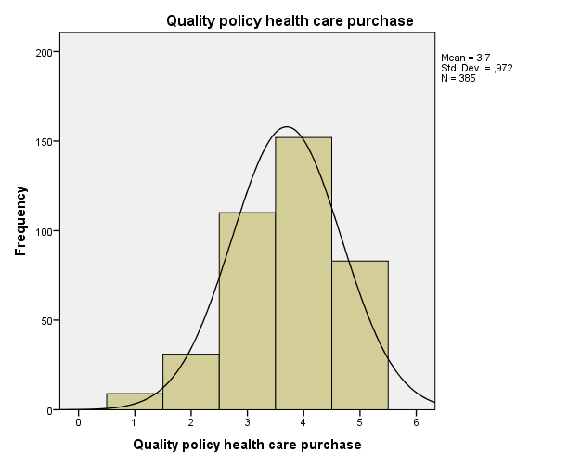
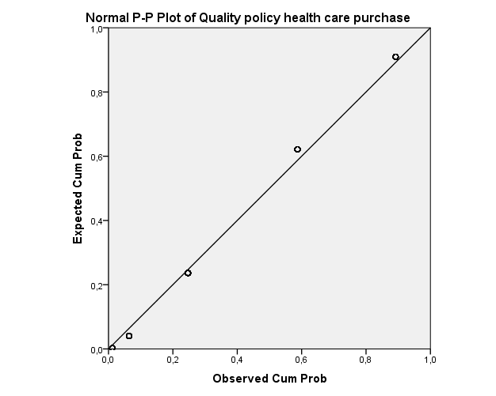
Price
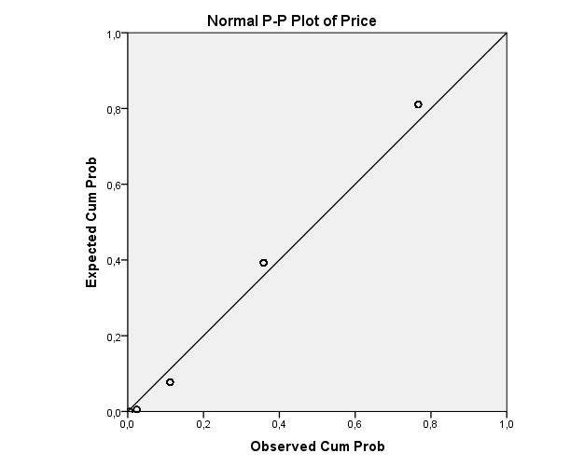
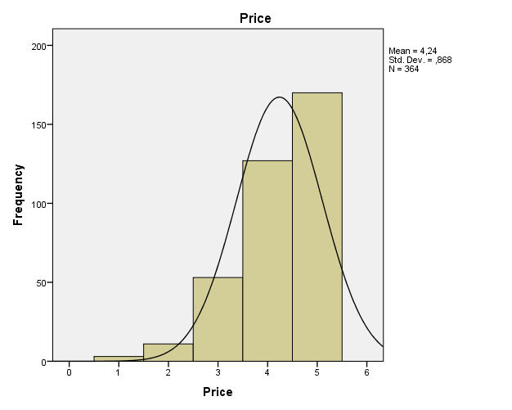
Intrinsic attributes
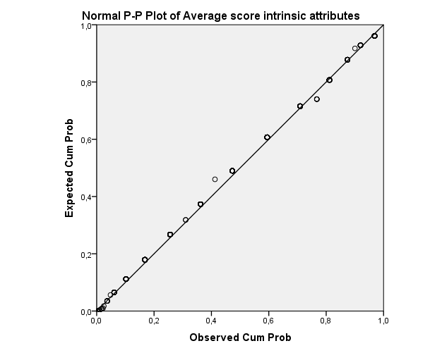
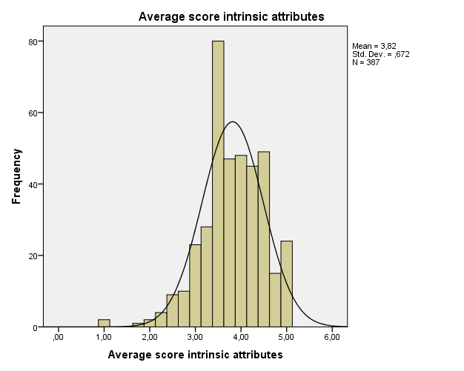

Relative use extrinsic over intrinsic attributes
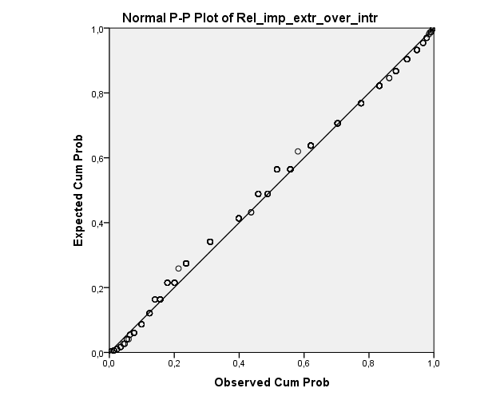
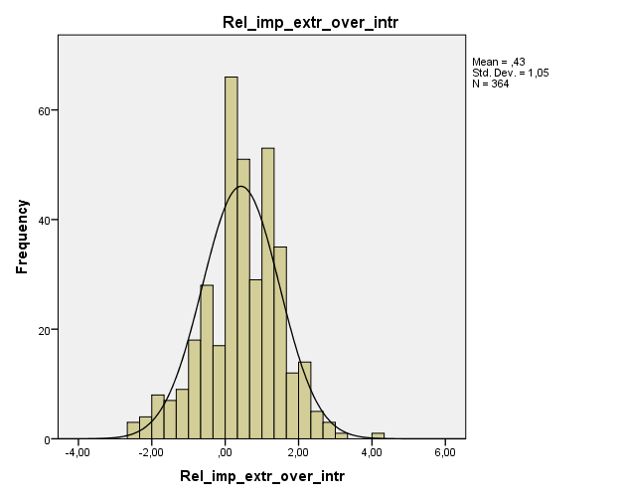

Use of memory
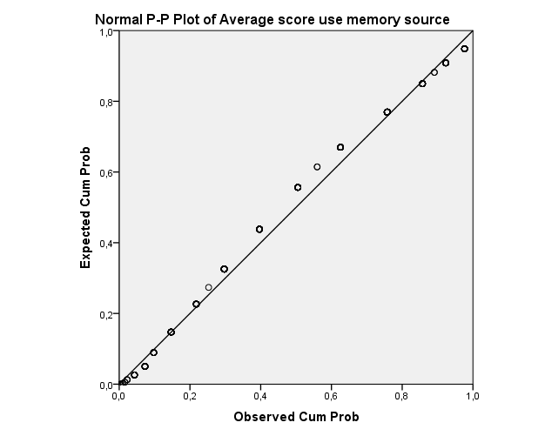
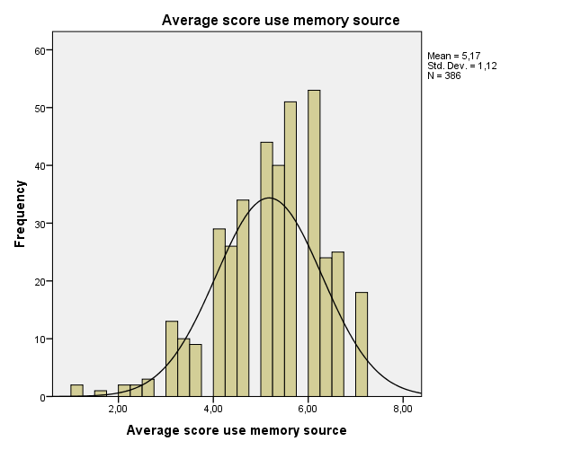
Use of external information sources
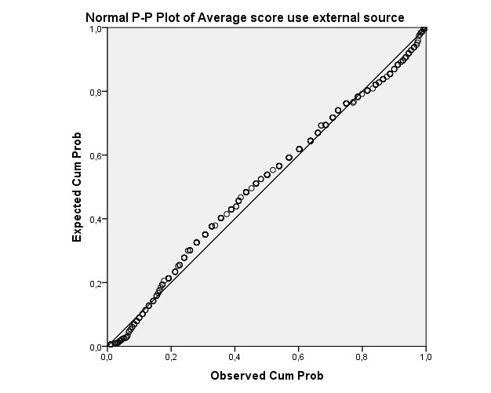
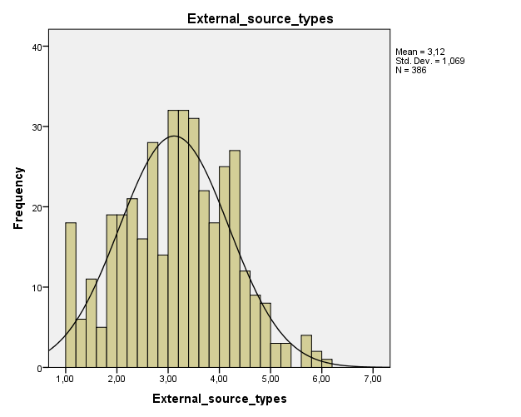

Use of personal information sources

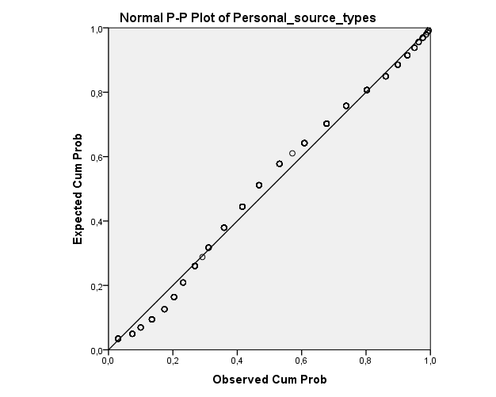
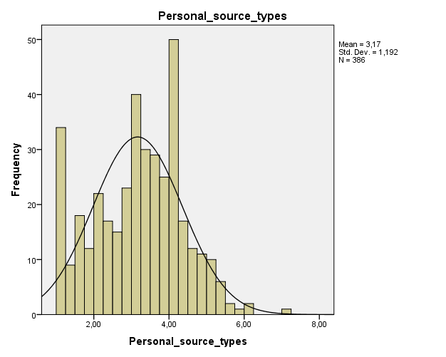

Use of impersonal information sources
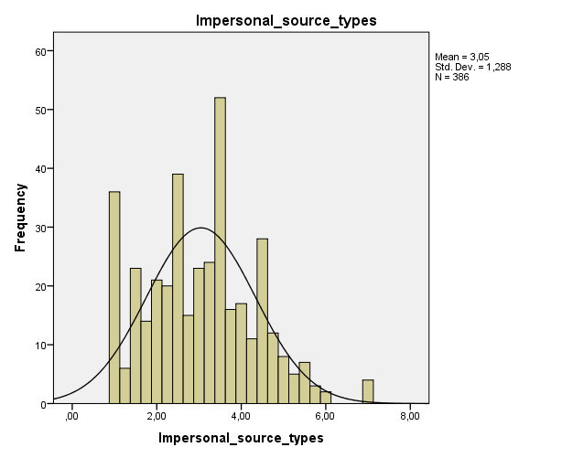
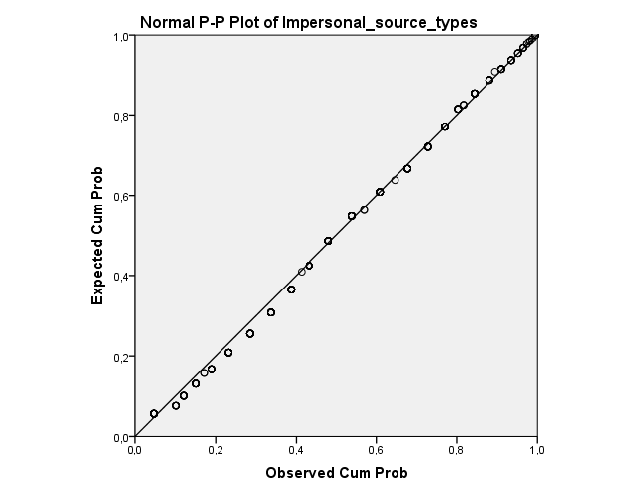

Involvement
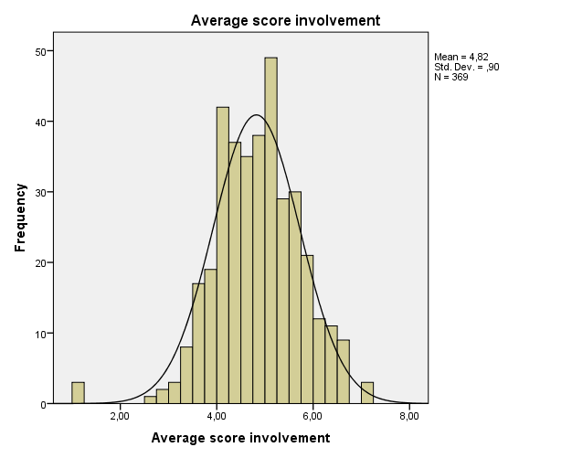
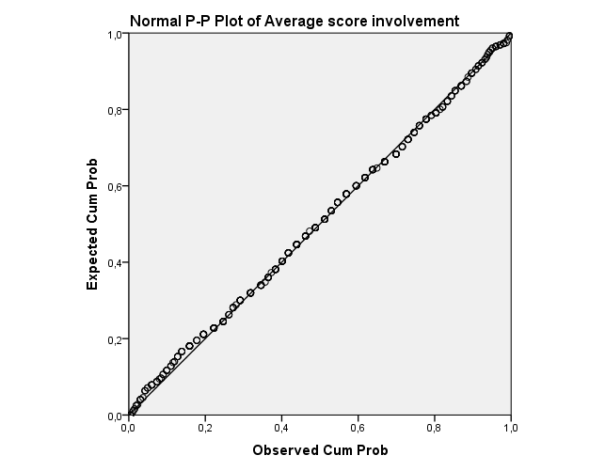

Consumer knowledge calibration

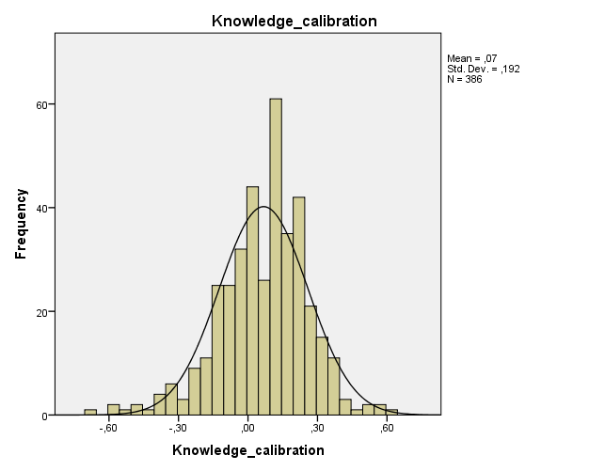
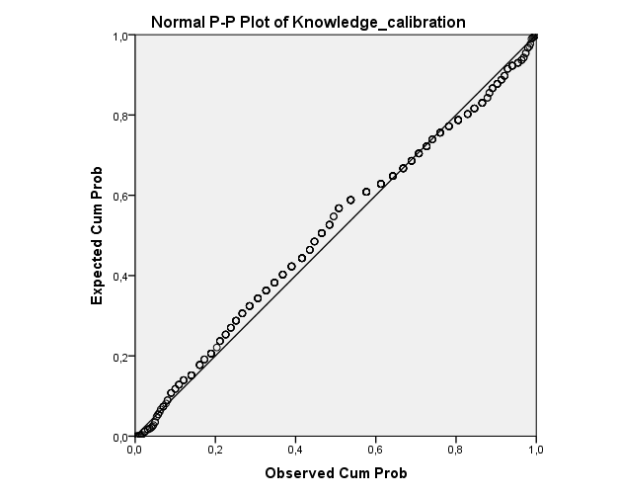

Variable | Total conclusion normal distribution
Objective knowledge | Normally distributed
Subjective knowledge | Normally distributed
Consideration set size | Normally distributed
Amount of attributes | Normally distributed
(Free) choice health care providers | Not normally distributed
Expenses claim | Normally distributed
Content additional coverage | Not normally distributed
Acceptance requirements | Normally distributed
Quality policy health care purchase | Normally distributed
Price | Not normally distributed
Preference intrinsic attributes | Normally distributed
Relative importance preference intrinsic over extrinsic attributes | Normally distributed
Use of memory | Normally distributed
Use of external information sources | Normally distributed
Use of personal information sources | Normally distributed
Use of impersonal information sources | Normally distributed
Involvement | Normally distributed
Knowledge calibration | Normally distributed

Validity and reliability

Validity – factor analysis
Subjective knowledge
KMO and Bartlett's Test
Kaiser-Meyer-Olkin Measure of Sampling Adequacy. |  |  |  |  |  |  |  | ,777
Bartlett's Test of Sphericity |  |  |  | Approx. Chi-Square |  |  |  | 712,649
 |  |  |  | df |  |  |  | 6
 |  |  |  | Sig. |  |  |  | ,000
Communalities
 |  |  | Initial |  | Extraction
General knowledge about health insurance companies |  |  | 1,000 |  | ,773
Knowledge about health insurance companies compared to average person |  |  | 1,000 |  | ,786
Confidence in ability to comprehend health insurance companies' information |  |  | 1,000 |  | ,468
Familiarity with health insurance companies |  |  | 1,000 |  | ,719
Extraction Method: Principal Component Analysis.
Total Variance Explained
Component | Initial Eigenvalues |  |  |  |  |  |  |  | Extraction Sums of Squared Loadings
 | Total | % of Variance |  |  |  | Cumulative % |  |  | Total |  | % of Variance | Cumulative %
1 | 2,746 | 68,646 |  |  |  | 68,646 |  |  | 2,746 |  | 68,646 | 68,646
2 | ,650 | 16,258 |  |  |  | 84,904
3 | ,378 | 9,453 |  |  |  | 94,357
4 | ,226 | 5,643 |  |  |  | 100,000
Extraction Method: Principal Component Analysis.

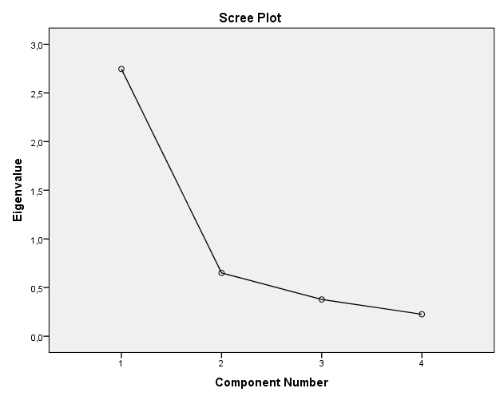
Component Matrixª
 | Component
 | 1
Knowledge about health insurance companies compared to average person | ,886
General knowledge about health insurance companies | ,879
Familiarity with health insurance companies | ,848
Confidence in ability to comprehend health insurance companies' information | ,684
Extraction Method: Principal Component Analysis.
a. 1 components extracted.
Item | Subjective knowledge
General knowledge about health insurance companies | .879
Knowledge about health insurance companies compared to average person | .886
Confidence in ability to comprehend health insurance companies’ information | .684
Familiarity with health insurance companies | .848
Eigenvalues | 2.75
% of variance | 68.6%

Attributes preferences
KMO and Bartlett's Test
Kaiser-Meyer-Olkin Measure of Sampling Adequacy. |  |  |  |  |  |  |  | ,750
Bartlett's Test of Sphericity |  |  |  | Approx. Chi-Square |  |  |  | 417,164
 |  |  |  | df |  |  |  | 21
 |  |  |  | Sig. |  |  |  | ,000
Communalities
 |  |  | Initial |  |  | Extraction
Price |  |  | 1,000 |  |  | ,894
(Free) choice health care providers |  |  | 1,000 |  |  | ,364
Expenses claim |  |  | 1,000 |  |  | ,465
Content additional coverage |  |  | 1,000 |  |  | ,533
Acceptance requirements |  |  | 1,000 |  |  | ,421
Customer satisfaction |  |  | 1,000 |  |  | ,473
Quality policy health care purchase |  |  | 1,000 |  |  | ,581
Extraction Method: Principal Component Analysis.
Total Variance Explained
Component | Initial Eigenvalues |  |  |  |  |  | Extraction Sums of Squared Loadings |  |  |  |  | Rotation Sums of Squared Loadingsª
 | Total | % of Variance |  |  | Cumulative % |  | Total |  | % of Variance |  | Cumulative % | Total
1 | 2,645 | 37,786 |  |  | 37,786 |  | 2,645 |  | 37,786 |  | 37,786 | 2,624
2 | 1,085 | 15,496 |  |  | 53,282 |  | 1,085 |  | 15,496 |  | 53,282 | 1,155
3 | ,809 | 11,562 |  |  | 64,843
4 | ,762 | 10,890 |  |  | 75,733
5 | ,683 | 9,762 |  |  | 85,495
6 | ,600 | 8,572 |  |  | 94,067
7 | ,415 | 5,933 |  |  | 100,000
Extraction Method: Principal Component Analysis.
a. When components are correlated, sums of squared loadings cannot be added to obtain a total variance.

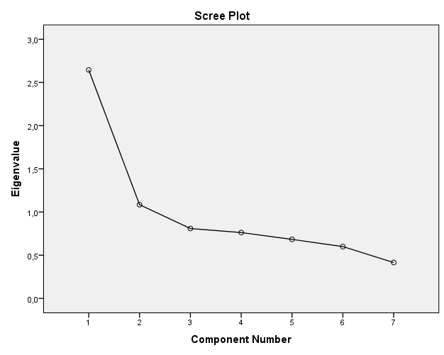
Pattern Matrixª
 | Component
 | 1 | 2
Quality policy health care purchase | ,737
Customer satisfaction | ,686
Expenses claim | ,680
Acceptance requirements | ,647
(Free) choice health care providers | ,602
Content additional coverage | ,580
Price |  | ,950
Extraction Method: Principal Component Analysis.
Rotation Method: Oblimin with Kaiser Normalization.
a. Rotation converged in 4 iterations.

Item | Intrinsic attributes | Extrinsic attributes
Price |  | .950
(Free) choice health care provider | .602
Expenses claim | .686
Content additional coverage | .580
Acceptance requirements | .647
Customer satisfaction | .686
Quality policy health care purchase | .737
Eigenvalues | 2.65 | 1.09
% of variance | 37.8% | 15.5%

Information source types
KMO and Bartlett's Test
Kaiser-Meyer-Olkin Measure of Sampling Adequacy. |  | ,823
Bartlett's Test of Sphericity | Approx. Chi-Square | 2843,981
 | df | 210
 | Sig. | ,000
Communalities
 |  |  | Initial |  | Extraction
Previous involvement |  |  | 1,000 |  | ,592
Health insurance companies of friends |  |  | 1,000 |  | ,573
Advice health insurance consultant |  |  | 1,000 |  | ,434
Magazine ads |  |  | 1,000 |  | ,687
Opinion of family member or relative |  |  | 1,000 |  | ,808
Radio commercials |  |  | 1,000 |  | ,766
Printed objective consumer information |  |  | 1,000 |  | ,498
Past personal experiences |  |  | 1,000 |  | ,751
Magazine articles |  |  | 1,000 |  | ,578
Newspapers ads |  |  | 1,000 |  | ,710
No additional information |  |  | 1,000 |  | ,680
Opinion of friend or someone I know |  |  | 1,000 |  | ,796
Recall relevant events |  |  | 1,000 |  | ,537
TV commercials |  |  | 1,000 |  | ,779
First health insurance found |  |  | 1,000 |  | ,576
Written description or detailed descriptive analysis |  |  | 1,000 |  | ,794
Available information such as printed brochure, pamphlet, etc. |  |  | 1,000 |  | ,717
Opinion of employee of health insurance company |  |  | 1,000 |  | ,513
Do not worry about requiring more information |  |  | 1,000 |  | ,608
Report written by knowledgeable third party |  |  | 1,000 |  | ,682
What previous customers had to say |  |  | 1,000 |  | ,530
Extraction Method: Principal Component Analysis.

Total Variance Explained
Component | Initial Eigenvalues |  |  | Extraction Sums of Squared Loadings |  |  | Rotation Sums of Squared Loadingsª
 | Total | % of Variance | Cumulative % | Total | % of Variance | Cumulative % | Total
1 | 5,827 | 27,745 | 27,745 | 5,827 | 27,745 | 27,745 | 4,538
2 | 2,420 | 11,523 | 39,269 | 2,420 | 11,523 | 39,269 | 2,083
3 | 1,748 | 8,323 | 47,592 | 1,748 | 8,323 | 47,592 | 3,369
4 | 1,332 | 6,341 | 53,933 | 1,332 | 6,341 | 53,933 | 2,554
5 | 1,279 | 6,091 | 60,024 | 1,279 | 6,091 | 60,024 | 2,278
6 | 1,004 | 4,782 | 64,806 | 1,004 | 4,782 | 64,806 | 2,734
7 | ,902 | 4,295 | 69,100
8 | ,811 | 3,861 | 72,961
9 | ,711 | 3,386 | 76,347
10 | ,683 | 3,251 | 79,598
11 | ,606 | 2,886 | 82,483
12 | ,568 | 2,707 | 85,190
13 | ,514 | 2,450 | 87,640
14 | ,453 | 2,157 | 89,797
15 | ,438 | 2,085 | 91,882
16 | ,389 | 1,854 | 93,736
17 | ,352 | 1,677 | 95,413
18 | ,318 | 1,514 | 96,927
19 | ,294 | 1,399 | 98,326
20 | ,191 | ,910 | 99,236
21 | ,160 | ,764 | 100,000
Extraction Method: Principal Component Analysis.
a. When components are correlated, sums of squared loadings cannot be added to obtain a total variance.
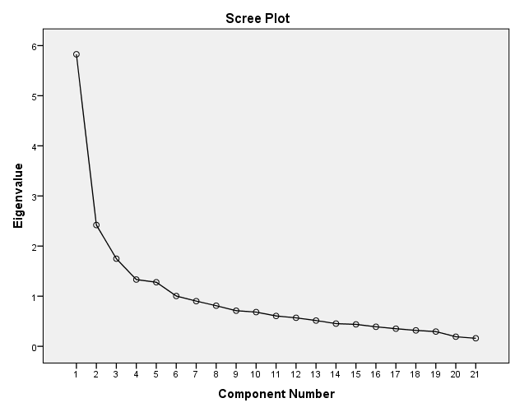

Pattern Matrixª
 | Component
 | 1 | 2 | 3 | 4 | 5 | 6
Magazine ads | ,828
Newspapers ads | ,823
Radio commercials | ,814
TV commercials | ,785
Magazine articles | ,635
Printed objective consumer information | ,449
No additional information |  | ,778
Do not worry about requiring more information |  | ,750
First health insurance found |  | ,652
Opinion of family member or relative |  |  | ,870
Opinion of friend or someone I know |  |  | ,845
Health insurance companies of friends |  |  | ,678
Report written by knowledgeable third party |  |  |  | ,731
What previous customers had to say |  |  |  | ,551
Advice health insurance consultant |  |  |  | ,550
Opinion of employee of health insurance company |  |  |  | ,522
Past personal experiences |  |  |  |  | ,879
Previous involvement |  |  |  |  | ,664
Recall relevant events |  |  |  |  | ,438
Written description or detailed descriptive analysis |  |  |  |  |  | ,891
Available information such as printed brochure, pamphlet, etc. |  |  |  |  |  | ,817
Extraction Method: Principal Component Analysis.
Rotation Method: Oblimin with Kaiser Normalization.
a. Rotation converged in 8 iterations.

Item | Impersonal advocate | Pick a brand | Personal independent | Personal advocate | Memory | Cancelled
Magazine ads | .828
Newspapers ads | .823
Radio commercials | .814
TV commercials | .785
Magazine articles | .635
Printed objective consumer information | .449
No additional information |  | .778
Do not worry about requiring more information |  | .750
First health insurance found |  | .652
Opinion of family member or relative |  |  | .870
Opinion of friend or someone I know |  |  | .845
Health insurance companies of friends |  |  | .678
Report written by knowledgeable third party |  |  |  | .731
What previous customers had to say |  |  |  | .551
Advice health insurance consultant |  |  |  | .550
Opinion of employee of health insurance company |  |  |  | .522
Past personal experiences |  |  |  |  | .879
Previous involvement |  |  |  |  | .664
Recall relevant events |  |  |  |  | .438
Written description or detailed descriptive analysis |  |  |  |  |  | .891
Available information such as printed brochure, pamphlet, etc. |  |  |  |  |  | .817
Eigenvalues | 5.83 | 2.42 | 1.75 | 1.33 | 1.28 | 1.00
% of variance | 27.7% | 11.5% | 8.3% | 6.3% | 6.0% | 4.8%

Involvement
KMO and Bartlett's Test
Kaiser-Meyer-Olkin Measure of Sampling Adequacy. |  |  |  |  | ,929
Bartlett's Test of Sphericity | Approx. Chi-Square |  |  | 3752,827
 | df |  |  | 190
 | Sig. |  |  | ,000
Communalities
 | Initial | Extraction
Unimportant - Important | 1,000 | ,694
Of no concern - Of concern to me | 1,000 | ,755
Irrelevant - Relevant | 1,000 | ,753
Means nothing to me - Means a lot to me | 1,000 | ,623
Useless - Useful | 1,000 | ,632
Worthless - Valuable | 1,000 | ,510
Trivial - Fundamental | 1,000 | ,660
Not beneficial - Beneficial | 1,000 | ,514
Does not matter - Matters to me | 1,000 | ,633
Uninterested - Interested | 1,000 | ,708
Insignificant - Significant | 1,000 | ,713
Superfluous - Vital | 1,000 | ,599
Boring - Interesting | 1,000 | ,692
Unexciting - Exciting | 1,000 | ,760
Unappealing - Appealing | 1,000 | ,704
Mundane - Fascinating | 1,000 | ,474
Nonessential - Essential | 1,000 | ,549
Undesirable - Desirable | 1,000 | ,726
Unwanted - Wanted | 1,000 | ,703
Not needed - Needed | 1,000 | ,586
Extraction Method: Principal Component Analysis.

Total Variance Explained
Component | Initial Eigenvalues |  |  | Extraction Sums of Squared Loadings |  |  | Rotation Sums of Squared Loadingsª
 | Total | % of Variance | Cumulative % | Total | % of Variance | Cumulative % | Total
1 | 8,204 | 41,022 | 41,022 | 8,204 | 41,022 | 41,022 | 6,303
2 | 2,590 | 12,949 | 53,971 | 2,590 | 12,949 | 53,971 | 3,153
3 | 1,191 | 5,956 | 59,927 | 1,191 | 5,956 | 59,927 | 4,257
4 | 1,003 | 5,013 | 64,940 | 1,003 | 5,013 | 64,940 | 5,489
5 | ,771 | 3,853 | 68,793
6 | ,689 | 3,446 | 72,239
7 | ,667 | 3,337 | 75,576
8 | ,590 | 2,951 | 78,526
9 | ,547 | 2,736 | 81,263
10 | ,473 | 2,363 | 83,626
11 | ,420 | 2,100 | 85,726
12 | ,409 | 2,044 | 87,771
13 | ,378 | 1,891 | 89,661
14 | ,368 | 1,842 | 91,503
15 | ,346 | 1,728 | 93,231
16 | ,313 | 1,563 | 94,794
17 | ,309 | 1,544 | 96,338
18 | ,262 | 1,309 | 97,647
19 | ,250 | 1,248 | 98,895
20 | ,221 | 1,105 | 100,000
Extraction Method: Principal Component Analysis.
a. When components are correlated, sums of squared loadings cannot be added to obtain a total variance.

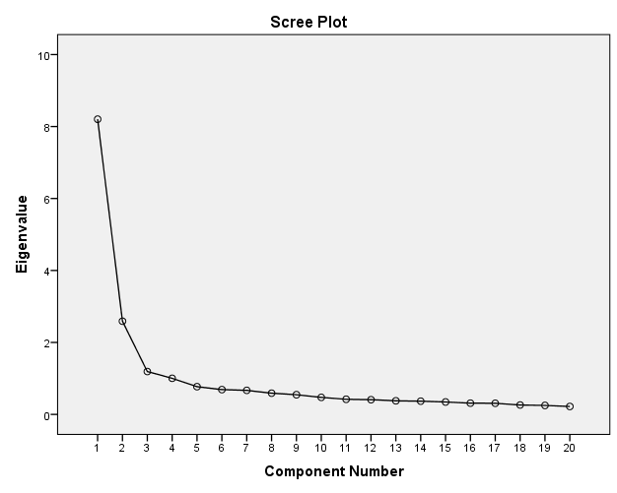

Pattern Matrixª
 | Component
 | 1 | 2 | 3 | 4
Of no concern - Of concern to me | ,923
Unimportant - Important | ,872
Irrelevant - Relevant | ,851
Means nothing to me - Means a lot to me | ,583
Trivial - Fundamental | ,492
Useless - Useful | ,432
Unexciting - Exciting |  | ,866
Unappealing - Appealing |  | ,771
Boring - Interesting |  | ,686
Mundane - Fascinating |  | ,654
Unwanted - Wanted |  |  | ,845
Undesirable - Desirable |  |  | ,795
Not needed - Needed |  |  | ,467
Insignificant - Significant |  |  |  | -,740
Not beneficial - Beneficial |  |  |  | -,735
Nonessential - Essential |  |  |  | -,507
Uninterested - Interested |  | ,446 |  | -,503
Does not matter - Matters to me | ,453 |  |  | -,457
Superfluous - Vital |  |  |  | -,408
Worthless - Valuable
Extraction Method: Principal Component Analysis.
Rotation Method: Oblimin with Kaiser Normalization.
a. Rotation converged in 11 iterations.
Item | Needed | Appealing | Wanted | Beneficial
Trivial – Fundamental | .795
Useless - Useful | .764
Means nothing to me - Means a lot to me | .759
Does not matter - Matters to me | .753
Superfluous - Vital | .747
Irrelevant - Relevant | .724
Uninterested - Interested | .717
Insignificant - Significant | .716
Worthless - Valuable | .709
Of no concern - Of concern to me | .683
Unimportant - Important | .677
Undesirable - Desirable | .632
Not needed - Needed | .625
Nonessential - Essential | .625
Boring - Interesting | .587
Unexciting - Exciting |  | .781
Unappealing - Appealing |  | .695
Mundane - Fascinating |  | .625
Unwanted - Wanted |  |  | .579
Not beneficial - Beneficial |  |  |  | -.477
Eigenvalues | 8.20 | 2.59 | 1.19 | 1.00
% of variance | 41.0% | 12.9% | 6.0% | 5.0%

Knowledge confidence
KMO and Bartlett's Test
Kaiser-Meyer-Olkin Measure of Sampling Adequacy. |  | ,893
Bartlett's Test of Sphericity | Approx. Chi-Square | 1235,784
 | df | 45
 | Sig. | ,000

Communalities
 | Initial | Extraction
Confidence percentage question 12 | 1,000 | ,484
Confidence percentage question 14 | 1,000 | ,489
Confidence percentage question 16 | 1,000 | ,397
Confidence percentage question 18 | 1,000 | ,493
Confidence percentage question 20 | 1,000 | ,597
Confidence percentage question 22 | 1,000 | ,406
Confidence percentage question 24 | 1,000 | ,512
Confidence percentage question 26 | 1,000 | ,415
Confidence percentage question 28 | 1,000 | ,322
Confidence percentage question 30 | 1,000 | ,404
Extraction Method: Principal Component Analysis.

Total Variance Explained
Component | Initial Eigenvalues |  |  | Extraction Sums of Squared Loadings
 | Total | % of Variance | Cumulative % | Total | % of Variance | Cumulative %
1 | 4,519 | 45,185 | 45,185 | 4,519 | 45,185 | 45,185
2 | ,979 | 9,792 | 54,977
3 | ,864 | 8,639 | 63,616
4 | ,756 | 7,565 | 71,181
5 | ,648 | 6,479 | 77,660
6 | ,528 | 5,278 | 82,938
7 | ,486 | 4,863 | 87,801
8 | ,428 | 4,282 | 92,083
9 | ,405 | 4,050 | 96,132
10 | ,387 | 3,868 | 100,000
Extraction Method: Principal Component Analysis.
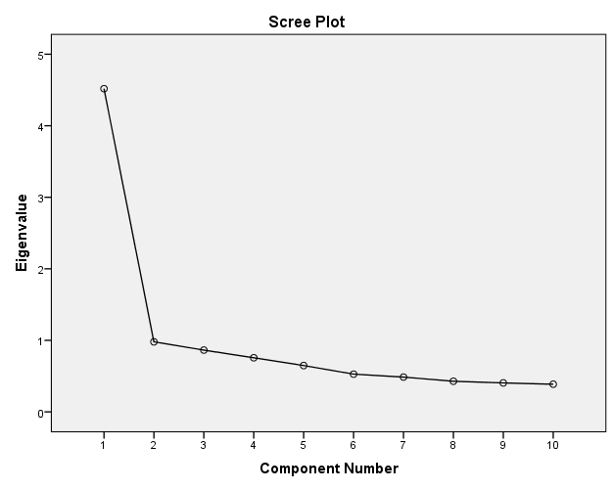

Component Matrixª
 | Component
 | 1
Confidence percentage question 20 | ,773
Confidence percentage question 24 | ,716
Confidence percentage question 18 | ,702
Confidence percentage question 14 | ,699
Confidence percentage question 12 | ,696
Confidence percentage question 26 | ,644
Confidence percentage question 22 | ,637
Confidence percentage question 30 | ,635
Confidence percentage question 16 | ,630
Confidence percentage question 28 | ,568
Extraction Method: Principal Component Analysis.
a. 1 components extracted.

Item | Knowledge confidence
Confidence percentage question 12 | .696
Confidence percentage question 14 | .699
Confidence percentage question 16 | .630
Confidence percentage question 18 | .702
Confidence percentage question 20 | .773
Confidence percentage question 22 | .637
Confidence percentage question 24 | .716
Confidence percentage question 26 | .644
Confidence percentage question 28 | .568
Confidence percentage question 30 | .635
Eigenvalues | 4.52
% of variance | 45.2%

Reliability – Cronbach’s alpha
Attributes
Reliability Statistics
Cronbach's Alpha | Cronbach's Alpha Based on Standardized Items | N of Items
,700 | ,696 | 7

Item-Total Statistics
 | Scale Mean if Item Deleted | Scale Variance if Item Deleted | Corrected Item-Total Correlation | Squared Multiple Correlation | Cronbach's Alpha if Item Deleted
Price | 22,89 | 15,017 | ,074 | ,084 | ,741
(Free) choice health care providers | 22,97 | 12,845 | ,408 | ,194 | ,667
Expenses claim | 23,41 | 11,974 | ,437 | ,226 | ,660
Content additional coverage | 23,04 | 12,235 | ,505 | ,271 | ,643
Acceptance requirements | 23,75 | 11,675 | ,440 | ,258 | ,659
Customer satisfaction | 23,27 | 12,635 | ,433 | ,288 | ,661
Quality policy health care purchase | 23,45 | 11,490 | ,589 | ,389 | ,618

Information source types
Reliability Statistics
Cronbach's Alpha | Cronbach's Alpha Based on Standardized Items |  |  | N of Items
,853 | ,847 |  |  | 21
Item-Total Statistics
 |  | Scale Mean if Item Deleted | Scale Variance if Item Deleted |  | Corrected Item-Total Correlation |  | Squared Multiple Correlation | Cronbach's Alpha if Item Deleted
Previous involvement |  | 67,80 | 272,171 |  | ,359 |  | ,346 | ,849
Health insurance companies of friends |  | 70,11 | 259,821 |  | ,503 |  | ,403 | ,843
Advice health insurance consultant |  | 71,14 | 274,029 |  | ,325 |  | ,195 | ,850
Magazine ads |  | 70,54 | 259,543 |  | ,588 |  | ,569 | ,840
Opinion of family member or relative |  | 69,61 | 255,778 |  | ,554 |  | ,708 | ,841
Radio commercials |  | 70,73 | 259,351 |  | ,615 |  | ,688 | ,839
Printed objective consumer information |  | 69,21 | 259,550 |  | ,526 |  | ,415 | ,842
Past personal experiences |  | 67,92 | 280,073 |  | ,275 |  | ,329 | ,852
Magazine articles |  | 69,88 | 260,967 |  | ,537 |  | ,451 | ,842
Newspapers ads |  | 70,46 | 259,439 |  | ,602 |  | ,592 | ,840
No additional information |  | 71,46 | 290,010 |  | ,013 |  | ,388 | ,861
Opinion of friend or someone I know |  | 69,71 | 257,163 |  | ,573 |  | ,708 | ,840
Recall relevant events |  | 69,22 | 261,327 |  | ,519 |  | ,392 | ,843
TV commercials |  | 70,66 | 259,427 |  | ,609 |  | ,687 | ,840
First health insurance found |  | 71,99 | 287,507 |  | ,118 |  | ,281 | ,855
Written description or detailed descriptive analysis |  | 68,79 | 270,825 |  | ,344 |  | ,499 | ,850
Available information such as printed brochure, pamphlet, etc. |  | 68,88 | 266,817 |  | ,420 |  | ,474 | ,847
Opinion of employee of health insurance company |  | 71,06 | 268,262 |  | ,453 |  | ,314 | ,846
Do not worry about requiring more information |  | 70,68 | 278,497 |  | ,193 |  | ,264 | ,856
Report written by knowledgeable third party |  | 70,18 | 271,851 |  | ,301 |  | ,376 | ,852
What previous customers had to say |  | 69,49 | 263,061 |  | ,473 |  | ,404 | ,845

Involvement
Reliability Statistics
Cronbach's Alpha | Cronbach's Alpha Based on Standardized Items | N of Items
,915 | ,918 | 20
Item-Total Statistics
 |  |  | Scale Mean if Item Deleted |  | Scale Variance if Item Deleted | Corrected Item-Total Correlation | Squared Multiple Correlation | Cronbach's Alpha if Item Deleted
Unimportant - Important |  |  | 90,10 |  | 289,462 | ,594 | ,546 | ,911
Of no concern - Of concern to me |  |  | 90,19 |  | 288,527 | ,595 | ,600 | ,910
Irrelevant - Relevant |  |  | 90,26 |  | 289,381 | ,625 | ,644 | ,910
Means nothing to me - Means a lot to me |  |  | 91,00 |  | 282,061 | ,699 | ,560 | ,908
Useless - Useful |  |  | 90,32 |  | 288,172 | ,684 | ,615 | ,909
Worthless - Valuable |  |  | 90,62 |  | 285,764 | ,640 | ,527 | ,909
Trivial - Fundamental |  |  | 90,76 |  | 285,253 | ,720 | ,644 | ,908
Not beneficial - Beneficial |  |  | 91,55 |  | 290,548 | ,433 | ,257 | ,915
Does not matter - Matters to me |  |  | 90,40 |  | 287,624 | ,675 | ,567 | ,909
Uninterested - Interested |  |  | 91,47 |  | 276,988 | ,706 | ,634 | ,908
Insignificant - Significant |  |  | 91,43 |  | 283,363 | ,678 | ,583 | ,908
Superfluous - Vital |  |  | 90,95 |  | 287,977 | ,672 | ,545 | ,909
Boring - Interesting |  |  | 92,26 |  | 279,280 | ,597 | ,579 | ,911
Unexciting - Exciting |  |  | 93,17 |  | 297,715 | ,378 | ,596 | ,915
Unappealing - Appealing |  |  | 92,66 |  | 293,195 | ,436 | ,548 | ,914
Mundane - Fascinating |  |  | 93,19 |  | 306,755 | ,200 | ,262 | ,919
Nonessential - Essential |  |  | 90,48 |  | 290,994 | ,535 | ,429 | ,912
Undesirable - Desirable |  |  | 90,76 |  | 287,256 | ,573 | ,511 | ,911
Unwanted - Wanted |  |  | 91,56 |  | 292,212 | ,478 | ,386 | ,913
Not needed - Needed |  |  | 90,12 |  | 292,568 | ,527 | ,491 | ,912

Subjective knowledge
Reliability Statistics
Cronbach's Alpha | Cronbach's Alpha Based on Standardized Items | N of Items
,844 | ,844 | 4

Item-Total Statistics
 | Scale Mean if Item Deleted | Scale Variance if Item Deleted | Corrected Item-Total Correlation | Squared Multiple Correlation | Cronbach's Alpha if Item Deleted
General knowledge about health insurance companies | 13,36 | 9,334 | ,745 | ,642 | ,772
Knowledge about health insurance companies compared to average person | 13,38 | 9,859 | ,767 | ,635 | ,766
Confidence in ability to comprehend health insurance companies' information | 12,22 | 11,286 | ,512 | ,276 | ,870
Familiarity with health insurance companies | 13,13 | 9,682 | ,710 | ,515 | ,789

Knowledge confidence
Reliability Statistics
Cronbach's Alpha | Cronbach's Alpha Based on Standardized Items | N of Items
,861 | ,864 | 10

Item-Total Statistics
 | Scale Mean if Item Deleted | Scale Variance if Item Deleted | Corrected Item-Total Correlation | Squared Multiple Correlation | Cronbach's Alpha if Item Deleted
Confidence percentage question 12 | 579,95 | 26729,582 | ,598 | ,426 | ,846
Confidence percentage question 14 | 585,45 | 26349,584 | ,603 | ,432 | ,845
Confidence percentage question 16 | 590,82 | 26240,103 | ,534 | ,329 | ,852
Confidence percentage question 18 | 556,03 | 26192,128 | ,603 | ,406 | ,845
Confidence percentage question 20 | 564,01 | 26026,805 | ,681 | ,503 | ,839
Confidence percentage question 22 | 544,37 | 28079,870 | ,532 | ,366 | ,852
Confidence percentage question 24 | 576,08 | 26349,483 | ,622 | ,417 | ,844
Confidence percentage question 26 | 556,02 | 26380,217 | ,552 | ,384 | ,850
Confidence percentage question 28 | 596,68 | 26725,576 | ,479 | ,278 | ,857
Confidence percentage question 30 | 549,69 | 26857,533 | ,537 | ,382 | ,851

Appendix V SPSS output chapter 6 Analysis and results

Subjective and objective consumer knowledge
Statistics
 |  | Average score subjective knowledge | Number of correct questions in total
N | Valid | 387 | 387
 | Missing | 0 | 0
Mean |  | 4,3467 | 5,6253
Median |  | 4,5000 | 5,7500
Mode |  | 4,75 | 6,25
Minimum |  | 1,00 | ,00
Maximum |  | 7,00 | 9,75

Consumer knowledge and consideration set size
Consideration set size
 |  | Frequency | Percent | Valid Percent | Cumulative Percent
Valid | 0 | 20 | 5,2 | 5,4 | 5,4
 | 1 | 200 | 51,7 | 53,9 | 59,3
 | 2 | 93 | 24,0 | 25,1 | 84,4
 | 3 | 38 | 9,8 | 10,2 | 94,6
 | 4 | 15 | 3,9 | 4,0 | 98,7
 | 5 | 4 | 1,0 | 1,1 | 99,7
 | 6 | 1 | ,3 | ,3 | 100,0
 | Total | 371 | 95,9 | 100,0
Missing | 999 | 16 | 4,1
Total |  | 387 | 100,0

Correlations
 |  | Average score use memory source | Consideration set size | External_source_types
Average score use memory source | Pearson Correlation | 1 | ,121* | ,412**
 | Sig. (2-tailed) |  | ,020 | ,000
 | N | 386 | 370 | 386
Consideration set size | Pearson Correlation | ,121* | 1 | ,064
 | Sig. (2-tailed) | ,020 |  | ,219
 | N | 370 | 371 | 370
External_source_types | Pearson Correlation | ,412** | ,064 | 1
 | Sig. (2-tailed) | ,000 | ,219
 | N | 386 | 370 | 386
*. Correlation is significant at the 0.05 level (2-tailed).
**. Correlation is significant at the 0.01 level (2-tailed).

H1a: The size of the consideration set is positively related to the level of consumers’ objective knowledge.
Correlations
 |  |  |  |  |  |  |  |  |  |  |  |  |  | Consideration set size |  |  |  |  | Number of correct questions in total
Consideration set size |  |  |  |  |  |  |  | Pearson Correlation |  |  |  |  |  | 1 |  |  |  |  | ,105*
 |  |  |  |  |  |  |  | Sig. (1-tailed) |  |  |  |  |  |  |  |  |  |  | ,021
 |  |  |  |  |  |  |  | N |  |  |  |  |  | 371 |  |  |  |  | 371
Number of correct questions in total |  |  |  |  |  |  |  | Pearson Correlation |  |  |  |  |  | ,105* |  |  |  |  | 1
 |  |  |  |  |  |  |  | Sig. (1-tailed) |  |  |  |  |  | ,021
 |  |  |  |  |  |  |  | N |  |  |  |  |  | 371 |  |  |  |  | 387
*. Correlation is significant at the 0.05 level (1-tailed).
Model Summary^{b}
Model |  |  | R | R Square |  | Adjusted R Square |  |  | Std. Error of the Estimate |  |  | Change Statistics
 |  |  |  |  |  |  |  |  |  |  |  | R Square Change |  |  | F Change |  |  | df1 |  |  |  | df2 | Sig. F Change
1 |  |  | ,105ª | ,011 |  | ,008 |  |  | ,988 |  |  | ,011 |  |  | 4,150 |  |  | 1 |  |  |  | 369 | ,042
a. Predictors: (Constant), Number of correct questions in total
b. Dependent Variable: Consideration set size
ANOVAª
Model |  |  |  |  | Sum of Squares |  |  |  |  | df |  |  | Mean Square |  |  |  | F |  |  |  | Sig.
1 | Regression |  |  |  | 4,052 |  |  |  |  | 1 |  |  | 4,052 |  |  |  | 4,150 |  |  |  | ,042^{b}
 | Residual |  |  |  | 360,352 |  |  |  |  | 369 |  |  | ,977
 | Total |  |  |  | 364,404 |  |  |  |  | 370
a. Dependent Variable: Consideration set size
b. Predictors: (Constant), Number of correct questions in total
Coefficientsª
Model |  |  |  |  |  |  | Unstandardized Coefficients |  |  |  |  |  |  |  |  | Standardized Coefficients |  |  |  | t |  |  |  | Sig.
 |  |  |  |  |  |  | B |  |  |  | Std. Error |  |  |  |  | Beta
1 |  | (Constant) |  |  |  |  | 1,128 |  |  |  | ,227 |  |  |  |  |  |  |  |  | 4,959 |  |  |  | ,000
 |  | Number of correct questions in total |  |  |  |  | ,080 |  |  |  | ,039 |  |  |  |  | ,105 |  |  |  | 2,037 |  |  |  | ,042
a. Dependent Variable: Consideration set size

H1b: The size of the consideration set is positively related to the level of consumers’ subjective knowledge.
Correlations
 |  | Consideration set size | Average score subjective knowledge
Consideration set size | Pearson Correlation | 1 | ,168**
 | Sig. (1-tailed) |  | ,001
 | N | 371 | 371
Average score subjective knowledge | Pearson Correlation | ,168** | 1
 | Sig. (1-tailed) | ,001
 | N | 371 | 387
**. Correlation is significant at the 0.01 level (1-tailed).

Model Summary^{b}
Model | R | R Square | Adjusted R Square | Std. Error of the Estimate | Change Statistics
 |  |  |  |  | R Square Change | F Change | df1 | df2 | Sig. F Change
1 | ,168ª | ,028 | ,026 | ,980 | ,028 | 10,752 | 1 | 369 | ,001
a. Predictors: (Constant), Average score subjective knowledge
b. Dependent Variable: Consideration set size

ANOVAª
Model |  | Sum of Squares | df | Mean Square | F | Sig.
1 | Regression | 10,317 | 1 | 10,317 | 10,752 | ,001^{b}
 | Residual | 354,087 | 369 | ,960
 | Total | 364,404 | 370
a. Dependent Variable: Consideration set size
b. Predictors: (Constant), Average score subjective knowledge

Coefficientsª
Model |  | Unstandardized Coefficients |  | Standardized Coefficients | t | Sig.
 |  | B | Std. Error | Beta
1 | (Constant) | ,867 | ,223 |  | 3,884 | ,000
 | Average score subjective knowledge | ,164 | ,050 | ,168 | 3,279 | ,001
a. Dependent Variable: Consideration set size

Consumer knowledge and attributes
Type of attributes
Correlations
 |  | Expenses claim | Acceptance requirements | Customer satisfaction | Quality policy health care purchase | Average score subjective knowledge | Number of correct questions in total
Expenses claim | Pearson Correlation | 1 | ,291** | ,315** | ,323** | ,050 | -,008
 | Sig. (2-tailed) |  | ,000 | ,000 | ,000 | ,323 | ,877
 | N | 386 | 385 | 386 | 384 | 386 | 386
Acceptance requirements | Pearson Correlation | ,291** | 1 | ,254** | ,396** | ,023 | ,011
 | Sig. (2-tailed) | ,000 |  | ,000 | ,000 | ,657 | ,827
 | N | 385 | 386 | 386 | 384 | 386 | 386
Customer satisfaction | Pearson Correlation | ,315** | ,254** | 1 | ,503** | ,018 | -,017
 | Sig. (2-tailed) | ,000 | ,000 |  | ,000 | ,725 | ,741
 | N | 386 | 386 | 387 | 385 | 387 | 387
Quality policy health care purchase | Pearson Correlation | ,323** | ,396** | ,503** | 1 | ,029 | -,020
 | Sig. (2-tailed) | ,000 | ,000 | ,000 |  | ,574 | ,693
 | N | 384 | 384 | 385 | 385 | 385 | 385
Average score subjective knowledge | Pearson Correlation | ,050 | ,023 | ,018 | ,029 | 1 | ,252**
 | Sig. (2-tailed) | ,323 | ,657 | ,725 | ,574 |  | ,000
 | N | 386 | 386 | 387 | 385 | 387 | 387
Number of correct questions in total | Pearson Correlation | -,008 | ,011 | -,017 | -,020 | ,252** | 1
 | Sig. (2-tailed) | ,877 | ,827 | ,741 | ,693 | ,000
 | N | 386 | 386 | 387 | 385 | 387 | 387
**. Correlation is significant at the 0.01 level (2-tailed).
Correlations
 |  |  | Price | (Free) choice health care providers | Content additional coverage | Average score subjective knowledge | Number of correct questions in total
Spearman's rho | Price | Correlation Coefficient | 1,000 | ,026 | ,201** | ,146** | ,132*
 |  | Sig. (2-tailed) | . | ,623 | ,000 | ,005 | ,012
 |  | N | 364 | 362 | 357 | 364 | 364
 | (Free) choice health care providers | Correlation Coefficient | ,026 | 1,000 | ,292** | ,086 | -,007
 |  | Sig. (2-tailed) | ,623 | . | ,000 | ,092 | ,895
 |  | N | 362 | 385 | 377 | 385 | 385
 | Content additional coverage | Correlation Coefficient | ,201** | ,292** | 1,000 | ,034 | ,079
 |  | Sig. (2-tailed) | ,000 | ,000 | . | ,511 | ,126
 |  | N | 357 | 377 | 379 | 379 | 379
 | Average score subjective knowledge | Correlation Coefficient | ,146** | ,086 | ,034 | 1,000 | ,209**
 |  | Sig. (2-tailed) | ,005 | ,092 | ,511 | . | ,000
 |  | N | 364 | 385 | 379 | 387 | 387
 | Number of correct questions in total | Correlation Coefficient | ,132* | -,007 | ,079 | ,209** | 1,000
 |  | Sig. (2-tailed) | ,012 | ,895 | ,126 | ,000 | .
 |  | N | 364 | 385 | 379 | 387 | 387
**. Correlation is significant at the 0.01 level (2-tailed).
*. Correlation is significant at the 0.05 level (2-tailed).

Correlations
 |  | Average score use memory source | External_source_types | Amount of personally relevant aspects
Average score use memory source | Pearson Correlation | 1 | ,412** | ,118*
 | Sig. (2-tailed) |  | ,000 | ,022
 | N | 386 | 386 | 375
External_source_types | Pearson Correlation | ,412** | 1 | ,029
 | Sig. (2-tailed) | ,000 |  | ,576
 | N | 386 | 386 | 375
Amount of personally relevant aspects | Pearson Correlation | ,118* | ,029 | 1
 | Sig. (2-tailed) | ,022 | ,576
 | N | 375 | 375 | 376
**. Correlation is significant at the 0.01 level (2-tailed).
*. Correlation is significant at the 0.05 level (2-tailed).

H2a: The relative importance of the use of extrinsic over intrinsic attributes for the purchase decision is negatively related to the level of consumers’ subjective knowledge.
Correlations
 |  | Rel_imp_extr_over_intr | Average score subjective knowledge
Rel_imp_extr_over_intr | Pearson Correlation | 1 | ,031
 | Sig. (1-tailed) |  | ,277
 | N | 364 | 364
Average score subjective knowledge | Pearson Correlation | ,031 | 1
 | Sig. (1-tailed) | ,277
 | N | 364 | 387

H2b: The use of intrinsic attributes is positively related to the level of consumers’ objective knowledge.
Correlations
 |  | Number of correct questions in total | Average scroe intrinsic attributes
Number of correct questions in total | Pearson Correlation | 1 | ,033
 | Sig. (1-tailed) |  | ,257
 | N | 387 | 387
Average scroe intrinsic attributes | Pearson Correlation | ,033 | 1
 | Sig. (1-tailed) | ,257
 | N | 387 | 387

Amount of attributes

Amount of personally relevant aspects
 |  | Frequency | Percent | Valid Percent | Cumulative Percent
Valid | 0 | 23 | 5,9 | 6,1 | 6,1
 | 1 | 99 | 25,6 | 26,3 | 32,4
 | 2 | 158 | 40,8 | 42,0 | 74,5
 | 3 | 68 | 17,6 | 18,1 | 92,6
 | 4 | 24 | 6,2 | 6,4 | 98,9
 | 5 | 3 | ,8 | ,8 | 99,7
 | 8 | 1 | ,3 | ,3 | 100,0
 | Total | 376 | 97,2 | 100,0
Missing | 999 | 11 | 2,8
Total |  | 387 | 100,0

H3a: The amount of attributes examined for the purchase decision is positively related to the level of consumers’ objective knowledge.
Correlations
 |  | Amount of personally relevant aspects | Number of correct questions in total
Amount of personally relevant aspects | Pearson Correlation | 1 | ,031
 | Sig. (1-tailed) |  | ,274
 | N | 376 | 376
Number of correct questions in total | Pearson Correlation | ,031 | 1
 | Sig. (1-tailed) | ,274
 | N | 376 | 387

H3b: The amount of attributes examined for the purchase decision is positively related to the level of consumers’ subjective knowledge.
Correlations
 |  | Amount of personally relevant aspects | Average score subjective knowledge
Amount of personally relevant aspects | Pearson Correlation | 1 | ,118*
 | Sig. (1-tailed) |  | ,011
 | N | 376 | 376
Average score subjective knowledge | Pearson Correlation | ,118* | 1
 | Sig. (1-tailed) | ,011
 | N | 376 | 387
*. Correlation is significant at the 0.05 level (1-tailed).

Model Summary^{b}
Model | R | R Square | Adjusted R Square | Std. Error of the Estimate | Change Statistics
 |  |  |  |  | R Square Change | F Change | df1 | df2 | Sig. F Change
1 | ,118ª | ,014 | ,011 | 1,049 | ,014 | 5,265 | 1 | 374 | ,022
a. Predictors: (Constant), Average score subjective knowledge
b. Dependent Variable: Amount of personally relevant aspects

ANOVAª
Model |  | Sum of Squares | df | Mean Square | F | Sig.
1 | Regression | 5,795 | 1 | 5,795 | 5,265 | ,022^{b}
 | Residual | 411,684 | 374 | 1,101
 | Total | 417,479 | 375
a. Dependent Variable: Amount of personally relevant aspects
b. Predictors: (Constant), Average score subjective knowledge

Coefficientsª
Model |  | Unstandardized Coefficients |  | Standardized Coefficients | t | Sig.
 |  | B | Std. Error | Beta
1 | (Constant) | 1,431 | ,238 |  | 6,019 | ,000
 | Average score subjective knowledge | ,122 | ,053 | ,118 | 2,294 | ,022
a. Dependent Variable: Amount of personally relevant aspects

Consumer knowledge and information sources
Information sources
 |  | Previous involvement | Health insurance companies of friends | Advice health insurance consultant | Magazine ads | Opinion of family member or relative | Radio commercials | Past personal experiences
N | Valid | 385 | 386 | 385 | 386 | 385 | 381 | 385
 | Missing | 2 | 1 | 2 | 1 | 2 | 6 | 2
Mean |  | 5,69 | 3,40 | 2,34 | 2,97 | 3,88 | 2,75 | 5,58
Median |  | 6,00 | 3,00 | 2,00 | 3,00 | 4,00 | 2,00 | 6,00
Mode |  | 7 | 1 | 1 | 1 | 5 | 1 | 6
Minimum |  | 1 | 1 | 1 | 1 | 1 | 1 | 1
Maximum |  | 7 | 7 | 7 | 7 | 7 | 7 | 7

 |  | Magazine articles | Newspapers ads | No additional information | Opinion of friend or someone I know | Recall relevant events | TV commercials | First health insurance found
N | Valid | 378 | 382 | 385 | 382 | 379 | 383 | 381
 | Missing | 9 | 5 | 2 | 5 | 8 | 4 | 6
Mean |  | 3,65 | 3,04 | 2,04 | 3,77 | 4,25 | 2,85 | 1,47
Median |  | 4,00 | 3,00 | 1,00 | 4,00 | 4,00 | 3,00 | 1,00
Mode |  | 4 | 1 | 1 | 4 | 5 | 2 | 1
Minimum |  | 1 | 1 | 1 | 1 | 1 | 1 | 1
Maximum |  | 7 | 7 | 7 | 7 | 7 | 7 | 7

 |  | Opinion of employee of health insurance company | Do not worry about requiring more information
N | Valid | 386 | 384
 | Missing | 1 | 3
Mean |  | 2,46 | 2,80
Median |  | 2,00 | 2,00
Mode |  | 1 | 1
Minimum |  | 1 | 1
Maximum |  | 7 | 7

Memory vs. external information sources
H4: The use of memory as an internal information source is positively related to the level of consumers’ subjective knowledge.
Correlations
 |  | Average score subjective knowledge | Average score use memory source
Average score subjective knowledge | Pearson Correlation | 1 | ,143**
 | Sig. (1-tailed) |  | ,002
 | N | 387 | 386
Average score use memory source | Pearson Correlation | ,143** | 1
 | Sig. (1-tailed) | ,002
 | N | 386 | 386
**. Correlation is significant at the 0.01 level (1-tailed).

Model Summary^{b}
Model | R | R Square | Adjusted R Square | Std. Error of the Estimate | Change Statistics
 |  |  |  |  | R Square Change | F Change | df1 | df2 | Sig. F Change
1 | ,143ª | ,021 | ,018 | 1,10993 | ,021 | 8,068 | 1 | 384 | ,005
a. Predictors: (Constant), Average score subjective knowledge
b. Dependent Variable: Average score use memory source

ANOVAª
Model |  | Sum of Squares | df | Mean Square | F | Sig.
1 | Regression | 9,939 | 1 | 9,939 | 8,068 | ,005^{b}
 | Residual | 473,068 | 384 | 1,232
 | Total | 483,007 | 385
a. Dependent Variable: Average score use memory source
b. Predictors: (Constant), Average score subjective knowledge

Coefficientsª
Model |  | Unstandardized Coefficients |  | Standardized Coefficients | t | Sig.
 |  | B | Std. Error | Beta
1 | (Constant) | 4,493 | ,246 |  | 18,247 | ,000
 | Average score subjective knowledge | ,157 | ,055 | ,143 | 2,840 | ,005
a. Dependent Variable: Average score use memory source

The use of memory as an internal information source and objective knowledge
Correlations
 |  | Average score use memory source | Number of correct questions in total
Average score use memory source | Pearson Correlation | 1 | -,014
 | Sig. (1-tailed) |  | ,393
 | N | 386 | 386
Number of correct questions in total | Pearson Correlation | -,014 | 1
 | Sig. (1-tailed) | ,393
 | N | 386 | 387

H5a: The use of external information sources is negatively related to the level of consumers’ subjective knowledge.
Correlations
 |  | External_source_types | Average score subjective knowledge
External_source_types | Pearson Correlation | 1 | -,067
 | Sig. (1-tailed) |  | ,093
 | N | 386 | 386
Average score subjective knowledge | Pearson Correlation | -,067 | 1
 | Sig. (1-tailed) | ,093
 | N | 386 | 387

H5b: The use of external information sources is positively related to the level of consumers’ objective knowledge.
Correlations
 |  | External_source_types | Number of correct questions in total
External_source_types | Pearson Correlation | 1 | -,043
 | Sig. (1-tailed) |  | ,200
 | N | 386 | 386
Number of correct questions in total | Pearson Correlation | -,043 | 1
 | Sig. (1-tailed) | ,200
 | N | 386 | 387

Personal vs. impersonal information sources
H6a: The use of personal information is negatively related to the level of consumers’ subjective knowledge.
Correlations
 |  | Average score subjective knowledge | Personal_source_types
Average score subjective knowledge | Pearson Correlation | 1 | -,134**
 | Sig. (1-tailed) |  | ,004
 | N | 387 | 386
Personal_source_types | Pearson Correlation | -,134** | 1
 | Sig. (1-tailed) | ,004
 | N | 386 | 386
**. Correlation is significant at the 0.01 level (1-tailed).

Model Summary^{b}
Model | R | R Square | Adjusted R Square | Std. Error of the Estimate | Change Statistics
 |  |  |  |  | R Square Change | F Change | df1 | df2 | Sig. F Change
1 | ,134ª | ,018 | ,015 | 1,18314 | ,018 | 6,981 | 1 | 384 | ,009
a. Predictors: (Constant), Average score subjective knowledge
b. Dependent Variable: Personal_source_types

ANOVAª
Model |  | Sum of Squares | df | Mean Square | F | Sig.
1 | Regression | 9,773 | 1 | 9,773 | 6,981 | ,009^{b}
 | Residual | 537,530 | 384 | 1,400
 | Total | 547,302 | 385
a. Dependent Variable: Personal_source_types
b. Predictors: (Constant), Average score subjective knowledge

Coefficientsª
Model |  | Unstandardized Coefficients |  | Standardized Coefficients | t | Sig.
 |  | B | Std. Error | Beta
1 | (Constant) | 3,841 | ,262 |  | 14,634 | ,000
 | Average score subjective knowledge | -,155 | ,059 | -,134 | -2,642 | ,009
a. Dependent Variable: Personal_source_types
H6b: The use of impersonal information sources is negatively related to the level of consumers’ subjective knowledge.
Correlations
 |  | Impersonal_source_types | Average score subjective knowledge
Impersonal_source_types | Pearson Correlation | 1 | ,032
 | Sig. (1-tailed) |  | ,268
 | N | 386 | 386
Average score subjective knowledge | Pearson Correlation | ,032 | 1
 | Sig. (1-tailed) | ,268
 | N | 386 | 387

H6d: The use of personal information sources is positively related to the level of consumers’ objective knowledge.

Correlations
 |  | Number of correct questions in total | Personal_source_types
Number of correct questions in total | Pearson Correlation | 1 | -,107*
 | Sig. (1-tailed) |  | ,018
 | N | 387 | 386
Personal_source_types | Pearson Correlation | -,107* | 1
 | Sig. (1-tailed) | ,018
 | N | 386 | 386
*. Correlation is significant at the 0.05 level (1-tailed).

Model Summary^{b}
Model | R | R Square | Adjusted R Square | Std. Error of the Estimate
1 | ,107ª | ,011 | ,009 | 1,18699
a. Predictors: (Constant), Number of correct questions in total
b. Dependent Variable: Personal_source_types

ANOVAª
Model |  | Sum of Squares | df | Mean Square | F | Sig.
1 | Regression | 6,270 | 1 | 6,270 | 4,450 | ,036^{b}
 | Residual | 541,032 | 384 | 1,409
 | Total | 547,302 | 385
a. Dependent Variable: Personal_source_types
b. Predictors: (Constant), Number of correct questions in total

Coefficientsª
Model |  | Unstandardized Coefficients |  | Standardized Coefficients | t | Sig.
 |  | B | Std. Error | Beta
1 | (Constant) | 3,703 | ,262 |  | 14,152 | ,000
 | Number of correct questions in total | -,096 | ,045 | -,107 | -2,110 | ,036
a. Dependent Variable: Personal_source_types
H6e: The use of impersonal information sources is positively related to the level of consumers’ objective knowledge.

Correlations
 |  | Number of correct questions in total | Impersonal_source_types
Number of correct questions in total | Pearson Correlation | 1 | ,053
 | Sig. (1-tailed) |  | ,148
 | N | 387 | 386
Impersonal_source_types | Pearson Correlation | ,053 | 1
 | Sig. (1-tailed) | ,148
 | N | 386 | 386

Consumer knowledge calibration

Statistics
 |  | Average score confidence | Number of correct questions in total | Knowledge_calibration
N | Valid | 386 | 387 | 386
 | Missing | 1 | 0 | 1
Mean |  | 63,2772 | 5,6253 | ,0673
Median |  | 65,6000 | 5,7500 | ,1000
Mode |  | 69,00 | 6,25 | ,11ª
Minimum |  | ,00 | ,00 | -,68
Maximum |  | 98,30 | 9,75 | ,64
a. Multiple modes exist. The smallest value is shown

 |  | Knowledge_calibration
Knowledge_calibration | Pearson Correlation | 1
 | Sig. (2-tailed)
 | N | 386
Average score use memory source | Pearson Correlation | ,101*
 | Sig. (2-tailed) | ,048
 | N | 385
External_source_types | Pearson Correlation | -,014
 | Sig. (2-tailed) | ,780
 | N | 385
Amount of personally relevant aspects | Pearson Correlation | ,044
 | Sig. (2-tailed) | ,399
 | N | 375
Consideration set size | Pearson Correlation | ,010
 | Sig. (2-tailed) | ,853
 | N | 370
Price | Pearson Correlation | -,024
 | Sig. (2-tailed) | ,648
 | N | 363
Rel_imp_extr_over_intr | Pearson Correlation | -,072
 | Sig. (2-tailed) | ,172
 | N | 363
Impersonal_source_types | Pearson Correlation | -,003
 | Sig. (2-tailed) | ,946
 | N | 385
Personal_source_types | Pearson Correlation | -,030
 | Sig. (2-tailed) | ,556
 | N | 385
Average score subjective knowledge | Pearson Correlation | ,225**
 | Sig. (2-tailed) | ,000
 | N | 386
Average score involvement | Pearson Correlation | ,148**
 | Sig. (2-tailed) | ,004
 | N | 369
Number of correct questions in total | Pearson Correlation | -,405**
 | Sig. (2-tailed) | ,000
 | N | 386
*. Correlation is significant at the 0.05 level (2-tailed).
**. Correlation is significant at the 0.01 level (2-tailed).

H7a: Consumer knowledge calibration moderates the relationship between the level of consumers’ objective knowledge and the size of the consideration set.

Model Summary^{c}
Model | R | R Square | Adjusted R Square | Std. Error of the Estimate | Change Statistics
 |  |  |  |  | R Square Change | F Change | df1 | df2 | Sig. F Change
1 | ,115ª | ,013 | ,008 | ,989 | ,013 | 2,478 | 2 | 367 | ,085
2 | ,119^{b} | ,014 | ,006 | ,990 | ,001 | ,273 | 1 | 366 | ,602
a. Predictors: (Constant), Knowledge_calibration_c, Objective_knowledge_c
b. Predictors: (Constant), Knowledge_calibration_c, Objective_knowledge_c, Ob_Knowledge_calibration
c. Dependent Variable: Consideration set size

ANOVAª
Model |  | Sum of Squares | df | Mean Square | F | Sig.
1 | Regression | 4,850 | 2 | 2,425 | 2,478 | ,085^{b}
 | Residual | 359,218 | 367 | ,979
 | Total | 364,068 | 369
2 | Regression | 5,117 | 3 | 1,706 | 1,739 | ,159^{c}
 | Residual | 358,950 | 366 | ,981
 | Total | 364,068 | 369
a. Dependent Variable: Consideration set size
b. Predictors: (Constant), Knowledge_calibration_c, Objective_knowledge_c
c. Predictors: (Constant), Knowledge_calibration_c, Objective_knowledge_c, Ob_Knowledge_calibration

Coefficientsª
Model |  | Unstandardized Coefficients |  | Standardized Coefficients | t | Sig.
 |  | B | Std. Error | Beta
1 | (Constant) | 1,578 | ,051 |  | 30,681 | ,000
 | Objective_knowledge_c | ,098 | ,044 | ,126 | 2,218 | ,027
 | Knowledge_calibration_c | ,318 | ,297 | ,061 | 1,068 | ,286
2 | (Constant) | 1,589 | ,055 |  | 28,766 | ,000
 | Objective_knowledge_c | ,098 | ,044 | ,125 | 2,209 | ,028
 | Knowledge_calibration_c | ,329 | ,298 | ,063 | 1,103 | ,271
 | Ob_Knowledge_calibration | ,107 | ,205 | ,027 | ,522 | ,602
a. Dependent Variable: Consideration set size
H7b: Consumer knowledge calibration moderates the relationship between the level of consumers’ subjective knowledge and the size of the consideration set.

Model Summary^{c}
Model | R | R Square | Adjusted R Square | Std. Error of the Estimate | Change Statistics
 |  |  |  |  | R Square Change | F Change | df1 | df2 | Sig. F Change
1 | ,170ª | ,029 | ,024 | ,982 | ,029 | 5,447 | 2 | 367 | ,005
2 | ,170^{b} | ,029 | ,021 | ,983 | ,000 | ,070 | 1 | 366 | ,792
a. Predictors: (Constant), Subjective_knowledge_c, Knowledge_calibration_c
b. Predictors: (Constant), Subjective_knowledge_c, Knowledge_calibration_c, Sub_Knowledge_calibration
c. Dependent Variable: Consideration set size

ANOVAª
Model |  | Sum of Squares | df | Mean Square | F | Sig.
1 | Regression | 10,495 | 2 | 5,248 | 5,447 | ,005^{b}
 | Residual | 353,572 | 367 | ,963
 | Total | 364,068 | 369
2 | Regression | 10,563 | 3 | 3,521 | 3,645 | ,013^{c}
 | Residual | 353,505 | 366 | ,966
 | Total | 364,068 | 369
a. Dependent Variable: Consideration set size
b. Predictors: (Constant), Subjective_knowledge_c, Knowledge_calibration_c
c. Predictors: (Constant), Subjective_knowledge_c, Knowledge_calibration_c, Sub_Knowledge_calibration

Coefficientsª
Model |  | Unstandardized Coefficients |  | Standardized Coefficients | t | Sig.
 |  | B | Std. Error | Beta
1 | (Constant) | 1,582 | ,051 |  | 30,998 | ,000
 | Knowledge_calibration_c | -,149 | ,276 | -,028 | -,540 | ,589
 | Subjective_knowledge_c | ,169 | ,051 | ,174 | 3,295 | ,001
2 | (Constant) | 1,579 | ,052 |  | 30,354 | ,000
 | Knowledge_calibration_c | -,138 | ,280 | -,026 | -,493 | ,622
 | Subjective_knowledge_c | ,168 | ,052 | ,173 | 3,257 | ,001
 | Sub_Knowledge_calibration | ,061 | ,230 | ,014 | ,264 | ,792
a. Dependent Variable: Consideration set size
H7c: Consumer knowledge calibration moderates the relationship between the level of consumers’ subjective knowledge and the relative importance of the use of extrinsic over intrinsic attributes for the purchase decision.
Model Summary^{c}
Model | R | R Square | Adjusted R Square | Std. Error of the Estimate | Change Statistics
 |  |  |  |  | R Square Change | F Change | df1 | df2 | Sig. F Change
1 | ,086ª | ,007 | ,002 | 1,05090 | ,007 | 1,343 | 2 | 360 | ,262
2 | ,092^{b} | ,008 | ,000 | 1,05183 | ,001 | ,365 | 1 | 359 | ,546
a. Predictors: (Constant), Subjective_knowledge_c, Knowledge_calibration_c
b. Predictors: (Constant), Subjective_knowledge_c, Knowledge_calibration_c, Sub_Knowledge_calibration
c. Dependent Variable: Rel_imp_extr_over_intr

ANOVAª
Model |  | Sum of Squares | df | Mean Square | F | Sig.
1 | Regression | 2,966 | 2 | 1,483 | 1,343 | ,262^{b}
 | Residual | 397,579 | 360 | 1,104
 | Total | 400,545 | 362
2 | Regression | 3,370 | 3 | 1,123 | 1,015 | ,386^{c}
 | Residual | 397,175 | 359 | 1,106
 | Total | 400,545 | 362
a. Dependent Variable: Rel_imp_extr_over_intr
b. Predictors: (Constant), Subjective_knowledge_c, Knowledge_calibration_c
c. Predictors: (Constant), Subjective_knowledge_c, Knowledge_calibration_c, Sub_Knowledge_calibration

Coefficientsª
Model |  | Unstandardized Coefficients |  | Standardized Coefficients | t | Sig.
 |  | B | Std. Error | Beta
1 | (Constant) | ,429 | ,055 |  | 7,774 | ,000
 | Knowledge_calibration_c | -,460 | ,301 | -,082 | -1,526 | ,128
 | Subjective_knowledge_c | ,050 | ,055 | ,048 | ,902 | ,368
2 | (Constant) | ,423 | ,056 |  | 7,544 | ,000
 | Knowledge_calibration_c | -,451 | ,302 | -,080 | -1,494 | ,136
 | Subjective_knowledge_c | ,046 | ,056 | ,045 | ,834 | ,405
 | Sub_Knowledge_calibration | ,149 | ,247 | ,032 | ,604 | ,546
a. Dependent Variable: Rel_imp_extr_over_intr
H7d: Consumer knowledge calibration moderates the relationship between the level of consumers’ objective knowledge and the use of intrinsic attributes for the purchase decision.

Model Summary^{c}
Model | R | R Square | Adjusted R Square | Std. Error of the Estimate | Change Statistics
 |  |  |  |  | R Square Change | F Change | df1 | df2 | Sig. F Change
1 | ,096ª | ,009 | ,004 | ,67120 | ,009 | 1,778 | 2 | 383 | ,170
2 | ,127^{b} | ,016 | ,008 | ,66973 | ,007 | 2,687 | 1 | 382 | ,102
a. Predictors: (Constant), Objective_knowledge_c, Knowledge_calibration_c
b. Predictors: (Constant), Objective_knowledge_c, Knowledge_calibration_c, Ob_Knowledge_calibration
c. Dependent Variable: Average scroe intrinsic attributes

ANOVAª
Model |  | Sum of Squares | df | Mean Square | F | Sig.
1 | Regression | 1,602 | 2 | ,801 | 1,778 | ,170^{b}
 | Residual | 172,547 | 383 | ,451
 | Total | 174,149 | 385
2 | Regression | 2,808 | 3 | ,936 | 2,086 | ,102^{c}
 | Residual | 171,342 | 382 | ,449
 | Total | 174,149 | 385
a. Dependent Variable: Average scroe intrinsic attributes
b. Predictors: (Constant), Objective_knowledge_c, Knowledge_calibration_c
c. Predictors: (Constant), Objective_knowledge_c, Knowledge_calibration_c, Ob_Knowledge_calibration

Coefficientsª
Model |  | Unstandardized Coefficients |  | Standardized Coefficients | t | Sig.
 |  | B | Std. Error | Beta
1 | (Constant) | 3,818 | ,034 |  | 111,746 | ,000
 | Knowledge_calibration_c | ,354 | ,195 | ,101 | 1,809 | ,071
 | Objective_knowledge_c | ,035 | ,029 | ,068 | 1,220 | ,223
2 | (Constant) | 3,840 | ,037 |  | 104,971 | ,000
 | Knowledge_calibration_c | ,385 | ,196 | ,110 | 1,968 | ,050
 | Objective_knowledge_c | ,035 | ,029 | ,068 | 1,224 | ,222
 | Ob_Knowledge_calibration | ,215 | ,131 | ,084 | 1,639 | ,102
a. Dependent Variable: Average scroe intrinsic attributes
H7e: Consumer knowledge calibration moderates the relationship between the level of consumers’ objective knowledge and the amount of attributes examined for the purchase decision.
Model Summary^{c}
Model | R | R Square | Adjusted R Square | Std. Error of the Estimate | Change Statistics
 |  |  |  |  | R Square Change | F Change | df1 | df2 | Sig. F Change
1 | ,070ª | ,005 | ,000 | 1,057 | ,005 | ,913 | 2 | 372 | ,402
2 | ,095^{b} | ,009 | ,001 | 1,056 | ,004 | 1,544 | 1 | 371 | ,215
a. Predictors: (Constant), Objective_knowledge_c, Knowledge_calibration_c
b. Predictors: (Constant), Objective_knowledge_c, Knowledge_calibration_c, Ob_Knowledge_calibration
c. Dependent Variable: Amount of personally relevant aspects

ANOVAª
Model |  | Sum of Squares | df | Mean Square | F | Sig.
1 | Regression | 2,039 | 2 | 1,020 | ,913 | ,402^{b}
 | Residual | 415,438 | 372 | 1,117
 | Total | 417,477 | 374
2 | Regression | 3,762 | 3 | 1,254 | 1,124 | ,339^{c}
 | Residual | 413,716 | 371 | 1,115
 | Total | 417,477 | 374
a. Dependent Variable: Amount of personally relevant aspects
b. Predictors: (Constant), Objective_knowledge_c, Knowledge_calibration_c
c. Predictors: (Constant), Objective_knowledge_c, Knowledge_calibration_c, Ob_Knowledge_calibration

Coefficientsª
Model |  | Unstandardized Coefficients |  | Standardized Coefficients | t | Sig.
 |  | B | Std. Error | Beta
1 | (Constant) | 1,962 | ,055 |  | 35,946 | ,000
 | Knowledge_calibration_c | ,377 | ,314 | ,068 | 1,199 | ,231
 | Objective_knowledge_c | ,048 | ,046 | ,060 | 1,056 | ,292
2 | (Constant) | 1,988 | ,059 |  | 33,981 | ,000
 | Knowledge_calibration_c | ,404 | ,315 | ,073 | 1,283 | ,200
 | Objective_knowledge_c | ,049 | ,046 | ,060 | 1,068 | ,286
 | Ob_Knowledge_calibration | ,263 | ,212 | ,064 | 1,243 | ,215
a. Dependent Variable: Amount of personally relevant aspects
H7f: Consumer knowledge calibration moderates the relationship between the level of consumers’ subjective knowledge and the amount of attributes examined for the purchase decision.
Model Summary^{c}
Model | R | R Square | Adjusted R Square | Std. Error of the Estimate | Change Statistics
 |  |  |  |  | R Square Change | F Change | df1 | df2 | Sig. F Change
1 | ,119ª | ,014 | ,009 | 1,052 | ,014 | 2,682 | 2 | 372 | ,070
2 | ,125^{b} | ,016 | ,008 | 1,052 | ,001 | ,545 | 1 | 371 | ,461
a. Predictors: (Constant), Subjective_knowledge_c, Knowledge_calibration_c
b. Predictors: (Constant), Subjective_knowledge_c, Knowledge_calibration_c, Sub_Knowledge_calibration
c. Dependent Variable: Amount of personally relevant aspects

ANOVAª
Model |  | Sum of Squares | df | Mean Square | F | Sig.
1 | Regression | 5,935 | 2 | 2,967 | 2,682 | ,070^{b}
 | Residual | 411,542 | 372 | 1,106
 | Total | 417,477 | 374
2 | Regression | 6,538 | 3 | 2,179 | 1,968 | ,118^{c}
 | Residual | 410,939 | 371 | 1,108
 | Total | 417,477 | 374
a. Dependent Variable: Amount of personally relevant aspects
b. Predictors: (Constant), Subjective_knowledge_c, Knowledge_calibration_c
c. Predictors: (Constant), Subjective_knowledge_c, Knowledge_calibration_c, Sub_Knowledge_calibration

Coefficientsª
Model |  | Unstandardized Coefficients |  | Standardized Coefficients | t | Sig.
 |  | B | Std. Error | Beta
1 | (Constant) | 1,961 | ,054 |  | 36,091 | ,000
 | Knowledge_calibration_c | ,100 | ,294 | ,018 | ,341 | ,733
 | Subjective_knowledge_c | ,118 | ,055 | ,114 | 2,155 | ,032
2 | (Constant) | 1,968 | ,055 |  | 35,555 | ,000
 | Knowledge_calibration_c | ,083 | ,295 | ,015 | ,282 | ,778
 | Subjective_knowledge_c | ,121 | ,055 | ,117 | 2,208 | ,028
 | Sub_Knowledge_calibration | -,180 | ,243 | -,038 | -,738 | ,461
a. Dependent Variable: Amount of personally relevant aspects
H7g: Consumer knowledge calibration moderates the relationship between the level of consumers’ subjective knowledge and the use of memory as an internal information source.

Model Summary^{c}
Model | R | R Square | Adjusted R Square | Std. Error of the Estimate | Change Statistics
 |  |  |  |  | R Square Change | F Change | df1 | df2 | Sig. F Change
1 | ,158ª | ,025 | ,020 | 1,10635 | ,025 | 4,916 | 2 | 382 | ,008
2 | ,158^{b} | ,025 | ,017 | 1,10780 | ,000 | ,006 | 1 | 381 | ,938
a. Predictors: (Constant), Subjective_knowledge_c, Knowledge_calibration_c
b. Predictors: (Constant), Subjective_knowledge_c, Knowledge_calibration_c, Sub_Knowledge_calibration
c. Dependent Variable: Average score use memory source

ANOVAª
Model |  | Sum of Squares | df | Mean Square | F | Sig.
1 | Regression | 12,034 | 2 | 6,017 | 4,916 | ,008^{b}
 | Residual | 467,576 | 382 | 1,224
 | Total | 479,610 | 384
2 | Regression | 12,041 | 3 | 4,014 | 3,271 | ,021^{c}
 | Residual | 467,569 | 381 | 1,227
 | Total | 479,610 | 384
a. Dependent Variable: Average score use memory source
b. Predictors: (Constant), Subjective_knowledge_c, Knowledge_calibration_c
c. Predictors: (Constant), Subjective_knowledge_c, Knowledge_calibration_c, Sub_Knowledge_calibration

Coefficientsª
Model |  | Unstandardized Coefficients |  | Standardized Coefficients | t | Sig.
 |  | B | Std. Error | Beta
1 | (Constant) | 5,179 | ,056 |  | 91,852 | ,000
 | Knowledge_calibration_c | ,426 | ,302 | ,073 | 1,408 | ,160
 | Subjective_knowledge_c | ,136 | ,056 | ,125 | 2,416 | ,016
2 | (Constant) | 5,180 | ,058 |  | 90,055 | ,000
 | Knowledge_calibration_c | ,423 | ,304 | ,073 | 1,391 | ,165
 | Subjective_knowledge_c | ,137 | ,057 | ,126 | 2,412 | ,016
 | Sub_Knowledge_calibration | -,020 | ,251 | -,004 | -,078 | ,938
a. Dependent Variable: Average score use memory source
Objective knowledge memory

Model Summary^{c}
Model | R | R Square | Adjusted R Square | Std. Error of the Estimate | Change Statistics
 |  |  |  |  | R Square Change | F Change | df1 | df2 | Sig. F Change
1 | ,101ª | ,010 | ,005 | 1,11473 | ,010 | 1,983 | 2 | 382 | ,139
2 | ,112^{b} | ,013 | ,005 | 1,11489 | ,002 | ,888 | 1 | 381 | ,347
a. Predictors: (Constant), Objective_knowledge_c, Knowledge_calibration_c
b. Predictors: (Constant), Objective_knowledge_c, Knowledge_calibration_c, Ob_Knowledge_calibration
c. Dependent Variable: Average score use memory source

ANOVAª
Model |  | Sum of Squares | df | Mean Square | F | Sig.
1 | Regression | 4,929 | 2 | 2,465 | 1,983 | ,139^{b}
 | Residual | 474,681 | 382 | 1,243
 | Total | 479,610 | 384
2 | Regression | 6,032 | 3 | 2,011 | 1,618 | ,185^{c}
 | Residual | 473,578 | 381 | 1,243
 | Total | 479,610 | 384
a. Dependent Variable: Average score use memory source
b. Predictors: (Constant), Objective_knowledge_c, Knowledge_calibration_c
c. Predictors: (Constant), Objective_knowledge_c, Knowledge_calibration_c, Ob_Knowledge_calibration

Coefficientsª
Model |  | Unstandardized Coefficients |  | Standardized Coefficients | t | Sig.
 |  | B | Std. Error | Beta
1 | (Constant) | 5,179 | ,057 |  | 91,156 | ,000
 | Knowledge_calibration_c | ,613 | ,325 | ,105 | 1,885 | ,060
 | Objective_knowledge_c | ,009 | ,048 | ,010 | ,182 | ,856
2 | (Constant) | 5,200 | ,061 |  | 85,200 | ,000
 | Knowledge_calibration_c | ,645 | ,327 | ,111 | 1,972 | ,049
 | Objective_knowledge_c | ,009 | ,048 | ,010 | ,186 | ,853
 | Ob_Knowledge_calibration | ,206 | ,219 | ,048 | ,942 | ,347
a. Dependent Variable: Average score use memory source

H7h: Consumer knowledge calibration moderates the relationship between the level of consumers’ subjective knowledge and the use of external information sources.

Model Summary^{c}
Model | R | R Square | Adjusted R Square | Std. Error of the Estimate | Change Statistics
 |  |  |  |  | R Square Change | F Change | df1 | df2 | Sig. F Change
1 | ,067ª | ,005 | -,001 | 1,07063 | ,005 | ,872 | 2 | 382 | ,419
2 | ,069^{b} | ,005 | -,003 | 1,07195 | ,000 | ,063 | 1 | 381 | ,801
a. Predictors: (Constant), Subjective_knowledge_c, Knowledge_calibration_c
b. Predictors: (Constant), Subjective_knowledge_c, Knowledge_calibration_c, Sub_Knowledge_calibration
c. Dependent Variable: External_source_types

ANOVAª
Model |  | Sum of Squares | df | Mean Square | F | Sig.
1 | Regression | 1,999 | 2 | ,999 | ,872 | ,419^{b}
 | Residual | 437,868 | 382 | 1,146
 | Total | 439,867 | 384
2 | Regression | 2,072 | 3 | ,691 | ,601 | ,615^{c}
 | Residual | 437,795 | 381 | 1,149
 | Total | 439,867 | 384
a. Dependent Variable: External_source_types
b. Predictors: (Constant), Subjective_knowledge_c, Knowledge_calibration_c
c. Predictors: (Constant), Subjective_knowledge_c, Knowledge_calibration_c, Sub_Knowledge_calibration

Coefficientsª
Model |  | Unstandardized Coefficients |  | Standardized Coefficients | t | Sig.
 |  | B | Std. Error | Beta
1 | (Constant) | 3,118 | ,055 |  | 57,137 | ,000
 | Knowledge_calibration_c | ,005 | ,293 | ,001 | ,016 | ,987
 | Subjective_knowledge_c | -,070 | ,055 | -,068 | -1,291 | ,198
2 | (Constant) | 3,115 | ,056 |  | 55,966 | ,000
 | Knowledge_calibration_c | ,012 | ,295 | ,002 | ,042 | ,966
 | Subjective_knowledge_c | -,072 | ,055 | -,069 | -1,304 | ,193
 | Sub_Knowledge_calibration | ,061 | ,243 | ,013 | ,252 | ,801
a. Dependent Variable: External_source_types
H7i: Consumer knowledge calibration moderates the relationship between the level of consumers’ objective knowledge and the use of external information sources.

Model Summary^{c}
Model | R | R Square | Adjusted R Square | Std. Error of the Estimate | Change Statistics
 |  |  |  |  | R Square Change | F Change | df1 | df2 | Sig. F Change
1 | ,057ª | ,003 | -,002 | 1,07136 | ,003 | ,613 | 2 | 382 | ,542
2 | ,062^{b} | ,004 | -,004 | 1,07239 | ,001 | ,260 | 1 | 381 | ,610
a. Predictors: (Constant), Objective_knowledge_c, Knowledge_calibration_c
b. Predictors: (Constant), Objective_knowledge_c, Knowledge_calibration_c, Ob_Knowledge_calibration
c. Dependent Variable: External_source_types

ANOVAª
Model |  | Sum of Squares | df | Mean Square | F | Sig.
1 | Regression | 1,407 | 2 | ,703 | ,613 | ,542^{b}
 | Residual | 438,460 | 382 | 1,148
 | Total | 439,867 | 384
2 | Regression | 1,706 | 3 | ,569 | ,494 | ,686^{c}
 | Residual | 438,161 | 381 | 1,150
 | Total | 439,867 | 384
a. Dependent Variable: External_source_types
b. Predictors: (Constant), Objective_knowledge_c, Knowledge_calibration_c
c. Predictors: (Constant), Objective_knowledge_c, Knowledge_calibration_c, Ob_Knowledge_calibration

Coefficientsª
Model |  | Unstandardized Coefficients |  | Standardized Coefficients | t | Sig.
 |  | B | Std. Error | Beta
1 | (Constant) | 3,118 | ,055 |  | 57,106 | ,000
 | Knowledge_calibration_c | -,216 | ,313 | -,039 | -,692 | ,490
 | Objective_knowledge_c | -,049 | ,046 | -,060 | -1,071 | ,285
2 | (Constant) | 3,107 | ,059 |  | 52,930 | ,000
 | Knowledge_calibration_c | -,233 | ,314 | -,042 | -,740 | ,460
 | Objective_knowledge_c | -,049 | ,046 | -,060 | -1,072 | ,284
 | Ob_Knowledge_calibration | -,107 | ,210 | -,026 | -,510 | ,610
a. Dependent Variable: External_source_types
H7j: Consumer knowledge calibration moderates the relationship between the level of consumers’ subjective knowledge and the use of personal information sources.

Model Summary^{c}
Model | R | R Square | Adjusted R Square | Std. Error of the Estimate | Change Statistics
 |  |  |  |  | R Square Change | F Change | df1 | df2 | Sig. F Change
1 | ,135ª | ,018 | ,013 | 1,18542 | ,018 | 3,531 | 2 | 382 | ,030
2 | ,136^{b} | ,018 | ,011 | 1,18680 | ,000 | ,107 | 1 | 381 | ,744
a. Predictors: (Constant), Subjective_knowledge_c, Knowledge_calibration_c
b. Predictors: (Constant), Subjective_knowledge_c, Knowledge_calibration_c, Sub_Knowledge_calibration
c. Dependent Variable: Personal_source_types

ANOVAª
Model |  | Sum of Squares | df | Mean Square | F | Sig.
1 | Regression | 9,924 | 2 | 4,962 | 3,531 | ,030^{b}
 | Residual | 536,790 | 382 | 1,405
 | Total | 546,713 | 384
2 | Regression | 10,074 | 3 | 3,358 | 2,384 | ,069^{c}
 | Residual | 536,639 | 381 | 1,409
 | Total | 546,713 | 384
a. Dependent Variable: Personal_source_types
b. Predictors: (Constant), Subjective_knowledge_c, Knowledge_calibration_c
c. Predictors: (Constant), Subjective_knowledge_c, Knowledge_calibration_c, Sub_Knowledge_calibration

Coefficientsª
Model |  | Unstandardized Coefficients |  | Standardized Coefficients | t | Sig.
 |  | B | Std. Error | Beta
1 | (Constant) | 3,168 | ,060 |  | 52,441 | ,000
 | Knowledge_calibration_c | -6,091E-005 | ,324 | ,000 | ,000 | 1,000
 | Subjective_knowledge_c | -,157 | ,060 | -,135 | -2,590 | ,010
2 | (Constant) | 3,164 | ,062 |  | 51,351 | ,000
 | Knowledge_calibration_c | ,011 | ,326 | ,002 | ,034 | ,973
 | Subjective_knowledge_c | -,158 | ,061 | -,136 | -2,604 | ,010
 | Sub_Knowledge_calibration | ,088 | ,269 | ,017 | ,327 | ,744
a. Dependent Variable: Personal_source_types

H7k: Consumer knowledge calibration moderates the relationship between the level of consumers’ subjective knowledge and the use of impersonal information sources.

Model Summary^{c}
Model | R | R Square | Adjusted R Square | Std. Error of the Estimate | Change Statistics
 |  |  |  |  | R Square Change | F Change | df1 | df2 | Sig. F Change
1 | ,031ª | ,001 | -,004 | 1,28849 | ,001 | ,183 | 2 | 382 | ,832
2 | ,036^{b} | ,001 | -,007 | 1,28995 | ,000 | ,137 | 1 | 381 | ,712
a. Predictors: (Constant), Subjective_knowledge_c, Knowledge_calibration_c
b. Predictors: (Constant), Subjective_knowledge_c, Knowledge_calibration_c, Sub_Knowledge_calibration
c. Dependent Variable: Impersonal_source_types

ANOVAª
Model |  | Sum of Squares | df | Mean Square | F | Sig.
1 | Regression | ,609 | 2 | ,305 | ,183 | ,832^{b}
 | Residual | 634,198 | 382 | 1,660
 | Total | 634,807 | 384
2 | Regression | ,837 | 3 | ,279 | ,168 | ,918^{c}
 | Residual | 633,970 | 381 | 1,664
 | Total | 634,807 | 384
a. Dependent Variable: Impersonal_source_types
b. Predictors: (Constant), Subjective_knowledge_c, Knowledge_calibration_c
c. Predictors: (Constant), Subjective_knowledge_c, Knowledge_calibration_c, Sub_Knowledge_calibration

Coefficientsª
Model |  | Unstandardized Coefficients |  | Standardized Coefficients | t | Sig.
 |  | B | Std. Error | Beta
1 | (Constant) | 3,051 | ,066 |  | 46,456 | ,000
 | Knowledge_calibration_c | -,071 | ,352 | -,011 | -,200 | ,841
 | Subjective_knowledge_c | ,040 | ,066 | ,032 | ,602 | ,548
2 | (Constant) | 3,046 | ,067 |  | 45,477 | ,000
 | Knowledge_calibration_c | -,057 | ,354 | -,008 | -,160 | ,873
 | Subjective_knowledge_c | ,038 | ,066 | ,030 | ,572 | ,567
 | Sub_Knowledge_calibration | ,108 | ,293 | ,019 | ,370 | ,712
a. Dependent Variable: Impersonal_source_types

H7l: Consumer knowledge calibration moderates the relationship between the level of consumers’ objective knowledge and the use of personal information sources.

Model Summary^{c}
Model | R | R Square | Adjusted R Square | Std. Error of the Estimate | Change Statistics
 |  |  |  |  | R Square Change | F Change | df1 | df2 | Sig. F Change
1 | ,145ª | ,021 | ,016 | 1,18375 | ,021 | 4,079 | 2 | 382 | ,018
2 | ,146^{b} | ,021 | ,014 | 1,18512 | ,000 | ,117 | 1 | 381 | ,732
a. Predictors: (Constant), Objective_knowledge_c, Knowledge_calibration_c
b. Predictors: (Constant), Objective_knowledge_c, Knowledge_calibration_c, Ob_Knowledge_calibration
c. Dependent Variable: Personal_source_types

ANOVAª
Model |  | Sum of Squares | df | Mean Square | F | Sig.
1 | Regression | 11,433 | 2 | 5,716 | 4,079 | ,018^{b}
 | Residual | 535,281 | 382 | 1,401
 | Total | 546,713 | 384
2 | Regression | 11,597 | 3 | 3,866 | 2,752 | ,042^{c}
 | Residual | 535,116 | 381 | 1,405
 | Total | 546,713 | 384
a. Dependent Variable: Personal_source_types
b. Predictors: (Constant), Objective_knowledge_c, Knowledge_calibration_c
c. Predictors: (Constant), Objective_knowledge_c, Knowledge_calibration_c, Ob_Knowledge_calibration

Coefficientsª
Model |  | Unstandardized Coefficients |  | Standardized Coefficients | t | Sig.
 |  | B | Std. Error | Beta
1 | (Constant) | 3,170 | ,060 |  | 52,538 | ,000
 | Knowledge_calibration_c | -,581 | ,345 | -,093 | -1,682 | ,093
 | Objective_knowledge_c | -,141 | ,051 | -,155 | -2,794 | ,005
2 | (Constant) | 3,178 | ,065 |  | 48,983 | ,000
 | Knowledge_calibration_c | -,569 | ,348 | -,091 | -1,636 | ,103
 | Objective_knowledge_c | -,141 | ,051 | -,155 | -2,789 | ,006
 | Ob_Knowledge_calibration | ,080 | ,232 | ,017 | ,342 | ,732
a. Dependent Variable: Personal_source_types

H7m: Consumer knowledge calibration moderates the relationship between the level of consumers’ objective knowledge and the use of impersonal information sources.

Model Summary^{c}
Model | R | R Square | Adjusted R Square | Std. Error of the Estimate | Change Statistics
 |  |  |  |  | R Square Change | F Change | df1 | df2 | Sig. F Change
1 | ,039ª | ,002 | -,004 | 1,28812 | ,002 | ,292 | 2 | 382 | ,747
2 | ,074^{b} | ,005 | -,002 | 1,28731 | ,004 | 1,485 | 1 | 381 | ,224
a. Predictors: (Constant), Objective_knowledge_c, Knowledge_calibration_c
b. Predictors: (Constant), Objective_knowledge_c, Knowledge_calibration_c, Ob_Knowledge_calibration
c. Dependent Variable: Impersonal_source_types

ANOVAª
Model |  | Sum of Squares | df | Mean Square | F | Sig.
1 | Regression | ,970 | 2 | ,485 | ,292 | ,747^{b}
 | Residual | 633,837 | 382 | 1,659
 | Total | 634,807 | 384
2 | Regression | 3,431 | 3 | 1,144 | ,690 | ,558^{c}
 | Residual | 631,376 | 381 | 1,657
 | Total | 634,807 | 384
a. Dependent Variable: Impersonal_source_types
b. Predictors: (Constant), Objective_knowledge_c, Knowledge_calibration_c
c. Predictors: (Constant), Objective_knowledge_c, Knowledge_calibration_c, Ob_Knowledge_calibration

Coefficientsª
Model |  | Unstandardized Coefficients |  | Standardized Coefficients | t | Sig.
 |  | B | Std. Error | Beta
1 | (Constant) | 3,050 | ,066 |  | 46,460 | ,000
 | Knowledge_calibration_c | ,094 | ,376 | ,014 | ,249 | ,804
 | Objective_knowledge_c | ,042 | ,055 | ,043 | ,762 | ,447
2 | (Constant) | 3,019 | ,070 |  | 42,839 | ,000
 | Knowledge_calibration_c | ,046 | ,378 | ,007 | ,122 | ,903
 | Objective_knowledge_c | ,042 | ,055 | ,042 | ,757 | ,450
 | Ob_Knowledge_calibration | -,308 | ,252 | -,063 | -1,219 | ,224
a. Dependent Variable: Impersonal_source_types

Involvement

Statistics
Average score involvement
N | Valid | 369
 | Missing | 18
Mean |  | 4,8216
Median |  | 4,8000
Mode |  | 5,20
Minimum |  | 1,00
Maximum |  | 7,00

Average score involvement
 |  | Frequency | Percent | Valid Percent | Cumulative Percent
Valid | 1,00 | 3 | ,8 | ,8 | ,8
 | 2,65 | 1 | ,3 | ,3 | 1,1
 | 2,80 | 1 | ,3 | ,3 | 1,4
 | 2,90 | 1 | ,3 | ,3 | 1,6
 | 3,05 | 2 | ,5 | ,5 | 2,2
 | 3,10 | 1 | ,3 | ,3 | 2,4
 | 3,25 | 4 | 1,0 | 1,1 | 3,5
 | 3,30 | 1 | ,3 | ,3 | 3,8
 | 3,45 | 3 | ,8 | ,8 | 4,6
 | 3,50 | 2 | ,5 | ,5 | 5,1
 | 3,55 | 6 | 1,6 | 1,6 | 6,8
 | 3,60 | 4 | 1,0 | 1,1 | 7,9
 | 3,64 | 1 | ,3 | ,3 | 8,1
 | 3,65 | 2 | ,5 | ,5 | 8,7
 | 3,70 | 2 | ,5 | ,5 | 9,2
 | 3,75 | 5 | 1,3 | 1,4 | 10,6
 | 3,80 | 3 | ,8 | ,8 | 11,4
 | 3,84 | 1 | ,3 | ,3 | 11,7
 | 3,85 | 2 | ,5 | ,5 | 12,2
 | 3,90 | 4 | 1,0 | 1,1 | 13,3
 | 3,95 | 4 | 1,0 | 1,1 | 14,4
 | 4,00 | 11 | 2,8 | 3,0 | 17,3
 | 4,05 | 3 | ,8 | ,8 | 18,2
 | 4,10 | 10 | 2,6 | 2,7 | 20,9
 | 4,15 | 10 | 2,6 | 2,7 | 23,6
 | 4,20 | 8 | 2,1 | 2,2 | 25,7
 | 4,25 | 3 | ,8 | ,8 | 26,6
 | 4,30 | 5 | 1,3 | 1,4 | 27,9
 | 4,32 | 1 | ,3 | ,3 | 28,2
 | 4,35 | 7 | 1,8 | 1,9 | 30,1
 | 4,40 | 13 | 3,4 | 3,5 | 33,6
 | 4,45 | 7 | 1,8 | 1,9 | 35,5
 | 4,47 | 1 | ,3 | ,3 | 35,8
 | 4,50 | 5 | 1,3 | 1,4 | 37,1
 | 4,53 | 1 | ,3 | ,3 | 37,4
 | 4,55 | 7 | 1,8 | 1,9 | 39,3
 | 4,60 | 6 | 1,6 | 1,6 | 40,9
 | 4,65 | 6 | 1,6 | 1,6 | 42,5
 | 4,70 | 10 | 2,6 | 2,7 | 45,3
 | 4,75 | 7 | 1,8 | 1,9 | 47,2
 | 4,78 | 1 | ,3 | ,3 | 47,4
 | 4,80 | 10 | 2,6 | 2,7 | 50,1
 | 4,85 | 8 | 2,1 | 2,2 | 52,3
 | 4,90 | 5 | 1,3 | 1,4 | 53,7
 | 4,95 | 7 | 1,8 | 1,9 | 55,6
 | 5,00 | 10 | 2,6 | 2,7 | 58,3
 | 5,05 | 9 | 2,3 | 2,4 | 60,7
 | 5,10 | 8 | 2,1 | 2,2 | 62,9
 | 5,15 | 7 | 1,8 | 1,9 | 64,8
 | 5,16 | 1 | ,3 | ,3 | 65,0
 | 5,20 | 14 | 3,6 | 3,8 | 68,8
 | 5,25 | 8 | 2,1 | 2,2 | 71,0
 | 5,30 | 4 | 1,0 | 1,1 | 72,1
 | 5,35 | 7 | 1,8 | 1,9 | 74,0
 | 5,40 | 5 | 1,3 | 1,4 | 75,3
 | 5,45 | 5 | 1,3 | 1,4 | 76,7
 | 5,50 | 8 | 2,1 | 2,2 | 78,9
 | 5,53 | 2 | ,5 | ,5 | 79,4
 | 5,55 | 7 | 1,8 | 1,9 | 81,3
 | 5,58 | 1 | ,3 | ,3 | 81,6
 | 5,60 | 4 | 1,0 | 1,1 | 82,7
 | 5,65 | 5 | 1,3 | 1,4 | 84,0
 | 5,70 | 3 | ,8 | ,8 | 84,8
 | 5,75 | 4 | 1,0 | 1,1 | 85,9
 | 5,80 | 8 | 2,1 | 2,2 | 88,1
 | 5,85 | 2 | ,5 | ,5 | 88,6
 | 5,90 | 1 | ,3 | ,3 | 88,9
 | 5,95 | 6 | 1,6 | 1,6 | 90,5
 | 6,00 | 2 | ,5 | ,5 | 91,1
 | 6,05 | 3 | ,8 | ,8 | 91,9
 | 6,10 | 4 | 1,0 | 1,1 | 93,0
 | 6,15 | 1 | ,3 | ,3 | 93,2
 | 6,17 | 1 | ,3 | ,3 | 93,5
 | 6,20 | 1 | ,3 | ,3 | 93,8
 | 6,25 | 1 | ,3 | ,3 | 94,0
 | 6,30 | 2 | ,5 | ,5 | 94,6
 | 6,35 | 1 | ,3 | ,3 | 94,9
 | 6,40 | 2 | ,5 | ,5 | 95,4
 | 6,45 | 5 | 1,3 | 1,4 | 96,7
 | 6,50 | 3 | ,8 | ,8 | 97,6
 | 6,55 | 4 | 1,0 | 1,1 | 98,6
 | 6,58 | 1 | ,3 | ,3 | 98,9
 | 6,70 | 1 | ,3 | ,3 | 99,2
 | 7,00 | 3 | ,8 | ,8 | 100,0
 | Total | 369 | 95,3 | 100,0
Missing | 999,00 | 18 | 4,7
Total |  | 387 | 100,0

H8a: Involvement moderates the relationship between the level of consumers’ objective knowledge and the size of the consideration set.

Model Summary^{c}
Model | R | R Square | Adjusted R Square | Std. Error of the Estimate | Change Statistics
 |  |  |  |  | R Square Change | F Change | df1 | df2 | Sig. F Change
1 | ,109ª | ,012 | ,006 | ,994 | ,012 | 2,096 | 2 | 351 | ,125
2 | ,135^{b} | ,018 | ,010 | ,992 | ,006 | 2,242 | 1 | 350 | ,135
a. Predictors: (Constant), Objective_knowledge_c, Involvement_c
b. Predictors: (Constant), Objective_knowledge_c, Involvement_c, Ob_Involvement
c. Dependent Variable: Consideration set size

ANOVAª
Model |  | Sum of Squares | df | Mean Square | F | Sig.
1 | Regression | 4,142 | 2 | 2,071 | 2,096 | ,125^{b}
 | Residual | 346,897 | 351 | ,988
 | Total | 351,040 | 353
2 | Regression | 6,351 | 3 | 2,117 | 2,150 | ,094^{c}
 | Residual | 344,689 | 350 | ,985
 | Total | 351,040 | 353
a. Dependent Variable: Consideration set size
b. Predictors: (Constant), Objective_knowledge_c, Involvement_c
c. Predictors: (Constant), Objective_knowledge_c, Involvement_c, Ob_Involvement

Coefficientsª
Model |  | Unstandardized Coefficients |  | Standardized Coefficients | t | Sig.
 |  | B | Std. Error | Beta
1 | (Constant) | 1,599 | ,053 |  | 30,260 | ,000
 | Involvement_c | -,034 | ,061 | -,029 | -,553 | ,581
 | Objective_knowledge_c | ,083 | ,041 | ,107 | 2,004 | ,046
2 | (Constant) | 1,605 | ,053 |  | 30,346 | ,000
 | Involvement_c | -,058 | ,063 | -,050 | -,919 | ,359
 | Objective_knowledge_c | ,083 | ,041 | ,107 | 2,009 | ,045
 | Ob_Involvement | -,064 | ,043 | -,082 | -1,497 | ,135
a. Dependent Variable: Consideration set size
H8b: Involvement moderates the relationship between the level of consumers’ subjective knowledge and the size of the consideration set.

Model Summary^{c}
Model | R |  | R Square |  | Adjusted R Square | Std. Error of the Estimate |  |  | Change Statistics
 |  |  |  |  |  |  |  |  | R Square Change | F Change | df1 |  | df2 |  | Sig. F Change
1 | ,174ª |  | ,030 |  | ,025 | ,985 |  |  | ,030 | 5,475 | 2 |  | 351 |  | ,005
2 | ,180^{b} |  | ,032 |  | ,024 | ,985 |  |  | ,002 | ,768 | 1 |  | 350 |  | ,381
a. Predictors: (Constant), Subjective_knowledge_c, Involvement_c
b. Predictors: (Constant), Subjective_knowledge_c, Involvement_c, Sub_Involvement
c. Dependent Variable: Consideration set size
ANOVAª
Model |  |  |  | Sum of Squares |  |  | df | Mean Square |  | F |  | Sig.
1 |  | Regression |  | 10,620 |  |  | 2 | 5,310 |  | 5,475 |  | ,005^{b}
 |  | Residual |  | 340,420 |  |  | 351 | ,970
 |  | Total |  | 351,040 |  |  | 353
2 |  | Regression |  | 11,365 |  |  | 3 | 3,788 |  | 3,904 |  | ,009^{c}
 |  | Residual |  | 339,674 |  |  | 350 | ,970
 |  | Total |  | 351,040 |  |  | 353
a. Dependent Variable: Consideration set size
b. Predictors: (Constant), Subjective_knowledge_c, Involvement_c
c. Predictors: (Constant), Subjective_knowledge_c, Involvement_c, Sub_Involvement

Coefficientsª
Model |  | Unstandardized Coefficients |  | Standardized Coefficients | t | Sig.
 |  | B | Std. Error | Beta
1 | (Constant) | 1,600 | ,052 |  | 30,564 | ,000
 | Involvement_c | -,090 | ,063 | -,079 | -1,427 | ,155
 | Subjective_knowledge_c | ,178 | ,054 | ,182 | 3,282 | ,001
2 | (Constant) | 1,612 | ,054 |  | 29,788 | ,000
 | Involvement_c | -,100 | ,064 | -,088 | -1,561 | ,119
 | Subjective_knowledge_c | ,179 | ,054 | ,183 | 3,302 | ,001
 | Sub_Involvement | -,043 | ,049 | -,047 | -,876 | ,381
a. Dependent Variable: Consideration set size
H8c: Involvement moderates the relationship between the level of consumers’ subjective knowledge and the relative importance of the use of extrinsic over intrinsic attribute for the purchase decision.

Model Summary^{c}
Model | R | R Square | Adjusted R Square | Std. Error of the Estimate | Change Statistics
 |  |  |  |  | R Square Change | F Change | df1 | df2 | Sig. F Change
1 | ,176ª | ,031 | ,025 | 1,04588 | ,031 | 5,537 | 2 | 346 | ,004
2 | ,269^{b} | ,072 | ,064 | 1,02477 | ,041 | 15,403 | 1 | 345 | ,000
a. Predictors: (Constant), Involvement_c, Subjective_knowledge_c
b. Predictors: (Constant), Involvement_c, Subjective_knowledge_c, Sub_Involvement
c. Dependent Variable: Rel_imp_extr_over_intr

ANOVAª
Model |  | Sum of Squares | df | Mean Square | F | Sig.
1 | Regression | 12,113 | 2 | 6,056 | 5,537 | ,004^{b}
 | Residual | 378,475 | 346 | 1,094
 | Total | 390,588 | 348
2 | Regression | 28,288 | 3 | 9,429 | 8,979 | ,000^{c}
 | Residual | 362,300 | 345 | 1,050
 | Total | 390,588 | 348
a. Dependent Variable: Rel_imp_extr_over_intr
b. Predictors: (Constant), Involvement_c, Subjective_knowledge_c
c. Predictors: (Constant), Involvement_c, Subjective_knowledge_c, Sub_Involvement

Coefficientsª
Model |  | Unstandardized Coefficients |  | Standardized Coefficients | t | Sig.
 |  | B | Std. Error | Beta
1 | (Constant) | ,429 | ,056 |  | 7,655 | ,000
 | Subjective_knowledge_c | ,091 | ,058 | ,087 | 1,566 | ,118
 | Involvement_c | -,214 | ,065 | -,182 | -3,277 | ,001
2 | (Constant) | ,375 | ,057 |  | 6,625 | ,000
 | Subjective_knowledge_c | ,101 | ,057 | ,097 | 1,774 | ,077
 | Involvement_c | -,186 | ,065 | -,158 | -2,885 | ,004
 | Sub_Involvement | ,189 | ,048 | ,206 | 3,925 | ,000
a. Dependent Variable: Rel_imp_extr_over_intr

Coefficientsª
Model |  | Collinearity Statistics
 |  | Tolerance | VIF
1 | Subjective_knowledge_c | ,904 | 1,107
 | Involvement_c | ,904 | 1,107
2 | Subjective_knowledge_c | ,902 | 1,109
 | Involvement_c | ,892 | 1,121
 | Sub_Involvement | ,981 | 1,020
a. Dependent Variable: Rel_imp_extr_over_intr

H8d: Involvement moderates the relationship between the level of consumers’ objective knowledge and the use of intrinsic attributes for the purchase decision.

Model Summary^{c}
Model | R | R Square | Adjusted R Square | Std. Error of the Estimate | Change Statistics
 |  |  |  |  | R Square Change | F Change | df1 | df2 | Sig. F Change
1 | ,418ª | ,175 | ,170 | ,60420 | ,175 | 38,797 | 2 | 366 | ,000
2 | ,431^{b} | ,185 | ,179 | ,60114 | ,011 | 4,737 | 1 | 365 | ,030
a. Predictors: (Constant), Objective_knowledge_c, Involvement_c
b. Predictors: (Constant), Objective_knowledge_c, Involvement_c, Ob_Involvement
c. Dependent Variable: Average scroe intrinsic attributes

ANOVAª
Model |  | Sum of Squares | df | Mean Square | F | Sig.
1 | Regression | 28,327 | 2 | 14,163 | 38,797 | ,000^{b}
 | Residual | 133,613 | 366 | ,365
 | Total | 161,940 | 368
2 | Regression | 30,039 | 3 | 10,013 | 27,708 | ,000^{c}
 | Residual | 131,901 | 365 | ,361
 | Total | 161,940 | 368
a. Dependent Variable: Average scroe intrinsic attributes
b. Predictors: (Constant), Objective_knowledge_c, Involvement_c
c. Predictors: (Constant), Objective_knowledge_c, Involvement_c, Ob_Involvement

Coefficientsª
Model |  | Unstandardized Coefficients |  | Standardized Coefficients | t | Sig.
 |  | B | Std. Error | Beta
1 | (Constant) | 3,807 | ,031 |  | 121,037 | ,000
 | Involvement_c | ,310 | ,035 | ,421 | 8,802 | ,000
 | Objective_knowledge_c | -,017 | ,024 | -,034 | -,720 | ,472
2 | (Constant) | 3,814 | ,031 |  | 121,233 | ,000
 | Involvement_c | ,283 | ,037 | ,384 | 7,618 | ,000
 | Objective_knowledge_c | -,022 | ,024 | -,043 | -,896 | ,371
 | Ob_Involvement | -,050 | ,023 | -,110 | -2,176 | ,030
a. Dependent Variable: Average scroe intrinsic attributes

Coefficientsª
Model |  | Collinearity Statistics
 |  | Tolerance | VIF
1 | Objective_knowledge_c | ,985 | 1,015
 | Involvement_c | ,985 | 1,015
2 | Objective_knowledge_c | ,979 | 1,021
 | Involvement_c | ,876 | 1,141
 | Ob_Involvement | ,877 | 1,140
a. Dependent Variable: Average score intrinsic attributes

H8e: Involvement moderates the relationship between the level of consumers’ objective knowledge and the amount of attributes examined for the purchase decision.
Model Summary^{c}
Model | R | R Square | Adjusted R Square | Std. Error of the Estimate | Change Statistics
 |  |  |  |  | R Square Change | F Change | df1 | df2 | Sig. F Change
1 | ,058ª | ,003 | -,002 | 1,055 | ,003 | ,608 | 2 | 357 | ,545
2 | ,083^{b} | ,007 | -,002 | 1,055 | ,003 | 1,226 | 1 | 356 | ,269
a. Predictors: (Constant), Objective_knowledge_c, Involvement_c
b. Predictors: (Constant), Objective_knowledge_c, Involvement_c, Ob_Involvement
c. Dependent Variable: Amount of personally relevant aspects

ANOVAª
Model |  | Sum of Squares | df | Mean Square | F | Sig.
1 | Regression | 1,354 | 2 | ,677 | ,608 | ,545^{b}
 | Residual | 397,621 | 357 | 1,114
 | Total | 398,975 | 359
2 | Regression | 2,719 | 3 | ,906 | ,814 | ,487^{c}
 | Residual | 396,256 | 356 | 1,113
 | Total | 398,975 | 359
a. Dependent Variable: Amount of personally relevant aspects
b. Predictors: (Constant), Objective_knowledge_c, Involvement_c
c. Predictors: (Constant), Objective_knowledge_c, Involvement_c, Ob_Involvement

Coefficientsª
Model |  | Unstandardized Coefficients |  | Standardized Coefficients | t | Sig.
 |  | B | Std. Error | Beta
1 | (Constant) | 1,991 | ,056 |  | 35,796 | ,000
 | Involvement_c | ,014 | ,064 | ,012 | ,219 | ,827
 | Objective_knowledge_c | ,045 | ,043 | ,056 | 1,047 | ,296
2 | (Constant) | 1,998 | ,056 |  | 35,723 | ,000
 | Involvement_c | -,010 | ,067 | -,008 | -,144 | ,886
 | Objective_knowledge_c | ,042 | ,043 | ,052 | ,983 | ,326
 | Ob_Involvement | -,046 | ,042 | -,062 | -1,107 | ,269
a. Dependent Variable: Amount of personally relevant aspects

H8f: Involvement moderates the relationship between the level of consumers’ subjective knowledge and the amount of attributes examined for the purchase decision.
Model Summary^{c}
Model | R | R Square | Adjusted R Square | Std. Error of the Estimate | Change Statistics
 |  |  |  |  | R Square Change | F Change | df1 | df2 | Sig. F Change
1 | ,102ª | ,010 | ,005 | 1,052 | ,010 | 1,884 | 2 | 357 | ,153
2 | ,103^{b} | ,011 | ,002 | 1,053 | ,000 | ,086 | 1 | 356 | ,770
a. Predictors: (Constant), Subjective_knowledge_c, Involvement_c
b. Predictors: (Constant), Subjective_knowledge_c, Involvement_c, Sub_Involvement
c. Dependent Variable: Amount of personally relevant aspects

ANOVAª
Model |  | Sum of Squares | df | Mean Square | F | Sig.
1 | Regression | 4,167 | 2 | 2,084 | 1,884 | ,153^{b}
 | Residual | 394,808 | 357 | 1,106
 | Total | 398,975 | 359
2 | Regression | 4,263 | 3 | 1,421 | 1,282 | ,280^{c}
 | Residual | 394,712 | 356 | 1,109
 | Total | 398,975 | 359
a. Dependent Variable: Amount of personally relevant aspects
b. Predictors: (Constant), Subjective_knowledge_c, Involvement_c
c. Predictors: (Constant), Subjective_knowledge_c, Involvement_c, Sub_Involvement

Coefficientsª
Model |  | Unstandardized Coefficients |  | Standardized Coefficients | t | Sig.
 |  | B | Std. Error | Beta
1 | (Constant) | 1,989 | ,055 |  | 35,878 | ,000
 | Involvement_c | -,017 | ,066 | -,014 | -,253 | ,801
 | Subjective_knowledge_c | ,109 | ,057 | ,106 | 1,910 | ,057
2 | (Constant) | 1,993 | ,057 |  | 34,882 | ,000
 | Involvement_c | -,019 | ,067 | -,016 | -,288 | ,773
 | Subjective_knowledge_c | ,109 | ,057 | ,105 | 1,902 | ,058
 | Sub_Involvement | -,014 | ,049 | -,016 | -,293 | ,770
a. Dependent Variable: Amount of personally relevant aspects
H8g: Involvement moderates the relationship between the level of consumers’ subjective knowledge and the use of memory as an internal information source.

Model Summary^{c}
Model | R | R Square | Adjusted R Square | Std. Error of the Estimate | Change Statistics
 |  |  |  |  | R Square Change | F Change | df1 | df2 | Sig. F Change
1 | ,237ª | ,056 | ,051 | 1,07882 | ,056 | 10,908 | 2 | 366 | ,000
2 | ,242^{b} | ,059 | ,051 | 1,07892 | ,002 | ,933 | 1 | 365 | ,335
a. Predictors: (Constant), Subjective_knowledge_c, Involvement_c
b. Predictors: (Constant), Subjective_knowledge_c, Involvement_c, Sub_Involvement
c. Dependent Variable: Average score use memory source

ANOVAª
Model |  | Sum of Squares | df | Mean Square | F | Sig.
1 | Regression | 25,391 | 2 | 12,696 | 10,908 | ,000^{b}
 | Residual | 425,967 | 366 | 1,164
 | Total | 451,358 | 368
2 | Regression | 26,477 | 3 | 8,826 | 7,582 | ,000^{c}
 | Residual | 424,882 | 365 | 1,164
 | Total | 451,358 | 368
a. Dependent Variable: Average score use memory source
b. Predictors: (Constant), Subjective_knowledge_c, Involvement_c
c. Predictors: (Constant), Subjective_knowledge_c, Involvement_c, Sub_Involvement

Coefficientsª
Model |  | Unstandardized Coefficients |  | Standardized Coefficients | t | Sig.
 |  | B | Std. Error | Beta
1 | (Constant) | 5,195 | ,056 |  | 92,496 | ,000
 | Involvement_c | ,246 | ,066 | ,200 | 3,754 | ,000
 | Subjective_knowledge_c | ,087 | ,058 | ,080 | 1,503 | ,134
2 | (Constant) | 5,208 | ,058 |  | 89,967 | ,000
 | Involvement_c | ,238 | ,066 | ,193 | 3,591 | ,000
 | Subjective_knowledge_c | ,085 | ,058 | ,079 | 1,479 | ,140
 | Sub_Involvement | -,048 | ,050 | -,050 | -,966 | ,335
a. Dependent Variable: Average score use memory source

Objective knowledge memory

Model Summary^{c}
Model | R | R Square | Adjusted R Square | Std. Error of the Estimate | Change Statistics
 |  |  |  |  | R Square Change | F Change | df1 | df2 | Sig. F Change
1 | ,232ª | ,054 | ,049 | 1,08012 | ,054 | 10,439 | 2 | 366 | ,000
2 | ,276^{b} | ,076 | ,068 | 1,06892 | ,022 | 8,710 | 1 | 365 | ,003
a. Predictors: (Constant), Objective_knowledge_c, Involvement_c
b. Predictors: (Constant), Objective_knowledge_c, Involvement_c, Ob_Involvement
c. Dependent Variable: Average score use memory source

ANOVAª
Model |  | Sum of Squares | df | Mean Square | F | Sig.
1 | Regression | 24,357 | 2 | 12,179 | 10,439 | ,000^{b}
 | Residual | 427,001 | 366 | 1,167
 | Total | 451,358 | 368
2 | Regression | 34,310 | 3 | 11,437 | 10,009 | ,000^{c}
 | Residual | 417,049 | 365 | 1,143
 | Total | 451,358 | 368
a. Dependent Variable: Average score use memory source
b. Predictors: (Constant), Objective_knowledge_c, Involvement_c
c. Predictors: (Constant), Objective_knowledge_c, Involvement_c, Ob_Involvement

Coefficientsª
Model |  | Unstandardized Coefficients |  | Standardized Coefficients | t | Sig.
 |  | B | Std. Error | Beta
1 | (Constant) | 5,195 | ,056 |  | 92,389 | ,000
 | Involvement_c | ,285 | ,063 | ,232 | 4,526 | ,000
 | Objective_knowledge_c | -,051 | ,043 | -,060 | -1,169 | ,243
2 | (Constant) | 5,212 | ,056 |  | 93,166 | ,000
 | Involvement_c | ,220 | ,066 | ,179 | 3,331 | ,001
 | Objective_knowledge_c | -,061 | ,043 | -,072 | -1,414 | ,158
 | Ob_Involvement | -,120 | ,041 | -,159 | -2,951 | ,003
a. Dependent Variable: Average score use memory source

Coefficientsª
Model |  | Collinearity Statistics
 |  | Tolerance | VIF
1 | Ob_Involvement | ,883 | 1,133
 | Involvement_c | ,883 | 1,133
a. Dependent Variable: Average score use memory source

H8h: Involvement moderates the relationship between the level of consumers’ subjective knowledge and the use of external information sources.

Model Summary^{c}
Model | R | R Square | Adjusted R Square | Std. Error of the Estimate | Change Statistics
 |  |  |  |  | R Square Change | F Change | df1 | df2 | Sig. F Change
1 | ,230ª | ,053 | ,048 | 1,02918 | ,053 | 10,233 | 2 | 366 | ,000
2 | ,231^{b} | ,053 | ,046 | 1,03031 | ,001 | ,201 | 1 | 365 | ,654
a. Predictors: (Constant), Subjective_knowledge_c, Involvement_c
b. Predictors: (Constant), Subjective_knowledge_c, Involvement_c, Sub_Involvement
c. Dependent Variable: External_source_types

ANOVAª
Model |  | Sum of Squares | df | Mean Square | F | Sig.
1 | Regression | 21,679 | 2 | 10,839 | 10,233 | ,000^{b}
 | Residual | 387,673 | 366 | 1,059
 | Total | 409,352 | 368
2 | Regression | 21,893 | 3 | 7,298 | 6,875 | ,000^{c}
 | Residual | 387,460 | 365 | 1,062
 | Total | 409,352 | 368
a. Dependent Variable: External_source_types
b. Predictors: (Constant), Subjective_knowledge_c, Involvement_c
c. Predictors: (Constant), Subjective_knowledge_c, Involvement_c, Sub_Involvement

Coefficientsª
Model |  | Unstandardized Coefficients |  | Standardized Coefficients | t | Sig.
 |  | B | Std. Error | Beta
1 | (Constant) | 3,127 | ,054 |  | 58,359 | ,000
 | Involvement_c | ,277 | ,063 | ,236 | 4,426 | ,000
 | Subjective_knowledge_c | -,123 | ,055 | -,120 | -2,243 | ,026
2 | (Constant) | 3,133 | ,055 |  | 56,667 | ,000
 | Involvement_c | ,273 | ,063 | ,233 | 4,322 | ,000
 | Subjective_knowledge_c | -,124 | ,055 | -,120 | -2,250 | ,025
 | Sub_Involvement | -,021 | ,048 | -,023 | -,449 | ,654
a. Dependent Variable: External_source_types

H8i: Involvement moderates the relationship between the level of consumers’ objective knowledge and the use of external information sources.

Model Summary^{c}
Model | R | R Square | Adjusted R Square | Std. Error of the Estimate | Change Statistics
 |  |  |  |  | R Square Change | F Change | df1 | df2 | Sig. F Change
1 | ,214ª | ,046 | ,041 | 1,03297 | ,046 | 8,821 | 2 | 366 | ,000
2 | ,255^{b} | ,065 | ,057 | 1,02396 | ,019 | 7,465 | 1 | 365 | ,007
a. Predictors: (Constant), Objective_knowledge_c, Involvement_c
b. Predictors: (Constant), Objective_knowledge_c, Involvement_c, Ob_Involvement
c. Dependent Variable: External_source_types

ANOVAª
Model |  | Sum of Squares | df | Mean Square | F | Sig.
1 | Regression | 18,824 | 2 | 9,412 | 8,821 | ,000^{b}
 | Residual | 390,528 | 366 | 1,067
 | Total | 409,352 | 368
2 | Regression | 26,651 | 3 | 8,884 | 8,473 | ,000^{c}
 | Residual | 382,701 | 365 | 1,048
 | Total | 409,352 | 368
a. Dependent Variable: External_source_types
b. Predictors: (Constant), Objective_knowledge_c, Involvement_c
c. Predictors: (Constant), Objective_knowledge_c, Involvement_c, Ob_Involvement

Coefficientsª
Model |  | Unstandardized Coefficients |  | Standardized Coefficients | t | Sig.
 |  | B | Std. Error | Beta
1 | (Constant) | 3,125 | ,054 |  | 58,116 | ,000
 | Involvement_c | ,245 | ,060 | ,209 | 4,070 | ,000
 | Objective_knowledge_c | -,063 | ,041 | -,078 | -1,522 | ,129
2 | (Constant) | 3,140 | ,054 |  | 58,597 | ,000
 | Involvement_c | ,188 | ,063 | ,160 | 2,962 | ,003
 | Objective_knowledge_c | -,072 | ,041 | -,089 | -1,750 | ,081
 | Ob_Involvement | -,107 | ,039 | -,148 | -2,732 | ,007
a. Dependent Variable: External_source_types

Coefficientsª
Model |  | Collinearity Statistics
 |  | Tolerance | VIF
1 | Objective_knowledge_c | ,985 | 1,015
 | Involvement_c | ,985 | 1,015
2 | Objective_knowledge_c | ,979 | 1,021
 | Involvement_c | ,876 | 1,141
 | Ob_Involvement | ,877 | 1,140
a. Dependent Variable: External_source_types

H8j: Involvement moderates the relationship between the level of consumers’ subjective knowledge and the use of personal information sources.
Model Summary^{c}
Model | R | R Square | Adjusted R Square | Std. Error of the Estimate | Change Statistics
 |  |  |  |  | R Square Change | F Change | df1 | df2 | Sig. F Change
1 | ,253ª | ,064 | ,059 | 1,15579 | ,064 | 12,519 | 2 | 366 | ,000
2 | ,253^{b} | ,064 | ,056 | 1,15737 | ,000 | ,005 | 1 | 365 | ,946
a. Predictors: (Constant), Subjective_knowledge_c, Involvement_c
b. Predictors: (Constant), Subjective_knowledge_c, Involvement_c, Sub_Involvement
c. Dependent Variable: Personal_source_types

ANOVAª
Model |  | Sum of Squares | df | Mean Square | F | Sig.
1 | Regression | 33,446 | 2 | 16,723 | 12,519 | ,000^{b}
 | Residual | 488,922 | 366 | 1,336
 | Total | 522,369 | 368
2 | Regression | 33,453 | 3 | 11,151 | 8,325 | ,000^{c}
 | Residual | 488,916 | 365 | 1,339
 | Total | 522,369 | 368
a. Dependent Variable: Personal_source_types
b. Predictors: (Constant), Subjective_knowledge_c, Involvement_c
c. Predictors: (Constant), Subjective_knowledge_c, Involvement_c, Sub_Involvement

Coefficientsª
Model |  | Unstandardized Coefficients |  | Standardized Coefficients | t | Sig.
 |  | B | Std. Error | Beta
1 | (Constant) | 3,186 | ,060 |  | 52,952 | ,000
 | Involvement_c | ,305 | ,070 | ,231 | 4,343 | ,000
 | Subjective_knowledge_c | -,228 | ,062 | -,196 | -3,691 | ,000
2 | (Constant) | 3,185 | ,062 |  | 51,288 | ,000
 | Involvement_c | ,306 | ,071 | ,231 | 4,307 | ,000
 | Subjective_knowledge_c | -,228 | ,062 | -,196 | -3,683 | ,000
 | Sub_Involvement | ,004 | ,054 | ,003 | ,068 | ,946
a. Dependent Variable: Personal_source_types

H8k: Involvement moderates the relationship between the level of consumers’ subjective knowledge and the use of impersonal information sources.

Model Summary^{c}
Model | R |  | R Square |  | Adjusted R Square | Std. Error of the Estimate |  | Change Statistics
 |  |  |  |  |  |  |  | R Square Change |  | F Change |  | df1 |  | df2 | Sig. F Change
1 | ,161ª |  | ,026 |  | ,021 | 1,24922 |  | ,026 |  | 4,892 |  | 2 |  | 366 | ,008
2 | ,162^{b} |  | ,026 |  | ,018 | 1,25071 |  | ,000 |  | ,130 |  | 1 |  | 365 | ,718
a. Predictors: (Constant), Subjective_knowledge_c, Involvement_c
b. Predictors: (Constant), Subjective_knowledge_c, Involvement_c, Sub_Involvement
c. Dependent Variable: Impersonal_source_types
ANOVAª
Model |  |  |  | Sum of Squares |  |  | df |  | Mean Square |  | F |  | Sig.
1 |  | Regression |  | 15,267 |  |  | 2 |  | 7,634 |  | 4,892 |  | ,008^{b}
 |  | Residual |  | 571,160 |  |  | 366 |  | 1,561
 |  | Total |  | 586,427 |  |  | 368
2 |  | Regression |  | 15,471 |  |  | 3 |  | 5,157 |  | 3,297 |  | ,021^{c}
 |  | Residual |  | 570,956 |  |  | 365 |  | 1,564
 |  | Total |  | 586,427 |  |  | 368
a. Dependent Variable: Impersonal_source_types
b. Predictors: (Constant), Subjective_knowledge_c, Involvement_c
c. Predictors: (Constant), Subjective_knowledge_c, Involvement_c, Sub_Involvement

Coefficientsª
Model |  | Unstandardized Coefficients |  | Standardized Coefficients | t | Sig.
 |  | B | Std. Error | Beta
1 | (Constant) | 3,050 | ,065 |  | 46,899 | ,000
 | Involvement_c | ,223 | ,076 | ,159 | 2,930 | ,004
 | Subjective_knowledge_c | ,010 | ,067 | ,008 | ,150 | ,881
2 | (Constant) | 3,056 | ,067 |  | 45,535 | ,000
 | Involvement_c | ,219 | ,077 | ,156 | 2,852 | ,005
 | Subjective_knowledge_c | ,009 | ,067 | ,008 | ,141 | ,888
 | Sub_Involvement | -,021 | ,058 | -,019 | -,361 | ,718
a. Dependent Variable: Impersonal_source_types

H8l: Involvement moderates the relationship between the level of consumers’ objective knowledge and the use of personal information sources.

Model Summary^{c}
Model | R | R Square | Adjusted R Square | Std. Error of the Estimate | Change Statistics
 |  |  |  |  | R Square Change | F Change | df1 | df2 | Sig. F Change
1 | ,221ª | ,049 | ,044 | 1,16500 | ,049 | 9,441 | 2 | 366 | ,000
2 | ,279^{b} | ,078 | ,071 | 1,14864 | ,029 | 11,500 | 1 | 365 | ,001
a. Predictors: (Constant), Objective_knowledge_c, Involvement_c
b. Predictors: (Constant), Objective_knowledge_c, Involvement_c, Ob_Involvement
c. Dependent Variable: Personal_source_types

ANOVAª
Model |  | Sum of Squares |  | df |  |  | Mean Square |  |  | F | Sig.
1 | Regression | 25,627 |  | 2 |  |  | 12,813 |  |  | 9,441 | ,000^{b}
 | Residual | 496,742 |  | 366 |  |  | 1,357
 | Total | 522,369 |  | 368
2 | Regression | 40,800 |  | 3 |  |  | 13,600 |  |  | 10,308 | ,000^{c}
 | Residual | 481,569 |  | 365 |  |  | 1,319
 | Total | 522,369 |  | 368
a. Dependent Variable: Personal_source_types
b. Predictors: (Constant), Objective_knowledge_c, Involvement_c
c. Predictors: (Constant), Objective_knowledge_c, Involvement_c, Ob_Involvement
Coefficientsª
Model |  |  | Unstandardized Coefficients |  |  |  |  |  | Standardized Coefficients |  |  | t |  | Sig.
 |  |  | B |  |  | Std. Error |  |  | Beta
1 | (Constant) |  | 3,183 |  |  | ,061 |  |  |  |  |  | 52,483 |  | ,000
 | Involvement_c |  | ,249 |  |  | ,068 |  |  | ,188 |  |  | 3,661 |  | ,000
 | Objective_knowledge_c |  | -,129 |  |  | ,047 |  |  | -,142 |  |  | -2,765 |  | ,006
2 | (Constant) |  | 3,204 |  |  | ,060 |  |  |  |  |  | 53,298 |  | ,000
 | Involvement_c |  | ,169 |  |  | ,071 |  |  | ,127 |  |  | 2,373 |  | ,018
 | Objective_knowledge_c |  | -,142 |  |  | ,046 |  |  | -,156 |  |  | -3,068 |  | ,002
 | Ob_Involvement |  | -,149 |  |  | ,044 |  |  | -,182 |  |  | -3,391 |  | ,001
a. Dependent Variable: Personal_source_types
Coefficientsª
Model |  |  | Collinearity Statistics
 |  |  | Tolerance |  | VIF
1 | Objective_knowledge_c |  | ,985 |  | 1,015
 | Involvement_c |  | ,985 |  | 1,015
2 | Objective_knowledge_c |  | ,979 |  | 1,021
 | Involvement_c |  | ,876 |  | 1,141
 | Ob_Involvement |  | ,877 |  | 1,140
a. Dependent Variable: Impersonal_source_types

H8m: Involvement moderates the relationship between the level of consumers’ objective knowledge and the use of impersonal information sources.

Model Summary^{c}
Model | R | R Square | Adjusted R Square | Std. Error of the Estimate | Change Statistics
 |  |  |  |  | R Square Change | F Change | df1 | df2 | Sig. F Change
1 | ,161ª | ,026 | ,021 | 1,24923 | ,026 | 4,888 | 2 | 366 | ,008
2 | ,174^{b} | ,030 | ,022 | 1,24815 | ,004 | 1,631 | 1 | 365 | ,202
a. Predictors: (Constant), Objective_knowledge_c, Involvement_c
b. Predictors: (Constant), Objective_knowledge_c, Involvement_c, Ob_Involvement
c. Dependent Variable: Impersonal_source_types

ANOVAª
Model |  | Sum of Squares | df | Mean Square | F | Sig.
1 | Regression | 15,257 | 2 | 7,629 | 4,888 | ,008^{b}
 | Residual | 571,170 | 366 | 1,561
 | Total | 586,427 | 368
2 | Regression | 17,798 | 3 | 5,933 | 3,808 | ,010^{c}
 | Residual | 568,630 | 365 | 1,558
 | Total | 586,427 | 368
a. Dependent Variable: Impersonal_source_types
b. Predictors: (Constant), Objective_knowledge_c, Involvement_c
c. Predictors: (Constant), Objective_knowledge_c, Involvement_c, Ob_Involvement

Coefficientsª
Model |  | Unstandardized Coefficients |  | Standardized Coefficients | t | Sig.
 |  | B | Std. Error | Beta
1 | (Constant) | 3,050 | ,065 |  | 46,901 | ,000
 | Involvement_c | ,225 | ,073 | ,160 | 3,086 | ,002
 | Objective_knowledge_c | ,006 | ,050 | ,007 | ,126 | ,899
2 | (Constant) | 3,059 | ,065 |  | 46,825 | ,000
 | Involvement_c | ,192 | ,077 | ,137 | 2,488 | ,013
 | Objective_knowledge_c | ,001 | ,050 | ,001 | ,024 | ,981
 | Ob_Involvement | -,061 | ,048 | -,070 | -1,277 | ,202
a. Dependent Variable: Impersonal_source_types

Hypotheses testing summary
Hypothesis | Rejected/Accepted
H1a: The size of the consideration set is positively related to the level of consumers’ objective knowledge. | Accepted
H1b: The size of the consideration set is positively related to the level of consumers’ subjective knowledge. | Accepted
H1c: The size of the consideration set is more positively related to level of consumers’ objective knowledge than to subjective knowledge. | Rejected
H2a: The relative importance of the use of extrinsic over intrinsic attributes for the purchase decision is negatively related to the level of consumers’ subjective knowledge. | Rejected
H2b: The use of intrinsic attributes for the purchase decision is positively related to the level of consumers’ objective knowledge. | Rejected
H3a: The amount of attributes examined for the purchase decision is positively related to the level of consumers’ objective knowledge. | Rejected
H3b: The amount of attributes examined for the purchase decision is positively related to the level of consumers’ subjective knowledge. | Accepted
H3c: The amount of attributes examined for the purchase decision is more positively related to the level of consumers’ objective knowledge than to subjective knowledge. | Rejected
H4: The use of memory as an internal information source is positively related to the level of consumers’ subjective knowledge. | Accepted
H5a: The use of external information sources is negatively related to the level of consumers’ subjective knowledge. | Rejected
H5b: The use of external information sources is positively related to the level of consumers’ objective knowledge. | Rejected
H6a: The use of personal information sources is negatively related to the level of consumers’ subjective knowledge. | Accepted
H6b: The use of impersonal information sources is negatively related to the level of consumers’ subjective knowledge. | Rejected
H6c: The use of impersonal information sources compared to personal information sources is more negatively related to the level of consumers’ subjective knowledge. | Rejected
H6d: The use of personal information sources is positively related to the level of consumers’ objective knowledge. | Rejected
H6e: The use of impersonal information sources is positively related to the level of consumers’ objective knowledge. | Rejected
H6f: The use of impersonal information sources compared to personal information sources is more positively related to the level of consumers’ objective knowledge. | Rejected
H7a: Consumer knowledge calibration moderates the relationship between the level of consumers’ objective knowledge and the size of the consideration set. | Rejected
H7b: Consumer knowledge calibration moderates the relationship between the level of consumers’ subjective knowledge and the size of the consideration set. | Rejected
H7c: Consumer knowledge calibration moderates the relationship between the level of consumers’ subjective knowledge and the relative importance of the use of extrinsic attributes over intrinsic attributes for the purchase decision. | Rejected
H7d: Consumer knowledge calibration moderates the relationship between the level of consumers’ objective knowledge and the use of intrinsic attributes for the purchase decision. | Rejected
H7e: Consumer knowledge calibration moderates the relationship between the level of consumers’ objective knowledge and the amount of attributes examined for the purchase decision. | Rejected
H7f: Consumer knowledge calibration moderates the relationship between the level of consumers’ subjective knowledge and the amount of attributes examined for the purchase decision. | Rejected
H7g: Consumer knowledge calibration moderates the relationship between the level of consumers’ subjective knowledge and the use of memory as an internal information source. | Rejected
H7h: Consumer knowledge calibration moderates the relationship between the level of consumers’ subjective knowledge and the use of external information sources. | Rejected
H7i: Consumer knowledge calibration moderates the relationship between the level of consumers’ objective knowledge and the use of external information sources. | Rejected
H7j: Consumer knowledge calibration moderates the relationship between the level of consumers’ subjective knowledge and the use of personal information sources. | Rejected
H7k: Consumer knowledge calibration moderates the relationship between the level of consumers’ subjective knowledge and the use of impersonal information sources. | Rejected
H7l: Consumer knowledge calibration moderates the relationship between the level of consumers’ objective knowledge and the use of personal information sources. | Rejected
H7m: Consumer knowledge calibration moderates the relationship between objective knowledge and the use of impersonal information sources. | Rejected
H8a: Involvement moderates the relationship between the level of consumers’ objective knowledge and the size of the consideration set. | Rejected
H8b: Involvement moderates the relationship between the level of consumers’ subjective knowledge and the size of the consideration set. | Rejected
H8c: Involvement moderates the relationship between the level of consumers’ subjective knowledge and the relative importance of the use of extrinsic over intrinsic attributes for the purchase decision. | Accepted
H8d: Involvement moderates the relationship between the level of consumers’ objective knowledge and the use of intrinsic attributes for the purchase decision. | Accepted
H8e: Involvement moderates the relationship between the level of consumers’ objective knowledge and the amount of attributes examined for the purchase decision. | Rejected
H8f: Involvement moderates the relationship between the level of consumers’ subjective knowledge and the amount of attributes examined for the purchase decision. | Rejected
H8g: Involvement moderates the relationship between the level of consumers’ subjective knowledge and the use of memory as an internal information source. | Rejected
H8h: Involvement moderates the relationship between the level of consumers’ subjective knowledge and the use of external information sources. | Rejected
H8i: Involvement moderates the relationship between the level of consumers’ objective knowledge and the use of external information sources. | Accepted
H8j: Involvement moderates the relationship between the level of consumers’ subjective knowledge and the use of personal information sources. | Rejected
H8k: Involvement moderates the relationship between the level of consumers’ subjective knowledge and the use of impersonal information sources. | Rejected
H8l: Involvement moderates the relationship between the level of consumers’ objective knowledge and the use of personal information sources. | Accepted
H8m: Involvement moderates the relationship between objective knowledge and the use of impersonal information sources. | Rejected
Total: 43 | Total accepted: 9

The medical expenses that are covered with an additional health insurance.
Whether there are requirements such as a medical test in order to be accepted or not accepted for an additional health insurance.
Dutch health insurances make arrangements with for example hospitals and make their policy to maintain high quality public.
The attribute ‘customer satisfaction’ is left out of the analysis based on the results of the factor analysis (section 5.4).
f² = (R² full model - R² with interaction model) / (1 - R² full model) = (0.072-0.031) / (1-0.072) = 0.04
Important note: the β1 value is not significant in the regression model.
f² = (R² full model - R² with interaction model) / (1 - R² full model) = (0.185-0.175) / (1-0.185) = 0.01
Important note: the β1 value is not significant in the regression model.
f² = (R² full model - R² with interaction model) / (1 - R² full model) = (0.076-0.054) / (1-0.076) = 0.02
Important note: the β1 value is not significant in the regression model.
f² = (R² full model - R² with interaction model) / (1 - R² full model) = (0.065-0.046) / (1-0.065) = 0.02
Important note: the β1 value is not significant in the regression model.
f² = (R² full model - R² with interaction model) / (1 - R² full model) = (0.078-0.049) / (1-0.078) = 0.03
All questions contain a 5-point Likert scale from 1 (not at all important) to 5 (very important)
All questions contain a 7-point Likert scale from 1 (definitely not) to 7 (definitely would)
All questions contain a 7-point Likert scale from 1 to 7

