Erasmus School of Economics

Thesis

To obtain the academic degree of
Master of Science in Economics & Business
(Major in Marketing)

Customers’ fairness perception and satisfaction while using dynamic pricing. Influence of Product Uniqueness.

Author: Pavel Kozlov
Email address: 372821pk@eur.nl, mail@kozlov-pavel.ru
Supervisor: B.J.D. (Bruno) Jacobs
Study Program: Business Economics
Specialization: Marketing
Date: 19th of August 2013

Abstract
Dynamic pricing is a common topic nowadays, because more and more companies apply it and customers face it very often. Along with additional profit out of this technic, firms get customers’ negative feedback and dissatisfaction, which can be converted to financial damage. This paper investigates different aspects of dynamic pricing and customers’ response to it.
Particular attention is paid to product uniqueness as a factor that potentially influences customers’ reactions to price adjustment. In addition to different types of products, three different situations and three possible price positions are investigated. Not all hypotheses about product uniqueness are supported. However, the impact of different purchase scenarios on customers’ feelings of unfairness and satisfaction is estimated. Moderation and mediation effects are established in the model.

Table of Contents
1. Introduction 3
1.1. Problem Statement and Research Objective 4
1.2. Scientific and Managerial Relevance 7
1.3. Structure of the Thesis 7
2. Theory and Hypotheses 8
2.1. Conceptual Framework 8
2.2. Dependent Variables 9
2.2.1 Fairness Perception 9
2.2.2 Purchase satisfaction 10
2.3. Key Independent Variables 11
2.3.1 Situations 11
2.3.2 Uniqueness 14
2.3.3 Price position 16
2.4 Moderation and mediation effect 17
2.5 Literature review 20
2.5.1 Dynamic Pricing 20
2.5.2 Fairness Perception 22
2.5.3 Satisfaction 24
2.4.4 Situations 25
2.4.5 Uniqueness 26
3. Research Methodology 29
4. Data analysis 33
ANOVA for Unfairness 33
ANOVA for Satisfaction 35
Analysis of moderating effect 37
Analysis of mediating effect 37
5. Conclusion 41
5.1 General discussion 41
5.2 Academic contribution 43
5.3 Managerial Implications 44
5.4. Limitations and Directions for Future Research 44
Appendix 46
Reference list 59

1. Introduction
Dynamic Pricing (DP) is a definition that is not alien to general audience nowadays. People are often informed about principle of discrimination and aware that seller can manipulate price. DP is a type of price discrimination, which different from individual or group discrimination or other particular degree of discrimination (Armstrong , 2006). Seller adjust price for same (or very similar) product based on different factors, such as quantity of unsold items, customers’ income or any other available information. DP technic is by no means exotic for customers. Bitran and Caldentry (2003) list a number of industries where DP is in use and researches were done: retailers, car rental agencies, hotels, bandwidth Internet providers, passenger railways, cruise lines, electric power supply. Some authors investigate customer’s fairness perception of DP technics for a long time. Researchers conclude that customers become used to DP because of presence of experience with this pricing technique. The more consumers face with DP, the more honest they evaluate it (Kimes, 1994), (Kimes & Wirtz 2003).
Firms become more and more acquainted with DP. Elmaghraby and Keskinocak (2003) distinguish three factors which accelerate the implementation of dynamic pricing policy: the increased availability of demand data, the ease of changing prices due to new technologies and the availability of decision-support tools for analyzing demand data and for dynamic pricing. Thus customers face with dynamic pricing in a wide range of industries, both in big and small businesses.
DP can be regarded from the point of view of firms, customers as well as other third parts. First, studies investigating on the third part point of view imply a relation between the main topic and subjects that are not under the study and do not relate to the object of the study directly. For example employee mistreatment can be considered not only from employer’s and employee’s point of view. In this case coworkers, customers, investors, judges, and members of the general public can be involved to measuring of situation’s fairness as a third party (Skarlicki & Kulik , 2004). However for Dynamic Pricing field there is a lack of studies in this field due to low managerial interest.
DP was widely investigated from revenue management perspective, in other words from firm’s point of view. Firms are looking for a price strategy that can increase the revenue under fixed and perishable set of resources and over a finite period of time. A considerable amount of literature has been published on this topic (see summary at Bitran and Caldentey, 2003).
Third possible standpoint is a customers’ point of view – reaction to the price alteration. This area is relatively well investigated. For example one research provides a summary of articles about fairness perception (Xia, Monroe, & Cox, 2004). Many authors suggest, that DP can lead to negative emotions and damage firm’s long-term revenues (Kimes S. E., 1994), (Campbell, 1999). Current research will investigate customers’ point of view on dynamic pricing practices.
Research paid a lot of attention to fairness perception in DP due to its influence to purchase satisfaction (Ordonez, Connolly, & Coug, 2000), purchase intentions (Campbell, 1999), self-protection and revenge intentions (Dai, 2010). Scientific and managerial interest led to investigations in field of factors that influence fairness perception. Haws and Bearden (2006) showed that time and price setter are significant factors, customer and relationship to her (Gelbrich , 2011), motives, company reputation and previous customer satisfaction (Campbell, 1999), (Homburg, Hoyer, & Koschatу, 2005). However there is a lack of information about influence of product uniqueness on fairness perception and customer’s satisfaction. Current paper provides an investigation in this area.

1.1. Problem Statement and Research Objective
Except of maximizing revenues with the help of dynamic pricing in a short-term period, companies also have to think about customers’ response on this type of pricing policy. There are several examples in the literature where customers react negatively to dynamic pricing and the dynamic pricing implementation becomes a scandal. Lan Xia (2004) describes the behavior of the worldwide leading online retailer Amazon, which changed a price for the same DVD disk depending on the purchase occasion. This resulted in a considerable amount of negative customer feedback and press (Lan Xia, 2004). In 1999, Coca-Cola made dynamic pricing vending machines, which raised the prices when the temperature was high. Although peak/off-peak pricing has positive examples for the transportation industry, Coca-Cola was confronted by negative customers’ responds (Wu, Liu, Chen, & Wang, 2012).
Another example of negative customers’ reaction to dynamic pricing is a price drop for Apple’s iPhone in 2007: 60 days after launch buyers paid $599; then after the most loyal customers got it, Apple changed price to $399 (Michaels, 2007). The company revealed a group of customers, who were ready to pay extra money for being the first owners of the phone by Apple, and charged $200 more from this group. In other words firms do not alter price according to cost change or inflation, but advisedly discriminate the group of buyers. Apple received lot of negative feedback. It can be explained by researches of Bolton, Warlop and Alba (2003) and Haws and Bearden (2006). These authors argue that higher price paid compare to another customer caused the highest negative response. Authors suggest to pay attention to influence of DP on customers’ perception of fairness. It is worth to mention, that in 2007 Apple launched 1st generation of IPhones and this model had a unique feature on the market – touch screen. After price change for this exclusive product was announced, besides strongly negative responds, Apple’s shares had fallen 5 percent (Wong, 2007). This case shows that implementation of DP strategy for a unique product can cause unfairness perception and customers’ dissatisfaction and actually may damage a company in terms of market value.
This case corroborates the assumption that Product Uniqueness has an impact to Fairness Perception and Purchase Satisfaction. However, there is no estimation to which extent price changes for unique products influence fairness perception and satisfaction compared to usual products. Thus, companies which sell unique products and use dynamic pricing may be exposed to unrated risk. Therefore research is needed to investigate to which extent product uniqueness influence customer’s fairness perception while using dynamic pricing. This statement can be expressed in a form of research question: To which extent product uniqueness influences customer’s fairness perception and satisfaction while using dynamic pricing?
Fairness Perception and Purchase Satisfaction are similar, though distinct concepts (Ordonez, Connolly, & Coug, 2000). For example Haws & Bearden (2006) measured influence of different purchase situations under DP condition both on Fairness Perception and Purchase Satisfaction and revealed, that Satisfaction replicates results of Fairness. Other authors explain level of Satisfaction through level of Fairness (Darke & Dahl, 2003), in other words Fairness predicts Satisfaction. Thus in current paper Fairness perception and Purchase Satisfaction will be considered separately, but similar results are expected for them. To be more concrete, the list of questions below describes the current research regarding Fairness Perception and Purchase Satisfaction:
- Which factors influence Fairness Perception and Purchase Satisfaction?
- What is the nature of uniqueness and how could it influence Fairness Perception and Purchase Satisfaction?
- To what degree Product Uniqueness influences Fairness perception and Purchase Satisfaction?
- Is product uniqueness a moderator between purchase situations (Consumer, Auction, Time) and Perceived Fairness?
- Is Fairness a mediator which explains the nature of relationship between Situations and Satisfaction?
To sum up, the aim of this thesis is to analyze consumer Fairness Perception and Purchase Satisfaction with regard to dynamic pricing. Thereby factors should be identified which affect Fairness and Satisfaction. Influence of factors should be estimated. There are following steps (and method which I am going to use) to achieve the aim:
- To gather a literature review, which provides relevant information about Fairness and Satisfaction while dynamic pricing is used (Method: literature observation)
- To conduct a research among students using surveys to find out the significance and consequence of factors that influence Fairness Perception and Purchase Satisfaction (Participant observation through questionnaire. Single researcher will be involved.)
- To analyze the data and provide relevant implications (collected data will be processed at SPPS through analysis of variance (ANOVA)).

1.2. Scientific and Managerial Relevance
This research contributes to the field of dynamic pricing, in particular to the subject of customers’ fairness judgments about dynamic pricing practices. Investigation of variables that influence fairness perception and purchase satisfaction help in better understanding of this sphere of Dynamic Pricing. Current research will fulfill the gap in knowledge about affect of product uniqueness on fairness and satisfaction under price-changing conditions. Also mediating and moderating relationships will be checked, aiding further researches. Hence, current research will have a scientific relevance.
This thesis also will have a managerial relevance, because it will be useful for managers and price-policy makers at all levels. They would consider information about different reactions of customers in different situations where they face dynamic pricing. Companies that use dynamic pricing for unique products will be also interested in results of this research. It will help to set a wise pricing policy, taking into account potential risk of customers’ dissatisfaction.

1.3. Structure of the Thesis
This thesis consists of several parts. First, conceptual framework of the current paper will be described, including variable description. In this part, the relationship between variables, as well as hypotheses will be presented. Secondly, literature review will be provided to give a deeper understanding of discussing topic and show the degree of development in this area of researches. It can also help to understand the results of the current paper. Then, research methodology will be defined for understanding how hypotheses will be tested. Fourth, part of the current paper reports how data analysis was done and which results were obtained. The last part of the thesis contains general discussion, academic and managerial contribution, limitations, and directions for future research.

2. Theory and Hypotheses

2.1. Conceptual Framework
This research investigates customers’ reactions to different purchase scenarios. Each scenario will be evaluated in terms of fairness and satisfaction. These scenarios contain the following components:
- Purchase Situations: different types of situations where the customer can face dynamic pricing policy.
- Price position: whether the customer found a higher, equal, or lower price point after the purchase.
- Product type: whether the customer bought a common or unique product.
The main goal of current research is to determine weather a type of product influences fairness perception and purchase satisfaction. If it does, to what extent. Purchase situations used in this research are known to have influence both on fairness and satisfaction. Therefore, product uniqueness and price position will be included to the model as moderators.
Potential problems could occur during interpretation of variables among different readers of this paper. For example, product uniqueness for some people means expensiveness, for others it is scarcity or assumed high quality. In order to avoid wrong interpretation of variables, their description is provided in the following section of this thesis. Several simplifications are applied, but situations are still very similar to real life conditions. Figure 1 provides visual explanation of interrelation between variables. There are also mediatior and moderator effects marked on it. These roles will be discussed in a distinct section.
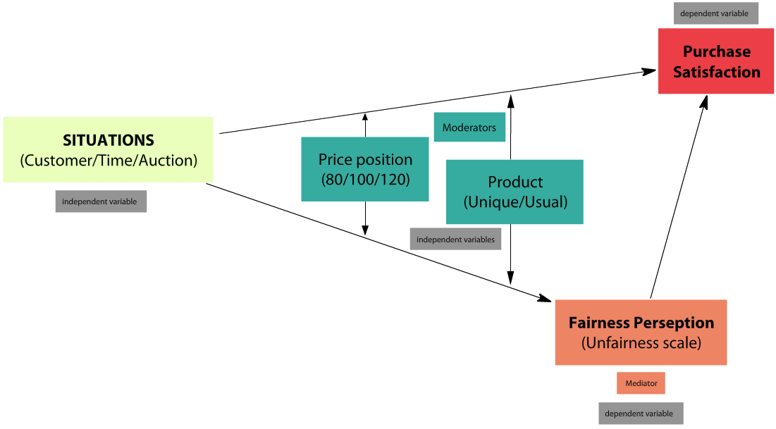
Figure 1 Conceptual model

2.2. Dependent Variables
There are two dependent variables considered in this paper: fairness perception and purchase satisfaction.

2.2.1 Fairness Perception
Fairness perception, or fairness (these definitions used in the paper interchangeably) is a consumer’s subjective assessment of whether the difference between a seller’s price and the price of a comparative other party is reasonable, acceptable, or justifiable (Bolton, Warlop, & Alba, 2003). Most of the authors in the field of fairness perception in DP discuss the theory of fairness and use variable fairness. However, some researches argue that unfairness is not an opposite reflection of fairness. Unfairness is sharper, evokes stronger feelings and therefore enables to evaluate purchase situations precisely (Xia, Monroe, & Cox, 2004), (Wu, Liu, Chen, & Wang, 2012). Because of the last suggestions, the scale of unfairness will be used in this paper. However it does not mean that different concepts are used. Fairness perception concept includes different scales; the subject of study is still fairness. From this point on, “fairness” and ”unfairness” will be used interchangeably, because it does not make sense to distinguish the concepts of fairness and unfairness.
Fairness perception was measured by giving the following task to participants of the survey: “Please, evaluate the following statement: ‘I think that the pricing of this store is unfair’. Strongly agree or disagree.” Theoretically, the statement “I strongly disagree that pricing of this store is unfair” is the same as “I think that pricing of this store is fair”. However, during the survey only the word “unfair” was used to evoke strong feelings to the participants.
Ordonez, Connolly, and Coug (2000) stress that fairness and satisfaction are similar concepts, and they are correlated, but they are distinct. Xia, Monroe, & Cox (2004) support this point of view, as do other researchers, and consider fairness and satisfaction different conceptions.
In many articles, authors provide evidence that the price fairness perception is an important predictor of consumer satisfaction (Dai, 2010). Haws & Bearden (2006) use both of these concepts in their research and consider fairness perception as a mediator between a number of factors (including customer, time, and auction) and purchase satisfaction. Based on Haws’s paper, this research will also use fairness for the explanation of the nature of the relationship between independent variables and satisfaction. Also Darke & Dahl (2003) revealed the mediation role of fairness perception in explaining satisfaction (in that study influence of equity inputs and outcomes on satisfaction was explained through fairness). Mediation role of satisfaction will be described later in this research in more detail.

2.2.2 Purchase satisfaction
Purchase satisfaction (or satisfaction, these definitions are used in the paper interchangeably) is a term that is used by general public in an everyday life and therefore, is easy to understand. Cronin (2000) provides a definition of purchase satisfaction – the extent to which the customer believes the shopping experience evokes positive feelings. Negative emotions, including dissatisfaction, can be caused by perceived price unfairness (Xia, Monroe, & Cox, 2004). Previous researches show that purchase dissatisfaction can lead to negative consequences for a firm, as was mentioned before in the case of the IPhone price drop. Purchase satisfaction is used by many researches as an independent variable - Campbell (1999), Haws & Bearden (2006) and others.
In the survey that was launched to collect data for the hypothesis check, the level of purchase satisfaction was measured. Since the general public is familiar with the purchase satisfaction concept, additional explanation of this variable was not necessary. The question was formulated as following: “Please rate your overall satisfaction towards the purchase.”

2.3. Key Independent Variables
In this research, 3 independent variables are used: situations, product uniqueness, and price position. All together, these variables form 18 different purchase scenarios, which are discussed in the Research Methodology part.

2.3.1 Situations
Situations could also be called “transaction characteristics,” as Haws & Bearden (2006) use it. Xia, Monroe, & Cox (2004) argue that customers make judgments by comparing situations. It can be comparisons with previous experiences or with other situations. Since comparisons give a sufficient base for judgment, it was decided that this paper’s respondents will discover dynamic pricing manipulation through three different situations. Respondents will compare their situations with the situations of other customers. There are three situations considered in this paper: Customer, time, and auction.
Customer. This variable represents the “pure” dynamic pricing situation. Customer variable is explained by a customer overhearing a conversation from another customer about purchasing the same product at the same retailer with the same purchase conditions, however, at a different price. A firm uses dynamic pricing and manipulates the price on a discrimination basis, and a customer reveals it through another customer. The concept of equity, which underlies fairness, suggests that generally consumers should pay the same price for the same product (Darke & Dahl, 2003). Without any reason of price alteration, consumers will perceive a price as unfair when it differs from the price paid by other consumers (Haws & Bearden, 2006). Several studies labeled the customer as the most influential factor (Xia, Monroe, & Cox, 2004), (Haws & Bearden, 2006).
Questionnaire (can be found in Appendix 1) contains a question with the following text: “Imagine you want to buy a pair of shoes. You chose one, which fits you, you like design, quality, price, delivery conditions and so on. You go on-line and use your own money to purchase it from a well-known on-line retailer for a total price of €100. Next day you find out during conversation, that another student purchased the exact same pair of shoes as you from the same on-line retailer the same day. It seems that s/he had the same purchase conditions as you. S/he paid for it…”. Thus the customer (respondent) is faced with another customer’s case and understands that the firm sold the same product at the same place and the same time under the same conditions, but for a different price. It is a typical situation for dynamic pricing. It is relatively easy to show different prices for different customers, because in the Internet every person sees the price on his/her own display.
Time. One study shows that customers are very sensitive for proximal price changes, but after a month delay pricing-level differences do not affect fairness perceptions any more (Haws & Bearden, 2006). Andrew Sweeting (2012) argues that the price of a ticket in a secondary market significantly increases one month before the game. Therefore, different reaction for a “month before” situation is expected. Investigation of unfairness perception of price adjustment under one month delay condition would have both scientific and managerial interest.
The question that describes purchase situation under time condition looks like this: “Imagine you want to buy a pair of shoes. You chose one, which fits you, you like design, quality, price, delivery conditions and so on. You go on-line and use your own money to purchase it from a well-known on-line retailer for a total price of €100. Next day you find out during conversation, that another student purchased the exact same pair of shoes as you with the same purchase conditions, from the same on-line retailer 1 month before for...”. Therefore, a situation is almost the same as “pure” DP (customer), but one important aspect is changed – the price was changed 1 month ago. Previous researches showed that customers perceive such a situation as distinct from pure DP, that’s why variable time is used in current research.
Auction. There are 2 types of dynamic pricing: price setting (goods are sold at take-it-or-leave-it prices determined by sellers) and price discovery (prices are determined via bidding processes such as auctions) (Elmaghraby & Keskinocak, 2003). Under previous factors the customer is faced with take-it-or-leave-it situation. Under Auction conditions the customer gets the product via auction, but at another auction the price was different.
The question that depicts this situation: “You go on-line and use your own money to purchase it from a well-known on-line retailer using auction by placing the winning bid for €100. You notice later that another similar auction that ended around the same time as yours had…” Therefore, price changed again, but in this situation there is a different price setter – price was set via the bidding process, the firm did not change it. An auction is a kind of dynamic pricing, a firm can manipulate the starting price, minimum bid, and so on, but it is significantly different from the posted-price approach anyway. The study of Lee & Illia (2011) demonstrates that consumers’ perception of the illusion of control in the price determination in an online auction significantly affects the price fairness perception.
Therefore an auction is a variable that describes price alteration through the Dynamic Pricing process, but distinguishes from the previous two situations in one point – the way in which the price was discovered. As previous researches show, customers assume that an auction situation is different than other situations.
All in all, these three variables (customer, time, and auction) describe three different situations during which the customer reveals DP. Influence of different situations on the fairness perception and purchase satisfaction is investigated. Thus one of three situations is a part of the description of the whole imaginary purchase scenario. All scenarios are provided in the Research Methodology part.
It is possible to imagine many more types of situations where customers face DP, but a wider list of situations would make research more complex. The model is simplified. It should be considered as a limitation, however chosen variables provide adequate for analysis representation of DP situations.

2.3.2 Uniqueness
Besides the 3 purchase situations that a customer can face, his/her reaction for price alteration can differ depending on the type of product s/he buys. It can be a usual product, bit it also can be something unique. Uniqueness in papers is usually defined as something that makes item more valuable. Tian, Bearden, & Hunter (2001) argue, that it is something that enhance one’s personal and social identity. The nature of uniqueness is not unambiguous and can be based on scarcity, assumed quality, high price and so on. Same authors mention that special consumer goods, for example a limited editions, meet customers’ striving for being different (Wu, Lu, Wu, & Fu, 2012). Therefore a limited edition of shoes should be a correct example of a unique product. Narrowing the definition of a unique product to a limited edition of shoes does not depict reality well. This simplification will be considered as the limitation.
The uniqueness in current paper is a dichotomy variable: presence of it is called “unique product” and absence of it is called “usual product”. The questions on pages 1-3 of the questionnaire (see appendix 1) describe Usual product. Description was also cited in section 2.3.1 Situations. In this thesis the same purchase situations will be also investigated for a unique products. Description of this scenario (questions 4-6 in appendix 1) looks like following: “You have been wanting for a unique product: limited editions of shoes – only 100 pairs were manufactured. You chose one, which fits you, you like design, quality, price, delivery conditions and so on”. Thus the uniqueness of the pair of shoes from the questions is based on a product scarcity. Personal preferences are excluded from a decision-making process, because of the vague description of the shoes. Probably each respondent will imagine a pair of unique shoes that are valuable only for him/her.
Several researches provide investigations in the area of Uniqueness. Wu, Lu, Wu, & Fu (2012) argue that perceived uniqueness is positively related to perceived value. In other words since an item is assumed to be unique, its value for a customer increases. It can be proposed that price alteration connected with a product that is more valuable for a customer can cause stronger emotions compare to a usual product. Kukar-Kinney, Xia, & Monroe (2007) investigated not DP topic, but presence of the best price guarantee policy in retailer’s pricing policy. When in experiment a price-matching policy was presented in the both cases (so, ceteris paribus), respondents were asked to evaluate the price policy fairness for 1) high- and 2) low-unique product assortment store. Consumers judged low-unique assortment store’s policy as more fair. Thus a number of unique products are presented in a store influences customers’ fairness perception, to put it differently, uniqueness may enhance an effect of unfairness. Correspondingly, it is reflected on Satisfaction: a price alteration for a unique product will cause higher purchase dissatisfaction compare to a usual product. This supposition leads to the following hypotheses:
H1a. Consumers will perceive price changes for unique products as in general more unfair compare to usual products.
H1b. Price changes for unique products will lead to in general lower Purchase Satisfaction evaluation compare to usual products.
It is also interesting from managerial point of view to propose the most fair and satisfied purchase scenario, and the opposite scenario. It has managerial interest because it shows situations that involve the highest and the lowest risk in DP. Research of Haws & Bearden (2006) reveals, that auction is assumed by customers as the most fair, and customer as the most unfair factor. As it was surmised before, product uniqueness should increase unfairness and absence of it should not. The same process should be true for the satisfaction variable, because usually it replicates results of fairness. Thus following hypotheses can be assumed:
H2a. Price changes during the Auction for a usual product will cause the least customer’s Unfair perception among other considered situations.
H2b. Price changes during the Auction for a usual product will cause the highest customer’s Purchase Satisfaction among other considered situations.

H3a. Price changes for unique product known from other customer will cause the most unfair perception among other considered situations.
H3b. Price changes for unique product known from other customer will cause the least Satisfaction level among other considered situations

2.3.3 Price position
Besides all possible variations of purchase conditions that are already described, there is one more important variable. After a price changes, a customer profits from it. In the case of current research it means that after paying €100, a customer finds out price €120. S/he would pay more, but s/he didn’t. It is called advantaged inequality. On the contrary, a customer could pay €100 and then discover the lower price – €80. It is called disadvantaged inequality. Price change in 20% relative to a baseline price is recommended by Blattberg, Briesch, & Fox (1995), because this alteration is certainly remarkable and aloud for a customer. A baseline situation, also called equality, when a customer faces with the same price she paid (€100 after paying €100 in our case) is ignored by some researches, for example Wu, Liu, Chen, & Wang (2012). However other researches add it to their models, for example Haws & Bearden (2006). In this thesis a baseline of price position is included to the model. All in all for the price position variable three alternatives are possible: disadvantaged inequality, equality and advantaged inequality (€80/€100/€120).
There are different levels of fairness perception for different outputs of price changes: usually a disadvantaged inequality leads to customers’ higher unfairness perception compare to advantaged inequality (Haws & Bearden, 2006), (Xia, Monroe, & Cox, 2004). Earlier Ordonez, Connolly, & Coug (2000) concluded that an advantaged and a disadvantaged inequality are both unfair and a disadvantaged inequality is judged as more unfair. In other words a price position moderates customers’ fairness perception and satisfaction; it enhances the impact of situation. Disadvantaged Inequality is assumed as more fair, it was proved by other researches. Therefore there is no sense to propose the same hypothesis. It would be better to check a moderation effect of Price position. This idea will be elaborated in the next section.

2.4 Moderation and mediation effect
Moderation effect is assumed previously for Product Uniqueness and Price Position. Baron & Kenny (1986) explain what a moderator means: “moderation occurs when the relationship between two variables depends on a third variable. <…> Moderator is a qualitative (e.g., sex, race, class) or quantitative (e.g., level of reward) variable that affects the direction and/or strength of the relation between an independent or predictor variable and a dependent or criterion variable”.
Figure 2 graphically demonstrates the moderation effect of the price position on the fairness. It was discussed previously, that advantaged inequality usually causes the fairest perception, baseline less fair and disadvantaged inequality leads to the most unfair perception. Thus every next level of the price (€120, €100, €80) strengths the feeling of unfairness and decreases the level of satisfaction. Figure 2 is provided as an example and explains only part of the whole model.
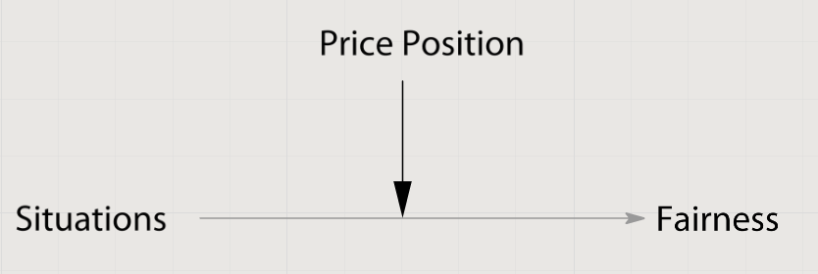
Figure 2 Moderation effect of Price Position on relationship between Situation variable and Fairness outcome
Together with Price Position this thesis is aimed to reveal whether the product uniqueness is a mediator for the fairness and satisfaction. Similar to previous explanation, it is expected, that the level of fairness and satisfaction is higher for usual products while DP is in use. In opposite, unique products enhance feeling of unfairness and dissatisfaction. In fact, hypothesis H1a and H1b are formulated in accord to proposition of Uniqueness’ moderation effect.
Mediator “speak to how or why such effects occur” (Baron & Kenny, 1986), in other words when third variable explains the nature of influence of one variable to another. As was discussed before, concerning to Darke & Dahl (2003) and Haws & Bearden (2006), it can be proposed that fairness is a mediator for satisfaction. In other words if some situation caused customer’s feeling of unfairness, then it is the reason why a customer is dissatisfied. Figure 3 shows graphically the simple explanation of how situation, fairness and satisfaction are connected.
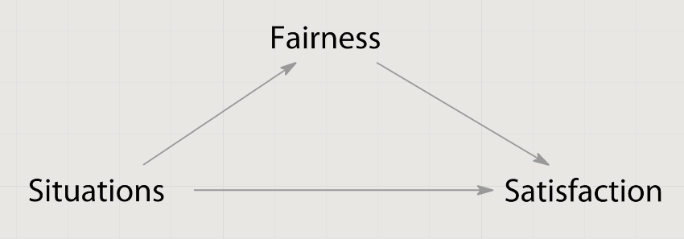
Figure 3 Mediation effect of Fairness that explains nature of relationship between Situation and Satisfaction
Summing up, discussed effects can be formulated in a form of hypotheses. Graphical depiction from Figure 4 will help in understanding of proposed relations.
H4a. Price Position moderates the effect of Situations on Fairness Perception.
H4b. Price Position moderates the effect of Situations on Purchase Satisfaction.
H5a. Product Uniqueness moderates the effect of Situations on Fairness Perception.
H5b. Product Uniqueness moderates the effect of Situations on Purchase Satisfaction.
H6. Fairness Perception is a mediator of the effect of Situations on Purchase Satisfaction.

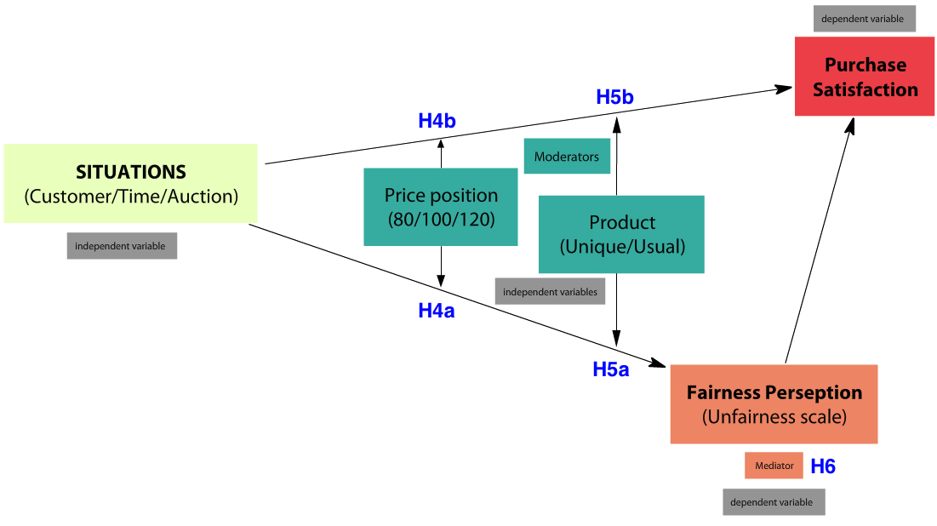
Figure 4 Graphical explanation of hypothesis concerning Mediator and Moderators
For easier understanding of discussed informantion, hypothesis of current research are gathered in the Table 1.
H1a | Consumers will perceive price changes for unique products as in general more unfair compare to usual products
H1b | Price changes for unique products will lead to in general lower Purchase Satisfaction evaluation compare to usual products
H2a | Price changes during the Auction for a usual product will cause the least customer’s Unfair perception among other considered situations.
H2b | Price changes during the Auction for a usual product will cause the highest customer’s Purchase Satisfaction among other considered situations.
H3a | Price changes for unique product known from other customer will cause the most unfair perception among other considered situations.
H3b | Price changes for unique product known from other customer will cause the least Satisfaction level among other considered situations.
H4a | Price Position moderates the effect of Situations on Fairness Perception.
H4b | Price Position moderates the effect of Situations on Purchase Satisfaction.
H5a | Product Uniqueness moderates the effect of Situations on Fairness Perception.
H5b | Product Uniqueness moderates the effect of Situations on Purchase Satisfaction.
H6 | Fairness Perception is a mediator of the effect of Situations on Purchase Satisfaction.
Table 1 Summary of hypothesis of current study
Before providing Research methodology for testing hypothesis, it is worth to render Literature Review for complete understanding of the variables and discussed topic in general.

2.5 Literature review
In the beginning information about DP will be provided. It describes both posted prices and auctions. Then a stream of literature concerning to the fairness perception in DP is described, and factors that influence fairness perception are gathered in the table. Besides an investigation about roots of dependent variables, short literature review is provided for all independent variables used in the conceptual model.

2.5.1 Dynamic Pricing
The main idea of DP is explained by Gallego & Ryzin (1994) - dealing with a fixed inventory when a demand is price sensitive and stochastic, and a firm's objective is to maximize expected revenues. The research overview in dynamic pricing in presence of inventory is procided by Elmaghraby & Keskinocak (2003). It reveals three main characteristics of a market environment that influence the type of dynamic pricing problem a retailer faces: Replenishment of Inventory, Independent Demand over time and Strategic customers. For example for a grocery store typical model includes Replenishment of Inventory, Independent demand and Myopic customers. For fashion industry two models exist: in both cases there is No Replenishment and Independent Demand, but customers can be both Strategic and Myopic.
Based on three characteristics authors investigate different market types, provide detailed literature review. General conclusion is that wide list of authors state applicability and potential benefits of dynamic pricing in traditional and online channels. This study concentrates only on posted price policies. Another part of Dynamic Pricing – auctions is not covered, however links for corresponding studies are provided.
Bitran & Caldentey (2003) provide deep Dynamic Pricing literature review from revenue management perspective. They consider situation when perishable and nonrenewable set of resources satisfy stochastic price-sensitive demand processes over a finite period of time. “In this framework, where capacity is fixed, the seller is mainly interested in finding an optimal pricing strategy that maximizes the revenue collected over the selling horizon”.
The influence of Dynamic Pricing on demand was investigated by A.Faruqui & S.George (2005). The aim of the research was to manipulate demand (energy consumption) using dynamic pricing. Energy companies used time-based price varying that lead to average 13.1 percent reduction in peak-period energy use on critical days. Moreover capacity restructuration brought benefits trough decrease of operational savings. This study shows that Dynamic Pricing can be used not only for profit maximization, but also for influencing a demand.
There is important to notice that several studies mention that use of static pricing is more effective compare to dynamic pricing. The following conclusions can be cited from the study of Gallego & Ryzin (1994): “using simple fixed-price policies appears to work surprisingly well in many instances”. Authors made this conclusion based on prediction of both upper bounds on the expected revenue and insights into the form of near-optimal policies. Also fixed price policy can be effective if customers are strategic. Cachon & Feldman (2010) show that the advantage of static pricing relative to dynamic pricing can be substantially larger than the advantage of dynamic pricing over static pricing: “Static price can be the preferable pricing strategy when consumers are strategic.”
Besides the wide list of researches about Posted-Prices, Dynamic Pricing includes Price Discovery (auctions). The general review in the field of auctions is provided by Paul Klemperer (1999). There is a summary of several important papers in this field and step-by-step explanation of the essence of the auction – basic analysis of optimal auctions, revenue theorem and so on. Several papers underline, that usage of DP, specifically auction type, is profitable. Research of Andrew Sweeting concludes: «the simplest dynamic pricing models describe very accurately both the pricing problem faced by sellers and how they behave <…>. The estimates also imply that dynamic pricing is valuable, raising the average seller’s expected payoff by around 16 percent» (Sweeting, 2012). Moreover auctions have industry-specific benefits, for example, it helps ticket-sellers to fight with second-hand dealers in a ticket industry; auction approach significantly decreases (or even eliminate) profits of speculators, in addition it is profitable - auction revenues are more than twice higher, than static pricing ones (Bhave & Budish, 2012).

2.5.2 Fairness Perception
Apart from papers, describing DP from optimal price-strategy and revenue maximization point of view, there are a number of studies focused on fairness perception in Dynamic Pricing. This area of research gets quite enough attention from researches. Lan Xia, et al. (2004) provide fundamental summary of researches relevant to Price Fairness. This study summarizes different explorations and in three parts describes The Concept of Price Fairness, factors that influence fairness and buyers' behavioral reactions to sellers when unfair occur.
There are five main conclusions about concept of price fairness. First is about distinction of Fairness and Unfairness. Although most of the studies use fairness as a main variable, Norman J. Finkel in his book “Not fair! The typology of commonsense unfairness” argue, that notion of unfairness is normally more clear and concrete, them fairness (Brendt, 2004). Second conclusion states that all fairness judgments are comparative. Price comparisons lead consumer to one of three types of judgment – in case of equality, advanced inequality and disadvantaged inequality. Third conclusion is about subjectivity of judgment. Therefore perceived fairness effect of another buyer paying less is stronger than when the comparable other pays more (Martins, 1995). Forth, affect is an important element of price fairness perception, due to emotions may occur concurrently with the unfair cognition. Fifth, in case of price unfairness customers’ negative emotions are usually directed toward the seller, then toward a comparative other buyer. Sixth conclusion is about distinction between fairness and satisfaction, although that these two concepts are highly correlated.
K. Haws and W. Bearden investigate the effects of seller-, consumer-, time-, and auction-based price differences on perceived price fairness and purchase satisfaction (Haws & Bearden, 2006). Differences between consumers resulted in the greatest perceptions of unfairness and the lowest overall satisfaction. The least perceived unfairness was caused by auctions. Price discovery process (auction) compare with posted prices (retailer) brings to customer more satisfaction and assumed as more fair across all price-levels, however this effect disappears as soon as consumer gets a good deal. Effect of unfairness is also vanishes after a month delay, though the shorter period is the less fair price change is perceived.
Various researchers investigate different factors concerned with Price Fairness. For easier understanding they are introduced in Table 1.
Factors | Study
Seller, Consumer, Price-setter, Time | Haws & Bearden (2006)
Relationship with consumer who shared information about changed price | Gelbrich (2011)
Previous customer satisfaction, Motives, Company reputation | Campbell (1999), Homburg, Hoyer, & Koschatу (2005)
Intensity and recency of last purchase, Tangible and intangible goods | Rondan-Cataluna & Martin-Ruiz, (2011)
Eco-orientation of customer | Theotokis, Pramatari, & Tsiros (2012)
Attitude toward to Dynamic Pricing System | Heo & Lee (2011)
Disclosing of dynamic pricing rules before and after the deal | Wu, Liu, Chen, & Wang (2012)
Inertia, Need for interaction, Quickness | White, Breazeale, & Collier (2012)
Table 2 List of factors that correlate with Price Fairness and links to papers where these connections were investigated
Interaction between discriminating bases and inequality status; and discriminating bases to negative emotions were examined by Wu, Liu, Chen, & Wang (2012); influence of cultural differences to Fairness Perception was observed by Bolton, Keh, & Alba (2010). Lan Xia and Kent B. Monroe (2010) empirically compared price fairness and transaction value and extended knowledge in field of advantaged price inequity. Cindy Yoonjoung Heo and Seoki Lee (2011) examined what consumers’ characteristics influence their fairness perceptions of Revenue Management practices in the hotel context. Study of perceived price fairness in a framework of distributive justice utilizing a variety of contexts, products, and services was done (and revealed significant differences in perceptions of price fairness in terms of the nature of the product or service) (Rondan-Cataluna & Martin-Ruiz, 2011). Finishing with describing Fairness variable, there is worth to mention that it has strong positive impact not only with Satisfaction (Dai, 2010), but also it influences, purchase intentions (Campbell, 1999), intention to stay, future spending, and negative WOM (White, Breazeale, & Collier, 2012). Therefore this variable is highly important and its investigation has a significant managerial contribution.

2.5.3 Satisfaction
The main interest of scientists is fairness perception, but also many of them place emphasis to purchase satisfaction. Dai (2010) provides short literature analysis and concludes: “the marketing literature has emphasized price fairness perceptions as important predictors of consumer satisfaction”. First the idea of similarity of two concepts was discussed by Ordonez, Connolly, & Coug (2000). Then in Xia, Monroe, & Cox, (2004) underline that fairness and satisfaction are distinct concepts and it worth to investigate in separately. Later authors refer to this paper and never use these definitions interchangeably.
In fact, Satisfaction is a self-sufficient stream of literature and has its own authorities, bases, roots and so on. For general idea of this area of researches see paper of Tsiotsou (2006). Importance is Satisfaction can be explained by its high managerial relevance - Satisfaction is a good predictor customer locality and purchase behavior (repurchase, purchase intentions, brand choice and switching behavior). Satisfaction is expected to be similar to fairness perception, therefore the main focus will be on Fairness. However, Satisfaction will be anyway measured and interpreted, due to valuable conclusions are expected.

2.4.4 Situations
The number of situations used in current research is also used by Haws & Bearden (2006). There customer, time, auction variables have significant effect on price fairness. Customer variable basis lying on concept of equity, because it argues that consumers should pay the same price for the same product and therefore they perceive us unfair situation, when another customer pays different price under the same conditions (Darke & Dahl, 2003). And even when customers are aware about basis of price difference (for example for new customers), they judge it as unfair pricing policy (Grewal, Hardesty, & Gopalkrishnan, 2004). Customer is known as variable that evokes the highest unfairness feeling (Xia, Monroe, & Cox, 2004), (Haws & Bearden, 2006).
Time variable is also got attention of researches. For example Zeithaml (1988) revealed that shoppers can be separated to two groups based on time-conscious and these groups have different perceptions. Wu, Liu, Chen, & Wang, (2012) conceder price changes connected with coupons, membership, limited offers (lunch offer from 2pm to 5pm etc.) In other words it is another price manipulation based on time.
Boltin, Warlop, & Alba (2003) revealed - customer do not change their expectations about price and do not adjust expected price during the time, even thinking about inflation. Therefore customers should assume every little price change as unfair. However it is not true, because in a real life people become used to DP policies. Research of Kimes & Wirtz (2002) fits this idea, because pre-reservation is a well-known technique in restaurant industry and study showed that price difference based on time of booking was perceived by customers as neutral or slightly unfair.
Liberman & Trope (1998) are comparing near and distant future activities and argue that distant acts are assumed as more abstract and influenced by desirability, in contrast with near future activities, that are influenced by feasibility. This study supports the approach of Haws & Bearden (2006) to mark out time as a variable that influences fairness perception. In this study time had significant influence, higher then Auction, but not that strong as Customer.
Auction is the last of possible situations. This variable can be called Price Setter, because namely price setter varies under this condition. As was mentioned before, price can be set by seller (posted price) and by customers (discovered price). Wang (1993) made a comparison of two approaches and revealed that without auctioning costs auctions always (and with auctioning costs – in a lot of cases) perform better, then posted price mechanism. Deep understanding of auction mechanism is not necessary for a current paper, however for general idea it is possible to check non-technical overview of auction literature by Klemperer (1999). Auctions have high popularity in a B2B environment, Bichler, et al. (2002) give understanding of place of auctions in Dynamic pricing.
Lee & Illia (2011) made a research about group buying and on-line auction. Two veriables were tested – illusion of control and lateral consumer relationship – and both had significant effect on Fairness Perception. Lateral consumer relationship is describing need of equality between customers and illusion of control is estimating the chance to success higher then the objective probability. These two factors making Auction a distincs situation where different outcome is expected. Haws & Bearden (2006) tested Auction amongoter factors and it shows the highest Fairness Perception.

2.4.5 Uniqueness
There are a high variety of possible directions for a research in the area of Fairness perception and Dynamic Pricing; trying to choose one, I found a lack of researches viewing such factor as uniqueness of a product. Potentially this factor could influence fairness perception while dynamic pricing is in use. There is an article that includes product assortment uniqueness (Kukar-Kinney, Xia, & Monroe, 2007). Store’s pricing policy implies not Dynamic Pricing but presence or absence of price-matching policy (best price guarantee). However under presence of price-matching policy, respondents were asked to evaluate price policy fairness for 1) high- and 2) low- unique product assortment store and they judged low-unique assortment store’s policy as more fair. Authors conclude: “Product assortment uniqueness influenced consumers’ fairness perceptions in two ways: directly, and indirectly through inferred motive. <…> A high level of product assortment uniqueness may inadvertently damage consumers’ fairness perceptions”.
Tian, Bearden, & Hunter (2001) investigate customers’ need for uniqueness and nature of this phenomenon. It is known from paper of Snyder & Fromkin (1980) that people have social desire to maintain a sense of uniqueness and authors discuss how people reveal it. Unique product should enhance self-image through gaining desired evaluations by others. Tian, Bearden, & Hunter, (2001) mention three “behavioral manifestations” or dimensions, that show how people reveal their uniqueness: Creative Choice Counterconformity (being socially different from majority of others with a low risk of being rejected by society), Unpopular Choice Counterconformity (being socially different from majority of others with higher risk of being rejected by society) and Avoidance of Similarity (spot using products that are used by everyone around).
According to (Narahari, Raju, Ravikumar, & Sourabh (2005) product can become unique and after customizing. Authors provide an example of Dell Computers Company that provides unique set of computer’s characteristics for each customer depends on their needs. It is the reason for company to set different prices for computers. There is also popular model to explain the nature of Uniqueness: Lynn’s S-E-В model. It explains customers’ strive to uniqueness by arguing that Scarce goods cost more, it’s Expensiveness brings assumed quality and status, together it explains why product become Desirable.
Wu, Lu, Wu, & Fu (2012) made a research and provided basis for several reasons why product is assumed as unique – because of assumed expensiveness, perceived uniqueness, perceived quality or perceived sacrifice. The most interest for current paper is influence of product scarcity. Authors conclude: “perceived scarcity has been proven to influence assumed expensiveness and perceived uniqueness”. In the same paper authors provide evidence that scarcity has a connection with customer’s purchase decisions, that one more time underlines importance of this variable for managers and marketers.
2.4.6 Price levels. Differed price levels are used often in researches about Fairness Perception. The basis of this assumptions in papers could be explained by paper of Adams (1965). Author refers to the theory of equality and argues that disadvantaged customers show higher level of dissatisfaction and feel angry compare with customers who were treated equally. Xia, Monroe, & Cox (2004) citing other authors argue, that perceived fairness is touched less, when advantaged inequality takes place and more, when disadvantaged inequality is involved.
Ordonez, Connolly, & Coug (2000) made a research where checked salary satisfaction and fairness on three equality levels and concludes: “most subjects judged both types of inequalities unfair, with disadvantageous inequality more unfair than advantageous inequality”. Haws & Bearden (2006) also used three different price levels and output of analysis shows that disadvantaged inequality leads to the highest unfairness response, equality is in the middle or on the same level with advantaged equality. In some researches authors do not use a baseline and measure only two options: advantaged and disadvantaged inequality; for example, see paper of Wu, Liu, Chen, & Wang (2012).
Short literature review of both dependent and independent variables of current research was provided for better understanding of the topic. It also gives a possibility to find more information about particular topic, due to links to prior studies are provided.

3. Research Methodology
Price difference level | Situations | Product type
Disadvantaged inequality | Customer | Usual
 |  | Unique
 | Time | Usual
 |  | Unique
 | Auction | Usual
 |  | Unique
Equality | Customer | Usual
 |  | Unique
 | Time | Usual
 |  | Unique
 | Auction | Usual
 |  | Unique
Advantaged inequality | Customer | Usual
 |  | Unique
 | Time | Usual
 |  | Unique
 | Auction | Usual
 |  | Unique
Table 2 Purchase scenarios used in the current research
In order to check hypothesis, survey design was developed. Imaginary situations were created based on ideas from previous researches. Situations typical for factors Customer, Time, Auction are already described in the description of dependent variables. There are two types of product in current research: usual and unique pair of shoes. No image was used in survey due to avoid personal preferences, item was described as appropriate for you in terms of price, style, size and purchase conditions. Showing the scarcity of product depicted uniqueness: only 100 pairs limited edition shoes were produced.
Dynamic pricing under different factors had 3 types price differences: customer buys item for €100, and them faces with disadvantaged inequality, when another customer buys item for €80; advantaged inequality, when another customer buys the same item for €120; of with absence of Dynamic Pricing, when another customer also pays €100 – this data is going to be used as a baseline.
These prices are chosen according to article of Blattberg, Briesch, & Fox (1995) where argued that price changes in 20% are remarkable. Consequently 2 (Usual and Unique product) * 3 (Factors: Customer, Time, Auction)* 3 (Price difference level) experimental design was used. All purchase scenarios are observed in Table 2.
Questionnaire (can be seen in Appendix 1) was developed based on previous researches, all purchase situations were precisely described and included to questionnaire. In order to avoid respondents tendency to mark answers automatically by inertia, when s/he sees similar questions, randomization was used and each respondent received only one price difference level for each of six (3 factors * 2 types of product) purchase situations. That means questions were formed in blocks and only one question from it was showed to the respondent. Therefore none respondent were asked to evaluate particular situation on all of 3 levels of Price Position, questionnaire were programmed to evaluate all €80, €100 and €120 levels, but individual respondent saw only one of them per purchase situation.
In terms of using scale for Unfairness, Wu's approach was taken: «As Finkel (2001) and Xia et al. (2004) suggest, fairness and unfairness may be individual unipolar constructs. In other words, the lack of unfairness does not lead to fairness, and vice versa. In response to their suggestions, this study measures unfairness directly. Perceived price unfairness has a concrete singular object (i.e., pricing mechanism) and the attribute (i.e., unfairness) is concrete. Thus, this study creates a single item to measure the perception of unfairness as “I think that the pricing of this store is unfair” (from 1 = strongly disagree to 7 = strongly agree).» (Wu, Liu, Chen, & Wang, 2012)
Darke & Dahl (2003) use 11-point scale for 4 questions to evaluate overall satisfaction, however other researchers suggest to use simple scales with one question: Bei & Chiao (2001) use 5-point scale, Woo & Fock (1999) use 6-point scale. The latter argue that the use of multi-item for measuring summary evaluation does not increase reliability over time. Therefore I consider using the one item (question) and a 11-point scale to be sufficient enough to evaluate customers’ satisfaction.
Survey was distributed on-line among local and international students in Russia and the Netherlands first for a small group of people (pre-test). After feedback was collected, questionnaire was improved. Most of notes concerned to the difficulties in understanding questions. First problem, Unfairness scale confused people: unfairness is negation of fairness and it was asked to agree with fact of Unfairness or disagree, that is negation of agreement. Double negation tangled respondents and they evaluated Unfairness wrong. To avoid it I added description to the ends of each scale during the questionnaire and used green color for more absence of Unfairness, as it is associated with something good and red color for high level of Unfairness, due to red is associated with danger. Second problem, beta-testers of questionnaire complained for questions presence of with Equality: they were notified in the introduction that they will evaluate Dynamic Pricing situations, but then they met €100 and €100 situation. To avoid potential confusion I edited disclaimer of questionnaire and informed respondents about Quality situations. After all improvements link to the questionnaire was distributed to the wide audience.
For checking Hypotheses 1-3 analysis of variances in SPPS will be launched. Janssens, Wijnen, Pelsmacker, & Kenhove (2008, p. 92) call it analysis of variance for a complete factorial design; Field (2009, p. 421) calls it Factorial ANOVA. Table with means for each purchase scenario will be presented, that will help to understand whether proposed situations showed expected level of Unfairness and Satisfaction or not.
Hypotheses 4-6 are connected with Moderator and Mediator effects. Analysis of these effects is discussed by Baron & Kenny (1986). In fact, number of regressions should be launched to check whether desired effect presented or not. Moderator hypothesis is supported in case cross-effect of predictor and moderator variables is significant (Baron & Kenny, 1986, p. 1174). The same author explains (on the page 1177) how to prove mediating effect: “To test for mediation, one should estimate the three following regression equations: first, regressing the mediator on the independent variable; second, regressing the dependent variable on the independent variable; and third, regressing the dependent variable on both the independent variable and on the mediator”. Such analysis in SPSS and output interpretation will be done.

4. Data analysis

ANOVA for Unfairness
During data collection 261 surveys were finished, however only 173 of them were complete. Even if one of questions was skipped, the whole form was deleted from database. Survey was distributed online and completed by international students, mainly from Russia and the Netherlands. The average age is 22, 57% of respondents are female.
According to manuals of A. Field (2009) and Janssens, Wijnen, Pelsmacker, & Kenhove (2008) it is important to check homogeneity of variances, because it is important assumption for current test. Tests showed, that analysis can be continued (for details see Appendix 2)
Tests of between-subjects effects (see Appendix 3) show that Product Uniqueness itself has no influence to Unfairness (sig.=.408). In contrast Situation and Price both has significant effect (sig.=.000). All interaction contains Product are not significant, except of Situation*Price (sig.=.000).
 |  | Customer |  | Time |  | Auction |  | Total
 |  | Mean | Std. Dev | Mean | Std. Dev | Mean | Std. Dev | Mean | Std. Dev
Usual | Disadvantaged | 5.130 | 1.933 | 3.333 | 1.836 | 2.531 | 1.860 | 3.594 | 2.155
 | Equality | 1.542 | 1.512 | 2.125 | 1.663 | 2.400 | 1.872 | 2.012 | 1.713
 | Advantaged | 5.000 | 1.948 | 2.279 | 1.634 | 2.418 | 1.536 | 3.250 | 2.126
 | Total | 3.861 | 2.455 | 2.575 | 1.784 | 2.454 | 1.759 | 2.962 | 2.118
Unique | Disadvantaged | 5.639 | 1.539 | 3.618 | 2.041 | 2.946 | 1.820 | 3.856 | 2.159
 | Equality | 1.833 | 1.527 | 2.552 | 1.893 | 1.915 | 1.512 | 2.059 | 1.693
 | Advantaged | 4.232 | 2.027 | 2.707 | 1.864 | 2.140 | 1.846 | 3.135 | 2.112
 | Total | 3.977 | 2.316 | 2.947 | 1.977 | 2.322 | 1.775 | 3.021 | 2.130
Total | Disadvantaged | 5.400 | 1.746 | 3.473 | 1.936 | 2.723 | 1.845 | 3.856 | 2.159
 | Equality | 1.681 | 1.519 | 2.342 | 1.789 | 2.149 | 1.705 | 2.059 | 1.693
 | Advantaged | 4.629 | 2.015 | 2.487 | 1.756 | 2.277 | 1.699 | 3.135 | 2.112
 | Total | 3.919 | 2.384 | 2.759 | 1.889 | 2.388 | 1.765 | 3.021 | 2.130
Table 3 Descriptive Statistics for Unfairness variable
Descriptive statistics (Table 3) shows means and standard deviations. Together with other coefficients it will help to check hypothesis.
H1a – Consumers will perceive price changes for Unique products as in general more unfair compare to Usual products. Average evaluation of case with Unique products (3.021) indeed is higher ten for Usual products (2.962). However the difference seems to be not that big (0.059) and pairwise comparison (see Appendix 4) shows sig.=.454. Therefore situations with Unique and Usual products are not really distinct for customers, when they evaluate level of Unfairness. Thus it could be concluded, that H1a is rejected.
H2a – Price changes during the Auction for a usual product will cause the least customer’s Unfair perception among other considered situations. According to means there is a situation that has lower Unfairness level. Respondents assume price change during the Auction for Unique product as more fair (unfairness level is 2.322) compare to the same situations with Usual product (2.454). Therefore hypothesis H2a is not supported.
H3a – Price changes for unique product known from other customer will cause the most unfair perception among other considered situations. On average it is true – 3.977 is the highest index among all situations. However for advantaged inequality this hypothesis will not be true (4.232 for Unique product is less, then 5.000 for Usual one). Generally speaking, H3a is supported. Figure 5 illustrates H2a and H3a.
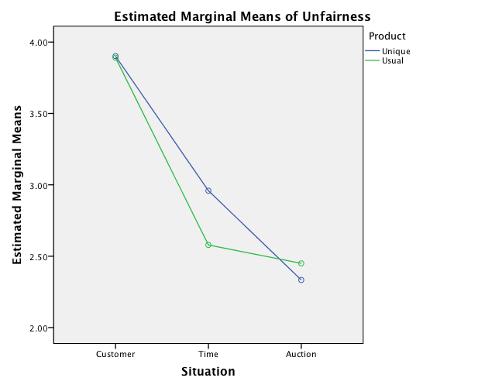
Figure 5 Graph that illustrates correlation of means for 3 Situations and 2 Product types for Unfairness

ANOVA for Satisfaction
Number of observations for current ANOVA the same as in previous test. Homogeneity tests and variance ratio were done (full description is in Appendix 5), data shows homogeneity of variances for each independent variable. Thus hypothesis of equal error variances is supported and analysis can be continued.
Tests of Between-Subject Effects (see Appendix 6) show that Product has influence on Satisfaction (sig.=.034), as well as Situations (sig.=.001) and Price (sig.=.000). There is only one interaction effect that is significant for Satisfaction – it is Situation*Price (sig.=.018).
Figure 6 with two dimensions (Situation and Product) shows, that price changes for Unique items provide customers less Satisfaction compare to price alterations for Usual products.
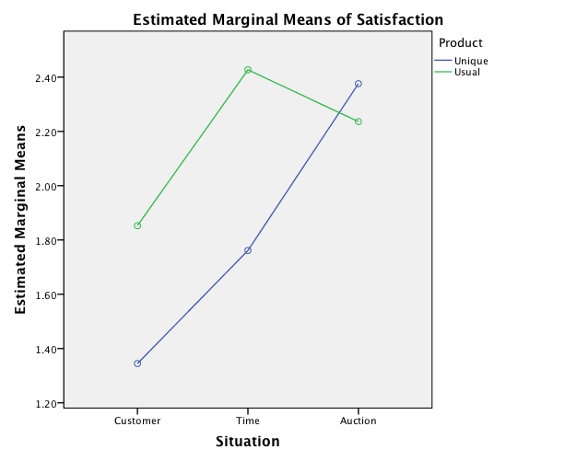
Figure 6 visual interpretations of means of Satisfaction for 3 Situations and 2 Product types.
Numbers from Descriptive statistics (Table 4) and other coefficients help to make conclusions and interpret the graph.

 |  | Customer |  | Time |  | Auction |  | Total
 |  | Mean | Std. Dev | Mean | Std. Dev | Mean | Std. Dev | Mean | Std. Dev
Usual | Disadvantaged | -0.833 | 3.266 | 0.316 | 2.647 | 0.563 | 2.771 | 0.051 | 2.941
 | Equality | 3.458 | 2.628 | 3.179 | 2.650 | 2.946 | 2.103 | 3.200 | 2.473
 | Advantaged | 2.933 | 2.049 | 3.787 | 1.684 | 3.200 | 2.704 | 3.313 | 2.185
 | Total | 1.936 | 3.257 | 2.454 | 2.791 | 2.149 | 2.818 | 2.180 | 2.964
Unique | Disadvantaged | -1.541 | 2.930 | -0.509 | 2.860 | 0.273 | 2.902 | -0.626 | 2.978
 | Equality | 2.593 | 3.271 | 2.759 | 2.487 | 3.136 | 2.374 | 2.836 | 2.718
 | Advantaged | 2.982 | 2.453 | 3.035 | 2.520 | 3.719 | 2.128 | 3.246 | 2.383
 | Total | 1.246 | 3.559 | 1.801 | 3.059 | 2.409 | 2.885 | 1.819 | 3.210
Total | Disadvantaged | -1.209 | 3.099 | -0.089 | 2.772 | 0.429 | 2.824 | -0.283 | 2.974
 | Equality | 3.044 | 2.971 | 2.965 | 2.566 | 3.044 | 2.240 | 3.018 | 2.601
 | Advantaged | 2.957 | 2.243 | 3.420 | 2.157 | 3.464 | 2.431 | 3.280 | 2.282
 | Total | 1.593 | 3.423 | 2.130 | 2.941 | 2.278 | 2.851 | 2.001 | 3.092
Table 4 Descriptive Statistics for Satisfaction variable
Pairwise comparison of Unique and Usual Product shows sig.=.034 (see Appendix 7). That means customers assume these situations as distinct. Average Satisfaction after price alteration for unique product is 1.819 and for Usual product – 2.180. Thus it could be concluded that H1b – Price changes for unique products will lead to in general lower Purchase Satisfaction evaluation compare to usual products – is supported.
Figure 6 shows evidence, that H2b will be not supported, because line of Unique product lies higher, then Usual one and it means Auction situation for Unique product brings more Satisfaction. It is proved by numbers: average Satisfaction after Auction's price alteration does not show the highest index among all Situations and Product types: it’s index 2.149 is lower then 2.409 for Auction situation with Unique product. Consequently, H2b – Price changes during the Auction for a usual product will cause the highest customer’s Purchase Satisfaction among other considered situations – is not supported.
Conclusion about H3b can be also made from graph: line of Unique product lies lower then line of Usual one for Customer and Time situation and point “Customer situation, Unique product” lies below all; to put it into words, when Customer reveals price change for a Unique product, it brings the lowest Satisfaction (mean 1.246 according to Table 4). Thus, H3b – Price changes for unique product known from other customer will cause the least Satisfaction level among other considered situations – is supported.

Analysis of moderating effect
Hypotheses 4-5 are connected with moderating effect. Baron & Kenny, (1986, p. 1174) explain how to support moderation hypothesis. “The moderator hypothesis is supported if the interaction (Path c) is significant. There may also be significant main effects for the predictor and the moderator (Paths a and b), but these are not directly relevant conceptually to testing the moderator hypothesis” (Baron & Kenny, 1986, p. 1174). Figure 7 depicts paths for checking H4a as example for better understanding of requirements of moderating effect.
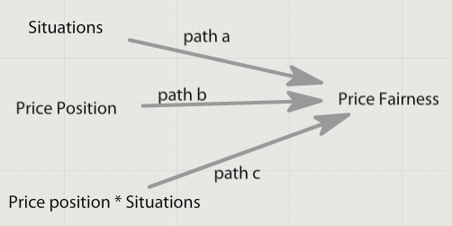
Figure 7 Moderator model for checking H4a
Data analysis was launched for hypotheses 4-5; output tables are in Appendix 8. Price position and Situations in checked model did not show significant interaction (sig.=.4303). It means that Price Position does not moderate the effect of Situations on Fairness Perception. However test for Price Position moderating effect of Situations on Fairness showed expected results – Price position is a moderator in this case (sig.=0.0317) as was proposed in H4b. Interaction effect Situations*Product type is not significant (sig.=.4389) for Unfairness, but significant (sig.=.0479) for Satisfaction, to put in into words H5a is not supported and H5b is supported.

Analysis of mediating effect
Baron & Kenny (1986, p. 1177) describe mediator model and the way to check it: “to test for mediation, one should estimate the three following regression equations: first, regressing the mediator on the independent variable; second, regressing the dependent variable on the independent variable; and third regressing the dependent variable on both the independent variable and on the mediator”. Converting these general recommendations to current model, three following regressions should be launched (Figure 8 will help in understanding):
- Situations -> Fairness
- Situations -> Satisfaction
- Situations&Fairness -> Satisfaction
Regressions were launched and all of them showed significant results (see Appendix 9). All the coefficients show predicted direction. Situation has negative influence on Unfairness. As we know from ANOVA analysis every next situation (in order Customer, Time, Auctions) assumed as less unfair; coefficient -0.765 means that Situation changed by one “unit” brings decrement in Unfairness by 0.765 units (while level of Satisfaction is the same, i.e. ceteris paribus). Influence of Unfairness on Satisfaction is also negative – every extra unit in Unfairness brings decrement of Satisfaction by 0.433 units. In general Situation has positive influence on Satisfaction, coefficient equals 0.09, to put it into words, every next Situation from considered list brings to customers more satisfaction.
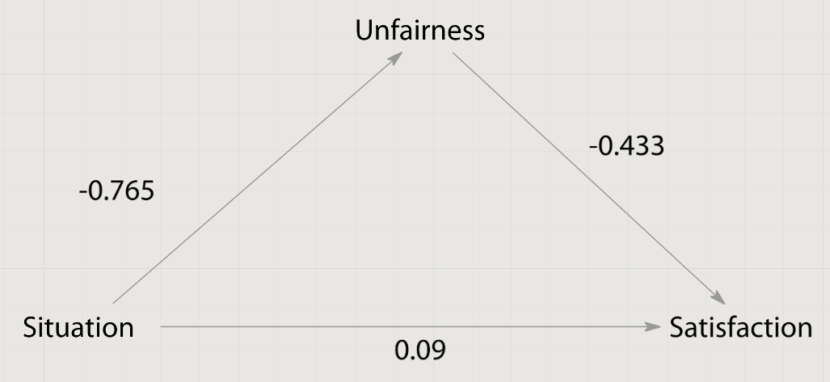
Figure 8 Mediator model
However there are several more requirements for proving mediating model. Baron & Kenny (1986, p. 1177) write: “the effect of the independent variable on the dependent variable must be less in the third equation than in the second. Perfect mediation holds if the independent variable has no effect when the mediator is controlled.” For the second equation we have B=.343, sig.=0.004, for the third – B=-0.138, sig.=0.217. In other words both requirements are satisfied. Sobel’s test is also mentioned in article of Baron & Kenny (1986), it helps to evaluate “an approximate significance test for the indirect effect of the independent variable on the dependent variable via the mediator”. Calculations showed sig.=0.0581; as it is approximate index and all other requirements are satisfied, mediation effect can be established and H6 – Fairness Perception is a mediator of the effect of Situations on Purchase Satisfaction – is supported.
For better understanding of results Table 5 summing up conclusions concerning hypotheses and Figure 9 shows results for moderator and mediator analysis depicted on conceptual model.
H1a | Consumers will perceive price changes for unique products as in general more unfair compare to usual products | Rejected
H1b | Price changes for unique products will lead to in general lower Purchase Satisfaction evaluation compare to usual products | Supported
H2a | Price changes during the Auction for a usual product will cause the least customer’s Unfair perception among other considered situations. | Rejected
H2b | Price changes during the Auction for a usual product will cause the highest customer’s Purchase Satisfaction among other considered situations. | Rejected
H3a | Price changes for unique product known from other customer will cause the most unfair perception among other considered situations. | Supported
H3b | Price changes for unique product known from other customer will cause the least Satisfaction level among other considered situations. | Supported
H4a | Price Position moderates the effect of Situations on Fairness Perception. | Rejected
H4b | Price Position moderates the effect of Situations on Purchase Satisfaction. | Supported
H5a | Product Uniqueness moderates the effect of Situations on Fairness Perception. | Rejected
H5b | Product Uniqueness moderates the effect of Situations on Purchase Satisfaction. | Supported
H6 | Fairness Perception is a mediator of the effect of Situations on Purchase Satisfaction. | Supported
Table 5 Summarized results of hypotheses check

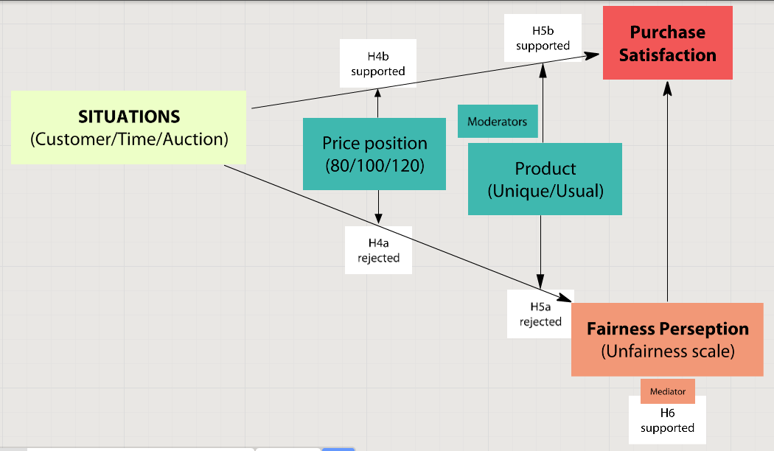
Figure 9 Visual explanation of results

5. Conclusion

5.1 General discussion
This study is aimed to investigate the influence of product uniqueness on fairness perception and customer satisfaction while dynamic pricing is in use. Concepts of fairness and satisfaction are similar (though distinct) and comparable results were expected. However, analysis revealed surprising results: in general product uniqueness has impact on satisfaction, but no influence on fairness. To put this more precisely, product uniqueness did not show the predicted or any consistent pattern for perceived fairness.
For unfairness variable, situations showed expected results. In general customers assume “pure dynamic pricing” situation (customer) as the most unfair situation, and auction as the most fair. However, several unexpected results were obtained. For example, for the equality situation the predicted pattern did not occur – pure DP is assumed as the most fair among other situations. If fact, the equality situations were used as a baseline in the model, and respondents faced the same price as they paid. Thus, irregularity in equality price position does not cast a shadow on the truth of the results.
Price position, in general, showed expected results for unfairness: disadvantaged inequality is the most unfair price alteration. Fairer than this situation is advantaged inequality. Still, the most fair price position is the equality situation. The anomaly of the quality situation for the customer was already mentioned, except for this proposed pattern, which was found in every other case. However, the moderating effect of price position on fairness was found insignificant.
Product uniqueness shows expected result of unfairness only for the time variable, but as was mentioned before, in general, customers do not differentiate purchase situations with unique and usual products. To put this more precisely, the respondents did not mention the difference between a pair of shoes and a limited edition pair of shoes. As was discussed earlier, product uniqueness has an ambiguous nature and only one aspect, which assumed product scarcity, was investigated in this research. For the model and example used in the survey, product uniqueness is not a moderator between situation and unfairness.
Another reason why several hypotheses were rejected could be the average age of the respondents. Students (an average age 22 years old) have different attitudes toward unique products and different values for money. Therefore respondents did not distinct usual and unique products. A relatively small size of sample could also influence the results of this research. Unfortunately, other papers did not show such an effect, when variables have effect on satisfaction but not on fairness. The reason for unexpected results could be limitations of this research.
Situations, in general, showed expected results: customer situations bring the lowest level of satisfaction, while auctions bring the highest. The only irregularity was found for the usual product under auction conditions. This situation should bring more satisfaction than time. However, customers evaluated the level of satisfaction for auctions lower than for 1 month delay situations. Also, price alterations through auctions cause higher dissatisfaction for usual products, than for unique ones. Sudden fall of the usual products’ line on Figure 10 illustrates the described phenomenon.
Figure 10 Illustration of level Satisfaction for different levels of Situation and Product variables
Though equality and advantaged equality do not show such distinctiveness from each other as disadvantaged inequality does (and equality situations shows anomaly as for the fairness case), price position shows the mediating effect on satisfaction. The product type variable is also a moderator for satisfaction, as was revealed during analysis.
Thereby, it can be concluded, that though the concepts of fairness and satisfaction are similar, its reaction to product uniqueness is different – the moderating effect is revealed for satisfaction, but not for unfairness. Nevertheless, this research shows that customers’ satisfaction can be explained by the assumed level of fairness, because the mediating effect was established.

5.2 Academic contribution
This study reveals new facts and finds support for the known hypothesis. It is the first investigation of its kind about the impact of product uniqueness on fairness perception and purchase satisfaction while DP is in use. Though the moderation role of the product uniqueness is not confirmed for the fairness variable, impact on the satisfaction was revealed. The results could be a basis for further studies in this field, because the DP topic is still not investigated thoroughly enough. Other types of uniqueness, a correlation with other variables, and a nature of these connections may be analyzed in future researches for complete understanding of the topic.
At the same time, several findings from previous studies are also confirmed in this research. For example, the strength of the impact of different situations – findings are in accord with Haws & Bearden (2006), and unfairness of different price positions – consistent with Ordonez, Connolly, & Coug (2000). Moderation analysis was done to support a close interconnection of fairness and satisfaction mentioned in previous studies (Darke & Dahl, 2003).

5.3 Managerial Implications
From a managerial point of view, it makes sense to pay attention to disadvantaged inequality. When a firm manipulates price, one customer gets a higher price than another customer. In case they reveal this treatment, it does not matter that the customer with the advantaged inequality has the average level of dissatisfaction, because another customer faced disadvantaged inequality, and it led to the highest possible level of unfairness and dissatisfaction. In other words, since the DP policy was implemented, at least one customer is treated unfairly. This single customer can spread WOM and cause a lot of trouble for the firm.
According to this and previous studies, customers react worse to pure DP when the same item was sold at the same time with the same purchase conditions to different customers at a different price. Therefore, using this approach the company takes the highest risk. More fair situations is time, in other words, a delayed dynamic pricing treatment is less risky for a firm. The most fair situation is an auction. According to the research of Haws & Bearden (2006), auctions are justifications of paying a higher price, even is a lower price was found at a different retailer (i.e. normal situation, without DP)

5.4. Limitations and Directions for Future Research
There are several limitations in this research. First of all, when one respondent evaluates several situations where the same variables are involved, within-participant variability appears and influences analysis (Field, 2009, p. 463). The simplification of this research is that within-participant variability is not taken into account, because each respondent answered the same amount of questions, which were with randomization, so they should not look similar for respondents.
Secondly, doing a survey instead of observing actual customer behavior brings limitations in a certain way. In this study there was no possibility to collect data of actual customers’ behavior; though the last option would be more preferable, because people just assume a situation during a survey but do not spend actual money.
Thirdly, there are a limited number of situations considered in this paper. Many more situations and types of uniqueness can be tested. As was mentioned before, result may depend on the basis of product uniqueness. A painting of Picasso is also considered a unique product, but it cannot be equated with limited edition shoes. It is the important limitation from the managerial point of view. And also it is a field for further researches: a wider list of situations will be covered by researches and a more complete picture could be realized.
One more limitation is connected with the sample used in a research. The average age of the respondents is 22. They are students and a solvency of this group can be argued. More adult samples would present different results, because of a different attitude to the value of money, value of unique products and so on. It is also one of the possible explanations of why influence of product uniqueness on the fairness perception is not revealed, and impact on purchase satisfaction is weak. Future researches can check the influence of age and social status in the researched topic.

Appendix
Appendix 1
Only one from 3 questions on this page was showed to respondent. Customer and usual product.
Imagine you want to buy a pair of shoes. You chose one, which fits you, you like design, quality, price, delivery conditions and so on. You go on­line and use your own money to purchase it from a well-known on­line retailer for a total price of €100.
Next day you find out during conversation, that another student purchased the exact same pair of shoes as you from the same on­line retailer the same day. It seems that s/he had the same purchase conditions as you. S/he purchased it for €80.
I think that pricing of this store is unfair
I STRONGLY DISAGREE that the pricing of this store is UNFAIR | 1 | 2 | 3 | 4 | 5 | 6 | 7 | STRONGLY AGREE that the pricing of this store is UNFAIR
Please, rate your purchase satisfaction for the same situation.
Dissatisfied | -5 | -4 | -3 | -2 | -1 | 0 | 1 | 2 | 3 | 4 | 5 | Satisfied

Imagine you want to buy a pair of shoes. You chose one, which fits you, you like design, quality, price, delivery conditions and so on. You go on­line and use your own money to purchase it from a well-known on­line retailer for a total price of €100.
Next day you find out during conversation, that another student purchased the exact same pair of shoes as you from the same on­line retailer the same day. It seems that s/he had the same purchase conditions as you.
S/he purchased it for €100.
I think that pricing of this store is unfair
I STRONGLY DISAGREE that the pricing of this store is UNFAIR | 1 | 2 | 3 | 4 | 5 | 6 | 7 | STRONGLY AGREE that the pricing of this store is UNFAIR
Please, rate your purchase satisfaction for the same situation.
Dissatisfied | -5 | -4 | -3 | -2 | -1 | 0 | 1 | 2 | 3 | 4 | 5 | Satisfied

Imagine you want to buy a pair of shoes. You chose one, which fits you, you like design, quality, price, delivery conditions and so on. You go on­line and use your own money to purchase it from a well-known on­line retailer for a total price of €100.
Next day you find out during conversation, that another student purchased the exact same pair of shoes as you from the same on­ line retailer the same day. It seems that s/he had the same purchase conditions as you.
S/he purchased it for €120.
I think that pricing of this store is unfair
I STRONGLY DISAGREE that the pricing of this store is UNFAIR | 1 | 2 | 3 | 4 | 5 | 6 | 7 | STRONGLY AGREE that the pricing of this store is UNFAIR
Please, rate your purchase satisfaction for the same situation.
Dissatisfied | -5 | -4 | -3 | -2 | -1 | 0 | 1 | 2 | 3 | 4 | 5 | Satisfied

Only one from 3 questions on this page was showed to respondent. Time and usual product.

Imagine you want to buy a pair of shoes. You chose one, which fits you, you like design, quality, price, delivery conditions and so on. You go on­line and use your own money to purchase it from a well-known on­line retailer for a total price of €100.
Next day you find out during conversation, that another student purchased the exact same pair of shoes as you with the same purchase conditions, from the same on­line retailer 1 month before for a total price €80.
I think that pricing of this store is unfair
I STRONGLY DISAGREE that the pricing of this store is UNFAIR | 1 | 2 | 3 | 4 | 5 | 6 | 7 | STRONGLY AGREE that the pricing of this store is UNFAIR
Please, rate your purchase satisfaction for the same situation.
Dissatisfied | -5 | -4 | -3 | -2 | -1 | 0 | 1 | 2 | 3 | 4 | 5 | Satisfied

Imagine you want to buy a pair of shoes. You chose one, which fits you, you like design, quality, price, delivery conditions and so on. You go on­line and use your own money to purchase it from a well-known on­line retailer for a total price of €100.
Next day you find out during conversation, that another student purchased the exact same pair of shoes as you with the same purchase conditions, from the same on­line retailer 1 month before for a total price €100.
I think that pricing of this store is unfair
I STRONGLY DISAGREE that the pricing of this store is UNFAIR | 1 | 2 | 3 | 4 | 5 | 6 | 7 | STRONGLY AGREE that the pricing of this store is UNFAIR
Please, rate your purchase satisfaction for the same situation.
Dissatisfied | -5 | -4 | -3 | -2 | -1 | 0 | 1 | 2 | 3 | 4 | 5 | Satisfied

Imagine you want to buy a pair of shoes. You chose one, which fits you, you like design, quality, price, delivery conditions and so on. You go on­line and use your own money to purchase it from a well-known on­line retailer for a total price of €100.
Next day you find out during conversation, that another student purchased the exact same pair of shoes as you with the same purchase conditions, from the same on­line retailer 1 month before for a total price €120.
I think that pricing of this store is unfair
I STRONGLY DISAGREE that the pricing of this store is UNFAIR | 1 | 2 | 3 | 4 | 5 | 6 | 7 | STRONGLY AGREE that the pricing of this store is UNFAIR
Please, rate your purchase satisfaction for the same situation.
Dissatisfied | -5 | -4 | -3 | -2 | -1 | 0 | 1 | 2 | 3 | 4 | 5 | Satisfied

Only one from 3 questions on this page was showed to respondent. Auction and usual product.

Imagine you want to buy a pair of shoes. You chose one, which fits you, you like design, quality, price, delivery conditions and so on. You go on­line and use your own money to purchase it from a well-known on­line retailer using auction by placing the winning bid for €100.
You notice later that another similar auction that ended around the same time as yours had winning bid €80.
I think that pricing of this store is unfair
I STRONGLY DISAGREE that the pricing of this store is UNFAIR | 1 | 2 | 3 | 4 | 5 | 6 | 7 | STRONGLY AGREE that the pricing of this store is UNFAIR
Please, rate your purchase satisfaction for the same situation.
Dissatisfied | -5 | -4 | -3 | -2 | -1 | 0 | 1 | 2 | 3 | 4 | 5 | Satisfied

Imagine you want to buy a pair of shoes. You chose one, which fits you, you like design, quality, price, delivery conditions and so on. You go on­line and use your own money to purchase it from a well-known on­line retailer using auction by placing the winning bid for €100.
You notice later that another similar auction that ended around the same time as yours had winning bid €100.
I think that pricing of this store is unfair
I STRONGLY DISAGREE that the pricing of this store is UNFAIR | 1 | 2 | 3 | 4 | 5 | 6 | 7 | STRONGLY AGREE that the pricing of this store is UNFAIR
Please, rate your purchase satisfaction for the same situation.
Dissatisfied | -5 | -4 | -3 | -2 | -1 | 0 | 1 | 2 | 3 | 4 | 5 | Satisfied

Imagine you want to buy a pair of shoes. You chose one, which fits you, you like design, quality, price, delivery conditions and so on. You go on­line and use your own money to purchase it from a well-known on­line retailer using auction by placing the winning bid for €100.
You notice later that another similar auction that ended around the same time as yours had winning bid €120.
I think that pricing of this store is unfair
I STRONGLY DISAGREE that the pricing of this store is UNFAIR | 1 | 2 | 3 | 4 | 5 | 6 | 7 | STRONGLY AGREE that the pricing of this store is UNFAIR
Please, rate your purchase satisfaction for the same situation.
Dissatisfied | -5 | -4 | -3 | -2 | -1 | 0 | 1 | 2 | 3 | 4 | 5 | Satisfied

Only one from 3 questions on this page was showed to respondent. Customer and unique product.

You have been wanting for a unique product: limited editions of shoes – only 100 pairs were manufactured. You chose one, which fits you, you like design, quality, price, delivery conditions and so on.
You go on­line and use your own money to purchase it for a total price of €100.
Next day you find out during conversation, that another student also purchased the pair of this limited edition shoes from the same on­ line retailer, with the same purchase conditions, the same day as you for a total price of €80.
I think that pricing of this store is unfair
I STRONGLY DISAGREE that the pricing of this store is UNFAIR | 1 | 2 | 3 | 4 | 5 | 6 | 7 | STRONGLY AGREE that the pricing of this store is UNFAIR
Please, rate your purchase satisfaction for the same situation.
Dissatisfied | -5 | -4 | -3 | -2 | -1 | 0 | 1 | 2 | 3 | 4 | 5 | Satisfied

You have been wanting for a unique product: limited editions of shoes – only 100 pairs were manufactured. You chose one, which fits you, you like design, quality, price, delivery conditions and so on.
You go on­line and use your own money to purchase it for a total price of €100.
Next day you find out during conversation, that another student also purchased the pair of this limited edition shoes from the same on­ line retailer, with the same purchase conditions, the same day as you for a total price of €100.
I think that pricing of this store is unfair
I STRONGLY DISAGREE that the pricing of this store is UNFAIR | 1 | 2 | 3 | 4 | 5 | 6 | 7 | STRONGLY AGREE that the pricing of this store is UNFAIR
Please, rate your purchase satisfaction for the same situation.
Dissatisfied | -5 | -4 | -3 | -2 | -1 | 0 | 1 | 2 | 3 | 4 | 5 | Satisfied

You have been wanting for a unique product: limited editions of shoes – only 100 pairs were manufactured. You chose one, which fits you, you like design, quality, price, delivery conditions and so on.
You go on­line and use your own money to purchase it for a total price of €100.
Next day you find out during conversation, that another student also purchased the pair of this limited edition shoes from the same on­ line retailer, with the same purchase conditions, the same day as you for a total price of €120.
I think that pricing of this store is unfair
I STRONGLY DISAGREE that the pricing of this store is UNFAIR | 1 | 2 | 3 | 4 | 5 | 6 | 7 | STRONGLY AGREE that the pricing of this store is UNFAIR
Please, rate your purchase satisfaction for the same situation.
Dissatisfied | -5 | -4 | -3 | -2 | -1 | 0 | 1 | 2 | 3 | 4 | 5 | Satisfied

Only one from 3 questions on this page was showed to respondent. Time and unique product.

You have been wanting for a unique product: limited editions of shoes – only 100 pairs were manufactured. You chose one, which fits you, you like design, quality, price, delivery conditions and so on.
You go on­line and use your own money to purchase it for a total price of €100.
Next day you find out during conversation, that another student also purchased the pair of this limited edition shoes from the same on­ line retailer, with the same purchase conditions, 1 month before for a total price €80.
I think that pricing of this store is unfair
I STRONGLY DISAGREE that the pricing of this store is UNFAIR | 1 | 2 | 3 | 4 | 5 | 6 | 7 | STRONGLY AGREE that the pricing of this store is UNFAIR
Please, rate your purchase satisfaction for the same situation.
Dissatisfied | -5 | -4 | -3 | -2 | -1 | 0 | 1 | 2 | 3 | 4 | 5 | Satisfied

You have been wanting for a unique product: limited editions of shoes – only 100 pairs were manufactured. You chose one, which fits you, you like design, quality, price, delivery conditions and so on.
You go on­line and use your own money to purchase it for a total price of €100.
Next day you find out during conversation, that another student also purchased the pair of this limited edition shoes from the same on­ line retailer, with the same purchase conditions, 1 month before for a total price €100.
I think that pricing of this store is unfair
I STRONGLY DISAGREE that the pricing of this store is UNFAIR | 1 | 2 | 3 | 4 | 5 | 6 | 7 | STRONGLY AGREE that the pricing of this store is UNFAIR
Please, rate your purchase satisfaction for the same situation.
Dissatisfied | -5 | -4 | -3 | -2 | -1 | 0 | 1 | 2 | 3 | 4 | 5 | Satisfied

You have been wanting for a unique product: limited editions of shoes – only 100 pairs were manufactured. You chose one, which fits you, you like design, quality, price, delivery conditions and so on.
You go on­line and use your own money to purchase it for a total price of €100.
Next day you find out during conversation, that another student also purchased the pair of this limited edition shoes from the same on­ line retailer, with the same purchase conditions, 1 month before for a total price €100.
I think that pricing of this store is unfair
I STRONGLY DISAGREE that the pricing of this store is UNFAIR | 1 | 2 | 3 | 4 | 5 | 6 | 7 | STRONGLY AGREE that the pricing of this store is UNFAIR
Please, rate your purchase satisfaction for the same situation.
Dissatisfied | -5 | -4 | -3 | -2 | -1 | 0 | 1 | 2 | 3 | 4 | 5 | Satisfied

Only one from 3 questions on this page was showed to respondent. Auction and unique product.

You have been wanting for a unique product: limited editions of shoes – only 100 pairs were manufactured. You chose one, which fits you, you like design, quality, price, delivery conditions and so on.
You go on­line and use your own money to purchase it via auction by placing the winning bid for €100. You notice later that another similar auction that ended around the same time as yours had winning bid €80.
I think that pricing of this store is unfair
I STRONGLY DISAGREE that the pricing of this store is UNFAIR | 1 | 2 | 3 | 4 | 5 | 6 | 7 | STRONGLY AGREE that the pricing of this store is UNFAIR
Please, rate your purchase satisfaction for the same situation.
Dissatisfied | -5 | -4 | -3 | -2 | -1 | 0 | 1 | 2 | 3 | 4 | 5 | Satisfied

You have been wanting for a unique product: limited editions of shoes – only 100 pairs were manufactured. You chose one, which fits you, you like design, quality, price, delivery conditions and so on.
You go on­line and use your own money to purchase it via auction by placing the winning bid for €100.
You notice later that another similar auction that ended around the same time as yours had winning bid €100.
I think that pricing of this store is unfair
I STRONGLY DISAGREE that the pricing of this store is UNFAIR | 1 | 2 | 3 | 4 | 5 | 6 | 7 | STRONGLY AGREE that the pricing of this store is UNFAIR
Please, rate your purchase satisfaction for the same situation.
Dissatisfied | -5 | -4 | -3 | -2 | -1 | 0 | 1 | 2 | 3 | 4 | 5 | Satisfied

You have been wanting for a unique product: limited editions of shoes – only 100 pairs were manufactured. You chose one, which fits you, you like design, quality, price, delivery conditions and so on.
You go on­line and use your own money to purchase it via auction by placing the winning bid for €100.
You notice later that another similar auction that ended around the same time as yours had winning bid €120.
I think that pricing of this store is unfair
I STRONGLY DISAGREE that the pricing of this store is UNFAIR | 1 | 2 | 3 | 4 | 5 | 6 | 7 | STRONGLY AGREE that the pricing of this store is UNFAIR
Please, rate your purchase satisfaction for the same situation.
Dissatisfied | -5 | -4 | -3 | -2 | -1 | 0 | 1 | 2 | 3 | 4 | 5 | Satisfied

Appendix 2
Due to be sure, that data is good enough to launch the analysis, it should be proved that error variance of the dependent variable is equal across groups. Levene’s test should show sig.>0.05 to prove it (Field, 2009, p. 150). However it shows sig.=.000
Levene's Test of Equality of Error Variancesª
Dependent Variable: Unfairness
F | df1 | df2 | Sig.
3.110 | 17 | 1016 | .000
Tests the null hypothesis that the error variance of the dependent variable is equal across groups.
a. Design: Intercept + Product + Situation + Price + Product * Situation + Product * Price + Situation * Price + Product * Situation * Price

Data transformations (suggested at (Field, 2009, p. 153)) did not show changes in homogeneity tests. One more way to check data homogeneity is Variances ratio method that described in (Field, 2009, p. 152). In each group the highest variance should be divided by the smallest one and then ration will be compared with recommended one.
 | Customer | Time | Auction
Mean | 3.9186 | 2.7594 | 2.3884
Std. Deviation | 2.38418 | 1.88864 | 1.76526
Variance | 5.684 | 3.567 | 3.116
Ratio Unfair = 2.38418/1.76526 = 1.351
According to table, variance should be [1; 1.85]
 | Usual | Unique
Mean | 2.9616 | 3.0819
Std. Deviation | 2.11825 | 2.14265
Variance | 4.487 | 4.591
Ratio Unfairness = 4.591/4.487 = 1.023
According to table, variance should be [1; 1.67]
 | 80 | 100 | 120
Mean | 3.8555 | 2.0587 | 3.1354
Std. Deviation | 2.15942 | 1.69326 | 2.11151
Variance | 4.663 | 2.867 | 4.458
Ratio Unfairness = 4.663/2.867 = 1.6264
According to table, variance should be [1; 1.85]
Suggested ratios were picked from the table “Critical Values of F_{max} for Hartley’s Homogeneity of Variance Test”. Due to all ratios satisfy requirements, assumption of equal variances is satisfied, analysis can be continued without any limitations.
Appendix 3
Tests of Between-Subjects Effects
Dependent Variable: Unfairness
Source | Type III Sum of Squares | df | Mean Square | F | Sig. | Partial Eta Squared
Corrected Model | 1476.041ª | 17 | 86.826 | 27.469 | .000 | .315
Intercept | 9403.553 | 1 | 9403.553 | 2974.945 | .000 | .745
Product | 2.163 | 1 | 2.163 | .684 | .408 | .001
Situation | 420.899 | 2 | 210.450 | 66.579 | .000 | .116
Price | 564.002 | 2 | 282.001 | 89.215 | .000 | .149
Product * Situation | 11.431 | 2 | 5.716 | 1.808 | .164 | .004
Product * Price | 16.032 | 2 | 8.016 | 2.536 | .080 | .005
Situation * Price | 412.937 | 4 | 103.234 | 32.660 | .000 | .114
Product * Situation * Price | 23.944 | 4 | 5.986 | 1.894 | .109 | .007
Error | 3211.491 | 1016 | 3.161
Total | 14126.000 | 1034
Corrected Total | 4687.532 | 1033
a. R Squared = .315 (Adjusted R Squared = .303)

Appendix 4
Pairwise Comparisons
Dependent Variable: Unfairness
(I) Product | (J) Product | Mean Difference (I-J) | Std. Error | Sig.ª | 95% Confidence Interval for Differenceª
 |  |  |  |  | Lower Bound | Upper Bound
Unique | Usual | .092 | .111 | .408 | -.126 | .309
Usual | Unique | -.092 | .111 | .408 | -.309 | .126
Based on estimated marginal means
a. Adjustment for multiple comparisons: Least Significant Difference (equivalent to no adjustments).

Appendix 5
Levene’s test has sig.=0.000, that means error variance of independent variable is not equal across groups.
Levene's Test of Equality of Error Variancesª
Dependent Variable: Satisfaction
F | df1 | df2 | Sig.
4.481 | 17 | 1016 | .000
Tests the null hypothesis that the error variance of the dependent variable is equal across groups.
a. Design: Intercept + Product + Situation + Price + Product * Situation + Product * Price + Situation * Price + Product * Situation * Price

Transformations (suggested at (Field, 2009, p. 151) did not help with revealing data homogeneity. Then variance ration was calculated:
 | Customer | Time | Auction
Mean | 1.593 | 2.1304 | 2.2783
Std. Deviation | 3.42305 | 2.94086 | 2.85058
Variance | 11.717 | 8.649 | 8.126
Ratio Satisfaction = 11.717 / 8.126 = 1.442
According to table, variance should be [1; 1.85]
 | Usual | Unique
Mean | 2.1804 | 1.8187
Std. Deviation | 2.96422 | 3.21013
Variance | 8.787 | 10.305
Ratio Satisfaction = 10.305/8.787 = 1.1728
According to table, variance should be [1; 1.67]
 | 80 | 100 | 120
Mean | -0.2832 | 3.0176 | 3.2795
Std. Deviation | 2.9744 | 2.60085 | 2.28205
Variance | 8.847 | 6.764 | 5.208
Ratio Satisfaction = 8.847 / 5.208 = 1.6987
According to table, variance should be [1; 1.85]
Suggested ratios were picked from the table “Critical Values of F_{max} for Hartley’s Homogeneity of Variance Test”. Due to all ratios satisfy requirements, assumption of equal variances is satisfied, analysis can be continued without any limitations.
Appendix 6
Tests of Between-Subjects Effects
Dependent Variable: Satisfaction
Source | Type III Sum of Squares | df | Mean Square | F | Sig. | Partial Eta Squared
Corrected Model | 2994.179ª | 17 | 176.128 | 25.991 | .000 | .303
Intercept | 4125.262 | 1 | 4125.262 | 608.769 | .000 | .375
Product | 30.631 | 1 | 30.631 | 4.520 | .034 | .004
Situation | 90.554 | 2 | 45.277 | 6.682 | .001 | .013
Price | 2718.195 | 2 | 1359.097 | 200.563 | .000 | .283
Product * Situation | 31.360 | 2 | 15.680 | 2.314 | .099 | .005
Product * Price | 12.935 | 2 | 6.467 | .954 | .385 | .002
Situation * Price | 81.295 | 4 | 20.324 | 2.999 | .018 | .012
Product * Situation * Price | 13.084 | 4 | 3.271 | .483 | .748 | .002
Error | 6884.820 | 1016 | 6.776
Total | 14019.000 | 1034
Corrected Total | 9878.999 | 1033
a. R Squared = .303 (Adjusted R Squared = .291)

Appendix 7
Pairwise Comparisons
Dependent Variable: Satisfaction
(I) Product | (J) Product | Mean Difference (I-J) | Std. Error | Sig.^{b} | 95% Confidence Interval for Difference^{b}
 |  |  |  |  | Lower Bound | Upper Bound
Unique | Usual | -.345* | .162 | .034 | -.663 | -.027
Usual | Unique | .345* | .162 | .034 | .027 | .663
Based on estimated marginal means
*. The mean difference is significant at the
b. Adjustment for multiple comparisons: Least Significant Difference (equivalent to no adjustments).
Appendix 8
Output for checking H4a:
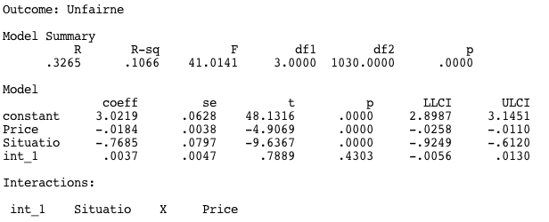
Output for checking H4b:
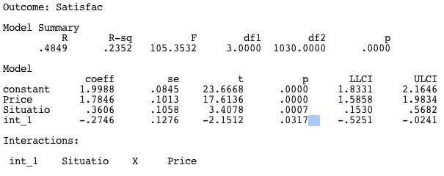

Output for checking H5a:
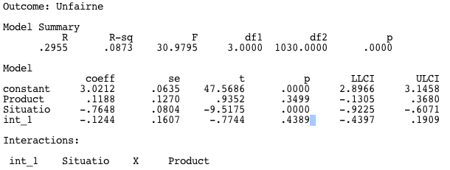
Output for checking H5b:
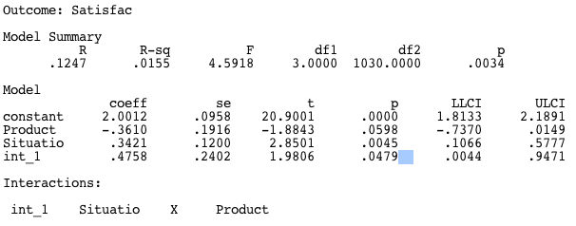
Appendix 9
1. Regressing the mediator on the independent variable:
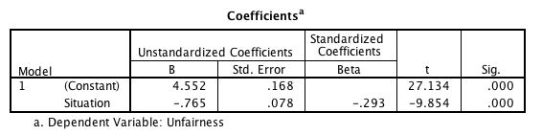
2. Regressing the dependent variable on the independent variable: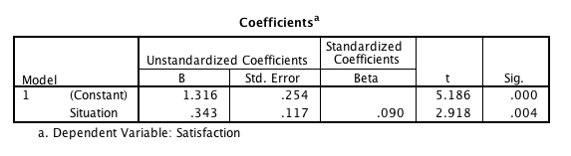
3. Regressing the dependent variable on both the independent variable and on the mediator: 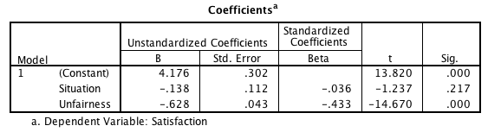
In the third regression only mediator (Unfairness) must affect dependent variable (Satisfaction) and it does (sig.=.000).

Reference list
Armstrong , M. (2006, Oct). Price Discrimination. Retrieved Aug 5, 2013, from Centre for Economic Learning and Social Evolution (ELSE): http://else.econ.ucl.ac.uk/papers/uploaded/222.pdf
Xia, L., Monroe, K. B., & Cox, J. L. (2004). The price is Unfair! A Conceptual Framework of Price Fairness Perception. Journal of Marketing , 68 (4), 1-15.
Kimes, S. E. (1994). Percieved Fairness of Yield Management. Cornell Hospitality Quarterly , 22-30.
Campbell, M. C. (1999). Perceptions of Price Unfairness: Antecedents and Consequences. Journal of Marketing Research , 36, 187-99.
Dai, B. (2010). The Impact of Perceived Price Fairness of Dynamic Pricing on Customer Satisfaction and Behavioral Intentions: The Moderating Role of Customer Loyalty. Dissertation, Auburn University .
Gelbrich , K. (2011). I Have Paid Less Than You! The Emotional and Behavioral Consequences of Advantaged Price Inequality . Journal of Retailing , 87, 207–224 .
Homburg, C., Hoyer, W. D., & Koschatу, N. (2005). Customers’ Reactions to Price Increases: Do Customer Satisfaction and Perceived Motive Fairness Matter? Journal of the Academy of Marketing Science , 36-49.
Lan Xia, K. B. (2004). The price is Unfair! A Conceptual Framework of Price Fairness Perception. Journal of Marketing , 68 (4), 1-15.
Wu, C.-C., Liu, Y.-F., Chen, W.-J., & Wang, C.-J. (2012). Consumer responses to price discrimination: Discriminating bases, inequality status, and information disclosure timing influences. Journal of Business Research , 65, 106-116.
Michaels, P. (2007, Sept 5). Apple slashes 8GB iPhone price by $200. Retrieved 7 1, 2013, from http://www.macworld.com/article/1059838/iphonepricecut.html
Haws, K. L., & Bearden, W. O. (2006). Dynamic pricing and consumer fairness perceptions. Journal of consumer research , 33, 304-311.
Wong, M. (2007, Sept 6). Apple Stock Falls After IPhone Price Cut. Retrieved 7 1, 2013, from The Washington Post: http://www.washingtonpost.com/wp-dyn/content/article/2007/09/06/AR2007090600581.html
Kukar-Kinney, M., Xia, L., & Monroe, K. B. (2007). Consumers’ perceptions of the fairness of price-matching refund policies. Journal of Retailing , 325–337.
Wu, W.-Y., Lu, H.-Y., Wu, Y.-Y., & Fu, C.-S. (2012). The effects of product scarcity and consumers’ need for uniqueness on purchase intention. International Journal of Consumer Studies , 36, 263-274.
Darke, P. R., & Dahl, D. W. (2003). Fairness and Discounts: The Subjective Value of a Bargain . Journal of Consumer Psychology , 328-338.
Cronin, J. J. (2000). Assessing the effect of quality, value, and customer satisfaction on consumer behavioral intentions in service environments . Journal of Retailing , 193-218.
Darke, P. R., & Dahl, D. W. (2003). Fairness and Discounts: The Subjective Value of a Bargain. Journal of Consumer Psychology , 328-338.
Bolton, L. E., Warlop, L., & Alba, J. W. (2003). Consumer Perceptions of Price (Un)Fairness. Journal of Concumer Research , 474-491.
Sweeting , A. (2012). Dynamic Pricing Behavior in Perishable Goods Markets: Evidence from Secondary Markets for Major League Baseball Tickets . Journal of Political Economy , 120 (6), 1133-1172.
Elmaghraby, W., & Keskinocak, P. (2003). Dynaimc price in the Presence of Inventory Considerations: Research Overview, Current Practices, and Future Directions. Management Science , 49 (10), pp. 1287-1309.
Lee, S., & Illia , A. (2011). Perceived price fairness of dynamic pricing. Industrial Management & Data Systems , 531-550 .
Tian, K. T., Bearden, W. O., & Hunter, G. L. (2001). Consumers' Need for Uniqueness: Scale Development and Validation. Journal of Consumer Research , 50-66.
Blattberg, R. C., Briesch, R., & Fox, E. J. (1995). How promotions work. Marketing Science , 122-132.
Baron, R. M., & Kenny, D. A. (1986). The Moderator Variable Distinction in Social Psychological Research: Conceptual, Strategic, and Statisctical Considerations. Journal of Personality and Social Psychology , 1173-1182.
Gallego, G., & Ryzin, G. v. (1994). Optimal Dynamic Pricing of Inventories with Stochastic Demand over Finite Horizons. Management Science , 999-1020.
Cachon, G. P., & Feldman , P. (2010, December 12). Dynamic versus Static Pricing in the Presence of Strategic Consumers. Retrieved April 2013, 1, from The Wharton School, University of Pennsylvania : http://opim.wharton.upenn.edu/~cachon/pdf/dpricingV1all.pdf
Klemperer, P. (1999). Auction Theory: A Guide to the Literature. Journal of Economic Surveys , 13 (3), 227-86.
Bhave, A., & Budish, E. (2012). Primary-Market Auctions for Event Tickets: Eliminating the Rents of “Bob the Broker”. Retrieved 05 22, 2013, from Stanford University website: http://public-prod-acquia.gsb.stanford.edu/sites/default/files/documents/ame_9_12_Budish.pdf
Brendt, T. J. (2004). Book Reviews. Not fair!: the typology of commonsense unfairness. Journal of Moral Education , 33 (1), 97-99.
Martins, M. (1995). An Experimental Investigation of the Effect of Perceived Price Fairness on Perceptions of Sacrifice and Value. doctoral dissertation .
Rondan-Cataluna, F. J., & Martin-Ruiz, D. (2011). Moderating effects in consumers' perceptions of price unfairness. Journal of Consumer Behaviour , 10, 245-254.
Theotokis, A., Pramatari, K., & Tsiros, M. (2012, Jan). Effects of Expiration Date-Based Pricing on Brand Image Perceptions. Journal of Retailing , 72-87.
Heo, C. Y., & Lee, S. (2011). Influences of consumer characteristics on fairness perceptions of revenue management pricing in the hotel industry. International Journal of Hospitality Management , 30, 243-251.
White, A., Breazeale, M., & Collier, J. E. (2012). The Effects of Perceived Fairness on Customer Responses to Retailer SST Push Policies. Journal of Retailing , 250-261.
Bolton, L. E., Keh, H. T., & Alba, J. W. (2010). How Do Price Fairness Perceptions Differ Across Culture? 564–576 .
Xia, L., & Monroe, K. B. (2010). Is a good deal always fair? Examining the concepts of transaction value and price fairness . Journal of Economic Psychology , 31, 884-894.
Tsiotsou, R. (2006). The role of perceived product quality and overall satisfaction on purchase intentions. International Journal of Consumer Studies , 207–217.
Grewal, D., Hardesty, D., & Gopalkrishnan, I. (2004). The Effects of Buyer Identification and Purchase Timing on Consumers’ Perceptions of Trust, Price Fairness, and Repurchase Intentions. Journal of Interactive Marketing , 87–100.
Zeithaml, V. A. (1988). Consumer Perceptions of Price, Quality, and Value: A Means-End Model and Synthesis of Evidence. Journal of Marketing , 2-22.
Boltin, L. E., Warlop, L., & Alba, J. W. (2003). Consumer Perceptions of Price (Un)Fairness. Journal of Concumer Research , 474-491.
Kimes, S., & Wirtz, J. (2002). Perceived fairness of demand-based pricing for restaurants. Cornell Hotel and Restaurant Administration Quarterly , 31–37.
Liberman , N., & Trope, Y. (1998). The Role of Feasibility and Desirability Considerations in Near and Distant Future Decisions: A Test of Temporal Construal Theory. Journal of Personality and Social Psychology , 5-18.
Wang, R. (1993). Auctions versus posted-price selling. American Economic Review , 838–851.
Bichler, M., Kalagnanam, J., Katirciglu, K., King, A., Lawrence, R., Lee, H., et al. (2002). Applications of flexible pricing in business-to-business electronic commerce. IBM Systems Journal , 287-302.
Snyder, C., & Fromkin, H. L. (1980). Uniqueness, the human pursuit of difference. New York: Plenum Press.
Narahari, Y., Raju, C., Ravikumar, K., & Sourabh, S. (2005). Denamic pricing models for electronic business. Sadhana , 231-256.
Adams , S. J. (1965). Inequity in social exchange. Advances in Experimental Social Psychology , 267-299.
Janssens, W., Wijnen, K., Pelsmacker, P. D., & Kenhove, P. V. (2008). Marketing Research with SPSS. Pearson Education Limited.
Field, A. (2009). Discovering Statistics Using SPSS. London: SAGE Publications Ltd.
Hayes, A. F. (2013). Introduction to Mediation, Moderation, and Conditional Process Analysis: A Regression-Based Approach. Guilford Press.
Ordonez, L. D., Connolly, T., & Coug, R. (2000). Multiple Reference Points in Satisfaction and Fairness Assesment. Journal of Behavioral Decision Making , 13 (3), 329–44.

