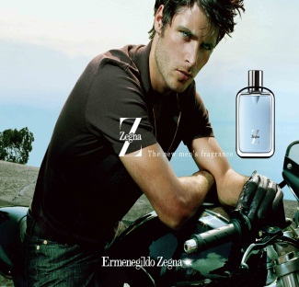
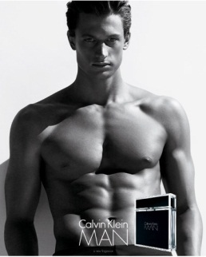
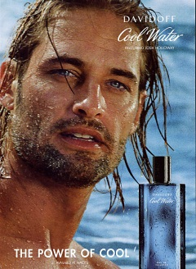
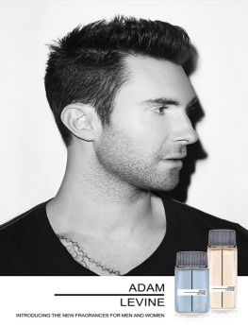
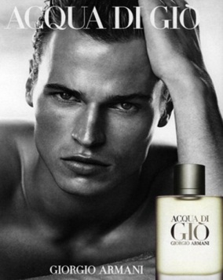
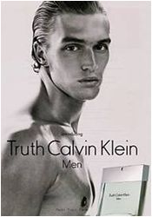
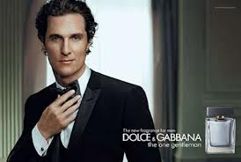

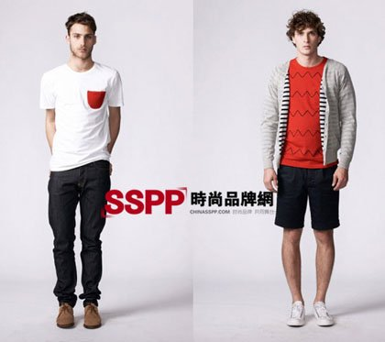
Spokesperson Effectiveness of Attractive Males versus Successful Males in Advertising

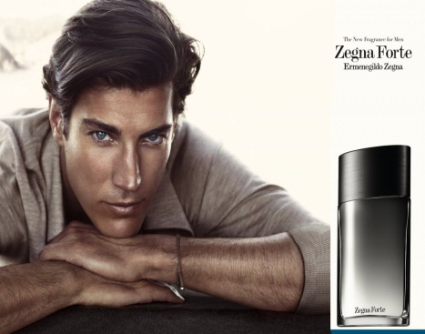

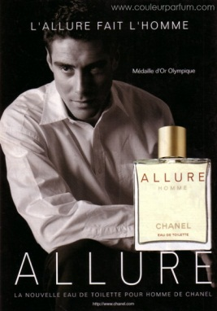

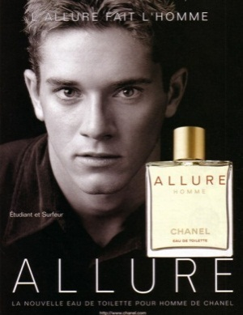
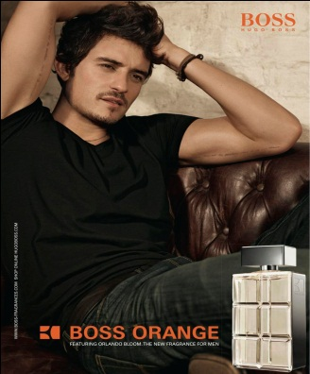
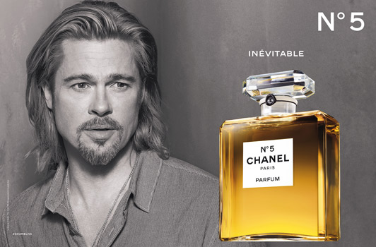
Student: Renata Buranello - 374858
Supervisor: Prof. Dr. Feray Adiguzel
Erasmus University Rotterdam

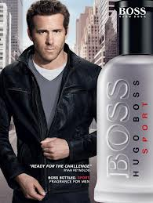
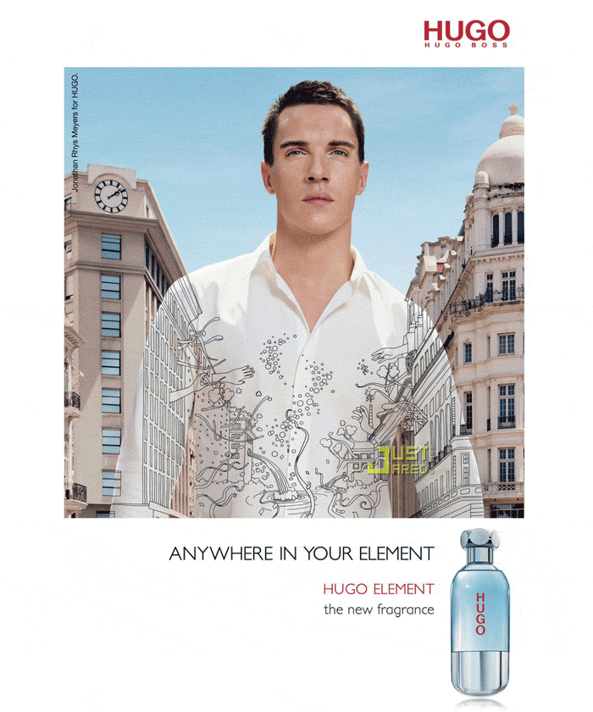
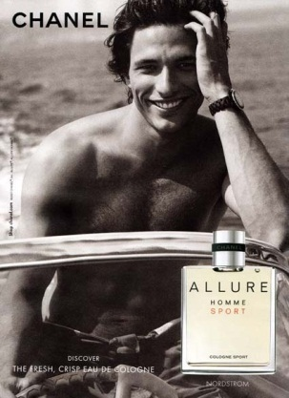

Table of Contents
Management Summary 3
1. Introduction 5
1.1 Research question and sub-questions 7
1.2 Scientific relevance 7
1.3 Managerial relevance 9
1.4 Outline 10
2. Theory Chapter 11
2.1 Factors influencing spokesperson effectiveness 11
2.1.1 Using attractive persons in ads 11
2.1.2 Using celebrity endorsements in ads 12
2.1.3 Using Expert/Credible persons in ads 13
2.1.4 Using successful persons in ads 13
2.2 Social Comparison theory 14
2.3 Hypotheses Development 15
2.5 Conceptual Framework 17
3. Methodology 19
4. Results 23
4.1 Manipulation check 23
4.2 Reliability and Validity analysis 23
4.3 Hypotheses results 24
4.4 Control variables 29
4.5 Additional findings 30
5. Conclusion 33
5.1 Scientific Implications 34
5.2 Managerial Implications 34
5.3 Limitations 35
5.4 Future Research 36
6. References 37
7. Appendix 40
7.1 Questionnaire 40
7.2 Results 44

Management Summary
The purpose of this research was to identify the type of male spokespersons which generates the highest positive attitude towards the ad, in order to serve as a guideline for companies wishing to maximize the effectiveness of an ad targeting the male audience. In order to fulfil this purpose, four different ads were used: an ad with a both a successful and attractive male spokesperson, an ad with a successful non-attractive male spokesperson, an ad with a non-successful attractive male spokesperson, and finally, one ad with a non-successful average looking male spokesperson. The figure below shows the ranking of the respondents’ preferences for each of the ads.

Figure 1: Ranking of attitude towards the ad for the four ads
Although attractiveness creates a higher positive attitude towards the ad, which indicates that men do not show the same jealousy towards attractive spokespersons as women do, the effect between attractive and non-attractive spokespersons in the ads is not statistically significant. In addition to that, the ad preferred the least by men, contrary to expectations, is the one with the average looking non-successful spokesperson. A second interesting finding in this research is that among men who compare themselves (i.e. higher on social comparison) to an attractive spokesperson, the attitude towards the ad is significantly positive; among men who compare themselves (i.e. higher on social comparison) to a successful spokesperson, the attitude toward the ad is significant and negative. In this sense, men who compare themselves with a successful spokesperson do show a similar derogation effect seen with women who compare themselves with a highly attractive model. This is not the case for men who compare themselves with an attractive spokesperson. Therefore, men who compare themselves with the ad do feel more negative towards an ad with a successful spokesperson than with an attractive one. Hence, the results of this research indicate that looks do matter in an ad for the male audience.
Because consumers get into comparison mode as the social comparison theory predicts, using a successful male spokesperson can have a derogation effect for consumers who compare themselves with the spokesperson, and therefore could hurt the image that the brand want to create on consumers, as they would have a negative feeling towards it. On the other hand, an attractive spokesperson creates a more positive attitude towards the ad for consumers who compare themselves (Figure 15); hence the ad will create a positive image on the consumers’ minds, making it easier to persuade them. Therefore, it is important that the right message is being communicated, along with the right spokesperson.
When making a cross-country comparison, for respondents who compare themselves with a successful spokesperson in the ad, Brazilians showed a more negative attitude towards the ad than the Dutch did. This effect was not seen for the attractive spokesperson. However, among non-comparers, Brazilians were more positive towards every type of advertisement than the Dutch. Therefore, the derogation effect occurs for Brazilians as compared to the Dutch among comparers, but not among non-comparers. It also became apparent that Brazilians do compare themselves more with the spokesperson that the Dutch do: 54% of Brazilian respondents compared themselves to the spokesperson in the ad, versus 39% of Dutch respondents (Figure 16). Both groups showed the same preference pattern for all of ads, indicating that the ads would not need to be customized for these two countries (Figure 2).

Figure 2: Attitude towards the ad for Brazil and the Netherlands among non-comparers
In terms of the purchase intention, the results from Brazil follow the same pattern as the attitude towards the ad: a higher purchase intention for the ads with attractive spokespersons than for ads with successful spokespersons. On the other hand, although the Dutch also show a more positive attitude for ads with attractive spokespersons, their purchase intention is higher for ads with successful spokespersons (Figure 17). For both countries, the ad with an average looking, non-successful spokesperson generates the lowest purchase intention. Hence, as companies spend large sums of money to create a positive image on the consumers’ minds with the aim to increase purchase volumes, it is important to keep these findings in mind when targeting the male audience in these countries.
The results of this research make a significant contribution to a field scarcely studied in the past: the male behaviour with regard to spokesperson effectiveness. Men who compare themselves with a successful spokesperson do show a similar derogation effect seen with women who compare themselves with a highly attractive model. This was not the case for men who compared themselves with an attractive spokesperson. Therefore, for companies targeting the male audience, the most effective way of generating a positive attitude towards the ad is by using a handsome spokesperson in the ad. Furthermore, using an average-looking spokesperson in an ad is least desired by men. This is an important finding given the significant effect the evaluation of a spokesperson can have on product evaluations and the desire of brands to communicate the right message, persuading consumers to purchase their products.

1. Introduction
Advertising has the power to persuade, to influence the mind and shape destiny. It has the power to change markets and improve profit margins. In the short-term, advertising conveys new information, builds awareness and enhances credibility. In the long-term, it conveys brand image, attaches emotional values to the brand (which generates loyalty), and builds positive reputation. The most important role of advertising is the help to increase sales by creating awareness. As consumers become acquainted with different products from different brands, a decision is made to purchase these products based on the information they have about the brand. Therefore, the more advertising, the more information the consumer receives about the brand. Besides from creating brand awareness, advertising can be used to make a brand more popular within its core target audience. Moreover, the expenditure made on advertisement can boost the profits of the company.
Advertising continues to grow despite the recession. In 2012, ad expenditure amounted to a total of $508 billion worldwide, a 4.6% increase over 2011, when ad expenditure reached $486 billion. The expectation for 2013 is that ad expenditure will increase 4.5%, representing $531 billion (GroupM, 2013). These numbers show the increasing importance given by companies to advertising. Due to the importance in generating the intended results via advertising, ad effectiveness attracts many researchers with studies that touch on different aspects of ad effectiveness. These studies have investigated the effect of physical attractiveness on ad effectiveness from different aspects (Petty, Cacioppo and Schumann, 1983; Bower, 2001; Trampe et. al 2010), endorser credibility/expertness on ad effectiveness (Hung, 2011), celebrity endorsements on ad effectiveness (Till, 1998; Silvera and Austad, 2004). Recent study indicated the effect of female spokesperson attractiveness on ad effect differs across gender. This leads to wondering how using successful male spokesperson influences ad effectiveness.
Although the previous researches’ results are very interesting, no research has yet been elaborated on analysing the male behaviour with regard to spokesperson effectiveness. Willis and Carlson (1993) found that whilst men select their partners based on physical attractiveness, women select partners based on their social power and their financial ability. Therefore, financial success can be considered an important feature of males. Moreover, besides attractiveness, social status among boys is also associated with high expected earning power (Dong et al. 1996). This leads to wondering whether financial success is for men what attractiveness is for women. In addition to that, Gulas and McKeage (2000) found that exposure to advertising containing idealized images of financially successful males reduced male viewers' level of self-esteem. This shows that success plays an important role in how men see themselves.
Therefore, taking these findings into consideration, it is important to investigate the derogation effect of a successful (male) spokesperson on male behaviour as opposed to the derogation effect that the use of an attractive (male) spokesperson would cause. In order to do so, an analysis will be made on the presence of successful versus handsome male spokespersons in an ad, more specifically, the aim is to research the derogation effect of successful spokespersons in the ad and the brand compared with the derogation effect of handsome spokespersons in the ad and the brand. This is based on the above assumption that men tend to feel more threatened by successful men than by handsome men, which would result in a higher level of derogation.
In addition to that, the cross-cultural differences of Brazil and the Netherlands will be studied, by comparing the derogation effects between successful and male spokespersons resulted from the answers from Dutch and Brazilian respondents. The reason why these two countries will be compared is, in addition to the researcher’s own interest, due to their striking differences in their level of the 4 cultural dimensions found by Hofstede (1983) in his study of cross-cultural differences, which are: power distance, individualism/collectivism, uncertainty avoidance and masculinity.
In this study, power distance measured the degree of inequality between a less powerful and a more powerful person; individualism/collectivism refers to the form of relationship between the individual and the collectivism in a society; uncertainty avoidance refers to the anxiety level among respondents in a country and avoidance of attitudes and behaviours that could increase this anxiety (doing away with rules, considering leaving one's employer); and finally, masculinity, indicates the relative importance of the job aspects earnings, recognition, advancement, and challenge.
These measures can be very significant in terms of how respondents will perceive an ad with a successful person. For example, income inequality (reflected in the power distance dimension), was found to generate a status effect among the rich and a jealousy effect amongst the poor (Smyth and Qian, 2008). Respondents from a country with a high level of power distance can therefore show higher derogation levels to an ad with a successful spokesperson due to the jealousy perceived. The uncertainty avoidance dimension is not perceived to impact how people may perceive successful persons.
In addition to that, in collectivist societies people are less inner-directed, which results in a higher need to maintain face (desire to fit in). Face is lost when individuals fail to meet the obligations placed on them by virtue of their social position (Bochner and Hesketh, 1994). Masculinity, as mentioned above, indicates the relative importance of the job aspects earnings, recognition, advancement, and challenge, which is in line with the dominant pattern of sex roles found to exist in nearly all societies: boys are socialized toward assertiveness and self-reliance, and girls, toward nurturance and responsibility. Both dimensions can have a significant effect in the ad perception with a successful male spokesperson in an ad: a person from a more collectivist and masculine society has a higher pressure to keep up with appearances and to have higher earnings and recognition, which can lead to higher jealousy of a successful person (Bhugra, 1993).
With the findings of this research, it will be possible to conclude if there is higher level of derogation when males compared themselves with a successful male as opposed to an attractive male as well as how this effect differs between countries (i.e. Netherlands and Brazil). This will add value to the social comparison theory, in which Festinger (1954) states that individuals have a drive for self-evaluation and this self-evaluation can only be accomplished by means of comparisons with other persons. Thus, individuals seek continuous improvement and, in order to achieve this improvement, they would compare themselves to similar others.

1.1 Research question and sub-questions
The research objective is therefore to investigate the level of derogation effect that successful male spokespersons have on the ad as opposed to the level of derogation effect that attractive male spokespersons have on the ad. Moreover, the differences between respondents that compare themselves to the ad and respondents who do not compare themselves to the ad will be researched.
This leads to the following research question and sub-questions:
What is the effect of using attractive males versus successful male spokespersons in ads on advertising effectiveness?
- What is the attitude towards the ad of male respondents on an ad with attractive spokespersons?
- What is the attitude towards the ad of male respondents on an ad with successful spokespersons?
- Do the results differ between respondents who compare themselves to the spokesperson and those who do not compare themselves to the spokesperson?
- How do these effects differ across the Netherlands versus Brazil?

1.2 Scientific relevance
Several previous researches have been conducted linking physical attractiveness to advertising effectiveness. Petty, Cacioppo and Schumann (1983) showed that, all else being equal, a message delivered by a physically attractive source will tend to be more persuasive than a similar message delivered by a less physically attractive source. In addition to that, they showed that the attractiveness of a message source has a greater impact on persuasion under conditions of low involvement rather than high involvement. Bower (2001) linked female attractiveness to advertising effectiveness and concluded that the use of highly attractive models in an ad leads to derogation of the ad and of the brand.
A more recent study from Trampe et. al (2010) shows that, when individuals cognitively elaborate on the ad, its effectiveness depends on the type of product the attractive model endorses. That is, the use of an attractive model is more effective when a product relevant for attractiveness is promoted than for a product less relevant for attractiveness. When elaboration likelihood is high, the attractive model serves as a persuasive argument for a product for which attractiveness is relevant, but not for a product for which attractiveness is less relevant. For the latter, an attractive model was not more effective than a regular-looking model.
Another recent article shows that the endorser credibility affects advertising effectiveness and the trustworthiness, relevance, and likability has higher positive relationship whilst attractiveness and expertness were found to have lower positive relationship (Hung, 2011). Several other studies show how celebrity endorsers affect product evaluations. Silvera and Austad (2004) found that the attitude toward the (celebrity) endorser was associated with the attitude toward the product, and furthermore, when individuals believed the endorser truly liked the advertised product, a more favorable attitude toward the endorsed product is found. Till (1998) shows some important findings, such as that the consistent use over time of the celebrity endorser increases the strength of the link between the celebrity and the endorsed brand, as well as ensuring that there is a ‘fit’ between the celebrity and the brand increases the believability of the endorsement.
As mentioned in Section 1, there are 3 out of 4 Hofstede’s dimensions that can impact how people in a country view a successful person. These are: power distance, individualism/ collectivism and masculinity (Hofstede, 1983). Income inequality, measured by the power distance dimension between a less powerful and a more powerful person, was found to generate a status effect among the rich and a jealousy effect amongst the poor (Smyth and Qian, 2008). Moreover, a person from a more collectivist and masculine society has a higher desire to fit in and to have higher earnings and recognition, which can lead to higher jealousy of a more powerful/successful person (Bhugra, 1993).
Therefore, a country with a higher level of power distance, collectivism and masculinity is expected to show higher derogation levels towards successful spokespersons in an ad than countries scoring lower on these dimensions. This is likely to be reflected in the answers from Brazilian respondents versus the Dutch respondents when viewing an ad with a successful spokesperson. This is because Brazil scores higher on the abovementioned dimensions than the Netherlands. With regards to power distance, Brazil has a score of 69 against 38 of the Netherlands. In what concerns individualism (as opposed to collectivism), its score is of 38 against 80 in the Netherlands. Lastly, with regard to masculinity, it scores 49 against 14 in the Netherlands. Hence, it is possible to conclude that Brazil is more collective, masculine country with higher power distance. All these dimensions can reflect on how people view a successful person and it is therefore expected that Brazilian respondents will show higher levels of derogation toward a successful person in an ad compared to Dutch respondents.
As best of author knowledge, none of these studies has investigated either the effect of successful versus attractive male spokesperson on ad effectiveness or its cross-cultural differences, yet. The moderating role of social comparison on these effects is also under researched area on this topic. As the social comparison theory states, individuals constantly compare themselves to others in order to look for improvement. Richins (1991) hypothesized that consumers compare themselves with idealized advertising images, and suggested that idealized images raised the individuals’ comparison standards for attractiveness and lowered satisfaction with their own attractiveness. This lower satisfaction may influence their attitude towards the ad negatively, resulting in a lower purchase intention. Therefore, this research will investigate whether this is indeed the case, by comparing ads with successful, attractive and average-looking spokespersons and investigating the respondents’ attitude towards the ad, as well as their purchase intention.

1.3 Managerial relevance
Companies spend large sums of money to create a positive image on the consumers’ minds and to persuade them. Because consumers get into comparison mode as the social comparison theory predicts, using a spokesperson that would cause a high level of derogation towards the ad and the brand would create a negative attitude towards the ad, and the purchase intention would decrease; customers would ignore the ad, and even worse, can have a negative feeling towards it. Therefore, it is important that the right message is being communicated, along with the right spokesperson.
Based on this research, managers and ad agencies can understand whether an attractive versus a successful (male) spokesperson should be used in their advertising, and the importance to create effective ads. Companies want creative ads which get attention of audience in the first place, persuade them by delivering a positive message, and want them to remember it easily; not ads that would take away the desired effect and in turn lead to a bad attitude of the consumer towards the ad and to the brand. Thus, with the results of this research it will be possible to conclude whether the use a successful spokesperson would be more, or less effective than using a handsome one in an ad. This would be an important finding given the significant effect that the evaluation of a spokesperson can have on product evaluations.
In addition to that, it will be possible to account for cross-country differences in the attitude of consumers towards an ad with a specific spokesperson. This will be useful for companies when deciding whether to adapt a specific ad to a different culture or to change it completely (in this case, by changing the type of spokesperson). Moreover, a successful spokesperson in one country does not necessarily guarantee its success in other countries. The results of this research will make it possible for the countries studied (and similar ones) to know which type of spokesperson will be more effective for an ad, and thus the type of spokesperson that can generate higher likability and success for the ad.
Table 1 shows how the current literature contributed to ad effectiveness studies. Although attractiveness and successfulness have been studied separately, no research has yet investigated the different effects on the consumer behaviour between a successful (male) spokesperson in an ad as opposed to an attractive one. This research aims to add value to the current literature investigating these effects.
Source | Attractive-ness | Successful-ness | Gender studied | Attitude towards the ad | Social Compari-son Theory | Cross-country comparison | Method
Bower (2001) | Yes | No | Female | Yes | Yes | No | Experimental survey
Dong et al. (1996) | Yes | Yes | Male and Female | No | No | No | Experimental survey
Gulas and McKeage (2000) | Yes | Yes | Male and Female | No | Yes | No | Experimental survey
Silvera and Austad (2004) | Yes | No | Male and Female | Yes | No | No | Experimental survey
Petty, Cacioppo, and Schumann (1983) | No | No | Male and Female | Yes | No | No | Experimental survey
Till (1998) | No | No | Male and Female | Yes | No | No | Qualita-tive study
Trampe et. al (2010) | Yes | No | Female | Yes | No | No | Experimental survey
Willis and Carlson (1993) | Yes | Yes | Male and Female | No | No | No | Experimental survey
This study | Yes | Yes | Male | Yes | Yes | Yes | Experimental survey
Table 1. Overview of previous studies on ad effectiveness in usage of attractive and/or successful spokespersons.

1.4 Outline
The chapters that follow attempt to provide additional insight in what contributes to ad effectiveness and in which situations specific spokespersons should be used. Chapter 2 will discuss the theory behind advertising effectiveness and social comparison, Chapter 3 will discuss the methodology used for the experiment. Results will be presented in Chapter 4, followed by the conclusion of the research and directions for future studies.

2. Theory Chapter

2.1 Factors influencing spokesperson effectiveness
The selection of a spokesperson for an ad can be one of the most important decisions for companies as spokespersons are an important part of the cognitive representation of the products they endorse (Burroughs and Feinberg, 1987). The authors found that products were more quickly identified when the product was linked to a spokesperson’s name rather than by no name or a name not associated with the products. Furthermore, characteristics that increase the strength of memory linkages between products and endorsers were found to be present in effective spokespersons. Thus, if this linkage between a product name and a spokesperson is highly important, presentation of a spokesperson name will significantly increase the likelihood that the product name will be called to mind. Taking this into account, it is important to examine which characteristics make a good spokesperson.

Petroshius and Crocker (1989) assessed the impact of the physical attractiveness, sex and race of a spokesperson on the respondent's evaluation of an advertisement. They concluded that the overall liking of an ad and the willingness to purchase the product were influenced by spokesperson attractiveness. With regards to the spokesperson sex, a significant impact was found on respondent's perceptions of the product: female spokespersons resulted in respondents perceiving performance, distinctiveness compared to other products, and quality compared to other products as superior than a male spokesperson whilst male spokespersons resulted in more positive evaluations of distinctiveness and quality. Moreover, the spokesperson’s race of the communicator had a significant impact on quality perceptions: ads containing white communicators resulted in respondents perceiving the advertised product as better quality, better comparative quality, and better expected performance whilst black communicators resulted in more positive ratings on distinctiveness compared to other products.
Kanungo and Pang (1973) showed that there should be ‘fittingness’ between a model in an ad and the type of product being advertised. If there is a match between the product and a model in an ad, consumer evaluations of the product will be more positive. The use of a model with one product can have a positive attitude toward the product, whilst use of the same model with another product may cause a negative attitude. For instance, overall favourable attitude toward the product was created when a male model was used for the car and when a female model was used for the sofa. Therefore, what determines the product-model interaction is the "fittingness" of the model for the product: some products are perceived as either being masculine, feminine or neither. Fittingness of a male model is greater for a product with a masculine image fittingness of a female model is greater for a product with feminine image.

2.1.1 Using attractive persons in ads
There have been numerous studies examining the role of attractive spokespersons in ad effectiveness. For instance, Patzer (1983) suggested a causal relationship between communicator physical attractiveness and perceived trust, expertise, and likeability. Kahle and Homer (1985) found that brand recall is enhanced by source attractiveness and thus the use of an attractive spokesperson appears to enhance memory. Moreover, Baker and Churchill (1977) found that attractive models produce higher ad ratings than unattractive models. Patzer (1983) made four generalizations with regard to physical attractiveness: attractive people have greater social power than unattractive people; they are perceived to have more favourable personal and non-personal characteristics, such as intelligence, personality traits, and success in life; attractive people have more positive effects on other people and receive more positive responses from others, including work requests, and requests for help, than do unattractive people; and, finally and attractive people are more persuasive than unattractive people. In summary, the consequences of being attractive are positive, while the consequences of being unattractive are negative.

2.1.2 Using celebrity endorsements in ads
The use of celebrity endorsers in ads is very popular. However, is it always a good idea to use celebrity endorser? Despite their popularity, many commercials using celebrity endorsers do not live up to advertisers’ expectations (Miciak and Shanklin, 1994). Nevertheless, celebrity endorsers can help develop brand equity and improve a brand’s competitive position if used in the right way. Till (1998) has identified how basic associative learning principles can be invoked to improve the use of celebrity endorsers. The author has found important aspects to take into account when selecting a celebrity endorser: celebrity endorsements will be more effective when used consistently over time to increase the strength of the link between the celebrity and the endorsed brand; when selecting an endorser, it is better to choose a celebrity who is not already strongly associated with another product and it is very important to carefully consider the “fit” of the celebrity and brand. Another important aspect to bear in mind is the potential risk of the celebrity’s reputation damaging the brand’s image.
There are also instances when the use of a celebrity does not have any effect of on product evaluations. For instance Petty, Cacioppo and Schumann (1983) have shown that when an advertisement concerned a product of low involvement, the celebrity status of the product endorsers was a very potent determinant of attitudes about the product. On the other hand, when the advertisement concerned a product of high involvement, the celebrity status of the product endorsers had no effect on attitudes, but the strength of the information about the product contained in the ad was a powerful determinant of product evaluations.
Choi et. Al (2005) studied the cross-cultural similarities and differences in the practice of celebrity endorsement in advertising from two very different countries, the United States, an individualistic culture with a low-context communication style, and South Korea, which represents a collectivistic culture with a high-context communication pattern. One difference found was that celebrities in U.S. advertising often portrayed themselves (serving as spokespersons), whereas the majority of Korean celebrities acted in roles, which enhances the entertainment or publicity value of the commercials. Results also showed that Korean celebrity advertising contained less information and exhibited more collectivism-oriented values American celebrity advertising. Both Korean and U.S. commercials used celebrities mainly for food/ beverages, personal care products, and services. Since it is not easy to differentiate products in terms of technologies or physical features in these categories, celebrities might be used as a means of creating and maintaining distinctive images for brands.

2.1.3 Using Expert/Credible persons in ads
Ad effectiveness depends mainly on the credibility of the source (Patzer, 1983). Source credibility refers to the characteristics of a communicator that have a positive effect on the receivers’ acceptance of a message (Ohanian, 1990). Patzer (1983) identified three elements of source credibility: expertise, trust, and likeability. Moreover, attractiveness and similarity are also elements of source credibility. Expertise refers to the perceived ability of a source to make valid claims, and spokespersons with higher expertise levels are more believable. When expertise is desired in an ad, a CEO or an educated expert in the field is often chosen. CEOs appear to be trustworthy, have expertise and have credibility. As to trustworthiness, it represents the degree of acceptance of the consumers to the spokesperson’s message, or the believed willingness of the spokesperson to make those claims (Hovland, Janis, and Kelley 1953; Ohanian 1990). Likeability and trustworthiness are highly related. People who are liked tend to be trusted, and people who are disliked tend not to be trusted. Attractiveness and similarity are closely related: ads with attractive spokespersons score better than ads with less attractive spokespersons; at the same time, consumers are more inclined to be influenced by a message delivered by a person who is similar to them, as it allows them to identify with the spokesperson (Clow and Baack, 2007).
Yoon et. Al (1998), examined if the underlying dimensions (expertise, trustworthiness and attractiveness) of source credibility found mostly in the United States (a more individualistic country) would also emerge in a widely different culture, such as South Korea (a more collectivistic country). This is because the influence of source credibility on the dependent variables may be different in different cultures. For example, a message source perceived as an expert might be more persuasive than a source perceived as trustworthy in certain culture; and a trustworthy source might be more effective in other cultures in eliciting more positive reactions to the advertisement and the advertised brand. The results did not differ among the countries. However, one surprising finding of the authors when testing the collectivism of South Korean participants showed that the Korean participants revealed a stronger tendency toward independence rather than interdependence, which is inconsistent with the literature that classifies Korea as a highly collectivistic culture. This might explain why no difference was seen in the results between US and South Korea.

2.1.4 Using successful persons in ads
There have not been many studies analysing the impact of successful spokesperson in ads up until now. Most studies analysing the role of success concern gender differences for desired partner attributes as well as how success replicates in social status, which can reflect on how men see themselves or would like to see themselves. According to Goode (1996), attractiveness tends to be valued more in women by men, whereas economic success tends to be valued more in men by women. This suggests that the desire for being successful is very important to men, and can be even more important than being attractive, as men are significantly more likely to request attractiveness in a partner and offer financial and occupational success whilst women are more likely to request financial and occupational success and offer attractiveness.
In the same study, when women were asked whether they preferred an attractive male who ranks low in economic success as opposed to an ordinary-looking male who ranks high in economic success, they opted for the latter. This again shows that success can be a bigger desire for men rather than attractiveness. In a similar line of thought, Davis (1990) found that women are more likely to emphasize desirable masculine traits such as financial, employment, and intellectual status, and valued commitment in a relationship, and therefore men are viewed as success objects.

2.2 Social Comparison theory
Festinger (1954) proposed that persons have a drive for self-evaluation and the necessity for such evaluation is based on the comparison with other persons, to the extent that self-evaluation can only be accomplished by means of comparison with other persons. Other authors recognized that when we do not compare well to others, we may experience envy and jealousy (Salovey and Rodin, 1984). Moreover, the authors stated that, when we attack a similar other, we attack part of ourselves, because our self-definition was obtained through social comparison in the first place. In addition to that, Bers and Rodin (1984) use the term social-comparison jealousy to describe “feelings, thoughts, and behaviour that occur when another person enjoys more success and advantages, attainments, or possessions of the other person provoke dissatisfaction, resentment, and sometimes behaviours such as backbiting”. Thus, the envious behaviour of the comparer results in depreciation, taking the form of backbiting the superior person.
According to Silver and Sabini (1978), social-comparison jealousy occurs when the possessions, attributes, and attainments of one person diminish the status of another person. In such a situation, if the person diminished is seen to depreciate the character of the successful person or derogation of the person’s success, envy will be perceived. The envious person is someone who is threatened by the accomplishments of a comparable other. Thus, there must be a demeaning difference between the estate of the envious person and that of the superior person. This difference can be small or large, but in order for envy to take place, there must be a disparaging difference.
Social comparison jealousy has been associated with a diversity of negative emotions, such as depression, anger and frustration (Salovey and Rodin, 1984). Furthermore, social comparison has been found to lower the self-esteem of the comparers (Gulas and McKeage, 2000). One of the consequences of this social comparison jealousy resulting in a lower self-esteem is the derogation of the comparison other (Bower, 2001). According to the author, social comparison jealousy is said to only exist when the comparer begins to depreciate the other person. They do so as an attempt to stop their loss of self-esteem resulted from the comparison and, in order to regain their self-evaluation, they belittle the superior person, causing the derogating behaviour.
Sweeney and McFarlin (2004) examined the cross-country effect of social comparisons on pay satisfaction. In their study, social comparison was used to predict that our satisfaction with work outcomes (e.g. pay) depends on relative comparisons with other people. Contrary to the authors’ expectations that comparison levels would be lower in Japan than in the US (as the Japanese culture is collectivist, takes an interdependent view of the self, and emphasizes harmony), comparison effects were found for these countries, even though their cultures and work environments are very different from the American ones.

2.3 Hypotheses Development
As discussed in section 2.1.4, success can be a bigger desire for men rather than attractiveness (Davis 1990; Goede 1996). Given the importance that financial success can be considered have on males (Willis and Carlson 1993; Dong et al., 1996) and the fact that advertising containing idealized images of financially successful males reduces male viewers' level of self-esteem (Gulas and McKeage, 2000), it becomes essential to find out what level of derogation advertising images of successful spokespersons can have on the respondents. If the level of derogation is high, using an average looking spokesperson (neither successful nor attractive) might in fact be the best option if it increases the positive attitude towards the ad. The first hypothesis illustrates this:
H1: Using a successful spokesperson in an ad will have a more negative effect on attitude towards the ad than if a non-successful spokesperson is used.
In section 2.1.1 we have already discussed positive effects of using attractive spokesperson in ads (Patzer 1983; Kahle and Homer 1985; Baker and Churchill 1977). However, researchers have investigated specifically the potential for derogation of beautiful comparison others. For instance, Bower (2001) found that subjects that were exposed to a highly attractive model showed high levels of derogation toward the model, followed by negative perceptions of model expertise, which suggests that using an average looking person may be more effective as the ad would seem more real and not lead to negative attitudes towards the ad. Furthermore, a study from Trampe et. al (2010) shows that, when elaboration likelihood is high, an attractive model that advertises a product that is relevant for physical attractiveness affects product attitudes more favourably than does an attractive model that advertises a product that is less relevant for attractiveness. This suggests that, for products which attractiveness is less relevant, the usage of a more ‘normal-looking’ spokesperson will lead to more favourable attitudes as the ad would seem more real. This therefore leads to hypothesis H2:
H2: Using an attractive spokesperson in an ad will have a more negative effect on attitude towards the ad than if a non-attractive spokesperson is used.
As discussed in section 2.4, social comparison jealousy occurs not only because a person is exposed to a superior one, but as a result of comparison between the comparer and the person who is perceived to be superior. This derogation is thus driven by the comparison and its consequences resulting from it. Therefore, a better way to predict jealousy and derogation may be to consider specifically the extent to which the male compares himself with successful and attractive male spokespersons. Moreover, Bower (2001) found that subjects who compared themselves with a highly attractive model experienced more negative feelings towards the ad than did non-comparers. This leads to the following two hypotheses:
H3a: The higher the comparison made between the respondents and a successful male spokesperson, the lower the attitude towards the ad.
H3b: The higher the comparison made between the respondents and an attractive male spokesperson, the lower the attitude towards the ad.
As discussed in section 2.1.4, men are more likely to desire economic success as economic success tends to be valued more in men by women (Goode, 1996; Davis 1990). Although attractiveness tends to be valued more in women by men, this is not the so much the case the other way around. This suggests that success is the ultimate goal for men, even more than attractiveness, and therefore they might be likely to develop a more negative attitude towards the ad when a successful male spokesperson is used than when an attractive male spokesperson is used, given the fact that their main aim is to be successful. This leads to the following hypothesis:
H4: Using a successful spokesperson in an ad will have more negative effect on attitude towards the ad compared to using an attractive spokesperson in an ad.
Given the stronger negative effect expected in H1 and H2 if a successful/attractive spokesperson is used in an ad compared with an average looking spokesperson, it is expected that an ad with a successful and attractive spokesperson will generate a more negative attitude towards the ad than if a successful average-looking spokesperson is used. The following hypothesis is developed based on this assumption.
H5: Using a successful and attractive spokesperson in an ad will have more negative effect on attitude towards the ad compared to using a successful average looking spokesperson in an ad.
Many studies have focused on understanding how ads affect consumers' attitudes toward advertised brands. Research has shown that consumers' brand beliefs affect brand attitude formation (e.g., Mitchell and Olson 1981). Moreover, it has been found that the attitude towards the brand attitudes is based on both brand-related beliefs and attitude towards the ad (Gardner, 1985). Hence, it is essential to find out if the respondents who show a more positive attitude towards the brand will also show a positive attitude towards the ad, that is, if a positive attitude towards the brand is indeed a mediator to a positive attitude towards the ad in this study. Generating a positive attitude towards the brand and, in turn, a positive attitude towards the ad may increase the likelihood of a purchase intention of the brand. This is very important for companies, as generating sales is their main reason to advertise. For that reason, hypothesis 6 will test whether this assumption is indeed the case.
H6: The attitude towards the brand in the ad will act as a mediating effect between the attitude towards the ad and the purchase intention.
As mentioned in Section 1.2, Brazilian respondents are expected to show higher levels of derogation toward a successful person in an ad compared to Dutch respondents due to the country’s high levels of power distance, collectivism and masculinity as compared to the Netherlands (Hofstede, 1983). Power distance reflects the high degree of inequality between a less powerful and a more powerful person in Brazil, which results in a jealousy effect of a high power person (Smyth and Qian, 2008). Collectivism refers to the form of relationship between the individual and the collectivism in a society which is followed by the desire to fit in; and masculinity, indicates the relative importance of the job aspects earnings, recognition, advancement, and challenge, which can lead to jealousy of a more powerful/successful person (Bhugra, 1993). The three hypotheses below therefore illustrate results that are expected to come out of the comparison between Dutch and Brazilian respondents.
H7: The attitude towards the ad will be more negative among Brazilian respondents (compared to Dutch respondents) if a successful male spokesperson is used in an ad than if an average looking male spokesperson is used.
H8: The attitude towards the ad will be more negative among Brazilian respondents (compared to Dutch respondents) if an attractive male spokesperson is used in an ad than if an average looking male spokesperson is used.
H9: The attitude towards the ad will be more negative among Brazilian respondents (compared to Dutch respondents) for respondents who compare themselves with a successful male spokesperson than for respondents who do not compare themselves.

2.5 Conceptual Framework
Figure 3 is a representation of the expected relationships in this research. The hypothesized types of spokespersons are included on the left-hand side of the model. Because of the potential influence that the different spokespersons may have on the attitude towards the ad, attitude towards the brand and purchase intention, both attitudes and purchase intention are included in this research to establish that a connection between the type of spokesperson and attitudes/intention may exist. Furthermore, hypotheses 3a and 3b are moderated by social comparison, with the expectation that comparers will show a more negative attitude towards the ad than non-comparers.
Social comparison
H1
Attitude towards the ad
H3a
Successful spokesperson
H3b
H5
H4
Attractive spokesperson
H2
Attitude towards the brand in the ad
H6
Successful and attractive spokesperson

Control: ordinary John *(not attractive/successful)
Purchase intention of brand

Figure 3: Conceptual Framework (General)
Figure 4 is a representation of the expected relationships in this research for respondents from the Brazil and the Netherlands. The hypothesized relationships are the same as the Figure 3.

Social comparison
H1
Attitude towards the ad
Successful spokesperson
H3a
H3b
H4
H5
Attractive spokesperson
H2
Attitude towards the brand in the ad
H6
Successful and attractive spokesperson

Control: ordinary John *(not attractive/successful)
Purchase intention of brand
H7
H9
H8

Social comparison
H3a
H1
Attitude towards the ad
Successful spokesperson
H3b
H4
H5
Attractive spokesperson
H2
Attitude towards the brand in the ad
Successful and attractive spokesperson
H6

Control: ordinary John *(not attractive/successful)
Purchase intention of brand

Figure 4: Conceptual Framework (Brazil and the Netherlands)

3. Methodology
In order to minimize the chance of error, a minimum of 30 participants are required to participate in this experimental survey in each of the conditions (successful spokesperson, attractive spokesperson and control group), totalling 120 participants (Fraenkel and Wallen, 1993). Since a comparison will be made between the answers of the Dutch and Brazilian citizens, a minimum of 240 male respondents (120 Dutch and 120 Brazilians) will be required for the experiment. The participants will be assigned randomly to conditions in a 2 X 2 between-subject design with two levels of success (successful or not successful) and two levels of attractiveness (attractive or not attractive). A third independent variable (social comparison) will be included to test if the respondents who compare themselves to the spokesperson will show a stronger negative effect.

 | Successful | Not successful
Attractive | Successful, and attractive | Not successful, but attractive
Not Attractive | Successful, but not attractive | Not successful, not attractive
Figure 5: 2 X 2 between subject design

One male product (i.e. men’s perfume) will be selected and four advertisements will be created. The first ad will contain a successful and attractive male spokesperson (David Beckham), the second ad will contain a successful and non-attractive male spokesperson (Lionel Messi), the third ad will contain a non-successful but attractive spokesperson and the fourth ad will contain an average looking spokesperson as a control condition. The successful spokespersons were selected from a pre-test conducted with 6 different ads with different types of spokesperson (football players, actors, and businessmen). The pair of David Beckham and Lionel Messi was chosen given that the former received the highest score for success and attractiveness and the latter received the highest score for success and lowest score for attractiveness.
The ads for each condition are indicated in the Appendix. The data will be gathered via a questionnaire sent to male respondents (see Appendix 7.1). To minimize bias, the hypotheses of the study and the purpose of this study will not be revealed to the respondents. Each respondent will be randomly assigned to one ad. The questionnaire will contain ratings of the attitude towards the ad, social comparison, attitude towards the brand and purchase intention on a multi-item with Likert-type scaling ranging from 1 (Strongly Disagree/ Very Unlikely) to 7 (Strongly Agree/Very Likely). A manipulation check will be conducted in order to verify if the respondent considers the spokesperson attractive and successful for each ad. Moreover, an additional question will be included in order to account for the nationality of the respondent. The answers of the respondents will be collected and regressed in a SPSS output, with the results based on analysis of variance (ANOVA) method.
Independent variable
X1: dummy variable for the condition 1- successful 0=not – successful
X2: dummy variable for the condition 1- attractive 0=not – attractive
X3: social comparison: The independent variable X3 will be measured by the Social Comparison Tendency scale, which will be composed seven-point Likert-type statements intended to measure the tendency to compare one's self to people in ads or to friends as a way to determine how to look (Bruner II, 2012).
Dependent variable
Attitude towards the ad (Y1): The dependent variable Y1 will be measured by the Attitude Toward the Ad (Overall) scale, in addition to four questions from the Attitude Toward the Ad (Cognitive) scale, in order to make this measure more complete. This scale will be composed of a seven-point scale and is used to assess a person's attitude toward some specific advertisement (Bruner II, 2012).
Attitude towards the brand in the ad (Y2): The dependent variable Y2 will be measured by the Attitude Toward the Product/Brand (General Evaluative) scale, which is composed of a seven-point scale that measures a consumer's evaluation of a product. The scale measures some aspects of purchase intention and/or product quality (Bruner II, 2012).
Purchase intention of the brand (Y3): The dependent variable Y3 will be measured by the Purchase Intention scale, which is a Likert-type measure of the degree to which a consumer means to buy/try a specified brand in the future and recommend it to a friend if asked (Bruner II, 2012).
Testing hypotheses
Although in experimental research ANOVA analysis is commonly preferred, multiple regression analysis will be used in this research. Multiple regression analysis will be conducted in order to find out if the independent categorical variables and one continuous independent variable “social comparison” have any effect on the dependent variable. For instance in this research we hypothesize that a successful/attractive spokesperson and social comparison causes the attitude towards the ad to be more negative, therefore the variable "attitude towards the ad" is dependent on the independent variables "successfulness", "attractiveness" and "social comparison". Successfulness and attractiveness are categorical (if the spokesperson is successful, successfulness = 1, if not, successfulness = 0; same applies for attractiveness). Therefore the independent categorical variables may influence in the dependent variable attitude towards the ad. Social comparison is a continuous independent variable. If we have a continuous independent variable next to categorical independent variables, we can use both ANCOVA and multiple regression analysis.
Testing H1 – H5
The dependent variable Y1 will be a measure of the 4 independent variables (success, attractiveness, their interaction and social comparison) via the models below:
Y1= β0 + β1 X1 (successful) + β2 X2 (attractive) + β3 X3 (social comparison) + β4 (X1 X3) + β5 (X2 X3) + β6 (X1 X2) + error term
The significance and sign of the coefficient of:
β1 will be checked for H1,
β4 will be checked for H3a,
β2 will be checked for H2,
β5 will be checked for H3b; and
β6 will be checked for H5.
To test H4, the coefficient of (β1- β2>0) will be tested.
Testing H6
Mediating effect
Attitude towards the brand in the ad (Y2): this variable will act as a mediator for the attitude towards the ad (Y1) and the purchase intention (Y3) via the models below:
I. Y2= β0 + β1 Y1 + error term Y3 = β0 + β1 Y1 + error term
II. Y3= β0 + β2 Y2 + error term
III. Y3= β0 + β1 Y2 + β2 Y1 + error term
In step I, β1 should be significant.
In step II, β2 should be significant.
In step III, if the coefficient of Y2 is not significant, but Y1 is significant, Y1 is a full mediator.
If the coefficient of Y2 is significant but smaller than in step II, and Y1 is significant, Y1 is a partial mediator.
Testing H7 – H9
Data will be combined via the below model:
Y1= β0 + β1 X1 (successful) + β2 X2 (attractive) + β3 X3 (social comparison) + β4 (X1 X3) + β5 (X2 X3) + β6 (X1 X2) + β7 X4 (country dummy 1=Brazil, 0=NL) + β8 (X1 X4) + β9 (X2 X4) + β10 (X1 X3 X4) + β11 (X2 X3 X4) + error term
β8 should be significant and negative to conclude H7,
β9 should be significant and negative to conclude H8,
β10 should be significant and negative to conclude H9.
When interaction effects are added, multicollinearity might occur. This will be checked with the VIF values. If the sample size is not enough or data is not normal or homogenous for the full model testing, a simpler independent t-test will be employed to test hypotheses (bivariate test).
The dependent variable can be influenced by other variables. When investigating the effect of a variable on a response, we have to control for other variables that can influence results if omitted. In this research, three control variables will be used: age, involvement with the brand and self-perceptions of attractiveness and success compared with the spokesperson in the ad. They will be controlled in order to balance the effect across subjects and groups, and only study the relationship between the independent and the dependent variables.
There are five main assumptions made for multiple regression analysis: normality, linearity, equality of variances of the residuals (homoscedasticity), independence of residuals and lack of collinearity. The normality assumption predicts that the residuals should follow a normal distribution; the linearity assumption predicts that the relationship between dependent and independent variables is linear; homoscedasticity predicts that the variance of data in groups should be the same; the independence of residuals assumption predicts that the residuals are uncorrelated with each other; and, lastly, the lack of collinearity assumption predicts that there is no linear relationship between the independent variables.
In order to assure the multi-item scales used in experiment is consistent and measures what it is supposed to, a reliability and validity check will be conducted once all answers are computed. Reliability refers to the extent a study yields consistent results over repeated tests under identical conditions and will be measured by performing a Cronbach alpha (α) test on SPSS: if α < 0.7 then it has unsatisfactory internal consistency reliability. Validity refers to the degree a study correctly measures the concept the research is attempting to measure. A validity test can be done by conducting a factor analysis, in which it detects the constructs of a dataset based on the correlations between the multi-item scales of the questionnaire. If the all the items of a question load on the same factor, it means that they measure the same construct, and therefore are valid.

4. Results
A total of 257 males responded to the questionnaires, 131 Dutch and 126 Brazilians. All ads had at least 30 subjects, meeting the sample size requirements. Social comparison had a mean of 2.44 (maximum score is 7), meaning that the respondents in general do not tend to compare themselves with the spokesperson in the ad. However, out of the 257 respondents, 120 were above the median of social comparison: 68 Brazilians and 52 Dutch, meaning that out of the ones who compare themselves with the spokesperson in the ad, the group amongst the Brazilians tend to compare themselves relatively more than the Dutch do, but not with a very high difference (Figure 18; Appendix 7.2).

4.1 Manipulation check
Firstly, a manipulation check was conducted with a two-way ANOVA analysis. Participants were asked to rate spokesperson’s attractiveness and success on a scale ranging from 1 (strongly disagree) to 7 (strongly agree). As Figure 20 of the Appendix shows, the analysis is statistically significant (F(3, 253)=69.90, P=.000; F(3, 252)=51.34, P=.000), and therefore we can conclude that there is a statistically significant difference between the conditions. Participants ranked the attractiveness and success for each of the conditions as expected: the successful and attractive spokesperson was more successful and more attractive than the non-successful and non-attractive spokespersons and the successful and non-attractive spokesperson was more successful than the non-successful spokespersons and less attractive than the attractive spokespersons. The summary of the results can be seen on the below table (Figure 6) and the histograms are presented in Figures 22-29.
Moreover, a post-hoc test was conducted in order to find out which of the condition means were different. As can be seen from Figure 21, no statistical difference was seen between the conditions 1 and 2 and between conditions 3 and 4 in terms of success. This is as expected, since the spokespersons for conditions 1 and 2 are both considered successful and the spokespersons from conditions 3 and 4 are both considered non-successful, and therefore they should not have had indeed any difference in terms of success, as was the case. In terms of attractiveness, no statistically significant difference was seen between conditions 2 and 3. This also occurs as expected, as both spokespersons from conditions 2 and 3 are not considered attractive, and therefore no difference in terms of attractiveness should have occurred, as indeed was the case.
Condition | Advertisement | Successful | Attractive
1 | Beckham (Successful and attractive) | 6.13 | 5.18
2 | Messi (Successful non-attractive) | 5.92 | 2.71
3 | Average looking, (non-successful) | 3.65 | 2.24
4 | Attractive non-successful | 3.92 | 4.37
Figure 6: Manipulation check

4.2 Reliability and Validity analysis
The reliability and factor analysis were also conducted in order to ensure the data was consistent and valid. Cronbach’s alpha was measured for four different constructs: attitude towards the ad, attitude towards the brand, purchase intention and social comparison. As Figures 30-33 show, all constructs had coefficients higher than 0.70 (a coefficient higher than .70 is necessary for satisfactory internal consistency reliability). Cronbach’s alpha coefficient was 0.944 for the construct “attitude towards the ad”, 0.959 for “attitude towards the brand”, 0.924 for “purchase intention”, and 0.824 for “social comparison”, suggesting that all constructs have very high internal consistency.
In addition to that, in order to test validity, a factor analysis was conducted to find out if the scale items of the questionnaire would load under the same factor. Looking at the Scree Plot (Figure 34), the results suggest a four-factor solution, which explain a 72.8% variance in the survey items (Figure 35). As can be seen, the factors are separated well, with the exception of factor Q11_1. Discriminant validity (i.e. how well different constructs/scale are separated from each other) and convergent validity (i.e. how well the items of construct/scale measure the same concept) are confirmed. Finally, Figure 36 presents the factor loadings from the factor analysis. The Q11 items loaded on the first factor represent the “Attitude towards the brand” scale; the Q10 items loaded on factor 2 represent the ‘’Attitude towards the ad’’ scale; same goes for factor 3, with Q12 items representing the “Purchase Intention” scale, and factor 4 with Q13 items representing the “Social Comparison” scale, therefore it is possible to conclude that the study correctly measures the concept the research is attempting to measure, and is therefore valid.

4.3 Hypotheses results
Multiple regression analysis and independent t-tests were conducted, with the findings analysed and discussed below (in relation to the hypotheses). Interpretation of hypotheses 1 to 5 will be based on the model below with the help of Figure 37. As can be seen, the analysis is statistically significant (F=11.916, P =.000), and therefore the null hypothesis can be rejected. This means that independent variables have an effect on attitude towards the ad. The R-squared has a value of 0.472, meaning that 47.2% of the variance in attitude towards the ad can be explained by the independent variables (successfulness, attractiveness, social_comparison, successfulness_comparison, attractiveness_comparison and successfulness_attractiveness). Moreover, this regression has accounted for multicollinearity. All VIF values are smaller than 10, therefore there is no multicollinearity.
To compare the magnitude of effects, standardized beta coefficients are used. As can be seen from the Figure 7 below, the most important effect was attractiveness_comparison (.493), the second was successfulness (.362), and the third and last was successfulness_comparison (-.284). All the other effects were insignificant. Interestingly, for subjects who compare themselves to the model in the ad, the effect of successfulness becomes significantly negative (i.e. when we add the interaction effect: -.284), while successful has a positive main effect (.362), and attractiveness becomes strongly positive (.493) instead of the negative effect expected, while attractiveness has no significant main effect (-.089).

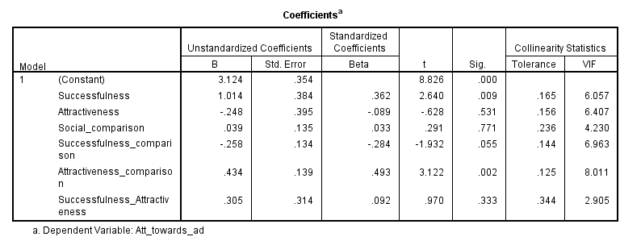
Figure 7: Testing hypotheses H1-H5
Testing H1 – H5
Y1=3.124 + 1.014*X1 + -.248*X2 + .039*X3 + -.258*(X1*X3) + .434*(X2*X3) + .305*(X1*X2)
Condition | Advertisement | Netherlands | Brazil | TOTAL
1 | Beckham (Successful and Attractive) | 4.35 | 5.18 | 4.76
2 | Messi (Successful and Average looking) | 3.54 | 3.71 | 3.62
3 | Average looking person (not successful, not attractive) | 3.00 | 3.42 | 3.21
4 | Attractive looking person (not successful, attractive) | 3.82 | 4.30 | 4.02
(1+2) versus (3+4) | Successful versus not successful | 3.93 | 4.40 | 4.17
(1+4) versus (2+3) | Attractive versus not attractive | 4.04 | 4.73 | 4.36
Figure 8: Means “Attitude towards the ad” per condition per country

Hypothesis 1 (H1): Using a successful spokesperson in an ad will have a more negative effect on attitude towards the ad than if a non-successful spokesperson is used. As can be seen in Figure 7, the β1 coefficient of successfulness is positive and statistically significant (P=0.009). This means that, contrary to expected, a successful make spokesperson in an ad leads to a more positive attitude towards the ad (M=4.17 overall i.e. combined Brazil and Netherlands) than if a non-successful spokesperson is used (M=3.62), ceteris paribus.
Hypothesis 2 (H2): Using an attractive spokesperson in an ad will have a more negative effect on attitude towards the ad than if a non-attractive spokesperson is used. As can be seen from Figure 7, β2 coefficient of attractiveness in insignificant (P=0.531). Therefore, it is not possible to confirm the hypothesis. In fact, by looking at Figure 8 above, the mean of the attractive looking spokespersons (M=4.36) is higher than the mean of the average looking spokespersons (M=3.42), meaning that an attractive spokesperson will lead to a more positive attitude towards the ad than a non-attractive spokesperson, however this effect is not statistically significant.
Hypothesis 3a (H3a): The higher the comparison made between the respondents and a successful male spokesperson, the lower the attitude towards the ad. Indeed, β4 is statistically significant (P=0.055) with a negative coefficient (.-258), therefore it is possible to conclude that respondents who compare themselves with a successful spokesperson will have a more negative attitude towards the ad than those who do not compare themselves, ceteris paribus.
Hypothesis 3b (H3b): The higher the comparison made between the respondents and an attractive male spokesperson, the lower the attitude towards the ad. β4 is statistically significant (P=0.002) with a positive coefficient (.434), therefore respondents who compare themselves with an attractive spokesperson will have a more positive (instead of negative) attitude towards the ad than those who do not compare themselves, ceteris paribus.
Hypothesis 4 (H4): Using a successful spokesperson in an ad will have more negative effect on attitude towards the ad compared to using an attractive spokesperson in an ad. As β2 (attractiveness) in the regression is insignificant, but β1 (successfulness) is significant, it could be stated that successfulness is more important than attractiveness. Standardized beta coefficient of β1 is 3.602 and of β2 is negative, -.089 (and not significant). A t-test was conducted in order to arrive to a conclusion. As Figure 38 of the Appendix shows, the t-test conducted was significant (P<0.05) and the mean of attractiveness (M=4.36) was higher than the mean of successfulness (M=4.17). Therefore, it can be concluded that using a successful spokesperson in an ad will indeed have a more negative effect on attitude towards the ad compared to using an attractive spokesperson in an ad.
Hypothesis 5 (H5): Using a successful and attractive spokesperson in an ad will have more negative effect on attitude towards the ad compared to using a successful average looking spokesperson in an ad. Figure 7 shows that the β6 coefficient of a both successful and attractive spokesperson is insignificant; therefore we cannot conclude this hypothesis. A t-test was conducted in order to arrive to a conclusion. As Figure 39 of the Appendix shows, the t-test conducted was significant (P<0.05) and the mean of successfulness_attractiveness (M=4.76) was higher than the mean of successfulness/average looking (M=4.17). Therefore, it can be concluded that using a successful and attractive spokesperson in an ad will actually have a more positive effect on attitude towards the ad (instead of negative) compared to using a successful average looking spokesperson in an ad.
In addition to multiple regression analysis, a two-way ANCOVA analysis was conducted. The results can be seen on Figure 40 of the Appendix. As can be seen, the results are very similar to the regression results. The significant variables are the same as the ones from the regression analysis: successfulness (F=10.40; P=.001), attractiveness_comparison (F=9.74; P=.002) and successfulness_comparison (F=3.73; P=.055). All the other variables were insignificant, as was also the case in the regression results. 4% of the variability in attitude towards the ad can be accounted for the independent variable successfulness, 3.8% by attractiveness_comparison and 1.5% by successfulness_comparison. Therefore, successfulness is the most important variable, followed by attractiveness_comparison and successfulness_comparison. Homogeneity of variance was tested using the Levene test. Assuming a significance alpha=0.01, Levene’s test was just above the significant level (P=.011) and thus we can assume equal variances across groups.
Testing H6
H6 is tested and interpreted by making use of Figures 41-44 of the Appendix, which contain the regression results.
 | Standardized Coefficients, Beta | Sig. | R-square
Attitude towards ad=> Attitude towards brand | .603 | *(p=.000) | .363
Att. Towards Ad=> purchase intention=> | .514 | *(p=.000) | .264
Att. Towards brand=>purchase intention | .739 | *(p=.000) | .546
Att. Towards brand+ Att. Towards Ad =>purchase intention | .674; .108 | *(p=.000); *(p=.041) | .553
Figure 9: Testing H6
Hypothesis 6 (H6): The attitude towards the brand in the ad will act as a mediating effect between the attitude towards the ad and the purchase intention. The β coefficients are significant for all three steps. In step III, the coefficient of “Attitude towards the brand” (Y2) is significant but smaller than in step II (Step III=0.819; Step II=0.898) and Y1 is significant, therefore “Attitude towards the brand” indeed acts as a mediating effect between the “Attitude towards the ad” and the “Purchase intention”, but it acts as a partial mediator, which means that the effect of attitude towards the ad on purchase intention is influenced by the attitude towards the brand in the ad. Based on the brand attitude, this effect will either increase, if brand attitude is positive, or decrease, if brand attitude is negative.
Testing H7 – H9
Interpretation of hypotheses 7 to 9 will be based on the model below with the help of Figure 46 of the Appendix. On the initial regression (Figure 45), multicollinearity was taken into account and as most VIF values were larger than 10, mean centering was done in order to account for the multicollinearity. Therefore, Figure 46 shows the results after the mean centering was done. As can be seen, the analysis is statistically significant (F=8.218, P =.000), and therefore the null hypothesis can be rejected. This means that the independent variables have an effect on dependent variable. To understand which variables influential, we look at beta coefficients. The R-squared has a value of 0.519, meaning that 51.9% of the variance in attitude towards the ad can be explained by the independent variables (C_Successfulness, C_Attractiveness, C_Comparison, C_Successfulness_comparison, C_Attractiveness_comparison, C_Successfulness_Attractiveness, C_Brazil, C_Successfulness_Brazil, C_Attractiveness_Brazil, C_Comparison_Brazil_Successfulness, C_Comparison_Brazil_Attractiveness).
Y1= 3.886 + .566*X1 + .997*X2 + .131*X3 + -.194*(X1*X3) + .414*(X2*X3) + .272*(X1* X2) + .446*X4 + .067*(X1*X4) + .295*(X2*X4) + -.706*(X1*X3*X4) + .008*(X2*X3*X4)
To compare the magnitude of effects, standardized beta coefficients are used. As can be seen from the Figure 10 below, for the entire sample, attractiveness is the most important positive effect on attitude towards the ad (.357), followed by successfulness (.202), and attractiveness*comparison (.174). With regard to country-effect, Brazil has a more positive attitude towards the ad relative to the Netherlands (Stand beta= .159). Furthermore, the higher the comparison of all respondents with an attractive spokesperson, the higher the attitude towards the ad (.174); for Brazilian respondents, the higher the comparison to successful spokesperson, the lower the attitude towards the ad (Stand beta= -.151) relative to Dutch subjects. However, comparisons to attractive spokesperson does not influence attitude towards the ad for Brazilian relative to Dutch (i.e. both in the same direction, no differences observed).
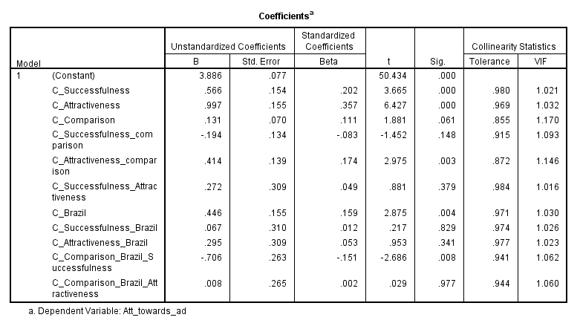
Figure 10: Testing hypotheses H7-H9
The reference category is NL
Hypothesis 7 (H7): The attitude towards the ad will be more negative among Brazilian respondents (compared to Dutch respondents) if a successful male spokesperson is used in an ad than if an average looking male spokesperson is used. The coefficient of β8 is insignificant (P=0.829), therefore it is not possible to conclude H7. A t-test was also conducted but the coefficients were insignificant (Figure 47). By looking at the means of Figure 8 above, it is possible to see that Brazilians have, contrary to expectation, a more positive attitude towards the ad with a successful male spokesperson (M=3.71) than the Dutch do (M=3.54), however this effect is not statistically significant.
Hypothesis 8 (H8): The attitude towards the ad will be more negative among Brazilian respondents (compared to Dutch respondents) if an attractive male spokesperson is used in an ad than if an average looking male spokesperson is used. Again, the coefficient of β9 is insignificant (P=0.360), meaning that it is not possible to conclude H8 Contrary to expectation, the means of Figure 8 point to a more positive attitude of Brazilians (M=4.30) towards an ad with an attractive spokesperson than the Dutch (M=3.82). A t-test was conducted in order to arrive to a conclusion. As Figure 49 shows, the t-test was significant for attractiveness (P=.001) and insignificant for non-attractiveness (P=.242; Figure 48). In addition to that, the Brazilians scored a higher mean for attitude towards the ad for an attractive spokesperson (M=4.73) than the Dutch did (M=4.04). Therefore, there are some indications that the attitude towards the ad is more positive among Brazilian respondents (compared to Dutch respondents) if an attractive male spokesperson is used in an ad than if an average looking male spokesperson is used, but this effect is not statistically significant.
Hypothesis 9 (H9): The attitude towards the ad will be more negative among Brazilian respondents (compared to Dutch respondents) for respondents who compare themselves with a successful male spokesperson than for respondents who do not compare themselves. Β10 is statistically significant (P=0.008) with a negative coefficient (-.706), therefore the attitude towards the ad is indeed more negative among Brazilian respondents (compared to Dutch respondents) for respondents who compare themselves with a successful male spokesperson than for people who do not compare themselves, ceteris paribus. A derogation effect does occur towards a successful spokesperson (higher in Brazil than Netherlands).Moreover, a test was conducted on the following additional hypothesis: The attitude towards the ad will be more negative among Brazilian respondents (compared to Dutch respondents) for respondents who compare themselves with an attractive male spokesperson than for respondents who do not compare themselves. As Figure 10 above shows, the interaction effect attractiveness*comparison*country is not significant (P>0.05), therefore a derogation effect does not occur towards attractiveness of spokesperson.

4.4 Control variables
In addition to the variables studied, this research accounts for three control variables that could influence results if omitted. These are: age, involvement with the brand and self- perceptions of attractiveness and success. As Figure 50 shows, the coefficients of age and self-perceptions of attractiveness and success are insignificant and therefore there is not enough evidence that they could influence the attitude towards the ad. Involvement with the brand, on the other hand, has a positive and significant coefficient (P=0.009), which means that respondents that are more involved with the brand tend to have a more positive attitude towards the ad, ceteris paribus. Hence, involvement with the brand can influence attitude towards the ad positively.
Furthermore, the variables self-perception success and self-perception attractiveness have been added on the regression of hypotheses H1-H5 in order to check for any effect on attitude towards the ad and purchase intention. As Figures 51-52 show, both variables are insignificant for both attitude towards the ad and purchase intention, indicating that there is not enough evidence that they could influence the attitude towards the ad. In addition to that, the figure below shows the means of self-perception attractiveness and self-perception success next to the means of the opinion of respondents on how successful, attractive and average looking the spokesperson is based on Figures 53-56 of the Appendix. As can be seen, respondents had the highest self-perception on attractiveness for Condition 3 (average looking spokesperson) and the lowest for Condition 1 (Beckham: successful and attractive spokesperson) which is in line with expectations. As for self-perception on success, respondents scored the highest for Condition 4 (attractive non-successful), and the lowest for Condition 2 (Messi: successful non-attractive spokesperson), which is also in line with expectations.
Condition | Advertisement | Successful | Attractive | Average | Self-perception attractiveness | Self-perception success
1 | Beckham (Successful and attractive) | 6.13 | 5.18 | 2.65 | 3.60 | 4.07
2 | Messi (Successful and Average looking) | 5.92 | 2.71 | 4.73 | 3.78 | 3.83
3 | Average looking person (non-successful, non-attractive) | 3.65 | 2.24 | 5.11 | 3.89 | 3.95
4 | Attractive looking person (non-successful, attractive) | 3.92 | 4.37 | 3.90 | 3.80 | 4.51
Figure 11: Means of self-perceptions compared to opinion on success/attractiveness of the spokesperson

4.5 Additional findings
Purchase intention across conditions
A one-way ANOVA for attitude towards ad and purchase intention was conducted for each of the four conditions separately, in order to find out which one would show the highest attitude towards the ad and the highest purchase intention. As can be seen from the figure below and the means plot on Figures 57-60, the ad with the successful and attractive spokesperson generated the highest attitude towards the ad (M=4.76) and the highest purchase intention (M=3.75). The ad with the average looking (non-successful) spokesperson is the ad which generated the lowest attitude towards the ad (M=3.21) and the lowest purchase intention (M=2.92). The other two ads had insignificant coefficients.
Condition | Advertisement | Attitude towards the ad | Purchase intention
1 | Beckham (Successful and attractive) | M = 4.76; Sig. = .000 | M = 3.75; Sig. = .013
2 | Messi (Successful non-attractive) | M = 3.62; Sig. = 0.66 | M = 3.22; Sig. = .715
3 | Average looking, (non-successful) | M= 3.21; Sig. = .000 | M = 2.92; Sig. = .050
4 | Attractive non-successful | M = 4.02; Sig. = .382 | M = 3.26; Sig. = .900
Figure 12: Means attitude towards the ad and Purchase Intention
Interesting cross-country differences can be seen from Figures 61-78, which show the means of purchase intentions for Brazil and the Netherlands. The results from Brazil follow the same pattern as the attitude towards the ad: a higher purchase intention for the ads with attractive spokespersons (M=4.31) than for ads with successful spokespersons (M=3.99). The Netherlands, on the other hand, shows the opposite: the purchase intention is higher for the ads with successful spokespersons (M=2.95) than for the ads with attractive spokespersons (M=2.77). This is also surprising because it goes against what was observed in the attitude towards the ad: the Dutch showed a more positive attitude towards the ad for ads with attractive spokespersons (M=4.04) than for ads with successful spokespersons (M=3.93). Therefore, even though the Dutch have a more positive attitude for ads with attractive spokespersons, their purchase intention is higher for ads with successful spokespersons. For both countries, the ad with an average looking, non-successful spokesperson generates the lowest purchase intention.
Condition | Advertisement | Netherlands | Brazil | Total
1 | Beckham (Successful and attractive) | 2.97 | 4.54 | 3.75
2 | Messi (Successful and Average looking) | 2.92 | 3.50 | 3.22
3 | Average looking person (non-successful, non-attractive) | 2.41 | 3.40 | 2.92
4 | Attractive looking person (non-successful, attractive) | 2.62 | 4.09 | 3.26
(1+2) versus (3+4) | Successful versus not successful | 2.95 | 3.99 | 3.48
(1+4) versus (2+3) | Attractive versus not attractive | 2.77 | 4.31 | 3.49
Figure 13: Cross-country differences on Purchase Intention
Summary Table
H1: Using a successful spokesperson in an ad will have a more negative effect on attitude towards the ad than if a non-successful spokesperson is used. | Not confirmed (significant, but in opposite direction)
H2: Using an attractive spokesperson in an ad will have a more negative effect on attitude towards the ad than if a non-attractive spokesperson is used. | Not confirmed
H3a: The higher the comparison made between the respondents and a successful male spokesperson, the lower the attitude towards the ad. | Confirmed
H3b: The higher the comparison made between the respondents and an attractive male spokesperson, the lower the attitude towards the ad. | Not confirmed
H4: Using a successful spokesperson in an ad will have more negative effect on attitude towards the ad compared to using an attractive spokesperson in an ad. | Confirmed
H5: Using a successful and attractive spokesperson in an ad will have more negative effect on attitude towards the ad compared to using a successful average looking spokesperson in an ad. | Not confirmed
H6: The attitude towards the brand in the ad will act as a mediating effect between the attitude towards the ad and the purchase intention. | Confirmed
H7: The attitude towards the ad will be more negative among Brazilian respondents (compared to Dutch respondents) if a successful male spokesperson is used in an ad than if an average looking male spokesperson is used. | Not confirmed
H8: The attitude towards the ad will be more negative among Brazilian respondents (compared to Dutch respondents) if an attractive male spokesperson is used in an ad than if an average looking male spokesperson is used. | Not confirmed
H9: The attitude towards the ad will be more negative among Brazilian respondents (compared to Dutch respondents) for respondents who compare themselves with a successful male spokesperson than for people who do not compare themselves. | Confirmed
Figure 14: Results Summary

5. Conclusion
This research makes a number of theoretical and practical contributions. In a scale of the ads which generated the most positive attitude, there are:
- Ad with a spokesperson who is both successful and attractive
- Ad with an attractive spokesperson, but not successful
- Ad with a successful spokesperson, but not attractive
- Ad with an average spokesperson, not successful and not attractive
Firstly, contrary to expectations, men do seem to prefer ads with attractive looking spokespersons, given that the highest positive attitude towards the ad comes from the ads with attractive spokespersons; however this result was not statistically significant. Second, men are prefer the ad with an average looking spokesperson the least, both in comparison with attractive and with successful spokespersons. Third, when comparing an ad of a non-successful attractive looking spokesperson with a successful average looking one, men do prefer an ad with the non-successful attractive spokesperson; therefore looks do matter for men. This research confirmed that, as predicted, amongst respondents who compare themselves with a successful spokesperson, a derogation effect occurs, as the attitude towards the ad is negative. This derogation effect does not occur for attractive-looking spokespersons, on the opposite, the attitude towards the ad becomes positive when respondents compare themselves with an attractive-looking spokesperson.
Therefore, the effect that social comparison has on the attitude towards the ad leads to two conclusions. On the one hand, the attitude towards the ad is more negative for respondents who compare themselves with a successful male spokesperson than for people who do not compare themselves. On the other hand, the attitude towards the ad is more positive for respondents who compare themselves with an attractive male spokesperson than for people who do not compare themselves, again highlighting the effect that looks have on the attitudes. Moreover, the attitude towards the brand has been found to act as a partial mediating effect between the attitude towards the ad and the purchase intention, therefore a person who is more involved with a brand will show a more positive attitude towards the ad and hence will be more inclined to purchasing the brand’s products.
With regard to the cross-cultural differences, an interesting fact has been observed. Brazilian respondents were expected to show higher levels of derogation toward a successful and attractive spokespersons in the ads compared to Dutch due to the country’s high levels of power distance, collectivism and masculinity (Hofstede, 1983). On the one hand, Brazilians showed a more positive attitude towards the ads than the Dutch did, for all the 4 ads. On the other hand, when a regression was run only amongst respondents who compared themselves with a successful spokesperson, the derogation effect was indeed higher among Brazilian comparers than among Dutch comparers, as predicted. No derogation effect was seen among respondents comparing themselves with an attractive-looking spokesperson.

5.1 Scientific Implications
Given the lack of previous research in the effect of successful versus attractive male spokesperson on ad effectiveness, this study makes a number of contributions. Contrary to the findings of Bower (2001), in which women who compared themselves showed a high level of derogation towards highly attractive models, this does not seem to be the case with men. Rather, the derogation effect for men occurs when a successful (rather than attractive) spokesperson is used, which is in line with expectations. In fact, men seem to prefer ads with highly attractive male spokespersons, as measured by the means of the ads with attractive looking spokespersons as opposed to ads with average looking spokespersons. These findings confirm those of Petty, Cacioppo and Schumann (1983) who showed that, all else being equal, a message delivered by a physically attractive source will tend to be more persuasive than a similar message delivered by a less physically attractive source. Moreover, confirming the study of Gardner (1985), attitude towards the ad was a significant (partial) mediator of purchase attitude in this study.
Richins (1991) hypothesized that consumers compare themselves with idealized advertising images, and suggested that idealized images raised the individuals’ comparison standards for attractiveness and lowered satisfaction with their own attractiveness, which could influence the attitude towards the ad negatively. Indeed, this was the case with the ad with a successful spokesperson; however, the ad with an attractive spokesperson showed the reverse effect: those who compared themselves with the ad showed a more positive attitude towards the ad. This suggests that men do not show the same pattern of jealousy towards other males with regard to attractiveness like women do with other females; but jealousy occurs for successfulness of spokesperson for men (H3a).
Lastly, when comparing answers from Brazil and the Netherlands, Hofstede’s theory was proven correct for respondents who compare themselves with a successful spokesperson in the ad: Brazilians indeed showed a more negative attitude towards the ad than the Dutch did, as it was expected since Brazil is a country with a higher level of power distance, collectivism and masculinity. However, among non-comparers, Brazilians were more positive towards every type of advertisement than Dutch men. Therefore, the derogation effect occurs for Brazilians as compared to the Dutch among comparers, but not among non-comparers.

5.2 Managerial Implications
Based on this the importance of creating an effective advertisement and a positive image on consumers’ minds, this research contributes to the understanding of managers and ad agencies to the type of spokesperson that generate the most positive attitude towards the ad, and thus purchase intention for male consumers. It has been found that, for consumers who compare themselves to the spokesperson in the ad, the effect of successfulness on attitude towards the ad becomes significantly negative, and attractiveness becomes strongly positive (instead of the negative effect expected). Following this line of thought, using a successful spokesperson in an ad leads to a derogation from consumers who would compare themselves with a spokesperson, but this derogation effect does not occur when an attractive-looking spokesperson is used. Thus, it would be more effective to use an attractive spokesperson in an ad over a successful one for consumers who would compare themselves, as it would create a more positive image on their minds, instead of causing derogation. Moreover, the use of an average looking spokesperson in an ad is the least desired by a male consumer.
In addition to that, with regard to cross-country differences in the attitude of consumers towards an ad, although results were more positive for Brazilian respondents in all ads (among non-comparers), for consumers who compared themselves with a successful spokesperson, Brazilians showed a more negative attitude towards the ad than the Dutch. This did not occur for the attractive-looking spokesperson. Overall, both nationalities show the same pattern of preferences for all four ads, indicating that ads do not need to be changed or adapted when used in one of the two countries. This way, if companies are facing a decision on whether to adapt a specific ad to a different culture or to change it completely, this would not be necessary, at least in countries such as Brazil and the Netherlands, given the fact that both countries showed similar preferences.

5.3 Limitations
One of the limitations of this research was the use of football players for featuring the ads with successful spokespersons, given the fact that Brazil has a strong passion for football. Originally the intention was to use famous businessmen as successful spokespersons for the ads; however, the believability of the ads would be very low as, in real life businessmen are not used for in product ads in general. Therefore, a pre-test was conducted prior to the research in order to find out which pair of successful spokespersons (attractive and average looking) would be the most effective to use, given how realistic the ad looked, spokesperson recognition and the opinion of the respondent on the looks of the spokesperson. Out of three pairs of successful spokespersons (actors Bradley Cooper and Jonah Hill, businessmen Mark Zuckerberg and Eduardo Saverin, and footballers Beckham and Messi), the pair of footballers (Beckham and Messi) was the one which scored the highest in both realism of the ad, spokesperson recognition and looks (M=6.66 for Beckham and M=2.6 for Messi); hence this pair was chosen. It would be interesting to use another type of successful spokesperson in order to confirm the results.
In addition to that, it is possible that respondents were very positive about the brand “Hugo Boss” used in the ads, as it is a high end brand and might be more relevant for attractiveness. Ads from a more functional (“neutral”) type of brand for the same category can produce different results, as a more functional brand could be seen as less relevant for attractiveness. Therefore, further research is needed for other types of brands, product category and spokespersons. Another limitation of this research was the use of the country as a proxy for masculinity, individualism and power distance. No question was asked with regard to these three cultural dimensions in order to confirm Hofstede’s theory; rather these dimensions were assumed by taking the country as a representation of the dimensions. Given the fact that Hofstede’s study is dated 30 years ago (1983), and that Brazil is a strong emerging country, the scores on these dimensions may no longer reflect today’s reality. Therefore, a new research would be required in order to assess how much the score on the cultural dimensions has changed between the countries. Alternatively, using Schwartz individual values can explain more within country differences. Three of out of seven of Schwartz individual values could be used in future researches to explain more within country differences: conservatism (maintaining the status quo), hierarchy (legitimacy of an unequal distribution of power), egalitarianism (equality) and mastery (ambition, success). Therefore, further research is needed on this topic.

5.4 Future Research
Limitations to this study suggest opportunities for further research. A study from Trampe et. al (2010) found that the use of an attractive model was more effective when a product relevant for attractiveness was promoted than for a product less relevant for attractiveness. In this line of thought, due to the fact that perfume can be considered an emotional product and relevant for attractiveness, it would be interesting to conduct a research with a functional product, in which the product is less relevant for attractiveness (i.e. beer or cleaning products) in order to assess the attitude towards the ad. It may be the case the respondents will prefer an average looking spokesperson due to the fact that a functional product is more neutral and less relevant for attractiveness.
Another opportunity for further research arises from the type of successful spokespersons used in the ads from the research conducted. Due to the fact that the successful spokespersons used in this research are also famous football players, this might have had an influence on the results. Using other types of successful spokespersons might have an impact of the attitude towards the ad, and therefore show different results. Given the difficulty in finding the most appropriate successful spokesperson to be used, as well as the type of product (functional or emotional), and the lack of previous research in the topic, further research is necessary. Furthermore, as mentioned in section 5.3, using Schwartz individual values can explain more within country differences for future cross-country comparisons, as it is also a more recent study than Hofstede’s, which was used for this research.

6. References
Baker, M.J. and Churchill Jr., G.A (1977). “The Impact of Physically Attractive Models on Advertising Evaluations”. Journal of Marketing Research, Vol. 14, No. 4, pp. 538-555.
Bers, Susan A. and Judith Rodin (1984), "Social-Comparison Jealousy: A Developmental and Motivational Study," Journal of Personality and Social Psychology, 47 (4), 766-779.
Bhugra, D. (1993). “Cross-cultural aspects of jealousy”. International Review of Psychiatry, 5, 271-280.
Bochner, S. and Hesketh, B. (1994). “Power Distance, Individualism/Collectivism, and Job-Related Attitudes in a Culturally Diverse Work Group”. Journal of Cross-Cultural Psychology, (25), 233-257.

Bower, A. (2001). "Highly Attractive Models in Advertising and the Women Who Loathe
Them: The Implications of Negative Affect for Spokesperson Effectiveness". Journal of
Advertising, 30(3), 51-63.

Bruner II, Gordon C. (2012). Marketing Scales Handbook: A Compilation of Multi-Item Measures for Consumer Behavior & Advertising. Retrieved from www.marketingscales.com.

Bower, A. and Landreth, S. (2001). “Is Beauty Best? Highly versus Normally Attractive Models in Advertising”. Journal of Advertising, Vol. 30, No. 1 (Spring, 2001), pp. 1-12.
Burroughs, W. J. and Feinberg, R. A. “Using Response Latency to Assess Spokesperson Effectiveness”. Journal of Consumer Research, Vol. 14, No. 2 (Sep., 1987), pp. 295-299.
Caballero, Marjorie J., James R. Lumpkin, and Charles S. Madden (1989), "Using Physical Attractiveness as an Advertising Tool: An Empirical Test of the Attraction Phenomenon," Journal of Advertising Research, 29 (August/September) 16-22.
Choi, S. M., Lee, W. N. and Kim, H. J. (2005): “Lessons from the Rich and Famous: A Cross-Cultural Comparison of Celebrity Endorsement in Advertising”, Journal of Advertising, 34:2, 85-98.
Clow, K.E. and Baack, D. (2007). “Integrated Advertising, Promotion, and Marketing Communications”. Pearson Education, Inc. Published by Prentice Hall, Third Edition, Ch. 7, 214-216.
Davis , S. (1990). “Men as success objects and women as sex objects: A study of personal advertisements”. Sex Roles, 23, 43-50.
Dong, Qi, Glenn Weisfeld, Ronald H. Boardway and Jiliang Shen (1996),"Correlates of Social Status Among Chinese Adolescents," Journalof Cross-Cultural Psychology, 476.
Festinger, L. (1954). "A Theory of Social Comparison Processes". Human Relations, 7 (May), 117-140.
Fraenkel, J. R., and Wallen, N. E. (1993). How to design and evaluate research in education. New York: McGraw-Hill.
Gardner, Meryl Paula (1985), “Does Attitude Toward the Ad Affect Brand Attitude Under a Brand Evaluation Set?” Journal of Marketing Research, 22 (May), 192–198.
Goode, E. (1996). “Gender and courtship entitlement: responses to personal ads”. Sex Roles, 34 (1996), pp. 141–169.
GroupM (2013). “GroupM Revises Global 2013 Ad Spending Forecast to 4.5% Growth”. Retrieved from http://www.groupm.com/bulleting/press-release/groupm-revises-global-2013-ad-spending-forecast-45-growth.
Gulas, C. and McKeage, K. (2000). "Extending Social Comparison: An Examination of the Unintended Consequences of Idealized Advertising Imagery". Journal of Advertising, Vol. 29, No. 2 (Summer, 2000), pp. 17-28.
Hofstede, G. (1983). “National Cultures in Four Dimensions: A Research-based Theory of Cultural Differences among Nations”. Int. Studies of Man. & Org.. Vol. Xlll. No. 1-2, pp. 46-74.
Hovland, C.L., Irving, L.J., and Harold, H.K. (1953), Communication and Persuasion, New Haven, CT: Yale University Press.
Hung, C. (2011). "The Influence Of Endorser Credibility on Advertising Effectiveness Exemplified By P&G Inc". Department of Business Management.
Kahle, L.R. and Homer, P.M. (1985). “Physical attractiveness of the celebrity endorser: A social adaptation perspective.” Journal of Consumer Research, 11, 954-961.
Kanungo, R. N. and Pang S. (1973). “Effects of human models on perceived product quality.“ Journal of Applied Psychology, 57, 172-178.
Miciak, A.R. and Shanklin, W.L. (1994), “Choosing celebrity endorsers”, Marketing Management, Winter, pp. 51-9.
Mitchel, A.A. and Olson, J.C. (1981), “Are Product Attribute Beliefs the Only Mediator of Advertising Effects on Brand Attitude?” Journal of Consumer Research, 18 (August), 318–332.
Ohanian, R. (1990). “Construction and validation of a scale to measure celebrity endorsers’ perceived expertise, trustworthiness, and attractiveness.” Journal of Advertising, 19, 39-52.
Patzer, G.L. (1983). Source credibility as a function of communicator physical attractiveness. Journal of Business Research, 11, 229-241.
Petroshius, S.M. and Crocker, K.E. (1989). “An Empirical Analysis of Spokesperson Characteristics on Advertisement and Product Evaluations”. Journal of the Academy of Marketing Science Vol. 17, Number 3, pages 217-225.
Petty, R. E., Cacioppo, J.T. and Schumann, D. (1983), "Central and Peripheral Routes to Advertising Effectiveness: The Moderating Role of Involvement," Journal of Consumer Research, pages 135-146.
Richins, M. (1991). "Social Comparison and the Idealized Images of Advertising". Journal of Consumer Research, Vol. 18, No. 1 (Jun., 1991), pp. 71-83.
Salovey, Peter and Judith Rodin (1984), "Some Antecedents and Consequences of Social-Comparison Jealousy," Journal of Personality and Social Psychology, 47 (4), 780-792.
Silver, Maury and John Sabini (1978), 'The Perception of Envy," Social Psychology, 41 (2), 105-117.
Silvera, D.H. and Austad, B. (2004). "Factors predicting the effectiveness of celebrity endorsement advertisements", European Journal of Marketing, Vol. 38 Iss: 11 pp. 1509 – 1526.
Smith, P. B., Peterson, M. F., & Schwartz, S. H. 2002. “Cultural values, sources of guidance, and their relevance to managerial behaviour”. Journal of Cross-Cultural Psychology, 33 (2): 188-208.
Smyth, R. and Qian, X. (2008) "Inequality and Happiness in Urban China." Economics Bulletin, Vol. 4, No.23 pp. 1-10.
Sweeney, P. D. and McFarlin, D. B. (2004). “Social comparisons and income satisfaction: A cross-national examination”. Journal of Occupational and Organizational Psychology (2004), 77, 149–154.
Till, B.D. (1998). "Using celebrity endorsers effectively: lessons from associative learning." Journal of Product & Brand Management, Vol. 7(5), 400-409.
Trampe, D. et. al (2010). "Beauty as a tool: The effect of model attractiveness, product relevance, and elaboration likelihood on advertising effectiveness". Psychology & marketing (0742-6046), 27 (12), p. 1101.
Willis, F. and Carlson. R. (1993), "Gender, Social Class, and Time". Sex Roles, 29 (September), 387-404.
Yoon, K., Kim, C. H. and Kim, M. S. (1998). “A Cross-Cultural Comparison of the Effects of Source Credibility on Attitudes and Behavioral Intentions, Mass Communication and Society” 1:3-4, 153-173.

7. Appendix

7.1 Questionnaire

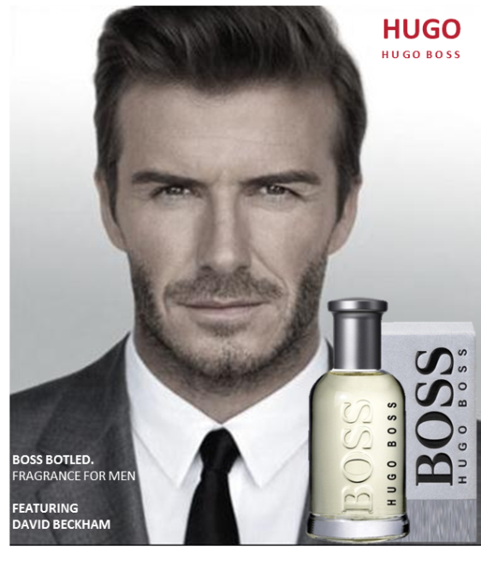
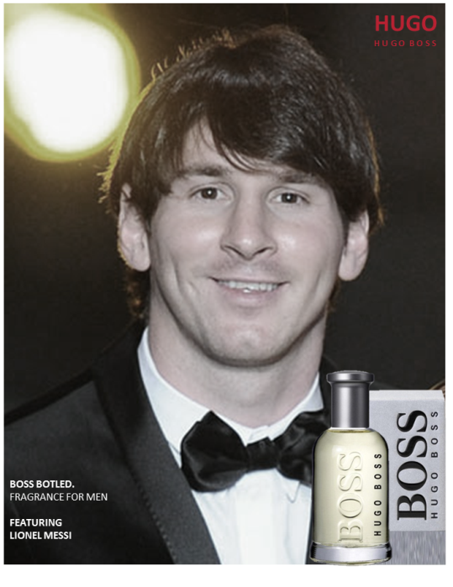
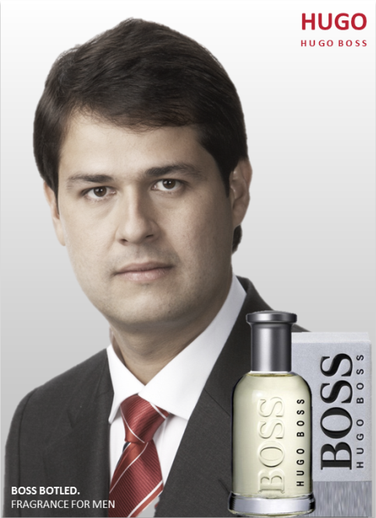
1. Successful spokesperson 2. Successful attractive spokesperson
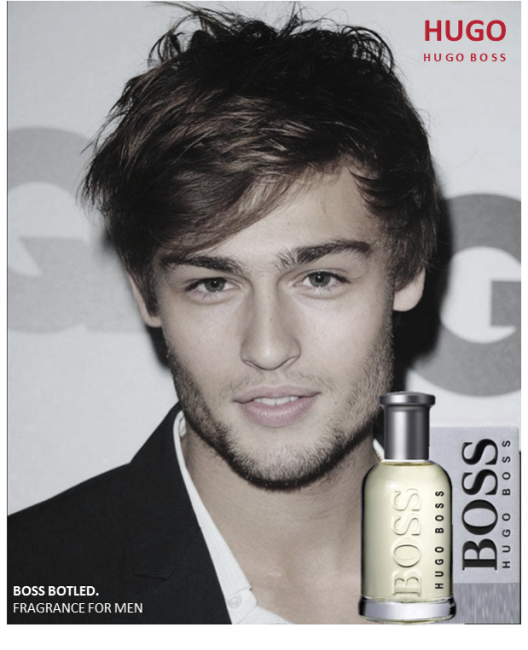

3. Attractive spokesperson 4. Average looking spokesperson
Now we will indicate a newcoming ad about Hugo Boss. Please check the ad carefully and answer the next questions.
Nationality
- What is your nationality?
Familiarity with the Spokesperson
(Possible answers to the following questions: Strongly Disagree, Disagree, Somewhat Disagree, Neither Agree nor Disagree, Somewhat Agree, Agree, Strongly Agree)
- Do you recognize the person in the ad? (for successful spokespersons only)
- Do you find the person in ad successful/attractive/average looking?
1 (Strongly disagree) to 7 (Strongly agree), what do you think about the person in the ad
 | Strongly disagree |  |  |  |  |  | Strongly agree
 | 1 | 2 | 3 | 4 | 5 | 6 | 7
This person is an average looking person
This person is a very successful person
This person is a very attractive person

4. Attitude towards the Ad
Here are a number of statements about the ad with which you may agree or not agree. Please select the answer that best indicates the extent to which you agree or disagree with that statement.
(Possible answers to the following questions: Strongly Disagree, Disagree, Somewhat Disagree, Neither Agree nor Disagree, Somewhat Agree, Agree, Strongly Agree)
• I dislike the ad/ I like the ad
• I react unfavourably to the ad/ I react favourably to the ad
• I feel negative toward the ad/ I feel positive toward the ad
• The ad is bad/ the ad is good
• I find this ad trustworthy/ untrustworthy
• I find this ad persuasive/ not at all persuasive
• I find this ad believable/ unbelievable
• I find this ad appealing/ unappealing
5. Attitude towards the Brand
(Possible answers to the following questions: Strongly Disagree, Disagree, Somewhat Disagree, Neither Agree nor Disagree, Somewhat Agree, Agree, Strongly Agree)
• I would not purchase this perfume/ I would purchase this perfume
• I find this perfume a mediocre product/ an exceptional product
• I find this brand of not at all high quality/ extremely high quality
• I find this perfume of poor value/ excellent value
• I find this perfume poorly made/ well made
• I find this perfume boring/ exciting
• I find this perfume not a worthwhile product/ a worthwhile product
• I find this perfume an unappealing product/ appealing product
• I find this perfume common/ unique
• I would not recommend this perfume to a friend/ I would recommend this perfume to a friend
• I find this perfume very bad / very good
6. Purchase Intention
(Possible answers to the following questions: Strongly Disagree, Disagree, Somewhat Disagree, Neither Agree nor Disagree, Somewhat Agree, Agree, Strongly Agree)
• It is very likely that I will buy the Hugo Boss perfume
• I will purchase Hugo Boss the next time I need a perfume
• I will definitely try the Hugo Boss perfume
• Suppose that a friend called you last night to get your advice in his/her search for a perfume. Would you recommend him to buy a perfume from Hugo Boss?
7. Social comparison
(Possible answers to the following questions: Strongly Disagree, Disagree, Somewhat Disagree, Neither Agree nor Disagree, Somewhat Agree, Agree, Strongly Agree)
• When I see models in this Hugo Boss ad, I think about how well or how badly I look compared to the person.
• Ads for perfumes make me feel dissatisfied with the way I look.
• When getting ready for a special occasion or buying a perfume, I look at ads to give me ideas about how I should look.
• I have wished that I looked more like models in Hugo Boss advertisements.
• When getting ready for a special occasion or buying a product, I look to Hugo Boss ads to get an idea about how I should look.
Background questions
- Age
- Brand involvement
- Self-perceptions of attractiveness (success) compared to the one in the ad

 | 1 Strongly disagree |  |  |  |  |  | 7  Strongly agree
I am as attractive as the guy in the ad
I am also a successful person relative to my environment like the guy in the ad

Thank you for your cooperation.

7.2 Results

Figure 15: Social comparison among consumers for successful and attractive spokespersons
Figure 16: Proportion of Brazilian and Dutch respondents who compare themselves with the spokesperson in the ad

Figure 17: Purchase intention of Brazilian and Dutch respondents
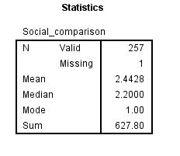

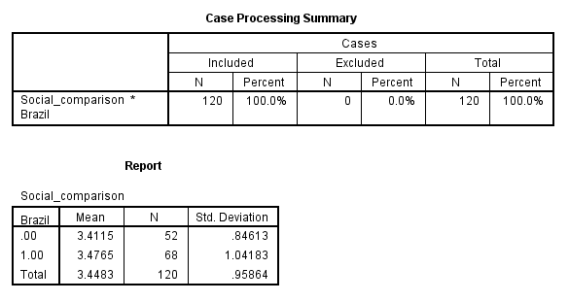
Figure 18: Number of subjects above social comparison mean for Brazil and the Netherlands
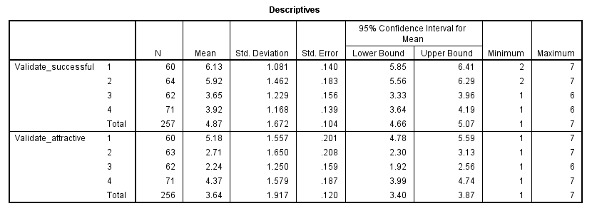
Figure 19: Manipulation check descriptives
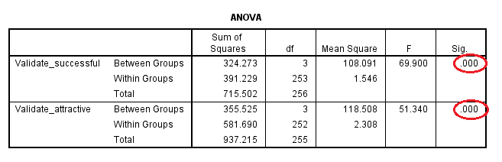
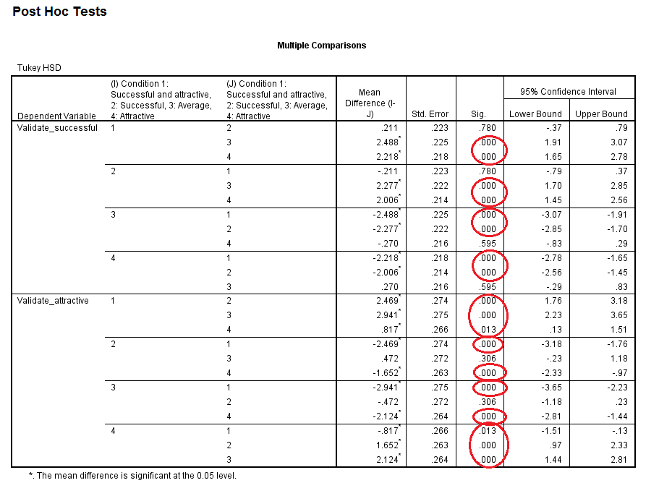
Figure 20: Manipulation check ANOVA

Figure 21: Manipulation check Post Hoc test

Successful and Attractive

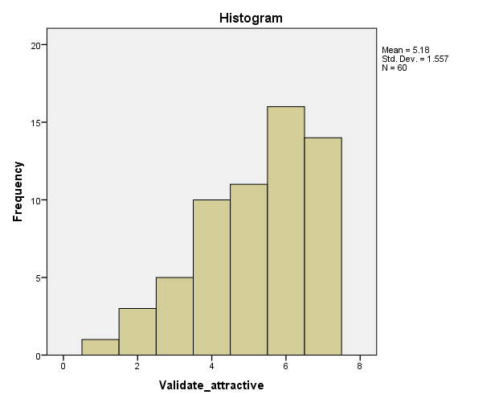
Statistics
Validate_attractive
N | Valid | 60
 | Missing | 0
Mean |  | 5.18
Median |  | 5.50
Mode |  | 6
Sum |  | 311

Figure 22: Histogram attractiveness for Condition 1

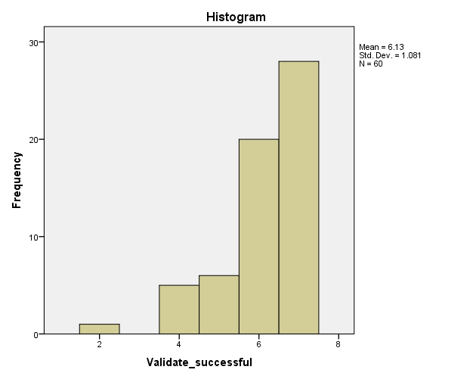
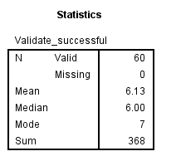

Figure 23: Histogram success for Condition 1

Successful non-attractive
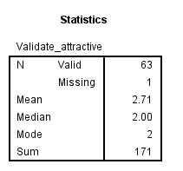
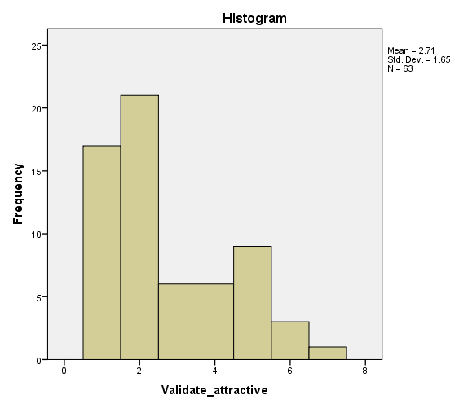

Figure 24: Histogram attractiveness for Condition 2
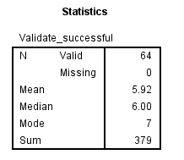
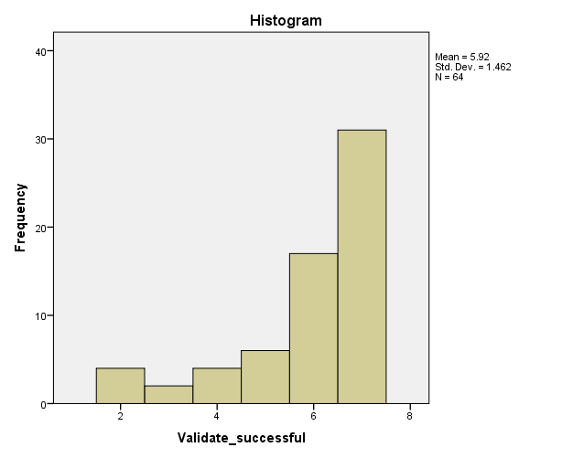

Figure 25: Histogram success for Condition 2
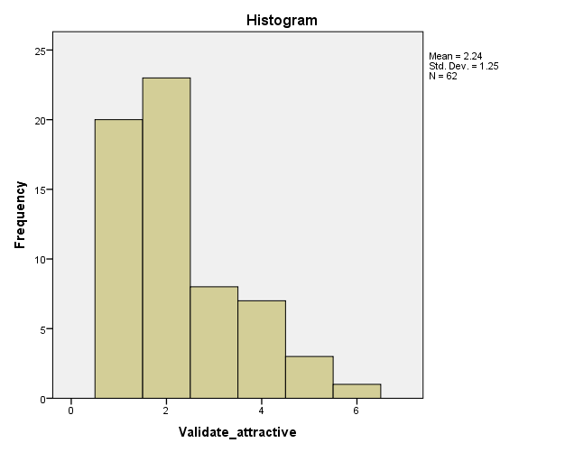
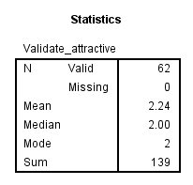
Average looking non-successful

Figure 26: Histogram attractiveness for Condition 3
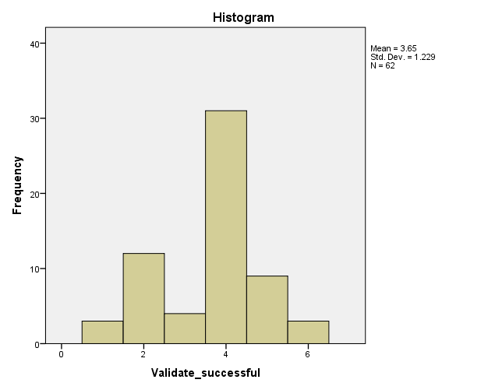
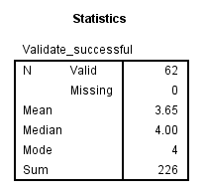

Figure 27: Histogram success for Condition 3

Attractive non-successful

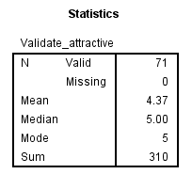
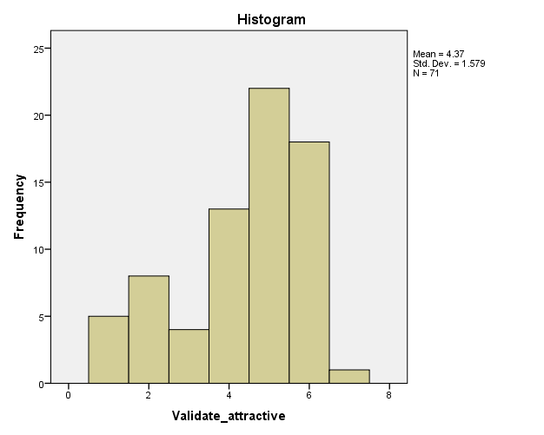

Figure 28: Histogram attractiveness for Condition 4
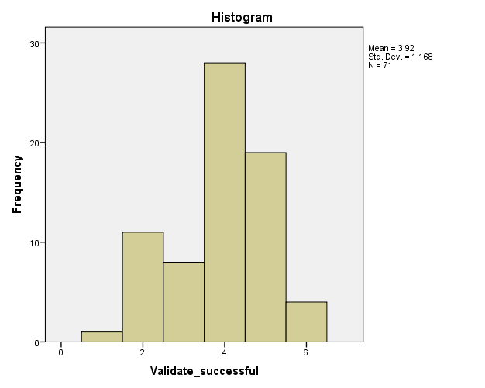
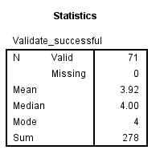

Figure 29: Histogram success for Condition 4

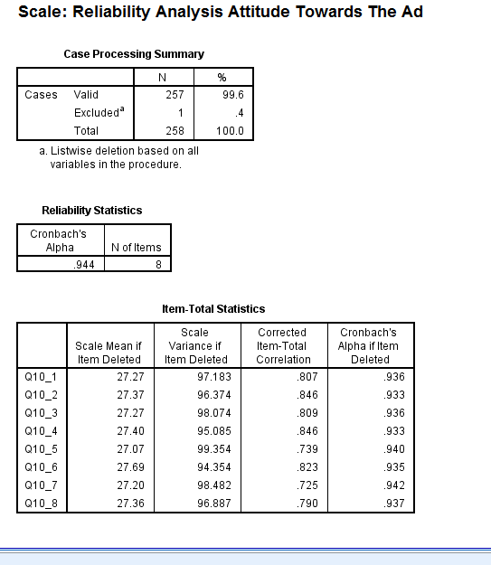
Figure 30: Reliability Analysis Attitude Towards the Ad

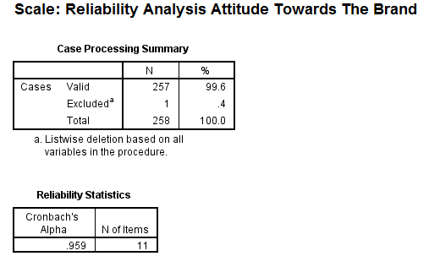
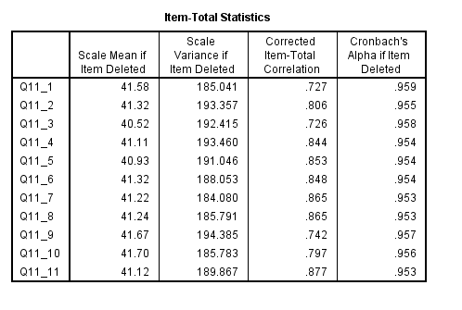
Figure 31: Reliability Analysis Attitude Towards the Brand
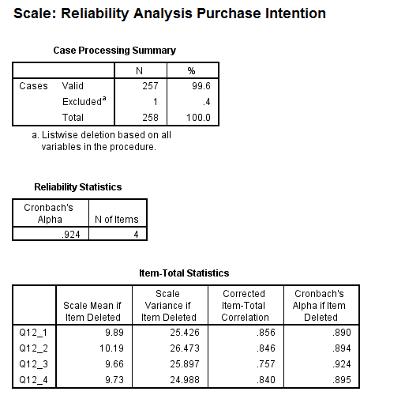
Figure 32: Reliability Analysis Purchase Intention

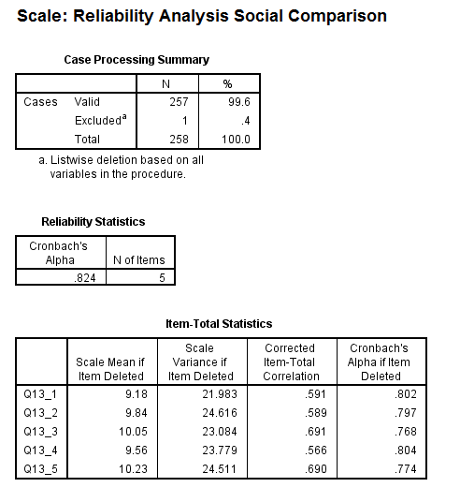
Figure 33: Reliability Analysis Attitude Social Comparison

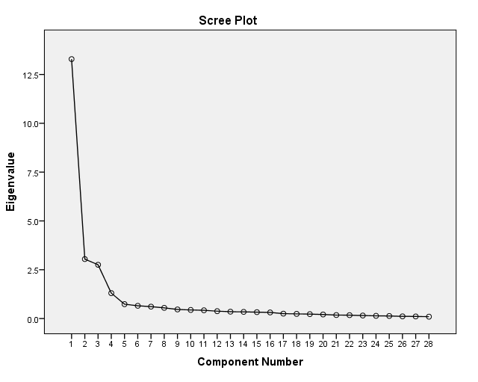
Figure 34: Factor Analysis Scree Plot

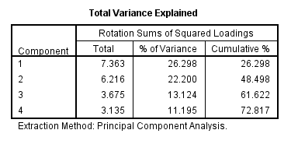
Figure 35: Factor Analysis Total Variance Explained

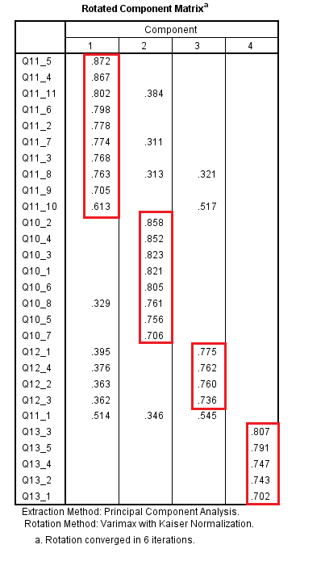
Figure 36: Factor Analysis – factor loadings

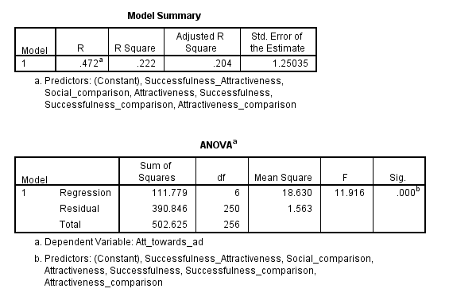

Figure 37: Regression analysis H1 – H5

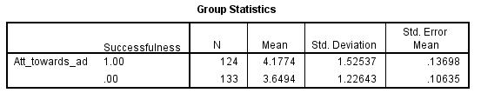

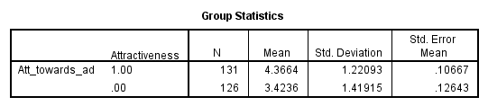
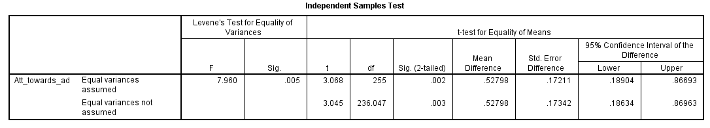

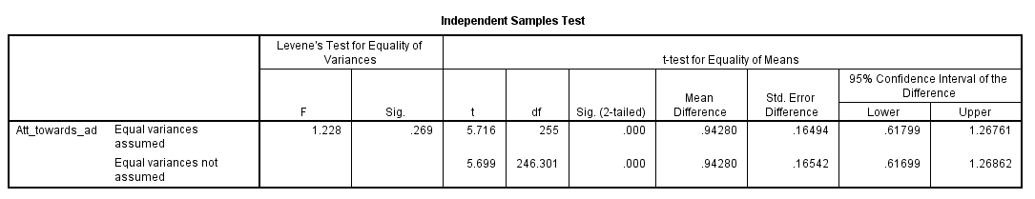
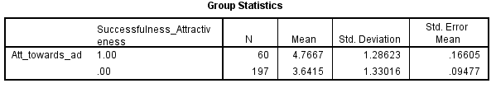
Figure 38: T-test H4 - successfulness vs. attractiveness

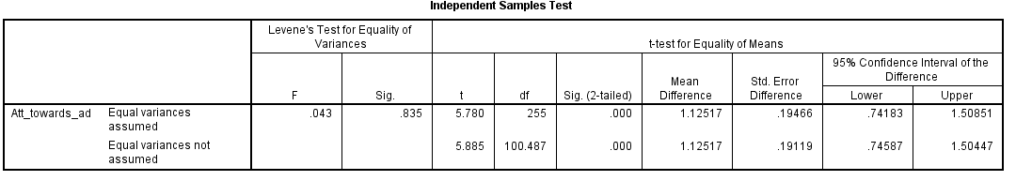
Figure 39: T-test H5 – attractiveness and successfulness vs. successfulness

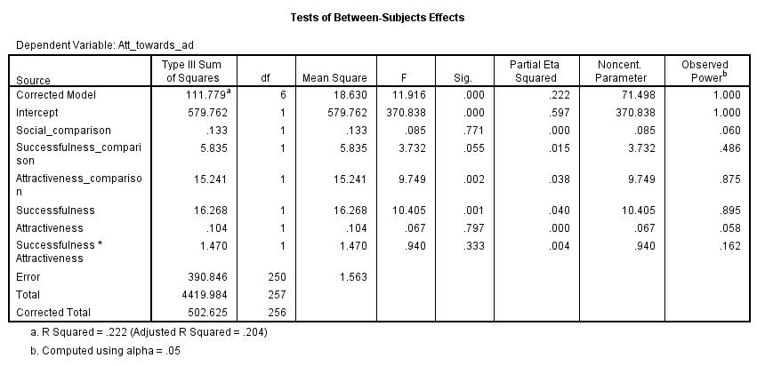
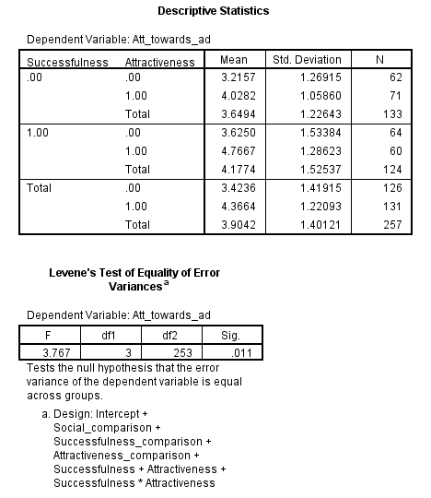

Figure 40: Two-way ANCOVA analysis

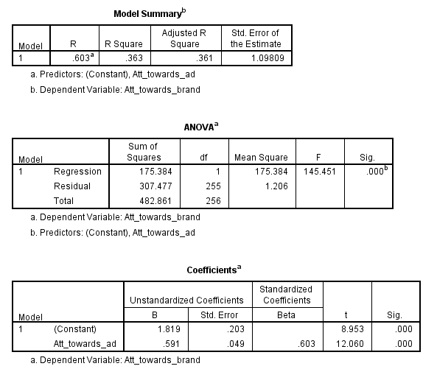

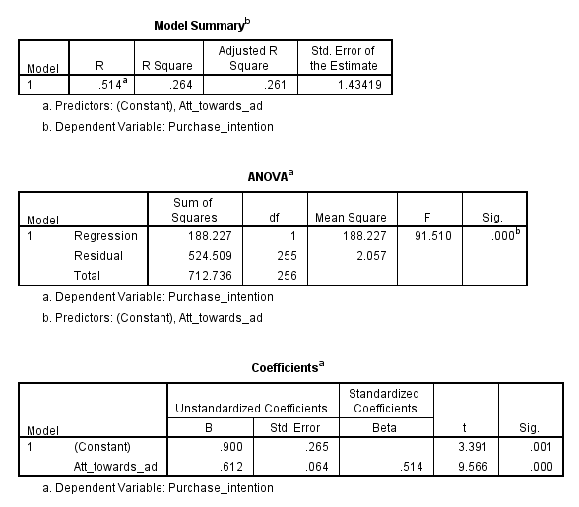
Figure 41: Testing H6 (I. Y2= β0 + β1 Y1 + error term)

Figure 42: Testing H6 (I. Y3 = β0 + β1 Y1 + error term)
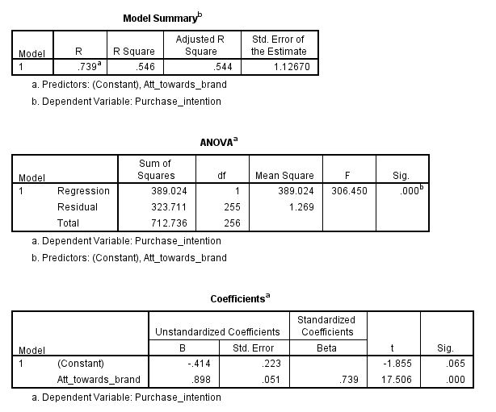

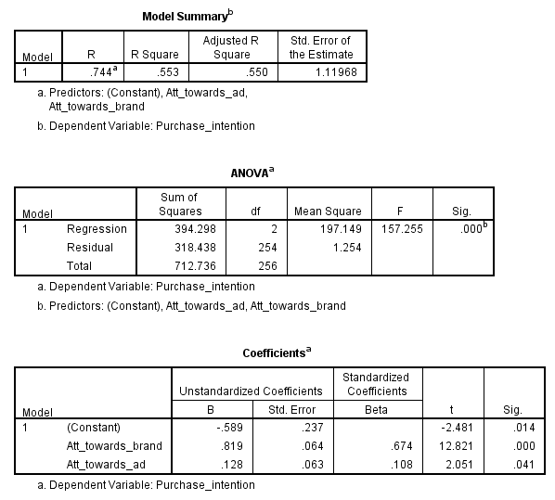
Figure 43: Testing H6 (II. Y3= β0 + β2 Y2 + error term)

Figure 44: Testing H6 (III. Y3= β0 + β1 Y2 + β2 Y1 + error term)
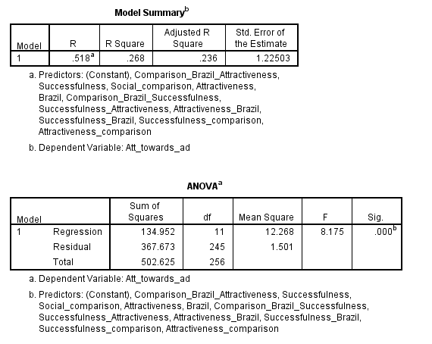
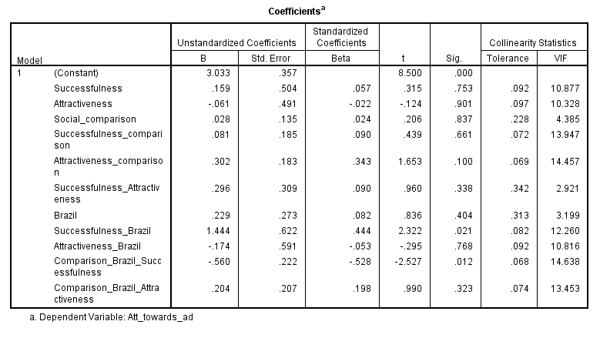
Figure 45: Regression analysis H7 – H9 before means centering
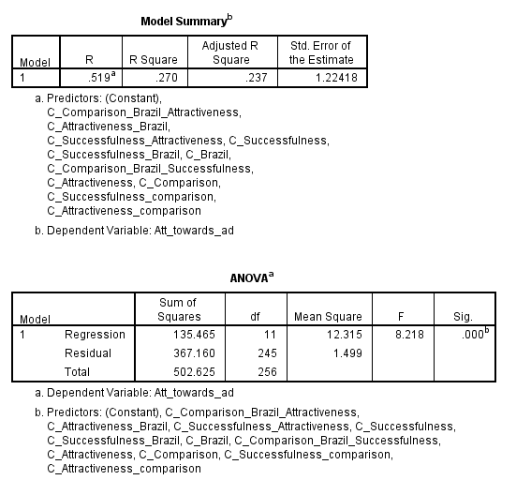
Figure 46: Regression analysis H7 – H9 after means centering
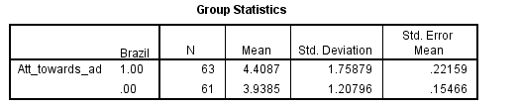

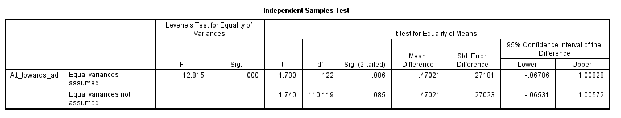

Figure 47: T-test for successful spokespersons Brazil vs. the Netherlands
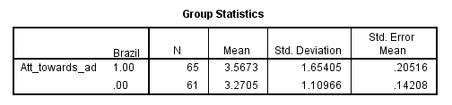

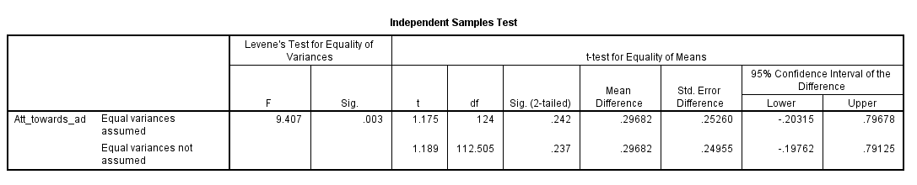

Figure 48: T-test for average looking spokespersons Brazil vs. the Netherlands
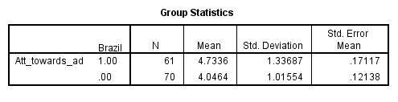
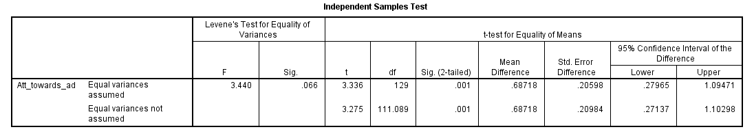

Figure 49: T-test for attractive spokespersons Brazil vs. the Netherlands

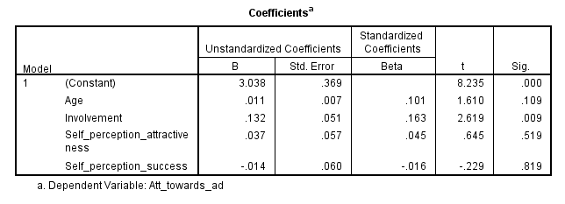

Figure 50: Control variables
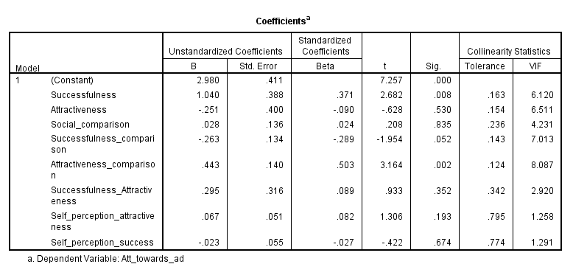

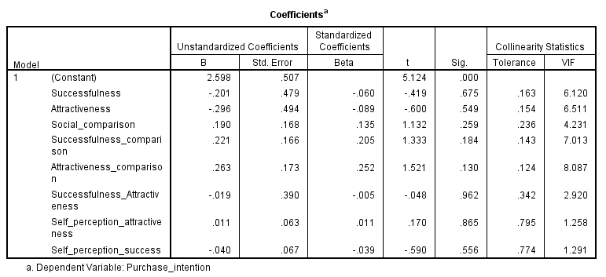
Figure 51: Self-perception success and self-perception attractiveness on attitude towards the ad
Figure 52: Self-perception success and self-perception attractiveness on purchase intention

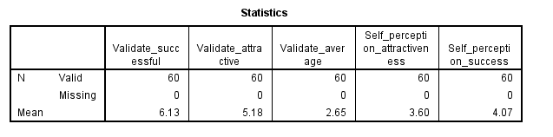
Figure 53: Control variables - self-perception attractiveness and self-perception success for Condition 1 (Successful and attractive)
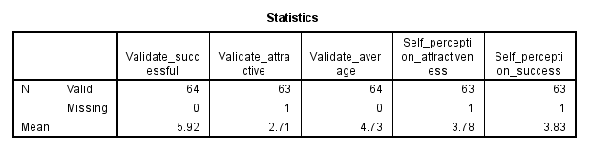

Figure 54: Control variables - self-perception attractiveness and self-perception success for Condition 2 (Successful and non-attractive)
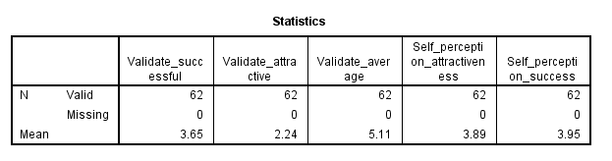

Figure 55: Control variables - self-perception attractiveness and self-perception success for Condition 3 (Average looking and non-successful)
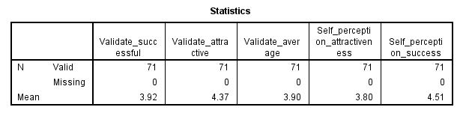
Figure 56: Control variables - self-perception attractiveness and self-perception success for Condition 4 (Attractive and non-successful)
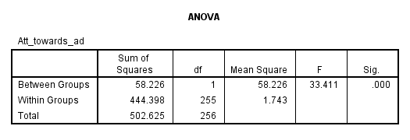
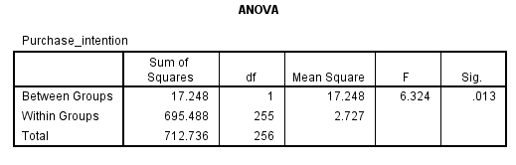

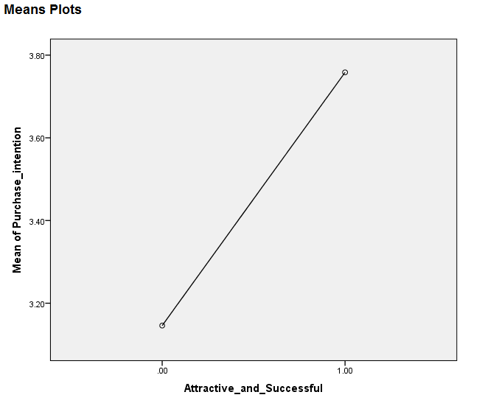
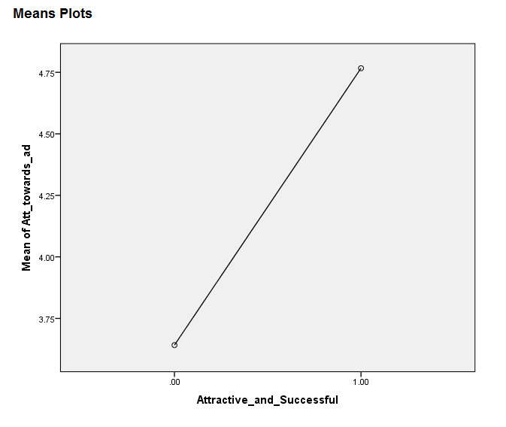

Figure 57: Additional analysis - attitude towards the ad and purchase intention for attractive and successful spokesperson

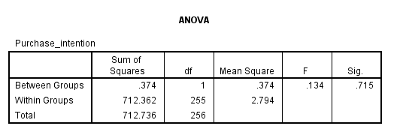
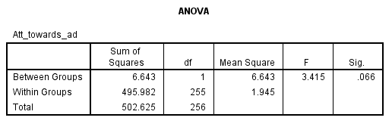
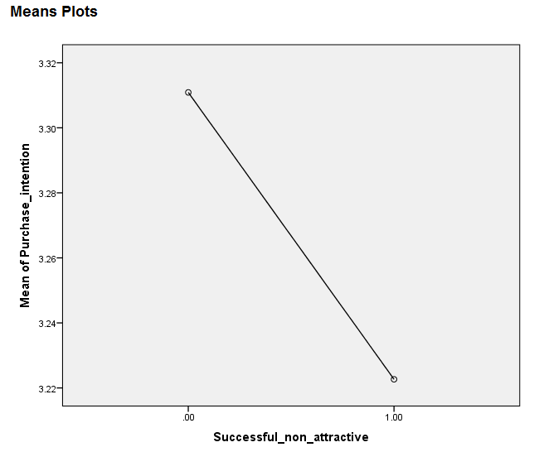
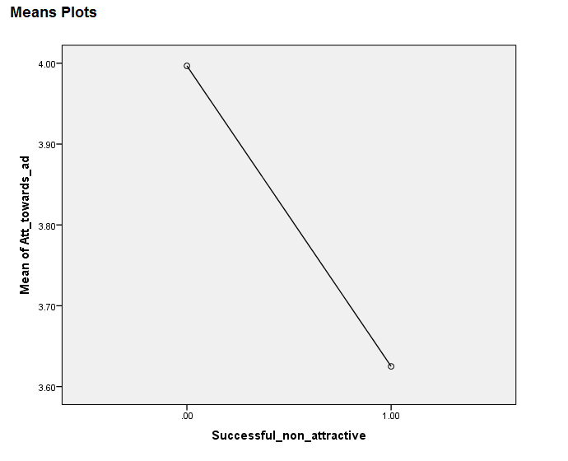

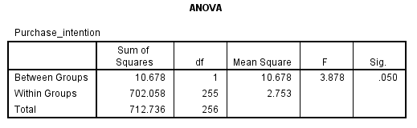
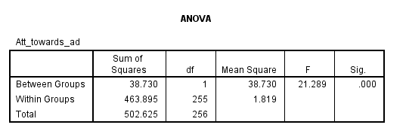
Figure 58: Additional analysis - attitude towards the ad and purchase intention for successful non-attractive spokesperson
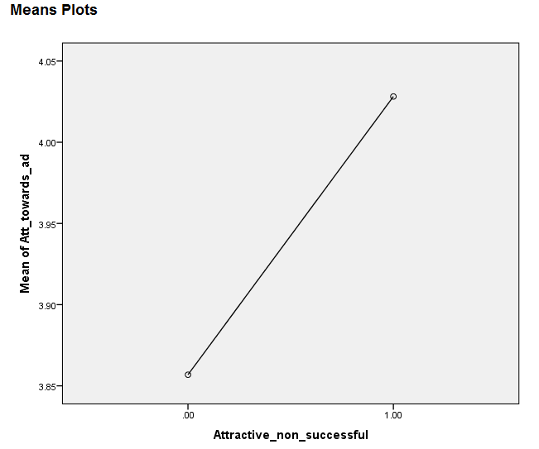
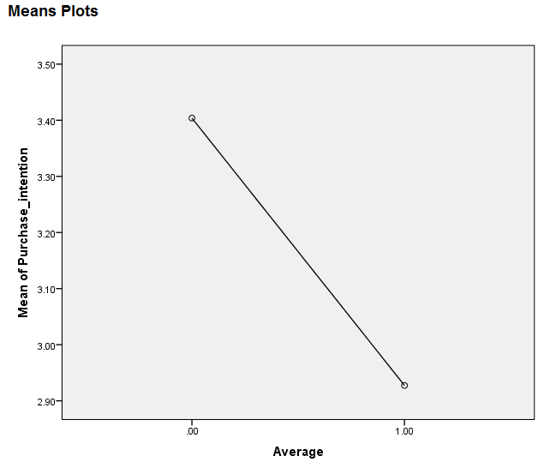

Figure 59: Additional analysis - attitude towards the ad and purchase intention for average looking non-successful spokesperson
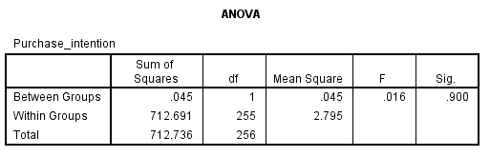
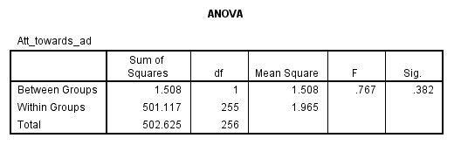
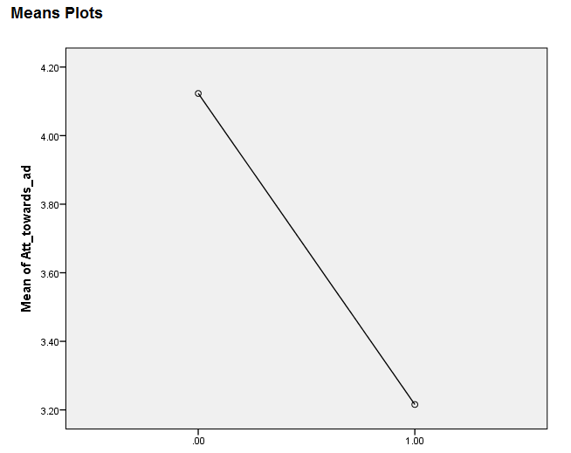
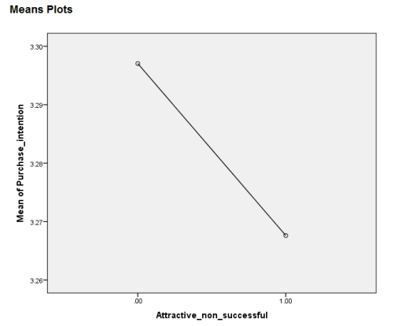
Figure 60: Additional analysis - attitude towards the ad and purchase intention for attractive non-successful spokesperson
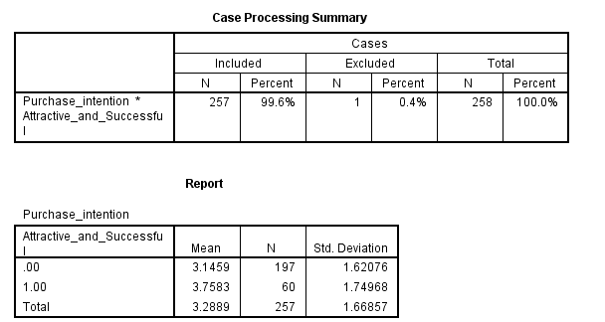

Figure 61: Additional analysis - total mean score for Purchase intention condition 1 (Attractive and successful)
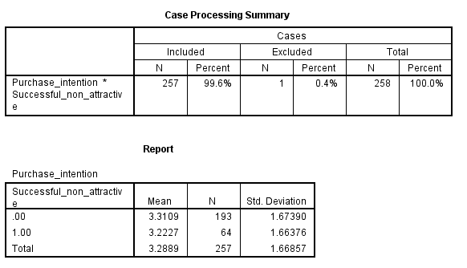

Figure 62: Additional analysis - total mean score for Purchase intention condition 2 (Successful and non-attractive)
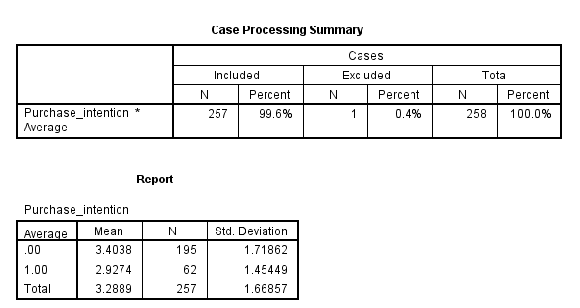
Figure 63: Additional analysis - total mean score for Purchase intention condition 3 (Average looking non-successful)
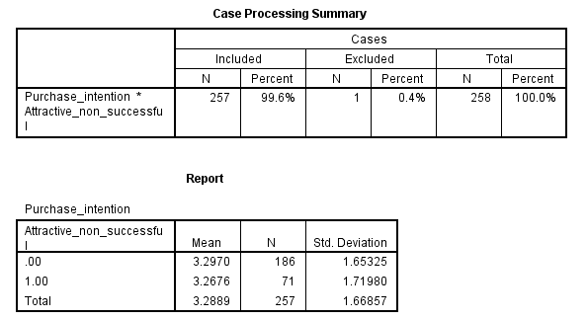
Figure 64: Additional analysis - total mean score for Purchase intention condition 4 (Attractive non-successful)
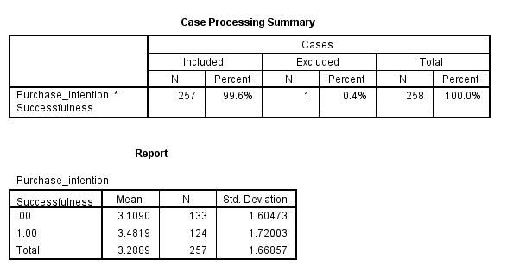
Figure 65: Additional analysis - total mean score for Purchase intention successful vs. non-successful -> (1+2) versus (3+4)
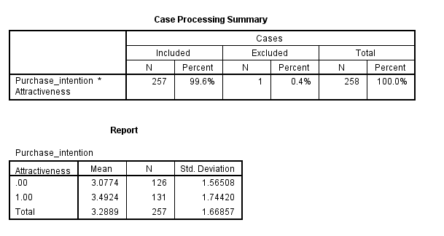
Figure 66: Additional analysis - total mean score for Purchase intention attractive vs. non-attractive -> (1+4) versus (2+3)
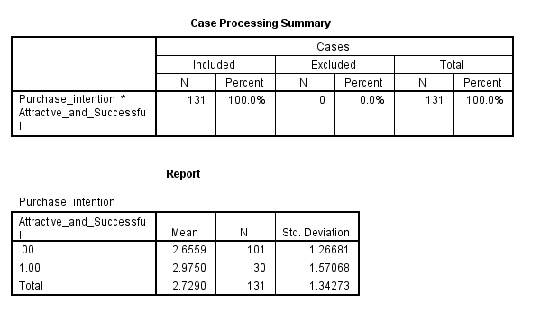
Figure 67: Additional analysis - Netherlands mean score for Purchase intention condition 1 (Attractive and successful)
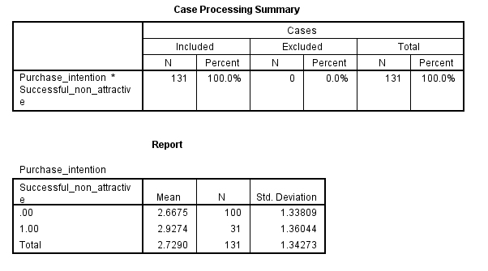
Figure 68: Additional analysis - Netherlands mean score for Purchase intention condition 2 (Successful and non-attractive)
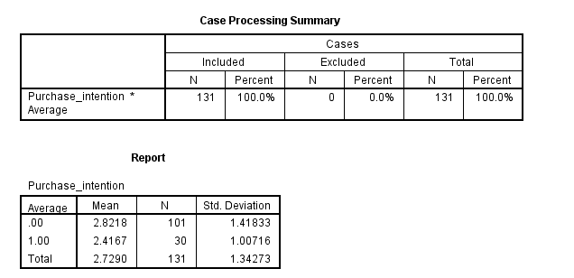
Figure 69: Additional analysis - Netherlands mean score for Purchase intention condition 3 (Average looking non-successful)
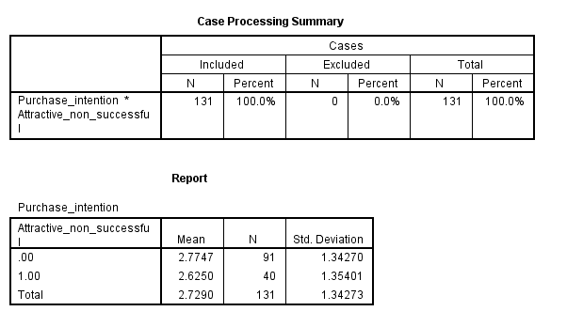
Figure 70: Additional analysis - Netherlands mean score for Purchase intention condition 4 (Attractive non-successful)
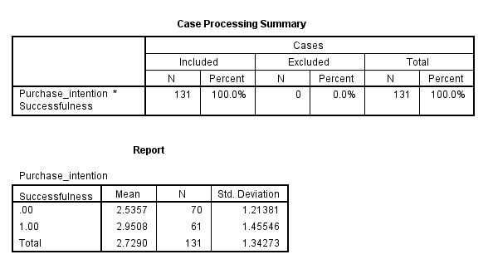

Figure 71: Additional analysis - Netherlands mean score for Purchase intention successful vs. non-successful -> (1+2) versus (3+4)

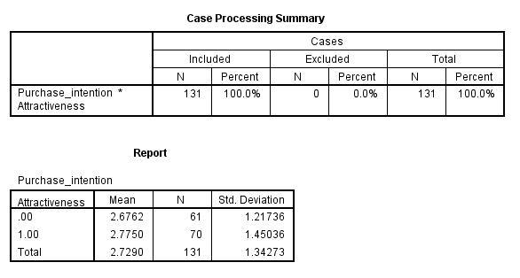

Figure 72: Additional analysis - Netherlands mean score for Purchase intention attractive vs. non-attractive -> (1+4) versus (2+3)

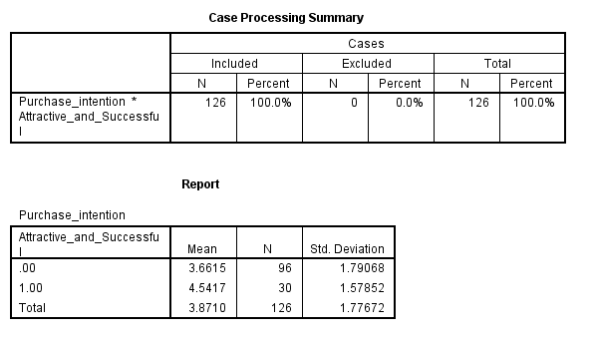
Figure 73: Additional analysis - Brazil mean score for Purchase intention condition 1 (Attractive and successful)

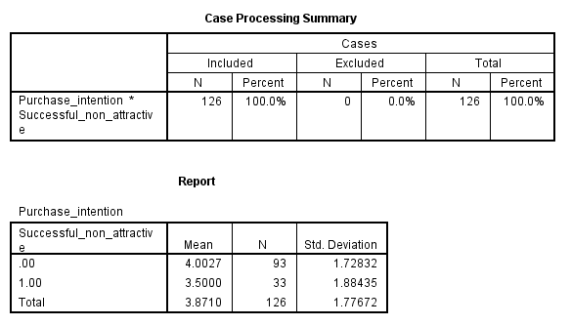
Figure 74: Additional analysis - Brazil mean score for Purchase intention condition 2 (Successful and non-attractive)
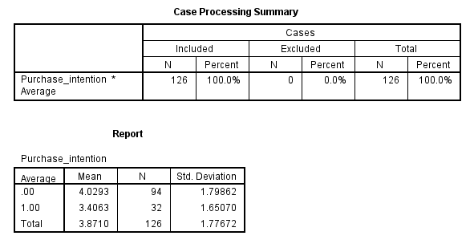
Figure 75: Additional analysis - Brazil mean score for Purchase intention condition 3 (Average looking non-successful)
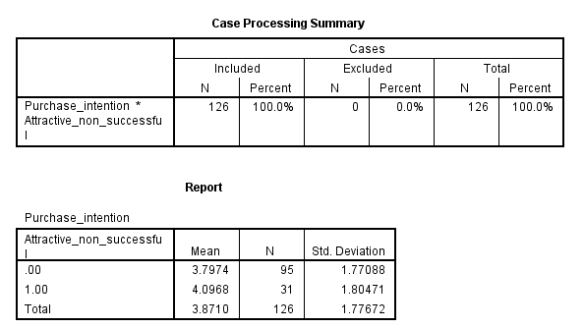
Figure 76: Additional analysis - Brazil mean score for Purchase intention condition 4 (Attractive non-successful)
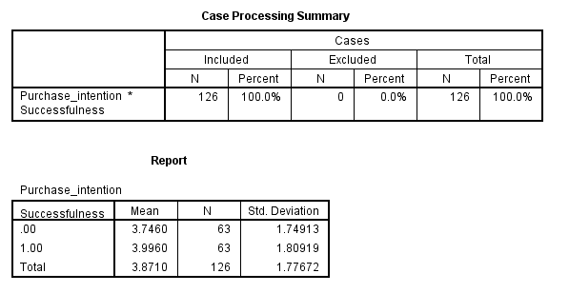
Figure 77: Additional analysis - Brazil mean score for Purchase intention successful vs. non-successful -> (1+2) versus (3+4)
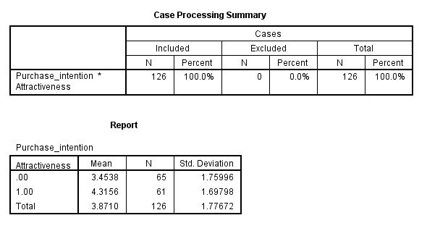
Figure 78: Additional analysis - Brazil mean score for Purchase intention attractive vs. non-attractive -> (1+4) versus (2+3)

